

Flood Plain Lower Ringarooma River Ramsar site

Ecological Character Description

March 2012
Blank page
Citation:
Newall, P.R. and Lloyd, L.N. 2012. Ecological Character Description for the Flood Plain Lower Ringarooma River Ramsar Site. Lloyd Environmental Pty Ltd Report (Project No: LE0944) to the Department of Sustainability, Environment, Water, Population and Communities (SEWPaC), Australian Government. Lloyd Environmental, Syndal, Victoria, 2nd March 2012.
Copyright
© Copyright Commonwealth of Australia, 2012.

The Ecological Character Description for the Flood Plain Lower Ringarooma River Ramsar site is licensed by the Commonwealth of Australia for use under a Creative Commons By Attribution 3.0 Australia licence with the exception of the Coat of Arms of the Commonwealth of Australia, the logo of the agency responsible for publishing the report, content supplied by third parties, and any images depicting people. For licence conditions see: http://creativecommons.org/licenses/by/3.0/au/
This report should be attributed as ‘Ecological Character Description for the Flood Plain Lower Ringarooma River Ramsar site, Commonwealth of Australia 2012’.
The Commonwealth of Australia has made all reasonable efforts to identify content supplied by third parties using the following format ‘© Copyright, [name of third party] ’.
Acknowledgements:
- Chris Bobbi, Senior Water Environment Officer, Water Assessment Branch, Water Resources Division, Department of Primary Industries and Water (DPIW)
- Sally Bryant, Manager Threatened Species Section, Biodiversity Conservation Branch, DPIW
- Jenny Davis, Associate Professor, School of Environmental Science, Murdoch University, Western Australia
- Louise Gilfedder, (Senior Conservation Scientist), Private Land Conservation Program, DPIW
- Kath Jerie, Earth Science Section, Resource Management and Conservation Division, DPIW
- Bronwen Wicks, Wetlands Section, SEWPaC
- Anya Lam, Wetlands Section, SEWPaC
- Ken Morgan, Wetlands Section, SEWPaC
- John Pemberton, Senior Geologist, Industrial Minerals and Land Management, Mineral Resources Tasmania
- Greg Pinkard, Manager, Land Conservation Branch, DPIW
- Andrew Baldwin, NRM North
- Adrian James, NRM North
- Jay Wilson, NRM North Facilitator
- Elisha Atchison, Lloyd Environmental Pty Ltd
This project was funded by NRM North Tasmania and the Australian Government.
The steering committee was comprised of the following:
- Scott Schilg, Program Manager, Healthy Coasts and Seas, NRM North
- Emma Williams, Healthy Coasts and Seas Coordinator, NRM North
- Imogen Birley, SEWPaC
- Stewart Blackhall, Wildlife Biologist, Wildlife and Marine Conservation Section, Biodiversity Conservation Branch, DPIW
- Dominique Couzens, Ranger in Charge – Scottsdale, Parks & Wildlife, Tasmania
- Jay Wilson, Dorset Natural Resource Management Facilitator, Dorset Council

Introductory Notes
This Ecological Character Description (ECD Publication) has been prepared in accordance with the National Framework and Guidance for Describing the Ecological Character of Australia’s Ramsar Wetlands (National Framework) (Department of the Environment, Water, Heritage and the Arts, 2008).
The Environment Protection and Biodiversity Conservation Act 1999 (EPBC Act) prohibits actions that are likely to have a significant impact on the ecological character of a Ramsar wetland unless the Commonwealth Environment Minister has approved the taking of the action, or some other provision in the EPBC Act allows the action to be taken. The information in this ECD Publication does not indicate any commitment to a particular course of action, policy position or decision. Further, it does not provide assessment of any particular action within the meaning of the EPBC Act, nor replace the role of the Minister or his delegate in making an informed decision to approve an action.
This ECD Publication is provided without prejudice to any final decision by the Administrative Authority for Ramsar in Australia on change in ecological character in accordance with the requirements of Article 3.2 of the Ramsar Convention.
Disclaimer
While reasonable efforts have been made to ensure the contents of this ECD are correct, the Commonwealth of Australia as represented by the Department of the Environment does not guarantee and accepts no legal liability whatsoever arising from or connected to the currency, accuracy, completeness, reliability or suitability of the information in this ECD.
Note: There may be differences in the type of information contained in this ECD publication, to those of other Ramsar wetlands.
Cover photos (left to right):
The Ringarooma River - Michelle McAulay, SEWPaC; Panoramic View of the Ringarooma River - Michelle McAulay, SEWPaC; The Ringarooma River - Michelle McAulay, SEWPaC; The Ringarooma River - Michelle McAulay, SEWPaC.
Contents
List of Abbreviations 7
Executive Summary 8
1. Introduction 20
1.1. Purpose 20
1.2. Site Details 21
1.3. Date of Description 22
1.4. Relevant Treaties, Legislation or Regulations 23
1.4.1. International treaties and strategies 23
1.4.2. Commonwealth Legislation and Policy 24
1.4.3. State legislation 25
2. Detailed Description of the Site 26
2.1 Setting 26
2.2 Ramsar Listing 30
2.2.1 Original Listing Criteria 30
2.2.2 Assessment of remaining criteria 34
2.3 Land Use and Tenure 35
3. Ecological Character of the Flood Plain Lower Ringarooma River Ramsar Site 40
3.1 Ecological Zones of the Site 40
3.1.1 The Coastal Zone 42
3.1.2 The Estuary Zone 45
3.1.3 The Freshwater Zone 47
3.2 Components and Processes of the Site 51
3.2.1 Climate 51
3.2.2 Geomorphology 54
3.2.3 Substrate 56
3.2.4 Hydrology 56
3.2.5 Water Quality 59
3.2.6 Vegetation 60
3.2.7 Fauna 64
3.3 Benefits and Services of the Site 70
3.4 Critical Components and Processes and Essential Elements 74
3.4.1 Critical components and processes 74
3.4.2 Essential elements 77
3.5 Critical benefits and services 77
3.6 Conceptual Models of the Site 78
3.6.1 Overview Model 78
3.6.2 Conceptual Model for the Coastal Zone 81
3.6.3 Conceptual Model for the Estuary 83
3.6.4 Conceptual Models for the Freshwater River, Flood Plain and Wetland Zone 86
4. kEY ACTUAL OR POTENTIAL THREATS TO THE SITE 90
4.1 Threats to the Coastal Zone 90
4.2 Threats to the Estuary Zone 90
4.3 Threats to the Freshwater Zone 94
4.4 Summary of the Key Threats 104
5. lIMITS OF ACCEPTABLE CHANGE 106
6. Changes in Ecological Character Since Listing 113
7. Knowledge Gaps 117
8. Key Site Monitoring Needs 120
9. Communication, Education and Public Awareness (CEPA) Messages 123
10. Glossary 129
11. References 133
12. Appendices 137
Appendix 1: Plant Lists of the Flood Plain Lower Ringarooma River Ramsar Site. 137
Appendix 2: Species associated with major plant communities in the Flood Plain Lower Ringarooma Ramsar Site (DPIW 2006). 144
Appendix 3: List of bird species recorded during surveys at the Flood Plain Lower Ringarooma Ramsar Site in winter and spring 2002. 146
Appendix 4: The Consultants 149
Appendix 5: Methodology to Develop the ECD 151

List of Abbreviations
AAS | Armstrong Agricultural Services
ANZECC | Australia and New Zealand Environment and Conservation Council
ARMCANZ | Agriculture and Resource Management Council of Australia and New Zealand
BIS | Badcock Irrigation Services
CAMBA | China-Australia Migratory Birds Agreement
CBD | Convention on Biodiversity
CEPA | Community Education and Public Awareness
CMS | Bonn Convention on Migratory Species
DAFF | Department of Agriculture, Fisheries and Forestry (Commonwealth)
DEH | Department of the Environment and Heritage (Commonwealth)
DEWHA | Department of the Environment, Water, Heritage and the Arts (formerly DEH) (Commonwealth)
DoE | Department of the Environment (formerly SEWPaC)(Commonwealth)
DPIPWE | Department of Primary Industries, Parks, Water and Environment (Tasmania)
DPIW | Department of Primary Industries and Water (Tasmania)
DTAE | Department of Tourism, Arts and the Environment (Tasmania)
ECD | Ecological Character Description
EPBC | Environment Protection and Biodiversity Conservation Act 1999 (Commonwealth)
IMCRA | Integrated Marine and Coastal Regionalisation of Australia
JAMBA | Japan-Australia Migratory Birds Agreement
LAC | Limits of Acceptable Change
MCFFA | Ministerial Council on Forestry, Fisheries and Aquaculture
NWC | National Water Commission
NRM | Natural Resource Management
PWS | Parks and Wildlife Service, Tasmania
RIS | Ramsar Information Sheet
ROKAMBA | Republic of Korea-Australia Migratory Birds Agreement
SEWPaC | Department of Sustainability, Environment, Water, Population and Communities (formerly DEWHA) (Commonwealth)
TSPA | Threatened Species Protection Act 1995 (Tasmania)
TSS | Threatened Species Section

Executive Summary
Background
Australia, as a contracting party to the Ramsar Convention on Wetlands, must meet specified obligations in the maintenance of the ecological character of its Wetlands of International Importance (Ramsar sites). An Ecological Character Description (ECD) is one of the management tools used in the protection of Ramsar sites.
An ECD of a Ramsar site must support the requirements of the Ramsar Convention to maintain ecological character of Ramsar sites, as well as provide site-specific objectives based on the intrinsic social, cultural and environmental features of the site. The preparation of an ECD assists management of the wetland, including information required to:
- provide a benchmark for the wetland ecological character at the time of listing;
- designing programs for monitoring its ecological character;
- determining methods and approaches for assessing changes to its ecological character;
- identifying potential threats and impacts, and evaluating risks;
- devising efficient and appropriate management plans for the ongoing protection of the wetland; and
- identifying critical gaps in knowledge and approaches/methods for addressing these gaps.
The process for preparing an ECD can also engage the relevant stakeholders, thereby laying the foundations for alignment of goals and agreed management outcomes.
The Flood Plain Lower Ringarooma River Ramsar site (‘the site’) was first listed in November 1982.

General Site Description
The site covers an area of 3519 hectares near the coast of north-eastern Tasmania, near the towns of Bridport and Gladstone. At its northern edge, the site includes the Boobyalla Inlet estuary and a mobile sand dune system. The site extends a distance of approximately eight kilometres to the south, encompassing a variety of habitats including a mosaic of freshwater wetlands which are significant to a number of species.
The ecological data available for the site are very limited with the exception of a detailed vegetation survey covering much of the Flood Plain vegetation, and some geomorphic examination of the landforming processes within the site. There are several documents that provide some qualitative information on the site’s ecological character. The available information was supplemented with a field inspection by the study team and steering committee, as well as a flight over the site to increase understanding of the site’s physical geography. Information gained from the site inspections was used with aerial photography and the vegetation survey of part of the site to produce a vegetation map of the whole site. This provided the only quantitative data available for the ECD.
The site can be separated into three zones – a coastal zone, an estuary zone and an aquatic (freshwater) zone. The coastal zone covers the entire coast of the site (three to four kilometres), including the combined mouth of the Boobyalla and Ringarooma Rivers and their delta. The Ramsar wetland types that occur within the coastal zone are: sandy shores (wetland type E); delta (wetland type F); and intertidal mud and sand flats (wetland type G). A number of beach nesting shorebirds have been recorded breeding on the beaches of the site, comprising the little tern (Sterna albifrons), hooded plover (Thinornis rubricollis), fairy tern (Sterna nereis), pied oystercatcher (Haematopus longirostris) and red-capped plover (Charadrius ruficapillus).
The estuary zone is wave dominated, with a flood tide delta. Wave dominated deltas are considered ‘mature’ in terms of evolution and tend to be morphologically stable (assuming stable sea levels). They often have a narrow entrance which can restrict marine flushing, although this is counter-balanced by high river flows that expel marine water and flush material from the delta. The short residence time for deposited material results in little processing or trapping of associated nutrients and contaminants. The Ramsar wetland types that occur within the estuary zone include estuarine waters (wetland type F); intertidal mud and sand flats (wetland type G); intertidal salt marshes (wetland type H); and coastal brackish/saline lagoons (wetland type J).
Typical of wave dominated delta estuaries, the Ringarooma estuary has a direct connection between river and sea, via a channel flanked by a low-lying vegetated Flood Plain. The channel is kept open by the relatively high river velocities and a dune barrier partially constricts the estuary entrance, preventing it from expanding into a large, open estuary. The ‘mature’ nature of wave dominated deltas means that they have been mostly filled by sediments. In the case of the Ringarooma estuary, this ‘maturation’ has probably been created prematurely through an increased rate of sediment yield from the catchment as a result of tin mining during the late 1800s and early 1900s.
The freshwater zone contains wetlands formed on a lowland Flood Plain that widens out downstream of a shallow and constricted valley. In the wider and flatter area of the Flood Plain, water from high flows sometimes leaves the channel and spreads out, filling in depressions in the landscape. As the water leaves the channel during high flows it quickly loses velocity and deposits the heavier sediment along the channel edge, forming natural levees. These natural levees impede the water from subsequently returning to the channel, leaving it to form a mosaic of seasonally-inundated and permanent water bodies. The Ramsar wetland types that occur within the freshwater zone include: seasonal waterways (wetland type N); permanent freshwater marshes, pools and ponds (below 8 hectares), with emergent vegetation (wetland type Tp); seasonal freshwater marshes and pools, including seasonally flooded meadows and sedge marshes (wetland type Ts); shrub-dominated wetlands (wetland type W); and freshwater, tree-dominated wetlands (freshwater swamp forest) (wetland type Xf).
The freshwater wetland complex is surface water dominated. Local groundwater appears to be controlled by river flows and floods, with the surface water generally recharging the local groundwater. The site’s hydrology is therefore dependent on the Ringarooma River and several small tributaries to the site. The wetlands are generally shallow and clear, providing ideal conditions for submerged and emergent macrophyte vegetation. The extent and period of inundation varies substantially across the site’s wetlands with corresponding variations in abundances and distributions of plant species. The water quality data from the Ringarooma River suggests that the wetlands’ water is of high quality for aquatic ecosystems, with low nutrients, low salinities and near-neutral pH.
The bulk of the wetland area is altered from its natural condition. This has resulted from large-scale sedimentation arising from mining operations in the late 1800s and early 1900s. However, the large trees on the site, as well as aerial photographs over several decades show that many of the current conditions have been established for decades and sediment movement is no longer as dynamic as it once was. Therefore, current condition of the site is likely to be indicative of the condition at the time of listing.
Areas that remain relatively unaffected by this mining-induced sedimentation include Bowlers Lagoon (a dune-barred lake in the sand sheet behind Boobyalla Beach) and some deflation hollows with associated lunettes.
The site is at significant potential risk from the disturbance of acid sulphate soils. Sources of sulphide include seawater and sediments derived from mining. While the sediments are identified as “potential”, there is a risk of increased acidification of the soil and of the drainage waters from these soils if any groundwater extraction or local drainage systems lead to a lowering of the groundwater table and exposure of the potential acid sulphate soils to oxidation.

Criteria for Ramsar Listing of the Site

The site is currently listed against the following criteria:
Criterion one: A wetland should be considered internationally important if it contains a representative, rare, or unique example of a natural or near-natural wetland type found within the appropriate biogeographic region.
The Flood Plain Lower Ringarooma River Ramsar Site is rare within the bioregion (Tasmania Drainage Division, Commonwealth of Australia 2010; Bass Strait IMCRA Province, Commonwealth of Australia, 2006). The site contains good condition, regionally representative examples of wetland systems within a Flood Plain, with a mosaic of permanent and seasonal marshlands and a large river estuary (Boobyalla Inlet). Boobyalla Inlet is recognised as a Tasmanian estuary with high conservation significance (Edgar et al. 1999).
Wetland vegetation communities recognised as threatened under Tasmanian legislation (DPIW 2007) and the site contains various wetland types which support these communities (DPIW 2006). These include Ramsar wetland types:
- Ts (equivalent DPIPWE classification is freshwater aquatic sedgeland and rushland - vulnerable in Tasmania; also Lacustrine herbland and Lowland grassy sedgeland);
- Tp (equivalent DPIPWE classification is freshwater aquatic herbland - vulnerable in Tasmania);
- Tp (equivalent DPIPWE classification is lacustrine herbland - vulnerable in Tasmania) ;
- P and U (Undifferentiated wetland); and,
- Xf (equivalent DPIPWE classification is Melaleuca ericifolia swamp forest - rare and endangered in Tasmania).

Criterion two: A wetland should be considered internationally important if it supports vulnerable, endangered, or critically endangered species or threatened ecological communities.
The site supports six fauna species listed on the IUCN redlist or as nationally threatened under the EPBC Act, including four wetland-dependent species:
- green and gold frog (Litoria raniformis) (Vulnerable, EPBC Act)
- dwarf galaxias (Galaxiella pusilla) (Vulnerable, EPBC Act and IUCN Redlist)
- fairy tern (Sterna nereis) (Vulnerable, IUCN Redlist)
- Australian grayling (Prototroctes maraena) (Vulnerable, EPBC Act)
- Australasian bittern(Botaurus poiciloptilus) (Endangered, EPBC Act and IUCN Redlist)
- shiny grasstree (Xanthorrhoea bracteata) (Endangered, EPBC Act).

Criterion three: A wetland should be considered internationally important if it supports populations of plant and/or animal species important for maintaining the biological diversity of a particular biogeographic region.
This criterion includes consideration of the site’s regional biodiversity, including biodiversity ‘hotspot’ status and regional endemism. The site has been described as important due to its diverse invertebrate fauna (RIS 2005). The series of shallow freshwater lagoons at the site are an important feeding and nesting place for many species of waterbirds. Approximately three kilometres of beaches are included in the site, from which a number of shorebirds have been recorded, including the hooded plover (Thinornis rubricollis), red-capped plover (Charadrius ruficapillus), greenshank (Tringa nebularia), red-necked stint (Calidris ruficollis), ruddy turnstone (Arenaria interpres), curlew sandpiper (Calidris ferruginea), black-fronted dotterel (Elseyornis melanops) and fairy tern (Sterna nereis) (Sally Bryant, personal communication). Approximately forty species of wetland dependent plants have been recorded at the site.
Species considered rare or threatened in the bioregion contribute to the justification of this criterion. The site provides wetland habitat for two regionally threatened bird species and four regionally listed flora species considered to be at risk in the bioregion (Tasmania). These are:
- little tern (Sterna albifrons, rare, TSPA)
- white-bellied sea eagle (Haliaeetus leucogaster, vulnerable, TSPA)
- purple loosestrife (Lythrum salicaria, vulnerable, TSPA), occurs in open areas in Melaleuca ericifolia swamp forest and in freshwater aquatic sedgeland and rushland wetlands in the site
- ribbon weed (Vallisneria australis, rare, TSPA), occurs in freshwater aquatic herbland in the site
- erect marshflower (Villarsia exaltata, rare, TSPA), for which the Chimneys is a key site
- native gypsywort (Lycopus australis, endangered, TSPA), which was previously thought to be extinct in Tasmania, has recently been found at the site. It occurs in association with lacustrine herbland in the site. Observed at one location on the western edge of Shantys Lagoon
- Persicaria subsessilis (endangered TPSA).
An assessment of the remaining Ramsar listing criteria was undertaken to determine whether the site meets any criteria beyond the original listing. The assessment determined that the site also meets criterion four.

Criterion four: A wetland should be considered internationally important if it supports plant and/or animal species at a critical stage in their life cycles, or provides refuge during adverse conditions.
A number of migratory birds have been recorded from the site, including eleven migratory birds listed in CAMBA, JAMBA, ROKAMBA and/or the CMS. The site also provides support for five nesting shorebirds at a critical stage of their life cycle: breeding, including the little tern (which has migratory listing as noted above), and the fairy tern (IUCN red listed, as noted above).
Tasmanian mudfish (Galaxias cleaveri), Tasmanian whitebait (Lovettia sealli) and Australian grayling (Prototroctes maraena) have been recorded in the Ringarooma River. These species all migrate between fresh and marine waters. These species highlight the importance of the estuarine habitat provided by the site and constitutes support for these species during a critical stage of their life cycles.
This criterion is therefore met by the site and should be added to the listing criteria.
Benefits and Services of the Site
Although the site performs a range of benefits and services, the critical benefits and services of the site were identified as:
- maintenance of rare and representative wetland types for the bioregion
- support for rare or threatened species
- support populations important for regional biodiversity and/or at critical stages
Critical Components and Processes of the Site
Using SEWPaC recommended determinants, the following components and processes were identified as critical to the Flood Plain Lower Ringarooma River Ramsar Site:
- wetland types (six identified Ramsar wetland types)
- regionally listed plant species (four State-listed species)
- nationally listed bird species (fairy tern)
- regionally listed bird species (white-bellied sea eagle and little tern)
- nationally listed fish species (dwarf galaxias and Australian grayling)
- green and gold frog
- nesting shorebirds (including the fairy tern)
- listed migratory birds (11 JAMBA/CAMBA/ROKAMBA/CMS species)
- migrating fish (Australian grayling, Tasmanian mudfish and Tasmanian whitebait)

Conceptual Models of the Site
The Flood Plain Lower Ringarooma Ramsar Site encompasses several integrated ecosystems, including at least eleven identified Ramsar wetland types encompassing the river/Flood Plain/wetland complex, estuary, coast, dunefields, terraces and sand plains. These features are displayed in Figure E1, below.
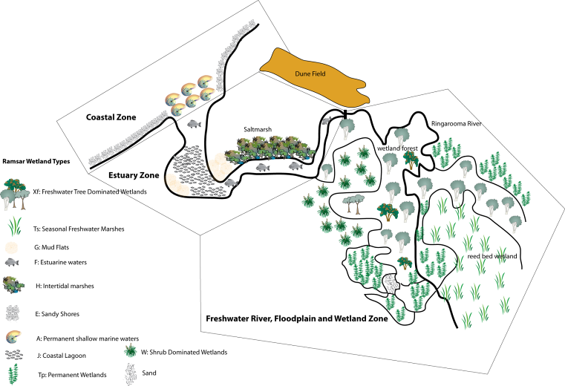

Figure E1: Broad ecological zones (and Ramsar wetland types) across the Flood Plain Lower Ringarooma Ramsar Site.
The key features of the landscape conceptual model include the river within its flood plain, surrounded by heathland and marshes, breaking out of its channel at some points and discharging into lagoons, before reaching the estuary near the dune barrier (Figure E2). Within the area of estuarine influence, the channel widens and is bounded by a saltmarsh on part of its northern bank before reaching a developing central basin and discharging over the delta into Ringarooma Bay.
Threats to the Site’s Ecological Character
Climate change was identified as the largest threat to the site’s coastal zone.
The major threats to the estuary zone were identified as:
- damage to soil and sediment structure through direct stock access to the riparian zone
- loss of threatened vegetation through direct stock access to the riparian zone
- impacts of excess sediment deposition through past mining practices
- declines in water quality through dairying impacts
- changes to hydrology through water extraction
- rising sea levels
Direct threats to the freshwater zone of the site include:
- the impacts of sedimentation, particularly through the progression of the fine sands generated by past mining practices
- damage to the wetland soil/sediment structure through stock trampling
- inputs of excess nutrients through grazing and dairy wastes
- loss of threatened vegetation communities (including weed invasions), via stock grazing and pasture management practices
- changes to the hydrologic regime via:
  - local (water extraction)
  - regional/global (climate change) impacts; and/or
  - lowering of the stream bed

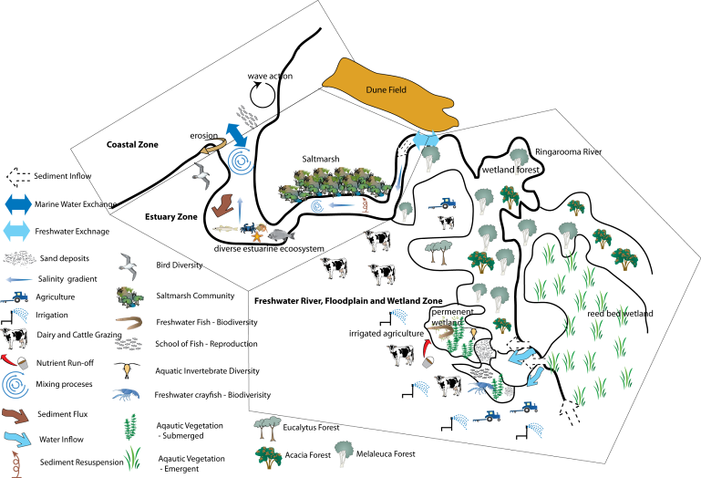

Figure E2: Natural processes, systems and impacts within the Ringarooma Ramsar Site
Limits of Acceptable Change
Limits of Acceptable Change (LACs) were derived for each of the critical components/processes and benefits and services identified. The LACs derived for each of the nine components/processes are:
- Not more than a 20 percent loss in area of any wetland type in nine out of 10 years.

- No less than 298 hectares of freshwater aquatic sedgeland and rushland should be present at the site (representing 80 percent of the current area) in nine out of 10 years.

- Presence of the following plant species in nine out of 10 years:
- native gipsywort (Lycopus australis)
- erect marshflower (Villarsia exaltata)
- purple loosestrife (Lythrum salicaria)
- ribbon weed (Vallisneria australis)

- Presence of the following fish species in nine out of 10 years:
- Australian grayling (Prototroctes maraena)
- dwarf galaxias (Galaxiella pusilla)

- Presence of the green and gold frog (Litoria raniformis) in nine out of 10 years.

- Presence in two out of three years of the following migratory bird species:
- Latham’s snipe (Gallinago hardwickii)
- curlew sandpiper (Calidris ferruginea)
- red-necked stint (Calidris ruficollis)
- ruddy turnstone (Arenaria interpres)
- bar-tailed godwit (Limosa lapponica)
- Caspian tern (Hydroprogne caspia)
- little tern (Sterna albifrons)
- greenshank (Tringa nebularia)
- cattle egret (Ardea ibis)
- great egret (Ardea modesta)
- white-bellied sea eagle (Haliaeetus leucogaster)

- Presence in two out of three years of the following nesting shorebird species:
- little tern (Sterna albifrons)
- hooded plover (Thinornis rubricollis)
- fairy tern (Sterna nereis)
- pied oystercatcher (Haematopus longirostris)
- red-capped plover(Charadrius ruficapillus)

- Presence in two out of three years of the following migratory fish species:
- Tasmanian mudfish (Galaxias cleaveri)
- Tasmanian whitebait (Lovettia sealli)
- Australian grayling (Prototroctes maraena)

Explanatory Notes on LACs:
- Limits of Acceptable Change are a tool by which ecological change can be measured. However, Ecological Character Descriptions are not management plans and LACs do not constitute a management regime for the Ramsar site.
- Exceeding or not meeting LACs does not necessarily indicate that there has been a change in ecological character within the meaning of the Ramsar Convention. However, exceeding or not meeting LACs may require investigation to determine whether there has been a change in ecological character.
- While the best available information has been used to prepare this Ecological Character Description and define LACs for the site, a comprehensive understanding of site character may not be possible as in many cases only limited information and data is available for these purposes. The LACs may not accurately represent the variability of the critical components, processes, benefits or services under the management regime and natural conditions that prevailed at the time the site was listed as a Ramsar wetland.
- Users should exercise their own skill and care with respect to their use of the information in this Ecological Character Description and carefully evaluate the suitability of the information for their own purposes.
- LACs can be updated as new information becomes available to ensure they more accurately reflect the natural variability (or normal range for artificial sites) of critical components, processes, benefits or services of the Ramsar wetland.
Changes in Ecological Character since Listing
Although there have been changes to the site between listing and present day, it is difficult to argue that these are a change in ecological character of the site. The site features that supported its listing remain, apart from an increase in sedgeland/rushland. Further, the limits of acceptable change that have been derived are applicable to the site at the time of listing, except for the increased area requirement for the sedgeland/rushland.
Encroachment of irrigated pasture is a serious, on-going and expanding cause for concern for the ecological character of the site. This has occurred on land classed as ‘agricultural land’ that was previously dry-grazed. If not controlled, this activity may change the site’s ecological character by altering the vegetation communities through the introduction of pasture or weed species. The sedimentation from mining waste has also moved further into the site between listing and present day. Advances of sediment into Shantys Lagoon indicate that small areas of the wetland have been altered (to other wetland types) since listing. This process is ongoing and is likely to continue for several decades.
Knowledge Gaps
There is a general paucity of baseline data at the site, and for the ecological character to be defined in a quantitative way, there needs to be a more strategic collection of a baseline. Data should be gathered using standard methods that allow comparisons to future monitoring programs. The initial sampling strategy design must be cognisant of repeatability. The data should also be gathered using similar approaches and methods comparison with other Tasmanian data sets and the rest of Australia, to facilitate comparisons and assessment of communities.
Community Education and Public Awareness (CEPA)
The primary messages to be communicated to relevant stakeholders are:
- An Ecological Character Description (ECD) of the Flood Plain Lower Ringarooma Ramsar Site has been commissioned to understand the ecological character at the time of listing in 1982.
- The Flood Plain Lower Ringarooma Ramsar Site is listed against the following Ramsar criteria:
  - one (international significant wetland type)
  - two (supports threatened species)
  - three (a site of high biological diversity)
  - four (supports a species during a critical stage of its life cycle).
- This site is a complex wetland, coastal and estuarine ecosystem which provides habitat for important and nationally threatened species. The ECD includes documented past and current conditions, determines approaches to assess changes in condition, identifies potential threats to the wetland’s condition, devises appropriate management actions, and identifies critical information gaps for management.

Introduction
This document is the Ecological Character Description (ECD) for the Flood Plain Lower Ringarooma Ramsar Site (hereinafter referred to as ‘the site’). It contains:
- site details
- a description of the site’s ecological character (including components/benefits and services of the site) as at 1982 and currently
- actual or potential threats to the site
- knowledge gaps in the description and management needs for the site
- changes that have occurred since 1982 or are currently occurring
- site monitoring needs and Limits of Acceptable Change
- communication, education and public awareness messages that will facilitate management and planning for the site

Purpose
Ecological Character Descriptions are critical in understanding the ecological character of a Ramsar site through the description of ecosystem components, processes, benefits and services. They form the benchmark for management action, including site monitoring to detect negative impacts, thus ensuring the site maintains its ecological character. It is imperative that the limits of acceptable change are documented as managers need to know how extensively ecosystem components, processes, benefits and services can vary without the ecological character changing. Information on the benchmarks or limits of acceptable change indicates when the ecological character has changed or is likely to change. The Environment Protection and Biodiversity Conservation Act 1999 (the EPBC Act) provides the legal framework for ensuring the ecological character of all Australian Ramsar sites is preserved (DEWHA 2008).
The objectives of this ECD are (McGrath 2006):
ECD Objective | Relevant Section
- To assist in implementing Australia’s obligations under the Ramsar Convention, as stated in Schedule 6 (Managing wetlands of international importance) of the Environment Protection and Biodiversity Conservation Regulations 2000 (Commonwealth of Australia):  - to describe and maintain the ecological character of declared Ramsar wetlands in Australia; and  - to formulate and implement planning that promotes:  - conservation of the wetland; and  - wise and sustainable use of the wetland for the benefit of humanity in a way that is compatible with maintenance of the natural properties of the ecosystem. | Sections 2, 3, 5 and 9
- To assist in fulfilling Australia’s obligation under the Ramsar Convention to arrange to be informed at the earliest possible time if the ecological character of any wetland in its territory and included in the Ramsar List has changed, is changing or is likely to change as the result of technological developments, pollution or other human interference. | Sections 4, 5 and 6
- To supplement the description of the ecological character contained in the Ramsar Information Sheet submitted under the Ramsar Convention for each listed wetland and, collectively, form an official record of the ecological character of the site. | Sections 2 and 3
- To assist the administration of the EPBC Act, particularly:  - to determine whether an action has, will have or is likely to have a significant impact on a declared Ramsar wetland in contravention of sections 16 and 17B of the EPBC Act; or  - to assess the impacts that actions referred to the Minister under Part 7 of the EPBC Act have had, will have or are likely to have on a declared Ramsar wetland. | Sections 4, 5 and 6
- To assist any person considering taking an action that may impact on a declared Ramsar wetland whether to refer the action to the Minister under Part 7 of the EPBC Act for assessment and approval. | Sections 4, 5 and 8
- To inform members of the public who are interested generally in declared Ramsar wetlands to understand the value the wetlands. | Section 9

The preparation of an ECD also forms the basis of understanding and management of the listed wetland site, including the information required for:
- designing monitoring programs
- determining methods and approaches for assessing changes to its ecological character
- identifying potential threats and impacts, and evaluating risks
- devising efficient and appropriate management plans for the ongoing protection of the wetland
- identifying critical gaps in knowledge and approaches/methods for addressing these gaps
The process for preparing an ECD should also engage the relevant stakeholders, thereby laying the foundations for alignment of goals and agreed management outcomes. The site, with its mix of private and public land-owners, potential for impacts of upstream and greater catchment actions, and array of significant features, presents a situation where stakeholder understanding will greatly assist future management.

Site Details
The site was first listed in November 1982 against the (then) Criteria 2a and 2b of the Ramsar Convention. Following revision of the listing criteria in 1999, the site is now listed under criteria one, two and three of the revised convention (Refer Section 2.2 for details of the previous and current criteria). Introductory site details are presented in Table 1.

Table 1: Introductory Site Details for the Flood Plain Lower Ringarooma River Ramsar Site
Ramsar Site | Flood Plain Lower Ringarooma River.
General Location | The Flood Plain Lower Ringarooma River Ramsar Site is located on the far north-east coast of Tasmania, nine kilometres north-west of the township of Gladstone. The site lies between Cape Portland and Waterhouse Point, extending from Boobyalla Beach inland along the Ringarooma River Flood Plain. The site is in the Dorset municipality.
Area | 3519 hectares.
Geographical Coordinates | Latitude: 40 degrees 53' 00" Longitude: 147 degrees 56' 00" (approximate centre of site).
Date of Listing | November 1982.
Baseline Year Used for Description | 1982.
Original Description Date | October 2008 (updated February 2012, this version).
Version Number | 2.
Status of Description | First description following site visit and consultation with stakeholders and land owners. This version is updated from the 2008 description to more fully describe the site and meet SEWPaC guideline requirements.
Compiler's Name | Lance Lloyd (Lloyd Environmental Pty Ltd) lance@lloydenviro.com.au  Peter Newall (Independent Ecological Consultants) p.newall@bigpond.com
Ramsar Information Sheet | Ramsar Information Sheet: Flood Plain Lower Ringarooma River (June 2010; previously updated June 2005).  Ramsar sites information service, Ramsar sites database: http://ramsar.org/ris/key_ris_index.htm  Ramsar Site No.: 257.  Wetlands International Site Reference No.: 5AU009.
Management Plan | GHD 2008. Flood Plain Lower Ringarooma River Ramsar Wetland Site: Management Plan. Report to NRM North, June 2008.
Responsible Management Authority | For areas reserved under the Nature Conservation Act 2002 -Director, Parks and Wildlife Service, GPO Box 1751, Hobart Tasmania 7001.

Date of Description
This ecological character description was undertaken in October 2008 (and updated in June 2010), approximately 28 years after the Flood Plain Lower Ringarooma River Site was listed in November 1982. It is a Ramsar Convention requirement that the ecological character description reflects the conditions at the time of listing. Consequently, this document is focused on the 1982 condition of the site. Due to a paucity of pre-listing information, this ECD utilises various studies and reports on the wetland system undertaken since listing, interpreted to infer the conditions at the time of listing as accurately as possible.

Relevant Treaties, Legislation or Regulations
Most of the treaties, legislation and regulations relevant to the protection of the site have been enacted subsequent to its 1982 listing date. However, this section discusses relevant legislation and regulations up to present day.

International treaties and strategies
Ramsar Convention
The Convention on Wetlands (Ramsar, Iran, 1971) or as it is more commonly known, the Ramsar Convention, is an international treaty dedicated to the conservation and sustainable use of wetlands (Environment Australia 2001). Australia was one of the first 18 countries to become a signatory to the Convention in 1971. The Ramsar Convention Bureau maintains a List of Wetlands of International Importance that includes 64 Australian sites totalling 7.5 million hectares.
Australia’s obligation to protect and maintain the ecological character of its Ramsar sites is recognised in Commonwealth legislation through the EPBC Act.
Ramsar wetlands and the EPBC Act
Under the EPBC Act, any action or proposed action that is likely to have a significant impact on the ecological character of a declared Ramsar wetland is considered a matter of National Environmental Significance and should be referred to the Commonwealth Minister for Environment for assessment. Actions that are considered to have an effect or potential effect on wetland ecological character involve:
- areas of the wetland being destroyed or substantially modified, or
- a substantial and measurable change in the hydrological regime of the wetland for example, a substantial change to the volume, timing, duration and frequency of ground and surface water flows to and within the wetland, or
- the habitat or lifecycle of native species dependent upon the wetland being seriously affected, or
- a substantial and measurable change in the physico-chemical status of the wetland for example, a substantial change in the level of salinity, pollutants, or nutrients in the wetland, or water temperature which may adversely impact on biodiversity, ecological integrity, social amenity or human health, or
- an invasive species that is harmful to the ecological character of the wetland being established in the wetland (DEH 2006).
The EPBC Act also dictates standards for managing Ramsar wetlands through the Australian Ramsar Management Principles that have been established as regulations under the Act (Environment Australia 2001).
International conventions on migratory species
Australia is a signatory to five international conventions on migratory species. The conventions are:
- The Japan-Australia Migratory Birds Agreement (JAMBA)
- The China-Australia Migratory Birds Agreement (CAMBA)
- The Republic of Korea-Australia Migratory Birds Agreement (ROKAMBA)
- The Bonn Convention on Migratory Species (CMS)
- The Convention on Biological Diversity (CBD)
JAMBA, CAMBA and ROKAMBA are bilateral agreements between the governments of Japan and Australia, China and Australia and the Republic of Korea and Australia, respectively, which seek to protect migratory birds in their migration flight paths. Each agreement lists species that migrate between Australia and the respective countries. In each case the majority of listed species are shorebirds. Each agreement requires the parties to protect migratory birds, including the protection and conservation of their habitats. The JAMBA agreement also includes specific provisions for cooperation on conservation of threatened birds (DEH 2005).
The Bonn CMS adopts a framework in which countries with jurisdiction over any part of the range of a particular species co-operate to prevent migratory species becoming endangered. For Australian purposes, many of the migratory species are birds.
In 1993, Australia ratified its support of the CBD, whose objectives include the conservation of biological diversity, sustainable use of its components and fair and equitable sharing of the benefits arising from commercial and other utilisation of genetic resources. Appropriate management of Ramsar wetlands results in the conservation of biodiversity and wise use of its components.

Commonwealth Legislation and Policy
Environment Protection and Biodiversity Conservation Act 1999.
The principle Commonwealth environmental legislation that relates to wetland conservation is the EPBC Act. Under the EPBC Act any actions that have, or are likely to have, a significant impact on a matter of national environmental significance require approval from the Commonwealth Environment Minister.

There are seven matters of national environmental significance identified in the Act; three of these relevant to the site are:
- wetlands of international importance (Ramsar wetlands)
- threatened species and ecological communities and
- migratory species.

State legislation
The Tasmanian legislation of most relevance to the site includes the
- Threatened Species Protection Act 1995
- Nature Conservation Act 2002
- Forest Practices Act 1985
- Inland Fisheries Act 1995
- Living Marine Resources Management Act 1995
- National Parks and Reserve Management Act 2002
- Weed Management Act 1999
The Threatened Species Protection Act (TSPA) establishes a Scientific Advisory Committee and enables the development of threatened species lists, strategies, threat abatement and recovery plans. The TSPA also enables the imposition of interim protection orders and facilitates the development of land-management plans.
Threatened vegetation communities at the site and elsewhere in Tasmania are protected through recent amendments to the Nature Conservation Act and the Forest Practices Act:
- Nature Conservation Amendment (Threatened Native Vegetation Communities) Act 2006; and
- Forest Practices Amendment (Threatened Native Vegetation Communities) Act 2006.
The new legislation establishes a list of threatened communities under the Nature Conservation Act (NCA 2002), and provides measures to protect these communities from clearance and conversion under the Forest Practices Act.
The Inland Fisheries Act details fishing regulations and licence requirements in freshwater areas, as well as prohibited actions in relation to impacts on fish in these areas. The Living Marine Resources Management Act 1995 contains similar provisions for the estuarine and marine areas of the site.
The Regional Reserve and the Conservation Area have been declared under the Nature Conservation Act 2002, which sets out the values and purposes of each reserve class and are managed in accordance with the National Parks and Reserve Management Act 2002.

Detailed Description of the Site
This section describes the site and its setting at the time of listing. Relevant changes to the site after listing are presented in section 6.

Setting
The Ringarooma River originates in the far north-east of Tasmania (Figure 1) in the foothills between Ben Nevis (part of the Ben Lomond ranges) and Mount Maurice (Graham 1999). From there it flows north for approximately 150 river kilometres before discharging into Bass Strait via Ringarooma Bay located nine kilometres north-west of the township of Gladstone between Cape Portland and Waterhouse Point. Average annual rainfall of the area is 625 to 750 millimetres (RIS 2005).
The mid to upper catchment is described as “humid cool/cold mountain ranges situated in Tasmania's inland north-east. The mountains are capped by Jurassic dolerite with shallow gradational soils. Silurian-Devonian siltstones and mudstones covered with gradational soils constitute a substantial part of the lower hills. Lowland vegetation comprising mainly open sclerophyll woodlands and heath while the upper slopes consist of wet sclerophyll forests, some rainforest and alpine vegetation in the highest regions. Land use: forestry, mining and agriculture (grazing)” (Environment Australia 2000).
The lower to mid catchment is described as “moist and dry subhumid warm coastal plains. Devonian granites dominate the elevated areas of the subregion forming low rugged ranges. These are overlain by shallow stony/gravelly gradational or duplex soils carrying Eucalyptus amygdalina open forest and woodland with open heath on higher peaks. Quaternary/Tertiary materials overlain by deep sandy soils typify extensive lowland plains, coastal deposits and dunes. Coastal plains have been heavily modified by agriculture (grazing)” (Environment Australia 2000).
The catchment covers an area of approximately 975 square kilometres (NWC 2009 and Figure 1). At its lower end, the catchment encompasses the site, which lies on the sandy flood plain and contains extensive marshlands including Fosters Marshes and a number of shallow lagoons including Rushy Lagoon, Shantys Lagoon, Blueys Lagoon and Bowlers Lagoon.
The site is irregularly shaped and covers an area of 3,519 hectares. At its northern edge, the site includes the Boobyalla Inlet estuary and parts of both Boobyalla Beach and Murdochs Beach to the east and west of the River mouth respectively (Figure 2). A mobile sand dune system occurs in the northern part of the site. The site extends approximately eight kilometres north to south, encompassing a variety of habitats which are significant to a number of species.
The bulk of the wetland area is altered from its natural condition. This has resulted from large-scale sedimentation arising from mining operations in the late 1800s and early 1900s. However, the large trees on the site, as well as aerial photographs over several decades, show that many of the current conditions have been established for decades and sediment movement is no longer as dynamic as it once was. Therefore, current conditions for many of the site features are likely to be indicative of the conditions at the time of listing.
Areas that remain relatively unaffected by this mining-induced sedimentation include Bowlers Lagoon (a dune-barred lake in the sand sheet behind Boobyalla Beach) and some deflation basins (basins formed by wind blowing sediments from the site) with associated lunettes (arc-shaped mounds formed on the lee side of deflation basins, made up of deposited sediment blown from the deflation basin).
The sediment load of the Ringarooma River was estimated to include 40 million cubic metres of mine tailings since the late nineteenth century (Knighton 1991). Some of this sediment has been transported to the Ramsar site, where it has been deposited to form a huge and complex set of levees and sediment splays. These trap water on the Flood Plain, forming extensive wetlands that have evolved and migrated for approximately 100 years (Jerie and Houshold 2001). As a result, the placement and evolution of biological communities and habitats featured in the site reflect anthropogenic influences. Further, much of this mining-derived sediment remains upstream of the site and is predicted to be transported to the site, further changing its character, including the nature and location of the wetlands (Jerie and Houshold 2001).
However, it is likely that many of the habitat and community types present today and at the time of listing were present at the site prior to mining impacts. As geomorphic processes fill in depressions at one location and create new ones elsewhere on the site, wetland vegetation shifts, creating a mosaic of community types, with differing ages and attributes. This dynamic nature of the vegetation is a common feature of Flood Plain wetlands and it is likely that the rapid input of the mining sediment increased the rate of change rather than completely changing the direction of the wetland’s evolution.
There is potential for new releases of mining-derived sediment, with a former mine soon to re-open at a site north of the Ringarooma River near Gladstone. This mine - the Scotia Mine - is situated on Newhaven Creek, a tributary which enters the Ringarooma River downstream of Gladstone. Further, the majority of the Ramsar site itself is covered by mining tenements, which extend beyond the site and out into Ringarooma Bay. These are discussed further in the threats section (Section 4).
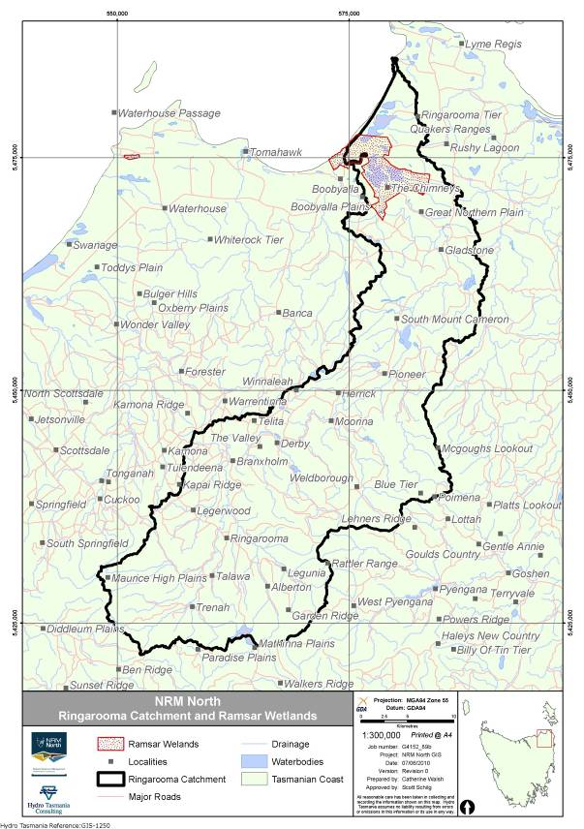
Figure 1: Ringarooma catchment, showing location within Tasmania.
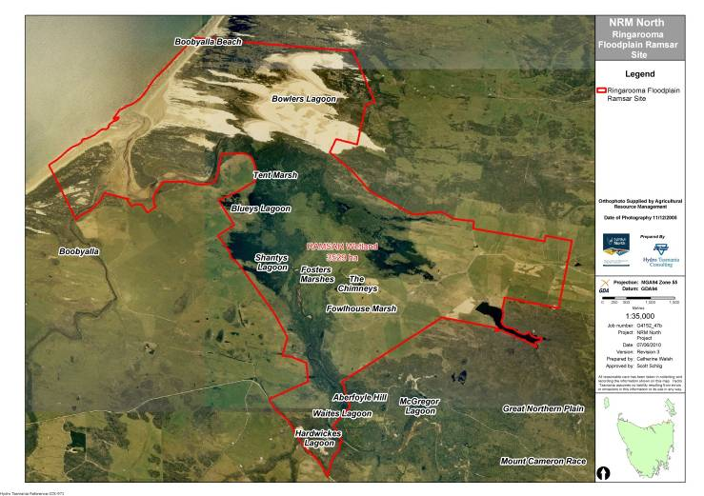
Figure 2: Boundary of Ramsar site displaying lagoons and marshes.
The mining-derived silt and sand from the river catchment overlies flat plains of Quaternary clays, sands and gravels. Silty clay soil overlays a deep grey sand, with silt content decreasing with depth. The area is regularly flooded by overflow from the river. The maximum depth of water in The Chimneys is between two and four metres, and its maximum depth of permanent water is between half a metre and one metre. The 2005 RIS notes that water pH in the wetland is around five, although the source of this data is not cited.
The hydrology of this site is influenced by tidal flows and river flows. Local groundwater also influences the site’s hydrology, particularly in areas that are separate from the river, such as Bowlers Lagoon, (Jerie, personal communication). In particular, water that is discharged from the Ringarooma River during flood events is prevented from re-entering the river channel due to the presence of natural levees adjacent to the channels. The trapped water maintains the surface water of the nearby wetlands and also replenishes the local groundwater, thereby sustaining more distant wetlands, such as Bowlers Lagoon. Most of the wetland is above the tidal limit and is mostly influenced by inflows from the Ringarooma River. The hydrology is also influenced by mining-related sediment deposition and water trapping described above. The estuary mouth is open and therefore the estuary experiences tides.

Ramsar Listing
2.2.1 Original Listing Criteria
The site was originally listed in November 1982 and is currently listed against the following criteria:
- A wetland should be considered internationally important if it contains a representative, rare, or unique example of a natural or near-natural wetland type found within the appropriate biogeographic region.
- A wetland should be considered internationally important if it supports vulnerable, endangered, or critically endangered species or threatened ecological communities.
- A wetland should be considered internationally important if it supports populations of plant and/or animal species important for maintaining the biological diversity of a particular biogeographic region.
At the time of its original listing, the site was the subject of a RIS, a requirement of the Ramsar listing process. Since that time, the RIS has been updated in 1988, twice in 2003 and again in 2005. The updates have provided substantial increases in site information, including the justifications for listing under the specified criteria.
Criterion one: A wetland should be considered internationally important if it contains a representative, rare, or unique example of a natural or near-natural wetland type found within the appropriate biogeographic region.
The Flood Plain Lower Ringarooma River Ramsar Site is rare within the bioregion (Tasmania Drainage Division, Commonwealth of Australia 2010; Bass Strait IMCRA Province, Commonwealth of Australia, 2006), as it is rare for large rivers in Tasmania to be flowing through Flood Plains and forming the mosaic of wetlands that the Ringarooma River does (Stewart Blackhall, personal communication). The site contains good condition, regionally representative examples of wetland systems within a Flood Plain, with a mosaic of permanent and seasonal marshlands and a large river estuary (Boobyalla Inlet). Boobyalla Inlet is recognised as a Tasmanian estuary with high conservation significance (Edgar et al. 1999).
Wetland vegetation communities recognised as threatened under Tasmanian legislation (DPIW 2007) and the site contains various wetland types which support these communities (DPIW 2006). These include Ramsar wetland type:
- Ts (freshwater aquatic sedgeland and rushland - vulnerable in Tasmania)
- Tp (freshwater aquatic herbland - vulnerable in Tasmania)
- Tp (lacustrine herbland - vulnerable in Tasmania)
- P and U (Undifferentiated wetland)
- Xf (Melaleuca ericifolia swamp forest - rare and endangered in Tasmania)
A section of the marshes known as The Chimneys is thought to be a remnant of a once more extensive lake system, older than other lakes in the area (being situated well within known Pleistocene dunefields) and potentially containing palynological and palaeobotanical fossils and megafaunal remains (Blackhall et al 2000, DEWHA 2010a).
Criterion two: A wetland should be considered internationally important if it supports vulnerable, endangered, or critically endangered species or threatened ecological communities.
This criterion is focused on species and communities listed at the Commonwealth level, principally through the EPBC Act or through international agreements, such as JAMBA, CAMBA, ROKAMBA and CMS Convention, discussed in Section 1.
The site supports six fauna species listed on the IUCN redlist or as nationally threatened under the EPBC Act, including four wetland-dependent species:
- green and gold frog (Litoria raniformis) (Vulnerable, EPBC Act)
- dwarf galaxias (Galaxiella pusilla) (Vulnerable, EPBC Act and IUCN Redlist)
- fairy tern (Sterna nereis) (Vulnerable, IUCN Redlist) and
- Australian grayling (Prototroctes maraena) (Vulnerable, EPBC Act).
The green and gold frog has declined dramatically across its range. Population studies have shown that green and gold frog populations are positively influenced by permanent water, the extent of aquatic vegetation, extensive riparian or Flood Plain grasslands and the presence of other nearby green and gold frog populations (Heard et. al. 2004). In Tasmania, the species occurred broadly across the north and east of the island and on Bass Strait Islands, although there is a report that in the Launceston area the number of individuals has shifted from abundant to scarce and that the species range has contracted in north-west, central and south Tasmania (DEWHA 2010b).
The species is dependent upon permanent, still or slow flowing freshwater for breeding. The ideal breeding habitat is the shallow part of still or slow-flowing lagoons, generally with a complex vegetation structure (DEWHA 2010b). The combined habitat requirement of permanent, still or slow-flowing waters and nearby forests and grasslands is provided by the site through the many lagoons, herblands, sedgelands, swamp forests and coastal forests. Despite their requirement for permanent water for breeding, they also require terrestrial habitat (such as grasslands and forests), feeding mainly on terrestrial invertebrates such as beetles, termites, cockroaches, moths, butterflies and various insect larvae (DEWHA 2010b).
Among the threats to the green and gold frog, habitat loss through stock grazing and irrigation are considered major (DEWHA 2010b). The ungrazed areas of the site provide sanctuary from these impacts, making it a key refuge for this species.
The dwarf galaxias occurs in lowland areas in the north-east and north-west of Tasmania, on Flinders Island and in southern Victoria and South Australia (TSS 2006). Due to a declining total population and fragmented distributions of the dwarf galaxias, all known populations are important (TSS 2006). The species has declined and its genetic structure within the distribution is not yet known. Consequently, all areas where the species occurs are considered critical to survival (TSS 2006).
The dwarf galaxias favours a shallow, stagnant, swampy environment with abundant aquatic plants and is typically found in still waters such as swamps, drains and backwaters of creeks and streams (DEWHA 2010b). The waters inhabited by this species are often temporary, drying up partially or completely during summer, and being replenished by rainfall or floodwaters from watercourses during the wetter months (DEWHA 2010b). This makes the Flood Plain Lower Ringarooma River Ramsar Site an ideal site for the dwarf galaxias, offering a range of permanent and seasonal waterbodies, mostly still or slow-flowing and many with abundant submerged vegetation. The extent and variety of waterbodies at the site, combined with the importance placed on all existing populations, highlights the importance of the site to the support of this species.
The fairy tern is a marine listed species under the EPBC Act. In Australia, there are approximately 5000 to 6000 mature birds at around 170 sites, with estimates of 100 to a few hundred pairs in Tasmania (Birdlife International 2008). Disturbance by humans, dogs and vehicles, either causing the direct destruction of eggs or desertion of nests are key threats to the species, and the site offers refuge from these. The fairy tern has been recorded nesting at the site (see criterion 4).
Australian grayling are an estuary dependent species which spends most of its lifecycle in freshwater, migrating between freshwater streams and the estuary to breed (DEWHA 2010b). The species is found in rivers with water ranging from clear to muddy and with substrates ranging from gravel to mud-bottomed. The species is described as occurring widely within Tasmania (DEWHA 2010b) and the importance of the site to the species is not known. The significant estuary and the large upstream river system makes this ideal habitat for the species, which is threatened at the national level.
Criterion three: A wetland should be considered internationally important if it supports populations of plant and/or animal species important for maintaining the biological diversity of a particular biogeographic region.
This criterion includes consideration of the site’s regional biodiversity, including biodiversity ‘hotspot’ status and regional endemism. The site has been described as important due to its diverse invertebrate fauna (RIS 2005). The series of shallow freshwater lagoons at the site are an important feeding and nesting place for many species of waterbirds. Approximately three kilometres of beaches are included in the site, from which a number of shorebirds have been recorded, including the hooded plover (Thinornis rubricollis), red-capped plover (Charadrius ruficapillus), greenshank (Tringa nebularia), red-necked stint (Calidris ruficollis), ruddy turnstone (Arenaria interpres), curlew sandpiper (Calidris ferruginea), black-fronted dotterel (Elseyornis melanops) and fairy tern (Sterna nereis) (Sally Bryant, personal communication). Approximately forty species of wetland dependent plants have been recorded at the site (see list below and Appendix 2).
This criterion also includes species listed at the regional (in this case State) level. The site supports rare, poorly reserved and scientifically valuable species. It provides wetland habitat for two regionally threatened bird species and four regionally threatened flora species considered to be at risk in Tasmania. These are:
- little tern (Sterna albifrons)( rare, TSPA)
- white-bellied sea eagle (Haliaeetus leucogaster) (vulnerable, TSPA)
- purple loosestrife (Lythrum salicaria) (vulnerable, TSPA), occurs in open areas in Melaleuca ericifolia swamp forest and in freshwater aquatic sedgeland and rushland wetlands in the site.
- ribbon weed (Vallisneria australis) ( rare, TSPA), occurs in freshwater aquatic herbland in the site.
- erect marshflower (Villarsia exaltata) (rare, TSPA), for which the Chimneys is a key site; and
- native gypsywort (Lycopus australis) (endangered, TSPA), which was previously thought to be extinct in Tasmania, has recently been found at the site. It occurs in association with lacustrine herbland of the Ramsar site. Observed at one location on the western edge of Shantys Lagoon.

2.2.2 Assessment of remaining criteria
An assessment of the remaining Ramsar listing criteria was undertaken to determine whether the site meets any criteria beyond the original listing. The results are as follows:
Criterion four: A wetland should be considered internationally important if it supports plant and/or animal species at a critical stage in their life cycles, or provides refuge during adverse conditions.
A number of migratory birds have also been recorded from the site, including eleven migratory birds listed in CAMBA, JAMBA, ROKAMBA and/or the CMS. These species include:
- Latham’s snipe (Gallinago hardwickii)
curlew sandpiper (Calidris ferruginea)
- red-necked stint (Calidris ruficollis)
- ruddy turnstone (Arenaria interpres)
- bar-tailed godwit (Limosa lapponica)
- little tern (Sterna albifrons)
- greenshank (Tringa nebularia)
- Caspian tern (Hydroprogne caspia)
- cattle egret (Ardea ibis)
- great egret (Ardea modesta)
- white-bellied sea-eagle (Haliaeetus leucogaster)
Quantitative data were not found for these species, however the provision of support for these species during migration constitutes support during a critical stage of their life cycle.
The site also provides support for nesting shorebirds at a critical stage of their life cycle: breeding. Five beach nesting shorebirds have been recorded breeding within the site, including the little tern (which has migratory listing as noted above), and the fairy tern (IUCN red listed, as noted above) (Eric Woehler, Birds Tasmania, unpublished data). The site is known to ornithologists for its nesting by little terns and fairy terns, and its relatively low disturbance levels make breeding success per pair far more likely than elsewhere in Tasmania (Eric Woehler, Birds Tasmania, personal communication).
Tasmanian mudfish (Galaxias cleaveri), Tasmanian whitebait (Lovettia sealli) and Australian grayling (Prototroctes maraena) have been recorded in the Ringarooma River. Mudfish habitat is swampy areas near the coast and the species is found mostly in still waters, heavily vegetated mud bottomed swamps and estuarine marshes. These habitats are under continual threat from drainage and reclamation (Read 1999). The juveniles of the species form part of the whitebait runs on their return from the sea in spring and they take up residence in the lower part of coastal streams, including the Ringarooma River (Read 1999).
Tasmanian whitebait migrate into freshwater to breed. The larvae are then washed down into the sea. Read (1999) notes that this species was once the basis of an important commercial fishery, however since the 1940s populations have declined to the point where the fishery was closed from 1973 to 1990. The fishery has since been opened on a restricted basis. Australian grayling lives in coastal streams and rivers and needs to migrate to and from the sea. It spawns in autumn and when the larvae hatch they are swept down to the sea. Larval life is marine and juveniles return to rivers from the sea during spring, spending the rest of their life in rivers (Read 1999).
The migration between fresh and marine waters highlights the importance of the estuarine habitat provided by the site and constitutes support for these species during a critical stage of their life cycle. This criterion is therefore met by the site and should be added to the listing criteria.
Criterion five: A wetland should be considered internationally important if it regularly supports 20,000 or more waterbirds
There are no data available to support the site meeting this criterion.
Criterion six: A wetland should be considered internationally important if it regularly supports one percent of the individuals in a population of one species or subspecies of waterbird.
There are no data available to support the site meeting this criterion.
Criterion seven: A wetland should be considered internationally important if it supports a significant proportion of indigenous fish subspecies, species or families, life-history stages, species interactions and/or populations that are representative of wetland benefits and/or components and thereby contributes to global biological diversity.
There are insufficient data to assess against this criterion.
Criterion eight: A wetland should be considered internationally important if it is an important source of food for fishes, spawning ground, nursery and/or migration path on which fish stocks, either within the wetland or elsewhere, depend.
There are no data available to support the site meeting this criterion.
Criterion nine: A wetland should be considered internationally important if it regularly supports one percent of the individuals in a population of one species or subspecies of wetland-dependent non-avian animal species
There are no data available to support the site meeting this criterion.

Land Use and Tenure
The land tenure of the site is complex. Within the site, approximately 60 percent of the area is owned by Rushy Pastoral (Figure 3), with the remainder being Crown land reserved under the Nature Conservation Act 2002. The Crown land includes the area between the Ringarooma River and the western boundary which is reserved as part of the Cameron Regional Reserve and the coastal and estuarine zone at the northern end of the site which is reserved as part of the Boobyalla Conservation Area (Figure 3 and Table 2). The boundary of the Ramsar site is displayed with a red line in Figure 3, The land owned by Rushy Pastoral (with the property name ‘Rushy Lagoon’ on Figure 3) extends well beyond the Ramsar site boundary, covering a total of 20 758 hectares.
Table 2: Land tenure and area of parcels within the Flood Plain Lower Ringarooma River Ramsar Site
Land parcel | Area (hectares)*
Rushy Lagoon (owned by Rushy Pastoral). | 1992
Boobyalla Conservation Area.Managed by PWS DPIPWE. | ~759
Cameron Regional Reserve. Managed by PWS (DPIPWE)  - (303ha of the Regional Reserve under temporary grazing lease, see Figure 5). | 584
*Areas in Table 2 do not add up to total site area, as there is no cadastral information (and hence no area data) for the foreshore and estuary of the site (see Figure 4). Areas rounded to whole hectares.
Figure 4 displays in more detail the land tenure within the site. Crown land areas are shown with red hatch overlay, the privately-owned land has yellow diagonal lines as overlay and the boundary of the Ramsar site is shown as a thick red line. There is no cadastral information (and hence no area data) for the foreshore and estuary of the site, and these areas have no overlay in Figure 4.

The site accommodates livestock grazing on the Crown leasehold land and the private land. Much of the land surrounding the site has been cleared for agriculture. The surrounding areas of the site are prone to siltation which has been primarily caused by erosion from mining areas.
Within the site, one or more dams have been proposed (Dominique Couzens, personal communication) potentially impacting the input of freshwater tributaries to the wetland system. New dam developments near the wetland would require a referral under the EPBC Act and would require assessment of the potential impacts under this Act. Water extraction rights have also been allocated upriver, including some for hydroelectric purposes. Potential impacts of these on the hydrology are discussed in a later section (Section 3.2.5).

Figure 3: Private land ownership in the Flood Plain Lower Ringarooma Ramsar Site (Supplied by NRM North).
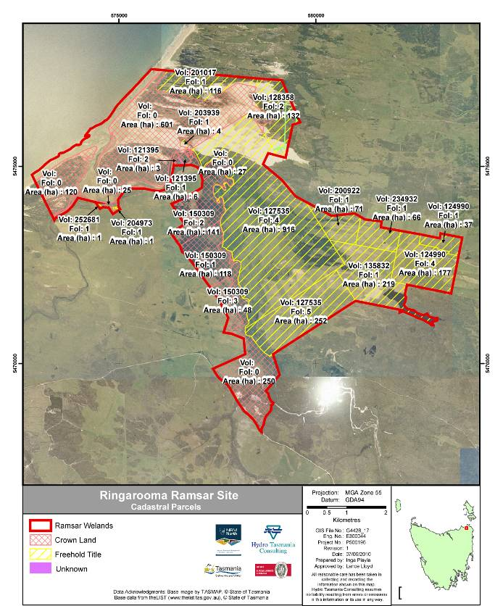

Figure 4: Land tenure of the Flood Plain Lower Ringarooma River Ramsar Site (Supplied by NRM North).

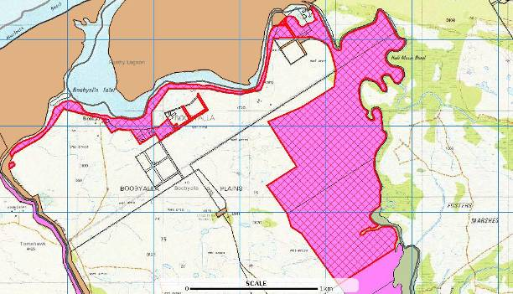

Figure 5: Leasehold land within Flood Plain Lower Ringarooma River Ramsar Site. Pink hatching indicates the leasehold land. (Map courtesy of Emma McDowell of Tasmanian Parks & Wildlife Service, from The List. Quality of the image is poor due to it being sourced as a screen image of the online database, the only source of the information)

Ecological Character of the Flood Plain Lower Ringarooma River Ramsar Site
This chapter describes the components, processes and benefits and services of the site and the linkages between them. Subsequent to these descriptions, the components, processes and benefits and services that are critical to the site’s character are identified, followed by presentation of conceptual models of the site.

Ecological Zones of the Site
The site can be separated into three zones – a coastal zone, an estuary zone and a freshwater zone (Figure 6). This section of the ECD briefly describes the coastal zone, followed by the estuary and freshwater zones.

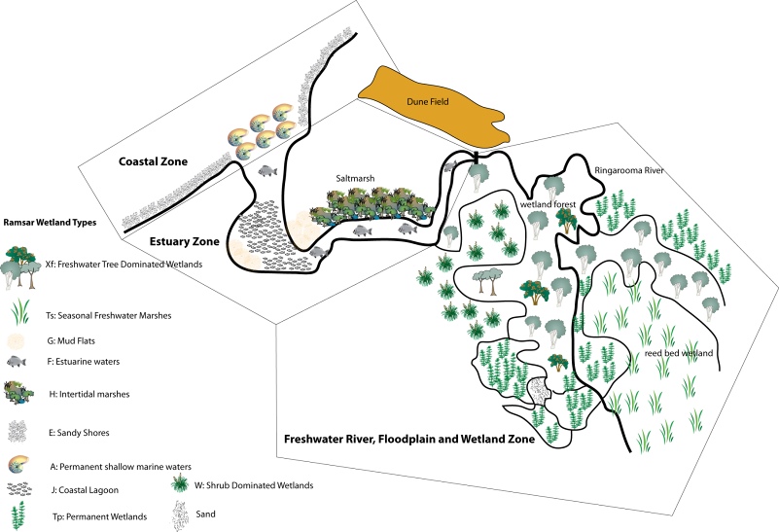

Figure 6: The three ecological zones of the Flood Plain Lower Ringarooma Flood Plain Ramsar Site.

The Coastal Zone
The coastal zone covers the entire coast of the site (three to four kilometres), including the combined mouth of the Boobyalla and Ringarooma Rivers and hence part of the estuary zone described in the following section. The coastal zone contains the foredunes and sandy beach of the site, as well as the delta (Figure 7).
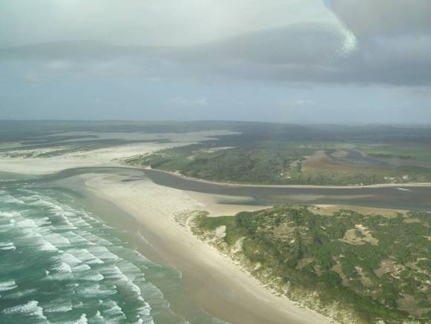
Figure 7: Coastal Zone of the Flood Plain Lower Ringarooma River Ramsar Site (May 2007, L.N. Lloyd).
The coast of north-east Tasmania is largely formed of, or underlain by, extensive folded and metamorphosed sandstones and slates deposited during the Ordovician and Silurian periods (DTAE 2007). Granite rocks of Devonian age are prominant in the catchment. This is the source of the tin which has been mined in weathered deposits. Since the middle Tertiary (approximately 36 million years ago) and especially during the last two million years, the geomorphology of the site has been dominated by alternating glacial and interglacial phases, with glacial phases characterised by colder, drier conditions and lower sea levels than the interglacials. During glacial periods, Bass Strait was a broad sandy plain and it is thought that sands blown from Bass Strait during glacial phases provided source material for the extensive sandy shores and coastal dune complexes along the north-east coast of Tasmania (DTAE 2007).
The site contains good examples of parallel dunes (dunes located behind the foredunes) and also large transgressive dune fields, which migrate across the landscape reworking sediments and inundating pre-existing landform features (DTAE 2007). Other bedforms within transgressive dune fields can include parabolic dunes, blowouts, lagoons, swales and deflation basins that demonstrate a range of process-response feedbacks in the system. The range in bedform adds diversity to the geomorphic components of the dune field (DTAE 2007). The transgressive dune fields at the site are listed on the Tasmanian Geodiversity Database as part of the Northeast Tasmania Pleistocene Aeolian Systems and include Bowlers Lagoon.
The estuary of the site contains a flood tide delta (see section 3.1.2), which is expected to be dominated by sediment of marine origin, or at least reworked by marine processes (Bradbury, personal communication).
The Ramsar wetland types (Figure 10) that occur within the coastal zone are: sandy shores (wetland type E); delta (wetland type F); and intertidal mud and sand flats (wetland type G).
A number of beach nesting shorebirds have been recorded breeding on the beaches of the site, comprising the little tern, hooded plover, fairy tern, pied oystercatcher and red-capped plover (Eric Woehler, Birds Tasmania, unpublished data). Within the site, part of the beach is a known site for nesting by little terns and fairy terns. Although the total numbers of nesting terns within the site are small, the relatively low disturbance of the site makes breeding success far more likely at the site than elsewhere in Tasmania with more nests but greater disturbance; that is, one pair of small terns nesting at the site is more likely to succeed in breeding than other small colonies around the state (Eric Woehler, Birds Tasmania, personal communication).
Although information on these species is limited, some general information on habitat and diet for each species is provided in Table 3, below. The information provided in Table 3 has been collated from Birdlife International (2009), DEWHA (2010b), Birds Australia (2010) and Pizzey (1980).
Table 3: Nesting shorebird species of the Ringarooma coastal zone, with their common habitat and diet (Pizzey 1980; Birdlife International 2009; Birds Australia 2010; DEWHA 2010b).
Species | Habitat(s) | Diet
Little tern | The species breeds on barren or sparsely vegetated beaches, islands and spits on seashores or in estuaries, saltmarshes, saltpans, offshore coral reefs rivers, lakes, and reservoirs. It shows a preference for islets surrounded by saline or fresh water where small fish can be caught without the need for extensive foraging flights.  In Australia the species frequents tidal creeks, coastal lagoons and saltpans and may foraging at sea up to 15 kilometres offshore. | Diet consists predominantly of small fish and crustaceans three to six centimetres long as well as insects, annelid worms and molluscs.
Fairy tern | The fairy tern usually breeds on sandy beaches on sheltered mainland coastlines and close islands. | Feeds almost entirely on fish.
Hooded plover | The hooded plover primarily inhabits sandy, ocean beaches, with the highest densities on beaches with large amounts of beach-washed seaweed that are backed by extensive open dunes. The species shows a preference for nesting on flat beaches and stony terraces8 and primary sand dunes. | In eastern Australia, it is an opportunistic feeder and takes a range of invertebrates.
Pied oyster catcher | The pied oystercatcher prefers mudflats, sandbanks and sandy ocean beaches and is less common along rocky or shingle coastlines. Although rarely recorded far from the coast, the pied oystercatcher may occasionally be found in estuarine mudflats and short pasture. Nesting takes place on sand, shell grit or shingle just above high water mark on beaches, sandbars, margins of estuaries and lagoons. | Oystercatchers feed on bivalve molluscs, which are prised apart with their specially adapted bills. Food is found by sight, or by probing their long, chisel-shaped bills in the mud. Young pied oystercatchers are one of the few waders that are fed by their parents using this specialised feeding technique. Worms, crustaceans and insects are also eaten.
Red-capped plover | The red-capped plover is found in wetlands, especially in arid areas, and prefers saline and brackish waters. The nest site of the red-capped plover is a shallow scrape on a beach or stony area, nearly always close to water. | The red-capped plover may be seen foraging for molluscs, small crustaceans and some vegetation, on mudflats, sandy beaches and salt-marsh.

The Estuary Zone
The estuary zone is wave dominated, with a flood tide delta (Jason Bradbury, personal communication). Physical features present at Ringarooma Estuary that are considered typical of flood tide deltas include a shorefront barrier, a flood/ebb delta, an area of salt marsh, tidal sand banks and the channel. There also appears to be the beginning of a central basin (coastal lagoon) behind the shorefront barrier (Figure 7). These estuaries often have abundant intertidal habitats including salt marshes, salt flats, and melaleucas (Heap et al. 2004). The high-energy channels in river dominated estuaries allow increased flushing of sediment, water and nutrients into the sea (Figure 8).
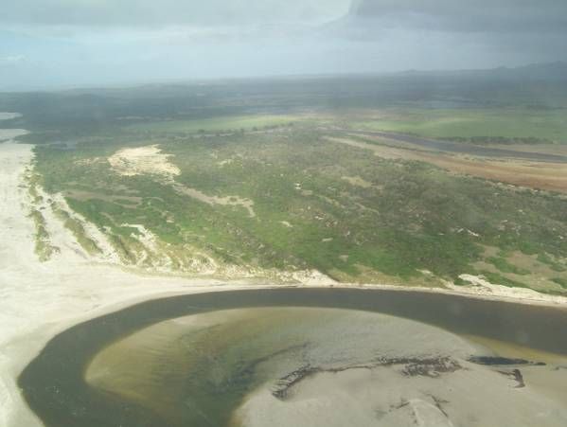
Figure 8: Estuary Zone of the Flood Plain Lower Ringarooma River Ramsar Site (May 2007, L.N. Lloyd).
Wave dominated estuaries are considered ‘mature’ in terms of evolution and tend to be morphologically stable (assuming stable sea levels). They often have a narrow entrance which can restrict marine flushing, although this is counter-balanced by high river flows that expel marine water and flush material from the delta. The short residence time for deposited material results in little processing or trapping of associated nutrients and contaminants (Coastal Zone Australia Ltd 2005).
Typical of flood tide deltas, the Ringarooma estuary has a direct connection between river and sea, via a channel flanked by a low-lying vegetated Flood Plain. The channel is kept open by the relatively high river velocities and a dune barrier partially constricts the estuary entrance, preventing it from expanding into a large, open estuary. The ‘mature’ nature of flood tide deltas means that they have been mostly filled by sediments. In the case of the Ringarooma estuary, this ‘maturation’ has probably been created prematurely through an increased rate of sediment yield from the catchment as a result of tin mining (discussed in Section 2.1).
The Ramsar wetland types that occur within the estuary zone (Figure 10, Table 4) include estuarine waters (permanent water of estuaries and estuarine systems of deltas wetland type F); intertidal mud, sand or salt flats (wetland type G); intertidal marshes (includes salt marshes, salt meadows, saltings, raised salt marshes[tidal brackish and freshwater marshes] wetland type H); and coastal brackish/saline lagoons (brackish to saline lagoons with at least one relatively narrow connection to the sea; wetland type J).
Saltmarsh has been noted as being present in the estuary section of the site (RIS 2005; personal observations) but without assessment its extent, composition or condition is not known. Similarly, species of fish in the region that inhabit coastal streams or migrate between freshwater and the sea have been identified, but no data have been found on their distribution or abundance. Macroinvertebrate data were also unable to be found for the estuary at the time of listing, although some information in Edgar et al. (1999) suggests the estuary supports an average number of macroinvertebrate species for this estuary-type within Tasmania.
Bird surveys were undertaken in the southern section of the Ramsar site as part of the Musselroe wind farm studies (Organ et al. 2003) and in November 2000 DPIW personnel recorded shorebirds at the mouth of the Ringarooma River and Boobyalla Rivers, including hooded plover, red-capped plover, greenshank, red-necked stint, ruddy turnstone, curlew sandpiper, black-fronted dotterel and fairy tern (Sally Bryant, DPIW, personal communication). These records contribute useful information on the site; however, systematic surveying of the estuary area would contribute important data for the understanding of the estuary avifauna.
Similar to other components contributing to the ecological character of the estuary, there is little information available on the water quality of the estuary. Given the location of Ringarooma Bay, any impacts on water quality in the estuary would originate from the freshwater input rather than the marine. Despite this reported contamination, the estuary supports an invertebrate fauna of average diversity, significant fish populations, and a diverse bird fauna including the species listed above.

The Freshwater Zone
The freshwater wetlands of the site are formed on a Flood Plain that widens downstream of a shallow and constricted valley (Jerie and Household 2001). In the wider and flatter area of the lowland Flood Plain, water from high flow events can leave the channel and spread out, filling in depressions in the landscape. As the water leaves the channel during high flows it quickly loses velocity and deposits the heavier sediment along the channel edge, forming natural levees. These natural levees impede the water from subsequently returning to the channel, leaving it to form a mosaic of seasonally-inundated and permanent water bodies (Figure 9).
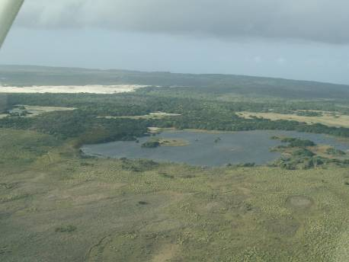
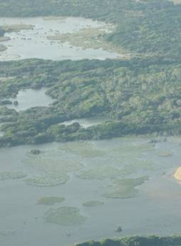

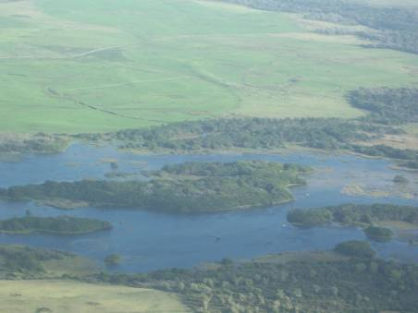

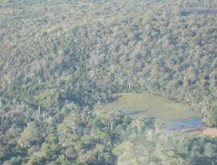

Figure 9: Freshwater Zone of the Flood Plain Lower Ringarooma River Ramsar Site (Mosaic of Photos, May 2007, L.N. Lloyd).
The freshwater wetland complex is surface water dominated. Local groundwater appears to be controlled by river flows and overflows, with the surface water generally recharging the local groundwater. The site’s hydrology is therefore dependent on the Ringarooma River and several small tributaries to the site. The wetlands are generally shallow and clear, providing optimal conditions for submerged and emergent macrophyte vegetation. The extent and period of inundation varies substantially across the site’s wetlands with corresponding variations in abundances and distributions of plant species. The water quality data from the Ringarooma River suggests that the wetlands’ water is of high quality for aquatic ecosystems, with low nutrients, low salinities and pH readings approximating neutral (that is, pH of 7).
The wetland complex contains a shallow mosaic of temporary and permanent wetlands with low nutrients, clear-water, circum-neutral pH and low salinities. The vegetation is largely emergent and submerged leaf macrophytes within the areas of standing water, grading through sedgeland and heathland to treed swamp forests. The diversity of fauna at the site is dependent on the diversity of habitat afforded by the geomorphic, wetland and vegetation mosaic.
The Ramsar wetland types that occur within the freshwater zone include: seasonal waterways (wetland type N); permanent freshwater marshes, pools and ponds (below 8 hectares), with emergent vegetation (wetland type Tp); seasonal freshwater marshes and pools, including seasonally flooded meadows and sedge marshes (wetland type Ts); shrub-dominated wetlands (wetland type W); and freshwater, tree-dominated wetlands (freshwater swamp forest) (wetland type Xf).
Within this system, the geomorphology of the site is a primary driver of the other components of ecological character. The landforms have a profound influence on the distribution of flows and the expression of groundwater influences. Further, the landforms – through the control of spatial and temporal extent of inundation – also have a profound influence on the distribution of vegetation communities and their dependent fauna and allied flora.
Currently, water quality data is limited to the Ringarooma River at Gladstone, which indicates that the water entering the wetland system from the River is high quality. However, water also enters the Ringarooma River and wetlands from tributaries downstream of Gladstone and the impacts of land uses (including the re-opened Scotia mine and increasingly intensive dairying) on the water quality needs assessing. Water quality needs to be maintained, particularly for fish and macroinvertebrate species that live in the water column, but also for the aesthetics of the site and the water fowl that rely on the system as breeding and feeding habitat.

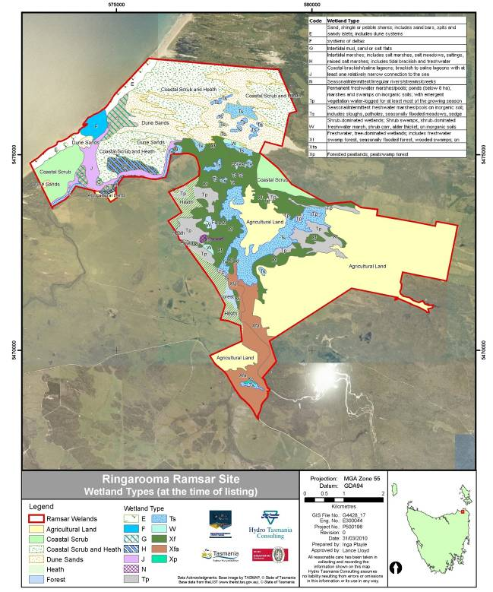
Figure 10: Ramsar wetland types of the site (at time of Listing; Source NRM North).

Table 4: Ramsar wetland types identified for the site at time of listing and their areas (in hectares).
Ramsar wetland type | Ramsar wetland type code | Area (hectares)
Sand, shores; includes sand bars, spits and sandy islets. | E | 74
Estuarine waters. | F | 33
Intertidal mud, sand or salt flats. | G | 58
Intertidal marshes; includes salt marshes, raised salt marshes. | H | 44
Coastal brackish/saline lagoons; brackish to saline lagoons with at least one relatively narrow connection to the sea. | J | 74
Seasonal/intermittent/irregular rivers/streams/creeks. | N | 5
Permanent freshwater marshes/pools; ponds (below 8 hectares), marshes and swamps on inorganic soils; with emergent vegetation water-logged for at least most of the growing season. | Tp | 169
Seasonal/intermittent freshwater marshes/pools on inorganic soil; includes seasonally flooded meadows, sedge marshes. | Ts | 257
Shrub-dominated wetlands. | W | 13
Freshwater swamp forest, total  - Paperbark  - Blackwood (Acacia). | Xf  Xf  Xfa | 614  414  200
Forested peatlands; peat swamp forest. | Xp | 1

Components and Processes of the Site
Ecosystem components include the physical, chemical and biological parts of a wetland (Millennium Ecosystem Assessment 2005). Ecosystem processes are dynamic forces and include all those processes that occur between organisms and within and between populations and communities. This includes interactions with the non-living environment that result in existing ecosystems and bring about changes in ecosystems over time (Australian Heritage Commission 2002). They may be physical, chemical or biological.
In practice, many components can also be processes. For example, climate, hydrology and geomorphology can each be viewed as static parts (components) of the sites as well as dynamic forces (processes) that bring about change to wetlands. In this ECD they are considered together.
At a high level, the components and processes of the site include:
- climate
- geomorphology
- substrate
- hydrology
- water quality
- vegetation
- fauna
Beyond this higher level, each component consists of subcomponents. These are presented and discussed below.

Climate
At a global level, all of Tasmania is classified as ‘temperate rainy climate with warm summers’ (Strahler and Strahler 1992). Average annual rainfall varies substantially across the island but at nearby Bridport (approximately 45 kilometres southwest of the site) rainfall has averaged 723 millimetres since records have been kept (13 years). Rainfall peaks in winter (the June average is nearly 95 millimetres), extending through spring, with lowest rainfall in late summer – early autumn (February average rainfall is just over 30 millimetres) (Figure 11). Eddystone (just under 40 kilometres to the southeast of the site) has a substantially longer record and supports the results for Bridport, though with a more even rainfall throughout the year (Figure 11), reflecting Eddystone’s east coast position rather than the north coast location occupied by Bridport and the site.
Within the context of this ECD, the key features of climate would include extremes in natural fluctuations and also possible impacts of climate change. Although neither of these can be controlled, future management of the site may need to consider potential impacts of changes in climate. Of particular importance to the site would be how to manage changes to the volume, seasonality and delivery (magnitude, intensity and frequency) of rainfall events.
Despite the relatively short period of data collection at Bridport, the information provides an important baseline for future comparisons, particularly in relation to climate change and is supported by data derived from nearby Eddystone Point (Figure 11). Figure 12 displays the highest and lowest monthly rainfalls received at Bridport over the 13 years of data collection. There has been substantial variability over the recording period, with both January and June recording monthly rainfalls below 25 millimetres and above 125 millimetres on separate occasions.
Any sea level rise associated with climate change could allow an incursion of estuary waters into the freshwater wetland habitat, impacting on the freshwater biota within the wetlands.

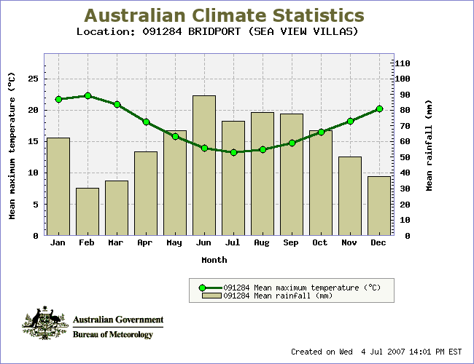
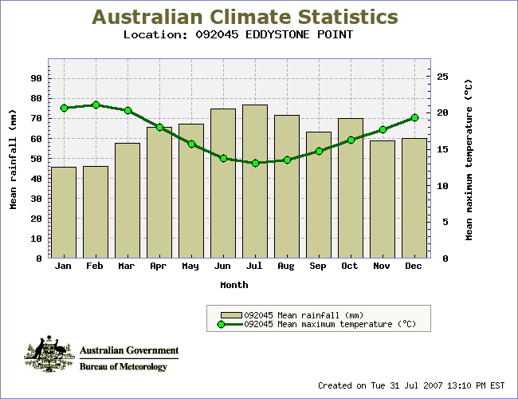
Figure 11: Climograph of Bridport 1994 – 2007 and Eddystone Point 1957 – 2007. (Source: Bureau of Meteorology 2007)
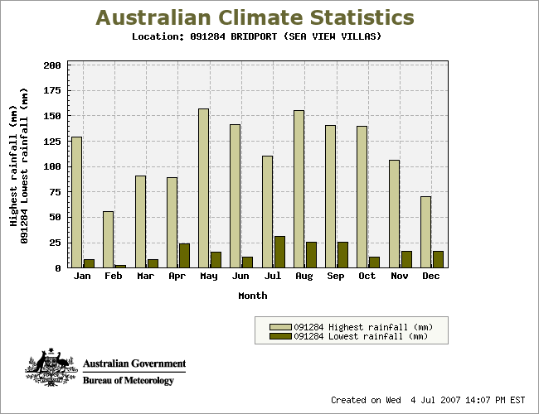
Figure 12: Monthly highest and lowest rainfalls recorded at Bridport 1994 – 2007. Source: Bureau of Meteorology 2007.

Geomorphology
Geomorphology of the Ringarooma River catchment is a key feature and a controlling factor of the ecological character of the site. The river originates in a granodiorite massif, passes mostly through granite in its middle reaches and into alluvium in its lower reaches (Nelson 1999). The upper reaches are typified by a cobble-gravel substrate grading to boulder-cobble in the highest reaches (Nelson 1999). The extensive history of alluvial tin mining in the river and surrounding catchment has led to a massive release of sand and silt into the stream. The sand component has been progressing downstream in a large wave of sediment (termed a ‘sand slug’), with the finer and less heavy silts being more rapidly washed downstream. The sand slug has changed the stream bed from gravel-dominated to sand-dominated as the river progressively aggraded (built up) with the sediment. The sand aggradation has increased bed height by more than 10 metres in the lower reaches of the Ringarooma River (Knighton 1991). Upstream supplies of the sediment have gradually been depleted as the sediment is carried downstream by the river. This has led to a subsequent degradation (lowering) of the stream bed. The process of aggradation followed by degradation of the bed is gradually moving downstream.
Degradation has yet to reach the downstream reaches of the Ringarooma, where sediment waves continue to pass over a slightly aggrading bed. In 1991, Knighton predicted that at least another 50 years will be needed for degradation to cleanse the Ringarooma of mining debris. However, Jerie and Houshold (2001) have noted that much of the sediment may not reach the sea, instead being deposited in the wetlands. They note, “the Ringarooma will not be a stable place for some time”. A series of aerial photographs of the site were presented in Jerie and Houshold (2001) which are presented in section 4. Once the degradation of the stream bed reaches the wetlands, it is possible that channel incision will drain pools connected to the stream. The effect on the groundwater hydrology may also be sufficient to affect wetlands not connected to the river (Jerie, personal communication).
Sediment aggradation has been responsible for creating wetlands and filling in wetlands at the site. The site currently contains a mosaic of landforms including dunefields, lunettes, natural levees, active and abandoned stream channels, sand splays from avulsions, as well as a variety of wetlands including lakes, ponds, lagoons and intermittently wet areas (Hydro Tasmania 2003). The area is regularly flooded by overflow from the river. As noted in Section 2.1, the maximum depth of water in The Chimneys is between two and four metres during flooding, whilst the maximum depth of permanent water is between half a metre and one metre (RIS 2005). Observations of the site in late autumn 2007 (in dry conditions) noted depths of approximately half a metre in the few remnant pools in The Chimneys. At the same time, water depths in Shantys Lagoon and Blueys Lagoon were estimated as being approximately two metres, indicating that during flood periods these could be up to six metres deep.
Similar to most wetland complexes, the mosaic of landforms and habitats at the site is a naturally dynamic system. Localised erosion and aggradation shift the depth, hydrologic regime and even the location of the wetland habitats. However, a key consideration for management of this site is that the rate of geomorphic change has been greatly accelerated, and the direction altered, by the massive inputs of mine-derived sediment. The extent to which the mosaic of landforms is maintained by future geomorphic changes will have an effect on the number and variety of wetland habitat types at the site.
Future management decisions may need to address whether the site will be actively managed to maintain its geomorphic diversity (and its Ramsar status), or whether a more passive management regime will be adopted, allowing the system to determine its own form – even if it loses features that contributed to its Ramsar listing.
Beyond the freshwater zone, the estuary zone is wave dominated, with a flood tide delta (Jason Bradbury, personal communication; Coastal Zone Australia Ltd 2005). Geomorphic characteristics of wave dominated deltas typically include the deltas themselves, barriers, mudflats, channels and beaches, and these are found in the Ringarooma estuary. The Ringarooma Estuary and sections of the adjacent coast are also geomorphic features within the site boundary. Mine-derived sediments have filled the estuary and large sand flats now exist where once large ships were able to traverse (Jerie and Houshold 2001).
The geomorphology of the coastline has not been documented (Jerie personal communication). although part of the site is listed on the Tasmanian Geoconservation Database (DPIW 2009) as part of the Northeast Tasmanian Pleistocene Aeolian System.

Substrate
Currently, the most important feature of the substrate in the site is its movement within the site and its ongoing accumulation of mining sediment across the site. As well as influencing landform as described above, the mine waste is affecting soil texture. The Holocene Flood Plain sediments, consisting mainly of clays, sands and gravels (RIS 2005), are overlain by silty clay soils, with the silt being derived from the mine waste, and decreasing with depth in the soil profile. Mapping conducted in 2008 indicates a high risk of potential acid sulphate soils in the area.

Hydrology
The hydrology of any wetland is a vital determinant of its ecological character. The season of delivery, the period of inundation for ephemeral wetlands (or water level rises for permanent wetlands), fluctuations in water levels and interannual variations can all affect the ecological character of a wetland. In the Ringarooma wetlands, the hydrology is largely influenced by the interaction between geomorphology and river flows. The timing of delivery and the volumes delivered influence a number of important biotic responses, such as seed germination, triggers for breeding (for birds, fish, frogs), success of breeding, and provision of food.
The hydrology of the site is not well-documented but excellent information is available upstream in the Ringarooma River. There are useful hydrological flow data from the Ringarooma River at Moorina, approximately 20 kilometres upstream of the site (Graham 1999) and also from several of its tributaries. Additionally, there are some water depth data for Rushy Lagoon (Read and Graham 2000). However, data on the hydrologic regime within the site, such as specific timing, volumes, extent of inundation and drying regime of the wetlands are not available.
Despite the lack of wetland specific data for the site, flow patterns of the lower Ringarooma River can provide clear indications of flow inputs to the Flood Plain wetlands. The seasonal flow patterns of the Ringarooma River follow the rainfall patterns, with highest flows in the winter/spring months and lowest in late summer to early autumn (Read and Graham 2000). Data in Graham (1999) from Moorina in the mid-catchment show average monthly flows of approximately 16-18 cubic metres per second from July to September, whereas February and March recorded average monthly flows of approximately two cubic metres per second (Figure 13). These data are supported by flow measures between 2002 and 2007 (Figure 14) which show distinct winter peaks, punctuated with occasional very high flow peaks, and very low flows in the February – March period. The median annual flow of the Ringarooma River at Moorina was measured as 5.9 cubic metres per second and summer median flow was 2.4 cubic metres per second (Nelson 1999).
Water levels measured at the Ringarooma River entrance to Rushy Lagoon between December 1998 and March 2000 (Figure 15) supported the rainfall patterns described above, with maximum depths occurring in the winter months, although there was a period of deeper water in January of 2000.
Figure 13: Box and whisker plots of monthly flows in the Ringarooma River at Moorina (Source: Graham 1999).
Figure 14: Instantaneous flows in the Ringarooma River at Moorina, 2002 – 2007 (Supplied by Chris Bobbi, DPIW, unpublished data).
Figure 15: Water level at the entrance of the Ringarooma River to Rushy Lagoon, Dec 1998 to March 2000 (Source: Read and Graham 2000).
As part of a study deriving an Index of River Condition for sites on the Ringarooma River, Nelson (1999) assigned a low hydrology rating to sites in the lower Ringarooma mainstream due to allocated water extraction rights being high. However, a subsequent study (Read and Graham 2000) notes that the actual volume of water taken from the Lower Ringarooma River during the lower flow months (December – April) is a small proportion of the flow in the River and therefore current water extraction rates are unlikely to impact significantly on the ecosystem of the Lower Ringarooma. Despite higher quantities of water being taken from the tributaries and the mid-reaches of the river, much of this is ultimately returned to the waterway. The water is primarily used for hydropower generation and this has negligible impact on the quality of the returned water (Bobbi, personal communication).
Read and Graham (2000) note that little is known of the ecology of the Lower Ringarooma wetlands and that informed management decisions on the ecosystems’ requirements will require comprehensive surveys of the flora and fauna. Hydrological surveys would complement these biological surveys. Many waterbirds commonly found in this area are reliant on wetting and drying cycles of wetlands for food supply and breeding habitat (Read and Graham 2000). Scott (1997) suggests that “the best scenario for managing regulated rivers and their associated wetlands is to reflect the natural patterns of flows, particularly in terms of critical parameters such as the season, duration and frequency of floods, and also periods of low flow” (Read and Graham 2000). Quantifying natural flows at the site will require flow monitoring.
The freshwater wetland complex buffers flood peaks and processes nutrients that would otherwise be deposited in the estuary. This occurs through the overbank deposition and subsequent retention of flood waters and sediments into the freshwater wetlands. It also continues to trap a portion of the mine-related sediment that will continue to be transported down the river for at least 50 years (Knighton 1991). A proportion of this sediment will continue to be transported through the estuary to the sea. In the long term, sediment trapped in the wetlands will continue to change the form and location of the flooded area (Jerie and Houshold 2001), and so has the potential to impact on the ecological character of the site (Jerie, personal communication).

Water Quality
Similar to hydrology, there are little water quality data from within the site for either the wetland habitats or river. However, water quality data are available from the Ringarooma River, upstream of the site, at Gladstone (Bobbi 1999), providing some information on the quality of water that enters the wetlands from the river. Note that the comparison of the Ringarooma River water quality against trigger values (below) is provided to give a general understanding of the quality of water that enters the site. From the perspective of an ECD, the quality of the water at the time of listing is the baseline water quality, not the trigger values provided in Table 5.
Table 5 shows the data compared against default trigger values from the ANZECC and ARMCANZ (2000) Guidelines for Marine and Freshwaters, which were published after the 1999 report by Bobbi (1999). The ANZECC default trigger values are set at a broad scale, ranging from south-east Queensland to Tasmania and cannot be applied to all rivers within the region. The ANZECC guidelines document states a clear preference for locally derived trigger values over the default values, as the default values are generalised for large regions. Bobbi (1999) provided locally derived trigger values for turbidity and electrical conductivity, and these should be considered in preference to the ANZECC trigger values.
The data from the Ringarooma River at Gladstone is indicative of high quality waters for a lowland river in south-eastern Australia (Table 5). Although several of the data points in Table 5 were read from graphs and therefore may not be precise, the nature of the water quality is evident regardless of this imprecision. The water is high quality for an aquatic ecosystem with low electrical conductivity (an indicator of salinity) and turbidity (‘muddiness’), and high dissolved oxygen concentrations.
Table 5: Median Water Quality Data and relevant indicative guidelines for the Ringarooma River at Gladstone.
Water Quality Indicator | Trigger Value§ | Median reading from the Ringarooma River at Gladstone‡
pH | 6.5 – 8.0 | 6.6
Turbidity (NTU) | (6 – 50) 12* | 6
Dissolved Oxygen | 85 - 100% | 9.5 mg/L
Electrical Conductivity (μS/cm) | (125 – 2200) 500* | 75
Total Phosphorus μg/L | 50 | 12
Total Nitrogen μg/L | 500 | 583
§ANZECC, ARMCANZ 2000 default Trigger values for Lowland Rivers in SE Australia.
*Value derived from professional judgement.
‡ Median from 12 samples taken between January and December 1988 (Bobbi 1999).
The ANZECC guideline value for dissolved oxygen was presented as percent saturation but measured in mg/L in Bobbi (1999). A median concentration of 9.5 milligrams per litre is indicative of well aerated waters and for the temperatures encountered at the site is likely to be within the 90 percent saturation guideline. Phosphorus and nitrogen are typically the two major nutrients associated with excessive growths of algae and other water plants. Phosphorus concentrations are well below the ANZECC default trigger values, whereas nitrogen concentrations slightly exceed the default. In combination, the water quality indicators show that the water delivered from the Ringarooma River to the site is high quality.

Vegetation
Vegetation can be described and classified in a number of ways, including the use of species lists, structure, communities/species associations, or a combination of these. A classification for mapping vegetation communities in Tasmania was developed by DPIW and is available online (refer DPIW 2008b). This classification was used by DPIW (2006) in a survey of a large part of the site (Figure 16). Plant communities and their corresponding Ramsar Wetland Type found onsite are described in Table 6. Not all wetland types were covered by DPIW (2006).
Table 6: Plant communities identified & their corresponding Ramsar Wetland Types.
DPIPWE Classification | Ramsar Wetland Types
Coast paperbark swamp forest | Type Xf: Freshwater, tree-dominated wetlands
Blackwood swamp forest | Type Xf: Freshwater, tree-dominated wetlands (listed as Xfa in Figure 10)
Scented paperbark scrub | Type W: Shrub-dominated wetlands
Freshwater aquatic herbland | Type Tp: Permanent freshwater marshes/pools; ponds (below 8 ha), marshes and swamps on inorganic soils; with emergent vegetation water-logged for at least most of the growing season
Freshwater aquatic rushland & sedgeland | Type Ts: Seasonal/intermittent freshwater marshes/pools on inorganic soils
Lacustrine herbland | Type Ts: Seasonal/intermittent freshwater marshes/pools on inorganic soils
Lowland grassy sedgeland | Type Ts: Seasonal/intermittent freshwater marshes/pools on inorganic soils
Coastal heathland | Type W: Shrub-dominated wetlands; shrub swamps, shrub-dominated freshwater marshes, shrub carr, alder thicket on inorganic soils
Lowland sedgy heathland | Type W: Shrub-dominated wetlands; shrub swamps, shrub-dominated freshwater marshes, shrub carr, alder thicket on inorganic soils
Wet heathland | Type W: Shrub-dominated wetlands; shrub swamps, shrub-dominated freshwater marshes, shrub carr, alder thicket on inorganic soils
Black peppermint coastal forest & woodland | Not wetland

The key species associated with each plant community is presented in Appendix 2.
Coast paperbark swamp forest native vegetation community is listed as threatened under the NCA 2002. The freshwater aquatic herbland, lacustrine herbland and lowland grassy sedgeland are all within the ‘wetland’ category and this entire category is also classified threatened (NCA 2002).
The swamp forests (coast paperbark and blackwood) both require poorly drained or intermittently inundated land for survival (DPIW 2006) and a key issue for management of these forests is the maintenance of adequate water inputs.
Coast paperbark swamp forest tends to occupy a zone that is poorly drained and sometimes waterlogged, whereas blackwood (Acacia melanoxylon) swamp forest occurs on wetter areas such as the alluvial flats that are generally inundated or very poorly drained. Within the site the blackwood swamp forest shows an association with the Ringarooma River and some of the smaller drainage channels that meander through the area. Although blackwood is the dominant tree in the blackwood swamp forest, coast paperbark also occurs and its abundance is probably associated with the level of flood disturbance that occurs at the site, the more disturbance, the more coast paperbark (DPIW 2006).
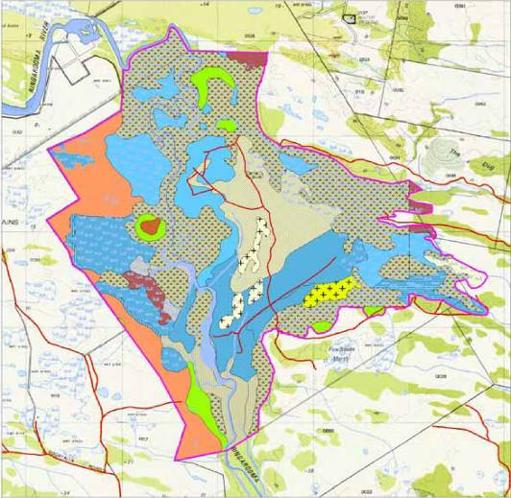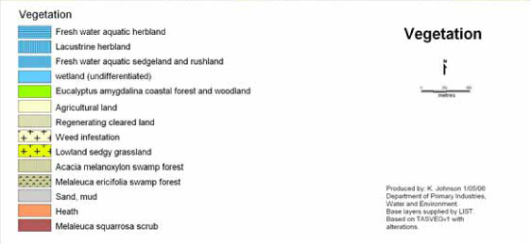
Figure 16: Vegetation Survey of part of the Flood Plain Lower Ringarooma Ramsar Site (DPIW 2006). Mapping units used are from TASVEG (Harris and Kitchener 2005.
DPIW (2006) notes that, “the size, shape and species composition of the wetlands is largely related to the amount of water present and the length of time for which water is present each year. Changes in water availability would have a direct impact on the wetland environments”. Permanent or semi-permanent inundation is required for the freshwater aquatic herbland and the freshwater aquatic sedgeland and rushland. The lacustrine herbland is essentially an ecotone between the aquatic wetlands and the drier communities. DPIW (2006) note that the most extensive lacustrine herbland observed occurs on the western edge of Shantys Lagoon. This community is relatively diverse and includes species of sedge, herb and rush.
In addition to the rare or threatened plant communities, threatened flora species known to occur on the site include one terrestrial species shiny grasstree, (Xanthorrea bracteata) (vulnerable, TSPA, in the coastal heathland) and four wetland dependent species:
- purple loosestrife (vulnerable, TSPA), found in the more open areas of the coastal paperbark swamp forest, and also in the wetland communities (Freshwater aquatic herbland, lacustrine herbland and lowland grassy sedgeland);
- ribbon weed (rare, TSPA), in the freshwater aquatic herbland community;
- native gypsywort (endangered, TSPA), found in the lacustrine herbland communities; and
- erect marshflower (rare, TSPA), which wasn’t recorded by DPIW (2006) but is reported elsewhere (DPIW, undated b) as occurring in The Chimneys and being found in stationary to slow-flowing water to a depth of 50 centimetres.
The DPIW survey was not conducted across the entire site. Other vegetation communities recorded as occurring on the site (RIS 2005) include:
- saltmarsh
- coastal grass and herbfield
- coastal scrub
- Acacia longifolia coastal scrub
- Allocasuarina verticillata forest
While these are not mapped they all occur in the estuarine or coastal zones.
A number of species found on the flood plain are of botanical interest, including Persicaria praetermissa (located at less than 20 sites in the State); Centipeda elatinoides; and the Isolepis fluitans aquatic community at the site, which are all poorly reserved in Tasmania (RIS 2005).
Within Tasmania, saltmarsh vegetation communities which occur on the site qualify for two of the Biodiversity Criteria developed by the National Forest Policy Statement Implementation Sub-committee [a joint committee of ANZECC] and MCFFA. These criteria are:
- Criterion (one); as less than three percent of the pre-1750 distribution of saltmarsh vegetation is protected in the Comprehensive Adequate and Representative (CAR) reserve system and
- Criterion (five); as they are a habitat for migratory species which are also often rare, vulnerable or endangered.
Although saltmarsh communities are not currently listed as threatened within Tasmania, these communities serve a critical ecological function and are at risk due to their low reservation status (RIS 2005).

Fauna
Although data on faunal presence, abundance and distribution are limited for the site, there is some useful information available including site records on the DPIW Natural Values Atlas. This includes a list of bird species for part of the site (Appendix 3), species listed under international agreements and a list of rare and threatened species at State and Commonwealth level (refer Section 2.2). Additionally, the DPIW (2006) vegetation survey noted habitat types that may be utilised by threatened species that had been recorded, or are likely to be present, at the site (Table 7). Table 7 presents the species and their habitat (as described by DPIW vegetation community), as well as the relevant Ramsar wetland type (in parentheses).
Table 7: Identified habitat types for threatened species and migratory birds.
Fauna species & notes | Habitat
Tasmanian spotted-tailed quoll (Dasyurus maculatus maculatus)(vulnerable, EPBC)  - Almost certain to be present.  - Known from private land west of the site. | - Blackwood swamp forest: potential habitat is widespread in this community within the site (Xf)  - Coastal heathland: potential habitat is widespread in this community within the site (W)  - Black peppermint coastal forest: potential habitat is widespread in this community within the site
Grey goshawk (Accipiter novaehollandiae) (Endangered TPSA) | - Blackwood swamp forest: potential nesting habitat (Xf)  - Coast paperbark swamp forest: potential nesting habitat where the community contains blackwoods (Xf)
Dwarf galaxias (Galaxiella pusilla) (vulnerable, EPBC)  - Known to be associated with wetland habitat types at the site.  - species range declining due to wetland drainage. | - Freshwater aquatic herbland (Tp)  - Freshwater aquatic rushland and sedgeland (Ts)  - Lacustrine herbland (Ts)
Tasmanian mudfish (Neochanna cleaveri) (not listed as threatened)  - species range declining due to wetland drainage. | - Freshwater aquatic herbland (Tp)  - Freshwater aquatic rushland and sedgeland (Ts)  - Lacustrine herbland (Ts)
Tasmanian whitebait (Lovettia seali) (not listed as threatened)  - species range declining due to wetland drainage. | - Estuarine waters (F)
Australian grayling (Prototroctes maraena)(vulnerable, EPBC) | - Estuarine waters (F)  - Permanent rivers, streams & creeks (M)
Green and gold frog (Litoria raniformis) (vulnerable, EPBC) | - Freshwater aquatic herbland (Tp)  - Freshwater aquatic rushland and sedgeland (Ts)  - Lacustrine herbland (Ts)
Cattle egret (Ardea ibis)  Great egret (Ardea modesta)  Black-fronted dotterel (Elseyornis melanops) | - Freshwater aquatic herbland (Tp)  - Freshwater aquatic rushland and sedgeland (Ts)  - Lacustrine herbland (Ts)  - Non-forested peatlands (U)  - Seasonal intermittent lakes (P)
Latham’s snipe (Gallinago hardwickii)  Australasian shoveler (Anas rhynchotis) | - Freshwater aquatic herbland (Tp)  - Freshwater aquatic rushland and sedgeland (Ts)  - Lacustrine herbland (Ts)
Curlew sandpiper (Calidris ferruginea)  Red-necked stint (Calidris ruficollis)  Caspian tern (Hydroprogne caspia)  Greenshank (Tringa nebularia)  Red-capped plover (Charadrius ruficapillus). | - Freshwater aquatic herbland (Tp)  - Freshwater aquatic rushland and sedgeland (Ts)  - Lacustrine herbland (Ts)  - Non-forested peatlands (U)  - Seasonal intermittent lakes (P)  - Estuarine waters (F)  - Sand, shingle or pebble shores; includes sand bars, spits and sandy islets; includes dune systems and humid dune slacks (E)  - Coastal brackish/saline lagoons; brackish to saline lagoons with at least one relatively narrow connection to the sea (J)  - Intertidal mud, sand or salt flats (G)  - Intertidal marshes; includes salt marshes, salt meadows, saltings, raised salt marshes; includes tidal brackish and freshwater marshes (H)
Bar-tailed godwit (Limosa lapponica)  Ruddy turnstone (Arenaria interpres)  Little tern (Sterna albifrons, rare, TSPA)  Fairy tern (Sterna nereis, rare, TSPA)  Hooded plover (Thinornis rubricollis) | - Estuarine waters (F)  - Sand, shingle or pebble shores; includes sand bars, spits and sandy islets; includes dune systems and humid dune slacks (E)  - Coastal brackish/saline lagoons; brackish to saline lagoons with at least one relatively narrow connection to the sea (J)  - Intertidal mud, sand or salt flats (G)  - Intertidal marshes; includes salt marshes, salt meadows, saltings, raised salt marshes; includes tidal brackish and freshwater marshes (H)
Tasmanian wedge-tailed eagle (Aquila audax fleayi, Endangered, EPBC and endangered, TSPA) | - All habitat except closed forest
White-bellied sea eagle (Haliaeetus leucogaster, vulnerable, TSPA). | - Estuarine waters (F)  - Permanent rivers, streams & creeks (M)  - Seasonal intermittent lakes (P).

Eleven migratory bird species listed in CAMBA, JAMBA, ROKAMBA and/or CMS are:
- cattle egret
- great egret
- white-bellied sea-eagle
- Latham’s snipe
- curlew sandpiper
- red-necked stint
- ruddy turnstone
- bar-tailed godwit
- Caspian tern
- little tern
- greenshank
Information on these species at the site is limited to occasional sightings. However, some general information on habitat and diet for each species is provided in Table 8, below.
Table 8: Migratory bird species of the Flood Plain Ringarooma River Ramsar Site, with their common habitat and diet (Pizzey 1980; Birdlife International 2009; Birds Australia 2010; DEWHA 2010b).
Species | Habitat(s) | Diet
Cattle egret | The cattle egret inhabits a range of habitats, including open grassy areas such as meadows, livestock pastures, semi-arid steppe and open savannah grassland subject to seasonal inundation, dry arable fields, artificial grassland sites (for example lawns, parks, road margins and sports fields), flood-plains, freshwater swamps, rice-fields, wet pastures, shallow marshes, mangroves and irrigated grasslands (with ponds, small impoundments, wells, canals, small rivers and streams). It rarely occupies marine habitats or forested areas although in Australia it may enter woodlands and forests, and it shows a preference for fresh water although it may also use brackish or saline habitats. It occurs from sea-level up to approximately 1,500 metres. | Its diet consists primarily of insects such as locusts, grasshoppers, beetles, adult and larval butterflies and moths, dragonflies and centipedes. However, worms, spiders, crustaceans, frogs, tadpoles, molluscs, fish, lizards, small birds, rodents and vegetable matter may also be taken.
Great egret | The great egret inhabits many kinds of inland and coastal wetlands although it is mainly found along the coast in the winter or during droughts (for example in Australia). It frequents river margins, lakes shores, marshes, flood-plains, oxbow lakes, streams, damp meadows, aquaculture ponds, reservoirs, and the shallows of, mudflats, coastal swamps, saltmarshes, seagrass flats, offshore coral reefs, lagoons and estuaries when in coastal locations. | In aquatic habitats its diet consists of fish, amphibians, snakes, aquatic insects and crustaceans although in drier habitats terrestrial insects, lizards, small birds and mammals are more commonly taken.
White-bellied sea eagle | This species is generally found in coastal habitats, characterised by the presence of large areas of open water (larger rivers, swamps, lakes, the sea). Breeding territories are located close to water, and mainly in tall open forest or woodland  The white-bellied sea-eagle generally forages over large expanses of open water; particularly individuals that occur in coastal environments close to the sea-shore, where they forage over in-shore waters. | The white-bellied sea-eagle feeds opportunistically on a variety of fish, birds, reptiles, mammals and crustaceans, and on carrion.
Latham’s snipe | Latham's snipe are found in any vegetation around wetlands, such as sedges, grasses, reeds and rushes and also in saltmarsh and creek edges on migration. They are usually seen in small groups or singly in freshwater wetlands on or near the coast, generally among dense cover. | Latham's snipe feed at night, early morning or evening, thrusting their long bill into mud in soft mudflats or shallow water. They are omnivorous, eating seeds and plant material, worms, spiders and insects, some molluscs, isopods and centipedes.
Curlew sandpiper | The curlew sandpiper breeds in the lowlands of the high Arctic and also along the coast and islands of the Arctic Ocean. within Australia the species chiefly occurs on coastal brackish lagoons, tidal mud- and sandflats, estuaries, saltmarshes, exposed coral, rocky shores and tidewrack on sandy beaches and also inland on the muddy edges of marshes, large rivers and lakes (both saline and freshwater), irrigated land, flooded areas, dams and saltpans. | During breeding its diet consists mainly of insects, such as the adults, pupae and larva of midges, craneflies and beetles, as well as bugs and leeches. In Australia its diet is more likely to consist of invertebrates such as worms, molluscs, crustaceans and occasionally insects and seeds.
Red-necked stint | The red-necked stint is found on the coast, in sheltered inlets, bays, lagoons, estuaries, intertidal mudflats and protected sandy or coralline shores. | Red-necked stints are omnivorous, taking seeds, insects, small vertebrates, plants in saltmarshes, molluscs, gastropods and crustaceans.
Ruddy turnstone | The ruddy turnstone forages in close flocks of 10-100 or more individuals, especially in tidal areas. In Australia the species is mainly coastal, frequenting productive rocky and shingle shores, breakwaters, sandy beaches with storm-wracked seaweed, saltmarshes, sheltered inlets, estuaries, mangrove swamps, exposed reefs and mudflats with beds of molluscs. | Within its Arctic breeding grounds the species takes insects and spiders, occasionally also taking vegetable matter. In Australia its diet consists of insects, crustaceans, molluscs (especially mussels or cockles), annelids, echinoderms, small fish, carrion and birds eggs.
Bar-tailed godwit | The bar-tailed godwit breeds in, swampy areas tundra and on swampy heathlands near the Arctic treeline. In Australia it is more common in intertidal areas along muddy coastlines, estuaries, inlets, mangrove-fringed lagoons and sheltered bays with tidal mudflats or sandbars. | When breeding the species feeds on insects, worms, molluscs and occasionally seeds and berries. In Australia, in intertidal areas the species diet consists of annelid worms, bivalves and crustaceans and occasionally larval amphibians (tadpoles) and small fish. When on grasslands it will also take cranefly larvae and earthworms.
Little tern | The species breeds on barren or sparsely vegetated beaches, islands and spits on seashores or in estuaries, saltmarshes, saltpans, offshore coral reefs rivers, lakes, and reservoirs. It shows a preference for islets surrounded by saline or fresh water where small fish can be caught without the need for extensive foraging flights.  In Australia the species frequents tidal creeks, coastal lagoons and saltpans and may foraging at sea up to 15 kilometres offshore. | Its diet consists predominantly of small fish and crustaceans three and six centimetres long as well as insects, annelid worms and molluscs.
Caspian tern | The breeding, passage and wintering habitats of the Caspian tern are similar, although during the winter it is largely confined to the coast. It frequents sheltered sea coasts, estuaries, inlets, bays, harbours, coastal lagoons, and saltmarshes. When breeding the species shows a preference for nesting on sandy, shell-strewn or shingle beaches, sand-dunes, flat rock-surfaces, sheltered reefs or islands with sparse vegetation and flat or gently sloping margins surrounded by clear, shallow, undisturbed waters. It also forms winter roosts on sandbars, mudflats and banks of shell. | The Caspian tern’s diet consists predominantly of fish five and -25 centimetres in length as well as the eggs and young of other birds, carrion, aquatic invertebrates (e.g. crayfish), flying insects and earthworms.
Greenshank | In its wintering grounds the greenshank frequents a variety of freshwater, marine and artificial wetlands, including swamps, open muddy or rocky shores of lakes and large rivers, sewage farms, saltmarshes, sandy or muddy coastal flats, estuaries, lagoons and pools on tidal reefs or exposed coral, although it generally avoids open coastline. On migration (including within Australia) this species occurs on inland flooded meadows, dried-up lakes, sandbars and marshes. | This species is chiefly carnivorous, its diet consisting of insects and their larvae (especially beetles), crustaceans, annelids, molluscs, amphibians, small fish and occasionally rodents.

Benefits and Services of the Site
Benefits and services of Ramsar listed sites include:
- non-anthropocentric ecosystem services derived from the site; and,
- benefits to humans derived from the site (DEWHA 2008).
Table 9 and Table 10 are based on a format provided by DEWHA (2008) and list the identified benefits and services provided by Flood Plain Lower Ringarooma Ramsar Site.

Table 9: Benefits to humans provided by the Flood Plain Lower Ringarooma Ramsar Site with relevant components and processes.
Benefits provided | Ecological processes creating/supporting the benefit | Specific components and processes
Wetland products (fodder and water for livestock in Rushy Lagoon and leased crown land). | Maintenance of physical template for water retention and vegetation growth. | geomorphology
 | Provision of water for plant growth and livestock. | hydrology, water quality, climate
Replenish local groundwater (surface water/groundwater interactions not yet fully understood at the site). | Maintenance of hydrological stability. | hydrology, climate
Protection from erosion due to wind and wave action and currents. | Coastal shoreline and river bank stabilization and storm protection by site vegetation. | vegetation (terrestrial and wetland)
Water purification (including sediment and nutrient retention). | Removal and dilution of contaminants from diffuse sources (from grazing and catchment inflows). | vegetation (terrestrial and wetland), hydrology, water quality
 | Sediment (and attached nutrients) deposition in wetland basin stores and delays sediments reaching estuary. | geomorphology, water quality
Biological control of pests and diseases. | Support of predators of agricultural and other pests (for example, the site supports ibis which feed on grasshoppers, and eagles which feed on rabbits). | terrestrial vegetation, hydrology
Recreation and tourism | Provision of water regime to meet tourism/recreation needs, including recreational fishing, hunting (duck shooting), and nature observation. | hydrology, climate
Recreation and tourism | Maintenance of water quality to meet tourism/recreation needs including recreational fishing hunting (duck shooting) and nature observation. | water quality
Recreation and tourism | Maintenance of biotic communities to meet tourism/recreation needs, including recreational fishing hunting (duck shooting) aesthetic enjoyment and nature observation. | hydrology, water quality, vegetation (terrestrial and wetland)
Scientific and educational values, including possible palaeobotanical and palaeofaunal remains due to age of wetland type (in particular The Chimneys). | Maintenance of geodiversity, including deflation hollows, lunettes, and a dune barred lake (Bowlers Lagoon). | geomorphology
 | Maintenance of reducing environment required for preservation of palaeobotanical and palaeofaunal remains. | geomorphology, hydrology

Table 10: Ecosystem services (based on criteria) provided by the Flood Plain Lower Ringarooma Ramsar site with supporting components and processes.
Ecosystem Services | Ecological Processes Creating/Supporting the Service | Specific Supporting Components & Processes
Maintenance of rare and representative wetland type for the bioregion (criterion one). | Maintenance of landforms (and landforming dynamics) that provide the base for the wetland ecosystem in general including freshwater wetlands, the estuary and saltmarshes. | fluvial geomorphology, coastal geomorphology
 | Provision of fresh water (quality and quantity) for ecosystem requirements including freshwater wetlands, the estuary and saltmarshes. | hydrology, water quality
 | Provision of influx of marine waters for estuary and saltmarsh. | coastal geomorphology
Support for rare or threatened species (criterion two). | Provision of feeding and breeding habitat for green and gold frog, including permanent waters next to grasslands. | hydrology, water quality, vegetation (terrestrial & wetland)
Support for rare or threatened species (criterion two). | Provision of feeding and breeding habitat for dwarf galaxias, including heavily vegetated seasonal wetlands close to permanent waters. | hydrology, water quality, wetland vegetation
Support for rare or threatened species (criterion two). | Provision of feeding and breeding habitat for Australian grayling, including freshwater river for adults and estuary for recruitment and juveniles. | hydrology, water quality, wetland vegetation
Support for rare or threatened species (criterion two). | Provision of feeding and breeding habitat for fairy terns. | geomorphology, water quality, fish (as food)
Supports populations important for regional biodiversity and/or at critical stages (criteria three and four). | Provision of feeding and resting habitat for eleven migratory bird species listed under CAMBA, JAMBA, ROKAMBA, and CMS. | geomorphology, hydrology, water quality, invertebrates (as food), fish (as food), Vegetation (as habitat)
 | Provision of feeding and breeding habitat for beach nesting shorebirds, including listed species. | coast geomorphology, invertebrates (as food) fish (as food)
 | Providing important habitat for Tasmanian mudfish at critical/vulnerable stages of its life cycle. | hydrology, water quality, wetland vegetation geomorphology
 | Providing important habitat for Tasmanian whitebait at critical/vulnerable stages of its life cycle. | hydrology, water quality, wetland vegetation geomorphology
 | Providing important habitat for Australian grayling at critical/vulnerable stages of its life cycle. | hydrology, water quality, wetland vegetation geomorphology
 | Provision of habitat for diverse vegetation including listed species of flora and rare vegetation communities. | wetland vegetation

The specific components and processes listed in Figure 17and Table 10 (third column) identified as supporting the site’s benefits and services can be summarised as follows:
- geomorphology (fluvial and coastal)
- hydrology (freshwater and marine)
- water quality
- climate
- vegetation (intrinsic and as habitat)
- fish (as food)
- invertebrates (as food)
The benefits and services listed in Table 9 and Table 10 are all important elements in the ecological character of the site. However, not all are critical to the site’s listing. The critical benefits and services, and the approach to identifying them, are presented below, in section 3.5 of this document.

Critical Components and Processes and Essential Elements

Critical components and processes
The production of an ECD requires the identification, description and where possible, quantification of the critical components and processes that characterise the site. As a minimum, DEWHA (2008) recommends the selection of critical components and processes as those:
- that are important determinants of the site’s unique character;
- that are important for supporting the Ramsar criteria under which the site was listed;
- for which change is reasonably likely to occur over short to medium time scales (<100 years); and
- that will cause significant negative consequences if change occurs.
Identification of the critical components and processes also lead to identification of components and processes that may not be critical to the site, but are important in supporting the critical components, processes, benefits and services. These have been termed ‘essential elements’ by DEWHA and may act as early warning indicators of a potential change in character and therefore should be considered in management planning for the site (Hale 2010). Using the approach of Hale (2010), a simple conceptual model has been developed that displays the essential elements for the site, the critical components and processes and benefits and services and the listing criteria (Figure 17). The model also shows the links between these features.
Nine critical components and processes were identified for the site. These are summarised as follows:
- wetland types (the eleven identified Ramsar wetland types)
- regionally rare plant species (the four State-listed species)
- internationally rare bird species (the fairy tern)
- regionally rare bird species (white-bellied sea eagle and little tern)
- nationally rare fish species (including the dwarf galaxias and Australian grayling)
- green and gold frog
- nesting shorebirds (including the fairy tern)
- listed migratory birds (the eleven JAMBA/CAMBA/ROKAMBA/CMS species)
- migrating fish, including the Australian grayling, Tasmanian mudfish and Tasmanian whitebait.
All of these meet the four criteria provided by DEWHA (2008): they are central to the unique character of the site; they are directly linked to the Ramsar criteria for which the site was listed; they could potentially change in the next 100 years; and their change would result in a negative change in the ecological character of the site. Each of these has been described within the sections above (3.1 and 3.2).
In this ECD, geomorphic components and processes are split into ‘coastal’ and ‘fluvial’ geomorphology. The distinction in this report is to separate the coastal processes that form the sandy beaches and dunes, from the effects of the river water flows on the wetland landforms.

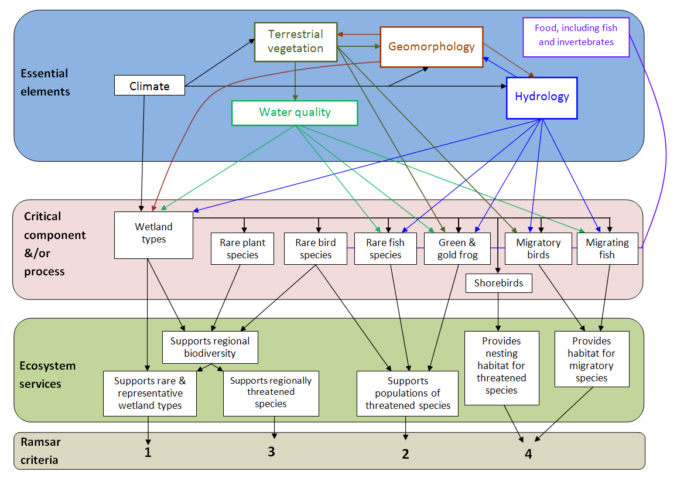

Figure 17: Conceptual model of the components, processes and services of the site, and their links to the Ramsar criteria.

Essential elements
The identified essential elements for the site are:
- climate
- geomorphology
- hydrology
- water quality
- terrestrial vegetation
- fish and invertebrates (as food for fish and birds)
Each of these provide essential support to the critical components and processes of the site, but are not part of the site’s unique character. Significant changes to any of the essential element will be reflected in one or more of the critical components and processes.

Critical benefits and services
The critical services supporting the ecosystems of the site can be identified using the same determinants (Section 3.4.1) as those used for selecting the critical components and processes (DEWHA 2008).
None of the benefits displayed in Table 9 were considered critical to the site’s ecological character. Although they may be beneficial to humans, they do not support the listing criteria nor would a change to any of them be likely to have significant consequences to the site’s ecological character. In contrast, each of the ecosystem services presented in Table 10 are critical to the site’s ecological character.
Each of the critical benefits and services of the site is represented through critical components and processes as displayed in Table 11.

Table 11: Summary of critical ecosystem services and their associated critical components and processes.
General ecosystem service | Specific ecosystem service | Associated critical component/process
Maintenance of rare and representative wetland types for the bioregion (criterion one). | Supports Ramsar wetland types. | The eleven Ramsar wetland types.
Support for rare or threatened species (criterion two). | Support nationally rare bird species. | Fairy tern
Support for rare or threatened species (criterion two). | Supports nationally rare fish species. | Australian grayling and dwarf galaxias
Support for rare or threatened species (criterion two). | Supports green and gold frog. | green and gold frog
Supports populations important for regional biodiversity and/or at critical stages (criteria three and four). | Supports regionally rare bird species. | little tern, white-bellied sea eagle
 | Supports regionally rare plant species. | The four wetland dependent State listed species.
 | Supports migratory bird species. | The eleven listed migratory bird species.
 | Supports nesting shorebird species. | little tern, hooded plover, fairy tern, pied oystercatcher and red-capped plover.
 | Supports migrating fish species. | Tasmanian mudfish, Tasmanian whitebait, Australian grayling.

Conceptual Models of the Site

Overview Model
The Flood Plain Lower Ringarooma Ramsar Site encompasses several integrated ecosystems, including the freshwater river, Flood Plain and wetland zone, estuary zone, coast, dunefields, terraces and sand plains. Some features of these are displayed in a diagrammatic representation of the site (Figure 18).
The key features of Figure 18 include the river within its Flood Plain, surrounded by heathland and marshes, breaking out of its channel at some points and discharging into lagoons, before reaching the estuary near the dune barrier. Where the river reaches the area of estuarine influence, the channel widens and is bounded by a saltmarsh on part of its northern bank before reaching a developing central basin and discharging over the delta into Ringarooma Bay. More specific conceptual models are presented for the estuary zone (Figure 19); for the coastal zone (Figure 20) and for the freshwater river, Flood Plain and wetland zone (Figure 21).
The generalised conceptual model displays the basic components and processes of the system. The major wetland systems of the estuary, seasonal wetlands, permanent wetlands, wetland forest and the river itself are integrated by freshwater inflow. Sediment inflow also arrives from upstream due to natural catchment processes and also due to historical mining activities. There are also irrigated agriculture activities adjacent to the freshwater river, Flood Plain and wetland zone which continue to change the vegetation, due to grazing and direct irrigation of the grasslands as well as water quality changes due to sediment and nutrient run-off.
The estuary is maintained by the freshwater inflows from upstream which provide habitat for a diverse estuarine ecosystem. The natural process of stream inflows and water mixing results in a salinity gradient from the upstream extent of the estuary (near the dune barrier) where it is relatively fresh, to the river’s mouth where it is close to sea water salinities. The salinity gradient changes (in position and extent) with tides and periods of large river flows. Wave action, erosion and water and sediment exchange at the River’s mouth maintains a dynamic estuary.
The models shown in subsequent sections display the components of the systems, focusing on the key features of relevance to Ramsar listing and the environmental components that influence them.

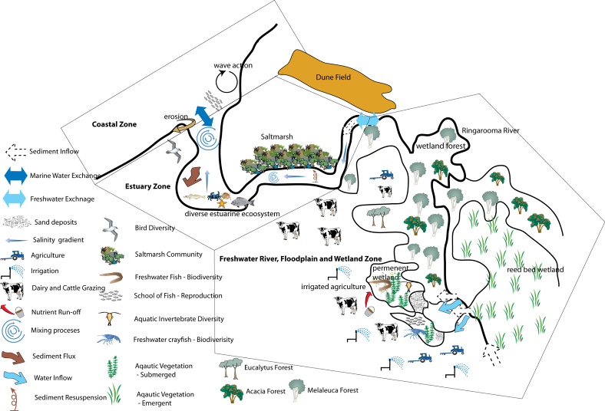

Figure 18: Landscape conceptual model of the Flood Plain Lower Ringarooma River Ramsar Site.

Conceptual Model for the Coastal Zone
Components and processes of the coastal zone that are important contributors to the site’s ecological character include the zone’s geomorphology, water quality, shorebirds and food for the shorebirds (fish and invertebrates) (Figure 19). Coastal vegetation is also important, contributing some stability to an otherwise dynamic landforming environment.
Although there is little information on the site’s coastal geomorphology, information presented earlier (Section 3.1) highlights the importance of sediment supply from Bass Strait, as source material for the north-east coast of Tasmania. Coastal geomorphic processes that contribute to the existing landforms include: wave wash depositing greater volumes of sand than it removes as backwash thereby providing the sandy beach; longshore drift of sand creating the sandy spit barrier at the mouth of the Ringarooma and Boobyalla Rivers; and the combination of wind and wave action that encourages dune formation behind the beach front.
The little tern, hooded plover, fairy tern, pied oystercatcher and red-capped plover nest in this zone and would use the area of the sandy beaches above the highest water line. Below the high water mark, the wetted beach, shallows, and any rocky reefs would be used for foraging by several species, including ruddy turnstone, red-necked stint and possibly greenshank. These species all prey on invertebrates and their larvae, including insects, annelids, crustaceans, molluscs and gastropods. Although the little tern and fairy tern feed mostly on fish, they would also use the sandy beach for foraging and/or resting.
No known data has been collected on the marine fish fauna nor the invertebrate fauna of the site. However, the supply of both of these as food for the species listed above is a vital component of the site. Similarly, no known data were found for the marine water quality of the site, although it is an important component of the site as well. Water quality is unlikely to change dramatically (beyond natural variability) unless through climate change. Although the marine water of the site is beyond the site’s boundaries, it is a component of the ecosystem and therefore pertinent to its ecological character. This will be influenced by processes such as mixing, upwelling, and sediment and nutrient flux.

Summary of conceptual modelling for the Ringarooma Coast
The coastal geomorphology of the Ringarooma coastal zone provides a sandy beach habitat that supports nesting, resting and feeding shorebirds, including migratory species. The water quality and food supply for these species are important contributors to the site’s ecological character.
Critical components, processes & essential elements: sandy shores (wetland type E); delta (wetland type F); and intertidal mud and sand flats (wetland type G), water quality, nesting shore birds, fairy tern, migratory fish, other fish (as food), macro-invertebrates (as food).
Critical services: Support rare and regionally rare bird species; supports rare fish species; supports migratory bird species; supports nesting shorebird species; supports migratory fish species.
Threats: water quality decline from up-catchment; hydrologic change; rising sea level (refer Section 4).
Knowledge Gaps: Current condition of all identified components, including quantitative measures.
Monitoring Needs: There is very little data or information on the identified components or their threats. The first requirement for monitoring is the completion of a baseline assessment that will enable comparison with future/ongoing assessments. Derivation of monitoring programs as part of the management plan should incorporate these.

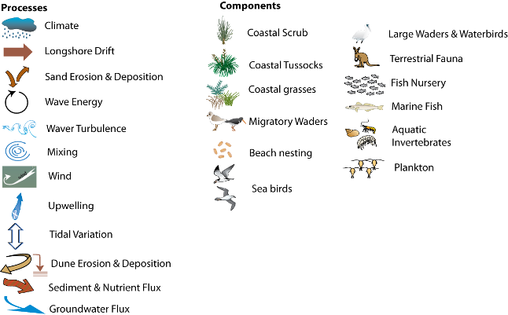
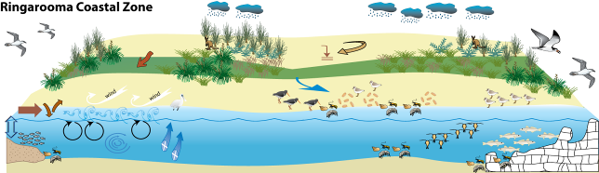

Figure 19: Processes, components and impacts within the Coastal Zone of the Ringarooma Ramsar Site.

Conceptual Model for the Estuary
The components of the ecological character of the Ringarooma Estuary (Figure 20) include the zone’s geomorphology, formed through energy provided from the seaward side via waves and currents, as well as the fluvial energy provided via regular river flows and floods. The geomorphology impacts directly on the biota in terms of frequency, predictability, magnitude, duration and intensity of disturbances, as well as indirectly through influences on land forming processes, sediment movement and habitat changes. The disturbance regime will influence the biological make-up of the site, with some species more able to cope with unpredictable or frequent disturbances, whereas others are more adapted to regular or cyclic disturbance regimes. Sediment deposition can also result in the loss of submerged aquatic macrophytes due to a lack of light or burying if the sediment load is large. Invertebrate populations are also usually less diverse in rivers with sand beds and habitat is simplified or removed. Sediment deposition threatens aquatic macroinvertebrates and fish eggs, by smothering them and depriving them of oxygen.
The freshwater and marine water inputs to the estuary also influence the biota through processes such as salinity fluxes, nutrient exchanges, and thermal regimes. Together these influences create the estuarine habitat, which is required for some fish species for their entire life cycle or critical stages of others. These estuarine habitats provide critical habitat for Australian grayling, Tasmanian whitebait, Tasmanian mudfish, or other Galaxias species which spawn in the estuary or depend upon the estuary for part of their life-cycle.
Sediment inputs to the estuary directly influence the biota through the provision of substrate and, when in excess, the impact of smothering. Sediment inputs also provide the material for most of the estuary landforms and, when in excess, form large depositional features such as deltas and the infilling of central basins.
Other components of the Ringarooma Estuary include the saltmarsh habitat, the avifauna (particularly waders and waterbirds), fish and macroinvertebrates. Although not listed as threatened, saltmarsh is recognised as poorly reserved in Tasmania and is an important habitat for many listed bird species. Saltmarsh requires a low energy environment for development (Kirkpatrick and Glasby 1981) and has formed within the estuary zone upstream of the direct influence of most coastal waves.
There are 41 species of waterbirds/waders at the site (Appendix 3) of which ten are listed as having state, national and/or international significance (and the eleven JAMBA/CAMBA/ROKAMBA/CMS-listed species). The low energy environment conducive to the development of saltmarsh also enables the formation of mudflats and sandflats within the estuary. These provide important foraging habitat for the red-necked stint and greenshank, and to a lesser extent the great egret and cattle egret. The low energy open water surface of the estuary also provides potentially valuable fishing waters for the white-bellied sea eagle.

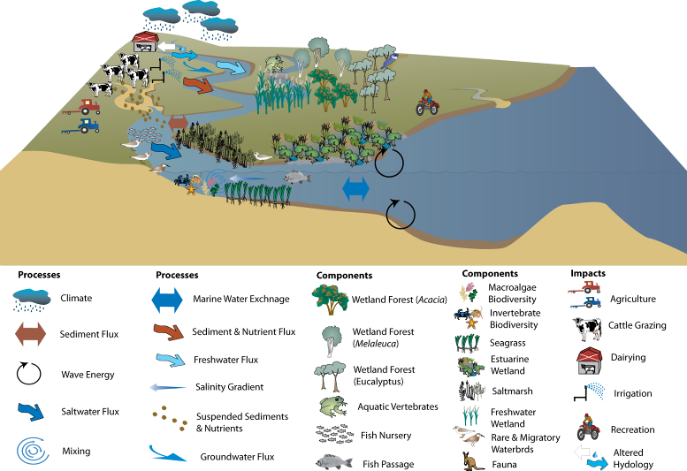

Figure 20: Processes, components and impacts within the estuarine zone of the Ringarooma Ramsar Site.
One species of fish, Australian grayling, has national conservation significance and inhabits the estuary at critical stages of its life cycle. Also, significant fish communities including Tasmanian whitebait occur within the site’s estuary (Table 11). Although there were no data on macroinvertebrates at the site, macroinvertebrate presence is significant in estuarine habitats, as they typically form the basis of the food chain for the fish and waterbirds of the zone.
Little information was found in the literature in relation to the condition of most of these components, or the estuary in general, at the time of listing. Some information is available from a site description of the estuary which is available on the Ozcoasts website (Coastal Zone Australia Ltd 2005) and based on information gathered for the National Land and Water Audit (1998).

Summary of conceptual modelling for the Ringarooma Estuary
The Ringarooma estuary is ‘wave dominated’ with a flood tide delta, incorporating an open channel with a direct connection between river and sea. Its physical environment includes a shore-front barrier, a flood/ebb delta, saltmarsh, tidal sandbanks and a central basin.
Critical components, processes & essential elements: estuarine waters (wetland type F); intertidal mud, sand or salt flats (wetland type G); intertidal marshes (salt marsh; wetland type H); and coastal brackish/saline lagoons (wetland type J), migratory and rare birds, migratory and rare fish, macroinvertebrates (as food), landforms.
Critical services: Support rare and representative wetland types; supports rare and regionally rare bird species; supports rare fish species; supports migratory bird species; supports nesting shorebird species; supports migratory fish species.
Threats: Sedimentation; water quality decline; hydrologic change; rising sea level.
Knowledge Gaps: Current condition of all identified components, including quantitative measures.
Monitoring Needs: Although the original listing identified components associated with the estuary, these components could not be detailed due to a lack of quantitative information. The literature search for this report also found very little data or information on the identified components or their threats. The first requirement for monitoring is the completion of a baseline assessment that will enable comparison with future/ongoing assessments. Derivation of monitoring programs as part of the management plan should incorporate these.

Conceptual Models for the Freshwater River, Flood Plain and Wetland Zone
Climate dominates the conceptual model for the freshwater river, Flood Plain and wetland zone with rainfall and subsequent stream flow as the major driver for the wetland system (Figure 21). Local groundwater inflows from the river are thought to be important to the wetlands but these are unmeasured. Stream flow events allow for fish passage along the river for important fish such as river blackfish, Australian grayling and various galaxiids which utilises both the freshwater reaches and wetlands and the estuarine or marine habitat, downstream. Nutrients and sediment (derived from both natural and human sources) are also important in terms of the provision of substrate and, when in excess, the impact of smothering.
Nutrients are critical to allow the high biological production levels of the wetlands. Sediment is deposited in the wetlands as the river breaks its banks and stream power declines into the mouths of the permanent wetlands.
The wetlands provide habitat for significant aquatic fauna such as green and gold frogs, dwarf galaxiids, macroinvertebrates species and a wide diversity of aquatic vegetation including swamp forests.
Ecological processes within the wetlands, such as organic decay and photosynthesis from the extensive aquatic macrophytes providing valuable oxygen flux and nutrient cycling, underpin the biological production of the wetlands. Mixing and sediment release from flow and wind driven events resuspend and release nutrients and sediments to be more available. The sediment/water interface is also active in storing and releasing nutrients under different water quality conditions and under low dissolved oxygen conditions can result in phosphorous flux into the water column. In excess, this process can also cause impacts by promoting algal bloom development.
From the perspective of Ramsar listing, the important features of the Ringarooma freshwater river, Flood Plain and wetland zone (noted in the original RIS and more recently re-affirmed by the technical/stakeholders workshop) are as follows:
- potential palaeobotanical and palaeofaunal remains on the site
- geological diversity, including deflation hollows, lunettes, and a dune barred lake (Bowlers Lagoon)
- an abundance of the Australasian shoveler (Anas rhynchotis)
- 11 migratory bird species listed under JAMBA, CAMBA, ROKAMBA, and/or CMS
- 154 taxa of native plants and 71 indigenous bird species
- providing significant wetland habitat and
- threatened ecological communities, including 4 species of threatened flora, seven species of threatened fauna and 3 threatened ecological communities.

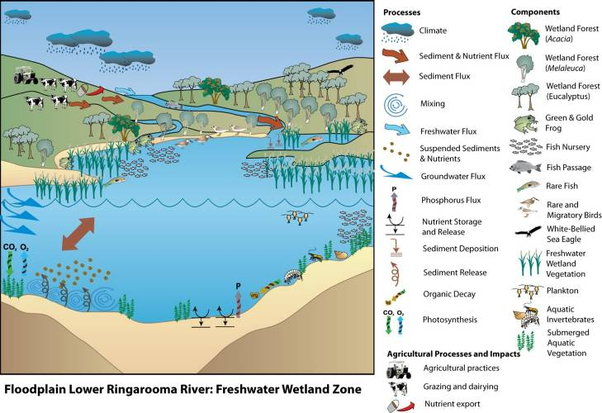

Figure 21: Processes, components and impacts within the freshwater river, Flood Plain and wetland zone of the Ringarooma Ramsar Site.

Summary of conceptual modelling for the Freshwater River, Flood Plain and Wetland Zone
The wetland complex contains a shallow mosaic of temporary and permanent wetlands with low nutrients, clear-water, circum neutral pH and low salinities. The vegetation is largely emergent and submerged leaf macrophytes within the areas of standing water, grading through sedgeland and heathland to treed swamp forests.
Critical components, processes & essential elements: Geomorphology; hydrology; seasonal waterways (wetland type N); permanent freshwater marshes, pools and ponds (below 8 hectares), with emergent vegetation (wetland type Tp); seasonal freshwater marshes and pools, including seasonally flooded meadows and sedge marshes (wetland type Ts); shrub-dominated wetlands (wetland type W); and freshwater, tree-dominated wetlands (freshwater swamp forest) (wetland type Xf); regionally rare plant species; rare and regionally rare bird fauna; rare fish and frog species; migratory fish species.
Critical services: Support rare and representative wetland types; supports rare and regionally rare bird species; supports rare fish and frog species; supports migratory bird species; supports migratory fish species.
Threats: Sedimentation; damage to wetland substrate; eutrophication; weed infestation; hydrologic change; rising sea levels.
Knowledge Gaps: Current condition of all identified components, including quantitative measures (note: extant vegetation community data that can be supplemented).The exceptionally dynamic processes of sediment movement at the site requires a thorough geomorphological understanding of the site, and at present this is lacking.
Monitoring Needs: Although the original listing identified components and threats associated with the wetlands, it could not detail these components due to a lack of quantitative information. The literature search for this document found very little data or information on many of the identified components or their threats. The first requirement for monitoring is the completion of a baseline assessment that will enable comparison with future/ongoing assessments. Derivation of monitoring programs as part of the management plan should incorporate these. Monitoring of the site should adopt a risk-based approach and must consider the sediment budget, rates of landform change, and likely pathways of landscape evolution at the site.

kEY ACTUAL OR POTENTIAL THREATS TO THE SITE
From discussions with local landholders and the project Steering Committee, and through review of relevant documents, the drivers of major actual and likely threats were determined. The threats to the estuary zone and freshwater zone are discussed separately, as there are several significant differences in the types and extent of threats between the two zones.

Threats to the Coastal Zone
Apart from potential climate change and associated sea level rises, there are few human derived threats to the coastal zone. Impacts of recreation currently appear minor. There is no apparent indication of increasing recreational activity, although there are no data on recreation at the site. The potential impacts of climate change are discussed in association with the estuary zone in Section 4.2 (below).

Threats to the Estuary Zone
The key components of the estuary zone (discussed in Section 3.5.2) are the wetland habitat types (saltmarsh, intertidal mud and sand flats, estuarine waters, and coastal lagoons); the avifauna (particularly shorebirds/waders and water birds), migratory and rare fish; and fish and macroinvertebrates (as food). Major threats to these components exist through potential impacts on key site components.
The major direct threats to the Ringarooma Estuary were identified as:
- damage to soil and sediment structure through direct stock access to the riparian zone
- loss of threatened vegetation through direct stock access to the riparian zone
- impacts of excess sediment deposition through past mining practices
- declines in water quality through dairying impacts
- changes to hydrology through water extractions
- rising sea levels
These are presented in Figure 22.
Excessive inputs of sediment from past mining have already occurred in the site’s estuary zone (for example Jerie and Houshold 2001), causing infilling of the formerly deep channel at the Port of Boobyalla. Data suggest that the high level of sedimentation at the site is likely to persist for decades (Knighton 1991) although the effects on the site in general - and the estuary zone in particular - are difficult to predict. It is possible that much of the remaining sediment may not reach the estuary zone, being trapped within the freshwater zone of the site (Jerie and Houshold 2001).
Similarly, the threat of dairying directly impacting on the water quality of the estuary zone is difficult to assess, as the water and suspended sediment pass through the freshwater zone prior to reaching the estuary zone. If the freshwater zone provides a filtering mechanism, retaining many of the nutrient-carrying particles and also absorbing many of the bio-available nutrients, the threat to the estuary zone may be small. The difficulty in predicting the impacts of both the mining sediment and the dairy-affected water quality on the estuary zone represents an important knowledge gap. The recent development of management plans for the property (Sherriff 2007; AAS and BIS 2007) and the Ramsar site (GHD 2007) has meant that threats from these impacts should reduce into the future. Further discussion of these two threats is presented in the section on threats to the freshwater zone (Section 4.3), as the threats are likely to be greater in that zone.
There are also potential impacts from stock access to the riparian zone of the estuary, with private leasehold on land right up to the water (Figure 5) and close to areas of saltmarsh (compare Figure 5 and Figure 10).
With the exception of potential climate change impacts on delivery of rainfall, the main changes to hydrology within the Ringarooma Estuary are likely to be a result of geomorphic changes, unless water extractions increase. Current extractions of water in the lower catchment are only a small percentage of total discharge in the summer low flow season (which is also the peak extraction season) and much of the water extracted in the upper catchment is returned to the stream system (Read and Graham 2000). However, substantial increases in water extraction or stream regulation (dam building) could significantly alter the balance of freshwater and marine water causing shifts in the habitat and vegetation communities. In addition, reduced water availability may result in reduced flushing of sediment in the system.
A potentially major impact on the site is a possible predicted rise in sea levels accompanying global warming. As discussed earlier, an incursion of the marine waters beyond the current limit of estuarine influence could severely impact the ecological character of the site. Apart from drowning the existing saltmarsh community if sea rises are significant, increased depths would impact on many of the existing geomorphic features and processes, through inundation of the site and beach translation. This includes impacts upon the maintenance of the barrier, and the morphology of the delta and the channel.
Although there is little that can be done at the site or regional scale in terms of reducing rising sea level, there are management options that can be taken to reduce the impacts of rising sea level, including vegetation protection and management, and revegetation.

The listing of key threats does not preclude the existence of other threats that must be considered and evaluated as part of future management planning. Other potential threats that have been identified for the estuary zone include:
- impacts of excess sediment deposition through future land uses, including new mines
- declines in water quality which ultimately reach the estuary zone. These may occur through agricultural activities other than dairying, such as stock access to streams and water bodies
- declines in water quality through forestry activities upstream
- introduction of weeds and pest animals
- changes in hydrologic regime through climate change and
- human access and illegal recreational activities (for example, trail and quad bikes).

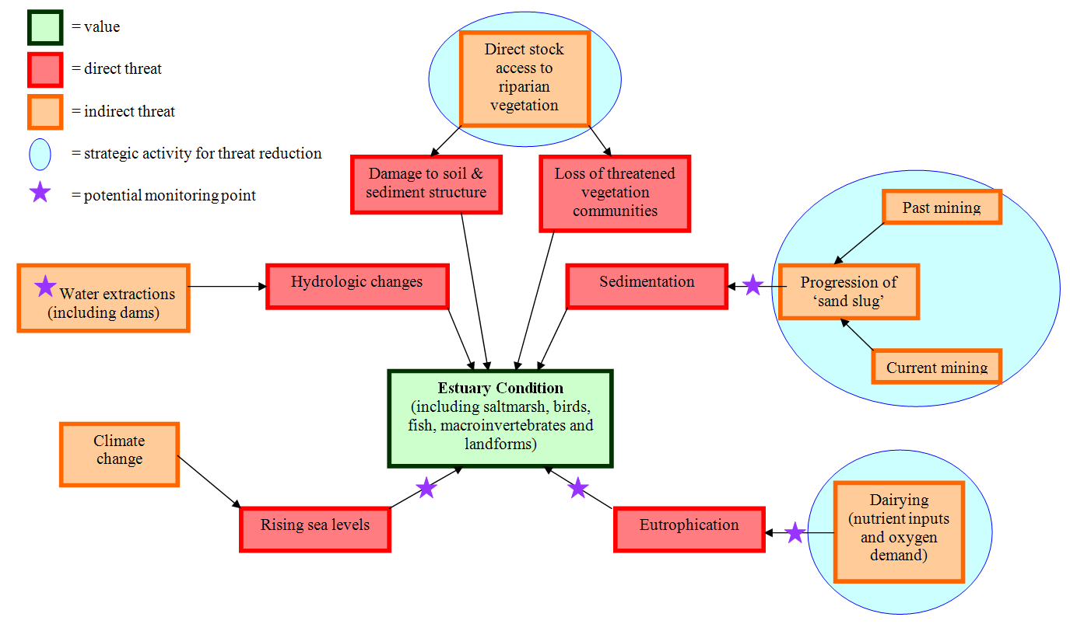
Figure 22: Conceptual model for threats to the estuary zone of the site.

Threats to the Freshwater Zone
Components identified as contributing to the ecological character of the site’s freshwater zone are: wetland habitat (seasonal waterways, permanent freshwater marshes, pools and ponds, some with emergent vegetation seasonally flooded meadows and sedge marshes, shrub-dominated wetlands, and freshwater swamp forest); regionally rare plant species; rare and regionally rare bird fauna; rare fish and frog species; migratory fish species.
Within the setting provided by the Ringarooma catchment, the key threatening processes to these components can be separated into direct and indirect threats (Figure 23). The direct threats include:
- the impacts of sedimentation, particularly through the progression of the fine sands generated by past mining practices
- damage to the wetland soil/sediment structure through stock trampling
- inputs of excess nutrients through grazing and dairy wastes
- loss of threatened vegetation communities (including weed invasions), via stock grazing and pasture management practices
- changes to the hydrologic regime via:
  - local (water extraction)
  - regional/global (climate change) impacts and/or
  - lowering of the stream bed.
Similar to the estuary zone, sedimentation from historical mining practices poses a major threat to the freshwater zone, particularly through the alteration of abundance and diversity of geomorphic features (for example channels, levees, depressions) that form the basis of the different habitats. The issues and threats to the freshwater zone of the Ramsar wetland were identified through research and a second workshop of the Steering Committee and technical experts in September 2009 and discussed below.
The sand deposition dominates the channel environment from upstream of the Ramsar site to the mouth of the Ringarooma River. This sedimentation has been evident for decades. Examination of the maps and aerial photographs in Jerie and Houshold (2001) shows that the quantity and location of the sediment has changed markedly since the earliest aerial photographs were taken in 1949 (Figure 24). This has had an impact on the depth of sediments dammed by the river levee and the area of dammed water (Jerie, personal communication). For example, the 1964 aerial photograph (red circle in Figure 25) shows a large area of standing water to the west of the original channel, north of Shantys Lagoon. By 1978, this waterbody had been substantially filled in with sand (indicated by the red circle in Figure 26). However, this process of sediment movement does not necessarily lead to a loss of wetland, with some wetland types changing to other wetland types. For example, comparison of the 1978 (Figure 26) and 1999 (Figure 27) aerial photographs shows that a considerable part of Shantys Lagoon has been altered and changed over the 21 year period from bare sand to coast paperbark swamp forest (indicated by the green circles in the photographs).
The extent to which this sedimentation poses a threat to the ecological character of the site is uncertain. Recent observations (Figure 28) and photographs (supplied by Michael Propsting, neighbouring landholder and pilot) indicate a minor change in the area of sedimentation after a recent period of flow (early June 2007). A review of the flow records show these were equivalent to an annual flow event (Chris Bobbi, DPIW, personal communication). If this sand splay is growing in area, or moving, it is likely to be only occurring during much larger and less frequent flow events.
The present geomorphic rate of change (sedimentation rate) presents itself as a significant knowledge gap. Similarly, the length of time before the sedimentation regime is likely to change to an erosion regime, and the form that erosion may take, is also a significant knowledge gap. Further, the rate and extent of change from one wetland type to another over time is unknown.
The input of sediment through current and future mining, vegetation clearance and grazing practices also has the potential to exacerbate the impacts. Management of the sedimentation threat will require detailed consideration and clarification of management objectives. A key issue to resolve will be whether to allow the upstream sediment that is already in the system to ‘run its course’ regardless of impacts on the wetland system, or whether active management of the site will be undertaken. This analysis of objectives is required prior to the development of management plans.
Over a longer period of time (several decades) the cessation of sedimentation and the onset of channel degradation (that is, the sediment runs out and the Ringarooma River starts picking up the previously deposited sediment, thereby cutting its channel deeper into the Flood Plain), may be a far greater threat than the current sedimentation, with channel incision potentially causing isolation, and ultimately, a drying of the wetlands.

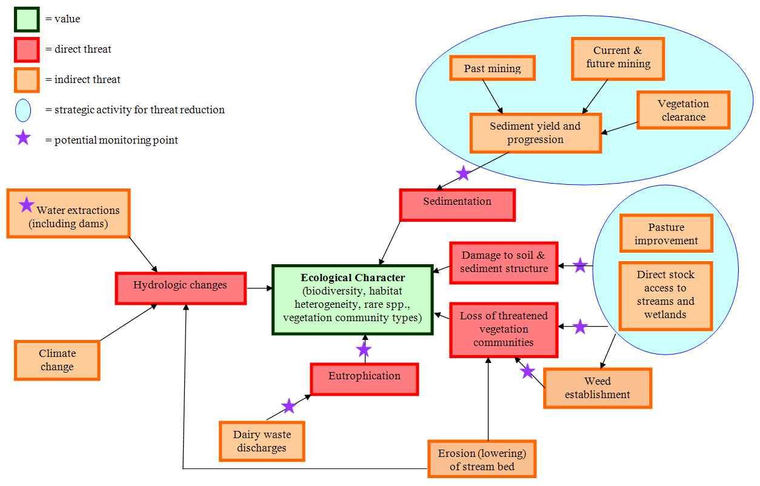
Figure 23: Conceptual model for threats to the Ringarooma freshwater river, Flood Plain and wetland zone.
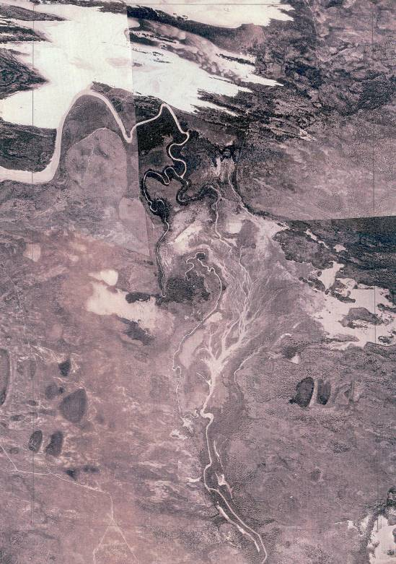
Figure 24: Aerial Photograph of the Lower Ringarooma Flood Plain, 1949 (Source: Jerie and Houshold 2001; base images produced by Tasmap DPIW).
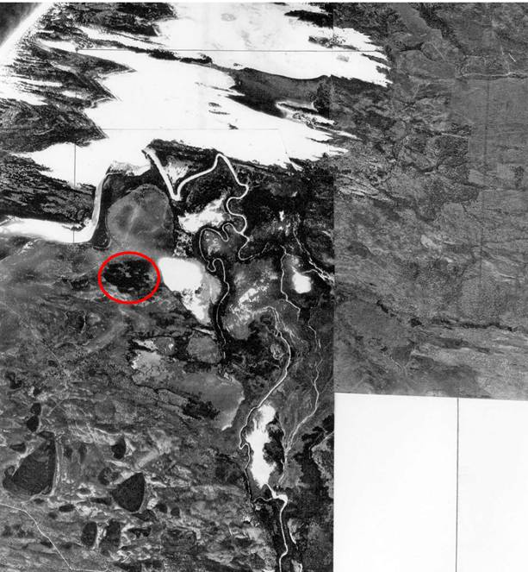
Figure 25: Aerial Photograph of the Lower Ringarooma Flood Plain, 1964 (Source: Jerie and Houshold 2001; base images produced by Tasmap DPIW). The red circle marks the location of the wetland later filled by sand.
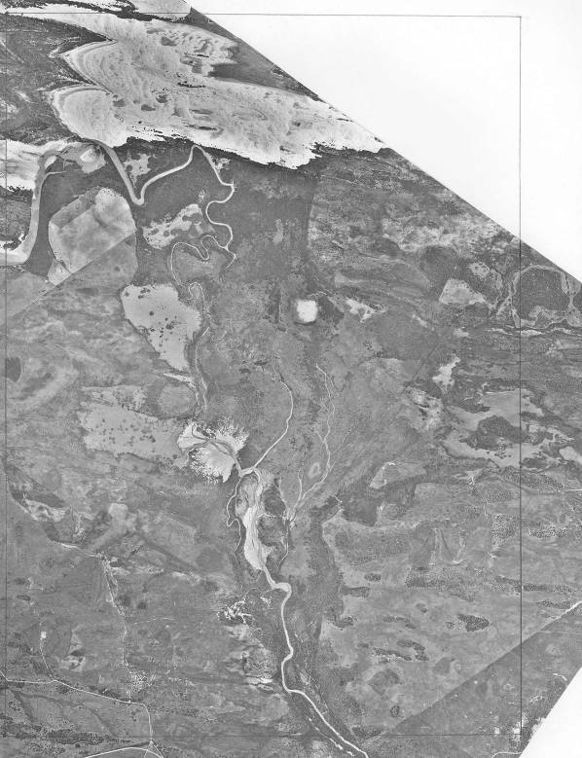
Figure 26: Aerial Photograph of the Lower Ringarooma Flood Plain, 1978 (Source: Jerie and Houshold 2001; base images produced by Tasmap DPIW). The red circle marks the location of the wetland filled by sand. Green Circle shows sand splay initial encroachment into Shantys Lagoon.
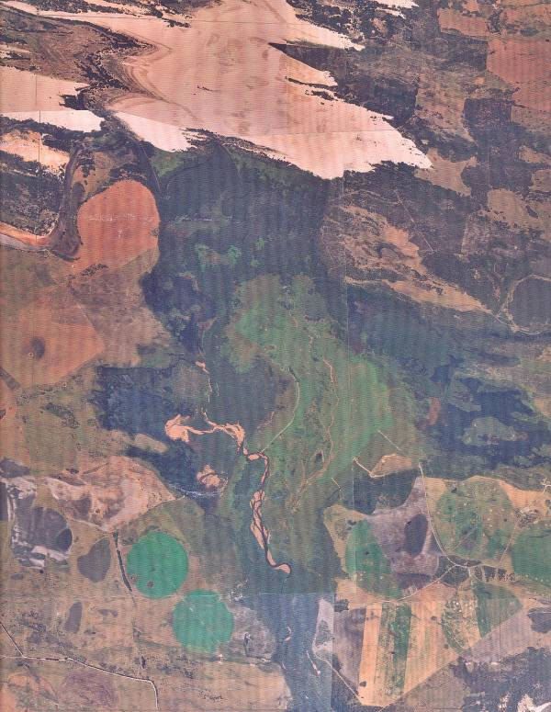
Figure 27: Aerial Photograph of the Lower Ringarooma Flood Plain, 1999 (Source: Jerie and Houshold 2001; base images produced by Tasmap DPIW). Green circle shows sand splay encroaching into Shantys Lagoon.
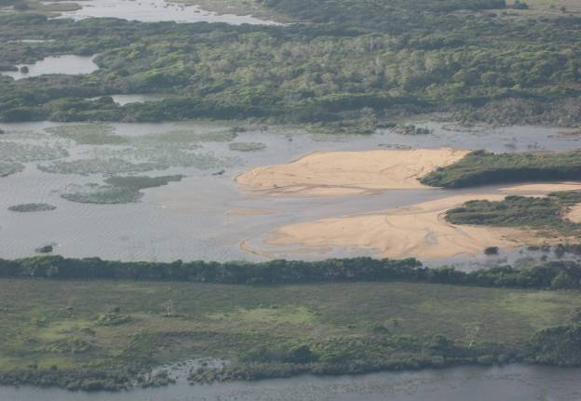
Figure 28: Sand encroachment at the entrance to a permanent wetland (Shantys Lagoon, Ringarooma Ramsar Site; photo: L.N. Lloyd, May 2007). Note vegetation stabilising sand on right hand side of photo.
The second major threat to the freshwater zone is the rapid increase in weed cover, through the expansion of grazed pasture within the site. In a site managed for conservation purposes, the increasing cover of pasture leads to the loss of native vegetation communities, accompanied by the establishment of large areas of introduced grasses and other weeds. This threat is particularly large as it has already encroached onto a substantial part of the site (see Section 6 for discussion of changes in ecological character to the site). At the time of listing, a large part of the site was rough grazed, including Fosters Marsh in the centre of the site (labelled ‘Agricultural Land” in Figure 10) and the south-eastern area of the site (also labelled ‘Agricultural Land” in Figure 10).The spread of weeds is exacerbated by the grazing cattle, with seeds often attaching to the cattle hair and being transported to new areas.
The south-eastern pasture area of the site has changed since listing, from rough grazed to pivot irrigation. Figure 26 (taken approximately four years before listing of the site in 1978) and Figure 27 (taken approximately 17 years after listing in 1999) show the change from rough grazed pasture to irrigated pasture. Although the irrigated land was already designated as agricultural land, further expansion of the irrigation would encroach into the more natural areas of the site and must be considered a serious threat to the site. In contrast to the south-eastern part of the site, the previously grazed Fosters Marsh has subsequently had cattle removed and is now being regenerated.
There is also the threat of weed incursion (e.g. Salix sp.) from materials distributed downstream from higher in the catchment. Although gorse has been controlled by substantial on-ground work, the remaining seed bank is an ongoing threat.
The dairying activities within and adjacent to the site also pose a threat to water quality. Rushy Pastoral currently leases three commercial dairies in the Rushy Lagoon property. These dairies are located to the south of the Ramsar site, and together comprise approximately 760 hectares, or 22 percent, of the site (GHD 2008). Although the dairying operations are not on the Ramsar site, the dairies have the potential to impact the health and status of the site through high nutrient waste discharge. However, the development of management plans for the property (Sherriff 2007; AAS & BIS 2007) and the Ramsar site (GHD 2008) should mean that if these activities have been contributing nutrients to the site, they should be reduced into the future.
Inputs of elevated nutrient concentrations to the freshwater zone have the potential to turn the site eutrophic, leading to algal blooms and oxygen deficits in the water column, with potentially sever impacts on the aquatic fauna. The most likely source of nutrients comes from cattle faecal inputs through grazing, particularly grazing of improved pasture by dairy cattle. In particular, the irrigation of improved pasture provides a mechanism for washing the faecal material into drainage lines. Any discharges from dairying activities would also pose a threat to the site. Read and Graham (2000) note: “The majority of the wetlands are surrounded by woodland used for rough grazing until 1998 although certain areas have been subject to draining. Recently, the area surrounding the wetland has been developed extensively for dairying. One of the major threats to the wetland is the establishment of pasture in close proximity to the wetland perimeter. This may pose a serious threat to the ecological health of the wetland in terms of enrichment via sedimentation and nutrient runoff from surrounding pasture and dairy practices”. Effective management of the Ramsar site must include buffer zones and clear directions on acceptable limits of on-site and off-site impacts from dairying and rough (unimproved pasture) grazing.
Potential threats to water quality not presented in processes, components and impacts within the freshwater zone (Figure 23) but still worthy of investigation, include: the use of biocides and other chemicals in forestry and agriculture within the catchment; and current/future mining impacts. Some of these potential impacts may be measurable in the waters of the Ringarooma River at Gladstone. Others may occur in tributaries that enter the Ringarooma River downstream of Gladstone, and may need to be assessed at the point of input and also closer to the Ramsar site.
One particular concern is the potential for pulse impacts, through short-term agricultural spraying events or mine waste spills, where routine (for example monthly) water monitoring may not register any impacts. These types of threats require biological monitoring, to assess impacts on the biota that may be missed by routine water chemistry sampling. This approach of highlighting key threats and their potential impacts is termed a ‘risk-based approach’ and is advocated by ANZECC & ARMCANZ (2000).
Grazing also poses significant threats to the freshwater zone through direct trampling damaging the wetland substrate. Trampling of wetland substrate can lead to desiccation in drier weather and the formation of eroding drainage lines during storm events.
Hydrologic changes also pose a significant threat to the freshwater zone. Currently water extractions and river regulation are not a significant issue and the primary focus for these should be to maintain extractions at an acceptable volume. Similarly, any proposed dams anywhere within the catchment of the Ringarooma River or its tributaries should undergo detailed assessment to determine possible impacts on water delivery to the site, including dams for mining and dairying.
Climate change is the main factor that possibly threatens the hydrology of the wetlands but its impacts on rainfall are not predictable with any certainty. The predicted rise in sea level (of up to one metre over the next 50 -100 years) is likely to have a significant impact on many coastal wetlands from marine incursions, increased erosion and storm surge damage (Sharples 2006; DPIPWE 2010; Grose et al. 2010). Sea level rises of one metre at the Ringarooma/Boobyalla estuary would likely result in significant incursions of marine waters into the freshwater wetland zone as these are currently protected from seawater incursions by a low, one metre high natural barrier which is rarely overtopped by marine waters (Bobbi, personal communication). If significant incursion of marine waters into the wetlands did occur, it may arguably lead to large-scale death of the extant vegetation, with subsequent ramifications for habitat, fauna and geomorphology. Similar to the issue of sedimentation, management components and attitudes towards intervention and direct management action will need to be determined before specific management plans can be developed.
Similar to the key threats to the Ringarooma Estuary, other threats have been identified for the freshwater zone that must be considered and evaluated as part of future management plans for the site. These include:
- drainage of the wetland from agricultural activities (either intentionally or through stock tracks creating linear depressions that form drainage lines)
- loss of habitat and vegetation communities through land clearance
- damage to riparian condition in the Flood Plain through agricultural activities, including stock access
- impacts of increased sediment deposition through future land uses, including land clearance in the catchment and new mines
- drainage of wetland over the long-term, accompanying a shift from an aggradation regime to a degradation regime in the Ringarooma River
- declines in water quality through forestry activities upstream, including use of biocides and other chemicals (discussed above)
- declines in water quality through mining impacts, including spills of chemicals and discharges other than sediment
- introduction of weeds and pest animals through grazing on and near the site and also through on-site dwellings
- changes in hydrologic regime through climate change
- changes to hydrologic regime through increased water extraction
- damage to habitat and vegetation communities through human access and illegal recreation activities (for example trail and quad bikes) and
- loss of habitat and vegetation communities through gravel extraction.

Summary of the Key Threats
Although there are many other potential or less major threats (see sections 4.1 to 4.3, above), Table 12 focuses on the major threats confronting the site.
Table 12: Summary of the key threats to the site.
Threat | Details | Likelihood | Severity | Time frame
Sedimentation | Ongoing deposition of sand in the wetlands of the site, reducing habitat extent and diversity. Direct threat to estuary and freshwater zone. | Almost certain | Unknown | up to 50 years
Erosion | Indirect threat to freshwater zone - eventual scour of the river channel, when upstream sediment supply decreases. Result could be lowering of river bed and subsequent isolation of the wetlands from the river. | Possible | High | Unknown
Expansion of agriculture into natural/near natural vegetation communities | Expansion of grazed land into the currently ungrazed areas of the site could lead to loss of vegetation communities and soil structure of freshwater zone. | Possible | Potentially severe | Unknown
Weed invasion | Can occur through existing agricultural activities and any expansion of grazing at the site. Indirect threat to freshwater and estuarine zone, through loss of natural vegetation. Incursion of weeds brought downstream from higher in the catchment and the persistence of gorse (Ulex eurpaeus) are threats. | Likely | Unknown | Indefinite
Eutrophication | Inputs of excess nutrients, leading to problems with algal blooms in permanent and temporary waters of the site. Direct threat to water quality of freshwater and estuarine zones. | Possible | Potentially very severe | Indefinite
Climate Change | Most likely impact is through rising sea levels inundating the (currently) freshwater and estuarine zones of the site. Changes to precipitation also pose an indirect threat to freshwater zone. | Possible | Potentially very severe | Medium to long term (50 to 100 years)

lIMITS OF ACCEPTABLE CHANGE
LAC explanatory notes
1. Limits of Acceptable Change are a tool by which ecological change can be measured. However, Ecological Character Descriptions are not management plans and LACs do not constitute a management regime for the Ramsar site.
2. Exceeding or not meeting LACs does not necessarily indicate that there has been a change in ecological character within the meaning of the Ramsar Convention. However, exceeding or not meeting LACs may require investigation to determine whether there has been a change in ecological character.
3. While the best available information has been used to prepare this Ecological Character Description and define LACs for the site, a comprehensive understanding of site character may not be possible as in many cases only limited information and data is available for these purposes. The LACs may not accurately represent the variability of the critical components, processes, benefits or services under the management regime and natural conditions that prevailed at the time the site was listed as a Ramsar wetland.
4. Users should exercise their own skill and care with respect to their use of the information in this Ecological Character Description and carefully evaluate the suitability of the information for their own purposes.
5. LACs can be updated as new information becomes available to ensure they more accurately reflect the natural variability (or normal range for artificial sites) of critical components, processes, benefits or services of the Ramsar wetland.

The following components and processes were identified (Section 3.4) as critical to the ecological character of the Flood Plain Lower Ringarooma River Ramsar Site ecosystem:
- wetland vegetation types
- regionally rare plant species
- nationally and regionally listed bird species
- nationally listed fish species
- green and gold frog
- nesting shorebirds
- listed migratory birds
- migrating fish
Table 13 presents the limits of acceptable change for the critical components, processes and services, as identified within the ECD process. Limits are typically set for the time of listing and, if change in ecological character has occurred since listing, a second set of limits is provided. In the case of the Flood Plain Lower Ringarooma River Ramsar Site, there was one change to a critical component that did not constitute a change in ecological character but was worthy of a refinement of the limits. This change was the increase in area of freshwater aquatic sedgeland and rushland (Ramsar wetland type Ts). Rather than prepare two LAC for this component the LAC area was increased to accommodate the increase.
The confidence levels for the limits of acceptable change represent the degree to which the authors are confident that the LAC represents the point at which a change in character has occurred and follow the approach of Hale (2010):
High – Quantitative site specific data; good understanding linking the indicator to the ecological character of the site; LAC is objectively measureable.
Medium – Some site specific data or strong evidence for similar systems elsewhere derived from the scientific literature; or informed expert opinion; LAC is objectively measureable.
Low – no site specific data or reliable evidence from the scientific literature or expert opinion, LAC may not be objectively measurable and / or the importance of the indicator to the ecological character of the site is unknown.

Table 13: Limits of Acceptable Change for the Flood Plain Lower Ringarooma River Ramsar Site.
Critical Component, Process or Service | Baseline information | Limits of acceptable change* | Confidence level | Justification and Comments
All Ramsar wetland types identified as being present at time of listing except Freshwater aquatic sedgeland and rushland (Ts) (service = supports Ramsar wetland types). | Using a vegetation survey (DPIW 2006), aerial photographs, and a site inspection, the following areas were identified for each wetland type (hectares):  E = 74  F = 33  G = 58  H = 44  J = 74  N = 5  Tp= 169  W = 13  Xf = 614  Xp = 1 | Not more than a 20 percent loss in area of any wetland type in nine out of 10 years. So that is, no more than:  - 15 hectares for E  - 6.5 hectares for F  - 12 hectares for G  - 9 hectares for H  - 15 hectares for J  - 1 hectare for N  - 34 hectares for Tp  - 2.5 hectares for W  - 123 hectares for Xf  - 0.2 hectares for Xp | Medium – site specific measures of area are used: however, the 20 percent change is not quantitatively derived. | There are no data on the variability of the wetland habitat types and, until this ECD, there was no mapping of the wetland types. These limits have been set as a common sense approach to defining a significant change in the area of each wetland type. Monitoring into the future should incorporate changes to wetland type over time to refine this LAC.
Freshwater aquatic sedgeland and rushland (Ts) (service = supports Ramsar wetland types). | Using a vegetation survey (DPIW 2006), aerial photographs and a site inspection, an area of 257 hectares was identified as freshwater aquatic sedgeland and rushland at the time of listing. | No less than 298 hectares of freshwater aquatic sedgeland and rushland should be present at the site in nine out of 10 years.  This represents 80 percent (for example a 20 percent loss) of the current area of this wetland type (373 hectares). | Medium – site specific measures of area are used: however, the 20 percent change is not quantitatively derived. | At listing, the site contained a large area of agricultural land (rough grazing) in Fosters Swamp. Grazing has subsequently ceased and the area allowed to regenerate into sedgeland and rushland, increasing the total area of this vegetation type to 373 hectares. There are no data on the variability of the wetland habitat type at the site and, until this ECD, there was no mapping of the wetland types. A limit of 20 percent has been set as a common sense approach to defining a significant change in the area of each wetland type. Monitoring into the future will refine this LAC.
Rare plant species (service = supporting populations important for regional biodiversity). | The only baseline information available is that four rare wetland dependent species were recorded as being at the site at the time of designation. | Presence in nine out of 10 years of:  - native gypsywort  - erect marshflower  - purple loosestrife  - ribbon weed | Low | There is no quantitative information on these species within the site. Therefore quantitative limits of acceptable change cannot be set and a qualitative LAC based on presence / absence of these four species is provided.  Based on lack of data for the site, confidence in the LAC representing good indicator of change in ecological character is low.
Australian grayling and dwarf galaxias (service = support for rare or threatened species). | The only baseline information available is that these species were recorded as being at the site at the time of designation. | Presence in nine out of 10 years of:  - Australian grayling  - dwarf galaxias | Low | There is no quantitative information on any fish species at the site. Therefore quantitative limits of acceptable change cannot be set and a qualitative LAC based on presence / absence of the species is provided.  Based on lack of data for the site, confidence in the LAC representing good indicator of change in ecological character is low.
Green and gold frog (service = support for rare or threatened species). | This species has been seen and heard at the site on different occasions. There are no quantitative data for this species. | Presence in nine out of 10 years of the green and gold frog | Low | There is no quantitative information on Litoria raniformis at the site. Therefore quantitative limits of acceptable change cannot be set and a qualitative LAC based on presence / absence of the species is provided.  Based on lack of data for the site, confidence in the LAC representing good indicator of change in ecological character is low.
Migratory bird species (service = support for a population at a critical stage of its life cycle) and regionally rare bird species (service = supporting populations important for regional biodiversity). | The only baseline information available is that these eleven species were recorded as using the site at the time of designation. | Presence in 2 out of 3 years of:  - Latham’s snipe  - curlew sandpiper  - red-necked stint  - ruddy turnstone  - bar-tailed godwit  - caspian tern  - little tern  - greenshank  - cattle egret  - great egret  - white-bellied sea eagle | Low | There is no quantitative information on these species at the site. Therefore quantitative limits of acceptable change cannot be set and a qualitative LAC based on presence / absence of the species is provided.  Based on lack of data for the site, confidence in the LAC representing good indicator of change in ecological character is low.
Nesting shorebird species (service = support for a population at a critical stage of its life cycle) and rare bird species (service = support for rare or threatened species). | The only baseline information available is that five species of shorebirds nest at the site, one of which (fairy tern) is listed on the IUCN redlist. | The presence of nesting populations in 2 out of 3 years for:  - little tern  - hooded plover  - fairy tern  - pied oystercatcher  - red-capped plover | Low | No quantitative information on these species at the site means that no quantitative limits of acceptable change can be set and a qualitative LAC based on presence / absence of the species is provided.  Based on lack of data for the site, confidence in the LAC representing good indicator of change in ecological character is low.
Migratory fish species (service = support for a population at a critical stage of its life cycle). | The only baseline information available is that three migratory fish species occur at the site, one of which is the rare Australian grayling. | Presence in 2 out of 3 years of:  - Tasmanian mudfish  - Tasmanian whitebait  - Australian grayling | Low | Again, no quantitative information on these species at the site means that no quantitative limits of acceptable change can be set and a qualitative LAC based on presence / absence of the species is provided.  Based on lack of data for the site, confidence in the LAC representing good indicator of change in ecological character is low.
* Exceeding or not meeting a LAC does not automatically indicate that there has been a change in ecological character.

Changes in Ecological Character Since Listing
There is a paucity of recorded information on the ecological character of the Flood Plain Lower Ringarooma Ramsar Site at the time of listing (November 1982). Since that time, some pieces of information have been gathered that contribute to a general understanding of the site [for example State of the Environment reports for the Ringarooma River (Bobbi 1999; Graham 1999; Nelson 1999; Read 1999), and an environmental flows report for the lower Ringarooma River (Read and Graham 2000)]. A few directed studies of parts of the site have also been undertaken (for example a vegetation survey of a substantial part of the site, bird counts for a section of the site). While there is no complete survey for any specific ecological component across the whole Ramsar site, before 1982 or since, there are a series of studies which can be used for management planning purposes into the future. For example, an environmental impact assessment was completed for the Mussellroe Windfarm development which included surveys of avifauna and vegetation for a part of the site.
Some information is available through comparison of aerial photographs taken in 1978 and in 1999 (Jerie and Houshold 2001), supplemented by a site inspection and aerial survey in 2007. The key pieces of information gained through these comparisons relate to two of the major threats to the site: sediment encroachment and dairying encroachment. The clearest differences between the 1978 and 1999 aerial photographs are the development of pivot irrigation south of Shantys Lagoon.
This encroachment of pasture irrigation is difficult to assess, as the area now under pivot irrigation was previously grazed ‘unimproved’ pasture. As the aerial photographs do not coincide directly with the 1982 listing (for example there is an aerial photograph for 1978 and one for 1999), they do not distinguish whether the pivot system was installed before or after listing. However, members of the steering committee for this project (Dominique Couzens, Parks and Wildlife; Stewart Blackhall, DPIW) have stated that prior to Ramsar listing the site was not used for pivot irrigation and dairying. The major changes that might be expected from grazing and pasture improvement of the agricultural land are damage to soil structure and impacts on threatened vegetation communities (Figure 23). However, these impacts would already have been occurring on the agricultural land under rough grazing (albeit at a slower rate). Therefore, it is unlikely that this intensification of grazing will have led to a change in ecological character, when the irrigated land was already under agricultural use.
A further complication is that during the same period that the pivot irrigation was installed, a large area in the centre of the site (Fosters Marsh) had grazing removed and has been set aside for regeneration. This has resulted in a large area of land changing from agricultural land to freshwater aquatic sedgeland and rushland (Ts), increasing the overall area of wetland at the site since listing (compare Figure 10 with Figure 29). Therefore the intensification of grazing on the agricultural land is not assessed as causing significant changes to the critical components or listing criteria.
Although the pivot irrigation was established on existing agricultural land, it does have the potential to change the character of the site if not appropriately managed. One issue is the potential impetus for further expansion into the site and another is likely impact on water quality through (a) loss of capacity for filtering surface runoff, and (b) through discharge of dairy effluent to the site. However, these threats cannot be assessed as having caused change to the ecological character of the site, partly due to a lack of baseline data but largely due to the fact that the major change - the loss of unimproved pasture to irrigated pasture - is difficult to measure as a change.
The issue of discharge of dairy effluent is being addressed through the implementation of best practice dairy effluent management in the three dairies on the site (AAS and BIS 2007). Although the implementation of best practice could be expected to reduce impacts, water quality monitoring focused on this issue is recommended (see Section 7).
Similar to the irrigation, the in-stream sedimentation resulting from historical tin mining activities higher in the catchment also appears to have made some advances between the 1978 and 1999 photographs. The advances made into Shantys Lagoon, discussed in Section 3, indicate that part of the wetland has been lost since listing. This process was occurring at the time of listing and is likely to continue for decades (Knighton 1991, Jerie, personal communication), occurring during large hydrological events. While it is not known what size flow event is required to move sediment further into the wetlands, it is known that the 2007 event (an ‘annual’ high flow event) did not move measurable amounts of sediment (Bobbi personal communication and personal observations). As some areas are covered in the fine sands and silt, they may change from one wetland type to another (e.g. from open water to rushland). The changes that have occurred since listing cannot be assessed as significant enough to be classed as changing character. However, the ongoing nature of this process also warrants its inclusion in the monitoring program (Section 7).
In addition to direct evidence, anecdotal evidence can also provide some useful information on changes within the site. Comments from a landholder at Ringarooma have indicated a decline in eastern quoll numbers and a simultaneous rise in feral cat sightings. This phenomenon has been noticed elsewhere in Tasmania and has been associated with the decline in Tasmanian devils over the last five years, whereby the devil population previously kept feral cat numbers low, which reduced cat predation on the quolls (Jay Wilson, personal communication).
Another piece of landholder anecdotal evidence for faunal changes is a noted decline in wombats. A landholder on the site noted that once wombats were common enough to be regarded as pests, whereas now the few that are observed appear to be suffering from severe mange. Mange has been noted in other areas across Tasmania and also the south-east Australian mainland (Skerratt 2001).
In summary, it is difficult to argue that the alterations of use of the site are a change in ecological character of the site. The site features that supported its listing remain intact and in fact there has been a rehabilitation of some grazed areas resulting in an increase of sedgeland/rushland.
Cessation of grazing has allowed the seasonal wetland in the central part of the site to regenerate into a more natural wetland type (Figure 29), although the intensification of dairying has meant that other areas of rough grazing have been permanently altered from natural wetlands (that is, prior to pivot irrigation the areas may have been more readily restored).
The encroachment of irrigated pasture is a serious and potentially continuing cause for concern for the ecological character of the site. If not controlled, this activity may jeopardise the site’s Ramsar status. However, the expansion has now ceased and the owners have developed management plans for the property (Sherriff 2007; AAS and BIS 2007) and an overall Ramsar Site Management Plan has also been developed (GHD 2008). The implementation of these plans should adequately manage and reduce any impacts from the use of the site.
Future mining operations may also pose a threat to the site, although these impacts may be avoided through strict environmental management plans and systems.
The lack of substantial changes to the site’s critical components, and the Limits of Acceptable Change (LAC) set in this ECD currently being met, is indicative of the site retaining its ecological character as at the time of listing.

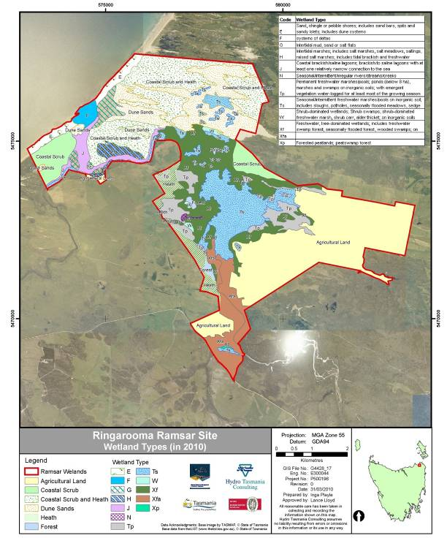
Figure 29: Ramsar wetland types as present on the site in March 2010.

Knowledge Gaps
The key knowledge gaps for the site include systematically collected data for all the critical components. Data should be gathered using standard methods that allow derivation of a ’point-in-time’ baseline which can be compared to future monitoring programs. Therefore, the initial sampling strategy must be designed in a way that allows repeatability (see section 8, below). The data should also be gathered using approaches and methods that allow comparison with other data sets within Tasmania and the rest of Australia.
Data and information available for most components of the site are poor. The vegetation has been recently mapped for a considerable portion of the site (DPIW 2006). However, a supplementary survey of the remaining areas would allow a more complete assessment of the site’s vegetation biodiversity, habitat heterogeneity and rare species. Quantitative faunal surveys for mammal, amphibian, reptile and bird abundances and distributions are required to provide adequate baseline assessments for future comparisons. Fish communities in fresh, estuarine and marine environments underpin much of the components of this site and these populations need to be understood with baseline assessment and then monitored regularly to improve our understanding of their role in this ecosystem.
Examples of the information types required are presented in Table 14. Priorities for knowledge gaps were established by considering the critical components which face the highest threat. The key knowledge gaps required to support the critical components fall into seven broad component categories:
- hydrology
- geomorphology
- water quality
- vegetation
- fauna
- habitat
- substrate
Knowledge of these areas will allow a detailed understanding of the vegetation communities of the site which are structured by the hydrology, geomorphology and water quality. The vegetation communities have their own intrinsic value and also provide habitat to the frogs, fish and birds of the site.

Table 14: Knowledge gaps for the Flood Plain Lower Ringarooma Ramsar site.
Information requirement | Identified Knowledge Gaps | Recommended Monitoring or other action to address the gap. | Priority
Hydrology | Inundation records for each wetland not available, including aerial coverage and depths over time. | Remote sensing or aerial photos of wetland extent over time, followed-up with ground truthing and depth measurements. | High
Hydrology | Rates of flows filling wetlands. | Gauge information. | Medium
Hydrology | Contributions from groundwater are not yet quantified. | Monitor groundwater levels. | Low
Geomorphology | Annotated geomorphic map across site, with descriptions of landforms and ongoing geomorphic processes (includes sediment movement from freshwater zone to estuary zone. | Geomorphic mapping survey of site, incorporating information from aerial photographs and including cross-sections. Strong focus on areas of active sand deposition and recently vegetated areas, with sufficient frequency to determine rates of change. | High
Geomorphology | Sediment deposition volume. | Sediment volume measurement and calculations. | High
Water Quality | Baseline water quality data for the freshwater zone and estuary zone. | Monthly monitoring program for at least two years, including inputs from discharge drains and other identifiable sources. | High
Water Quality | Storm-event water quality data for the freshwater zone and estuary zone. | Storm-event sampling for wetland systems, including inputs from discharge drains. | Medium
Vegetation | Complete vegetation map of site, consistent with TASVEG survey program. | Undertake vegetation survey to complement/supplement DPIW 2006 non-forest veg survey, includes species lists and distributions across site. | High
Vegetation | Extensive map of rare floral species across site. | Location map of vulnerable, rare or threatened species with information on habitat preferences and tolerances. | High
Fauna | Data base of faunal distributions across site. | Systematic faunal surveys across site, including but not limited to: fish; mammals; birds; aquatic macroinvertebrates and amphibians, especially targeting fauna species with likely potential habitat in the site such as New Holland Mouse, Eastern barred bandicoot and Giant Freshwater Crayfish. Also to provide information on habitat preferences and tolerances and infectious disease status. | High
Fauna | Extensive map of rare faunal species across site. | Location map of vulnerable, rare or threatened species with information on habitat preferences and tolerances. | High
Habitat | Map of habitats across site, with particular reference to vulnerable, rare or threatened species’ requirements. | Prepare habitat map based on vegetation and geomorphic maps, aerial photographs and using habitat preferences and requirements of identified species. | High
Substrate | Map of substrate with particular reference natural vs. impacted condition. | Survey of substrate, with representation of areas with high stock access. Measurement criteria to include colour, texture and structure, as well as measures of impacts. | Medium

Key Site Monitoring Needs
The monitoring needs of the site should incorporate a risk-based approach by focusing on the major threats to the ecological components. The critical components, essential elements, and threats have been discussed in Sections 3 and 4. These components and threats are presented in Table 15, with associated monitoring needs and prioritisations.
Priorities for monitoring were established by considering the critical components and highest threats.
Table 15: Key monitoring needs for the site.
Monitoring Focus | Threat | Details (type and frequency) | Priority
Geomorphic features, with particular focus on rate of change of landforms and sedimentation impacts. | Sedimentation; drainage. | Baseline: Geomorphic mapping survey of site, incorporating information from aerial photographs and including cross-sections to determine rates of change.  Ongoing: Five yearly (and after each major flood event) review of aerial photographs and cross-sections to assess ongoing geomorphic change. | Very High
Vegetation community with emphasis on supplementing existing survey data and also rare or threatened species and communities. | Sedimentation; irrigated pasture encroachment; stock trampling & foraging; hydrologic changes, drainage. | Baseline: Undertake vegetation survey to complement and supplement DPIW 2006 non-forest veg survey. Need to include estuary and coastal zones.  Ongoing: Two yearly survey of key locations (focusing on priority areas) to assess changes in vegetation communities (cover and diversity).  Baseline: Establish baseline flora species and community data; ecological community identification and composition; ecological community mapping and extent; and threatened species population size and health.  Ongoing: Low level aerial photography taken in November/December every five years in conjunction with resurveying of transects. | Medium  High
Water quality, with particular focus on nutrients, oxygen concentrations, oxygen demand, and biological assessment. | Stock access to waterbodies; dairy effluent (point source and non-point source). | Baseline: Monthly monitoring program for at least two years, including assessment of any inputs from discharge drains and other identifiable sources.  Ongoing: continuation of baseline monitoring program, with two-five yearly review to determine options for scaling-down or scaling-up. Any new development or expansion of existing catchment activities should undergo a risk-based assessment to determine monitoring requirements. | Very High
Substrate, with focus on cattle tracks being formed within and leading to wetland habitat. Also focus on general compaction in high stock areas. | Stock trampling. | Baseline: Mapping of substrate, with representation of areas with high stock access. Measurement criteria to include colour, texture & structure, as well as measures of impacts including photographic records.  Ongoing: Two yearly review with focus on vulnerable areas (based on stock access & numbers, and substrate sensitivity). | Medium
Weed infestation, focus on general weed spread and also increase in area of exotic pasture. | Pasture improvement; rough grazing. | Baseline: As part of vegetation survey, (above) record location and abundance of all weed species encountered on site, including coverage of irrigated pasture.  Ongoing: continue as part of vegetation survey. | Medium
Hydrology, with focus on characterising relationship between flows in the Ringarooma River and water regime in freshwater zone and estuary zone. | Climate change; increased extractions. | Baseline: Remote sensing or aerial photos of wetland extent over time, followed-up with ground-truthing, cross section and depth measurements of wetlands, and analysis of flow records.  Ongoing: rates of inundation and recession of flood waters within wetland (for example 1:1 year flood events 1:2 year flood events, etc.). | High
Rare Species. | Habitat change. | Baseline: Location map of vulnerable, rare or threatened species with information on habitat preferences and tolerances.  Ongoing: Two - five yearly repeat of flora and fauna survey with focus on rare species’ locations and abundances. | High

Communication, Education and Public Awareness (CEPA) Messages
The primary message that needs to be communicated to relevant stakeholders is:
“An Ecological Character Description (ECD) of the Flood Plain Lower Ringarooma Ramsar Site has been commissioned to understand the ecological character at the time of listing in 1982. The Flood Plain Lower Ringarooma Ramsar Site is listed against criterion one (international significant wetland type), criterion two (supports threatened species) and criterion three (a site of high biological diversity) of the Ramsar Convention. This ECD has identified a fourth criterion met by the site (criterion four: supporting a species during a critical stage of its life cycle). This site is a complex wetland, a coastal and estuarine ecosystem which provides habitat for important and nationally threatened species. The ECD includes documented past and current conditions, determines approaches to assess changes in condition, identifies potential threats to the wetland’s condition, devises appropriate management actions, and identifies critical information gaps for management.”
The stakeholders of the Flood Plain Lower Ringarooma Ramsar Site are numerous and the messages required for each may be different, especially once the management plan begins (when a full communications plan should be developed). Stakeholders for the site have been separated into four groups according to their role and interest in the site (Table 16). Initially, however, a combined set of messages relevant to the ECD can be used to communicate the importance of the site, why it was listed, the threats to the site and future actions required. The combined, key communications and public education messages for the Flood Plain Lower Ringarooma Ramsar Site are displayed in Table 17.

Table 16: Stakeholder groups for the Flood Plain Lower Ringarooma Ramsar Site.
Stakeholder Group | Stakeholders
Managers and Users | NRM North  Parks & Wildlife, Tasmania  Dorset Council  Department of Primary Industries and Water  Mineral Resources Tasmania  Inland Fisheries Service  Mining Companies  Agricultural Companies/Landholders
Regulators | Department of Tourism, Arts and the Environment (EPA)  DPIW  SEWPaC (EPBC)  Mineral Resources Tasmania (Mining)
Advisors and Funders | Australian Government – DAFF and SEWPaC  Consultants and Contractors  Universities and Researchers:  - Queen Victoria Museum and Art Gallery  - Tasmanian Aquaculture and Fisheries Institute  - University of Tasmania
Broader Community | Landholders  Environment Tasmania  Birds Tasmania  General Public

Table 17: Key communications and public education messages for the Flood Plain Lower Ringarooma Ramsar Site.
Message No. | Simple Message | Detailed Message
1 | The Flood Plain Lower Ringarooma Ramsar Site is an internationally important wetland | The Flood Plain Lower Ringarooma Ramsar Site is an internationally important wetland, and is now listed under criteria one, two and three:  - A wetland should be considered internationally important if it contains a representative, rare, or unique example of a natural or near-natural wetland type found within the appropriate biogeographic region.  - A wetland should be considered internationally important if it supports vulnerable, endangered, or critically endangered species or threatened ecological communities.  - A wetland should be considered internationally important if it supports populations of plant and/or animal species important for maintaining the biological diversity of a particular biogeographic region.  This ECD has identified a fourth criterion met by the site:  - Criterion four: A wetland should be considered internationally important if it supports plant and/or animal species at a critical stage in their life cycles, or provides refuge during adverse conditions.
2 | The site is a zone of high biodiversity | The site is a zone of high biodiversity. The surrounding area is dominated by scrub and tussock grassland vegetation, and includes substantial areas of freshwater marsh habitat in the Flood Plain. The variety of habitats support the following vegetation communities: saltmarsh, coastal grass and herbfield, lowland sedgy heathland, wet heathland, coastal heathland, coastal scrub, Acacia longifolia coastal scrub, Allocasuarina verticillata forest and Eucalyptus amygdalina coastal forest. The large area of shallow water allows the site to be a good feeding area for dabbling ducks and other waterbirds. The area provides nesting habitat for many species of waterbirds, particularly the Australasian shoveler (Anas rhynchotis). A number of migratory birds have been recorded from the site; including eleven migratory birds listed on the China - Australia Migratory Bird Agreement (CAMBA), the Japan - Australia Migratory Bird Agreement (JAMBA) the Republic of Korea - Australia Migratory Bird Agreement (ROKAMBA) and/or the Bonn Convention on Migratory Species (CMS). The lagoons, marshlands and dunes also support a rich variety of invertebrate fauna.
3 | The site contains many national and Tasmanian threatened species | The site contains many national and Tasmanian threatened species. The Ringarooma wetland communities are considered vulnerable in Tasmania and Melaleuca ericifolia swamp forest is a rare and endangered community.  The site supports four nationally threatened wetland fauna species;  - green and gold frog (vulnerable, EPBC Act, also TSPA)  - dwarf galaxias (vulnerable, EPBC Act, also TSPA)  - fairy tern ( vulnerable, IUCN Redlist)  - Australian grayling (vulnerable, EPBC Act)  Wetland flora species threatened within Tasmania and known to occur on the site are:  - purple loosestrife (vulnerable, TSPA)  - ribbon weed (rare, TSPA)  - erect marshflower (rare, TSPA), for which the Chimneys is a key site  - native gypsywort ( endangered, TSPA), which was previously thought to be extinct in Tasmania, has recently been found at the site
4 | The site provides many important services and benefits to the region | The site provides many important services and benefits to the region, which include:  - Wetland products such as food and water for livestock and water for irrigated agriculture.  - Maintenance of hydrological stability by replenishing groundwater.  - Coastal shoreline and river bank stabilization and storm protection.  - Sediment and nutrient retention including trapping of mining-generated sediment from up-catchment.  - Local climate regulation.  - Climate change mitigation through sequestering carbon.  - Water purification though removal and dilution of wastewaters from irrigation areas, and diffuse sources (rough grazing and dairying).  - Biological control of pests and diseases through provision of habitat for predators of agricultural pests (for example, ibis feeding on grasshoppers; eagles feeding on rabbits).  - Recreation and tourism such as recreational fishing and hunting (duck shooting), picnics, bushwalking, touring and nature observation (including bird watching).  - Cultural value.  - Ecological value.
5 | Understanding the ecology of the site will enhance future management of the site | Understanding the ecology of the site will enhance future management of the site. The ECD will provide a complete description of the wetland’s condition at the time of listing, the changes since listing, the threats likely to cause changes in the wetland’s ecological character (including the ecological benefits the site provides), the key knowledge gaps of the site’s ecology and functioning, monitoring requirements and limits of acceptable change.
6 | Past and present management practices provide some threats to the site’s values such as human use, grazing, water extraction and sedimentation from past mining activities | Past and present management practices provide some threats to the site’s values, including  - changes to the landforms, including infilling of wetland areas, through the deposition of sediment, particularly through the ongoing downstream progression of the fine sands generated by past mining practices  - vegetation community loss or change through sedimentation  - inputs of excess nutrients and other contaminants (including oxygen-demanding substances) through grazing and dairy wastes  - changes to the hydrologic regime via either local (water extraction) or regional/global (climate change) impacts  - drainage of the wetland from agricultural activities (either intentionally or through stock tracks)  - loss of habitat and vegetation communities through land clearance  - damage to riparian condition in the Flood Plain through agricultural activities, including direct stock access  - damage to the wetland soil/sediment structure through stock trampling  - impacts of excess sediment deposition through future land uses, including catchment land clearance and new mines  - declines in water quality through forestry activities upstream  - introduction of weeds and pest animals  - damage to habitat and vegetation communities through human access and inappropriate recreation (for example trail and quad bikes)  - damage to habitat and vegetation communities through salinisation of groundwater; and,  - loss of habitat and vegetation communities from gravel extraction
7 | The ECD project has summarised the available information on the site which describes its ecological character | The ECD project has:  - collated all the available information on the site  - begun to gain a wider understanding of the site, its biodiversity and its functions  - brought stakeholders together in the management of the site  - discovered that the site has substantial gaps in the information required for its management and protection indicating more research and monitoring is required
8 | Landholders, managers and users should promote the wise use of wetlands | Landholders, managers and users should promote the wise use of wetlands:  - The wise use of wetlands is a key concept of the Ramsar Convention on Wetlands and is defined as the ‘sustainable utilisation for the benefit of humankind in a way compatible with the maintenance of the natural properties of the ecosystem’.

Glossary
Definitions of words associated with ecological character descriptions. These are taken from DEWHA (2008) unless otherwise indicated.
Assessment | The identification of the status of, and threats to, wetlands as a basis for the collection of more specific information through monitoring activities.
Avulsion | A point in a stream channel, at which the stream breaks through the bank, often creating a new path for the stream and leaving behind disused (relict) channels.
Baseline | Condition at a starting point. For Ramsar wetlands it will usually be the time of listing of a Ramsar site.
Benchmark | A standard or point of reference.  A pre-determined state (based on the components which are sought to be protected) to be achieved or maintained.
Benefits | Benefits and services are defined in accordance with the Millennium Ecosystem Assessment definition of ecosystem services as "the benefits that people receive from ecosystems.  See also “Ecosystem Services”.
Biogeographic region | A scientifically rigorous determination of regions as established using biological and physical parameters such as climate, soil type, vegetation cover, etc.
Biological diversity | The variability among living organisms from all sources including, inter alia, terrestrial, marine and other aquatic ecosystems and the ecological complexes of which they are part; this includes diversity within species (genetic diversity), between species (species diversity), of ecosystems (ecosystem diversity), and of ecological processes. This definition is largely based on the one contained in Article 2 of the Convention on Biological Diversity.
Catchment | The total area draining into a river, reservoir, or other body of water.
Change in ecological character | Defined as the human-induced adverse alteration of any ecosystem component, process, and/or ecosystem benefit/service.
Community | An assemblage of organisms characterised by a distinctive combination of species occupying a common environment and interacting with one another.
Conceptual model | Wetland conceptual models express ideas about components and processes deemed important for wetland ecosystems.
Contracting Parties | Countries that are Member States to the Ramsar Convention on Wetlands; 154 as at March 2007. Membership in the Convention is open to all states that are members of the United Nations, one of the UN specialized agencies, or the International Atomic Energy Agency, or is a Party to the Statute of the International Court of Justice [http://www.ramsar.org/key_cp_e.htm].
Deflation basin | Basins formed by wind blowing sediments from the site.
Ecological character | The combination of the ecosystem components, processes and benefits and services that characterise the wetland at a given point in time. Within this context, ecosystem benefits are defined in accordance with the variety of benefits to people (Ecosystem Services). (Millennium definition of ecosystem services as "the benefits that people receive from ecosystems".  The phrase "at a given point in time" refers to Resolution VI.1 paragraph 2.1, which states that "It is essential that the ecological character of a site be described by the Contracting Party concerned at the time of designation for the Ramsar List, by completion of the Information Sheet on Ramsar Wetlands (as adopted by Recommendation IV. 7).
Ecological communities | Any naturally occurring group of species inhabiting a common environment, interacting with each other especially through food relationships and relatively independent of other groups. Ecological communities may be of varying sizes, and larger ones may contain smaller ones.
Ecosystems | The complex of living communities (including human communities) and non-living environment (Ecosystem Components) interacting (through Ecological Processes) as a functional unit which provides inter alia a variety of benefits to people (Ecosystem Services). (Millennium Ecosystem Assessment 2005).
Ecosystem components | The physical, chemical and biological parts of a wetland (from large scale to very small scale, e.g. habitat, species and genes) (Millennium Ecosystem Assessment 2005).
Ecosystem processes | The dynamic forces within an ecosystem. They include all those processes that occur between organisms and within and between populations and communities, including interactions with the non-living environment that result in existing ecosystems and bring about changes in ecosystems over time (Australian Heritage Commission 2002). They may be physical, chemical or biological.
Ecosystem services | The benefits that people receive or obtain from an ecosystem. The components of ecosystem services are provisioning (for example food and water), regulating (for example flood control), cultural (for example spiritual, recreational), and supporting (for example nutrient cycling, ecological value). (Millennium Ecosystem Assessment 2005).  See also “Benefits”.
Fluvial geomorphology | The study of water-shaped landforms.
Geodiversity | The natural range (diversity) of geological (bedrock), geomorphological (landform) and soil features, assemblages, systems and processes. Geodiversity includes evidence of the past life, ecosystems and environments in the history of the earth as well as a range of atmospheric, hydrological and biological processes currently acting on rocks, landforms and soils (Australian Heritage Commission 2002).
Granodiorite | An igneous rock, similar to granite but usually darker in appearance.
Indicator | Feature whose status provides information on the overall condition of the ecosystem, and which can therefore be used to assess environmental quality.
Indigenous species | A species that originates and occurs naturally in a particular country.
Introduced (non-native) species | A species that does not originate or occur naturally in a particular country.
Limits of Acceptable Change | The variation that is considered acceptable in a particular component or process of the ecological character of the wetland without indicating change in ecological character which may lead to a reduction or loss of the criteria for which the site was Ramsar listed’.
List of Wetlands of International Importance ("the Ramsar List") | The list of wetlands which have been designated by the Ramsar Contracting Party in which they reside as internationally important, according to one or more of the criteria that have been adopted by the Conference of the Parties [http://www.ramsar.org/about/about_glossary.htm].
Lunette | An arc-shaped mound formed on the lee side of a deflation basin, made up of sediment blown from the deflation basin.
Mesotidal | Coastal ocean or waterway with a moderate mean tidal range, for example between two and four metres (http://www.ozcoasts.org.au/glossary/def_m-p.jsp).
Monitoring | The collection of specific information for management purposes in response to hypotheses derived from assessment activities, and the use of these monitoring results for implementing management.
Ramsar | City in Iran, on the shores of the Caspian Sea, where the Convention on Wetlands was signed on 2 February 1971; thus the Convention's short title, "Ramsar Convention on Wetlands" [http://www.ramsar.org/about/about_glossary.htm].
Ramsar Criteria | Criteria for Identifying Wetlands of International Importance, used by Contracting Parties and advisory bodies to identify wetlands as qualifying for the Ramsar List on the basis of representativeness or uniqueness or of biodiversity values. http://www.ramsar.org/about/about_glossary.htm
Ramsar Convention | Convention on Wetlands of International Importance especially as Waterfowl Habitat. Ramsar (Iran), 2 February 1971. UN Treaty Series No. 14583. As amended by the Paris Protocol, 3 December 1982, and Regina Amendments, 28 May 1987. The abbreviated names "Convention on Wetlands (Ramsar, Iran, 1971)" or "Ramsar Convention" are more commonly used [http://www.ramsar.org/index_very_key_docs.htm].
Ramsar Information Sheet (RIS) | The form upon which Contracting Parties record relevant data on proposed Wetlands of International Importance for inclusion in the Ramsar Database; covers identifying details like geographical coordinates and surface area, criteria for inclusion in the Ramsar List and wetland types present, hydrological, ecological, and socioeconomic issues among others, ownership and jurisdictions, and conservation measures taken and needed (http://www.ramsar.org/about/about_glossary.htm).
Ramsar List | The List of Wetlands of International Importance [http://www.ramsar.org/about/about_glossary.htm].
Ramsar Sites | Wetlands designated by the Contracting Parties for inclusion in the List of Wetlands of International Importance because they meet one or more of the Ramsar Criteria [http://www.ramsar.org/about/about_glossary.htm].
Ramsar Sites Database | Repository of ecological, biological, socio-economic, and political data and maps with boundaries on all Ramsar sites, maintained by Wetlands International in Wageningen, the Netherlands, under contract to the Convention [http://www.ramsar.org/about/about_glossary.htm].
Sand Splay  Threatened species | A deposit of water-borne sand at a point in the landscape where the water loses its capacity to carry the sediment and consequently deposits the sediment in a sheet or delta-like formation. This often happens at the site of avulsions.  A term used sometimes to cover species listed as threatened or listed as endangered, vulnerable or rare.
Wetlands | Areas of marsh, fen, peatland or water, whether natural or artificial, permanent or temporary with water that is static or flowing, fresh, brackish or salt, including areas of marine water the depth of which at low tide does not exceed six metres.
Wetland types | As defined by the Ramsar Convention’s wetland classification system [http://www.ramsar.org/ris/key_ris.htm#type].
Wise use of wetlands | The maintenance of their ecological character, achieved through the implementation of ecosystem approaches[1], within the context of sustainable development[2]".  1. Including inter alia the Convention on Biological Diversity's "Ecosystem Approach" (CBD COP5 Decision V/6) and that applied by HELCOM and OSPAR (Declaration of the First Joint Ministerial Meeting of the Helsinki and OSPAR Commissions, Bremen, 25-26 June 2003).  2. The phrase "in the context of sustainable development" is intended to recognize that whilst some wetland development is inevitable and that many developments have important benefits to society, developments can be facilitated in sustainable ways by approaches elaborated under the Convention, and it is not appropriate to imply that 'development' is an objective for every wetland.

References
AAS and BIS. 2007. Best Practice Dairy Effluent Management in Tasmania Rushy Lagoon dairies; Quinfields, Centre View and Cygneus. Armstrong Agricultural Services Pty. Ltd, LAUNCESTON and Badcock Irrigation Services, TAS. 20th April, 2007.
ANZECC & ARMCANZ. 2000. Australian and New Zealand Guidelines for Fresh and Marine Water Quality. Canberra, Australia: Australian and New Zealand Environment and Conservation Council and the Agriculture and Resource Management Council of Australia and New Zealand.
Australian Heritage Commission 2002. Australian Natural Heritage Charter for conservation of places of natural heritage significance. Second Edition. Australian Heritage Commission. Canberra.
Birdlife International 2009. http://www.birdlife.org/index.html.
BirdLife International 2008. Sterna nereis. In: IUCN 2010. IUCN Red List of Threatened Species. Version 2010.1. <www.iucnredlist.org>.
Birds Australia 2010. Birds in backyards, on-line information site: http://birdsinbackyards.net/.
Blackhall, S., McEntee, A. and Rollins, E. 2000. Listing of Lower Ringarooma River including “The Chimneys”, Tasmania – an update of RAMSAR listing. Nature Conservation Branch, Department of Primary Industries, Water and Environment, Tasmania.
Bobbi, C. 1999. Water Quality Of Rivers In The Ringarooma Catchment. A Report Forming Part of the Requirements for State of Rivers Reporting. Land and Water Assessment Branch, DPIWE. Report Series WRA 99/01.
Bureau of Meteorology 2007. Climate Data Online. http://www.bom.gov.au/climate/averages/index.shtml. Commonwealth of Australia.
Coastal Zone Australia Ltd 2005. OzCoast and OzEstuaries, Conceptual Models, Wave dominated deltas. http://www.ozcoasts.org.au/conceptual_mods/wdd/wdd.jsp
Commonwealth of Australia, 2006, A guide to The Integrated Marine and Coastal Regionalisation of Australia - version 4.0 June 2006 (IMCRA v4.0).
Commonwealth of Australia 2010. http://www.bom.gov.au/hydro/wr/basins/index.shtml.
DEH 2005. Bilateral migratory bird agreements with Japan (JAMBA) and China (CAMBA). Department of the Environment and Heritage, Canberra, ACT.
DEH 2006. EPBC Act Policy Statement 1.1, Significant Impact Guidelines: Matters of National Environmental Significance. Department of the Environment and Heritage, Canberra ACT.
DTAE (Department of Tourism, Arts and the Environment), (2007), Vegetation, Fauna Habitat and Geomorphology Coastal Values Information for the Northern Tasmania NRM Region, Interpretation Manual. Coastal and Marine Branch, DTAE, Tasmania.
Department of Primary Industries, Parks, Water and Environment, Resource Management and Conservation Division (2010). Vulnerability of Tasmania’s Natural Environment to Climate Change: An Overview. Unpublished report. Department of Primary Industries, Parks, Water and Environment, Hobart.
DEWHA 2008. National Framework and Guidance for Describing the Ecological Character of Australia’s Ramsar Wetlands. Module 2 of the National Guidelines for Ramsar Wetlands–Implementing the Ramsar Convention in Australia. Australian Government Department of the Environment, Water, Heritage and the Arts, Canberra.
DEWHA 2010a. Australian Wetlands Database, Directory of Important Wetlands, http://www.environment.gov.au/cgi-bin/wetlands/search.pl?smode=DOIW.
DEWHA 2010b. Biodiversity Species Profile and Threats Database, http://www.environment.gov.au/cgi-bin/sprat/public/sprat.pl.
DPIW 2006. Vegetation of the Ringarooma Ramsar Wetlands, Tasmania (Non-forest Vegetation Program).
DPIW 2007. Online list of native vegetation communities listed under Schedule 3A of the Nature Conservation Act 2002 http://www.dpiw.tas.gov.au/inter.nsf/WebPages/AWAH-6547ZL?open.
DPIW. 2008a. Threatened Native Communities Vegetation List http://www.dpiw.tas.gov.au/inter.nsf/WebPages/AWAH-6547ZL?open.
DPIW 2008b. Online vegetation map and vegetation community classification for Tasmania (http://www.thelist.tas.gov.au/asdd/ANZTA0015000012.html).
DPIW 2009. http://www.dpiw.tas.gov.au/inter.nsf/WebPages/LBUN-6TY32G?open.
DPIW undated b. Note sheet; Villarsia exaltata, http://www.dpiw.tas.gov.au/inter.nsf/Attachments/LJEM-76QVMK/$FILE/Villarsia%20exaltata.pdf.
Edgar, G.J., Barrett, N.S. and Graddon, D.J. 1999. A Classification of Tasmanian Estuaries and Assessment of their Conservation Significance Using Ecological and Physical Attributes, Population and Land Use. Marine Research Laboratories – Tasmanian Aquaculture and Fisheries Institute, UTAS.
Environment Australia 1997. http://www.environment.gov.au/water/publications/environmental/wetlands/pubs/policy.pdf.
Environment Australia 2000. Revision of the Interim Biogeographic Regionalisation of Australia (IBRA) and the Development of Version 5.1. - Summary Report. Department of Environment and Heritage, Canberra.
Environment Australia 2001. A Directory of Important Wetlands in Australia. Third Edition, Environment Australia, Canberra.
GHD 2008. Flood Plain Lower Ringarooma River Ramsar Wetland Site: Management Plan. Report to NRM North, June 2008.
Graham, B. 1999. Hydrological analysis of the Ringarooma catchment. Land and Water Assessment Branch DPIWE Report Series WRA 99/02.
Grose MR, Barnes-Keoghan I, Corney SP, White CJ, Holz GK, Bennett JB, Gaynor SM and Bindoff NL 2010, Climate Futures for Tasmania: general climate impacts technical report, Antarctic Climate & Ecosystems. Cooperative Research Centre, Hobart, Tasmania.
Hale, J. (2010). Ecological Character Description for the Pulu Keeling National Park Ramsar Site. Report to the Department of Environment, Water, Heritage and the Arts, Canberra.
Harris, S and Kitchener, A (2005). From Forest to Fjaeldmark: Descriptions of Tasmania's Vegetation. Department of Primary Industries, Parks, Water and Environment, Printing Authority of Tasmania. Hobart.
Heap, A.D., Bryce, S. and Ryan, D. 2004. Facies evolution of Holocene estuaries and deltas: a large sample statistical study from Australia. Sedimentary Geology 168:1-17.
Heard, G., Robertson, P. & Scroggie, M. 2004. The Ecology and conservation status of the Growling Grass Frog (Litoria raniformis) within Merri Creek corridor. Second Report: Additional field survey and site monitoring. Wildlife Profiles Report to DSE and Yarra Valley Water.
Hydro Tasmania. 2003. Wetland Ecology, Chapter 5, Musselroe Wind Farm Project, Volume 3 – Transmission Line, March 2003 pp107-118.
Jerie, K. and Houshold, I. 2001. The Ringarooma Wetlands – a Temporary Landscape (Or: The Muddy Truth About Mining Sediments and Conservation). Nature Conservation Branch, DPIWE, Tasmania.
Kirkpatrick, J and Glasby, J 1981. Saltmarshes in Tasmania: Distribution, Community Composition and Conservation. Occasional Paper 8, Department of Geography, University of Tasmania, Hobart.
Knighton, A. D. 1991. Channel bed adjustment along mine-affected rivers of northeast Tasmania. Geomorphology Vol. 4, No 3-4: 205-219.
McGrath, C. 2006. Legal review of the framework for describing the ecological character of Ramsar wetlands to support implementation of the EPBC Act. Report to the Department of the Environment and Heritage, unpublished.
Millennium Ecosystem Assessment (2005). Ecosystem Services and Human Well-Being: Wetlands & Water: Synthesis. 2005. Millennium Ecosystem Assessment report to the Ramsar Convention: World Resources Institute, Washington D.C.
National Land and Water Audit. 1998. http://dbforms.ga.gov.au/pls/www/npm.Ozcoast.show_mm?pBlobno=9233.
Nelson, M. 1999. Index of River Condition for the Ringarooma River Catchment: A Report Forming Part of the Requirements for State of Rivers Reporting. Land and Water Assessment Branch, DPIWE. Report Series WRA 99/04.
NWC. 2009. from National Water Commission webpage: http://www.water.gov.au/PerformanceIndicatorData/swmareports.aspx?id=TAS_SW_46. Date accessed: 2 September 2009.
Organ,A. Meredith, C. and Timewell, C. 2003. Bird surveys along the proposed Musselroe Wind Farm Transmission Line - Ringarooma Ramsar area, north-east Tasmania. FINAL REPORT to Hydro Tasmania by Biosis Research, Melbourne.
Pizzey, G. 1980. A Field Guide to the Birds of Australia. Collins, Sydney, Australia.
Read, M. 1999. Aquatic Ecology of Rivers In the Ringarooma Catchment: A Report Forming Part of The Requirements for State of Rivers Reporting. Land and Water Assessment Branch, DPIWE. Report Series WRA 99/03.
Read, M. and Graham, B. 2000. Environmental Water Requirements for the Lower Ringarooma River. Report Series WRA 00/11 Department of Primary Industries, Water and Environment, Tasmania.
RIS (Ramsar Information Sheet). 2003. Information Sheet on Ramsar Wetlands, Flood Plain Lower Ringarooma River – 9. Compiled by Blackhall, S., McEntee, A. and E. Rollins, DPIWE, Tasmania.
RIS (Ramsar Information Sheet). 2005. Information Sheet on Ramsar Wetlands, Flood Plain Lower Ringarooma River, Tasmania. Compiled by DPIWE, Tasmania.
Scott, A. 1997. Relationships between waterbird ecology and river flows in the Murray-Darling Basin. CSIRO division of Land and Water, Technical Report No. 5/97.
Sharples, C., 2006: Indicative Mapping of Tasmanian Coastal Vulnerability to Climate Change and Sea-Level Rise: Explanatory Report (Second Edition); Consultant Report to Department of Primary Industries & Water, Tasmania, 173 pp., plus accompanying electronic (GIS) maps.
Sherriff, L. 2007. Property Management Plan Tier 2: Including Environmental Management Plan, Water Resources Overview and detailed farm maps. Agricultural Resource Management Pty Ltd Report for Rushy Pastoral, Rushy Lagoon, Tasmania. August 2007.
Skerratt, Lee Francis. 2001. Sarcoptic Mange In The Common Wombat, Vombatus ursinus (Shaw, 1800). PhD thesis, Department of Veterinary Science, The University of Melbourne.
Strahler A.H. and Strahler, A.N. 1992. Modern Physical Geography. John Wiley and Sons 4th Ed. New York.
TSS (Threatened Species Section) 2006. Recovery Plan: Tasmanian Galaxiidae 2006-2010. Department of Primary Industries, Water, Hobart.

Appendices

Appendix 1: Plant Lists of the Flood Plain Lower Ringarooma River Ramsar Site.
List of plant species found at the Flood Plain Lower Ringarooma Ramsar Site during a vegetation survey (from DPIW 2006; (e) = endemic; (i) = introduced).
Dicotyledonae
APIACEAE
Centella cordifolia Swampwort
Hydrocotyle hirta Hairy pennywort
Hydrocotyle muscosa Mossy pennywort
Lilaeopsis polyantha Jointed swampstalks
ASTERACEAE
Cassinia aculeata Dollybush
Chrysocephalum apiculatum Common everlasting
Cirsium vulgare Spear thistle (i)
Cotula coronopifolia Water buttons (i)
Euchiton collinus Common cottonleaf
Helichrysum scorpioides Curling everlasting
Hypochoeris radicata Rough catsear (i)
Leontodon taraxacoides Hairy hawkbit (i)
Senecio species Fireweed
CAMPANULACEAE
Lobelia anceps Angled lobelia
Pratia pedunculata Matted pratia
Wahlenbergia sp. Bluebell
CARYOPHYLLACEAE
Scleranthus biflorus Twinflower knawel
Stellaria pungens Prickly starwort
CASUARINACEAE
Allocasuarina monilifera Necklace sheoak (e)
CLUSIACEAE
Hypericum japonicum Matted St Johns-wort
DILLENIACEAE
Hibbertia riparia Erect guineaflower
DROSERACEAE
Drosera peltata Pale sundew
Drosera pygmaea Dwarf sundew
ELATINACEAE
Elatine gratioloides Waterwort
EPACRIDACEAE
Acrotriche serrulata Ants delight
Astroloma humifusum Native cranberry
Epacris lanuginosa Swamp heath
Leucopogon virgatus
var. virgatus Twiggy beardheath
Styphelia adscendens Golden heath
EUPHORBIACEAE
Amperea xiphoclada Broom spurge
FABACEAE
Aotus ericoides Golden pea
Bossiaea cinerea Showy bossia
Bossiaea prostrata Creeping bossia
Dillwynia glaberrima Smooth parrotpea
Gompholobium huegelii Common wedgepea
Kennedia prostrata Running postman
Lotus species Birdsfoot-trefoil (i)
Medicago lupulina Black medick (i)
Platylobium formosum Handsome flatpea
Platylobium triangulare Arrow flatpea
Trifolium repens White clover (i)
Ulex europaeus Gorse (i)
GENTIANACEAE
Centaurium erythraea Common centaury (i)
GERANIACEAE
Geranium retrosum Grassland cranesbill
GOODENIACEAE
Goodenia elongata Lanky native-primrose
Selliera radicans Shiny swampmat
HALORAGACEAE
Gonocarpus micranthus
subsp. micranthus Creeping raspwort
Gonocarpus serpyllifolius Alpine raspwort
Gonocarpus tetragynus Common raspwort
Gonocarpus teucrioides Forest raspwort
Myriophyllum simulans Amphibious watermilfoil
Myriophyllum sp. Watermilfoil
LAMIACEAE
Lycopus australis Australian gypsywort
Prunella vulgaris Selfheal (i)

LAURACEAE
Cassytha sp. Dodderlaurel
LENTIBULARIACEAE
Utricularia sp. Bladderwort
LYTHRACEAE
Lythrum hyssopifolia Small loosestrife
Lythrum salicaria Purple loosestrife
MENYANTHACEAE
Villarsia reniformis Running marshflower
MIMOSACEAE
Acacia dealbata
subsp. dealbata Silver wattle
Acacia melanoxylon Blackwood
Acacia verticillata
subsp. verticillata Prickly moses
MYRTACEAE
Eucalyptus amygdalina Black peppermint (e)
Eucalyptus ovata Black gum
Eucalyptus pauciflora
subsp. pauciflora Cabbage gum
Eucalyptus viminalis
subsp. viminalis White gum
Kunzea ambigua White kunzea
Leptospermum lanigerum Woolly teatree
Leptospermum scoparium
var. scoparium Common teatree
Melaleuca ericifolia Coast paperbark
Melaleuca gibbosa Slender honeymyrtle
Melaleuca squamea Swamp honeymyrtle
OXALIDACEAE
Oxalis perennans Grassland woodsorrel
PITTOSPORACEAE
Bursaria spinosa Prickly box
PLANTAGINACEAE
Plantago coronopus subsp.
coronopus Buckshorn plantain (i)
Plantago major Great plantain (i)
POLYGONACEAE
Acetosella vulgaris Sheep sorrel (i)
Persicaria sp. Waterpepper
Polygonum sp. Beardgrass
Rumex crispus Curled dock (i)
Rumex pulcher subsp. pulcher Fiddle dock (i)
PORTULACACEAE
Neopaxia australasica White purslane
PRIMULACEAE
Anagallis arvensis var.
arvensis Scarlet pimpernel (i)
PROTEACEAE
Banksia marginata Silver banksia
Hakea microcarpa Smallfruit needlebush
Persoonia sp. Geebung
RANUNCULACEAE
Ranunculus amphitrichus River buttercup
Ranunculus lappaceus Woodland buttercup
Ranunculus repens Creeping buttercup (i)
RHAMNACEAE
Pomaderris apetala Dogwood
ROSACEAE
Acaena novae-zelandiae Common buzzy
Rubus fruticosus Blackberry (i)
RUBIACEAE
Coprosma quadrifida Native currant
Galium australe Tangled bedstraw
SALICACEAE
Salix fragilis Crack willow
SCROPHULARIACEAE
Digitalis purpurea Foxglove (i)
Mazus pumilio Swamp mazus
Parentucellia viscosa Yellow glandweed (i)
SOLANACEAE
Lycium ferocissimum African boxthorn (i)
Solanum sp. Nightshade (i)
STYLIDIACEAE
Stylidium graminifolium Narrowleaf triggerplant
THYMELAEACEAE
Pimelea humilis Dwarf riceflower

Monocotyledonae
APONOGETONACEAE
Aponogeton distachyos Cape pondweed (i)
CENTROLEPIDACEAE
Centrolepis strigosa subsp.
strigosa Hairy bristlewort
CYPERACEAE
Baumea juncea Bare twigsedge
Baumea species Twigsedge
Carex appressa Tall sedge
Carex fasicularis Sedge
Carex inversa Knob sedge
Cyperus gunnii Flecked flat-sedge
Cyperus lucidus Leafy flat-sedge
Cyperus tenellus Tiny flat-sedge (i)
Eleocharis acuta Common spikesedge
Eleocharis sphacelata Tall spikesedge
Gahnia sieberiana Redfruit sawsedge
Isolepis inundata Swamp clubsedge
Isolepis nodosa Clubsedge
Isolepis sp. Clubsedge
Lepidosperma concavum Sand swordsedge
Lepidosperma gladiatum Coast swordsedge
Lepidosperma ensiforme Arching swordsedge
Schoenus apogon Common bogsedge
Schoenus sp. Bogsedge
HYDROCHARITACEAE
Vallisneria australis River ribbons
IRIDACEAE
Diplarrena moraea White flag-iris
Patersonia fragilis Short purpleflag
JUNCACEAE
Juncus articulatus Jointed rush (i)
Juncus australis Southern rush
Juncus bufonius Toad rush
Juncus pallidus Pale rush
Juncus procerus Tall rush
Luzula sp. Rush
JUNCAGINACEAE
Triglochin procerum Greater waterribbons
Triglochin striatum Streaked arrowgrass
LEMNACEAE
Wolffia australiana Tiny duckweed
LILIACEAE
Burchardia umbellata Milkmaids
Dianella revoluta Spreading flaxlily
Hypoxis hygrometrica Golden weatherglass
ORCHIDACEAE
Gastrodia sesamoides Short potato-orchid
Lyperanthus suaveolens Brown beaks
Microtis species Onion orchid
Spiranthes australis Spiral orchid
Thelymitra sp. Sun orchid
POACEAE
Agrostis capillaris Browntop bent (i)
Agrostis sp. Bent grass
Aira caryophyllea Silvery hairgrass (i)
Anthoxanthum odoratum Sweet vernalgrass (i)
Austrodanthonia sp. Wallaby grass
Austrostipa species Spear grass
Briza minor Lesser quaking-grass (i)
Cynosurus echinatus Rough dogstail (i)
Dactylis glomerata Cocksfoot (i)
Danthonia sp. Wallabygrass
Deyeuxia quadriseta reed Bentgrass
Dichelachne crinita Longhair plumegrass
Ehrharta stipoides Weeping grass
Elymus scaber Rough wheatgrass
Holcus lanatus Yorkshire fog (i)
Lolium perenne Perennial ryegrass (i)
Pentapogon quadrifidus var.
quadrifidus Five-awn speargrass
Phalaris species Canarygrass (i)
Phragmites australis Southern reed
Poa labillardierei var.
labillardierei Silver tussockgrass
Themeda triandra Kangaroo grass
Vulpia sp. Fescue (i)
POTAMOGETONACEAE
Potamogeton ochreatus Blunt pondweed
Potamogeton tricarinatus Floating pondweed
RESTIONACEAE
Empodisma minus Spreading roperush
Eurychorda complanata Flat cordrush
Hypolaena fastigiata Tassel roperush
Leptocarpus tenax Slender twinerush
Sporadanthus tasmanicus Branching scalerush
XANTHORRHOEACEAE
Lomandra longifolia Sagg
Xanthorrhoea bracteata Shiny grasstree (e)
XYRIDACEAE
Xyris species Yelloweye
Pteridophyta
AZOLLACEAE
Azolla filiculoides
BLECHNACEAE
Blechnum nudum Fishbone waterfern
Blechnum wattsii Hard waterfern
DENNSTAEDTIACEAE
Histiopteris incisa Batswing fern
Hypolepis rugosula Ruddy groundfern
Pteridium esculentum Bracken
DICKSONIACEAE
Dicksonia antarctica Soft treefern
DRYOPTERIDACEAE
Polystichum proliferum Mother shieldfern
Rumohra adiantiformis Leathery shieldfern
GLEICHENIACEAE
Gleichenia dicarpa Pouched coralfern
LINDSAEACEAE
Lindsaea linearis Screw fern
POLYPODIACEAE
Microsorum pustulatum subsp.
pustulatum Kangaroo fern
SELAGINELLACEAE
Selaginella Clubmoss

Appendix 2: Species associated with major plant communities in the Flood Plain Lower Ringarooma Ramsar Site (DPIW 2006).
Vegetation community | Key species
Coast paperbark swamp forest | Overstorey:  - Coast paperbark (Melaleuca ericifolia)  Understorey  - Batswing fern (Histiopteris incisa)  - Ruddy groundfern (Hypolepis rugosula)
Blackwood swamp forest | Overstorey:  - Blackwood (Acacia melanoxylon)  - Coast paperbark (Melaleuca ericifolia)  Shrubs & Understorey  - Silver banksia (Banksia marginata)  - Woolly tea-tree (Leptospermum lanigerum)  - Native currant (Coprosma quadrifida)  - Dogwood (Pomaderris apetala)  - Hardwater fern (Blechnum wattsii)  - Fishbone fern (Blechnum nudum)  - Leafy flatsedge (Cyperus lucidus)  - Tall sedge (Carex appressa)  - Arching swordsedge (Lepidosperma ensiforme)  - Rushes (Juncus species)
Scented paperbark scrub | Overstorey:  - Scented paperbark (Melaleuca squarrosa)  No specific sampling was undertaken in this community. Similar to coast paperbark swamp forest at the site.
Freshwater aquatic herbland | - Pondweed (Potamogeton spp)  - Watermilfoil (Myriophyllum species)  - River ribbons (Vallisneria species)  - Greater waterribbons (Troglochin procerum)  Note: the introduced weed species cape pondweed (Aponogeton distachyos) has been observed within this community type
Freshwater aquatic sedgeland and rushland | - Tall spikesedge (Eleocharis sphacelata)  - Leafy flatsedge (Cyperus spp.)  - Tallsedge (Carex spp.)  - Swordsedge (Lepidosperma spp.)  - Rush (Juncus spp.)
Lacustrine herbland | - Angled lobelia (Lobelia anceps)  - Jointed swampstalks (Lilaeopsis polyantha)  - Bogsedge (Schoenus species)  - Clubsedge (Isolepis species)  - Mossy pennywort (Hydrocotyle muscosa)  - White purslane (Neopaxia australasica)  - Swamp mazus (Mazus pumilio).
Lowland grassy sedgeland | - Sagg (Lomandra longifolia)  - Kangaroo grass (Themeda triandra)  - Wallaby grass (Austrodanthonia species)  - Spear grass (Austrostipa species)  Note: Introduced grasses also make up about 30 percent cover.
Coastal heathland | - Smallfruit needlebush (Hakea microcarpa)  - Guinea flower (Hibbertia spp.)  - Ants delight (Acrotriche serrulata)  - Silver banksia (Banksia marginata)  - Common wedgepea (Gompholobium huegelii)  - Necklace sheoak (Allocasuarina monilifera)
Lowland sedgy heathland | - Sagg (Lomandra longifolia)  Note: Coastal heathland can become lowland sedgy heathland where excessive firing or root rot infection has eliminated many heath and shrub species
Wet heathland | - Woolly tea-tree (Leptospermum lanigerum)  - Swamp heath (Epacris lanuginosa)  Note: May also contain species common to the other two heathland communities described above
Black peppermint coastal forest and woodland | Overstorey:  - Black peppermint (Eucalyptus amygdalina)  - Cabbage gum (E. pauciflora)  Shrubs & understorey  As for lowland sedgy heathland and coastal heathland

Appendix 3: List of bird species recorded during surveys at the Flood Plain Lower Ringarooma Ramsar Site in winter and spring 2002.
Waterbirds/waders
Chestnut teal (Anas castanea)
Grey teal (Anas gracilis)
Australasian shoveler (Anas rhynchotis)
Pacific black duck (Anas superciliosa)
Great egret (Ardea modesta)
Cattle egret (Ardea ibis)
Ruddy turnstone (Arenaria interpres)
Hardhead (Aythya australis)
Musk duck (Biziura lobata)
Australasian bittern( Botaurus poiciloptilus)
Curlew sandpiper (Calidris ferruginea)
Red-necked stint (Calidris ruficollis)
Cape Barren goose (Cereopsis novaehollandiae)
Australian wood duck (Chenonetta jubata)
Black swan (Cygnus atratus)
White-faced heron (Egretta novaehollandiae)
Eurasian coot (Fulica atra)
Dusky moorhen Gallicrex cinerea)
Latham’s snipe (Gallinago hardwickii)
Tasmanian native-hen (Gallinula mortierii)
Black-tailed native-hen (Gallinula ventralis)
Pied oystercatcher (Haematopus longirostris)
Kelp gull (Larus dominicanus)
Silver gull (Larus novaehollandiae)
Pacific gull (Larus pacificus)
Bar-tailed godwit (Limosa lapponica)
Blue-billed duck (Oxyura australis)
Australian pelican (Pelecanus conspicillatus)
Great cormorant (Phalacrocorax carbo)
Little pied cormorant (Phalacrocorax melanoleucos)
Little black cormorant (Phalacrocorax sulcirostris)
Pied cormorant (Phalacrocorax varius)
Yellow-billed spoonbill (Platalea flavipes)
Hoary-headed grebe (Poliocephalus poliocephalus)
Purple swamphen (Porphyrio porphyrio)
Little tern (Sterna albifrons)
Caspian tern (Hydroprogne caspia)
Australasian grebe (Tachybaptus novaehollandiae)
Australian shelduck (Tadorna tadornoides)
Greenshank (Tringa nebularia)
Masked lapwing (Vanellus miles)
Banded lapwing (Vanellus tricolor)
Raptors
Collard sparrowhawk (Accipiter cirrhocephalus)
Wedge-tailed eagle (Aquila audax fleayi)
Swamp harrier (Circus approximans)
Brown falcon (Falco berigora)
Peregrine falcon (Falco peregrines)
White-bellied sea-eagle (Haliaeetus leucogaster)
Other Significant Birds
Richard's pipit (Anthus novaeseelandiae)
Fan-tailed cuckoo (Cacomantis flabelliformis)
Yellow-tailed black-cockatoo (Calyptorhynchus funereus)
Horsfield's bronze-cuckoo (Chrysococcyx basalis)
Black-faced cuckoo-shrike (Coracina novaehollandiae)
Forest raven (Corvus tasmanicus)
Pallid cuckoo (Cuculus pallidus)
Welcome swallow (Hirundo neoxena)
Tree martin (Hirundo nigricans)
Blue-winged parrot (Neophema chrysostoma)
Flame robin (Petroica phoenicea)
Silvereye (Zosterops lateralis)
Other native birds
Yellow-rumped thornbill (Acanthiza chrysorrhoa)
Striated thornbill (Acanthiza lineata)
Brown thornbill (Acanthiza pusilla)
Eastern spinebill (Acanthorhynchus tenuirostris)
Little wattlebird (Anthochaera chrysoptera)
Yellow wattlebird (Anthochaera paradoxa)
Dusky woodswallow (Artamus cyanopterus)
Striated fieldwren (Calamanthus fuliginosus)
Grey shrike-thrush (Colluricincla harmonica)
Brown quail (Coturnix ypsilophora)
Grey butcherbird (Cracticus torquatus)
Grey currawong (Strepera versicolor)
White-fronted chat (Epthianura albifrons)
Fairy martin (Hirundo ariel)
Yellow-throated honeyeater (Lichenostomus flavicollis)
Superb Fairy-wren (Malurus cyaneus)
Dusky robin (Melanodryas vittata)
Golden whistler (Pachycephala pectoralis)
Striated pardalote (Pardalotus striatus)
Scarlet robin (Petroica multicolour)
Tawny-crowned honeyeater (Phylidonyris melanops)
Green rosella (Platycercus caledonicus)
Grey fantail (Rhipidura fuliginosa)
Black currawong (Strepera fuliginosa)
Non-indigenous Birds
Skylark (Alauda arvensis)
European goldfinch (Carduelis carduelis)
European greenfinch (Carduelis chloris)
Laughing kookaburra (Dacelo novaeguineae)
Common starling (Sturnus vulgaris)
(Organ et al. 2003; RIS 2005; some migratory wader species are also from Sally Bryant, personal communications).

Appendix 4: The Consultants
Peter Newall, Independent Consulting Aquatic Ecologist
Peter Newall has over 20 years experience in studying, monitoring and assessing the physical, chemical and biological condition of water bodies and their catchments. His work has included: examining the ecological condition of a broad range of aquatic ecosystems; developing systems for the use of biological indicators in ecosystem assessment and management; derivation of condition targets/objectives for natural resources; and developing river management policies for the care and protection of rivers.
Peter has been involved in developing guidelines and objectives for aquatic ecosystem health, deriving biological regions for the assessment of stream condition across Victoria, developing the EPA (Victoria) protocol for the monitoring of licensed discharges to streams across Victoria, and furthering the development of biological indicators of stream condition. His work in these areas has been incorporated into the Victorian State Environment Protection Policy (Waters of Victoria) and its supporting documents.
Other studies he has undertaken include assessing catchment and land use management impacts upon receiving waterways; ecological risk assessments of streams; environmental assessment of streams and catchments; and character descriptions of wetlands.
Peter was a member of the CRC for Freshwater Ecology for five years, and has also worked in Environmental Auditing with EPA and as a consultant, particularly in natural resource auditing, focusing on waterway and catchment auditing.
Lance Lloyd, Principal Consulting Ecologist,
Lloyd Environmental Pty Ltd
Principal Consulting Ecologist, Lance Lloyd, BSc, MSc., MAIBiol., provides high level strategic advice and services to industry and Government across Australia. He has 27 years experience in environmental consulting, research and management. His key expertise developed over this time is in relating the ecology of aquatic systems to the needs of management issues. The majority of work during his professional life, since 1979, has been in the ecology of aquatic and Flood Plain ecosystems and water regimes in flowing and lentic waters and their management. His M.Sc. studies, some of his major research projects and several published papers focused upon the central role of environmental water management to the ecology and biological requirements of fish, invertebrates and plants.
Lance also led a project to develop a wetlands inventory on Commonwealth Land as a contribution to the “Directory of Important Wetlands in Australia (3rd Edition)”. In 2003, Lance led an expert team to review the Environmental Water Requirements for Internationally Significant Wetlands Framework where he undertook detailed studies on the Wyndgate Wetlands which are part of Coorong and Lakes Alexandrina and Albert Ramsar Site. He has contributed significantly to the MDBC Flood Plain Wetlands Management Strategy. He was the lead author of the paper entitled “Natural Processes in Flood Plain Ecosystems” which synthesised the current knowledge of Flood Plain wetland ecosystems and was produced as part of the MDBC Flood Plain Wetlands Management Strategy.
Lance was a co-author of the FLOWs methodology for Victorian Streams and Rivers and is lead a project to develop, pilot and refine a draft FLOWs methodology for the estuary ecosystems of Victoria. He was a key member of the team which developed the wetlands R&D requirements for Land & Water Australia in 1998, which included a specific review of water regime management and its research requirements.
Further, he was a board member of the Fisheries Co-management Council of Victoria (an advisory group to the Victorian Minister of Agriculture) in 2002 -2005. On the FCC he was responsible for the Estuaries, Bays and Inlets Fisheries. He led a process to develop a 10 year Vision for the Fisheries Industry in the region. He also served on the Victorian Fisheries Research Advisory Board for the Fisheries R&D Corporation. He currently chairs the Translocation Evaluation Panel for the Victorian Government which evaluates risks from fish translocations in Victoria.
In addition to the initial Flood Plain Lower Ringarooma Ramsar Site ECD, in 2007, Lance also led the Ecological Character Description Project for the South Australian Government on the Riverland Ramsar Site (River Murray Flood Plain). He is currently completing ECDs for Lavinia, Little Waterhouse Lake, Jocks Lagoon and Bool and Hacks Lagoons Ramsar Sites.

Appendix 5: Methodology to Develop the ECD
Completion of the ECD comprised ten major steps:
- Project inception and site visit
- Literature and information review
- Content of the ECD
- Preparation of first draft ECD for review by SEWPaC
- Preparation of revised RIS, using the ECD
- Revision of first draft ECD (with SEWPaC comments)
- Presentation of second draft ECD to stakeholders in a workshop format, seeking comments/feedback
- Finalisation of ECD, incorporating stakeholder comments
- SEWPaC external review of submitted ECD
- Update and finalise revised ECD
Client-consultant partnership was an important component of the process to ensure alignment of goals and common understanding of approaches. This included client-consultant meetings to ensure a high level of communication. The team also conducted interviews and informal discussions with relevant stakeholders and resource managers, to further develop our understanding of the site. The structured workshop (Step seven) assisted with crystallising our understanding of the site and developing the conceptual model for the wetland.
The steps outlined above are described in the following sections.
Step one: Project inception and site inspection
The project commenced with an inception meeting with the Client Project Manager and the Consultants’ project manager. This meeting was to:
- Confirm project objectives, and outputs sought;
- Discuss and finalise timeframes and key dates for delivery of project outputs; and,
- Confirm existing information sources and obtain relevant reports, information, and data from the client.
This component was vital for ensuring alignment of objectives and discussion of approaches. The inception meeting was also used as a springboard for making contacts, obtaining details of key stakeholders and pursuing reference documents.
Site Inspection: Following the inception meeting a site inspection was undertaken to view the key areas and habitats of the Flood Plain Lower Ringarooma River Ramsar Site. The site inspection was led by the client Project Manager, who had extensive experience managing the site. A small plane was also chartered to fly over the Ramsar site, providing greater spatial perspective of the site.

Step two: Literature and information review
The literature review initially focussed on the condition of the Ramsar site at the time of Ramsar listing. Information on changes to condition since listing was subsequently reviewed and documented. Information reviewed included documents prepared prior to and during the listing process, as well as through perusal of subsequent reports and studies on the condition of the wetland.
Collate/summarise information from inception meeting and Stakeholders: At the inception meeting relevant available documents held by the client were requested, as well as contact details of stakeholders and their relevant roles in relation to the Ramsar site. Subsequent to the inception meeting contact was made with relevant stakeholders as part of document searching/gathering. The collated and summarised information enabled an assessment of information gaps and needs.
Information and data search and review: Using the approaches and structures identified at the inception meeting and the collated information, information needs were prioritised and the most likely sources (people and documents) were identified. The data search and summary was a key component of the project and was allocated a substantial amount of time. An “information log” was developed to document the reports and information resources available to the project. The “information log” was used during the course of the project to inform stakeholders which documents the project team possessed and which ones were missing for the project. The “information log” will be continually updated throughout the project. A significant component of this included interviews and discussions with key stakeholders.
Literature Summary: The information and data obtained was summarised to facilitate review of knowledge status and gaps, and was used as an important basis for the production of the ECD. The literature summary was structured to enable ready assessment against ECD requirements.
Discussions with DEH and Government Agencies: Discussion with the client and key Government stakeholders was a regular and vital part of the project, both in the collection of information and also in the compilation of the literature summary. Regular feedback maximised the opportunity to uncover all relevant information.
Step three: Content of the ECD
A scientific panel was convened and focussed on identifying:
- key ecological components and processes in the Flood Plain Lower Ringarooma River Ramsar Site
- the benefits and services that characterise the site
- key actual or potential threats to the site
- knowledge gaps
- monitoring needs
- an appropriate preliminary conceptual model of the system.
Two workshops were conducted; one before the draft ECD had been completed and one following the review and updating of the ECD. Both workshops consisted of the project team, NRM North, SEWPaC and stakeholders.

Step four: Preparation of a draft ECD for review by SEWPaC
A draft of the ECD was prepared from the information gathered through the literature review, Scientific Panel and through liaison with the client. The draft was provided to the client manager, for distribution to relevant staff within SEWPaC.
The draft ECD generally followed the draft national framework, which includes:
- Executive Summary
- Acknowledgements
- Table of Contents
- List of Abbreviations
- Introduction, including site details, purpose of the ECD, legislative context
- Detailed Description of the Site, including overview of the site; ECD context; Ramsar/DIWA criteria; geographic and ecosystem description
- Description of Ecological Character of the Site, focusing on components, processes & benefits and services; conceptual model of site & system, quantified limits of change. Consideration will need to include biological, physical and chemical aspects of wetland condition and processes
- Key Actual or Potential Threats or Risks to the Site, to aid identification of potential changes and their importance
- Knowledge Gaps (and suggested approaches for addressing them)
- Changes in Ecological Character (if appropriate), including whether changes have occurred since listing
- Key Site Monitoring Needs, identified from conceptual model, and covering knowledge gaps, assessing trends/changes and monitoring management outcomes
- Communication, Education and Public Awareness (CEPA) Messages, summarising key ecological messages that will facilitate management planning and action
- Glossary
- References; and,
- Appendices.
The ‘Executive Summary’ to ‘List of Abbreviations’ and ‘Glossary’ to ‘Appendices’ were not completed at this draft stage.
Describing the Components, Processes and Benefits and services: The development of ecological character required a description of the ecosystem components, processes and benefits and services that characterise the Ramsar site. An important requirement within this task was the need to document the ecological character of the site at the time of its designation for the Ramsar list as well as current ecological character. This included assessments of trends in the condition of relevant components, processes and services and past and current changes in its character.
Development of Conceptual Models: Conceptual models were developed to represent the ecological processes and components of the Ramsar Site in a simplified way, to will assist in describing the ecological character of the site.
Conceptual models draw on existing scientific information to describe the critical processes that contribute to (or limit) wetland or ecosystem health. A model can describe a 'healthy' ecosystem that meets the management objective and can include known impacts and show how they reduce health or biodiversity.
Conceptual models are defined as “a generalised description or representation of the structure and function of a complex system”. In order to develop a conceptual model, the following steps were undertaken:
- define the purpose of the conceptual model
- specify the system boundaries
- identify individual model components
- describe relationships between components
- “build” the conceptual model
Prepare draft ECD: The ecological character was described in accordance with the SEWPaC National Framework. This required a description of the ecosystem components, processes and benefits and services that characterise the wetland as well as the conceptual model of the ecological functioning of the wetland system (described above).
Beyond the description of the wetland site, knowledge gaps were identified and recommendations made accordingly, including the development of monitoring recommendations. As well as filling of knowledge gaps, monitoring recommendations considered information required for assessment of trends, assessments of threats or risks, and feedback on management actions.
Step five: Preparation of revised RIS, using the ECD
The preparation of the revised RIS used the existing RIS as a basis and incorporated changes to the site boundaries as well as any relevant changes to the ecology of the site since the preparation of the previous RIS. Much of the work undertaken as part of the Literature Review and also stakeholder discussion and team-member knowledge of the site fed into this task.
Step six: Revision of first Draft ECD (SEWPaC comments)
The project team collated the comments provided by SEWPaC and incorporated those comments into a revision of the draft ECD, producing a second draft ECD for key stakeholder review. The second draft ECD was circulated to the key stakeholders prior to the presentation and workshop (Task 7).
Step seven: Presentation of second draft ECD to stakeholders in a workshop format, seeking comments/feedback
The purpose of the presentation was to field feedback from the client, Steering Committee and other key stakeholders in a face-to-face situation. The goal was to encapsulate the key comments in a workshop environment after the presentation and seek agreement/consensus on those comments. Feedback received from the presentation/workshop was documented and circulated to ensure completeness and alignment of understandings prior to preparation of the final draft of the ECD.
Step eight: Finalisation and submission of ECD
The ECD was finalised, incorporating the stakeholder and SEWPaC comments following the second workshop and subsequent feedback.

Step nine: SEWPaC external review of submitted ECD
Prior to finalisation, SEWPaC had the ECD externally reviewed against the revised SEWPaC guidelines. SEWPaC requested that the authors update the ECD according to the revised guidelines and comments.
Step ten: Update and finalise revised ECD
Following the external ECD review, an additional workshop was held to identify the major elements of the document which required updating. The project team addressed the comments provided and incorporated them into a revision of the ECD, thus finalising the ECD. This version was subject to a further final review before being revised as the final version.

