Animal Health Committee (AHC) provides veterinary leadership and technical expertise for Australia’s animal health system. AHC includes the Australian, state and territory chief veterinary officers (CVOs), and the Australian Centre for Disease Preparedness (ACDP); with Animal Health Australia (AHA), Wildlife Health Australia (WHA) and New Zealand Ministry for Primary Industries (NZ MPI) as observers. AHC met for its first face-to-face (F2F) meeting of 2025 in Sydney on 4-6 March 2025 (AHC47). The next AHC F2F meeting will be held in October 2025 in Queensland.

**AHC chairing arrangements**

AHC implemented new co-chairing arrangements in 2025 with a permanent Commonwealth co-chair and an annually rotating jurisdictional co-chair. AHC47 was the first face-to-face meeting under the new model, with Dr Beth Cookson, Australian Chief Veterinary Officer, as the Commonwealth co-chair leading the meeting. The Victorian CVO, Dr Graeme Cooke, is the jurisdictional co-chair for 2025.

**AHC strategic priorities**

AHC confirmed its 2025 strategic priorities to improve Australia’s preparedness and response capacity for emergency animal diseases and to improve Australia’s animal health surveillance, diagnostic and data capabilities. AHC’s workplan supports the National Biosecurity Committee objectives, including delivery of the priorities outlined in the [National Biosecurity Strategy](https://www.biosecurity.gov.au/about/national-biosecurity-committee/nbs) and the [National Biosecurity Action Plan](https://www.biosecurity.gov.au/sites/default/files/2024-12/national-biosecurity-strategy-national-action-plan.pdf).

**Avian influenza response and preparedness**

The Australian Government’s HPAI Preparedness Taskforce provided an update on its range of activities.

Consideration is being given to global attitudes and approaches to vaccination for both emergency use and prevention within the Australian context. Joint efforts with the Environment and Invasives Committee on response planning for a potential outbreak involving wildlife also remains a priority. Applying evidence and experience from outbreaks overseas and through Australia’s recent experience in responding to H7 HPAI is another important area of focus, as we prepare to return poultry enterprises back to business as soon as practicable, and manage risks to human health, wild birds and other species, as effectively as possible. More information can be found at [Avian influenza (bird flu) - DAFF](https://www.agriculture.gov.au/campaigns/birdflu)

**Point of Care Testing (POCT)**

AHC endorsed guidelines developed by the POCT Task Group to support government decision-makers in   
  
determining the selection and appropriate use of a POCT in various applications and scenarios. AHC will now develop a public facing document to support stakeholder engagement.

**LSD National Action Plan**

AHC continues to progress its activities under the [National LSD Action Plan](https://www.agriculture.gov.au/biosecurity-trade/pests-diseases-weeds/animal/lumpy-skin-disease/national-action-plan) which includes developing a surveillance strategy by September 2025.

**Stakeholder session**

This year AHC is trialling a new model for stakeholder sessions. In addition to the two cross-sectoral sessions held at face-to-face meetings each year, there will be dedicated sector-specific sessions. This aims to enable more in-depth and comprehensive engagement on sector priorities, including preparedness and response activities for specific animal diseases. Key topics discussed at the AHC47 session at included HPAI preparedness, aquaculture industry exercises and POCT for aquatic and terrestrial animals. AHC will continue to work closely with industry members to ensure AHC engagement is fit for purpose and continues to provide valuable touch points between government and industry.

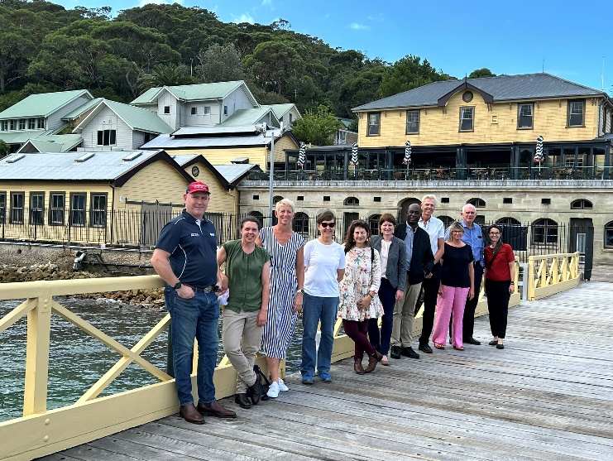

AHC members and observers at the Sydney Institute of Marine Science. Photo: Vicki Asciak, NSW Department of Primary Industries and Regional Development.