Prepared for the Department of Agriculture, Fisheries & Forestry
10th April 2026

Independent review of viability of night-time livestock vessel inspections
  - Final report
Disclaimer
This report is for the use of the client only and is confidential information. If you have received a copy of this report in error, please delete it and notify the sender. Ausvet gives no warranty that the information contained in this report is correct or complete and shall not be liable for any loss howsoever caused, whether due to negligence or other circumstances, arising from use of or reliance on this information.
Any mention of products or services is based on material presented to Ausvet, or illustrative, and should not be taken as endorsement of those products or services, or suggestion that they have been fully tested for any purpose.
© 2026 Ausvet
This work is copyright and, apart from any fair use as permitted under the Copyright Act 1968, no part may be reproduced without written permission from the publishers, Ausvet. Requests and inquiries concerning reproduction and rights should be addressed to Ausvet at the address below.
Ausvet
5 Shuffrey St, Fremantle, WA, 6160 Australia
www.ausvet.com.au
ABN: 64 613 142 9

Executive summary
Background
In 2017, the Department of Agriculture, Fisheries & Forestry ceased all night-time vessel biosecurity inspections for returning commercial and non-commercial vessels. At the time, it was deemed that detection of Biosecurity Risk Material (BRM) could not be adequately managed during night-time inspections due to issues such as limited lighting and altered insect activity. This applied to all incoming vessels, regardless of the vessel type – commercial and non-commercial.
Restricting biosecurity inspections to daylight hours may impede the operational efficiency and economic viability of livestock carrier vessels. The livestock industry has requested an independent review of existing policy and scientific evidence to evaluate the scientific effectiveness and operational feasibility of night-time inspections. Contingent upon initial findings, the project aimed to evaluate potential mitigation measures that could be implemented to support the reintroduction of night-time inspections.
The risks associated with fatigue and operator error are important for the conduct of effective inspections, and have been considered. Issues associated with performance and human-resource management were not a part of this review.
Methods
The review consisted of four components, including:
- a literature review on relevant topics pertaining to livestock carrier vessel inspections being conducted at night-time
- a descriptive data analysis of inspection data from 2016–2025 (limited scope)
- vessel inspection observations of livestock carrier vessels arriving in Darwin and Fremantle ports
- the development of a decision criteria support framework to assist the Department in deciding whether the biosecurity risks associated with a night-time inspection can be effectively mitigated.
Darwin and Fremantle were chosen for observations as they have the highest frequency of livestock carrier vessel visits (and Ausvet staff are present at each of these ports).
Key findings and knowledge gaps
The review identified that the biosecurity risk profile of a vessel is more closely linked to its design, the experience of the crew and the origin than the time of day it is inspected.
Literature review
The review notes that all livestock carrier vessels currently undergo an in-person inspection on return to Australia, regardless of their compliance history. This is to align with Australia’s strict biosecurity standards to ensure that no BRM is present. Visual inspections require adequate conditions, such as sufficient lighting, and mental bandwidth to be effective. However, there are currently no illumination standards dictated for biosecurity inspections in enclosed spaces on vessels, and the outer decks of a vessel may present a range of lighting issues, such as high levels of glare and high contrasting shadows. Vessels that have closed decks rely on artificial lighting, regardless of the time of day. Therefore, the open decks are more important in assessing risks associated with night-time inspection.
The key target of inspections on livestock carriers is to assess risk due to BRM and hitchhiker pests (mostly invertebrate, but occasionally vertebrate). In this context, and given the recent epidemic spread of lumpy skin disease (LSD) and foot and mouth disease (FMD) in target markets, cleaning of livestock vessels has never been more important. There are generally high quality resources available to guide cleaning and assessment based on these risks, although less is known about the survivability of FMD virus on fomites or organic material in maritime environments. The inspections conducted by maritime staff were thorough and it would be extremely unlikely to miss a significant failure of cleaning and disinfection.
The risks associated with hitchhiker pests are less well defined. Strategic knowledge gaps regarding invertebrate detection at night and in enclosed spaces with limited diurnal experience must be closed to standardise risk management. Moreover, there is limited published research on the infective dose and survivability of LSD virus on potential hitchhiker insect vectors.
Other factors such as operator fatigue and work health and safety will impact the ability to undertake effective inspections and must be appropriately managed, creating additional resourcing requirements.
Vessel observations
Field observations confirmed that purpose-built vessels can achieve exceptional hygiene standards, with minor amounts of BRM detected upon inspection. All the vessels observed in Darwin during this project were purpose built for the carriage of livestock and had returned from carrying livestock to Indonesian ports. The Master and crew were familiar with the biosecurity standards and expectations for entering Australian territory. It was observed that the visibility in enclosed decks would be the same, regardless of the time of day, due to the need for artificial lighting at all times. Open livestock decks and other open decks of the vessel may potentially pose some challenges for night-time inspections, due to the need for more lighting and the subsequent formation of shadows. However, the glare that can be present during daytime inspections also impacts the ability for inspectors to effectively detect BRM.
Vessels entering Fremantle port during the project were more variable. Some matched the standards observed in Darwin, while others fell short, and required repeated inspection and cleaning cycles before they were cleared. Familiarity with Australian processes (assessed by recent visit history) appeared very high, but expectations may not have matched those of the inspectors. The short journey time from Indonesian ports to Australia would appear to be an issue for cleaning.
Conclusions
Arrival of vessels in Australian ports has been shown to be a pathway for the introduction of pests and disease, and a high standard of inspection of these vessels is appropriate for the protection of Australia’s biosecurity status. Based on the available literature, data and vessel observations, there is no definitive evidence confirming that livestock vessel inspections at night-time pose a higher risk of disease or invertebrate incursion than those conducted during daylight hours. These data are limited and the consequences that may accompany a failure of detection are high. Further research to address the knowledge gaps is warranted to support future decisions in this area, such as objective vessel performance metrics, lighting requirements, invertebrate biology and detection and virus viability on vessels, as well as the potential for increasing risk by delaying inspections. Incentives for higher performance should also be incorporated into the trial, as avoiding demerit points provides limited incentive given the requirement for 100% inspection of livestock vessels.
Conducting a 12-month trial will enable adequate data to be collected for a comparative study between daytime and night-time inspection. This will allow better understanding of the benefits and risks of night-time inspections. A risk-based approach to implement the trial (i.e. using a decision support tool) will ensure only those vessels that meet strict eligibility criteria will be authorised for night-time inspection.
Recommendations
The following recommendations aim to improve understanding around vessel risk to support a decision on the reintroduction of night-time biosecurity inspections. These include:
- Comprehensive data capture and vessel risk profiling:
Current inspection protocols can be improved by capturing more detailed historical and operational data to better understand the potential risk of each arriving vessel such as complete port and animal transport history, vessel Master changes and more detail on the location and type of detected BRM.
- Implementation of a standardised demerit system:
There are currently no formal procedures for vessels that consistently fail to meet biosecurity standards. To support better compliance, the allocation and management of demerit points could be improved by implementing compliance incentives and having a centralised system of demerit and vessel information that will allow for efficient risk profiling of vessels.
- Lighting optimisation and managing inspector fatigue:
Ensuring suitable illumination is available during all parts of the inspection is important to ensure consistent, effective observation and detection of BRM. This includes managing low and high light levels, and managing the effects of continuously changing light. Team resource management (which includes noise, fatigue, provision of on-demand services and other work health and safety issues) is critical to maintaining inspection performance.
- Comparative trial of night-time and daytime inspections:
Conducting a well-designed and implemented trial (of at least 12-months duration) to compare night-time vs daytime inspections is the only way to test whether night-time inspections can be done with no higher risk of introduction of BRM. Such a trial will involve direct comparison between the same vessels, being observed during the day and night. Identification and collection of all appropriate data parameters will be needed to enable analysis with adequate power to make an informed decision. To support this next step, Ausvet has developed a preliminary decision support tool to implement a risk-based approach for vessel eligibility for night-time inspection to minimise biosecurity risk.
Decision support tool
Vessel inspections present a number of risks for the introduction of BRM. Based on the current findings, there is limited scientific evidence to support the exclusion of night-time inspections on livestock carrier vessels, but the consequences of an unintended release of a pathogen or pest could be extremely high. As a result, we have recommended a trial that will provide adequate information that will allow for an informed decision to be made. To implement night-time inspections, there needs to be a strict decision support criteria to determine which vessels may be eligible for night-time inspection to mitigate any potential risks for BRM. Ensuring adequate surface illumination, reduction of inspector fatigue and other safety issues would require further investigation.
A two-part decision support tool was developed. Vessels are initially required to meet an eligibility criteria, based on port of origin, time since returning to Australia, origin of stock transported since visiting Australia, presence of feed, fodder and landed goods, and Master and crew status. Secondly, the Department has criteria associated with resources and facilities available at the berthing harbour, and may vary on a case-by-case basis.
To support the use of the decision support tool, we also recommend the development of a target invertebrate species list.

Contents
1 Introduction 2
2 Methods 3
2.1 Literature review 3
2.2 Data analysis 3
2.3 Vessel observations and data collection 3
3 Literature review 5
3.1 Legislative requirements 5
3.1.1 Emergency animal diseases and biosecurity 5
3.1.2 Routine inspections 5
3.1.3 Vessel lighting 6
3.1.4 Pratique 7
3.2 Vision, cognition and environment 8
3.2.1 Human vision 8
3.2.2 Mechanisms of night vision 8
3.2.3 Lighting and vision considerations for daytime and night-time inspections 8
3.2.4 Cognition and executive function 9
3.2.5 Summary of vision and cognition issues 10
3.3 Livestock carrier vessels 10
3.3.1 Vessel layout and capacity 11
3.3.2 Feed and fodder 12
3.3.3 Waste and cleaning of BRM 12
3.3.4 Matching risk to transit routes and visit history 12
3.4 Biosecurity risk material 13
3.4.1 Target invertebrate species 14
3.4.2 Factors that can impact biosecurity inspections 15
3.4.3 Foot and mouth disease 16
3.4.4 Lumpy skin disease 18
4 Descriptive analysis 19
4.1 Vessel and arrival port analysis 19
4.2 Inspection and demerit analysis 20
4.3 Livestock carrier vessels 22
4.4 Departure ports 25
5 Vessel observations and data collection 27
5.1 Overview 27
5.2 Darwin 27
5.2.1 Inspection processes and tools 27
5.2.2 Impact of lighting on inspection rigour 28
5.2.3 Biosecurity risks 28
5.3 Fremantle 28
5.3.1 Inspection processes and tools 28
5.3.2 Impact of lighting on inspection rigour 29
5.3.3 Biosecurity risks 29
6 Discussion 33
6.1 Key findings 33
6.2 Knowledge gaps 34
6.2.1 Lighting requirements 34
6.2.2 Invertebrate biology and detection 34
6.2.3 Foot and mouth disease virus viability in tropical/maritime climates 34
6.2.4 Vessel port history and other data parameters 35
6.3 Recommendations 35
6.3.1 Comprehensive data capture and vessel risk profiling 35
6.3.2 Implementation of a standardised demerit system 35
6.3.3 Lighting optimisation and management of inspector fatigue 36
6.3.4 Comparative trial of daytime and night-time inspections 36
7 Decision support tool 37
8 Conclusion 41
9 References 42

Tables
Table 1 Livestock carrier vessels observed at Darwin and Fremantle ports. 4
Table 2 Survivability of FMDV on soil, straw and hay. 17
Table 3 Survivability of FMDV on fomites. 18
Table 4 Total number of demerits due to ‘Livestock’ non-compliance (total number of demerits across all categories / total number of arrivals into Australia), categorised by vessel and year. 24
Table 5 Light measurements (lux) taken on vessels berthed in Darwin during daylight and night-time. 32
Table 6 Potential incoming livestock carrier vessel risk factors. 38

Figures
Figure 1 An example of an insectocutor found on the livestock decks 6
Figure 2 Increased risk of missing Biosecurity Risk Material as cognition drops (the "Vigilance Decrement"). Even with a conservative decision threshold (moved to the left) the ratio of false negatives to true positives increases. (based on Broadbent & Gregory, 1963). 10
Figure 3 A purpose built livestock carrier vessel with opened and closed decks. 12
Figure 4 Common livestock transport routes from Australia. 13
Figure 5 Total number of vessel arrivals into Australian ports between November 2016 and November 2025. 19
Figure 6 Total number of vessel arrivals into Australian ports categorised by month and port between November 2016 and November 2025. 19
Figure 7 Total number of livestock carrier vessel arrivals into Australian ports categorised by vessel from November 2016 and November 2025. 20
Figure 8 Total number of inspections categorised by inspection type at Australian ports between November 2016 and November 2025 (demerit due to non-compliance). 21
Figure 9 Total number of breaches by category for livestock carrier vessels between November 2016 and November 2025. 22
Figure 10 Total number of livestock inspections by month at Australian ports between November 2016 and November 2025, categories by inspection result (demerit or no demerit due to non-compliance). 22
Figure 11 Total number of livestock carrier vessel arrivals from different departure ports that have arrived into Australian between 2021 and 2025 (with 2 or more visits). 25
Figure 12 Livestock carrier vessel inspections conducted between November 2016 and November 2025, categorised by vessel. 26
Figure 13 Time points of ‘Livestock’ inspections on livestock carrier vessels between 2021–2025, with inspections where demerit points were applied in red. 26
Figure 14 An example of a mirror being used to observe the undersides or railings and gates 30
Figure 15 A comparison of illumination at various locations on open decks of a livestock vessel during the day and repeated at night. 30
Figure 16 Fodder troughs are hung on a raised railing to prevent damage during loading 31
Figure 17 Changes in light when a) a trough was obstructing direct lighting, b) the trough was not present, c) a LedLenser P7R torch was used to illuminate the space. 31
Figure 18 Vessel eligibility criteria for consideration of night-time inspections. 39
Figure 19 Department of Agriculture, Fisheries and Forestry decision criteria for night-time inspections (* refers to the risk posed by a vessel for the escape of non-indigenous insects due to an extended duration at anchorage or dock prior to inspection). 40

Abbreviations and acronyms
Abbreviation | Definition
ACCL | Australian certification for the carriage of livestock
ALAN | Artificial light at night
AMSA | Australian Maritime Safety Authority
ASEL | Australian Standards for the Export of Livestock
BRM | Biosecurity risk material
BSD | Biosecurity status document
DAFF | the Department of Agriculture, Fisheries and Forestry (the Department)
EAD | Emergency animal disease
FMD | Foot and mouth disease
FMDV | Foot and mouth disease virus
LSD | Lumpy skin disease
LSDV | Lumpy skin disease virus
MARPOL | International Convention for the Prevention of Pollution from Ships
NWS | New world screwworm fly (Cochliomyia hominivorax)
OWS | Old world screwworm fly (Chrysomya bezziana)
PAR | Pre-arrival report
RA | Risk assessment
WHS | Work health and safety
WOAH | World Organisation for Animal Health

Introduction
The Department of Agriculture, Fisheries and Forestry (DAFF, the Department) is responsible for regulating and managing biosecurity risks associated with livestock carrier vessels entering Australian territory. Within the Department, the maritime operations team undertakes biosecurity inspections across all vessel types during daylight hours, in accordance with current departmental decision support material.
Inspection protocols (work instructions) are guided by policy and scientific advice to ensure biosecurity risks are effectively managed. Daylight inspections offer greater visibility and reliability in detecting biosecurity risk material (BRM), which is critical in maintaining Australia’s biosecurity integrity. The Department continues to remain vigilant in monitoring global biosecurity threats, including lumpy skin disease (LSD) and foot and mouth disease (FMD), and is committed to proportionate, risk-based inspection protocols.
In 2017, the Department made the decision to cease all night-time vessel inspections. At that time, it was deemed that biosecurity risks could not be adequately managed during night-time inspections. This applied to all incoming vessels, regardless of the vessel type – commercial, non-commercial, bulk carrier, container carrier, pleasure craft, cruise liner and others.
The livestock industry has requested an independent review of existing policy and scientific evidence to evaluate the effectiveness and feasibility of night-time inspections. Loading cattle onto vessels is logistically complex, and there are strict welfare standards which must be adhered to. Restricting biosecurity inspections to daylight hours can impede the operational efficiency and economic viability of livestock carrier vessels. Contingent upon initial findings, the project aimed to evaluate potential mitigation measures that could be implemented to support the reintroduction of night-time inspections.
This document contains a literature review examining available information on various topics relating to livestock carrier vessel inspections being conducted at night-time, a descriptive data analysis of inspection data from 2016–2025, and inspection observations of livestock carrier vessels arriving in Darwin and Fremantle ports. A decision support tool has been developed which may assist the Department in determining the whether a night-time inspection of a livestock carrier vessel can be effectively implemented.

Methods

Literature review
A review of available literature was conducted to investigate whether biosecurity risks posed by returning livestock carrier vessels can be effectively managed when inspections are conducted at night.
Web of Science Core Collection (Clarivate) was used to search for peer-reviewed articles. Key search terms included combinations of the following: “vision”, “night-time”, “visual inspection”, “biosecurity”, “lighting”, “insects”, “foot and mouth disease”, “lumpy skin disease”, “old world screw worm fly”, “tabanids”, “circadian rhythm”. The Google search engine was used to further search for grey literature, presentations, and publicly available commercial information relevant to the review. A snowball approach was also used when searching with both databases whereby peer reviewed articles and grey literature that cite selected articles were screened for inclusion. Government-associated websites were searched for documents applicable to Australia’s biosecurity requirements.
The literature review identified information gaps. More research will be required to support future recommendations and information needs for developing a reliable decision support framework.

Data analysis
Two data reports were provided by the Department titled ‘Vessel data’ and ‘Demerit data’. The first report (Vessel data) contained information on vessel voyages arriving into Australian ports covering vessel details (i.e. name, type), inspection details (i.e. date, time, type, duration, demerit status) and vessel port history (i.e. previous departure port and arrival port into Australia). The second report (Demerit data) provided further data on inspection information, such as breach category and breach details and any additional comments.
A limited descriptive analysis was conducted, focusing on relevant data to provide background information and to support development of a decision support tool. Limited data were available for an extensive analysis and this was considered out of scope for the project.
For data cleaning, time-series data (i.e. time of inspection and duration of inspection) were assessed for outliers and plausibility. Inspections that took longer than 4 hours were removed as outliers (31 in total). A further 12 records were removed as inspection duration was only 1 minute and 1 row removed as departure port was blank. An additional 25 records were removed due to no time of inspection being recorded. Data were further categorised into day and night, with inspections conducted between 05:30h and 18:30h being classified as ‘day’ and the remainder as ‘night’.

Vessel observations and data collection
Livestock carrier vessels were observed at the East Arm Port, Darwin, Northern Territory, and Fremantle Port, Fremantle, Western Australia between the 28th November 2025 and 17th January 2026. In Darwin, six vessels were observed (Table 1) during routine daytime vessel inspections, and five were observed after sunset. The night-time observations occurred either during or after cattle loading, restricting which areas could be inspected. Light readings were recorded for the dock, top deck, bow end, mid deck and stern end of the livestock decks during the daytime inspection and again at the night visit using a Protech Digital Light Meter. Not all locations had readings taken at night.
In Fremantle, three vessels were observed, one of them on two occasions. The first vessel was loaded and departed before nightfall, so only daytime inspections could be conducted. During the course of the project, only one vessel was inspected that was not a purpose built vessel. Unfortunately, two vessels inspected in Fremantle failed inspection and had to be subsequently re-inspected, but were unable to be visited by the project team.

Table 1 Livestock carrier vessels observed at Darwin and Fremantle ports.
Port | Vessel | Vessel type | Daytime inspection | Night-time observation
East Arm, Darwin | Friesian Express | Purpose built - open and closed | Yes | Yes
East Arm, Darwin | Nine Eagle | Purpose built - open and closed | Yes | Yes – open decks only
East Arm, Darwin | Brahman Express | Purpose built - fully closed | Yes | Yes
East Arm, Darwin | Gloucester Express | Purpose built - fully closed | Yes | No
East Arm, Darwin | Gelbray Express | Purpose built - fully closed | Yes | Yes
East Arm, Darwin | Girolando Express | Purpose built - fully closed | Yes | Yes
Fremantle | Friesian Express | Purpose built - open and closed | Yes | No
Fremantle | Dareen | Converted – open and closed | Yes | Yes
Fremantle | Ganado Express | Purpose built – fully closed | Yes | Yes

Literature review

Legislative requirements

Emergency animal diseases and biosecurity
The Department is generally responsible for managing the biosecurity risks from commercial and non-commercial vessels returning to Australia. Regarding general plant and animal risks, vessels are managed through pre-arrival reporting, assessment and inspection of returning vessels arriving at Australian ports. For the duration of time a vessel is in Australian waters, vessels must report the following:
- the human health of travellers
- crew changes
- animals on board
- hitchhiking animals and birds
- plant and insect pests
- ballast water and biofouling.
The vessel operator is obligated to accurately report information per Section 193 of the Biosecurity Act. Where a vessel operator uses a shipping agent, the agent is responsible for the lodgement of accurate and timely pre-arrival reporting (DAFF 2025b).

Routine inspections
Returning livestock carrier vessels are classified as a ‘high biosecurity risk’ due to the nature of their cargo and the epidemiological profile of destination countries that these vessels may visit prior to returning to Australia (e.g. carrying infected vectors or contaminated waste). Therefore, all livestock vessels are inspected at berth on every return visit to Australia, irrespective of the vessel’s history (including demerit point status) or last departure port (DAFF 2025c). Inspectors may review previous inspection records to identify any prior areas of non-compliance (pers. comm T Ritchie). Vessels must be thoroughly cleaned, disinfected with sodium carbonate/soda ash (minimum 4% concentration) and disinsected (application of approved measures to eliminate insects to prevent introduction of new species or spread of vector-borne diseases) before arrival (DAFF 2025c). Current protocols approve the use of permethrin for residual disinsection (e.g. Coopex ®), and Pestigas-P (active ingredients Pyrethrins and Piperonyl Butoxide) or Insectigas-D (active ingredient Dichlorvos) for knockdown disinsection (DAFF 2022a). Permethrin must be applied via a low pressure applicator to a minimum of 10% of the surfaces of the open deck pennage areas, crew quarters, recreation areas, dining areas and any area that is unlikely to be adequately treated by the knock-down insecticide (DAFF 2022a). This process is expected to be undertaken before entering Australian waters. The knock down insecticides are to be used in all below deck and enclosed animal holding areas 2–48 hours before entering Australian waters. After the gas has been applied in the prescribed manor, the enclosed areas must remain sealed until permission is granted by the Department office to ventilate the areas (DAFF 2022a). Vessels must carry sufficient spare chemicals to conduct a full disinsection with knock down and residual insecticides (DAFF 2022a).
Insectocutors (Figure 1) must be used on all livestock holding decks (open and enclosed), with at least one present on each deck. They are required to have a minimum light intensity of 160 watts UV, with bulbs replaced every 18–24 months. They must be activated 24 hours after leaving the last international port enroute to Australia (DAFF 2022a). Any potential exotic insects, such as yellow faced blowflies, that are found are sent to the regional entomology department for identification (DAFF 2022a).
In response to the LSD outbreak in Indonesia in 2022, the industry and the Department’s biosecurity officers were formally advised to be vigilant in managing the biosecurity risk of returning livestock vessels from Indonesia. The Department issued targeted communications to vessel Masters and shipping agents to ensure any returning livestock vessels were compliant with Australia’s requirements. Following the subsequent notification of FMD in Indonesia, additional biosecurity measures were implemented, such as disinfectant footbaths, for all commercial and military vessels departing from Indonesia.
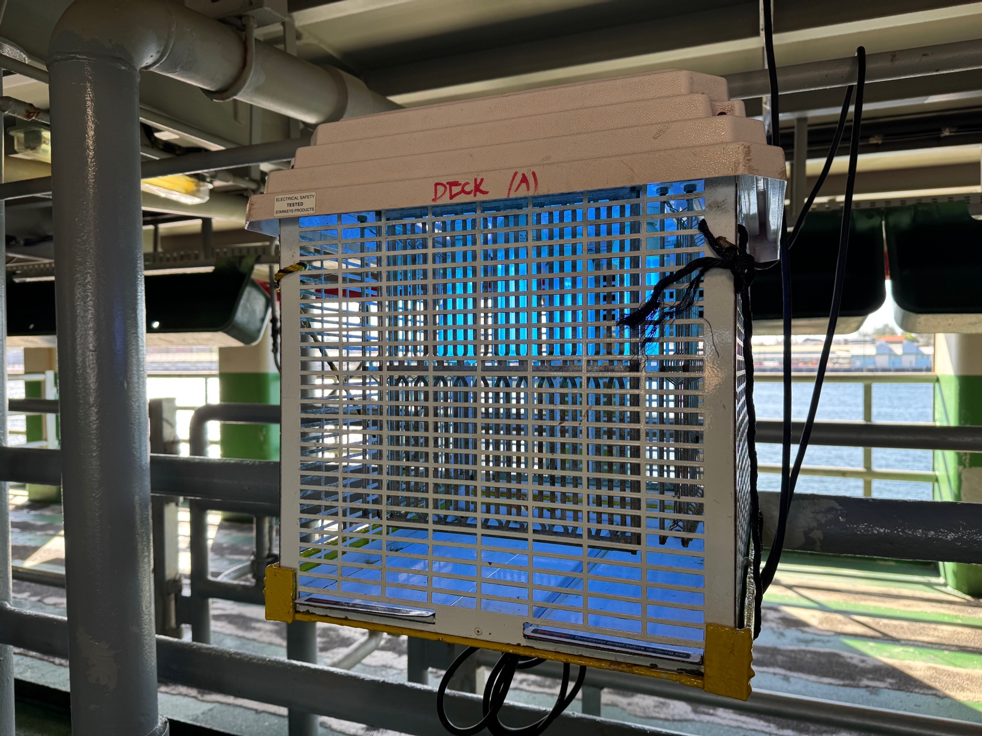
Figure 1 An example of an insectocutor found on the livestock decks

Vessel lighting
Appropriate lighting is important for the detection of BRM and invertebrates, as well as work health and safety (WHS). Lighting should be sufficient to allow personnel to conduct their job without causing injury through eye strain or awkward postures or positions (Safe Work Australia 2011). Lighting that is too dim or too bright (causing glare) needs to be managed appropriately. Lighting requirements vary depending on the task and primary colour of the work surface. Lighting levels up to 800 lux may be required (Safe Work Australia 2011).
Airports and international mail inspection centres have minimum lighting requirements incorporated into the infrastructure compliance standards for Approved Arrangements at First Points of Entry. The lighting requirements are to ensure effective screening can take place, while aligning with WHS guidelines (AS/NZS 1680 series of Australian Standards for General Lighting: Interior lighting guidelines for inspection tasks). Airport inspection areas generally require a minimum of 400–500 lux for detailed visual work, such as baggage screening and detector dog operations. At international mail centres, there is a minimum requirement of 400 lux for general inspections and 600 lux for detailed inspections such as unpacking small articles (pers. comm. Tracey Stonehouse). However, there is no minimum lighting requirement stipulated for livestock carrier vessel inspections, or vessel inspections in general. Inspectors use a Ledlenser® P7Core torch, or similar model. These torches typically emit ≈ 1000 lumens, although they can be adjusted up to 1400 lumens and as low at 15. This produces a light intensity (at a distance of 3–4 metres) which testing during the project demonstrated ranges from ≈ 700–1700 lux, depending on the degree of ‘coning’ of the torch beam (tests conducted on board during inspection).
During the course of the project, illuminance levels were recorded in lux at various positions on the vessel and during daytime and night-time at the same location. It was also noted that high risk inspection areas (i.e. under the bottom rail, in sumps and around objects) were nearly always aided by the use of a torch, whether daytime or night-time, to ensure consistent lighting and remove the impact of shadows.
The AMSA requirements for lighting on vessels carrying livestock specify a minimum level of illumination of 110 lux in livestock spaces, and a minimum of 20 lux in adjoining spaces (passageways between pens, beside pens and access routes) (AMSA 2019, Schedule 2, Part 3). These levels are insufficient for inspection.

Pratique
Pratique is defined as “permission for a ship to enter a port, embark or disembark, discharge or load cargo (goods) or stores” (DAFF 2025a). Pratique may be granted to a vessel following submission of a pre-arrival report (PAR) and assessment to ensure it does not pose a biosecurity or human health risk on entry to Australia. It must be granted prior to a vessel berthing, unloading cargo and personnel disembarking. All incoming vessels must submit a PAR if they intend to enter Australian waters and the voyage commenced outside Australia, or if the vessel was exposed to another conveyance while outside an Australian territory. Vessel Masters are required to provide details of any personnel illnesses with a Listed Human Disease, or if there has been a death onboard (DAFF 2025a). Depending on the vessel type, the vessels are then assessed for compliance history and high risk indicators to determine whether a routine vessel inspection is required. All livestock vessels require a vessel inspection on 100% of first arrivals at an Australian Port.

Vision, cognition and environment
Vessel inspection is critically dependant on the ability of the inspector to identify “objects” that are potential biosecurity hazards across a varying domain with inconsistent light, normal objects and other noise. This is based on the ability of the eyes to:
- capture the light (transduction),
- transmit the details to the primary visual cortex,
- construct a neural representation of the “object”, where perception of “what” it is seeing occurs, then
- finally a stage of cognition where the “image” is compared with known and unknown images and a decision on a course of action is made based on matching and training.

Human vision
The human eye is composed of a series of structures designed to capture and focus light on to the retina. These include vitreous humour (vitreous chamber), aqueous humour (anterior and posterior chamber), a crystalline lens and the cornea. The iris, retina, macula and optic nerve all help to transmit the images to the brain where they are processed. Vision is the term to describe the whole process of sight and processing images in the brain. The retina consists of photoreceptors (rods and cones) – rods are sensitive to low light conditions, whereas cones are responsible for collecting and transmitting colour information and high-acuity photopic (daytime) vision (Sánchez López de Nava et al. 2025).

Mechanisms of night vision
Scotopic (night) vision is the ability to see in dim or dark lighting. The mesopic range is the transition between photopic and scotopic vision where both cones and rods are active. This represents a complex physiological transition where visual acuity and colour discrimination begin to degrade as light levels drop. The process involves pupil dilation to allow more light to pass through the lens, and the activation of rods by the protein rhodopsin (Mehra and Le 2025). Rhodopsin can be sensitive to vitamin A deficiencies, leading to reduced ability to process sight into vision in low light settings (Mehra and Le 2025). The process of eyes adapting to dark lighting will vary depending on the intensity of prior light exposure. For example, the larger the contrast between bright and dark settings, the longer it takes for the eye to adapt. It can take up to 30 minutes for rods to fully adapt (Hecht et al. 1937). Therefore, moving from bright day light (such as an open deck at midday) to dark enclosed spaces will require longer duration for eyes to adapt.

Lighting and vision considerations for daytime and night-time inspections
Contrast sensitivity is the ability of the eyes and brain to distinguish the subtle differences between shades, shapes and brightness. It has been measured in diagnostic (e.g. laboratory) settings, but there is limited research demonstrating its application in real world settings. Spatial frequency is the way an image changes in detail over distance. This can influence contrast sensitivity, with decreases occurring as spatial frequency decreases (Bex et al. 2009; Maniglia et al. 2018). Further, lighting and sources of light, such as glare, can impact an individual’s contrast sensitivity (Maniglia et al. 2018). Under photopic conditions (bright light), cones are the predominant cells activated for vision. Therefore, contrast thresholds remain relatively consistent across different luminance levels (Maniglia et al. 2018). In mesopic conditions (the transitional stage of vision under bright light through to low light levels) the proportion of active cones decreases, while rods increase.
Glare is caused by light, usually environmental light, that enters the eye but does not actually aid in vision (Mainster and Turner 2012). It occurs when there is a high level of luminance and it is within a particular angle to the observer, usually in an upward direction into the eye and some glares are sufficient to cause damage to the eye (Brotas and Wienold 2014). Vailing glare is the term used when surface reflections can result in transient impaired vision (Brotas and Wienold 2014). However, there is limited research on glare in outdoor settings. The pupil constricts or dilates as part of the pupillary light reflex in response to available light. In high light settings, such as when glare is present, the pupil will constrict to limit the amount of light allowed in. This is an active process and in constant high light settings can result in ‘pupillary unrest’ (Hamedani et al. 2020). An increase in pupillary activity has been correlated to visual fatigue (Lin et al. 2015). As a result, glare also needs consideration when determining appropriate timing and light sources for vessel inspections.
Daylight hours provide high-intensity and diffuse lighting, which supports inspection across areas such as upper decks. However, the amount of glare due to natural light and reflective surfaces may negatively impact an inspector’s ability to adequately conduct observations in these locations. In lower decks, only artificial lighting is available. Artificial lighting can provide light of variable intensity and has a narrow and specific directional focus. This can lead to more shadows and lower contrast of objects. Rod cells are predominantly active in low light settings, which can impact an individual’s ability to accurately perceive colours and detect contrasts (Wang et al. 2025). As it can take up to 30 minutes for eyes to fully adjust to low light settings when transitioning from full exposure, it is important that inspectors take this into account when they plan their inspection route, or ensure that they wear appropriately shaded lenses when they are working outdoors to reduce the adaption time when moving between different areas.

Cognition and executive function
Presuming light levels are adequate, the “objects” that have been identified are compared with known objects, a decision on a course of action will require input from the pre-frontal cortex. With training and experience a degree of automaticity develops, but decision making is still required. As with all tests, a sensitivity threshold exists between a true positive result (or signal) and a negative result (noise). Substantial research (reviewed by Klein & Feltmate, 2025) shows that this threshold is affected by factors including time on task, repetitiveness, general fatigue and alertness. (Klein and Feltmate 2025)
Research firmly establishes that performing complex visual tasks after midnight conflicts directly with inspection performance, primarily due to a severe drop in sustained attention known as the “vigilance decrement”. Foundational studies, such as the Mackworth Clock Test, alongside modern reviews by chronobiologists like Valdez (2019), demonstrate that the ability to maintain high-level focus degrades over time. This cognitive decline peaks during the biological “circadian trough” between 2:00 AM and 5:00 AM—a window where rising melatonin and dropping body temperatures actively force the brain to shut down, making it incredibly difficult for an inspector to maintain the prolonged alertness needed to spot rare biosecurity hazards. Figure 2 shows the change in false negative detections (missed BRM) as the signal and noise curve overlap increases during this window.
Compounding this loss of vigilance is the deterioration of oculomotor function and visual processing. Sleep medicine researchers, including Fransson et al. (2008), Flynn-Evans et al. (2026) and Stone et al. (2019), have documented that as sleep deprivation sets in, the rapid eye movements (saccades) required to effectively scan an environment are impaired and can significantly slow down and become erratic. The eyes physically struggle to track movement, maintain fixations, or process visual contrast efficiently, meaning a fatigued inspector cannot reliably scan a vessel’s hull or quickly distinguish a camouflaged pest from its background, even when using a performant torch. This time of day also creates a WHS risk for staff who are required to travel longer distances to attend inspections. (Fransson et al. 2008; Valdez 2019; Broadbent and Gregory 1963; Flynn-Evans et al. 2026; Stone et al. 2019)

Figure 2 Increased risk of missing Biosecurity Risk Material as cognition drops (the "Vigilance Decrement"). Even with a conservative decision threshold (moved to the left) the ratio of false negatives to true positives increases. (based on Broadbent & Gregory, 1963). (Harrison and Horne 2000; Khan et al. 2023)
Finally, this combination of sensory limitation and circadian strain overwhelms the prefrontal cortex, leading to dangerous levels of decision fatigue. Research by cognitive psychologists like Harrison and Horne (2000) and Kahn et al. (2023) highlight that a sleep-deprived brain quickly loses its working memory capacity and begins to rely heavily on cognitive shortcuts, or heuristics, to conserve energy. Instead of actively evaluating object images against mental templates of biosecurity threats, humans are neurologically predisposed to default to the path of least resistance—assuming a lump is just harmless dirt or rust—which drastically increases the risk of false negatives during any form of inspections. Even using conservative decision thresholds will only have a limited impact on reducing this.

Summary of vision and cognition issues
Inspection of upper and open decks will face challenges, regardless of time of day. During daylight hours, glare may be considerable, which can lead to reduced ability to interpret the environment, inspector fatigue and impact the ability to smoothly transition between areas of the vessel. Whereas, inspections at night-time may result in challenges in accurately identifying BRM if contrast sensitivity is reduced. Regardless of the time of day, constantly varying light levels across the vessel will create a risk for fatigue and need to be considered in any decision making around inspection processes. As inspection time increases and optimal time of day decreases, the risk of poor decision making around risk increases.

Livestock carrier vessels
Livestock vessel design and operations are major contributors to the risk of introduction of pests and other BRM. The very features that improve their suitability for the carriage of livestock may complicate inspection activities.

Vessel layout and capacity
Livestock carriers may be purpose-built or converted cargo carriers, and may have ‘open’ or ‘closed’ pens, or a combination (Figure 3). Open-pens utilise natural air flow, supplemented by venting where needed. Closed-pens are fully enclosed and require mechanical ventilation, but do provide a more controllable environment for livestock.
Vessel size typically ranges between 4000m² to 11,000m² (ALE 2023). The layout and capacity will differ depending on whether the vessel has been purpose-built or converted to carry livestock. To carry Australian livestock, the vessel must be issued with an Australian certificate for the carriage of livestock (ACCL) (AMSA 2019). When applying for an ACCL, the following scale drawings must be submitted to Australian Maritime Safety Authority (AMSA) providing details of (AMSA 2022):
- The design, material, methods of construction and arrangement of fittings for the containment and movement of the livestock
- Ventilation arrangements, including current test measurements, together with the gross volume of enclosed spaces
- Lighting
- Provisions for storage and distribution of fodder and water
- Drainage arrangements
- Arrangements of main and secondary supplies of power
- Provision of firefighting appliances
- The general arrangement of the vessel, before and after modification, to carry livestock if a converted vessel.
The concerns for a livestock carrier vessel are to ensure balance with even weight distribution, structural features associated with holding livestock are sound and will not fail mid-voyage, ventilation is optimised, and heat stress is minimised. In addition, the Marine Order 43 (MO 43) outlines the minimal requirements for pen sizes (AMSA 2019). Under the Australian Standards for the Export of Livestock (ASEL) 3.2 (Standard 5.3.2: Table 9) for animals loaded at a port north of the latitude 26ºS, the minimum space required per head ranges from 0.99m² for 200 kg cattle to 1.813m² for 500 kg cattle (DAWE 2021). However, exporters can apply to use alternative pen spacing for these animals when accessing ‘near’ or ‘far’ markets (Standard 5.3.3: Table 10a and 10b). These range from 0.77m²/head for cattle 200 kg to 1.725m²/head (near markets) and 1.790m²/head (far markets) for cattle 500 kg (DAWE 2021).

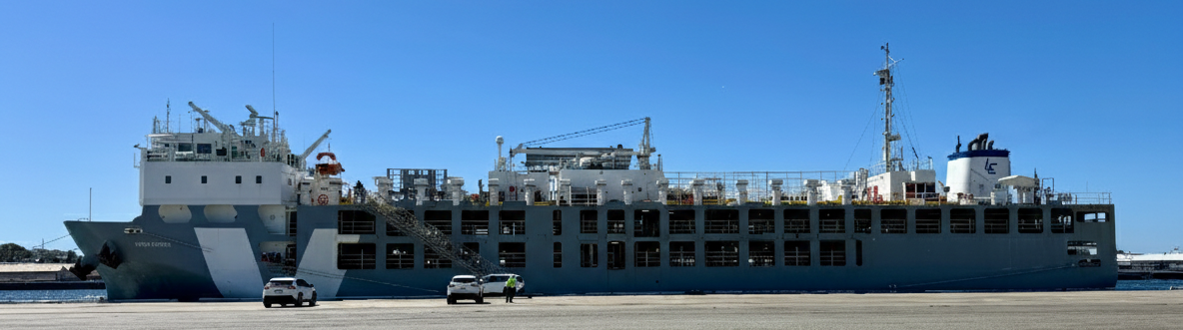
Figure 3 A purpose built livestock carrier vessel with opened and closed decks.

Feed and fodder
Management of fodder is important for risk management on returning voyages. Voyages from Australia are typically classed as short (<10 days), or long (10-31 days) (DAWE 2021). Under ASEL guidelines, voyages must be carrying fodder at a rate of 2.5% of liveweight per head per day, with a minimum of 1% of the required feed as chaff or hay (Standard 5.3.7). Standard 5.1.14 (d) states that fodder is only allowed to be loaded post departure (i.e. sourced from another country) under exceptional circumstances and with written approval from the Department, and that importing country requirements must be met. Further, Standards 5.1.15 and 5.1.16 state that a minimum of three days of reserve feed and water must be carried on vessels to account for any unexpected delays, in addition to extra loading/unloading of provisions that must also be carried (DAWE 2021). As a result, on most voyages, vessels might return to Australia already carrying some fodder, creating a potential biosecurity hazard for exotic pests or insects. Under the ASEL Standard 5.1.14, Australian-origin feed from a previous journey may remain on the vessel in a feed storage tank or suitably secured on deck, provided that the tank/deck is completely emptied and cleaned at least every 90 days. If any feed is not suitable for consumption, the entire storage tank should be emptied and cleaned. Records must be kept of the emptying and cleaning schedules and available for review by authorities when requested (DAWE 2021).

Waste and cleaning of BRM
Until the time of discharge, waste management on the vessel complies with the AMSA MO 43 and ASEL. This covers frequency of cleaning (normally every 3–4 days, but depends on deck condition), compliance with MARPOL and ship arrangements for the management of effluent and storage of sewage (if within 12nm of shore). Once the discharge is completed and the vessel returned to international waters, cleaning becomes the priority. Cattle feed as discussed in Section 3.3.2 will produce around 10–15kg per day, or around 25 tonnes per day on a medium sized vessel. This is removed, and all surfaces cleaned (including walls, pen rails, gates and fodder and water troughs) to ensure no BRM remains. The vessel is then treated with soda ash or Virkon at a prescribed rate, and once completed disinsection can begin.

Matching risk to transit routes and visit history
Common destinations over the last decade or so include countries in the following regions: Middle East/North Africa, South East Asia, North East Asia, South East Europe, Madagascar, Sri Lanka, western Russia ports and Mexico (Sadler et al. 2021). Vessels may do several back-to-back voyages between Australia and a foreign port (Figure 4). These vessels are anticipated to pose a lower risk as the Master and crew are aware of the strict biosecurity requirements in Australia, and have experience meeting this high standard of cleanliness. These vessels also have a negligible likelihood of transporting infectious livestock as they have only been carrying Australian livestock. However, those with shorter return voyages may face challenges in cleaning to a high standard due to limited time. A four day return voyage from Indonesia to Fremantle only allows three days for cleaning before the holds have to be treated with soda ash and Insectigas®. As a result, vessels may travel slowly or slightly longer routes to allow for time.
As vessels are contracted by various export companies, they may have voyages between other countries before returning to Australia. The biosecurity requirements and standards of these countries may be lower than what is enforced on entry to Australia. This may increase the likelihood that vessels may transport infectious animals, and become more heavily contaminated with BRM.
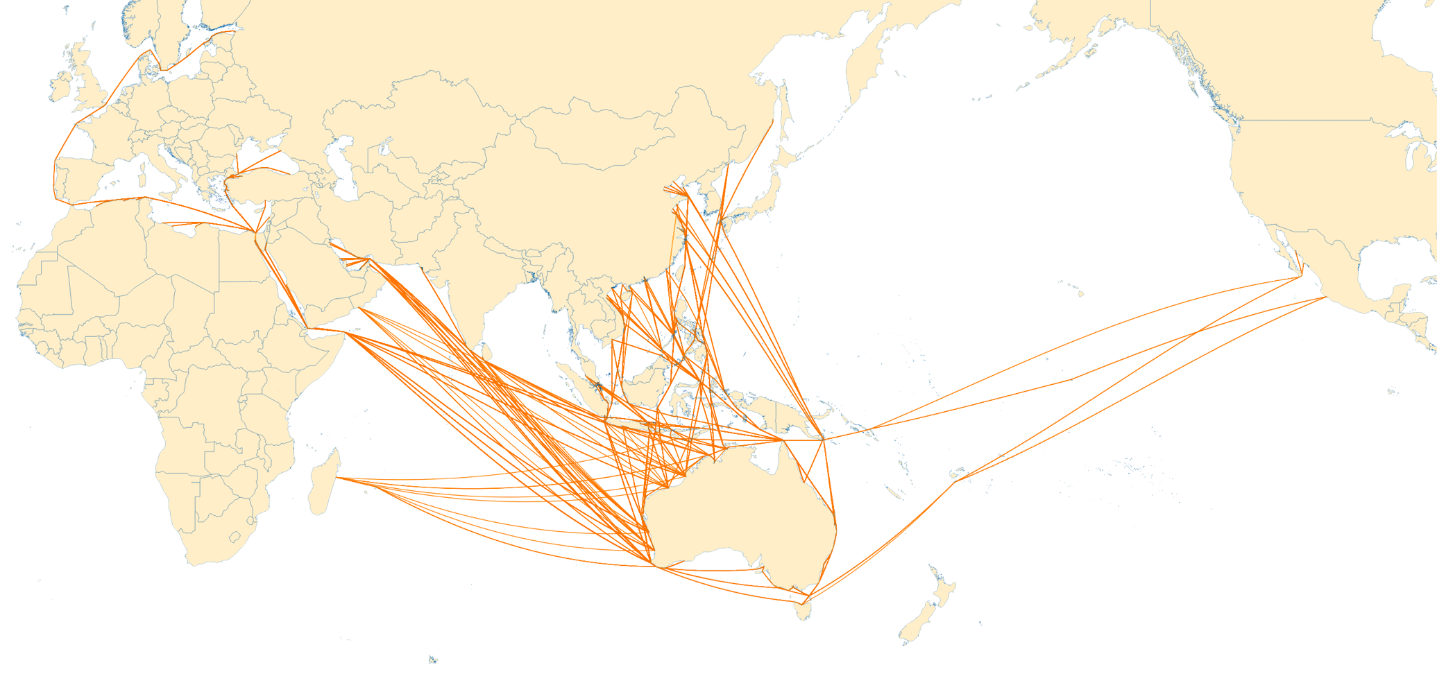
Figure 4 Common livestock transport routes from Australia.

Biosecurity risk material
Biosecurity risk material refers to, but not limited to animal material, live animals such as rodents, food scraps, plant material, live plants, live invertebrates, and evidence of their presence, plant pathogens, soil, and water (DAFF 2023). As discussed previously, all incoming livestock carrier vessels, regardless of their port of departure are required to undergo returning vessel inspections. When the inspections are occurring, inspectors look for evidence of live or dead stow away animals, including invertebrates. Surfaces will be inspected for evidence of egg masses, holes or frass (the powdery substance expelled by borers). Unprocessed plant material, even that used as packaging may harbour pest invertebrate or seeds. Stagnant or pooled water should not be present as it can harbour invertebrates such as mosquitoes and other pest eggs. Organic material, such as mud or manure on equipment and machinery can provide environments for eggs and larvae (DAFF 2022b). Organic material can also contain pathogens, such as FMD Virus (FMDV). However, if appropriate biosecurity measures are implemented when personnel disembark the vessel, such as footbaths, the likelihood of FMDV being spread should be reduced.
Commercial and non-commercial vessels are known to be vectors for terrestrial invertebrates. There are three primary introduction routes, 1. contamination of food stores (human and cattle), ornamental plants, wood, animals, and freshwater storage, 2. hitch hiker or stowaways associated with cargo and 3. within vessel infrastructure (McKirdy et al. 2019). If invertebrates are allowed to become established within a vessel, eradication can become extremely challenging as they will inhabit niches that are inaccessible and not visible on routine inspections (McKirdy et al. 2019). Thorough inspection with portable light sources is required in areas where invertebrates may hide, regardless of time of day.

Target invertebrate species
Invertebrates may follow one of three activity patterns: nocturnal, diurnal and crepuscular. While nocturnal and diurnal invertebrates are active at night and during daylight hours, respectively, crepuscular invertebrates are most active at twilight hours i.e. around dawn and dusk. These activity patterns may impact the ability of detection during certain times of the day. However, there is a lack of research documenting how artificial lighting in fully enclosed spaces influences invertebrate circadian rhythms.

Screw worm fly
Old world screw-worm fly (OWS) (Chrysomya bezziana) and new world screw-worm fly (NWS) (Cochliomyia hominivorax) are exotic to Australia. Their introduction would cause significant impacts on livestock production and public health. Australia’s close neighbours, namely Papua New Guinea and Indonesia, currently have OWS and pose a potential risk to Australia (AHA 2020). NWS occurs in southern-central America and the Caribbean islands, so may pose a threat if there are any livestock vessels returning from this region that have not been adequately cleaned of organic material.
Adult flies lay eggs in wounds of mammals and birds. The maggots then drop from the wound to the ground where they bury into soil to pupate. The adults are consider diurnal, primarily feeding during daylight hours (AHA 2020).
Adult OWS have the ability to fly an average of 11km, but may fly up to 100km under the right climatic conditions, such as increased wind and warm humid temperatures (Queensland Government 2024). The feeding frequency of adult OWS is not investigated in current literature. Thus, it is unclear how long one may survive on a vessel if its key food sources are absent. If they are able to survive a voyage without feeding, then there is the potential likelihood that an adult could fly from the vessel once at anchorage or berth.

Culicoides
Culicoides species are small (1-5mm) biting insects (midges) of medical and veterinary importance. They are vectors for numerous important arboviruses, such as epizootic haemorrhagic disease virus and bluetongue virus. Only the females feed on blood and require a blood meal to produce eggs (Mills et al. 2017). Larvae develop in moist organic material and stagnant water. Adults are sexually mature at 24–48 hours post-eclosion and are crepuscular, being more active in the late afternoon and evening (Mills et al. 2017).

Culex and Aedes mosquitoes
Mosquitoes rely on water for the early development of their offspring. Culex and Aedes mosquitoes typically lay eggs on still or stagnant water and have a wriggler (larvae) and tumbler (pupae) stage within water. Culex eggs may hatch within 1–2 days of being laid. Aedes may also lay their eggs on dry substrates where they remain dormant until they are submerged in water and hatch. Mosquitoes do not generally fly long distances in search of feed or egg sites; winds may move them further. The females require a blood meal to breed while the males feed from nectar (Inzecto 2023). Mosquitoes are vectors of notable animal diseases such as LSD and Rift Valley Fever (zoonotic).

Biting flies: genera Tabanus
Flies from the genera Tabanus include large biting flies such as march flies, horse flies and deer flies. They are generally 10–30mm in length, and can be responsible for the spread of disease and reduction in livestock weight gains. These flies are haematophagous feeders, with females requiring blood meals to lay eggs. Eggs are generally laid on organic material, rocks or debris that overhang water. Larvae then migrate to damp organic material near water once hatched (University of Saskatchewan 2021).
By ensuring all organic material and stagnant water is removed from a vessel as soon as livestock are discharged will reduce the likelihood of the above invertebrates remaining present on the vessel for a return voyage.

Lighting and insect activity
The visual spectrum of insects is generally concentrated within the wavelength range of 253–700nm (Pan et al. 2021). However, different insects are attracted to different light sources. Nocturnal insects are attracted to ultraviolet (UV) radiation (~100–400nm), whereas diurnal insects are commonly attracted to yellow light (~570–590nm) (Shimoda and Honda 2013). Additionally, insects have an internal circadian rhythm which dictates times of activity, eclosion and migration (Numata et al. 2015). The photoperiod, including twilight and dusk, is believed to have more influence over circadian rhythm than the absolute day length (Kuriwada 2025). The lighting environment on and within a vessel has high levels of artificial light at night (ALAN) which may alter the perceived photoperiod (Kuriwada 2025). Further, many insects will enter a hormonally triggered diapause during winter, which is initiated by decreasing day length. The presence of ALAN on vessels may prevent this from happening, especially on voyages further from the equator (Kuriwada 2025; Levy et al. 2024).
ALAN on vessels at anchorage has been shown to attract insects as inspectors have reported finding endemic insects on vessels. Therefore, it could be assumed that if the port or harbour is within the vicinity of a coastal area with significant ALAN, then insects from the vessel may fly to land. It is unclear how continuous artificial light, such as that found on enclosed decks, influences insect behaviours, such as locomotion, oviposition and feeding. For invertebrates that rely on photoperiodic cues, continuous artificial light (as experienced on fully enclosed decks), is expected to have some influence on behaviour (Jiang et al. 2023). Nocturnal and crepuscular insects are expected to experience more pronounced detrimental impacts, whereas diurnal insects may initially have positive impacts, such as extended feeding periods. In the longer term, prolonged light is expected to lead to negative impacts such as reduced oviposition (Jiang et al. 2023). Further field research is required to determine the effect of vessel lighting on insect activity and the likelihood that insects on open decks may fly to land if there are sufficient attractive light sources.

Factors that can impact biosecurity inspections
Biosecurity inspections are manual, visual activities, that may be conducted in challenging environmental conditions. They require considerable mental bandwidth for concentration, visual processing, and decision making (Esfandi et al. 2024). A review of visual inspection found five key factors that contribute to inspection performance (See 2012):
- the inspection task i.e. complexity, standards, non-compliance rate
- the individual i.e. experience, visual acuity, age, biases, fatigue
- the environment i.e. lighting, noise, temperature, duration of work shift
- the organisation i.e. training, instruction, incentives, management support
- social factors i.e. communication, pressure, isolation.
Time constraints for inspection activities affect overall rigor and thoroughness. There is a higher level of detection success when inspectors are allowed to set the pace, and they are not under undue external time pressures (See 2012). Visual aids can improve inspection accuracy, such as mirrors, torches and magnifying glasses, if used appropriately. The use of these tools can simultaneously increase the cognitive demand and physiological pressure associated with changing light levels, and hasten the onset of fatigue. Regular breaks may be required to sustain inspection performance.
Environmental factors such as lighting, temperature and noise can play a significant role. However, finding the appropriate light level without inducing glare and affecting colour perception can be challenging (See 2012). Colour, focus (diffuse vs directional) and quality of the lighting can also influence inspector accuracy (See 2012). Surface and target BRM colours, along with the size of target BRM have been shown to impact the likelihood of detection, e.g. small, or low contrast surface and BRM as less likely to be detected (Esfandi et al. 2024). Further, colour vision has been shown to deteriorate with physical exertion (Tekavcic et al. 2017), while temperatures over 30°C can have a negative impact on complex mental tasks (See 2012). While Tekavcic et al. (2017) examined elite athletes, the conditions (high ambient temperature and relative humidity) experienced in enclosed decks of livestock vessels in northern ports, such as Broome, Wyndham, Darwin and Townsville, may cause similar physiological acidotic changes. High levels of noise, e.g. over 95dBA, can be detrimental to task performance, especially when ongoing concentration is required. Sound levels in excess of 90dBA are commonly experienced on board vessels in the livestock pen areas due to airflow fans. The use of suitable noise reduction PPE was not universal due to the need to communicate with vessel crew. Allowing inspectors to have regular mental breaks during these activities with high noise levels, such as in enclosed decks, may help. These regular breaks, at 30 minute intervals can also assist in maintaining a high level of vigilance (See 2012).
Mental or cognitive fatigue is another factor that has the potential to impact the effectiveness of biosecurity inspections. Those that occur late at night, early in the morning, or as part of a ‘swing’ shift have been found to be less accurate than those conducted in normal business hours (See 2012). Fatigue has been shown to negatively impact sustained attention for tasks, especially if they are complex and distractors are present (Csathó et al. 2012). Mental fatigue can lead to increased error rates, reduced concentration on high cognitive load tasks and a decreased ability to manage distractions (Csathó et al. 2012). These physiological effects should be taken into account when determining an inspectors ability to conduct a biosecurity inspection, regardless of time of day, and ensuring adequate time is available to allow breaks. Most inspections observed during this project had more than one inspector present during the inspection, as well as other DAFF staff and observers, so may not be representative of normal processes.

Foot and mouth disease
FMD is one of the priority diseases of concern for Australian pre-border and border biosecurity. FMDV is highly infectious via direct and indirect transmission routes. FMDV can easily contaminate fomites, and, depending on the climate (e.g. temperature and relative humidity) and presence of organic material (e.g. fodder, manure, mud), the virus can remain infectious for a few hours to up to 14 weeks (Bøtner and Belsham 2012). However, the majority of FMDV viability research has been conducted in temperate climates, with minimal data relevant to tropical climates.
If a vessel is used to transport non-Australian livestock between FMD endemic areas, there may be an increase in likelihood that a vessel becomes contaminated with FMDV. However, the likelihood of incursion into Australia is expected to differ depending on the port of entry in Australia – i.e. the environment in surrounding southern ports may be more amenable to virus survival. Available research describes the optimal conditions for FMDV survival in the environment as temperatures below 20°C and relative humidity above 55% (Mielke and Garabed 2020). Modelling the effects of temperature and relative humidity on virus survivability suggest that FMDV viability on vegetation increases when temperature and humidity are low (-6°C and 37.5%), or when relative humidity is high (86.1%) at increased temperatures (16°C and 37°C) (Table 2). These conflicting results suggest that the relationship between FMDV viability, temperature and humidity is complex. However, data are scarce and predominantly obtained in laboratory settings or temperate climates thus limiting their applicability in real world settings.
A potential source of FMDV on returning vessels may be organic material from livestock pens which has not been adequately cleaned from the drains, livestock sewage tanks or scuppers. Manure slurries may be produced during the cleaning process and FMDV can remain viable in this mixture for at least 24 hours at 35ºC or up to three weeks at 20ºC (Bøtner and Belsham 2012). However, the likelihood of FMDV being present in organic material on a vessel is negligible if there were no active FMD cases on board during the prior voyage.
Equipment can also act as a fomite, and may include personal equipment, such as boots, and other materials including cardboard, wood and metal items (Animal Health Australia 2022) (Table 3). Available literature that investigated virus viability on these fomites does not necessarily include hot and dry Australian conditions or the hot and humid conditions expected at sea. Therefore, it is difficult to determine the duration of viral viability on incoming vessels if not adequately cleaned. Further, vessels require footbaths at each end of the gangway, remaining crew are not allowed to leave the port and those that are disembarking have their footwear and any equipment inspected (DAFF 2022a). Thus, the likelihood that contaminated organic material will spread beyond the port is unlikely.
Table 2 Survivability of FMDV on soil, straw and hay.
Fomite | Conditions | Viability (days) | References
Soil surface | Summer conditions (Kazakhstan) | 3 | (Morgan 1993)
Soil surface | Autumn / winter (Kazakhstan) | 28 | (Morgan 1993)
Soil surface | 16.6 – 30.6 °C, RH 69% (Russia) | < 5 | (Podrezova 1969; Bartley et al. 2002)
Soil surface | Ambient temp ≤ 34°C & soil temp ≤ 50°C, RH 51% (Russia) | < 2 | (Podrezova 1969; Bartley et al. 2002)
Straw | 16.7 °C, RH 43 – 68% (experiment) | 28 – 42 | (Bedson et al. 1927)
Hay | Drought area (Kazakhstan) | 185 – 200 | (Morgan 1993)
Hay | Stored in dry and dark conditions | 105 | (Animal Health Australia 2022)
Hay | Stored in the light at 16.8 °C, RH 43 – 68% (experiment) | 14 – 21 | (Bedson et al. 1927)
Hay | Dry, stored in the dark at 16.8 °C, RH 43 – 68% (experiment) | ≥ 105 | (Bedson et al. 1927)
Hay | Damp hay, 16.7 °C, RH ~100% (experiment) | < 5 | (Bedson et al. 1927)

Table 3 Survivability of FMDV on fomites.
Fomite | Conditions | Viability (days) | References
Boots | Leather: contaminated with tissue fluids or blood, kept indoors at room temperature | 77 | (Animal Health Australia 2022)
Boots | Rubber: contaminated with tissue fluids or blood, kept indoors at room temperature | 77 | (Animal Health Australia 2022)
Sacks | Unknown environmental conditions | 140 | (Morgan 1993)
Cardboard, wood and metal | Contaminated with serum, stored at 4°C and RH 85% | ≤ 35 | (Gailiunas et al. 1969)
Cardboard, wood and metal | Contaminated with blood, stored at 4°C and RH 85% | ≤ 55 | (Gailiunas et al. 1969)
Cardboard, wood and metal | Contaminated with ground lymph nodes, stored at 4°C and RH 85% | ≤ 57 | (Gailiunas et al. 1969)
Cardboard, wood and metal | Contaminated with fat, stored at 4°C and RH 85% | ≤ 398 | (Gailiunas et al. 1969)

Lumpy skin disease
LSD is thought to be primarily spread via mechanical vectors, namely haematophagous invertebrates (Chihota et al. 2001; Tuppurainen and Oura 2012; Sprygin et al. 2019; Namazi and Khodakaram Tafti 2021). It is not known precisely how many insects are necessary to transmit a sufficient dose of LSD virus (LSDV) to initiate an infection in a bovine and it cannot be ruled out that a single insect is not capable of LSDV transmission under the right circumstances. However, based on experimental transmission studies, the minimum number of infectious invertebrates required for successful LSDV transmission is considered 14 Aedes mosquitoes (Hall et al. 2023).
In 2022, a risk assessment was conducted investigating the likelihood of LSDV introduction into Australia. The risk assessment reviewed several different entry pathways, including commercial non-livestock and commercial livestock vessels. There was a high level of uncertainty associated with the parameters involved in the risk assessment. However, the assessment found the risk of incursion via commercial non-livestock vessels was considered high if the vessel was returning from a country with a high bovine population. The result was highly sensitive to the probability of vectors dispersing from the port and landing on a vessel. Commercial livestock vessels were found to be lower risk than the other pathways assessed due to the decontamination measures that are required for permission to enter Australian territory. However, due to the high proportion of cattle in central Indonesia, the route to Darwin was deemed a potential incursion risk (Hall et al. 2023). The current mitigation measures in place, including cleaning and disinsection protocols, and arrival inspections are believed to be sufficient in managing any potential risk.

Descriptive analysis

Vessel and arrival port analysis
Vessel data between 18/11/2016 to 17/11/2025 were analysed. Sixteen different ports in Australia received livestock carrier vessels returning for inspection. The most frequently used ports were Darwin, Fremantle and Townsville (Figure 5). Darwin and Townsville service the northern Australian extensive cattle industry, while Fremantle services the cattle industry as well as the Western Australian sheep industry. Vessels arrived consistently throughout the year, with peaks in May and December (Figure 6).
A total of 37 different livestock carrier vessels returned to Australian ports between November 2016 and November 2025. The vessel with the highest number of arrivals included the Gloucester Express, followed by the Nine Eagle and the MV Greyman Express (Figure 7).
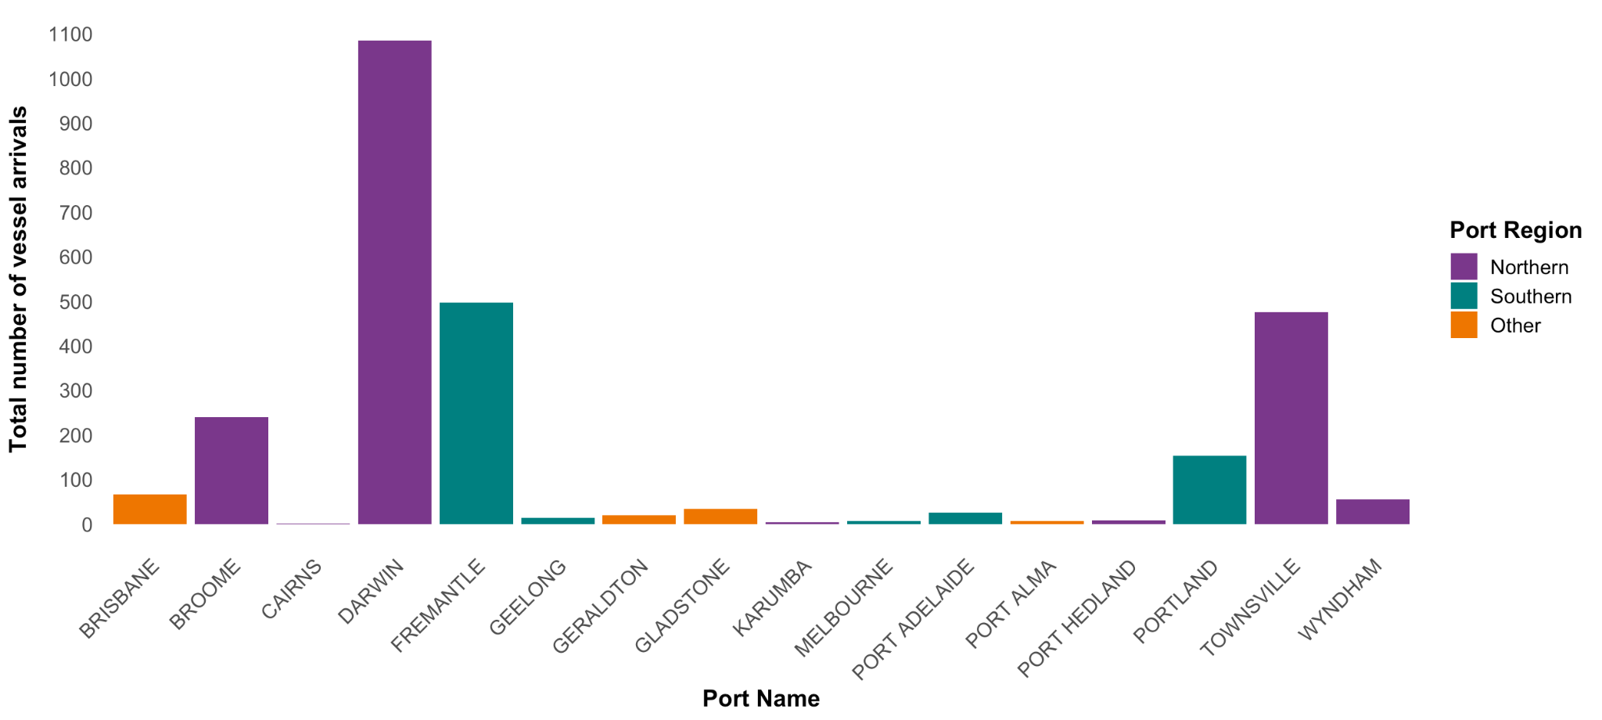
Figure 5 Total number of vessel arrivals into Australian ports between November 2016 and November 2025.

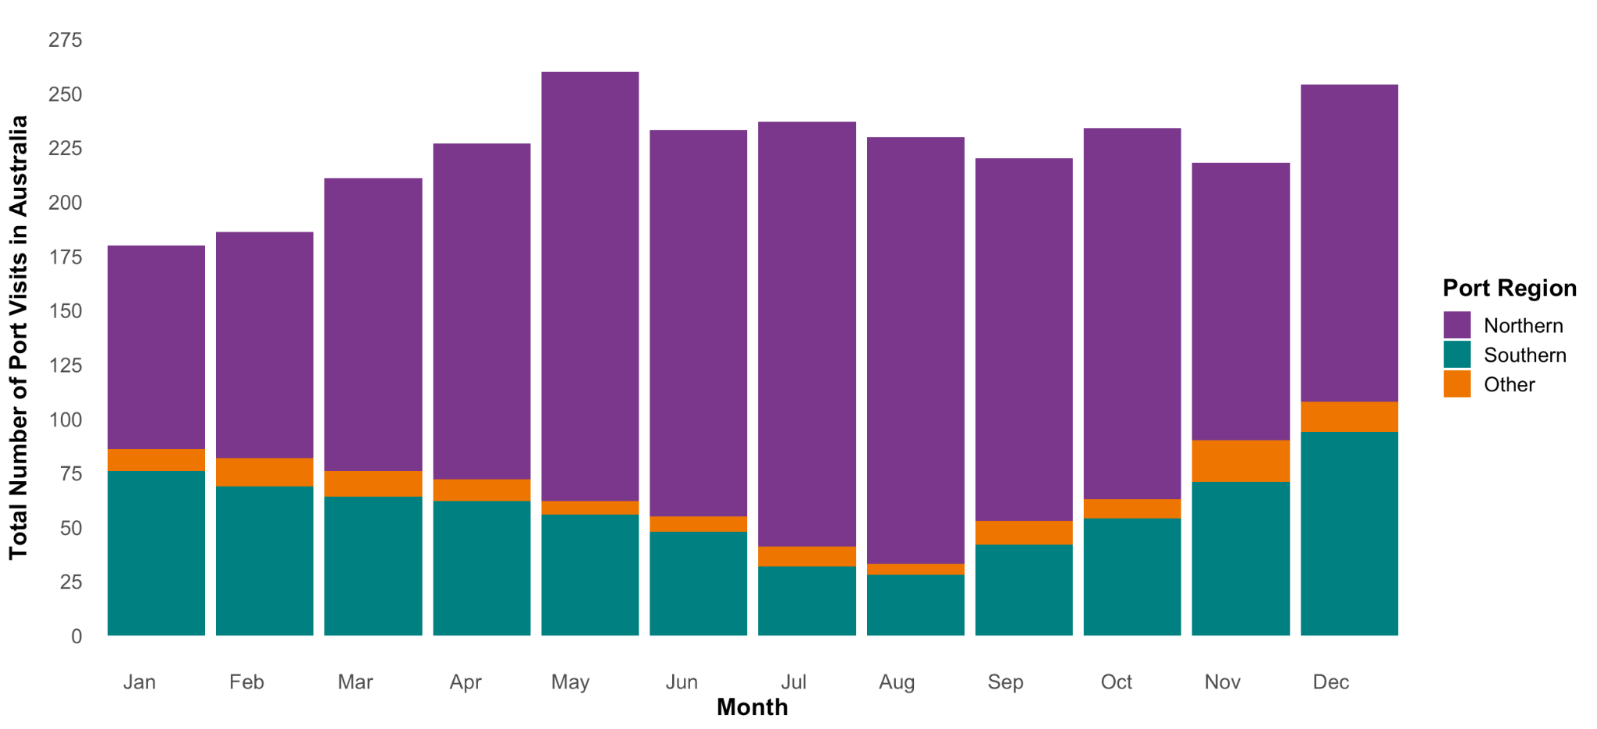
Figure 6 Total number of vessel arrivals into Australian ports categorised by month and port between November 2016 and November 2025.

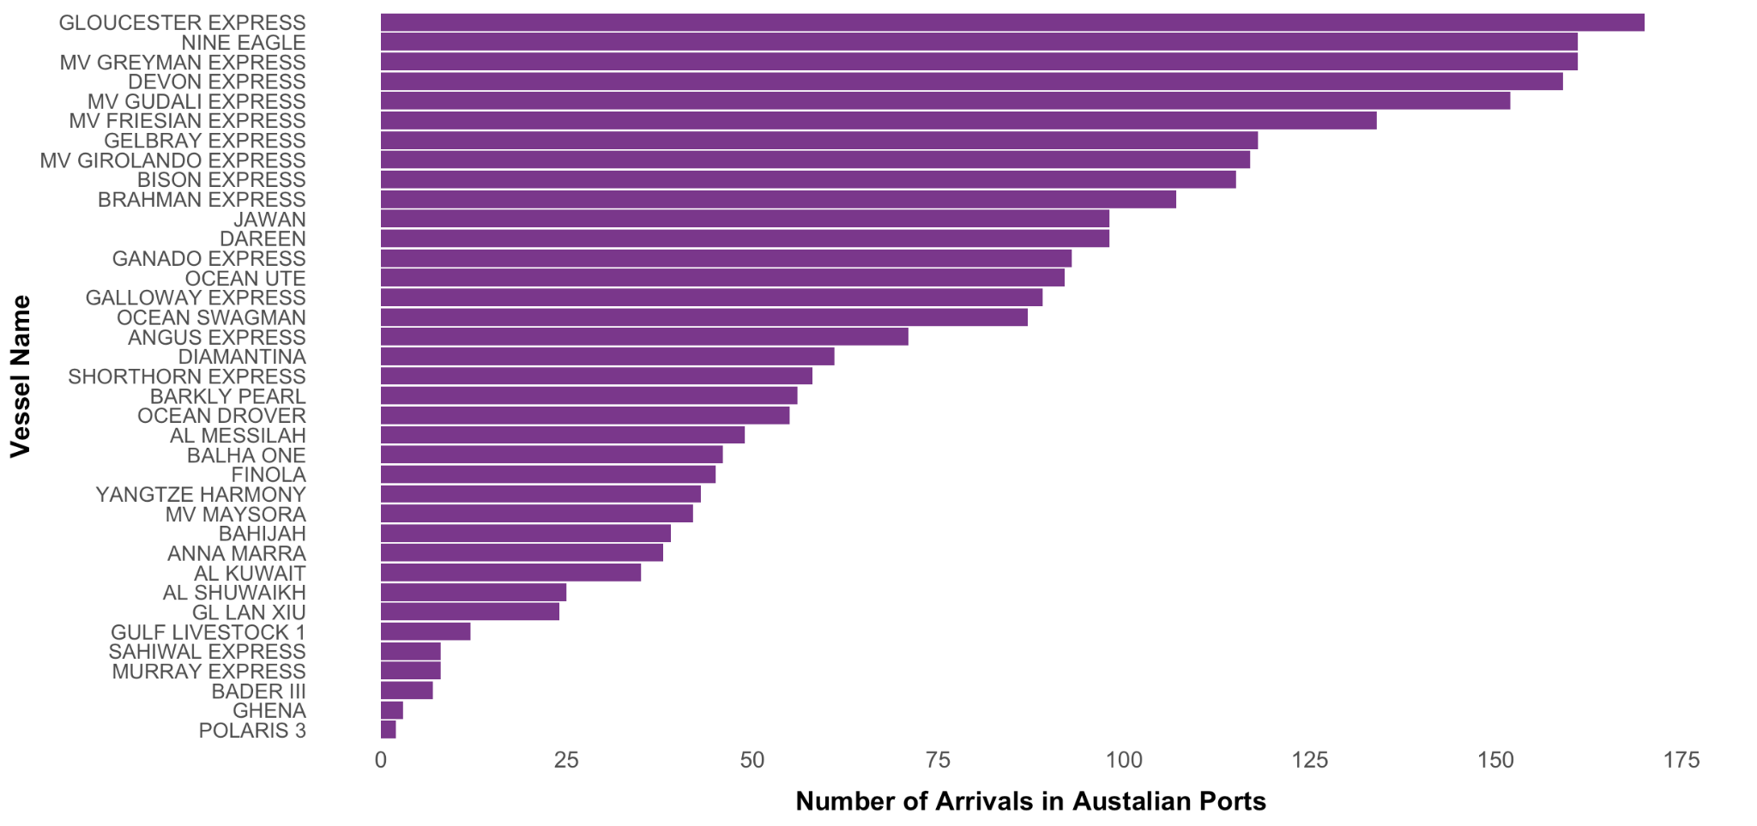
Figure 7 Total number of livestock carrier vessel arrivals into Australian ports categorised by vessel from November 2016 and November 2025.

Inspection and demerit analysis
A total of 5681 inspections were performed on livestock carrier vessels at Australian ports between November 2016 and November 2025. These were recorded under 12 different inspection type categories (Figure 8). All returning livestock carrier vessels must undergo a routine vessel inspection, as well as a specific inspection of the livestock related areas. The ‘Livestock’ inspections are defined as a thorough inspection of livestock decks, stockman rooms and returning feed and fodder. ‘Routine vessel inspections’ are defined as inspection of all the internal areas such as the galley, kitchen, hospital, crew rooms, the brig and external structure such as the top deck and waste storage. Demerits were applied to vessels for failure to meet the required standard. For example, if there was evidence of rodents, or insects, demerits would be applied. Demerits can be applied for both the routine and livestock inspection components. During the observed period, 2481 inspections were categorised as ‘Livestock’, 2178 as ‘Routine vessel inspections’ and 1021 as ‘Other’. For ‘Livestock’ inspections, 238 demerits were allocated between November 2016 and 2025 and 445 for ‘Routine vessel inspections’ and 160 demerits for ‘Other’.
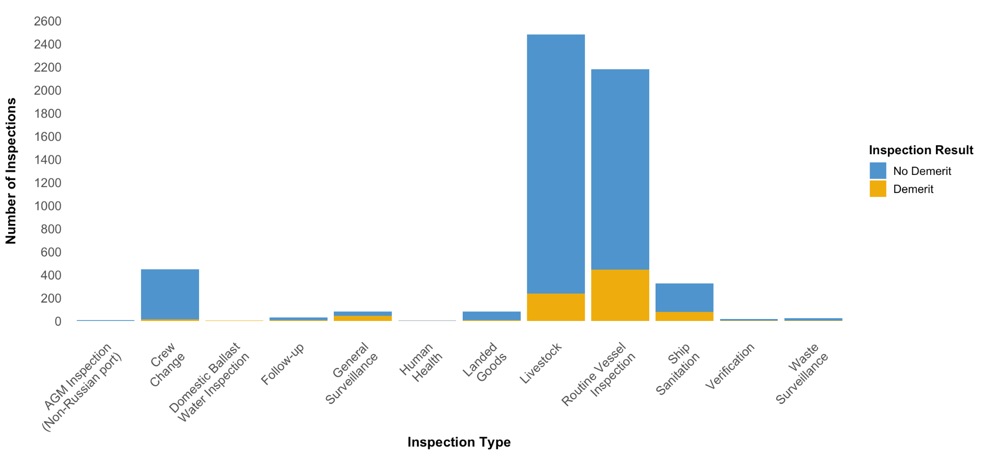
Figure 8 Total number of inspections categorised by inspection type at Australian ports between November 2016 and November 2025 (demerit due to non-compliance).

Demerit points are applied for non-compliance to biosecurity requirements and are used in the risk assessment of vessels to determine whether they require an in-person inspection. However, livestock carrier vessels are different as they all require an in-person inspection on every arrival, regardless of previous history. Figure 9 presents the total number of different non-compliance breach categories that were recorded between November 2016 and November 2025. Ballast water, livestock and insects were the most frequently recorded.
Figure 10 highlights the distribution of demerit points across the year and identifies where night-time inspections resulted in a demerit. A total of 126 breaches were recorded during night-time inspections, with ballast water (47 demerits), documents (18 demerits), insects (17 demerits) and livestock (12 demerits) being the top breach categories recorded. Livestock breaches were primarily ‘Failure to clean and treat decks that resulted in minor/major issues’. ‘Insects’ were all either minor or major infestations on board. Insects may be detected in the routine vessel inspection, such as in the food stores or general rubbish, or in the livestock inspection and may include flying insects. No data are collected to record where breaches occur on the vessel.
Overall, May had the highest number of livestock inspections (244 in total), with 79.5% conducted during the day and 20.5% at night. Darwin has the highest number of night-time livestock inspections (243 in total) across the data set. This is possibly due to the night-time ban not coming into effect until 2021, whereas other ports ceased night-time inspections in 2017. Some data were classified as night-time inspections following the ban on night-time inspections. However, this is due to the variation in sunset time between the different ports, with light still present at some ports post 18:30h - such as southern ports during the summer months.
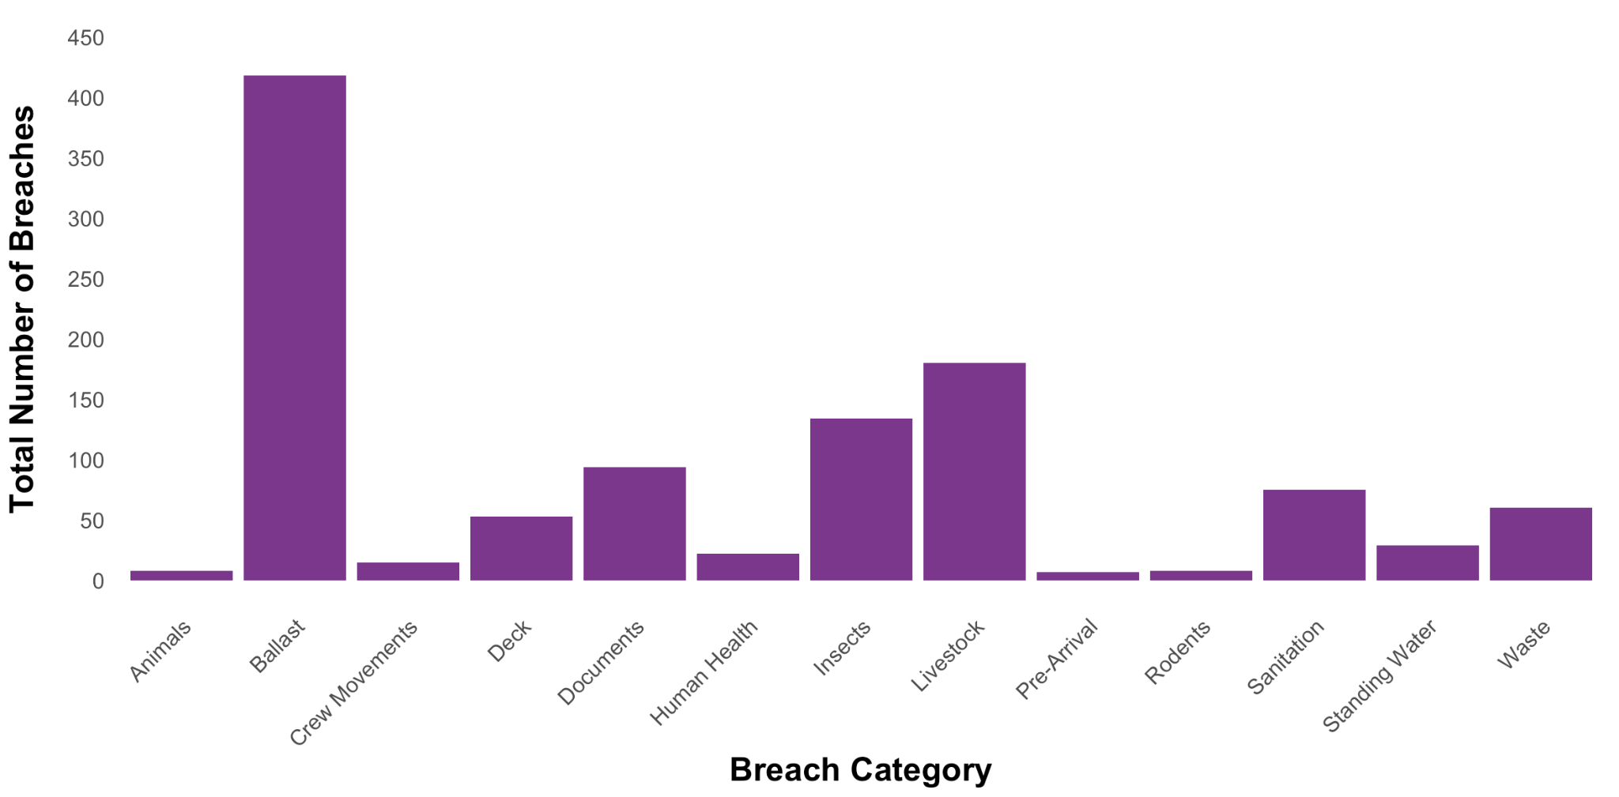
Figure 9 Total number of breaches by category for livestock carrier vessels between November 2016 and November 2025.

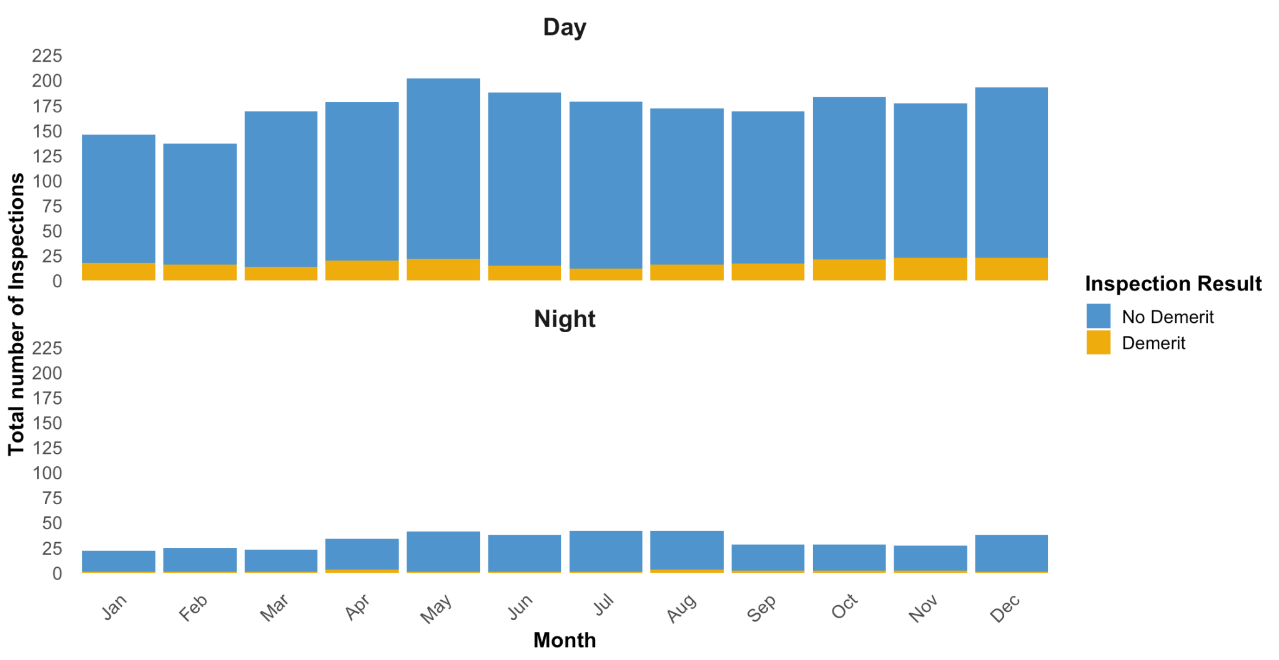
Figure 10 Total number of livestock inspections by month at Australian ports between November 2016 and November 2025, categories by inspection result (demerit or no demerit due to non-compliance).

Livestock carrier vessels
Table 4 summarises the allocation of demerit points to different vessels between 2016 and 2025. Vessel 28 received the highest total number of remedial actions (48), with the highest occurring in 2019 with three related to livestock non-compliance and seven to other non-compliance categories. In 2025, this vessel underwent seven remedial actions. These included livestock breaches due to failure to clean and treat decks, evidence of seeds/organic material on deck (moderate contamination), major insect infestation found on board and not following directions on Biosecurity Status Document (BSD).
The next vessel with the highest number of remedial actions included Vessel 21. Six were allocated during 2025, with five of those due to a livestock breach. This included with failure to clean and treat decks and one for an insect infestation found on board.
Vessel 1 has received the most demerits in 2025 (9 in total) for a range of breaches including critical rodent infestations, evidence of seeds/organic material on deck, not managing ship’s pet/animal as directed and failure to follow directions on BSD.
Vessel 21 had the highest number of arrivals into Australia (170 in total between 2016-2025; Figure 7). From these visits, 346 inspections took place, 43 resulted in a demerit (12.4% of inspections). In 2025, out of 46 total inspections, this vessel received 6 demerits. Five of these from livestock inspections and 1 from routine vessel inspection. Table 4 outlines the number of demerits by breach category for all returning livestock vessels.

Table 4 Total number of remedial actions due to ‘Livestock’ inspection non-compliance (total number of demerits across all categories / total number of arrivals into Australia), categorised by vessel and year.
Vessel (de-identified) | 2016 | 2017 | 2018 | 2019 | 2020 | 2021 | 2022 | 2023 | 2024 | 2025 | Total
Vessel 1 |  |  |  | 1 (2/1) | 2 (5/11) | 2 (6/9) | 1 (1/4) | 0 (2/2) |  | 2 (9/8) | 8 (25/35)
Vessel 2 | 1 (2/1) | 1 (2/4) | 1 (1/5) | 2 (2/7) | 1 (2/4) | 2 (5/7) | 1 (2/6) | 0 (4/8) | 2 (3/2) | 1 (4/5) | 12 (27/49)
Vessel 3 | 0 (1/1) | 0 (3/9) | 0 (0/7) | 0 (0/5) | 1 (1/3) |  |  |  |  |  | 1 (5/25)
Vessel 4 | 0 (2/2) | 0 (1/7) | 1 (3/12) | 3 (7/10) | 1 (3/10) | 1 (6/9) | 0 (7/13) | 0 (1/8) |  |  | 6 (30/71)
Vessel 5 | 0 (0/1) | 1 (6/9) | 1 (3/6) | 2 (10/12) | 0 (1/3) | 1 (2/1) | 2 (5/3) |  | 2 (4/3) |  | 9 (31/38)
Vessel 6 |  | 0 (1/4) | 0 (1/3) |  |  |  |  |  |  |  | 0 (2/7)
Vessel 7 | 0 (2/2) | 1 (2/6) | 0 (1/6) | 0 (1/5) | 1 (3/4) | 0 (1/3) | 1 (1/4) | 0 (1/3) | 0 (2/5) | 1 (1/1) | 4 (15/39)
Vessel 8 |  | 1 (1/4) | 6 (10/12) | 2 (8/8) | 0 (4/6) | 1 (6/7) | 1 (6/7) | 0 (0/1) |  | 0 (0/1) | 11 (35/46)
Vessel 9 | 0 (1/1) | 2 (5/7) | 0 (3/15) | 0 (0/20) | 0 (2/13) |  |  |  |  |  | 2 (11/56)
Vessel 10 |  | 1 (2/10) | 0 (1/14) | 1 (2/13) | 1 (3/10) | 0 (7/12) | 0 (6/10) | 1 (8/18) | 1 (4/17) | 0 (1/11) | 5 (34/115)
Vessel 11 |  |  |  | 0 (3/8) | 0 (1/13) | 0 (2/18) | 0 (1/19) | 0 (7/23) | 3 (7/17) | 4 (4/14) | 7 (25/112)
Vessel 12 | 0 (0/2) | 1 (7/12) | 2 (6/13) | 0 (2/11) | 1 (1/10) | 1 (3/8) | 1 (4/8) | 0 (1/12) | 2 (4/14) | 2 (4/9) | 10 (32/99)
Vessel 13 |  | 0 (1/1) | 1 (5/20) | 1 (3/22) | 2 (5/19) | 0 (3/23) | 0 (5/21) | 0 (1/20) | 0 (2/20) | 3 (5/14) | 7 (30/160)
Vessel 14 | 1 (2/1) | 1 (4/9) | 2 (6/18) | 3 (6/8) | 2 (7/19) | 0 (0/6) |  |  |  |  | 9 (25/61)
Vessel 15 | 0 (1/2) | 0 (0/5) | 0 (5/17) | 1 (2/10) | 0 (2/10) |  |  |  |  |  | 1 (10/44)
Vessel 16 | 0 (0/1) | 0 (3/7) | 0 (2/15) | 1 (2/16) | 0 (1/15) | 0 (0/2) | 1 (3/5) | 1 (4/16) | 1 (1/12) |  | 4 (16/89)
Vessel 17 | 0 (0/1) | 0 (3/12) | 2 (5/17) | 0 (4/16) | 0 (4/16) | 0 (2/11) |  |  | 0 (0/4) | 2 (4/15) | 4 (22/92)
Vessel 18 | 0 (1/1) | 1 (5/10) | 0 (0/2) | 0 (4/11) | 1 (3/16) | 2 (5/17) | 1 (3/21) | 0 (3/15) | 0 (0/17) | 2 (3/9) | 7 (27/119)
Vessel 19 | 0 (0/1) | 0 (0/1) |  |  | 0 (0/1) |  |  |  |  |  | 0 (0/3)
Vessel 20 | 1 (2/1) | 3 (7/14) | 1 (2/8) |  |  |  |  |  |  |  | 5 (11/23)
Vessel 21 | 0 (1/2) | 2 (11/24) | 1 (6/13) | 0 (2/16) | 0 (4/13) | 0 (0/19) | 2 (6/18) | 2 (6/20) | 2 (4/21) | 5 (6/24) | 14 (170)
Vessel 22 |  | 0 (1/1) | 0 (0/3) | 0 (2/5) | 0 (2/3) |  |  |  |  |  | 0 (5/12)
Vessel 23 |  | 1 (6/8) | 2 (4/12) | 5 (7/15) | 0 (1/6) | 0 (0/7) | 0 (1/9) | 4 (7/13) | 4 (9/15) | 5 (6/13) | 21 (41/98)
Vessel 24 | 0 (0/1) | 0 (3/7) |  |  |  |  |  |  |  |  | 0 (3/8)
Vessel 25 |  | 1 (3/7) | 2 (6/16) | 2 (3/14) | 1 (5/16) | 0 (3/17) | 2 (6/13) | 1 (4/15) | 2 (3/19) | 0 (2/17) | 11 (35/134)
Vessel 26 | 1 (1/3) | 0 (1/6) | 1 (4/5) | 0 (6/16) | 0 (5/16) | 0 (0/5) | 0 (5/16) | 0 (3/13) | 0 (0/22) | 1 (2/17) | 3 (27/119)
Vessel 27 | 0 (4/5) | 1 (5/24) | 0 (5/16) | 0 (2/18) | 0 (3/21) | 0 (6/18) | 1 (2/2) | 0 (9/15) | 0 (1/22) | 3 (4/21) | 5 (41/162)
Vessel 28 | 0 (2/2) | 0 (4/18) | 2 (7/16) | 3 (10/22) | 0 (5/15) | 0 (5/15) | 0 (6/18) | 0 (0/7) | 1 (4/18) | 2 (5/21) | 8 (48/152)
Vessel 29 | 0 (1/1) | 0 (1/2) | 3 (5/5) | 2 (4/7) | 1 (1/3) | 0 (2/8) | 0 (0/1) | 2 (5/10) | 1 (3/4) | 1 (1/1) | 10 (23/42)
Vessel 30 | 0 (0/1) | 0 (3/14) | 0 (6/15) | 1 (3/16) | 1 (4/17) | 1 (1/19) | 4 (11/22) | 1 (9/22) | 1 (3/18) | 2 (2/19) | 11 (42/163)
Vessel 31 | 1 (1/1) | 1 (6/10) | 0 (2/8) | 0 (4/8) | 0 (2/9) | 0 (0/3) | 0 (3/11) | 0 (0/3) | 1 (1/1) |  | 3 (19/54)
Vessel 32 | 1 (2/2) | 2 (6/10) | 3 (6/11) | 2 (4/12) | 0 (1/8) | 1 (2/10) | 1 (1/11) | 0 (0/2) | 0 (1/12) | 1 (2/9) | 11 (25/87)
Vessel 33 | 0 (2/2) | 2 (3/13) | 3 (5/14) | 3 (8/12) | 1 (2/12) | 0 (3/8) | 2 (2/9) | 3 (9/14) | 1 (3/8) |  | 15 (37/92)
Vessel 34 |  |  |  |  |  | 3 (4/2) |  |  |  |  | 3 (4/2)
Vessel 35 | 1 (2/2) | 0 (3/6) |  |  |  |  |  |  |  |  | 1 (5/8)
Vessel 36 | 0 (1/3) | 1 (3/10) | 0 (1/15) | 0 (0/20) | 0 (1/10) |  |  |  |  |  | 1 (6/58)
Vessel 37 |  | 1 (2/5) | 1 (7/9) | 3 (5/8) | 1 (3/10) | 1 (3/4) | 0 (1/6) |  |  |  | 7 (21/42)

Departure ports
Between 2016 and 2025, the highest number of vessel arrivals came from Southeast Asia, with 21.0% (566 voyages) from Singapore and 20.1% came from Java (542 voyages). In the past several years, the number of voyages returning to Australia from Indonesia have increased. Figure 11 illustrates vessel arrivals during 2025, with Java as the highest contributor.
In regard to vessel voyage history, data provided by the Department only contained one previous departure port and not all ports since departing Australia. A biosecurity risk for livestock carrier vessels is their voyage and port history and the countries they have travelled to and berthed at. Those vessels that have not returned to Australia for an extended period of time, have either been dry docked, or more likely, have been to overseas ports and thus present a potentially higher disease risk. Figure 12 illustrates the history and inspections conducted on each vessel since 2016 and demonstrates those vessels with an extended period of time outside Australian ports. For example, Vessel 27 underwent a livestock inspection on 7th February 2023, and did not return until the 10th February March 2023. To investigate this gap more closely, Figure 13 presents voyages over the past five years, identifying which livestock inspections resulted in a remedial action. These data show that on return from an extended period outside of Australian ports, this vessel received a non-compliance during a livestock inspection on arrival. Less stringent biosecurity requirements may be found at some overseas ports, presenting a higher risk for BRM on return.
Figure 11 Total number of livestock carrier vessel arrivals from different departure ports that have arrived into Australian during 2025.

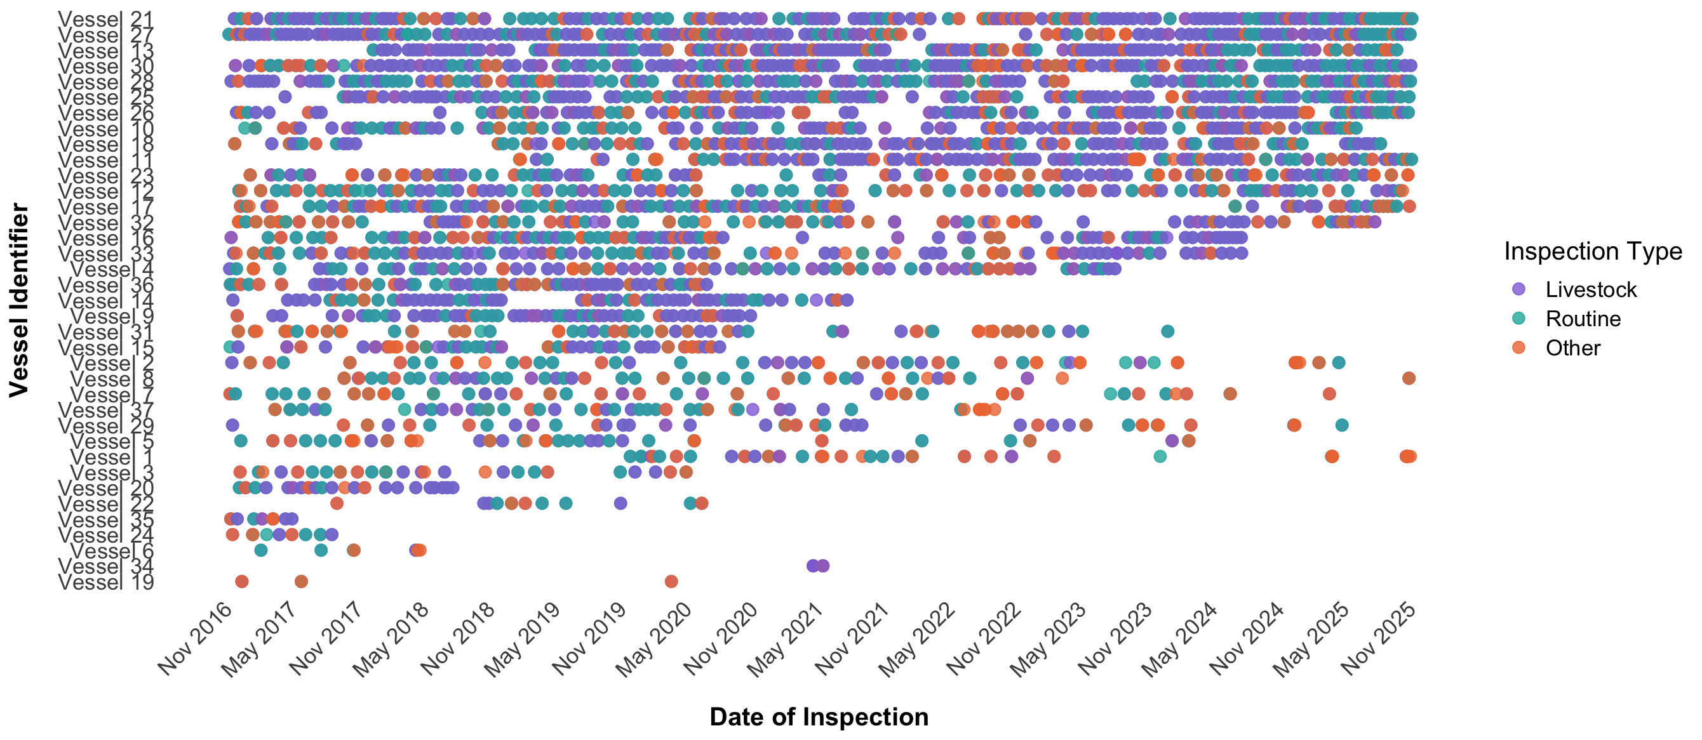
Figure 12 Livestock carrier vessel inspections conducted between November 2016 and November 2025, categorised by vessel.
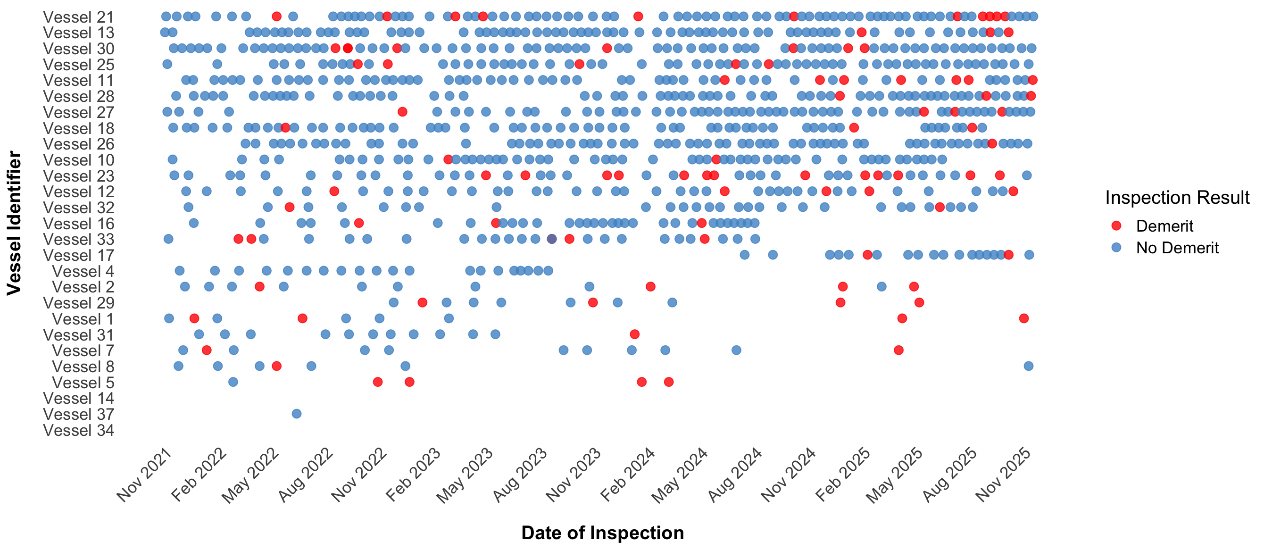
Figure 13 Time points of ‘Livestock’ inspections on livestock carrier vessels between 2021–2025, with inspections where demerit points were applied in red.

Vessel observations and data collection

Overview
Vessel observations were conducted at Darwin’s East Arm Port and Fremantle ports between November 28th and December 17th 2025. These included viewing vessels during daylight hours for the Routine Vessel Inspection and the Livestock Inspection and after dark with biosecurity officers. Light measurements were recorded during daytime and night-time visits (Table 5). The purpose of light readings were to determine where notable lighting differences are located on vessels at different time points. Observations provided a critical comparative framework for understanding the operational differences between daytime and night-time biosecurity inspections. By subjecting each vessel to assessments during both time periods, observers could evaluate how fluctuating light levels, environmental conditions, and structural features influenced the overall rigor and approach of the inspection process.
Overall, vessels presented with a high standard of cleanliness. Inspection protocols were similar across vessels, with additional tools being utilised in Fremantle to support inspection processes, including mirrors. Lighting across internal areas was relatively comparable across vessels, given the use of artificial lighting on closed decks and internally. However, structural differences i.e. purpose-built vs retro-fitted vessels saw differences in where BRM might be detected. Open top decks demonstrated more variability in light levels, being influenced by glare during daylight hours and shadows from torches at night. Lighting between docks is also highly variable.
It should be noted that during daytime observations, any detected BRM was cleaned at time of inspection. As a result, this limited visual comparisons between day and night.

Darwin
Six vessels were inspected at Darwin’s East Arm port between the 28th November and the 3rd December 2025. Findings are summarised in the key themes below:

Inspection processes and tools
- Routine vessel inspections focussed on internal areas of the vessel, including the bridge as well as the open top deck and the hull. These inspections focussed on general BRM, such as hitchhiker animals and invertebrates, plants, domestic waste, insect breeding sights. It also included a human health check. A separate AMSA inspection generally occurs around the same time, which focusses on vessel safety.
- Inspections of livestock areas involved an inspector examining each deck, accompanied by at least one crew member as an escort and to spot clean any BRM found. Inspectors will examine the floors, feed bins, water troughs and permanent structures such as gates and their pins, cross beams and drainage. Certain structures or features may differ between the vessels, but if they are present in the enclosed deck, time of inspection is unlikely to impact the ability to inspect them.
- Darwin inspectors did not utilise a mirror for their biosecurity inspections (in contrast to Fremantle)
- LedLenser® P7R torches were used. A notable different was detected in lighting ability between the high-quality LedLenser and Pelican torches used by observers on the vessel.

Impact of lighting on inspection rigour
- Of the six vessels observed in Darwin, two had open decks and the remainder were fully enclosed. For the fully enclosed decks, the time of inspection did not impact available light levels (Table 5). On the open livestock decks, it was observed that inspections at night-time may present some challenges due to the shadows created from artificial lights on the vessel and dock. Lighting available on docks will differ between ports and cannot be standardised.
- Glare and shadows from torches may impact inspection ability. However, some vessels had considerable glare during daylight due to the strength of the sun and reflective surface of the ship. LedLenser® P7R torches were used by inspectors (and have been discussed in Part 3). Pelican torches were used by observers and it was obvious the difference torch quality makes.

Biosecurity risks
- The open top decks may pose a challenge for night-time inspections, depending on what equipment and stored goods are present.
- One vessel was found to have evidence of rodents on the top deck, which was most likely due to feed and fodder being stored on that deck. This vessel was issued with a notice and was required to have a pest control treatment applied. As this vessel was only in port for a short period, it did not require a follow up inspection. When berthed, the vessels are required to use rodent guards on all ropes coming from the vessel.
- Vessels may berth after dark and remain at the dock until their inspection at daylight the following day. Vessels may also remain at anchorage in the harbour for a period before a berth is available. It was noted that in Darwin, endemic insects have been found on vessels at anchorage, even if they are a number of kilometres from the coast. This suggests that there is a likelihood that exotic hitchhiker flying insects may exit a vessel at anchorage or when berthed after dark if the disinsection measures were unsuccessful.
- It was reported that compliance success was generally more associated with the Master of the vessel rather than the vessel itself. However, current data collected for inspections does not include the Master of the voyage.

Fremantle
Inspections at Fremantle occurred between 13th December 2025 and 17th 2026. Three separate vessels were inspected, one of them twice. One of the vessels had previously been inspected in Darwin. Findings are summarised in the key themes below:

Inspection processes and tools
- Inspections protocols were similar to those followed in Darwin. However, a noticeable difference was the use of mirrors by inspectors to inspect hard to reach areas of the vessel, such as under railings and above light fittings (Figure 14). This required some skill and practice, but was clearly a valuable addition to the inspection process as it routinely discovered faecal material on the underside of gates and pen railings. A potential risk with mirror usage is fatigue and tendency for the user to focus on the tool, and perhaps less likely to see other parts of the environment.
- The presence of a crew team to clean as the inspection is undertaken is efficient. However, an intangible but greater benefit is in the opportunity for the crew to better understand the high expectation around cleaning. This is probably of more benefit in ensuring the ongoing risk to Australia associated with returning livestock export vessels.

Impact of lighting on inspection rigour
- As with Darwin, inspection on the top of the vessel (i.e. around stored fodder and loading ramps) was affected by changes in light from daytime to night-time. During clear sky daylight conditions, peak illumination was 125,000 lux although a small amount of cloud was observed to reduce this to 15–20,000 lux. It was observed that the mix of shadow and glare did make looking under objects more difficult (working without sunglasses was uncomfortable) and having a quality torch was helpful for looking under pallets and around other equipment. At night-time, limited light was available from the port overhead lighting, with recorded surface illumination levels < 10 lux.
- Unsurprisingly, open decks had higher light levels during the day, although this was less important in the ‘inside’ pens. Illumination measurements were taken in the middle of a pen at floor level at 19 sites on three open decks on one vessel. The pens ranged from the outer pens of a vessel through the middle the other side. The measurements were taken during the midday period (between 11:00 and 14:00). These were repeated in the same locations at night (a gibbous moon was present). During the day, the average illumination was 289 lux across these sites, and at night it was 28 lux. The results are shown in Figure 15.
- Where light sources are limited, illumination is further reduced by obstructions. An example of this occurs where fodder troughs are hung near the ceiling to simplify cleaning and reduce risks of damage during livestock loading (Figure 16). Unfortunately, the proximity to the light sources reduces light in pens during the inspection. Figure 17 shows the changes in light when a) a trough is present, b) when a trough is removed, and c) when the provided torch was used to illuminate the pen (regardless of trough status).
- Regardless of the time of day or location, inspectors were observed to frequently use a torch as they scanned surfaces, used their mirrors or looked into sumps and other corners. Light levels were also taken while inspections were being conducted with torches. The results have been presented in Table 5. Given the inherently low light conditions required in livestock vessels, these results would suggest the routine use of high quality torches is likely to improve inspection outcomes by lifting illumination from below recommended working levels. As well as the livestock decks, this applies during other parts of the inspection; the illumination in the galley and food storage areas was also measured, with readings as low as 30 lux.

Biosecurity risks
- Painting is an almost continuous requirement on ocean-going vessels. However, on more than one occasion, BRM was found under recently applied paint. Risk material was also found between panels, and under general equipment. This reduces the rate of desiccation of the BRM, and while protecting it may increase the risk when the paint eventually breaks off. Clear instruction and feedback to the Master and shipping agent may help to reduce this.
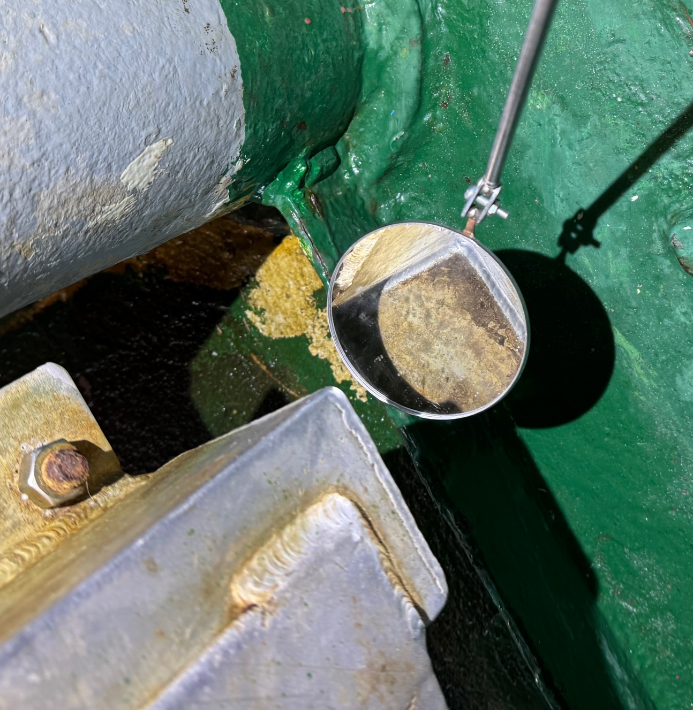
Figure 14 An example of a mirror being used to observe the undersides or railings and gates
Figure 15 A comparison of illumination at various locations on open decks of a livestock vessel during the day and repeated at night.

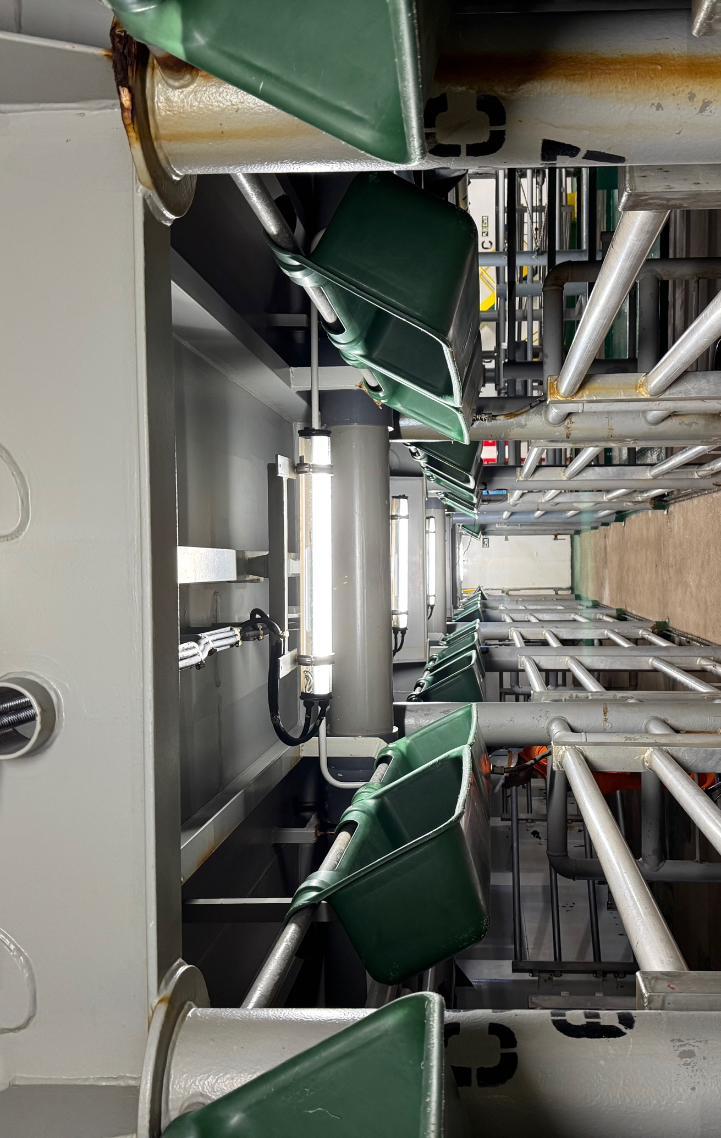
Figure 16 Fodder troughs are hung on a raised railing to prevent damage during loading
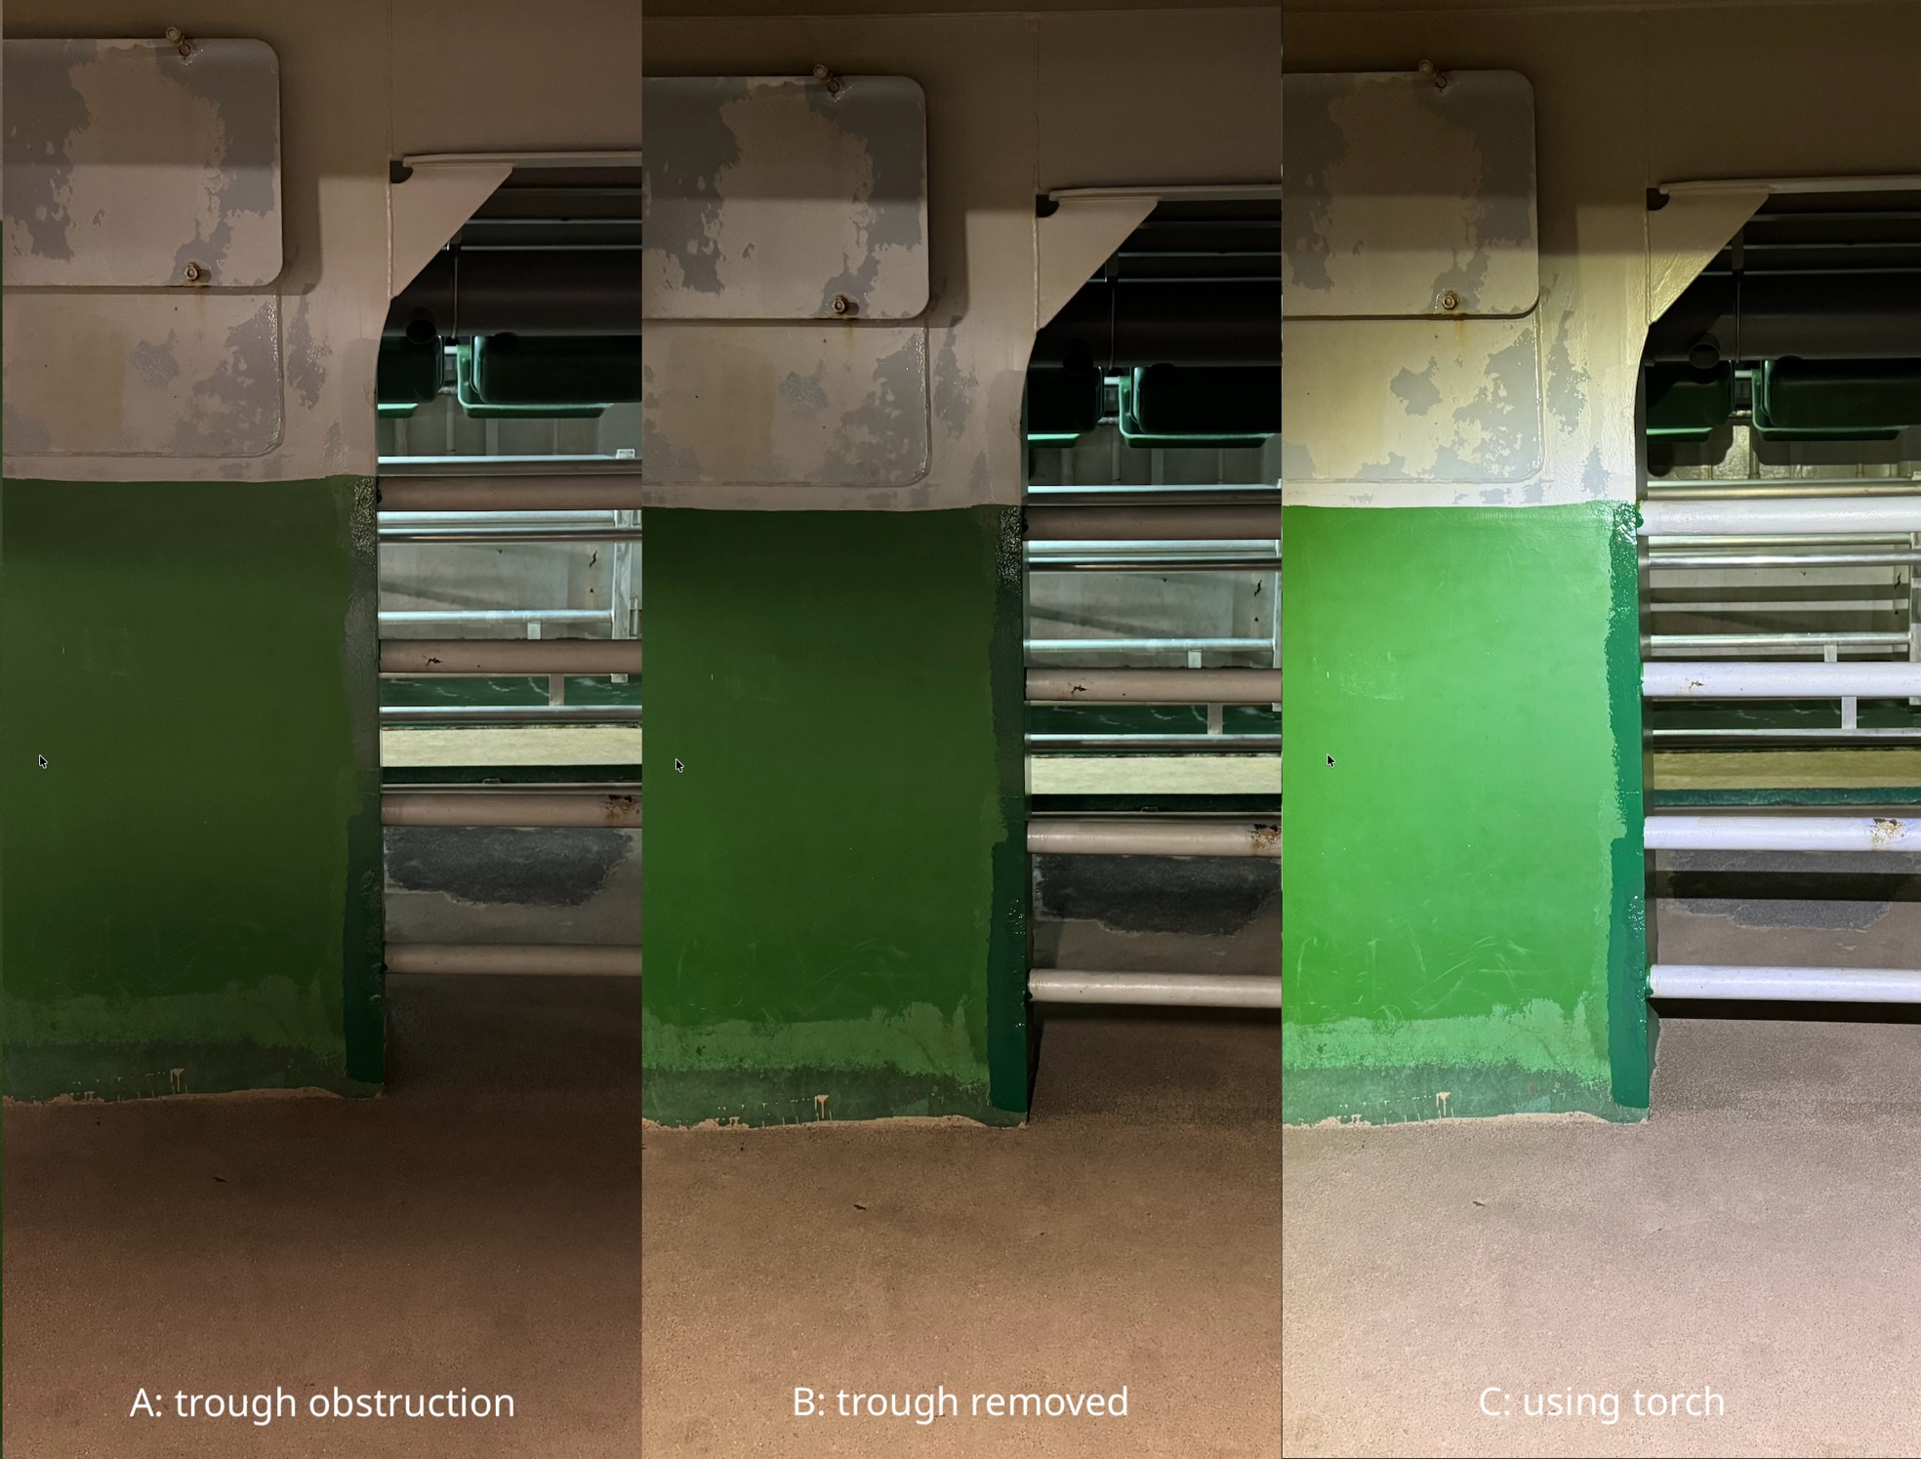
Figure 17 Changes in light when a) a trough was obstructing direct lighting, b) the trough was not present, c) a LedLenser P7R torch was used to illuminate the space.

Table 5 Light measurements (lux) taken on vessels berthed in Darwin during daylight and night-time.
Vessel | Location | Day | Night
Brahman Express | Dock | 6800 | 12.7
 | Top deck | 6120 | 8.8
Gelbray | Deck 1 mid deck stairs | 41.9 | 14
 | Deck 2 Bow end | 10.9 | 11.9
 | Deck 2 Bow end – floor level | 8.1 | 16.6
 | Deck 2 mid deck stairs | 46.8 | 44.5
 | Deck 2 Stern end | 7.6 | 10
 | Deck 2 Stern end – floor level | 4.7 | 6.4
 | Deck 3 Bow end | 7.2 | 8
 | Deck 3 Bow end – floor level | 4.6 | 3.5
 | Deck 3 mid deck stairs | 46.8 | 43.3
 | Deck 3 Stern end | 12.9 | 8.9
 | Deck 3 Stern end – floor level | 5.5 | 11.1
 | Deck 4 Bow end | 3.3 | 6.8
 | Deck 4 Bow end – floor level | 3.3 | 5.1
 | Deck 4 mid deck | 49.7 | 46.1
 | Deck 4 Stern end | 7.4 | 6.2
 | Deck 4 Stern end – floor level | 16 | 4.7
 | Deck 5 Bow end | 3.4 | 5.2
 | Deck 5 Bow end – floor level | 4.3 | 6.9
 | Deck 5 mid deck stairs | 332 | 279
 | Deck 5 Stern end | 5.9 | 10.2
 | Deck 5 Stern end – floor level | 3.8 | 4.7
 | Top deck | 52600 | 13
Girolando | Deck 5 Bow end | 13.6 | 11.8
 | Deck 5 Bow end – floor level | 12.2 | 8.7
 | Deck 5 mid deck stairs | 397 | 0
 | Deck 5 Stern end | 3.2 | 5.9
 | Dock | 84000 | 21.8
 | Top deck | 94600 | 71.9

Discussion

Key findings
Incoming livestock carrier vessels are classified as high biosecurity risk. Appropriately, on arrival at an Australian port the vessels must withstand a high standard of scrutiny; this includes 100% in-person inspections at the port of entry on every return trip to Australia, regardless of visit history and accrual (or not) of demerit points. On the return voyage, they must undergo cleaning, disinfection and disinsection, as well as complying with routine Pre-arrival Reporting (PAR) requirements.
Inspection performance is influenced by a number of factors that can be categorised by task, individual, environment, organisation and other social factors (See 2012). Lighting is a critical environmental factor when considering inspections for the detection of Biological Risk Material (BRM), hitchhiker pests and work health and safety. While airports and international mail centres have strict minimum lighting requirements, the levels of lighting required for livestock carrier vessels are much lower than for other workplaces. Other factors such as personnel fatigue, visual acuity and experience may all play a role in an inspectors ability to properly conduct an inspection and need to be managed accordingly.
Commercial and non-commercial vessels are known vectors for terrestrial invertebrates. There are three main introductory pathways including - contamination of food stores (human and cattle), ornamental plants, wood, animals, and freshwater storage; hitch hiker or stowaways associated with cargo; and within vessel infrastructure (McKirdy et al. 2019). The most commonly used departure ports by livestock carrier export vessels included Jakarta (Java), Singapore and Panjang. Indonesia and Singapore have a number of insect vectors and diseases that are a concern to Australia, including LSD, old world screw-worm fly and surra (transmitted by biting flies) (Alimsijah et al. 2024; Qudsiyati et al. 2025). Indonesia also presents a risk for FMD introduction.
Vessel inspection observations demonstrate that there are no reasons that fully enclosed decks could not be inspected at any time of day as artificial lighting is the only light source available. However, open decks (livestock and non-livestock) may be impacted by lighting availability and shadows. Regardless of time of day, light levels on open decks and other parts of the boat were variable. Light level measurements taken on the enclosed decks were far below the recommended minimum of 400 lux for workplaces such as airports (Safe Work Australia 2011; pers comm. Tracey Stonehouse). Inspectors were observed using torches to conduct almost all of their inspections, regardless of light availability. This allows almost all inspections to take place under acceptable illuminance, but the contrast between the areas illuminated by the torch, and the surrounding darker areas will increase fatigue due to the aforementioned pupillary unrest and increased concentration required in these environments where full dilation is unlikely to occur.
The BRM that was observed during vessel inspections in Darwin and Fremantle was very limited, mostly desiccated and unlikely to pose a significant likelihood of pathogen or pest introduction into Australia. However, the vessels observed during this investigation were presented at a high biosecurity standard. Concurrent with this project, two vessels were presented on arrival and failed inspection (one repeatedly) when project personnel were unfortunately unavailable to attend (photographs were subsequently available).
Vessels may spend some time berthed or at anchorage before being inspected, while within visual range of lights on the shore. This waiting period may increase the likelihood of hitchhiker/stowaway invertebrates escaping the vessel.
Observations of the inspection process were an important part of this project. Aside the questions asked in the project, two other observations should be recorded. From a research perspective, there is a risk of confounding in assessing the inspections by observation in person, especially when accompanied by senior staff. Second, the inspectors were clearly well trained, experienced, thorough and professional; performance review was being undertaken continuously.

Knowledge gaps
There were a number of significant gaps identified in published literature, outlined below. These impact the understanding and knowledge needed to determine whether biosecurity inspections on incoming livestock carrier vessels at night pose an elevated biosecurity risk.

Lighting requirements
There are no stipulated minimum lighting requirements for biosecurity inspections on livestock carrier vessels. The only requirements are for light levels well below those required for inspection in other biosecurity domains (i.e. airports and mail centres). While fully enclosed decks have artificial lighting and inspectors use good quality torches, the available lighting on open-penned and top decks can be variable. Further, the colour of flooring and surface paint may differ between vessels which may impact the ability to detect invertebrates, and the amount of glare that may be produced at different times of day. Low light levels during inspection was not limited to the livestock decks.

Invertebrate biology and detection
It is well established that insects have a circadian rhythm that dictates progression of life stages, migration and activity levels (Kuriwada 2025; Numata et al. 2015). The lack of data on insect circadian rhythms in 100% artificial environments represents a primary biosecurity uncertainty.
Most invertebrate studies have been conducted in laboratory settings. This makes it difficult to extrapolate and determine how valid findings are in field settings. For example, while there are data stating how long an old world screwworm fly may live for, data investigating how long a female may survive between meals is lacking.
There are still significant knowledge gaps regarding the minimum infective dose and minimum number of infected vectors required to transmit diseases, such as LSD.

Foot and mouth disease virus viability in tropical/maritime climates
Risks associated with introduction or establishment of specific pathogens were not studied in this review, but provide important context for the inspection process. In particular, FMD and LSD are active in countries where livestock carrier vessels are travelling from. The risk associated with BRM is highly dependent on the viability of any pathogens or pests which may have survived the voyage to an Australian port. A considerable proportion of FMDV viability research has been conducted in cool or temperate climates. It remains unclear how the temperature and relative humidity present on a marine voyage may impact the viability of FMDV if a vessel happens to become contaminated due to transporting clinically infected livestock. Nevertheless, the origin of the livestock transported on the vessel immediately prior to the vessel returning to an Australian port should be known in order to assess the risk of livestock origin BRM.

Vessel port history and other data parameters
Currently, only the last port of departure before entry to Australia is recorded by the Department. Knowledge of all ports visited since last departing Australian territory would be useful information to collect to help determine the likelihood of contamination and subsequent risk a vessel may pose. This information is available through other responsible agencies or AIS data aggregators (e.g. Marine Traffic, Vessel Finder). There are other notable parameters that would be beneficial to record to support risk assessment of vessels when returning to Australia, such as the Master, the location of previous breaches on a vessel and fodder presence as well as whether the vessel is purpose built or retrofitted.
A target list of invertebrate vector species has not been developed for vessel inspections. This should be prioritised as it will help to support vessel inspection and surveillance approaches and to guide future research areas.

Recommendations
The following recommendations aim to improve understanding around vessel risk to support a decision on the reintroduction of night-time biosecurity inspections. These include:

Comprehensive data capture and vessel risk profiling
Current inspection protocols can be improved be capturing more detailed historical and operational data to better understand the potential risk of each arriving vessel. These data need to be reviewed prior to a vessel arrival and may impact on a decision to issue pratique. Key data points include:
  - Port history: a complete record of all ports visited since the vessel was last in Australia to identify the risk of potential diseases or pests.
  - Animal transport history: a full record of animals transported by the vessel and their country of origin to identify the risk of potential diseases or pests.
  - Vessel master and related changes: documentation of vessel Masters on each voyage, due to the association of Master in relation to biosecurity compliance.
  - Demerit and compliance history: a complete record of past non-compliance to identify the potential likelihood of recurring issues.
  - Enhanced reporting on BRM: more granular details need to be collected on BRM and non-compliance, such as where on the vessel this occurred. This will support future inspections by identifying high-risk structural features on different vessels.
  - Target list of invertebrate vector species: A refined list of high-priority invertebrate species will help to support vessel inspection and surveillance approaches and to guide future research areas.

Implementation of a standardised demerit system
There are currently no formal procedures for vessels that consistently fail to meet biosecurity standards. That said, there is currently little incentive to avoid demerits for livestock vessels. To support better compliance, the allocation and management of demerit points could be improved by:
- Define with greater granularity what constitutes a demerit point to ensure a transparent and consistent process.
- Enhanced reporting on the inspection to ensure standardised and repeatable, and the issue of demerits is defensible.
- Compliance incentives: demerits should serve as a practical tool for enforcement. For example, poor demerit history could be used to determine a vessel’s eligibility for certain inspection time windows. This should undergo further discussions and considerations for implementation.
- Centralised management: A centralised system is needed to compile demerit and vessel information to provide a central location for information that can be used for vessel risk profiling prior to inspections.

Lighting optimisation and management of inspector fatigue
Ensuring suitable illumination is available during all parts of the inspection is important to ensure consistent, effective observation and detection of BRM. This includes managing low and high light levels, and managing the effects of continuously changing light. Team resource management (which includes noise, fatigue, provision of on-demand services and other work health and safety issues) is critical to maintaining inspection performance.

Comparative trial of daytime and night-time inspections
Given the gaps in knowledge and the lack of recent experience with night-time inspection, a trial comparing night-time and daytime inspections is recommended. This should involve the development of a study design and identification of all appropriate data parameters that require collection to ensure there is sufficient information at the end to enable analysis with adequate power for decision making. The trial should involve direct comparison between the same vessels, being observed during the day and night, to understand detection efficiency of BRM and other risk factors. It will be important to consider environmental factors such as season, that may influence the risk of diseases or pests; a minimum trial duration of 12 months is recommended. To support this next step, a preliminary decision support tool to implement a risk-based approach for vessel eligibility for night-time inspection to minimise biosecurity risk is presented in Section 7.

Decision support tool
Vessel inspections present a number of various risks for the introduction of BRM. However, based on the current findings, there is limited scientific evidence to support the exclusion of night-time inspections on livestock carrier vessels. The development of a decision support tool to mitigate these risks and to determine which vessels might be eligible for night-time inspection is highly recommended. It should be noted that this support tool does not account for staffing or any additional budget required (out of project scope).
Based on the findings detailed in this report, a list of risk factors that may be considered for inclusion in the decision framework has been developed. This will aid in building a risk profile for vessels in which they must meet strict criteria for night-time inspection eligibility. Table 6 includes some of the initial risk factors to be considered when determining the risk a vessel may pose on return to Australian territory. These risk factors and framework should be re-evaluated and adjusted based on findings from the inspection trial.
To simplify and maintain transparency of the decision making process, the eligibility criteria is divided into “vessel eligibility criteria” and “DAFF eligibility criteria” (Figure 18 and Figure 19). This two-step process allows the Department to make decisions based on their workforce capacity, while also placing responsibility on the vessel to meet certain requirements before a night-time inspection will be granted. Both criteria are presented as easy to follow flow charts, to assist in rapid assessment. Figure 18 presents the vessel eligibility criteria. Based on the literature review, and inspection observations, these five questions were determined to be the most significant to determine the potential risk a vessel may pose.
It is recommended that a target invertebrate species list be developed to guide use of the decision support tool.

Table 6 Potential incoming livestock carrier vessel risk factors.
Risk Factor | Rationale
Previous departure port
Disease status of country | Presence of FMD and important vector borne diseases may increase the likelihood of vessel contamination. Some FMD-endemic countries may pose a higher risk than others, depending on the Progressive Control Pathway stage the country is designated (WOAH 2018).
Presence of key insect vector species | May increase the likelihood of stowaway/hitchhiker insects. Arthropods of concern would be OWS/NWS, haematophagus flying insects and ticks.
Voyage history in the past 12 months including the intervals between returning to an Australian port. | Vessels that have not frequently returned to Australia may have a higher likelihood of BRM due to less strict biosecurity measures enforced by other countries. Those vessels that have been conducting back-to-back voyages between Australia and a foreign port are expected to have a higher standard of cleanliness.
Arrival time at dock or anchorage – e.g. between dusk and midnight vs midnight and dawn. | The duration that a vessel must remain at dock or anchorage may present a risk for the escape of non-indigenous insects. However, night-time inspections after midnight are not recommended due to the aforementioned limits on inspector performance.
Duration of previous livestock voyage (e.g. short haul vs long haul) | Long haul voyages may provide more opportunity for insects to breed and invade structures of the vessel. Short haul voyages (<10 days) may still provide the conditions for insects to breed, but it is less likely that multiple generations will occur.
Duration of return voyage (i.e. without livestock) | Return voyage duration may influence insect survival in the absence of a food source i.e. a longer voyage may allow for more thorough cleaning and disinsection of the vessel. Moreover, this is likely to support degradation of other BRM, with a longer duration of time in high and humid temperatures influencing pathogen inactivation.
Vessel integrity - purpose built or retro-fitted | Retro-fitted vessels may have more areas within internal infrastructure for insects to colonise and hide. Vessels with open livestock decks may be more challenging to conduct a thorough inspection due to different light sources, such as diffuse light from the dock.
Available lighting on open decks and dockside | Artificial lighting at night may create shadows or glare that increase the difficulty in observing structures. Solar glare during daylight hours can also impede an inspectors ability to detect BRM.
Master, crew and previous vessel inspection records (this record would need to be started) | Masters tend to dictate the hygiene status of vessels and inspection records should be note Master details. Significant crew changes since last docking in Australia may also potentially lead to a higher likelihood of BRM being present if the crew is unfamiliar with the Australian biosecurity standard.
Returning with feed | Increases the likelihood of stowaway insects or rodents. Feed should be stored in silos. Some vessels may not have this capacity and may store on open decks leading to a higher likelihood of attracting insects or pests.
Presence of landed goods on open decks | In this context ‘landed goods’ is referring to goods that are destined to be discharged in Australia – may be to another vessel. The presence of these on open decks can create difficulties in inspections and may harbour pest species.

Risk Factor | Rationale
Deck paint colour | Dark surface paint may make it more difficult to identify BRM at night-time due to less colour contrast, light surface paint may create more glare with artificial or bright natural light.
Logistics/availability of night-time staff
Biosecurity officer experience and past performance | Some inspectors, if they have a history of suboptimal performance, may be less suitable for conducting night-time inspections, due to the higher likelihood of potential errors due to fatigue.
Managing fatigue and availability | Staff require a 8 hr standdown period between shifts and fatigue is known to impact detail oriented tasks. Mental fatigue and physical exertion can negatively impact detail-oriented task performance.

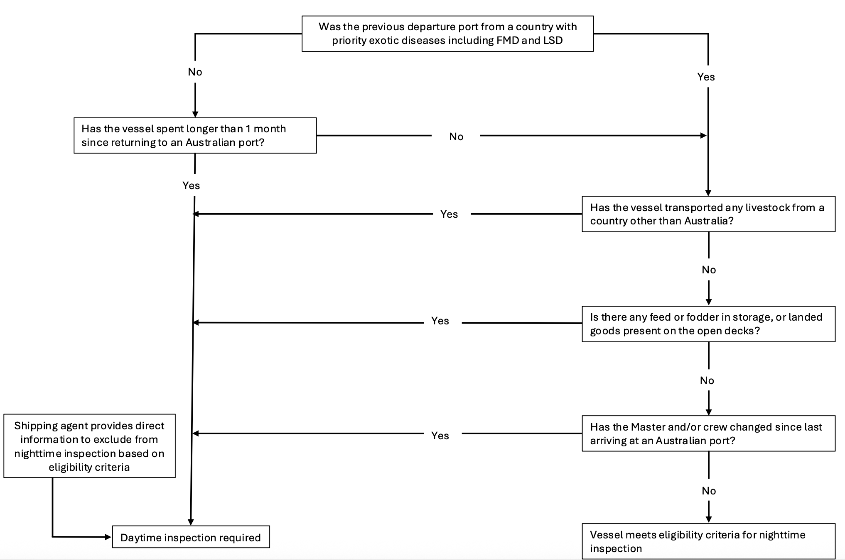
Figure 18 Vessel eligibility criteria for consideration of night-time inspections.

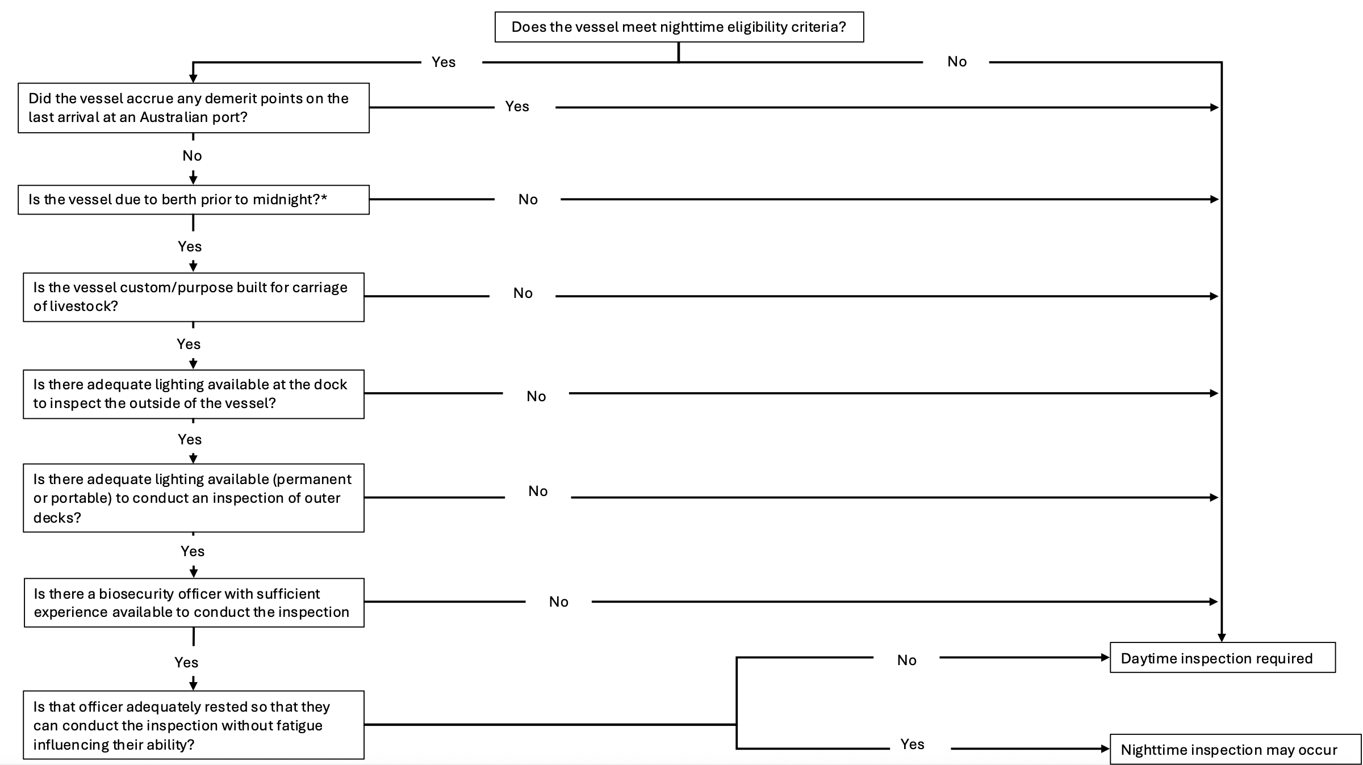
Figure 19 Department of Agriculture, Fisheries and Forestry decision criteria for night-time inspections (* refers to the risk posed by a vessel for the escape of non-indigenous insects due to an extended duration at anchorage or dock prior to inspection).

Conclusion
Based on available literature, data and vessel observations, there is no definitive evidence confirming that livestock vessel inspections at night-time pose a higher risk of disease or invertebrate incursion than those conducted during daylight hours. It is recognised that failure to ensure appropriate lighting and managing operator fatigue are vital, regardless of the time of day. Further, there is concern that having vessels at anchorage at night prior to inspection may pose a risk for hitchhiker insects to fly to land if there is sufficient artificial light at night present on shore.
Conducting a well-designed trial will enable data to be collected for a comparative study between daytime and night-time inspection. By implementing the trial with the decision support tool, only those vessels that meet strict eligibility criteria will be authorised for night-time inspection. This will ensure the necessary mitigation strategies are in place to ensure higher risk vessels will only undergo daytime inspections. Moreover, this places responsibility for meeting eligibility criteria on the vessel operator. Resourcing, financial and staffing may play a more significant role in the Department’s ability to conduct high quality inspections during after-hours than hygiene of the vessel. Due to work health and safety responsibilities of employers, and the detrimental effect of fatigue on inspectors, these would be valid considerations for the Department to take into account when deciding whether to approve a night-time inspection of a livestock carrier vessel.
Further research to address the knowledge gaps is warranted to support future decisions in this area.

9 References
AHA (2020) A manual for the identification of Screw-worm Fly, 4th Edition, Animal Health Australia, Canberra.
ALE (2023) Shipping capacity for livestock exports, https://www.australiaslivestockexporters.com/shipping-australian-livestock.html, accessed 1 May 2023.
Alimsijah PI, Ang CY and Han HS (2024) ‘Old World Screwworm myiasis: First report of auricular Chrysomya bezziana myiasis in a dog in Singapore’, Veterinary Parasitology, Regional Studies and Reports, 48:100991, doi:10.1016/j.vprsr.2024.100991.
AMSA (2019) Marine Order 43 (Cargo and cargo handling — livestock) 2018, Attorney-General’s Department, Canberra, ACT, https://www.legislation.gov.au/Details/F2019C00887/Html/Text, http://www.legislation.gov.au/Details/F2019C00887, accessed 12 April 2023.
AMSA (2022) Transporting livestock from Australia, Australian Maritime Safety Authority, https://www.amsa.gov.au/vessels-operators/cargoes-and-dangerous-goods/transporting-livestock-australia, accessed 14 April 2023.
Animal Health Australia (2022) ‘AUSVETPLAN response strategy: foot-and-mouth disease’, https://animalhealthaustralia.com.au//wp-content/uploads/dlm_uploads/2022/12/AVP_FMD_v5.0_2022.pdf, accessed 5 April 2023.
Bartley LM, Donnelly CA and Anderson RM (2002) ‘Review of foot-and mouth disease virus survival in animal excretions and on fomites’, Veterinary Record, 151(22):667–669, doi:10.1136/vr.151.22.667.
Bedson SP, Maitland HB and Burbury YM (1927) ‘Further Observations on Foot-and-Mouth Disease’, Journal of Comparative Pathology and Therapeutics, 40:5–36, doi:10.1016/S0368-1742(27)80002-0.
Bex PJ, Solomon SG and Dakin SC (2009) ‘Contrast sensitivity in natural scenes depends on edge as well as spatial frequency structure’, Journal of Vision, 9(10):1, doi:10.1167/9.10.1.
Bøtner A and Belsham GJ (2012) ‘Virus survival in slurry: Analysis of the stability of foot-and-mouth disease, classical swine fever, bovine viral diarrhoea and swine influenza viruses’, Veterinary Microbiology, 157(1–2):41–49, doi:10.1016/j.vetmic.2011.12.010.
Broadbent DE and Gregory M (1963) ‘Vigilance Considered as a Statistical Decision’, British Journal of Psychology, 54(4):309–323, doi:10.1111/j.2044-8295.1963.tb00886.x.
Brotas L and Wienold J (2014) ‘Solar reflected glare affecting visual performance’, in Proceedings of 8th Windsor Conference: Counting the Cost of Comfort in a changing world, Windsor Conference, Network for Comfort and Energy Use in Buildings, Cumberland Lodge, Windsor, UK, https://d1wqtxts1xzle7.cloudfront.net/79169686/W14154_Brotas-libre.pdf?1642693505=&response-content-disposition=inline%3B+filename%3DSolar_reflected_glare_affecting_visual_p.pdf&Expires=1767852478&Signature=fhzlPiVeDxIScn1-pqcspoZZPb0ac40jlBn-WW3WzeKiTjoZ3yovTWGNqtUzdvjAPUp1yBz~QqKqRAK4Mbqq0yWeI7hMi4dq3iM12gOKUASugkHti-GpF-0d~-76alK9z7wvdEEZIWLuN2Nj4~dojsu2rRyE8G0YtMkID2fdZ-xWOkgxwZjPVwRUyAaADM-f-zwN7zx5zWlD0CGon8tTpm1BjoTFQm9Ze9RiGiZYTKj8Naz-ZSyFgplKER5i25Yd9AwfGTCD1iBJvWOyq9CBkDANRDW-0gSATaMaUcM9DdSXpuneuac-7yeUIEqSbGud3PI7cqj52BZKftW5~fefTA__&Key-Pair-Id=APKAJLOHF5GGSLRBV4ZA, accessed 8 January 2026.
Chihota CM, Rennie LF, Kitching RP and Mellor PS (2001) ‘Mechanical transmission of lumpy skin disease virus by Aedes aegypti (Diptera: Culicidae)’, Epidemiology and Infection, 126(2):317–321, doi:10.1017/S0950268801005179.
Csathó Á, Van Der Linden D, Hernádi I, Buzás P and Kalmár G (2012) ‘Effects of mental fatigue on the capacity limits of visual attention’, Journal of Cognitive Psychology, 24(5):511–524, doi:10.1080/20445911.2012.658039.
DAFF (2022a) Undertaking a livestock vessel inspection, Department of Agriculture, Forestry and Fisheries, Canberra.
DAFF (2022b) Check cargo, containers and vessels for pests - Department of Agriculture, Fisheries and Forestry, https://www.agriculture.gov.au/biosecurity-trade/import/arrival/pests, accessed 24 November 2025.
BICON (2023) Australian Biosecurity Import Conditions and Food Safety Requirements - Import Conditions - Conditions, https://bicon.agriculture.gov.au/BiconWeb4.0/ImportConditions/Conditions?EvaluatableElementId=718623&Path=UNDEFINED&UserContext=External&EvaluationStateId=93c01821-e269-4aae-81a3-9f17ac3bcc6c&CaseElementPk=2070855&EvaluationPhase=ImportDefinition&HasAlerts=True&HasChangeNotices=False&IsAEP=False, accessed 20 April 2023.
DAFF (2025a) Vessel Pratique - Department of Agriculture, Fisheries and Forestry, https://www.agriculture.gov.au/biosecurity-trade/aircraft-vessels-military/vessels/vessel-pratique, accessed 21 November 2025.
DAFF (2025b) Vessels - Department of Agriculture, Fisheries and Forestry, https://www.agriculture.gov.au/biosecurity-trade/aircraft-vessels-military/vessels, accessed 19 January 2026.
DAFF (2025c) Commercial vessel biosecurity reporting - Department of Agriculture, Fisheries and Forestry, https://www.agriculture.gov.au/biosecurity-trade/aircraft-vessels-military/vessels/commercial-vessels, accessed 19 January 2026.
DAWE (2021) Australian Standards for the Export of Livestock 3.2, Department of Agriculture, Water and the Environment, Canberra, Australia.
Esfandi K, Afsar S, Richards K, Hedderley D, Brown SDJ, Najar-Rodriguez A and Ormsby M (2024) ‘Determining the efficacy of visual inspections at detecting non-biosecurity–compliant goods’, Journal of Vision, 24(8):8, doi:10.1167/jov.24.8.8.
Flynn-Evans EE, Tyson TL, Costedoat G, Pradhan S and Stone LS (2026) ‘Chronic sleep restriction induces oculomotor impairment with inadequate compensation’, Sleep Advances: A Journal of the Sleep Research Society, 7(1):zpaf095, doi:10.1093/sleepadvances/zpaf095.
Fransson PA, Patel M, Magnusson M, Berg S, Almbladh P and Gomez S (2008) ‘Effects of 24-hour and 36-hour sleep deprivation on smooth pursuit and saccadic eye movements’, Journal of Vestibular Research, 18(4):209–222, doi:10.3233/VES-2008-18404.
Gailiunas P, Cottral GE and Scott FW (1969) ‘Survival of foot-and-mouth disease virus on meat packaging materials’, Proceedings, Annual Meeting of the United States Animal Health Association, 73:425–436.
Hall RN, Torpy JR, Nye R, Zalcman E and Cowled BD (2023) ‘A quantitative risk assessment for the incursion of lumpy skin disease virus into Australia via long-distance windborne dispersal of arthropod vectors’, Preventive Veterinary Medicine, 218:105990, doi:10.1016/j.prevetmed.2023.105990.
Hamedani Z, Solgi E, Hine T, Skates H and Et. A (2020) ‘Lighting for work: A study of the relationships among discomfort glare, physiological responses and visual performance’, Building and Environment, doi:10.1016/j.buildenv.2019.106478.
Harrison Y and Horne JA (2000) ‘The impact of sleep deprivation on decision making: a review’, Journal of Experimental Psychology. Applied, 6(3):236–249, doi:10.1037//1076-898x.6.3.236.
Hecht S, Haig C and Chase AM (1937) ‘The influence of light adaptation on subsequent dark adaptation of the eye’, The Journal of General Physiology, 20(6):831–850, doi:10.1085/jgp.20.6.831.
Inzecto (2023) Learn About Mosquito Biology, Life Cycle and Habitats, INZECTO, https://inzecto.com/post/learn-about-mosquito-biology-life-cycle-and-habitats/, accessed 8 December 2025.
Jiang X, Ren Z, Hai X, Zhang L, Wang Z and Lyu F (2023) ‘Exposure to artificial light at night mediates the locomotion activity and oviposition capacity of Dastarcus helophoroides (Fairmaire)’, Frontiers in Physiology, 14, doi:10.3389/fphys.2023.1063601.
Khan D, Edgell H, Rotondi M and Tamim H (2023) ‘The association between shift work exposure and cognitive impairment among middle-aged and older adults: Results from the Canadian Longitudinal Study on Aging (CLSA)’, PloS One, 18(8):e0289718, doi:10.1371/journal.pone.0289718.
Klein RM and Feltmate BBT (2025) ‘The vigilance decrement: its first 75 years’, Frontiers in Cognition, 4, doi:10.3389/fcogn.2025.1632885.
Kuriwada T (2025) ‘The age of bright nights: Photoperiodic disruption of insect diapause by artificial light at night’, Journal of Insect Physiology, 167:104901, doi:10.1016/j.jinsphys.2025.104901.
Levy K, Wegrzyn Y, Moaraf S, Barnea A and Ayali A (2024) ‘When night becomes day: Artificial light at night alters insect behavior under semi-natural conditions’, Science of The Total Environment, 926:171905, doi:10.1016/j.scitotenv.2024.171905.
Lin Y, Fotios S, Wei M, Liu Y, Guo W and Sun Y (2015) ‘Eye Movement and Pupil Size Constriction Under Discomfort Glare’, Investigative Ophthalmology & Visual Science, 56(3):1649–1656, doi:10.1167/iovs.14-15963.
Mainster MA and Turner PL (2012) ‘Glare’s Causes, Consequences, and Clinical Challenges After a Century of Ophthalmic Study’, American Journal of Ophthalmology, doi:10.1016/j.ajo.2012.01.008.
Maniglia M, Thurman SM, Seitz AR and Davey PG (2018) ‘Effect of Varying Levels of Glare on Contrast Sensitivity Measurements of Young Healthy Individuals Under Photopic and Mesopic Vision’, Frontiers in Psychology, 9, doi:10.3389/fpsyg.2018.00899.
McKirdy SJ, O’Connor S, Thomas ML, Horton KL, Williams A, Hardie D, Coupland GT and van der Merwe J (2019) ‘Biosecurity risks posed by a large sea-going passenger vessel: challenges of terrestrial arthropod species detection and eradication’, Scientific Reports, 9(1):19339, doi:10.1038/s41598-019-55554-4.
Mehra D and Le PH (2025) ‘Physiology, Night Vision’, in StatPearls, StatPearls Publishing, Treasure Island (FL), http://www.ncbi.nlm.nih.gov/books/NBK545246/, accessed 6 January 2026.
Mielke SR and Garabed R (2020) ‘Environmental persistence of foot-and-mouth disease virus applied to endemic regions’, Transboundary and Emerging Diseases, 67(2):543–554, doi:10.1111/tbed.13383.
Mills MK, Michel K, Pfannenstiel RS, Ruder MG, Veronesi E and Nayduch D (2017) ‘Culicoides–virus interactions: infection barriers and possible factors underlying vector competence’, Current Opinion in Insect Science, 22:7–15, doi:10.1016/j.cois.2017.05.003.
Morgan IR (1993) Spread of foot-and-mouth disease, review prepared for the Australian Meat Research Corporation, Victorian Institute of Animal Science, Victoria.
Namazi F and Khodakaram Tafti A (2021) ‘Lumpy skin disease, an emerging transboundary viral disease: A review’, Veterinary Medicine and Science, 7(3):888–896, doi:10.1002/vms3.434.
Numata H, Miyazaki Y and Ikeno T (2015) ‘Common features in diverse insect clocks’, Zoological Letters, 1(1):10, doi:10.1186/s40851-014-0003-y.
Pan H, Liang G, Lu Y, Pan H, Liang G and Lu Y (2021) ‘Response of Different Insect Groups to Various Wavelengths of Light under Field Conditions’, Insects, 12(5), doi:10.3390/insects12050427.
Podrezova E (1969) ‘Viability of foot-and-mouth disease virus in pastures’, Veterinariia, 5:94–96.
Qudsiyati N, Nurcahyo W, Priyomidodo D and Soedarmanto I (2025) ‘Diversity of Flies and Molecular Detection in Blood Sucking Flies in Surra Endemic Area in Indonesia’, Advances in Animal and Veterinary Sciences, doi:10.17582/journal.aavs/2025/13.5.987.993.
Queensland Government (2024) Screwworm fly | Business Queensland, https://www.business.qld.gov.au/industries/farms-fishing-forestry/agriculture/biosecurity/animals/diseases/guide/screw-worm-fly, accessed 4 December 2025.
Sadler R, Leslie E, Hillman A, Black A and Madin B (2021) A review of Shipboard Mortality Data 1988–2017, MLA.
Safe Work Australia (2011) Managing the work environment and facilities: Code of Practice, Safe Work Australia, Sydney.
Sánchez López de Nava A, Somani AN and Salini B (2025) ‘Physiology, Vision’, in StatPearls, StatPearls Publishing, Treasure Island (FL), http://www.ncbi.nlm.nih.gov/books/NBK538493/, accessed 6 January 2026.
See JE (2012) Visual Inspection: A Review of the Literature, United States Department of Energy, Albuquerque, New Mexico.
Shimoda M and Honda K (2013) ‘Insect reactions to light and its applications to pest management’, Applied Entomology and Zoology, 48(4):413–421, doi:10.1007/s13355-013-0219-x.
Sprygin A, Pestova Y, Wallace DB, Tuppurainen E and Kononov AV (2019) ‘Transmission of lumpy skin disease virus: A short review’, Virus Research, 269:197637, doi:10.1016/j.virusres.2019.05.015.
Stone LS, Tyson TL, Cravalho PF, Feick NH and Flynn‐Evans EE (2019) ‘Distinct pattern of oculomotor impairment associated with acute sleep loss and circadian misalignment’, The Journal of Physiology, 597(17):4643–4660, doi:10.1113/JP277779.
Tekavcic B, Milić RČ and Pompe MT (2017) ‘Does Physical Fatigue Affect Color Vision?’, Sports Medicine International Open, 1(5):E155–E159, doi:10.1055/s-0043-115378.
Tuppurainen ESM and Oura C a. L (2012) ‘Review: Lumpy Skin Disease: An Emerging Threat to Europe, the Middle East and Asia’, Transboundary and Emerging Diseases, 59(1):40–48, doi:10.1111/j.1865-1682.2011.01242.x.
University of Saskatchewan (2021) Tabanids: Tabanus species - Horse Flies; Chrysops species – Deer Flies; Haematopota species - Clegs, Learn About Parasites, https://wcvm.usask.ca/learnaboutparasites/parasites/tabanids.php, accessed 8 December 2025.
Valdez P (2019) ‘Circadian Rhythms in Attention’, The Yale Journal of Biology and Medicine, 92(1):81–92.
Wang Y, Durmus D, Wang Y and Durmus D (2025) ‘The Effect of Color Contrast on the Visual Clarity of Images of Complex Indoor Environments’, Buildings, 15(7), doi:10.3390/buildings15071157.
WOAH (2018) The Progressive Control Pathway for Foot and Mouth Disease control (PCP-FMD) Principles, Stage Descriptions and Standards, World Organisation for Animal Health, Paris, France, https://openknowledge.fao.org/server/api/core/bitstreams/117c6cd3-3a59-473f-82a9-19390271b610/content, accessed 12 January 2026.

Other commercial and non-commercial vessels may be exempt from in-person inspections based on the risk they pose and compliance history.
Disinsection is the procedure of using insecticides and other methods to kill or control insects in vessels, cargo, aircraft etc to comply with health and biosecurity requirements. It can refer to use of residual or knockdown products, as well as attractant traps.
Insectocutors are electronic devices that use ultraviolet (UV-A) light to attract flying insects, killing them instantly via an electrified grid. Alternate designs include trapping the insects on a glue board.
https://www.agriculture.gov.au/biosecurity-trade/import/industry-advice/2022/29-2022
https://www.agriculture.gov.au/biosecurity-trade/import/industry-advice/2022/162-2022
Lux is the SI unit used to measure the intensity of illumination of a surface. It is calculated as the amount of light (in lumens) divided by the area (in square metres). As the same light source is spread over a larger area, the lux falls inversely proportional to the coverage.
https://www.amsa.gov.au/vessels-operators/cargoes-and-dangerous-goods/transporting-livestock-australia
Eclosion refers to invertebrates emerging from a pupal case or hatching from an egg.
Statistical confounding occurs when a hidden third factor influences both the presumed cause and the effect, creating a false or misleading impression that the two are directly connected. In management, this is sometimes referred to as the Hawthorne Effect.

