

REFERENCE

# Plant Exports Management System (PEMS) Authorised Officer User Guide

**In this document**

This document contains the following topics.

Purpose of this document 4

Acronyms and abbreviations 4

Plant Export Management System Overview 5

What is PEMS and what does it do? 5

Authorised officers and PEMS 5

Interactions with EXDOC and ER 5

Conventions used in this user guide 6

Conventions used in PEMS 6

Saving and submitting records 8

Abiding by instructional material 8

1 Getting started 9

1.1 Accessing and registering for PEMS 9

1.2 Logging into PEMS 9

PEMS menu bar 10

Job functions 11

My inspections record list 11

Managing your PEMS profile 12

2 PEMS search functions 15

2.1 Inspection search 15

Opening the inspection search page 15

Conducting a simple inspection search 15

Selecting inspection records from search results 17

2.2 RFP search 18

Opening the RFP search page 18

Conducting a simple RFP search 18

Conducting an advanced RFP search 19

Selecting RFP records from search results 20

2.3 Calibration search 21

3 General PEMS functions 23

3.1 Assigning authorised officers (inspection records only) 24

Searching for authorised officers 24

Assigning authorised officers to the inspection 26

Opening an assigned inspection record 27

3.2 Joining an active record 28

Joining an active inspection 28

Joining an active calibration 29

3.3 Recording a passed after rectification flow path result 31

3.4 Time Entry 33

Open the Time Entry tab 33

Recording time entry data for an external AO 34

Recording time entry data for a departmental AO 36

Edit or remove time entry data 38

Invoicing (For departmental AOs only) 38

Downloading an activity report (departmental AO) 44

3.5 Communications 47

Attaching files to a record 47

Attaching files to an record post completion 49

Recording correspondence relating to an inspection/calibration 50

Recording correspondence post completion of an inspection/calibration 52

3.6 Actions tab 54

Download inspection report 54

Download calibration certificate 55

Download calibration certificate (Thailand) 56

Cancelling an active inspection/calibration 58

Withdrawing an active inspection/calibration 59

Reactivating a completed record 60

Refresh from EXDOC 68

3.7 PEMS offline 69

Locating your PEMS security PIN 69

Checkout a record 70

Uncheckout 70

Logging in to PEMS offline 71

Opening the checked out inspection record 71

Entering inspection data in PEMS offline 72

Opening the checked out calibration record 73

Entering calibration data in PEMS offline 74

Check in a record 75

Remove stored data 75

3.8 Adding comments to a record 77

3.9 Alternate way to initiate an inspection or calibration 78

Initiating an inspection record 78

Initiating a calibration record 79

4 RFP functions in PEMS (commodity inspections) 80

4.1 Reload RFP from EXDOC 80

4.2 Recording import permit details 81

4.3 Navigating to related inspections/calibrations from the RFP screen 83

Document information 84

Version history 84

Appendix A: Empty container inspections

Appendix B: Containerised goods inspection

Appendix C: Horticulture inspection

Appendix D: Bulk vessel inspection

Appendix E: Bulk into ship hold inspection

Appendix F: Quality Systems Recognition

Appendix G: In-transit cold treatment calibration record

Appendix H: Mobile Bulk Loading

## Purpose of this document

This guide includes step-by-step instructions for using PEMS and:

* provides a brief overview of PEMS and supporting systems
* outlines how to get started in PEMS
* explains how to search in PEMS
* explains how to initiate inspections in PEMS
* explains how to complete inspection records in PEMS
* explains how to join an active inspection/calibration
* explains how to initiate an in-transit cold treatment in PEMS
* explains how to complete an in-transit cold treatment calibration record in PEMS
* explains how to enter other data into PEMS.

## Acronyms and abbreviations

|  |  |
| --- | --- |
| AO | Authorised Officer |
| BVAR | Bulk Vessel Approval Record |
| CAR | Container Approval Record |
| ECR | Export Compliance Record |
| ELSA | Electronically Lodged Service Advice |
| ER | Establishment Register |
| EXDOC | Department of Agriculture’s electronic documentation system |
| IMO | International Maritime Organisation |
| ITCT | In-transit cold treatment |
| MICoR | Manual of Importing Country Requirements |
| PEMS | Plant Exports Management System |
| RFP | Request for Permit |

## Plant Export Management System Overview

### What is PEMS and what does it do?

The Plant Export Management System (PEMS) is a web based IT system that:

* automatically extracts relevant details from the RFP in EXDOC and establishment details in the Establishment Register (ER)
* allows inspection AOs to enter and submit inspection results, ITCT calibrations records, and any supporting documentation to the department
* allows exporters and EDI users to view their RFPs in PEMS and upload supporting documentation directly into the system, post inspection
* allows export registered establishments to view and download inspection records from all inspections conducted at their establishment
* centralises and stores all plant export inspection records and supporting documentation, making record keeping easier and accessing these records faster
* automatically validates AO competencies and inspection data to improve the accuracy and quality of inspection records and improve the efficiency of export documentation processing
* automatically calculates inspection expiration dates
* works on a range of devices including desktop computers, laptops and mobile devices, such as a tablet or iPad

**Note:** PEMS is not currently supported on mobile phones.

* includes an offline mode so AOs can record inspection data even when there is no internet / network connection at the inspection location
* is available 24 hours a day, seven days a week.

### Authorised officers and PEMS

AOs can use PEMS to:

* initiate inspections
* initiate ITCT calibration records
* complete inspection and calibration records
* record and capture effort (through time entries)
* communicate through attachments and correspondence functions
* search for an RFP
* submit inspection and calibration records to the department

**Important:**

* If an AO completes and submits an inspection or calibration record in PEMS, the AO is not required to complete the manual inspection record.
* AOs do not need to print and retain PEMS records, or keep copies of supporting documents uploaded into PEMS.

### Interactions with EXDOC and ER

PEMS has been designed to improve efficiency and accuracy in completing inspection or calibration records by reducing manual transcription and eliminating data duplication. PEMS achieves this by automatically extracting relevant details from the RFP in EXDOC and establishment details in the Establishment Register (ER).

### Conventions used in this user guide

This user guide uses several conventions to explain how to use PEMS.

The guide uses a series of descriptions and screenshots to describe how to perform functions in PEMS. Descriptions are positioned directly above the screenshot being described.

When discussing a specific field or tab/button in PEMS, this user guide will write the field or tab/button name in bold along with a number in superscript, for example:

**Field Name1**

The number in superscript refers to a numbered arrow pointing to the tab/button or field on the screenshot being discussed. The arrow will look like the following:

**#**

If a range of fields or columns are being discussed or referred to in the text, they will be identified on the screenshot by a box with a numbered arrow pointing at it, for example:

**#**

Key points will be presented in information boxes, for example:

**!** Key information is presented here.

.

Some functions in PEMS are only accessible by departmental AOs. In these circumstances the section heading in this user guide will specify whether the instructions relate to external AOs or departmental AOs, for example:

**Entering time entry data (departmental AOs)**

Be sure to refer to the instructions that are relevant to you. For departmental AOs, once the time entry is complete refer to the section Adding invoices to the record.

### Conventions used in PEMS

A number of conventions have been used in PEMS to assist you.

All mandatory fields on PEMS are marked with **asterisk (*) 1** to the right of the field name. You must enter information for these mandatory fields before you can either save the record or move to a different window. If you have not entered information into a mandatory field and attempt to save or more to a different page, PEMS will highlight the field in red and **display an instructional message2**.

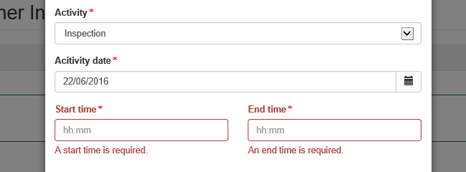

**1**

**2**

PEMS will display an appropriate **error message1** when information is entered incorrectly into the system or a particular function cannot be performed.

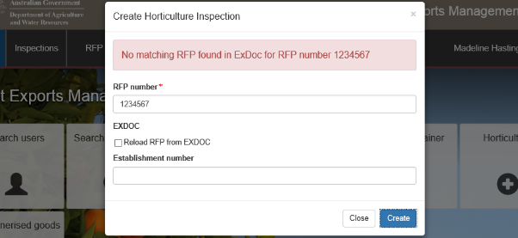

**1**

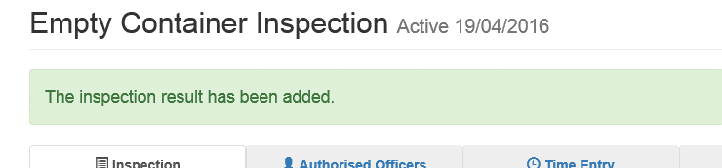PEMS will display an **acknowledgement message1** when you successfully perform certain actions, such as saving a record.

**1**

If you decide you would like to exit a window at any time, you can click **Close1** or click **Exit (X) 2**.

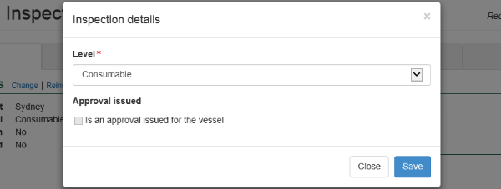

**1**

**2**

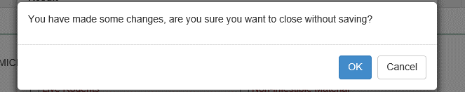PEMS will display a **confirmation message1** when you perform certain actions, such as closing a window without saving (such as demonstrated in the screen shot below) or submitting, cancelling or withdrawing an inspection/calibration record.

**1**

### Saving and submitting records

There is a difference between saving records and submitting a record in PEMS.

When you save a record, PEMS will save the record to the database. When you open the saved record, you are still able to update that record if you have the appropriate permissions.

When you submit a record, PEMS will finalise the record on the database. When you open the submitted record, it will appear as read-only and you will not be able to change the record.

### Abiding by instructional material

This user guide provides instructions for using the PEMS system. Authorised officers must perform their tasks consistent with all approved instructional material for their appointed job function(s).

**!** Remember you are responsible for maintaining the confidentiality of your PEMS user login and password.

## 1 Getting started

To help you get started in using PEMS, this section provides information on:

* how to login
* the PEMS menu and home page
* how to manage your PEMS user profile

### 1.1 Accessing and registering for PEMS

PEMS can be accessed by all departmental and external plant export AOs. Once AOs have successfully registered as a PEMS user and the administrator has enabled the account, PEMS will identify the AO’s appointed job functions and provide the AO with appropriate access to enable completion of records for these job functions.

### 1.2 Logging into PEMS

To access PEMS, go to: <https://online.agriculture.gov.au/selfservice>

The log in page will display.

Enter your **User Login1** and **Password2**. This information will have been circulated to you via email by the Department of Agriculture, Plant Export Training following registration.

If you agree to the **terms of use** select the **I accept the terms of use3**checkbox.

Click **Log in4**.

**!** If you forget your password click **Forgotten Password?5** link and follow the prompts.

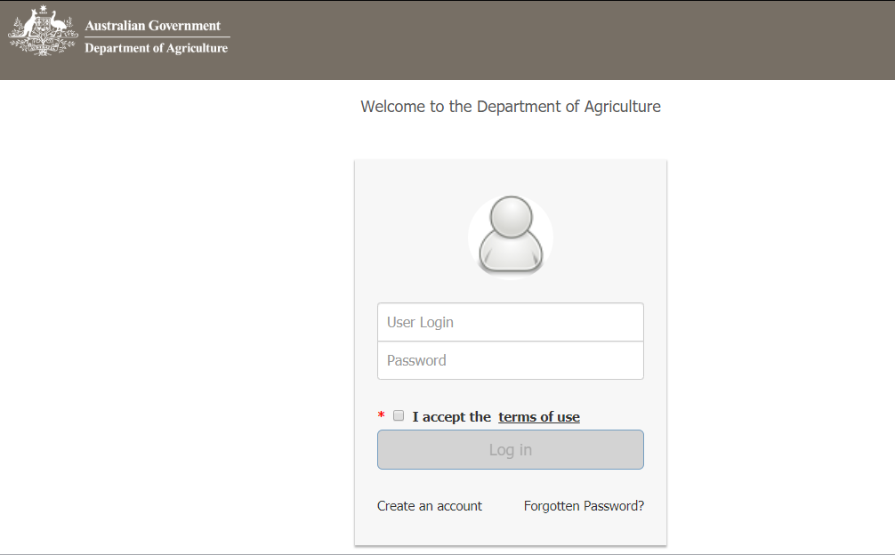

**!** Remember you are responsible for maintaining the confidentiality of your PEMS user login and password.

**1**

**2**

**3**

**4**

**5**

The PEMS self-service page will display.

Click the **PEMS**1 button to enter the PEMS home page.

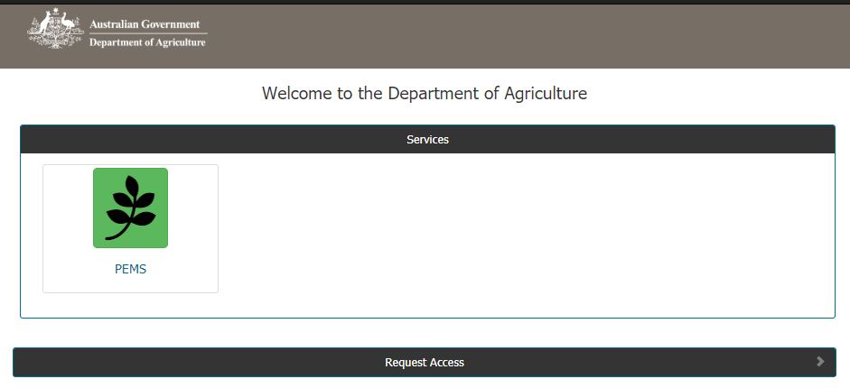

#### PEMS menu bar

There are six items displayed in the PEMS menu bar:

* **Home1** – view your records, or initiate a record as outlined in Appendices A–H.
* **Inspections2** – search for and initiate an inspection record, as outlined in Sections 2.1 Inspection search and Section 3.9 Alternate way to initiate an inspection or calibration respectively.
* **RFP3** – search for an RFP as outlined in Section 2.2.
* **Calibration4** – search for and initiate a ITCT calibration record, as outlined in Section 2.3 Calibration search and Section 3.9 Alternate way to initiate an inspection or calibration respectively
* **User Profile5** - view or change your personal details (see **‘Managing your PEMS profile’** below).
* **Log Out6** – log out of PEMS.

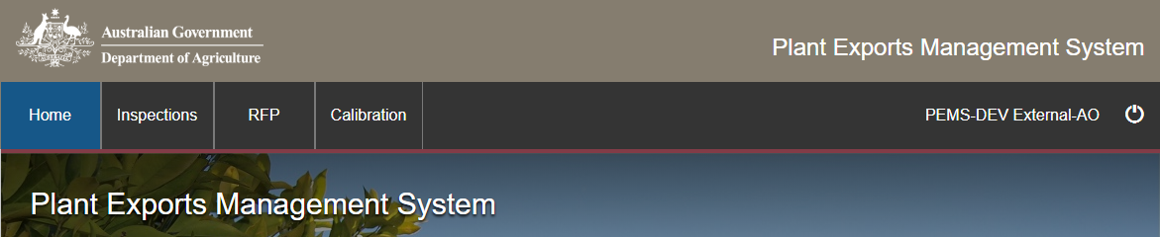

**1**

**6**

**5**

**4**

**3**

**2**

#### Job functions

The homepage of PEMS will display a **Button1** for each of the job functions that you have been appointed to perform. In the screen shot below, the AO has been appointed to perform the displayed inspection and calibration job functions.

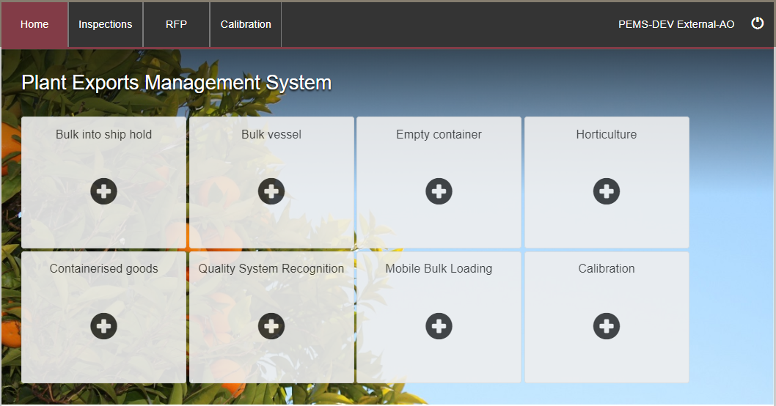

**1**

#### My inspections record list

A list of your incomplete inspection records will display on the PEMS homepage under the **My inspections1** section.

Click **Open2** beside any inspection record to open the record, make changes or finalise the inspection record. Section 3 and Appendices A–H provide more information on entering results, time entries, attachments and correspondence to the inspection record.

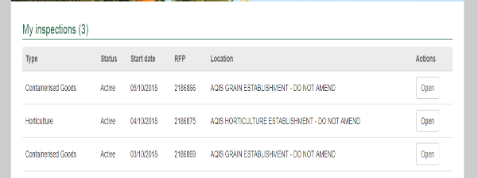

**!** For information on the PEMS offline function see Section 3.7 PEMS offline.

**1**

**2**

**My Calibrations record list**

A list of your incomplete calibrations records will be displayed on the PEMS homepage under the   
**My Calibrations1** section.

Click **Open2** beside any calibration record to open the record, make changes or finalise the calibration record.

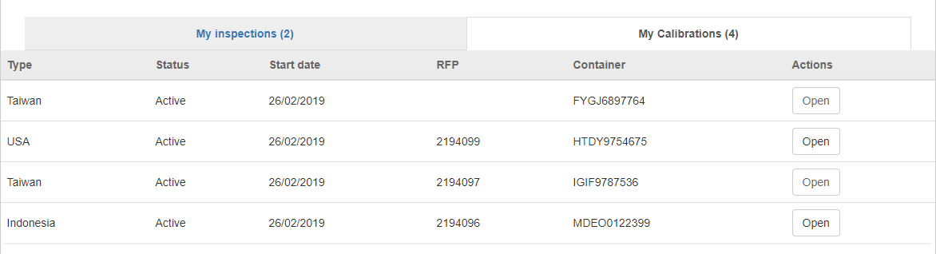

**2**

**1**

#### Managing your PEMS profile

To view or edit your PEMS profile, click **User Profile1** (your name) on the PEMS menu bar.



**11**

*My profile* page will display.

Your **Personal details1, Authorised officer details2** and **PEMS roles3** will be displayed, as well as the list and status of your AO **Job functions4** (including job function attachments).

You can change your personal details by clicking **Change5** under the personal details section. You cannot change information in the Authorised officer details, Job functions or PEMS roles sections.

Click **Home6** on the top menu bar to return to the PEMS homepage at any time.

**6**

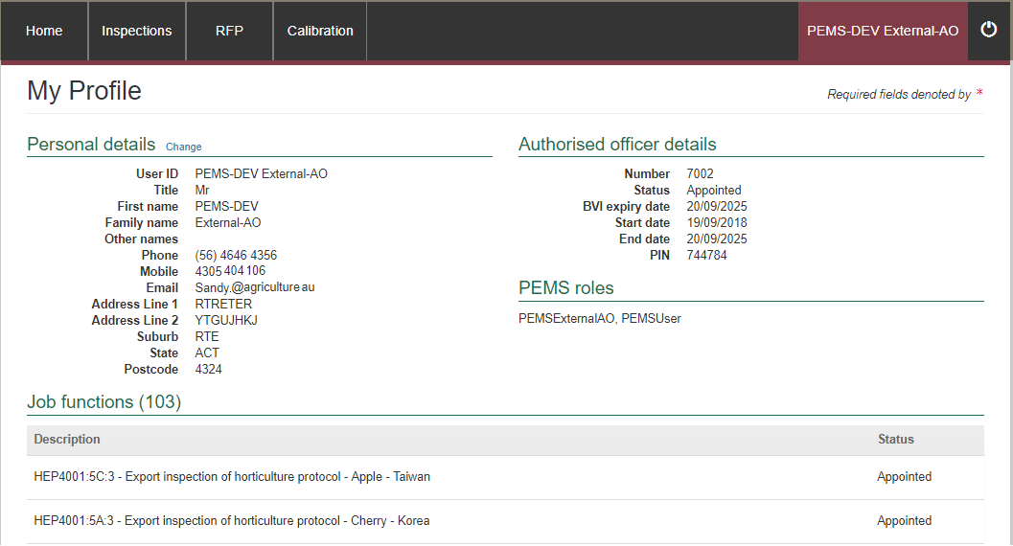

**4**

**3**

**2**

**1**

**5**

If you chose to change your personal details, the *Personal Details* window will display.

You can edit all fields in this window, except the **Email1**field. To make changes to your personal details select the applicable information from the drop down lists or enter information into the appropriate free text fields.

Click **Save2** to save any changes to your personal details.

**!** The region and office fields are only applicable for departmental AOs.

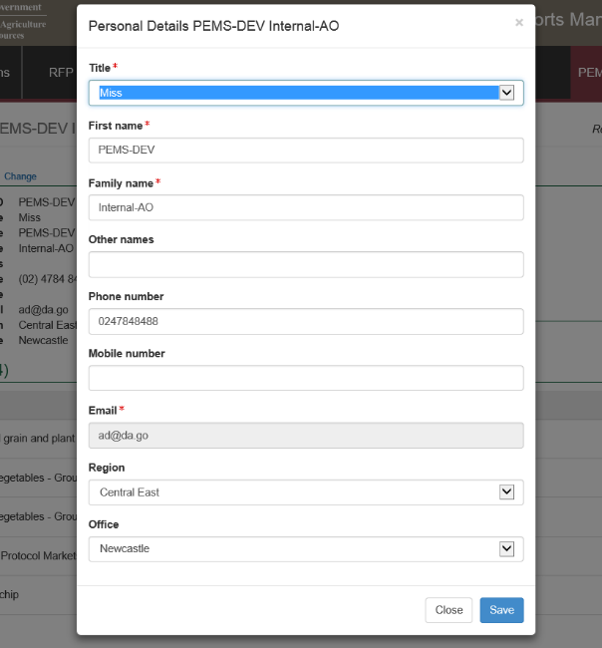

**2**

**1**

## 2 PEMS search functions

As PEMS captures and records information relating to inspections/calibrations, it is important to be able to search for the record you are looking for.

This section guides you through the process for searching for the following information:

* Inspection records
* RFPs
* Calibration records.

**Note:** you will only be able to search for and view information that your permissions allow.

### 2.1 Inspection search

PEMS inspection search allows you to search for inspection records.

External AOs can search for and view all active, checked out, withdrawn, completed or created in error inspection records that they are assigned to or have been initiated by them. Departmental AOs and supervisors from Inspections Group can search for any inspection record on PEMS.

#### Opening the inspection search page

To initiate an inspection record search click on the **Inspections1** tab in the PEMS menu bar.

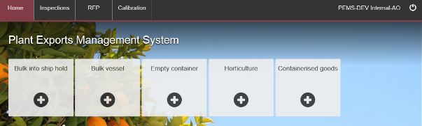

**1**

The *Search Inspections* page will display.

You can perform a simple search or advanced search for the inspection record.

#### Conducting a simple inspection search

Under the simple search mode you can search for inspection records by entering the RFP, container or International Maritime Organisation (IMO) number, an establishment name or number or an authorised officer name or number into the **search criteria field1** before clicking **Search2.**

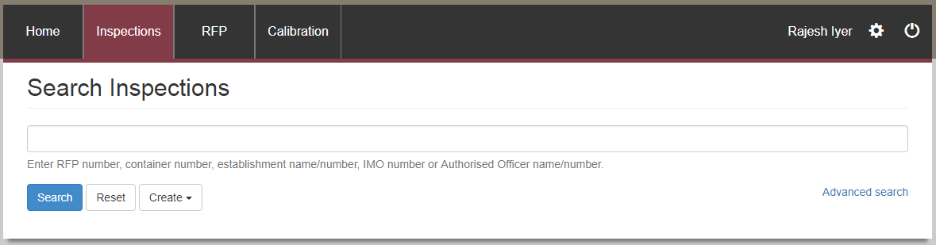

**1**

**2**

Conducting an advanced inspection search

Under the **Advanced search1** mode you can enter all search criteria in any combination to quickly locate a specific inspection record.

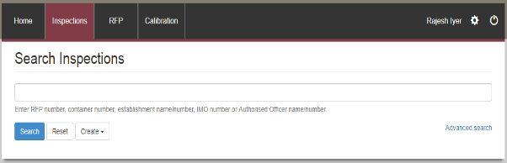

**1**

Enter data into the **search criteria fields1**, and then click **Search2**.

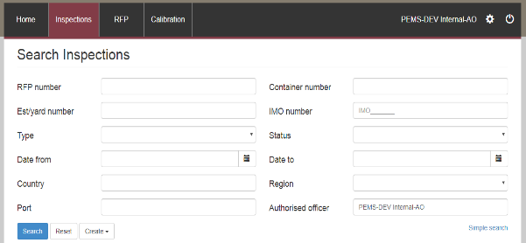

**2**

**1**

**1**

**!** You must provide at least one search criteria.

**!** If PEMS does not find records matching search criteria, it will display a message “No search results”

#### Selecting inspection records from search results

After a search has been entered, PEMS will display all **inspection records1** that meet the supplied search criteria, in order of newest to oldest.

Click **Open2** beside the appropriate inspection record to view the record. If the search results in one record, that record will be opened automatically.

Click **Reset3** to clear or reset the search criteria.

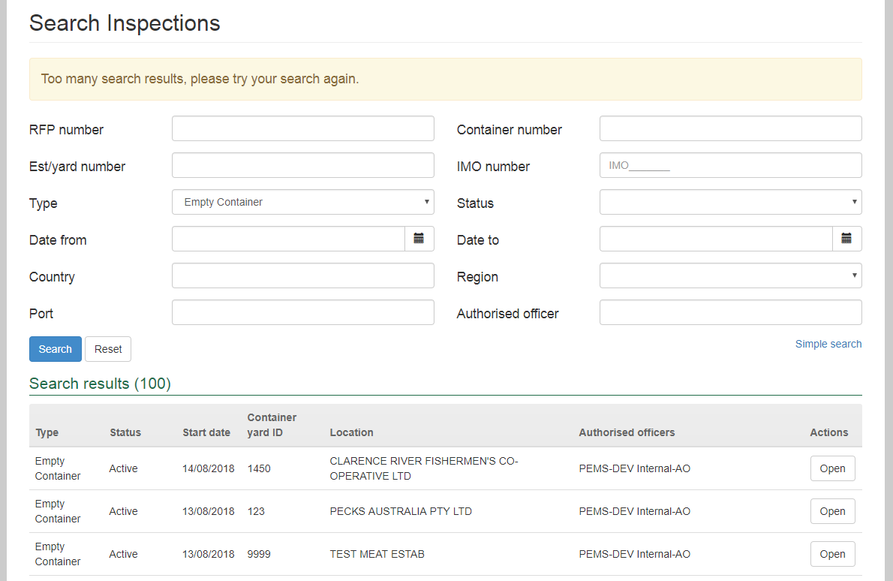

**!** For a Bulk into Ship Hold inspection, if a user performs the search inspection function using an Associated RFP, PEMS will display the inspection record associated with that RFP.

**2**

**1**

**3**

### 2.2 RFP search

PEMS RFP extract search allows you to search for RFP records.

External AOs can search for and view RFP records where at least one record was assigned to or initiated by the AO (whether the record is active, checked out, withdrawn, completed or created in error). Departmental AOs and supervisors can search for any RFP record extracted to PEMS.

#### Opening the RFP search page

To initiate an RFP record search click the **RFP1** tab in the PEMS menu bar.

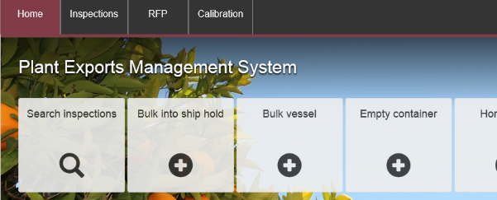

**1**

The *Search Requests For Permit* page will display.

You can perform a simple search or advanced search for the RFP record.

#### Conducting a simple RFP search

Under the simple search mode you can enter the RFP number, establishment name or number into the **search criteria field1** before clicking **Search2.**

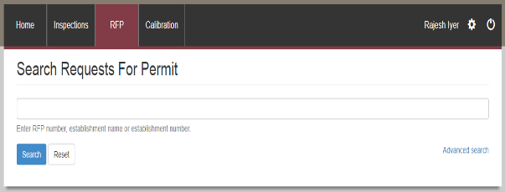

**2**

**1**

#### Conducting an advanced RFP search

Under the **Advanced search1** mode you can enter all search criteria in any combination to quickly locate a specific record.

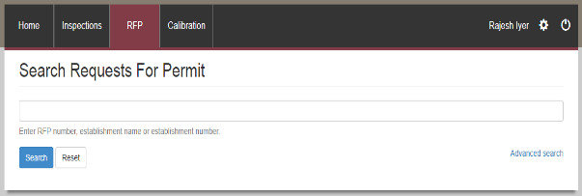

**1**

The *Search Request For Permit* page will expand.

Enter data into the **search criteria fields1**, and then click **Search2**.

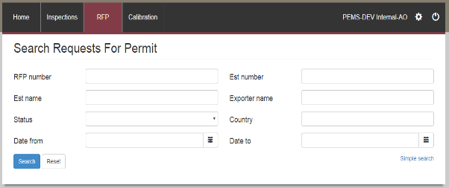

**2**

**1**

**1**

**!** You must provide at least one search criteria.

**!** If PEMS does not find records matching search criteria, it will display “*No search results*” message.

#### Selecting RFP records from search results

After a search has been entered, PEMS will display all RFP **records1** that meet the supplied search criteria, in order of newest to oldest, consistent with the user’s permissions.

Click **Open2** beside the appropriate RFP record to view the record. If the search results in one record, that record will be opened automatically.

Click **Reset3** to clear or reset the search criteria.

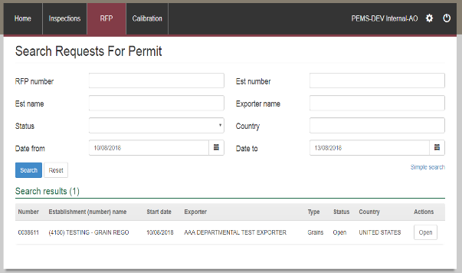

**2**

**1**

**3**

**!** For a Bulk into Ship Hold inspection, if a user performs the search RFP function using an Associated RFP, PEMS will display the extracted details of the RFP from EXDOC.

When the user navigates through the inspection tab, PEMS will display the inspection record associated with that RFP.

### 2.3 Calibration search

PEMS Calibration extract search allows you to search for calibration records.

External AOs can search for and view calibration records where at least one record was assigned to or initiated by the AO (whether the record is active, checked out, withdrawn, completed or created in error).

**Opening the Calibrations search page**

To initiate a Calibration record search click the **Calibrations1** tab in the PEMS menu bar.

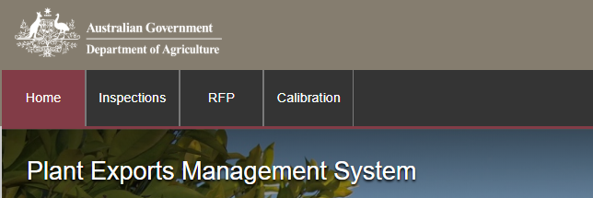

**1**

The *Search Calibrations* page will display.

You can perform a simple search or advanced search for the calibration record.

**Conducting a simple calibration search**

Under the simple search mode you can search for a calibration record by entering the RFP number, establishment number or container number into the **search criteria field1** before clicking **Search2.**

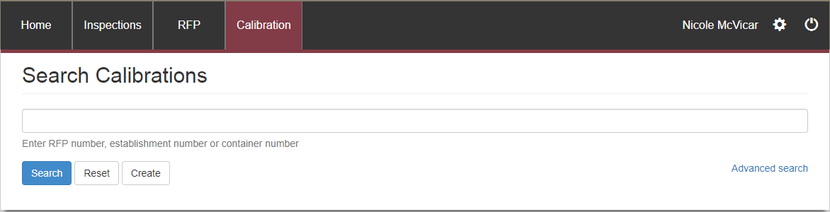

**1**

**2**

**Conducting an advanced calibration search**

Under the **Advanced search1** mode you can enter all search criteria, in any combination, to quickly locate a specific calibration record.



**1**

The *Search Calibrations* page will expand.

Enter data into the **search criteria fields1**, then click **Search2**.

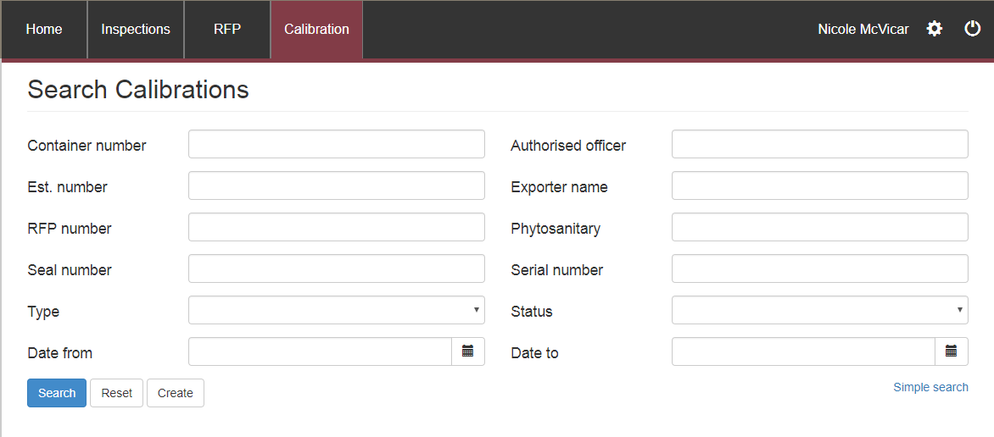

**1**

**1**

**2**

**!** You must provide at least one search criteria.

**!** If PEMS does not find records matching search criteria, it will display a message “No search results”

**Selecting a calibration record from search results**

After a search has been entered, PEMS will display all calibration **records1** that meet the supplied search criteria, in order of newest to oldest, consistent with the user’s permissions.

Click **Open2** beside the appropriate calibration record to view the record. If the search results is one record, that record will be opened automatically.

Click **Reset3** to clear or reset the search criteria.

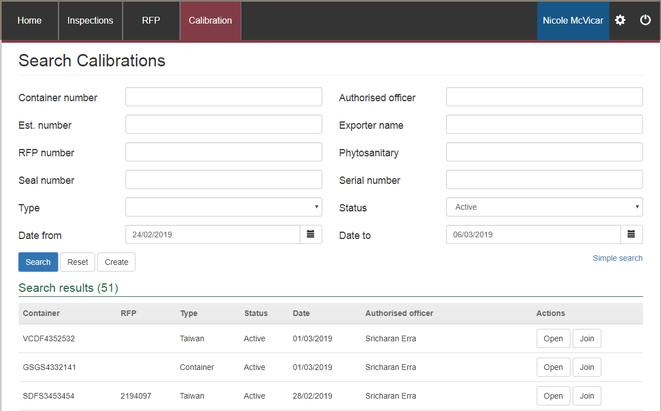

**2**

**3**

**1**

## 3 General PEMS functions

Once a record is initiated in PEMS, you can perform other activities relating to the record. These activities capture key information relating to the activities performed and the step-by-step instructions for completing these activities are the same, regardless of the inspection/calibration type you are performing.

This section provides step-by-step instructions for:

* assigning additional AOs to an inspection record
* joining an active inspection
* recording a result of ‘passed after rectification’
* recording time entries, adding invoices and downloading an activity report
* attaching relevant supporting documentation
* recording correspondence relating to an inspection/calibration
* downloading an inspection/calibration report
* withdrawing or cancelling an inspection/calibration
* using the PEMS offline functionality
* using PEMS to refresh containers, import permits and treatment information from EXDOC
* adding comments to a record
* alternate ways to initiate an inspection/calibration record in PEMS

### 3.1 Assigning authorised officers (inspection records only)

#### Searching for authorised officers

Once an inspection is initiated (see Appendices A–E) it is possible to assign additional AOs with the required job function(s) to the inspection record. The process for assigning additional AOs is the same for all inspection types.

Click the **Authorised Officers1** tab. PEMS will automatically assign the **logged in user2** as the assigned AO for the inspection. PEMS will also display the list of **required job functions3** needed to complete the inspection. You can added internal or external AOs to the inspection.

Click **Add4** under the assigned authorised officers section to add an AO to the inspection.

**!** It is recommended that where an inspection will take place over multiple days/sessions, such as a bulk into ship hold inspection, that an existing assigned AO should ensure that at least one AO, who will be present for the next inspection session, is assigned to the inspection record so that inspection data can continue to be added to the inspection record.

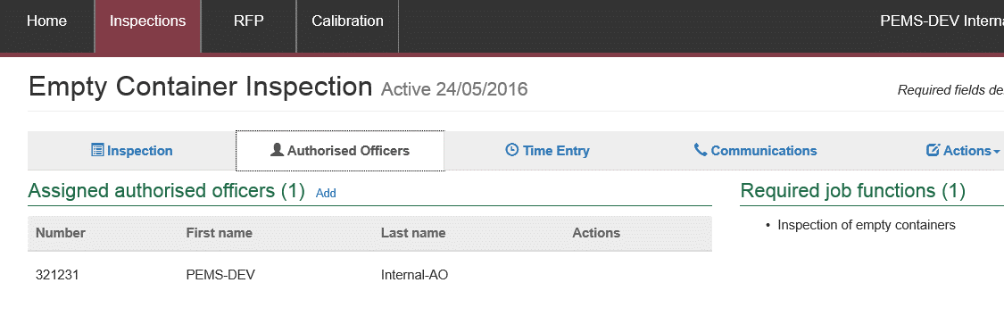

**1**

**4**

**2**

**3**

The *Authorised officer’s* window will display.

If you know the name or number of an AO you wish to assign, enter this information into the **simple search1** field and then click **Search2**. If you do not know the AO’s name or number, you can create a shortlist of candidate AOs by clicking **advanced search3**.

Simple search window:

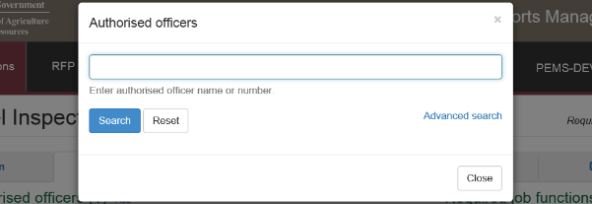

**3**

**1**

**2**

**Advanced search window**

The advanced search function allows you to enter data into any appropriate **search criteria1** field(s), in any combination, to create a shortlist of candidate AOs.

Once all the known search data is entered, click **Search2**.

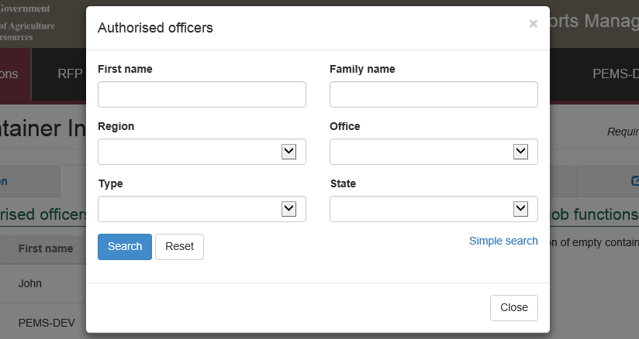

**1**

**2**

#### Assigning authorised officers to the inspection

A **list of candidate AOs1** matching the search criteria data will display. Click **Add2** to add an applicable AO to the inspection record.

Click **Reset3** to reset the search criteria.

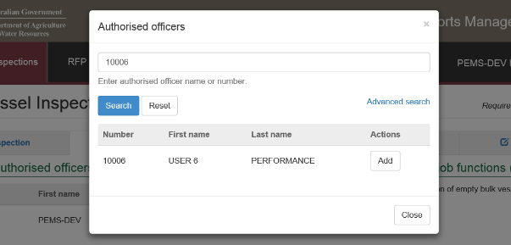

**1**

**2**

**3**

Once an AO is added to the inspection record, the authorised officer page will display the updated list of **assigned authorised officers**1.

An email notification will be sent to the Authorised Officer notifying them that they have been added to that particular inspection.

You can add more AOs to the inspection record by clicking **Add2** and repeating the steps above.

You can **Remove3** any assigned AO from the inspection record up until the record is submitted, withdrawn or cancelled, as long as the AO has not recorded an inspection result or flow path result or a time entry on the inspection record.

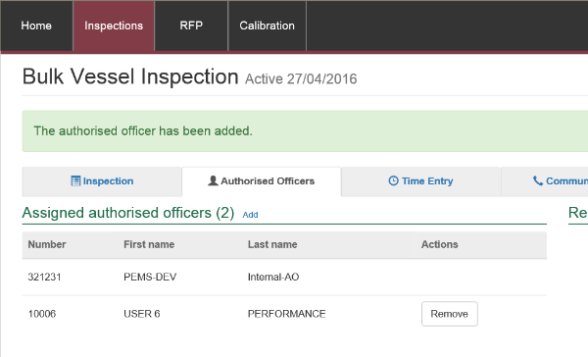

**1**

**2**

**3**

The **assigned AOs1** will be available to select when recording inspection results (see Appendices A–H). For example, the following screen shot displays the list of AOs that are assigned to an empty container inspection record.

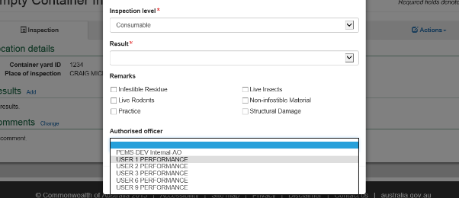

**1**

#### Opening an assigned inspection record

Where an AO with the required job function and attachments has been assigned to an inspection record by another AO, the inspection record will appear in the assigned AO’s **My inspections**1 list on the PEMS home page. The process for opening assigned inspection records is the same for all inspection types.

To open the assigned inspection record, click **Open2** beside the relevant inspection record.

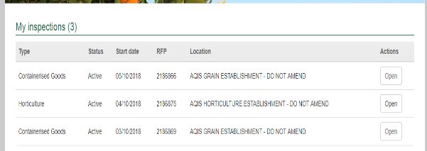

**2**

**1**

The inspection page will display. The inspection record may already include **inspection data1** that other AO’s assigned to the inspection have recorded.

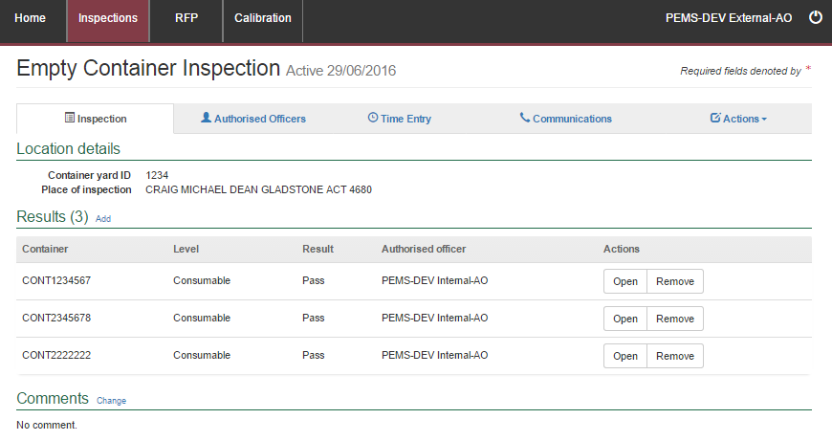

**1**

### 3.2 Joining an active record

#### Joining an active inspection

PEMS allows multiple AOs, with the required job function, to join an active inspection record for all inspection types (except empty container inspections). For information about joining a bulk vessel inspection you should consult **Appendix D Bulk Vessel Inspection** as it has additional security requirements.

To join an active inspection record, follow the step-by-step instructions provided in the relevant appendices A–H for **‘Initiating an inspection’**. After you click the relevant inspection button, the create inspection window will appear and you will need to enter the **RFP number1** and **Establishment number2**, and click **Create3**.

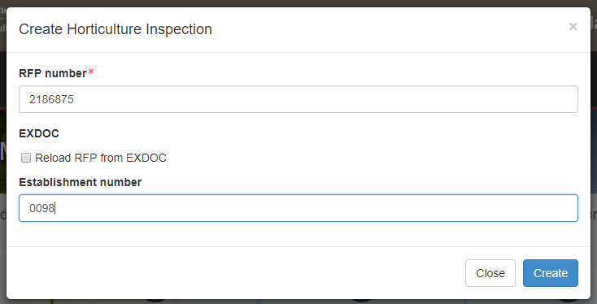

**1**

**3**

**2**

The join inspection window will display. Click **Join1**.

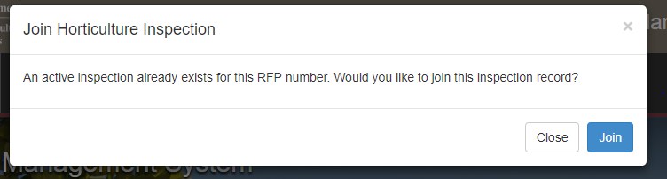

**1**

#### Joining an active calibration

PEMS allows multiple AOs, with the required job function, to join an active calibration record. To join an active calibration, follow the step-by-step instructions provided in Section 2.3 Calibration search to locate the record.

The *Search Calibration* window will display. Click **Join1** *(located under the Actions heading).

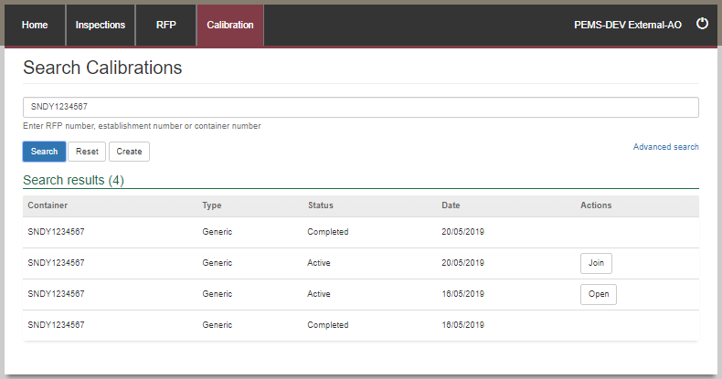

**1**

If you are an external AO there are extra validation steps.

To join an *onsite calibration* you will need to add the **RFP number1** and **Establishment number2.**

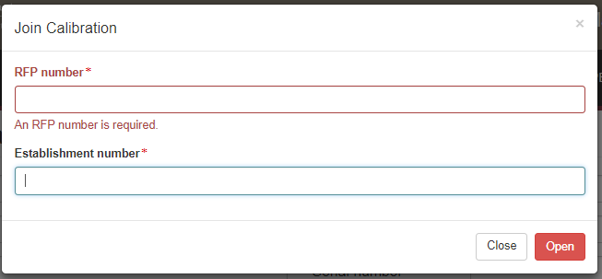

**2**

**1**

To join an *offsite calibration* you will need to add the **RFP number1**, **Establishment number2** and **Offsite calibration seal** **number2**, and click **Join4**.

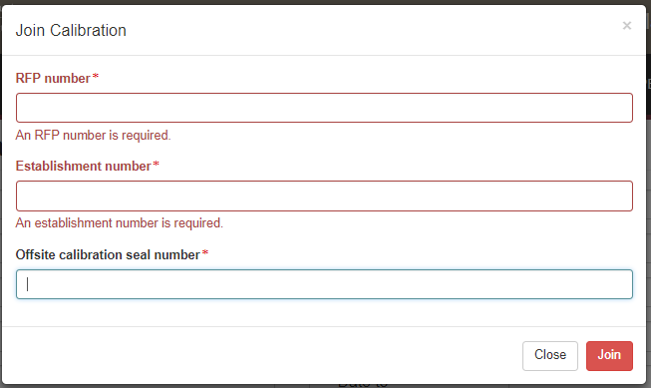

**4**

**3**

**2**

**1**

### 3.3 Recording a passed after rectification flow path result

Flow path inspection results must be recorded before entering the commodity inspection results and this result can be changed at any time until the record is submitted, cancelled or withdrawn.

To record the flow path inspection result, click the **Inspection1** tab and then click **Change2** under the flow path details section.

**1**

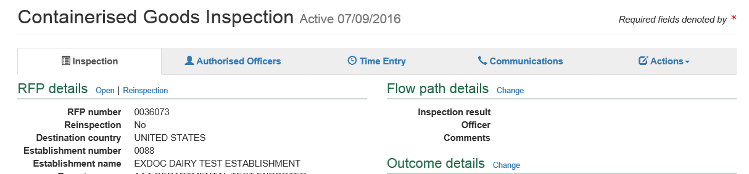

**2**

The *Flow path details* window will display.

If the flow path is failed at any time, you will have the option to change the flow path inspection result to ‘Passed after rectification’.

Select a flow path **Inspection result1** of ‘Passed after rectification’. The flow path details window will expand and you must enter **Authorised Officer2**, **Result date3** and **Result time4**.**Failed date5** and **Failed time6** will automatically generate from the failed results entry but can be altered.

When inspection result is ‘Passed after rectification’ it is mandatory to provide **Comments7** to explain what has occurred in order to change the result from Failed.

Click **Save8**.

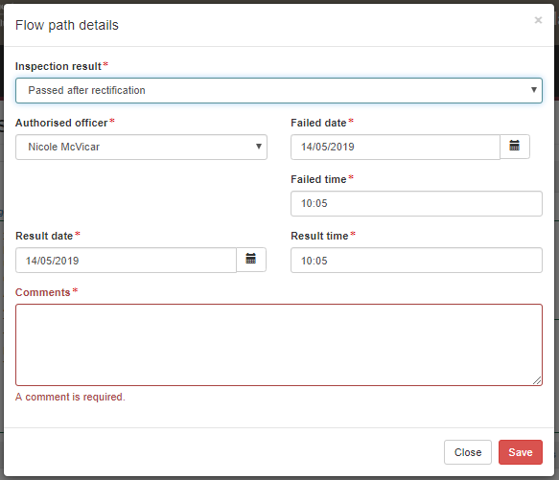

**6**

**5**

**4**

**3**

**2**

**1**

**!** The whole consignment presented for inspection will fail if the flow path receives a fail result. Do not continue with the commodity inspection as you will not be able to add results against RFP line. You must enter an appropriate time entry record (see Section 3.4 Time Entry) before the inspection record is submitted on PEMS.

**!** The flow path date/time must not be in the future and must be within the start and end date of the inspection. If you fail the flow path initially and then provide a passed after rectification result, rectification date/time must be after the flow path failed date/time.

**8**

**7**

The commodity inspection page will display the updated **flow path** **inspection result1** and PEMS will populate the name of the authorised **Officer2** who recorded the flow path inspection results in PEMS.

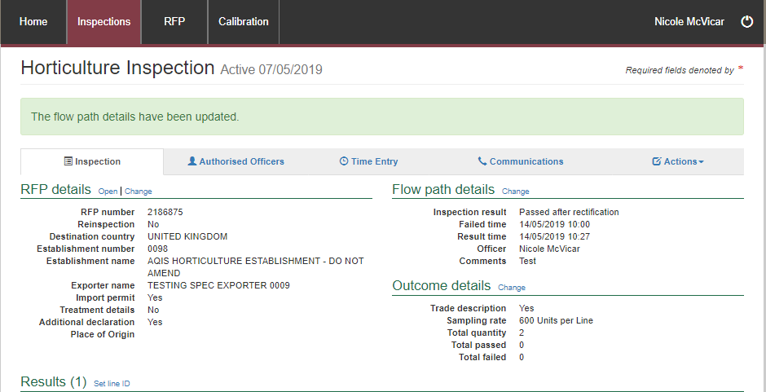

**2**

**1**

### 3.4 Time Entry

#### Open the Time Entry tab

The Time Entry tab is designed to record accurate data on the effort an AO spends on chargeable and non-chargeable activities. The process for recording time entry data is the same for all inspection/calibration types.

Once a record (see Appendices A–H) is initiated, you can add a time entry record for an AO by clicking the **Time Entry1** tab and then clicking **Add2** under the time entry section.

A time entry must be recorded for every AO who recorded an inspection/calibration result or flow path result for PEMS to allow submission of the record. This includes both internal and external AOs.

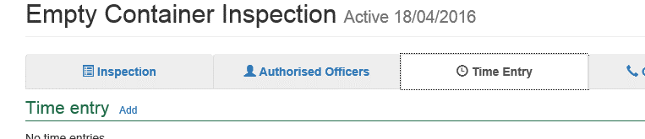

**2**

**1**

#### Recording time entry data for an external AO

The *Time Entry* window will display. Select the applicable **Authorised officer1** for the time entry record. Select the relevant **Activity2** type from the list based on the task you have completed—you can select from inspection, calibration, calibration and loading, and loading.

Enter the **start time** and **end time3** for the inspection/calibration in 24-hour format (hh:mm). The time can be 15 minutes in the future from the current system time. Time entries for an AO cannot overlap.

For example, if one time entry for an AO is from 11:00 – 12:00 then the start time for the AO’s next time entry could be from 12:01 onwards.

If applicable, enter **Comments4** relating to the AO’s time entry record.

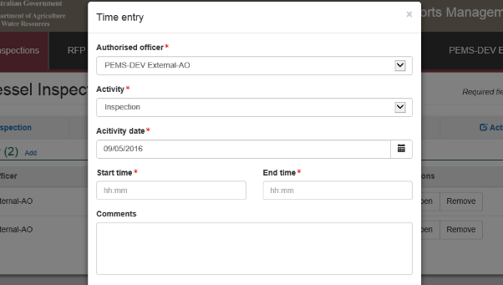

**2**

**3**

**1**

**4**

The activity date will default to the current date. To change the activity date select the **calendar icon1** and select the date from the pop-up **calendar2**. The activity date cannot be in the future.

Click **Save3**.

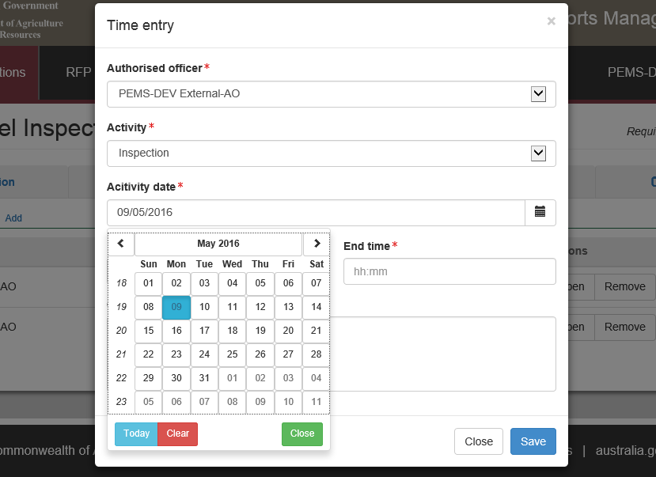

**1**

**2**

**3**

The *Time Entry* page will display the new **time entry record1**.

Additional time entry records can be added to the record by clicking **Add**2 and repeating the steps outlined above.

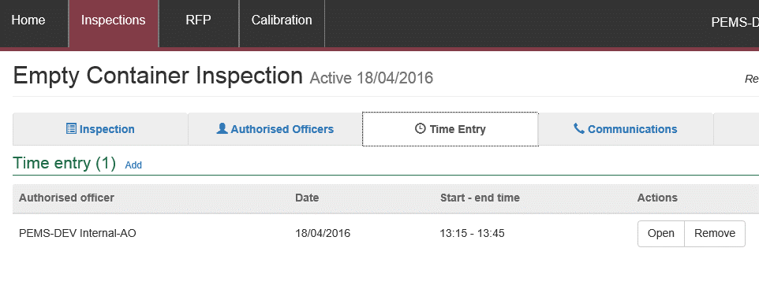

**2**

**1**

#### Recording time entry data for a departmental AO

The *Time entry* window will display.

Select the applicable **Authorised officer1**. Select the relevant **Activity2** type from the list based on the task you have completed—you can select from pre- inspection, inspection, calibration, calibration and loading, and loading.

Enter the **start** **time** and **end time3** for the inspection/calibration in 24-hour format (hh:mm). The time can be 15 minutes in the future from the current system time. Time entries for an AO cannot overlap. For example, if one time entry for an AO is from 11:00 – 12:00 then the start time that AO’s next time entry could be from 12:01 onwards.

There are a range of entry option check boxes for departmental AO time entries. The **time entry is chargeable4** check box will be selected by default for all activities. The **time entry is overtime5** check box will auto-select if the start time or end time for the activity falls outside core business hours (06:30 to 18:30). The **apply minimum charge6** check box will appear when the time entered is less than 30 minutes (you should only select this check box where activities fall outside core business hours). You can select or deselect any of these entry options check boxes at any time.

If applicable, enter any **Comments7** relating to the time entry (mandatory if the entry option checkboxes are changed from their default setting).

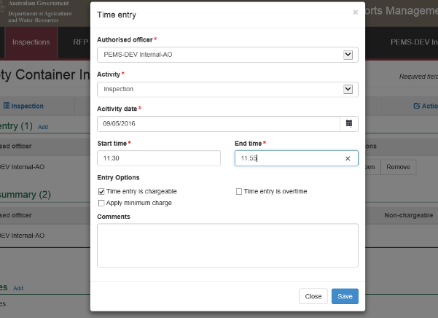

**1**

**3**

**5**

**6**

**7**

**2**

**4**

The activity date will default to the current date. To change the activity date select the **calendar icon1** and then select the applicable date from the pop-up **calendar2**. The activity date cannot be in the future.

Click **Save3**.

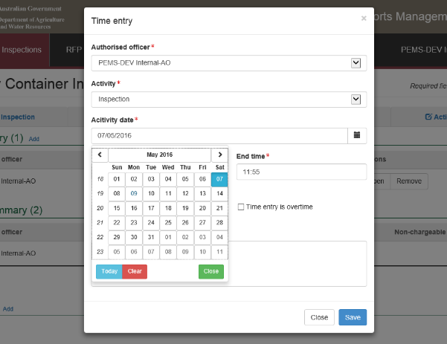

**1**

**2**

**3**

The *Time Entry* page will display the new **time entry1**.

Additional time entry records can be created by clicking **Add2** and repeating the steps outlined above. PEMS will populate the **Time summary3** (*departmental AOs only*)as more time entries are added to the record.

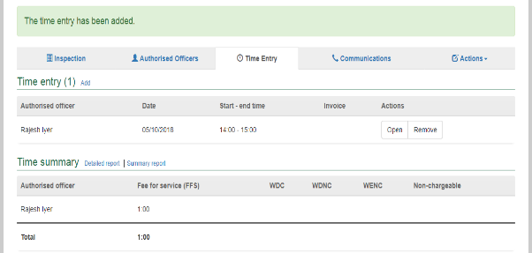

**2**

**3**

**1**

#### Edit or remove time entry data

You can **Open1** a time entry to edit the record or **Remove2** the time entry up until the inspection/calibration is cancelled, withdrawn or submitted.

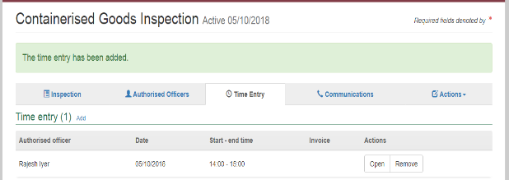

**2**

**1**

#### Invoicing (For departmental AOs only)

##### Commodity inspections only;

To see the Invoice details, select the **Time Entry1** tab.

Once the Time entry has been provided (see section 3.4 Time Entry), the **Invoice Details2** will automatically populate details for the client based on the exporter number which has been provided on the RFP.

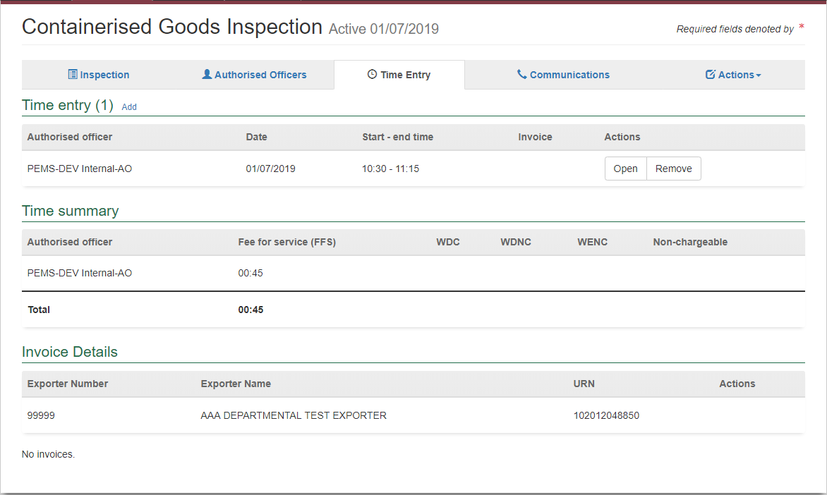

**2**

**1**

Once the inspection has been completed and submitted an **Invoice number** and **Status1** will appear.

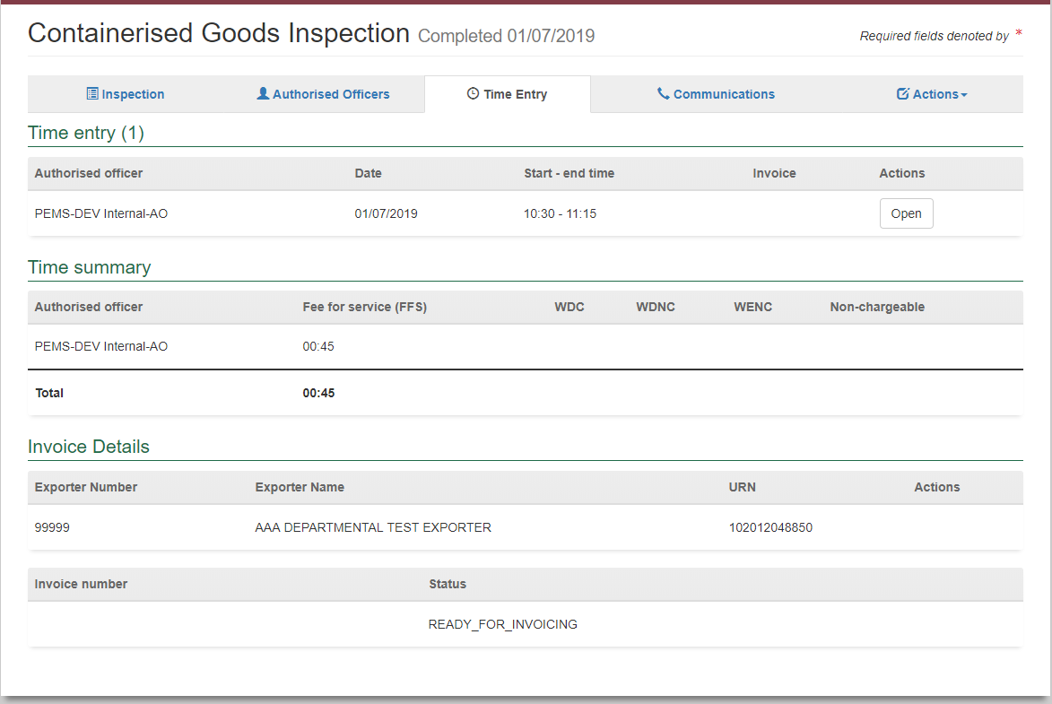

**1**

The **Status1** options are:

*Ready for Invoicing* – display after submit

*Invoiced* – generated by system and delivered to exporter

*Failed* – system failed to generate an invoice

*Paid* – invoice paid by exporter and transaction completed

**!** If the invoice status is failed you do not need to take any further action as this will be managed by the PEMS administrators. Do not create a new invoice in an alternate system (ELSA) as this will lead to duplication of charges.

##### Non-Commodity inspections

Select the **Time Entry1** tab then select **Add2** beside the Invoice Details.

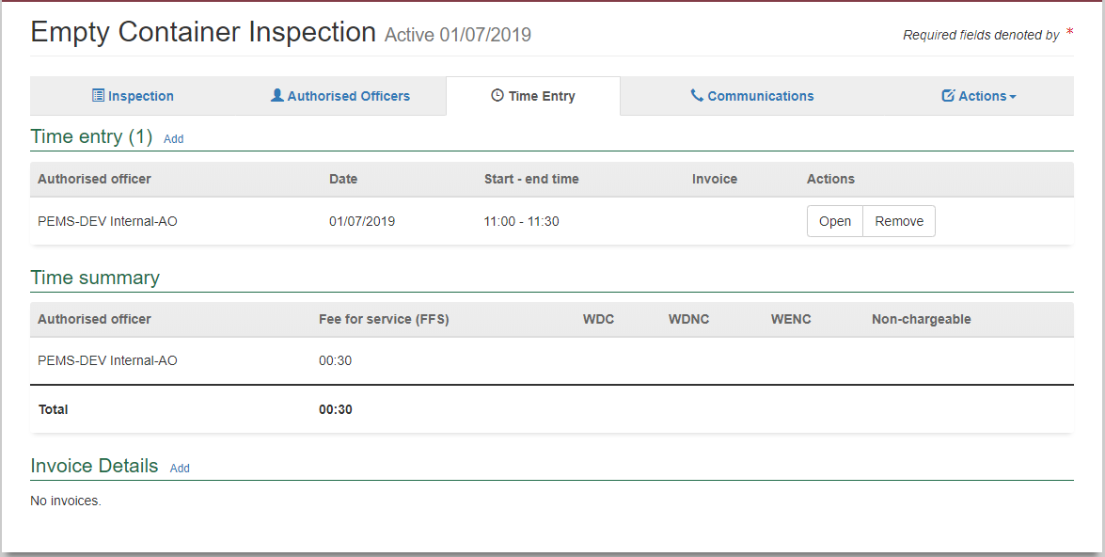

**2**

**1**

The *Invoicing Details* window appears.

There are two types of clients who can be invoiced:

* Exporter
* Other (Shipping Agent/Freight Forwarder)

If the client that needs to be invoiced is an Exporter then select **Client Type1** as Exporter and then enter the **Exporter Number2** and then click **Search3**. The **Client Name4** will appear and click **Save5**.

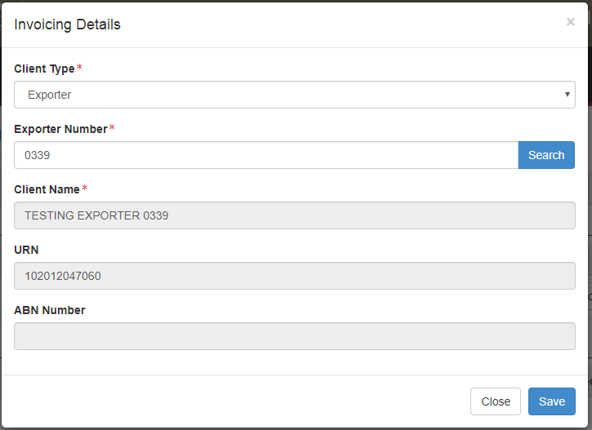

**1**

**4**

**2**

**5**

**3**

If the client is a Freight Forwarder or a Shipping Agent, then select **Client Type1** as Other (Freight Forwarder/Shipping Agent), then enter the **ABN Number2** and then click **Search3**. The **Client Name4** would only appear if the client account details are available in PEMS and then click **Save5**.

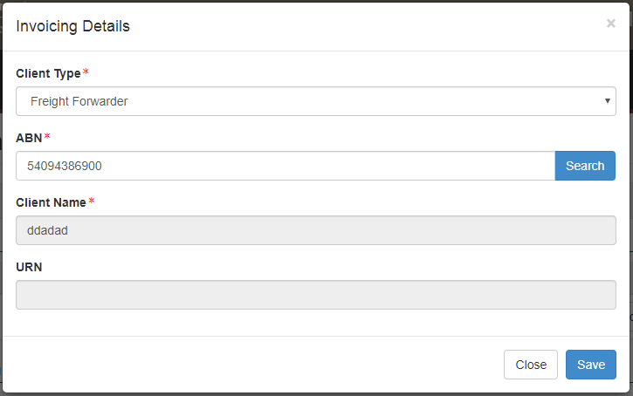

**4**

**3**

**1**

**5**

**2**

If the searchdetails are not available in the PEMS database, you will receive a warning message saying ‘**No search results found1**’.

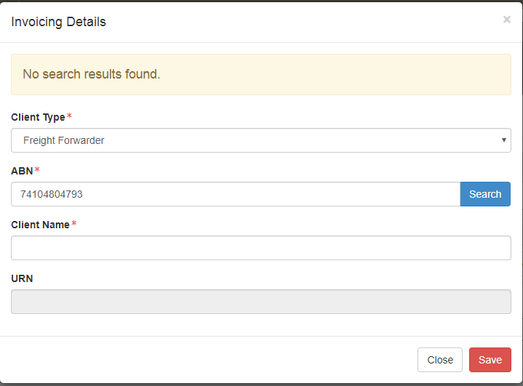

**1**

You can then choose to select the **Client Type1** , enter a **Client Name2** and then **Save3** the Invoicing details dialog box.



**3**

**2**

**1**

The Time Entry page will display the **Exporter details1** have been added.

The invoice details can be **Removed2** from the inspection until the inspection record has been submitted and the invoicing details can be **Opened3** viewed.

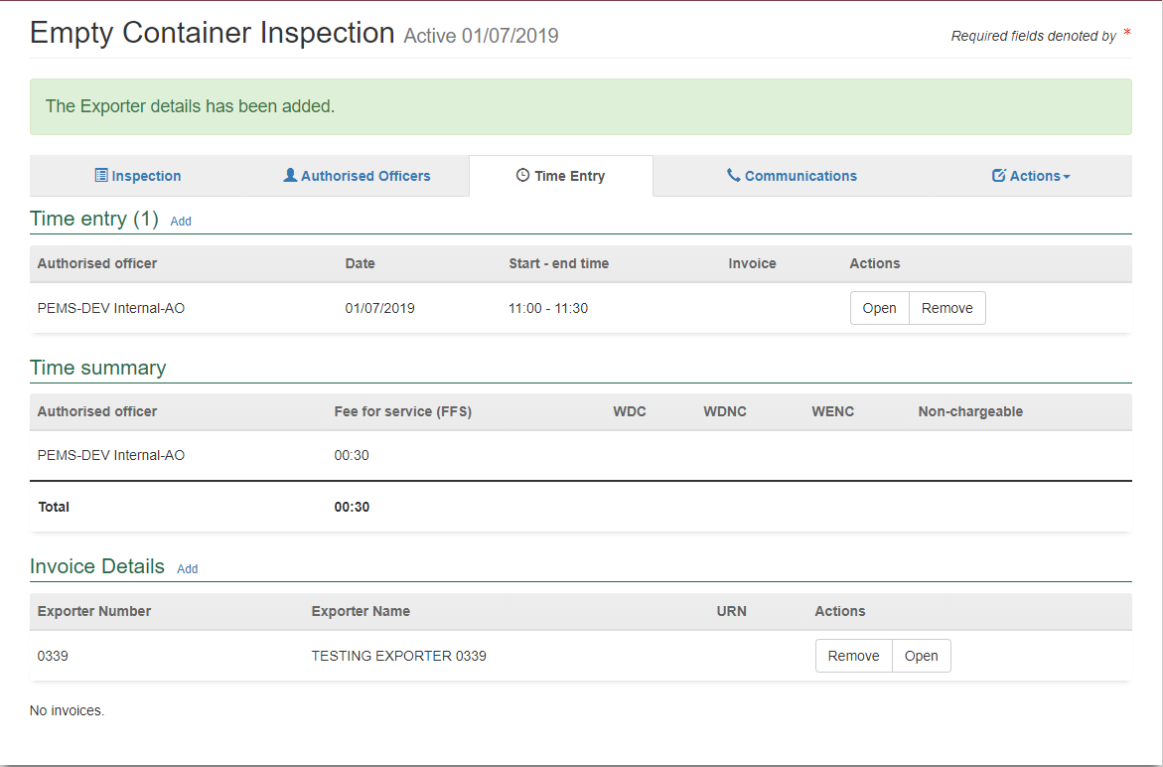

**3**

**2**

**1**

Once the inspection has been completed and submitted, the Invoice details will provide further information. The Invoice number and Status headings will appear. This will show the progress of the invoice.

##### Types of invoice status.

Ready for Invoicing – display after submit

Invoiced – generated by system and delivered to exporter

Failed – system failed to generate an invoice

Paid – invoice paid by exporter and transaction completed

**!** If the invoice status is failed, you do not need to take any further action as this will be managed by the PEMS administrators.

**Do not** create a new invoice in an alternate system (ELSA) as this will lead to duplication of charges.

#### Downloading an activity report (departmental AO)

Once an inspection/calibration has been initiated (see Appendices A–H) and time entries have been added to the record, you can download an activity report (PDF or RTF format) that captures the time effort recorded for the activities performed. Activity reports can be made available to the client along with the invoice.

The process for downloading activity reports is the same for all inspection/calibration types. PEMS allows you to download two types of activity reports: a summary report or a detailed activity report.

**Summary report**

The summary report is an extract of the record’s time summary and will display the overall effort recorded by all the assigned AOs for their activities.

To download a summary report click the **Time Entry1** tab and then click **Summary report2** under the time summary section.

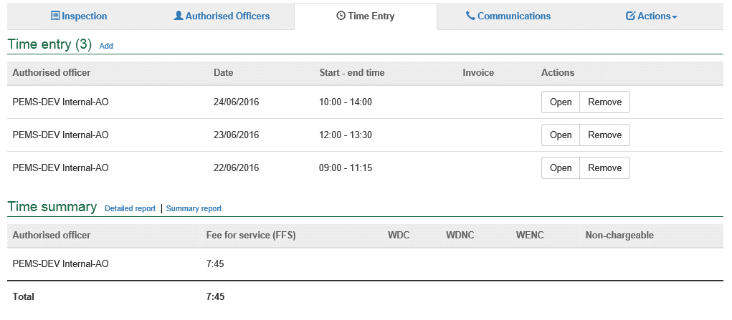

**1**

**2**

A *Summary Report* window will display.

Select either PDF or RTF for the **Report format1** to download onto your device and then click **Download2**.

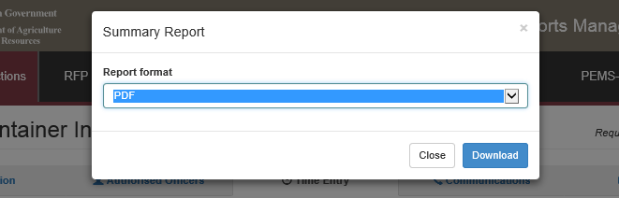

**2**

**1**

A document of the summary activity report will be downloaded onto your device. You can save or print the summary activity report for you or your client’s records.

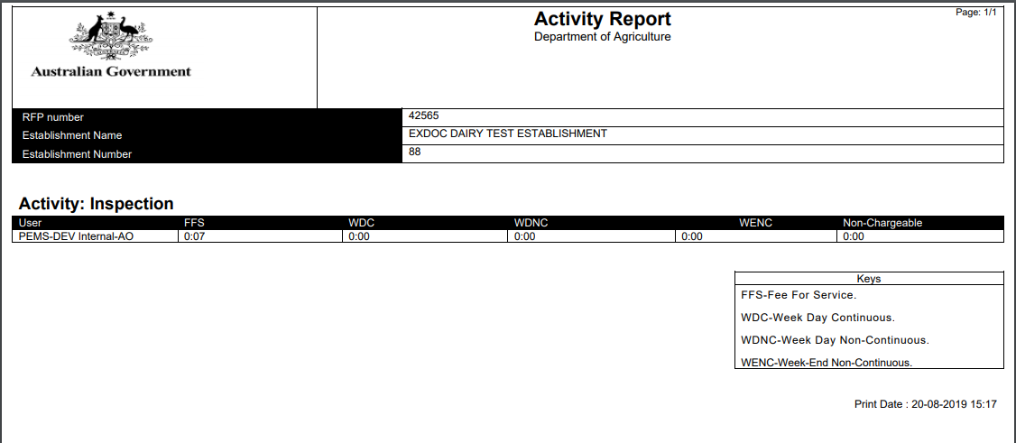

**Detailed activity report**

The detailed activity report allows you to select parameters to display a report for specific activities performed. The detailed activity report can be used to provide a client with an itemised list of charges that have been applied on the invoice.

To download a detailed activity report click the **Time Entry1** tab and then click **Detailed report2** under the time summary section.

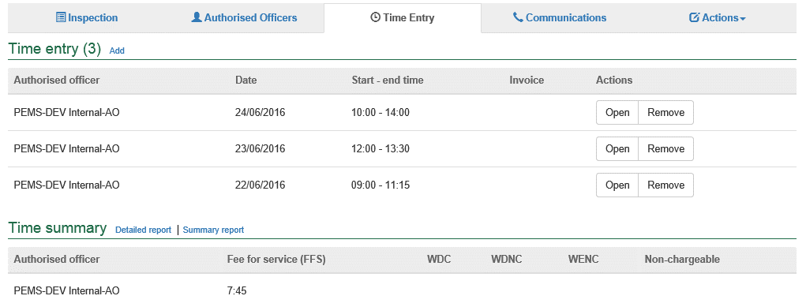

**1**

**2**

The *Activity Report* window will display.

You can choose to enter specific report parameters as necessary by:

* selecting a **Start date1** and/or **End date2**
* selecting an **Activity3** type
* selecting a **User4** (AO)
* entering an **Invoice number5**
* selecting one or more **Show these columns on the report6** checkboxes.

Alternatively, you can leave the report parameters blank.

Select a **Report format7** of either PDF or RTF.

Click **Download8**.

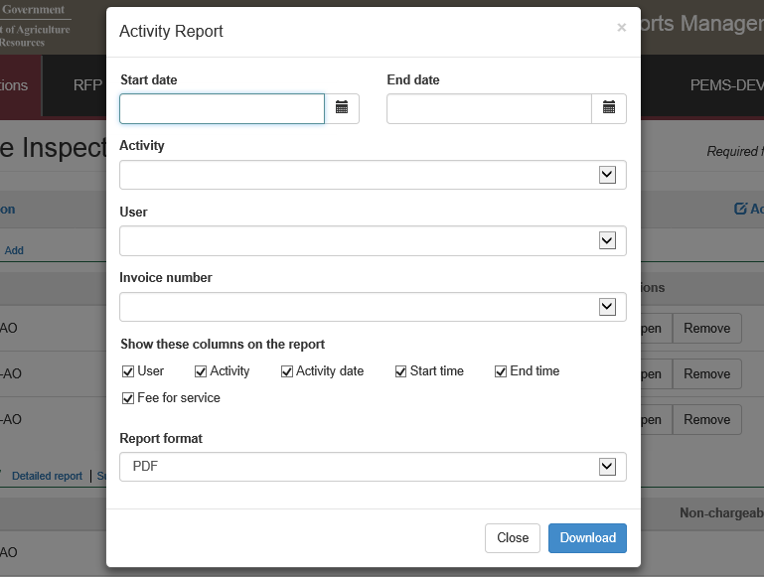

**1**

**2**

**3**

**4**

**5**

**6**

**7**

**8**

A document of the detailed activity report will be downloaded onto your device. You can save or print the detailed activity report for you or your client’s records.

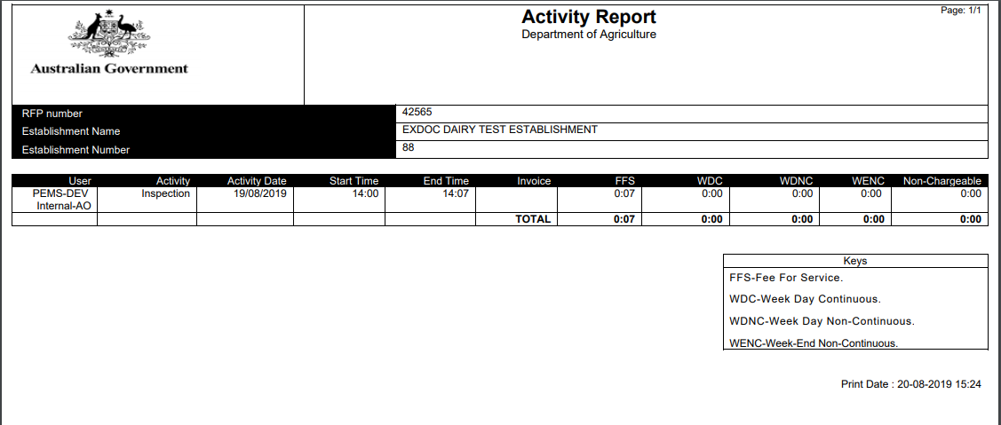

### 3.5 Communications

#### Attaching files to a record

Once an inspection/calibration is initiated (see Appendices A–H), you can attach any number of files relating to the record. The process for attaching files is the same for all inspection/calibration types.

To attach a file, click the **Communications1** tab and then clicking **Add2** under the attachments section.

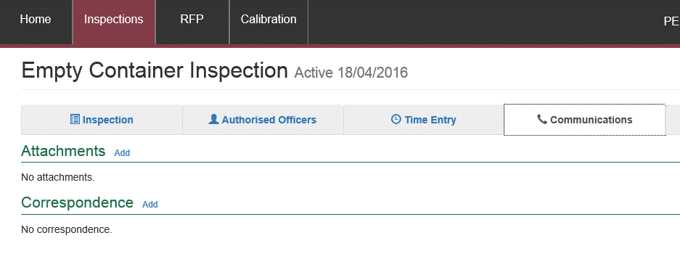

**1**

**2**

The *Attachment* window will display (below).

Click **Choose File1** and a file browser will display to allow you to search and select the relevant file from your device. You can attach Word, PDF and image files to the record. Emails will need to be saved as a PDF before attaching to the record.

The maximum file size permitted for each file is 9MB. Once selected, the file will appear in the **File input2** field.

Select the **Document type3** based on the check boxes provided. Where you have scanned more than one document into a single PDF you are able to tick as many check boxes as applicable.

Only documents that are required for the inspection or the RFP should be attached.

From the dropdown box select the **Outcome4**noting that the default is set as ‘Accepted’.

If **Other** is selected as a Document type, then the **Other document5** line will appear. You will need to enter a description identifying the document.

You can provide additional **Comments6** regarding the attachments if required. Comments are mandatory if the ‘Other’ tick box is selected.

Click **Save7**.

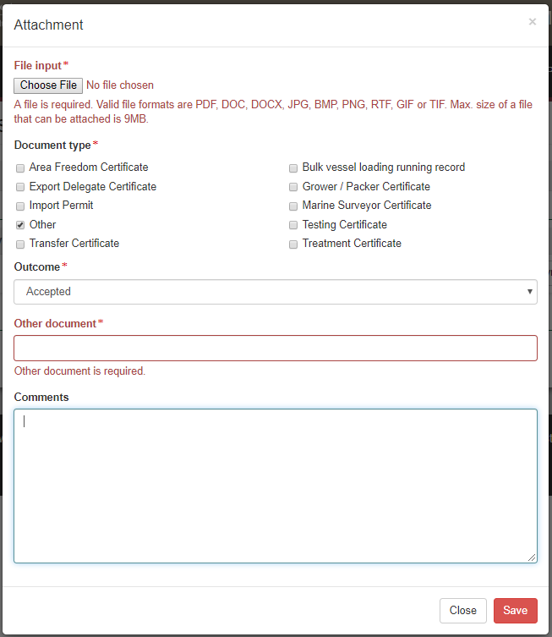

**6**

**7**

**5**

**4**

**3**

**2**

**1**

The *Communications* page will display the **newly attached file1**.

You then have the option to click **Download2** to download and view any attached file. You can also click **Remove3** to remove the file from the record if you have attached something in error.

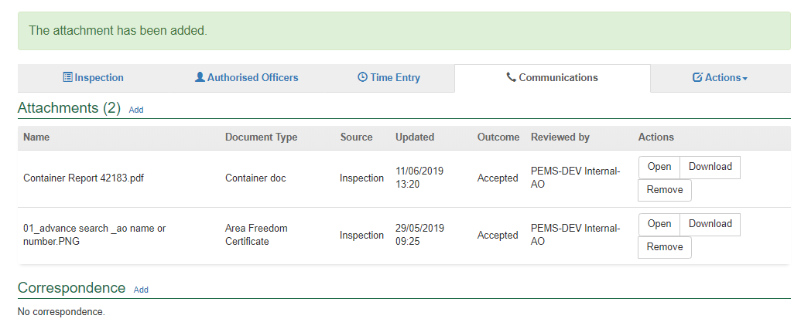

**3**

**2**

**1**

#### Attaching files to an record post completion

Once an inspection/calibration is completed, you can attach any number of files relating to the inspection/calibration to the record. The process for attaching files is the same for all inspection/calibration types.

To attach a file, click the **Communications1** tab and then click **Add2** under the *Attachments* section.

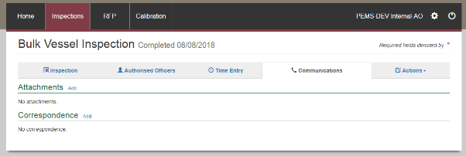

**2**

**1**

The *Attachment* window will display.

Click **Choose File1** and a file brower will display to allow you to search and select the relevant file from your device. You can attach Microsoft Word, PDF and image files to the record. The maximum file size permitted for each file is 9MB. Once selected, the file will appear in the **File input2** field. Record an **Outcome3** by selecting *accepted*, *not required* or *rejected* from the drop down lists and provide **Comments4**

Click **Save5**.

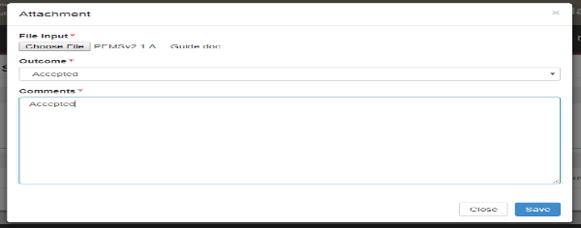

**5**

**4**

**3**

**2**

**1**

**5**

The *Communications* page will display the **newly attached file1**.

You then have the option to click **Download2**, to download and view any attached file. You can also click **Remove3** to remove the file from the record.

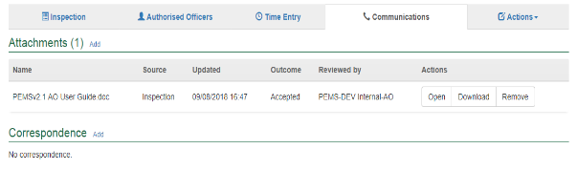

**!** Documents attached to the record in Active status cannot be removed once the inspection/calibration is completed. You also won’t be able to open the record and change the outcome. You will be able to download the document.

**1**

**2**

**3**

#### Recording correspondence relating to an inspection/calibration

Once an inspection/calibration is initiated, you can make a record of correspondence relating to the inspection/calibration. The process for recording correspondence is the same for all inspection/calibration types.

To record correspondence relating to a record, click the **Communications1** tab and then click **Add2** under the correspondence section.

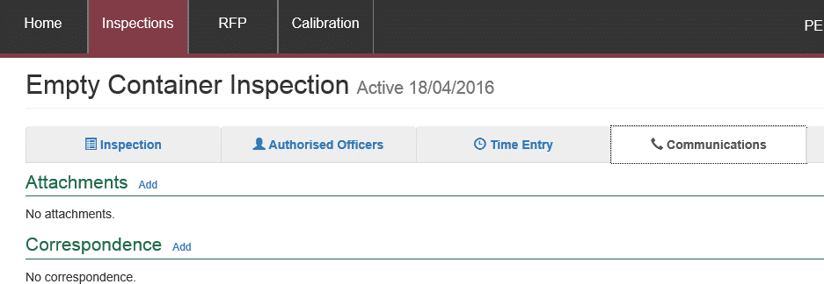

**2**

**1**

The *Correspondence* window will display.

Enter an appropriate **Subject1** for the correspondence and select the applicable correspondence **Type2** of mail, email, phone, on site or none from the drop down list.

Add details of the correspondence in **Comments3**.

Click **Save4**.

**2**

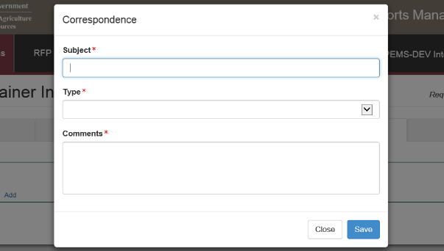

**1**

**3**

**4**

The *Communications* page will display the **newly added record**1.

Click **Open2** to edit the correspondence or click **Remove3** to remove the correspondence at any time until the inspection/calibration record is cancelled, withdrawn or submitted.

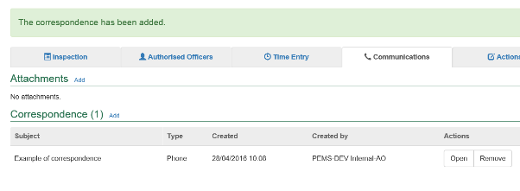

**2**

**3**

**1**

#### Recording correspondence post completion of an inspection/calibration

Once an inspection/calibration is completed, you can make a record of correspondence relating to the inspection/calibration. The process for recording correspondence is the same for all inspection/calibration types.

To record correspondence relating to a record, click the **Communications1** tab and then click **Add2** under the correspondence section.

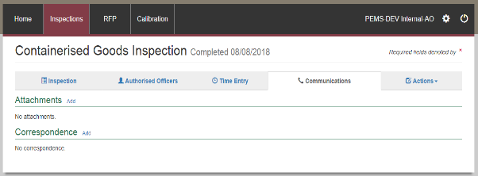

**2**

**1**

The *Correspondence* window will display.

Enter an appropriate **Subject1** for the correspondence and select the applicable correspondence **Type2** of email, mail, none, on site, or phone, from the drop down list.

Add details or a summary of the correspondence in **Comments3**.

Click **Save4**.

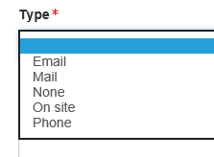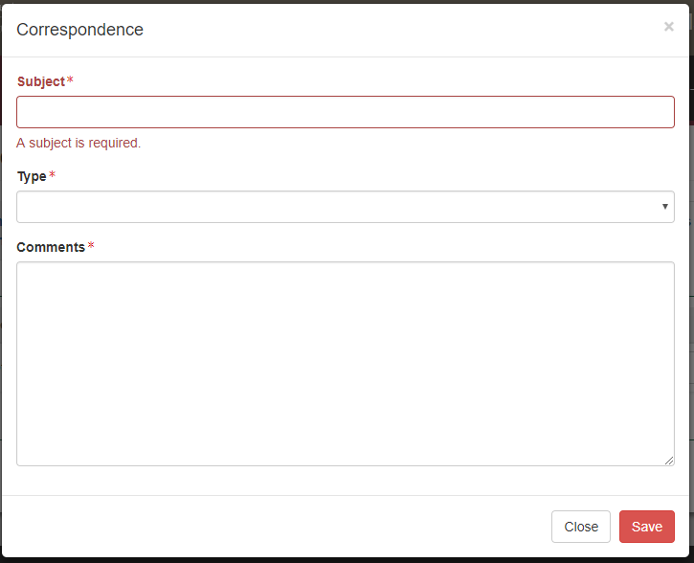

**2**

**1**

**4**

**3**

The *Communications* page will display the **newly added record**1.

Click **Open2** to edit the correspondence or click **Remove3** to remove the correspondence at any time until the inspection/calibration record is cancelled, withdrawn or submitted.

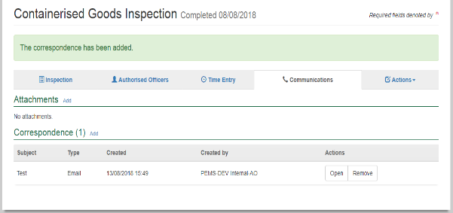

**2**

**!** Any correspondence added to the record in Active status cannot be removed once the inspection/calibration is completed. You will be allowed to open the record in Read Only mode.

**3**

**1**

### 3.6 Actions tab

#### Download inspection report

Before or after an inspection record is submitted you can download the inspection report. The process for downloading a report is the same for all inspection types.

To download the report click the **Actions1** tab and then select **Download report2**.

**Inspection reports**

A PDF document will be downloaded onto your device (next two screen shots). Once the document is opened the inspection report will display in the relevant ECR, BVAR or CAR format.

For inspection records downloaded after submission on PEMS, all inspection details will be included on the record. Where multiple AOs are assigned to an inspection, only the details of the **AO who submitted the record1** will display.

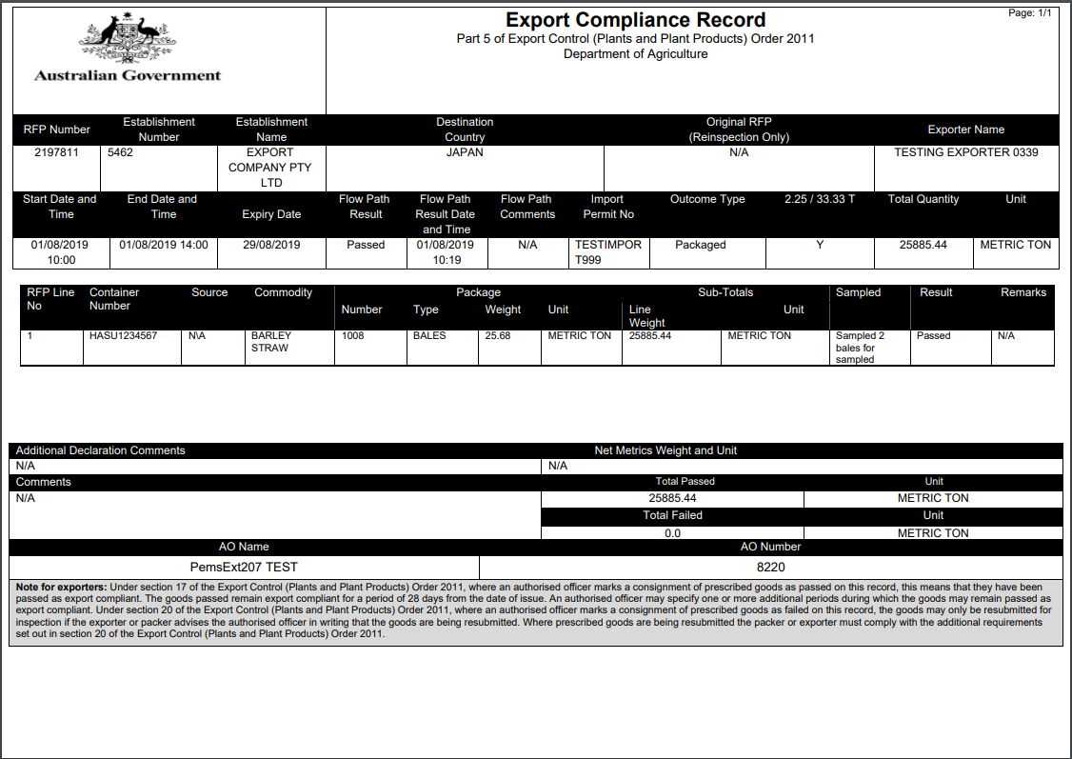

**!** Once the inspection records are downloaded they can be saved or printed for you or your client’s records.

**1**

If the inspection record is downloaded before the record has been submitted on PEMS, the inspection record will be a summary of inspection information provided to date and will not display:

* an end time or date for the inspection
* any AO details
* the department’s logo and name
* the note for exporters regarding the Export Control (Plant and Plant Products) Order 2011.

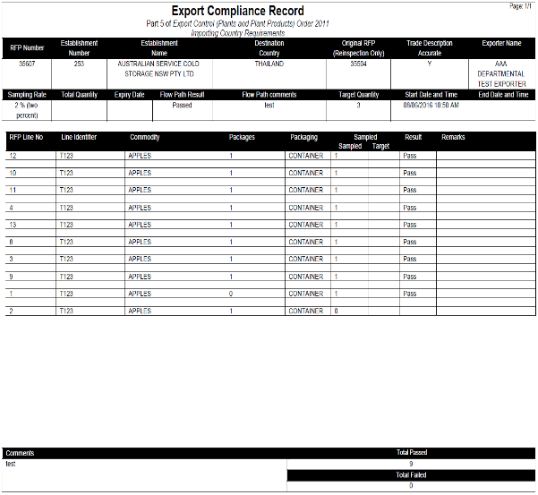

#### Download calibration certificate

Before or after a calibration record is submitted you can download the calibration certificate.

To download the report click the **Actions1** tab and then select Download **Certificate2**.

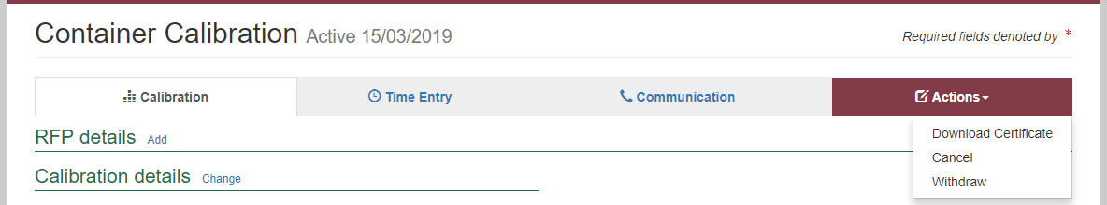

**1**

**2**

**Calibration certificate**

A PDF document will be downloaded onto your device. The certificate will be a summary of calibration information provided to date and will not display:

* the department’s logo
* the signature block (including wet stamp)

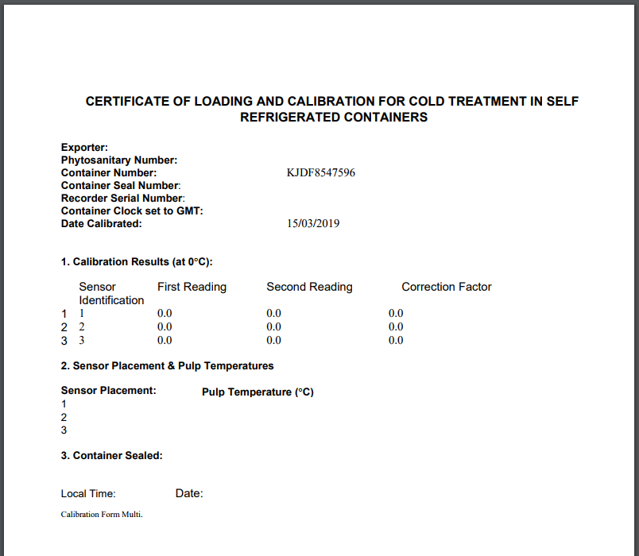

**!** AOs are advised to preview the record by downloading the certificate before the calibration record is submitted on PEMS

#### Download calibration certificate (Thailand)

Before or after a calibration record is submitted you can download the calibration certificate.

To download the report click the **Actions1** tab and then select **Download certificate2**.

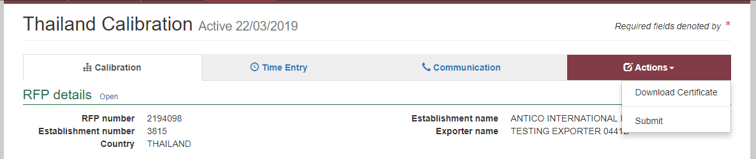

**2**

**1**

*Download Thailand Certificate* window will display. Select **commodity1** and click **download2**.

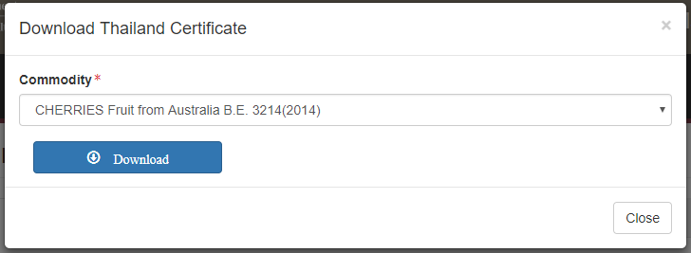

**1**

**2**

A PDF document will be downloaded onto your device. The certificate will be a summary of calibration information provided to date and will not display:

* the department’s logo
* the signature block (including wet stamp)

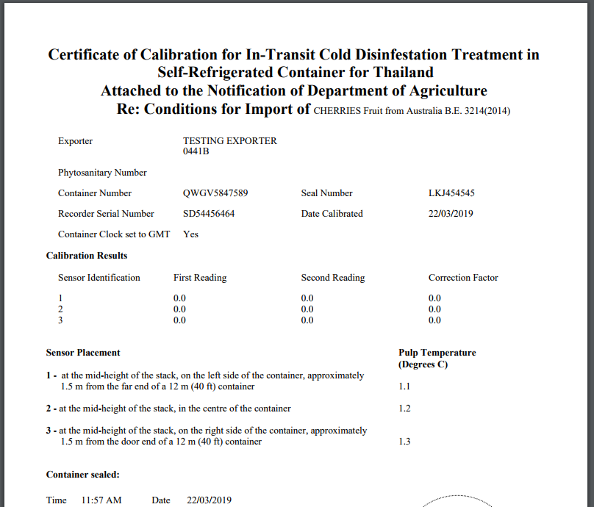

#### Cancelling an active inspection/calibration

Situations may arise where you decide to cancel an inspection/calibration before completion. Once an inspection/calibration is initiated (see Appendices A–H) it can be cancelled. The process for cancelling a record in PEMS is the same for all inspection/calibration types.

To cancel an active inspection/calibration, click the **Actions1** tab and then click **Cancel2**.

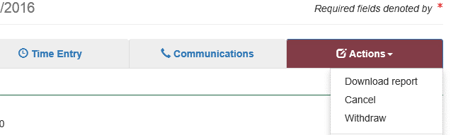

**1**

**2**

**!** For departmental AOs: when a record containing time entries for chargeable activities is cancelled, PEMS will exclude those time entries in calculations for total chargeable times.

The page will display a confirmation that the record was **created in error1** for the relevant inspection or calibration.

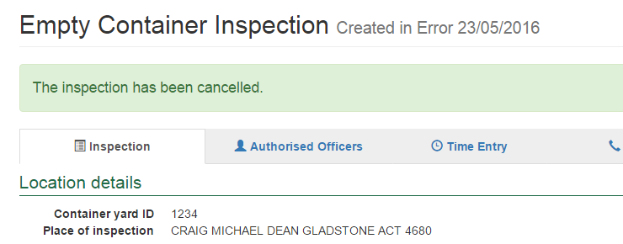

**1**

**!** Where a time entry was recorded on the record, the date(s) specified on the cancelled record will be the start date and end date for the inspection/calibration. The record date corresponds with the earliest and latest time entry across all AOs for the inspection/calibration.

#### Withdrawing an active inspection/calibration

Situations may arise where the client requests that you withdraw an inspection/calibration before completion. Once an inspection/calibration (see Appendices A–H) is initiated it can be withdrawn. The process for withdrawing a record on PEMS is the same for all inspection/calibration types.

To withdraw an active inspection/calibration click the **Actions1** tab and select **Withdraw2**.

**!** For departmental AOs: where chargeable activities should be recorded against the record, the record should be withdrawn. PEMS will include the recorded time entries in calculations for total chargeable times.

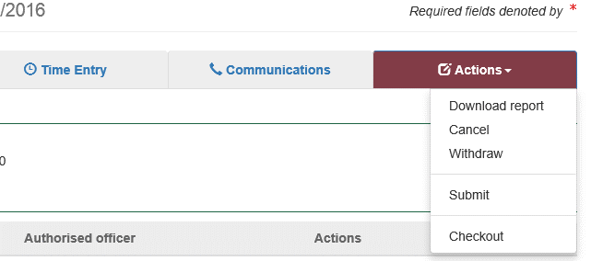

**1**

**2**

The page will display a confirmation that the record has been **withdrawn1** for the relevant inspection or calibration.

**!** Where a time entry was recorded on the record, the date(s) specified on the withdrawn record will be the start date and end date for the inspection/calibration. The record date corresponds with the earliest and latest time entry across all AOs for the inspection/calibration.

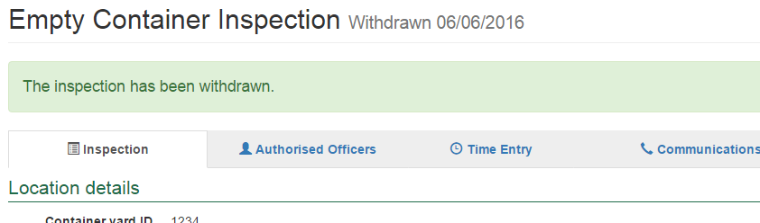

**1**

#### Reactivating a completed record

Once a record has been submitted in PEMS, it is locked and no changes can be made. However an inspection/calibration can be reactivated to correct minor errors or to correct an Exporter name where the complete name has not been extracted into PEMS from EXDOC (system constraint) see Edit Exporter name (if applicable) in the relevant commodity inspection Appendix

An AO is able to reactivate the record themselves, however rules exist in relation to which fields can be changed. The AO must record a reason for the reactivation in the comments field.

When reactivating an inspection/calibration, only the comments section and the following fields will be able to be changed:

|  |  |
| --- | --- |
| Type of inspection | ONLY fields that can be changed when reactivating |
| **Empty Container Inspection** | Container number |
| **Horticulture Inspection** | Product origin / Line ID / Exporter name |
| **Containerised Goods Inspection** | Container number / Exporter name |
| **Bulk into Ship Hold Inspection** | Loading rate / Rejection limit / Exporter name |
| **Bulk Vessel Inspection** | None. This inspection type cannot be reactivated. A new inspection record must be created. |
| **Calibrations (generic)** | Recorder serial number/ container seal number/ container Sealed date and time/ Local date / Local time/ Address (if calibration record is created using physical address and not Est Number) / Town / Postcode / Date of loading / Comments |
| **Calibrations (Japan Only)** | Treatment start date GMT / Treatment start time GMT |
| **Calibrations (USA only)** | Start loading time / Complete loading time |
| **Offsite Calibrations** | Recorder serial number / Local date and time/ Container number |
| **Quality System Recognition Inspection** | Container number / Exporter name |
| **Mobile Bulk Loading** | Loading Rate / Rejection Limit /Exporter name |

If the associated RFP has been authorised in EXDOC and the status in PEMS is ‘closed with export’, you cannot reactivate the record yourself. You will need to contact the AO Hotline to have this reopened, before the inspection/calibration can be reactivated.

! PEMS will capture the original record and the new record created and apply a version number to reactivated records (see: Viewing the original inspection/calibration).

For example, if you need to attach documents to an inspection in PEMS.

**A record can only be reactivated once.**

If a record is reactivated and resubmitted, and subsequent errors are identified, then a new record must be created with the correct information. You will need to create the new inspection/calibration record by following the instructions for the relevant inspection/calibration type, in the appendices. The new inspection/calibrations will appear on top of the list of inspection/calibration records.

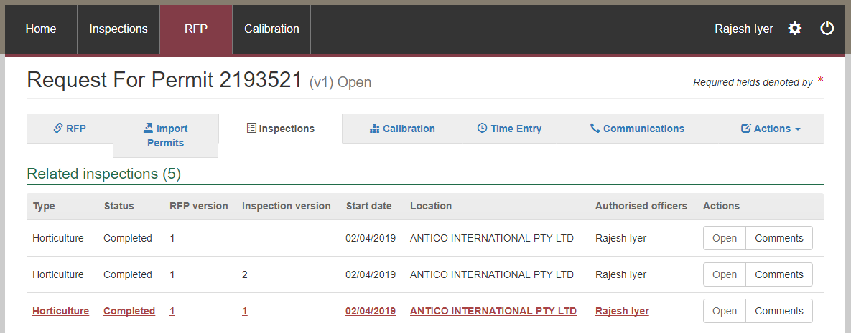

**Note:** To assist in the prevention of errors, PEMS has a **‘download report’** function located under the Actions tab, which should be used to view and check the record information prior to submission. All fields in the inspection/calibration can be corrected prior to submission.

**Reactivating a record and resubmitting**

In order to reactivate a record, you will need to open the relevant inspection/calibration. If you are unsure how to locate the relevant inspection you should refer to the Section 2: PEMS search functions.

**!** If a Mobile Bulk Loading inspection and the flow path at Upcountry has failed, you are unable to reactivate the inspection. The inspection will move to completed status and time entry becomes mandatory, refer to Section 3.4 Time Entry.

To reactivate the record, click on the **Actions1** tab and select **Reactivate2**.

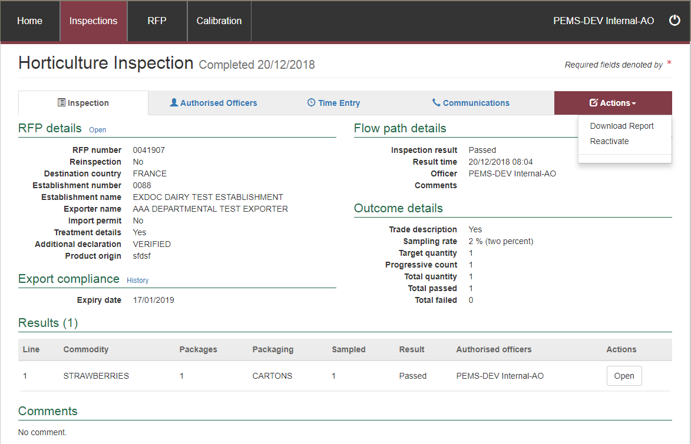

**2**

**!** If you are not associated with the inspection/calibration record, you will not be able to see the reactivate option.

**1**

A message will appear asking to confirm this action. Select **OK1**.

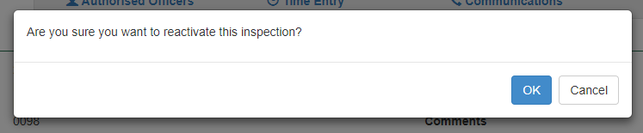

**1**

**Confirmation1** of the inspection/calibration being reactivated will then appear on the record.

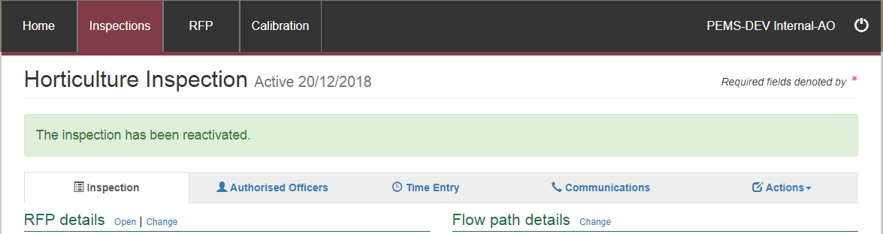

**1**

You can now change the details in the record, noting that only certain fields can be altered. Fields that cannot be changed will be greyed out. Any changes made to the record will be **highlighted in red1**.

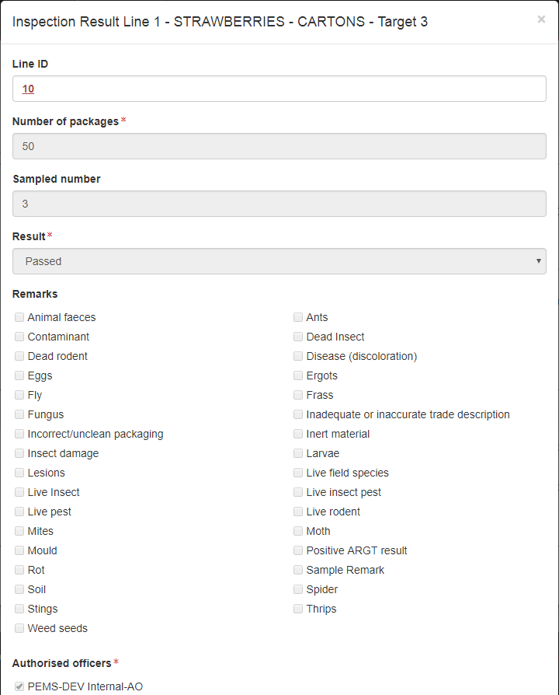

**1**

Once all changes have been made, select the **Actions1** tab and click on **Submit2**.

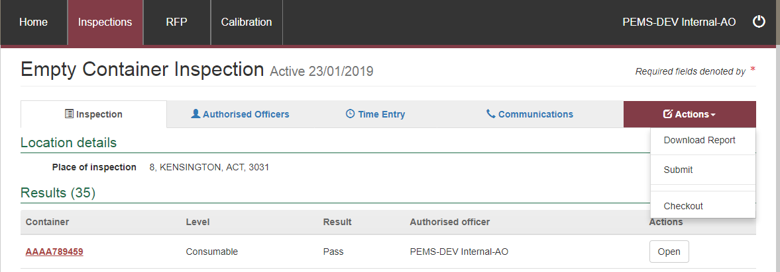

**2**

**1**

The **Comments1** box will automatically appear and you must record comments as to why the inspection/calibration was reactivated.

Select **Save2**.

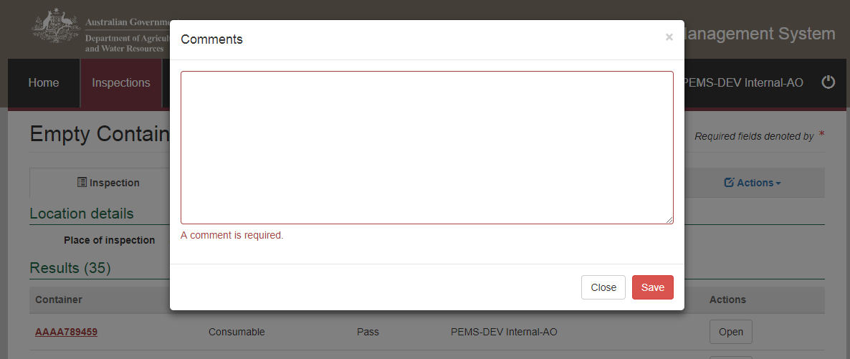

**2**

**1**

**!** The comments entered are for audit purposes.

A message will appear asking to confirm this action.

To confirm, select **OK1**.

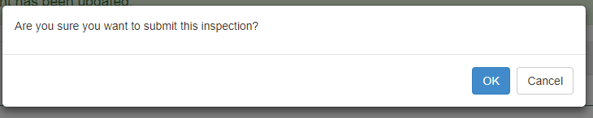

**1**

**Viewing the original inspection**

The **Inspections1** screen will show the number of related inspections. The version in red will be the original inspection and will state under the **Inspection version2** field that it is **Inspection version 13**.

Click **Open4** to to view inspection.

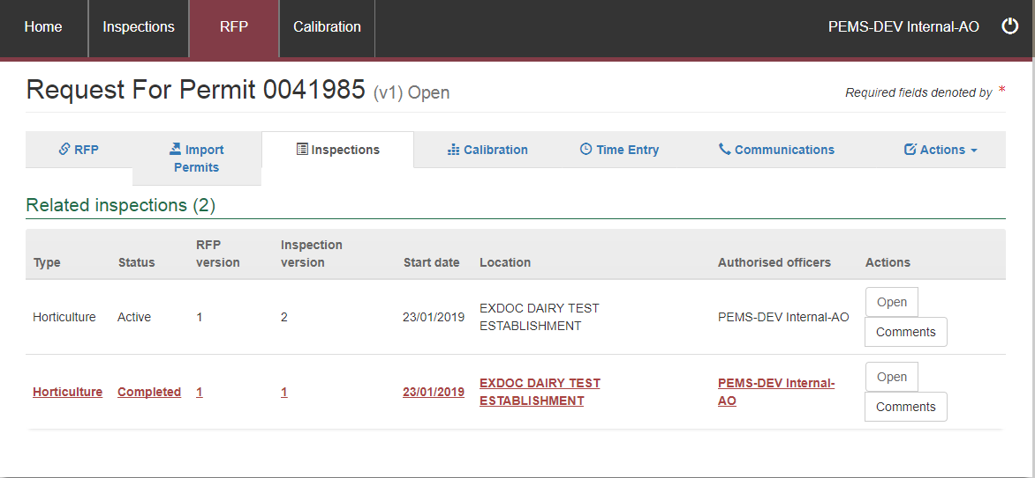

**1**

**2**

**3**

**4**

The inspection record will open. Select **Actions1** and **Download Report2**.

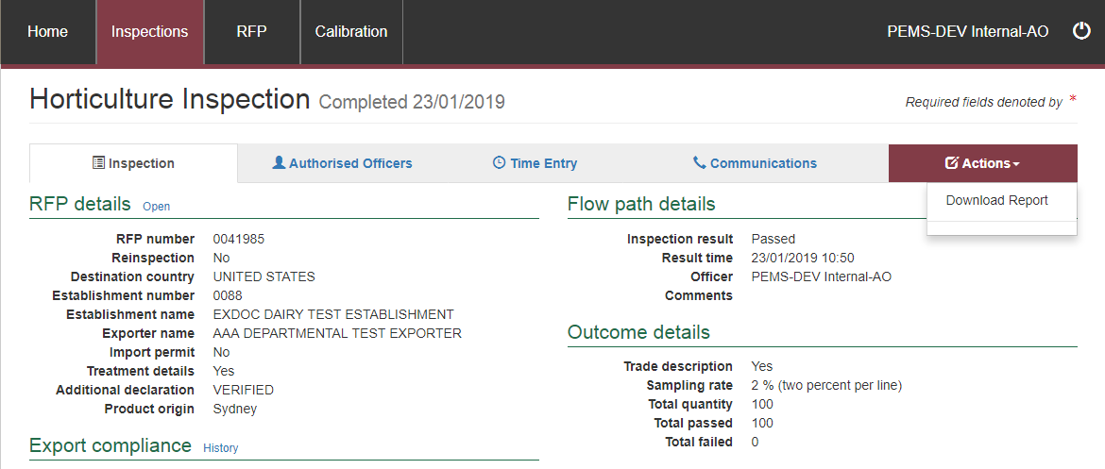

**2**

**1**

A copy of the report will appear and it will now state that it has been rescinded (cancelled).

This confirms the original record has been made null and void.

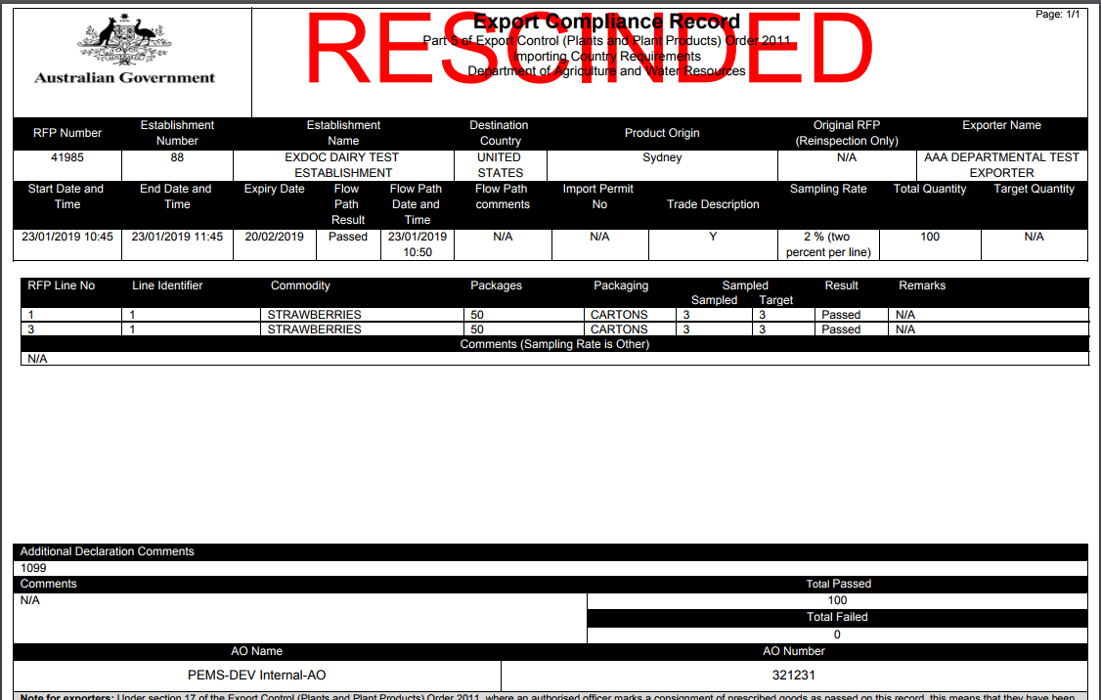

**Viewing the original calibration**

The **Calibrations1** tab will show the number of related records. The version in red will be the original record and will state under the **Calibration version2** field that it is **Calibration version 13**.

Click **Open4** to to view the calibration.

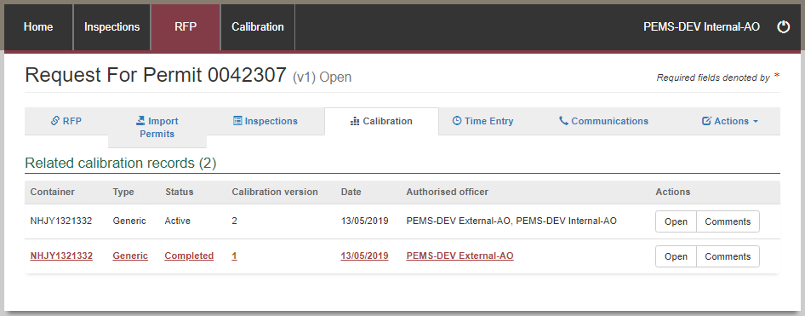

**1**

**4**

**3**

**2**

The calibration record will open. Select **Actions1** and **Download Certificate2**.

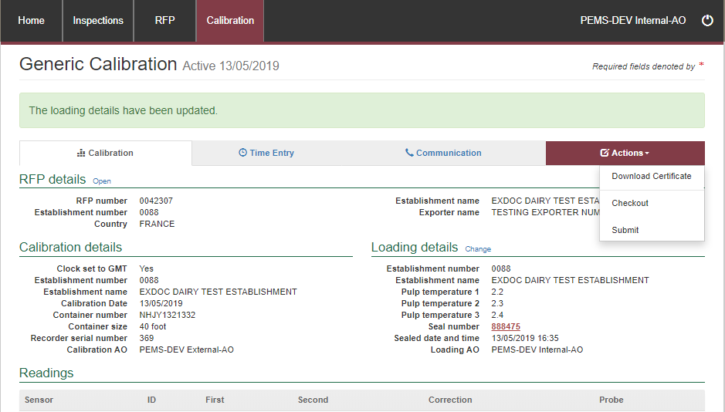

**2**

**1**

A copy of the certificate will appear and it will now state that it has been rescinded (cancelled).

This confirms the original record has been made null and void.

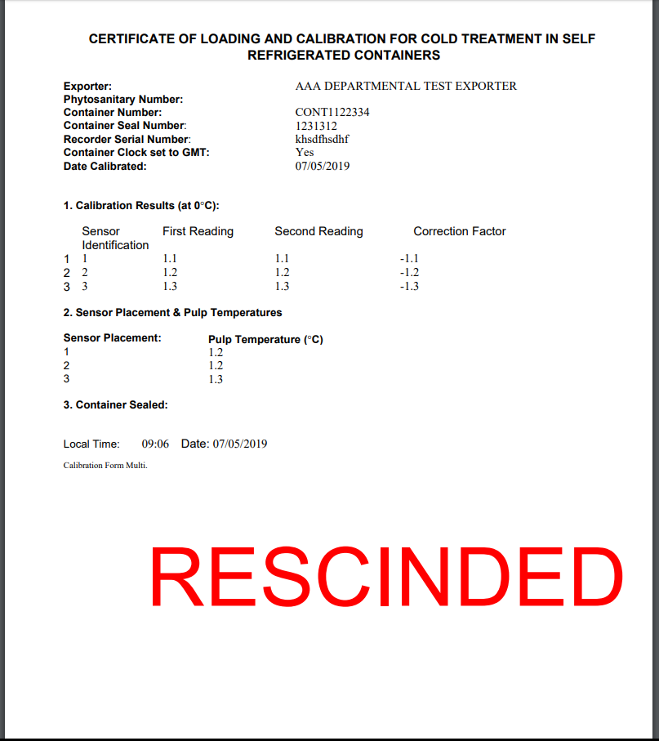

#### Refresh from EXDOC

Once extracted into PEMS, the record can be updated by clicking on the **Refresh from EXDOC1**button. The refresh will update containers, treatment information and import permits that may have been added/changed in EXDOC since the RFP was extracted into PEMS. Containers and import permits can be updated in PEMS anytime until the RFP is closed in PEMS.

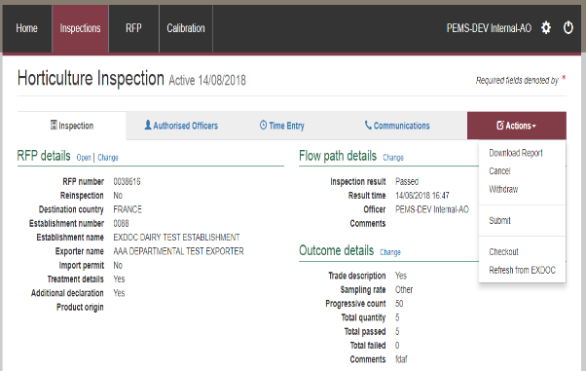

**1**

### 3.7 PEMS offline

PEMS offline allows you to “check out” an inspection or calibration record to a mobile device and continue to record certain data even where there is no internet/network connection.

In this checked out mode the data that you enter into the record will be stored in the internet browser storage on your chosen mobile device, until an internet connection becomes available and the record is checked back into PEMS online. You should not clear your cache while in offline mode or you will lose any PEMS data stored locally on your device at the time. In the checked out mode PEMS will not be able to validate any of the data entered and you will not be able to submit the record.

#### Locating your PEMS security PIN

Before checking out a record and using PEMS offline, you will need to identify your individual PEMS security PIN. You will need to remember and use this PIN to log in to PEMS offline.

Click on **PEMS profile1** to access your four to six digit AO security **PIN2** under the authorised officer details section.

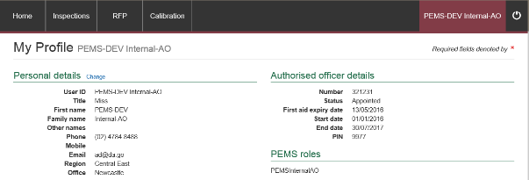

**1**

**2**

#### Checkout a record

Once an inspection/calibration record is initiated (see Appendices A–H) you can check out the record. You must have an internet connection to check a record out of PEMS online. The process for checking out a record is the same for all inspection types and for onsite and offsite calibrations.

To check out the record, open the relevant record, click the **Actions1** tab and then click **Checkout2**.

**!** If a record that you are assigned to has been checked out by another assigned AO, contact the AO Hotline for assistance.

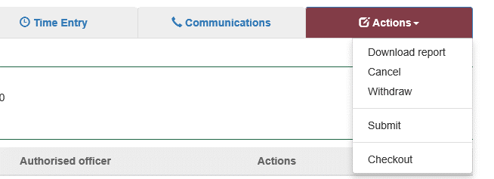

**1**

**2**

**!** Once a record is checked out of PEMS the PEMS online record will be read-only. Only the AO that checked the record out of PEMS online will be able to access and add data to the record in PEMS offline.

The **checked out inspection/calibration record1** will display under My inspections/My calibrations list on your PEMS online homepage. For demonstration purposes, the following screen shots relate to an inspection record in PEMS offline.

Checked out records that are highlighted in bold and red have been checked out of PEMS online in a different internet browser and/or different device from the one you are currently using. You can click **Errors2** beside the relevant record to confirm the error.

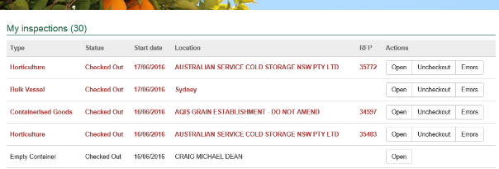

**1**

**2**

#### Uncheckout

Where you accidentally check out a record it is possible to undo the check out. If you undo a checkout, any information you may have entered into the record in PEMS offline will not transfer into PEMS online.

To undo the check out, click **Uncheckout1** beside the relevant record.



**1**

#### Logging in to PEMS offline

When you no longer have an internet/network connection, you can refresh your PEMS homepage and the logon to PEMS offline window will display.

Select your **Authorised officer1** name. The AO that checked out the record will appear by default.

Enter your four to six digit PEMS security **PIN2**, and then click **Logon3**.

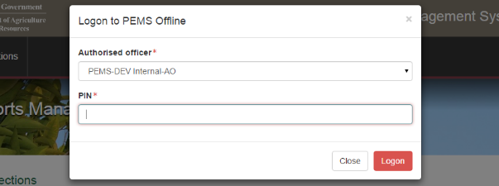

**1**

**3**

**2**

#### Opening the checked out inspection record

Once you have logged on to PEMS offline, the PEMS offline homepage will display your offline (checked out) inspection records.

To open a checked out inspection record, click **Open1** beside the relevant inspection record under the *My offline inspections* section. The process for opening an offline record is the same for all inspection types. For demonstration purposes, the following screen shots relate to an empty container inspection record in PEMS offline.

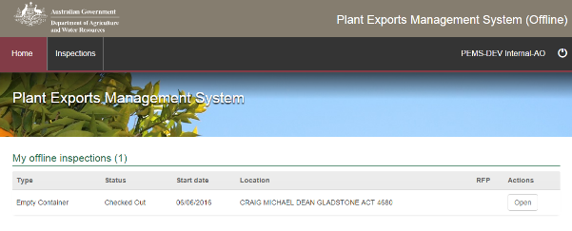

**1**

For all inspection types the PEMS offline inspection page will display by default. The PEMS offline inspection page will have limited functionality compared with PEMS online.

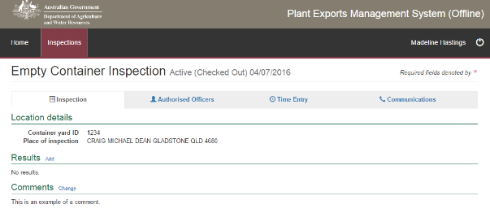

#### Entering inspection data in PEMS offline

In the PEMS offline mode, for each checked out inspection record, you will only be able to:

* record relevant inspection results (see Appendices A–H), including:
* recording inspection results
* recording reinspection status
* if applicable, recording flow path inspection results
* if applicable, changing outcome type
* if applicable, selecting sampling rate
* if applicable, record marine surveyor certificate details
* if applicable, record results for additional areas of a bulk vessel.
* view assigned AOs
* add comments (see Section 3.8)
* record time entry data (see Section 3.4)
* record correspondence relating to the inspection (see Section 3.5).

You will not be able to:

* assign additional AOs to the inspection record
* add attachments to the inspection record
* view time summary information or activity reports
* add invoices to the inspection record
* view any RFP details
* submit, cancel or withdrawn the inspection record
* download an inspection report (Export Compliance Report (ECR), Container Approval Record (CAR) or Bulk Vessel Approval Record (BVAR)).
* issue bulk vessel approval
* check empty container approvals.

#### Opening the checked out calibration record

Once you have logged on to PEMS offline, the PEMS offline homepage will display your offline (checked out) calibration records.

To open a checked out calibration record, click **Open1** beside the relevant calibration record under the *My offline calibrations* section. The process for opening an offline calibration record is the same for all calibration types. For demonstration purposes, the following screen shots relate to an onsite calibration record in PEMS offline.

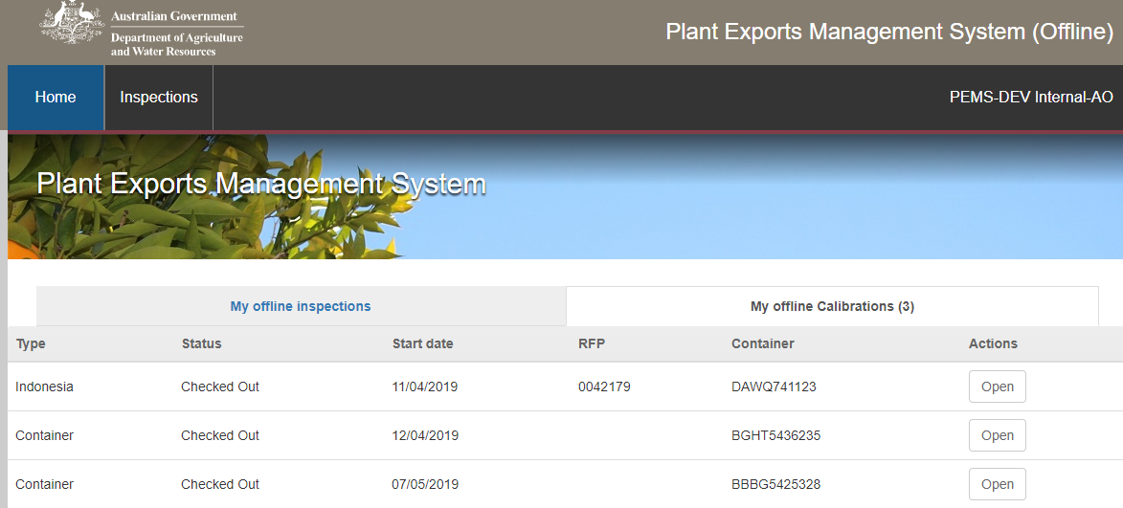

**1**

For all calibration types, the PEMS offline calibration page will display by default. The PEMS offline calibration page will have limited functionality compared with PEMS online.

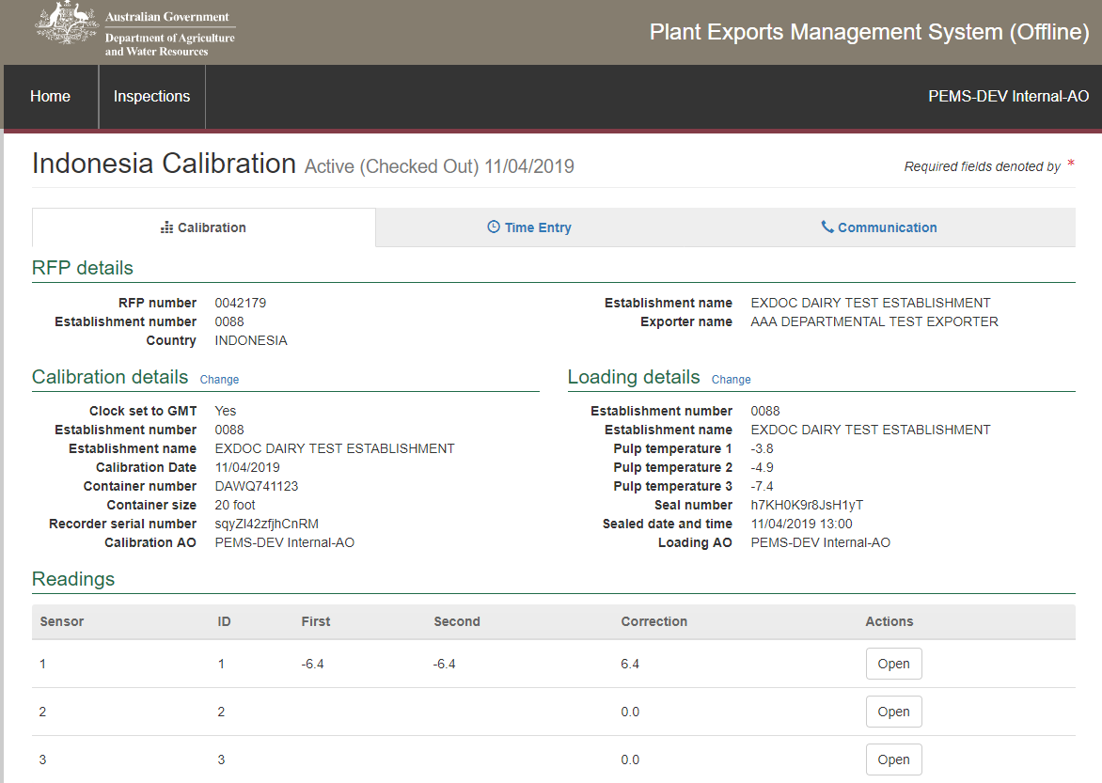

#### Entering calibration data in PEMS offline

In the PEMS offline mode, for each checked out calibration record, you will only be able to:

* record calibration results including:
* recording calibration details
* recording sensor readings
* recording pre-cooling temperatures
* recording Loading details
* add comments (see Section 3.8)
* record time entry data (see Section 3.4)

You will not be able to:

* assign additional AOs to the calibration record
* add attachments to the calibration record
* record correspondence relating to the calibration
* view time summary information or activity reports
* add invoices to the calibration record
* view any RFP details
* submit, cancel or withdrawn the calibration record
* download a calibration report

**!** Once a record is checked out of PEMS, the PEMS online record will be read-only. Only the AO that checked the record out of PEMS will be able to access and add data to the record in PEMS offline and only using the device that they used to check the record out of PEMS.

#### Check in a record

Once an internet/network connection becomes available you can check a record back into PEMS online in order to complete and submit the record.

Before checking a record back into PEMS online ensure that you are checking the record back in using the same device and the same browser that you used to record data in PEMS offline.

To check a record back in to PEMS online, click **Check in1** beside the relevant record under the My inspections/My calibrations list on your PEMS online homepage.

**!** Checked out records that are highlighted in bold and red have been checked out of PEMS online in a different browser and/or different device from the one you are currently using.

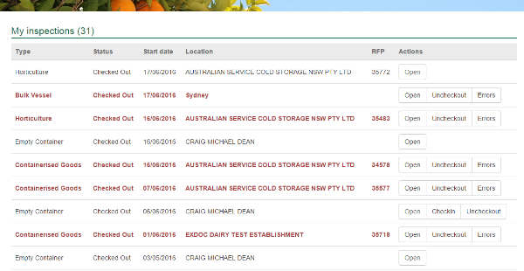

**1**

PEMS will synchronise and validate the record when it is translated from PEMS offline to PEMS online.

Once the record has checked in you can open the record from the *My inspections/My calibrations* list on the PEMS online homepage. If no other data is required you can continue to complete and submit the record consistent with relevant inspection/calibration type instructions (see Appendices A–H).

#### Remove stored data

PEMS will allow an AO to remove locally stored data from the *My inspections/My calibrations* list on the PEMS home page in certain circumstances.

Where two or more AOs are assigned to a record. AO 1 may check out the record but be unable to proceed with entering data, undo the check out, or otherwise check the record back into PEMS.

In these situations AO 2 may contact the AO Hotline to request that the record checkout be reversed. Once the record is active, AO 2 can then check the record out of PEMS.

When AO 2 checks out the record, AO 1 will not be able to check in their offline data. As a result, PEMS will allow AO 1 to click **Remove1** to remove the locally stored data from AO 1’s list. The remove function does not remove the record from PEMS.

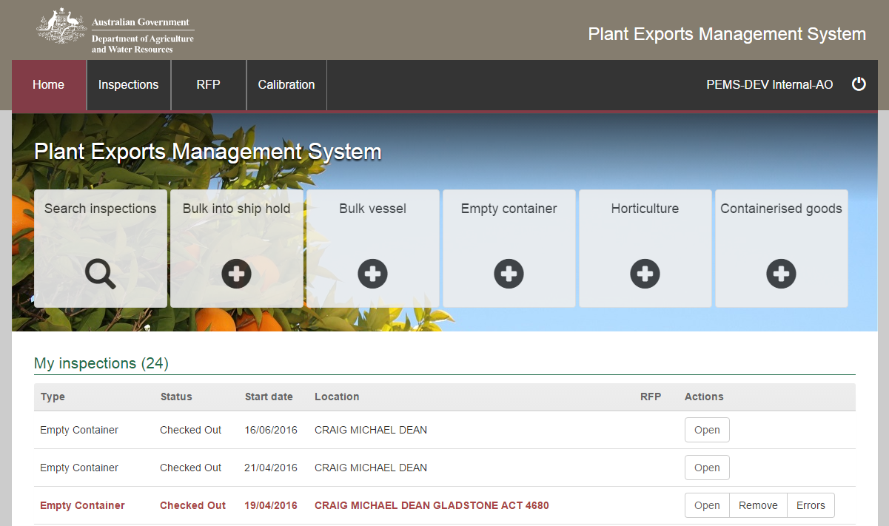

**1**

**1**

### 3.8 Adding comments to a record

PEMS allows you to add general comments to all inspection and calibration records. The process for adding general comments is the same for all inspection/calibration types. The following screen shots are taken from an empty container inspection record for demonstration purposes.

To add comments to the record, click the **Inspection1 (or Calibration)** tab and then click **Change2** under the comments section of the relevant inspection page.

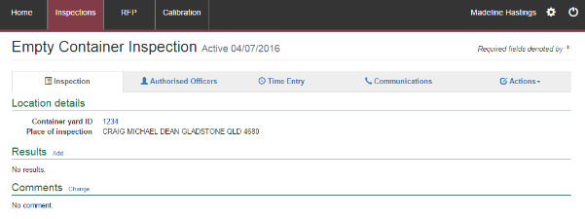

**1**

**2**



The *Comments* window will display.

Enter general comments about the inspection/calibration into the **free text field**1. There is a limit of 500 characters for the field.

Click **Save2**.

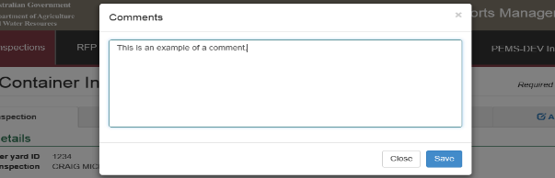

**1**

**2**

The inspection/calibration record page will display the **comment1**.

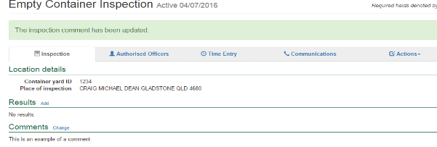

**1**

### 3.9 Alternate way to initiate an inspection or calibration

There is an alternate way to initiate a record on PEMS in addition to the process outlined under Appendices A–H.

#### Initiating an inspection record

Click the **Inspections1** PEMS menu tab on the PEMS home page.



**1**

The search inspections page will display.

Click **Create1**, and then select the relevant **inspection type2** from the drop down list.

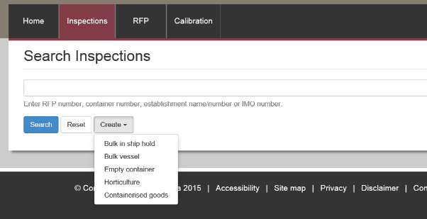

**1**

**2**

The relevant create inspection window will display.

Continue by following the step-by-step instructions provided in Appendices A–H to complete the process for initiating an inspection record on PEMS.

#### Initiating a calibration record

Click the **Calibrations1** PEMS menu tab on the PEMS home page

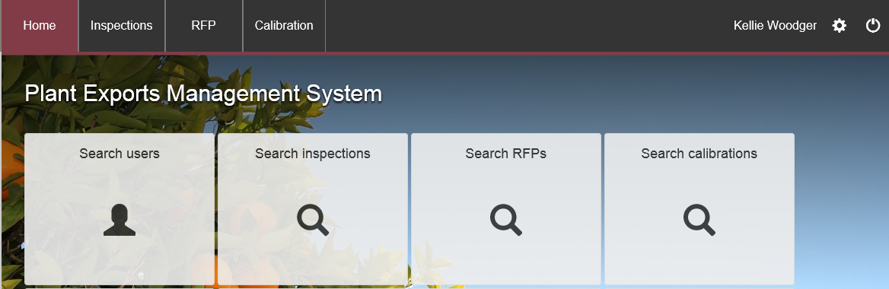

**1**

The *Search Calibrations* page will display.

Click **Create1**, and the relevant create calibration window will display.

Continue by following the step-by-step instructions provided in Appendices A–H to complete the process for initiating a calibration record on PEMS.

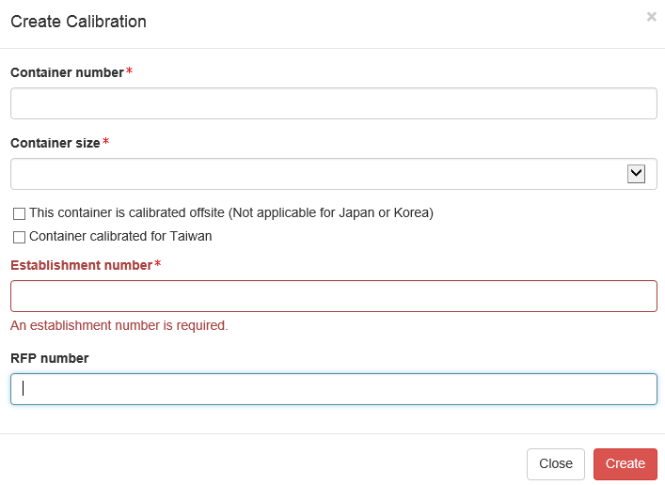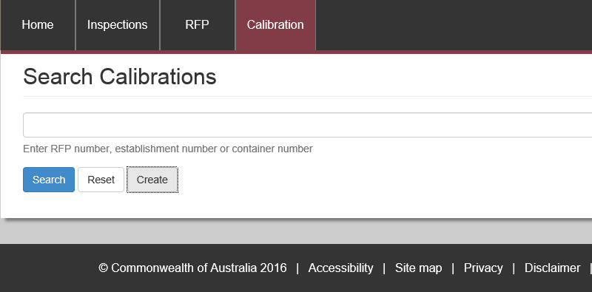

**1**

## 4 RFP functions in PEMS (commodity inspections)

This section provides step-by-step instructions for creating and completing various activities that are related to the RFP record in PEMS.

This section assumes that as an AO, you are skilled in using MICoR to determine the importing country requirements pertaining to the RFP. PEMS will assist this process by displaying a summary of the RFP details extracted from EXDOC and inspection history for an RFP. This section is organised into the following sections:

* reloading an RFP from EXDOC
* import permits
* navigating to related inspections/calibrations from the RFP screen.

While PEMS contains other RFP sections, this section only covers those functions that are relevant to an AO completing their inspection job functions.

### 4.1 Reload RFP from EXDOC

During an inspection an exporter may make changes to the RFP in EXDOC, such as add or remove commodity lines or change the net weight of the consignment. PEMS allows you to reload the RFP from EXDOC and preserve data that was translated from the inspection record onto the RFP recording PEMS, such as time entries, attachments or correspondence.

Where an RFP is reloaded from EXDOC inspection results will need to be re-entered into the inspection record in PEMS. Inspection results entered before the exporter made changes to their RFP in EXDOC, can be viewed in previous versions of the RFP (see Section 4.3 Inspections).

The process for reloading an RFP for EXDOC is the same for all commodity inspection types. The following screen shots are based on a containerised goods inspection record and are for demonstration purposes only.

**!** Once an inspection has been submitted for the RFP you cannot reactivate this inspection and reload RFP from EXDOC.

**!** Do not reload an RFP from EXDOC where additional containers are added to a containerised goods inspection record. The AO must ask the exporter to update their RFP record in EXDOC to reflect the additional containers

To reload an RFP from EXDOC:

* Withdraw the current active commodity inspection from PEMS (see Section 3.6 Actions tab)
* Go to the PEMS home page and initiate a new inspection record (see Appendices B, C or E).

The relevant create inspection window will display. You should then:

* as required for the relevant inspection, enter the required information (such as **RFP number1**, **Establishment number2** (mandatory for external AOs) and IMO number for bulk into ship hold inspections (see Appendices B, C or E)
* select the **Reload RFP from EXDOC3** checkbox
* click **Create4.**

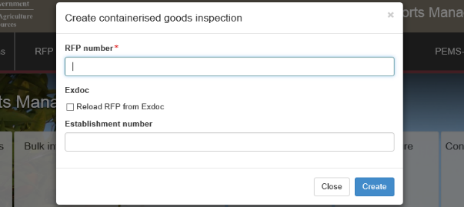

**1**

**3**

**2**

**4**

The relevant inspection page will display.

**!** A new version number will be allocated to the RFP record when the RFP is reloaded from EXDOC into PEMS. RFP cannot be re-loaded into PEMS if there is one active or completed inspection for the RFP.

### 4.2 Recording import permit details

Where an importing country requires that an exporter has an import permit this will be reflected in EXDOC. Import permit details which have been provided by the exporter in EXDOC will translate automatically into PEMS and will be listed under the Import Permits tab. The Import Permits tab allows you to record the details of the import permit after it has been sighted.

To record the import permit details, click the **Import Permits1** tab and then click **Open2** beside the relevant import permit listed.

**1**

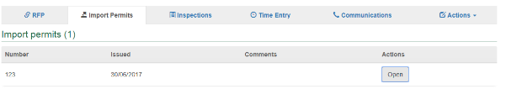

**2**

The *Import Permit* window will display.

If applicable, enter **Comments1** relating to the import permit.

Click **Save2.**

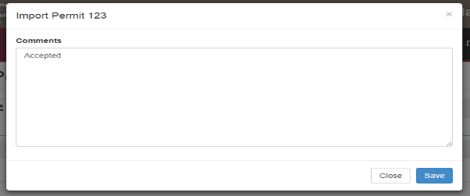

**2**

**1**

The *Import Permits* page will display the **newly added import permit details1**.

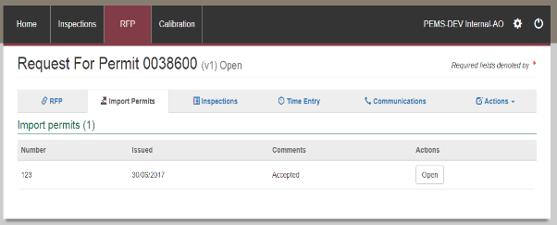

**1**

### 4.3 Navigating to related inspections/calibrations from the RFP screen

To view the list of inspections/calibrations related to an RFP select the **Inspections1**/Calibrations tab.

Each RFP extracted from EXDOC can have multiple inspection/calibration records listed under the related inspections/calibrations section. However, there can only be one active inspection record listed at any one time. Each time an RFP is reloaded from EXDOC the new active inspection record will correspond with a new RFP version number.

You can **Open2** any inspection record related to the RFP from this page to view the inspection record data. All inspection records other than the current active inspection record will be read-only.

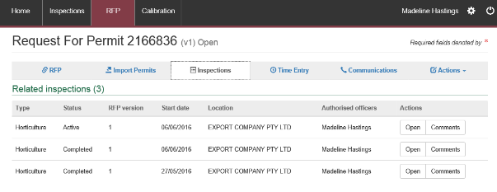

**2**



**1**

## Document information

The following table contains administrative metadata.

|  |  |
| --- | --- |
| Instructional material owner: | Director, Business Systems Program. |

## Version history

The following table details the published date and amendment details for this document.

| Version | Date | Amendment details |
| --- | --- | --- |
| 1.0 | 08/07/2016 | New user guide. |
| 1.1 | 12/07/2016 | Minor variations for accuracy and clarity. |
| 2.0 | 30/09/2016 | Complete document restructure  Addition of sections on:   * Logging into PEMS * Calibration records * Calibration search |
| 2.1 | 16/12/2016 | * Minor variations for accuracy and clarity * Removal of Appendix F – Calibrations and loading * Removal of Section 2.3 – Calibration search |
| 3.0 | 09/10/2018 | * AO user guide updated with PEMS v2.1 enhancements |
| 4.0 | 21/05/2019 | * AO user guide updated with PEMS v3.1 and v3.2 enhancements |
| 5.0 | 4/11/2019 | * Updated with PEMS v3.3 and 3.4 enhancements |