# Farmers’ terms of trade - April 2022

2021-22 has been characterised by high production, prices and costs for Australian agriculture. ABARES data indicates that, on average, costs rose faster than prices. Stabilising costs and ongoing strong prices are expected to improve farmers’ terms of trade by 5% in 2022-23.

## Prices increase, but costs also rise

* In 2021-22, farm production and the average prices farmers received for their products increased. However, input costs, including fuel, fertiliser and labour, also increased.
* ABARES’ farmers’ terms of trade (FToT) index measures the overall profitability of the agriculture sector by comparing the average price received by farmers with average farm costs. When the FToT rises, prices received for produce increased more than farms costs (and vice-versa).
* In 2021-22, prices received are estimated to be 10% higher than in 2020-21 and overall production volume is forecast to increase by 6%. However, a 16% increase in input costs is likely to offset these gains and lead to a 6% fall in the FToT index.

Figure 1 - Australian Farmers' Terms of Trade index, 2014-15 to 2022-23

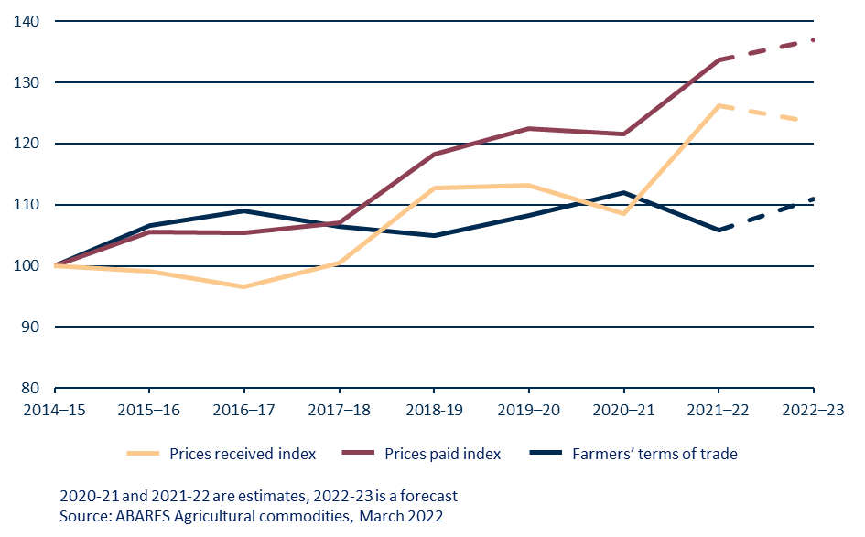

## Improved prices for producers

* Prices received for most agricultural products increased in 2021-22. For some products, the increases were substantial, such as cotton (+45%) and canola (+39%), while for others, such as horticulture (+3%), price increases were smaller.
* Herd rebuilding by Australian beef producers and strong global demand for protein have seen cattle prices rise consistently since 2018-19.
* Tariffs on Australian wine have contributed to a fall in the average price received from wine grapes, while barley (part of the grains grouping) made up some of the ground lost since 2018.

Figure 2 - Prices received by Australian farmers 2014-15 to 2022-23

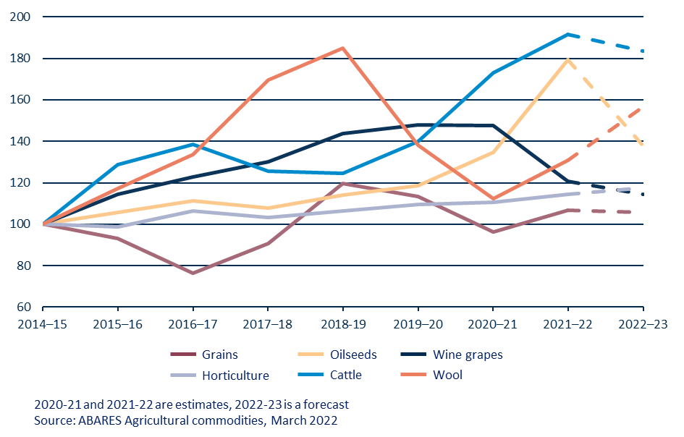

## Rising farm costs

* Farmers need inputs, such as fuel, fertiliser and labour. The proportion of these costs varies between farm types. For example, in 2020-21 fertiliser and fuel accounted for 20% of farm cash costs for broadacre cropping farms, while horticulture producers are more affected by labour costs and availability.
* Between 2014-15 and 2020-21 the average costs of most farm inputs were relatively stable and some key costs decreased.
* 2021-22 saw large increases in fuel and fertiliser costs. Labour costs continued to rise steadily and labour availability was an issue for some producers. Fodder costs remained relatively low due to good hay and pasture growing conditions.

Figure 3 - Prices paid by Australian farmers 2014-15 to 2022-23

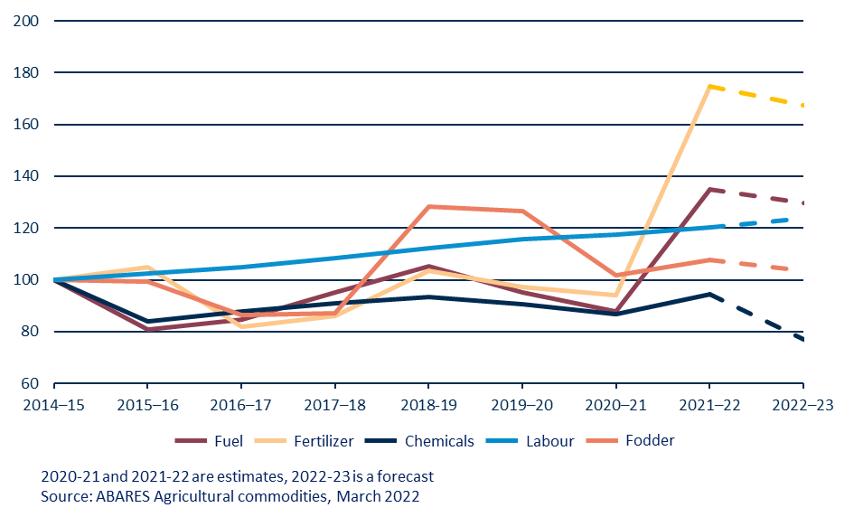

## Outlook for 2022-23

* Stabilising input prices and ongoing high food prices are expected to drive a 5% rise in the FToT index in 2022-23.
  + Grain markets are currently highly volatile. This increases the level of uncertainty about future price predictions.
  + Future input costs will partly depend on the length and severity of the Russia-Ukraine conflict and the policy responses from other energy and fertilizer exporting countries.
* As a proportion of farm costs, broadacre farms are most exposed to fuel and fertilizer prices. However, prices for broadacre produce are at record or near-record levels.
* Seasonal conditions are the most important determinant of farm gate returns. Recent predictions for a wet Autumn are good news for the Australian agriculture sector.

Figure 4 - Gross value of Australian farm, fisheries and forestry production, in selected years

