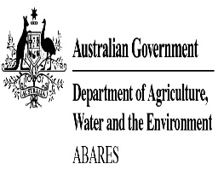

**Australia’s Indigenous land and forest estate: separate reporting of Indigenous ownership, management and other special rights**

**Rohan Jacobsen, Claire Howell, Steve Read**

Research by the Australian Bureau of Agricultural and Resource Economics and Sciences

Technical report 20.15

December 2020

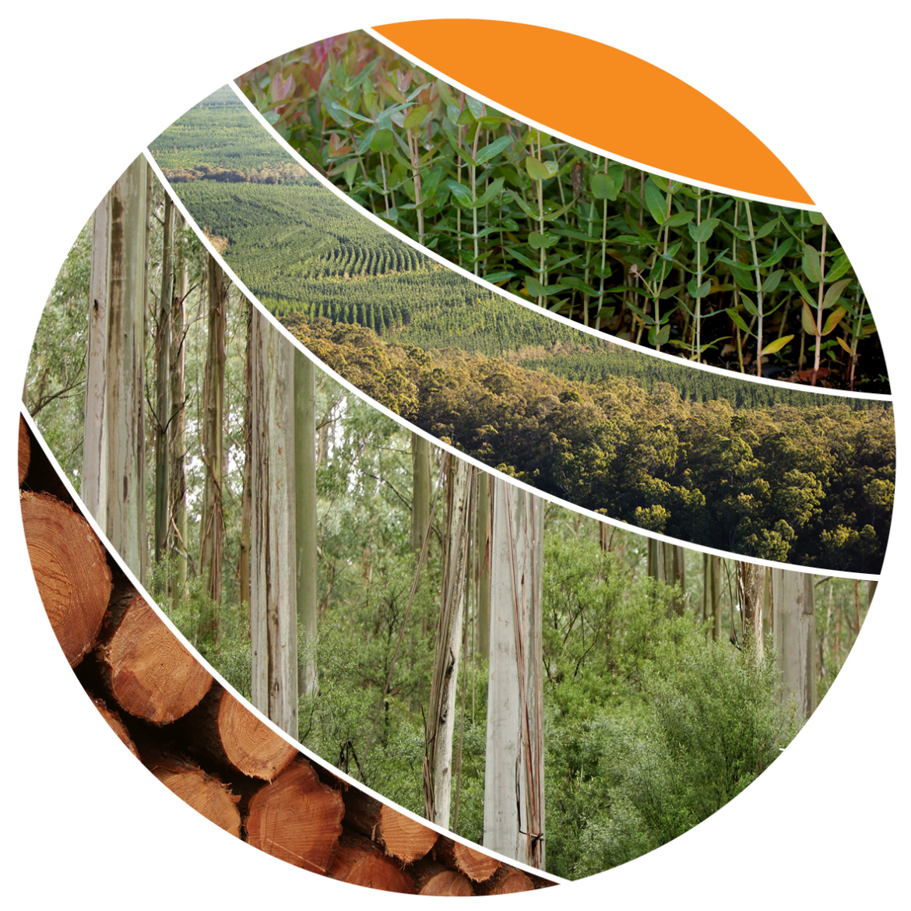

© Commonwealth of Australia 2020

**Ownership of intellectual property rights**

Unless otherwise noted, copyright (and any other intellectual property rights, if any) in this publication is owned by the Commonwealth of Australia (referred to as the Commonwealth).

**Creative Commons licence**

All material in this publication is licensed under a [Creative Commons Attribution 4.0 International Licence](https://creativecommons.org/licenses/by/4.0/legalcode) except content supplied by third parties, logos and the Commonwealth Coat of Arms.

Inquiries about the licence and any use of this document should be emailed to [copyright@awe.gov.au](mailto:copyright@awe.gov.au).



**Cataloguing data**

This publication (and any material sourced from it) should be attributed as: Jacobsen R, Howell C, Read SM 2020, *Australia’s Indigenous land and forest estate: separate reporting of Indigenous ownership, management and other special rights*, ABARES technical report, Canberra, December, DOI: [doi.org/10.25814/bqr0-4m20](https://doi.org/10.25814/bqr0-4m20). CC BY 4.0.

ISSN 189-3128

Australian Bureau of Agricultural and Resource Economics and Sciences (ABARES)

GPO Box 858 Canberra ACT 2601

Telephone 1800 900 090

Web [awe.gov.au/abares](https://www.awe.gov.au/abares)

**Disclaimer**

The Australian Government acting through the Department of Agriculture, Water and the Environment, represented by the Australian Bureau of Agricultural and Resource Economics and Sciences, has exercised due care and skill in preparing and compiling the information and data in this publication. Notwithstanding, the Department of Agriculture, Water and the Environment, ABARES, its employees and advisers disclaim all liability, including liability for negligence and for any loss, damage, injury, expense or cost incurred by any person as a result of accessing, using or relying on any of the information or data in this publication to the maximum extent permitted by law.

**Professional independence**

The views and analysis presented in ABARES publications, including this one, reflect ABARES professionally independent findings, based on scientific and economic concepts, principles, information and data. These views, analysis and findings may not reflect or be consistent with the views or positions of the Australian Government, or of organisations or groups who have commissioned ABARES reports or analysis. More information on [professional independence](https://www.agriculture.gov.au/abares/about/research-and-analysis#professional-independence) is provided on the ABARES website.

**Acknowledgements**

The authors wish to thank those that contributed to this report, in particular Dr Rosemary Lott for the input she made in sourcing and attribution of the datasets used for *Australia’s State of the Forests Report 2018* that were also used for this report.

Contents

**1 Summary 1**

**2 Purpose 2**

**3 Background and issue 2**

3.1 Development of Australia’s Indigenous forest estate methodology and dataset 4

3.2 Issues with reporting Australia’s Indigenous forest estate to date 6

**4 Separate reporting of Indigenous ownership, management and other special rights 7**

4.1 Constituent datasets and data processing 8

4.2 Land and forest under Indigenous ownership, Indigenous management or co-management, or with other special rights for Indigenous communities 10

4.3 Areas of land and forest with more than one Indigenous estate attribute 11

4.4 Australia’s Indigenous estate in different jurisdictions 14

4.5 Australia’s Indigenous estate by tenure 15

**5 Discussion 17**

5.1 From combined categories to separate reporting of attributes of Australia’s Indigenous estate 17

**6 Conclusion 19**

**7 Appendix 20**

**8 References 26**

**Tables**

Table 1 Indigenous land reporting categories devised by Dillon et al. (2015), and used in SOFR 2013 and SOFR 2018 4

Table 2 Area of land and forest in Australia’s Indigenous estate as reported in SOFR 2013 and SOFR 2018 (‘000 hectares) 5

Table 3 Separate Indigenous estate attributes applied in this work 8

Table 4 Datasets used for reporting on Indigenous land, by area, attributed separately by Indigenous ownership, management or co-management, and other special rights, as well as classification into the Indigenous estate categories previously used for SOFR 2018 9

Table 5 Area of land and forest in Australia’s Indigenous estate (‘000 hectares) 10

Table 6 Areas of land with a combination of Indigenous owned, and Indigenous managed or co‑managed, attributes ('000 hectares) 11

Table 7 Areas of land with a combination of Indigenous owned and other special rights attributes ('000 hectares) 11

Table 8 Areas of land with combination of Indigenous managed or co-managed and other special rights attributes ('000 hectares) 12

Table 9 Areas of forest with a combination of Indigenous owned, and Indigenous managed or co‑managed, attributes ('000 hectares) 12

Table 10 Areas of forest with a combination of Indigenous owned and other special rights attributes ('000 hectares) 12

Table 11 Areas of forest with a combination of Indigenous managed or co-managed and other special rights attributes ('000 hectares) 13

Table 12 Attributes of Australia’s Indigenous land and forest estate 13

Table 13 Area of land by Indigenous ownership, management arrangement or other special rights, by jurisdiction ('000 hectares) 14

Table 14 Area of forest by Indigenous ownership, management arrangement or other special rights, by jurisdiction ('000 hectares) 15

Table 15 Area of land by Indigenous ownership, management arrangement or other special rights, by NFI tenure class ('000 hectares) 16

Table 16 Area of forest by Indigenous ownership, management arrangement or other special rights, by NFI tenure class ('000 hectares) 17

**Figures**

Figure 1 Area of land and forest that is Indigenous owned 20

Figure 2 Area of land and forest that is Indigenous managed or Indigenous co-managed 21

Figure 3 Area of land and forest that is covered by other special rights for Indigenous peoples and communities 22

Figure 4 Total area of land and forest that is in the Indigenous estate 23

Figure 5 Area of land that is in the Indigenous estate, by separate Indigenous estate attributes 24

Figure 6 Area of forest that is in the Indigenous estate, by separate Indigenous estate attributes 25

## Summary

A range of Commonwealth, state and territory legislation and programs provide for Indigenous recognition, access or participation in land management. This relationship between Indigenous peoples and land or forest is described in Australia’s National Forest Inventory by compiling the available Commonwealth, state and territory agency datasets that relate to these legislation and programs, then assembling these into a single national Indigenous estate dataset. The Indigenous estate is the total area of land over which Indigenous peoples and communities have either ownership, or management, or rights of use for customary purposes (ABARES 2020a). Since the Commonwealth, state and territory agency datasets underpinning the Indigenous estate are not derived from state and territory land title registers, the Indigenous estate dataset prepared by ABARES does not describe the formal tenure of land, and does not draw on the tenure dataset prepared by ABARES (ABARES 2018b; Jacobsen et al. 2019).

To capture the range of relationships between Indigenous peoples and land or forest, Dillon et al. (2015) created four derived categories that combined in various ways the attributes of Indigenous ownership, Indigenous management or co‑management, and other special rights. These derived categories were used for reporting in *Australia’s State of the Forests Report 2013* and *Australia’s State of the Forests Report 2018* (MIG and NFISC 2013, 2018). However, this previous schema allocated an area of land or forest to only one of the four derived categories, and did not describe land or forest separately by ownership, management or other attributes.

In the current work, we have disentangled the original four category combinations, and report separately on each of the individual attributes of the Indigenous estate. These attributes are Indigenous ownership of land or forest, Indigenous management or co‑management of land or forest, and land or forest over which Indigenous peoples and communities have other special rights, as defined in ABARES (2020a). Creating separate spatial layers for each of these attributes allows clear reporting of the areas of land or forest to which they apply. A new spatial dataset (ABARES 2020b) restructures in this way the previous spatial dataset describing the Indigenous estate (ABARES 2018c), and can form the basis for subsequent reporting on the relationships between Indigenous peoples and land or forest.

These analyses show that a total of 134 million hectares of land in Australia (17%) is Indigenous owned, of which 22 million hectares is forest. A total of 174 million hectares of land is under some form of Indigenous management (22%), with 141 million hectares Indigenous managed and 33 million hectares Indigenous co-managed; of this, 29 million hectares is forest, with 18 million hectares Indigenous managed and 10 million hectares Indigenous co-managed. A total of 337 million hectares of land (44%) is subject to other special rights for Indigenous peoples, of which 51 million hectares is forest.

These areas of land are not mutually exclusive: there is substantial overlap between Indigenous owned land, Indigenous managed or co-managed land, and land subject to other special rights. Intersection of the three new spatial attributes confirms the total area of land in the Indigenous estate in Australia as at 2016 was 438 million hectares (57%), and the total area of forest in the Indigenous estate as 70 million hectares, as reported in *Australia’s State of the Forests Report 2018*.

All the 134 million hectares of Indigenous owned land in Australia is either Indigenous managed (124 million hectares) or Indigenous co-managed (10 million hectares). Of this, 66 million hectares (49%) are in the Northern Territory and 36 million hectares (27%) are in Western Australia; 94 million hectares (71%) are on private land tenure, with the remaining area on a variety of other tenures. Of the 33 million hectares of Indigenous co-managed land, 22 million hectares (69%) are on nature conservation reserve tenure, with the remaining area on a variety of other tenures. Of the 337 million hectares of land with other special rights for Indigenous peoples and communities, 169 million hectares (50%) are on leasehold tenure, with the remaining area on a variety of other tenures.

Similarly, all the 22 million hectares of Indigenous owned forest in Australia is either Indigenous managed (18 million hectares) or Indigenous co-managed (4.5 million hectares). Of this, 13 million hectares (60%) are in the Northern Territory and 7.0 million hectares (32%) are in Queensland; 19 million hectares (85%) are on private tenure. Of the 10 million hectares of Indigenous co-managed forest, 6.0 million hectares (59%) are on nature conservation reserve tenure. Of the 51 million hectares of forest with other special rights for Indigenous peoples and communities, 22 million hectares (44%) are on leasehold tenure.

The report presents maps of the distribution of land and forest that is Indigenous owned; land and forest that is Indigenous managed or co-managed; land and forest that is covered by other special rights for Indigenous peoples and communities; and the total Indigenous land and forest estate.

This report, tables and all maps are available at [doi.org/10.25814/p7fq-3v20](https://doi.org/10.25814/p7fq-3v20). The *Australia’s Indigenous forest estate (2020)* spatial dataset is available at [doi.org/10.25814/bem5-sm50](https://doi.org/10.25814/bem5-sm50).

## Purpose

This ABARES Technical Report has been produced to:

* describe the limitations of the four category combinations historically used by Australia’s National Forest Inventory for reporting the Indigenous estate in the *Australia’s State of the Forests Report* (SOFR) series
* articulate a methodology that will allow separate identification and reporting of the extent of land and forest in Australia that is subject to:
  + Indigenous ownership
  + Indigenous management or co-management
  + other special rights for Indigenous peoples and communities
* analyse and report separately on the areas of land and forest with the above Indigenous estate attributes
* describe the overlap between the areas of land or forest with the above attributes, and confirm the total area of the Indigenous estate
* assemble and publish an updated Australia’s Indigenous land and forest estate spatial dataset that separately reports on each of the above attributes.

This new structure for the Indigenous land and forest estate allows simpler reporting of the ways in which Indigenous peoples have rights of access, use and management of land and forest.

## Background and issue

Indigenous people value land and forests for a range of cultural, social and economic reasons, including heritage, identity and connection to country. Recognition, access, management, stewardship, ownership and other rights are components of the relationship of Indigenous people with land.

Information on Australia’s forests for national and international monitoring and reporting is collected, curated and communicated through the National Forest Inventory (NFI)[1]. The NFI is guided by the National Forest Inventory Steering Committee (NFISC), which comprises representatives from national, and state and territory agencies involved in forest management. The NFI is housed in, and managed by, the Australian Bureau of Agricultural and Resource Economics and Sciences (ABARES). The NFI contains multiple public national spatial datasets on key features of Australia’s forests, including forest type (ABARES 2018a), forest tenure (ABARES 2018b), and the Indigenous forest estate (ABARES 2018c)[2].

The *Australia’s State of the Forests Report* (SOFR) series[3] is the primary reporting mechanism through which the spatial datasets in the NFI are collated, reported and released. Each SOFR is a comprehensive five-yearly national synthesis of the status of Australia’s forests, covering the environmental, economic, and social values provided by forests. The reports use Australia’s framework of seven criteria and 44 indicators for reporting the components of sustainable forest management, adapted from that of the Montreal Process (Department of Agriculture, Fisheries and Forestry 2008).

The extent of Indigenous interest in land and forest is reported across two indicators under Criterion 6 *Maintenance and enhancement of long term multiple socio-economic benefits to meet the needs of societies*:

Indicator 6.4a *Area of forest to which Indigenous people have use and rights that protect their special values and are recognised through formal and informal management regimes*

Indicator 6.4c *The extent to which Indigenous values are protected, maintained and enhanced through Indigenous participation in forest management*.

Indicator 6.4a reports on the extent to which land is placed under classifications or management regimes that protect the special values of Indigenous peoples and communities with regard to forests, while Indicator 6.4c describes the extent to which Indigenous people participate in forest management. Together, these indicators attempt to quantify the extent of Indigenous participation in forest management, and mechanisms by which this participation protects, maintains and enhances environmental, social, cultural, religious and spiritual values.

Reporting against these indicators is completed by drawing on information on legislation and other frameworks established for the involvement of Indigenous peoples and communities with land, such as land rights, native title and cultural heritage laws. These differ from other extant frameworks such as land tenure systems, which are reported separately (ABARES 2018b; Jacobsen et al. 2019).

### Development of Australia’s Indigenous forest estate methodology and dataset

For the production of the *Australia’s State of the Forests Report 2013* (SOFR 2013) and the associated *Australia’s Indigenous forest estate (2013)* spatial dataset, ABARES developed a methodology for reporting the land, and within that the forest, over which Indigenous peoples and communities have ownership, management or special rights in Australia (ABARES 2013a; MIG and NFISC 2013).

As described in Dillon et al. (2015), this methodology identified Commonwealth legislation and programs that provides for Indigenous recognition, access or participation in land management, as well as state and territory legislation and programs that allow for Indigenous peoples’ involvement with land. Available national, state and territory datasets deriving from these instruments were then assembled and analysed (see Table 4).

These component datasets covering Indigenous interest over land were not derived from the state and territory land title registers used to assemble tenure information. The Indigenous estate dataset generated in this report therefore does not relate to the formal tenure of land, which is reported separately (Jacobsen et al. 2019), and the Indigenous estate occurs across all tenure categories. As an example, land is granted to Indigenous communities by the Indigenous Land and Sea Corporation (ILSC) under the *Aboriginal and Torres Strait Islander Act 2005*[4], and this land is therefore classified as Indigenous owned for the purposes of the Indigenous estate dataset (Dillon et al. 2015). However, datasets derived from state and territory land title registers show this land occurring across multiple tenure types, predominantly leasehold.

Following collection of the datasets, the original methodology of Dillon et al. (2015) then allocated each dataset into one (and only one) of four broad reporting categories based on the nature of the underpinning agreements and arrangements relating to land (Table 1).

Table 1 Indigenous land reporting categories devised by Dillon et al. (2015), and used in SOFR 2013 and SOFR 2018

|  |  |
| --- | --- |
| **Category** | **Definition (see Dillon et al. 2015)** |
| **Indigenous owned and managed** | Freehold lands that are both owned and managed by Indigenous communities |
| **Indigenous managed** | Lands that are managed but not owned by Indigenous communities; and lands that are owned by Indigenous people, but have formal shared management agreements with Australian and state and territory government agencies |
| **Indigenous co‑managed** | Lands that are owned and managed by other parties, but have formal, legally binding agreements in place to include input from Indigenous people in the process of developing and implementing a management plan |
| **Other special rights** | Lands subject to native title determinations, registered Indigenous Land Use Agreements and legislated special cultural use provisions. |
| *Areas in the above four categories are mutually exclusive, and sum directly to the total Indigenous estate* | |

The categories are ranked in the order shown above. Land was allocated to a category only if it could not be allocated to a category higher in the list. The allocation of land to categories was not based on considerations of tenure. The categories were used for reporting both areas of land and, within that, areas of forest.

These categories were then ranked, following the order on Table 1, according to the level of involvement of Indigenous people in decision-making. Land that could be classified in more than one category was allocated only to the highest-ranking category. For example, for an area of land in which a registered Indigenous Land Use Agreement (ILUA) is in place that also includes a portion of land that is Indigenous freehold, that portion under Indigenous freehold would be reported as ‘Indigenous owned and managed’, and the balance of the ILUA would be reported as ‘Other special rights’.

Because land was classified into only one of the above four categories in the Dillon et al. (2015) methodology, these categories are non-overlapping, and the sum of their areas comprises the Indigenous estate, that is, the total area of land over which Indigenous peoples and communities have ownership, management, or rights of use for customary purposes (ABARES 2020a).

Intersection of the spatial coverage of land in the Indigenous estate with Australia’s forest coverage from the *Forests of the Australia* spatial dataset (ABARES 2013a) then allowed determination of the area of forest in the Indigenous estate (MIG & NFISC 2013).

SOFR 2013 Indicator 6.4a reported that, in 2011, the Indigenous estate contained 310 million hectares of land, of which 42 million hectares was forested (MIG & NFISC 2013). Of this total area of forest in the Indigenous estate, application of the classification scheme of Dillon et al. (2015) showed that 14 million hectares of forest was in the ‘Indigenous owned and managed’ category, 2.4 million hectares was in the ‘Indigenous managed’ category, 5.4 million hectares was in the ‘Indigenous co-managed’ category, and 21 million hectares was in the ‘Other special rights’ category (Table 2).

Table 2 Area of land and forest in Australia’s Indigenous estate as reported in SOFR 2013 and SOFR 2018 (‘000 hectares)

|  |  |  |  |
| --- | --- | --- | --- |
| **Indigenous estate category**  **according to Dillon et al. (2015)** | **Land cover type** | **SOFR 2013** | **SOFR 2018** |
| Indigenous owned and managed | Land | 106,032 | 124,317 |
| Forest | 13,542 | 17,989 |
| Indigenous managed | Land | 29,908 | 27,450 |
| Forest | 2,400 | 4,907 |
| Indigenous co-managed | Land | 15,834 | 22,297 |
| Forest | 5,364 | 5,731 |
| Other special rights | Land | 158,125 | 263,615 |
| Forest | 20,622 | 40,916 |
| **Total Indigenous estate** | **Land** | **309,899** | **437,678** |
| **Forest** | **41,928** | **69,543** |
| SOFR, *Australia’s State of the Forests Report*.  Totals may not tally due to rounding. | | | |

The same approach was used for assembling the *Australia’s Indigenous forest estate (2018)* spatial dataset for reporting in *Australia’s State of the Forests Report 2018* (SOFR 2018), with this compiled dataset drawing on a wider range of input datasets than were previously available (ABARES 2018c; MIG and NFISC 2018). SOFR 2018 Indicator 6.4a reported that, in 2016, the Indigenous estate contained 438 million hectares of land, of which 70 million hectares was forested (Table 2). Of this total area of forest in the Indigenous estate, application of the classification scheme of Dillon et al. (2015) showed that 18 million hectares was in the ‘Indigenous owned and managed’ category, 4.9 million hectares was in the ‘Indigenous managed’ category, 5.7 million hectares was in the ‘Indigenous co-managed’ category, and 41 million hectares was in the ‘Other special rights’ category (Table 2).

The change in total area of land reported in the Indigenous estate between the two reporting periods was due both to an increase in area of land over which Indigenous peoples and communities have ownership, management or other rights, and to the increased availability of data (especially spatial data) on the various components that contribute to the Indigenous estate. The change in the total area of forest reported in the Indigenous estate between the two reporting periods was due to the change in total area of land reported in the Indigenous estate, as above, plus differences in the forest extents identified in the respective SOFR reports.

Overall, this formalised approach to identifying Indigenous land significantly improved the understanding of the degree of Indigenous interest and involvement over land and forest.

### Issues with reporting Australia’s Indigenous forest estate to date

The methodology for reporting Australia’s Indigenous forest estate in 2011 was guided by the information available within legislation and programs that provide for Indigenous land ownership, management, use or access, and furthermore by how far it was possible to identify spatially the Indigenous lands described under these instruments. At that time, the four categories served their intended purpose within these constraints, and were designed to allow reporting of discrete (non-overlapping) areas of land.

However, it has since become apparent that the individual attributes of Indigenous ownership, management and other special rights are conflated in the definitions of these categories (see Section 3.1). Following the publication of SOFR 2018, requests were received for the extent of land and forest that is Indigenous owned (whether or not it is Indigenous managed), and the extent of land and forest that is Indigenous managed (whether or not it is Indigenous owned), but responses could not be derived from the data published in SOFR 2018, nor extracted from the associated *Australia’s Indigenous forest estate (2018)* spatial dataset (ABARES 2018c).

A review of the categories developed by Dillon et al. (2015) for reporting the Indigenous estate in Australia identified two issues.

First, as noted in Section 3.1, land areas that could be classified in more than one of the above four categories were allocated *only* to the highest ranked of these categories. Areas reported under lower-ranking categories are therefore only a subset of the land to which the individual category definitions apply. For example:

* the ‘Indigenous managed’ category contained land managed by Indigenous peoples that is not owned by Indigenous peoples, *but not* land that is managed and owned by Indigenous communities
* the ‘Indigenous co-managed’ category only contained land co-managed by Indigenous peoples that is public land or land not otherwise owned by Indigenous peoples, *but not* land that is owned and co-managed by Indigenous communities
* the ‘Other special rights’ category reported land with special rights of Indigenous access or use where it was not Indigenous owned, or managed or co‑managed, *but not* where it was Indigenous owned, or managed or co-managed.

Second, the treatment of land that is owned or managed by Indigenous communities was not straightforward. For example:

* land owned by Indigenous peoples and communities was classified into the ‘Indigenous owned and managed’ category if directly managed by Indigenous peoples and communities, but was classified into the ‘Indigenous managed’ category if managed under formal agreements with government agencies. The ‘Indigenous owned’ category thus did not contain all land that is Indigenous owned, and the ‘Indigenous managed’ category contained some land that is managed under a co-management agreement
* land under Indigenous management was classified into the ‘Indigenous owned and managed’ category if owned by Indigenous peoples or communities, but into the ‘Indigenous managed’ category if owned by non-Indigenous entities
* land for which formal joint management agreements exist between Indigenous peoples and communities and government agencies was classified into the ‘Indigenous managed’ category if it was owned by Indigenous peoples and communities. However, it was classified into the ‘Indigenous co-managed’ category if it was owned by other parties.

The more elementary attributes of Indigenous ownership, Indigenous management or co‑management, and other special rights were therefore not independently and separately identified in the four Indigenous estate categories created by Dillon et al. (2015) and reported in SOFR 2013 or SOFR 2018 (MIG & NFISC 2013, 2018).

This document addresses the above issues, by allowing the determination and reporting of Australia’s Indigenous estate separately by attributes of ownership, management arrangement, and other special rights.

## Separate reporting of Indigenous ownership, management and other special rights

Australia’s Indigenous estate is the area of land over which Indigenous peoples and communities have ownership, management, or rights of use for customary purposes (ABARES 2020a). This new work disentangles the four categories within the Indigenous estate created by Dillon et al. (2015), and reports separately on each of the attributes of Indigenous ownership, Indigenous management or co-management, and other special rights. The definitions for these separate attributes apply equally to land or forest (ABARES 2020a; Table 3), and allow the Indigenous management or co-management of land or forest to be reported separately from its ownership, or from any other special rights.

The names and definitions of the attributes of the Indigenous estate were derived from the language used in the Commonwealth, state and territory legislation and programs that provide for Indigenous recognition, access or participation in land management. Similar to the categories used by Dillon et al. (2015), these attributes do not carry any implications for the underlying tenure of that land, which is derived from state and territory land title registers. For example, land denoted as Indigenous owned in Commonwealth, state and territory legislation and programs is not necessarily recognised as private land tenure in state and territory land title registers: the term ‘ownership’ in this context has a broader meaning than simply tenure.

Table 3 Separate Indigenous estate attributes applied in this work

|  |  |
| --- | --- |
| **Attribute** | **Definition (see ABARES 2020a)** |
| **Indigenous owned** | Freehold land or forest that is owned by Indigenous communities, or land or forest for which ownership is vested through other mechanisms |
| **Indigenous managed** | Land or forest that is managed by Indigenous communities |
| **Indigenous co-managed** | Land or forest that has a formal, legally binding agreement in place to include input from Indigenous people in the process of developing and implementing a management plan |
| **Other special rights** | Land or forest subject to native title determinations, registered Indigenous Land Use Agreements and legislated special cultural use provisions |
| *Areas with the above four attributes are not mutually exclusive, and their cumulative area is greater than the total Indigenous estate. Spatial analysis is therefore required to calculate the total Indigenous estate* | |

The attributes are unranked, and land or forest can be given more than one attribute if more than one attribute applies. The allocation of the above attributes to land or forest is not based on considerations of tenure.

### Constituent datasets and data processing

For reporting in SOFR 2013 and SOFR 2018, national, state and territory government agencies and non-government organisations contributed to the National Forest Inventory spatial data on land over which Indigenous people and communities have ownership, management or other special rights. The datasets used for reporting in SOFR 2018 are listed in Table 4, together with the area of land and forest in each sourced from the *Forests of Australia (2018)* dataset (ABARES 2018a). Details of source agencies and data availability are given in Table 6.43 of SOFR 2018.

The separate Indigenous estate attributes that underpin the four categories reported in SOFR 2018 are shown in Table 4 (Indigenous owned, Indigenous managed or co‑managed, and other special rights), as they were applied to each individual spatial dataset (Dillon et al. 2015). Land in some datasets has multiple attributes deriving from the nature of the underpinning legislation or programs. The four derived Indigenous estate categories (‘Indigenous owned and managed’, ‘Indigenous managed’, ‘Indigenous co‑managed’, and ‘Other special rights’) into which each dataset was previously classified for SOFR 2018 are also shown (Table 4).

Each individual spatial dataset was converted into a consistent data format, and separate spatial layers were constructed describing land with attributes of Indigenous ownership, of Indigenous management or co‑management, and of other special rights. Datasets were not broken down into individual parcels of land for attribution; instead, in every case the entire land area described in a dataset was given the attributes shown.

These spatial layers were then intersected to determine overlaps between areas described in more than one spatial layer, and therefore with further multiple attributes. The total land area with each attribute or combination of attributes was separately calculated and mapped, and intersected with Australia’s forest coverage from the *Forests of the Australia (2018)* spatial dataset (ABARES 2018a) to determine the associated forest areas.

Table 4 Datasets used for reporting on Indigenous land, by area, attributed separately by Indigenous ownership, management or co-management, and other special rights, as well as classification into the Indigenous estate categories previously used for SOFR 2018

|  |  |  |  |  |  |  |  |  |  |  |  |  |  |
| --- | --- | --- | --- | --- | --- | --- | --- | --- | --- | --- | --- | --- | --- |
| **Jurisdiction** | **Contributed dataset** | **Dataset area a (‘000 hectares)** | |  | **Indigenous estate attributes** | | | |  | **Classification into Indigenous estate categories previously used for SOFR 2018 (Dillon et al. 2015)** | | | |
| **Land** | **Forest a** | **Indigenous owned** | **Indigenous managed** | **Indigenous co-managed** | **Other special rights** | **‘Indigenous owned and managed’** | **‘Indigenous managed’** | **‘Indigenous co-managed’** | **‘Other special rights’** | |
| Cth | Indigenous Land Corporation owned and transferred lands | 5,926 | 1,495 | Yes | Yes | – | – | Yes | – | – | – | |
| Cth | Indigenous Protected Areas **b** | 65,016 | 4,751 | Yes | Yes | – | – | Yes | – | – | – | |
| NSW | Aboriginal Land Council lands | 132 | 74 | Yes | Yes | – | – | Yes | – | – | – | |
| NT | ALT lands | 63,767 | 12,478 | Yes | Yes | – | – | Yes | – | – | – | |
| Qld | Deed of Grant in Trust | 876 | 493 | Yes | Yes | – | – | Yes | – | – | – | |
| Qld | ATSI land trusts | 5,794 | 4,784 | Yes | Yes | – | – | Yes | – | – | – | |
| SA | ALT with freehold tenure, APY and Maralinga Tjarutja lands | 19,238 | 250 | Yes | Yes | – | – | Yes | – | – | – | |
| Tas. | Indigenous owned lands | 63 | 9 | Yes | Yes | – | – | Yes | – | – | – | |
| Vic. | Indigenous owned lands | 3 | 2 | Yes | Yes | – | – | Yes | – | – | – | |
| WA | Freehold Aboriginal Community held | 41 | 4 | Yes | Yes | – | – | Yes | – | – | – | |
| Cth | Indigenous owned Commonwealth national parks | 2,039 | 1,218 | Yes | – | Yes | – | – | Yes **c** | – | – | |
| NSW | Aboriginal-owned parks with lease-back agreements | 105 | 26 | Yes | – | Yes | – | – | Yes **c** | – | – | |
| NT | Indigenous freehold parks with joint-management governance | 2,507 | 672 | Yes | – | Yes | – | – | Yes **c** | – | – | |
| Qld | ATSI land trusts: co-managed conservation reserves | 2,031 | 1,698 | Yes | – | Yes | – | – | Yes **c** | – | – | |
| SA | Aboriginal-owned co-managed parks | 35,160 | 915 | Yes | – | Yes | – | – | Yes **c** | – | – | |
| Vic. | Indigenous owned co-managed conservation reserves | 103 | 82 | Yes | – | Yes | – | – | Yes **c** | – | – | |
| WA | Indigenous owned co-managed national parks | 5 | 0 | Yes | – | Yes | – | – | Yes **c** | – | – | |
| NSW | Aboriginal Land Council Indigenous managed lands | 257 | 34 | – | Yes | – | – | – | Yes **c** | – | – | |
| SA | ALT lands with Crown land tenure | 1,010 | 2 | – | Yes | – | – | – | Yes **c** | – | – | |
| WA | ALT lands | 24,183 | 834 | – | Yes | – | – | – | Yes **c** | – | – | |
| WA | Indigenous pastoral leases | 10,684 | 377 | – | Yes | – | – | – | Yes **c** | – | – | |
| Cth | World Heritage area with Indigenous advisory committees | 7,712 | 4,741 | – | – | Yes | – | – | – | Yes **d** | – | |
| Various | Other government owned co-managed nature conservation reserves | 25,016 | 5,470 | – | – | Yes | – | – | – | Yes **d** | – | |
| Cth | Native Title determination areas | 239,655 | 28,038 | – | – | – | Yes | – | – | – | Yes **e** | |
| Cth | Indigenous Land Use Agreements | 215,605 | 33,032 | – | – | – | Yes | – | – | – | Yes **e** | |
| Various | Other areas with customary practice rights | 17,660 | 5,052 | – | – | – | Yes | – | – | – | Yes **e** | |

Cth, Commonwealth; NFI, National Forest Inventory; ASTI, Aboriginal and Torres Strait Islander; ALT, Aboriginal Lands Trust; APY, Aṉangu Pitjantjatjara Yankunytjatjara; SOFR, *Australia’s State of the Forests Report*.

**a** From intersection with areas sourced from the *Forests of Australia (2018)* dataset (ABARES 2018a). **b** Originally IPAs were dedicated solely on freehold land held by Indigenous groups, and IPAs were considered Indigenous owned for the analyses in SOFR 2018 and the analyses in this work. However, since 2012 a small number of IPAs have been dedicated on land that includes small areas managed by Indigenous peoples and communities but owned by non-Indigenous entities; the IPA areas that are not Indigenous owned will be separately attributed in future versions of this dataset. **c** In the schema of Dillon et al. (2015), land was allocated to the ‘Indigenous managed’ category only if it was not present in the ‘Indigenous owned and managed’ category. **d** In the schema of Dillon et al. (2015), land was allocated to the ‘Indigenous co-managed’ category only if it was not present in the ‘Indigenous owned and managed’ category or the ‘Indigenous managed’ category. **d** In the schema of Dillon et al. (2015), land was allocated to the ‘Other special rights’ category only if it was not present in the ‘Indigenous owned and managed’ category, the ‘Indigenous managed’ category or the ‘Indigenous co-managed’ category.

Note: Datasets were not broken down into individual parcels of land for attribution; instead, in every case the entire land area described in a dataset was given the attribute shown.

### Land and forest under Indigenous ownership, Indigenous management or co-management, or with other special rights for Indigenous communities

The new schema described in this work allows for separate reporting of the areas of land and forest in Australia under Indigenous ownership, and/or under Indigenous management or co‑management, and/or subject to other special rights for Indigenous communities. The areas of land and forest with these attributes are shown in Table 5.

Table 5 Area of land and forest in Australia’s Indigenous estate (‘000 hectares)

|  |  |  |  |  |
| --- | --- | --- | --- | --- |
| **Attribute** | **Land area (‘000 hectares)** | **Proportion of Australia’s total land area b (%)** | **Forest area (‘000 hectares)** | **Proportion of Australia’s total forest area c (%)** |
| **Indigenous owned** | **133,501** | **17** | **22,015** | **16** |
| Not Indigenous owned | 635,408 | 83 | 112,022 | 84 |
| **Indigenous managed** | **141,357** | **18** | **18,434** | **14** |
| **Indigenous co-managed** | **32,707** | **4.3** | **10,194** | **7.6** |
| Not Indigenous managed or co-managed | 594,844 | 77 | 105,410 | 79 |
| **Subject to other special rights** | **337,174** | **44** | **50,866** | **38** |
| Not subject to other special rights | 431,735 | 56 | 83,171 | 62 |
| **Total Indigenous estate a** | **437,679** | **57** | **69,543** | **52** |
| Not in Indigenous estate | 331,230 | 43 | 64,494 | 48 |
|  | | | | |
| **Total area in Australia** | **768,909** | **100** | **134,037** | **100** |

**a** Total areas after taking account of overlaps (land or forest with more than one attribute).

**b** Calculated from total land area of Australia.

**c** Calculated from total forest area of Australia (SOFR 2018).

Totals may not tally due to rounding. This table is available in Microsoft Excel at [doi.org/10.25814/z4sf-xw47](https://doi.org/10.25814/z4sf-xw47).

A total of 134 million hectares of land is Indigenous owned. Of this, 22 million hectares is forest.

A total of 174 million hectares of land is under some form on Indigenous management, with 141 million hectares Indigenous managed and 33 million hectares Indigenous co-managed. Of this, 29 million hectares is forest, with 18 million hectares Indigenous managed and 10 million hectares Indigenous co-managed.

A total of 337 million hectares of land is subject to other special rights. Of this, 51 million hectares is forest.

Intersecting these areas, and taking into account of areas with more than one of the above attributes, gives the total area of land in Australia’s Indigenous estate as 438 million hectares, and the total area of forest in Australia’s Indigenous estate as 70 million hectares (Table 5). The use of a different schema to attribute the Indigenous estate has not changed these total figures from those reported in SOFR 2018. Maps of the area of land and forest in Australia’s Indigenous estate are shown in the Appendix:

* Area of land and forest that is Indigenous owned (Figure 1)
* Area of land and forest that is Indigenous managed or Indigenous co-managed (Figure 2)
* Area of land and forest that is covered by other special rights for Indigenous peoples and communities (Figure 3)
* Total area of land and forest that is in the Indigenous estate (Figure 4).

### Areas of land and forest with more than one Indigenous estate attribute

The advantage of the schema described in this work is that it allows separate reporting of land and forest by Indigenous ownership, management or other special rights. Spatial analysis then allows identification of areas of land or forest that have two or more of these attributes. This section first reports land and forest that has two of these attributes, followed by reporting the complete Indigenous estate which includes some land and forest with three attributes.

All land that is Indigenous owned is also identified within individual datasets as either Indigenous managed or Indigenous co-managed. In addition, a substantial area of land that is Indigenous owned, whether Indigenous managed or co-managed, is also covered by other special rights, such as through Native Title determinations or Indigenous Land Use Agreements. Table 6–8 show the areas of overlap between these various attributes for land, and Table 9–11 show the areas of overlap for forest.

Of the 134 million hectares of land in Australia that is Indigenous owned, 124 million hectares is also Indigenous managed (Table 6). This corresponds to the 124 million hectares of land identified in the ‘Indigenous owned and managed’ category published in SOFR 2018. The balance of Indigenous owned land—10 million hectares—is Indigenous co-managed. There is no identified land that is Indigenous owned that does not have a form of Indigenous management or co‑management. Further, a total of 46 million hectares of this Indigenous owned land is also subject to other special rights (Table 7), which includes land where native title has been determined to exist or an ILUA applies to land that is owned by Indigenous peoples or communities.

Of the 174 million hectares of land under some form of Indigenous management arrangement (comprising 141 million hectares Indigenous managed and 33 million hectares Indigenous co‑managed), 134 million hectares is also Indigenous owned (Table 6). Further, a total of 74 million hectares of land under some form of Indigenous management arrangement (comprising 52 million hectares Indigenous managed and 22 million hectares Indigenous co-managed), is also subject to other special rights (Table 8).

Table 6 Areas of land with a combination of Indigenous owned, and Indigenous managed or co‑managed, attributes ('000 hectares)

|  |  |  |  |  |
| --- | --- | --- | --- | --- |
|  |  | **Indigenous owned** | | |
|  |  | **Yes** | **No** | **Total** |
| **Indigenous management arrangement** | **Managed** | 123,608 | 17,749 | 141,357 |
| **Co-managed** | 9,893 | 22,814 | 32,707 |
| **Not managed or co-managed** | 0 | 594,845 | 594,845 |
|  | **Total** | 133,501 | 635,408 | 768,909 |

Table 7 Areas of land with a combination of Indigenous owned and other special rights attributes ('000 hectares)

|  |  |  |  |  |
| --- | --- | --- | --- | --- |
|  |  | **Indigenous owned** | | |
|  |  | **Yes** | **No** | **Total** |
| **Other special rights** | **Yes** | 45,850 | 291,324 | 337,174 |
| **No** | 87,651 | 344,084 | 431,735 |
|  | **Total** | 133,501 | 635,408 | 768,909 |

Table 8 Areas of land with combination of Indigenous managed or co-managed and other special rights attributes ('000 hectares)

|  |  |  |  |  |  |
| --- | --- | --- | --- | --- | --- |
|  |  | **Indigenous management arrangement** | | | |
|  |  | **Managed** | **Co-managed** | **Not managed or co-managed** | **Total** |
| **Other special rights** | **Yes** | 51,595 | 21,964 | 263,614 | 337,174 |
| **No** | 89,762 | 10,743 | 331,230 | 431,735 |
|  | **Total** | 141,357 | 32,707 | 594,845 | 768,909 |

Of the 22 million hectares of forest that is Indigenous owned, 18 million hectares is also Indigenous managed (Table 9). This corresponds to the 18 million hectares of forest identified in the ‘Indigenous owned and managed’ category published in SOFR 2018. The balance of Indigenous owned forest—4.5 million hectares—is Indigenous co-managed. As with land, there is no identified instance of forest that is Indigenous owned that does not have a form of Indigenous management or co-management. Further, a total of 6.9 million hectares of this Indigenous owned forest is also subject to other special rights (Table 10), which includes forest where native title exists or an ILUA applies to forest that is owned by Indigenous peoples or communities.

Of the 29 million hectares of forest under some form of Indigenous management arrangement (comprising 18 million hectares Indigenous managed and 10 million hectares Indigenous co‑managed), 22 million hectares is also Indigenous owned (Table 11). Further, a total of 10 million hectares of forest under some form of Indigenous management arrangement (comprising 5 million hectares Indigenous managed and 5 million hectares Indigenous co‑managed) is also subject to other special rights (Table 11).

Table 9 Areas of forest with a combination of Indigenous owned, and Indigenous managed or co‑managed, attributes ('000 hectares)

|  |  |  |  |  |
| --- | --- | --- | --- | --- |
|  |  | **Indigenous owned** | | |
|  |  | **Yes** | **No** | **Total** |
| **Indigenous management arrangement** | **Managed** | 17,502 | 931 | 18,433 |
| **Co-managed** | 4,513 | 5,681 | 10,194 |
| **Not managed or co-managed** | 0 | 105,410 | 105,410 |
|  | **Total** | 22,015 | 112,022 | 134,037 |

Table 10 Areas of forest with a combination of Indigenous owned and other special rights attributes ('000 hectares)

|  |  |  |  |  |
| --- | --- | --- | --- | --- |
|  |  | **Indigenous owned** | | |
|  |  | **Yes** | **No** | **Total** |
| **Other special rights** | **Yes** | 6,908 | 43,958 | 50,866 |
| **No** | 15,106 | 68,065 | 83,171 |
|  | **Total** | 22,015 | 112,022 | 134,037 |

Table 11 Areas of forest with a combination of Indigenous managed or co-managed and other special rights attributes ('000 hectares)

|  |  |  |  |  |  |
| --- | --- | --- | --- | --- | --- |
|  |  | **Indigenous management arrangement** | | | |
|  |  | **Managed** | **Co-managed** | **Not managed or co-managed** | **Total** |
| **Other special rights** | **Yes** | 4,807 | 5,144 | 40,916 | 50,866 |
| **No** | 13,627 | 5,050 | 64,494 | 83,171 |
|  | **Total** | 18,433 | 10,194 | 105,410 | 134,037 |

Further, there are areas of land and forest in the Indigenous estate that have three attributes. A total of 41 million hectares of land is Indigenous owned, and Indigenous managed, and subject to other special rights; 4.4 million hectares of this land is forest. Similarly, a total of 4.7 million hectares of land is Indigenous owned, and Indigenous co-managed, and subject to other special rights; 2.5 million hectares of this land is forest (Table 12). Table 12 shows the full set of combinations of Indigenous attributes that apply to Australia’s Indigenous land and forest estate.

Table 12 Attributes of Australia’s Indigenous land and forest estate

|  |  |  |  |  |  |  |  |
| --- | --- | --- | --- | --- | --- | --- | --- |
| **Attribute** | | | | **Area with this combination**  **of attributes (‘000 ha)** | | **Colour**  **fill in Figures 5 and 6** | |
| **Indigenous**  **owned** | **Indigenous managed** | **Indigenous**  **co-managed** | **Other**  **special rights** | **Land** | **Forest** |
| ✓ | ✓ | – | – | 82,434 | 13,120 |  | |
| ✓ | – | ✓ | – | 5,217 | 1,986 |  | |
| ✓ | ✓ | – | ✓ | 41,174 | 4,382 |  | |
| ✓ | – | ✓ | ✓ | 4,676 | 2,526 |  | |
| – | ✓ | – | – | 7,328 | 507 |  | |
| – | – | ✓ | – | 5,526 | 3,064 |  | |
| – | ✓ | – | ✓ | 10,422 | 425 |  | |
| – | – | ✓ | ✓ | 17,288 | 2,617 |  | |
| – | – | – | ✓ | 263,614 | 40,915 |  | |
| – | – | – | – | 331,230 | 64,494 | **a** | **b** |
|  |  |  | **Total** | **768,909** | **134,037** |  | |
| **a** Colour fill for the extent of land that is non-Indigenous.  **b** Colour fill for the extent of forest that is non-Indigenous.  There is no identified instance of forest that is Indigenous owned that does not have a form of Indigenous management or co‑management | | | | | | | |

Totals may not tally due to rounding. This table is available in Microsoft Excel at [doi.org/10.25814/z4sf-xw47](https://doi.org/10.25814/z4sf-xw47).

The 264 million hectares of land that are subject to other special rights but that are not Indigenous owned or under some form of Indigenous management comprise the sole area of land that was identified in the ‘Other special rights’ category published in SOFR 2018. Similarly, the 41 million hectares of forest that are subject to other special rights but that are not Indigenous owned or under some form of Indigenous management comprise the sole area of forest that was identified in the ‘Other special rights’ category published in SOFR 2018.

Maps of the area of land and forest in the Indigenous estate, showing all areas with combinations of Indigenous attributes, are shown in the Appendix:

* Area of land that is in the Indigenous estate, by separate Indigenous estate attributes (Figure 5)
* Area of forest that is in the Indigenous estate, by separate Indigenous estate attributes (Figure 6).

### Australia’s Indigenous estate in different jurisdictions

Of the 134 million hectares of Indigenous owned land, 66 million hectares are in the Northern Territory and 36 million hectares are in Western Australia (Table 13; Figure 1). Of the 141 million hectares of Indigenous managed land, 62 million hectares are in the Northern Territory and 52 million hectares are in Western Australia, while of the 33 million hectares of Indigenous co managed land, 15 million hectares are in South Australia and 4.6 million hectares are in the Northern Territory (Table 13; Figure 2). Finally, of the 337 million hectares of land with other special rights, 145 million hectares are in Western Australia and 84 million hectares are in Queensland (Table 13; Figure 3).

By jurisdiction, therefore, the largest areas of land in Australia’s Indigenous estate are 153 million hectares in Western Australia and 104 million hectares in the Northern Territory (Table 13; Figure 4). By proportion, 80% of the land in South Australia is in the Indigenous estate, as is 77% of the land in the Northern Territory. New South Wales is the jurisdiction with the lowest proportion of land area in the Indigenous estate, with only 6.1%.

Table 13 Area of land by Indigenous ownership, management arrangement or other special rights, by jurisdiction ('000 hectares)

|  |  |  |  |  |  |  |  |
| --- | --- | --- | --- | --- | --- | --- | --- |
| **Jurisdiction** | **Area (‘000 hectares)** | | | | | | **Proportion of total land area that is in the Indigenous estate (%)** |
| **Total land area** | **Indigenous owned** | **Indigenous managed** | **Indigenous co-managed** | **Other special rights** | **Total land area in the Indigenous estate a** |
| ACT | 236 | 0 | 0 | 107 | 0 | 107 | 45 |
| NSW | 80,131 | 447 | 444 | 3,171 | 1,920 | 4,862 | 6.1 |
| NT | 134,837 | 66,016 | 61,601 | 4,567 | 40,262 | 103,552 | 77 |
| Qld | 173,002 | 8,847 | 6,626 | 4,358 | 84,046 | 86,887 | 50 |
| SA | 98,430 | 22,217 | 20,259 | 14,908 | 57,767 | 79,083 | 80 |
| Tas. | 6,829 | 69 | 68 | 1,555 | 0 | 1,624 | 24 |
| Vic. | 22,742 | 111 | 12 | 429 | 8,518 | 8,579 | 38 |
| WA | 252,702 | 35,794 | 52,346 | 3,613 | 144,660 | 152,985 | 61 |
| **Total** | **768,909** | **133,501** | **141,357** | **32,707** | **337,174** | **437,679** | **57** |

**a** The total land area in the Indigenous estate is not the sum of the areas in the preceding columns as some land has more than one attribute (see Tables 6–8).

Total may not tally due to rounding. This table is available in Microsoft Excel at [doi.org/10.25814/z4sf-xw47](https://doi.org/10.25814/z4sf-xw47).

Of the 22 million hectares of Indigenous owned forest, 13 million hectares are in the Northern Territory and 7.0 million hectares are in Queensland (Table 14; Figure 1). Of the 18 million hectares of Indigenous managed forest, 11 million hectares are in the Northern Territory and 4.9 million hectares are in Queensland, while of the 10 million hectares of Indigenous co‑managed forest, 3.4 million hectares are in Queensland and 2.3 million hectares are in New South Wales (Table 14; Figure 2). Finally, of the 51 million hectares of forest with other special rights, 27 million hectares are in Queensland and 12 million hectares are in Western Australia (Table 14; Figure 3).

By jurisdiction, therefore, the largest areas of forest in Australia’s Indigenous estate are 29 million hectares in Queensland and 19 million hectares in the Northern Territory (Table 14; Figure 4). By proportion, over 79% of the forest in the Northern Territory is in the Indigenous estate, as is 71% of the forest in the Australian Capital Territory. New South Wales has the lowest proportion of forest area in the Indigenous estate, with only 15% (Table 14; Figure 4).

Table 14 Area of forest by Indigenous ownership, management arrangement or other special rights, by jurisdiction ('000 hectares)

|  |  |  |  |  |  |  |  |
| --- | --- | --- | --- | --- | --- | --- | --- |
| **Jurisdiction** | **Area (‘000 hectares)** | | | | | | **Proportion of total forest area that is in the Indigenous estate (%)** |
| **Total forest area** | **Indigenous owned** | **Indigenous managed** | **Indigenous co-managed** | **Other special rights** | **Total forest area in the Indigenous estate a** |
| ACT | 142 | 0 | 0 | 100 | 0 | 100 | 71 |
| NSW | 20,368 | 161 | 150 | 2,300 | 1,237 | 3,029 | 15 |
| NT | 23,735 | 13,216 | 11,327 | 1,945 | 5,819 | 18,693 | 79 |
| Qld | 51,830 | 7,024 | 4,936 | 3,454 | 26,672 | 29,097 | 56 |
| SA | 5,060 | 269 | 253 | 654 | 1,972 | 2,175 | 43 |
| Tas. | 3,699 | 11 | 11 | 863 | 0 | 874 | 24 |
| Vic. | 8,222 | 85 | 5 | 336 | 2,938 | 2,988 | 36 |
| WA | 20,981 | 1,250 | 1,752 | 541 | 12,229 | 12,587 | 60 |
| **Total** | **134,037** | **22,015** | **18,433** | **10,194** | **50,866** | **69,543** | **52** |

**a** The total forest area in the Indigenous estate is not the sum of the areas in the preceding columns as some forest has more than one attribute (see Tables 9–11).

Total may not tally due to rounding. This table is available in Microsoft Excel at [doi.org/10.25814/z4sf-xw47](https://doi.org/10.25814/z4sf-xw47).

### Australia’s Indigenous estate by tenure

Land tenure is the mechanism that describes the legal relationship between people and land, with land title registers in each jurisdiction being the formal legal source of tenure information. Tenure has a major bearing on the management of land and forests. The National Forest Inventory uses six national tenure categories for classification of Australia’s land and forest (ABARES 2018b; Jacobsen et al. 2019); none of these national tenure categories are specific to Indigenous peoples.

A total of 174 million hectares of Australia’s Indigenous estate is on land with leasehold tenure, and 132 million hectares is on land with private tenure. A further 68 million hectares is on other Crown land, 58 million hectares is on nature conservation reserve tenure and 4.5 million hectares is on multiple-use public forest tenure (Table 15).

Of the 134 million hectares of Indigenous owned land, 94 million hectares (71%) are on private land tenure. Of the 141 million hectares of Indigenous managed land, 87 million hectares (72%) are on private tenure, while of the 33 million hectares of Indigenous co‑managed land, 22 million hectares (69%) are on nature conservation reserve tenure. Of the 337 million hectares of land with other special rights, 169 million hectares (50%) are on leasehold tenure (Table 15).

A total of 23 million hectares of Australia’s Indigenous estate is on forest with leasehold tenure, and 24 million hectares is on forest with private tenure. A further 5.4 million hectares is on forest on other Crown land, 12 million hectares is on forest on nature conservation reserve tenure and 4.3 million hectares is on forest on multiple-use public forest tenure (Table 16).

Of the 22 million hectares of Indigenous owned forest, 19 million hectares (85%) are on private tenure. Of the 18 million hectares of Indigenous managed forest, 15 million hectares (82%) are also on private tenure, while of the 10 million hectares of Indigenous co-managed forest, 6.0 million hectares (59%) are on nature conservation reserve tenure. Of the 51 million hectares of forest with other special rights, 22 million hectares (44%) are on leasehold tenure (Table 16).

Table 15 Area of land by Indigenous ownership, management arrangement or other special rights, by NFI tenure class ('000 hectares)

|  |  |  |  |  |  |  |  |
| --- | --- | --- | --- | --- | --- | --- | --- |
| **Attribute** | **Leasehold** | **Multiple-use public forest** | **Nature conservation reserve** | **Other Crown land** | **Private** | **Unresolved tenure** | **Total** |
| **Indigenous owned** | **16,181** | **3** | **6,042** | **16,780** | **94,466** | **29** | **133,501** |
| Not Indigenous owned | 308,712 | 11,226 | 66,961 | 89,840 | 154,677 | 3,991 | 635,408 |
| **Indigenous managed** | **26,069** | **1** | **11,455** | **16,706** | **87,108** | **18** | **141,357** |
| **Indigenous co-managed** | **361** | **66** | **22,459** | **597** | **9,108** | **116** | **32,707** |
| Not managed or co-managed | 298,463 | 11,162 | 39,089 | 89,317 | 152,927 | 3,887 | 594,844 |
| **Subject to other special rights** | **168,515** | **4,490** | **50,097** | **67,001** | **45,994** | **1,077** | **337,174** |
| Not subject to other special rights | 156,378 | 6,739 | 22,906 | 39,619 | 203,149 | 2,943 | 431,735 |
| **Total Indigenous estate a** | **174,376** | **4,497** | **58,167** | **67,817** | **131,665** | **1,156** | **437,679** |
| Not in Indigenous estate | 150,517 | 6,732 | 14,837 | 38,803 | 117,478 | 2,864 | 331,230 |
|  | | | | | | | |
| **Total area in Australia** | **324,893** | **11,229** | **73,003** | **106,620** | **249,143** | **4,020** | **768,909** |
| NFI, National Forest Inventory. **a** Determined from the intersection of the Indigenous estate attribute areas.  The attributes of the Indigenous estate (this work) and the NFI tenure classes (ABARES 2018b) are assembled independently using different sources of data, which have varying currency. The datasets used in this work are those used for reporting in SOFR 2018 (MIG & NFISC 2018), and different results could be obtained using more recent datasets. Totals may not tally due to rounding. This table is available in Microsoft Excel at [doi.org/10.25814/z4sf-xw47](https://doi.org/10.25814/z4sf-xw47). | | | | | | | |

The Indigenous estate attributes described in this work are derived from a range of Commonwealth, state and territory datasets that describe Indigenous recognition, access or participation in land management (Table 4), and do not reflect tenure categories or derive from jurisdictional land title registers. As a consequence, the area of land with any particular Indigenous attribute does not match the area of land in any particular tenure category, as shown in Table 15–Table 16.

In particular, there is no reason to expect that, at any one point in time, all the land identified as Indigenous owned in the Commonwealth, state and territory datasets on Indigenous interest in land (Table 4) has been gazetted as private land in the respective jurisdictional land title registers that are the source of tenure information. The use of older tenure data from Western Australia and South Australia in the ABARES tenure dataset (ABARES 2018b; Jacobsen et al. 2019) may be a contributing factor to these differences (Table 15–Table 16).

As a further example of differences between Indigenous land attributes and tenure, the Indigenous Land and Sea Corporation (ILSC) is responsible for acquiring, granting and managing Indigenous land as outlined in the *Aboriginal and Torres Strait Islander Act 2005*[5]. Lands held and granted by the ILSC are thus allocated to the Indigenous owned attribute as outlined in Table 4. However, tenure datasets from multiple jurisdictions identify lands held and granted by the ILSC as occurring across a range of tenure types, predominantly leasehold tenure.

Table 16 Area of forest by Indigenous ownership, management arrangement or other special rights, by NFI tenure class ('000 hectares)

|  |  |  |  |  |  |  |  |
| --- | --- | --- | --- | --- | --- | --- | --- |
| **Attribute** | **Leasehold forest** | **Multiple-use public forest** | **Nature conservation reserve** | **Other Crown land** | **Private forest** | **Unresolved tenure** | **Total forest** |
| **Indigenous owned** | **1,327** | **3** | **1,462** | **458** | **18,753** | **13** | **22,015** |
| Not Indigenous owned | 45,942 | 10,670 | 20,290 | 10,645 | 23,683 | 793 | 112,022 |
| **Indigenous managed** | **1,953** | **1** | **908** | **452** | **15,111** | **9** | **18,434** |
| **Indigenous co-managed** | **94** | **65** | **6,046** | **148** | **3,811** | **30** | **10,194** |
| Not managed or co-managed | 45,221 | 10,607 | 14,799 | 10,502 | 23,514 | 767 | 105,410 |
| **Subject to other special rights** | **22,455** | **4,301** | **9,035** | **5,231** | **9,566** | **279** | **50,866** |
| Not subject to other special rights | 24,814 | 6,372 | 12,717 | 5,872 | 32,870 | 527 | 83,171 |
| **Total Indigenous estate a** | **23,459** | **4,307** | **12,483** | **5,407** | **23,579** | **308** | **69,543** |
| Not in Indigenous estate | 23,810 | 6,366 | 9,269 | 5,695 | 18,857 | 498 | 64,494 |
|  | | | | | | | |
| **Total area in Australia** | **47,268** | **10,673** | **21,752** | **11,102** | **42,436** | **806** | **134,037** |
| NFI, National Forest Inventory. **a** Determined from the intersection of the Indigenous estate attribute areas.  The attributes of the Indigenous estate (this work) and the NFI tenure classes (ABARES 2018b) are assembled independently using different sources of data, which have varying currency. The datasets used in this work are those used for reporting in SOFR 2018 (MIG & NFISC 2018), and different results could be obtained using more recent datasets. Totals may not tally due to rounding. This table is available in Microsoft Excel at [doi.org/10.25814/z4sf-xw47](https://doi.org/10.25814/z4sf-xw47). | | | | | | | |

## Discussion

### From combined categories to separate reporting of attributes of Australia’s Indigenous estate

This work introduces a simpler process for reporting the Indigenous estate, that allows identification of the full extent of:

* Indigenous owned land or forest regardless of its management or special rights characteristics
* Indigenous managed land or forest regardless of its ownership or special rights characteristics
* Indigenous co-managed land or forest regardless of its ownership or special rights characteristics
* land or forest that is subject to other special rights, regardless of its ownership or management arrangements.

The total of 438 million hectares of land identified in Australia’s Indigenous estate using the methodology developed in this work, including 70 million hectares of forest, is the same area that were identified in SOFR 2018 using the methodology of Dillon et al. (2015), and draws on the same datasets as presented in SOFR 2018. However, the more direct classification presented here recognises where more than one of the defined ownership, management or other special rights attributes applies to any piece of land.

This work therefore better reflects the on-ground situation. It replaces one Indigenous spatial layer with five categories with complex definitions, with three separate spatial layers, one for each Indigenous estate attribute, with simple definitions: an Indigenous ownership spatial attribute with two categories (Indigenous owned, not Indigenous owned), an Indigenous management spatial attribute with three categories (Indigenous managed, Indigenous co-managed, not Indigenous managed or co‑managed), and an Indigenous rights spatial attribute with two categories (other special rights, not other special rights).

This work identified 134 million hectares of land (including 22 million hectares of forest) as Indigenous owned, whether or not it is subject to any form of Indigenous management, co‑management, or other special rights. This area figure is greater than the 124 million hectares of land (and 18 million hectares of forest) identified in the ‘Indigenous owned and managed’ category published in SOFR 2018, because the latter category excluded land or forest that is Indigenous owned but co‑managed with non-Indigenous entities, which was allocated instead to the ‘Indigenous managed’ category.

This work also identified 141 million hectares of land (including 29 million hectares of forest) that is Indigenous managed. This includes all identified Indigenous managed land or forest, whether or not it is Indigenous owned or subject to other special rights. This area figure is substantially greater than the 27 million hectares of land (and 4.9 million hectares of forest) identified in the ‘Indigenous managed’ category published in SOFR 2018, because the latter category excluded land or forest that is also Indigenous owned, which was allocated instead to the ‘Indigenous owned and managed’ category.

A further 33 million hectares of land (including 10 million hectares of forest) were identified in this work as Indigenous co-managed with agreements between Indigenous peoples and communities and non-Indigenous entities. This includes all identified Indigenous co-managed land or forest, whether or not it is Indigenous owned or subject to other special rights. This area figure is greater than the 22 million hectares of land (and 5.7 million hectares of forest) in the ‘Indigenous co‑managed’ category published in SOFR 2018 , because the latter category omits land or forest with co-management arrangements that is also Indigenous owned, which was allocated instead to the existing ‘Indigenous managed’ category.

A total of 337 million hectares of land (and 51 million hectares of forest) were identified in this work as being subject to other special rights arrangements. This includes all such land or forest, whether or not it is Indigenous owned or has some form of Indigenous management. This area figure is substantially greater than the 264 million hectares of land (and 41 million hectares of forest) in the ‘Other special rights’ category published in SOFR 2018, because the latter category omits land or forest that is also Indigenous owned, managed or co-managed, which was allocated to other categories.

Intersection of the different spatial data layers of the Indigenous estate (this work) with the tenure spatial layer (ABARES 2018b) shows some general relationships, as well as highlighting the diverse history of, and approaches to, land ownership and management. Land attributed as Indigenous owned is generally on private land tenure; land attributed as Indigenous co‑managed is generally on nature conservation reserve tenure (with most of the remainder being private land leased back to governments for management as reserves); and land attributed as subject to other special rights for Indigenous peoples and communities lies across a range of tenures, including leasehold.

This work has also shown with greater clarity the differences between the Indigenous attributes of ownership, management and other special rights that derive from legislation, programs and other instruments, and the formal land tenure system codified in jurisdictional title registers. Some of the arrangements and programs for Indigenous land convey forms of ownership may not be reflected in tenure registers, and the concept of ownership in this context is broader than its use in tenure. However, the majority of land attributed in the Indigenous estate as Indigenous owned is expected in time to be listed as private land tenure in datasets produced by consolidation of state and territory title registers. This work uses data on Indigenous interest in land as available at 2016 (as collected for SOFR 2018), and similarly uses data on land tenure as available at 2016 (as also collected for SOFR 2018), and it is likely that a greater proportion of the Indigenous owned land reported here would be reported as private tenure were updated tenure datasets to be used, particularly for South Australia and Western Australia.

Finally, resulting from this work is the publication of a new spatial dataset that employs the new methodology for the extent of land and forest over which Indigenous peoples and communities have ownership, management or co-management, or other special rights. The *Australia’s Indigenous estate (2020)*[6] dataset contains separate spatial attributes for, respectively, land and forest with Indigenous ownership, land and forest with Indigenous management arrangements (including co-management), and land and forest with other special rights for Indigenous peoples and communities. This dataset uses the same sources of data used to compile the *Australia’s Indigenous forests estate (2018)* spatial dataset, but applies the schema articulated in this work, which allows calculation of areas with more than one of these attributes, as well as the total area in the Indigenous estate. Maps in the appendix of this report are all derived from information contained in the *Australia’s Indigenous estate (2020)* dataset.

Subsequent national reporting on Indigenous involvement in forests and forest management, including in the SOFR series, can employ the new methodology articulated in this work.

## Conclusion

The previous methodology for developing and reporting on Australia’s Indigenous land and forest estate (Dillon et al. 2015) identified and assembled the appropriate fundamental spatial datasets for attributing land or forest as subject to Indigenous ownership, management or co‑management, and other special rights, but then combined these into a relatively complex classification scheme. The area figures that resulted were published in SOFR 2013 (MIG and NFISC 2013), with updated figures in SOFR 2018 (MIG and NFISC 2018). Associated spatial coverages were also published (ABARES 2013a, 2018a).

Subsequent requests for more simplified information has led creation of a simpler and more direct process to separately identify and report the full extent of:

* the area of land and forest that is Indigenous owned (whether or not it is Indigenous managed, co-managed or subject to other special rights)
* the area of land and forest that is Indigenous managed or co-managed (whether or not it is Indigenous owned or subject to other special rights), and
* the area of land and forest that is subject to other special rights (whether or not it is Indigenous owned, managed or co-managed).

Areas with these attributes are presented separately in the new dataset, *Australia’s Indigenous estate (2020)* (ABARES 2020b). Spatial analysis then identifies areas of land and forest that have more than one of these Indigenous estate attributes, as well as the total area of the Indigenous land or forest estate in Australia.

## Appendix

Figure 1 Area of land and forest that is Indigenous owned

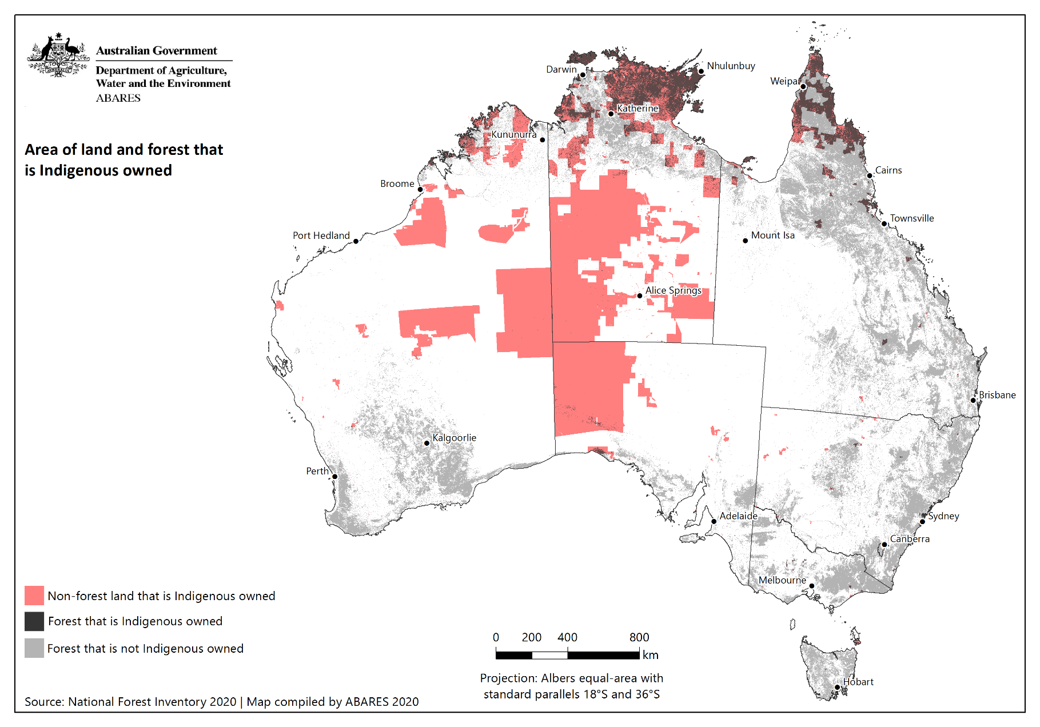

A higher resolution version of this map is available at [doi.org/10.25814/z4sf-xw47](https://doi.org/10.25814/z4sf-xw47).

Figure 2 Area of land and forest that is Indigenous managed or Indigenous co-managed

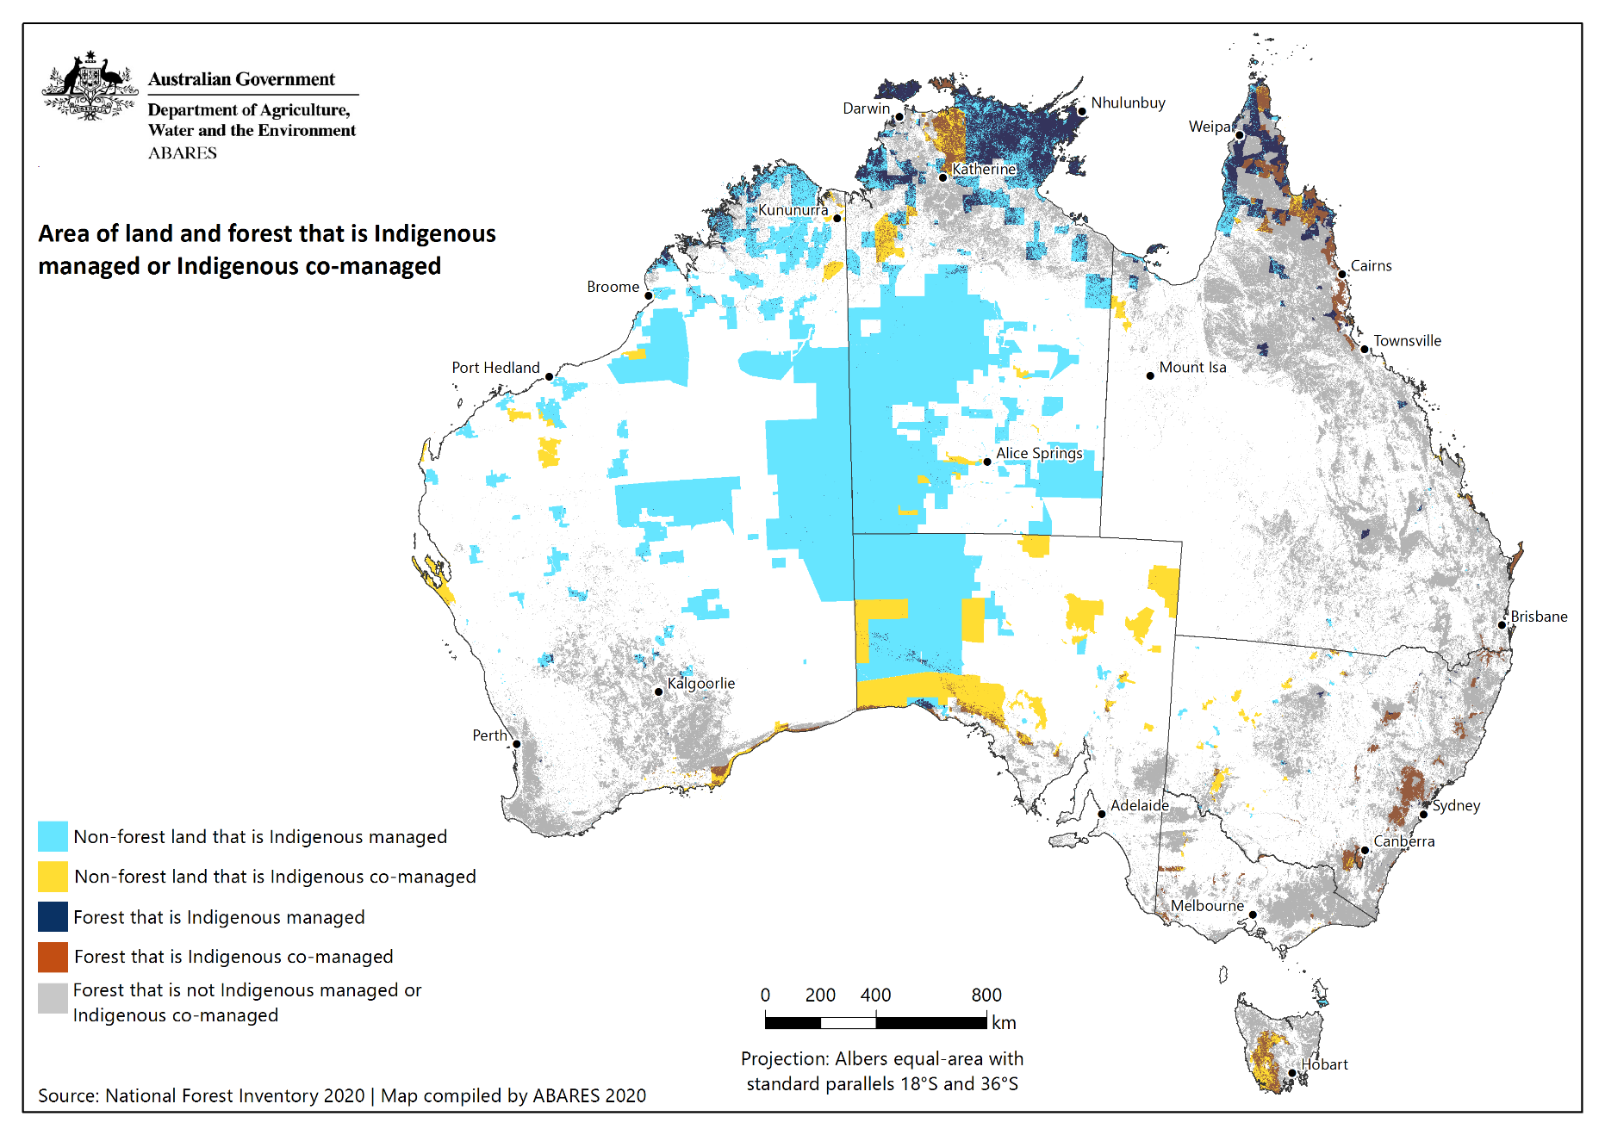

A higher resolution version of this map is available at [doi.org/10.25814/z4sf-xw47](https://doi.org/10.25814/z4sf-xw47).

Figure 3 Area of land and forest that is covered by other special rights for Indigenous peoples and communities

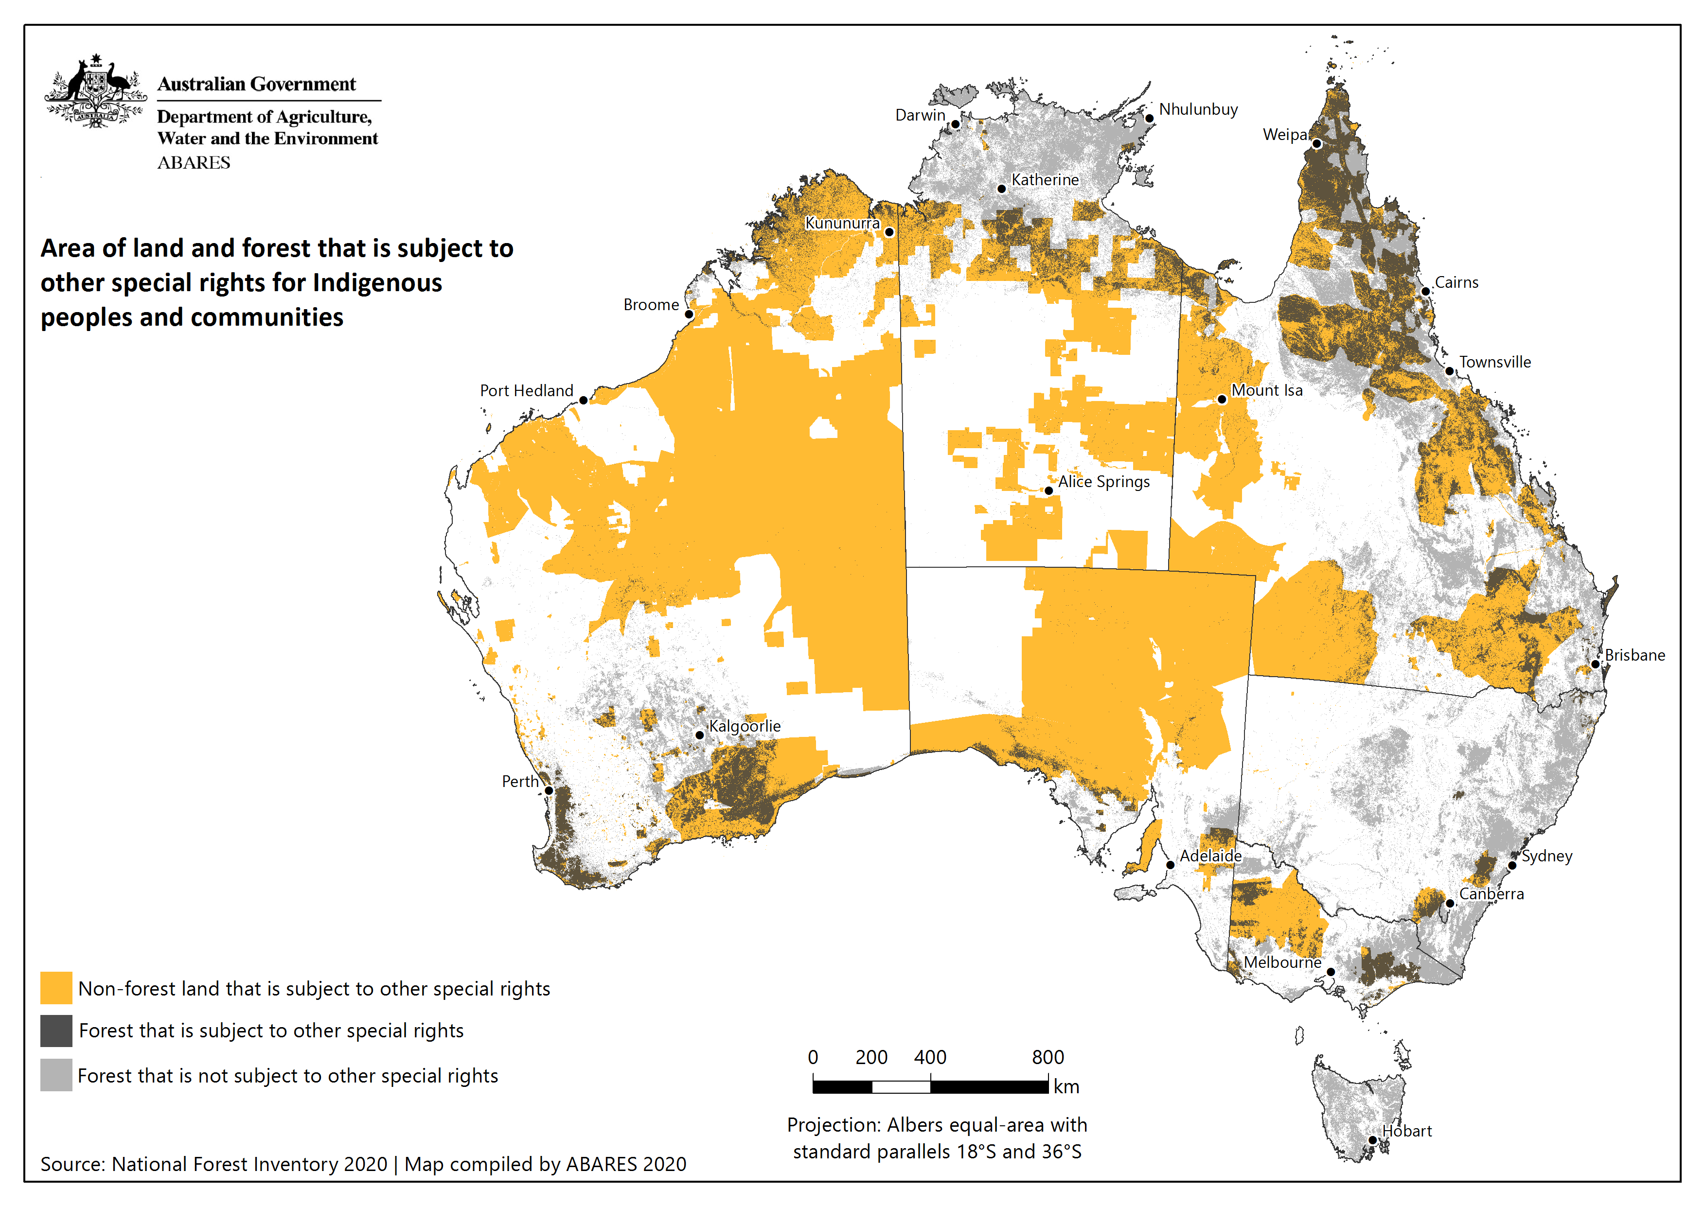

A higher resolution version of this map is available at [doi.org/10.25814/z4sf-xw47](https://doi.org/10.25814/z4sf-xw47).

Figure 4 Total area of land and forest that is in the Indigenous estate

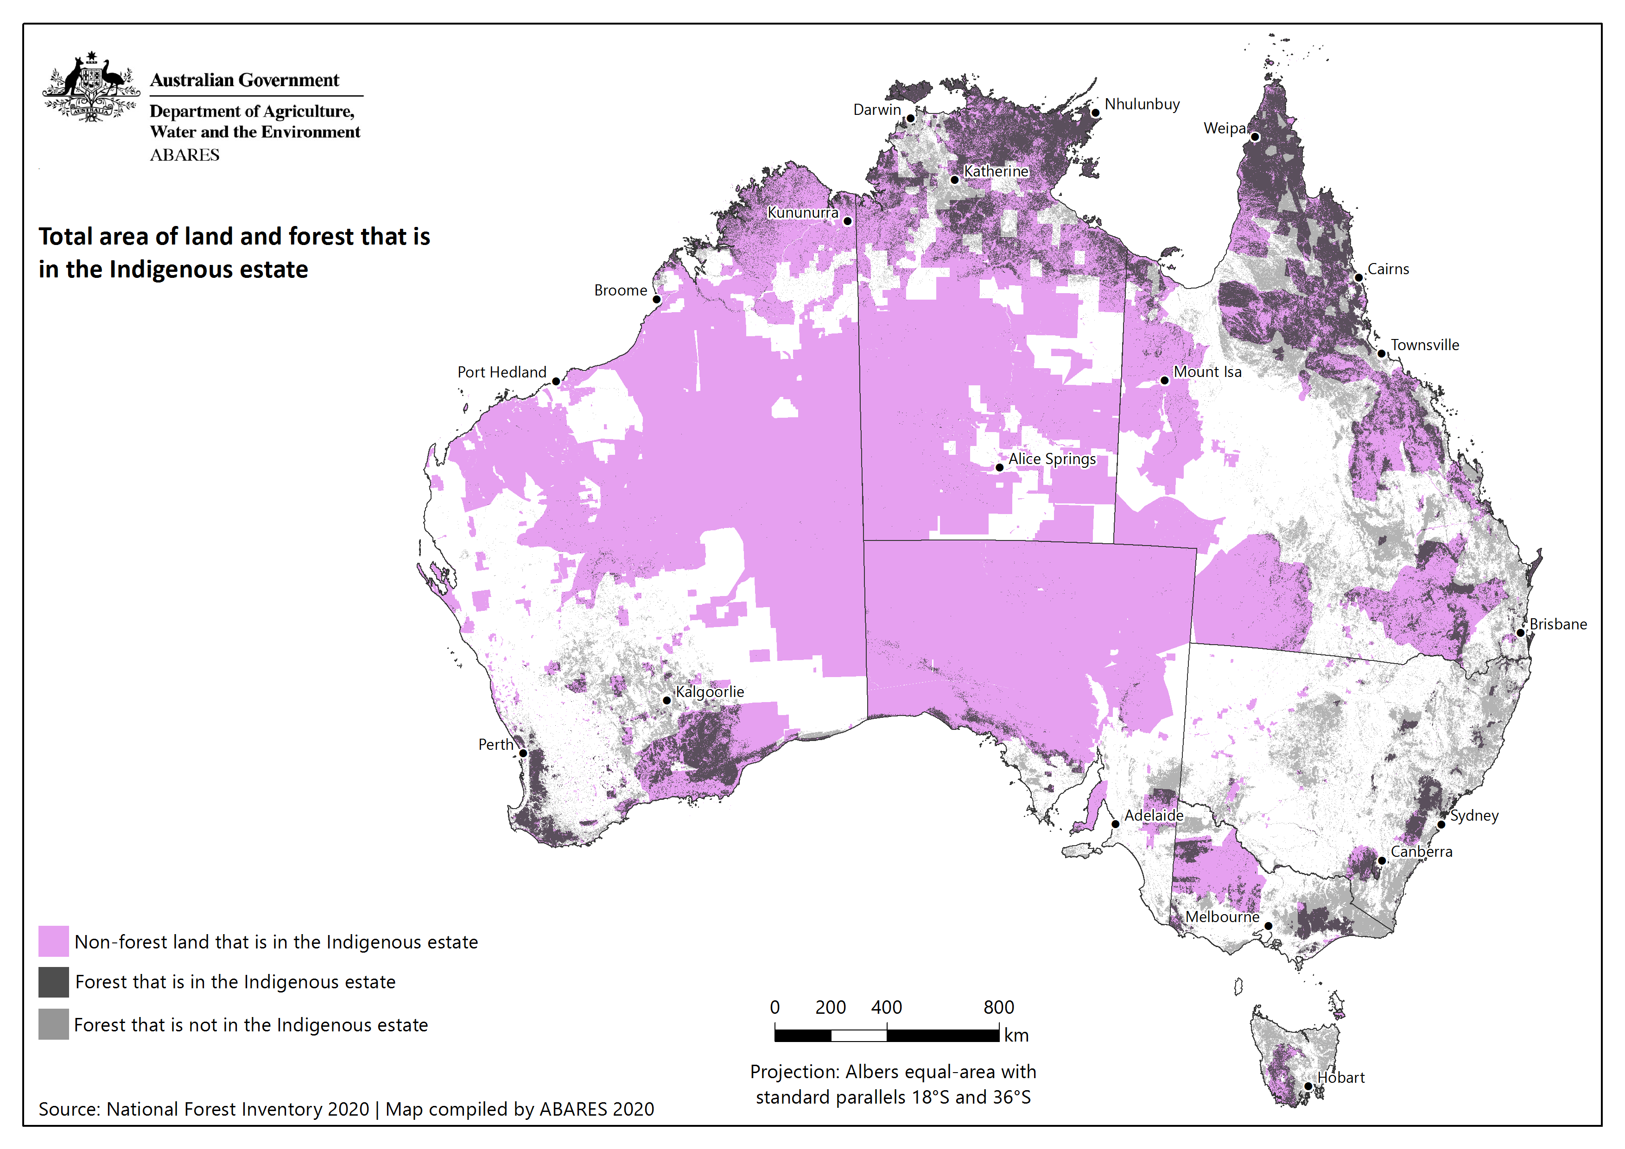

A higher resolution version of this map is available at [doi.org/10.25814/z4sf-xw47](https://doi.org/10.25814/z4sf-xw47).

Figure 5 Area of land that is in the Indigenous estate, by separate Indigenous estate attributes

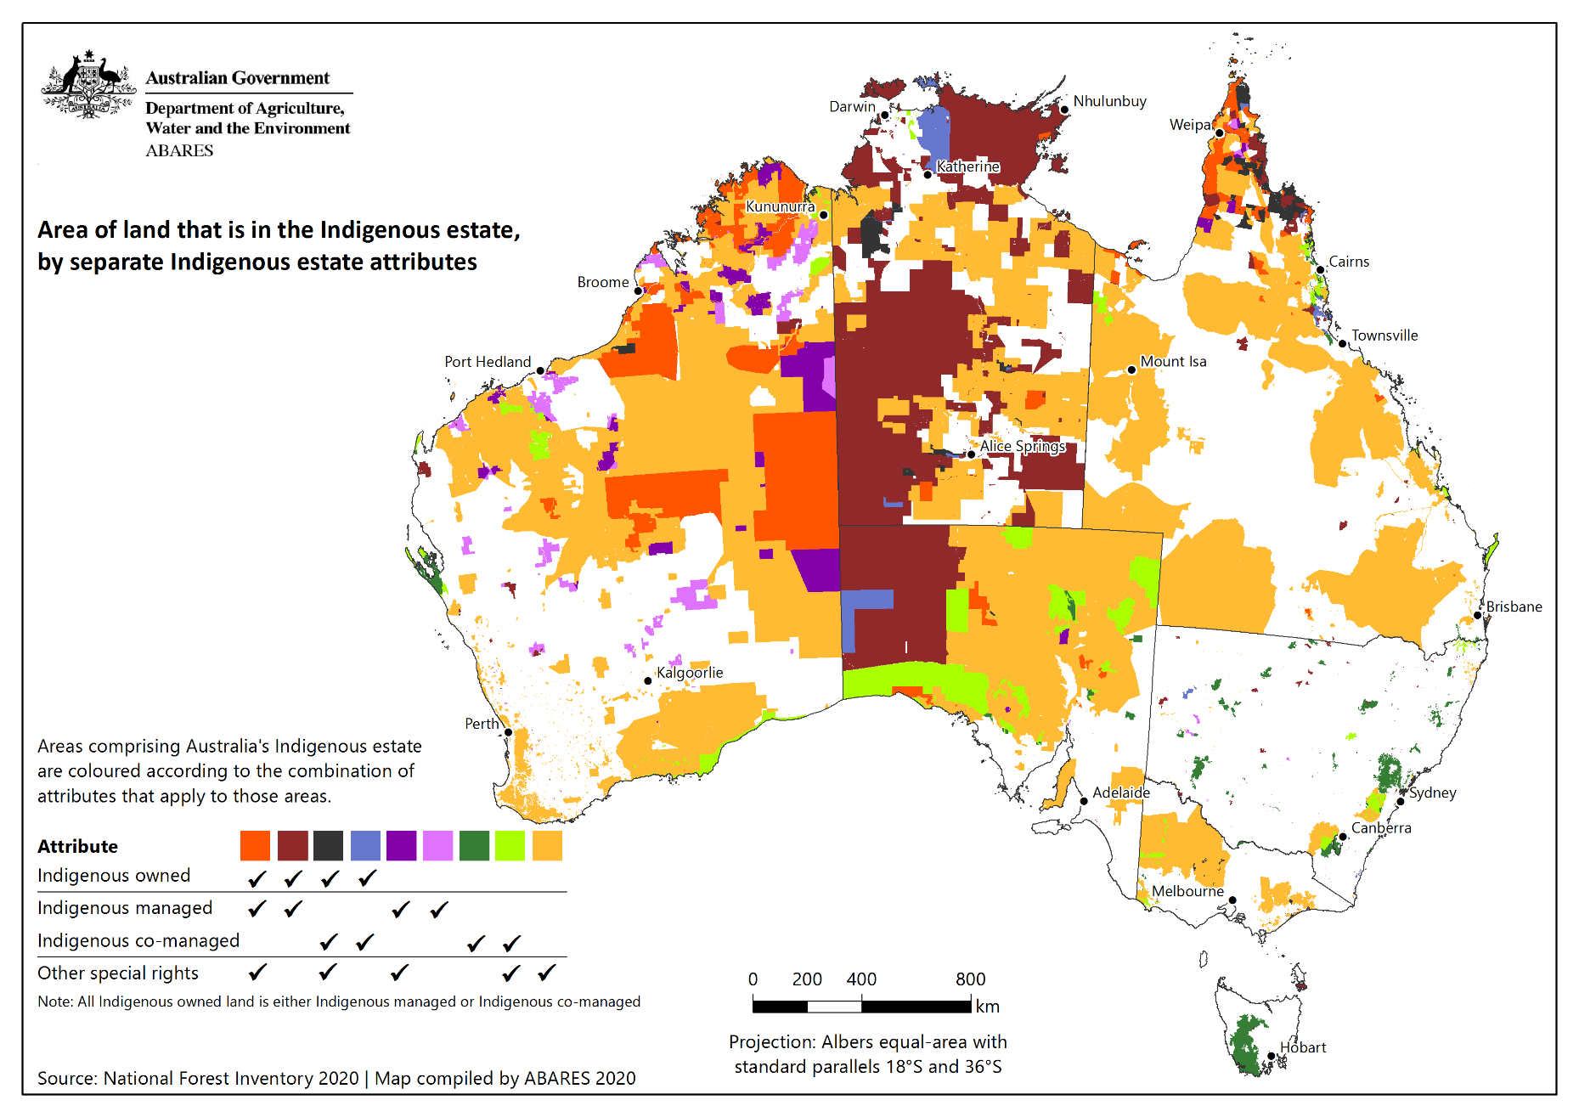

A higher resolution version of this map is available at [doi.org/10.25814/z4sf-xw47](https://doi.org/10.25814/z4sf-xw47).

Figure 6 Area of forest that is in the Indigenous estate, by separate Indigenous estate attributes

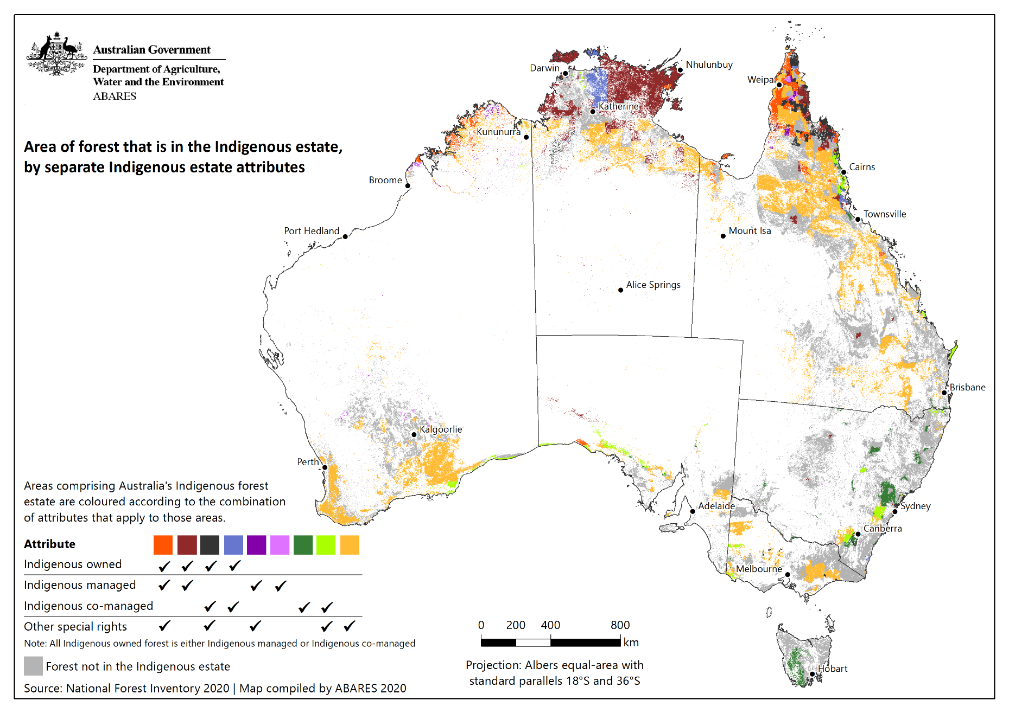

A higher resolution version of this map is available at [doi.org/10.25814/z4sf-xw47](https://doi.org/10.25814/z4sf-xw47).

## References

ABARES 2013a, [Australia’s Indigenous forest estate (2013)](https://www.agriculture.gov.au/abares/forestsaustralia/forest-data-maps-and-tools/spatial-data/superseded-datasets), ABARES, Canberra, CC BY 3.0.

ABARES 2013b, [Forests of Australia (2013)](https://www.agriculture.gov.au/abares/forestsaustralia/forest-data-maps-and-tools/spatial-data/superseded-datasets), ABARES, Canberra, CC BY 4.0.

ABARES 2018a, [Forests of Australia (2018)](https://doi.org/10.25814/5c59170ec780d), ABARES, Canberra, CC BY 4.0.

ABARES 2018b, [Tenure of Australia’s forests (2018)](https://doi.org/10.25814/5c592792c780e), ABARES, Canberra, CC BY 4.0.

ABARES 2018c, [Australia’s Indigenous forest estate (2018)](https://doi.org/10.25814/5c5a1732757f8), ABARES, Canberra, CC BY 4.0.

ABARES 2020a, [Australia’s forests and forestry glossary](https://www.agriculture.gov.au/abares/forestsaustralia/glossary), ABARES, Canberra, CC BY 4.0.

ABARES 2020b, [Australia’s Indigenous forest estate (2020)](https://doi.org/10.25814/bem5-sm50), ABARES, Canberra, [doi.org/10.25814/bem5-sm50](https://doi.org/10.25814/bem5-sm50), CC BY 4.0.

Department of Agriculture, Fisheries and Forestry 2008, [Australia’s Sustainable Forest Management Framework of Criteria and Indicators 2008: Policy Guidelines](https://www.agriculture.gov.au/abares/forestsaustralia/framework). Commonwealth of Australia, Canberra.

Dillon R, Jeyasingham J, Eades S, & Read S 2015, [Development of the Australia’s Indigenous forest estate (2013) dataset](https://www.agriculture.gov.au/sites/default/files/documents/IndigenousForestEstate_20150828_v1.0.0.pdf), ABARES Research report 15.6, Canberra.

Jacobsen R, Mutendeudzi M, Howell CI, Read SM 2019, [Development of a national tenure dataset for reporting the tenure of Australia’s forests](https://doi.org/10.25814/5d5e34e2d3dcc), ABARES Technical Report 19.4, Canberra, August, CC BY 4.0.

MIG and NFISC (Montreal Process Implementation Group for Australia and National Forest Inventory Steering Committee) 2013, [Australia’s State of the Forests Report 2013](https://www.agriculture.gov.au/abares/forestsaustralia/sofr/sofr-2013), ABARES, Canberra, CC BY 3.0.

MIG and NFISC (Montreal Process Implementation Group for Australia and National Forest Inventory Steering Committee) 2018, [Australia’s State of the Forests Report 2018](https://doi.org/10.25814/5be1205b3aa33), ABARES, Canberra, CC BY 4.0.

1. [www.agriculture.gov.au/abares/forestsaustralia/australias-national-forest-inventory](http://www.agriculture.gov.au/abares/forestsaustralia/australias-national-forest-inventory)
2. [www.agriculture.gov.au/abares/forestsaustralia/forest-data-maps-and-tools/spatial-data](http://www.agriculture.gov.au/abares/forestsaustralia/forest-data-maps-and-tools/spatial-data)
3. [www.agriculture.gov.au/abares/forestsaustralia/sofr](http://www.agriculture.gov.au/abares/forestsaustralia/sofr)
4. <https://www.legislation.gov.au/Details/C2012C00258/Controls/>
5. <https://www.legislation.gov.au/Details/C2012C00258/Controls/>
6. See [doi.org/10.25814/bem5-sm50](https://doi.org/10.25814/bem5-sm50)