Biosecurity funding and expenditure report 2025‒26

© Commonwealth of Australia 2026
Ownership of intellectual property rights
Unless otherwise noted, copyright (and any other intellectual property rights) in this publication is owned by the Commonwealth of Australia (referred to as the Commonwealth).
Creative Commons licence
All material in this publication is licensed under a Creative Commons Attribution 4.0 International Licence except content supplied by third parties, logos and the Commonwealth Coat of Arms.

Cataloguing data
This publication (and any material sourced from it) should be attributed as: DAFF 2026, Biosecurity funding and expenditure report 2025‒26, Department of Agriculture, Fisheries and Forestry, Canberra. CC BY 4.0.
This publication is available at agriculture.gov.au/biosecurity-trade/policy/sustainable-biosecurity-funding.
Department of Agriculture, Fisheries and Forestry
GPO Box 858 Canberra ACT 2601
Telephone 1800 900 090
Web agriculture.gov.au
Disclaimer
The Australian Government acting through the Department of Agriculture, Fisheries and Forestry has exercised due care and skill in preparing and compiling the information and data in this publication. Notwithstanding, the Department of Agriculture, Fisheries and Forestry, its employees and advisers disclaim all liability, including liability for negligence and for any loss, damage, injury, expense or cost incurred by any person as a result of accessing, using or relying on any of the information or data in this publication to the maximum extent permitted by law.
Acknowledgement of Country
We acknowledge the continuous connection of First Nations Traditional Owners and Custodians to the lands, seas and waters of Australia. We recognise their care for and cultivation of Country. We pay respect to Elders past and present, and recognise their knowledge and contribution to the productivity, innovation and sustainability of Australia’s agriculture, fisheries and forestry industries.

Contents
Introduction 5
Biosecurity in action 6
Funding the biosecurity system 7
Appropriations from government 7
Cost recovery revenue 7
Own-source revenue 8
National biosecurity emergency responses 8
Biosecurity budget 10
Biosecurity expenditure 11
Expenditure by control stage and pathway 13
Financial performance 16
Cost recovery revenue performance 16
Cargo volumes and self-assessed clearance reform 16
Progress against DAFF Biosecurity 2030 Roadmap 18
Strategic action 1 18
Strategic action 2 19
Strategic action 3 20
Strategic action 4 21
Strategic action 5 22
Strategic action 6 23
Strategic action 7 24
Strategic action 8 25
Strategic action 9 26
Appendix A: Status of cost-shared biosecurity emergency responses 27

Tables
Table 1 Biosecurity budget, by funding source, 2025‒26 to 2029‒30 10
Table 2 Biosecurity budget, by funding source and subcategory, 2025–26 to 2029–30 10
Table 3 Biosecurity expenses, by activity, 2025‒26 12
Table 4 Control stage definitions 14
Table 5 Pathway class definitions 15
Table 6 Biosecurity expenditure and budget variance, 2025‒26 16
Table A1 Nationally cost-shared pest and disease eradication response programs, at June 2026 27
Figures
Figure 1 Commonwealth biosecurity funding sources 7
Figure 2 Expenditure by control stage and funding source, 2025–26 13
Figure 3 Expenditure by pathway class and funding source, 2025–26 15
Figure 4 Cargo volumes, 2021–22 to 2025–26 17
Case studies
Case study 1 Cultural wisdom protecting forests and Country 18
Case study 2 Ethyl formate fumigation for brown marmorated stink bug 19
Case study 3 Timor-Leste Biosecurity Development Program 20
Case study 4 Building First Nations biosecurity leadership through workforce development 21
Case study 5 Simplified Targeting and Enhanced Processing Systems program 22
Case study 6 Khapra beetle response – national biosecurity leadership in action 23
Case study 7 Taxodactyl DNA intelligence dashboard 24
Case study 8 Commercial avian influenza testing and point-of-care validation 25
Case study 9 National Biosecurity Forum, 2025 26

Introduction
The Biosecurity funding and expenditure report 2025–26 continues the Australian Government’s commitment to transparent biosecurity financial reporting.
This report retains the structure established in previous editions, providing continuity across reporting periods, including progress updates against the DAFF Biosecurity 2030 Roadmap. It also expands analysis of biosecurity expenditure and introduces a new section on national biosecurity emergency response management.
This report focuses on Commonwealth biosecurity system funding and expenditure and provides visibility of Commonwealth contributions to national emergency biosecurity response activities administered through intergovernmental agreements. This recognises the importance of these contributions in supporting coordinated national responses to pest and disease incursions.
The report complements existing public reporting, including portfolio budget statements, annual reports and corporate plans. For a complete view of the Department of Agriculture, Fisheries and Forestry’s financial and non-financial performance for 2025–26, see the Annual report 2025–26.
The portfolio budget statements and annual reports present aggregated financial information at an outcome and departmental level. In contrast, this report focuses specifically on biosecurity funding and expenditure. Funding is represented as budgeted figures up to and including Budget 2026–27, while expenditure figures reflect actual expenditure for the 2025–26 financial year.

Biosecurity in action
Australia’s biosecurity system protects the environment, economy and way of life by reducing the risk of exotic pests and diseases entering, establishing and spreading, while managing those already present. As an island nation with extensive coastlines, high trade volumes and unique biodiversity, Australia is particularly vulnerable to biosecurity threats. A strong, coordinated system is essential to safeguard industries, maintain market access and protect our community and environment.
In 2025–26, the biosecurity system operated in an increasingly complex risk environment. Growing trade and passenger movements, combined with climate variability, continued to influence pest and disease spread. Global instability added further risk – conflict in the Middle East disrupted supply chains, altered shipping routes and increased freight costs. Rerouted cargo and shifts to alternative suppliers created new biosecurity pathways, requiring adaptive border management. The Australian Government responded by streamlining import processes to reduce costs and clearance times while maintaining strict biosecurity standards.
In 2025–26, we assessed over 22,000 import permits and supported the clearance of approximately:
- 169 million import cargo consignments
- 2.8 million containers (with over 712,800 requiring department intervention)
- 23.8 million international travellers, consisting of over 23.4 million air travellers and over 402,200 sea travellers (resulting in over 10,200 pest and disease identifications)
- 20,000 vessels arriving in Australia (resulting in over 4,300 pest and disease identifications)
- 113,500 international aircraft
- 7,600 animals (cats, dogs and horses).
Australia’s biosecurity system operates across the full risk continuum – from prevention and preparedness to surveillance, response and recovery. At the border, this includes inspection and certification of imported goods, passengers and mail, and regulation of live animals, plants and biological materials. Beyond the border, it includes surveillance, monitoring and coordinated responses to incursions of national significance.
These frontline activities are supported by legislation, policy, scientific advice, diagnostics, data and intelligence, emergency preparedness and public education. Together, they promote shared responsibility, encourage early reporting and strengthen public confidence in how risks are managed.
Key 2025–26 activities contributing to a productive, resilient and sustainable system are highlighted through case studies in this report (see Progress against DAFF Biosecurity 2030 Roadmap).

Funding the biosecurity system
Funding for the Commonwealth biosecurity system is allocated to meet the department’s statutory responsibilities for managing biosecurity risks. The Secretary of the Department of Agriculture, Fisheries and Forestry is the Director of Biosecurity and is responsible for the general administration of the Biosecurity Act 2015. The Commonwealth biosecurity system is funded through appropriations from government, cost recovery revenue and own-source revenue. A fourth source of funding is separately committed by government for national biosecurity emergency responses (Figure 1).
Figure 1 Commonwealth biosecurity funding sources
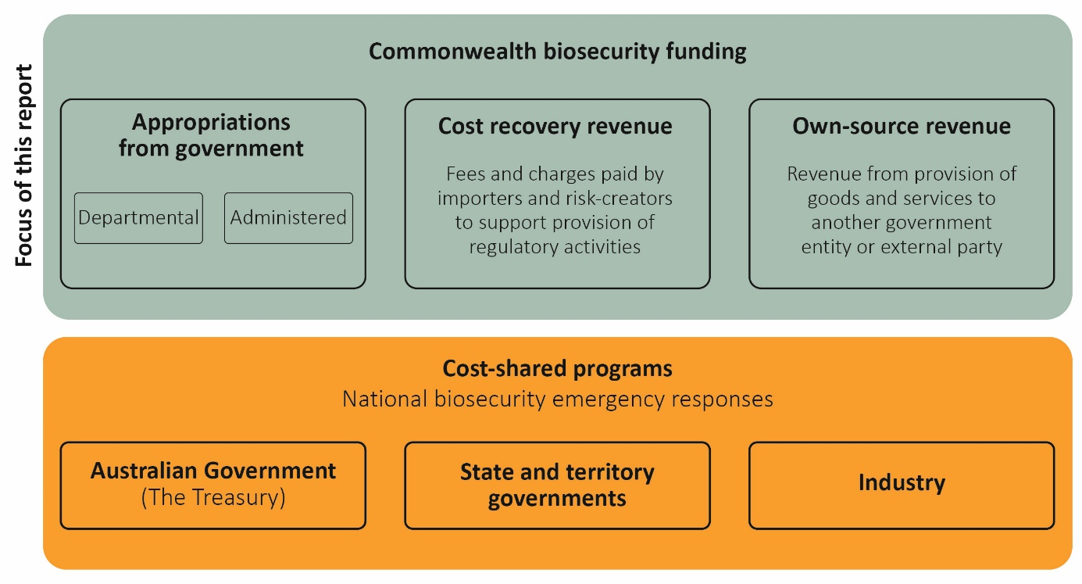

Appropriations from government
We receive departmental and administered appropriations from government:
- Departmental appropriations – We have control over these funds to run day-to-day and program support operations (e.g. staff salaries, goods and services, property-related costs and other operational expenditure).
- Administered appropriations – We manage these funds on behalf of the government, including for payments to state and territories, grant programs and other expenditure for specific government or public purposes.

Cost recovery revenue
We recover costs from industry for a range of regulatory activities and receive revenue through fees and charges for the provision of biosecurity regulatory activities under the biosecurity cost recovery arrangement. Cost recovery activities must comply with the Australian Government Charging Framework.
The annual Biosecurity Cost Recovery Implementation Statement sets out the fees and charges applied under the biosecurity cost recovery arrangement during the financial year.
We also receive a legislated annual fee from Australia Post for conducting biosecurity clearance on items processed at international mail gateway facilities.

Own-source revenue
We raise other revenue to offset the costs of providing biosecurity goods and services.
Section 74 of the Public Governance, Performance and Accountability Act 2013 provides a mechanism that allows us to retain funds (revenue) to cover the costs of specified activities. This includes revenue from services such as offshore biosecurity inspections, application and processing fees, and services to other government agencies.
We raise additional revenue from service contracts and activities we participate in that are funded by other departments, including:
- offshore inspections and auditing – activities undertaken offshore by the department, or an approved provider, to mitigate certain biosecurity risks
- National Arbovirus Monitoring Program – revenue from Animal Health Australia to deliver the program
- Pacific Biosecurity Strategy – delivering capacity-building activities, supported by funding from the Department of Foreign Affairs and Trade (DFAT)
- Australian Plague Locust Commission – cost-shared arrangement to monitor and manage locust populations across New South Wales, Victoria, Queensland and South Australia.
We recover biosecurity costs associated with the movement of military goods, conveyances and personnel into Australia via a memorandum of understanding with the Department of Defence (Defence). This includes an indexed annual payment from Defence to cover costs associated with Australian Defence Force movements. Additional Section 74 revenue is received for offshore biosecurity inspection activities requested by foreign defence forces.
This arrangement funds dedicated resourcing for these activities, reducing the demand on biosecurity resources intended to support clearance of commercial cargo, passengers and conveyances.

National biosecurity emergency responses
The Australian Government supports agricultural producers and protects Australia’s unique environment by contributing to the eradication of exotic animal, plant and environmental pests and diseases. Funding for these emergency biosecurity responses is separate to the biosecurity operational funding outlined in this report.
The Australian Government contributes to nationally cost-shared emergency biosecurity responses under established intergovernmental and industry agreements, including:
- the Emergency Animal Disease Response Agreement (EADRA)
- the Emergency Plant Pest Response Deed (EPPRD)
- the National Environmental Biosecurity Response Agreement (NEBRA)
- the National Management Agreement for H5 High Pathogenicity Avian Influenza in Wildlife (H5 NMA)
- other responses established outside of EADRA, EPPRD and NEBRA.
Under these arrangements, national biosecurity emergency response costs are shared between the Commonwealth, states and territories and, where appropriate, industry parties to EADRA and EPPRD. Funding contributions, including from industry (where appropriate), are approved by the National Management Group (NMG) as set out in the relevant agreement or deed in response to biosecurity incidents. The NMG comprises representatives of each cost-sharing party to the individual response.
The Project Agreement for Pest and Disease Preparedness and Response Programs (the project agreement) provides the mechanism for the Commonwealth to pay its cost-sharing contribution to the responsible jurisdiction on an individual response basis. The impacted state or territory delivers the response.
At Budget 2026–27, the Australian Government committed $440.2 million in funding from 2025–26 to 2029–30 under the project agreement (Budget Paper No. 3, Environment, energy and water, p. 106). This includes provision to underwrite industry contributions, which are repaid through levy arrangements prescribed in each deed or agreement, or by voluntary means. Because these payments are made to states and territories for specific purposes, the Treasury facilitates the payments in consultation with our department.
Due to the variable nature of national emergency pest and disease responses, a statement of risk is provided in Budget Paper No. 1, Statement 9: Statement of risks (p. 300).
In 2025–26, we supported 18 nationally cost-shared biosecurity responses, with a total Commonwealth commitment in 2025–26 of $164.6 million, including underwriting industry contributions. For an overview of national biosecurity emergency responses at 30 June 2026, see Appendix A.

Biosecurity budget
The department had a biosecurity budget of over $960 million for 2025–26. Table 1 shows the biosecurity budget by funding source for 2025‒26 and over the forward estimates.
Table 1 Biosecurity budget, by funding source, 2025‒26 to 2029‒30
Funding source | 2025‒26 ($m) | 2026‒27 ($m) | 2027‒28 ($m) | 2028‒29 ($m) | 2029‒30 ($m)
Cost recovery ª | 502.8 | 517.3 | 522.4 | 530.3 | 540.2
Base appropriation | 409.6 | 401.4 | 366.0 | 377.2 | 387.5
STEPS program appropriation | 57.2 | 19.8 | n/a | n/a | n/a
Total biosecurity funding ^{b} | 969.6 | 938.4 | 888.4 | 907.4 | 927.7
Note: Figures reflect government decisions made up to and including Budget 2026‒27. a Includes the cost recovery arrangement, Australia Post, Defence and other own-source revenue. b Differences between total biosecurity funding and the sum of individual line items is due to rounding. STEPS Simplified Targeting and Enhanced Processing Systems.
The observable decline in appropriation funding from 2026–27 to 2027–28 is primarily due to the completion of terminating budget measures and revised timeframes for the Simplified Targeting and Enhanced Processing Systems program.
Budgeted cost recovery revenue continues to grow over the forward estimates (from 2027–28 to 2029–30) due to expected growth in demand for biosecurity regulatory activities.
A breakdown of the budget by funding sources is detailed in Table 2.
Table 2 Biosecurity budget, by funding source and subcategory, 2025–26 to 2029–30
Funding source | Subcategory | 2025‒26 ($m) | 2026‒27 ($m) | 2027‒28 ($m) | 2028‒29 ($m) | 2029‒30 ($m)
Cost recovery | Existing cost recovery arrangement | 394.2 | 409.5 | 418.0 | 426.7 | 435.4
Cost recovery | Cost recovery – SAC | 65.5 | 66.8 | 68.2 | 69.7 | 71.1
Cost recovery | Australia Post | 15.6 | 15.8 | 16.0 | 16.0 | 16.0
Cost recovery | Defence | 16.4 | 13.2 | 12.9 | 13.5 | 13.2
Cost recovery | Other s74 revenue | 11.1 | 11.9 | 7.2 | 4.4 | 4.5
Cost recovery | Total cost recovery | 502.8 | 517.3 | 522.4 | 530.3 | 540.2
Appropriation | Departmental appropriation | 381.0 | 366.0 | 339.9 | 350.7 | 360.1
Appropriation | Departmental equity injection | 47.6 | 18.2 | 0.8 | 0.7 | 1.2
Appropriation | Department of Finance gateway review departmental appropriation | 0.1 | 0.1 | n/a | n/a | n/a
Appropriation | Administered | 38.1 | 36.8 | 25.3 | 25.7 | 26.2
Appropriation | Total appropriation | 466.8 | 421.2 | 366.0 | 377.2 | 387.5
Total ª |  | 969.6 | 938.4 | 888.4 | 907.4 | 927.7
Note: Figures do not reflect decisions made after Budget 2026–27. a Differences between totals and the sum of individual line items is due to rounding. SAC Self-assessed clearance.

Biosecurity expenditure
In 2025‒26, our biosecurity expenses totalled $937.5 million. With the exception of biosecurity clearance of passengers, direct border regulatory activities are typically cost-recovered and cover:
- import and traveller risk management
  - inspecting, assessing and managing biosecurity risks associated with imported goods and packaging, including air and sea cargo, containers, food, live animals and plants (including post-entry quarantine)
  - assessing biosecurity risks associated with vessels and aircraft entering Australia
  - managing biosecurity risks associated with international traveller baggage
- regulatory administration
  - administering approved arrangements, including associated policy, operational processes and regulatory conditions
  - regulatory services that support compliance with Australia’s biosecurity requirements
Appropriation funding complements cost-recovered activities by supporting statutory functions and other essential biosecurity activities. There are also national public benefits that cannot be fully funded through cost recovery arrangements. Examples of activities supported through appropriation funding include:
- science, policy and innovation
  - providing scientific, technical and policy advice to inform evidence-based biosecurity policy, regulation and operational decision-making
  - delivering research, innovation and emerging technologies to strengthen biosecurity capability, improve risk management and respond to evolving pest and disease threats
  - investing in advanced diagnostics, genomics, digital technologies and data analytics to improve surveillance, risk assessment and the timely detection of pests and diseases
- border capabilities
  - conducting frontline biosecurity operations to detect, manage and contain biosecurity risks at Australia’s border
  - operating certain laboratory and diagnostic services, and specific operations at the Post Entry Quarantine Facility at Mickleham, to support the detection, assessment and management of biosecurity risks
- preparedness, surveillance and response
  - undertaking surveillance, preparedness and detection activities through initiatives such as the Northern Australia Quarantine Strategy and the Indigenous Ranger Biosecurity Program
  - supporting emergency preparedness, response and recovery activities outside established cost-sharing arrangements
- national and international leadership
  - implementing the Intergovernmental Agreement on Biosecurity to maintain a nationally coordinated system across animal, plant, environmental and marine sectors
  - supporting the Australian Chief Veterinary Officer, Australian Chief Plant Protection Officer, and Australian Chief Environmental Biosecurity Officer, and their offices, to
    - provide scientific expertise and leadership to support Australia’s animal, plant and environmental health, including preparedness and emergency response
    - support and expand overseas market access by providing technical advice on standards development and representation in international forums
  - meeting Australia’s international obligations and strengthening regional biosecurity capability through partnerships, technical cooperation, training and capacity building, particularly across the Pacific and Southeast Asia
  - maintaining Australia’s favourable biosecurity status to protect agricultural production, the environment and the community while supporting continued access to international export markets.
Our biosecurity expenditure also includes the supporting and enabling services required to deliver on our outcomes – for example, payroll, human resources, finance, ICT, legal and communication support, uniforms and operational consumables such as personal protective equipment and scientific equipment. Table 3 shows these expenses disbursed across activities for 2025–26.
Table 3 Biosecurity expenses, by activity, 2025‒26
Category | Activities | Expenses (actual, $m)
Direct border protection activities | Import clearance (international air cargo, sea cargo and containers) | 296.9
Direct border protection activities | Post-entry quarantine | 28.5
Direct border protection activities | Seaports program (maritime vessels entering Australia) | 34.7
Direct border protection activities | Self-assessed clearance | 57.1
Direct border protection activities | International mail | 25.6
Direct border protection activities | International passengers | 117.3
Direct border protection activities | Total direct border protection activities | 560.1
Non-direct border activities | Administered funding – biosecurity activities and programs | 35.1
Non-direct border activities | Government-funded and s74 external revenue (including offshore) biosecurity activities ª | 270.8
Non-direct border activities | Simplified Targeting and Enhanced Processing Systems | 15.9
Non-direct border activities | Digital capability and overseas counsellor network | 1.6
Non-direct border activities | ABARES | 10.2
Non-direct border activities | Indirect costs ^{b} | 43.9
Non-direct border activities | Total non-direct border activities | 377.5
Total expenses ^{c} |  | 937.5
a Includes surveillance, compliance, risk analysis, workforce management, policy development, international engagement, commodity import forecasting and staff training activities. b Includes asset-related and/or lease-related expenses such as depreciation and amortisation (e.g. lease expenses from Melbourne Mickleham office are attributable to post-entry quarantine activities within the biosecurity cost recovery arrangement). c Differences between totals and the sum of individual line items is due to rounding.

Expenditure by control stage and pathway
Australia’s biosecurity system involves multiple control stages and pathways. The department invests resources to prevent, manage and respond to biosecurity risks pre-border, at-border and post-border across multiple pathways. For the first time, the 2025–26 report shows total expenditure for each control stage and pathway, and how that expenditure was funded.

Control stages
Biosecurity controls are designed to reduce the probability of entry, establishment and spread of pests, diseases and weeds in Australia (see definitions in Table 4). Just over half of the department’s $937.5 million in biosecurity expenditure supports activities to manage risks at the border (Figure 2). The balance supports pre-border and post-border activities and activities that support effective risk management across the biosecurity continuum, including investments in:
- regulatory capability
- ICT systems and data analytics capability
- strategy and reform
- intelligence, engagement and coordination efforts.
Figure 2 Expenditure by control stage and funding source, 2025–26
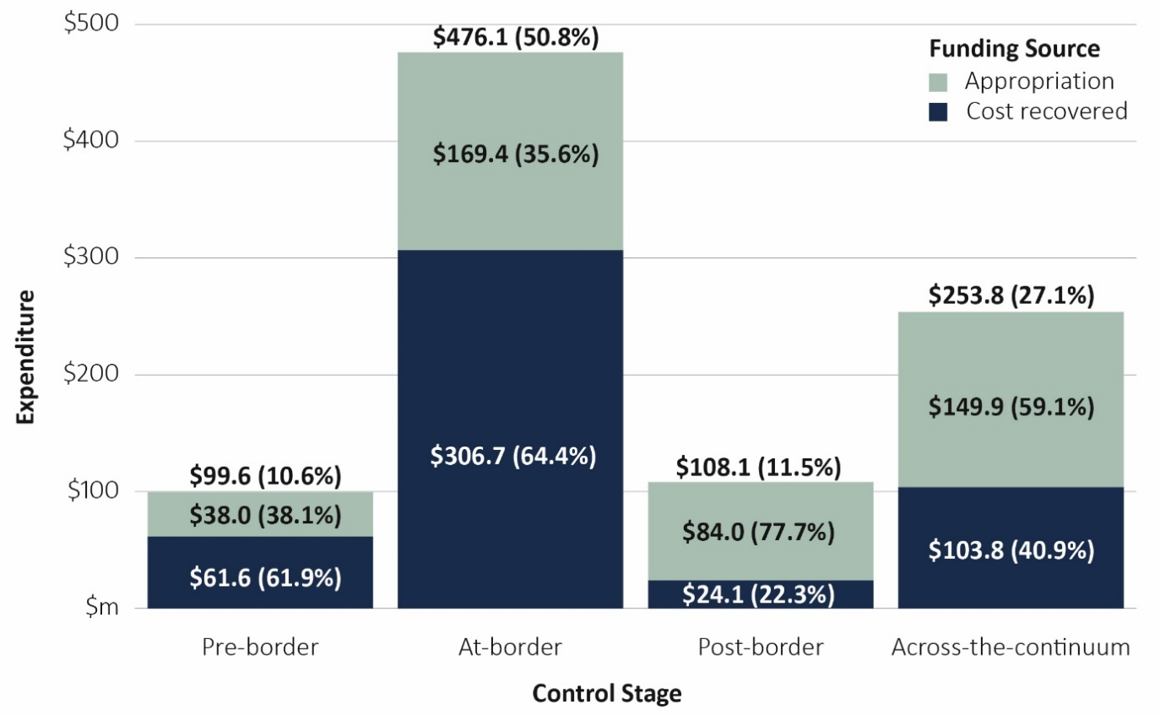
Note: Figures shown are approximate. Financial system constraints result in a small proportion of expenditure funded from own-source revenue being reported as appropriation funded.
Table 4 Control stage definitions
Term | Definition
Pre-border (overseas) | - Working with overseas governments, agencies, importers and other stakeholders to mitigate risk and reduce the number and frequency of pests and diseases that reach Australia.
At-border | - Screening and inspection of air and sea vessels, cargo, mail and travellers to assess and manage biosecurity risk.  - Conducting surveillance to ensure the earliest and most effective response to exotic pests, diseases and weeds.  - Undertaking laboratory diagnostics, verification, assurance and post-entry quarantine to prevent pests and diseases entering Australia.
Post-border | - Addressing non-compliance with biosecurity legislation.  - Working with the states, territories and industry partners to detect and respond to incursions and contain and eradicate pests and diseases within Australia.
Across the continuum | - Delivering whole-of system strategy, engagement, business administration or law reform activities.  - Includes costs that cannot be assigned to a specific stage.

Pathway classes
Biosecurity risk pathways describe how a pest, disease or weed travels to and arrives in Australia (see definitions in Table 5). Understanding these pathways and investing in effective measures is critical in the prevention of risk.
The 2 largest categories of expenditure are the cargo, containers and conveyances pathway class and post-border and across-the-continuum pathway class, approximately 40% and 39% respectively (Figure 3):
- Cargo, containers and conveyances pathway – expenditure reflects the assessed risk and importance of managing this pathway as cargo volumes continue to grow. This expenditure is primarily cost-recovered.
- Post-border and across-the-continuum pathway – expenditure includes preparing for and detecting pest and disease incursions post-border, and compliance and enforcement across the system. This expenditure supports the biosecurity system and is primarily funded through appropriation.
Figure 3 Expenditure by pathway class and funding source, 2025–26
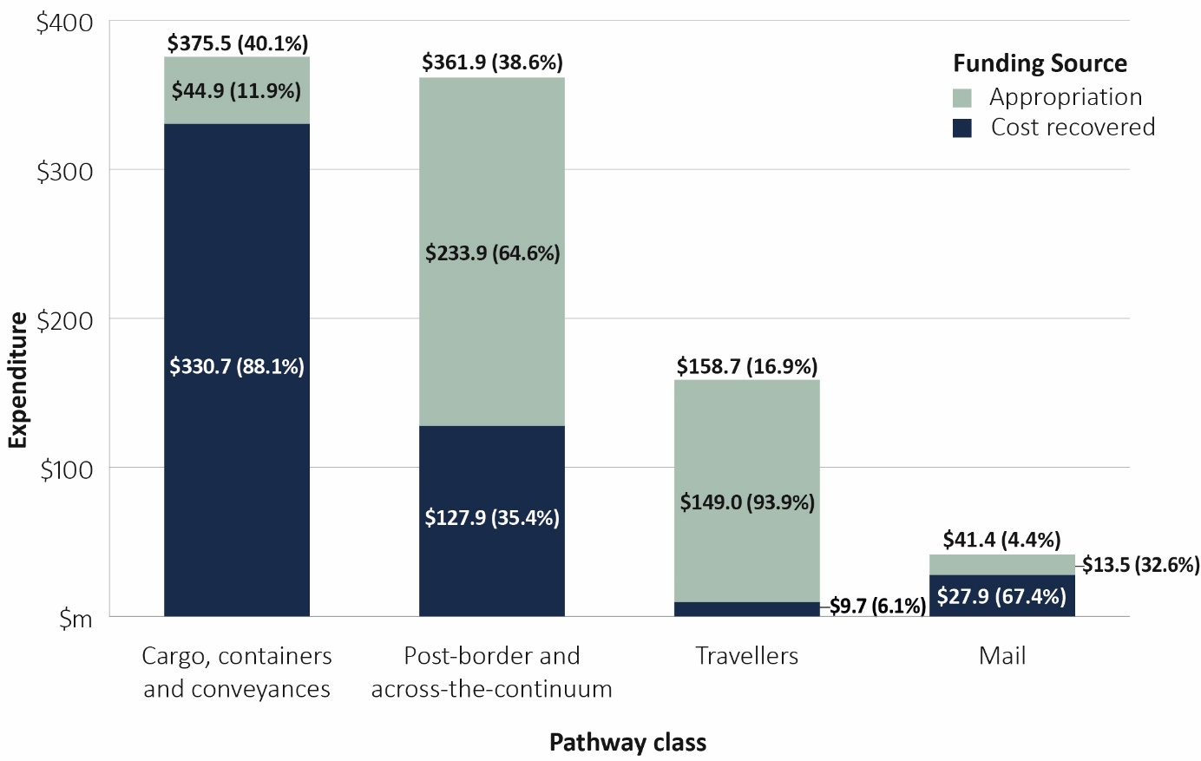
Note: Figures shown are approximate. Financial system constraints result in a small proportion of own-source revenue funded expenditure being reported as appropriation funded.
Table 5 Pathway class definitions
Term | Definition
Travellers | - Airline and cruise ship passengers and crew and their accompanying luggage. This category excludes people arriving in Australia on any other vessels, which are considered in the conveyances pathway class.
Mail | - International mail managed by Australia Post.
Cargo, containers and conveyances | - Vessels, aircraft, external and internal surfaces of sea and air containers, and imported cargo (excluding mail items handled by Australia Post).
Post border and across-the-continuum | - This expenditure is not assigned to a specific pathway class. It supports system-wide functions such as ICT delivery, preparedness, surveillance, diagnostics, and coordination of biosecurity activities.

Financial performance
Variance analysis of our 2025–26 biosecurity budget and expenditure is provided in Table 6.
Table 6 Biosecurity expenditure and budget variance, 2025‒26
Category | Budget ($m) ª | Actual ($m) | Variance ($m)
Appropriation and other s74 revenue | 392.2 | 368.9 | 23.3 ^{b}
Existing cost recovery arrangement | 459.7 | 453.7 | 6.0 ^{c}
Australia Post | 15.6 | 27.0 | −11.4 ^{d}
Defence | 16.4 | 15.5 | 0.9
Department of Finance gateway review departmental appropriation | 0.1 | 0.1 | n/a
Departmental equity injection | 47.6 | 37.3 | 10.3 e
Administered | 38.1 | 35.1 | 3.0 ^{f}
Total biosecurity expenditure ^{g} | 969.6 | 937.5 | 32.1
a At Budget 2026‒27. b Underspend due to delays in delivering key initiatives such as the Simplified Targeting and Enhanced Processing Systems program and the Western Sydney International Airport project. c Includes self-assessed clearance. Expenses below budget primarily due to departmental staffing constraints. d Australia Post statutory fee of $15.3 million is supplemented by ongoing appropriation funding of around $7 million per annum (included in ‘Appropriation and other s74 revenue’). Remaining expenses above budget are appropriation funded and largely driven by ICT and digital capability investments. e Underspend largely attributable to project delivery delays. We are exploring options to move unspent equity (capital) to future years. f Underspend largely due to supply constraints and other delays. g Differences between total biosecurity expenditure and the sum of individual line items is due to rounding.

Cost recovery revenue performance
Cost recovery revenue collected from importers, excluding Australia Post, increased from $428.8 million in 2024–25 to $466.0 million in 2025–26 (including $60.6 million for SAC). This increase of $37.2 million (around 9%) is largely attributable to the growth in SAC volumes, annual indexation of regulatory charges and increased volumes of fee-for-service activities.
Australia Post pays the department a legislated annual fee of $15.3 million for biosecurity clearance at international mail gateway facilities, which is below the cost of managing and assessing biosecurity risks associated with international mail. Since 2024–25, the government has provided the department with an additional $7.0 million appropriation funding per annum to help close this gap.

Cargo volumes and self-assessed clearance reform
In 2025‒26, total cargo volumes increased by 9.1% compared to the previous year. Full import declarations and long-form SAC volumes increased by 3.6%, reaching more than 4.6 million. SAC consignments, which account for more than 97% of total cargo, grew by 9.3% to 164.3 million. This continues the trend of increased volumes over past years (Figure 4).
Figure 4 Cargo volumes, 2021–22 to 2025–26
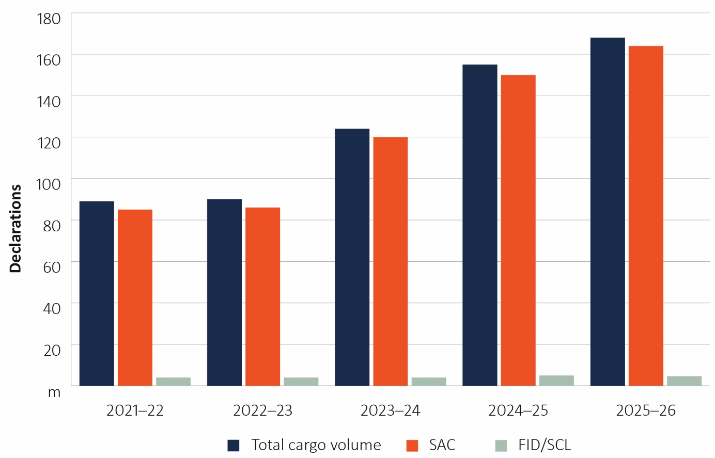
SAC Self-assessed clearance. FID Full import declaration. SCL Cargo reported (long-form) self-assessed clearance.
The department is continuing to reform the SAC pathway through the delivery of the SAC Reform Program, ensuring biosecurity activities are fit for purpose and that risks are managed effectively and efficiently. This builds on progress in 2024–25. Efforts in 2025–26 have seen an increase in frontline resources, enhanced pathway verification and intelligence activity to support our risk assessments and control settings, and investment in data and digital management systems. This has included collaborative work with industry partners across several initiatives.
Given the current global economic environment and slowdown in the rate of growth in this pathway, we will be closely tracking changes in SAC volumes, predicted revenue and associated expenditure. We regularly review our efforts in the SAC pathway to ensure they are appropriate and efficient.

Progress against DAFF Biosecurity 2030 Roadmap
The DAFF Biosecurity 2030 Roadmap outlines our strategic direction for strengthening the Australian biosecurity system to 2030 and beyond. It sets out 9 strategic actions that guide our efforts to ensure the system remains fit for purpose amid evolving challenges and opportunities. These strategic actions align with the 6 priority areas of the National Biosecurity Strategy. The case studies in this chapter showcase the progress of key initiatives undertaken during 2025‒26 against the roadmap’s strategic actions.

Strategic action 1
Accelerate our efforts with key partners to create a strong, future-oriented and efficient national biosecurity system and to better promote our leadership role.
Building strong partnerships with Australian Government agencies, state and territory governments, industry, research institutions, First Nations people and community groups helps implement system improvements that manage biosecurity risks efficiently and effectively.
Case study 1 Cultural wisdom protecting forests and Country
The ‘Cultural wisdom protecting forests and Country’ initiative strengthens Australia’s environmental biosecurity by partnering with First Nations communities to protect culturally significant landscapes from invasive pests and diseases.
This multi-year initiative is supported by the department’s Environmental Biosecurity Project Fund and brings together the Department of Climate Change, Energy, the Environment and Water (NSW), the Department of Agriculture and Fisheries (Qld), and scientists and communities in South-East Queensland and northern New South Wales. Forest pests and pathogens, including myrtle rust, pose significant risks to biodiversity and cultural values, reinforcing the need for locally led detection and response.
The first phase (2022 to 2024) focused on building national capability by co-designing workshops and practical tools for Indigenous rangers and land managers. These activities increased awareness and improved the identification and response to biosecurity threats, supported by resources such as the Roots for Resilience video. The success of the first phase of the program led to its extension to 2029.
The initiative has delivered recognised outcomes, including the awarding of the 2025 Australian Biosecurity Award for Environmental Biosecurity to Dr Geoff Pegg (project leader) and Aj Perkins. It has also strengthened detection and reporting capability and established trans-Tasman partnerships in Indigenous forest health and environmental biosecurity with Māori custodians and scientists from New Zealand (Aotearoa).
The current phase (2024 to 2029) expands on‑ground reporting, surveillance and monitoring, with regional coordinators and ranger networks enhancing national detection capacity and strengthening connections between communities and government partners.
By integrating cultural knowledge with scientific practice, the initiative supports stronger biosecurity outcomes, protecting biodiversity, culture and Country while building a skilled and connected locally led workforce.

Strategic action 2
Expand offshore assurance arrangements and overseas supply chain integration.
Addressing biosecurity risks offshore helps prevent threats from reaching our borders and reduces the need for costly interventions. We continue to implement measures to enhance compliance with import standards overseas, enabling faster and safer processing of goods at the border.
Case study 2 Ethyl formate fumigation for brown marmorated stink bug
Breakthrough innovation in fumigation practice is significantly enhancing the safety and environmental sustainability of offshore biosecurity treatments, while aligning with international best practice.
Methyl bromide has historically been used to treat pests in trade, including brown marmorated stink bug (BMSB; Halyomorpha halys). However, since 1992 methyl bromide has been listed under the Montréal Protocol due to its ozone-depleting properties, with continued use permitted only for quarantine and pre-shipment where no viable alternative exists.
BMSB is an exotic pest that poses a major problem to agricultural industries due to its ability to infest and damage a wide range of vegetables, fruits and nuts, resulting in potential yield and quality losses. It can also invade buildings in large numbers, becoming a persistent nuisance in everyday life. The pest is difficult to control and may be transported in machinery, vehicles and containers from high-risk countries during the September to April risk season.
In 2025 we approved a new fumigation method using ethyl formate (EF) combined with carbon dioxide as a more environmentally friendly and safer alternative to methyl bromide. Implementation began offshore during the 2025–26 BMSB risk season, with onshore expansion planned for 2026–27. Offshore treatment providers can now register to use EF under our pre-border biosecurity treatment assurance scheme, AusTreat.
This innovation strengthens offshore biosecurity measures, reducing risks before goods reach Australia. It supports faster, safer border processing and compliance with global standards – delivering a win-win outcome for industry and the environment.

Strategic action 3
Increase partnership activities with Australia’s near neighbours.
Preventing biosecurity risks from reaching Australia is just as crucial as supporting neighbouring countries in protecting their environments from biosecurity threats and promoting economic development. We strengthen regional biosecurity through partnerships and collaboration with international organisations to improve global standards and practices.
Case study 3 Timor-Leste Biosecurity Development Program
From 2023 to 2026, we partnered with Timor-Leste’s Ministry of Agriculture, Livestock, Fisheries and Forestry (MALFF) to deliver the Timor-Leste Biosecurity Development Program (TLBDP), funded by DFAT.
The program recognises that preventing biosecurity risk from reaching Australia is closely linked to supporting neighbouring countries to protect their environments, safeguard agricultural industries and promote sustainable economic development.
The TLBDP focused on activities across the biosecurity system to strengthen Timor-Leste’s capacity to meet international sanitary and phytosanitary requirements, supporting its recent accession to the World Trade Organization and the Association of Southeast Asian Nations (ASEAN). Through this partnership, the department and MALFF delivered a range of workshops and targeted training to build technical expertise, improve capability and strengthen risk-based analyses and decision-making across plant, animal and aquatic biosecurity.
The program also delivered practical biosecurity initiatives, including the development of a priority pest list to guide plant surveillance and diagnostic activities, and the construction and opening of a point-of-care testing facility at the Batugade border. In addition, biosecurity communication tools were developed for the coffee and poultry sectors to improve biosecurity awareness and support safe trade.
The program supported Timor-Leste’s response to rabies through targeted technical assistance and capacity building. This involved development of a national strategic plan for rabies management to coordinate a unified response across the animal health, human health, and education sectors. A One Health rabies risk communication strategy delivered public awareness and engagement, including national distribution of life-saving educational materials to high-risk populations. Practical biosecurity training of the animal health workforce strengthened disease risk management across livestock production systems.
This collaboration is contributing to the development of a robust national biosecurity system in Timor-Leste that is aligned with international standards and best practice. By strengthening joint capability and expertise across the biosecurity continuum – pre-border, at-border and post-border – the program is supporting Timor-Leste’s economic diversification. It is also advancing Australia’s biosecurity interests through improved regional preparedness, early detection and response capability, reducing the likelihood of plant pests and animal diseases reaching Australia.

Strategic action 4
Invest in a skilled and responsive workforce supported by improved regulatory tools and information.
A skilled and responsive workforce is essential to managing biosecurity risks. We empower our staff and people working under third-party arrangements by investing in their knowledge, skills and technology, supporting ongoing development and providing key regulatory tools. This boosts our effectiveness, agility and resilience as a regulator.
Case study 4 Building First Nations biosecurity leadership through workforce development
A skilled workforce is critical to maintaining Australia’s biosecurity system. This is particularly important in northern Australia, where the risk of biosecurity incursion through natural (unregulated) pathways is increased by the region’s proximity to Papua New Guinea and Southeast Asia, its vast, remote coastline and meteorological factors including monsoons and cyclones. These factors, combined with low population density in northern Australia, reinforce the need to build strong local capability and capacity for early detection of biosecurity incursions within existing workforce structures.
Through the Indigenous Ranger Biosecurity Program, we are investing in First Nations leadership and workforce capability across this high-risk region. In 2025–26, 27 Indigenous learners commenced Certificate IV in Tropical Biosecurity. The qualification forms part of a 3-year initiative supporting up to 50 Indigenous rangers to develop specialist biosecurity expertise, leadership capabilities and career pathways in remote communities.
Funded under the department’s Indigenous Biosecurity sustainable funding measure, the program is delivering tailored and culturally appropriate training through 5 workshops held in Cairns and Darwin. These sessions focus on surveillance, detection, emergency response and community engagement, with electives aligned to local biosecurity priorities.
We are also strengthening First Nations participation across our frontline biosecurity workforce through the On Country Program (OCP). Launched in March 2025 in partnership with the Aboriginal Health and Medical Research Council, the OCP is a co-designed pre-employment program that provides a culturally informed pathway into biosecurity officer roles at the new Western Sydney International Airport. Developed to support the airport’s new biosecurity workforce, the program builds job readiness, teamwork and safety capabilities while reflecting First Nations cultural values and strong connections to Country. To date, 10 participants have secured biosecurity officer positions, with a second cohort recently completing the program and recommended for employment. These officers now contribute to frontline biosecurity operations, supporting the clearance of international travellers while helping to strengthen engagement with First Nations communities.
Together, these initiatives strengthen Australia’s biosecurity capability by building a skilled, diverse and responsive workforce across both remote surveillance and frontline border operations. They create meaningful career pathways for First Nations peoples, enhance national surveillance and preparedness, and recognise the critical role First Nations communities play in protecting Australia’s environment, agriculture, human health and cultural landscapes.

Strategic action 5
Adopt advancements and innovations in detection technologies, risk assessments and business practices.
Innovative and emerging technologies offer enhanced ways for us to operate. We explore and integrate new tools, technologies and work practices to strengthen our systems. Through collaboration with industry and other stakeholders, we aim to improve system efficiency and resilience, helping to mitigate biosecurity threats.
Case study 5 Simplified Targeting and Enhanced Processing Systems program
The Simplified Targeting and Enhanced Processing Systems (STEPS) program is a $145 million investment from 2023 to 2027 to modernise the department’s digital systems, streamlining cargo clearance through faster, simpler and more integrated processes.
The program simplifies complex biosecurity import procedures, enhancing efficiency, visibility and data insights for industry and government. In 2025–26 we continued enhancing products released in previous years and released new digital services to better enable industry to undertake biosecurity activities, including:
- Integrated Cargo and Container Platform – delivered the first release of a modern cargo processing platform as a pilot in Melbourne for unaccompanied personal effects. This platform establishes the foundation for the department’s future cargo processing environment, which will improve our operational efficiency and reduce holding costs and delays for industry.
- Cargo Online Lodgement System upgrade – enhanced to enable online lodgement of ship or aircraft stores and carnet entries, replacing an email-based process.
- ProviderHub – delivered a new online registration portal for offshore treatment providers (OTPs) under AusTreat, replacing manual email- and spreadsheet-based processes with a streamlined digital service.
- Enhanced industry reporting – enhanced and expanded self-service access beyond myID users, to include email and password authentication to ensure a broader segment of industry can access the data.
- Biosecurity Diagnostics Database – replaced a legacy department system with a modern, web-based platform for recording, tracking and managing biosecurity risk material and diagnostic activities, resulting in faster clearances for industry.
These activities reflect a strong focus on ensuring new tools are practical, usable and shaped by the people who rely on them, in turn strengthening the quality, integration and accessibility of biosecurity data. This provides officers with more complete and timely information. This supports more targeted, risk-based decision-making and better allocation of resources toward higher-risk consignments.
STEPS is shifting Australia’s import system toward a streamlined, intelligence-led and connected model – one that reduces friction for industry while strengthening biosecurity decision-making at the border.

Strategic action 6
Generate a stronger shared responsibility and commitment to biosecurity by enhancing awareness and understanding.
Everyone has a role to play in protecting Australia’s economy and environment from biosecurity risks. We work with all biosecurity stakeholders to raise awareness and understanding of these risks across the Australian community and business sectors.
Case study 6 Khapra beetle response – national biosecurity leadership in action
Khapra beetle (Trogoderma granarium) is Australia’s second-highest National Priority Plant Pest and the highest priority pest for the grains sector. It is a serious pest of stored grain and dry foodstuffs worldwide. While not present in Australia, its establishment would pose a major threat to the grains industry and broader plant industries.
In September 2025 khapra beetle was detected in imported nappy pants in New South Wales. We rapidly responded by establishing an incident management team and a response coordination group to manage activities across the country.
The rapid response was possible due to the early detection and reporting by a member of the public, who first found larvae in a pack of nappy pants and reported it to the NSW Department of Primary Industries and Regional Development (DPIRD). Immediate action by the resident and NSW DPIRD enabled rapid intervention, reducing the risk of spread and demonstrating the importance of shared responsibility in Australia’s biosecurity system.
We worked closely with retailers, industry partners, state governments and the community to contain and mitigate the risk. Evidence confirmed the detection was a hitchhiker event linked to a single contaminated shipping container, consistent with previous incidents.
Over 3 months, more than 350 staff were mobilised, bringing together expertise in incident management, operations, planning, communications and logistics. Activities included inspections of more than 800 sites, including the importer’s warehouse, distribution centres, retail stores, residences and conveyances. Only 20 positive detections were identified, all of which were treated. A targeted public campaign generated more than 500 reports, which were all assessed and investigated.
No further detections were made during follow-up monitoring in 5 states: NSW, Queensland, Victoria, South Australia and Western Australia. We are confident the risk has been effectively managed, with strong biosecurity measures continuing to protect Australia’s industries and communities.

Strategic action 7
Increase use of offshore intelligence, research and data to support risk-based interventions, preparedness and response.
We are strengthening overseas strategic and operational intelligence and analytics to quickly detect current and emerging risks. This will enhance future planning, border security, intervention and preparedness for potential incursions.
Case study 7 Taxodactyl DNA intelligence dashboard
Every day, our scientists analyse samples to identify unknown organisms that could threaten Australia’s biosecurity – a process that is complex, time-consuming and labour-intensive.
To improve efficiency, the Queensland Cyber Infrastructure Foundation (QCIF) Data and Software Solutions team and QCIF Bioinformatics team, led by Dr Cameron Hyde, worked closely with department experts to translate existing diagnostic processes into a scalable reproducible workflow, producing a powerful engine that streamlines complex data analysis.
This collaboration delivered Taxodactyl, a bioinformatics tool launched in 2025–26. The platform performs a complex search pattern of international DNA databases, presenting a streamlined analytics dashboard that facilitates faster, more reliable and more precise identification of pests and diseases.
By streamlining and standardising complex diagnostic processes, Taxodactyl improves the accuracy, consistency and confidence of species identification. This supports more targeted biosecurity interventions, helping regulators focus resources on genuine risks while reducing unnecessary treatments, delays and costs associated with uncertain diagnostic outcomes.
Its open-source design allows researchers, state and territory governments, and other diagnostics users to adopt the tool, improving consistency and coordination across the national biosecurity system. The project’s innovation and impact have also been recognised through its selection as a Queensland finalist in the prestigious Australian Information Industry Association iAwards.
Through improved efficiency, transparency and accessibility of genomic analysis, Taxodactyl supports a more connected and resilient approach to protecting Australia from biosecurity risks.

Strategic action 8
Lift our national preparedness, resilience and response to exotic pest and disease incursions and strengthen our national leadership role.
As the national leader in biosecurity, we prepare and act promptly to protect Australia from exotic biosecurity threats. We continue to invest in prevention, preparedness, resilience and response strategies to minimise potential impacts and disruptions.
Case study 8 Commercial avian influenza testing and point-of-care validation
Australia’s biosecurity system relies on strong preparedness, rapid diagnostic capability and coordinated national response arrangements to minimise the impacts of exotic pest and disease incursions. We are strengthening preparedness and response capability through investment in innovative, evidence-based approaches. Validation studies mean practical tools can be used with confidence to rapidly screen for avian influenza.
The Laboratory and Field Validation of Commercial Avian Influenza Point-of-Care Screening Tests project commenced in December 2024 and is at the halfway point. The project is funded through the 2024–25 MYEFO measure Supporting Australian Avian Influenza Preparedness and Response, to provide targeted investment in national preparedness capability. Further field validation activities are due for delivery by February 2027.
The project assesses and validates commercially available influenza A rapid antigen tests (RATs) to determine their suitability as point-of-care screening tools in wild birds and poultry. Following laboratory evaluation, high-performing test kits were selected for progression to field validation trials, which are currently underway in real-world operational settings, including remote locations.
Delivered through the Australian Centre for Disease Preparedness (ACDP), in collaboration with state, territory and international biosecurity partners, the project supports a coordinated approach to validation, preparedness and capability development.
Key outcomes for 2025–26 include field validation activities and the completion of laboratory evaluation of candidate tests. This work is strengthening understanding of RAT performance in Australian field conditions and providing scientific evidence to support the use of rapid screening tools for field-based decision-making and diagnostic sample triage during an outbreak response. Validated RAT kits provide additional early detection options, particularly in remote locations, to collectively enhance Australia’s preparedness, resilience and response capability for avian influenza.

Strategic action 9
Align our funding and investment model to emerging system needs.
Consistent and collaborative investment by government, businesses and community groups is crucial for addressing emerging challenges and enhancing the effectiveness of the national biosecurity system.
Case study 9 National Biosecurity Forum, 2025
In November 2025, we hosted the National Biosecurity Forum on behalf of the National Biosecurity Committee (NBC). The forum brought together more than 180 participants from government, industry, research and community sectors to discuss how Australia’s biosecurity investment model can better respond to emerging system needs.
The forum was held against a backdrop of increasing biosecurity risk complexity, rising emergency response costs and growing operational and financial pressure across the system.
Three targeted workshops covered sustainable funding and investment, research and innovation priorities and national biosecurity emergency response arrangements.
Participants identified prevention, surveillance, preparedness, and research and innovation as priority investment areas, recognising the importance of maintaining a strong and responsive biosecurity system. While resources are limited, there was broad agreement that better prioritisation and coordination of existing funding can improve system outcomes.
Discussions explored long-term investment planning, governance improvements, flexible delivery approaches, and possible legislative or structural changes to support sustainability. Participants also explored whether cost-sharing beyond emergency response could support co-investment in preparedness and surveillance, reflecting biosecurity as a shared responsibility across government, industry and the community.
The research and innovation session reinforced the need to direct limited funding toward high-value, data-driven approaches and better coordination of research outcomes. The emergency response session highlighted the increasing cost and complexity of responses and discussed potential reform of national cost-sharing arrangements.
Insights from the forum have informed the NBC’s development of a series of proposed short- and long-term national reforms to refocus delivery efforts under the 6 National Biosecurity Strategy priorities. In May 2026 we invited stakeholder input to refine these proposals.
Overall, the forum reconfirmed the need for:
- funding and investment settings to continue to stay aligned to emerging pressures and priorities
- a coordinated, practical and sustainable approach to ensuring Australia’s biosecurity system stays resilient and sustainable.

Appendix A: Status of cost-shared biosecurity emergency responses
Table A1 Nationally cost-shared pest and disease eradication response programs, at June 2026
Funding category | No. | Program name | Location | Response agreement | Status
Category 1 (100% government funded) | 1 | Polyphagous shot-hole borer/Fusarium sp. – (Euwallacea fornicatus/Fusarium sp.) | WA | EPPRD | Active, not technically feasible to eradicate – transition to management
Category 1 (100% government funded) | 2 | Browsing ant (Lepisiota frauenfeldi) | Darwin and Jabiru, NT | NEBRA | Active, Eradication – response ongoing
Category 1 (100% government funded) | 3 | Browsing ant (Lepisiota frauenfeldi) | WA | NEBRA | Finalised, Eradicated
Category 1 (100% government funded) | 4 | African black sugar ant (Lepisiota incisa) | WA | NEBRA | Active, Eradication – response ongoing
Category 1 (100% government funded) | 5 | Electric ant (Wasmannia auropunctata) | Cairns, Qld | Deed-like (NEBRA) | Active, Eradication – response ongoing
Category 1 (100% government funded) | 6 | Red imported fire ant (Solenopsis invicta) | South-East Qld, Northern NSW | Deed-like (NEBRA) | Active, Eradication – response ongoing
Category 1 (100% government funded) | 7 | National tropical weeds (Limnocharis flava, Miconia calvescens, M. racemose, M. nervosa and Mikania micrantha) | Qld, Northern NSW | Deed-like (NEBRA) | Active, Eradication – response ongoing
Category 1 (100% government funded) | 8 | Asian green mussel (Perna viridis) | Qld | NEBRA | Active, Incident definition – response ongoing
Category 2 (80% government, 20% industry) | 9 | Varroa mite (Varroa destructor) | NSW | EPPRD | Closure pending, Transition to management – pending final reporting and cost claims
Category 2 (80% government, 20% industry) | 10 | Exotic fruit fly in the Torres Strait (Zeugodaus cucurbitae, Bactrocera dorsalis and Bactrocera trivialis) | Qld | EPPRD | Active, Eradication – response ongoing
Category 2 (80% government, 20% industry) | 11 | High pathogenicity avian influenza (H7N3, H7N9) | Vic. | EADRA | Finalised, Eradicated
Category 2 (80% government, 20% industry) | 12 | High pathogenicity avian influenza (H7N8) | NSW | EADRA | Finalised, Eradicated
Category 2 (80% government, 20% industry) | 13 | High pathogenicity avian influenza (H7N8) | ACT | EADRA | Finalised, Eradicated
Category 2 (80% government, 20% industry) | 14 | High pathogenicity avian influenza (H7N8) | Vic. | EADRA | Finalised, Eradicated
Category 3 (50% government, 50% industry) | 15 | Banana freckle (Phyllosticta cavendishii) | NT | EPPRD | Closure pending, Transition to management – pending final reporting and cost claims
Category 3 (50% government, 50% industry) | 16 | Tomato brown rugose fruit virus | SA, Vic. | EPPRD | Closure pending, not technically feasible to eradicate – eradication response stood down – pending cost claims
Category 3 (50% government, 50% industry) | 17 | Red witchweed (Striga asiatica) | Qld | Deed-like (EPPRD) | Active, Eradication – response ongoing
Uncategorised (97.5% government, 2.5% industry) | 18 | Red dwarf honey bee (Apis florea) | WA | EPPRD | Active, Eradication response ongoing
EADRA Emergency Animal Disease Response Agreement. EPPRD Emergency Plant Pest Response Deed. NEBRA National Environmental Biosecurity Response Agreement.

