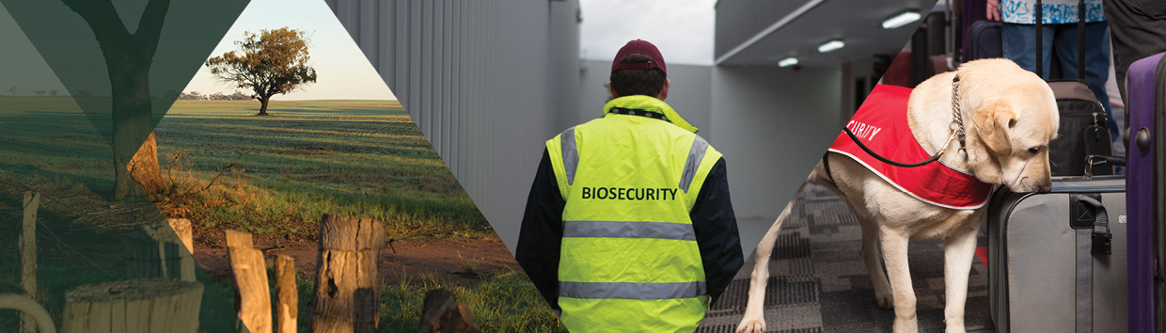

**Sustainable funding for a  
strong biosecurity system**

**$1.03 billion plus ongoing**

Strong and sustainably funded biosecurity is essential to protect Australia from potentially devastating pest and disease outbreaks, safeguarding our national economy, our agriculture, fisheries and forestry industries, our regional communities and our unique environment. Biosecurity is fundamental to protect our international agricultural trade, fisheries and forestry jobs and to keep our regional, rural and remote communities strong. This includes our:

* **$ 96.0 billion** (total GVP) agriculture, fisheries and forestry industries[1]
* **$ 79.3 billion** agriculture, fisheries and forestry exports[2]
* **$ 36.5 billion** (and growing) GDP from tourism[3]
* **$ 5.7 trillion** environmental assets[4]
* **1.6 million jobs** across the agricultural supply chain**[5]**
* **87,800 farms** (with value of operations over $40,000 per annum)[6]

**What does biosecurity mean for regional, rural and remote communities?**

Australian agriculture accounts for 55% of Australia’s land use. Strong and sustainably funded biosecurity supports regional, rural and remote communities by helping to minimise the financial, social, health and environmental impacts caused by biosecurity outbreaks.

Strong biosecurity enables our regional, rural and remote communities to prosper and grow by providing job security, maintaining supply chains, increasing production yields and minimising stock and production losses.

**Building on the $134 million targeted investment in biosecurity in the October Budget, the 2023-24 Budget delivers on the government’s election commitment to strengthen Australia’s biosecurity system with long‑term, predictable and sustainable funding, coupled with increased equity and greater accountability and transparency, with more emphasis on shared responsibility.**

**The sustainable funding package in the Budget is a new era for biosecurity in Australia. Australia has never had sustainable and predictable biosecurity funding, despite this being recommended in multiple reviews, and continually sought by industry and environmental groups.**

**The Australian Government is committing more permanently dedicated taxpayer funding than ever before and recovering the cost of maintaining a strong biosecurity system from those who create risk. Those who receive significant benefits from the system will also make modest contributions.**

**The new investment in the Budget reverses the funding cliff for biosecurity that the government inherited.**

Without this new package, Australian Government funding for the biosecurity system would have declined over the forward estimates by 15.9% (almost $100 million) to less than $500 million in 2025-26 and 2026-27.

The Budget package not only delivers greatly increased funding for biosecurity, it also ensures, through the provision of ongoing funding from 2027-28, that the level of biosecurity funding provided in 2026-27 will be permanently maintained into the future (Figure 1). **This has never happened before now.**

Figure 1:

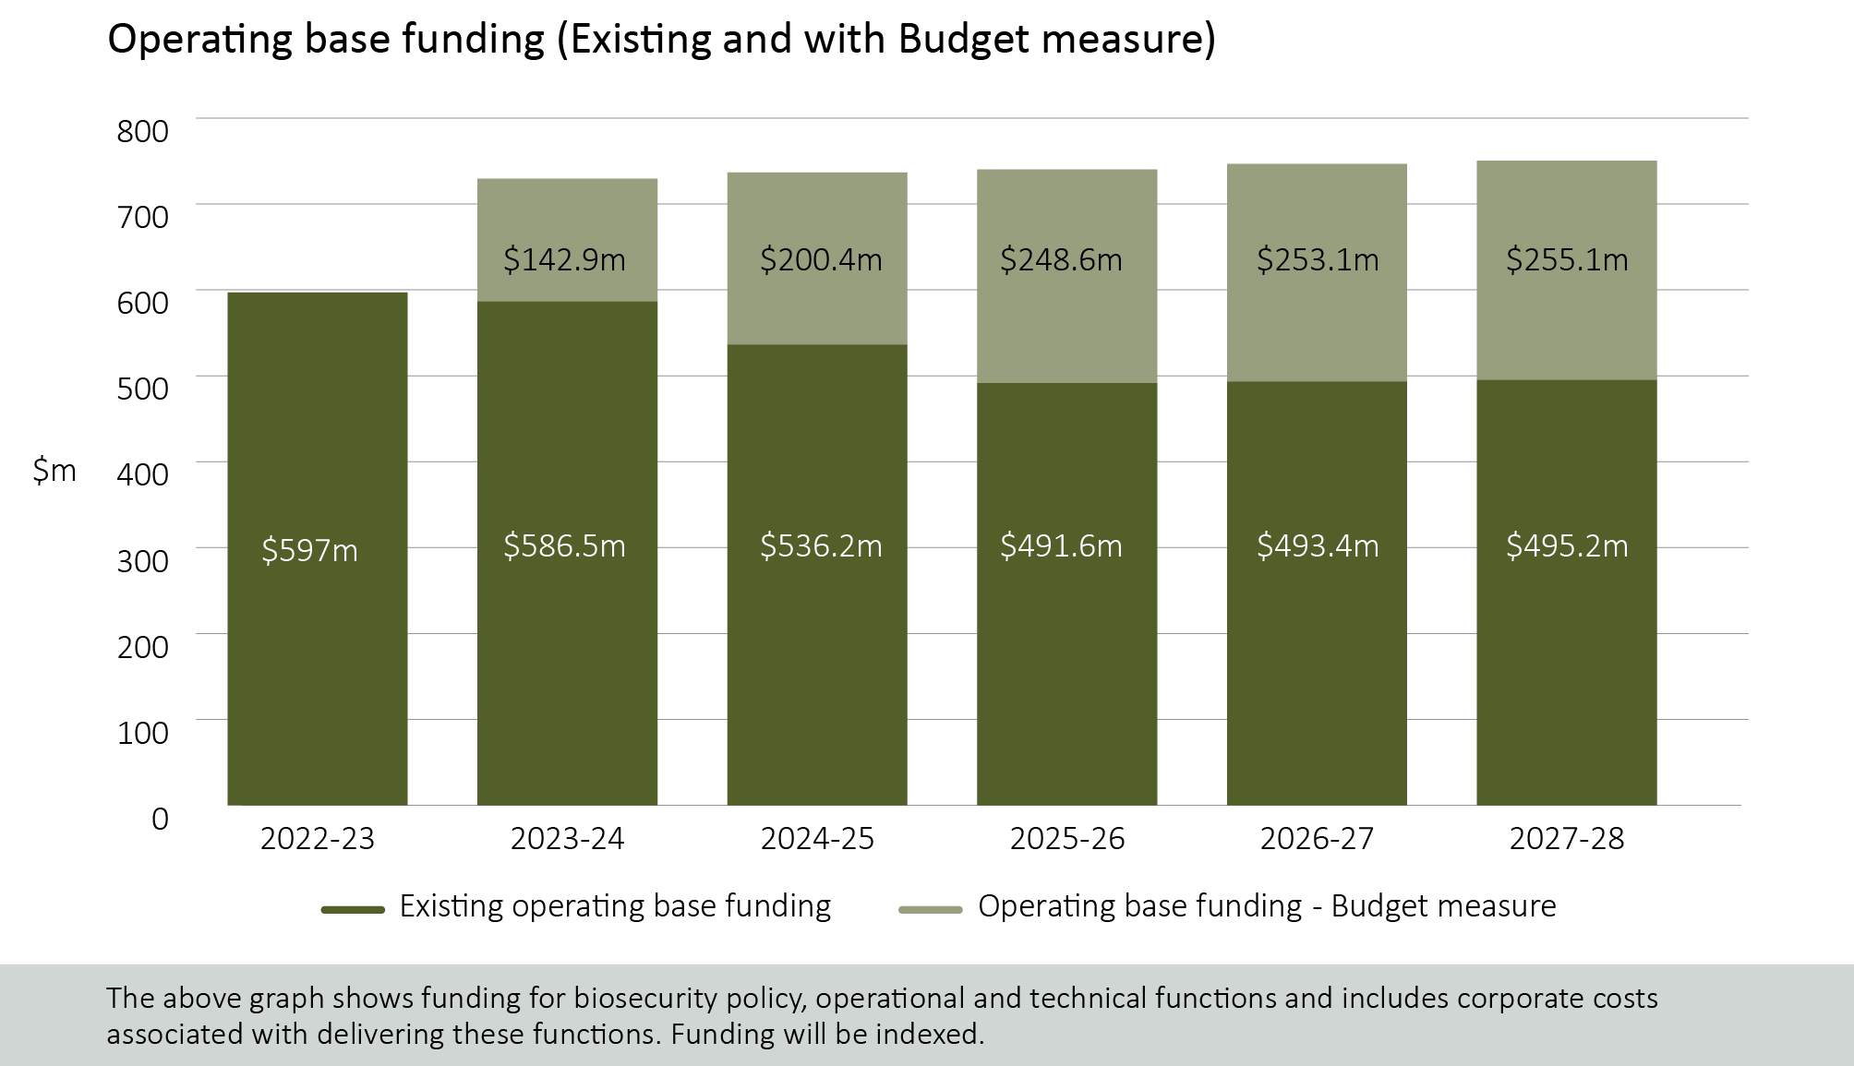

**What’s in this year’s Budget?**

**New and permanently increased funding**

**The Budget includes more than $1 billion in new biosecurity investments over the next four years, with over $260 million in new funding per year, ongoing and locked, from 2027-28. This funding increase is permanent.**

**The government is locking in increased, long-term funding for a strengthened biosecurity system to help safeguard against biosecurity incursions that would impact trade, jobs, regional Australia, health and our environment.**

**The $1.03 billion Budget package delivers the government’s election commitment to deliver long-term, sustainable funding that goes directly to strengthening Australia’s biosecurity system.**

* **$845 million over four years from 2023-24, and $255 million per year ongoing from 2027-28, to** maintain biosecurity policy, operational and technical functions on a sustainable basis**.**
* **$40.6 million over four years from 2023-24, and $12 million per year ongoing from 2027-28, for the Indigenous Ranger Biosecurity Program. This secures funding for an essential partnership with First Nations people to protect our north by detecting exotic weeds, pests and diseases before they get a chance to establish.**
* **$145.2 million over three years from 2023-24 for the Simplified Targeting and Enhanced Processing System, or STEPS – a modern digital system to improve the effectiveness and efficiency of biosecurity clearance in cargo pathways.**

**Paying for biosecurity – a shared responsibility**

Everyone has a role to play in strengthening Australia’s biosecurity system, including contributing to its cost. That’s because biosecurity is a shared responsibility. To complement the government’s decision to lock in permanent increases in biosecurity funding, risk creators and those who benefit from strong biosecurity protection are being asked to make modest additional contributions to these costs. Taxpayers will also contribute more.

We are delivering a fairer system to pay for biosecurity that shares the cost between taxpayers, importers, international travellers and producers (Figure 2(a) and 2(b)).

*Figure 2:* 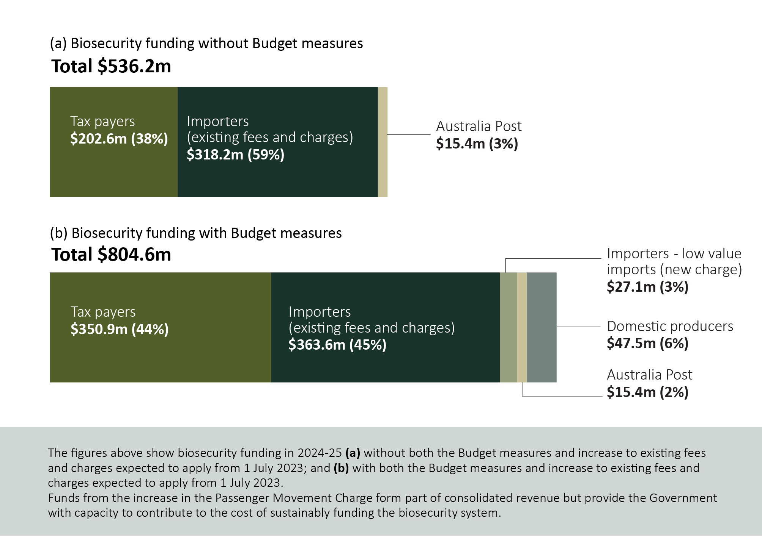

**Expanded and strengthened cost-recovery arrangements for importers**

**Importers will be paying their share. By 2024-25, importers will pay over $390 million or around 48 per cent of total biosecurity costs (Figure 2 (b)).**

**From 1 July 2024, a new cost recovery charge on low value ($1,000 or less) goods imported into Australia by air or sea will be introduced. This charge** will cover the cost of biosecurity clearance on imported goods that are not currently subject to cost recovery – up to now taxpayers have been paying this cost.

**While a small impost on individual imports (approximately 40 cents), this fairer system is expected to raise around $27 million per year ongoing. The new charge will be equivalent to around:**

* 4% of the value of a $10 parcel
* 0.25% of a $150 parcel
* 0.04% of a $999 parcel

**In addition, work is being undertaken to ensure the current fees and charges applied to importers and other key system participants at the border meet the actual costs associated with managing biosecurity risk.**

The current Sea Full Import Declaration (FID) charge was increased from $49 to $58 on 16 January 2023 to implement cost recovery for the 2021-22 hitchhiker pest measure.

Following the first comprehensive review of biosecurity cost recovery since 2015, further increases to existing fees and charges are expected from 1 July 2023. These changes are estimated to recover an additional $36 million in 2023-24, with annual reviews to ensure actual costs are being recovered into the future. These changes are essential to restoring the integrity of cost recovery arrangements for biosecurity services that the government provides. This work protects taxpayers and ensures the department can provide more efficient regulatory services to support trade.

**Prices, on average, are proposed to increase by around 28%. For example:**

* **A Full Import Declaration for imported goods arriving by air will increase by $5 from $38 to $43 per declaration.**
* **A commercial vessel arrival charge will increase by $300 from $1,054 to $1,354.**

**Funding arrangements recovering the cost of biosecurity clearance of international mail, and military equipment and personnel coming into Australia, will also be reviewed to ensure appropriate contributions.**

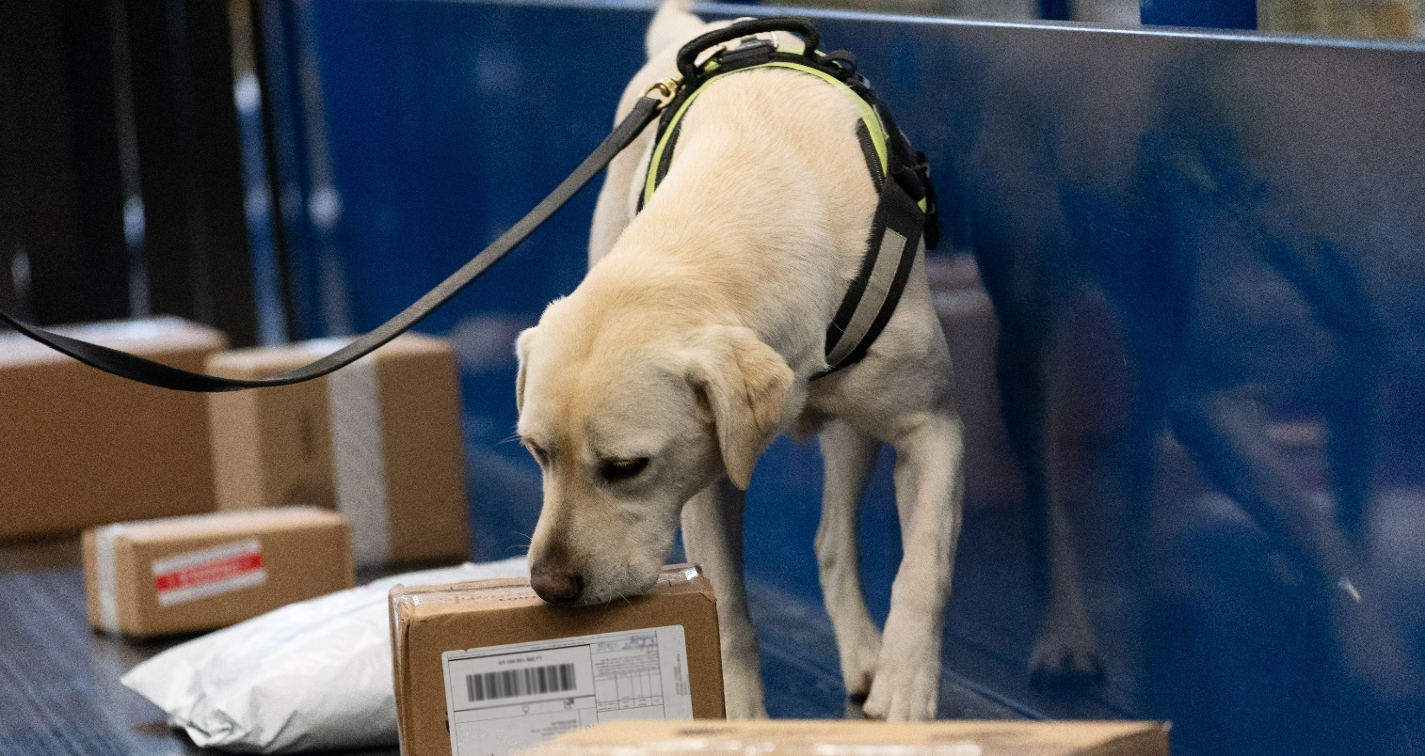**Going forward, the Department of Agriculture, Fisheries and Forestry will work with industry to provide advice on potential changes to these charging models to ensure they are fit for purpose and contemporary for the future. This will include looking at other options to address the biosecurity risk created by imports, including an import levy. Any new levy would need to be consistent with Australia’s international trade law obligations.**

**Biosecurity protection levy**

**To help meet the cost of sustainably funding the biosecurity system, a new biosecurity protection levy on all domestic agricultural, fisheries and forestry producers will commence on 1 July 2024. This levy will collect an amount equivalent to 10 per cent of 2020-21 levy rates or another comparable metric where such levies are not in place.**

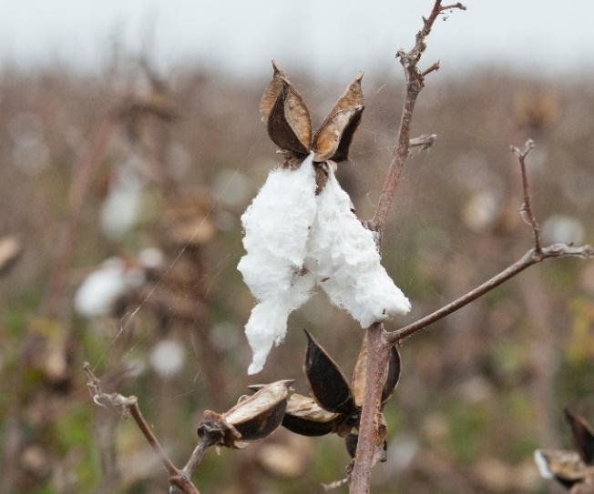**What does this mean for producers?**

**Based on levy rates as at 1 July 2020:**

* A **cattle (grass fed) producer** will pay an extra $0.5 or **50 cents per head** (cattle and livestock (producers) charge)
* A **cotton producer** will pay an extra $0.225 or **22.5 cents per 227kg** **bale** (cotton levy)
* An **egg producer** will pay an extra $0.0325 or **3.25 cents per chick** (eggs (promotion) levy)
* A **honey producer** will pay an extra $0.0046 or less than **0.5 cents per kg** (honey levy)
* A **domestic apple producer** will pay an extra $0.001845 or **less than 0.19 cents per kg** (apple levy).
* A **forest grower, for plantation logs** – (exotic softwood) will pay an extra $0.0105 or **1.05 cents per cubic metre of the log** (forest growers levy)
* A **forest grower, for other logs** will pay an extra $0.005 or **0.5 cents per cubic metre of the log** (forest growers levy)
* A **prawn farmer** will pay an extra $0.00665 or **less than 0.67c per kg of whole farmed prawns** (farmed prawns levy)

For those producers with commodities not subject to statutory levies, arrangements will be negotiated on a commodity-specific basis.

Feedback from consultation on the development of long-term sustainable funding model for biosecurity was clear – a strong biosecurity system is of national significance and should be funded by risk creators as well as beneficiaries. The biosecurity protection levy will not commence until 1 July 2024 to ensure there is time to plan and negotiate new arrangements.

**Why this is important?**

We need a biosecurity system that keeps pace with today’s needs and prepares for the threats of tomorrow. A strong, smart and sustainably funded system will help us manage growing biosecurity risks and help safeguard Australia’s industries, our export trade and our environment.

Efficient biosecurity operations are critical to meet industries’ needs, otherwise it slows down trade and supply chains, adding cost to industry and consumers.

A strengthened biosecurity system not only secures better economic outcomes for producers and related industries, but it protects Australia’s environment, biodiversity and our people.

Improvements to the system

**This is not set and forget for Australia’s biosecurity system, but the start of a stronger, sustainably funded biosecurity system. The Australian Government will work with industry to review and consider further reform to continue to deliver a strong and equitably funded biosecurity system that is ready for future challenges.**

**Immediate and longer-term improvements will be made to help minimise delays and costs at the border and to show where funding is being spent. These include:**

* **$145.2 million over three years from 2023-24 to deliver the Simplified Targeting and Enhanced Processing System - a modern, integrated digital system that to improve the effectiveness and efficiency of biosecurity clearance for cargo. Making our systems as efficient as possible will free up our biosecurity workers for other jobs and reduce congestion at the border.**
* **Annual publication of biosecurity income and expenditure to provide transparency and accountability.**
* **Working with industry to consider options for greater effectiveness and efficiency to meet emerging threats, and to consider further reform to funding arrangements.**

Passenger Movement Charge

**The arrival of people from overseas is a significant biosecurity risk. It has been the focus of considerable recent effort to prevent the arrival into Australia of exotic diseases like foot and mouth disease and African swine fever.**

**The Passenger Movement Charge was established with the intent, among other things, to support biosecurity costs associated with international travellers. The Australian Government will increase the current charge from $60 to $70 per person from 1 July 2024, the first increase since 2017.**

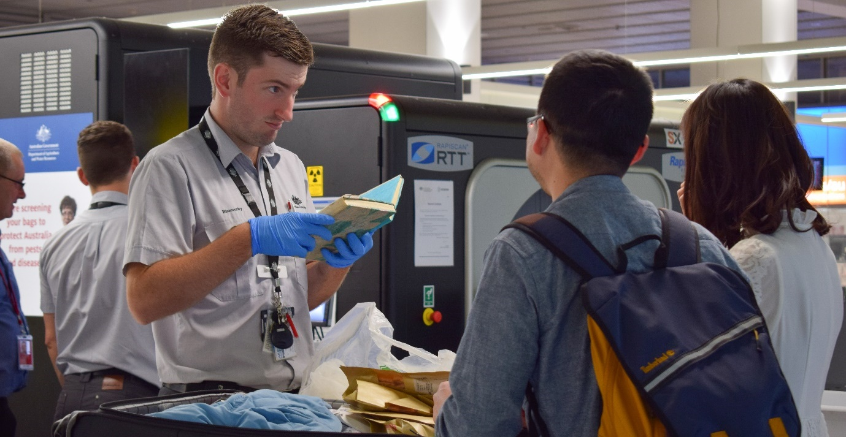

More information

For more information about sustainable funding for a strong biosecurity system visit [agriculture.gov.au](http://www.agriculture.gov.au)

For more information about the 2023–24 Budget visit [budget.gov.au](http://www.budget.gov.au)





**agriculture.gov.au**

1. https://www.agriculture.gov.au/fast-facts-aff#key-statistics (estimate 2022-2023)
2. https://www.agriculture.gov.au/fast-facts-aff#key-statistics (forecast 2022-2023)
3. National Tourism Satellite Account 2021-22 | Tourism Research Australia
4. Calculated in August 2020 www.agriculture.gov.au/biosecurity-trade/policy/australia (accessed 2/02/23)
5. www.agriculture.gov.au/biosecurity-trade/policy/australia (accessed 2/02/23)
6. www.agriculture.gov.au/fast-facts-aff#key-statistics (2021-22)