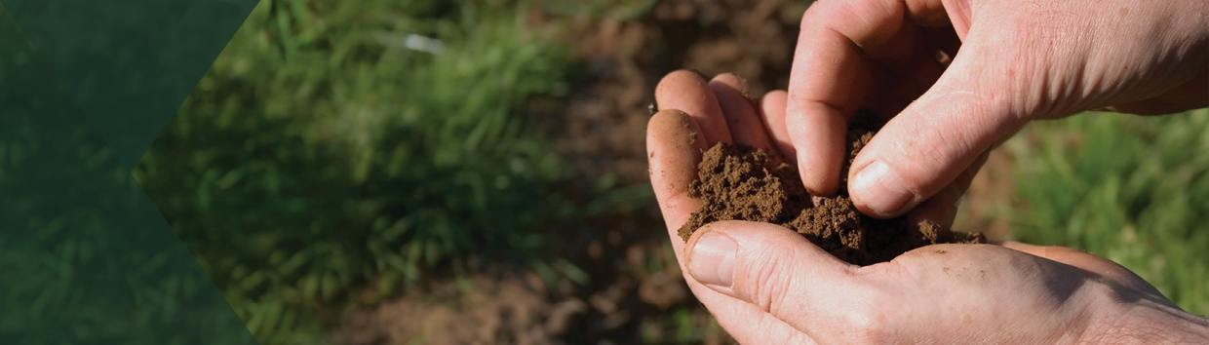



**Partnering to implement the National Soil Action Plan**

**$20 million**

Bilateral partnership agreements between the Australian Government and the states and territories will support the implementation of the first ever National Soil Action Plan.

These agreements will provide clear, partnership-based commitments to action to progress the priorities of the National Soil Action Plan and the National Soil Strategy for future years.

**What’s in this year’s Budget**

**The Australian Government is committed to supporting efforts to better manage soil by investing $56 million over 5 years in the 2023-24 Budget. This work includes $20 million to partner with state and territories to drive the implementation of the National Soil Action Plan** and $36 million over 5 years from 2023-24 through the Natural Heritage Trust (NHT) to implement a national soil monitoring program and continue the Regional Soil Coordinators program and the National Soil Community of Practice.

**Partnering to implement the National Soil Action Plan**

**The government is committing $20 million in 2023-24 to contribute to projects under a Federation Funding Agreement with the states and territories to address the priorities of the National Soil Action Plan and the National Soil Strategy.**

**This work will operate alongside new investments in a national soil monitoring program and the continuation of the Regional Soil Coordinators program and the National Soil Community of Practice through the 5 year, $36 million investment in the next phase of the NHT.**

Why this is important

Managing soil is a critical part of a climate-smart, productive, and sustainable agricultural sector. Soil is vulnerable to the impacts of climate change and plays a role in resilience to natural disasters and the path to net-zero emissions.

Soil is a national asset, which is managed by state and territory governments and thousands of individual land managers. Soil type, usage and challenges are highly variable, so management of this national asset requires practical, place-based planning and responses.

States and territories know their local soil users and the challenges they face, and are well placed to direct and invest in effective measures. The Australian Government will work in partnership with states and territories to drive the implementation of measures which contribute to meeting the priorities of the National Soil Action Plan. The measures will assist farmers and a range of soil-related stakeholders to better understand and respond to soil challenges and opportunities to improve overall soil trends.

How much this will cost

|  |  |  |  |  |  |  |  |  |  |  |
| --- | --- | --- | --- | --- | --- | --- | --- | --- | --- | --- |
|  | | **2023-24 $m** | **2024-25 $m** | | **2025-26 $m** | | **2026-27 $m** | | **TOTAL $m** | |
| **Partnering to implement the National Soil Action Plan** |  | | |  | |  | |  | |  | |
| Partnering to implement the National Soil Action Plan | 20.000 | | | - | | - | | - | | 20.000 | |
| **Subtotal** | | **20.000** | **0000** | | **0000** | | **0000** | | **20.000** | |

More information

For more information about our National Soil Action Plan visit [agriculture.gov.au](http://www.agriculture.gov.au)

For more information about the 2023–24 Budget visit [budget.gov.au](http://www.budget.gov.au)