Lodge a Request for Export (REX) for Meat (including Halal exports)
The below guide shows how to lodge a Request for Export (REX) in NEXDOC for Meat
(including Halal exports).
This guide assumes that you have already registered as a Meat exporter or are a member of a Client Group in NEXDOC.
- If you have not yet registered as a NEXDOC exporter or as a member of a Client Group, please refer to the Create a NEXDOC Exporter Account pdf or docx guide.
- If you are registered as a NEXDOC exporter or are a member of a Client Group but need to add Meat to your exporter account, please refer to the Add or Remove Exporter to Exporter Account pdf or docx guide.

Log in to the Online Services Portal
Go to the Online Services Portal and click on the Login button. | 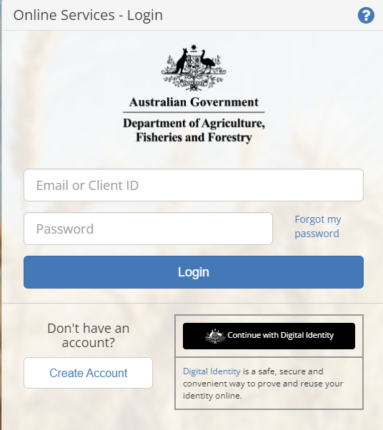

NEXDOC Portal Homepage
Click on the Lodge a Request for Export (REX) link. | 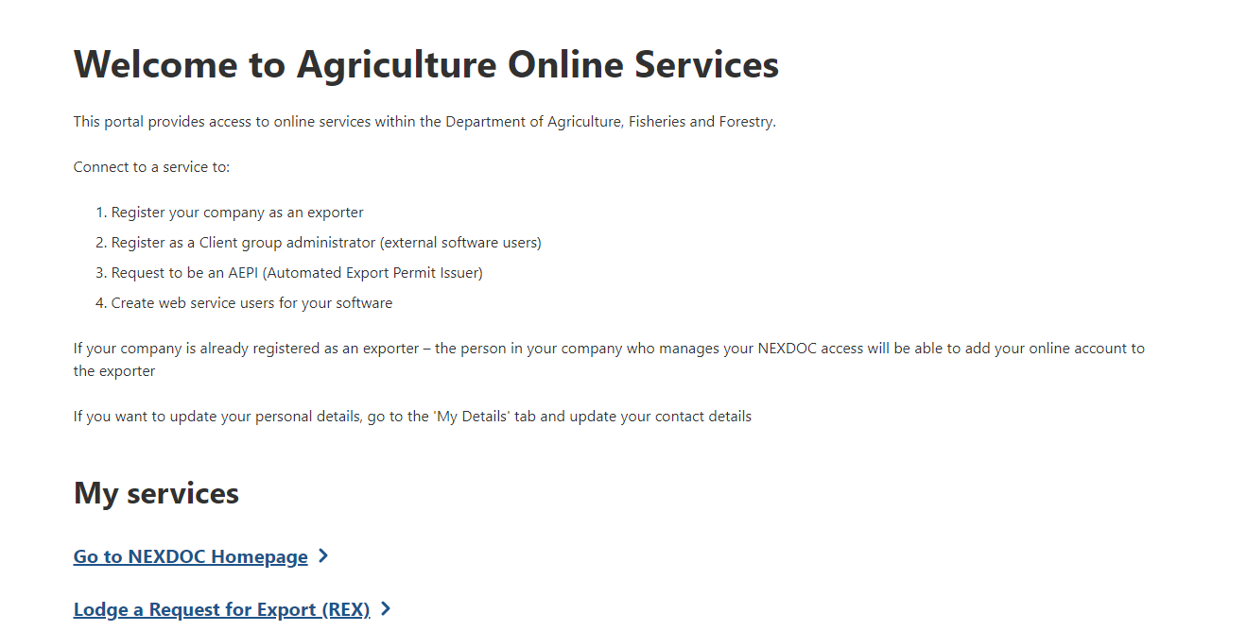

Start a new request for export (REX)
Step 1  Select the Client Group for this request (only applicable to client group users) and Meat from the Commodity type of your export drop-down menu.  Click on the Start button.  Note:  If you are an exporter, the Client Group dropdown will not display, and the screen will look like this.  Click on the Start button. | 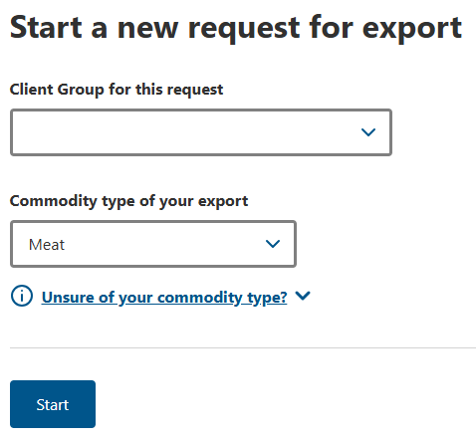  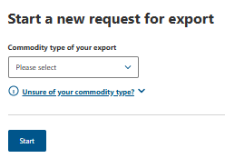

REX Section 1: Country
Select the destination country from the Country you wish to export to drop-down menu.  Select Next.  (If the goods are being used as ship stores, please select the Yes radio button under the Ship Stores question as shown.) | 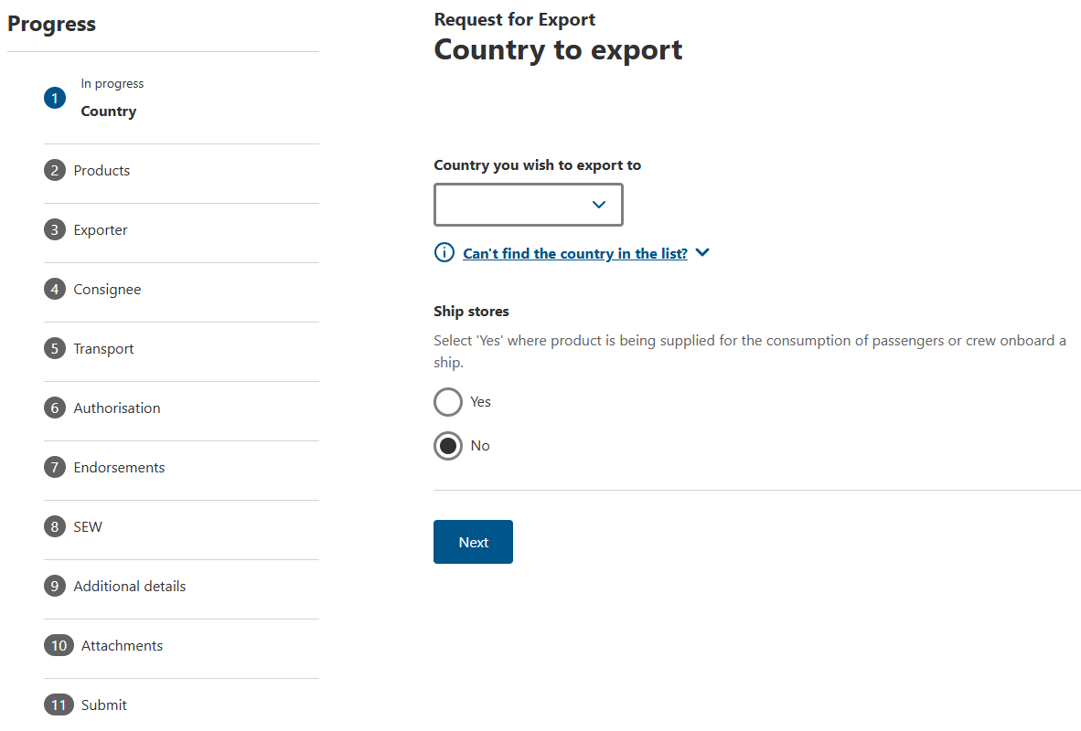  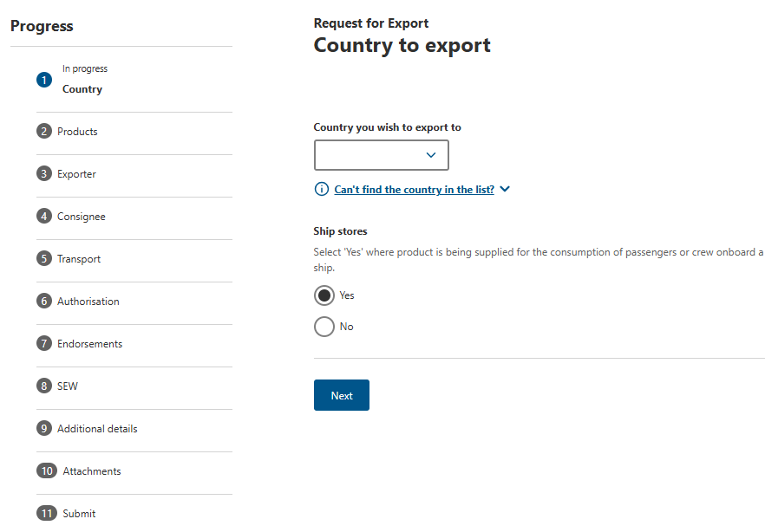

REX Section 2: Products
Step 1  Select + Add a product to export button to add your export products.  Note: Repeat this step to add multiple products. | 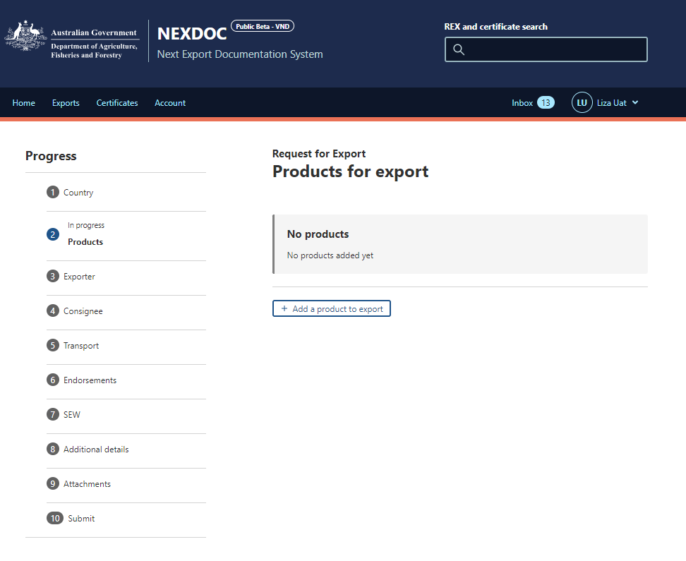
Step 2  Select the product from the Product you wish to export drop-down list.  Note: Start typing to see a smaller group of relevant products. | 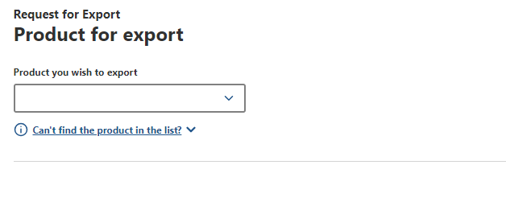

Step 3  Select product details from the drop-down boxes for:  What is the product cut type - mandatory  What is the product packed in? - mandatory  Preservation – mandatory  (Note: this is displayed once pack type has been entered. Supplementary code will be displayed once Preservation has been entered.)  AHECC - optional  Net metric weight amount -mandatory  Net metric weight unit -mandatory  Gross metric weight amount -optional  Gross metric weight unit -optional  Note: Optional fields may be mandatory in certain cases, such as when using SEW, specific pack types (e.g., BP), or for some transit/destination countries.  Note:  Tick the Ungraded checkbox if the product is ungraded.  If the product is Halal select the Yes radio button as shown in the screenshot. | 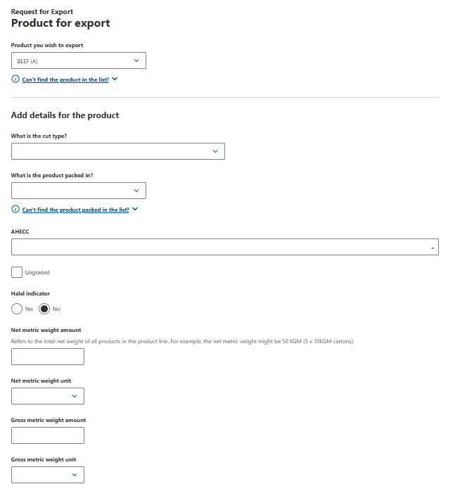  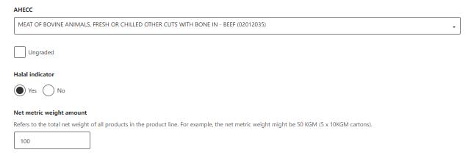
Step 4  Enter mandatory product details for:  Manual product description  Line item description  Note:  Additional description is not mandatory and only permitted for some countries/products  Note:  These additional details may display on the export certificate. | 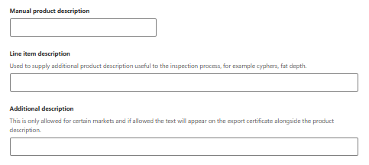
Step 5  Select the Outer packaging details from the drop-down boxes for:  Package type - mandatory  Quantity - mandatory  Individual package weight -optional  Weight unit - optional | 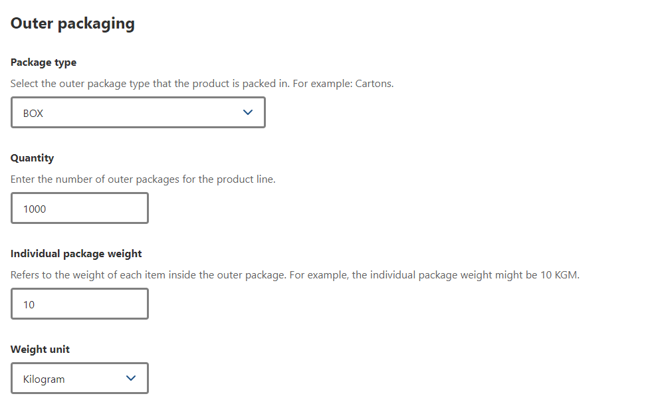
Step 6  If required, provide the Shipping marks.  Note: This field is optional and can be alphanumeric with no more than 20 characters. For some countries this field is mandatory. | 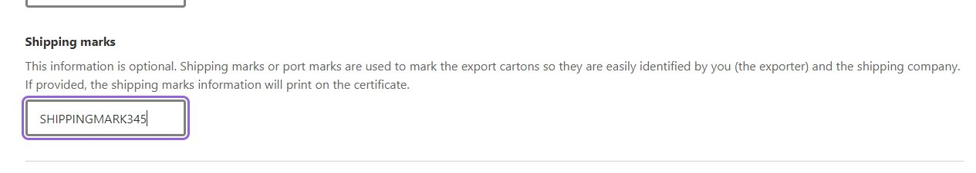
The below information relates to the Add Additional details for the product.

Step 7  Depending on the importing country requirements these tabs can be optional or mandatory.  Additional packaging  Containers  SEW  Production processes  Additional details | 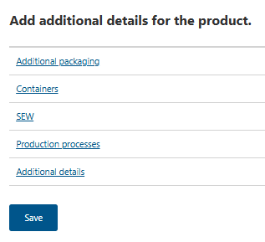
Step 8  If required, enter Additional packaging details for:  Intermediate packaging  Package type  Quantity  Individual package weight  Weight unit  Inner packaging  Package type  Quantity  Individual package weight  Weight unit  Click Save.  Note: These details are optional, but may be required by some importing countries. | 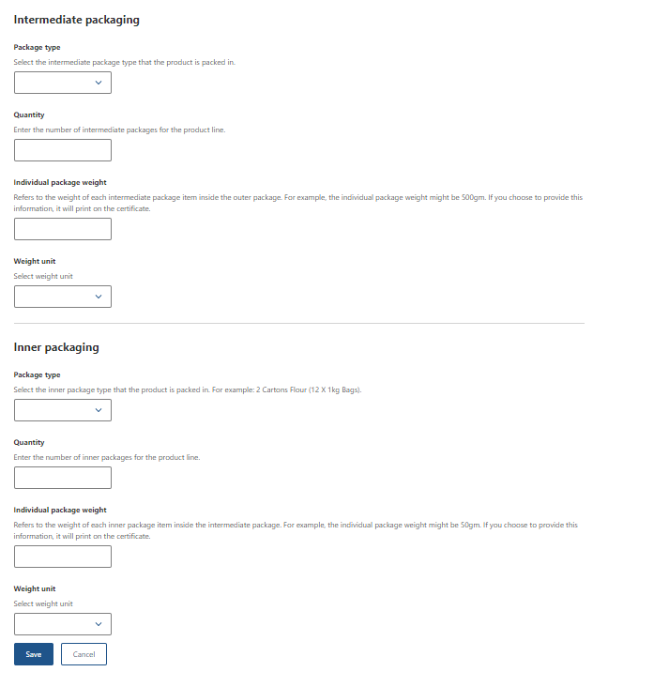
Step 9  If required, enter Containers details for:  Type of freight container – choose Air or Sea  Click + Add container  Enter Container number  Click + Seal number  Enter Seal number  Click Add.  Note:  These details are optional but may be required by some importing country requirements.  If you provide container details for one product line, you must provide containers against all product lines.  Seal number can only be added if there are container numbers. | 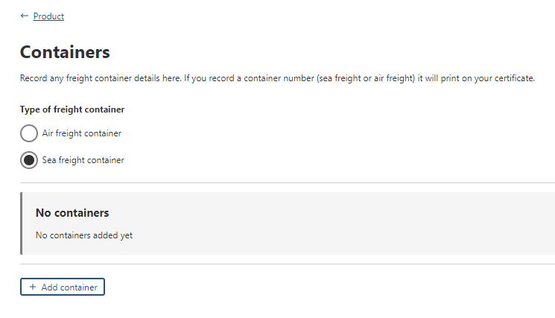  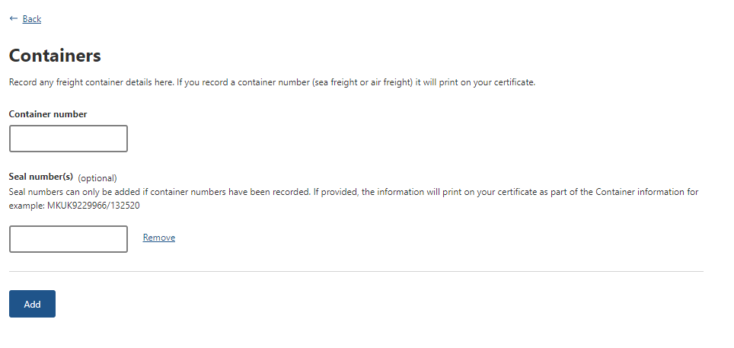
Step 10  If required, enter SEW details in:  FOB amount  Additional permit details  Related export permit number  Export permit type  Related export permit date  Click Save  Note: SEW will need to be selected and completed if you wish to obtain your EDN through NEXDOC. Not all products require additional permit details. These details are optional but may be required by some importing countries. | 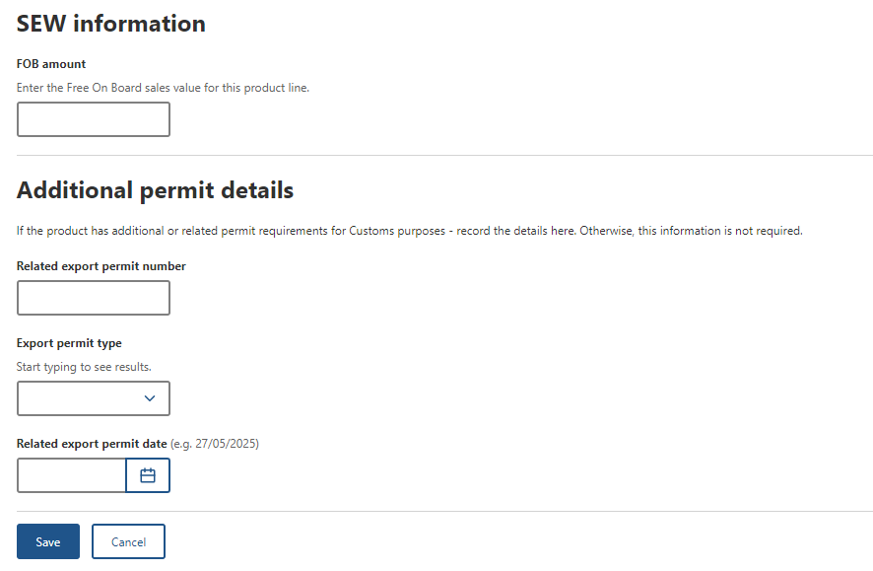
Step 11
Click on the highlighted Production processes hyperlink.
Step 12 (Registered or Listed establishment)  Select + Add Production process.  Complete the fields for establishments including  Process Start and End dates  Process Establishment number  Establishment Indicator  Select Add.  Note: Click + Add Production process to add more than one process details. | 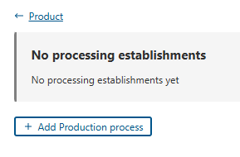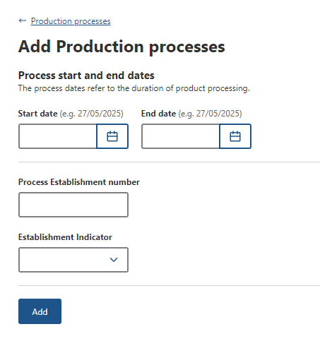
Step 13  If required, enter Additional details.  Durability start and end dates  Import authority code  Nature of the commodity  EU Treatment type  Product Source State  Batch code  Click Save.  Note: These details are optional but may be required by some importing countries. | 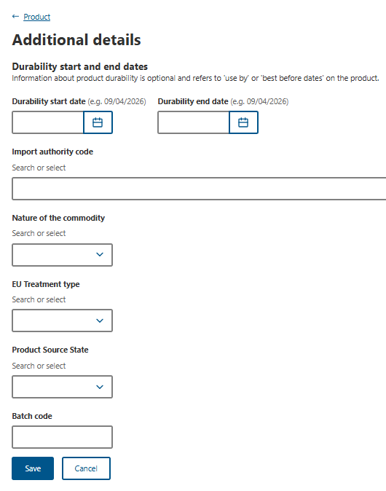
Step 14
Once you have provided all necessary information for the product line, select Save.

Step 15  Once saved you will return to the Products for export page.  If you need to add another product line, select either Add a product to export or Copy a product line.  If you copy an existing product line, NEXDOC will copy all basic information and allow you to amend any unique information, such as the batch number, weights, packaging etc.  Once you have all product line information saved, select Next. | 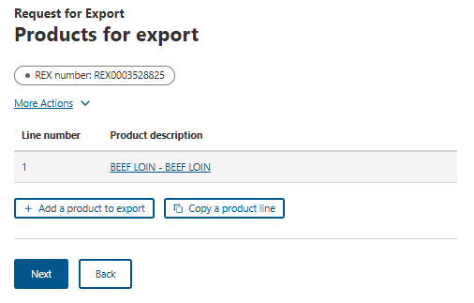

REX Section 3: Exporter details
Step 1  Exporter details are prepopulated from your NEXDOC exporter registration.  If you need to update these details, select  Change exporter, Edit exporter details or Request new exporter  Provide Your reference.  Note: This is a mandatory field and limited to 35 characters. This will assist you in identifying the REX. The exporter reference will also appear on your invoice.  Select Save and next. | 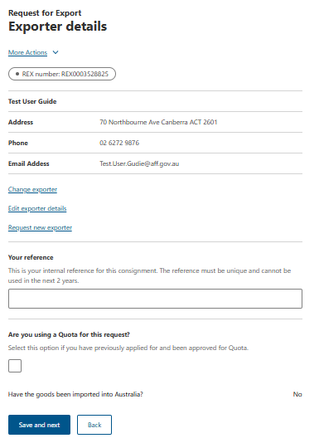

REX Section 4: Consignee
Step 1  Enter the Consignee details:  Name - mandatory  Consignee Representative – mandatory for Japan and Korea  Consignee Reference number - mandatory for Singapore and Canada  Phone number - optional  Consignee address - mandatory  Note: While you can enter consignee details manually per consignment, you can also add consignee details to the consignee address book for future use.  If you wish to add an address to the consignee address book, go to Step 2. | 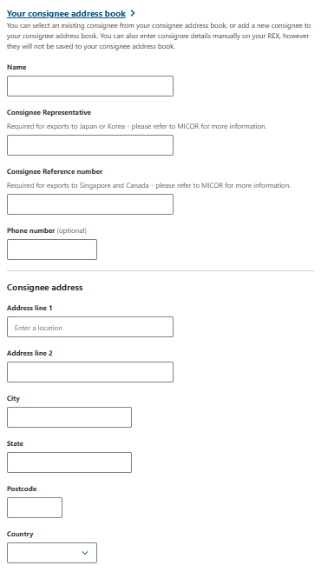
Step 2  To add a consignee, click the Your consignee address book link. | 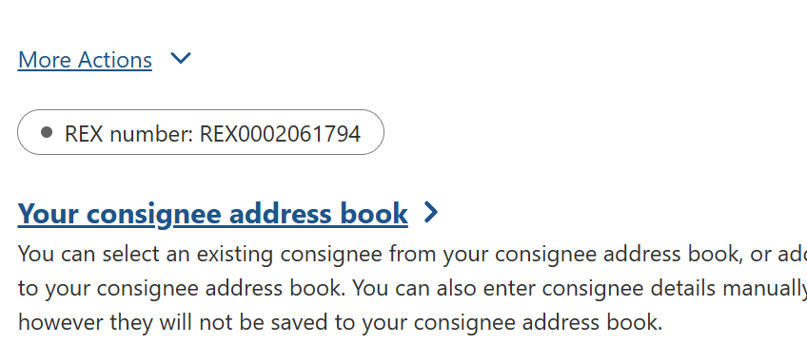
Step 3  Select Add consignee. | 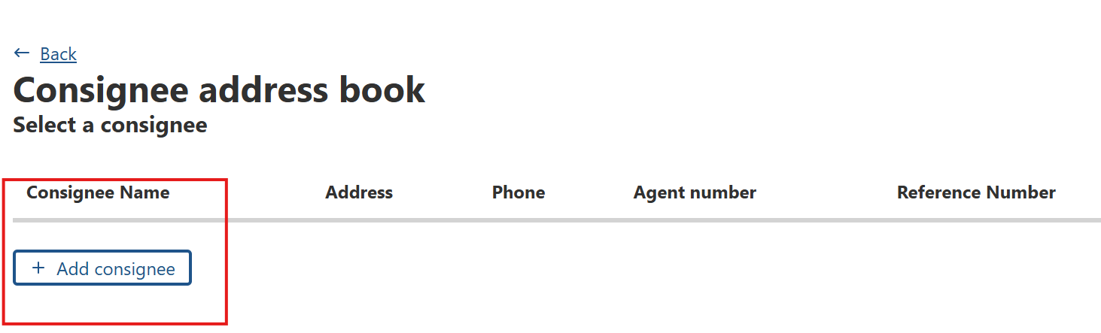
Step 4  Enter all relevant details and select Save. | 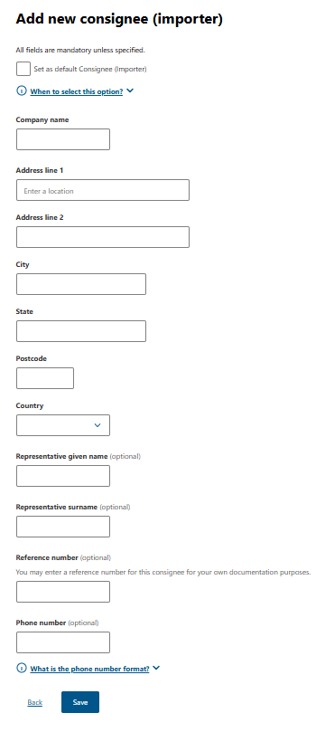
Step 5  If required, enter Additional information.  Notify party text  Traces Approval ID  Click Save and next.  Note: These details are optional but may be required by some importing countries. | 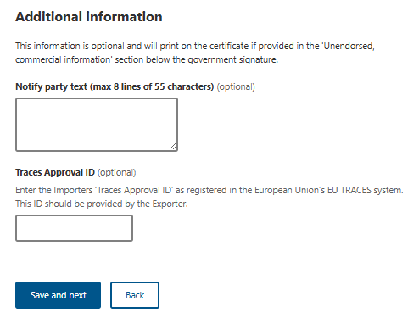

REX Section 5: Transport
Step 1  Enter the following details.  Departure date - mandatory  Load port - mandatory  Discharge port - mandatory  Border inspection port - optional  Destination city - mandatory  Destination country  Transit countries - optional  Note: Fields that are optional may be required by some importing countries. | 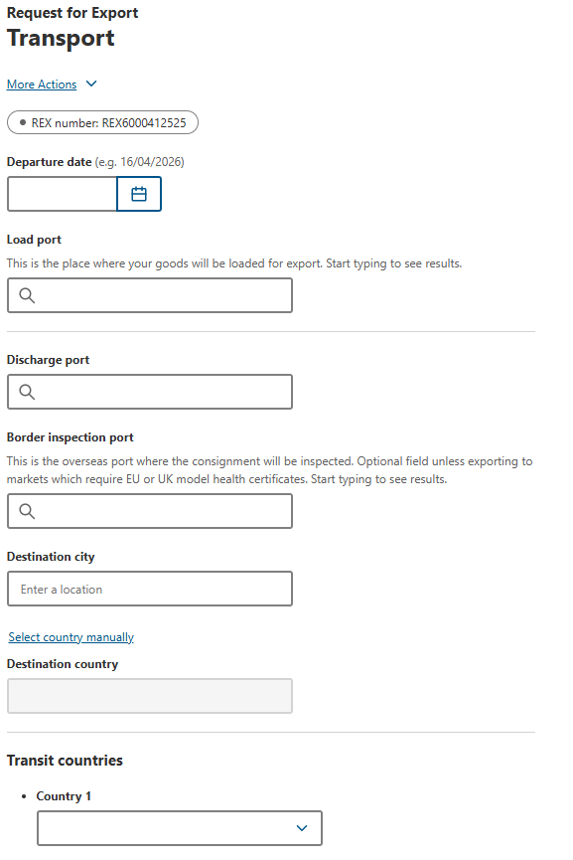
Step 2  Enter the transport details:  Transport storage temperature – optional  Transport storage temperature unit – optional  Transfer information - optional  Transport mode - mandatory  Select one  Sea - go to Step 3  Air - go to Step 4  Mail - go to Step 5  Note: Fields that are optional may be required by some importing countries. | 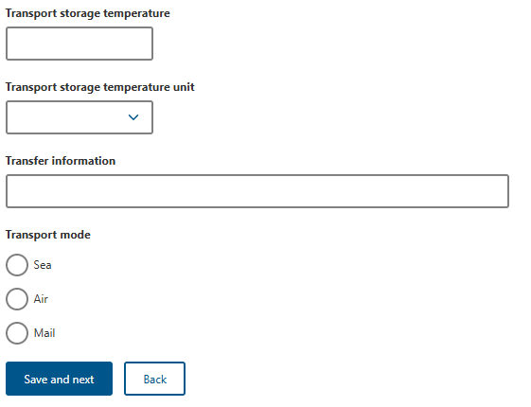
Step 3  Enter transport mode for Sea.  Vessel name - mandatory  Voyage - mandatory  Click Save and next. | 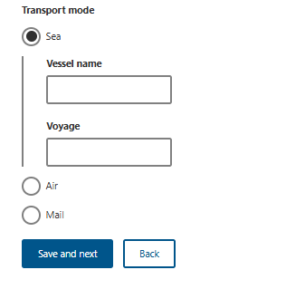
Step 4  Enter transport mode for Air.  Flight number - mandatory  Click Save and next. | 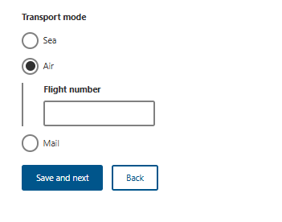
Step 5  Enter transport mode for Mail.  Click Save and next. | 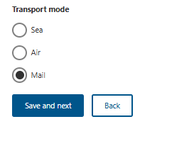

REX Section 6: Authorisation
Step 1  Enter the Authorising Establishment Number in the free text field.  (NOTE: If you are an AEPD please select the Yes radio button to make the export permit declaration. And go to Step 2.)  Click Save and next. This will take you to the Endorsements section. | 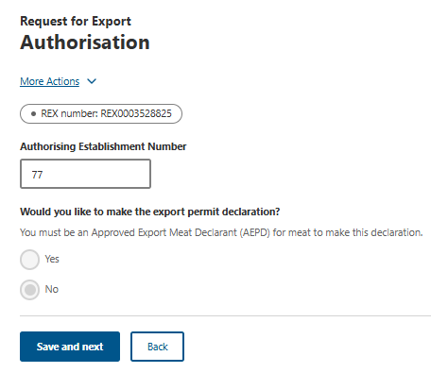
Step 2  The Yes radio button has been selected as the user is an AEPD. Complete the Declaration date and Declaration Comments and select the check boxes to confirm the Declaration. Click Save and next.  This will then bring you to the Endorsements screen. | 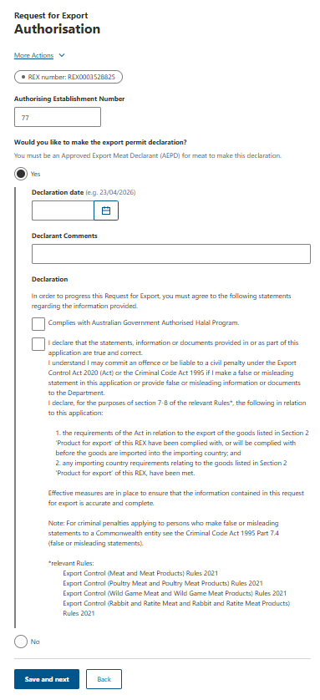

REX Section 7: Endorsements
Step 1  To check or change the allocated endorsement and certificate template  Click Select next to the product line.  Note: NEXDOC will automatically allocate you an appropriate certificate template and endorsement.  It is important to check you are allocated the correct certificate template and endorsement. | 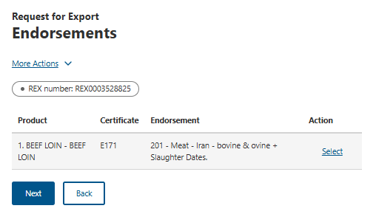
Step 2  Select either or both  Certificate Template Endorsement  drop-down to view available options.  Click on a new template or endorsement if you would like to change from the default.  Click Save. | 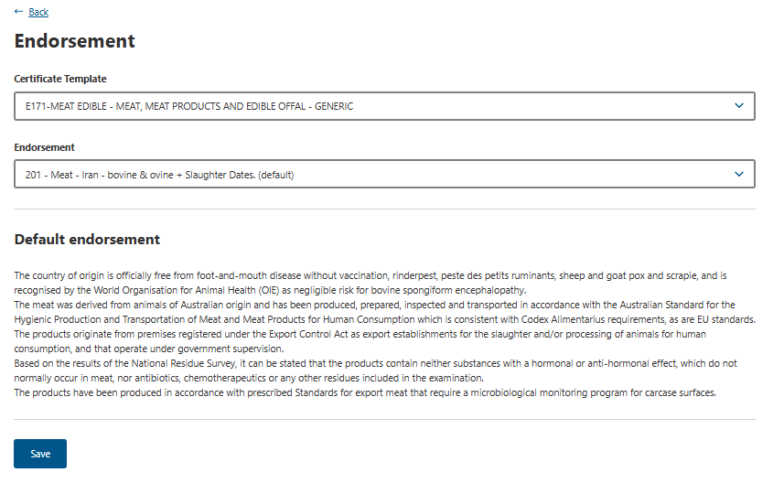
Step 3  Once you have confirmed the template and/or endorsement combination  Click Next. | 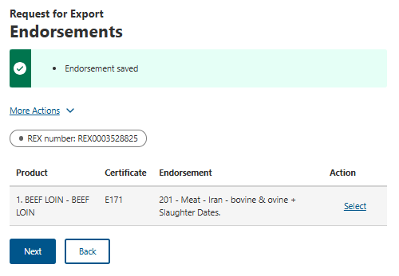

REX Section 7: SEW Integration
Step 1  Should you wish to use Single Electronic Window (SEW) integration to obtain your EDN (Export Declaration Number),  tick - Would you like to use SEW integration (ICS)?  Note:  - You must have requested access to SEW in your exporter registration for this to be available.  - If you wish to use the SEW connection, you must have SEW details in each of your product lines.  - The FOB total is calculated from the information in the SEW tab of each product line.  - An EDN can only have a consignee name of 35 characters. If the consignee name you provided to appear in the certificate is greater than 35 characters, supply a shorter version here so that you can obtain an EDN. | 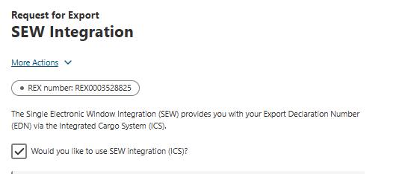
Step 2  Enter the below details:  FOB currency  SEW consignee name  Click Save and next  Note: The FOB total is drawn from the total amount in the product lines. | 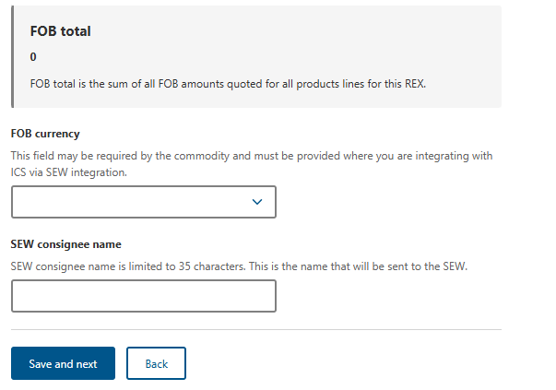

REX Section 8: Additional details
Step 1  Select one Certificate print indicator value.  Automatic  Hold  None  This selection is mandatory.  Note:  If you select Automatic, a print file will generate as soon as the certificate is ready to print.  If you select Hold, you can preview the certificate prior to finalising it.  If you select None, a certificate will not generate.  Please refer to the NEXDOC Printing FAQ on the NEXDOC Help Page for further information regarding these options. | 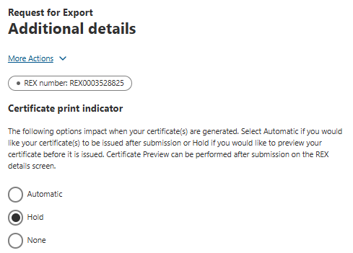
Step 2  Select either  Use your own printer  or  Print to a departmental regional office  This selection is mandatory.  Note:  Use your own printer allows you to print your certificate remotely e.g.: in your own office. However, this is not available for all certification and will depend on the importing country requirements.  Print to a departmental regional office will print the certificate to the nominated regional department office, where you will need to collect.  If you do not have the use your own printer option on screen, it may be that this particular certificate cannot be remote printed or that you do not have this option set up on your account.  Please request this permission via your registered NEXDOC exporter account. Refer to the Manage Your Details guide on the NEXDOC help page. | 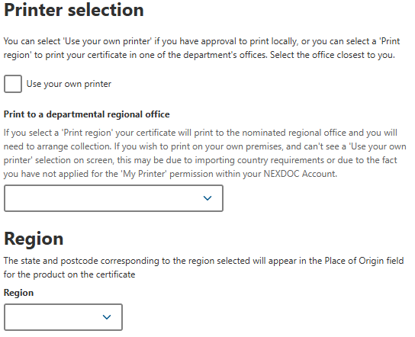
Step 3  If required, enter Other details  Separate certificate by  Header Storage Establishment Number  Note: These details are optional but may be required by some importing countries. | 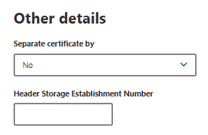
If required, under Request extra certificates, click  + Add extra certificate request – go to Step 4  And/or  + Add an import permit – go to Step 5. | 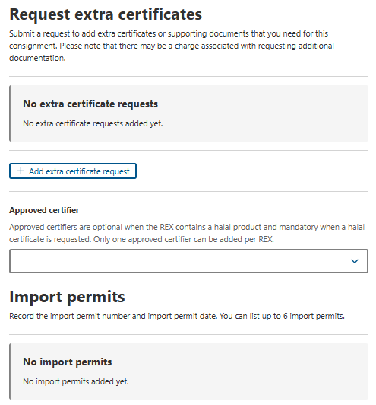
Step 4  If required, enter  Certificate type  Reason  Then select which line/s the extra certificate applies to.  Click Save. | 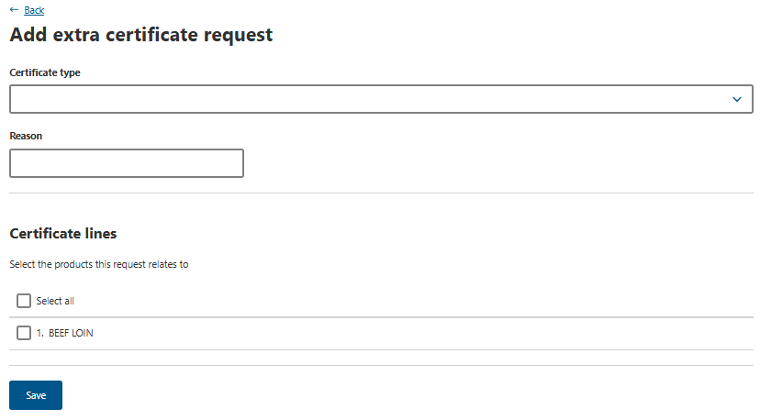

For all Halal products select Halal Certificate in the certificate type box and  Halal cert required for importer in the free text reason field as shown.  Then select which line/s the extra certificate applies to.  Click Save. | 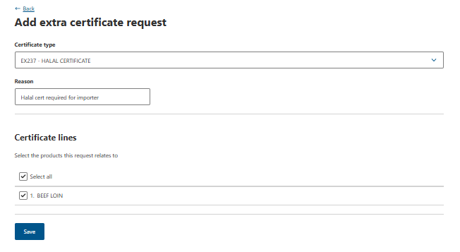
For all Halal products  You will be returned to the Additional details screen and will see the Halal certificate in the Request Extra Certificates section.  Select the Approved certifier from the dropdown options. | 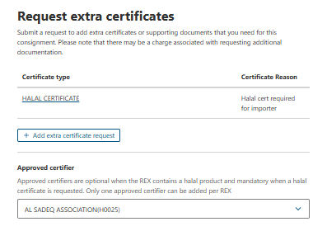
Step 5  If required, enter  Import permit number  Import permit date  Click Save. | 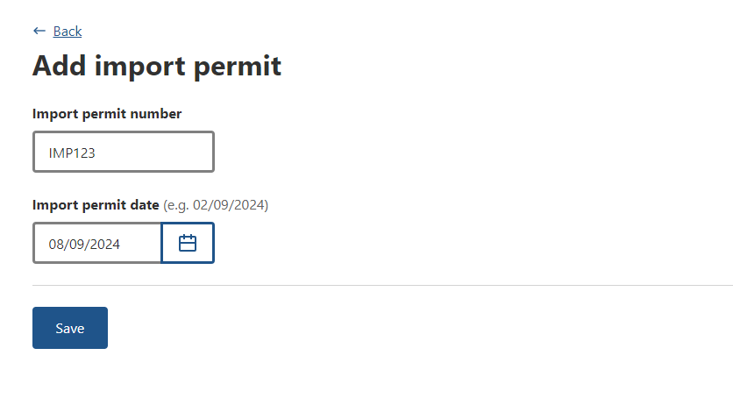
Step 6  Select Save and next. | 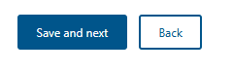

REX Section 9: Attachments
Step 1  Each certificate must comply with importing country requirements. Where required, provide all relevant documentation to support your request. Relevant documentation may include, but is not limited to, import permits and manufacturers declarations.  Select + Add attachment. | 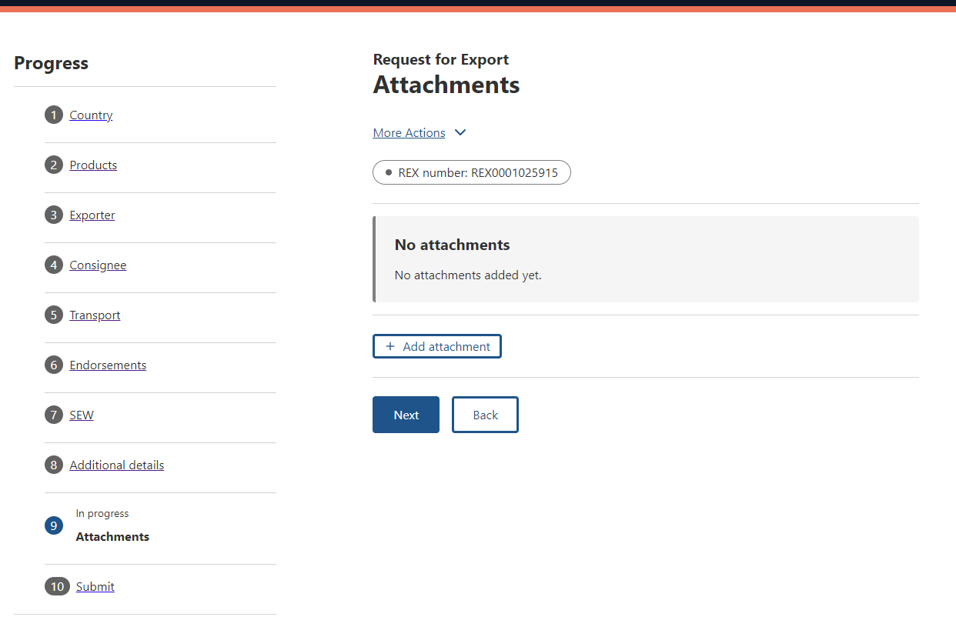
Step 2  Select the Document Type drop-down menu and select the type of attachment. Supported file types include: jpg, tiff, gif, rtf, jfif, png, docx, tif, txt, pdf, xml, jpeg, doc, and jpe.  The Document Type field is mandatory if you are attaching a document.  Provide a Comment in relation to your attachment, if applicable.  The Comment field is optional.  Select Choose Files or drag and drop the file to attach.  Select Save. | 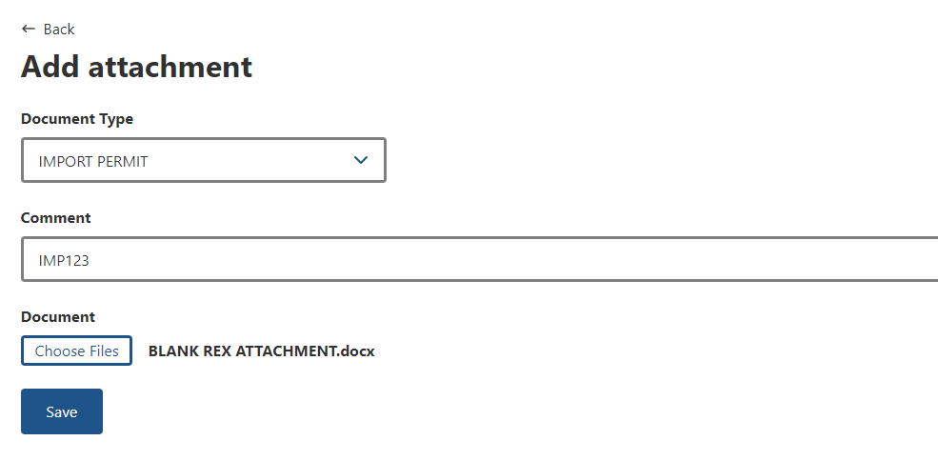
Step 3  Repeat Step 2 until you have attached all necessary documentation to support your application. You must attach all required documents so that the departmental officer has them available to review when assessing your REX.  Select Next. | 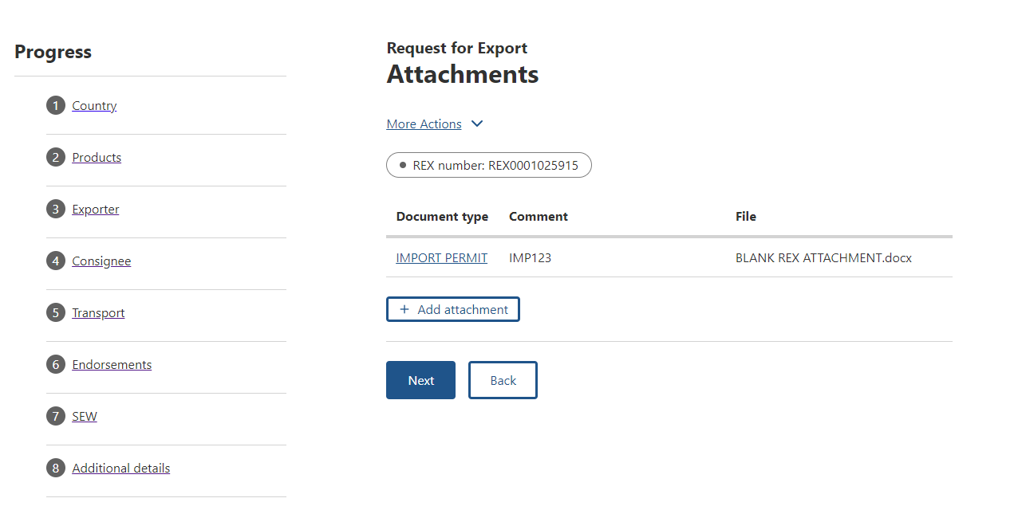

REX Section 10: Lodge REX
Step 1  The Declaration will display.  If you wish to proceed with your lodgement, click I agree. | 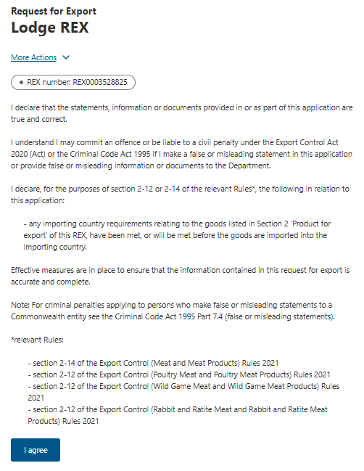

Step 2  If displayed, select declarations.  Select Next.  Note: Not all REXs will have declarations, these are determined by importing countries. | 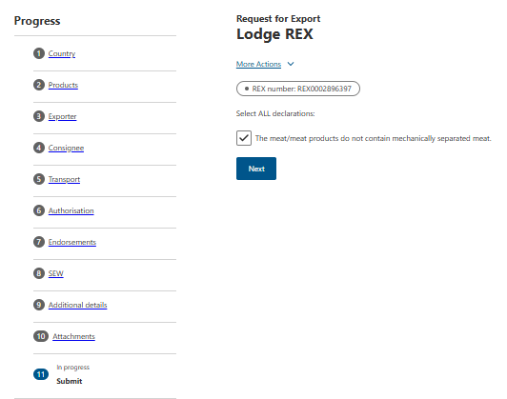
Step 3  The destination country and products will display. If there are no changes required,  Click Lodge REX. | 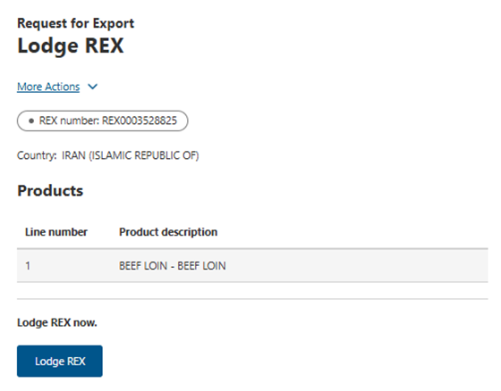
Step 4  A confirmation message will appear; if relevant, so will a Service ID. | 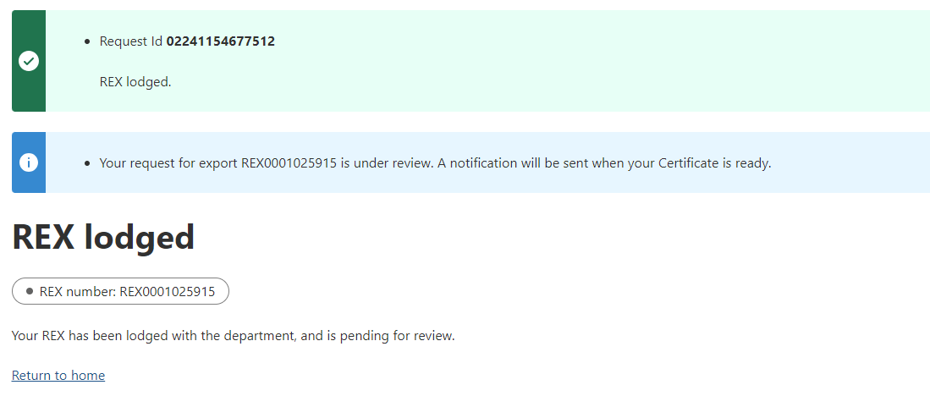
END

