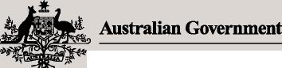**Legislative basis**

**March**

2022

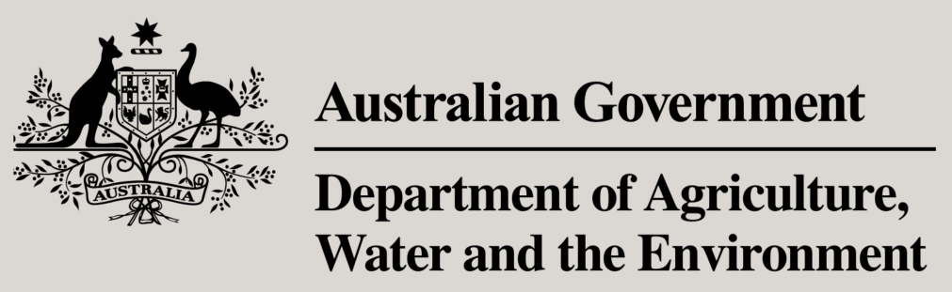

**Meat Export Policy**

# Loading for export and export permit application and issuing policy



Under the Export Control (Meat and Meat Products) Rules 2021, Export Control (Wild Game Meat and Wild Game Meat Products) Rules 2021, Export Control (Rabbit and Ratite Meat and Rabbit and Ratite Meat Products) Rules 2021 and the Export Control (Poultry Meat and Poultry Meat Products) Rules 2021 ('the Rules') there are legislative requirements relating to:

* loading of prescribed meat and meat products as conditions of an approved arrangement
* notices of intention to export and the issuance of export permits.

**Purpose**

To outline the process for loading of export meat and meat products and issuing export permits under the new *Export Control Act 2020* and relevant rules. The required procedure is summarised schematically in Figure 1.

**In this document**

Loading for export and export permit application and issuing policy 1

Loading for export 2

Notice of intention to export 2

Applying for an export permit 2

Declaration of 'verification of compliance' 2

Issuing of export permit 3

Related Materials 4

Attachment 1: Roles and responsibilities 4

Person supervising or directing loading of goods for export 4

Exporter or on behalf of Exporter **Error! Bookmark not defined.**

RFP declarant 4

Secretary of the department 4

Attachment 2: Definitions 5

## Loading for export

Meat and meat products must be loaded for export under the supervision or direction of a person designated in the approved arrangement at the establishment where the loading for export occurs, or under supervision or direction of a Commonwealth authorised officer. The establishment designated person does not need to be listed on the establishment registration as someone in management or control. The approved arrangement must detail the procedures that will be followed during the loading for export.

## Notice of intention to export

A notice of intention to export meat or meat products must be given for every consignment intended for export. The notice may be made by, or on behalf of, the exporter and it must state the place where the meat or meat products may be inspected. Making an electronic application for an export permit using the EXDOC/NEXDOC system, called a request for permit (RFP)/request for export documentation (REX), is taken to meet the requirements of giving a notice of intention.

## Applying for an export permit

Before meat or meat products can be exported, the exporter must be in possession of an export permit. The electronic application (RFP/REX) is made to the department using the EXDOC/NEXDOC system. The application can be made by, or on behalf of, the exporter.

### Declaration of 'verification of compliance'

As part of the submission of the RFP application to the department (and issuing of the export permit and government certificate), a declaration verifying compliance must be made. This declaration must state that the meat and meat products described in the application meet the conditions of export and any relevant importing country requirements. The verification process must be conducted by a person who is authorised to use the EXDOC/NEXDOC system (have an AQA user ID) and appears on the establishment registration as someone in management or control for the establishment where the meat or meat products are last prepared before export. This designated person is called an RFP/REX declarant. This person must follow the process detailed in the approved arrangement to verify compliance. Auditable evidence must be maintained by the RFP/REX declarant for all RFP compliance declarations made.

To summarise, the verification of the compliance process of the product to be exported comprises of:

* verifying compliance of the product with export conditions and importing country requirements, and
* making an RFP/REX declaration in the EXDOC/NEXDOC system.

The establishment approved arrangement must detail the procedure, and information required, for conducting the verification of compliance. This procedure may differ between establishments. It may occur progressively as a product is being produced, or it may occur at the point of loading.

Note: Where the loading establishment is an independent cold store, there must be a check of the product's eligibility against the carton labelling and incoming Meat Transfer Certificates.

Note: For European Union markets (and those requiring EU certification requirements), the declaration of 'verification of compliance' is made by a Commonwealth authorised officer. The process is essentially the same as outlined above and schematically illustrated below (Figure 1).

## Issuing of export permit

If all requirements are met, then the Secretary may issue an export permit to the exporter. The permit may be given as an electronic notice generated by the EXDOC/NEXDOC system. A permit given to the exporter by the EXDOC/NEXDOC system is taken to be given by the Secretary.

Figure 1: Schematic summary of required procedure for loading of goods and export permit application

## Related Materials

The following related material is available on the internet:

* Webpage: [*Export Control Act 2020*](https://www.legislation.gov.au/Series/C2020A00012)
* Webpage: [Export Control (Meat and Meat Products) Rules 2021](https://www.legislation.gov.au/Series/F2021L00334)
* Webpage: [Export Control (Wild Game Meat and Wild Game Meat Products) Rules 2021](https://www.legislation.gov.au/Series/F2021L00313)
* Webpage: [Export Control (Rabbit and Ratite Meat and Rabbit and Ratite Meat Products) Rules 2021](https://www.legislation.gov.au/Series/F2021L00308)
* Webpage: [Export Control (Poultry Meat and Poultry Meat Products) Rules 2021](https://www.legislation.gov.au/Series/F2021L00310)

## Attachment 1: Roles and responsibilities

### Commonwealth authorised officer

* Supervision of the loading of meat and meat products for export (where there is not a person designated in the approved arrangement to supervise loading of the meat and meat products).

### Establishment management

* Have an approved arrangement that designates any person that will supervise the loading of meat and meat products (where a Commonwealth authorised officer is not supervising the loading of meat and meat products).
* Have an approved arrangement that details the procedure, and information required, for conducting the verification of compliance.

### Exporter

* Must be a person who is authorised to use the EXDOC/NEXDOC system (have an AQA user ID)
* The applicant for an export permit for the meat or meat products, or if an export permit has been issued for the meat or meat products, the holder of the export permit.

### RFP declarant

* Must be a person who is authorised to use the EXDOC/NEXDOC system (have an AQA user ID) and appears on the establishment registration as someone in management or control for the establishment where the meat or meat products are last prepared before export
* Must follow the process detailed in the approved arrangement to make the declaration of 'verification of compliance'.
* Must maintain auditable evidence for all RFP compliance declarations made.

### Person supervising or directing loading of goods for export

* Must be a person designated in the approved arrangement to supervise the loading of the meat and meat products.
* Must follow the procedures for the loading of product for export as detailed in the approved arrangement.

## Attachment 2: Definitions

**Approved arrangement**

As per the relevant Rules, means an arrangement approved under Chapter 5 of those Rules.

**Commonwealth authorised officer**

As per the *Export Control Act 2020* means an authorised officer who is an officer or employee of a Commonwealth body. For the purposes of this document, this includes On-Plant Veterinarians.

**EXDOC**

The Department of Agriculture, Water and the Environment Export Documentation System (EXDOC) is the department's established system used to generate export documents. This may include export permits, certificates and related documents as required by importing countries.​

**NEXDOC**

The Next Export Documentation System (NEXDOC) modernises the existing IT system platforms of EXDOC (Export Documentation System), the export establishment registration database (ER) and will incorporate the Tracking Animal Certification Exports (TRACE) system and enhancements to the Plant Exports Management System (PEMS).

**Request for export documentation (REX)**

A request for export documentation (REX) replaces the 'request for permit (RFP)' in EXDOC.

**Request for permit (RFP)**

A request to obtain an export permit for prescribed goods as defined under the *Export Control Act 2020* andtermed a request for permit (RFP) in the EXDOC system. The main function of an export permit is to verify that product is eligible for export.