GENERAL SITUATION in Autumn and OUTLOOK to Spring 2026

Australian Plague Locust Chortoicetes terminifera
The overall locust population increased substantially during autumn from previously low-level background to medium-high levels across much of the southern half of inland eastern Australia. Surveys conducted in late March only identified low-density populations in accessible parts of New South Wales and southern Queensland. However, surveys undertaken from mid-April onwards identified consistent medium–high density adults over much of New South Wales, north-western Victoria and South Australia with some low–medium density nymphs detected. Most sampled adult were observed with eggs developing or signs of egg-laying occurred. Only low-density adults were identified in inland Queensland except for the southern part of Channel Country where frequent medium-densities were identified.
Ancillary information suggested the progress of locust population development and redistribution in inland eastern Australia. No locust captures were recorded by any light traps in Dulkaninna of South Australia, Fowlers Gap and White Cliffs of NSW until mid-February when 300 and 350 locusts were caught by the light trap in White Cliffs on the two consecutive nights of 19–21 February, which indicates some successful breeding and movements after 25–50 mm of rainfall over the arid inland in late December. Several high captures were recorded in White Cliffs between early March and mid-April. The light trap in Dulkaninna did not catch any locusts during the whole season though the increase of nymphs and adults were observed locally since mid-February. The light trap in Fowlers Gap ceased operation after it was damaged by the heavy rainfall in early March while the one in Thargomindah of Queensland was not in operation during the season due to lack of operator. The UNSW insect monitoring radar in Hay detected several nights of significant eastward locust migrations during late March to late April. A couple of dozen reports of locust swarming from inland NSW had been confirmed by the Local Land Services between mid-April and mid-May. The Department of Primary Industries and Regions South Australia (PIRSA) received reports of locust swarming from the Flinders to Murraylands districts in late April. PRISA conducted ground surveys in mid-May and identified low-medium density adults remained in the Flinders district with evidence of oviposition behaviour. Agriculture Victoria joining forces with APLC conducted ground surveys in the Mallee district in mid-May and identified consistent medium-high density adults. This season demonstrated that the locust population can build up rapidly from very low background to outbreak level under optimal conditions.
Heavy rainfall in February and March produced favourable habitats for locust breeding in inland eastern Australia and warm late autumn weather encouraged southward/south-eastward migrations and redistributions. Apart from some moderate rainfall in mid-September and mid-December respectively, the arid/semi-arid interior experienced a generally dry spring and early summer but received very much above average to highest on record rainfall in February and March with two-month totals of 100 – 400 mm with the heavier falls in the arid interior. Although the interior received little rainfall in April, above average to very much above average rainfall of 25 – 100 mm in May prolonged good habitat conditions for locust breeding. Autumn temperatures were above average to very much above average (0-3 degrees) except for the heavy March rainfall zone of South Australia at below average levels (0-2 degrees). Despite the forecast for below average rainfall and warmer temperatures for winter and likely El Niño development by the Bureau of Meterology, overwintering eggs are likely to survive with sufficient soil moisture.
The overall outlook is for some medium-high density nymphs hatching in the southern part of inland eastern Australia with likely bands developing from mid-September onwards.
There is a moderate-high likelihood of a widespread infestation developing in spring.
05 June 2026

Locust distribution map—Chortoicetes terminifera

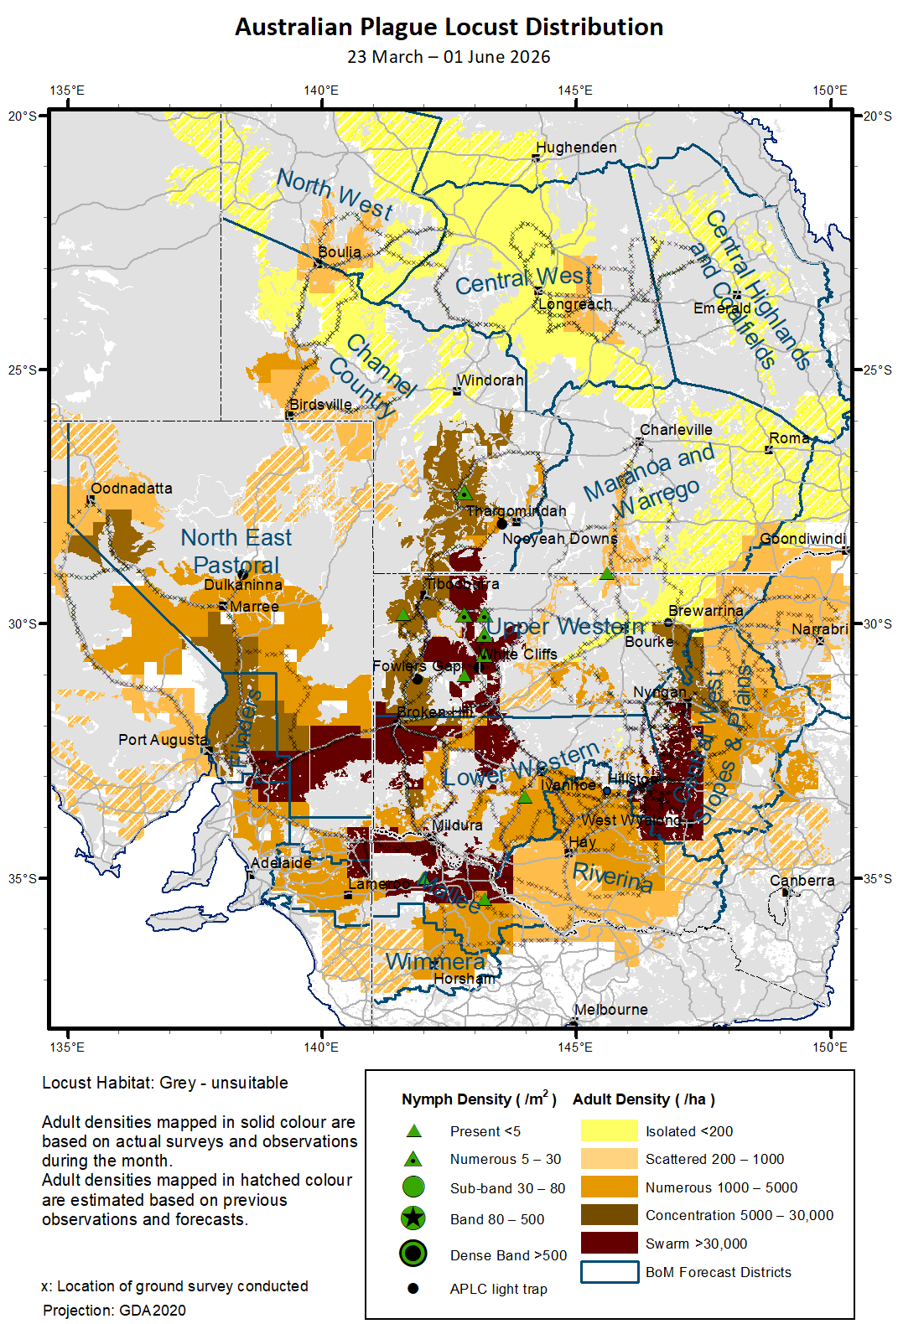
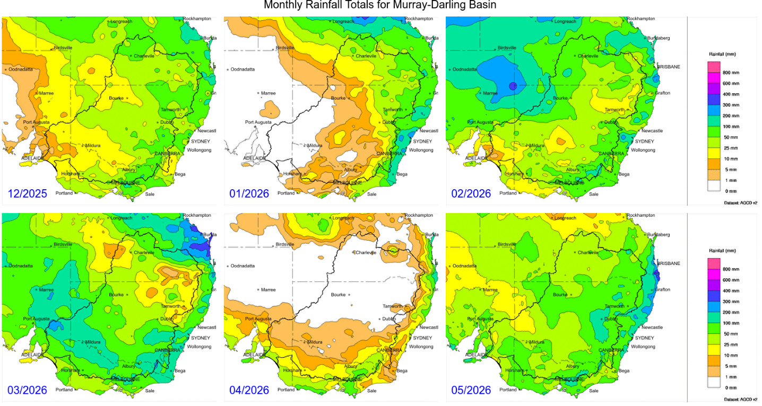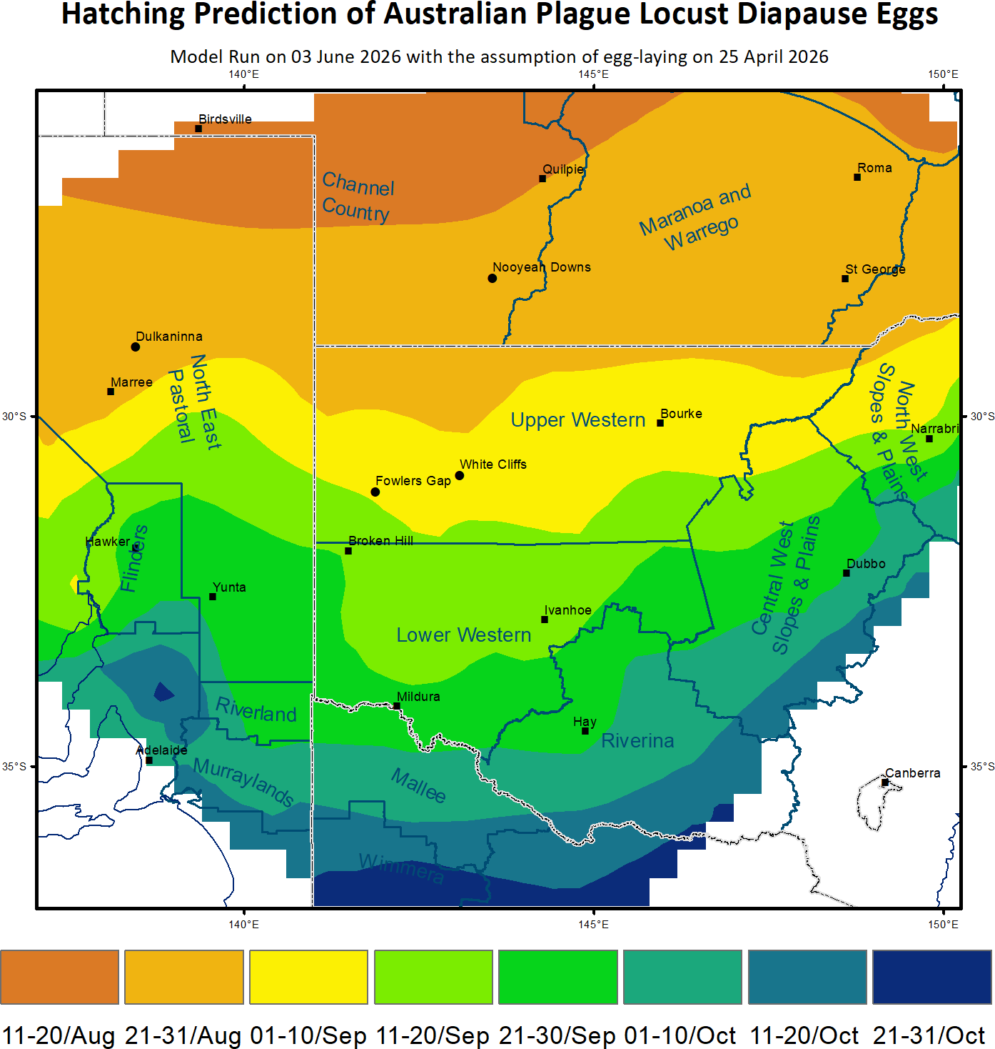

Spur-throated Locust Austracris guttulosa
The overall population remained at low-medium levels in autumn across inland eastern Australia with a significant buildup in Central West district of Queensland. Late instar nymphs were still observed by survey in early May, indicating an extended breeding season from November. Consistent Numerous to Concentration-density adults were identified by survey in Central West district with a Low-Density Swarm detected. Frequent Scattered to Numerous-density adults were also identified by survey in North West and Channel Country districts of Qld, North East district of South Austtralia and Upper Western district of New South Wales. Only a few captures were recorded by the light trap in White Cliffs in early April, but several reports of locust swarming activities were received from Central West Qld at the end of May. Although below average rainfall and warmer temperatures for winter were forecasted, habitat conditions should remain in favour for locust survival, and additional swarms are likely to form in winter.
There is a moderate risk of a regional infestation in Central West Queensland. However, a widespread infestation is less likely to occur in winter and spring.
Spur-throated Locust Distribution (23 March - 01 June 2026)
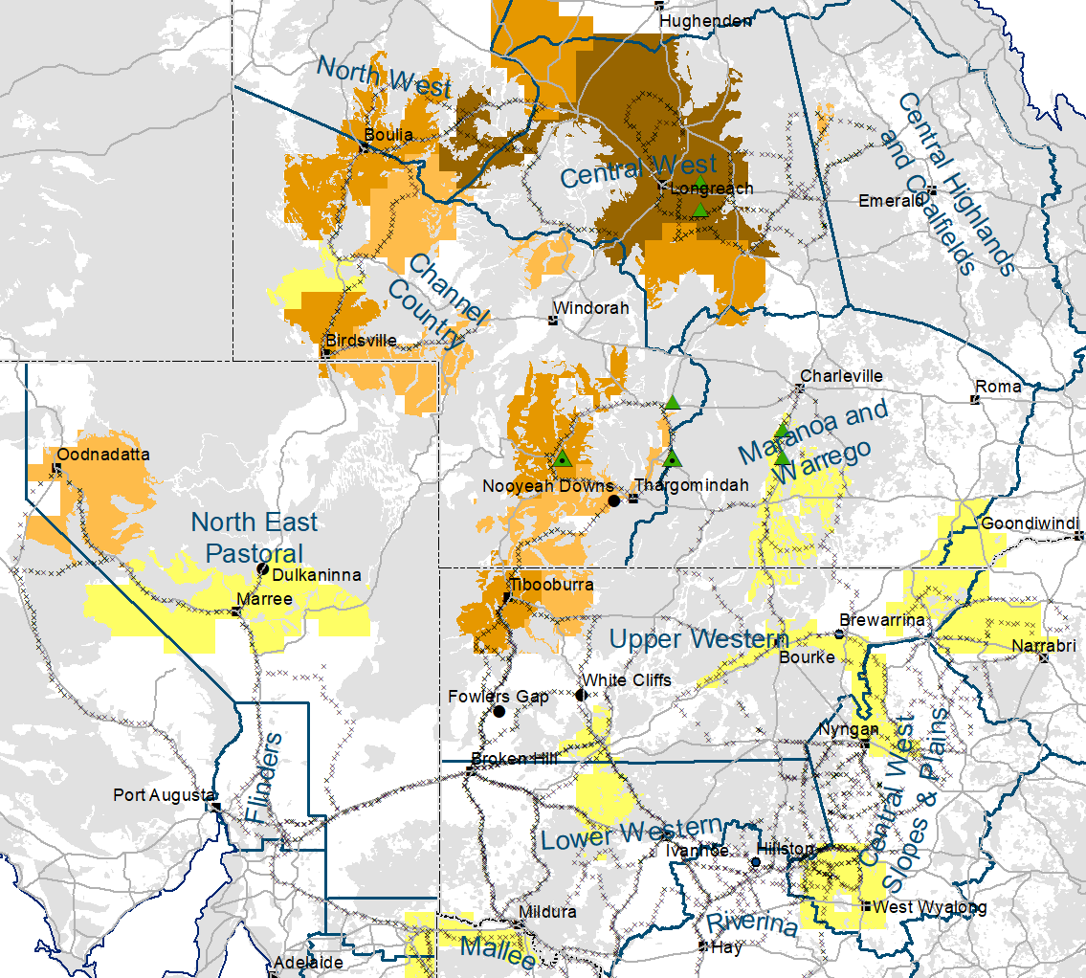

Migratory Locust Locusta migratoria
The locust population persisted at a low – medium level in Central West district of Queensland in autumn, while the population declined significantly in the adjacent Central Highlands district. Locust bands were first reported from the Central Highlands and confirmed by survey. Queensland Department of Primary Industries (QDPI) conducted several aerial controls of nymphal bands over a total area of approximately 16,000 hectares including organic properties in parts of western Central Highlands and eastern Central West during summer. Landholders also controlled some locust bands. QDPI has been closely monitoring the locust situation and controlled some small residual bands in mid-May in the northeast of Jericho (eastern Central West district). Surveys conducted in autumn identified Isolated to Scattered-density adults remained in the Central Highlands and similar levels of populations detected in the northern part of Channel Country with Scattered to Numerous-density adults identified in the Longreach-Hughenden areas. With the forecast for warm winter temperatures, habitat conditions should remain in favour for locust survival, and some breeding can occur where rainfall above 30 mm. Under low night temperatures of late autumn and winter, nocturnal long-range migration is unlikely but daytime short-distance dispersal can take adults tens of kilometres away in a warm day on a general westward direction.
There is a low-moderate risk of a regional infestation developing in the Central West and a low risk in the Central Highlands during winter and spring.
Migratory Locust Distribution (23 March - 01 June 2026)
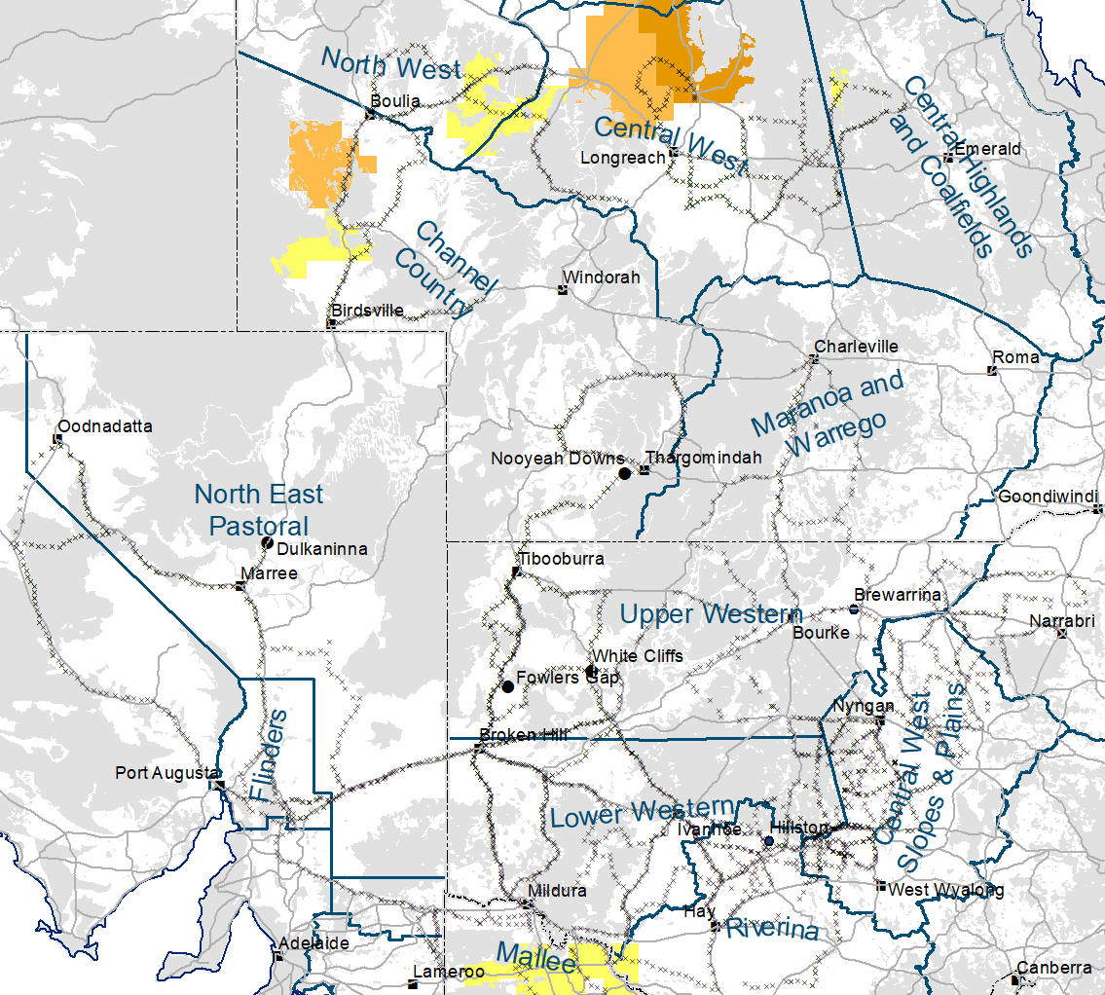
It is important that any locust activity be reported as soon as possible to your local biosecurity authority or to the Commission. A toll-free call to the Commission can be made on 1800 635 962. An answering machine is attached to this locust hotline for after-hours calls. Reports can also be emailed to the Commission at locust.report@agriculture.gov.au or sent through the web page at https://www.agriculture.gov.au/pests-diseases-weeds/locusts/landholders/reporting_locusts.

Australian Plague Locust (Chortoicetes terminifera)

SITUATION in Autumn and OUTLOOK to Spring 2026

NEW SOUTH WALES

NORTH WEST SLOPES & PLAINS

Northwest Local Land Services

Locusts and conditions
- No surveys were conducted in this district in March and April. Surveys conducted in early May identified Isolated – Scattered-density adults with no nymphs detected.
- LLS followed up two reports of flying locusts from this district in mid-April.
- After slight dry summer, this district only received heavy rainfall of 50-80mm (above average) in the Narrabri area in March, nearly nil rainfall (very much below average) for April, but 50-100mm of rainfall (above average to very much above average) over much of this district for May. Habitats were not in favour for locust breeding in most time during the season and only localised breeding was possible.

Forecast
- Limited number of eggs may have been laid in suitable habitats and remain in diapause/dormancy for overwintering. Spring hatching may commence from late August onwards resulting in some localised populations.
- There is a low probability of any large bands developing or significant migrations occurring in spring.
- The general population density is expected to be at low levels in spring with possible localised higher densities developing under favourable habitat conditions.

Risks
- There is a low risk of a regional infestation developing in spring.

CENTRAL WEST SLOPES & PLAINS

Central West Local Land Services

Locusts and conditions
- Surveys conducted in the north-western part of this district identified occasional Isolated-density adults in late March without any nymphs detected. By mid-April frequent Numerous – Concentration-density adults were identified by survey with some Low-Density-Swarm detected in this district. Higher numbers concentrated in the Lake Cargelligo area where more Low-Density swarms were identified by survey on 28 April after more reports received. Surveys still identified consistent Numerous-density adults with some Concentration and Low-Density-Swarm adults remaining in the western part of this district in mid-May. The sequence of ground surveys and the observed locust migrations by the UNSW insect monitoring radar in Hay indicate that locust immigrations from west/southwest occurred in the autumn.
- LLS followed up a half dozen reports of locust swarming received from this district in mid-April.
- This district experienced some dry periods during both spring (October and November) and summer (January). In addition to 25-50 mm of rainfall for February, much of this district received 25 – 150 mm of rainfall from north to south in March, at average to very much above average historically. Despite nearly nil April rainfall, May rainfall totals were from 50 mm to 150 mm over much of this district, at above average to very much above average level. Most habitats should have remained in good condition for overwintering eggs laid in autumn.

Forecast
- Overwintering eggs may have been laid in favourable habitats in autumn and remain in diapause/dormancy. Nymph hatching may commence from early September onwards.
- There is a high probability of some large bands developing or significant migrations occurring in spring.
- The general population is expected to be at medium-high levels with likely bands and swarms developing in spring.

Risks
- There is a high risk of regional infestations developing in spring.

RIVERINA

Riverina, Murray Local Land Services

Locusts and conditions
- Surveys conducted in the north-western part of this district identified some Isolated-density adults with occasional Scattered-density detected in late March, and frequent Isolated – Numerous-density adults with higher numbers in the Hillston area in late April. No nymphs were detected by survey. By mid-May, some Numerous-density adults were still present in the northern part of this district.
- A couple reports of locust swarming were received and followed up by LLS from this district in mid-April.
- The UNSW insect monitoring radar in Hay detected several significant locust migration events in autumn: three nights of 06, 09, and 26 April on which the migration process (take-off, windborne transport and landing) completed on the same night, and three late overflights of 31 March, 08 and 25 April on which the migration process lasted to the next morning. All these migrations had a general eastward displacement direction and likely to redistribute locust populations to the northeast after passing through Hay from 150 – 500 km away.
- This district received 30 – 120 mm of rainfall in March, at above average to very much above average levels over much of this district. April rainfall totals were below 10 mm at below average to very much below average levels, but 30 – 60 mm at average to above average levels over much of this district. Some habitats should remain favourable for locust breeding during autumn.

Forecast
- Some eggs may have been laid in autumn for overwintering and spring hatching may start from late September onwards, resulting some localised high densities likely in the Hillston area.
- There is a low-moderate probability of some bands developing and migrations occurring in spring.
- The overall population is likely to be at low-medium levels for spring.

Risks
- There is a low-moderate risk of regional infestation developing in spring.

UPPER and LOWER WESTERN

Western Local Land Services

Locusts and conditions
- Surveys conducted in late March identified frequent Isolated-Scattered density adults in the western part of these two districts with some Numerous-density adults in the Wilcannia-Ivanhoe areas. Occasional Isolated-density adults were identified in the north-eastern half of these two districts. Only occasional nymphs were identified by survey. During late April to early May frequent Numerous – Concentration-density adults were identified by survey with some Low-Density-Swarm adults in the western part of these two districts. Some Present – Numerous-density nymphs were detected in the western part of the Upper Western district, and some LDS adults were also identified in the eastern part of the Lower Western district. By late May to early June, there were still some Numerous – Concentration-density adults remaining in the western part of the Upper Western district with occasional LDS adults, and frequent Numerous-density adults present in the Lower Western district.
- Light trap in Fowlers Gap did not catch any locusts before early March when it was damaged by the heavy rain. The light trap in White Cliffs first caught locusts during 16 – 23 February with the peak night of 350 locusts on 20 February, indicating the regional good rainfall in late December produced some good habitats for locust breeding. The light trap recorded continuous captures from early March to mid-April with peaks at 08-11 (peak night of 1200 locusts on 09 April) and 15-18 April (peak night of 600 locusts on 16 April) respectively. This indicates nocturnal migrations and daytime dispersals occurred in these districts during autumn.
- A half dozen locust reports of swarming were received by LLS from these two districts in mid-April.
- After 50 – 200 mm of February rainfall over the arid/semi-arid interior of the Upper Western district (west of Bourke), March rainfall totals were from 50 mm to 150 mm were received by the western half of these two districts, again at above average to highest on record. Although nearly nil rainfall over the Upper Western district and less than 5 mm over the Lower Western district for April, May rainfall totals were from 10 mm to 60 mm over these two districts, at average to very much above average levels. Some habitats should remain favourable for locust breeding and survival.

Forecast
- Overwintering eggs may have been laid in favourable habitats in autumn, and spring generation may start to hatch from mid-August onwards resulting some localised high densities.
- There is a moderate-high probability of some significant hatchlings in early spring and migrations in late spring.
- The overall population is likely at low-medium levels, with possible localised high-density populations developing in spring dependent on winter and spring conditions.

Risks
- There is a moderate-high risk of regional infestations developing in spring.

All locust activity should be reported to your nearest Local Land Services Biosecurity Officer on 1300 795 299 or to the Commission. A toll-free call to the Commission can be made on 1800 635 962. An answering machine is attached to this phone for after-hours calls. Reports can also be emailed to the Commission at locust.report@agriculture.gov.au or sent through the web page at https://www.agriculture.gov.au/pests-diseases-weeds/locusts/landholders/reporting_locusts.

QUEENSLAND

CENTRAL HIGHLANDS AND COALFIELDS

Isaac and Central Highlands Regional Councils; Banana Shire

Locusts and conditions
- Limited surveys conducted in the Emerald area did not identify any locust in early March. Some Isolated-density adults were identified by survey in the western part of this district without any nymphs detected in late April.
- No reports of locust activity were received from this district in autumn.
- In March this district received 40 – 250 mm of rainfall, ranging from average to very much above average levels. However, less than 25 mm of rainfall was received by much of this district in April, from average to very much below average levels. Only 25 – 50 mm of rainfall was received by the southern part with nearly nil rainfall over the northern part of this district in May, but generally at average levels. Some habitats should have remained favourable for locust breeding.

Forecast
- Localised breeding is possible under favourable habitat conditions, but general population is likely to remain at low levels.
- There is a very low probability of any significant bands developing or migrations occurring in spring.

Risks
- There is a very low risk of a regional infestation developing in spring.

DARLING DOWNS AND GRANITE BELT

Western Downs and Goondiwindi Regional Councils

Locusts and conditions
- No surveys were conducted in this district in autumn.
- No report of locust activity was received from this district in autumn.
- After a dry summer, March rainfall totals were from nearly nil in the south to over 250 mm in the north, ranging from very much below average to highest on record. April rainfall was nearly nil over much of this district, but May rainfall totals were 30 – 80 mm at above average levels. Some habitats may have remained favourable for locust breeding.

Forecast
- Sporadic breeding is possible under favourable habitat conditions, but any resulting population is likely to be at low levels.
- There is a low probability of any significant bands developing or migrations occurring in spring.

Risks
- There is a low risk of a regional infestation developing in spring.

CENTRAL WEST

Barcaldine, Longreach, and Blackall-Tambo Regional Council; Flinders and Winton Shires

Locusts and conditions
- Limited surveys conducted in the Longreach-Winton areas only identified some occasional Isolated-density adults in early March. Some Isolated-density adults were identified by survey in late April in this district with no nymphs detected.
- No reports of locust activities were received from this district in autumn.
- This district received 20 – 200 mm from the southwest to northeast, ranging from average to very much above average levels for March. April rainfall totals were from nil in the southeast to 80 mm in the northwest, ranging from average to above average levels. May rainfall totals were less than 10 mm over the north and 10 – 30 mm over the south of this district but generally at average levels. Some habitats should remain favourable for locust breeding.

Forecast
- Breeding is possible under favourable habitat conditions, but overall population is likely to remain at low levels.
- There is a low probability of any significant bands developing or migrations occurring in spring.

Risks
- There is a low risk of a regional infestation developing in spring.

MARANOA AND WARREGO

Maranoa Regional Council; Murweh, Paroo, and Balonne Shires

Locusts and conditions
- Surveys conducted in late March identified some Isolated-density adults with occasional Scattered-density adults and Present-density nymphs detected. No surveys were conducted in this district in April and May.
- No locust reports were received from this district in autumn.
- March rainfall varied from nil to over 160 mm, but generally at 25 – 50 mm at average levels over much of this district. This district received nearly nil rainfall in April, and 25 – 50 mm (at average to above average levels) over much of this district in May. Some habitats may remain unfavourable for locust breeding.

Forecast
- Sporadic breeding is possible under favourable habitat conditions, but the resulting locust population is likely to remain at low levels.
- There is a low probability of any significant nymphs hatching or migrations occurring in spring.

Risks
- There is a low risk of a regional infestation developing in spring.

NORTH WEST

Mt Isa, Cloncurry, McKinlay, Boulia, and Winton Shires

Locusts and conditions
- No surveys were conducted in this district in March and April. Surveys conducted in mid-May identified some Isolated – Scattered-density adults with no nymphs detected in this district.
- No locust reports were received from this district in autumn.
- This district received variable rainfall from 25 mm to 100 mm with higher volume in the northwest at average to above average levels for March, from nil in the southwest to 100 mm in the northeast at average to above average levels for April, and from nearly nil in the northeast to 60 mm in the southwest at average to very much above average levels for May. Some habitats may remain favourable for locust breeding.

Forecast
- Sporadic breeding is possible, but any resulting locust population is likely to remain at low levels.
- There is a low probability of any significant migration/redistribution events in spring.

Risks
- There is a low risk of a regional infestation developing in spring.

CHANNEL COUNTRY

Boulia, Diamantina, Barcoo, Quilpie, and Bulloo Shires

Locusts and conditions
- No surveys were conducted in this district in March and April. Surveys conducted in May identified frequent Numerous – Concentration-density adults with some Present – Numerous-density nymphs detected in the southern part of this district, and some Isolated – Scattered-density with occasional Low-Numerous density adults detected in the norther part of this district.
- The light trap in Thargomindah was not in operation during the season due to lack of operator.
- No locust reports were received from this district in autumn.
- After a very wet February (above average to highest on record rainfall) this district received variable amount of rainfall from below 10 mm to over 140 mm at below average to highest on record for March. April rainfall totals were less than 50 mm but only up to 10 mm over much of this district, ranging from below average to above average levels, and May rainfall totals varied from 25 mm to 70 mm at above average to very much above average levels. Some habitats especially these along drainages may remain favourable for locust breeding.

Forecast
- Sporadic breeding is possible under favourable habitat conditions, but any resulting population is likely to remain at low levels.
- There is a low probability of any significant bands developing or migrations occurring in spring.

Risks
- There is a low risk of a regional infestation developing in spring.

All locust activity should be reported to Department of Primary Industries via the Customer Service Centre on 13 25 23, online reporting form at https://www.dpi.qld.gov.au/contact/report-a-biosecurity-pest-or-disease?form=other-1554285, email at locustreports@dpi.qld.gov.au, or to the Commission. A toll-free call to the Commission can be made on 1800 635 962. An answering machine is attached to this locust hotline for after-hours calls. Reports can also be sent to the Commission through the web page at https://www.agriculture.gov.au/pests-diseases-weeds/locusts/landholders/reporting_locusts or emailed at locust.report@agriculture.gov.au.

SOUTH AUSTRALIA

NORTH EAST PASTORAL and FLINDERS

Locusts and conditions
- No surveys were conducted in this district in March and April. Surveys conducted in early May identified frequent Numerous-density adults in Flinders district and southern part of North East district with no nymphs detected. Surveys conducted in late May identified frequent Numerous-density – Medium-Density-Swarm adults in the southern part and frequent Numerous-density adults with occasional Concentration-density in south-western part of North East district, and frequent Numerous – Concentration-density adults in Flinders district with some Isolated-density adults in the south-western part of this district.
- The light-trap at Dulkaninna did not capture any locusts in autumn, but local population buildup observed by the light-trap operator started from mid-February.
- Several locust reports of swarming were received from these two districts in late April, indicating some late southward migrations. PIRSA followed up these reports and conducted ground surveys in mid-May when some medium-density adults remained in the Flinders district.
- After a very wet February (above average to highest on record rainfall), these two districts received variable amount of rainfall from 60 mm to over 200 mm with heavier rains in the southwest for March, ranging from very much above average to highest on record levels. Flinders district received less than 15 mm of rainfall (average levels) but the northern part of North East district received nil for April. May rainfall totals varied from 10 to 25 mm for North East district and 25 – 60 mm for Flinders district, generally at above average to very much above average levels. Some habitats may remain favourable for locust breeding.

Forecast
- Locust breeding is possible under favourable habitat conditions where some eggs may have laid in autumn, and spring nymphs may commence to hatch from these overwintering eggs in Flinders district and the southern part of North East district from mid-September onwards, likely resulting some localised high densities.
- There is a moderate-high probability of some significant bands developing in early spring or migrations developing in late spring.

Risks
- There is a moderate-high risk of a regional infestation developing in the southern part of these two districts in spring.

RIVERLAND and MURRAYLANDS

Locusts and conditions
- No surveys were conducted in this district in March and April. Surveys conducted in early May identified consistent Isolated – Numerous-density adults in Riverland district and the north-eastern part of Murraylands district without any nymphs detected. By mid-May, frequent Numerous – Medium-Density-Swarm adults were identified by survey in the eastern part of these two districts, indicating redistribution may have occurred in May after initial immigrations occurred in late April.
- Several locust reports were received from these two districts in late April, indicating immigrations from the north and redistribution to the east may have occurred.
- These two districts received 40 – 120 mm of rainfall in March, ranging from above average to highest on record. April rainfall totals varied from nearly nil in the northeast to 30 mm in the southwest, generally at average levels over much of these two districts. May rainfall totals varied from 25 mm to 80 mm at average to highest on record levels. Some habitats should remain in favour for locust breeding.

Forecast
- Some overwintering eggs may have been laid in favourable habitats in autumn, and spring generation may start to hatch from these eggs from late September onwards, likely resulting some localised high densities.
- There is a moderate-high probability of some nymph bands developing in early spring or migrations occurring in late spring.

Risks
- There is a moderate-high risk of a regional infestation developing in spring.

All locust activity should be reported to Primary Industries and Regions South Australia via the Exotic Plant Pest Hotline on 1800 084 881, online plant pest reporting form at https://form.jotform.co/70732909804864, or to the Commission. A toll-free call to the Commission can be made on 1800 635 962. An answering machine is attached to this locust hotline for after-hours calls. Reports can also be sent to the Commission through the web page at https://www.agriculture.gov.au/pests-diseases-weeds/locusts/landholders/reporting_locusts or email at locust.report@agriculture.gov.au.

VICTORIA

MALLEE
Mildura and Swan Hill Rural Cities; Yarriambiack and Buloke Shires

Locusts and conditions
- No surveys were conducted in this district in March and April. Surveys conducted in early May identified frequent Numerous-density adults with occasional Concentration and Low-Density-Swarm detected in the northern part and consistent Isolated – Scattered-density adults in the southern part of this district without nymphs detected. Surveys conducted in mid-May identified Isolated – Medium-Density-Swarm adults in this district with higher numbers in the north-western part, indicating redistribution/aggregation may have occurred after immigration. Some Present-density nymphs were still present by mid-May.
- Several reports of locust swarming were received from this district in late April, and Agriculture Victoria joining forces with APLC conducted ground surveys in mid-May. Field samples indicate a big proportion of locusts still have fully developed egg onboard while others may have laid at least once already.
- After slightly wet February (average to above average levels) this district received 70 – 130 mm of rainfall, ranging from very much above average to highest on record levels for March. April rainfall totals were less than 10 mm, ranging from very much below average to average levels over much of this district. In May, this district received 35 – 80 mm of rainfall, ranging from average to very much above average levels. Some habitats should remain favourable for locust breeding.

Forecast
- Spring generation may commence to hatch from overwintering eggs laid in late autumn in favourable habitats from late September onwards, and result some high density nymphs.
- There is a moderate-high probability of some bands developing and migrations occurring in spring.

Risks
- There is a moderate-high risk of a regional infestation developing in spring.

WIMMERA
Hindmarsh and West Wimmera Shires

Locusts and conditions
- No surveys were conducted in this district in March and April. Limited surveys conducted in the north-eastern part of this district identified some Isolated-density adults with occasional Numerous-density detected in early May. No nymphs were identified by survey.
- No locust reports were received from this district in autumn.
- This district received 40 – 100 mm of rainfall at average to very much above average levels during March, 5 – 25 mm of rainfall at below average to average levels in April, and 40 – 80 mm of rainfall generally at average levels in May. Some habitats should remain favourable for locust breeding.

Forecast
- Some overwintering eggs may have laid in favourable habitats, and spring nymphs may start to hatch from early October onwards producing some localised high densities.
- There is a low-moderate probability of some small bands developing in spring.

Risks
- There is a low-moderate risk of a regional infestation developing in spring.

All locust activity should be reported to Agriculture Victoria via the Customer Contact Centre on 136 186, online form at https://forms.bio.vic.gov.au/locusts, or to the Commission. A toll-free call to the Commission can be made on 1800 635 962. An answering machine is attached to this locust hotline for after-hours calls. Reports can also be sent to the Commission through the web page at https://www.agriculture.gov.au/pests-diseases-weeds/locusts/landholders/reporting_locusts, or emailed at locust.report@agriculture.gov.au.

Glossary of locust terms and density categories used in the Locust Bulletin
Term | Definition
adult | A fully developed, sexually mature locust capable of flight and reproduction
band | Dense congregation of nymphs (hopper band), usually marching together
diapause | Period of dormancy induced in anticipation of unfavourable environmental conditions
dispersal  egg bed | Spreading of individuals away from others (adaptation)  An area of soil containing many egg pods (usually hundreds per square metre)
fledge | Final instar moulting to a soft-bodied adult (fledgling) incapable of long-distance flight
hatch | A young nymph (hatchling) emerging from an egg
instar | A discrete stage of nymphal development after hatch/moult
laying | Female locusts depositing clutches of 20–60 eggs into the ground in froth-lined egg pods
migration  nymph  quiescence | Seasonal collective movements from one place to another (behaviour)  An immature locust (hopper) having the same morphological appearance as the adult  Cessation of growth and reduction of metabolic activity under unfavourable conditions
swarm | Dense congregation of adults, milling at the same spot or flying closely together

Locust density categories
Where higher densities occur, a large proportion of the regional population is concentrated in very small areas with lower densities elsewhere, so the higher densities cannot be extrapolated over the area of an entire region. A range of density classes is usually found within a surveyed region.
Nymph Densities | Number per m²
Present | 1 – 5
Numerous | 6 – 30
Sub-band | 31 – 80
Band | 81 – 500
Dense Band | >500
Adult Densities | Number per m² | Number per 250 m²
Isolated | < 0.02 | 1 – 5
Scattered | 0.024 – 0.1 | 6 – 25
Numerous | 0.104 – 0.5 | 26 – 125
Concentration | 0.504 – 3 | 126 – 750
Low Density Swarm | 4 – 10 | 751 – 2,500
Medium Density Swarm | 11 – 50 | 2,501 – 12,500
High Density Swarm | >50 | >12,500
General density classes | Nymph densities | Adult densities
very low, occasional | Nil – Present | Nil – Isolated
low | Present – Numerous | Isolated – Scattered
medium | Numerous – Sub-band | Scattered – Numerous
high | Bands | Concentration – Swarms

Reporting locust infestations
It is important that all locust activity be reported as soon as possible to your nearest state biosecurity agency office or to the Australian Plague Locust Commission.
State | Authority for reporting locusts
New South Wales | Local Land Services (LLS)
Queensland | Department of Agriculture and Fisheries
South Australia | Department of Primary Industries and Regions
Victoria | Agriculture Victoria
Reports to the Australian Plague Locust Commission can be made by:
Free call (Canberra): 1800 635 962 (24 hours)
Email: locust.report@agriculture.gov.au
Website: https://www.agriculture.gov.au/pests-diseases-weeds/locusts/landholders/reporting_locusts

