The following update is issued as an interim advice in lieu of the regular monthly Locust Bulletin. Full details of locust population densities and forecasts for regions are not available as ground surveys were limited in December 2025 due to prolonged drought conditions in the interior of eastern Australia.
Surveys will resume as soon as weather and ground conditions permit. Once additional field population information is available, a full detailed Bulletin will be prepared.

GENERAL SITUATION in December and OUTLOOK to March 2026

Australian Plague Locust Chortoicetes terminifera
The overall locust population likely remained at low levels across inland eastern Australia due to extended periods of low rainfall in the arid/semi-arid interior. Limited surveys conducted in mid-December identified Isolated – Scattered density adults in the North West and Central West districts of New South Wales without nymphs detected. No locust captures were recorded by any light traps in Dulkaninna of South Australia, Fowlers Gap and White Cliffs of NSW. The UNSW insect monitoring radar in Hay did not detect any significant migration of locust. No locust reports were received during December.
Much of the arid/semi-arid interior of eastern Australia received less than 25 mm of rainfall in December, while some eastern and north-eastern parts had monthly rainfall totals of 50 – 100 mm, varying from very much below average to very much above average levels. December temperatures were warmer by 1 – 3 degrees over the inland. With the forecast for average/slightly above average rainfall and warmer temperatures for February and March, some habitats will become favourable for locust breeding during the remainder of summer and early autumn. With continuous above average sea surface temperatures in the tropical Pacific Ocean, the El Niño–Southern Oscillation indicate a weak La Niña pattern persistent in northern parts of Queensland which will bring some heavy rains in coming months.
The overall outlook is for low-density populations across inland eastern Australia, with possible localised higher densities developing in inland Queensland and parts of NSW if sufficient rainfall is received.
There is a low likelihood of widespread infestations developing in the remainder of summer and early autumn.

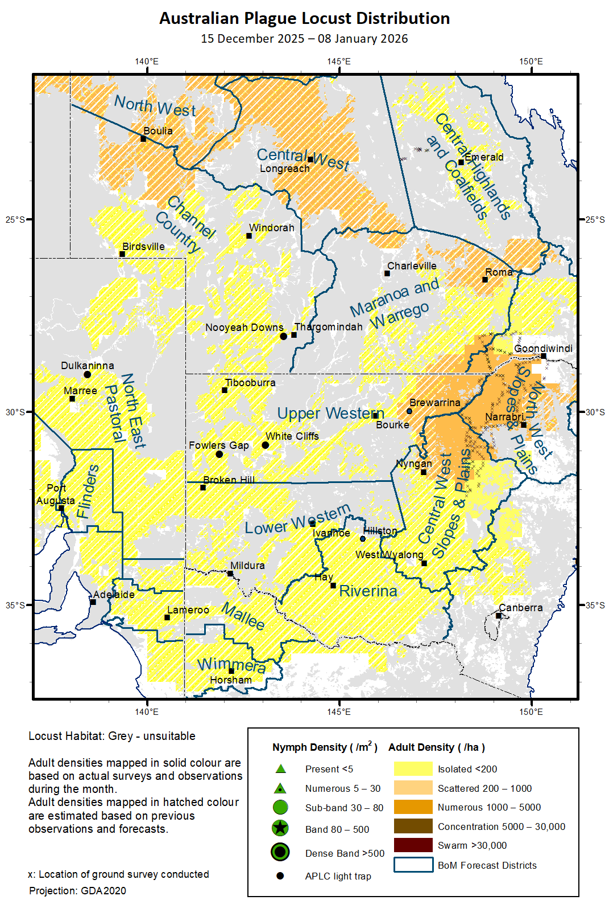

Spur-throated Locust Austracris guttulosa
The overall population likely remained at low-medium levels across inland eastern Australia with consistent medium-density adults in central and northern parts of Queensland. Low-density adults were identified in surveyed areas of NSW North West and Central West districts. No capture was recorded by any light traps in White Cliffs and Fowlers Gap of NSW, and Dulkaninna of South Australia. With good November and December rainfall received by parts of Queensland, and the forecast of above average rainfall for the remainder of summer and early autumn, habitats will remain favourable for locust survival and breeding which may result in localised high-density populations.
There is a low-moderate risk of a regional infestation in Central Highlands, North West and Central West of Queensland. However, a widespread infestation is less likely to occur during the remainder of summer and early autumn.

Migratory Locust Locusta migratoria
The local population continued to increase in some parts of the Central Highlands of Queensland and adjacent regions where localised high-density populations (bands and swarms) were reported and identified. The Queensland Department of Primary Industries confirmed more than two dozen reports from the Central Highlands – Issac and Barcaldine regions during late December and early January. Queensland Department of Primary Industries conducted aerial surveys and control over several properties in early January. With the good background population and heavy rainfall, improved habitat conditions will encourage locust breeding and produce localised high-density populations.
There is a moderate risk of a regional infestation developing in the Central Highlands and Central West, and a low-moderate risk in the Darling Downs in the remainder of summer and early autumn.

It is important that any locust activity be reported as soon as possible to your local biosecurity authority or to the Commission. A toll-free call to the Commission can be made on 1800 635 962. An answering machine is attached to this locust hotline for after-hours calls. Reports can also be emailed to the Commission at locust.report@agriculture.gov.au or sent through the web page at https://www.agriculture.gov.au/pests-diseases-weeds/locusts/landholders/reporting_locusts.

