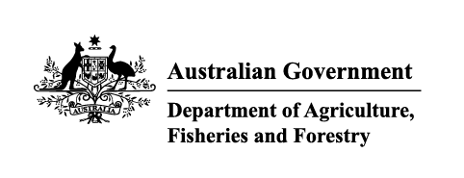

Instrument revoking a holding order under section 15(2) of the Imported Food Control Act 1992
The listed holding orders, having satisfied the circumstances under which the orders will be revoked, are revoked under section 15(2) of the Imported Food Control Act 1992 (the Act).
The circumstances being that the Secretary or delegate is satisfied that the basis for the order no longer applies.
Holding order number | Date revoked
19589 | 04/05/2026
20254 | 04/05/2026
18267 | 12/05/2026
18284 | 12/05/2026
20138 | 12/05/2026
20352 | 12/05/2026
20355 | 12/05/2026
18495 | 26/05/2026
19558 | 26/05/2026
18198 | 27/05/2026
19176 | 27/05/2026
19503 | 27/05/2026
19682 | 27/05/2026
20003 | 27/05/2026
20015 | 27/05/2026
20049 | 27/05/2026
20067 | 27/05/2026

Delegate position number | Date
100091 | 19/06/2026
Delegate of the secretary for the purposes of section 15(2) of the Act.

