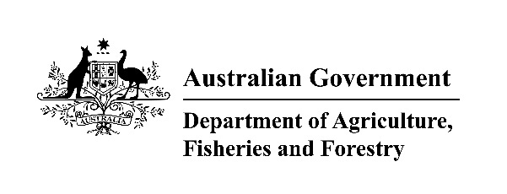

Notice of intent (NOI) to import livestock and equine reproductive material

Purpose
Importers of fresh livestock and equine reproductive material must provide this completed NOI or other written notification to the Department of Agriculture, Fisheries and Forestry (the department) no later than 3 working days prior to importation of the consignment.
It is recommended that importers of frozen livestock and equine reproductive material also complete this NOI and return it to the department, to facilitate efficient processing of the consignment and its associated documents.
The NOI also outlines the timing of other documentation you must submit to the department for consignments to be eligible for importation to Australia.

Requirements
Prior to filling out this NOI, please ensure you have the following:
- A valid import permit
- Final, endorsed copies of health certificate/s and associated documents (e.g. endorsed laboratory reports). These should be submitted by email to the regional office at the first point of entry for the reproductive material at least 3-5 days prior to the scheduled date of import and can be submitted with the NOI.
Note: The first point of entry is a legislative term referring to the port where the reproductive material tank/s will first land in Australia. If the tank/s will stay onboard for disembarkation and inspection at another location, the appointment should be made at the office where the inspection will take place. Please be aware that any secondary location would still need to have a determination as a first point of entry (i.e. one of the office locations listed below). For more information on which landing places or ports are determined to be a first point of entry, refer to Sending your goods to Australia - DAFF (agriculture.gov.au).
Email this NOI to the relevant regional office at least 3 prior to the scheduled arrival of the reproductive material in Australia.
Regional office contacts are as follows:
Melbourne – SEAnimal@agriculture.gov.au
Sydney – CERAnimalImports@agriculture.gov.au
Brisbane – qldliveanimalimports@agriculture.gov.au
Perth – WAliveanimalimports@agriculture.gov.au
If you are unable to provide any of the information requested in this NOI, please advise the regional office as soon as the information is available. The AIMS entry number must be provided prior to the tank inspection date.
Note: In accordance with Notice to Industry 2: Storage and inspection of imported livestock and equine reproductive material, an inspection of the tank/s must be booked with the relevant regional office. Bookings may be requested at the time the NOI and health certificate/s are sent to the regional office. Please be aware booking requests will not be accepted before these documents are presented and assessed as compliant.
Consignment details:
Flight number:
Air waybill number:
AIMS Entry number:
Import permit number:
Commodity (e.g. equine semen; bovine embryos):
Fresh or frozen (mark applicable box): | Fresh ☐ | Frozen ☐
Country of export:
Place of loading in country of export:
Exporter name:
Exporting organization (if applicable):
Number of tanks/containers

Seal number/s:
Contacts and inspection preferences:
Name of person in charge (permit holder/importer):
Organisation (if applicable):
Address:
Phone:
First landing place in Australian territory:
Preferred inspection location/date/time:
(Note: location refers to Regional Office or Class 1.2 Approved Arrangement site – specify name.
For Melbourne, please indicate either WCBM World Freight or Melbourne Regional Office)
Estimated day and time of arrival:
Name of person/agent attending inspection:

Privacy notice
‘Personal information’ means information or an opinion about an identified individual, or an individual who is reasonably identifiable. Personal information that is collected under or in accordance with the Biosecurity Act 2015 is also ‘protected information’ under the Biosecurity Act 2015.
The collection of ‘protected information’ including personal and sensitive information by the Department of Agriculture, Fisheries and Forestry (the department) in relation to this form is being collected under the Biosecurity Act 2015 for the purposes of determining the eligibility of the consignment for import and to assign appropriate resources to the clearance of this import and related purposes. If the relevant personal information requested in this form is not provided by you, the department may be unable to provide clearance services for your import. Information collected by the department will only be used or disclosed as authorised under the Biosecurity Act 2015.
The personal information requested on this form may be disclosed to the police or other commonwealth agencies. It will not usually be disclosed overseas. In every case it will only be disclosed if authorised by the Biosecurity Act 2015.
See our Privacy Policy web page (Privacy - DAFF (agriculture.gov.au)) to learn more about accessing or correcting personal information or making a complaint. Alternatively, telephone the department on +61 2 6272 3933.

