Resource title | National Plantation Inventory regions boundaries (2016) dataset Version 2
Graphic(s) | 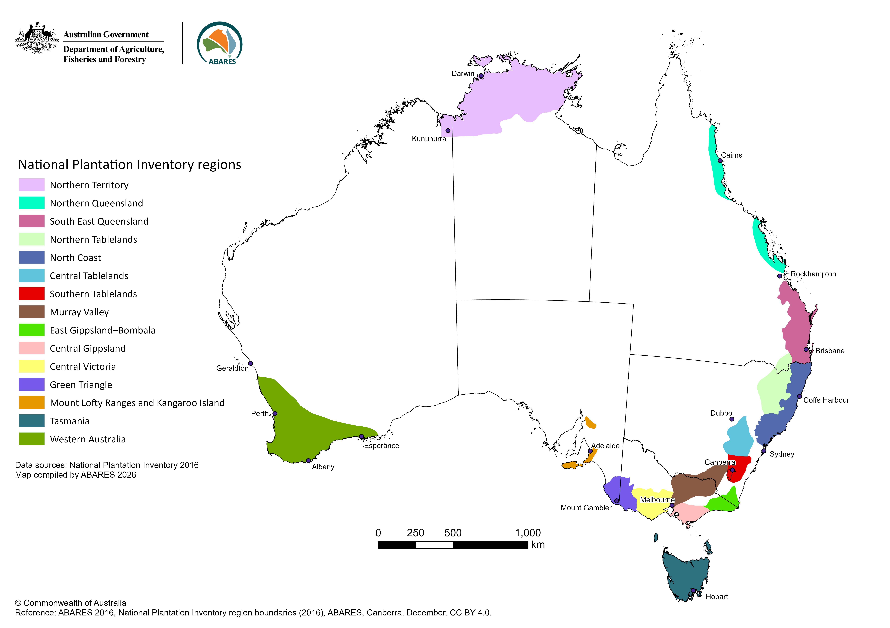
Citation | ABARES 2026, National Plantation Inventory Regions boundaries (2016) dataset Version 2, Australian Bureau of Agricultural and Resource Economics and Sciences, Canberra, October. CC BY 4.0
Digital object identifier (DOI) | https://doi.org/10.25814/3fa8-5356
Custodian  Jurisdiction | Australian Government Department of Agriculture, Fisheries and Forestry – Australian Bureau of Agricultural and Resource Economics and Sciences (ABARES)
Custodian  Jurisdiction | Australia
Contact organisation  Address  Email | ABARES
Contact organisation  Address  Email | GPO Box 858 Canberra ACT Australia 2601
Contact organisation  Address  Email | Info.ABARES@aff.gov.au​
Summary | The National Plantation Inventory regions boundaries (2016) dataset describes the boundaries of the 15 National Plantation Inventory (NPI) regions for Australia. The NPI is a component of the National Forest Inventory (NFI), managed by the Australian Bureau of Agricultural and Resource Economics and Sciences (ABARES). This updated version removes a minor duplication in the dataset attribute table and data not directly related to the regional boundaries. No changes have been made to the NPI regions boundaries since 2016.
Abstract | The National Plantation Inventory (NPI) is a component of the National Forest Inventory (NFI), managed by the Australian Bureau of Agricultural and Resource Economics and Sciences (ABARES).  The National Plantation Inventory (NPI) regions were established by the Bureau of Resource Sciences (now ABARES) in 1995 to facilitate national reporting on Australia’s commercial (industrial) plantation estate regionally, as well as at state, territory and national levels. The boundaries were developed in consultation with the NPI Reference Committee which consisted largely of grower and industry representatives.  The 15 NPI regions are largely based on the extant plantation estate and represent economic wood supply zones. Wood flows are not constrained by political borders, and thus six of the regions span state or territory borders: Northern Tablelands (New South Wales/Queensland); Southern Tablelands (Australian Capital Territory/New South Wales); Murray Valley (New South Wales/Victoria); East Gippsland/Bombala (Victoria/New South Wales); Green Triangle (Victoria/South Australia); and Northern Territory (Northern Territory/Western Australia).  This dataset represents the date that the NPI regions boundaries were last modified (2016). The first compilation of spatial data for commercial plantations, reported by the NPI regions, was completed in 1996 with a map-based report published in 1997 (National Forest Inventory, 1997). An update to the regions boundaries occurred for the 2006 five-yearly spatial NPI report (Parsons et al. 2006) with the renaming of the Lofty Block NPI region to Mount Lofty Ranges and Kangaroo Island to better reflect the geographic extent of the region; the expansion of the North Queensland NPI region to include additional plantations between Rockhampton and Mackay, effectively merging the central and southern areas; and the expansion of the Western Australia NPI region to encompass the Esperance region. The Northern Territory NPI region was expanded for the 2016 five-yearly spatial NPI report (ABARES 2016) to encompass existing and potential plantations in the Daly River area in the Northern Territory and the Ord River irrigation area in northeastern Western Australia.  The NPI regions were designed to capture most of the plantation estate. However, commercial and farm forestry plantations can occur outside the currently defined NPI regions, in accordance with landholder decision making.  NPI reporting of annual tabular (non-spatial) plantation statistics began in 1999, to complement the 5-yearly spatial updates, with reporting limited to state, territory and national levels. Validation and reporting by each NPI region is only possible in the comprehensive five-yearly spatial reports (Wood et al, 2001).  The National Plantation Inventory regions boundaries (2016) dataset is used by the Australian Government for domestic reporting.
Purpose | To facilitate national reporting on Australia’s plantation estate and wood flows.
ANZLIC search words | FORESTS  FORESTS Natural  FORESTS Plantation  FORESTS Production  FORESTS Agroforestry  BOUNDARIES Administrative
Keyword(s) | Australia  Forest  Forestry  Plantation  Farm forestry  NPI  National Plantation Inventory region  Forest industry
Sources used to generate this resource | ABARES (2016). Australian plantation statistics 2016, Australian Bureau of Agricultural and Resource Economics and Sciences, Canberra, August. CC BY 3.0  National Forest Inventory (1997). National Plantation Inventory of Australia. Bureau of Resource Sciences, Canberra.  Parsons M, Gavran M and Davidson J (2006). Australia’s plantations 2006. Bureau of Rural Sciences, Canberra.  Wood M, Stephens NC, Allison BK and Howell CI (2001). Plantations of Australia 2001 – a report from the National Plantation Inventory and the National Farm Forestry Inventory. National Forest Inventory, Bureau of Rural Sciences, Canberra.
Publication date | 11 June 2026
Latest date of information/currency | 17 August 2016
Data file name | NPI_regions_2016_v2
Stored data format | GIS files created using Esri ArcPro 3.5.0 software: Shapefile feature vector digital data
Compressed file size | 645 KB
Geographic extent | Australia’s mainland and close offshore islands, excluding external territories.
Geographic extent | North bounding Latitude: -8.2°  South bounding Latitude: -44.4°  East bounding Longitude: 157.2°  West bounding Longitude: 109.5°
Scale 1: 250,000 | Scale 1: 250,000
Spatial reference | ESPG:3577 GDA94 Australian Albers
Spatial reference | Coordinate system: GDA_1994_Albers  False Easting: 0  False Northing: 0  Central meridian: 132°  Standard parallels: -18°, -36°  Latitude of origin: 0°  Datum: D_GDA_1994
Positional accuracy | Horizontal: ±50 metres  Vertical: not applicable
Attribute accuracy | Attributes are compiled exercising due care and skill. However, accuracy of attributes is in part dependent on the accuracy of data supplied to ABARES and therefore cannot be guaranteed.
Completeness | Dataset provides coverage of the fifteen National Plantation Inventory regions boundaries in Australia, listed in Appendix 1, as at date of publishing.
Update frequency | As required
Licencing | Creative Commons by Attribution 4.0 International (CC BY 4.0)
Access constraints | No restriction, nil cost.
Use constraints | CC BY 4.0 permits:  Share – users may copy and redistribute the material in any medium or format.  Adapt – users may remix, transform, and build upon the material for any purpose, even commercially.  Attribution – users must give appropriate credit using the citation listed, provide a link to the licence, and indicate if changes were made. Users may do so in any reasonable manner, but not in any way that suggests the licensor endorses the use.
Disclaimer | The Australian Government acting through the Department of Agriculture, Fisheries and Forestry, represented by the Australian Bureau of Agricultural and Resource Economics and Sciences, has exercised due care and skill in preparing and compiling the information and data in this publication. Notwithstanding, the Department of Agriculture, Fisheries and Forestry, ABARES, its employees and advisers disclaim all liability, including liability for negligence and for any loss, damage, injury, expense or cost incurred by any person as a result of accessing, using or relying on any of the information or data in this publication to the maximum extent permitted by law.
Metadata date | 11 June 2026
Additional metadata | See Appendix 1 and Appendix 2

Appendix 1
Table 1: Name of National Plantation Inventory regions boundaries
National Plantation Inventory Region | Date of establishment | Notes
Western Australia | 2006 | Developed in 1996 as the south-west corner of Western Australia from east of Albany to a midpoint between Perth and Geraldton, it was extended to the east to encompass the Esperance region for the 2006 NPI reporting cycle.
Northern Territory | 2016 | Developed in 1996 as Northern Territory, this region was expanded in the 2016 NPI reporting cycle to encompass areas south of Darwin in the Northern Territory and in the Ord Valley in northeast Western Australia.
Mount Lofty Ranges and Kangaroo Island | 2006 | Developed in 1996 as Lofty Block, this region was renamed Mount Lofty Ranges and Kangaroo Island to better reflect its geographical extent.
Green Triangle | 1996
Northern Queensland | 2006 | Developed in 1996 comprising three areas in North Queensland, this region was expanded in the 2006 NPI reporting cycle to include additional plantations between Rockhampton and Mackay, effectively merging the central and southern areas. The region is included in the shapefile as comprising two separate areas.
South East Queensland | 1996
Northern Tablelands (NSW) | 1996
North Coast (NSW) | 1996
Central Tablelands (NSW) | 1996
Southern Tablelands (NSW) | 1996
Murray Valley | 1996
Central Victoria | 1996
Central Gippsland | 1996
Bombala-East Gippsland | 1996
Tasmania | 1996

Appendix 2
Table 2: Data table description
Attribute name | Description
NPI_region | NPI region name
NPI_ID | Numeric identifier allocated to each NPI region. The two areas comprising North Queensland are represented by the NPI_ID 5, reflecting historic numbering.
REGCODE | Text code allocated to each NPI region, where North Queensland is represented by two areas with codes 5a and 5b, reflecting historic numbering

Bibliography
ABARES 2016, Australian plantation statistics 2016, Australian Bureau of Agricultural and Resource Economics and Sciences, Canberra, August.
Gavran, M & Parsons, M 2011, Australian plantation statistics 2011, Australian Bureau of Agricultural and Resource Economics and Sciences, Canberra
Legg, P., Frakes, I., and Gavran, M. (2021), Australian plantation statistics and log availability report 2021, ABARES research report, Canberra, October, DOI: 10.25814/ xj7c-p829. CC BY 4.0.
National Forest Inventory (1997), National Plantation Inventory of Australia, Bureau of Resource Sciences. Canberra.
Parsons, M., Gavran, M., and Davidson, J. (2006), Australia’s Plantations 2006, Bureau of Rural Sciences, Canberra.
Wood, M.S., Stephens, N.C., Allison, B.K., and Howell, C.I. (2001), Plantations of Australia – A report from the National Plantation Inventory and the National Farm Forest Inventory, National Forest Inventory, Bureau of Rural Sciences, Canberra.

