# National Traceability Framework

Enhancing Australia’s world-class agricultural traceability systems

Final version as at 7 March 2019

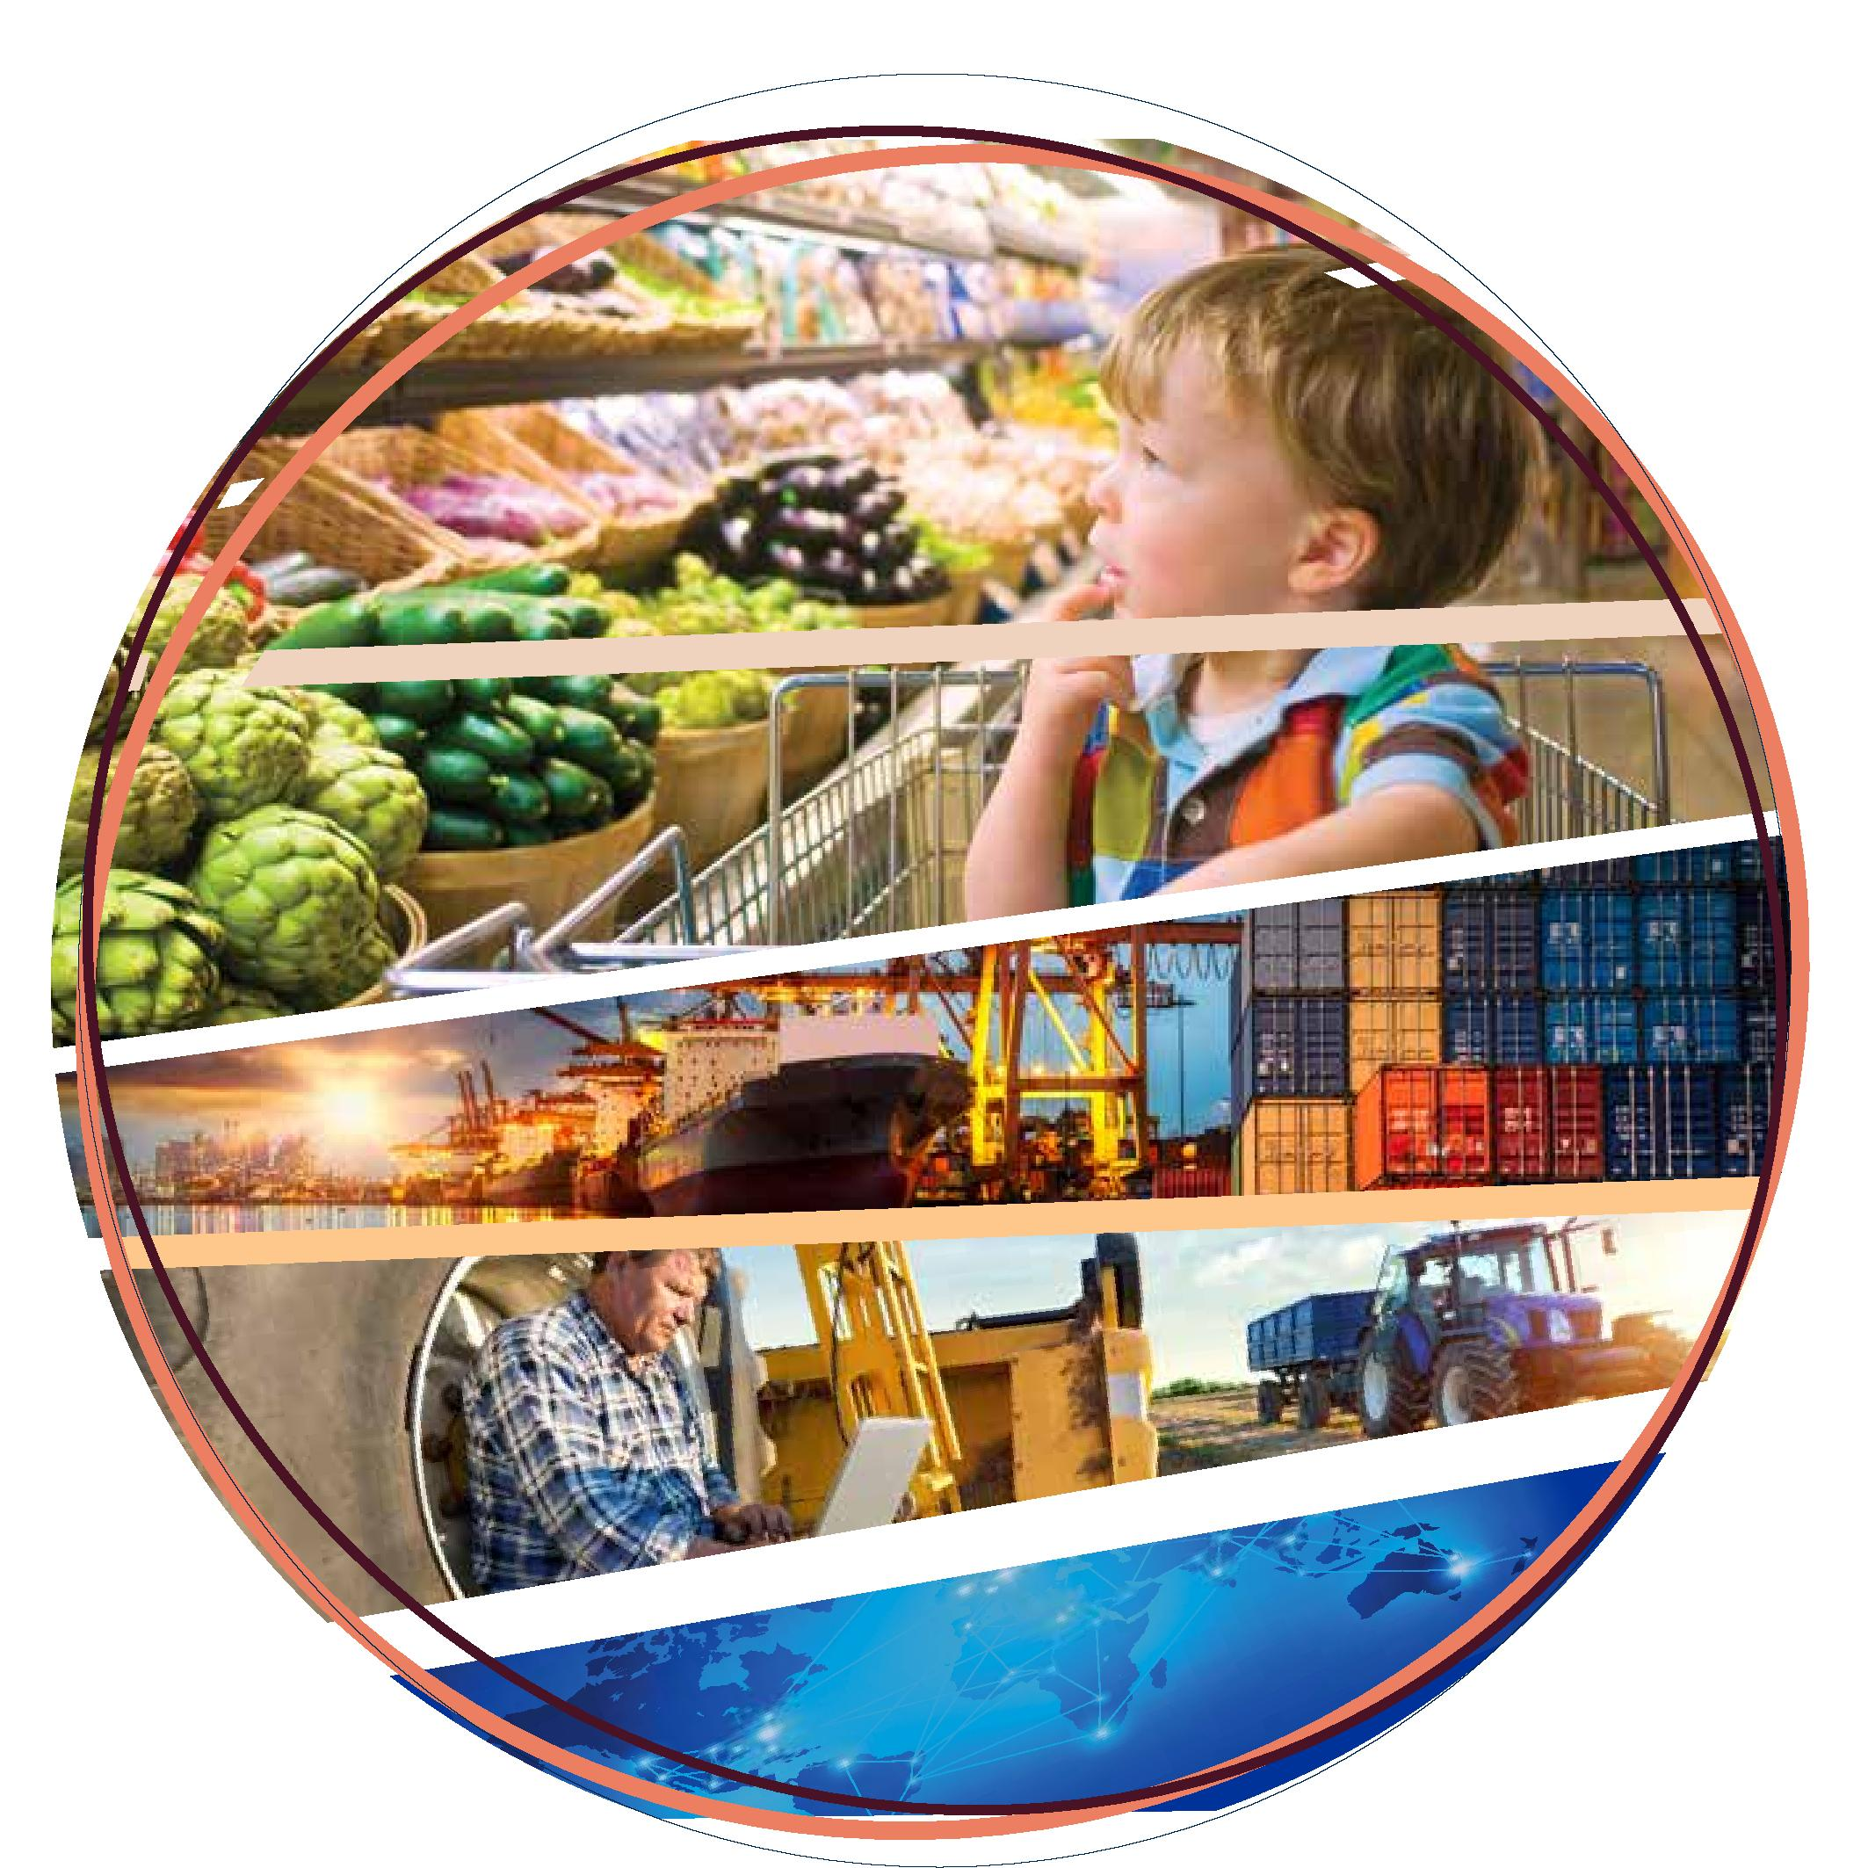

© Commonwealth of Australia 2019

**Ownership of intellectual property rights**

Unless otherwise noted, copyright (and any other intellectual property rights, if any) in this publication is owned by the Commonwealth of Australia (referred to as the Commonwealth).

**Creative Commons licence**

All material in this publication is licensed under a Creative [Commons Attribution 4.0 International Licence](https://creativecommons.org/licenses/by/4.0/legalcode) except content supplied by third parties, logos and the Commonwealth Coat of Arms.

Inquiries about the licence and any use of this document should be emailed to [copyright@agriculture.gov.au](mailto:copyright@agriculture.gov.au).

C:\Documents and Settings\west merryn\Local Settings\Temporary Internet Files\Content.Word\by.png

**Cataloguing data**

This publication (and any material sourced from it) should be attributed as: The Traceability Working Group 2019, *National Traceability Framework: enhancing Australia’s world-class agricultural traceability systems*, Canberra, 29 January. CC BY 4.0.

ISBN: 978-1-76003-197-8

This publication is available at [www.haveyoursay.agriculture.gov.au/national-traceability-project](https://haveyoursay.agriculture.gov.au/national-traceability-project).

Department of Agriculture

GPO Box 858 Canberra ACT 2601

Telephone 1800 900 090

Web [agriculture.gov.au](http://agriculture.gov.au/)

The Australian Government acting through the Department of Agriculture has exercised due care and skill in preparing and compiling the information and data in this publication. Notwithstanding, the Department of Agriculture, its employees and advisers disclaim all liability, including liability for negligence and for any loss, damage, injury, expense or cost incurred by any person as a result of accessing, using or relying on any of the information or data in this publication to the maximum extent permitted by law.

Contents

Introduction iv

1 Purpose 1

2 Scope 3

3 Vision 4

4 Principles 5

5 Developing an industry action plan 6

Outline of action plan elements 6

Outcomes of traceability systems 7

6 Governance 9

Monitoring, evaluation and review 10

7 Co-creators 11

Appendix A: Industry action plan template 1

References 1

**Tables**

Table 1 National Traceability Framework—roles and responsibilities 9

**Figures**

Figure 1 Australian traceability governance—relationship between industry and government 10

## Introduction

The value of Australian farm production is forecast to reach $60 billion in 2018–19, according to the [Agriculture overview: September quarter 2018](http://www.agriculture.gov.au/abares/research-topics/agricultural-commodities/sept-2018/agriculture-overview). It is estimated that 70 per cent of this production will be exported. Trend growth of Australian agriculture will depend on maintaining and improving access to export markets for our agricultural products and food.

Australia has a reputation for producing safe, high quality agricultural products and food, for both domestic and export markets, supported by effective traceability systems. Our traceability systems serve us well. However, if we are to continue to build on our reputation, including maintaining and improving our competitive advantage in international markets, it is timely that we look at enhancing our traceability systems to ensure our agricultural products are well supported into the future and able to respond to international drivers for change.

The National Traceability Framework is a tool to guide Australian agricultural industries and food producers, governments and related businesses in enhancing our traceability systems and promoting ‘brand Australia’ in our international markets. Modern, accurate, and timely traceability systems can assist in providing additional assurances to consumers of Australian agricultural products, and our trading partners, while also producing a range of other benefits such as increasing our market share in international markets.

Traceability is a key focus for Australian industries and government, and is increasingly gaining international attention. Many Australian agricultural and food producers, exporters and related businesses realise the commercial benefits of enhancing traceability.

Consumers and trading partners want to know more about the products they buy. This includes information about food safety, animal and plant pest and disease status, provenance, authenticity, sustainability and animal welfare. In the case of authenticity, improving transparency and strengthening assurances translates to building consumer trust and therefore, delivering on brand Australia’s promise. The desire to know more about products has been heightened by social media, which can intensify the impact of real or perceived food safety and biosecurity incidents.

Our international competitors are already responding to changing international dynamics and anticipating changes in global standards. Enhancing our traceability systems for agricultural products and food will ensure we continue to be a global leader with world-class agricultural traceability systems. It will assist in increasing our competitive advantage in export markets for our food and other agricultural products.

Australia’s agriculture ministers saw value in developing a national approach to enhancing our traceability systems to complement the extensive work being undertaken in this area by industries, Australian, state and territory governments, and through international fora. The framework complements and does not duplicate this work.

The framework supports a variety of agricultural industries and food producers with diverse requirements, under the umbrella of a united vision, to guide their approach to enhancing traceability.

The framework sets out a common vision, principles for traceability systems, roles and responsibilities of industries, governments and other stakeholders, suggestions for developing an industry action plan to implement the framework, traceability objectives and measures of success. It is the result of extensive collaboration between Australian agricultural industries and Australian governments. It is based on a [review of existing traceability systems in agricultural production](http://www.agriculture.gov.au/market-access-trade/traceability-project/report), mainly focussing on comparisons between industries that have regulated systems and those that do not. It assesses the performance of those systems and identifies global and future drivers for traceability systems that are commercial only, or regulated by the Australian government, and/or state and territory governments.

## Purpose

Changing consumer preferences including the desire for greater transparency along the food supply chain are driving demand for greater traceability world-wide. Modern consumers are more technologically connected, and socially and environmentally aware. They demand more timely and detailed information about the agricultural products they purchase such as matters concerning food safety, quality, provenance, authenticity, animal welfare practices and the sustainability of the processes associated with production. Trading partners are also demanding stronger assurances about agricultural and seafood products, often imposing new or changing import requirements. There is also evidence that trading partners are increasingly looking for certification attestations from the Australian Government that extend beyond food safety and biosecurity, the traditional drivers of government regulation in exported food and other agricultural products.

Alongside governments’ regulated requirements for traceability systems for either/both the domestic and export markets, commercial factors are driving the need for producers of agricultural products and food to implement effective traceability systems to support claims made about their produce. Industries have responded to these drivers and most have developed traceability systems that deliver a range of benefits for that industry. For industries where traceability systems are regulated, commercial traceability systems often provide what is needed by government in addition to providing commercial benefits.

Evolving and emerging technologies may provide new solutions for tracing agricultural products and food through the supply chain. They have the potential to reduce the cost of tracing, and provide accurate, accessible and timely information and identification of goods.

A national approach to both regulated and commercial traceability systems across agricultural supply chains provides the potential for benefits through consistent, coordinated regulation across jurisdictions, and the sharing of information and experiences between industries.

Alongside the commercial benefits and opportunities provided by a national approach to our traceability systems, it is also clear that a food safety or biosecurity incident involving a particular product or food can impact the entire sector, or even extend to other sectors, if the cause of the incident cannot be traced quickly and accurately. Reputational damage can take some time to repair, possibly years. Increasing global production and movement of agricultural products and food means that the risk of such an incident occurring is also increasing.

In this context, it is timely for Australia to seize the opportunity to enhance our traceability systems, and respond proactively to global drivers for change, utilising existing and new technologies and positioning agricultural industries to reap the significant benefits that enhanced traceability offers.

Benefits of enhancing traceability include marketability and market development, consumer confidence, biosecurity, market access, brand protection, waste reduction, emergency management, compliance with regulations, and collaboration with supply chain partners. Enhancing our traceability systems will mean that domestic and international consumers and trading partners have greater confidence in the approach taken by each agricultural industry and governments to trace agricultural products and food forward and back in each supply chain. Consumer trust in a variety of claims will be strengthened.

The framework is aimed at assisting industries and governments to approach the development and enhancement of national traceability systems. It will help ensure that Australia is well positioned to continue to meet the growing demands of our domestic and global consumers, and will be a useful document to showcase our systems to trading partners.

**By delivering** a common vision, a set of nationally consistent principles and specific guidance upon which enhanced systems can be developed, this framework will assist Australia to develop an advanced and consistent approach to traceability—across and within agricultural and food industries. While the framework may be amended over time to meet the requirements of industry and government, it will lay out some enduring values for the sectors.

The framework’s development through a co-design process with industries and governments has fostered a strong sense of collaboration. The framework acknowledges that this cooperation will be essential to achieving the framework’s outcomes.

**The** action plan template attached to the framework is designed to assist industries to set out their traceability plans for the future, and how they will implement these plans. The industry action plan template is composed of separate sections in which industries identify current traceability arrangements and initiatives, as well as the industry’s desired future-state. Australian governments will support and assist industries in the development and implementation of their action plans.

## Scope

The framework is concerned with the traceability of Australian agricultural food and other products destined for both export and domestic markets, including products sourced from goods imported into Australia. Traceability systems may be developed commercially and independently by industries, or they may be mandated and regulated by government.

Quality management systems provide the foundation for the production and processing of foods and other agricultural goods and ensure they meet specific requirements. The ability to trace the food or other goods through sourcing, processing and distribution, for example, a traceability system, is an important element of or partner to a quality management system. Traceability systems provide the mechanism to provide assurances about the claims made about the goods. Traceability systems and quality management systems are not the same, but do complement each other.

Regardless of whether they are voluntary or regulated, traceability systems should enable visibility throughout the entire supply chain, from the point of origin, through all stages of production, processing and distribution through to the point of sale, or clearance in the importing country, in the case of exported goods.

**This document** is concerned with the enhancement and harmonisation of traceability systems across state and territory borders, as well as our international border to derive net benefit for Australia domestically and internationally.

The framework is a guiding document primarily for agricultural industries and Australian governments. It can also be a point of reference for other participants in the supply chain, including producers, processors, retailers and exporters.

The framework is not a policy document, but rather a guide to develop approaches, systems, strategies, and any policies which may be required in the future. It is about positioning Australia to be prepared for the future, so that we have the flexibility to respond when faced with changing consumer or trading partner requirements.

**The industry** action plan and associated outputs will be developed with [the *Privacy Act 1988*](https://www.oaic.gov.au/privacy-law/) in mind, which regulates how personal information of individuals must be handled.

For the purposes of this framework:

**Traceability** is defined as ‘the ability to track any food/fibre through all stages of production, processing and distribution (including importation and at retail)’ (FSANZ 2017).

**Quality management systems** are the systems that describe production, processing and distribution. They are used for the purposes of ensuring food safety, supporting market access, and preventing the spread of pests and disease, of food and other agricultural goods produced. Traceability may be a feature of the assurance element of a quality management system.

**Agricultural products and foods** include raw and processed products and foods, such as meat, fibre, horticulture, dairy, eggs, forestry, grains, fertilisers, seafood and other fisheries products, honey and other bee products, oils, wine, animal by-products including skins and hides, rendered products and blood products, live animals and animal feed.

## Vision

Our vision for future traceability systems, for Australian food and other agricultural products, is:

Australia has world leading traceability systems that provide accurate information about, and timely identification and location of Australian agricultural products and food in domestic and global supply chains, and deliver benefits for consumers, industries and governments.

## Principles

The framework is underpinned by the following principles (not in order of priority):

1. **Industry-government partnerships:** assisting all industries to harness commercial opportunities and manage risks, and supporting government’s role as a regulator and certifier, through a combination of voluntary and regulated approaches.
2. **Industry ownership:** developing approaches to tracing agricultural products and foods is the primary responsibility of industries, incorporating the associated accountability, supported by governments.
3. **Trust:** supporting existing industry systems and facilitating community, consumer and trading partner trust by enabling claims to be more accurately assessed and strongly verified and improving transparency along the entire supply chain.
4. **Information:** enabling data collection that is meaningful, timely, complete, accurate, and can be readily shared between all supply chain stakeholders and government for mutually agreed purposes, and when it is economically beneficial to do so. Where desired by all industry participants in a supply chain, this could include the use of standardised codes and attributes to facilitate interoperability and visibility through the entire supply chain.
5. **Visibility through the entire supply chain:** enabling tracing of foods and other agricultural products through the supply chain. Where required this covers activities, from the point of origin, through all stages of production, processing, and distribution.
6. **Use of existing systems:** leveraging and building on existing systems, business processes and technologies where possible, to reduce cost and improve uptake.
7. **Harmonisation with standards:** implementing relevant international standards, to the extent desired, for both commercial and regulated traceability systems, that require each participant in the supply chain to be able to trace one-step forward and one-step back, as a minimum, and implementing domestic standards, as outlined in the Australia New Zealand Food Standards Code or other legislative instruments, and utilising these systems to facilitate domestic and international trade.
8. **Flexible and outcome-based solutions are ‘fit for purpose’:** accommodating a broad range of industry and government needs across agricultural products and foods, varying in their complexity and reasons for traceability.

## Developing an industry action plan

The action plan describes how an industry intends to proactively reap the benefits of enhanced traceability. Each industry, with support from government, is developing an action plan specific to that group. The industry action plan details current traceability systems and also represents industries’ commitment and vision for enhancing their future traceability systems. It is intended to be revised and updated from time to time, if required.

The industry action plan is an important part of the framework. The action plan template is attached (Appendix A). Industry themes and corresponding initiatives are expected to be made available on the department’s website. It is a working document and will therefore be reviewed from time to time, and amended if necessary.

In developing the industry action plan, consideration should be given to the principles outlined in the framework, which are reflected in this section.

### Outline of action plan elements

#### A national industry-government partnership

* a national approach to an enhanced traceability system is developed by each industry or group of related industries or producers, in collaboration with Australian governments, and is available along the supply chain to all participants in the sector, providing benefits for industry, businesses and government.
* an industry culture that stresses the importance of risk awareness and benefits to be realised by a collaborative national approach to traceability that enhances our current arrangements.
* industry traceability systems are transparent, ‘fit for purpose’, responsive to drivers for change and meet international standards, if relevant.
* if the system is regulated, Australian governments work together, and with the sector concerned, to regulate in a consistent and cost-effective manner.
* regular, open communication between agricultural industries and Australian governments.

#### Good governance

* for the enhanced traceability system for each industry, governance arrangements are clear, defining responsibility and accountability for the performance of the system.
* industries have primary responsibility for developing traceability approaches and systems, however, government collaboration may assist in achieving traceability outcomes.
* to the extent possible, Australian governments, have a responsibility for consistently regulating various aspects of agricultural and food supply chains. Collaboration and harmonisation of regulatory efforts and incident response systems is critical to achieve the optimal outcome.

#### Timely and accurate information and data management

* data and information provided along the chain is accurate and their management is efficient and secure, with sharing and governance arrangements in place.
* information is accessible and available for a range of purposes, while at the same time, commercially sensitive data or data which provides a competitive advantage is protected.
* the adoption of new technologies for data and information management is encouraged. Disruptive technologies should demonstrate a net benefit across the supply chain before adoption.

#### Cost effective

* both regulated and commercial traceability systems utilise and build on existing systems and technologies, where possible.
* each industry’s traceability system is ‘fit for purpose’ and responsive to external drivers for change.
* each industry’s traceability system manages risk with the benefits outweighing the costs.
* if regulation of food and other agricultural products is required, the regulation is outcome-based, and only regulates to the extent required.

#### Trust

* producers, businesses, and governments acknowledge the importance of trust and mutual commitment and collaboration in achieving visibility through the entire supply chain, including a greater emphasis on improving end-to-end capabilities.
* industries and government can provide strong and timely evidence to support claims made about agricultural products and food and thereby strengthen the trust of domestic and international consumers and trading partners.

### Outcomes of traceability systems

The five outcomes that follow can be delivered by a national approach to enhancing Australian agricultural traceability systems. These measures will be used by industry and government in considering the effectiveness of action plans in the future, and in informing any changes that may be required.

The success of each outcome can be measured qualitatively and through industry feedback and surveys.

Outcome 1: All participants along the supply chain are able to trace their goods one step forward and one step back as a minimum, with a view to increasing end-to-end capabilities in the future in order to remain competitive in an environment that is generating the rapid adoption of new technology on a global scale.

Success will be measured by:

* + The uptake, or increase in uptake, of voluntary commercial systems by supply chain participants, for industries that do not have established traceability systems.
  + The demonstrated ability to accurately trace specified product or animals within a given time period, for industries with established traceability systems.

Outcome 2: The speed and type of data required when tracing goods through the entire supply chain reflects the associated risk, with higher risk food and other agricultural products in terms of food safety and biosecurity, able to be traced much faster than lower risk food and other agricultural products. The economic impact of any incident is reduced because food safety incidents or pest or disease outbreaks can be quickly contained.

Success will be measured by:

* + A reduction in cost to industries caused by market disruptions resulting from food safety or biosecurity incidents that is associated with finding product, because food and other agricultural products of concern can be identified quickly.
  + Improved animal health and welfare with tracing livestock enabling containment and eradication of pest or disease outbreaks.

Outcome 3: Accurate records are maintained, available for scrutiny by all participants in the supply chain including end product consumers; and can be interrogated to enable more targeted tracing of food and other agricultural products.

Success will be measured by:

A reduction in the time taken to trace during market disruptions resulting from food safety, biosecurity, or other trade incidents, that is associated with finding product, and a reduction in the cost of compliance.

Outcome 4: All participants in the supply chain have the potential to benefit from the opportunity afforded to food and other agricultural products in market access and competitiveness by being able to establish and market provenance, and to provide stronger assurances about provenance.

Success will be measured by:

Feedback on improved access and returns*.*

Outcome 5**:** Opportunities presented by new technologies and platforms for automation are explored and harnessed as appropriate to keep Australian food and agricultural production at the forefront of an internationally competitive landscape.

Success will be measured by:

The uptake, or increased uptake, of electronic systems by supply chain participants where there is a net benefit to doing so.

## Governance

A strong industry-government partnership has been critical in the development of the framework and industry action plan, and will continue to be vital to their successful implementation. All stakeholders (industries, businesses and governments) must be committed to the outcomes of the Framework and continue to advocate for the importance of traceability. It is important that industries and governments work collaboratively if potential benefits are to be realised.

Industry and government each have important roles and responsibilities in developing and implementing the industry action plan. Within government, states and territories have different roles, at times, based on different objectives and policies. Governments continue to work toward integrating and aligning approaches.

Table 1 notes the most significant tasks and the responsible parties.

Table 1 National Traceability Framework—roles and responsibilities

| Roles and responsibilities | Industry and standards bodies | Businesses and primary producers | State and territory governments | Australian Government |
| --- | --- | --- | --- | --- |
| Developing an industry action plan, implementing, and periodically revising them | Yes | Yes | Yes | Yes |
| Coordinating ongoing stakeholder and/or member engagement regarding the industry action plan | Yes | Yes | Yes | Yes |
| Monitoring and reviewing progress towards action plan implementation, and measuring success in achieving outcomes | Yes | Yes | Yes | Yes |
| Collaboration between industry and governments on progress and challenges, and communicating updates across networks | Yes | Yes | Yes | Yes |
| Regulating traceability systems for biosecurity and food safety reasons, where, and if, required | – | – | Yes | Yes |
| Ensuring data and information is accurate and available if required. | Yes | Yes | Yes | Yes |

Traceability systems have been a feature of Australian agricultural supply chains for many years. This Framework is about developing a common approach to their future enhancement. The governance arrangements for the project are relatively simple, with industry and governments jointly responsible for ensuring the framework remains contemporary, and that the action plan’s implementation is monitored and amended, if required.

However, governanceof agricultural traceability systems, more broadly, is very complex. Industry is primarily responsible for developing commercial systems for individual or broad industry purposes. Australian governments also have a responsibility to regulate traceability systems if, and when, required. Where a traceability system is mandated by government for an industry, that industry may implement a commercial traceability system that goes beyond regulatory requirements.

Australian governments have traditionally regulated traceability systems for agricultural products and foods for purposes such as addressing food safety or biosecurity risks, addressing fraud, and for other market access purposes.

Figure 1 shows the relationship between industry and government, at a very high level, where industry may develop traceability systems for a broader range of purposes than government. Government’s regulation of food and other agricultural products may change in the future in response to global and other drivers, moving into new areas, extending to other food and other agricultural products in response to drivers for change, or being reduced in some areas.

Figure 1 Australian traceability governance—relationship between industry and government

**Government-regulated traceability systems**   
(For example, food safety, biosecurity, fraud)

**Industry and commercial   
traceability systems**

(For example, food safety and biosecurity,   
provenance, authenticity, sustainability)

Government responsibilities for food and other agricultural products are spread across a number of Australian and state and territory government ministers, departments and portfolios. This presents challenges for governments in the regulation of traceability systems to ensure they are coordinated, cost effective and cover all aspects of the supply chain appropriately.

### Monitoring, evaluation and review

The industry action plan template has been developed and populated through the collaboration of industries and government. It covers current initiatives and the future state of traceability systems. Ongoing monitoring of the implementation of the action plan is essential if the benefits of the framework are to be realised. Monitoring should ideally include measuring the success in achieving each of the outcomes outlined in the framework. The cross-jurisdictional traceability working group, led by the Commonwealth, with membership from the states and territories, will make recommendations to Agriculture Senior Officals’ Committee and the Agriculture Ministers Forum regarding future arrangements for this task.

## Co-creators

A broad range of Australian feed, food and fibre industries, supporting businesses, research bodies, technology providers, transport sectors, governments and other supply chain actors have contributed to the development of the framework through co-design workshops, individual meetings, and online consultation.

## Appendix A: Industry action plan template

Chapter five of the National Traceability Framework describes the elements for the industry to consider when developing an action plan. The action plan should reflect that the development of an action plan is an industry responsibility but there are benefits from doing this in partnership with government.

The action plan should include good governance arrangements, enable the provision of timely and accurate information about the product and data management, be cost effective and engender the trust of consumers and trading partners. It should ideally deliver five outcomes. The success of each outcome should be measured qualitatively and used to inform any future amendments to the plan (refer to the Outcomes of traceability systems in chapter five of the National Traceability Framework).

The action plan enables industries or industry groups to provide a snapshot of their current traceability systems and their future vision. Each industry will have a more detailed plan to support the snapshot provided in this document.

The action plan (and overarching framework) will be used by industry and governments to identify areas of collaboration, which may include allocation of resources. This plan may also be used to support export market access and shape global positions on traceability.

Industry themes from their action plans and corresponding initiatives may be made available on the department’s website.

| **Industry** | **Current arrangements**  Describe your industry’s current traceability system(s), and actions your industry is taking. For a regulated system, write ‘regulated’. | **Comments**  For example: Does your industry have systems in place or is more work required? Are there any impediments? Consider whether there is visibility across the supply chain and how quickly the product can be traced using your current systems. | **Where to next**  Describe your industry’s vision for a traceability system to be achieved in the next five years or beyond, including mechanisms to increase end-to-end capabilities and the potential use of technologies to record/share information. Estimate the value proposition of the proposed enhancements. | **Steps/time frames/issues**  For example: What are the steps to achieve your industry’s vision for future traceability? What issues and risks does your industry need to address, and how will your industry do this? How will your industry achieve broad uptake? How will these enhancements improve and/or protect your industry’s market access? |
| --- | --- | --- | --- | --- |
| **[Industry]**  Current as at:  Endorsed by: |  |  |  |  |

## References

ABARES 2016, [Agriculture overview: September quarter 2018](http://www.agriculture.gov.au/abares/research-topics/agricultural-commodities/sept-2018/agriculture-overview), Australian Bureau of Agricultural and Resource Economics and Sciences, Canberra.

FSANZ 2017, [Food traceability](http://www.foodstandards.gov.au/industry/safetystandards/traceability/pages/default.aspx), Food Standards Australia New Zealand.

Traceability Working Group 2018, [Enhancing Australia’s systems for tracing agricultural production and products](http://www.agriculture.gov.au/market-access-trade/traceability-project/report), Department of Agriculture and Water Resources, Canberra.