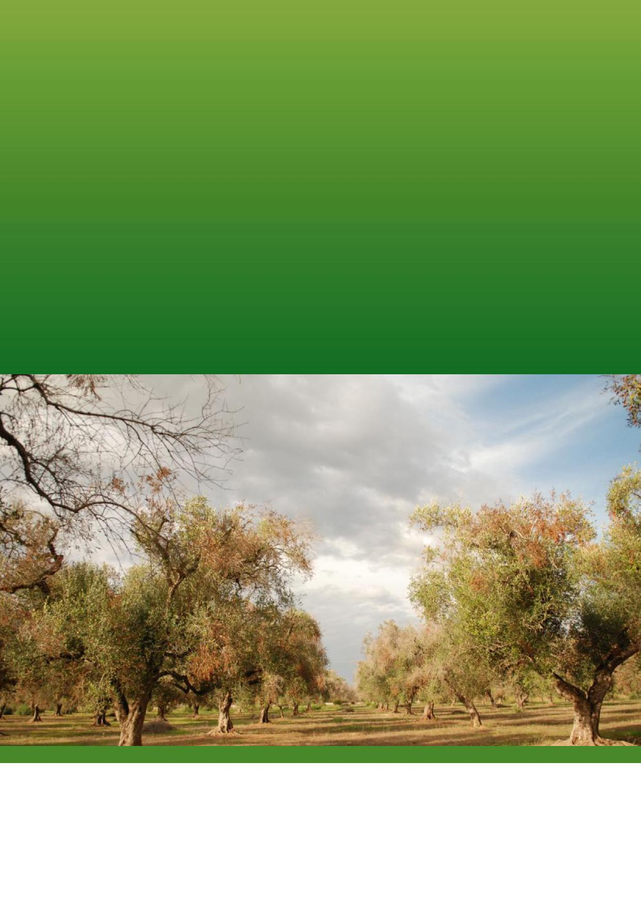

National *Xylella* Action Plan

2019–2029

Plant Health Committee

© Commonwealth of Australia 2019



National *Xylella*Action Plan 2019–2029

**Ownership of intellectual property rights**

Unless otherwise noted, copyright (and any other intellectual property rights) in this publication is owned by the

Commonwealth of Australia (referred to as the Commonwealth).

**Creative Commons licence**

All material in this publication is licensed under a Creative [Commons Attribution 4.0 International Licence](https://creativecommons.org/licenses/by/4.0/legalcode) except content

supplied by third parties, logos and the Commonwealth Coat of Arms.

Inquiries about the licence and any use of this document should be emailed to [copyright@agriculture.gov.au](mailto:copyright@agriculture.gov.au).



**Cataloguing data**

This publication (and any material sourced from it) should be attributed as: Department of Agriculture 2019, National

Xylella Action Plan 2019–2029, Canberra, December. CC BY 4.0.

ISBN 978-1-76003-###-#

This publication is available at **####**.

Department of Agriculture

GPO Box 858, Canberra ACT 2601

Telephone 1800 900 090

Web [agriculture.gov.au](http://agriculture.gov.au/)

The Australian Government acting through the Department of Agriculture has exercised due care and skill in preparing and compiling the information and data in this publication. Notwithstanding, the Department of Agriculture, its employees and advisers disclaim all liability, including liability for negligence and for any loss, damage, injury, expense or cost incurred by any person as a result of accessing, using or relying on any of the information or data in this publication to the maximum extent permitted by law.

**Cover page**

Symptoms in an olive orchard, © Camille Picard (DGAL-SDQPV, FR), European and Mediterranean Plant Protection

Organization (EPPO).

**Version control**

30 Jul-1 Aug 2019 v1.0 Endorsed by Plant Health Committee

Contents



National *Xylella*Action Plan 2019–2029

**Acknowledgments 2**

|  |  |  |  |
| --- | --- | --- | --- |
| **Executive summary** | **3** |  |  |
| **1. Introduction** | **4** |  |  |
| **2. *Xylella* and insect vectors** | **5** |  |  |
| **3. National *Xylella* Action Plan** | **7** |  |  |
| 3.1 Scope of the Plan | 7 |  |  |
| 3.2 Structure of the Plan | 7 |  |  |
| **4. National context** | **8** |  |  |
| 4.1 Legislation | 8 |  |  |
| 4.2 National arrangements | 9 |  |  |
| 4.3 The biosecurity continuum | 12 |  |  |
| **5. Action Areas** | **14** |  |  |
| Action Area 1: PREVENTION | 14 |  |  |
| Action Area 2: DETECTION | 19 |  |  |
| Action Area 3: RESPONSE | 23 |  |  |
| Action Area 4: CROSS-CUTTING ISSUES | 27 |  |  |
| **6. Implementation** | **32** |  |  |
| **7. Monitoring, evaluation and review** | **33** |  |  |
| **8. Relevant sources of information** | **34** |  |  |
| **9. Acronyms and abbreviations** | **36** |  |  |
| **10. Definitions/Glossary** | **37** |  |  |
|  |  |  |  |

**National *Xylella* Action Plan 2019–2029**





Acknowledgments

The Department of Agriculture has developed the National *Xylella* Action Plan 2019–2029 (the Plan) by drawing on input and feedback from a diverse group of experts and stakeholders gained through several national workshops and an International Symposium in 2017. This input has assisted the identification of the core biosecurity activities to prevent and prepare for *Xylella* should it be detected in Australia, and to validate the actions proposed in this Plan. The contribution of these people and organisations is acknowledged.

Our particular thanks go to speakers at the International Symposium for sharing their expertise and experiences. Video presentations and a report on the outcomes of the symposium are available on the [Department of Agriculture website](http://www.agriculture.gov.au/pests-diseases-weeds/plant/xylella/international-symposium-xylella-fastidiosa).

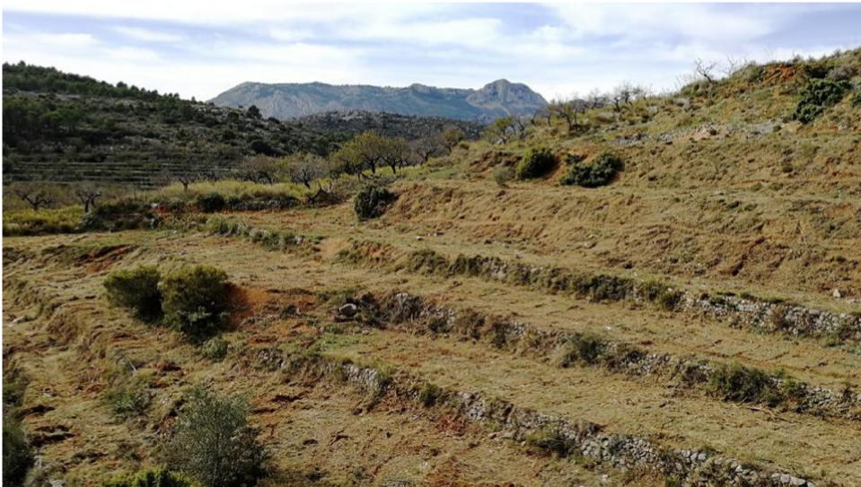

Uprooted almond orchard in the Alicante province following the detection of an infested tree (Spain, 2018) © Camille PICARD (EPPO)

Executive summary



**N** National *Xylella*Action Plan 2019–2029

*Xylella fastidiosa* is one of the most significant emerging plant disease threats worldwide, and we are fortunate that it is not present in Australia. The vision is that Australia remains free of bacterial pathogens of the *Xylella* genus and is prepared to respond should the need arise. *Xylella* and exotic vectors have been identified as Australia’s top National Priority Plant Pest in recognition of the potential to severely impact Australia’s plant industries and environment.

Managing *Xylella*-caused disease is economically costly, with management activities costing the Californian grape industry an estimated US$104 million per annum and the Brazilian citrus industry US$120 million per annum (IPPC 2017). An economic modelling study conducted by the Australian Bureau of Agricultural and Resource Economics and Sciences (ABARES 2017) estimated, that if established, the potential cost of *Xylella fastidiosa* to Australia’s grape and wine sector alone could range from $2.8 billion to $7.9 billion over 50 years in adjustment costs and foregone gross margins.

*Xylella* has complex epidemiology with broad genetic diversity that enables it to colonise numerous host species, and when transmitted by common xylem sap-feeding insects, it has potential to spread vast distances. For the purposes of this document, use of the name *Xylella* is inclusive of all *Xylella fastidiosa* subspecies, genetic strains and closely related species (such as *Xylella taiwanensis*).

*Xylella* is known to naturally infect 664 species from 88 families of commercial, ornamental and native plants. It kills susceptible plants, though there is genetic diversity within certain host plant species that have a level of tolerance to the pathogen, and can be asymptomatic. There is no known practical treatment once a plant has been infected.

The National *Xylella* Action Plan (the Plan) provides a national approach to enhance Australia’s

capacity to prevent the introduction of *Xylella* and prepare for a response, should it be detected in Australia, and sets out how the actions to achieve this outcome.

The success of this Plan is dependent on a high level of cooperation and collaboration between horticultural industries, all levels of government, non-government organisations and individuals, experts, and research agencies. The Plan is supported by an implementation schedule which will be used to record the progress of actions; set out roles, responsibilities and funding; and to communicate with stakeholders on progress.

Plant Health Committee, as the relevant national committee for plant biosecurity has endorsed the Plan and will oversee implementation of the Plan on behalf of governments. Relevant peak industry bodies will be engaged on implementation of the Plan through the recently appointed National *Xylella* Preparedness Coordinator (jointly funded by Horticulture Innovation and Wine Australia), relevant research and development corporations, Plant Biosecurity Research Initiative and other forums.

The Plan will be formally reviewed every five years, but the actions set out in the Plan will evolve as knowledge is gained through research and overseas experience.





National *Xylella*Action Plan 2019–2029

**1. Introduction**

The National *Xylella* Action Plan (the Plan) is intended to guide the implementation of nationally-agreed actions for a strategic and risk-based approach to enhance Australia’s ability to prevent the introduction of species of the bacterial genus *Xylella* and to prepare for a response, should *Xylella* be detected in Australia. The vision is that Australia remains free of *Xylella*, but is prepared to respond should the need arise.

The Plan recognises that there are many unknowns regarding potential impact of *Xylella* on the Australian environment and plant industries. Knowledge gaps for native insects that may be vectors and vector plant hosts should be addressed to help prepare for an incursion. The Plan identifies areas for further work to better understand the pest, and to build national expertise and capability.

Determining *Xylella* as Australia’s top National Priority Plant Pest (2019) is reflective of the significant potential impact to Australia’s plant industries and environment. National Priority Plant Pests are identified by the Plant Health Committee as exotic plant pests of significant concern to Australia, are under eradication, or have limited distribution and are the focus of government investment and action. *Xylella* is also a High Priority Pest for 12 Australian plant industries, as identified through Plant Health Australia’s biosecurity planning processes (see section 4.2). Box 1 outlines the characteristics of *Xylella*, highlighting the potential threat to Australia.

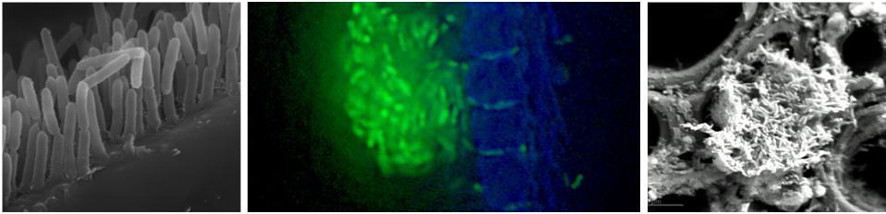

|  |  |  |
| --- | --- | --- |
| *Xylella* in vector foregut © Rodrigo Almeida | *Xylella* were passing through almost all of the narrow pits between xylem vessels (arrows). The *Xylella* cells were fluorescing green because they were mutants created by inserting a green fluorescent protein gene  © Alexander Purcell | *Xylella fastidiosa* in tomato © Alexander Purcell |

|  |
| --- |
| **Box 1. Species of *Xylella*:**   1. are spreading globally into new areas through human-mediated spread and xylem sap-feeding insects 2. live within the water conducting tissues of plants and have a complex epidemiology that enables them to colonise numerous host species and xylem sap-feeding insects 3. may be asymptomatic in some plants; or show symptoms that could be confused with water stress, the presence of other plant pathogens, or nutrient disorders 4. have the potential to have significant impacts totalling millions of dollars annually to horticultural industries, and unquantifiable impacts on communities and the environment 5. are currently managed by control of insect vectors, and removal of infected plants plus all surrounding vegetation 6. would be challenging to eradicate if not detected early given the broad host range and large number of potential native insect vectors 7. would be challenging to eradicated given the wide host range and spectrum of insect species capable of serving as vectors. |

*2. Xylella* and insect vectors



National *Xylella*Action Plan 2019–2029

*Xylella* is one of the most significant emerging plant disease threats worldwide. The bacterium is transmitted by

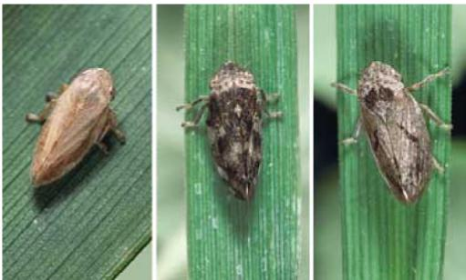

*Xylella* vectors

© Jack Clark, UCCE, Davis, CA

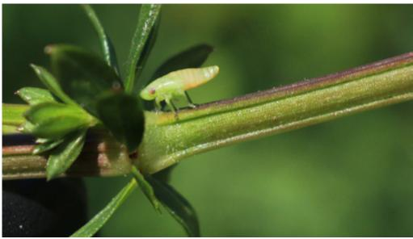

Close up of a spittle bug nymph. Scientific name *Philaenus spumarius*. Creates a foam of bubbles around them for protection. This is known as cuckoo spit. Spreads the *Xylella* bacterium.

© [shutterstock.com](http://shutterstock.com)

common xylem sap-feeding insects, with human-mediated long-distance dispersal of infected plants and/or insects a primary driver of introduction. The bacterial pathogen is not present in Australia, but its global distribution is rapidly increasing. Australia has many native xylem sap-feeding insects that could be potential vectors of the pathogen.

*Xylella* infects and establishes within the water-conducting system (the xylem) of plants, where bacterial aggregates, and tyloses and gums formed by the plant can block xylem vessels causing water stress symptoms. Disease induction may not be due simply to water blockage, and some plant species are more susceptible than others.

A typical symptom of *Xylella-*caused diseases is ‘leaf scorch’ due to prolonged water-stress; however, plants may be asymptomatic, especially in the first two years of infection and dependent on *Xylella*-plant host species interactions. *Xylella* is known to naturally infect 664 species from 88 families across commercial, ornamental and native plant species, with the host range increasing as *Xylella* is introduced into new territory. The European Food Safety Authority (2018) maintains a

database of plants that are known hosts for the bacterium.

*Xylella-*caused diseases include Pierce’s disease of grapevines, citrus variegated chlorosis of citrus species, almond leaf scorch, pear leaf scorch, and olive quick decline syndrome. Diseases caused by *Xylella* can result in death within two years in susceptible plants, though there is some genetic diversity in tolerance to the pathogen within host plant species.

A serious disease on grapes in California during the late 1800s was caused by an unidentified pest since determined to be a bacterium in the late 1970s and named by Wells et al. (1987) as *Xylella fastidiosa*. *Xylella* has since spread with movement of asymptomatic infected plants and has been confirmed throughout the Americas, Middle East, Asia and Europe. *Xylella* has been reported in Italy, France, Germany, Switzerland and Spain over the last 10 years. The causal agent of pear leaf scorch in Taiwan was formerly published as a new species, *Xylella taiwanensis*, in 2016.

An overview of the current knowledge of hosts and global status for bacterial species in the genus *Xylella* is provided in Table 1.

**TABLE 1 Current understanding of bacterial species in the genus *Xylella***



National *Xylella*Action Plan 2019–2029

|  |  |  |  |
| --- | --- | --- | --- |
| **Species/subspecies** | **Reported host(s) \*** | **Associated disease(s)** | **Reported in** |
| ***Xylella fastidiosa*** | | | |
| *X. fastidiosa* subsp.  *fastidiosa*  which includes:  “*X. fastidiosa* subsp. *sandyi*” “*X. fastidiosa* subsp. *tashke*” “*X. fastidiosa* subsp. *morus*” | Hosts include: alfalfa, almond, walnut, peach, cherry, grape, elderberry, *Rubus*, citrus, avocado, coffee, guava, persimmon, maple, oleander, *Eucalyptus*, *Nandina* and mulberry | almond leaf scorch, Pierce’s disease of grapevines, alfalfa dwarf, bacterial leaf scorch, oleander leaf scorch, mulberry leaf scorch | North America, Central America, Iran, Asia (China, Taiwan), Turkey, Italy, Israel |
| *X. fastidiosa* subsp.  *multiplex* | Hosts include: almond, pecan, walnut, blueberry, elm, oak, beech, ash, alder, liquidamber, sumac, oleander, ginkgo, peach, plum, cherry, grape, pear, olive, sycamore, mulberry, fig, sunflower, grasses, *Acacia*, *Westringi*a | phony disease of peach, plum leaf scald, almond leaf scorch, pecan leaf scorch, blueberry leaf scorch, bacterial leaf scorch | North and South America, France, Spain |
| “*X. fastidiosa* subsp. *pauca*” | Hosts include: citrus, coffee, olive, almond, peach, plum, walnut, oak, oleander, grasses, Acacia, Grevillea, Westringia | citrus variegated chlorosis, coffee leaf scorch, olive quick decline, almond leaf scorch, bacterial leaf scorch | Central and South America, Italy, Spain |
| ***Xylella taiwanensis*** | | | |
| *X. taiwanensis* | Host: pear | pear leaf scorch of  Asian pear | Taiwan |

**\*** Indicative hosts only, as the understanding of hosts continues to evolve and change.

Virtually all insects of the suborder Auchenorrhyncha, which includes cicadas, leafhoppers, froghoppers, sharpshooters, spittle bugs and treehoppers, which feed predominantly on xylem sap can be considered to be potential vectors. The meadow spittle bug (*Philaenus spumarius*) and the glassy-winged sharpshooter (*Homalodisca vitripennis*) have proven to be highly efficient vectors of *Xylella*, leading to disease spread across Europe and California, respectively.

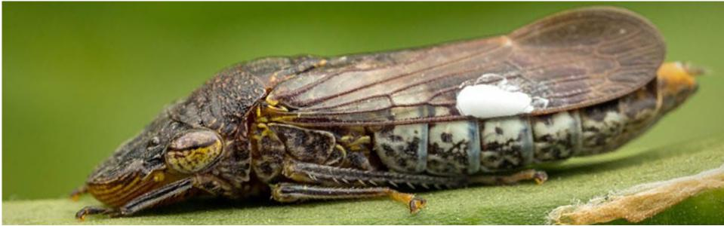

*Homalodisca vitripennis* (glassy winged sharpshooter), adult at rest. The white dots on the wings are a liquid containing a great number of microscopic structures called brochosomes. The insect paints these on her eggs, where they may serve to protect against desiccation or predation. Austin Texas, USA. March 2015

*© Alexander L. Wild*

3. National *Xylella* Action Plan



National *Xylella*Action Plan 2019–2029

3.1 Scope of the Plan

This Plan describes the elements of a national approach across the biosecurity continuum— prevention, detection and response—and sets out actions and priorities to improve the management of risks associated with *Xylella*. The actions are applicable to all subspecies and genetic strains of *X. fastidiosa*, and closely related species (such as *Xylella taiwanensis*), and are relevant to all stages of the biosecurity continuum.

3.2 Structure of the Plan

This Plan first describes the national context for biosecurity risk management and is then structured into three action areas aligned with the biosecurity continuum—prevention, detection and response—and one area of cross-cutting actions. The cross-cutting area has actions that fit into two or more of the key biosecurity continuum areas. The latter sections describe how the Plan will be implemented, and how progress monitored and evaluated.

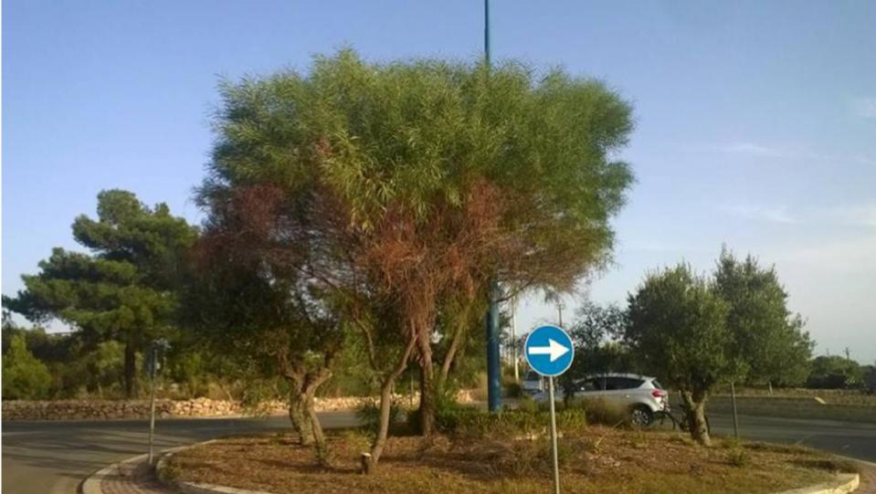

Symptoms on *Acacia saligna*

© Donato Boscia, CNR - Institute for Sustainable Plant Protection, UOS, Bari (IT), (EPPO)

4. National context



National *Xylella*Action Plan 2019–2029

Australia’s biosecurity system operates under Commonwealth, state and territory legislation which are administered and managed by the respective government agricultural and environmental agencies. These agencies also contribute to early detection, national response arrangements, and committees, in collaboration and consultation with industry and other stakeholders.

4.1 Legislation

Legislation relevant to the management of *Xylella* is listed in Table 2. Legislative provisions are used to prevent the entry, establishment and spread of *Xylella* in Australia. Application of other legislation, including instruments relating to environmental protection, may be used if *Xylella* was to become established in Australia.

**TABLE 2 Jurisdictional legislation relevant to *Xylella***

|  |  |  |
| --- | --- | --- |
| **Jurisdiction** | **Administering authority** | **Primary legislation** |
| Commonwealth | Department of Agriculture | *Biosecurity Act 2015* |
| Australian Capital Territory | Environment Planning and  Sustainable Development  Directorate | *Pest Plants and Animals Act 2005* |
| New South Wales | Department of Primary Industries | *Biosecurity Act 2015* |
| Northern Territory | Department of Primary Industries and Resources | *Plant Health Act 2008* |
| Queensland | Department of Agriculture and Fisheries | *Biosecurity Act 2014* |
| South Australia | Primary Industries and Regions | *Plant Health Act 2009*  *Phylloxera and Grape Industry Act 1995* |
| Tasmania | Department of Primary Industries, Parks, Water and Environment | *Plant Quarantine Act 1997* |
| Victoria | Department of Jobs, Precincts and Regions | *Plant Biosecurity Act 2010* |
| Western Australia | Department of Primary Industries and Regional Development | *Biosecurity and Agricultural Management Act 2007* |

4.2 National arrangements



National *Xylella*Action Plan 2019–2029

Well established relationships and national arrangements are in place between the Commonwealth, state and territory governments, industry and other stakeholders to coordinate and implement national action on biosecurity issues, including *Xylella*. Plant Health Australia is the national coordinator of the government-industry partnership for plant biosecurity in Australia, and is the custodian for the Emergency Plant Pest Response Deed (EPPRD).

Biosecurity planning and preparedness

Plant Health Australia works with industries and governments to develop strategies and plans that improve biosecurity standards, as well as providing assistance with implementation of agreed risk mitigation measures, such as biosecurity plans, biosecurity manuals for producers and awareness raising extension services.

Each of Plant Health Australia’s plant industry members (39 in mid-2019) undergoes biosecurity planning to identify their High Priority Pests (those assessed to pose the greatest risk) and risk mitigation measures. Through this process, 12 plant industries have identified *Xylella* as a High Priority Pest and several others will be potentially affected in the event of an incursion of *Xylella* in Australia (Table 3).

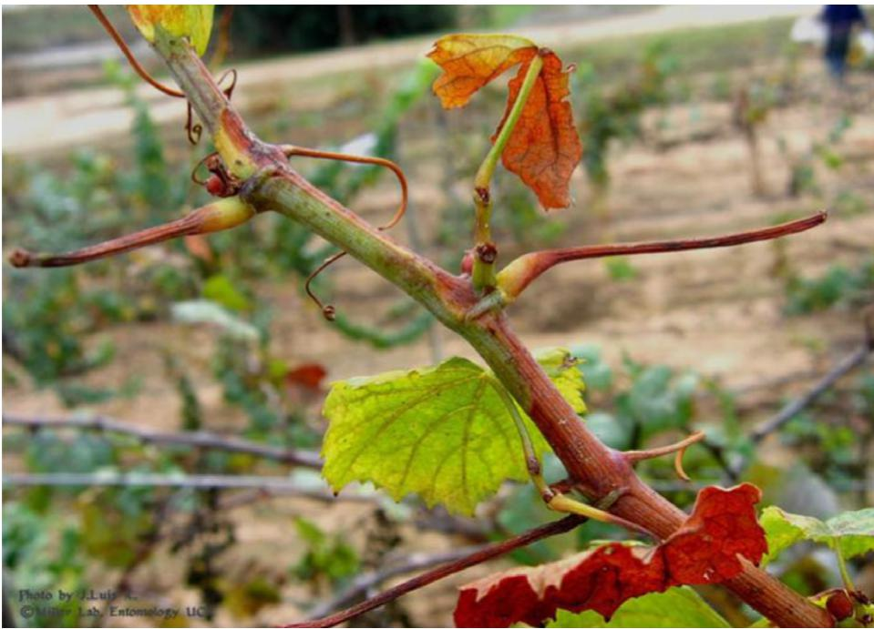

‘Green islands’, ‘match sticks’ and leaf necrosis - all characteristic symptoms of Pierce's Disease   
© Prof. Thomas A. Miller

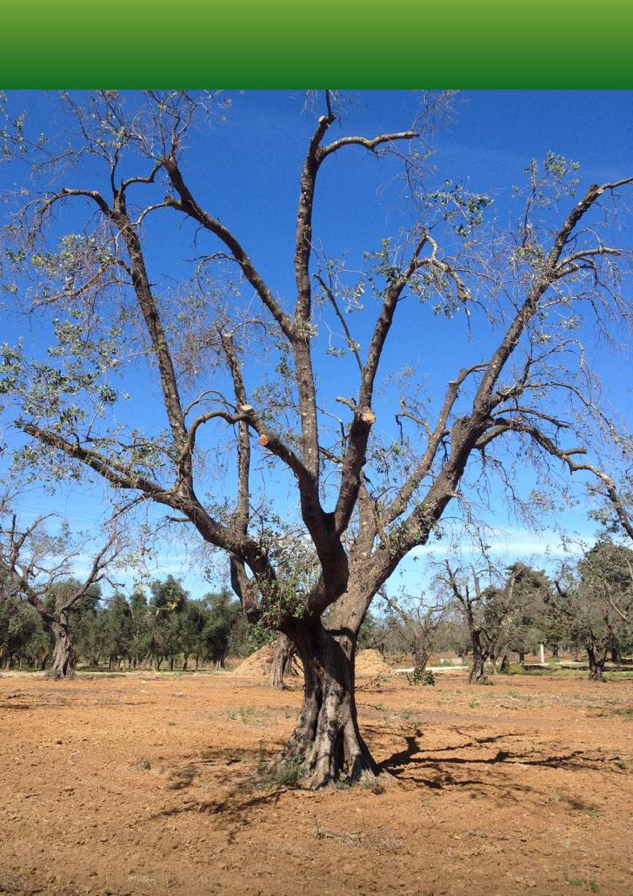

National *Xylella*Action Plan 2019–2029

Olive tree with decline symptoms from *Xylella* © Luigi Paglia

**TABLE 3** **Peak industry body for plant industries that are potentially affected by *Xylella***



National *Xylella*Action Plan 2019–2029

|  |  |  |
| --- | --- | --- |
| **Peak industry body for plant industry** | **EPPRD  signatory?** | **Identified *Xylella* spp.  as High Priority Pest?** |
| Almond Board of Australia | Yes | Yes |
| Apple and Pear Australia | Yes | No |
| Australian Blueberry Growers Council | No | Yes |
| Australian Forest Products Association | Yes | No |
| Australian Macadamia Society | Yes | Yes |
| Australian Mango Industry Association | Yes | No |
| Australian Olive Association | Yes | Yes |
| Australian Table Grape Association | Yes | Yes |
| Australian Tea Tree Industry Association | Yes | No |
| Australian Truffle Growers Association Inc | Yes | No |
| Australian Vignerons | Yes | Yes |
| Australian Walnut Industry Association | Yes | Yes |
| Avocadoes Australia | Yes | No |
| Canned Fruit Industry Council of Australia | Yes | No |
| Cherry Growers Association | Yes | Yes |
| Chestnuts Australia | Yes | No |
| Citrus Australia | Yes | Yes |
| Dried Fruits Australia | Yes | Yes |
| Hazelnut Growers of Australia | Yes | No |
| Nursery and Garden Industry Australia | Yes | Yes |
| Pistachio Growers Association | Yes | No |
| Raspberries and Blackberries Australia | Yes | No |
| Summerfruit Australia | Yes | Yes |
| Other crops with no representative body – coffee | No | No |

Emergency response arrangements



National *Xylella*Action Plan 2019–2029

For *Xylella*, the relevant national agreement governing a response is the EPPRD, which is a binding agreement between the Australian, state and territory governments, plant industry body signatories and Plant Health Australia. The EPPRD covers the management and funding of responses to Emergency Plant Pests and is supported by a nationally agreed technical plan, PLANTPLAN. All governments and industry signatories have agreed that eradication of economically important plant pests should be pursued when it is technically feasible and cost beneficial to do so, and that the costs of eradication are shared across affected parties.

*Xylella fastidiosa* is a Category 2 Emergency Plant Pest under the EPPRD, meaning that if a national eradication Response Plan was endorsed, the cost of implementing it would be shared 80:20 between governments and affected industry parties, respectively.

National committees

Australian governments have established national committees to provide a formal mechanism for developing and coordinating key plant biosecurity policy and procedures that are nationally consistent, and to identify activities to enhance national biosecurity preparedness and response capability.

The National Biosecurity Committee is responsible for a national strategic approach to emerging and ongoing biosecurity policy issues across jurisdictions. The National Biosecurity Committee is supported by a number of sectoral committees which provide policy, technical and scientific advice on matters affecting their sectors for all pests and disease risks to terrestrial and aquatic (inland water and marine) animals and plants, and the environment.

For *Xylella*, Plant Health Committee (which is supported by the Subcommittee on Plant Health Diagnostics, Subcommittee on National Plant Health Surveillance, and Subcommittee on Domestic Quarantine and Market Access) is the relevant sectoral committee to provide advice to the National Biosecurity Committee (Department of Agriculture 2019).

4.3 The biosecurity continuum

The generalised biosecurity invasion curve (Figure 1) outlines the changing role of governments and stakeholders as actions to respond to a pest or disease change from prevention, eradication, or containment to asset-based protection (management). ‘Entry’ or detection of a new pest incursion into Australia lies between prevention and eradication. The ‘return on investment’ of public funds generally reduces with progression along the invasion curve, but is still beneficial at the asset-based protection end of the curve for species that are of national interest.

As the area impacted by a pest increases (moving from left to right on the curve), the chance of successful eradication reduces and containment may become a preferred option. Ultimately and without intervention, asset-based protection, or management, will be the only option with the cost primarily borne by the land holder.

Governments are considered to have a greater responsibility in the earlier stages of the curve (prevention and eradication), whereas those best placed to protect assets (public or private) from established pests and diseases are generally the owners of those assets. The environmental, primary production and social costs of inaction are high, especially at the prevention and eradication end of the curve. While it is possible to determine the economic cost in terms of adverse effects on primary production, at present there are few agreed models to measure the ecological cost of exotic pests and diseases in economic terms.





**N** National *Xylella*Action Plan 2019–2029

**FIGURE 1 Biosecurity invasion curve**

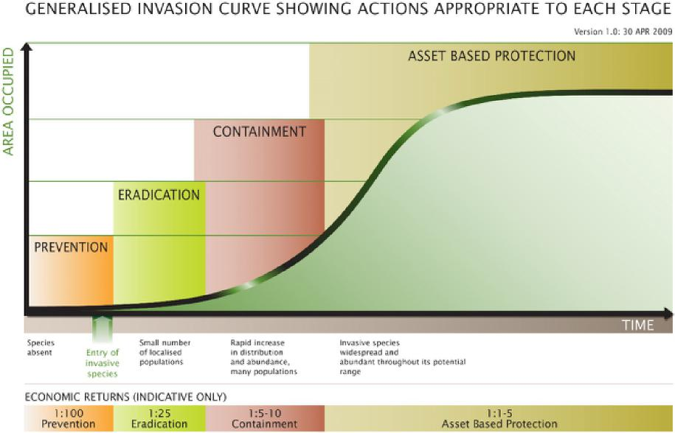

Source: Agriculture Victoria, 2009

The action areas identified in this Plan align with the early stages of the generalised invasion curve, noting that as Australia is currently free of *Xylella*, this Plan does not include actions relating to containment and asset-based protection. The take home message from Figure 1 is that the best investment of resources is in the early stages of an invasion of a pest—prevention and eradication.

5. Action Areas



National *Xylella*Action Plan 2019–2029

This section describes the elements of a national approach across the biosecurity continuum— prevention, detection and response—and sets out actions and priorities to improve the management of risks associated with *Xylella* spp*.* and vectors. It also identifies several cross-cutting actions that are relevant to two or more of the key biosecurity continuum areas.

**Action Area 1: PREVENTION**

Prevention is aimed at minimising the likelihood of entry of a new pest into Australia. The actions identified in this key area aim to achieve a better understanding of the diversity and relationship between *Xylella*, insect vectors and hosts, potential pathways into Australia, means by which to minimise the risk of this entry, establishment and spread, and capabilities needed to quickly identify *Xylella* and insect vectors.

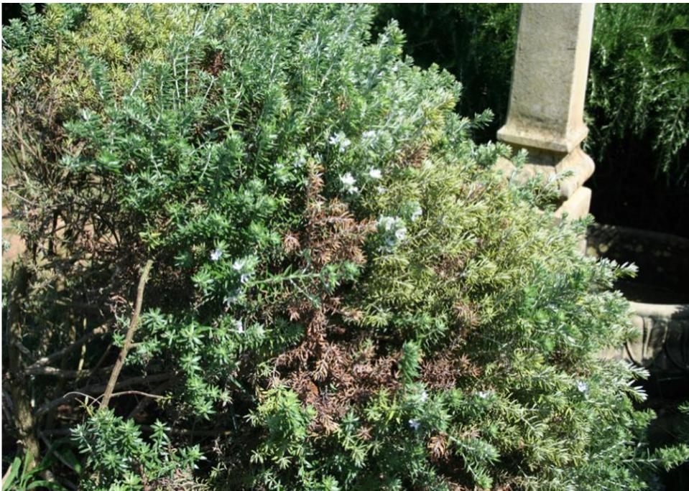

Symptoms on *Westringia fruticosa*

© Donato Boscia, CNR - Institute for Sustainable Plant Protection, UOS, Bari (IT), (EPPO)

**Action 1.1: Conduct a pest risk assessment and maintain appropriate regulation at the Australian border to minimise the risk of introduction into Australia.**



National *Xylella*Action Plan 2019–2029

***A pest risk assessment is an important tool to assess the changing global distribution and hosts of***

***this pathogen and to identify the most effective risk management measures available to prevent entry to Australia.***

The Department of Agriculture maintains biosecurity controls at the Australian border to prevent the introduction of *Xylella* and exotic vectors into Australia. Each year, the department clears and inspects large volumes of nursery stock, including materials that are potential hosts of *Xylella.* In response to an increasing threat, the department implemented emergency measures for *Xylella* in November 2015 to manage the import of an expanded range of host plant material, excluding fruit and seeds which are not considered a pathway for spread of the pathogen.

The emergency measures apply to nursery stock and live plant material of all species from regulated families of plants (currently 89 families are regulated) that are known to host *Xylella* from high and low risk countries. These measures include tissue cultures, cuttings, budwood, some corms and bulbs, but excludes fruit and seeds which are not known to transmit *Xylella*. The Department of Agriculture currently considers that all countries in the Americas including the Caribbean, all countries in Europe, India, Iran, Israel, Lebanon, Taiwan, Turkey and Israel to be high risk countries. Import measures are also in place to manage the risk of introduction of exotic vectors, for example on cut flowers. Australia’s import conditions are available at: [bicon.gov.au](https://bicon.agriculture.gov.au/BiconWeb4.0).

In line with international obligations and standards set by the International Plant Protection Convention, a pest risk assessment is being conducted to support the emergency measures. This is currently in progress and will include some information relevant to other actions identified in this Plan. Ongoing monitoring of the global situation and adjustment of border measures, as necessary, will be undertaken so that regulation at the Australian border remains appropriate.

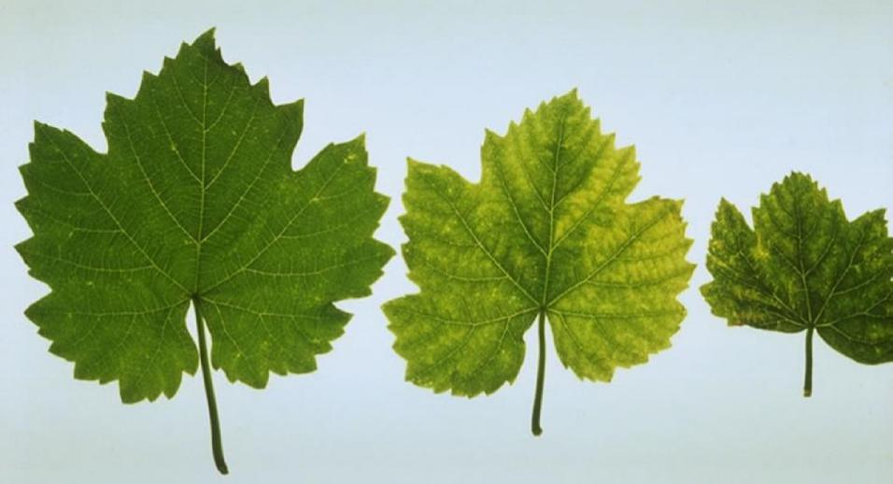

Pierce's disease of grapevine. Spring symptoms in cultivar Chardonnay (healthy leaf on the left)   
© A.H. Purcell, University of California, Berkeley (US).

**Action 1.2: Identify plants that occur in Australia that are known, or have potential, to be hosts.**



National *Xylella*Action Plan 2019–2029

***Understanding which plants that are native to, or grown in Australia are susceptible to infection will support surveillance, trade and response, and enable modelling of the potential distribution of* Xylella *in Australia.***

Overseas experience has shown the diverse range of plants that can host or be susceptible to *Xylella*, including those that are native or established in an area. Given this range, and the uncertainty of whether a plant can be an asymptomatic host, the Department of Agriculture has taken a strict approach on imports into Australia, with regulation based on families of plants that are known to host *Xylella.* Many of these families, such as Asteraceae, Myrtaecae, Proteaceae, include plant species that are native to Australia and some Australian species grown internationally have been infected, for example *Acacia dealbata* and *Westringia fruticosa* in Italy.

The pest risk assessment (Action 1.1) will address this action to some extent, but further work is required to identify and document plants that occur in Australia that are known, or have potential to be hosts of *Xylella*. As part of this action, research will be required to identify and test the pathogenicity on Australian native and key environmental plants that have the potential to be hosts. This research may need to be done offshore through suitable overseas laboratories, such as CSIRO’s European Laboratory in Montpellier and those identified by [Euphresco](https://www.euphresco.net/) (European Network for Phytosanitary Research Coordination). The Department of Agriculture has been a member of Euphresco since 2017 and can access a data-base listing projects, organisations, and individuals working on *Xylella*.

The International Plant Sentinel Network aims to facilitate collaboration amongst botanic gardens and arboreta, National Plant Protection Organizations, and plant health scientists to provide an early warning system of new and emerging pests. Member gardens will provide scientific evidence regarding known quarantine organisms and potential new risks to their respective government to inform plant health activities and thus help safeguard susceptible plant species worldwide. This network could provide informal intelligence on Australian plants grown overseas that are identified as hosts of *Xylella*.

**Action 1.3: Identify insects that occur in Australia that are known, or have potential, to vector *Xylella*.**

***If* Xylella *is detected in Australia, control of insects that have the potential to transmit the pathogen will be a key response tool. We need to understand the diversity of insects in Australia that will need to be controlled.***

There is enormous potential for *Xylella* to spread rapidly, with human-mediated plant movement and insect vectors likely to play a key role. As most plants (possibly up to 90 per cent of species, Purcell in DAWR 2017) could be affected, there is the potential for the pathogen to be present in asymptomatic plants from where it could be transmitted prior to detection. Work in affected countries highlights the importance of knowing which insects are vectors of *Xylella*, their distribution and biology, and how efficient they are at transmission; noting that in practice, transmission by vectors is also dependant on vector population densities and vector access to infected hosts.

This action aims to develop an understanding of the diversity of insects in Australia that will, or



National *Xylella*Action Plan 2019–2029

have the potential to vector *Xylella*, and their efficiency for transmitting the pathogen. As part of

this action, research should be undertaken to test the ability of potential Australian native vectors

(such as endemic Australian spittle bugs and leaf-hoppers) to transmit *Xylella*. This research may need

to be done through suitable overseas laboratories, similar to Action 1.2.

A project has been initiated and is being evaluated through Horticulture Innovation to increase Australia’s capacity and preparedness for *Xylella*, which includes a component aiming to identify potential native vectors and their distribution within Australia.

**Action 1.4: Analyse known and potential vectors and hosts to improve understanding of potential risks.**

***Some plant host and vector associations are likely to have a more significant impact than others, and need to be identified and understood in the Australian context.***

While most plants could be affected by *Xylella* , potential vectors may be restricted to a more limited number of plant species and some associations, such as the grapevine/glassy-winged sharpshooter association (in the United States) or the olive/meadow spittle bug association (in Italy). How these, or other similar associations or relationships, behave in the Australian context needs to be understood.

Relationships and interactions between *Xylella*, vectors, host plants, environment and crop management options are diverse. For example, the abundance of the glassy-winged sharpshooter is lower among water-stressed host plants compared with well-watered hosts. On the other hand, host water-stress (laboratory study on grapevines) was observed to increase the uptake of *Xylella* by the vector.

While it may be difficult to predict the actual association(s) in an establishment and spread event, a better understanding of potential host and vector interactions will provide the foundation for design of future response options. This work will also assist delivery of Action 4.4.

**Action 1.5: Build biosecurity capacity in our southeast Asian and Pacific neighbours.**

***Australia’s near neighbours are part of our pest and disease defence network and by working closely together, we can better protect the region from* Xylella*.***

Strong relationships and opportunities for collaboration with our southeast Asian and Pacific neighbours on biosecurity will strengthen their ability to recognise establishing pests and diseases to their region. This will improve effectiveness of response and control activities, as well as providing a level of early warning intelligence to Australia.

Strong ties already exist through regional biosecurity programs, such as in the Solomon Islands and surveillance activities Timor-Leste and Papua New Guinea. This work should encompass a review of capability for prevention and preparedness for *Xylella* in near neighbours, and aim to increase awareness and facilitate building of any required capability.

**TABLE 4 Summary table of Action Area 1: PREVENTION**



National *Xylella*Action Plan 2019–2029

|  |  |  |  |
| --- | --- | --- | --- |
| **Action Area 1** | | **Priority** | **Timeframe \*** |
| Action 1.1 | Conduct a pest risk assessment and maintain appropriate regulation at the Australian border to minimise the risk of introduction into Australia. | High | Short term |
| Action 1.2 | Identify plants that occur in Australia that are known, or have potential, to be hosts. | High | Short term |
| Action 1.3 | Identify insects that occur in Australia that are known, or have potential, to vector *Xylella* | High | Short term |
| Action 1.4 | Analyse known and potential vectors and hosts to improve understanding of potential risks. | Medium | Medium term |
| Action 1.5 | Build biosecurity capacity in our southeast Asian and Pacific neighbours. | Medium | Long term |

**\*** Indicative timeframes: SHORT up to 3 year; MEDIUM 4 to 8 years; LONG up to 10 years

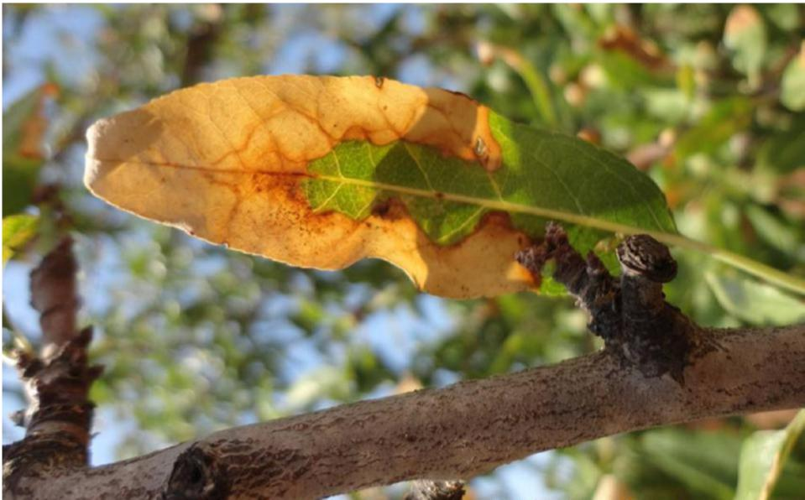

Symptoms on almond

© Donato Boscia, CNR - Institute for Sustainable Plant Protection, UOS, Bari (IT), (EPPO)

**Action Area 2: DETECTION**



National *Xylella*Action Plan 2019–2029

Detection is focused on ensuring that the right tools and strategies are in place to find and identify *Xylella* and exotic vectors. The actions identified include appropriate strategies for surveillance and diagnostic capacity.

**Action 2.1: Develop diagnostic testing capacity and capability to differentiate between species of *Xylella*, subspecies (and genotypes) of *X. fastidiosa* subsp. *fastidiosa*, and to identify vectors.**

***Standardised and nationally agreed diagnostics techniques including protocols that provide accurate, reproducible results are needed to support response activities.***

*Xylella* is genetically diverse and evolves quickly, and genotypes vary in their ability to cause disease in a broad range of plant species. This means that diagnostic capabilities are needed to differentiate subspecies and genetic strains (genotypes), and to be able to detect the pathogen in asymptomatic plants. In many cases, symptoms caused by *Xylella* are too generic and can be confused with water stress or diseases caused by other pathogens. For response purposes, the turnaround time of diagnostics and capacity (samples per day) will be very important—especially if looking for low prevalence in populations—so any culture-based diagnostics will be unlikely to be useful.

Capabilities required include development of diagnostic protocol(s), molecular diagnostic tools and techniques, and access to *Xylella* genomic DNA as positive controls and appropriate reagents such as PCR primers. Current diagnostic capabilities and national laboratory capacity to test for *Xylella* and exotic vectors should be reviewed as part of this work. Training will also be required to ensure that diagnosticians are suitability skilled.

An update to the International Plant Protection Convention diagnostic protocol (IPPC 2018) is now available. Protocols for the detection and identification of *Xylella fastidiosa* using culturing and pathogenicity tests, as well as serological and molecular methods are included (IPPC 2018).

A diagnostics project has been initiated through Horticulture Innovation and led by Agriculture Victoria to increase Australia’s capacity and preparedness for *Xylella*, which includes a component to increase national diagnostic capacity for the different species and subspecies of *Xylella*.

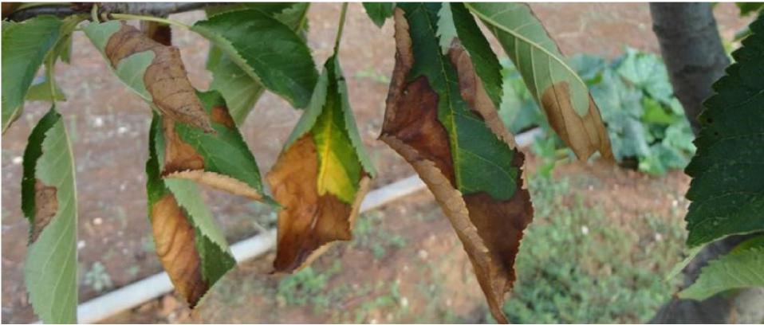

Symptoms on cherry

© Donato Boscia, CNR - Institute for Sustainable Plant Protection, UOS, Bari (IT), (EPPO)

**Action 2.2: Establish high-throughput diagnostic testing capacity   
and capability.**



National *Xylella*Action Plan 2019–2029

***Establishing and maintaining capability and capacity to test large volumes of samples will place us in a better position to respond should Xylella be detected in Australia.***

Mass-screening of thousands of plants and insects per year is done in the outbreak areas of Europe. Based on the Italian experience, mass screening was required of leaf samples from olive orchards and for insect samples, which assisted in identifying established insects able to vector the pathogen. This highlights the importance of having access to reliable and readily available diagnostic tests and processes for high-throughput screening, including Enzyme-Linked Immunosorbent Assay (ELISA), Polymerase Chain Reaction (PCR), Quantitative [real-time] PCR, and Loop-Mediated Isothermal Amplification (LAMP). Also important is to understand the options and constraints for pooling samples, and the specificity and sensitivity of any tests.

To ensure that laboratories in Australia are prepared to handle large numbers of samples, work is required to develop and validate high-throughput capacity and capability, and to ensure the availability of experienced diagnosticians.

The Subcommittee on Plant Health Diagnostics has assessed ‘surge capacity’ for *Xylella,* and

will propose strategies to improve national capability. Additionally, the Horticulture Innovation

diagnostics project being led by Agriculture Victoria (see Action 2.1) will contribute to this action.

**Action 2.3: Develop and validate cost-effective field-based diagnostic tools and procedures to support surveillance.**

***Reliable and affordable diagnostic tools that can be deployed in the field will assist rapid and accurate identification of* Xylella*.***

Clear guidelines are needed for sampling plants and vectors in the field and for triaging samples for diagnostics. We need to improve our knowledge of how sample pooling affects the reliability of different types of diagnostic tests used to detect the pathogen. A review of field-based diagnostic tools and procedures to support surveillance has been conducted as part of the Agricultural Competitiveness White Paper and determined that a LAMP assay for *Xylella fastidiosa* is available— but not to subspecies level.

The specificity and sensitivity of sampling and diagnostic procedures for systemic and non-systemic plant hosts need to be better understood. In systemic hosts, the bacterium can be found throughout the host. Whereas, in non-systemic hosts the bacterium is only present at local infection sites making sampling choice critical to diagnostic confidence.

Having a range of validated diagnostic tools and procedures available for use in the field will provide a more cost-effective way to test for *Xylella*, thereby increasing our ability to survey greater areas and numbers of plants and providing a more active, real-time early warning system.

The Horticulture Innovation diagnostics project being led by Agriculture Victoria (see Action 2.1) will contribute to this action.

**Action 2.4: Target and test potential vectors in current and future surveillance programs.**



National *Xylella*Action Plan 2019–2029

***An easy win–test potential insect vectors that have been collected in surveillance programs for* Xylella*.***

A range of insects that may be potential vectors are targeted in current border, offshore, national and industry surveillance programs, and could be analysed for *Xylella* to provide cost-effective early detection surveillance. This may include insects collected in sweep netting and sticky trapping programs, particularly at key high risk biosecurity entry points and also in crops, and in northern Australia. To focus effort, priority species should identified.

Monitoring *Xylella* and exotic vectors in neighbouring countries where the Department of Agriculture works with its counterpart agencies to conduct surveillance may also provide early warning intelligence to Australia.

**Action 2.5: Develop and implement national surveillance utilising best practice tools and methods for *Xylella*****and exotic vectors.**

***A review of current approaches to surveillance against international best practice, and implementation of nationally consistent and coordinated surveillance will provide assurance that our early detection systems are as effective as they can be.***

In Italy, remote sensing is used to detect disease symptoms and classify their severity, and monitoring of disease symptoms and testing asymptomatic plants can play a role in guiding a response to an incursion. Nurseries and home gardens have been identified as key risk areas and sources of the pathogen (for example, coffee plants from Central America imported to Europe as ornamentals). Surveillance protocols and procedures need to be in place to address this risk.

Nationally, *Xylella* and exotic vectors are targeted in a range of government and industry surveillance programs. However, there has been no assessment of the level of confidence provided by general versus specific surveillance, vector versus host surveillance, and asymptomatic versus symptomatic host plant surveillance.

These issues should be considered in the design and implementation of national surveillance, which should also take into account resourcing requirements and synergies with existing and planned surveillance activities. Amongst other things, surveillance should consider and include: landscape scale surveillance techniques and technologies; speculative testing of asymptomatic host plants which may be at risk of being infected with *Xylella*; use of sentinel plants in high risk areas; innovative delivery and reporting mechanisms, such as remote sensing and user-friendly reporting applications. Surveillance effort should be prioritised based on risk and pathways, and include: surveillance of hosts and exotic vectors, including glassy-winged sharpshooter and meadow spittle bug, given their demonstrated efficiency as vectors of *Xylella*.

*Xylella* will affect all industries and communities. It is essential that surveillance programs are collaboratively developed and actively conducted by all potentially affected industries (Table 3) and governments. Surveillance programs need to incorporate activities conducted by local industry and councils, the general community, and indigenous communities. This will provide opportunity for industry bodies and other stakeholders to work together to generate efficiencies, enhance strategic outcomes, and develop approaches that are relevant across sectors and regions.

**TABLE 5** **Summary table of Action Area 2: DETECTION**



National *Xylella*Action Plan 2019–2029

|  |  |  |  |
| --- | --- | --- | --- |
| **Action Area 2** | | **Priority** | **Timeframe \*** |
| Action 2.1 | Develop diagnostic testing capacity and capability to differentiate between species of *Xylella*, subspecies (and genotypes) of *X. fastidiosa* subsp. *fastidiosa*, and to identify vectors. | High | Short term |
| Action 2.2 | Establish high-throughput diagnostic testing capacity and capability. | Medium | Short term |
| Action 2.3 | Develop and validate cost-effective field-based diagnostic tools and procedures to support surveillance. | High | Short term |
| Action 2.4 | Target and test potential vectors in current and future surveillance programs. | High | Short term |
| Action 2.5 | Develop and implement national surveillance utilising best practice tools and methods for *Xylella* and exotic vectors. | Medium | Short term |

**\*** Indicative timeframes: SHORT up to 3 year; MEDIUM 4 to 8 years; LONG up to 10 years

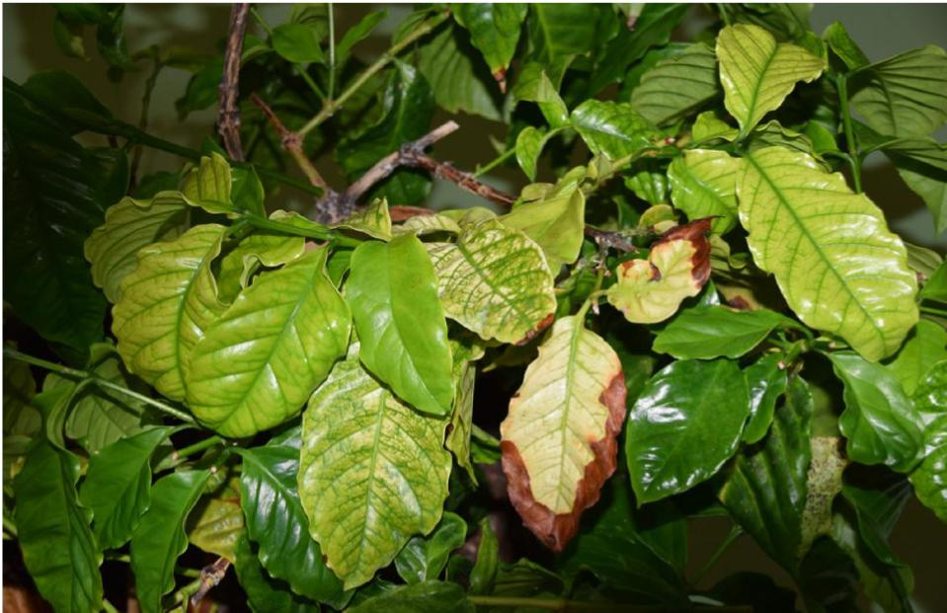

Symptoms on an imported coffee plant

© Bruno Legendre. Anses, Plant Health Laboratory, Angers (FR), (EPPO)

**Action Area 3: RESPONSE**



National *Xylella*Action Plan 2019–2029

Based on overseas experience, responding to an incursion of *Xylella* will be a challenging and lengthy process; complicated by, and dependant, on the species/subspecies/genotype(s) that is detected and the plant host-vector-pathogen interaction. International experience has shown that eradication is likely to be very difficult if detection is delayed. Advanced planning will maximise the chance of successful detection and eradication from Australia. In the event that eradication is not achievable, we should be prepared to minimise impact through effective management of disease.

**Action 3.1: Develop comprehensive national contingency plans and supporting operational procedures, and test through a national simulation exercise.**

***Planning potential incursion scenarios, and having national processes and procedures in place before they are needed, are key to being prepared for plant pests.***

Contingency planning is a pre-emptive preparedness activity that improves readiness for an exotic pest incursion. Contingency plans are commonly developed by industries and governments before an incursion, and aim to consolidate information on a particular pest or pest group, vectors, biology, and available control measures. There are currently contingency plans for eradication— ‘[*Contingency plan for Pierce’s disease and other diseases caused by*](https://planthealthaustralia.com.au/wp-content/uploads/2017/11/Xylella-fastidiosa-CP-NG-2017.pdf)Xylella fastidiosa’ and ‘*Threat Specific Contingency Plan for glassy-winged sharpshooter (*Homalodisca vitripennis*)*’ prepared by Queensland Department of Agriculture and Fisheries and Nursery and Garden Industry Australia (which has a focus on production nurseries). These contingency plans were tested through a national exercise in November 2018.

Given the relationship between *Xylella* and its vectors, the large diversity of plants that could be impacted both agriculturally and environmentally, and low likelihood of successful eradication, there is benefit in developing national contingency plans to cover all potentially affected industries and the environment. Contingency plans should be sufficiently detailed to clarify measures for eradication—including delimiting surveillance, hygiene, vector control, eradication, and host free periods; and for long term management options—including containment, control and treatment.

Developing contingency plans without an understanding of the pathogen and vector relationship will be challenging. However, plans should be developed assuming that an insect—either

exotic, established, or native—is capable of vectoring the pathogen, and be flexible enough to accommodate a range of scenarios.

Contingency plans should be developed with the technical and practical aspects of operational procedures in mind to enable a rapid response to be implemented. Potential for tailoring contingency plans to specific industries or situations would require plans and operational procedures to be developed collaboratively and tested through national simulation exercises. Regular updating and testing of plans and procedures would be required to maintain currency.

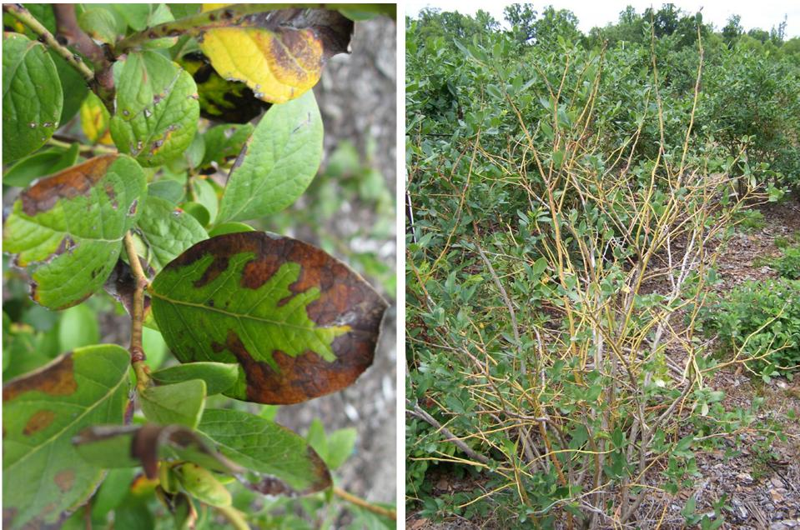



National *Xylella*Action Plan 2019–2029

|  |  |
| --- | --- |
| Scorch symptoms (late summer) observed on blueberry plants infected with *Xylella fastidiosa*  © Phillip M Brannen, University of Georgia (US), (EPPO) | Infected blueberry plants with yellow stems and ‘skeletal’ appearance  © Phillip M Brannen, University of Georgia (US), (EPPO) |

**Action 3.2: Develop tools and systems to capture, store and analyse real-time surveillance, spatial and diagnostic data to support a response in the Australian context.**

***Managing disease caused by* Xylella *requires sophisticated information and data management tools owing to its broad genetic diversity and complex epidemiology.***

Effective management strategies for diseases caused by *Xylella* internationally are developed for entire regions and landscapes, but are implemented at the farm and field level. In southern Italy, the XylWeb/XylApp systems supports this process by capturing, storing and analysing real-time surveillance, diagnostic, and spatial data (geo-referenced sample collection details). These systems help address the challenges of surveillance and management of *Xylella*, owing to the high number of host plants and potential vectors that would need to be inspected and tested.

In Australia, a number of data and information systems such as MAX (Agriculture Victoria) and other government response management information systems, [MyPestGuide](https://www.agric.wa.gov.au/pests-weeds-diseases/mypestguide) and [AUSPestCheck](https://www.planthealthaustralia.com.au/resources/auspestcheck/) are used to record data collected in emergency situations and surveillance, and for reporting. These systems could provide a similar function as those used internationally, or may require modification to be fit for purpose. Australian systems should be assessed as part of an overall preparedness capacity. The outcome of this action will also be applicable to other high priority pests.

**Action 3.3: Engage with the nursery and garden industry to enable the safe**



National *Xylella*Action Plan 2019–2029

**movement of nursery stock plants within Australia to prevent the spread of the pathogen, should *Xylella*****be detected.**

***Pre-emptive development and agreement of protocols or certification schemes to allow the safe movement of nursery material within Australia will minimise impact on producers.***

Human-mediated transport of the pathogen via nursery stock is likely to be a significant issue if *Xylella* is detected in Australia. Ideally, interstate certification or similar arrangements could be developed for implementation for key nursery stock material and risk pathways, and agreed in advance as a preparatory activity. While the regulation of movement of plant material between jurisdictions is the responsibility of the respective state and territory governments, the Australian Government, nursery and garden industry, and other relevant stakeholders should also be engaged in development of practical regulatory protocols. The Subcommittee on Domestic Quarantine and Market Access is well placed to lead this work.

**Action 3.4: Analyse literature and overseas experience to identify control and management options relevant to the Australian context.**

***Australia is fortunate to have the opportunity to learn from overseas experience and research, and should use this opportunity to prepare for* Xylella *in the Australian environment.***

*Xylella-*caused diseases are significant in terms of their economic, environmental and social impacts. Disease dynamics differ between countries and regions, and management strategies are designed for each agro-ecological setting. Both the United States and Italian experiences identified training, education, and outreach as core elements of an effective response and management strategy. Effective, evidence-based management strategies have been developed for California. Multiple measures to prevent and/or manage diseases caused by *Xylella* are integrated, and include quarantine regulations, permits to import plant material, a citrus clonal protection program, a nursery inspection program, nursery-approved treatment protocols, and vector trapping and monitoring programs. There are also collaboratively developed regulations for the nursery industry that recognise the biosecurity risks specific to that industry.

The Glassy-Winged Sharpshooter Area Wide Management Program in California involves stakeholders at various levels. The program manages vectors and *Xylella* related diseases at the regional and field level by linking research, and development and extension activities. A key feature of the Californian program is the presence of government-funded extension and extension officers who serve as an interface between research providers, regulators, industry adopters, and the community.

In California and the Pacific region, populations of the invasive glassy-winged sharpshooter are controlled using biological control agents, which could be considered as part of an integrated pest management plan for Australia if found to be suitable and environmentally sound.

International *Xylella* management practices and published research should be analysed to identify all control and management options relevant and appropriate to the Australian context. The analysis should focus on localised disease control to support eradication options and area wide control to support future management options. Where appropriate, any required research should be incorporated into the research agenda (Action 4.4). Outcomes of this action should be used to inform related actions, including contingency plans (Action 3.1) and movement protocols (Action 3.3), and be made available nationally as a single point of reference.

**TABLE 6 Summary table of Action Area 3: RESPONSE**



National *Xylella*Action Plan 2019–2029

|  |  |  |  |
| --- | --- | --- | --- |
| **Action Area 3** | | **Priority** | **Timeframe \*** |
| Action 3.1 | Develop comprehensive national contingency plans and supporting operational procedures, and test through a national simulation exercise. | High | Short term |
| Action 3.2 | Develop tools and systems to capture, store and analyse real-time surveillance, spatial and diagnostic data to support a response in the Australian context. | Medium | Medium term |
| Action 3.3 | Engage with the nursery and garden industry to enable the safe movement of nursery stock plants within Australia to prevent the spread of the pathogen, should *Xylella* be detected. | Low | Medium term |
| Action 3.4 | Analyse literature and overseas experience to identify control and management options relevant to the Australian context. | Medium | Medium term |

**\*** Indicative timeframes: SHORT up to 3 year; MEDIUM 4 to 8 years; LONG up to 10 years

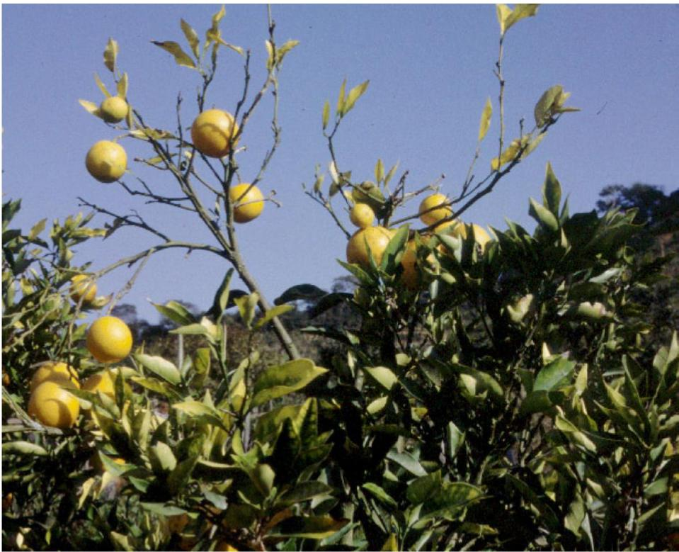

Citrus C: Twig dieback, reduction of production and dimension of sweet orange fruits induced by *Xylella fastidiosa* © M. Scortichini, Istituto Sperimentale per la Frutticoltura, Rome (IT), (EPPO)

**Action Area 4: CROSS-CUTTING ISSUES**



National *Xylella*Action Plan 2019–2029

A range of cross-cutting issues relating to building and retention of skills, governance, modelling, research, development and extension, and communication and engagement, are relevant across more than two action areas.

**Action 4.1: Develop an overarching communication and engagement**

**strategy, and deliver targeted activities relevant to the stakeholder group (industry, community, government).**

***There is a need for national awareness and understanding of the risks posed by* Xylella*.***

*Xylella* in Australia would impact on a diverse range of stakeholders, including horticultural industries, all levels of government, non-government organisations, and individuals. While there are a number of generic communication activities about biosecurity, and some specific activities relating to *Xylella*, raising awareness to drive change is of critical importance. A communication and engagement strategy needs to raise awareness about the pathogen and disease, promoting prevention, on farm biosecurity and general surveillance. Relevant messages need to be targeted to all stakeholder groups; for example, messaging should be strongly conveyed to both industry and the general public about the high level of risk to Australia of infected nursery stock, and the impacts of attempting to bring live plant material to Australia through illegal pathways.

Particular emphasis should be given to engaging with local governments given the extent of parkland and road verge plantings that they manage, and to other land managers, such as in national parks and defence estates. The outcomes of Action 4.3 could be, as part of the strategy, a tool to convey the potential *Xylella* risk areas to different stakeholders.

The strategy should build on and enhance current industry, government and community training, education and outreach programs to ensure there is national capability to prepare for and respond to plant pests in general, including *Xylella*.

Targeted communication outreach programs should be delivered to relevant stakeholders to enhance the national awareness and overall preparedness for the threat of *Xylella*, with a focus given to the peri-urban environment and backyard gardeners.

**Action 4.2: Build national surveillance and diagnostics capability and capacity through training and postgraduate opportunities.**

***Maintaining a national core skill set, succession planning, and building diagnostic and surveillance capacity, is an essential preparedness activity and supports other actions.***

There is a recognised need to build and retain expertise and core skill sets across the different biosecurity disciplines. This has been recognised in the:

Î [National Plant Biosecurity Diagnostic Strategy](https://www.planthealthaustralia.com.au/biosecurity/diagnostics/), Action D3.3—*Regularly review current and future needs of the diagnostic system in terms of human resources, skills and infrastructure, and implement proactive approaches to ensure these are met*.

Î [National Plant Health Surveillance Strategy](https://www.planthealthaustralia.com.au/biosecurity/surveillance/), Recommendation S.1—*Provide mechanisms for coordinating and establishing a nationally integrated and consistent plant biosecurity surveillance system and network that underpins Australia’s biosecurity system.*

Core capability and capacity in diagnostics and surveillance relies on an ongoing connectivity between experts both nationally and internationally, and in fostering partnerships with relevant institutions outside government and industry. Work continues through the Subcommittees on Plant Health Diagnostics and National Plant Health Surveillance to assess and build national diagnostic and surveillance capability, and capacity.



National *Xylella*Action Plan 2019–2029

To enhance preparedness for *Xylella*, there would be benefit in development of a structured program of training and postgraduate support, and career opportunities matched to industry(ies) with a view to maintaining long-term core capability. Focus could include plant pathology, physiology, plant and insect taxonomy, diagnostics, and surveillance. Regular evaluation of national capability and capacity should be undertaken.

**Action 4.3: Establish governance arrangements to coordinate and monitor national actions.**

***Formalised governance arrangements would guide implementation of the national action plan and coordinate national effort to ensure Australia is as prepared as possible for a post border detection or incursion.***

Participants at national workshops and the 2017 International Symposium agreed that there was a need to be proactive in national preparedness efforts, and to have in place a governance structure to drive the national work agenda. This included the appointment of a coordinator, establishment of a steering group or similar, and consideration of sustainable funding arrangements.

Any governance arrangement and associated communication activities, should engage all relevant stakeholders and include technical, industry, social sciences, policy and communications, and environmental expertise. Collaboration with New Zealand and other regional neighbours to align prevention and preparedness activities would be beneficial, as would establishment of an information repository on *Xylella* that is regularly updated and accessible in real-time.

Wine Australia and Horticulture Innovation, through a Plant Biosecurity Research Initiative, recently announced the appointment of a National *Xylella* Preparedness Coordinator to develop and coordinate research, and development priorities and projects for Australia’s wine and horticulture sectors. A role of the coordinator is to establish and facilitate a national steering committee, including industry and government representatives, to provide oversight to the national priorities for *Xylella* preparedness and assist delivery of the Plan.

See sections 6 and 7 for further information on implementation, monitoring, evaluation and review.

**Action 4.4: Map suitability zones for the spread and survival of *Xylella*, considering the dynamics between *Xylella*, plant hosts, vectors, and the Australian environment.**

***Understanding how* Xylella *will behave in Australia will help us identify risk areas to focus prevention and preparedness efforts, and in the event of* Xylella *establishing in Australia, provide the foundation for management of the disease.***

Temperatures affect bacterium survival, vector activity and abundance. There are reports of ‘cold curing’ of grapevines in cooler regions of California when specific temperature requirements are met, and the suggestion that the bacterium can die out in the absence of an effective vector. However, this is based on temperature constraints for the bacterium itself (i.e. the Pierce’s disease strain). The temperature requirements for insect vectors are a different issue, and both need to be considered to understand the potential distribution of *Xylella* in Australia.

There is benefit in mapping suitability zones for the spread and survival of *Xylella*. This should consider the dynamics between *Xylella* genetics, vectors, plant hosts, and environmental variables, including climate (particularly temperature and precipitation), landscape factors (for example alternative hosts, riparian vegetation), and management processes and options (irrigation, weed control, vector control).



**N** National *Xylella*Action Plan 2019–2029

Drawing on the outcomes of actions relating to hosts and vectors, the objective of this action is to map suitability zones or regions in Australia that are at risk from potential *Xylella* and introduced insect vectors. This work will guide prevention and preparedness efforts and, if *Xylella* were to establish in Australia, would provide the foundation for future management options of pathogen and vector.

**Action 4.5: Identify research and development priorities for investment.**

***Research and development is an important means to provide Australian governments and industries with the information, skills and tools they need to prevent entry of* Xylella *and to respond, if it were detected in Australia.***

An assessment is needed to identify gaps in our understanding around plant hosts, vectors, transmission (including mechanical), diagnostics and surveillance, treatment and control options, as outlined in several other actions; and to identify key priorities for research investment. Identification of additional risk management tools for *Xylella* and exotic vectors, potential biological control agents (such as endophytic microbes), and resistant varieties of commercially important plants, should be considered as part of a national research agenda.

Research investment priorities should be informed by all aspects of *Xylella*-related research being conducted, or completed overseas, and consolidate all relevant research to that needed for Australia—including those components identified in this Plan. There will be a need to collaborate with overseas researchers and research laboratories to undertake research on behalf of Australia; for example, laboratories identified via Euphresco, and to engage local research providers through relevant research and development corporations.

The major role of the National *Xylella* Preparedness Coordinator is to manage cross-sectoral biosecurity preparedness to prevent the pest arriving and establishing in Australia. The coordinator will act in a liaison role for potentially affected sectors, and ensure there is national awareness and coordination of high-priority research and development around *Xylella* (Action 4.2).

**Action 4.6: Assess the potential environmental and economic impacts of *Xylella*.**

***Understanding the potential impacts that* Xylella *could have if it were to establish in Australia will support national investment and decision making.***

Managing *Xylella*-caused disease is economically costly. For example, management activities cost the Californian grape industry an estimated US$104 million per annum and the Brazilian citrus industry US$120 million per annum (IPPC 2017). An economic modelling study conducted by ABARES (ABARES 2017), estimated the potential cost of *Xylella* to Australia’s grape and wine sector alone could range from $2.8 billion to $7.9 billion over 50 years depending on the extent of establishment and spread of *Xylella* and on expected future wine grape prices. The potential economic impacts for affected vineyards were assumed to comprise adjustment costs and foregone gross margins. Adjustment costs were largely associated replanting costs, which in turn, depended on expected gross margins and future wine grape prices.

Data and model parameters used in this study can be updated as research into the eco-climatic suitability for *Xylella* and vectors conducted in countries affected by the pathogen becomes available. *Xylella* poses a threat to the productivity, sustainability and competitiveness of Australia’s wine industry. While there is uncertainty about which wine grape areas would be affected, nearly all (98 per cent) vineyards could be partially or highly affected if only winter temperature thresholds matter.



National *Xylella*Action Plan 2019–2029

ABARES is undertaking a broader economic assessment to understand the potential cost to Australia across all horticultural industries and the environment, to support national investment and decision making. A similar modelling framework used for grapes is being adapted to other perennial crops susceptible to *Xylella*, including: horticultural crops (such as cherries, citrus, nuts, olives, and summer fruit), native trees, amenity trees, forests, and grasses.

**Action 4.7: Support international collaboration with researchers, experts and laboratories to build national capability and to deliver relevant actions from the Plan.**

***Collaboration on research projects and regular exchange of information at the international level will support preparedness for* Xylella *both regionally and beyond.***

Successful implementation of the actions identified in this Plan are dependent on collaboration and information sharing across horticultural industries, all levels of government, non-government organisations and between experts, both nationally and internationally. This should occur at both an organisational and individual level.

Collaborative opportunities, amongst others, which could be explored include the following.

Î Using suitable overseas laboratories to deliver projects as identified in the research agenda.

Î Exchanging information with overseas laboratories where diagnostic methods and sampling procedures for systemic and non-systemic hosts continue to be developed and improved.

Î Collaborating with the New Zealand Ministry for Primary Industries on regulatory tools, sampling and diagnostics protocols.

Î Cooperating with the USDA Glassy-Winged Sharpshooter Area Wide Management Program in California and the Italian programs at CHIEAM and the Institute for Sustainable Plant Protection in Apulia to explore the possibility of accessing data on early detection, spread and containment of vectors and disease.

Î Investigating application of the Italian data systems (XylWeb and XylApp) in Australia.

Î Cooperating with researchers from countries where *Xylella* is established to assist in the development of biosecurity risk management tools suited for use in Australia.

Î Engaging with Euphresco and other relevant research consortiums, such as POnTE (Pest Organisms Threatening Europe).

**TABLE 7 Summary table of Action Area 4: CROSS-CUTTING ISSUES**



National *Xylella*Action Plan 2019–2029

|  |  |  |  |
| --- | --- | --- | --- |
| **Action Area 2** | | **Priority** | **Timeframe \*** |
| Action 4.1 | Develop an overarching communication and engagement strategy, and deliver targeted activities relevant to the stakeholder group (industry, community, government). | High | Short term |
| Action 4.2 | Build national surveillance and diagnostics capability and capacity through training and postgraduate opportunities. | High | Ongoing |
| Action 4.3 | Establish governance arrangements to coordinate and monitor national actions. | High | Short term |
| Action 4.4 | Map suitability zones for the spread and survival of *Xylella*, considering the dynamics between *Xylella*, plant hosts, vectors and the Australian environment. | Medium | Medium term |
| Action 4.5 | Identify research and development priorities for investment | Medium | Medium term |
| Action 4.6 | Assess the potential environmental and economic impacts of *Xylella*. | High | Short term |
| Action 4.7 | Support international collaboration with researchers, experts and laboratories to build national capability and to deliver relevant actions from the Plan. | High | Ongoing |

**\*** Indicative timeframes: SHORT up to 3 year; MEDIUM 4 to 8 years; LONG up to 10 years.

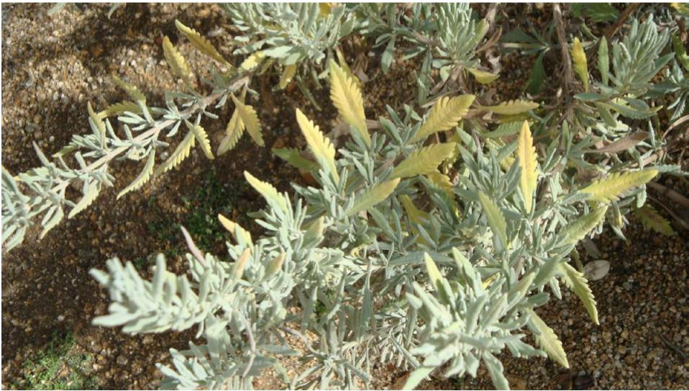

Symptoms of *Xylella fastidiosa* subsp. *multiplex* on *Lavandula x allardi*© Agnes POIRIER, NPPO of France, (EPPO)

**6. Implementation**



National *Xylella*Action Plan 2019–2029

The success of the National Action Plan depends on a high level of cooperation between a horticultural industries, all levels of government, non-government organisations and individuals, experts and research agencies. A clear understanding of participants’ roles and responsibilities, and ensuring adequate resources are allocated to protect Australia’s environment, primary industries, urban infrastructure, and way of life are necessary.

The Plan is supported by an implementation schedule which will be used to record the progress of actions; set out key performance indicators, roles, responsibilities and funding mechanisms; and to communicate with stakeholders on progress. Investment in *Xylella*-related activities is anticipated to be guided by the Plan, drawing on new or existing funding mechanisms such as research and development corporations.

Plant Health Committee, as the relevant national committee for plant biosecurity, will oversee implementation of the Plan on behalf of governments. Relevant peak industry bodies will be engaged on implementing the Plan through the recently appointed National *Xylella* Preparedness Coordinator (jointly funded by Horticulture Innovation and Wine Australia), relevant research and development corporations, Plant Biosecurity Research Initiative, and other forums.

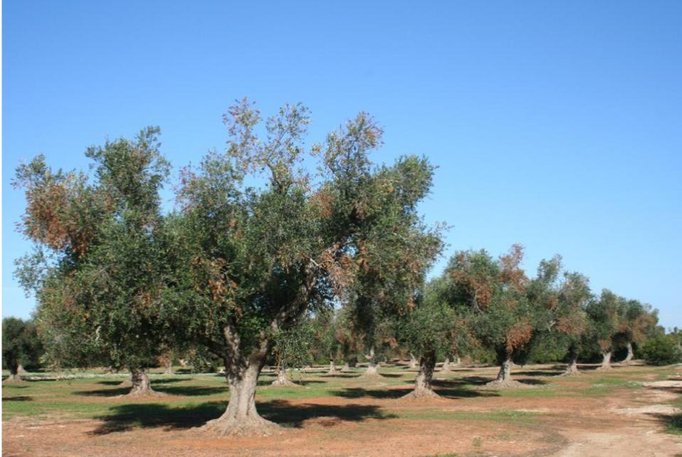

Symptoms of quick decline observed in Puglia (IT) on olive trees

© Donato Boscia, CNR - Institute for Sustainable Plant Protection, UOS, Bari (IT) - Franco Nigro, Dipartimento di Scienze del Suolo, della Pianta e degli Alimenti, Università degli Studi di Bari (IT) - Antonio Guario, Plant Protection Service, Regione Puglia (IT), (EPPO)

7. Monitoring, evaluation and review



National *Xylella*Action Plan 2019–2029

Plant Health Committee will undertake an annual review of progress on implementation of the Plan in collaboration with industry and other stakeholders and will report to the National Biosecurity Committee. Relevant industry bodies will be responsible for communicating outcomes to their members.

The Plan will be formally reviewed every five years using a monitoring and evaluation framework, but the actions set out in the Plan will evolve as knowledge is gained through research and overseas experience.

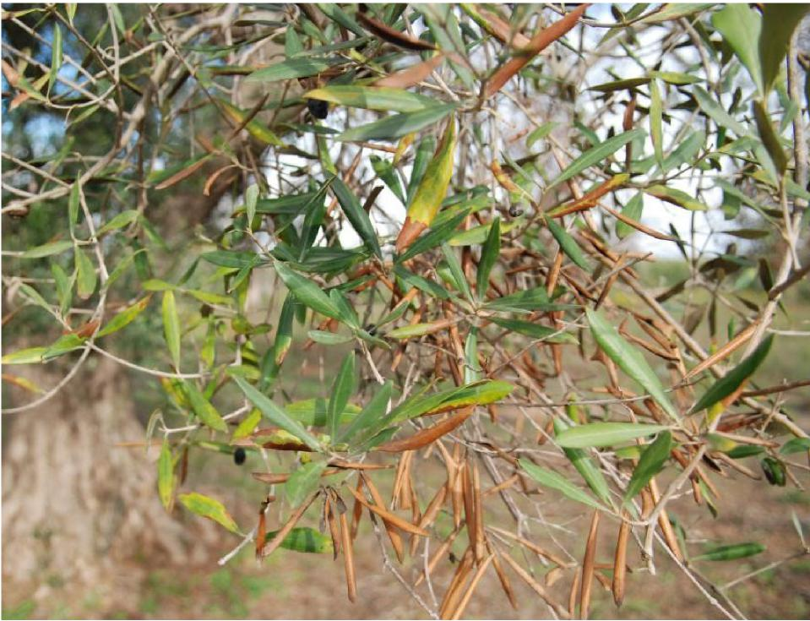

Symptoms on olive tree

© Camille Picard (DGAL-SDQPV, FR), (EPPO)

8. Relevant sources of information



National *Xylella*Action Plan 2019–2029

ABARES (2017) Potential economic impacts of *Xylella fastidiosa* on the Australian wine grape and wine industries. Available at [agriculture.gov.au/abares/research-topics/biosecurity/ biosecurity-economics/xyella-impact-report](http://agriculture.gov.au/abares/research-topics/biosecurity/biosecurity-economics/xyella-impact-report).

Almeida RP, Nunney L (2015) How do plant diseases caused by *Xylella fastidiosa* emerge? Plant Disease 99:1457-1467.

Cella E, Angeletti S, Fogolar, M, Bazzardi R, De Gara L, Ciccozzi M (2018). Two different *Xylella fastidiosa* strains circulating in Italy: phylogenetic and evolutionary analyses. Journal of plant interactions 13(1):428-432.

Chatterjee S, Almeida RP, Lindow S (2008) Living in two worlds: the plant and insect lifestyle*s of Xylella fastidiosa*. Annual Review of Phytopathology 46:243-271.

Cornara D, Saponari M, Zeilinger AR, de Stradis A, Boscia D, Loconsole G, Bosco D, Martelli GP, Almeida RPP, Porcelli F (2017) Spittlebugs as vectors of *Xylella fastidiosa* in olive orchards in Italy. Journal of Pest Science 90:521-530.

Department of Agriculture and Water Resources (DAWR) (2017) International symposium on *Xylella fastidiosa*, 17-18 May 2017: Summary and key learnings. Available at: [agriculture.gov.au/ pests-diseases-weeds/plant/xylella/international-symposium-xylella-fastidiosa](http://agriculture.gov.au/pests-diseases-weeds/plant/xylella/international-symposium-xylella-fastidiosa).

Department of Agriculture (2019) National Biosecurity Committee. Available at   
[www.agriculture.gov.au/biosecurity/partnerships/nbc](http://www.agriculture.gov.au/biosecurity/partnerships/nbc).

European Food Safety Authority. (2018) *Xylella*: host plant database updated. Available at [www.efsa.europa.eu/en/press/news/180910](http://www.efsa.europa.eu/en/press/news/180910).

Harper S, Ward L, Clover G (2010) Development of LAMP and real-time PCR methods for the rapid detection of *Xylella fastidiosa* for quarantine and field applications. Phytopathology 100:1282-1288.

Hopkins D, Purcell A (2002) *Xylella fastidiosa*: cause of Pierce’s disease of grapevine and other emergent diseases. Plant Disease 86:1056-1066.

IPPC (2017) Facing the treat of *Xylella fastidiosa* together. Food and Agriculture Organisation of the United Nations, International Plant Protection Convention, Rome, Italy.

IPPC (2018) International Standard on Phytosanitary Measures 27, Annex 25 Diagnostic Protocols (DP) for Regulated Pests, DP 25: *Xylella fastidiosa*. Available at [ippc.int/static/media/files/publication/ en/2018/09/DP_25_2018_Xylellafastidiosa_2018-09-21.pdf](http://ippc.int/static/media/files/publication/en/2018/09/DP_25_2018_Xylellafastidiosa_2018-09-21.pdf).

Leu LS, Su CC (1993) Isolation, cultivation, and pathogenicity of *Xylella fastidiosa,* the causal bacterium of pear leaf scorch disease in Taiwan. Plant Disease 77:642-646.

Martelli G, Boscia D, Porcelli F, Saponari M (2016) The olive quick decline syndrome in south-east Italy: a threatening phytosanitary emergency. European Journal of Plant Pathology 144:235-243.

Mendes JS, Santiago AS, Toledo MAS, Horta MAC, de Souza AA, Tasic L, de Souza AP (2016)

In vitro Determination of Extracellular Proteins from *Xylella fastidiosa*. Frontiers in Microbiology 7:1-15.

Minsavage G, Thompson C, Hopkins D, Leite R, Stall R (1994) Development of a polymerase chain reaction protocol for detection of *Xylella fastidiosa* in plant tissue. Phytopathology 84:456-461.

Rathé AA, Pilkington LJ, Hoddle MS, Spohr LJ, Daugherty MP, Gurr GM (2014) Feeding and development of the glassy-winged sharpshooter, *Homalodisca vitripennis*, on Australian native plant species and implications for Australian biosecurity. PLoS One 9:e90410.



National *Xylella*Action Plan 2019–2029

Redak RA, Purcell AH, Lopes JR, Blua MJ, Mizell Iii RF, Andersen PC (2004) The biology of xylem fluid-feeding insect vectors of *Xylella fastidiosa* and their relation to disease epidemiology. Annual Reviews in Entomology 49:243-270.

Retchless AC, Labroussaa F, Shapiro L, Stenger DC, Lindow SE, Almeida RP (2014) Genomic insights into *Xylella fastidiosa* interactions with plant and insect hosts. Genomics of Plant-Associated Bacteria. Springer, pp 177-202.

Saponari M, Boscia D, Nigro F, Martelli G (2013) Identification of DNA sequences related to *Xylella fastidiosa* in oleander, almond and olive trees exhibiting leaf scorch symptoms in Apulia (southern Italy). Journal of Plant Pathology 95:659-668.

SPHD (2010) National Diagnostic Protocol (6) for Pierce’s Disease, *Xylella fastidiosa*.

Available at [plantbiosecuritydiagnostics.net.au/wordpress/wp-content/uploads/2015/03/ NDP-6-Pierces-disease-Xylella-fastidiosa-V1.2.pdf](https://www.plantbiosecuritydiagnostics.net.au/app/uploads/2018/11/NDP-6-Pierces-disease-Xylella-fastidiosa-V1.2.pdf).

Su CC, Chang CJ, Chang CM, Shih HT, Tzeng KC, Jan FJ, Kao CW, Deng WL (2013). Pierce’s disease of grapevines in Taiwan: isolation, cultivation and pathogenicity of *Xylella fastidiosa*. Journal of Phytopathology 161:389-396.

Su CC, Deng WL, Jan FJ, Chang CJ, Huang H, Shih HT, Chen J (2016) *Xylella taiwanensis* sp. nov., causing pear leaf scorch disease. International Journal of Systematic and Evolutionary Microbiology 66:4766-4771.

Vanhove M, Retchless AC, Sicard A, Rieux A, Coletta-Filho HD, De La Fuente L, Stenger DC, Almeida RP (2019) Genomic diversity and recombination among *Xylella fastidiosa* subspecies. Applied and Environmental Microbiology, 85(13):e02972-18.

Wells, J. M., Raju, B. C., Hung, H. Y., Weisburg, W. G., Mandelco-Paul, L., & Brenner, D. J. (1987). *Xylella fastidiosa* gen. nov., sp. nov: gram-negative, xylem-limited, fastidious plant bacteria related to *Xanthomonas* spp. *International Journal of Systematic and Evolutionary Microbiology*, *37*(2), 136-143.

9. Acronyms and abbreviations



National *Xylella*Action Plan 2019–2029

|  |  |
| --- | --- |
| ABARES | Australian Bureau of Agricultural and Resource Economics and Sciences |
| CSIRO | Commonwealth Scientific and Industrial Research Organisation |
| DNA | Deoxyribonucleic acid |
| ELISA | Enzyme-linked immunosorbent assay |
| Euphresco | European Network for Phytosanitary Research Coordination |
| LAMP | Loop-mediated isothermal amplification |
| PCR | Polymerase chain reaction |
| POnTE | Pest Organisms Threatening Europe; EU funded research consortium |
| qPCR | Quantitative [real-time] polymerase chain reaction |
| XylApp | An application to upload geo-referenced field data to a web-based system developed in Italy |
| XylWeb | A web-based system to trace, store, manage, and analyse multiple data layers related to *Xylella* that has been developed in Italy |

|  |  |
| --- | --- |
| Asset based protection/ management | The asset-based protection approach is to manage the species only where reducing its adverse effects provides the greatest benefits by achieving protection and restoration outcomes for specific highly valued assets. |
| Biological control | The control of a species by introducing a natural predator or pathogen. |
| Biosecurity activity | An activity that mitigates the risks and impacts to the economy, the environment, social amenity or human health associated with pests and diseases. |
| Biosecurity continuum | An integrated approach to prevent, detect, contain, eradicate and/or lessen the impact of a pest or disease through complementary biosecurity activities undertaken offshore (in other countries), at the border and onshore (within Australia. |
| Biosecurity risk | The likelihood of a disease or pest entering Australian territory or a part of Australian territory; or establishing itself or spreading in Australian territory or a part of Australian territory; and the potential for any of the following: the disease or pest to cause harm to human, animal or plant health; the disease or pest to cause harm to the environment; economic consequences associated with the entry, establishment or spread of the disease or pest. |
| Containment | Restricting a detection of an invasive species/emergency plant pest to a defined area without the goal of eradication. |
| Conveyance | A means of transport such as an aircraft, vessel, vehicle, or train. |
| Detection | Finding the species through inspection and/or surveillance. |
| Eradication | Eliminating a pest or disease from an area. Eradication is indicated by the pest or disease no longer being detectable. |
| Established | A pest or disease that, for the foreseeable future, is perpetuated within any area and which it is deemed not feasible (either technically or as a result of a benefit:cost analysis) to eradicate. |
| Exotic | A species that is not present in Australia, or is present but under official control. |
| Native | A species, subspecies, or lower taxon, occurring within its natural range (past or present) and dispersal potential (i.e. within the range it occupies naturally or could occupy without direct or indirect introduction or care by humans). |
| Prevention | Stopping the introduction of a species into Australia. |
| Response | The management actions undertaken when an invasive species/emergency plant pest is detected. The response may be formalised through a national agreement or response plan. |
| Surveillance | The systematic investigation, over time, of a population or area to collect data and information about the presence, incidence, prevalence or geographical extent of a pest or disease. Surveillance includes active and passive approaches. |

10. Definitions/Glossary



National *Xylella*Action Plan 2019–2029