
No. 4/2023

2 February 2023

Summary of key issues
- For the week ending 1 February 2023, low-pressure systems and associated troughs remained active over most of the country and resulted in widespread rainfall and localised thunderstorm activity across northern, central and south-eastern Australia.
- Reduced rainfall across cropping regions of western Queensland have allowed floodwaters to recede, reduced the risk of waterlogging and improved the access to fields for the maintenance of summer crops. Reduced rainfall across southern Queensland likely improved field access for the harvesting of early sown summer crops to continue. Meanwhile, moderate rainfall across northern Queensland growing regions likely benefited the germination of late sown summer crops. Rainfall across New South Wales should support yield potential of summer crops as they near flowering (see Section 1.1).
- January 2023 rainfall was below average to average across most cropping regions, despite above average rainfall across cropping regions of northern Queensland and southern New South Wales. Extremely low to below average rainfall was recorded for the small parts of south-eastern Queensland. Lower rainfall totals in southern Queensland and northern New South Wales during January would have benefited the harvest of early sown summer crops. Across southern New South Wales and northern Queensland, moderate January rainfall would have provided ideal growing condition for summer crops and pastures, however, it may also have led to some disruptions in the harvest of early sown summer crops (see Section 1.1)
- Modelled pasture growth for the 3 months to January 2023, was above average to extremely high across western New South Wales, southern Victoria, northern Queensland, South Australia and northern Western Australia. This growth is likely to enable farmers to continue rebuilding stock numbers and provide opportunities to replenish fodder supplies during early summer, if conditions, such as dry warm weather suitable for fodder conservation, are to be experienced during this period (see Section 1.3).
- Over the 8-days to 9 February 2023, rainfall is expected to be restricted to northern and part of eastern Australia under the influence of low-pressure system and troughs. The moderate rainfall for summer cropping regions in Queensland and northern New South Wales is expected to build soil moisture levels and benefit the summer crops growth. However, this is likely to result in some harvest delays for early sown summer crops. The forecast rainfall over much of northern an eastern Australia is likely to build soil moisture levels in the led up to the winter cropping season and benefit pasture growth rates and availability (see Section 1.2).
- Water storage levels in the Murray-Darling Basin (MDB) decreased between 26 January 2023 and 1 February 2023 by 14 gigalitres (GL). Current volume of water held in storage is 23 421 GL which represents 93 percent of total capacity. This is 3 percent or 700 GL more than at the same time last year.
- Allocation prices in the Victorian Murray below the Barmah Choke decreased from $32 per ML on 20 January 2023 to $19 per ML on 2 February 2023. Prices are lower in the Murrumbidgee and regions above the Barmah choke due to the binding of the Murrumbidgee export limit and Barmah choke trade constraint.

Climate

Rainfall this week
For the week ending 1 February 2023, low-pressure systems and associated troughs remained active over most of the country and resulted in widespread rainfall and localised thunderstorm activity across northern, central and south-eastern Australia.
Weekly rainfall totals between 25 and 400 millimetres were recorded across much of New South Wales, Queensland and the Northern Territory, large areas of South Australia, and the Kimberley and Pilbara regions in Western Australia. Rainfall totals greater than 100 millimetres were recorded over tropical north of Australia and the South-West Slopes districts of New South Wales extending over the Victorian border.
Across Australian cropping regions, rainfall totals of between 10 and 50 millimetres were recorded across some parts of Queensland, much of New South Wales, western South Australia, and some pockets of eastern Western Australia. Little to no rainfall was recorded in the remaining cropping regions.
Reduced rainfall across the cropping region of western Queensland would have allowed floodwaters to recede, reduced the risk of waterlogging and improved the access to fields for the maintenance of summer crops. Reduced rainfall across southern Queensland likely improved field access for the harvesting of early sown summer crops to continue. Meanwhile, moderate rainfall across northern Queensland growing regions likely benefited the germination of late sown summer crops. Rainfall across New South Wales would support yield potential of summer crops as they near flowering.

Rainfall for the week ending 1 February 2023
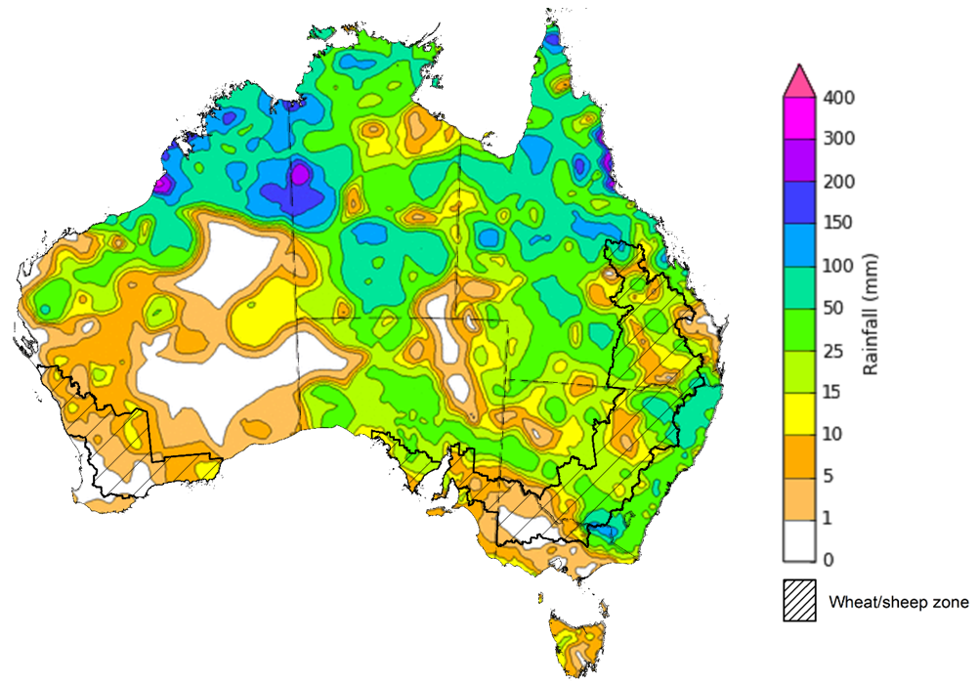
©Commonwealth of Australia 2023, Australian Bureau of Meteorology Issued: 01/02/2023
Note: The rainfall analyses and associated maps utilise data contained in the Bureau of Meteorology climate database, the Australian Data Archive for Meteorology (ADAM). The analyses are initially produced automatically from real-time data with limited quality control. They are intended to provide a general overview of rainfall across Australia as quickly as possible after the observations are received. For further information go to http://www.bom.gov.au/climate/rainfall/

Monthly rainfall
Rainfall during January 2023 was above average to extremely high for central and southern parts of the Northern Territory, northern, central and south-eastern Queensland, much of South Australia, northern rangelands and Gascoyne and Murchison regions in Western Australia, and parts of north-western and southern New South Wales. In contrast, rainfall was extremely low to below average for parts of south-eastern Queensland and much of southern Victoria,
The active La Niña event on the Pacific remained the main climate influence during the January. Extremely high rainfall total across the north of Australia were associated with the movement of low-pressure systems and troughs and break down of ex-tropical cyclones Ellie.
January 2023 rainfall was below average to average across most cropping regions, despite above average rainfall across cropping regions of northern Queensland and southern New South Wales. Extremely low to below average rainfall was recorded for the small parts of south-eastern Queensland.
Lower rainfall totals in southern Queensland and northern New South Wales during January should have benefited the harvest of early sown summer crops. Across southern New South Wales and northern Queensland, moderate January rainfall would have provided ideal growing condition for summer crops and pastures, however, it may also have led to some disruptions in the harvest of early sown summer crops

Rainfall percentiles for January 2023
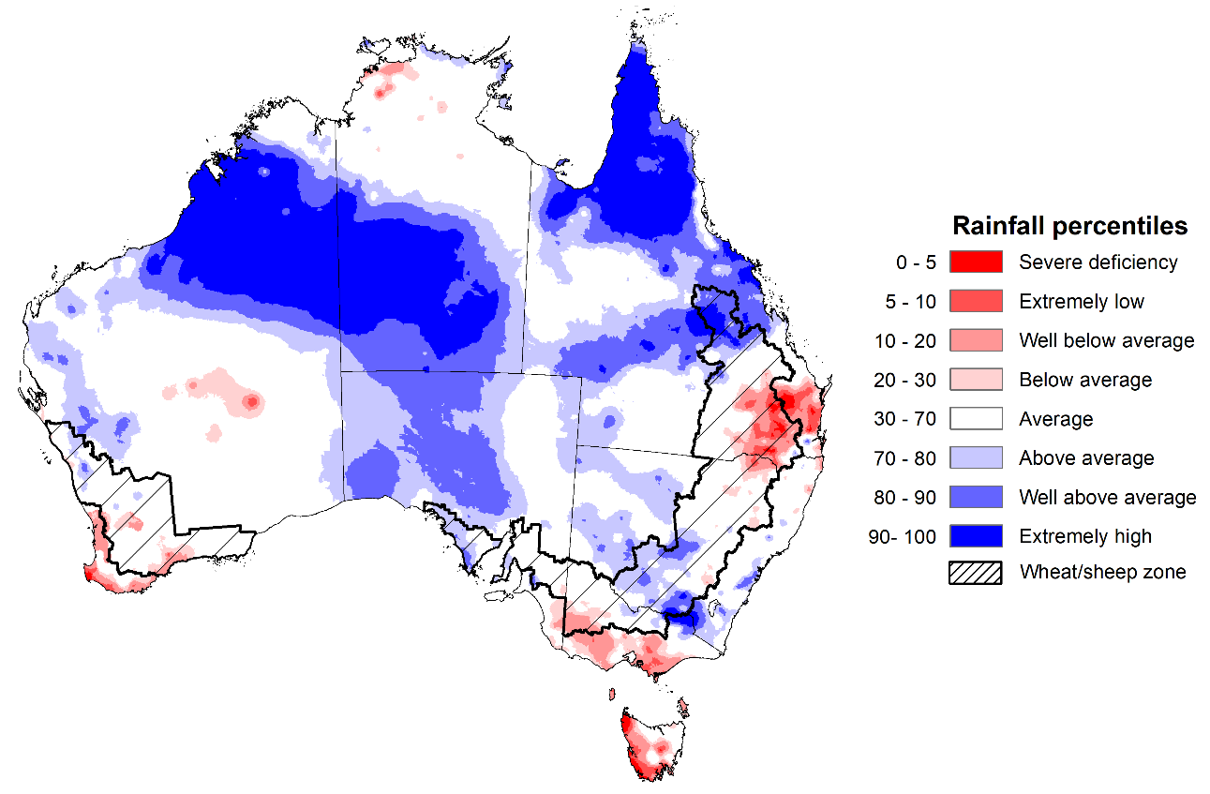
Note: Rainfall for January 2023 is compared with rainfall recorded for that period during the historical record (1900 to present). For further information, go to http://www.bom.gov.au/jsp/awap/
Source: Bureau of Meteorology

Monthly soil moisture
Modelled upper layer soil moisture for January 2023 was generally average or higher than average for this time of year across most of Australia, reflecting the high rainfall through the month. However, it had significantly geographic differences between the north and south of Australia, reflecting the spatial pattern of rainfall during January 2023. Extremely low upper soil moisture was modelled for some parts of south-eastern Queensland, the north-eastern New South Wales and southern Victoria, inland south and south-eastern seaboard in Western Australia, as well as western Tasmania. Extremely high upper layer moisture was evident across far north and central Queensland, the central and southern areas of the Northern Territory, Kimberly and Pilbara regions in Western Australia, and alpines region of south-eastern Australia.
At this time of year, upper layer soil moisture is important for late planted summer crops in northern New South Wales and Queensland and for pasture growth across northern Australia since plant germination and establishment utilise this moisture. It is also an important indicator of the ability to access paddocks for crop harvesting and planting activities.
Upper layer soil moisture was below average to average for this time of year across most of cropping regions with above average to very much above average dominated in the northern Queensland, south half of New South Wales and northern Western Australia. Extremely low levels of upper layer soil moisture were present for some parts of south-eastern Queensland and south-western tips of Western Australia. Low levels of upper layer soil moisture would have allowed paddock access to harvest early planted summer crops for northern cropping regions while moderate soil moisture in northern Queensland would have benefited the growth of pasture and some summer crops.

Modelled upper layer soil moisture for January 2023
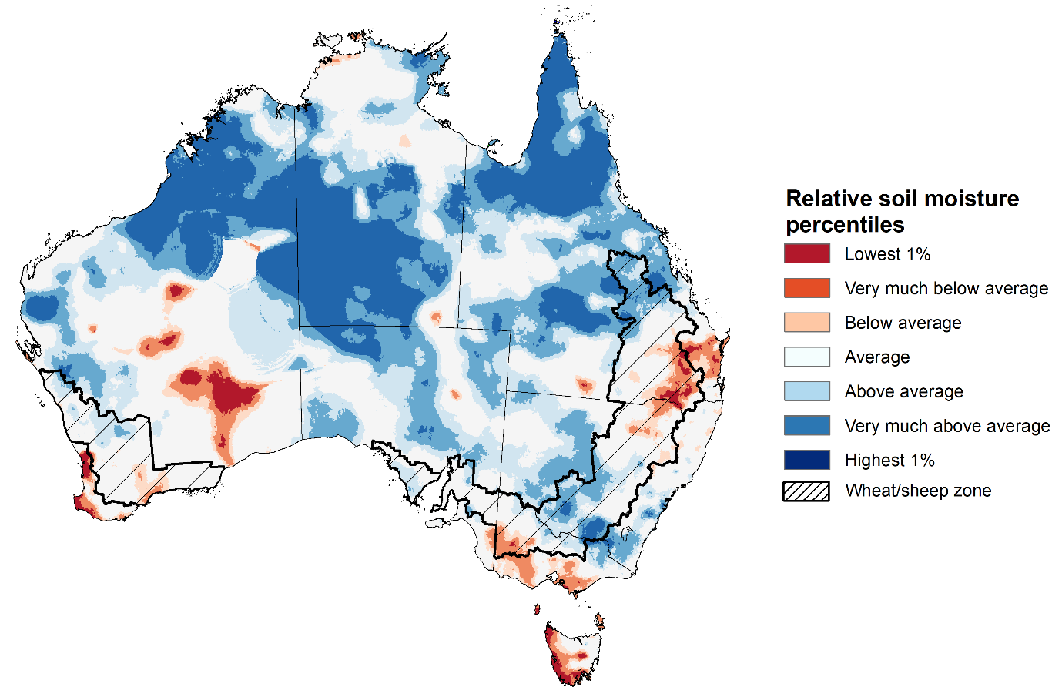
Note: This map shows the levels of modelled upper layer soil moisture (0 to 10 centimetres) during January 2023. This map shows how modelled soil conditions during January 2023 compare with January conditions modelled over the reference period (1911 to 2016). Dark blue areas on the maps were much wetter in January 2023 than during the reference period. The bulk of plant roots occur in the top 20 centimetres of the soil profile. Soil moisture in the upper layer of the soil profile is therefore useful indicator of the availability of water, particularly for germinating seed.
Source: Bureau of Meteorology (Australian Water Resources Assessment Landscape model)
Lower layer soil moisture for January 2023 was well above average to extremely high for this time of year across northern and central Queensland, much of the Northern Territory, the Kimberley , Gascoyne and Murchison regions in Western Australia. Lower layer of soil moisture was below average to extremely low in parts of southern Queensland, north-eastern New South Wales, southern Western Australia, and western Tasmania.
Lower layer soil moisture is important to support summer crops and pasture growth during the peak growth period. In Australian cropping regions, lower layer soil moisture was average to above average across northern Queensland and south-western New South Wales, South Australia, as well as scattered areas of Victoria and south-eastern Western Australia. Lower layer soil moisture was below average to average across large cropping areas of southern Queensland, eastern New South Wales, south-western Victoria and south-western Western Australia. High levels of lower layer soil moisture will continue to support above average yield prospects for summer crops and above average pasture growth for this time of year.
Modelled lower layer soil moisture for January 2023
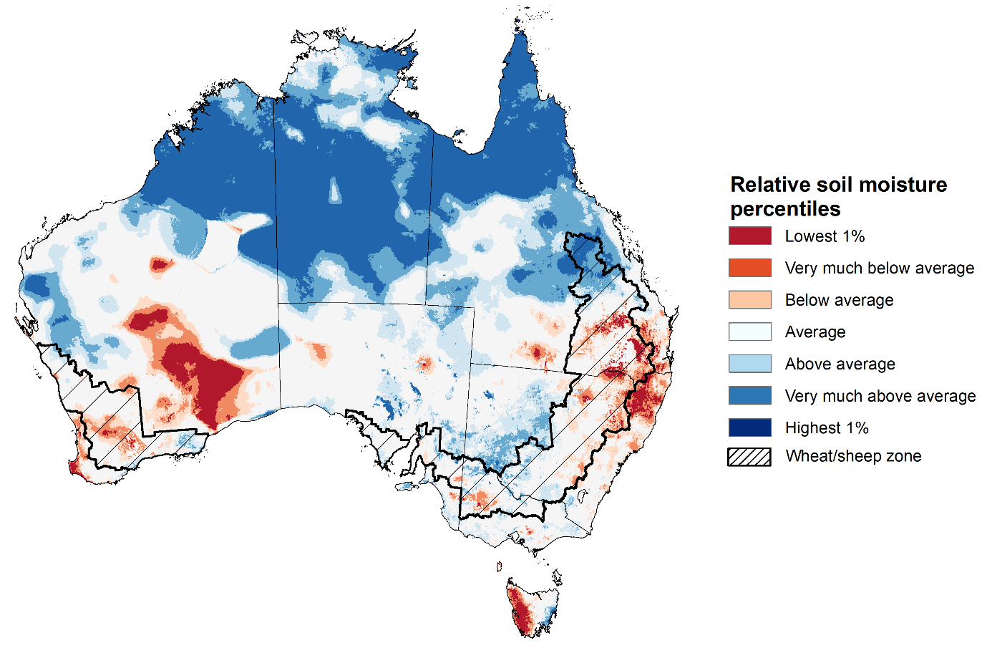
Note: This map shows the levels of modelled lower layer soil moisture (10 to 100 centimetres) during January 2023. This map shows how modelled soil conditions during January 2023 compare with January conditions modelled over the reference period (1911 to 2016). Dark blue areas on the maps were much wetter in January 2023 than during the reference period. The dark red areas were much drier than during the reference period. The bulk of plant roots occur in the top 20 centimetres of the soil profile. The lower layer soil moisture is a larger, deeper store that is slower to respond to rainfall and tends to reflect accumulated rainfall events over longer time periods.
Source: Bureau of Meteorology (Australian Water Resources Assessment Landscape model)

Pasture growth
Pasture growth during the November to January period is the peak pasture growth period for northern Australia which typically provides a bulk of feed to maintain production through the low pasture growth months of the northern dry season. Across southern Australia, November to January pasture growth is typically low reflecting lower rainfall totals, high temperature and high evapotranspiration rates at this time of year. Pasture availability during this period influences the growth and branding and marking rates of lambs and calves, livestock turnoff and the production of meat, milk, and wool.
For the 3 months to January 2023, above average rainfall totals and mild temperatures resulted in well above average pasture production for this time of year across most grazing regions primarily in the northern and central Australia.
Modelled pasture growth was above average to extremely high across western New South Wales, southern Victoria, northern Queensland, South Australia and northern Western Australia. This growth will likely enable farmers to continue rebuilding stock numbers and provide opportunities to replenish fodder supplies during late spring or early summer, if conditions, such as dry warm weather suitable for fodder conservation, were experienced during this period. In contrast, modelled pasture growth was extremely low to below average across scattered areas in the wheat/sheep zone, central and eastern New South Wales, south-eastern Queensland, north-eastern Victoria, and southern parts of Western Australia. In some regions, this low pasture growth likely reflects a decline in plant growth due to excess moisture.

Relative pasture growth for 3-months ending January 2023 (1 November to 31 January 2023)
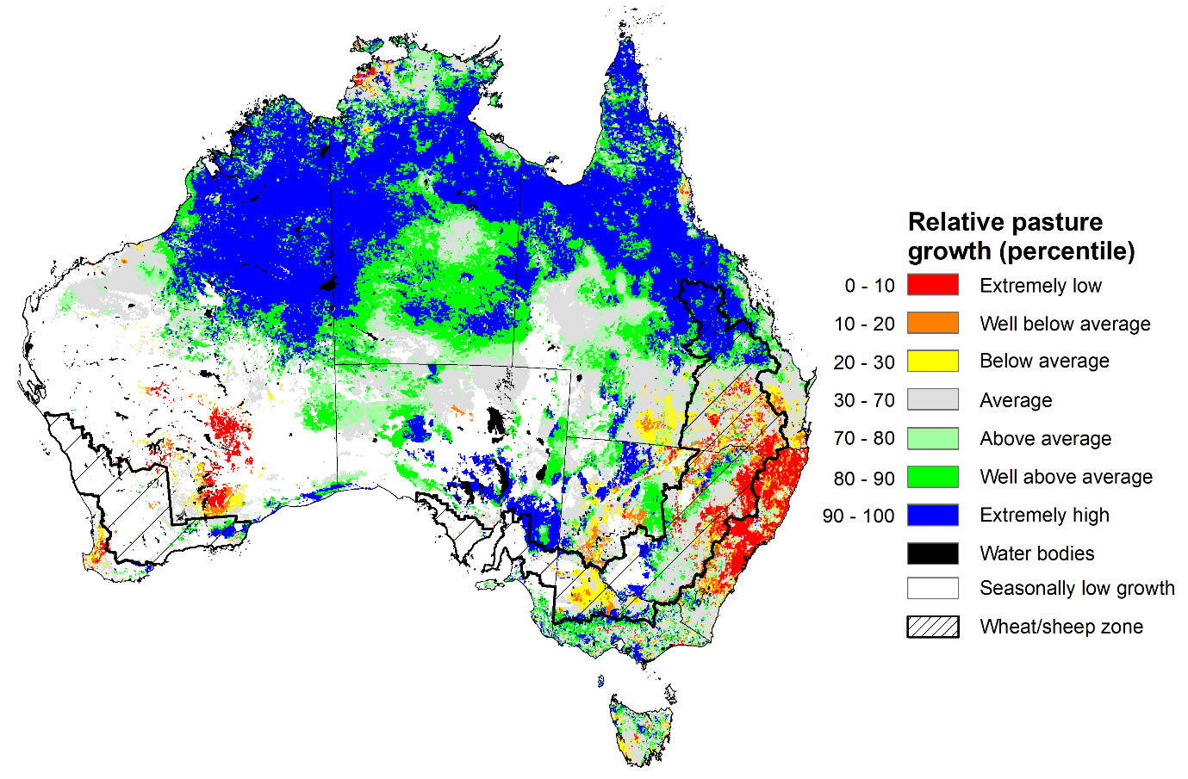
Notes: AussieGRASS pasture growth estimates are relative to the long-term record and shown in percentiles. Percentiles rank data on a scale of zero to 100. This analysis ranks pasture growth for the selected period against average pasture growth for the long-term record (1957 to 2016). Pasture growth is modelled at 5km2 grid cells.
Source: Queensland Department of Science, Information Technology and Innovation

Rainfall forecast for the next eight days
Over the 8-days to 9 February 2023, rainfall is expected to be restricted to northern and part of eastern Australia under the influence of low-pressure system and troughs. A monsoon trough is expected to bring increased rainfall across northern Australia, while onshore winds are expected to bring mostly dry conditions to much of eastern Australia. An approaching cold front is expected to bring showers to large areas of south-eastern Australia in the late of next week.
Rainfall totals exceeding 15 millimetres are expected across northern and central-eastern parts of the Northern Territory, much of Queensland and eastern New South Wales, southern Victoria and the Kimberley region and north-west in Western Australia, as well as western Tasmania. Rainfall totals in excess of 50 millimetres are expected for the north and eastern seaboard of Queensland and adjacent area of the Northern Territory, as well as some pockets of north-western of Kimberly region and Darwin region. Little to no rainfall is forecast for the remaining area of Australia for the next eight days.
Across Australian cropping regions, rainfall totals of between 10 and 50 millimetres are expected for most of the Queensland and northern New South Wales. Rainfall totals of between 50 and 100 millimetres are expected for the far northern Queensland cropping regions. Little to no rainfall is expected for the remaining cropping regions in the next eight days.
The moderate rainfall for summer cropping regions in Queensland and northern New South Wales is expected to build soil moisture levels and benefit the summer crops growth. However, this is likely to result in some harvest delays for early sown summer crops. The forecast rainfall over much of northern and eastern Australia is likely to build soil moisture levels in the led up to the winter cropping season and benefit pasture growth rates and availability

Total forecast rainfall for the period 2 February to 9 February 2023
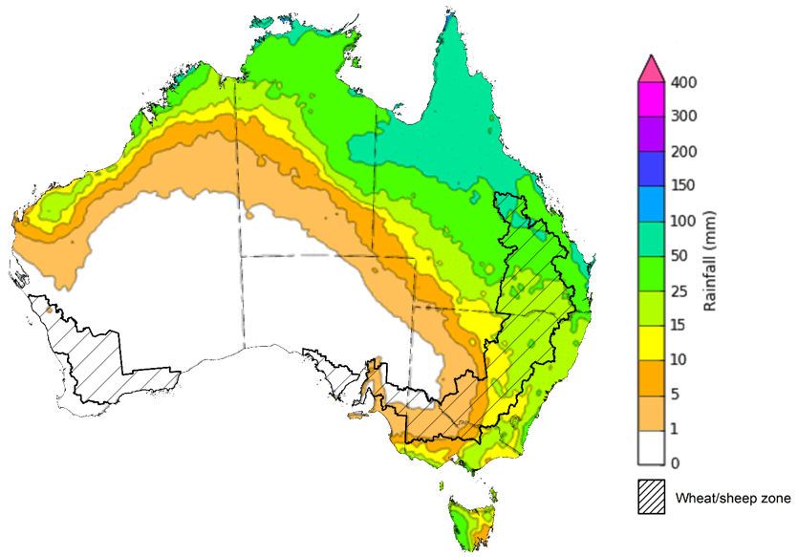

©Commonwealth of Australia 2023, Australian Bureau of Meteorology Issued 02/02/2023
Note: This rainfall forecast is produced from computer models. As the model outputs are not altered by weather forecasters, it is important to check local forecasts and warnings issued by the Bureau of Meteorology.

Water

Water markets – current week

Water storage levels in the Murray-Darling Basin (MDB) decreased between 26 January 2023 and 1 February 2023 by 14 gigalitres (GL). Current volume of water held in storage is 23 421 GL which represents 93 percent of total capacity. This is 3 percent or 700 GL more than at the same time last year.

Water storages in the Murray-Darling Basin, 2013–2023
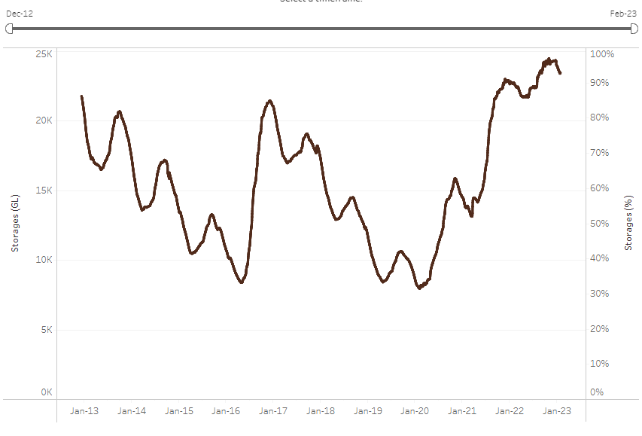
Allocation prices in the Victorian Murray below the Barmah Choke decreased from $32 per ML on 20 January 2023 to $19 per ML on 2 February 2023. Prices are lower in the Murrumbidgee and regions above the Barmah choke due to the binding of the Murrumbidgee export limit and Barmah choke trade constraint.
Water storage data is sourced from the Bureau of Meteorology.
Region | $/ML
NSW Murray Above | 12
NSW Murrumbidgee | 15
VIC Goulburn-Broken | 19
VIC Murray Below | 19

Surface water trade activity, Southern Murray–Darling Basin
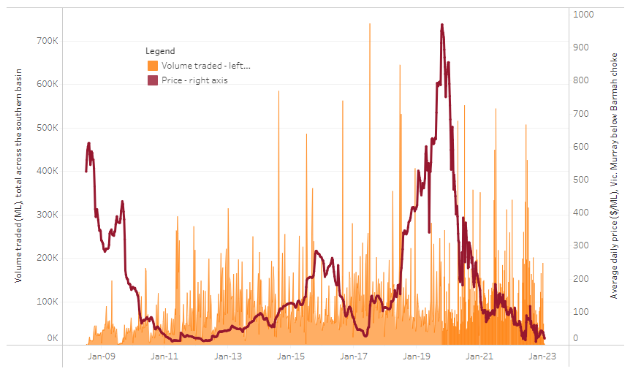
To access the full, interactive, weekly water dashboard, which contains the latest and historical water storage, water market and water allocation information, please visit http://www.agriculture.gov.au/abares/products/weekly_update/weekly-update-020223
The trades shown reflect estimated market activity and do not encompass all register trades. The price is shown for the VIC Murray below the Barmah choke. Historical prices (before 1 July 2019) are ABARES estimates after removing outliers from BOM water register data. Prices after 1 July 2019 and prior to the 30 October 2019 reflect recorded transaction prices as sourced from Ruralco. Prices after the 30 October 2019 are sourced from Waterflow. Data for volume traded is sourced from the BOM water register. Data shown is current on 02 February 2023.

Commodities
Indicator |  | Week ended | Unit |  | Latest price |  | Previous week |  | Weekly change |  | Price 12 months ago |  | Annual change
Selected world indicator prices
AUD/USD Exchange rate |  | 01-Feb | A$/US$ |  | 0.71 |  | 0.70 |  | 0% |  | 0.71 |  | -1%
Wheat – US no. 2 hard red winter wheat, fob Gulf |  | 01-Feb | US$/t |  | 392 |  | 374 |  | 5% |  | 379 |  | 3%
Corn – US no. 2 yellow corn, fob Gulf |  | 01-Feb | US$/t |  | 305 |  | 304 |  | 0% |  | 284 |  | 8%
Canola – Rapeseed, Canada, fob Vancouver |  | 01-Feb | US$/t |  | 674 |  | 650 |  | 4% |  | 870 |  | -23%
Cotton – Cotlook 'A' Index |  | 01-Feb | USc/lb |  | 101 |  | 102 |  | -1% |  | 140 |  | -28%
Sugar – Intercontinental Exchange, nearby futures, no.11 contract |  | 01-Feb | USc/lb |  | 20.2 |  | 19.9 |  | 1% |  | 18 |  | 13%
Wool – Eastern Market Indicator |  | 25-Jan | Ac/kg clean |  | 1,356 |  | 1,338 |  | 1% |  | 1,356 |  | 0%
Wool – Western Market Indicator |  | 25-Jan | Ac/kg clean |  | 1,510 |  | 1,475 |  | 2% |  | 1,360 |  | 11%
Selected Australian grain export prices
Milling Wheat – APW, Port Adelaide, SA |  | 01-Feb | A$/t |  | 505 |  | 501 |  | 1% |  | 489 |  | 3%
Feed Wheat – ASW, Port Adelaide, SA |  | 01-Feb | A$/t |  | 457 |  | 452 |  | 1% |  | 452 |  | 1%
Feed Barley – Port Adelaide, SA |  | 01-Feb | A$/t |  | 415 |  | 416 |  | 0% |  | 391 |  | 6%
Canola – Kwinana, WA |  | 01-Feb | A$/t |  | 1,061 |  | 1,042 |  | 2% |  | 1,009 |  | 5%
Grain Sorghum – Brisbane, QLD |  | 01-Feb | A$/t |  | 477 |  | 476 |  | 0% |  | 367 |  | 30%
Selected domestic livestock indicator prices
Beef – Eastern Young Cattle Indicator |  | 01-Feb | Ac/kg cwt |  | 776 |  | 781 |  | -1% |  | 1,144 |  | -32%
Mutton – Mutton indicator (18–24 kg fat score 2–3), Vic |  | 01-Feb | Ac/kg cwt |  | 342 |  | 305 |  | 12% |  | 600 |  | -43%
Lamb – Eastern States Trade Lamb Indicator |  | 01-Feb | Ac/kg cwt |  | 768 |  | 744 |  | 3% |  | 852 |  | -10%
Pig – Eastern Seaboard (60.1–75 kg), average of buyers & sellers |  | 18-Jan | Ac/kg cwt |  | 367 |  | 376 |  | -2% |  | 357 |  | 3%
Goats – Eastern States (12.1–16 kg) |  | 11-Jan | Ac/kg cwt |  | 350 |  | 350 |  | 0% |  | 813 |  | -57%
Live cattle – Light steers ex Darwin to Indonesia |  | 17-Aug | Ac/kg lwt |  | 420 |  | 480 |  | -13% |  | 320 |  | 31%
Live sheep – Live wethers (Muchea WA saleyard) to Middle East |  | 14-Sep | $/head |  | 93 |  | 113 |  | -18% |  | 114 |  | -18%
Indicator
Global Dairy Trade (GDT) weighted average prices ª
Dairy – Whole milk powder | 18-Jan |  |  | US$/t |  | 3,218 |  | 3,208 |  | 0% | 3,306 | -3%
Dairy – Skim milk powder | 18-Jan |  |  | US$/t |  | 2,842 |  | 2,838 |  | 0% | 3,044 | -7%
Dairy – Cheddar cheese | 18-Jan |  |  | US$/t |  | 4,871 |  | 4,690 |  | 4% | 4,078 | 19%
Dairy – Anhydrous milk fat | 18-Jan |  |  | US$/t |  | 5,337 |  | 5,395 |  | -1% | 4,604 | 16%
a Global Dairy Trade prices are updated twice monthly on the first and third Tuesday of each month.

Selected world indicator prices
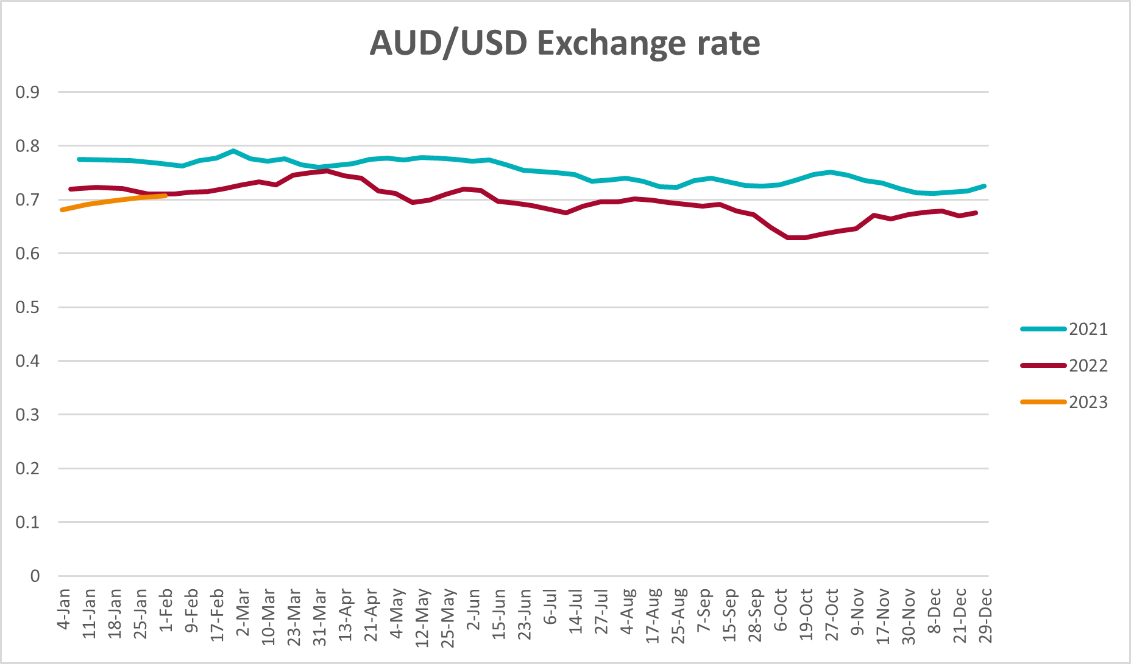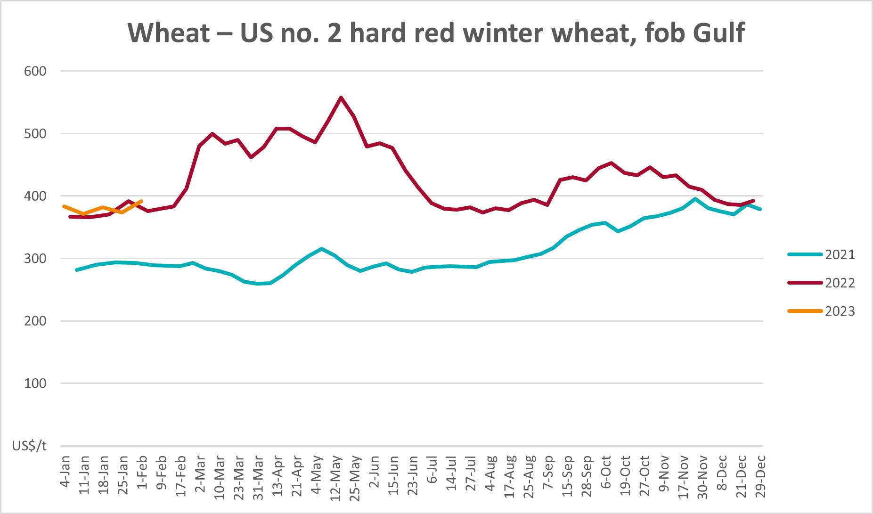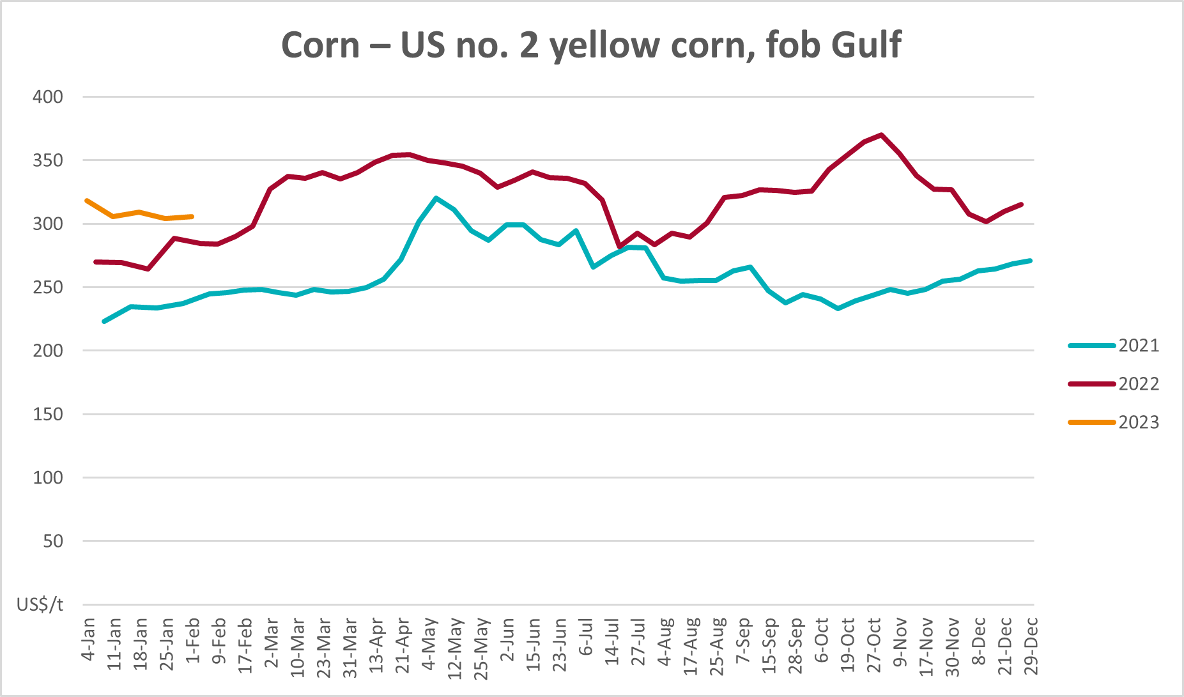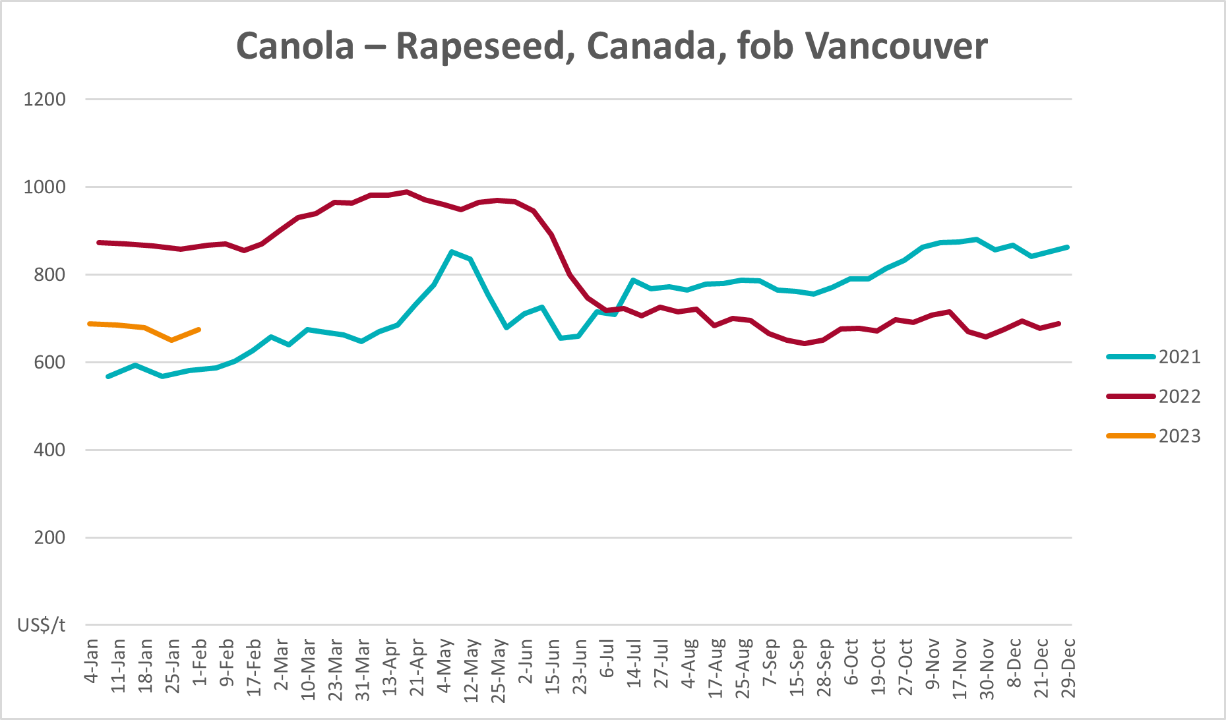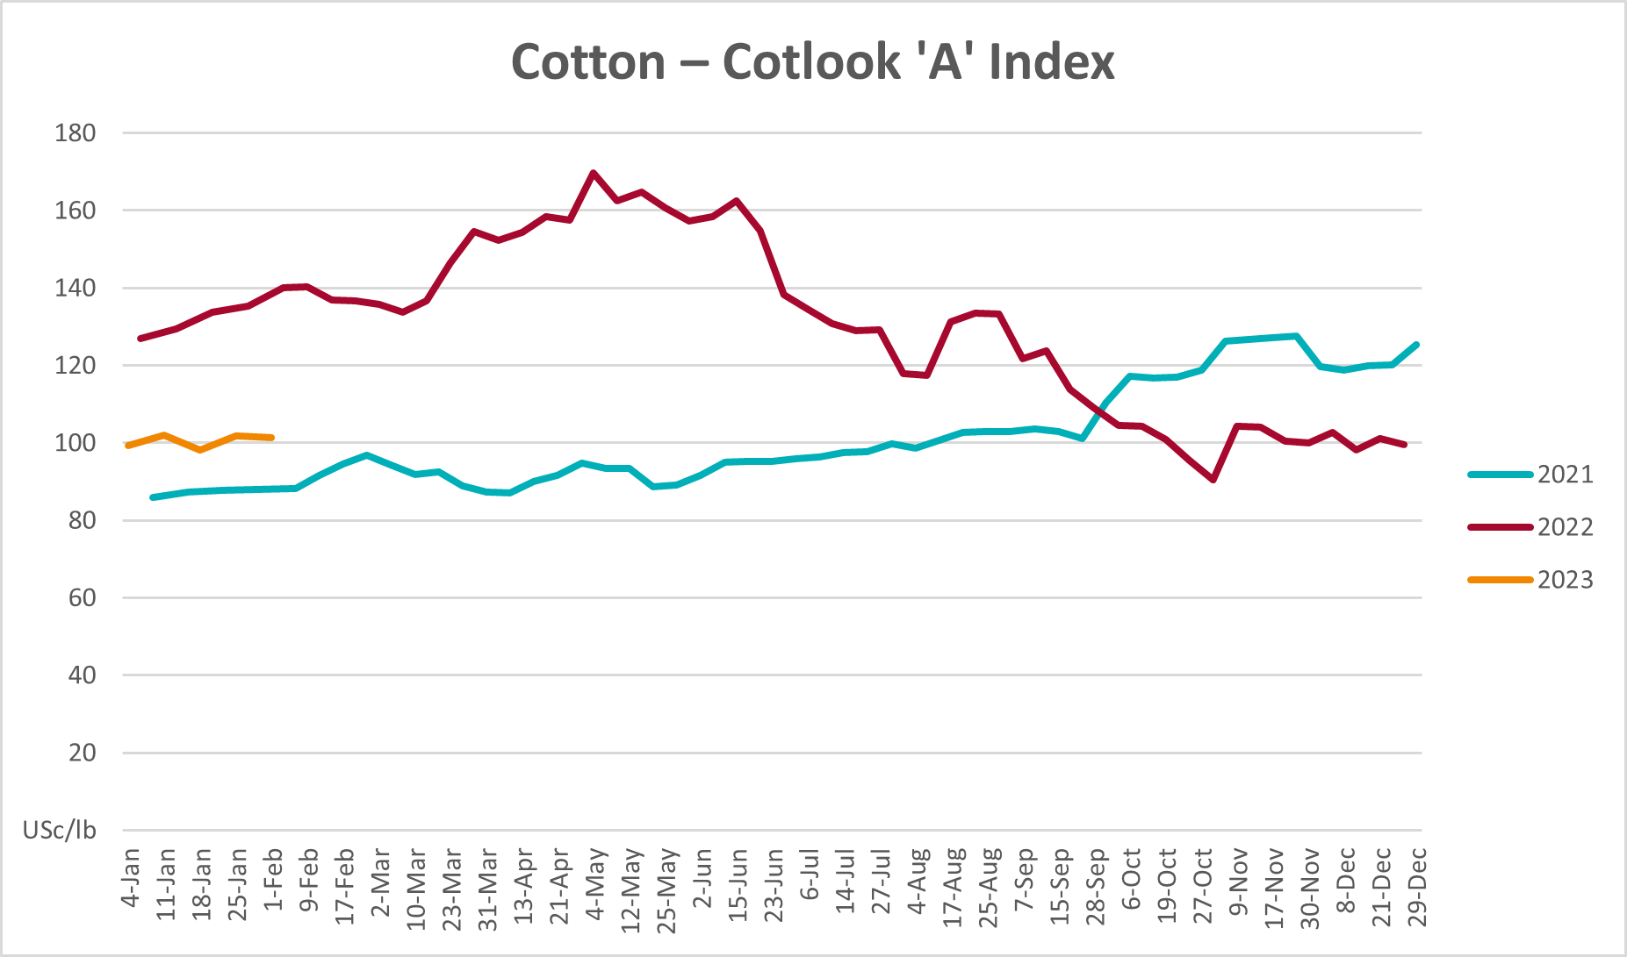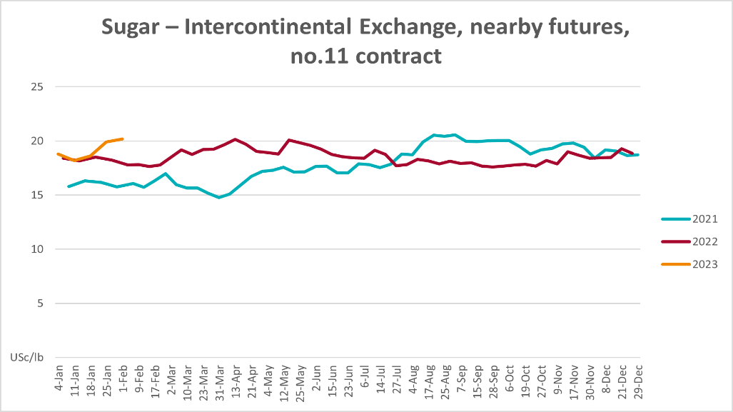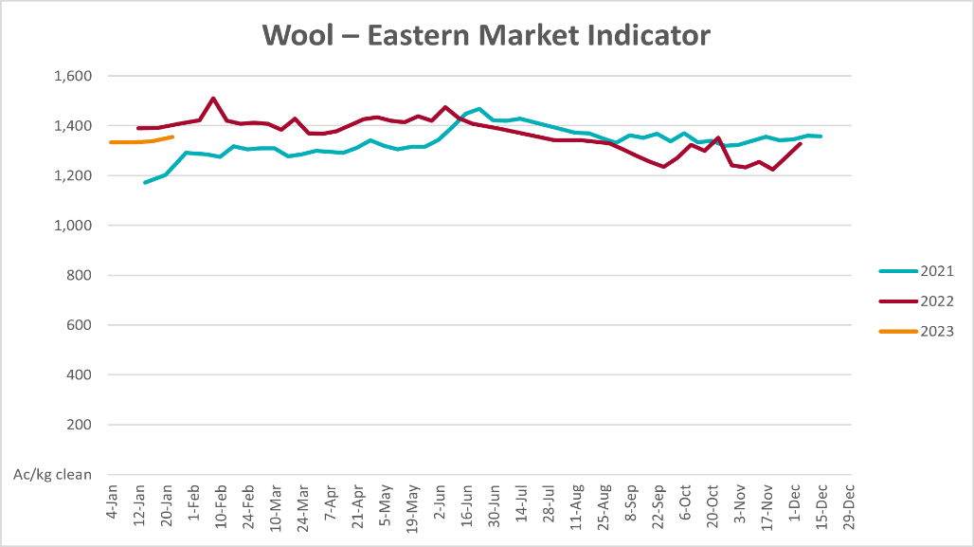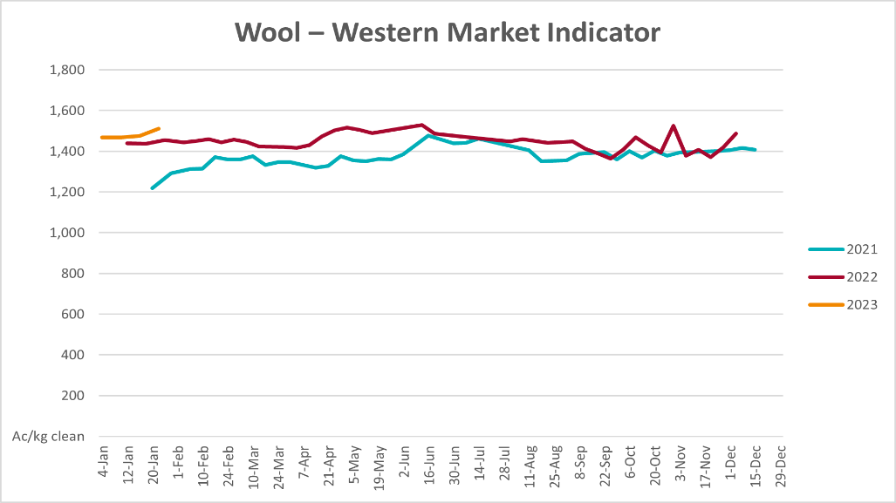

Selected domestic crop indicator prices
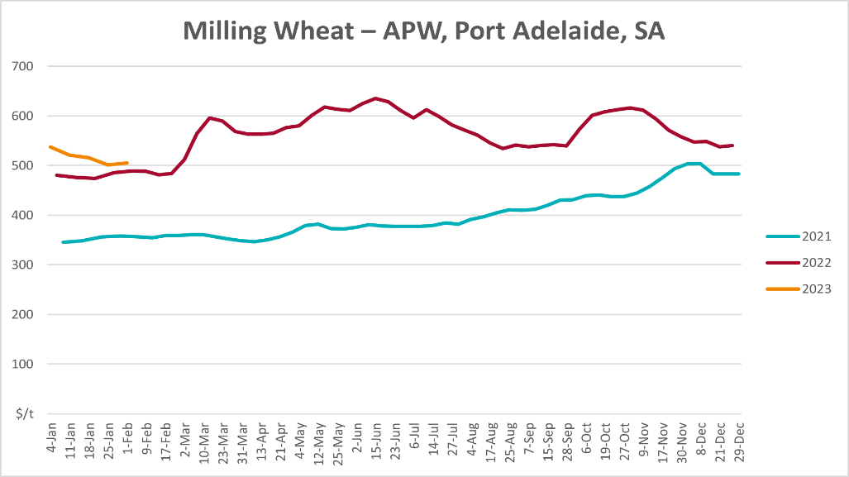
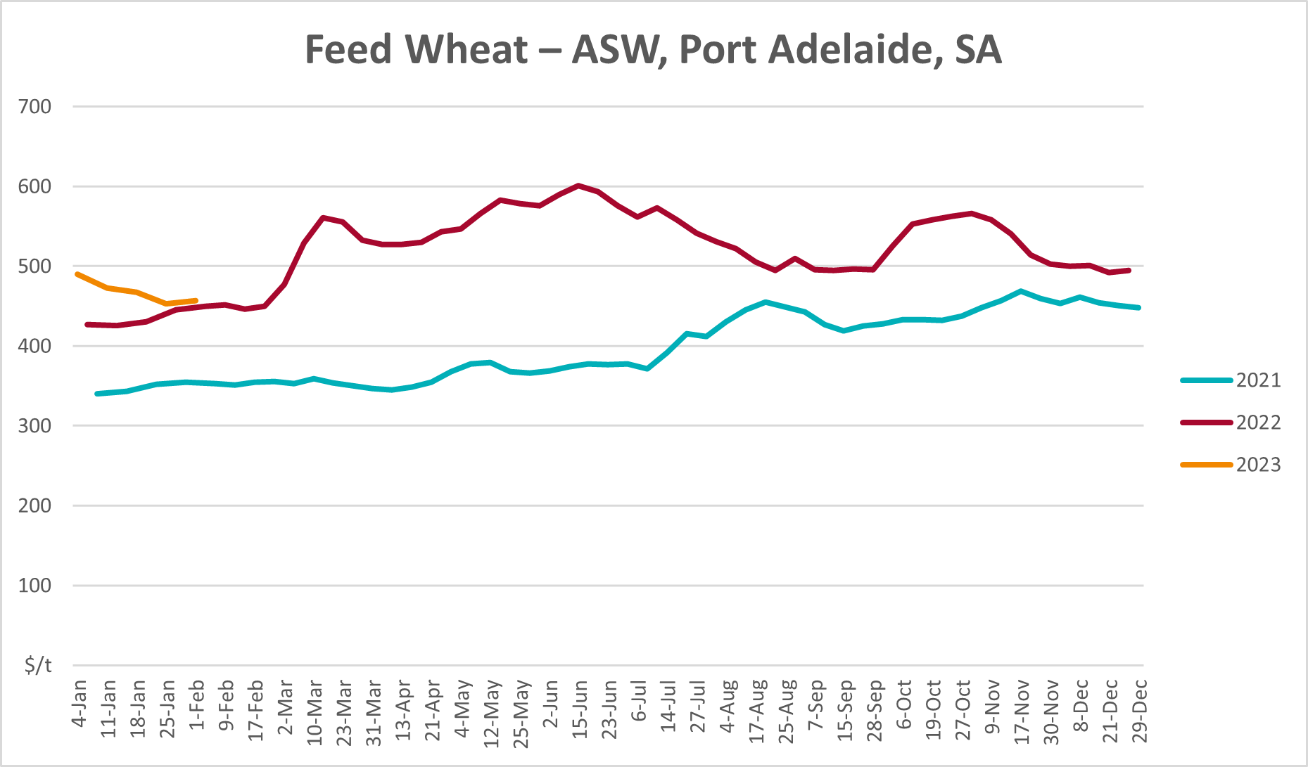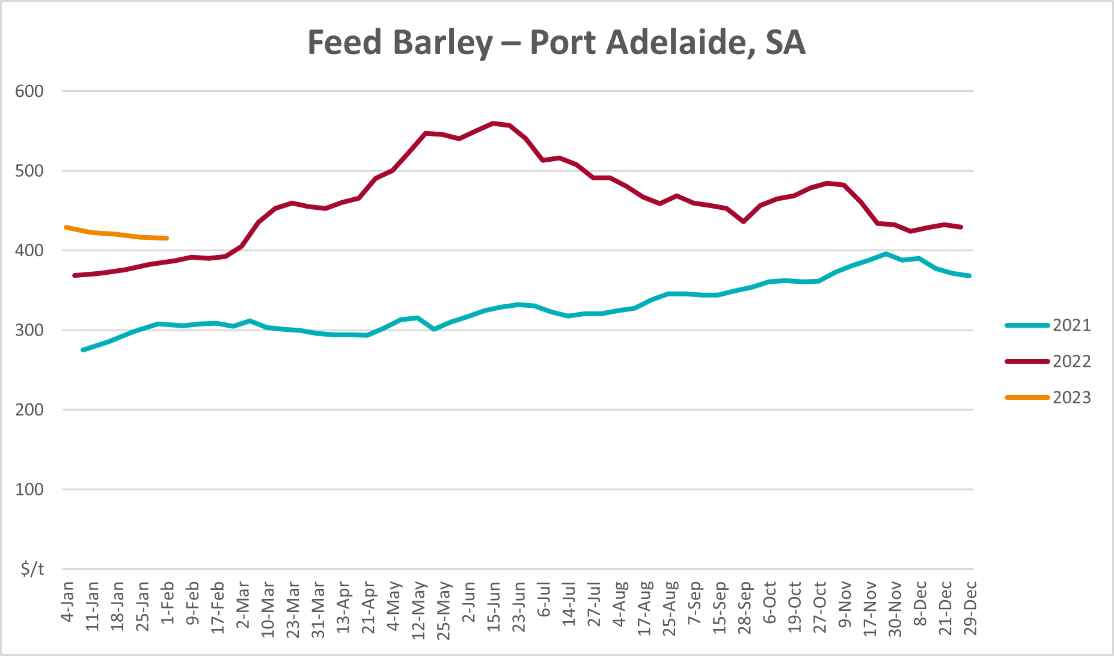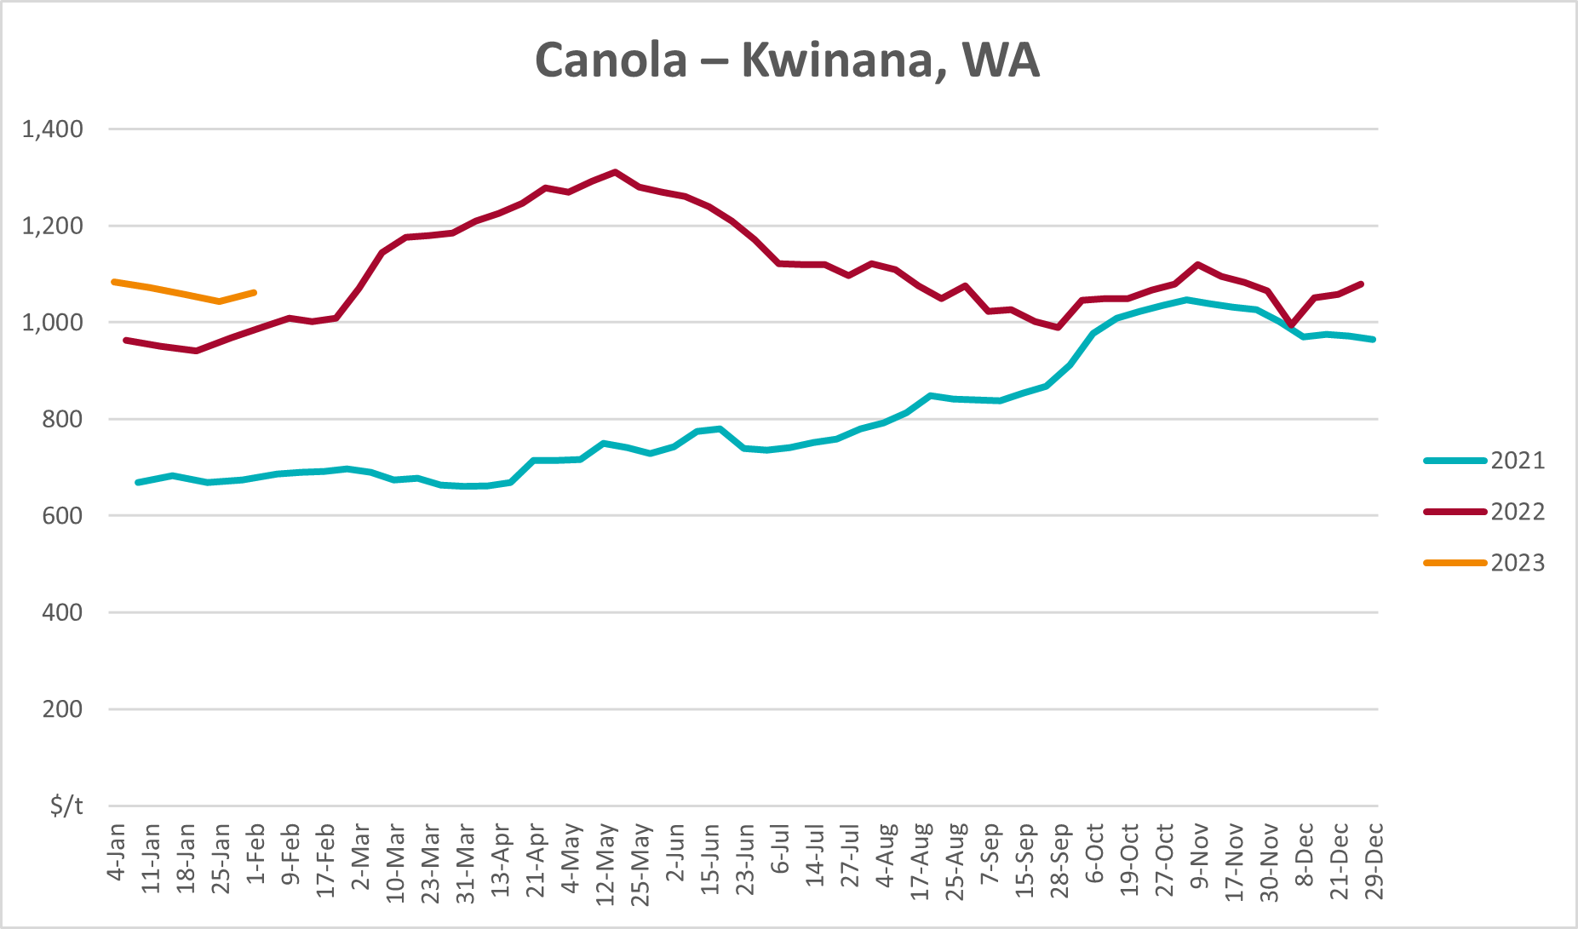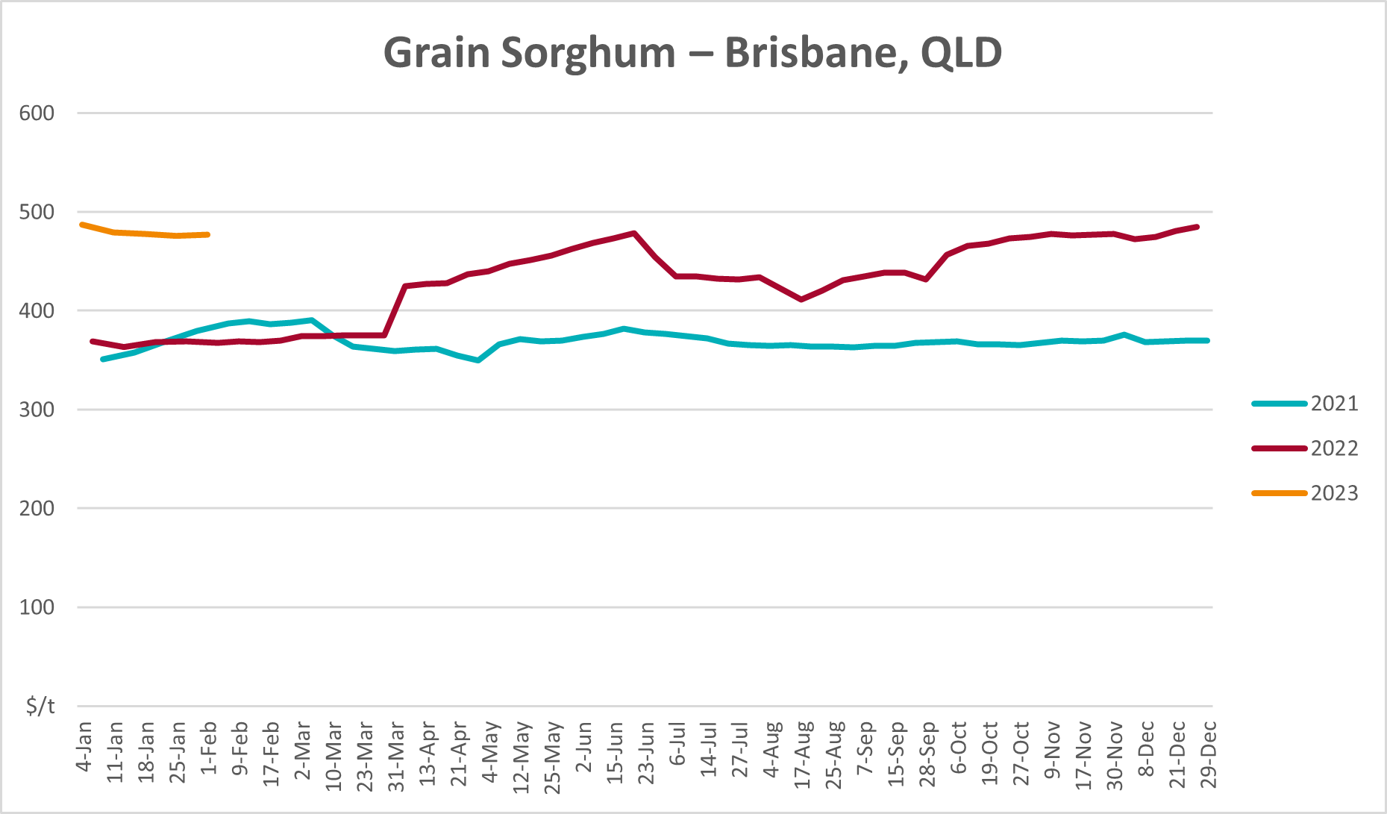

Selected domestic livestock indicator prices
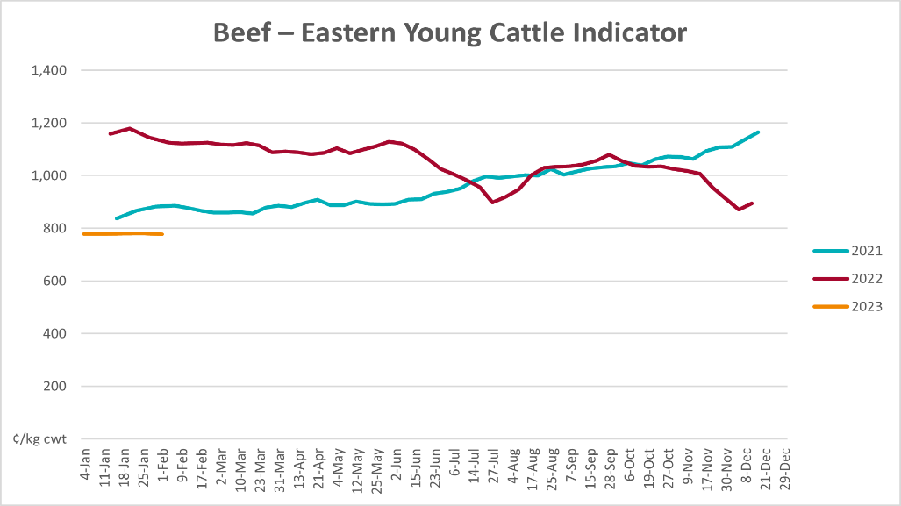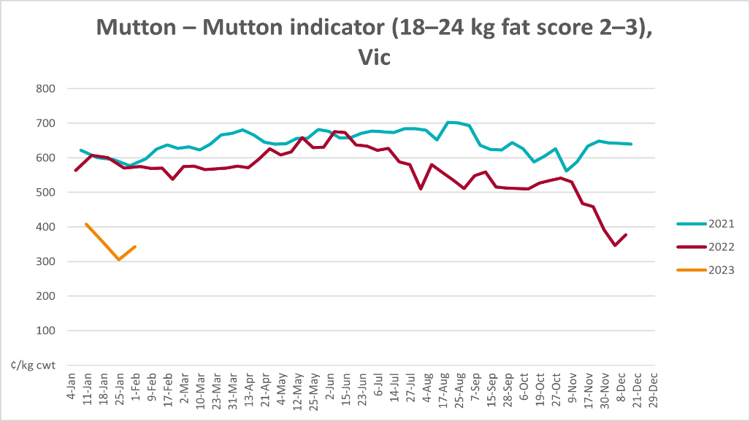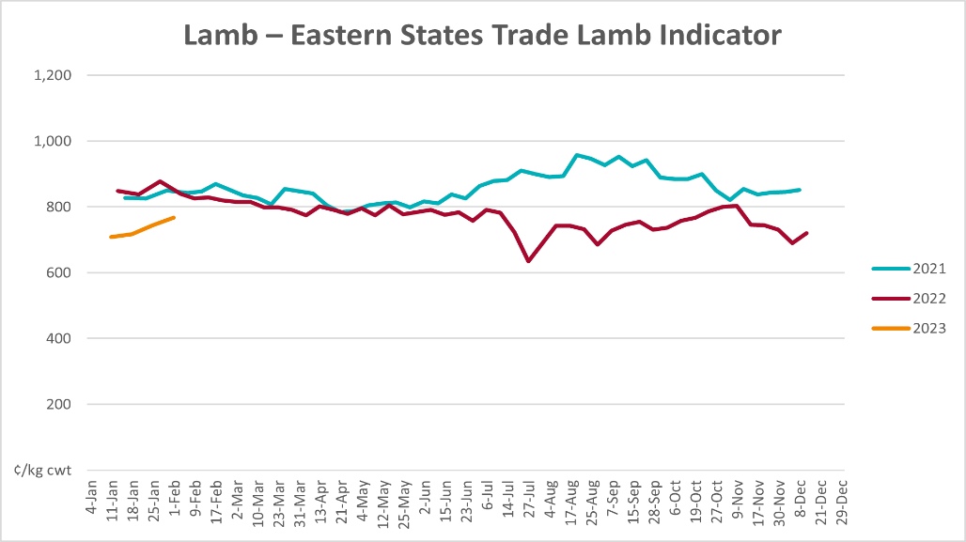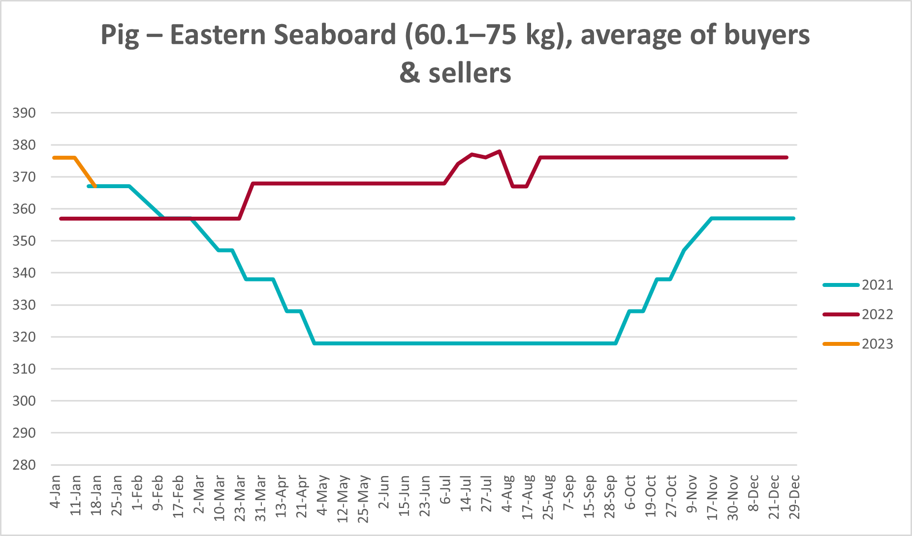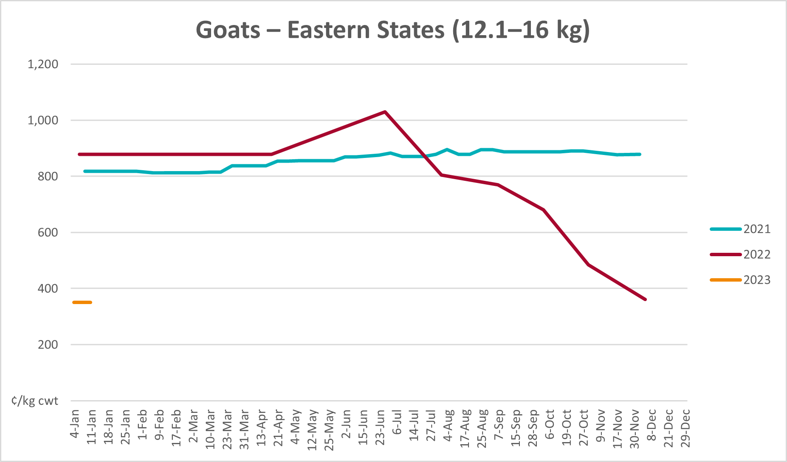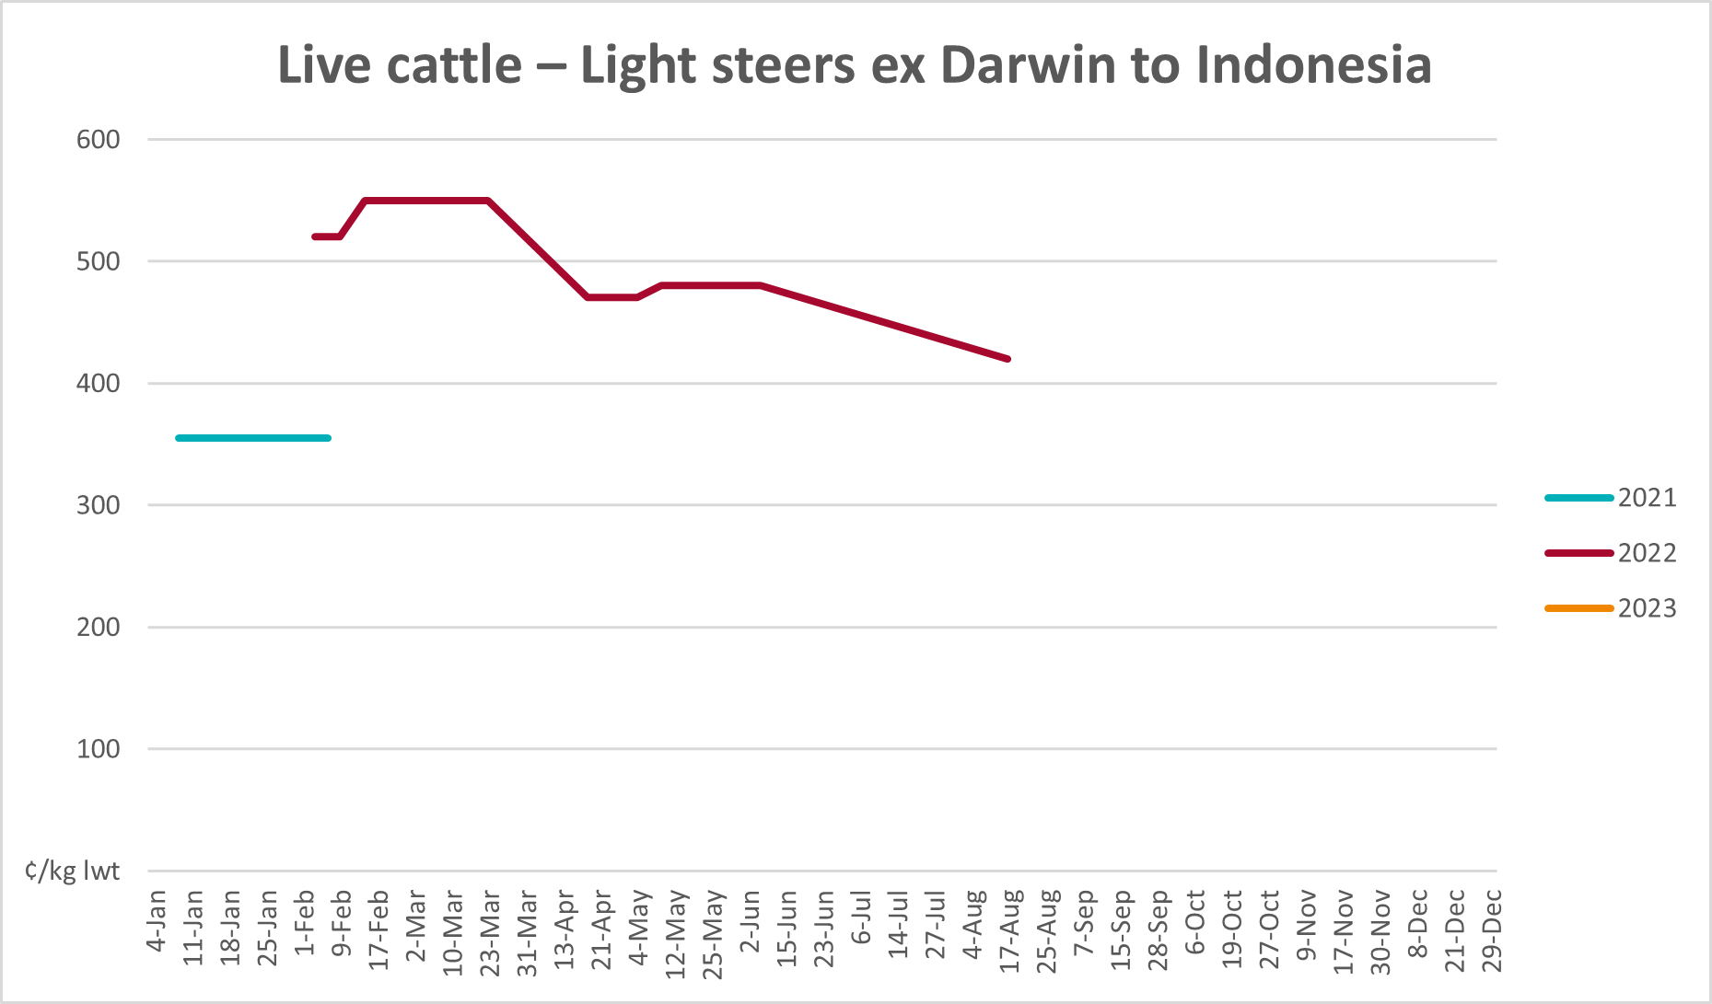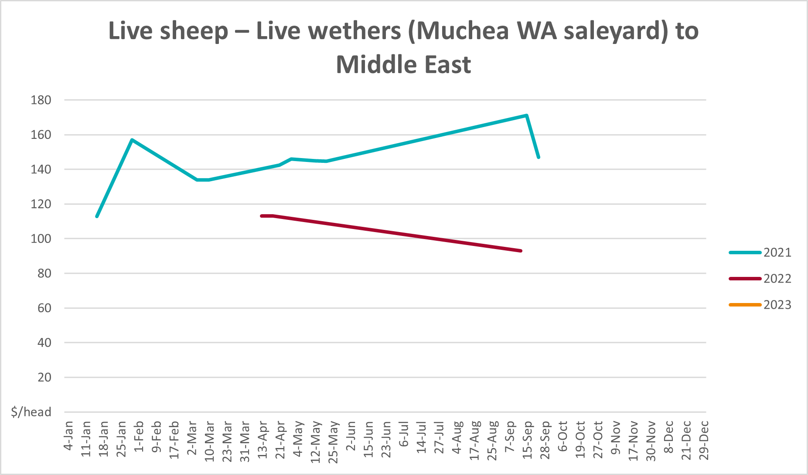

Global Dairy Trade (GDT) weighted average prices
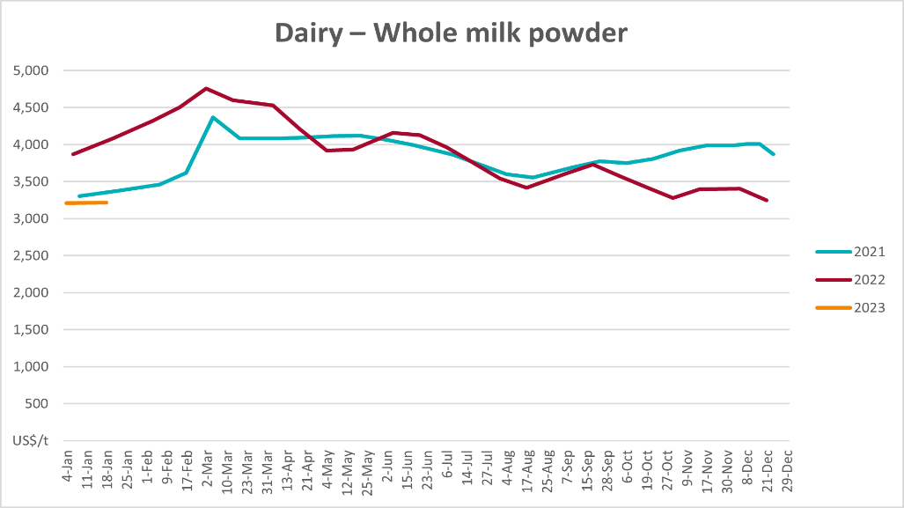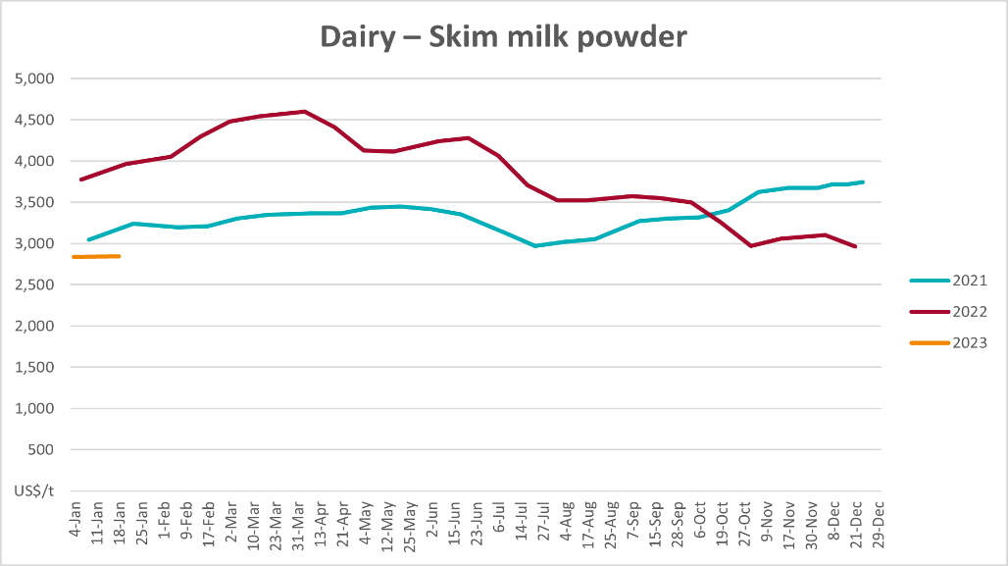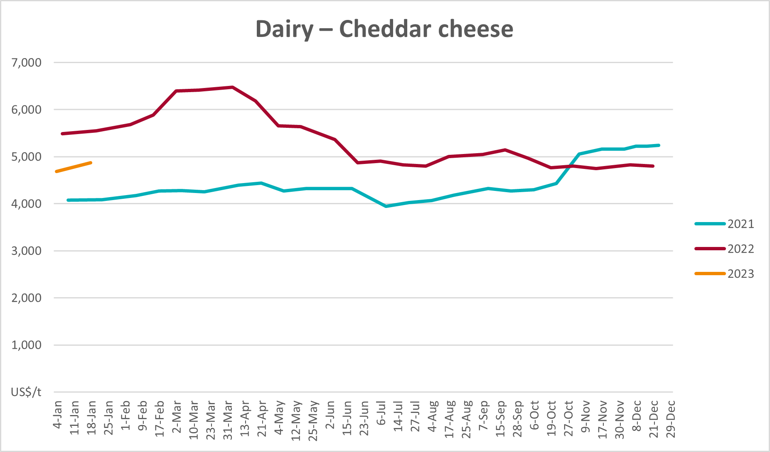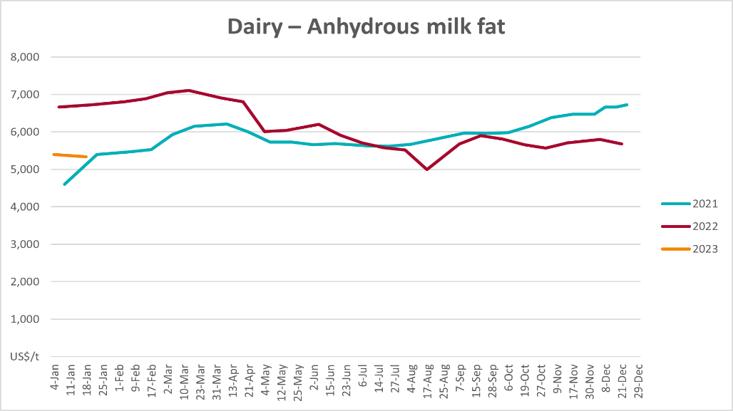

Selected fruit and vegetable prices
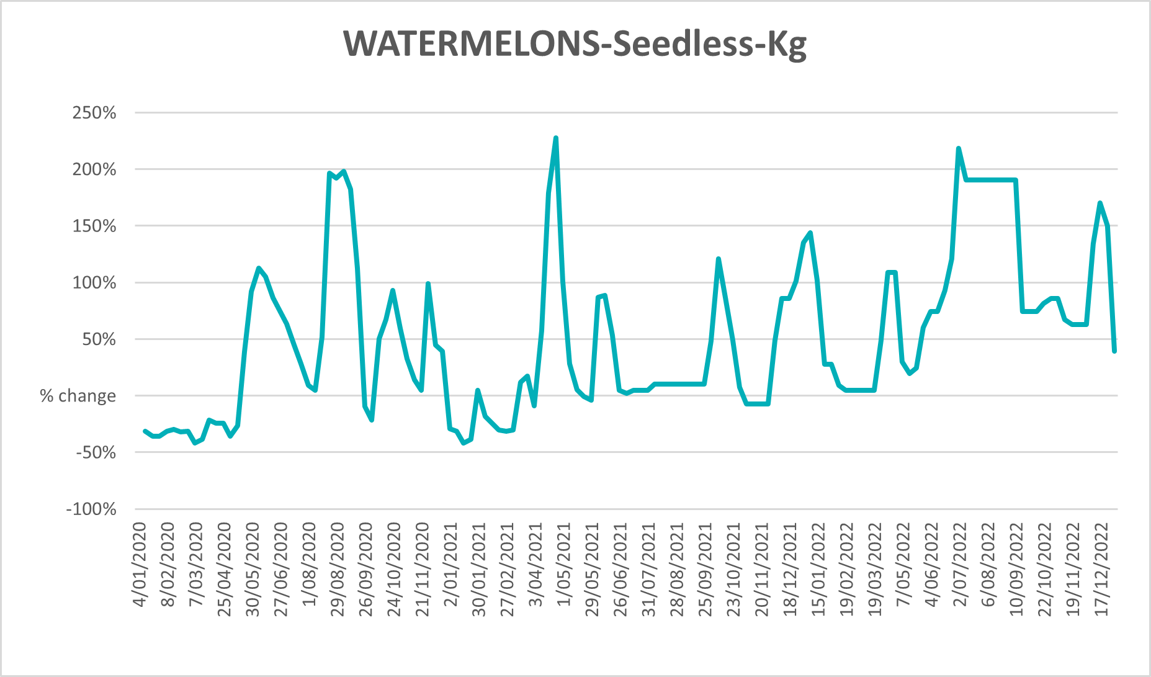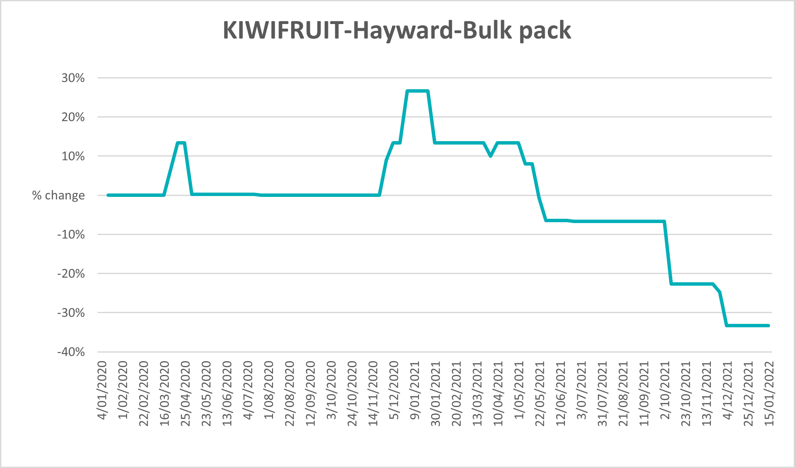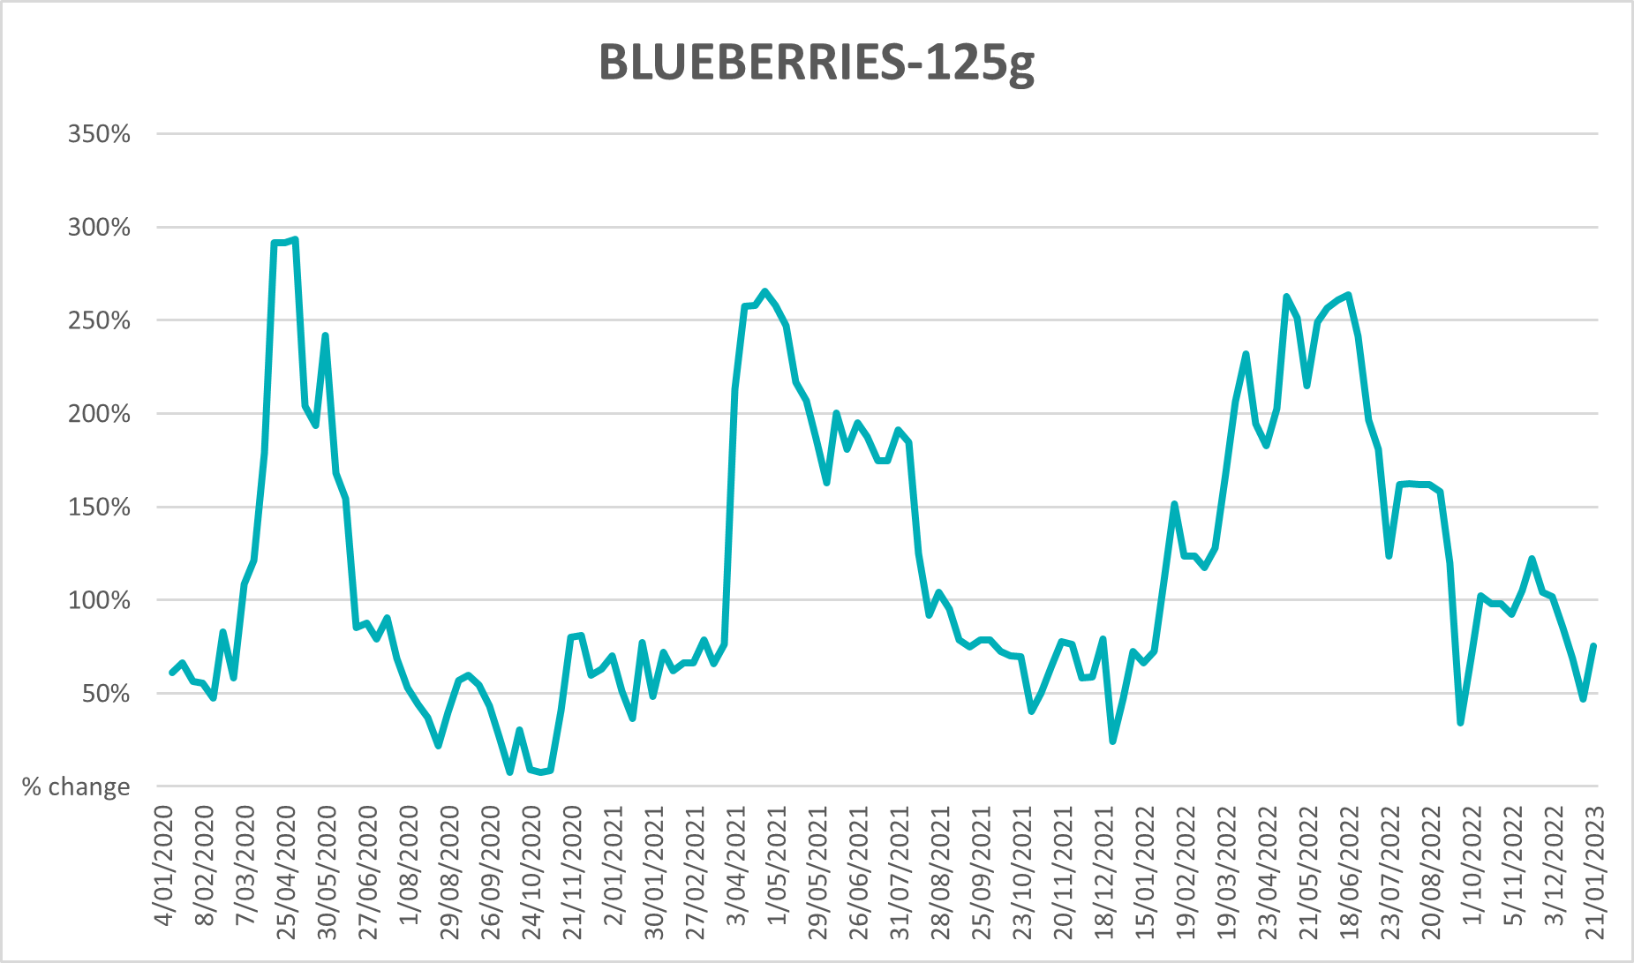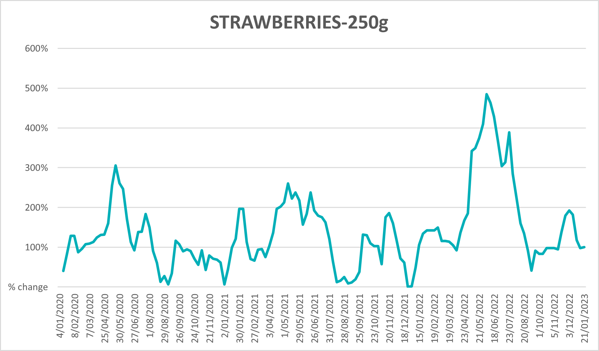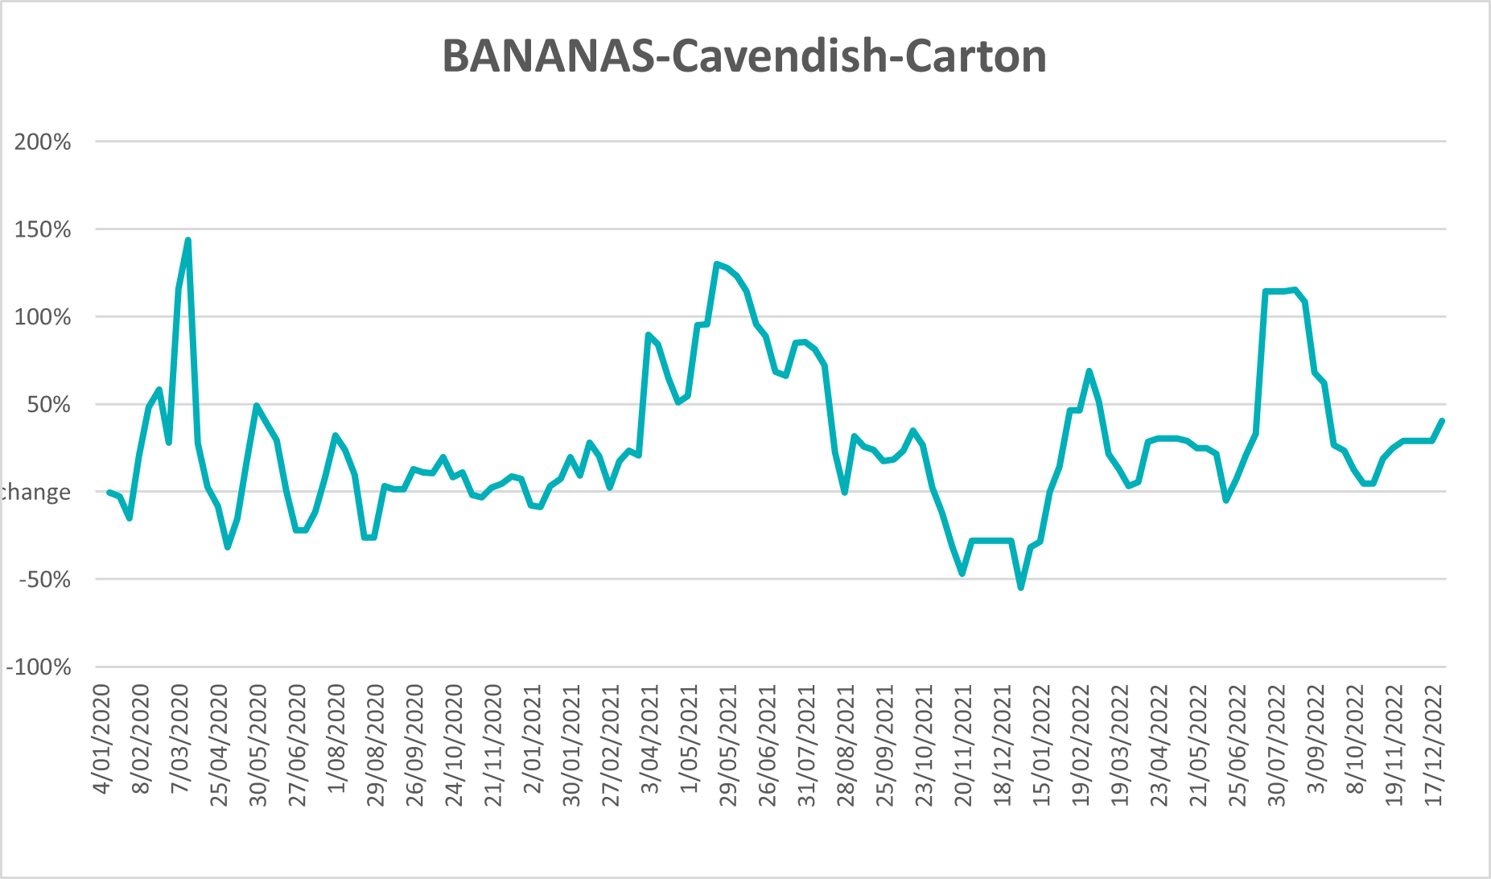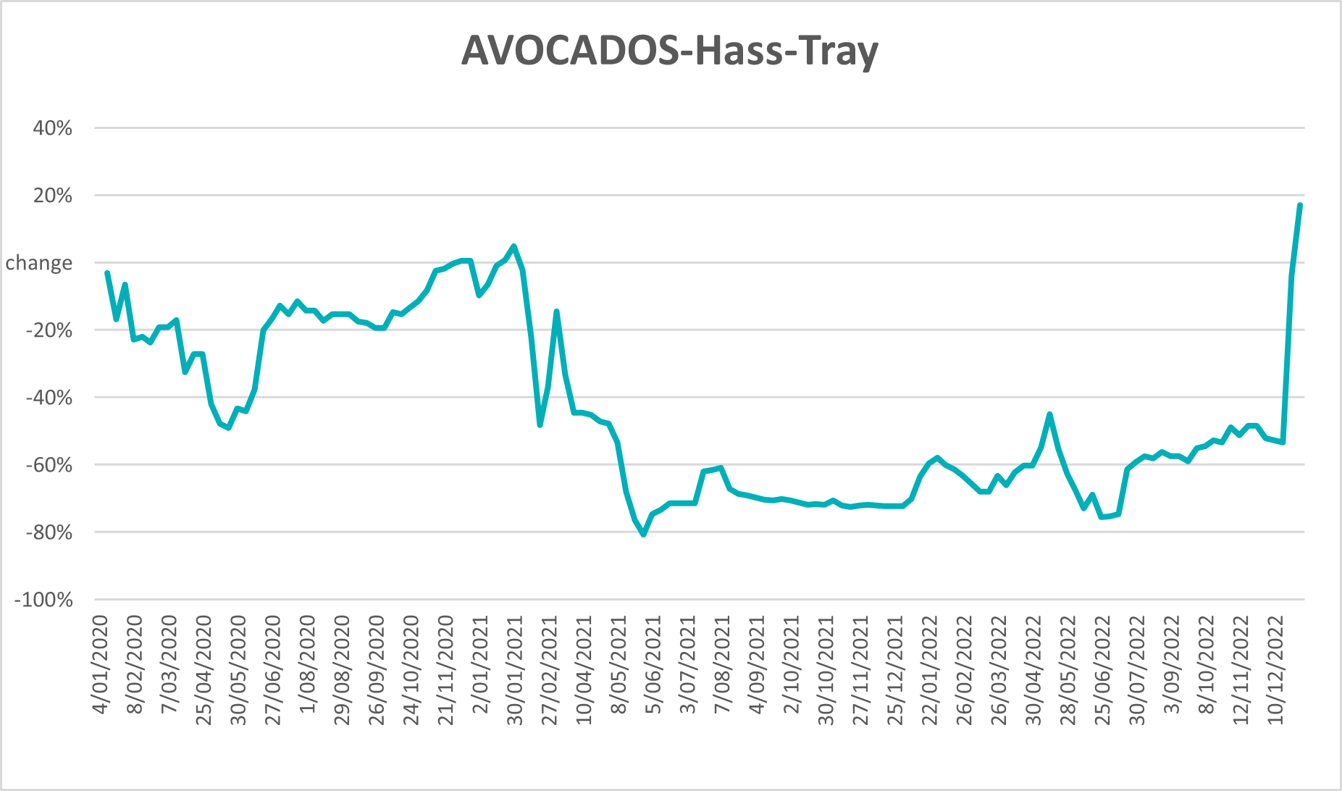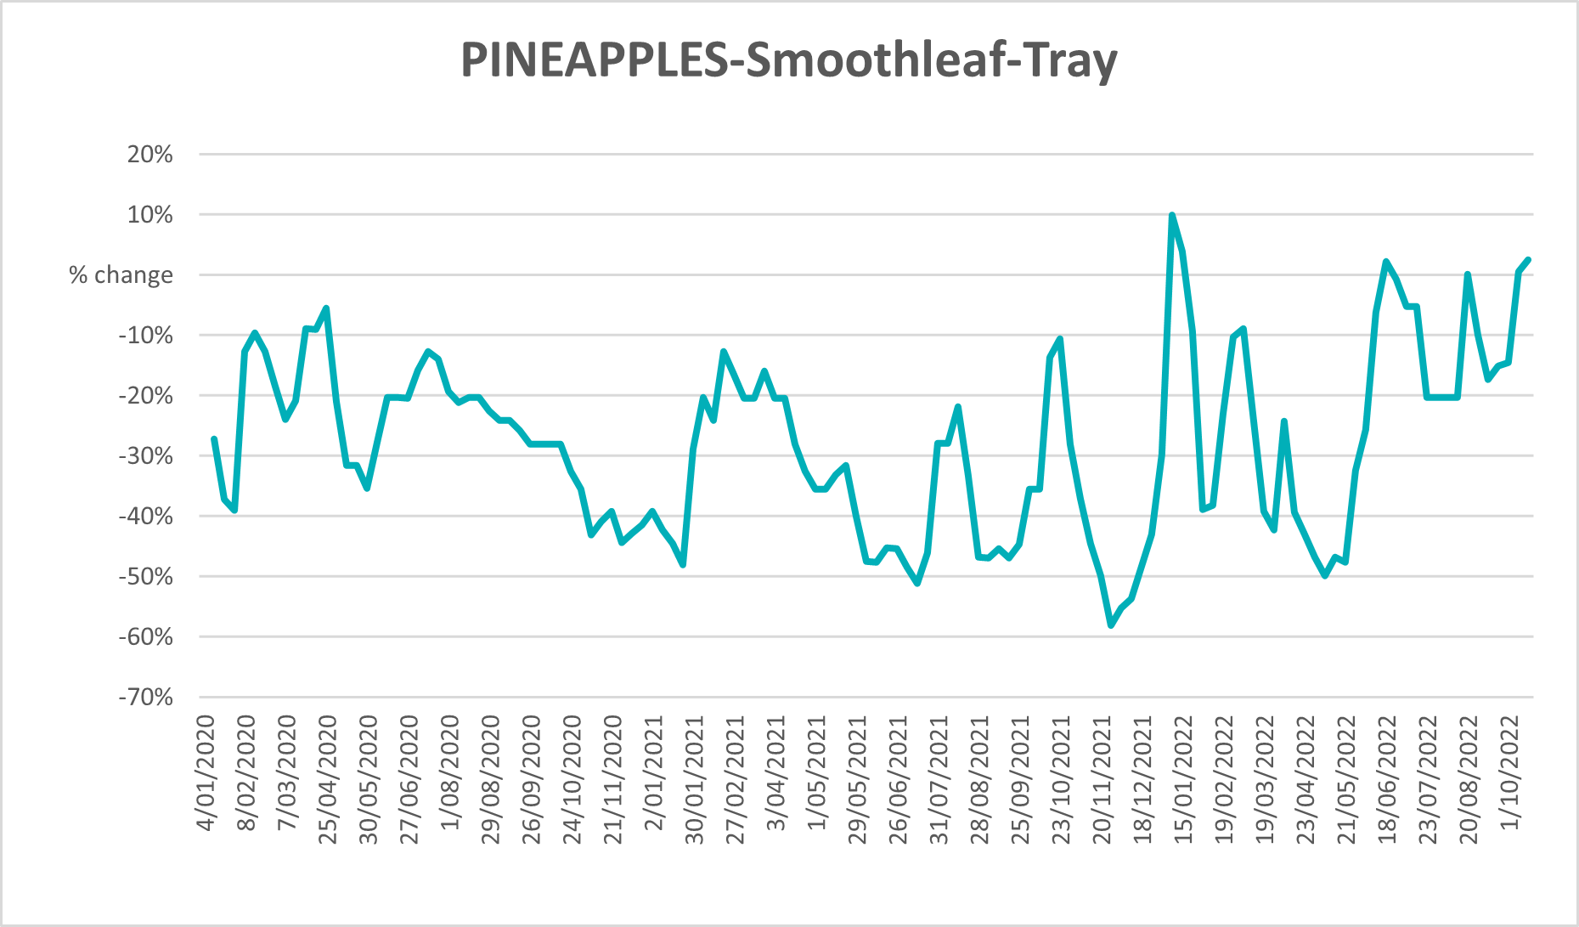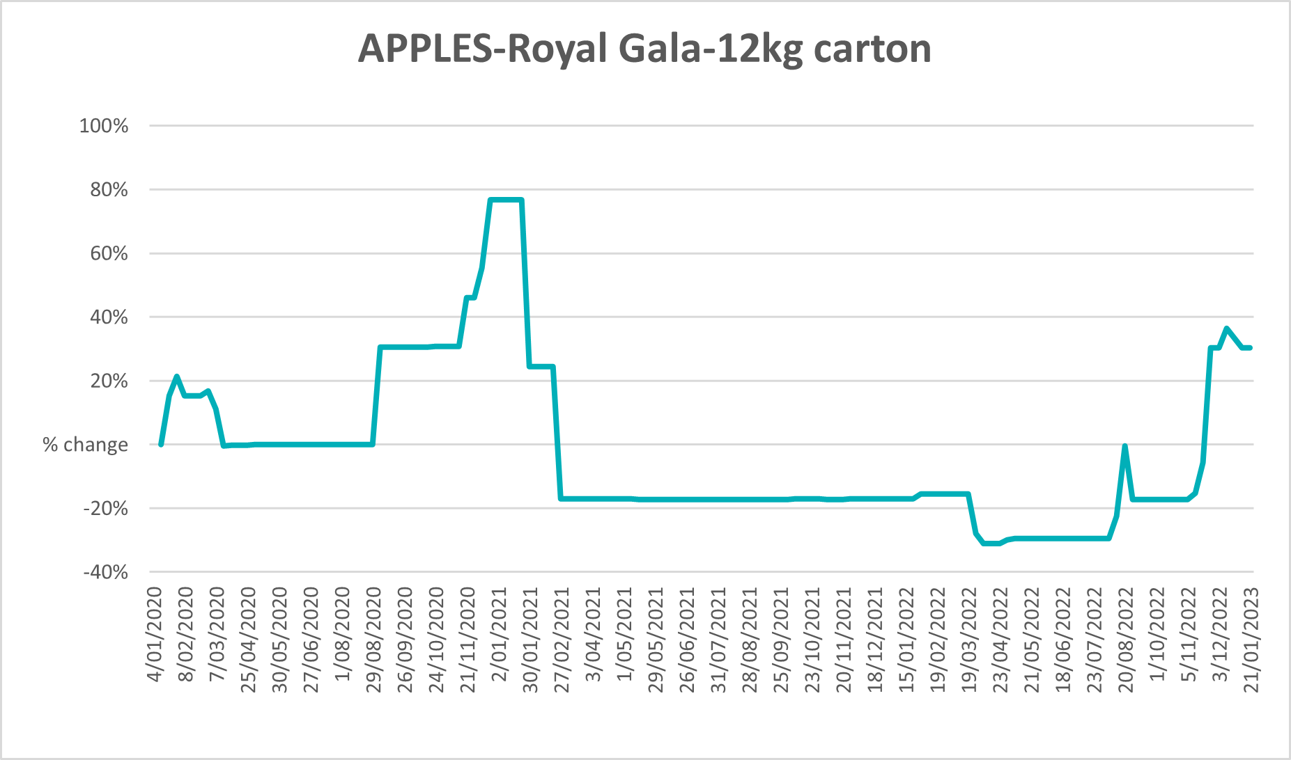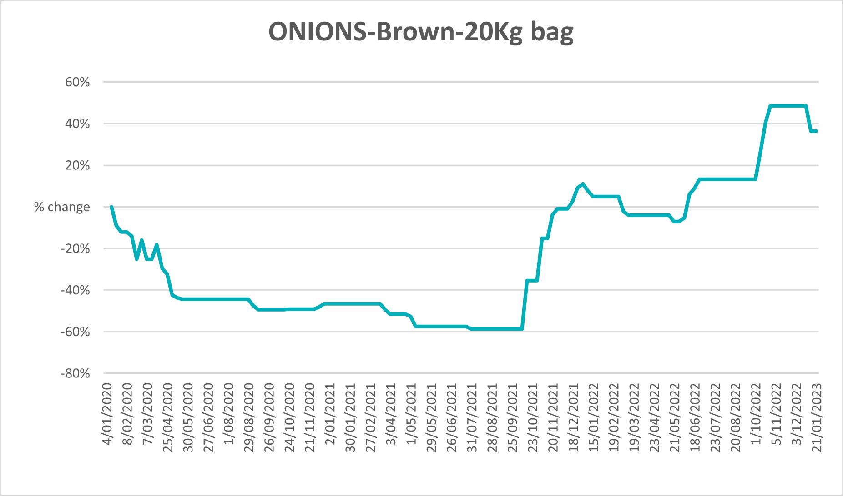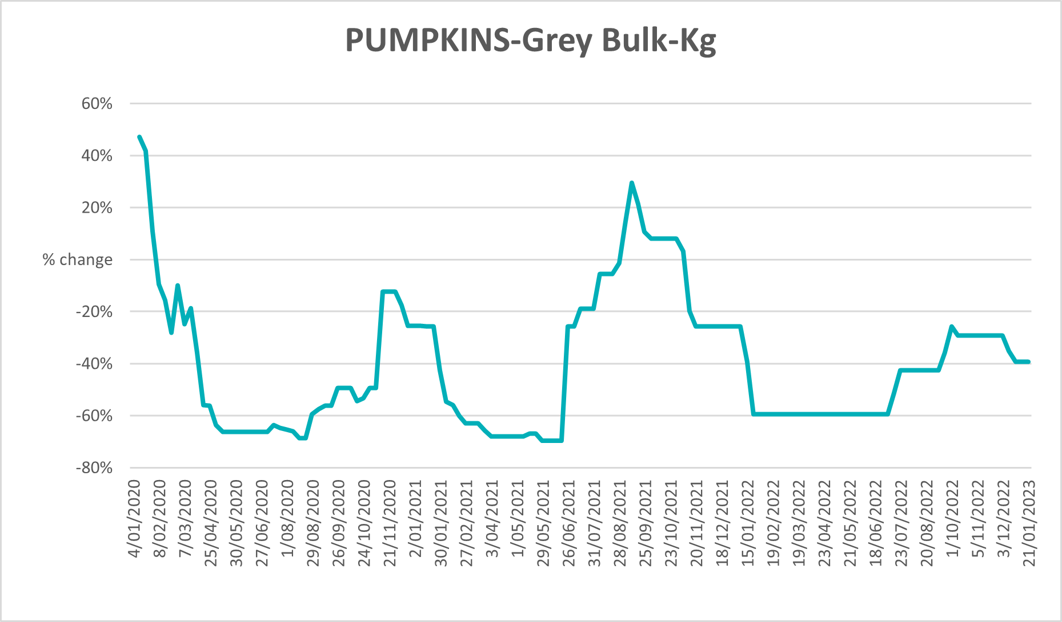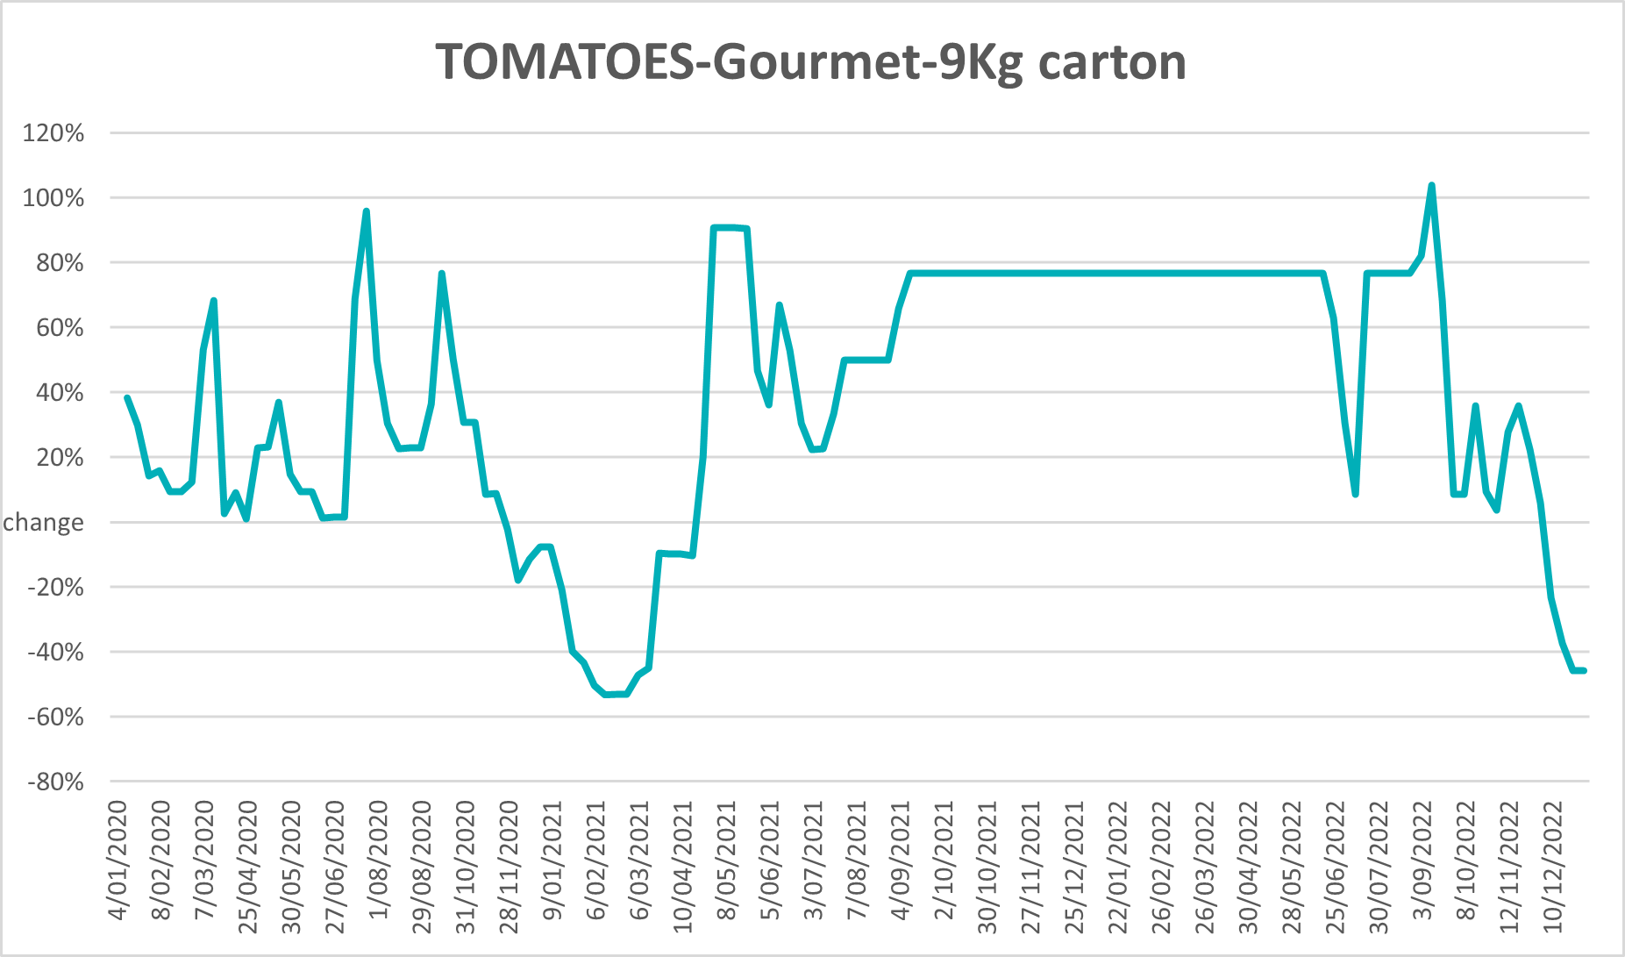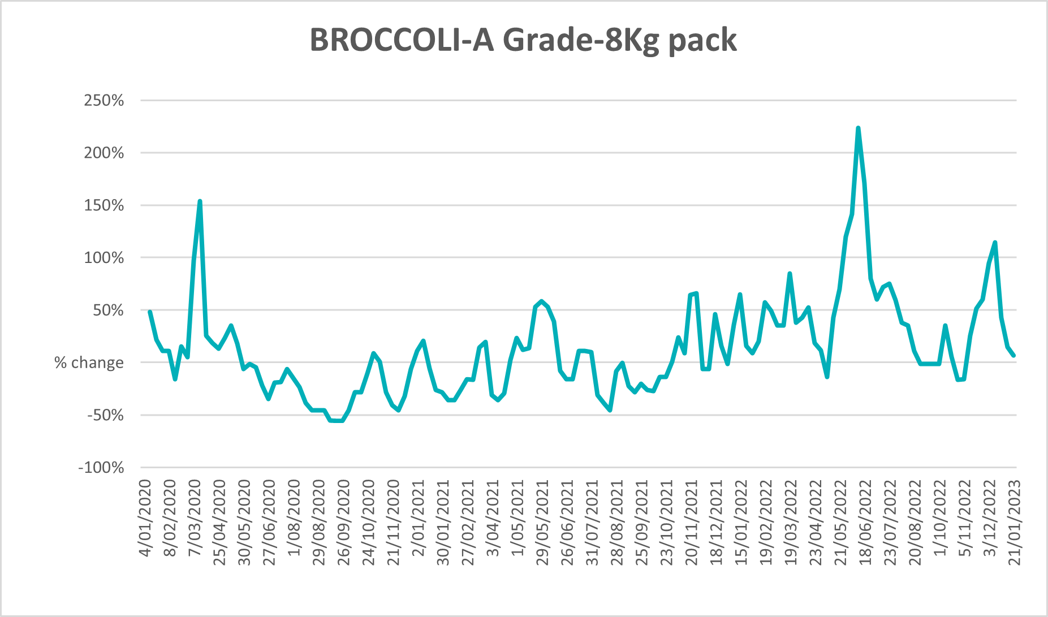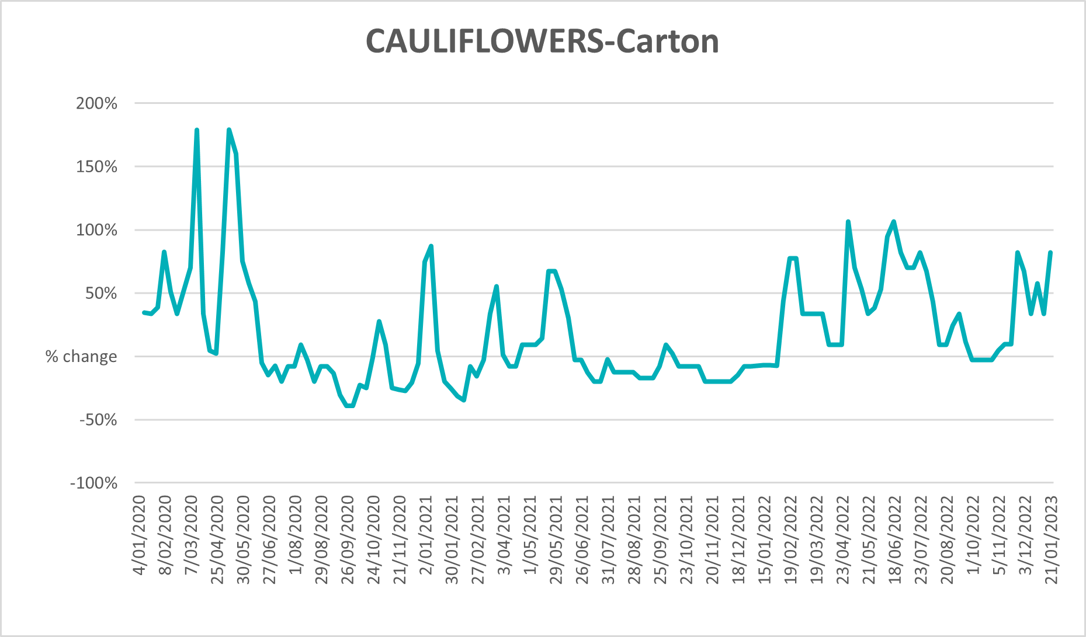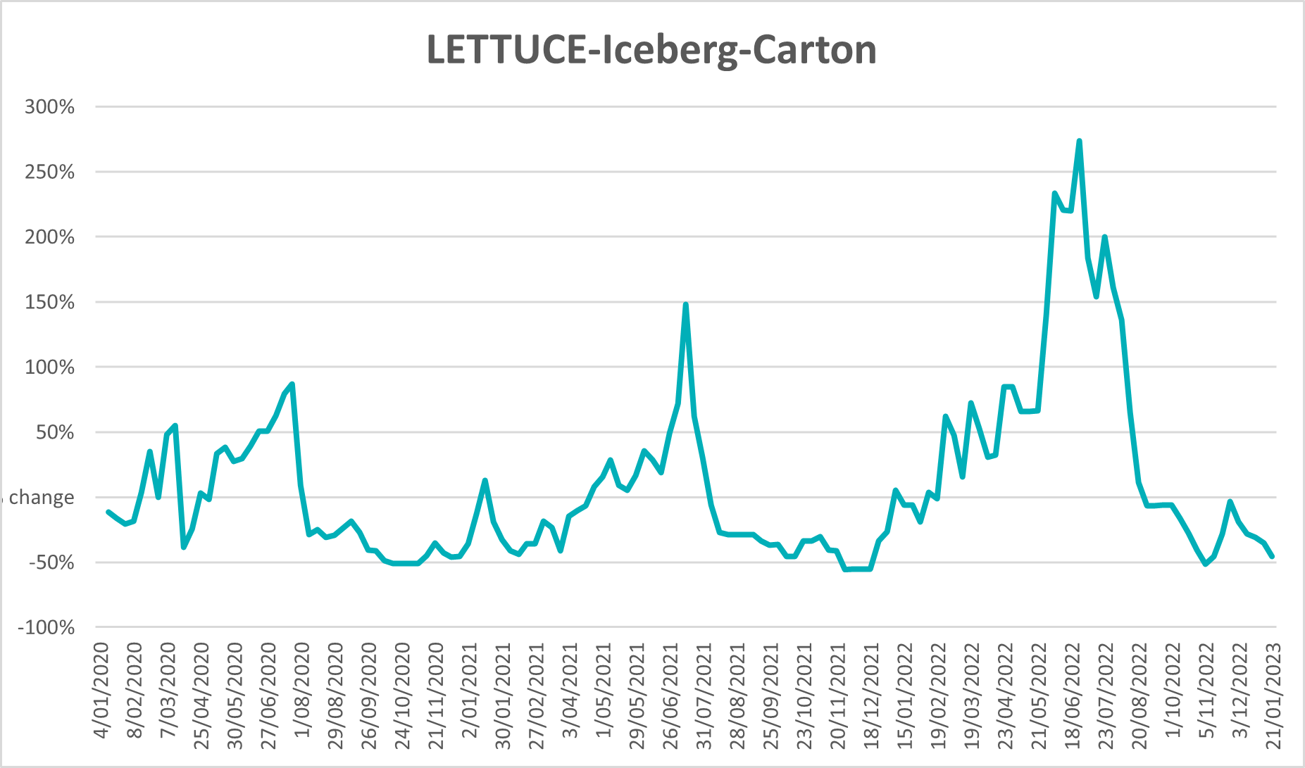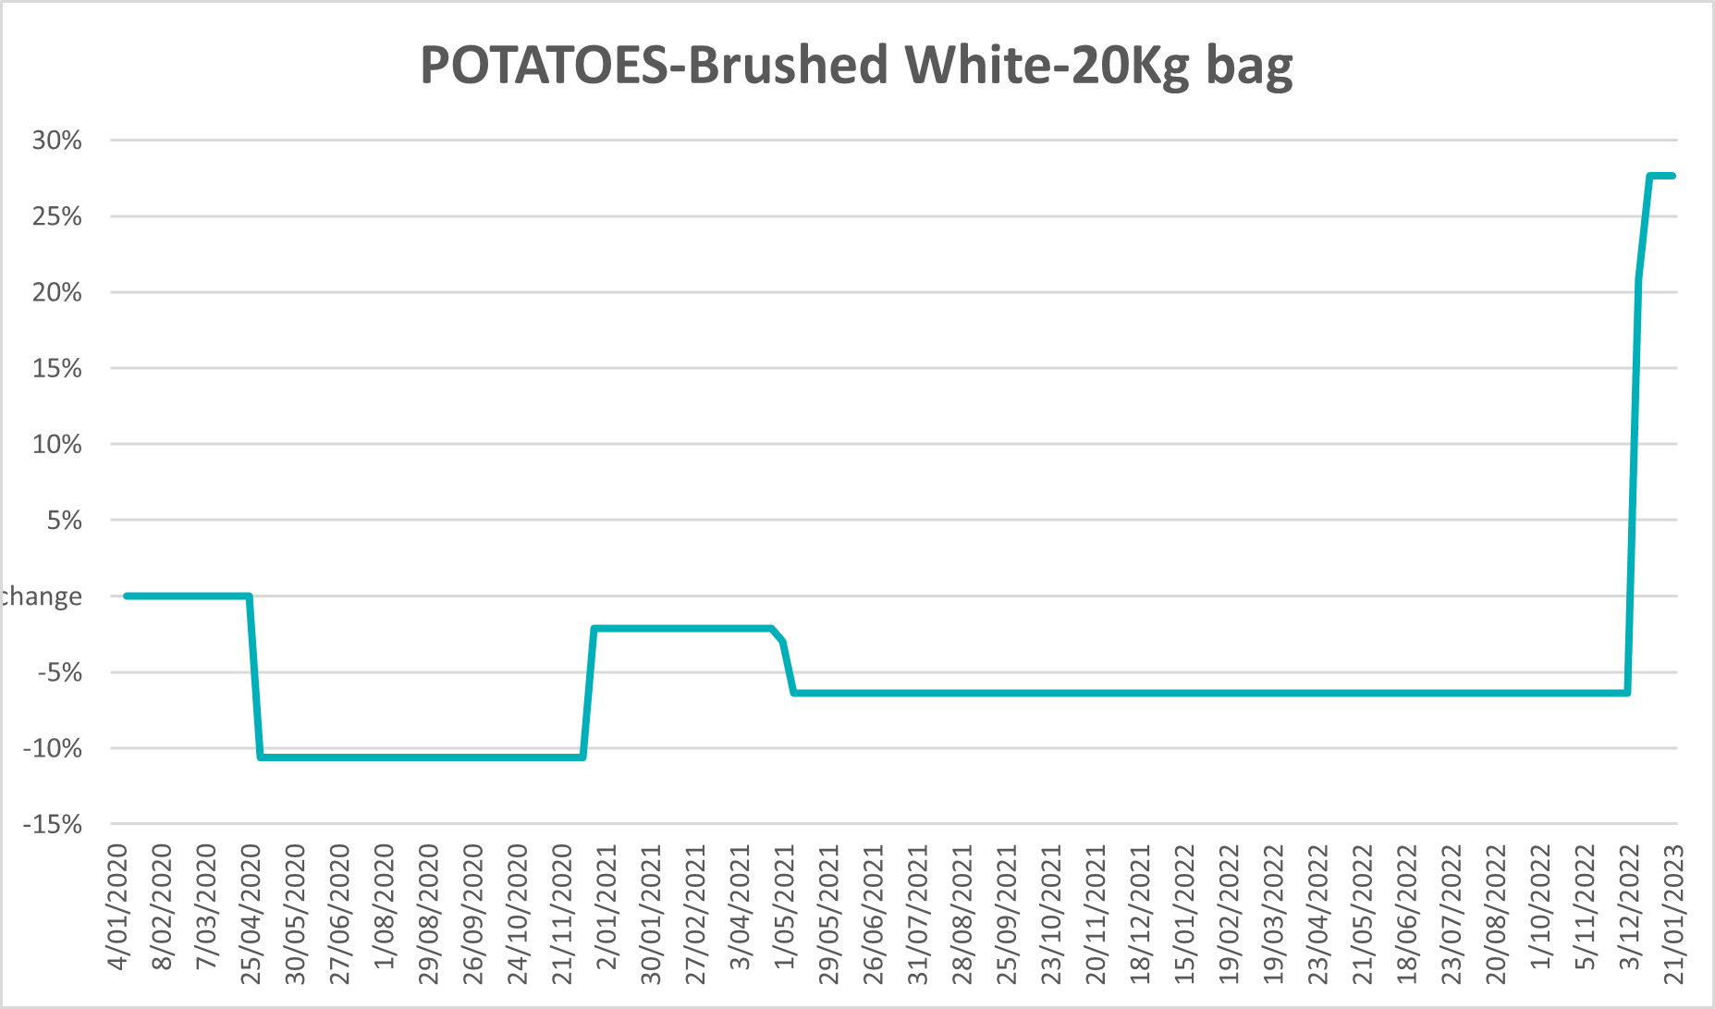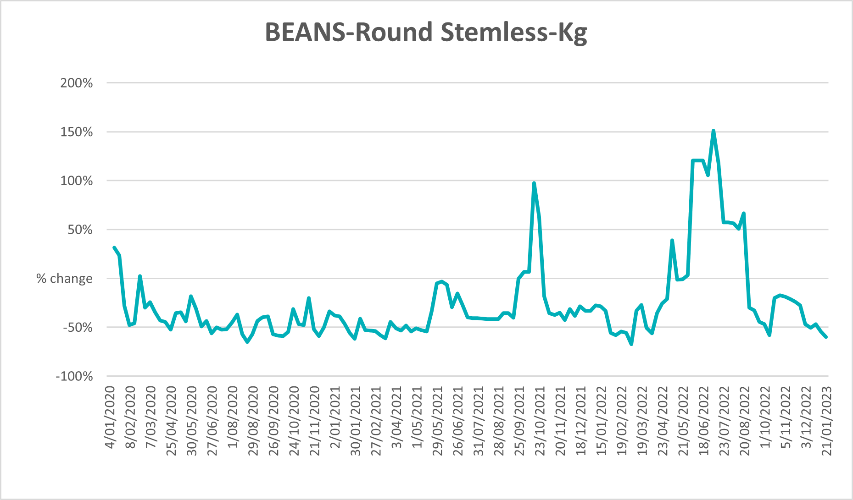

Selected domestic fodder indicator prices
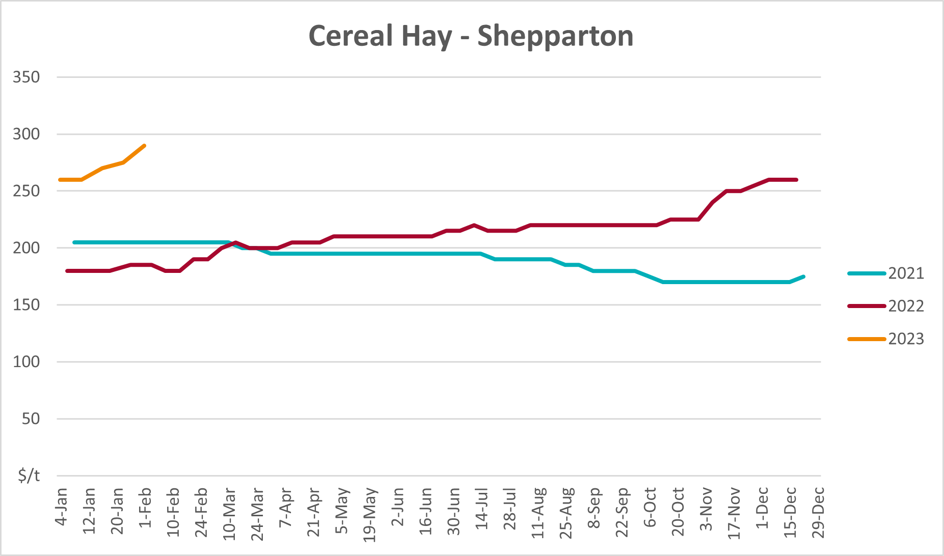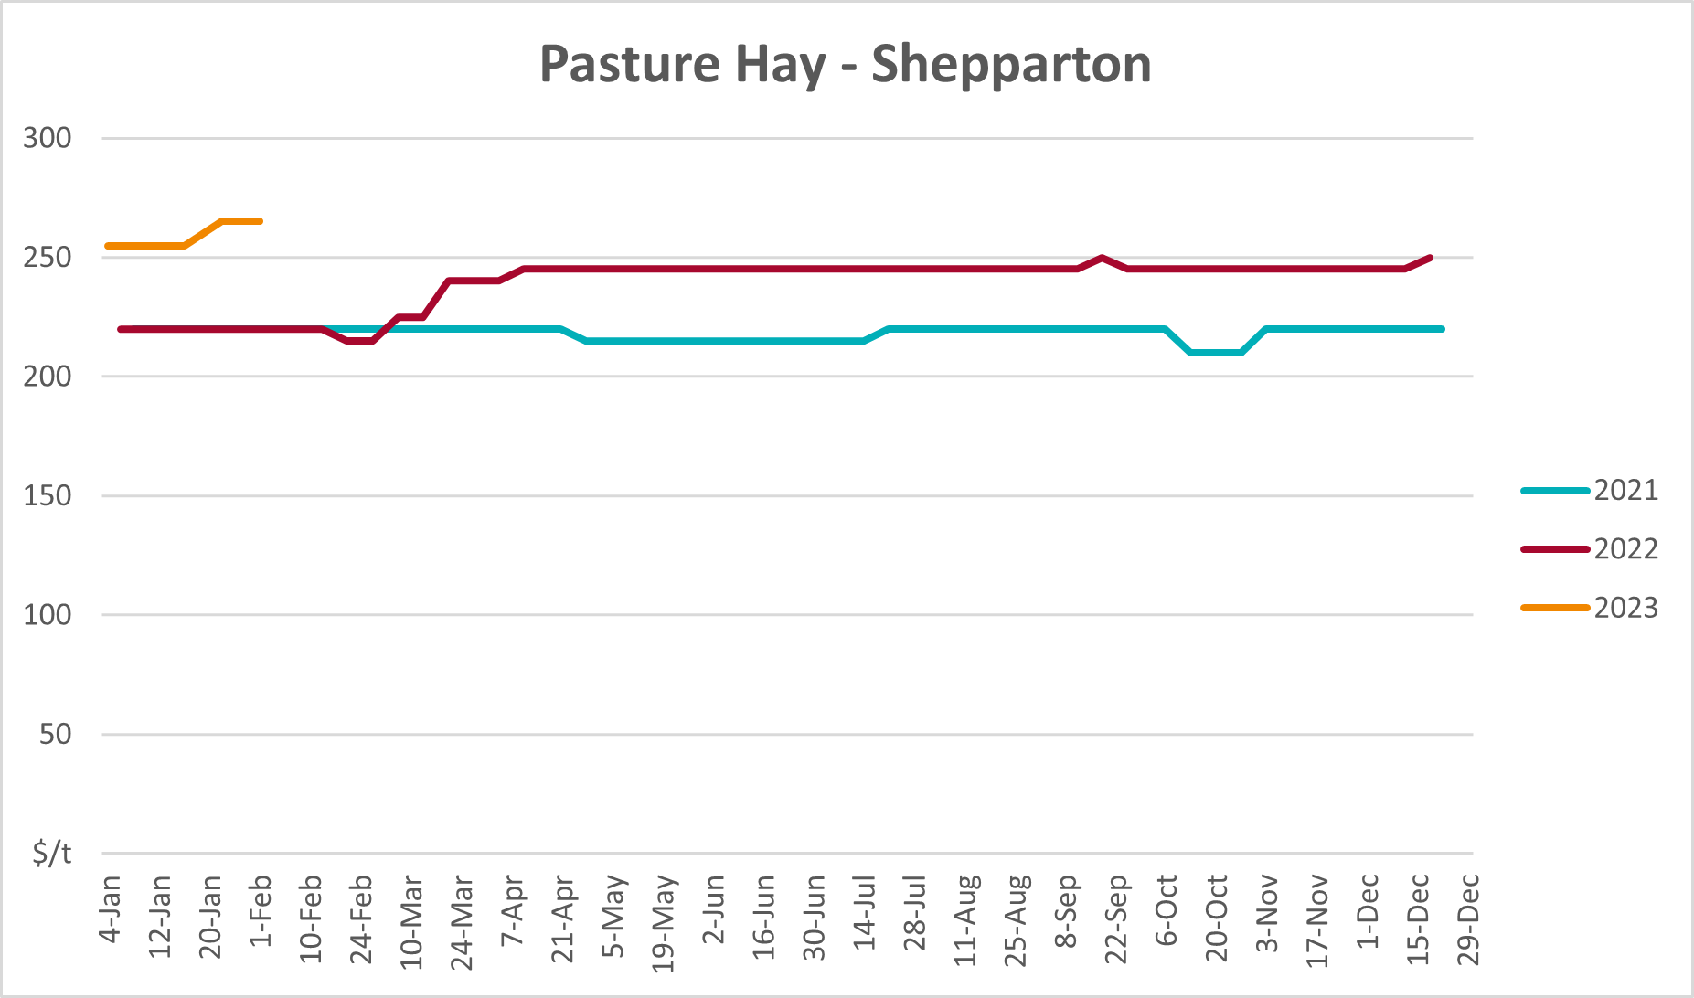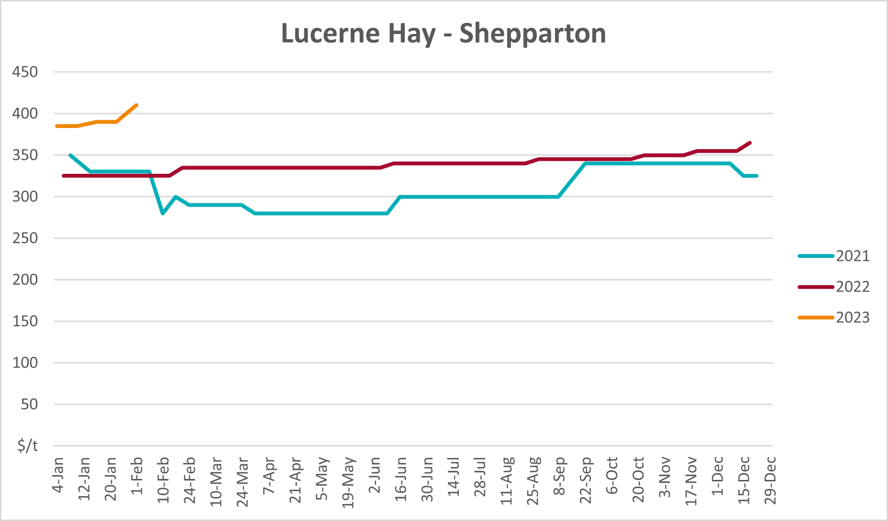

Data attribution

Climate
Bureau of Meteorology
- Weekly rainfall totals: www.bom.gov.au/climate/maps/rainfall/
- Monthly and last 3-month rainfall percentiles: www.bom.gov.au/water/landscape/
- Temperature anomalies: www.bom.gov.au/jsp/awap/temp/index.jsp
- Rainfall forecast: www.bom.gov.au/jsp/watl/rainfall/pme.jsp
- Seasonal outlook: www.bom.gov.au/climate/outlooks/#/overview/summary/
- Climate drivers: http://www.bom.gov.au/climate/enso/
- Soil moisture: www.bom.gov.au/water/landscape/
Other
- Pasture growth: www.longpaddock.qld.gov.au/aussiegrass/
- 3-month global outlooks: Environment and Climate Change Canada, NOAA Climate Prediction Center, EUROBRISA CPTEC/INPE, European Centre for Medium-Range Weather Forecasts, Hydrometcenter of Russia, National Climate Center Climate System Diagnosis and Prediction Room (NCC), International Research Institute for Climate and Society
- Global production: https://ipad.fas.usda.gov/ogamaps/cropmapsandcalendars.aspx
- Autumn break: Pook et al., 2009, https://rmets-onlinelibrary-wiley-com.virtual.anu.edu.au/doi/epdf/10.1002/joc.1833

Water
Prices
- Waterflow: https://www.waterflow.io/
- Ruralco: https://www.ruralcowater.com.au/
Bureau of Meteorology:
- Allocation trade: http://www.bom.gov.au/water/dashboards/#/water-markets/mdb/at
- Storage volumes: http://www.bom.gov.au/water/dashboards/#/water-storages/summary/drainage
Trade constraints:
- Water NSW: https://www.waternsw.com.au/customer-service/ordering-trading-and-pricing/trading/murrumbidgee
- Victorian Water Register: https://www.waterregister.vic.gov.au/TradingRules2019/

Commodities
Fruit and vegetables
- Datafresh: www.freshstate.com.au
Pigs
- Australian Pork Limited: www.australianpork.com.au
Dairy
- Global Dairy Trade: www.globaldairytrade.info/en/product-results/
World wheat, canola
- International Grains Council
World coarse grains
- United States Department of Agriculture
World cotton
- Cotlook: www.cotlook.com/
World sugar
- New York Stock Exchange - Intercontinental Exchange
Wool
- Australian Wool Exchange: www.awex.com.au/
Domestic wheat, barley, sorghum, canola and fodder
- Jumbuk Consulting Pty Ltd: http://www.jumbukag.com.au/
Cattle, beef, mutton, lamb, goat and live export
- Meat and Livestock Australia: www.mla.com.au/Prices-and-market
© Commonwealth of Australia 2023

Ownership of intellectual property rights
Unless otherwise noted, copyright (and any other intellectual property rights, if any) in this publication is owned by the Commonwealth of Australia (referred to as the Commonwealth).

Creative Commons licence
All material in this publication is licensed under a Creative Commons Attribution 4.0 International Licence except content supplied by third parties, logos and the Commonwealth Coat of Arms.
Inquiries about the licence and any use of this document should be emailed to copyright@awe.gov.au.


Cataloguing data
This publication (and any material sourced from it) should be attributed as:
ABARES 2023, Weekly Australian Climate, Water and Agricultural Update, Australian Bureau of Agricultural and Resource Economics and Sciences, Canberra, 2 February 2023. CC BY 4.0 DOI: https://doi.org/10.25814/5f3e04e7d2503
ISSN 2652-7561
This publication is available at https://www.agriculture.gov.au/abares/products/weekly_update
Department of Agriculture, Fisheries and Forestry
GPO Box 858 Canberra ACT 2601
Telephone 1800 900 090
Web agriculture.gov.au/abares

Disclaimer
The Australian Government acting through the Department of Agriculture, Fisheries and Forestry, represented by the Australian Bureau of Agricultural and Resource Economics and Sciences, has exercised due care and skill in preparing and compiling the information and data in this publication. Notwithstanding, the Department of Agriculture, Fisheries and Forestry, ABARES, its employees and advisers disclaim all liability, including liability for negligence and for any loss, damage, injury, expense or cost incurred by any person as a result of accessing, using or relying on any of the information or data in this publication to the maximum extent permitted by law.

Statement of Professional Independence
The views and analysis presented in ABARES publications, including this one, reflect ABARES professionally independent findings, based on scientific and economic concepts, principles, information and data. These views, analysis and findings may not reflect or be consistent with the views or positions of the Australian Government, or of organisations or groups who have commissioned ABARES reports or analysis. More information on professional independence is provided on the ABARES website.

Acknowledgements
This report was prepared by Ruirui Zhu and Matthew Miller.

