
No. 10/2023 16 March 2023

Summary of key issues
- For the week ending 15 March 2023, a tropical low produced weekly total rainfall of 300 to 600 millimetres over the Gulf Country in north-west Queensland; this is about 2.5 to 5 times the March average for these areas. Widespread weekly rainfall of 50 to 150 millimetres in the Northern Territory Top End, most of eastern Queensland and into north-eastern and coastal New South Wales. Weekly totals between 25 and 100 millimetres were recorded in central New South Wales and western Tasmania.
- In the cropping regions, 25 to 150 millimetres of rainfall was recorded in Queensland as well in central and northern New South Wales. Little to no rainfall was recorded across the remaining cropping regions over the past 7 days. Wet conditions across summer cropping regions would have prevented access to fields for crop maintenance activities and for the harvesting of early sown crops (see Section 1.1).
- As at the end of February 2023, global crop production conditions were generally favourable for the major grain and oilseed producing countries. However, dry conditions across parts of Argentina, Brazil and the United States have affected the production potential of wheat, corn and soybeans (see Section 1.2).
- Below average rainfall during February is likely to result in lower-than-expected corn and soybean production in Argentina. This is providing a deterioration in global production conditions compared to those seen back in January 2023, that were used to formulate ABARES forecasts of global grain supplies and the impact on world prices in its March 2023 edition of Agricultural commodities. As a result, global coarse grain and oilseed production is likely to be lower than that forecast in March. In contrast, improved growing conditions across Brazil, Kazakhstan and parts of India is expected to raise wheat production prospects in these key production regions (see Section 1.2).
- The global climate outlook indicates that average to above average rainfall is more likely between April and June 2023 for most of the world’s major grain- and oilseed-producing regions. This is in part due a return to El-Niño Southern Oscillation (ENSO) neutral conditions providing an improved climate outlook in a number of key grain- and oilseed-producing regions (see Section 1.2).
- Over the 8-days to 23 March 2023, a trough is expected to generate 10 to 50 millimetres of rain across the tropical north of Australia. The northeast Queensland coastline, around Cairns and Townsville, is expected to receive up to 200 millimetres of rainfall. A cold front should bring up to 50 millimetres of rainfall to the west coast of Tasmania mid-week. A high-pressure system is expected to bring mainly dry conditions elsewhere. Little to no rainfall is expected in the cropping regions (see Section 1.3).
- Water storage levels in the Murray-Darling Basin (MDB) decreased between 8 March 2023 and 15 March 2023 by 224 gigalitres (GL). Current volume of water held in storage is 22 228 GL which represents 88 per cent of total capacity. This is 0.2 percent or 36 GL more than at the same time last year.
- Allocation prices in the Victorian Murray below the Barmah Choke remained steady at $15 per ML from 9 March 2023 to 15 March 2023.

Climate

Rainfall this week
For the week ending 15 March 2023, rainfall was restricted to the north and east of the country. Weekly totals between 25 and 100 millimetres were recorded across central and north-eastern New South Wales, eastern and central Queensland, the north and east of the Northern Territory and western Tasmania. Meanwhile a tropical low brought weekly rainfall total of 300 to 600 millimetres and extensive flooding to the Gulf Country in north-west Queensland; these falls are equivalent to about 2.5 to 5 times the March average rainfall for these areas.
In the cropping regions, rainfall totals of between 25 to 150 millimetres were recorded across Queensland as well in central and northern New South Wales. Little to no rainfall was recorded across the remaining cropping regions over the past 7 days. Wet conditions across summer cropping regions would have prevented access to fields for crop maintenance activities and for the harvesting of early sown crops. For those regions that had started to see below average soil moisture levels and some moisture stress, these falls are likely to consolidate yield prospects for later sown summer crops and also provide sufficient moisture to plant early winter forage and grain crops in the coming weeks.

Rainfall for the week ending 15 March 2023
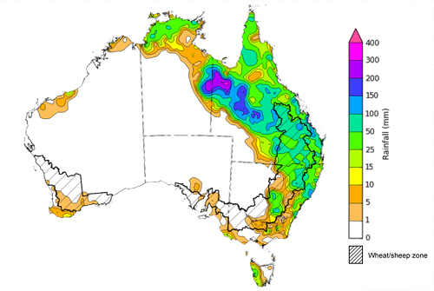
©Commonwealth of Australia 2023, Australian Bureau of Meteorology Issued: 15/03/2023
Note: The rainfall analyses and associated maps utilise data contained in the Bureau of Meteorology climate database, the Australian Data Archive for Meteorology (ADAM). The analyses are initially produced automatically from real-time data with limited quality control. They are intended to provide a general overview of rainfall across Australia as quickly as possible after the observations are received. For further information go to http://www.bom.gov.au/climate/rainfall/

Global production conditions and climate outlook
Crop production is affected by long-term trends in average rainfall and temperature, interannual climate variability, shocks during specific growth stages, and extreme weather events. Some crops are more tolerant than others to certain types of stresses, and at each growth stage, different types of stresses affect each crop species in different ways.
The precipitation anomalies and outlooks presented here give an indication of the current and future state of production conditions for the major grain and oilseed producing countries which are responsible for over 80% of global production. This is an important input to assessing the global grain supply outlook.
February precipitation percentiles and current production conditions
As of the end of February 2023, rainfall was mixed for the world’s major grain-producing and oilseed-producing regions.
The precipitation was below average across much of Argentina, the United Kingdom, northern India, central Brazil, Mexico, north-western United States, southeast and southwest Australia, western Europe and Türkiye. Precipitation was above average in the north-eastern United States, eastern Europe and much of Southeast Asia. Precipitation was close to average across the remainder of the major grain-producing and oilseed-producing regions.

Global precipitation percentiles, February 2023
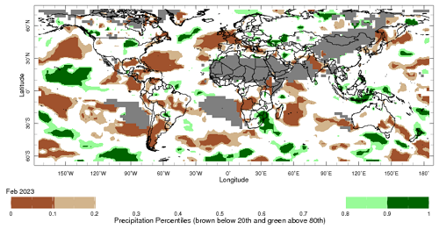
Note: The world precipitation percentiles indicate a ranking of precipitation for February, with the driest (0th percentile) being 0 on the scale and the wettest (100th percentile) being 1 on the scale. Percentiles are based on precipitation estimates from the NOAA Climate Prediction Center’s Climate Anomaly Monitoring System Outgoing Precipitation Index dataset. Precipitation estimates for February 2023 are compared with rainfall recorded for that period during the 1981 to 2010 base period.
Source: International Research Institute for Climate and Society
As of 2 March 2023, the global production conditions were generally favourable for the production of rice and corn. However, the lack of precipitation has affected the production potential of soybeans and wheat in some key grain exporting and importing countries.
In the northern hemisphere, growing conditions have been mixed for winter wheat production. Climatic conditions have been favourable for wheat development in Canada, China, the European Union, Türkiye, and the United Kingdom. However, production prospect is mixed in the United States, Ukraine and the Russian Federation due to dryness in some areas. Conditions were favourable for winter wheat sowing in India.
Corn production conditions have deteriorated in Argentina for both their early and late planted crop. The prolonged drought and high temperatures during the key reproductive stages, significantly affecting the yield potential for the early and late planted crop, while the late planted crop will require rainfall over the next few weeks to avoid further yield loss. In Brazil, conditions were generally favourable for spring-planted crop development except for in the Rio Grande do Sul region due to persistent lack of rain and high temperatures in the south. The sowing of summer-planted corn is commencing under favourable conditions in Brazil. In India, conditions have been favourable for Rabi crop sowing with an increase in the total sown area compared to the previous year.
Climatic conditions have been favourable for dry-season rice harvesting and sowing of wet-season rice in Indonesia, with an increase in the total sown area given plentiful rainfall. In the Philippines, Thailand and Vietnam, conditions have been favourable for the harvest of wet-season and sowing of dry-season rice. In Brazil, production conditions and yield potentials have declined due to lack of rain and high temperatures and low irrigated water availability. A reduction in total sown area is estimated for the next season due to the continuing dry conditions across key growing regions in southern Brazil.
Production conditions for soybeans have been less than favourable in Argentina. Both early (larger season) and late (smaller season)-planted crops continue to be affected by the prolonged drought and hot conditions, which caused flowers and pods to drop, reducing yields. Major yield losses are expected, with most affected areas located in the eastern Argentina. In the western Argentina, widespread frosts may have impacted the late-planted crop germination. In Brazil, the soybean harvest is ongoing with above average yields due to favourable growing conditions in most districts, except for in the south where a lack of rain and high temperatures have negatively impacted yields.
Crop conditions, AMIS countries, 2 March 2023

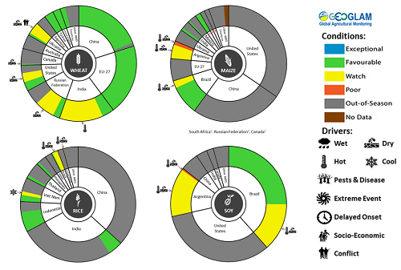
AMIS Agricultural Market Information System.
Source: AMIS

The global climate outlook for April 2023 to June 2023 indicates that generally average or better rainfall conditions are expected for the world’s major grain-producing and oilseed-producing regions. Outlooks and potential production impacts for the major grain and oilseed producing countries are presented in the table.
Rainfall outlook and potential impact on the future state of production conditions between April 2023 and June 2023
Region | April-June rainfall outlook | Potential impact on production
Argentina | Average rainfall is more likely across much of Argentina between April and June 2023. With above average rainfall more likely in the northeast. | Average to above average rainfall is likely to support favourable crops development and yield potential of sorghum, rice, millet, soybeans, corn, sunflower, cotton and nuts, and the planting of wheat in May 2023.
Black Sea region | Average rainfall is more likely across much of Black Sea region between April and June 2023, with below average rainfall is forecast for parts of northern and eastern Kazakhstan, eastern Ukraine and the south-west of the Russian Federation. | Below average rainfall in parts of Kazakhstan, Ukraine and the Russian Federation may adversely affect winter wheat and canola development, as well as cotton, corn and sunflower planting from April 2023. Average or above normal rainfall across remaining areas is likely to support growth and yield potentials of similar crops and the planting and development of spring wheat planting from April 2023.
Brazil | Above average rainfall is more likely across northern and central Brazil while average rainfall is more likely across parts of southern Brazil. | Above average rainfall across northern and central Brazil is likely to support the development of cotton and corn but may impede soybean harvesting. Average rainfall in the south is likely to improves crop prospects for rice, sorghum, millet, sunflower, soybeans, cotton, nuts and corn, and the planting of wheat in May 2023.
Canada | Average rainfall is more likely across much of Canada between April and June 2023, with below average rainfall expected across parts of southern Alberta and Saskatchewan | Average rainfall is likely to support winter wheat development in Canada from April 2023 and the planting of spring wheat, canola, corn, soybeans and sunflower from May 2023.
China | Average rainfall is more likely across much of China while below average rainfall is more likely across parts of north-western China and above average rainfall is more likely across parts of north-eastern China. | Average to above average rainfall across much of China is likely to support the development of winter wheat and canola and the planting and development of early rice, single rice, cotton, spring wheat, corn, sorghum, soybeans, sunflower and nuts from April 2022. Below average rainfall across parts of northern China may affect the development of these crops.
Europe | Average to above average rainfall is more likely for much of Europe between April and June 2023. | Average to above average rainfall across Europe is likely to support winter wheat and canola development and the planting and development of corn, cotton, spring wheat, soybeans, sunflower and sorghum between April and June 2023.
South Asia (India) | Average rainfall is more likely across much of India. | Average rainfall is likely to support the development of wheat and canola in India.
Southeast Asia (SEA) | Average rainfall is more likely across much of SEA between April and June 2023, while below average rainfall is more likely across much of Indonesia. | Average or better rainfall across most of Southeast Asia is likely to benefit corn and rice planting, development and harvesting. Below average rainfall in Indonesia may adversely impact rice, corn and soybean production.
The United States of America (US) | Average rainfall is more likely across much of the US between April and June 2023. Above average rainfall is more likely for parts of north-eastern US while below average rainfall is more likely for parts of southern and north-western US. | Average or better rainfall in eastern US is likely to support winter wheat as it comes out of dormancy, as well as the planting and development of spring wheat, canola, corn, cotton, rice, soybeans and nuts. Below average rainfall in the north-west and southern US may adversely impact the development of winter wheat and the planting and development of corn, cotton, nuts, rice and soybeans.

Rainfall forecast for the next eight days
Over the 8-days to 23 March 2023, a trough is expected to generate 10 to 50 millimetres of rain across the tropical north of Australia. The northeast Queensland coastline, around Cairns and Townsville, is expected to receive up to 200 millimetres of rainfall. A cold front should bring up to 50 millimetres of rainfall to the west coast of Tasmania mid-week. A high-pressure system is expected to bring mainly dry conditions elsewhere.
Across Australian cropping regions, little to no rainfall is expected over the next 8 days. Dry conditions over the next 8-days will allow for improved field access for harvest and maintenance activities following significant rainfall over the past week.

Total forecast rainfall for the period 16 March to 23 March 2023
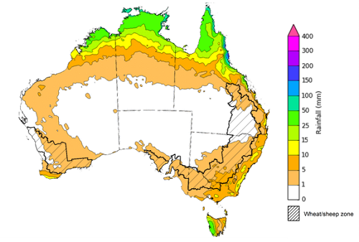

©Commonwealth of Australia 2023, Australian Bureau of Meteorology Issued 16/03/2023
Note: This rainfall forecast is produced from computer models. As the model outputs are not altered by weather forecasters, it is important to check local forecasts and warnings issued by the Bureau of Meteorology.

Water

Water markets – current week
Water storage levels in the Murray-Darling Basin (MDB) decreased between 8 March 2023 and 15 March 2023 by 224 gigalitres (GL). Current volume of water held in storage is 22 228 GL which represents 88 per cent of total capacity. This is 0.2 percent or 36 GL more than at the same time last year.

Water storages in the Murray-Darling Basin, 2013–2023
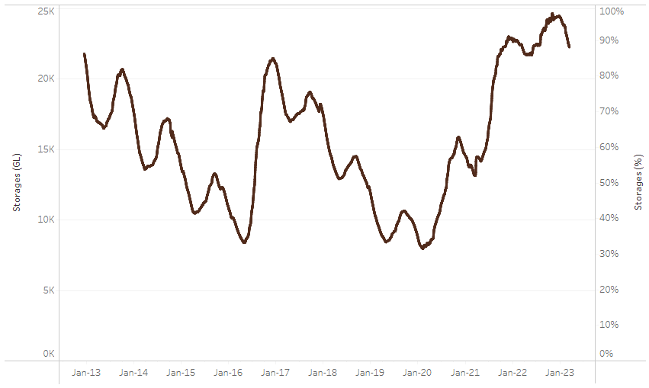
Allocation prices in the Victorian Murray below the Barmah Choke remained steady at $15 per ML from 9 March 2023 to 15 March 2023.
Water storage data is sourced from the Bureau of Meteorology.

Region | $/ML
NSW Murray Above | 6
NSW Murrumbidgee | 9
VIC Goulburn-Broken | 15
VIC Murray Below | 14

Surface water trade activity, Southern Murray–Darling Basin
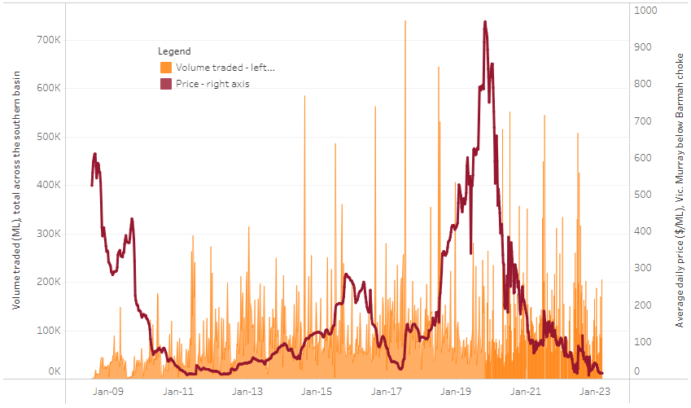
The trades shown reflect estimated market activity and do not encompass all register trades. The price is shown for the VIC Murray below the Barmah choke. Historical prices (before 1 July 2019) are ABARES estimates after removing outliers from BOM water register data. Prices after 1 July 2019 and prior to the 30 October 2019 reflect recorded transaction prices as sourced from Ruralco. Prices after the 30 October 2019 are sourced from Waterflow. Data for volume traded is sourced from the BOM water register. Data shown is current on 16 March 2023.

To access the full, interactive, weekly water dashboard, which contains the latest and historical water storage, water market and water allocation information, please visit https://www.agriculture.gov.au/abares/products/weekly_update/weekly-update-16323

Commodities
Indicator | Week ended | Unit | Latest Price | Previous Week | Weekly change | Price 12 months ago | Annual change
Selected world indicator prices
AUD/USD Exchange rate | 15-Mar | A$/US$ | 0.67 | 0.67 | 0% | 0.75 | -11%
Wheat – US no. 2 hard red winter wheat, fob Gulf | 15-Mar | US$/t | 362 | 358 | 1% | 490 | -26%
Corn – US no. 2 yellow corn, fob Gulf | 15-Mar | US$/t | 280 | 286 | -2% | 340 | -18%
Canola – Rapeseed, Canada, fob Vancouver | 15-Mar | US$/t | 612 | 654 | -6% | 965 | -37%
Cotton – Cotlook 'A' Index | 15-Mar | USc/lb | 95 | 99 | -5% | 146 | -35%
Sugar – Intercontinental Exchange, nearby futures, no.11 contract | 15-Mar | USc/lb | 20.7 | 20.3 | 2% | 19 | 8%
Wool – Eastern Market Indicator | 01-Mar | Ac/kg clean | 1,358 | 1,368 | -1% | 1,389 | -2%
Wool – Western Market Indicator | 01-Mar | Ac/kg clean | 1,501 | 1,524 | -2% | 1,393 | 8%
Selected Australian grain export prices
Milling Wheat – APW, Port Adelaide, SA | 15-Mar | A$/t | 486 | 497 | -2% | 590 | -18%
Feed Wheat – ASW, Port Adelaide, SA | 15-Mar | A$/t | 455 | 458 | -1% | 555 | -18%
Feed Barley – Port Adelaide, SA | 15-Mar | A$/t | 407 | 405 | 1% | 459 | -11%
Canola – Kwinana, WA | 15-Mar | A$/t | 980 | 1,014 | -3% | 1,180 | -17%
Grain Sorghum – Brisbane, QLD | 15-Mar | A$/t | 514 | 512 | 0% | 375 | 37%
Selected domestic livestock indicator prices
Beef – Eastern Young Cattle Indicator | 15-Mar | Ac/kg cwt | 691 | 698 | -1% | 1,116 | -38%
Mutton – Mutton indicator (18–24 kg fat score 2–3), Vic | 15-Mar | Ac/kg cwt | 302 | 344 | -12% | 575 | -47%
Lamb – Eastern States Trade Lamb Indicator | 15-Mar | Ac/kg cwt | 645 | 695 | -7% | 828 | -22%
Pig – Eastern Seaboard (60.1–75 kg), average of buyers & sellers | 01-Mar | Ac/kg cwt | 367 | 367 | 0% | 357 | 3%
Goats – Eastern States (12.1–16 kg) | 01-Mar | Ac/kg cwt | 325 | 325 | 0% | 813 | -60%
Live cattle – Light steers ex Darwin to Indonesia | 17-Aug | Ac/kg lwt | 420 | 480 | -13% | 320 | 31%
Live sheep – Live wethers (Muchea WA saleyard) to Middle East | 14-Sep | $/head | 93 | 113 | -18% | 114 | -18%
Global Dairy Trade (GDT) weighted average prices ª
Dairy – Whole milk powder | 08-Mar | US$/t | 3,277 | 3,264 | 0% | 3,615 | -9%
Dairy – Skim milk powder | 08-Mar | US$/t | 2,739 | 2,769 | -1% | 3,207 | -15%
Dairy – Cheddar cheese | 08-Mar | US$/t | 4,509 | 5,086 | -11% | 4,268 | 6%
Dairy – Anhydrous milk fat | 08-Mar | US$/t | 5,340 | 5,447 | -2% | 5,527 | -3%
a Global Dairy Trade prices are updated twice monthly on the first and third Tuesday of each month.

Selected world indicator prices
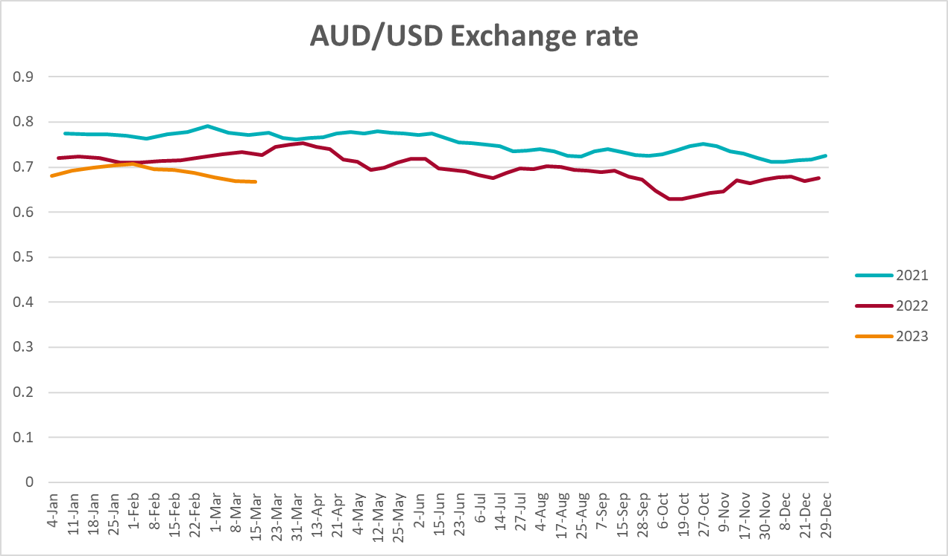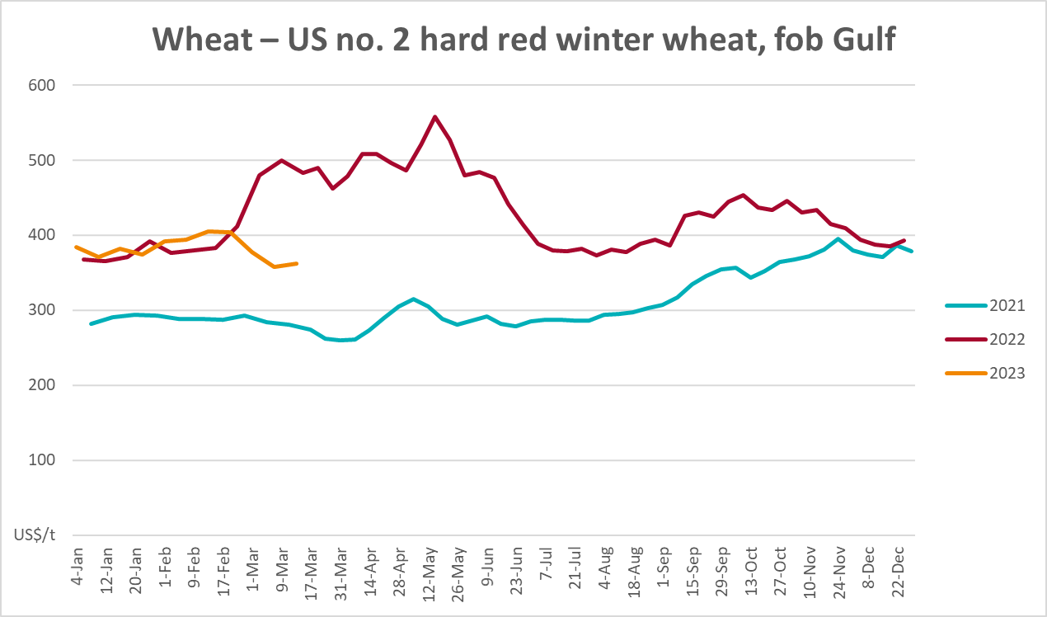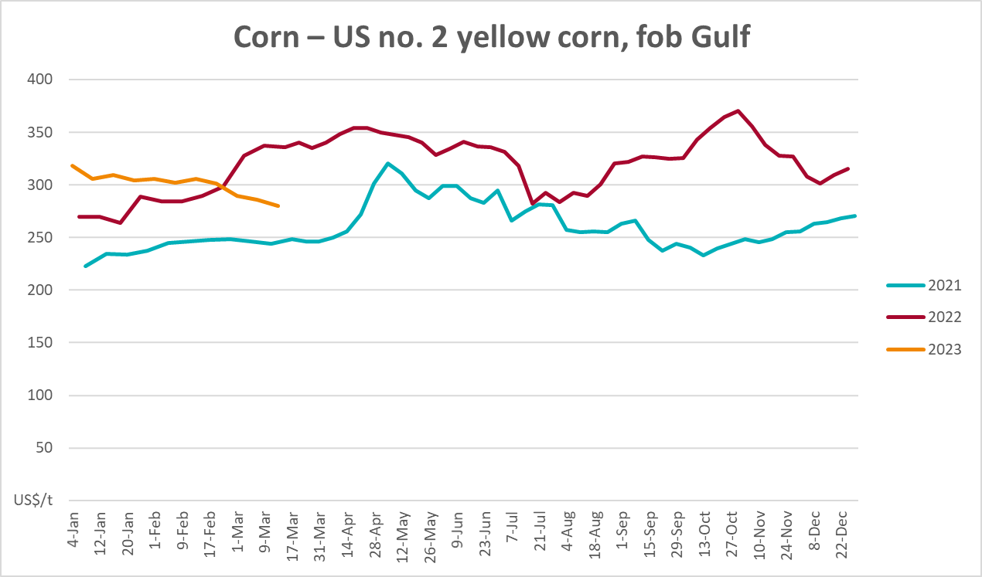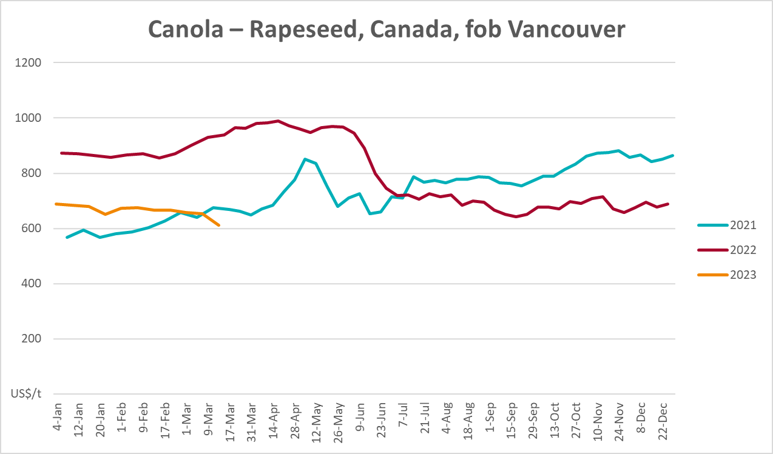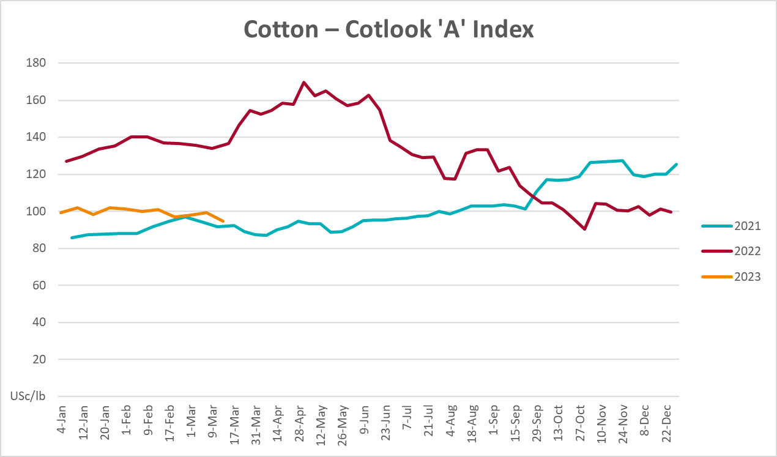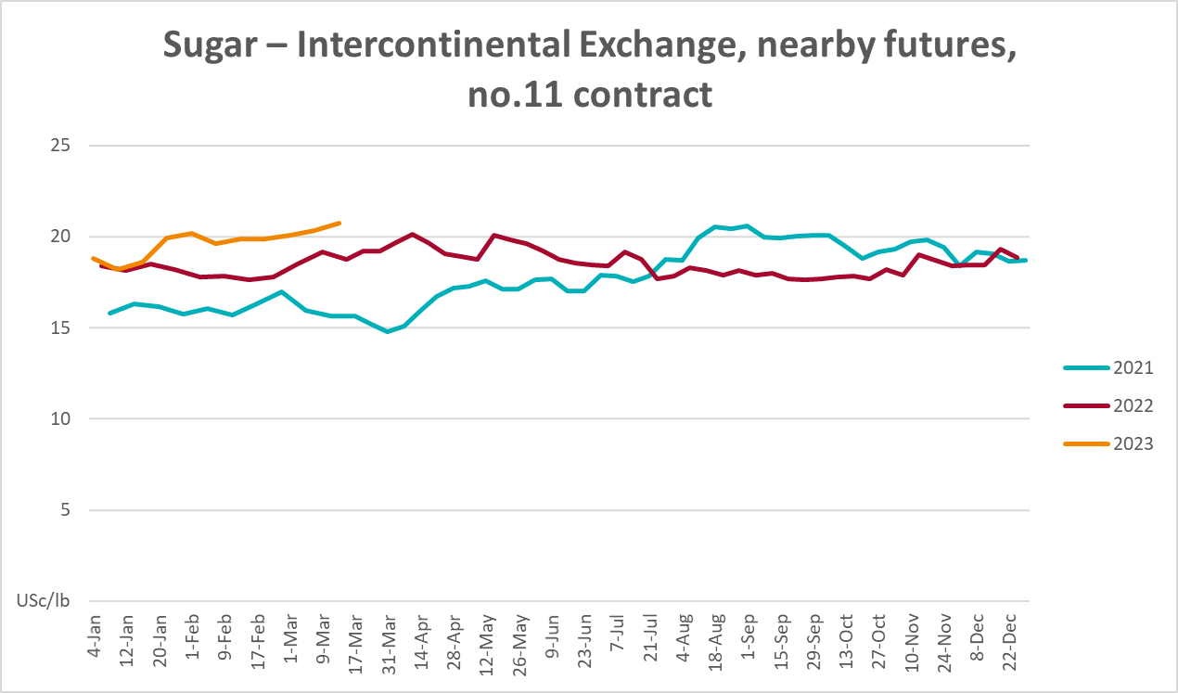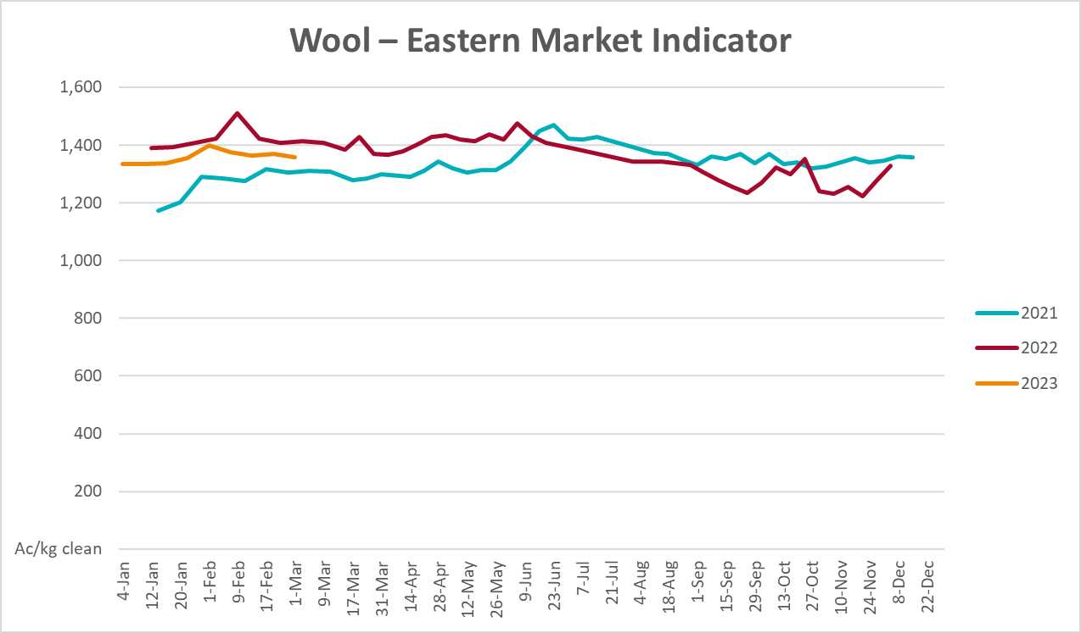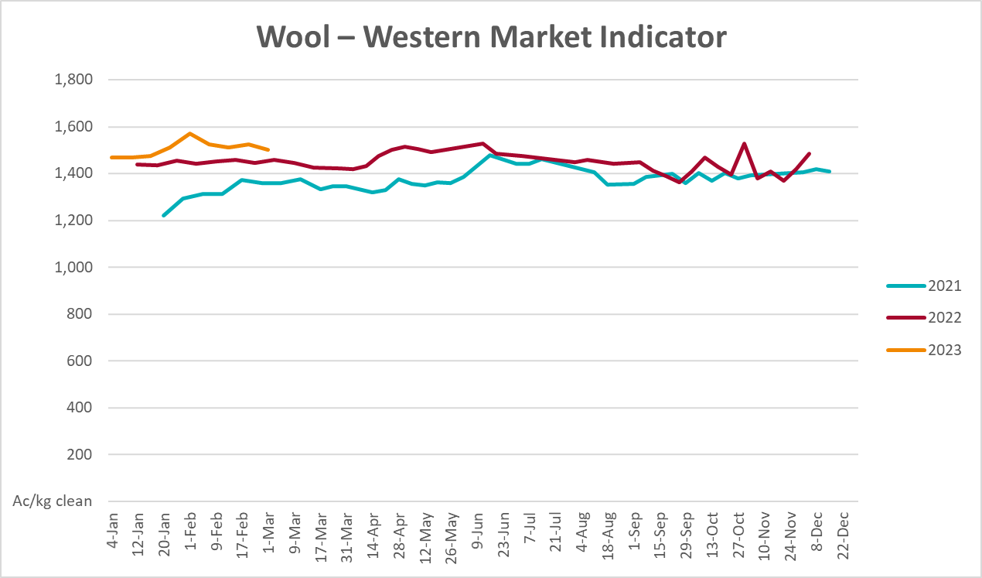

Selected domestic crop indicator prices
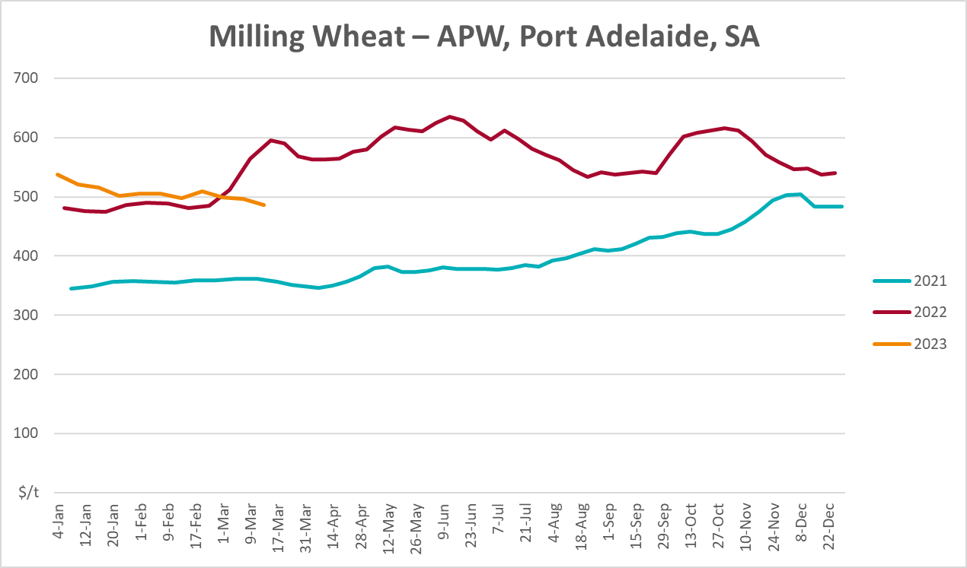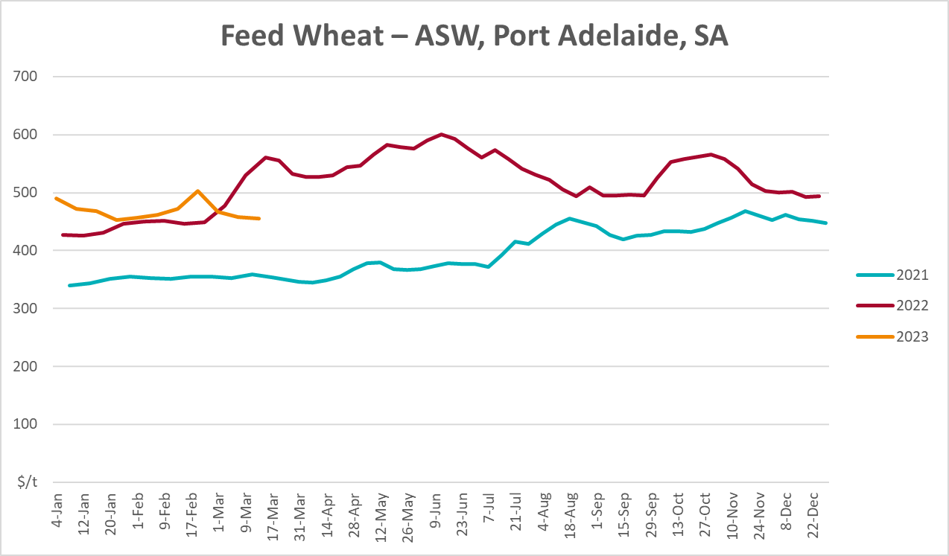
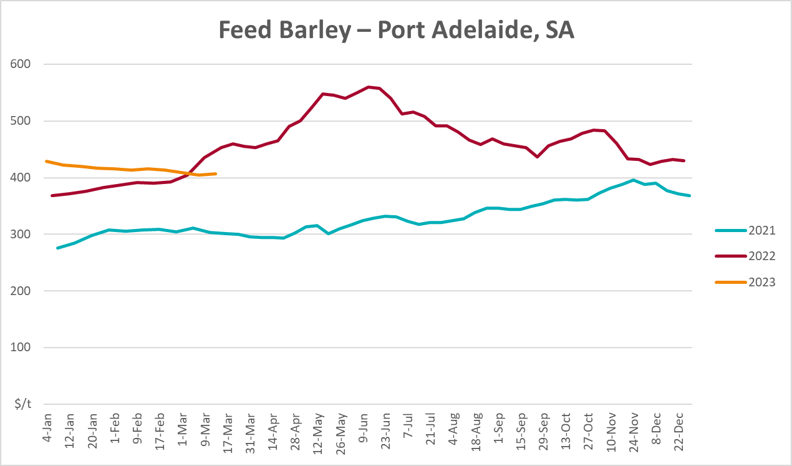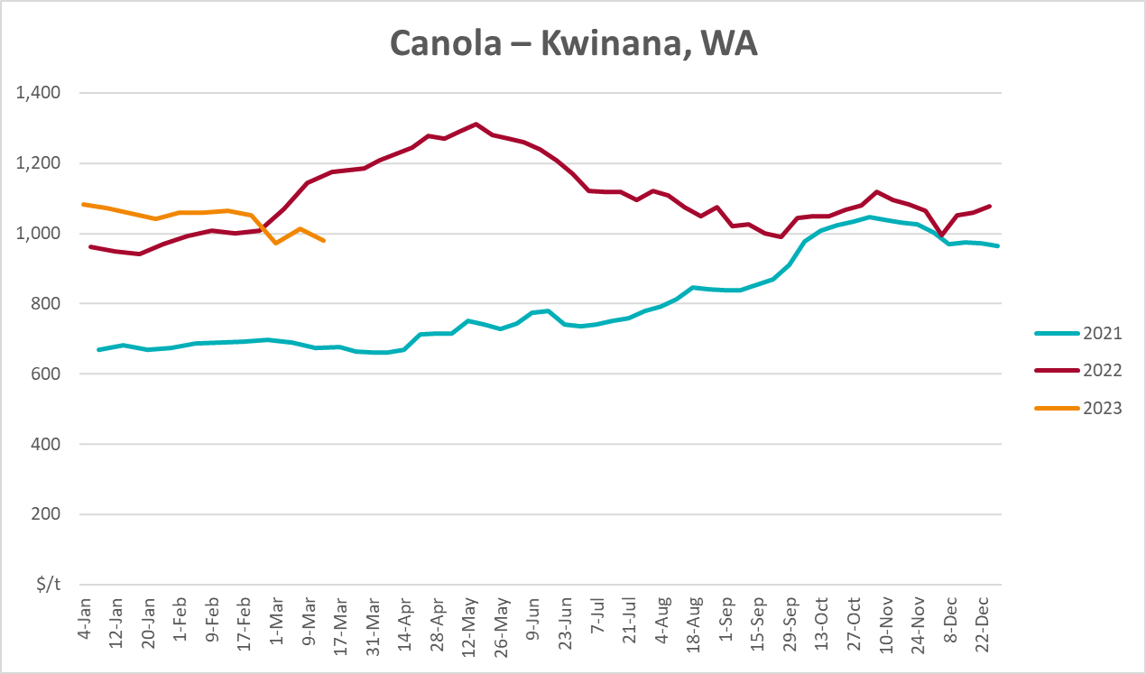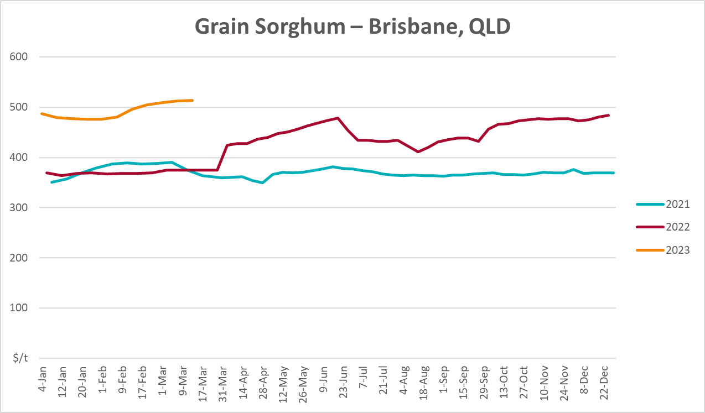

Selected domestic livestock indicator prices
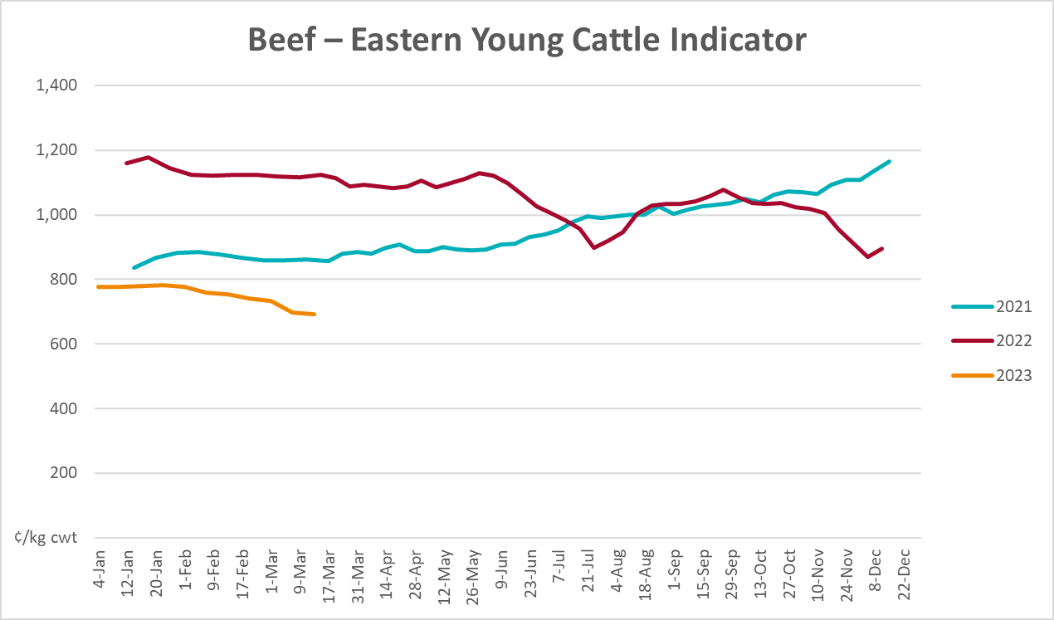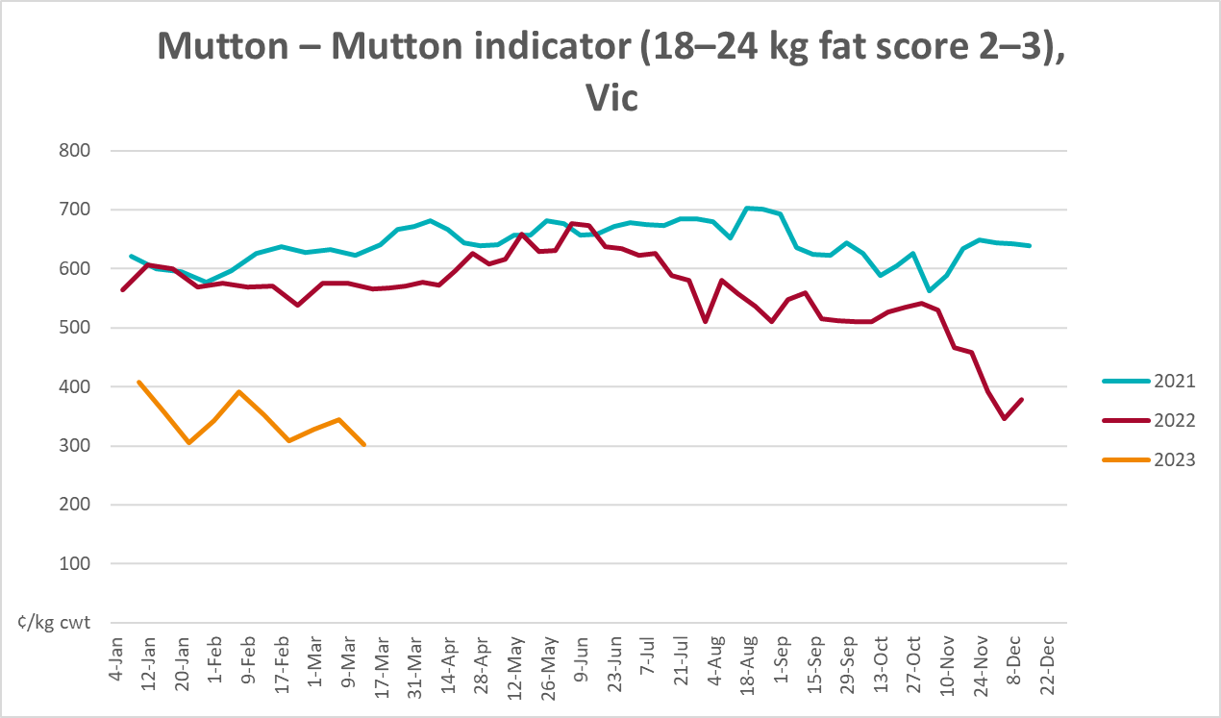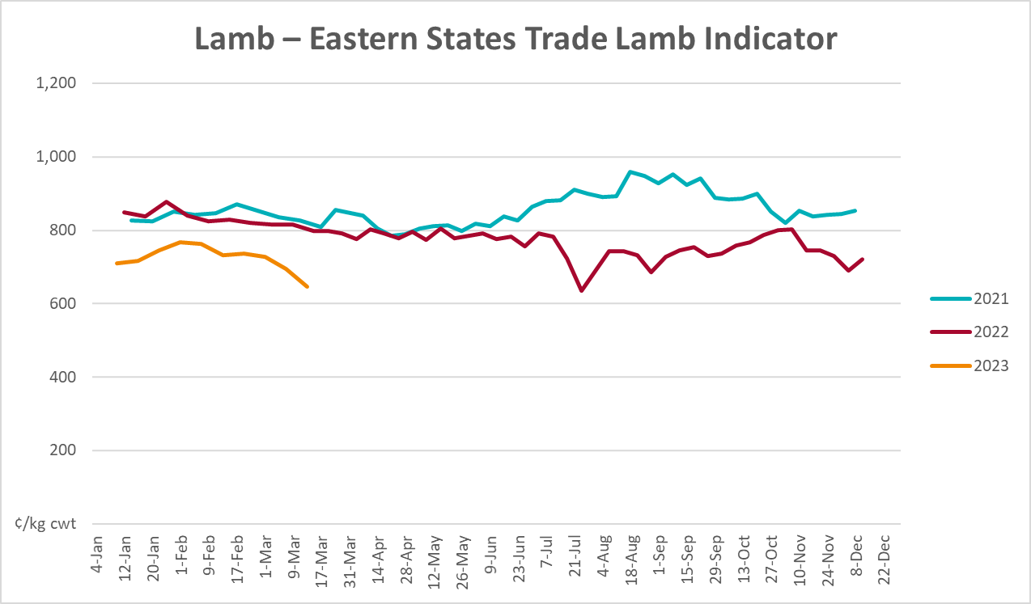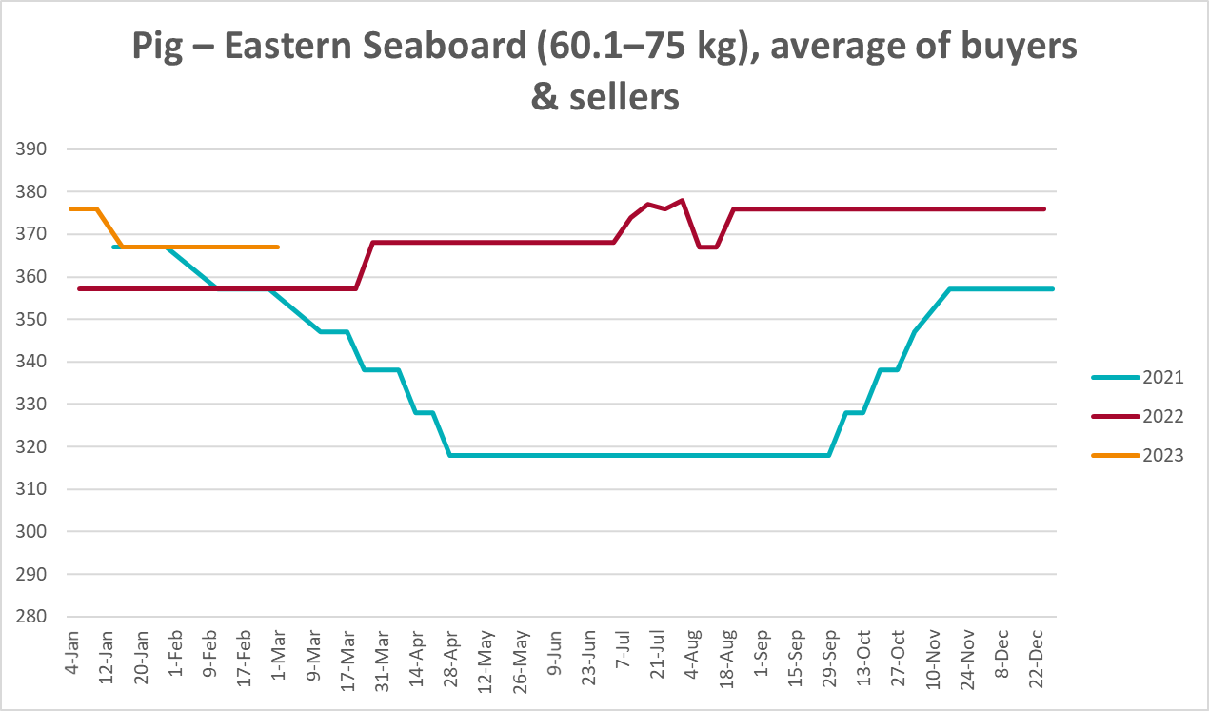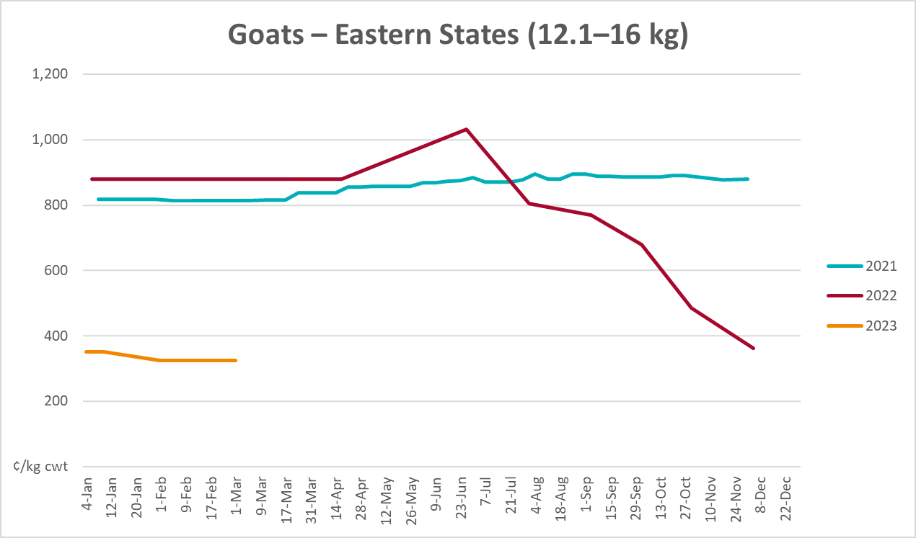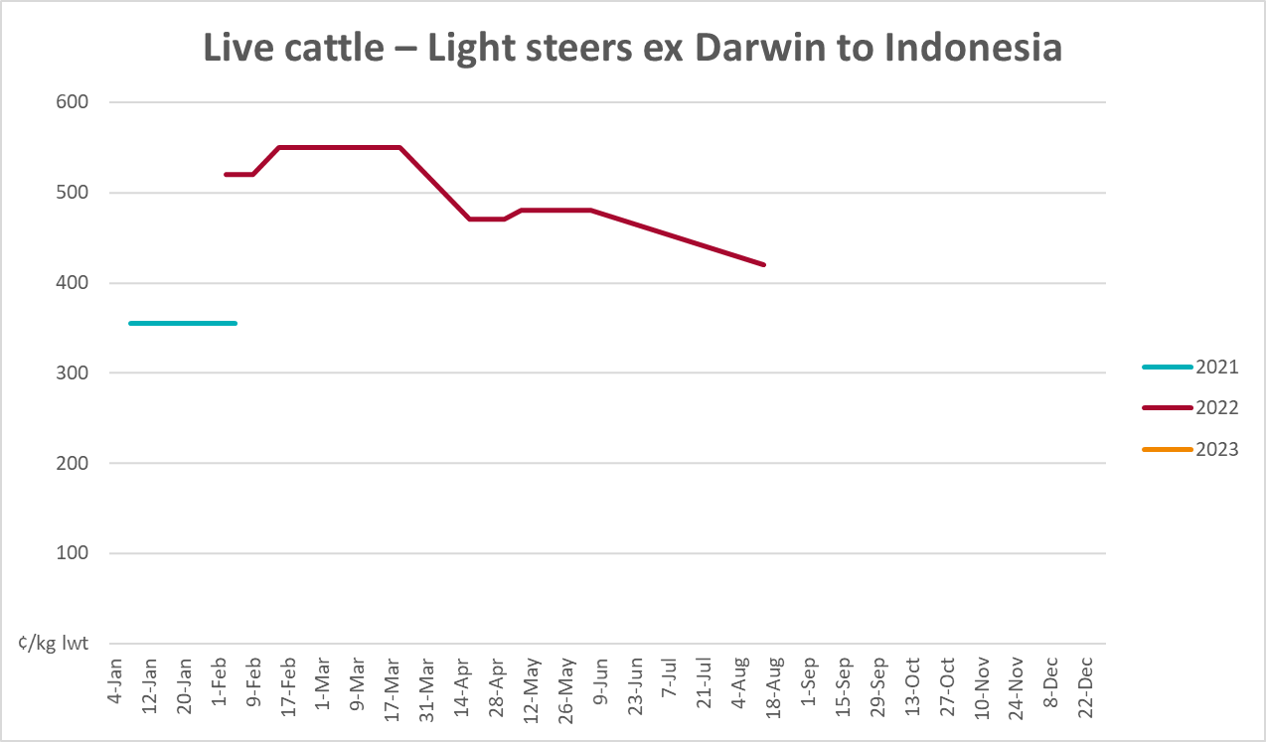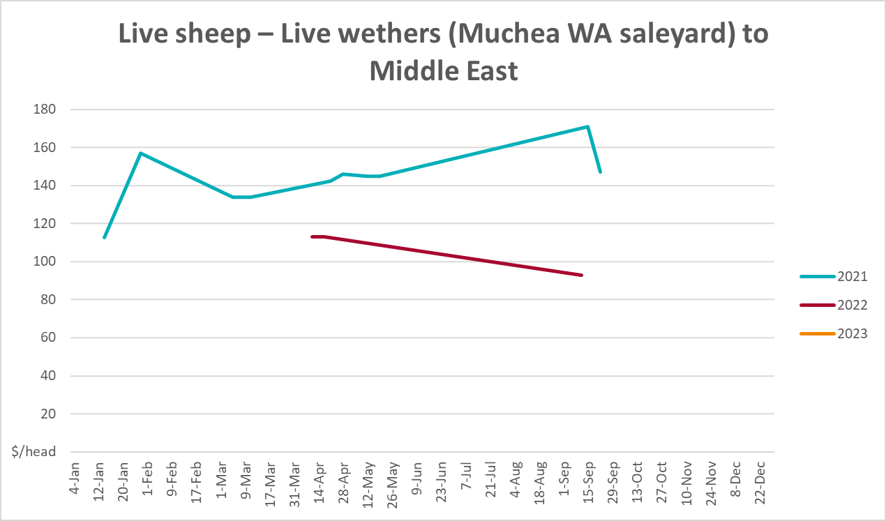

Global Dairy Trade (GDT) weighted average prices
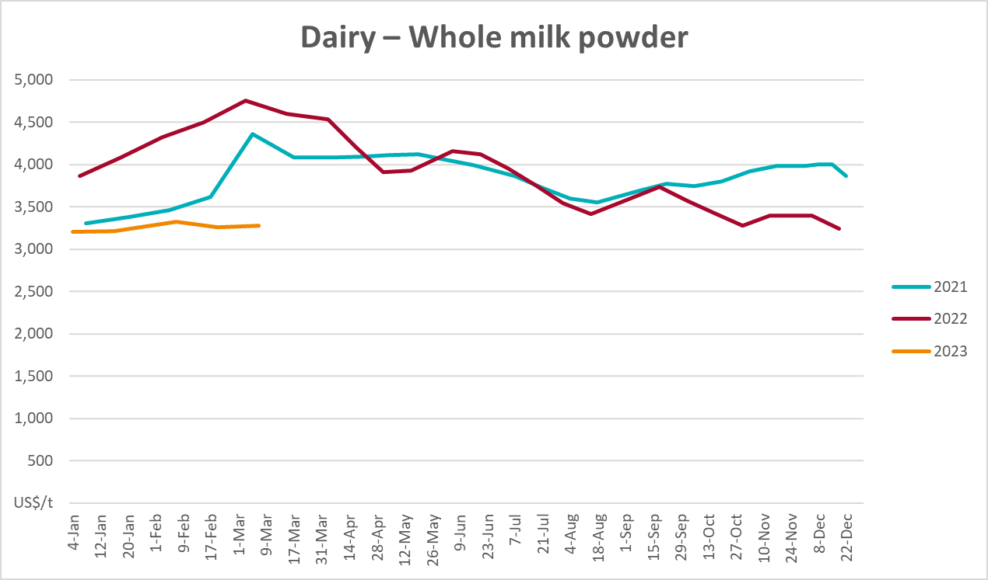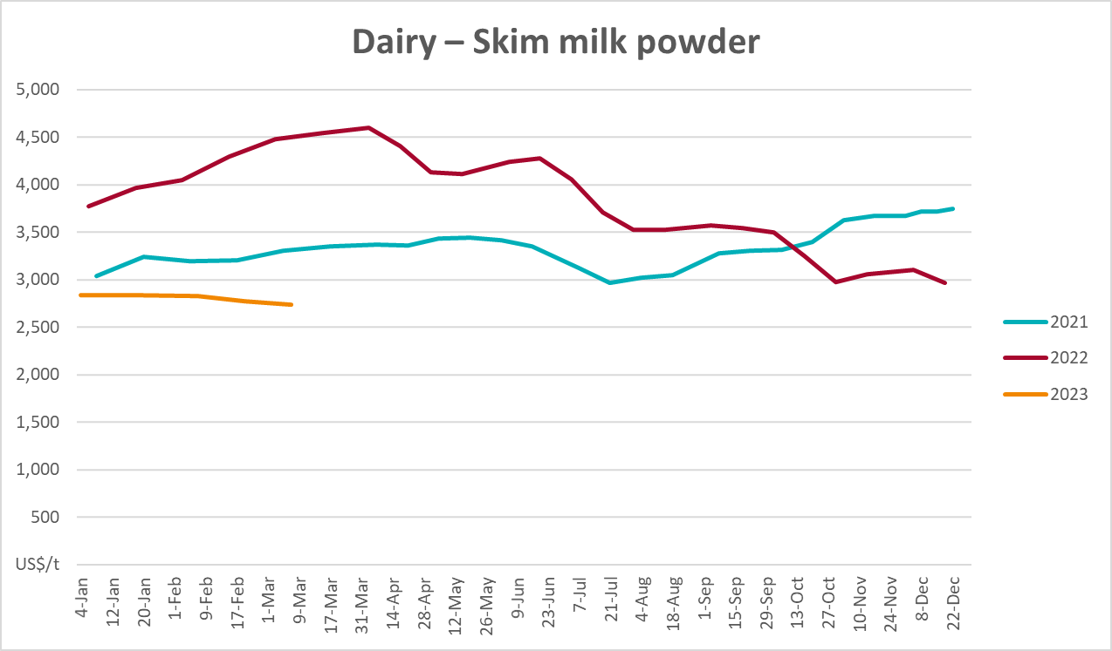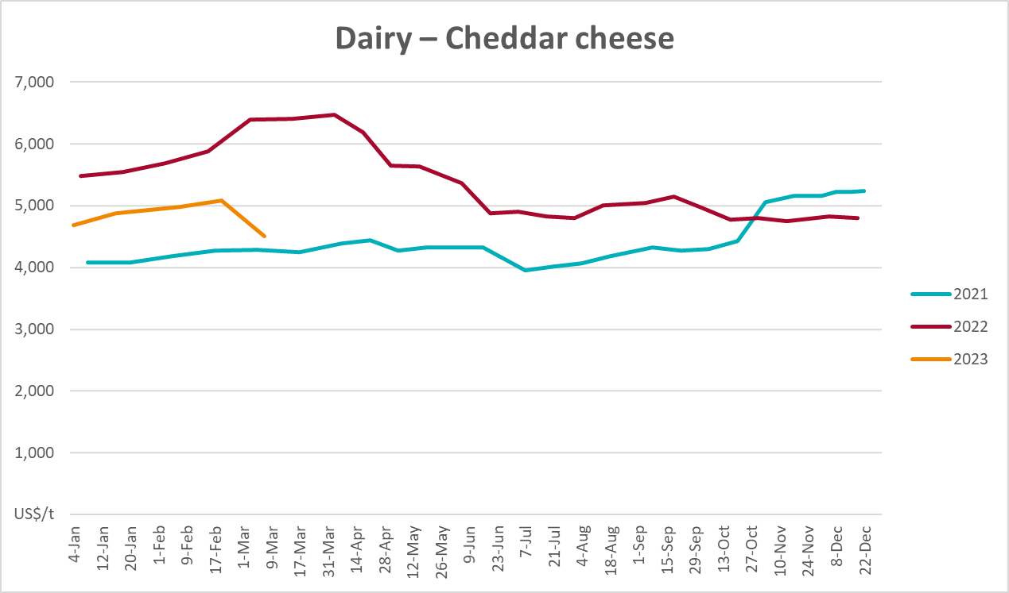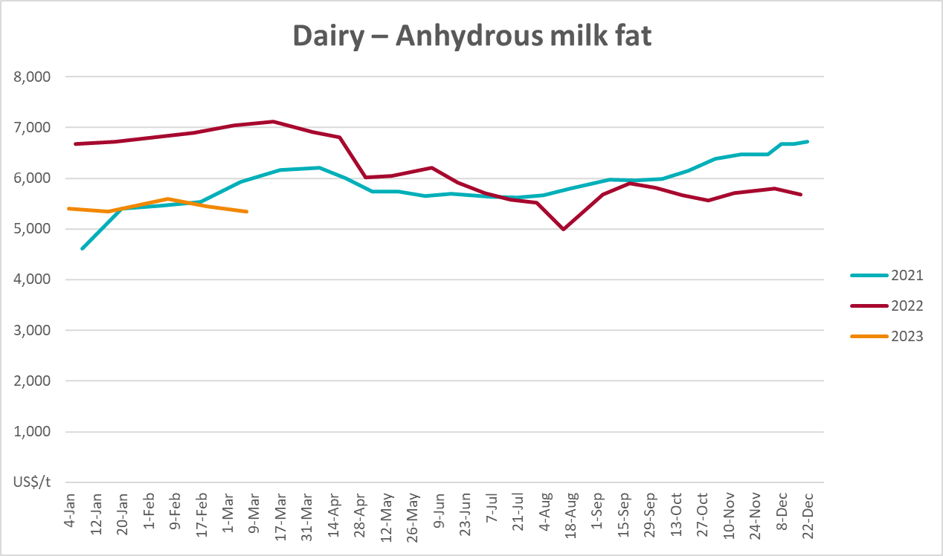

Selected fruit and vegetable prices
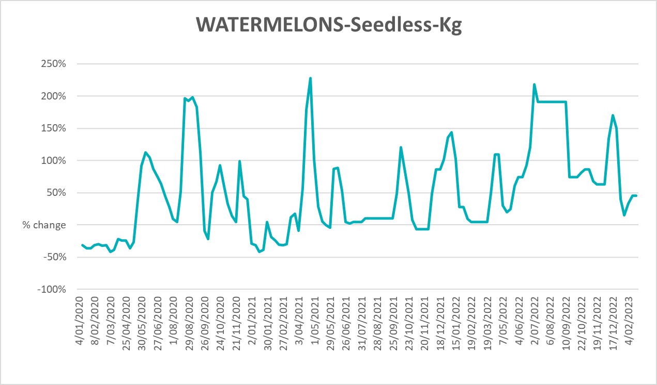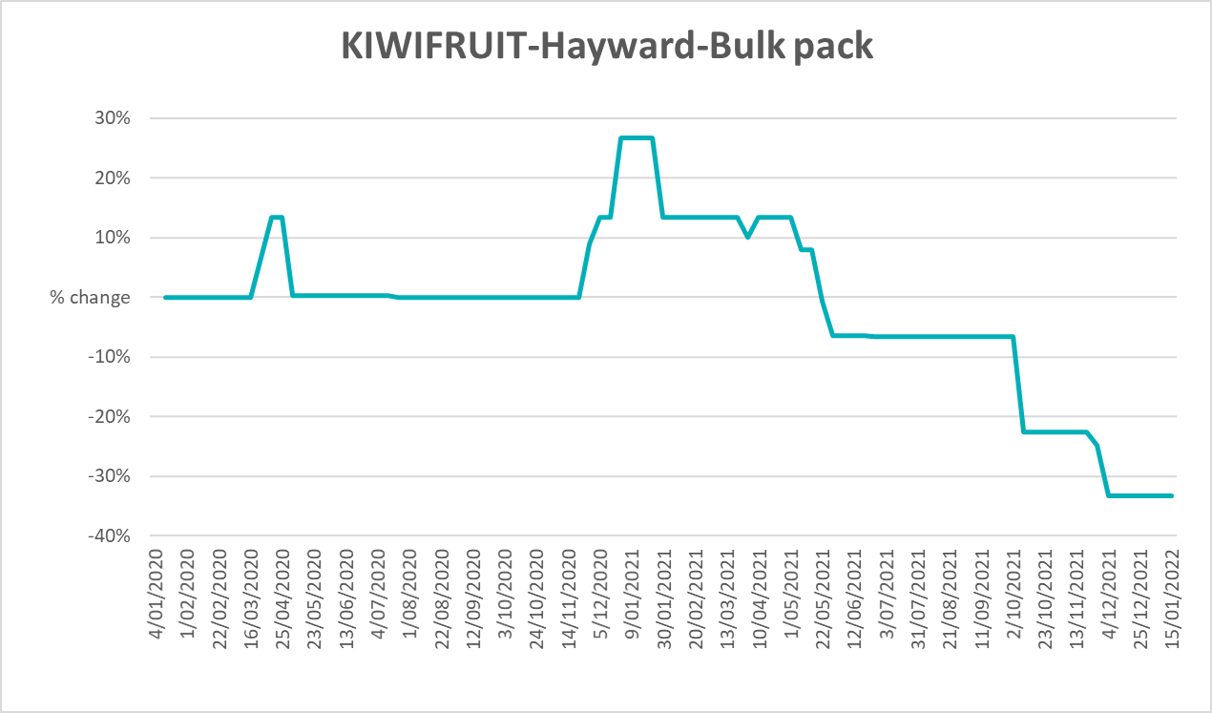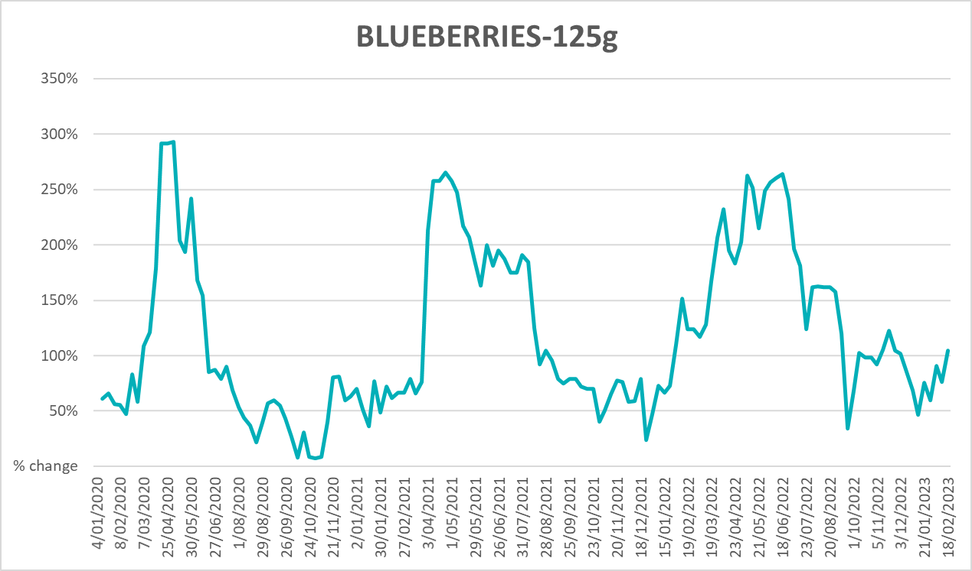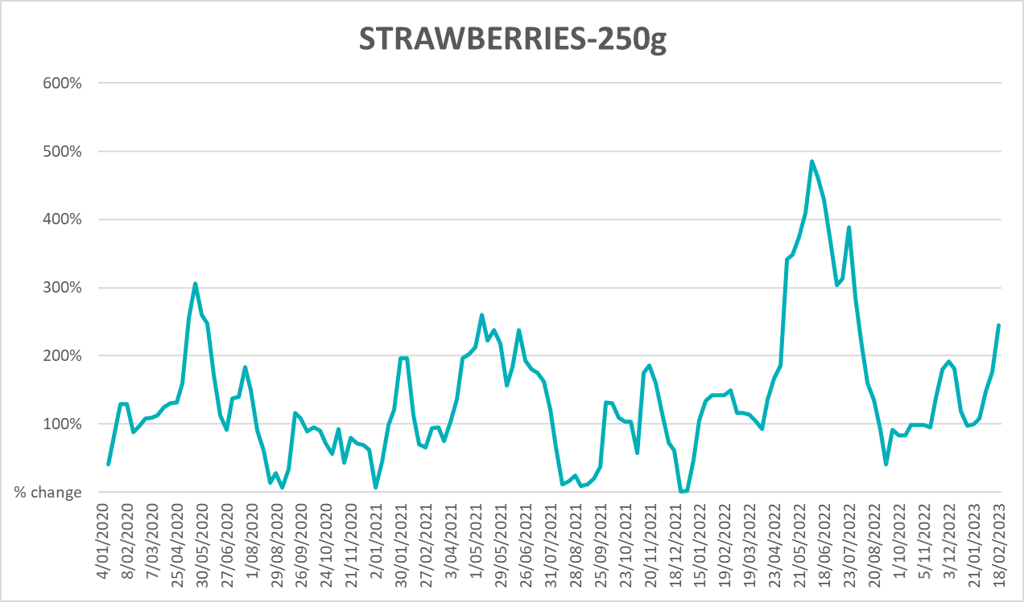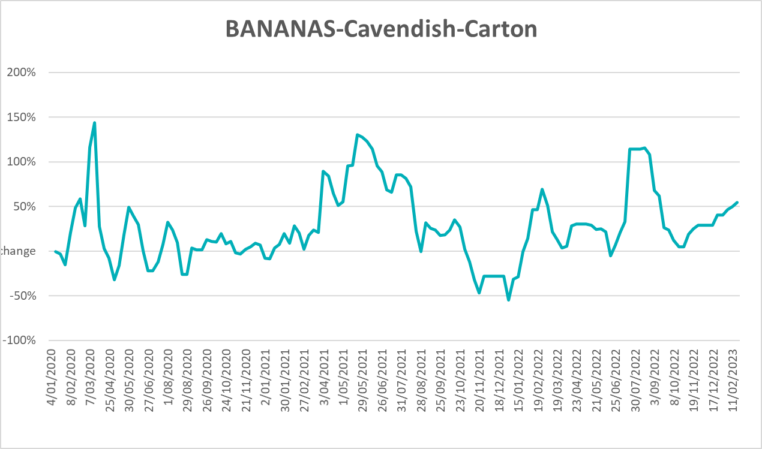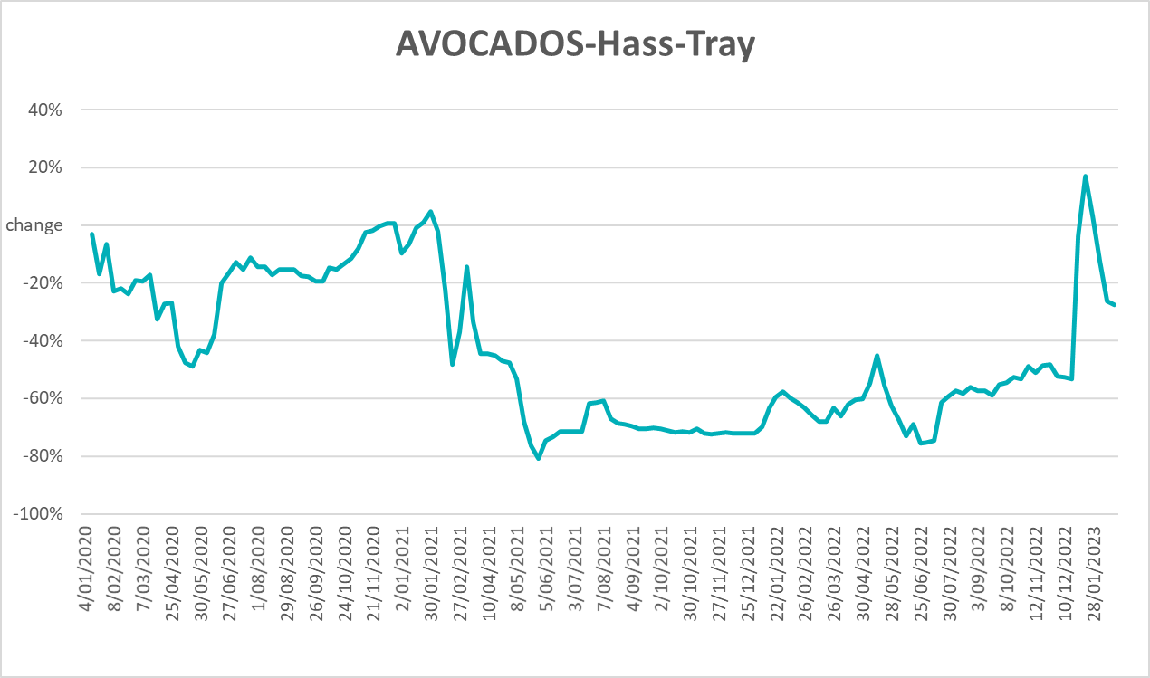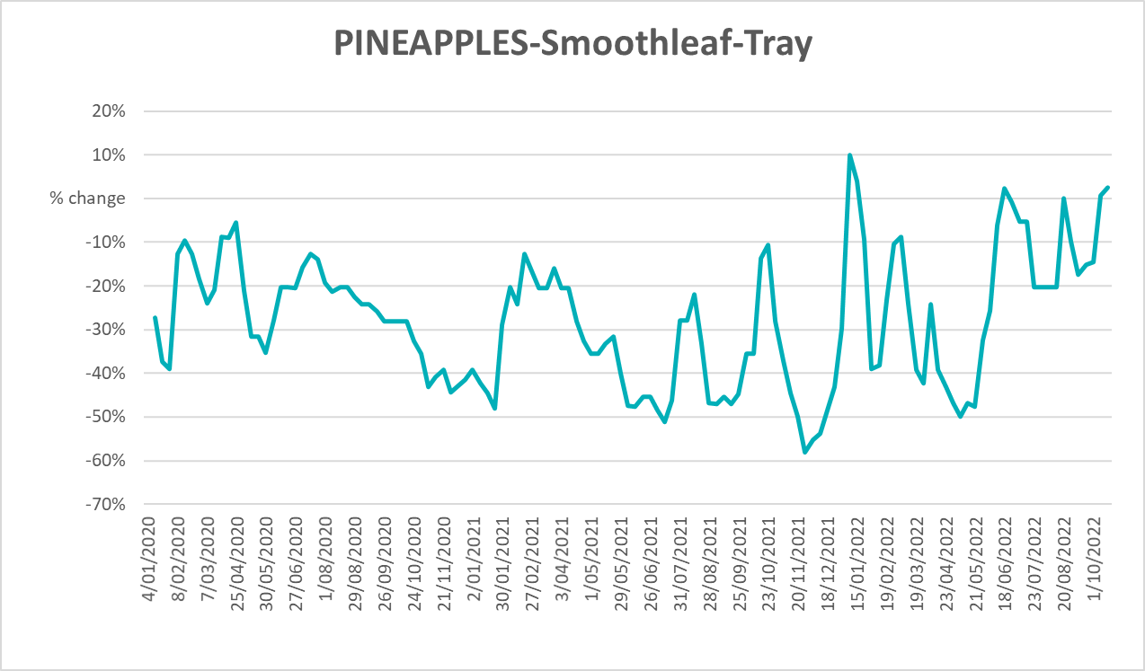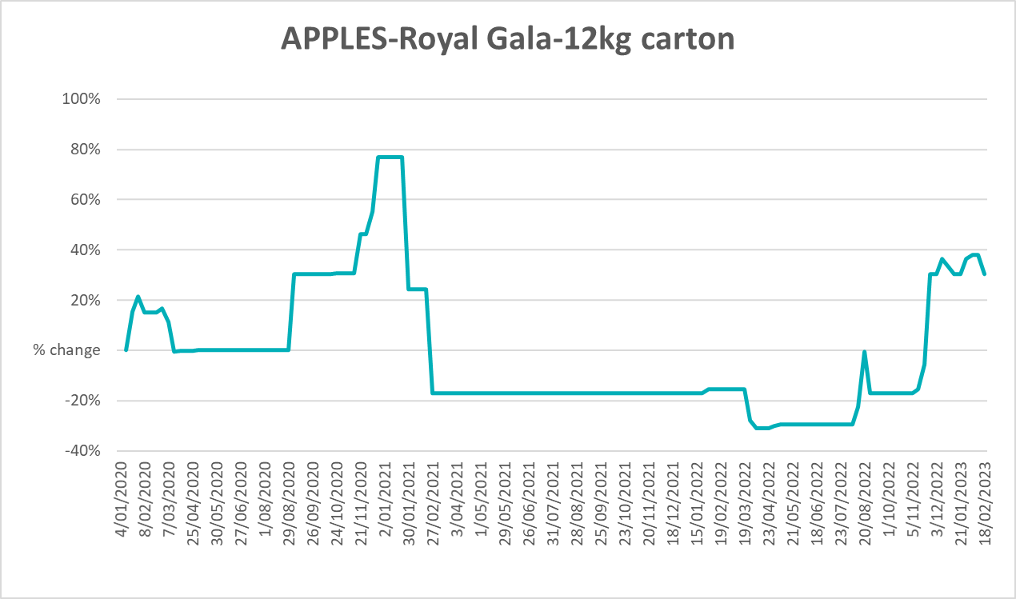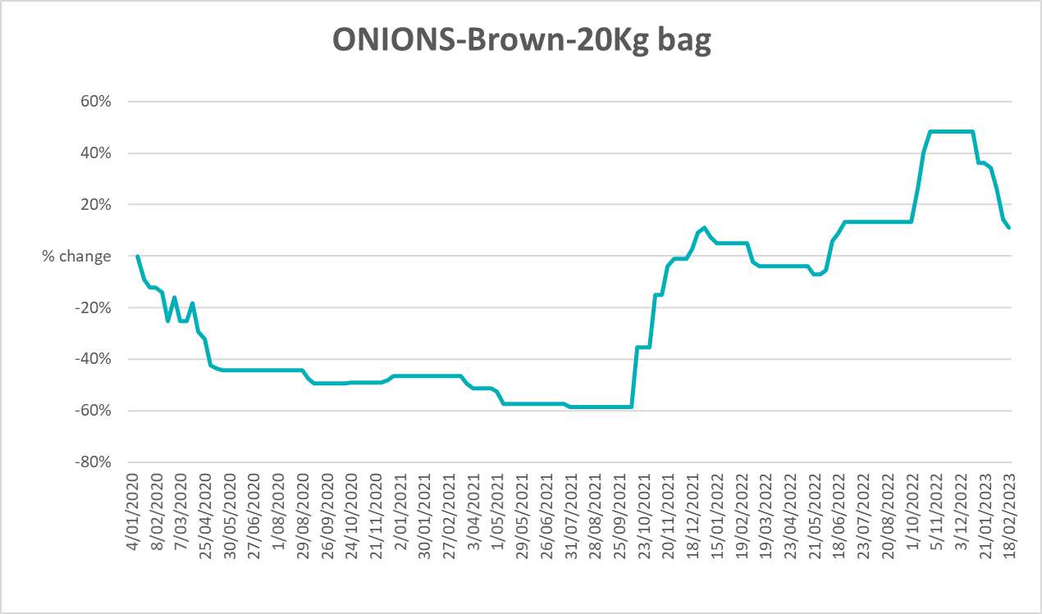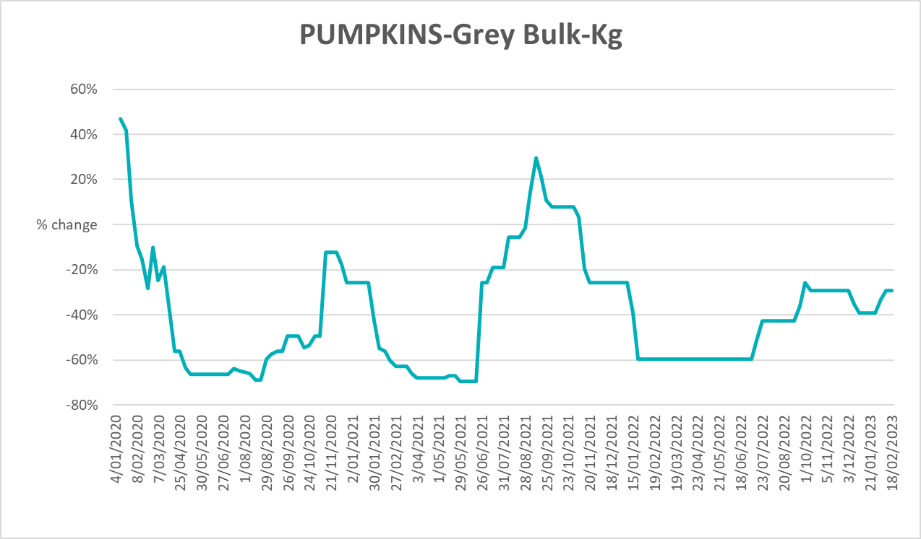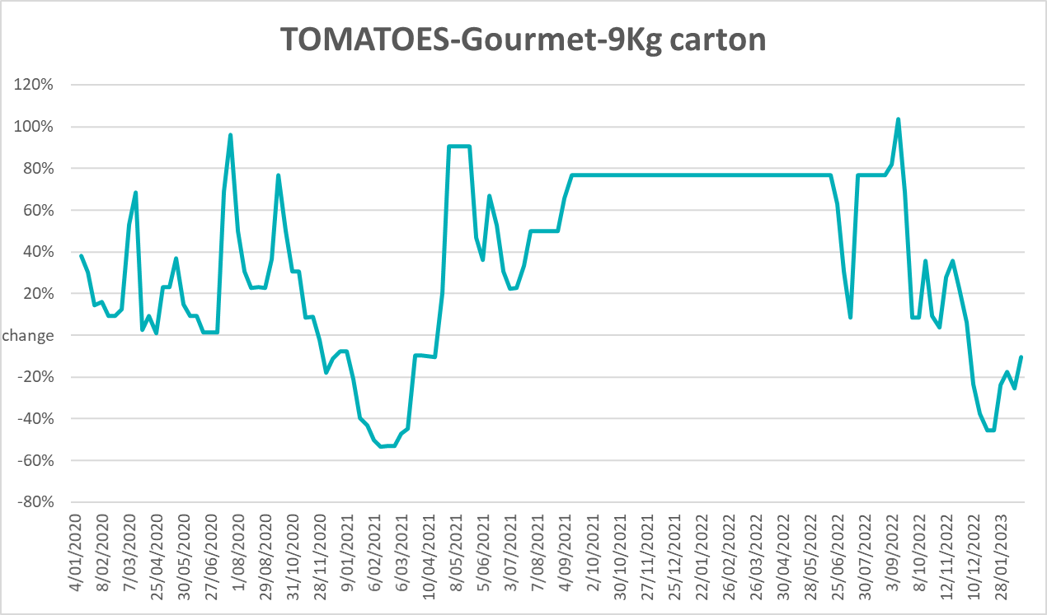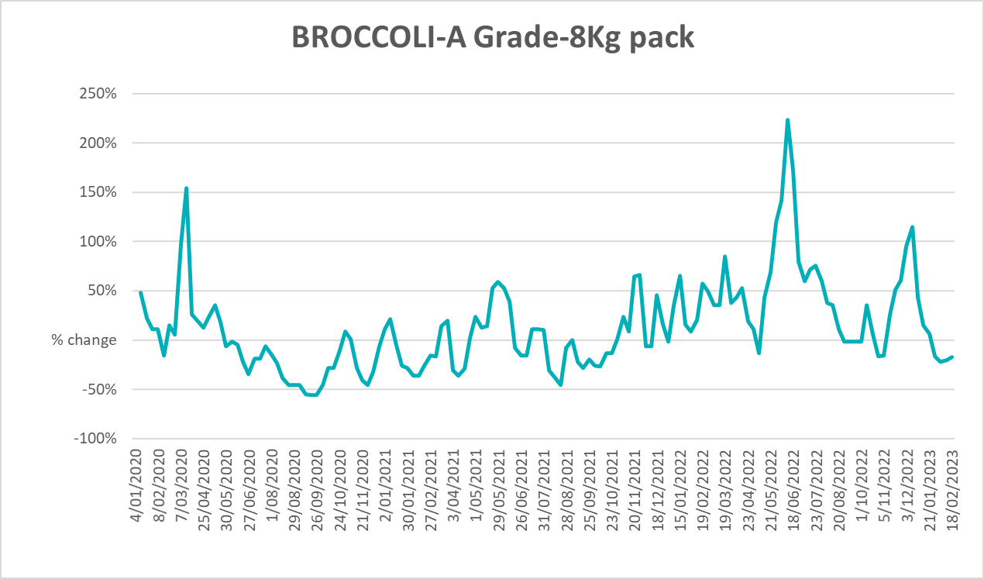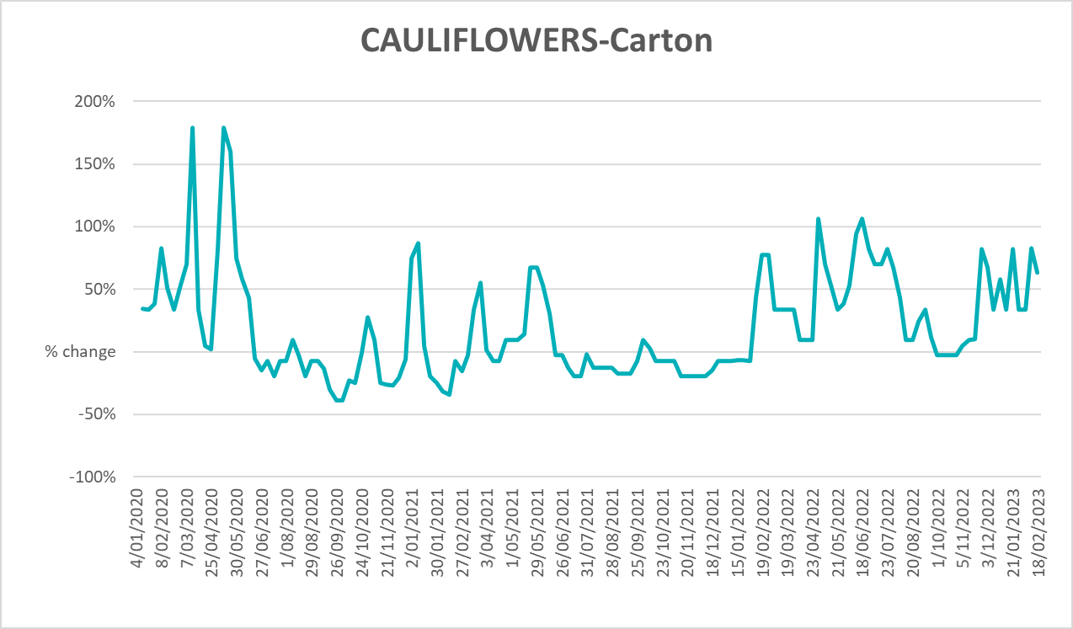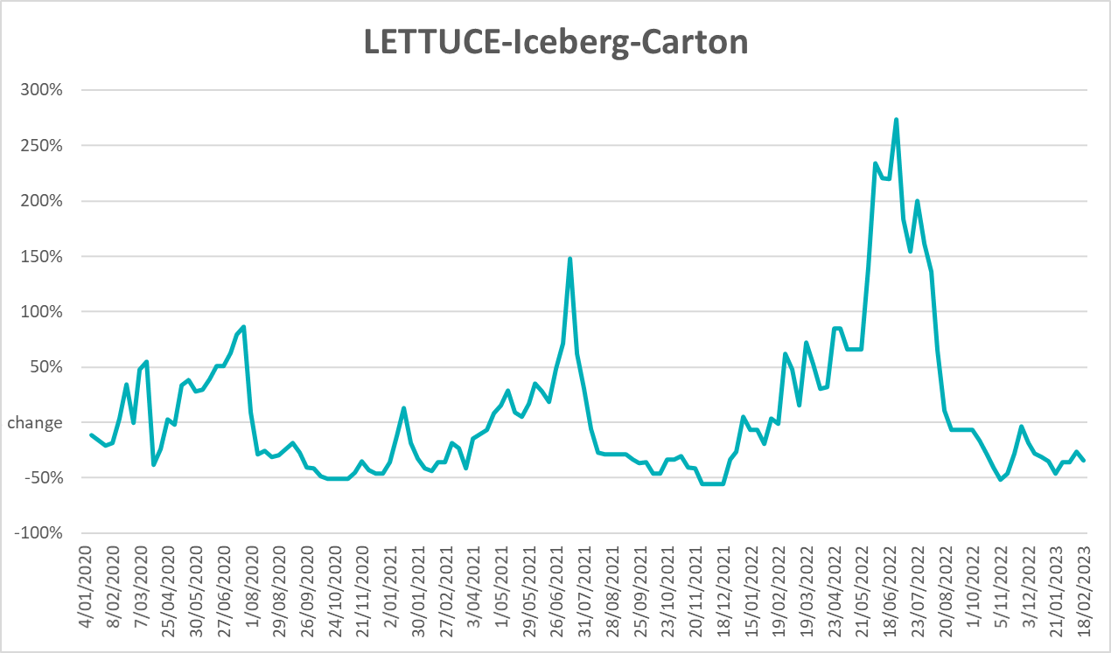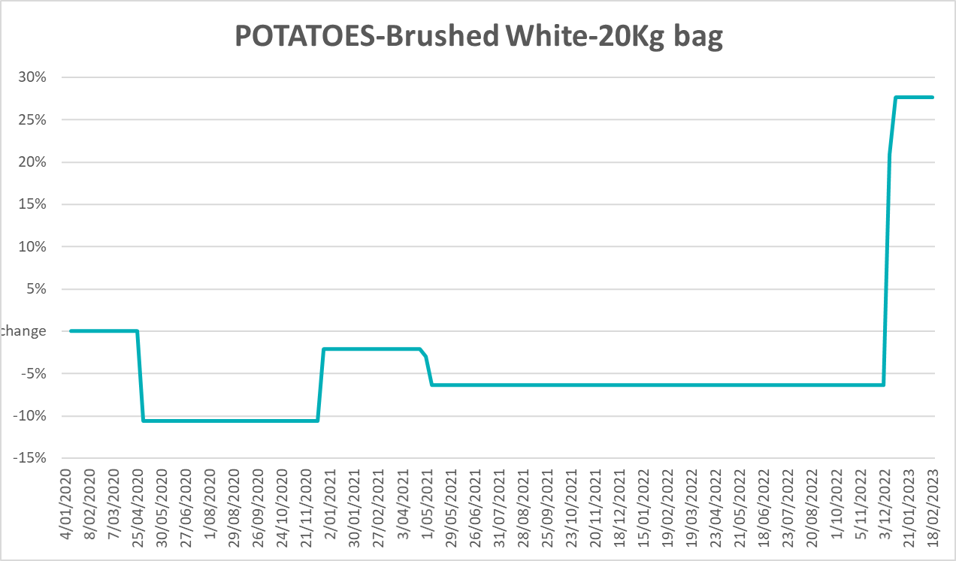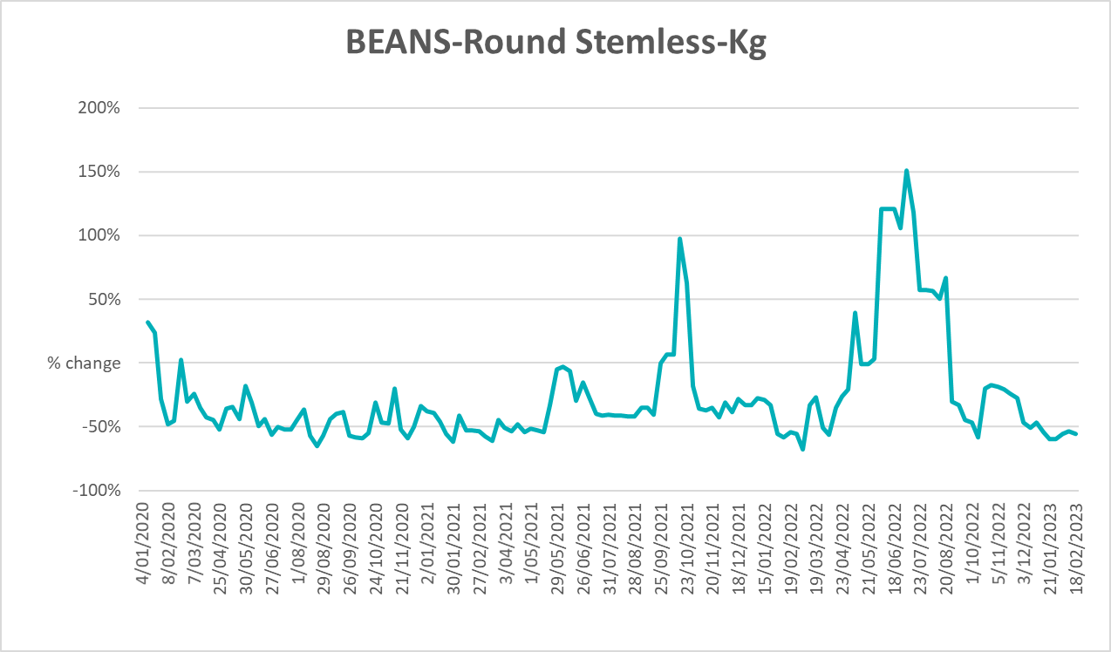

3.6 Selected domestic fodder indicator prices
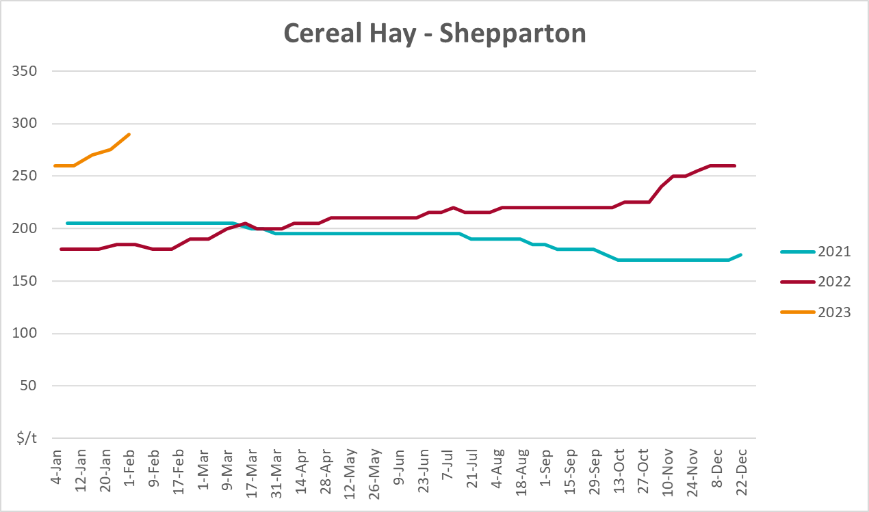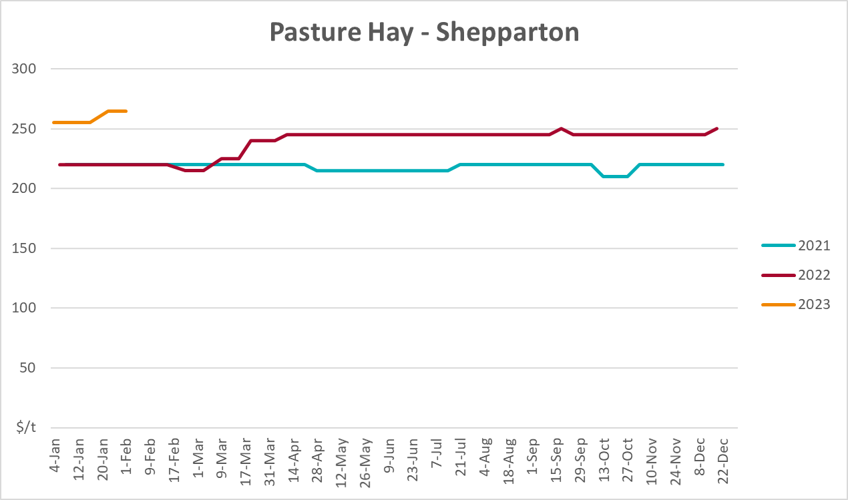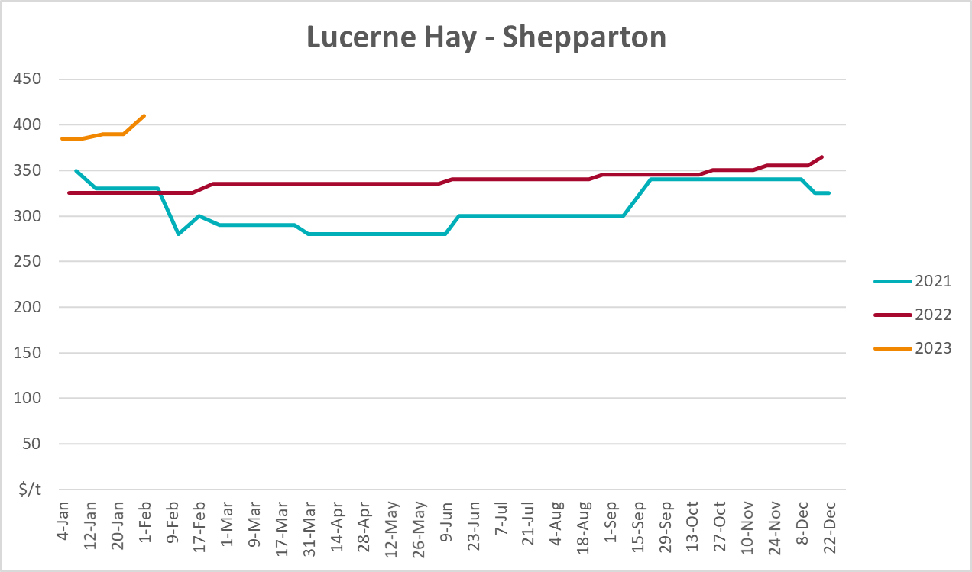

4. Data attribution

Climate
Bureau of Meteorology
- Weekly rainfall totals: www.bom.gov.au/climate/maps/rainfall/
- Monthly and last 3-month rainfall percentiles: www.bom.gov.au/water/landscape/
- Temperature anomalies: www.bom.gov.au/jsp/awap/temp/index.jsp
- Rainfall forecast: www.bom.gov.au/jsp/watl/rainfall/pme.jsp
- Seasonal outlook: www.bom.gov.au/climate/outlooks/#/overview/summary/
- Climate drivers: http://www.bom.gov.au/climate/enso/
- Soil moisture: www.bom.gov.au/water/landscape/
Other
- Pasture growth: www.longpaddock.qld.gov.au/aussiegrass/
- 3-month global outlooks: Environment and Climate Change Canada, NOAA Climate Prediction Center, EUROBRISA CPTEC/INPE, European Centre for Medium-Range Weather Forecasts, Hydrometcenter of Russia, National Climate Center Climate System Diagnosis and Prediction Room (NCC), International Research Institute for Climate and Society
- Global production: https://ipad.fas.usda.gov/ogamaps/cropmapsandcalendars.aspx
- Autumn break: Pook et al., 2009, https://rmets-onlinelibrary-wiley-com.virtual.anu.edu.au/doi/epdf/10.1002/joc.1833

Water
Prices
- Waterflow: https://www.waterflow.io/
- Ruralco: https://www.ruralcowater.com.au/
Bureau of Meteorology:
- Allocation trade: http://www.bom.gov.au/water/dashboards/#/water-markets/mdb/at
- Storage volumes: http://www.bom.gov.au/water/dashboards/#/water-storages/summary/drainage
Trade constraints:
- Water NSW: https://www.waternsw.com.au/customer-service/ordering-trading-and-pricing/trading/murrumbidgee
- Victorian Water Register: https://www.waterregister.vic.gov.au/TradingRules2019/

Commodities
Fruit and vegetables
- Datafresh: www.freshstate.com.au
Pigs
- Australian Pork Limited: www.australianpork.com.au
Dairy
- Global Dairy Trade: www.globaldairytrade.info/en/product-results/
World wheat, canola
- International Grains Council
World coarse grains
- United States Department of Agriculture
World cotton
- Cotlook: www.cotlook.com/
World sugar
- New York Stock Exchange - Intercontinental Exchange
Wool
- Australian Wool Exchange: www.awex.com.au/
Domestic wheat, barley, sorghum, canola and fodder
- Jumbuk Consulting Pty Ltd: http://www.jumbukag.com.au/
Cattle, beef, mutton, lamb, goat and live export
- Meat and Livestock Australia: www.mla.com.au/Prices-and-market
© Commonwealth of Australia 2023

Ownership of intellectual property rights
Unless otherwise noted, copyright (and any other intellectual property rights, if any) in this publication is owned by the Commonwealth of Australia (referred to as the Commonwealth).

Creative Commons licence
All material in this publication is licensed under a Creative Commons Attribution 4.0 International Licence except content supplied by third parties, logos and the Commonwealth Coat of Arms.
Inquiries about the licence and any use of this document should be emailed to copyright@awe.gov.au.


Cataloguing data
This publication (and any material sourced from it) should be attributed as:
ABARES 2023, Weekly Australian Climate, Water and Agricultural Update, Australian Bureau of Agricultural and Resource Economics and Sciences, Canberra, 16 March 2023. CC BY 4.0 DOI: https://doi.org/10.25814/5f3e04e7d2503
ISSN 2652-7561
This publication is available at https://www.agriculture.gov.au/abares/products/weekly_update
Department of Agriculture, Fisheries and Forestry
GPO Box 858 Canberra ACT 2601
Telephone 1800 900 090
Web agriculture.gov.au/abares

Disclaimer
The Australian Government acting through the Department of Agriculture, Fisheries and Forestry, represented by the Australian Bureau of Agricultural and Resource Economics and Sciences, has exercised due care and skill in preparing and compiling the information and data in this publication. Notwithstanding, the Department of Agriculture, Fisheries and Forestry, ABARES, its employees and advisers disclaim all liability, including liability for negligence and for any loss, damage, injury, expense or cost incurred by any person as a result of accessing, using or relying on any of the information or data in this publication to the maximum extent permitted by law.

Statement of Professional Independence
The views and analysis presented in ABARES publications, including this one, reflect ABARES professionally independent findings, based on scientific and economic concepts, principles, information and data. These views, analysis and findings may not reflect or be consistent with the views or positions of the Australian Government, or of organisations or groups who have commissioned ABARES reports or analysis. More information on professional independence is provided on the ABARES website.

Acknowledgements
This report was prepared by Kavina Dayal and Matthew Miller.

