
No. 12/2023 30 March 2023

Summary of key issues
- For the week ending 29 March 2023, a number of surface low pressure troughs combined with tropical moisture to form severe thunderstorms that resulted in heavy rainfall stretching from the Pilbara through central Australia and towards southeast Australia. Cold fronts reinforced cool conditions in the south with patchy showers, gusty winds and thunderstorms across the east coast, including Queensland, New South Wales and Victoria, leading to flash floodings.
- Weekly rainfall totals of between 25 and 100 millimetres were recorded across the Pilbara, northern Gascoyne and in southwest Western Australia, tropical Northern Territory and Queensland, southeast Queensland, across much of eastern New South Wales and Victoria, central South Australia and northern Tasmania. Rainfall in excess of 100 millimetres were recorded in the Gascoyne region in Western Australia and in isolated parts of eastern New South Wales. Dry conditions were recorded elsewhere (see Section 1.1).
- In cropping regions, rainfall totals of between 15 to 150 millimetres were recorded across southeast Queensland, most of New South Wales, eastern Victoria, parts of South Australia, and much of Western Australia. Little to no rainfall was recorded across the remaining cropping regions over the past 7 days. The heavy rainfalls across cropping regions in northern New South Wales and southern Queensland will have prevented field access for harvesting of what remains of early sown summer crops. On the other hand, the rainfall will have supported vegetative growth of late sown summer crops in southern Queensland, as well as boosting soil moisture levels across eastern and western cropping regions, as the planting window for winter crops approaches (see Section 1.1).
- ABARES analysis of daily rainfall data sourced from the Bureau of Meteorology indicates that the autumn break has been achieved across cropping regions of northern, eastern and southern New South Wales, southern Queensland, parts of central and eastern Victoria, northern Tasmania and large areas of northern Western Australia (see Section 1.2).
- Over the 8-days to 6 April 2023, troughs and lows will generate widespread rainfall across western, eastern, and parts of tropical north of Australia, as well as in western and eastern Tasmania. Rainfall between 15 and 50 millimetres is expected in the Gascoyne and Pilbara regions in the Western Australia, northwest South Australia, southern Northern Territory, and in eastern Australia. Similar rainfall range will be observed in the western and eastern Tasmania as well as in parts of the coastal tropical north. Rainfall in excess of 100 millimetres is expected in the central Western Australia. Little to no rain is expected elsewhere (see Section 1.3).
- Due to unavailability of new water information from the Bureau of Meteorology, the water storage levels in the Murray-Darling Basin (MDB) have not been updated this week.
- Allocation prices in the Victorian Murray below the Barmah Choke increased from $14 on 22 March 2023 to $17 on 29 March 2023.

Climate

Rainfall this week
For the week ending 29 March 2023, a number of surface low pressure troughs combined with tropical moisture to form severe thunderstorms that resulted in heavy rainfall stretching from the Pilbara through central Australia and towards southeast Australia. Cold fronts reinforced cool conditions in the south with patchy showers, gusty winds and thunderstorms across the east coast, including Queensland, New South Wales and Victoria, leading to flash floodings. Weekly rainfall totals of between 25 and 100 millimetres were recorded across the Pilbara, northern Gascoyne and in the southwest Western Australia, tropical Northern Territory and Queensland, southeast Queensland, across much of eastern New South Wales and Victoria, central South Australia and northern Tasmania. Rainfall in excess of 100 millimetres were recorded in the Gascoyne region in Western Australia and in the isolated parts of eastern New South Wales. Dry conditions were recorded elsewhere.
In cropping regions, rainfall totals of between 15 to 150 millimetres were recorded across southeast Queensland, much of New South Wales, eastern Victoria, parts of South Australia, and much of Western Australia. Little to no rainfall was recorded across the remaining cropping regions over the past 7 days. The heavy rainfalls across cropping regions in northern New South Wales and southern Queensland will have prevented field access for harvesting of what remains of early sown summer crops. On the other hand, the rainfall will have supported vegetative growth of late sown summer crops in southern Queensland, as well as boosting soil moisture levels across eastern and western cropping regions, as the planting window for winter crops approaches.

Rainfall for the week ending 29 March 2023
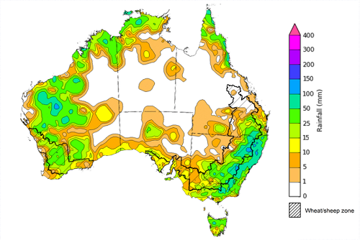
©Commonwealth of Australia 2023, Australian Bureau of Meteorology Issued: 29/03/2023
Note: The rainfall analyses and associated maps utilise data contained in the Bureau of Meteorology climate database, the Australian Data Archive for Meteorology (ADAM). The analyses are initially produced automatically from real-time data with limited quality control. They are intended to provide a general overview of rainfall across Australia as quickly as possible after the observations are received. For further information go to http://www.bom.gov.au/climate/rainfall/

Early autumn break
In southern Australia, the timing of the autumn break is an important factor for a successful pasture and crop production season. The autumn break is the first significant rainfall of the winter growing season and provides enough moisture to initiate crop and pasture germination and support early plant growth. The break generally applies to the southern pasture and cropping areas mainly in New South Wales, Victoria, South Australia, Western Australia and Tasmania — and occasionally parts of southern Queensland.

Areas likely to be influenced by the autumn break
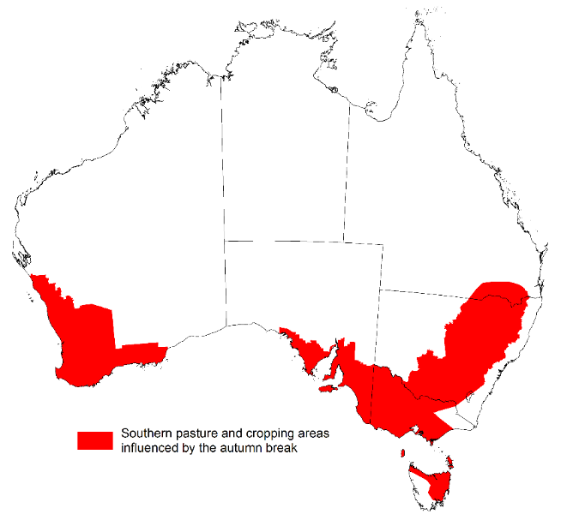
Source: ABARES
An early autumn break can increase the length of the growing season, potentially improving production and yield. The definition of the autumn break in southern Australia varies. Pook et al. (2009) suggested an ideal break for north-western Victoria occurs during March–June when a mean fall of 25 millimetres or more is recorded over a period of 3 days or less, or when a mean fall of 30 millimetres or more is recorded over a period of 7 days or less.
It is important to remember that while the timing of the rain is important, as to whether it constitutes a break or not, it is the weather following this early break that will determine whether this is a ‘false’ break or a true early break. For example, a 30mm rainfall event in March followed by warm, dry weather may not constitute the break. However, if a similar rainfall event were to occur during April, it will likely be the break that many southern farmers have been waiting for. An early autumn break in and of itself does not guarantee a successful growing season; sufficient winter and spring rainfall is still required, particularly in areas with little to no stored soil moisture, to deliver a successful crop and pasture production season.

Southern pasture and cropping areas that have achieved 30 millimetres in any 7‐day period from 1 March to 29 March 2023
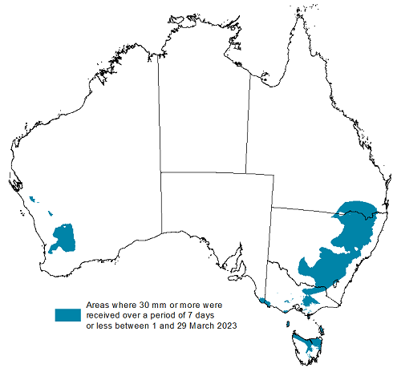
Source: Bureau of Meteorology, ABARES
ABARES has adapted the Pook et al. (2009) autumn break definition of falls of 30 millimetres or more recorded within any 7-day period from 1 March to identify where the autumn break threshold has been achieved across southern Australia. ABARES analysis of daily rainfall data sourced from the Bureau of Meteorology indicates that the autumn break has been achieved across cropping regions of northern, eastern and southern New South Wales, southern Queensland, parts of central and eastern Victoria, northern Tasmania and large areas of northern Western Australia.
Typically, the autumn break is driven by westerly fronts moving across southern Australia and cut-off low pressure systems. This early autumn break in south-eastern Australia has been driven by a number of thunderstorms that formed mainly from tropical moisture moving south and combining with the surface troughs creating the uplifts. In Western Australia the early autumn break has been the result of surface troughs stretching south from the tropical northwest of the country.

Rainfall forecast for the next eight days
Over the 8-days to 6 April 2023, troughs and lows will generate widespread rainfall across western, eastern, in parts of tropical north of Australia, and in western and eastern Tasmania. Easing showers are expected over coastal New South Wales and nearby ranges from the existing troughs moving eastwards towards the coast. Onshore winds will drive showers into southeast Queensland and northeast New South Wales. Humid and unstable winds will generate showers over northern tropics. In the Western Australia, a trough will continue to bring rain and storms across Pilbara and Gascoyne regions. Dry and cool conditions are expected through much of the country south as a high-pressure system moves in. Onshore winds around high-pressure system should bring a few showers to southern Australia.
Rainfall between 15 and 50 millimetres is expected in the Gascoyne and Pilbara regions in the Western Australia, northwest South Australia, southern Northern Territory, and in the eastern Queensland, New South Wales, and Victoria. Similar rainfall range will be observed in the western and eastern Tasmania as well as in parts of the coastal tropical north. Rainfall in excess of 100 millimetres is expected in the central Western Australia. Little to no rain is expected elsewhere.
Across Australian cropping regions, rainfall totals of between 15 and 25 millimetres are expected for much of Queensland and New South Wales, eastern Victoria, and much of Western Australia. Little to no rainfall is expected for the remaining cropping regions in the next eight days. If realised, the rainfall in the cropping regions is likely to result in some harvest delays for summer crops. The forecast rainfall over much of the Australian wheatbelt is likely to build soil moisture levels in the led up to the winter cropping season and also benefit pasture growth rates and availability.

Total forecast rainfall for the period 30 March to 6 April 2023
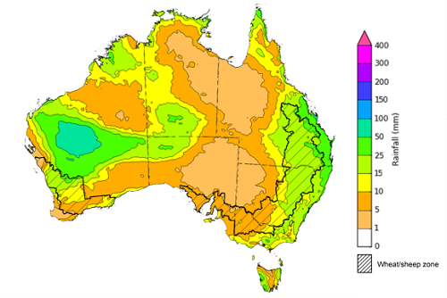

©Commonwealth of Australia 2023, Australian Bureau of Meteorology Issued 30/03/2023
Note: This rainfall forecast is produced from computer models. As the model outputs are not altered by weather forecasters, it is important to check local forecasts and warnings issued by the Bureau of Meteorology.

Water

Water markets – current week
Due to unavailability of new water information from the Bureau of Meteorology, the water storage levels in the Murray-Darling Basin (MDB) have not been updated this week.

Water storages in the Murray-Darling Basin, 2013–2023
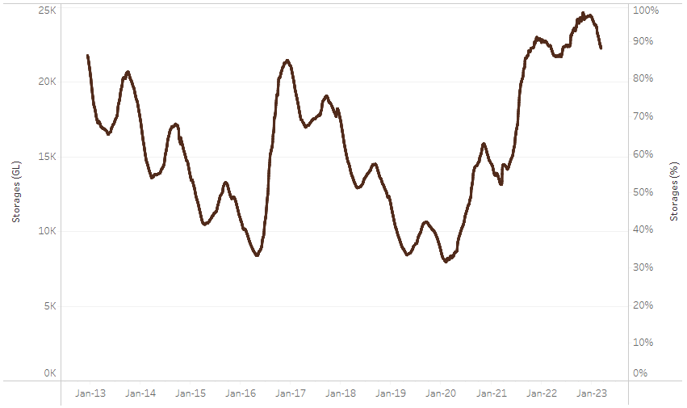
Allocation prices in the Victorian Murray below the Barmah Choke increased from $14 on 22 March 2023 to $17 on 29 March 2023.
Water storage data is sourced from the Bureau of Meteorology.

Region | $/ML
NSW Murray Above | 7
NSW Murrumbidgee | 9
VIC Goulburn-Broken | 18
VIC Murray Below | 17

Surface water trade activity, Southern Murray–Darling Basin
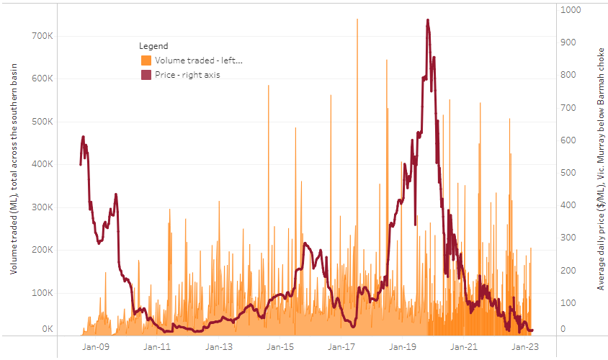
The trades shown reflect estimated market activity and do not encompass all register trades. The price is shown for the VIC Murray below the Barmah choke. Historical prices (before 1 July 2019) are ABARES estimates after removing outliers from BOM water register data. Prices after 1 July 2019 and prior to the 30 October 2019 reflect recorded transaction prices as sourced from Ruralco. Prices after the 30 October 2019 are sourced from Waterflow. Data for volume traded is sourced from the BOM water register. Only the price data shown is current on 30 March 2023.

To access the full, interactive, weekly water dashboard, which contains the latest and historical water storage, water market and water allocation information, please visit https://www.agriculture.gov.au/abares/products/weekly_update/weekly-update-30323

Commodities
Indicator | Week ended | Unit | Latest Price | Previous Week | Weekly change | Price 12 months ago | Annual change
Selected world indicator prices
AUD/USD Exchange rate | 29-Mar | A$/US$ | 0.67 | 0.67 | 0% | 0.75 | -11%
Wheat – US no. 2 hard red winter wheat, fob Gulf | 29-Mar | US$/t | 384 | 367 | 5% | 478 | -20%
Corn – US no. 2 yellow corn, fob Gulf | 29-Mar | US$/t | 294 | 288 | 2% | 340 | -14%
Canola – Rapeseed, Canada, fob Vancouver | 29-Mar | US$/t | 608 | 593 | 2% | 981 | -38%
Cotton – Cotlook 'A' Index | 29-Mar | USc/lb | 92 | 92 | 0% | 152 | -39%
Sugar – Intercontinental Exchange, nearby futures, no.11 contract | 29-Mar | USc/lb | 20.6 | 20.3 | 2% | 20 | 5%
Wool – Eastern Market Indicator | 08-Mar | Ac/kg clean | 1,317 | 1,358 | -3% | 1,392 | -5%
Wool – Western Market Indicator | 08-Mar | Ac/kg clean | 1,445 | 1,501 | -4% | 1,401 | 3%
Selected Australian grain export prices
Milling Wheat – APW, Port Adelaide, SA | 29-Mar | A$/t | 465 | 477 | -3% | 563 | -17%
Feed Wheat – ASW, Port Adelaide, SA | 29-Mar | A$/t | 440 | 452 | -3% | 527 | -17%
Feed Barley – Port Adelaide, SA | 29-Mar | A$/t | 407 | 409 | 0% | 453 | -10%
Canola – Kwinana, WA | 29-Mar | A$/t | 921 | 946 | -3% | 1,210 | -24%
Grain Sorghum – Brisbane, QLD | 29-Mar | A$/t | 509 | 521 | -2% | 375 | 36%
Selected domestic livestock indicator prices
Beef – Eastern Young Cattle Indicator | 29-Mar | Ac/kg cwt | 672 | 677 | -1% | 1,114 | -40%
Mutton – Mutton indicator (18–24 kg fat score 2–3), Vic | 29-Mar | Ac/kg cwt | 298 | 300 | -1% | 566 | -47%
Lamb – Eastern States Trade Lamb Indicator | 29-Mar | Ac/kg cwt | 662 | 664 | 0% | 815 | -19%
Pig – Eastern Seaboard (60.1–75 kg), average of buyers & sellers | 15-Mar | Ac/kg cwt | 357 | 357 | 0% | 357 | 0%
Goats – Eastern States (12.1–16 kg) | 01-Mar | Ac/kg cwt | 325 | 325 | 0% | 813 | -60%
Live cattle – Light steers ex Darwin to Indonesia | 17-Aug | Ac/kg lwt | 420 | 480 | -13% | 320 | 31%
Live sheep – Live wethers (Muchea WA saleyard) to Middle East | 14-Sep | $/head | 93 | 113 | -18% | 114 | -18%
Global Dairy Trade (GDT) weighted average prices ª
Dairy – Whole milk powder | 22-Mar | US$/t | 3,228 | 3,277 | -1% | 4,364 | -26%
Dairy – Skim milk powder | 22-Mar | US$/t | 2,648 | 2,739 | -3% | 3,302 | -20%
Dairy – Cheddar cheese | 22-Mar | US$/t | 4,052 | 4,509 | -10% | 4,280 | -5%
Dairy – Anhydrous milk fat | 22-Mar | US$/t | 5,150 | 5,340 | -4% | 5,929 | -13%
a Global Dairy Trade prices are updated twice monthly on the first and third Tuesday of each month.

Selected world indicator prices
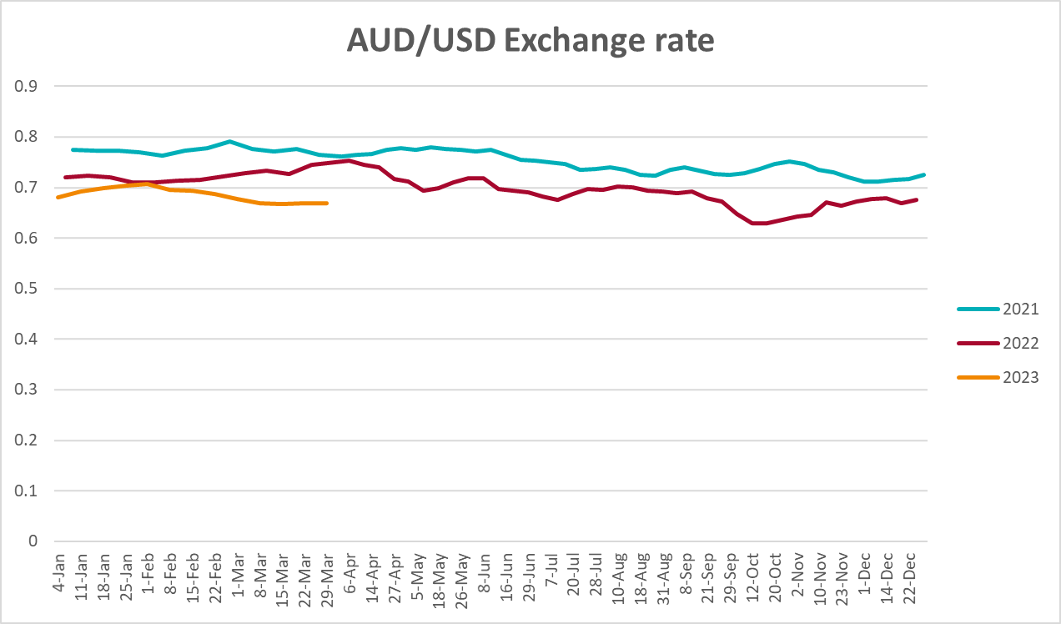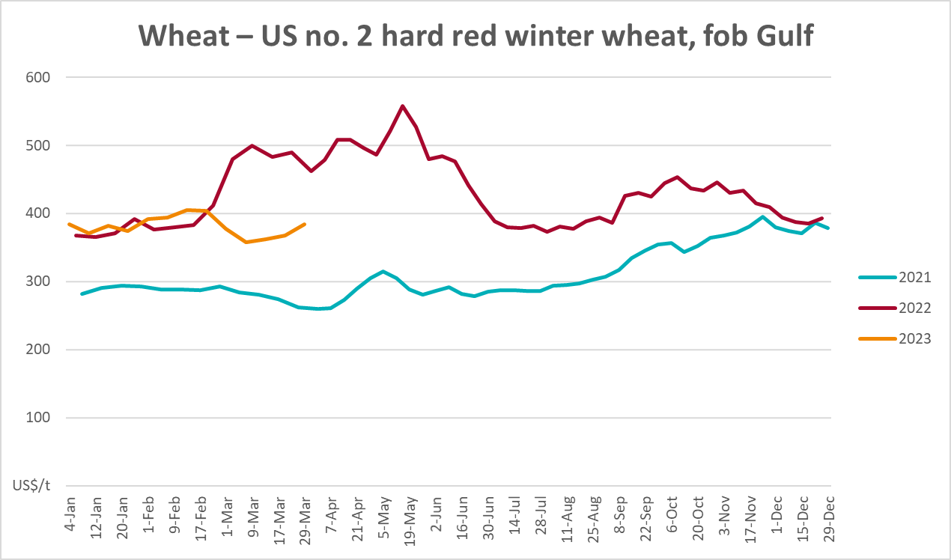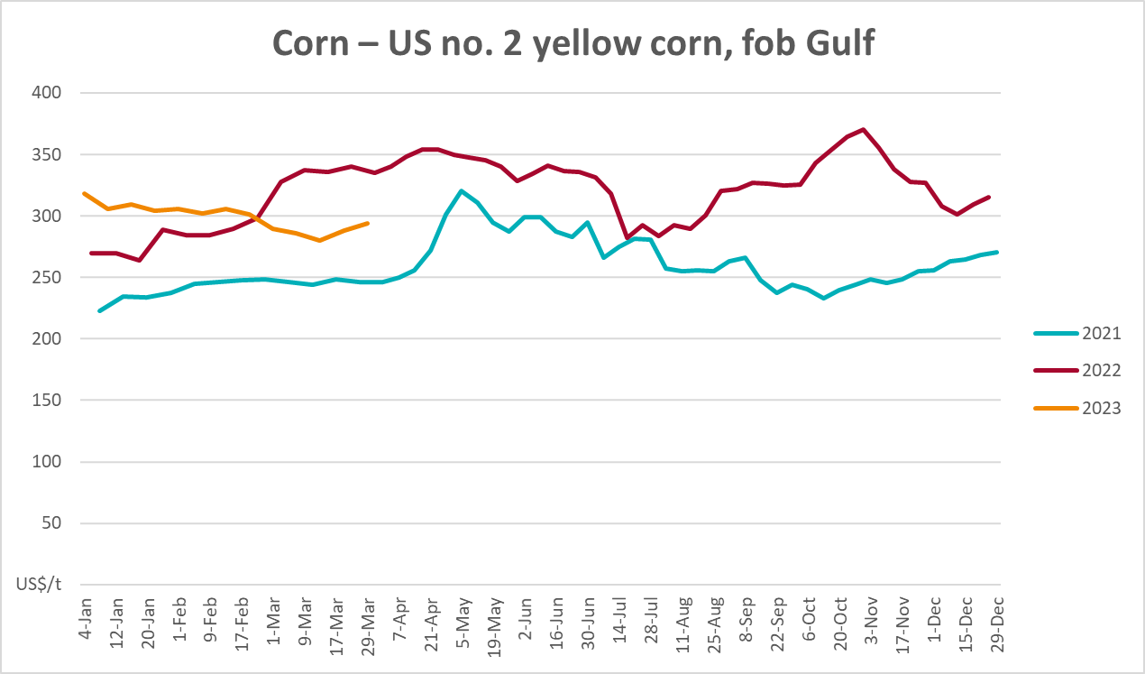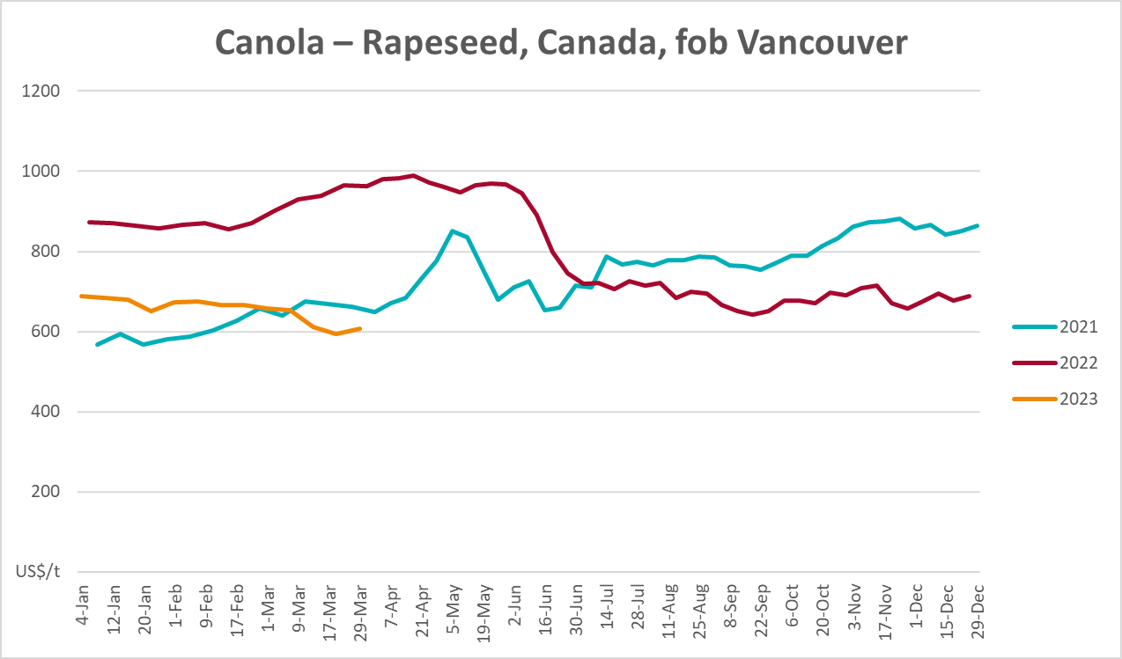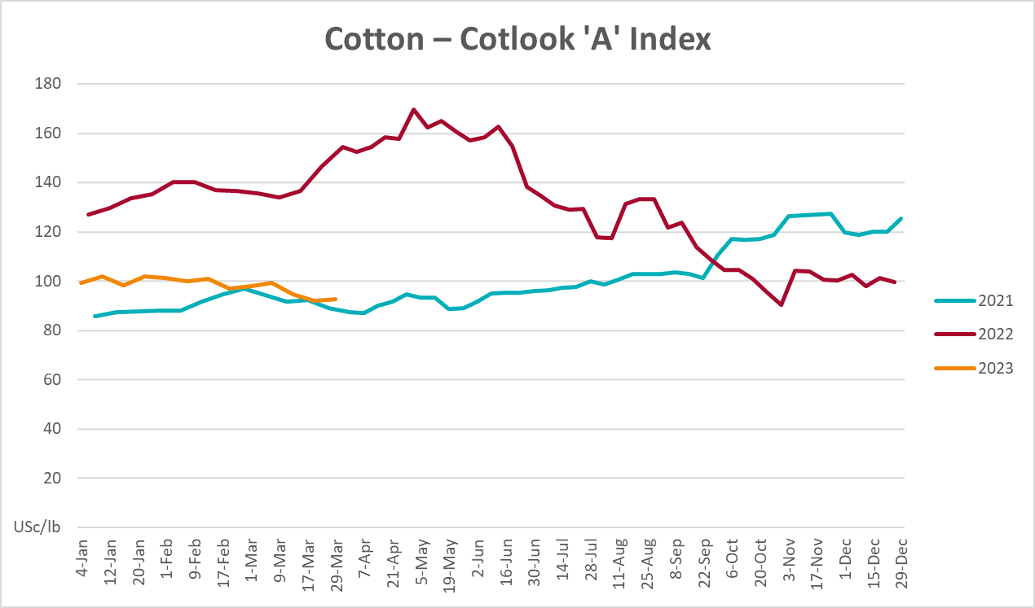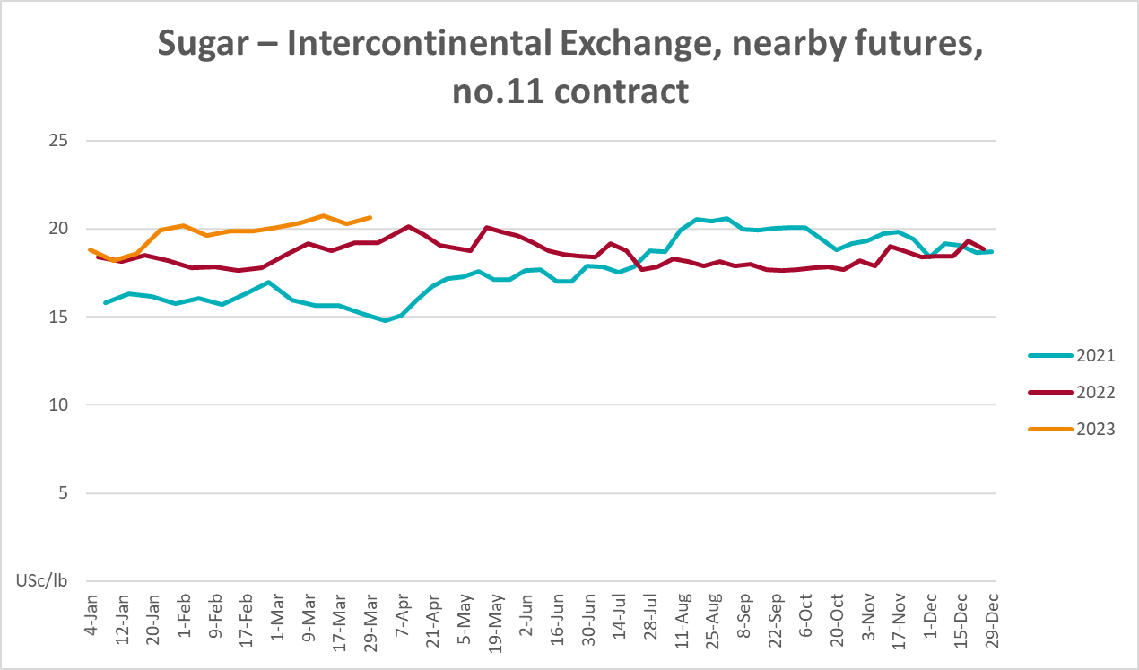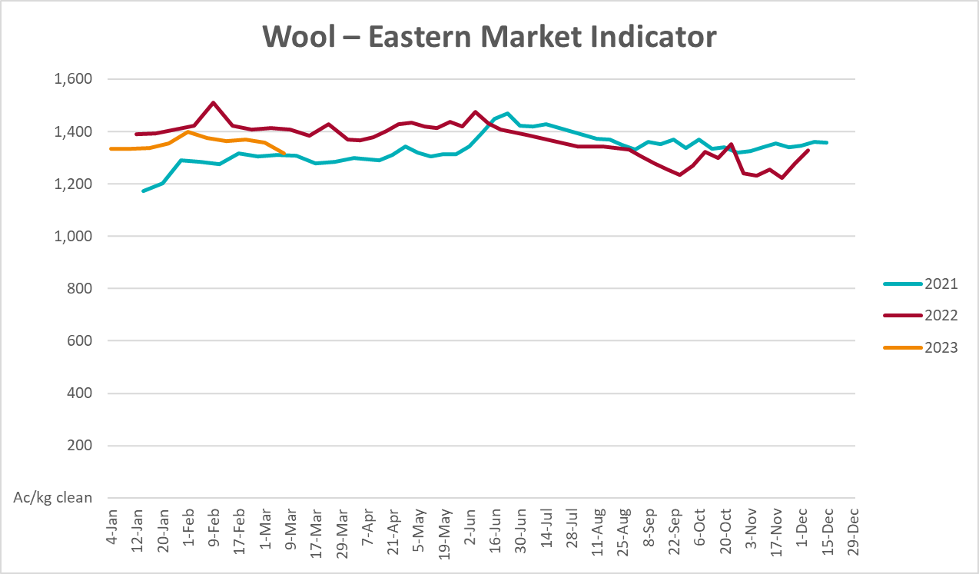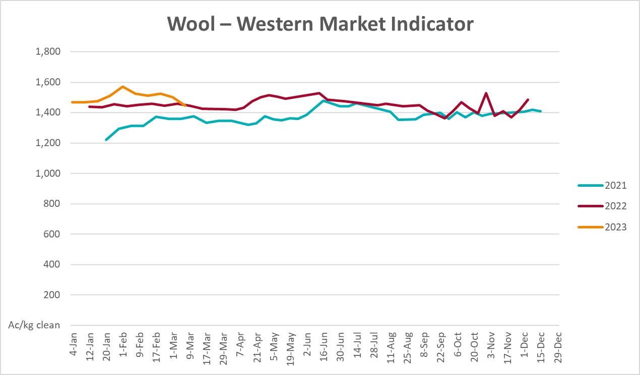

Selected domestic crop indicator prices
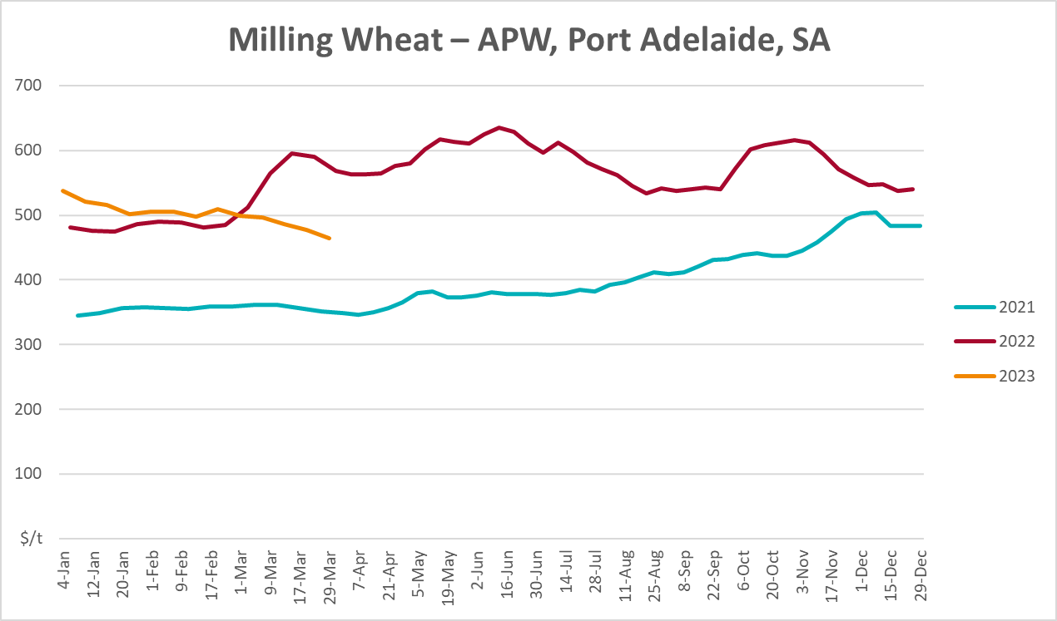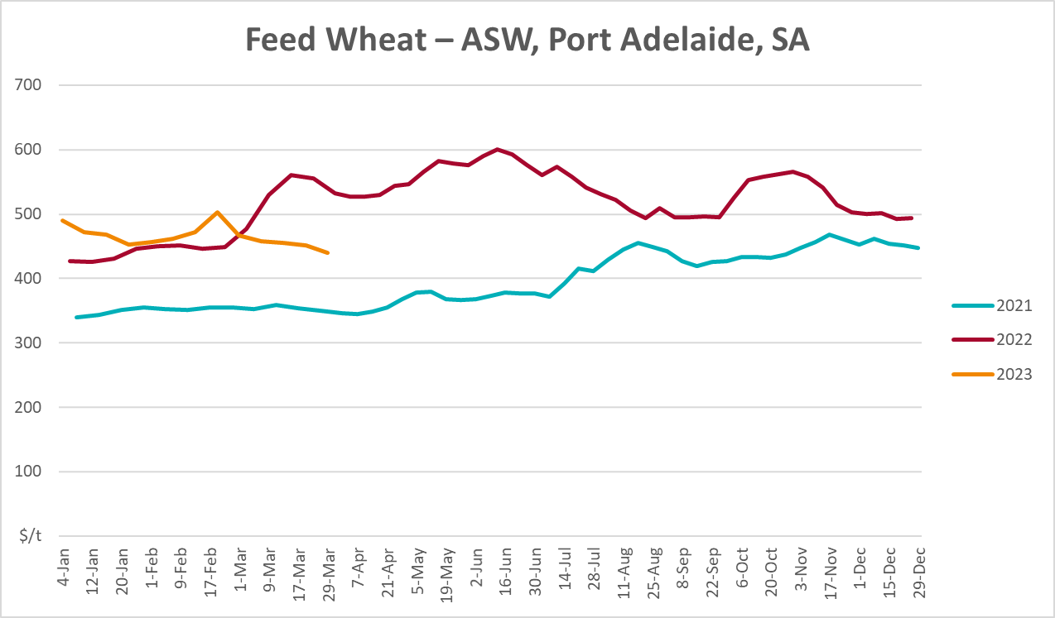
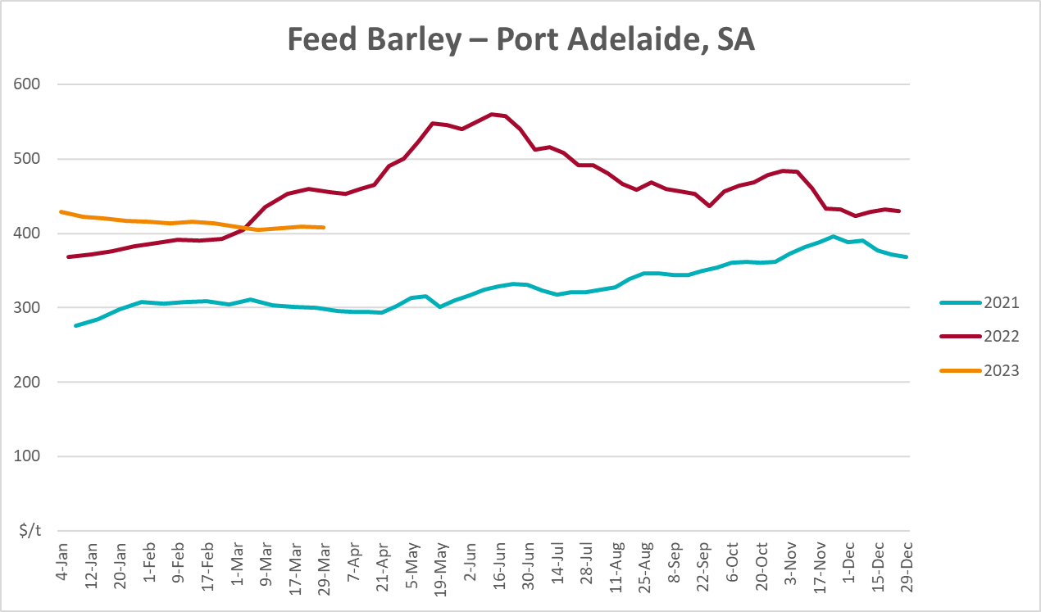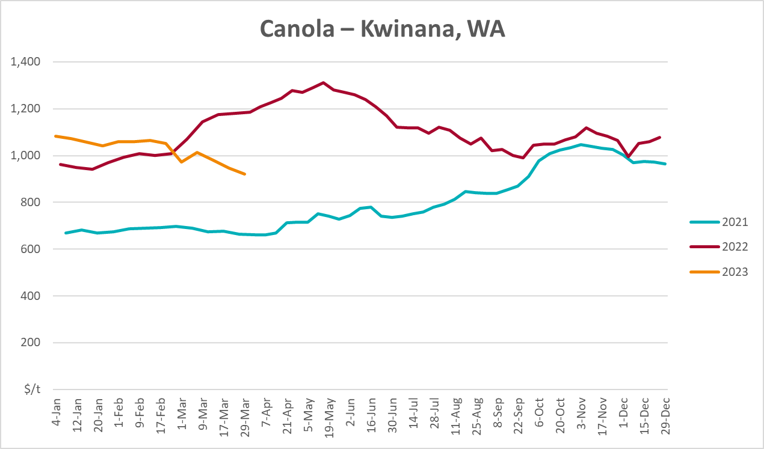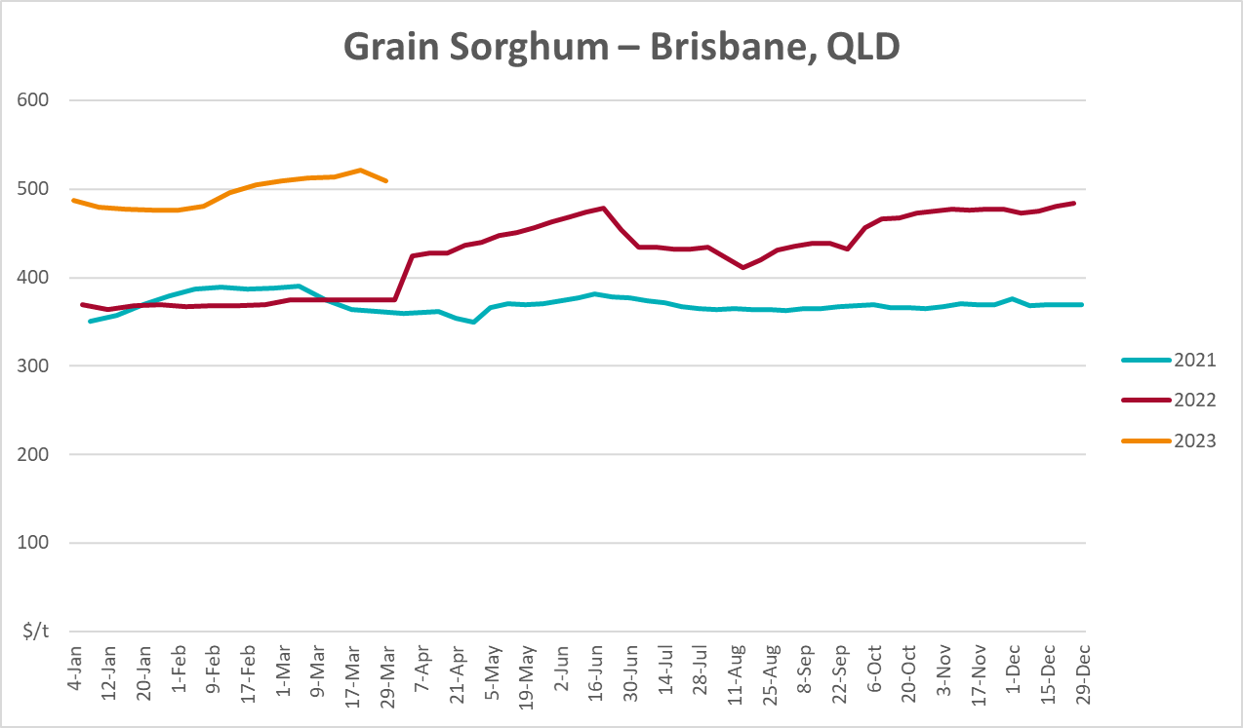

Selected domestic livestock indicator prices
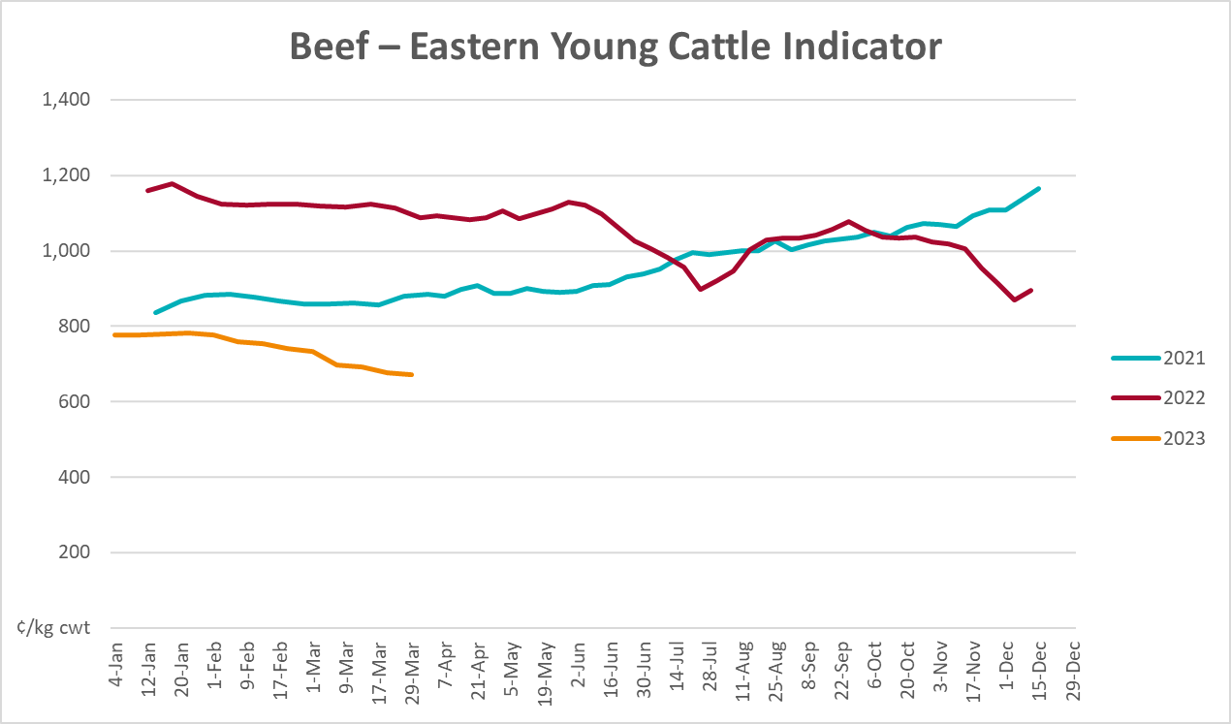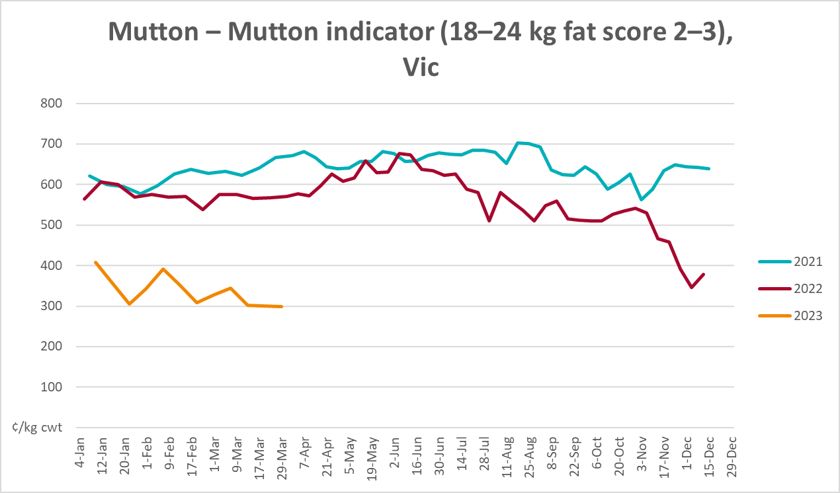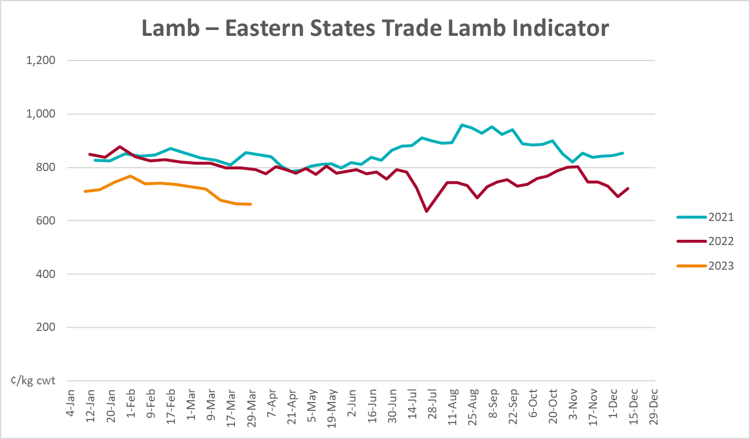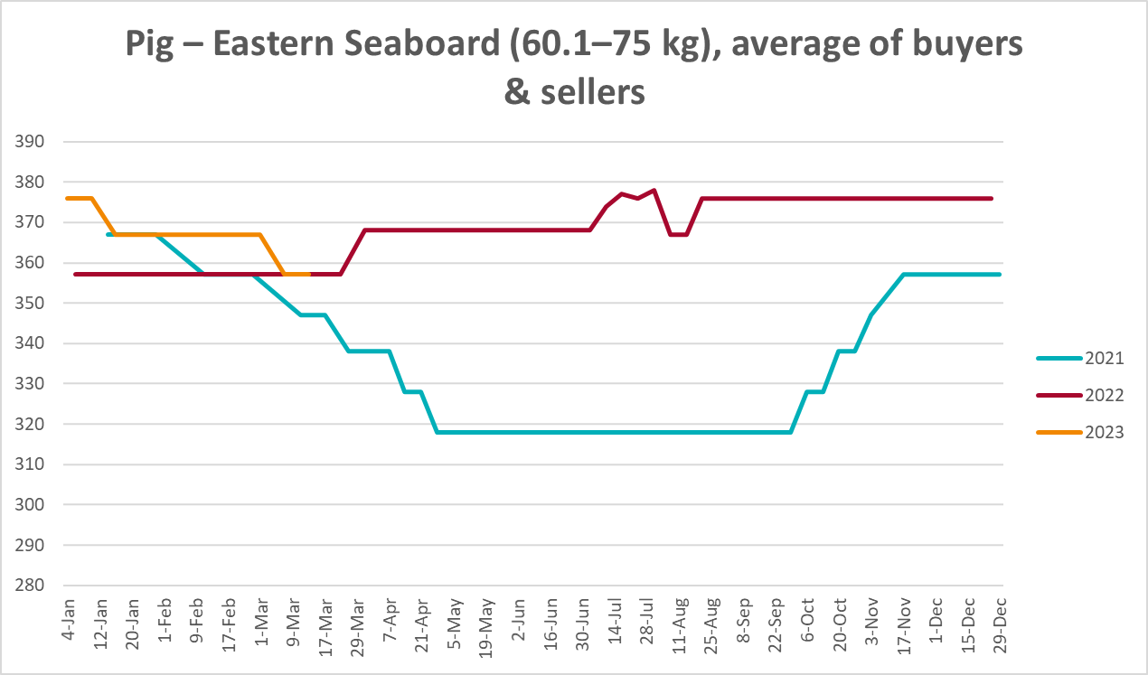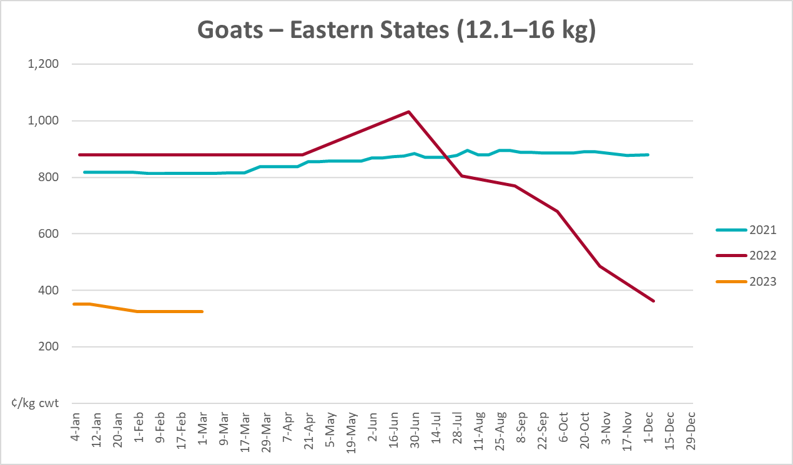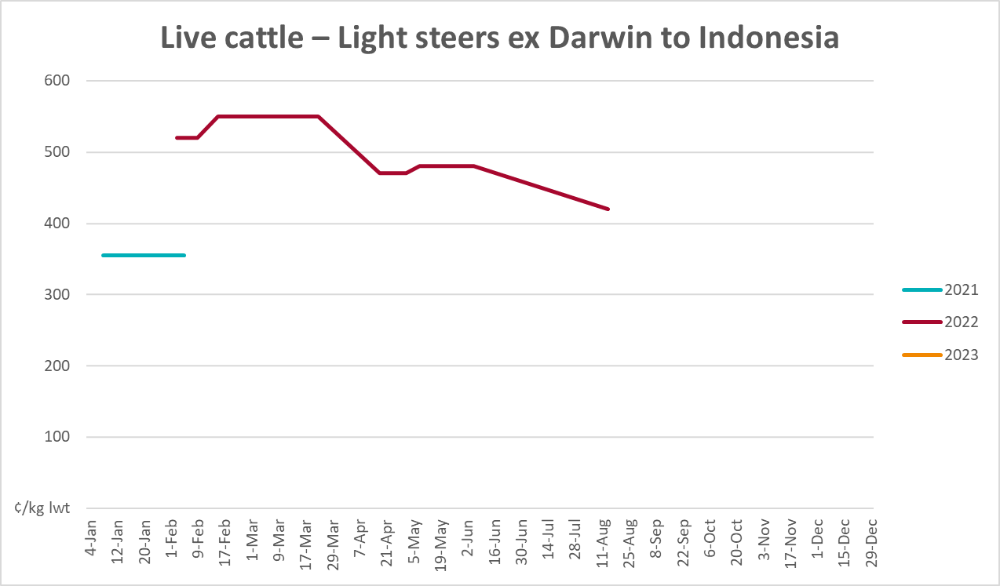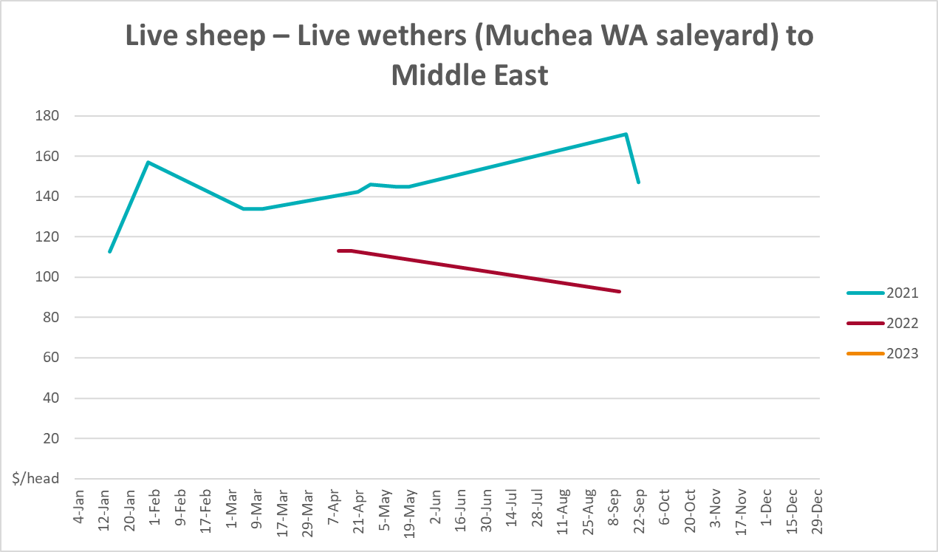

Global Dairy Trade (GDT) weighted average prices
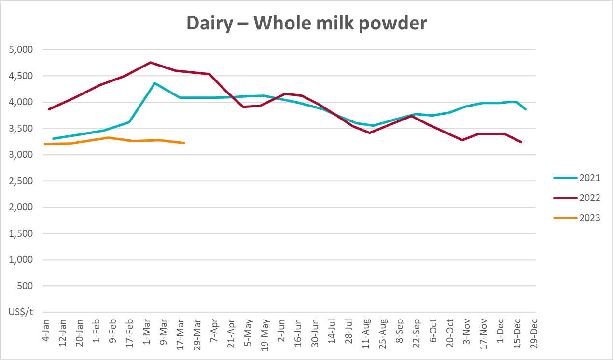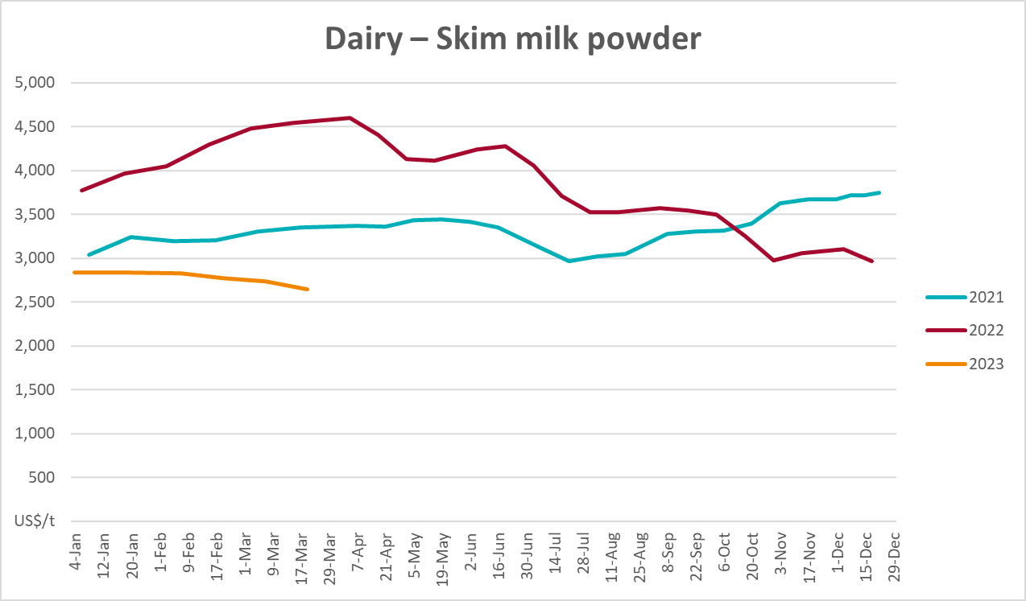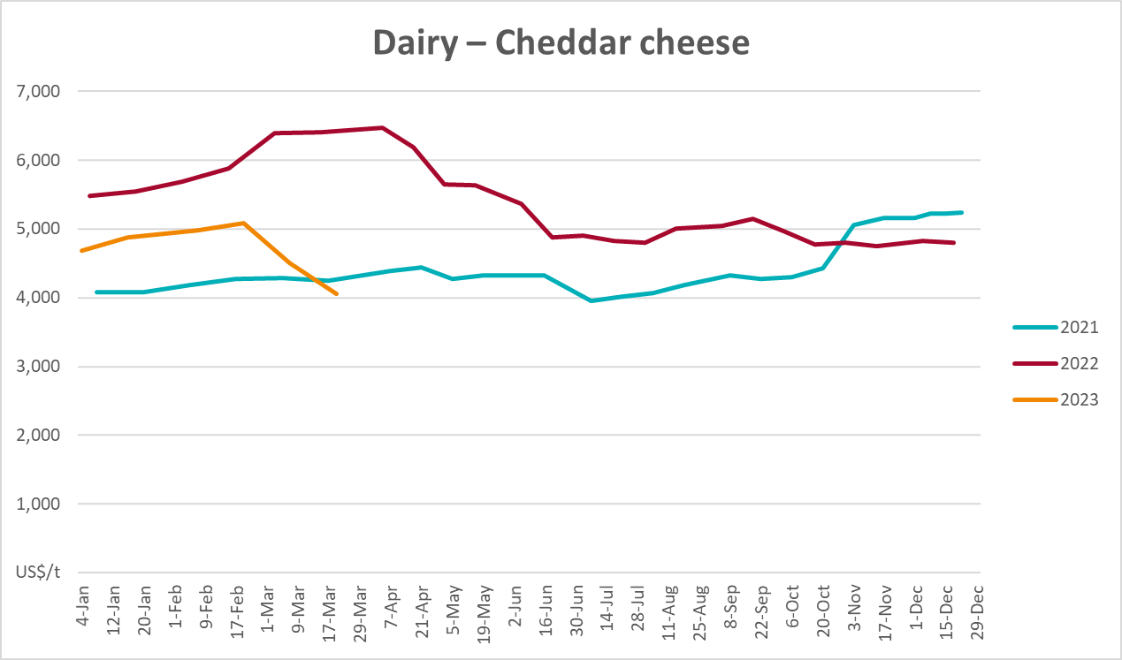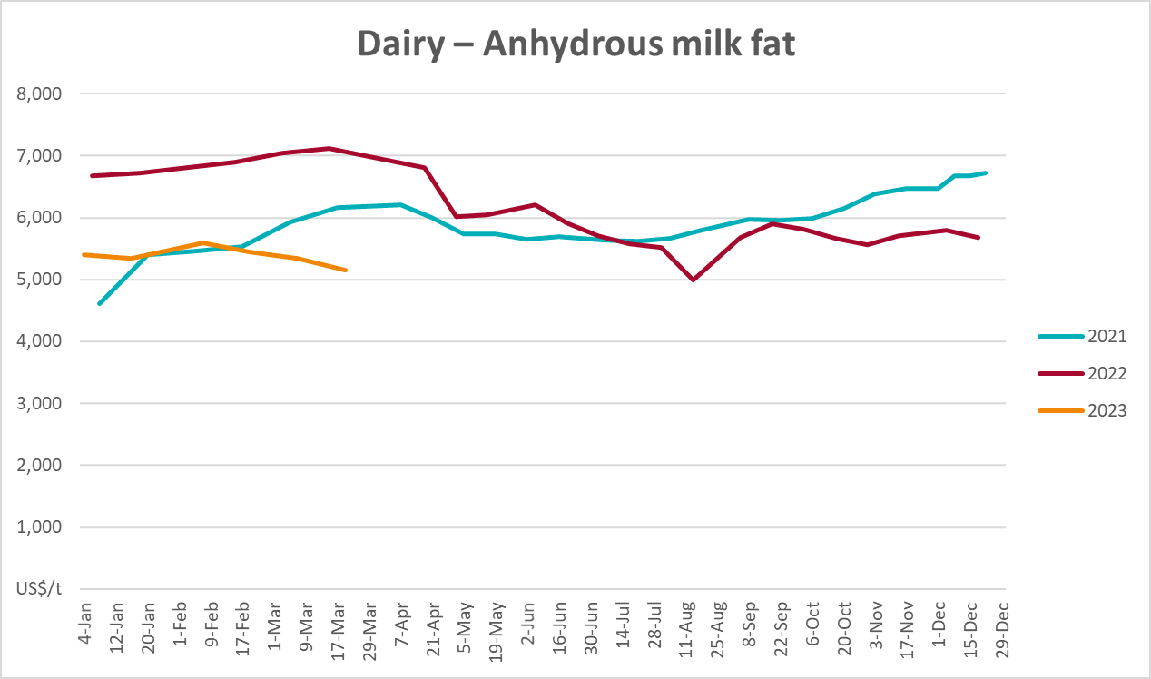

Selected fruit and vegetable prices
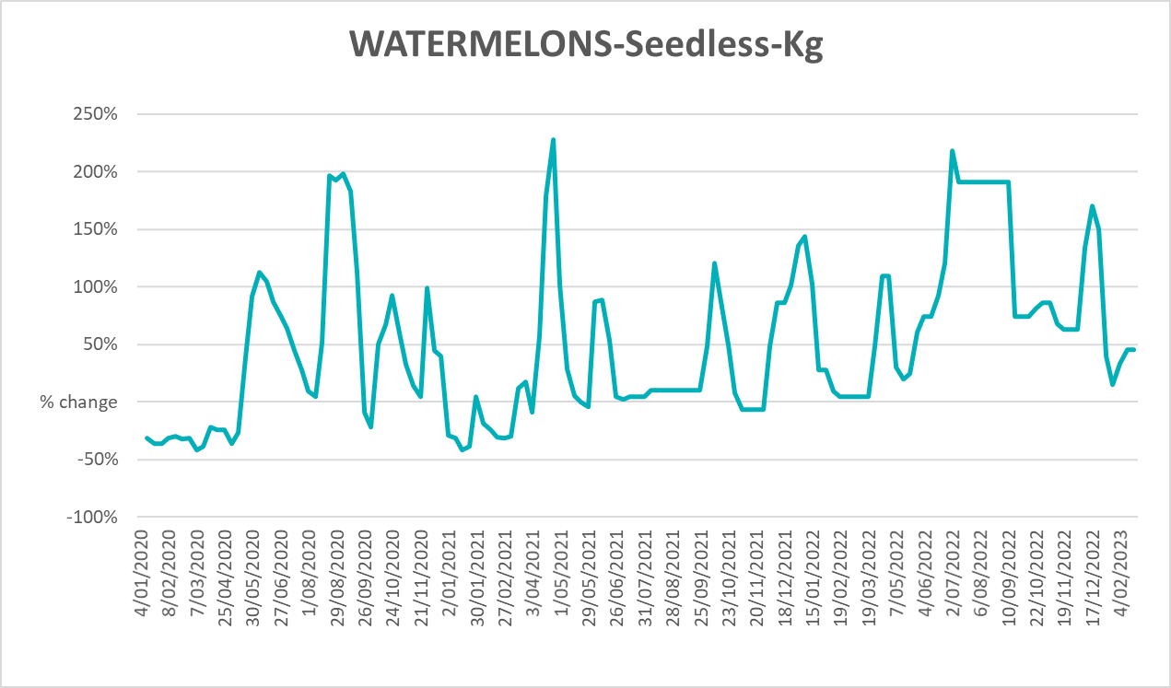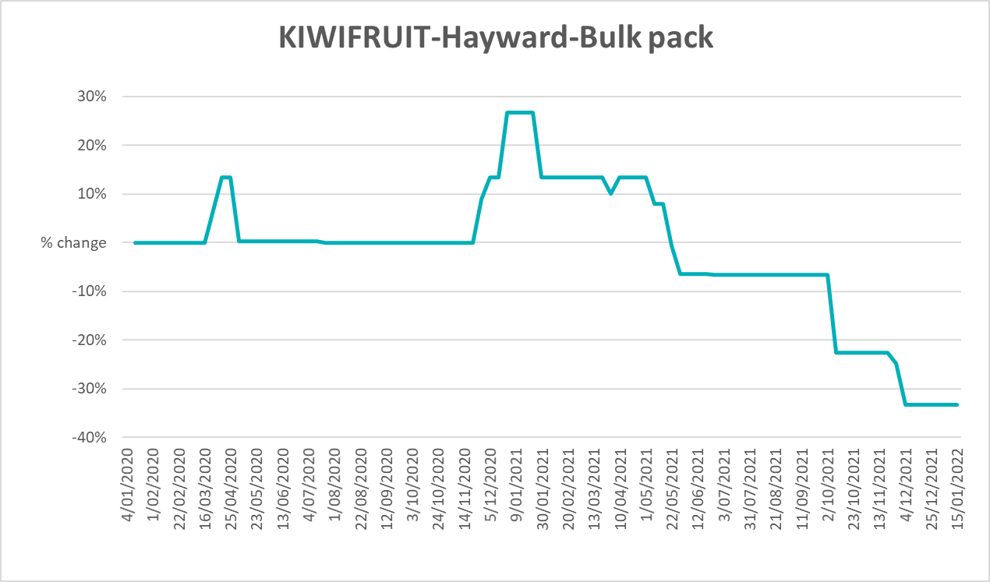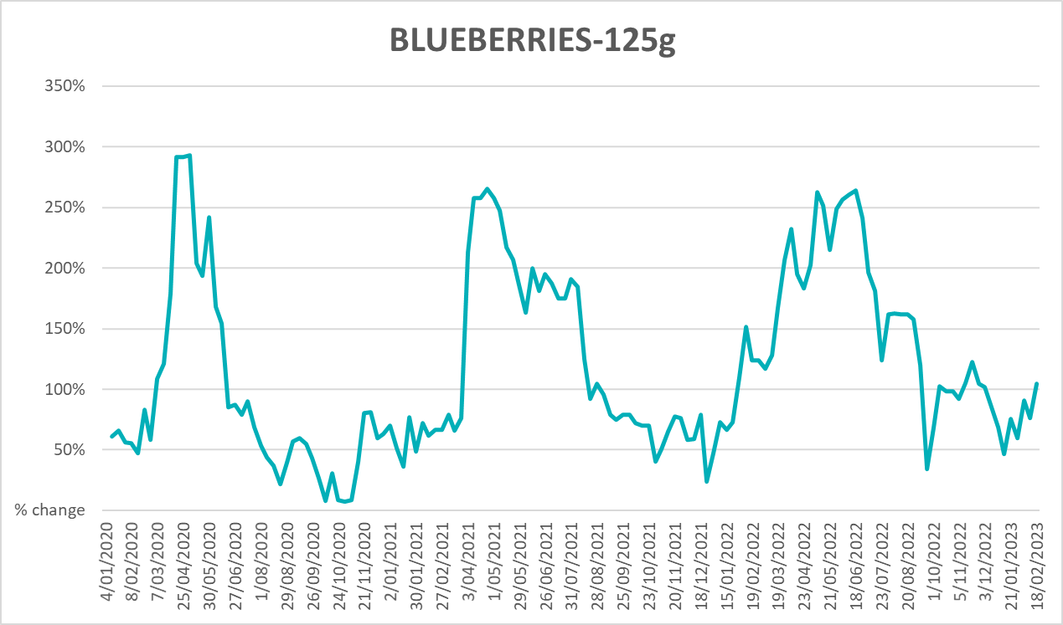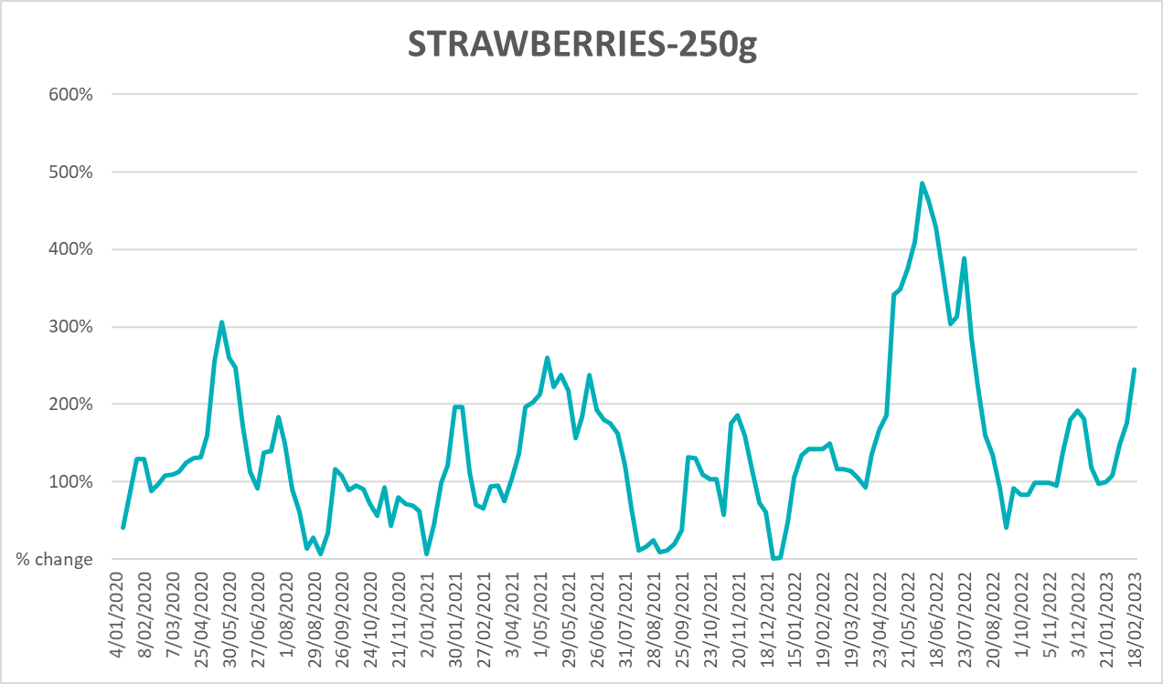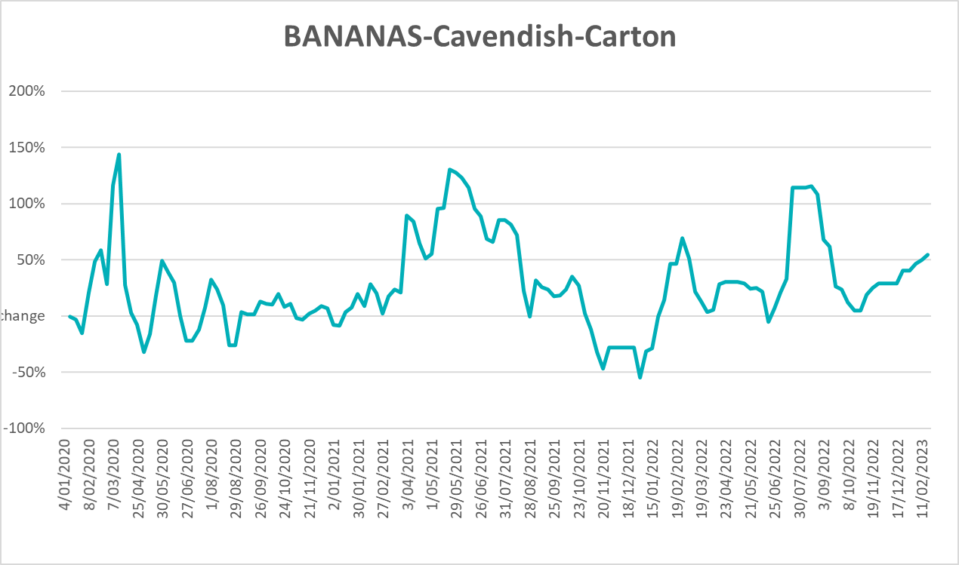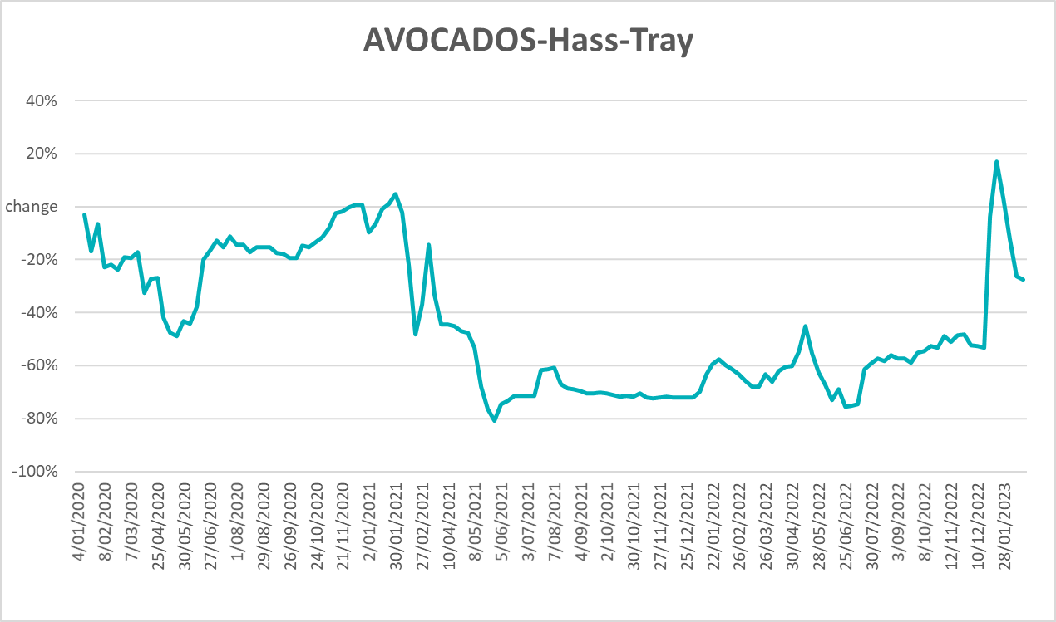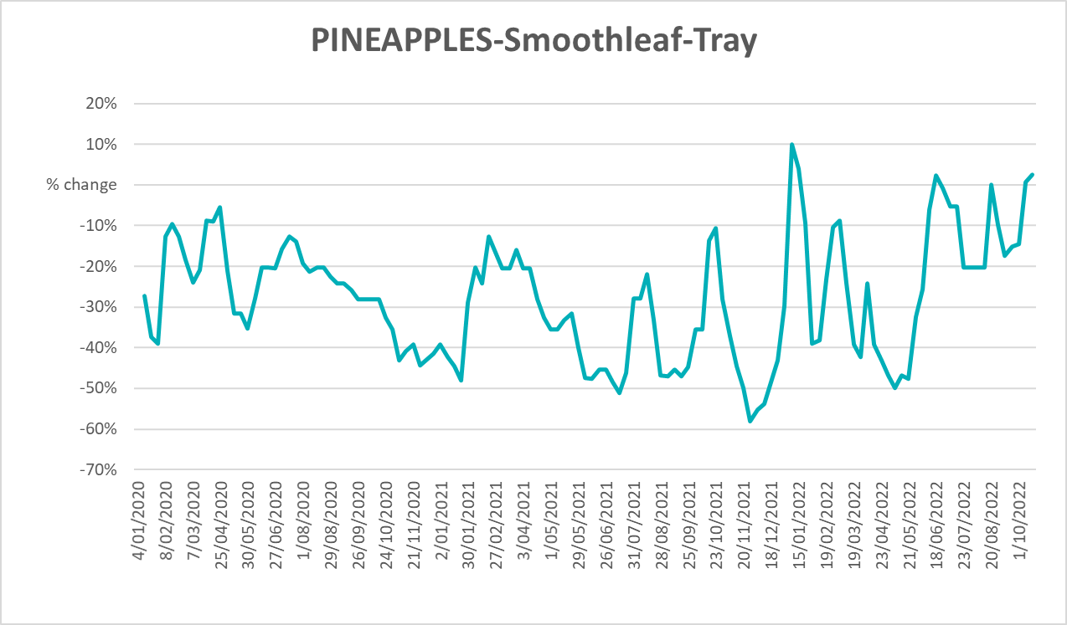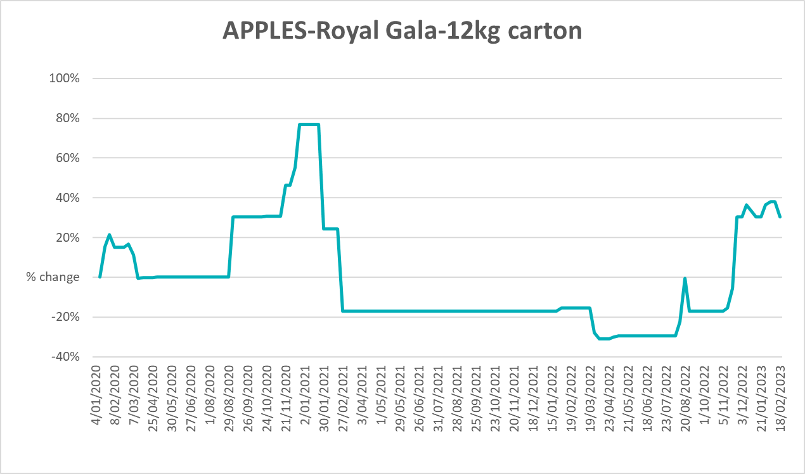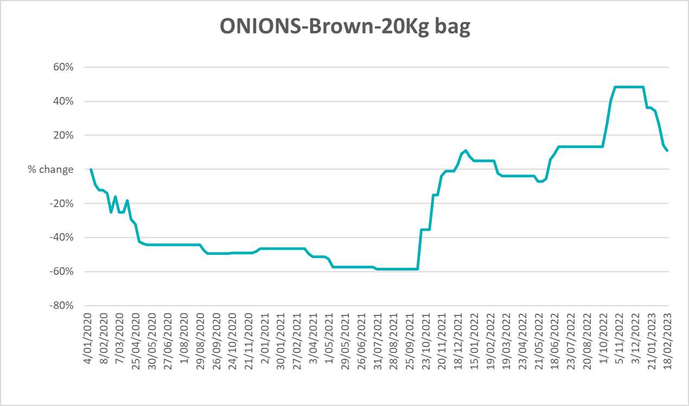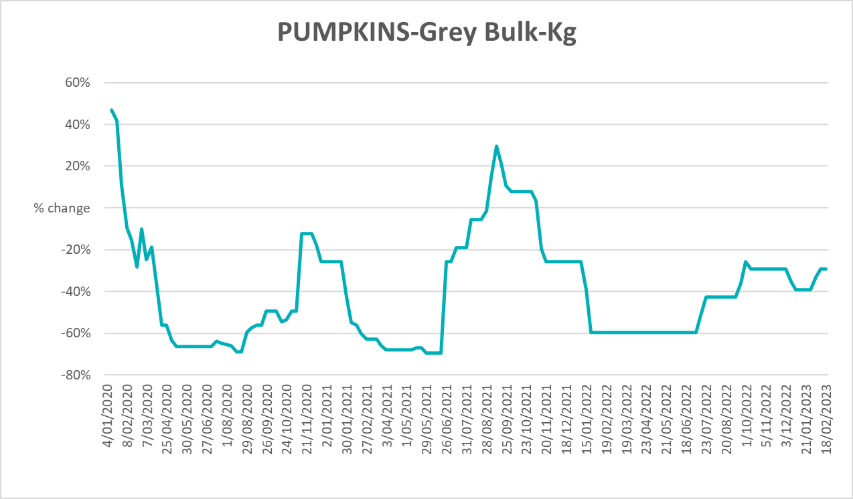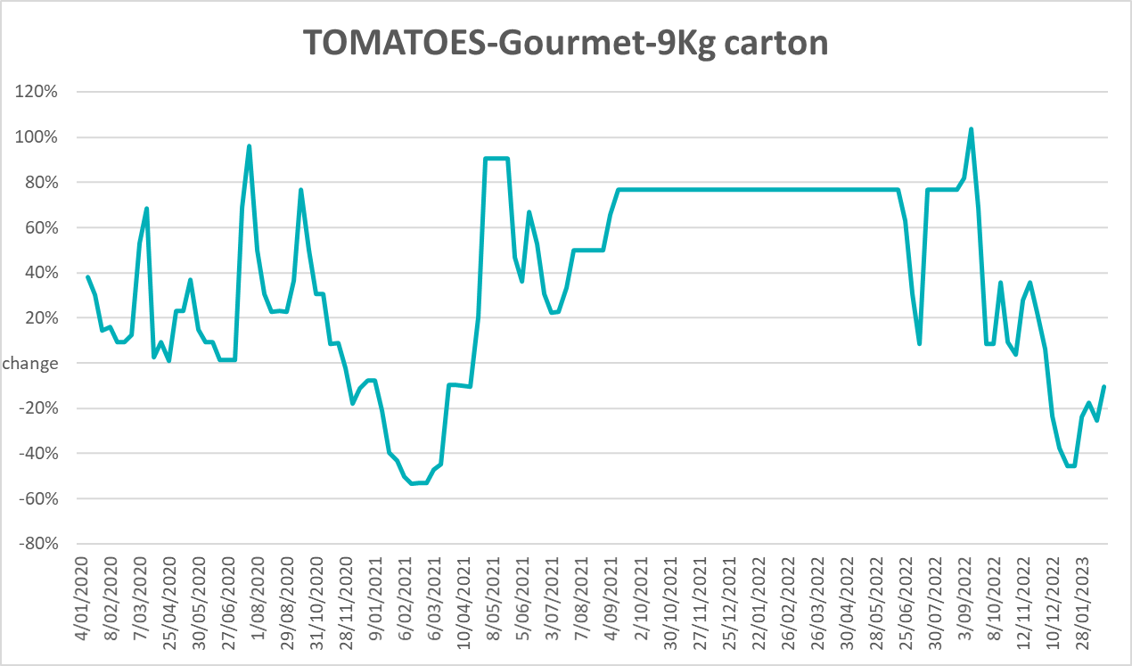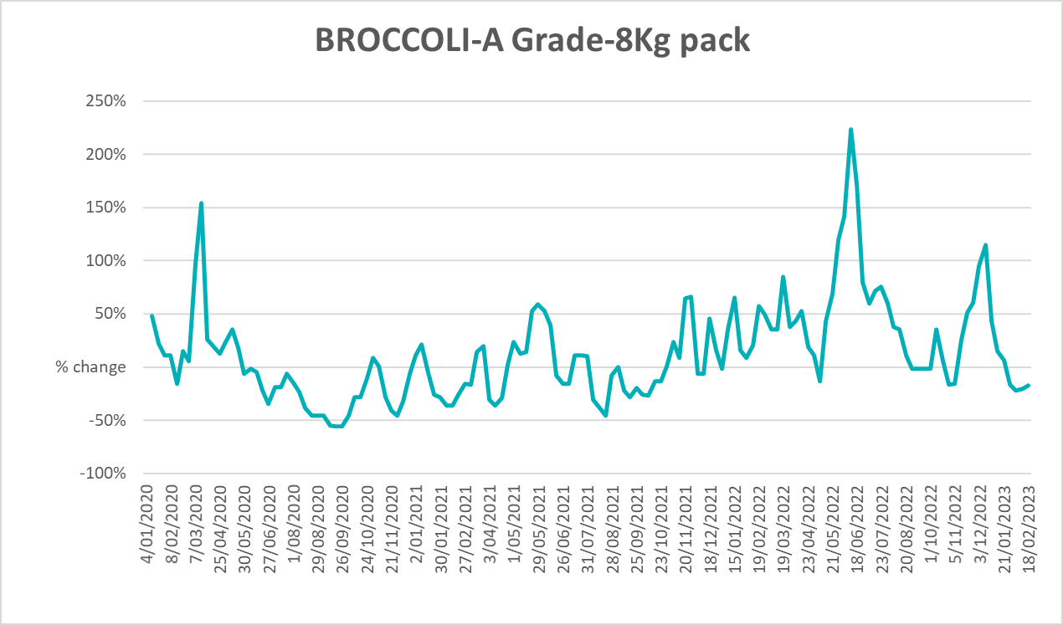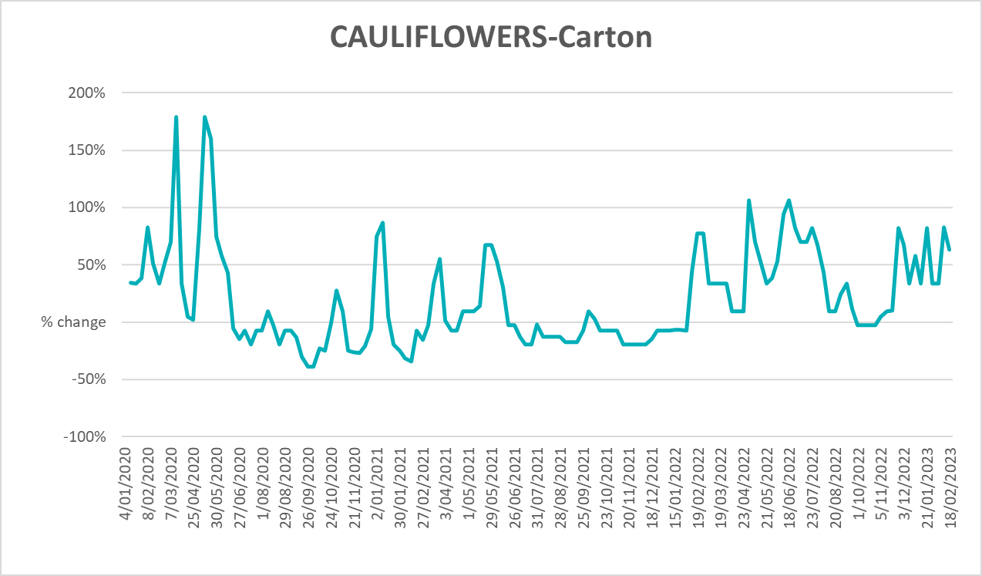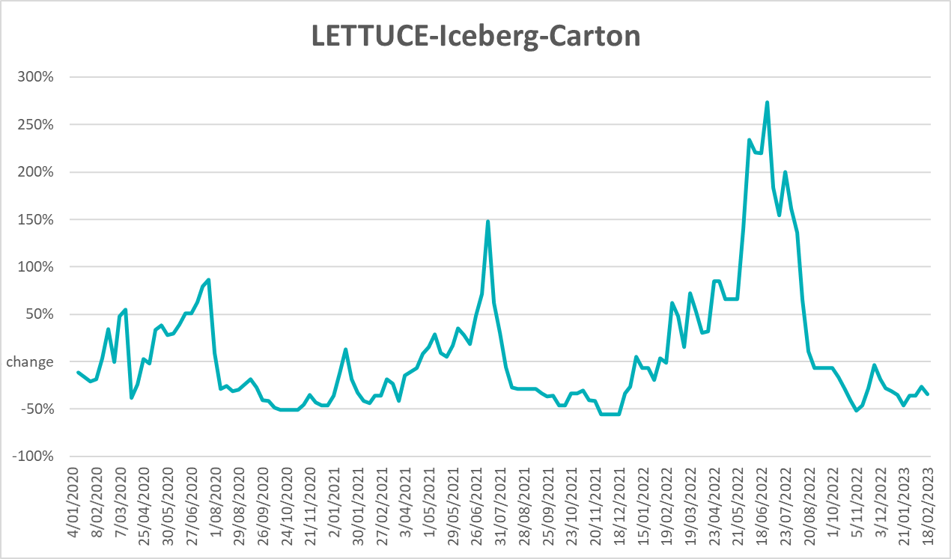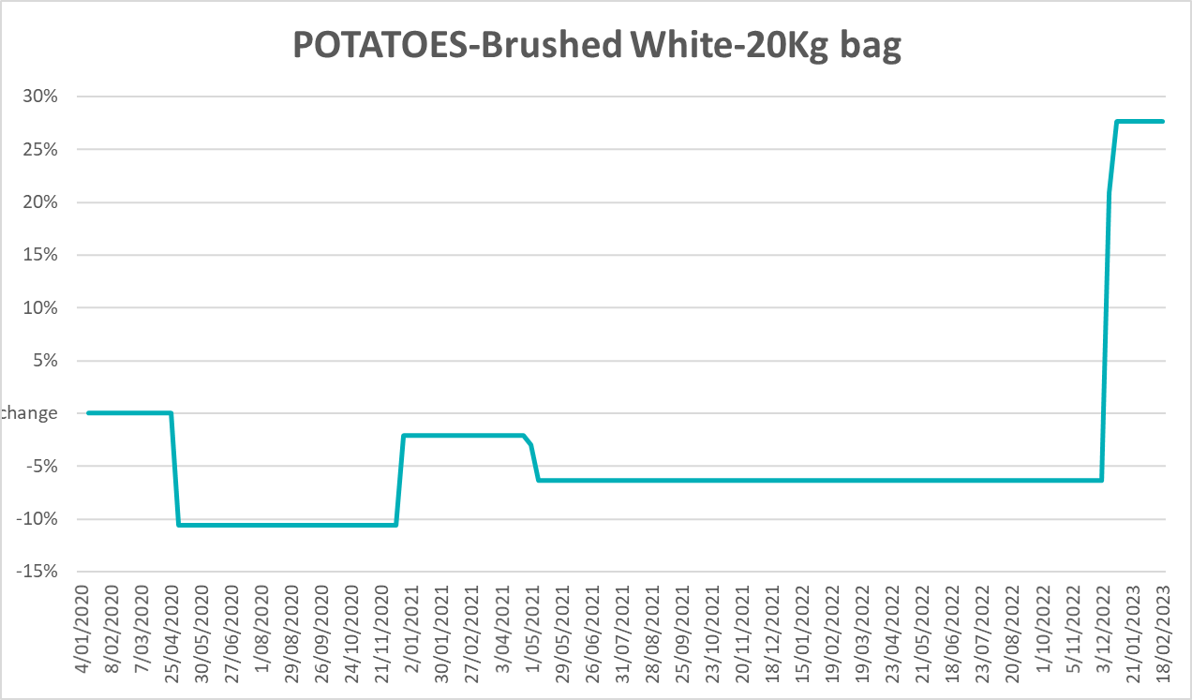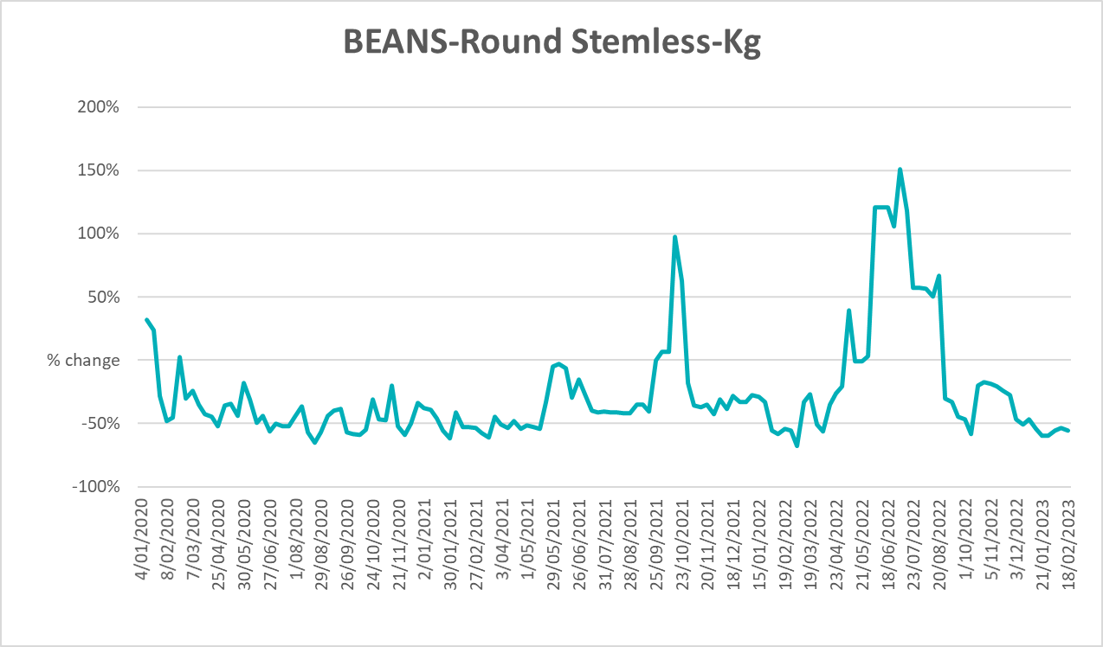

3.6 Selected domestic fodder indicator prices
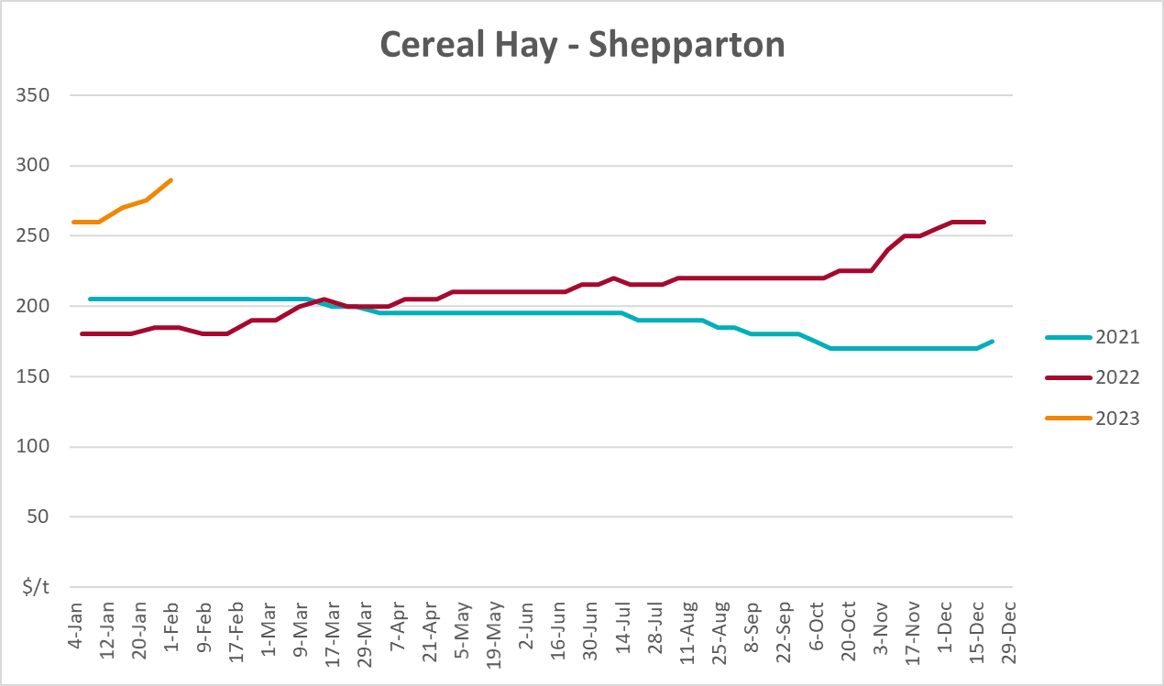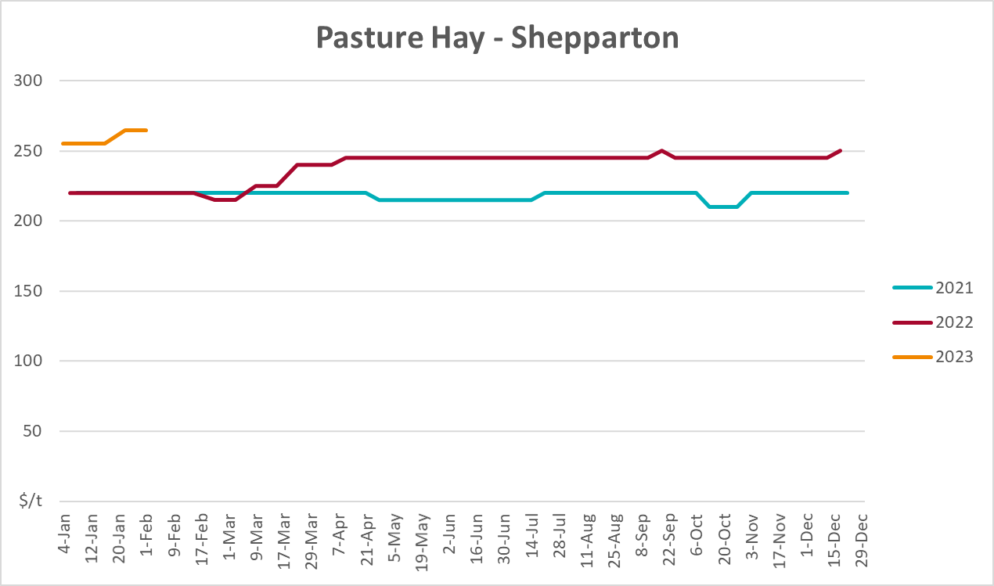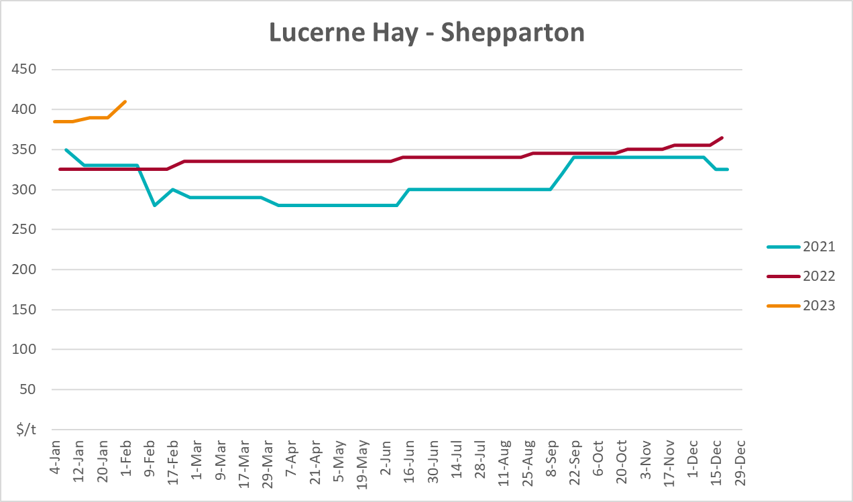

4. Data attribution

Climate
Bureau of Meteorology
- Weekly rainfall totals: www.bom.gov.au/climate/maps/rainfall/
- Monthly and last 3-month rainfall percentiles: www.bom.gov.au/water/landscape/
- Temperature anomalies: www.bom.gov.au/jsp/awap/temp/index.jsp
- Rainfall forecast: www.bom.gov.au/jsp/watl/rainfall/pme.jsp
- Seasonal outlook: www.bom.gov.au/climate/outlooks/#/overview/summary/
- Climate drivers: http://www.bom.gov.au/climate/enso/
- Soil moisture: www.bom.gov.au/water/landscape/
Other
- Pasture growth: www.longpaddock.qld.gov.au/aussiegrass/
- 3-month global outlooks: Environment and Climate Change Canada, NOAA Climate Prediction Center, EUROBRISA CPTEC/INPE, European Centre for Medium-Range Weather Forecasts, Hydrometcenter of Russia, National Climate Center Climate System Diagnosis and Prediction Room (NCC), International Research Institute for Climate and Society
- Global production: https://ipad.fas.usda.gov/ogamaps/cropmapsandcalendars.aspx
- Autumn break: Pook et al., 2009, https://rmets-onlinelibrary-wiley-com.virtual.anu.edu.au/doi/epdf/10.1002/joc.1833

Water
Prices
- Waterflow: https://www.waterflow.io/
- Ruralco: https://www.ruralcowater.com.au/
Bureau of Meteorology:
- Allocation trade: http://www.bom.gov.au/water/dashboards/#/water-markets/mdb/at
- Storage volumes: http://www.bom.gov.au/water/dashboards/#/water-storages/summary/drainage
Trade constraints:
- Water NSW: https://www.waternsw.com.au/customer-service/ordering-trading-and-pricing/trading/murrumbidgee
- Victorian Water Register: https://www.waterregister.vic.gov.au/TradingRules2019/

Commodities
Fruit and vegetables
- Datafresh: www.freshstate.com.au
Pigs
- Australian Pork Limited: www.australianpork.com.au
Dairy
- Global Dairy Trade: www.globaldairytrade.info/en/product-results/
World wheat, canola
- International Grains Council
World coarse grains
- United States Department of Agriculture
World cotton
- Cotlook: www.cotlook.com/
World sugar
- New York Stock Exchange - Intercontinental Exchange
Wool
- Australian Wool Exchange: www.awex.com.au/
Domestic wheat, barley, sorghum, canola and fodder
- Jumbuk Consulting Pty Ltd: http://www.jumbukag.com.au/
Cattle, beef, mutton, lamb, goat and live export
- Meat and Livestock Australia: www.mla.com.au/Prices-and-market
© Commonwealth of Australia 2023

Ownership of intellectual property rights
Unless otherwise noted, copyright (and any other intellectual property rights, if any) in this publication is owned by the Commonwealth of Australia (referred to as the Commonwealth).

Creative Commons licence
All material in this publication is licensed under a Creative Commons Attribution 4.0 International Licence except content supplied by third parties, logos and the Commonwealth Coat of Arms.
Inquiries about the licence and any use of this document should be emailed to copyright@awe.gov.au.


Cataloguing data
This publication (and any material sourced from it) should be attributed as:
ABARES 2023, Weekly Australian Climate, Water and Agricultural Update, Australian Bureau of Agricultural and Resource Economics and Sciences, Canberra, 30 March 2023. CC BY 4.0 DOI: https://doi.org/10.25814/5f3e04e7d2503
ISSN 2652-7561
This publication is available at https://www.agriculture.gov.au/abares/products/weekly_update
Department of Agriculture, Fisheries and Forestry
GPO Box 858 Canberra ACT 2601
Telephone 1800 900 090
Web agriculture.gov.au/abares

Disclaimer
The Australian Government acting through the Department of Agriculture, Fisheries and Forestry, represented by the Australian Bureau of Agricultural and Resource Economics and Sciences, has exercised due care and skill in preparing and compiling the information and data in this publication. Notwithstanding, the Department of Agriculture, Fisheries and Forestry, ABARES, its employees and advisers disclaim all liability, including liability for negligence and for any loss, damage, injury, expense or cost incurred by any person as a result of accessing, using or relying on any of the information or data in this publication to the maximum extent permitted by law.

Statement of Professional Independence
The views and analysis presented in ABARES publications, including this one, reflect ABARES professionally independent findings, based on scientific and economic concepts, principles, information and data. These views, analysis and findings may not reflect or be consistent with the views or positions of the Australian Government, or of organisations or groups who have commissioned ABARES reports or analysis. More information on professional independence is provided on the ABARES website.

Acknowledgements
This report was prepared by Kavina Dayal.

