
No. 13/2023 6 April 2023

Summary of key issues
- For the week ending 5 April 2023, a low-pressure trough extending from west to east across the country was responsible for thunderstorms and heavy rainfall across large parts of central western and eastern Australia. In the Western Australia, another low-pressure system offshore from the Pilbara brought showers, thunderstorms, and heavy rainfall.
- In cropping regions, rainfall totals of between 25 and 100 millimetres were recorded across northern and central Western Australia. Rainfall totals between 10 and 25 millimetres were recorded across isolated areas of northeast and southeast New South Wales, and in the northern and south-eastern Queensland. Little to no rainfall was recorded across the remaining cropping regions over the past 7 days (see Section 1.1).
- Rainfall during March 2023 was around 7% below the long-term average. Rainfall was above average for much of the central Northern Territory extending through the Gulf Country into western and central Queensland, large areas of western to central Western Australia, across pockets of eastern Australia, and the northern half of Tasmania. In contrast, rainfall was below average for much of the Top End and areas between Western Australia's Kimberley and the south-east of the Northern Territory, and an area spanning eastern South Australia, north-western New South Wales, and far south-west Queensland (see Section 1.2).
- For the 3 months to March 2023, above average rainfall totals and below average summer temperatures resulted in above average to extremely high pasture production for this time of year across much of northern Australia. Extremely low to below average pasture growth rates were recorded across isolated parts southern Western Australia, much of Victoria, much of New South Wales, except for in the southern cropping region, southern Queensland and in the tropical Northern Territory and Queensland owing to above average temperatures and/or below average rainfall (see Section 1.4).
- Over the 8-days to 13 April 2023, a series of troughs and lows is expected to trigger scattered showers and storms, some intense, across parts of all states and territories of Australia. A high-pressure system will bring more settled and dry condition to large areas of the interior of Australia. Across Australian cropping regions, rainfall totals of up to 15 millimetres are expected for central Western Australia and between 15 and 25 millimetres for parts of south-eastern Queensland, eastern New South Wales, eastern Victoria, and southern South Australia. Little to no rainfall is expected for the remaining cropping regions. If realised, the rainfall in the cropping regions is likely to result in some harvest delays for summer crops while also likely to build soil moisture levels in the led up to the winter cropping season and also benefit pasture growth rates and availability (see Section 1.5).
- Water storage levels in the Murray-Darling Basin (MDB) decreased between 30 March 2023 and 6 April 2023 by 83 gigalitres (GL). Current volume of water held in storage is 19 936 GL which represents 89 per cent of total capacity. This is 0.2 percent or 36 GL more than at the same time last year.
- Allocation prices in the Victorian Murray below the Barmah Choke decreased from $17 on 29 March 2023 to $16 on 6 April 2023. Prices are lower in the Murrumbidgee due to the binding of the Murrumbidgee export limit.

Climate

Rainfall this week
For the week ending 5 April 2023, a low-pressure trough extending from west to east across the country was responsible for thunderstorms and heavy rainfall across large parts of central western and eastern Australia. In the Western Australia, another low-pressure system offshore from the Pilbara brought showers, thunderstorms, and heavy rainfall.
Weekly rainfall totals greater than 25 millimetres were recorded across the Gascoyne and into Southern Interior districts, as well in the coastal parts of the Kimberly in Western Australia. Rainfall totals above 25 millimetres were also recorded in western and north-eastern Tasmania, along the ranges in Victoria and New South Wales, and in areas of coastal Queensland. A large area within the Gascoyne district of Western Australia received rainfall in excess of 100 millimetres. Dry conditions were recorded elsewhere.
In cropping regions, rainfall totals of between 25 and 100 millimetres were recorded across northern and central Western Australia. Rainfall total between 10 and 25 millimetres were recorded across isolated areas of northeast and southeast New South Wales, and in the northern and south-eastern Queensland. Little to no rainfall was recorded across the remaining cropping regions over the past 7 days. The heavy rainfalls across cropping regions in northern New South Wales and southern Queensland will have prevented field access for harvesting of what remains of early sown summer crops.

Rainfall for the week ending 5 April 2023
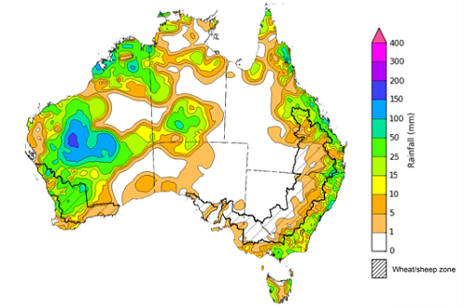
©Commonwealth of Australia 2023, Australian Bureau of Meteorology Issued: 5/04/2023
Note: The rainfall analyses and associated maps utilise data contained in the Bureau of Meteorology climate database, the Australian Data Archive for Meteorology (ADAM). The analyses are initially produced automatically from real-time data with limited quality control. They are intended to provide a general overview of rainfall across Australia as quickly as possible after the observations are received. For further information go to http://www.bom.gov.au/climate/rainfall/

Monthly Rainfall
For Australia as a whole, rainfall during March 2023 was around 7% below the long-term average. Rainfall was above average for much of the central Northern Territory extending through the Gulf Country into western and central Queensland, large areas of western to central Western Australia, across pockets of eastern Australia, and the northern half of Tasmania. In contrast, rainfall was below average for much of the Top End and areas between Western Australia's Kimberley and the south-east of the Northern Territory, and an area spanning eastern South Australia, north-western New South Wales, and far south-west Queensland.
Rainfall across Australia in March was mainly attributed to a series of surface troughs and lows and embedded thunderstorms. Towards the end of March, tropical moisture combined with a tropical low to the west of Western Australia, brought several days of widespread rainfall, showers and storms to large parts of Australia. The heavy rainfall was particularly concentrated in the southwest and the Gascoyne regions in Western Australia and in the isolated parts of eastern Australia, resulting in floodings.
March rainfall was generally average to above average across cropping regions. It was above average across parts of northern and south-eastern Queensland, northeast and southern New South Wales, and central and northern Western Australia. Average rainfall was recorded across much of the remaining cropping regions. These average to above average falls across most cropping regions would have provided a boost to soil moisture levels follow a dry January and February particularly across the summer cropping regions across Queensland and northern New South Wales. This has likely benefited the growth and yield prospects of later sown summer crops, but likely to have delayed the harvest of earlier sown crops.

Rainfall percentiles for March 2023

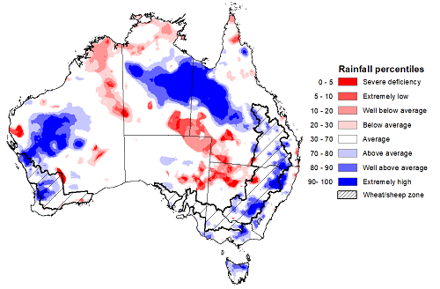
Note: Rainfall for March 2023 is compared with rainfall recorded for that period during the historical record (1900 to present). For further information, go to http://www.bom.gov.au/jsp/awap/
Source: Bureau of Meteorology

Monthly Soil Moisture
Upper layer soil moisture in March 2023 was average to very much above average for this time of year across much of the country. Extremely high upper layer soil moisture was evident across large areas of the Gulf Country, central and western parts of Western Australia, parts of south-east Queensland, eastern and southern New South Wales and Victoria, central and southern South Australia, as well as in the northern Tasmania reflecting heavy rainfall events towards the end of March.
At this time of year, upper layer soil moisture is important for the establishment and vegetative growth of late planted summer crops in the Central Queensland growing region and for pasture growth across northern Australia. It is also important indicator of the ability to access paddocks to undertake harvest of summer crops and planting activities for long season winter crops.
Upper layer soil moisture was average to above average for this time of year across most cropping regions. Upper layer soil moisture was below average for isolated parts of northwest New South Wales and eastern Western Australia. Extremely high upper layer soil moisture was evident across eastern Queensland, northeast and southeast New South Wales, eastern Victoria and northern and parts of northwest Western Australia. Extremely high upper layer soil moisture may have prevented field access for growers across parts of New South Wales and south-east Queensland. The above average to average upper layer soil moisture in parts of northern Queensland is likely to have benefited have late sown summer crops, but likely negatively affected field access for cotton harvesting to commence and field preparation for winter sowing.

Modelled upper layer soil moisture for March 2023
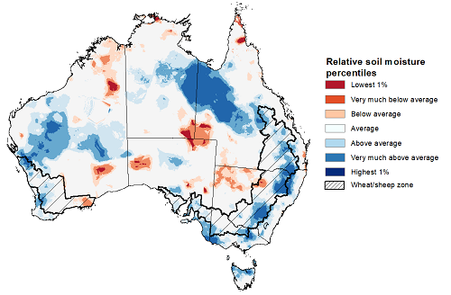
Note: This map shows the levels of modelled upper layer soil moisture (0 to 10 centimetres) during March 2023. This map shows how modelled soil conditions during March 2023 compare with the March conditions modelled over the reference period (1911 to 2016). Dark blue areas on the maps were much wetter in March 2023 than during the reference period. The bulk of plant roots occur in the top 20 centimetres of the soil profile. Soil moisture in the upper layer of the soil profile is therefore useful indicator of the availability of water, particularly for germinating seed.
Source: Bureau of Meteorology (Australian Water Resources Assessment Landscape model)

Lower layer soil moisture for March 2023 was well below average to average across much of the southern Australia, while it was extremely high across large areas of northern Australia. Lower layer soil moisture is a larger, deeper store that is slower to respond to seasonal conditions and tends to reflect the accumulated effects of events that have occurred over longer periods. Crop development and pasture growth in areas of above average lower layer soil moisture are typically less reliant on in-season rainfall than in areas with below average lower layer soil moisture.
In cropping regions, lower layer soil moisture was generally average. However, it was extremely low to below average in the isolated parts of Queensland, northwest and southern New South Wales, parts of northern Victoria, and in the western, southern and eastern Western Australia. March rainfall has generally benefitted lower layer soil moisture levels across most growing regions, this is likely to arrest further declined in the yield potential in later sown summer crops and provide increased confidence to plant longer season winter crops. Pasture growth in northern parts of Queensland and the Northern Territory has likely benefited from high lower layer soil moisture.
Modelled lower layer soil moisture for March 2023
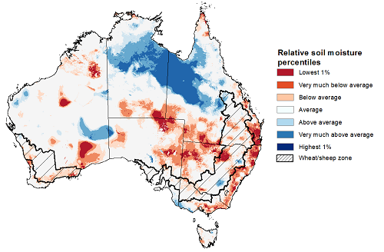
Note: This map shows the levels of modelled lower layer soil moisture (10 to 100 centimetres) during March 2023. This map shows how modelled soil conditions during March 2023 compare with March conditions modelled over the reference period (1911 to 2016). Dark blue areas on the maps were much wetter in March 2023 than during the reference period. The dark red areas were much drier than during the reference period. The bulk of plant roots occur in the top 20 centimetres of the soil profile. The lower layer soil moisture is a larger, deeper store that is slower to respond to rainfall and tends to reflect accumulated rainfall events over longer time periods.
Source: Bureau of Meteorology (Australian Water Resources Assessment Landscape model)

Pasture Growth
January to March is the peak pasture growth period across much of northern Australia which typically provides the bulk of feed to maintain production through the low pasture growth months of the northern dry season. Across southern Australia, January to March pasture growth is typically low reflecting lower rainfall totals, high temperatures and high evapotranspiration rates at this time of year. Pasture availability during this period influences the growth and branding and marking rates of lambs and calves, livestock turnoff and the production of meat, milk, and wool.
For the 3 months to March 2023, above average rainfall totals and below average summer temperatures resulted in above average to extremely high pasture production for this time of year across much of northern Australia. Extremely low to below average pasture growth rates were recorded across isolated parts of southern Western Australia and the Kimberley, much of Victoria and New South Wales (except for in the southern New South Wales cropping region), southern Queensland and in the tropical Northern Territory and Queensland owing to above average temperatures and/or below average rainfall.
Average to extremely high pasture production across much of northern Australia and isolated parts in the New South Wales and Victoria will likely enable farmers to continue to rebuild stock numbers and provide opportunities to build standing dry matter availability. Above average temperatures and below average rainfall across eastern New South Wales and south-eastern Queensland may have restricted summer pasture growth, however, it comes after extremely high pasture growth during winter and spring that supplied average to above average pasture availability and ample opportunities to conserve excess fodder.

Relative pasture growth for 3-months ending March 2023 (1 January 2023 to 31 March 2023)
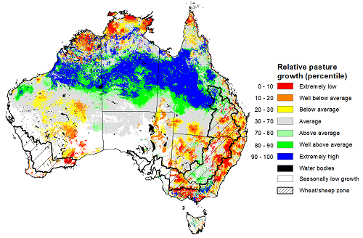
Notes: AussieGRASS pasture growth estimates are relative to the long-term record and shown in percentiles. Percentiles rank data on a scale of zero to 100. This analysis ranks pasture growth for the selected period against average pasture growth for the long-term record (1957 to 2016). Pasture growth is modelled at 5km2 grid cells.
Source: Queensland Department of Science, Information Technology, and Innovation

Rainfall forecast for the next eight days
Over the 8-days to 13 April 2023, a series of troughs and lows is expected to trigger scattered showers and storms, some intense, across parts of all states and territories of Australia. A high-pressure system will bring more settled and dry condition to large areas of the interior of Australia.
Rainfall between 15 and 50 millimetres is expected across inland and northern Western Australia, including the Gascoyne, Pilbara, and Kimberley. Similar rainfall totals are likely across the tropical north and southeast of the country, including much of eastern Victoria, Tasmania, and across and around the Great Diving Range in the New South Wales and southeast Queensland. Around 10 to 15 millimetres of rainfall is expected in the Eyre and Yorke Peninsula regions in South Australia and in the southwest Western Australia. Rainfall in excess of 50 millimetres is expected in the coastal northwest Western Australia and in parts of southeast Victoria. Little to no rain is expected elsewhere.
Across Australian cropping regions, rainfall totals of up to 15 millimetres are expected for central Western Australia and between 15 and 25 millimetres for parts of south-eastern Queensland, eastern New South Wales, eastern Victoria, and southern South Australia. Little to no rainfall is expected for the remaining cropping regions in the next eight days. If realised, the rainfall in the cropping regions is likely to result in some harvest delays for summer crops. For those area of the Australian wheatbelt where rainfall is forecast over the coming 8-days it is likely to build soil moisture levels in the led up to the winter cropping season and also benefit pasture growth rates and availability.

Total forecast rainfall for the period 6 April to 13 April 2023
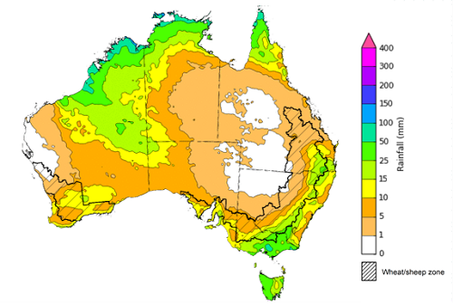

©Commonwealth of Australia 2023, Australian Bureau of Meteorology Issued 06/04/2023
Note: This rainfall forecast is produced from computer models. As the model outputs are not altered by weather forecasters, it is important to check local forecasts and warnings issued by the Bureau of Meteorology.

Water

Water markets – current week
Water storage levels in the Murray-Darling Basin (MDB) decreased between 30 March 2023 and 6 April 2023 by 83 gigalitres (GL). Current volume of water held in storage is 19 936 GL which represents 89 per cent of total capacity. This is 0.2 percent or 36 GL more than at the same time last year.

Water storages in the Murray-Darling Basin, 2013–2023
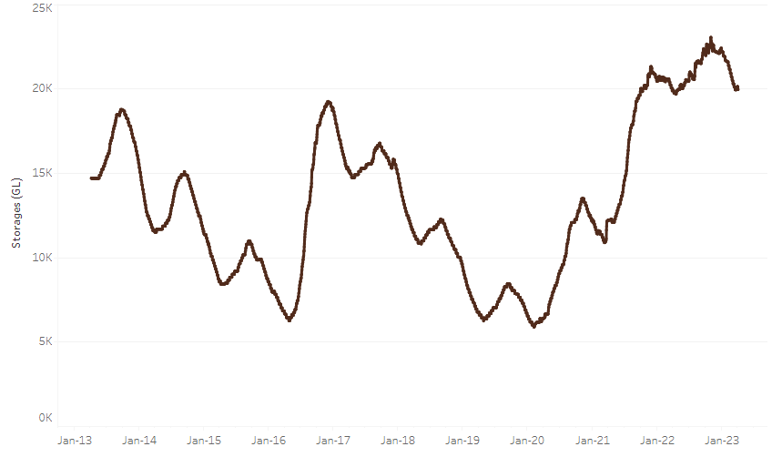
Allocation prices in the Victorian Murray below the Barmah Choke decreased from $17 on 29 March 2023 to $16 on 6 April 2023. Prices are lower in the Murrumbidgee due to the binding of the Murrumbidgee export limit.
Water storage data is sourced from the Bureau of Meteorology.

Region | $/ML
NSW Murray Above | 12
NSW Murrumbidgee | 8
VIC Goulburn-Broken | 16
VIC Murray Below | 16

Surface water trade activity, Southern Murray–Darling Basin
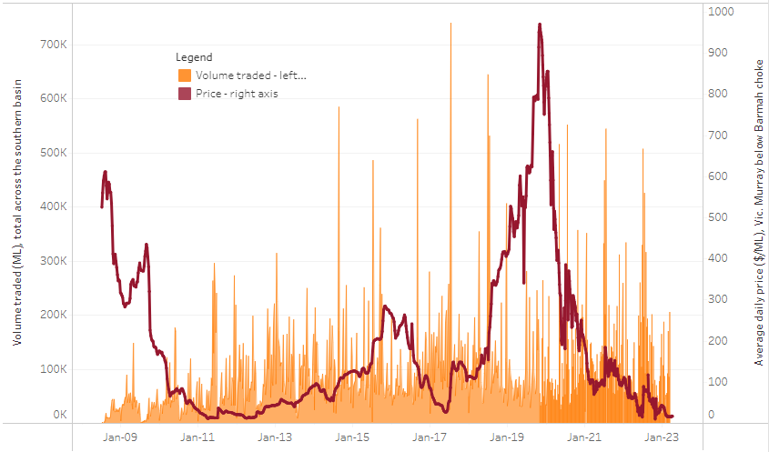
The trades shown reflect estimated market activity and do not encompass all register trades. The price is shown for the VIC Murray below the Barmah choke. Historical prices (before 1 July 2019) are ABARES estimates after removing outliers from BOM water register data. Prices after 1 July 2019 and prior to the 30 October 2019 reflect recorded transaction prices as sourced from Ruralco. Prices after the 30 October 2019 are sourced from Waterflow. Data for volume traded is sourced from the BOM water register. Only the price data shown is current on 6 April 2023.

To access the full, interactive, weekly water dashboard, which contains the latest and historical water storage, water market and water allocation information, please visit https://www.agriculture.gov.au/abares/products/weekly_update/weekly-update-06423

Commodities
Indicator | Week ended | Unit | Latest Price | Previous Week | Weekly change | Price 12 months ago | Annual change
Selected world indicator prices
AUD/USD Exchange rate | 05-Apr | A$/US$ | 0.67 | 0.67 | 0% | 0.74 | -10%
Wheat – US no. 2 hard red winter wheat, fob Gulf | 05-Apr | US$/t | 391 | 384 | 2% | 508 | -23%
Corn – US no. 2 yellow corn, fob Gulf | 05-Apr | US$/t | 299 | 294 | 2% | 348 | -14%
Canola – Rapeseed, Canada, fob Vancouver | 05-Apr | US$/t | 627 | 608 | 3% | 982 | -36%
Cotton – Cotlook 'A' Index | 05-Apr | USc/lb | 97 | 92 | 4% | 154 | -37%
Sugar – Intercontinental Exchange, nearby futures, no.11 contract | 05-Apr | USc/lb | 22.0 | 20.6 | 7% | 20 | 9%
Wool – Eastern Market Indicator | 29-Mar | Ac/kg clean | 1,300 | 1,318 | -1% | 1,511 | -14%
Wool – Western Market Indicator | 29-Mar | Ac/kg clean | 1,439 | 1,480 | -3% | 1,408 | 2%
Selected Australian grain export prices
Milling Wheat – APW, Port Adelaide, SA | 05-Apr | A$/t | 478 | 465 | 3% | 563 | -15%
Feed Wheat – ASW, Port Adelaide, SA | 05-Apr | A$/t | 448 | 440 | 2% | 527 | -15%
Feed Barley – Port Adelaide, SA | 05-Apr | A$/t | 415 | 407 | 2% | 460 | -10%
Canola – Kwinana, WA | 05-Apr | A$/t | 933 | 921 | 1% | 1,225 | -24%
Grain Sorghum – Brisbane, QLD | 05-Apr | A$/t | 511 | 509 | 0% | 425 | 20%
Selected domestic livestock indicator prices
Beef – Eastern Young Cattle Indicator | 05-Apr | Ac/kg cwt | 694 | 672 | 3% | 1,089 | -36%
Mutton – Mutton indicator (18–24 kg fat score 2–3), Vic | 05-Apr | Ac/kg cwt | 332 | 298 | 12% | 568 | -42%
Lamb – Eastern States Trade Lamb Indicator | 05-Apr | Ac/kg cwt | 680 | 662 | 3% | 815 | -17%
Pig – Eastern Seaboard (60.1–75 kg), average of buyers & sellers | 15-Mar | Ac/kg cwt | 357 | 357 | 0% | 357 | 0%
Goats – Eastern States (12.1–16 kg) | 01-Mar | Ac/kg cwt | 325 | 325 | 0% | 813 | -60%
Live cattle – Light steers ex Darwin to Indonesia | 17-Aug | Ac/kg lwt | 420 | 480 | -13% | 320 | 31%
Live sheep – Live wethers (Muchea WA saleyard) to Middle East | 14-Sep | $/head | 93 | 113 | -18% | 114 | -18%
Global Dairy Trade (GDT) weighted average prices ª
Dairy – Whole milk powder | 05-Apr | US$/t | 3,053 | 3,228 | -5% | 4,083 | -25%
Dairy – Skim milk powder | 05-Apr | US$/t | 2,579 | 2,648 | -3% | 3,350 | -23%
Dairy – Cheddar cheese | 05-Apr | US$/t | 4,167 | 4,052 | 3% | 4,250 | -2%
Dairy – Anhydrous milk fat | 05-Apr | US$/t | 4,736 | 5,150 | -8% | 6,155 | -23%
a Global Dairy Trade prices are updated twice monthly on the first and third Tuesday of each month.

Selected world indicator prices
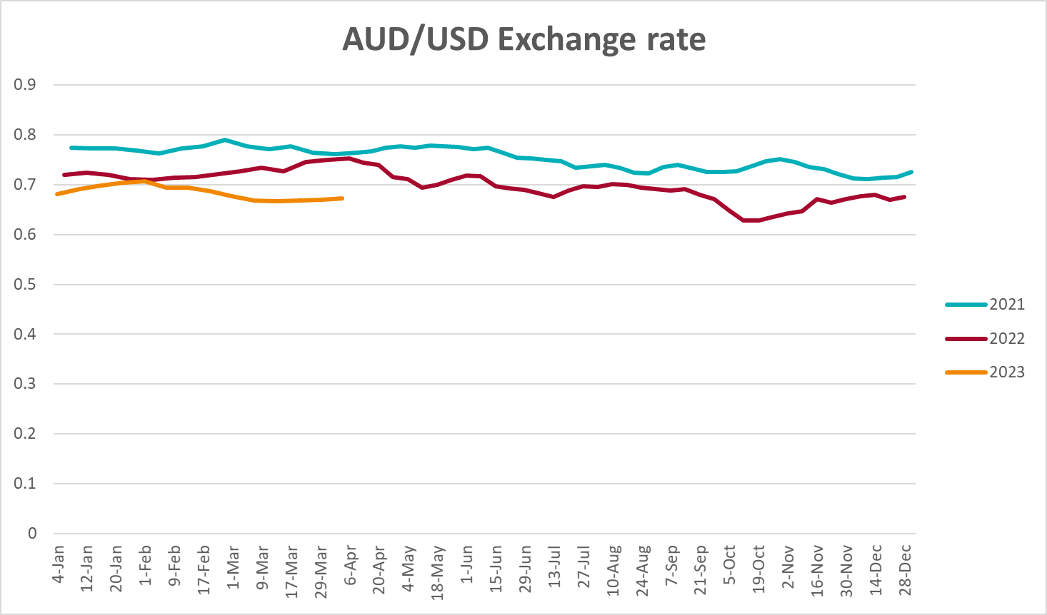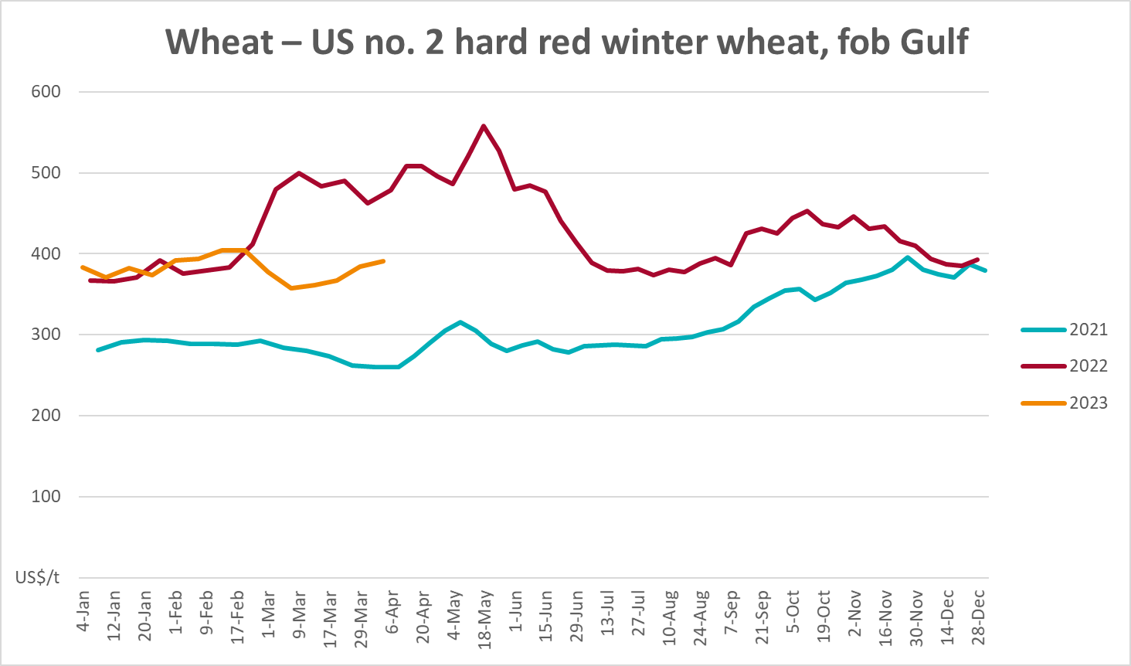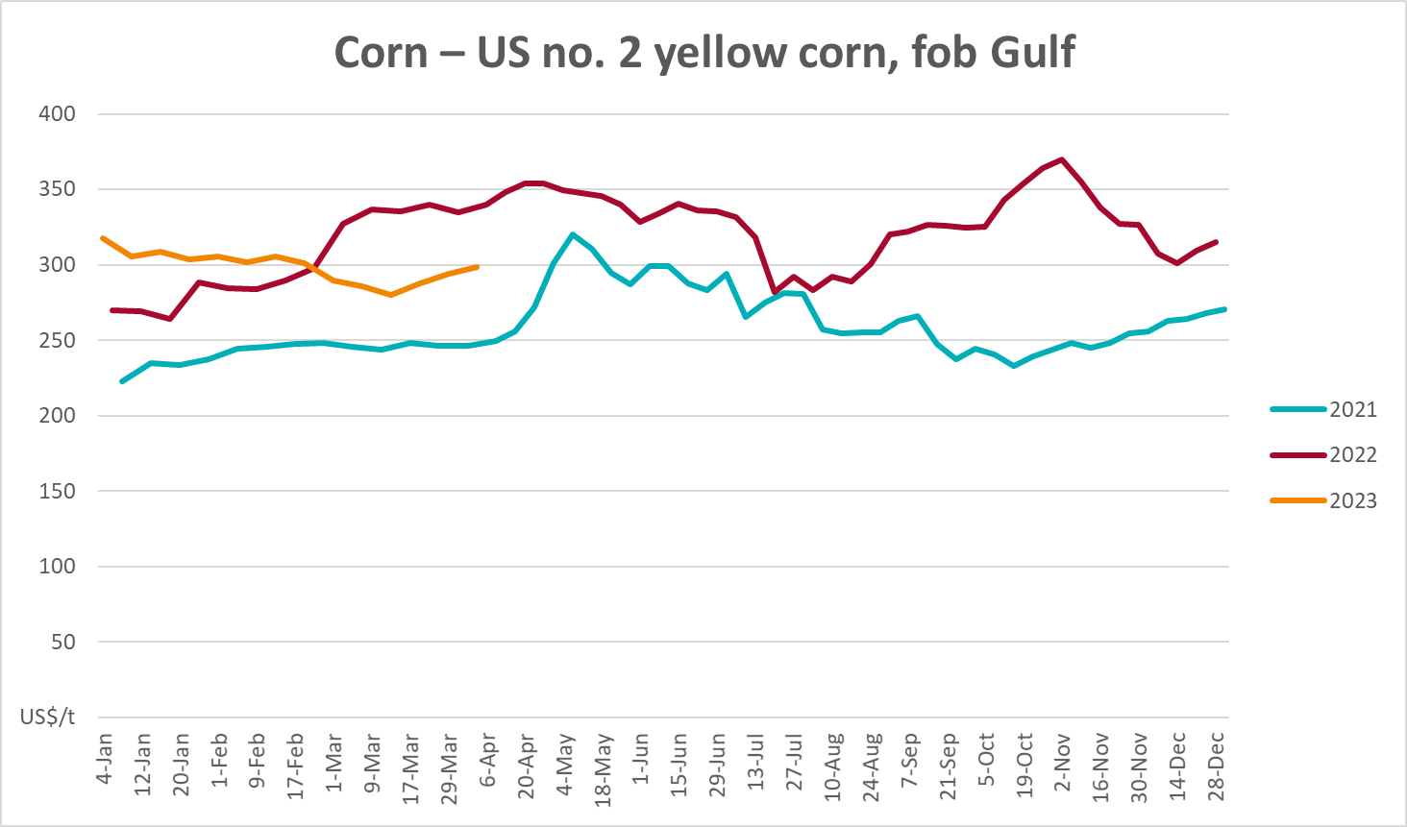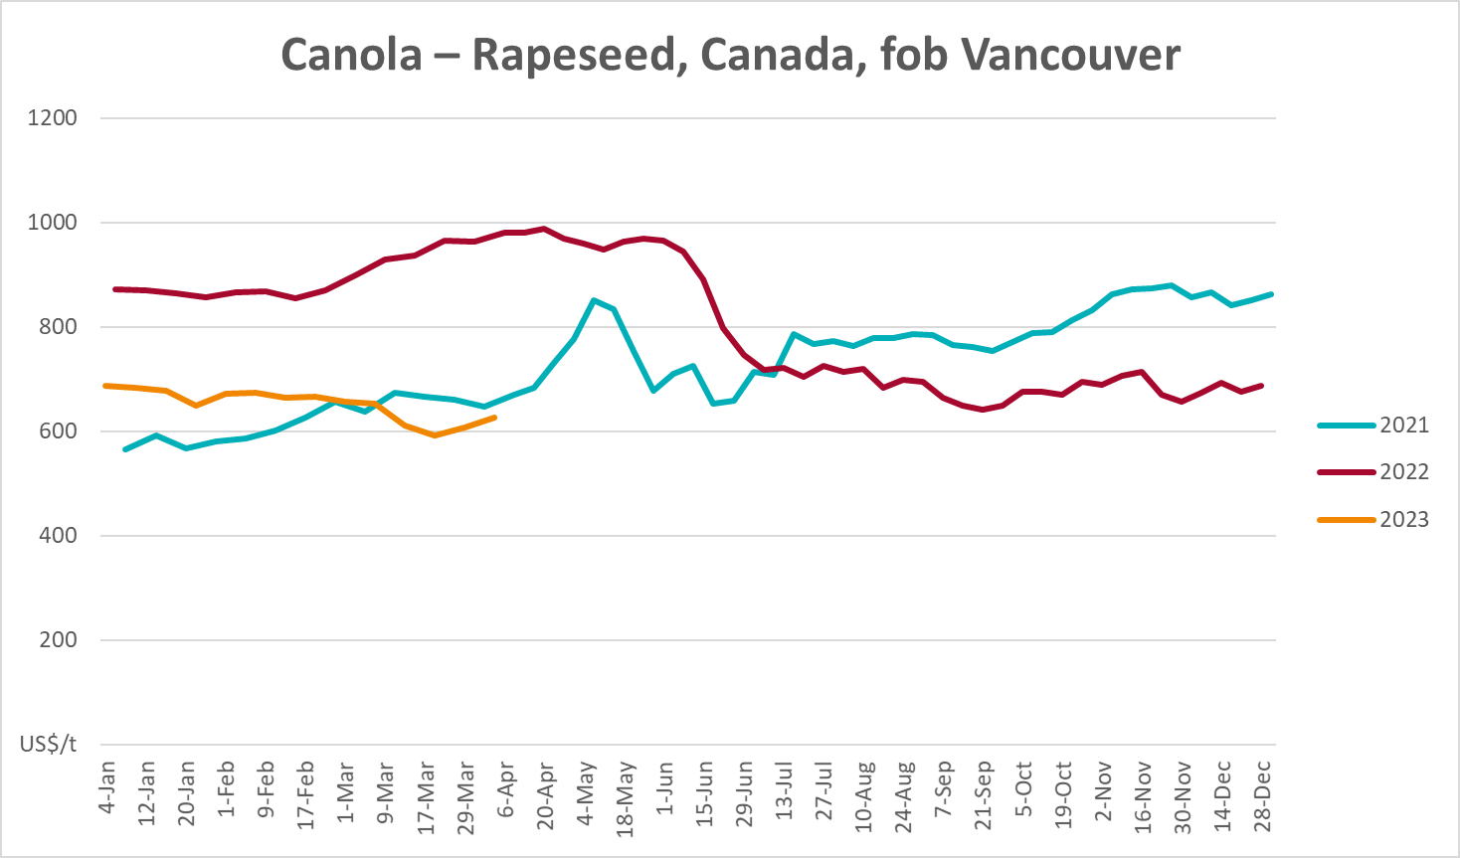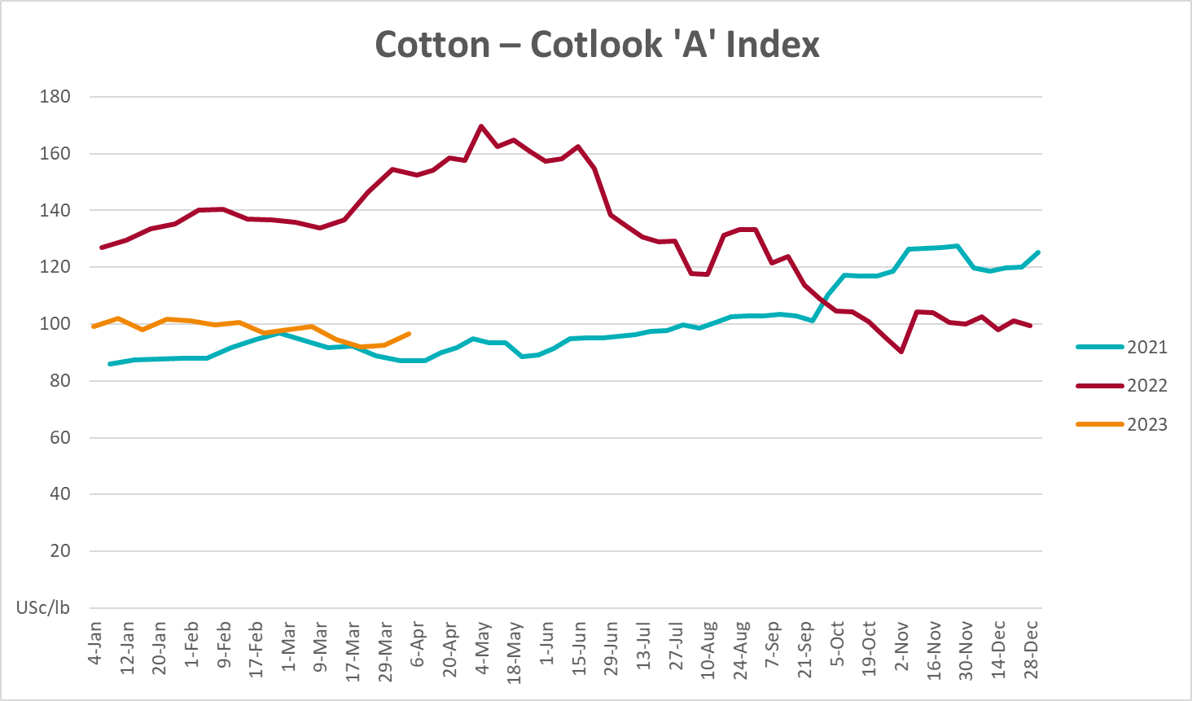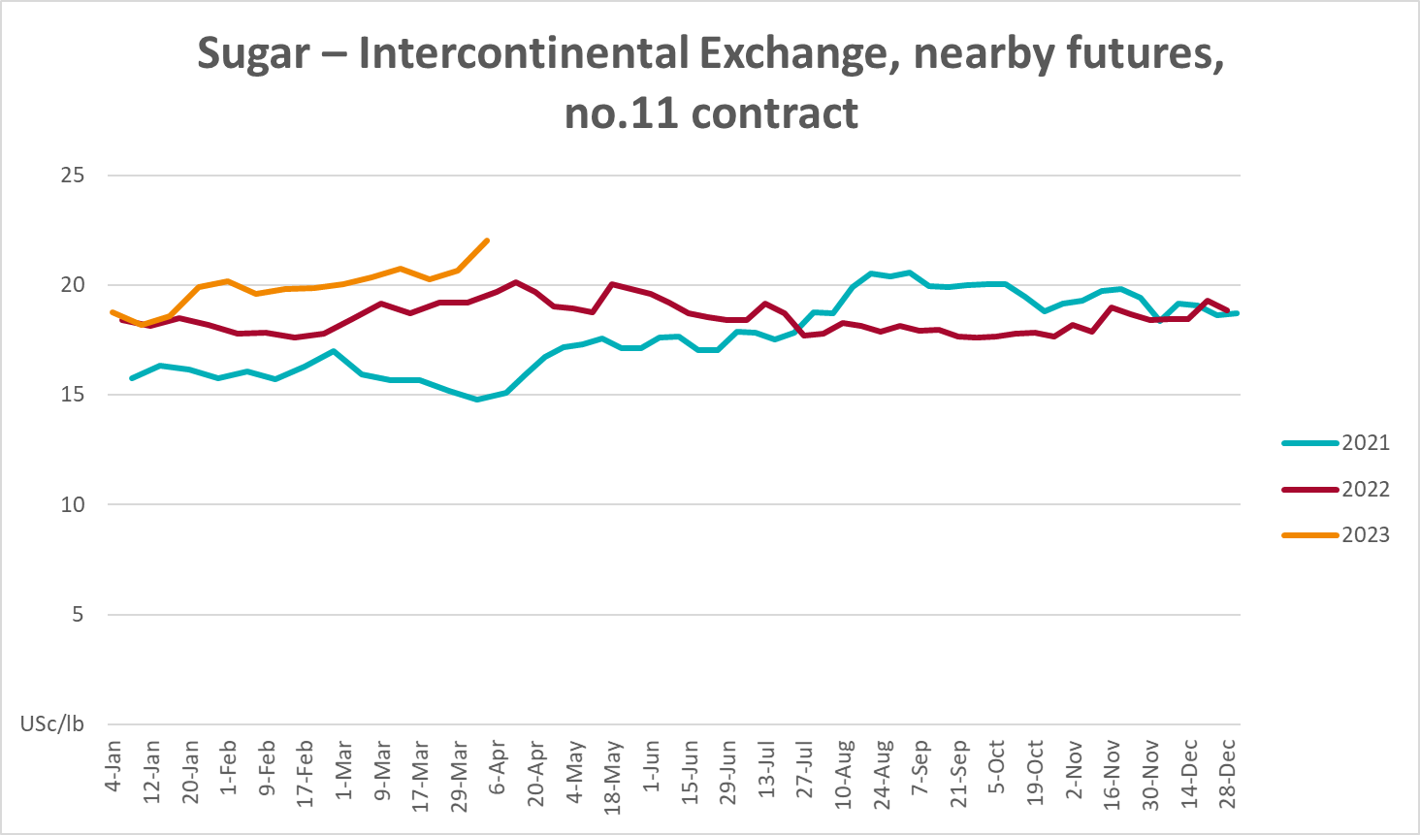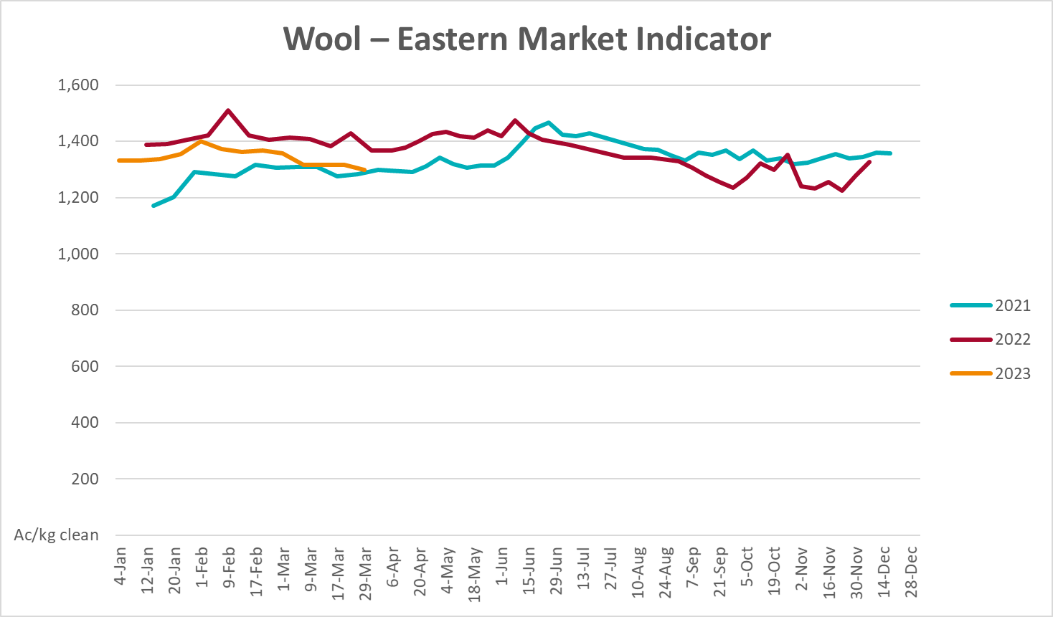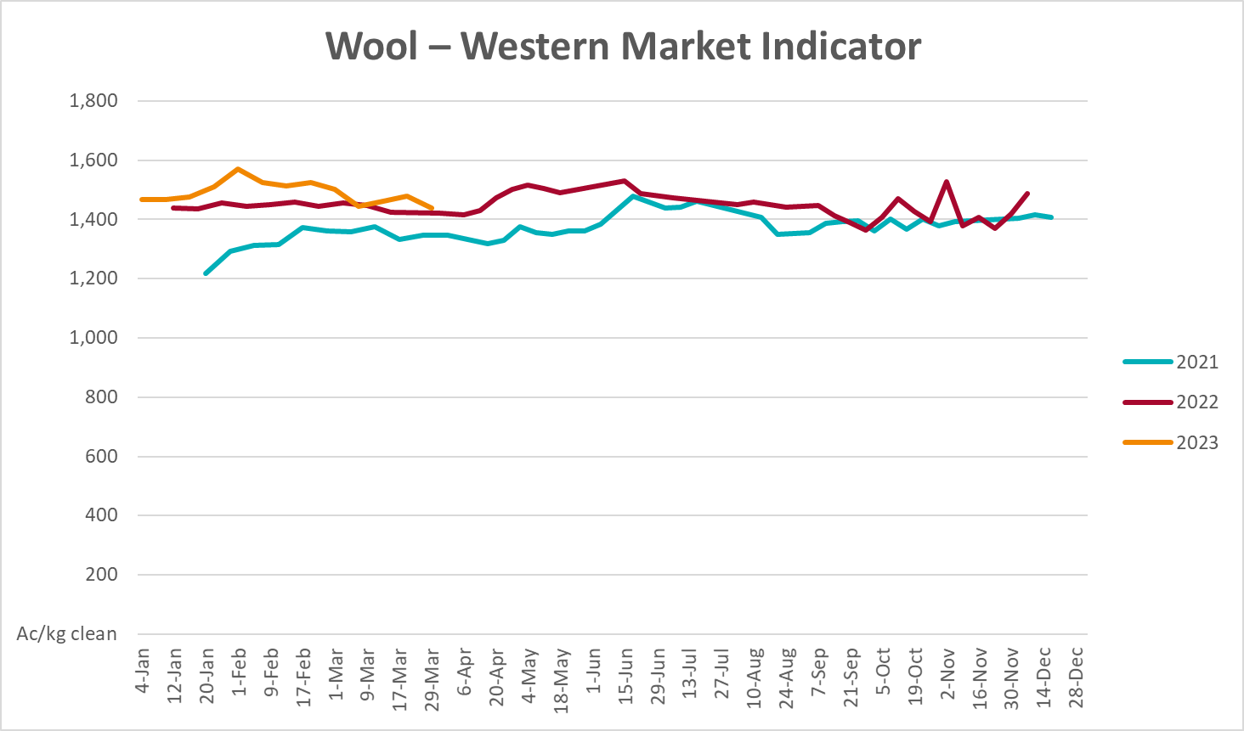

Selected domestic crop indicator prices
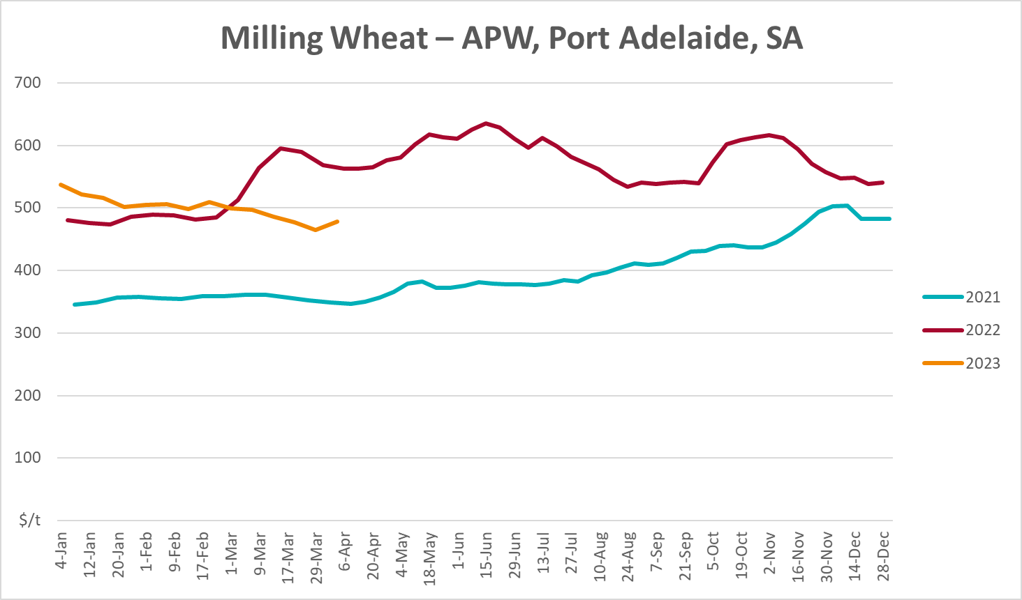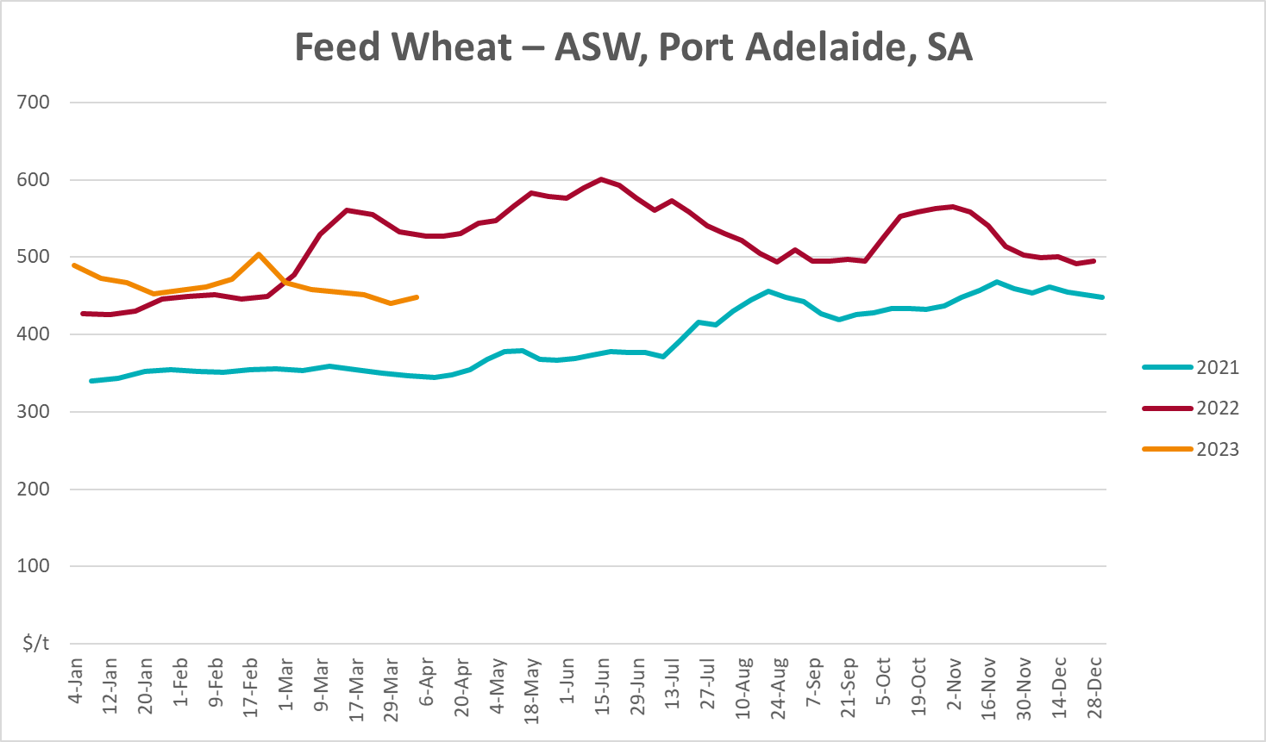
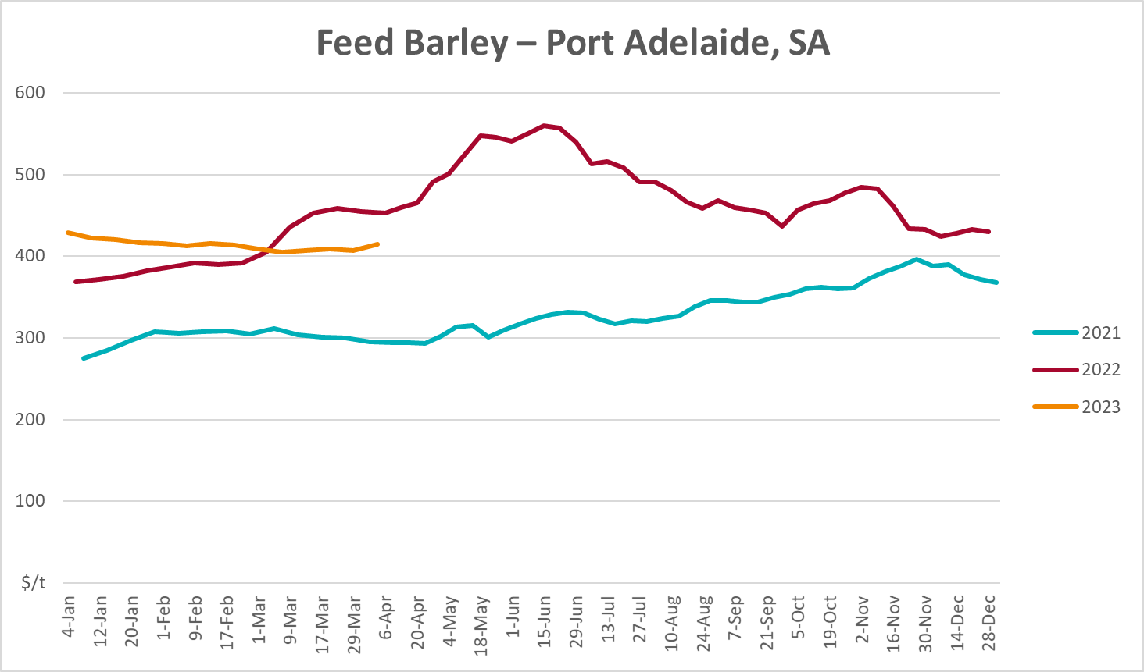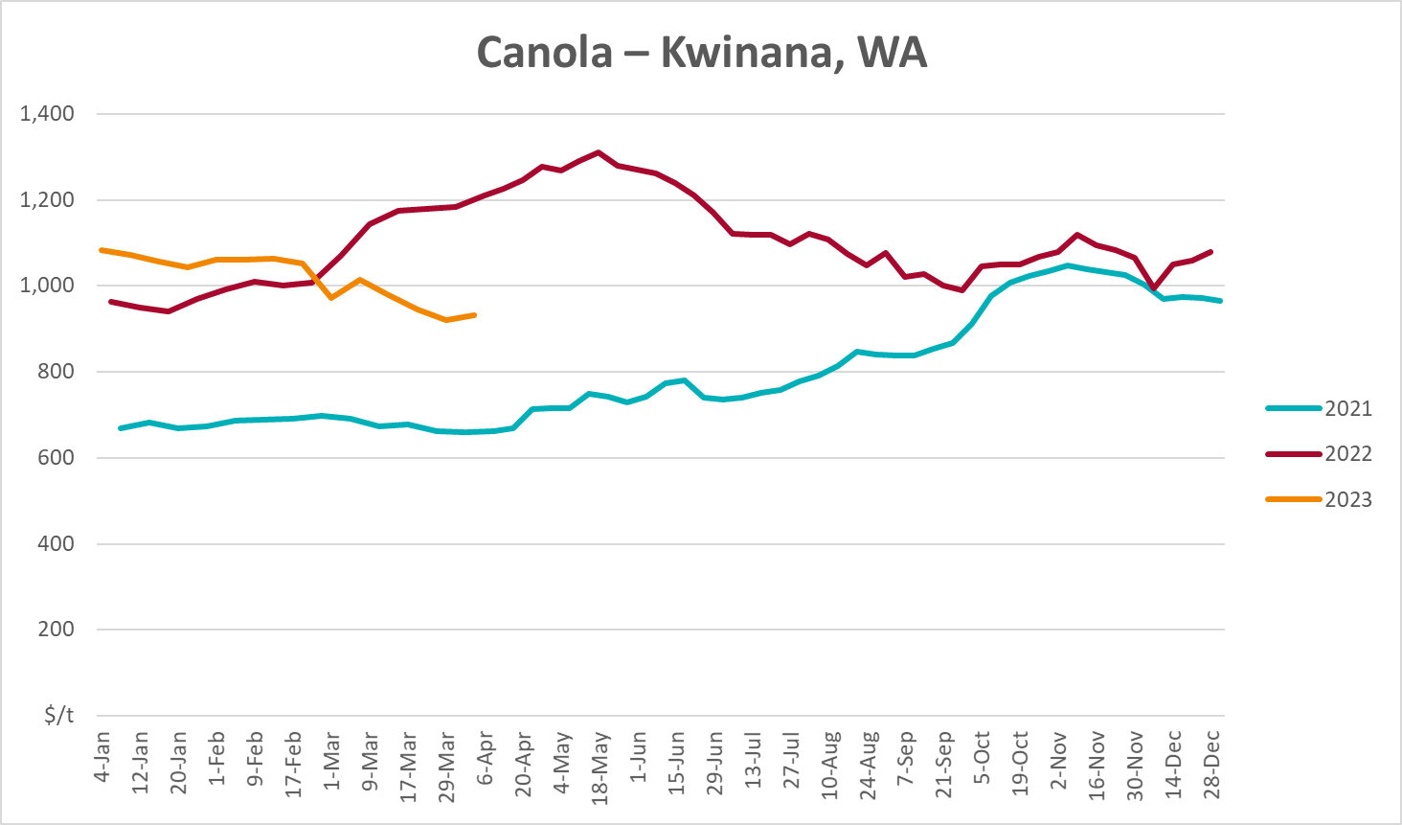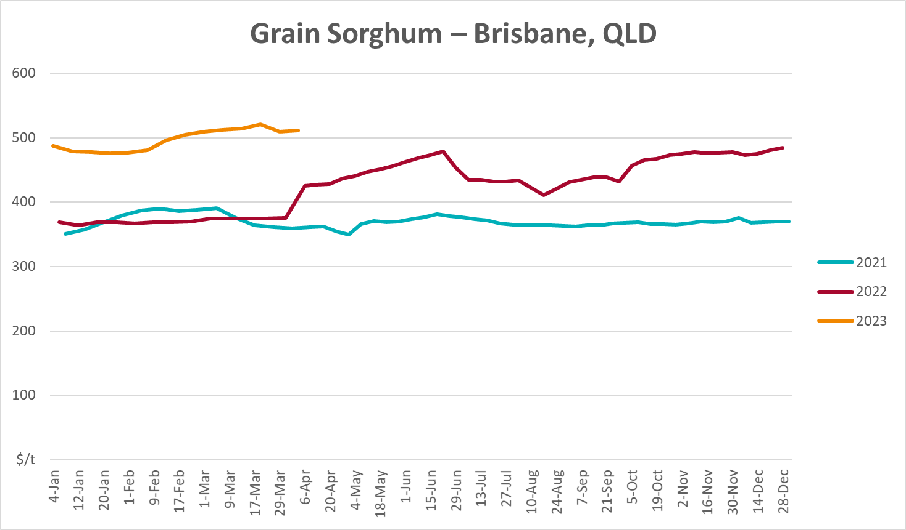

Selected domestic livestock indicator prices
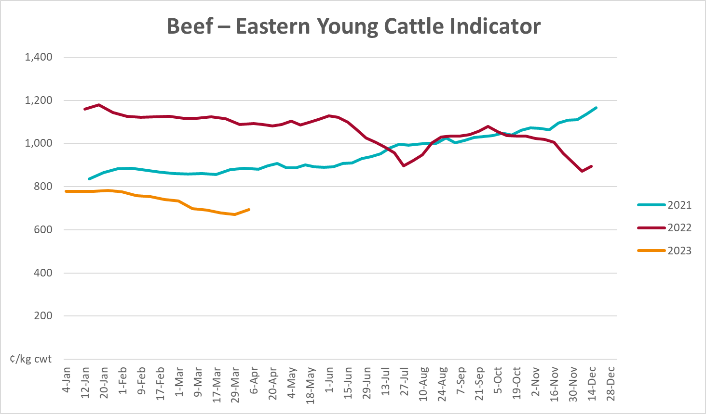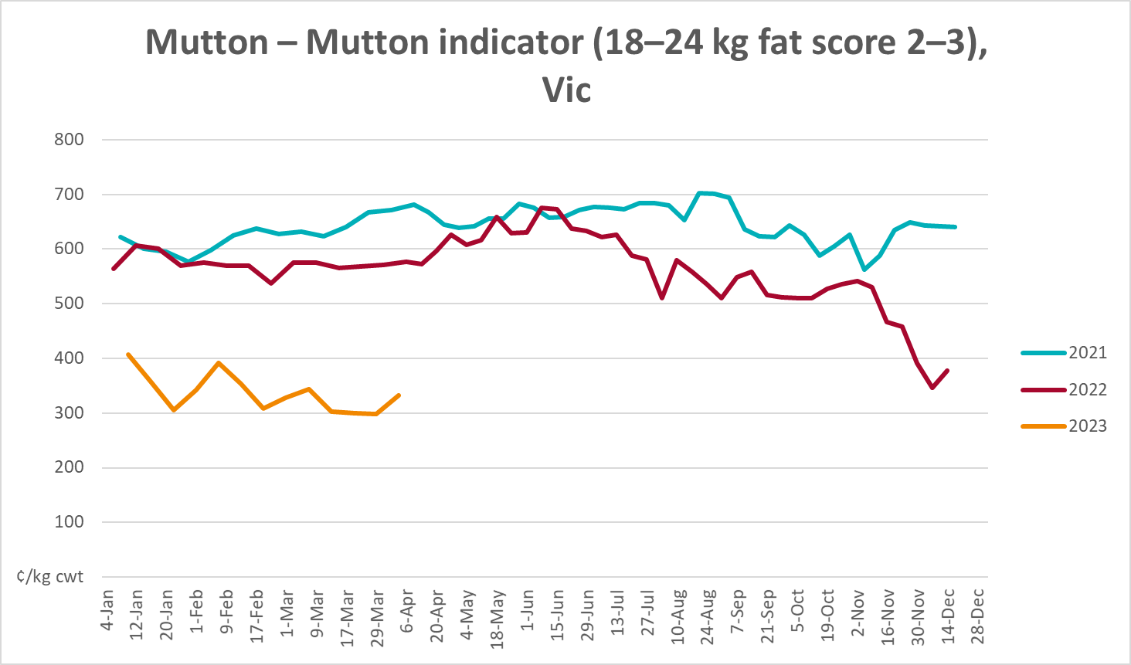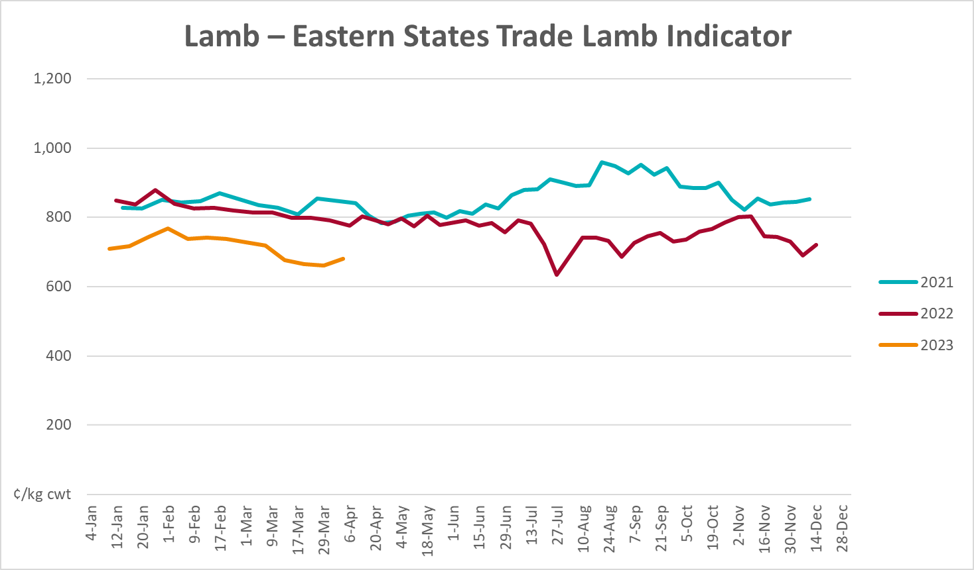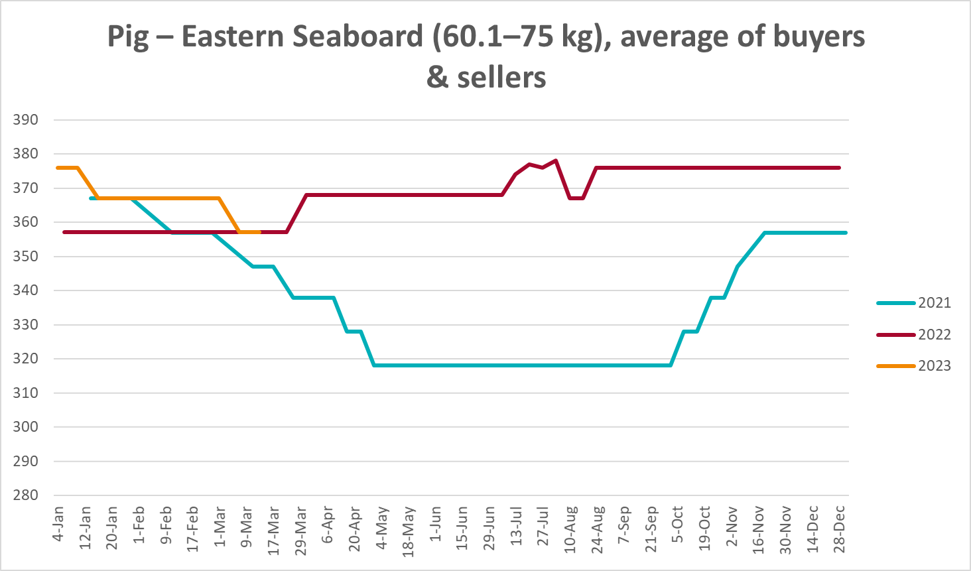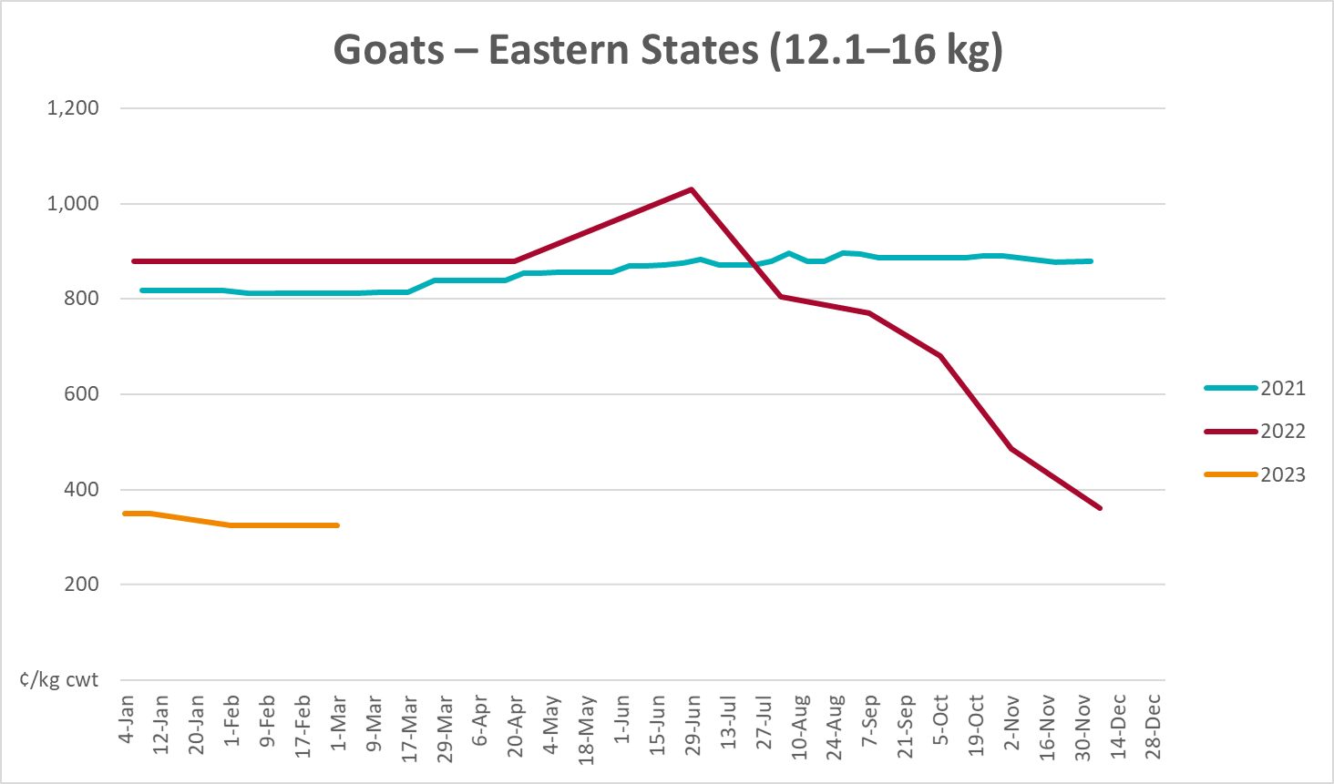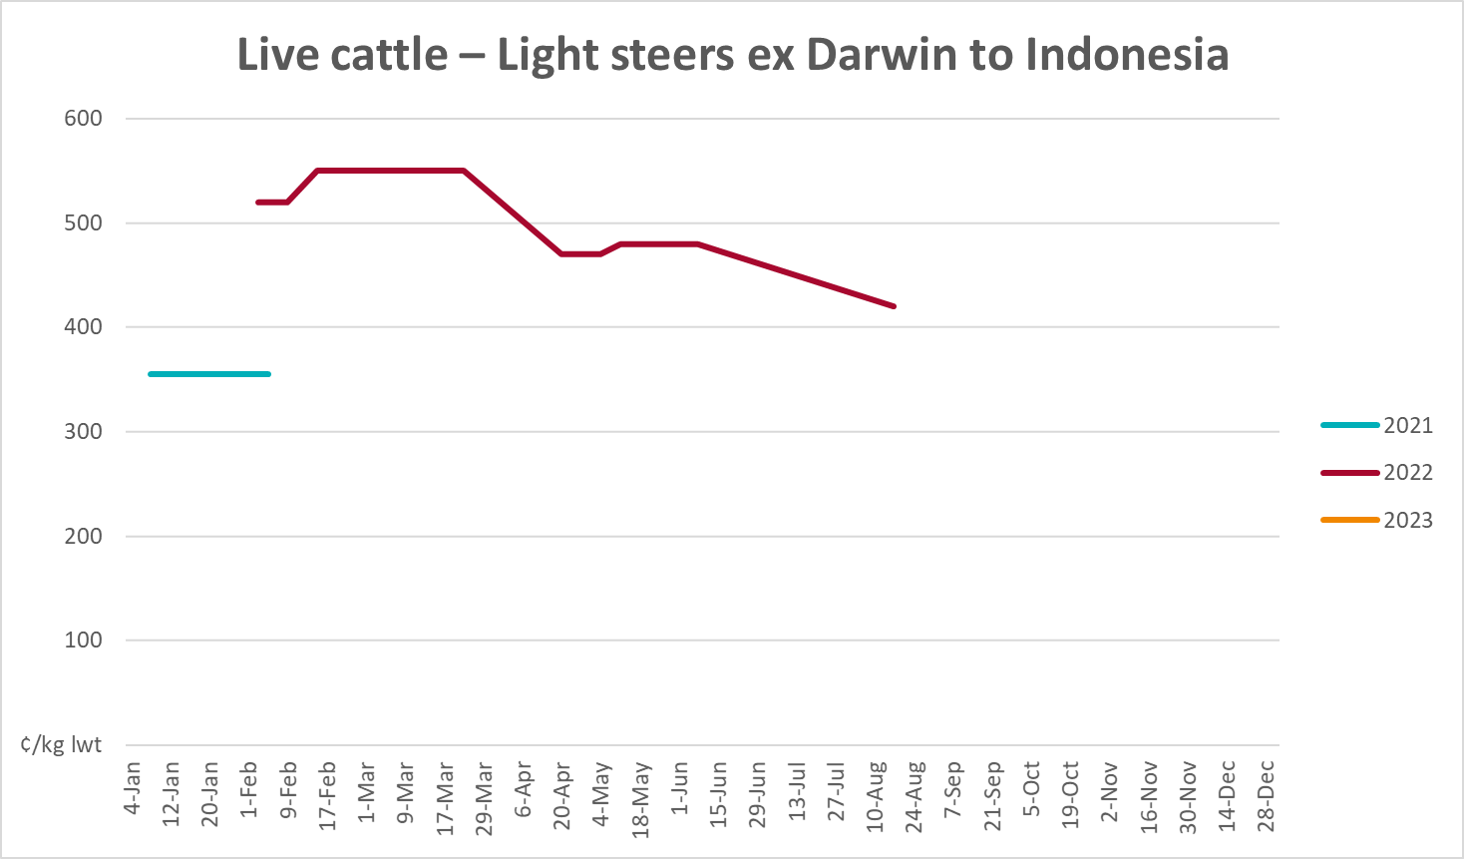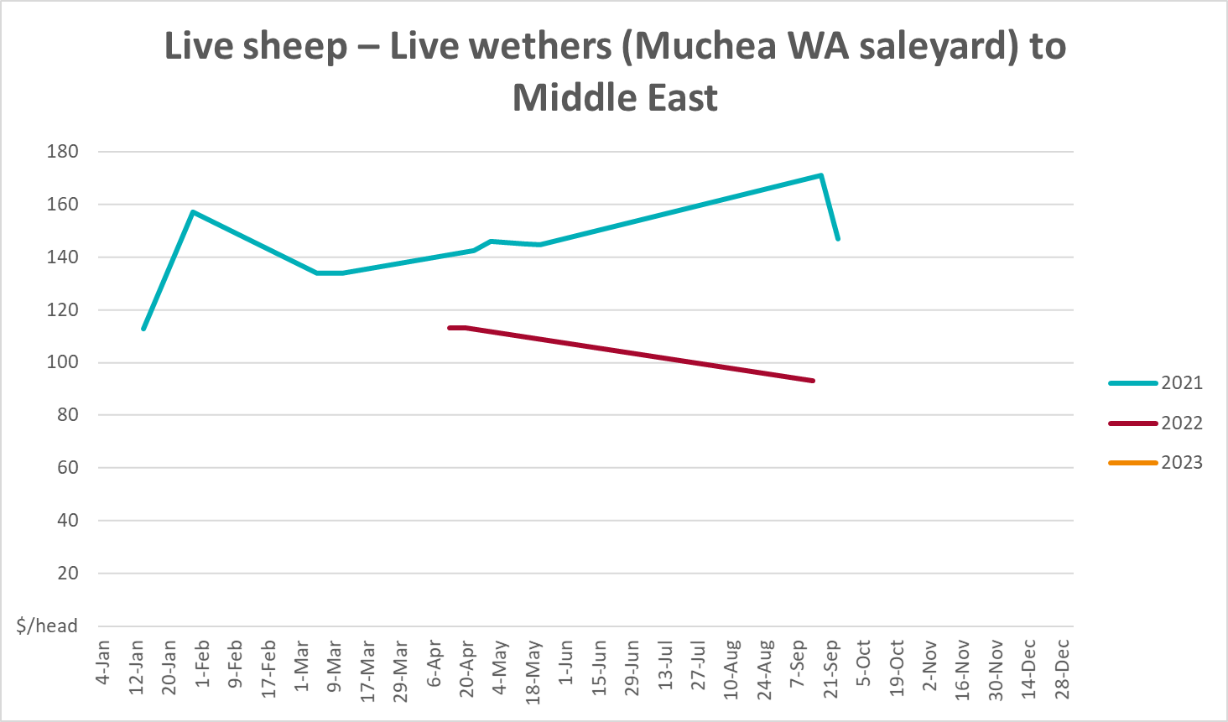

Global Dairy Trade (GDT) weighted average prices
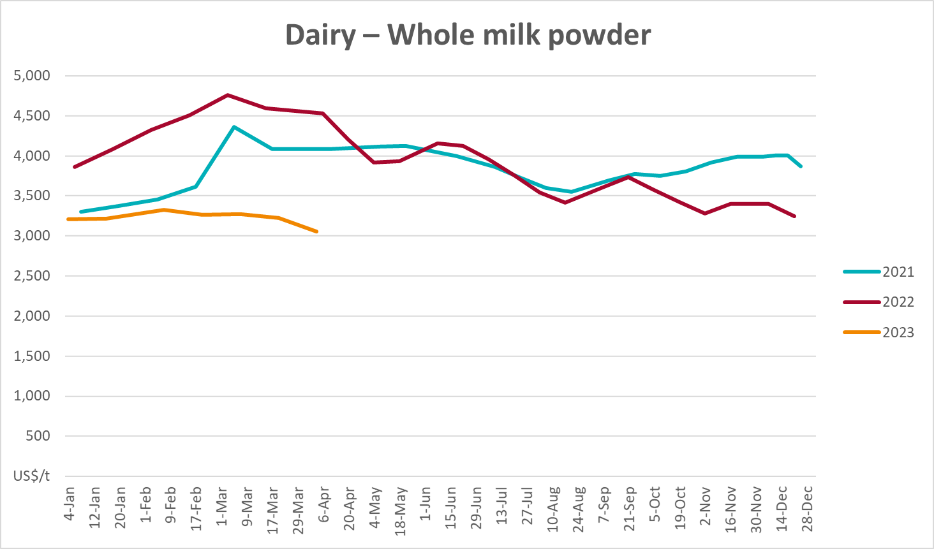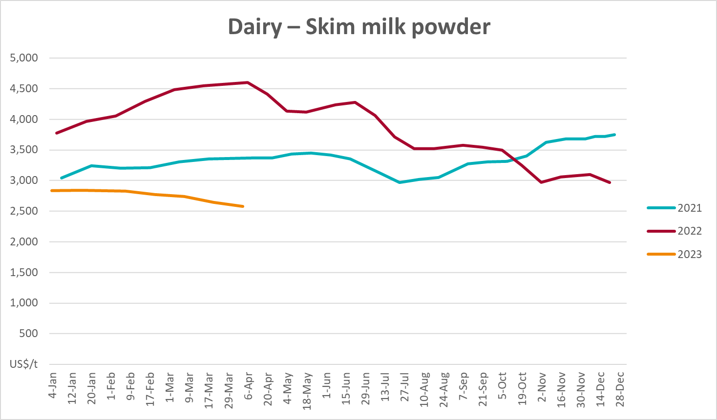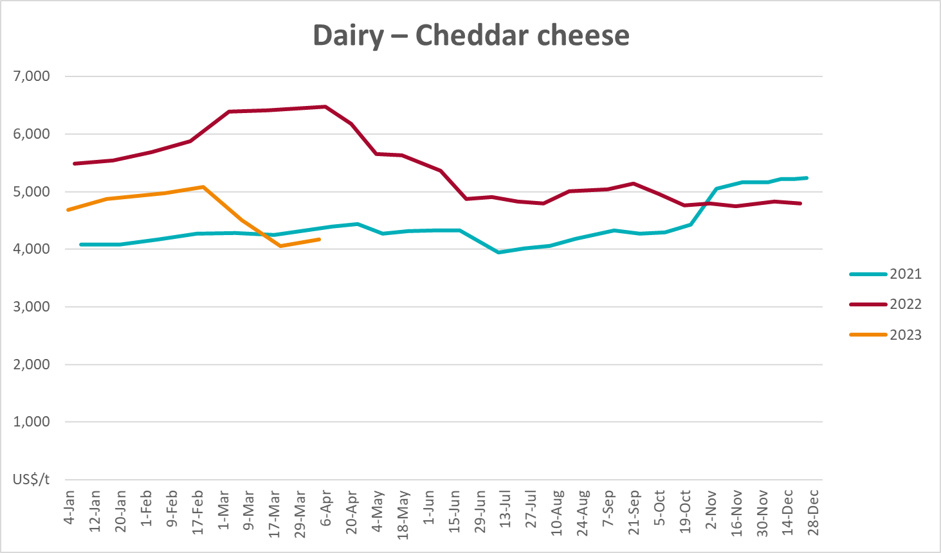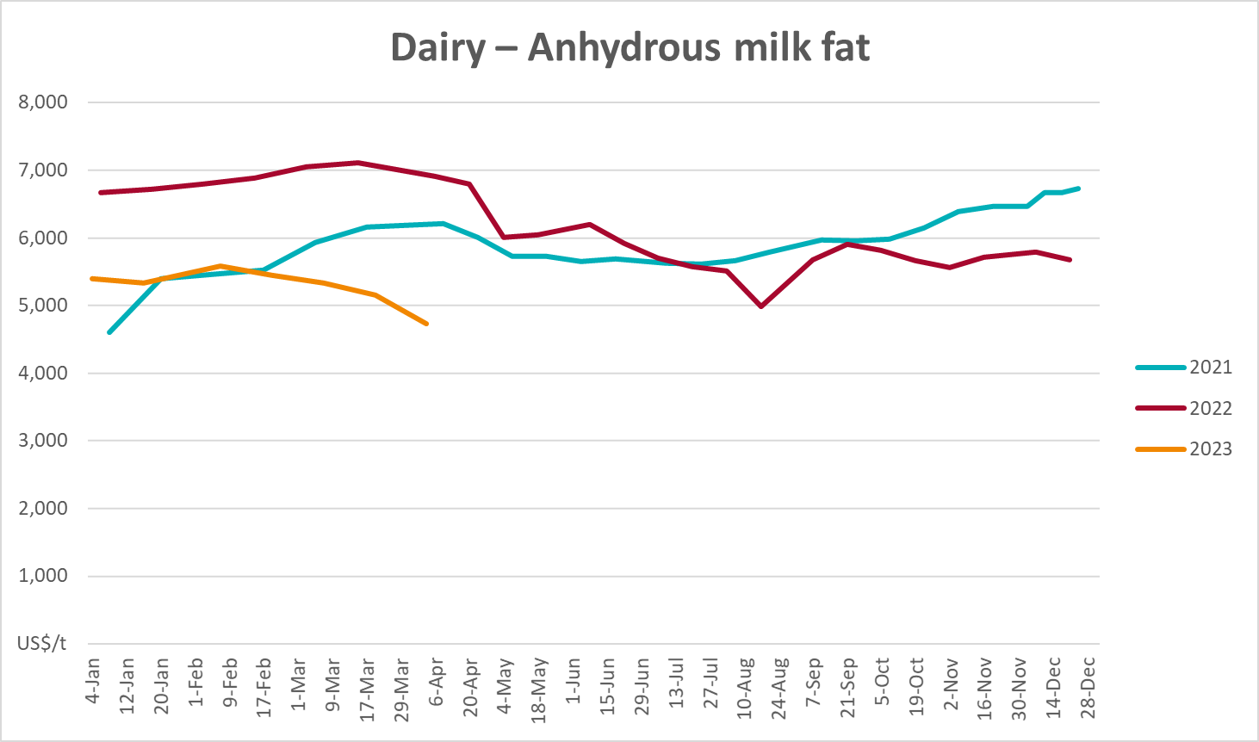

Selected fruit and vegetable prices
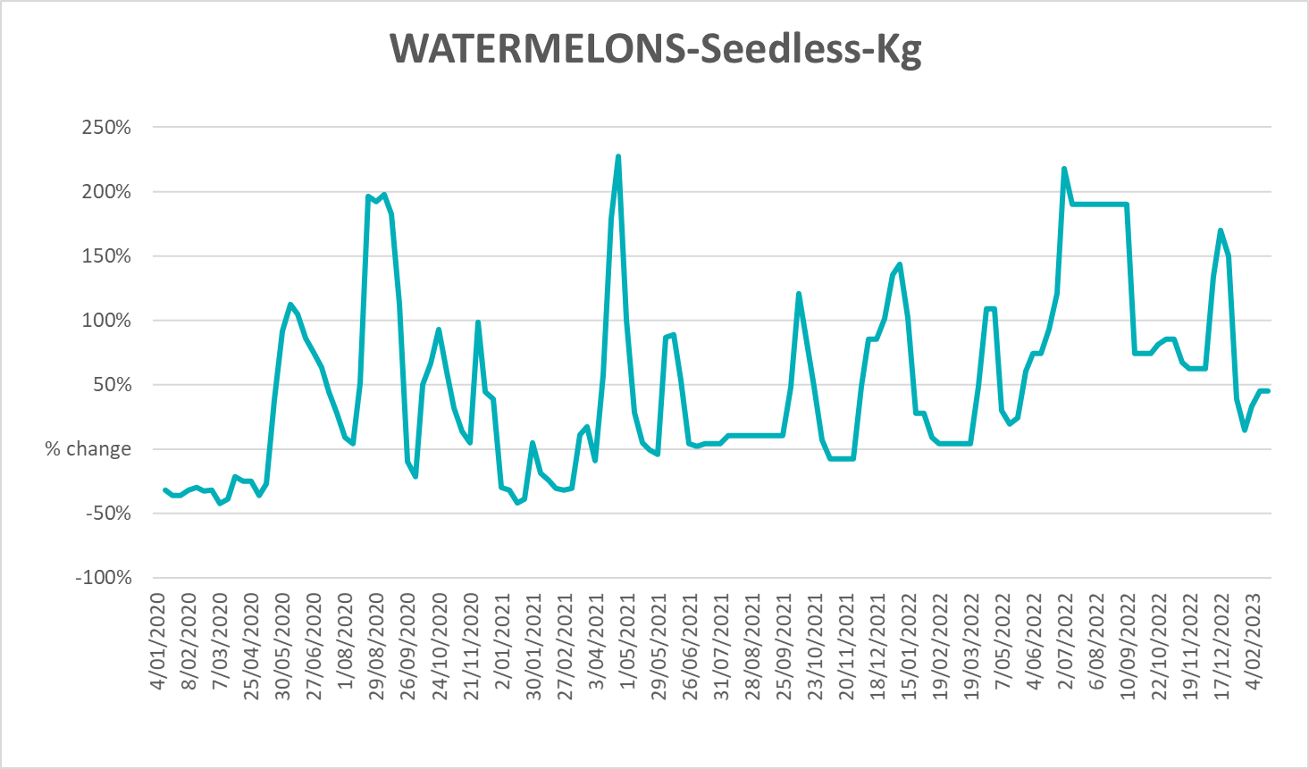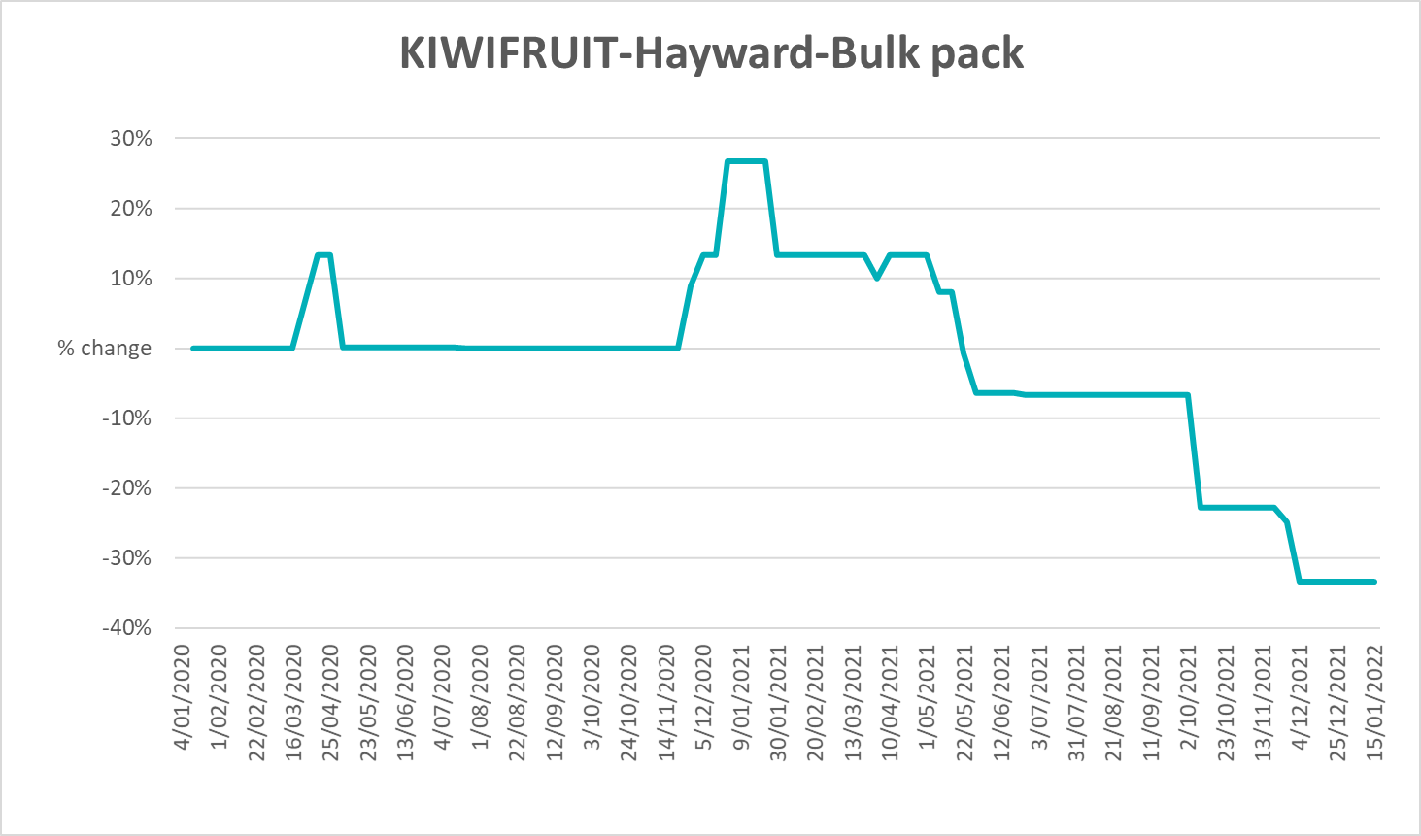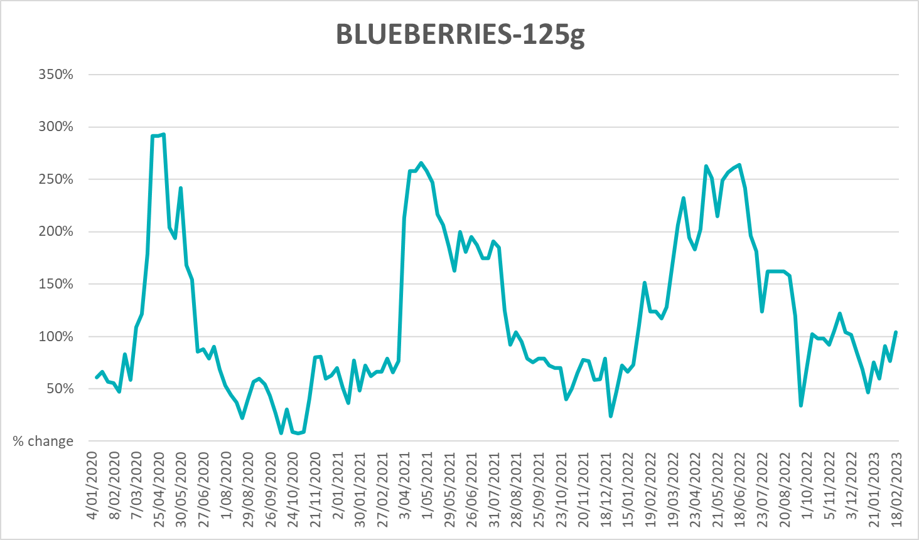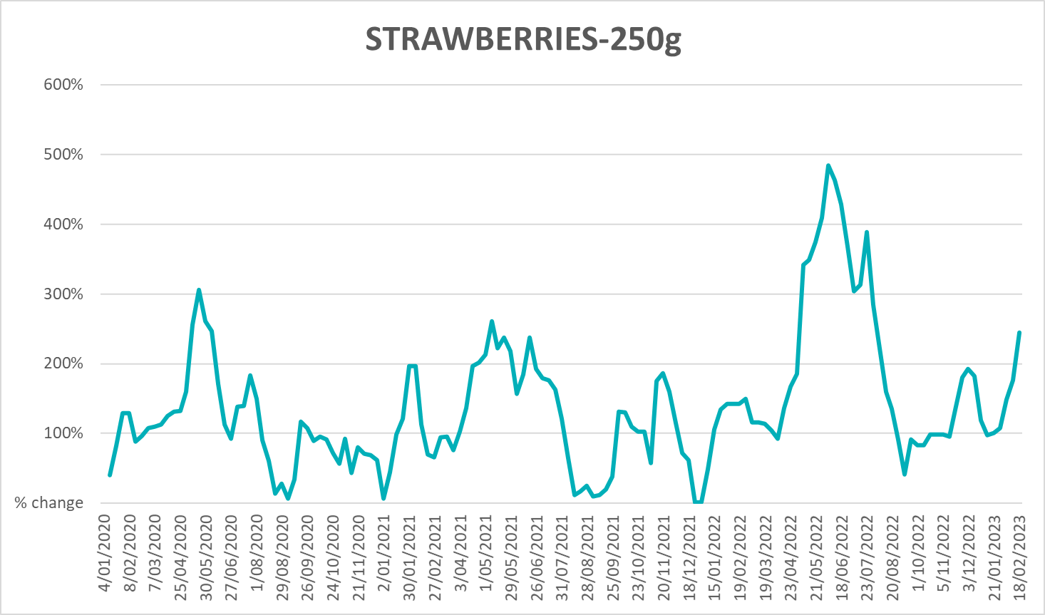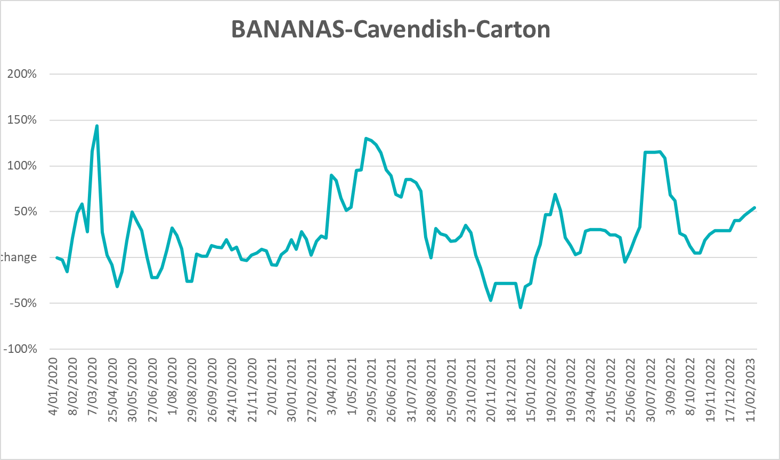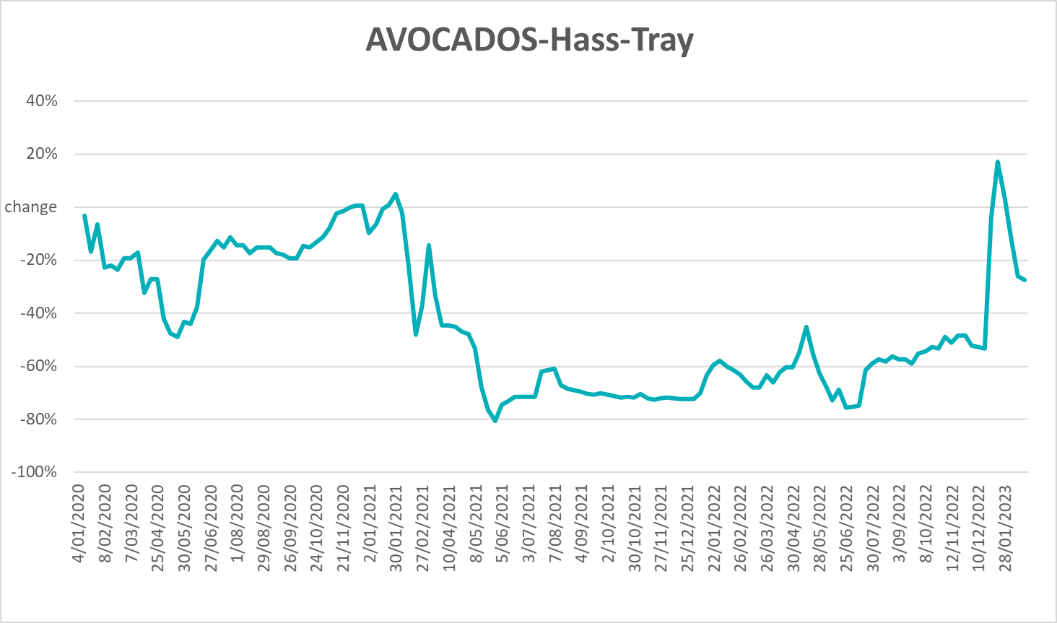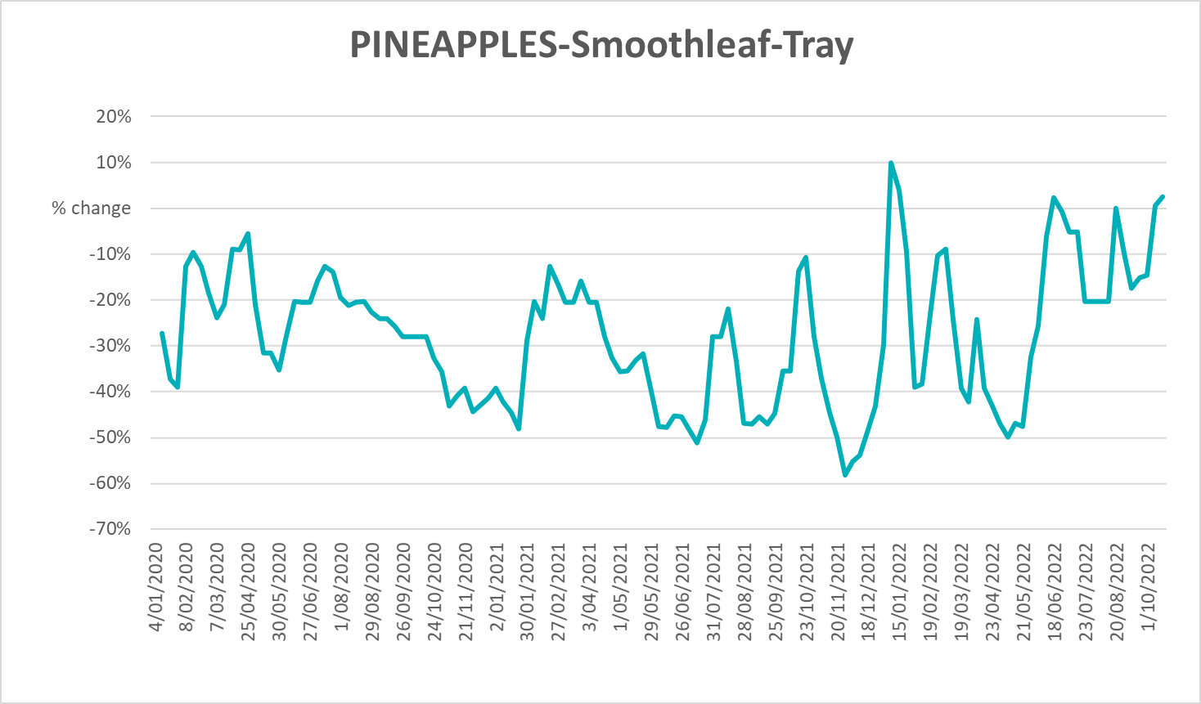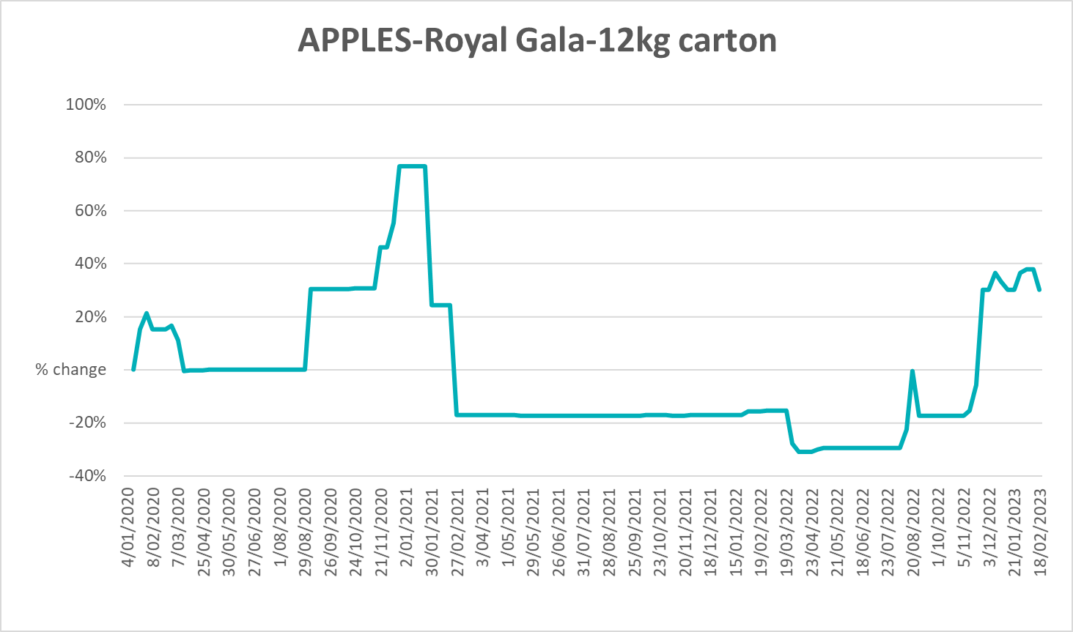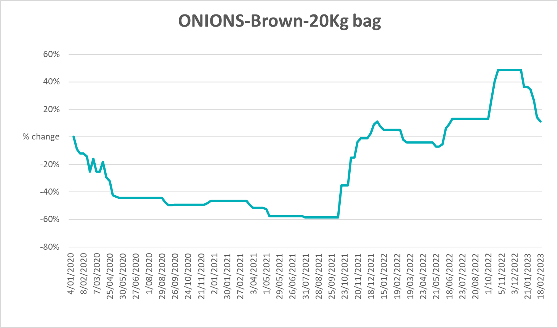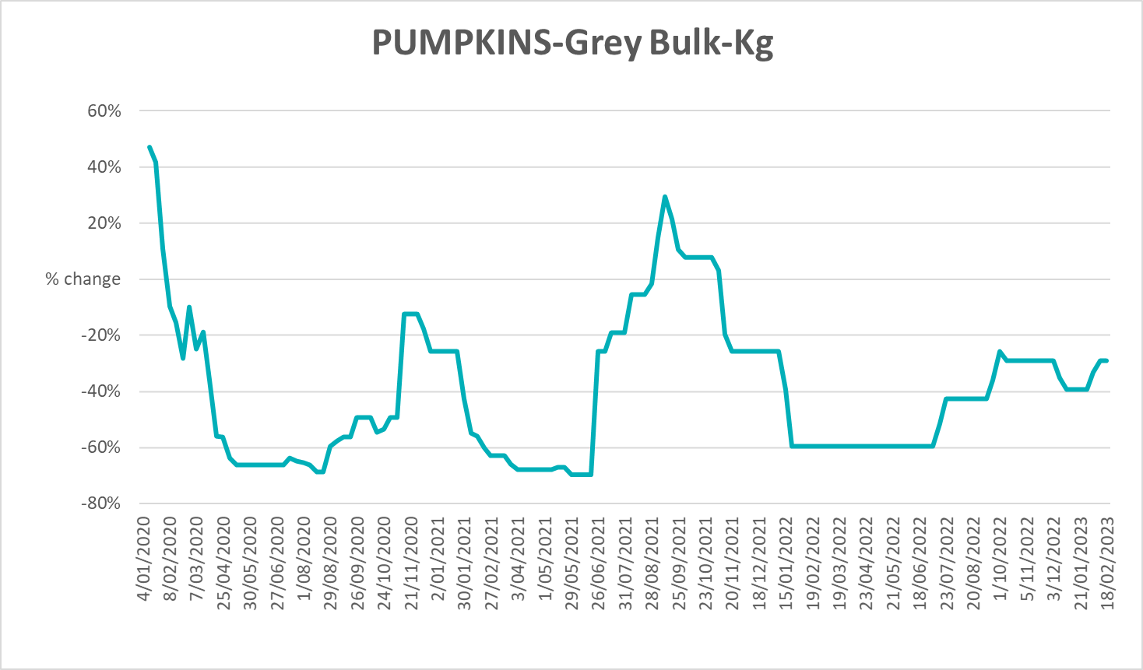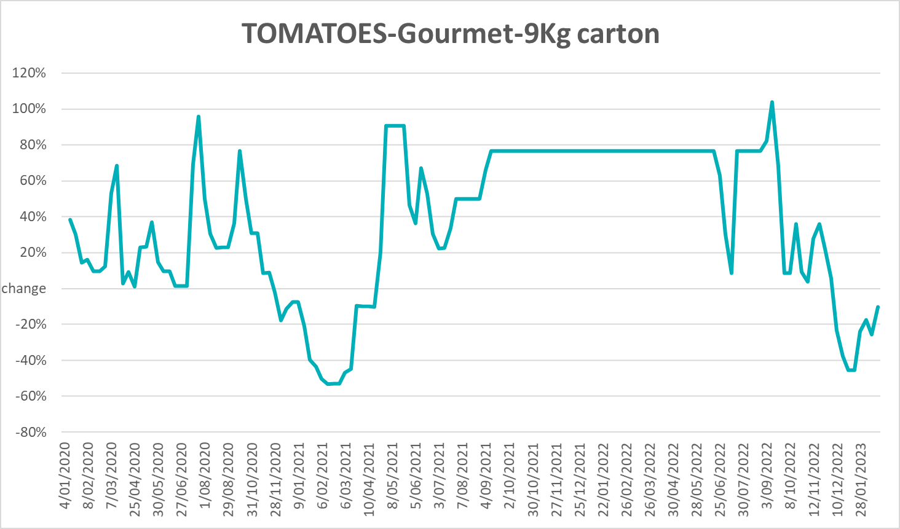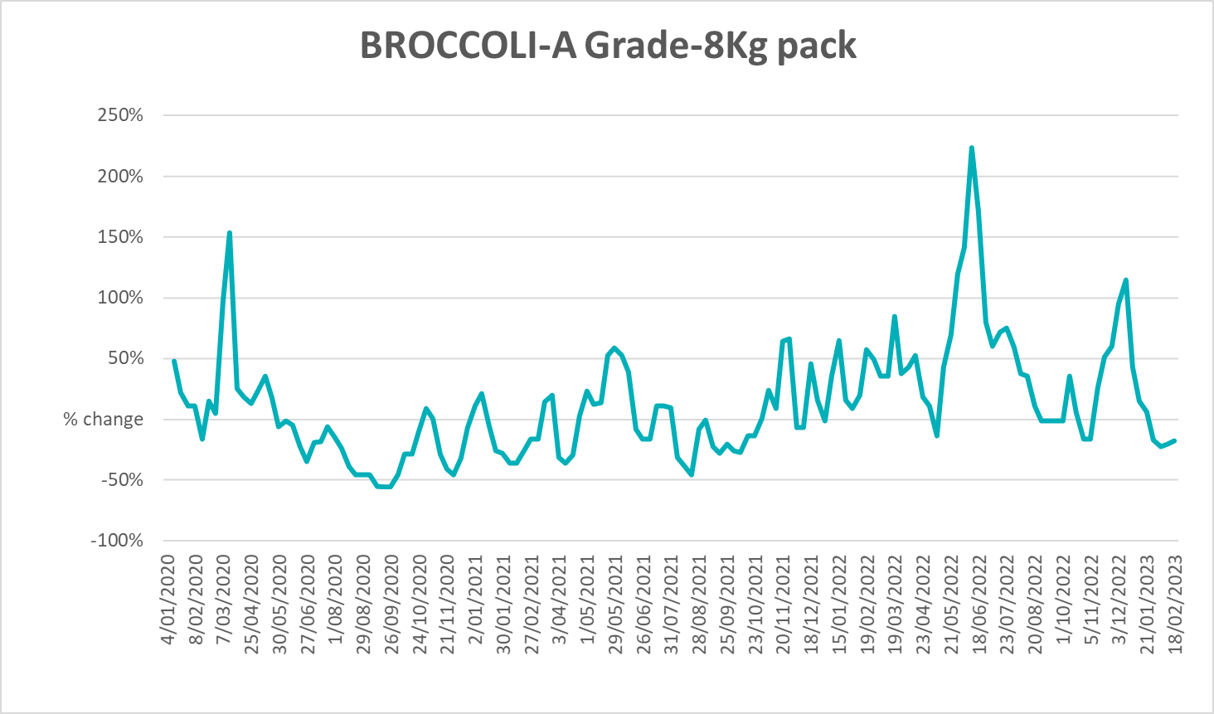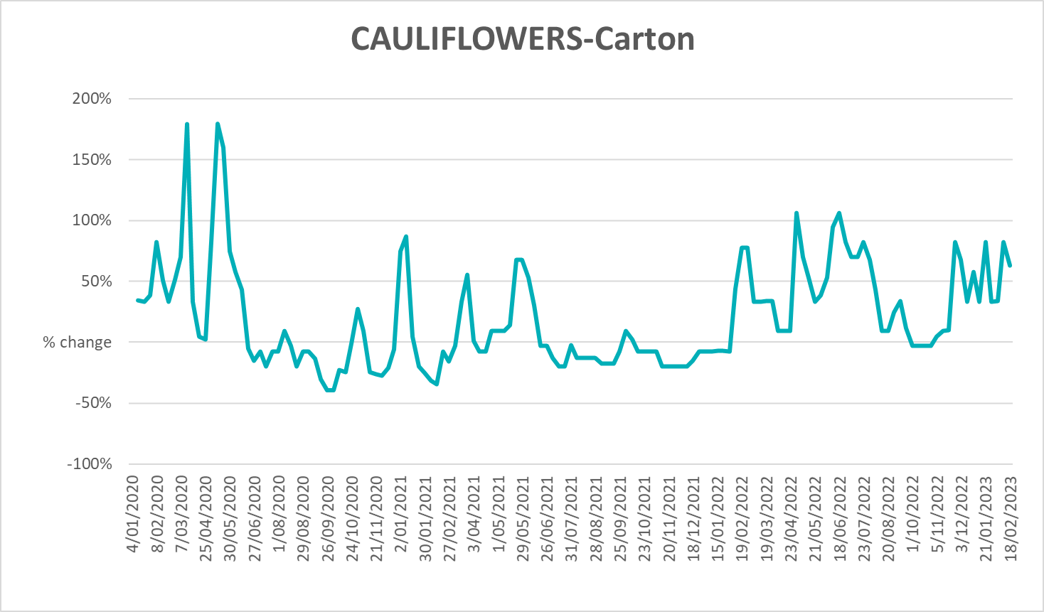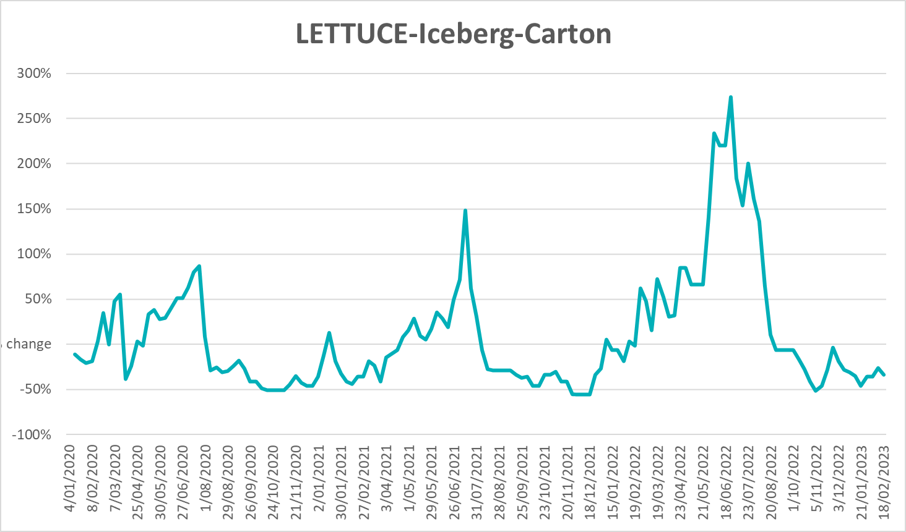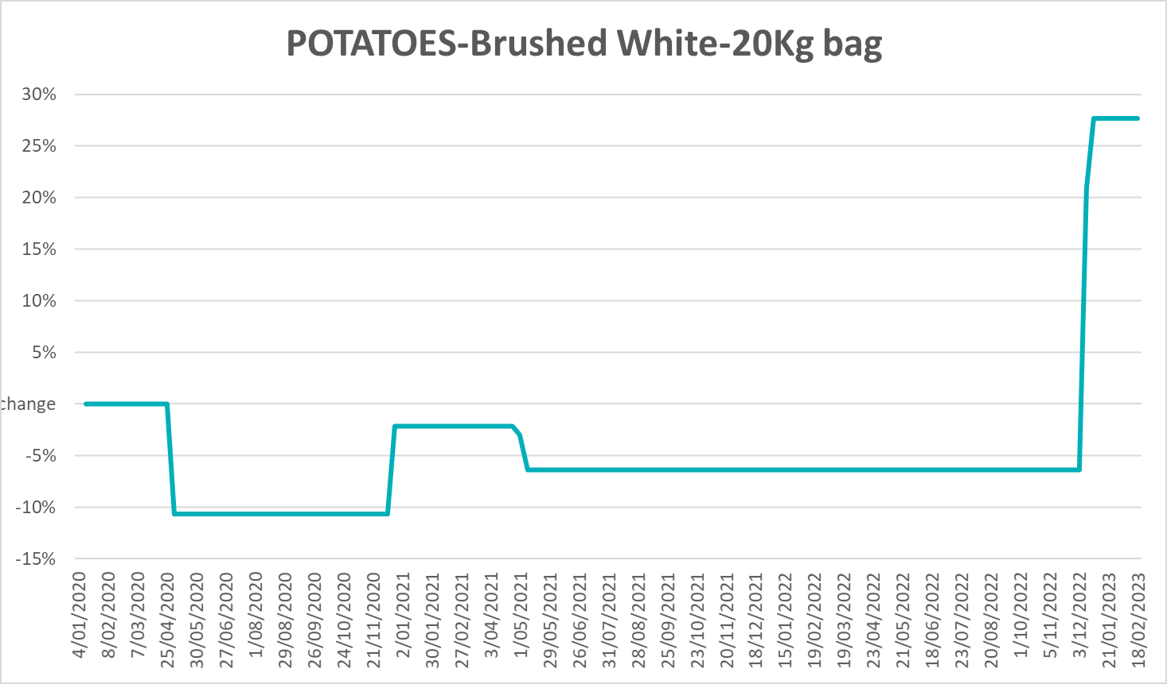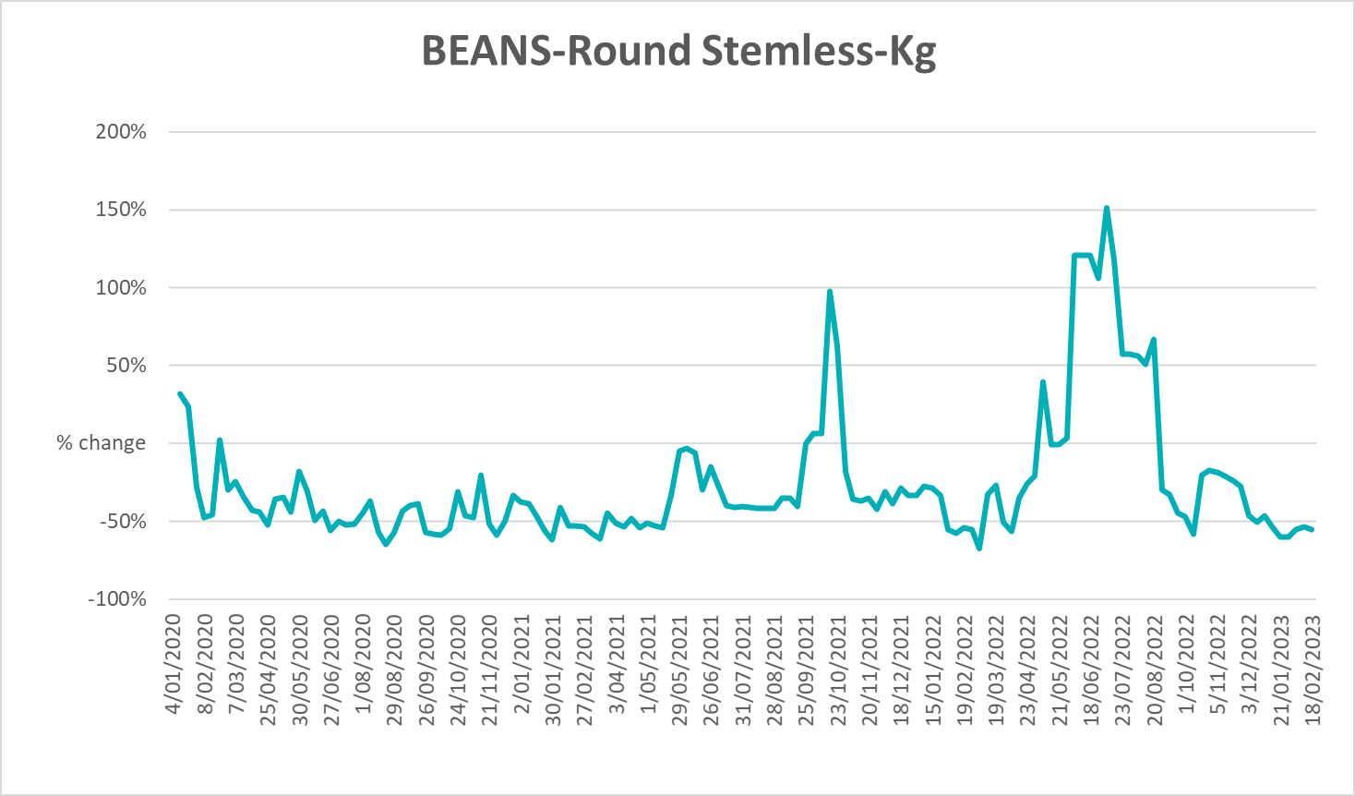

3.6 Selected domestic fodder indicator prices
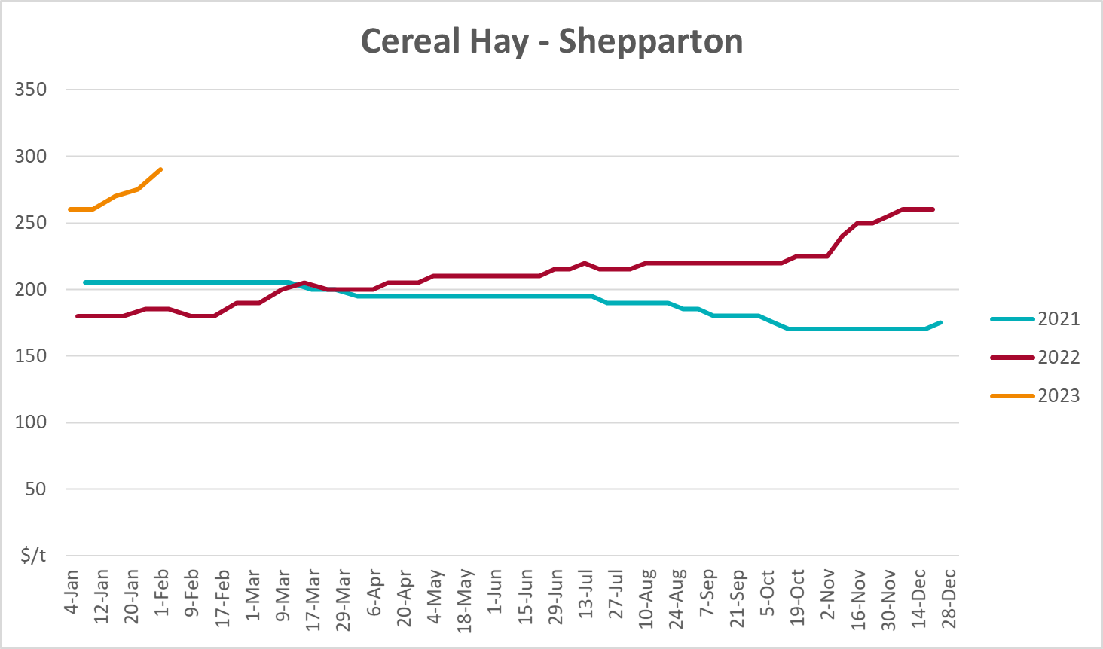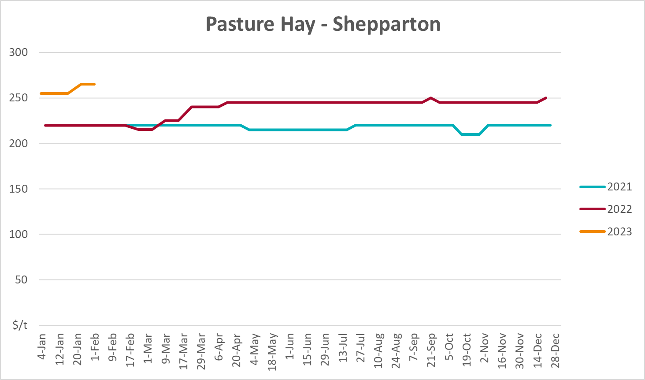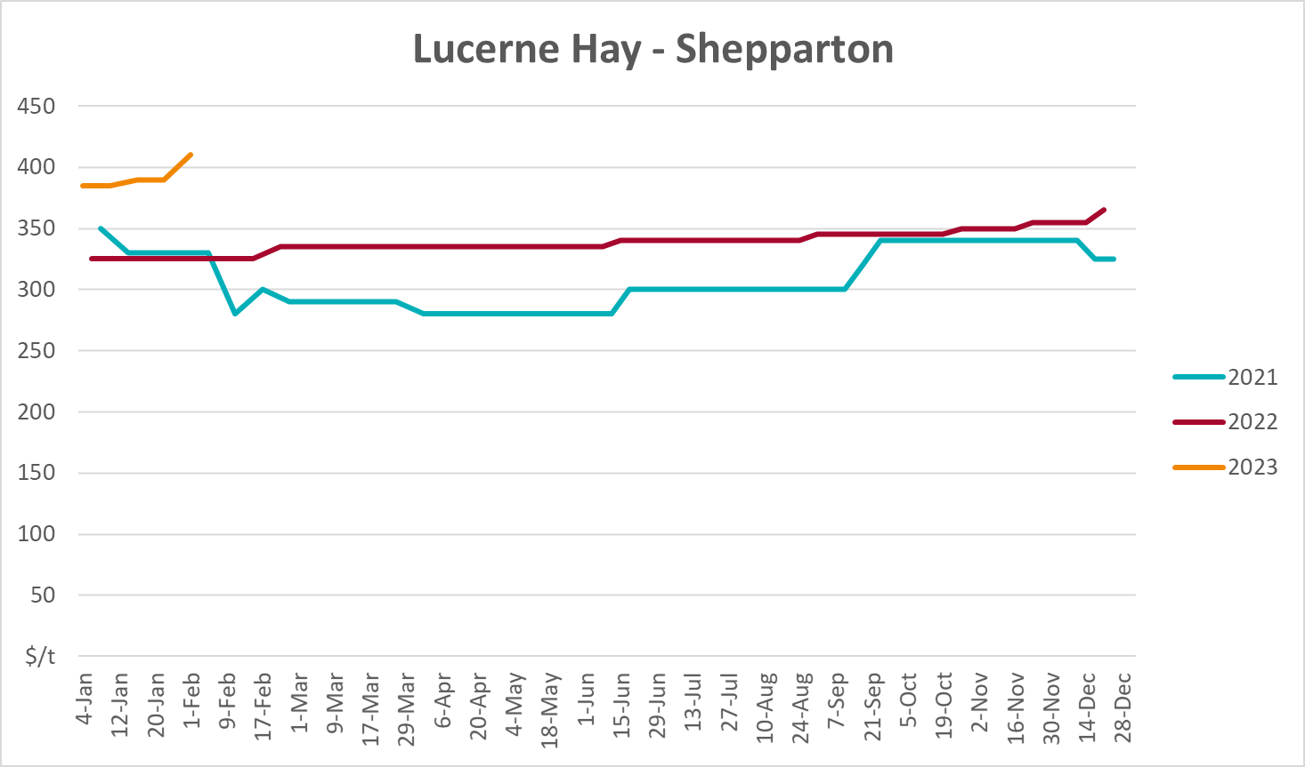

4. Data attribution

Climate
Bureau of Meteorology
- Weekly rainfall totals: www.bom.gov.au/climate/maps/rainfall/
- Monthly and last 3-month rainfall percentiles: www.bom.gov.au/water/landscape/
- Temperature anomalies: www.bom.gov.au/jsp/awap/temp/index.jsp
- Rainfall forecast: www.bom.gov.au/jsp/watl/rainfall/pme.jsp
- Seasonal outlook: www.bom.gov.au/climate/outlooks/#/overview/summary/
- Climate drivers: http://www.bom.gov.au/climate/enso/
- Soil moisture: www.bom.gov.au/water/landscape/
Other
- Pasture growth: www.longpaddock.qld.gov.au/aussiegrass/
- 3-month global outlooks: Environment and Climate Change Canada, NOAA Climate Prediction Center, EUROBRISA CPTEC/INPE, European Centre for Medium-Range Weather Forecasts, Hydrometcenter of Russia, National Climate Center Climate System Diagnosis and Prediction Room (NCC), International Research Institute for Climate and Society
- Global production: https://ipad.fas.usda.gov/ogamaps/cropmapsandcalendars.aspx
- Autumn break: Pook et al., 2009, https://rmets-onlinelibrary-wiley-com.virtual.anu.edu.au/doi/epdf/10.1002/joc.1833

Water
Prices
- Waterflow: https://www.waterflow.io/
- Ruralco: https://www.ruralcowater.com.au/
Bureau of Meteorology:
- Allocation trade: http://www.bom.gov.au/water/dashboards/#/water-markets/mdb/at
- Storage volumes: http://www.bom.gov.au/water/dashboards/#/water-storages/summary/drainage
Trade constraints:
- Water NSW: https://www.waternsw.com.au/customer-service/ordering-trading-and-pricing/trading/murrumbidgee
- Victorian Water Register: https://www.waterregister.vic.gov.au/TradingRules2019/

Commodities
Fruit and vegetables
- Datafresh: www.freshstate.com.au
Pigs
- Australian Pork Limited: www.australianpork.com.au
Dairy
- Global Dairy Trade: www.globaldairytrade.info/en/product-results/
World wheat, canola
- International Grains Council
World coarse grains
- United States Department of Agriculture
World cotton
- Cotlook: www.cotlook.com/
World sugar
- New York Stock Exchange - Intercontinental Exchange
Wool
- Australian Wool Exchange: www.awex.com.au/
Domestic wheat, barley, sorghum, canola and fodder
- Jumbuk Consulting Pty Ltd: http://www.jumbukag.com.au/
Cattle, beef, mutton, lamb, goat and live export
- Meat and Livestock Australia: www.mla.com.au/Prices-and-market
© Commonwealth of Australia 2023

Ownership of intellectual property rights
Unless otherwise noted, copyright (and any other intellectual property rights, if any) in this publication is owned by the Commonwealth of Australia (referred to as the Commonwealth).

Creative Commons licence
All material in this publication is licensed under a Creative Commons Attribution 4.0 International Licence except content supplied by third parties, logos and the Commonwealth Coat of Arms.
Inquiries about the licence and any use of this document should be emailed to copyright@awe.gov.au.


Cataloguing data
This publication (and any material sourced from it) should be attributed as:
ABARES 2023, Weekly Australian Climate, Water and Agricultural Update, Australian Bureau of Agricultural and Resource Economics and Sciences, Canberra, 6 April 2023. CC BY 4.0 DOI: https://doi.org/10.25814/5f3e04e7d2503
ISSN 2652-7561
This publication is available at https://www.agriculture.gov.au/abares/products/weekly_update
Department of Agriculture, Fisheries and Forestry
GPO Box 858 Canberra ACT 2601
Telephone 1800 900 090
Web agriculture.gov.au/abares

Disclaimer
The Australian Government acting through the Department of Agriculture, Fisheries and Forestry, represented by the Australian Bureau of Agricultural and Resource Economics and Sciences, has exercised due care and skill in preparing and compiling the information and data in this publication. Notwithstanding, the Department of Agriculture, Fisheries and Forestry, ABARES, its employees and advisers disclaim all liability, including liability for negligence and for any loss, damage, injury, expense or cost incurred by any person as a result of accessing, using or relying on any of the information or data in this publication to the maximum extent permitted by law.

Statement of Professional Independence
The views and analysis presented in ABARES publications, including this one, reflect ABARES professionally independent findings, based on scientific and economic concepts, principles, information and data. These views, analysis and findings may not reflect or be consistent with the views or positions of the Australian Government, or of organisations or groups who have commissioned ABARES reports or analysis. More information on professional independence is provided on the ABARES website.

Acknowledgements
This report was prepared by Kavina Dayal and Matthew Miller.

