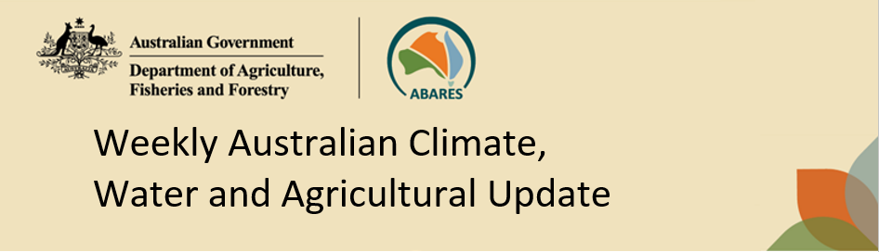
No. 19/2023 18 May 2023

Summary of key issues
- For the week ending 17 May 2023, high-pressure systems kept much of the country dry. Fronts and troughs brought isolated showers to southern parts of Australia. Meanwhile, moist onshore flow coupled with a low-pressure system brought showers and storms to far northeast New South Wales and southeast Queensland.
- In cropping regions, rainfall totals of up to 100 millimetres was recorded for parts of southern and central Queensland and up to 50 millimetres was recorded across parts of northern New South Wales. Little to no rainfall was recorded for the remaining cropping regions. These falls while delaying the harvest of some late sown summer crops, will provide relieving moisture to early sown winter crops in those regions that had seen a significant decline in soil moisture in recent weeks (see Section 1.1).
- Average to below average rainfall globally during April is likely to result in lower-than-expected winter wheat production potential in the United States, Canada and southern Europe. Below average rainfall and above average temperatures in recent months has also negatively affected corn and soybean production across Argentina and parts of Brazil. For most remaining major grain and oilseed production regions, production conditions have generally improved compared to those used to formulate ABARES forecasts of global grain supplies and world prices in its March 2023 edition of the Agricultural Commodities Report. As a result, global grain and oilseed production in 2023-24 is likely to be higher than that forecast in March (see Section 1.2).
- Over the 8-days to 25 May 2023, a high-pressure system is expected to keep much of the country generally dry. A front crossing southeast Australia should bring showers up to 50 millimetres over southern Victoria, parts of Tasmania and South Australia. Showers of up to 100 millimetres are expected in western Tasmania (see Section 1.3).
- Across Australian cropping regions, little to no rainfall is expected in the next eight days. The dry conditions will allow harvest of cotton and planting activities of winter crops to progress without delay (see Section 1.3).
- Water storage levels in the Murray-Darling Basin (MDB) remained steady at 90 percent of total capacity between 11 May 2023 and 18 May 2023. Current volume of water held in storage is 20 108 GL. This is 0.3 percent or 58 GL more than at the same time last year.
- Allocation prices in the Victorian Murray below the Barmah Choke decreased from $10 on 11 May 2023 to $8 on 18 May 2023. Prices are lower in the Murrumbidgee due to the binding of the Murrumbidgee export limit.

Climate

Rainfall this week
For the week ending 17 May 2023, high-pressure systems kept much of the country dry. Fronts and troughs brought isolated showers to southern parts of Australia. Meanwhile, moist onshore flow coupled with a low-pressure system brought showers and storms to far northeast New South Wales and southeast Queensland.
Across Australian cropping regions, rainfall totals of up to 100 millimetres was recorded for parts of southern and central Queensland and up to 50 millimetres was recorded across parts of northern New South Wales. Little to no rainfall was recorded for the remaining cropping regions. These falls while delaying the harvest of some late sown summer crops, will provide relieving moisture to early sown winter crops in those regions that had seen a significant decline in soil moisture in recent weeks.
The clear, dry conditions over the past week have reportedly allowed the cotton harvesting in northern Queensland and much of New South Wales to continue without delay.

Rainfall for the week ending 17 May 2023
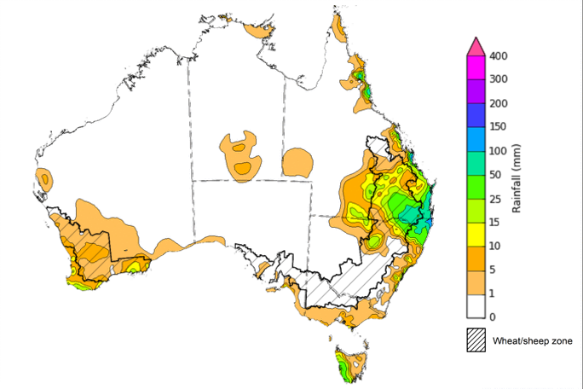
©Commonwealth of Australia 2023, Australian Bureau of Meteorology Issued: 17/05/2023
Note: The rainfall analyses and associated maps utilise data contained in the Bureau of Meteorology climate database, the Australian Data Archive for Meteorology (ADAM). The analyses are initially produced automatically from real-time data with limited quality control. They are intended to provide a general overview of rainfall across Australia as quickly as possible after the observations are received. For further information go to http://www.bom.gov.au/climate/rainfall/

Global production conditions and climate outlook
Crop production is affected by long-term trends in average rainfall and temperature, interannual climate variability, shocks during specific growth stages, and extreme weather events. Some crops are more tolerant than others to certain types of stresses, and at each growth stage, different types of stresses affect each crop species in different ways.
The precipitation anomalies and outlooks presented here give an indication of the current and future state of production conditions for the major grain and oilseed producing countries which are responsible for over 80% of global production. This is an important input to assessing the global grain supply outlook.

April precipitation percentiles and current production conditions
As of the end of April 2023, rainfall was mixed for the world’s major grain-producing and oilseed-producing regions.
In the northern hemisphere, precipitation was below average in central and western United States, central Canada, parts of southern Europe and much of Southeast Asia. Precipitation was above average for northeast and isolated parts of southern and eastern United States, eastern Canada, southern United Kingdom, much of central Europe, central and northern India, eastern China and southern parts of the Russian Federation. Precipitation was close to average across the remainder of the major grain-producing and oilseed-producing regions in the northern hemisphere.
In the southern hemisphere, April precipitation was below average across much of Argentina and northern Brazil. Precipitation was above average for a localised area of southwest Brazil, and parts of south-eastern Australia. Precipitation was close to average across the remainder of major grain-producing and oilseed-producing regions in the southern hemisphere.

Global precipitation percentiles, April 2023
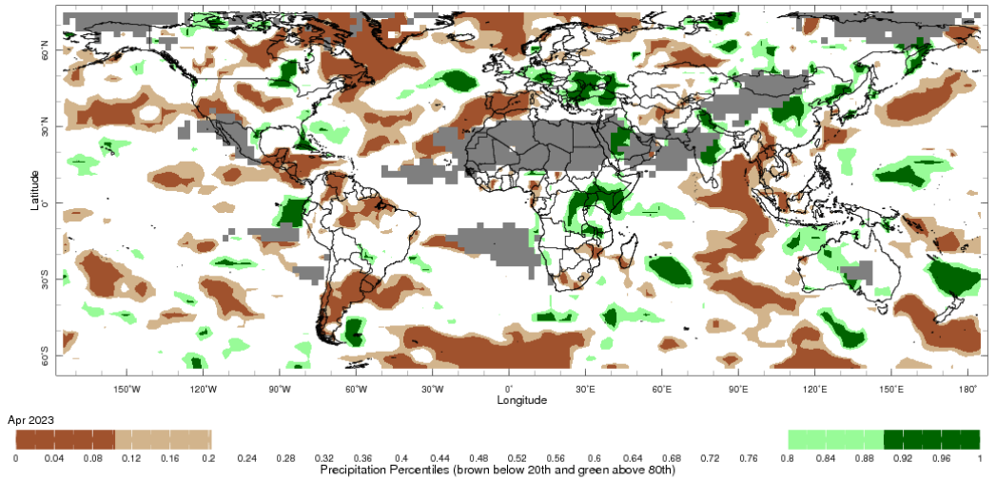

Note: The world precipitation percentiles indicate a ranking of precipitation for April, with the driest (0th percentile) being 0 on the scale and the wettest (100th percentile) being 1 on the scale. Percentiles are based on precipitation estimates from the NOAA Climate Prediction Center's Climate Anomaly Monitoring System Outgoing Precipitation Index dataset. Precipitation estimates for April 2023 are compared with rainfall recorded for that period during the 1981 to 2010 base period.
Source: International Research Institute for Climate and Society

As of 28 April 2023, global production were generally favourable for wheat, corn and rice, while mixed for soybeans.
In the northern hemisphere production conditions for wheat have been generally favourable, except for Spain and the United States due to dryness and the Ukraine due to the ongoing conflict. The harvesting of Rabi season wheat is taking place under favourable conditions in Pakistan, while winter wheat continues to develop elsewhere for harvest from May, benefitting from rainfall in the recent weeks. In the southern hemisphere, winter wheat sowing is beginning in Australia.
For corn, production conditions are generally favourable except for in Argentina and Sub-Saharan Africa. The harvest of the spring-planted crop is wrapping up in Brazil under exceptional conditions. In the northern hemisphere, sowing is beginning under generally favourable conditions.
For rice, production conditions are favourable except for in the Caribbean and parts of Sub-Saharan Africa. The harvesting of dry-season rice peaked in April in the north of Vietnam and conditions are favourable in the south benefiting from the receding flood waters. The planting of dry-season rice is underway under favourable conditions in Indonesia, benefitting from sufficient irrigation water supply. Conditions are favourable for the Rabi crop in India as harvesting begins.
For soybeans, production conditions are exceptional in Brazil but poor in Argentina due to prolonged drought. Drought induced poor growing conditions in Argentina have resulted in a decline in global production levels for soybeans in 2022–23. In the northern hemisphere, sowing underway in the US under favourable conditions. With an expected shift from La Nina to El Nino conditions in 2023–24, a return to more favourable growing conditions is likely to see global soybean production rebound to new record levels, mainly due to increased expected production across South America and the US.
Crop conditions, AMIS countries, 28 April 2023
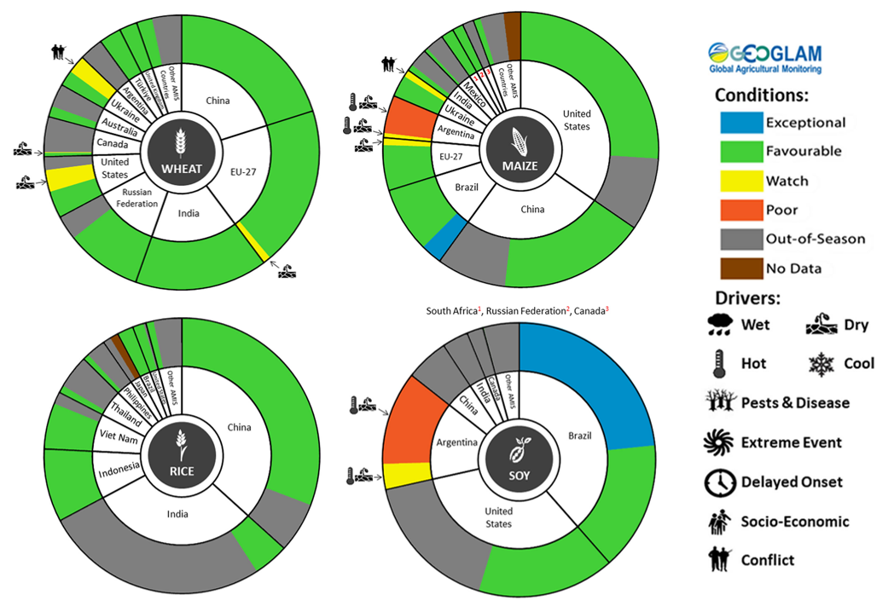
AMIS Agricultural Market Information System.
Source: AMIS

The global climate outlook for June 2023 to August 2023 indicates that variable rainfall conditions are expected for the world's major grain-producing and oilseed-producing regions. Outlooks and potential production impacts for the major grain and oilseed producing countries are presented in the table.
Rainfall outlook and potential impact on the future state of production conditions between June 2023 to August 2023
Region | June - August rainfall outlook | Potential impact on production
Argentina | Average to above rainfall is more likely across most major production areas of Argentina between June and August 2023, with eastern parts being the only exception, where below average rainfall is more likely. | Above average rainfall across most of Argentina is likely to benefit the planting and development of wheat. In contrast it may interrupt harvest of cotton, corn, sorghum, rice, millet and soybeans in June.
Black Sea Region | Average to above average rainfall is forecast for Ukraine, Türkiye, Kazakhstan and western regions in the Russian Federation. | Above average rainfall is likely to support the development of spring wheat, barley, canola, cotton, corn, soybeans, millet and sunflower. In contrast, above average rainfall may disrupt harvest of winter wheat in June.
Brazil | Average to above average rainfall is more likely across much of Brazil except for northern parts where below average rainfall is more likely between June and August 2023. | Average to above average rainfall across Brazil may benefit late planted corn and cotton prior to harvest in June. Below average rainfall may adversely affect the planting and development of late planted corn in the north.
Canada | Average rainfall is likely across Canadian prairies, and with below and above average rainfall in isolated areas. | Average rainfall is likely to support the development of spring wheat and canola, and the planting and development of corn, soybeans and sunflower. Below average rainfall in isolated areas may adversely impact the development of crops in these locations. In contrast, below average rainfall may allow for uninterrupted harvest of winter wheat in June.
China | Average to above average rainfall is more likely across much of China, while below average rainfall is more likely for parts of central, northwest and southwest China. | Average or better rainfall across much of China is likely to support the development of spring wheat, rice, cotton, corn, sorghum, soybeans, sunflower and nuts. This rainfall may delay harvesting winter wheat and canola in June and July.
Europe | Average rainfall is more likely for most of Europe between June and August 2023. | Average rainfall across Europe is likely to benefit the development of spring wheat, canola, corn, cotton, soybeans, sorghum and sunflower.
South Asia (India) | Average to below average rainfall is more likely across India, while above average rainfall is likely in the south between June and August 2023. | Below average rainfall in the west and north is likely to hinder development of cotton, corn, sorghum, rice, millet, nuts and sunflower from June 2023.
Southeast Asia (SEA) | Average to above average rainfall is more likely for much of SEA between June and August 2023, except for Malaysia and Indonesia which are expecting below average rainfall. | Average or better rainfall across much of Southeast Asia is likely to benefit corn and rice planting and development. Below average rainfall across Malaysia and Indonesia may adversely impact rice, cotton and corn production.
The United States of America | Average rainfall is likely across much of the US between June and August 2023 with exception in the central west and isolated areas in the central east where below average rainfall is likely. | Below average rainfall across central west US may hinder the development of spring wheat, canola, cotton and rice, corn, sorghum and nuts and the planting and development of soybeans, sunflower, millet and pastures.

Rainfall forecast for the next eight days
Over the 8-days to 25 May 2023, a high-pressure system is expected to keep much of the country generally dry. A front crossing southeast Australia should bring showers up to 50 millimetres over southern Victoria, parts of Tasmania and South Australia. Showers of up to 100 millimetres are expected in western Tasmania.
Across Australian cropping regions, little to no rainfall is expected in the next eight days. The dry conditions will allow harvest of cotton and planting activities of winter crops to progress without delay.

Total forecast rainfall for the period 18 May 2023 to 25 May 2023
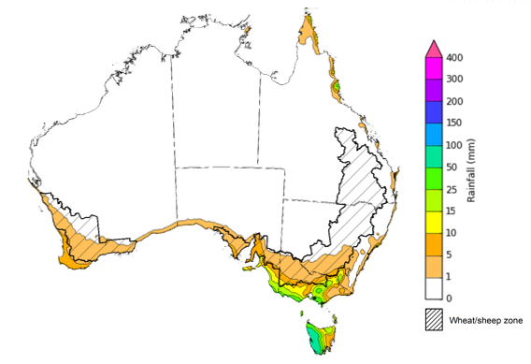

©Commonwealth of Australia 2023, Australian Bureau of Meteorology Issued 18/05/2023
Note: This rainfall forecast is produced from computer models. As the model outputs are not altered by weather forecasters, it is important to check local forecasts and warnings issued by the Bureau of Meteorology.

Water

Water markets – current week
Water storage levels in the Murray-Darling Basin (MDB) remained steady at 90 percent of total capacity between 11 May 2023 and 18 May 2023. Current volume of water held in storage is 20 108 GL. This is 0.3 percent or 58 GL more than at the same time last year.

Water storages in the Murray-Darling Basin, 2013–2023
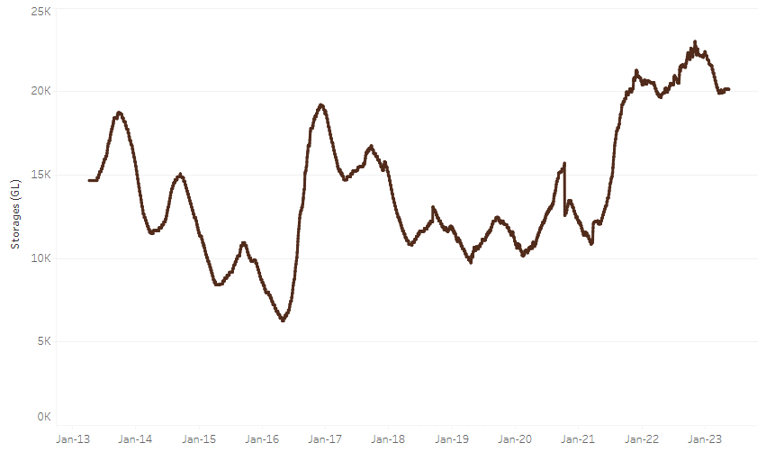
Allocation prices in the Victorian Murray below the Barmah Choke decreased from $10 on 11 May 2023 to $8 on 18 May 2023. Prices are lower in the Murrumbidgee due to the binding of the Murrumbidgee export limit.
Water storage data is sourced from the Bureau of Meteorology.

Region | $/ML
NSW Murray Above | 7
NSW Murrumbidgee | 3
VIC Goulburn-Broken | 10
VIC Murray Below | 8

Surface water trade activity, Southern Murray–Darling Basin
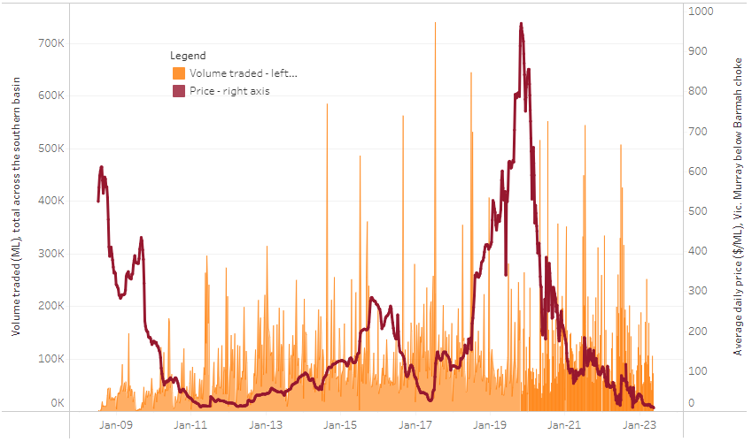
The trades shown reflect estimated market activity and do not encompass all register trades. The price is shown for the VIC Murray below the Barmah choke. Historical prices (before 1 July 2019) are ABARES estimates after removing outliers from BOM water register data. Prices after 1 July 2019 and prior to the 30 October 2019 reflect recorded transaction prices as sourced from Ruralco. Prices after the 30 October 2019 are sourced from Waterflow. Data for volume traded is sourced from the BOM water register. Only the price data shown is current on 18 May 2023.

To access the full, interactive, weekly water dashboard, which contains the latest and historical water storage, water market and water allocation information, please visit https://www.agriculture.gov.au/abares/products/weekly_update/weeakly-update-18523

Commodities
Indicator | Week ended | Unit | Latest Price | Previous Week | Weekly change | Price 12 months ago | Annual change
Selected world indicator prices
AUD/USD Exchange rate | 17-May | A$/US$ | 0.67 | 0.68 | -1% | 0.71 | -6%
Wheat – US no. 2 hard red winter wheat, fob Gulf | 17-May | US$/t | 390 | 371 | 5% | 527 | -26%
Corn – US no. 2 yellow corn, fob Gulf | 17-May | US$/t | 271 | 274 | -1% | 340 | -20%
Canola – Rapeseed, Canada, fob Vancouver | 17-May | US$/t | 591 | 599 | -1% | 970 | -39%
Cotton – Cotlook 'A' Index | 17-May | USc/lb | 93 | 95 | -2% | 161 | -42%
Sugar – Intercontinental Exchange, nearby futures, no.11 contract | 17-May | USc/lb | 25.8 | 25.8 | 0% | 20 | 30%
Wool – Eastern Market Indicator | 03-May | Ac/kg clean | 1,284 | 1,310 | -2% | 1,384 | -7%
Wool – Western Market Indicator | 03-May | Ac/kg clean | 1,418 | 1,479 | -4% | 1,451 | -2%
Selected Australian grain export prices
Milling Wheat – APW, Port Adelaide, SA | 17-May | A$/t | 441 | 434 | 2% | 613 | -28%
Feed Wheat – ASW, Port Adelaide, SA | 17-May | A$/t | 412 | 405 | 2% | 579 | -29%
Feed Barley – Port Adelaide, SA | 17-May | A$/t | 382 | 387 | -1% | 546 | -30%
Canola – Kwinana, WA | 17-May | A$/t | 859 | 859 | 0% | 1,281 | -33%
Grain Sorghum – Brisbane, QLD | 17-May | A$/t | 462 | 476 | -3% | 451 | 2%
Selected domestic livestock indicator prices
Beef – Eastern Young Cattle Indicator | 17-May | Ac/kg cwt | 613 | 633 | -3% | 1,085 | -43%
Mutton – Mutton indicator (18–24 kg fat score 2–3), Vic | 17-May | Ac/kg cwt | 349 | 415 | -16% | 608 | -43%
Lamb – Eastern States Trade Lamb Indicator | 17-May | Ac/kg cwt | 599 | 628 | -5% | 791 | -24%
Pig – Eastern Seaboard (60.1–75 kg), average of buyers & sellers | 03-May | Ac/kg cwt | 357 | 357 | 0% | 368 | -3%
Goats – Eastern States (12.1–16 kg) | 05-Apr | Ac/kg cwt | 280 | 280 | 0% | 815 | -66%
Live cattle – Light steers ex Darwin to Indonesia | 17-Aug | Ac/kg lwt | 420 | 480 | -13% | 320 | 31%
Live sheep – Live wethers (Muchea WA saleyard) to Middle East | 14-Sep | $/head | 93 | 113 | -18% | 114 | -18%
Global Dairy Trade (GDT) weighted average prices ª
Dairy – Whole milk powder | 17-May | US$/t | 3,244 | 3,230 | 0% | 4,115 | -21%
Dairy – Skim milk powder | 17-May | US$/t | 2,766 | 2,787 | -1% | 3,433 | -19%
Dairy – Cheddar cheese | 17-May | US$/t | 4,407 | 4,561 | -3% | 4,274 | 3%
Dairy – Anhydrous milk fat | 17-May | US$/t | 4,600 | 4,832 | -5% | 5,730 | -20%
a Global Dairy Trade prices are updated twice monthly on the first and third Tuesday of each month.

Selected world indicator prices
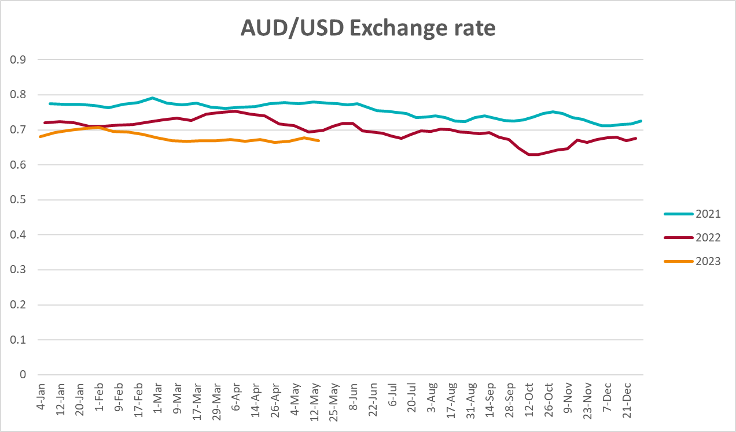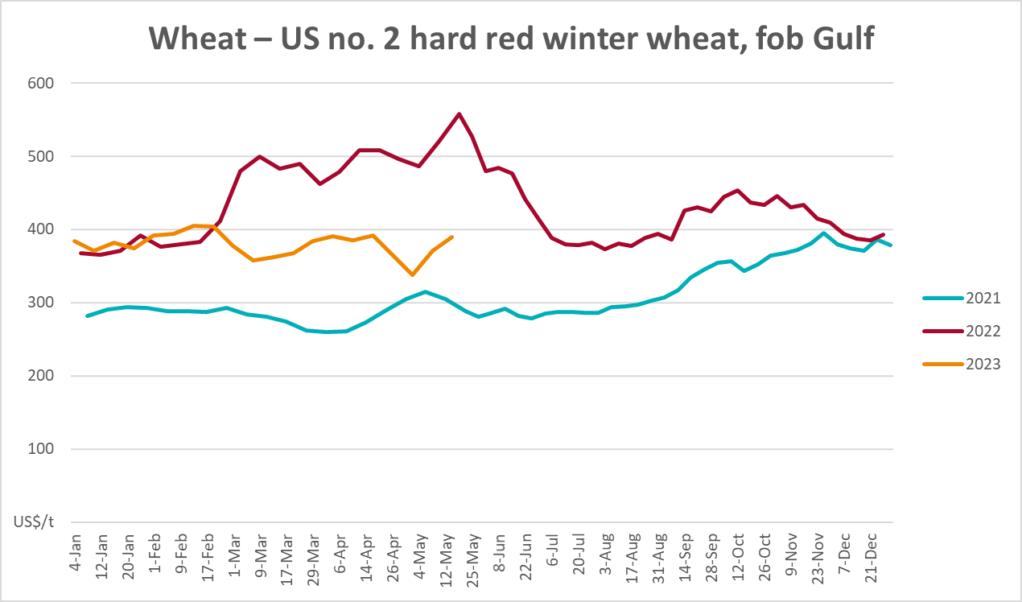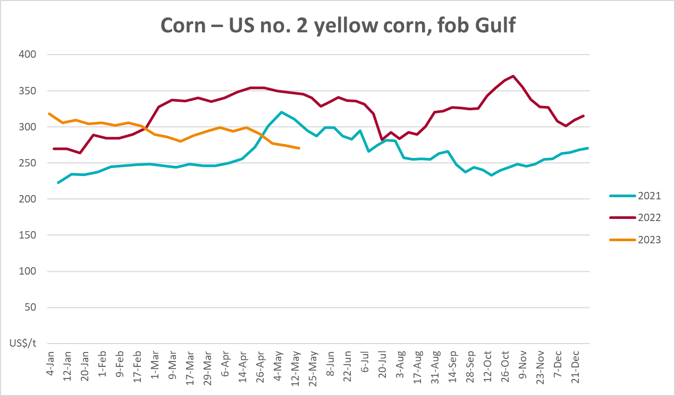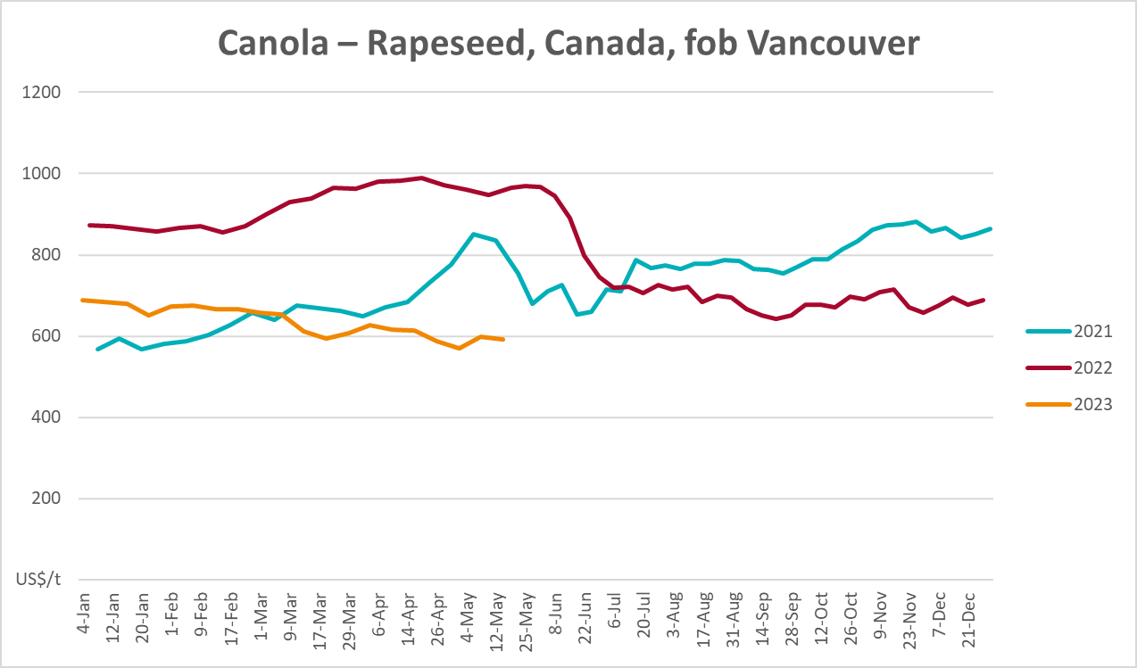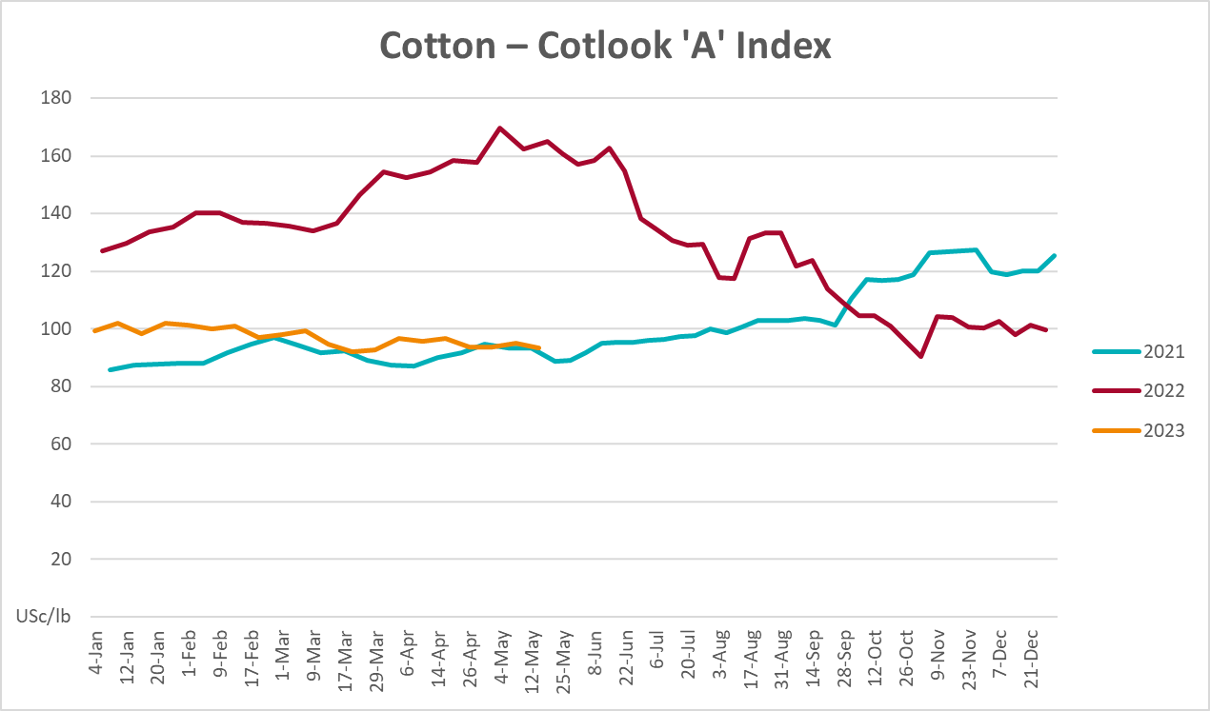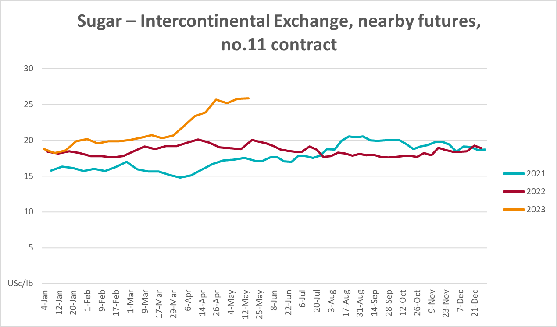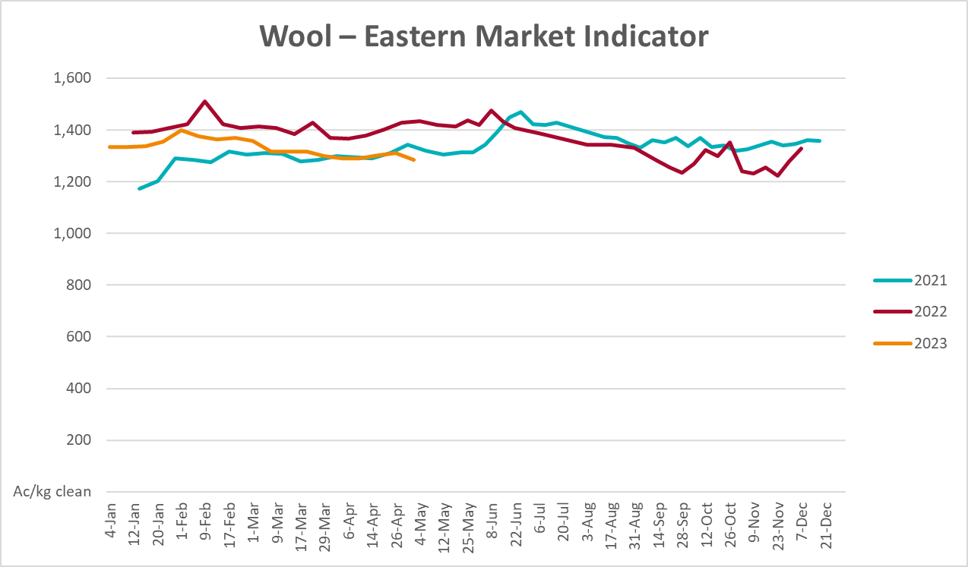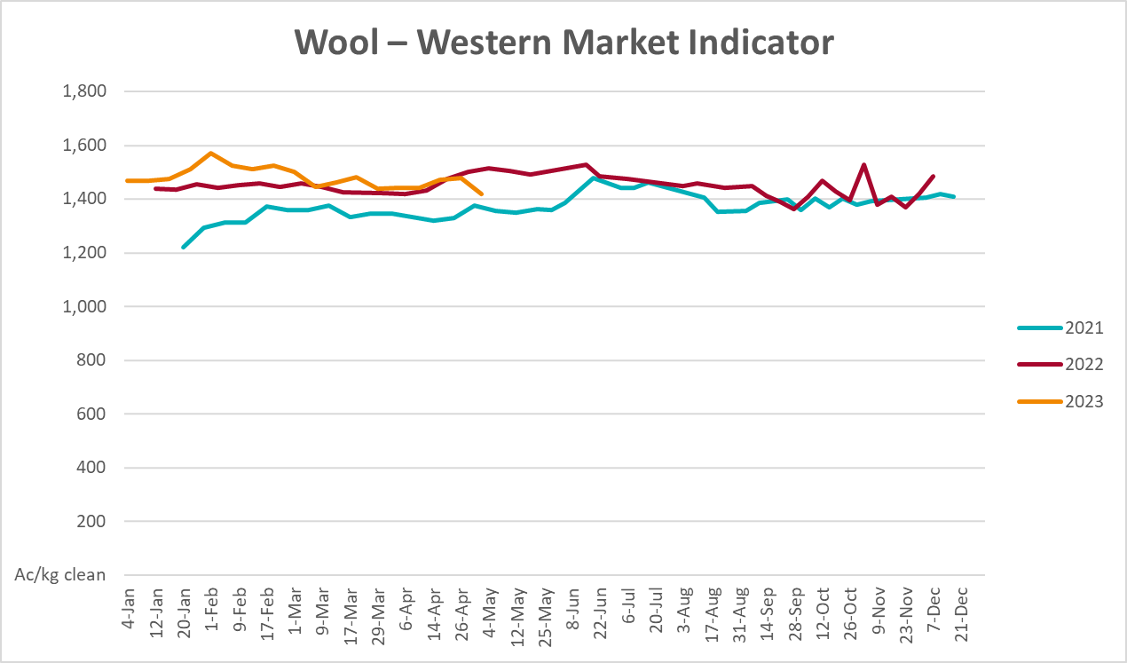

Selected domestic crop indicator prices

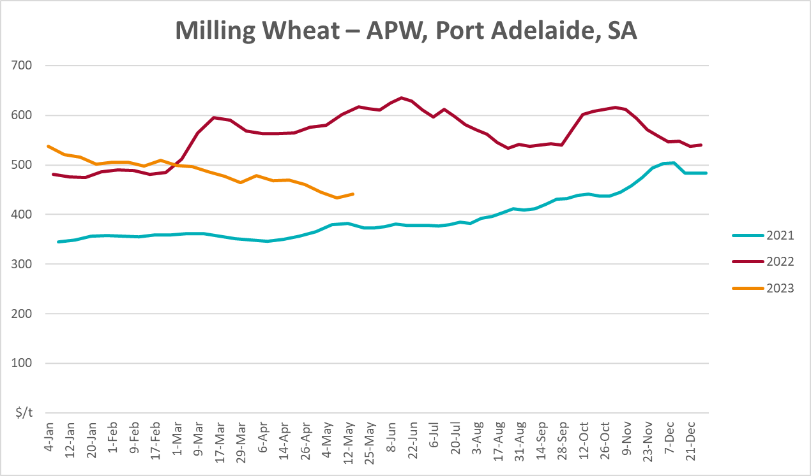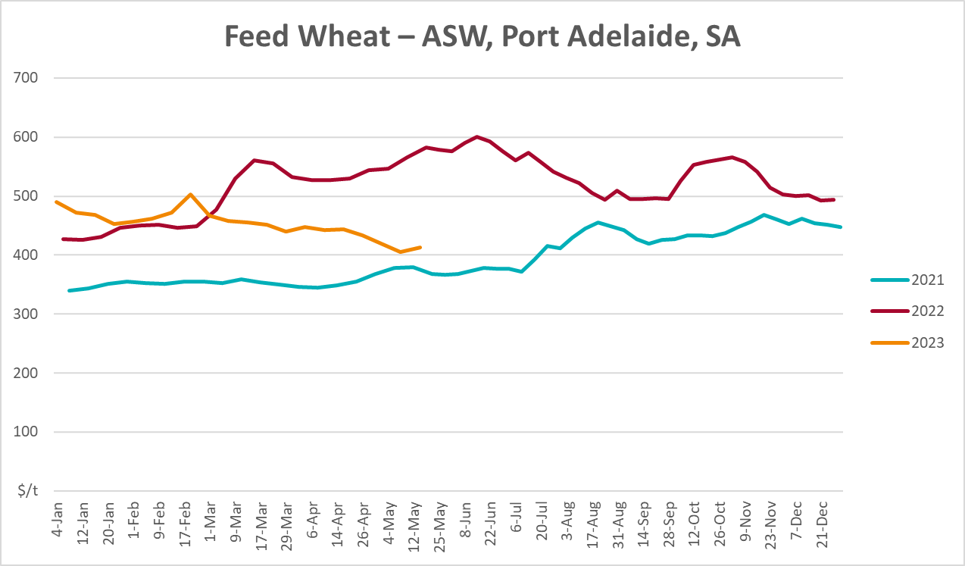
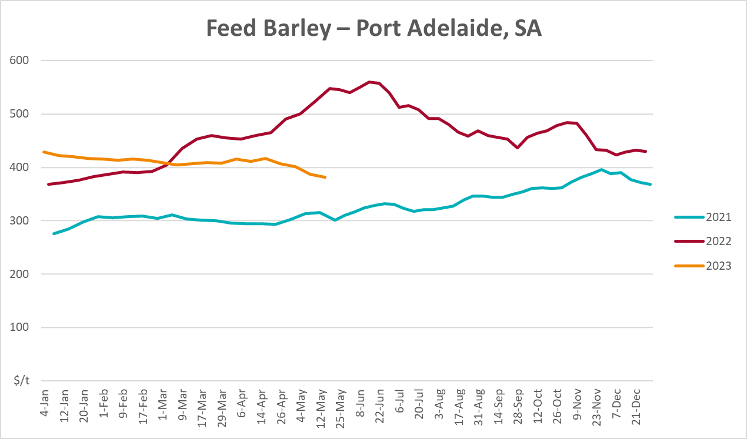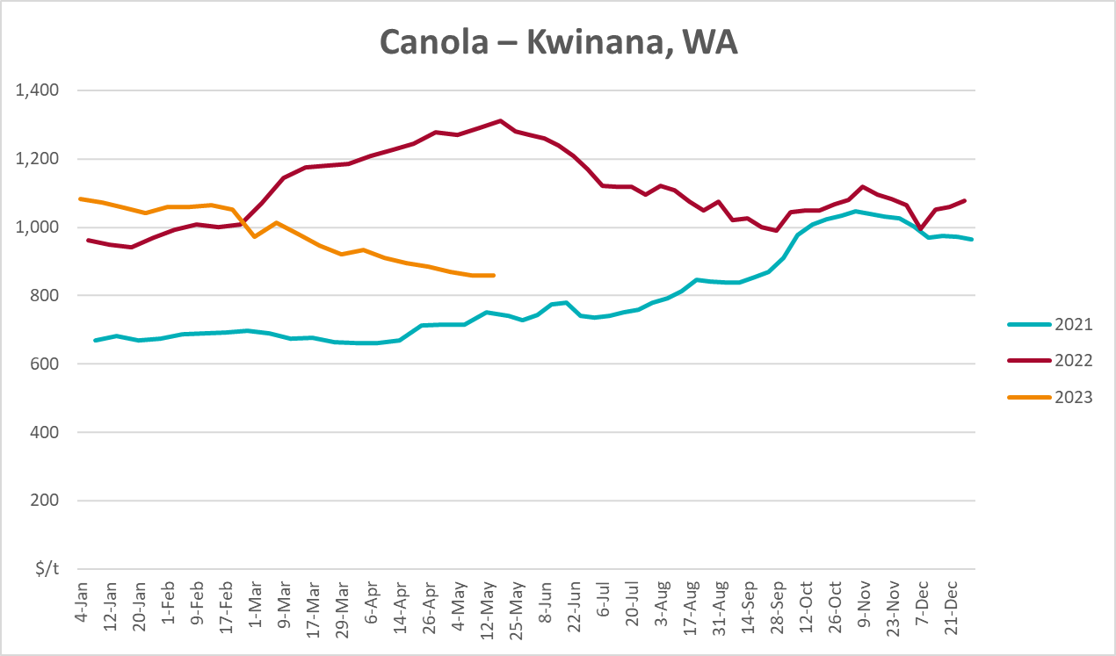
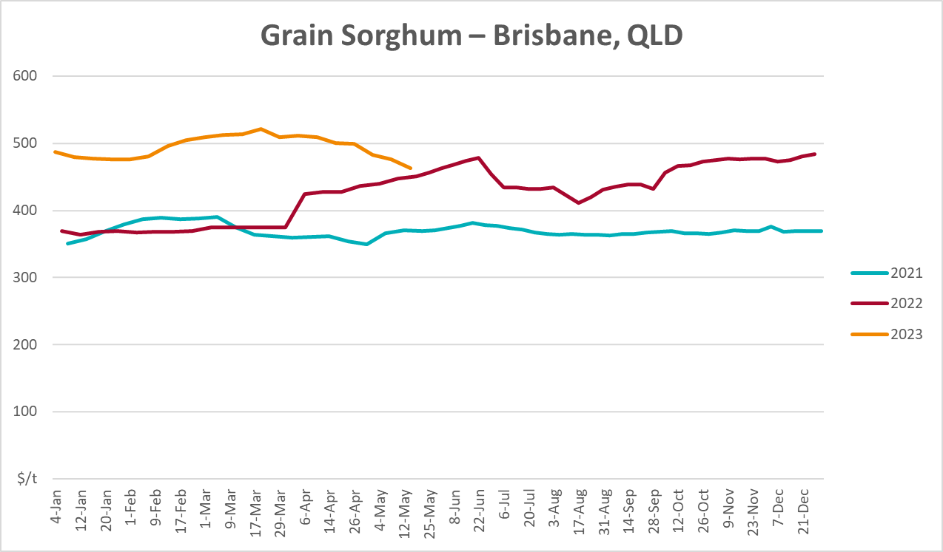

Selected domestic livestock indicator prices
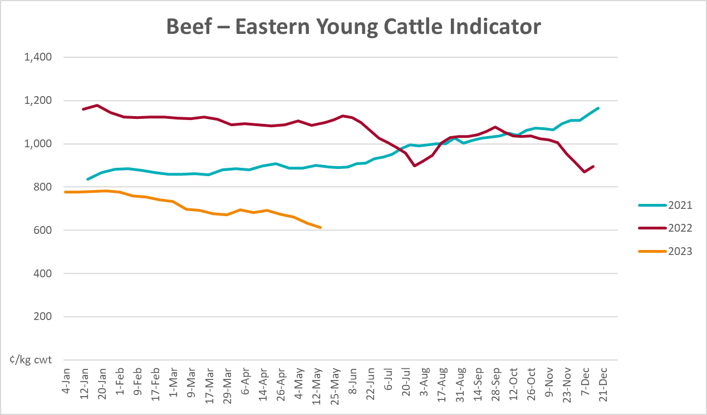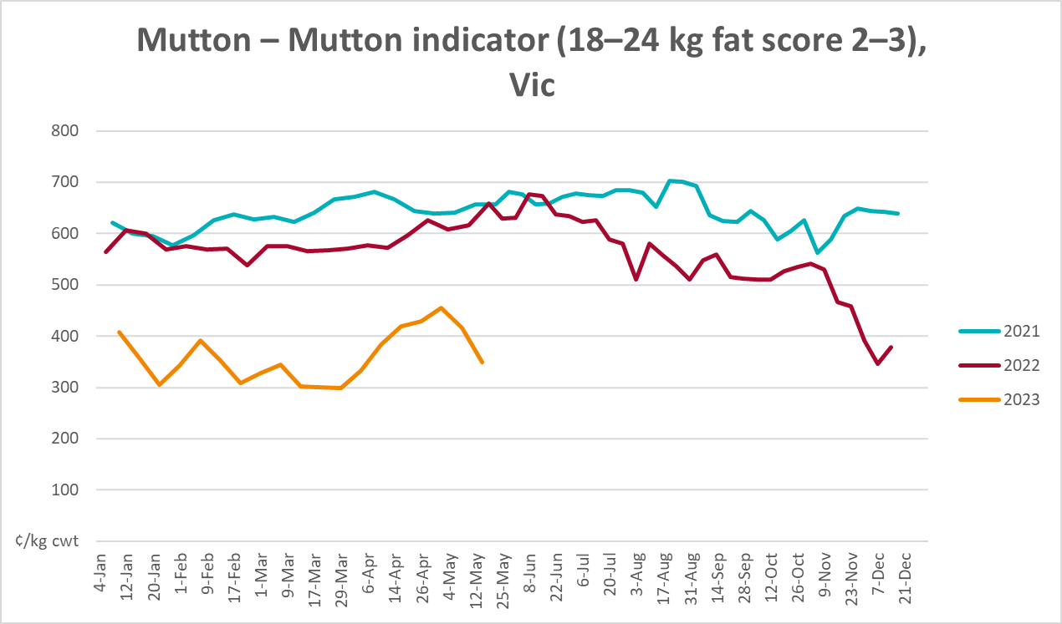
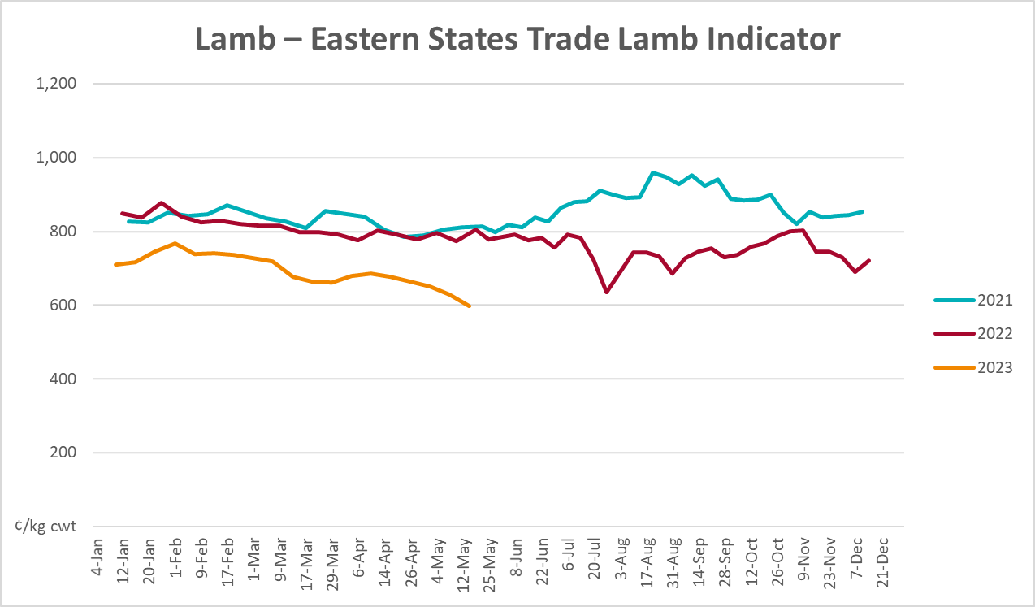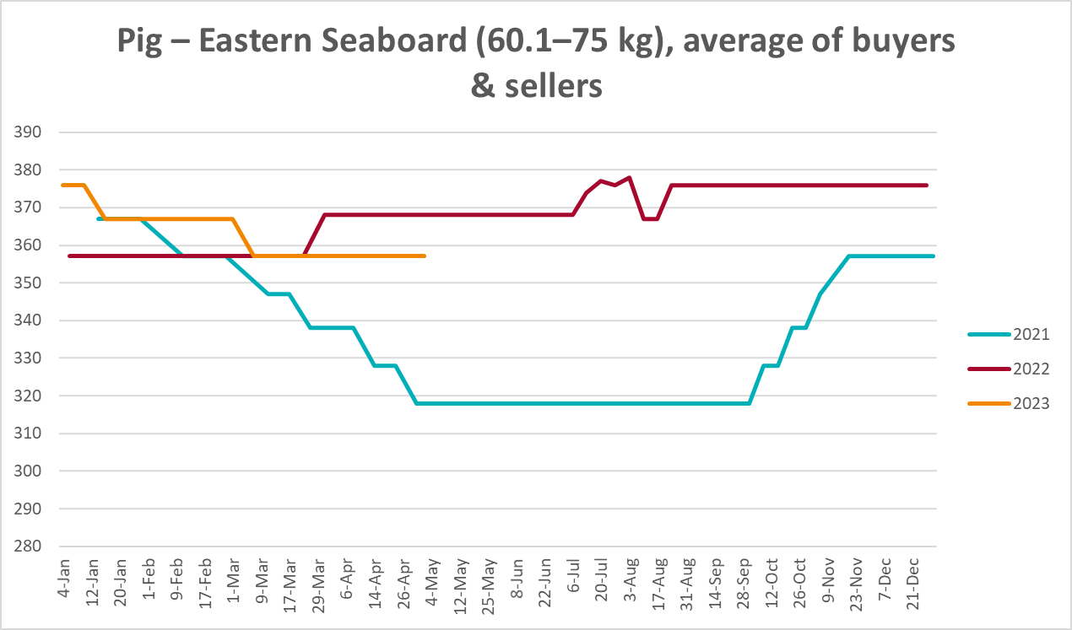
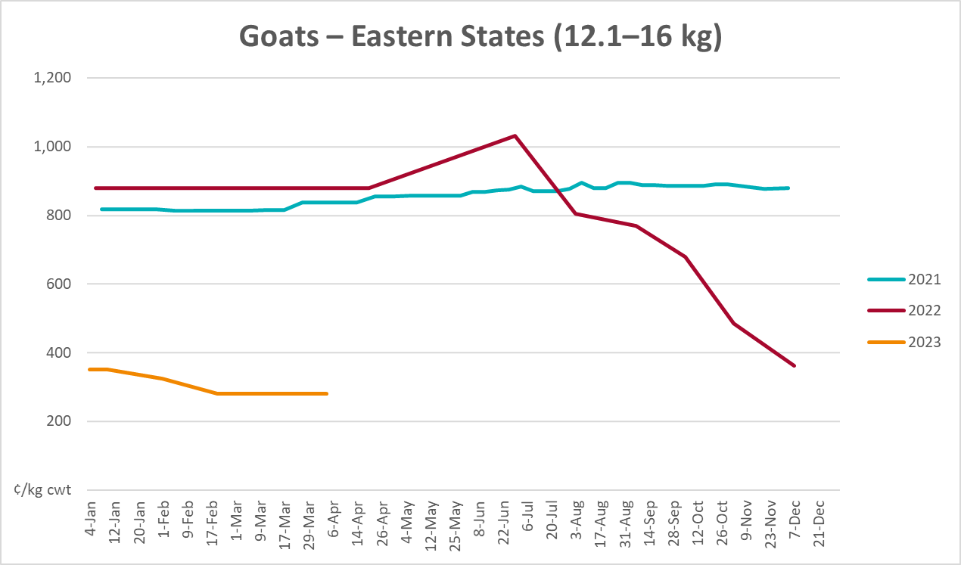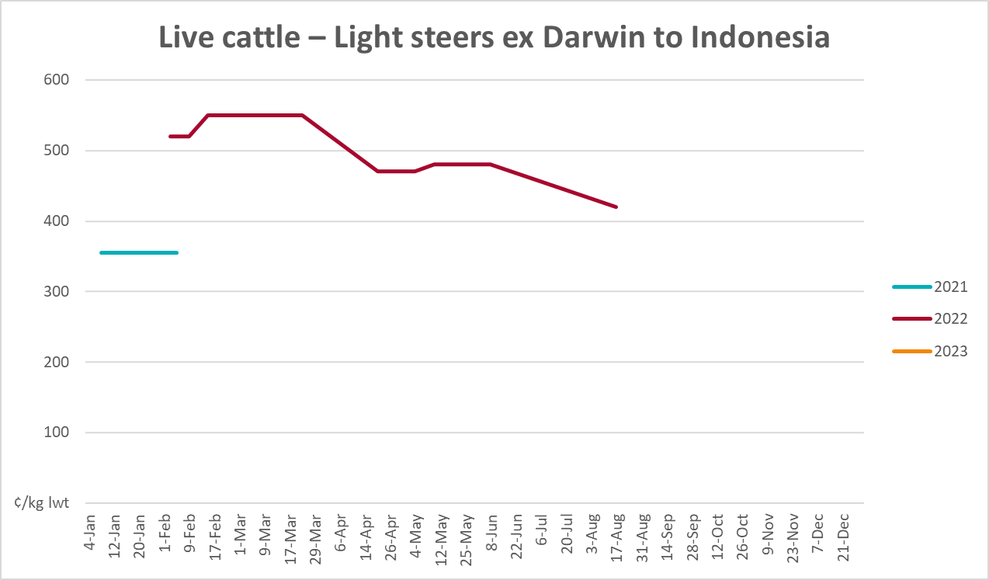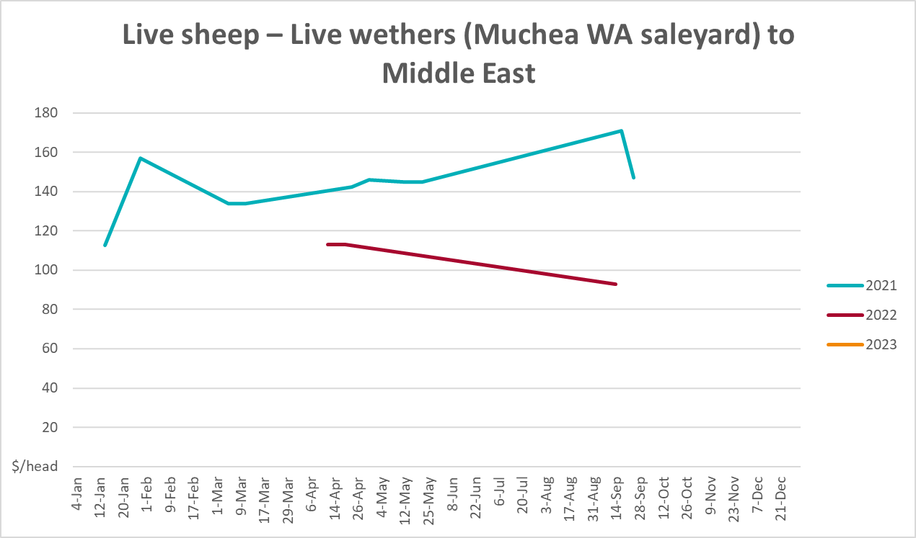

Global Dairy Trade (GDT) weighted average prices
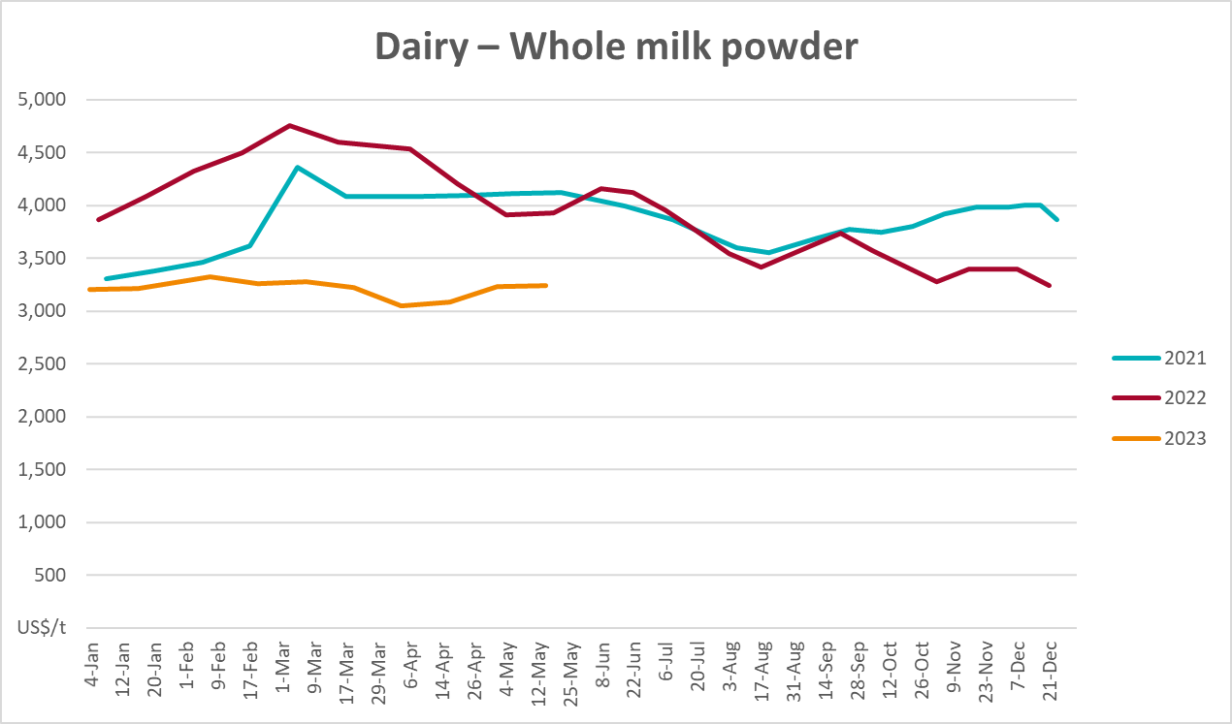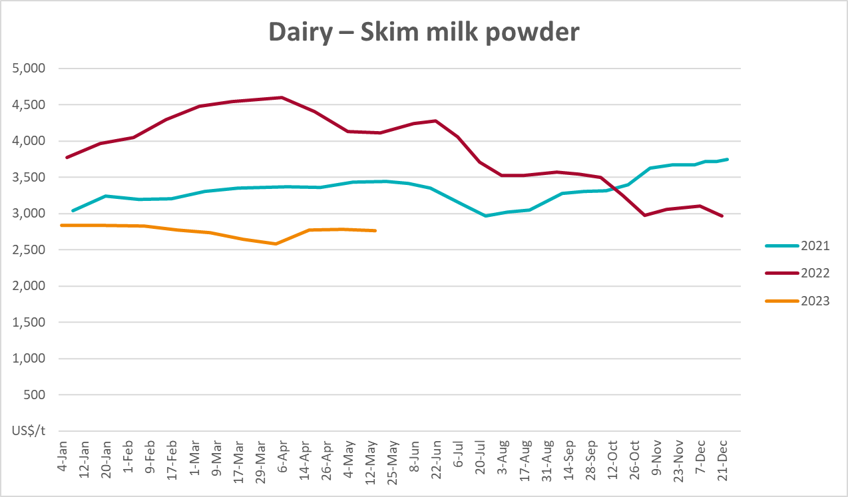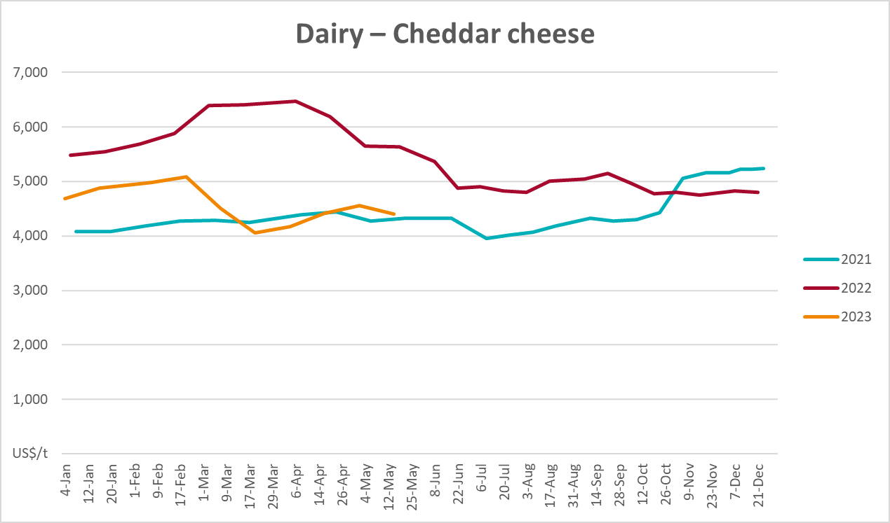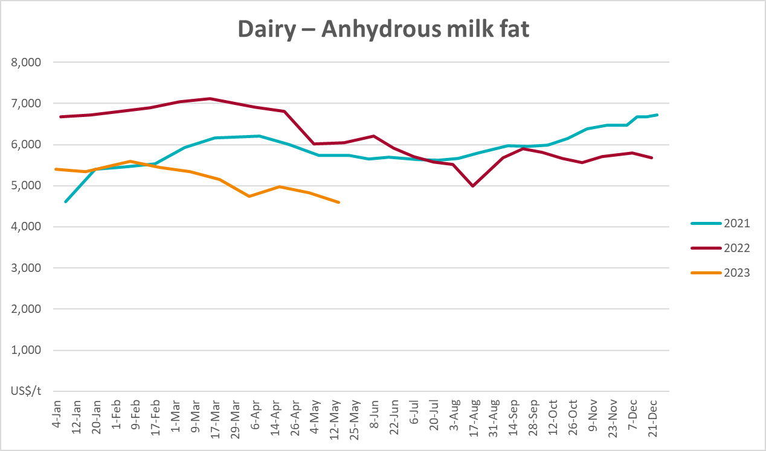

Selected fruit and vegetable prices
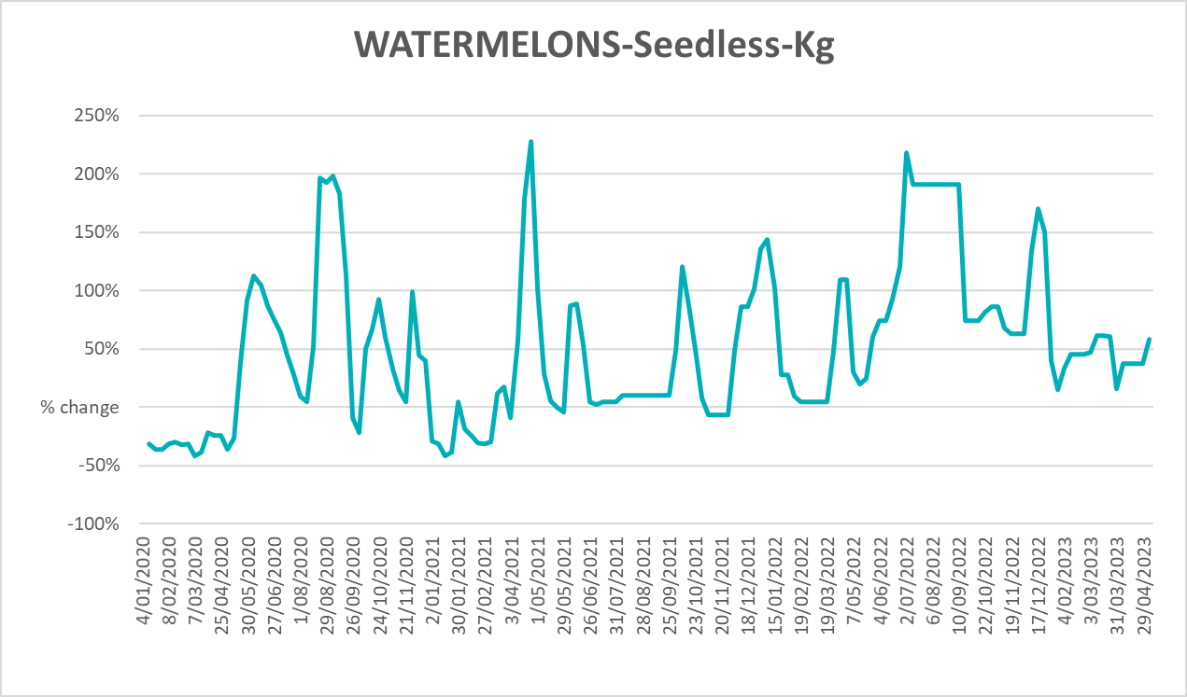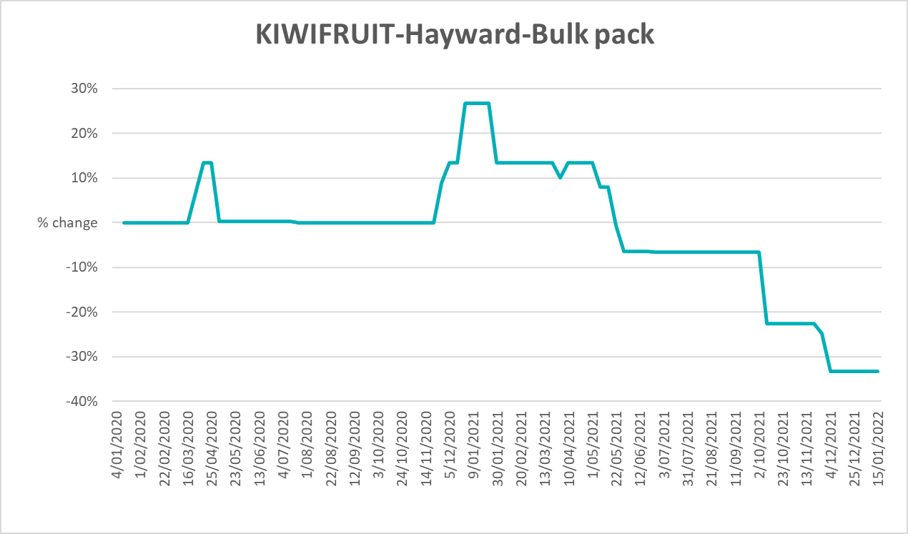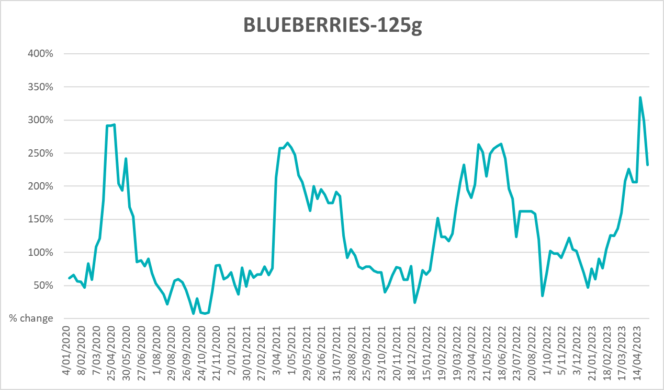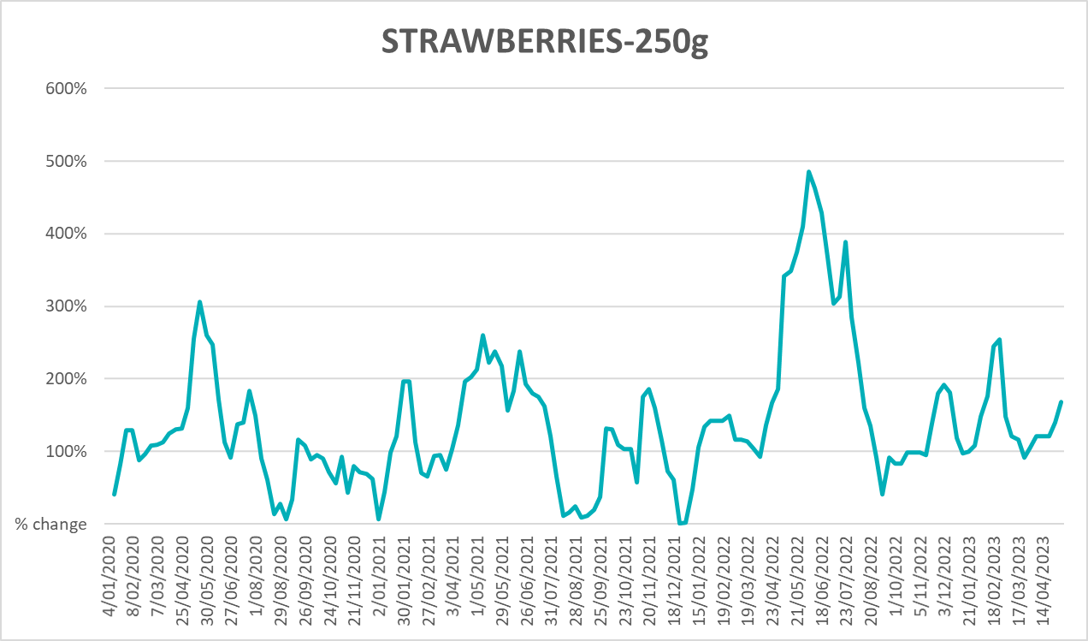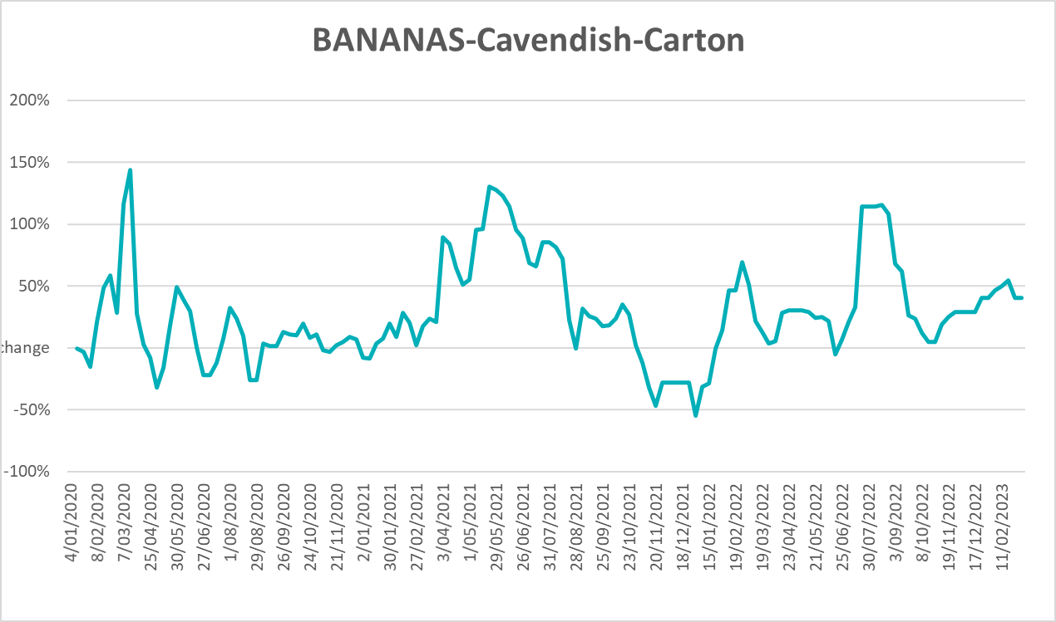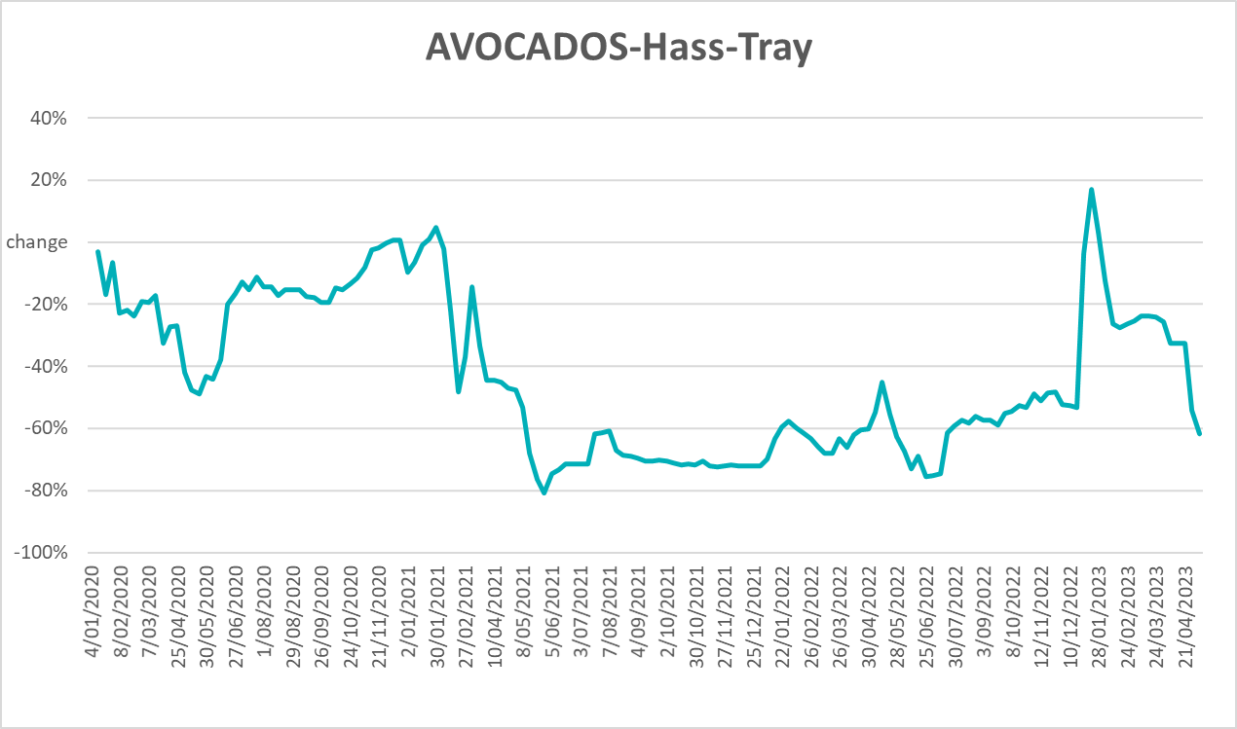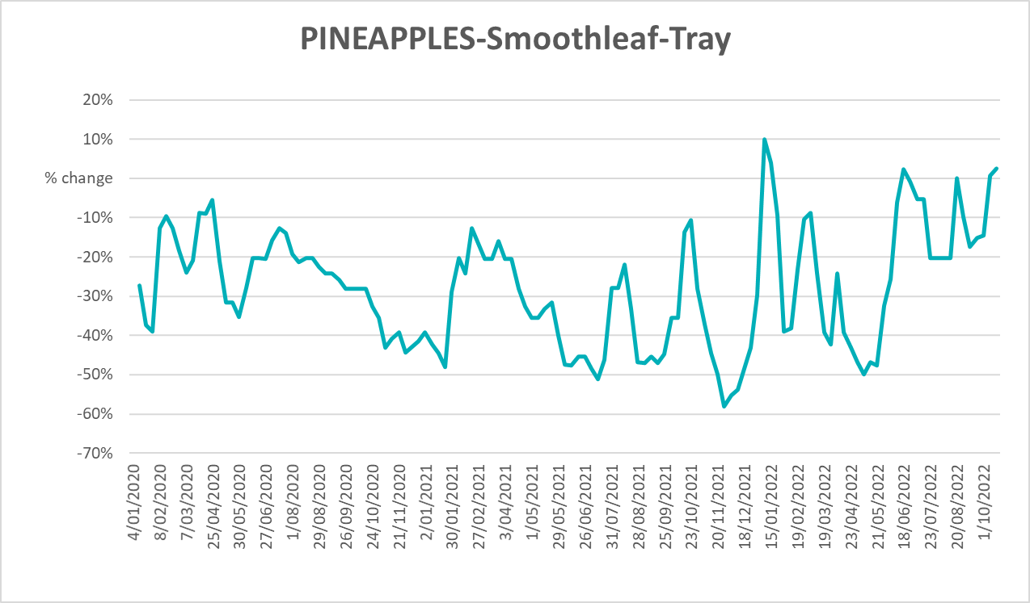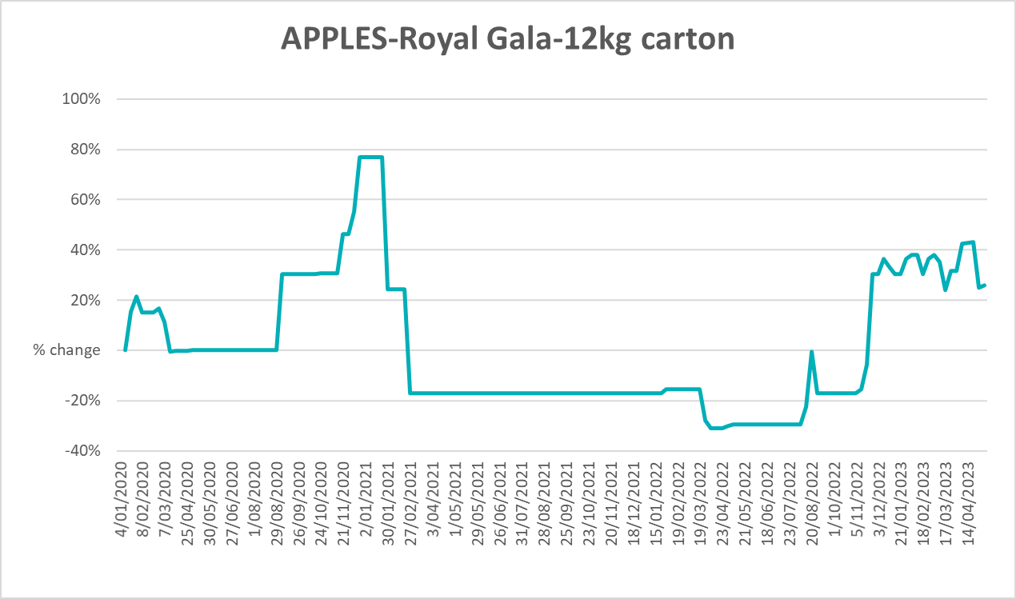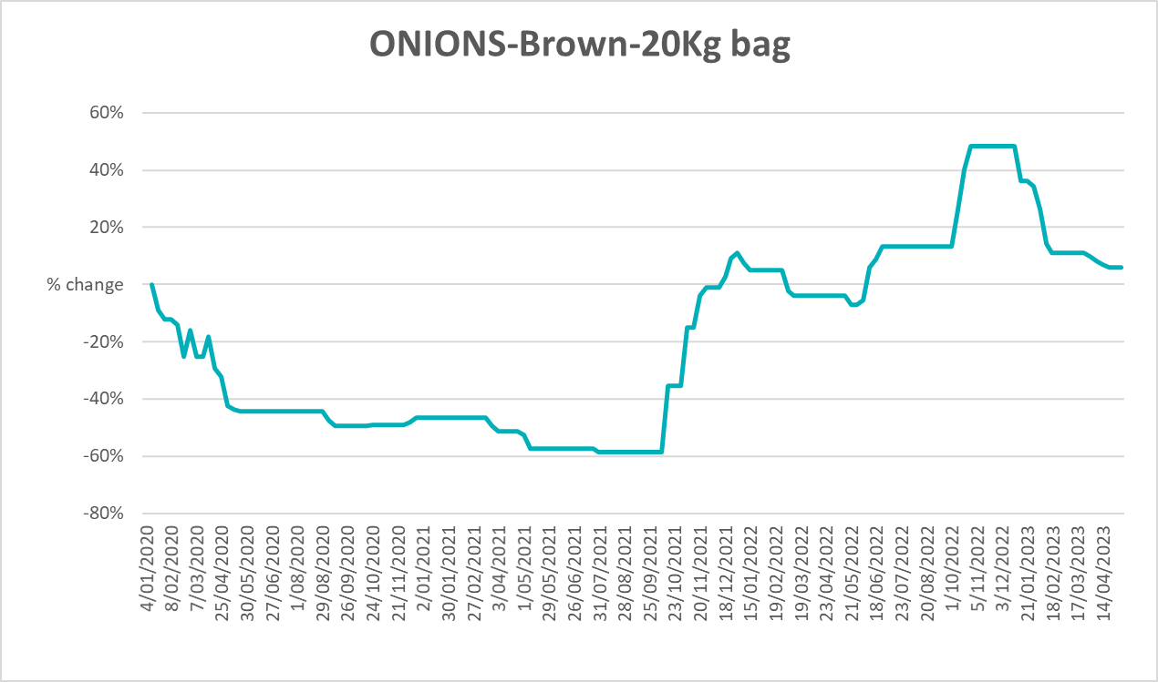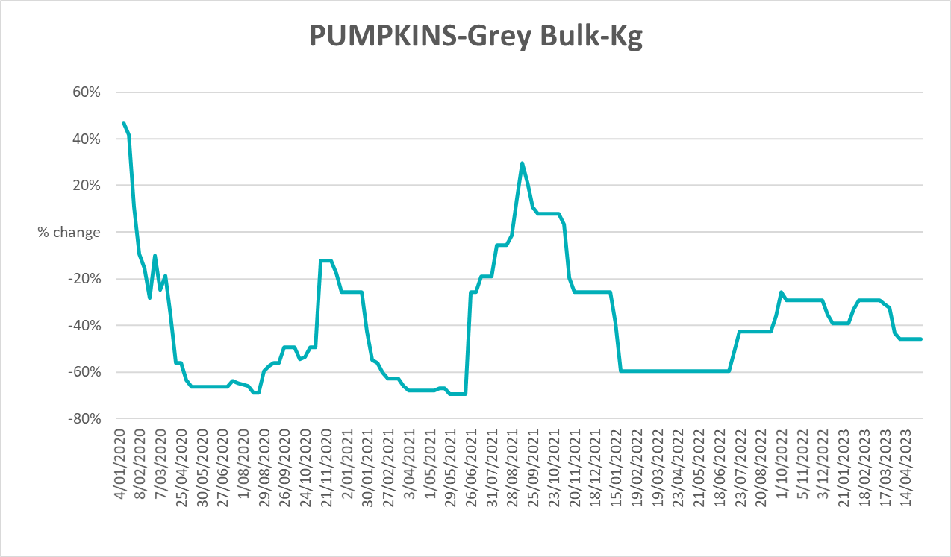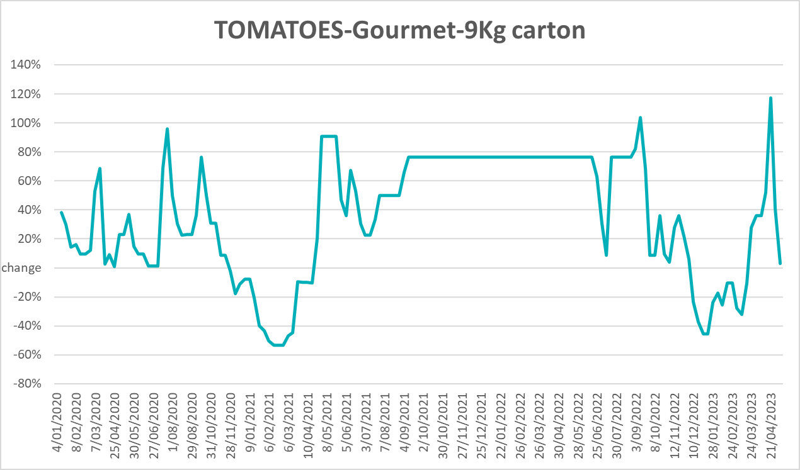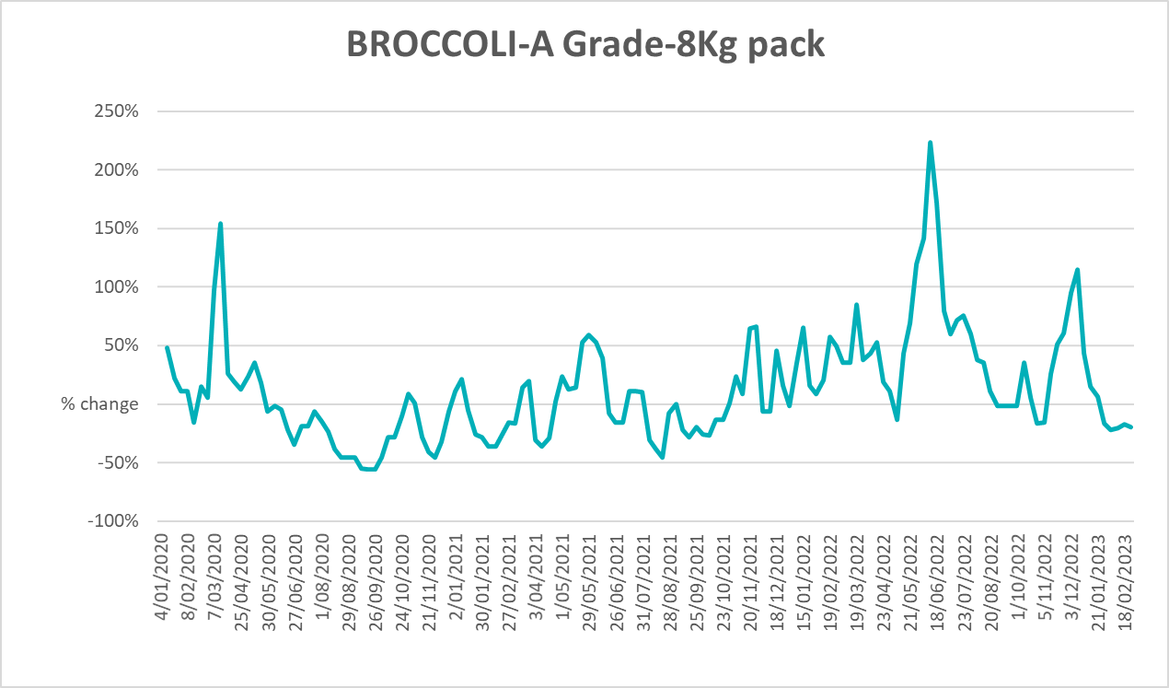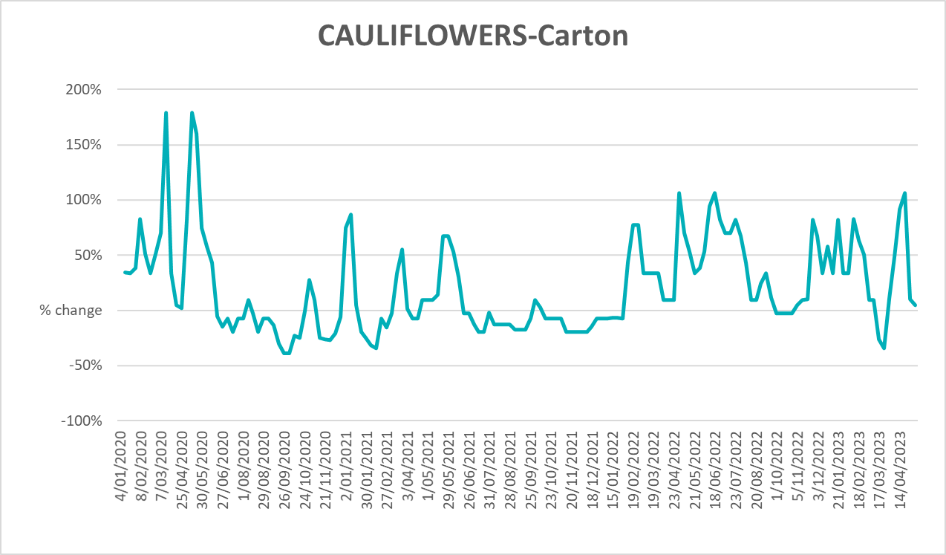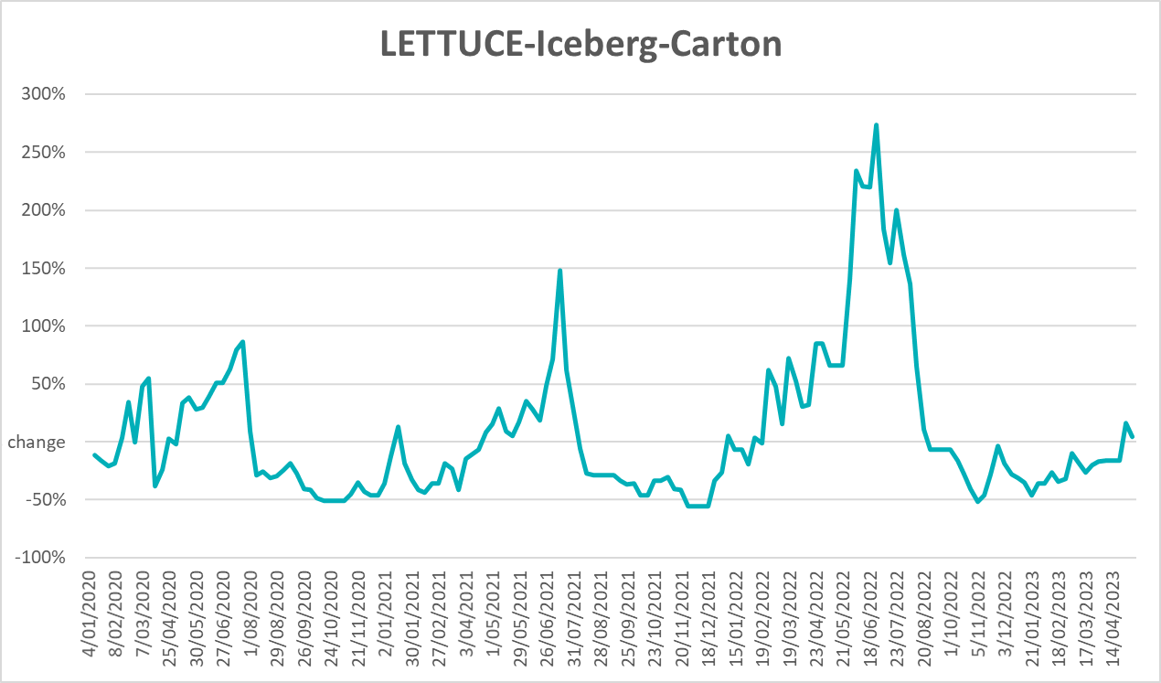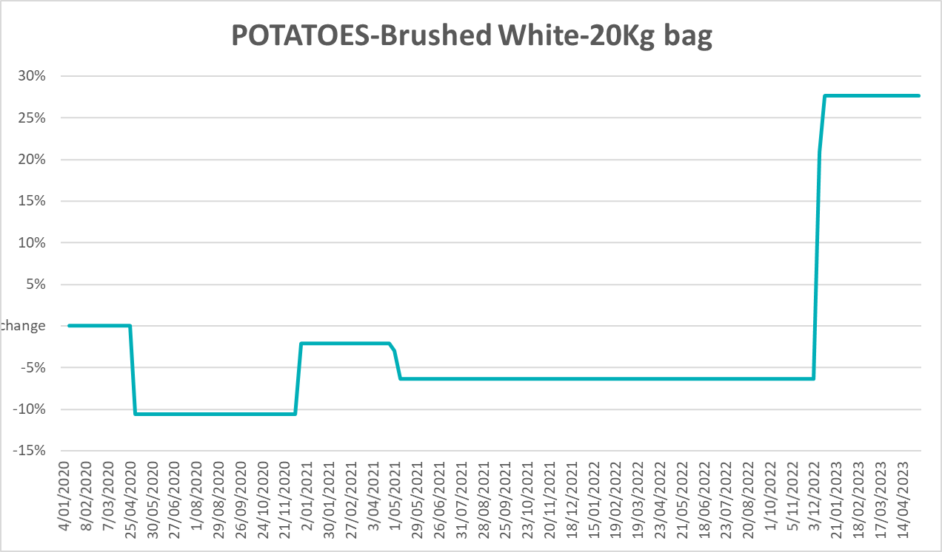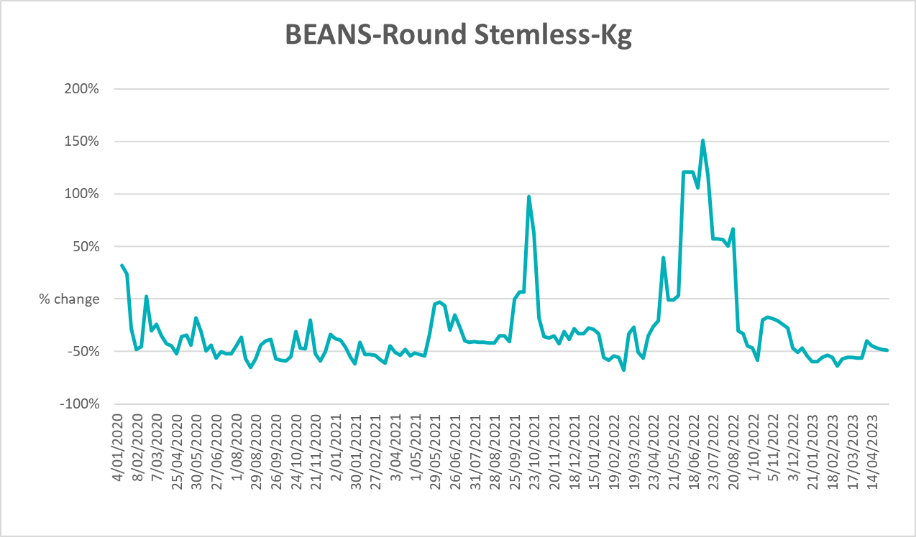

3.6 Selected domestic fodder indicator prices
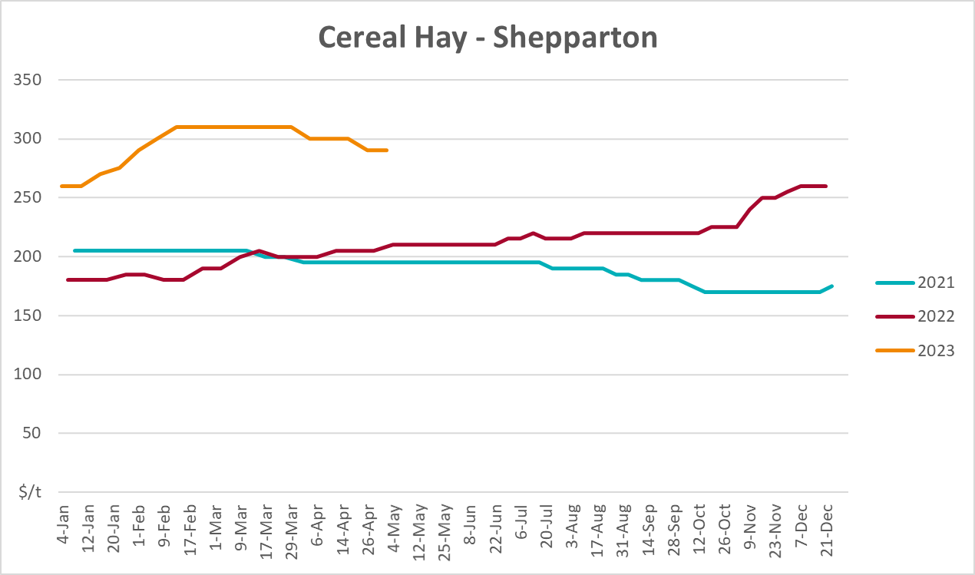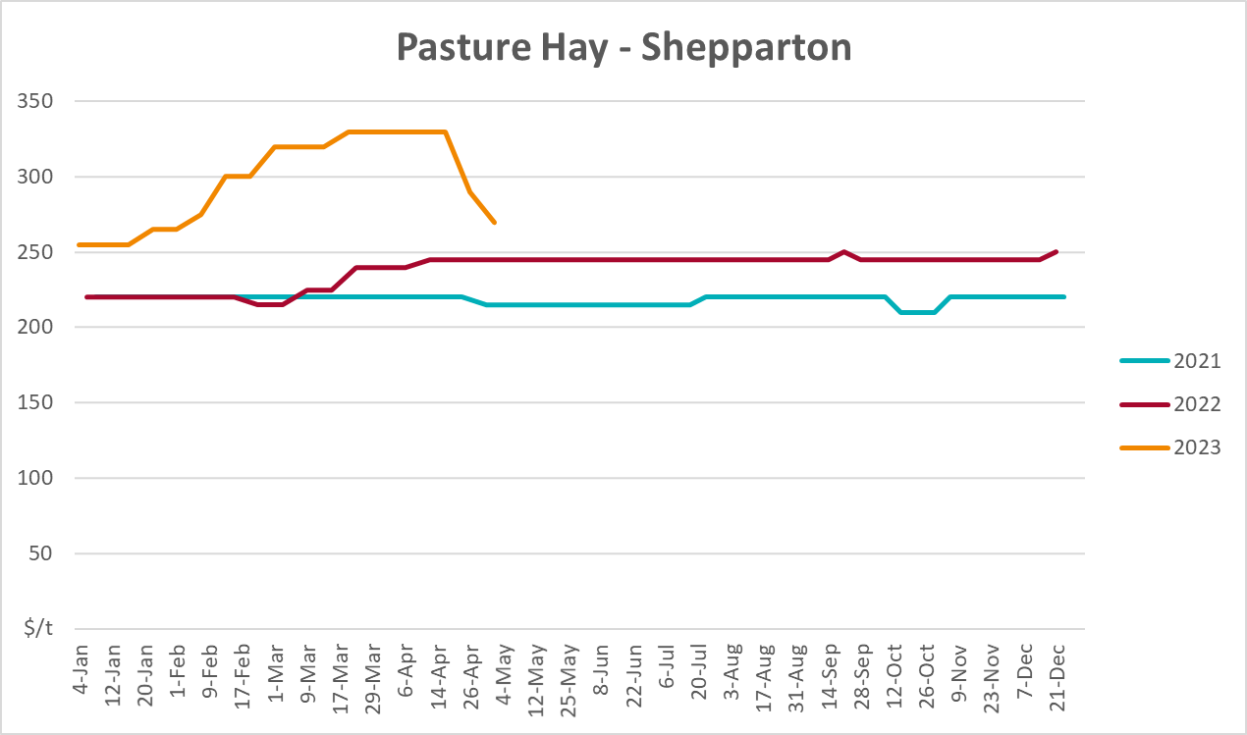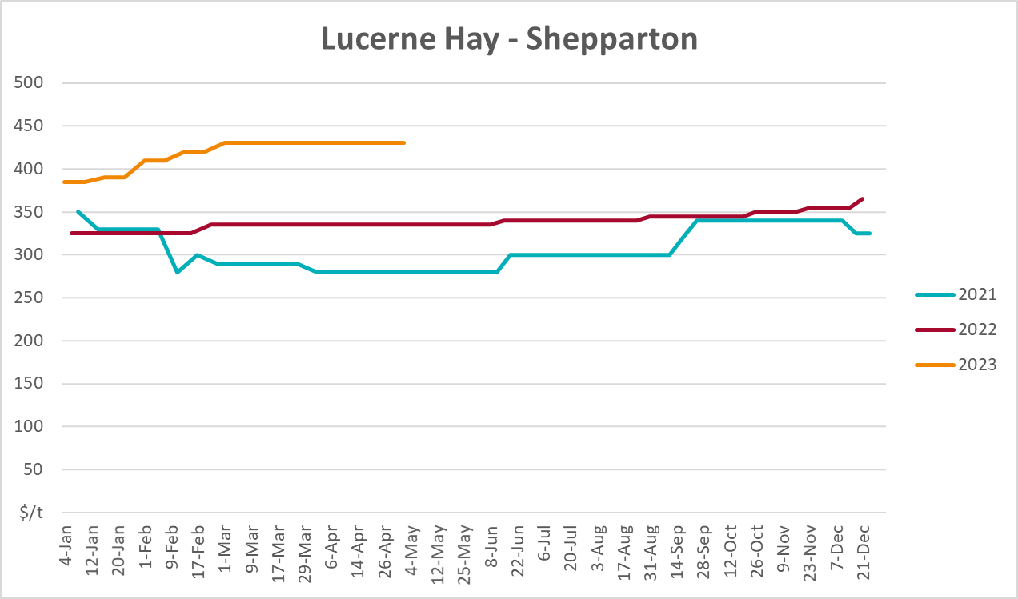

4. Data attribution

Climate
Bureau of Meteorology
- Weekly rainfall totals: www.bom.gov.au/climate/maps/rainfall/
- Monthly and last 3-month rainfall percentiles: www.bom.gov.au/water/landscape/
- Temperature anomalies: www.bom.gov.au/jsp/awap/temp/index.jsp
- Rainfall forecast: www.bom.gov.au/jsp/watl/rainfall/pme.jsp
- Seasonal outlook: www.bom.gov.au/climate/outlooks/#/overview/summary/
- Climate drivers: http://www.bom.gov.au/climate/enso/
- Soil moisture: www.bom.gov.au/water/landscape/
Other
- Pasture growth: www.longpaddock.qld.gov.au/aussiegrass/
- 3-month global outlooks: Environment and Climate Change Canada, NOAA Climate Prediction Center, EUROBRISA CPTEC/INPE, European Centre for Medium-Range Weather Forecasts, Hydrometcenter of Russia, National Climate Center Climate System Diagnosis and Prediction Room (NCC), International Research Institute for Climate and Society
- Global production: https://ipad.fas.usda.gov/ogamaps/cropmapsandcalendars.aspx
- Autumn break: Pook et al., 2009, https://rmets-onlinelibrary-wiley-com.virtual.anu.edu.au/doi/epdf/10.1002/joc.1833

Water
Prices
- Waterflow: https://www.waterflow.io/
- Ruralco: https://www.ruralcowater.com.au/
Bureau of Meteorology:
- Allocation trade: http://www.bom.gov.au/water/dashboards/#/water-markets/mdb/at
- Storage volumes: http://www.bom.gov.au/water/dashboards/#/water-storages/summary/drainage
Trade constraints:
- Water NSW: https://www.waternsw.com.au/customer-service/ordering-trading-and-pricing/trading/murrumbidgee
- Victorian Water Register: https://www.waterregister.vic.gov.au/TradingRules2019/

Commodities
Fruit and vegetables
- Datafresh: www.freshstate.com.au
Pigs
- Australian Pork Limited: www.australianpork.com.au
Dairy
- Global Dairy Trade: www.globaldairytrade.info/en/product-results/
World wheat, canola
- International Grains Council
World coarse grains
- United States Department of Agriculture
World cotton
- Cotlook: www.cotlook.com/
World sugar
- New York Stock Exchange - Intercontinental Exchange
Wool
- Australian Wool Exchange: www.awex.com.au/
Domestic wheat, barley, sorghum, canola and fodder
- Jumbuk Consulting Pty Ltd: http://www.jumbukag.com.au/
Cattle, beef, mutton, lamb, goat and live export
- Meat and Livestock Australia: www.mla.com.au/Prices-and-market
© Commonwealth of Australia 2023

Ownership of intellectual property rights
Unless otherwise noted, copyright (and any other intellectual property rights, if any) in this publication is owned by the Commonwealth of Australia (referred to as the Commonwealth).

Creative Commons licence
All material in this publication is licensed under a Creative Commons Attribution 4.0 International Licence except content supplied by third parties, logos and the Commonwealth Coat of Arms.
Inquiries about the licence and any use of this document should be emailed to copyright@awe.gov.au.


Cataloguing data
This publication (and any material sourced from it) should be attributed as:
ABARES 2023, Weekly Australian Climate, Water and Agricultural Update, Australian Bureau of Agricultural and Resource Economics and Sciences, Canberra, 18 May 2023. CC BY 4.0 DOI: https://doi.org/10.25814/5f3e04e7d2503
ISSN 2652-7561
This publication is available at https://www.agriculture.gov.au/abares/products/weekly_update
Department of Agriculture, Fisheries and Forestry
GPO Box 858 Canberra ACT 2601
Telephone 1800 900 090
Web agriculture.gov.au/abares

Disclaimer
The Australian Government acting through the Department of Agriculture, Fisheries and Forestry, represented by the Australian Bureau of Agricultural and Resource Economics and Sciences, has exercised due care and skill in preparing and compiling the information and data in this publication. Notwithstanding, the Department of Agriculture, Fisheries and Forestry, ABARES, its employees and advisers disclaim all liability, including liability for negligence and for any loss, damage, injury, expense or cost incurred by any person as a result of accessing, using or relying on any of the information or data in this publication to the maximum extent permitted by law.

Statement of Professional Independence
The views and analysis presented in ABARES publications, including this one, reflect ABARES professionally independent findings, based on scientific and economic concepts, principles, information and data. These views, analysis and findings may not reflect or be consistent with the views or positions of the Australian Government, or of organisations or groups who have commissioned ABARES reports or analysis. More information on professional independence is provided on the ABARES website.

Acknowledgements
This report was prepared by Kavina Dayal and Matthew Miller.

