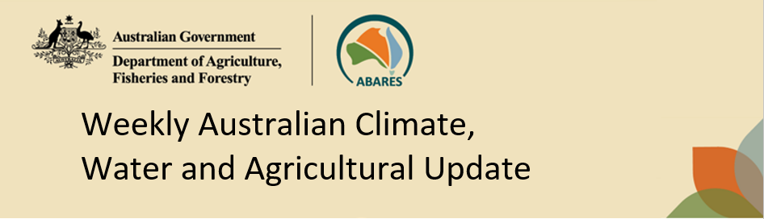
No. 20/2023 25 May 2023

Summary of key issues
- For the week ending 24 May 2023, a high-pressure system kept much of the country dry. Cold fronts moved across south-eastern parts of Australia bringing showers of up to 50 millimetres over parts of southern Victoria, western Tasmania and isolated parts of South Australia. Showers of up to 100 millimetres was recorded in parts of western Tasmania.
- In cropping regions, little to no rainfall was recorded. Clear and dry conditions would have allowed harvest of cotton and planting of winter crops to progress without delay. However, another dry week on top of a very dry finish to April and start to May will be weighting on growers’ confidence to commit to their full planting intentions for 2023 (see Section 1.1).
- The El Niño–Southern Oscillation is in its neutral phase. The El Niño WATCH issued by the Bureau of Meteorology continues. Climate models suggest sea-surface temperatures in the tropical Pacific will exceed El Niño thresholds in June. While the Indian Ocean Dipole (IOD) is currently neutral, a positive IOD event may develop in June. A positive IOD can suppress winter and spring rainfall over much of Australia, potentially exacerbating the drying effect of El Niño (see Section 1.2).
- In cropping regions during winter 2023, there is a 75% chance of receiving between 50 and 100 millimetres in south-eastern New South Wales, southern Victoria, western and central South Australia and Western Australia. In areas of average to above average levels of soil moisture these probable three-month rainfall totals are likely to be sufficient to sustain crop production. There is a similar probability of receiving between 10 and 50 millimetres across much of New South Wales, northern Victoria, Queensland and eastern South Australia. In areas with low soil moisture these three-month rainfall totals are unlikely to be sufficient to sustain crop production (see Section 1.3).
- Over the 8-days to 1 June 2023, a high-pressure system is expected to keep much of the country generally dry. A number of cold fronts crossing southern Australia should bring showers up to 50 millimetres over southern Victoria and South Australia and up to 25 millimetres in far southwest Western Australia. Showers of up to 150 millimetres are expected in Tasmania (see Section 1.4).
- Across Australian cropping regions, little to no rainfall is expected in the next eight days with exceptions in southern Victoria and some of South Australia where up to 25 millimetres is expected. The dry conditions will allow harvest of cotton and dry sowing of winter crops to progress without delay. However, the predicted lack of rainfall also presents a downside risk for winter crops that are starting to show signs of moisture stress following close to 4 weeks without a significant rainfall event in some key growing regions (see Section 1.4).
- Water storage levels in the Murray-Darling Basin (MDB) decreased between 18 May 2023 and 25 May 2023 by 47 gigalitres (GL). Current volume of water held in storage is 20 111 GL. This is 1 percent or 117 GL more than at the same time last year.
- Allocation prices in the Victorian Murray below the Barmah Choke increased from $8 on 18 May 2023 to $19 on 25 May 2023. Prices are lower in the Murrumbidgee due to the binding of the Murrumbidgee export limit.

Climate

Rainfall this week
For the week ending 24 May 2023, a high-pressure system kept much of the country dry. Cold fronts moved across south-eastern parts of Australia bringing showers up to 50 millimetres over parts of southern Victoria, western Tasmania and isolated parts of South Australia. Showers of up to 100 millimetres was recorded in parts of western Tasmania.
Across Australian cropping regions, little to no rainfall was recorded. The clear and dry conditions would have allowed harvest of cotton and planting of winter crops to progress without delay. However, another dry week on top of a very dry finish to April and dry start to May across many growing regions will be weighting on growers’ confidence to commit to their full planting intentions for 2023.

Rainfall for the week ending 24 May 2023
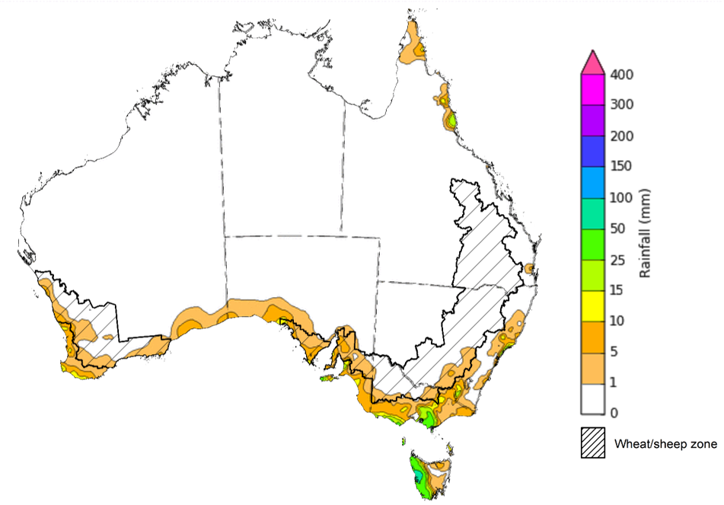
©Commonwealth of Australia 2023, Australian Bureau of Meteorology Issued: 24/05/2023
Note: The rainfall analyses and associated maps utilise data contained in the Bureau of Meteorology climate database, the Australian Data Archive for Meteorology (ADAM). The analyses are initially produced automatically from real-time data with limited quality control. They are intended to provide a general overview of rainfall across Australia as quickly as possible after the observations are received. For further information go to http://www.bom.gov.au/climate/rainfall/

Climate Drivers
The climate drivers with the largest potential impact on Australia’s climate patterns are the El Niño–Southern Oscillation (ENSO), Madden-Julian Oscillation (MJO), Indian Ocean Dipole (IOD) and Southern Annular Mode (SAM). These climate drivers are likely to influence harvest progress of later planted summer crops in northern growing regions, pasture growth across both northern and southern Australia, and planting opportunities and the establishment and growth for winter crops.
The Madden–Julian Oscillation (MJO) pulse is currently over the Western Pacific and is forecast to move into the central Pacific region in the coming week. At this time of the year MJO has little influence on northern Australia rainfall. However, an MJO pulse over the western Pacific would likely weaken trade winds across the equatorial Pacific Ocean. This, in turn, would result in further warming of the equatorial Pacific Ocean and hence drive further development towards El Niño.
The ENSO is currently in its neutral phase and the Bureau of Meteorology’s outlook is still at El Niño WATCH, i.e., chance of an El Niño developing is 50%. Oceanic indicators are measured in terms of the sea surface temperature (SST) anomalies. The weekly difference from average SST between 15 to 21 May the SST were warmer than average over the eastern equatorial Pacific Ocean, with anomalies over 4°C in the far east. Compared to two weeks ago, the warm anomalies have remained similar in strength but extended spatially reaching further westwards.
Atmospheric indicators are measured in terms of the surface air pressure difference between Tahiti and Darwin, called Southern Oscillation Index (SOI). For the period ending 23 May 2023, the 30-day SOI was -12.1 and the 90-day SOI was -2.9. The gradual decrease in both the 30-day and 90-day SOI continue to indicate the formation of an El-Niño event. However, the Western Pacific remains warmer than average, meaning there is little temperature gradient between the Eastern and Western Pacific along the equator. As a result, the atmospheric response, that is the change in the SOI, has been slow.

Difference from average sea surface temperature observations 15 May to 21 May 2023
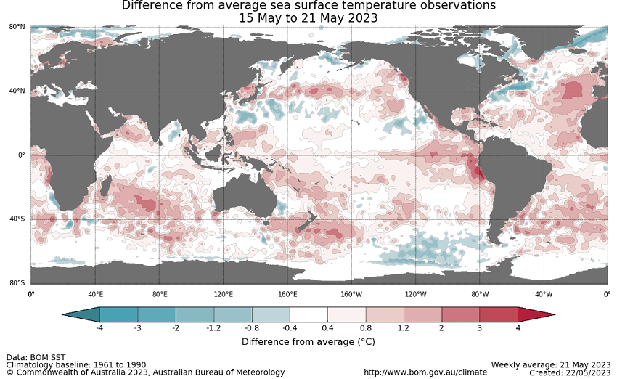

30-day Southern Oscillation Index (SOI) values ending 23 May 2023
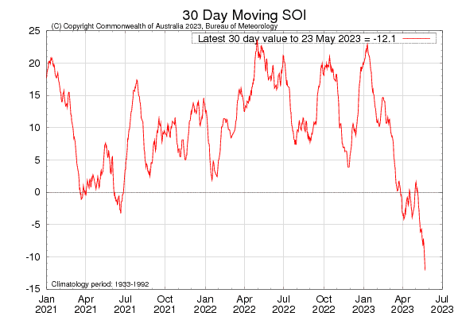

All but one international climate model surveyed by the Australian Bureau of Meteorology suggest sea-surface temperatures in the tropical Pacific will exceed El Niño thresholds in June.

International climate model outlooks for the ENSO in NINO 3.4 region
INCLUDEPICTURE "http://www.bom.gov.au/climate/model-summary/archive/20230523.nino_summary_2.png" \* MERGEFORMATINET INCLUDEPICTURE "http://www.bom.gov.au/climate/model-summary/archive/20230523.nino_summary_2.png" \* MERGEFORMATINET INCLUDEPICTURE "http://www.bom.gov.au/climate/model-summary/archive/20230523.nino_summary_2.png" \* MERGEFORMATINET INCLUDEPICTURE "http://www.bom.gov.au/climate/model-summary/archive/20230523.nino_summary_2.png" \* MERGEFORMATINET INCLUDEPICTURE "http://www.bom.gov.au/climate/model-summary/archive/20230523.nino_summary_2.png" \* MERGEFORMATINET INCLUDEPICTURE "http://www.bom.gov.au/climate/model-summary/archive/20230523.nino_summary_2.png" \* MERGEFORMATINET INCLUDEPICTURE "http://www.bom.gov.au/climate/model-summary/archive/20230523.nino_summary_2.png" \* MERGEFORMATINET 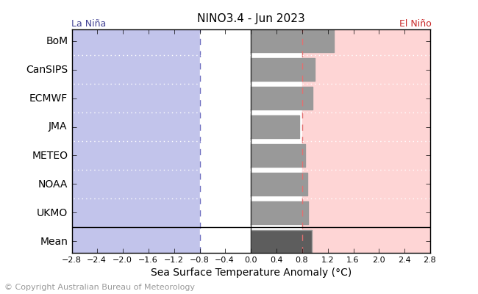
©Commonwealth of Australia 2023, Australian Bureau of Meteorology Issued: 23/5/2023

The Indian Ocean Dipole (IOD) is currently neutral. A negative phase typically sees above average winter-spring rainfall in Australia, while a positive phase brings drier than average seasons. All international climate models surveyed by the Bureau of Meteorology suggest a positive IOD event may develop in June. A positive IOD can supress winter and spring rainfall over much of central and south-eastern Australia, potentially exacerbating the drying effect of El Niño.

International climate model outlook for the Indian Ocean Dipole
INCLUDEPICTURE "http://www.bom.gov.au/climate/model-summary/archive/20230523.iod_summary_2.png" \* MERGEFORMATINET INCLUDEPICTURE "http://www.bom.gov.au/climate/model-summary/archive/20230523.iod_summary_2.png" \* MERGEFORMATINET INCLUDEPICTURE "http://www.bom.gov.au/climate/model-summary/archive/20230523.iod_summary_2.png" \* MERGEFORMATINET INCLUDEPICTURE "http://www.bom.gov.au/climate/model-summary/archive/20230523.iod_summary_2.png" \* MERGEFORMATINET INCLUDEPICTURE "http://www.bom.gov.au/climate/model-summary/archive/20230523.iod_summary_2.png" \* MERGEFORMATINET INCLUDEPICTURE "http://www.bom.gov.au/climate/model-summary/archive/20230523.iod_summary_2.png" \* MERGEFORMATINET INCLUDEPICTURE "http://www.bom.gov.au/climate/model-summary/archive/20230523.iod_summary_2.png" \* MERGEFORMATINET 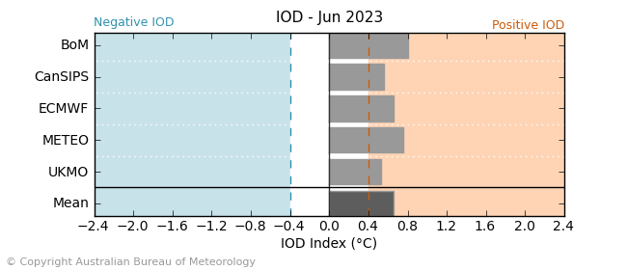
©Commonwealth of Australia 2023, Australian Bureau of Meteorology Issued: 23/5/2023

The Southern Annular Mode (SAM) index is currently positive and is expected to return to neutral towards the end of May. SAM typically has a weaker influence on Australian rainfall during autumn, but during winter, a positive SAM often has a drying influence for parts of south-west and south-east Australia.
Southern Annular Mode (SAM) daily index
INCLUDEPICTURE "http://www.bom.gov.au/clim_data/IDCK000080/sam_index.daily.20230522.png?1684894110703" \* MERGEFORMATINET INCLUDEPICTURE "http://www.bom.gov.au/clim_data/IDCK000080/sam_index.daily.20230522.png?1684894110703" \* MERGEFORMATINET INCLUDEPICTURE "http://www.bom.gov.au/clim_data/IDCK000080/sam_index.daily.20230522.png?1684894110703" \* MERGEFORMATINET INCLUDEPICTURE "http://www.bom.gov.au/clim_data/IDCK000080/sam_index.daily.20230522.png?1684894110703" \* MERGEFORMATINET INCLUDEPICTURE "http://www.bom.gov.au/clim_data/IDCK000080/sam_index.daily.20230522.png?1684894110703" \* MERGEFORMATINET INCLUDEPICTURE "http://www.bom.gov.au/clim_data/IDCK000080/sam_index.daily.20230522.png?1684894110703" \* MERGEFORMATINET INCLUDEPICTURE "http://www.bom.gov.au/clim_data/IDCK000080/sam_index.daily.20230522.png?1684894110703" \* MERGEFORMATINET 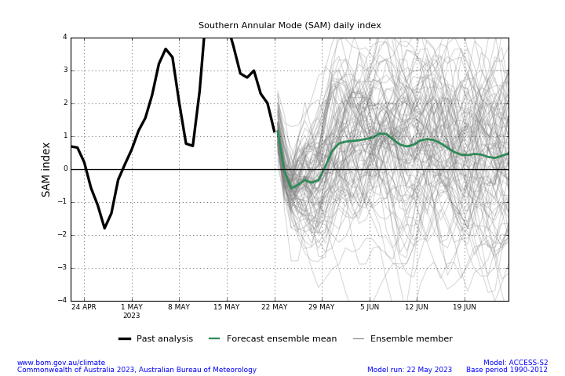

National Climate Outlook
These climate outlooks are generated by ACCESS–S (Australian Community Climate Earth-System Simulator–Seasonal). ACCESS–S is the Bureau of Meteorology's dynamic (physics-based) weather and climate model used for monthly, seasonal, and longer-lead climate outlooks. For further information, go to http://www.bom.gov.au/climate/ahead/about/.
The Bureau of Meteorology’s latest rainfall outlook for June 2023 indicates drier than average conditions are expected across much of Australia.
The ACCESS-S climate model suggests that there is a 75% chance of rainfall totals between 10 and 50 millimetres across parts of eastern New South Wales, scattered areas of coastal Queensland, southern Victoria and South Australia, much of Tasmania, and the southwest of Western Australia. Rainfall totals in excess of 100 millimetres are expected across western Tasmania.
There is a 75% chance of rainfall totals of between 10 and 25 millimetres across most Western Australia cropping regions as well as in the western and central South Australia, and the far south of Victoria and south-eastern New South Wales. June rainfall totals are expected to be below 10 millimetres in the remaining cropping regions. While many southern Australian winter cropping regions received enough rainfall to constitute a consolidated autumn break in March and April, May rainfall totals have been well below average.
In those areas that are likely to see June rainfall totals in excess of 10 millimetres, these falls are likely to be sufficient to sustain plant growth in early planted crops and provide sufficient moisture to germinate dry sown crops. However, for those regions that have seen a significant decline in soil moisture level on the back of a very dry May the expectation of rainfall totals of below 10 millimetres presents a significant downside risk for winter crop production.
Rainfall totals that have a 75% chance of occurring in June 2023
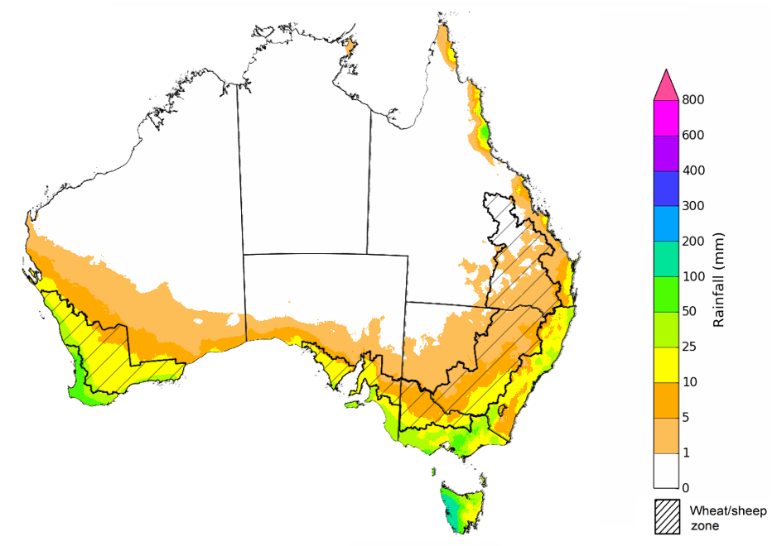
©Commonwealth of Australia 2023, Australian Bureau of Meteorology Issued: 25/05/2023

The rainfall outlook for June to August 2023 suggests that below median rainfall is likely to very likely (60% to greater than 80% chance) for much of Australia. However, there is close to equal chances of above or below median rainfall for parts of tropical Queensland and coastal New South Wales as well as in the southern Tasmania.
Bureau of Meteorology rainfall outlooks for June to August have greater than 55% past accuracy across most of Australia. Outlook accuracy is greater than 65% across large areas of western and eastern Australia. However, there is low past accuracy for scattered areas of northern Australia.
Chance of exceeding the median rainfall June to August 2023
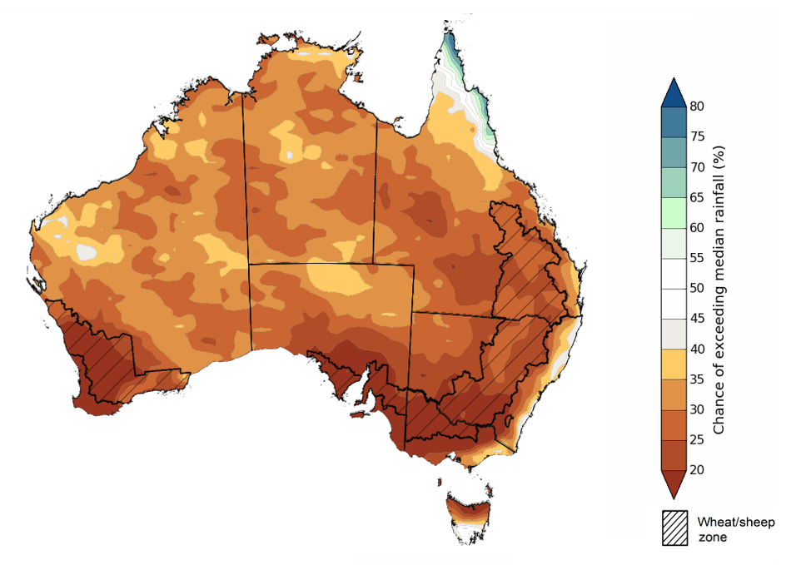
©Commonwealth of Australia 2023, Australian Bureau of Meteorology Issued: 25/05/2023

The outlook for June to August 2023 suggests there is a 75% chance of rainfall totals between 25 and 200 millimetres across central and eastern New South Wales, parts of southeast and coastal Queensland, southern parts of South Australia and Western Australia, and much of Victoria and Tasmania. Rainfall totals more than 200 millimetres are forecast for alpine regions of Victoria and New South Wales (snowy mountains), part of coastal northeast Queensland, far southwest of Western Australia and western Tasmania.
In cropping regions, there is a 75% chance of receiving between 50 and 100 millimetres in south-eastern New South Wales, southern Victoria, western and central South Australia and Western Australia between June and August 2023. In areas of average to above average levels of soil moisture these probable three-month rainfall totals are likely to be sufficient to sustain crop production.
There is a similar probability of receiving between 10 and 50 millimetres across much of New South Wales, northern Victoria, Queensland and eastern South Australia. In areas with low soil moisture these probable low three-month rainfall totals are unlikely to be sufficient to sustain crop production.
Rainfall totals that have a 75% chance of occurring June to August 2023 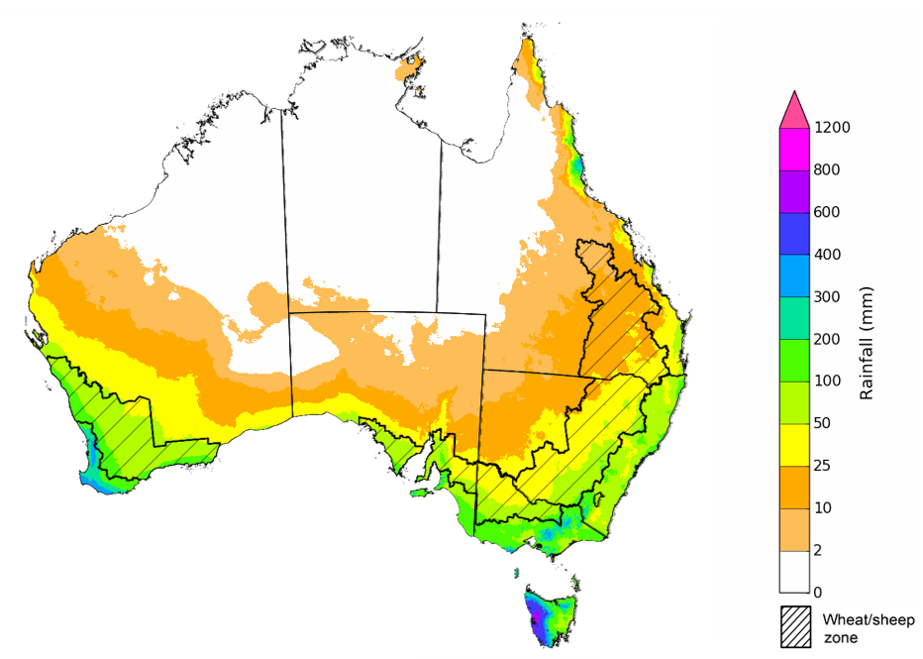
©Commonwealth of Australia 2023, Australian Bureau of Meteorology Issued: 25/05/2023

The temperature outlook for June to August 2023 indicates that maximum temperatures across the northern Australia, coastal east and Tasmania are likely to be close to the 1990-2012 average (-1°C to +1°C) while warmer (above +1°C) across much of southern Australia. The daytime temperatures in western parts of Western Australia are likely to be even warmer (above +2°C). The minimum temperatures across most of Australia are expected to be close to the 1990-2012 average (-1°C to +1°C). The night-time temperatures in western parts of Western Australia are likely to be even warmer (above +1°C).
Predicted maximum temperature anomaly for June to August 2023
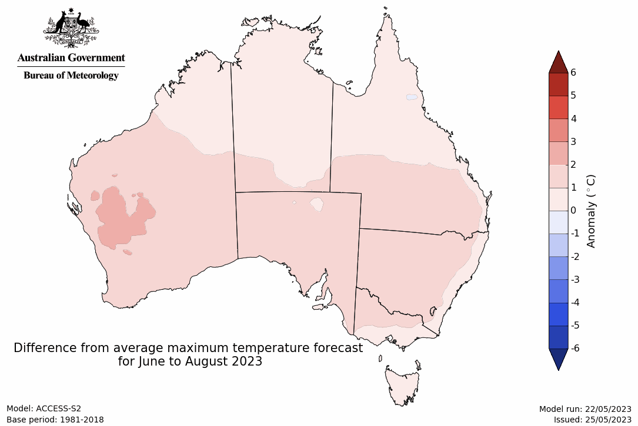
Predicted minimum temperature anomaly for June to August 2023
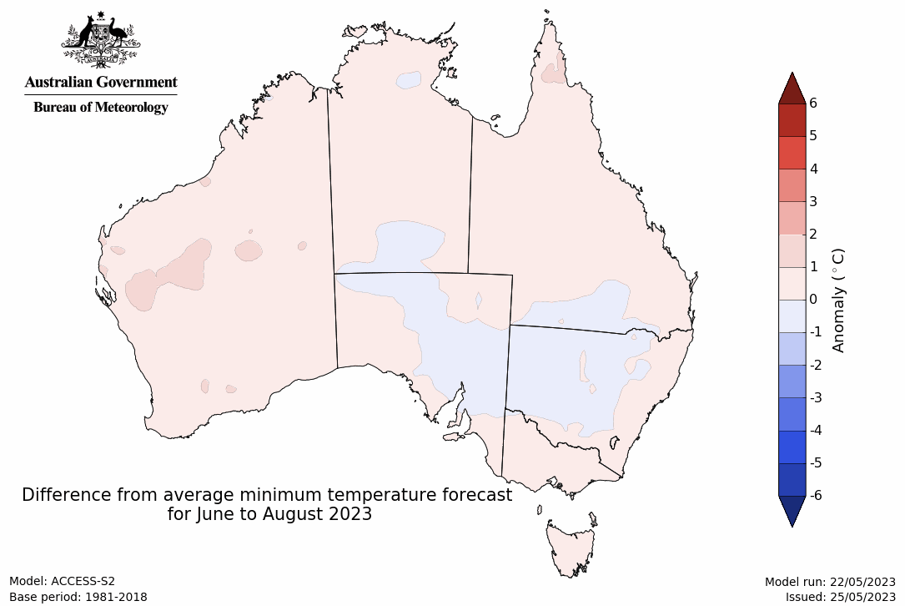

Rainfall forecast for the next eight days
Over the 8-days to 1 June 2023, a high-pressure system is expected to keep much of the country generally dry. A number of cold fronts crossing southern Australia should bring showers up to 50 millimetres over southern Victoria and South Australia and up to 25 millimetres in far southwest Western Australia. Showers of up to 150 millimetres are expected in Tasmania.
Across Australian cropping regions, little to no rainfall is expected in the next eight days with exceptions in southern Victoria and some of South Australia where up to 25 millimetres is expected. The dry conditions will allow harvest of cotton and dry sowing of winter crops to progress without delay. However, the predicted lack of rainfall also presents a downside risk for winter crops that are starting to show signs of moisture stress following close to 4 weeks without a significant rainfall even in some key growing regions.

Total forecast rainfall for the period 25 May 2023 to 1 June 2023
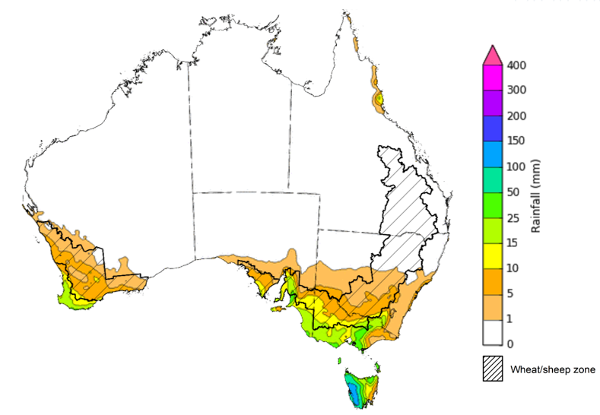

©Commonwealth of Australia 2023, Australian Bureau of Meteorology Issued 25/05/2023
Note: This rainfall forecast is produced from computer models. As the model outputs are not altered by weather forecasters, it is important to check local forecasts and warnings issued by the Bureau of Meteorology.

Water

Water markets – current week
Water storage levels in the Murray-Darling Basin (MDB) decreased between 18 May 2023 and 25 May 2023 by 47 gigalitres (GL). Current volume of water held in storage is 20 111 GL. This is 1 percent or 117 GL more than at the same time last year.

Water storages in the Murray-Darling Basin, 2013–2023
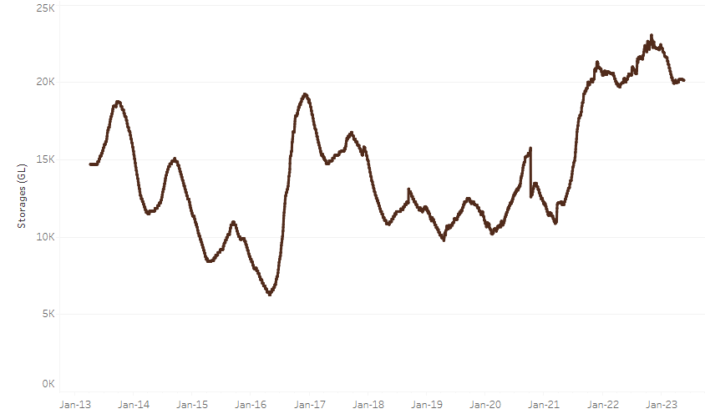
Allocation prices in the Victorian Murray below the Barmah Choke increased from $8 on 18 May 2023 to $19 on 25 May 2023. Prices are lower in the Murrumbidgee due to the binding of the Murrumbidgee export limit.
Water storage data is sourced from the Bureau of Meteorology.

Region | $/ML
NSW Murray Above | 7
NSW Murrumbidgee | 3
VIC Goulburn-Broken | 18
VIC Murray Below | 19

Surface water trade activity, Southern Murray–Darling Basin
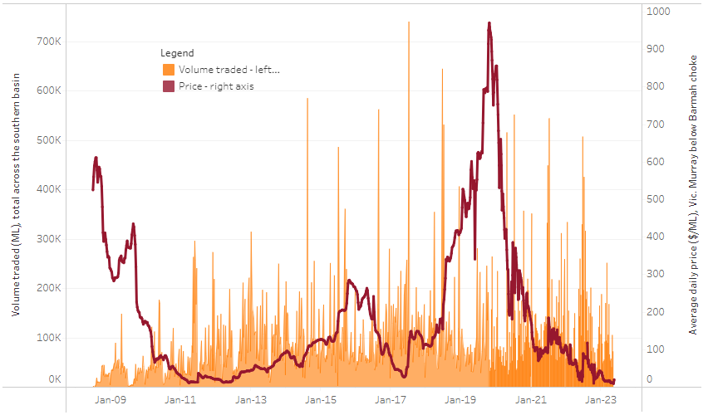
The trades shown reflect estimated market activity and do not encompass all register trades. The price is shown for the VIC Murray below the Barmah choke. Historical prices (before 1 July 2019) are ABARES estimates after removing outliers from BOM water register data. Prices after 1 July 2019 and prior to the 30 October 2019 reflect recorded transaction prices as sourced from Ruralco. Prices after the 30 October 2019 are sourced from Waterflow. Data for volume traded is sourced from the BOM water register. Only the price data shown is current on 25 May 2023.

To access the full, interactive, weekly water dashboard, which contains the latest and historical water storage, water market and water allocation information, please visit https://www.agriculture.gov.au/abares/products/weekly_update/weeakly-update-25523

Commodities
Indicator | Week ended | Unit | Latest Price | Previous Week | Weekly change | Price 12 months ago | Annual change
Selected world indicator prices
AUD/USD Exchange rate | 24-May | A$/US$ | 0.66 | 0.67 | -1% | 0.72 | -8%
Wheat – US no. 2 hard red winter wheat, fob Gulf | 24-May | US$/t | 367 | 390 | -6% | 479 | -23%
Corn – US no. 2 yellow corn, fob Gulf | 24-May | US$/t | 261 | 271 | -4% | 329 | -21%
Canola – Rapeseed, Canada, fob Vancouver | 24-May | US$/t | 567 | 591 | -4% | 966 | -41%
Cotton – Cotlook 'A' Index | 24-May | USc/lb | 96 | 93 | 3% | 157 | -39%
Sugar – Intercontinental Exchange, nearby futures, no.11 contract | 24-May | USc/lb | 25.9 | 25.8 | 0% | 20 | 32%
Wool – Eastern Market Indicator | 17-May | Ac/kg clean | 1,214 | 1,263 | -4% | 1,369 | -11%
Wool – Western Market Indicator | 17-May | Ac/kg clean | 1,337 | 1,402 | -5% | 1,444 | -7%
Selected Australian grain export prices
Milling Wheat – APW, Port Adelaide, SA | 24-May | A$/t | 442 | 441 | 0% | 611 | -28%
Feed Wheat – ASW, Port Adelaide, SA | 24-May | A$/t | 413 | 412 | 0% | 576 | -28%
Feed Barley – Port Adelaide, SA | 24-May | A$/t | 379 | 382 | -1% | 540 | -30%
Canola – Kwinana, WA | 24-May | A$/t | 818 | 859 | -5% | 1,270 | -36%
Grain Sorghum – Brisbane, QLD | 24-May | A$/t | 457 | 462 | -1% | 456 | 0%
Selected domestic livestock indicator prices
Beef – Eastern Young Cattle Indicator | 24-May | Ac/kg cwt | 600 | 613 | -2% | 1,098 | -45%
Mutton – Mutton indicator (18–24 kg fat score 2–3), Vic | 24-May | Ac/kg cwt | 375 | 349 | 7% | 617 | -39%
Lamb – Eastern States Trade Lamb Indicator | 24-May | Ac/kg cwt | 599 | 599 | 0% | 779 | -23%
Pig – Eastern Seaboard (60.1–75 kg), average of buyers & sellers | 03-May | Ac/kg cwt | 357 | 357 | 0% | 368 | -3%
Goats – Eastern States (12.1–16 kg) | 05-Apr | Ac/kg cwt | 280 | 280 | 0% | 815 | -66%
Live cattle – Light steers ex Darwin to Indonesia | 17-Aug | Ac/kg lwt | 420 | 480 | -13% | 320 | 31%
Live sheep – Live wethers (Muchea WA saleyard) to Middle East | 14-Sep | $/head | 93 | 113 | -18% | 114 | -18%
Global Dairy Trade (GDT) weighted average prices ª
Dairy – Whole milk powder | 17-May | US$/t | 3,244 | 3,230 | 0% | 4,115 | -21%
Dairy – Skim milk powder | 17-May | US$/t | 2,766 | 2,787 | -1% | 3,433 | -19%
Dairy – Cheddar cheese | 17-May | US$/t | 4,407 | 4,561 | -3% | 4,274 | 3%
Dairy – Anhydrous milk fat | 17-May | US$/t | 4,600 | 4,832 | -5% | 5,730 | -20%
a Global Dairy Trade prices are updated twice monthly on the first and third Tuesday of each month.

Selected world indicator prices
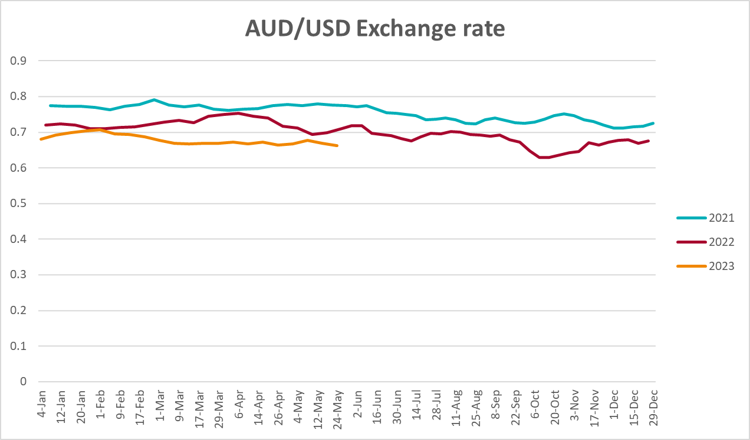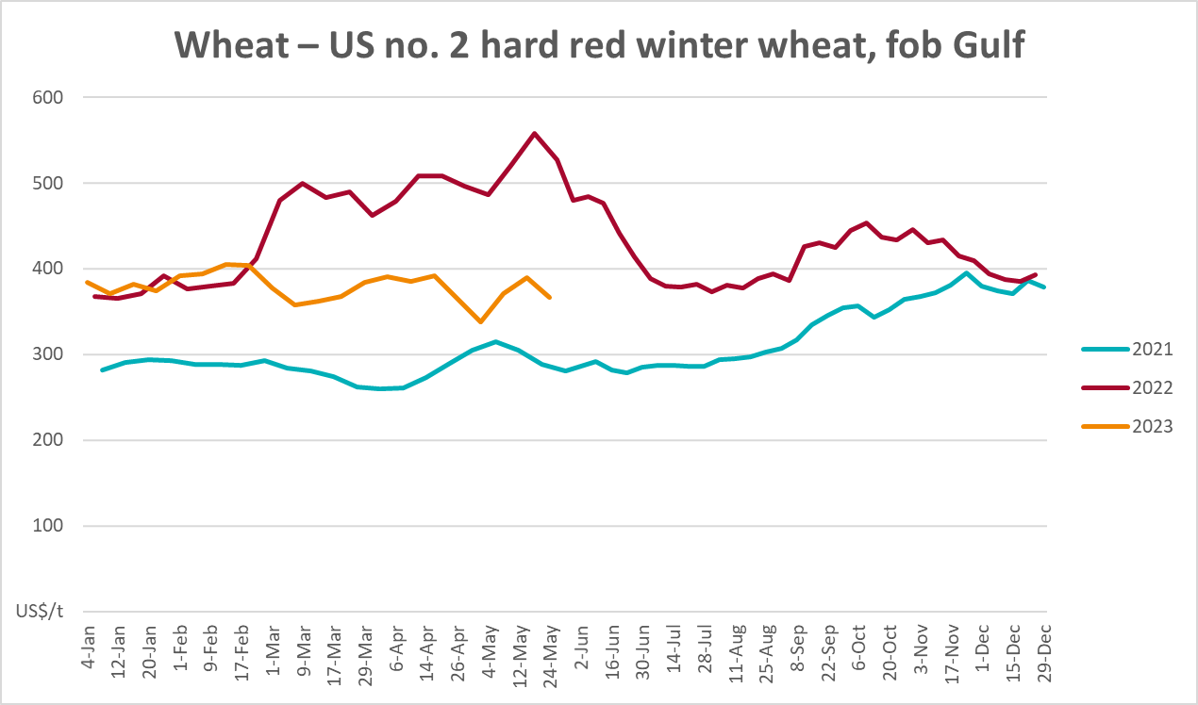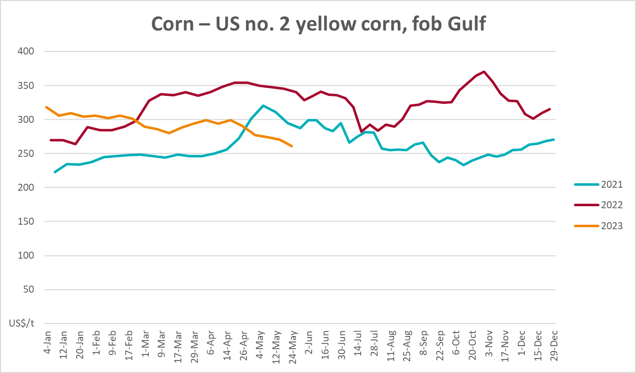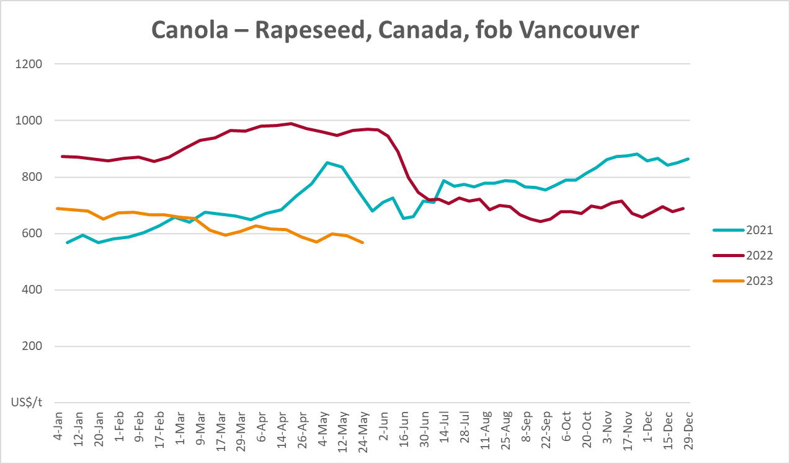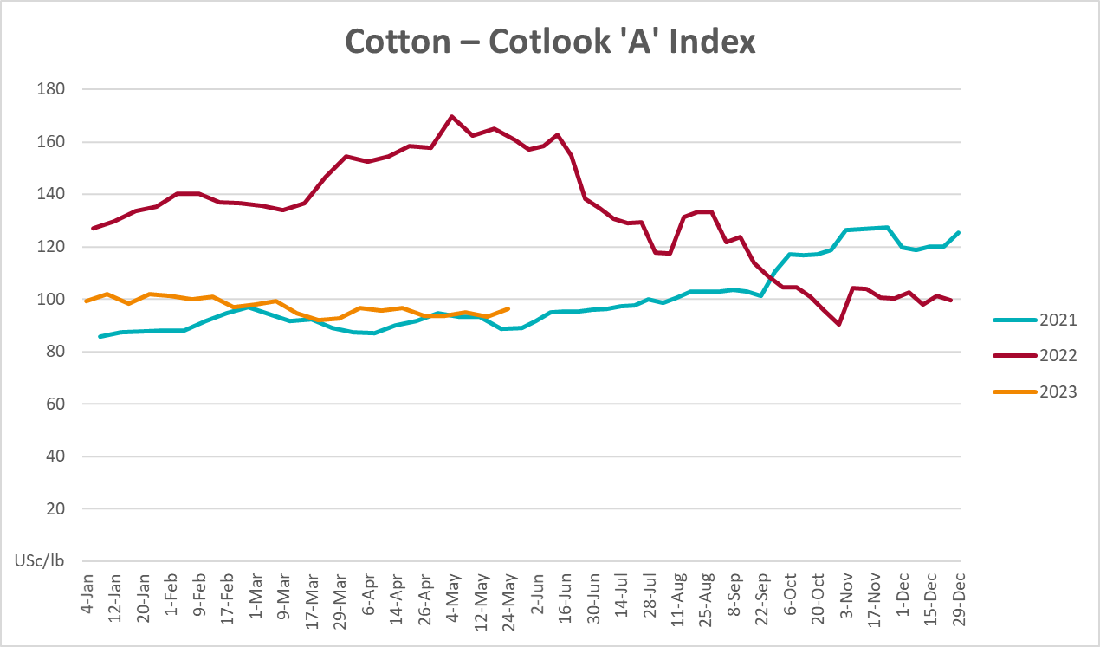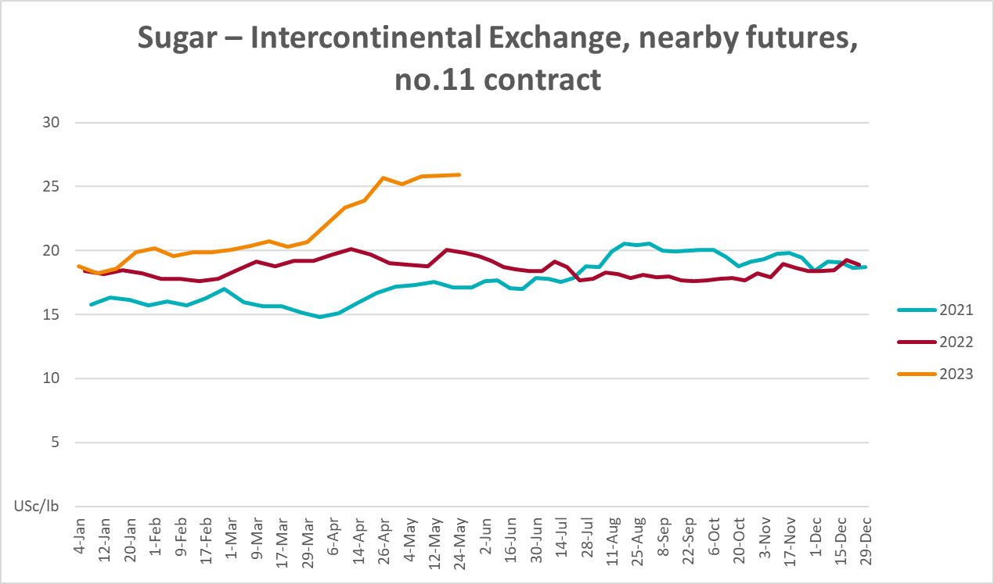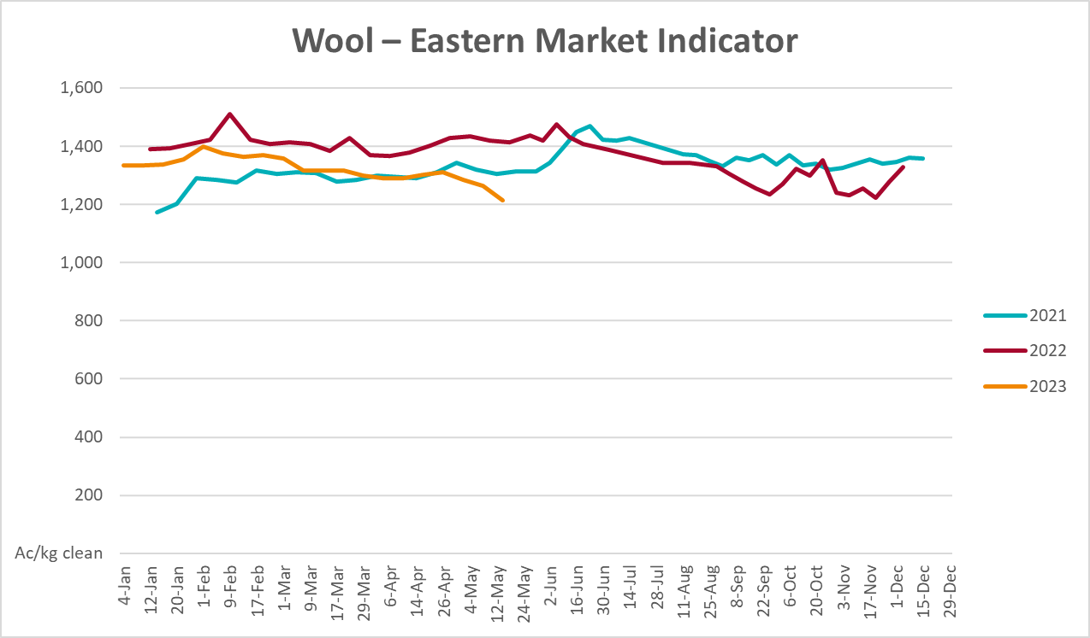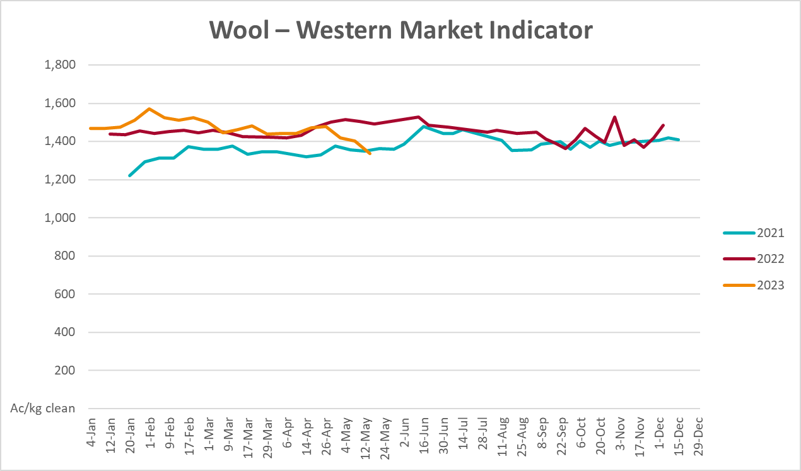

Selected domestic crop indicator prices
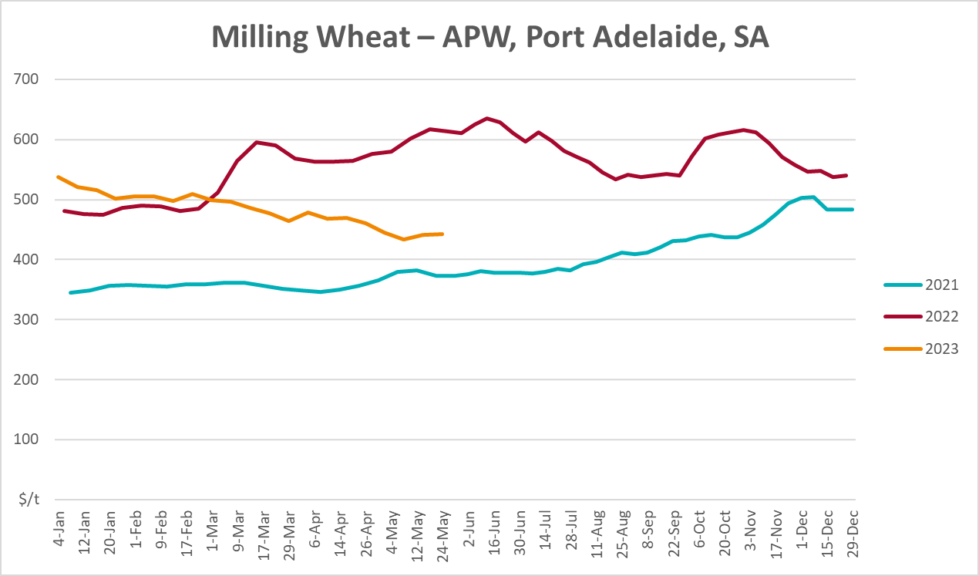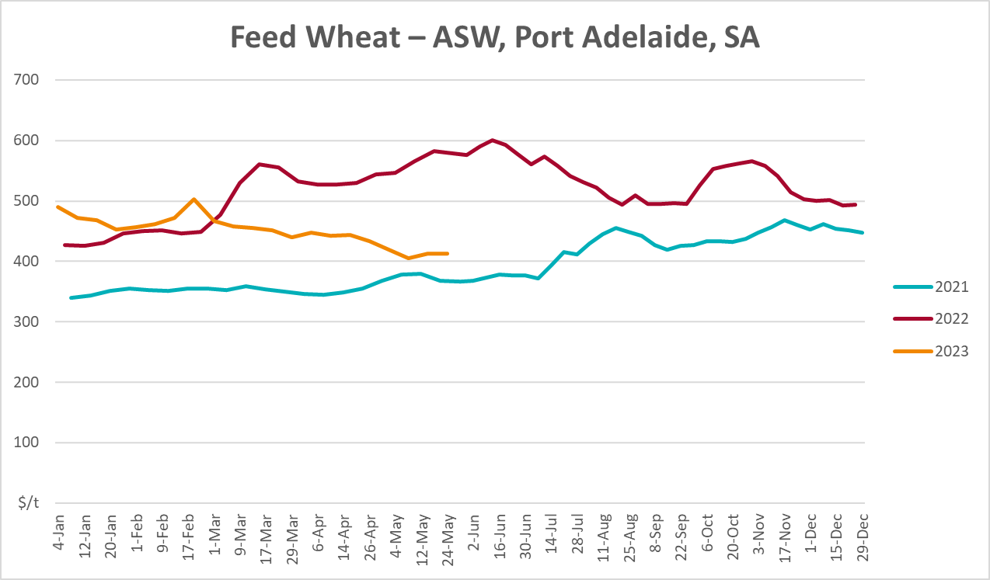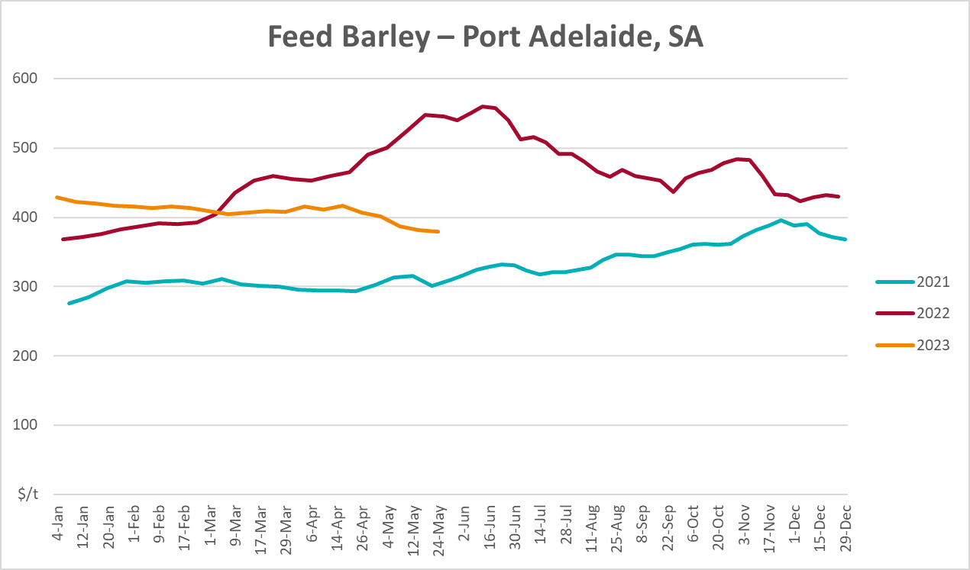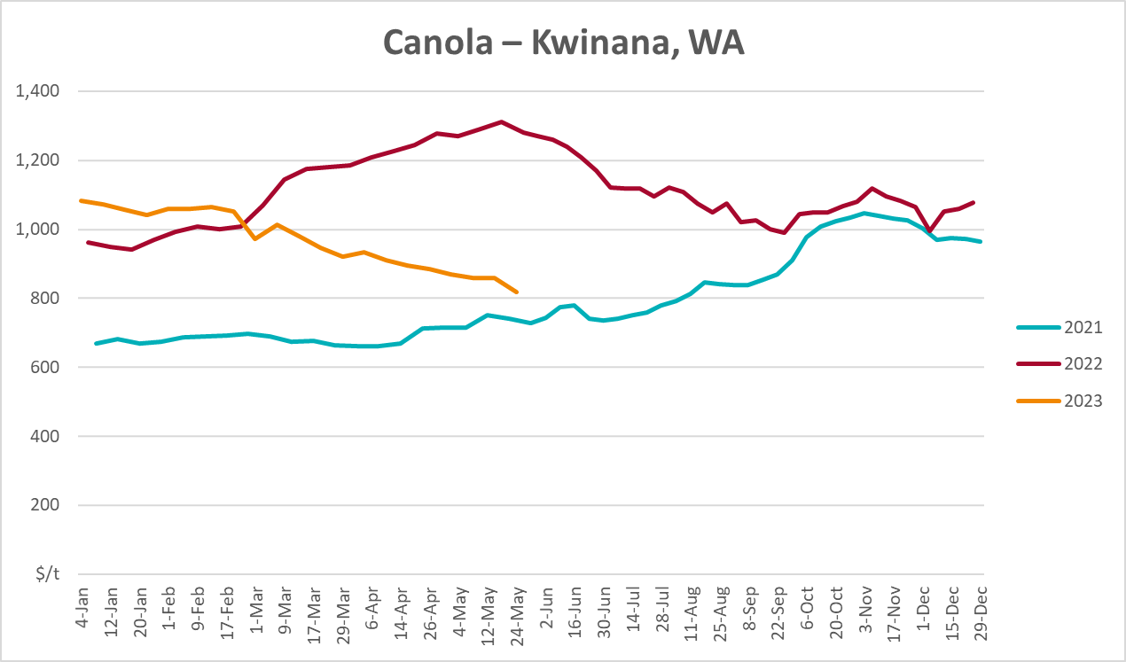
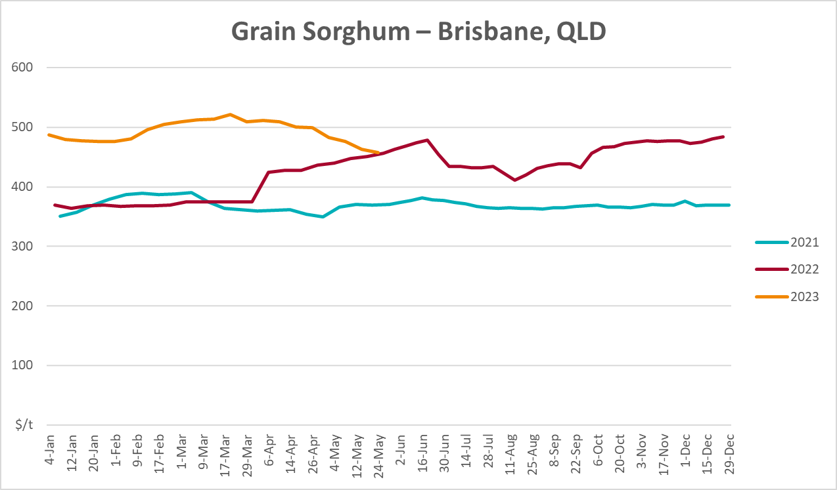

Selected domestic livestock indicator prices

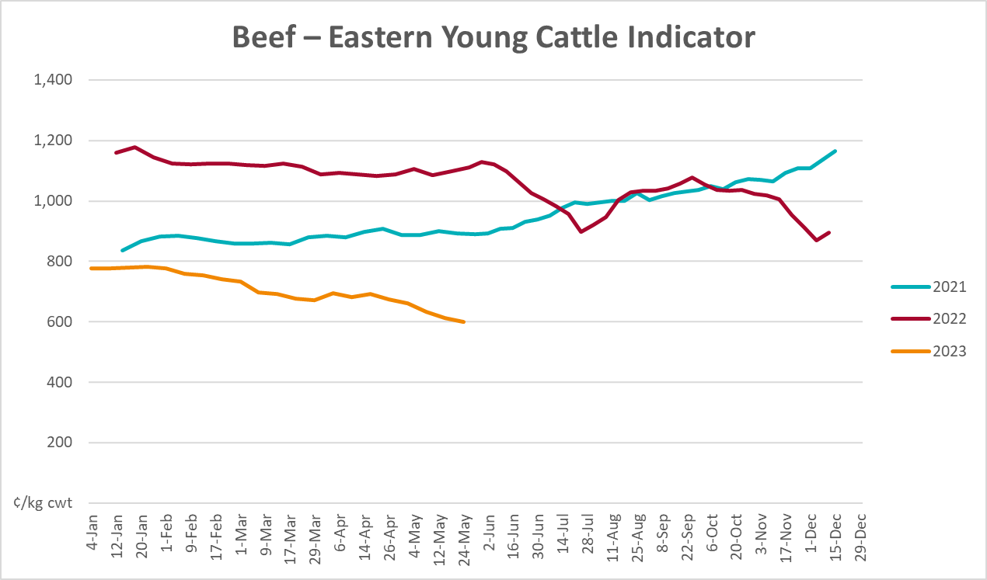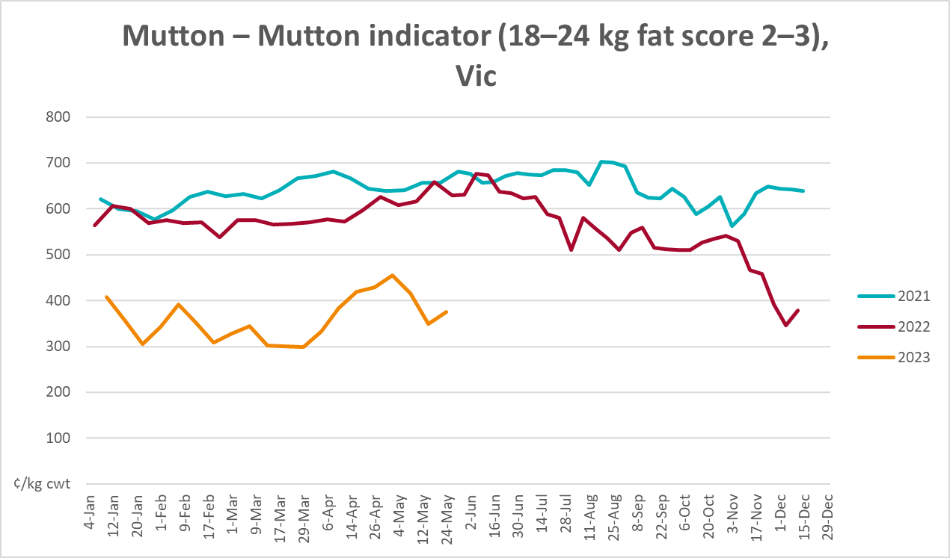
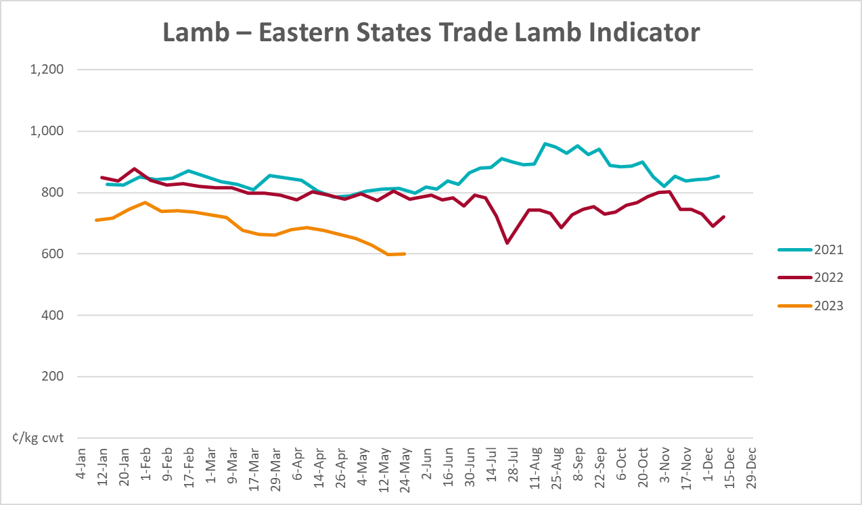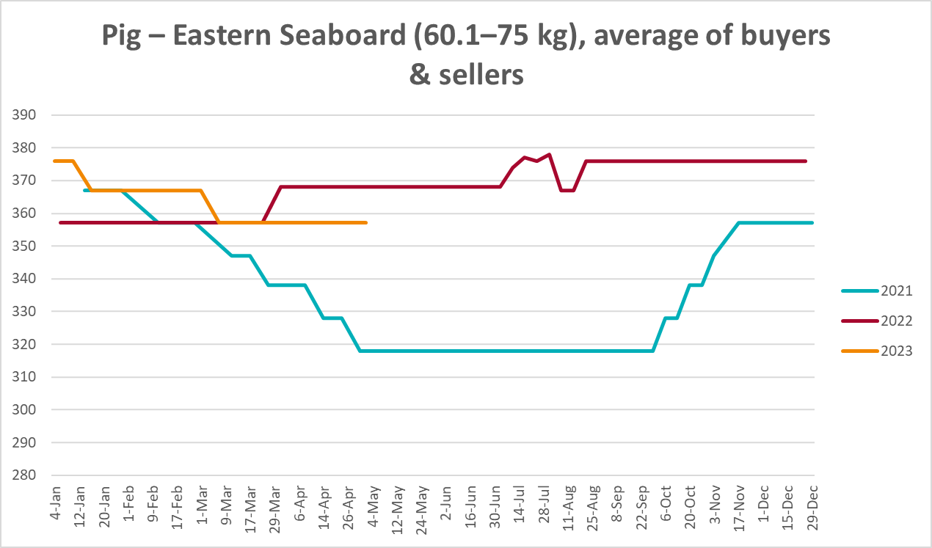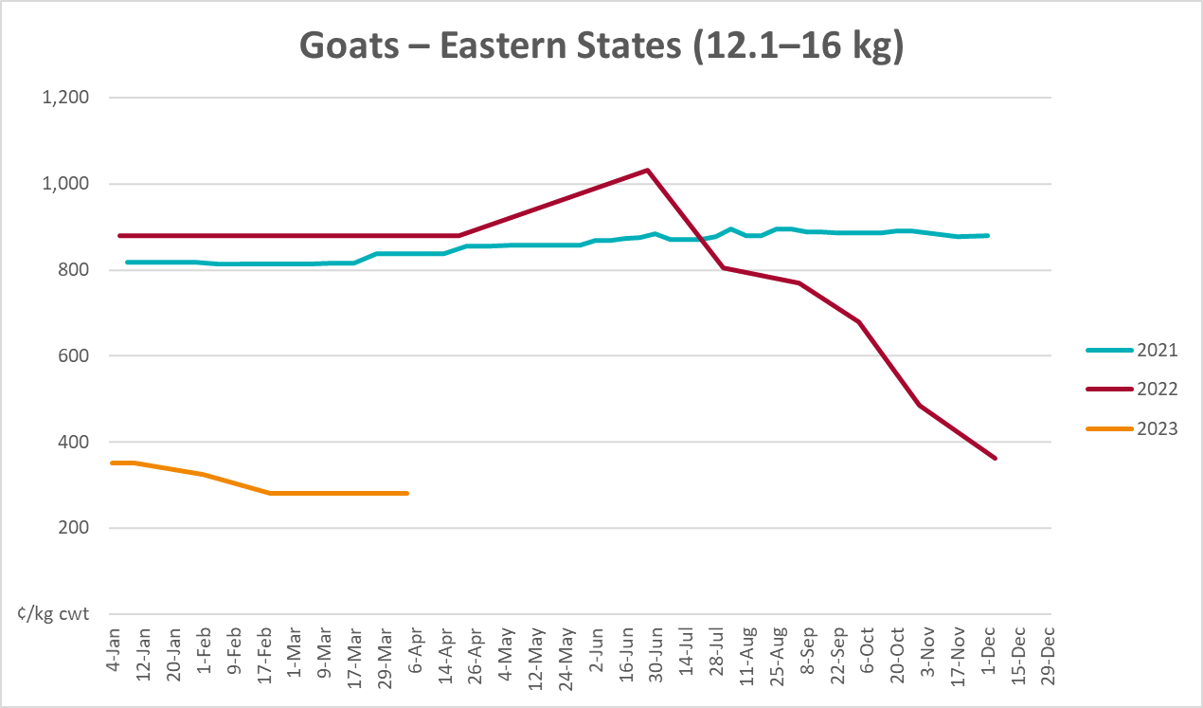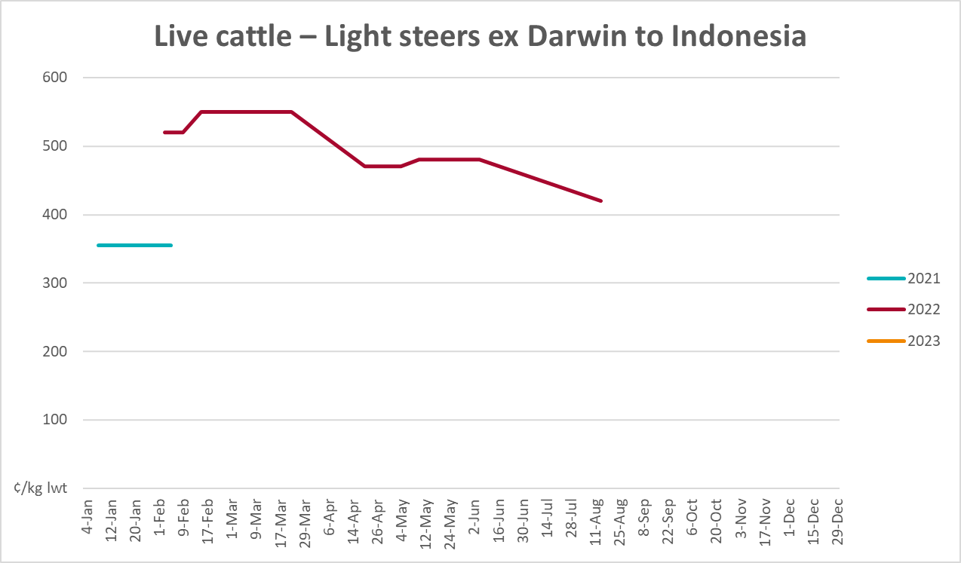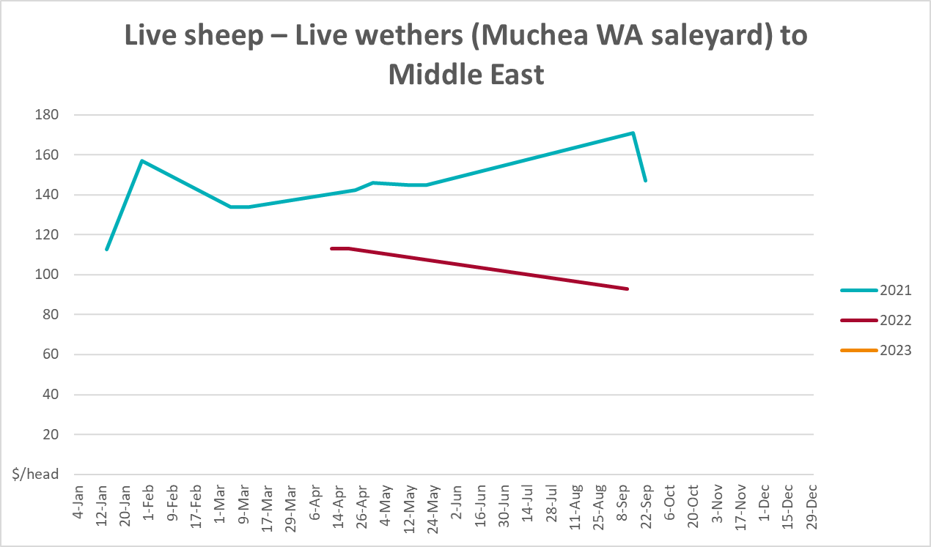

Global Dairy Trade (GDT) weighted average prices
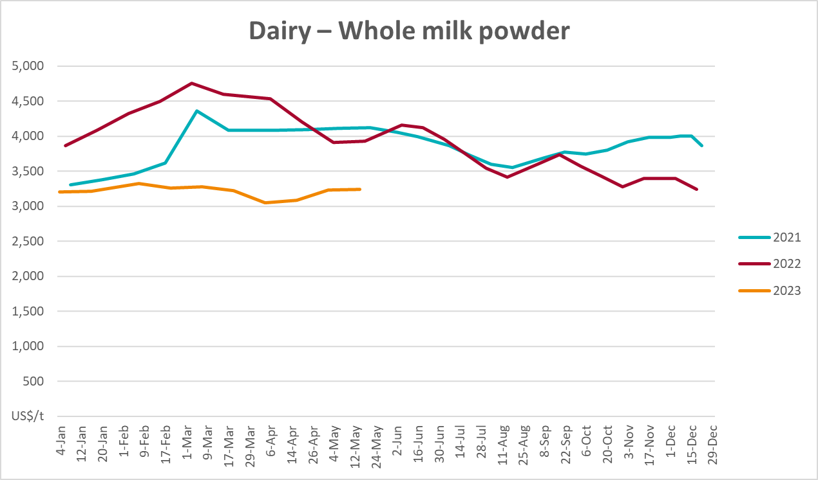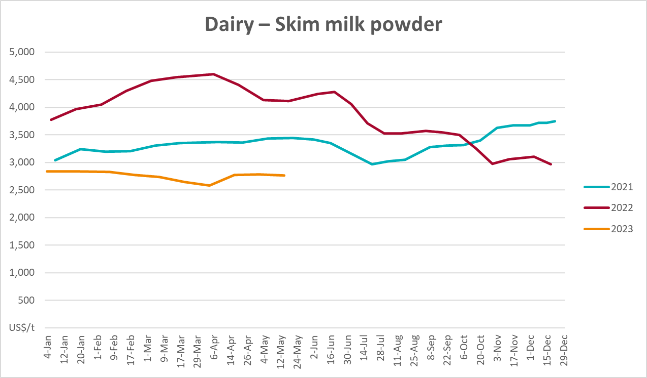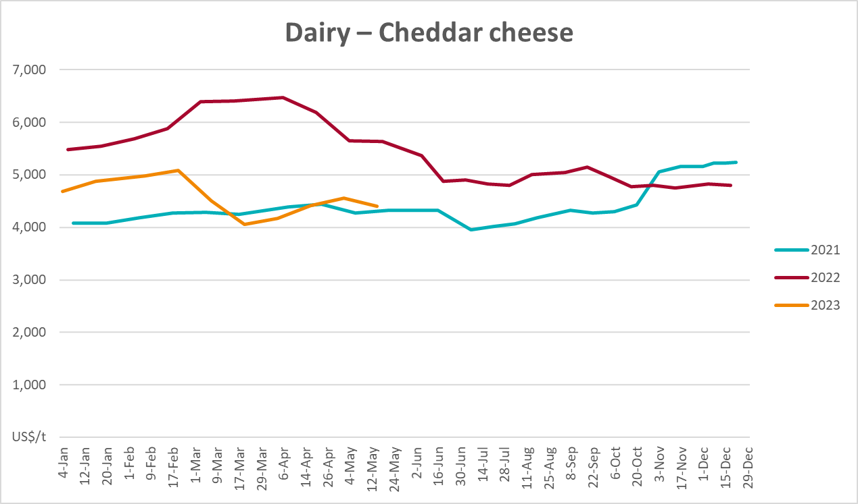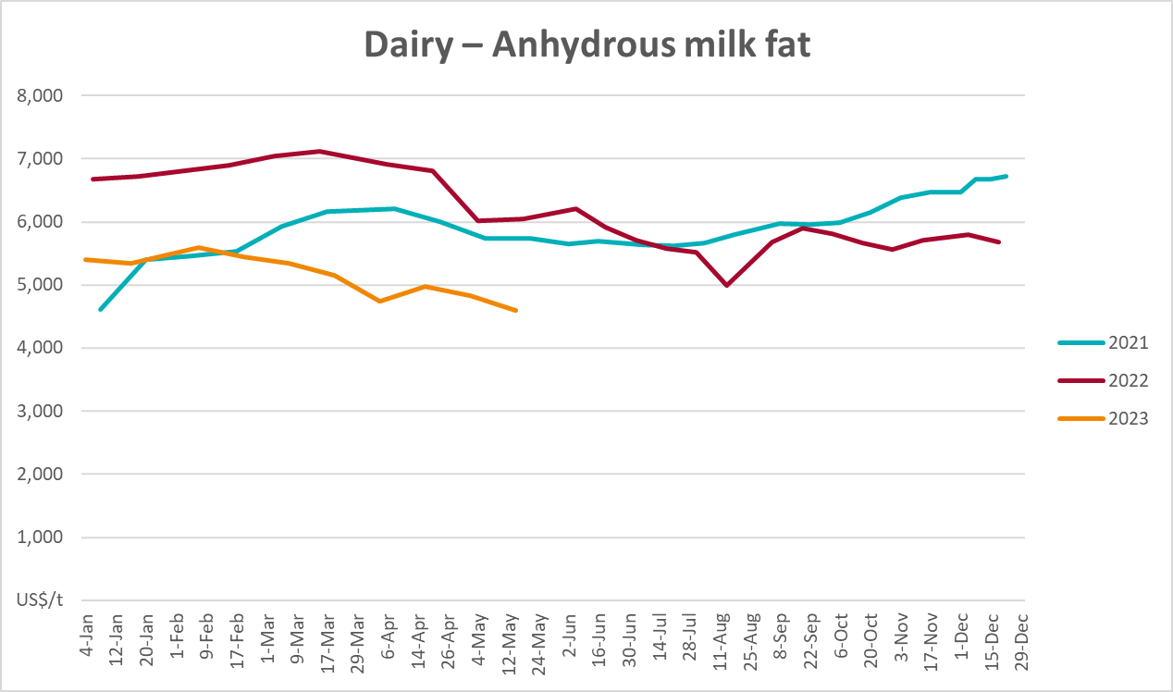

Selected fruit and vegetable prices
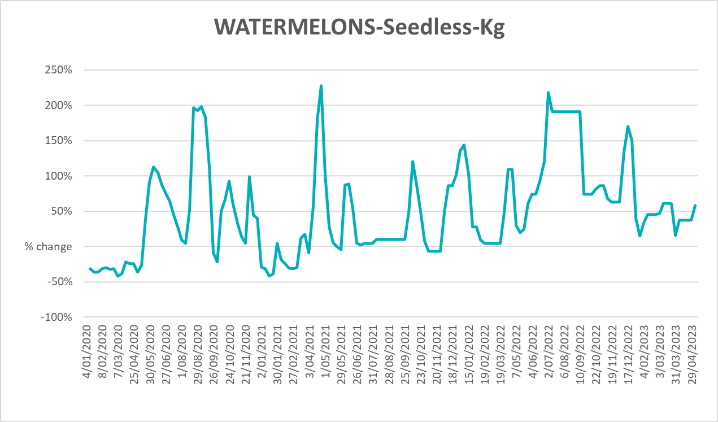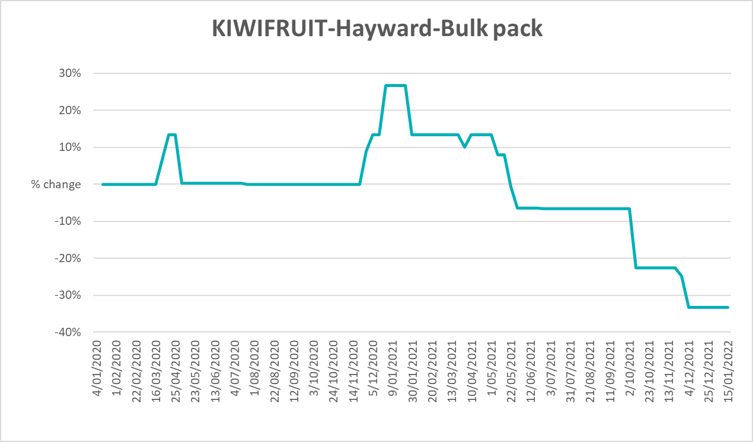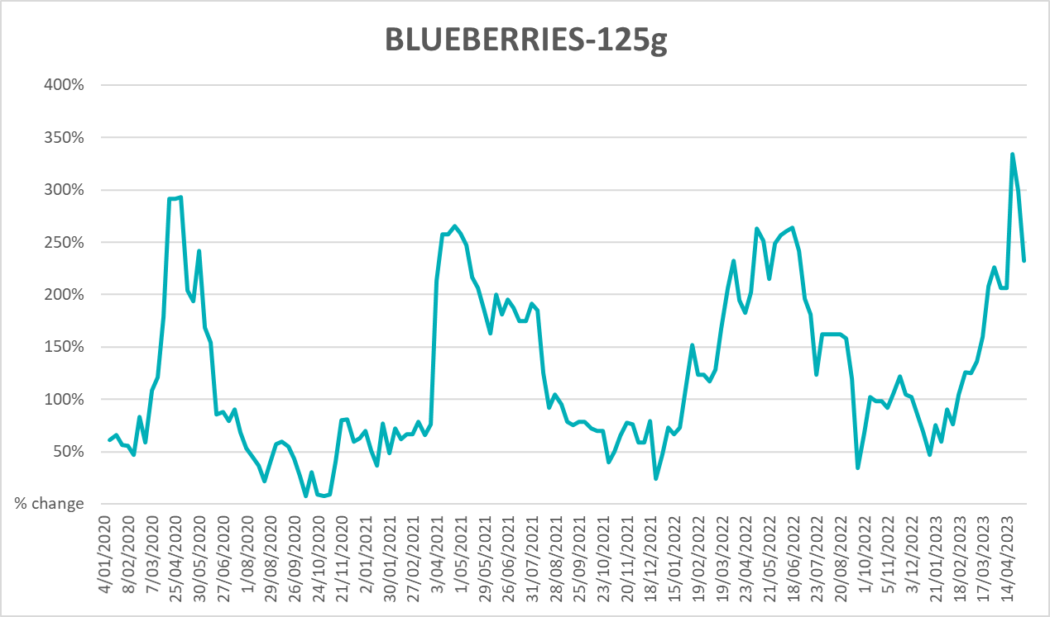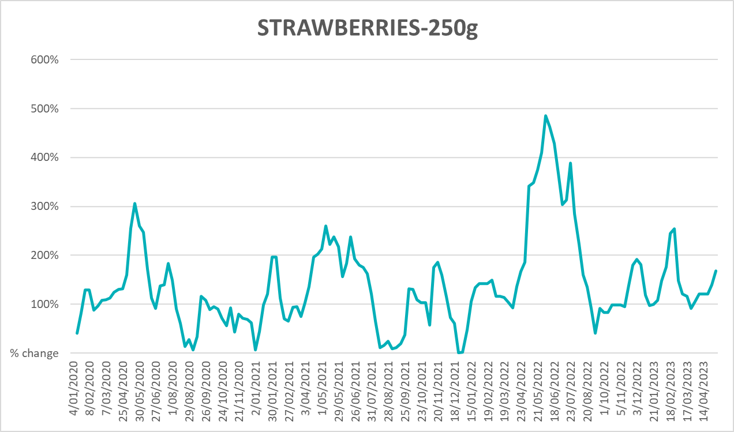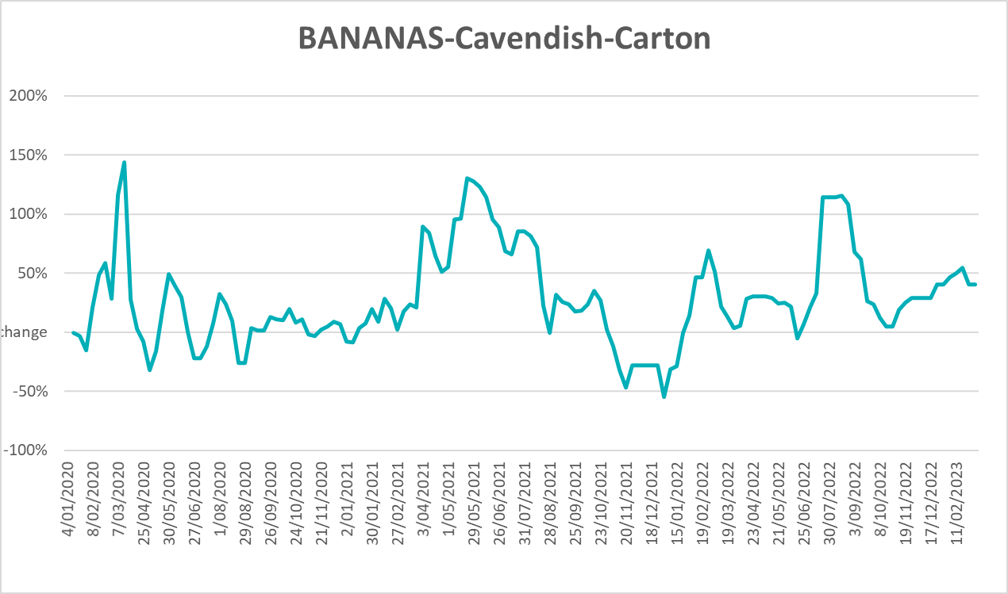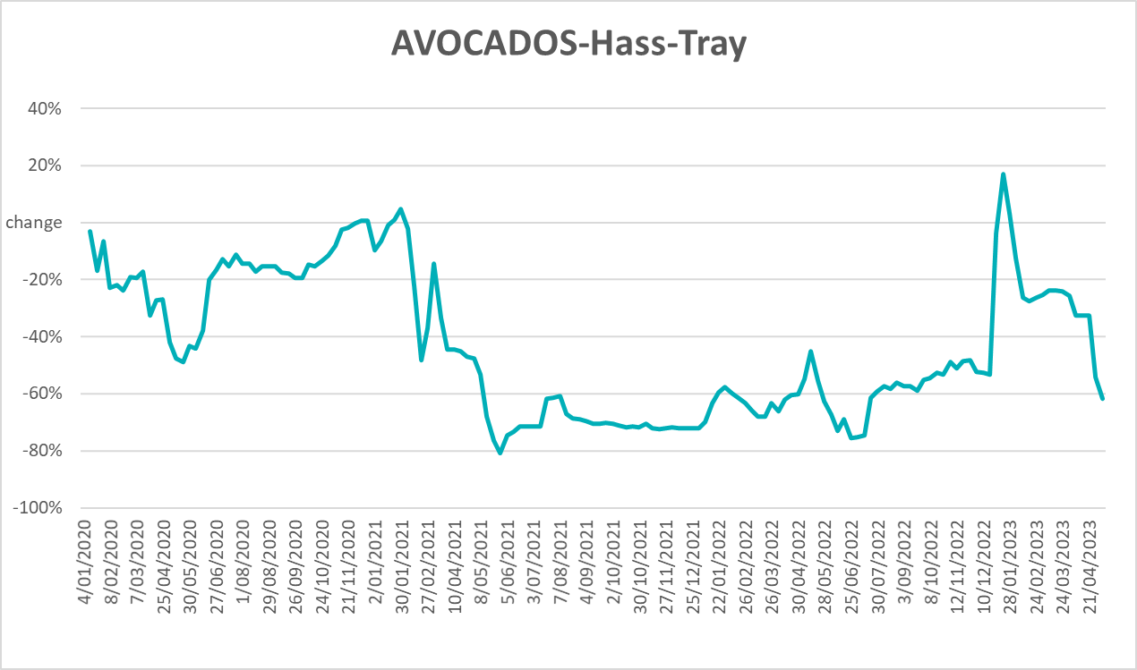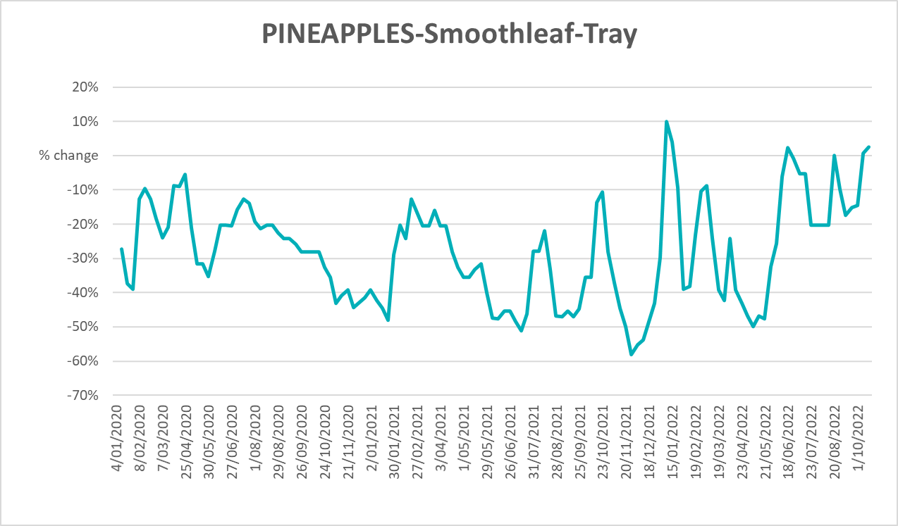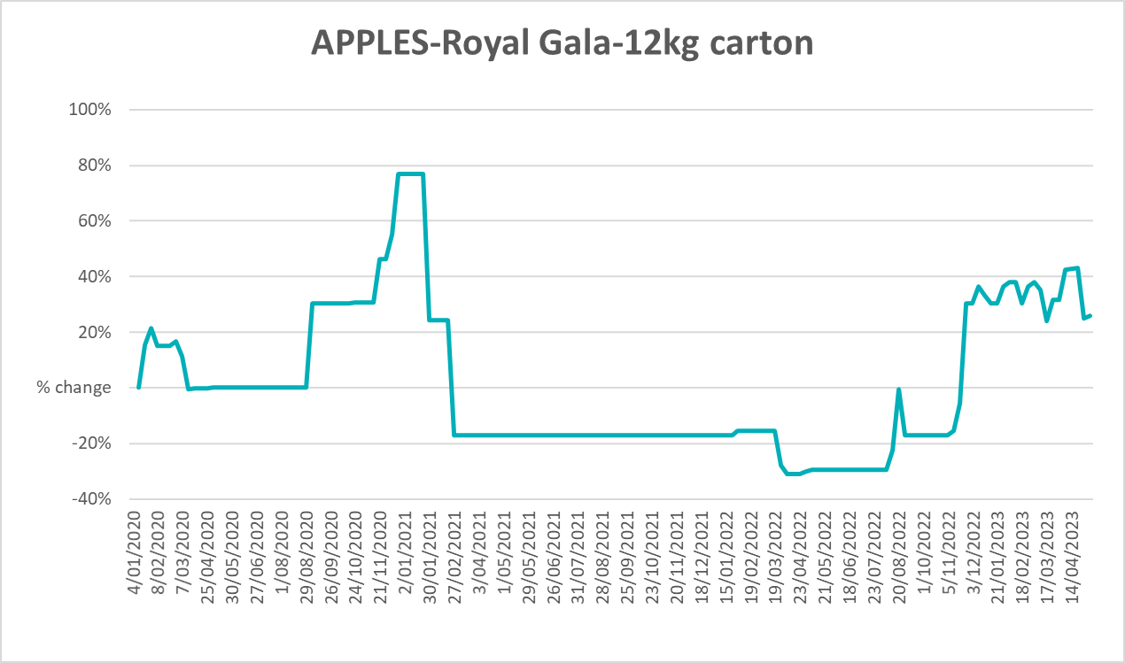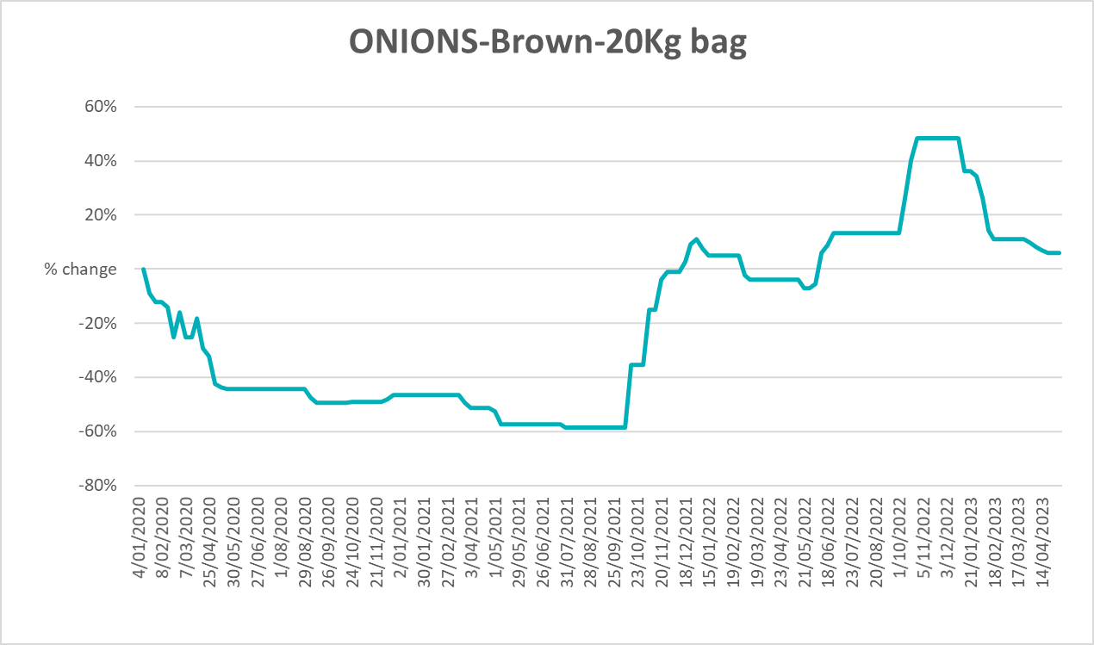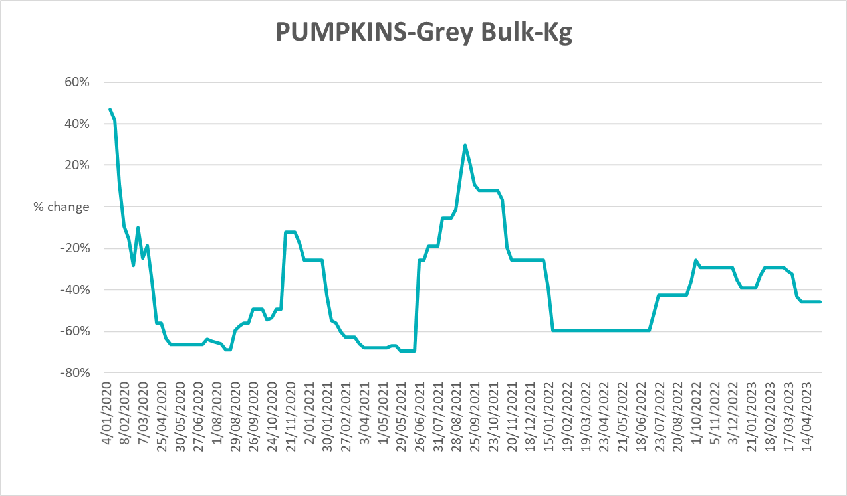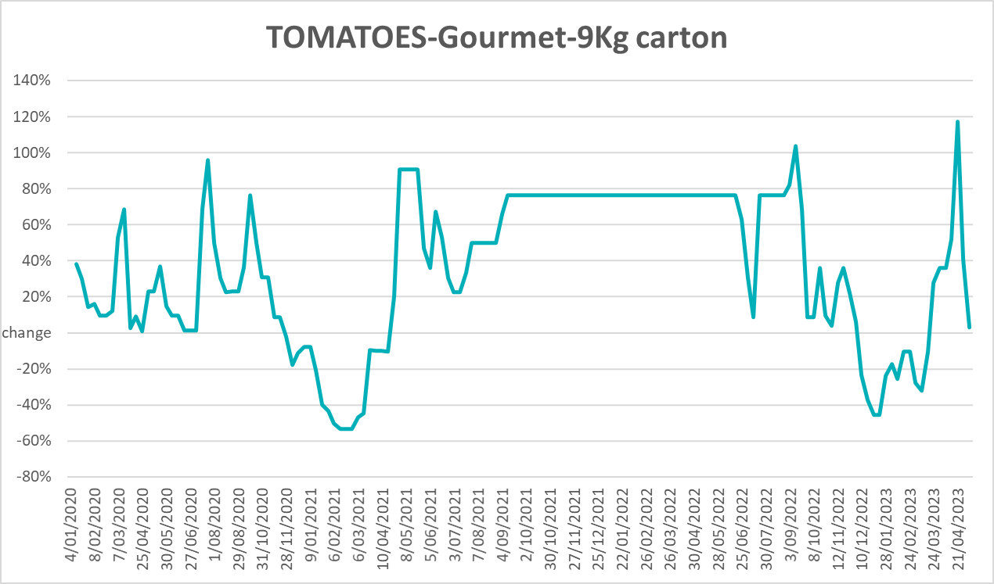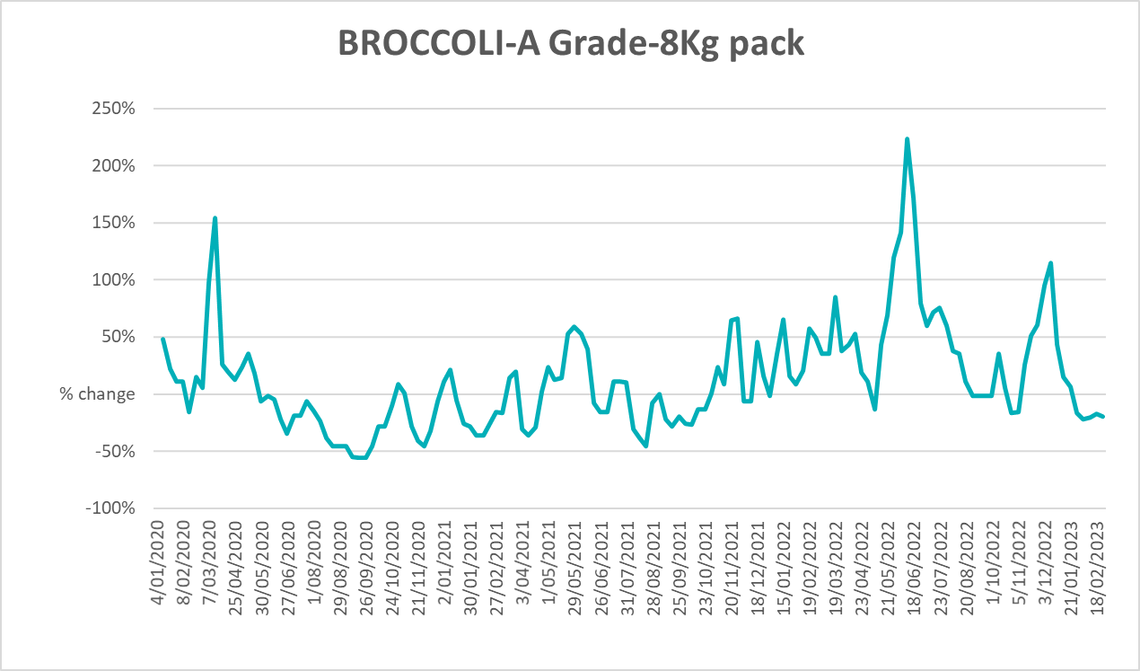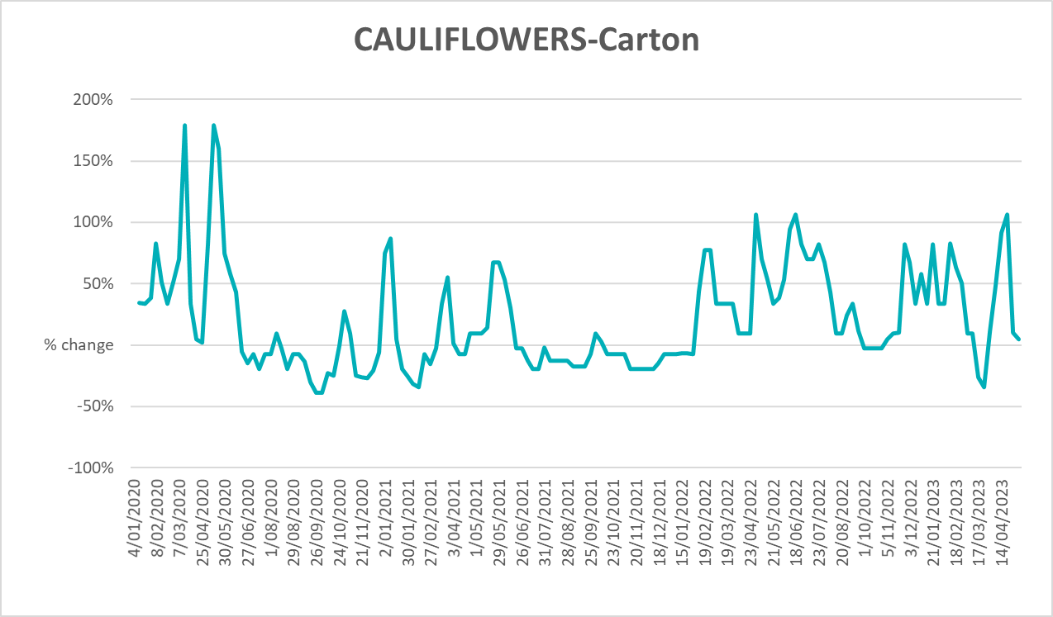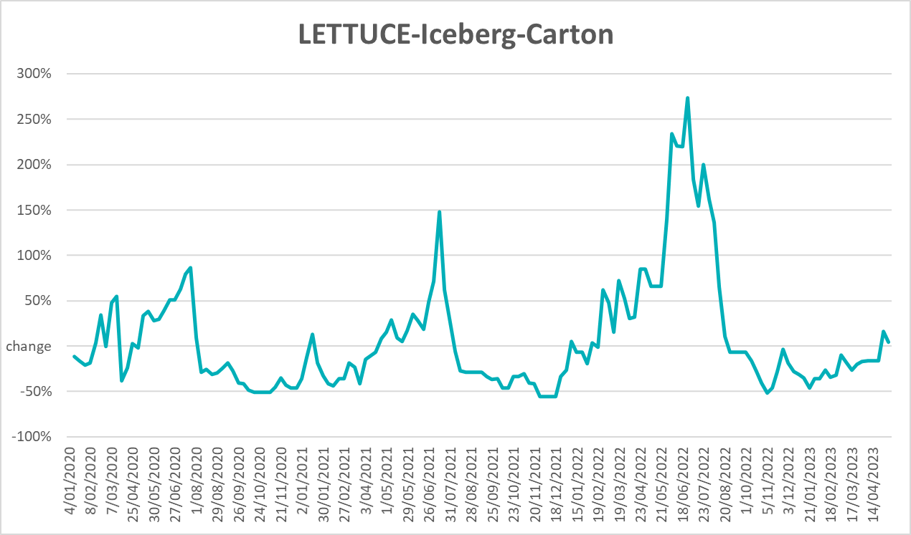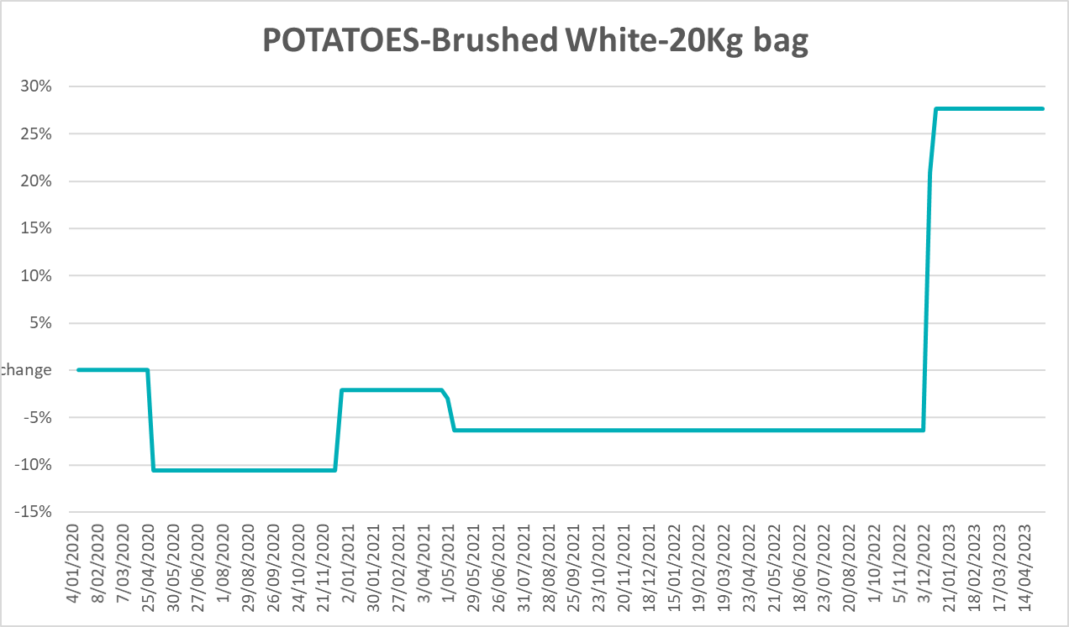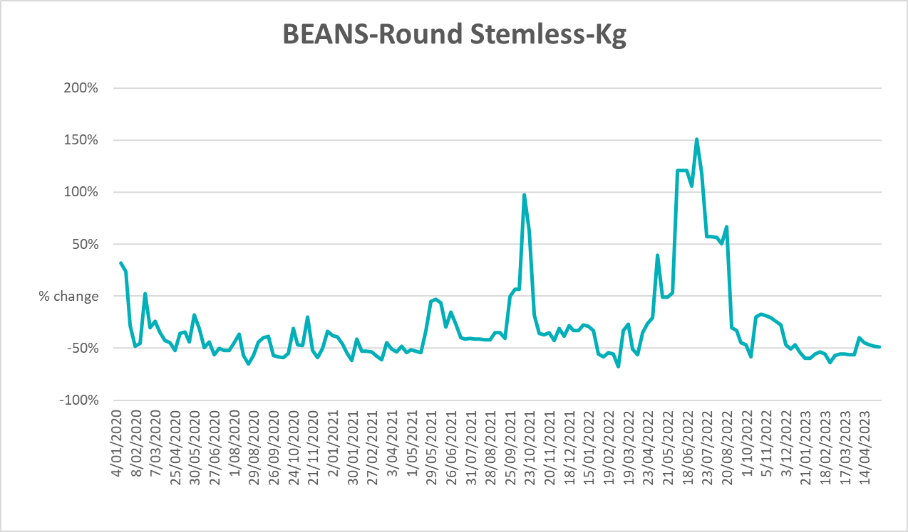

3.6 Selected domestic fodder indicator prices
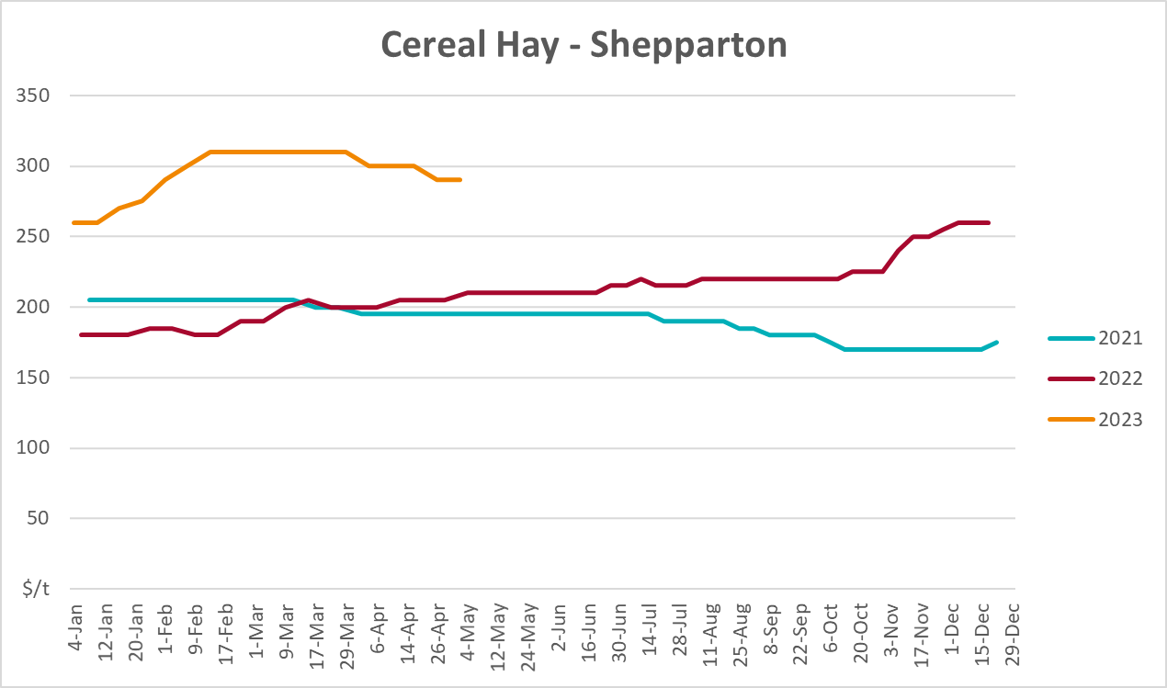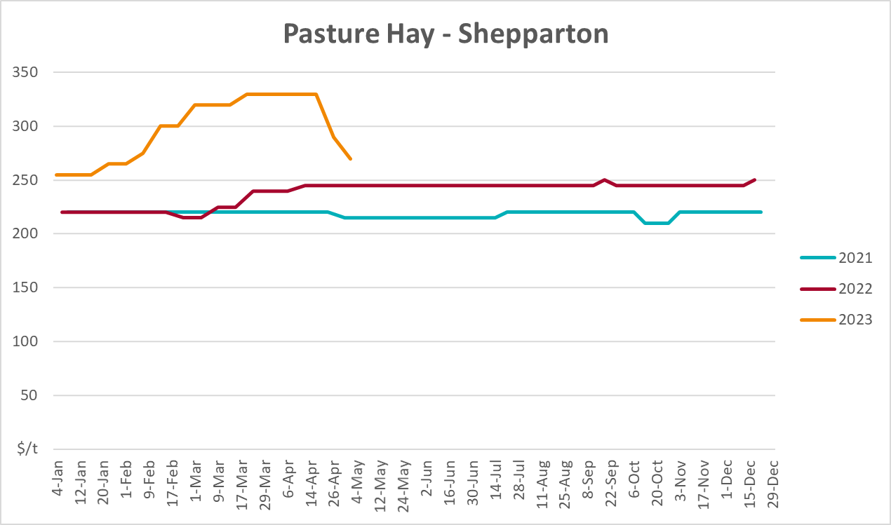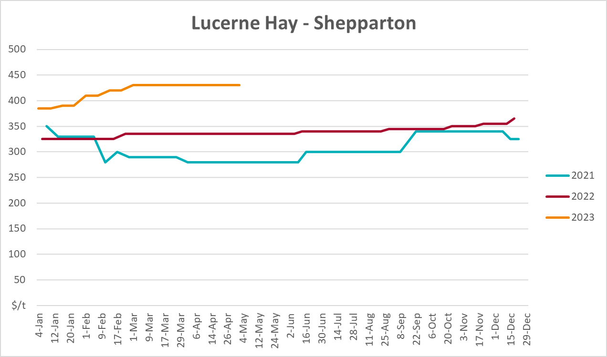

4. Data attribution

Climate
Bureau of Meteorology
- Weekly rainfall totals: www.bom.gov.au/climate/maps/rainfall/
- Monthly and last 3-month rainfall percentiles: www.bom.gov.au/water/landscape/
- Temperature anomalies: www.bom.gov.au/jsp/awap/temp/index.jsp
- Rainfall forecast: www.bom.gov.au/jsp/watl/rainfall/pme.jsp
- Seasonal outlook: www.bom.gov.au/climate/outlooks/#/overview/summary/
- Climate drivers: http://www.bom.gov.au/climate/enso/
- Soil moisture: www.bom.gov.au/water/landscape/
Other
- Pasture growth: www.longpaddock.qld.gov.au/aussiegrass/
- 3-month global outlooks: Environment and Climate Change Canada, NOAA Climate Prediction Center, EUROBRISA CPTEC/INPE, European Centre for Medium-Range Weather Forecasts, Hydrometcenter of Russia, National Climate Center Climate System Diagnosis and Prediction Room (NCC), International Research Institute for Climate and Society
- Global production: https://ipad.fas.usda.gov/ogamaps/cropmapsandcalendars.aspx
- Autumn break: Pook et al., 2009, https://rmets-onlinelibrary-wiley-com.virtual.anu.edu.au/doi/epdf/10.1002/joc.1833

Water
Prices
- Waterflow: https://www.waterflow.io/
- Ruralco: https://www.ruralcowater.com.au/
Bureau of Meteorology:
- Allocation trade: http://www.bom.gov.au/water/dashboards/#/water-markets/mdb/at
- Storage volumes: http://www.bom.gov.au/water/dashboards/#/water-storages/summary/drainage
Trade constraints:
- Water NSW: https://www.waternsw.com.au/customer-service/ordering-trading-and-pricing/trading/murrumbidgee
- Victorian Water Register: https://www.waterregister.vic.gov.au/TradingRules2019/

Commodities
Fruit and vegetables
- Datafresh: www.freshstate.com.au
Pigs
- Australian Pork Limited: www.australianpork.com.au
Dairy
- Global Dairy Trade: www.globaldairytrade.info/en/product-results/
World wheat, canola
- International Grains Council
World coarse grains
- United States Department of Agriculture
World cotton
- Cotlook: www.cotlook.com/
World sugar
- New York Stock Exchange - Intercontinental Exchange
Wool
- Australian Wool Exchange: www.awex.com.au/
Domestic wheat, barley, sorghum, canola and fodder
- Jumbuk Consulting Pty Ltd: http://www.jumbukag.com.au/
Cattle, beef, mutton, lamb, goat and live export
- Meat and Livestock Australia: www.mla.com.au/Prices-and-market
© Commonwealth of Australia 2023

Ownership of intellectual property rights
Unless otherwise noted, copyright (and any other intellectual property rights, if any) in this publication is owned by the Commonwealth of Australia (referred to as the Commonwealth).

Creative Commons licence
All material in this publication is licensed under a Creative Commons Attribution 4.0 International Licence except content supplied by third parties, logos and the Commonwealth Coat of Arms.
Inquiries about the licence and any use of this document should be emailed to copyright@awe.gov.au.


Cataloguing data
This publication (and any material sourced from it) should be attributed as:
ABARES 2023, Weekly Australian Climate, Water and Agricultural Update, Australian Bureau of Agricultural and Resource Economics and Sciences, Canberra, 25 May 2023. CC BY 4.0 DOI: https://doi.org/10.25814/5f3e04e7d2503
ISSN 2652-7561
This publication is available at https://www.agriculture.gov.au/abares/products/weekly_update
Department of Agriculture, Fisheries and Forestry
GPO Box 858 Canberra ACT 2601
Telephone 1800 900 090
Web agriculture.gov.au/abares

Disclaimer
The Australian Government acting through the Department of Agriculture, Fisheries and Forestry, represented by the Australian Bureau of Agricultural and Resource Economics and Sciences, has exercised due care and skill in preparing and compiling the information and data in this publication. Notwithstanding, the Department of Agriculture, Fisheries and Forestry, ABARES, its employees and advisers disclaim all liability, including liability for negligence and for any loss, damage, injury, expense or cost incurred by any person as a result of accessing, using or relying on any of the information or data in this publication to the maximum extent permitted by law.

Statement of Professional Independence
The views and analysis presented in ABARES publications, including this one, reflect ABARES professionally independent findings, based on scientific and economic concepts, principles, information and data. These views, analysis and findings may not reflect or be consistent with the views or positions of the Australian Government, or of organisations or groups who have commissioned ABARES reports or analysis. More information on professional independence is provided on the ABARES website.

Acknowledgements
This report was prepared by Kavina Dayal and Matthew Miller.

