
No. 21/2023 1 June 2023

Summary of key issues
- For the week ending 31 May 2023, a high-pressure system kept much of the country dry. A number of cold fronts crossed southern Australia bringing showers up to 50 millimetres over Victoria and southern South Australia and up to 25 millimetres in far southwest Western Australia. Showers of up to 200 millimetres were recorded in western Tasmania.
- Across Australian cropping regions, rainfall totals of between 10 to 50 millimetres were recorded in Victoria, South Australia and parts of south-eastern New South Wales. Little to no rainfall was recorded in remaining areas. The dry conditions would have allowed for the harvest of cotton and dry sowing of winter crops to progress without delay. However, the lack of rainfall also presents a downside reproduction risk for winter crops that are starting to show signs of moisture stress following very dry May in some key growing regions (see Section 1.1).
- In the cropping regions, May rainfall was highly variable ranging from severe rainfall deficiencies in the west to well above average falls across parts of the east. May rainfall was generally below average to average in Victoria, South Australia and parts of northern and southern New South Wales. Queensland saw highly variable falls ranging for severely deficient in the north to well above average in the southeast. May conditions were very dry across Western Australia and much of central New South Wales ranging from severely deficient to well below average (see Section 1.2).
- Over the 8-days to 8 June 2023, a low-pressure trough and a series of cold fronts are expected to bring showers up to 50 millimetres over much of New South Wales, Victoria, parts of southern Queensland, eastern South Australia, south-western Western Australia and northern and western Tasmania. A high-pressure system will keep the remainder of the country dry (see Section 1.4).
- Rainfall totals of between 10 and 50 millimetres are expected across most cropping regions over the next 8 days, except for much of central and northern Queensland and western parts of South Australia where totals are expected to be below 10 millimetres. This rainfall will bring some very welcome relief from dry conditions that were seen during May. If realised, these falls should be sufficient to allow for the germination and establishment of dry sown crops, and may give growers confidence to finish intended planting programs in areas with substantial subsoil moisture (see Section 1.4).
- Water storage levels in the Murray-Darling Basin (MDB) increased between 25 May 2023 and 1 June 2023 by 43 gigalitres (GL). Current volume of water held in storage is 20 141 GL. This is 1 percent or 112 GL more than at the same time last year.
- Allocation prices in the Victorian Murray below the Barmah Choke remained steady at $19 from 25 May 2023 to 1 June 2023. Prices are lower in the Murrumbidgee and regions above the choke due to the binding of the Murrumbidgee export limit and Barmah choke trade constraint.

Climate

Rainfall this week
For the week ending 31 May 2023, a high-pressure system kept much of the country dry. A number of cold fronts crossed southern Australia bringing showers up to 50 millimetres over Victoria and southern South Australia and up to 25 millimetres in far southwest Western Australia. Showers of up to 200 millimetres were recorded in western Tasmania.
Across Australian cropping regions, rainfall totals of between 10 to 50 millimetres were recorded in Victoria, South Australia and parts of south-eastern New South Wales. Little to no rainfall was recorded in remaining areas. The dry conditions would have allowed for the harvest of cotton and dry sowing of winter crops to progress without delay. However, the lack of rainfall also presents a downside reproduction risk for winter crops that are starting to show signs of moisture stress following very dry May in some key growing regions.

Rainfall for the week ending 31 May 2023
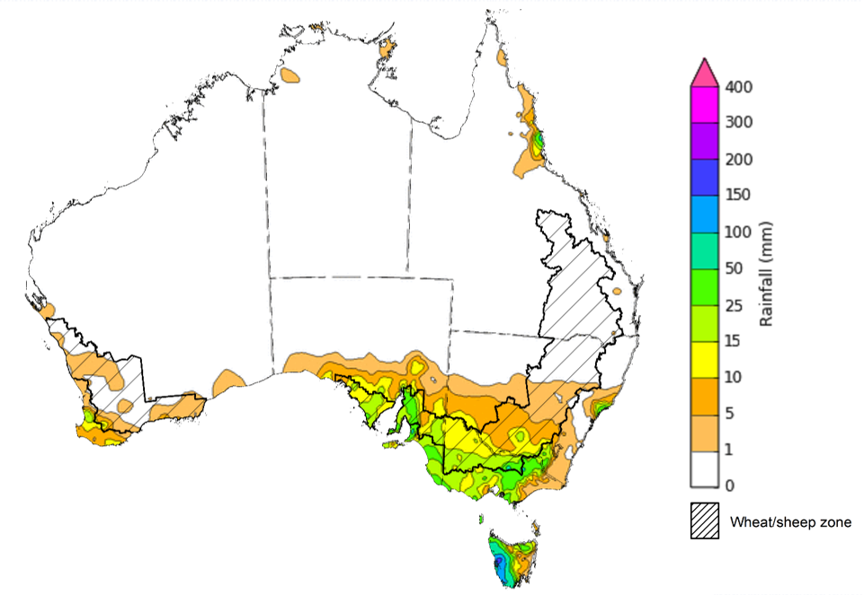
©Commonwealth of Australia 2023, Australian Bureau of Meteorology Issued: 31/05/2023
Note: The rainfall analyses and associated maps utilise data contained in the Bureau of Meteorology climate database, the Australian Data Archive for Meteorology (ADAM). The analyses are initially produced automatically from real-time data with limited quality control. They are intended to provide a general overview of rainfall across Australia as quickly as possible after the observations are received. For further information go to http://www.bom.gov.au/climate/rainfall/

Monthly rainfall
Rainfall during May 2023 was well below average for much of Australia. The main exceptions have been in parts of Cape York Peninsula and southeast Queensland, parts of northern and south-eastern New South Wales, much of Victoria, southern agricultural districts of South Australia as well as in western Tasmania where May rainfall has been average to above average.
In the cropping regions, May rainfall was highly variable ranging from severe rainfall deficiencies in the west to well above average falls across parts of the east. May rainfall was generally below average to average in Victoria, South Australia and parts of northern and southern New South Wales. Queensland saw highly variable falls ranging for severely deficient in the north to well above average in the southeast. May conditions were very dry across Western Australia and much of New South Wales ranging from severely deficient to well below average. The dry conditions would have allowed most producers to finalise the harvesting of summer crops without delay.
However, lack of rainfall in May affected germination of early planted winter crops (cereals), except for in southern Queensland. However, below average rainfall across some growing regions in New South Wales, Queensland and Western Australia this planting season is expected to curtail planting intentions, resulting in significant levels of available land being left fallow over winter in these areas.

Rainfall percentiles for May 2023

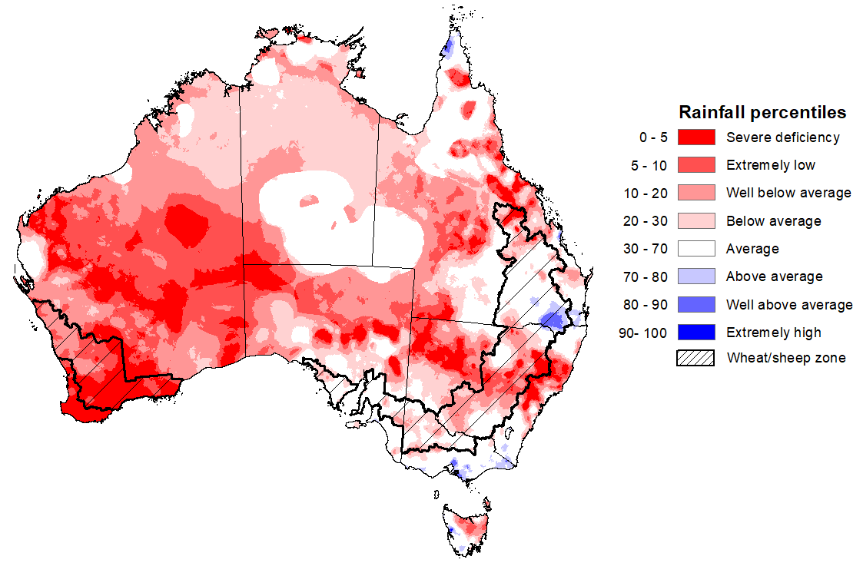
Note: Rainfall for May 2023 is compared with rainfall recorded for that period during the historical record (1900 to present). For further information, go to http://www.bom.gov.au/jsp/awap/
Source: Bureau of Meteorology

Soil Moisture
Upper layer soil moisture as at 30 May 2023 was very much below average to below average for this time of year across much of the country. Extremely low upper layer soil moisture was evident across large areas of Western Australia, eastern Queensland, northern South Australia and northern New South Wales. Above average upper layer soil moisture was evident in northern Victoria, southern South Australia, and western Tasmania.
At this time of year, upper layer soil moisture is important for the germination and establishment of winter crops across Australian cropping regions. It is also important indicator of the ability to access paddocks to undertake harvesting of summer crops in New South Wales and Queensland, as well as planting activities for winter crops.
In the cropping regions, upper layer soil moisture as at 30 May 2023 was extremely low to below average in Queensland, northern New South Wales, and much of Western Australia. Above average upper layer soil moisture was evident in Victoria and South Australia cropping regions. Upper layer soil moisture was average across central and southern New South Wales. The below average to average upper layer soil moisture in Queensland would have allowed field access for summer crop harvesting and field preparation for winter crop sowing. The above average upper layer soil moisture levels across southern cropping regions should have been sufficient to support the germination and establishment of winter crops, but prevented some field access for follow up winter crop planting.

Modelled upper layer soil moisture on 30 May 2023
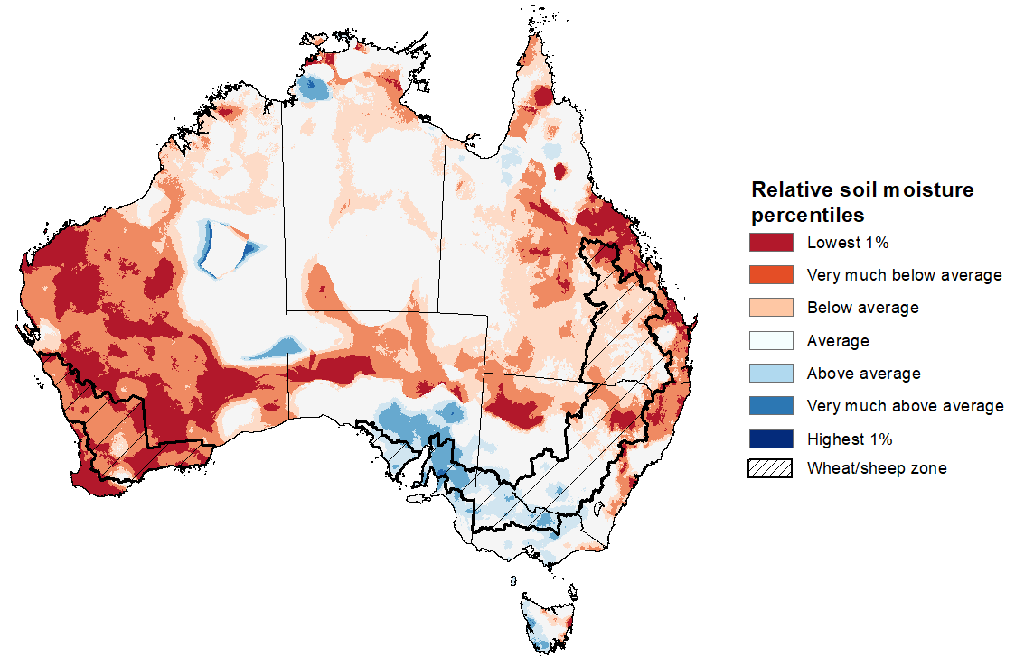
Note: This map shows the levels of modelled upper layer soil moisture (0 to 10 centimetres) during April 2023. This map shows how modelled soil conditions during May 2023 compare with the May conditions modelled over the reference period (1911 to 2016). Dark blue areas on the maps were much wetter in May 2023 than during the reference period. The bulk of plant roots occur in the top 20 centimetres of the soil profile. Soil moisture in the upper layer of the soil profile is therefore useful indicator of the availability of water, particularly for germinating seed.
Source: Bureau of Meteorology (Australian Water Resources Assessment Landscape model)

Lower layer soil moisture as at 30 May 2023 was average across much of Australia, except for large areas of eastern Queensland, northern and central New South Wales and Western Australia where it was extremely low to below average.
Lower layer soil moisture is a larger, deeper store that is slower to respond to seasonal conditions and tends to reflect the accumulated effects of events that have occurred over longer periods. Crop development and pasture growth in areas of above average lower layer soil moisture are typically less reliant on in-season rainfall than in areas with below average lower layer soil moisture.
In cropping regions, lower layer soil moisture was generally very much below average to average in Queensland and New South Wales with southeast Queensland being the main exception where it was above average. Lower layer soil moisture was extremely low to very much below average in Western Australia, generally average in Victoria and South Australian cropping regions. Areas with below average levels of lower layer soil moisture will be highly dependent on timely and sufficient in-season rainfall to support average winter crop production prospects.
Modelled lower layer soil moisture on 30 May 2023
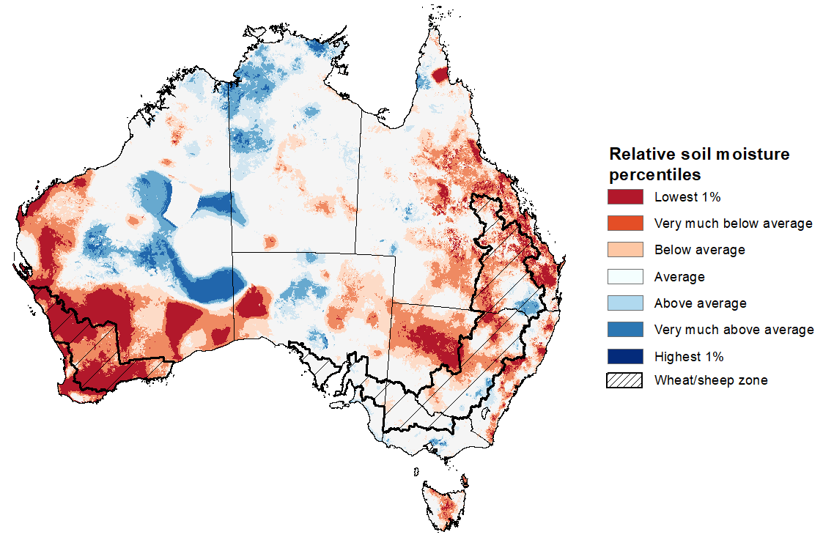
Note: This map shows the levels of modelled lower layer soil moisture (10 to 100 centimetres) during April 2023. This map shows how modelled soil conditions during May 2023 compare with May conditions modelled over the reference period (1911 to 2016). Dark blue areas on the maps were much wetter in May 2023 than during the reference period. The dark red areas were much drier than during the reference period. The bulk of plant roots occur in the top 20 centimetres of the soil profile. The lower layer soil moisture is a larger, deeper store that is slower to respond to rainfall and tends to reflect accumulated rainfall events over longer time periods.
Source: Bureau of Meteorology (Australian Water Resources Assessment Landscape model)

Rainfall forecast for the next eight days
Over the 8-days to 8 June 2023, a low-pressure trough and a series of cold fronts are expected to bring showers up to 50 millimetres over much of New South Wales, Victoria, parts of southern Queensland, eastern South Australia, south-western Western Australia and northern and western Tasmania. A high-pressure system will keep the remainder of the country dry.
Rainfall totals of between 10 and 50 millimetres are expected across most cropping regions, except for much of central and northern Queensland and western parts of South Australia where totals are expected to be below 10 millimetres. This rainfall will bring some very welcome relief from dry conditions that were seen during May. If realised, these falls should be sufficient to allow for the germination and establishment of dry sown crops, and may give growers confidence to finish intended planting programs in areas with substantial subsoil moisture.

Total forecast rainfall for the period 1 June 2023 to 8 June 2023
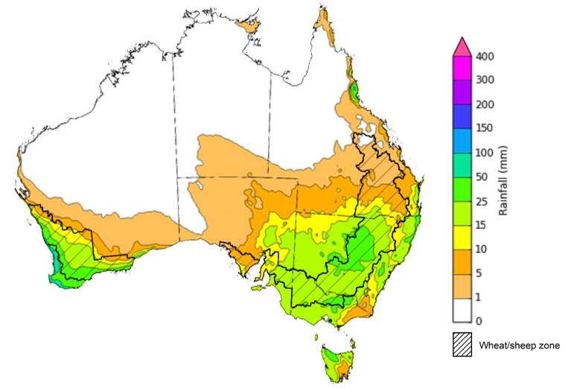

©Commonwealth of Australia 2023, Australian Bureau of Meteorology Issued 01/06/2023
Note: This rainfall forecast is produced from computer models. As the model outputs are not altered by weather forecasters, it is important to check local forecasts and warnings issued by the Bureau of Meteorology.

Water

Water markets – current week
Water storage levels in the Murray-Darling Basin (MDB) increased between 25 May 2023 and 1 June 2023 by 43 gigalitres (GL). Current volume of water held in storage is 20 141 GL. This is 1 percent or 112 GL more than at the same time last year.

Water storages in the Murray-Darling Basin, 2013–2023
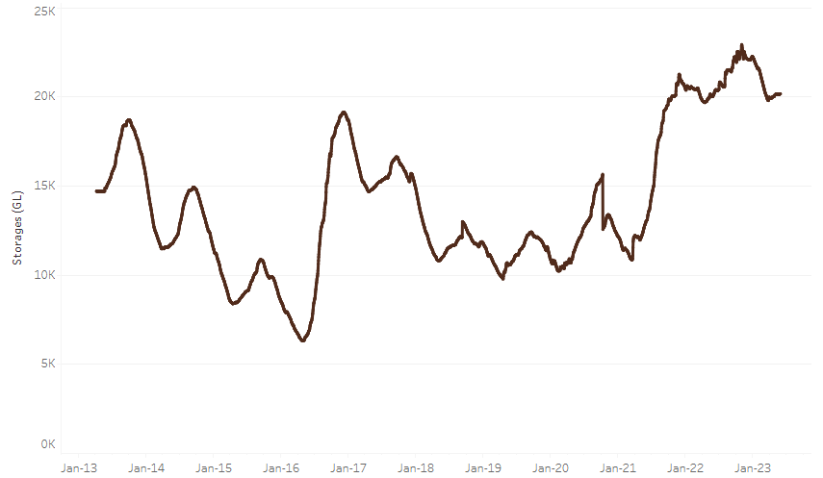
Allocation prices in the Victorian Murray below the Barmah Choke remained steady at $19 from 25 May 2023 to 1 June 2023. Prices are lower in the Murrumbidgee and regions above the choke due to the binding of the Murrumbidgee export limit and Barmah choke trade constraint.
Water storage data is sourced from the Bureau of Meteorology.

Region | $/ML
NSW Murray Above | 6
NSW Murrumbidgee | 3
VIC Goulburn-Broken | 19
VIC Murray Below | 19

Surface water trade activity, Southern Murray–Darling Basin
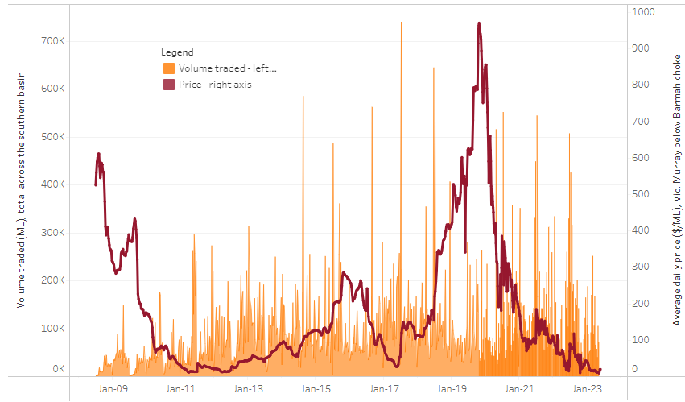
The trades shown reflect estimated market activity and do not encompass all register trades. The price is shown for the VIC Murray below the Barmah choke. Historical prices (before 1 July 2019) are ABARES estimates after removing outliers from BOM water register data. Prices after 1 July 2019 and prior to the 30 October 2019 reflect recorded transaction prices as sourced from Ruralco. Prices after the 30 October 2019 are sourced from Waterflow. Data for volume traded is sourced from the BOM water register. Only the price data shown is current on 1 June 2023.

To access the full, interactive, weekly water dashboard, which contains the latest and historical water storage, water market and water allocation information, please visit https://www.agriculture.gov.au/abares/products/weekly_update/weeakly-update-1623

Commodities
Indicator | Week ended | Unit | Latest Price | Previous Week | Weekly change | Price 12 months ago | Annual change
Selected world indicator prices
AUD/USD Exchange rate | 31-May | A$/US$ | 0.65 | 0.66 | -2% | 0.72 | -9%
Wheat – US no. 2 hard red winter wheat, fob Gulf | 31-May | US$/t | 357 | 367 | -3% | 484 | -26%
Corn – US no. 2 yellow corn, fob Gulf | 31-May | US$/t | 266 | 261 | 2% | 334 | -20%
Canola – Rapeseed, Canada, fob Vancouver | 31-May | US$/t | 552 | 567 | -3% | 945 | -42%
Cotton – Cotlook 'A' Index | 24-May | USc/lb | 96 | 93 | 3% | 157 | -39%
Sugar – Intercontinental Exchange, nearby futures, no.11 contract | 24-May | USc/lb | 25.9 | 25.8 | 0% | 20 | 32%
Wool – Eastern Market Indicator | 17-May | Ac/kg clean | 1,214 | 1,263 | -4% | 1,369 | -11%
Wool – Western Market Indicator | 17-May | Ac/kg clean | 1,337 | 1,402 | -5% | 1,444 | -7%
Selected Australian grain export prices
Milling Wheat – APW, Port Adelaide, SA | 31-May | A$/t | 441 | 442 | 0% | 625 | -29%
Feed Wheat – ASW, Port Adelaide, SA | 31-May | A$/t | 411 | 413 | 0% | 590 | -30%
Feed Barley – Port Adelaide, SA | 31-May | A$/t | 366 | 379 | -3% | 550 | -33%
Canola – Kwinana, WA | 31-May | A$/t | 819 | 818 | 0% | 1,261 | -35%
Grain Sorghum – Brisbane, QLD | 31-May | A$/t | 465 | 457 | 2% | 463 | 1%
Selected domestic livestock indicator prices
Beef – Eastern Young Cattle Indicator | 31-May | Ac/kg cwt | 583 | 600 | -3% | 1,112 | -48%
Mutton – Mutton indicator (18–24 kg fat score 2–3), Vic | 31-May | Ac/kg cwt | 412 | 375 | 10% | 658 | -37%
Lamb – Eastern States Trade Lamb Indicator | 31-May | Ac/kg cwt | 565 | 599 | -6% | 796 | -29%
Pig – Eastern Seaboard (60.1–75 kg), average of buyers & sellers | 03-May | Ac/kg cwt | 357 | 357 | 0% | 368 | -3%
Goats – Eastern States (12.1–16 kg) | 05-Apr | Ac/kg cwt | 280 | 280 | 0% | 815 | -66%
Live cattle – Light steers ex Darwin to Indonesia | 17-Aug | Ac/kg lwt | 420 | 480 | -13% | 320 | 31%
Live sheep – Live wethers (Muchea WA saleyard) to Middle East | 14-Sep | $/head | 93 | 113 | -18% | 114 | -18%
Global Dairy Trade (GDT) weighted average prices ª
Dairy – Whole milk powder | 17-May | US$/t | 3,244 | 3,230 | 0% | 4,115 | -21%
Dairy – Skim milk powder | 17-May | US$/t | 2,766 | 2,787 | -1% | 3,433 | -19%
Dairy – Cheddar cheese | 17-May | US$/t | 4,407 | 4,561 | -3% | 4,274 | 3%
Dairy – Anhydrous milk fat | 17-May | US$/t | 4,600 | 4,832 | -5% | 5,730 | -20%
a Global Dairy Trade prices are updated twice monthly on the first and third Tuesday of each month.

Selected world indicator prices
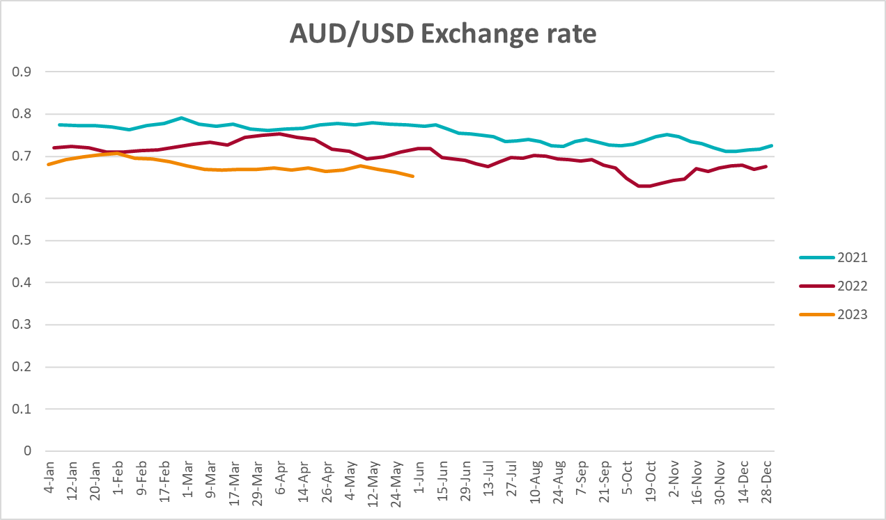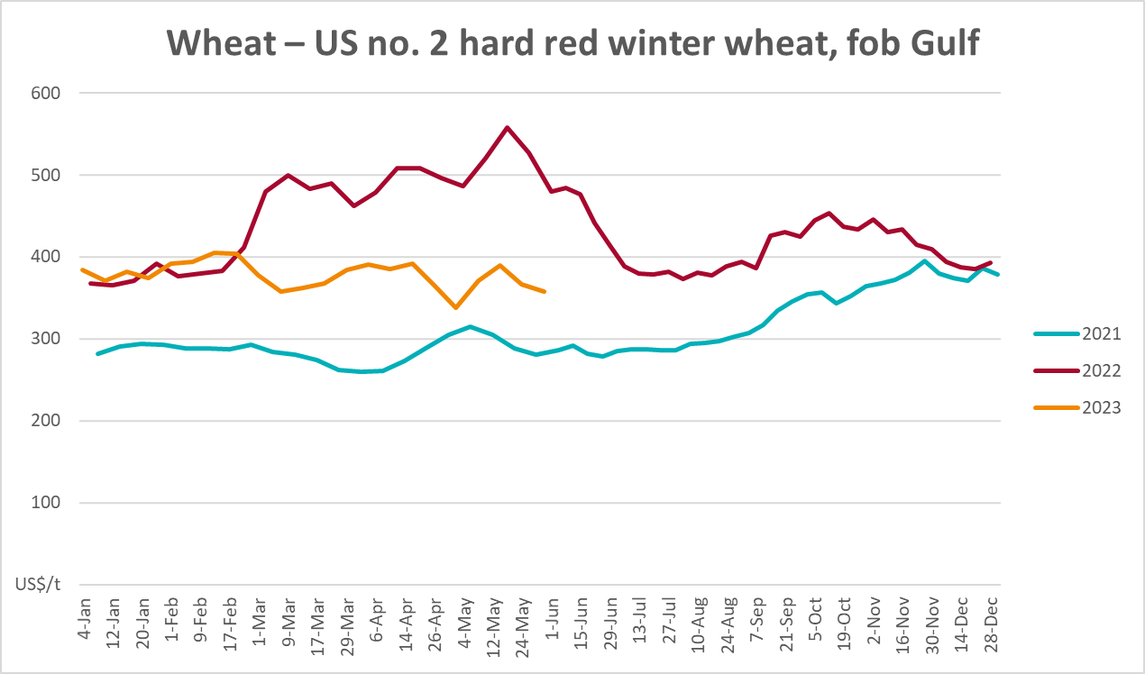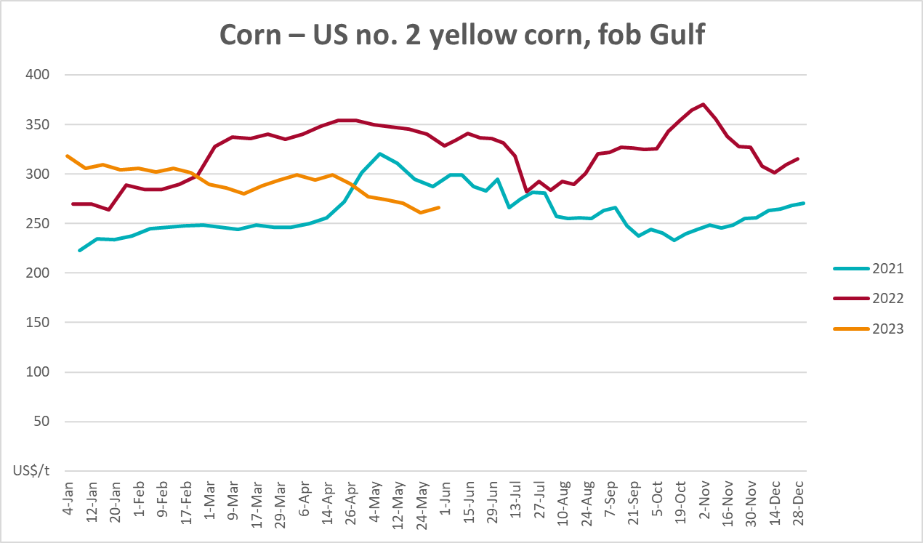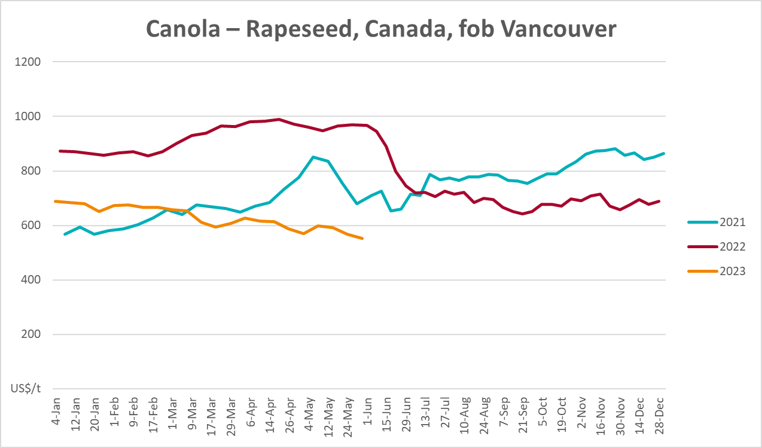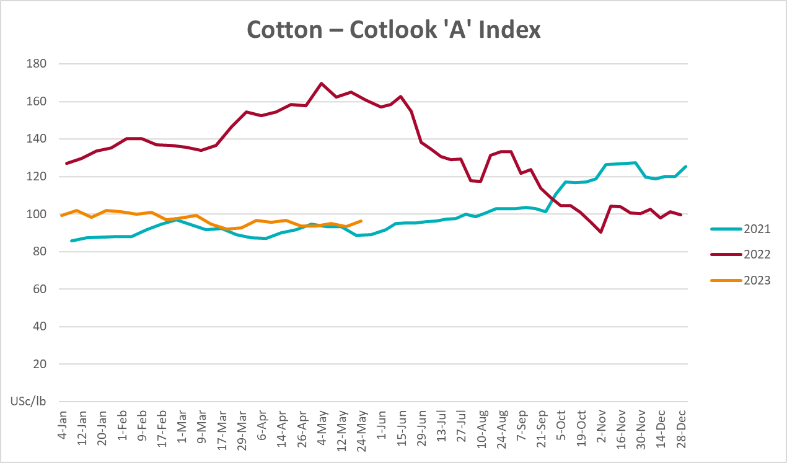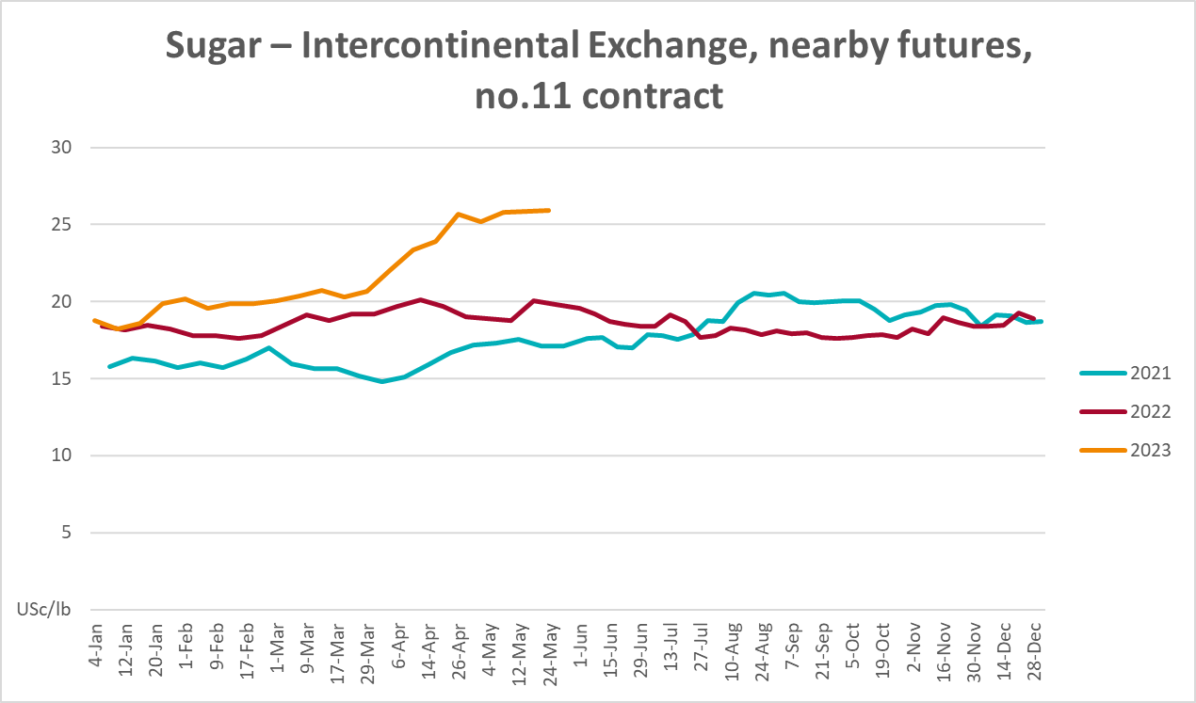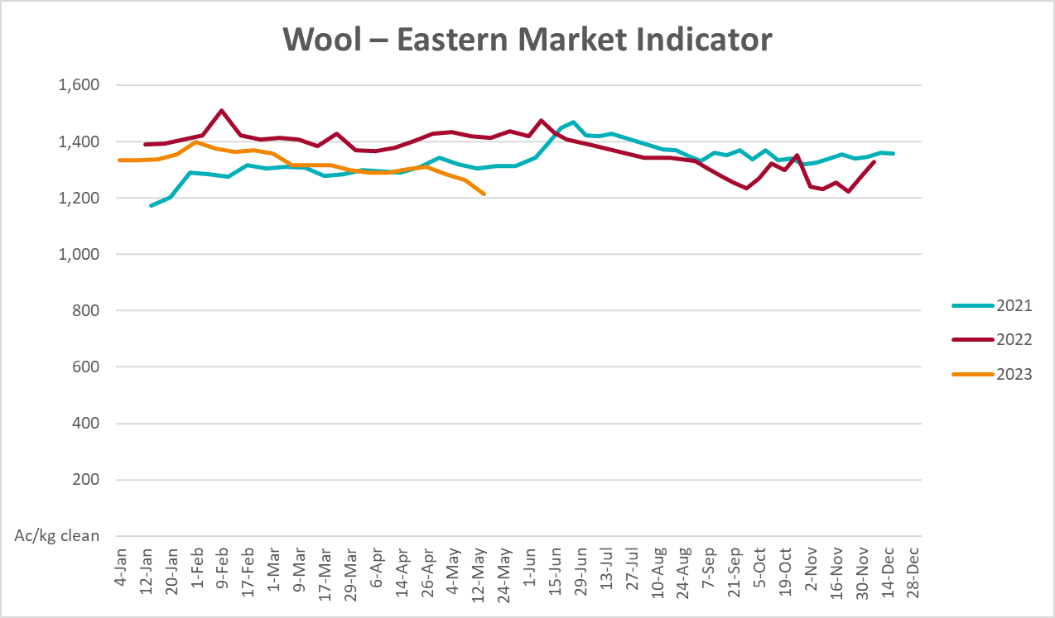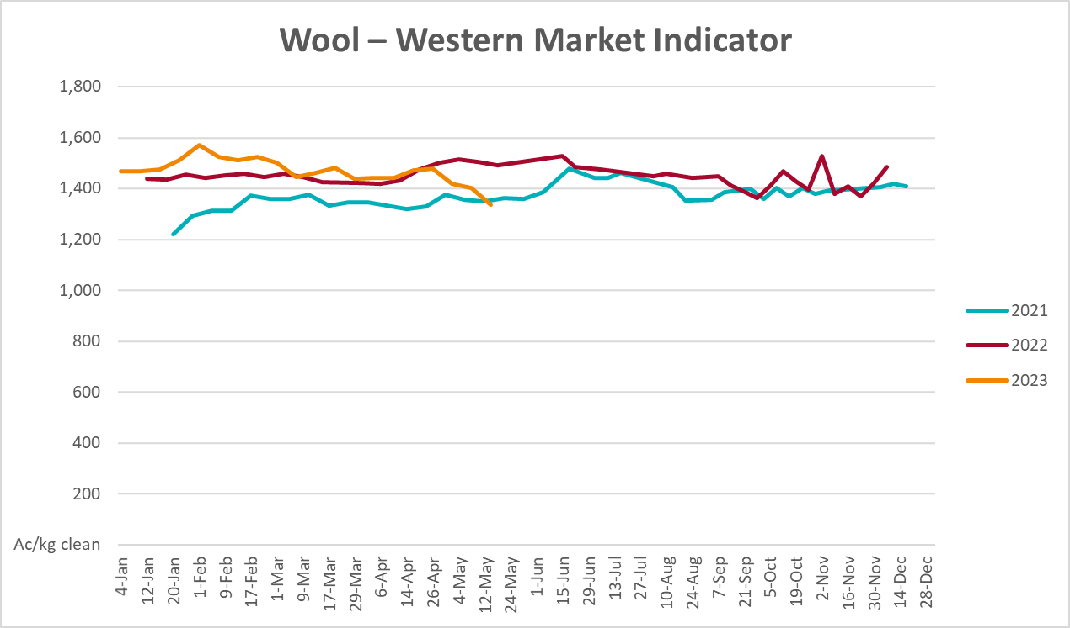

Selected domestic crop indicator prices
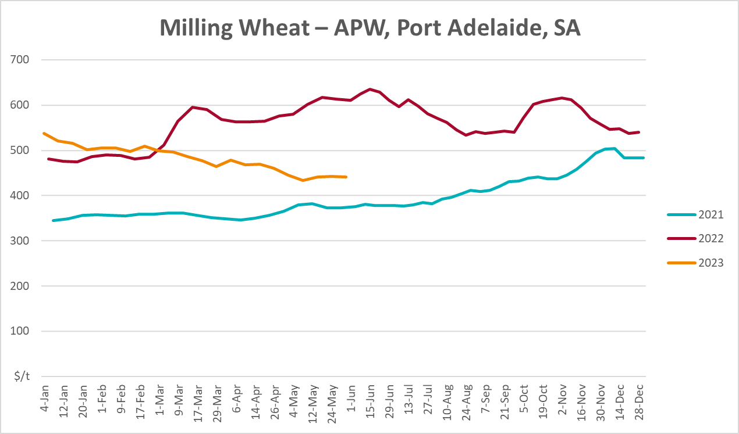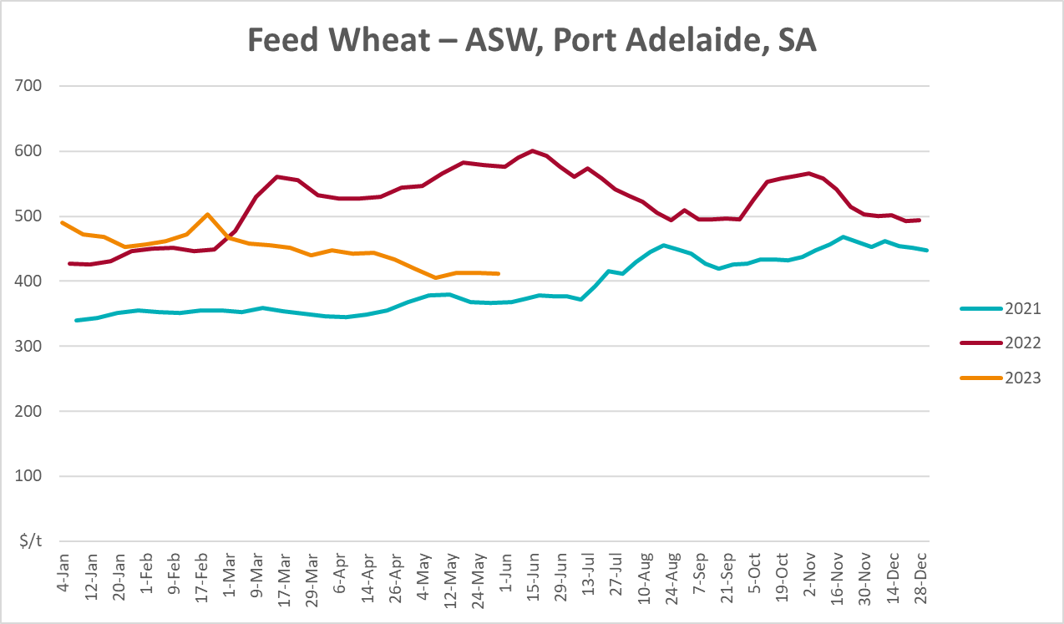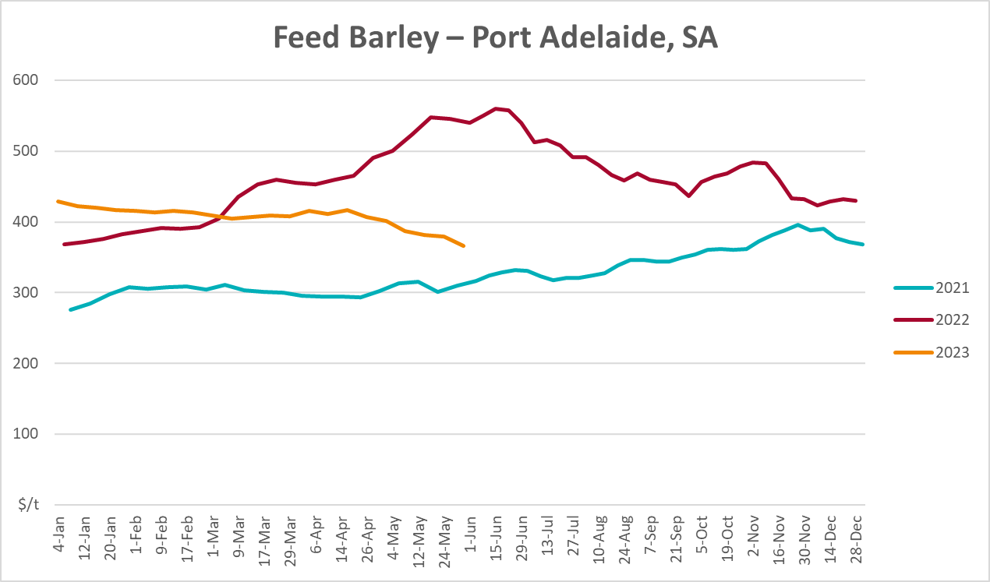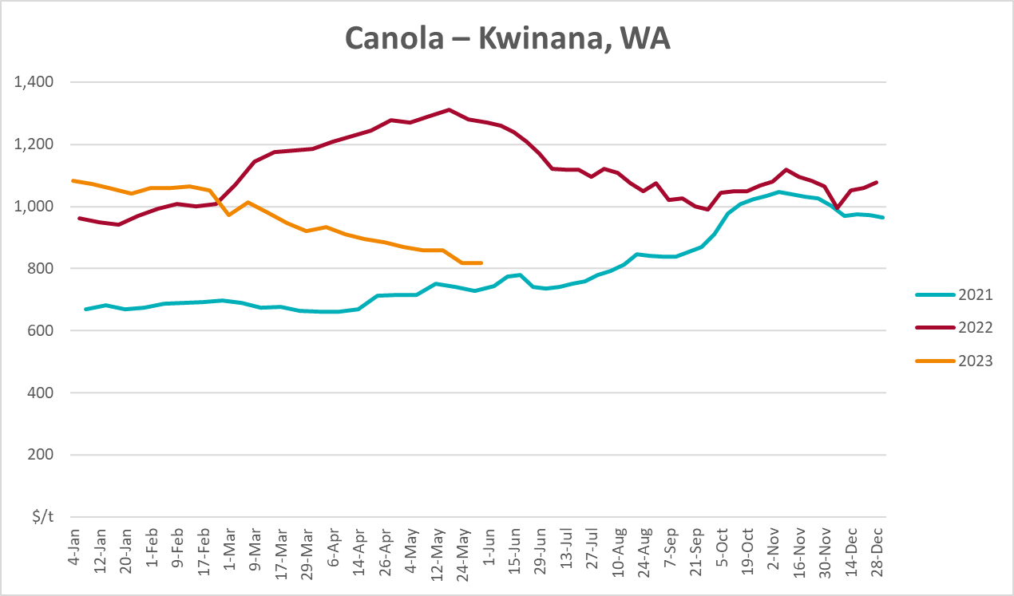
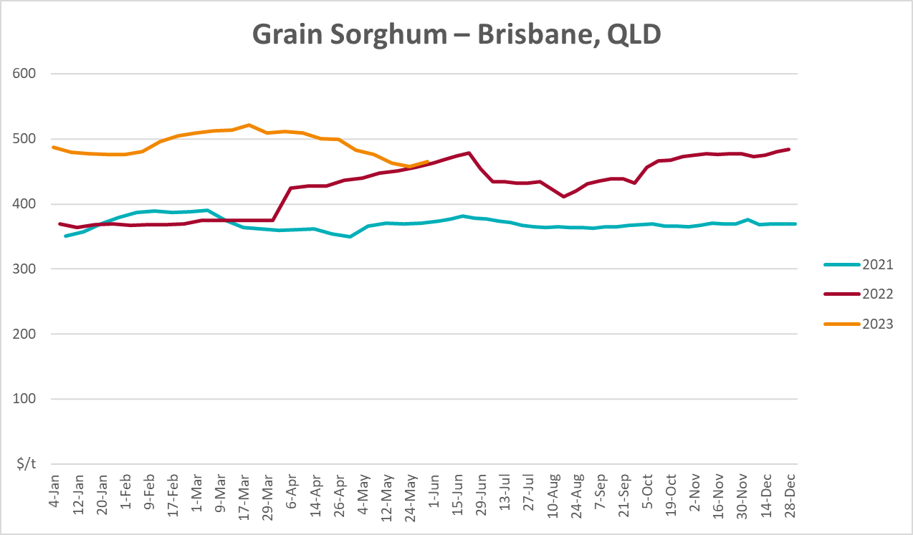

Selected domestic livestock indicator prices
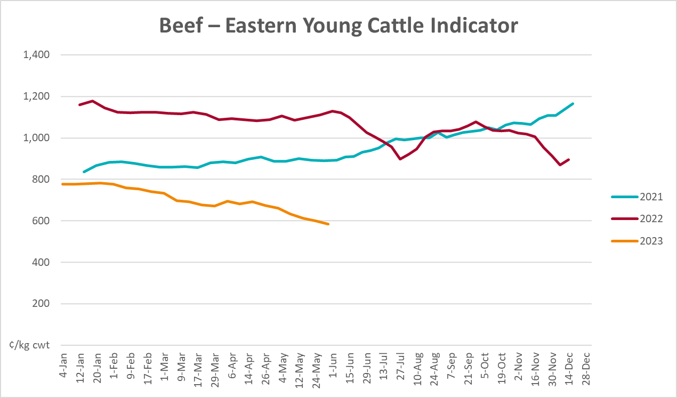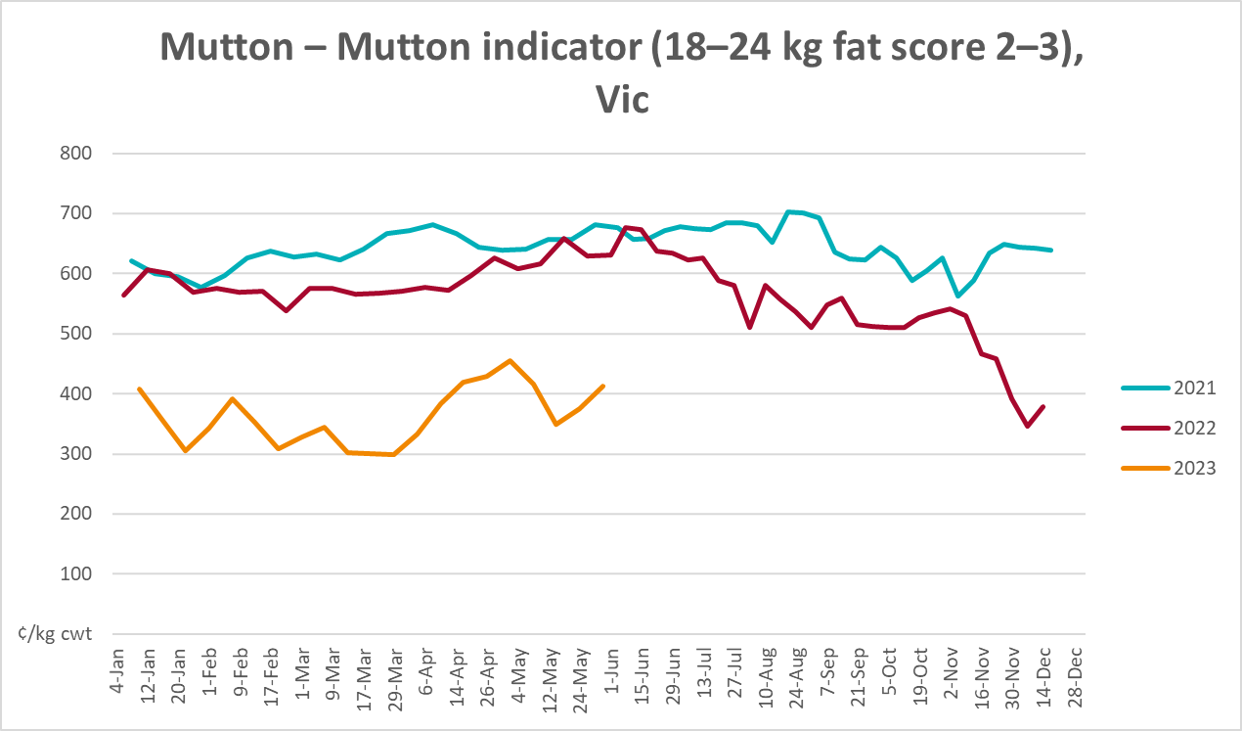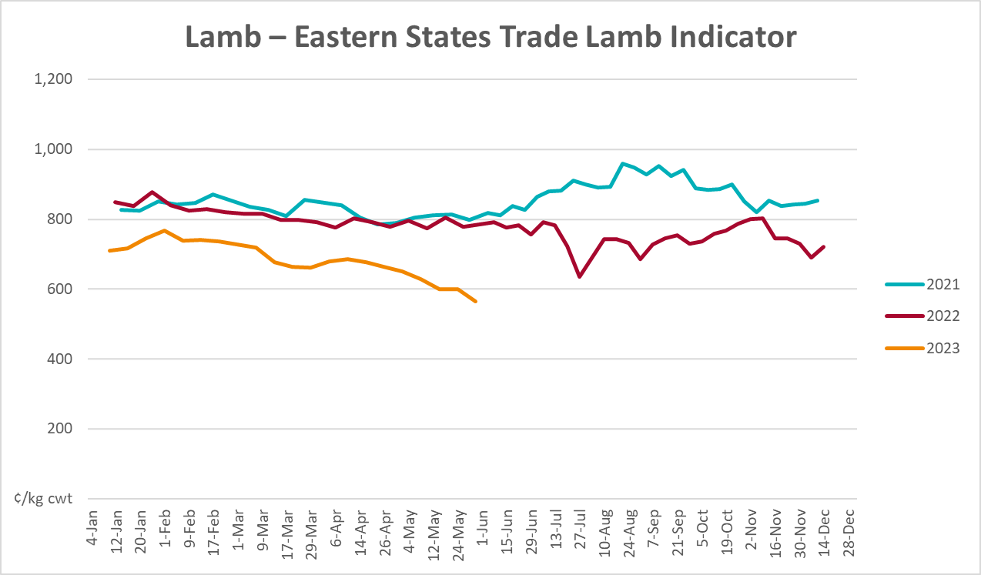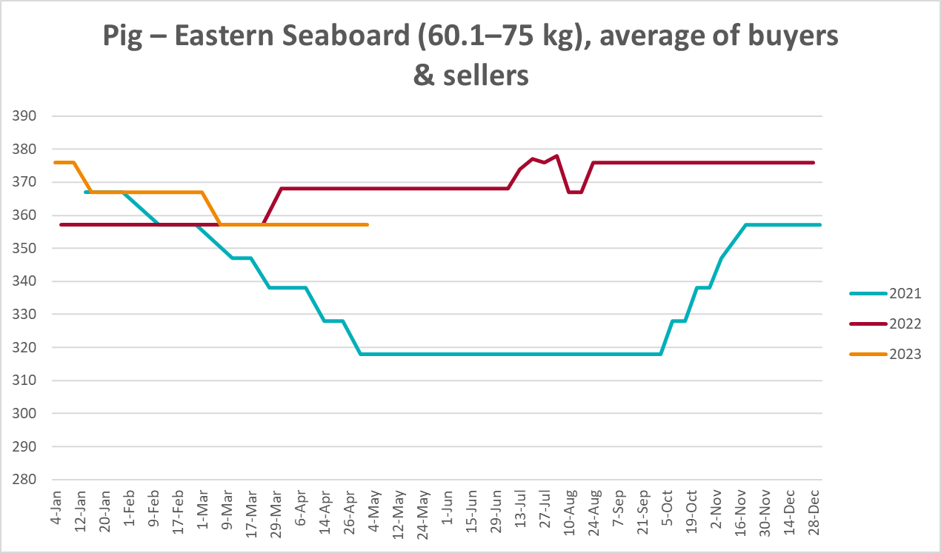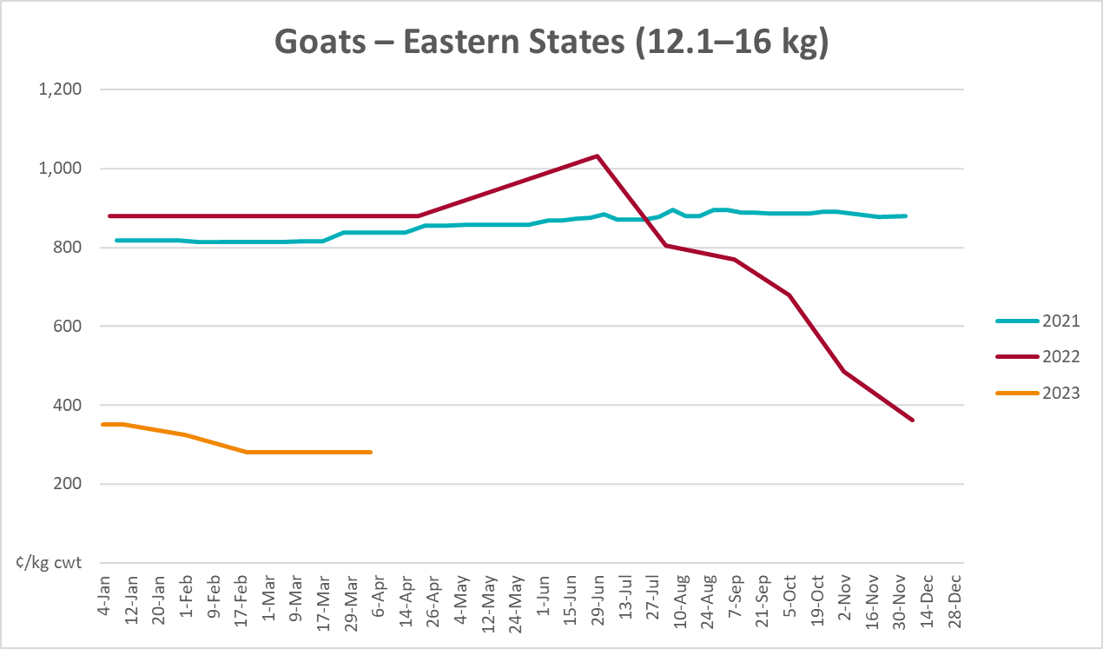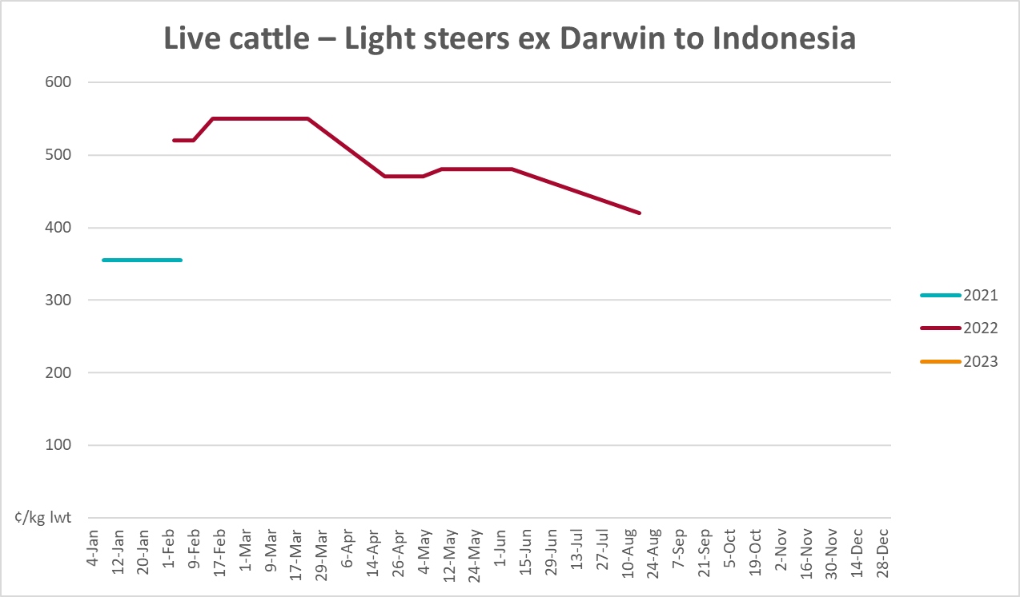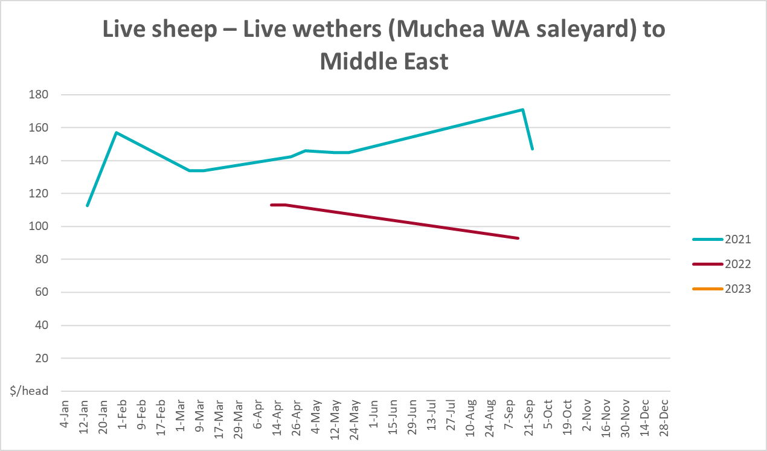

Global Dairy Trade (GDT) weighted average prices
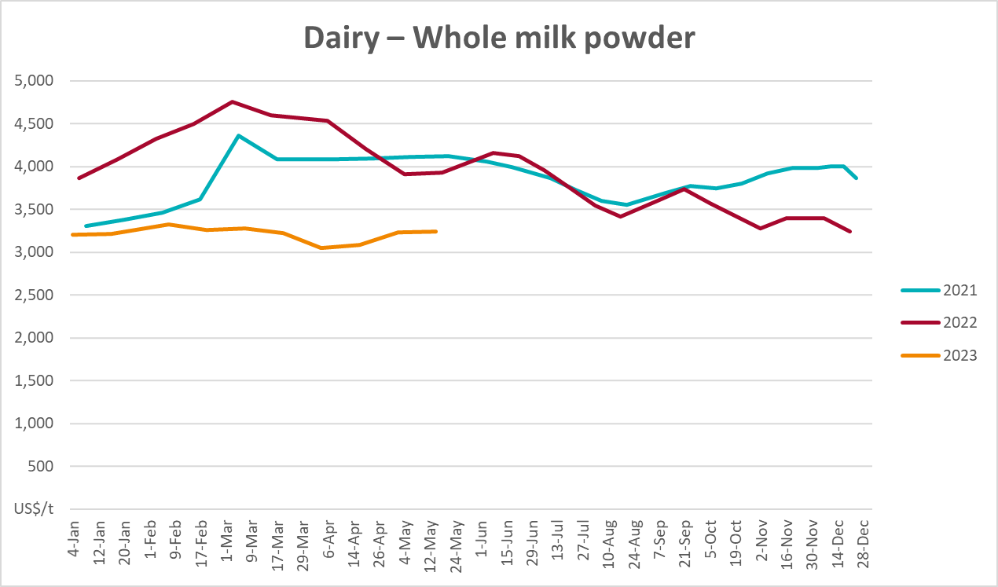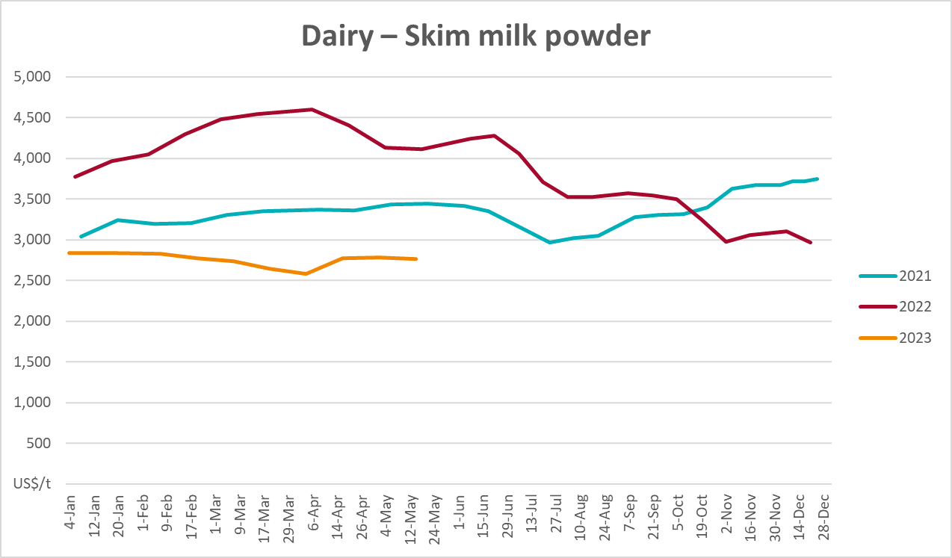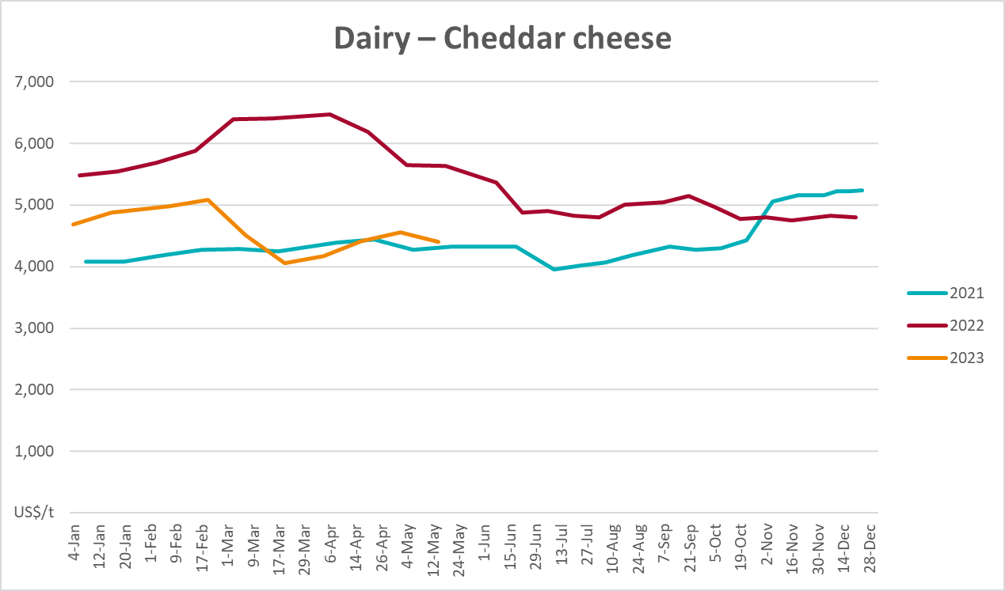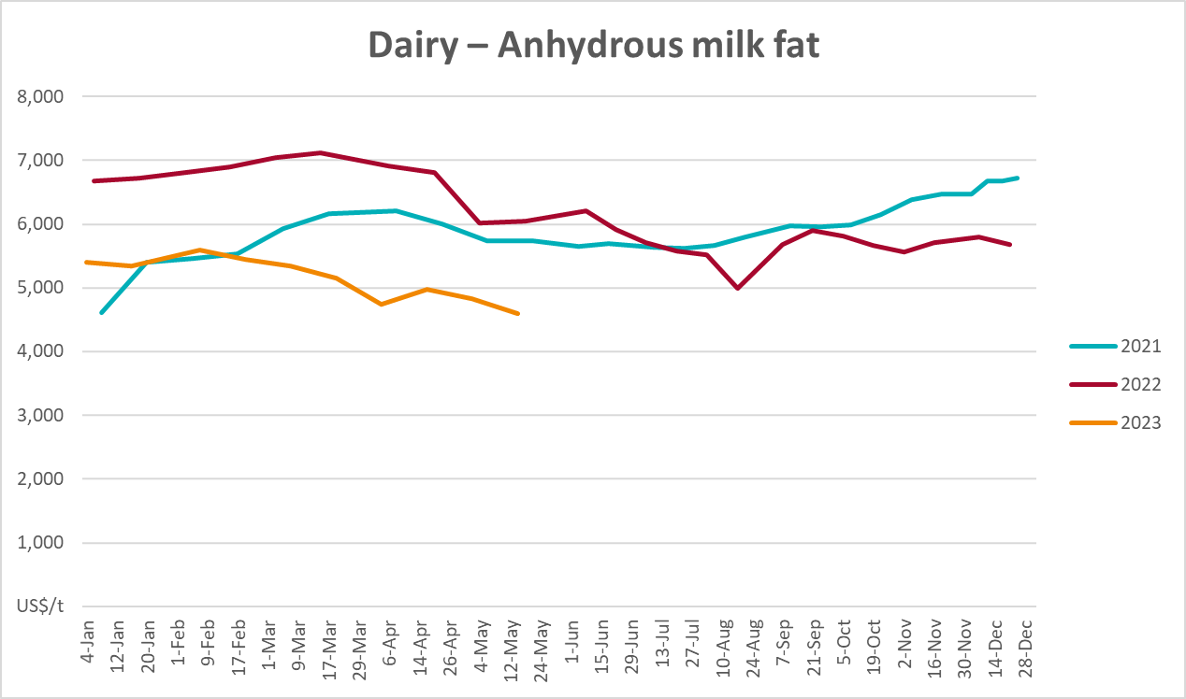

Selected fruit and vegetable prices
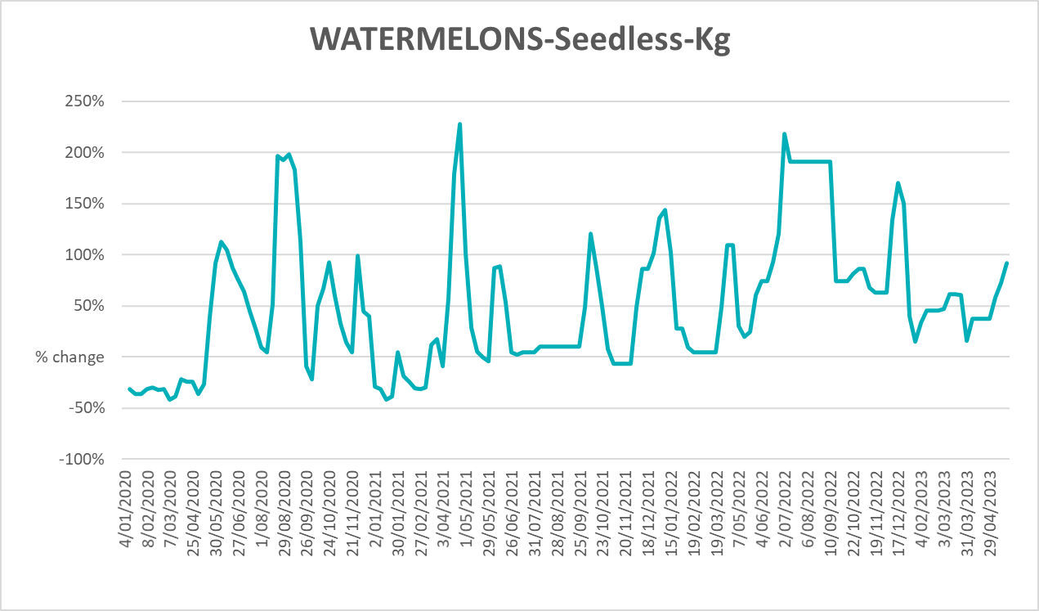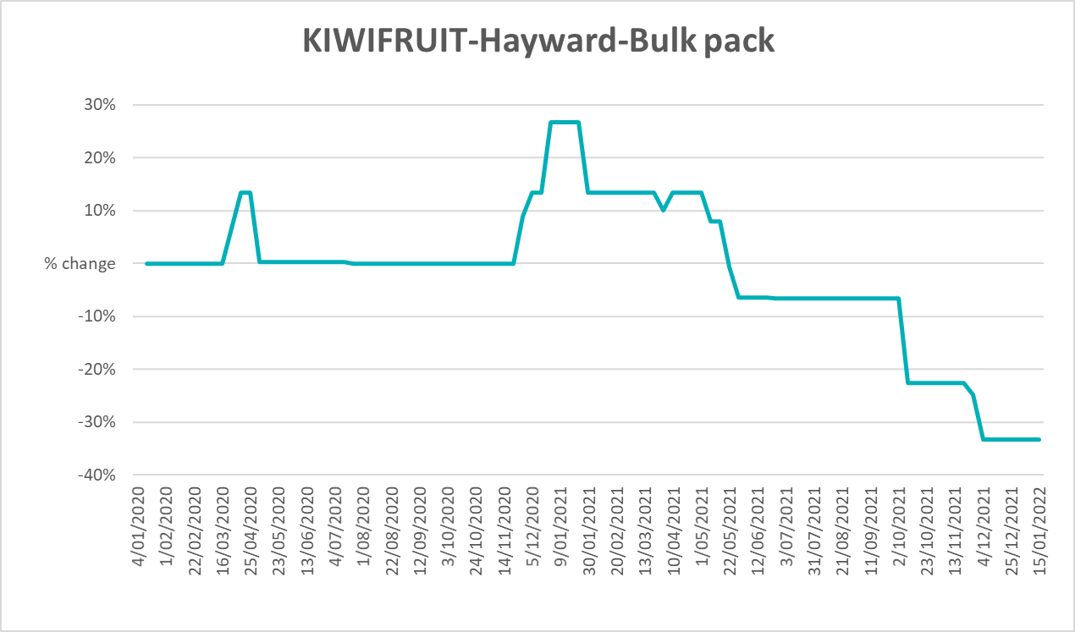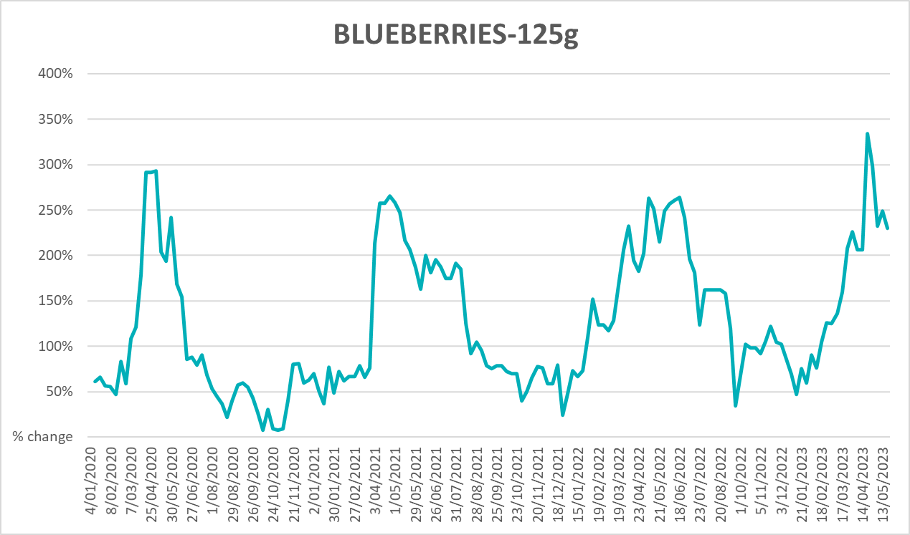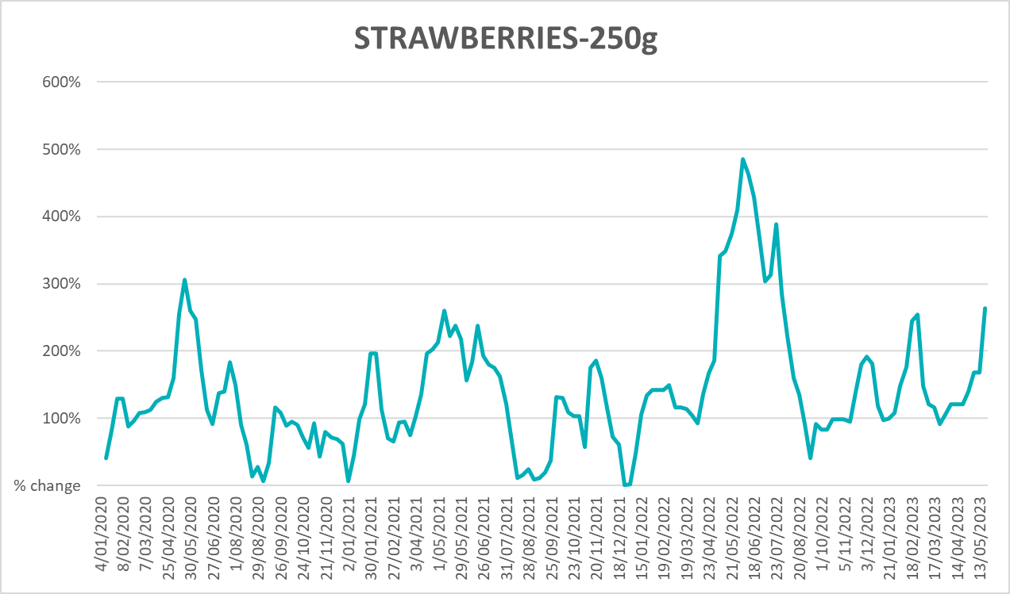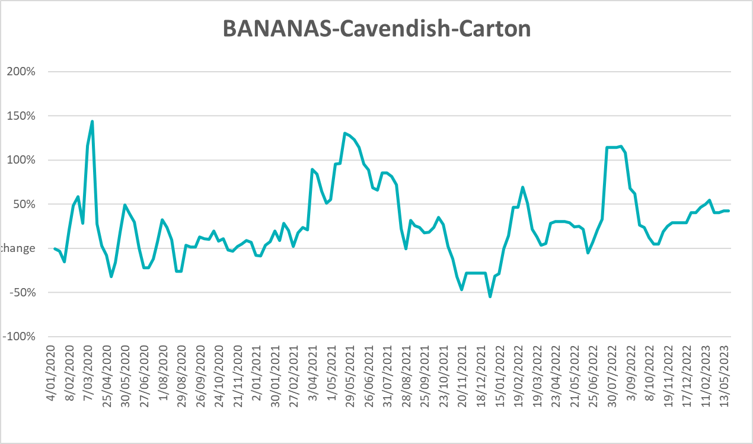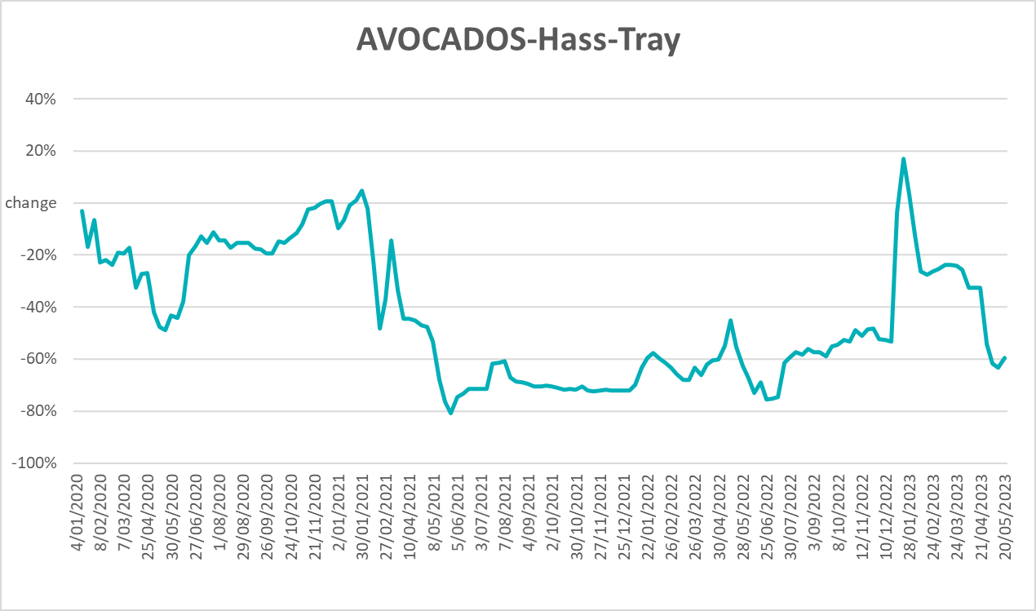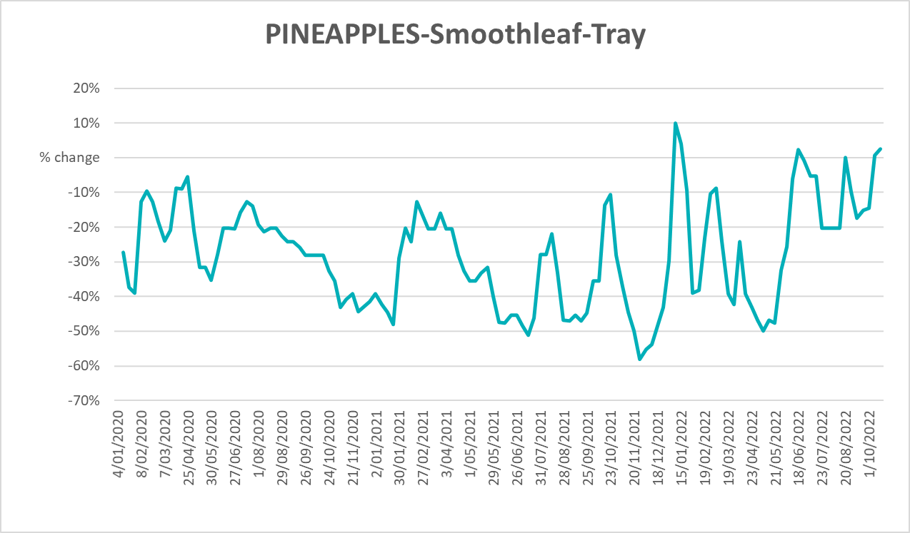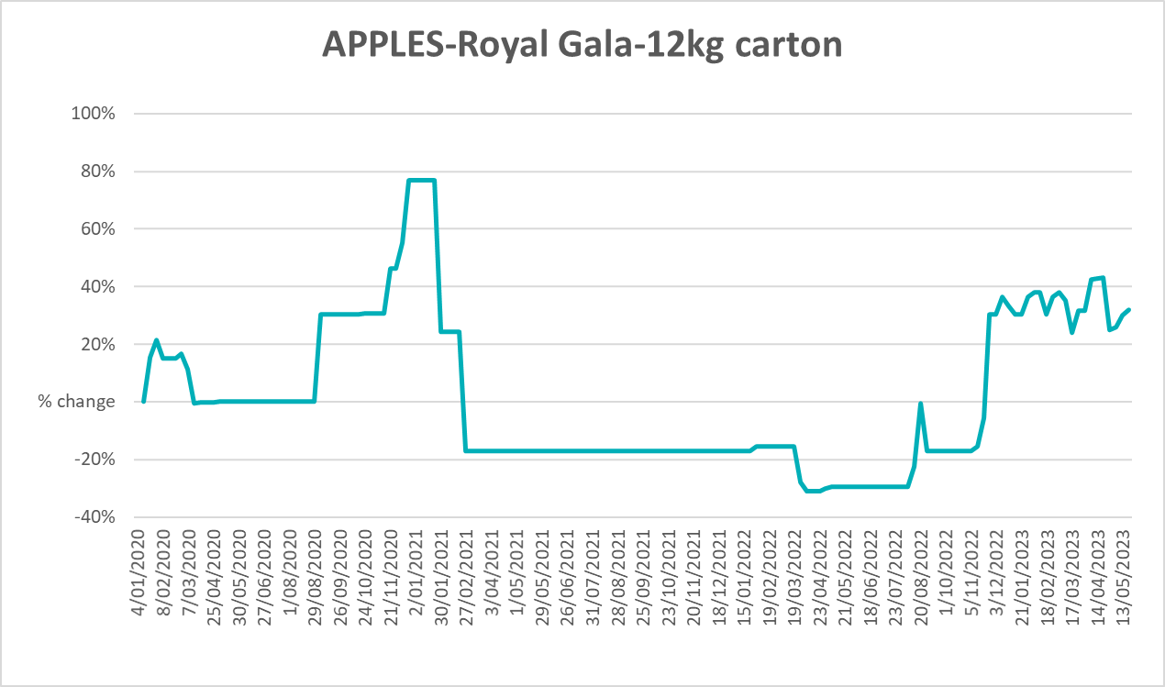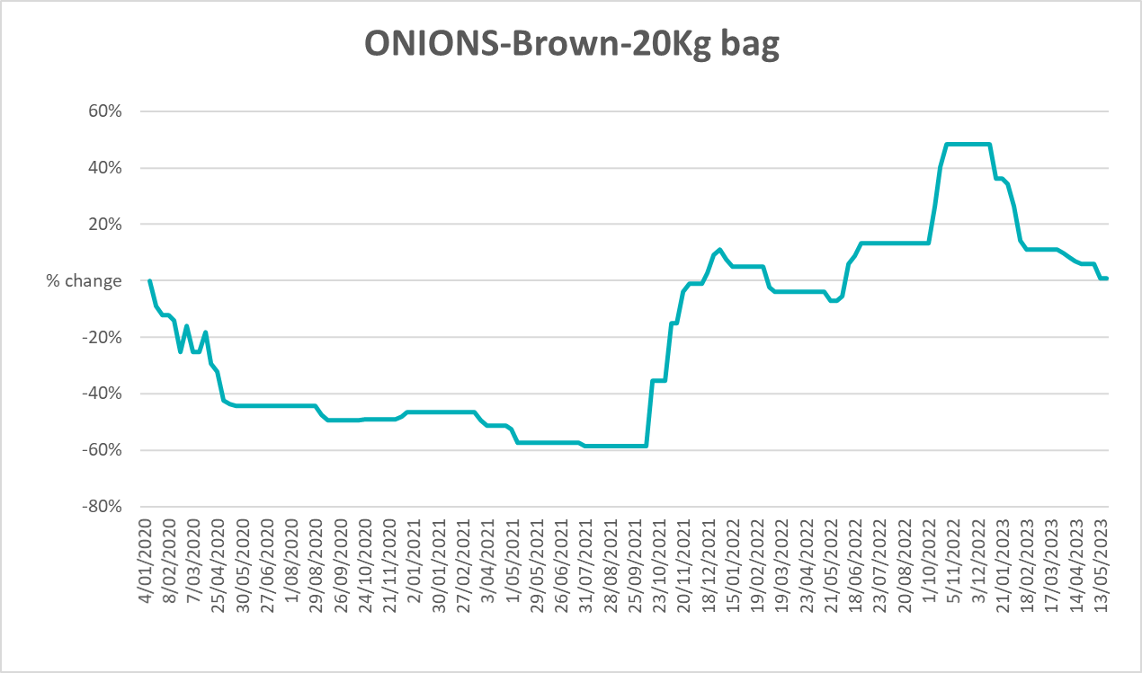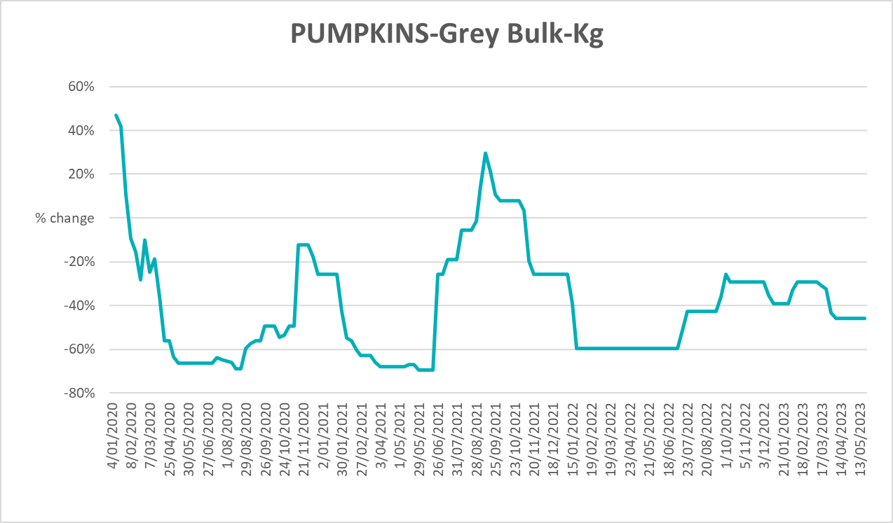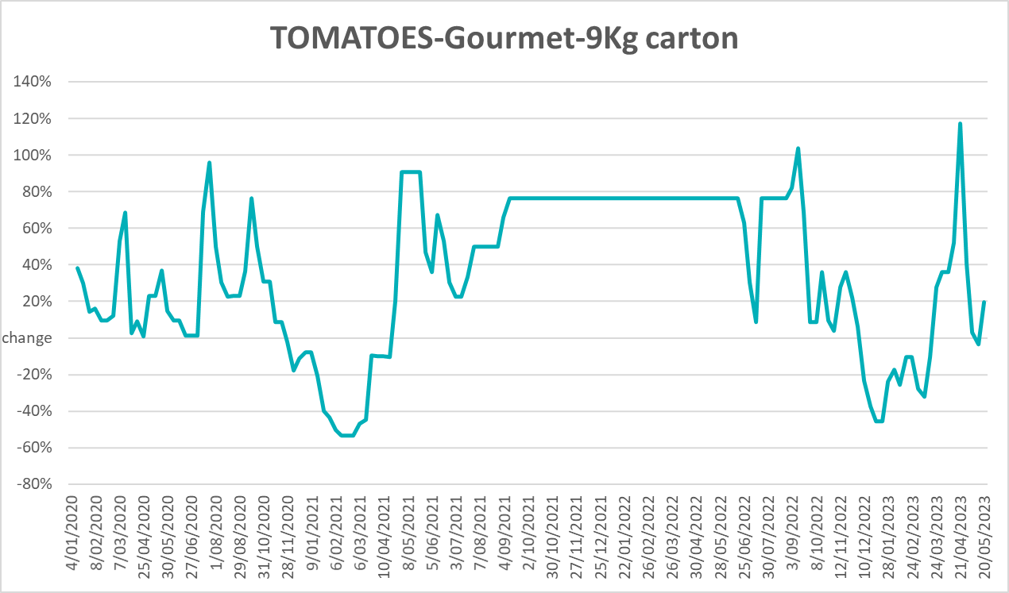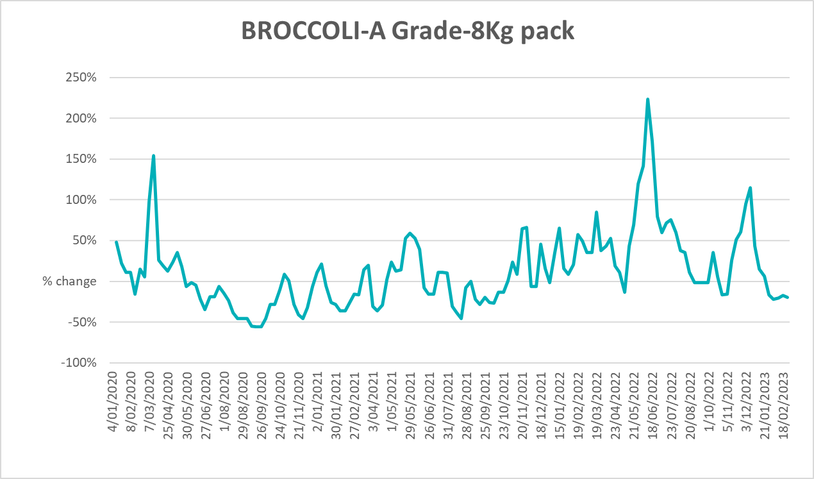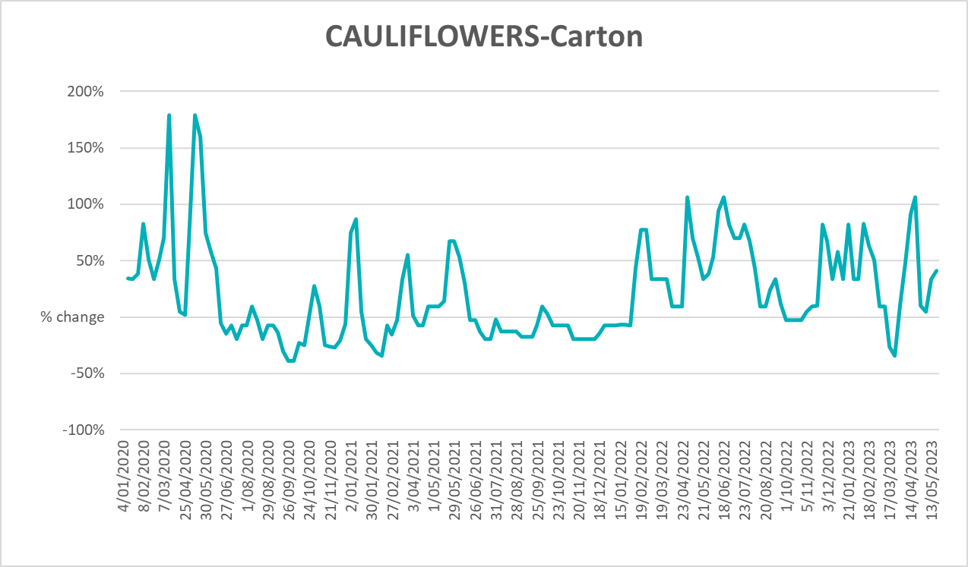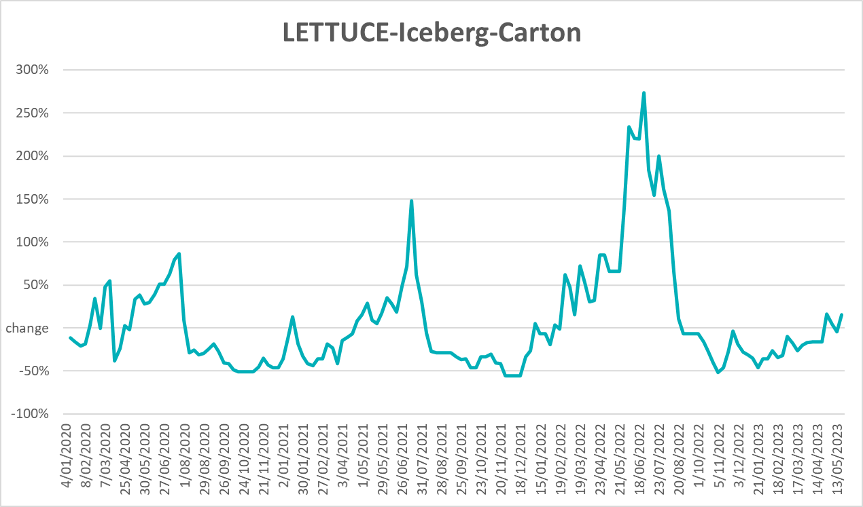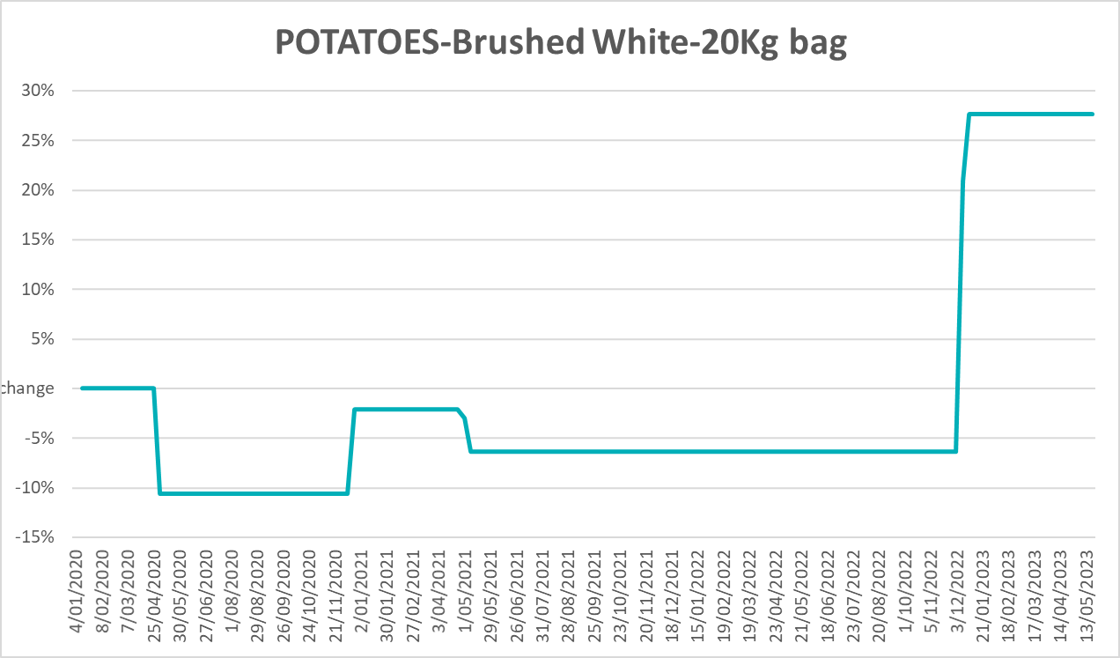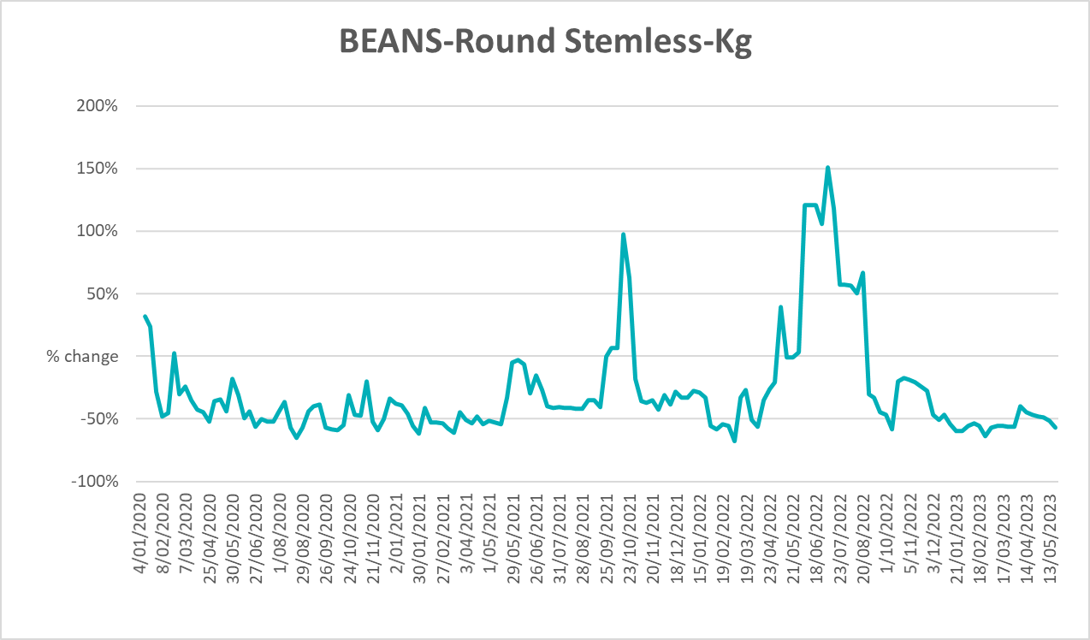

3.6 Selected domestic fodder indicator prices
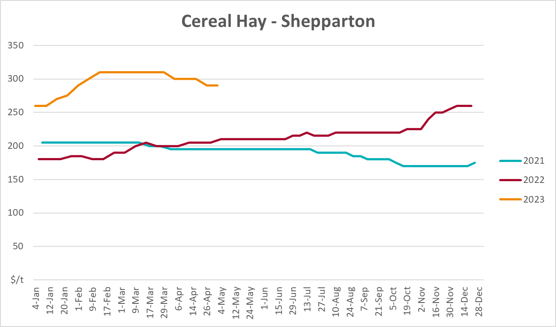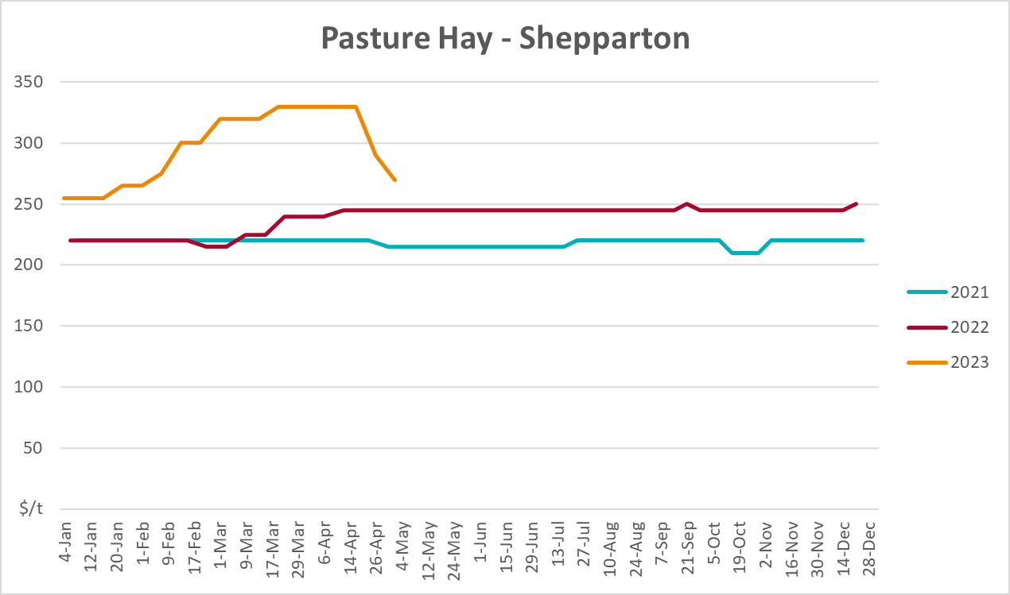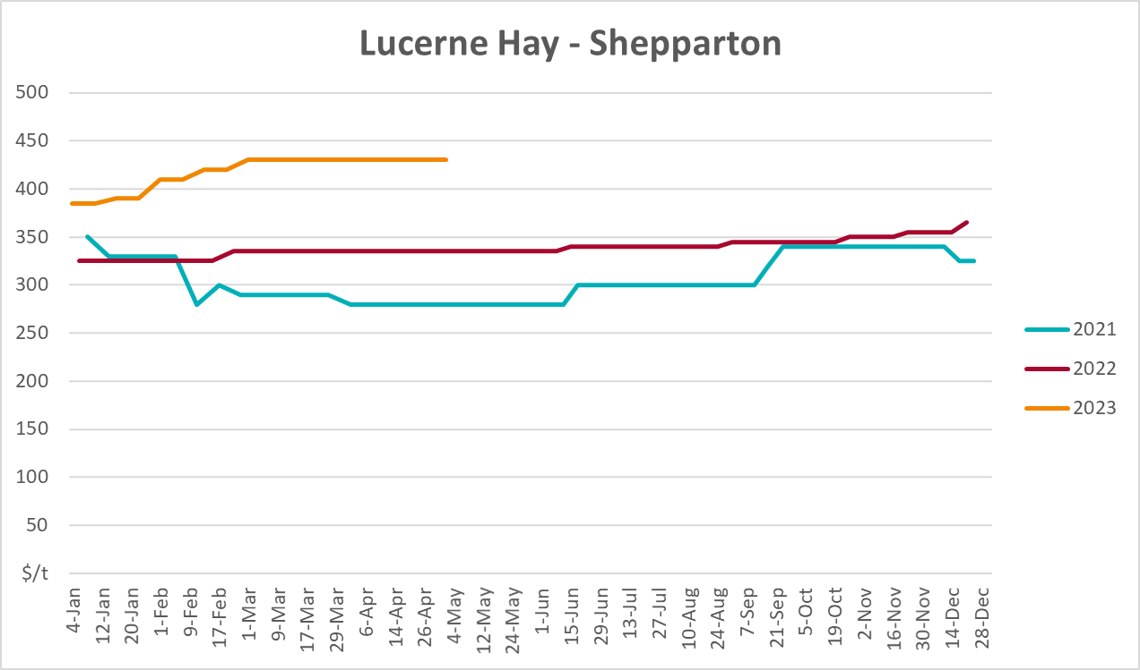

4. Data attribution

Climate
Bureau of Meteorology
- Weekly rainfall totals: www.bom.gov.au/climate/maps/rainfall/
- Monthly and last 3-month rainfall percentiles: www.bom.gov.au/water/landscape/
- Temperature anomalies: www.bom.gov.au/jsp/awap/temp/index.jsp
- Rainfall forecast: www.bom.gov.au/jsp/watl/rainfall/pme.jsp
- Seasonal outlook: www.bom.gov.au/climate/outlooks/#/overview/summary/
- Climate drivers: http://www.bom.gov.au/climate/enso/
- Soil moisture: www.bom.gov.au/water/landscape/
Other
- Pasture growth: www.longpaddock.qld.gov.au/aussiegrass/
- 3-month global outlooks: Environment and Climate Change Canada, NOAA Climate Prediction Center, EUROBRISA CPTEC/INPE, European Centre for Medium-Range Weather Forecasts, Hydrometcenter of Russia, National Climate Center Climate System Diagnosis and Prediction Room (NCC), International Research Institute for Climate and Society
- Global production: https://ipad.fas.usda.gov/ogamaps/cropmapsandcalendars.aspx
- Autumn break: Pook et al., 2009, https://rmets-onlinelibrary-wiley-com.virtual.anu.edu.au/doi/epdf/10.1002/joc.1833

Water
Prices
- Waterflow: https://www.waterflow.io/
- Ruralco: https://www.ruralcowater.com.au/
Bureau of Meteorology:
- Allocation trade: http://www.bom.gov.au/water/dashboards/#/water-markets/mdb/at
- Storage volumes: http://www.bom.gov.au/water/dashboards/#/water-storages/summary/drainage
Trade constraints:
- Water NSW: https://www.waternsw.com.au/customer-service/ordering-trading-and-pricing/trading/murrumbidgee
- Victorian Water Register: https://www.waterregister.vic.gov.au/TradingRules2019/

Commodities
Fruit and vegetables
- Datafresh: www.freshstate.com.au
Pigs
- Australian Pork Limited: www.australianpork.com.au
Dairy
- Global Dairy Trade: www.globaldairytrade.info/en/product-results/
World wheat, canola
- International Grains Council
World coarse grains
- United States Department of Agriculture
World cotton
- Cotlook: www.cotlook.com/
World sugar
- New York Stock Exchange - Intercontinental Exchange
Wool
- Australian Wool Exchange: www.awex.com.au/
Domestic wheat, barley, sorghum, canola and fodder
- Jumbuk Consulting Pty Ltd: http://www.jumbukag.com.au/
Cattle, beef, mutton, lamb, goat and live export
- Meat and Livestock Australia: www.mla.com.au/Prices-and-market
© Commonwealth of Australia 2023

Ownership of intellectual property rights
Unless otherwise noted, copyright (and any other intellectual property rights, if any) in this publication is owned by the Commonwealth of Australia (referred to as the Commonwealth).

Creative Commons licence
All material in this publication is licensed under a Creative Commons Attribution 4.0 International Licence except content supplied by third parties, logos and the Commonwealth Coat of Arms.
Inquiries about the licence and any use of this document should be emailed to copyright@awe.gov.au.


Cataloguing data
This publication (and any material sourced from it) should be attributed as:
ABARES 2023, Weekly Australian Climate, Water and Agricultural Update, Australian Bureau of Agricultural and Resource Economics and Sciences, Canberra, 1 June 2023. CC BY 4.0 DOI: https://doi.org/10.25814/5f3e04e7d2503
ISSN 2652-7561
This publication is available at https://www.agriculture.gov.au/abares/products/weekly_update
Department of Agriculture, Fisheries and Forestry
GPO Box 858 Canberra ACT 2601
Telephone 1800 900 090
Web agriculture.gov.au/abares

Disclaimer
The Australian Government acting through the Department of Agriculture, Fisheries and Forestry, represented by the Australian Bureau of Agricultural and Resource Economics and Sciences, has exercised due care and skill in preparing and compiling the information and data in this publication. Notwithstanding, the Department of Agriculture, Fisheries and Forestry, ABARES, its employees and advisers disclaim all liability, including liability for negligence and for any loss, damage, injury, expense or cost incurred by any person as a result of accessing, using or relying on any of the information or data in this publication to the maximum extent permitted by law.

Statement of Professional Independence
The views and analysis presented in ABARES publications, including this one, reflect ABARES professionally independent findings, based on scientific and economic concepts, principles, information and data. These views, analysis and findings may not reflect or be consistent with the views or positions of the Australian Government, or of organisations or groups who have commissioned ABARES reports or analysis. More information on professional independence is provided on the ABARES website.

Acknowledgements
This report was prepared by Kavina Dayal and Matthew Miller.

