How to fix common access issues to the Biosecurity Portal home page

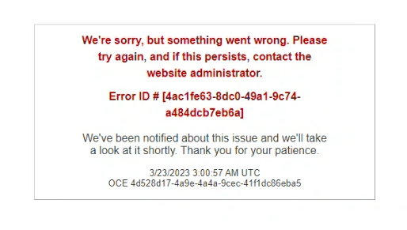This task card demonstrates how to resolve load errors when accessing the home screen of the Biosecurity Portal.

# Troubleshoot browser

## Access the Biosecurity Portal in a different browser

Open the Biosecurity Portal in both the Google Chrome and Microsoft Edge browser

* If the alternate browser is showing the portal correctly, clear cookies on your primary browser by following the steps in 1.3 Clear cookies from selected browser.
* If the issue remains on both browsers, proceed with the following steps.

## Access the Biosecurity Portal in private mode on either browser

### Chrome browser – Incognito window

Right click Chrome in taskbar and select **New Incognito window**

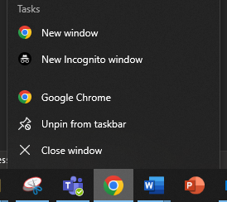

### Edge browser – InPrivate window

Right click Edge in taskbar and select **New InPrivate window**

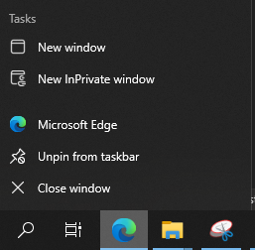

## Clear cookies from selected browser

If the steps in 1.2 Access the Biosecurity Portal in private mode on either browser

### Clearing data on Chrome

Open a new tab in chrome and **paste** the following link

<chrome://settings/content/siteDetails?site=https://biosecurity.awe.gov.au/>

Select **Clear data**

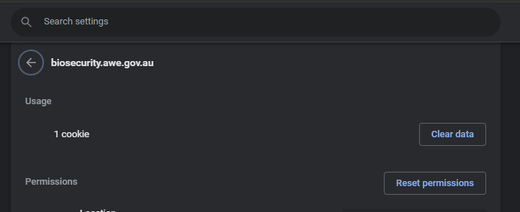

### Clearing data on Microsoft Edge

Open a **new tab** in chrome and **paste** the following link

<edge://settings/siteData?site=biosecurity.awe.gov.au>

**Expand** awe.gov.au and select the **trashcan** to **Remove biosecurity.awe.gov.au**

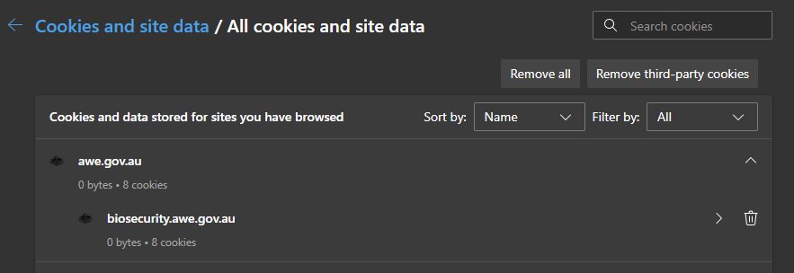

# Flush DNS cache

This step may require IT assistance for external users. If this problem persists after the recommended troubleshoot browser steps, users will need to flush their DNS cache via the Command Prompt.

DNS (Domain Name System) is the system that translates domain names (biosecurity.awe.gov.au) to IP addresses (192.1.1.1)

Flushing DNS cache ensures users are accessing the most up-to-date versions of their frequent sites

## Access Command Prompt

Select the search bar near the Windows icon

Search for Command Prompt

Select **Command Prompt App**

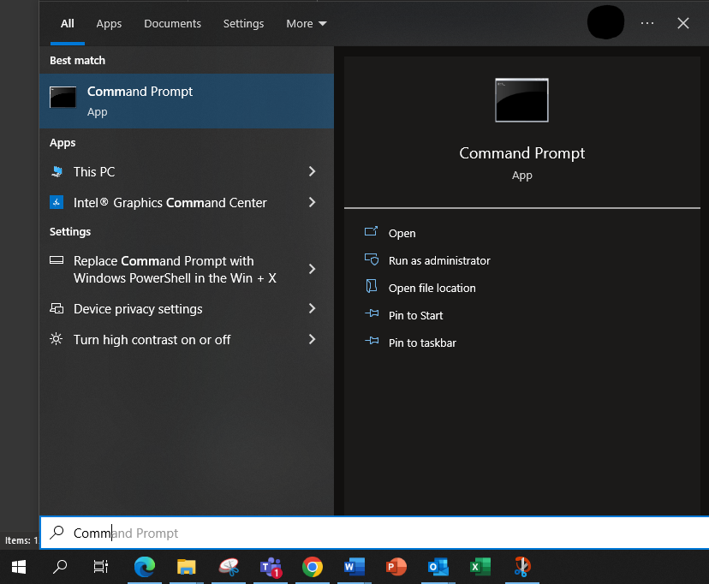

## Flush DNS

Copy or type **ipconfig/flushdns** in Command Prompt

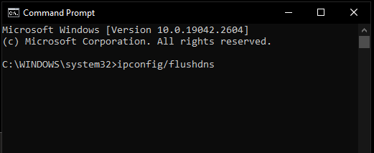Note: Right clicking in Command Prompt will paste

Select **Enter** on the keyboard

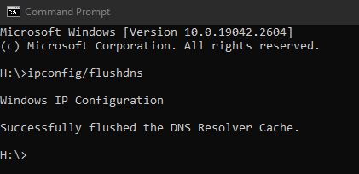Text will display Successfully flushed the DNS Resolver Cache.

Any other text, refer to your personal IT support to assist further.