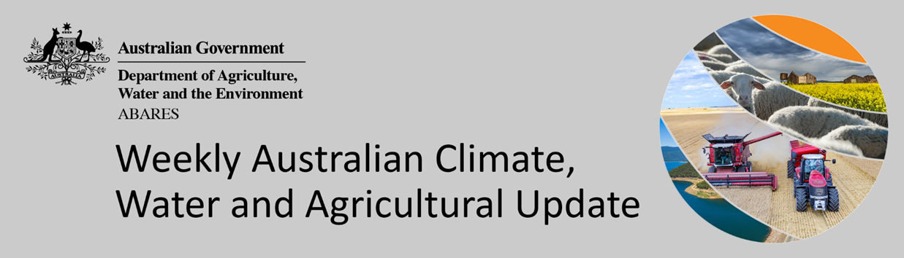
No. 15/2022

21 April 2022

Summary of key issues
- For the week ending 20 April 2022, low-pressure troughs and cold fronts brought rainfall to parts of southern Australia, and tropical lows resulted in heavy rainfall for parts of far northern Australia. Meanwhile, high-pressure systems and weak troughs provided clear, dry conditions for much of central Australia (see Section 1.1).
- Dry conditions across Queensland and northern New South Wales likely allowed harvesting of early sown summer crops to resume, while cotton harvesting in northern cropping regions of Queensland continued. In southern New South Wales, the recent rainfall is expected to have prevented field access for harvesting of summer crops, such as rice, as well as preparation and sowing of winter crops. Nevertheless, upper layer soil moisture levels across central and southern New South Wales, as well as northern Victoria, are well above average, which will provide a promising start to winter cropping.
- Below average rainfall globally during March is likely to result in lower-than-expected winter wheat production potential in the United States, parts of Europe and Canada. Further, the conflict in Ukraine has generated additional levels of uncertainty around wheat production for 2022. Below average rainfall during March has also negatively affected corn and soybean production across parts of Argentina and Brazil. Global production conditions have deteriorated compared to those used to formulate ABARES forecasts of global grain supplies and world prices in its March 2022 edition of the Agricultural Commodities Report. As a result, global grain and oilseed production is likely to be lower than that forecast in March (see Section 1.2).
- Over the 8-days to 28 April 2022, low-pressure troughs and onshore winds are expected to result in rainfall across eastern Australia, with a cold front bringing rainfall to the south-west. A high-pressure system to the south of Australia is forecast to bring mostly dry conditions for remaining parts of Western Australia (see Section 1.3).
- Water storage in the Murray–Darling Basin (MDB) decreased by 63 gigalitres (GL) between 13 April 2022 and 20 April 2022. The current volume of water held in storage is 21,452GL, which represents 85 per cent of total capacity. This is 50% or 7,118 GL more than at the same time last year.
- Allocation prices in the Victorian Murray below the Barmah Choke increased from $63 per ML on 9 April 2022 to $72 per ML on 14 April 2022. Prices are lower in the Goulburn-Broken, Murrumbidgee and regions above the Barmah choke due to the binding of the Goulburn intervalley trade limit, Murrumbidgee export limit and Barmah choke trade constraint.

Climate

Rainfall this week
For the week ending 20 April 2022, low-pressure troughs and cold fronts brought rainfall to parts of southern Australia, and tropical lows resulted in heavy rainfall for parts of far northern Australia. Meanwhile, high-pressure systems and weak troughs provided clear, dry conditions for much of central Australia.
Rainfall totals of between 10 and 50 millimetres were recorded across southern and north-eastern parts of New South Wales, isolated parts of south-eastern and northern Queensland, most of Victoria, south-central South Australia, northern and southern parts of Western Australia, as well as northern parts of the Northern Territory and much of Tasmania. Rainfall totals in excess of 50 millimetres were recorded across parts of northern Queensland and the Northern Territory, as well as central Victoria. Remaining parts of Australia received little to no rainfall.
In cropping regions, rainfall totals of between 10 and 50 millimetres were recorded across southern and central New South Wales, isolated parts of eastern Queensland, Victoria, central South Australia and eastern parts of Western Australia. Rainfall in excess of 50 millimetres was recorded in cropping regions in south-eastern and central Victoria. Little to no rainfall was recorded across cropping regions in remaining parts of New South Wales and Queensland, Western Australia or the east of South Australia.
Dry conditions across Queensland and northern New South Wales likely allowed harvesting of early sown summer crops to resume, while cotton harvesting in northern cropping regions of Queensland continued. In southern New South Wales, the recent rainfall is expected to have prevented field access for harvesting of summer crops, such as rice, as well as preparation and sowing of winter crops. Nevertheless, upper layer soil moisture levels across central and southern New South Wales, as well as northern Victoria, are well above average, which will provide a promising start to winter cropping. Meanwhile, the winter cropping season has started with canola planting in Western Australia.

Rainfall for the week ending 20 April 2022

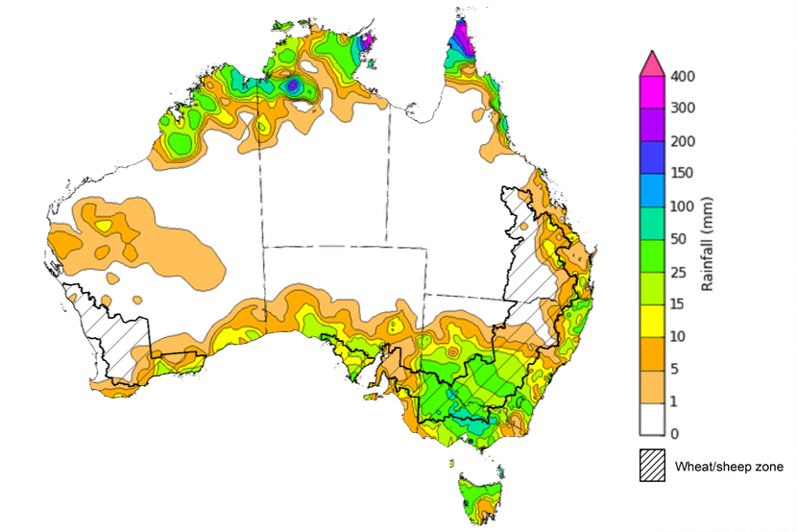
©Commonwealth of Australia 2022, Australian Bureau of Meteorology Issued: 20/4/2022
Note: The rainfall analyses and associated maps utilise data contained in the Bureau of Meteorology climate database, the Australian Data Archive for Meteorology (ADAM). The analyses are initially produced automatically from real-time data with limited quality control. They are intended to provide a general overview of rainfall across Australia as quickly as possible after the observations are received. For further information go to http://www.bom.gov.au/climate/rainfall/

Global production conditions and climate outlook
Crop production is affected by long-term trends in average rainfall and temperature, interannual climate variability, shocks during specific growth stages, and extreme weather events (IPCC 2012). Some crops are more tolerant than others to certain types of stresses, and at each growth stage, different types of stresses affect each crop species in different ways.
The precipitation anomalies and outlooks presented here give an indication of the current and future state of production conditions for the major grain and oilseed producing countries which are responsible for over 80% of global production. This is an important input to assessing the global grain supply outlook.
March precipitation percentiles and current production conditions
As of the end of March 2022, rainfall was mixed for the world’s major grain-producing and oilseed-producing regions.
In the northern hemisphere, precipitation was below average in northern and western United States, central and northern Europe, Ukraine, north-eastern India and parts of eastern Canada. Precipitation was above average for north-eastern United States, Kazakhstan, central Canada, northern and central China and south-western Europe. Precipitation was close to average across the remainder of the major grain-producing and oilseed-producing regions in the northern hemisphere.
In the southern hemisphere, March precipitation was below average in parts of northern Argentina and Paraguay, as well as parts of Brazil. Precipitation was above average for parts of southern and western Brazil, South Africa and eastern Australia. Precipitation was close to average across the remainder of major grain-producing and oilseed-producing regions in the southern hemisphere.

Global precipitation percentiles, March 2022
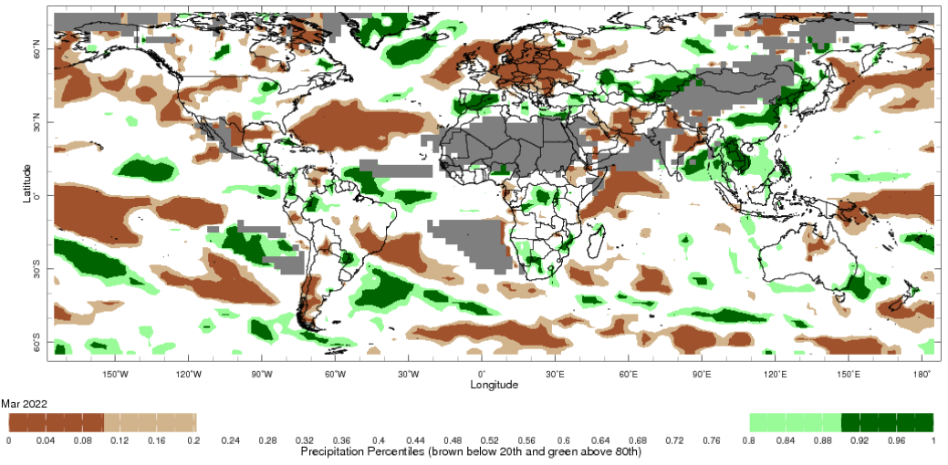
Note: The world precipitation percentiles indicate a ranking of precipitation for March, with the driest (0th percentile) being 0 on the scale and the wettest (100th percentile) being 1 on the scale. Percentiles are based on precipitation estimates from the NOAA Climate Prediction Center's Climate Anomaly Monitoring System Outgoing Precipitation Index dataset. Precipitation estimates for March 2022 are compared with rainfall recorded for that period during the 1981 to 2010 base period.
Source: International Research Institute for Climate and Society
As at 28 March 2022 global production conditions were mixed for the production of wheat, corn, rice and soybean.
In the northern hemisphere production conditions for wheat have been mixed. Climatic conditions have been favourable for wheat development in India, the Russian Federation, Turkey and the United Kingdom. Production is mixed in Canada, the European Union and the United States due to dryness in some areas. Flooding along the Yellow River in China last year delayed and reduced sowing of winter wheat in autumn, which is expected to negatively impact production. The conflict in Ukraine is expected to restrict access to inputs and limit field access, which has generated additional levels of uncertainty for the wheat production outlook.
Conditions for corn in Argentina for early- and late-planted crop development are below average to poor due to drought and high temperatures affecting yield potential. However, recent rainfall has benefited late-sown crops. In Brazil, hot and dry conditions during reproductive stages have negatively impacted yields for spring-planted crops in the south. Sowing of summer-planted corn is drawing to a close with favourable conditions expected. Likewise, sowing of corn in southern United States has started under favourable conditions. In India, Mexico and South Africa, conditions were generally favourable for crop development.
Transplanting of Rabi rice in India has finished under favourable conditions. Harvesting of wet-season rice continues following favourable seasonal conditions, resulting in above average yields. Sowing of early-season rice is underway in China with favourable conditions. In the Philippines and Thailand, harvesting of dry-season rice is underway. Yields in the Philippines are average thus far, while Thailand yields have increased since last year. Winter-spring rice in northern Vietnam is in early vegetative growth stages under favourable conditions, while harvesting is underway in the south with increased yields from last year. In Brazil, harvesting is underway with dry conditions during reproductive stages having reduced yields.
Harvesting of early-sown soybean is underway in Argentina. Rainfall in February and March improved yield potentials, but prolonged periods of hot, dry conditions have negatively impacted the crop in some areas. In Brazil, drought conditions and high temperatures in southern regions during reproductive stages have negatively impacted yield potential. However, in other regions, harvesting continues under favourable conditions.
Crop conditions, AMIS countries, 28 March 2022
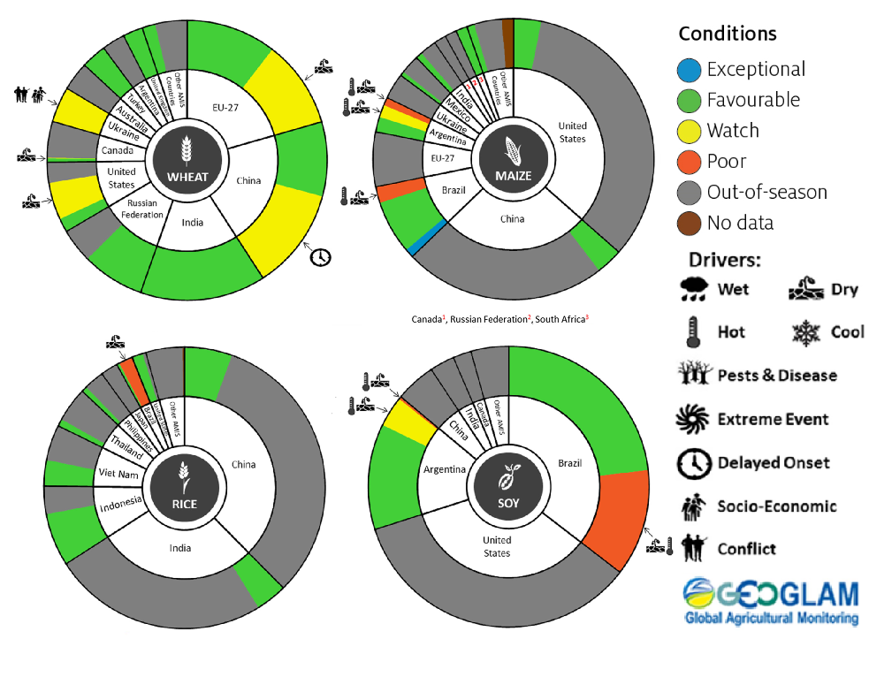
AMIS Agricultural Market Information System.
Source: AMIS
The global climate outlook for May 2022 to July 2022 indicates that mixed rainfall conditions are expected for the world's major grain-producing and oilseed-producing regions. Outlooks and potential production impacts for the major grain and oilseed producing countries are presented in the table.
Rainfall outlook and potential impact on the future state of production conditions between May 2022 to July 2022
Region | May-July rainfall outlook | Potential impact on production
Argentina | Below average rainfall is more likely across major production areas of Argentina, with isolated areas of above average rainfall, between May and July 2022. | Below average rainfall will facilitate the harvesting of sorghum, rice, millet, soybeans, corn, sunflower, cotton and nuts. However, the dry conditions are likely to negatively impact the germination and establishment of wheat.
Black Sea Region | Below average rainfall is forecast for most of Kazakhstan, Turkey and southern regions in the Russian Federation. The rainfall outlook for Ukraine is mixed, while average rainfall is expected for remaining parts of Russia between May and July 2022. | Below average rainfall in parts of Kazakhstan, Turkey and southern Russia may adversely affect grain filling of wheat and canola, as well as cotton, corn and sunflower from July 2022. Average rainfall across much of the Russian Federation is likely to support similar crops in the south and the heading of spring wheat in the north from June 2022.
Brazil | Above average rainfall is more likely across northern and western Brazil and below average rainfall is more likely across much of southern Brazil between May and July 2022. | Above average rainfall across central and western Brazil may interrupt the harvesting of cotton and corn. Below average rainfall in the south is likely to impede the germination and establishment of wheat in June and July 2022.
Canada | Below average rainfall is forecast for southern parts of the Canadian prairies, while average rainfall is more likely across remaining parts of Canada between May and July 2022. | Below average rainfall is likely to negatively impact yield potentials of winter wheat as they enter critical reproductive phases from July 2022, as well as the growth and development of corn, soybeans and sunflower.
China | Above average rainfall is more likely across much of northern and central China, while below average rainfall is more likely across south-eastern China. | Above average rainfall across much of China is likely to support the flowering of cotton, corn, groundnuts, single rice, soybeans, sorghum, sunflower and spring wheat. The wet conditions may also delay the harvest of early sown rice in July 2022.
Europe | Above average rainfall is more likely for parts of northern Europe, and below average rainfall is more likely for southern, western and eastern Europe. Average rainfall is expected for remaining parts of Europe between May and July 2022. | Above average rainfall across much of northern Europe is likely to support corn, soybeans, sunflower, canola and winter wheat through critical reproductive stages. Below average rainfall in the south, west and eastern Europe may adversely affect the yield potentials of sorghum, corn and cotton between May and July 2022.
South Asia (India) | Above average rainfall is more likely across much of India, although below average rainfall is expected in the west. | Above average rainfall may delay the planting of cotton, corn, groundnuts, millet, rice, sorghum and sunflower in May and June 2022. However, the increased soil moisture levels will support their germination and establishment.
Southeast Asia (SEA) | Above average rainfall is more likely for most countries in SEA between May and July 2022. | Above average rainfall across most of Southeast Asia is likely to benefit the growth, development and flowering of corn and rice.
The United States of America | Above average rainfall is more likely for parts of the north-eastern US and below average rainfall is more likely for the southern, central and western parts of the US between May and July 2022. | Average or better rainfall in the north-eastern US is likely to support yield potentials of spring wheat as it enters critical reproductive stages. Below average rainfall in the southern US may adversely impact the growth and development of corn, cotton, groundnuts, millet, rice, soybeans and sunflower.

Rainfall forecast for the next eight days
Over the 8-days to 28 April 2022, low-pressure troughs and onshore winds are expected to result in rainfall across eastern Australia, with a cold front bringing rainfall to the south-west. A high-pressure system to the south of Australia is forecast to bring mostly dry conditions for remaining parts of Western Australia.
Rainfall totals of between 10 and 50 millimetres are forecast for most of New South Wales, Queensland and South Australia, as well as northern Victoria, south-western Western Australia, the east of the Northern Territory and much of Tasmania. Rainfall in excess of 50 millimetres is expected for central and north-eastern Queensland.
In Australian cropping regions, rainfall totals of between 10 and 50 millimetres are expected across most of New South Wales, Victoria and South Australia, as well as western and northern Queensland, and parts of south-western Western Australia. Little to no rainfall is forecast for all remaining cropping regions during the next 8-days.
Relatively dry conditions across southern Queensland and northern New South Wales should allow for summer harvesting and winter planting activities to proceed. In Central Queensland, the expected rainfall may delay cotton harvesting activities but provide additional soil moisture for late sown summer crops. Upper soil moisture levels across southern New South Wales, Victorian and South Australian cropping regions are already above average, with the forecast rainfall to further boost soil moisture levels. These conditions will delay field access for the harvesting of summer crops, as well as planting of winter crops. For growers that dry sowed winter crops in recent weeks, the soil moisture conditions will support germination and establishment. However, most growers will be waiting for a break in the weather before the winter cropping season kicks off in earnest.

Total forecast rainfall (mm) for the period 21 April to 28 April 2022
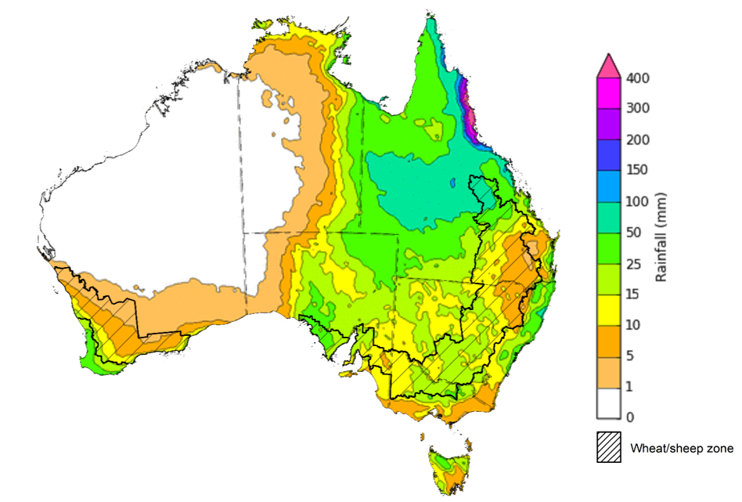
©Commonwealth of Australia 2022, Australian Bureau of Meteorology Issued: 20/04/2022
Note: This rainfall forecast is produced from computer models. As the model outputs are not altered by weather forecasters, it is important to check local forecasts and warnings issued by the Bureau of Meteorology.

Water

Water markets – current week
Water storage in the Murray–Darling Basin (MDB) decreased by 63 gigalitres (GL) between 13 April 2022 and 20 April 2022. The current volume of water held in storage is 21,452GL, which represents 85 per cent of total capacity. This is 50% or 7,118 GL more than at the same time last year.

Water storages in the Murray-Darling Basin, 2013–2022
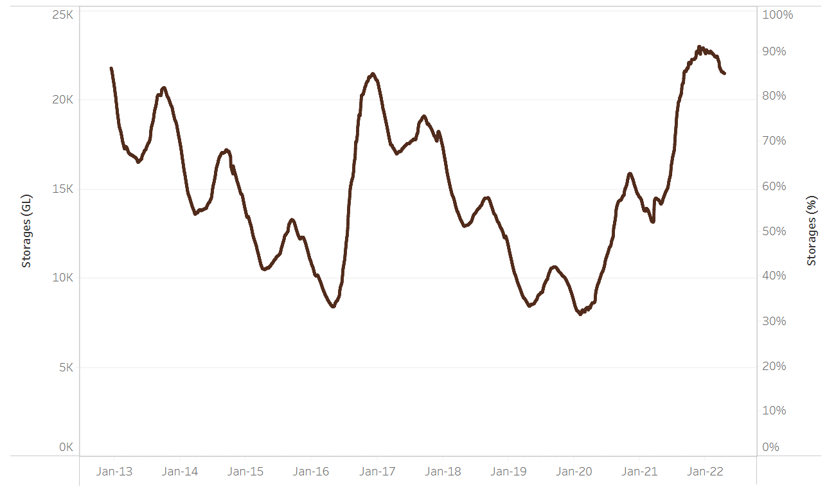
Allocation prices in the Victorian Murray below the Barmah Choke increased from $63 per ML on 9 April 2022 to $72 per ML on 14 April 2022. Prices are lower in the Goulburn-Broken, Murrumbidgee and regions above the Barmah choke due to the binding of the Goulburn intervalley trade limit, Murrumbidgee export limit and Barmah choke trade constraint.
Water storage data is sourced from the Bureau of Meteorology.

Region | $/ML
NSW Murray Above | 9
NSW Murrumbidgee | 11
VIC Goulburn-Broken | 41
VIC Murray Below | 72

Surface water trade activity, Southern Murray–Darling Basin

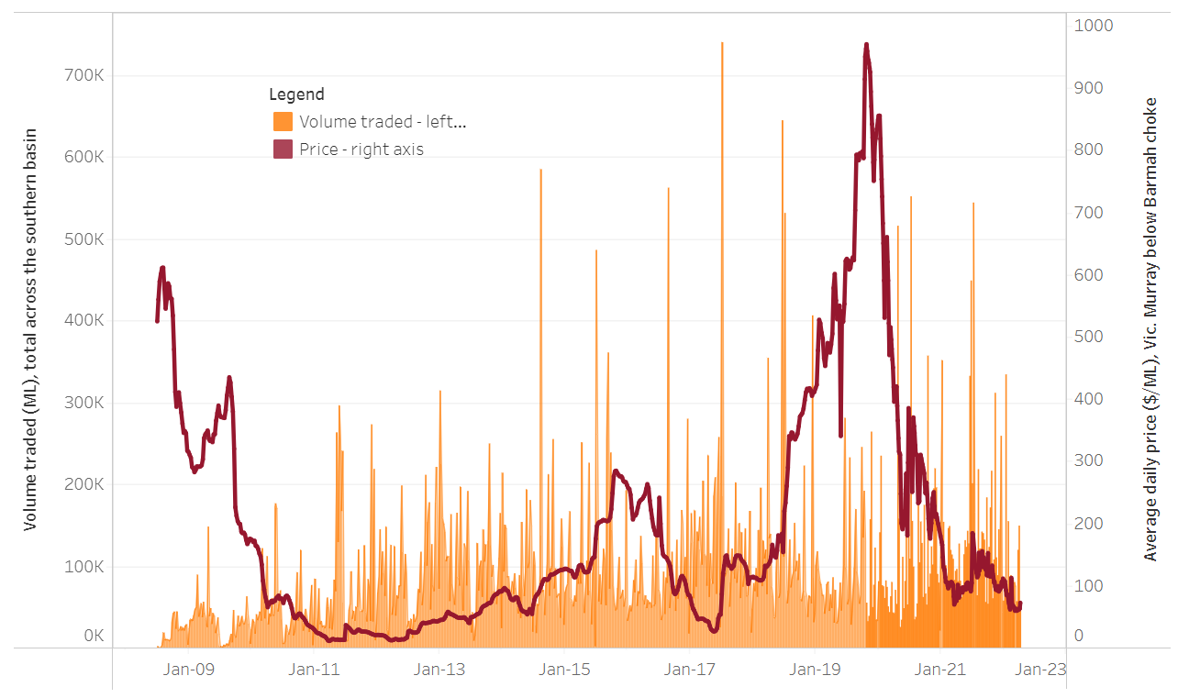
To access the full, interactive, weekly water dashboard, which contains the latest and historical water storage, water market and water allocation information, please visit http://www.agriculture.gov.au/abares/products/weekly_update/weekly-update-210422
The trades shown reflect estimated market activity and do not encompass all register trades. The price is shown for the VIC Murray below the Barmah choke. Historical prices (before 1 July 2019) are ABARES estimates after removing outliers from BOM water register data. Prices after 1 July 2019 and prior to the 30 October 2019 reflect recorded transaction prices as sourced from Ruralco. Prices after the 30 October 2019 are sourced from Waterflow. Data for volume traded is sourced from the BOM water register. Data shown is current at 21 April 2022.

Commodities

Indicator | Week ended | Unit | Latest price | Previous week | Weekly change | Price 12 months ago | Annual change
Selected world indicator prices
AUD/USD Exchange rate | 20-Apr | A$/US$ | 0.74 | 0.74 | -1% | 0.78 | -5%
Wheat – US no. 2 hard red winter wheat, fob Gulf | 20-Apr | US$/t | 417 | 419 | -1% | 315 | 32%
Corn – US no. 2 yellow corn, fob Gulf | 20-Apr | US$/t | 358 | 348 | 3% | 296 | 21%
Canola – Rapeseed, Canada, fob Vancouver | 20-Apr | US$/t | 990 | 982 | 1% | 590 | 68%
Cotton – Cotlook 'A' Index | 20-Apr | USc/lb | 162 | 154 | 5% | 95 | 71%
Sugar – Intercontinental Exchange, nearby futures, no.11 contract | 20-Apr | USc/lb | 19.9 | 20.1 | -1% | 17 | 17%
Wool – Eastern Market Indicator | 20-Apr | Ac/kg clean | 1,395 | 1,395 | 0% | 1,310 | 6%
Wool – Western Market Indicator | 06-Apr | Ac/kg clean | 1,417 | 1,421 | 0% | 1,222 | 16%
Selected Australian grain export prices
Milling Wheat – APW, Port Adelaide, SA | 20-Apr | A$/t | 528 | 527 | 0% | 360 | 47%
Feed Wheat – ASW, Port Adelaide, SA | 20-Apr | A$/t | 697 | 682 | 2% | 357 | 95%
Feed Barley – Port Adelaide, SA | 20-Apr | A$/t | 463 | 460 | 1% | 294 | 58%
Canola – Kwinana, WA | 20-Apr | A$/t | 1,238 | 1,225 | 1% | 717 | 73%
Grain Sorghum – Brisbane, QLD | 20-Apr | A$/t | 426 | 427 | 0% | 347 | 23%
Selected domestic livestock indicator prices
Beef – Eastern Young Cattle Indicator | 13-Apr | Ac/kg cwt | 1,088 | 1,094 | -1% | 886 | 23%
Mutton – Mutton indicator (18–24 kg fat score 2–3), Vic | 06-Apr | Ac/kg cwt | 570 | 569 | 0% | 687 | -17%
Lamb – Eastern States Trade Lamb Indicator | 06-Apr | Ac/kg cwt | 788 | 799 | -1% | 808 | -3%
Pig – Eastern Seaboard (60.1–75 kg), average of buyers & sellers | 30-Mar | Ac/kg cwt | 368 | 357 | 3% | 347 | 6%
Goats – Eastern States (12.1–16 kg) | 05-Jan | Ac/kg cwt | 879 | 879 | 0% | 818 | 8%
Live cattle – Light steers ex Darwin to Indonesia | 23-Mar | Ac/kg lwt | 550 | 550 | 0% | 260 | 112%
Live sheep – Live wethers (Muchea WA saleyard) to Middle East | 22-Sep | $/head | 147 | 171 | -14% | 126 | 17%

Indicator | Week ended | Unit | Latest price | Previous week | Weekly change | Price 12 months ago | Annual change
Global Dairy Trade (GDT) weighted average prices ª
Dairy – Whole milk powder | 20-Apr | US$/t | 4,207 | 4,532 | -7% | 2,952 | 43%
Dairy – Skim milk powder | 20-Apr | US$/t | 4,408 | 4,599 | -4% | 2,747 | 60%
Dairy – Cheddar cheese | 20-Apr | US$/t | 6,185 | 6,472 | -4% | 4,398 | 41%
Dairy – Anhydrous milk fat | 20-Apr | US$/t | 6,802 | 6,908 | -2% | 4,331 | 57%
a Global Dairy Trade prices are updated twice monthly on the first and third Tuesday of each month.

Selected world indicator prices
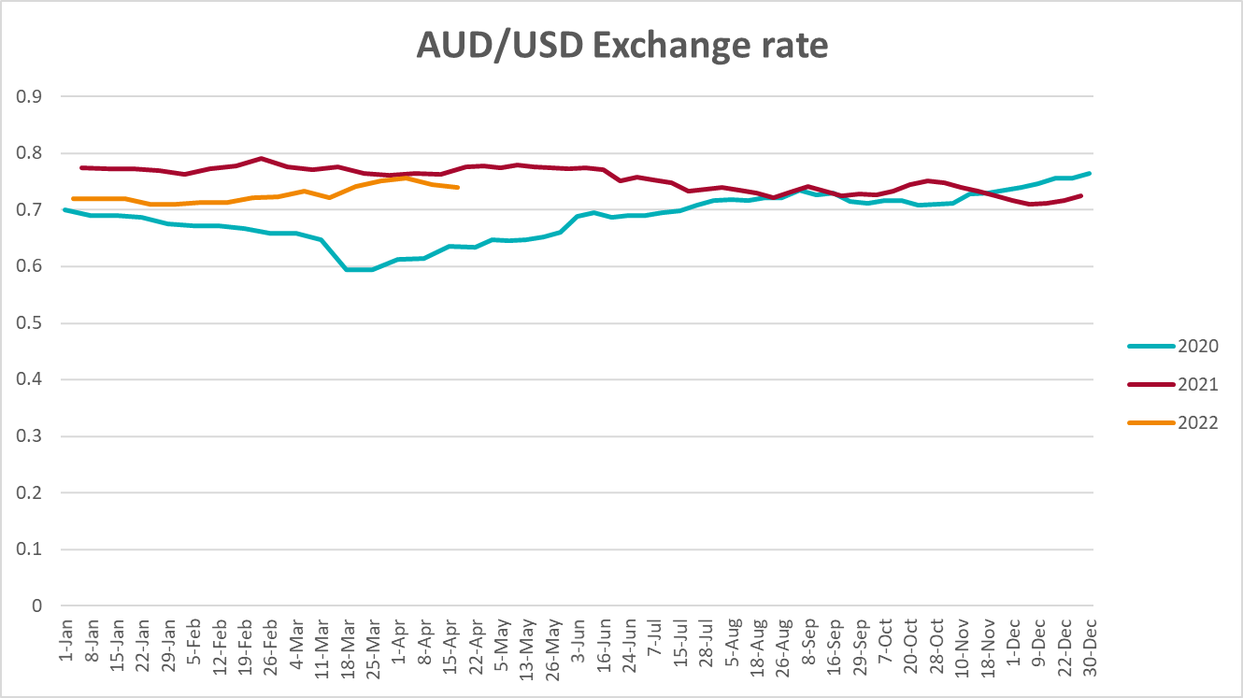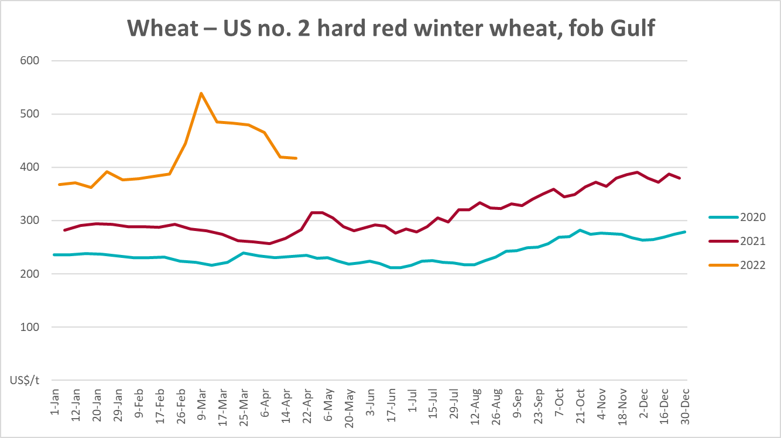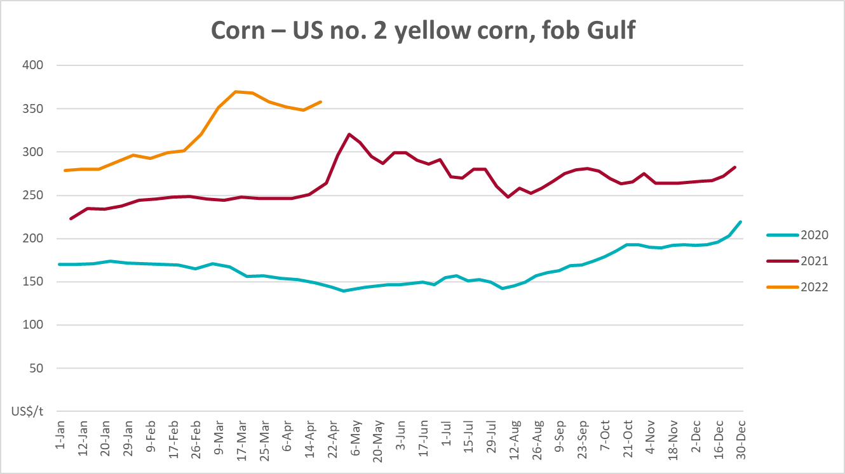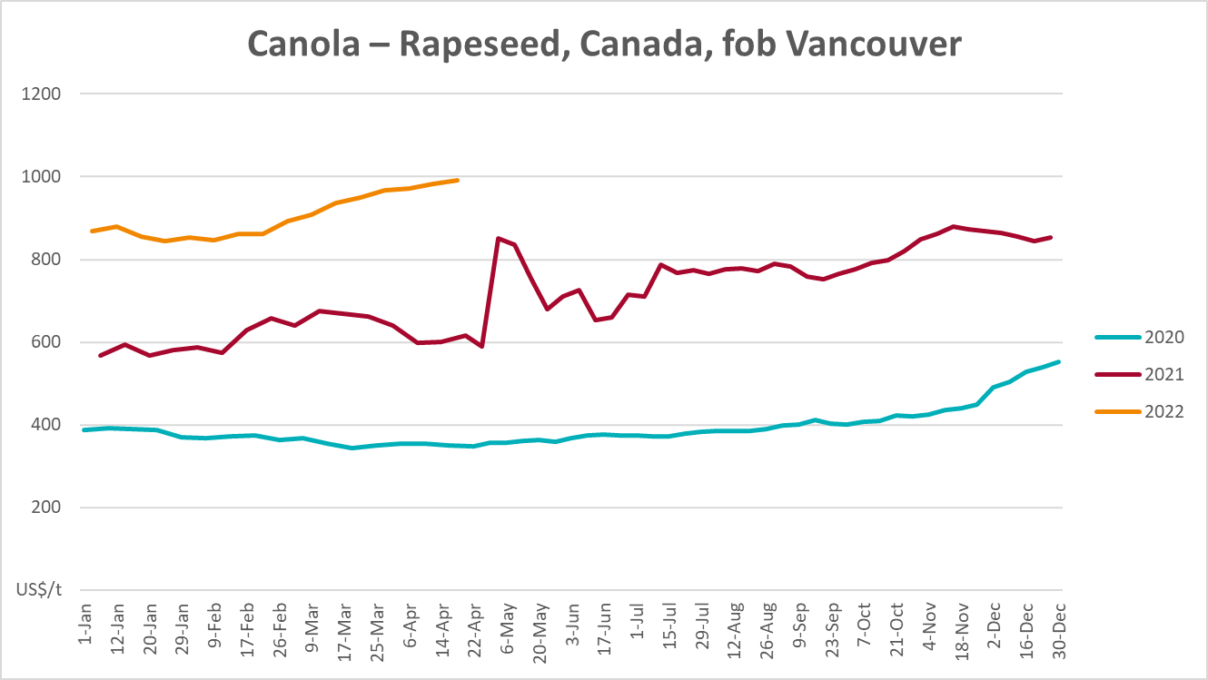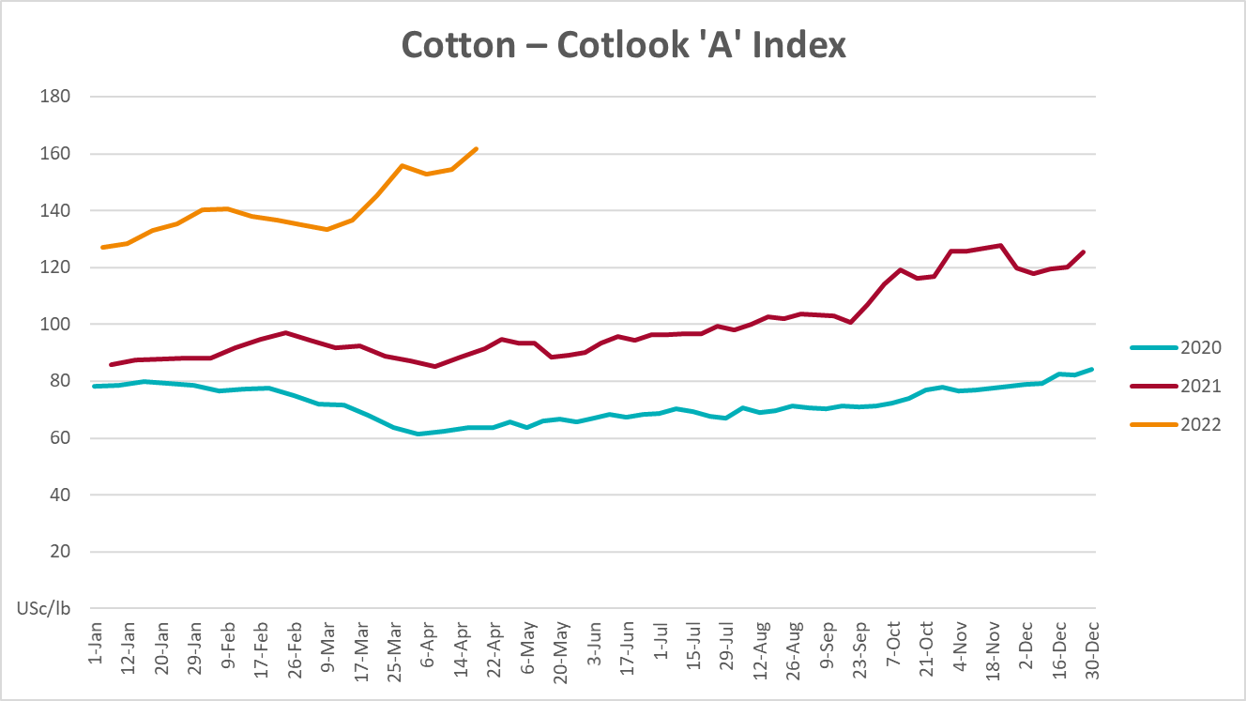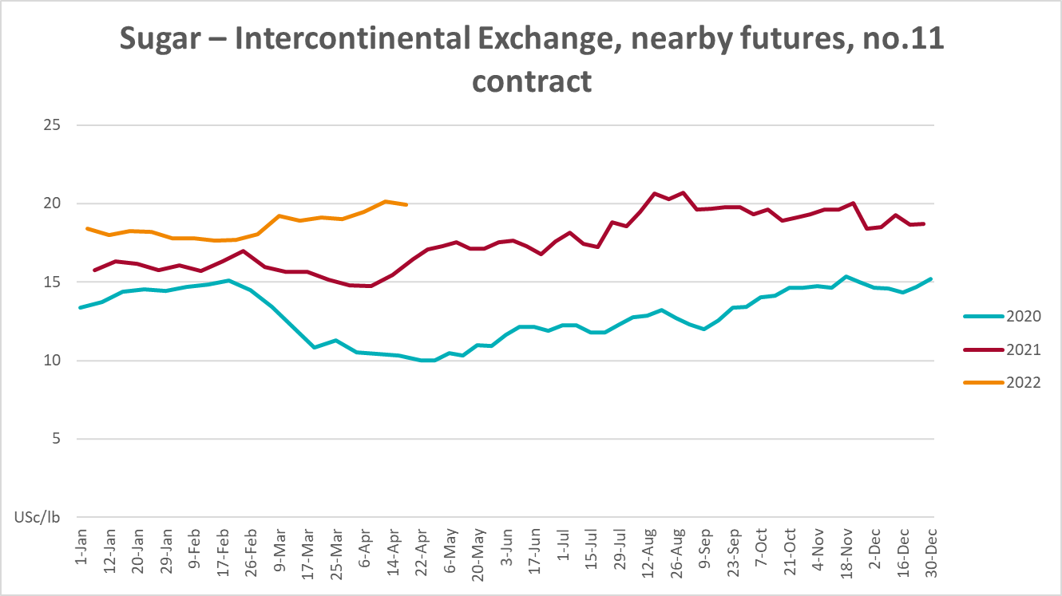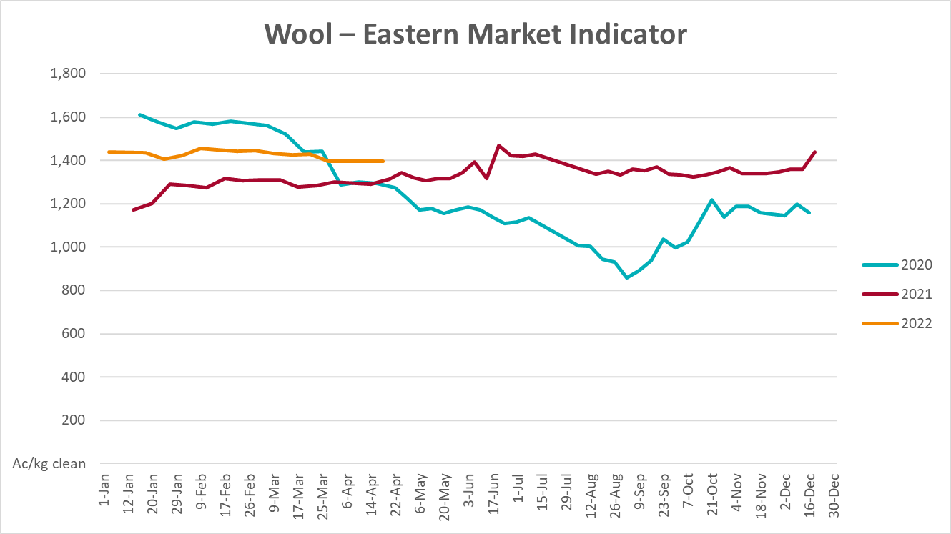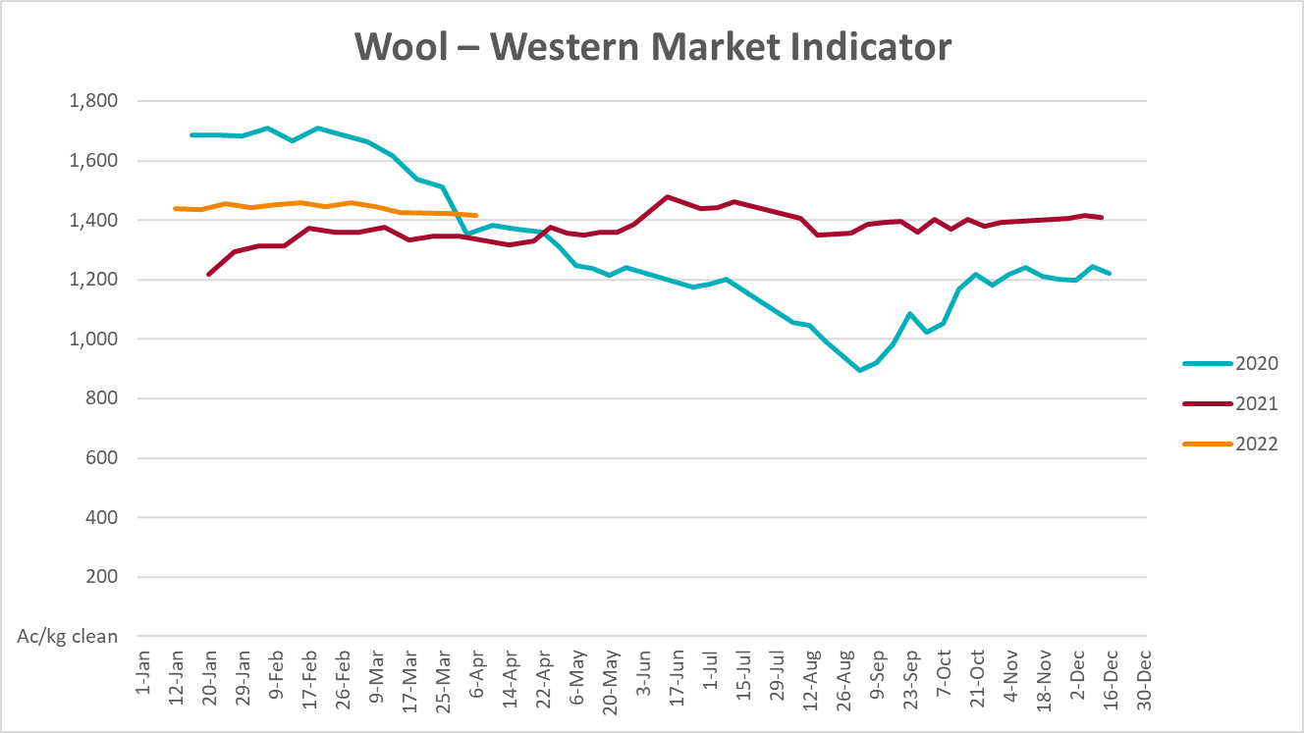

Selected domestic crop indicator prices
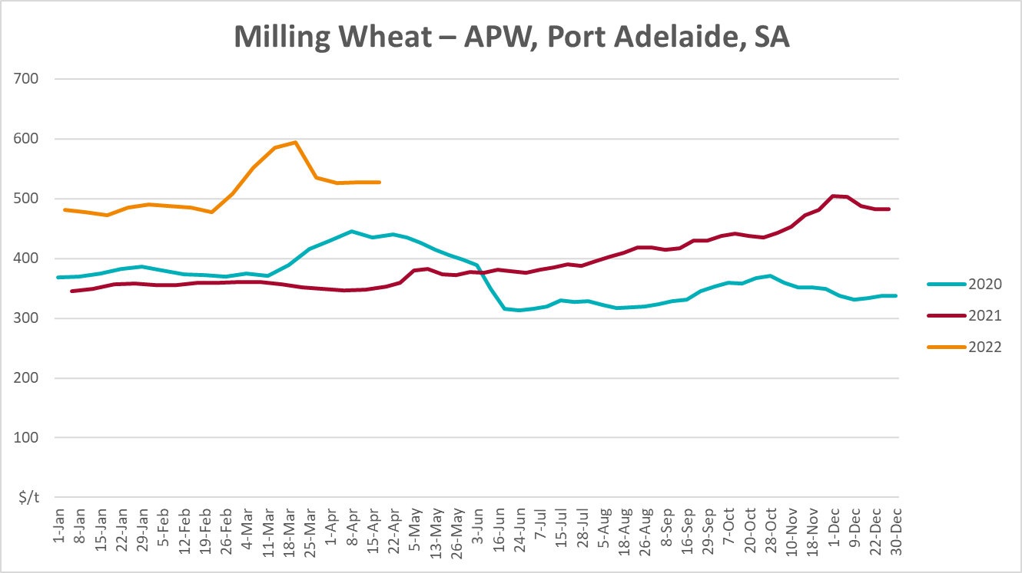
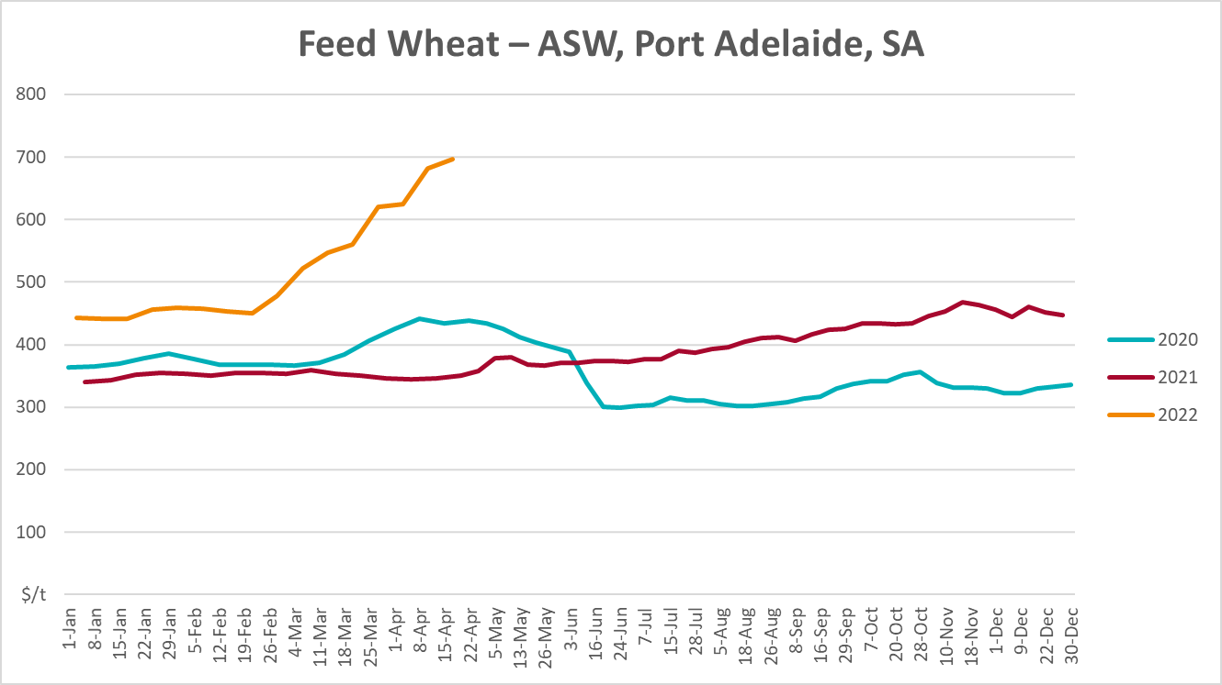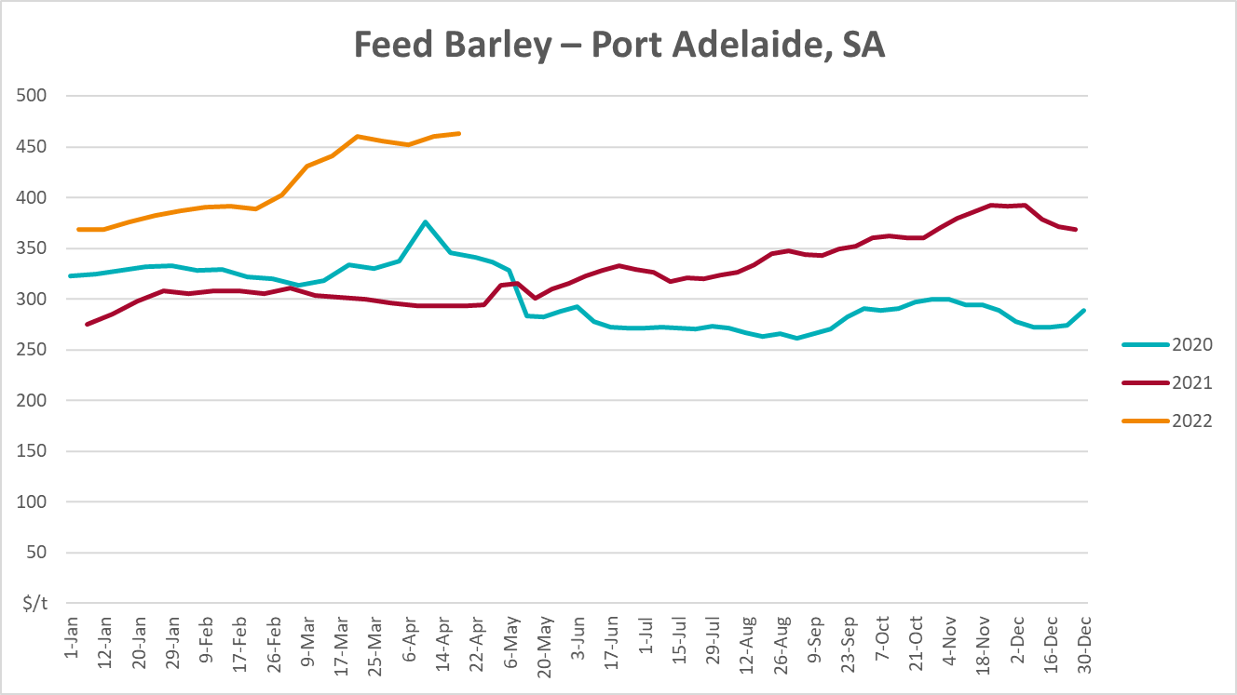
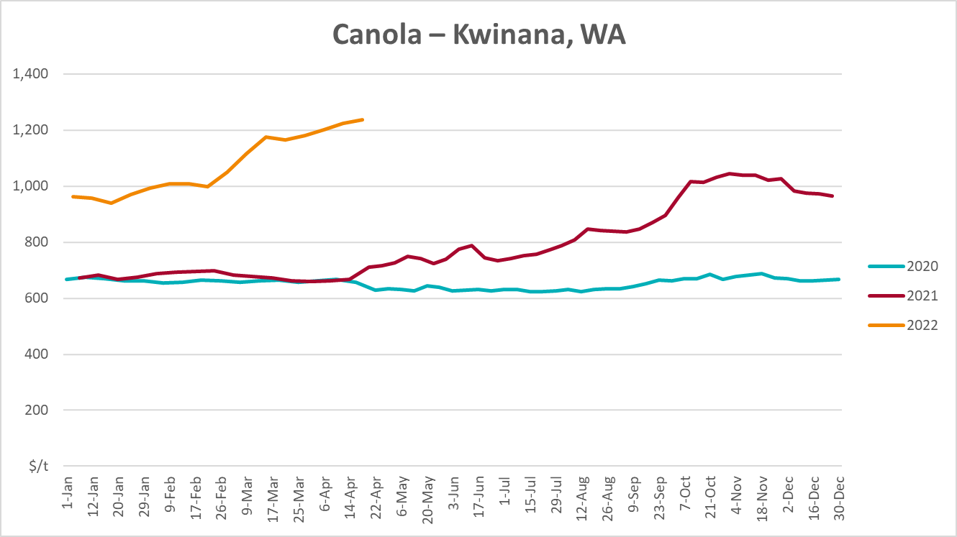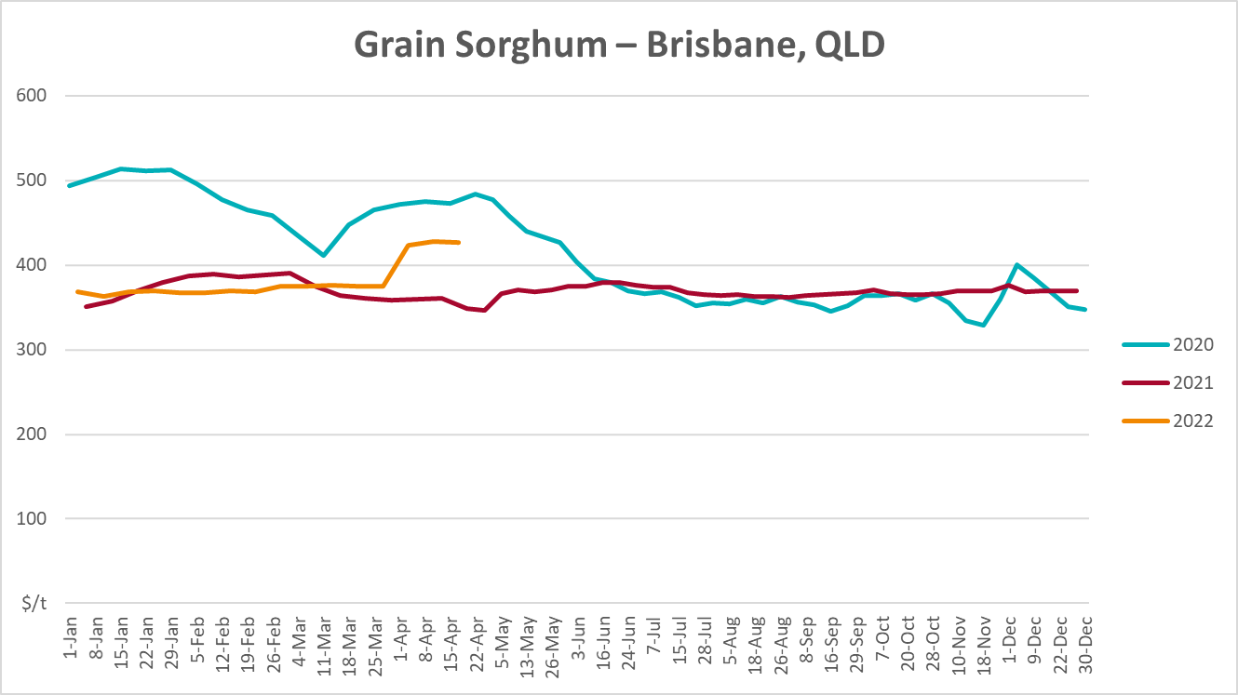

Selected domestic livestock indicator prices
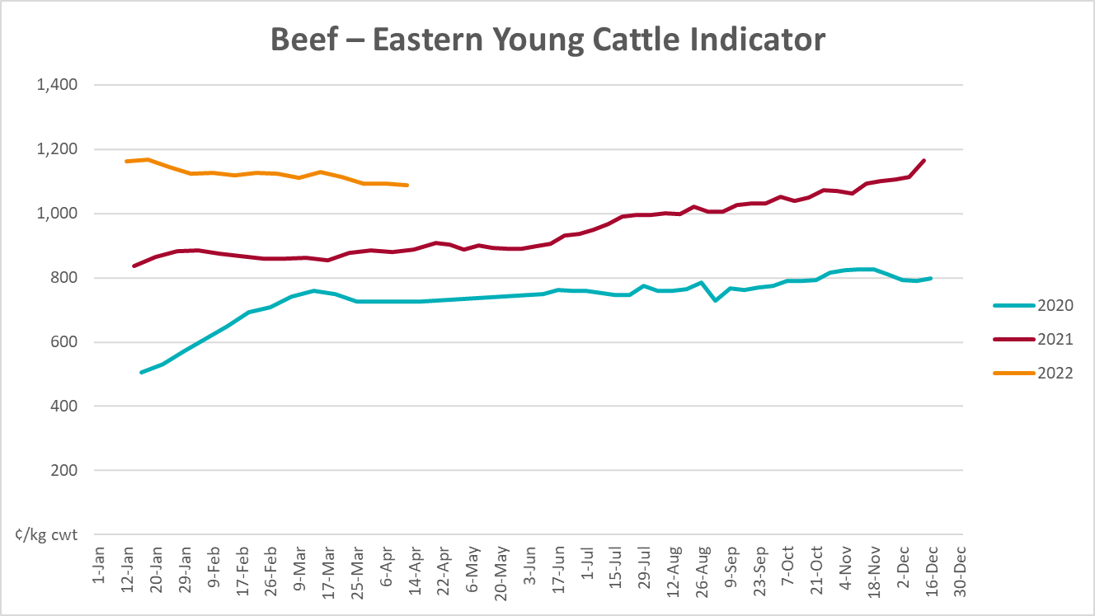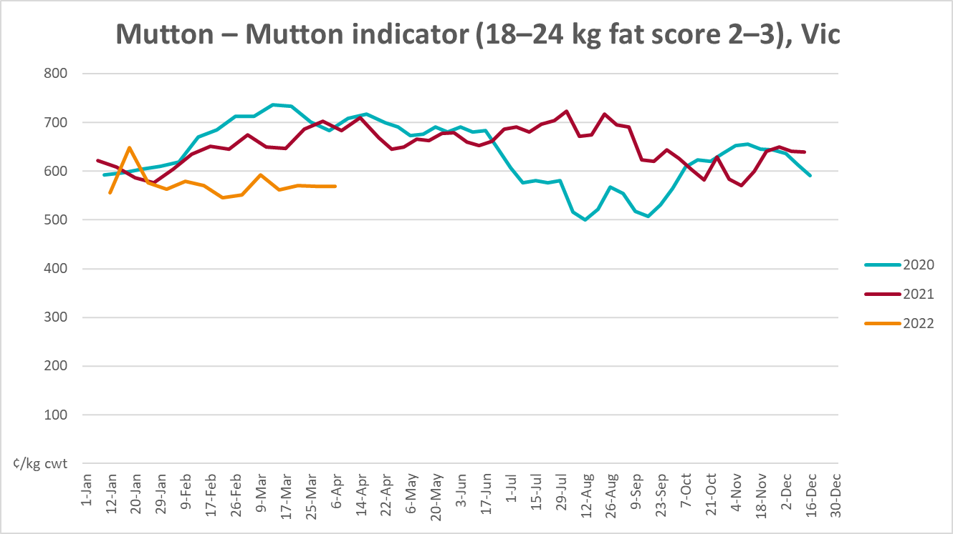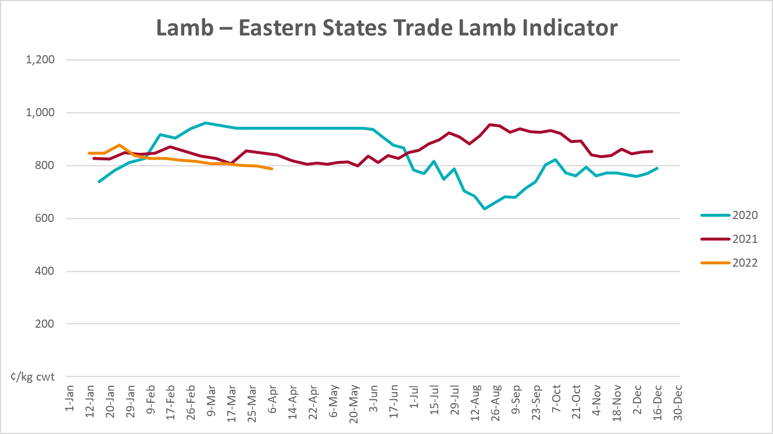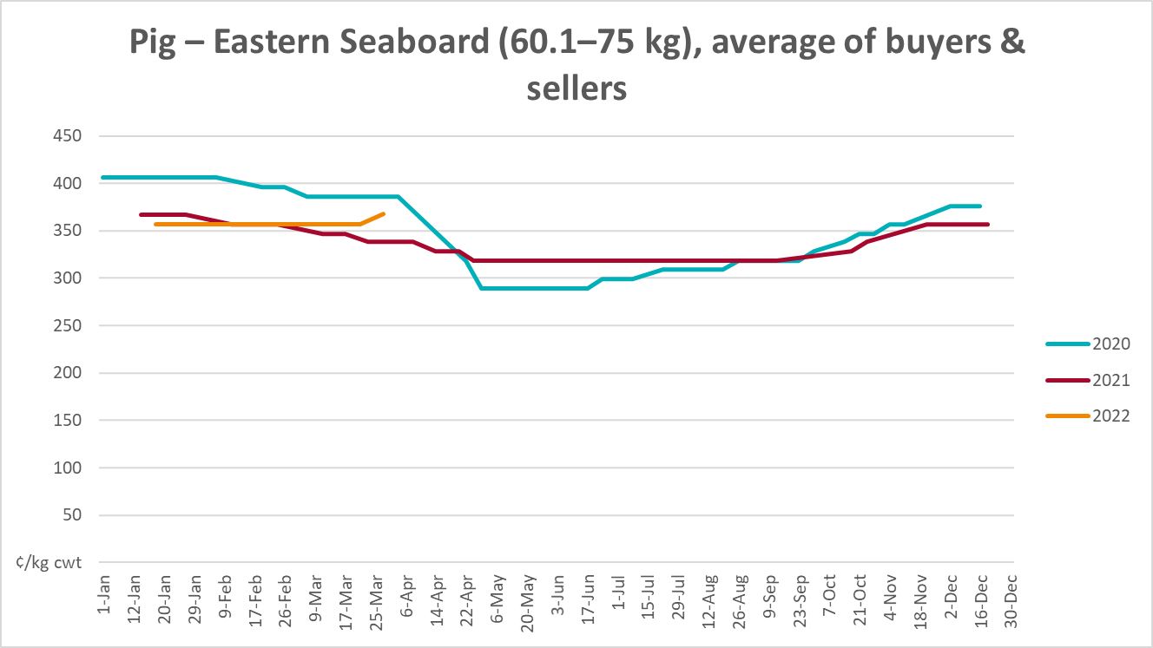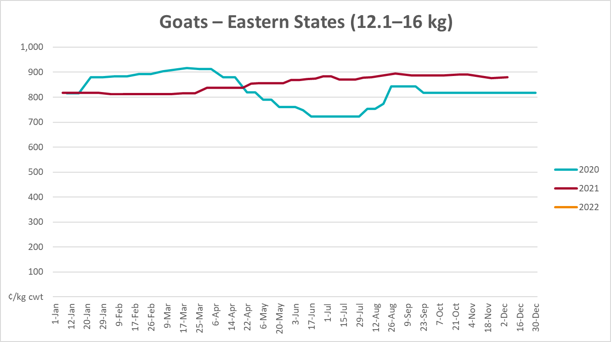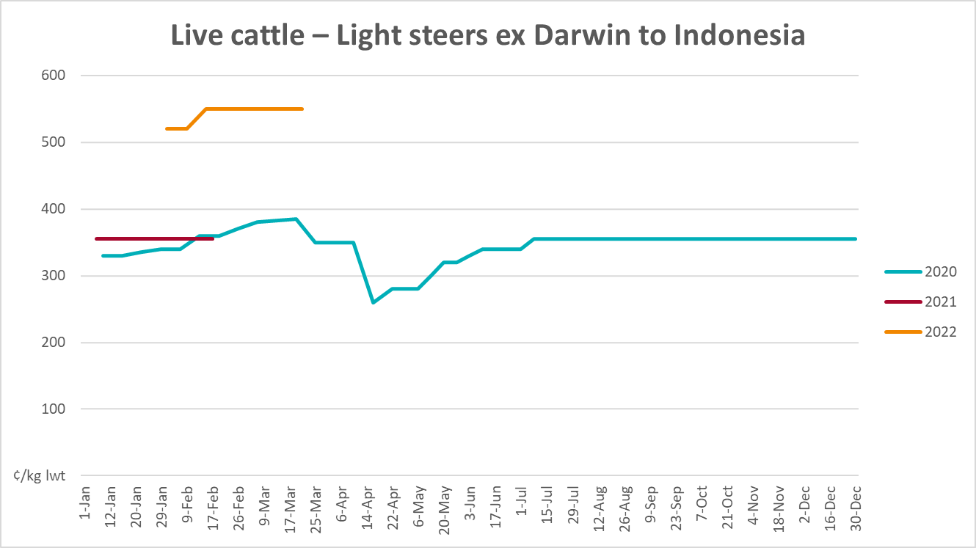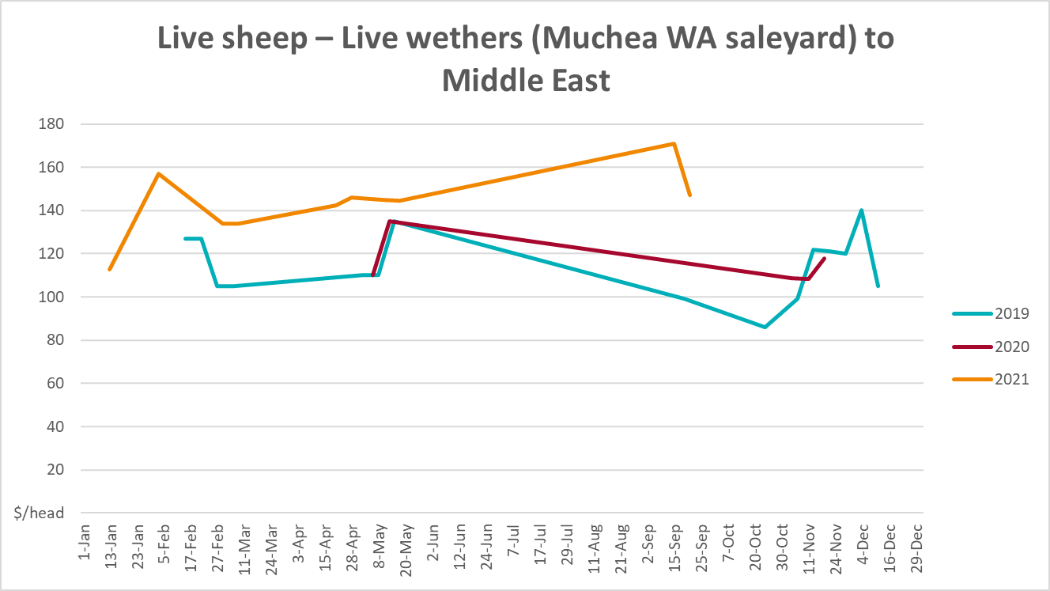

Global Dairy Trade (GDT) weighted average prices
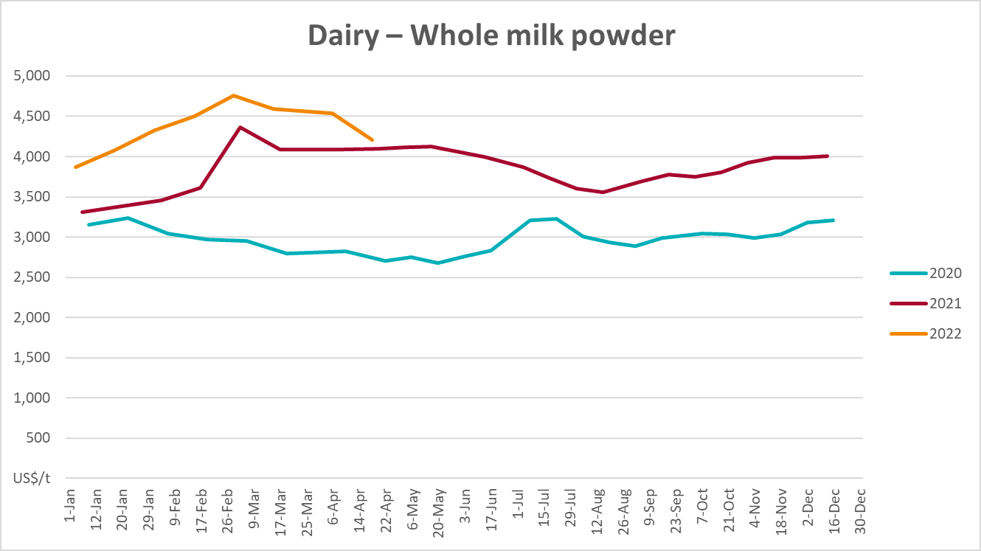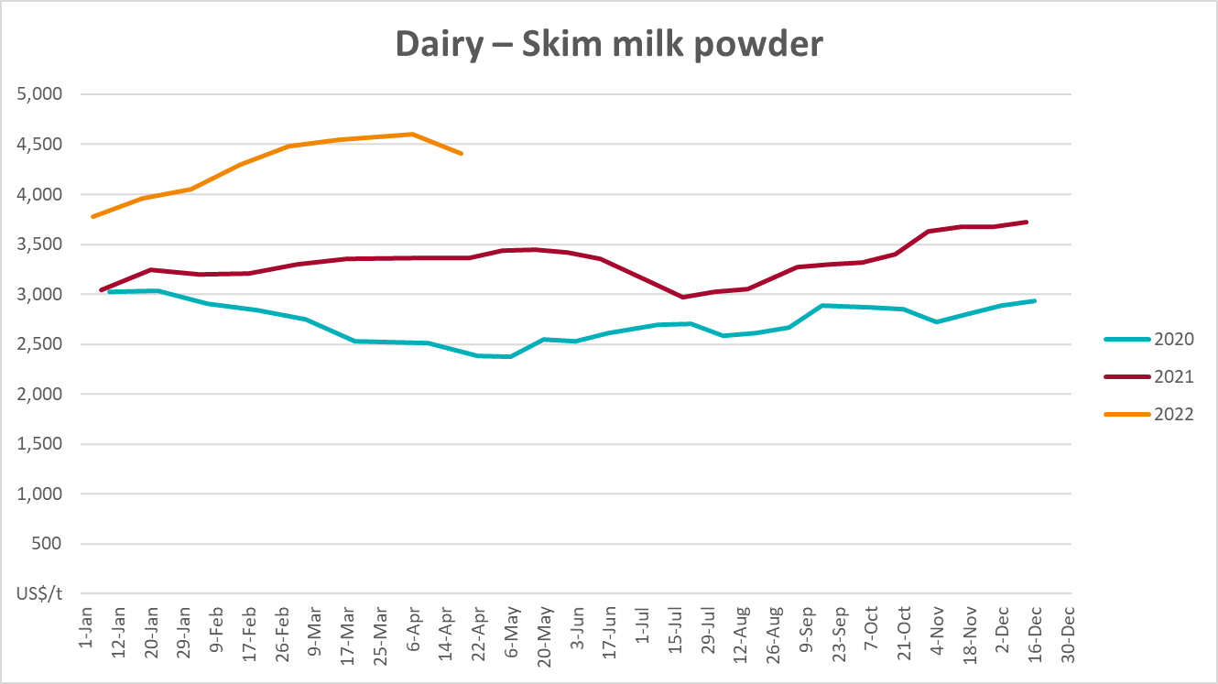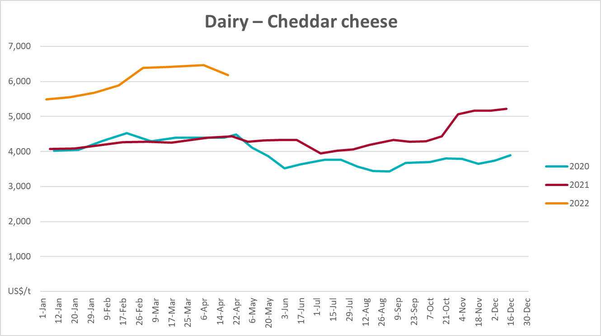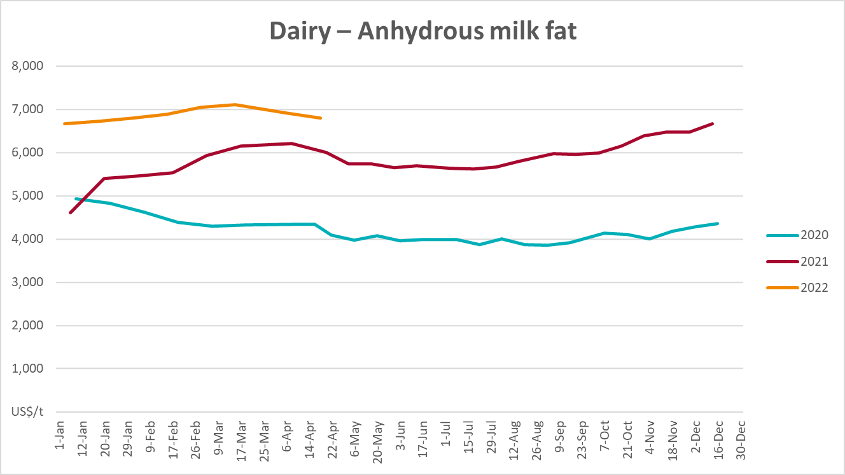

Selected fruit and vegetable prices
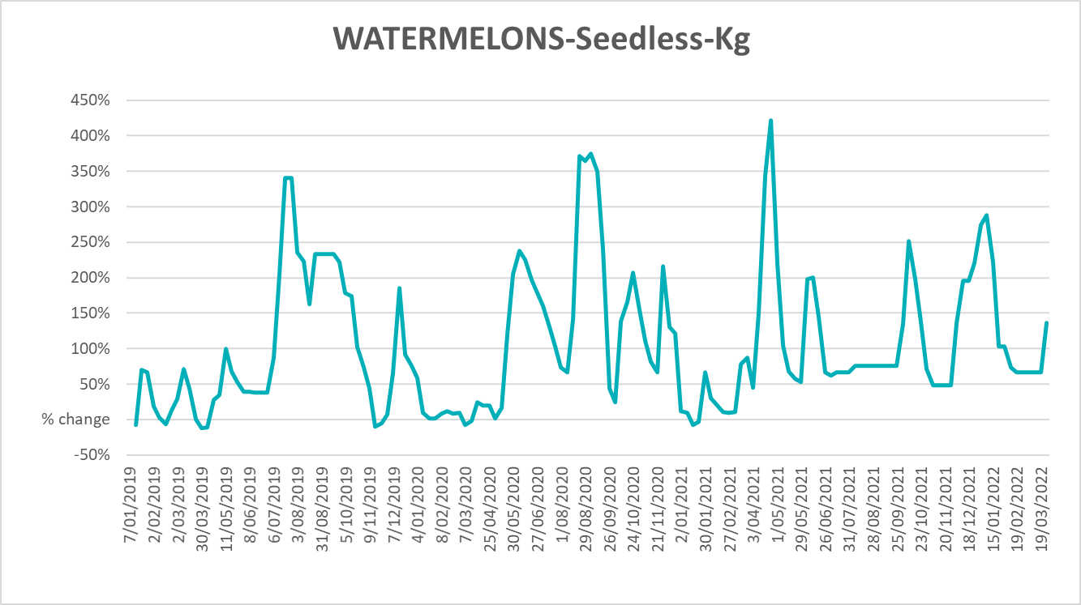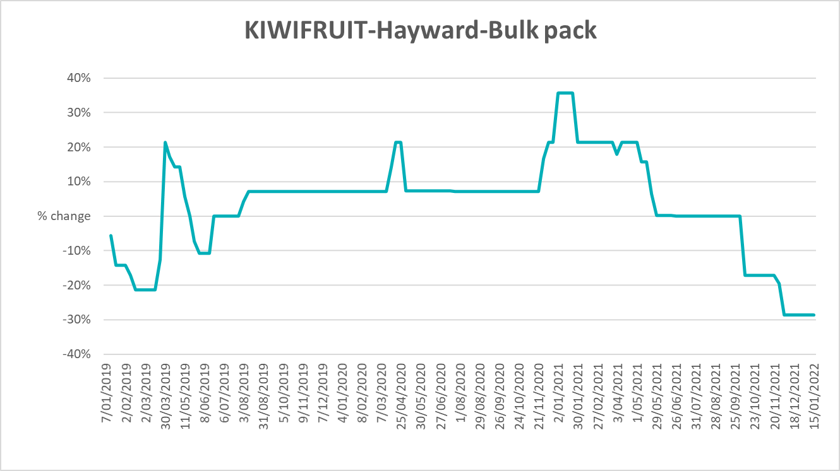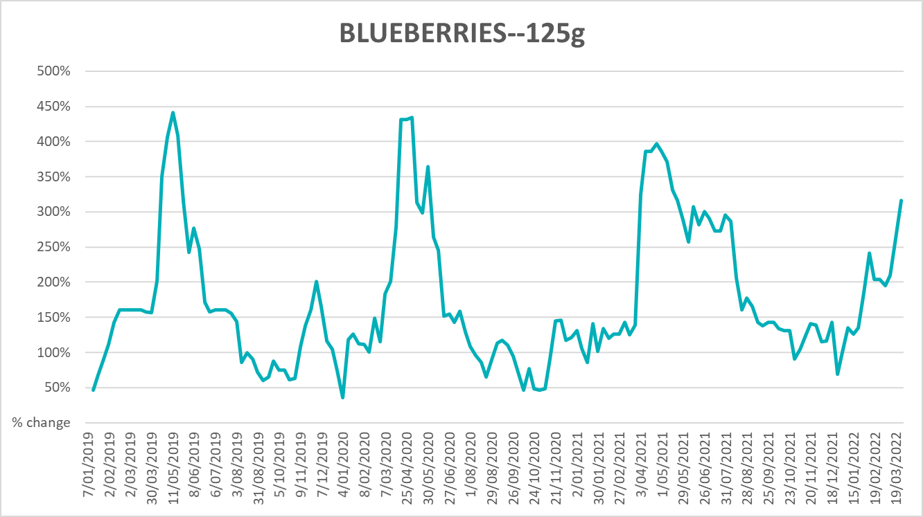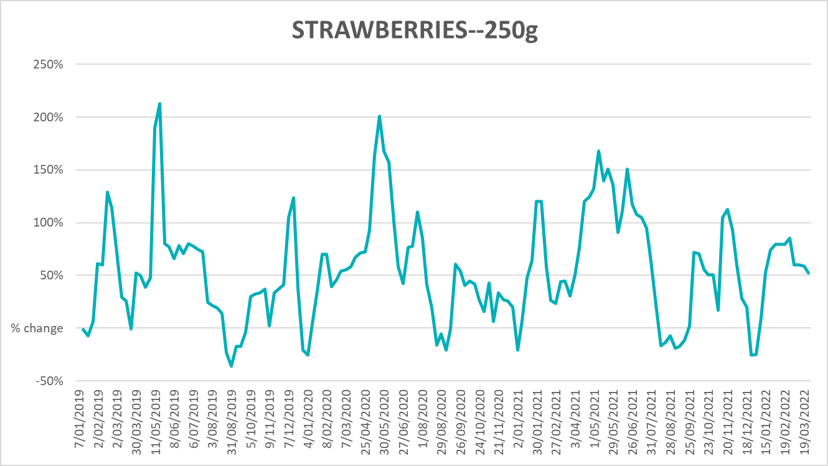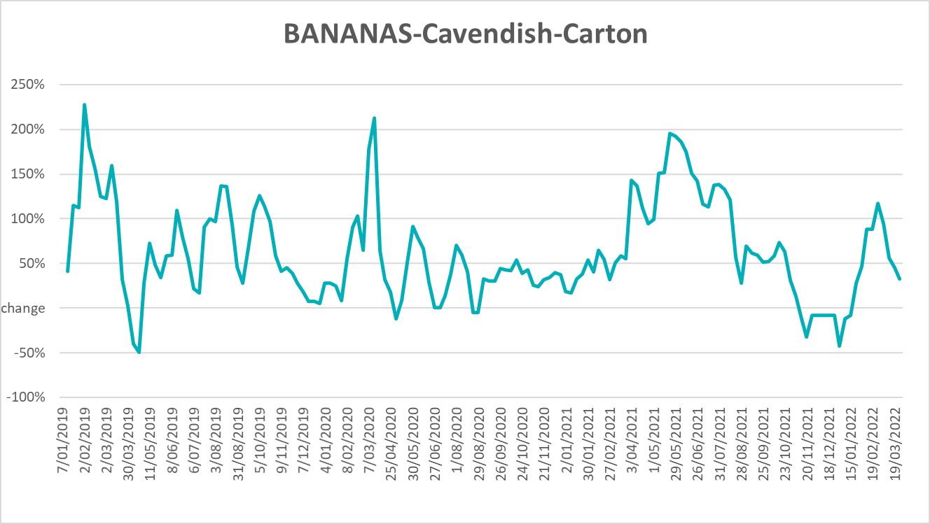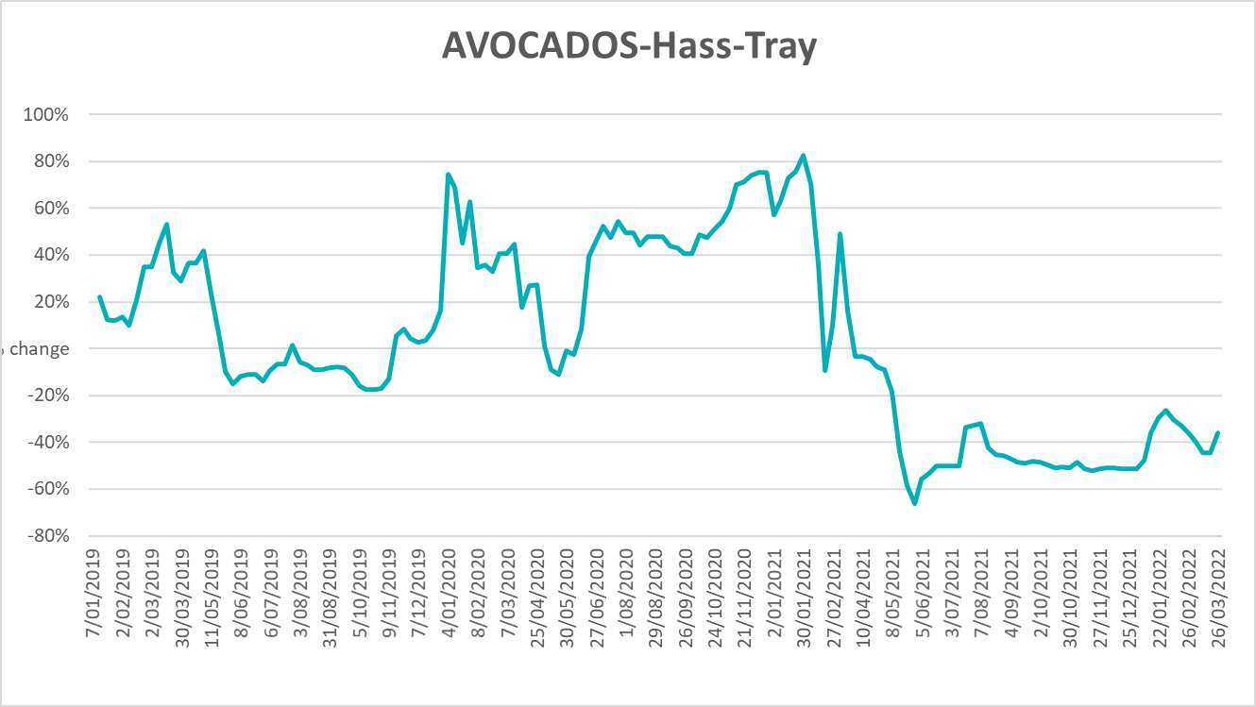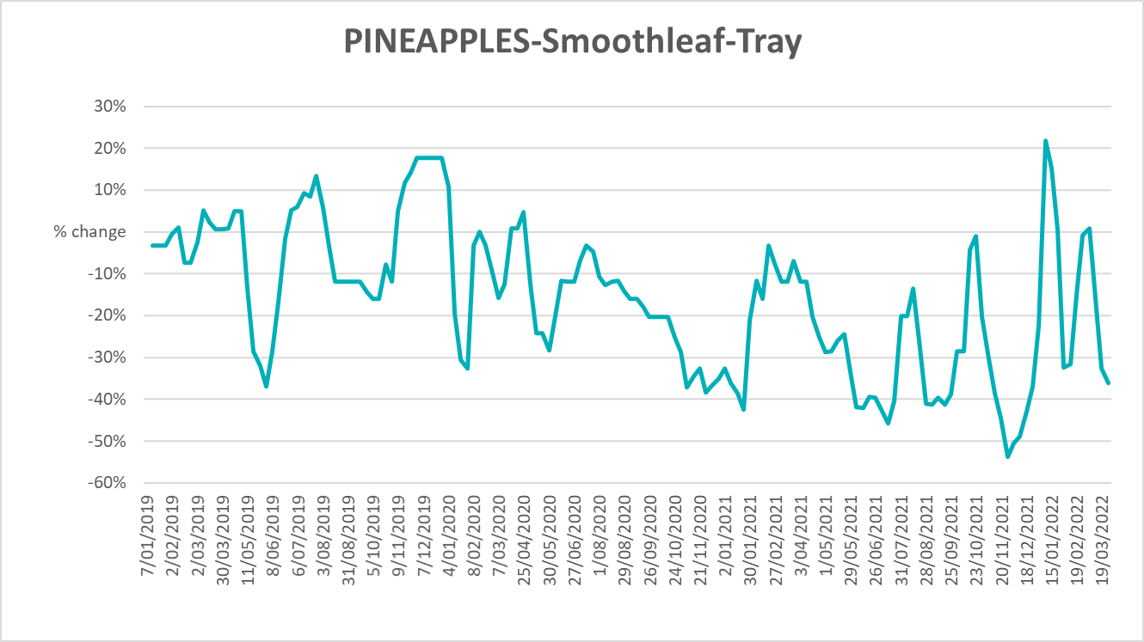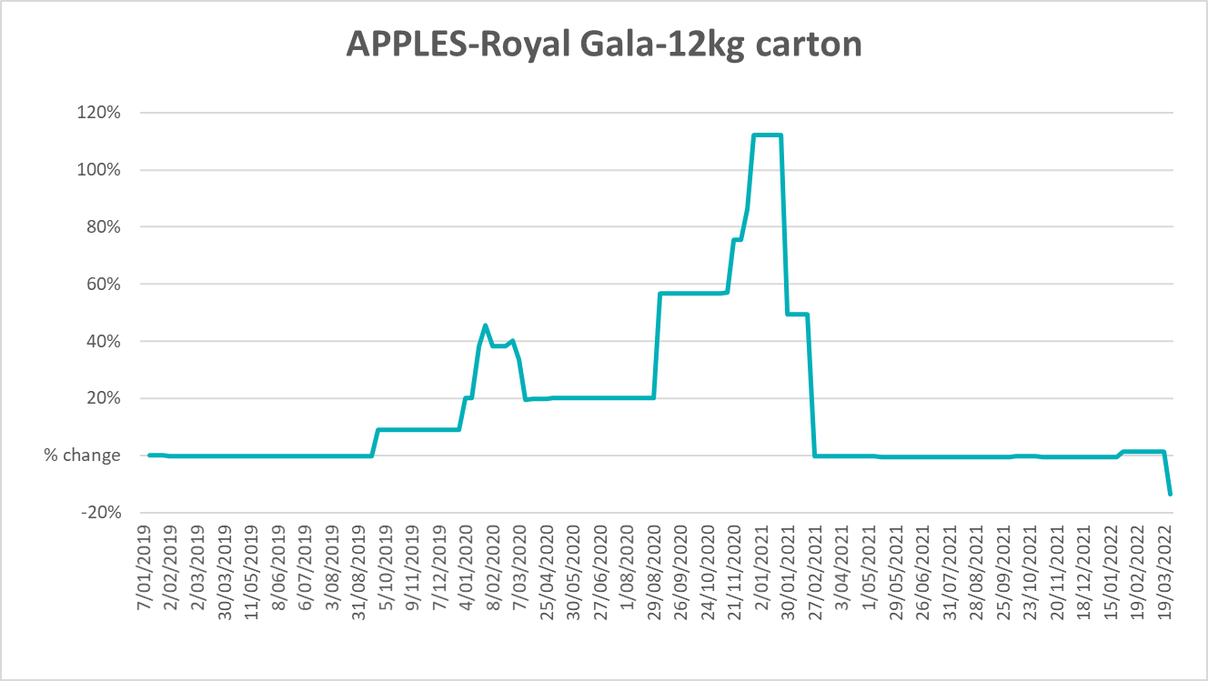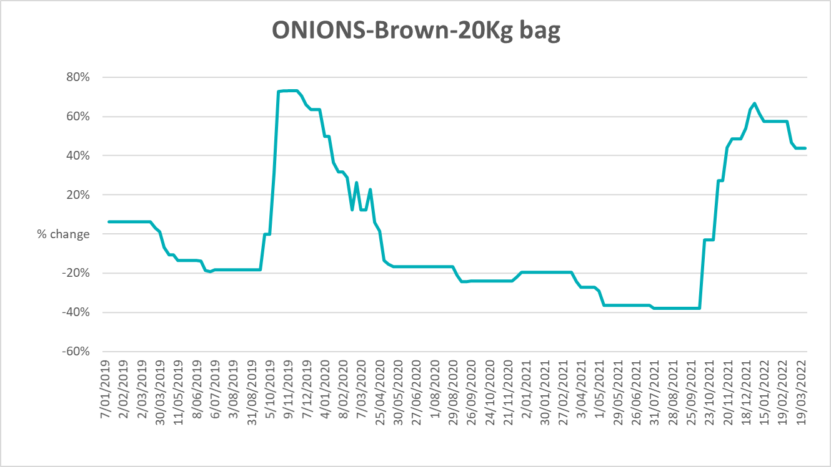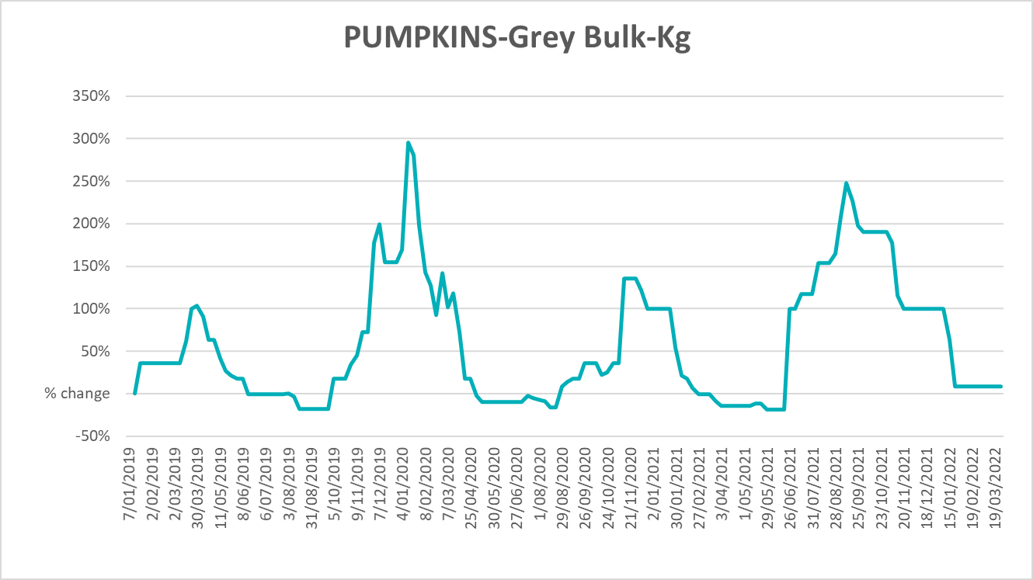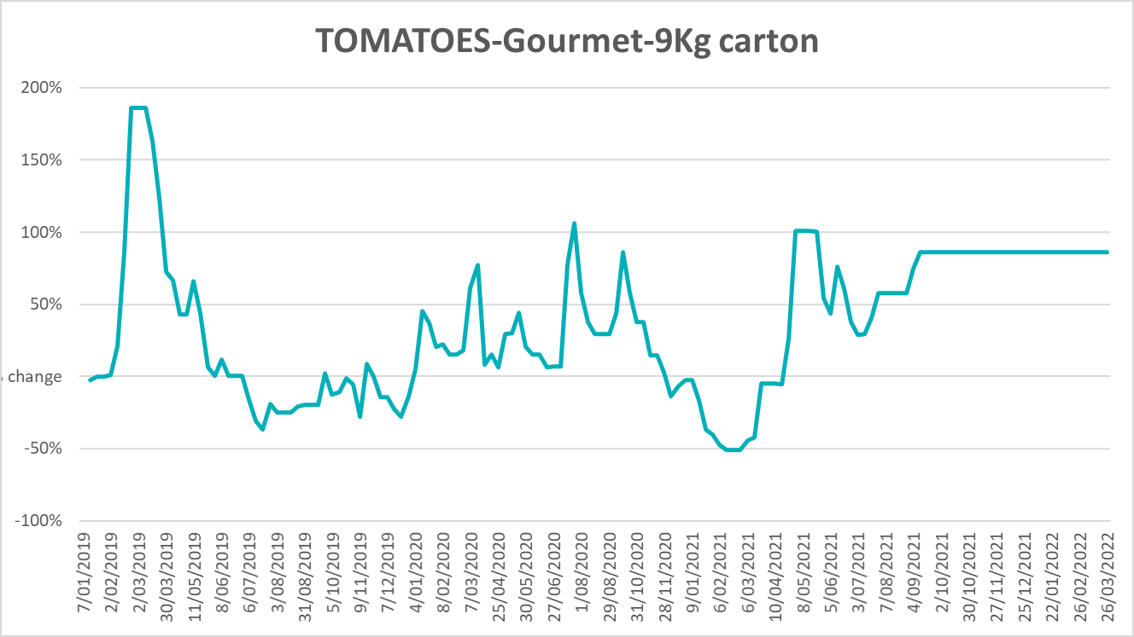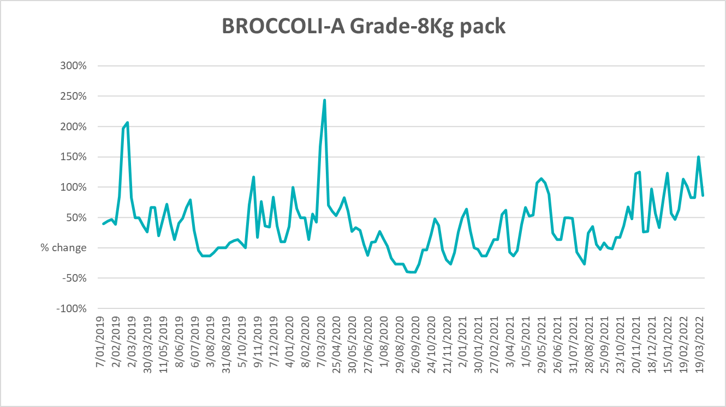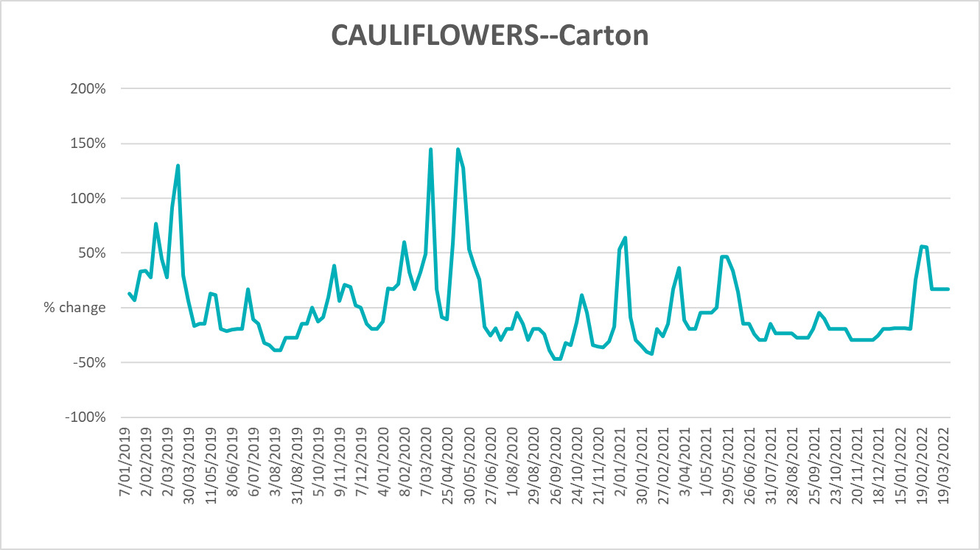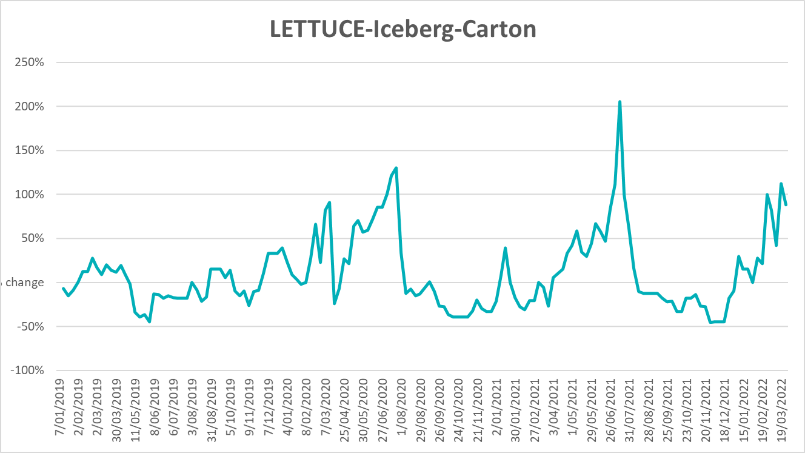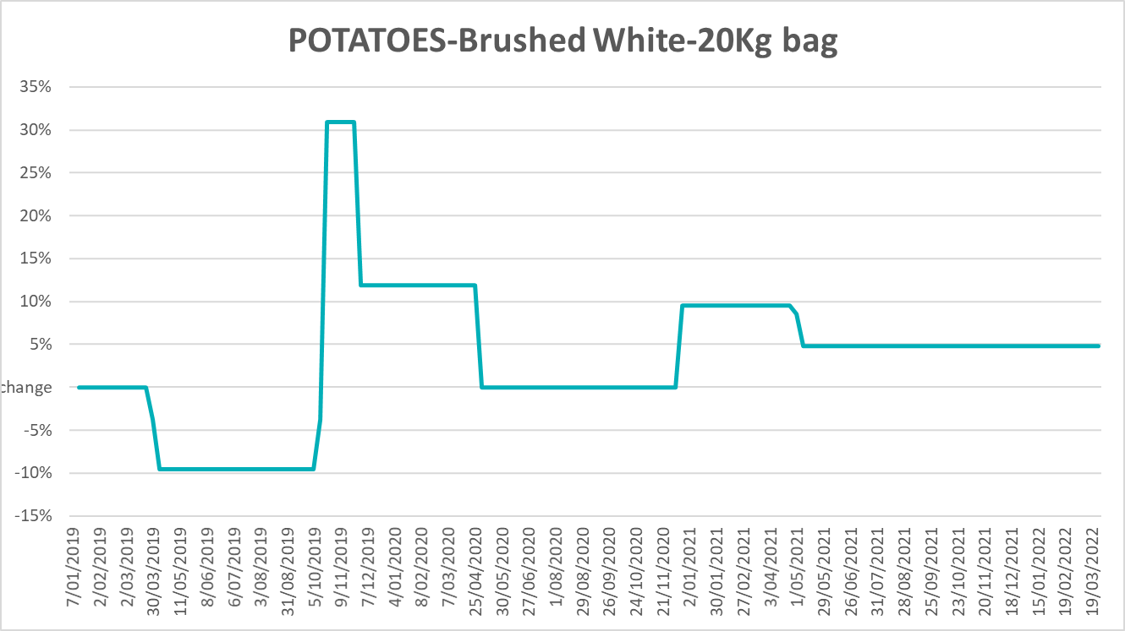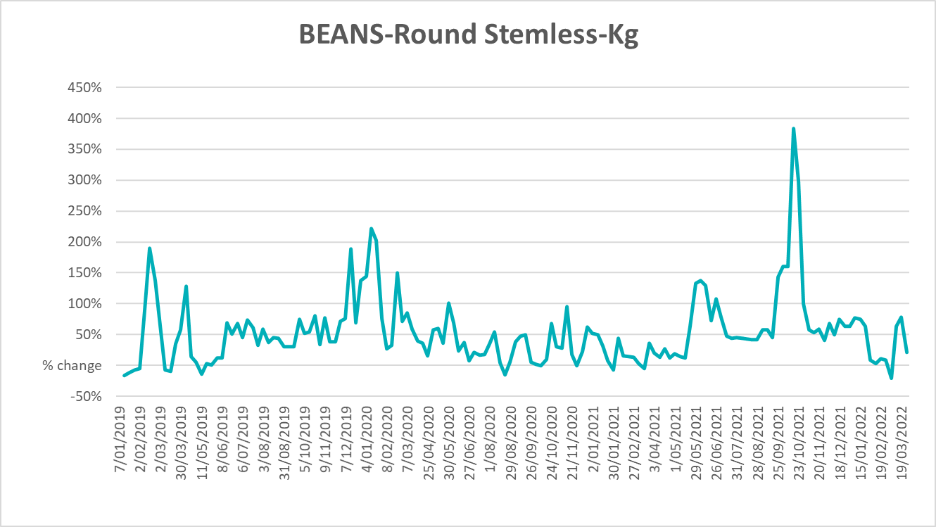

Selected domestic fodder indicator prices
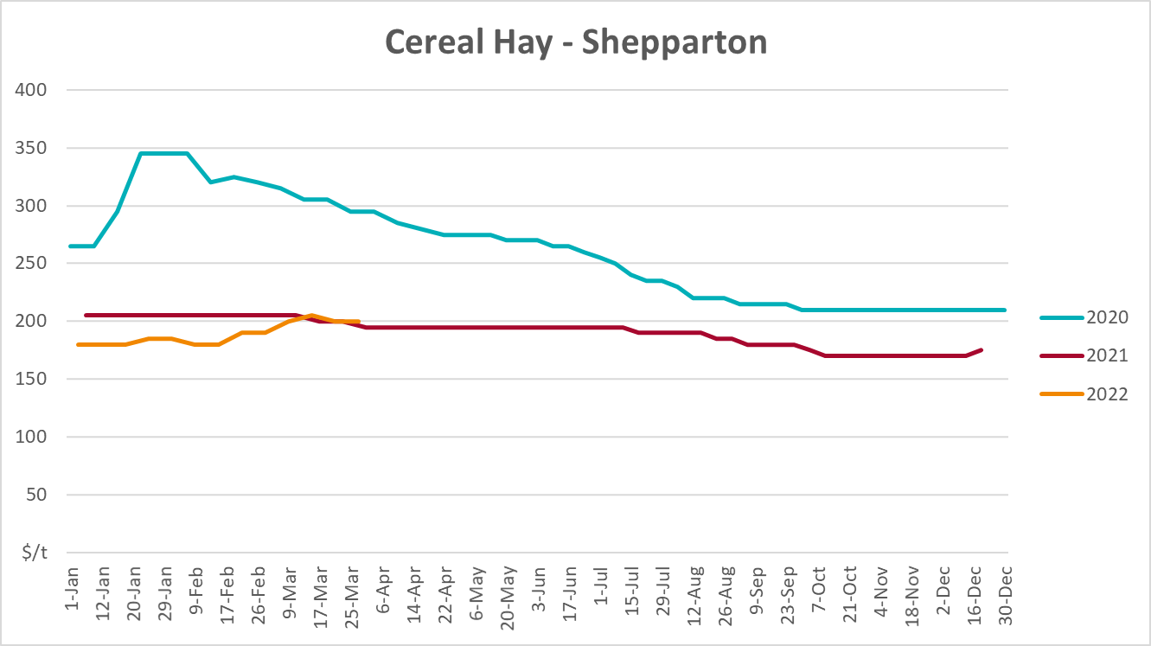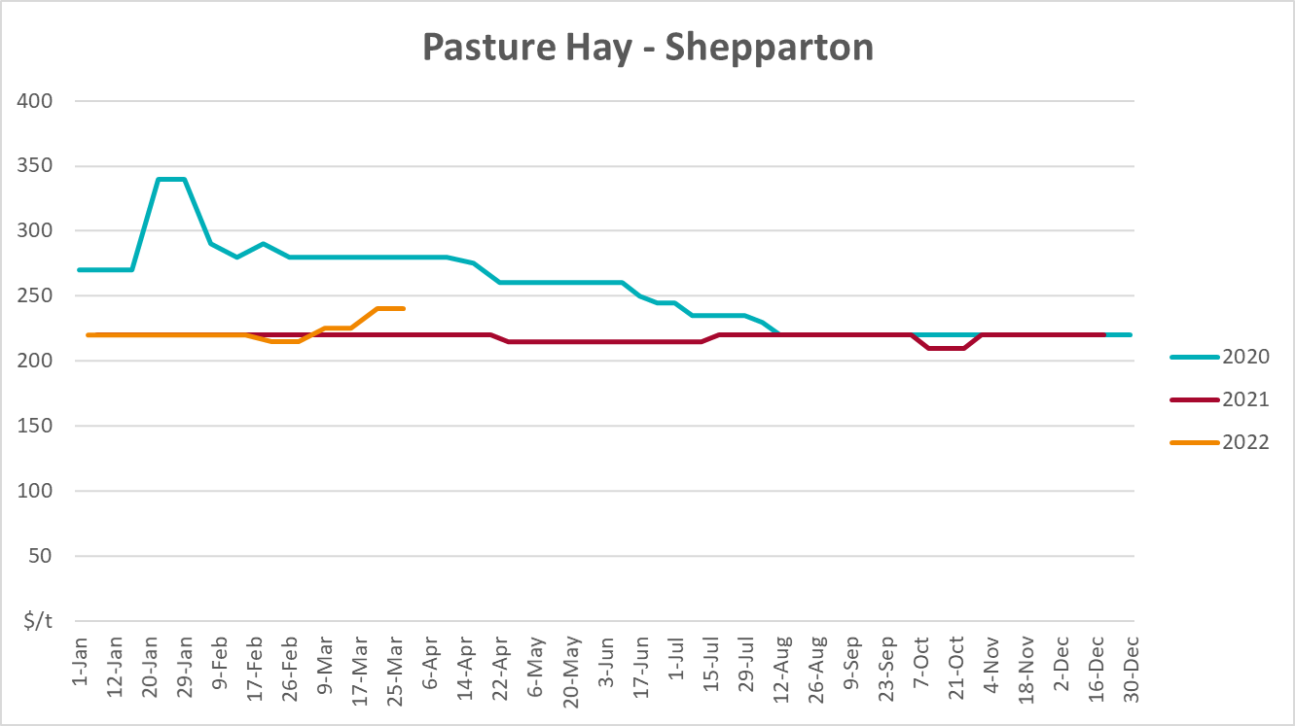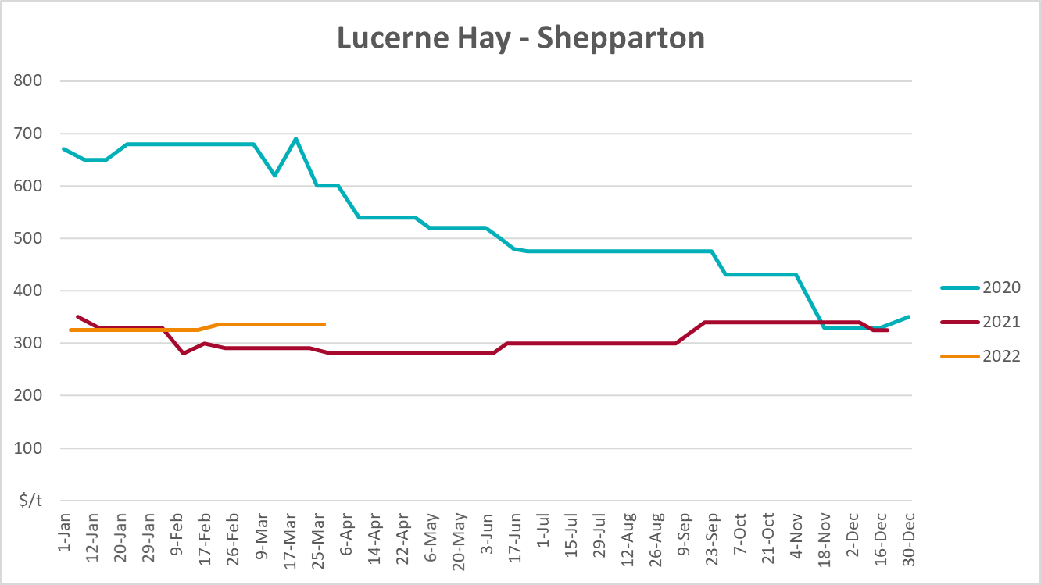

Data attribution

Climate
Bureau of Meteorology
- Weekly rainfall totals: www.bom.gov.au/climate/maps/rainfall/
- Monthly and last 3-month rainfall percentiles: www.bom.gov.au/water/landscape/
- Temperature anomalies: www.bom.gov.au/jsp/awap/temp/index.jsp
- Rainfall forecast: www.bom.gov.au/jsp/watl/rainfall/pme.jsp
- Seasonal outlook: www.bom.gov.au/climate/outlooks/#/overview/summary/
- Climate drivers: http://www.bom.gov.au/climate/enso/
- Soil moisture: www.bom.gov.au/water/landscape/
Other
- Pasture growth: www.longpaddock.qld.gov.au/aussiegrass/
- 3-month global outlooks: Environment and Climate Change Canada, NOAA Climate Prediction Center, EUROBRISA CPTEC/INPE, European Centre for Medium-Range Weather Forecasts, Hydrometcenter of Russia, National Climate Center Climate System Diagnosis and Prediction Room (NCC), International Research Institute for Climate and Society
- Global production: https://ipad.fas.usda.gov/ogamaps/cropmapsandcalendars.aspx
- Autumn break: Pook et al., 2009, https://rmets-onlinelibrary-wiley-com.virtual.anu.edu.au/doi/epdf/10.1002/joc.1833

Water
Prices
- Waterflow: https://www.waterflow.io/
- Ruralco: https://www.ruralcowater.com.au/
Bureau of Meteorology:
- Allocation trade: http://www.bom.gov.au/water/dashboards/#/water-markets/mdb/at
- Storage volumes: http://www.bom.gov.au/water/dashboards/#/water-storages/summary/drainage
Trade constraints:
- Water NSW: https://www.waternsw.com.au/customer-service/ordering-trading-and-pricing/trading/murrumbidgee
- Victorian Water Register: https://www.waterregister.vic.gov.au/TradingRules2019/

Commodities
Fruit and vegetables
- Datafresh: www.freshstate.com.au
Pigs
- Australian Pork Limited: www.australianpork.com.au
Dairy
- Global Dairy Trade: www.globaldairytrade.info/en/product-results/
World wheat, canola
- International Grains Council
World coarse grains
- United States Department of Agriculture
World cotton
- Cotlook: www.cotlook.com/
World sugar
- New York Stock Exchange - Intercontinental Exchange
Wool
- Australian Wool Exchange: www.awex.com.au/
Domestic wheat, barley, sorghum, canola and fodder
- Jumbuk Consulting Pty Ltd: http://www.jumbukag.com.au/
Cattle, beef, mutton, lamb, goat and live export
- Meat and Livestock Australia: www.mla.com.au/Prices-and-market
© Commonwealth of Australia 2022

Ownership of intellectual property rights
Unless otherwise noted, copyright (and any other intellectual property rights, if any) in this publication is owned by the Commonwealth of Australia (referred to as the Commonwealth).

Creative Commons licence
All material in this publication is licensed under a Creative Commons Attribution 4.0 International Licence except content supplied by third parties, logos and the Commonwealth Coat of Arms.
Inquiries about the licence and any use of this document should be emailed to copyright@awe.gov.au.


Cataloguing data
This publication (and any material sourced from it) should be attributed as:
ABARES 2021, Weekly Australian Climate, Water and Agricultural Update, Australian Bureau of Agricultural and Resource Economics and Sciences, Canberra, 21 April 2022. CC BY 4.0 DOI: https://doi.org/10.25814/5f3e04e7d2503
ISSN 2652-7561
This publication is available at https://www.awe.gov.au/abares/products/weekly_update
Department of Agriculture, Water and the Environment
GPO Box 858 Canberra ACT 2601
Telephone 1800 900 090
Web awe.gov.au/abares

Disclaimer
The Australian Government acting through the Department of Agriculture, Water and the Environment, represented by the Australian Bureau of Agricultural and Resource Economics and Sciences, has exercised due care and skill in preparing and compiling the information and data in this publication. Notwithstanding, the Department of Agriculture, Water and the Environment, ABARES, its employees and advisers disclaim all liability, including liability for negligence and for any loss, damage, injury, expense or cost incurred by any person as a result of accessing, using or relying on any of the information or data in this publication to the maximum extent permitted by law.

Statement of Professional Independence
The views and analysis presented in ABARES publications, including this one, reflect ABARES professionally independent findings, based on scientific and economic concepts, principles, information and data. These views, analysis and findings may not reflect or be consistent with the views or positions of the Australian Government, or of organisations or groups who have commissioned ABARES reports or analysis. More information on professional independence is provided on the ABARES website.

Acknowledgements
This report was prepared by Matthew Miller and Cameron Van-Lane.

