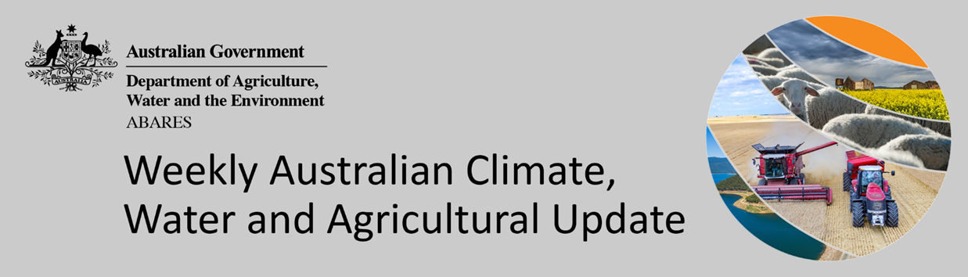
No. 17/2022

5 May 2022

Summary of key issues
- For the week ending 4 May 2022, low-pressure troughs in eastern Australia and cold fronts across southern Australia resulted in moderate rainfall. Meanwhile high-pressure systems provided mostly dry conditions for remaining parts of the country (see Section 1.1).
- Dry conditions across Queensland and, northern and southern New South Wales likely allowed field access for the harvesting of summer crops, as well as the planting of winter crops. In southern growing regions, planting of winter crops is also well underway. However, rainfall and extremely high upper layer soil moisture levels across parts of New South Wales and Victoria have likely limited field access over the past week. Upper layer soil moisture levels are average to above average across most Australian cropping regions, except for central cropping regions of South Australia which are yet to receive their autumn break to start the winter cropping season.
- Rainfall during April 2022 was 27% above average for Australia as a whole. Extremely high rainfall across eastern Australia in April followed a wet March and added to already saturate soil profiles, resulting in localised flooding. The wet conditions have delayed maturation and harvesting of long-lived summer crops in parts of New South Wales and Queensland. However, most southern cropping regions have received sufficient rainfall in recent weeks to classify as a consolidated autumn break (see Section 1.2).
- For the 3 months to April 2022, above average rainfall totals and mild temperatures resulted in average to well above average pasture production for this time of year across most grazing regions in central and western New South Wales, southern Queensland, western and northern Victoria, northern South Australia, northern Western Australia, and the south of the Northern Territory. Extremely low to below average pasture growth rates were recorded across southern Western Australia, south-eastern Victoria, parts of central and northern Queensland and the north of the Northern Territory consistent with above average temperatures and/or below average rainfall (see Section 1.4).
- Over the 8-days to 12 May 2022, low-pressure systems, fronts and troughs, coupled with onshore winds are expected to bring showers and storms to eastern Australia. In remaining parts of the country, high-pressure systems will bring mostly dry conditions (see Section 1.5).
- Water storage in the Murray–Darling Basin (MDB) decreased by 29 gigalitres (GL) between 27 April 2022 and 4 May 2022. The current volume of water held in storage is 21,512GL, which represents 85% of total capacity. This is 52% or 7,342 GL more than at the same time last year.
- Allocation prices in the Victorian Murray below the Barmah Choke decreased from $65 per ML on 22 April 2022 to $52 per ML on 29 April 2022. Prices are lower in the Goulburn-Broken, Murrumbidgee and regions above the Barmah choke due to the binding of the Goulburn intervalley trade limit, Murrumbidgee export limit and Barmah choke trade constraint.

Climate

Rainfall this week
For the week ending 4 May 2022, low-pressure troughs in eastern Australia and cold fronts across southern Australia resulted in moderate rainfall. Meanwhile high-pressure systems provided mostly dry conditions for remaining parts of the country.
Rainfall totals of between 10 and 50 millimetres were recorded across north-western to south-eastern New South Wales, much of Victoria, as well as isolated parts of the north of the Northern Territory, Queensland, South Australia and Western Australia. Rainfall totals in excess of 50 millimetres were recorded across much of Tasmania as well as isolated parts of eastern New South Wales, north-eastern Queensland and the north of the Northern Territory. Remaining parts of Australia received little to no rainfall.
In cropping regions, rainfall totals of between 10 and 50 millimetres were recorded across central New South Wales, southern Victoria and isolated parts of eastern Queensland and Western Australia. Rainfall in excess of 50 millimetres was recorded in cropping regions in eastern New South Wales. Little to no rainfall was recorded across cropping regions in remaining parts of New South Wales, Queensland, Victoria, South Australia and Western Australia.
Dry conditions across Queensland and, northern and southern New South Wales likely allowed field access for the harvesting of summer crops, as well as the planting of winter crops. In southern growing regions, planting of winter crops is also well underway. However, rainfall and extremely high upper layer soil moisture levels across parts of New South Wales and Victoria have likely limited field access over the past week. Upper layer soil moisture levels are average to above average across most Australian cropping regions, except for central cropping regions of South Australia which are yet to receive their autumn break to start the winter cropping season.

Rainfall for the week ending 4 May 2022

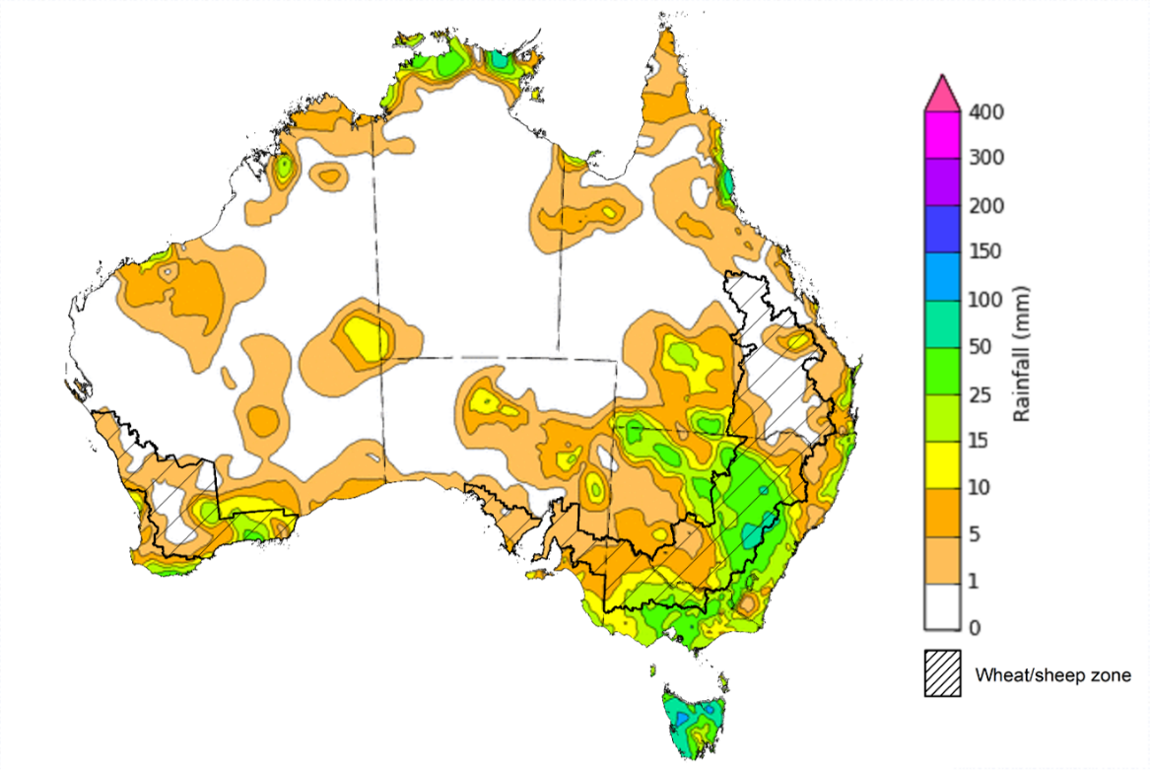
©Commonwealth of Australia 2022, Australian Bureau of Meteorology Issued: 4/5/2022
Note: The rainfall analyses and associated maps utilise data contained in the Bureau of Meteorology climate database, the Australian Data Archive for Meteorology (ADAM). The analyses are initially produced automatically from real-time data with limited quality control. They are intended to provide a general overview of rainfall across Australia as quickly as possible after the observations are received. For further information go to http://www.bom.gov.au/climate/rainfall/

Monthly rainfall
Rainfall during April 2022 was 27% above average for Australia as a whole. Rainfall was above average to extremely high for most of the eastern half of Australia, the south and west of Western Australia and the north-west of the Northern Territory. However, rainfall was extremely low to below average for south-western Victoria, south-eastern South Australia, a large area of central Australia, as well as western Tasmania.
The main climate influences for April were a La Niña event in the Pacific and a positive South Annular Mode (SAM). A La Niña is associated with above average rainfall for eastern Australia, and a positive SAM typically results in high-pressure systems over the Great Australian Bight, and above average sea surface temperatures to the north-west and south-east of Australia. The combination of high-pressure systems to the south and low-pressure systems off the east coast brought significant falls to parts of central and eastern Australia.
April rainfall was average to above average across cropping regions of New South Wales, northern and south-western Queensland, the west of South Australia, Western Australia and Victoria. Below average falls recorded in cropping regions of south-central Queensland and central South Australia.
Extremely high rainfall across eastern Australia in April followed a wet March and added to already saturate soil profiles, resulting in localised flooding. The wet conditions have delayed maturation and harvesting of long-lived summer crops in parts of New South Wales and Queensland. However, most southern cropping regions have received sufficient rainfall in recent weeks to classify as a consolidated autumn break.

Rainfall percentiles for April 2022

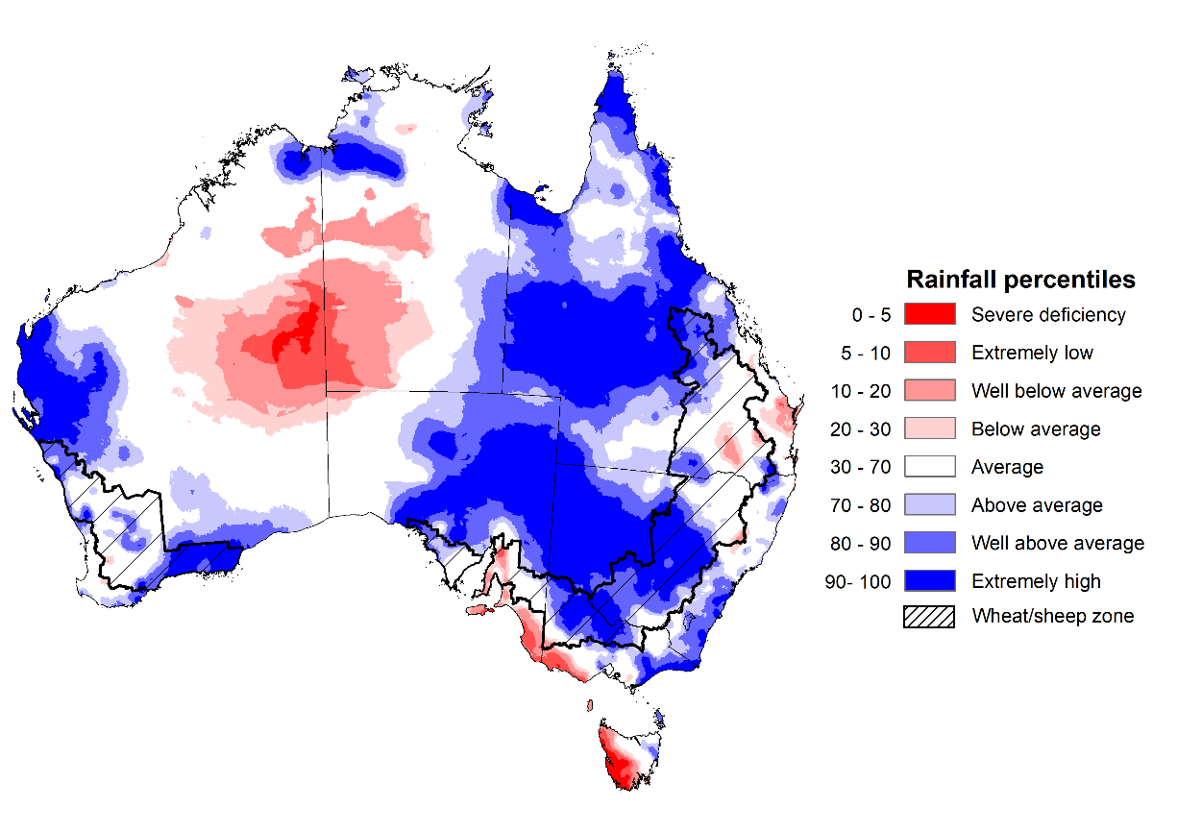
Note: Rainfall for April 2022 is compared with rainfall recorded for that period during the historical record (1900 to present). For further information, go to http://www.bom.gov.au/jsp/awap/
Source: Bureau of Meteorology

Monthly soil moisture
Upper layer soil moisture in April 2022 was extremely low for this time of year across south-western Victoria, south-eastern South Australia, large areas of central Australia, as well as western Tasmania due to below average rainfall in these areas during April. Extremely high upper layer soil moisture was evident across large areas of New South Wales, Queensland, eastern and northern Victoria, the east of South Australia, parts of western and southern Western Australia and northern parts of the Northern Territory reflecting heavy rainfall events in these areas. Modelled upper layer soil moisture was generally average across the remainder of the country.
At this time of year, upper layer soil moisture is important for the germination and establishment of early sown winter crops across Australian cropping regions. It is also important indicator of the ability to access paddocks to undertake harvesting of summer crops in New South Wales and Queensland, as well as planting activities for winter crops.
Upper layer soil moisture was average to above average for this time of year across cropping regions in New South Wales, Victoria and Western Australia, much of Queensland and western South Australia. Upper layer soil moisture was below average for isolated parts of the southern Queensland and central South Australia growing regions. Extremely high to above average upper layer soil moisture was evident across much of central New South Wales, western Queensland and the east of Western Australia cropping regions. Extremely high upper layer soil moisture would have prevented field access for growers across parts of New South Wales. However, the above average upper layer soil moisture levels across most cropping regions will support winter crops through germination and establishment.

Modelled upper layer soil moisture for April 2022

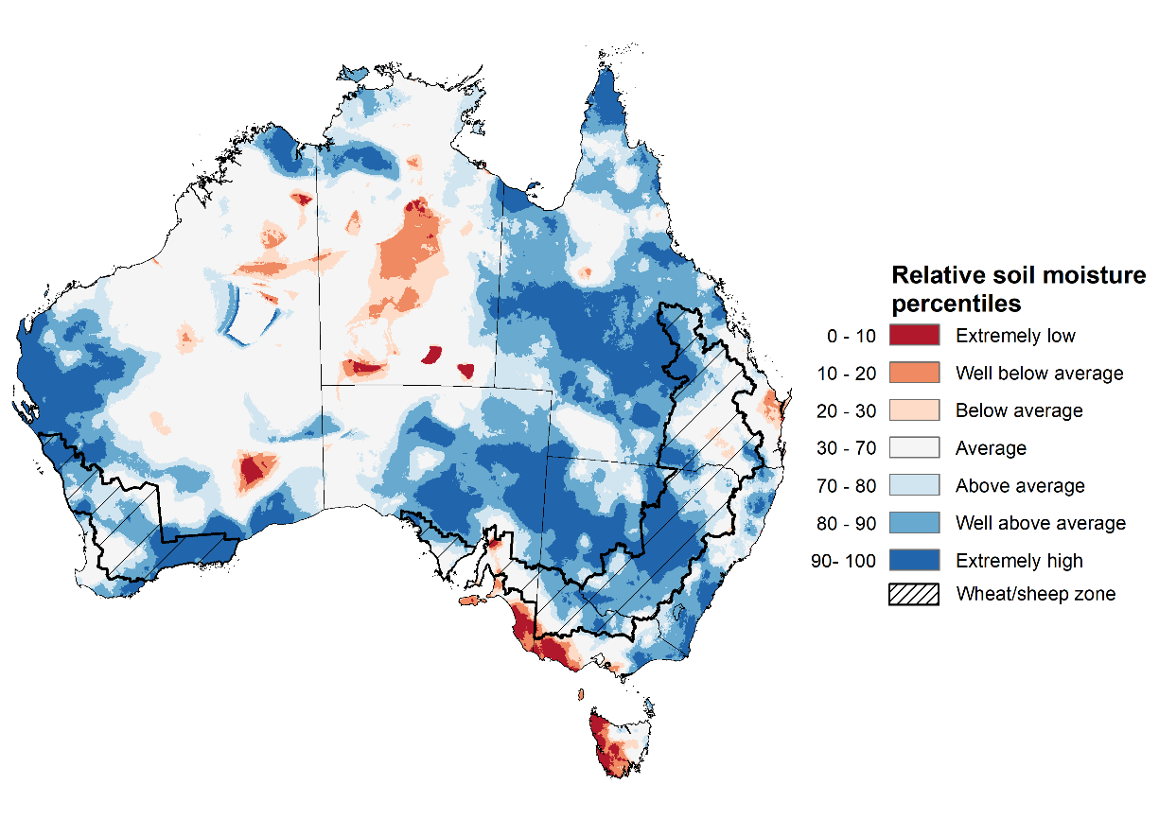
Note: This map shows the levels of modelled upper layer soil moisture (0 to 10 centimetres) during April 2022. This map shows how modelled soil conditions during April 2022 compare with April conditions modelled over the reference period (1911 to 2016). Dark blue areas on the maps were much wetter in April 2022 than during the reference period. The bulk of plant roots occur in the top 20 centimetres of the soil profile. Soil moisture in the upper layer of the soil profile is therefore useful indicator of the availability of water, particularly for germinating seed.
Source: Bureau of Meteorology (Australian Water Resources Assessment Landscape model)

Lower layer soil moisture for April 2022 was well above average to extremely high for this time of year across eastern New South Wales, parts of south-eastern, central and northern Queensland, eastern and north-western Victoria, as well as isolated parts of South Australia and large areas in central and the west of Western Australia. Lower layer soil moisture was well below average to below average across large parts of northern Queensland, southern Victoria, the south-east of South Australia, isolated parts of Western Australia, the north of the Northern Territory and much of Tasmania.
In cropping regions, lower layer soil moisture was well above average to extremely high for parts of New South Wales, southern Queensland, western Victoria, as well as much of Western Australia. Lower layer soil moisture was extremely low to below average for parts of Central Queensland and central South Australian cropping regions. The below average lower layer soil moisture may reduce yield potentials for late sown summer crops in Central Queensland as their root systems extend into lower soil layers. Similarly, pasture growth in northern parts of Queensland and the Northern Territory has likely struggled due to the lack of lower layer moisture.
Modelled lower layer soil moisture for April 2022
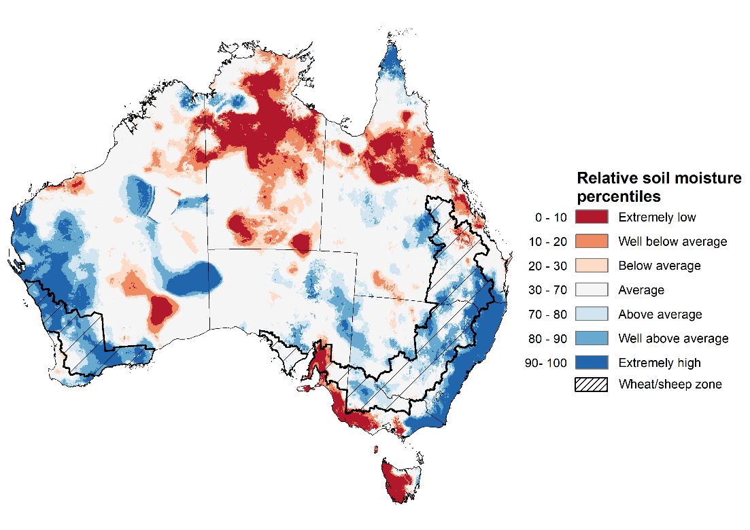
Note: This map shows the levels of modelled lower layer soil moisture (10 to 100 centimetres) during April 2022. This map shows how modelled soil conditions during April 2022 compare with April conditions modelled over the reference period (1911 to 2016). Dark blue areas on the maps were much wetter in April 2022 than during the reference period. The dark red areas were much drier than during the reference period. The bulk of plant roots occur in the top 20 centimetres of the soil profile. The lower layer soil moisture is a larger, deeper store that is slower to respond to rainfall and tends to reflect accumulated rainfall events over longer time periods.
Source: Bureau of Meteorology (Australian Water Resources Assessment Landscape model)

Pasture growth
February to April forms the final 3-months of the pasture growing season across much of northern Australia, providing a late season boost in growth and the bulk of feed to maintain production through the low pasture growth months of the northern dry season. Across south-eastern Australia, February to April pasture growth is typically increasing reflecting higher rainfall totals, and reduced temperatures and evapotranspiration rates at this time of year. Pasture availability during this period influences the growth and branding and marking rates of lambs and calves, livestock turnoff and the production of meat, milk, and wool.
For the 3 months to April 2022, above average rainfall totals and mild temperatures resulted in average to well above average pasture production for this time of year across most grazing regions in central and western New South Wales, southern Queensland, western and northern Victoria, northern South Australia, northern Western Australia, and the south of the Northern Territory. Extremely low to below average pasture growth rates were recorded across central Western Australia, south-eastern Victoria, parts of central and northern Queensland and the north of the Northern Territory consistent with above average temperatures and/or below average rainfall. In contrast, below average pasture growth rates across parts of eastern New South Wales and south-eastern Queensland are likely the result of below average temperatures and waterlogged soils.
Average to extremely high pasture production across much of New South Wales, Victoria, southern Queensland, South Australia, northern Western Australia and the south of the Northern Territory will likely enable farmers to continue to rebuild stock numbers and provide opportunities to build standing dry matter availability. Below average temperatures and waterlogged soils across eastern New South Wales and south-eastern Queensland may have restricted summer pasture growth. However, it comes after extremely high pasture growth during winter and spring that supplied average to above average pasture availability and ample opportunities to conserve excess fodder.

Relative pasture growth for 3-months ending April 2022 (1 February to 30 April 2022)
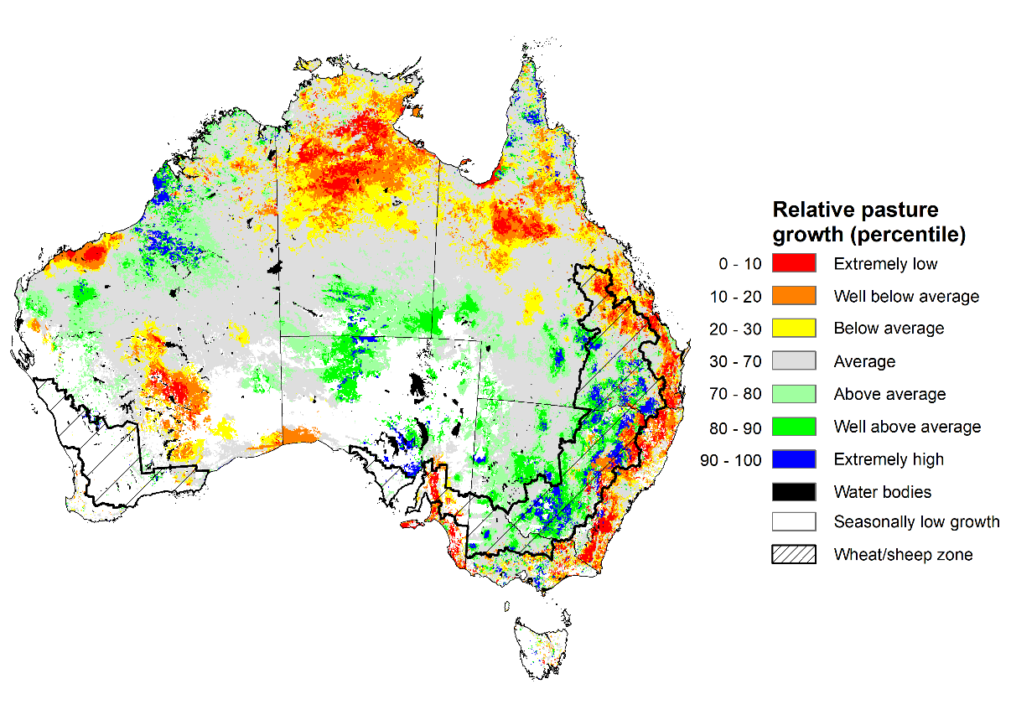
Notes: AussieGRASS pasture growth estimates are relative to the long-term record and shown in percentiles. Percentiles rank data on a scale of zero to 100. This analysis ranks pasture growth for the selected period against average pasture growth for the long-term record (1957 to 2016). Pasture growth is modelled at 5km2 grid cells.
Source: Queensland Department of Science, Information Technology and Innovation

Rainfall forecast for the next eight days
Over the 8-days to 12 May 2022, low-pressure systems, fronts and troughs, coupled with onshore winds are expected to bring showers and storms to eastern Australia. In remaining parts of the country, high-pressure systems will bring mostly dry conditions.
Rainfall totals of between 10 and 50 millimetres are forecast for much of northern and eastern New South Wales, much of Queensland, Tasmania, the far south-west of Western Australia and scattered areas of Victoria. Rainfall in excess of 50 millimetres is expected for the far north-east of New South Wales, much of the eastern half of Queensland, as well as parts of western and southern Tasmania.
In Australian cropping regions, rainfall totals of between 10 and 50 millimetres are expected across central and northern New South Wales and isolated areas of southern Queensland. Rainfall in excess of 50 millimetres is expected across most cropping regions in Queensland. Little to no rainfall is forecast for all remaining cropping regions during the next 8-days.
The wet conditions expected across Queensland and northern New South Wales cropping regions is likely to restrict field access, delaying the harvesting of cotton and sorghum, as well as the planting of winter crops. The dry conditions expected across southern New South Wales cropping regions will allow the harvesting of cotton and rice to continue, as well as the planting of winter crops. In Victoria, South Australia and Western Australia, planting activity is expected to increase over the coming week, with relatively dry conditions. Many growers will be eager to complete planting programs as soon as possible given the expectation for a wetter than average winter. The east of South Australia is still yet to receive an autumn break, but growers are likely to dry-sow winter crops given the favourable 3-month rainfall outlook.

Total forecast rainfall (mm) for the period 5 May to 12 May 2022
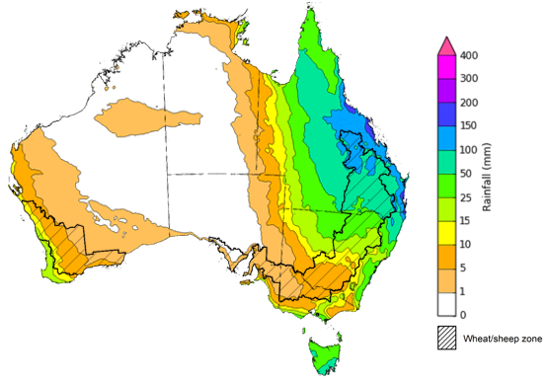
©Commonwealth of Australia 2022, Australian Bureau of Meteorology Issued: 05/05/2022

Water
Note: This rainfall forecast is produced from computer models. As the model outputs are not altered by weather forecasters, it is important to check local forecasts and warnings issued by the Bureau of Meteorology.

Water markets – current week
Water storage in the Murray–Darling Basin (MDB) decreased by 29 gigalitres (GL) between 27 April 2022 and 4 May 2022. The current volume of water held in storage is 21,512GL, which represents 85% of total capacity. This is 52% or 7,342 GL more than at the same time last year.

Water storages in the Murray-Darling Basin, 2013–2022
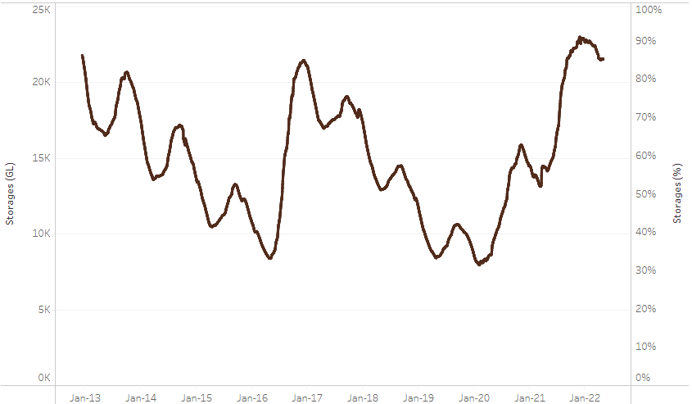
Allocation prices in the Victorian Murray below the Barmah Choke decreased from $65 per ML on 22 April 2022 to $52 per ML on 29 April 2022. Prices are lower in the Goulburn-Broken, Murrumbidgee and regions above the Barmah choke due to the binding of the Goulburn intervalley trade limit, Murrumbidgee export limit and Barmah choke trade constraint.
Water storage data is sourced from the Bureau of Meteorology.

Region | $/ML
NSW Murray Above | 4
NSW Murrumbidgee | 9
VIC Goulburn-Broken | 29
VIC Murray Below | 52

Surface water trade activity, Southern Murray–Darling Basin

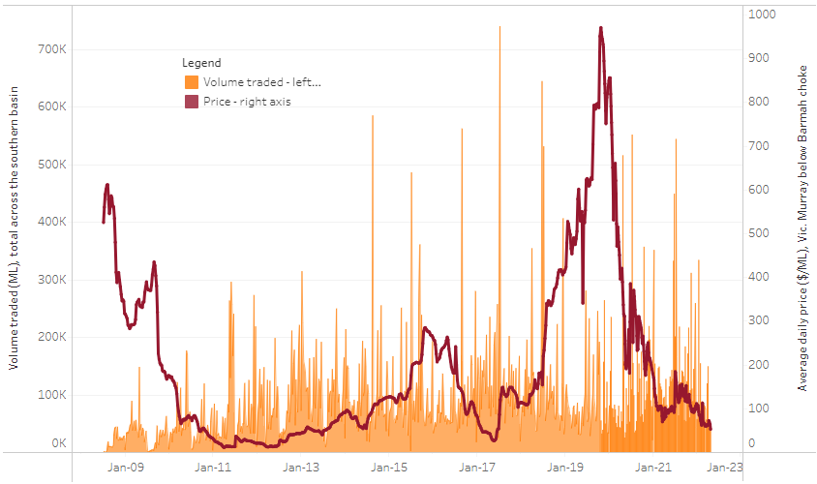
To access the full, interactive, weekly water dashboard, which contains the latest and historical water storage, water market and water allocation information, please visit http://www.agriculture.gov.au/abares/products/weekly_update/weekly-update-050522
The trades shown reflect estimated market activity and do not encompass all register trades. The price is shown for the VIC Murray below the Barmah choke. Historical prices (before 1 July 2019) are ABARES estimates after removing outliers from BOM water register data. Prices after 1 July 2019 and prior to the 30 October 2019 reflect recorded transaction prices as sourced from Ruralco. Prices after the 30 October 2019 are sourced from Waterflow. Data for volume traded is sourced from the BOM water register. Data shown is current at 5 May 2022.

Commodities

Indicator | Week ended | Unit | Latest price | Previous week | Weekly change | Price 12 months ago | Annual change
Selected world indicator prices
AUD/USD Exchange rate | 04-May | A$/US$ | 0.71 | 0.72 | -2% | 0.78 | -9%
Wheat – US no. 2 hard red winter wheat, fob Gulf | 04-May | US$/t | 472 | 413 | 14% | 305 | 55%
Corn – US no. 2 yellow corn, fob Gulf | 04-May | US$/t | 350 | 358 | -2% | 311 | 13%
Canola – Rapeseed, Canada, fob Vancouver | 04-May | US$/t | 967 | 982 | -2% | 836 | 16%
Cotton – Cotlook 'A' Index | 04-May | USc/lb | 169 | 155 | 10% | 93 | 81%
Sugar – Intercontinental Exchange, nearby futures, no.11 contract | 04-May | USc/lb | 18.8 | 18.9 | -1% | 18 | 7%
Wool – Eastern Market Indicator | 04-May | Ac/kg clean | 1,395 | 1,395 | 0% | 1,277 | 9%
Wool – Western Market Indicator | 06-Apr | Ac/kg clean | 1,417 | 1,421 | 0% | 1,222 | 16%
Selected Australian grain export prices
Milling Wheat – APW, Port Adelaide, SA | 04-May | A$/t | 581 | 576 | 1% | 382 | 52%
Feed Wheat – ASW, Port Adelaide, SA | 04-May | A$/t | 548 | 543 | 1% | 379 | 44%
Feed Barley – Port Adelaide, SA | 04-May | A$/t | 501 | 481 | 4% | 315 | 59%
Canola – Kwinana, WA | 04-May | A$/t | 1,284 | 1,268 | 1% | 749 | 71%
Grain Sorghum – Brisbane, QLD | 04-May | A$/t | 441 | 434 | 2% | 371 | 19%
Selected domestic livestock indicator prices
Beef – Eastern Young Cattle Indicator | 04-May | Ac/kg cwt | 1,102 | 1,085 | 2% | 909 | 21%
Mutton – Mutton indicator (18–24 kg fat score 2–3), Vic | 04-May | Ac/kg cwt | 601 | 597 | 1% | 668 | -10%
Lamb – Eastern States Trade Lamb Indicator | 04-May | Ac/kg cwt | 781 | 788 | -1% | 805 | -3%
Pig – Eastern Seaboard (60.1–75 kg), average of buyers & sellers | 30-Mar | Ac/kg cwt | 368 | 357 | 3% | 347 | 6%
Goats – Eastern States (12.1–16 kg) | 12-Jan | Ac/kg cwt | 879 | 879 | 0% | 818 | 8%
Live cattle – Light steers ex Darwin to Indonesia | 04-May | Ac/kg lwt | 470 | 470 | 0% | 280 | 68%
Live sheep – Live wethers (Muchea WA saleyard) to Middle East | 20-Apr | $/head | 113 | 113 | 0% | 122 | -7%

Indicator | Week ended | Unit | Latest price | Previous week | Weekly change | Price 12 months ago | Annual change
Global Dairy Trade (GDT) weighted average prices ª
Dairy – Whole milk powder | 04-May | US$/t | 3,916 | 4,207 | -7% | 2,797 | 40%
Dairy – Skim milk powder | 04-May | US$/t | 4,130 | 4,408 | -6% | 2,527 | 63%
Dairy – Cheddar cheese | 04-May | US$/t | 5,652 | 6,185 | -9% | 4,395 | 29%
Dairy – Anhydrous milk fat | 04-May | US$/t | 6,008 | 6,802 | -12% | 4,345 | 38%
a Global Dairy Trade prices are updated twice monthly on the first and third Tuesday of each month.

Selected world indicator prices
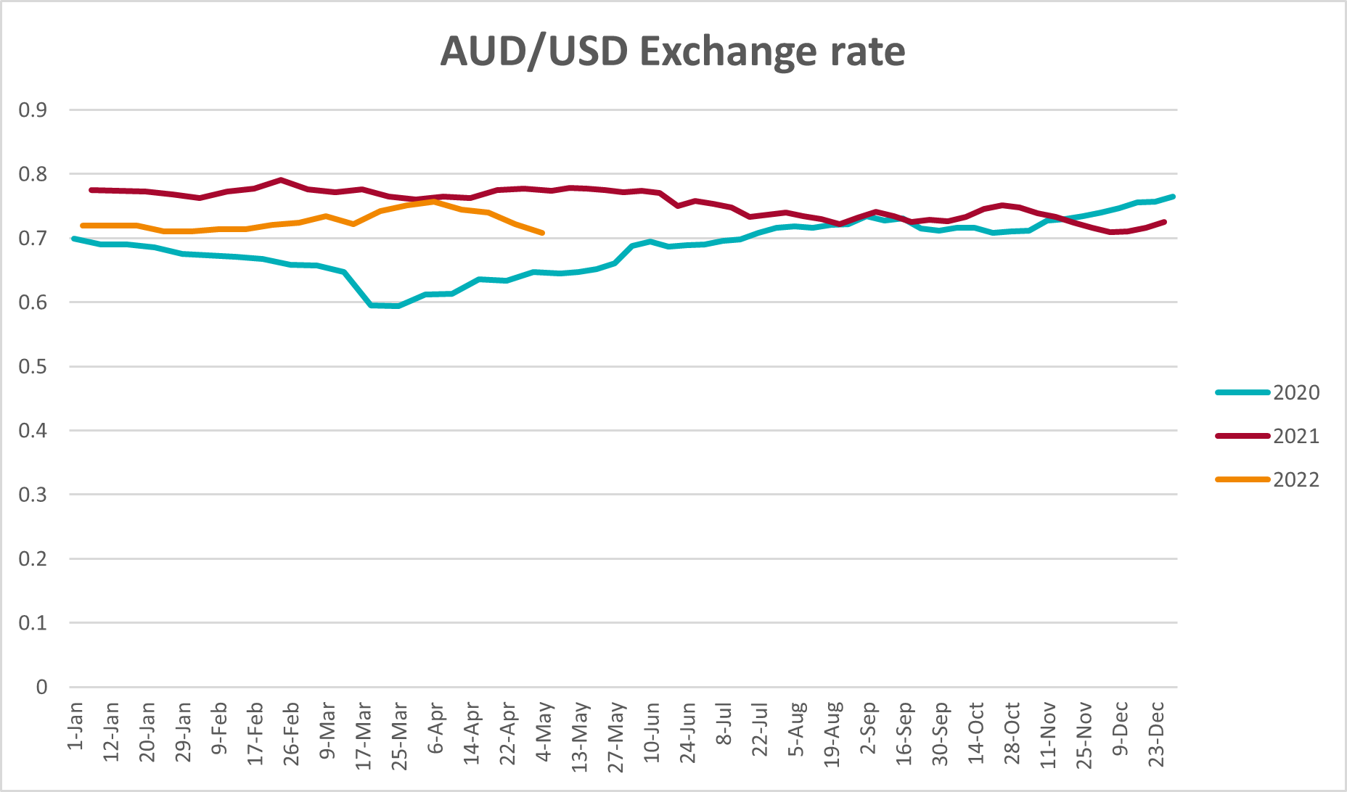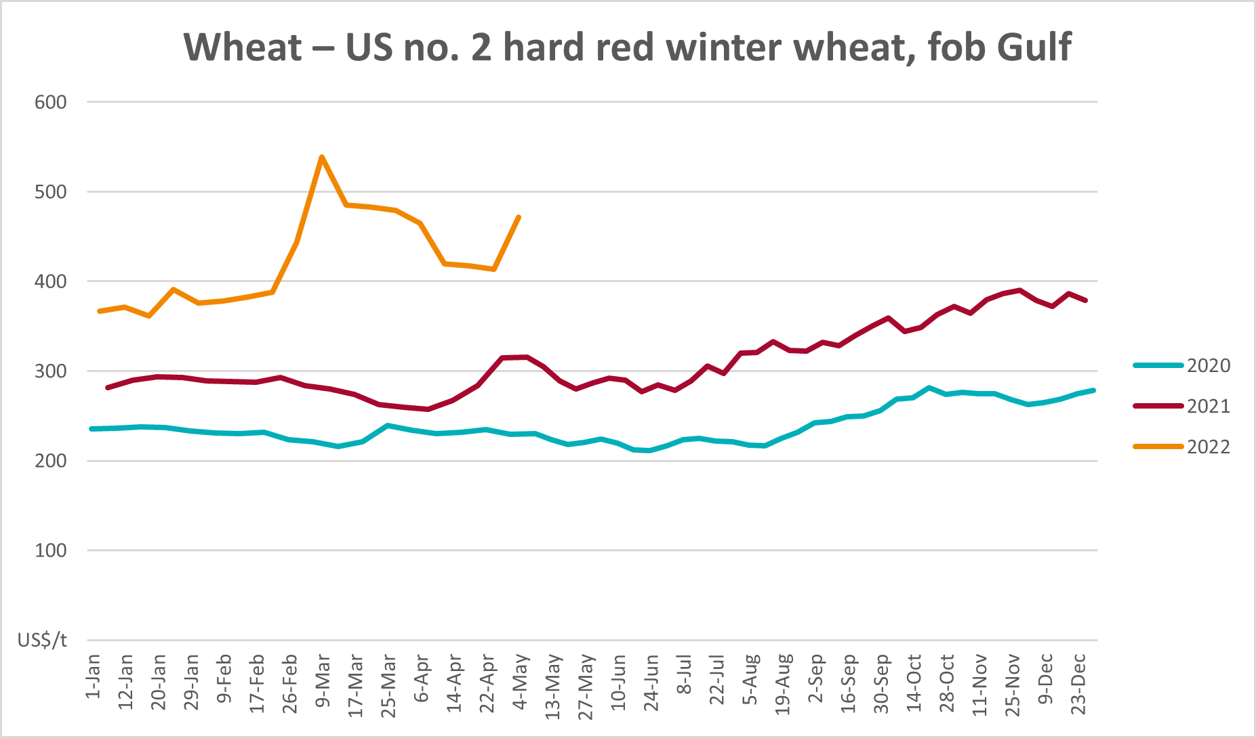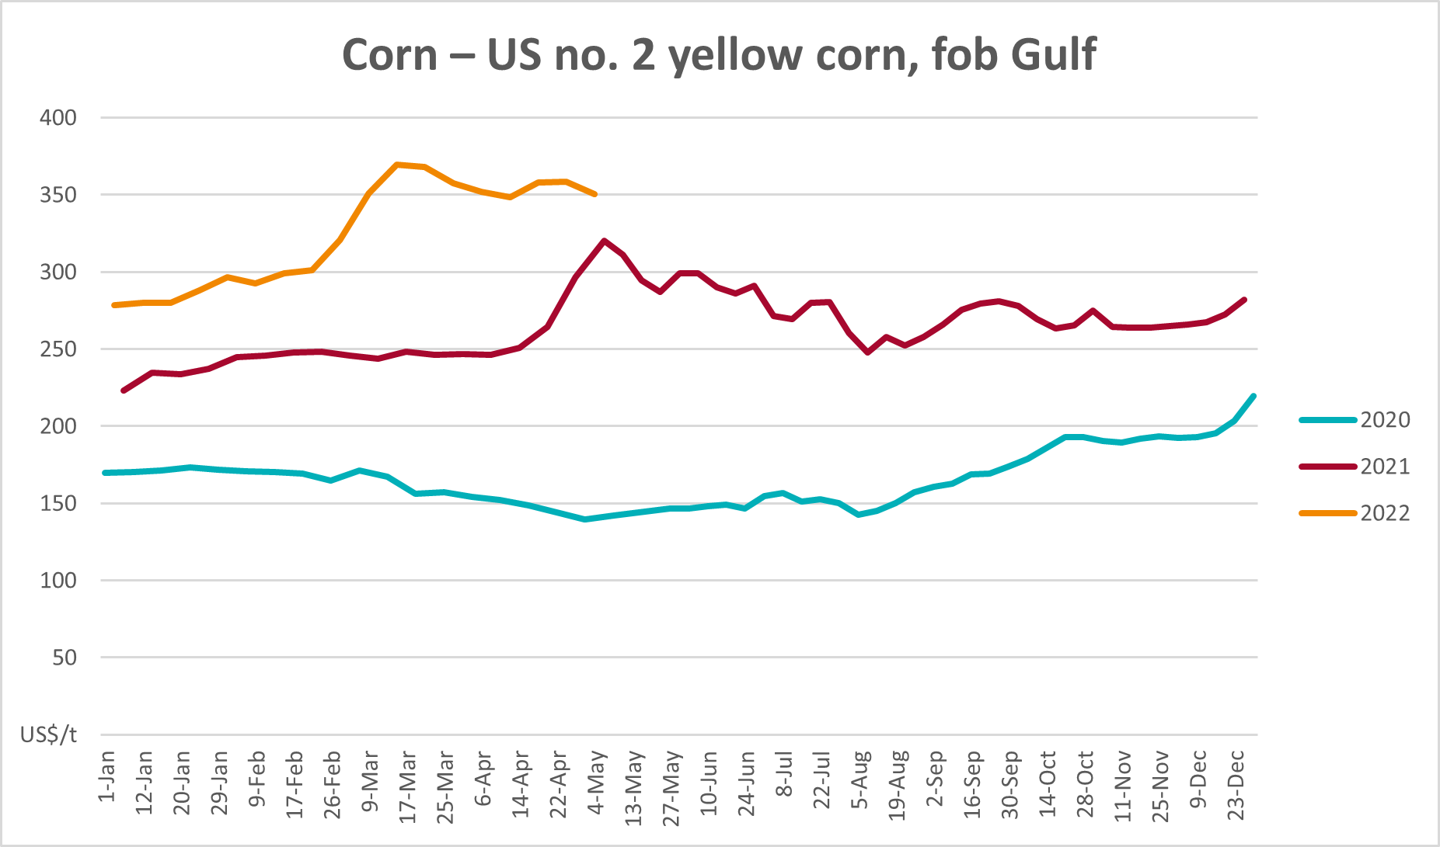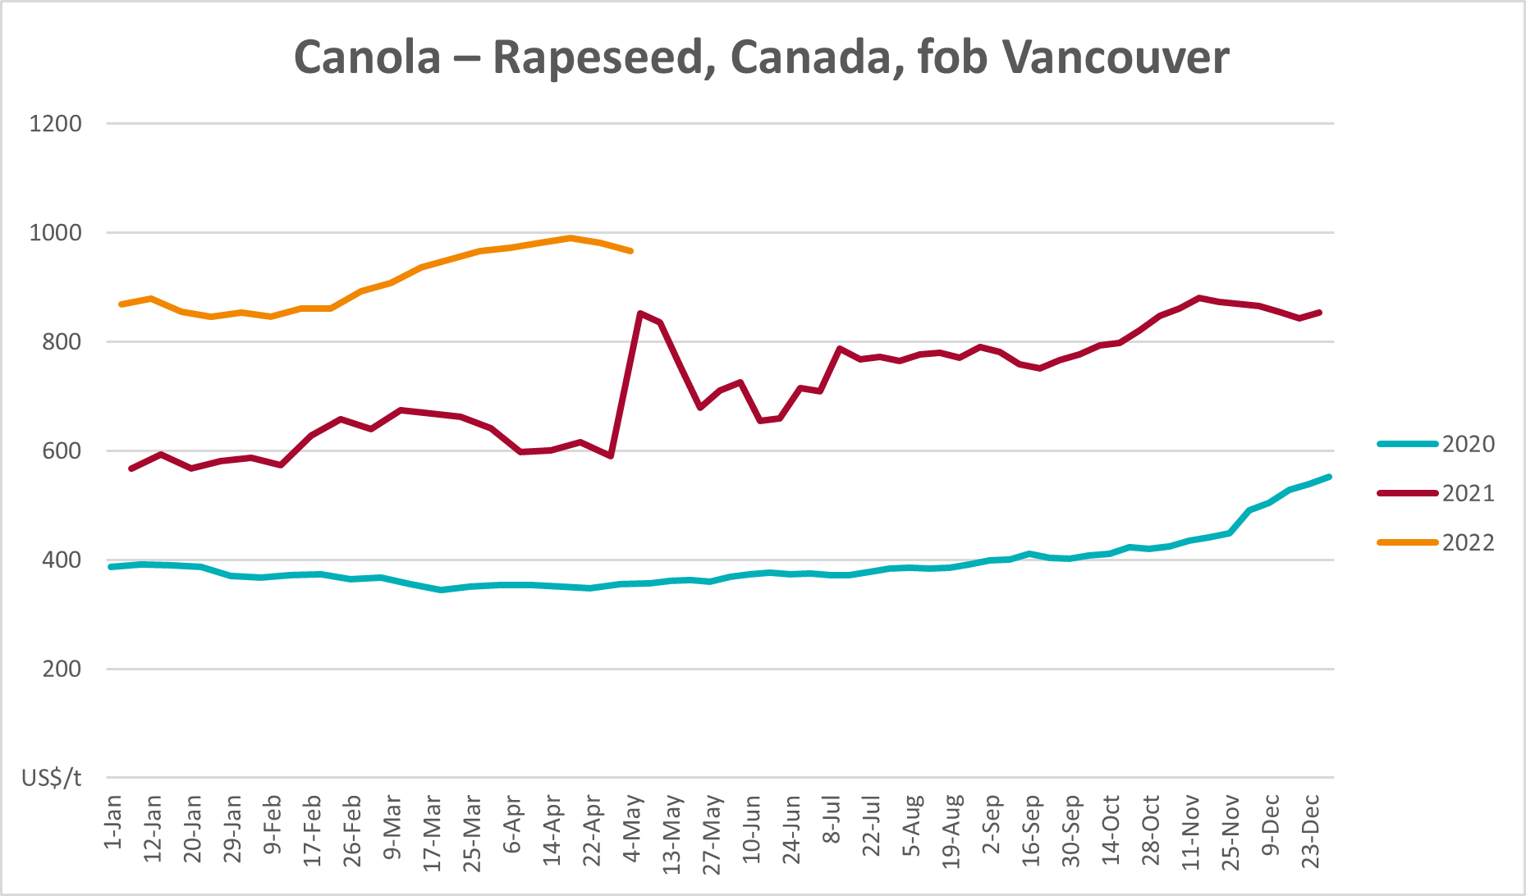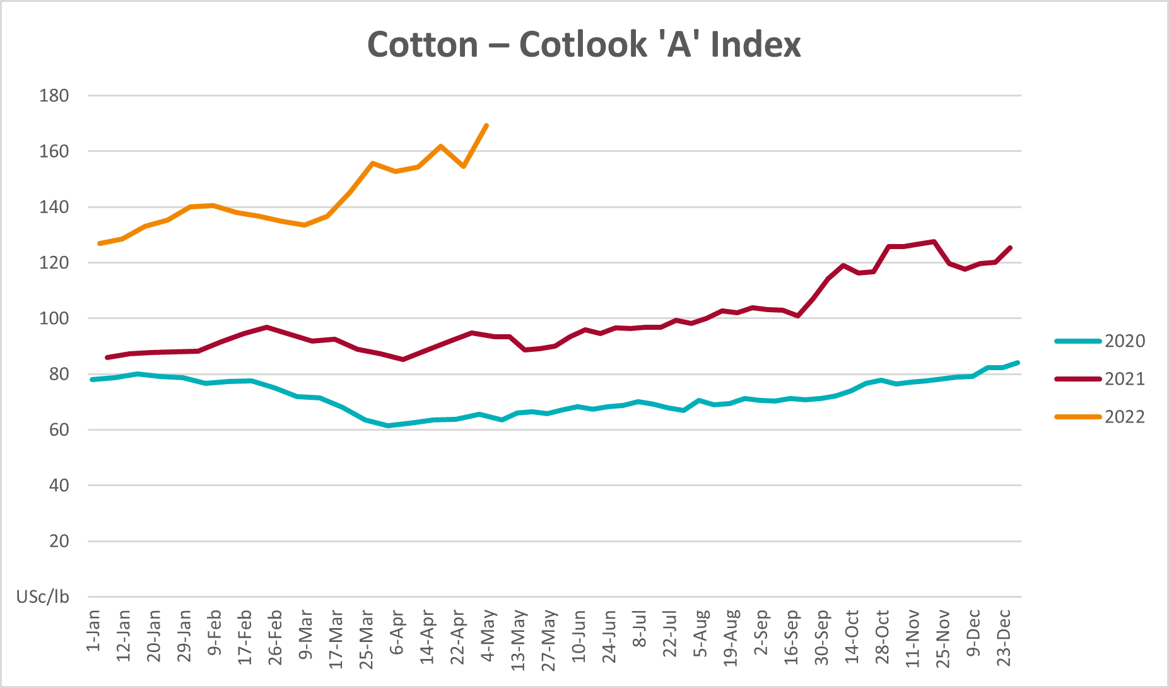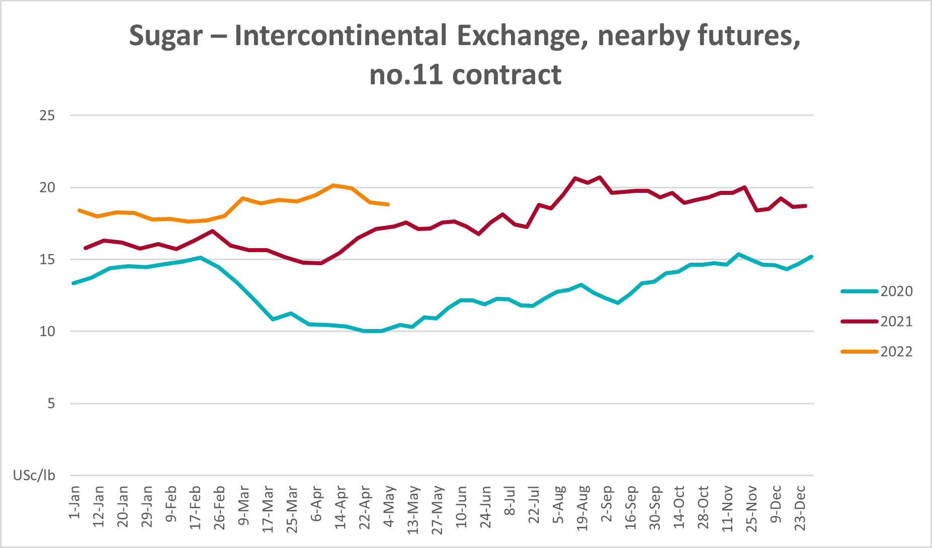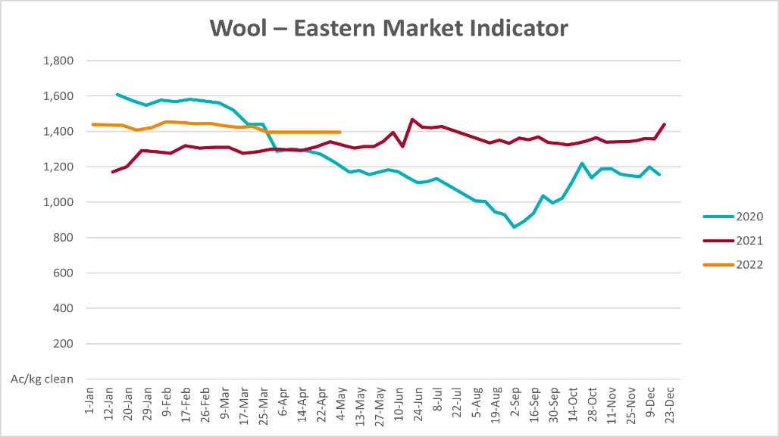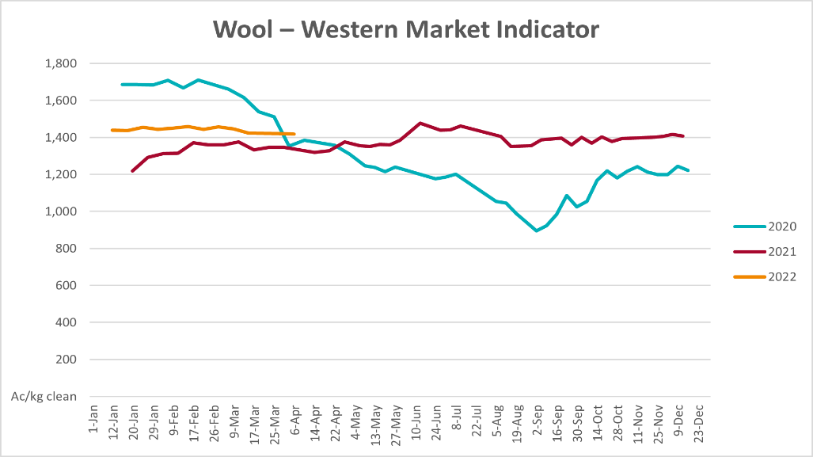

Selected domestic crop indicator prices
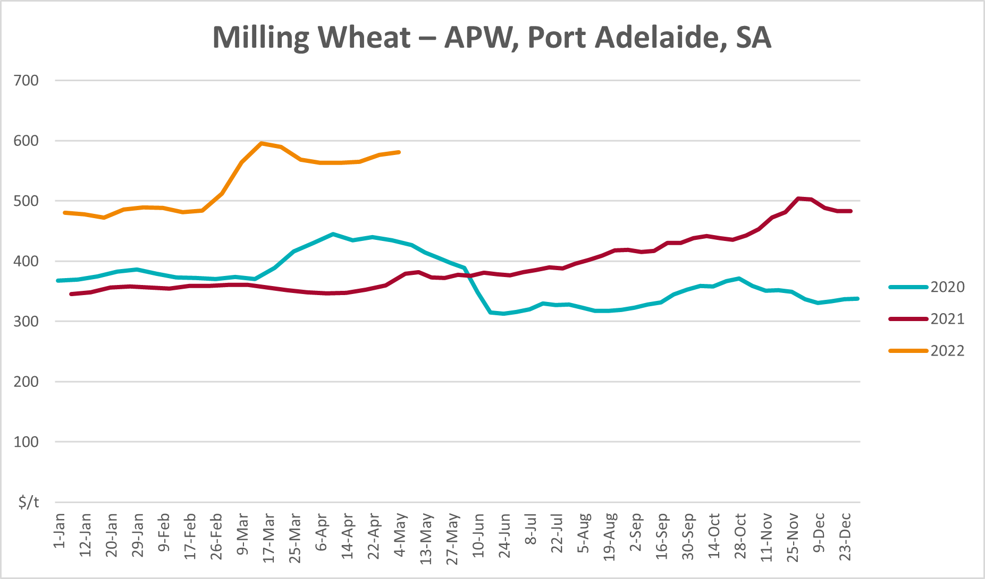
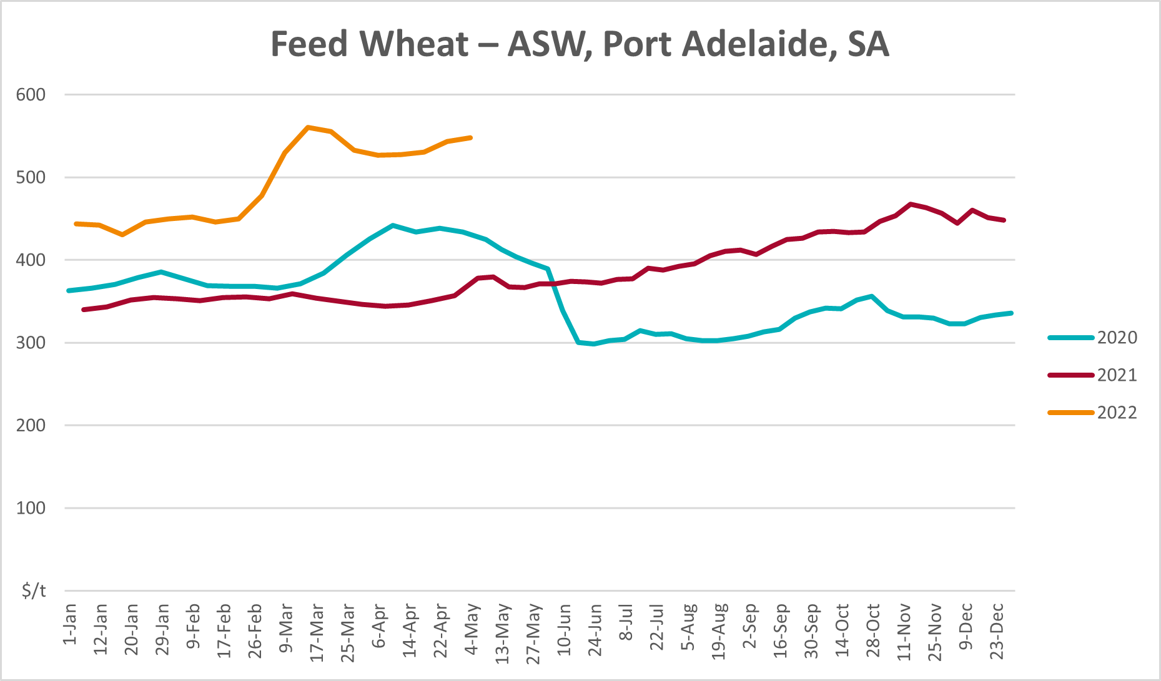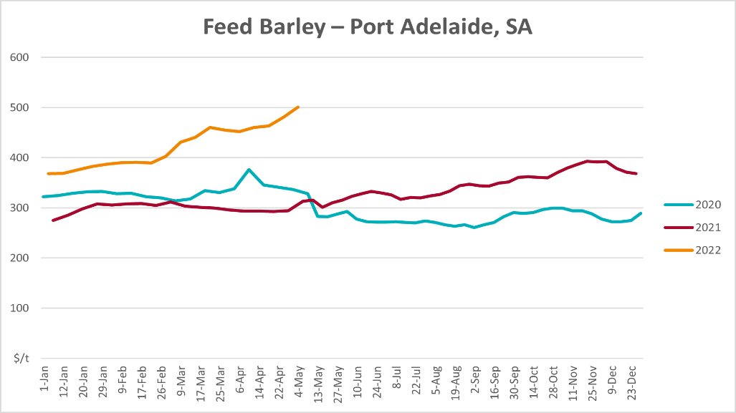
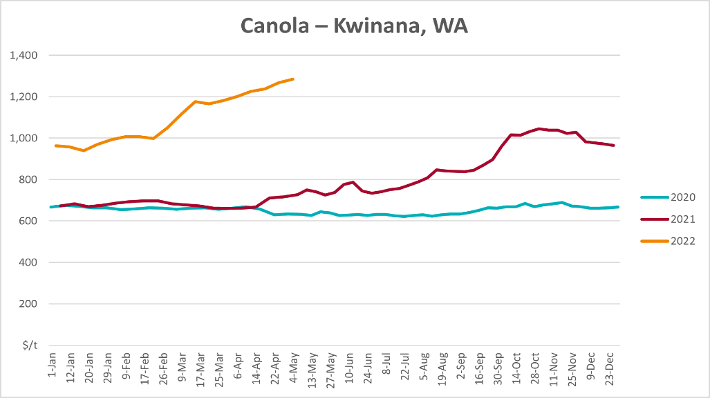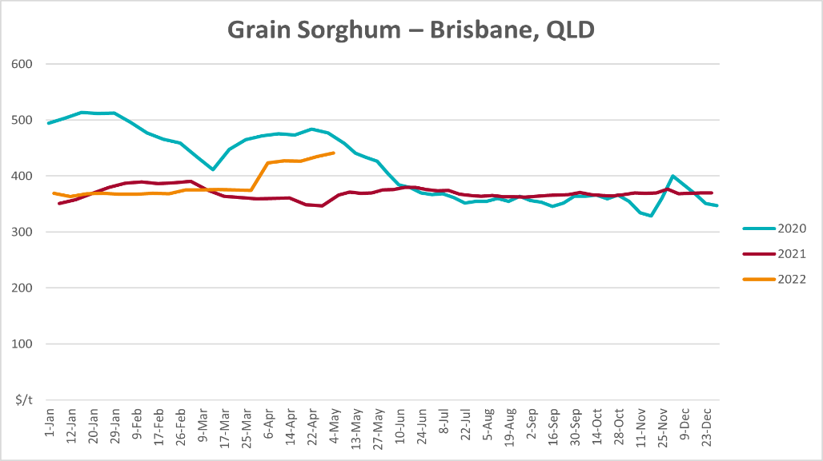

Selected domestic livestock indicator prices
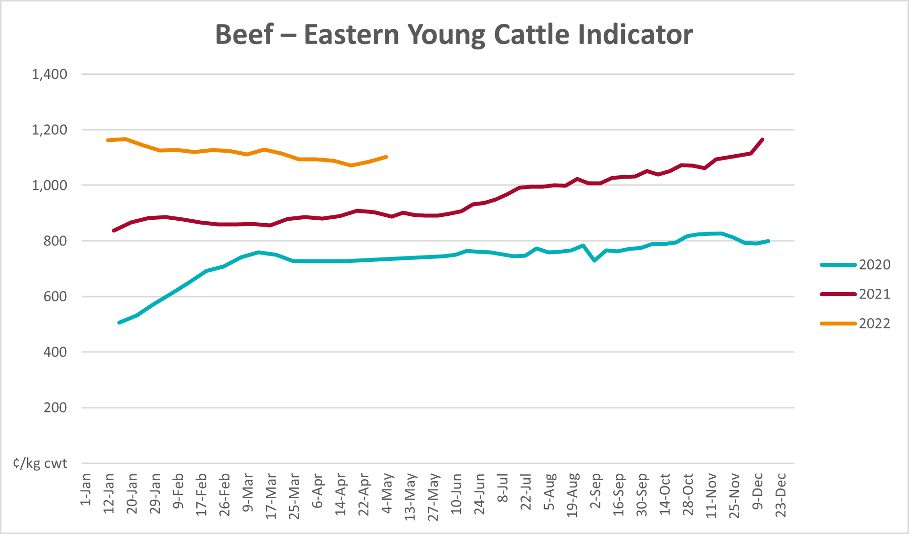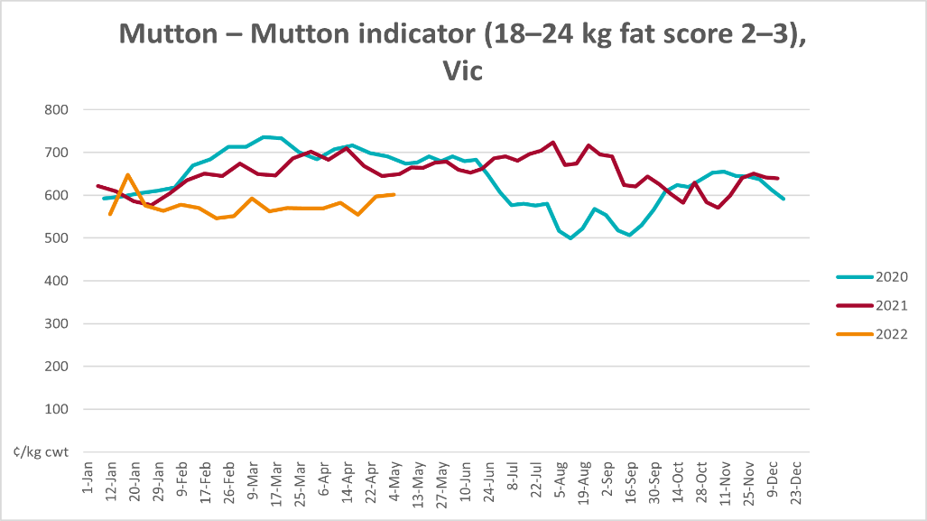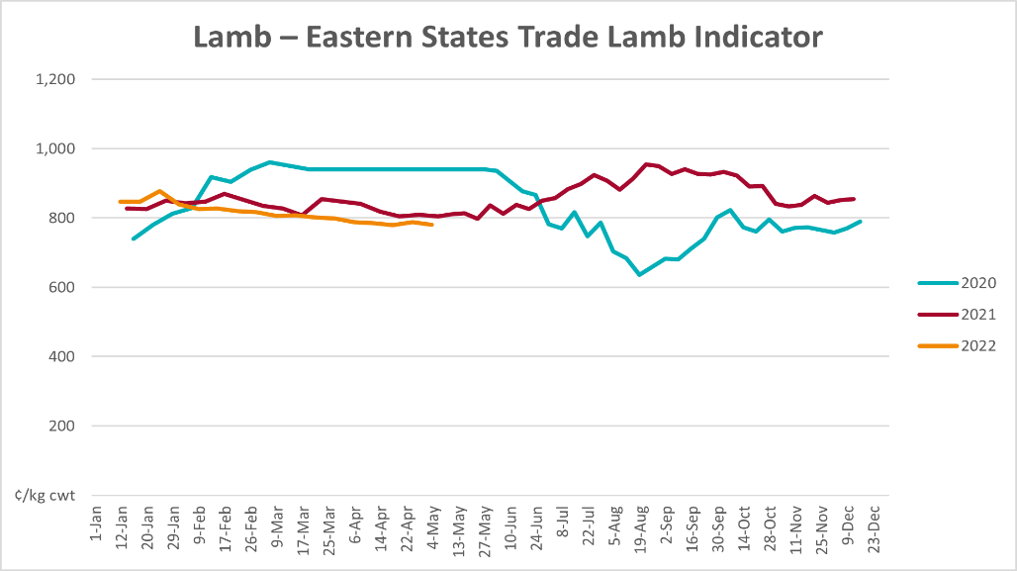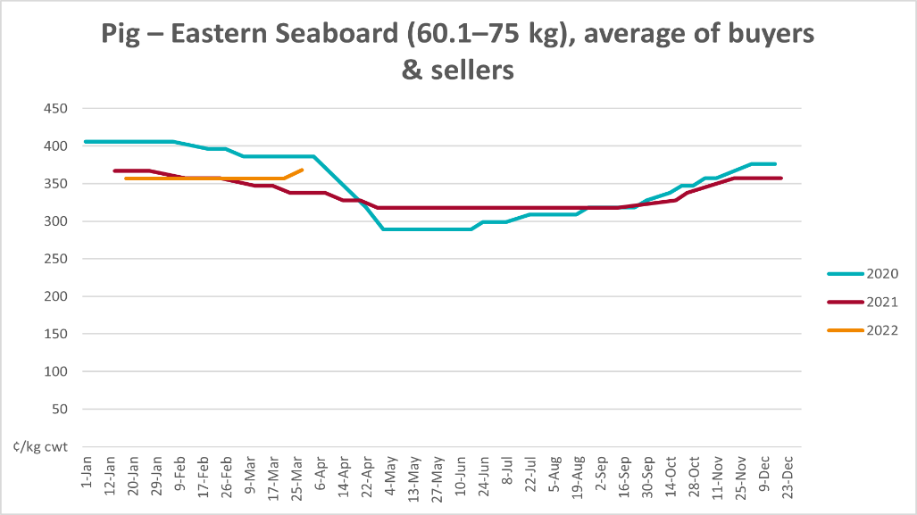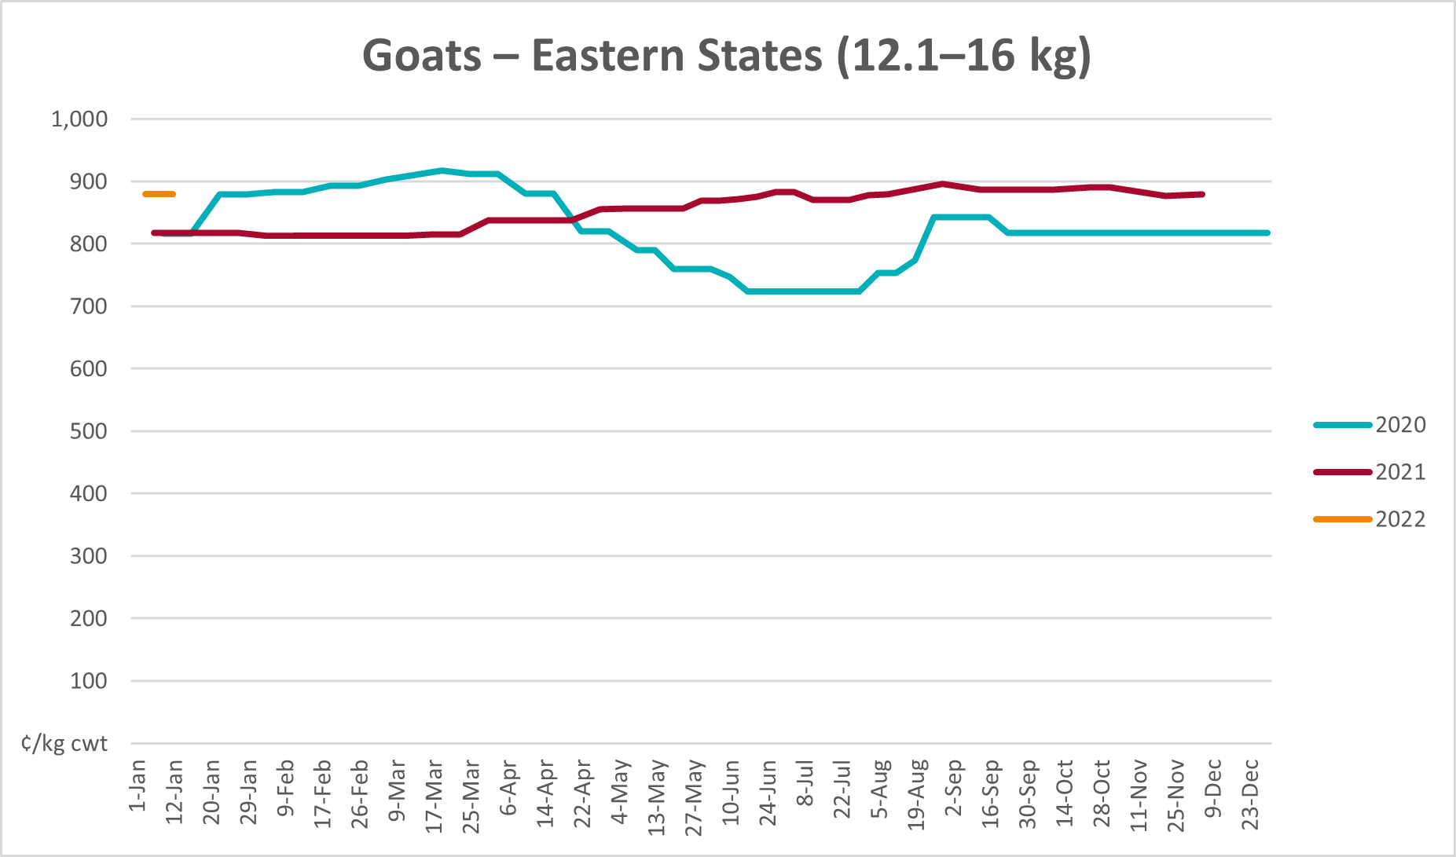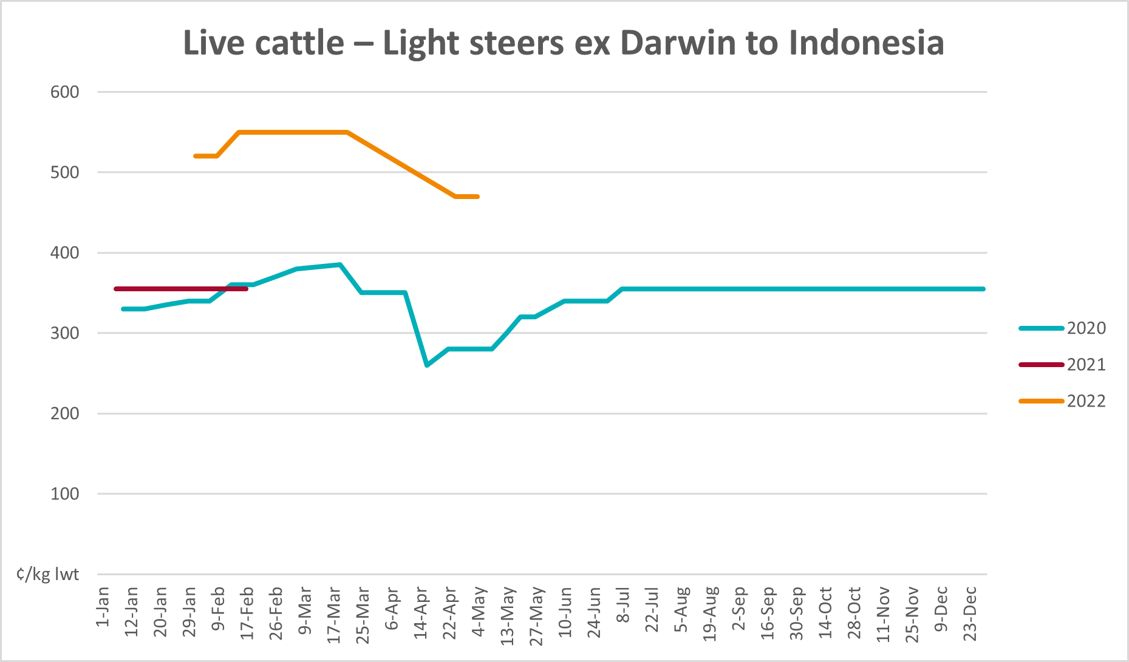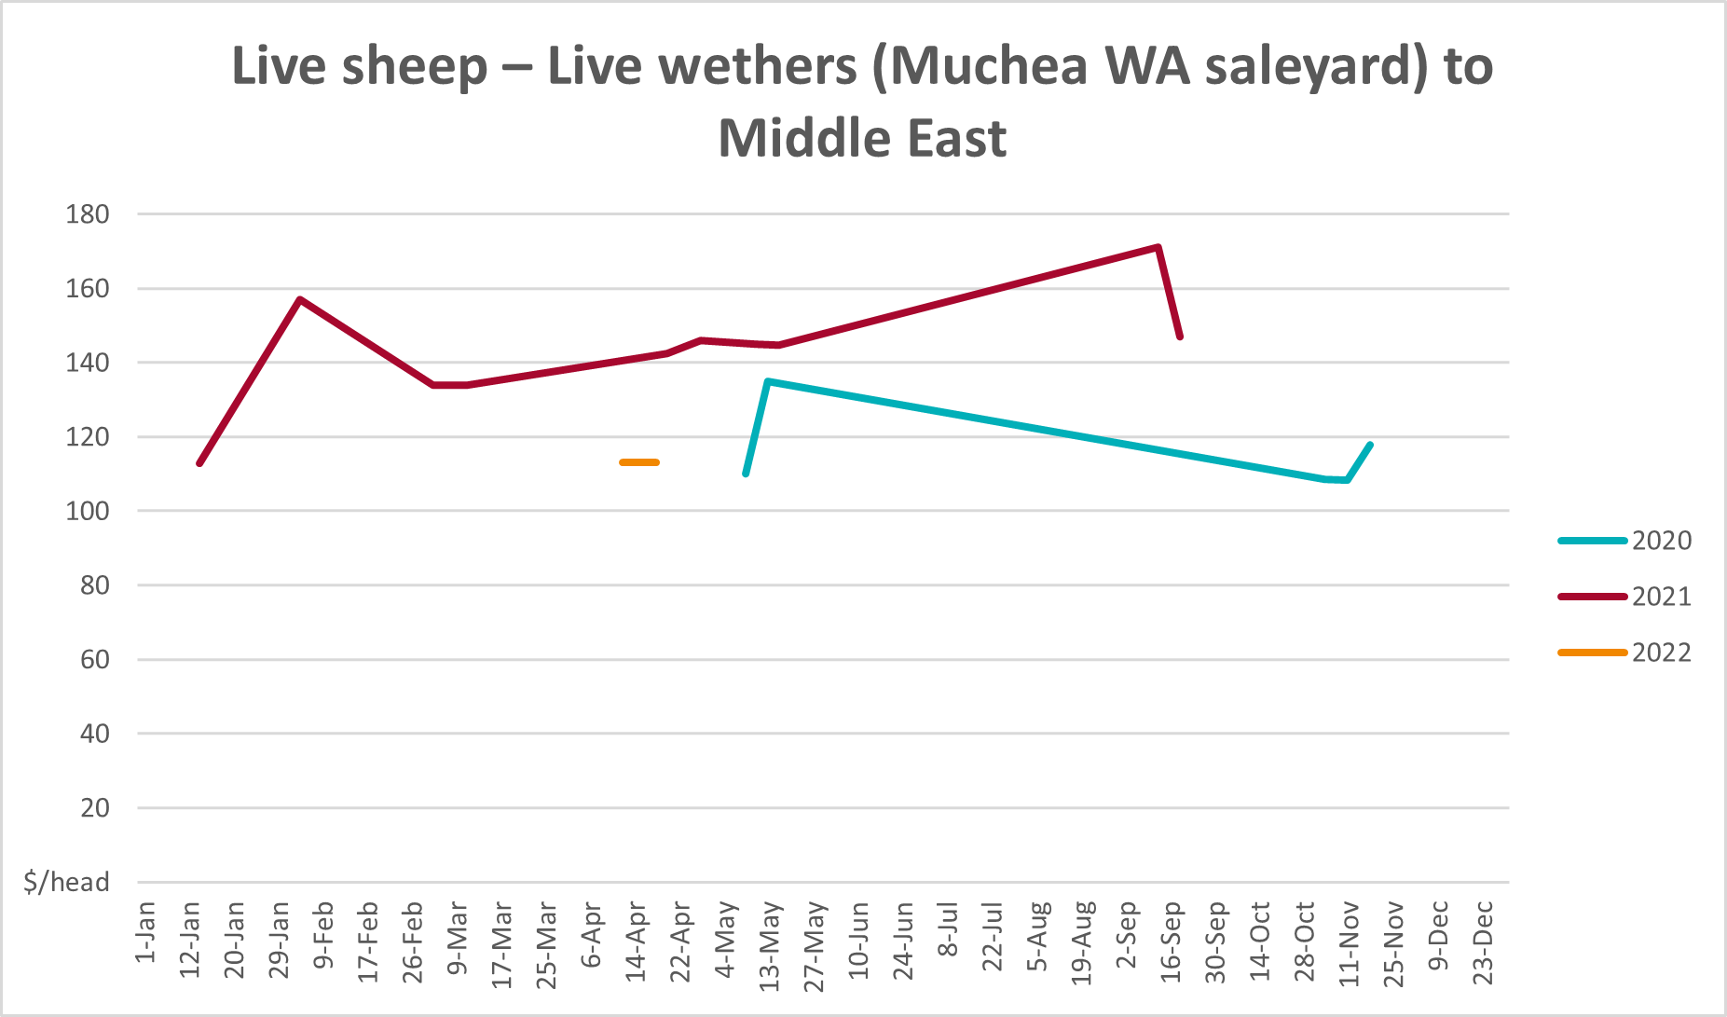

Global Dairy Trade (GDT) weighted average prices
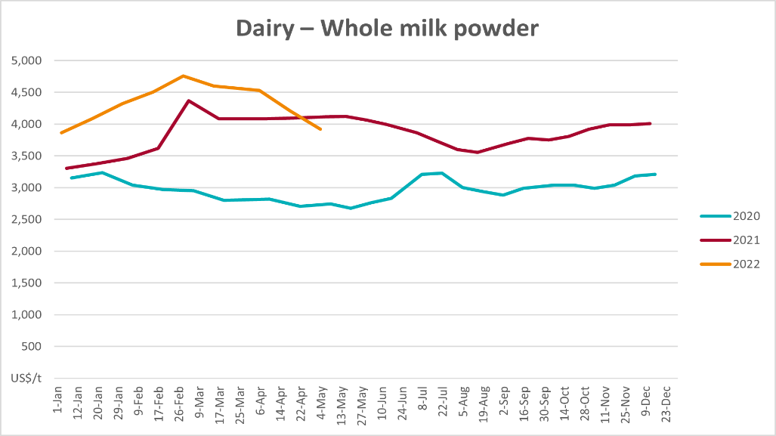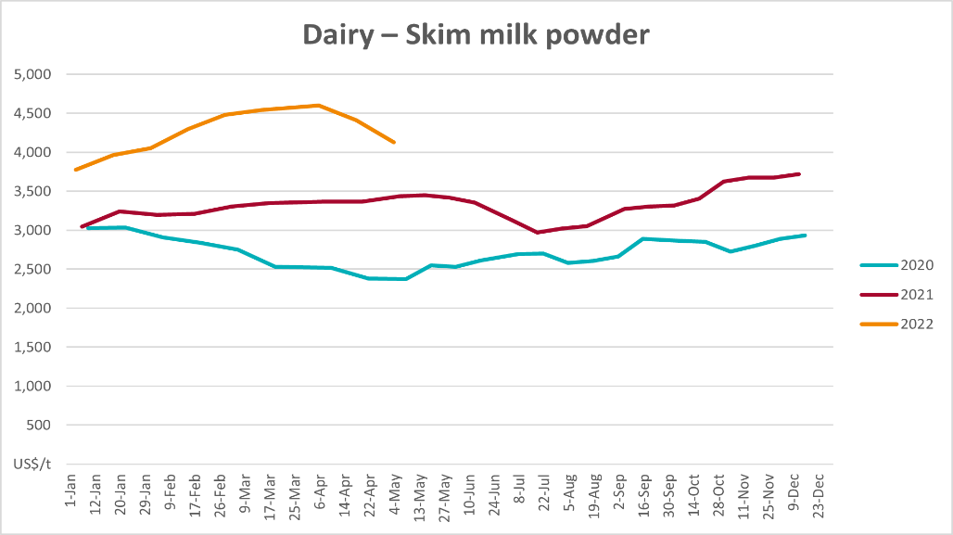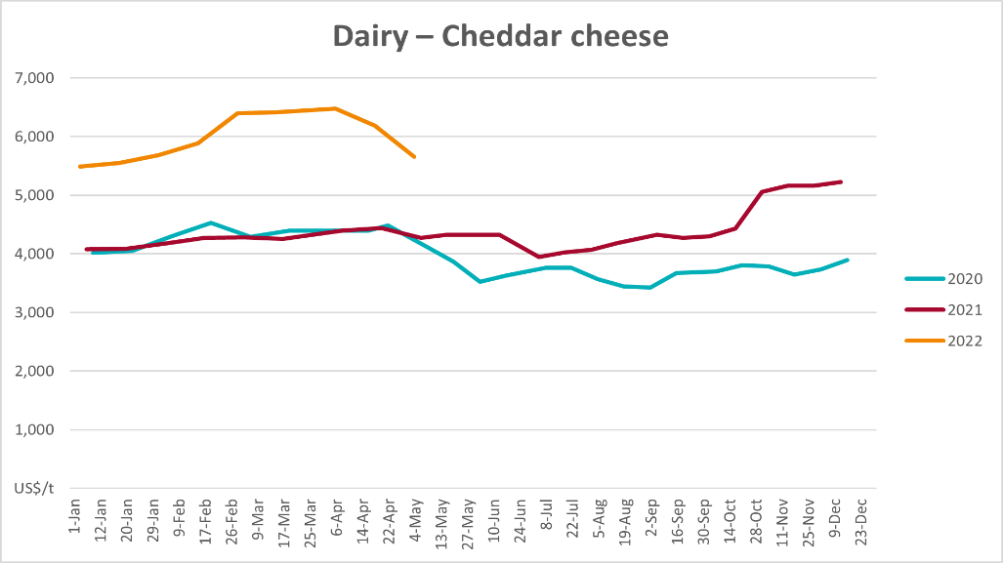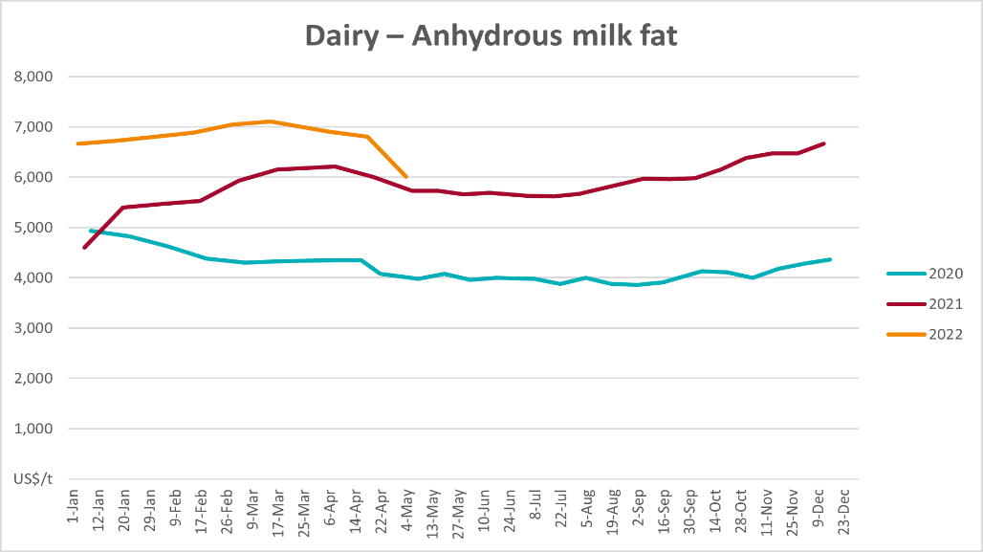

Selected fruit and vegetable prices
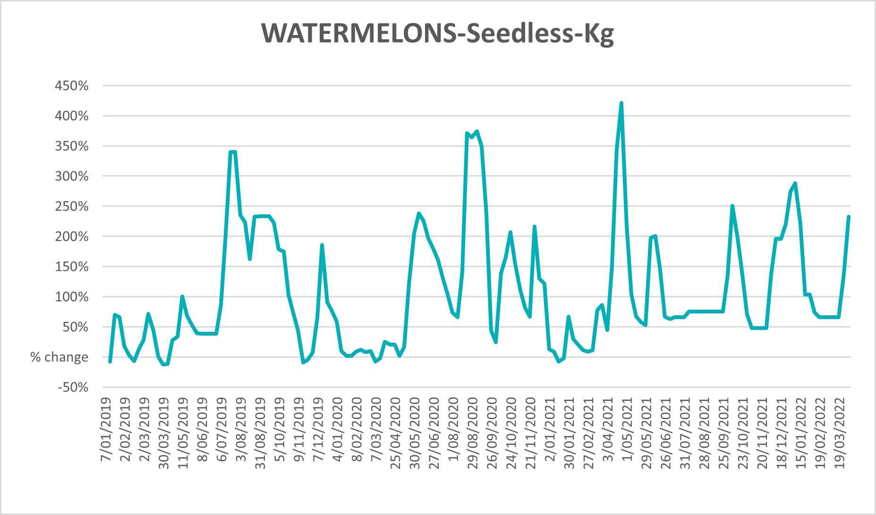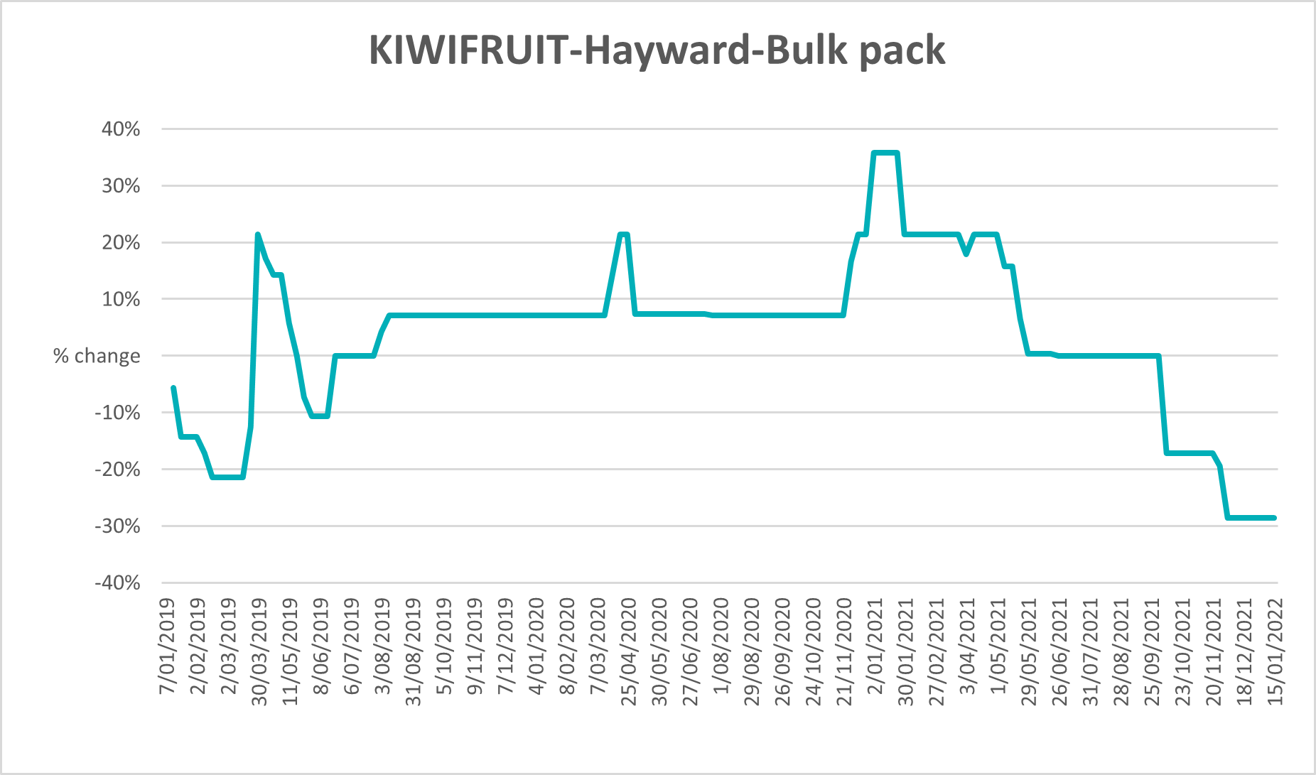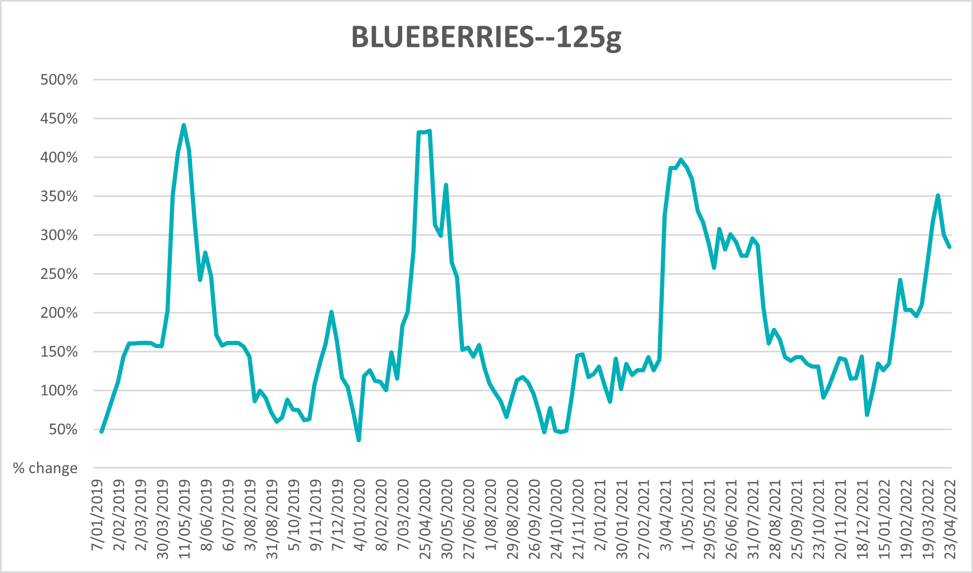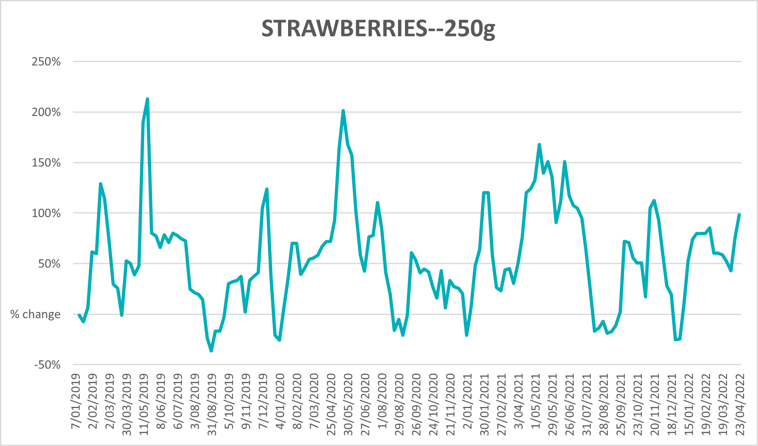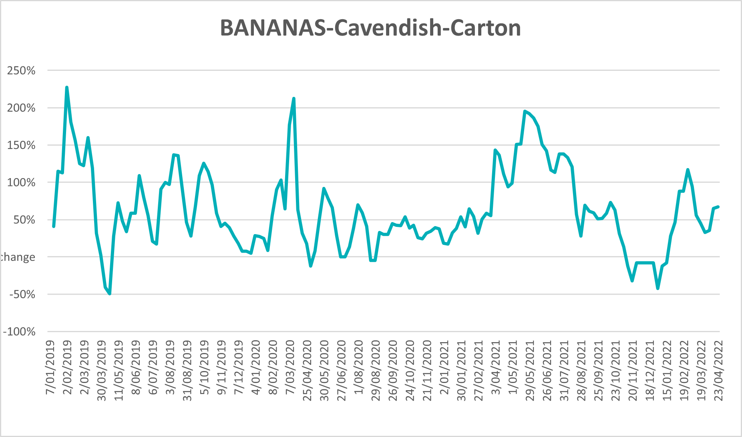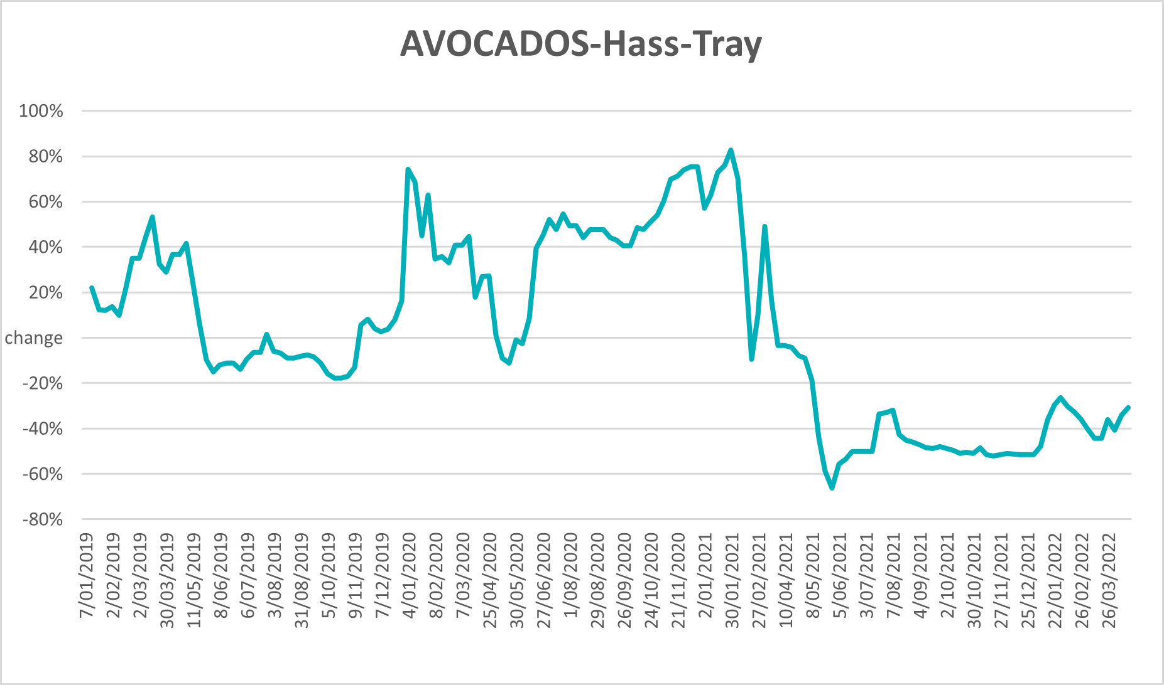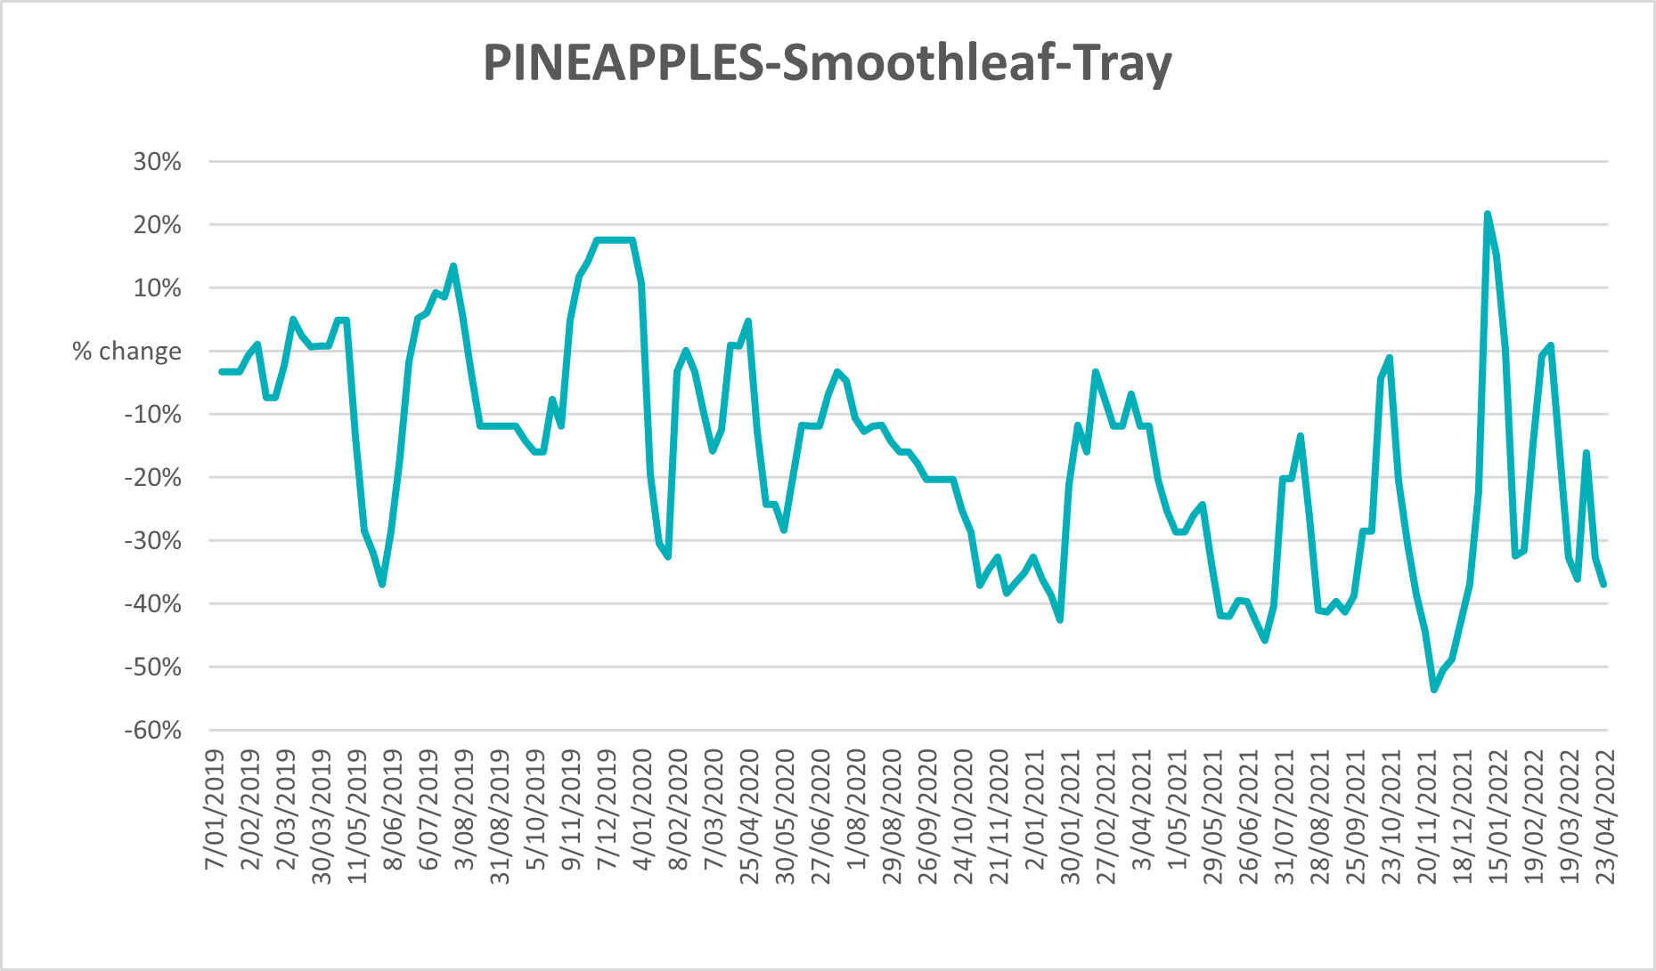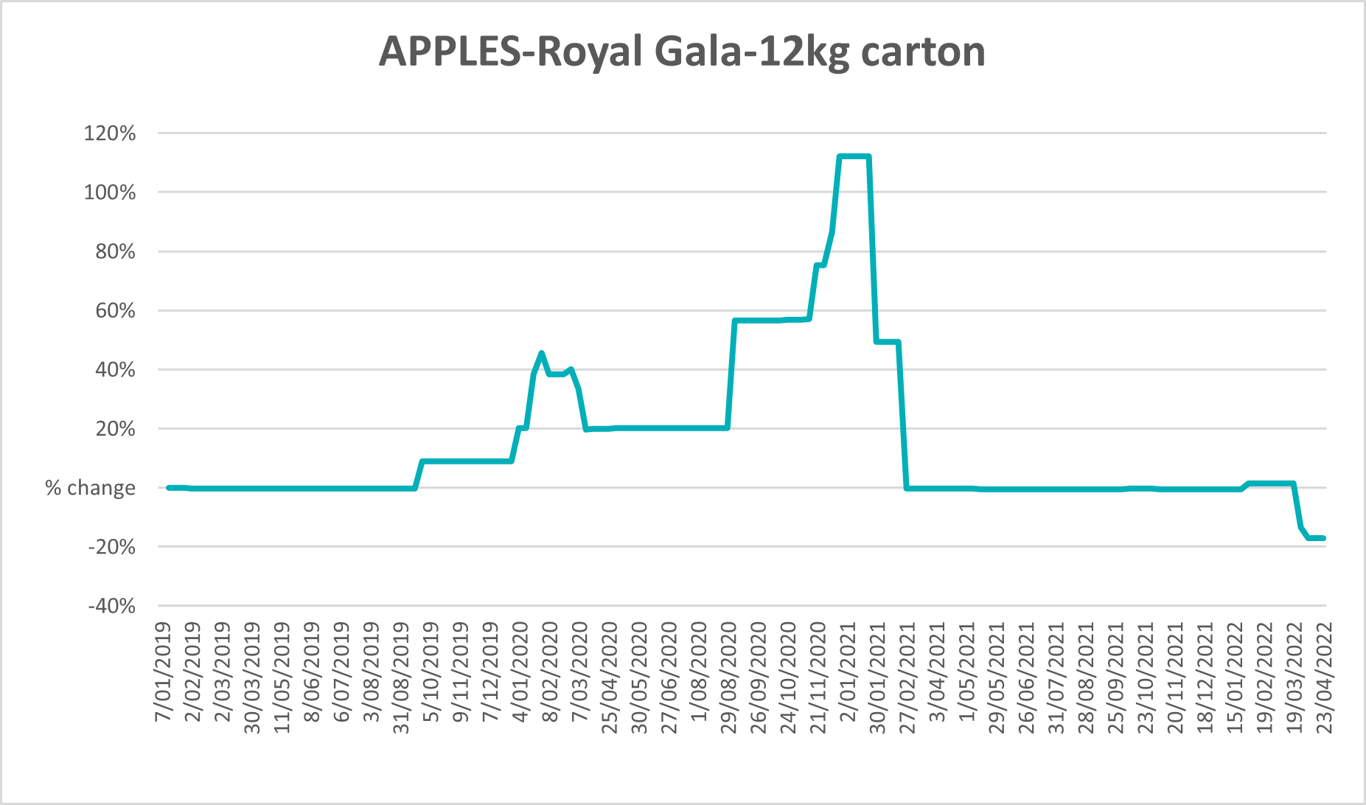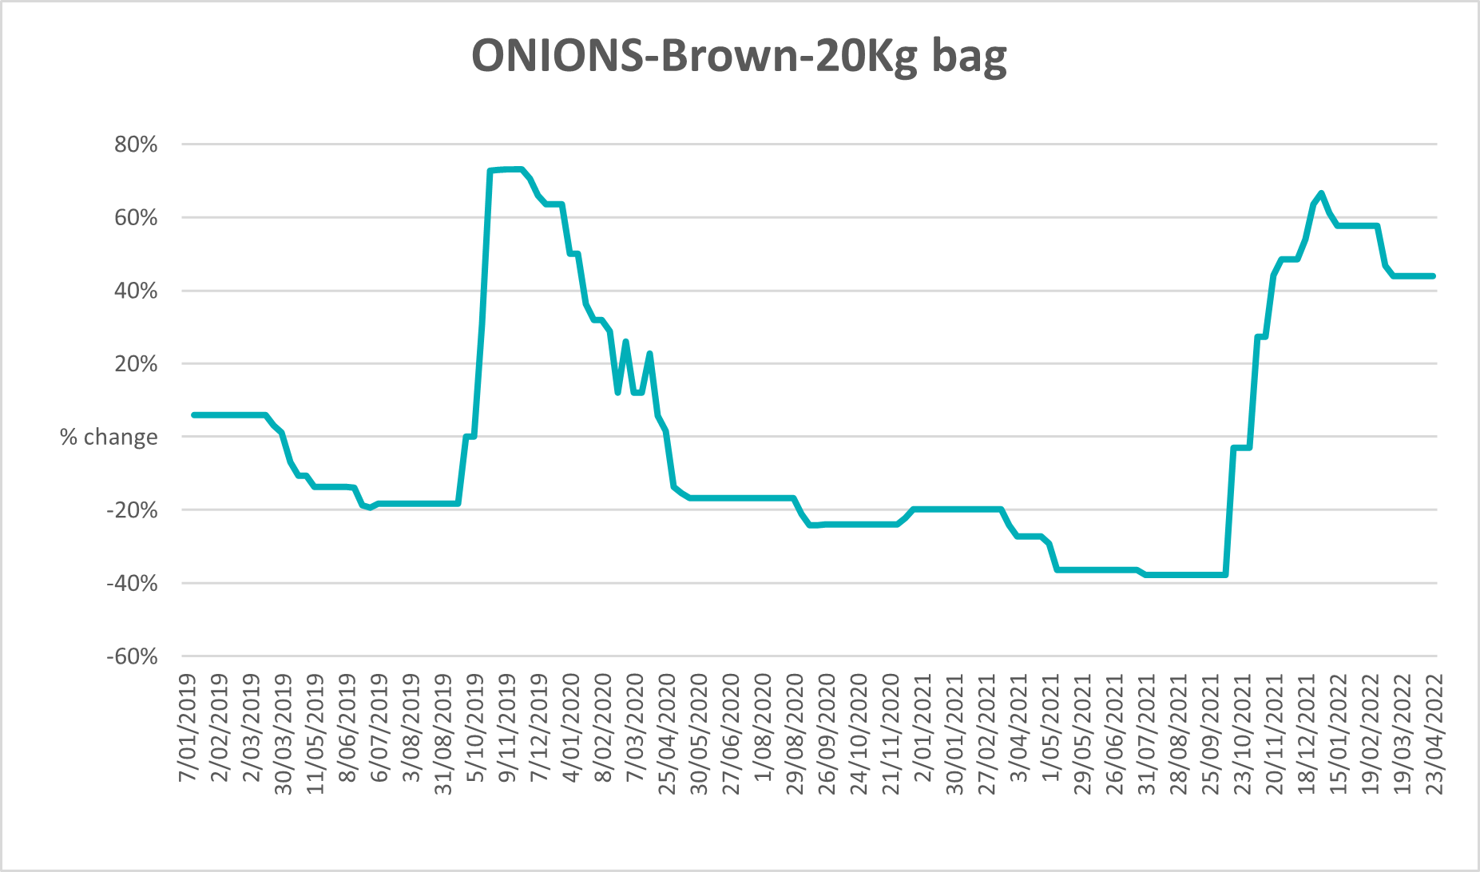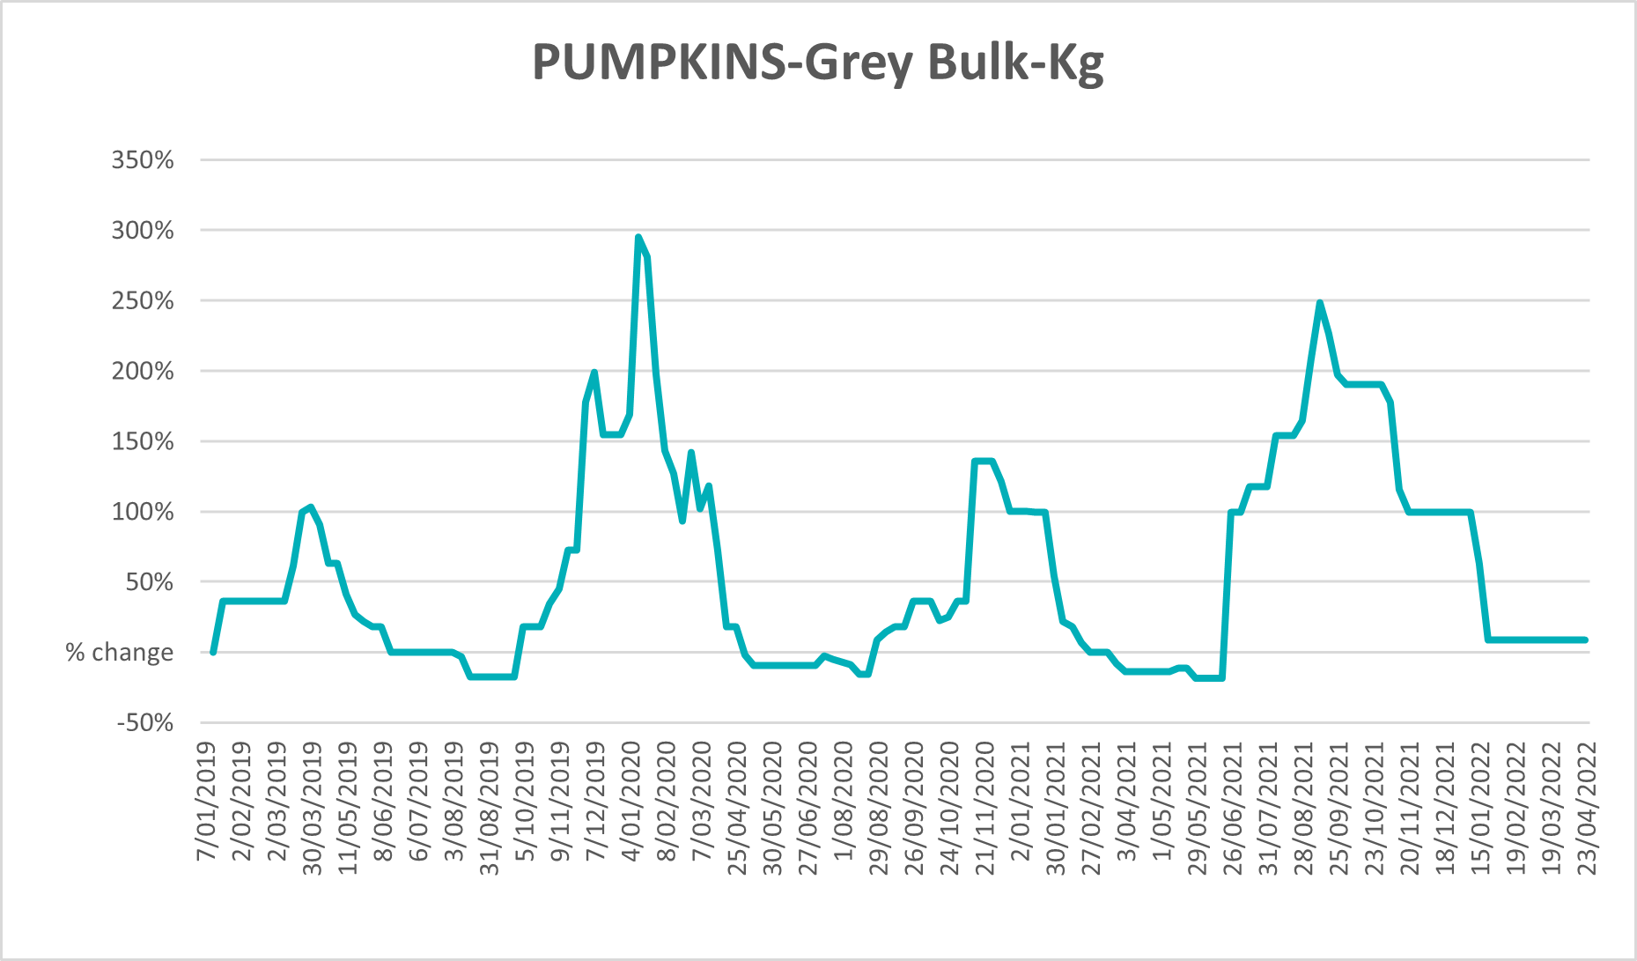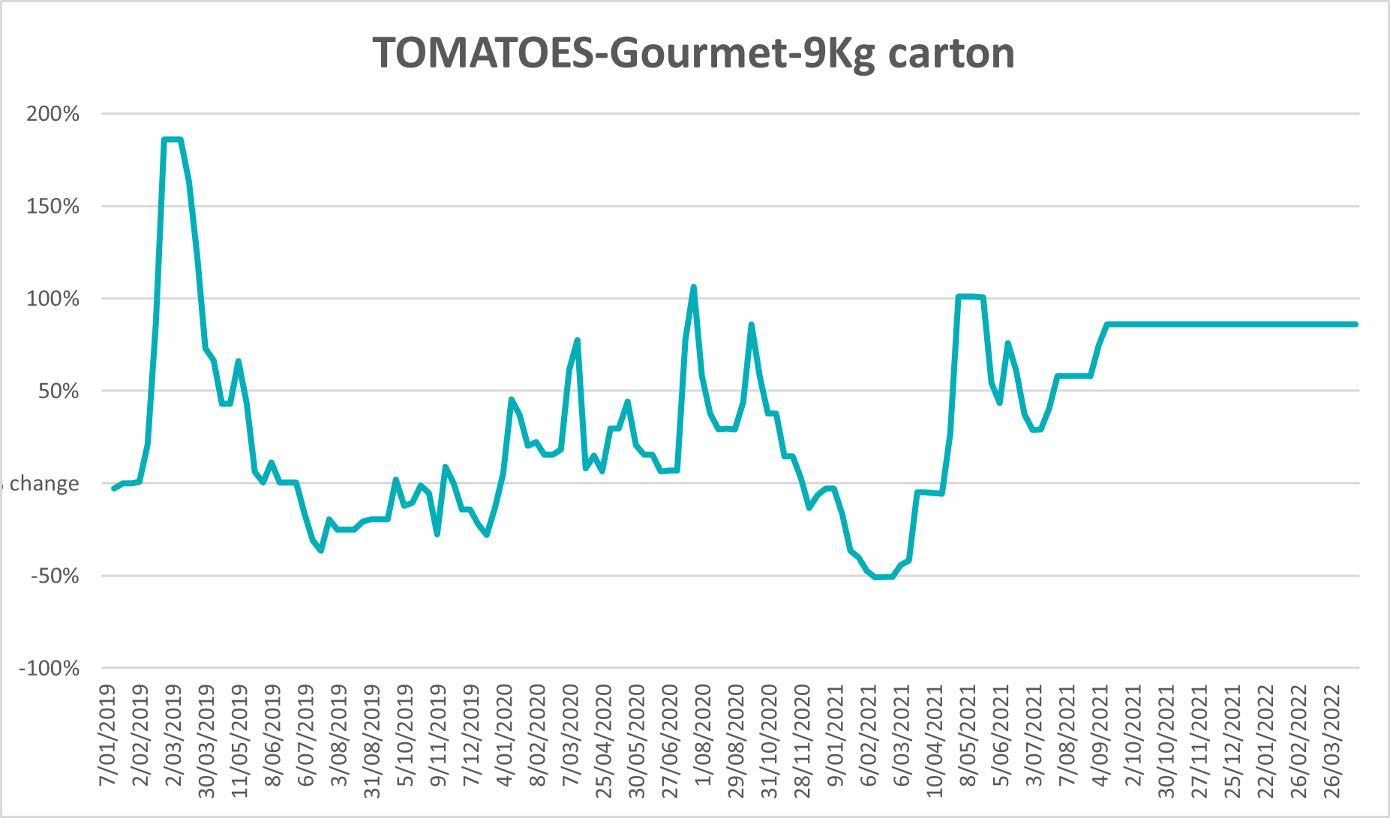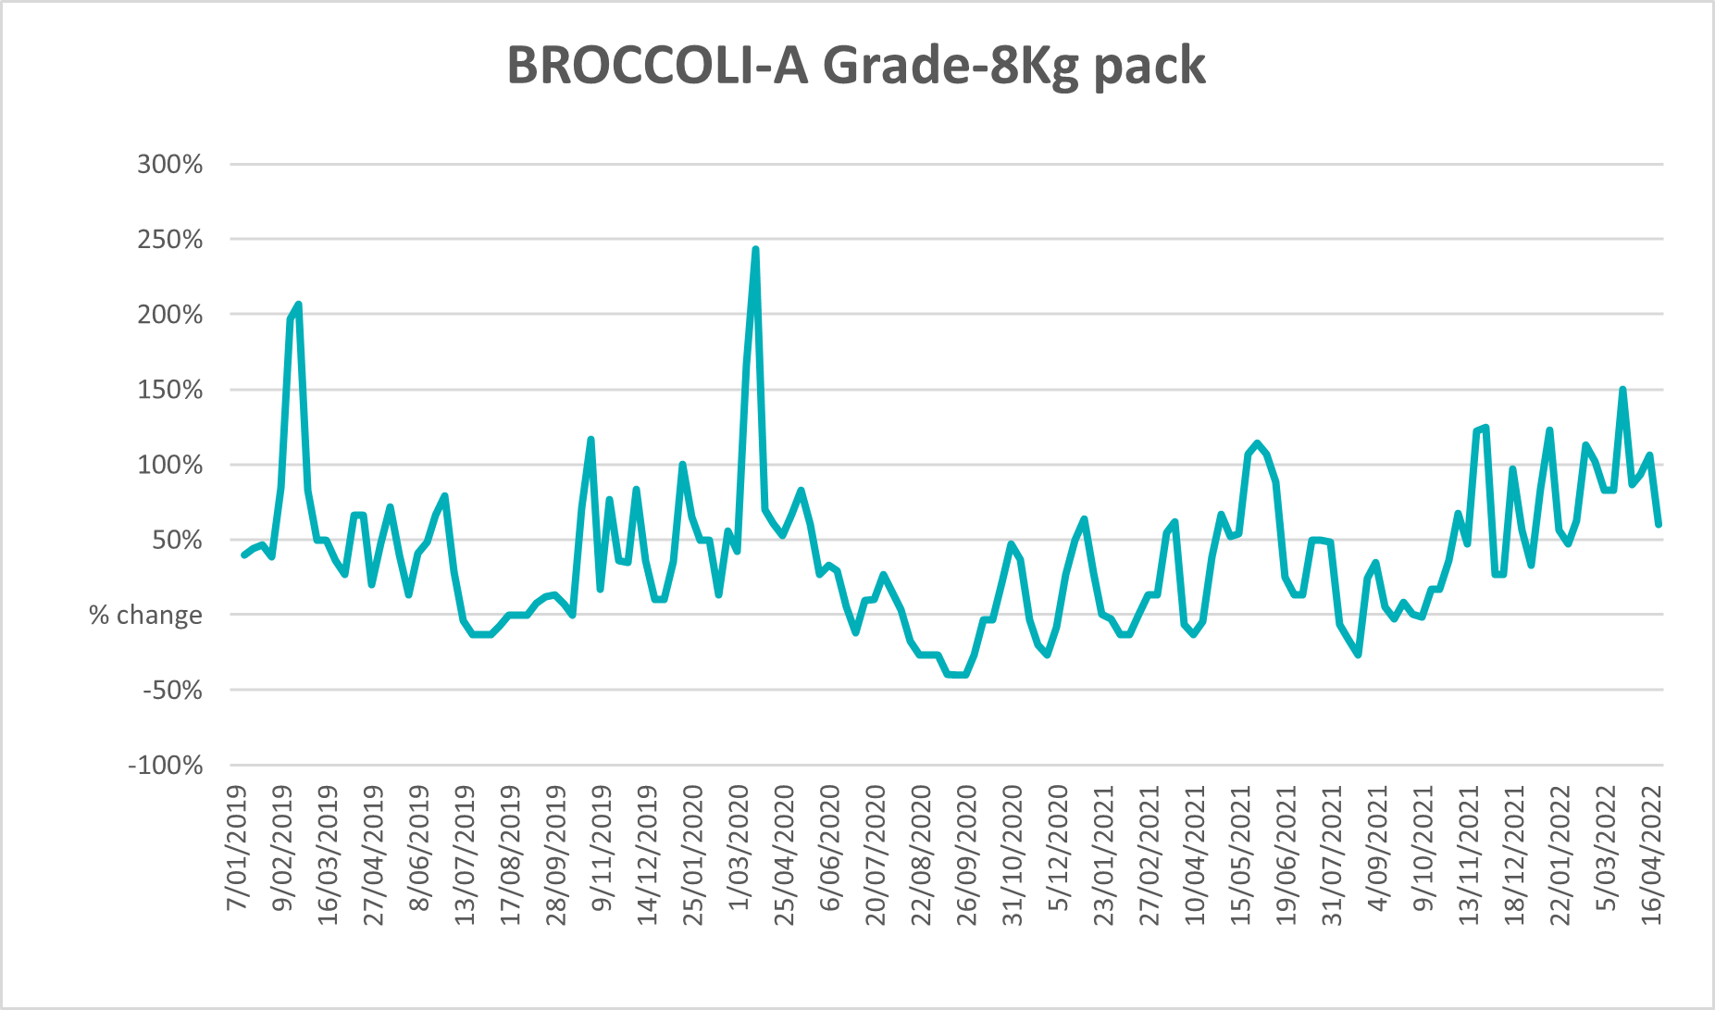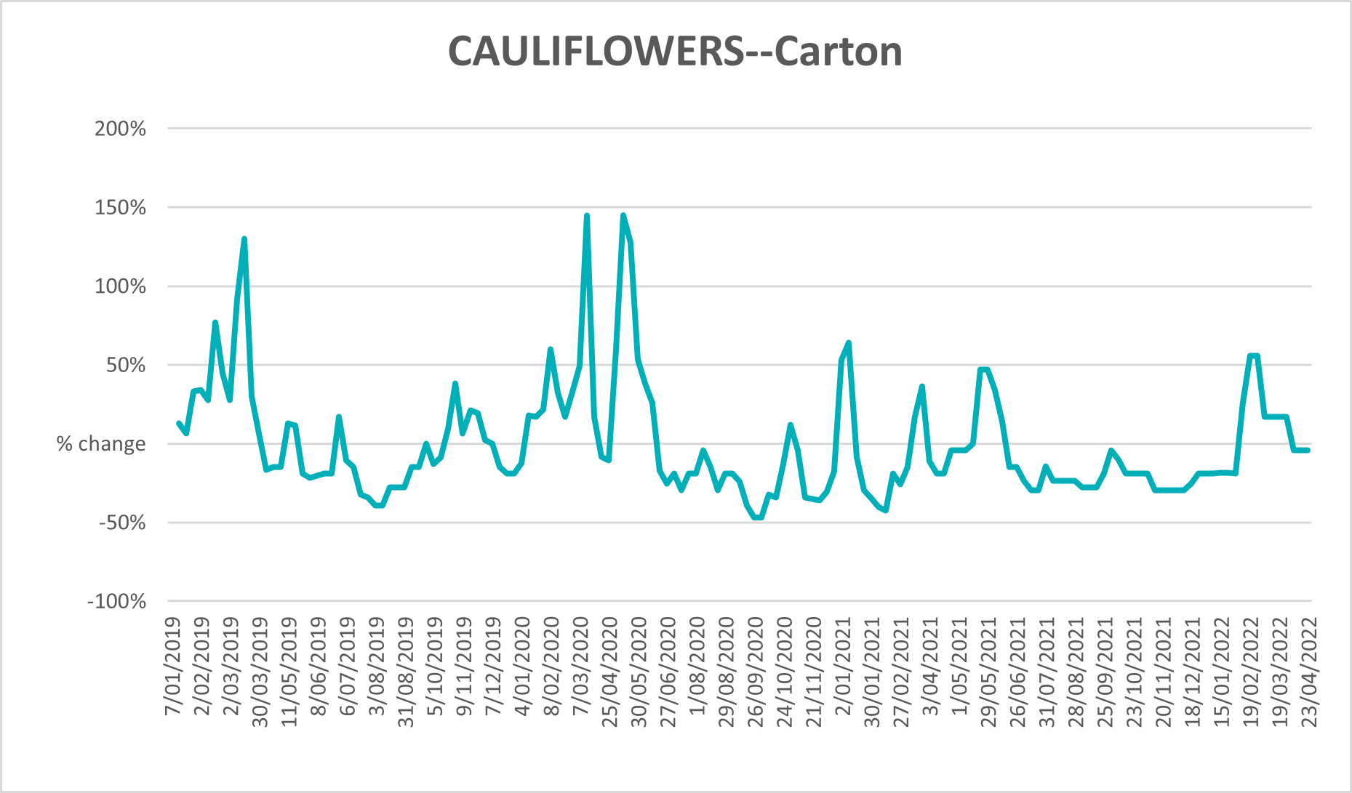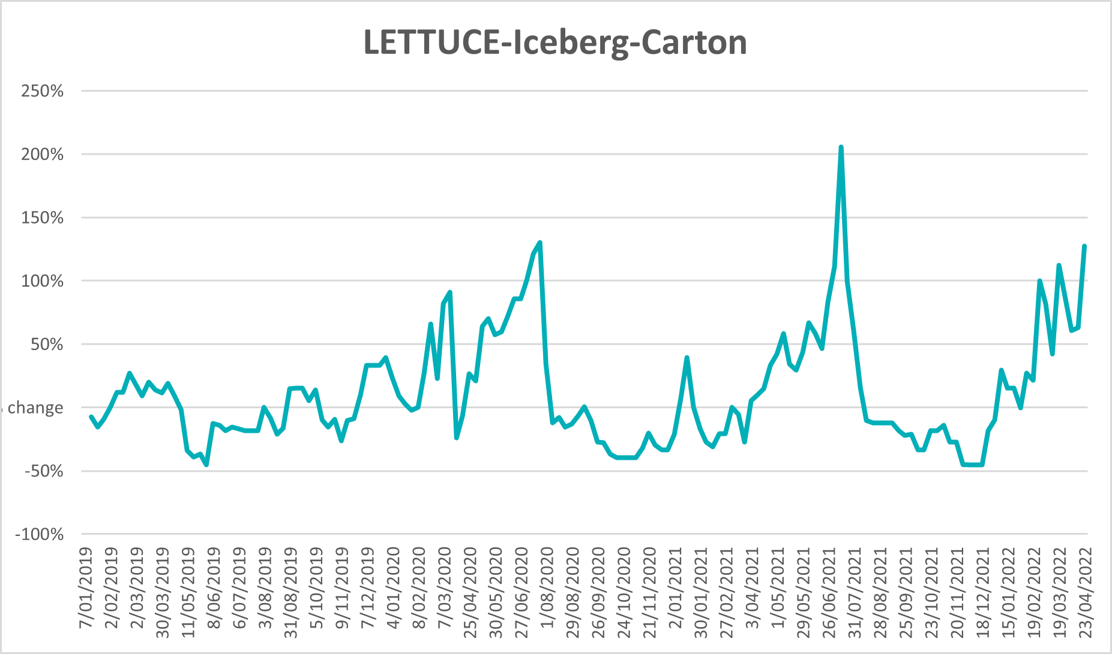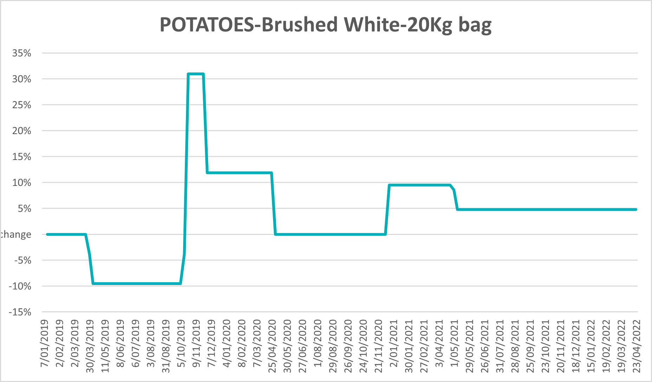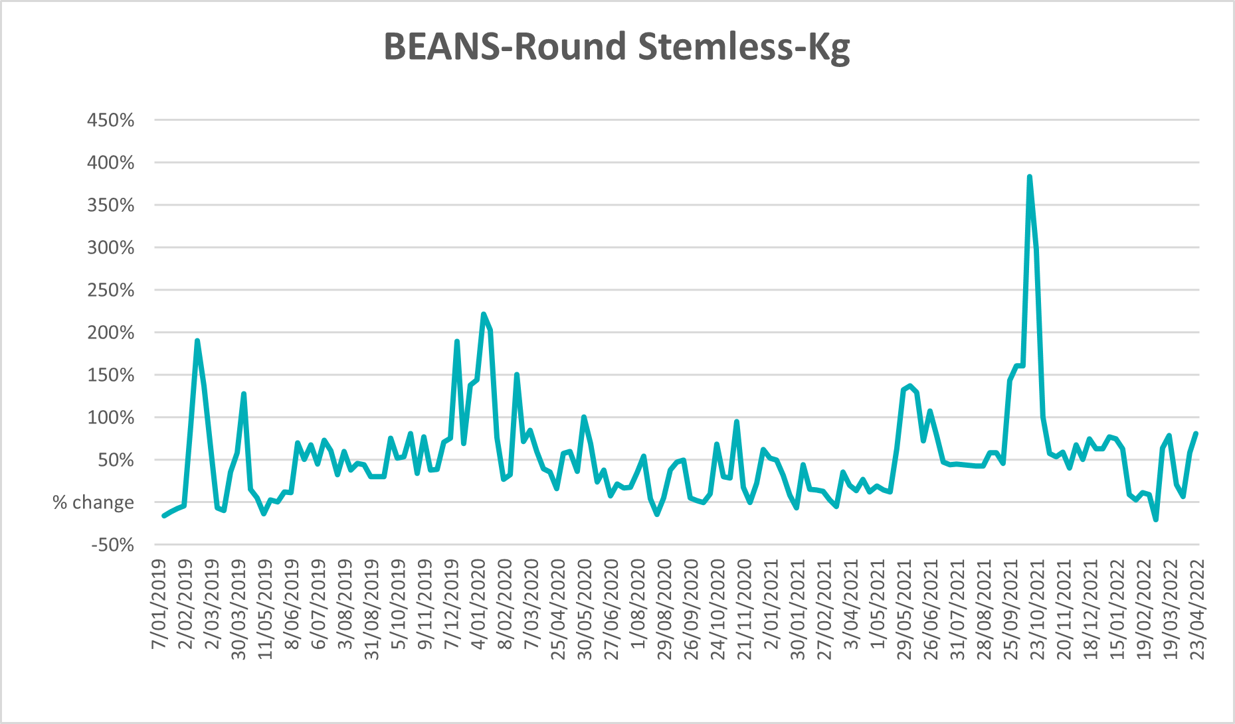

Selected domestic fodder indicator prices
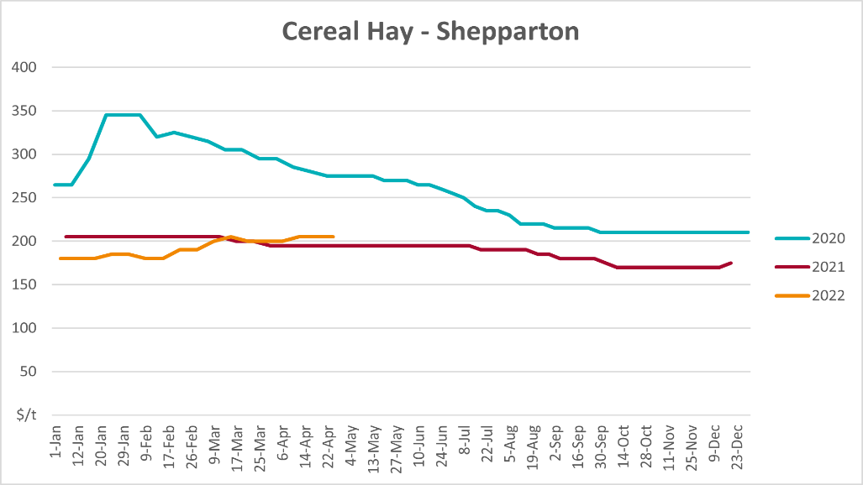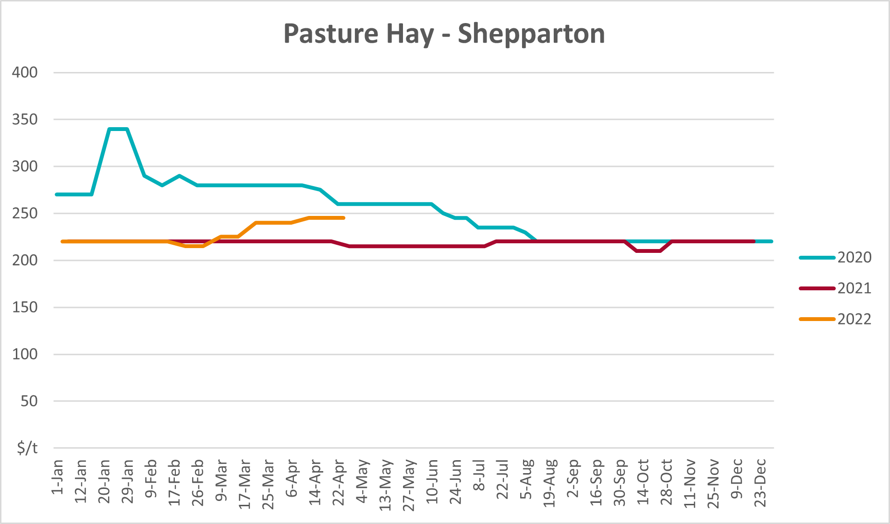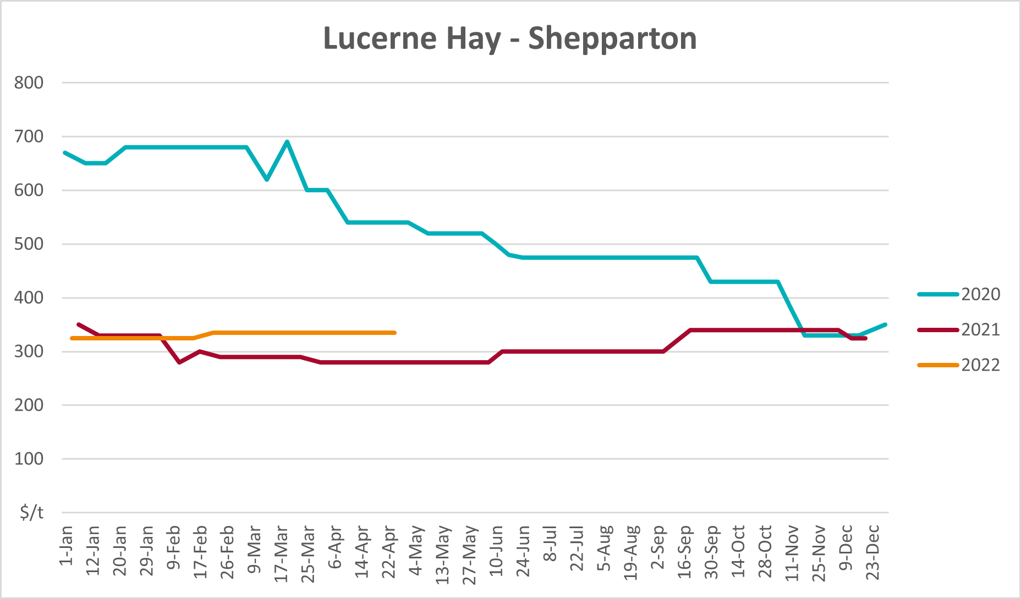

Data attribution

Climate
Bureau of Meteorology
- Weekly rainfall totals: www.bom.gov.au/climate/maps/rainfall/
- Monthly and last 3-month rainfall percentiles: www.bom.gov.au/water/landscape/
- Temperature anomalies: www.bom.gov.au/jsp/awap/temp/index.jsp
- Rainfall forecast: www.bom.gov.au/jsp/watl/rainfall/pme.jsp
- Seasonal outlook: www.bom.gov.au/climate/outlooks/#/overview/summary/
- Climate drivers: http://www.bom.gov.au/climate/enso/
- Soil moisture: www.bom.gov.au/water/landscape/
Other
- Pasture growth: www.longpaddock.qld.gov.au/aussiegrass/
- 3-month global outlooks: Environment and Climate Change Canada, NOAA Climate Prediction Center, EUROBRISA CPTEC/INPE, European Centre for Medium-Range Weather Forecasts, Hydrometcenter of Russia, National Climate Center Climate System Diagnosis and Prediction Room (NCC), International Research Institute for Climate and Society
- Global production: https://ipad.fas.usda.gov/ogamaps/cropmapsandcalendars.aspx
- Autumn break: Pook et al., 2009, https://rmets-onlinelibrary-wiley-com.virtual.anu.edu.au/doi/epdf/10.1002/joc.1833

Water
Prices
- Waterflow: https://www.waterflow.io/
- Ruralco: https://www.ruralcowater.com.au/
Bureau of Meteorology:
- Allocation trade: http://www.bom.gov.au/water/dashboards/#/water-markets/mdb/at
- Storage volumes: http://www.bom.gov.au/water/dashboards/#/water-storages/summary/drainage
Trade constraints:
- Water NSW: https://www.waternsw.com.au/customer-service/ordering-trading-and-pricing/trading/murrumbidgee
- Victorian Water Register: https://www.waterregister.vic.gov.au/TradingRules2019/

Commodities
Fruit and vegetables
- Datafresh: www.freshstate.com.au
Pigs
- Australian Pork Limited: www.australianpork.com.au
Dairy
- Global Dairy Trade: www.globaldairytrade.info/en/product-results/
World wheat, canola
- International Grains Council
World coarse grains
- United States Department of Agriculture
World cotton
- Cotlook: www.cotlook.com/
World sugar
- New York Stock Exchange - Intercontinental Exchange
Wool
- Australian Wool Exchange: www.awex.com.au/
Domestic wheat, barley, sorghum, canola and fodder
- Jumbuk Consulting Pty Ltd: http://www.jumbukag.com.au/
Cattle, beef, mutton, lamb, goat and live export
- Meat and Livestock Australia: www.mla.com.au/Prices-and-market
© Commonwealth of Australia 2022

Ownership of intellectual property rights
Unless otherwise noted, copyright (and any other intellectual property rights, if any) in this publication is owned by the Commonwealth of Australia (referred to as the Commonwealth).

Creative Commons licence
All material in this publication is licensed under a Creative Commons Attribution 4.0 International Licence except content supplied by third parties, logos and the Commonwealth Coat of Arms.
Inquiries about the licence and any use of this document should be emailed to copyright@awe.gov.au.


Cataloguing data
This publication (and any material sourced from it) should be attributed as:
ABARES 2021, Weekly Australian Climate, Water and Agricultural Update, Australian Bureau of Agricultural and Resource Economics and Sciences, Canberra, 5 May 2022. CC BY 4.0 DOI: https://doi.org/10.25814/5f3e04e7d2503
ISSN 2652-7561
This publication is available at https://www.awe.gov.au/abares/products/weekly_update
Department of Agriculture, Water and the Environment
GPO Box 858 Canberra ACT 2601
Telephone 1800 900 090
Web awe.gov.au/abares

Disclaimer
The Australian Government acting through the Department of Agriculture, Water and the Environment, represented by the Australian Bureau of Agricultural and Resource Economics and Sciences, has exercised due care and skill in preparing and compiling the information and data in this publication. Notwithstanding, the Department of Agriculture, Water and the Environment, ABARES, its employees and advisers disclaim all liability, including liability for negligence and for any loss, damage, injury, expense or cost incurred by any person as a result of accessing, using or relying on any of the information or data in this publication to the maximum extent permitted by law.

Statement of Professional Independence
The views and analysis presented in ABARES publications, including this one, reflect ABARES professionally independent findings, based on scientific and economic concepts, principles, information and data. These views, analysis and findings may not reflect or be consistent with the views or positions of the Australian Government, or of organisations or groups who have commissioned ABARES reports or analysis. More information on professional independence is provided on the ABARES website.

Acknowledgements
This report was prepared by Matthew Miller and Cameron Van-Lane.

