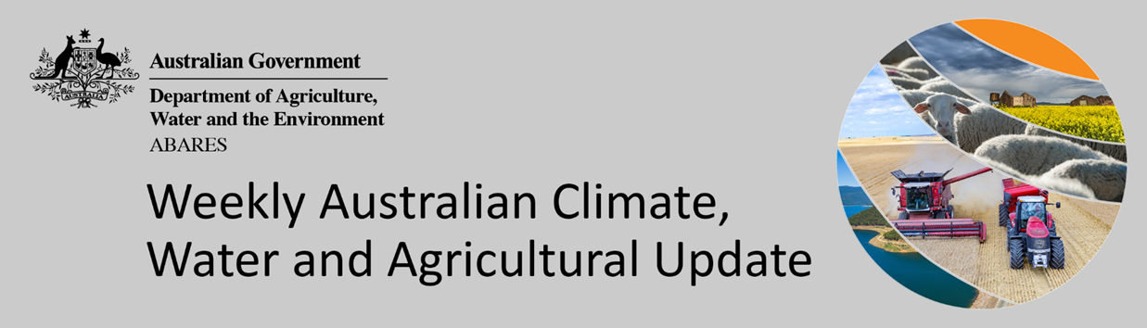
No. 24/2022

23 June 2022

Summary of key issues
- For the week ending 22 June 2022, low-pressure systems and associated cold fronts brought rainfall to western and southern parts of the country, while high-pressure systems were the dominant climate feature across remaining parts of Australia bringing clear, dry and colder than normal conditions (see Section 1.1).
- Dry conditions across New South Wales and Queensland would have been a welcome reprieve for many growers, allowing field access for the harvesting of summer crops and the planting of winter crops. Most growers have completed their winter planting programs across cropping regions of Victoria, South Australia and Western Australia, with previous rainfall supporting the establishment and development of crops. Rainfall across Western Australian cropping regions has provided a much-needed boost to soil moisture levels, where dry conditions have persisted over recent weeks.
- The 2021–22 La Niña event seems to be at an end, with key indicators having returned to neutral. However, some models suggest that La Niña may re-form during the southern hemisphere spring later in 2022. While back-to-back La Niña events are not uncommon, and have occurred in approximately half of all past events since 1900, three in a row is less common and has only occurred three times since 1900: 1954–57, 1973–76, and 1998–2001. Despite the end of the 2021–22 La Niña, the Bureau's long-range climate outlook remains wetter than average for most of Australia, reflecting a range of climate drivers including a developing negative Indian Ocean Dipole, and warmer than average waters around Australia (see Section 1.2).
- The outlook for July 2022 indicates that there is a 75% chance of rainfall totals between 10 and 50 millimetres across New South Wales, south-east Queensland, Victoria, southern South Australia, the southwest of Western Australia and Tasmania. Rainfall totals in excess of 100 millimetres are expected across alpine regions of New South Wales and Victoria, as well as the far southwest of Western Australia and western Tasmania (see Section 1.3).
- Over the 8-days to 30 June 2022, frontal activity moving across southern Australia is expected to bring moderate rainfall to parts of south-eastern Australia. Meanwhile, high pressure systems are forecast to be the dominant climate feature across much of the country, resulting in clear, dry conditions. If realised, a third week of dry conditions across cropping regions in New South Wales and Queensland should see soil moisture levels continuing to decrease, allowing improved access to fields for the harvest of summer crops and the sowing of winter crops (see Section 1.4).
- Water storage in the Murray–Darling Basin (MDB) increased by 5 gigalitres (GL) between 15 June 2022 and 22 June 2022. The current volume of water held in storage is 22,150 GL, which represents 88 of total capacity. This is 41% or 6,443 GL more than at the same time last year.
- Allocation prices in the Victorian Murray below the Barmah Choke decreased from $19 per ML on 10 June 2022 to $18 per ML on 17 June 2022. Prices are lower in the Murrumbidgee and regions above the Barmah choke due to the binding of the Murrumbidgee export limit and Barmah choke trade constraint.

Climate

Rainfall this week
For the week ending 22 June 2022, low-pressure systems and associated cold fronts brought rainfall to western and southern parts of the country, while high-pressure systems were the dominant climate feature across remaining parts of Australia bringing clear, dry and colder than normal conditions.
Rainfall totals of between 10 and 50 millimetres were recorded across alpine areas of New South Wales and Victoria, southern Victoria, the far south-east of South Australia, the south-west of Western Australia and much of Tasmania. Rainfall totals in excess of 50 millimetres were recorded in isolated parts of the south-west of Western Australia, as well as north-western Tasmania. Remaining parts of Australia received little to no rainfall.
In cropping regions, rainfall totals of between 10 and 50 millimetres were recorded in isolated parts of South Australia, southern New South Wales, southern and eastern Victoria and most of Western Australia. Little to no rainfall was recorded across cropping regions in New South Wales, Queensland, northern Victoria and remaining parts of South Australia.
Dry conditions across New South Wales and Queensland would have been a welcome reprieve for many growers, allowing field access for the harvesting of summer crops and the planting of winter crops. Most growers have completed their winter planting programs across cropping regions of Victoria, South Australia and Western Australia, with previous rainfall supporting the establishment and development of crops. Rainfall across Western Australian cropping regions has provided a much-needed boost to soil moisture levels, where dry conditions have persisted over recent weeks.

Rainfall for the week ending 22 June 2022
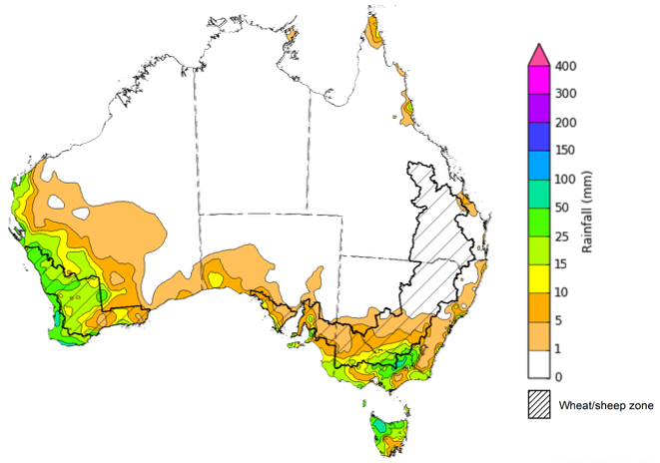
©Commonwealth of Australia 2022, Australian Bureau of Meteorology Issued: 22/6/2022
Note: The rainfall analyses and associated maps utilise data contained in the Bureau of Meteorology climate database, the Australian Data Archive for Meteorology (ADAM). The analyses are initially produced automatically from real-time data with limited quality control. They are intended to provide a general overview of rainfall across Australia as quickly as possible after the observations are received. For further information go to http://www.bom.gov.au/climate/rainfall/

Climate Drivers
Throughout winter, the climate drivers with the largest potential impact on Australia’s climate patterns are the El Niño–Southern Oscillation (ENSO), the Indian Ocean Dipole (IOD) and the Southern Annular Mode (SAM). These climate drivers are likely to influence pasture growth across southern Australia and the germination and growth for winter crops.
The 2021–22 La Niña event seems to be at an end, with key indicators having returned to neutral. However, some models suggest that La Niña may re-form during the southern hemisphere spring later in 2022. While back-to-back La Niña events are not uncommon, and have occurred in approximately half of all past events since 1900, three in a row is less common and has only occurred three times since 1900: 1954–57, 1973–76, and 1998–2001. Despite the end of the 2021–22 La Niña, the Bureau's long-range climate outlook remains wetter than average for most of Australia, reflecting a range of climate drivers including a developing negative Indian Ocean Dipole, and warmer than average waters around Australia.
The IOD is currently neutral. All international climate models surveyed by the Bureau of Meteorology indicate a negative IOD event could develop during early to mid-winter. A negative IOD increases the chances of above average winter–spring rainfall for much of Australia.
The Southern Annular Mode (SAM) index is currently negative but is expected to return to neutral values for at least the next two weeks. Neutral SAM conditions typically has little influence on Australian rainfall.
Compared to two weeks ago, tropical Pacific Ocean sea surface temperatures (SST) have cooled slightly, over much of the tropical central and eastern Pacific south of the equator. Meanwhile, SSTs close to the equator were generally near average, and small areas of warm anomalies have emerged in some parts of the eastern equatorial Pacific. Warmer than average sea surface temperatures around much of Australia are likely to be contributing to wetter outlooks over the coming months, and the forecast sea surface temperature pattern in the tropical Pacific still favours average to above average winter rainfall for eastern Australia.

Difference from average sea surface temperature observations 13 June to 19 June 2022
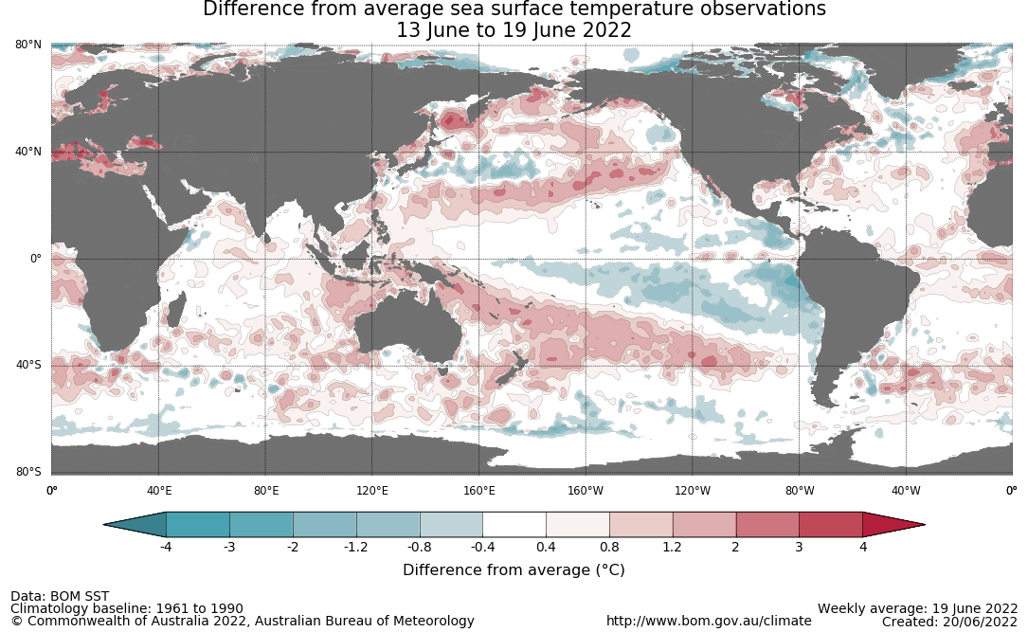

International climate model outlooks for the NINO 3.4 region in July 2022
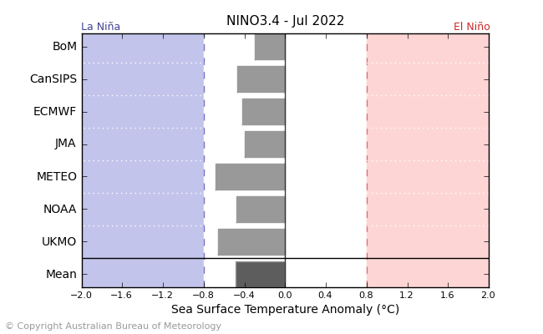
©Commonwealth of Australia 2022, Australian Bureau of Meteorology Issued:14/6/2022
Most climate models surveyed by the Bureau of Meteorology indicate that ENSO conditions have returned to neutral (neither El Niño nor La Niña). However, some models suggest that La Niña may re-form during the southern hemisphere spring later in 2022. For October, four of the seven international climate models surveyed by the Bureau indicate SSTs in the central equatorial Pacific Ocean could reach or exceed La Niña threshold values. Three of the seven models anticipate that the current ENSO-neutral state will continue through to at least November. ENSO events are usually most active throughout spring and summer, then decay and return to neutral conditions in autumn. For the period ending 19 June 2022, the 30-day and 90-day SOI value was +18.1, both well above the La Niña threshold of +7. While trade winds have returned to average strength in the Pacific, cloudiness near the Date Line remains below average.

30-day Southern Oscillation Index (SOI) values ending 19 June 2022
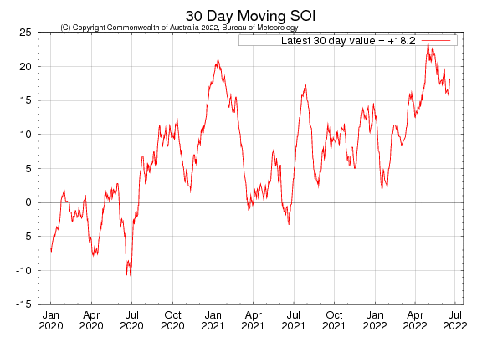

The Indian Ocean Dipole (IOD) is currently neutral. However, the IOD index has been below zero for the last six weeks with several of those weeks being around or below the negative IOD threshold (−0.4 °C). The latest IOD index value for the week ending 19 June 2022 was −0.49 °C. Cool anomalies are present near the Horn of Africa, while warm anomalies have persisted across waters to the north and north-west of Australia. The establishment of a clear gradient in the temperature anomalies across the Indian Ocean is consistent with a developing negative Indian Ocean Dipole pattern.
All international climate models surveyed by the Bureau of Meteorology indicate a negative IOD event will develop during early to mid-winter, with several forecasting strong negative values of the IOD index by August.

International climate model outlooks for the IOD index in August 2022
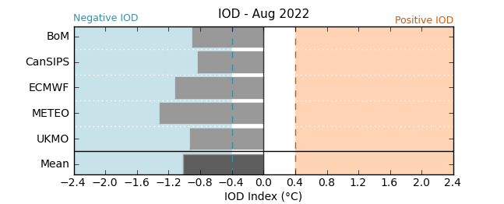

The Southern Annular Mode (SAM) has become increasingly negative over the past fortnight but is expected to return to neutral values and remain neutral over the coming weeks. The SAM refers to the north-south shift of the band of rain-bearing westerly winds and weather systems in the Southern Ocean compared to the usual position. A negative SAM in winter is associated with increased rainfall for parts of south-western and south-eastern Australia. It is also associated with decreased rainfall for parts of eastern Australia.

Southern Annular Mode (SAM) daily index
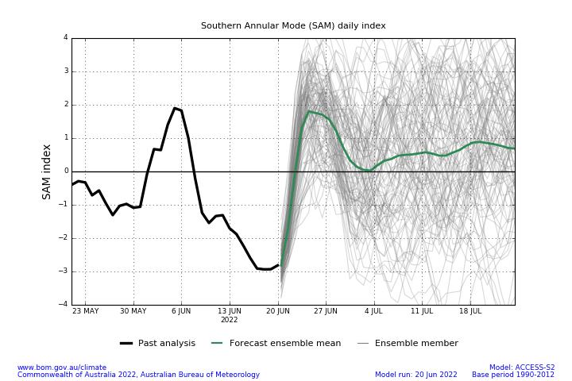

National Climate Outlook
These climate outlooks are generated by ACCESS–S (Australian Community Climate Earth-System Simulator–Seasonal). ACCESS–S is the Bureau of Meteorology's dynamical (physics-based) weather and climate model used for monthly, seasonal and longer-lead climate outlooks.
For further information, go to http://www.bom.gov.au/climate/ahead/about/
The Bureau of Meteorology’s latest rainfall outlook indicates wetter than average conditions are expected across the majority of Australia during July. The ACCESS-S climate model suggests there is close to a 65% chance of exceeding median for most of Australia, while the south-west and far south-east of Australia have roughly equal chances of being above or below median.
The outlook for July 2022 indicates that there is a 75% chance of rainfall totals between 10 and 50 millimetres across New South Wales, south-east Queensland, Victoria, southern South Australia, the southwest of Western Australia and Tasmania. Rainfall totals in excess of 100 millimetres are expected across alpine regions of New South Wales and Victoria, as well as the far southwest of Western Australia and western Tasmania.
Across cropping regions there is a 75% chance of rainfall totals of between 25 and 50 millimetres across most of New South Wales, Victoria, South Australia and Western Australia. There is a 75% chance of rainfall less than 25 millimetres for northwest Victoria, parts of eastern South Australia, most of Queensland, and eastern cropping regions in Western Australia.
Rainfall totals that have a 75% chance of occurring July 2022
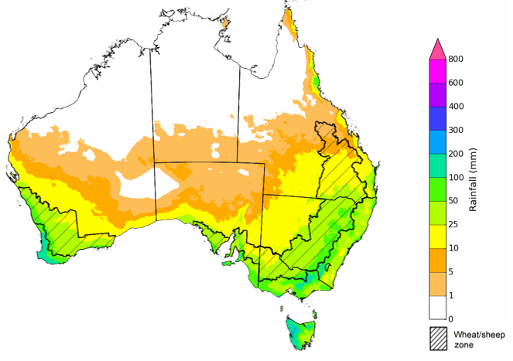
©Commonwealth of Australia 2022, Australian Bureau of Meteorology Issued: 16/06/2022

The rainfall outlook for July to September 2022 suggests there is a greater than 80% chance of exceeding median rainfall across most of New South Wales, Queensland, parts of South Australia, northern Victoria, as well as the Northern Territory. For remaining regions of Australia, there is an increased chance of above median rainfall between July to September 2022 (Bureau of Meteorology ‘National Climate Outlook’, 16 June 2022).
Bureau of Meteorology rainfall outlooks for July to September have greater than 55% past accuracy across most of Australia. Outlook accuracy is greater than 65% across large areas of western and eastern Australia.
Chance of exceeding the median rainfall July to September 2022
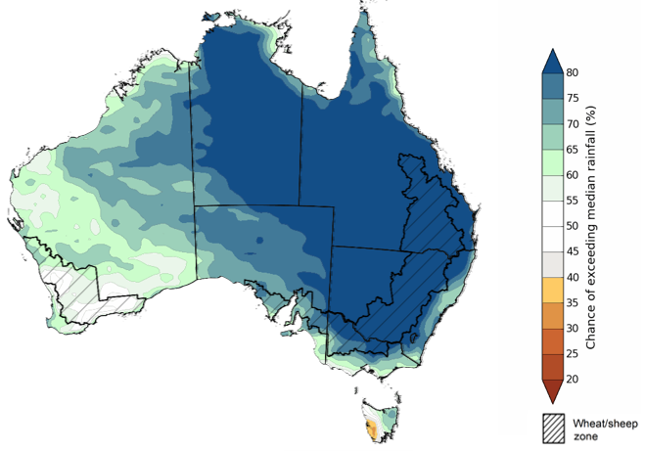
©Commonwealth of Australia 2022, Australian Bureau of Meteorology Issued: 16/06/2022

The outlook for July to September 2022 suggests there is a 75% chance of rainfall totals between 50 and 200 millimetres across much of New South Wales, south-eastern Queensland, Victoria, southern parts of South Australia, the south-west of Western Australia and Tasmania. Rainfall totals in excess of 200 millimetres are forecast for alpine regions of New South Wales and Victoria, the far southwest of Victoria, the far southeast of South Australia, the far south-west of Western Australia, and western and northern Tasmania.
Across cropping regions, there is a 75% chance of receiving between 50 and 100 millimetres across much of Queensland, northern Victoria, parts of eastern South Australia and the east of Western Australia. Totals of between 100 and 200 millimetres are expected across much of New South Wales, parts of southern Queensland, much of Victoria, central and western South Australia and western and southern Western Australia.
Root zone soil moisture levels are average to above average across much of the Wheat/sheep zone but below average to average across parts of Western Australia. There is a high—75%—chance that forecast rainfall totals across Western Australian cropping regions will be sufficient to support the establishment and growth of winter crops during the July to September period. In remaining cropping regions, the expectation of above average rainfall over the next three months increases the risk of waterlogging adversely affecting crop growth and development, particularly in areas with above average soil moisture levels for this time of year.
Rainfall totals that have a 75% chance of occurring July to September 2022
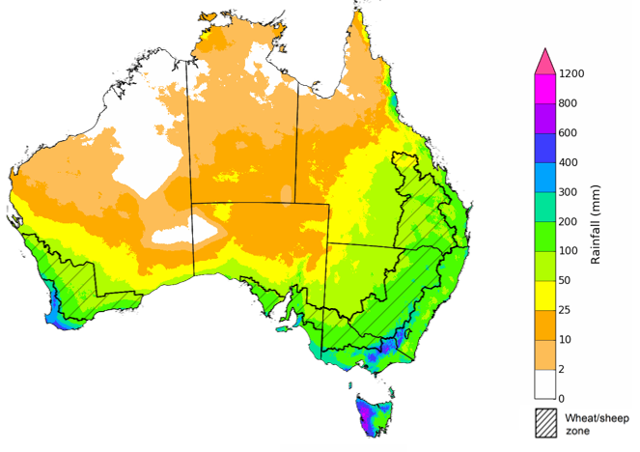
©Commonwealth of Australia 2022, Australian Bureau of Meteorology Issued: 16/06/2022

The temperature outlook for July to September 2022 indicates that maximum temperatures across most of Australia are likely to be close to the 1990-2012 average (- 1°C to 1°C), with slightly higher than average temperatures across the tropical north. Minimum temperatures are expected to be slightly above average for much of the northern and eastern Australia, and close to average for the rest of Australia (Bureau of Meteorology ‘National Climate Outlook’, 16 June 2022).
Predicted maximum temperature anomaly for July to September 2022

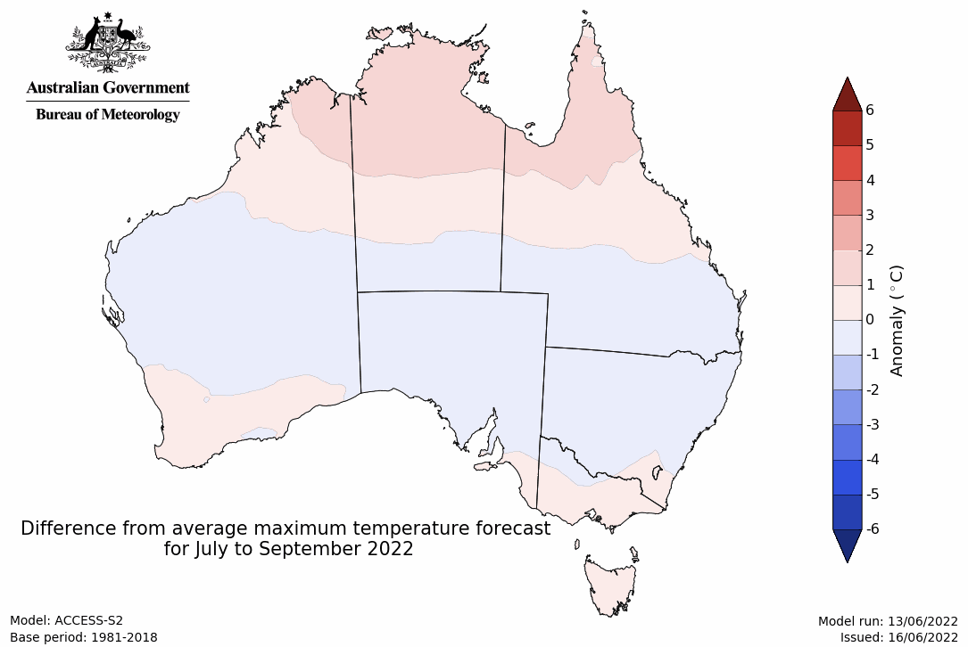
Predicted minimum temperature anomaly for July to September 2022
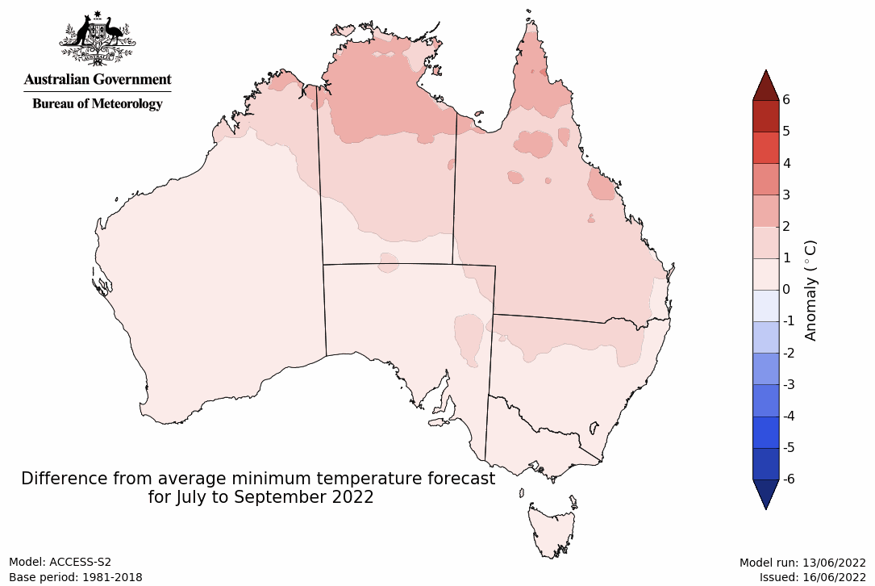

Rainfall forecast for the next eight days
Over the 8-days to 30 June 2022, frontal activity moving across southern Australia is expected to bring moderate rainfall to parts of south-eastern Australia. Meanwhile, high pressure systems are forecast to be the dominant climate feature across much of the country, resulting in clear, dry conditions.
Rainfall totals of between 10 and 50 millimetres are forecast for alpine regions of New South Wales and Victoria, southern parts of Victoria and South Australia, parts of the south-west of Western Australia and western Tasmania. Little to no rainfall is forecast across remaining parts of Australia over the next 8-days.
In Australian cropping regions, rainfall totals of between 10 and 50 millimetres are expected in isolated parts of southern and eastern Victoria. Little to no rainfall is forecast for all remaining cropping regions during the next 8-days.
A third week of dry conditions across cropping regions in New South Wales and Queensland should see soil moisture levels continuing to decrease, allowing improved access to fields. Significant progress has been made over recent weeks to finalise the harvest of summer crops in southern Queensland and northern New South Wales. Likewise, there has been good progress on plantings of winter crops, giving growers the opportunity to plant winter cereals before the planting window closes. Despite relatively dry conditions across cropping regions of southern Australia, soil moisture levels remain average to above average. The large winter crop planting is expected to have sufficient plant available water to support crop development over the coming weeks.

Total forecast rainfall (mm) for the period 23 June to 30 June 2022
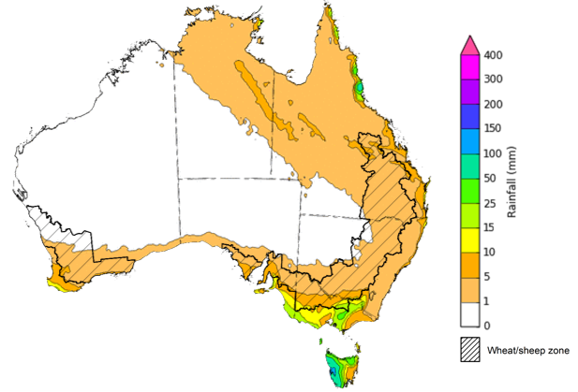
©Commonwealth of Australia 2022, Australian Bureau of Meteorology Issued:23/6/2022

Water
Note: This rainfall forecast is produced from computer models. As the model outputs are not altered by weather forecasters, it is important to check local forecasts and warnings issued by the Bureau of Meteorology.

Water markets – current week
Water storage in the Murray–Darling Basin (MDB) increased by 5 gigalitres (GL) between 15 June 2022 and 22 June 2022. The current volume of water held in storage is 22,150 GL, which represents 88 of total capacity. This is 41% or 6,443 GL more than at the same time last year.

Water storages in the Murray-Darling Basin, 2013–2022
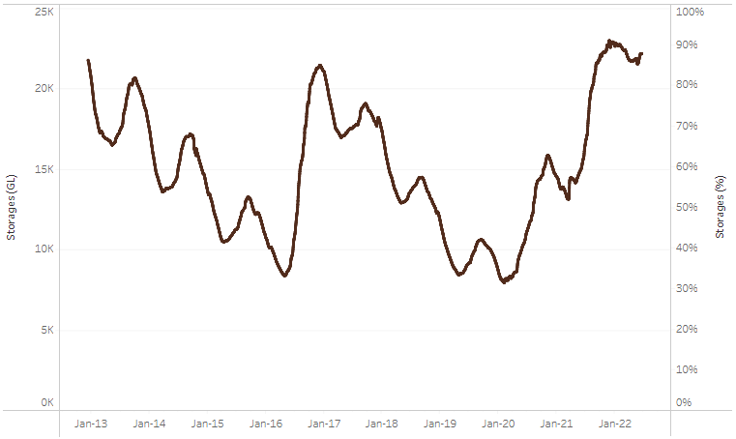
Allocation prices in the Victorian Murray below the Barmah Choke decreased from $19 per ML on 10 June 2022 to $18 per ML on 17 June 2022. Prices are lower in the Murrumbidgee and regions above the Barmah choke due to the binding of the Murrumbidgee export limit and Barmah choke trade constraint.
Water storage data is sourced from the Bureau of Meteorology.

Region | $/ML
NSW Murray Above | 1
NSW Murrumbidgee | 1
VIC Goulburn-Broken | 12
VIC Murray Below | 18

Surface water trade activity, Southern Murray–Darling Basin

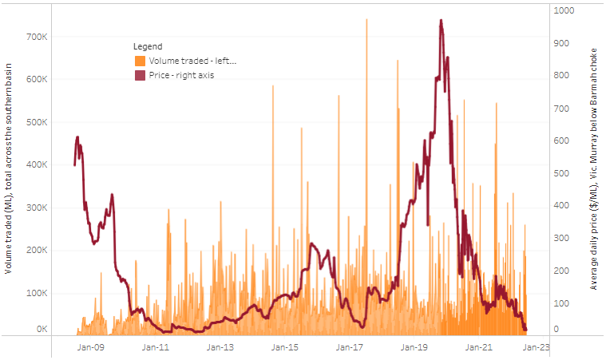
To access the full, interactive, weekly water dashboard, which contains the latest and historical water storage, water market and water allocation information, please visit http://www.agriculture.gov.au/abares/products/weekly_update/weekly-update-230622
The trades shown reflect estimated market activity and do not encompass all register trades. The price is shown for the VIC Murray below the Barmah choke. Historical prices (before 1 July 2019) are ABARES estimates after removing outliers from BOM water register data. Prices after 1 July 2019 and prior to the 30 October 2019 reflect recorded transaction prices as sourced from Ruralco. Prices after the 30 October 2019 are sourced from Waterflow. Data for volume traded is sourced from the BOM water register. Data shown is current at 23 June 2022.

Commodities

Indicator | Week ended | Unit | Latest price | Previous week | Weekly change | Price 12 months ago | Annual change
Selected world indicator prices
AUD/USD Exchange rate | 22-Jun | A$/US$ | 0.70 | 0.70 | 0% | 0.76 | -7%
Wheat – US no. 2 hard red winter wheat, fob Gulf | 22-Jun | US$/t | 453 | 482 | -6% | 284 | 59%
Corn – US no. 2 yellow corn, fob Gulf | 22-Jun | US$/t | 348 | 343 | 2% | 291 | 20%
Canola – Rapeseed, Canada, fob Vancouver | 22-Jun | US$/t | 864 | 927 | -7% | 714 | 21%
Cotton – Cotlook 'A' Index | 22-Jun | USc/lb | 161 | 163 | -1% | 96 | 67%
Sugar – Intercontinental Exchange, nearby futures, no.11 contract | 22-Jun | USc/lb | 18.8 | 18.8 | 0% | 18 | 7%
Wool – Eastern Market Indicator | 08-Jun | Ac/kg clean | 1,474 | 1,420 | 4% | 1,342 | 10%
Wool – Western Market Indicator | 06-Apr | Ac/kg clean | 1,417 | 1,421 | 0% | 1,222 | 16%
Selected Australian grain export prices
Milling Wheat – APW, Port Adelaide, SA | 22-Jun | A$/t | 628 | 629 | 0% | 376 | 67%
Feed Wheat – ASW, Port Adelaide, SA | 22-Jun | A$/t | 594 | 595 | 0% | 372 | 60%
Feed Barley – Port Adelaide, SA | 22-Jun | A$/t | 555 | 553 | 0% | 329 | 69%
Canola – Kwinana, WA | 22-Jun | A$/t | 1,215 | 1,238 | -2% | 733 | 66%
Grain Sorghum – Brisbane, QLD | 22-Jun | A$/t | 475 | 470 | 1% | 376 | 26%
Selected domestic livestock indicator prices
Beef – Eastern Young Cattle Indicator | 22-Jun | Ac/kg cwt | 1,070 | 1,107 | -3% | 898 | 19%
Mutton – Mutton indicator (18–24 kg fat score 2–3), Vic | 22-Jun | Ac/kg cwt | 657 | 688 | -5% | 659 | 0%
Lamb – Eastern States Trade Lamb Indicator | 22-Jun | Ac/kg cwt | 771 | 788 | -2% | 812 | -5%
Pig – Eastern Seaboard (60.1–75 kg), average of buyers & sellers | 30-Mar | Ac/kg cwt | 368 | 357 | 3% | 347 | 6%
Goats – Eastern States (12.1–16 kg) | 12-Jan | Ac/kg cwt | 879 | 879 | 0% | 818 | 8%
Live cattle – Light steers ex Darwin to Indonesia | 01-Jun | Ac/kg lwt | 480 | 480 | 0% | 320 | 50%
Live sheep – Live wethers (Muchea WA saleyard) to Middle East | 20-Apr | $/head | 113 | 113 | 0% | 122 | -7%

Indicator | Week ended | Unit | Latest price | Previous week | Weekly change | Price 12 months ago | Annual change
Global Dairy Trade (GDT) weighted average prices ª
Dairy – Whole milk powder | 22-Jun | US$/t | 4,125 | 4,158 | -1% | 2,745 | 50%
Dairy – Skim milk powder | 22-Jun | US$/t | 4,276 | 4,240 | 1% | 2,373 | 80%
Dairy – Cheddar cheese | 22-Jun | US$/t | 4,875 | 5,365 | -9% | 4,115 | 18%
Dairy – Anhydrous milk fat | 22-Jun | US$/t | 5,913 | 6,201 | -5% | 3,973 | 49%
a Global Dairy Trade prices are updated twice monthly on the first and third Tuesday of each month.

Selected world indicator prices
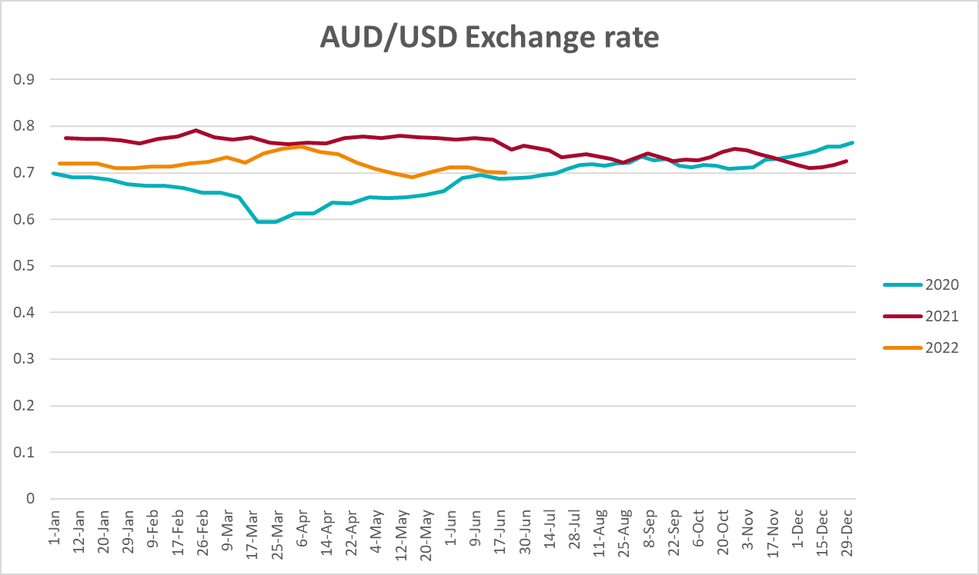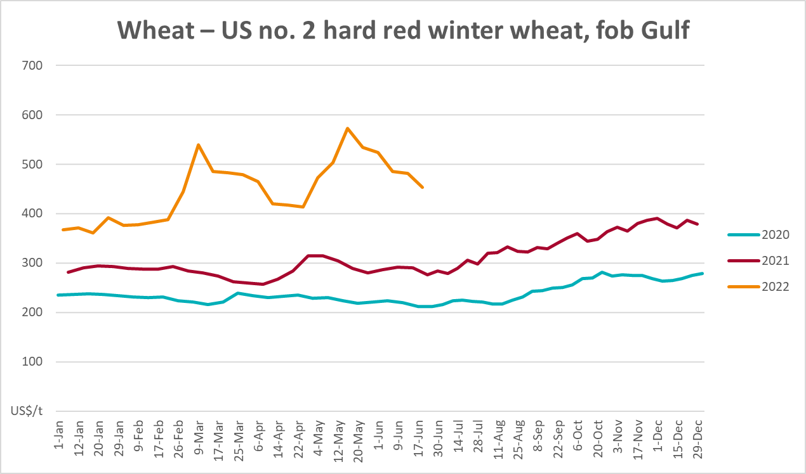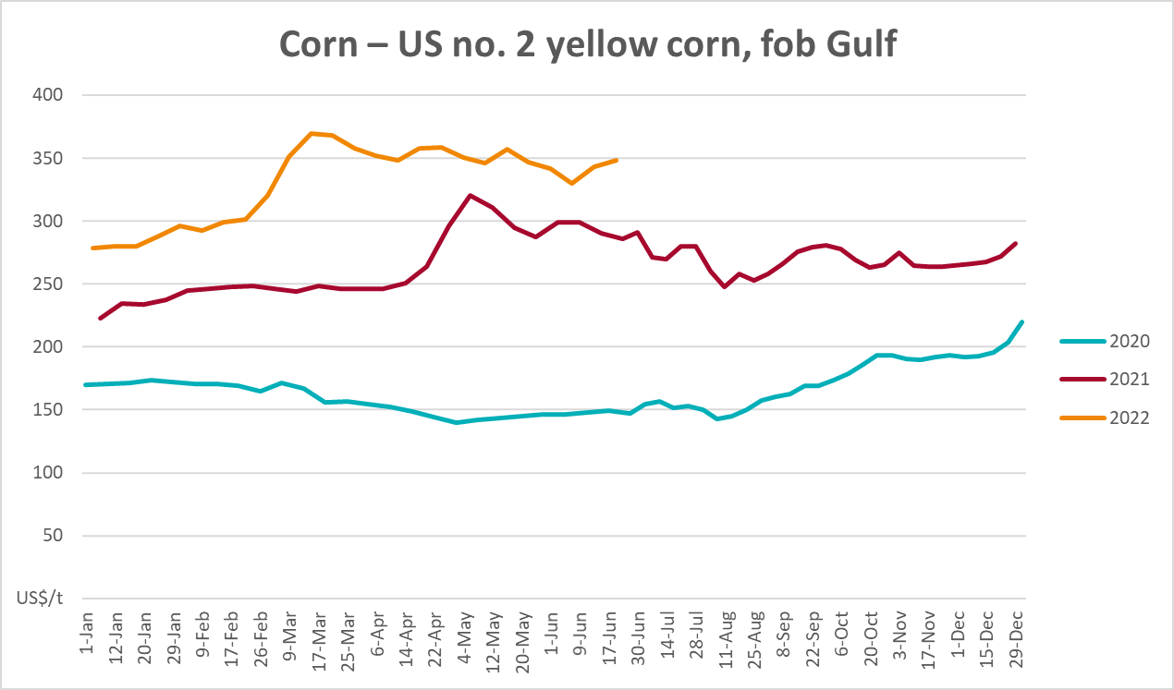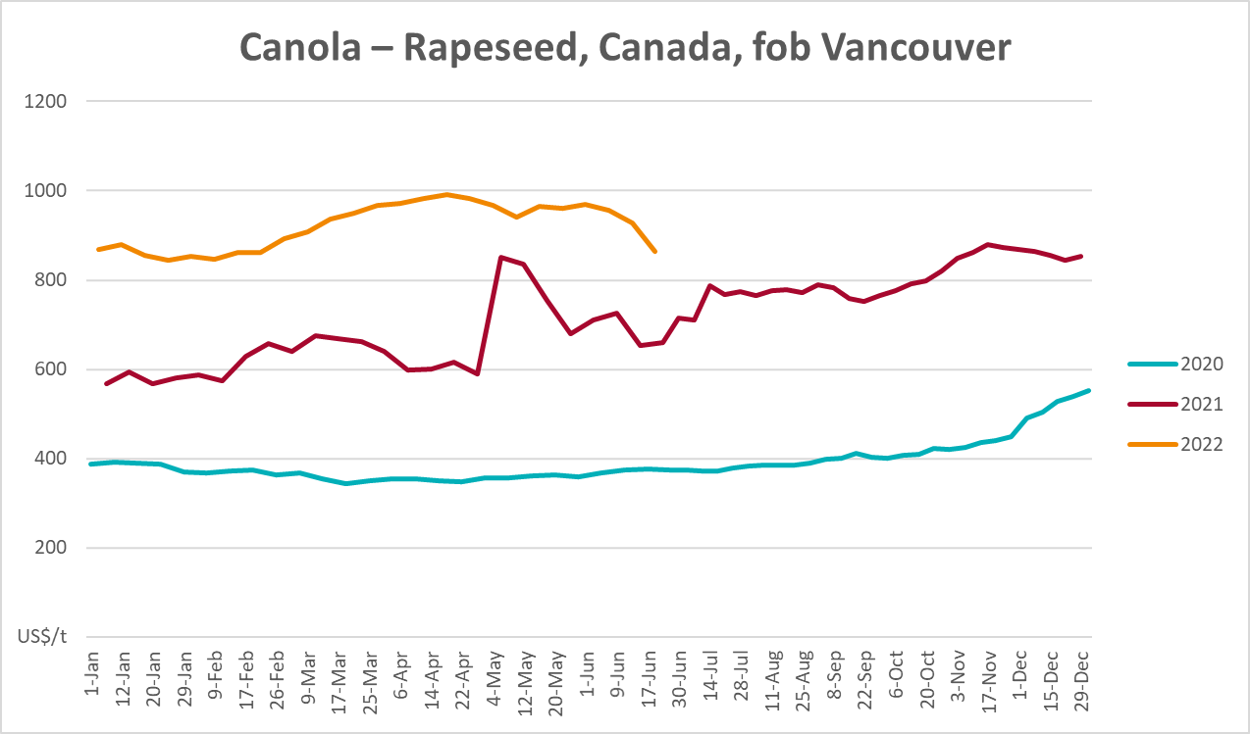
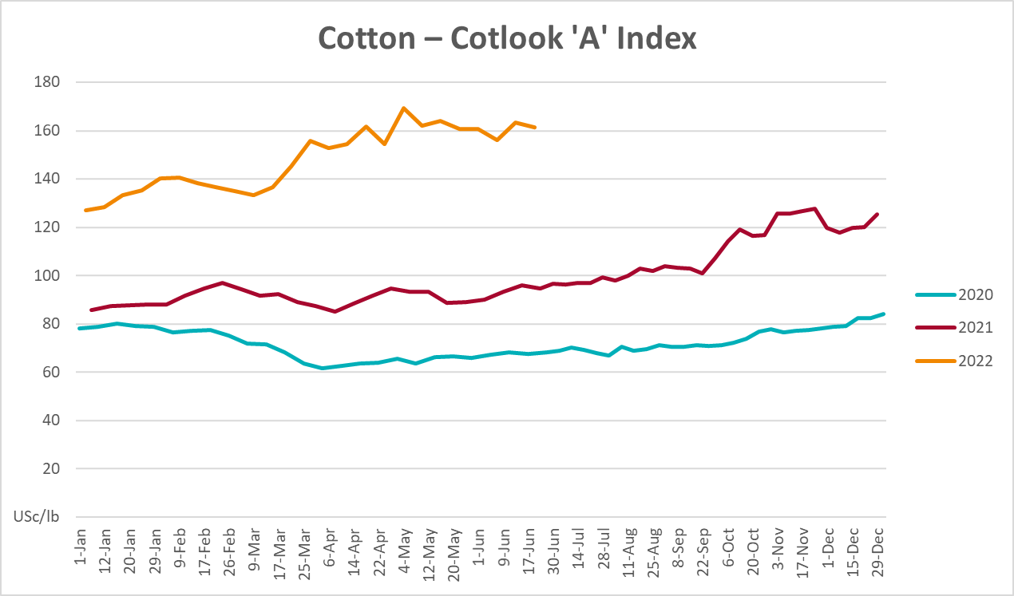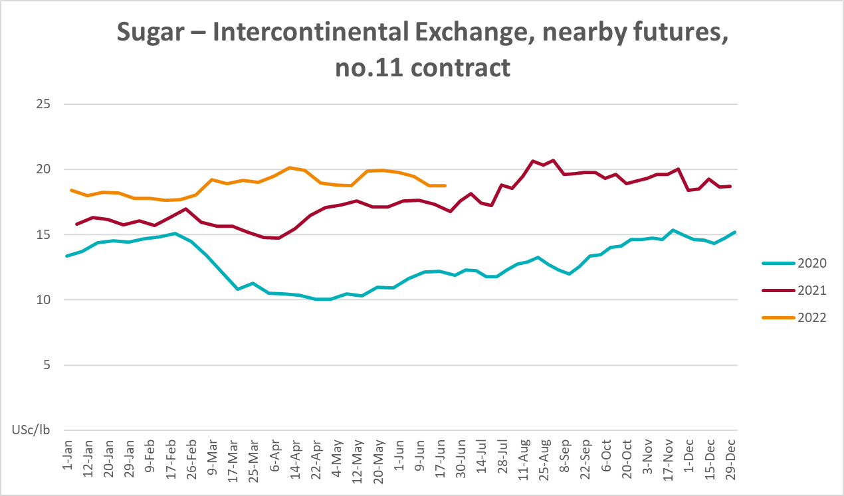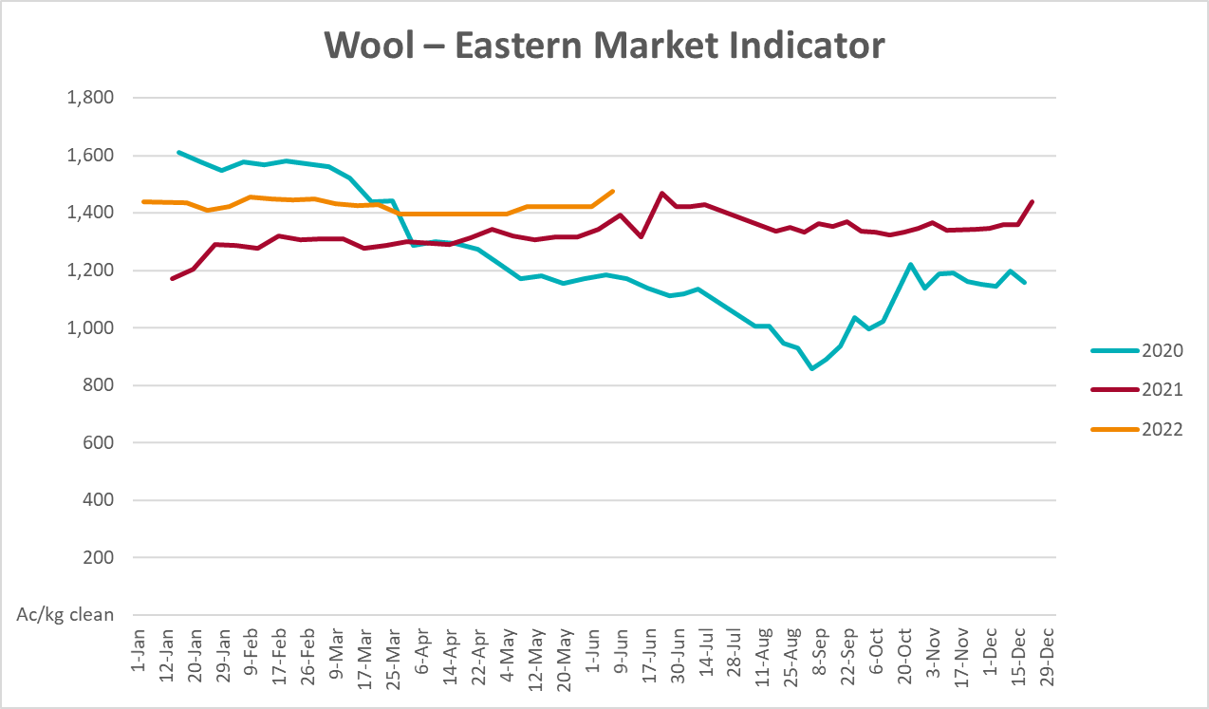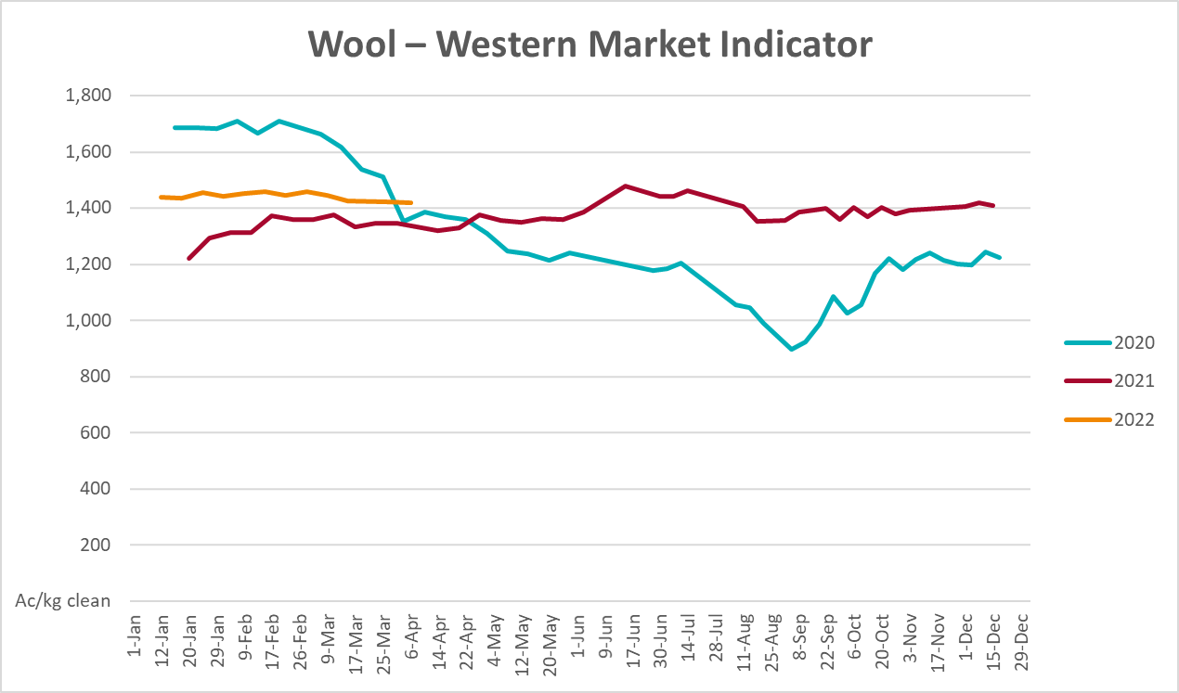

Selected domestic crop indicator prices
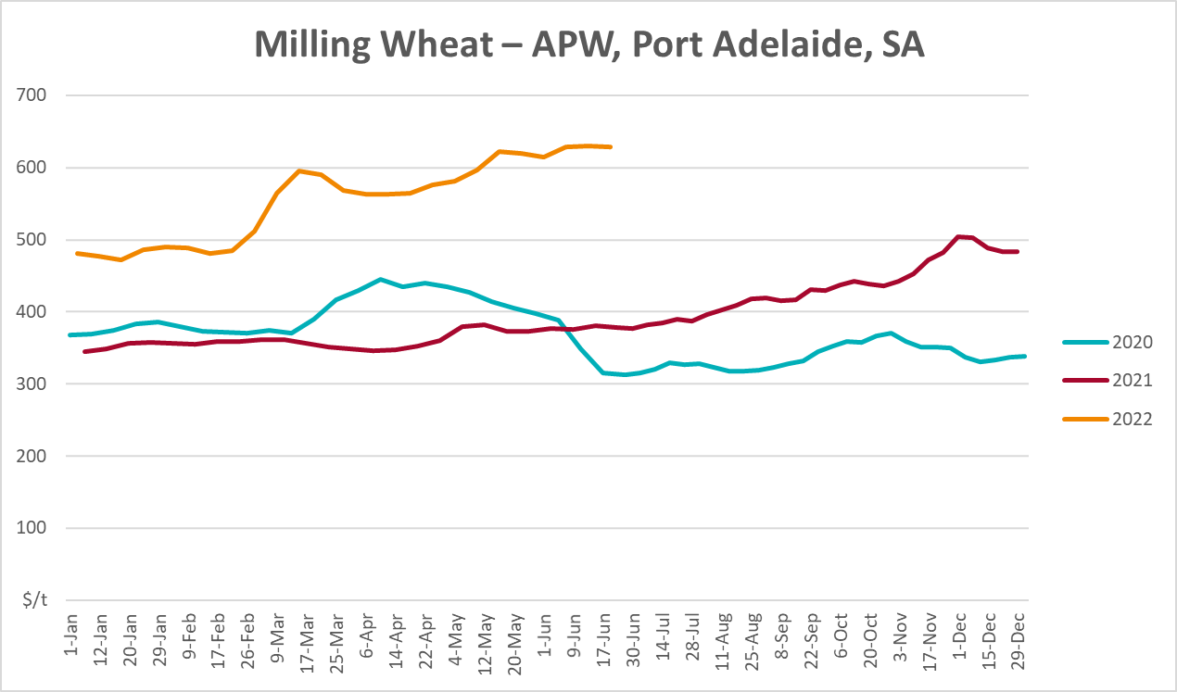
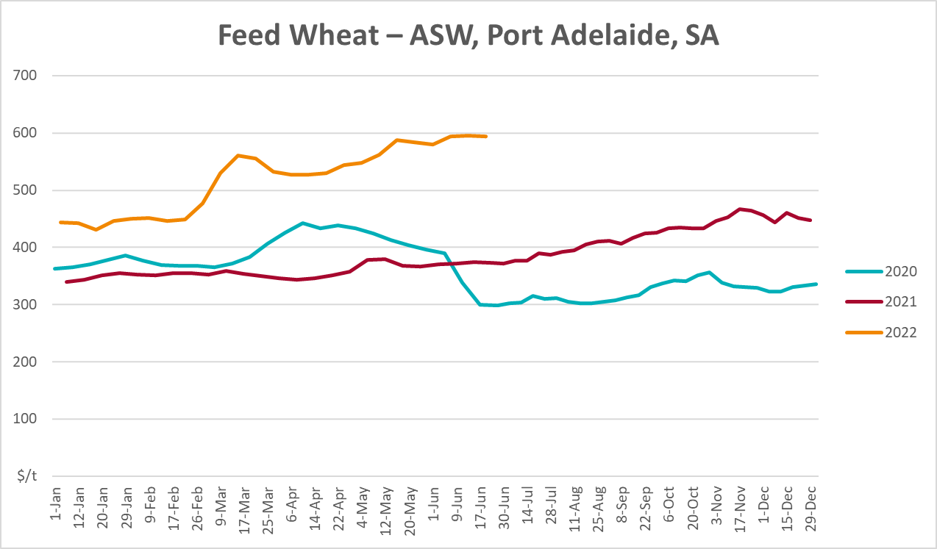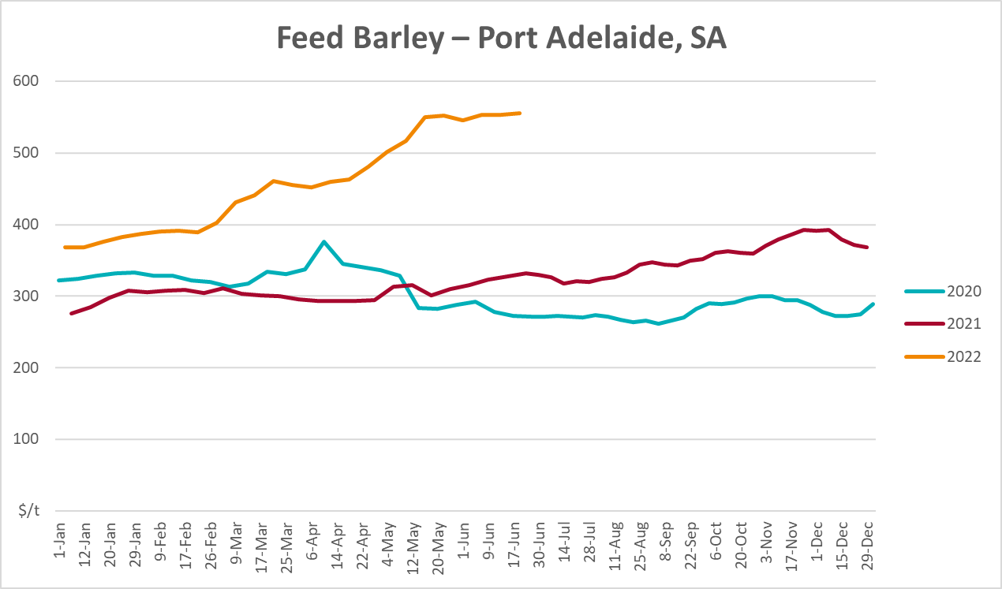
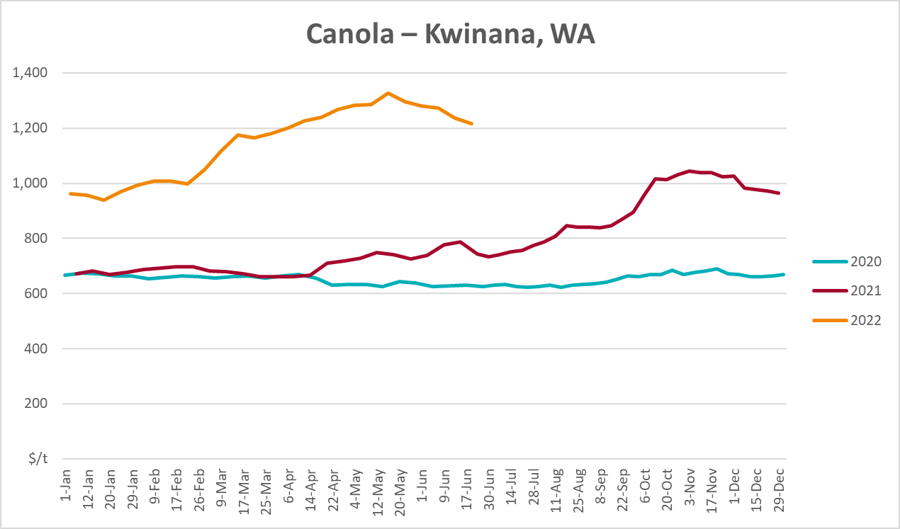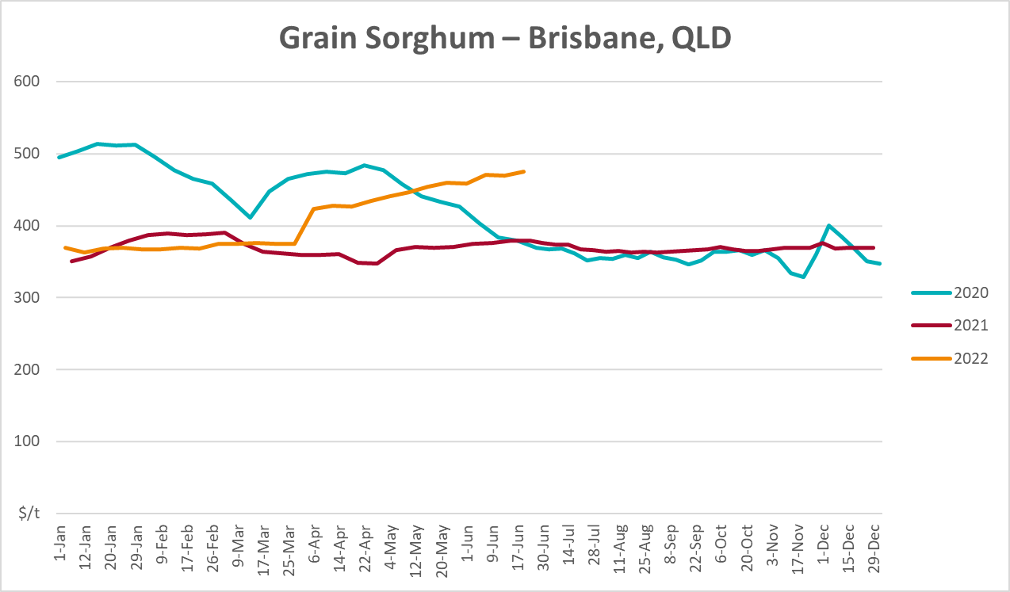

Selected domestic livestock indicator prices
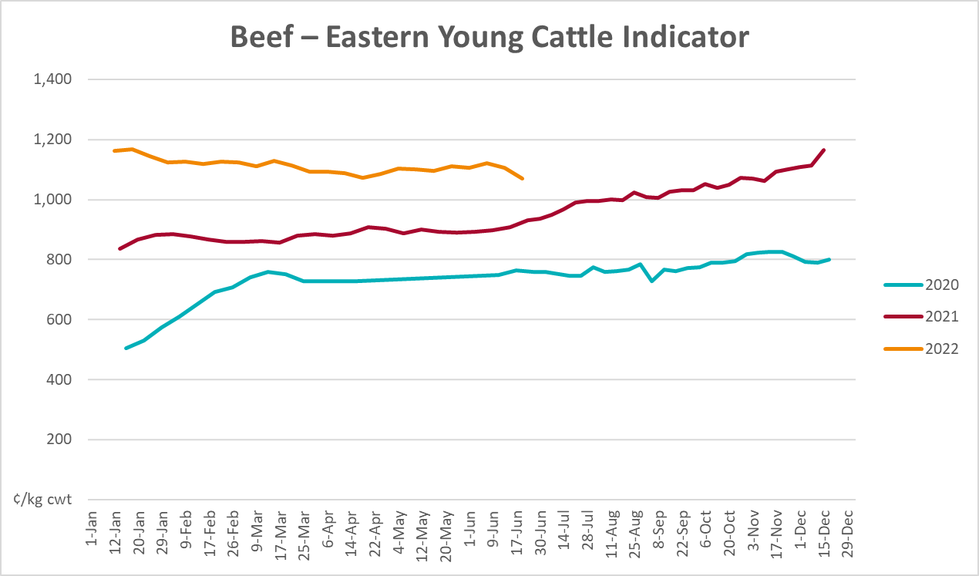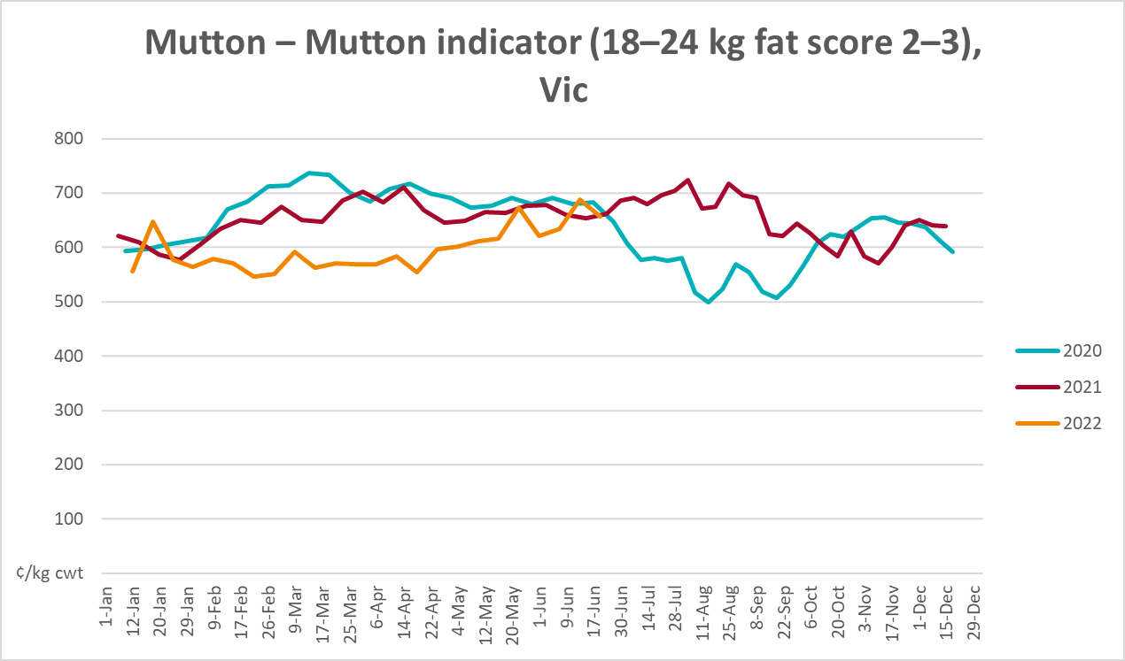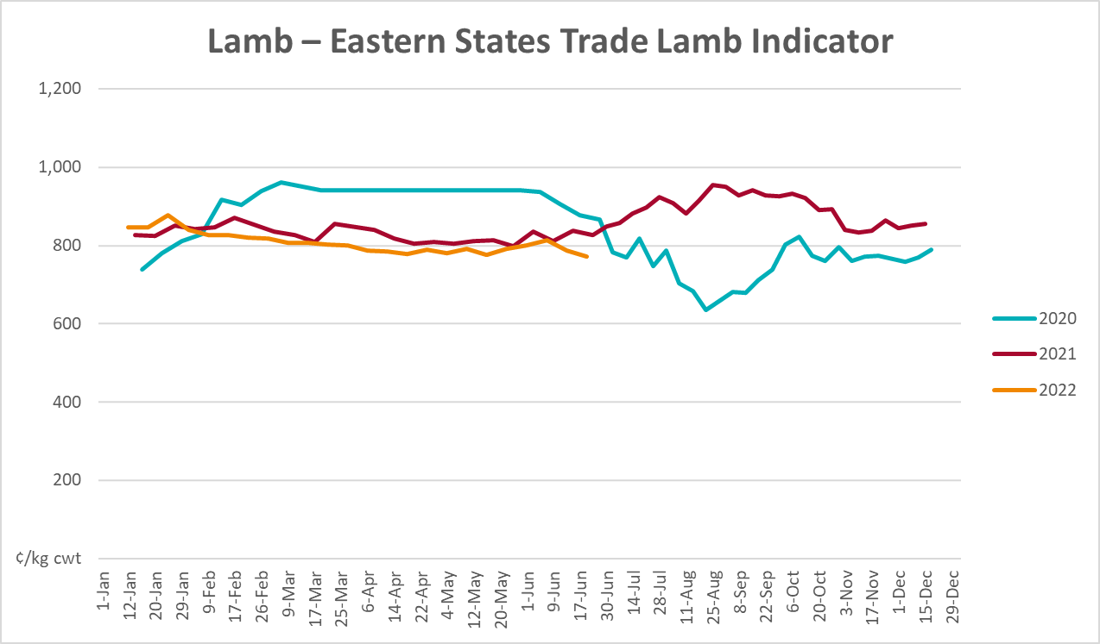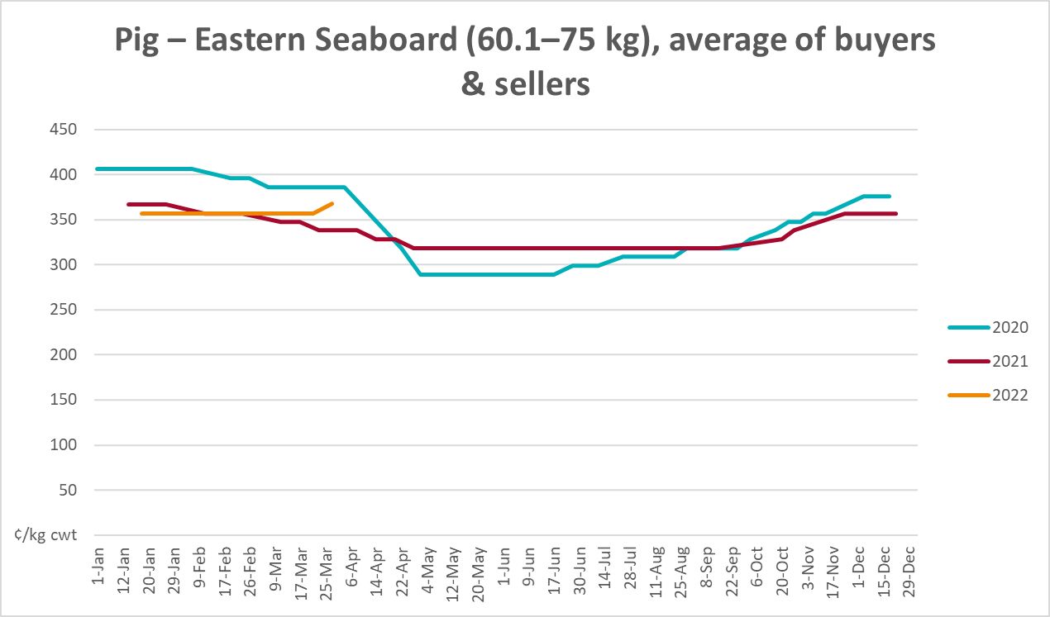

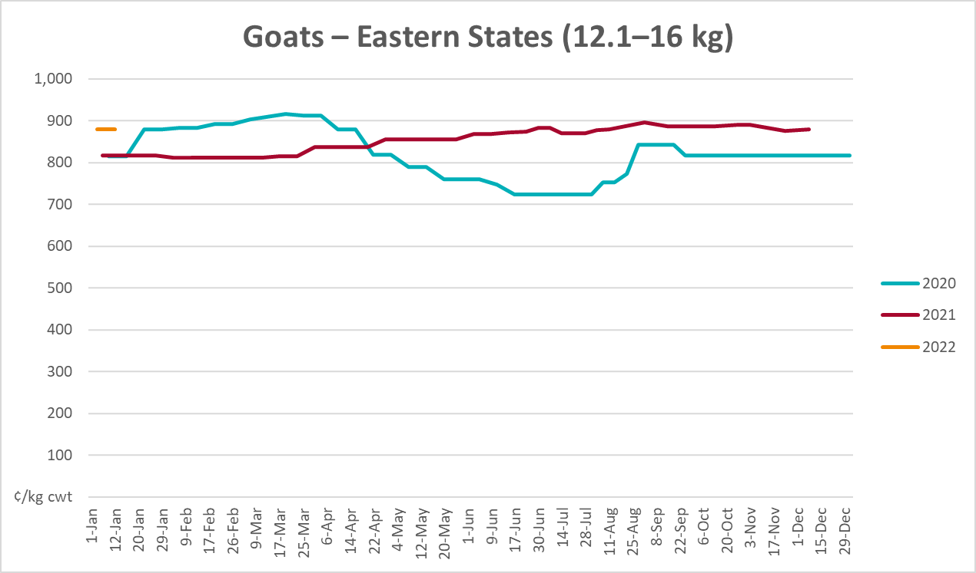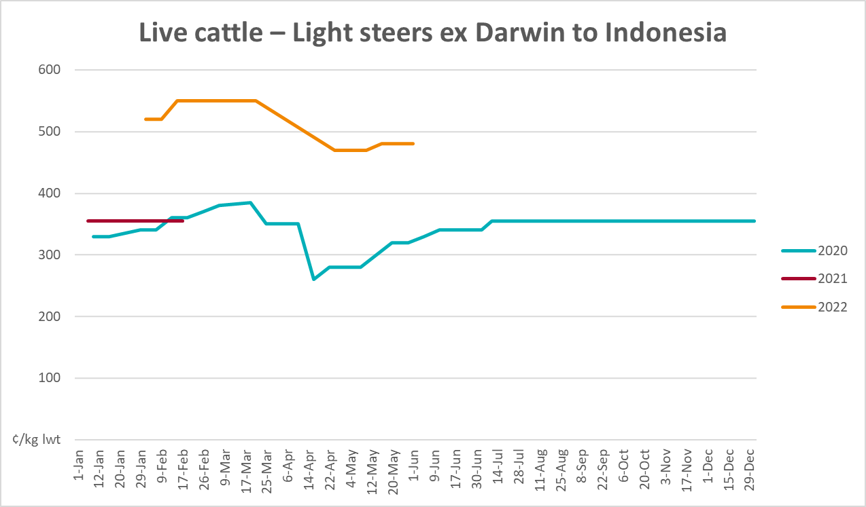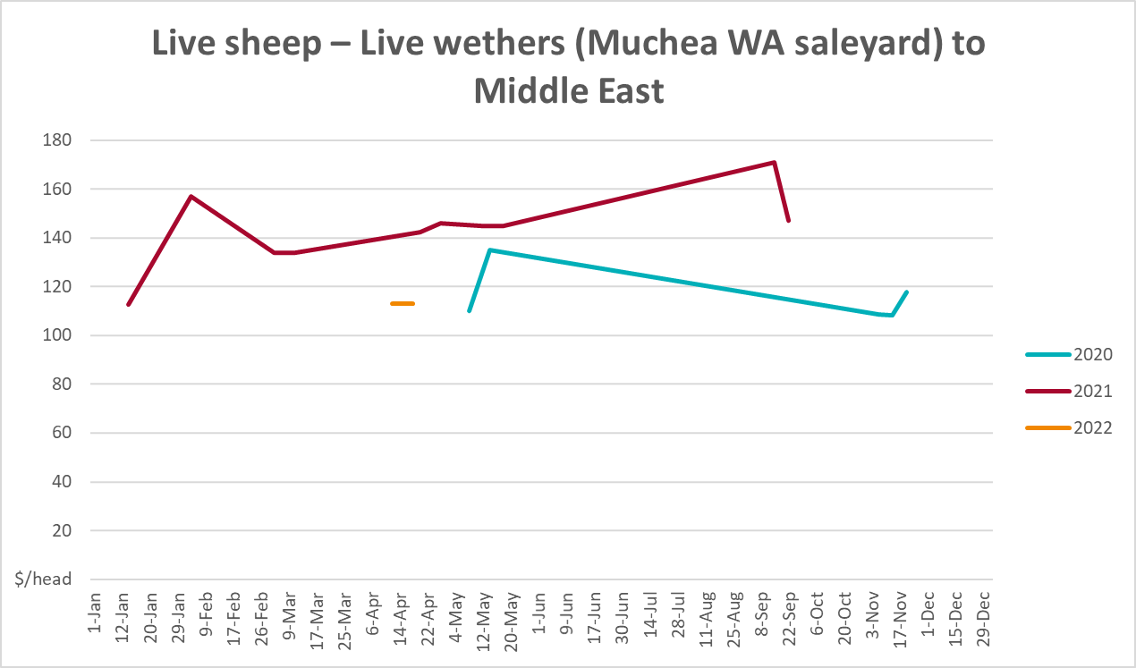

Global Dairy Trade (GDT) weighted average prices
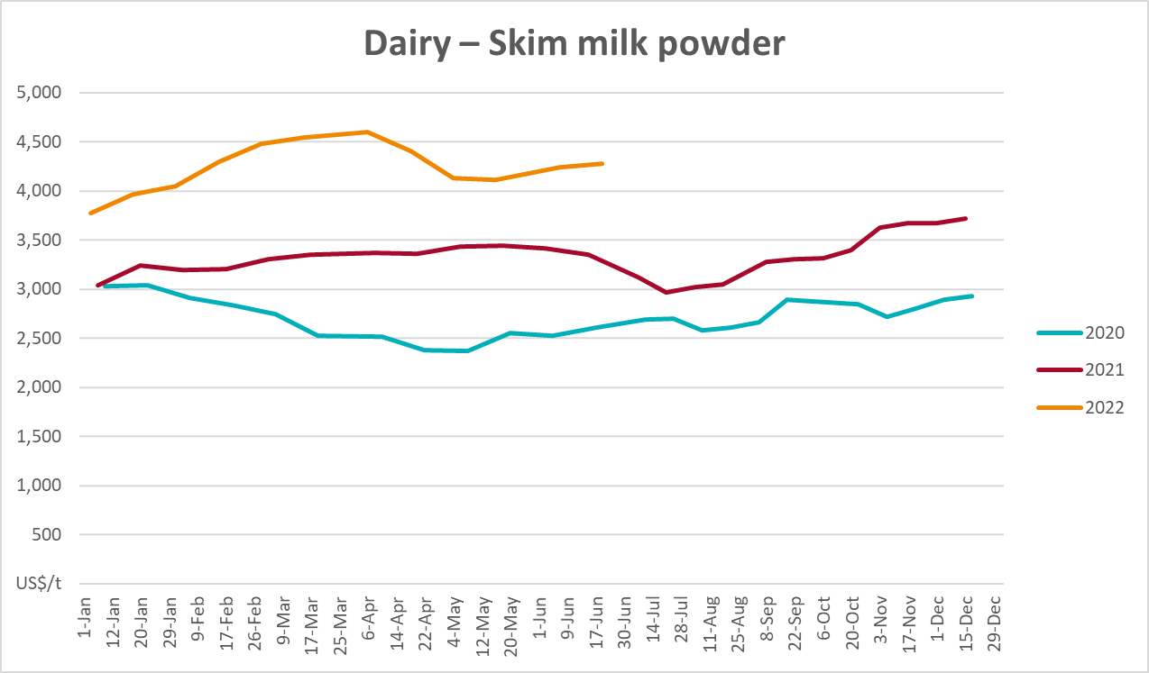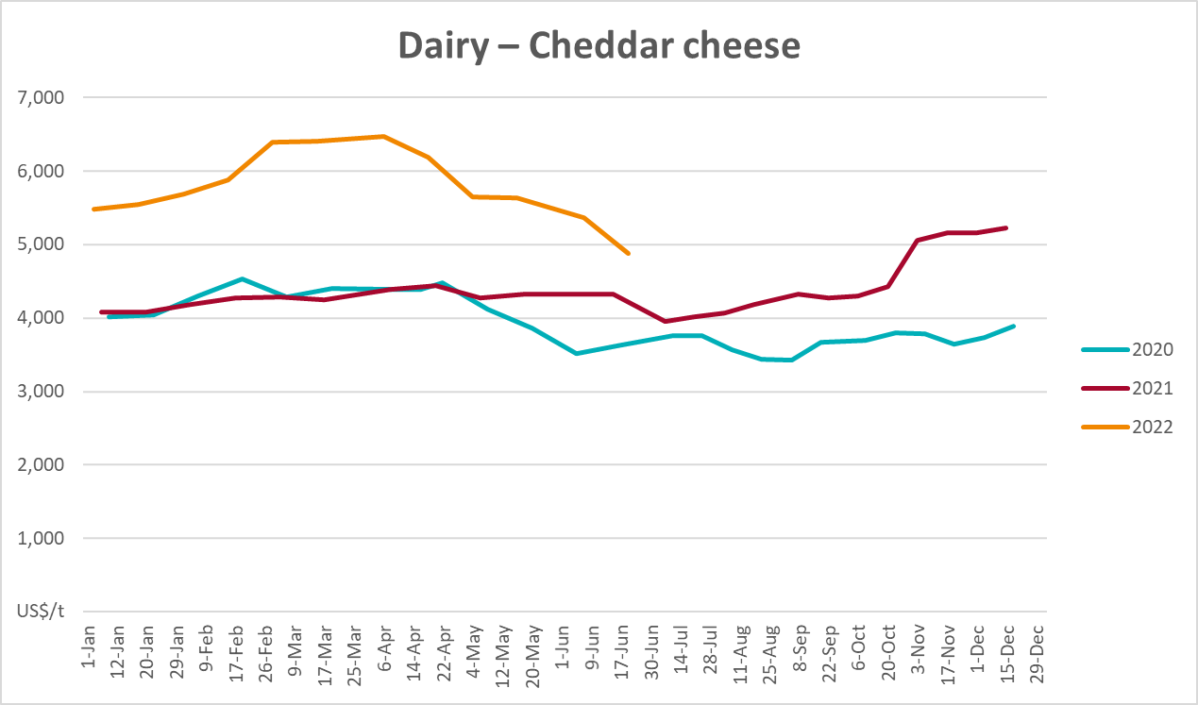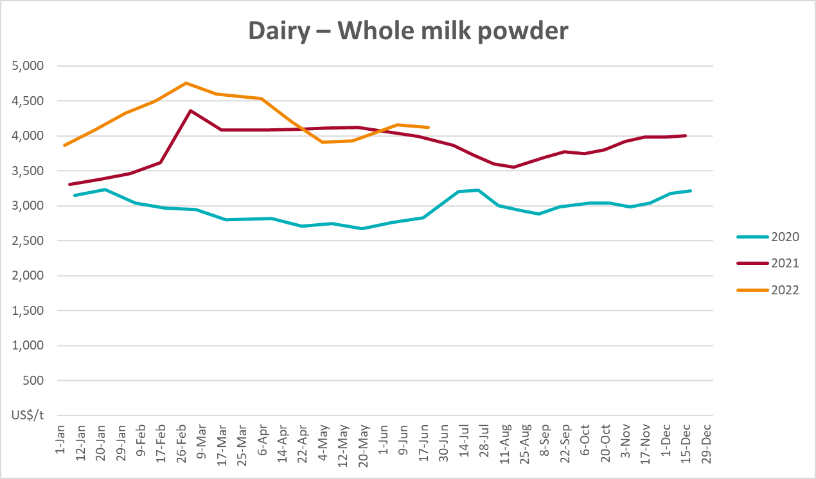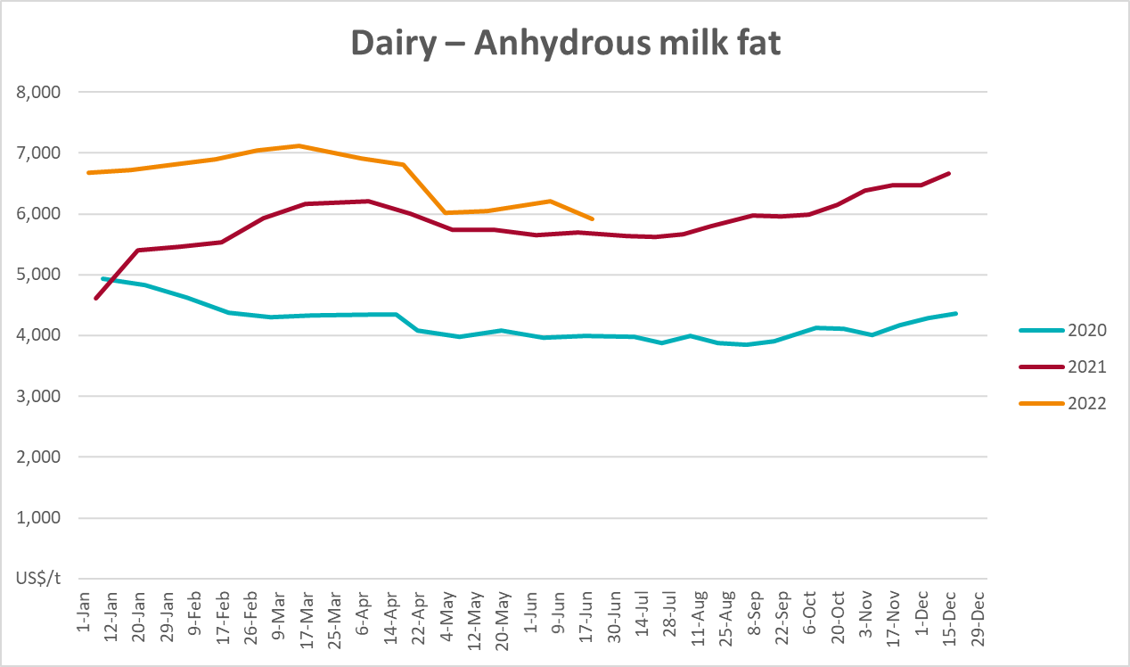

Selected fruit and vegetable prices
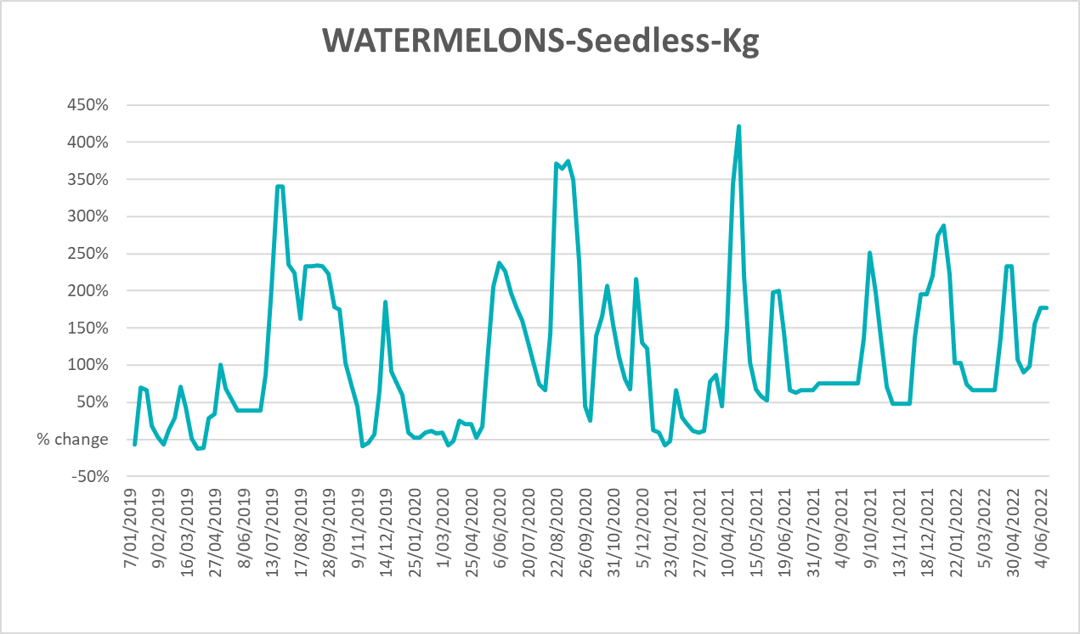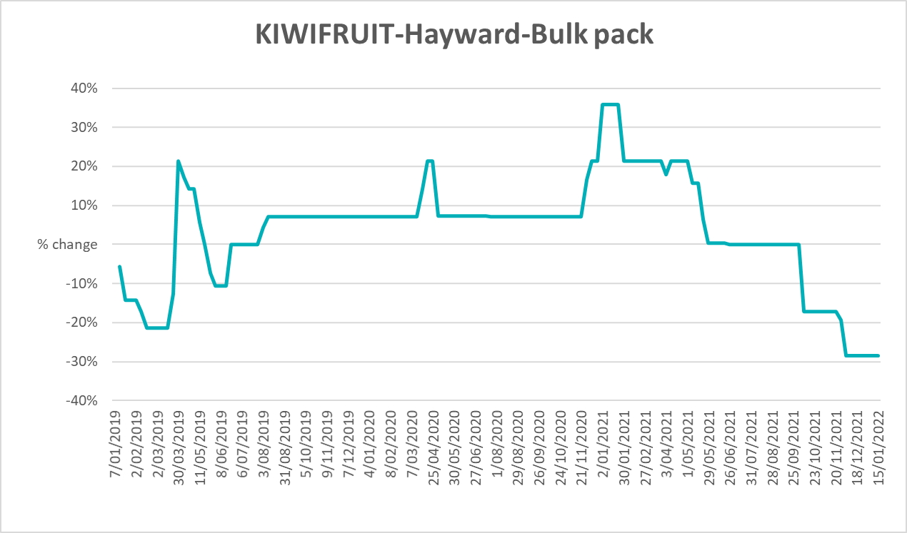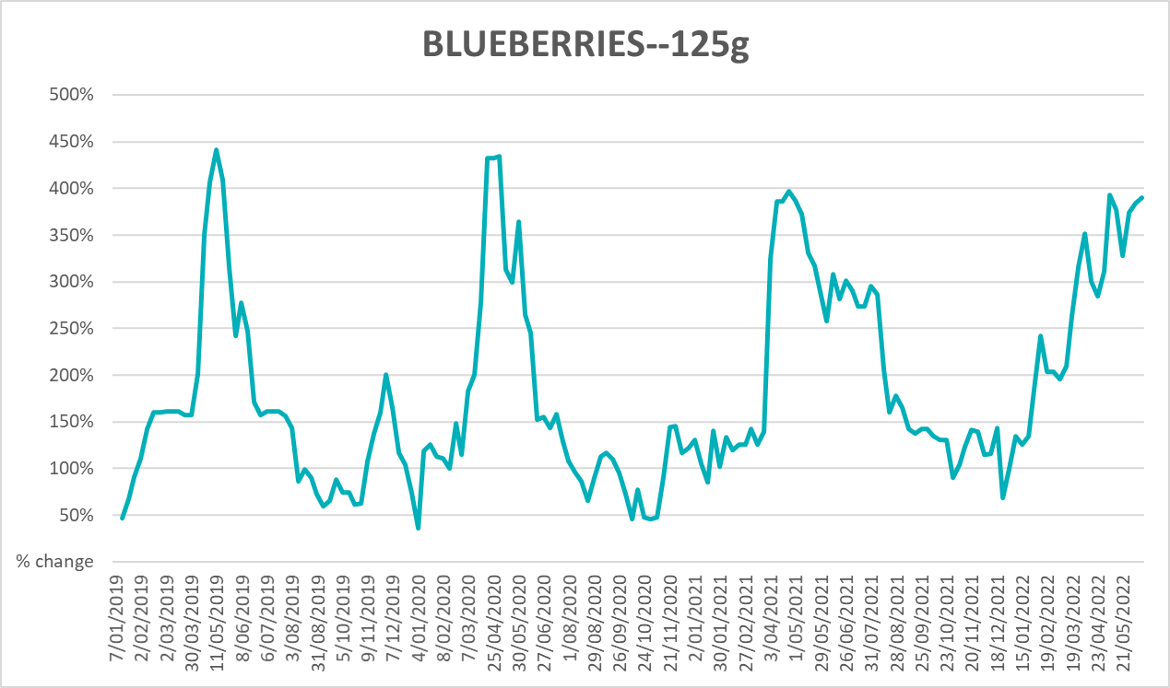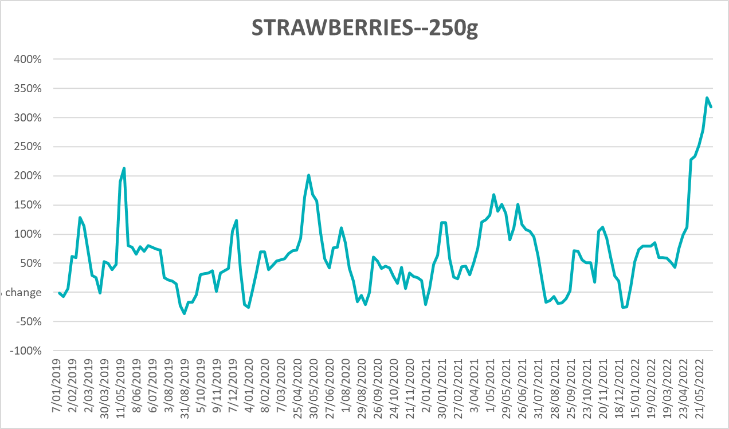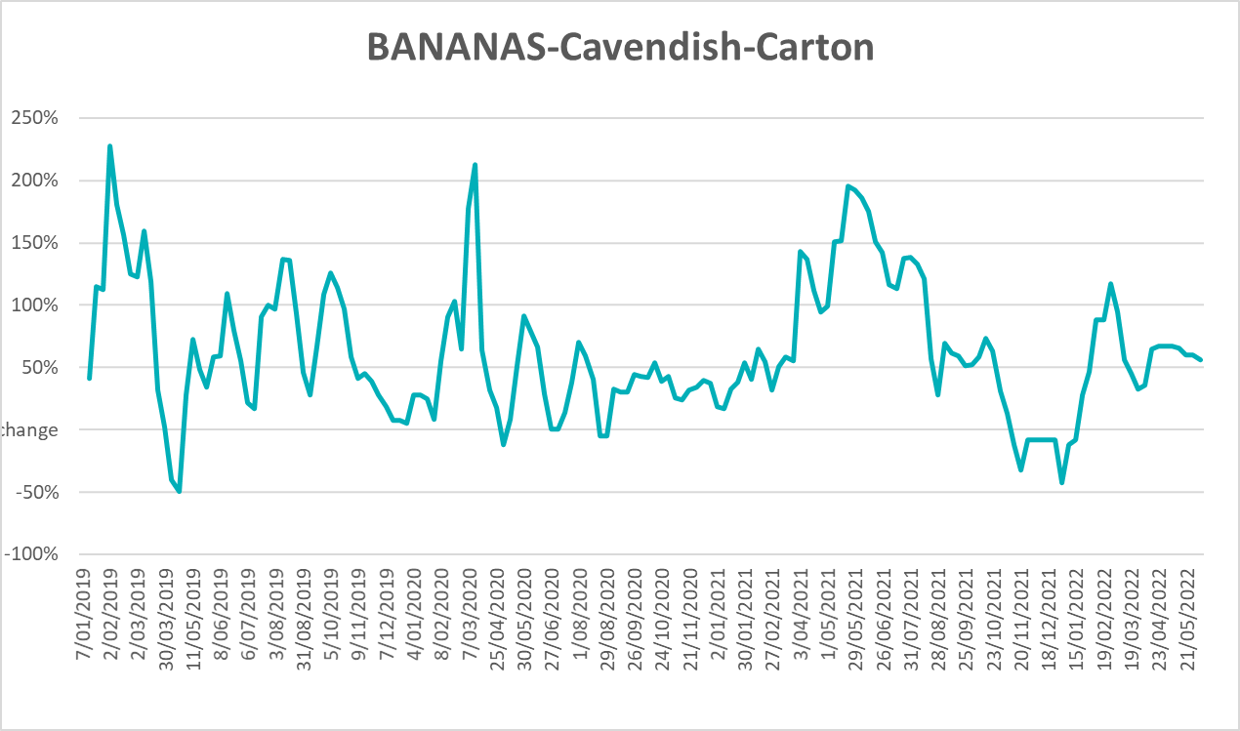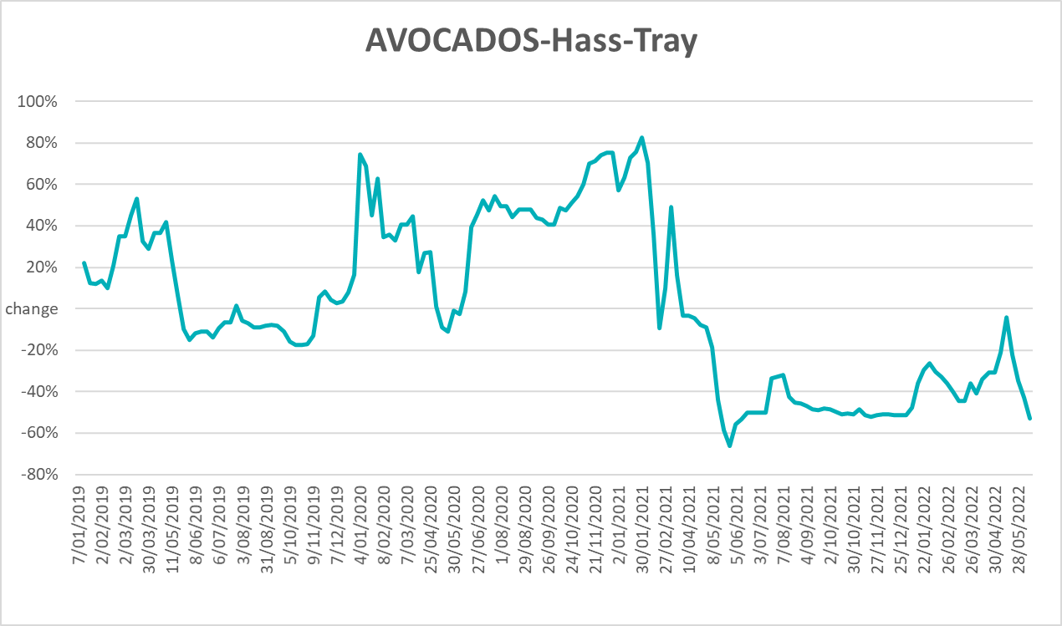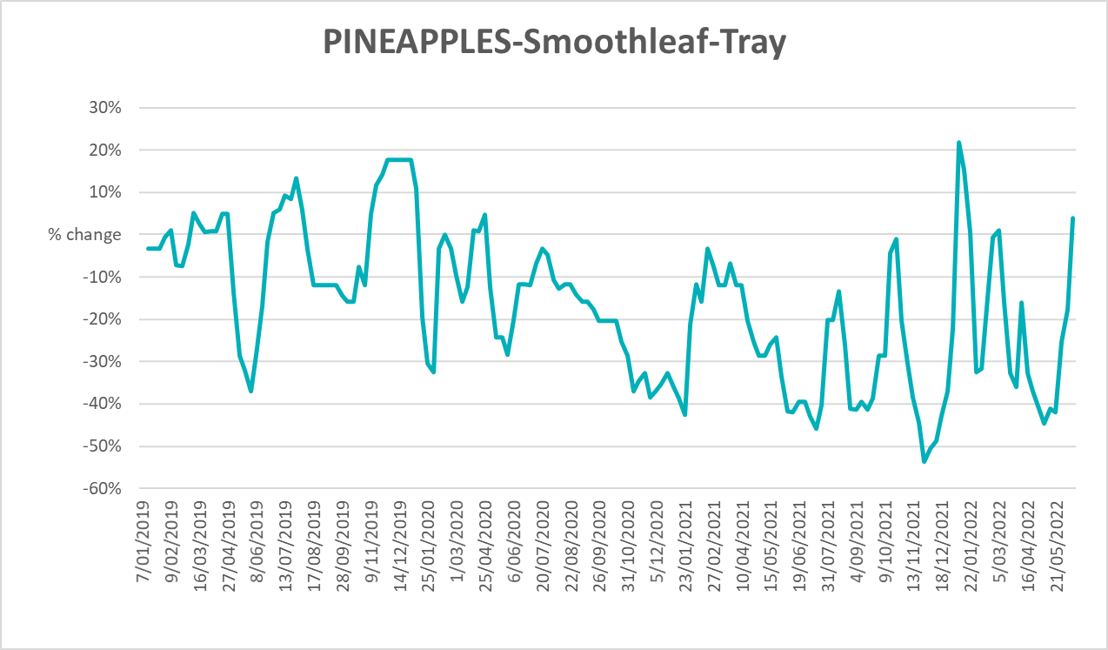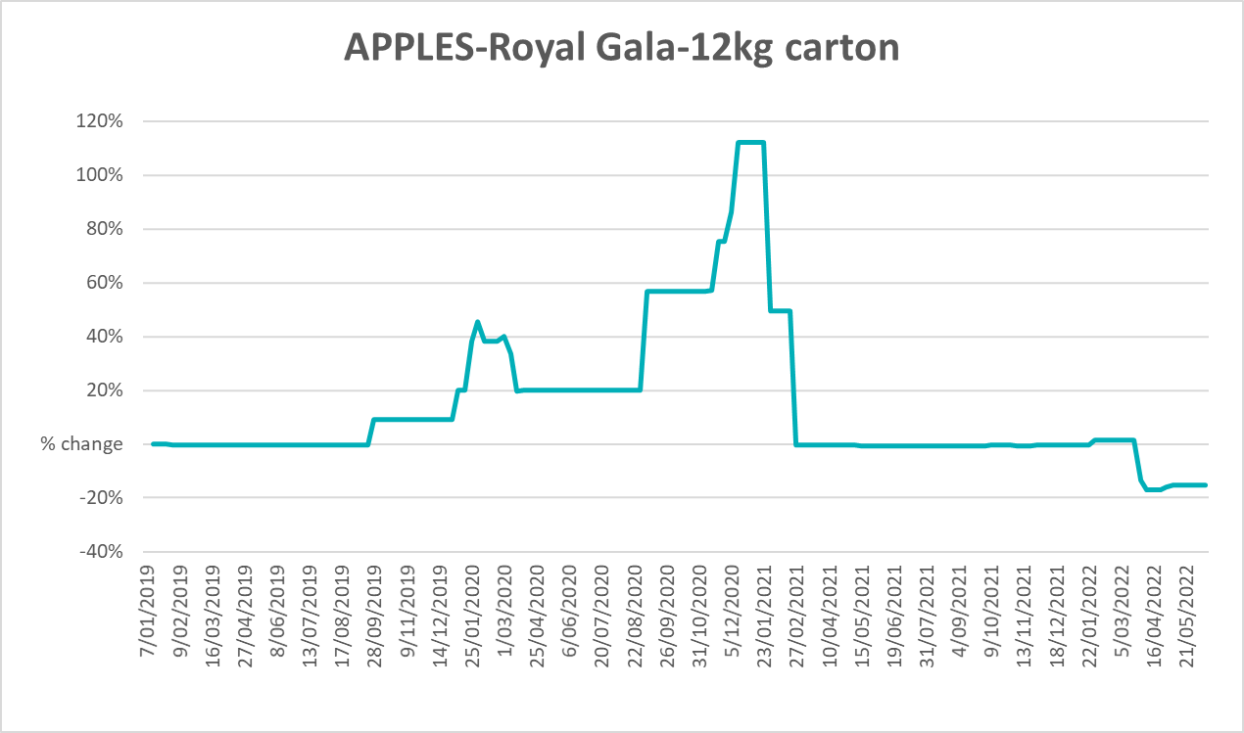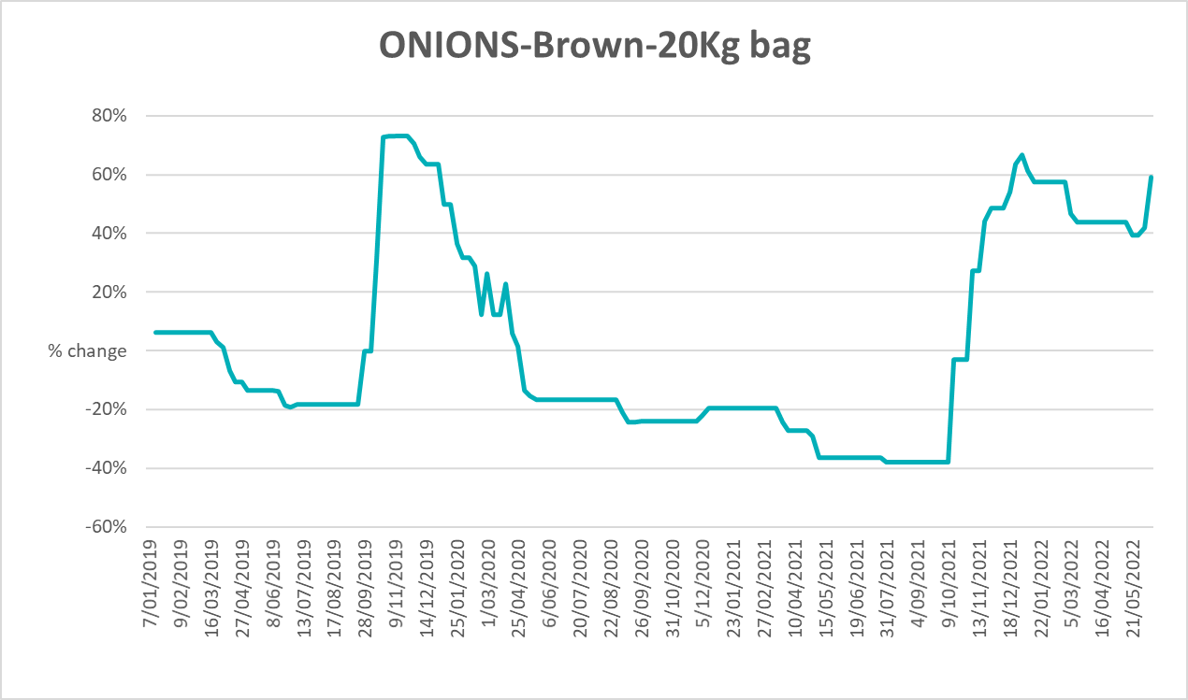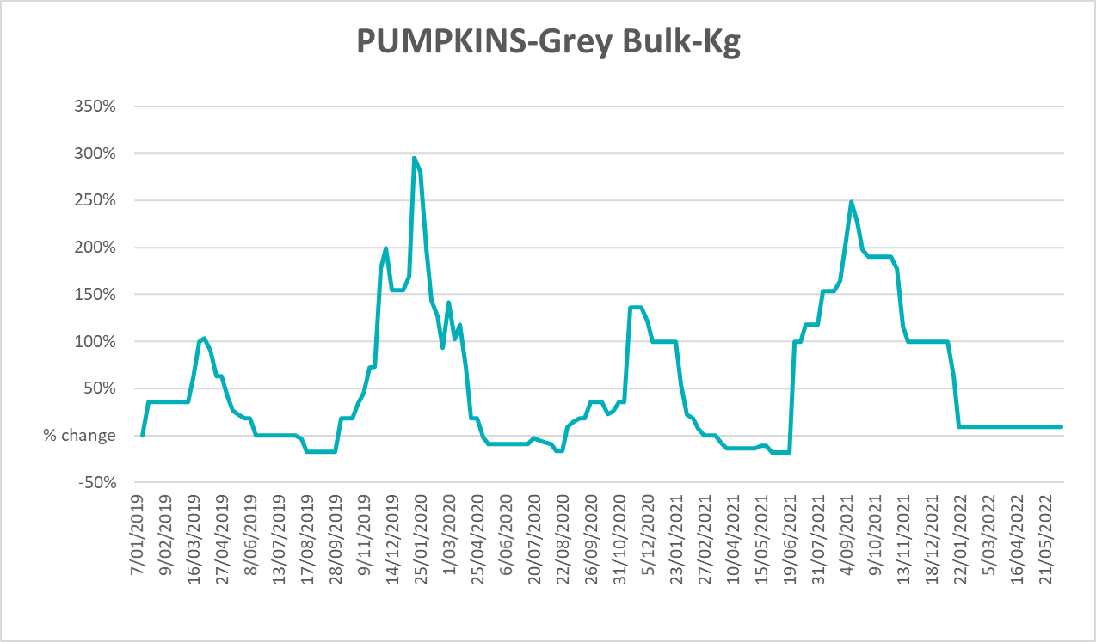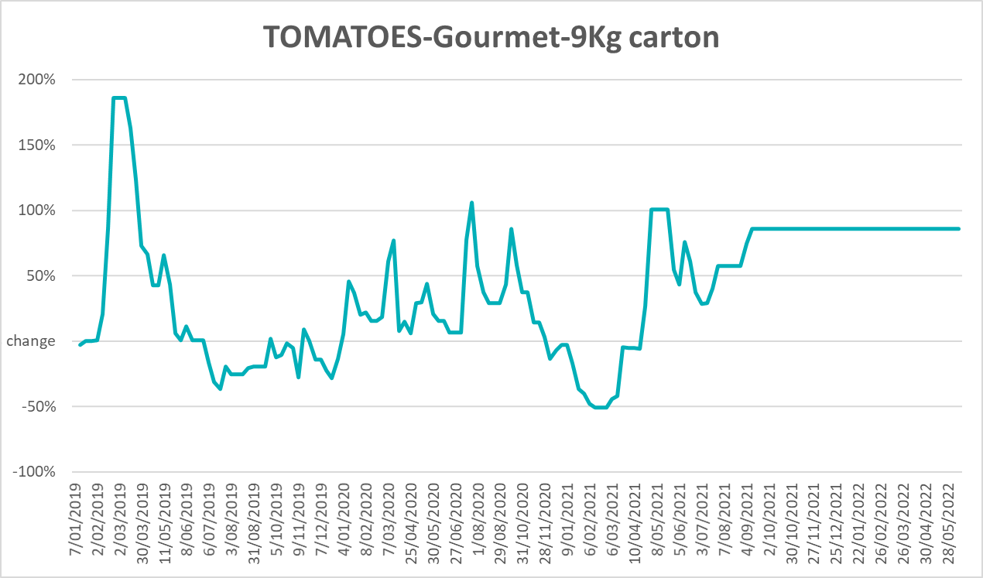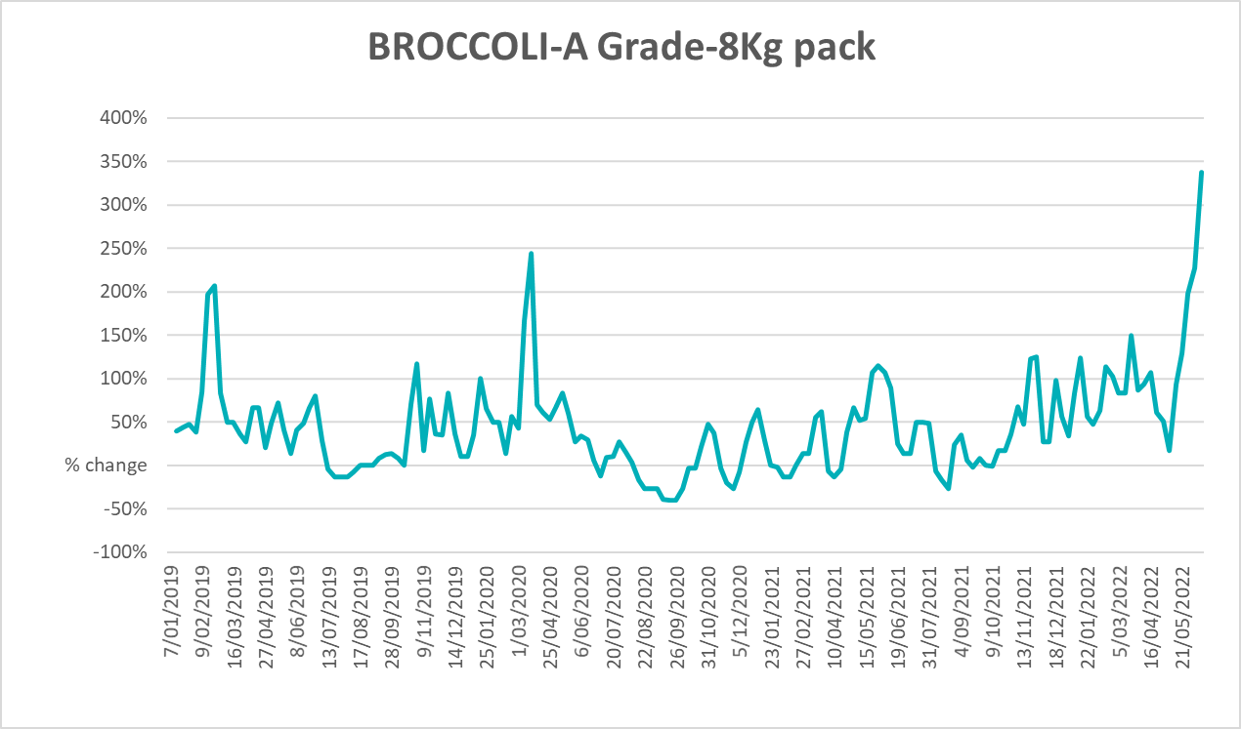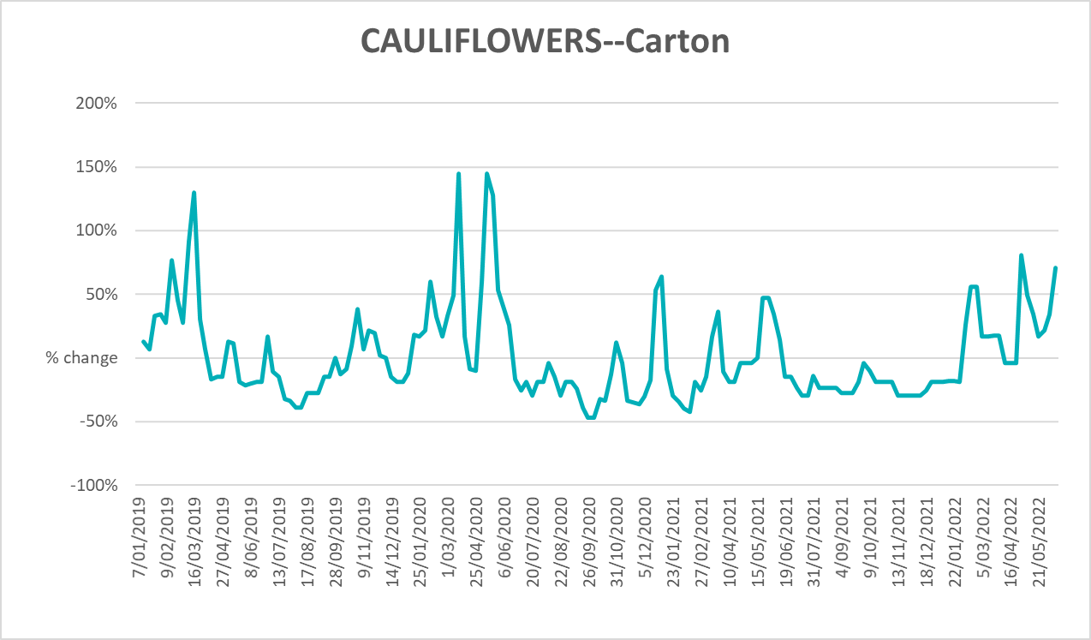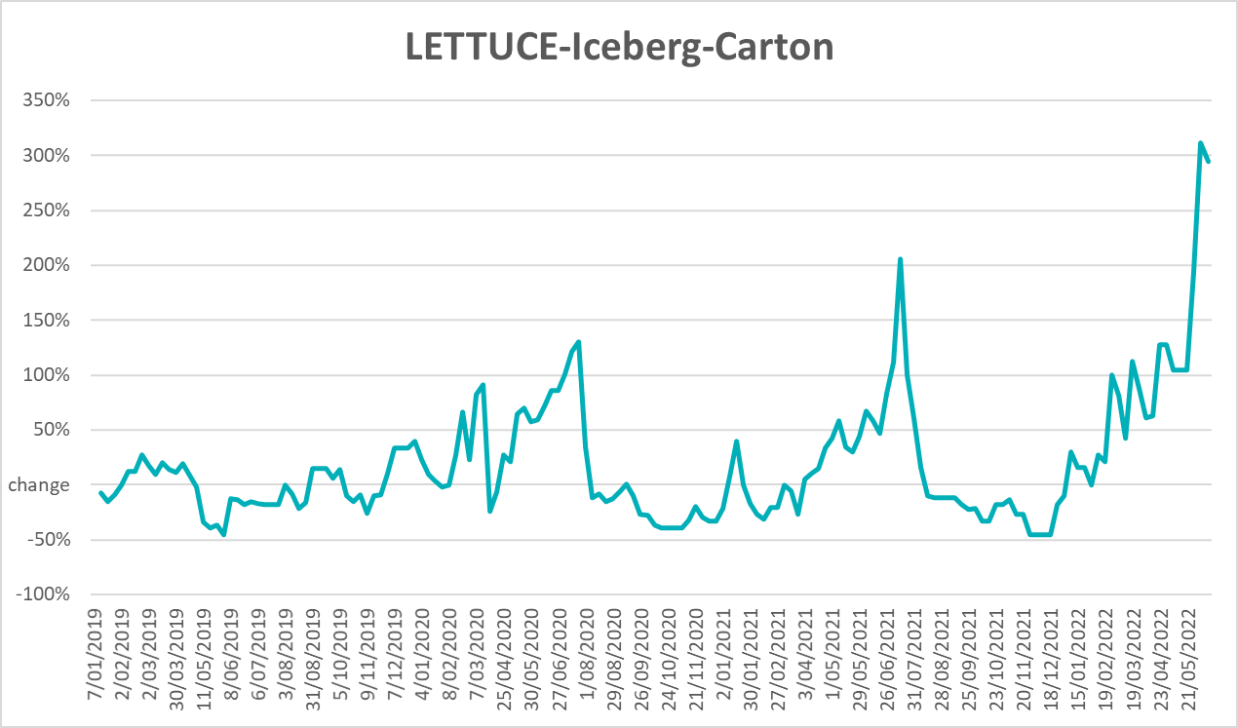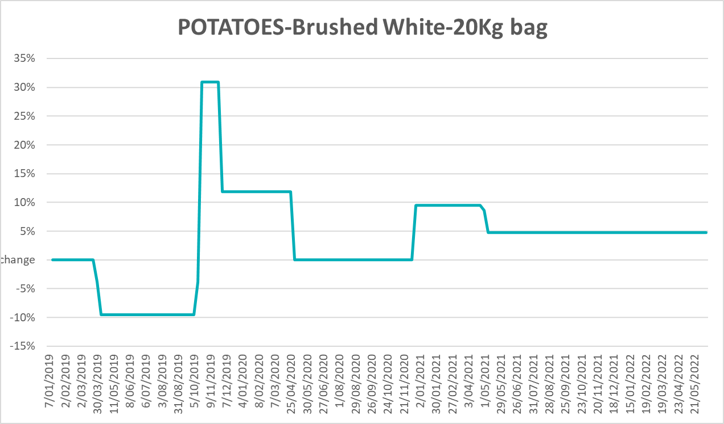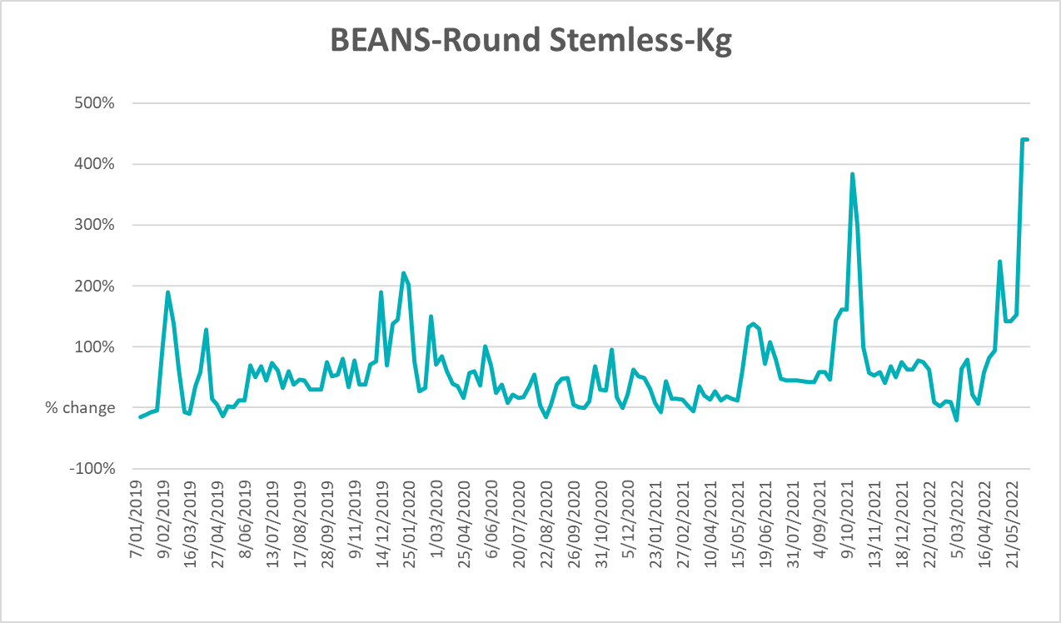

Selected domestic fodder indicator prices
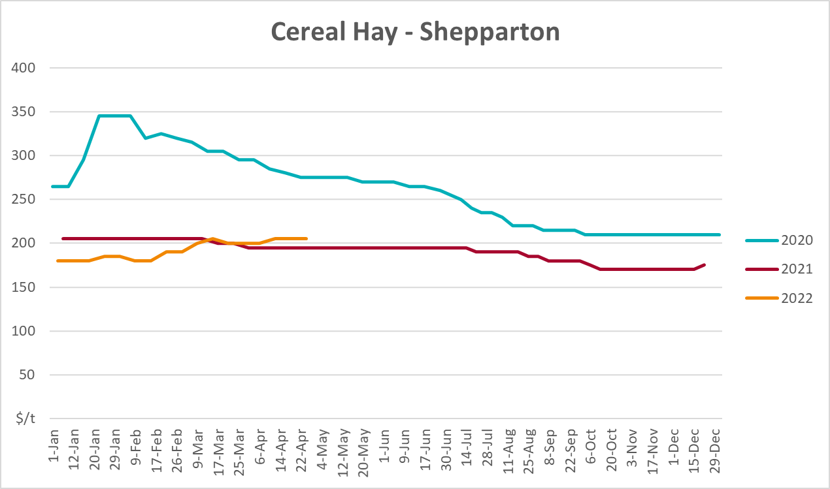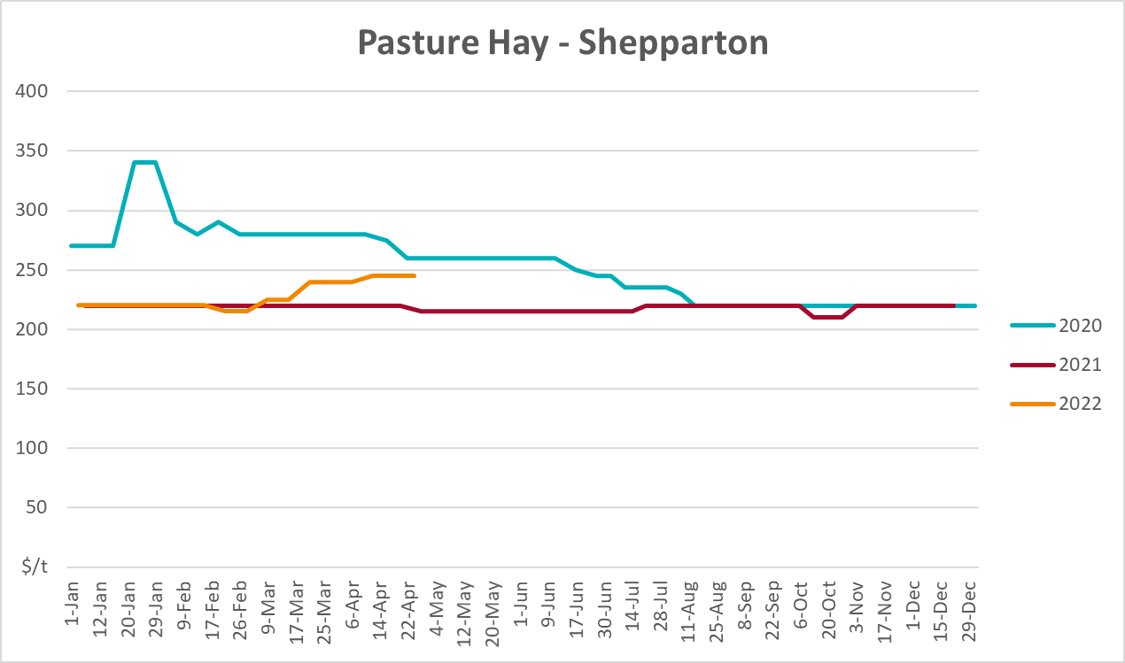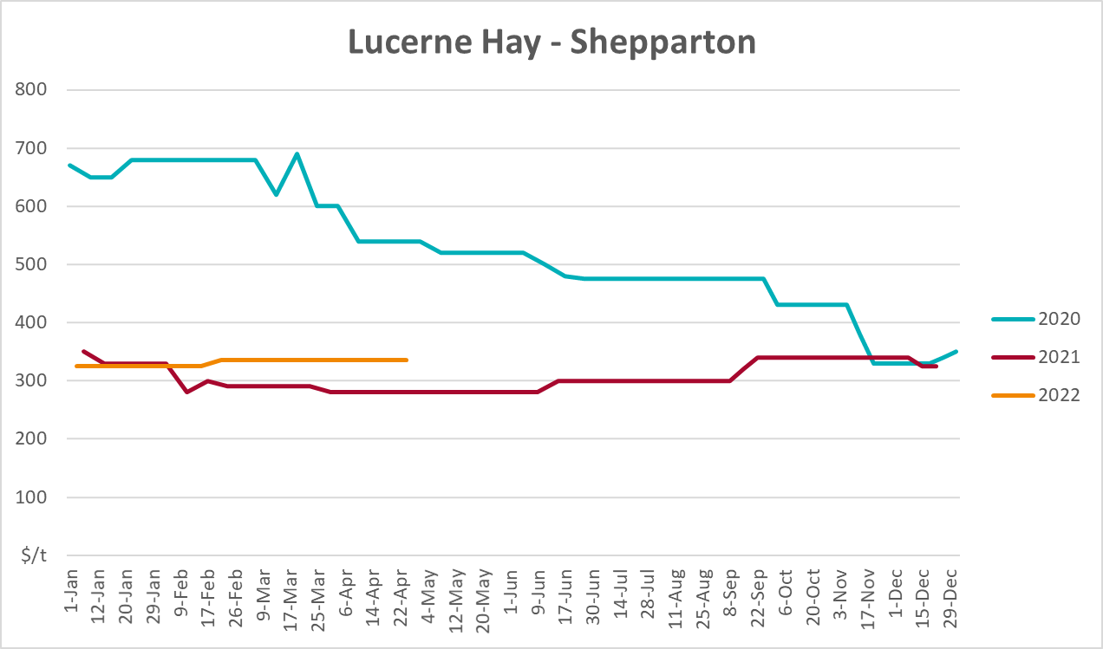

Data attribution

Climate
Bureau of Meteorology
- Weekly rainfall totals: www.bom.gov.au/climate/maps/rainfall/
- Monthly and last 3-month rainfall percentiles: www.bom.gov.au/water/landscape/
- Temperature anomalies: www.bom.gov.au/jsp/awap/temp/index.jsp
- Rainfall forecast: www.bom.gov.au/jsp/watl/rainfall/pme.jsp
- Seasonal outlook: www.bom.gov.au/climate/outlooks/#/overview/summary/
- Climate drivers: http://www.bom.gov.au/climate/enso/
- Soil moisture: www.bom.gov.au/water/landscape/
Other
- Pasture growth: www.longpaddock.qld.gov.au/aussiegrass/
- 3-month global outlooks: Environment and Climate Change Canada, NOAA Climate Prediction Center, EUROBRISA CPTEC/INPE, European Centre for Medium-Range Weather Forecasts, Hydrometcenter of Russia, National Climate Center Climate System Diagnosis and Prediction Room (NCC), International Research Institute for Climate and Society
- Global production: https://ipad.fas.usda.gov/ogamaps/cropmapsandcalendars.aspx
- Autumn break: Pook et al., 2009, https://rmets-onlinelibrary-wiley-com.virtual.anu.edu.au/doi/epdf/10.1002/joc.1833

Water
Prices
- Waterflow: https://www.waterflow.io/
- Ruralco: https://www.ruralcowater.com.au/
Bureau of Meteorology:
- Allocation trade: http://www.bom.gov.au/water/dashboards/#/water-markets/mdb/at
- Storage volumes: http://www.bom.gov.au/water/dashboards/#/water-storages/summary/drainage
Trade constraints:
- Water NSW: https://www.waternsw.com.au/customer-service/ordering-trading-and-pricing/trading/murrumbidgee
- Victorian Water Register: https://www.waterregister.vic.gov.au/TradingRules2019/

Commodities
Fruit and vegetables
- Datafresh: www.freshstate.com.au
Pigs
- Australian Pork Limited: www.australianpork.com.au
Dairy
- Global Dairy Trade: www.globaldairytrade.info/en/product-results/
World wheat, canola
- International Grains Council
World coarse grains
- United States Department of Agriculture
World cotton
- Cotlook: www.cotlook.com/
World sugar
- New York Stock Exchange - Intercontinental Exchange
Wool
- Australian Wool Exchange: www.awex.com.au/
Domestic wheat, barley, sorghum, canola and fodder
- Jumbuk Consulting Pty Ltd: http://www.jumbukag.com.au/
Cattle, beef, mutton, lamb, goat and live export
- Meat and Livestock Australia: www.mla.com.au/Prices-and-market
© Commonwealth of Australia 2022

Ownership of intellectual property rights
Unless otherwise noted, copyright (and any other intellectual property rights, if any) in this publication is owned by the Commonwealth of Australia (referred to as the Commonwealth).

Creative Commons licence
All material in this publication is licensed under a Creative Commons Attribution 4.0 International Licence except content supplied by third parties, logos and the Commonwealth Coat of Arms.
Inquiries about the licence and any use of this document should be emailed to copyright@awe.gov.au.


Cataloguing data
This publication (and any material sourced from it) should be attributed as:
ABARES 2022, Weekly Australian Climate, Water and Agricultural Update, Australian Bureau of Agricultural and Resource Economics and Sciences, Canberra, 23 June 2022. CC BY 4.0 DOI: https://doi.org/10.25814/5f3e04e7d2503
ISSN 2652-7561
This publication is available at https://www.awe.gov.au/abares/products/weekly_update
Department of Agriculture, Water and the Environment
GPO Box 858 Canberra ACT 2601
Telephone 1800 900 090
Web awe.gov.au/abares

Disclaimer
The Australian Government acting through the Department of Agriculture, Water and the Environment, represented by the Australian Bureau of Agricultural and Resource Economics and Sciences, has exercised due care and skill in preparing and compiling the information and data in this publication. Notwithstanding, the Department of Agriculture, Water and the Environment, ABARES, its employees and advisers disclaim all liability, including liability for negligence and for any loss, damage, injury, expense or cost incurred by any person as a result of accessing, using or relying on any of the information or data in this publication to the maximum extent permitted by law.

Statement of Professional Independence
The views and analysis presented in ABARES publications, including this one, reflect ABARES professionally independent findings, based on scientific and economic concepts, principles, information and data. These views, analysis and findings may not reflect or be consistent with the views or positions of the Australian Government, or of organisations or groups who have commissioned ABARES reports or analysis. More information on professional independence is provided on the ABARES website.

Acknowledgements
This report was prepared by Matthew Miller.

