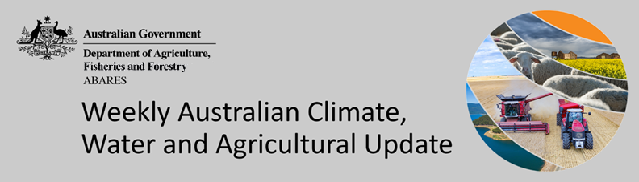
No. 38/2022

29 September 2022

Summary of key issues
- For the week ending 28 September 2022, a low-pressure system and onshore flow brought moderate to heavy rainfall to large areas of eastern Australia, with troughs and cold fronts resulting in isolated falls in other parts of the country. Weekly rainfall totals exceeding 50 millimetres were recorded in parts of eastern New South Wales and Victoria, as well as south-east Queensland and the far north of the Northern Territory. High-pressure systems over western and southern parts of the country resulted in clear, dry conditions (see Section 1.1).
- Another week of moderate to heavy rainfall across major cropping regions of eastern Australia has exacerbated waterlogging in low lying areas. Major flooding was also recorded across rivers in northern New South Wales, including the Culgoa, Bogan, Gwydir, Lachlan, Macquarie, Namoi and Narran rivers. Harvesting of winter crops is underway in Central Queensland, with the pace of activity expected to increase over the coming weeks if conditions allow.
- The northern rainfall onset occurs when the total rainfall after 1 September reaches 50 millimetres. This is considered approximately the amount of rainfall required to stimulate plant growth. Since 1 September 2022, rainfall in excess of 50 millimetres has been recorded across most of southern Queensland, as well as isolated parts of northern Queensland, Western Australia and the Northern Territory. The northern rainfall onset across cropping regions of eastern Australia is likely to impede the harvesting of winter crops and the sowing of summer crops, especially in areas that have already received above average rainfall throughout winter. However, the rainfall will boost soil moisture for summer crops and northern pastures (see Section 1.2).
- Over the 8 days to 6 October 2022, low-pressure systems and troughs are forecast to result in showers across eastern and north-western Australia. High-pressure systems will provide clear, dry conditions across remaining parts of the country. Limited rainfall in parts of Central Queensland over the coming week will allow the harvest of winter crops and the sowing of long-season summer crops to gather pace. Significant rainfall across remaining cropping regions of eastern and southern Australia will contribute to ongoing issues of waterlogging across low-lying areas (see Section 1.3).
- Water storage in the Murray–Darling Basin (MDB) increased by 60 gigalitres (GL) between 21 September 2022 and 28 September 2022. The current volume of water held in storage is 23,870 GL, which represents 95% of total capacity. This is 10% or 2,139 GL more than at the same time last year.
- Allocation prices in the Victorian Murray below the Barmah Choke decreased from $55 per ML on 16 September to $45 per ML on 23 September 2022. Prices are lower in the Goulburn-Broken and regions above the Barmah choke due to the binding of the Goulburn intervalley trade limit and the Barmah choke trade constraint.

Climate

Rainfall this week
For the week ending 28 September 2022, a low-pressure system and onshore flow brought moderate to heavy rainfall to large areas of eastern Australia, with troughs and cold fronts resulting in isolated falls in other parts of the country. Weekly rainfall totals exceeding 50 millimetres were recorded in parts of eastern New South Wales and Victoria, as well as south-east Queensland and the far north of the Northern Territory. High-pressure systems over western and southern parts of the country resulted in clear, dry conditions.
In Australian cropping regions, rainfall totals of between 10 and 50 millimetres were recorded across most of New South Wales, southern Queensland, Victoria and isolated parts of south-eastern South Australia. Rainfall in excess of 50 millimetres was recorded in isolated parts of New South Wales. Little to no rainfall was recorded in remaining cropping regions of northern Queensland, South Australia and Western Australia for the week ending 28 September 2022.
Another week of moderate to heavy rainfall across major cropping regions of eastern Australia has exacerbated waterlogging in low lying areas. Major flooding was also recorded across rivers in northern New South Wales, including the Culgoa, Bogan, Gwydir, Lachlan, Macquarie, Namoi and Narran rivers. The flooding is expected to result in isolated crop losses. More broadly, wet conditions will delay crop development and increase the risk of fungal damage. Root zone soil moisture levels remain well above average across most eastern and southern cropping regions, with further rainfall likely to diminish yield potentials.
Harvesting of winter crops is underway in Central Queensland, with the pace of activity expected to increase over the coming weeks if conditions allow. There are also reports of early harvesting in parts of Western Australia, however harvesting activity is unlikely to get underway in earnest for some weeks yet. The risk of frost and extreme heat will weigh on yield potentials through flowering and grain filling. Wet conditions across New South Wales, southern Queensland, Victoria and South Australia are expected to delay the start of harvesting of winter crops, especially for late sown crops.

Rainfall for the week ending 28 September 2022
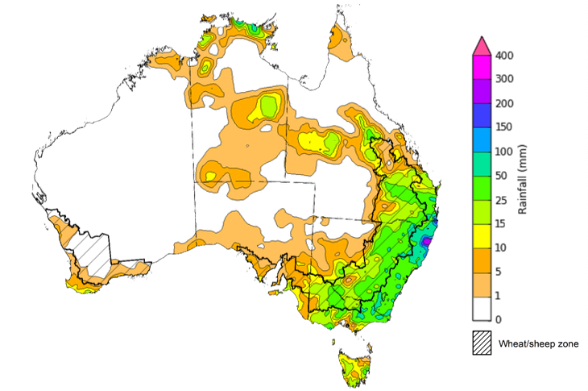
©Commonwealth of Australia 2022, Australian Bureau of Meteorology Issued:28/09/2022
Note: The rainfall analyses and associated maps utilise data contained in the Bureau of Meteorology climate database, the Australian Data Archive for Meteorology (ADAM). The analyses are initially produced automatically from real-time data with limited quality control. They are intended to provide a general overview of rainfall across Australia as quickly as possible after the observations are received. For further information go to http://www.bom.gov.au/climate/rainfall/

Northern rainfall onset
The northern rainfall onset occurs when the total rainfall after 1 September reaches 50 millimetres. This is considered approximately the amount of rainfall required to stimulate plant growth. Coastal parts of northern Australia usually accumulate 50 millimetres of rainfall by late October or early November, spreading to inland areas over subsequent weeks. The presence of La Niña conditions is associated with earlier than normal northern rainfall onset. Negative Indian Ocean Dipole conditions may also contribute to a higher likelihood of an earlier than normal northern rainfall onset.
Median northern rainfall onset in La Niña years 1981 to 2018
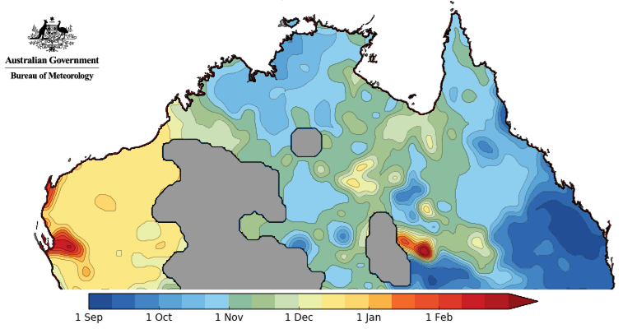
©Commonwealth of Australia 2022, Australian Bureau of Meteorology Issued:24/06/2022
Since 1 September 2022, rainfall in excess of 50 millimetres has been recorded across most of southern Queensland, as well as isolated parts of northern Queensland, Western Australia and the Northern Territory. For summer cropping regions, rainfall in excess of 50 millimetres has been recorded across New South Wales and most of Queensland. Rainfall in excess of 100 millimetres has also been received in parts of eastern and northern New South Wales and southern Queensland, causing localised flooding. The northern rainfall onset across cropping regions of eastern Australia is likely to impede the harvesting of winter crops and the sowing of summer crops, especially in areas that have already received above average rainfall throughout winter. However, the rainfall will boost soil moisture for summer crops and northern pastures.
Month-to-date rainfall at 28 September 2022
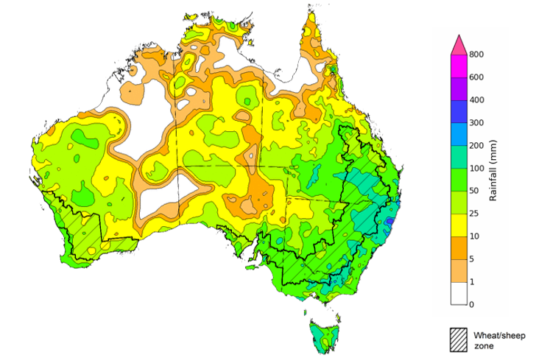
©Commonwealth of Australia 2022, Australian Bureau of Meteorology Issued:28/09/2022

Rainfall forecast for the next eight days
Over the 8-days to 6 October 2022, low-pressure systems and troughs are forecast to result in showers across eastern and north-western Australia. High-pressure systems will provide clear, dry conditions across remaining parts of the country.
In Australian cropping regions, rainfall totals of between 10 and 50 millimetres are expected across New South Wales, Victoria, South Australia, most of Queensland and isolated parts of the south of Western Australia. Little to no rainfall is forecast for remaining cropping regions in northern Queensland and Western Australia during the next 8-days.
Limited rainfall in parts of Central Queensland over the coming week will allow the harvest of winter crops and the sowing of long-season summer crops to gather pace. Significant rainfall across remaining cropping regions of eastern and southern Australia will contribute to ongoing issues of waterlogging across low-lying areas. These wet conditions are expected to prolong inundation of crops, negatively impacting yield potentials, as well as restricting the ability to access fields for disease management. Yield potentials remain above average across cropping regions, but rainfall over the coming weeks is unlikely to improve them further.
The biggest threat to yield potentials across eastern and southern cropping regions remain waterlogging and frost as winter crops enter flowering and grain filling. For Western Australia, frost and extreme heat present the biggest downside risk, given the favourable conditions to date. The continued influence of a negative Indian Ocean Dipole and the establishment of a La Niña event in the Pacific Ocean suggests a continuation of wet conditions over the coming months for eastern Australia. A likely consequence will be delays in harvesting winter crops and planting summer crops, as well as increased crop damage.

Total forecast rainfall (mm) for the period 29 September to 6 October 2022
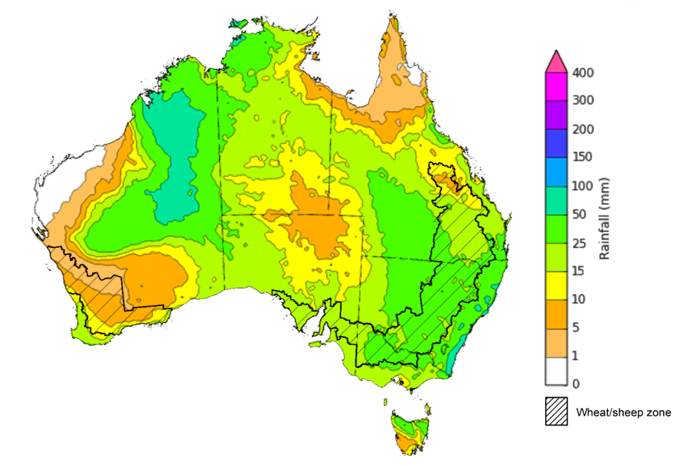
©Commonwealth of Australia 2022, Australian Bureau of Meteorology Issued 28/09/2022

Water
Note: This rainfall forecast is produced from computer models. As the model outputs are not altered by weather forecasters, it is important to check local forecasts and warnings issued by the Bureau of Meteorology.

Water markets – current week
Water storage in the Murray–Darling Basin (MDB) increased by 60 gigalitres (GL) between 21 September 2022 and 28 September 2022. The current volume of water held in storage is 23,870 GL, which represents 95% of total capacity. This is 10% or 2,139 GL more than at the same time last year.

Water storages in the Murray-Darling Basin, 2013–2022
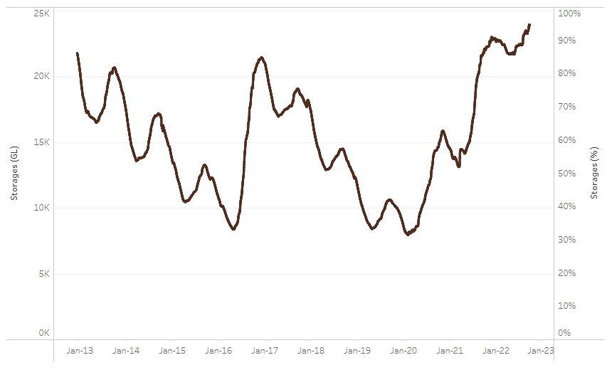
Allocation prices in the Victorian Murray below the Barmah Choke decreased from $55 per ML on 16 September to $45 per ML on 23 September 2022. Prices are lower in the Goulburn-Broken and regions above the Barmah choke due to the binding of the Goulburn intervalley trade limit and the Barmah choke trade constraint.
Water storage data is sourced from the Bureau of Meteorology.

Region | $/ML
NSW Murray Above | 31
NSW Murrumbidgee | 64
VIC Goulburn-Broken | 35
VIC Murray Below | 45

Surface water trade activity, Southern Murray–Darling Basin

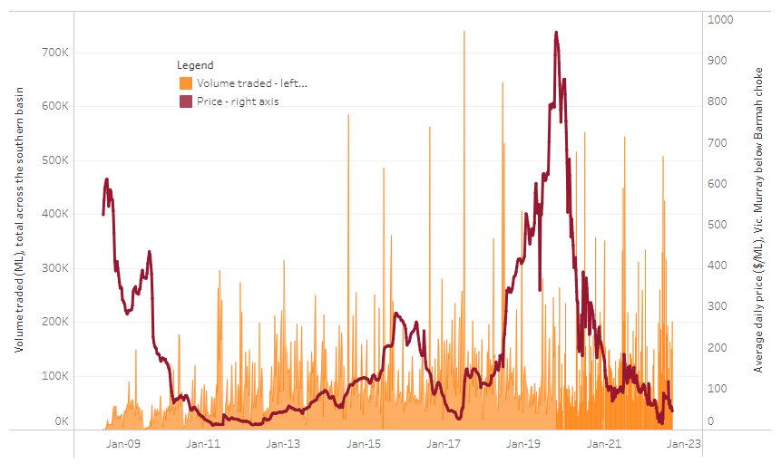
To access the full, interactive, weekly water dashboard, which contains the latest and historical water storage, water market and water allocation information, please visit http://www.agriculture.gov.au/abares/products/weekly_update/weekly-update-290922
The trades shown reflect estimated market activity and do not encompass all register trades. The price is shown for the VIC Murray below the Barmah choke. Historical prices (before 1 July 2019) are ABARES estimates after removing outliers from BOM water register data. Prices after 1 July 2019 and prior to the 30 October 2019 reflect recorded transaction prices as sourced from Ruralco. Prices after the 30 October 2019 are sourced from Waterflow. Data for volume traded is sourced from the BOM water register. Data shown is current at 29 September 2022.

Commodities

Indicator | Week ended | Unit | Latest price | Previous week | Weekly change | Price 12 months ago | Annual change
Selected world indicator prices
AUD/USD Exchange rate | 28-Sep | A$/US$ | 0.67 | 0.68 | -1% | 0.73 | -8%
Wheat – US no. 2 hard red winter wheat, fob Gulf | 28-Sep | US$/t | 425 | 430 | -1% | 357 | 19%
Corn – US no. 2 yellow corn, fob Gulf | 28-Sep | US$/t | 325 | 326 | 0% | 241 | 35%
Canola – Rapeseed, Canada, fob Vancouver | 28-Sep | US$/t | 650 | 643 | 1% | 790 | -18%
Cotton – Cotlook 'A' Index | 28-Sep | USc/lb | 109 | 114 | -4% | 117 | -7%
Sugar – Intercontinental Exchange, nearby futures, no.11 contract | 28-Sep | USc/lb | 17.6 | 17.7 | 0% | 20 | -12%
Wool – Eastern Market Indicator | 14-Sep | Ac/kg clean | 1,279 | 1,306 | -2% | 1,420 | -10%
Wool – Western Market Indicator | 10-Aug | Ac/kg clean | 1,459 | 1,449 | 1% | 1,346 | 8%
Selected Australian grain export prices
Milling Wheat – APW, Port Adelaide, SA | 28-Sep | A$/t | 540 | 542 | 0% | 439 | 23%
Feed Wheat – ASW, Port Adelaide, SA | 28-Sep | A$/t | 495 | 497 | 0% | 433 | 14%
Feed Barley – Port Adelaide, SA | 28-Sep | A$/t | 436 | 453 | -4% | 360 | 21%
Canola – Kwinana, WA | 28-Sep | A$/t | 989 | 1,001 | -1% | 976 | 1%
Grain Sorghum – Brisbane, QLD | 28-Sep | A$/t | 432 | 438 | -1% | 368 | 17%
Selected domestic livestock indicator prices
Beef – Eastern Young Cattle Indicator | 28-Sep | Ac/kg cwt | 1,079 | 1,056 | 2% | 1,027 | 5%
Mutton – Mutton indicator (18–24 kg fat score 2–3), Vic | 28-Sep | Ac/kg cwt | 517 | 516 | 0% | 622 | -17%
Lamb – Eastern States Trade Lamb Indicator | 21-Sep | Ac/kg cwt | 754 | 746 | 1% | 958 | -21%
Pig – Eastern Seaboard (60.1–75 kg), average of buyers & sellers | 10-Aug | Ac/kg cwt | 378 | 378 | 0% | 318 | 19%
Goats – Eastern States (12.1–16 kg) | 29-Jun | Ac/kg cwt | 1,030 | 879 | 17% | 818 | 26%
Live cattle – Light steers ex Darwin to Indonesia | 17-Aug | Ac/kg lwt | 420 | 480 | -13% | 320 | 31%
Live sheep – Live wethers (Muchea WA saleyard) to Middle East | 14-Sep | $/head | 93 | 113 | -18% | 114 | -18%

Indicator | Week ended | Unit | Latest price | Previous week | Weekly change | Price 12 months ago | Annual change
Global Dairy Trade (GDT) weighted average prices ª
Dairy – Whole milk powder | 07-Sep | US$/t | 3,610 | 3,417 | 6% | 2,936 | 23%
Dairy – Skim milk powder | 07-Sep | US$/t | 3,575 | 3,524 | 1% | 2,608 | 37%
Dairy – Cheddar cheese | 07-Sep | US$/t | 5,046 | 5,005 | 1% | 3,442 | 47%
Dairy – Anhydrous milk fat | 07-Sep | US$/t | 5,677 | 4,990 | 14% | 3,873 | 47%
a Global Dairy Trade prices are updated twice monthly on the first and third Tuesday of each month.

Selected world indicator prices
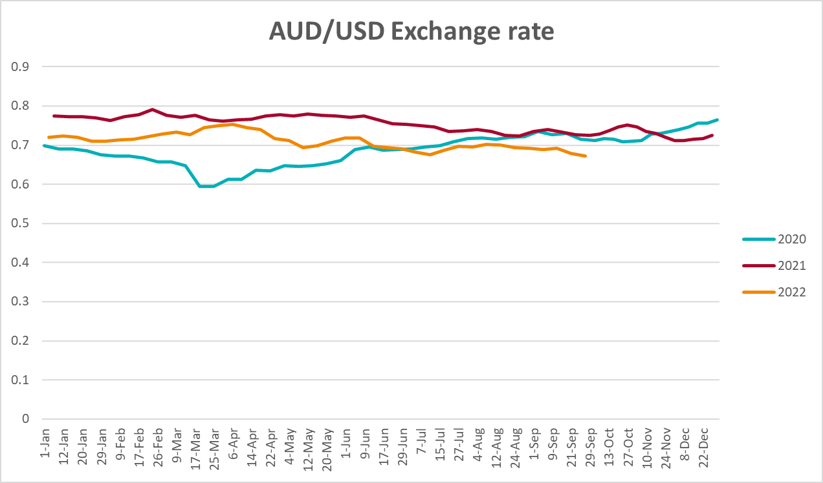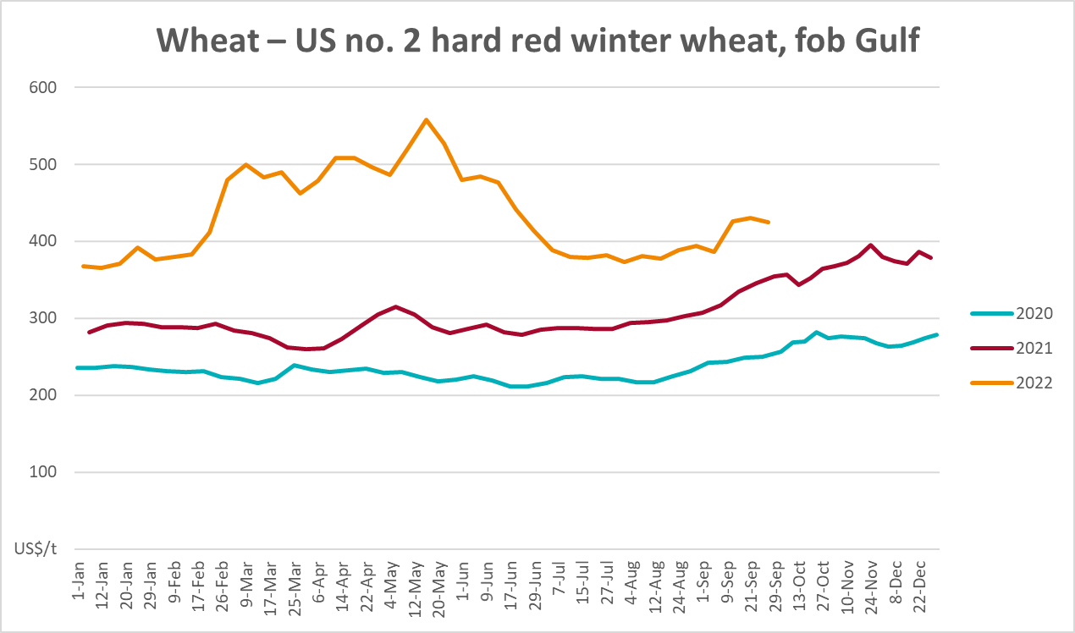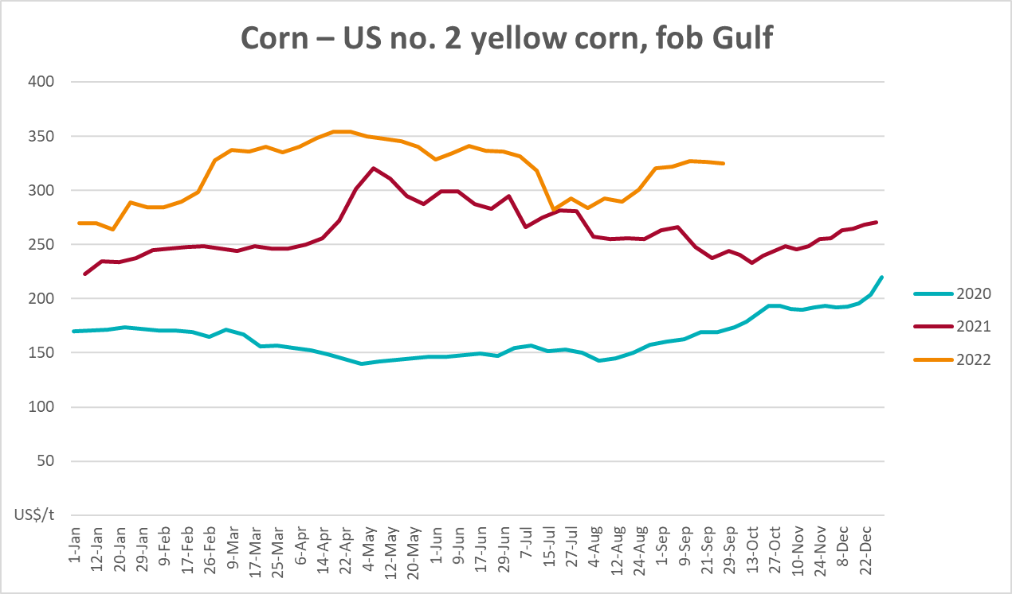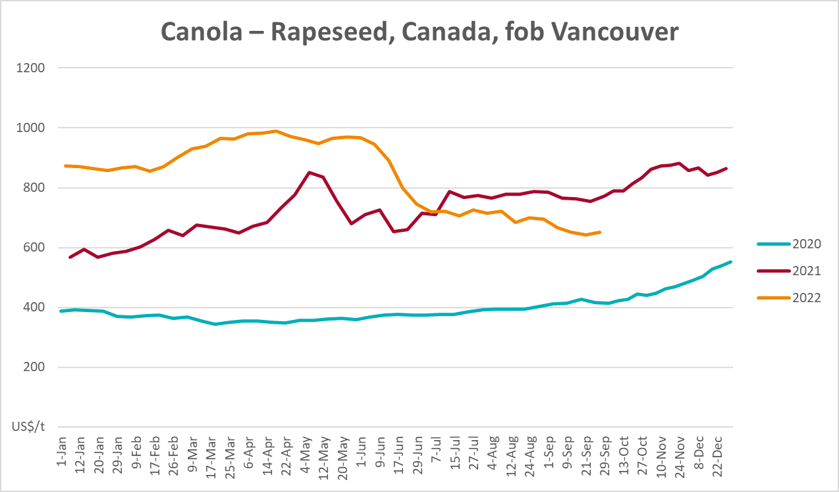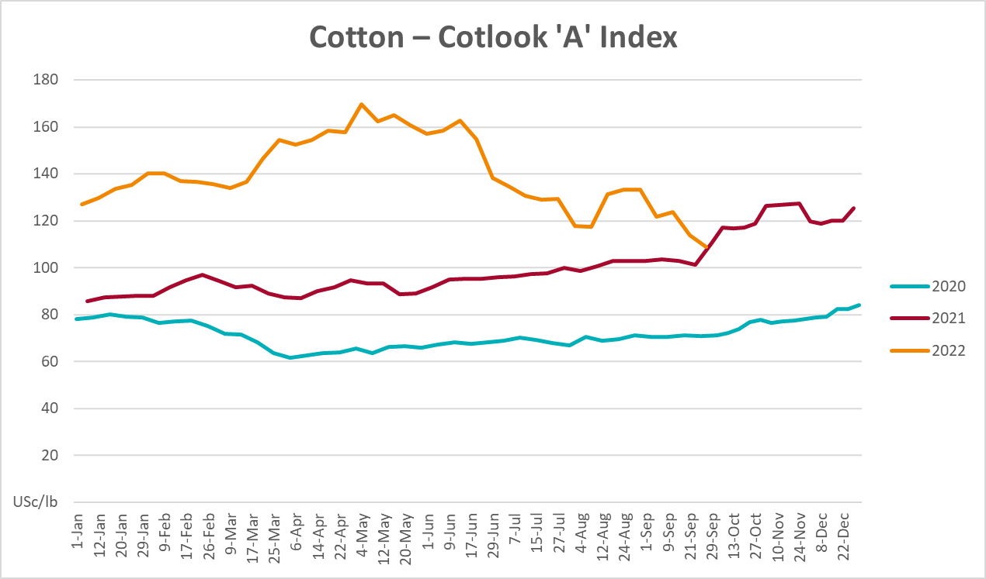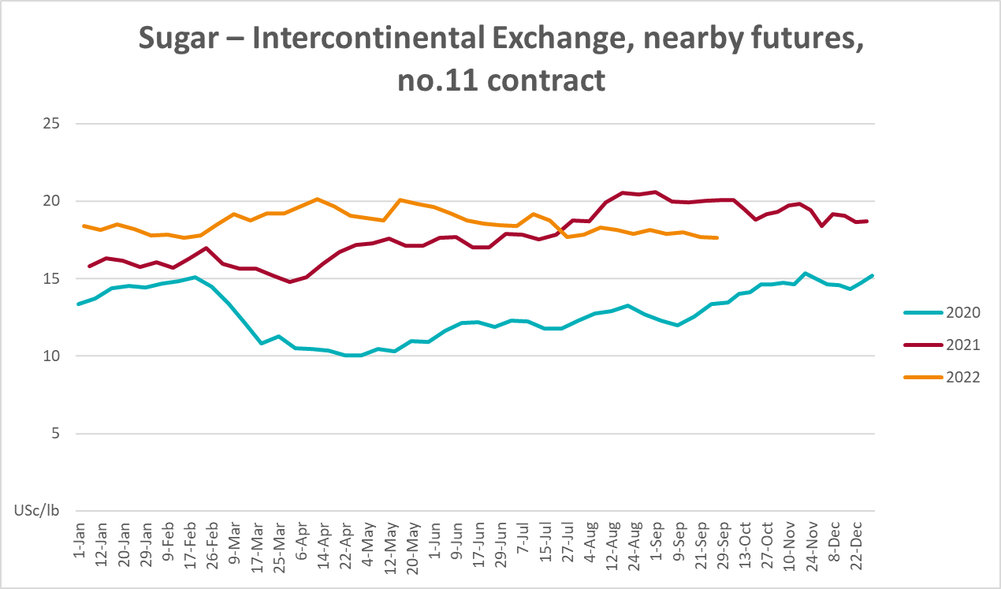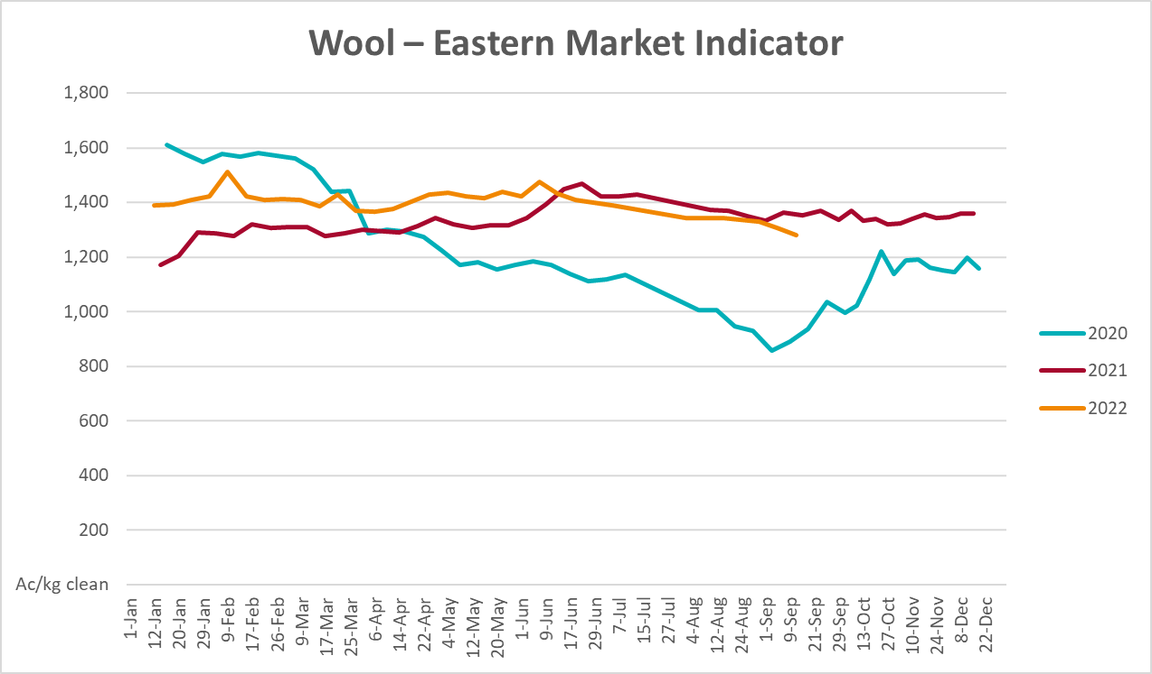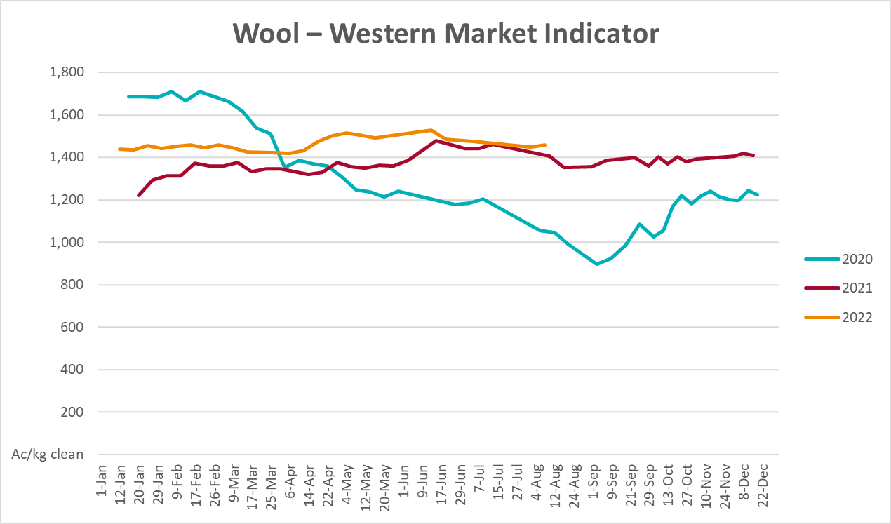

Selected domestic crop indicator prices
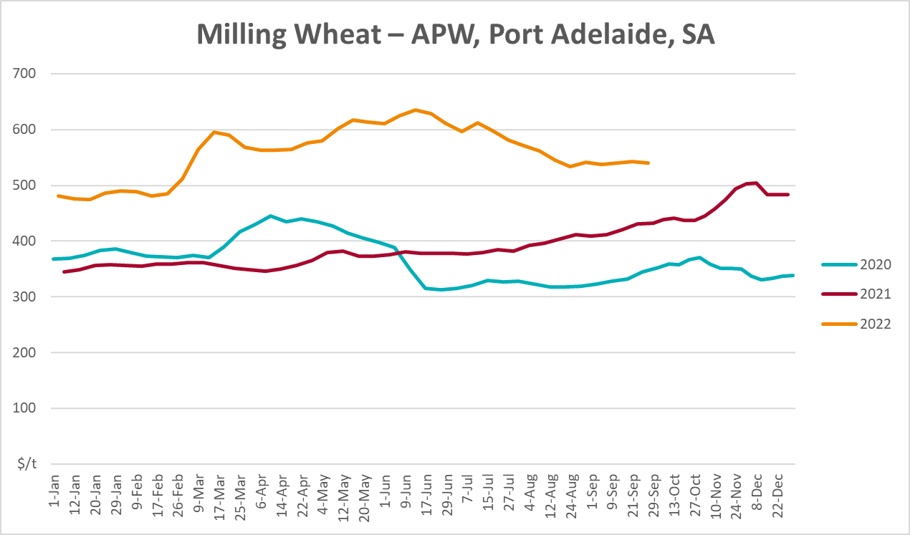
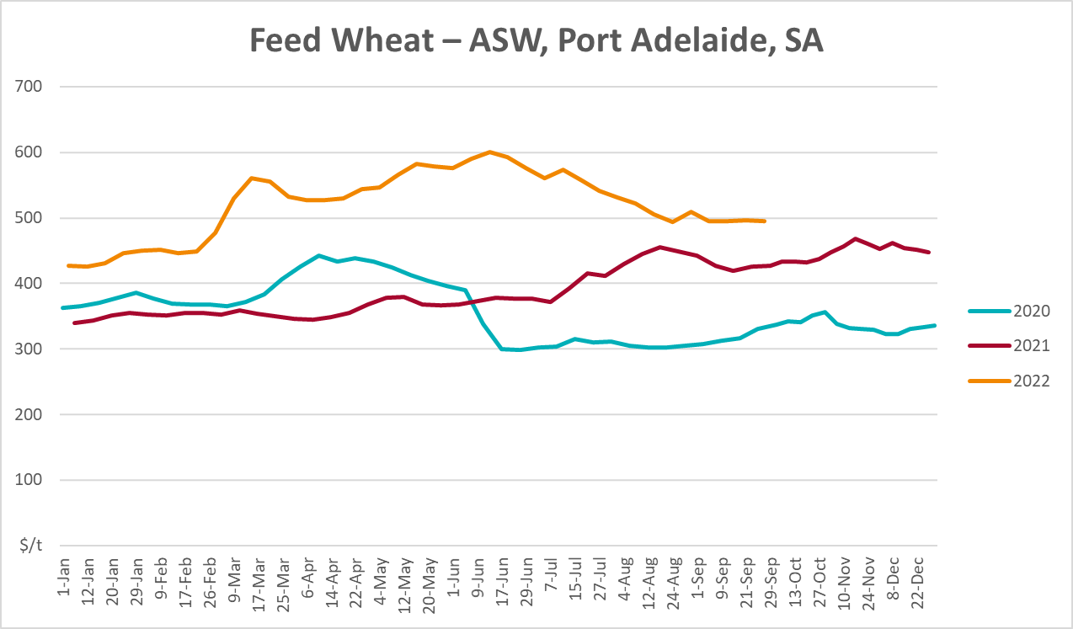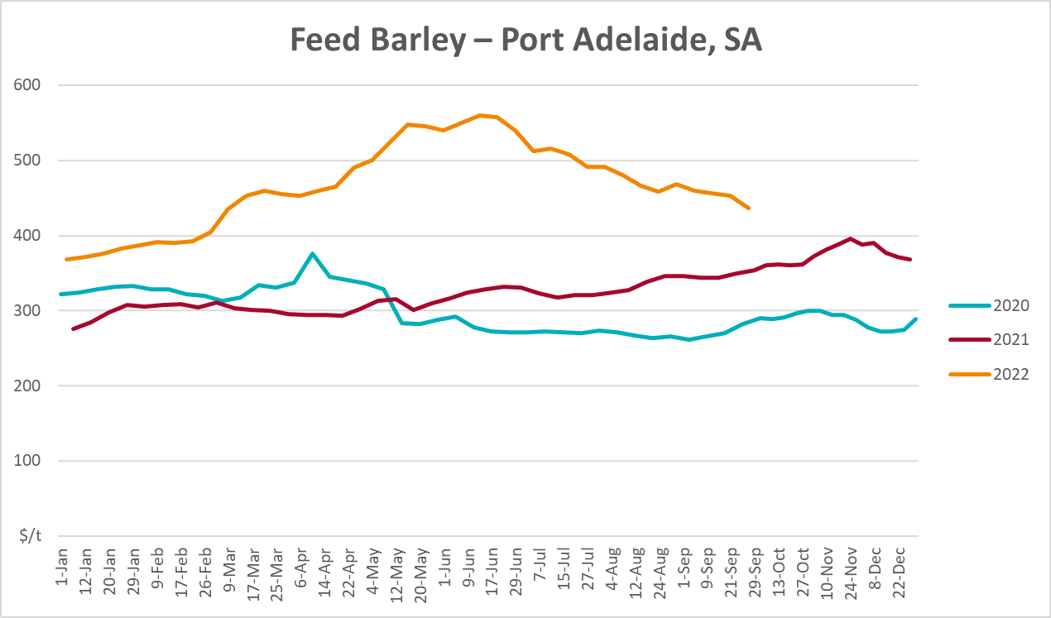
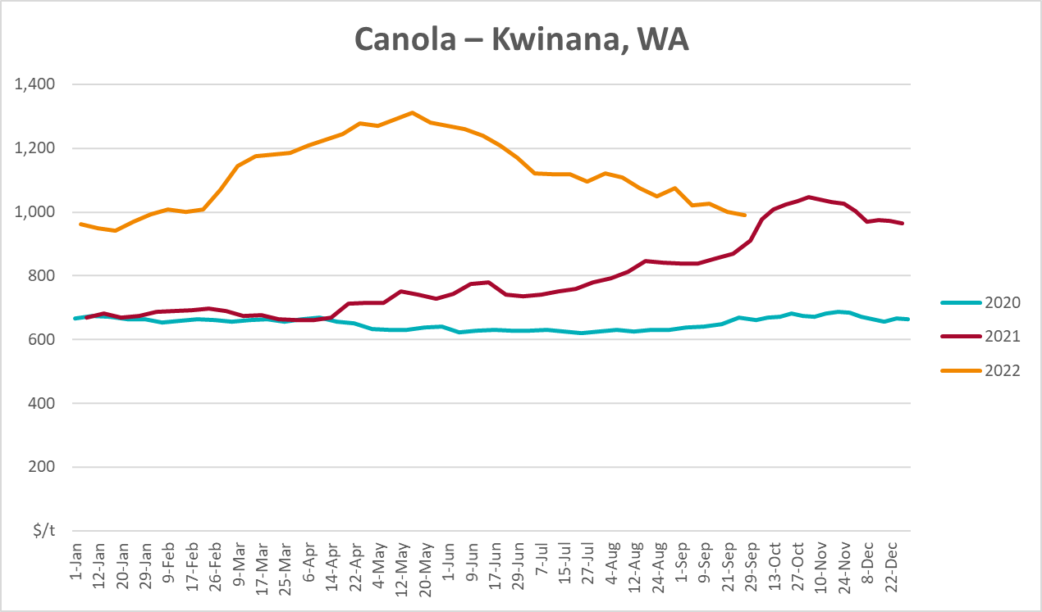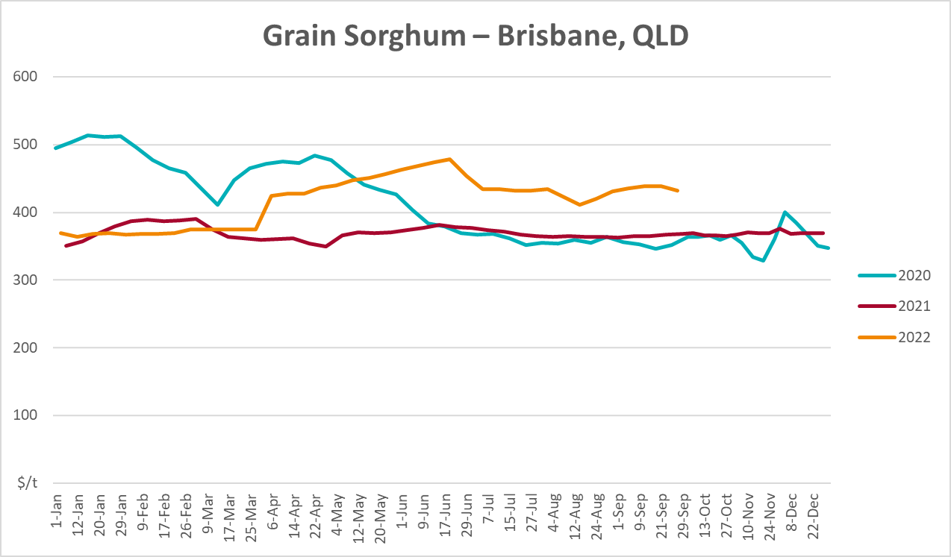

Selected domestic livestock indicator prices
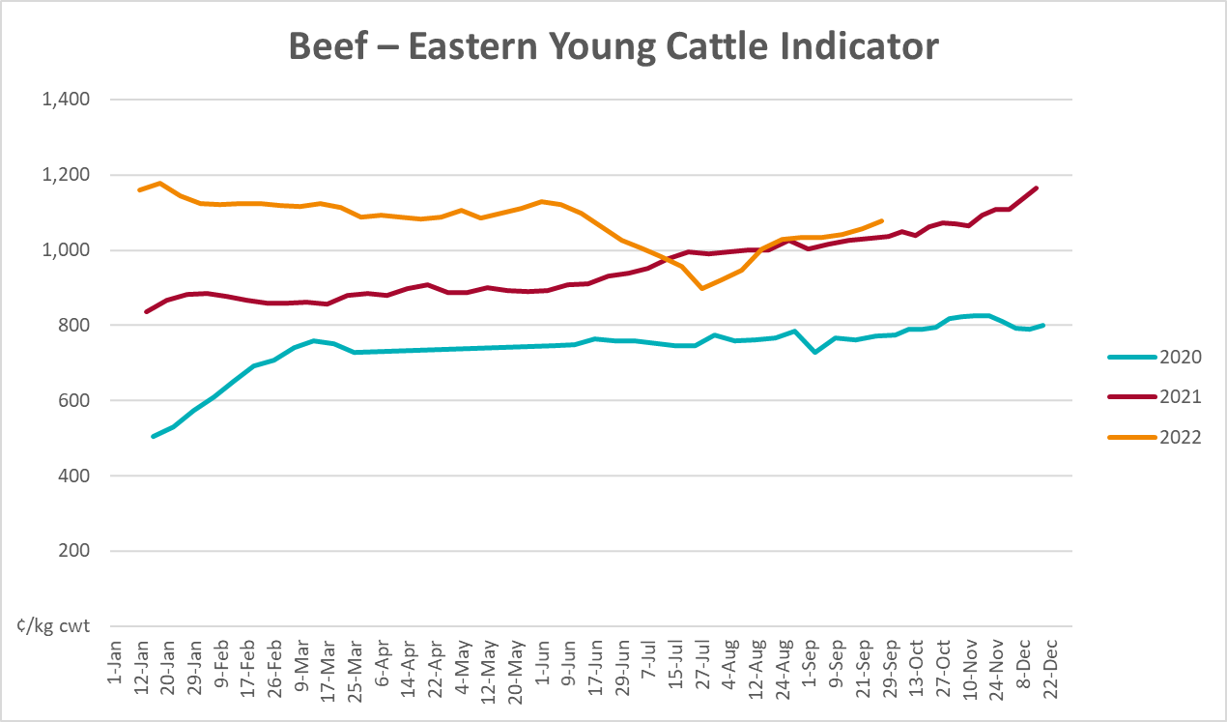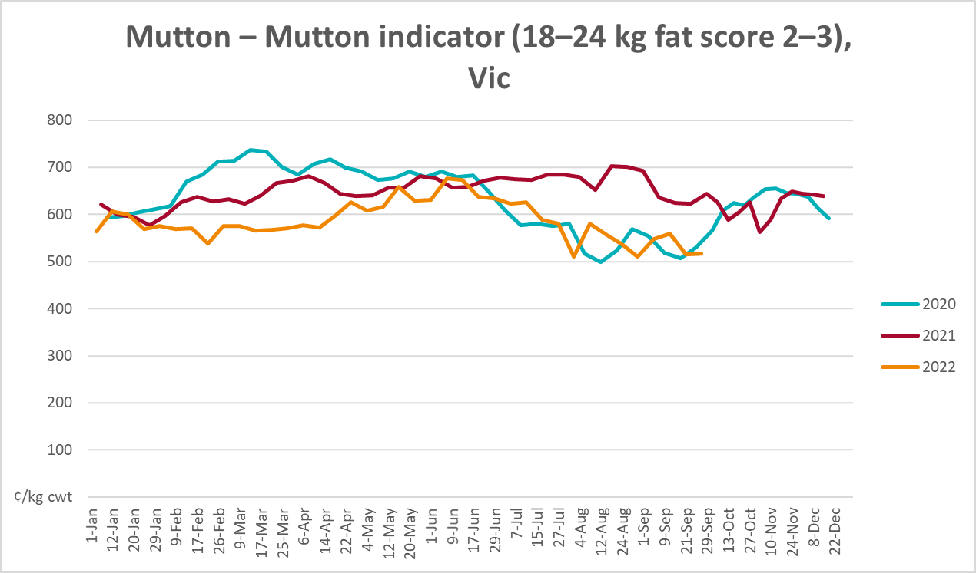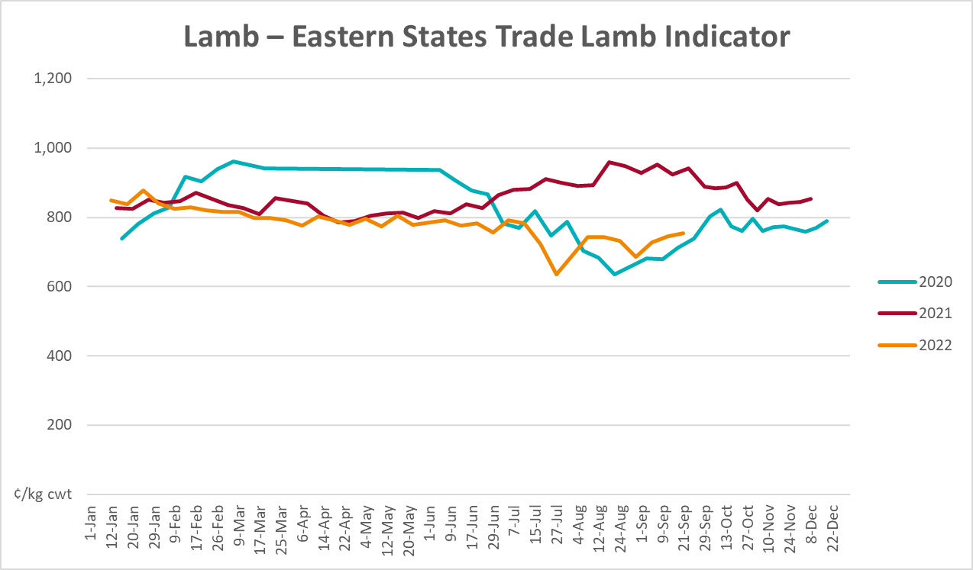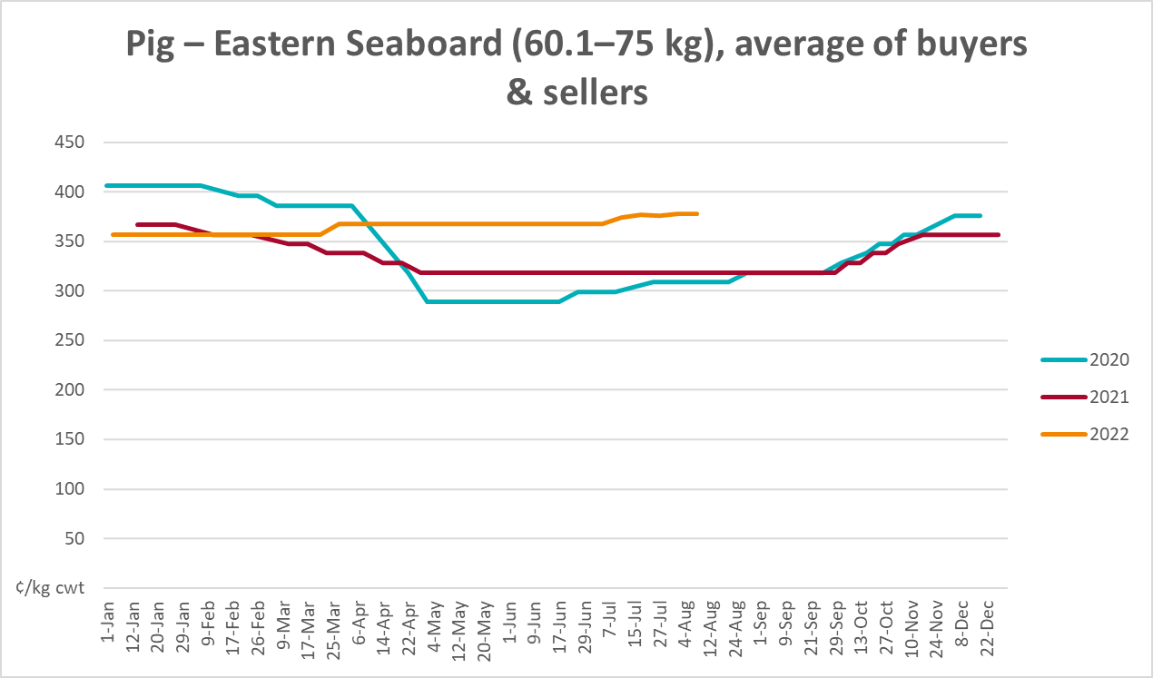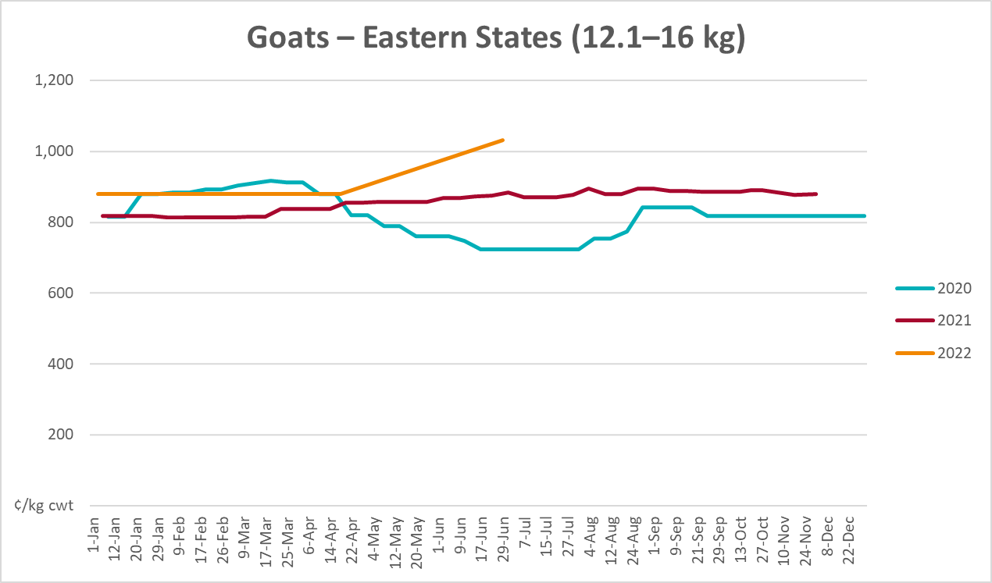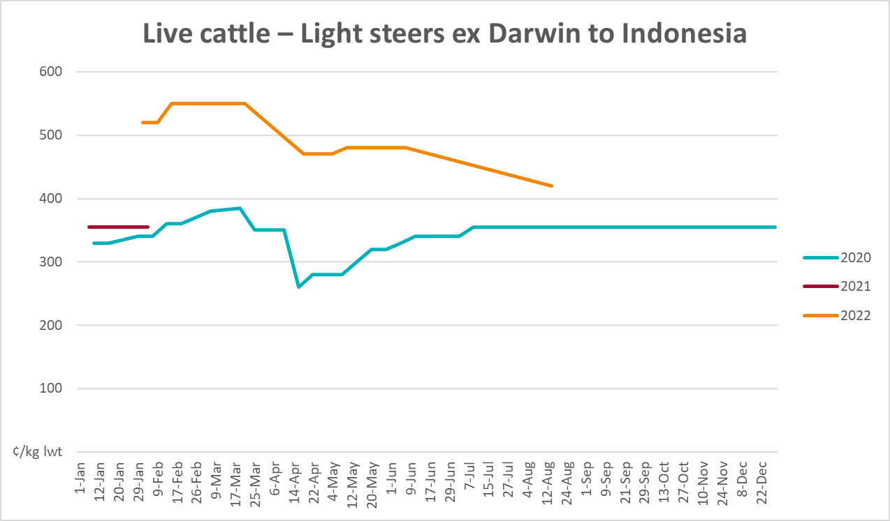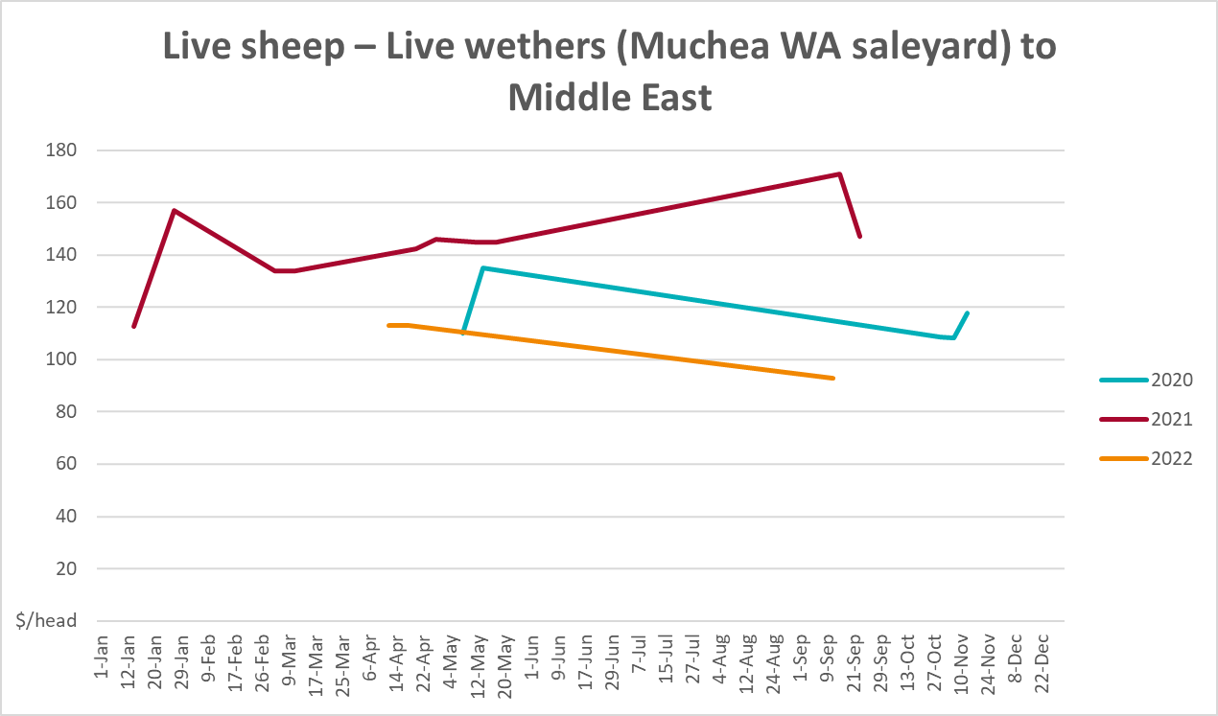

Global Dairy Trade (GDT) weighted average prices
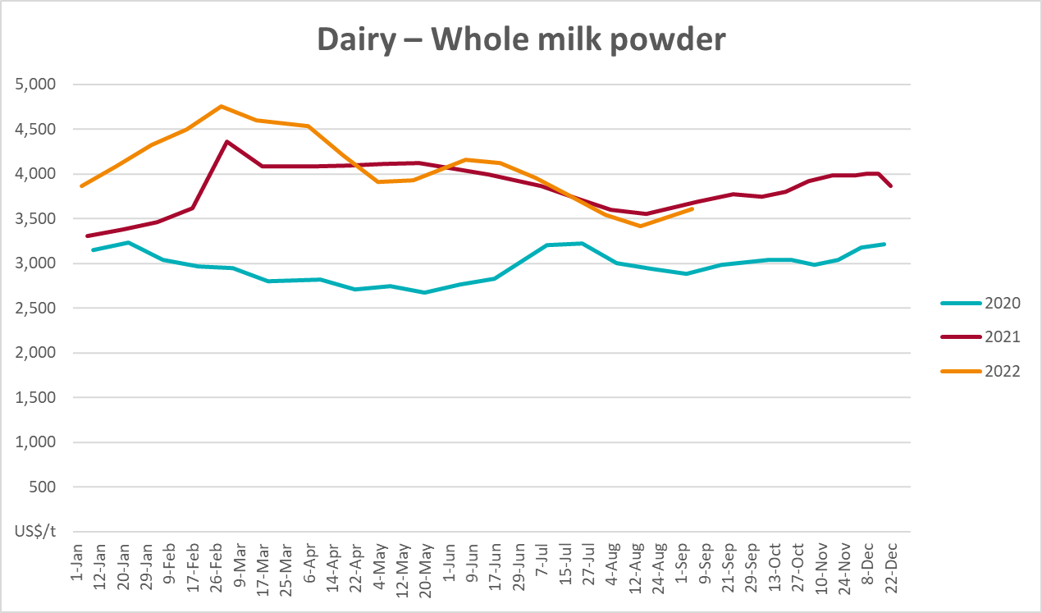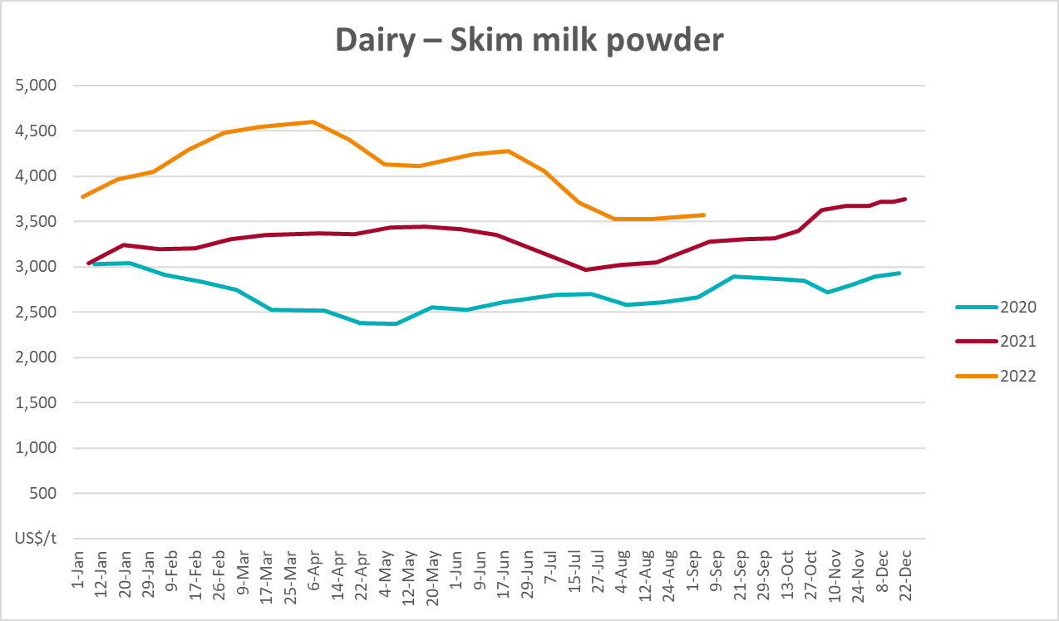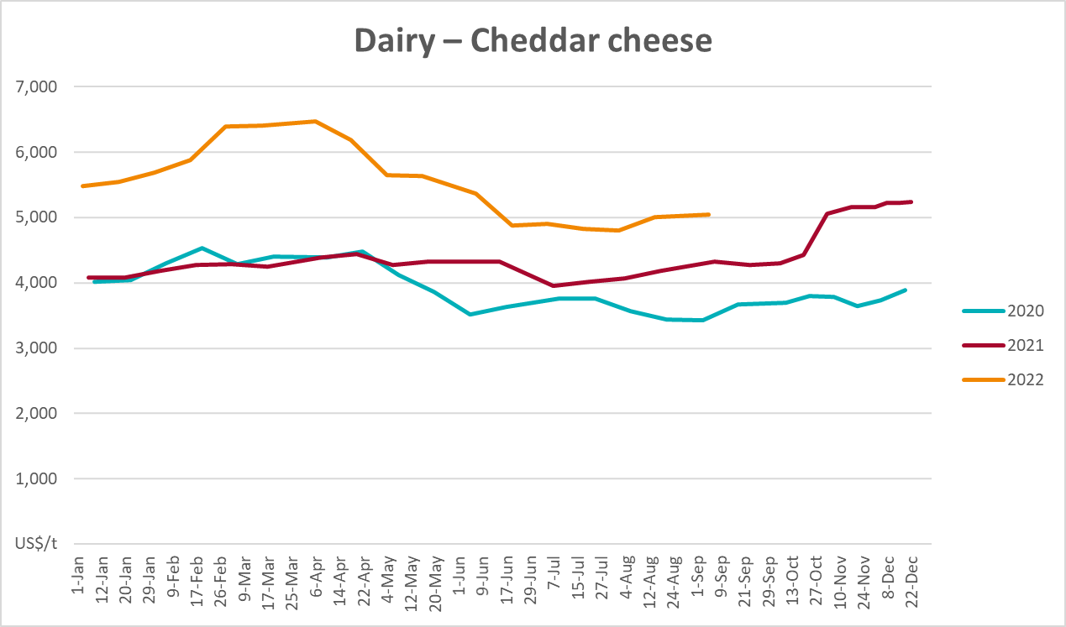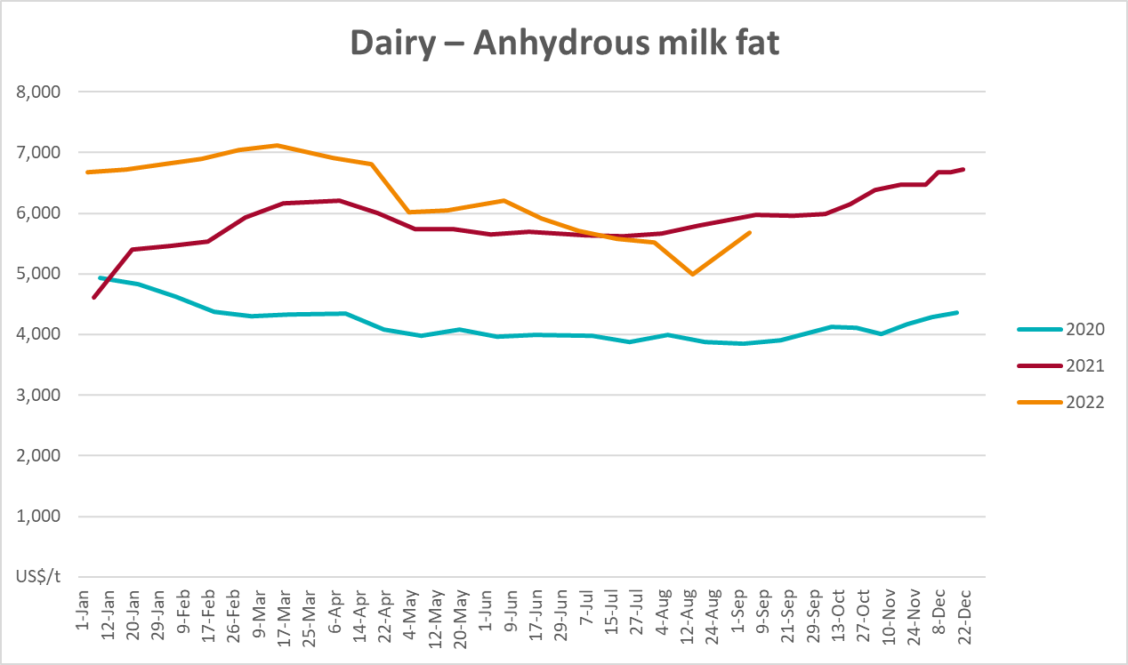

Selected fruit and vegetable prices
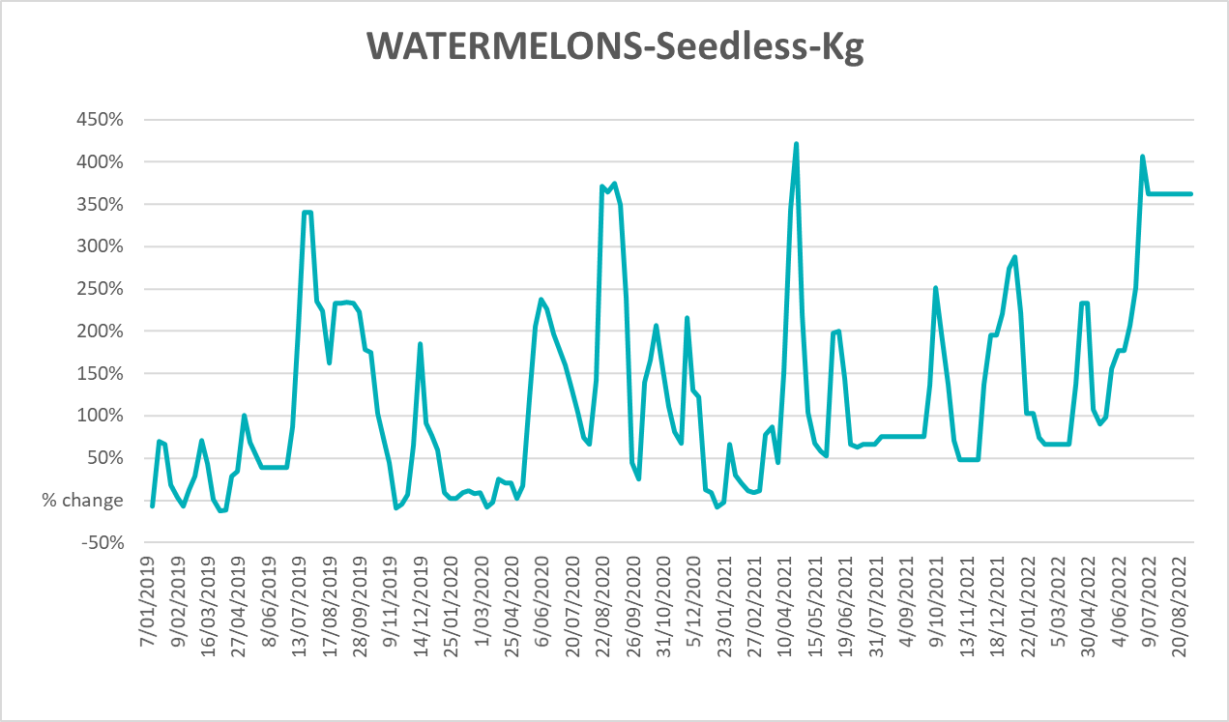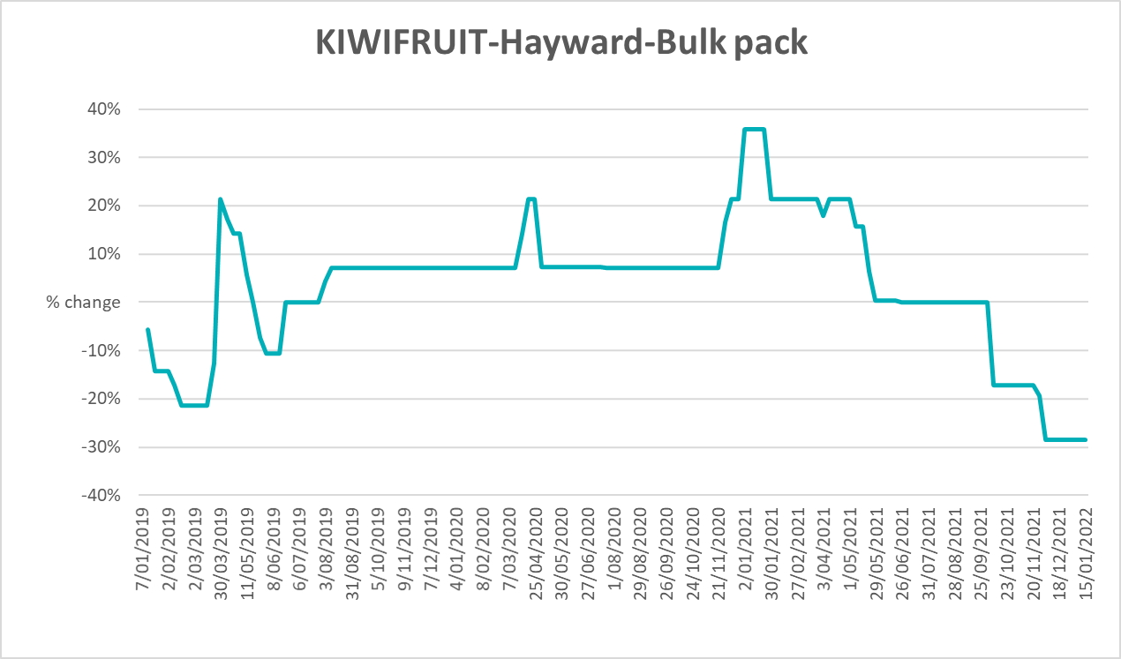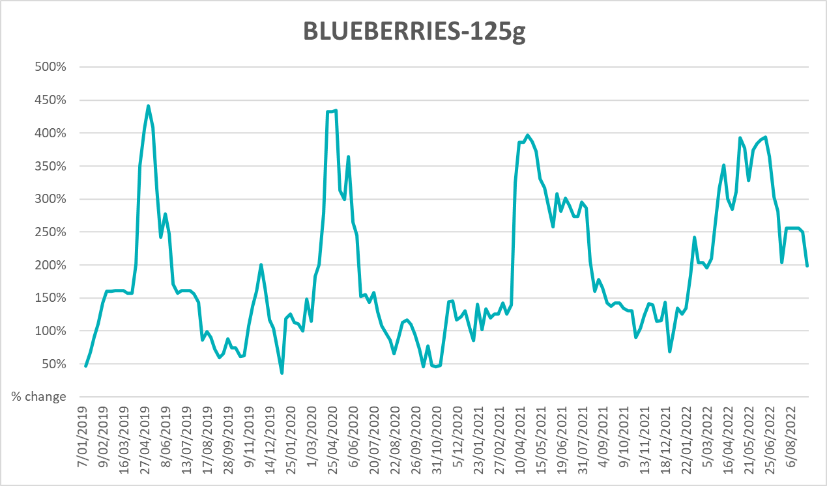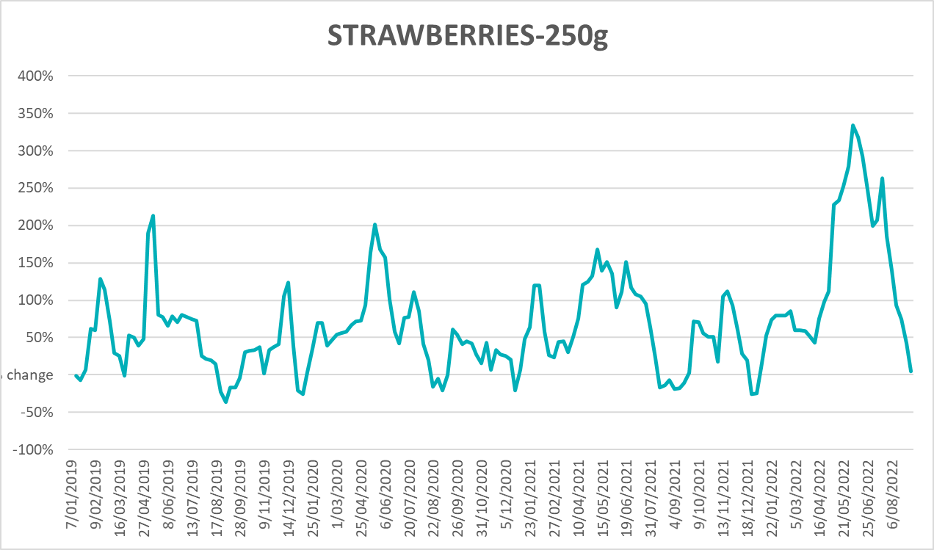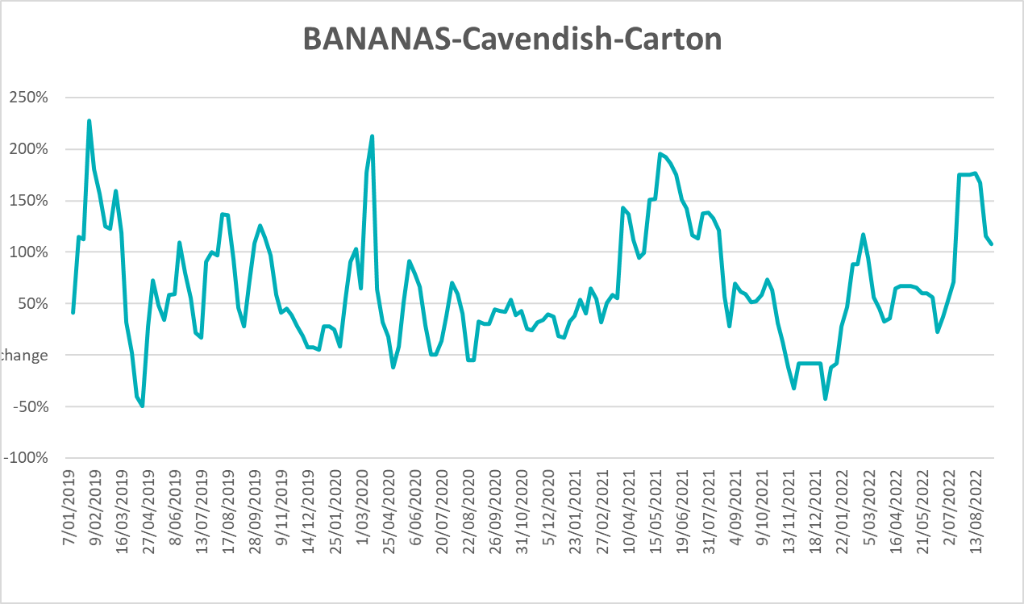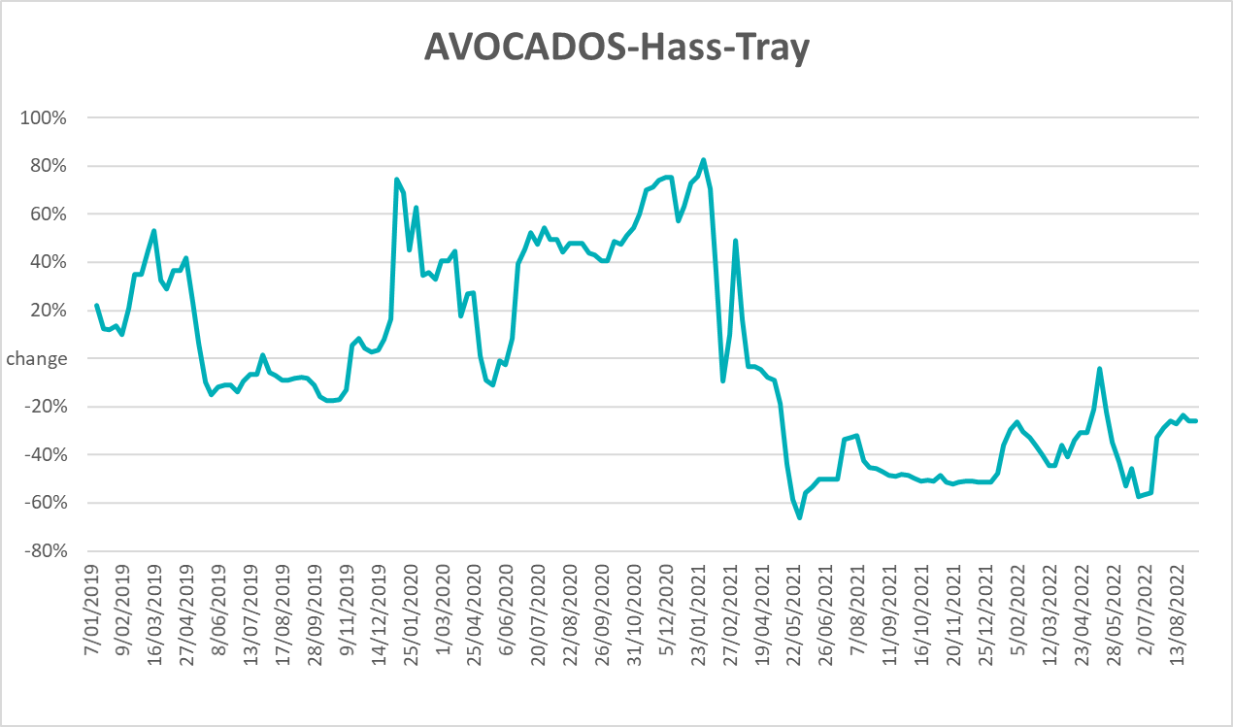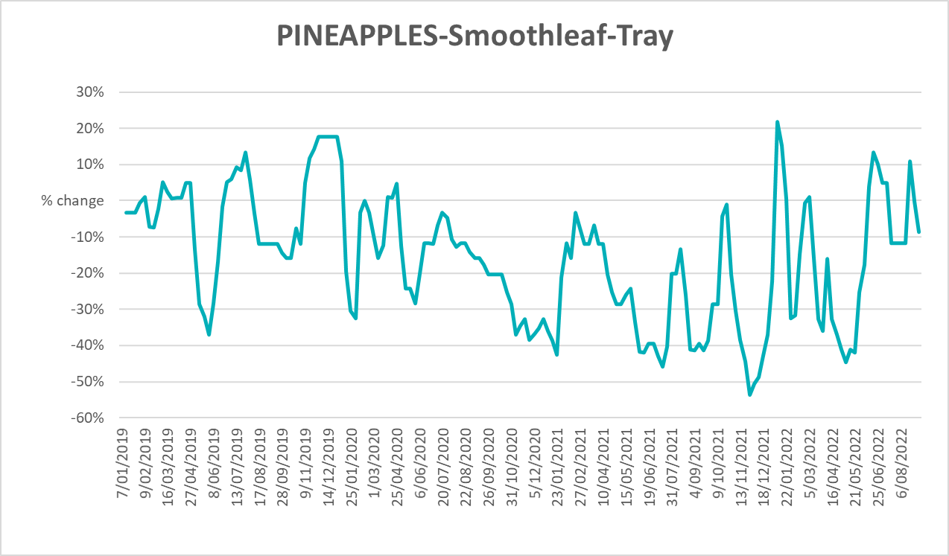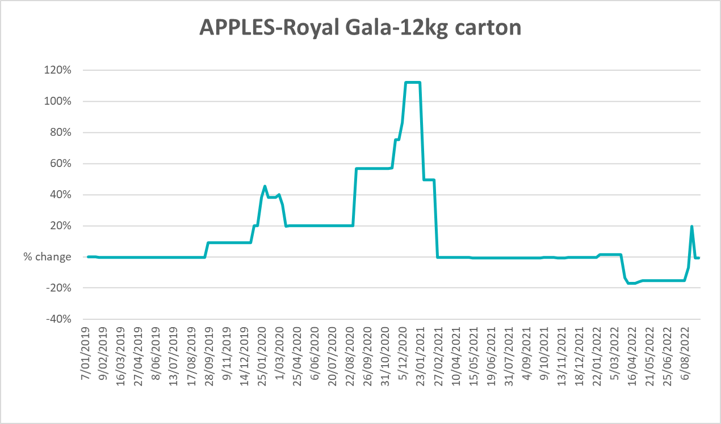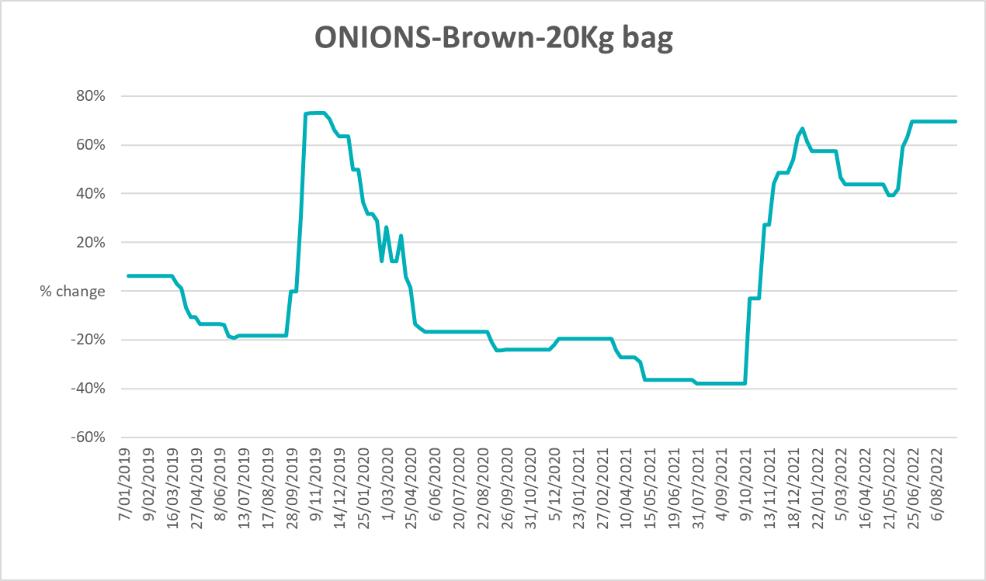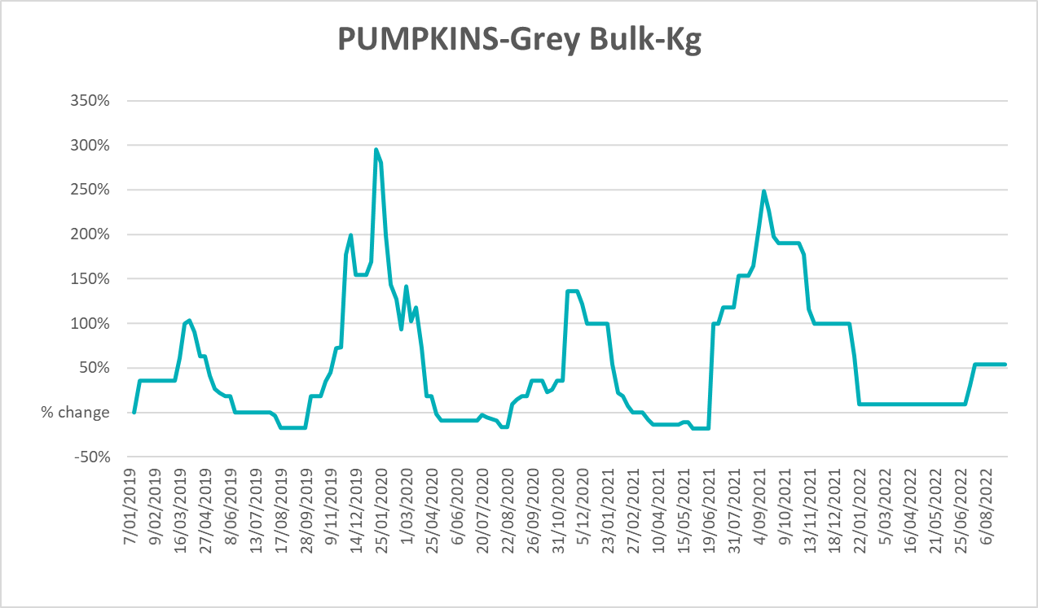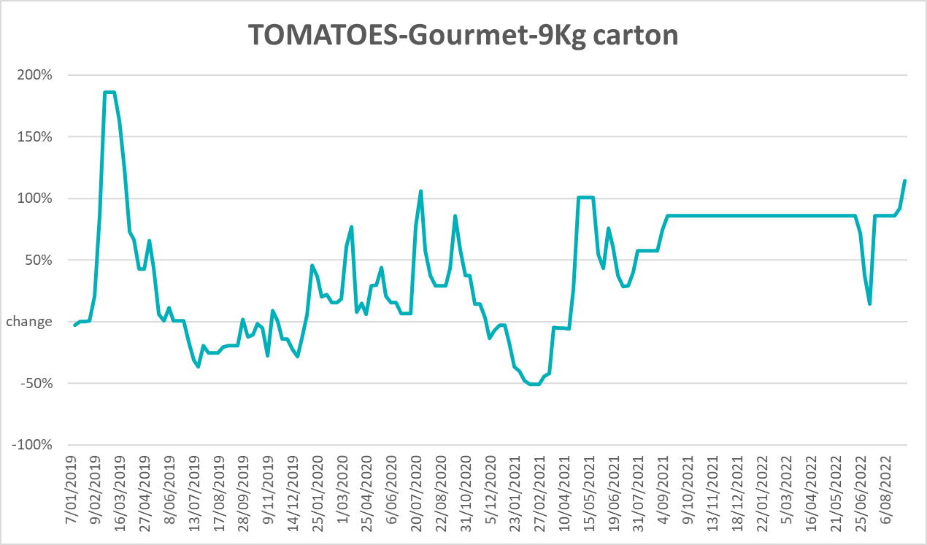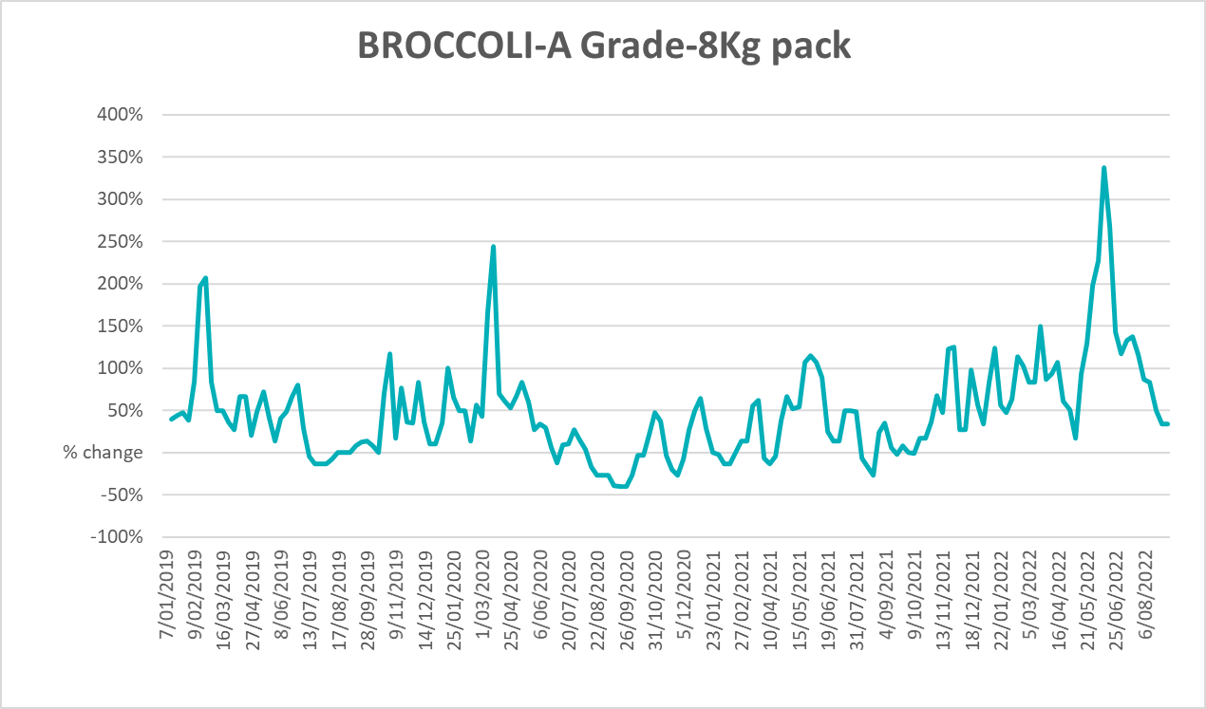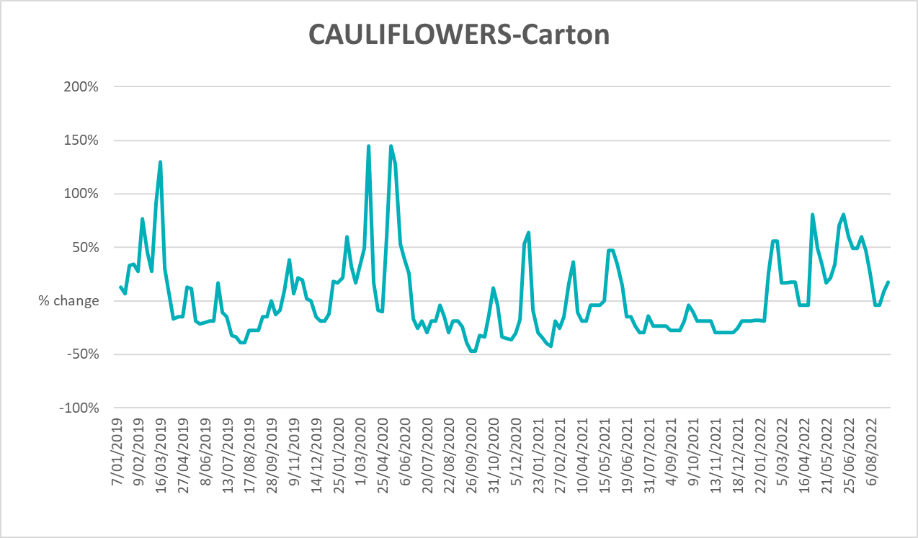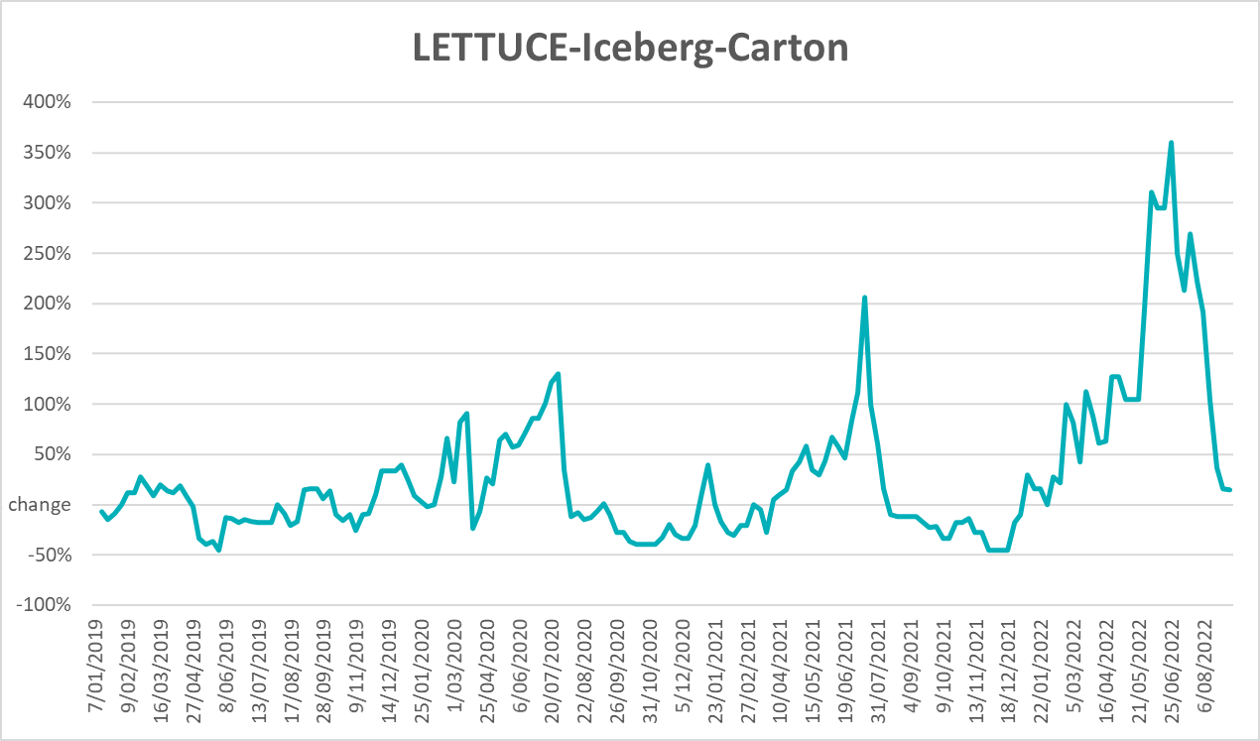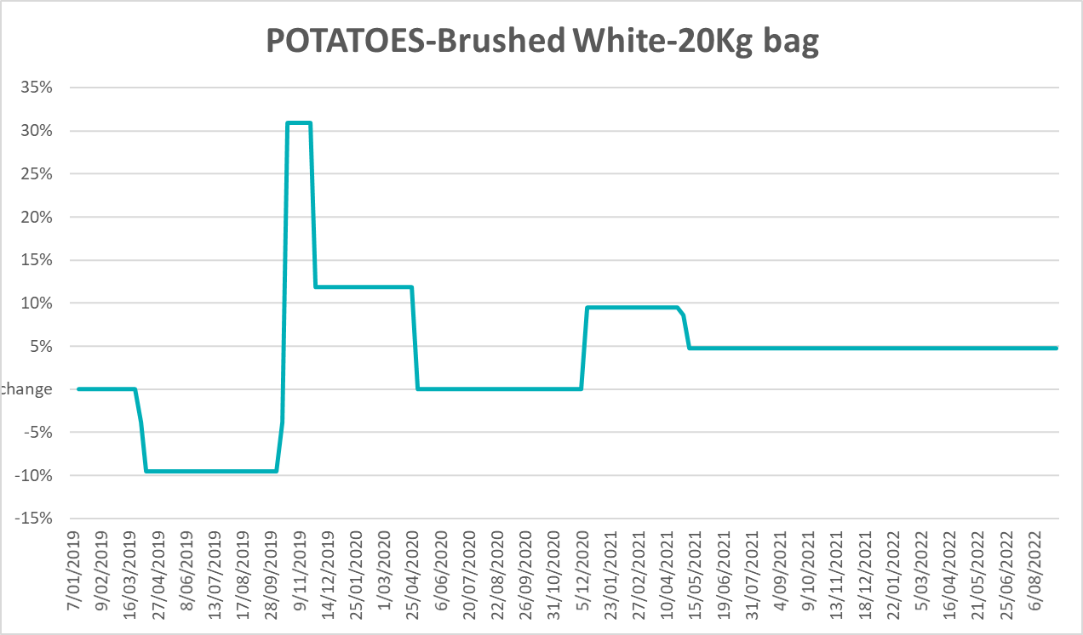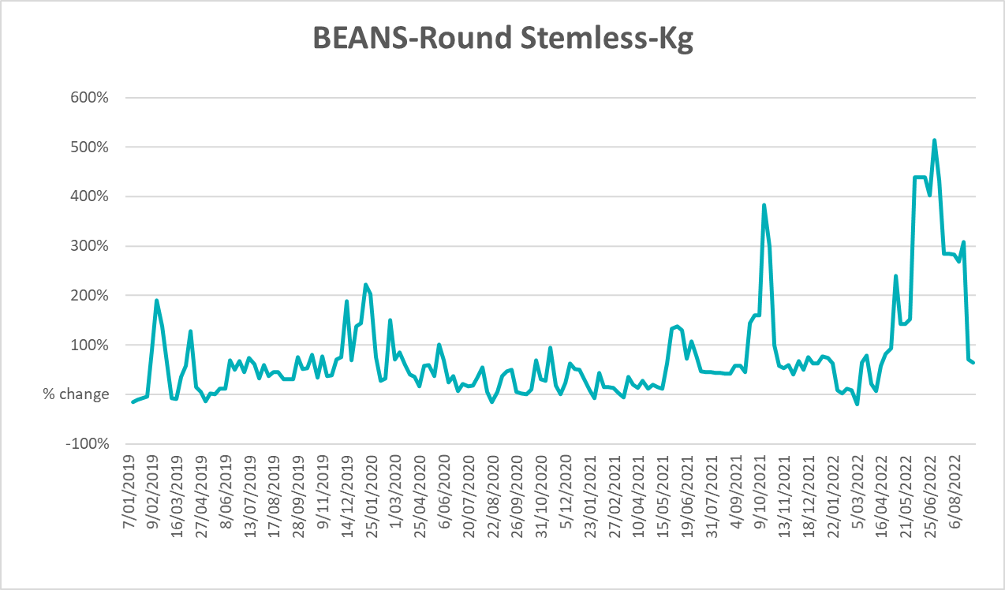

Selected domestic fodder indicator prices
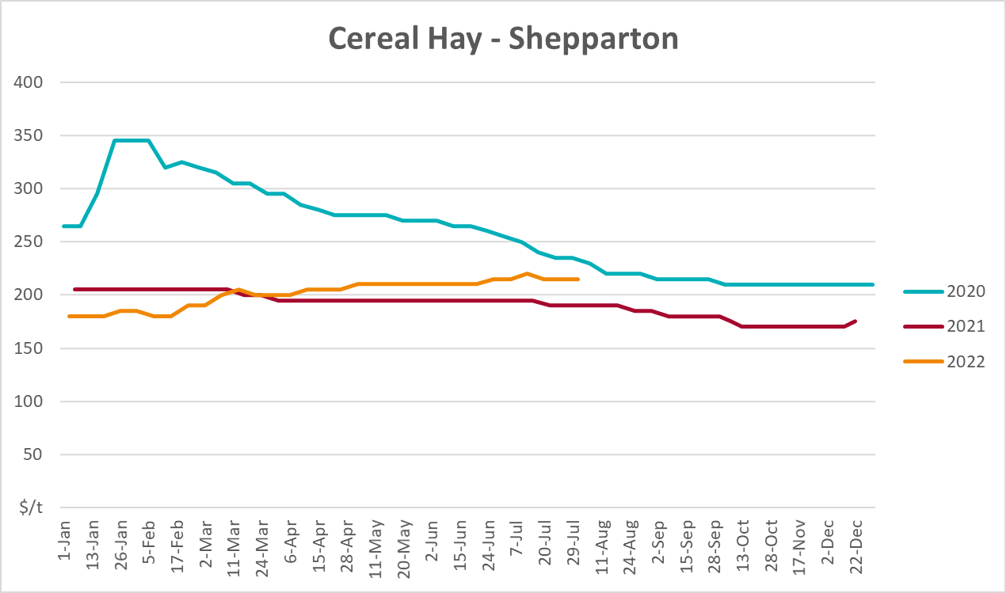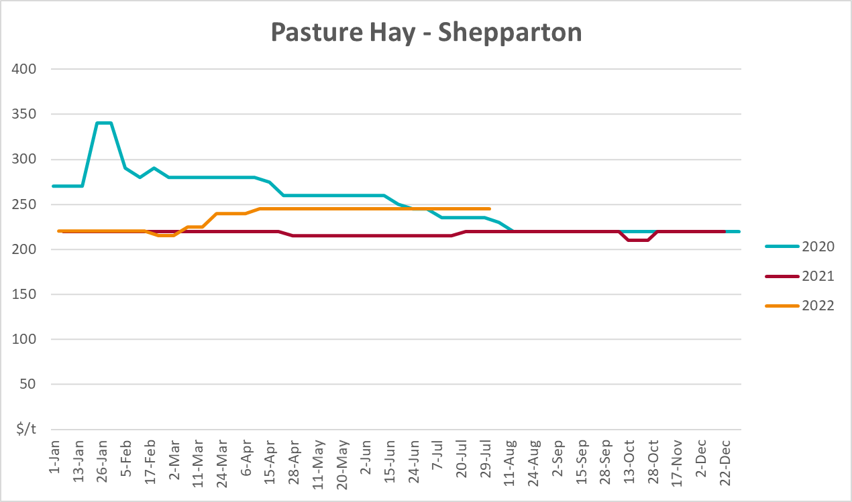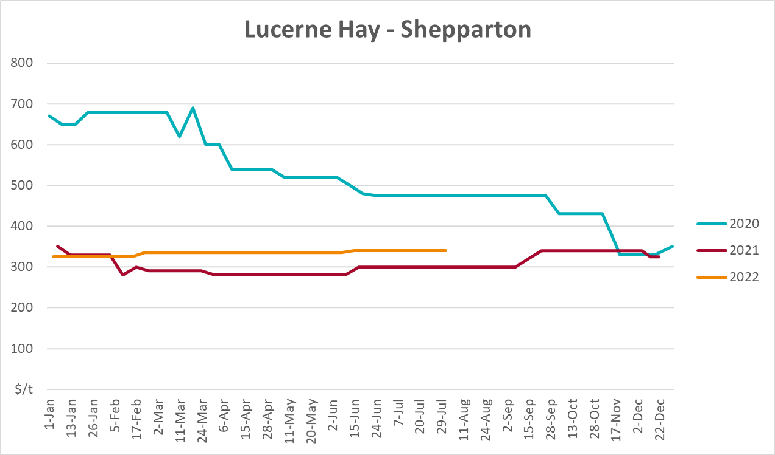

Data attribution

Climate
Bureau of Meteorology
- Weekly rainfall totals: www.bom.gov.au/climate/maps/rainfall/
- Monthly and last 3-month rainfall percentiles: www.bom.gov.au/water/landscape/
- Temperature anomalies: www.bom.gov.au/jsp/awap/temp/index.jsp
- Rainfall forecast: www.bom.gov.au/jsp/watl/rainfall/pme.jsp
- Seasonal outlook: www.bom.gov.au/climate/outlooks/#/overview/summary/
- Climate drivers: http://www.bom.gov.au/climate/enso/
- Soil moisture: www.bom.gov.au/water/landscape/
Other
- Pasture growth: www.longpaddock.qld.gov.au/aussiegrass/
- 3-month global outlooks: Environment and Climate Change Canada, NOAA Climate Prediction Center, EUROBRISA CPTEC/INPE, European Centre for Medium-Range Weather Forecasts, Hydrometcenter of Russia, National Climate Center Climate System Diagnosis and Prediction Room (NCC), International Research Institute for Climate and Society
- Global production: https://ipad.fas.usda.gov/ogamaps/cropmapsandcalendars.aspx
- Autumn break: Pook et al., 2009, https://rmets-onlinelibrary-wiley-com.virtual.anu.edu.au/doi/epdf/10.1002/joc.1833

Water
Prices
- Waterflow: https://www.waterflow.io/
- Ruralco: https://www.ruralcowater.com.au/
Bureau of Meteorology:
- Allocation trade: http://www.bom.gov.au/water/dashboards/#/water-markets/mdb/at
- Storage volumes: http://www.bom.gov.au/water/dashboards/#/water-storages/summary/drainage
Trade constraints:
- Water NSW: https://www.waternsw.com.au/customer-service/ordering-trading-and-pricing/trading/murrumbidgee
- Victorian Water Register: https://www.waterregister.vic.gov.au/TradingRules2019/

Commodities
Fruit and vegetables
- Datafresh: www.freshstate.com.au
Pigs
- Australian Pork Limited: www.australianpork.com.au
Dairy
- Global Dairy Trade: www.globaldairytrade.info/en/product-results/
World wheat, canola
- International Grains Council
World coarse grains
- United States Department of Agriculture
World cotton
- Cotlook: www.cotlook.com/
World sugar
- New York Stock Exchange - Intercontinental Exchange
Wool
- Australian Wool Exchange: www.awex.com.au/
Domestic wheat, barley, sorghum, canola and fodder
- Jumbuk Consulting Pty Ltd: http://www.jumbukag.com.au/
Cattle, beef, mutton, lamb, goat and live export
- Meat and Livestock Australia: www.mla.com.au/Prices-and-market
© Commonwealth of Australia 2022

Ownership of intellectual property rights
Unless otherwise noted, copyright (and any other intellectual property rights, if any) in this publication is owned by the Commonwealth of Australia (referred to as the Commonwealth).

Creative Commons licence
All material in this publication is licensed under a Creative Commons Attribution 4.0 International Licence except content supplied by third parties, logos and the Commonwealth Coat of Arms.
Inquiries about the licence and any use of this document should be emailed to copyright@awe.gov.au.


Cataloguing data
This publication (and any material sourced from it) should be attributed as:
ABARES 2022, Weekly Australian Climate, Water and Agricultural Update, Australian Bureau of Agricultural and Resource Economics and Sciences, Canberra, 29 September 2022. CC BY 4.0 DOI: https://doi.org/10.25814/5f3e04e7d2503
ISSN 2652-7561
This publication is available at https://www.agriculture.gov.au/abares/products/weekly_update
Department of Agriculture, Fisheries and Forestry
GPO Box 858 Canberra ACT 2601
Telephone 1800 900 090
Web agriculture.gov.au/abares

Disclaimer
The Australian Government acting through the Department of Agriculture, Fisheries and Forestry, represented by the Australian Bureau of Agricultural and Resource Economics and Sciences, has exercised due care and skill in preparing and compiling the information and data in this publication. Notwithstanding, the Department of Agriculture, Fisheries and Forestry, ABARES, its employees and advisers disclaim all liability, including liability for negligence and for any loss, damage, injury, expense or cost incurred by any person as a result of accessing, using or relying on any of the information or data in this publication to the maximum extent permitted by law.

Statement of Professional Independence
The views and analysis presented in ABARES publications, including this one, reflect ABARES professionally independent findings, based on scientific and economic concepts, principles, information and data. These views, analysis and findings may not reflect or be consistent with the views or positions of the Australian Government, or of organisations or groups who have commissioned ABARES reports or analysis. More information on professional independence is provided on the ABARES website.

Acknowledgements
This report was prepared by Cameron Van-Lane.

