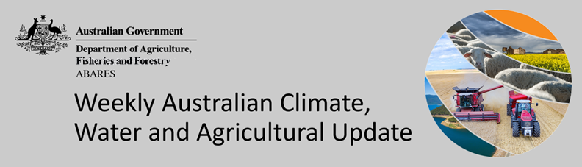
No. 40/2022

13 October 2022

Summary of key issues
- For the week ending 12 October 2022, low-pressure systems and troughs drew down moist, tropical air, resulting in rainfall across eastern and northern Australia. Weekly rainfall totals exceeding 50 millimetres were observed across large areas of New South Wales, southern Queensland, isolated parts of Victoria and north-western Tasmania. High-pressure systems over western parts of the country resulted in clear, dry conditions in most areas (see Section 1.1).
- A return of moderate to heavy rainfall across New South Wales and Queensland cropping regions has resulted in localised flooding along low-lying areas. The risk of damage due to disease pressure and waterlogging will be exacerbated by the recent rainfall. Light to moderate rainfall across Central Queensland may have interrupted the harvesting of winter crops and the sowing of long-season summer crops in some areas. Yield prospects for winter crops across South Australia and Western Australia are very favourable as the season inches closer to harvest.
- Atmospheric and oceanic indicators underpin the recent establishment of a third consecutive La Niña event in the tropical Pacific Ocean. A negative Indian Ocean Dipole (IOD) event continues in the tropical Indian Ocean, the Southern Annular Mode (SAM) is currently positive and expected to remain positive throughout spring, and a Madden-Julian Oscillation (MJO) pulse is expected to develop over the Maritime Continent in the coming days. All climate drivers are associated with above average rainfall for eastern Australia (see Section 1.2).
- The outlook for November 2022 to January 2023 suggests there is a 75% chance of rainfall totals between 50 and 200 millimetres across Victoria, most of New South Wales, Queensland and the Northern Territory, south-eastern parts of South Australia, the north of Western Australia, and Tasmania. Through late spring and early summer, winter crop grain quality, crop abandonment and the inability to plant summer crops are major risk factors for excessive moisture (see Section 1.3).
- Over the 8-days to 20 October 2022, low-pressure systems, frontal systems, and troughs are forecast to result in showers and storms across much of the eastern two-thirds of Australia. Heavy rainfall in parts of northern Queensland over the coming week will delay the harvest of winter crops and the sowing of long-season summer crops. Significant rainfall across remaining cropping regions of south-eastern Australia will contribute to ongoing issues of waterlogging across low-lying areas (see Section 1.4).
- Water storage in the Murray–Darling Basin (MDB) decreased by 196 gigalitres (GL) between 4 October 2022 and 11 October 2022. The current volume of water held in storage is 23,948 GL, which represents 95% of total capacity. This is 9% or 1,944 GL more than at the same time last year.
- Allocation prices in the Victorian Murray below the Barmah Choke decreased from $51 per ML on 30 September to $38 per ML on 7 October 2022. Prices are lower in the Murrumbidgee and regions above the Barmah choke due to the binding of the Murrumbidgee export limit and the Barmah choke trade constraint.

Climate

Rainfall this week
For the week ending 12 October 2022, low-pressure systems and troughs drew down moist, tropical air, resulting in rainfall across eastern and northern Australia. Weekly rainfall totals exceeding 50 millimetres were observed across large areas of New South Wales, southern Queensland, isolated parts of Victoria and north-western Tasmania. High-pressure systems over western parts of the country resulted in clear, dry conditions in most areas.
In Australian cropping regions, rainfall totals of between 10 and 50 millimetres were recorded across southern and northern New South Wales, much of Queensland and Victoria, as well as isolated parts of South Australia and Western Australia. Falls in excess of 50 millimetres were recorded across central New South Wales and parts of southern New South Wales and southern Queensland. Little to no rainfall was recorded in remaining cropping regions of South Australia and Western Australia for the week ending 12 October 2022.
A return of moderate to heavy rainfall across New South Wales and Queensland cropping regions has resulted in localised flooding along low-lying areas. Flood warnings have been issued for the Barwon, Bogan, Bokhara, Castlereagh, Culgoa, Darling, Edward, Gwydir, Lachlan, Macquarie, Mirrool Creek, Murray, Murrumbidgee, Namoi, Paroo and Warrego Rivers. While yield prospects remain strong for crops not affected by flooding, the risk of damage due to disease pressure and waterlogging will be exacerbated by the recent rainfall. Growers in southern Queensland and New South Wales will be hoping for dry weather to allow crops to mature and field access for harvesting.
Light to moderate rainfall across Central Queensland may have interrupted the harvesting of winter crops and the sowing of long-season summer crops in some areas. Yield prospects for winter crops across South Australia and Western Australia are very favourable as the season inches closer to harvest. Well-timed rainfall throughout the season and no significant frost events to-date have boosted crop yields. Wet conditions across eastern Australia will delay the harvesting of winter crops across most regions, as well as the planting of summer crops.

Rainfall for the week ending 12 October 2022
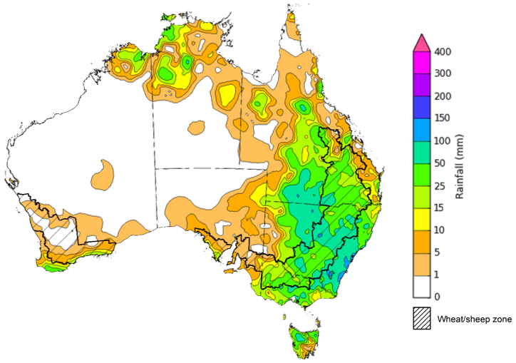
©Commonwealth of Australia 2022, Australian Bureau of Meteorology Issued:12/10/2022
Note: The rainfall analyses and associated maps utilise data contained in the Bureau of Meteorology climate database, the Australian Data Archive for Meteorology (ADAM). The analyses are initially produced automatically from real-time data with limited quality control. They are intended to provide a general overview of rainfall across Australia as quickly as possible after the observations are received. For further information go to http://www.bom.gov.au/climate/rainfall/

Climate Drivers
Throughout Australia’s late spring/early summer period the climate drivers with the largest potential impact on Australia’s climate patterns are the El Niño–Southern Oscillation (ENSO), the Indian Ocean Dipole (IOD), the Southern Annular Mode (SAM) and the Madden-Julian Oscillation (MJO). These climate drivers are likely to influence pasture growth across southern Australia, grain quality prospects and harvest conditions for winter crops, as well as the planting and establishment of summer crops across northern cropping regions.
Atmospheric and oceanic indicators underpin the recent establishment of a third consecutive La Niña event in the tropical Pacific Ocean. Cool sea surface temperature (SST) anomalies have strengthened in the central and eastern equatorial Pacific Ocean in recent weeks, while warmer temperatures persist across the Maritime Continent and to the north-east of Australia. Trade winds have been stronger than average in the western Pacific and cloudiness has also remained below average around the Date Line, which reflect the ongoing La Niña event.
A negative IOD event continues in the tropical Indian Ocean, with above average SSTs continuing in the east and below average SSTs observed in the west of the basin. The temperature gradient established across the tropical Indian Ocean reflects the ongoing negative IOD event.
The SAM is currently positive and expected to remain positive throughout spring. The MJO has remained weak throughout September and early October. However, an MJO pulse is expected to develop over the Maritime Continent in the coming days. Given current and expected conditions, the La Niña event, the negative IOD event, the positive SAM and an active MJO are all likely to influence rainfall across Australia over the coming weeks.

Difference from average sea surface temperature observations 3 October to 9 October 2022
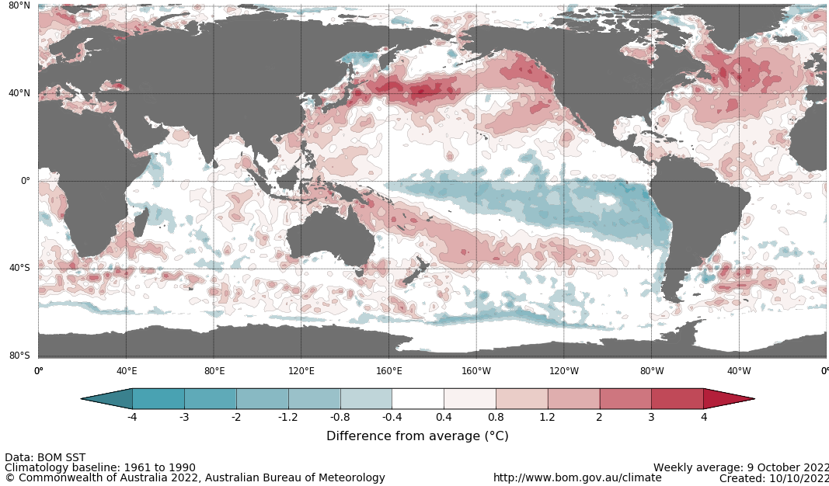

International climate model outlooks for the NINO 3.4 region in December 2022
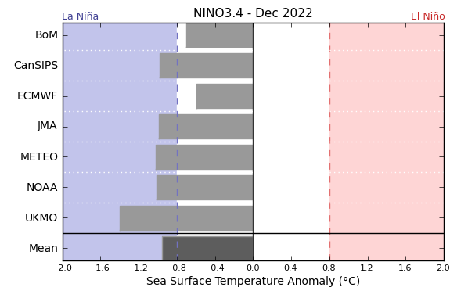
©Commonwealth of Australia 2022, Australian Bureau of Meteorology Issued: 12/10/2021
The La Niña event currently underway in the Pacific Ocean is expected to persist until the end of 2022 but rapidly decay in early 2023. Five of the seven international models surveyed predict the La Niña event to remain active in December, but all models expect the La Niña event to dissipate by February 2023. For the period ending 10 October, the 30-day Southern Oscillation Index (SOI) value was 19.7 and the 90-day value for the period ending 9 October was 13.4, both of which are above the La Niña threshold of +7. La Niña events are associated with above average rainfall across eastern and northern Australia through spring and summer.

30-day Southern Oscillation Index (SOI) values ending 10 October 2021
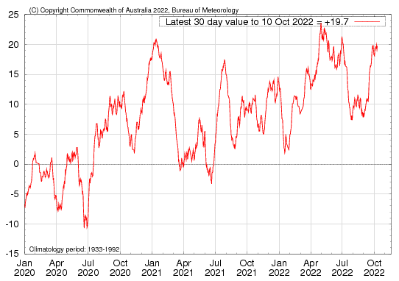

A negative IOD event persists in the Indian Ocean, with values exceeding the negative IOD threshold (−0.4 °C) since mid-June. Below average sea surface temperatures in western parts of the Indian Ocean, near the Horn of Africa, and warmer than average temperatures to the north-west of Australia tends to result in above average rainfall across southern Australia and the far north throughout spring. It is also associated with the early onset of northern Australia rainfall.
As at 9 October 2022, the Indian Ocean Dipole (IOD) weekly value was -0.57°C. All international climate models surveyed by the Bureau of Meteorology predict the negative IOD event to persist throughout spring. However, the negative IOD event is expected to decline rapidly through the remainder of spring, returning to neutral by early summer.

Monthly sea surface temperature anomalies for IOD region
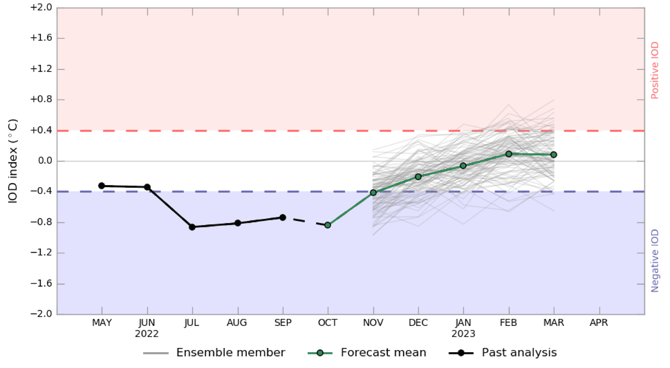
The Southern Annular Mode (SAM) is currently positive and is expected to remain positive throughout spring and early summer. The SAM refers to the north-south shift of the band of rain-bearing westerly winds and weather systems in the Southern Ocean compared to the usual position. A positive SAM in spring is associated with increased rainfall for parts of eastern New South Wales and Victoria as well as southern Queensland. It is also associated with decreased rainfall for parts of south-western and south-eastern Australia.

Southern Annular Mode (SAM) daily index
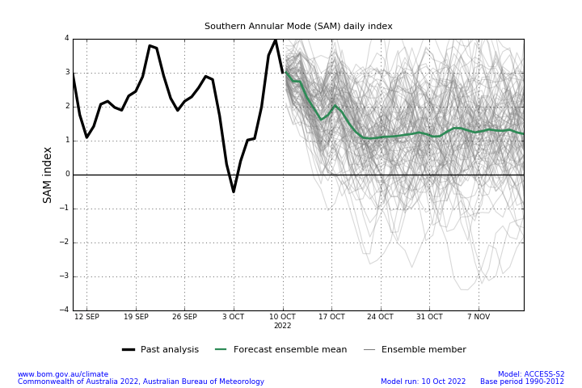

As at 11 October 2022 the Madden–Julian Oscillation (MJO) was forecast to strengthen over the Maritime Continent and maintain strength as it moves into the western Pacific. The MJO is a pulse of cloud and rainfall that moves eastward along the equator. An active MJO in the Pacific at this time of year increases the chance of above average rainfall over the eastern half of Australia.

Madden–Julian Oscillation (MJO) daily index
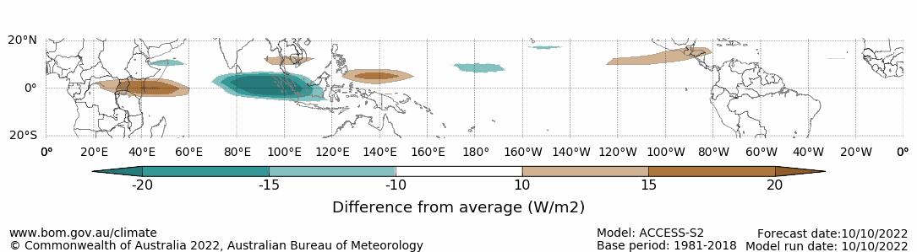
Note: This map displays the forecast outgoing longwave radiation (OLR) difference from expected cloudiness to identify convective rain clouds and the position of the Madden–Julian Oscillation (MJO). The blue shading indicates higher than normal, active or enhanced tropical weather and the brown shading indicates lower than normal clouds or suppressed conditions.

National Climate Outlook
These climate outlooks are generated by ACCESS–S (Australian Community Climate Earth-System Simulator–Seasonal). ACCESS–S is the Bureau of Meteorology's dynamic (physics-based) weather and climate model used for monthly, seasonal and longer-lead climate outlooks.
For further information, go to http://www.bom.gov.au/climate/ahead/about/
The Bureau of Meteorology’s latest rainfall outlook indicates wetter than average conditions are expected across parts of Australia during November. The ACCESS-S climate model suggests there is close to a 60% chance of exceeding median rainfall for parts of eastern and northern Australia, with below median rainfall likely for northern and central parts of Western Australia.
The outlook for November 2022 indicates that there is a 75% chance of rainfall totals between 10 and 50 millimetres across much of New South Wales, Queensland, Victoria, parts of southern and northern South Australia, the south-west and north-east of Western Australia, Tasmania, as well as much of the Northern Territory. Rainfall totals in excess of 100 millimetres are expected across isolated areas of alpine New South Wales and Victoria, north-eastern New South Wales and Queensland, the north of the Northern Territory, as well as western Tasmania.
Across cropping regions there is a 75% chance of rainfall totals of between 25 and 100 millimetres across much of New South Wales, Queensland, south-eastern Victoria and isolated parts of South Australia. There is a 75% chance of rainfall between 10 and 25 millimetres for remaining parts of New South Wales, Victoria and South Australia, as well as southern cropping regions of Western Australia. These falls are likely to be sufficient to support the current yield potential of winter crops, average or better pasture growth potential, and the establishment and growth of summer crops given average to above average soil moisture level across most growing regions.
Rainfall totals that have a 75% chance of occurring November 2022
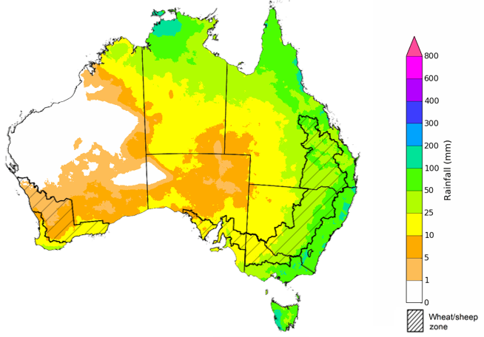
©Commonwealth of Australia 2022, Australian Bureau of Meteorology Issued: 6/10/2022

The rainfall outlook for November 2022 to January 2023 suggests there is a greater than 65% chance of exceeding median rainfall across Victoria, most of New South Wales and Queensland, the south-east of South Australia, the north of the Northern Territory and eastern Tasmania. For remaining regions of Australia, there is no strong tendency towards above or below median rainfall, except for parts of north-eastern and south-western Western Australia where below median rainfall is likely between November to January (Bureau of Meteorology ‘National Climate Outlook’, 6 October 2022).
Bureau of Meteorology rainfall outlooks for November to January have greater than 55% past accuracy across most of Australia. Outlook accuracy is greater than 65% across most of New South Wales and Victoria, as well as parts of Queensland, South Australia and the Northern Territory. Past accuracy is low (less than 50%) for large areas of central Australia.
Chance of exceeding the median rainfall November 2022 to January 2023
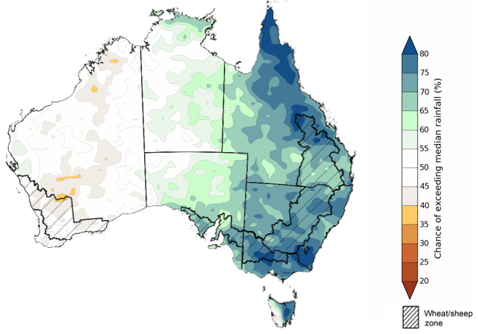
©Commonwealth of Australia 2022, Australian Bureau of Meteorology Issued: 6/10/2022
The outlook for November 2022 to January 2023 suggests there is a 75% chance of rainfall totals between 50 and 200 millimetres across Victoria, most of New South Wales, Queensland and the Northern Territory, south-eastern parts of South Australia, the north of Western Australia, and Tasmania. Rainfall totals in excess of 200 millimetres are forecast for alpine areas in New South Wales and Victoria, as well as eastern New South Wales and Victoria, parts of eastern and northern Queensland, the far north of Western Australia and the Northern Territory, and western Tasmania.
Across cropping regions, there is a 75% chance of receiving between 50 and 100 millimetres across south-western New South Wales, Victoria, much of South Australia and south-eastern parts of Western Australia. Totals of between 100 and 200 millimetres are expected across much of New South Wales and southern Queensland, and eastern Victoria. Higher rainfall totals of between 200 and 300 millimetres are expected across parts of north-eastern New South Wales and central and northern Queensland.
Through late spring and early summer, winter crop grain quality, crop abandonment and the inability to plant summer crops are major risk factors associated with excessive moisture. Average rainfall over the coming months in southern New South Wales, Victoria and South Australian cropping regions, and below average rainfall in Western Australia is likely to allow the harvesting of winter crop to progress with minimal interruption. In central and northern New South Wales and southern Queensland, winter cropping has already been heavily impacted by excessive moisture. Above average rainfall through late spring increases the risk of waterlogging, negatively impacting crop development. As crops mature, a continuation of wet conditions may cause quality downgrades and delay harvesting. Moreover, the wet conditions are likely to interrupt planting of summer crops, which is expected to begin over the coming weeks and continue through to late spring.
Rainfall totals that have a 75% chance of occurring November 2022 to January 2023
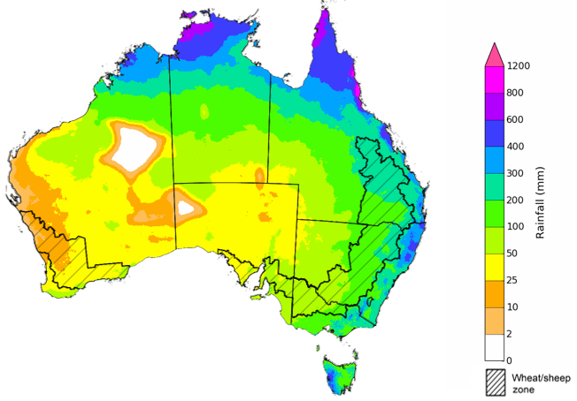
©Commonwealth of Australia 2022, Australian Bureau of Meteorology Issued: 6/10/2022
The temperature outlook for November 2022 to January 2023 indicates that maximum temperatures across most of Australia are likely to be close to the 1990-2012 average (the difference in the range of - 1°C to +1°C), with slightly lower than average maximum temperatures across eastern New South Wales and south-eastern Queensland. Minimum temperatures are expected to be slightly above average for isolated areas of the northern and south-eastern Australia, and close to average for the rest of Australia (Bureau of Meteorology ‘National Climate Outlook’, 6 October 2022).
Predicted maximum temperature anomaly for November 2022 to January 2023

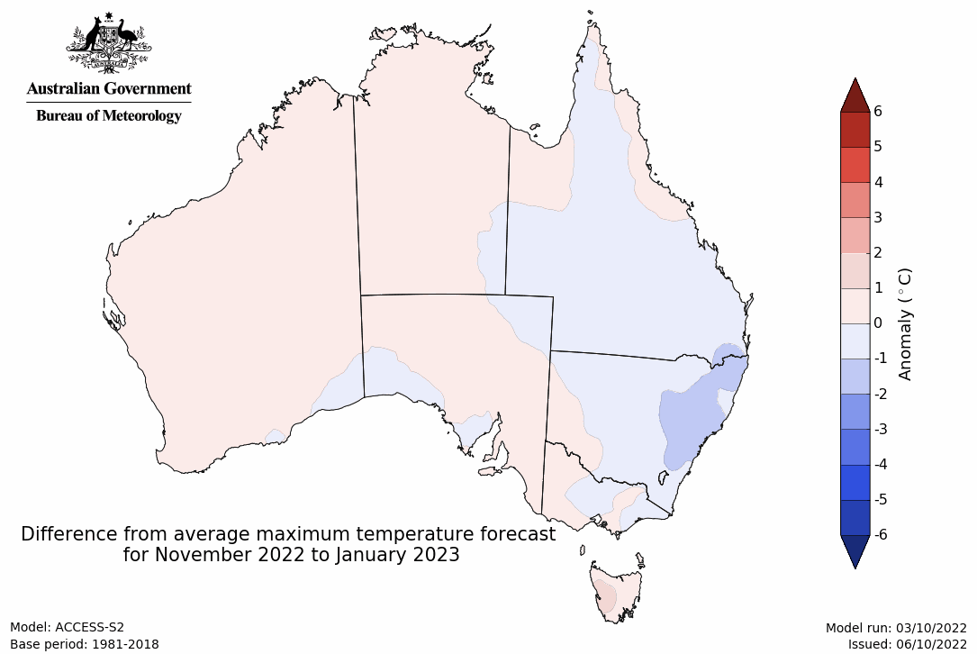
Predicted minimum temperature anomaly for November 2022 to January 2023
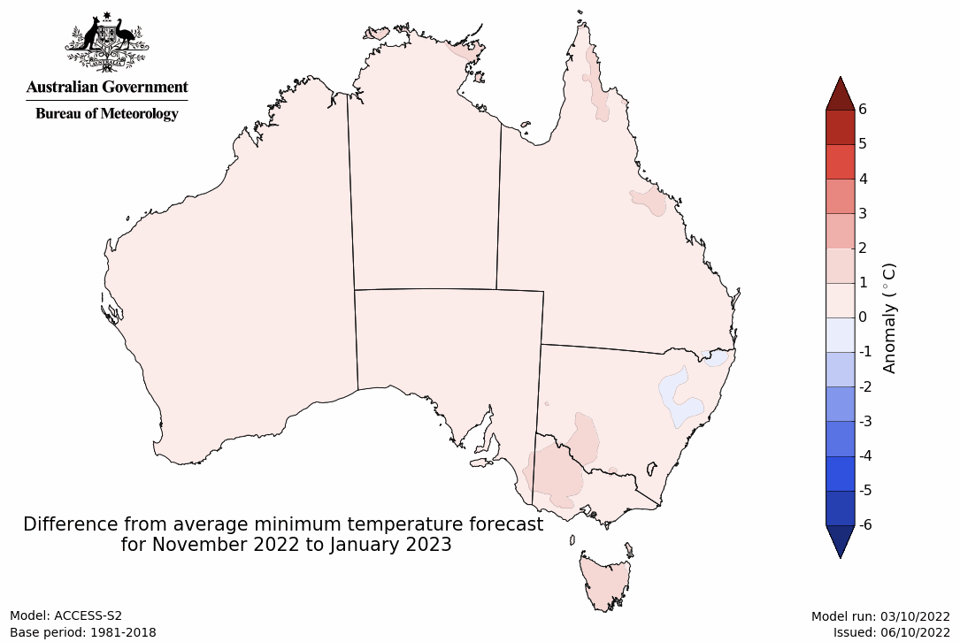

Rainfall forecast for the next eight days
Over the 8-days to 20 October 2022, low-pressure systems, frontal systems, and troughs are forecast to result in showers and storms across much of the eastern two-thirds of Australia. High-pressure systems will provide clear, dry conditions across remaining parts of the country.
In Australian cropping regions, rainfall totals of between 15 and 50 millimetres are expected across New South Wales, Victoria, South Australia, and Queensland. Rainfall in excess of the of the monthly median for October are forecast for large areas of southern New South Wales, eastern Victoria and parts of northern Queensland. Little to no rainfall is forecast for remaining cropping regions in Western Australia during the next 8-days.
Heavy rainfall in parts of northern Queensland over the coming week will delay the harvest of winter crops and the sowing of long-season summer crops. Significant rainfall across remaining cropping regions of south-eastern Australia will contribute to ongoing issues of waterlogging across low-lying areas. These wet conditions are expected to prolong inundation of crops, negatively impacting yield potentials, as well as restricting the ability to access fields for early harvest activities. Yield potentials remain above average across cropping regions, but rainfall over the coming weeks is unlikely to improve them further.
The biggest threat to yield potentials across eastern and southern cropping regions remain waterlogging as winter crops begin to ripen. The continued influence of a negative Indian Ocean Dipole and the establishment of a La Niña event in the Pacific Ocean suggests a continuation of wet conditions over the coming months for eastern Australia. A likely consequence will be delays in harvesting winter crops and planting summer crops, as well as increased crop damage, downgraded grain quality and potential crop abandonment.

Total forecast rainfall (mm) for the period 13 October to 20 October 2022
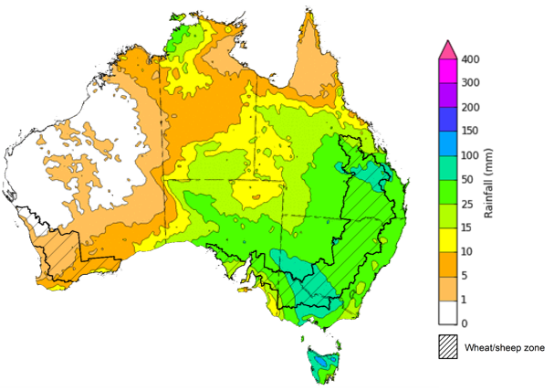
©Commonwealth of Australia 2022, Australian Bureau of Meteorology Issued 13/10/2022

Water
Note: This rainfall forecast is produced from computer models. As the model outputs are not altered by weather forecasters, it is important to check local forecasts and warnings issued by the Bureau of Meteorology.

Water markets – current week
Water storage in the Murray–Darling Basin (MDB) decreased by 196 gigalitres (GL) between 4 October 2022 and 11 October 2022. The current volume of water held in storage is 23,948 GL, which represents 95% of total capacity. This is 9% or 1,944 GL more than at the same time last year.

Water storages in the Murray-Darling Basin, 2013–2022
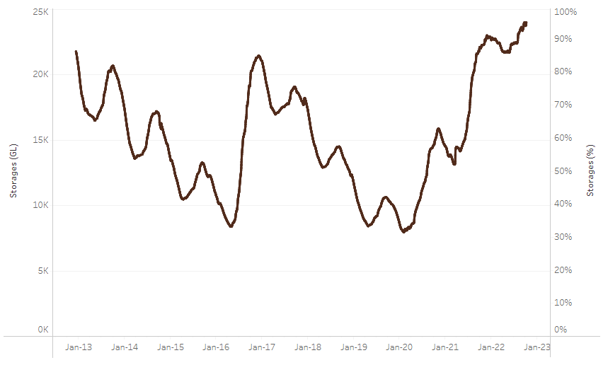
Allocation prices in the Victorian Murray below the Barmah Choke decreased from $51 per ML on 30 September to $38 per ML on 7 October 2022. Prices are lower in the Murrumbidgee and regions above the Barmah choke due to the binding of the Murrumbidgee export limit and the Barmah choke trade constraint.
Water storage data is sourced from the Bureau of Meteorology.

Region | $/ML
NSW Murray Above | 11
NSW Murrumbidgee | 30
VIC Goulburn-Broken | 43
VIC Murray Below | 28

Surface water trade activity, Southern Murray–Darling Basin

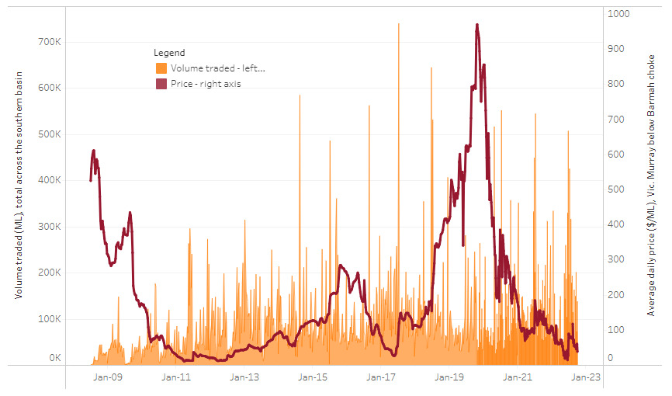
To access the full, interactive, weekly water dashboard, which contains the latest and historical water storage, water market and water allocation information, please visit http://www.agriculture.gov.au/abares/products/weekly_update/weekly-update-131022
The trades shown reflect estimated market activity and do not encompass all register trades. The price is shown for the VIC Murray below the Barmah choke. Historical prices (before 1 July 2019) are ABARES estimates after removing outliers from BOM water register data. Prices after 1 July 2019 and prior to the 30 October 2019 reflect recorded transaction prices as sourced from Ruralco. Prices after the 30 October 2019 are sourced from Waterflow. Data for volume traded is sourced from the BOM water register. Data shown is current at 6 October 2022.

Commodities

Indicator | Week ended | Unit | Latest price | Previous week | Weekly change | Price 12 months ago | Annual change
Selected world indicator prices
AUD/USD Exchange rate | 12-Oct | A$/US$ | 0.63 | 0.65 | -3% | 0.75 | -16%
Wheat – US no. 2 hard red winter wheat, fob Gulf | 12-Oct | US$/t | 453 | 444 | 2% | 352 | 29%
Corn – US no. 2 yellow corn, fob Gulf | 12-Oct | US$/t | 343 | 326 | 5% | 239 | 43%
Canola – Rapeseed, Canada, fob Vancouver | 12-Oct | US$/t | 677 | 676 | 0% | 814 | -17%
Cotton – Cotlook 'A' Index | 12-Oct | USc/lb | 104 | 105 | 0% | 117 | -11%
Sugar – Intercontinental Exchange, nearby futures, no.11 contract | 12-Oct | USc/lb | 17.8 | 17.7 | 1% | 19 | -5%
Wool – Eastern Market Indicator | 05-Oct | Ac/kg clean | 1,271 | 1,235 | 3% | 1,370 | -7%
Wool – Western Market Indicator | 10-Aug | Ac/kg clean | 1,459 | 1,449 | 1% | 1,346 | 8%
Selected Australian grain export prices
Milling Wheat – APW, Port Adelaide, SA | 12-Oct | A$/t | 601 | 572 | 5% | 437 | 38%
Feed Wheat – ASW, Port Adelaide, SA | 12-Oct | A$/t | 553 | 525 | 5% | 432 | 28%
Feed Barley – Port Adelaide, SA | 12-Oct | A$/t | 464 | 456 | 2% | 360 | 29%
Canola – Kwinana, WA | 12-Oct | A$/t | 1,049 | 1,045 | 0% | 1,023 | 3%
Grain Sorghum – Brisbane, QLD | 12-Oct | A$/t | 466 | 457 | 2% | 366 | 27%
Selected domestic livestock indicator prices
Beef – Eastern Young Cattle Indicator | 12-Oct | Ac/kg cwt | 1,037 | 1,055 | -2% | 1,036 | 0%
Mutton – Mutton indicator (18–24 kg fat score 2–3), Vic | 12-Oct | Ac/kg cwt | 510 | 515 | -1% | 626 | -19%
Lamb – Eastern States Trade Lamb Indicator | 12-Oct | Ac/kg cwt | 758 | 736 | 3% | 952 | -20%
Pig – Eastern Seaboard (60.1–75 kg), average of buyers & sellers | 28-Sep | Ac/kg cwt | 376 | 376 | 0% | 318 | 18%
Goats – Eastern States (12.1–16 kg) | 29-Jun | Ac/kg cwt | 1,030 | 879 | 17% | 818 | 26%
Live cattle – Light steers ex Darwin to Indonesia | 17-Aug | Ac/kg lwt | 420 | 480 | -13% | 320 | 31%
Live sheep – Live wethers (Muchea WA saleyard) to Middle East | 14-Sep | $/head | 93 | 113 | -18% | 114 | -18%

Indicator | Week ended | Unit | Latest price | Previous week | Weekly change | Price 12 months ago | Annual change
Global Dairy Trade (GDT) weighted average prices ª
Dairy – Whole milk powder | 05-Oct | US$/t | 3,573 | 3,610 | -1% | 2,884 | 24%
Dairy – Skim milk powder | 05-Oct | US$/t | 3,497 | 3,575 | -2% | 2,663 | 31%
Dairy – Cheddar cheese | 05-Oct | US$/t | 4,966 | 5,046 | -2% | 3,428 | 45%
Dairy – Anhydrous milk fat | 05-Oct | US$/t | 5,811 | 5,677 | 2% | 3,852 | 51%
a Global Dairy Trade prices are updated twice monthly on the first and third Tuesday of each month.

Selected world indicator prices
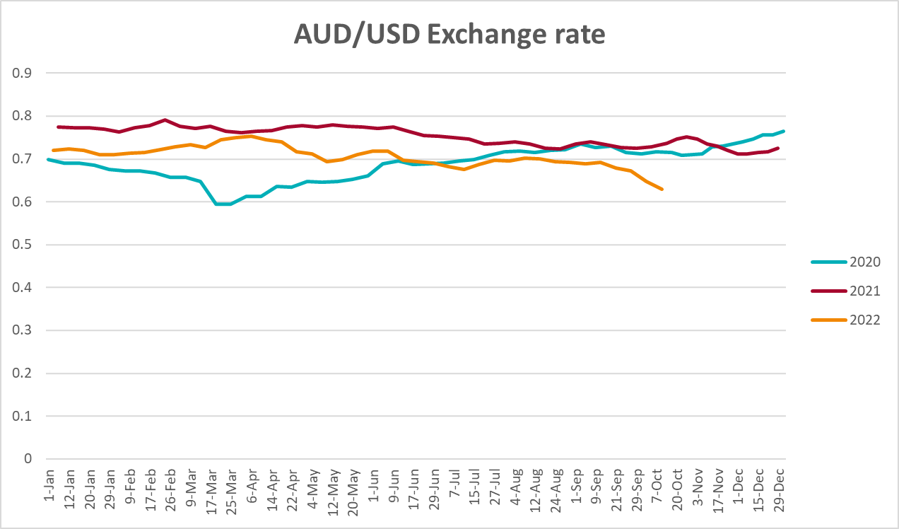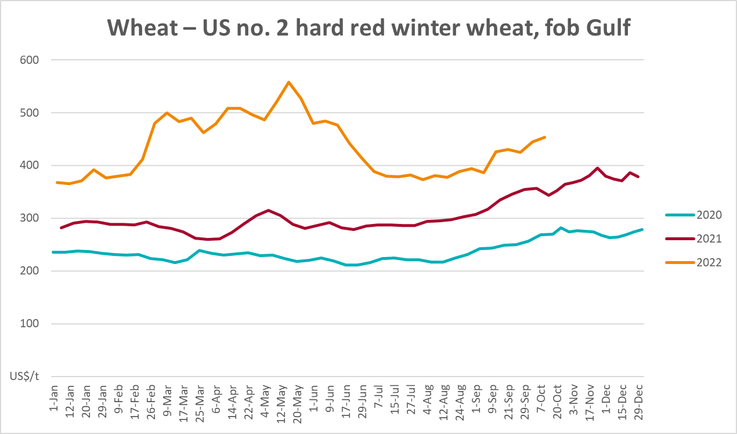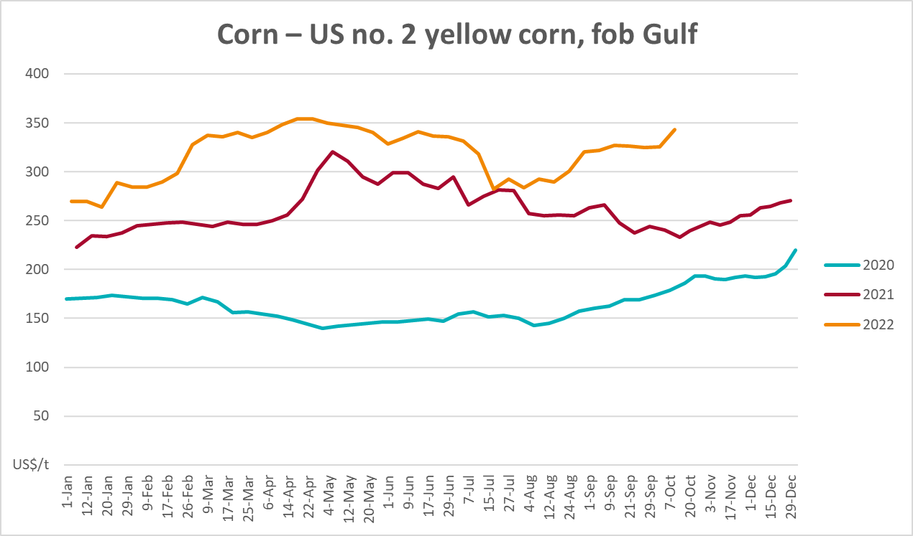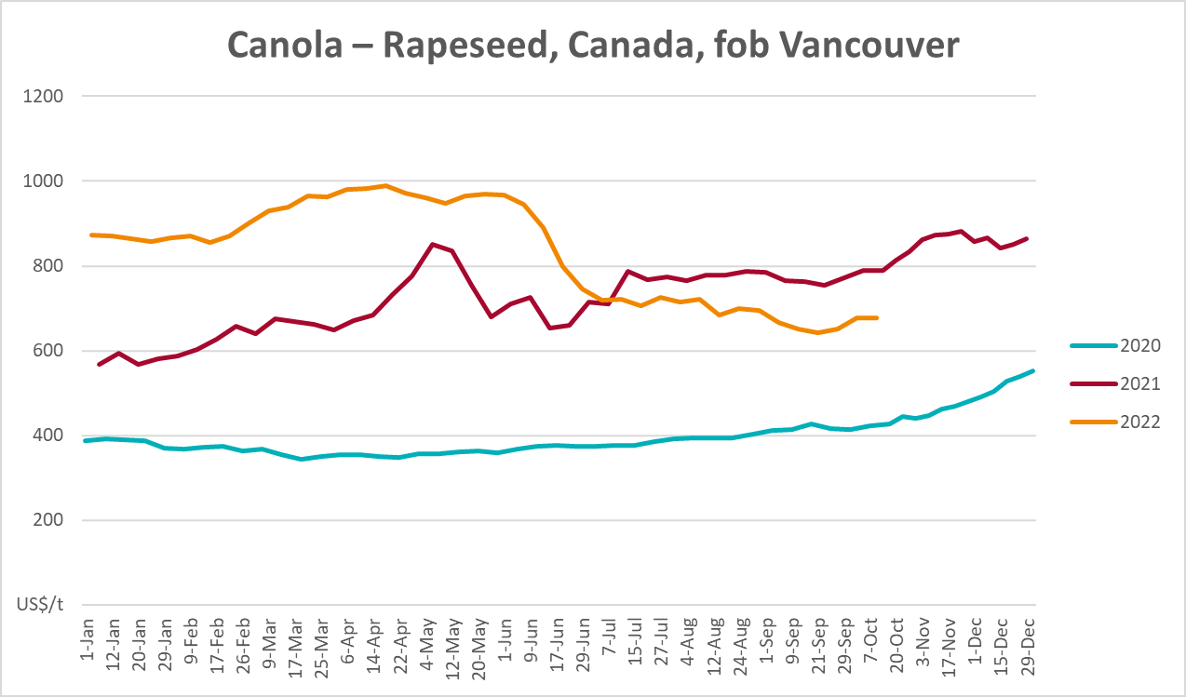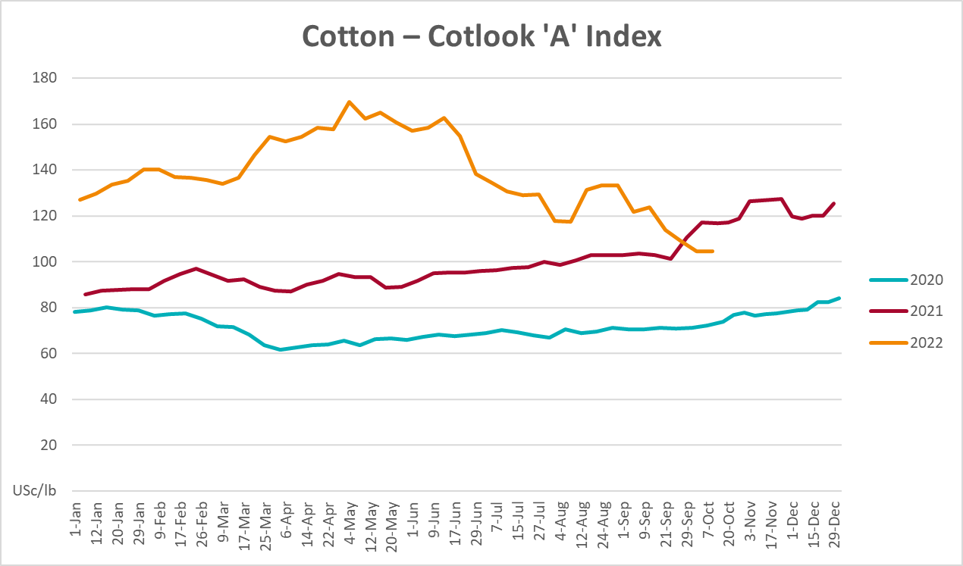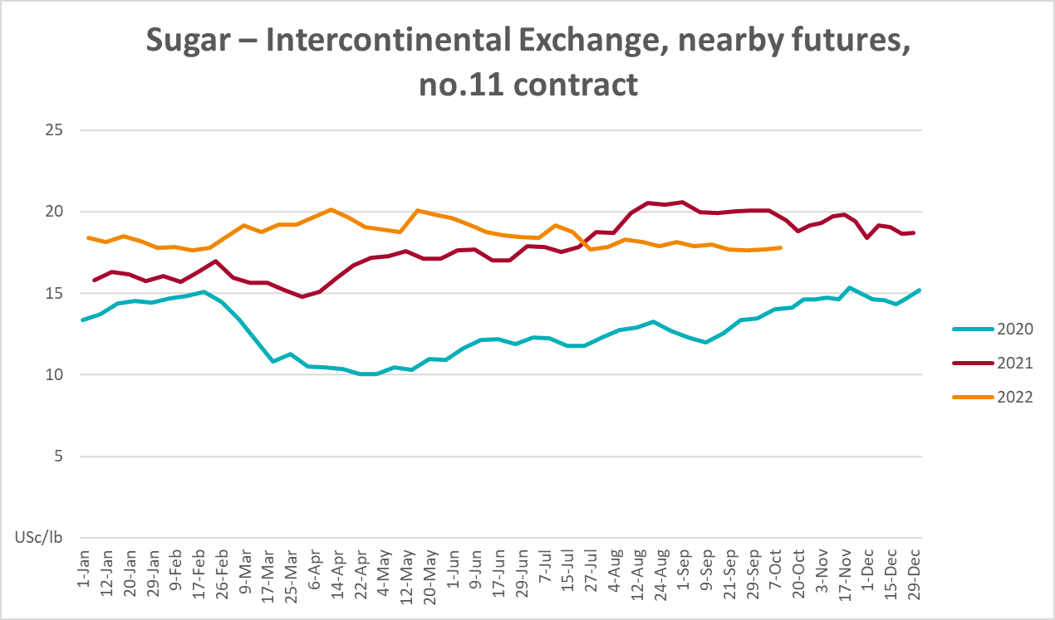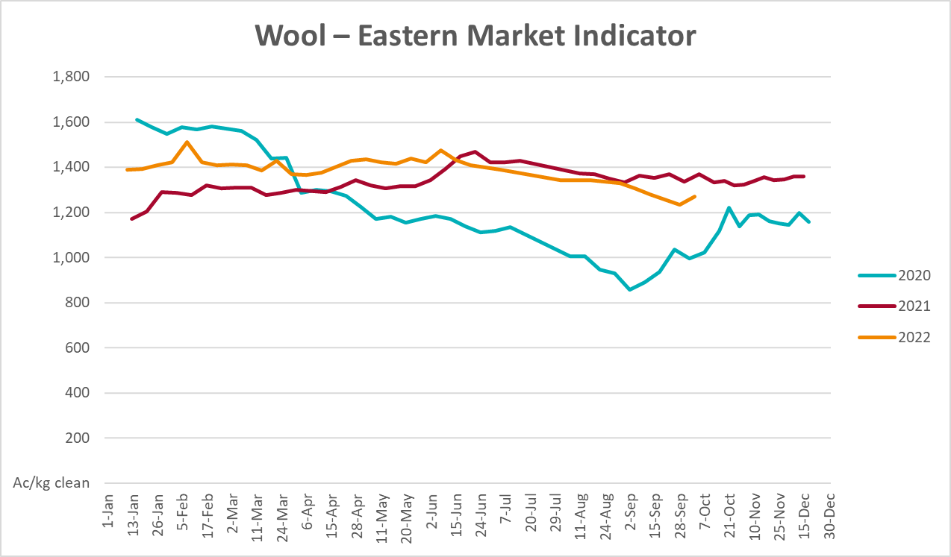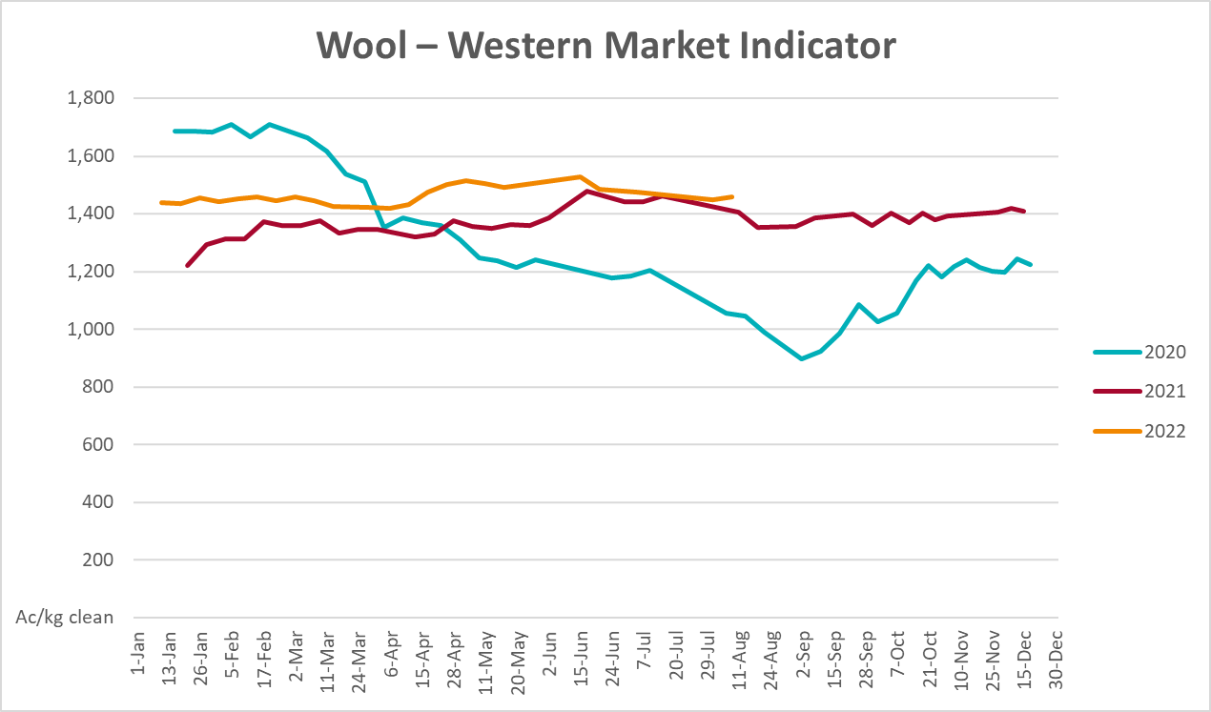

Selected domestic crop indicator prices
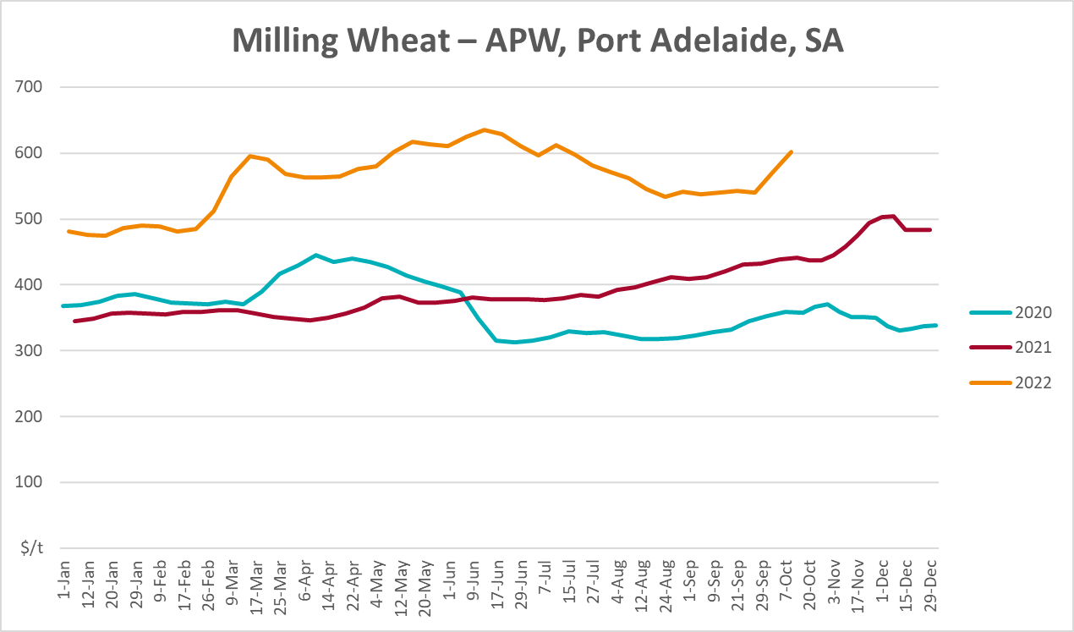
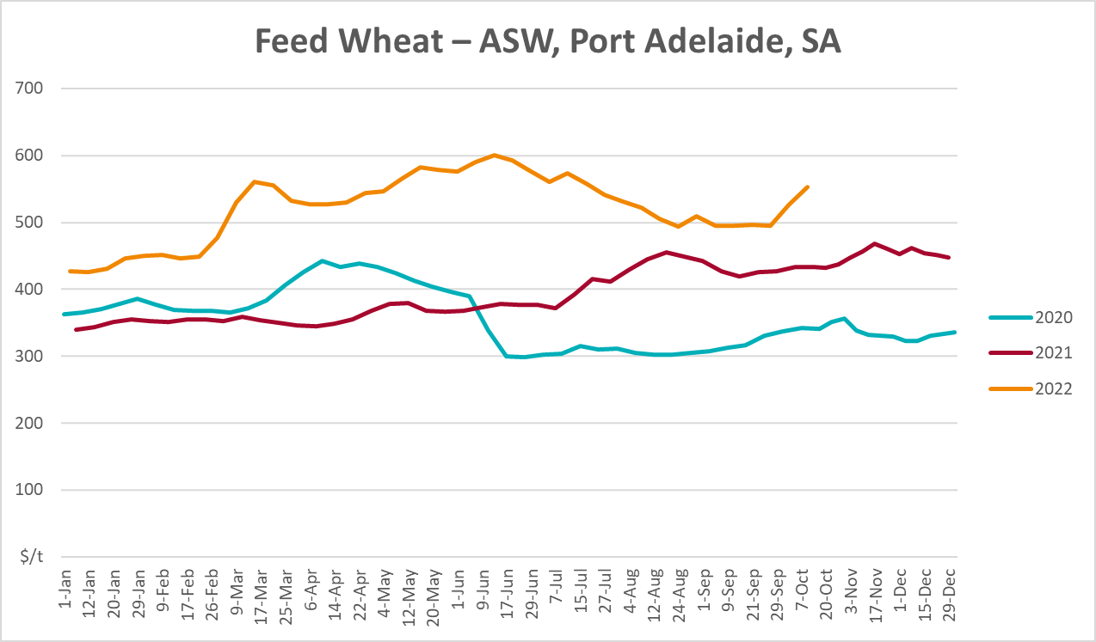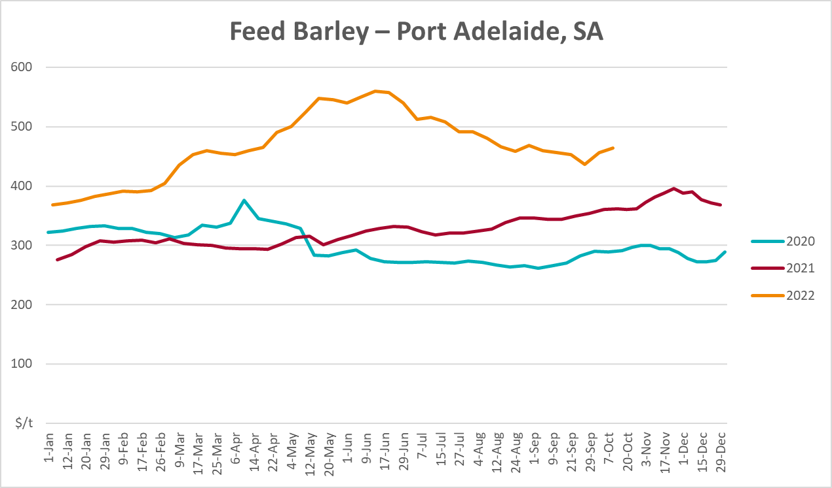
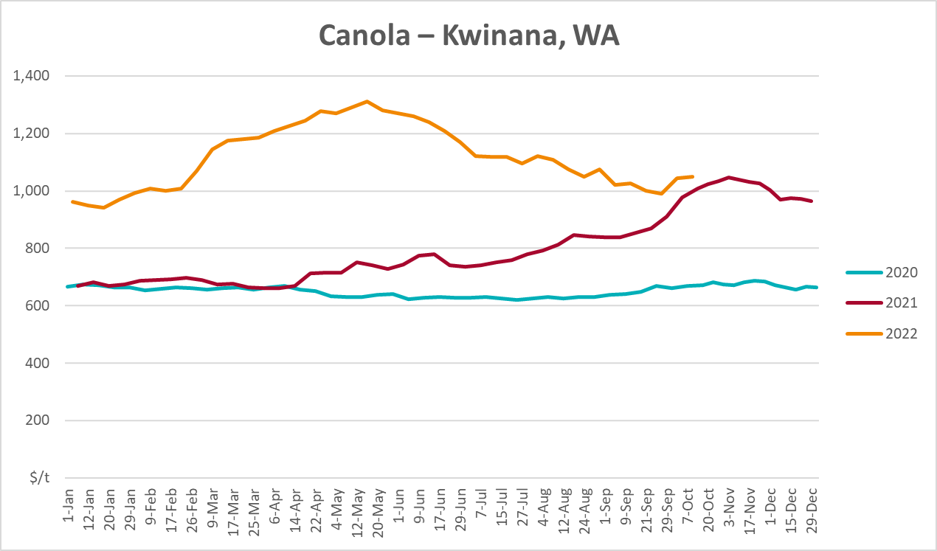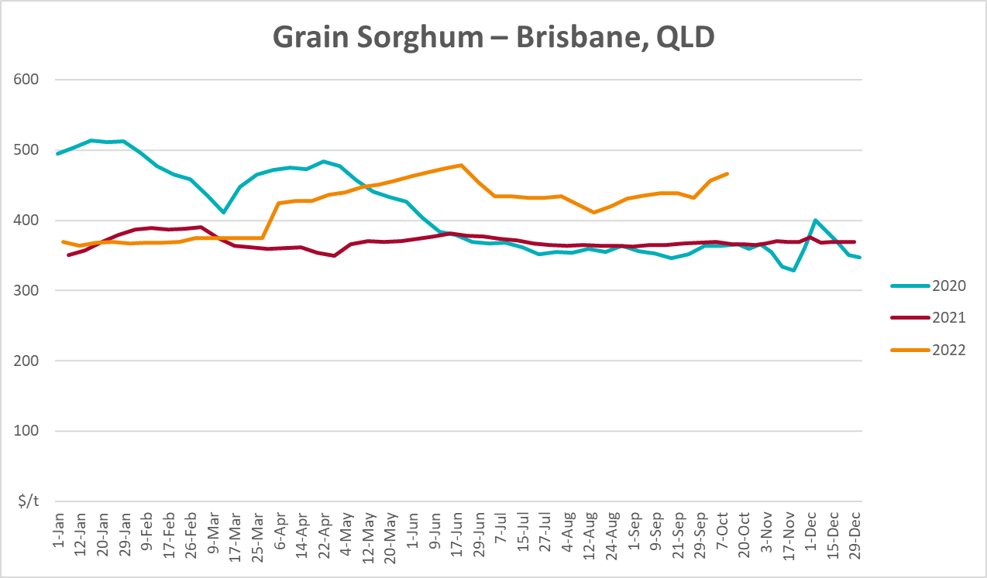

Selected domestic livestock indicator prices
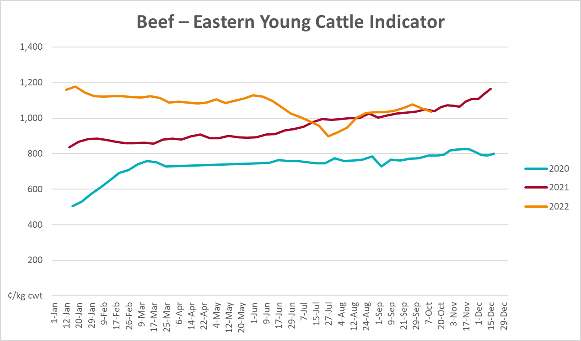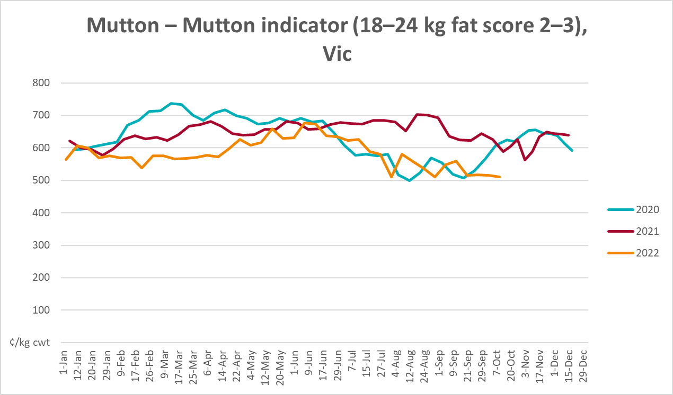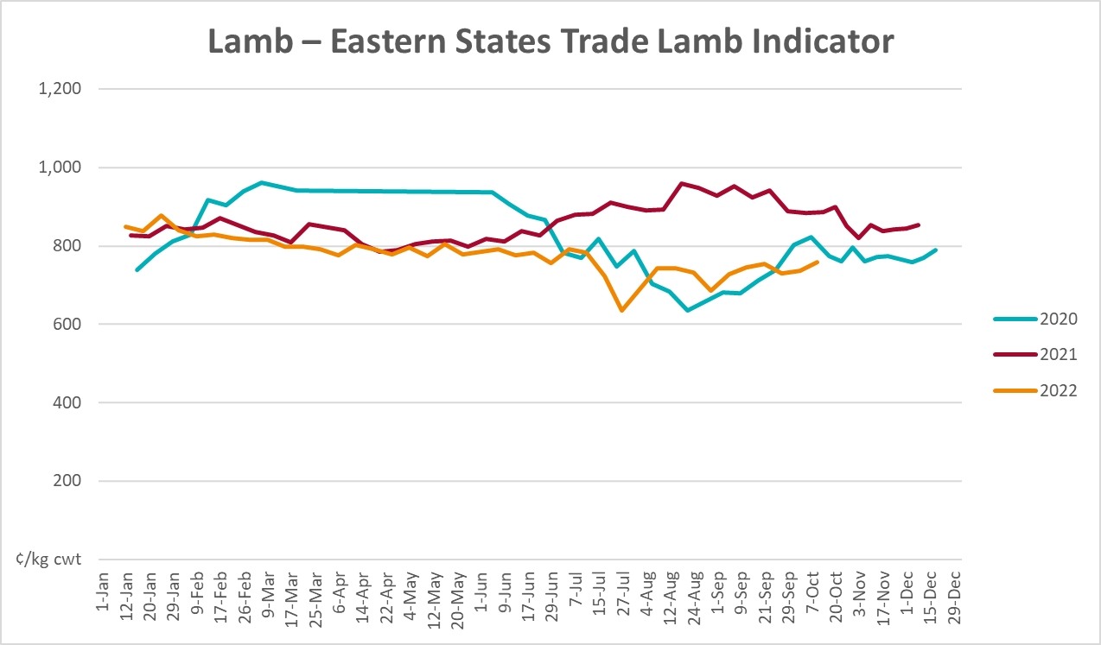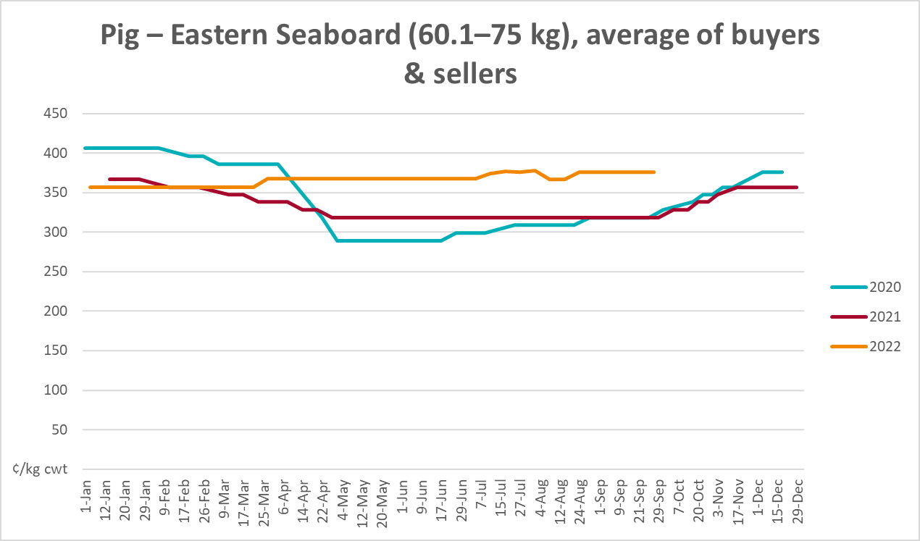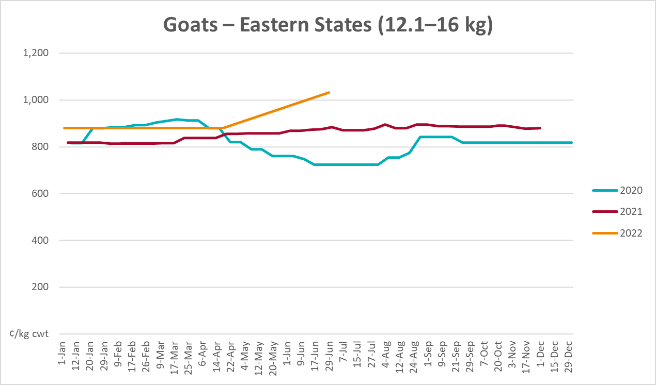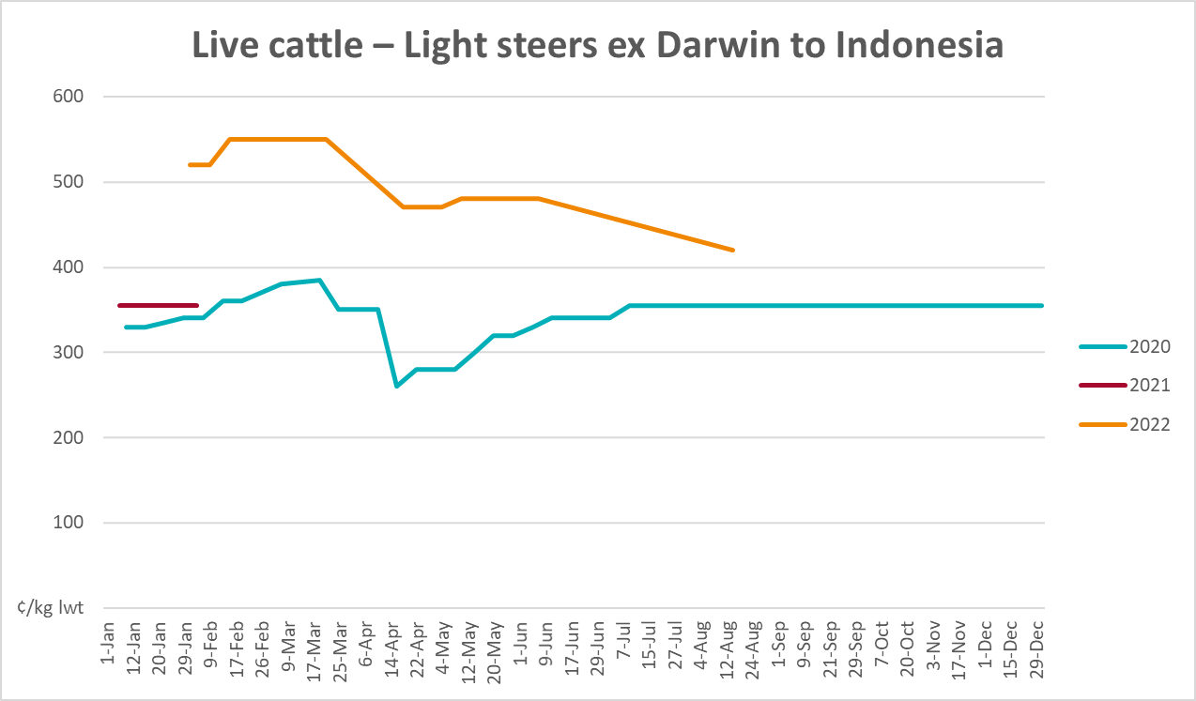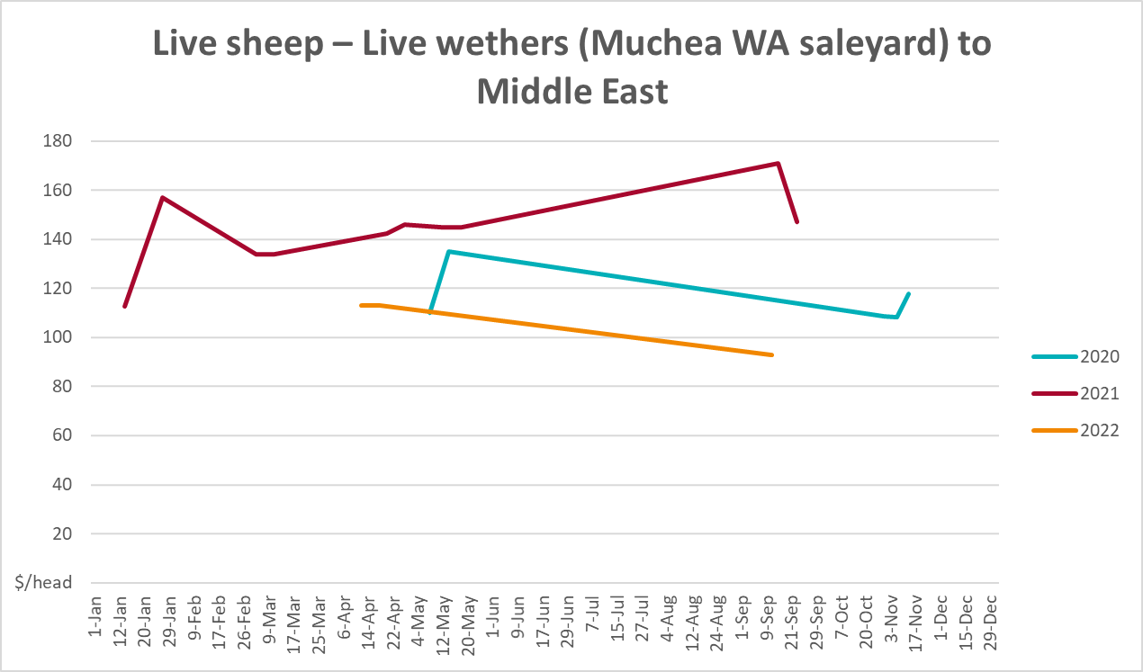

Global Dairy Trade (GDT) weighted average prices
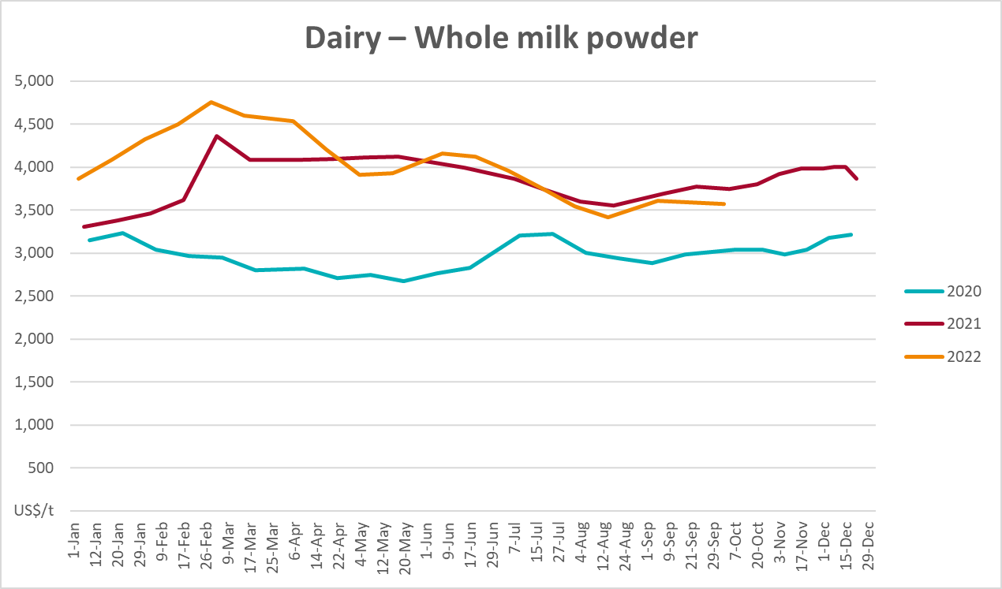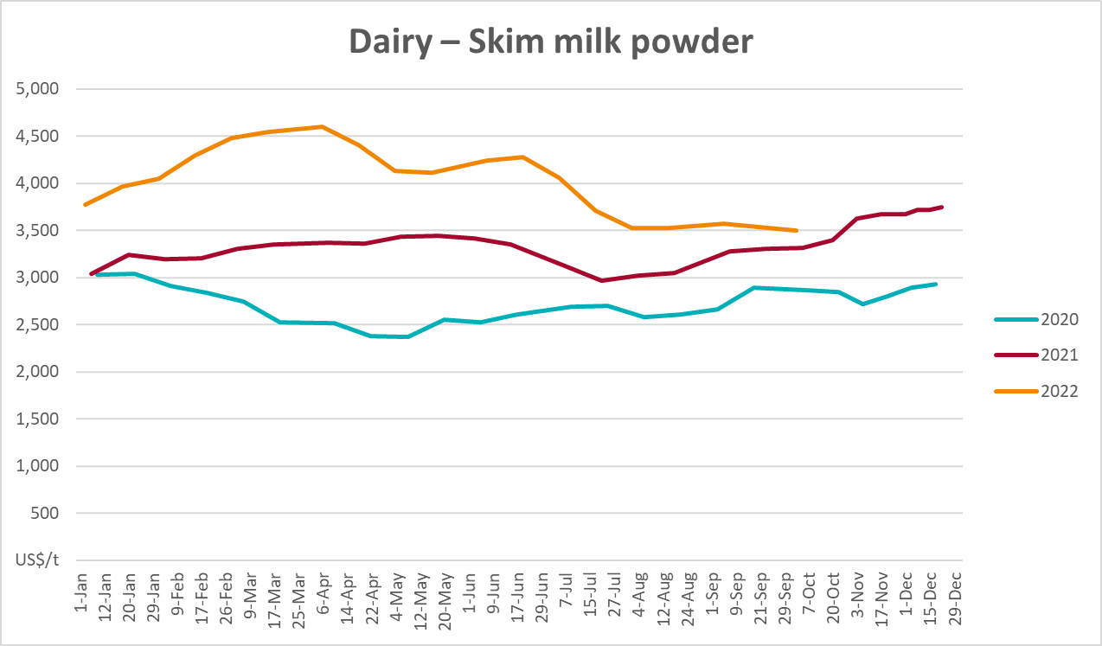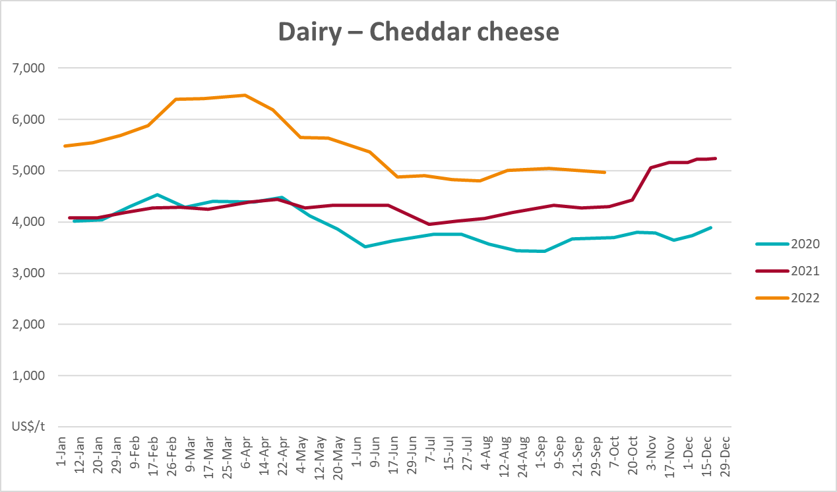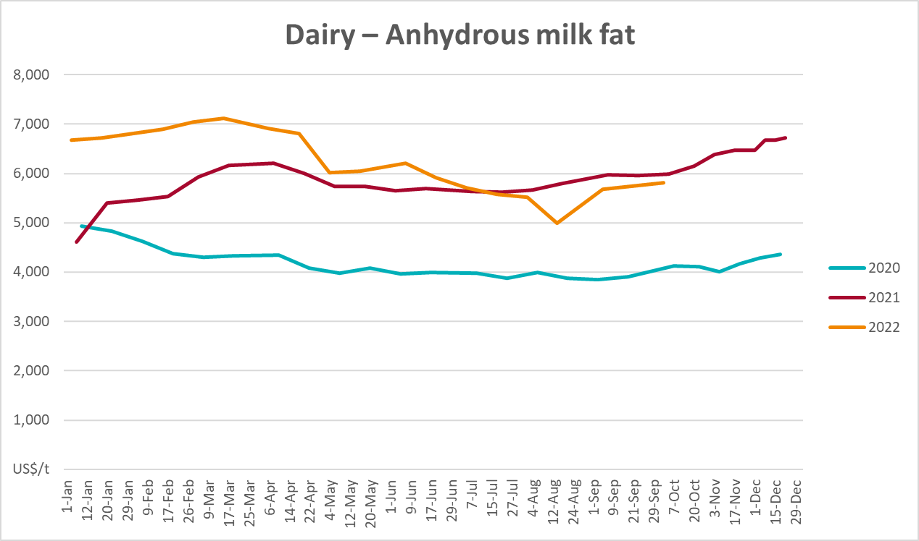

Selected fruit and vegetable prices
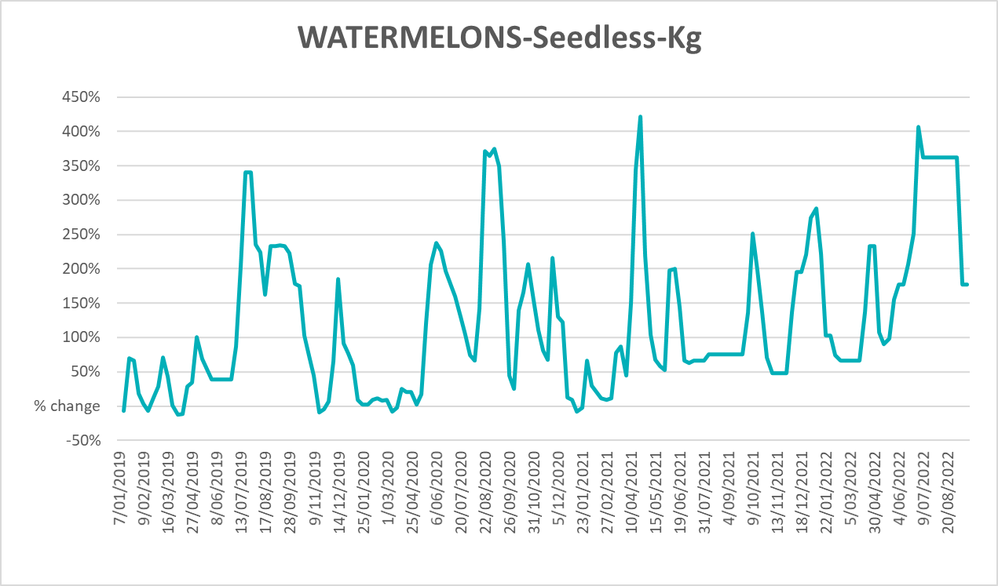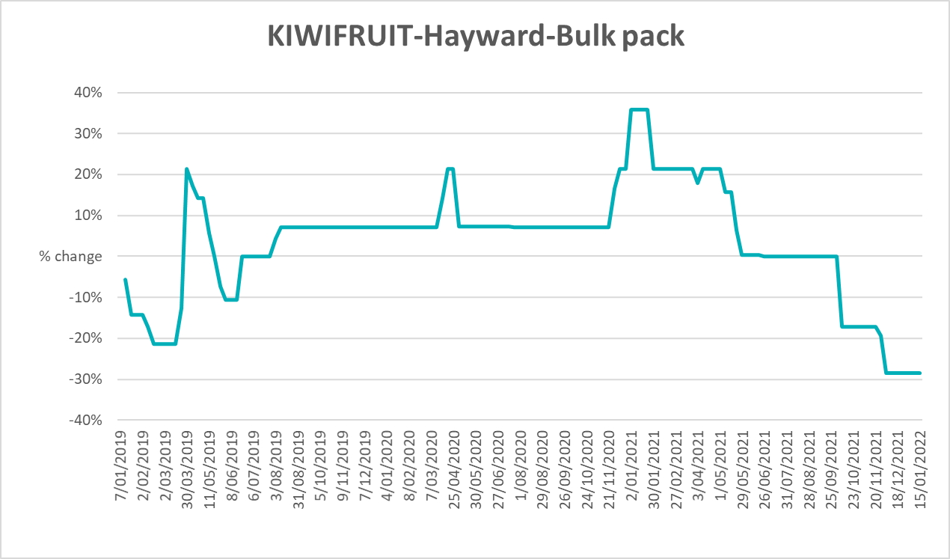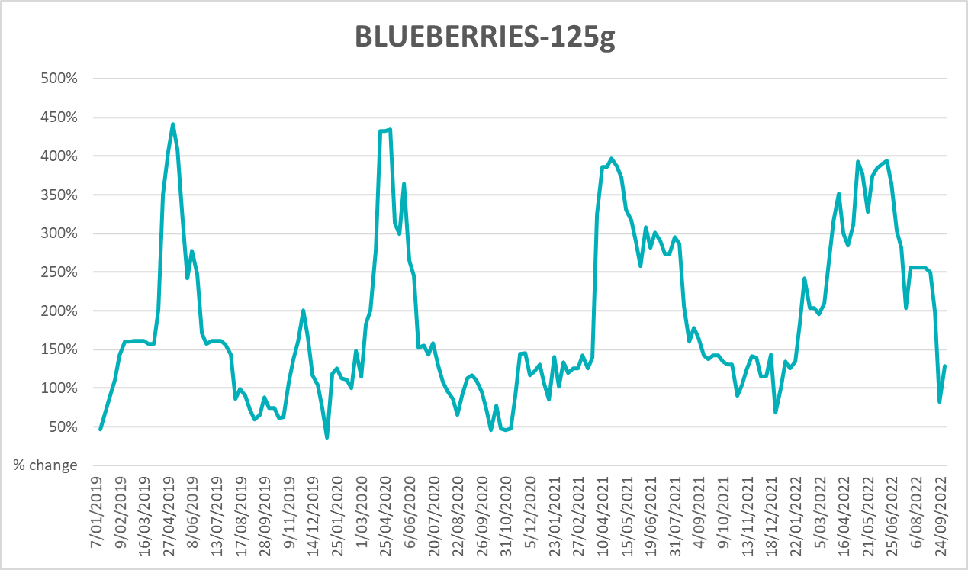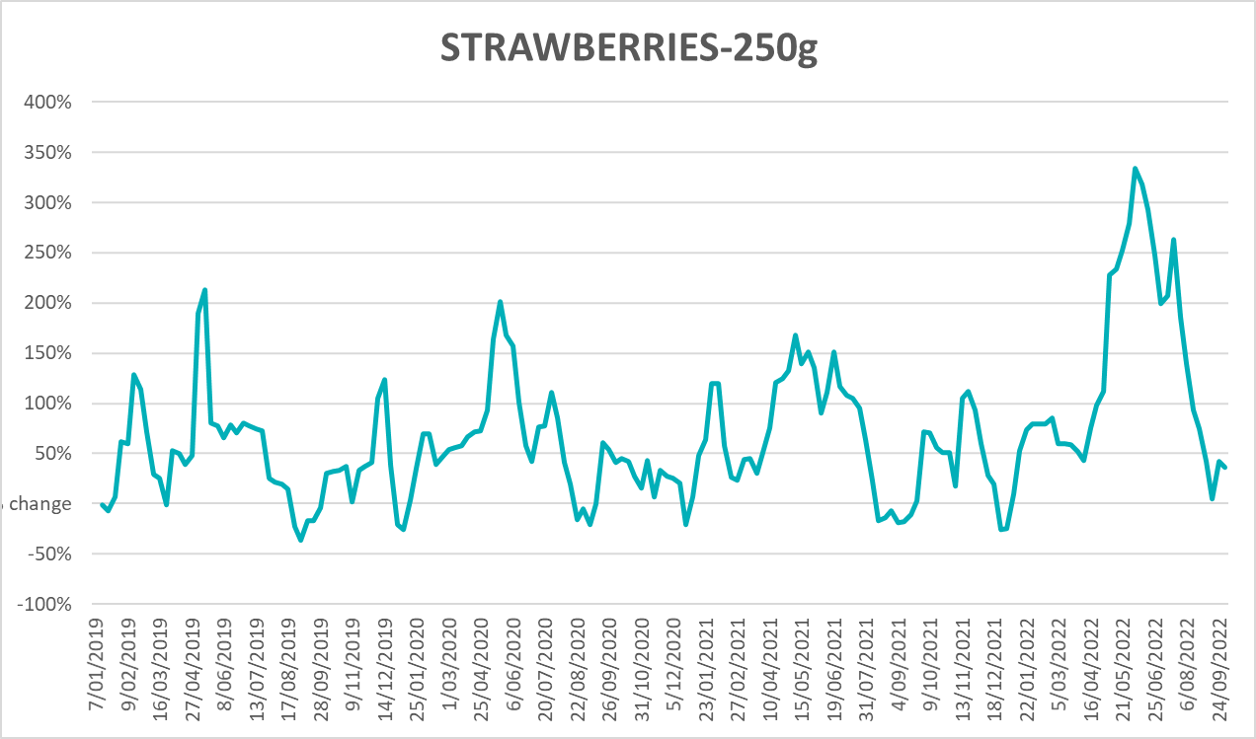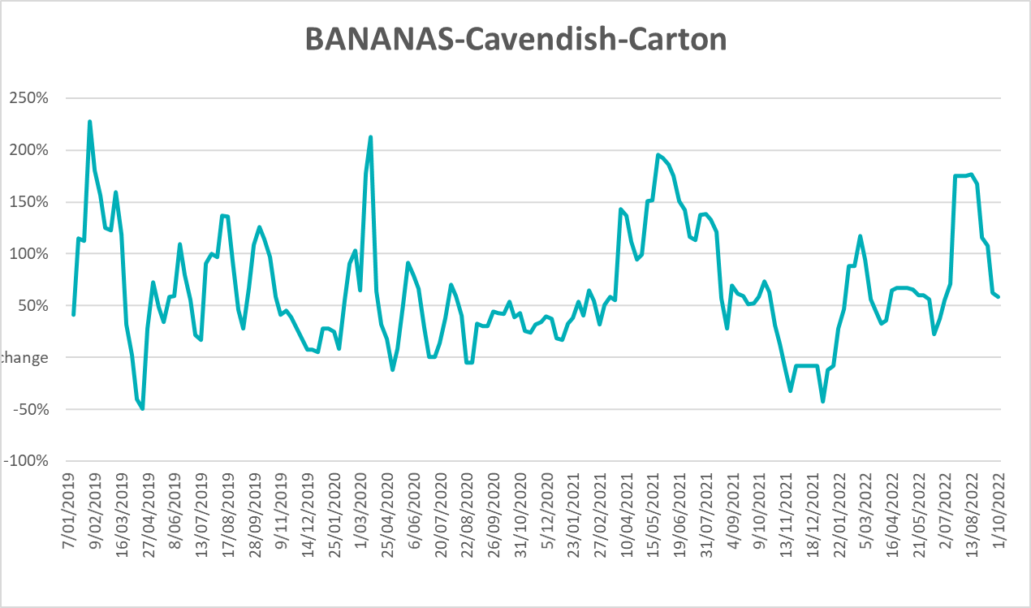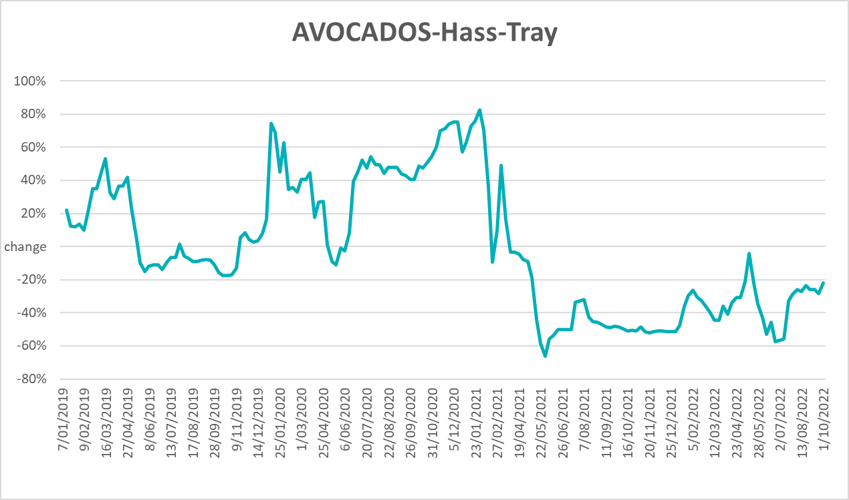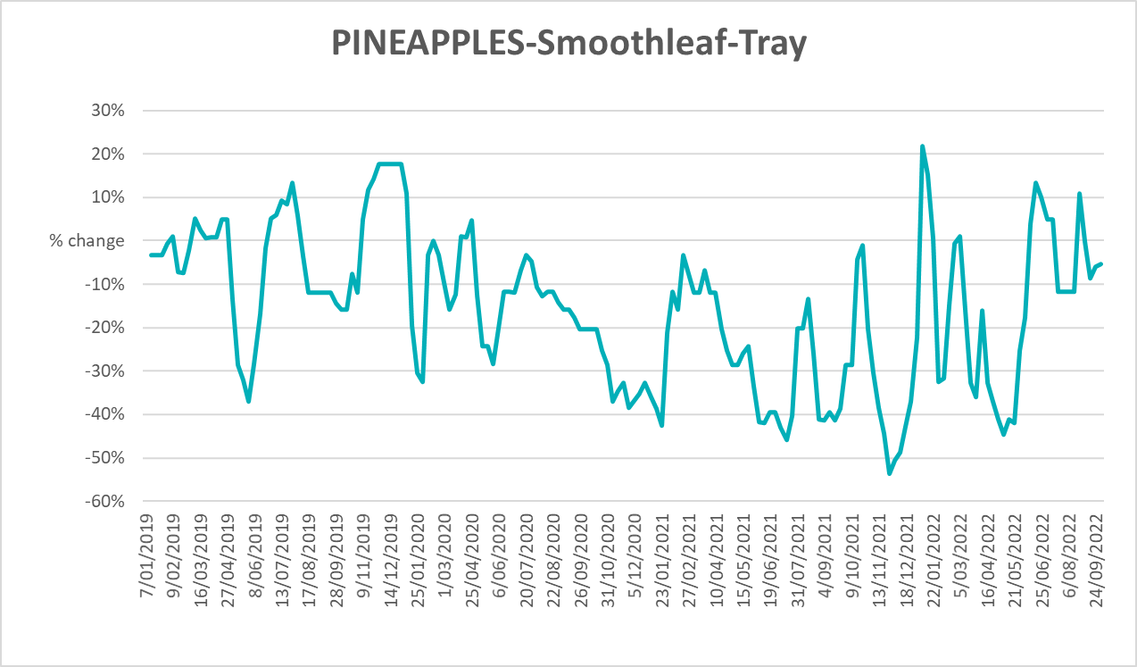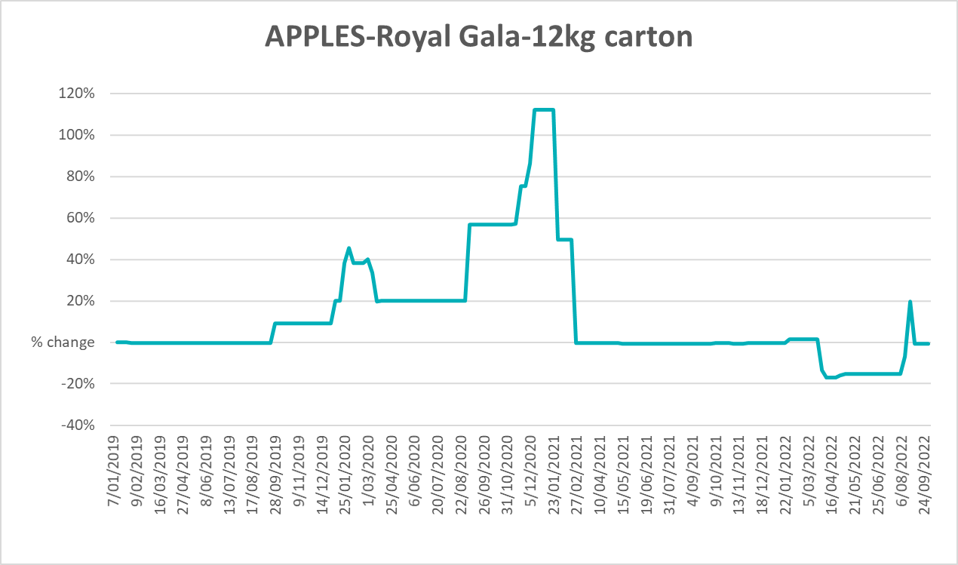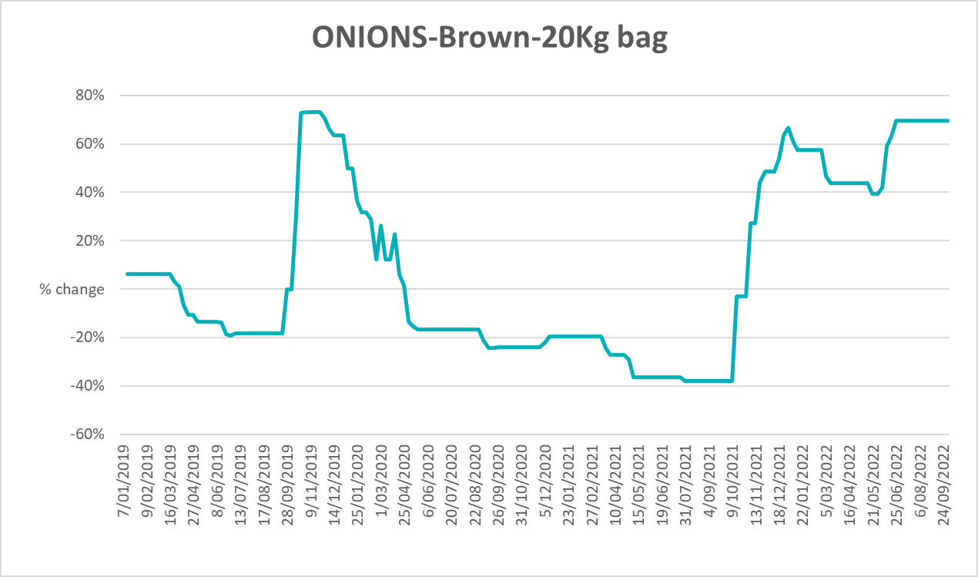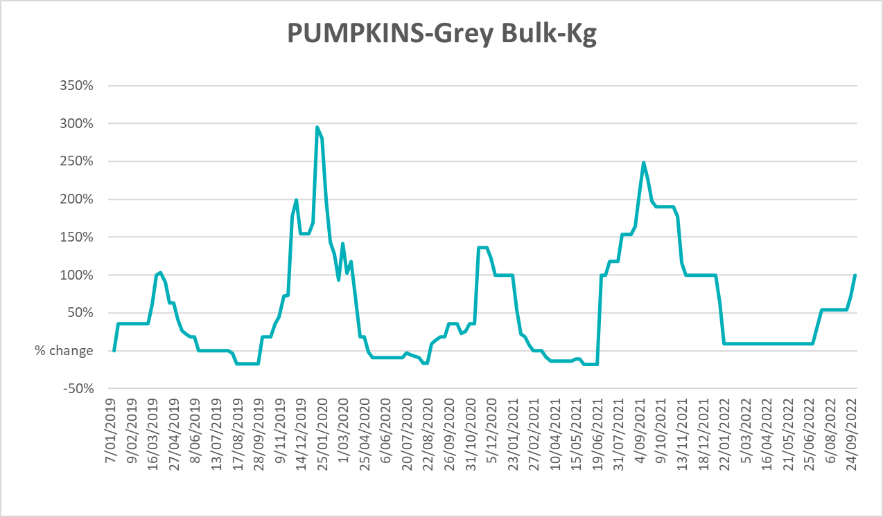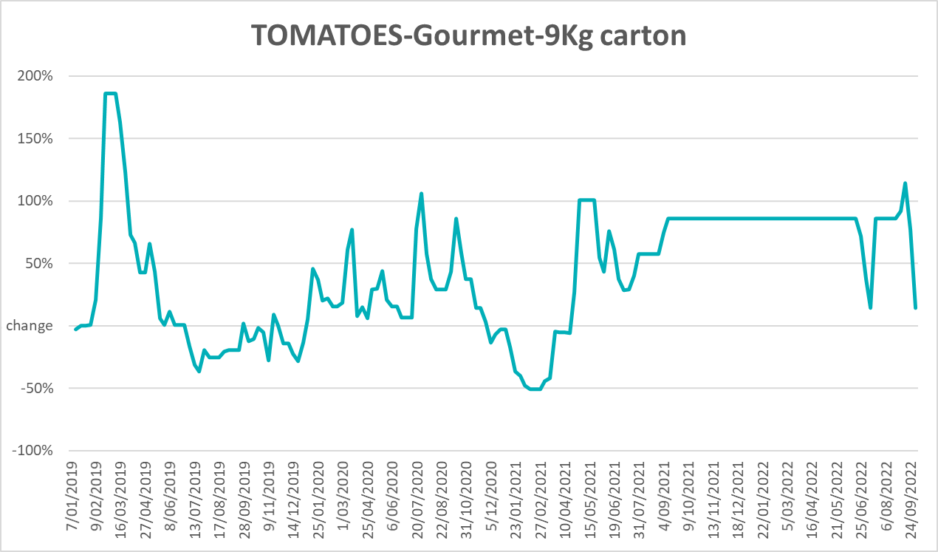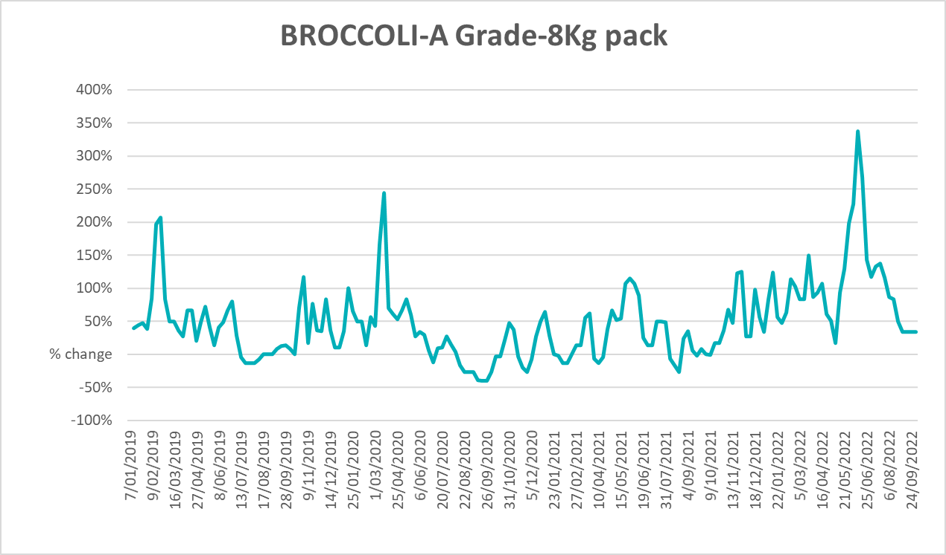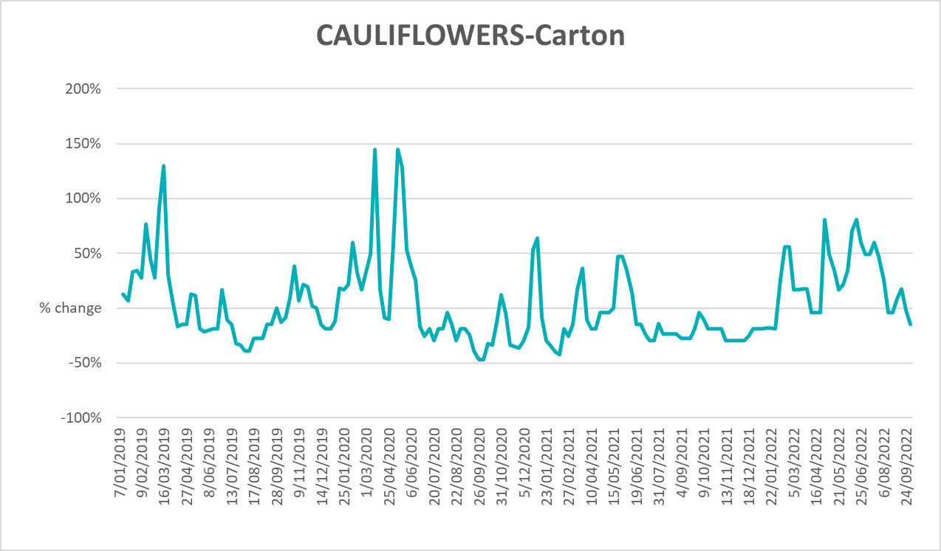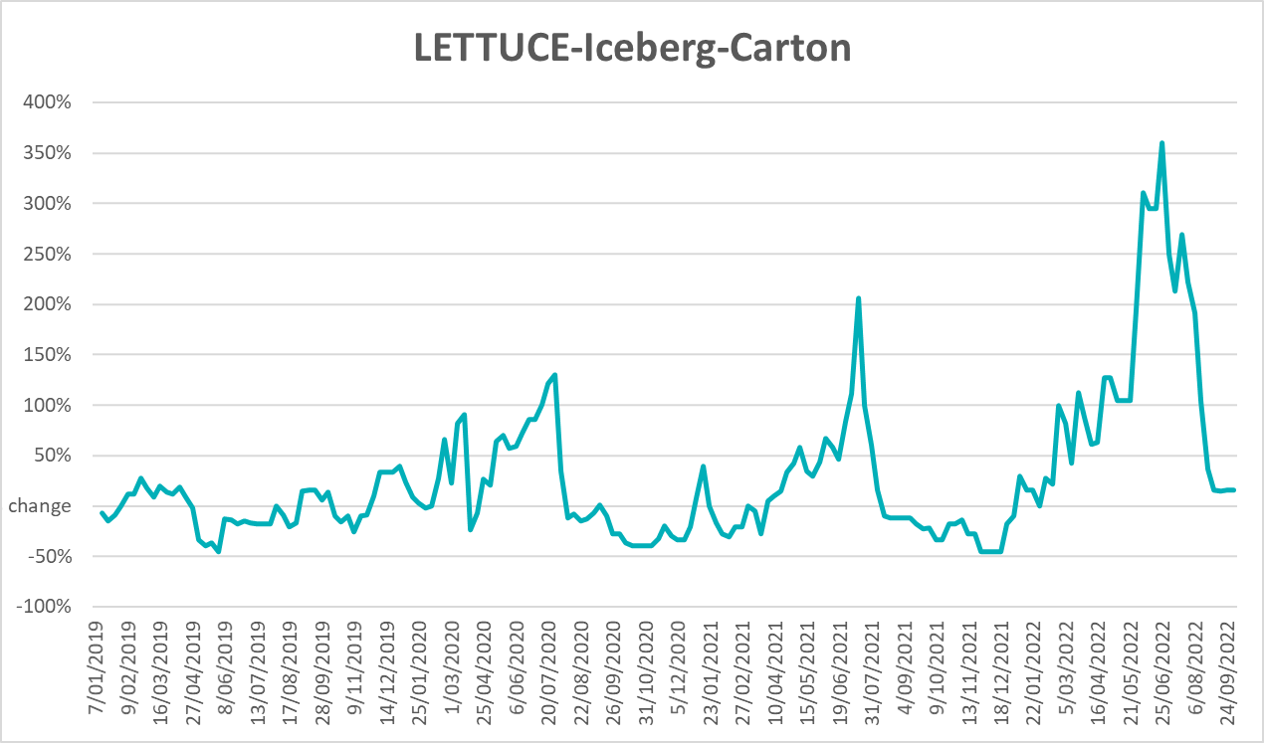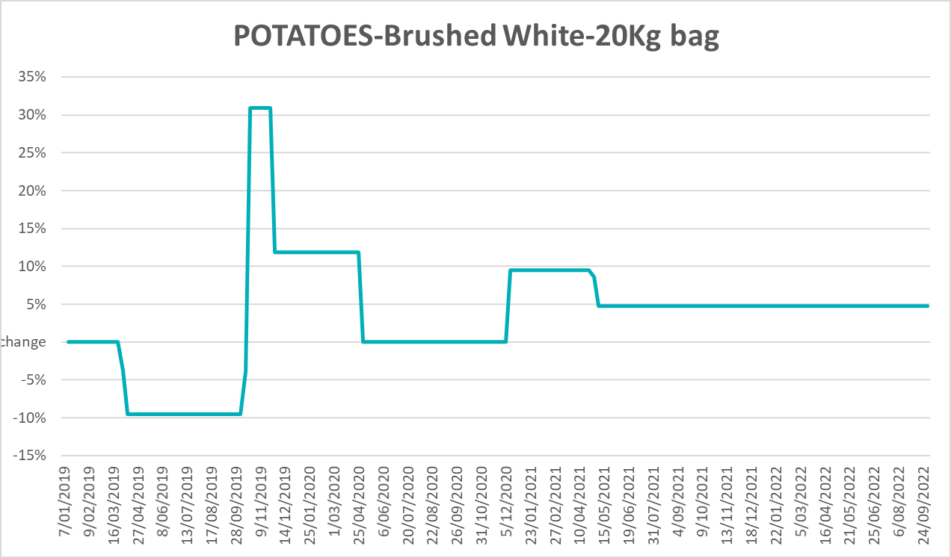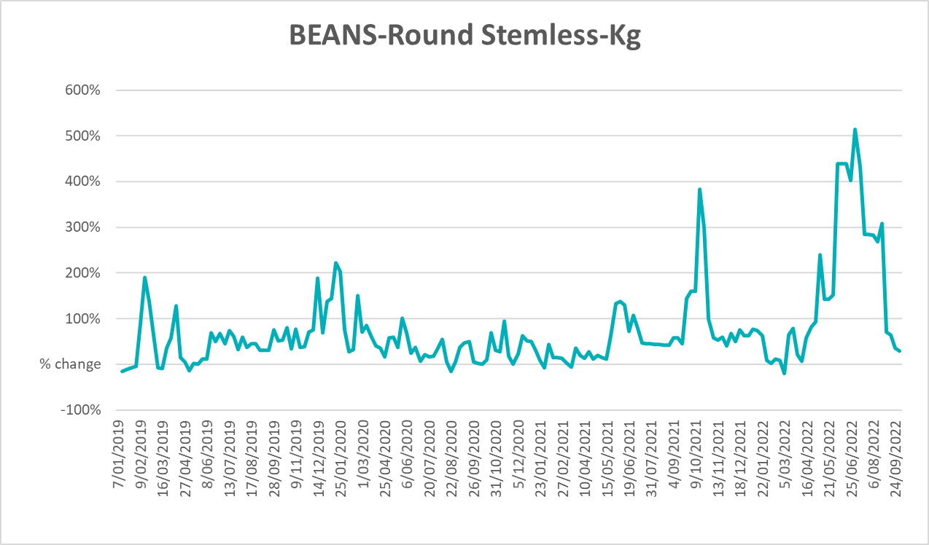

Selected domestic fodder indicator prices
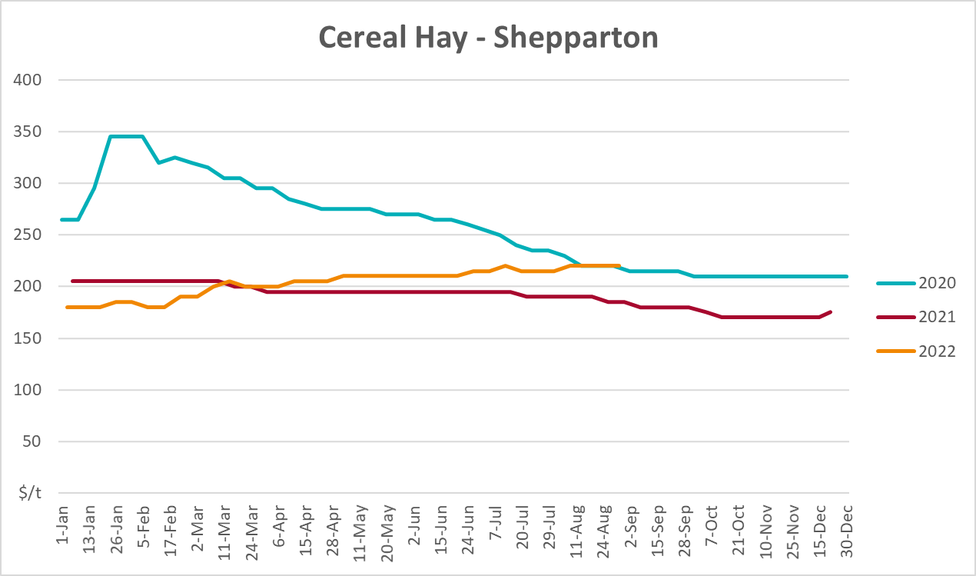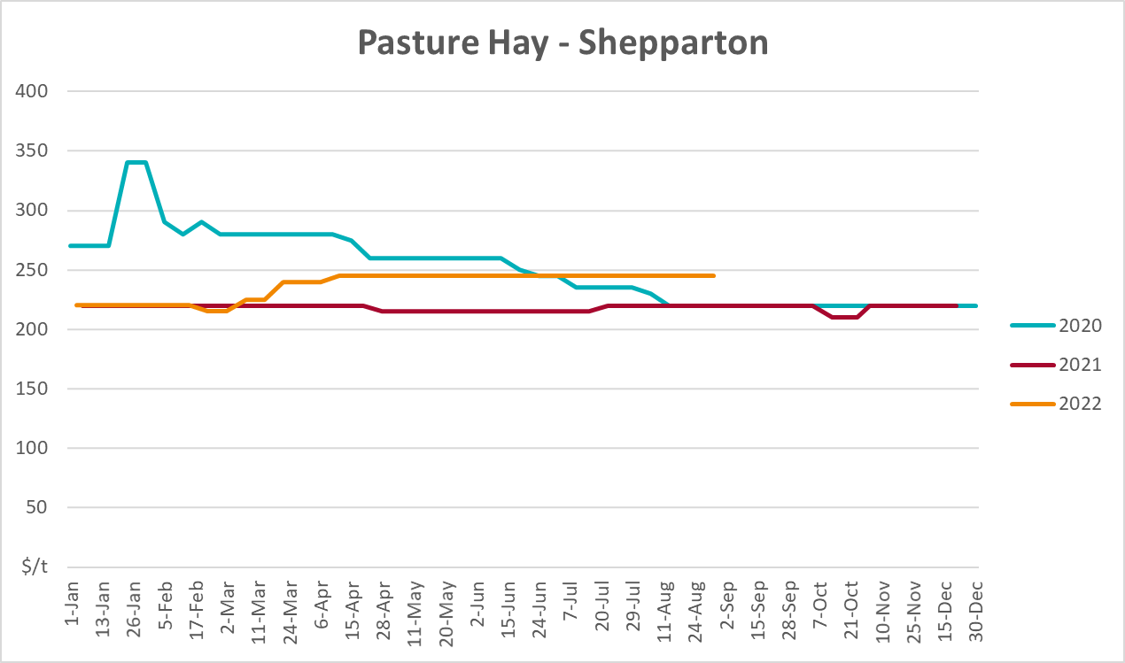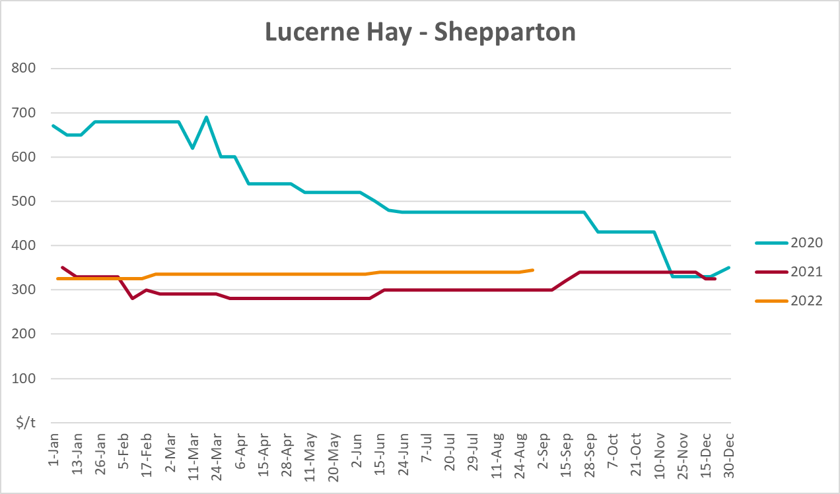

Data attribution

Climate
Bureau of Meteorology
- Weekly rainfall totals: www.bom.gov.au/climate/maps/rainfall/
- Monthly and last 3-month rainfall percentiles: www.bom.gov.au/water/landscape/
- Temperature anomalies: www.bom.gov.au/jsp/awap/temp/index.jsp
- Rainfall forecast: www.bom.gov.au/jsp/watl/rainfall/pme.jsp
- Seasonal outlook: www.bom.gov.au/climate/outlooks/#/overview/summary/
- Climate drivers: http://www.bom.gov.au/climate/enso/
- Soil moisture: www.bom.gov.au/water/landscape/
Other
- Pasture growth: www.longpaddock.qld.gov.au/aussiegrass/
- 3-month global outlooks: Environment and Climate Change Canada, NOAA Climate Prediction Center, EUROBRISA CPTEC/INPE, European Centre for Medium-Range Weather Forecasts, Hydrometcenter of Russia, National Climate Center Climate System Diagnosis and Prediction Room (NCC), International Research Institute for Climate and Society
- Global production: https://ipad.fas.usda.gov/ogamaps/cropmapsandcalendars.aspx
- Autumn break: Pook et al., 2009, https://rmets-onlinelibrary-wiley-com.virtual.anu.edu.au/doi/epdf/10.1002/joc.1833

Water
Prices
- Waterflow: https://www.waterflow.io/
- Ruralco: https://www.ruralcowater.com.au/
Bureau of Meteorology:
- Allocation trade: http://www.bom.gov.au/water/dashboards/#/water-markets/mdb/at
- Storage volumes: http://www.bom.gov.au/water/dashboards/#/water-storages/summary/drainage
Trade constraints:
- Water NSW: https://www.waternsw.com.au/customer-service/ordering-trading-and-pricing/trading/murrumbidgee
- Victorian Water Register: https://www.waterregister.vic.gov.au/TradingRules2019/

Commodities
Fruit and vegetables
- Datafresh: www.freshstate.com.au
Pigs
- Australian Pork Limited: www.australianpork.com.au
Dairy
- Global Dairy Trade: www.globaldairytrade.info/en/product-results/
World wheat, canola
- International Grains Council
World coarse grains
- United States Department of Agriculture
World cotton
- Cotlook: www.cotlook.com/
World sugar
- New York Stock Exchange - Intercontinental Exchange
Wool
- Australian Wool Exchange: www.awex.com.au/
Domestic wheat, barley, sorghum, canola and fodder
- Jumbuk Consulting Pty Ltd: http://www.jumbukag.com.au/
Cattle, beef, mutton, lamb, goat and live export
- Meat and Livestock Australia: www.mla.com.au/Prices-and-market
© Commonwealth of Australia 2022

Ownership of intellectual property rights
Unless otherwise noted, copyright (and any other intellectual property rights, if any) in this publication is owned by the Commonwealth of Australia (referred to as the Commonwealth).

Creative Commons licence
All material in this publication is licensed under a Creative Commons Attribution 4.0 International Licence except content supplied by third parties, logos and the Commonwealth Coat of Arms.
Inquiries about the licence and any use of this document should be emailed to copyright@awe.gov.au.


Cataloguing data
This publication (and any material sourced from it) should be attributed as:
ABARES 2022, Weekly Australian Climate, Water and Agricultural Update, Australian Bureau of Agricultural and Resource Economics and Sciences, Canberra, 13 October 2022. CC BY 4.0 DOI: https://doi.org/10.25814/5f3e04e7d2503
ISSN 2652-7561
This publication is available at https://www.agriculture.gov.au/abares/products/weekly_update
Department of Agriculture, Fisheries and Forestry
GPO Box 858 Canberra ACT 2601
Telephone 1800 900 090
Web agriculture.gov.au/abares

Disclaimer
The Australian Government acting through the Department of Agriculture, Fisheries and Forestry, represented by the Australian Bureau of Agricultural and Resource Economics and Sciences, has exercised due care and skill in preparing and compiling the information and data in this publication. Notwithstanding, the Department of Agriculture, Fisheries and Forestry, ABARES, its employees and advisers disclaim all liability, including liability for negligence and for any loss, damage, injury, expense or cost incurred by any person as a result of accessing, using or relying on any of the information or data in this publication to the maximum extent permitted by law.

Statement of Professional Independence
The views and analysis presented in ABARES publications, including this one, reflect ABARES professionally independent findings, based on scientific and economic concepts, principles, information and data. These views, analysis and findings may not reflect or be consistent with the views or positions of the Australian Government, or of organisations or groups who have commissioned ABARES reports or analysis. More information on professional independence is provided on the ABARES website.

Acknowledgements
This report was prepared by Matthew Miller and Cameron Van-Lane.

