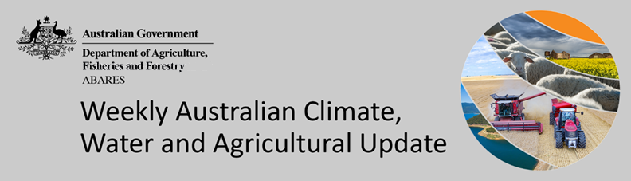
No. 43/2022

3 November 2022

Summary of key issues
- For the week ending 2 November 2022, low-pressure systems and surface troughs brought extensive rainfall to eastern, central and southern Australia. Weekly rainfall totals exceeding 50 millimetres were observed in the south and east of Victoria, much of Tasmania, as well as parts of eastern New South Wales, east-central Queensland, and southern parts of Western Australia (see Section 1.1).
- Rainfall during October 2022 was the second highest October on record for Australia as a whole, and the highest on record in New South Wales, Victoria and the Murray-Darling Basin. Significant flooding events occurred in large parts of eastern Australia, in some cases lasting for prolonged periods and recurring in multiple events throughout October (see Section 1.2).
- Soil moisture levels for October 2022 was extremely high for this time of year across much of New South Wales, Victoria, Queensland and South Australia, as well as parts of Western Australia, Tasmania and the Northern Territory, reflecting high monthly rainfall in these areas. For growers in eastern Australia, soil moisture levels, particularly in low lying areas, is delaying the harvesting of winter crops and the planting of some summer crops. Where fields are not waterlogged, the above-average soil moisture levels observed across much of eastern Australia will likely benefit summer crop germination and establishment (see Section 1.3).
- For the 3 months to October 2022 above average rainfall totals and mild temperatures resulted in well above average pasture production for this time of year across most grazing regions in eastern and southern Australia. This growth will likely enable farmers to continue rebuilding stock numbers and provide opportunities to replenish fodder supplies during late spring (see Section 1.4).
- Over the 8-days to 10 November 2022, high-pressure systems over southern Australia are forecast to bring limited rainfall across much of central and western Australia. Meanwhile, low-pressure systems are forecast to bring moderate rainfall to northern parts of Queensland and the Northern Territory as well as south-eastern Australia. The slight easing of wet conditions across flood-affected cropping regions of eastern Australian will likely allow floodwaters to recede and reduce the risk of waterlogging and fungal diseases. The forecast drier conditions are also expected to provide an opportunity for soils to drain and allow improved access to fields for harvest and disease management (see Section 1.5).
- Water storage levels in the Murray-Darling Basin (MDB) decreased between 25 October 2022 and 1 November 2022 by 75 gigalitres (GL). Current volume of water held in storage is 23 959 GL which represents 95 per cent of total capacity. This is 8 percent or 1715 GL more than at the same time last year (see Section 1.6).
- Allocation prices in the Victorian Murray below the Barmah Choke increased from $30 per ML on 21 October to $36 per ML on 28 October 2022. Prices are lower in regions above the Barmah choke due to the binding of the Barmah choke trade constraint (see Section 1.6).

Climate

Rainfall this week
For the week ending 2 November 2022, low-pressure systems and surface troughs brought extensive rainfall to eastern, central and southern Australia. Weekly rainfall totals exceeding 50 millimetres were observed in the south and east of Victoria, much of Tasmania, as well as parts of eastern New South Wales, east-central Queensland, and southern parts of Western Australia. High-pressure systems over western and northern parts of the country resulted in mostly dry conditions in much of Western Australia, the Northern Territory and western parts of Queensland.
In Australian cropping regions, rainfall totals of between 15 and 100 millimetres were recorded across much of Queensland, New South Wales and South Australia, as well as parts of Victoria and the southern half of the Western Australian wheatbelt. Little to no rainfall was recorded in remaining cropping regions of Western Australia, south-western Victoria and northern Queensland for the week ending 2 November 2022.
Heavy rain across New South Wales, Victoria, Queensland and Tasmania has led to continued major flood heights across several river catchments. The flooding events in eastern Australia have caused damage to agricultural and transport infrastructure and are expected to cause significant crop losses for some growers. However, the full extent of damage is yet unknown. Moderate to heavy rainfall across cropping regions in eastern Australia has interrupted the harvesting of winter crops and the sowing of summer crops.

Rainfall for the week ending 2 November 2022
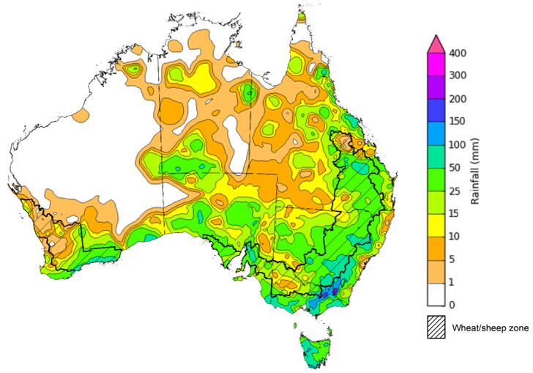
©Commonwealth of Australia 2022, Australian Bureau of Meteorology Issued: 03/11/2022
Note: The rainfall analyses and associated maps utilise data contained in the Bureau of Meteorology climate database, the Australian Data Archive for Meteorology (ADAM). The analyses are initially produced automatically from real-time data with limited quality control. They are intended to provide a general overview of rainfall across Australia as quickly as possible after the observations are received. For further information go to http://www.bom.gov.au/climate/rainfall/

Monthly rainfall
Rainfall during October 2022 was the second highest October on record for Australia as a whole, and the highest on record in New South Wales, Victoria and the Murray-Darling Basin. Monthly rainfall totals for October ranged from above average to extremely high for much of Australia. Significant flooding events occurred in large parts of eastern Australia, in some cases lasting for prolonged periods and recurring in multiple events throughout October. In contrast, rainfall was below average for isolated parts of western and central Western Australia, as well as parts of south-western Tasmania.
The main climate influences for October were a negative Indian Ocean Dipole (IOD), a positive Southern Annular Mode (SAM) and the continued La Niña event in the Pacific Ocean. A negative IOD typically results in enhanced rainfall in a broad band extending from the north-west to the south-east of Australia. A positive SAM is associated with increased rainfall across parts of eastern Australia but less rainfall for parts of southern Australia. La Niña events tend to increase rainfall across eastern, central and northern Australia.
October 2022 rainfall was extremely high across cropping regions of New South Wales, Queensland, Victoria, south-eastern parts of South Australia and southern parts of Western Australia. October rainfall was below average for some northern parts of Western Australian cropping regions but generally average for remainder of Western Australian cropping areas.
Extremely high rainfall across eastern Australia in October followed a wet start to the winter cropping season and well above average rainfall across much of Australia in September 2022. The persistent wet conditions have exacerbated waterlogging in low lying areas, negatively impacting winter crop development. The continuation of wet conditions has also increased fungal disease pressure and limited field access for harvesting and disease management. In some cropping regions across eastern Australia, harvesting of winter crops has been delayed by the wet conditions. However, harvesting is nearing completion in Central Queensland and is now underway in New South Wales, Victoria and South Australia. Yield potentials remain very favourable for crops not impacted by waterlogging and fungal diseases.

Rainfall percentiles for October 2022

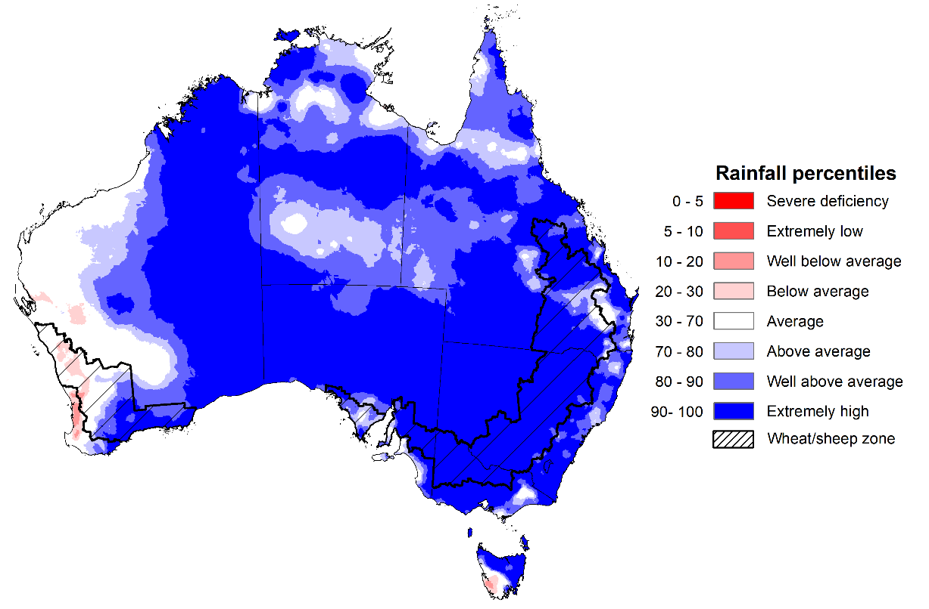
Note: Rainfall for October 2022 is compared with rainfall recorded for that period during the historical record (1900 to present). For further information, go to http://www.bom.gov.au/jsp/awap/
Source: Bureau of Meteorology

Monthly soil moisture
Upper layer soil moisture for October 2022 was extremely high for this time of year across much of New South Wales, Victoria, Queensland and South Australia, as well as parts of southern and north-western parts of Western Australia, north-western Tasmania and large areas of the Northern Territory, reflecting high monthly rainfall in these areas. Below average upper layer soil moisture was evident across isolated parts of the east and south-west of Western Australia, and south-western Tasmania. Modelled upper layer soil moisture was generally average to above average across the remainder of the country.
At this time of year, upper layer soil moisture determines the ability of growers to access paddocks for winter crop harvesting, as well as sowing and establishment of summer crops. For growers in eastern Australia, high upper layer soil moisture levels, particularly in low lying areas, is delaying the harvesting of winter crops and the planting of some summer crops. Fungal disease risks exacerbated by wet conditions are an ongoing concern, especially as timely disease management relies on access to paddocks. However, upper layer soil moisture is also critical for supporting the germination and establishment of summer crops. Where fields are not waterlogged, the above-average upper layer soil moisture levels observed across much of eastern Australia will likely benefit summer crop germination and establishment.

Modelled upper layer soil moisture for October 2022

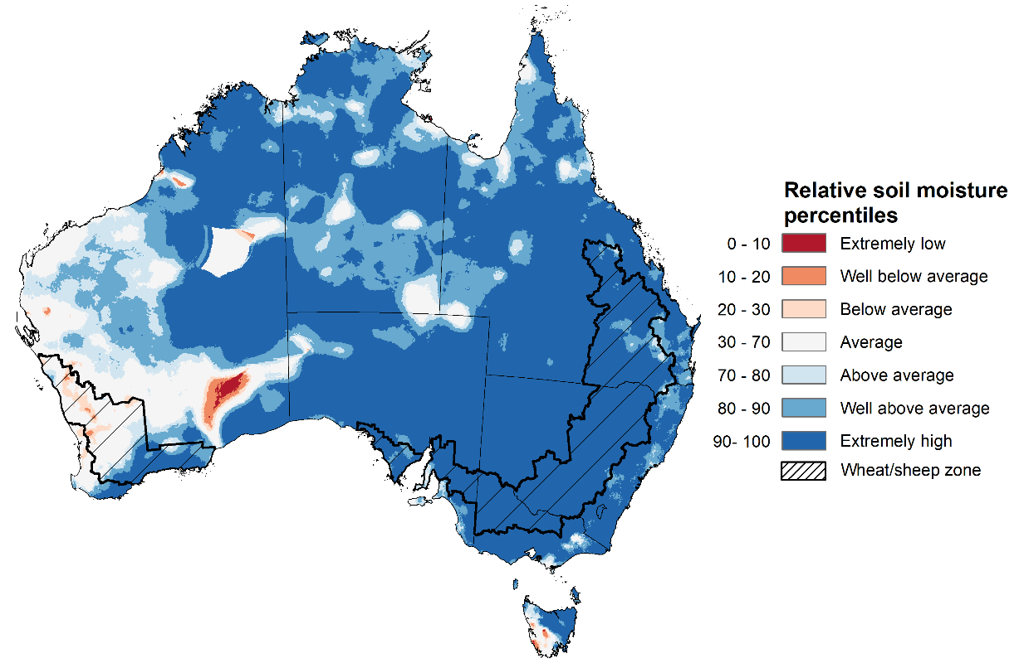
Note: This map shows the levels of modelled upper layer soil moisture (0 to 10 centimetres) during October 2022. This map shows how modelled soil conditions during October 2022 compare with October conditions modelled over the reference period (1911 to 2016). Dark blue areas on the maps were much wetter in October 2022 than during the reference period. The bulk of plant roots occur in the top 20 centimetres of the soil profile. Soil moisture in the upper layer of the soil profile is therefore useful indicator of the availability of water, particularly for germinating seed.
Source: Bureau of Meteorology (Australian Water Resources Assessment Landscape model)

Lower layer soil moisture for October 2022 was well above average to extremely high for this time of year across large parts of New South Wales, Queensland, Victoria, South Australia, as well as northern parts of Western Australia and the Northern Territory, and eastern Tasmania. Lower layer soil moisture was below average to extremely low in isolated parts of southern Western Australia and western Tasmania. Modelled lower layer soil moisture was generally average across the remainder of the country.
Lower layer soil moisture will be important for winter crops as they finish grain filling over the coming weeks and help support summer crops and pasture growth during a peak growth period.
In Australian cropping regions, lower layer soil moisture was well above average to extremely high across much of New South Wales, Queensland, northern Victoria, and central and eastern South Australia. Lower layer soil moisture was generally average or just above average across remaining cropping areas of New South Wales, Victoria and South Australia. In contrast, much of the cropping regions of Western Australia are experiencing average or below average lower layer soil moisture.
Well above average to extremely high lower layer soil moisture levels across New South Wales, Queensland and northern Victorian cropping regions present a potential downside risk to yields. These areas are expected to receive well above median rainfall over the next three months, increasing the risk that saturated soils and waterlogging will persist and reduce yield potentials. High lower layer soil moisture levels during October also provide a reserve of plant-available water for summer crops later in the growing season.
Modelled lower layer soil moisture for October 2022
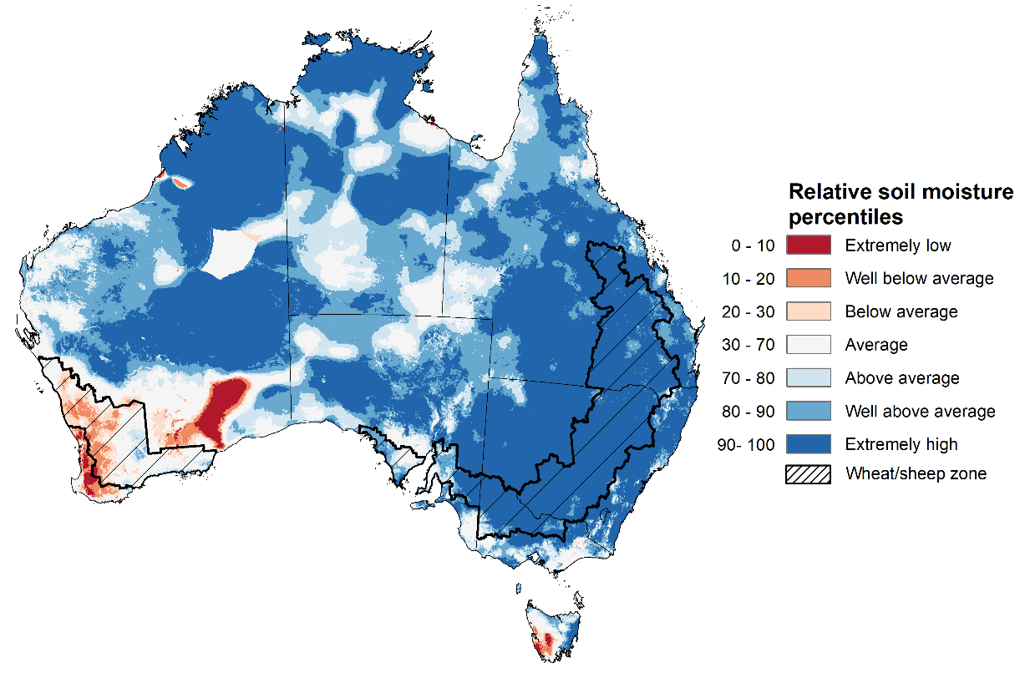
Note: This map shows the levels of modelled lower layer soil moisture (10 to 100 centimetres) during October 2022. This map shows how modelled soil conditions during October 2022 compare with October conditions modelled over the reference period (1911 to 2016). Dark blue areas on the maps were much wetter in October 2022 than during the reference period. The dark red areas were much drier than during the reference period. The bulk of plant roots occur in the top 20 centimetres of the soil profile. The lower layer soil moisture is a larger, deeper store that is slower to respond to rainfall and tends to reflect accumulated rainfall events over longer time periods.
Source: Bureau of Meteorology (Australian Water Resources Assessment Landscape model)

Pasture growth
Pasture growth during the August to October period is typically low across large areas of central and northern Australia as it is firmly in the dry season. Across southern Australia, August to October pasture growth provides the spring flush which typically allows producers to cease winter supplementary feeding with grain and hay. It also influences the growth, branding and marking rates of lambs and calves, and the production of meat, milk, and wool over this peak production period.
For the 3 months to October 2022 above average rainfall totals and mild temperatures resulted in well above average pasture production for this time of year across most grazing regions in eastern and southern Australia.
Modelled pasture growth was above average to extremely high across large areas of New South Wales, Victoria, and Western Australia, as well as south-eastern Queensland and southern South Australia. This growth will likely enable farmers to continue rebuilding stock numbers and provide opportunities to replenish fodder supplies during late spring, if suitable fodder conservation conditions arise. In contrast, modelled pasture growth was extremely low to below average across scattered areas of central and southern New South Wales, southern Queensland, South Australia, and southern parts of Western Australian grazing areas. In some regions this low pasture growth likely reflects a decline in plant growth due to excess moisture.

Relative pasture growth for 3-months ending October 2022 (1 August to 31 October 2022)
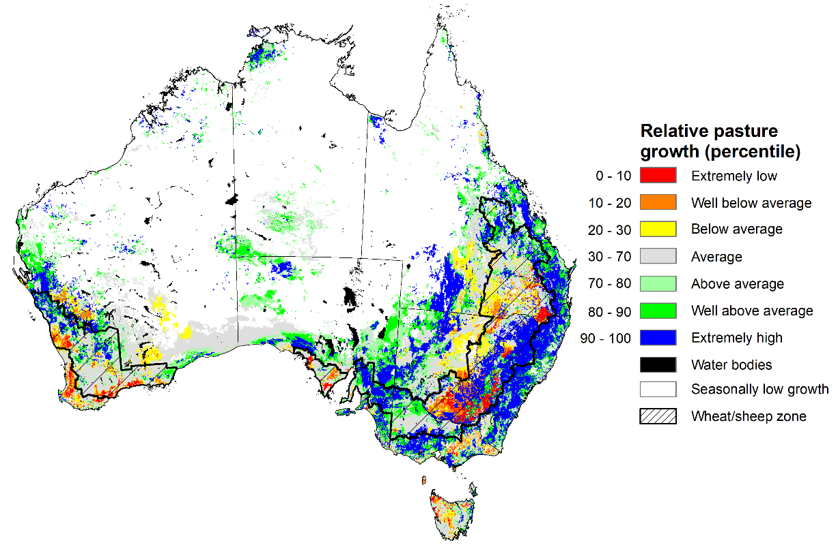
Notes: AussieGRASS pasture growth estimates are relative to the long-term record and shown in percentiles. Percentiles rank data on a scale of zero to 100. This analysis ranks pasture growth for the selected period against average pasture growth for the long-term record (1957 to 2016). Pasture growth is modelled at 5km2 grid cells.
Source: Queensland Department of Science, Information Technology and Innovation

Rainfall forecast for the next eight days
Over the 8-days to 10 November 2022, high-pressure systems over southern Australia are forecast to bring limited rainfall across much of central and western Australia. Meanwhile, low-pressure systems are forecast to bring moderate rainfall to northern parts of Queensland and the Northern Territory as well as south-eastern Australia.
In Australian cropping regions, rainfall totals of between 10 to 25 millimetres are expected across much of southern New South Wales and Victoria, as well as southern parts of the Western Australian wheatbelt. Little to no rainfall is forecast for remaining cropping regions during the next 8-days.
The slight easing of wet conditions across flood-affected cropping regions of eastern Australian will likely allow floodwaters to recede and reduce the risk of waterlogging and fungal diseases. The forecast drier conditions are also expected to provide an opportunity for soils to drain and allow improved access to fields for harvest and disease management.
Yield potentials for crops not impacted by flooding in south-eastern Australia remain very favourable. If this rainfall forecast is realised, it should allow for the harvesting of winter crops and provide ideal conditions for planting of summer crops across Queensland and New South Wales in the coming weeks.
The outlook for winter crops across South Australia and Western Australia remains very promising, as ideal conditions for the season to-date have established strong yield potentials. With little rainfall forecast for cropping regions in South Australia and Western Australia over the next week, this should provide favourable conditions for crop maturation and harvesting activities.

Total forecast rainfall (mm) for the period 3 November to 10 November 2022
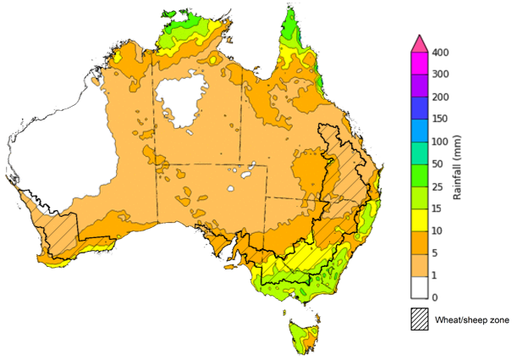
©Commonwealth of Australia 2022, Australian Bureau of Meteorology Issued 03/10/2022

Water
Note: This rainfall forecast is produced from computer models. As the model outputs are not altered by weather forecasters, it is important to check local forecasts and warnings issued by the Bureau of Meteorology.

Water markets – current week
Water storage levels in the Murray-Darling Basin (MDB) decreased between 25 October 2022 and 1 November 2022 by 75 gigalitres (GL). Current volume of water held in storage is 23 959 GL which represents 95 per cent of total capacity. This is 8 percent or 1715 GL more than at the same time last year.

Water storages in the Murray-Darling Basin, 2013–2022
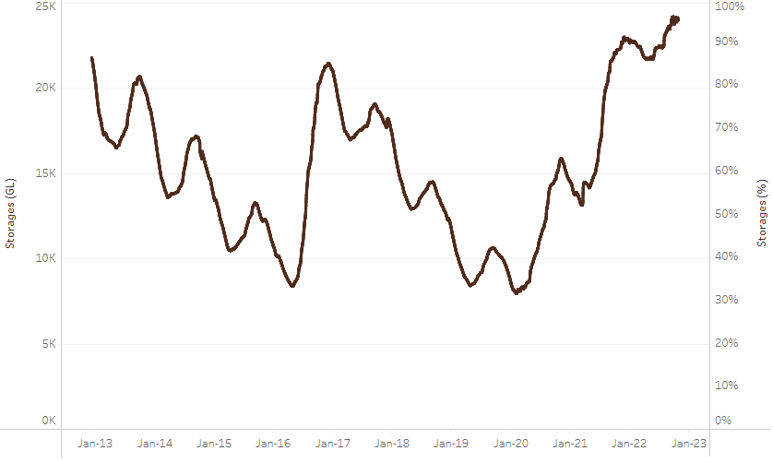
Allocation prices in the Victorian Murray below the Barmah Choke increased from $30 per ML on 21 October to $36 per ML on 28 October 2022. Prices are lower in regions above the Barmah choke due to the binding of the Barmah choke trade constraint.
Water storage data is sourced from the Bureau of Meteorology.

Region | $/ML
NSW Murray Above | 12
NSW Murrumbidgee | 102
VIC Goulburn-Broken | 52
VIC Murray Below | 36

Surface water trade activity, Southern Murray–Darling Basin

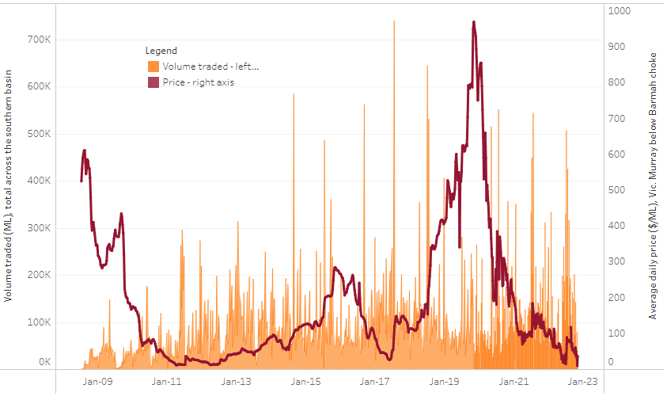
To access the full, interactive, weekly water dashboard, which contains the latest and historical water storage, water market and water allocation information, please visit http://www.agriculture.gov.au/abares/products/weekly_update/weekly-update-271022
The trades shown reflect estimated market activity and do not encompass all register trades. The price is shown for the VIC Murray below the Barmah choke. Historical prices (before 1 July 2019) are ABARES estimates after removing outliers from BOM water register data. Prices after 1 July 2019 and prior to the 30 October 2019 reflect recorded transaction prices as sourced from Ruralco. Prices after the 30 October 2019 are sourced from Waterflow. Data for volume traded is sourced from the BOM water register. Data shown is current at 03 November 2022.

Commodities

Indicator | Week ended | Unit | Latest price | Previous week | Weekly change | Price 12 months ago | Annual change
Selected world indicator prices
AUD/USD Exchange rate | 02-Nov | A$/US$ | 0.64 | 0.64 | 1% | 0.74 | -13%
Wheat – US no. 2 hard red winter wheat, fob Gulf | 02-Nov | US$/t | 446 | 433 | 3% | 373 | 20%
Corn – US no. 2 yellow corn, fob Gulf | 02-Nov | US$/t | 370 | 364 | 2% | 245 | 51%
Canola – Rapeseed, Canada, fob Vancouver | 02-Nov | US$/t | 691 | 696 | -1% | 872 | -21%
Cotton – Cotlook 'A' Index | 02-Nov | USc/lb | 90 | 95 | -5% | 127 | -29%
Sugar – Intercontinental Exchange, nearby futures, no.11 contract | 02-Nov | USc/lb | 18.2 | 17.7 | 3% | 20 | -8%
Wool – Eastern Market Indicator | 19-Oct | Ac/kg clean | 1,300 | 1,323 | -2% | 1,332 | -2%
Wool – Western Market Indicator | 19-Oct | Ac/kg clean | 1,427 | 1,469 | -3% | 1,385 | 3%
Selected Australian grain export prices
Milling Wheat – APW, Port Adelaide, SA | 02-Nov | A$/t | 616 | 612 | 1% | 458 | 35%
Feed Wheat – ASW, Port Adelaide, SA | 02-Nov | A$/t | 566 | 562 | 1% | 457 | 24%
Feed Barley – Port Adelaide, SA | 02-Nov | A$/t | 484 | 478 | 1% | 381 | 27%
Canola – Kwinana, WA | 02-Nov | A$/t | 1,080 | 1,067 | 1% | 1,039 | 4%
Grain Sorghum – Brisbane, QLD | 02-Nov | A$/t | 475 | 473 | 0% | 367 | 29%
Selected domestic livestock indicator prices
Beef – Eastern Young Cattle Indicator | 02-Nov | Ac/kg cwt | 1,024 | 1,035 | -1% | 1,062 | -4%
Mutton – Mutton indicator (18–24 kg fat score 2–3), Vic | 02-Nov | Ac/kg cwt | 541 | 535 | 1% | 626 | -14%
Lamb – Eastern States Trade Lamb Indicator | 02-Nov | Ac/kg cwt | 801 | 786 | 2% | 889 | -10%
Pig – Eastern Seaboard (60.1–75 kg), average of buyers & sellers | 19-Oct | Ac/kg cwt | 376 | 376 | 0% | 318 | 18%
Goats – Eastern States (12.1–16 kg) | 05-Oct | Ac/kg cwt | 680 | 770 | -12% | 818 | -17%
Live cattle – Light steers ex Darwin to Indonesia | 17-Aug | Ac/kg lwt | 420 | 480 | -13% | 320 | 31%
Live sheep – Live wethers (Muchea WA saleyard) to Middle East | 14-Sep | $/head | 93 | 113 | -18% | 114 | -18%

Indicator | Week ended | Unit | Latest price | Previous week | Weekly change | Price 12 months ago | Annual change
Global Dairy Trade (GDT) weighted average prices ª
Dairy – Whole milk powder | 02-Nov | US$/t | 3,279 | 3,421 | -4% | 3,041 | 8%
Dairy – Skim milk powder | 02-Nov | US$/t | 2,972 | 3,250 | -9% | 2,865 | 4%
Dairy – Cheddar cheese | 02-Nov | US$/t | 4,802 | 4,769 | 1% | 3,694 | 30%
Dairy – Anhydrous milk fat | 02-Nov | US$/t | 5,562 | 5,661 | -2% | 4,131 | 35%
a Global Dairy Trade prices are updated twice monthly on the first and third Tuesday of each month.

Selected world indicator prices
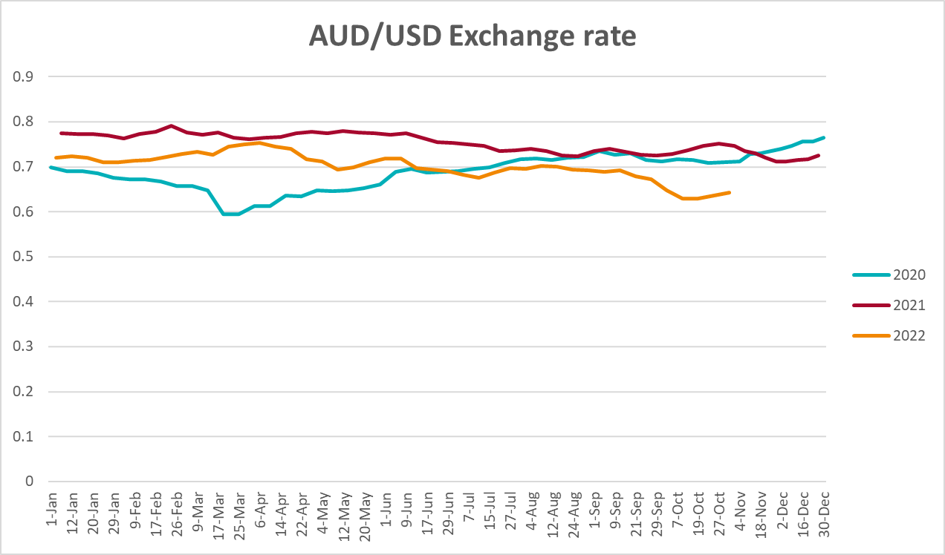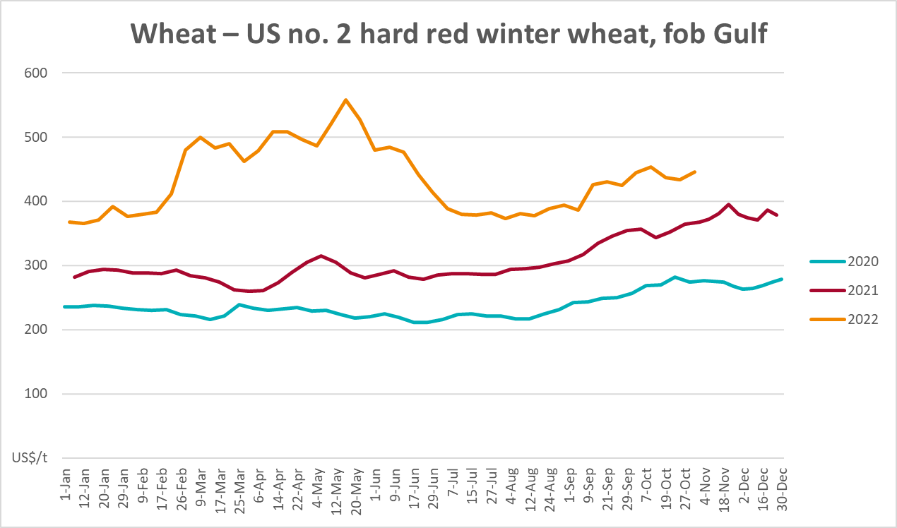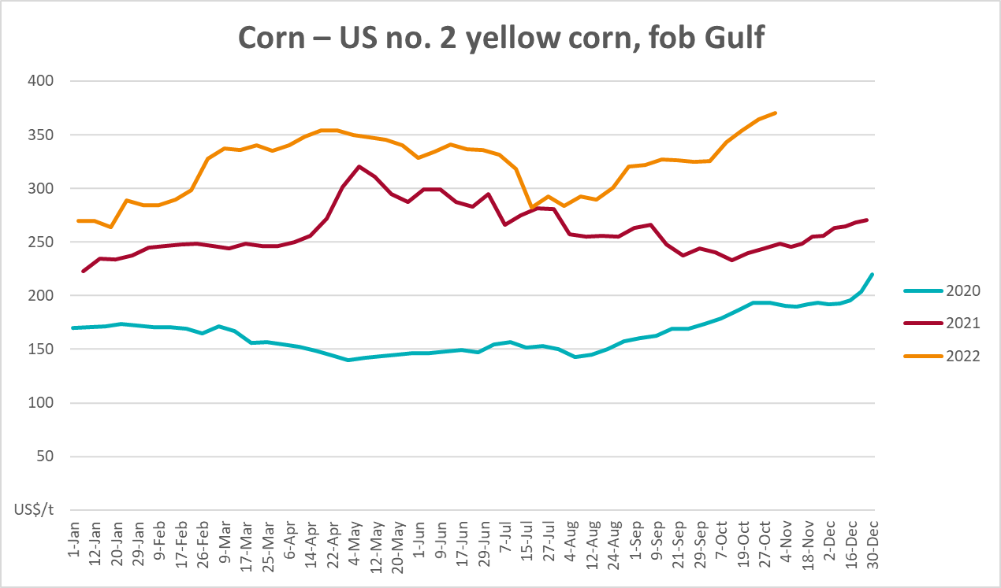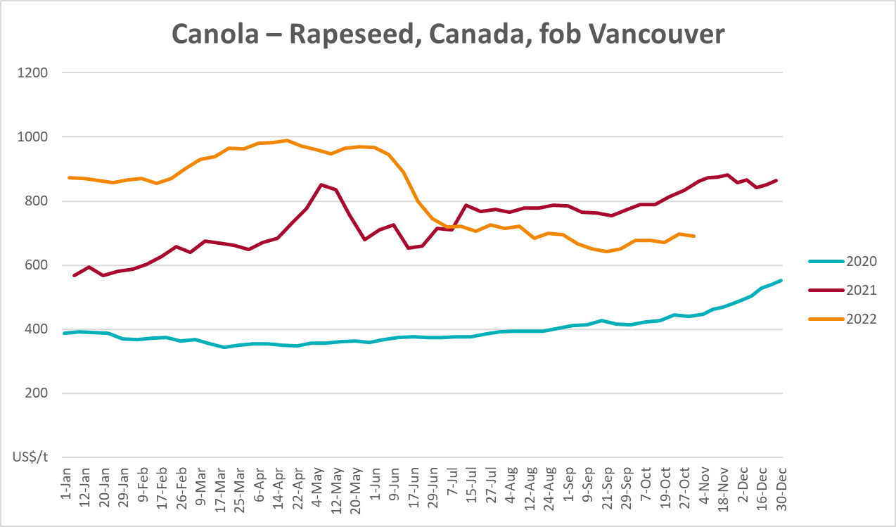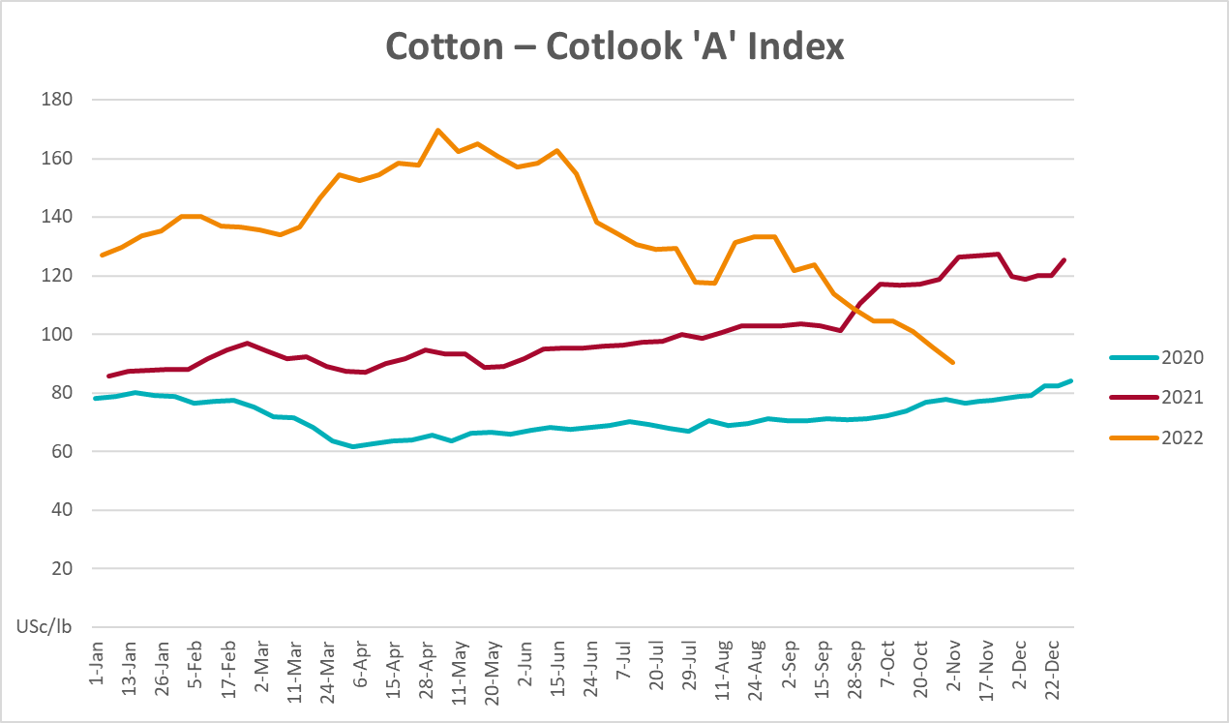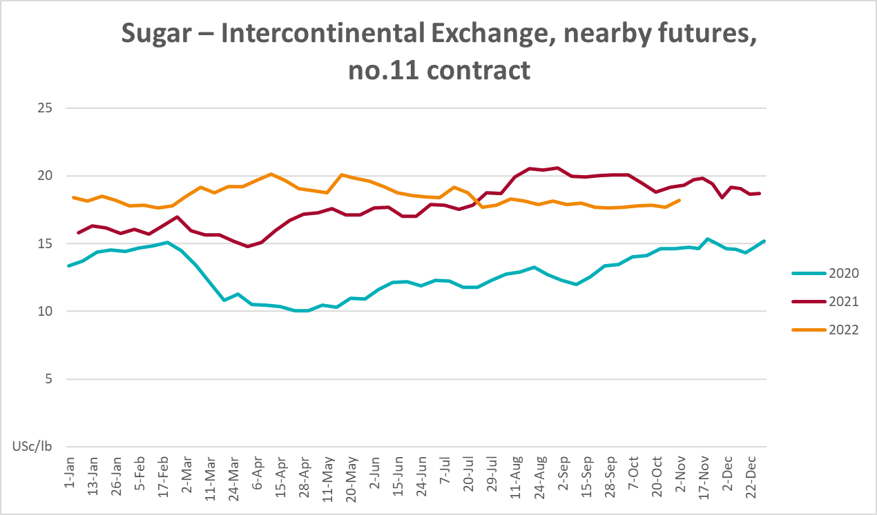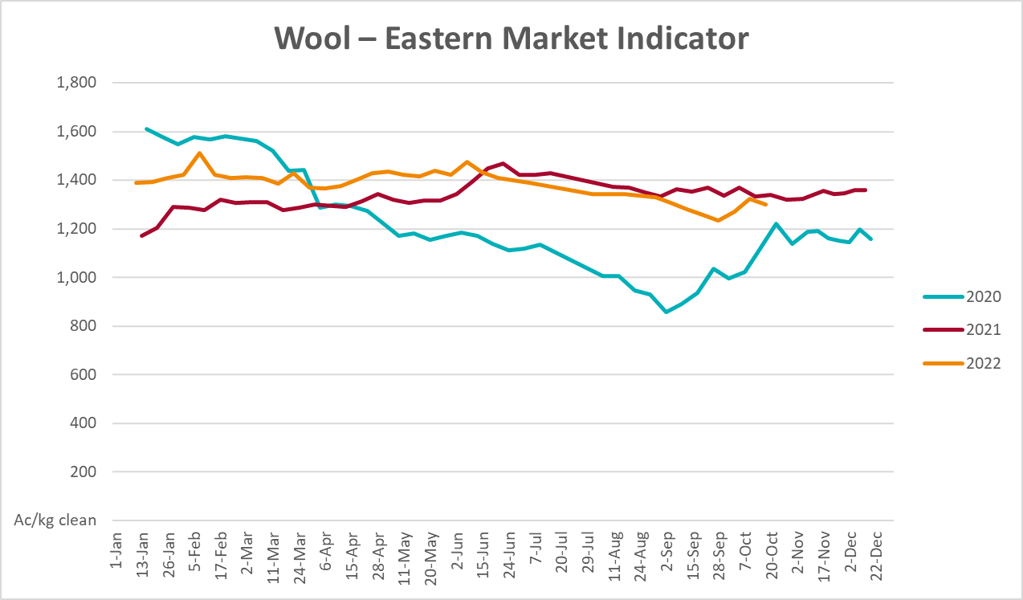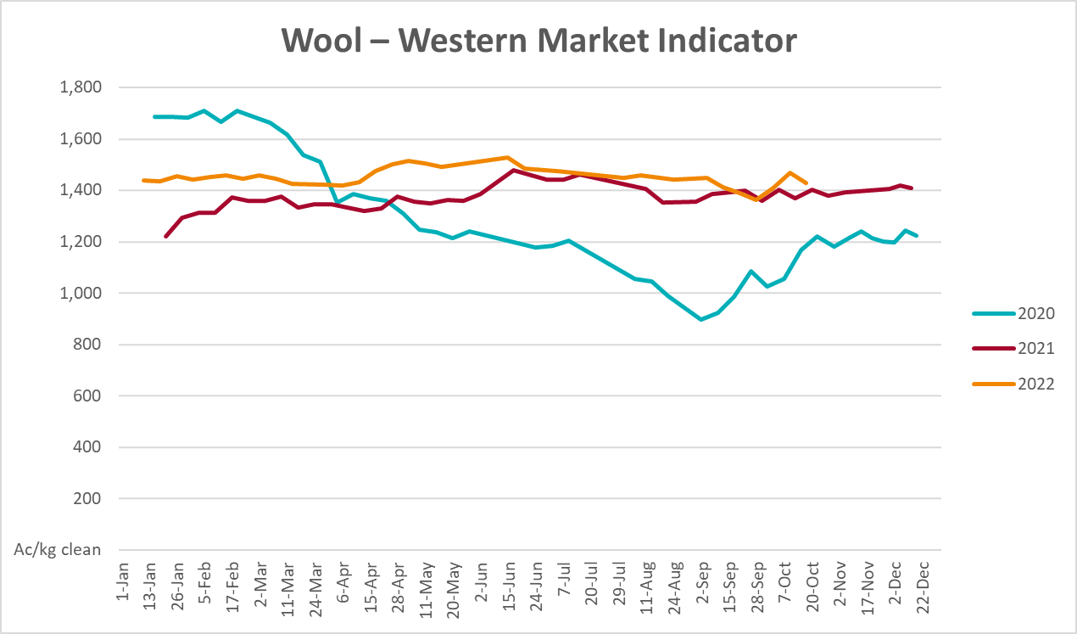

Selected domestic crop indicator prices
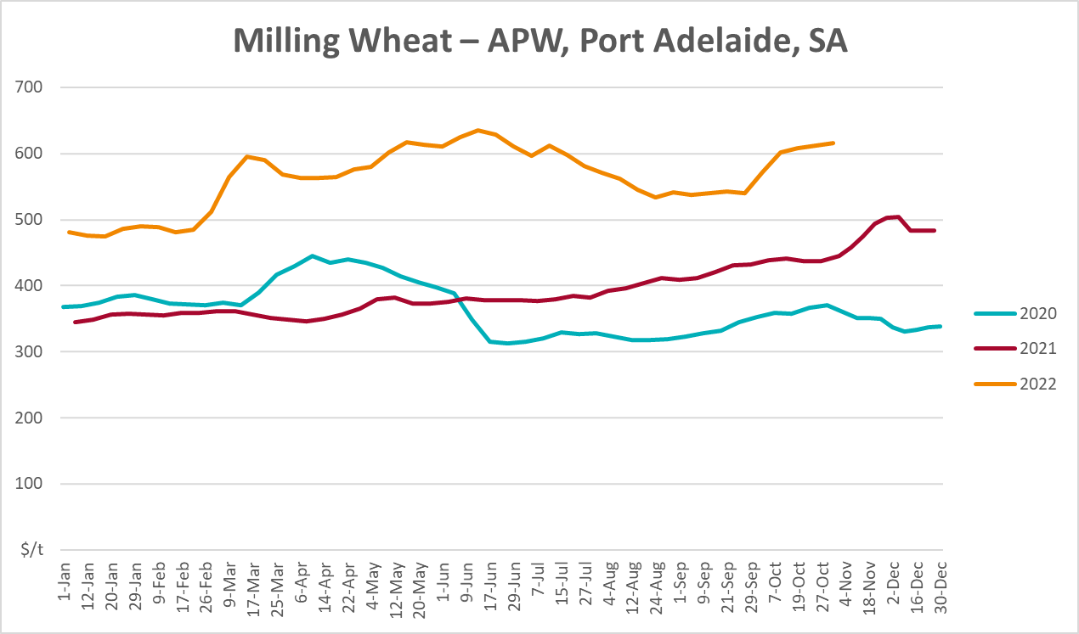
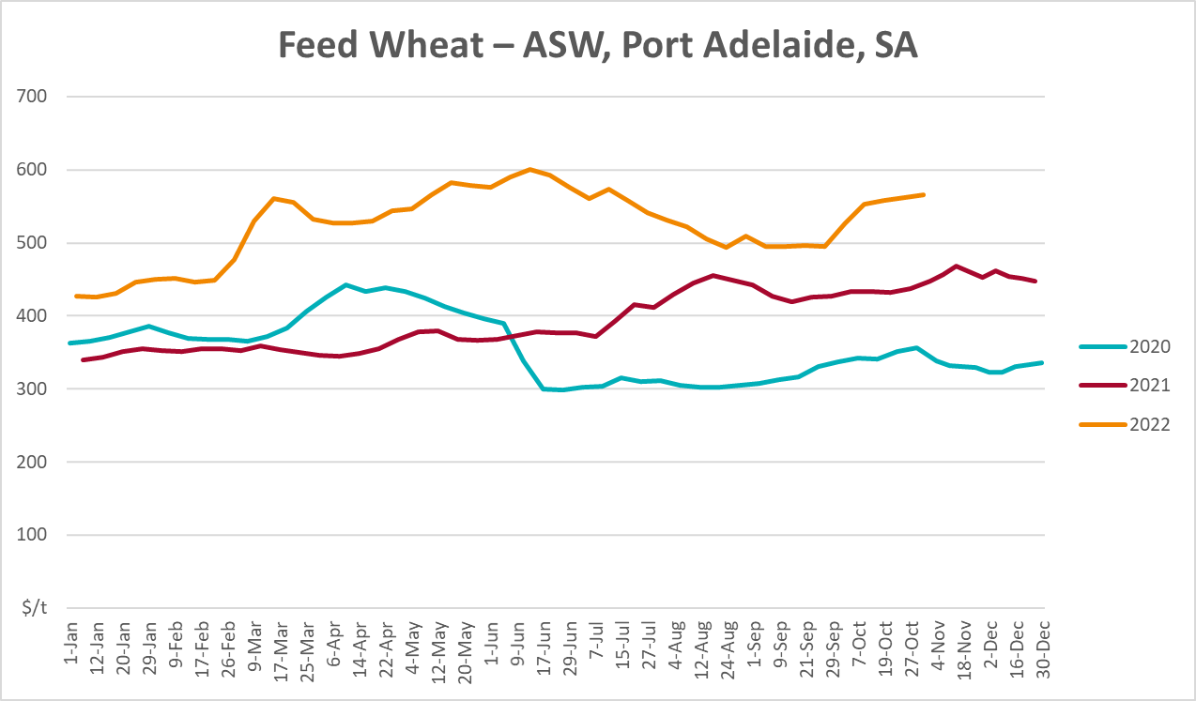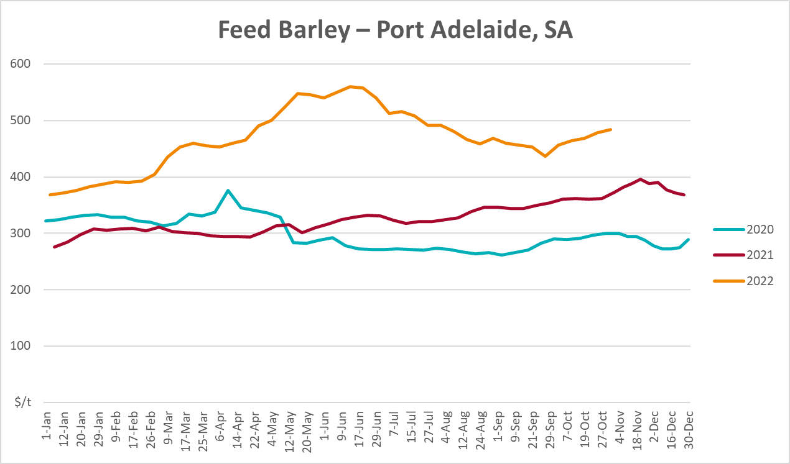

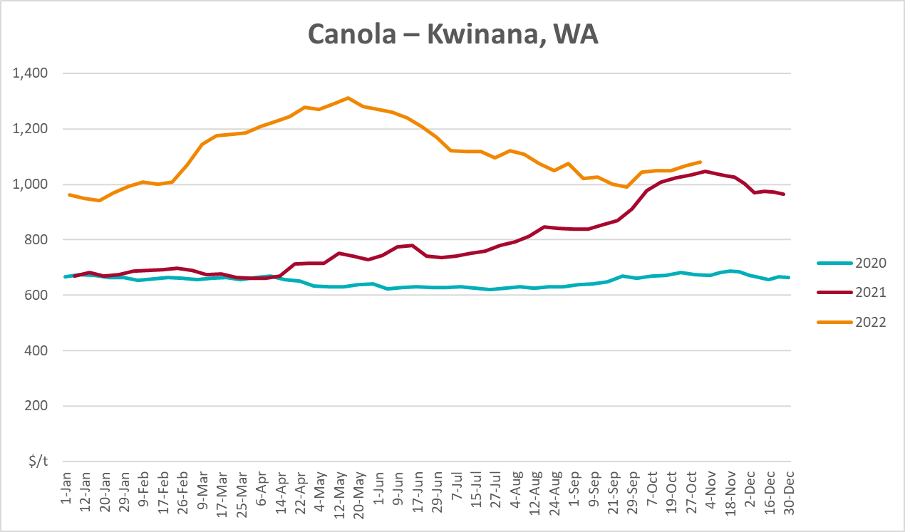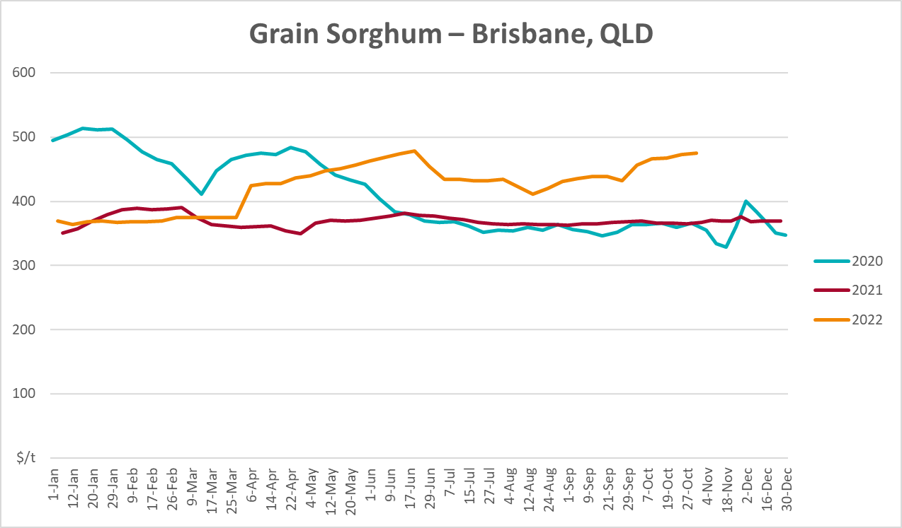

Selected domestic livestock indicator prices
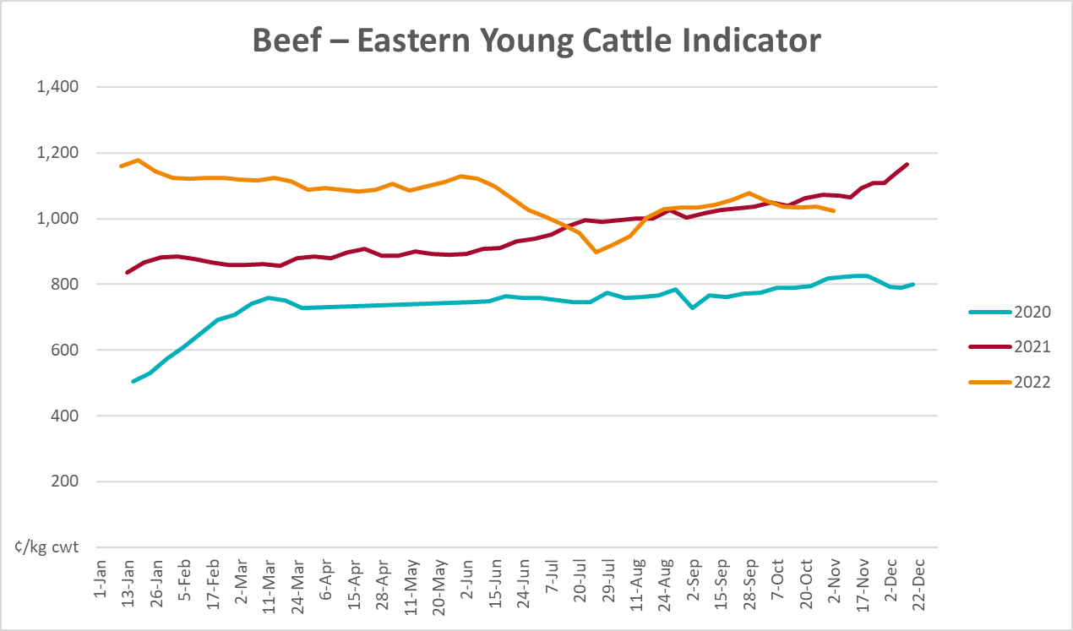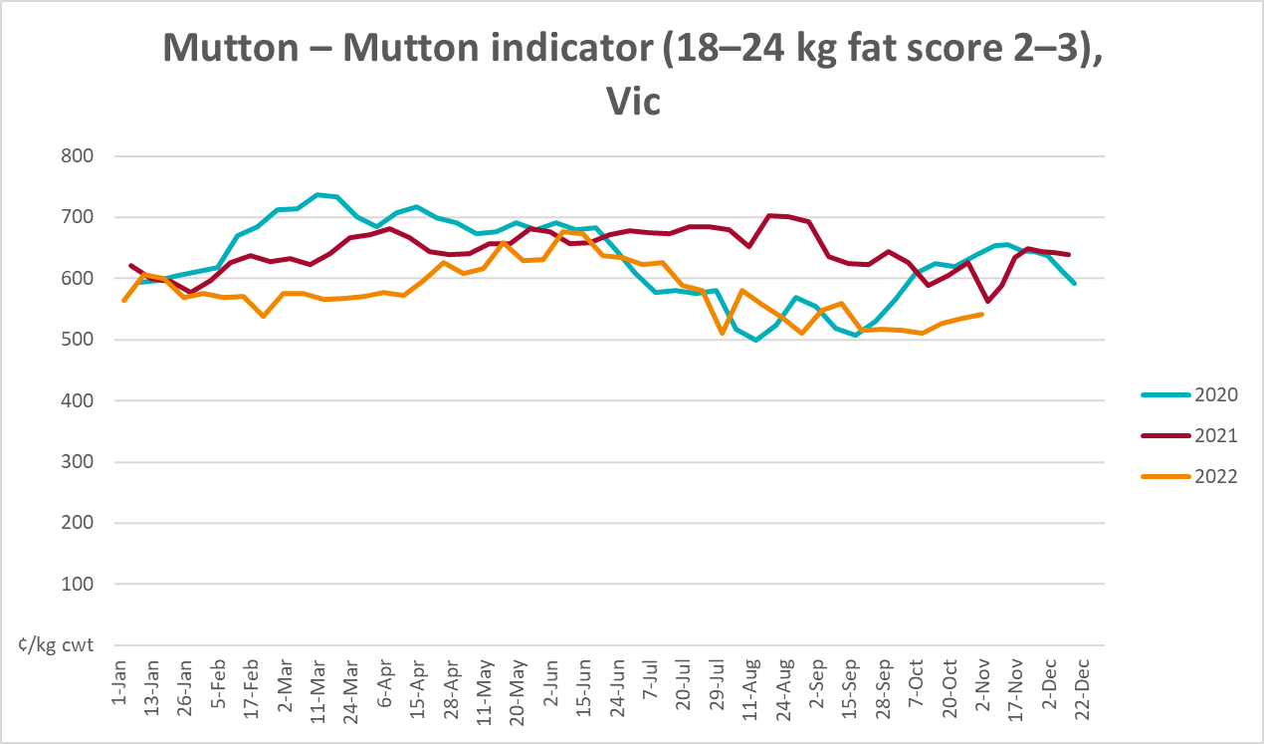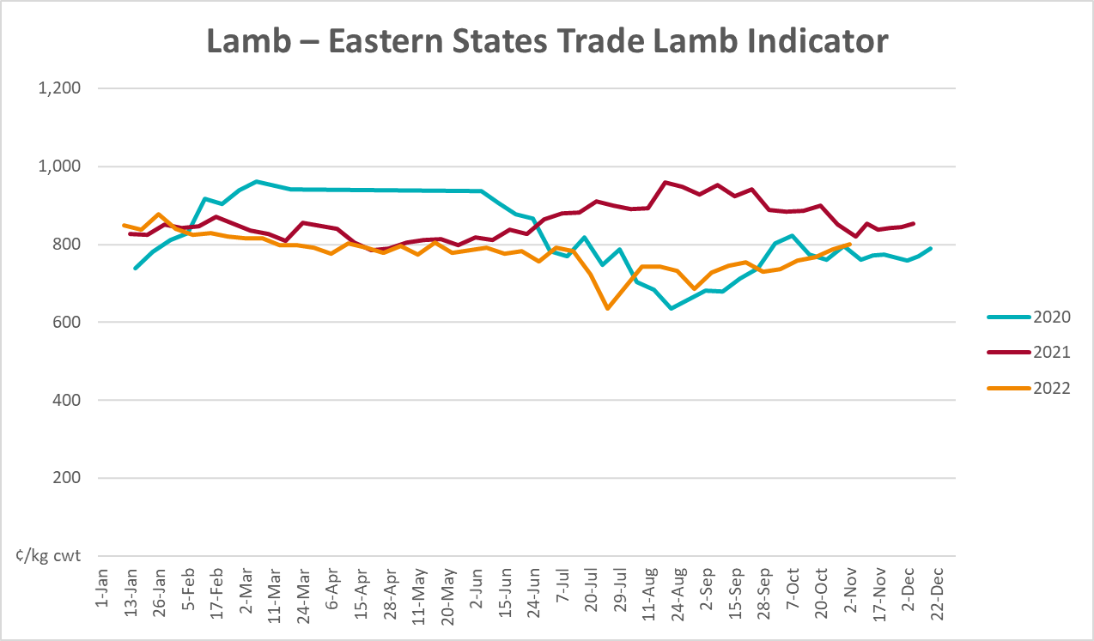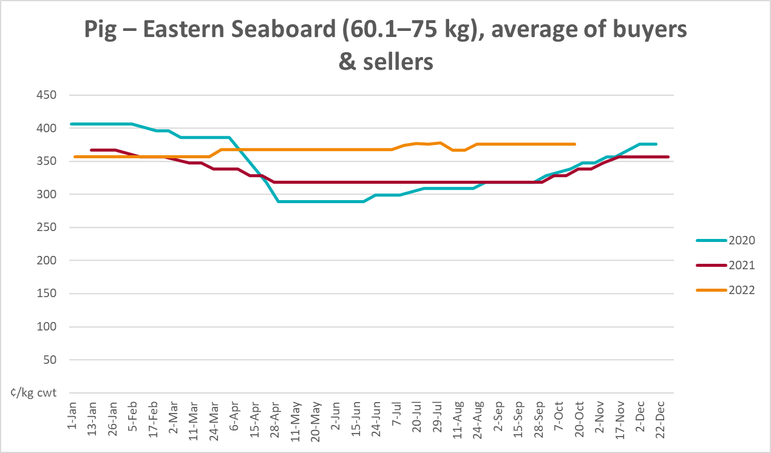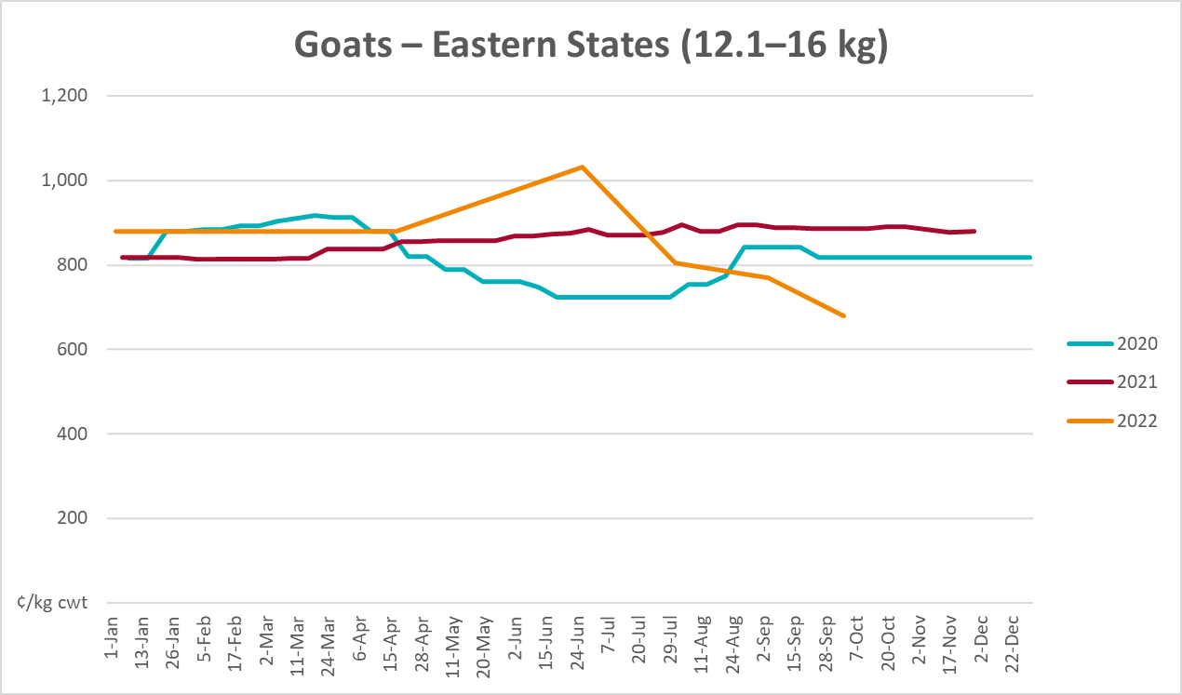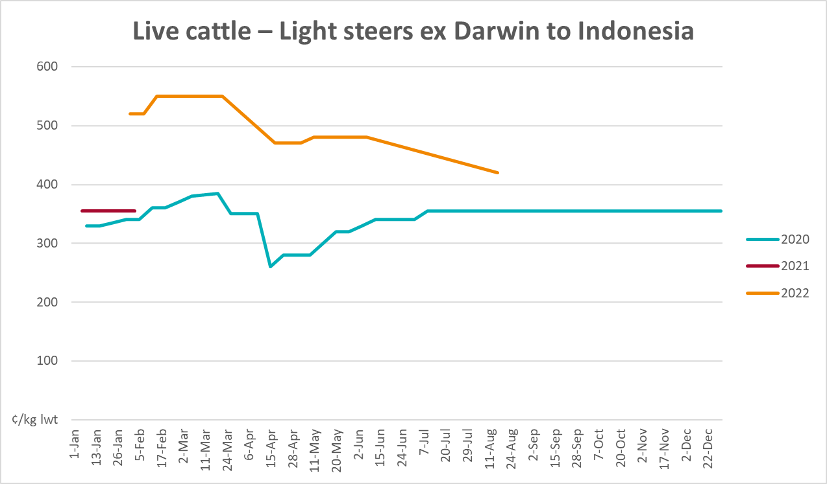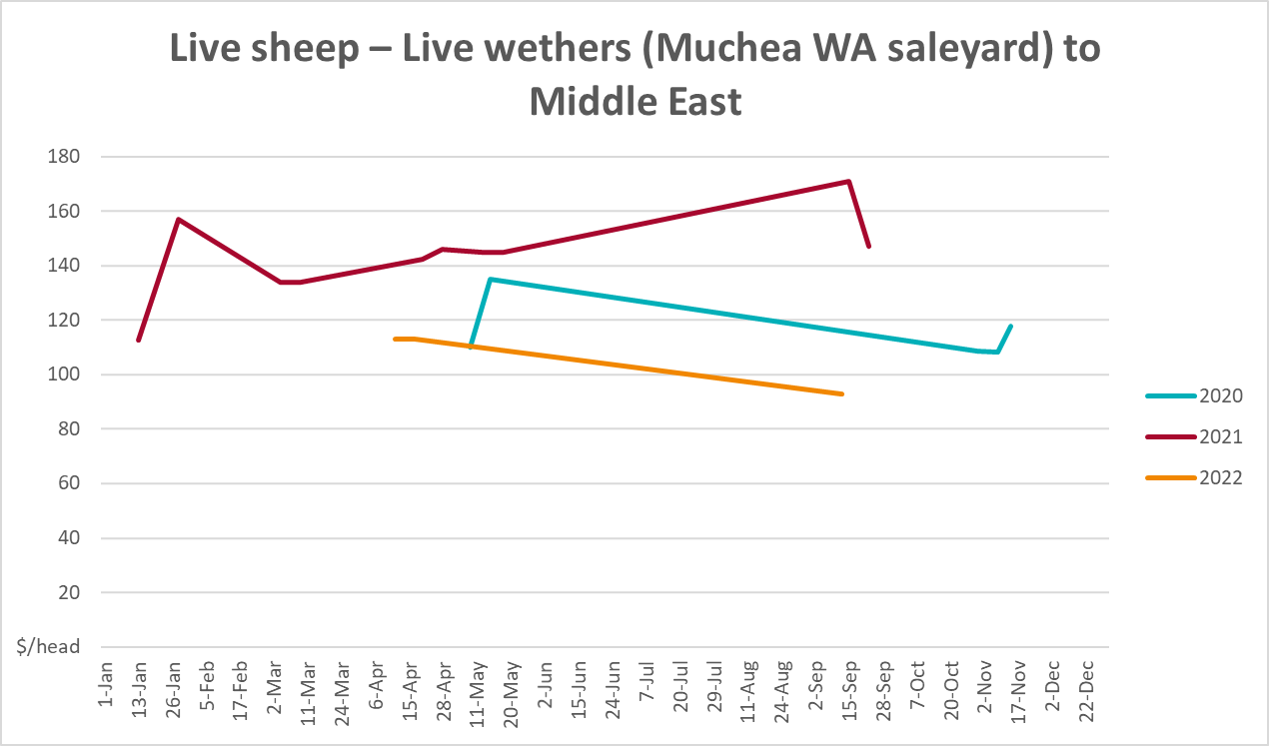

Global Dairy Trade (GDT) weighted average prices
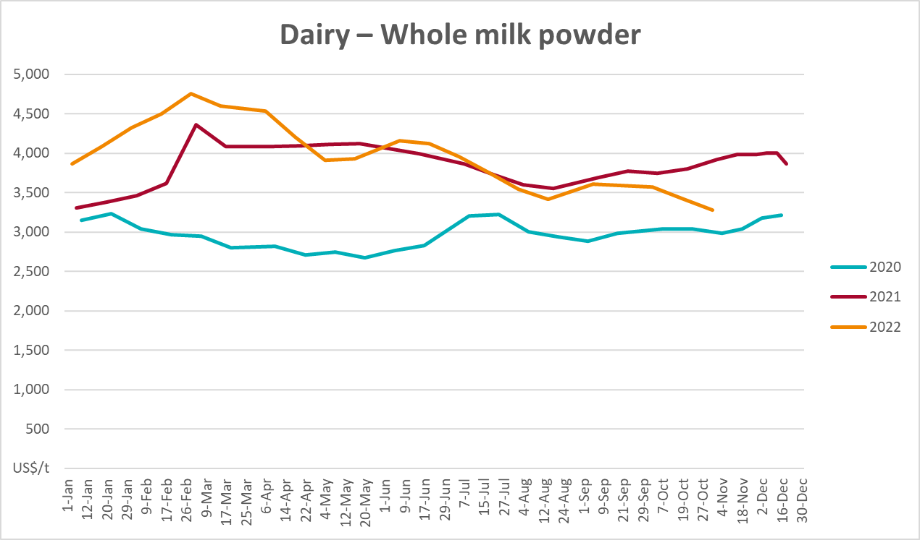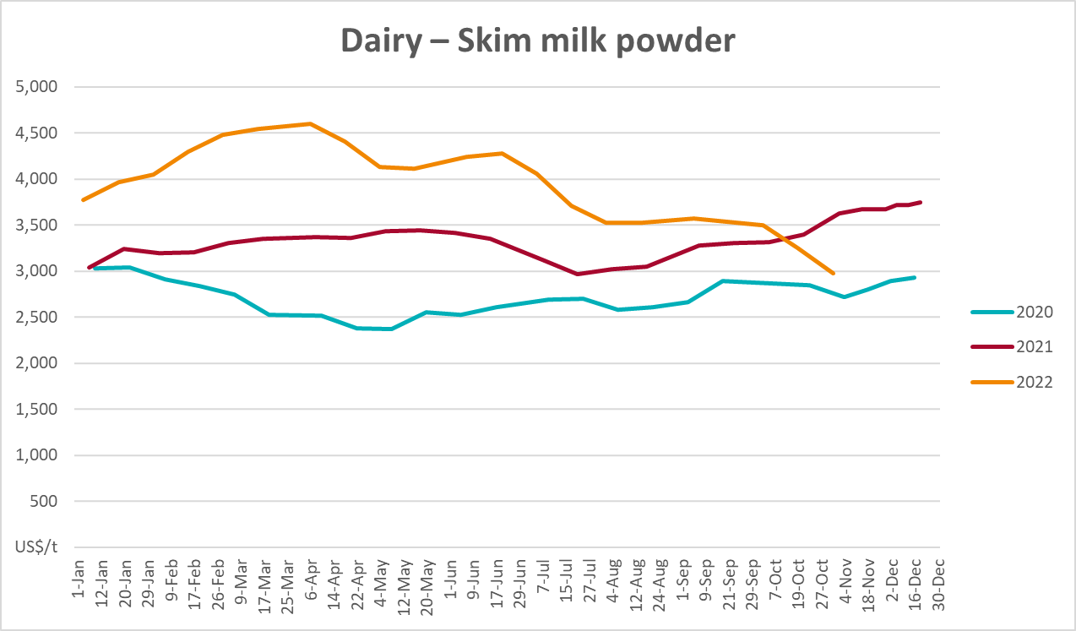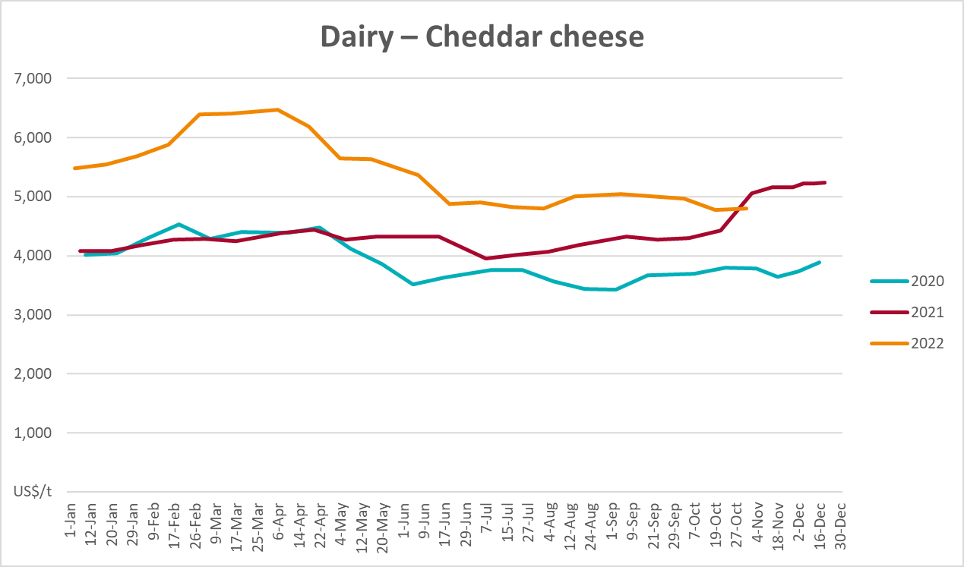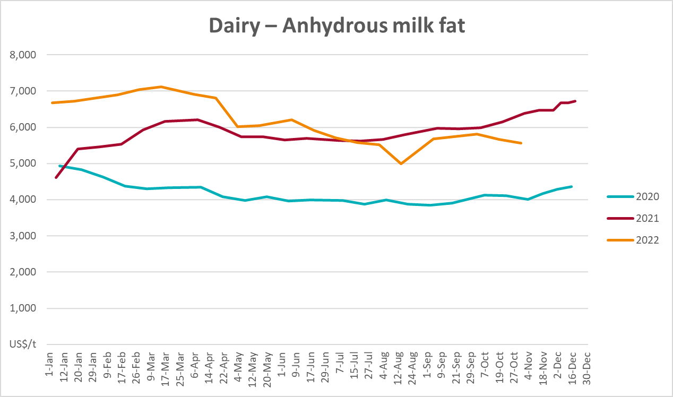

Selected fruit and vegetable prices
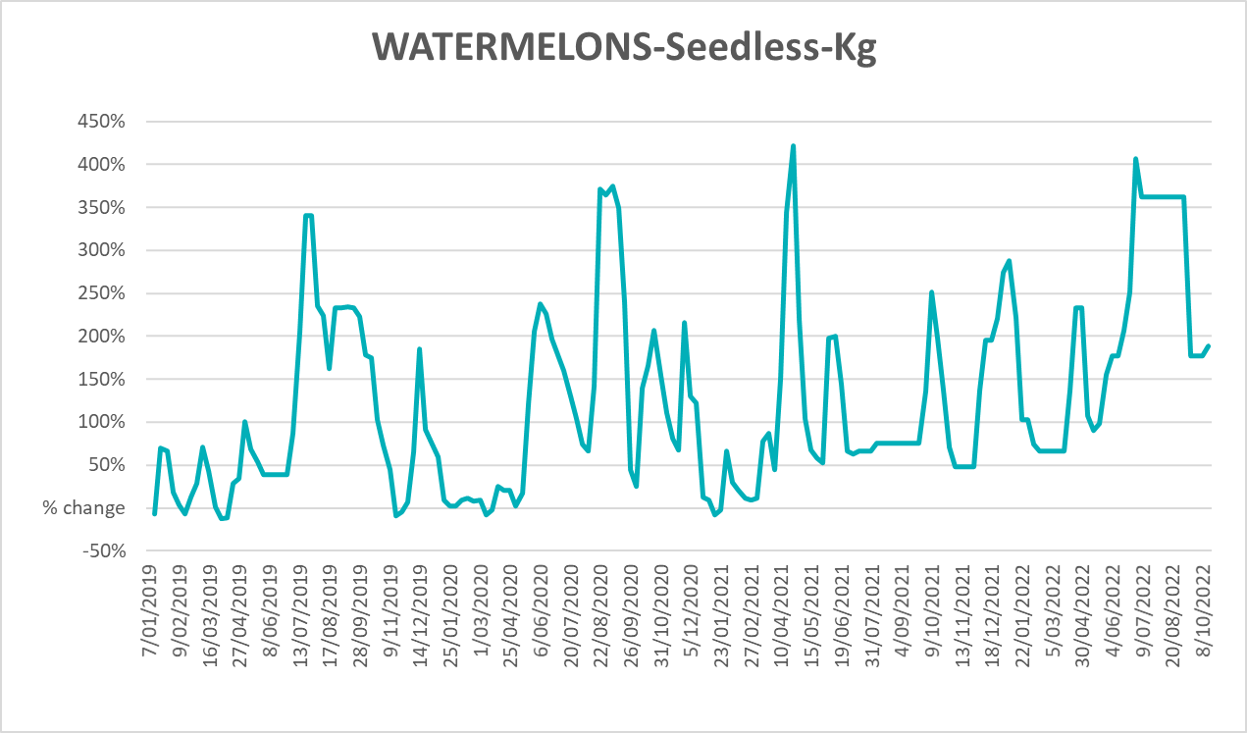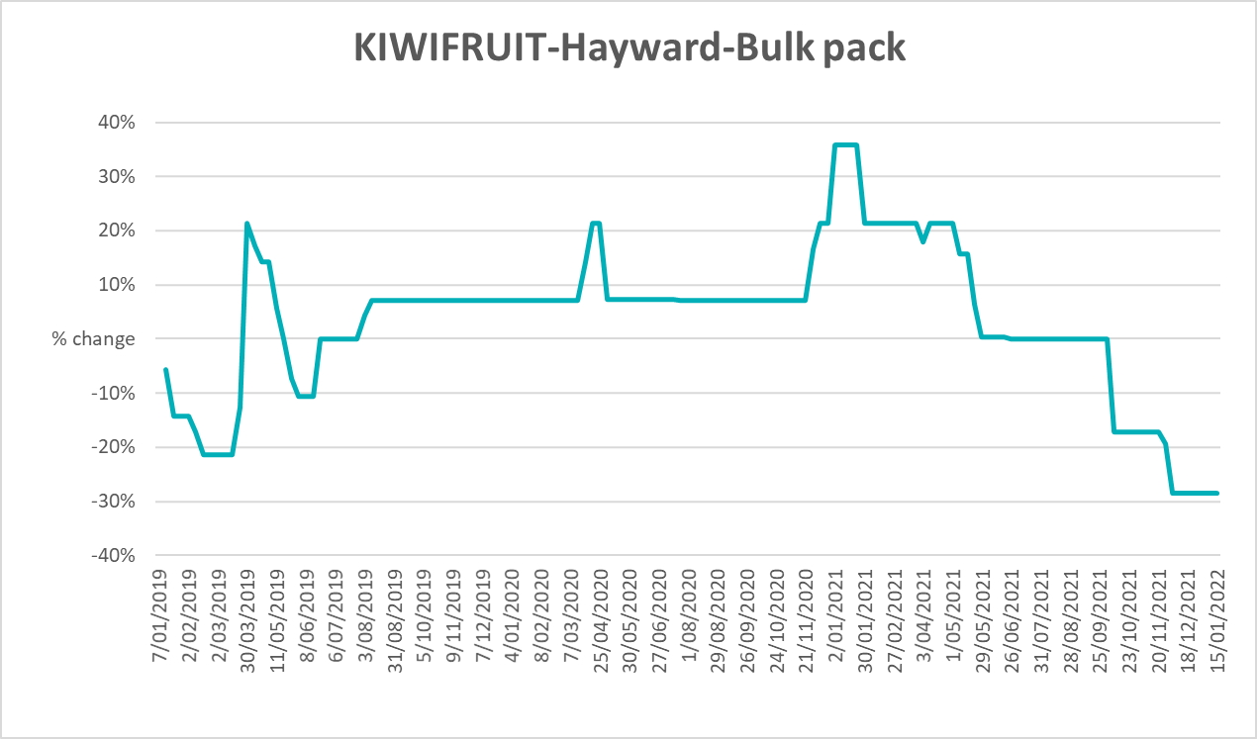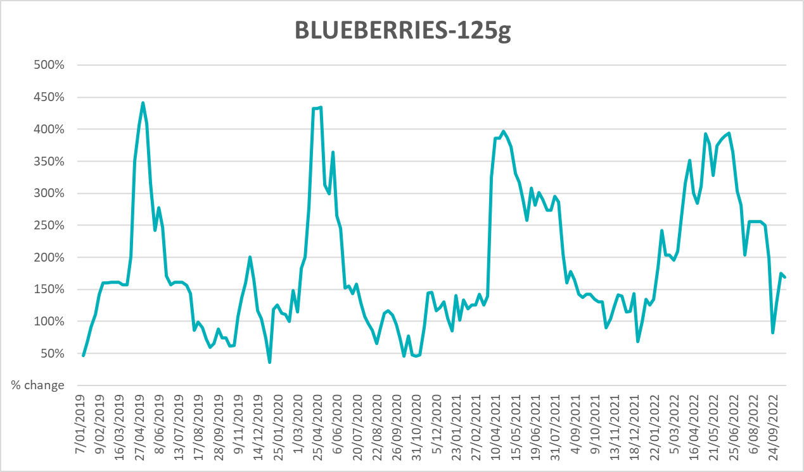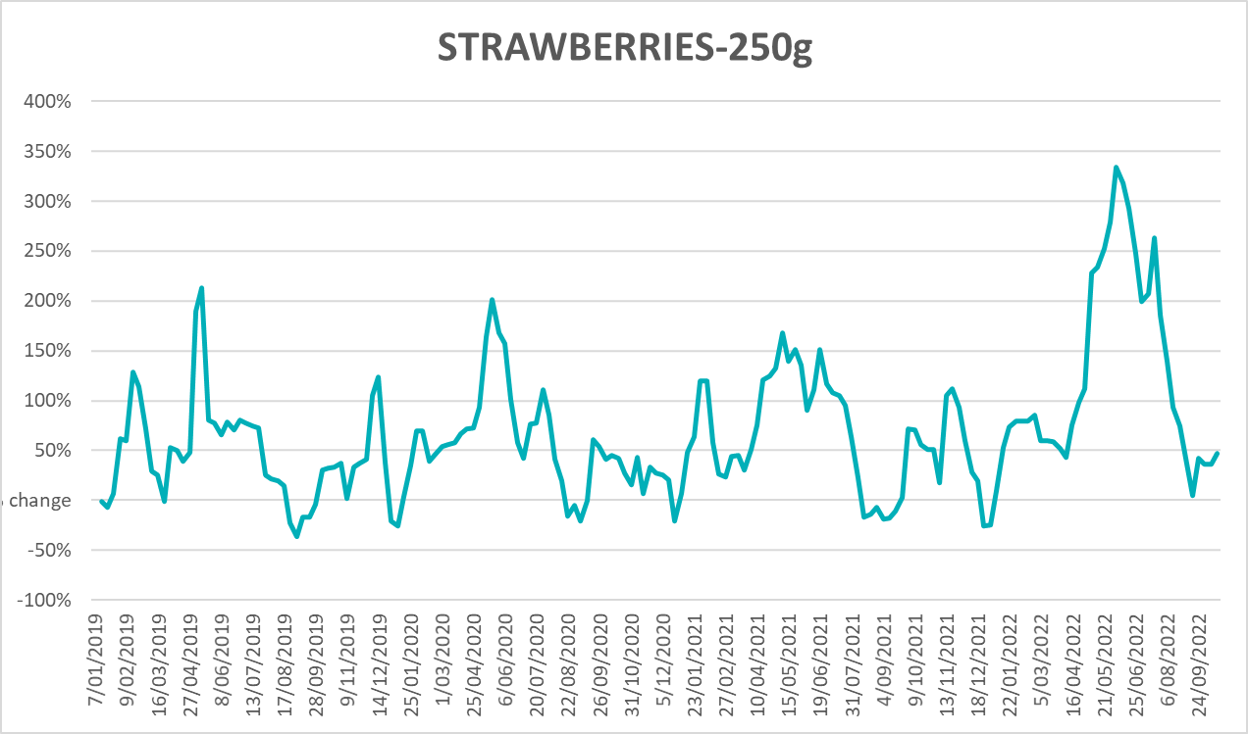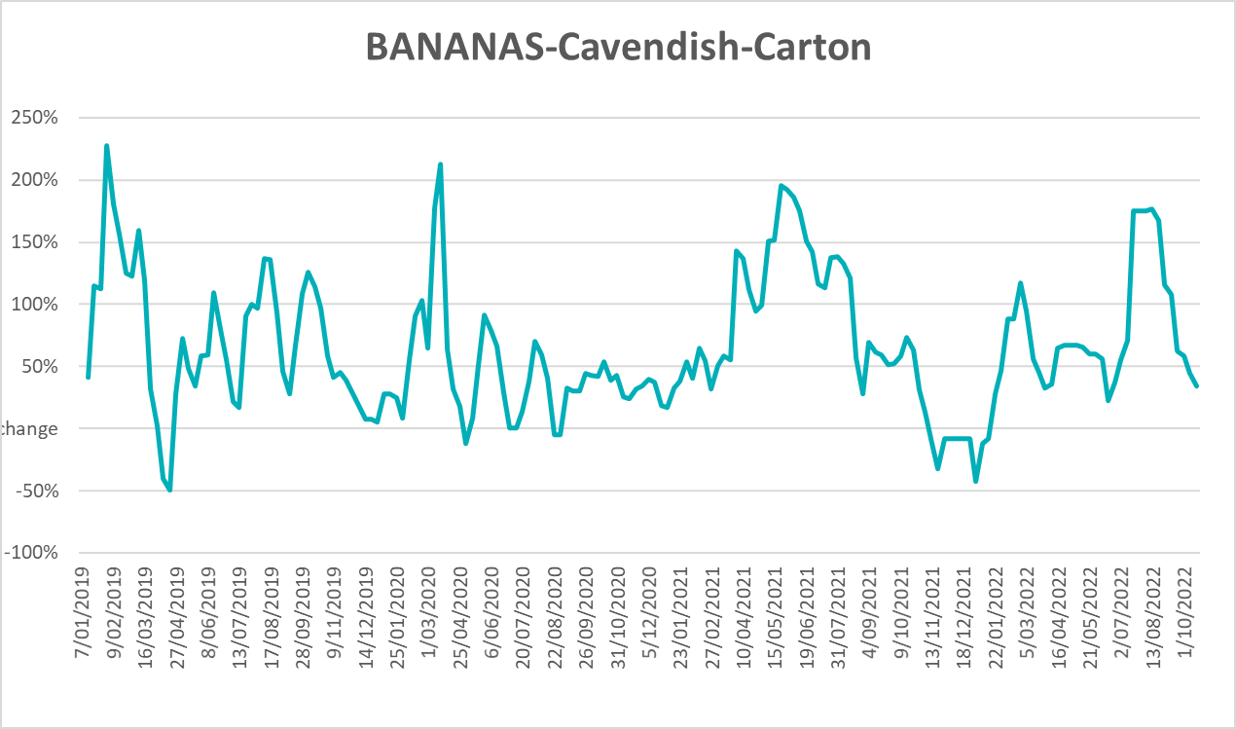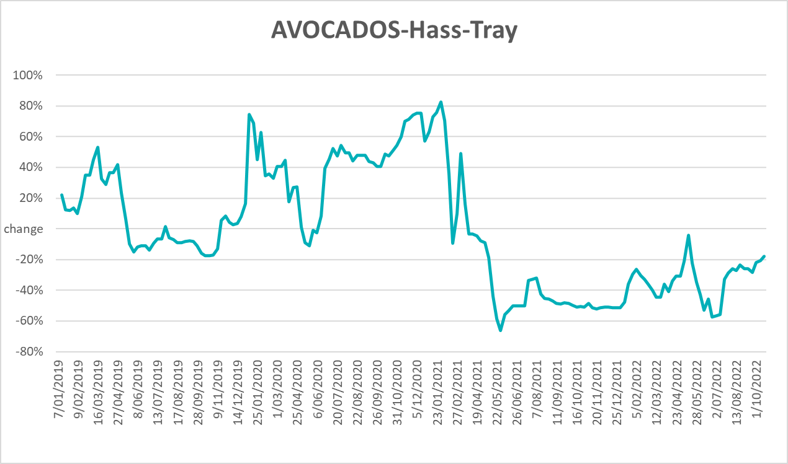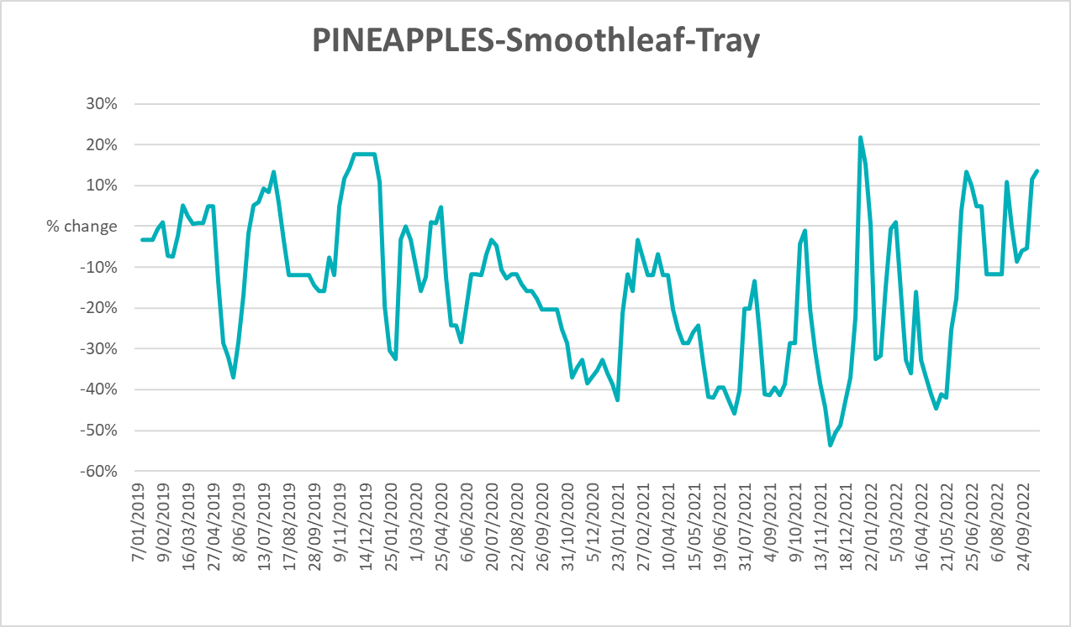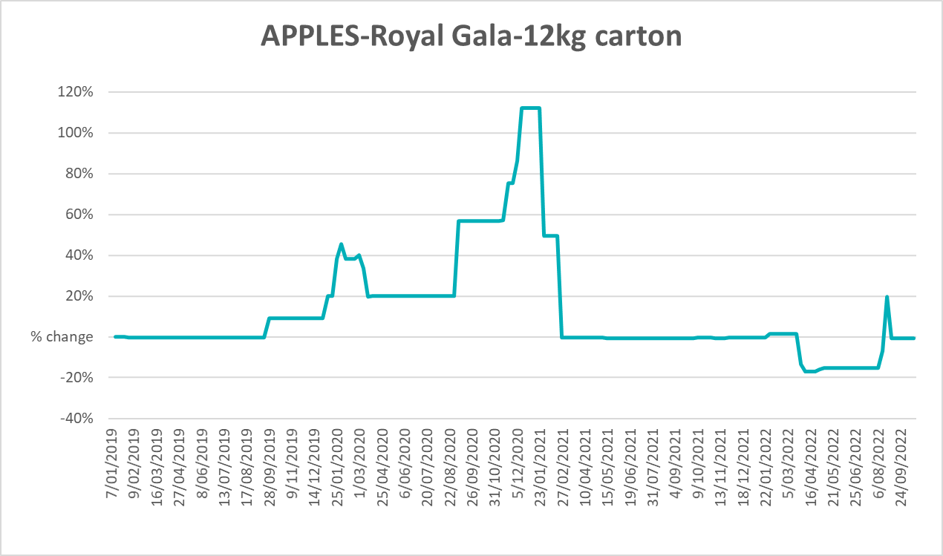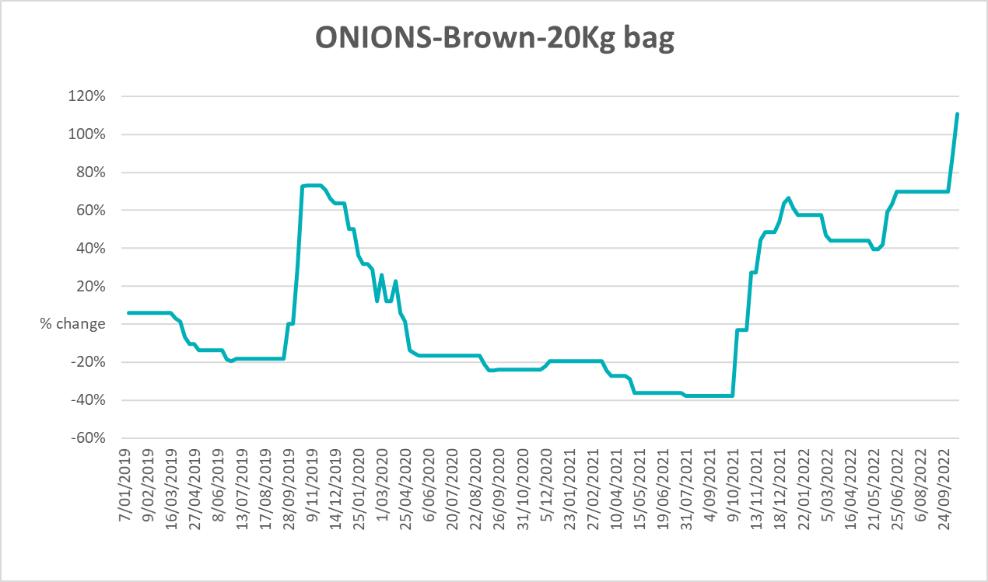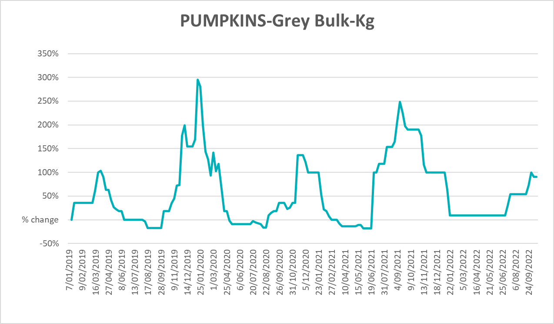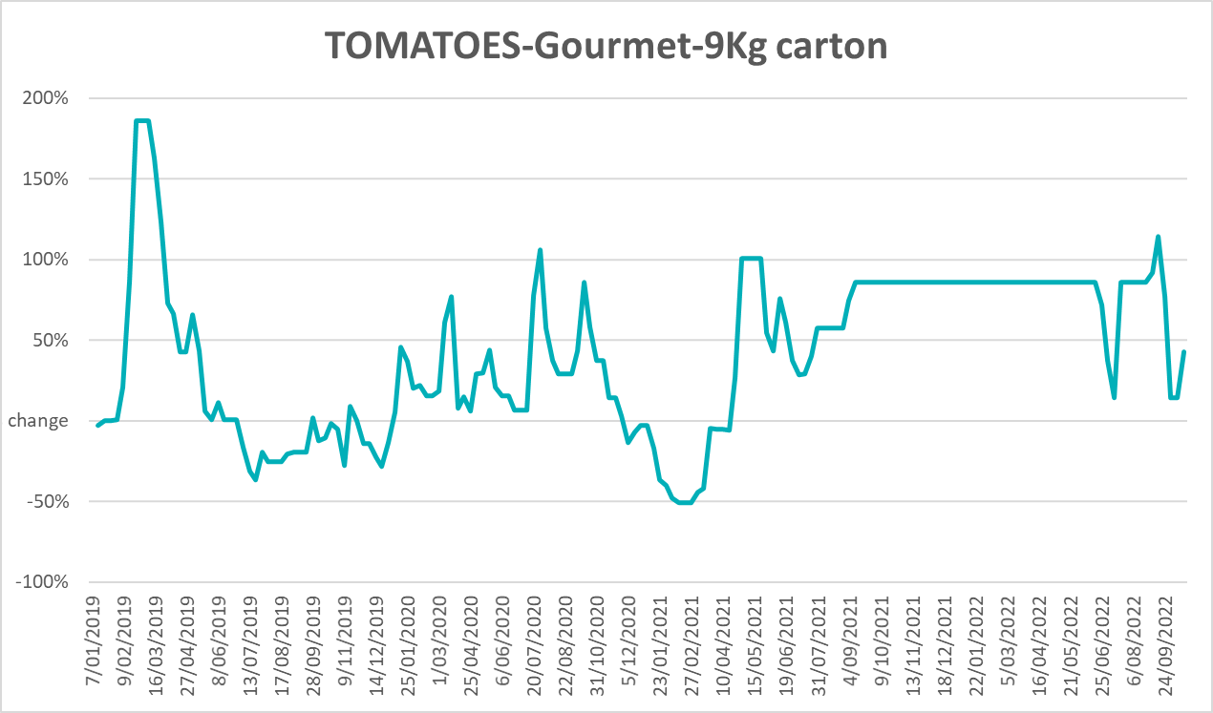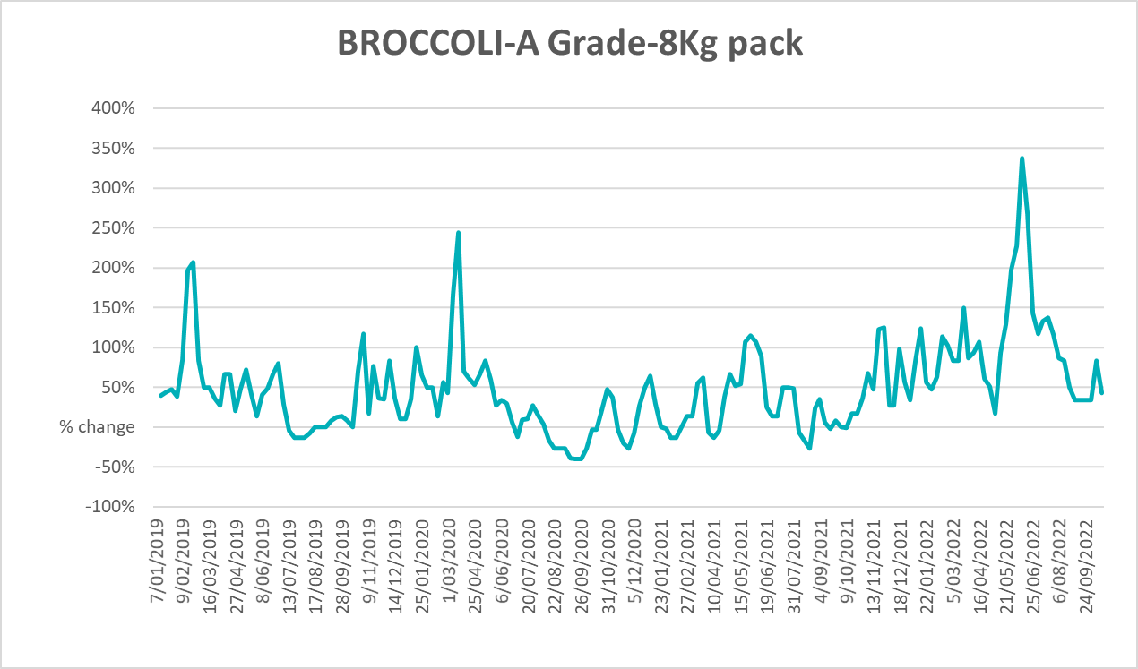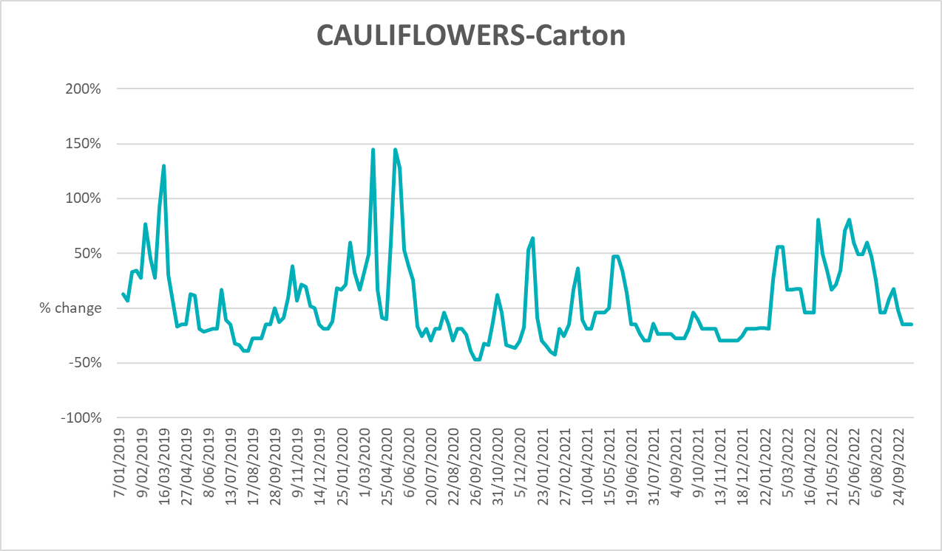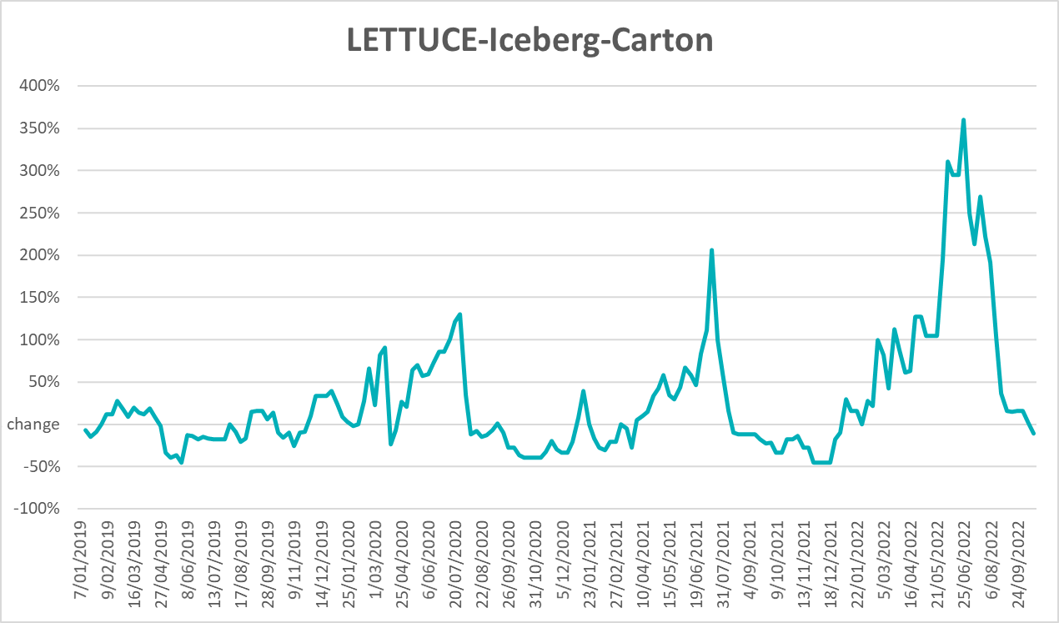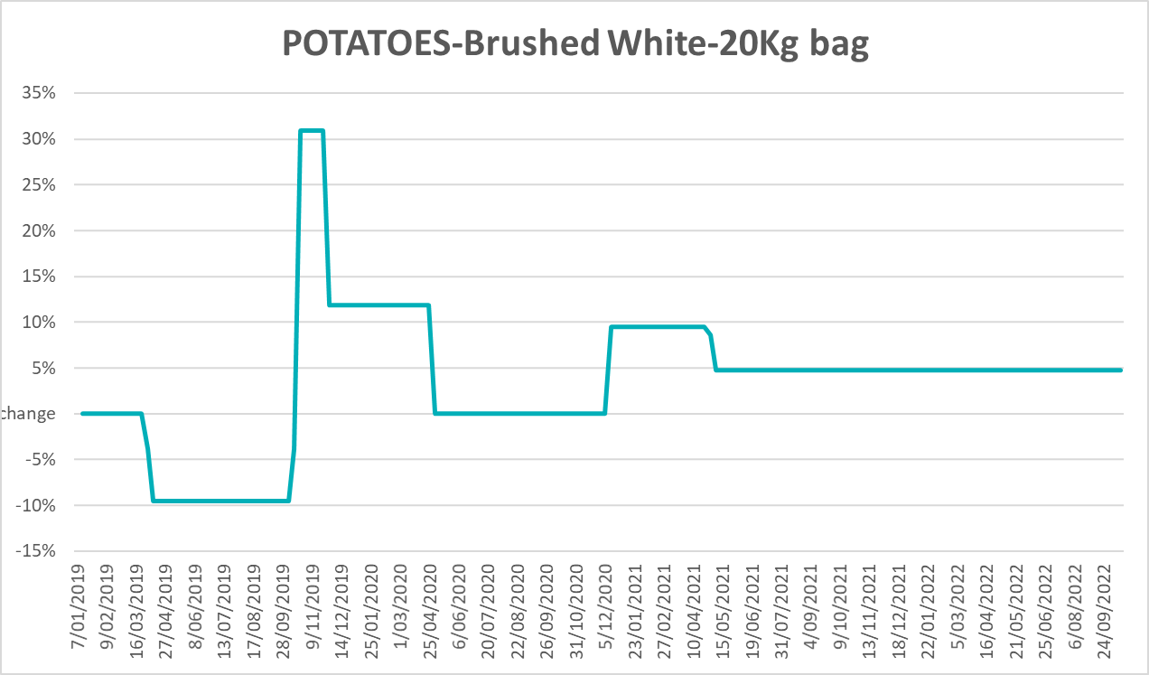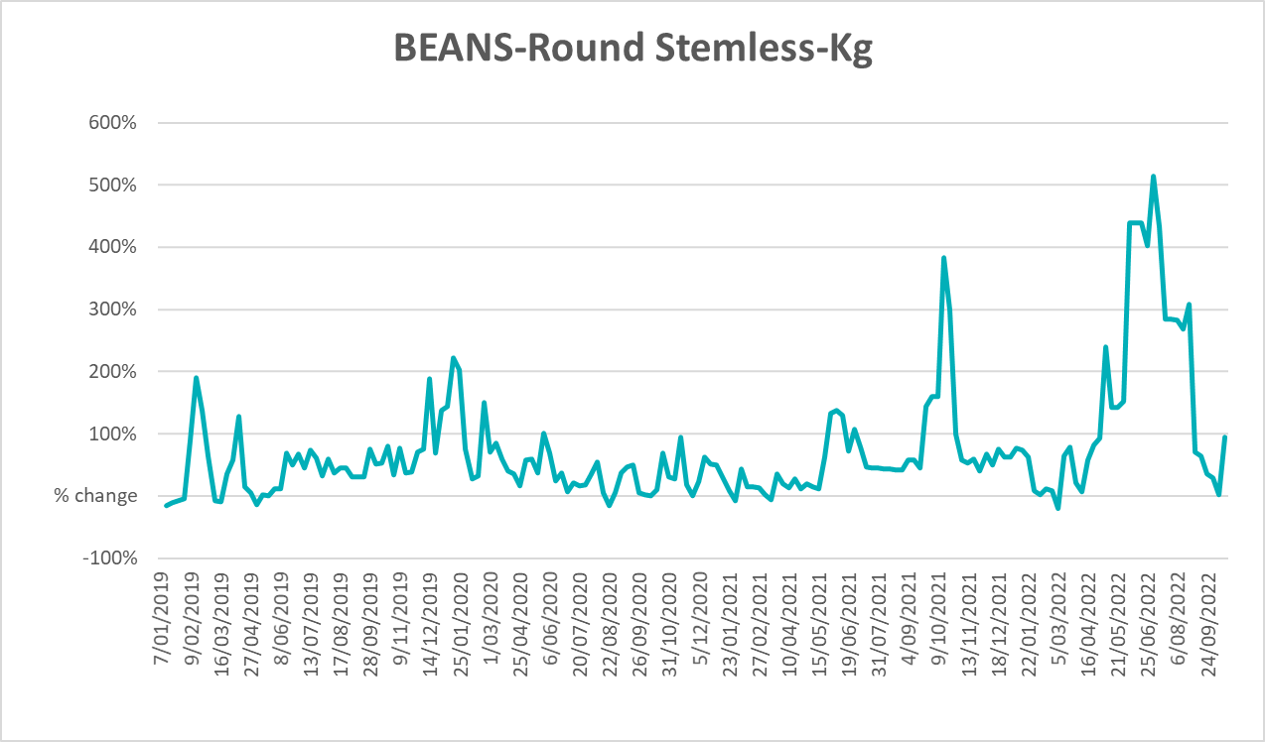

Selected domestic fodder indicator prices
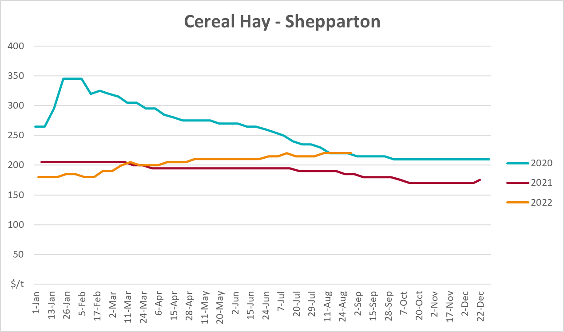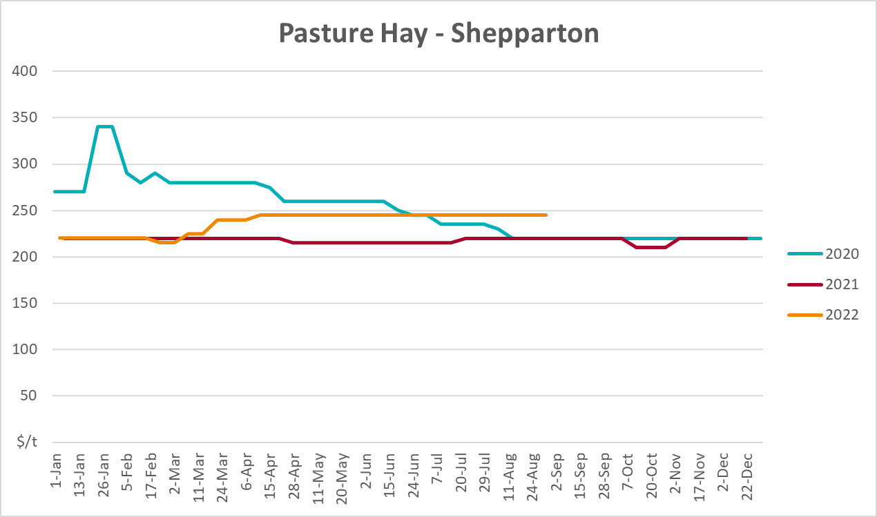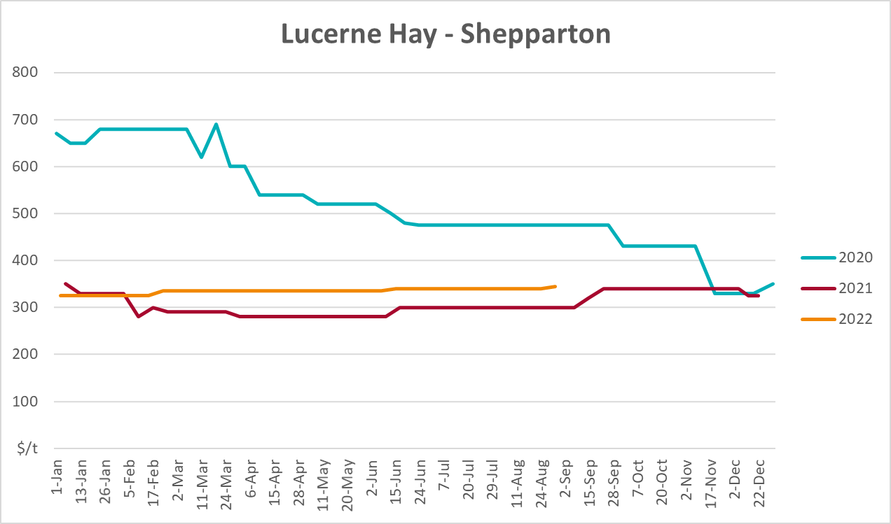

Data attribution

Climate
Bureau of Meteorology
- Weekly rainfall totals: www.bom.gov.au/climate/maps/rainfall/
- Monthly and last 3-month rainfall percentiles: www.bom.gov.au/water/landscape/
- Temperature anomalies: www.bom.gov.au/jsp/awap/temp/index.jsp
- Rainfall forecast: www.bom.gov.au/jsp/watl/rainfall/pme.jsp
- Seasonal outlook: www.bom.gov.au/climate/outlooks/#/overview/summary/
- Climate drivers: http://www.bom.gov.au/climate/enso/
- Soil moisture: www.bom.gov.au/water/landscape/
Other
- Pasture growth: www.longpaddock.qld.gov.au/aussiegrass/
- 3-month global outlooks: Environment and Climate Change Canada, NOAA Climate Prediction Center, EUROBRISA CPTEC/INPE, European Centre for Medium-Range Weather Forecasts, Hydrometcenter of Russia, National Climate Center Climate System Diagnosis and Prediction Room (NCC), International Research Institute for Climate and Society
- Global production: https://ipad.fas.usda.gov/ogamaps/cropmapsandcalendars.aspx
- Autumn break: Pook et al., 2009, https://rmets-onlinelibrary-wiley-com.virtual.anu.edu.au/doi/epdf/10.1002/joc.1833

Water
Prices
- Waterflow: https://www.waterflow.io/
- Ruralco: https://www.ruralcowater.com.au/
Bureau of Meteorology:
- Allocation trade: http://www.bom.gov.au/water/dashboards/#/water-markets/mdb/at
- Storage volumes: http://www.bom.gov.au/water/dashboards/#/water-storages/summary/drainage
Trade constraints:
- Water NSW: https://www.waternsw.com.au/customer-service/ordering-trading-and-pricing/trading/murrumbidgee
- Victorian Water Register: https://www.waterregister.vic.gov.au/TradingRules2019/

Commodities
Fruit and vegetables
- Datafresh: www.freshstate.com.au
Pigs
- Australian Pork Limited: www.australianpork.com.au
Dairy
- Global Dairy Trade: www.globaldairytrade.info/en/product-results/
World wheat, canola
- International Grains Council
World coarse grains
- United States Department of Agriculture
World cotton
- Cotlook: www.cotlook.com/
World sugar
- New York Stock Exchange - Intercontinental Exchange
Wool
- Australian Wool Exchange: www.awex.com.au/
Domestic wheat, barley, sorghum, canola and fodder
- Jumbuk Consulting Pty Ltd: http://www.jumbukag.com.au/
Cattle, beef, mutton, lamb, goat and live export
- Meat and Livestock Australia: www.mla.com.au/Prices-and-market
© Commonwealth of Australia 2022

Ownership of intellectual property rights
Unless otherwise noted, copyright (and any other intellectual property rights, if any) in this publication is owned by the Commonwealth of Australia (referred to as the Commonwealth).

Creative Commons licence
All material in this publication is licensed under a Creative Commons Attribution 4.0 International Licence except content supplied by third parties, logos and the Commonwealth Coat of Arms.
Inquiries about the licence and any use of this document should be emailed to copyright@awe.gov.au.


Cataloguing data
This publication (and any material sourced from it) should be attributed as:
ABARES 2022, Weekly Australian Climate, Water and Agricultural Update, Australian Bureau of Agricultural and Resource Economics and Sciences, Canberra, 27 October 2022. CC BY 4.0 DOI: https://doi.org/10.25814/5f3e04e7d2503
ISSN 2652-7561
This publication is available at https://www.agriculture.gov.au/abares/products/weekly_update
Department of Agriculture, Fisheries and Forestry
GPO Box 858 Canberra ACT 2601
Telephone 1800 900 090
Web agriculture.gov.au/abares

Disclaimer
The Australian Government acting through the Department of Agriculture, Fisheries and Forestry, represented by the Australian Bureau of Agricultural and Resource Economics and Sciences, has exercised due care and skill in preparing and compiling the information and data in this publication. Notwithstanding, the Department of Agriculture, Fisheries and Forestry, ABARES, its employees and advisers disclaim all liability, including liability for negligence and for any loss, damage, injury, expense or cost incurred by any person as a result of accessing, using or relying on any of the information or data in this publication to the maximum extent permitted by law.

Statement of Professional Independence
The views and analysis presented in ABARES publications, including this one, reflect ABARES professionally independent findings, based on scientific and economic concepts, principles, information and data. These views, analysis and findings may not reflect or be consistent with the views or positions of the Australian Government, or of organisations or groups who have commissioned ABARES reports or analysis. More information on professional independence is provided on the ABARES website.

Acknowledgements
This report was prepared by Katia Taylor and Matthew Miller.

