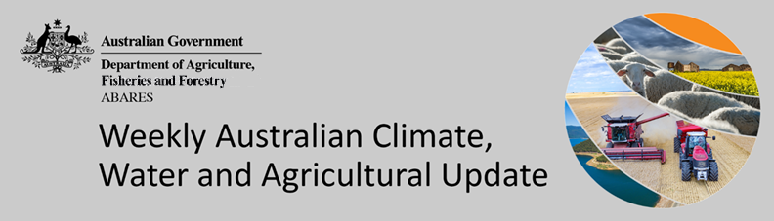
No. 2/2023

19 January 2023

Summary of key issues
- For the week ending 18 January 2023, a broad low-pressure trough remained active over northern Australia and resulted in widespread rainfall and thunderstorms across northern Australia. Meanwhile, onshore flow produced moderate to heavy rainfall in some areas of north-east Queensland. Large areas in the Central Coast district of Queensland received greater than 400 millimetres. However, little to no rainfall was recorded across most of the southern Australia (see section 1.1).
- The persistence of dry condition across cropping regions of Victoria, South Australia and Western Australia would have continued to support the harvesting of winter crops. Across parts of southern Queensland and New South Wales, little rainfall would have allowed access for field work related to the planting and maintenance of summer crops. However, heavy rainfall across the northern Queensland would likely have negative impact on the development of summer crops (see Section 1.1).
- As of the end of December 2022, rainfall was variable for the world’s major grain-producing and oilseed-producing regions. As a result, global production conditions have deteriorated compared to those used to formulate ABARES forecasts of global grain supplies and world prices in its December 2022 edition of the Agricultural Commodities Report. As a result, global grain and oilseed production is likely to be lower than that forecast earlier in December (see Section 1.2).
- Over the 8-days to 26 January 2023, widespread rainfall across Australia’s tropical north is expected to continue under the influence of a low-pressure system and troughs. Most of central and south-western Australia will likely have clear skies and dry conditions. However, an extending cold front and associated trough are predicted to bring clouds, rainfall, and thunderstorms to the southern and south-eastern Australia (see section 1.3).
- Across most of Australian cropping regions, little to no rainfall is forecast in the next eight days. The continuation of dry conditions will likely further allow saturated soil to drain, however, a flooding risk remains for some areas. Little to no rainfall forecast across most cropping regions is likely to provide favourable conditions for summer crop planting and maintenance (see section 3).
- Water storage levels in the Murray-Darling Basin (MDB) decreased between 11 January 2023 and 18 January 2023 by 143 gigalitres (GL). Current volume of water held in storage is 23 629 GL which represents 94 percent of total capacity. This is 4 percent or 894 GL more than at the same time last year.
- Allocation prices in the Victorian Murray below the Barmah Choke decreased from $40 per ML on 6 January 2023 to $36 per ML on 13 January 2023. Prices are lower in the Murrumbidgee and regions above the Barmah choke due to the binding of the Murrumbidgee export limit and Barmah choke trade constraint.

Climate

Rainfall this week
For the week ending 18 January 2023, a broad low-pressure trough remained active over northern Australia and resulted in widespread rainfall and thunderstorms across northern Australia. Meanwhile, onshore flow produced moderate to heavy rainfall in parts of north-east Queensland.
Weekly rainfall totals of more than 50 millimetres were recorded in large parts of Queensland, north parts of Northern Territory and the Kimberly region in Western Australia. Areas in the Central Coast district of Queensland received greater than 400 millimetres. Weekly rainfall totals between 10 and 50 millimetres were recorded across scattered areas of New South Wales, eastern Victoria, South Australia, parts of southern Western Australia and western Tasmania. Little to no rainfall was recorded across much of the remainder of southern Australia.
In Australian cropping regions, rainfall totals of between 15 and 300 millimetres were recorded across much of northern Queensland. Scattered small areas of New South Wales and eastern Victoria recorder 10 to 25 millimetres. Little to no rainfall was recorded in remaining cropping regions.
The impact of flooding across the northern Queensland would have slowed sowing of summer crops, degraded some crops and damaged crop production prospects of summer crops in the Queensland. The persistence of dry conditions across cropping regions of Victoria, South Australia and Western Australia will have continued to support the harvesting of winter crops. Across parts of southern Queensland and New South Wales, little rainfall would have allowed access for field work related to the planting and maintenance of summer crops. However, heavy rainfall across northern Queensland would likely have had a negative impact on the development of summer crops.

Rainfall for the week ending 18 January 2023

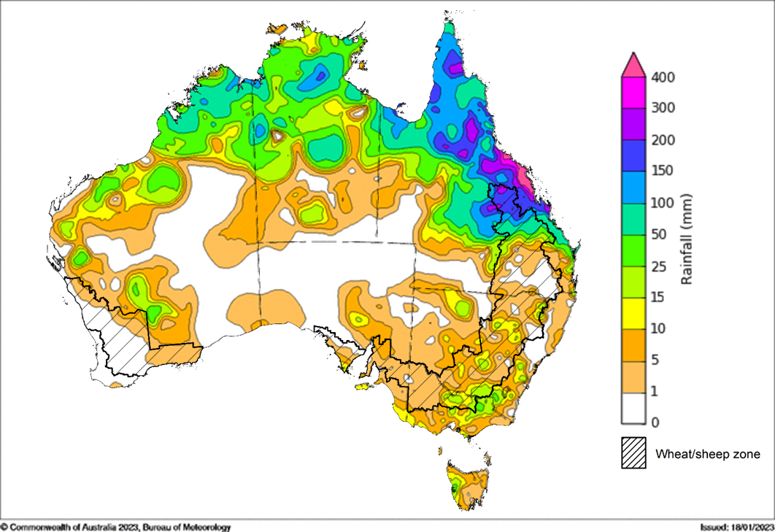
©Commonwealth of Australia 2023, Australian Bureau of Meteorology Issued: 18/01/2023
Note: The rainfall analyses and associated maps utilise data contained in the Bureau of Meteorology climate database, the Australian Data Archive for Meteorology (ADAM). The analyses are initially produced automatically from real-time data with limited quality control. They are intended to provide a general overview of rainfall across Australia as quickly as possible after the observations are received. For further information go to http://www.bom.gov.au/climate/rainfall/

Global production conditions and climate outlook
Crop production is affected by long-term trends in average rainfall and temperature, interannual climate variability, shocks during specific growth stages, and extreme weather events (IPCC 2012). Some crops are more tolerant than others to certain types of stresses, and at each growth stage, different types of stresses affect each crop species in different ways.
The precipitation anomalies and outlooks presented here give an indication of the current and future state of production conditions for the major grain and oilseed producing countries which are responsible for over 80% of global production. This is an important input to assessing the global grain supply outlook.
December precipitation percentiles and current production conditions
As of the end of December 2022, rainfall was variable for the world’s major grain-producing and oilseed-producing regions.
In the northern hemisphere, precipitation was below average across parts of western and southern Central Asia, Italy, Greece, Turkey, south-western Canada, central areas and the south-west of the Russian Federation, as well as small areas of north-eastern United States. Precipitation was above average for parts of the Russian Federation, parts of northern and south-western United States, western and southern Canada, much of Spain and Portugal, as well as northern Ukraine and Poland. Precipitation was close to average across the remainder of the major northern hemisphere grain-producing and oilseed-producing regions.
In the southern hemisphere, December precipitation was below average for Paraguay, northern Argentina and parts of eastern Australia. Precipitation was above average for central Brazil and South Africa. Precipitation was close to average across the remainder of major grain-producing and oilseed-producing regions.

Global precipitation percentiles, December 2022
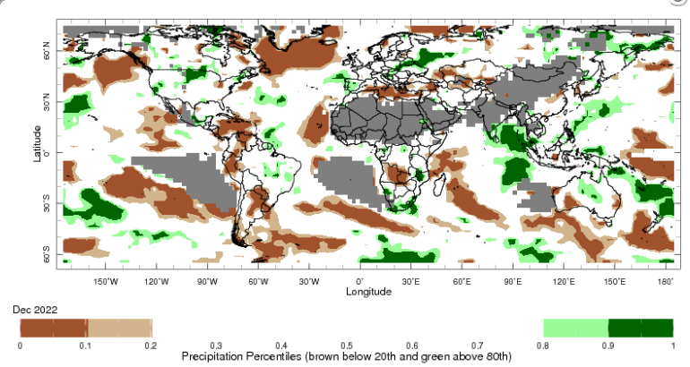
Note: The world precipitation percentiles indicate a ranking of precipitation for December, with the driest (0th percentile) being 0 on the scale and the wettest (100th percentile) being 1 on the scale. Percentiles are based on precipitation estimates from the NOAA Climate Prediction Center's Climate Anomaly Monitoring System Outgoing Precipitation Index dataset. Precipitation estimates for December 2022 are compared with rainfall recorded for that period during the 1991 to 2020 base period.
Source: International Research Institute for Climate and Society
The global climate outlook for January to March 2023 indicates that variable rainfall conditions are expected for the world's major grain-producing and oilseed-producing regions. Outlooks and potential production impacts for the major grain and oilseed producing countries are presented in the table.
Rainfall outlook and potential impact on the future state of production conditions between January to March 2023
Region | January to March rainfall outlook | Potential impact on production
Argentina | Below average rainfall is expected in north-eastern Argentina between January and March 2023, while above average rainfall is expected in the north-west and south of the country. | Below average rainfall is likely to adversely affect flowering of soybeans, sorghum, rice, and millet in the February. The dry conditions may also negatively impact yield potentials of those crops.
Black Sea Region | Below average precipitation is forecast for eastern Turkey and southern Kazakhstan. However, above average precipitation is expected across eastern and central parts of the Russian Federation between January and March 2023. | The above average rainfall conditions are likely to support the development of winter wheat and canola, and planting of corn, cotton and sunflower across Russia. However, below average precipitation in parts of Turkey and Kazakhstan may adversely affect the development and planting of these crops.
Brazil | Above average rainfall is expected in northern Brazil and parts of central Brazil between January to March 2023. Some southern areas of Brazil are expected to receive below-average rainfall. | Above average rainfall in northern and central Brazil will benefit the development of soybeans, cotton, rice, sorghum, millet, sunflower, peanuts, and corn prior to the harvesting of some crops beginning in March 2023. Below average rainfall in the south is likely to adversely affect the development and harvesting of crops in that region.
Canada | Above average precipitation is more possible in the southern half of Canada between January to March 2023. Below average rainfall is more likely in the coastal area of northern Canada. | Through January, February and March, winter wheat and canola will progress from dormant to heading. Above average rainfall will likely provide sufficient snowpack to prevent winterkill of winter wheat and canola and support vegetative growth and heading.
China | Below average rainfall is expected across western and south-eastern China in January to March 2023, while above average rainfall is possible in the north-eastern China. | Through January and February, winter wheat and canola will remain dormant. Below average rainfall may increase the risk of winterkill due to limited snowpack during winter.
Europe | Below average precipitation is more likely for most of Europe while above average precipitation is more expected in Switzerland, northern Italy, Romania, Finland, and northwest tips of Sweden between January to March 2023. | Below average rainfall may limit snowpack in parts of central Europe, increasing the risk of winterkill for winter wheat and canola. Meanwhile, above average rainfall in southern Europe should provide favourable conditions for winter wheat.
South Asia (India) | Above average rainfall is expected in far southern India while below average rainfall is expected in the southeast of the northern mountains and plains and in the east of the Deccan Plateau of India. | Below average rainfall in much India may negatively impact vegetative growth and heading of winter wheat and canola between January and February. In the far south, winter crops would be expected to benefit from above average rainfall.
Southeast Asia (SEA) | Above average rainfall is likely across much of northern maritime SEA and Malay Peninsula between January to March 2023, particularly in the Philippines. Southern mainland SEA will likely experience below - to near-average rainfall. | Above average rainfall in SEA likely supports vegetative growth for corn and rice throughout January to February. However, excessive rainfall may result in flooding and crop damage. Below average rainfall for southern mainland SEA may negatively impact the development of spring rice.
The United States of America | Above average precipitation is more likely for the northern half and large areas in the east parts of US while below average precipitation is more likely across much of the southern half the US. | Above average precipitation expected across the north is likely to provide sufficient snow cover through winter to protect wheat and canola through dormancy. Below average rainfall may adversely impact crop development and planting in the southern.

Rainfall forecast for the next eight days
Over the 8-days to 26 January 2023, widespread rainfall across Australia’s tropical north is expected to continue under the influence of low-pressure system and troughs. Most of central and south-western Australia will likely have clear skies and dry conditions in the next eight days. However, an extending cold front and associated trough are predicted to bring clouds, rainfall, and thunderstorms to the southern and south-eastern Australia.
Rainfall totals exceeding 10 millimetres are expected across Cape York, the northeast coast area and the south of Queensland, north-eastern and central eastern New South Wales, eastern Victoria, the north of the Northern Territory, and the Kimberley and north-western Western Australia, as well as most of Tasmania. Rainfall of more than 100 millimetres is forecast the far north and north-eastern coast area of Cape York, and small area of north-eastern New South Wales. Little to no rainfall is forecast for the remaining area of Australia for the next eight days.
Across most of Australian cropping regions, little to no rainfall is forecast in the next eight days. However, rainfall between 10 and 50 millimetres is expected for the south-western and southern Queensland and northern New South Wales.
Low rainfall in flood-affected cropping regions of northern Queensland is expected to allow floodwaters to recede, reduce the risk of waterlogging and improve the access to fields for planting activities. The continuation of dry conditions in flood-affected cropping regions of south-western New South Wales and western Victoria will likely further allow saturated soil to drain. Little to no rainfall forecast across most other cropping regions will provide favourable conditions for summer crop planting and maintenance. However, major flooding has been continuing across the Murray Darling Basin. A flood risk exists in some areas from the cold front bringing thunderstorms in the next eight days.

Total forecast rainfall for the period 19 January to 26 January 2023
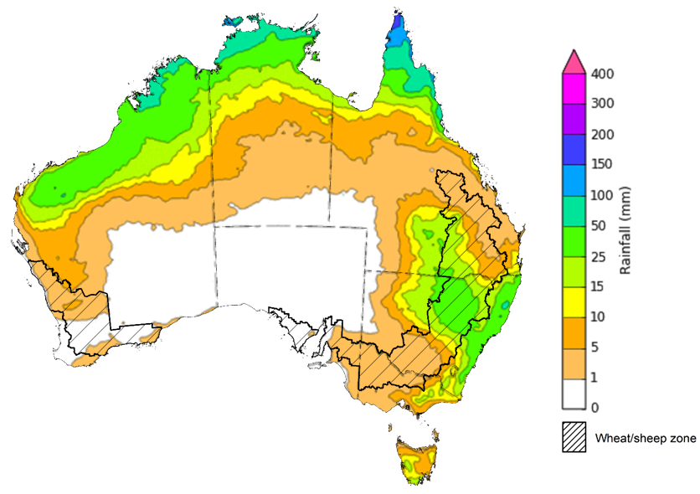

©Commonwealth of Australia 2023, Australian Bureau of Meteorology Issued 19/01/2023
Note: This rainfall forecast is produced from computer models. As the model outputs are not altered by weather forecasters, it is important to check local forecasts and warnings issued by the Bureau of Meteorology.

Water

Water markets – current week

Water storage levels in the Murray-Darling Basin (MDB) decreased between 11 January 2023 and 18 January 2023 by 143 gigalitres (GL). Current volume of water held in storage is 23 629 GL which represents 94 percent of total capacity. This is 4 percent or 894 GL more than at the same time last year.

Water storages in the Murray-Darling Basin, 2013–2023
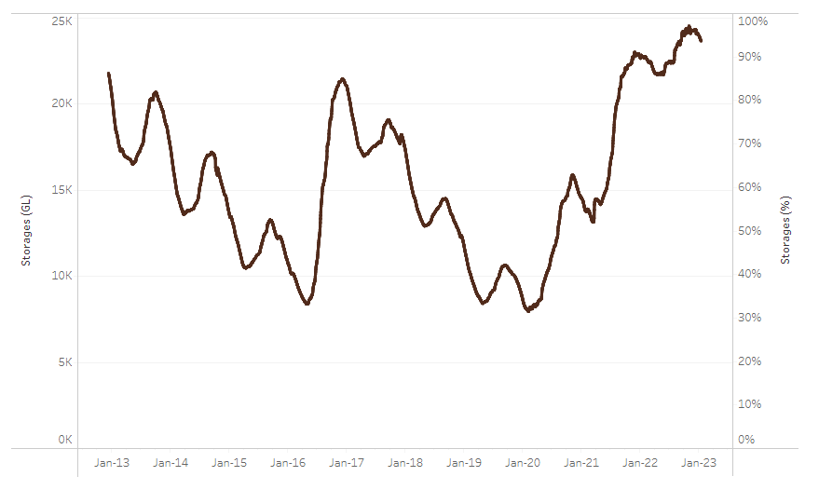
Allocation prices in the Victorian Murray below the Barmah Choke decreased from $40 per ML on 6 January 2023 to $36 per ML on 13 January 2023. Prices are lower in the Murrumbidgee and regions above the Barmah choke due to the binding of the Murrumbidgee export limit and Barmah choke trade constraint.
Water storage data is sourced from the Bureau of Meteorology.
Region | $/ML
NSW Murray Above | 13
NSW Murrumbidgee | 15
VIC Goulburn-Broken | 91
VIC Murray Below | 36

Surface water trade activity, Southern Murray–Darling Basin

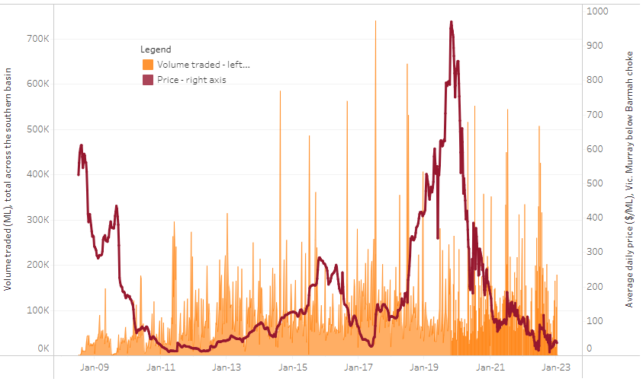
To access the full, interactive, weekly water dashboard, which contains the latest and historical water storage, water market and water allocation information, please visit http://www.agriculture.gov.au/abares/products/weekly_update/weekly-update-190123
The trades shown reflect estimated market activity and do not encompass all register trades. The price is shown for the VIC Murray below the Barmah choke. Historical prices (before 1 July 2019) are ABARES estimates after removing outliers from BOM water register data. Prices after 1 July 2019 and prior to the 30 October 2019 reflect recorded transaction prices as sourced from Ruralco. Prices after the 30 October 2019 are sourced from Waterflow. Data for volume traded is sourced from the BOM water register. Data shown is current on 19 January 2023.

Commodities
Indicator |  | Week ended | Unit |  | Latest price |  | Previous week |  | Weekly change |  | Price 12 months ago |  | Annual change
Selected world indicator prices
AUD/USD Exchange rate |  | 18-Jan | A$/US$ |  | 0.70 |  | 0.69 |  | 1% |  | 0.71 |  | -2%
Wheat – US no. 2 hard red winter wheat, fob Gulf |  | 18-Jan | US$/t |  | 382 |  | 371 |  | 3% |  | 392 |  | -3%
Corn – US no. 2 yellow corn, fob Gulf |  | 18-Jan | US$/t |  | 309 |  | 306 |  | 1% |  | 289 |  | 7%
Canola – Rapeseed, Canada, fob Vancouver |  | 18-Jan | US$/t |  | 679 |  | 684 |  | -1% |  | 858 |  | -21%
Cotton – Cotlook 'A' Index |  | 18-Jan | USc/lb |  | 98 |  | 102 |  | -4% |  | 135 |  | -28%
Sugar – Intercontinental Exchange, nearby futures, no.11 contract |  | 18-Jan | USc/lb |  | 18.6 |  | 18.2 |  | 2% |  | 18 |  | 2%
Wool – Eastern Market Indicator |  | 11-Jan | Ac/kg clean |  | 1,333 |  | 1,333 |  | 0% |  | 1,324 |  | 1%
Wool – Western Market Indicator |  | 11-Jan | Ac/kg clean |  | 1,467 |  | 1,467 |  | 0% |  | 1,392 |  | 5%
Selected Australian grain export prices
Milling Wheat – APW, Port Adelaide, SA |  | 18-Jan | A$/t |  | 516 |  | 521 |  | -1% |  | 486 |  | 6%
Feed Wheat – ASW, Port Adelaide, SA |  | 18-Jan | A$/t |  | 467 |  | 472 |  | -1% |  | 446 |  | 5%
Feed Barley – Port Adelaide, SA |  | 18-Jan | A$/t |  | 420 |  | 423 |  | -1% |  | 382 |  | 10%
Canola – Kwinana, WA |  | 18-Jan | A$/t |  | 1,058 |  | 1,071 |  | -1% |  | 969 |  | 9%
Grain Sorghum – Brisbane, QLD |  | 18-Jan | A$/t |  | 477 |  | 479 |  | 0% |  | 368 |  | 30%
Selected domestic livestock indicator prices
Beef – Eastern Young Cattle Indicator |  | 18-Jan | Ac/kg cwt |  | 779 |  | 778 |  | 0% |  | 1,159 |  | -33%
Mutton – Mutton indicator (18–24 kg fat score 2–3), Vic |  | 18-Jan | Ac/kg cwt |  | 357 |  | 407 |  | -12% |  | 564 |  | -37%
Lamb – Eastern States Trade Lamb Indicator |  | 18-Jan | Ac/kg cwt |  | 665 |  | 685 |  | -3% |  | 843 |  | -21%
Pig – Eastern Seaboard (60.1–75 kg), average of buyers & sellers |  | 28-Dec | Ac/kg cwt |  | 376 |  | 376 |  | 0% |  | 357 |  | 5%
Goats – Eastern States (12.1–16 kg) |  | 11-Jan | Ac/kg cwt |  | 350 |  | 350 |  | 0% |  | 813 |  | -57%
Live cattle – Light steers ex Darwin to Indonesia |  | 17-Aug | Ac/kg lwt |  | 420 |  | 480 |  | -13% |  | 320 |  | 31%
Live sheep – Live wethers (Muchea WA saleyard) to Middle East |  | 14-Sep | $/head |  | 93 |  | 113 |  | -18% |  | 114 |  | -18%
Indicator | 18-Jan |  |  | US$/t |  | 3,218 |  | 3,208 |  | 0% | 3,306 | -3%
Global Dairy Trade (GDT) weighted average prices ª | 18-Jan |  |  | US$/t |  | 2,842 |  | 2,838 |  | 0% | 3,044 | -7%
Dairy – Whole milk powder | 18-Jan |  |  | US$/t |  | 4,871 |  | 4,690 |  | 4% | 4,078 | 19%
Dairy – Skim milk powder | 18-Jan |  |  | US$/t |  | 5,337 |  | 5,395 |  | -1% | 4,604 | 16%
Dairy – Cheddar cheese | 18-Jan |  |  | A$/US$ |  | 0.70 |  | 0.69 |  | 1% | 0.71 | -2%
Dairy – Anhydrous milk fat | 18-Jan |  |  | US$/t |  | 382 |  | 371 |  | 3% | 392 | -3%
a Global Dairy Trade prices are updated twice monthly on the first and third Tuesday of each month.

Selected world indicator prices
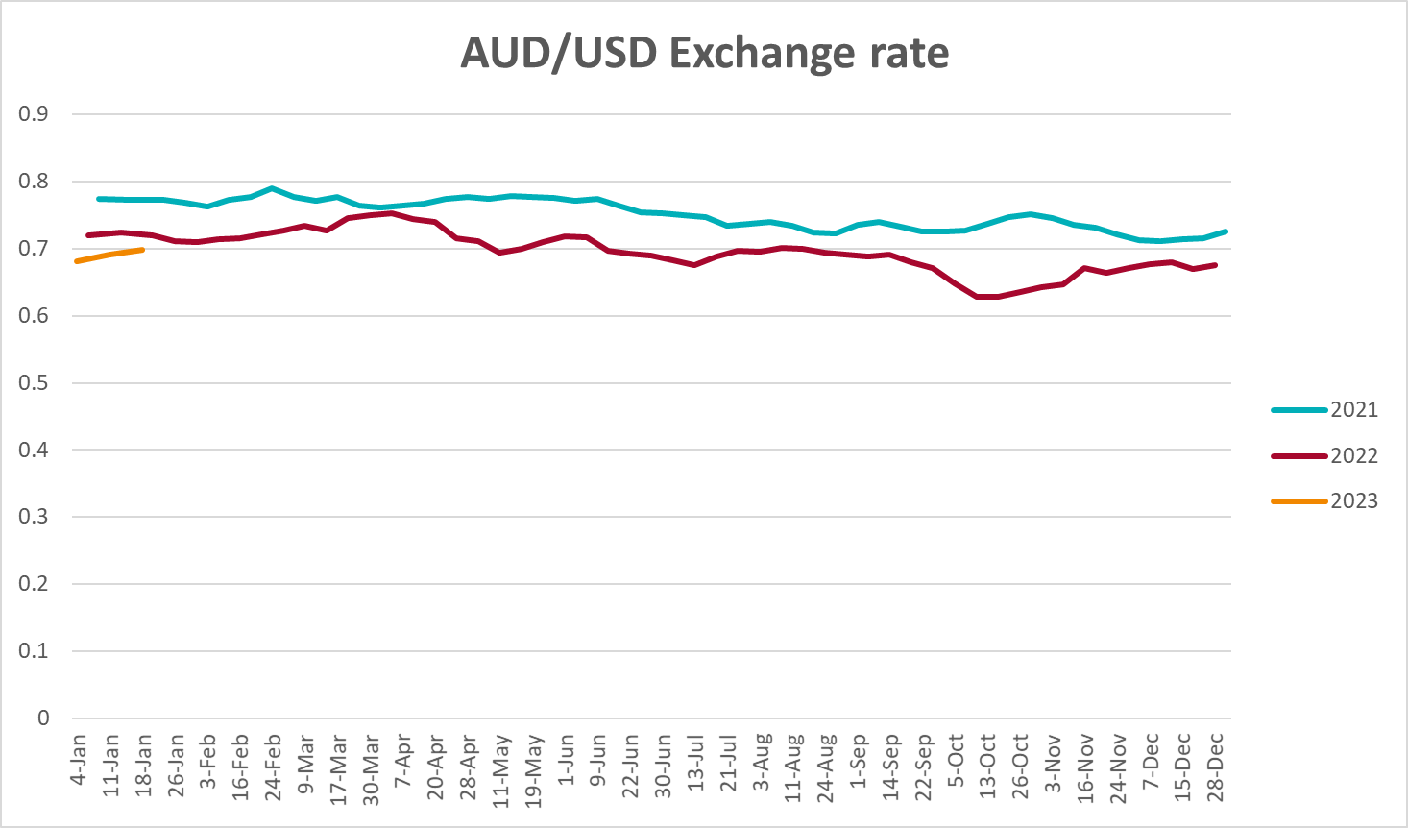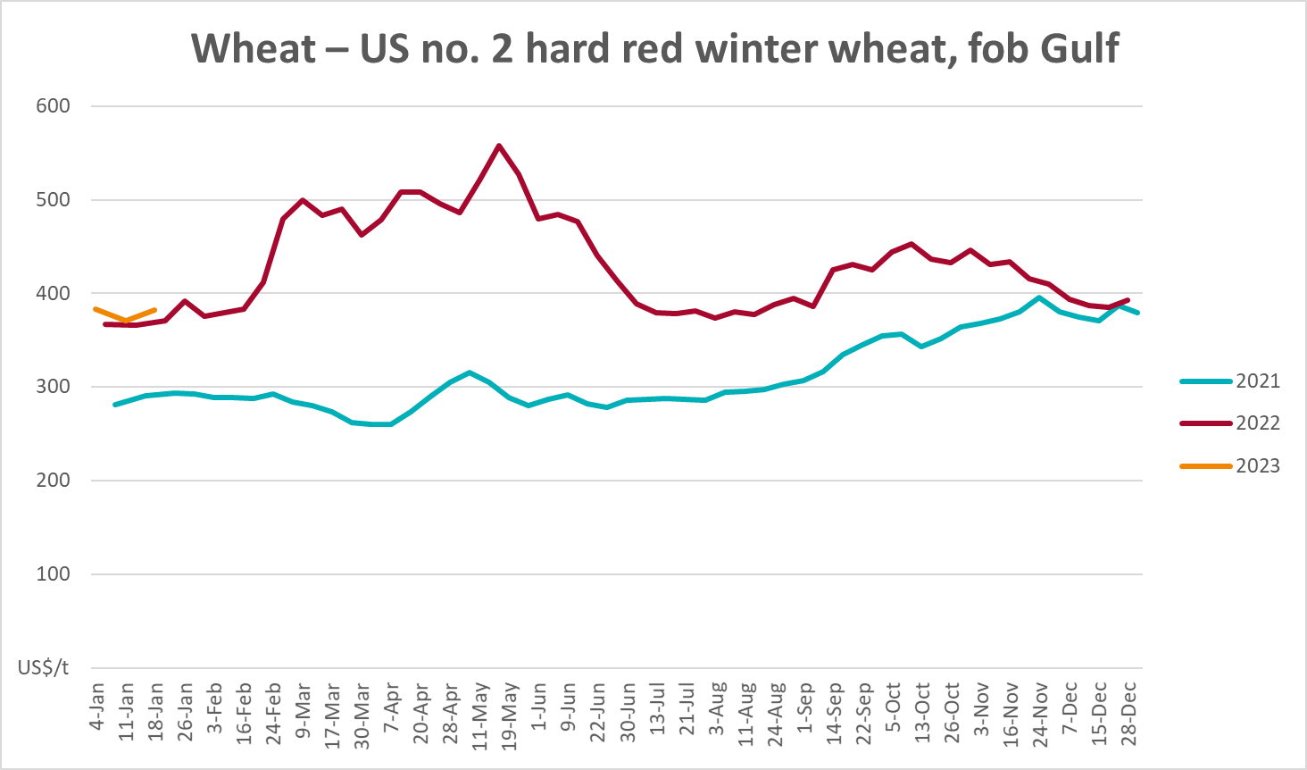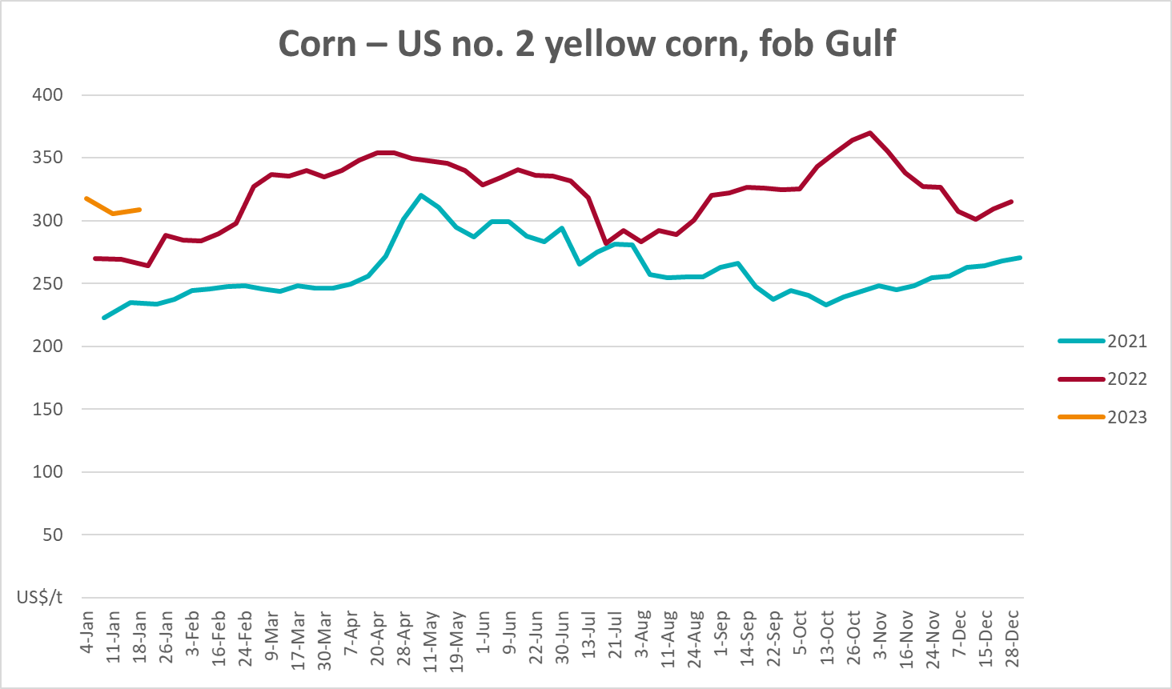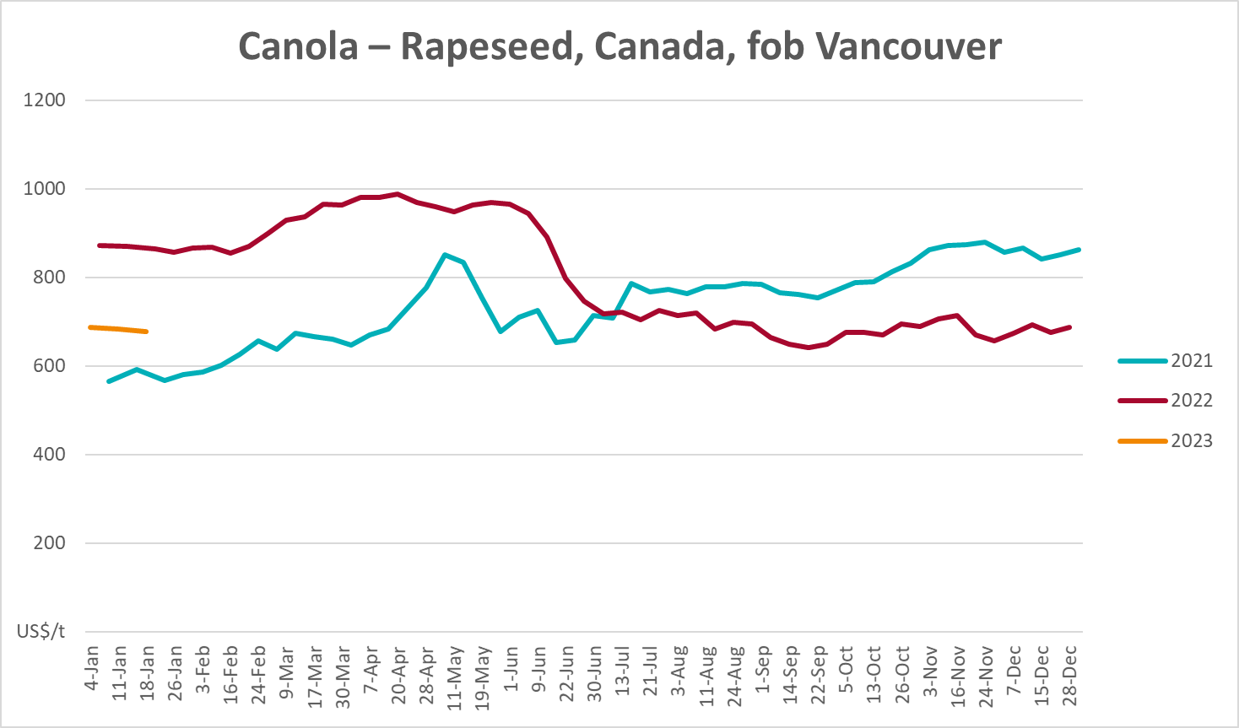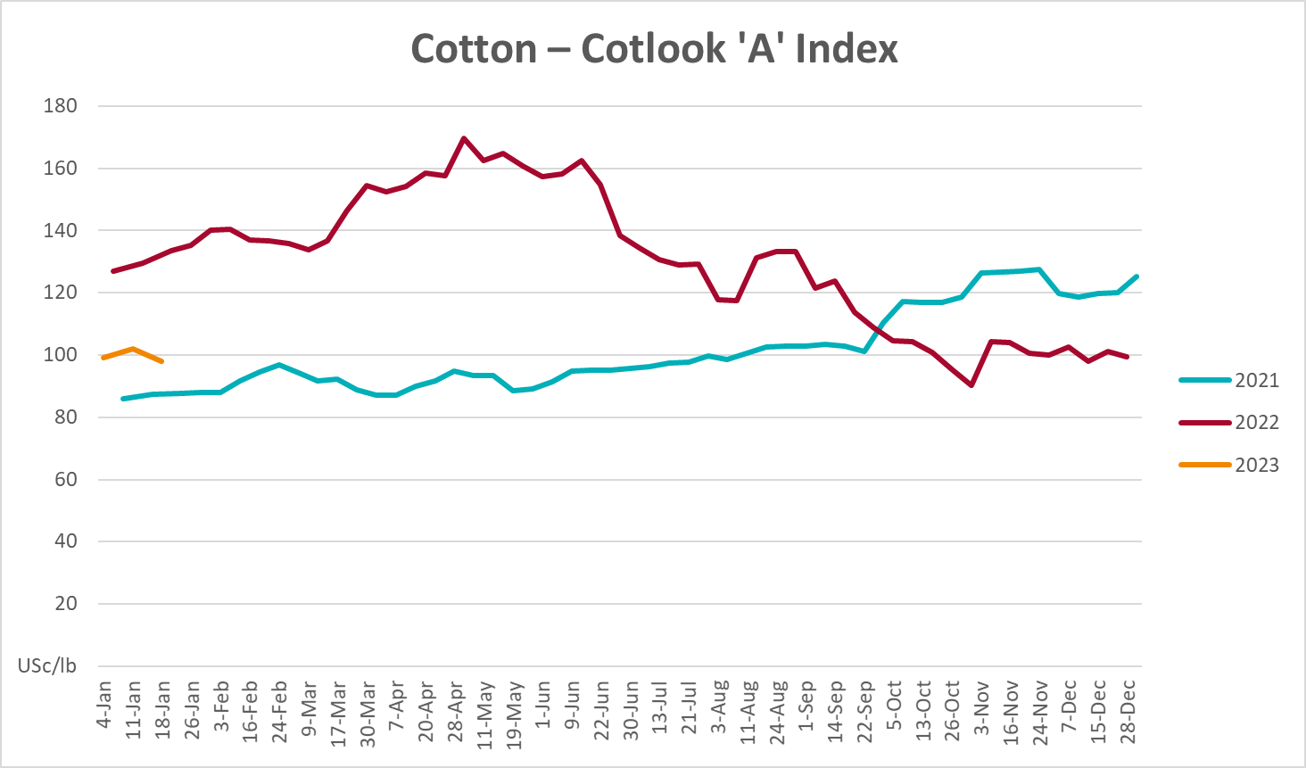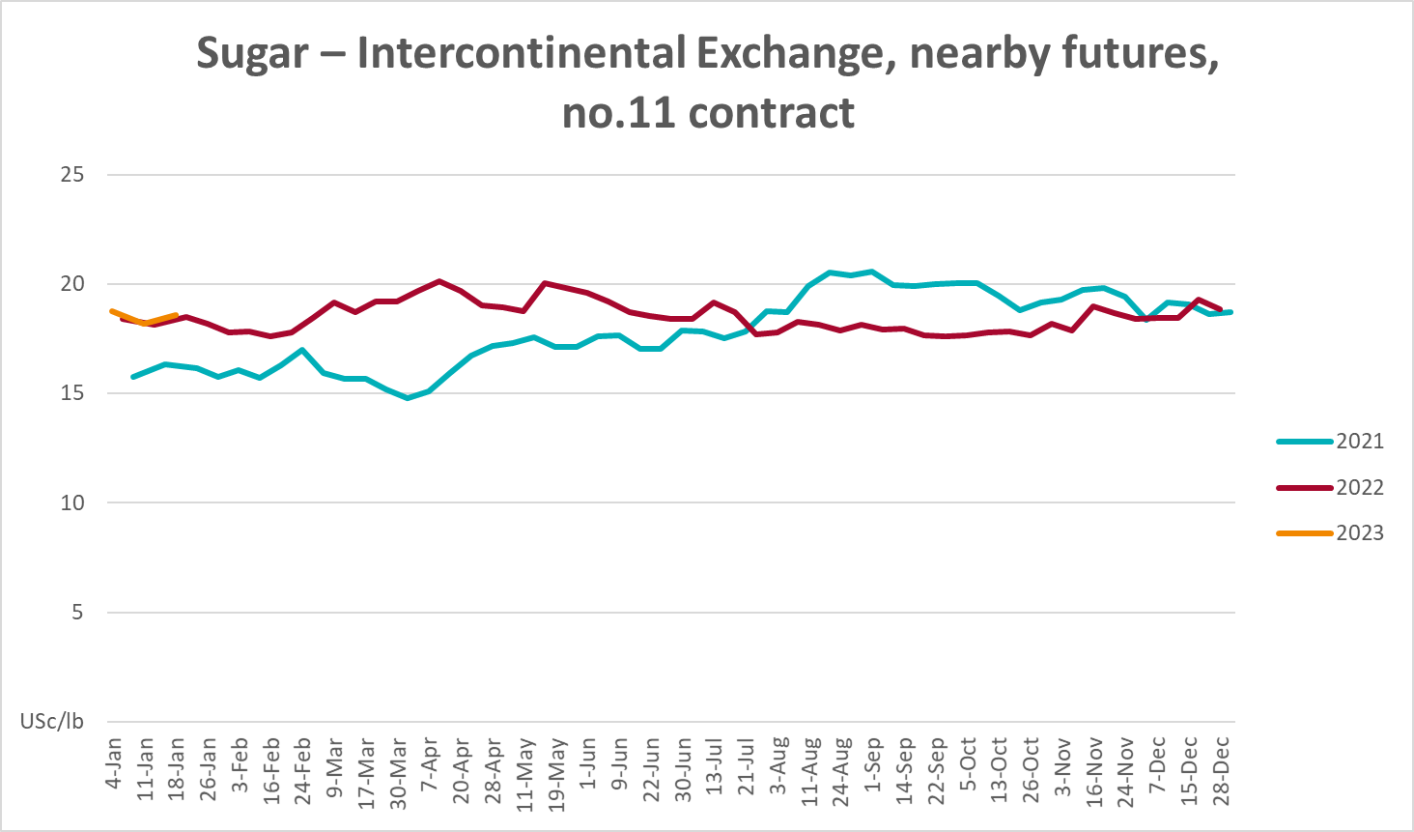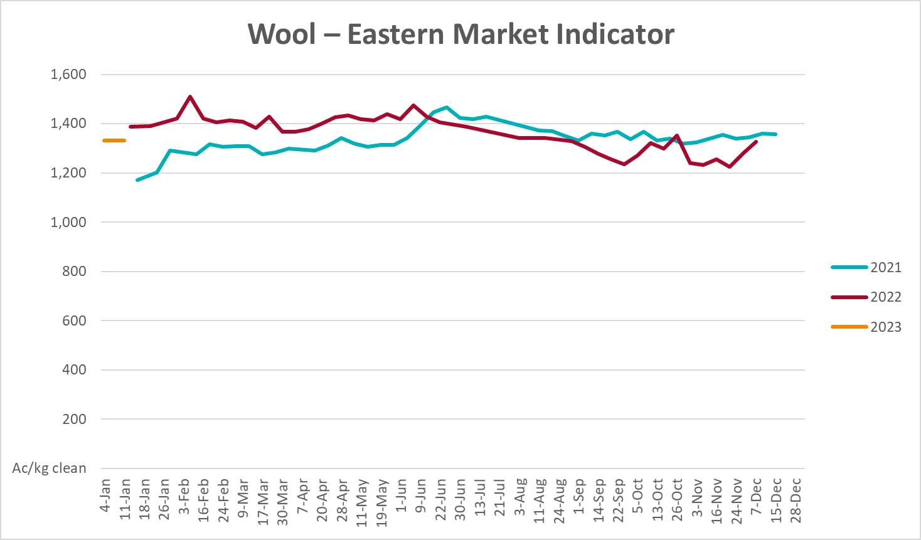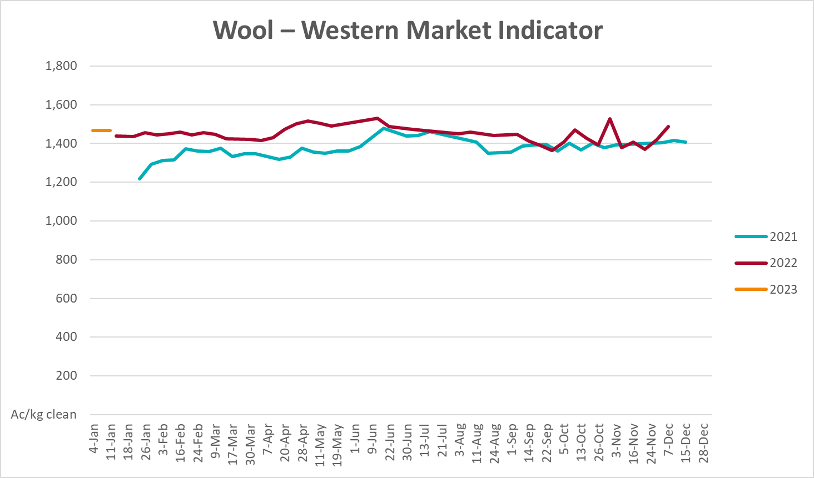

Selected domestic crop indicator prices
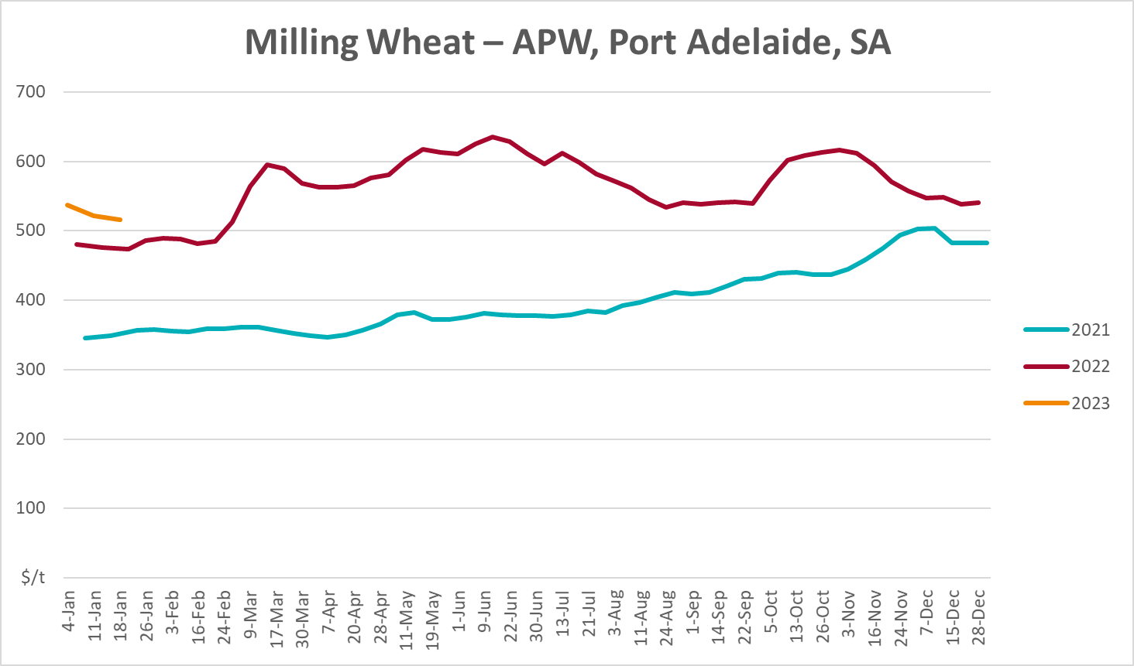
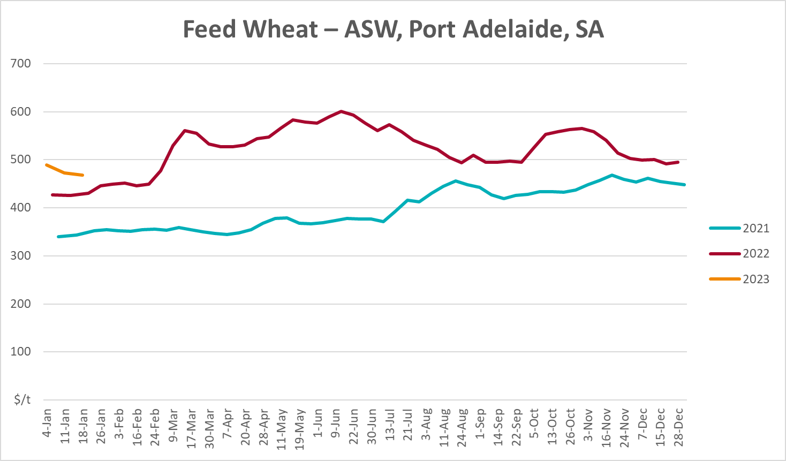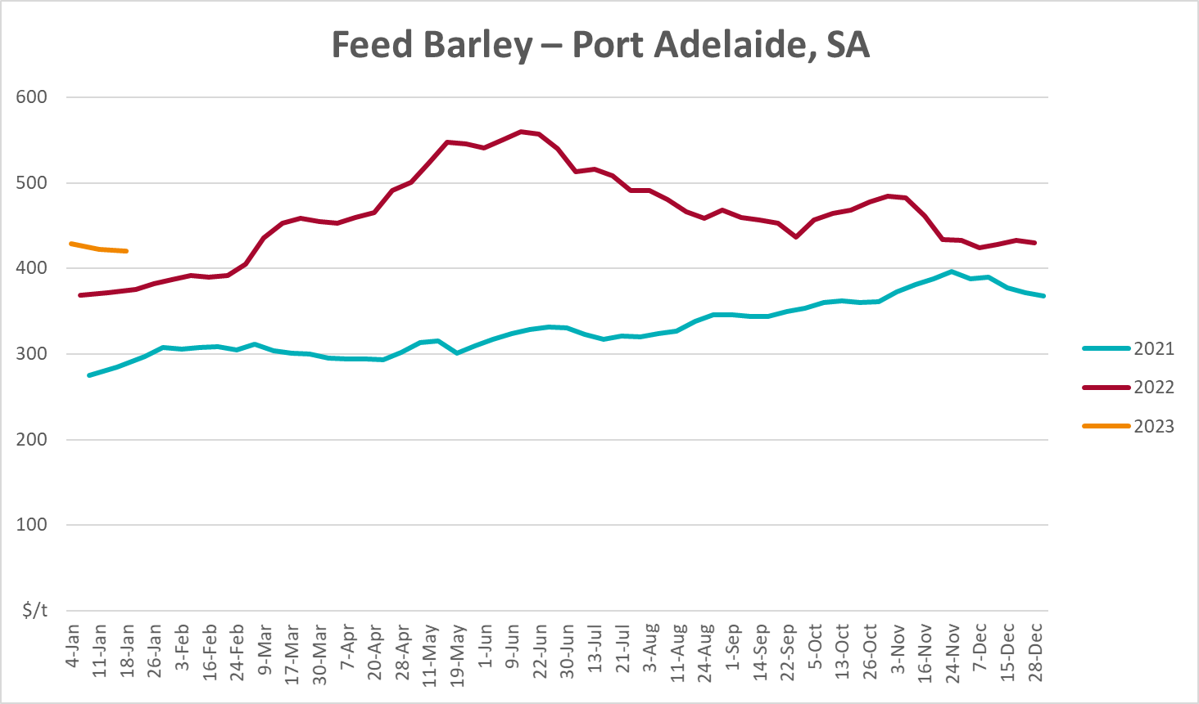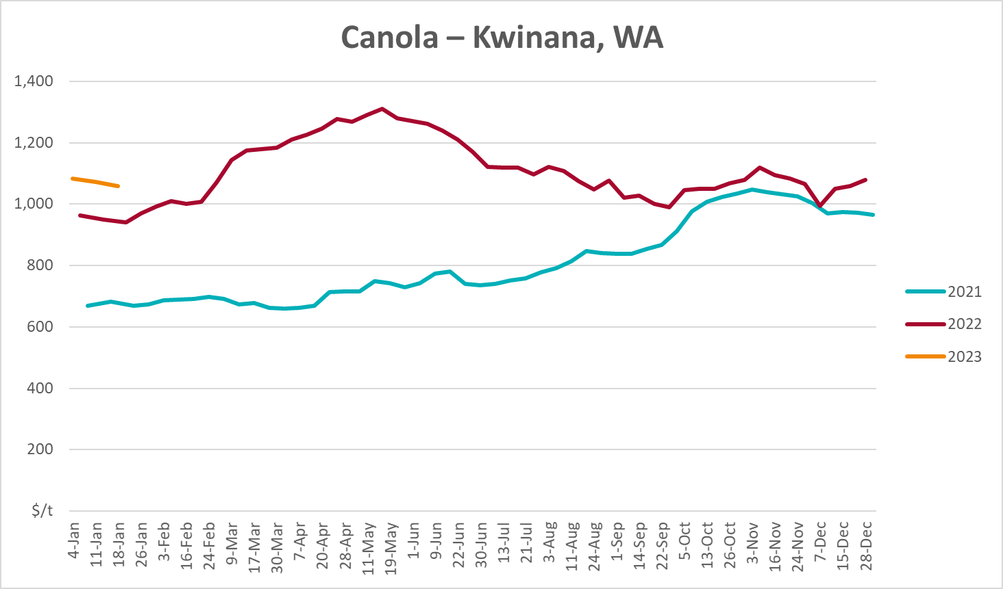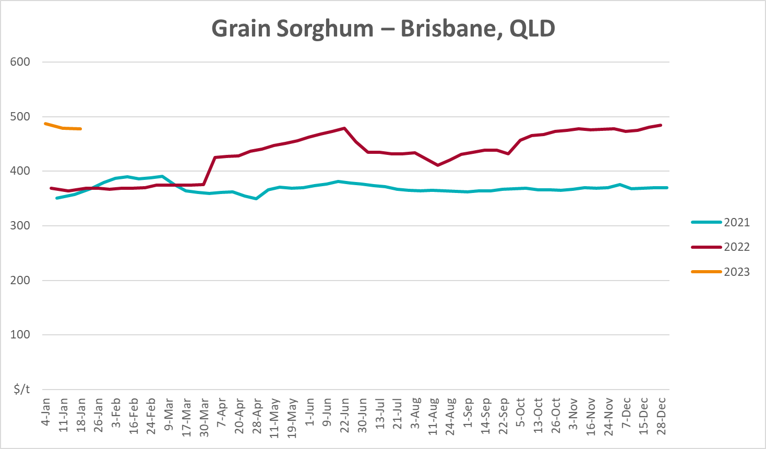

Selected domestic livestock indicator prices
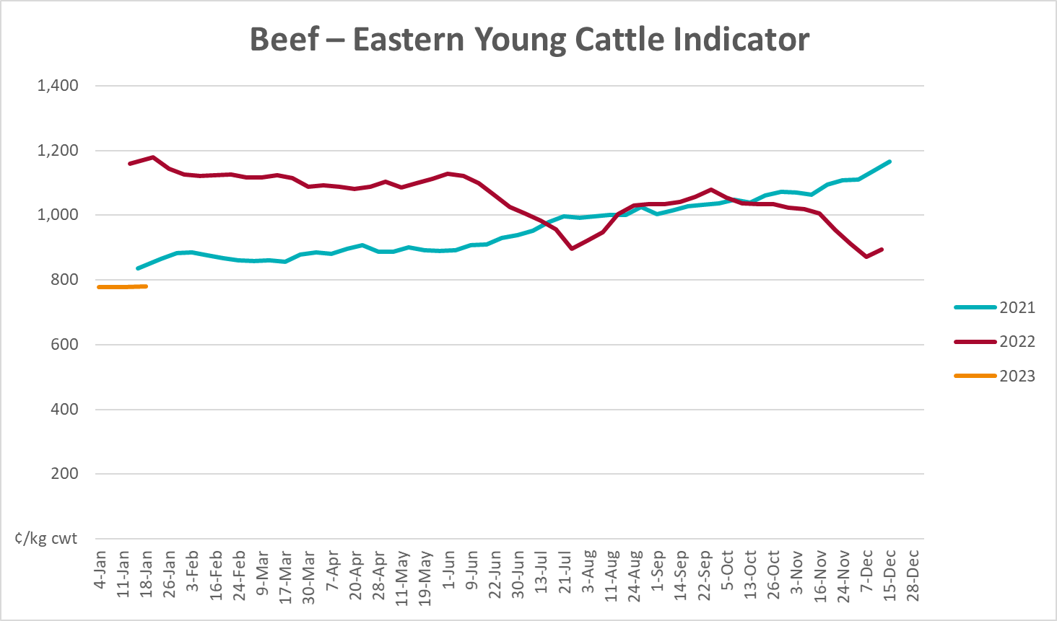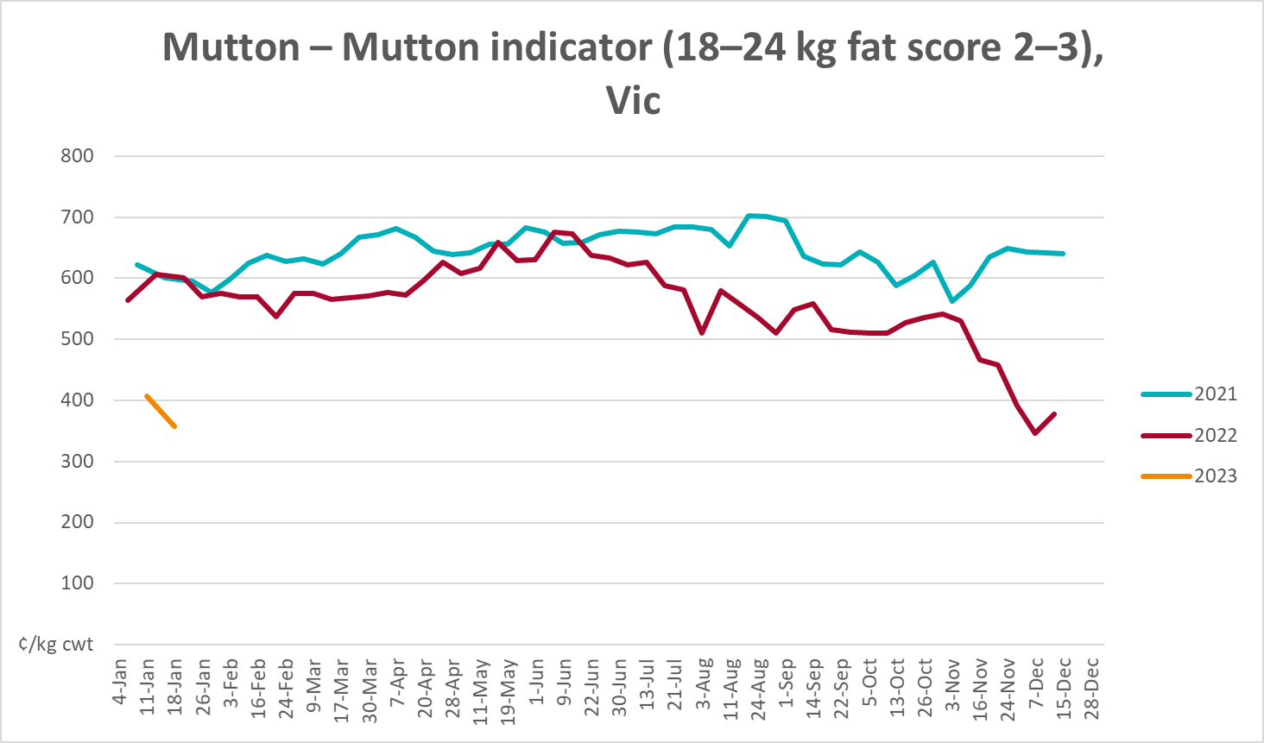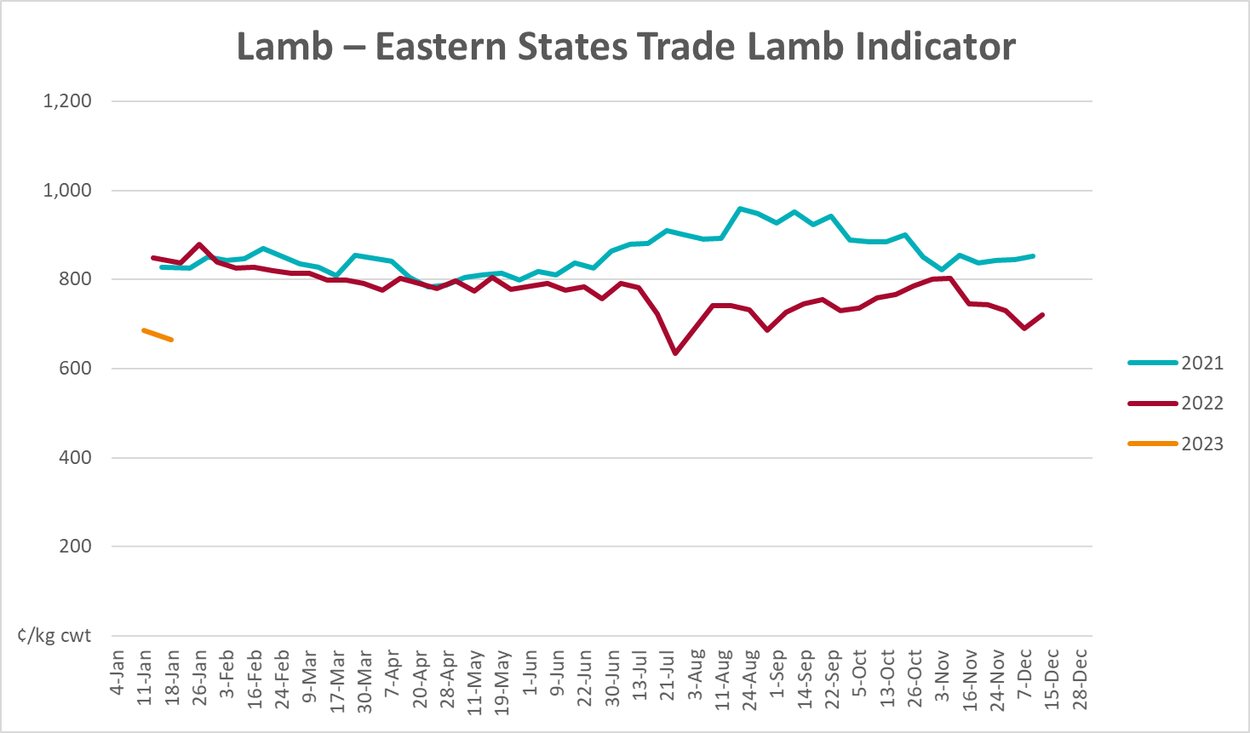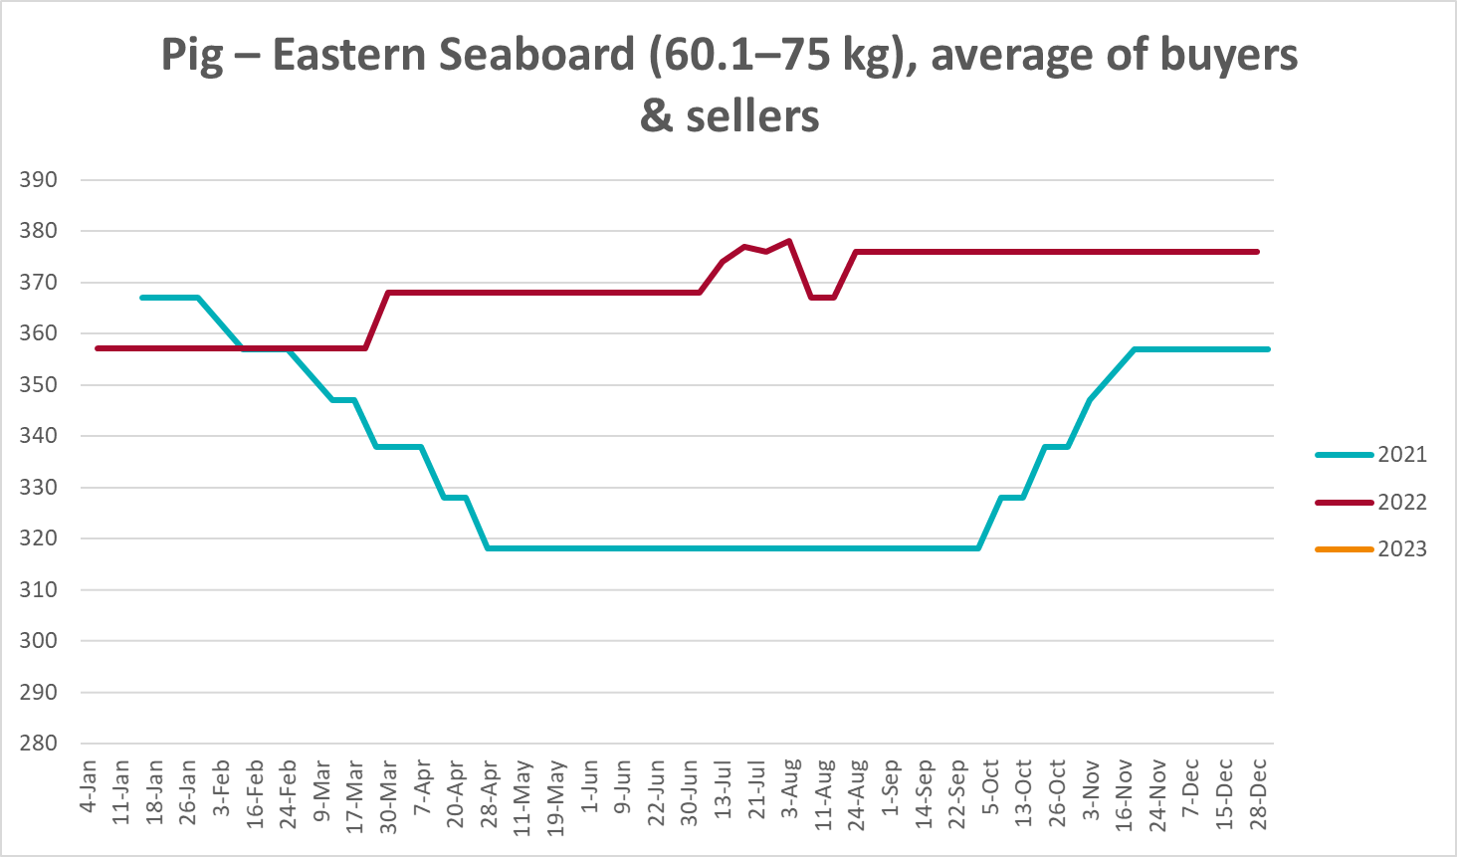

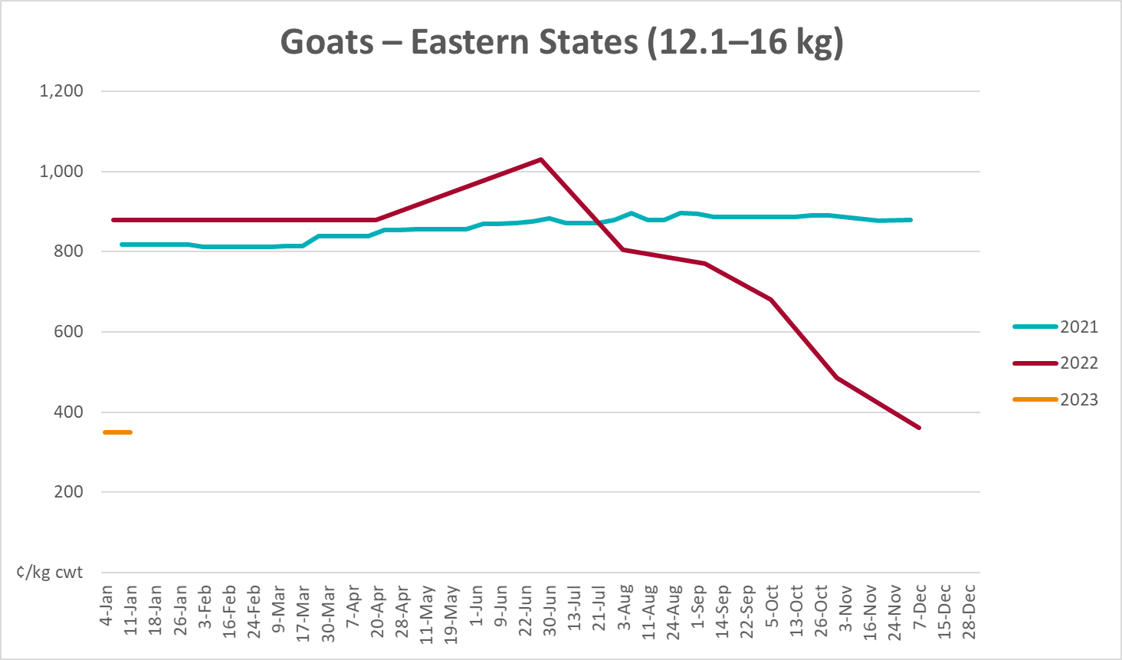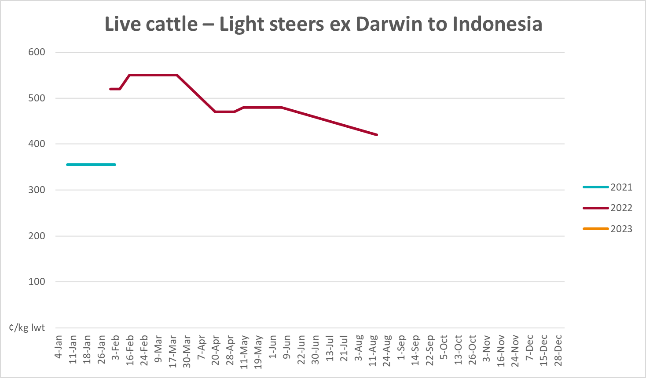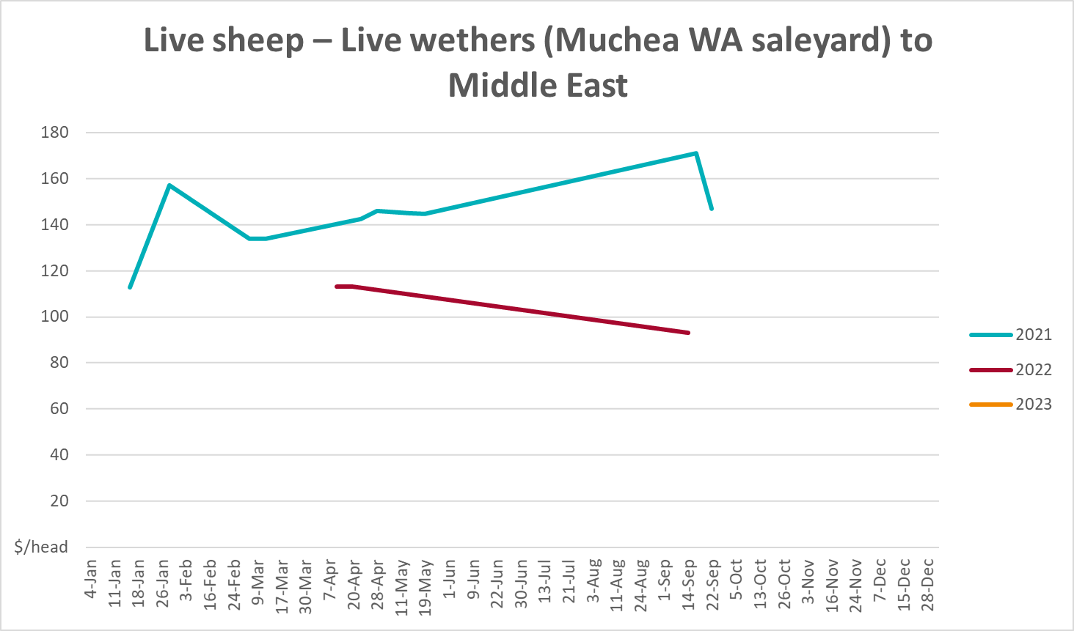

Global Dairy Trade (GDT) weighted average prices
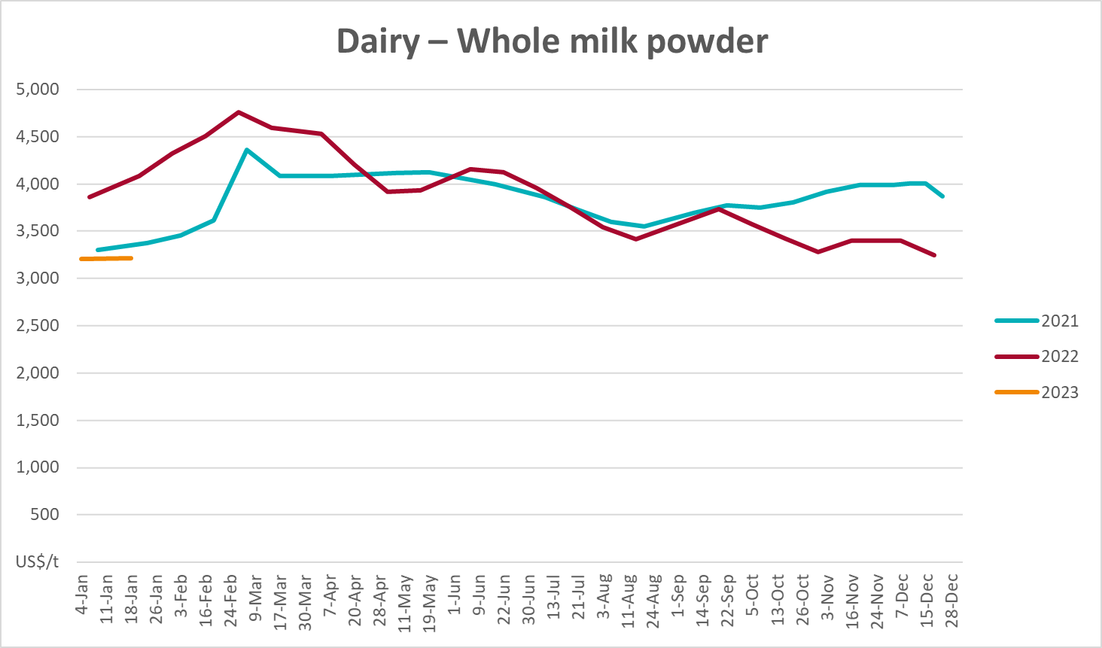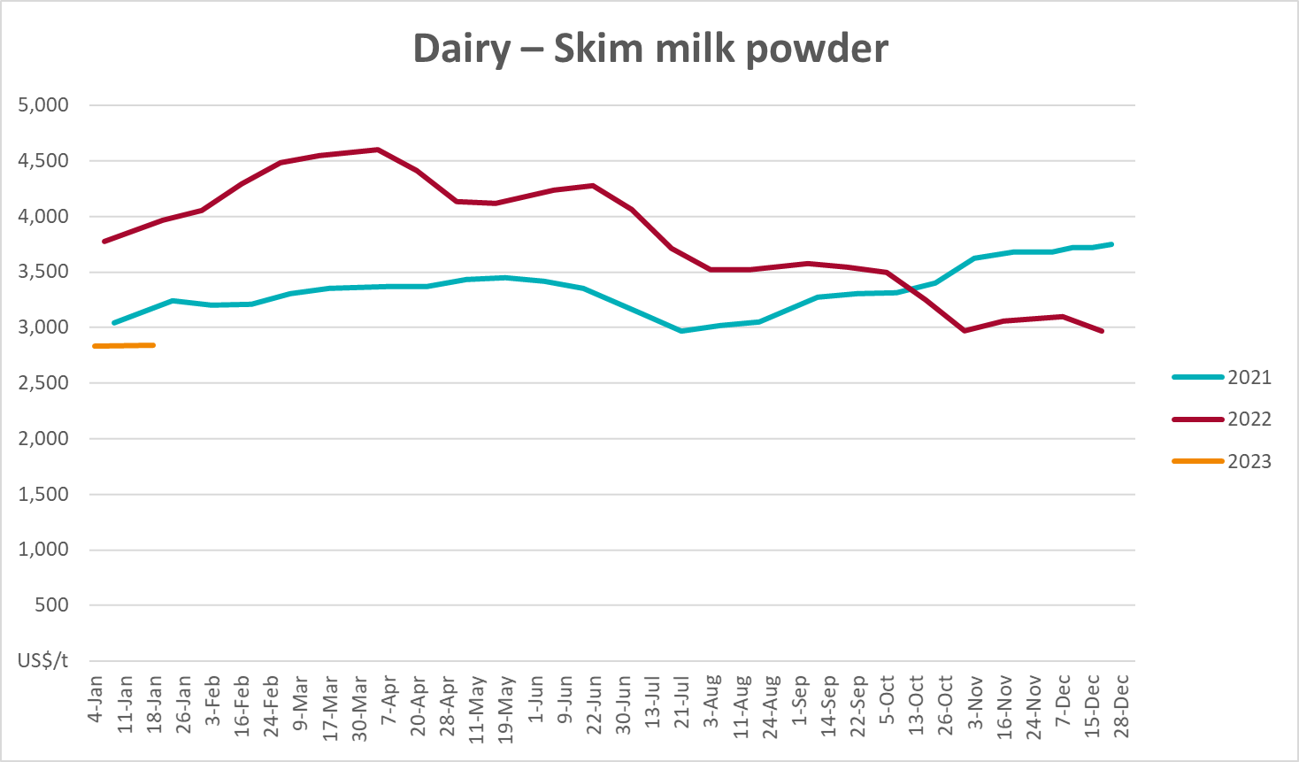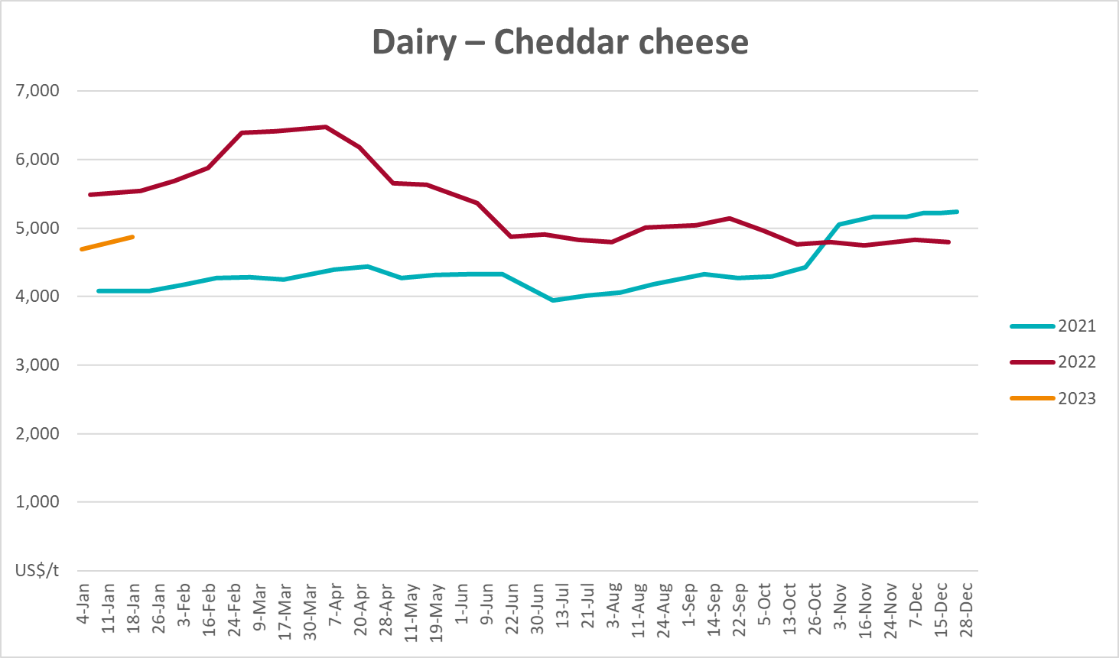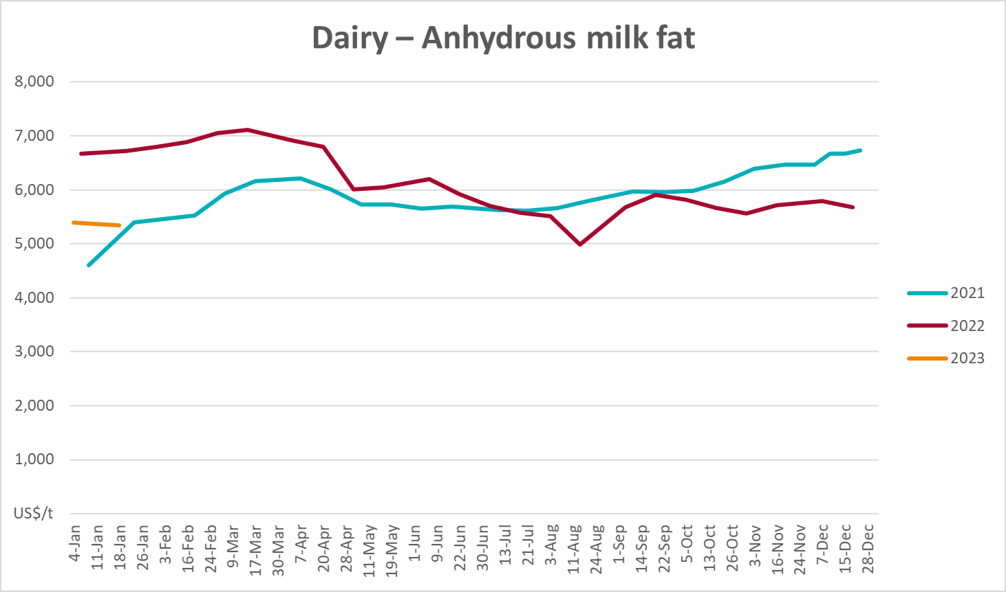

Selected fruit and vegetable prices

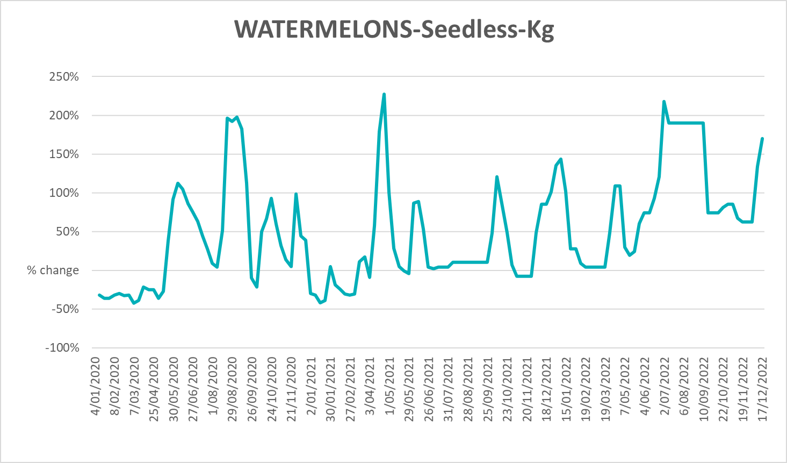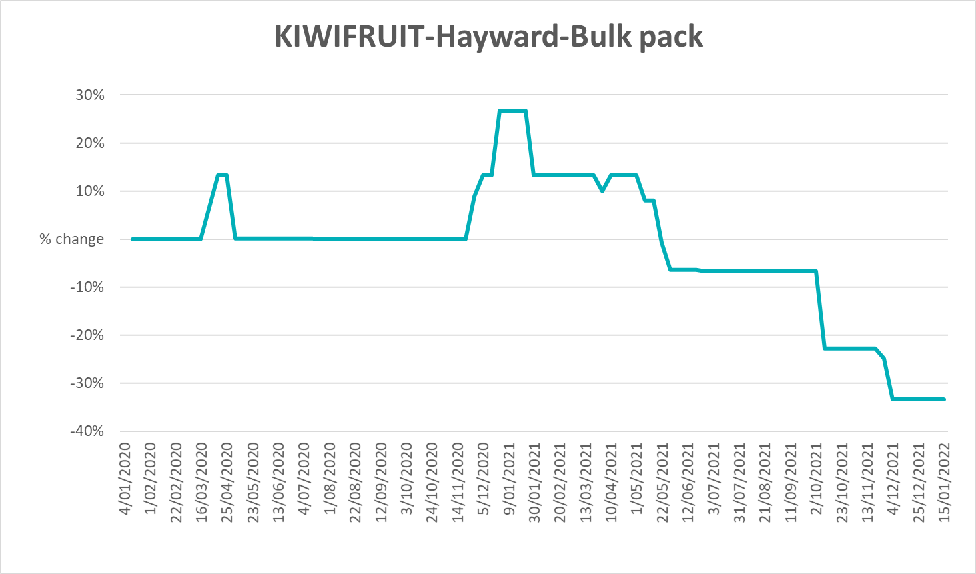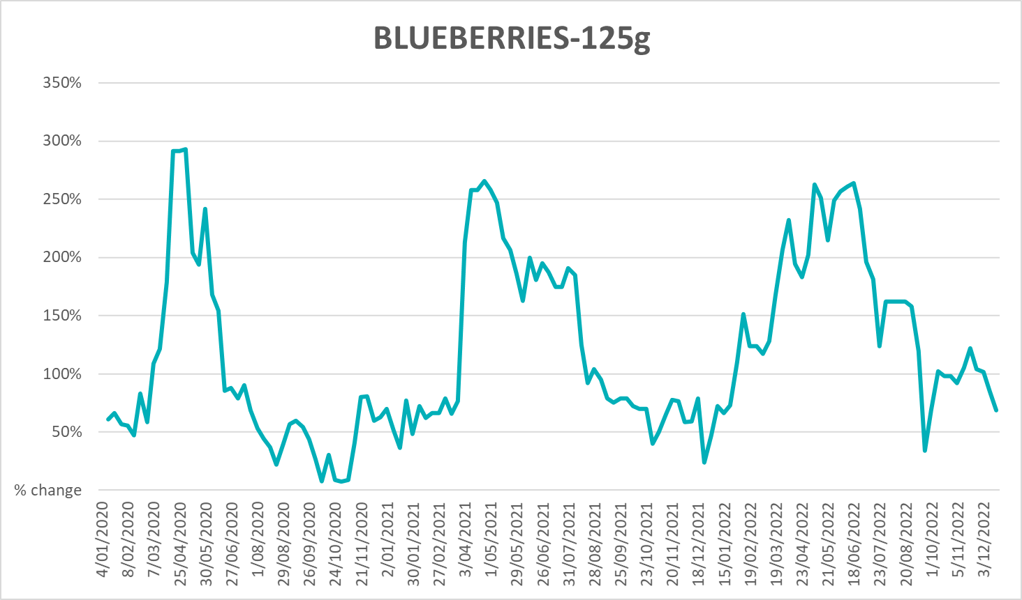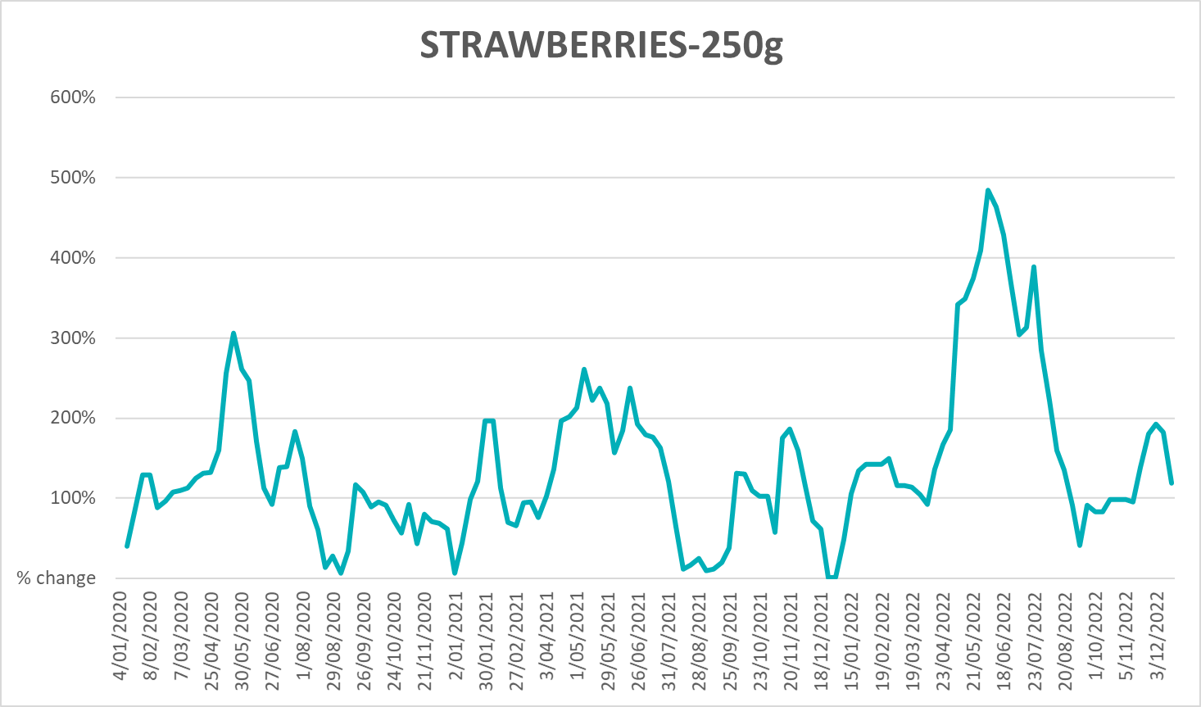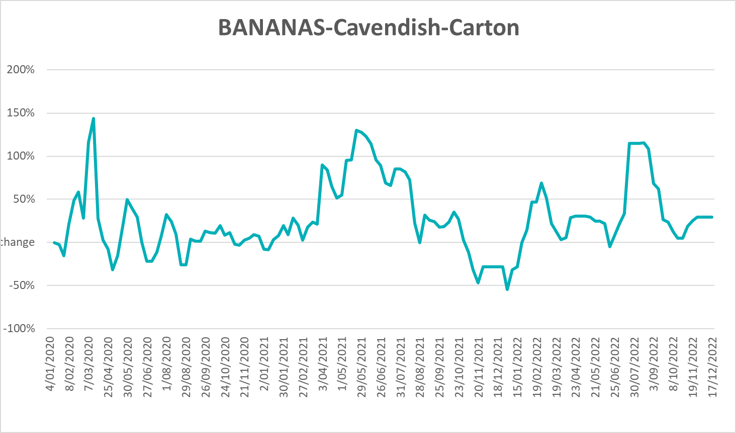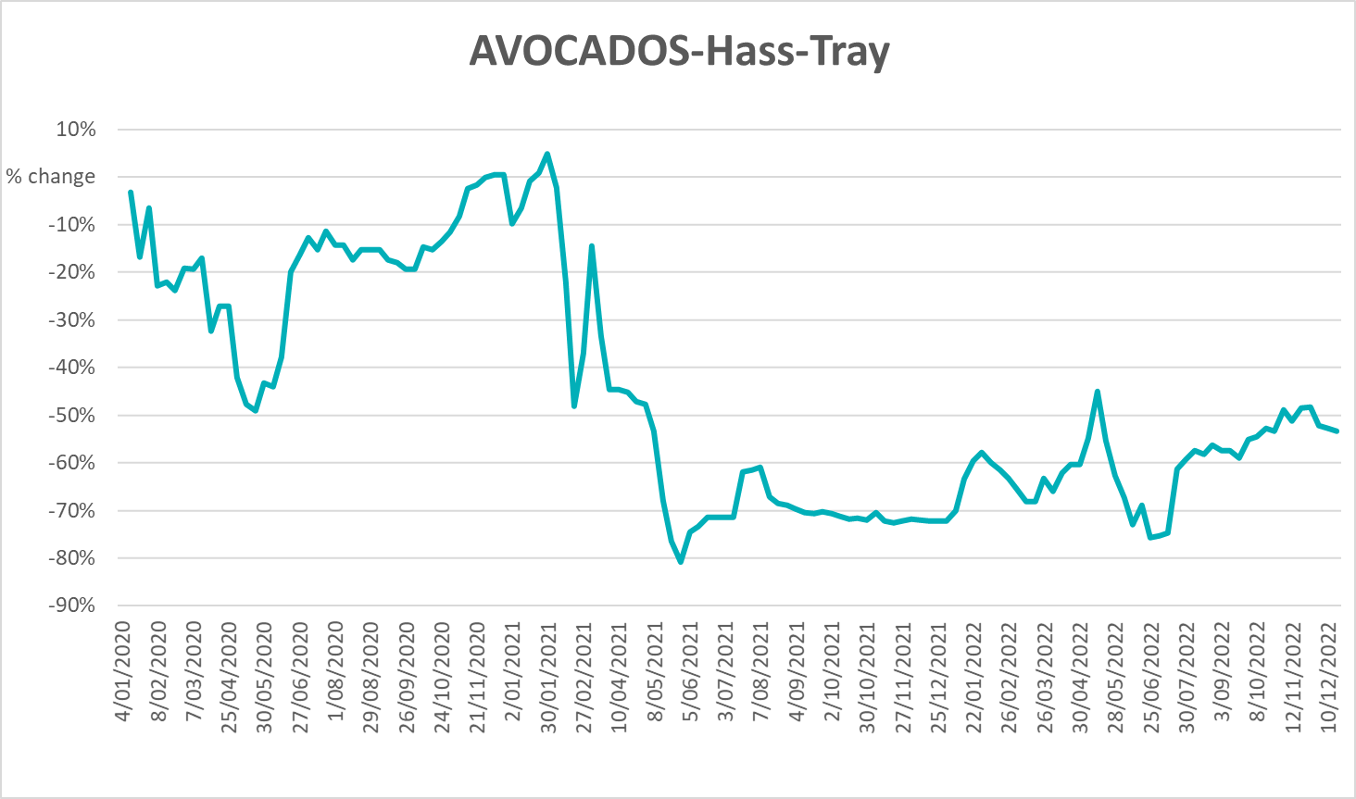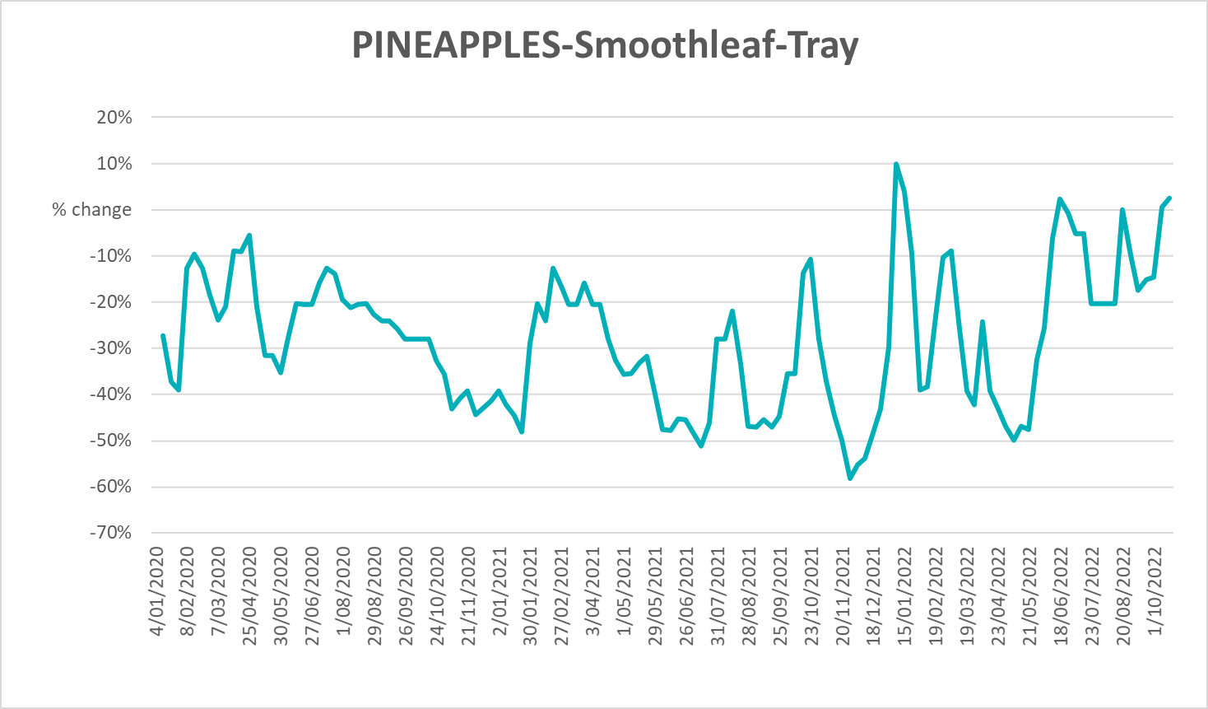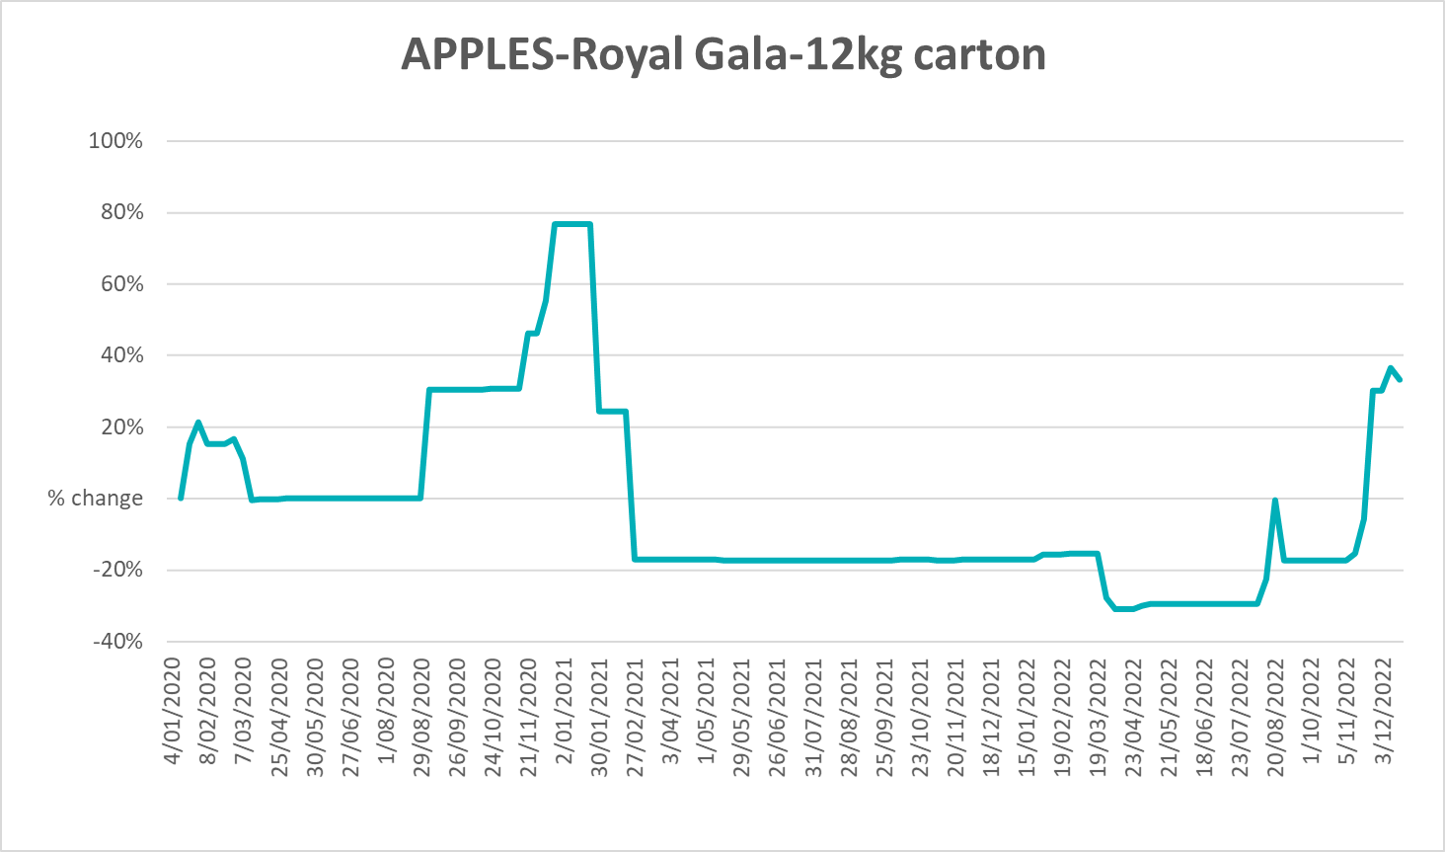
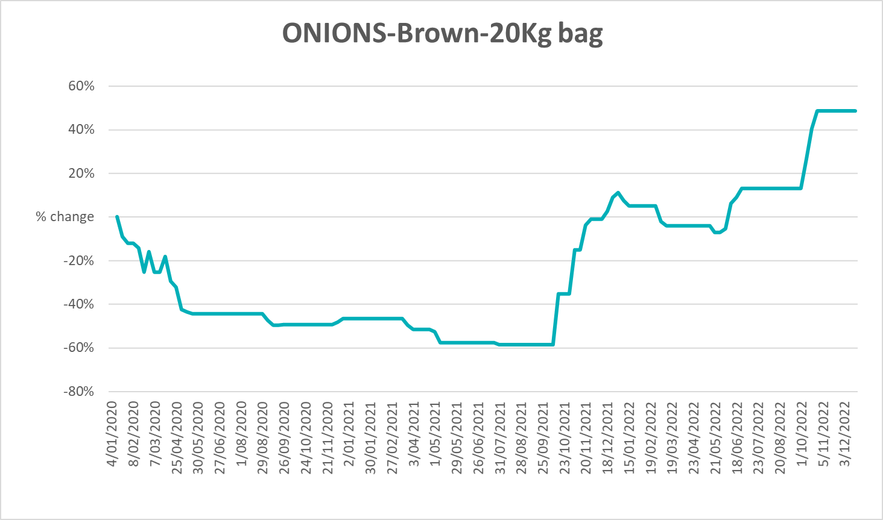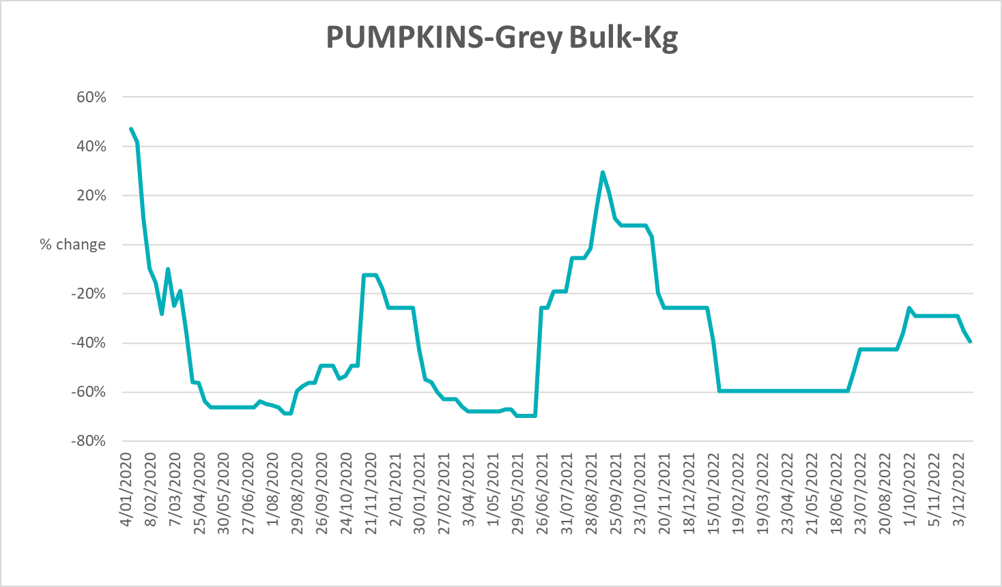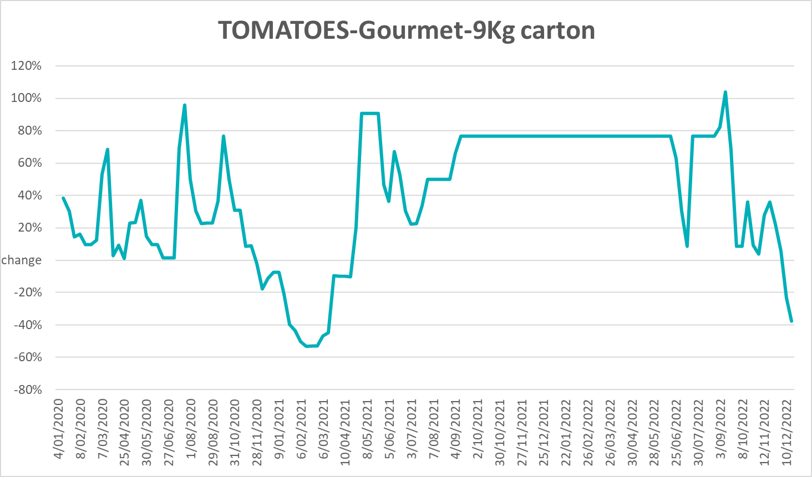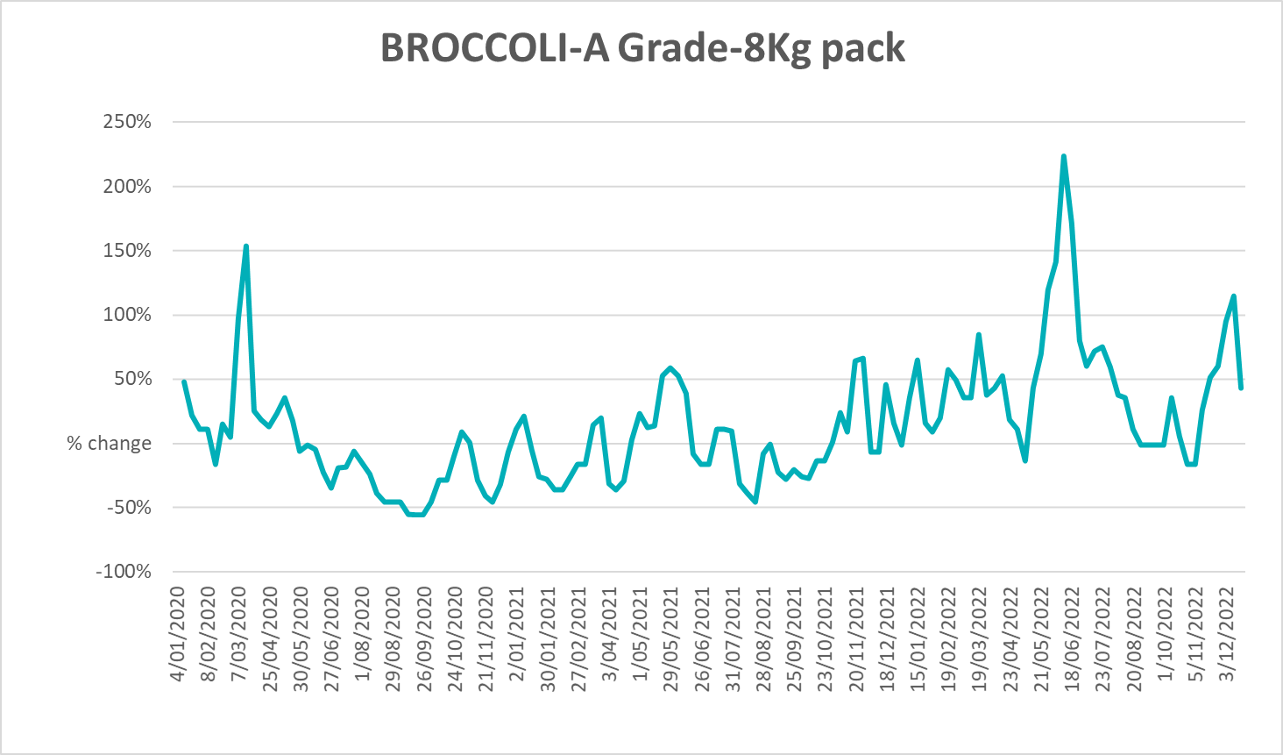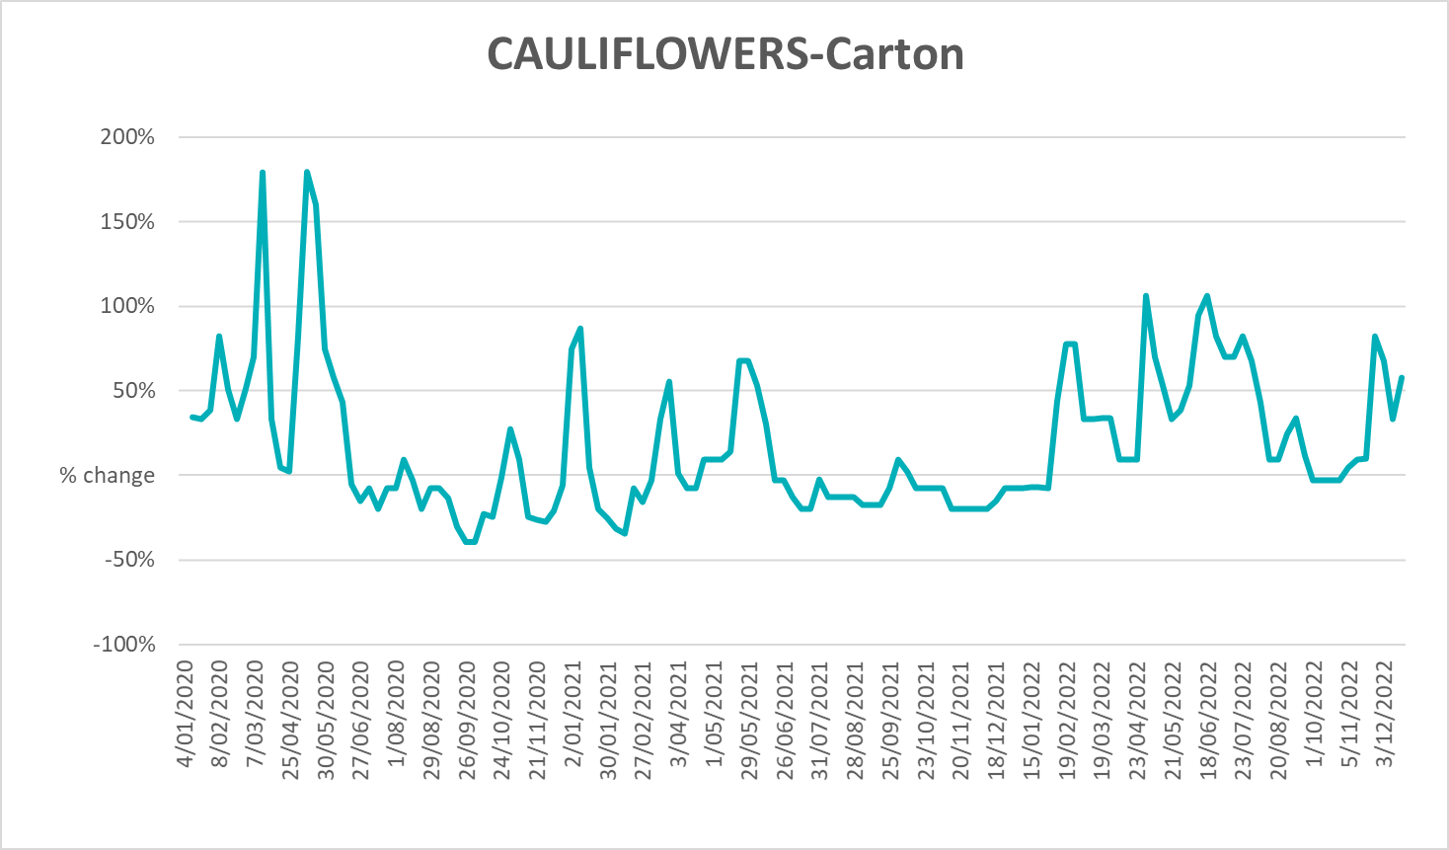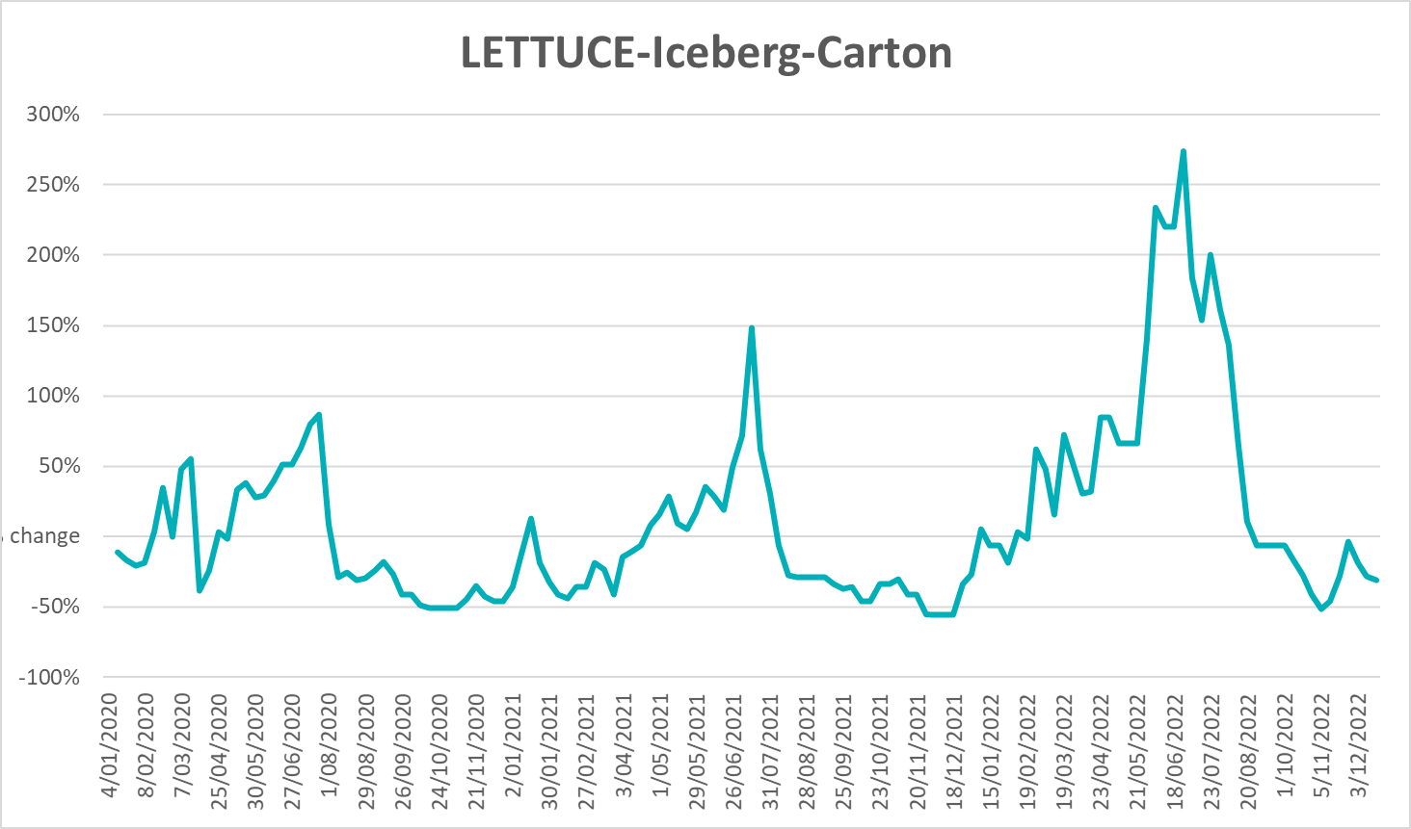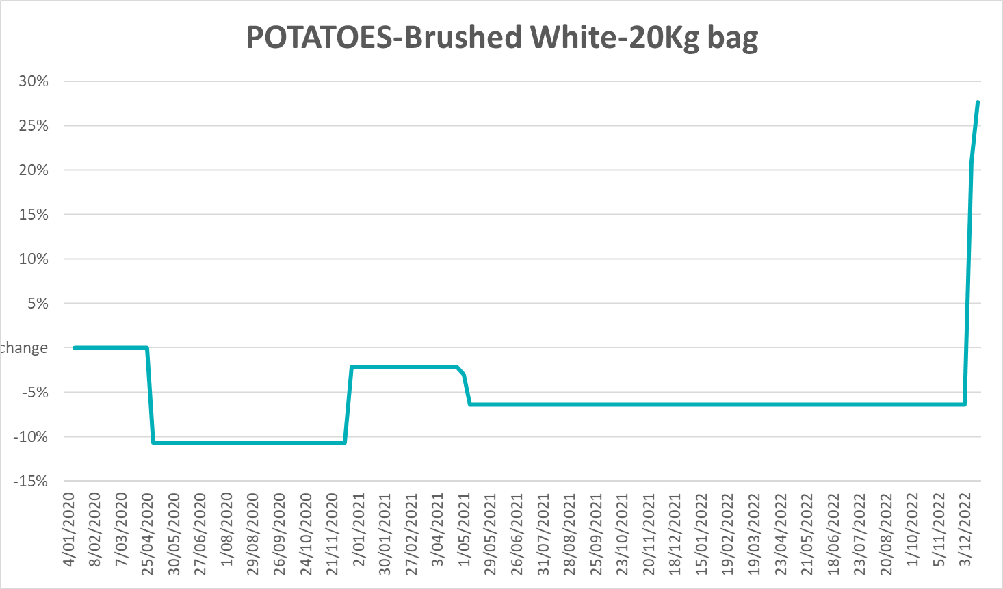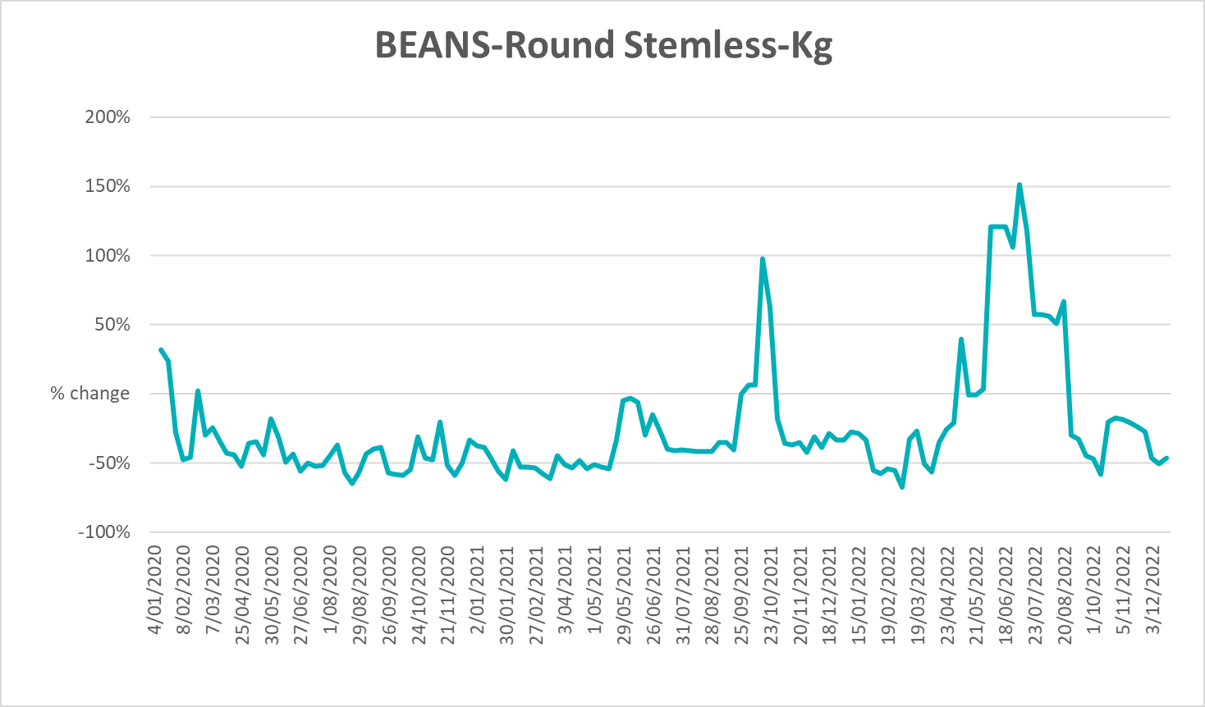

Selected domestic fodder indicator prices
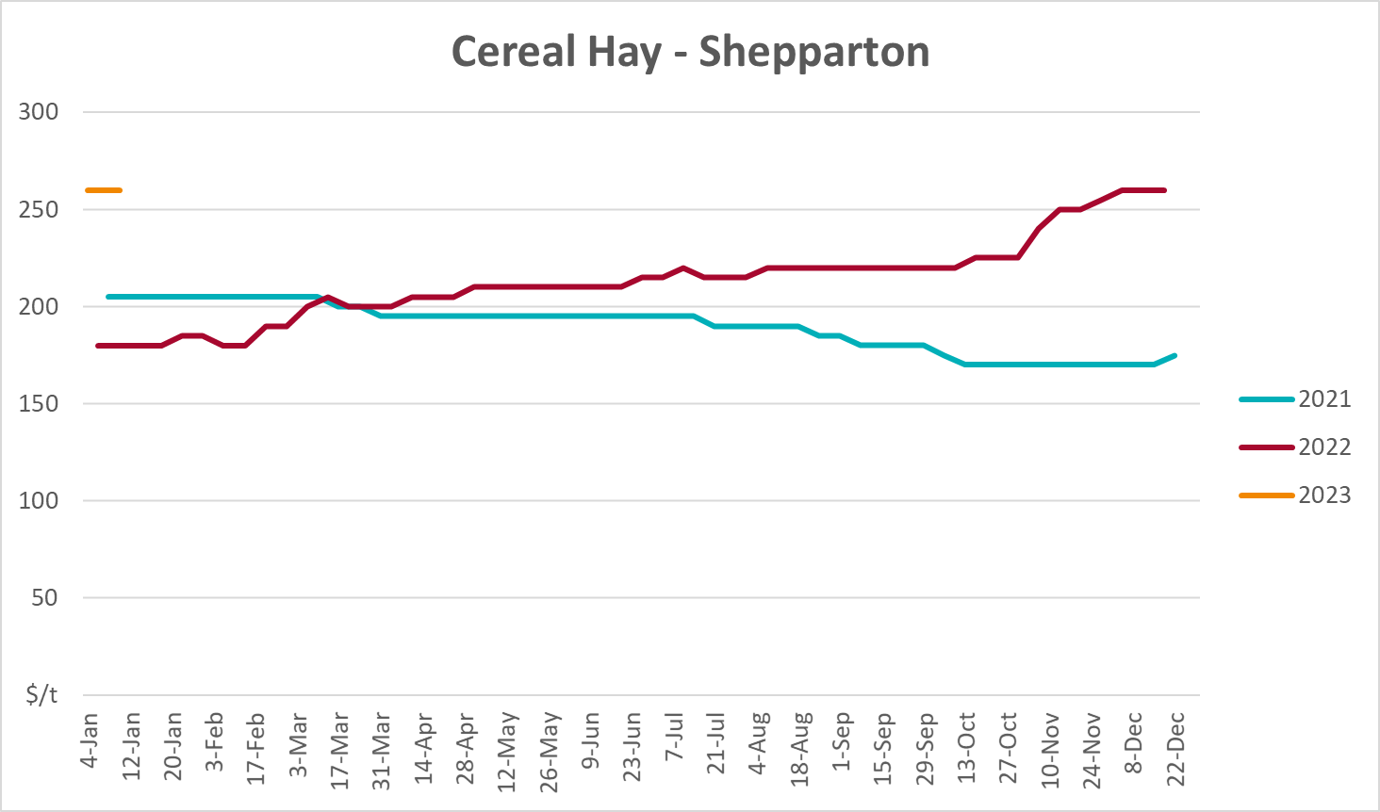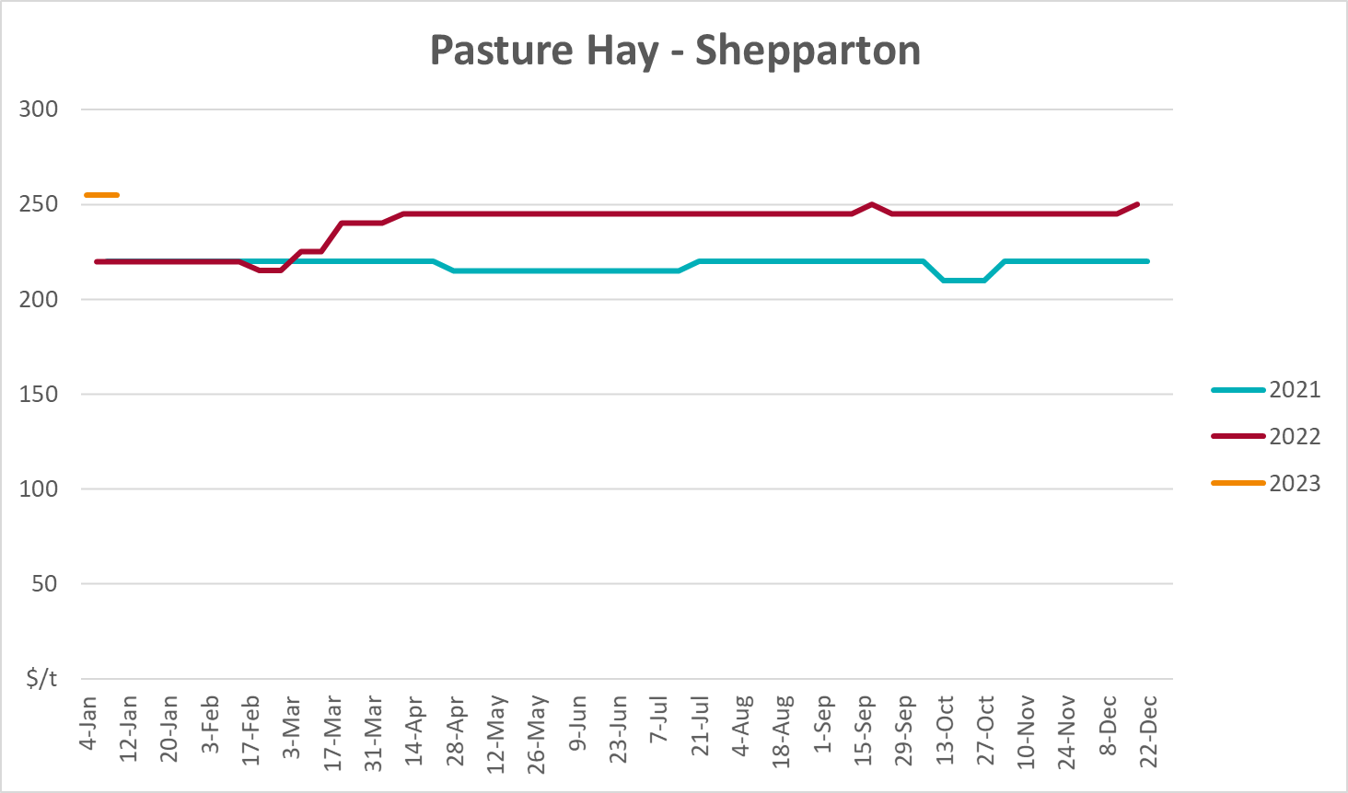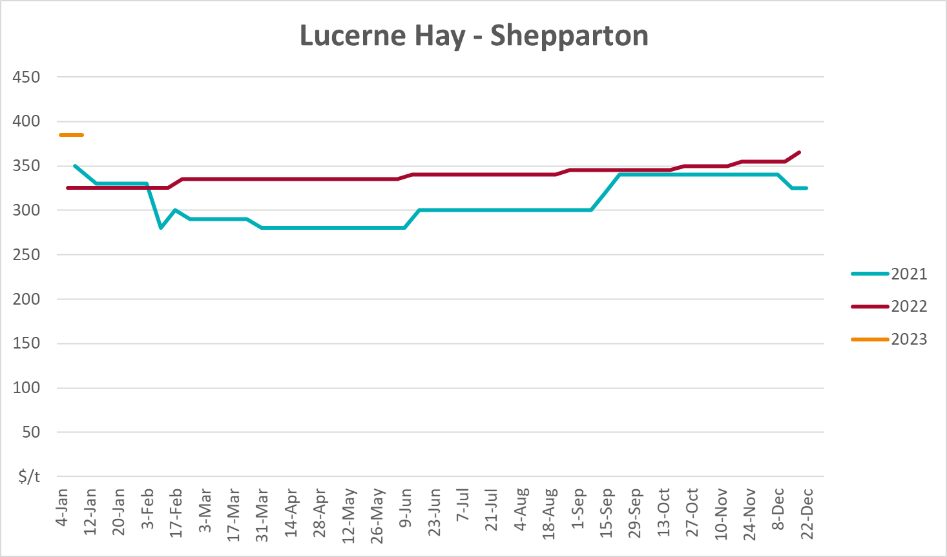

Data attribution

Climate
Bureau of Meteorology
- Weekly rainfall totals: www.bom.gov.au/climate/maps/rainfall/
- Monthly and last 3-month rainfall percentiles: www.bom.gov.au/water/landscape/
- Temperature anomalies: www.bom.gov.au/jsp/awap/temp/index.jsp
- Rainfall forecast: www.bom.gov.au/jsp/watl/rainfall/pme.jsp
- Seasonal outlook: www.bom.gov.au/climate/outlooks/#/overview/summary/
- Climate drivers: http://www.bom.gov.au/climate/enso/
- Soil moisture: www.bom.gov.au/water/landscape/
Other
- Pasture growth: www.longpaddock.qld.gov.au/aussiegrass/
- 3-month global outlooks: Environment and Climate Change Canada, NOAA Climate Prediction Center, EUROBRISA CPTEC/INPE, European Centre for Medium-Range Weather Forecasts, Hydrometcenter of Russia, National Climate Center Climate System Diagnosis and Prediction Room (NCC), International Research Institute for Climate and Society
- Global production: https://ipad.fas.usda.gov/ogamaps/cropmapsandcalendars.aspx
- Autumn break: Pook et al., 2009, https://rmets-onlinelibrary-wiley-com.virtual.anu.edu.au/doi/epdf/10.1002/joc.1833

Water
Prices
- Waterflow: https://www.waterflow.io/
- Ruralco: https://www.ruralcowater.com.au/
Bureau of Meteorology:
- Allocation trade: http://www.bom.gov.au/water/dashboards/#/water-markets/mdb/at
- Storage volumes: http://www.bom.gov.au/water/dashboards/#/water-storages/summary/drainage
Trade constraints:
- Water NSW: https://www.waternsw.com.au/customer-service/ordering-trading-and-pricing/trading/murrumbidgee
- Victorian Water Register: https://www.waterregister.vic.gov.au/TradingRules2019/

Commodities
Fruit and vegetables
- Datafresh: www.freshstate.com.au
Pigs
- Australian Pork Limited: www.australianpork.com.au
Dairy
- Global Dairy Trade: www.globaldairytrade.info/en/product-results/
World wheat, canola
- International Grains Council
World coarse grains
- United States Department of Agriculture
World cotton
- Cotlook: www.cotlook.com/
World sugar
- New York Stock Exchange - Intercontinental Exchange
Wool
- Australian Wool Exchange: www.awex.com.au/
Domestic wheat, barley, sorghum, canola and fodder
- Jumbuk Consulting Pty Ltd: http://www.jumbukag.com.au/
Cattle, beef, mutton, lamb, goat and live export
- Meat and Livestock Australia: www.mla.com.au/Prices-and-market
© Commonwealth of Australia 2023

Ownership of intellectual property rights
Unless otherwise noted, copyright (and any other intellectual property rights, if any) in this publication is owned by the Commonwealth of Australia (referred to as the Commonwealth).

Creative Commons licence
All material in this publication is licensed under a Creative Commons Attribution 4.0 International Licence except content supplied by third parties, logos and the Commonwealth Coat of Arms.
Inquiries about the licence and any use of this document should be emailed to copyright@awe.gov.au.


Cataloguing data
This publication (and any material sourced from it) should be attributed as:
ABARES 2023, Weekly Australian Climate, Water and Agricultural Update, Australian Bureau of Agricultural and Resource Economics and Sciences, Canberra, 19 January 2023. CC BY 4.0 DOI: https://doi.org/10.25814/5f3e04e7d2503
ISSN 2652-7561
This publication is available at https://www.agriculture.gov.au/abares/products/weekly_update
Department of Agriculture, Fisheries and Forestry
GPO Box 858 Canberra ACT 2601
Telephone 1800 900 090
Web agriculture.gov.au/abares

Disclaimer
The Australian Government acting through the Department of Agriculture, Fisheries and Forestry, represented by the Australian Bureau of Agricultural and Resource Economics and Sciences, has exercised due care and skill in preparing and compiling the information and data in this publication. Notwithstanding, the Department of Agriculture, Fisheries and Forestry, ABARES, its employees and advisers disclaim all liability, including liability for negligence and for any loss, damage, injury, expense or cost incurred by any person as a result of accessing, using or relying on any of the information or data in this publication to the maximum extent permitted by law.

Statement of Professional Independence
The views and analysis presented in ABARES publications, including this one, reflect ABARES professionally independent findings, based on scientific and economic concepts, principles, information and data. These views, analysis and findings may not reflect or be consistent with the views or positions of the Australian Government, or of organisations or groups who have commissioned ABARES reports or analysis. More information on professional independence is provided on the ABARES website.

Acknowledgements
This report was prepared by Ruirui Zhu and Matthew Miller.

