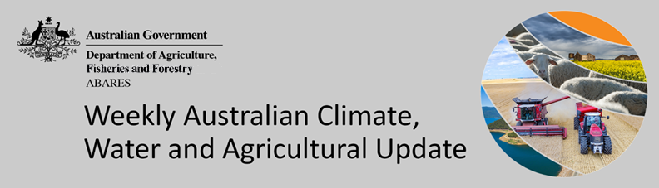
No. 6/2023

16 February 2023

Summary of key issues
- For the week ending 15 February 2023, monsoonal troughs remained active and together with the active Madden-Julian Oscillation (MJO) pulse resulted in widespread rainfall and localised thunderstorms, mainly in tropical northern Australia.
- Little to no rainfall across summer cropping regions in southern Queensland would have allowed for improving access to fields for crop maintenance activities and for the harvesting of early sown crops to continue. Meanwhile, rainfall across New South Wales cropping regions likely benefited the germination of late sown summer crops in northern growing regions and benefited soil moisture profiles in the lead up to the sowing on winter forage crops (see Section 1.1).
- Global crop production conditions have been generally favourable for the major grain and oilseed producing countries despite dry conditions across parts of Argentina, Brazil, and the United States, affecting the production potential of wheat, corn and soybeans (see Section 1.2).
- Below average rainfall during January is likely to result in lower-than-expected winter wheat production across parts of Argentina and Brazil. Average to above average rainfall across the United States, Australia, and parts of Europe is likely to improve production prospects in these key production regions. This is providing, on balance, a decline in global production conditions to those seen back in November 2022, that were used to formulate ABARES forecasts of global grain supplies and the impact on world prices in its December 2022 edition of Agricultural Commodities (see Section 1.2).
- The global climate outlook indicates that average to below average rainfall is slightly more likely between March and May 2023 for most of the world’s major grain- and oilseed-producing regions. Partly due to the influence of ENSO neutral, above average rainfall is expected for western Argentina and much of Brazil, parts of western Europe, and northwest and eastern United States (see Section 1.2).
- Over the 8-days to 16 February 2023, rainfall is expected to be restricted to northern Australia under the influence of monsoonal troughs. Little to no rainfall for summer cropping regions in northern New South Wales and Queensland is expected to improve access to fields for crop maintenance activities, benefit crop growth and allow for the uninterrupted harvest of early sown crops (see Section 1.3).
- Water storage levels in the Murray-Darling Basin (MDB) decreased between 8 February 2023 and 15 February 2023 by 171 gigalitres (GL). Current volume of water held in storage is 23 289 GL which represents 92 percent of total capacity. This is 3 percent or 729 GL more than at the same time last year.
- Allocation prices in the Victorian Murray below the Barmah Choke decreased from $18 per ML on 9 February 2023 to $15 per ML on 16 February 2023. Prices are lower in the Murrumbidgee and regions above the Barmah choke due to the binding of the Murrumbidgee export limit and Barmah choke trade constraint.

Climate

Rainfall this week
For the week ending 15 February 2023, a strong pulse of the Madden-Julian Oscillation (MJO) was in the Maritime Continent and resulted in widespread rainfall and localised thunderstorm activities across northern Australia.
Weekly rainfall totals of between 15 and 100 millimetres were recorded over large areas of northern Australia, with some pockets across northern Queensland and eastern Arnhem of the Northern Territory recording more than 200 millimetres. Meanwhile, a low-pressure trough brought rainfall totals of between 15 and 50 millimetres to large areas of southeast Queensland and eastern New South Wales. In contrast, little or no rainfall was recorded across the remainder of Australia.
Little to no rainfall was recorded across most of the cropping regions except central New South Wales where the rainfall between 15 and 25 millimetres was recorded. Little to no rainfall across summer cropping regions in southern Queensland would have allowed for improving access to fields for crop maintenance activities and for the harvesting of early sown crops to continue. Meanwhile, rainfall across New South Wales cropping regions likely benefited the germination of late sown summer crops in northern growing regions and benefited soil moisture profiles in the lead up to the sowing on winter forage crops.

Rainfall for the week ending 15 February 2023
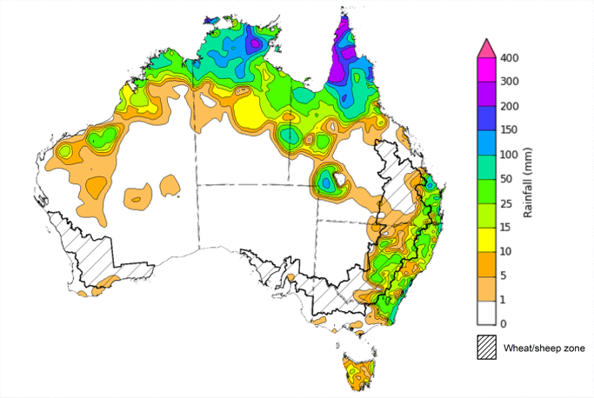
©Commonwealth of Australia 2023, Australian Bureau of Meteorology Issued: 15/02/2023
Note: The rainfall analyses and associated maps utilise data contained in the Bureau of Meteorology climate database, the Australian Data Archive for Meteorology (ADAM). The analyses are initially produced automatically from real-time data with limited quality control. They are intended to provide a general overview of rainfall across Australia as quickly as possible after the observations are received. For further information go to http://www.bom.gov.au/climate/rainfall/

Global production conditions and climate outlook
Crop production is affected by long-term trends in average rainfall and temperature, interannual climate variability, shocks during specific growth stages, and extreme weather events. Some crops are more tolerant than others to certain types of stresses, and at each growth stage, different types of stresses affect each crop species in different ways.
The precipitation anomalies and outlooks presented here give an indication of the current and future state of production conditions for the major grain and oilseed producing countries which are responsible for over 80% of global production. This is an important input to assessing the global grain supply outlook.
January precipitation percentiles and current production conditions
As of the end of January 2023, rainfall was mixed for the world’s major grain-producing and oilseed-producing regions.
The precipitation was below average across much of Canada, Mexico, eastern Ukraine, Türkiye, Bulgaria, the southwest of the Russian Federation, southern China, parts of southern Brazil, eastern Argentina, and eastern India. Precipitation was above average for large areas of the United States, UK, eastern Europe, northern India, and much of Southeast Asia. Precipitation was close to average across the remainder of the major grain-producing and oilseed-producing regions.

Global precipitation percentiles, January 2023
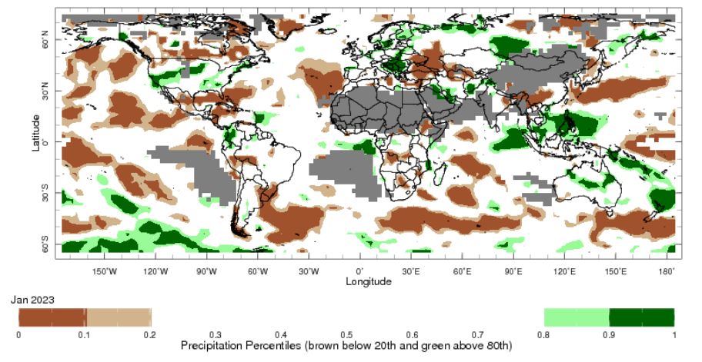
Note: The world precipitation percentiles indicate a ranking of precipitation for January, with the driest (0th percentile) being 0 on the scale and the wettest (100th percentile) being 1 on the scale. Percentiles are based on precipitation estimates from the NOAA Climate Prediction Center’s Climate Anomaly Monitoring System Outgoing Precipitation Index dataset. Precipitation estimates for January 2023 are compared with rainfall recorded for that period during the 1981 to 2010 base period.
Source: International Research Institute for Climate and Society
As of 28 January 2023, the global production conditions were generally favourable for the production of rice and wheat. However, a lack of precipitation has affected the production potential of corn and soybeans in some key grain exporting and importing countries.
The production conditions for wheat have been generally favourable. Climatic conditions have been favourable for wheat development in Canada, China, the European Union, Türkiye, and the United Kingdom. Production is mixed in the United States, Ukraine and the Russian Federation due to dryness in some areas. Conditions were favourable for winter wheat sowing in India.
Corn production conditions have deteriorated in Argentina for their early planted crop due to the prolonged drought and high temperatures throughout December and January affecting yield potential. The late planted crop will require rainfall over the next few weeks to avoid further yield loss. In Brazil, conditions were generally favourable for spring-planted crop development except for in Rio Grande do Sul region due to a lack of rain and high temperatures in the south. The sowing of summer-planted corn is commencing under favourable conditions in Brazil. In India, conditions have been favourable for Rabi crop sowing.
Production conditions have been favourable for transplanting of Rabi rice in India. Harvesting conditions have been favourable for dry-season rice harvesting and sowing of wet-season rice in Indonesia. In the Philippines, Thailand and Vietnam conditions have been favourable for the harvest of wet-season and sowing of dry-season rice. In Brazil, production conditions and yield potentials have declined due to lack of rain and high temperatures and low irrigated water availability.
Production conditions for soybeans have been less than favourable in Argentina. The early-planted crop reached flowering during prolonged drought and hot conditions, which caused flowers and pods to drop, reducing yields. Sowing of the late-planted crop is wrapping up but requires further rainfall and lower temperatures to boost yield productions. In Brazil, most crops are in the reproductive stages of development, with harvest just beginning in some places under favourable conditions in the northern and central regions. However, in the southern region reduced yields are expected due to prolonged dryness and high temperatures.
Crop conditions, AMIS countries, 28 January 2023

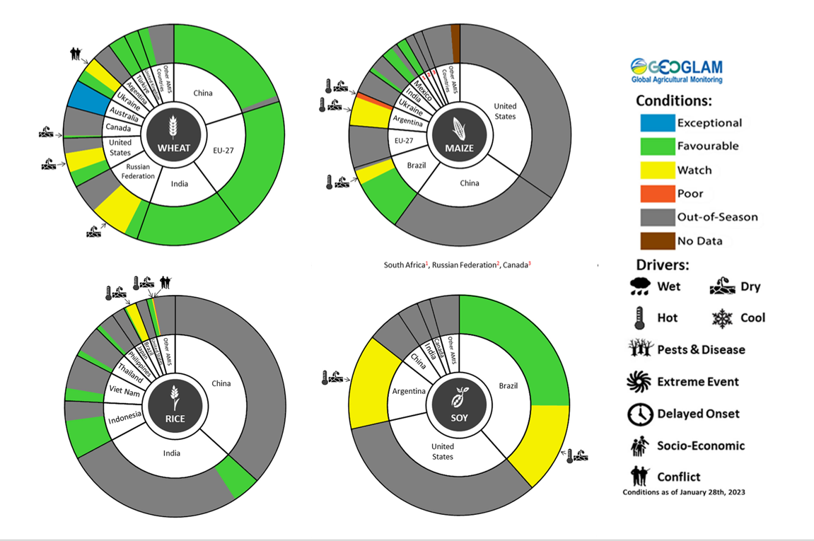
AMIS Agricultural Market Information System.
Source: AMIS

The global climate outlook for March 2023 to May 2023 indicates that mixed rainfall conditions are expected for the world’s major grain-producing and oilseed-producing regions. Outlooks and potential production impacts for the major grain and oilseed producing countries are presented in the table.
Rainfall outlook and potential impact on the future state of production conditions between March 2023 to May 2023
Region | March-May rainfall outlook | Potential impact on production
Argentina | Average rainfall is more likely across much of Argentina between March and May 2023. With below average rainfall more likely in the northeast. | Average to above average rainfall is likely to support the development of sorghum, rice, millet, soybeans, corn, sunflower, cotton and nuts, and the planting of wheat in May 2023.
Black Sea Region | Below average rainfall is forecast for parts of Kazakhstan, Ukraine and the Russian Federation, except for central Russia where it is forecast for above normal. | Below average rainfall in parts of Kazakhstan and Ukraine may adversely affect winter wheat and canola development, as well as cotton, corn and sunflower planting from March 2023. Average or above normal rainfall across the Russian Federation is likely to support similar crops in the south and the planting and development of spring wheat planting in the north from April 2023.
Brazil | Above average rainfall is more likely across northern and central Brazil while below average rainfall is more likely across parts of southern Brazil. | Above average rainfall across northern and central Brazil is likely to support the development of cotton and corn, and the harvesting of soybeans. Below average rainfall in the south may adversely affect the development and harvesting of rice, sorghum, millet, sunflower, soybeans, cotton, nuts and corn, and the planting of wheat in May 2023.
Canada | Average rainfall is more likely across much of Canada between March and May 2023 | Above rainfall is likely to support winter wheat development in Canada from March 2023 and the planting of spring wheat, canola, corn, soybeans and sunflower from May 2023.
China | Average rainfall is more likely across much of China while below average rainfall is more likely across parts of southern China. | Average rainfall across much China is likely to support the development of winter wheat and canola and the planting and development of early rice, single rice, cotton, spring wheat, corn, sorghum, soybeans, sunflower and nuts. Below average rainfall across southern China may affect the development of these crops from March 2023.
Europe | Average to above average rainfall is more likely for much of Europe between March and May 2023. | Average to above average rainfall across Europe is likely to support winter wheat and canola development and the planting and development of corn, cotton, spring wheat, soybeans, sunflower and sorghum between March and May 2023.
South Asia (India) | Average rainfall is more likely across much of India, while below average rainfall is more likely for parts of eastern India. | Average rainfall is likely to support the development of wheat and canola in India, while below average rainfall in the east may adversely affect the development of these crops.
Southeast Asia (SEA) | Above average rainfall in southeast Myanmar, Vietnam, Cambodia and Philippines. Average rainfall in Thailand and below average rainfall in the rest of SEA. | Average or better rainfall across most of Southeast Asia is likely to benefit corn and rice planting, development and harvesting. Below average rainfall may adversely impact rice, corn and soybean production.
The United States of America (US) | Above average rainfall is more likely for parts of eastern US while below average rainfall is more likely for parts of southern US. | Average or better rainfall in eastern US is likely to support winter wheat as it comes out of dormancy, as well as the planting and development of spring wheat, canola, corn, cotton, rice, soybeans and nuts. Below average rainfall in the southern US may adversely impact the development of winter wheat and the planting and development of corn, cotton, nuts, rice and soybeans.

Rainfall forecast for the next eight days
Over the 8-days to 16 February 2023, the monsoon trough is expected to bring increased rainfall across northern Australia. Low-pressure systems and troughs are expected to bring scattered rainfall to the eastern coast of Australia.
Monsoonal conditions, which recently developed across the south-eastern Indian Ocean, are expected to remain across northern Australia over the coming week. The presence of the monsoon trough will favour widespread thunderstorm activities with higher-than-average rainfall expected. A tropical low is being monitored in the Gulf of Carpentaria and is currently not expected to intensify into a Tropical Cyclone. It will, however, bring strong winds and heavy rainfall along the south-west coastal regions of the Gulf of Carpentaria during the week. Rainfall in this region is forecast to exceed 150 mm.
Little to no rainfall is expected for most cropping regions in the next eight days. Little to no rainfall for summer cropping regions in northern New South Wales and Queensland is expected to improve access to fields for the crop maintenance activities, benefit crop growth and allow for the uninterrupted harvest of early sown crops.

Total forecast rainfall for the period 9 February to 16 February 2023
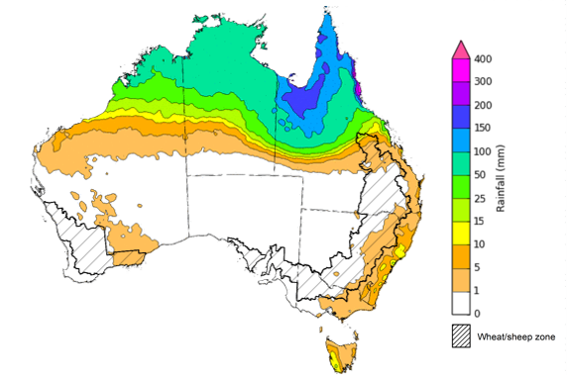

©Commonwealth of Australia 2023, Australian Bureau of Meteorology Issued 16/02/2023
Note: This rainfall forecast is produced from computer models. As the model outputs are not altered by weather forecasters, it is important to check local forecasts and warnings issued by the Bureau of Meteorology.

Water

Water markets – current week
Water storage levels in the Murray-Darling Basin (MDB) decreased between 8 February 2023 and 15 February 2023 by 171 gigalitres (GL). Current volume of water held in storage is 23 289 GL which represents 92 percent of total capacity. This is 3 percent or 729 GL more than at the same time last year.

Water storages in the Murray-Darling Basin, 2013–2023
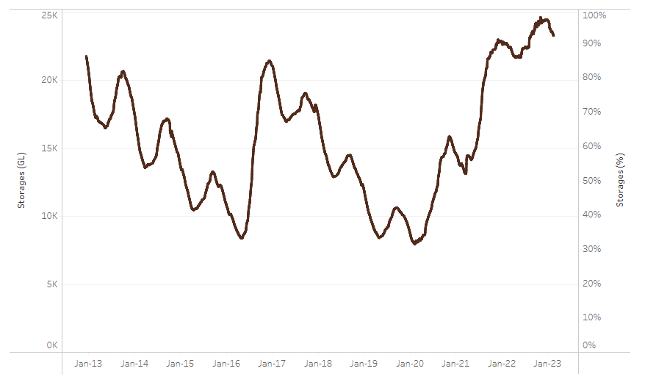
Allocation prices in the Victorian Murray below the Barmah Choke decreased from $18 per ML on 9 February 2023 to $15 per ML on 16 February 2023. Prices are lower in the Murrumbidgee and regions above the Barmah choke due to the binding of the Murrumbidgee export limit and Barmah choke trade constraint.
Water storage data is sourced from the Bureau of Meteorology.
Region | $/ML
NSW Murray Above | 5
NSW Murrumbidgee | 10
VIC Goulburn-Broken | 15
VIC Murray Below | 15

Surface water trade activity, Southern Murray–Darling Basin
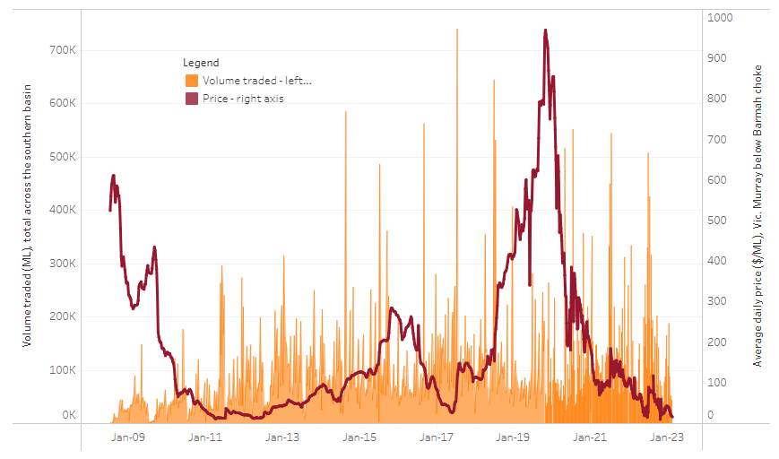
To access the full, interactive, weekly water dashboard, which contains the latest and historical water storage, water market and water allocation information, please visit http://www.agriculture.gov.au/abares/products/weekly_update/weekly-update-160223
The trades shown reflect estimated market activity and do not encompass all register trades. The price is shown for the VIC Murray below the Barmah choke. Historical prices (before 1 July 2019) are ABARES estimates after removing outliers from BOM water register data. Prices after 1 July 2019 and prior to the 30 October 2019 reflect recorded transaction prices as sourced from Ruralco. Prices after the 30 October 2019 are sourced from Waterflow. Data for volume traded is sourced from the BOM water register. Data shown is current on 16 February 2023.

Commodities
Indicator |  | Week ended | Unit |  | Latest price |  | Previous week |  | Weekly change |  | Price 12 months ago |  | Annual change
Selected world indicator prices
AUD/USD Exchange rate |  | 15-Feb | A$/US$ |  | 0.69 |  | 0.69 |  | 0% |  | 0.72 |  | -4%
Wheat – US no. 2 hard red winter wheat, fob Gulf |  | 15-Feb | US$/t |  | 405 |  | 393 |  | 3% |  | 412 |  | -2%
Corn – US no. 2 yellow corn, fob Gulf |  | 15-Feb | US$/t |  | 306 |  | 302 |  | 1% |  | 298 |  | 3%
Canola – Rapeseed, Canada, fob Vancouver |  | 15-Feb | US$/t |  | 666 |  | 674 |  | -1% |  | 870 |  | -23%
Cotton – Cotlook 'A' Index |  | 15-Feb | USc/lb |  | 101 |  | 100 |  | 1% |  | 137 |  | -26%
Sugar – Intercontinental Exchange, nearby futures, no.11 contract |  | 15-Feb | USc/lb |  | 19.8 |  | 19.6 |  | 1% |  | 18 |  | 12%
Wool – Eastern Market Indicator |  | 01-Feb | Ac/kg clean |  | 1,400 |  | 1,356 |  | 3% |  | 1,341 |  | 4%
Wool – Western Market Indicator |  | 01-Feb | Ac/kg clean |  | 1,570 |  | 1,510 |  | 4% |  | 1,401 |  | 12%
Selected Australian grain export prices
Milling Wheat – APW, Port Adelaide, SA |  | 15-Feb | A$/t |  | 498 |  | 505 |  | -1% |  | 484 |  | 3%
Feed Wheat – ASW, Port Adelaide, SA |  | 15-Feb | A$/t |  | 471 |  | 461 |  | 2% |  | 449 |  | 5%
Feed Barley – Port Adelaide, SA |  | 15-Feb | A$/t |  | 415 |  | 413 |  | 1% |  | 392 |  | 6%
Canola – Kwinana, WA |  | 15-Feb | A$/t |  | 1,064 |  | 1,061 |  | 0% |  | 1,008 |  | 6%
Grain Sorghum – Brisbane, QLD |  | 15-Feb | A$/t |  | 496 |  | 481 |  | 3% |  | 369 |  | 35%
Selected domestic livestock indicator prices
Beef – Eastern Young Cattle Indicator |  | 15-Feb | Ac/kg cwt |  | 753 |  | 758 |  | -1% |  | 1,122 |  | -33%
Mutton – Mutton indicator (18–24 kg fat score 2–3), Vic |  | 15-Feb | Ac/kg cwt |  | 353 |  | 391 |  | -10% |  | 575 |  | -39%
Lamb – Eastern States Trade Lamb Indicator |  | 15-Feb | Ac/kg cwt |  | 731 |  | 763 |  | -4% |  | 837 |  | -13%
Pig – Eastern Seaboard (60.1–75 kg), average of buyers & sellers |  | 25-Jan | Ac/kg cwt |  | 367 |  | 367 |  | 0% |  | 357 |  | 3%
Goats – Eastern States (12.1–16 kg) |  | 01-Feb | Ac/kg cwt |  | 325 |  | 350 |  | -7% |  | 813 |  | -60%
Live cattle – Light steers ex Darwin to Indonesia |  | 17-Aug | Ac/kg lwt |  | 420 |  | 480 |  | -13% |  | 320 |  | 31%
Live sheep – Live wethers (Muchea WA saleyard) to Middle East |  | 14-Sep | $/head |  | 93 |  | 113 |  | -18% |  | 114 |  | -18%
Indicator
Global Dairy Trade (GDT) weighted average prices ª
Dairy – Whole milk powder | 08-Feb |  |  | US$/t |  | 3,329 |  | 3,218 |  | 3% | 3,380 | -2%
Dairy – Skim milk powder | 08-Feb |  |  | US$/t |  | 2,829 |  | 2,842 |  | 0% | 3,243 | -13%
Dairy – Cheddar cheese | 08-Feb |  |  | US$/t |  | 4,980 |  | 4,871 |  | 2% | 4,082 | 22%
Dairy – Anhydrous milk fat | 08-Feb |  |  | US$/t |  | 5,586 |  | 5,337 |  | 5% | 5,398 | 3%
a Global Dairy Trade prices are updated twice monthly on the first and third Tuesday of each month.

Selected world indicator prices
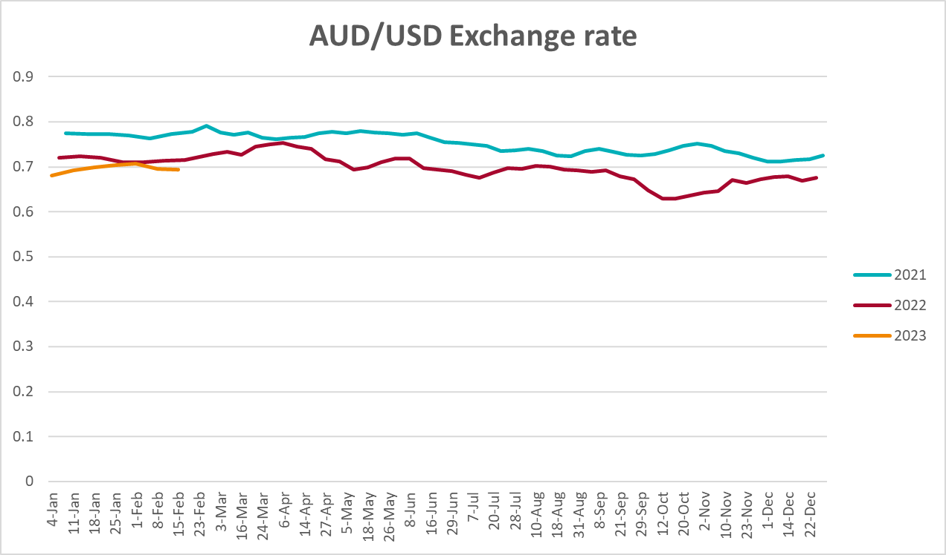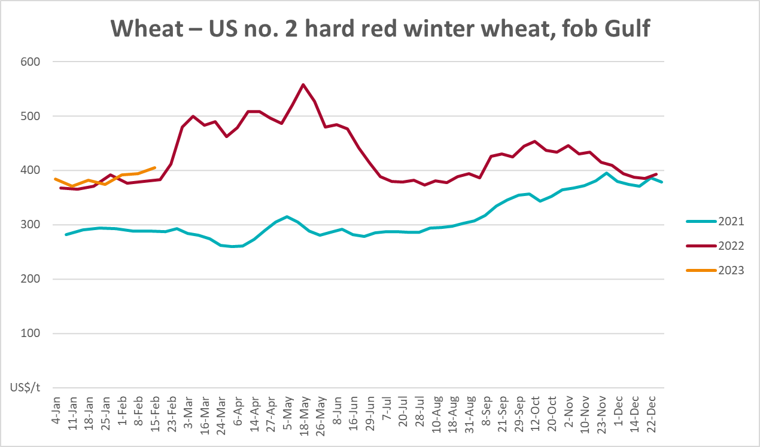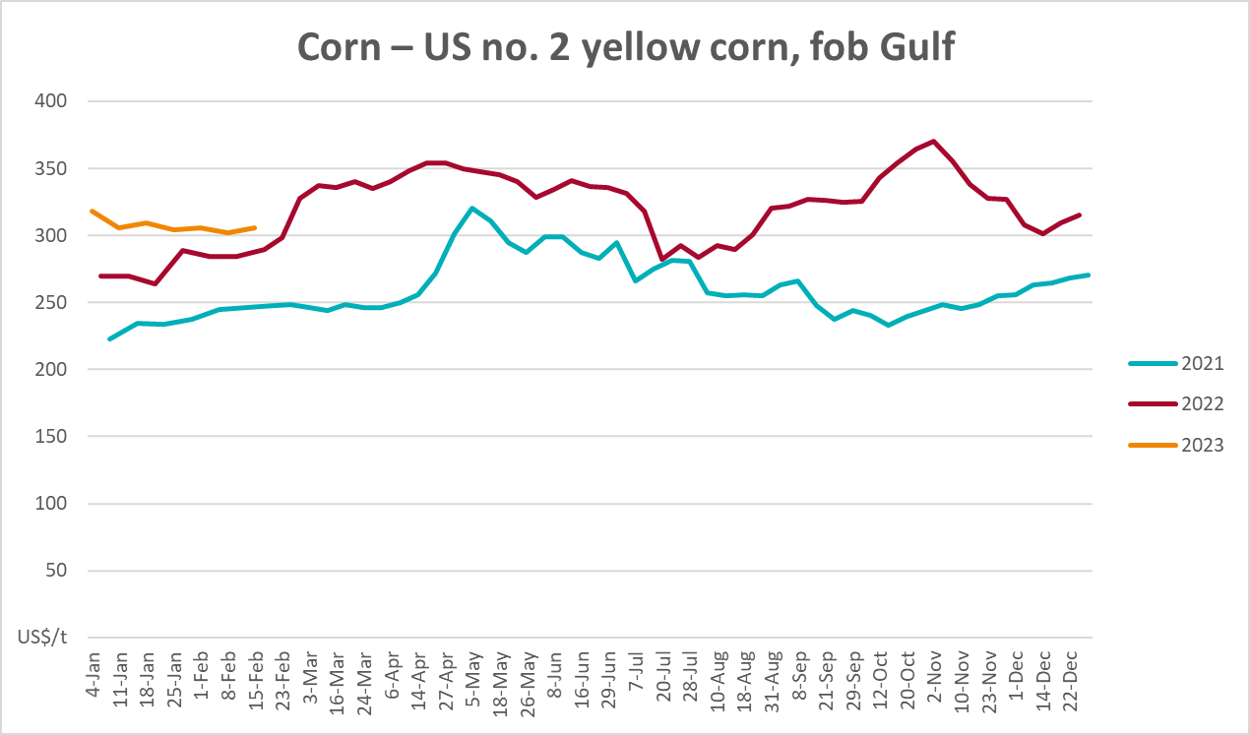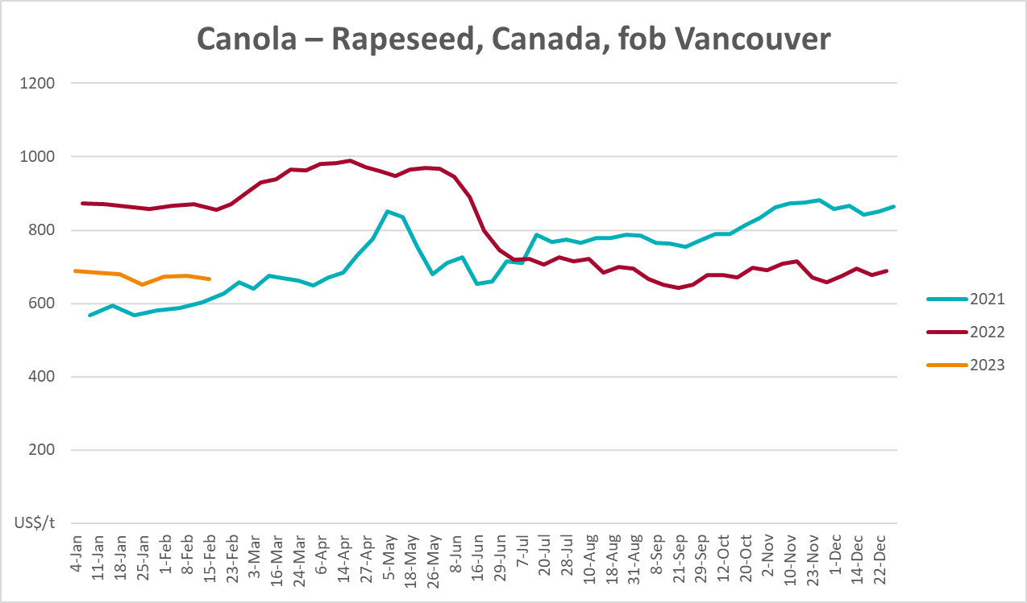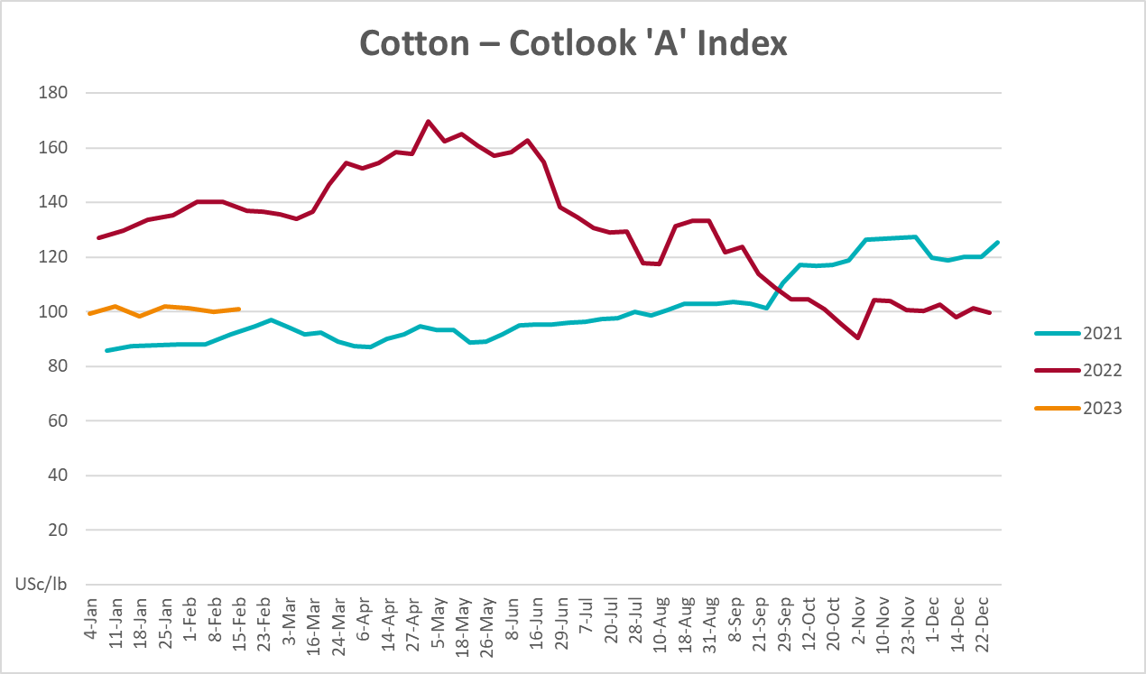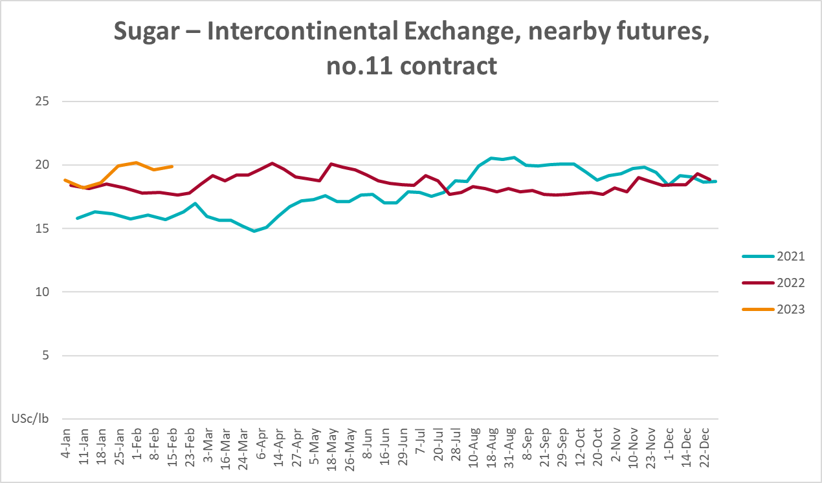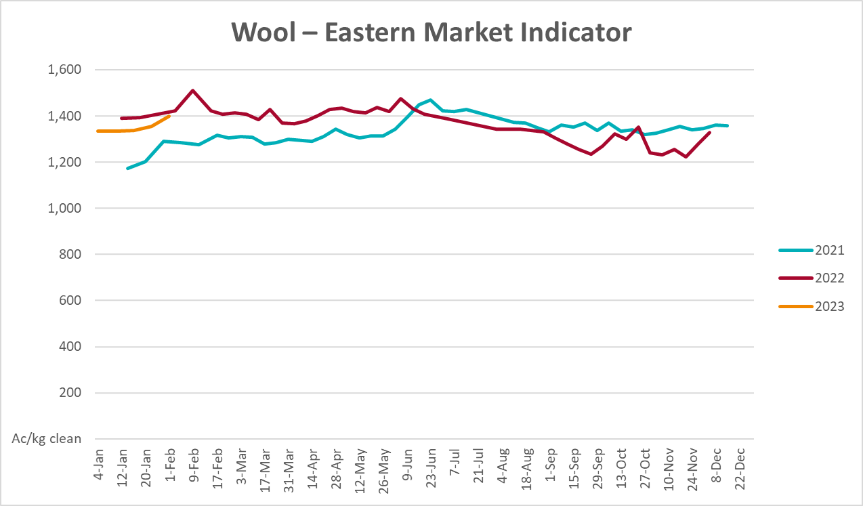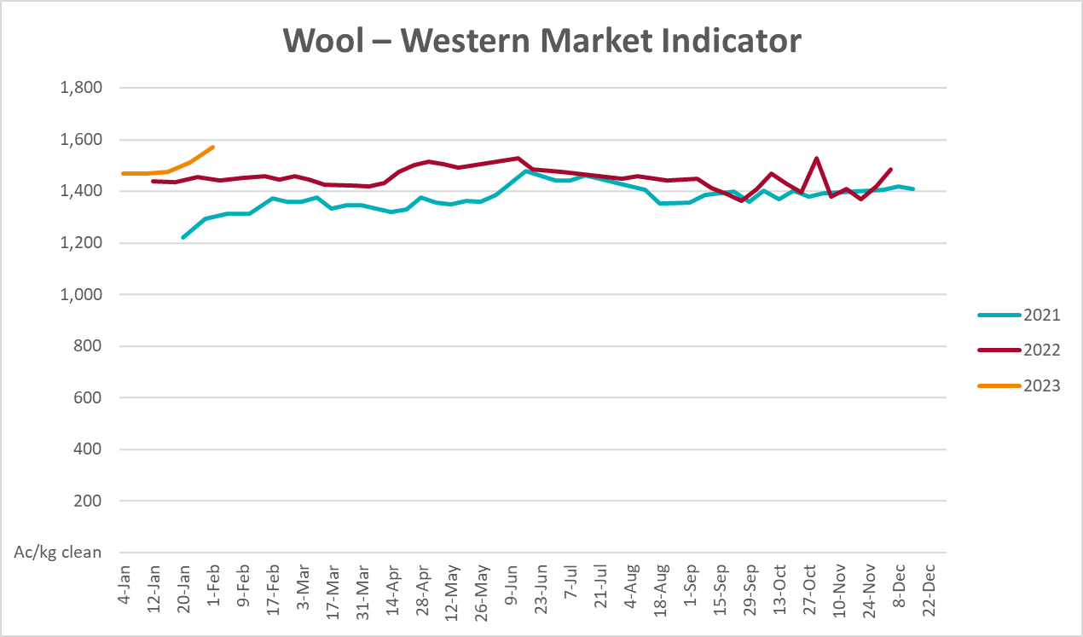

Selected domestic crop indicator prices
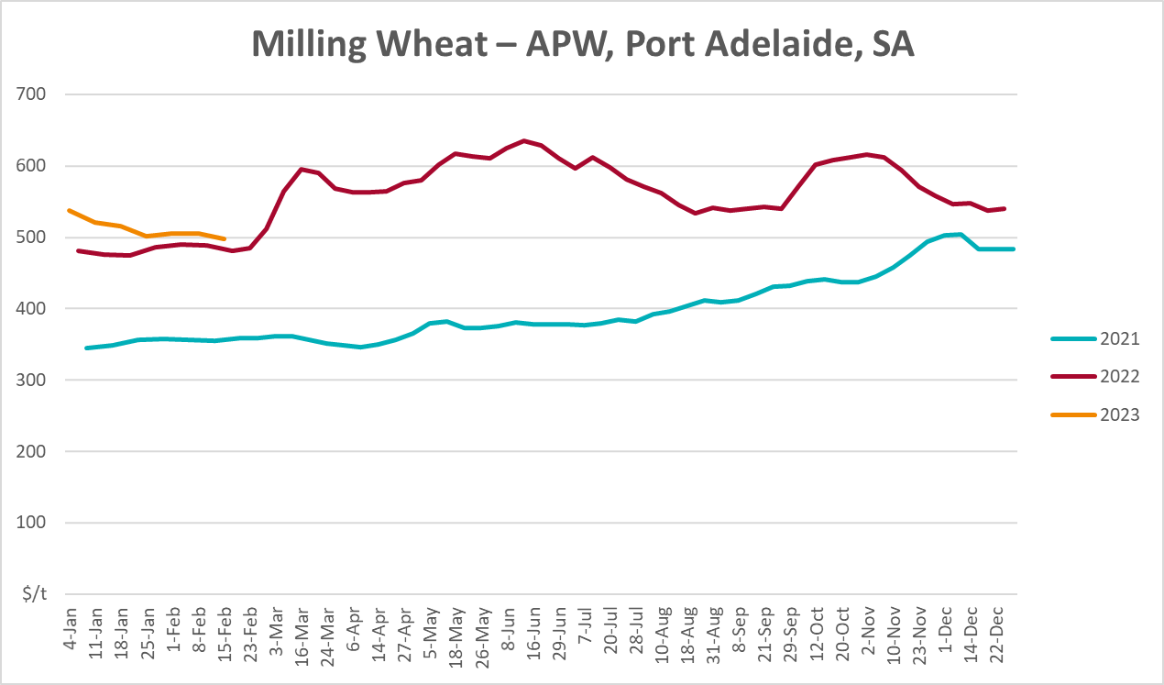

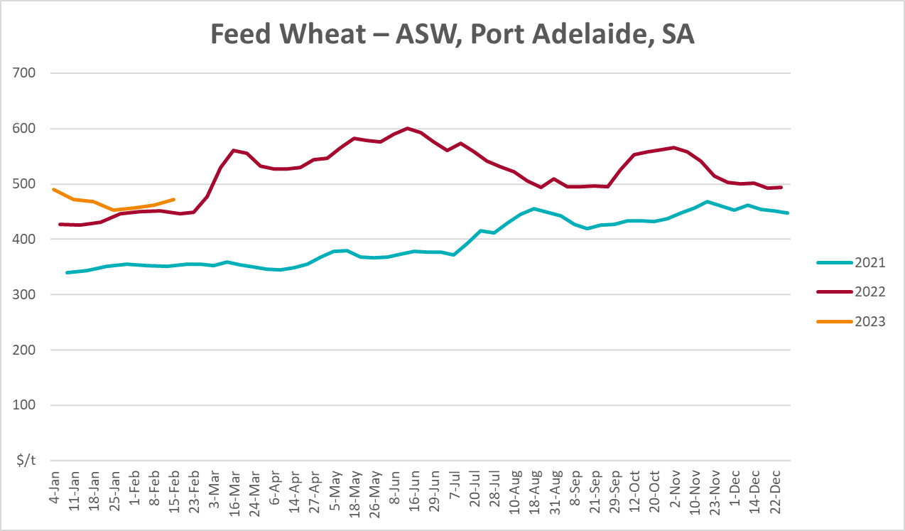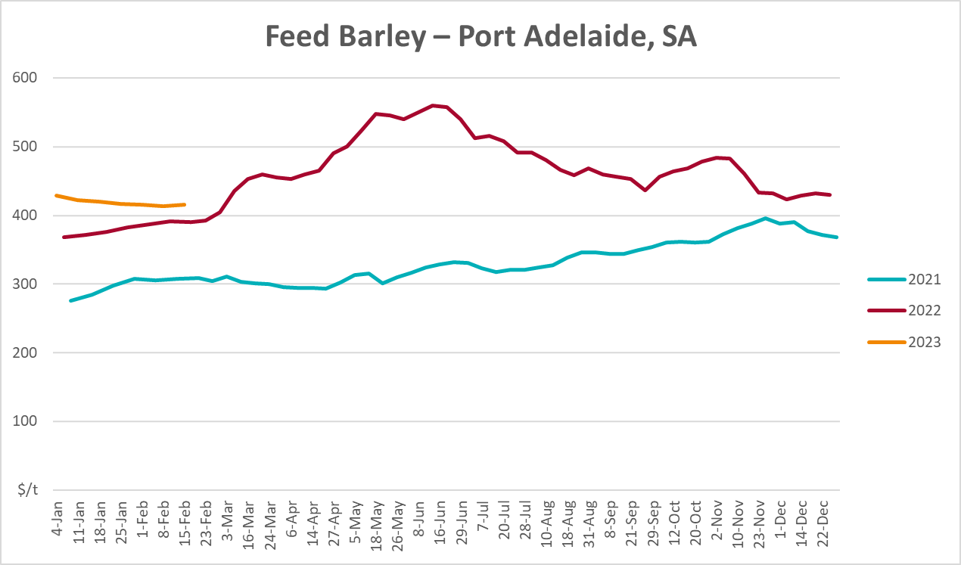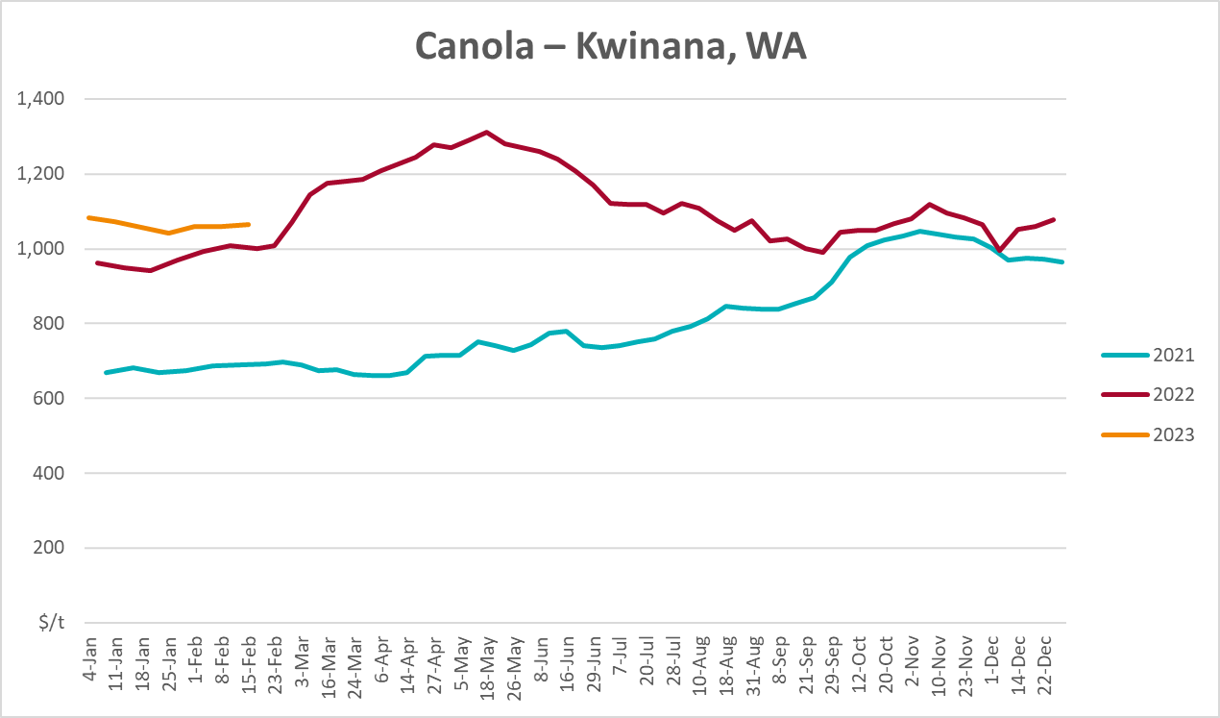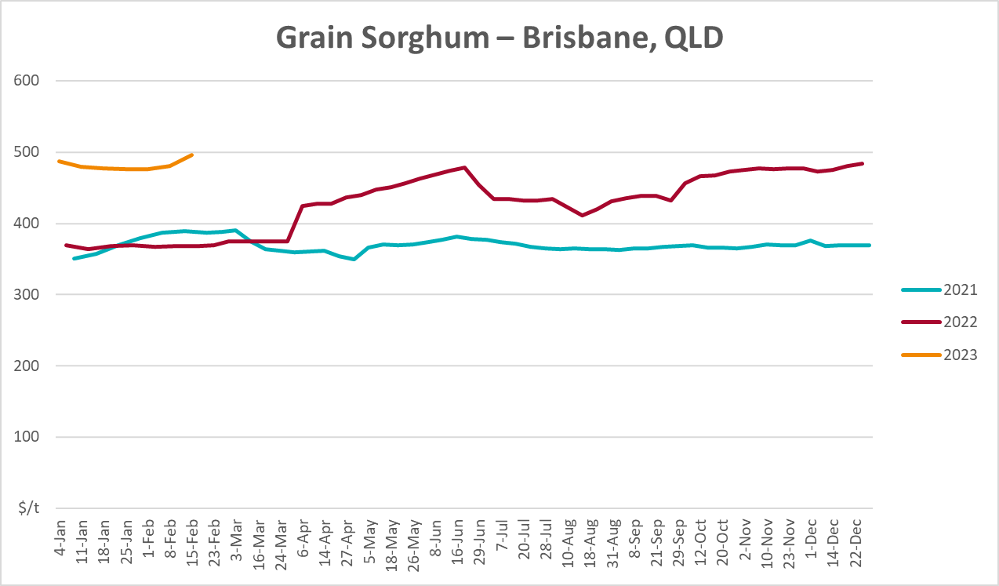

Selected domestic livestock indicator prices
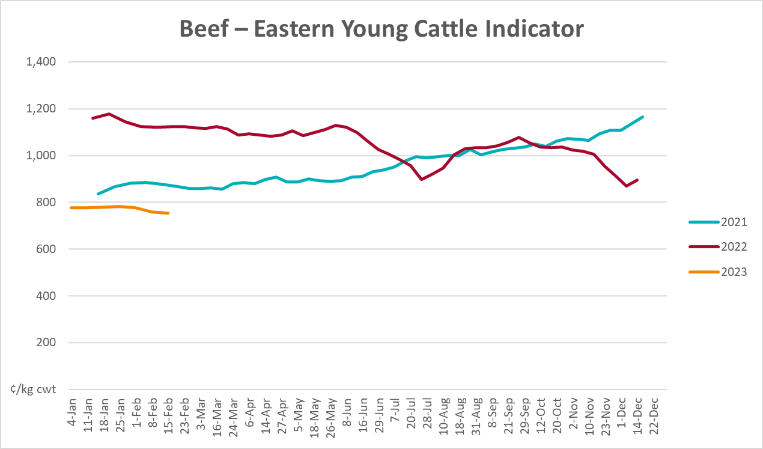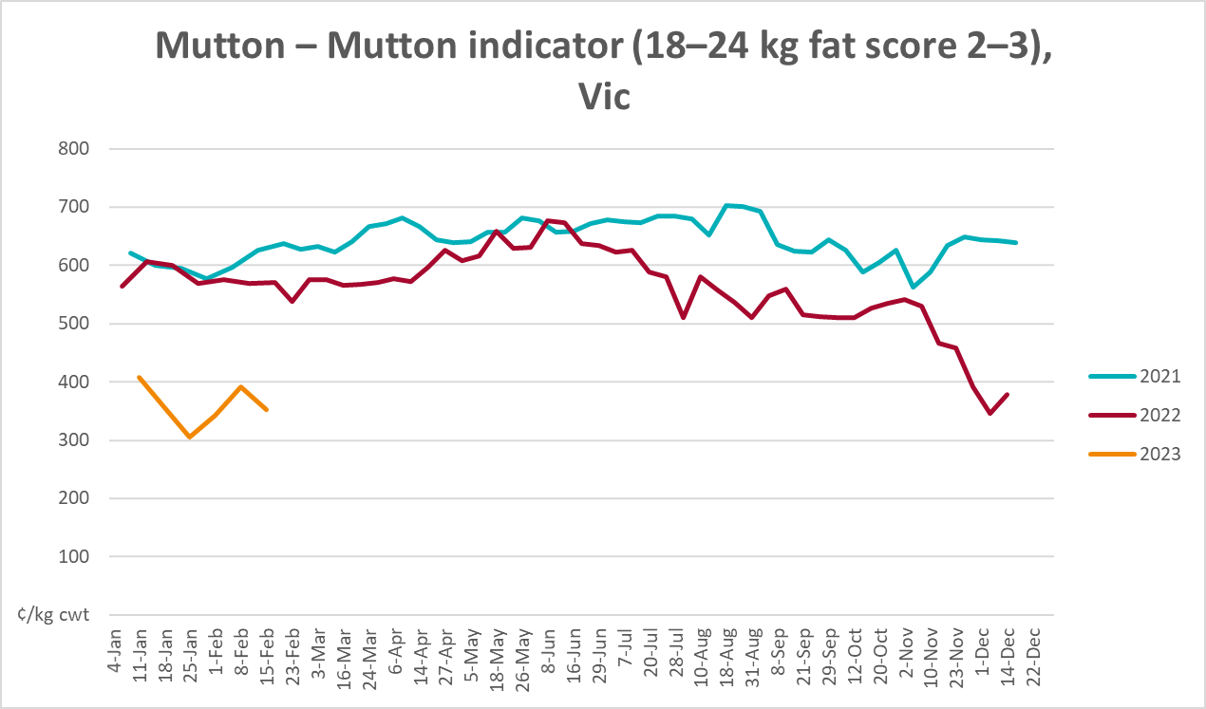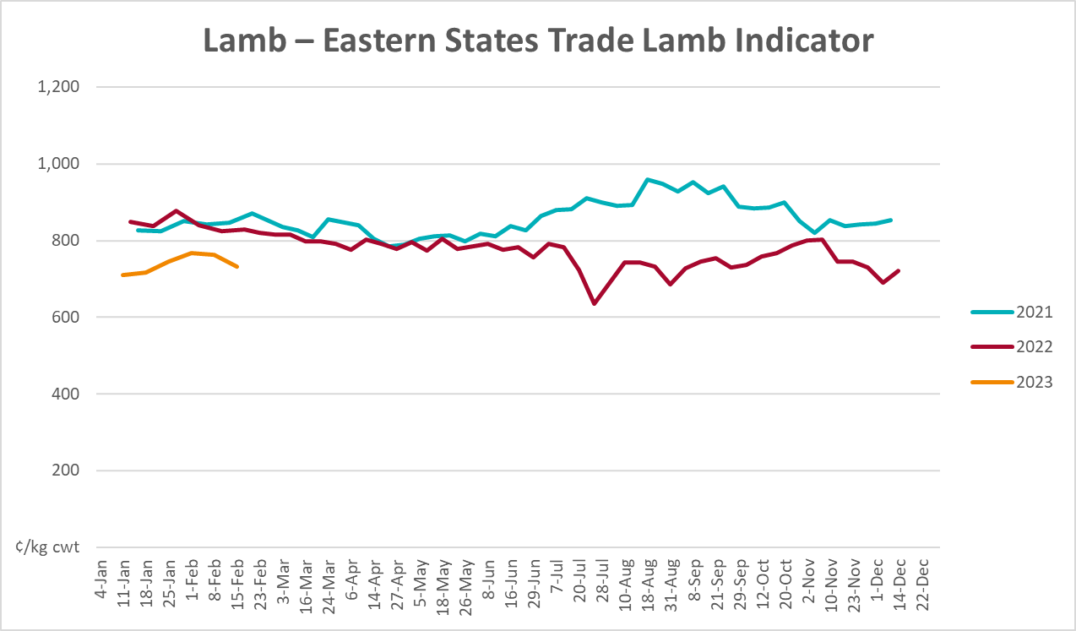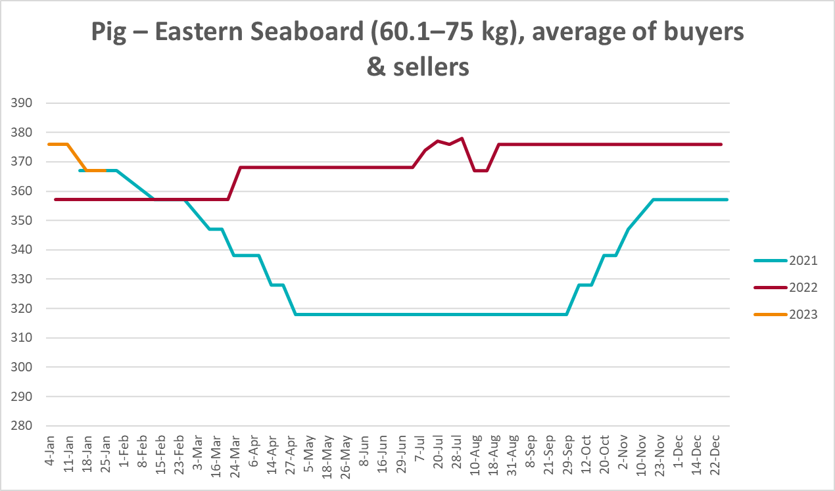
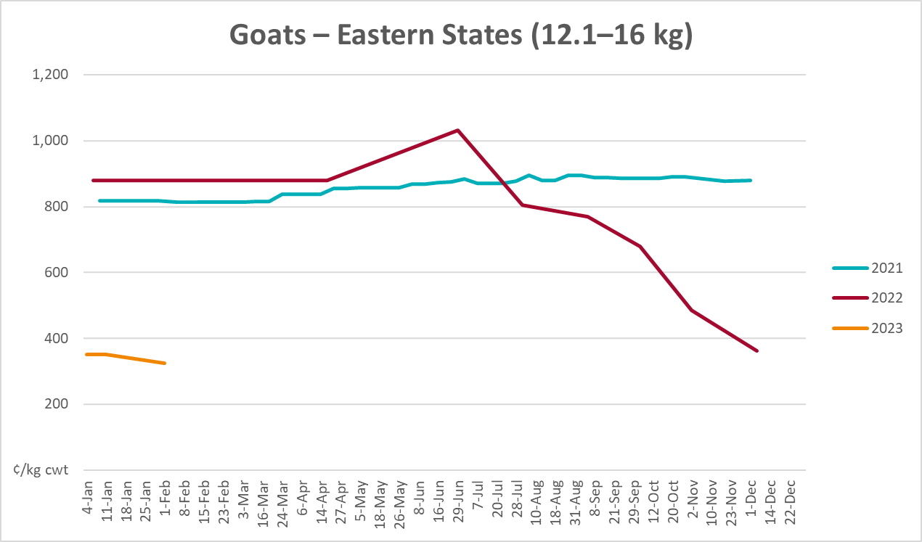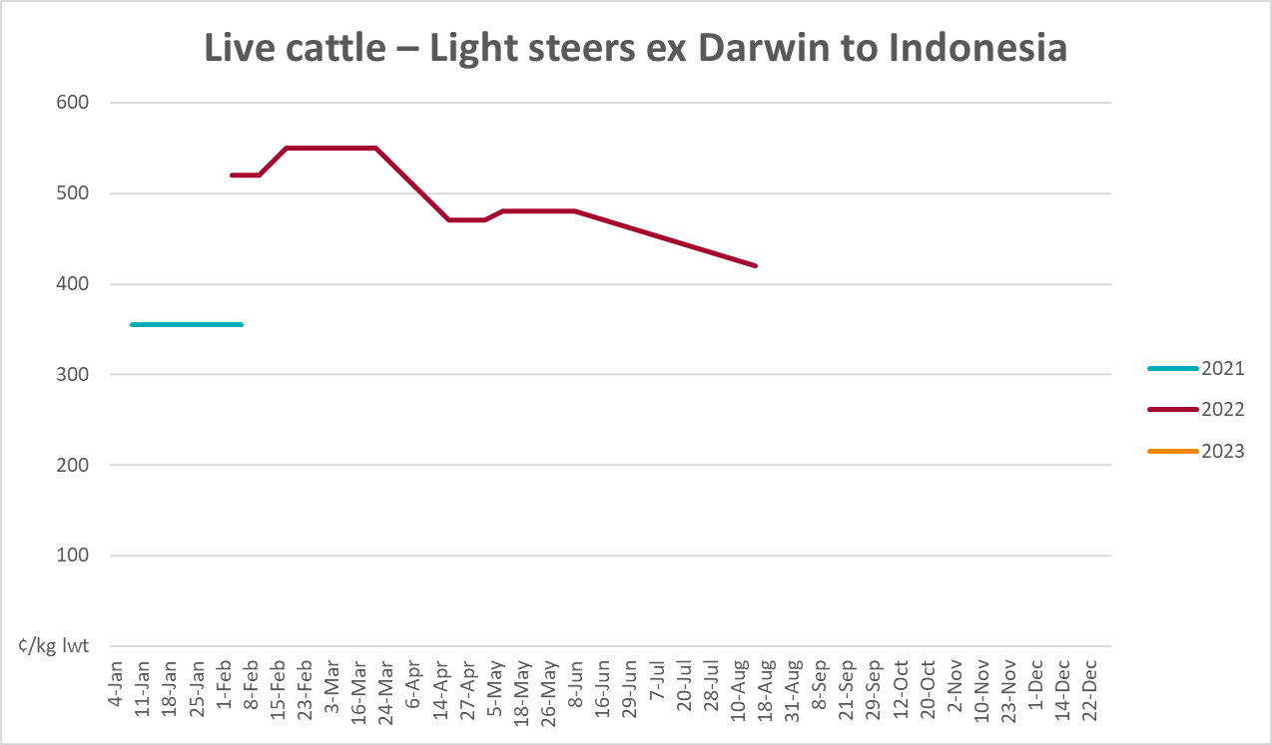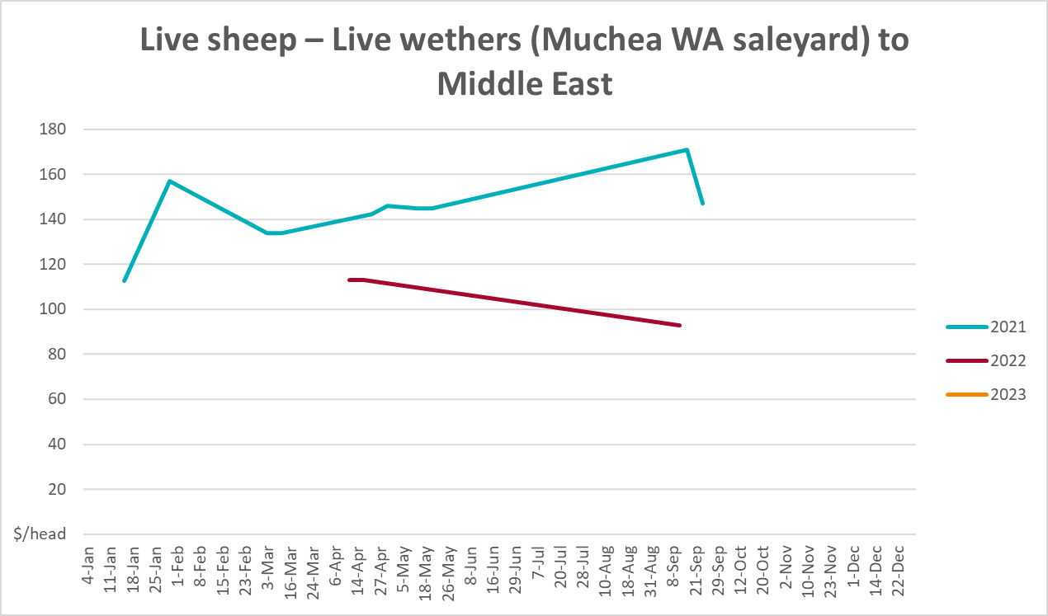

Global Dairy Trade (GDT) weighted average prices
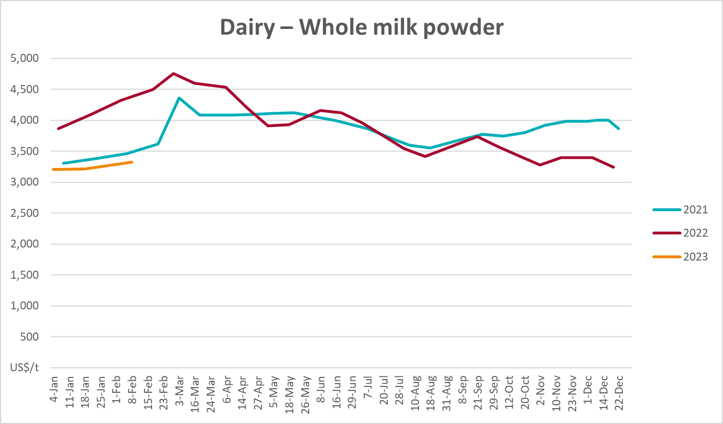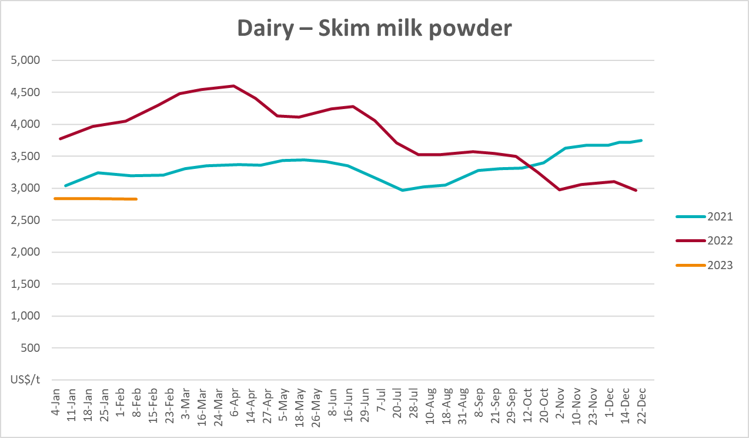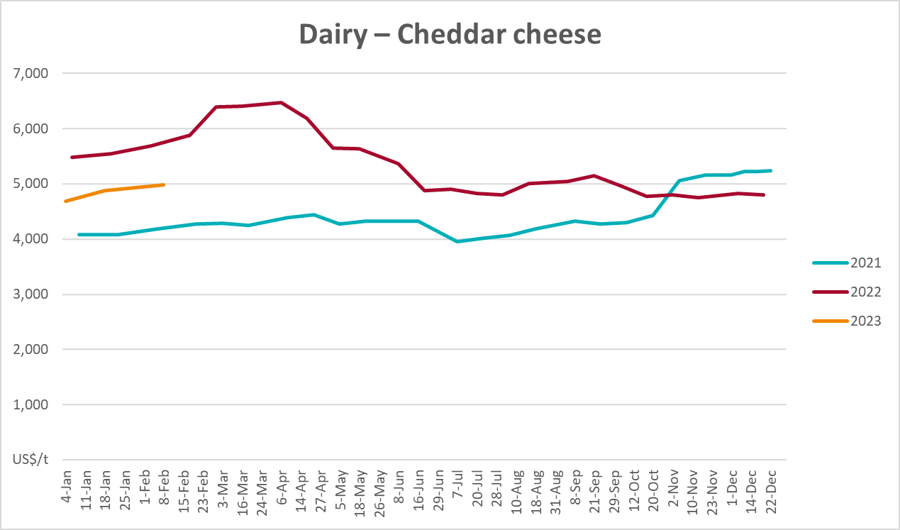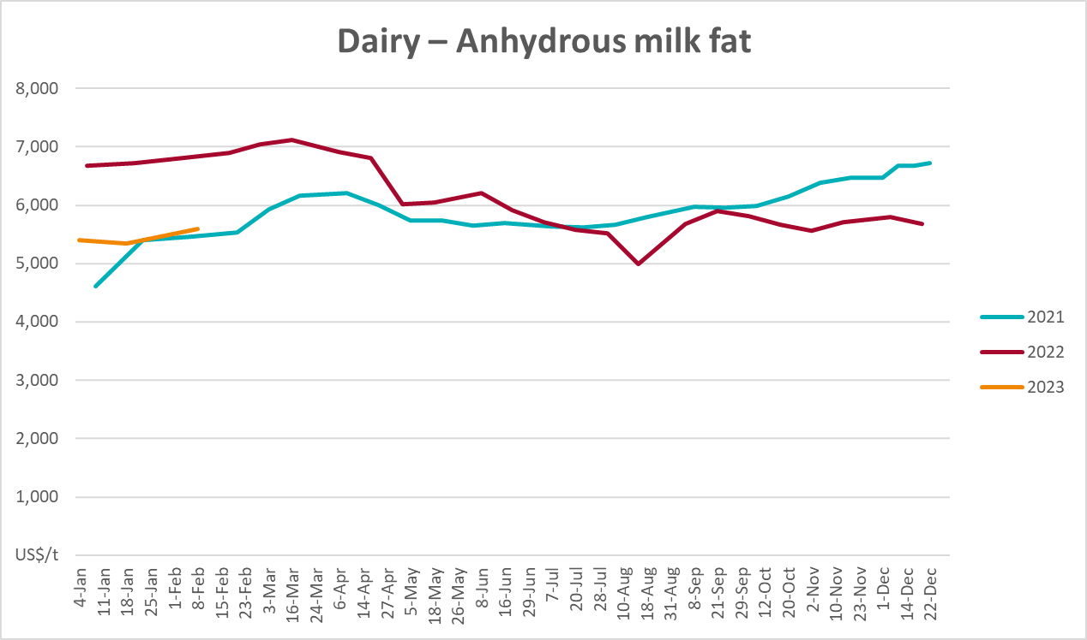

Selected fruit and vegetable prices
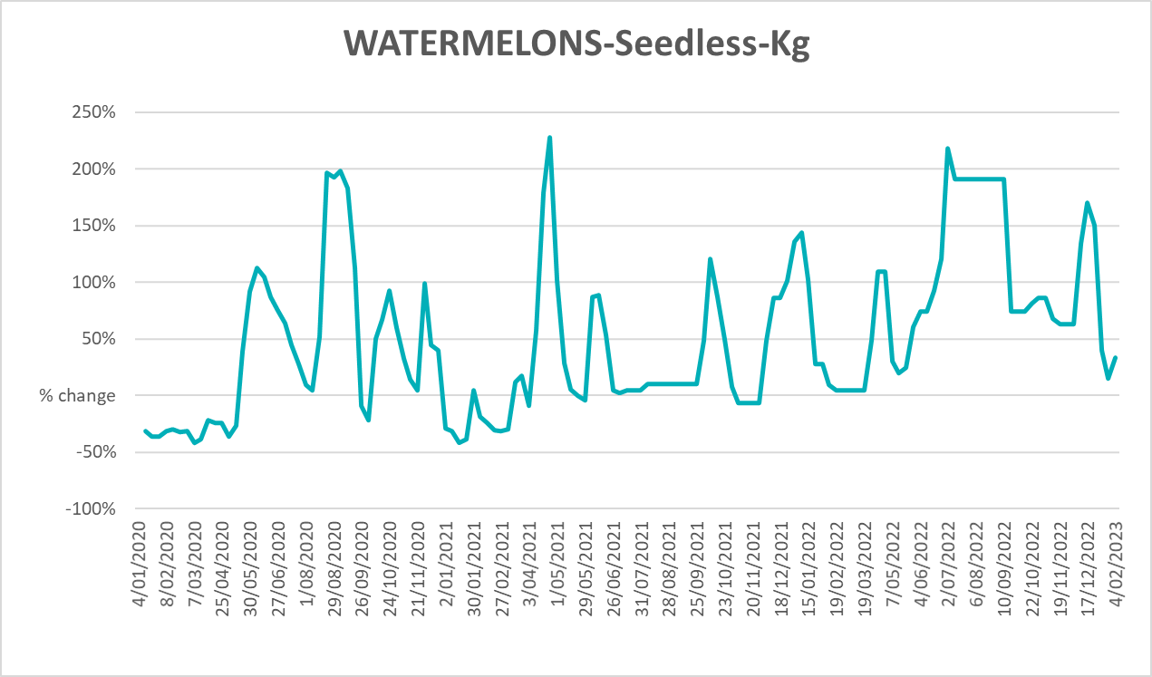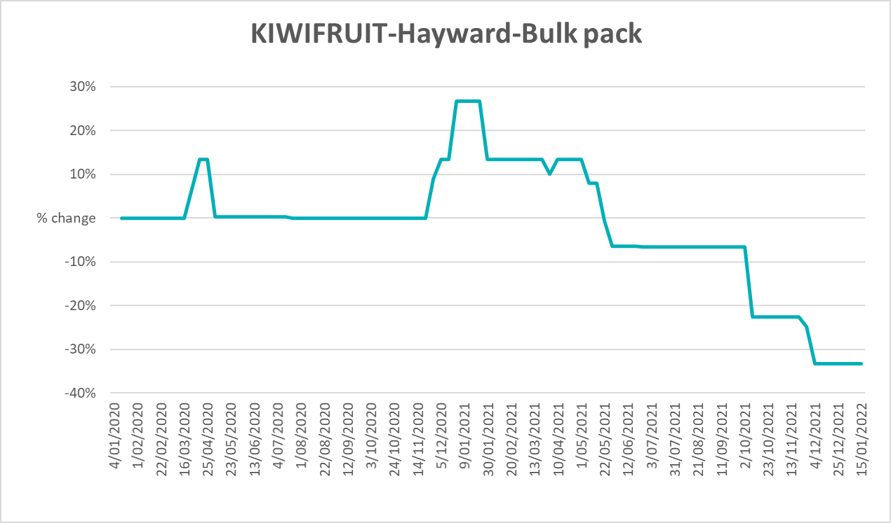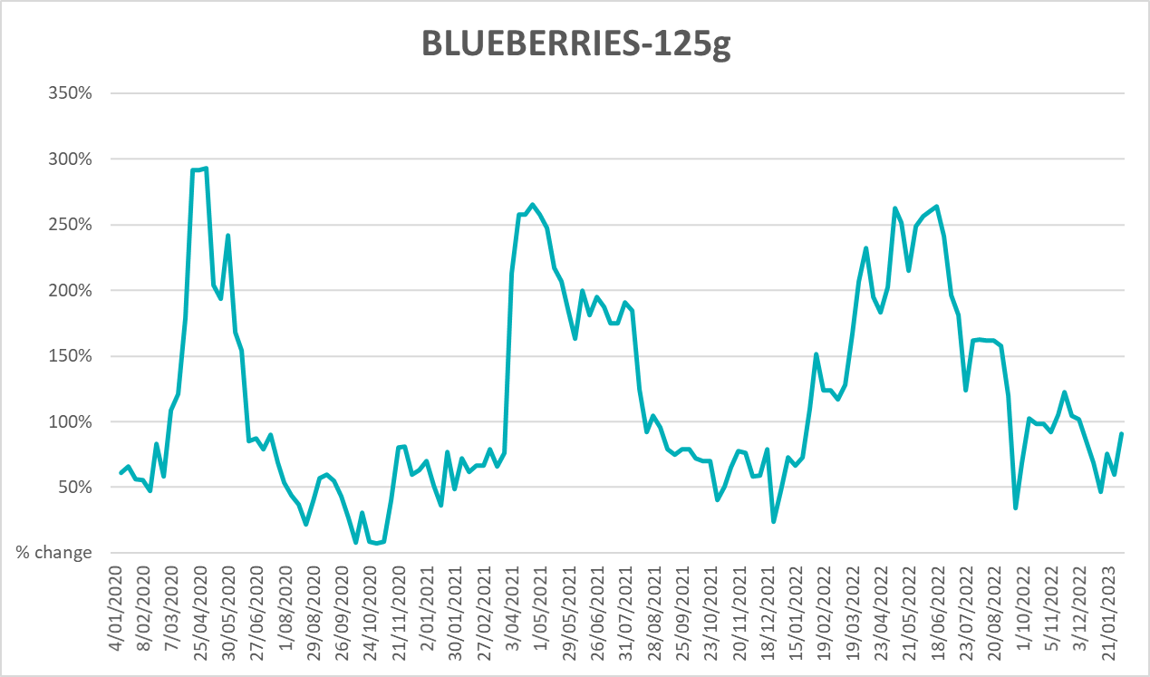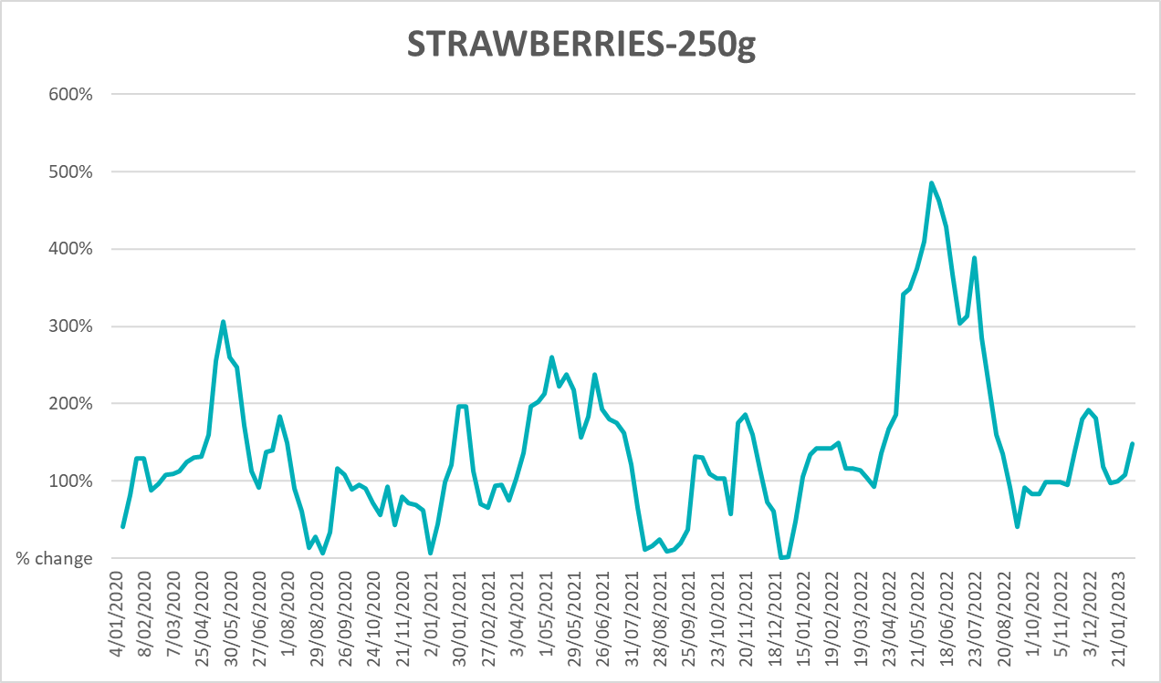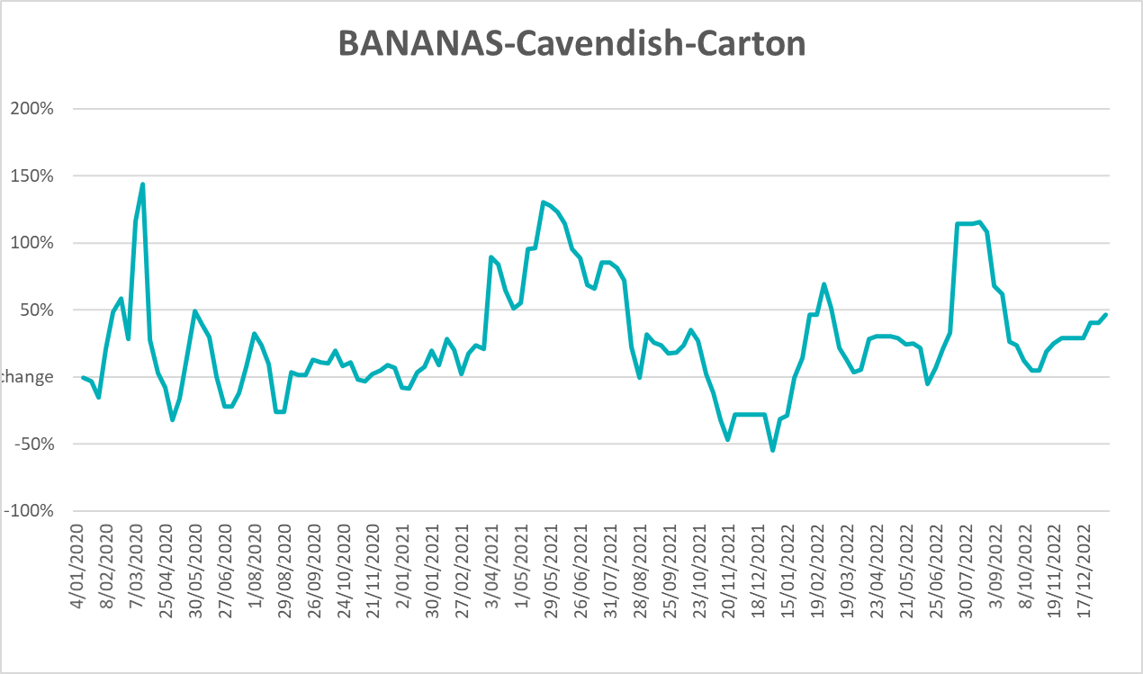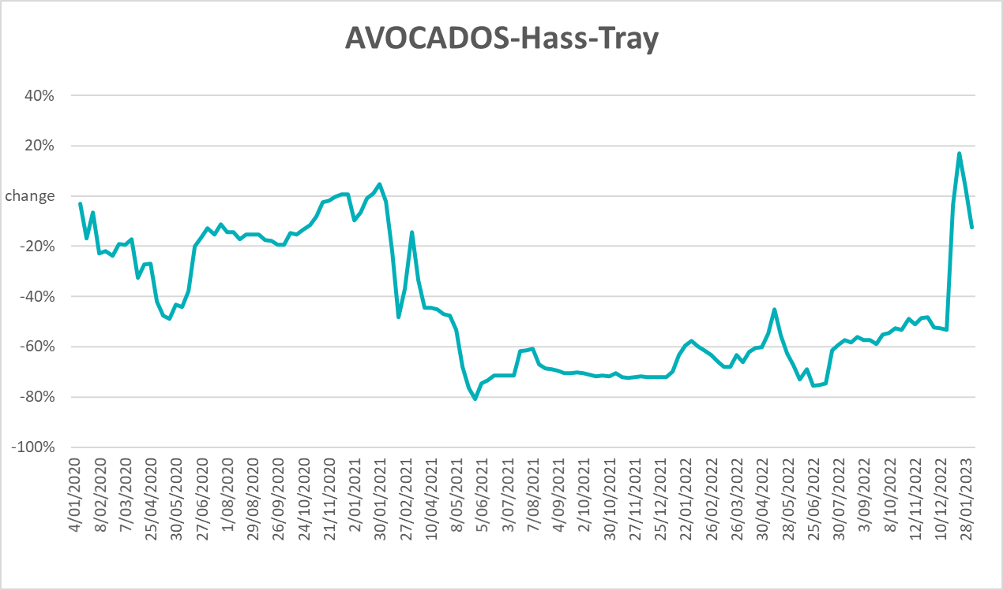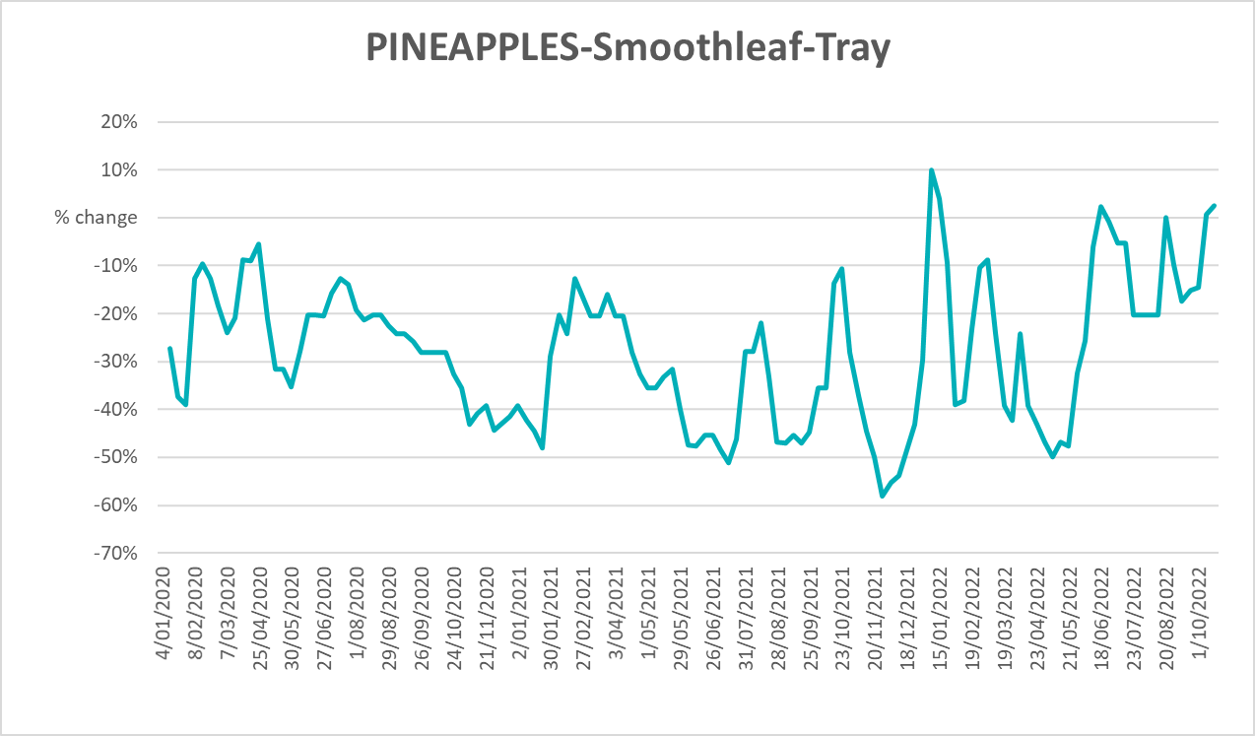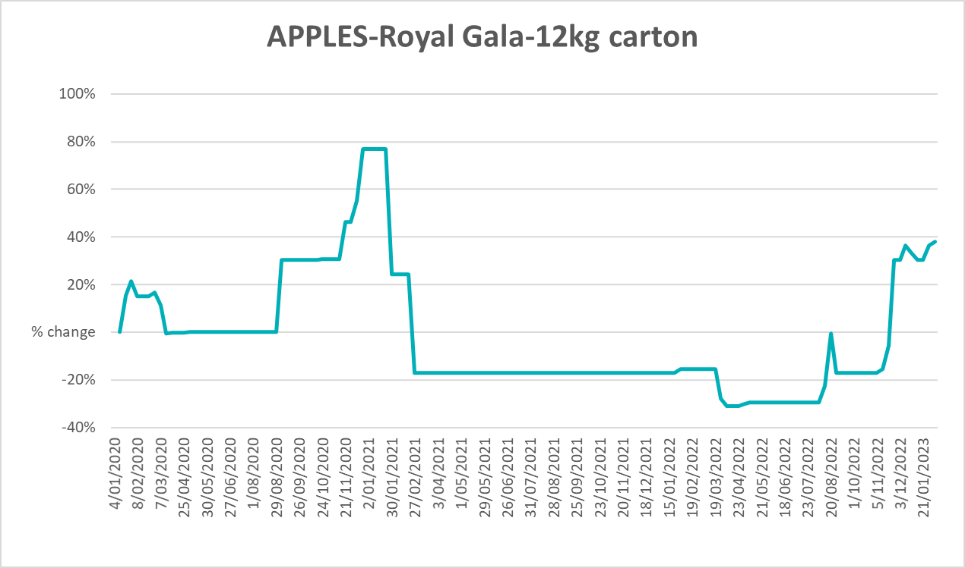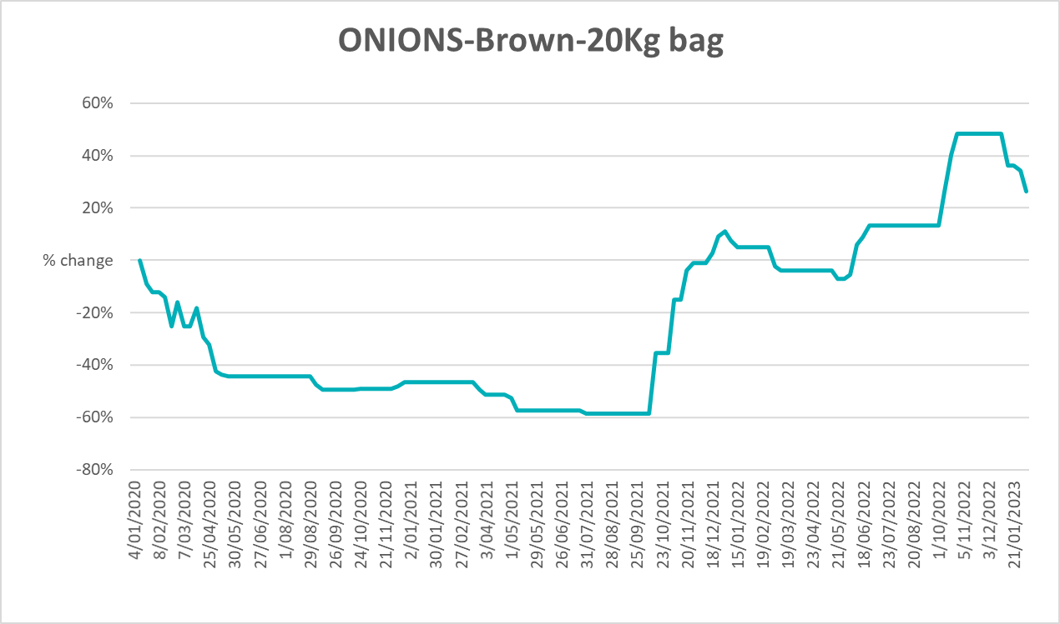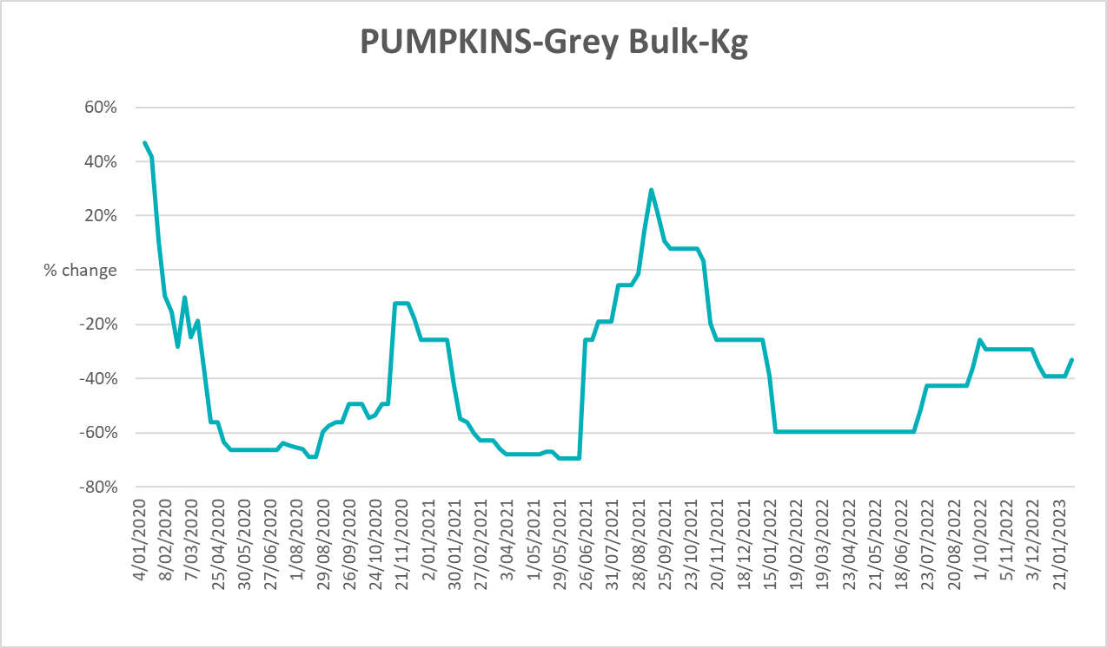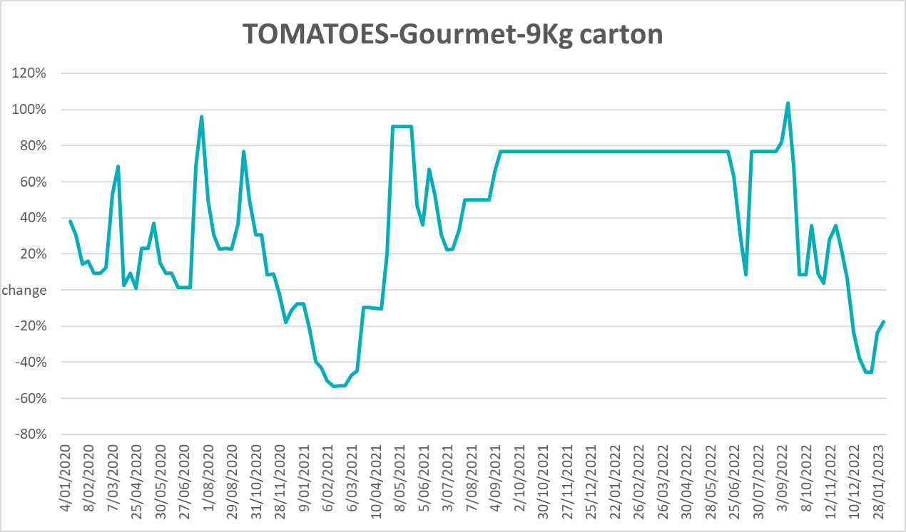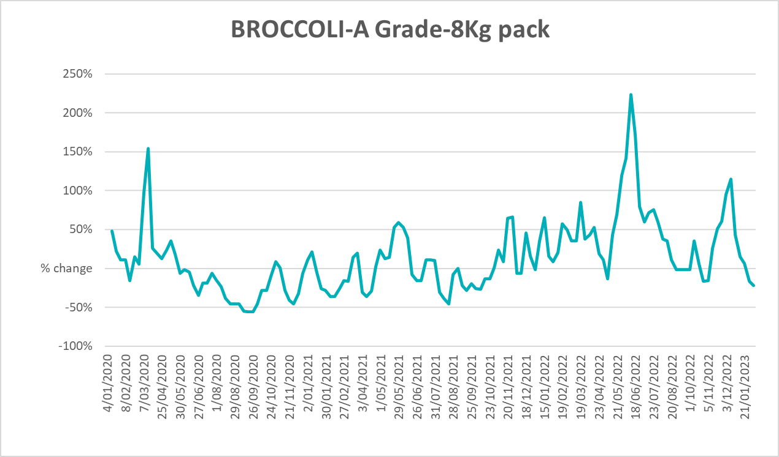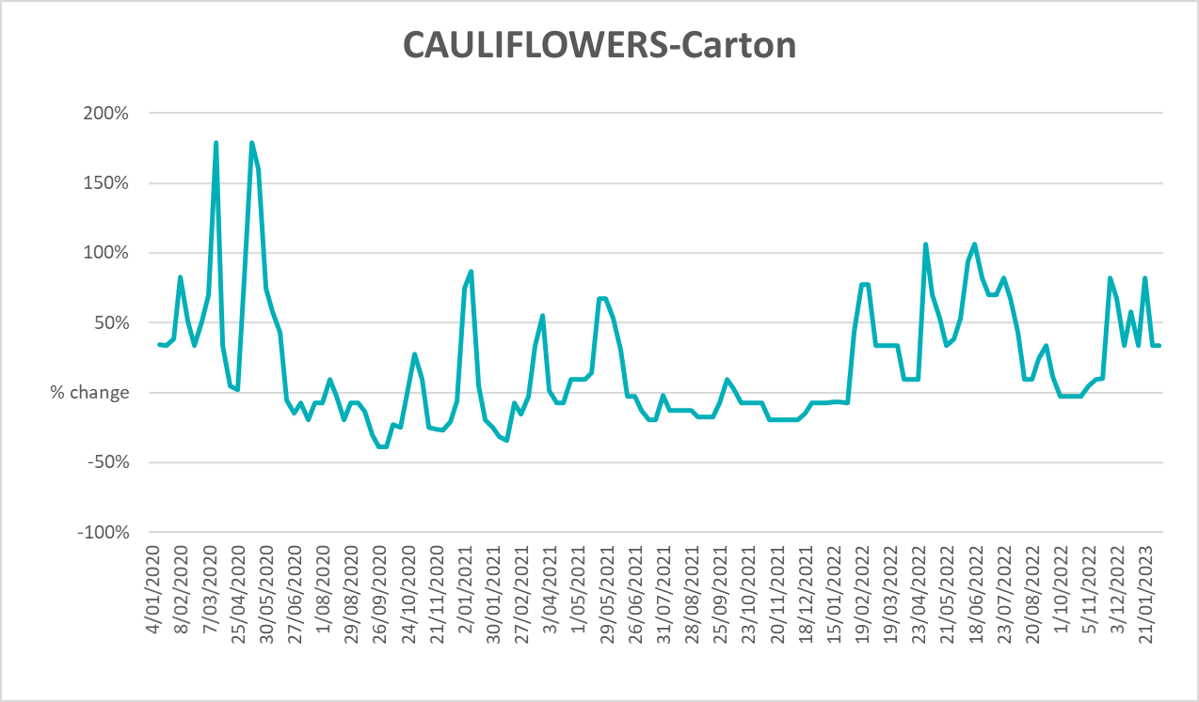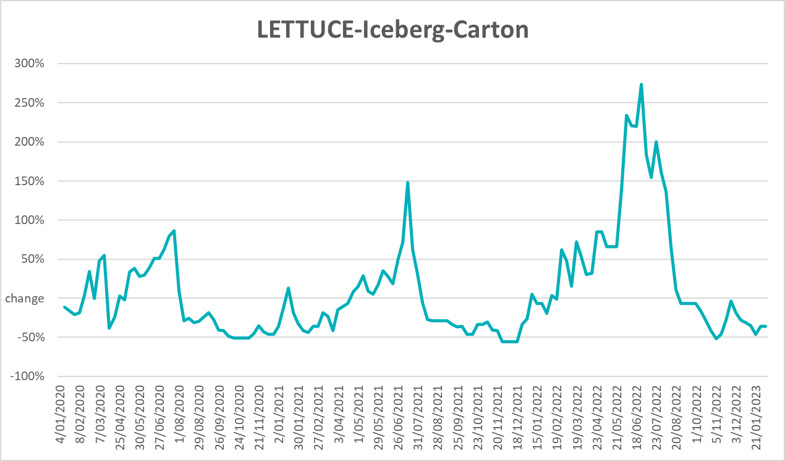
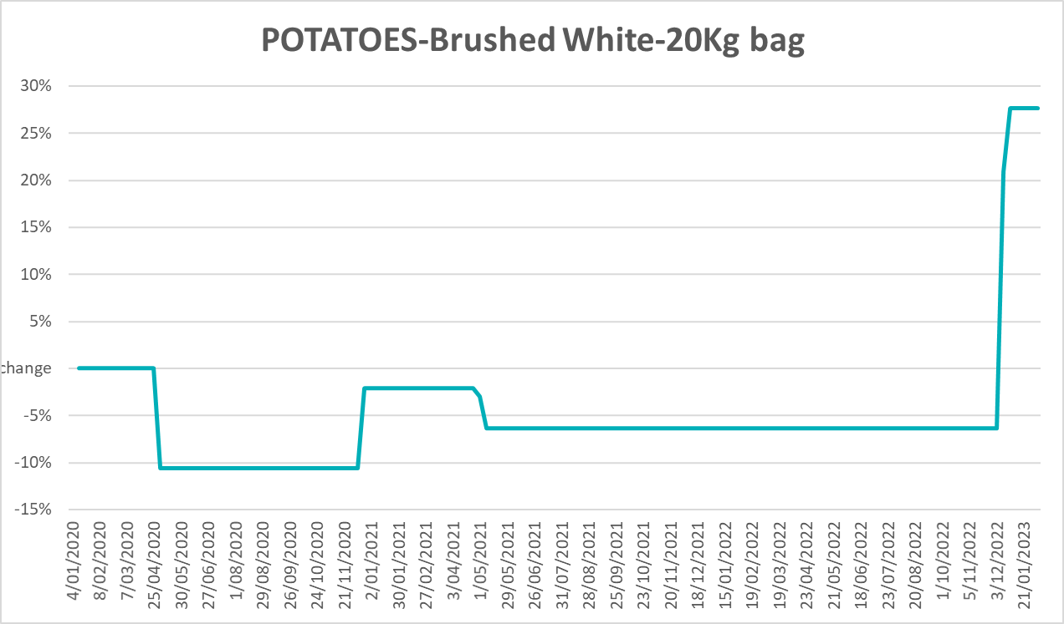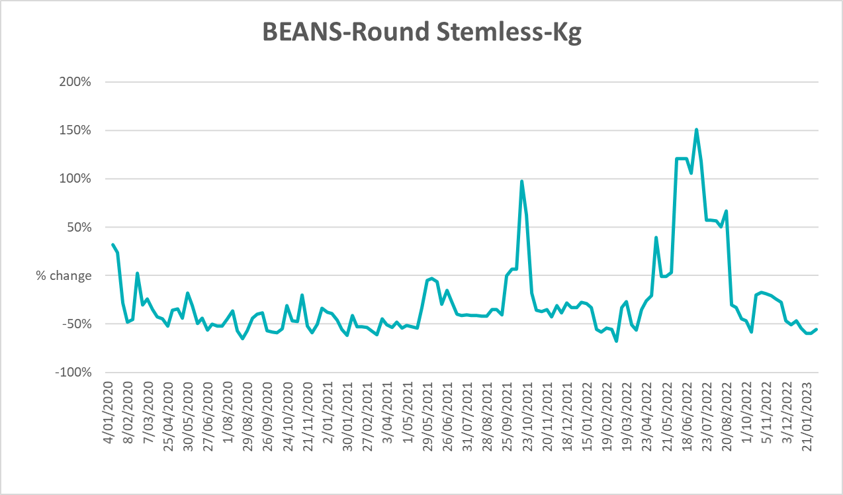

Selected domestic fodder indicator prices
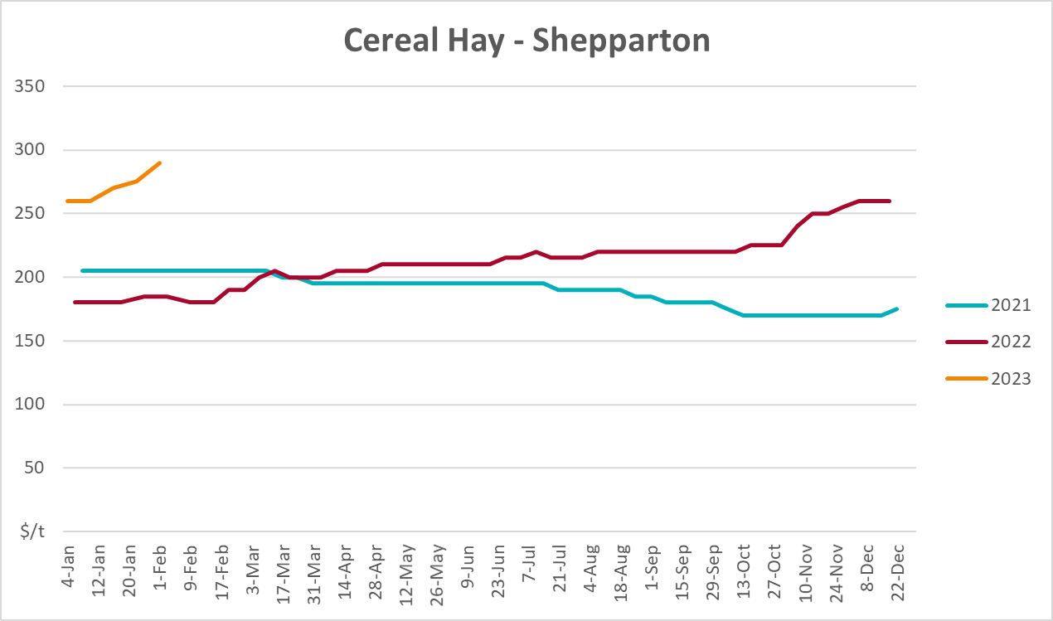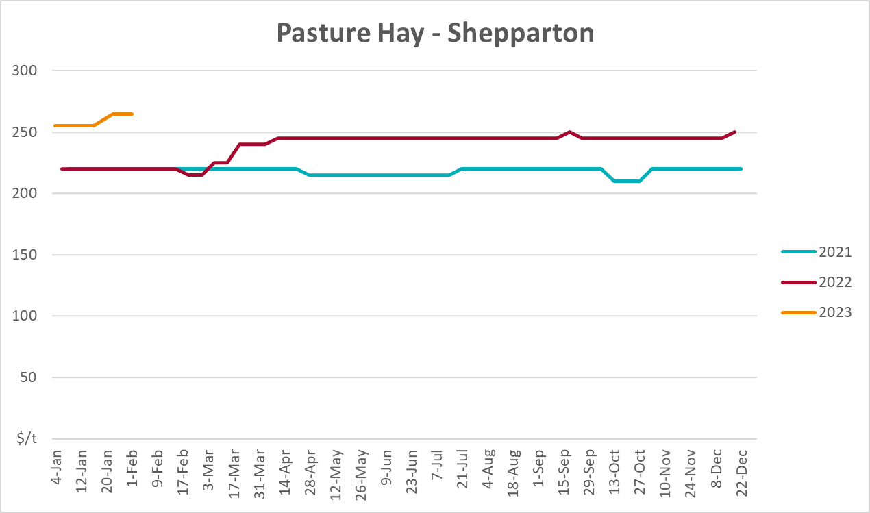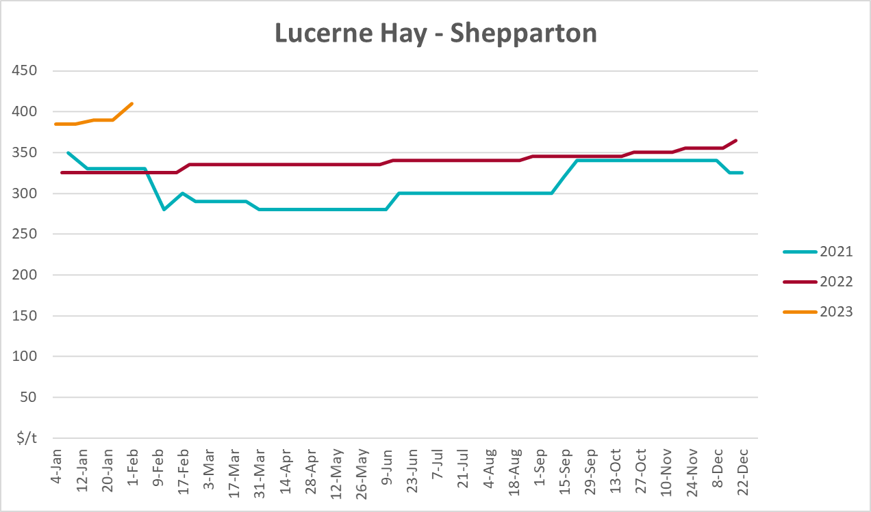

Data attribution

Climate
Bureau of Meteorology
- Weekly rainfall totals: www.bom.gov.au/climate/maps/rainfall/
- Monthly and last 3-month rainfall percentiles: www.bom.gov.au/water/landscape/
- Temperature anomalies: www.bom.gov.au/jsp/awap/temp/index.jsp
- Rainfall forecast: www.bom.gov.au/jsp/watl/rainfall/pme.jsp
- Seasonal outlook: www.bom.gov.au/climate/outlooks/#/overview/summary/
- Climate drivers: http://www.bom.gov.au/climate/enso/
- Soil moisture: www.bom.gov.au/water/landscape/
Other
- Pasture growth: www.longpaddock.qld.gov.au/aussiegrass/
- 3-month global outlooks: Environment and Climate Change Canada, NOAA Climate Prediction Center, EUROBRISA CPTEC/INPE, European Centre for Medium-Range Weather Forecasts, Hydrometcenter of Russia, National Climate Center Climate System Diagnosis and Prediction Room (NCC), International Research Institute for Climate and Society
- Global production: https://ipad.fas.usda.gov/ogamaps/cropmapsandcalendars.aspx
- Autumn break: Pook et al., 2009, https://rmets-onlinelibrary-wiley-com.virtual.anu.edu.au/doi/epdf/10.1002/joc.1833

Water
Prices
- Waterflow: https://www.waterflow.io/
- Ruralco: https://www.ruralcowater.com.au/
Bureau of Meteorology:
- Allocation trade: http://www.bom.gov.au/water/dashboards/#/water-markets/mdb/at
- Storage volumes: http://www.bom.gov.au/water/dashboards/#/water-storages/summary/drainage
Trade constraints:
- Water NSW: https://www.waternsw.com.au/customer-service/ordering-trading-and-pricing/trading/murrumbidgee
- Victorian Water Register: https://www.waterregister.vic.gov.au/TradingRules2019/

Commodities
Fruit and vegetables
- Datafresh: www.freshstate.com.au
Pigs
- Australian Pork Limited: www.australianpork.com.au
Dairy
- Global Dairy Trade: www.globaldairytrade.info/en/product-results/
World wheat, canola
- International Grains Council
World coarse grains
- United States Department of Agriculture
World cotton
- Cotlook: www.cotlook.com/
World sugar
- New York Stock Exchange - Intercontinental Exchange
Wool
- Australian Wool Exchange: www.awex.com.au/
Domestic wheat, barley, sorghum, canola and fodder
- Jumbuk Consulting Pty Ltd: http://www.jumbukag.com.au/
Cattle, beef, mutton, lamb, goat and live export
- Meat and Livestock Australia: www.mla.com.au/Prices-and-market
© Commonwealth of Australia 2023

Ownership of intellectual property rights
Unless otherwise noted, copyright (and any other intellectual property rights, if any) in this publication is owned by the Commonwealth of Australia (referred to as the Commonwealth).

Creative Commons licence
All material in this publication is licensed under a Creative Commons Attribution 4.0 International Licence except content supplied by third parties, logos and the Commonwealth Coat of Arms.
Inquiries about the licence and any use of this document should be emailed to copyright@awe.gov.au.


Cataloguing data
This publication (and any material sourced from it) should be attributed as:
ABARES 2023, Weekly Australian Climate, Water and Agricultural Update, Australian Bureau of Agricultural and Resource Economics and Sciences, Canberra, 16 February 2023. CC BY 4.0 DOI: https://doi.org/10.25814/5f3e04e7d2503
ISSN 2652-7561
This publication is available at https://www.agriculture.gov.au/abares/products/weekly_update
Department of Agriculture, Fisheries and Forestry
GPO Box 858 Canberra ACT 2601
Telephone 1800 900 090
Web agriculture.gov.au/abares

Disclaimer
The Australian Government acting through the Department of Agriculture, Fisheries and Forestry, represented by the Australian Bureau of Agricultural and Resource Economics and Sciences, has exercised due care and skill in preparing and compiling the information and data in this publication. Notwithstanding, the Department of Agriculture, Fisheries and Forestry, ABARES, its employees and advisers disclaim all liability, including liability for negligence and for any loss, damage, injury, expense or cost incurred by any person as a result of accessing, using or relying on any of the information or data in this publication to the maximum extent permitted by law.

Statement of Professional Independence
The views and analysis presented in ABARES publications, including this one, reflect ABARES professionally independent findings, based on scientific and economic concepts, principles, information and data. These views, analysis and findings may not reflect or be consistent with the views or positions of the Australian Government, or of organisations or groups who have commissioned ABARES reports or analysis. More information on professional independence is provided on the ABARES website.

Acknowledgements
This report was prepared by Kavina Dayal, Ruirui Zhu and Matthew Miller.

