
No. 7/2023 23 February 2023

Summary of key issues
- For the week ending 22 February 2023, a tropical low active in the Gulf of Carpentaria brought heavy rainfall to surrounding areas of the tropical north of Australia. Meanwhile, a low-pressure trough brought scattered rainfall to areas of southern Queensland as well as coastal and central New South Wales.
- In cropping regions, rainfall was restricted to parts of central New South Wales and isolated areas of western and northern Queensland. Ongoing dry conditions across most summer cropping regions would have allowed for uninterrupted access to fields for crop maintenance activities and for the harvesting of early sown crops. However, in regions with below average soil moisture levels little to no rainfall is likely to negative affected the growth and yield potential of late sown summer crops (see Section 1.1).
- The La Niña event is continuing to weaken. The Madden Julian Oscillation (MJO) is currently in the Western Pacific Ocean and will likely support ongoing monsoonal activity across northern Australia, although this influence will reduce if the MJO progresses eastward and into the eastern Pacific (see Section 1.2).
- The outlook for March to May 2023 suggests there is a 75% chance of receiving between 25 and 50 millimetres across cropping regions of western New South Wales, northern and south-western Queensland, most of Victoria and Western Australia, and southern areas of South Australia.
- These rainfall totals are below average for this three-month period across most cropping regions. Given that rootzone soil moisture levels are below average to average across most summer cropping regions in New South Wales and Queensland, this below average rainfall outlook represents a significant downside production risk for late sown summer crops. This below average rainfall outlook also represents a potential downside risk for pasture growth and the early planting of winter crops across large areas of southern Australia. In contrast, drier than average conditions will assist in a largely uninterrupted harvest for early sown summer crops and led to less rain affected grain quality downgrades (see Section 1.3).
- Over the 8-days to 2 March, rainfall is expected to be restricted to northern Australia under the influence of monsoonal troughs. Little to no rainfall is expected across cropping regions. Little to no rainfall for summer cropping regions in northern New South Wales and Queensland is expected to improve access to fields for crop maintenance activities and allow for the uninterrupted harvest of early sown crops (see Section 1.4).
- Water storage levels in the Murray-Darling Basin (MDB) decreased between 15 February 2023 and 22 February 2023 by 196 gigalitres (GL). Current volume of water held in storage is 23 059 GL which represents 91 per cent of total capacity. This is 3 percent or 624 GL more than at the same time last year.
- Allocation prices in the Victorian Murray below the Barmah Choke remained steady at $15 per ML from 16 February 2023 to 23 February 2023. Prices are lower in the Murrumbidgee due to the binding of the Murrumbidgee export limit and Barmah choke trade constraint.

Climate

Rainfall this week
For the week ending 22 February 2023, a tropical low active in the Gulf of Carpentaria brought heavy rainfall to surrounding areas of the tropical north of Australia. Weekly rainfall totals exceeded 100 millimetres in these areas. Meanwhile, a low-pressure trough brought rainfall totals of between 25 and 50 millimetres to scattered areas of southern Queensland as well as coastal and central New South Wales.
In cropping regions, rainfall was restricted to parts of central New South Wales and isolated areas of western and northern Queensland. Little to no rainfall was recorded across remaining cropping regions. Ongoing dry conditions across most summer cropping regions would have allowed for uninterrupted access to fields for crop maintenance activities and for the harvesting of early sown crops. However, in regions with below average soil moisture levels little to no rainfall is likely to negative affected the growth and yield potential of late sown summer crops.

Rainfall for the week ending 22 February 2023
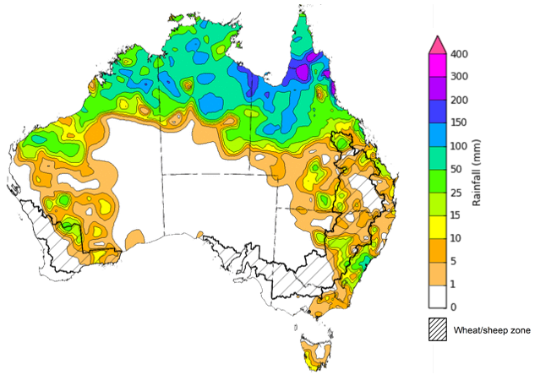
©Commonwealth of Australia 2023, Australian Bureau of Meteorology Issued: 22/02/2023
Note: The rainfall analyses and associated maps utilise data contained in the Bureau of Meteorology climate database, the Australian Data Archive for Meteorology (ADAM). The analyses are initially produced automatically from real-time data with limited quality control. They are intended to provide a general overview of rainfall across Australia as quickly as possible after the observations are received. For further information go to http://www.bom.gov.au/climate/rainfall/

Climate Drivers
Throughout summer the climate drivers with the largest potential impact on Australia’s climate patterns are the El Niño–Southern Oscillation (ENSO), the Southern Annular Mode (SAM) and the Madden-Julian Oscillation (MJO). These climate drivers are likely to influence the growth and development of summer crops in northern growing regions and pasture growth across northern Australia with the northern wet season.
La Niña continues in the tropical Pacific, but oceanic indicators have weakened to ENSO-neutral values. Sea surface temperature (SST) anomalies in the central equatorial Pacific continue to weaken, which is consistent with a weakening La Niña. Warmer than average temperatures persist to the south of Australia from the eastern Great Australian Bight to waters around New Zealand’s South Island, while generally weak warm anomalies persist across the west, north of the Maritime Continent and across the east of Australia. Trade winds have been stronger than average in the western half of the tropical Pacific Ocean. Elsewhere, trade wind strength was close to average. Cloudiness near the Date Line has been mostly below average, which reflects the easing La Niña event. As La Niña weakens it can continue to influence global weather and climate.

Difference from average sea surface temperature observations 6 to 12 February 2023
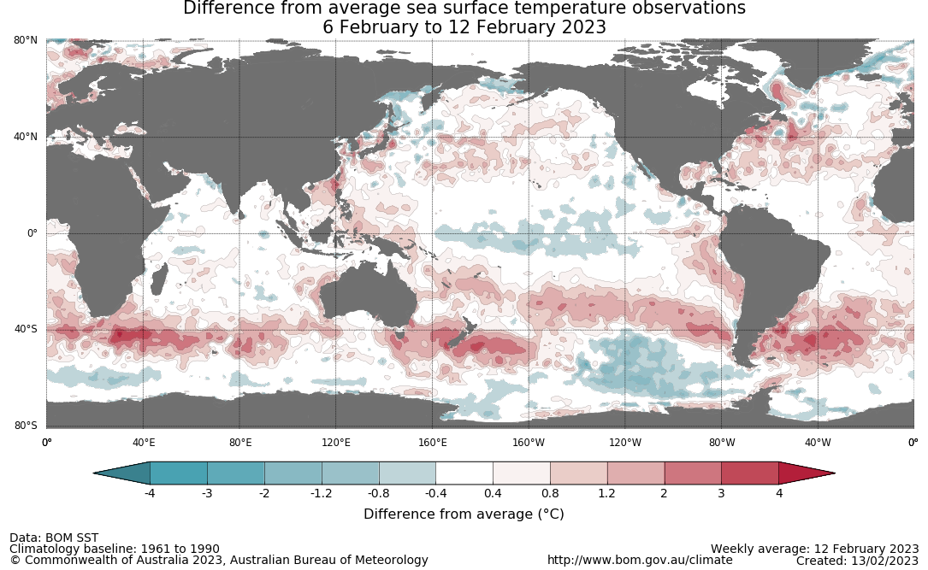

International climate model outlooks for the NINO 3.4 region in March 2023
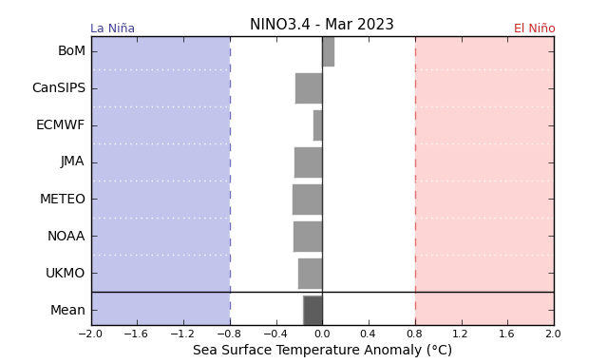
©Commonwealth of Australia 2023, Australian Bureau of Meteorology Issued: 14/2/2023
All climate models surveyed by the Bureau of Meteorology anticipate central Pacific sea-surface temperatures will remain ENSO-neutral into the southern hemisphere autumn. For the period ending 19 February 2023, the 30-day SOI was +14.1. For the period ending 12 February 2023, the 90-daySOI was +15.1, both above the La Niña threshold of +7.

30-day Southern Oscillation Index (SOI) values ending 19 February 2023
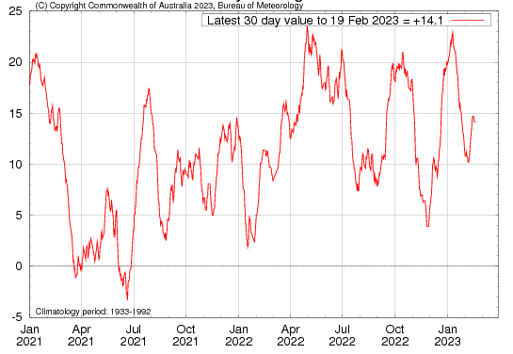

As at 19 February 2023 the Madden–Julian Oscillation (MJO) is currently over the western Pacific Ocean. Most climate models suggest the MJO is likely to progress eastwards into the eastern Pacific in the coming week. While over the western Pacific, it will likely support ongoing monsoonal activity across northern Australia, although this influence will reduce if the MJO progresses eastward and into the eastern Pacific. The MJO is a pulse of cloud and rainfall that moves eastward along the equator and increases the chance of above average cloudiness and rainfall across northern Australia.
Madden–Julian Oscillation (MJO) daily index
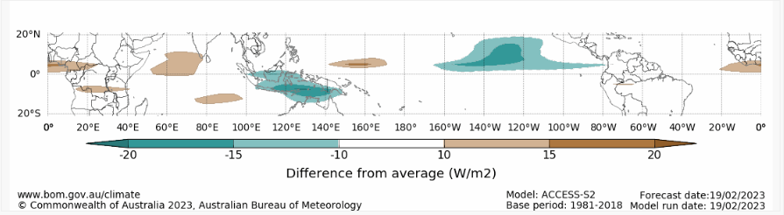
Note: This map displays the forecast outgoing longwave radiation (OLR) difference from expected cloudiness to identify convective rain clouds and the position of the Madden–Julian Oscillation (MJO). The blue shading indicates higher than normal, active or enhanced tropical weather and the brown shading indicates lower than normal clouds or suppressed conditions.

The Southern Annular Mode (SAM) is neutral but is expected to briefly dip into negative values before remaining neutral for the coming weeks to months. During summer, a negative SAM typically suppresses rainfall over south-eastern Australia.

Southern Annular Mode (SAM) daily index
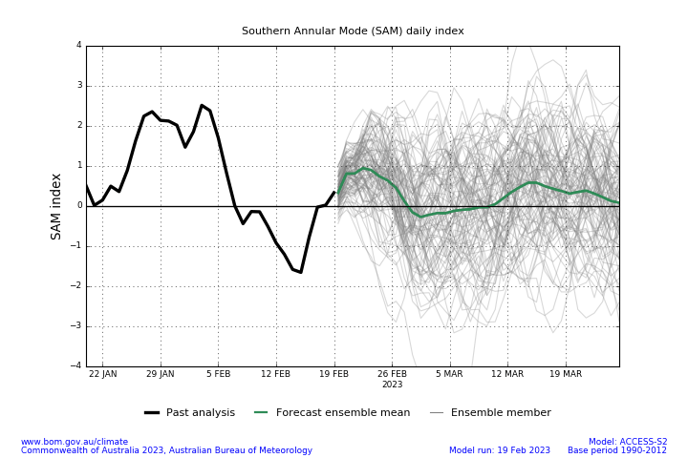

National Climate Outlook
These climate outlooks are generated by ACCESS–S (Australian Community Climate Earth-System Simulator–Seasonal). ACCESS–S is the Bureau of Meteorology's dynamic (physics-based) weather and climate model used for monthly, seasonal, and longer-lead climate outlooks. For further information, go to http://www.bom.gov.au/climate/ahead/about/.
The Bureau of Meteorology’s latest rainfall outlook for March 2023 indicates wetter than average conditions are expected across parts of western and eastern Australia. The ACCESS-S climate model suggests there is a greater than 55% chance of exceeding median March rainfall totals across eastern New South Wales, as well as parts of Victoria and Tasmania, and central areas of Western Australia.
The outlook for March 2023 indicates that there is a 75% chance of rainfall totals between 25 and 200 millimeters for tropical northern Australia, eastern and south-eastern coastal areas, as well as Tasmania. For the remainder of Australia, rainfall totals are not expected to exceed 25 millimeters.
Across cropping regions there is a 75% chance of rainfall totals of between 10 and 25 millimeters across eastern New South Wales, much of Queensland and small areas of eastern Victoria and Western Australia. There is a 75% chance of less than 10 millimeters of rainfall for the remaining cropping regions.
Rainfall totals that have a 75% chance of occurring March 2023
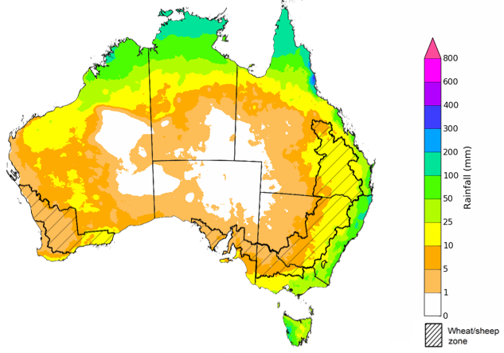
©Commonwealth of Australia 2023, Australian Bureau of Meteorology Issued: 23/2/2023

The rainfall outlook for March to May 2023 suggests that there is a more than 60% chance of below median rainfall for much of Australia over the next three months. In contrast, for coastal New South Wales, southern Victoria, eastern Tasmania and scattered areas of Australia’s tropical north, there is no strong tendency of above or below median rainfall.
Bureau of Meteorology rainfall outlooks for March to May have greater than 50% past accuracy across large area of Australia. Outlook accuracy is greater than 65% across Queensland, the Northern Territory and Kimberley region of Western Australia. Past accuracy is low (less than 50%) for inland distracts of Western Australia, parts of north-western New South Wales, eastern and north-western South Australia.
Chance of exceeding the median rainfall March to May 2023
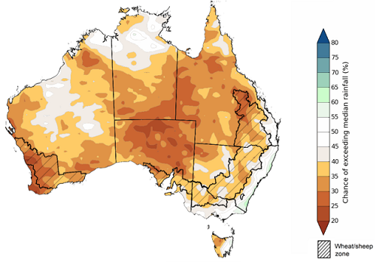
©Commonwealth of Australia 2023, Australian Bureau of Meteorology Issued: 23/2/2023

The outlook for March to May 2023 suggests there is a 75% chance of rainfall totals between 25 and 200 millimetres across most of Victoria and Tasmania, central and eastern New South Wales, eastern and northern Queensland, the far south of South Australia, the south-west and the Kimberley region of Western Australia, and the north of the Northern Territory. Rainfall totals in excess of 200 millimetres are forecast for the Top End of the Northern Territory, the Cape York Peninsula of Queensland and western Tasmania.
Across cropping regions, there is a 75% chance of receiving between 25 and 50 millimetres in western New South Wales, northern and south-western Queensland, most of Victoria and Western Australia, and southern areas of South Australia. There is a 75% chance of receiving between 50 and 100 millimetres across eastern New South Wales and Queensland, as well as parts of the far southeast of Western Australia.
These rainfall totals are below average for this three-month period across most cropping regions. Given that rootzone soil moisture levels are below average to average across most summer cropping regions in New South Wales and Queensland, this below average rainfall outlook represents a significant downside production risk for late sown summer crops. This below average rainfall outlook also represents a potential downside risk for pasture growth and the early planting of winter crops across large areas of southern Australia. In contrast, drier than average conditions will assist in a largely uninterrupted harvest for early sown summer crops and led to less rain affected grain quality downgrades.
Rainfall totals that have a 75% chance of occurring March to May 2023

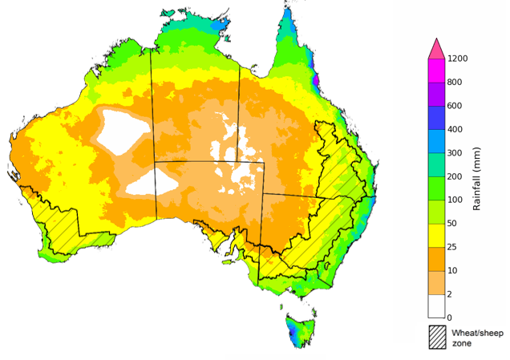
©Commonwealth of Australia 2023, Australian Bureau of Meteorology Issued: 23/2/2023

The temperature outlook for March to May 2023 indicates that maximum temperatures across most of Australia are likely to be close to the 1990-2012 average (- 1°C to 1°C) with slightly high temperature in the southern Western Australia. Minimum temperatures are expected to be slightly below average for the Northern Territory, Queensland, South Australia, Kimberly region of Western Australia, and above average for the rest of Australia (Bureau of Meteorology ‘National Climate Outlook’, 23 February 2023).
Predicted maximum temperature anomaly for March to May 2023
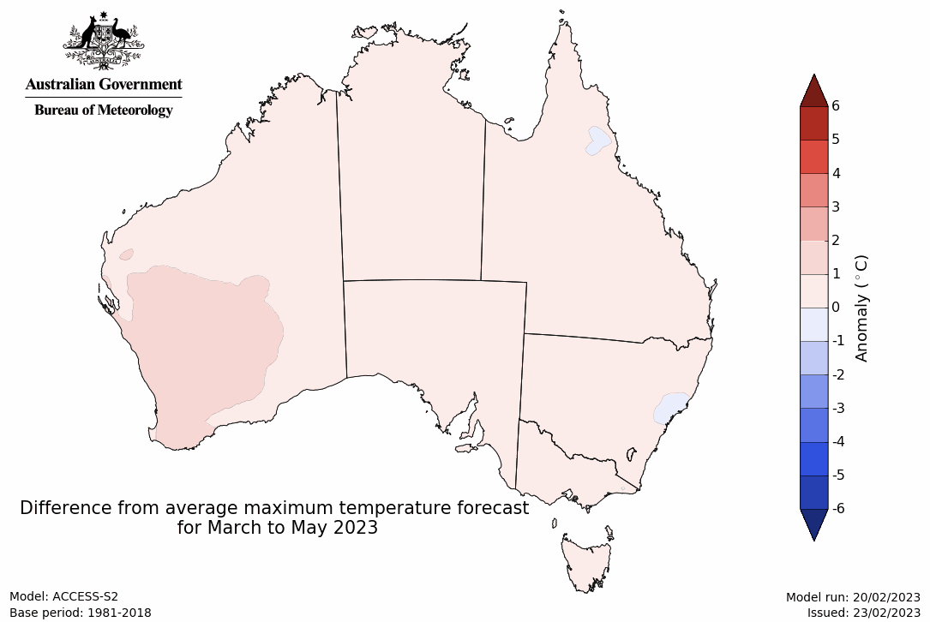
Predicted minimum temperature anomaly for March to May 2023
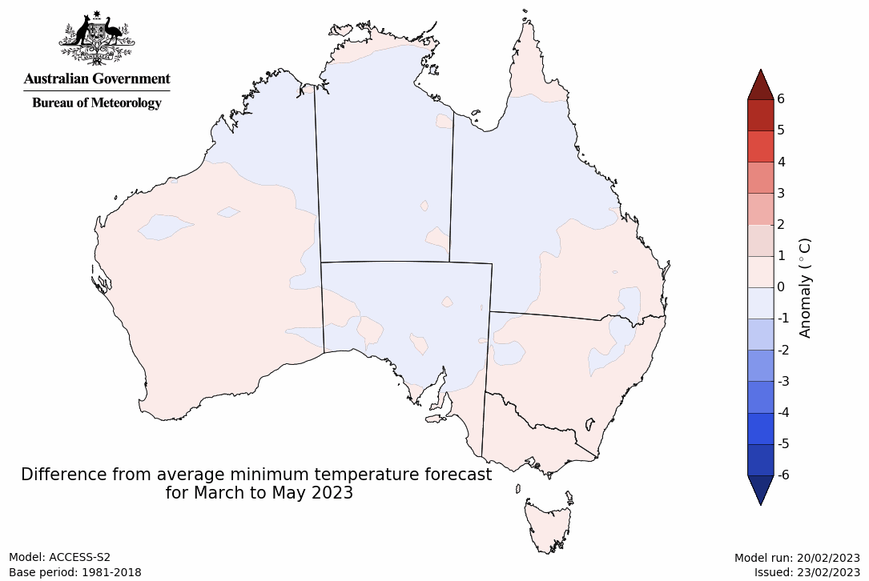

Rainfall forecast for the next eight days
Over the 8-days to 2 March 2023, tropical low activity persisting in northern Australia is expected to bring continuing heavy rainfall across Australia’s northern tropic. Meanwhile, low-pressure troughs in the eastern Australia are expected to bring scattered rainfall to the eastern coast of New South Wales and western Tasmania.
Rainfall totals exceeding 15 millimetres are expected across northern tropic of Australia, eastern coast of New South Wales, western Tasmania, and small parts of southern inland of Western Australia. Rainfall totals in excess of 50 millimetres are expected for Kimberly region of Western Australia, northern area of the Northern Territory, Cape York Peninsula of Queensland. Little to no rainfall is forecast for the remaining area of Australia for the next eight days.
Across Australian cropping regions, little to no rainfall is expected in the next 8 days. Little to no rainfall for summer cropping regions in New South Wales and Queensland is expected to further improve access to fields for the crop maintenance activities and allow for the harvest of early sown crops to continue. If realised, continued dry conditions in regions with low levels of soil moisture is likely to lead to further yield reductions for late sown summer crops. The forecast rainfall over much of northern Australia is likely to benefit pasture growth rates and availability.

Total forecast rainfall for the period 23 February to 2 March 2023
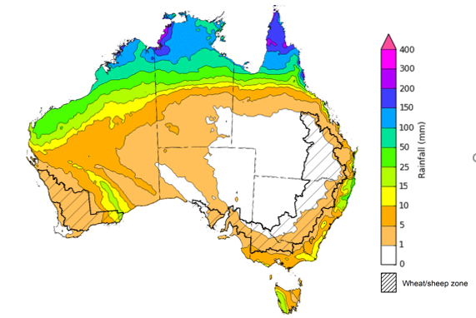

©Commonwealth of Australia 2023, Australian Bureau of Meteorology Issued 23/02/2023
Note: This rainfall forecast is produced from computer models. As the model outputs are not altered by weather forecasters, it is important to check local forecasts and warnings issued by the Bureau of Meteorology.

Water

Water markets – current week
Water storage levels in the Murray-Darling Basin (MDB) decreased between 15 February 2023 and 22 February 2023 by 196 gigalitres (GL). Current volume of water held in storage is 23 059 GL which represents 91 per cent of total capacity. This is 3 percent or 624 GL more than at the same time last year.

Water storages in the Murray-Darling Basin, 2013–2023
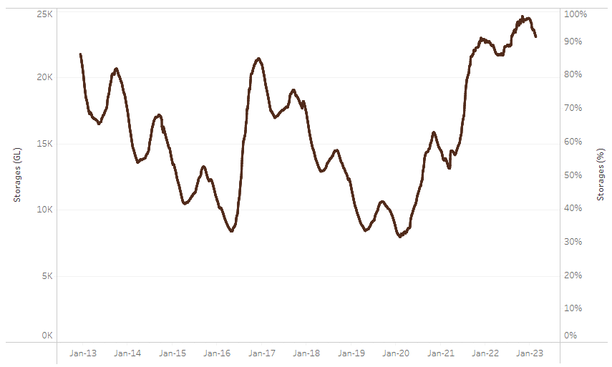
Allocation prices in the Victorian Murray below the Barmah Choke remained steady at $15 per ML from 16 February 2023 to 23 February 2023. Prices are lower in the Murrumbidgee due to the binding of the Murrumbidgee export limit and Barmah choke trade constraint.
Water storage data is sourced from the Bureau of Meteorology.
Region | $/ML
NSW Murray Above | 6
NSW Murrumbidgee | 9
VIC Goulburn-Broken | 15
VIC Murray Below | 15

Surface water trade activity, Southern Murray–Darling Basin
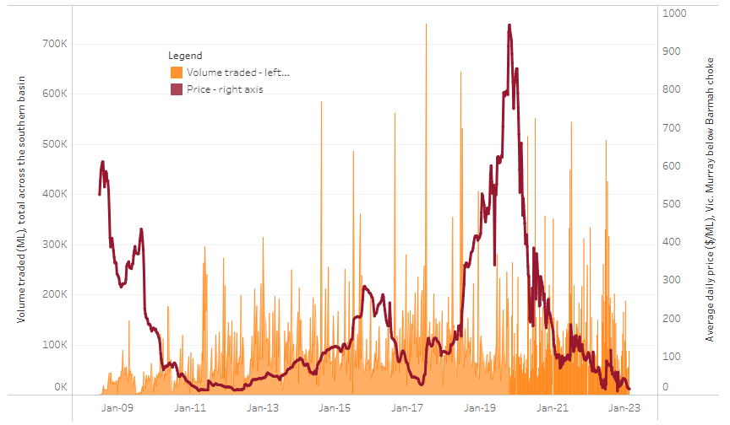
To access the full, interactive, weekly water dashboard, which contains the latest and historical water storage, water market and water allocation information, please visit http://www.agriculture.gov.au/abares/products/weekly_update/weekly-update-160223
The trades shown reflect estimated market activity and do not encompass all register trades. The price is shown for the VIC Murray below the Barmah choke. Historical prices (before 1 July 2019) are ABARES estimates after removing outliers from BOM water register data. Prices after 1 July 2019 and prior to the 30 October 2019 reflect recorded transaction prices as sourced from Ruralco. Prices after the 30 October 2019 are sourced from Waterflow. Data for volume traded is sourced from the BOM water register. Data shown is current on 23 February 2023.

Commodities
Indicator | Week ended | Unit | Latest Price | Previous Week | Weekly change | Price 12 months ago | Annual change
Selected world indicator prices
AUD/USD Exchange rate | 22-Feb | A$/US$ | 0.69 | 0.69 | -1% | 0.73 | -5%
Wheat – US no. 2 hard red winter wheat, fob Gulf | 22-Feb | US$/t | 404 | 405 | 0% | 480 | -16%
Corn – US no. 2 yellow corn, fob Gulf | 22-Feb | US$/t | 301 | 306 | -1% | 327 | -8%
Canola – Rapeseed, Canada, fob Vancouver | 22-Feb | US$/t | 667 | 666 | 0% | 900 | -26%
Cotton – Cotlook 'A' Index | 22-Feb | USc/lb | 97 | 101 | -4% | 136 | -29%
Sugar – Intercontinental Exchange, nearby futures, no.11 contract | 22-Feb | USc/lb | 19.9 | 19.8 | 0% | 18 | 8%
Wool – Eastern Market Indicator | 08-Feb | Ac/kg clean | 1,374 | 1,400 | -2% | 1,346 | 2%
Wool – Western Market Indicator | 08-Feb | Ac/kg clean | 1,525 | 1,570 | -3% | 1,368 | 11%
Selected Australian grain export prices
Milling Wheat – APW, Port Adelaide, SA | 22-Feb | A$/t | 509 | 498 | 2% | 512 | -1%
Feed Wheat – ASW, Port Adelaide, SA | 22-Feb | A$/t | 503 | 471 | 7% | 477 | 5%
Feed Barley – Port Adelaide, SA | 22-Feb | A$/t | 414 | 415 | 0% | 405 | 2%
Canola – Kwinana, WA | 22-Feb | A$/t | 1,051 | 1,064 | -1% | 1,071 | -2%
Grain Sorghum – Brisbane, QLD | 22-Feb | A$/t | 505 | 496 | 2% | 370 | 37%
Selected domestic livestock indicator prices
Beef – Eastern Young Cattle Indicator | 22-Feb | Ac/kg cwt | 741 | 753 | -2% | 1,123 | -34%
Mutton – Mutton indicator (18–24 kg fat score 2–3), Vic | 15-Feb | Ac/kg cwt | 353 | 391 | -10% | 575 | -39%
Lamb – Eastern States Trade Lamb Indicator | 22-Feb | Ac/kg cwt | 736 | 731 | 1% | 878 | -16%
Pig – Eastern Seaboard (60.1–75 kg), average of buyers & sellers | 25-Jan | Ac/kg cwt | 367 | 367 | 0% | 357 | 3%
Goats – Eastern States (12.1–16 kg) | 01-Feb | Ac/kg cwt | 325 | 350 | -7% | 813 | -60%
Live cattle – Light steers ex Darwin to Indonesia | 17-Aug | Ac/kg lwt | 420 | 480 | -13% | 320 | 31%
Live sheep – Live wethers (Muchea WA saleyard) to Middle East | 14-Sep | $/head | 93 | 113 | -18% | 114 | -18%
Global Dairy Trade (GDT) weighted average prices ª
Dairy – Whole milk powder | 22-Feb | US$/t | 3,264 | 3,329 | -2% | 3,458 | -6%
Dairy – Skim milk powder | 22-Feb | US$/t | 2,769 | 2,829 | -2% | 3,198 | -13%
Dairy – Cheddar cheese | 22-Feb | US$/t | 5,086 | 4,980 | 2% | 4,178 | 22%
Dairy – Anhydrous milk fat | 22-Feb | US$/t | 5,447 | 5,586 | -2% | 5,463 | 0%
a Global Dairy Trade prices are updated twice monthly on the first and third Tuesday of each month.

Selected world indicator prices
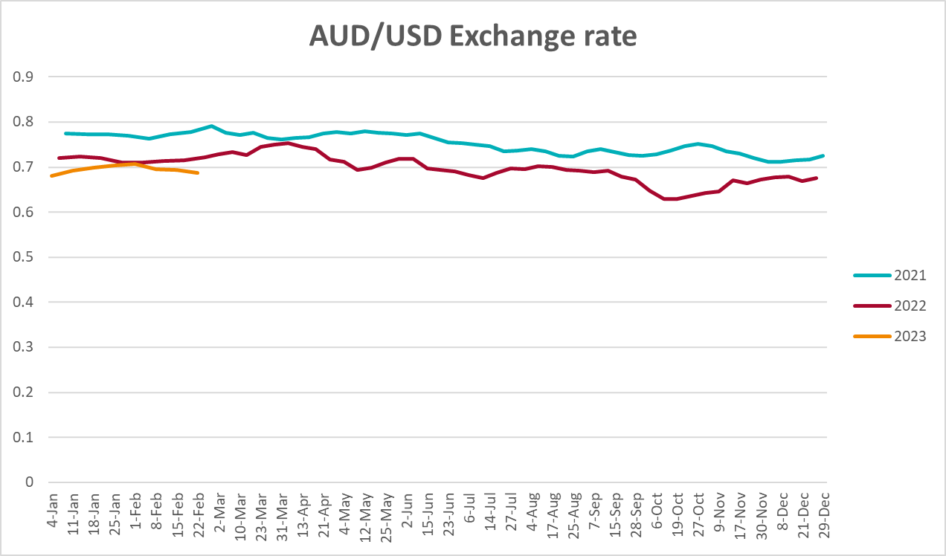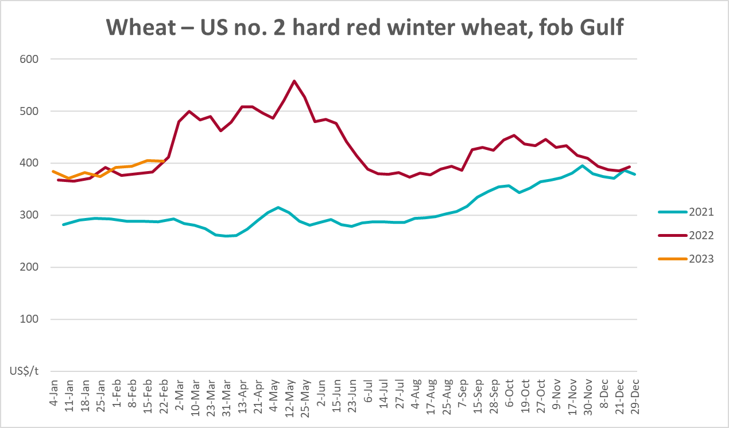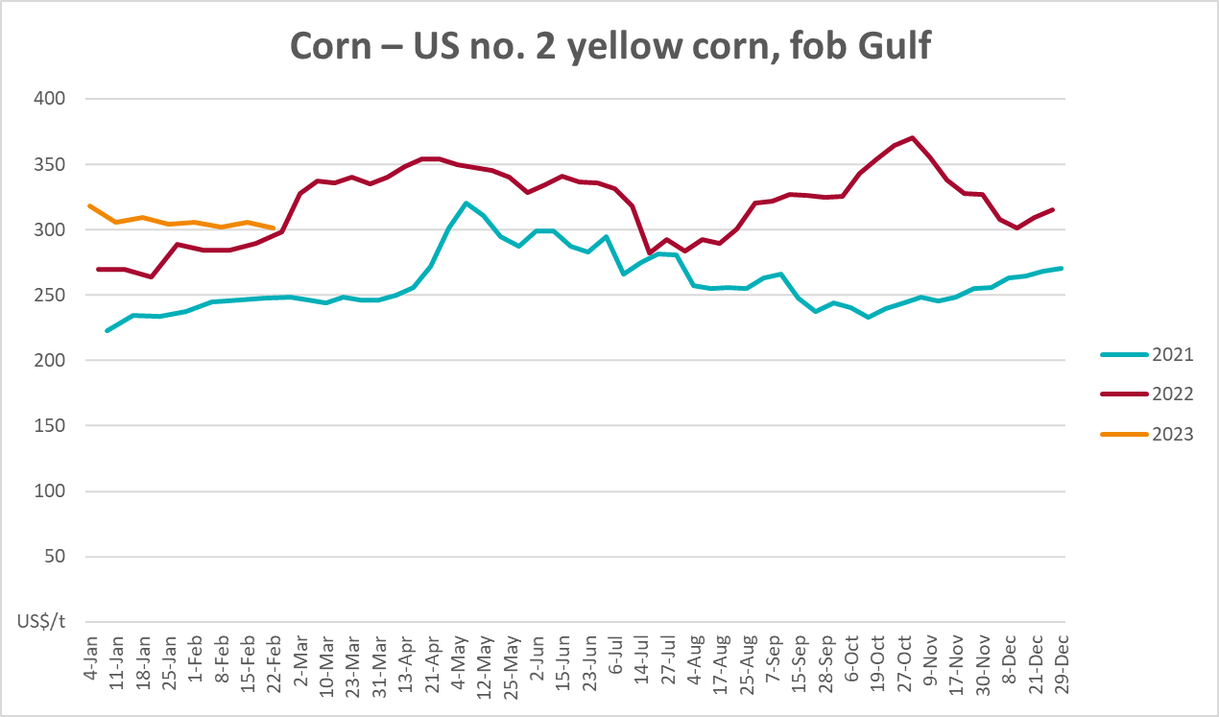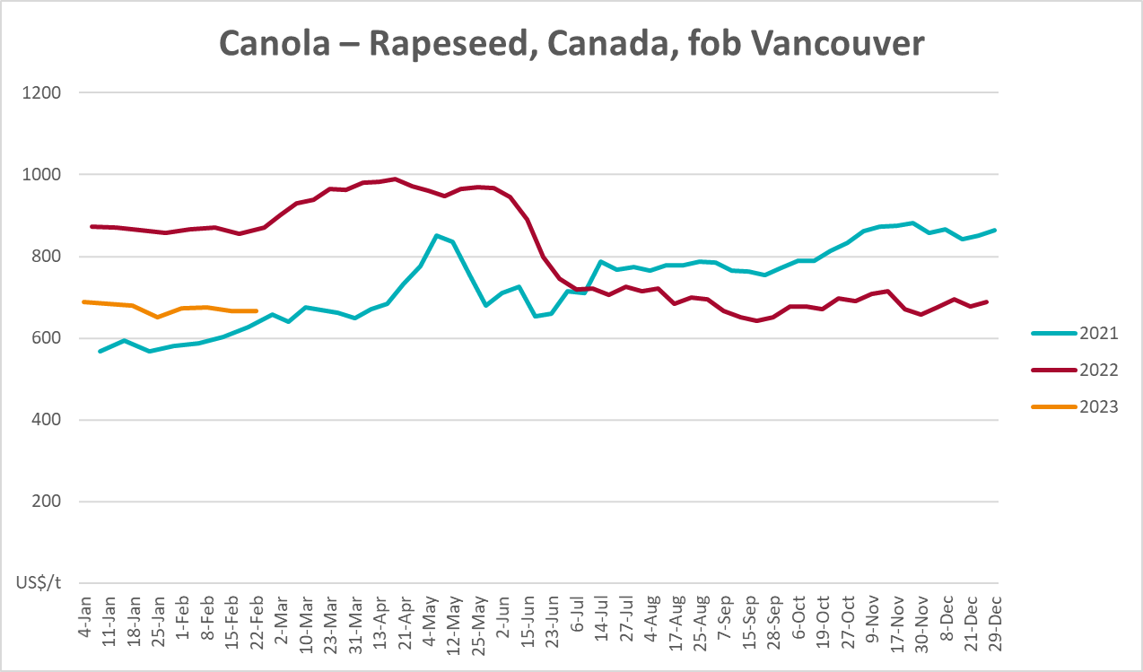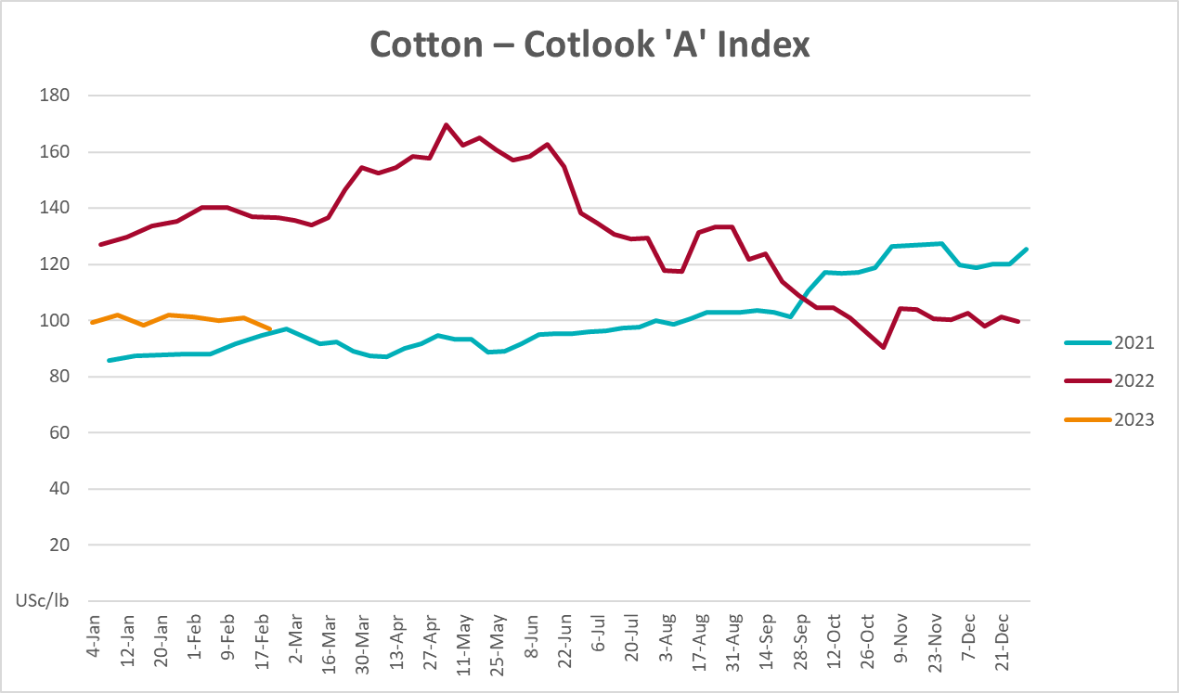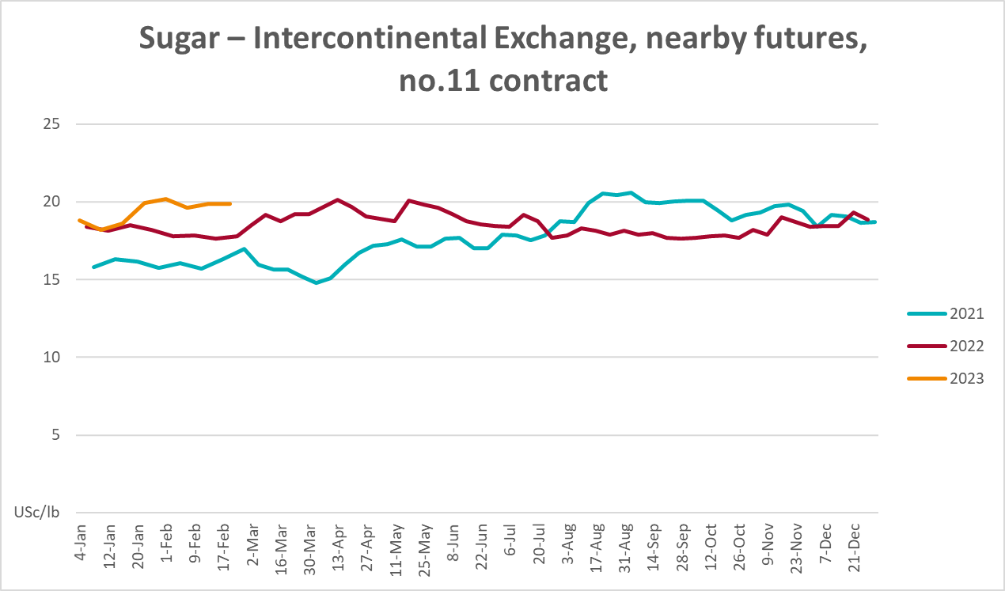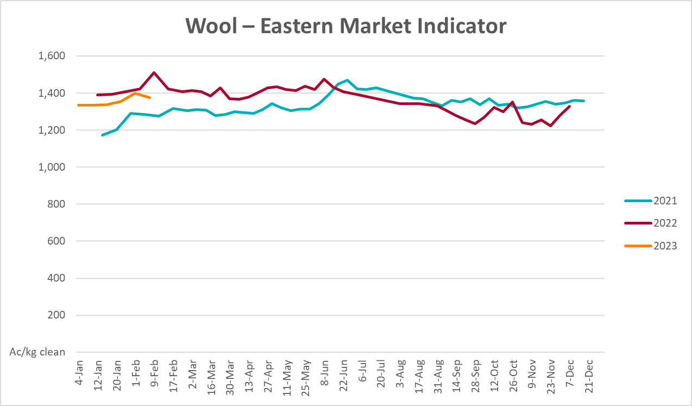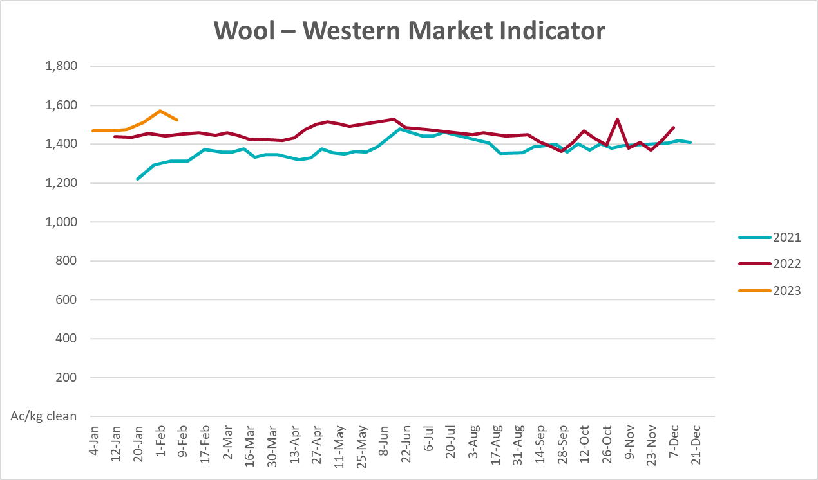

Selected domestic crop indicator prices
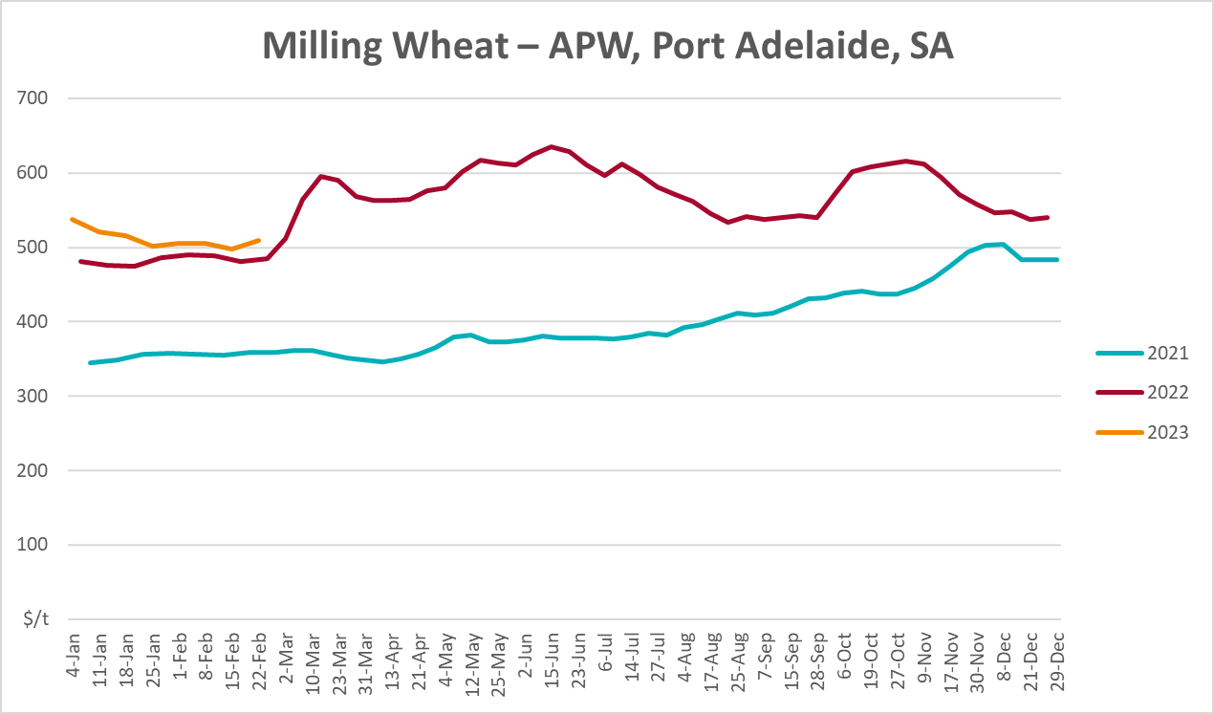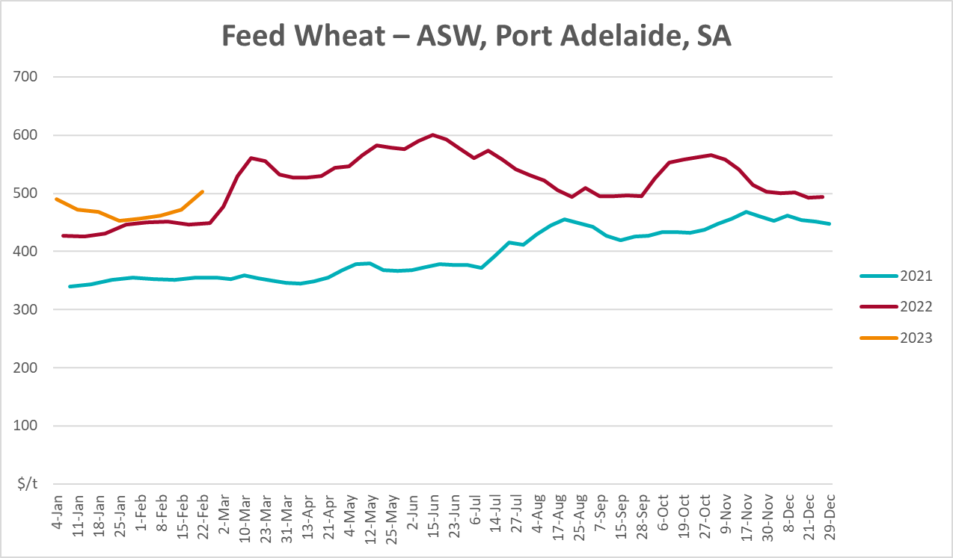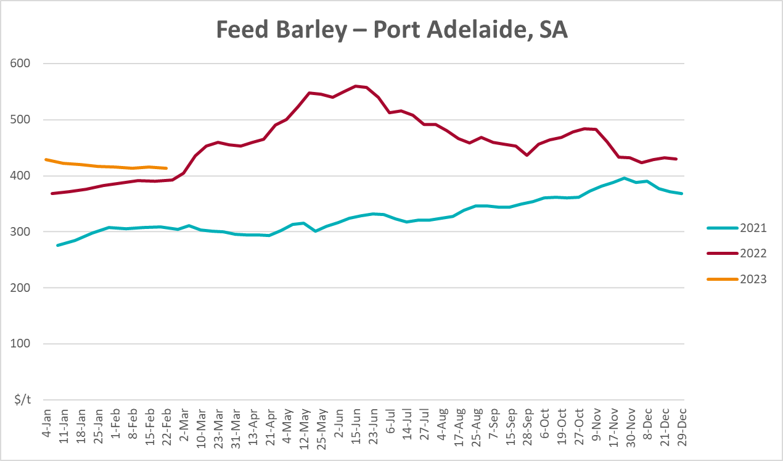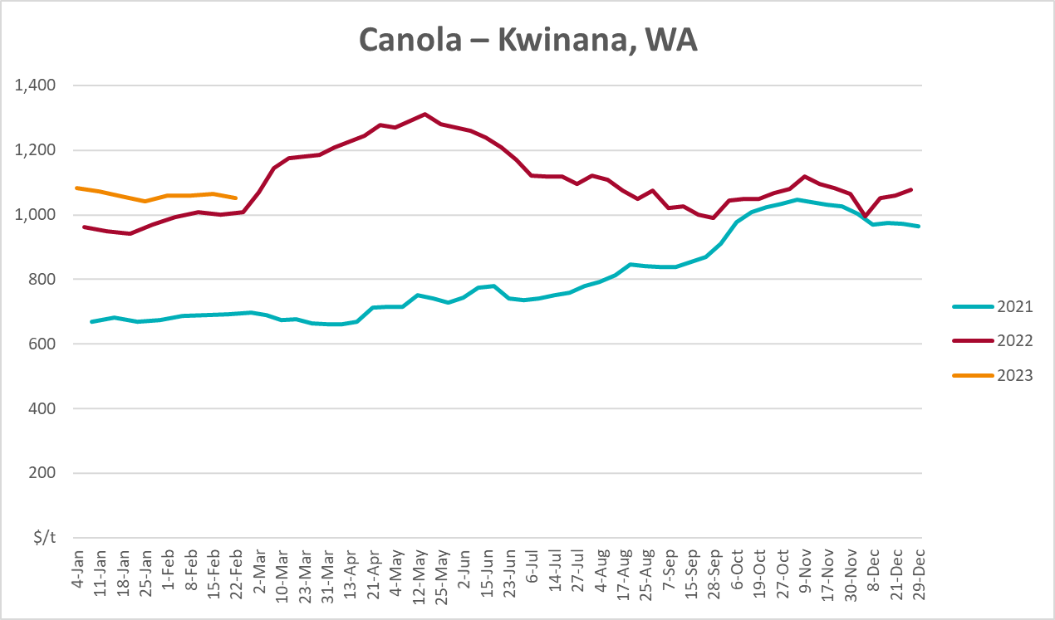
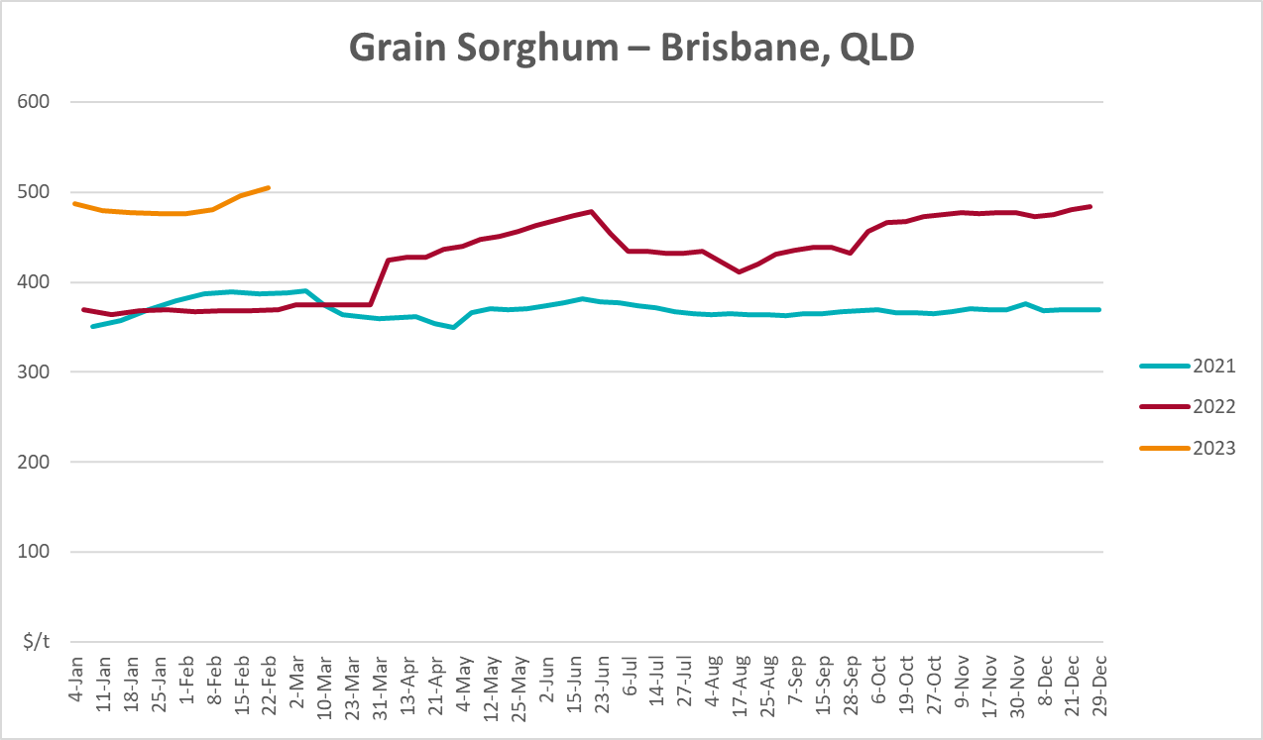

Selected domestic livestock indicator prices
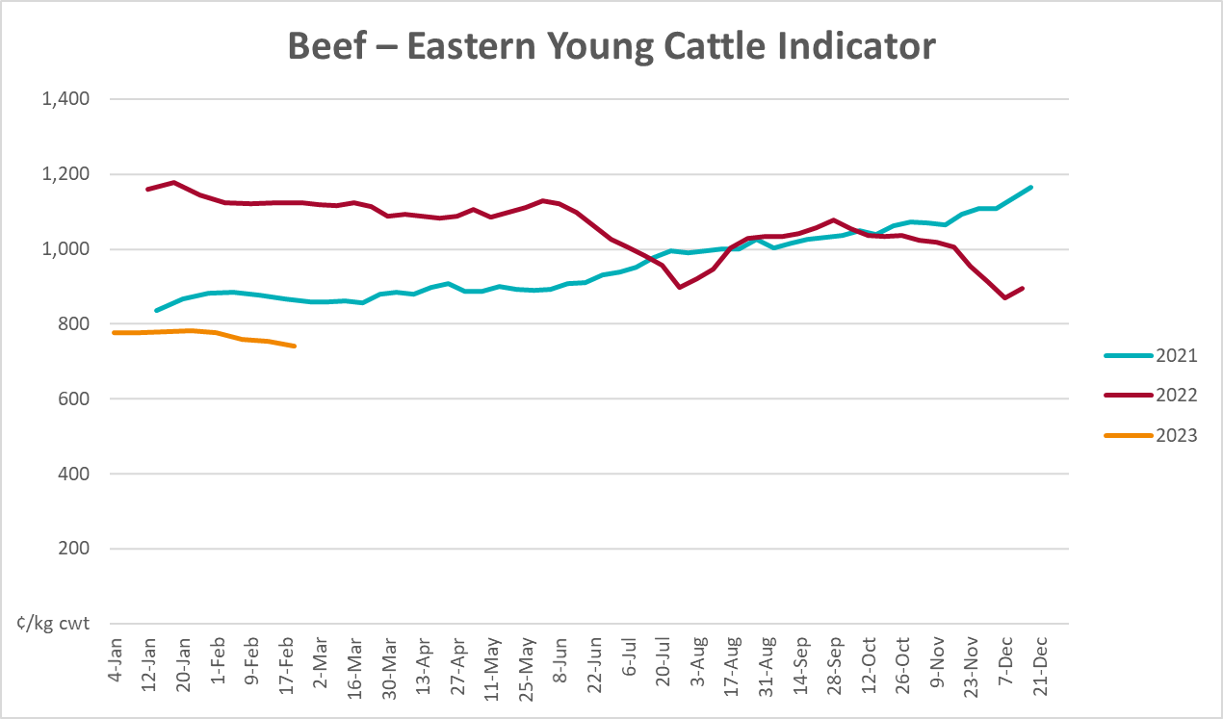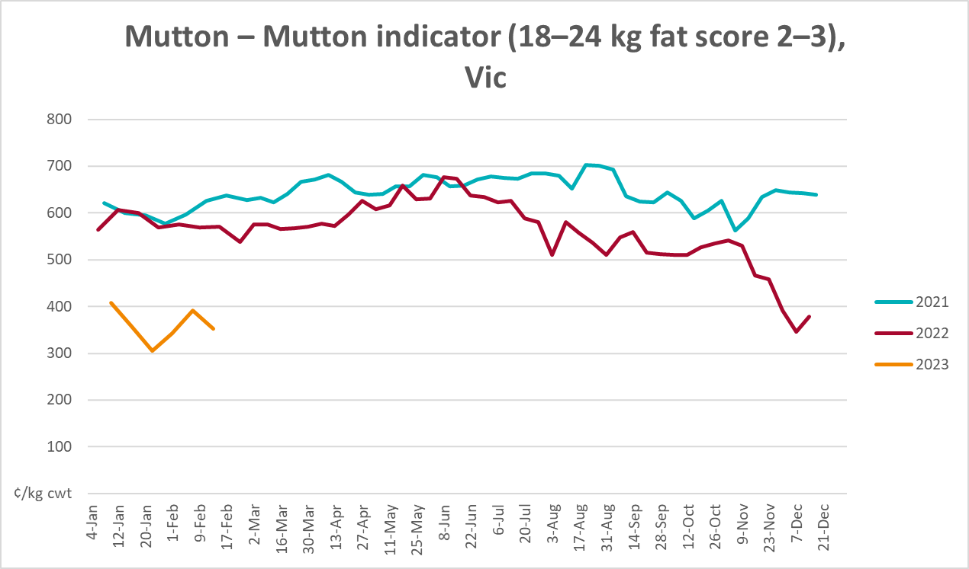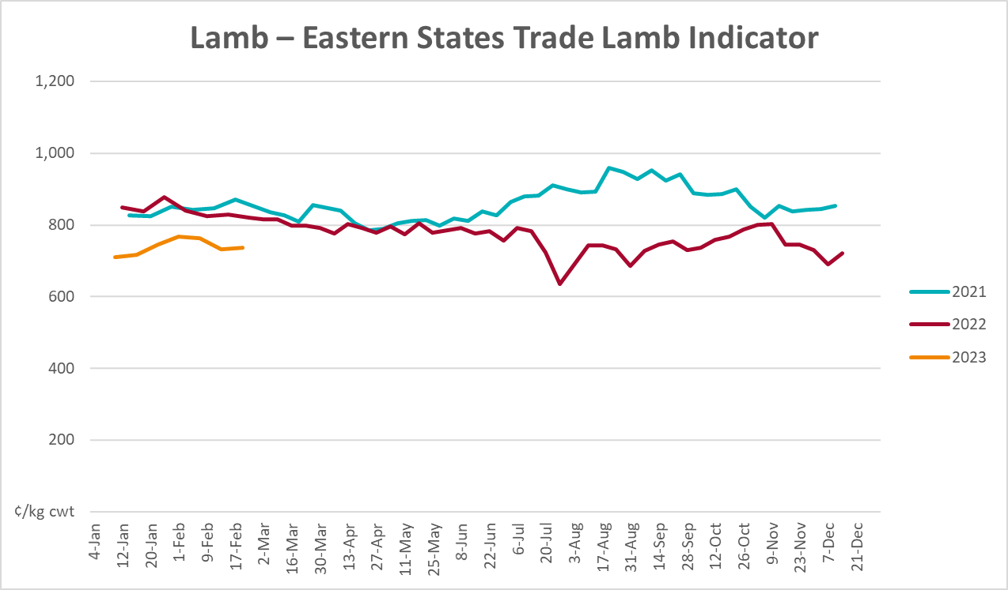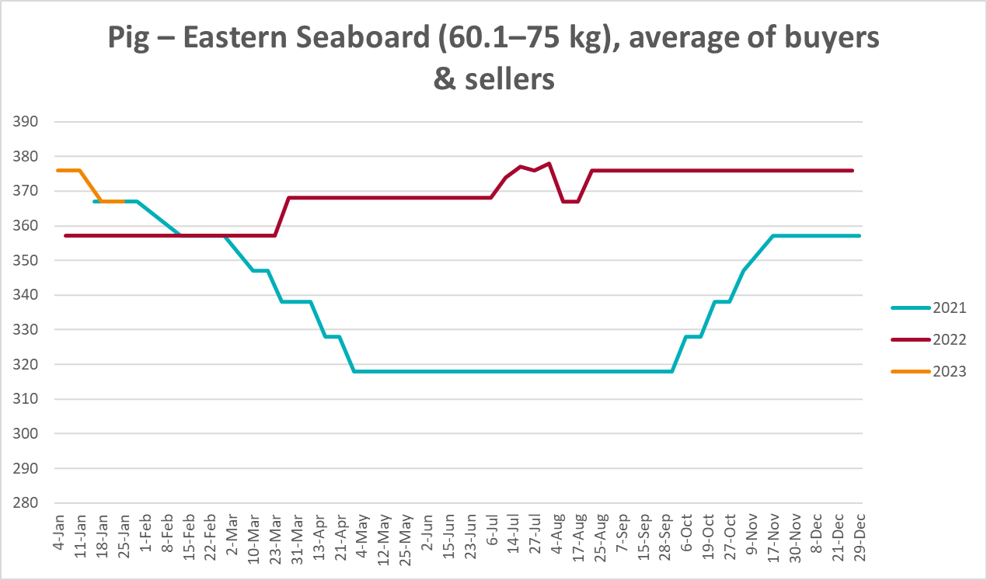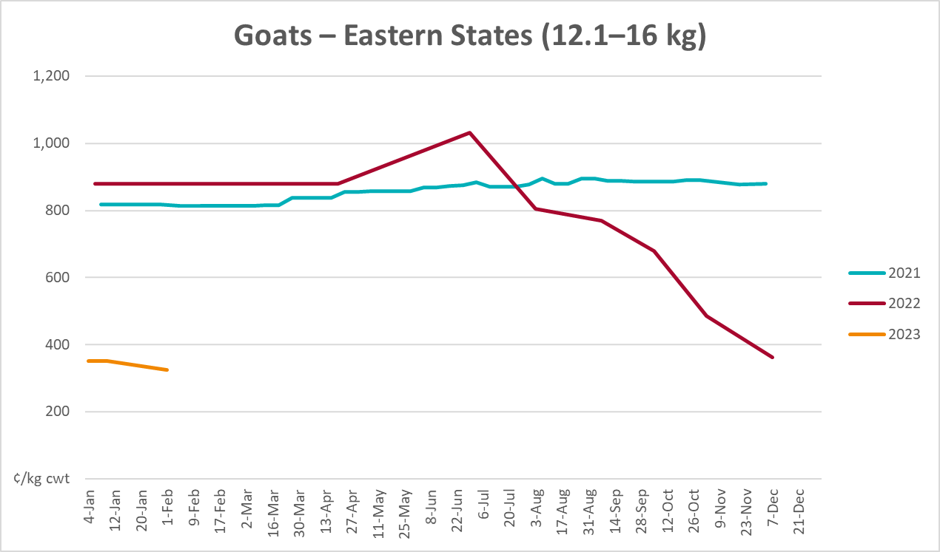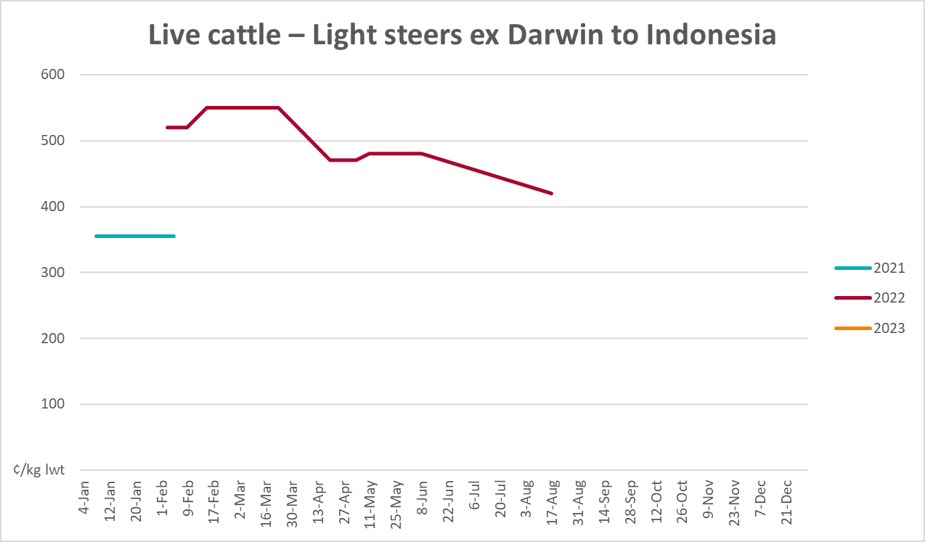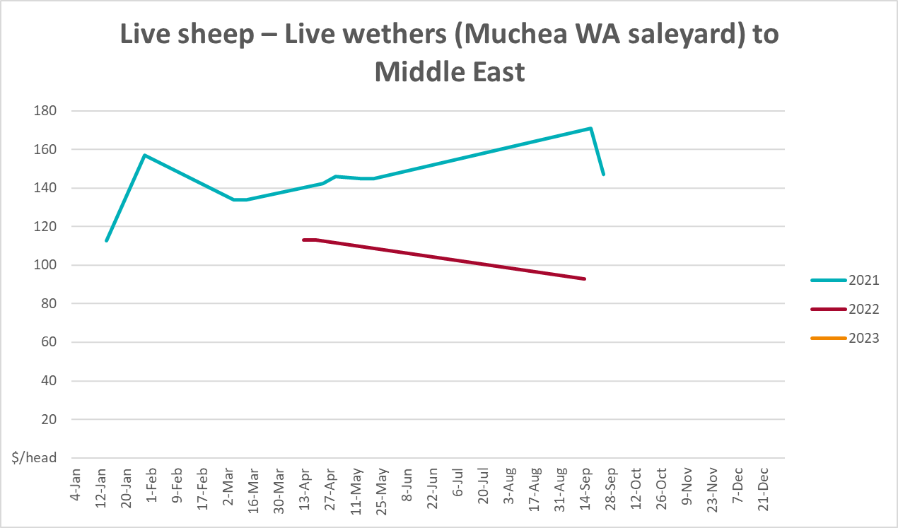

Global Dairy Trade (GDT) weighted average prices
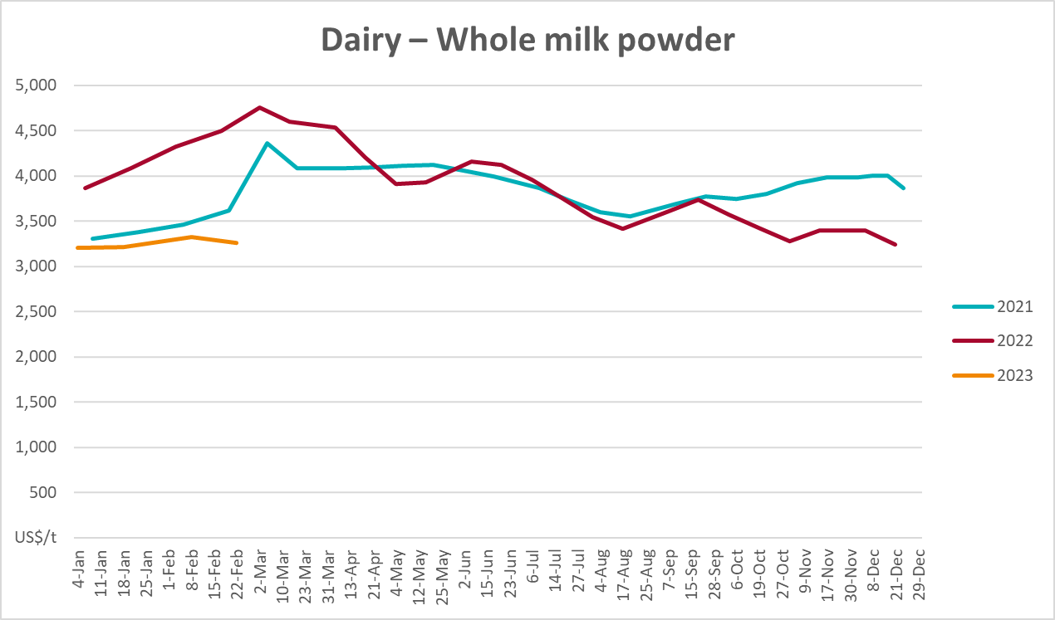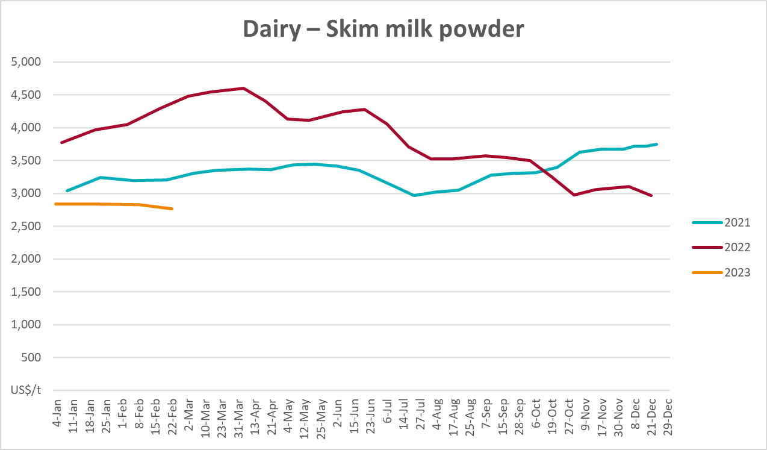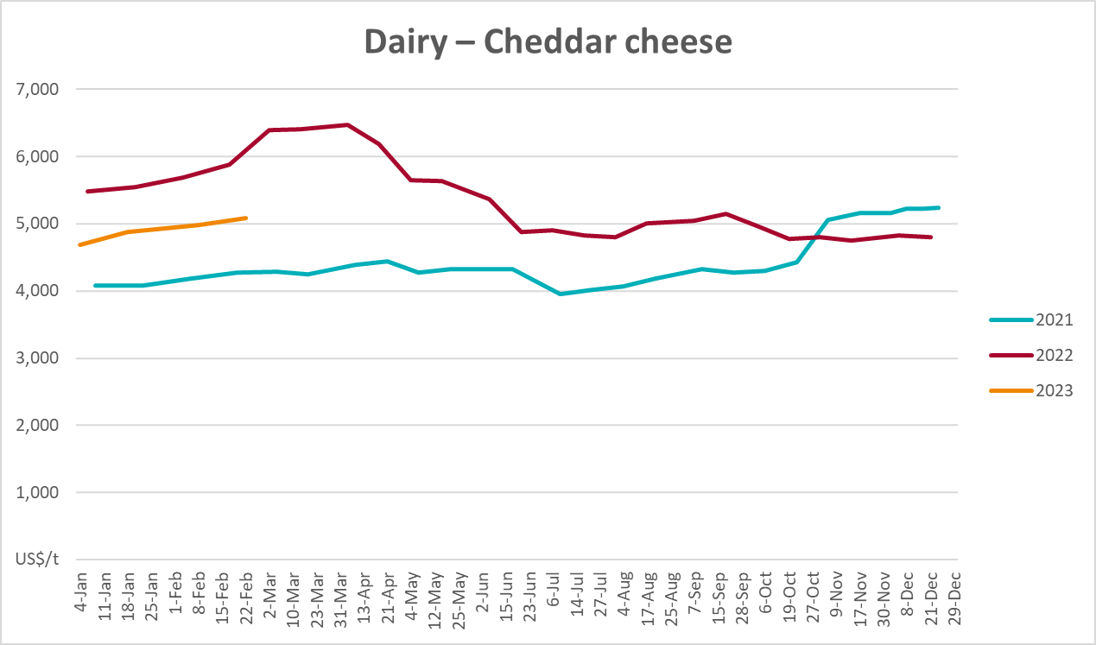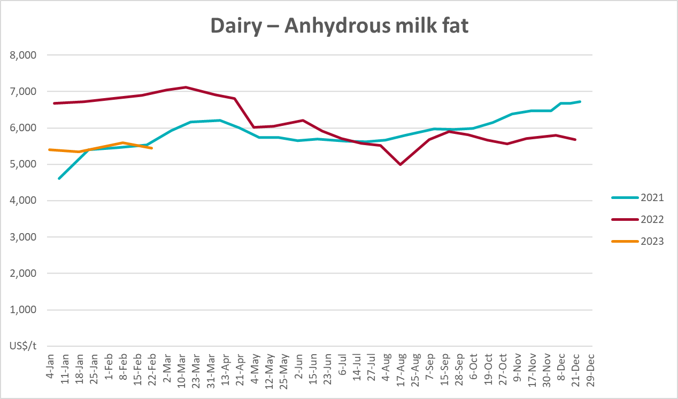

Selected fruit and vegetable prices
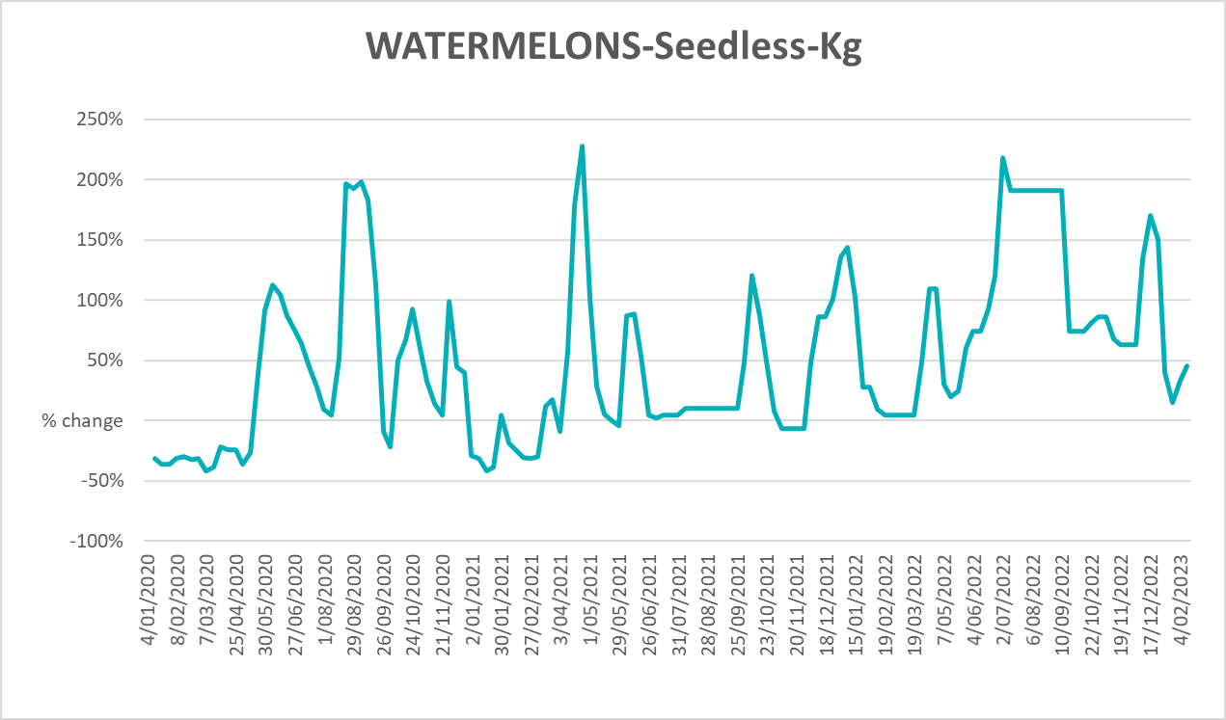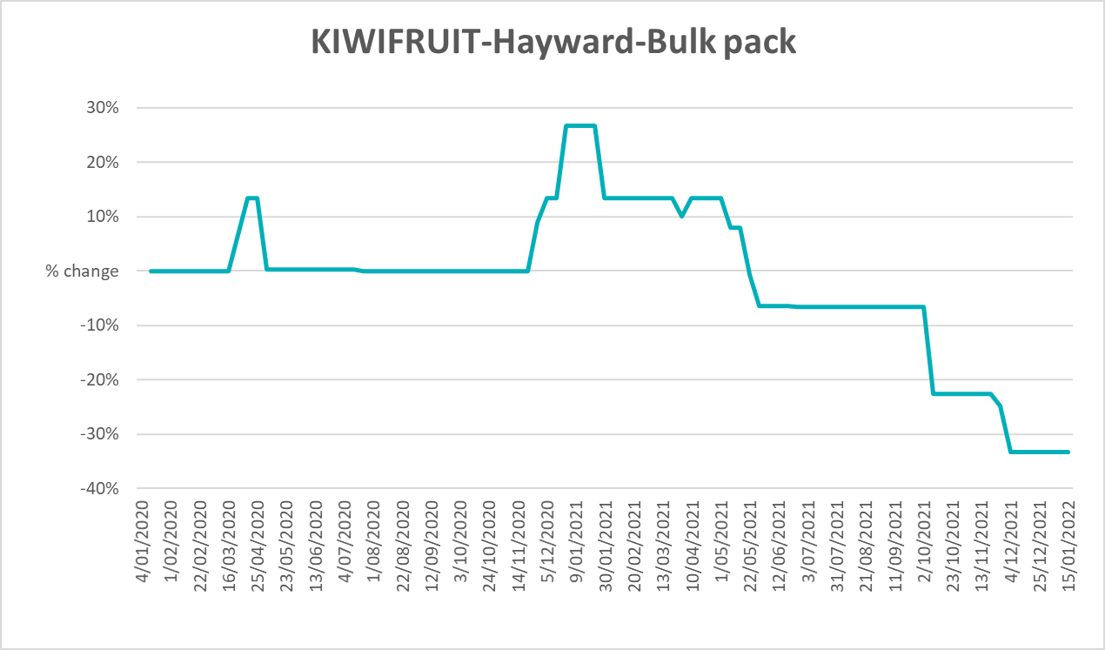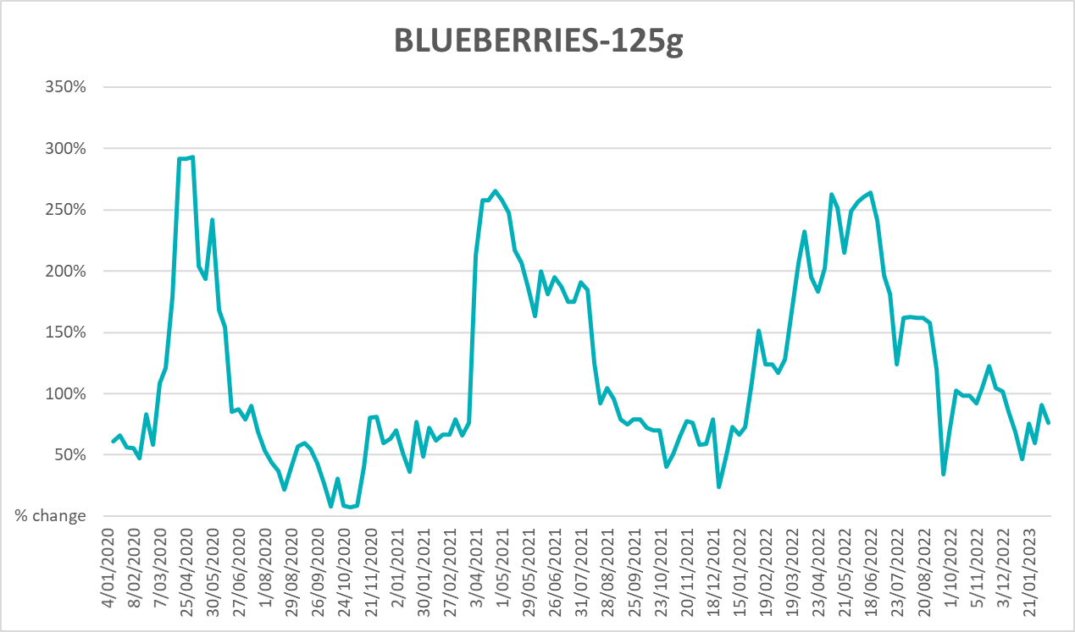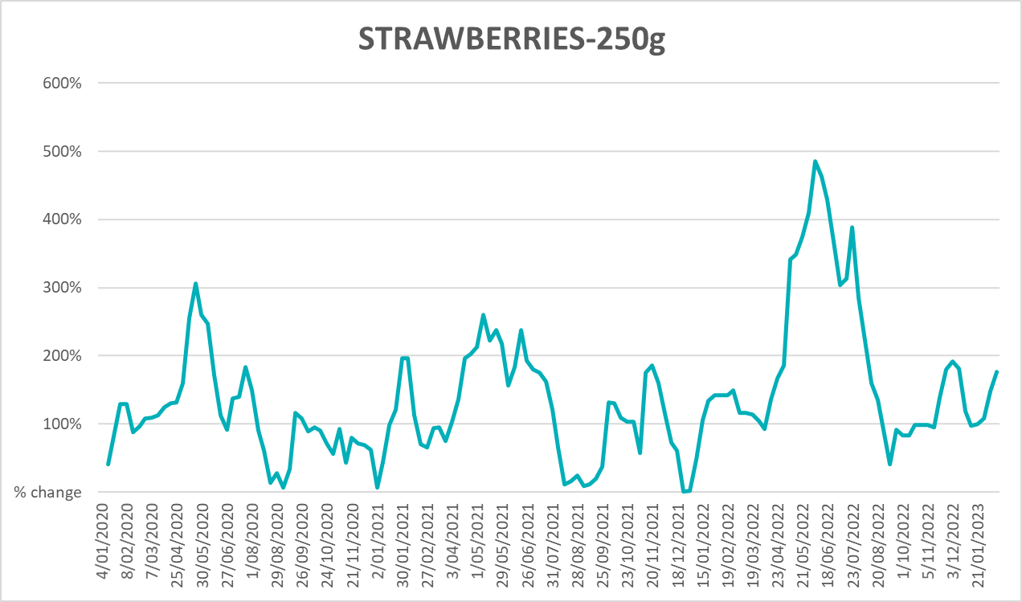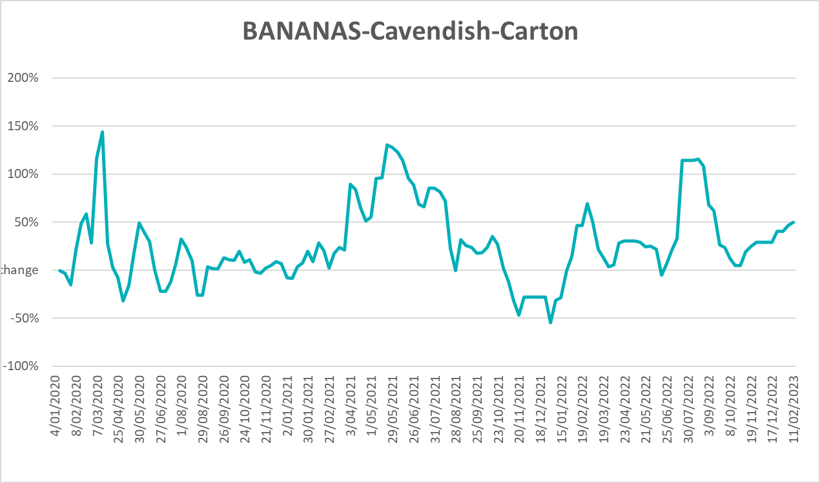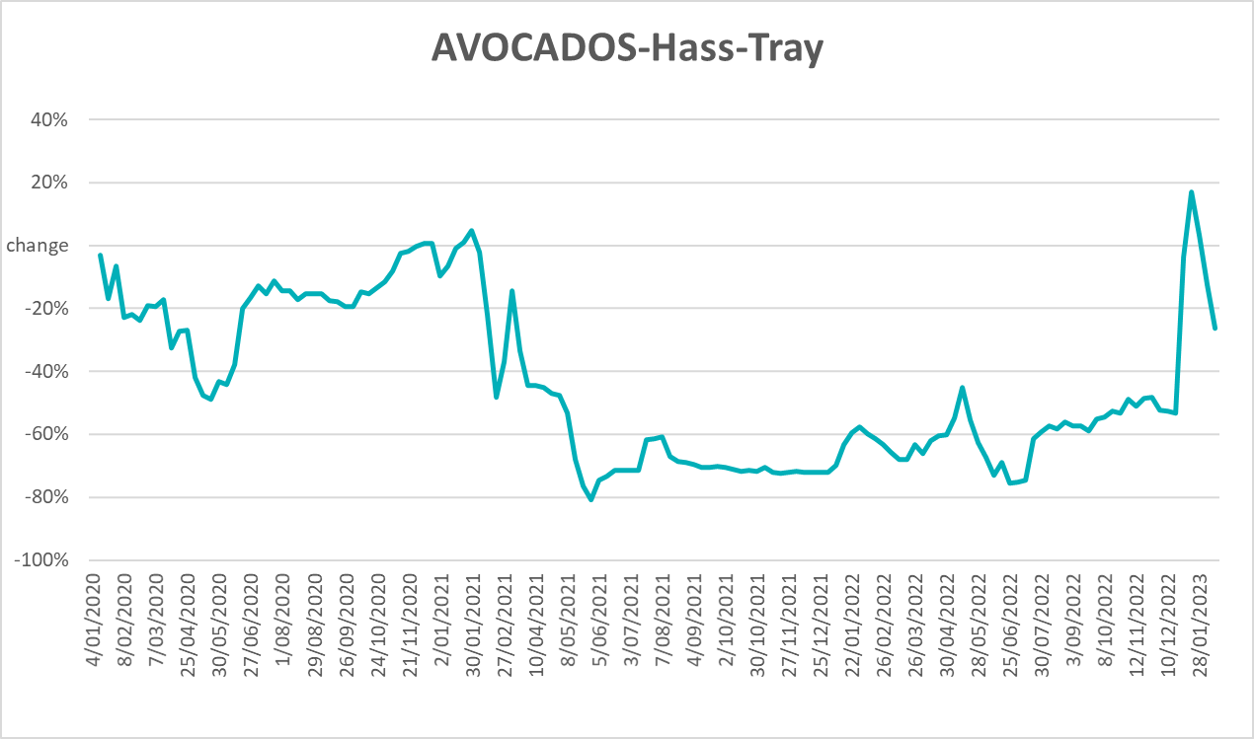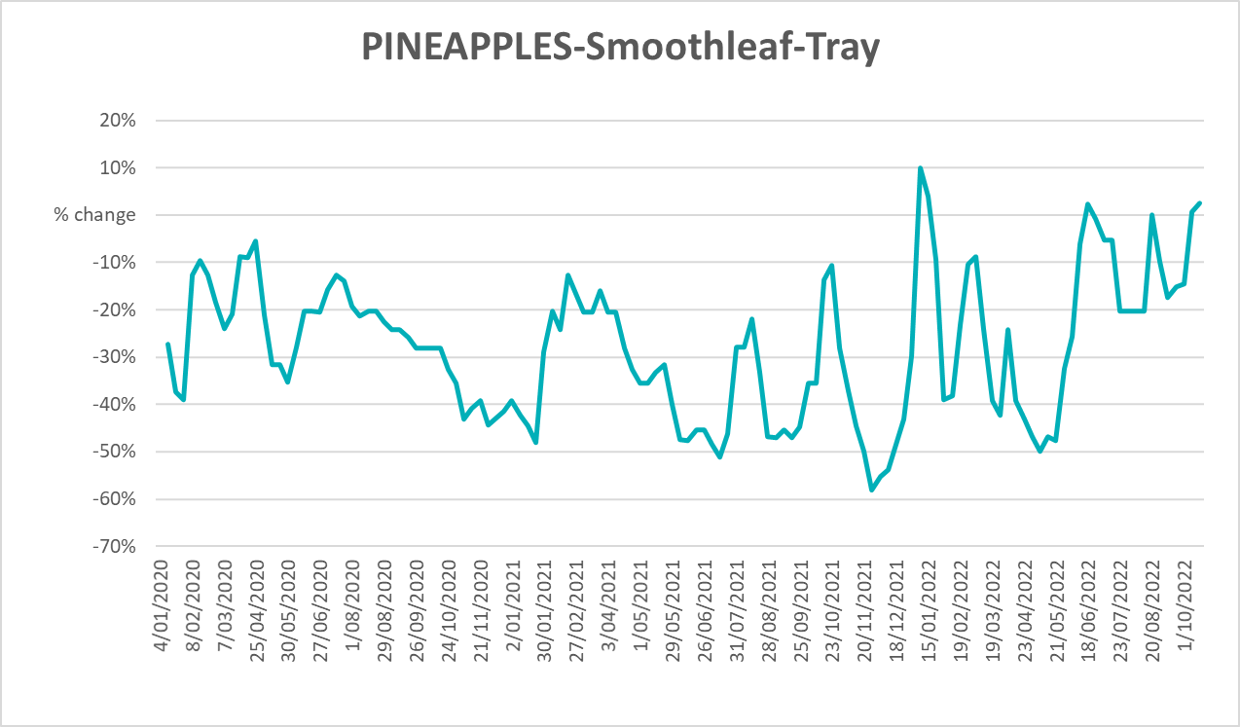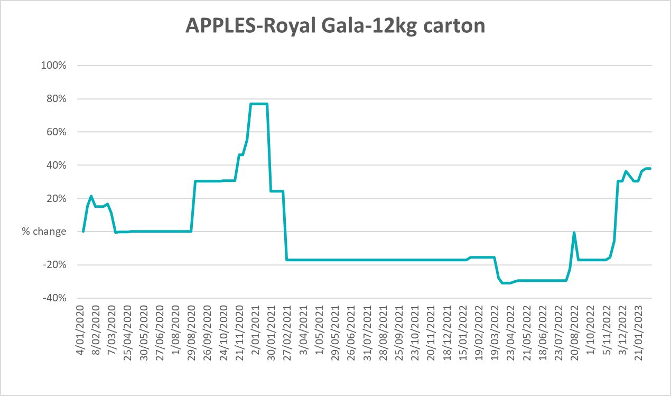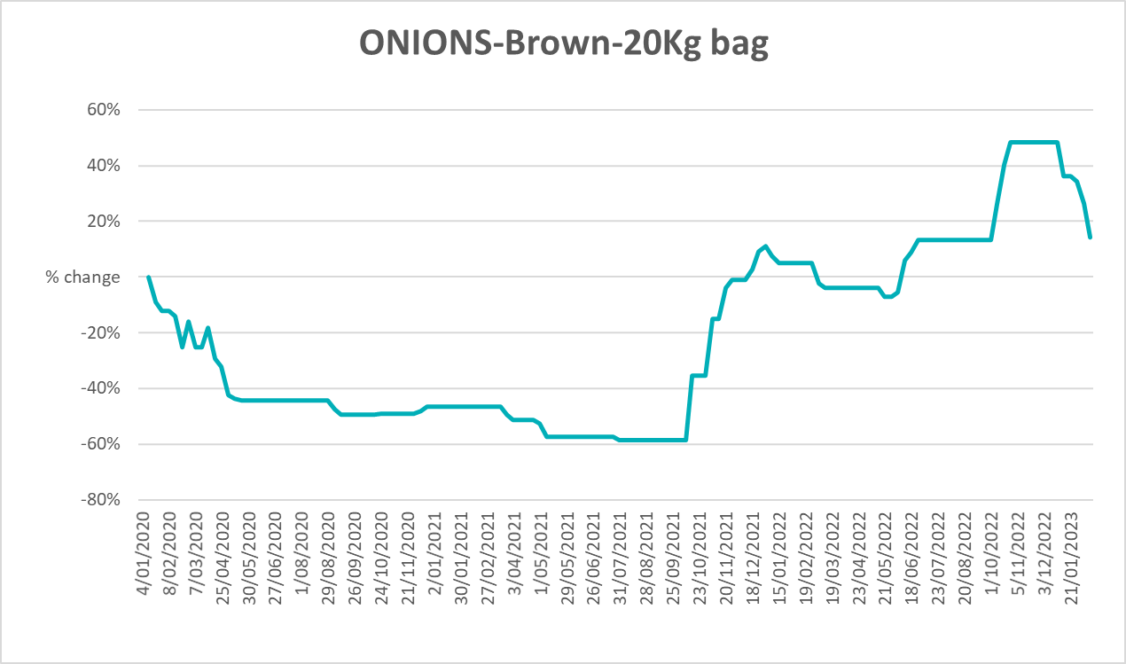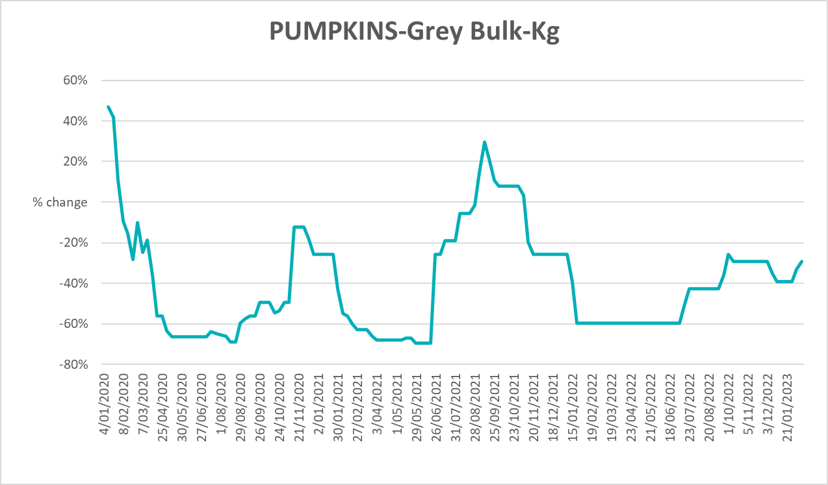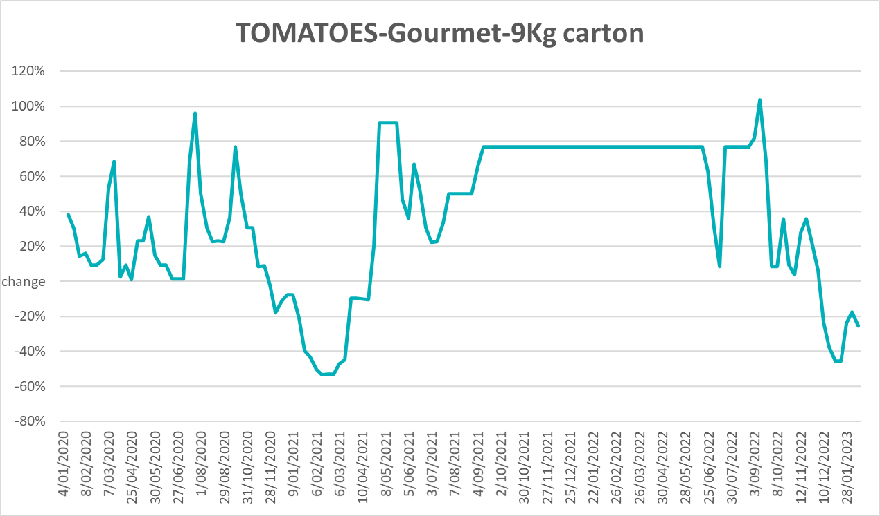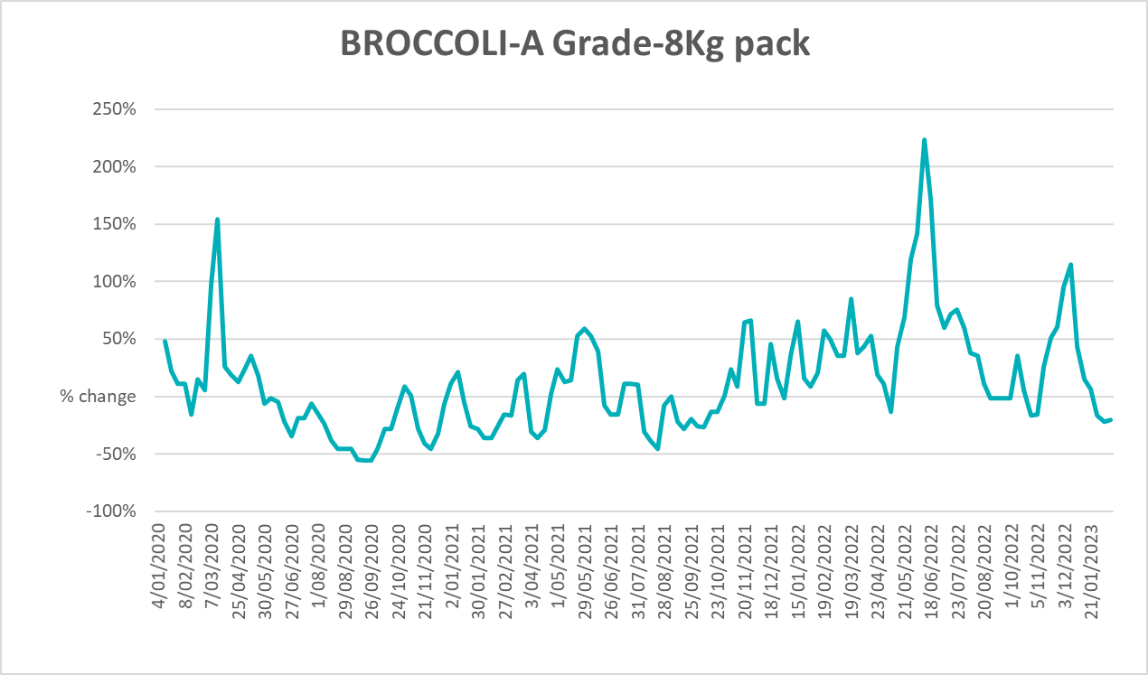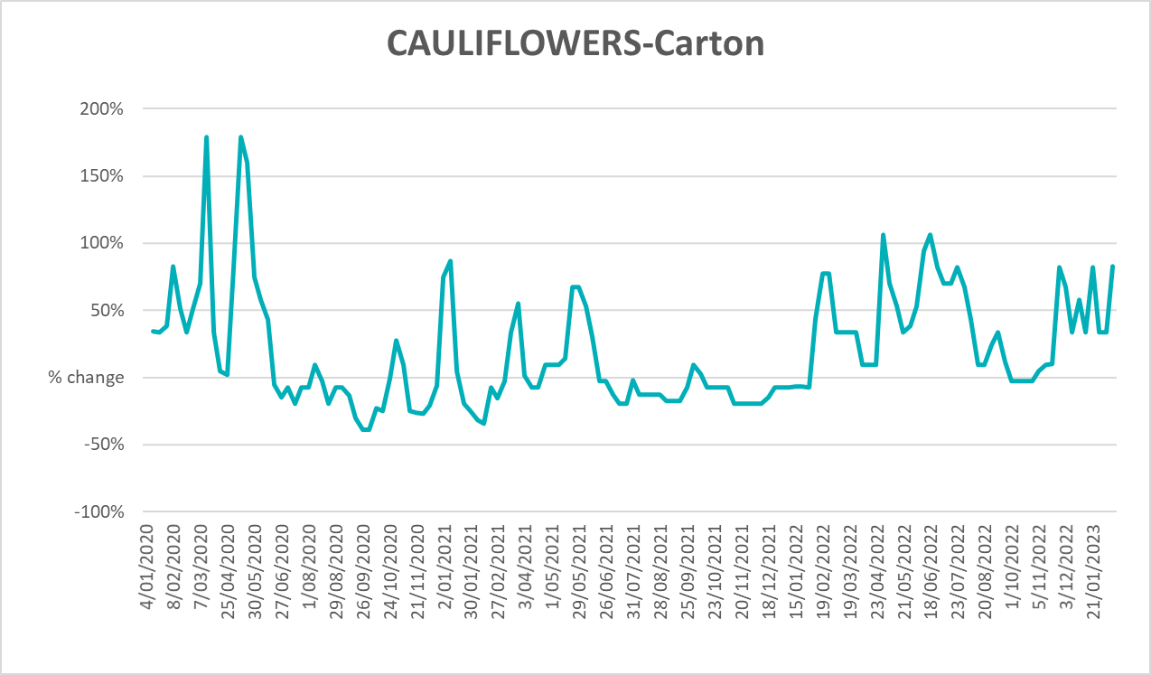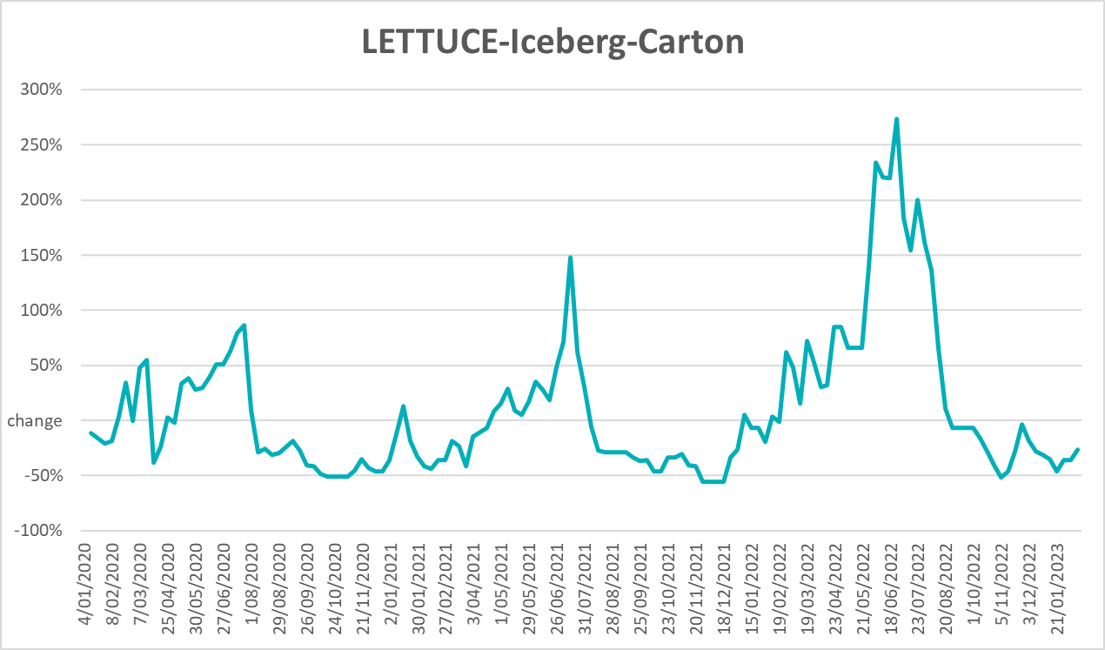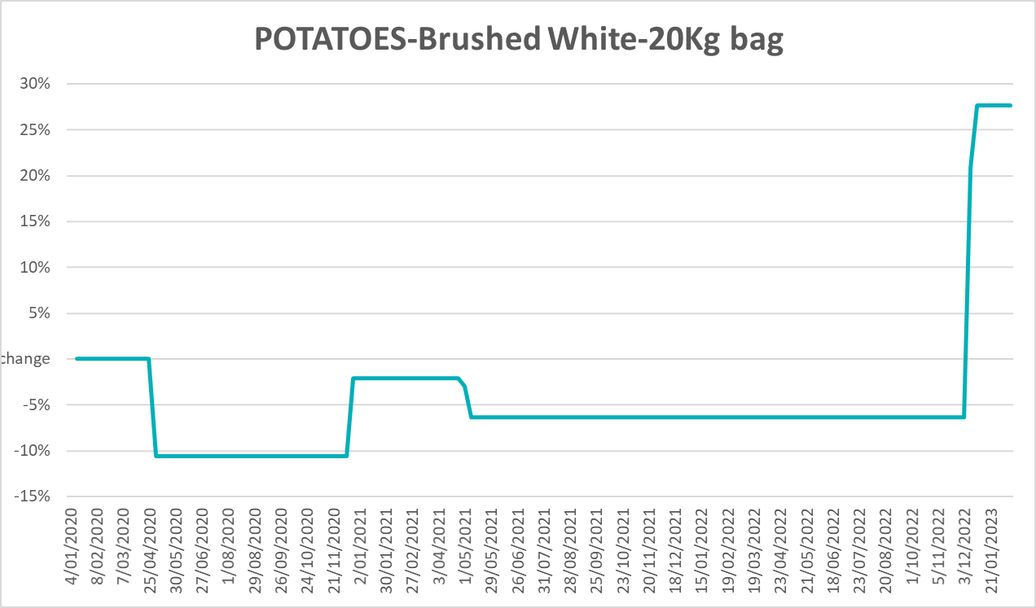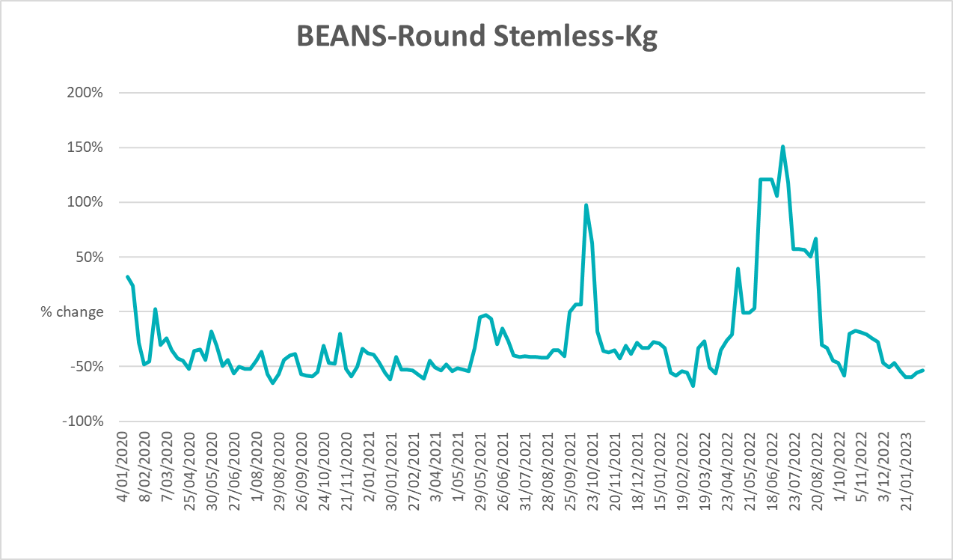

3.6 Selected domestic fodder indicator prices
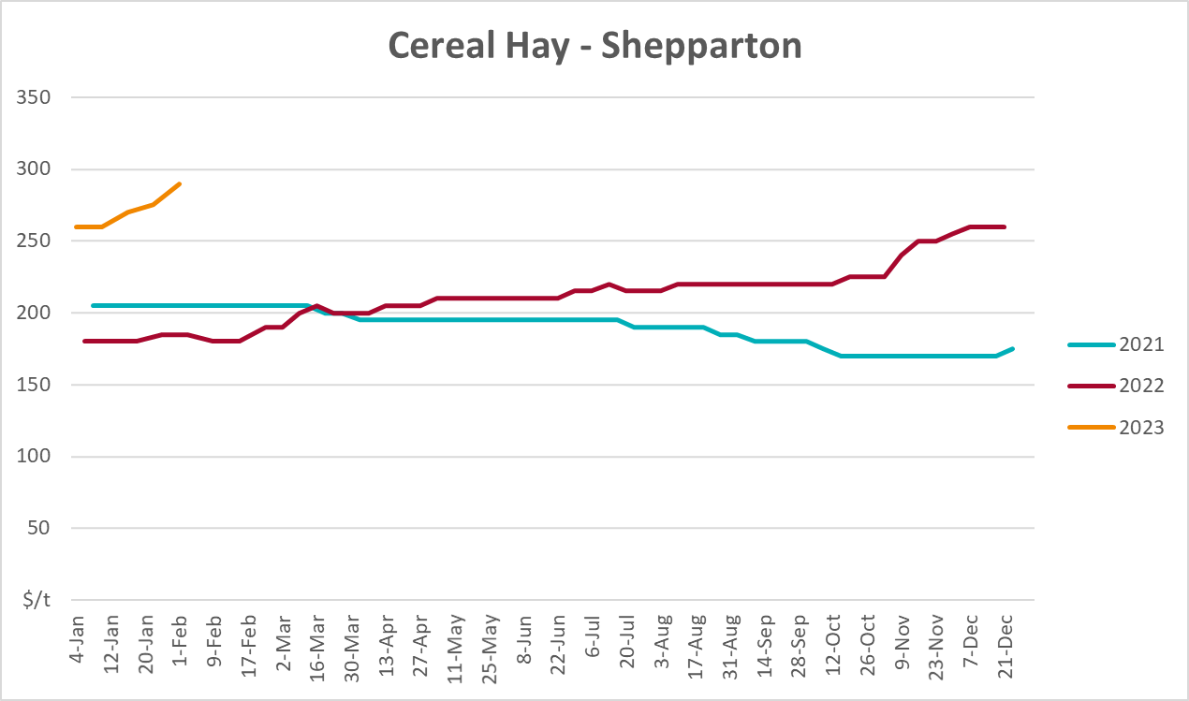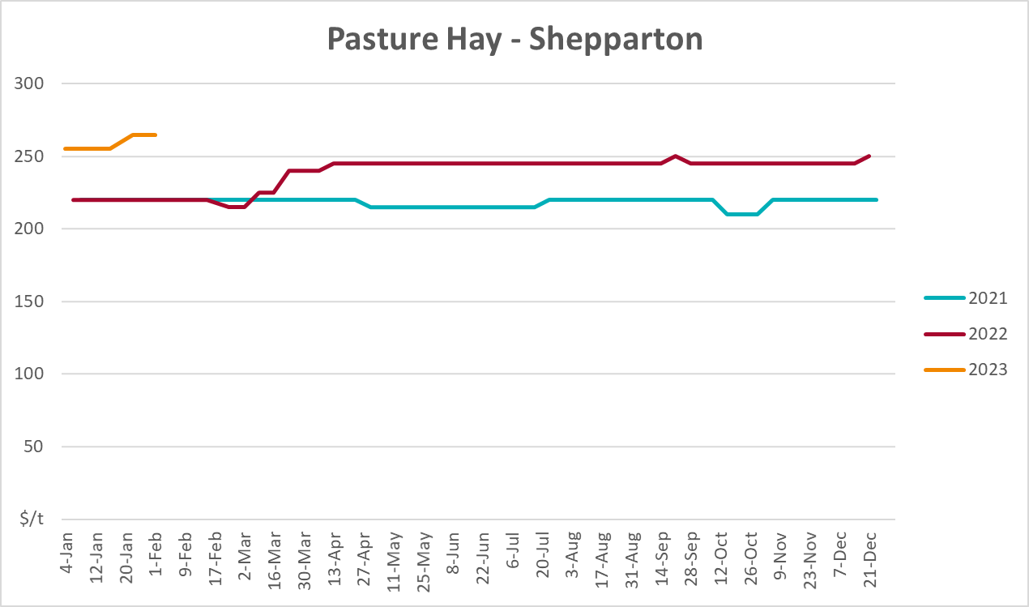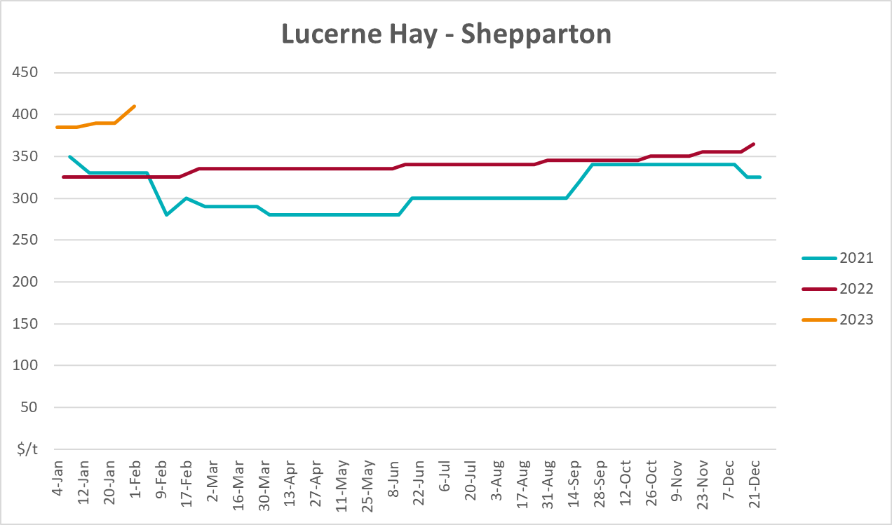

4. Data attribution

Climate
Bureau of Meteorology
- Weekly rainfall totals: www.bom.gov.au/climate/maps/rainfall/
- Monthly and last 3-month rainfall percentiles: www.bom.gov.au/water/landscape/
- Temperature anomalies: www.bom.gov.au/jsp/awap/temp/index.jsp
- Rainfall forecast: www.bom.gov.au/jsp/watl/rainfall/pme.jsp
- Seasonal outlook: www.bom.gov.au/climate/outlooks/#/overview/summary/
- Climate drivers: http://www.bom.gov.au/climate/enso/
- Soil moisture: www.bom.gov.au/water/landscape/
Other
- Pasture growth: www.longpaddock.qld.gov.au/aussiegrass/
- 3-month global outlooks: Environment and Climate Change Canada, NOAA Climate Prediction Center, EUROBRISA CPTEC/INPE, European Centre for Medium-Range Weather Forecasts, Hydrometcenter of Russia, National Climate Center Climate System Diagnosis and Prediction Room (NCC), International Research Institute for Climate and Society
- Global production: https://ipad.fas.usda.gov/ogamaps/cropmapsandcalendars.aspx
- Autumn break: Pook et al., 2009, https://rmets-onlinelibrary-wiley-com.virtual.anu.edu.au/doi/epdf/10.1002/joc.1833

Water
Prices
- Waterflow: https://www.waterflow.io/
- Ruralco: https://www.ruralcowater.com.au/
Bureau of Meteorology:
- Allocation trade: http://www.bom.gov.au/water/dashboards/#/water-markets/mdb/at
- Storage volumes: http://www.bom.gov.au/water/dashboards/#/water-storages/summary/drainage
Trade constraints:
- Water NSW: https://www.waternsw.com.au/customer-service/ordering-trading-and-pricing/trading/murrumbidgee
- Victorian Water Register: https://www.waterregister.vic.gov.au/TradingRules2019/

Commodities
Fruit and vegetables
- Datafresh: www.freshstate.com.au
Pigs
- Australian Pork Limited: www.australianpork.com.au
Dairy
- Global Dairy Trade: www.globaldairytrade.info/en/product-results/
World wheat, canola
- International Grains Council
World coarse grains
- United States Department of Agriculture
World cotton
- Cotlook: www.cotlook.com/
World sugar
- New York Stock Exchange - Intercontinental Exchange
Wool
- Australian Wool Exchange: www.awex.com.au/
Domestic wheat, barley, sorghum, canola and fodder
- Jumbuk Consulting Pty Ltd: http://www.jumbukag.com.au/
Cattle, beef, mutton, lamb, goat and live export
- Meat and Livestock Australia: www.mla.com.au/Prices-and-market
© Commonwealth of Australia 2023

Ownership of intellectual property rights
Unless otherwise noted, copyright (and any other intellectual property rights, if any) in this publication is owned by the Commonwealth of Australia (referred to as the Commonwealth).

Creative Commons licence
All material in this publication is licensed under a Creative Commons Attribution 4.0 International Licence except content supplied by third parties, logos and the Commonwealth Coat of Arms.
Inquiries about the licence and any use of this document should be emailed to copyright@awe.gov.au.


Cataloguing data
This publication (and any material sourced from it) should be attributed as:
ABARES 2023, Weekly Australian Climate, Water and Agricultural Update, Australian Bureau of Agricultural and Resource Economics and Sciences, Canberra, 23 February 2023. CC BY 4.0 DOI: https://doi.org/10.25814/5f3e04e7d2503
ISSN 2652-7561
This publication is available at https://www.agriculture.gov.au/abares/products/weekly_update
Department of Agriculture, Fisheries and Forestry
GPO Box 858 Canberra ACT 2601
Telephone 1800 900 090
Web agriculture.gov.au/abares

Disclaimer
The Australian Government acting through the Department of Agriculture, Fisheries and Forestry, represented by the Australian Bureau of Agricultural and Resource Economics and Sciences, has exercised due care and skill in preparing and compiling the information and data in this publication. Notwithstanding, the Department of Agriculture, Fisheries and Forestry, ABARES, its employees and advisers disclaim all liability, including liability for negligence and for any loss, damage, injury, expense or cost incurred by any person as a result of accessing, using or relying on any of the information or data in this publication to the maximum extent permitted by law.

Statement of Professional Independence
The views and analysis presented in ABARES publications, including this one, reflect ABARES professionally independent findings, based on scientific and economic concepts, principles, information and data. These views, analysis and findings may not reflect or be consistent with the views or positions of the Australian Government, or of organisations or groups who have commissioned ABARES reports or analysis. More information on professional independence is provided on the ABARES website.

Acknowledgements
This report was prepared by Kavina Dayal, Ruirui Zhu and Matthew Miller.

