
No. 8/2023 2 March 2023

Summary of key issues
- For the week ending 1 March 2023, storms have resulted in heavy rainfall across northern parts of the country with weekly totals exceeding 150 millimetres from the eastern Kimberley (Western Australia), through the Northern Territory Top End and the Cape York Peninsula (Queensland).
- Little to no rainfall was recorded in the cropping regions over the past 7 days. Ongoing dry conditions across most summer cropping regions would have allowed for uninterrupted access to fields for crop maintenance activities and for the harvesting of early sown crops. However, in regions with below average soil moisture levels, little to no rainfall is likely to have negatively affected the growth and yield potential of late sown summer crops (see Section 1.1).
- Rainfall during February 2023 was slightly above average for Australia as a whole. However, February rainfall was below average across most cropping regions in Queensland, northern and southern New South Wales, eastern South Australia and in the western half of the Western Australia (see Section 1.2).
- Summer rainfall has been variable across Australia but was 27% above the long-term average for Australia as a whole. A La Niña event throughout the summer contributed to above average rainfall for parts of Queensland, with some regions recording their highest total summer rainfall on record. Summer rainfall has been above average in the north, but below average across much of southern Australia, including north-eastern New South Wales, south-eastern Queensland and southern Western Australia. (see Section 1.3).
- For the 3 months to February 2023, above average rainfall totals and mild summer temperatures resulted in average to well above average pasture production for this time of year across most grazing regions. Average to extremely high pasture production across central New South Wales, much of Queensland, parts of South Australia, southern Victoria, western Tasmania, northern Western Australia and much of Northern Territory is likely to have enabled farmers to continue rebuilding stock numbers and provide opportunities to replenish fodder supplies during early summer (see Section 1.5).
- Over the 8-days to 9 March 2023, rainfall totals exceeding 150 millimetres are expected across northern tropic of Australia. Rainfall totals in excess of 50 millimetres are expected for the Kimberly region of Western Australia, the Cape York Peninsula of Queensland, and for western Tasmania. Little to no rainfall is forecast for the remaining areas of Australia for the next eight days (see Section 1.6).
- Water storage levels in the Murray-Darling Basin (MDB) decreased between 22 February 2023 and 1 March 2023 by 237 gigalitres (GL). Current volume of water held in storage is 22 816 GL which represents 90 per cent of total capacity. This is 2 percent or 408 GL more than at the same time last year.
- Allocation prices in the Victorian Murray below the Barmah Choke decreased from $15 per ML on 23 February 2023 to $9 per ML on 2 March 2023. Prices are lower in the Murrumbidgee due to the binding of the Murrumbidgee export limit.

Climate

Rainfall this week
For the week ending 1 March 2023, a tropical low-pressure system brought storms and heavy rainfall to the northern tropics of the country with weekly totals exceeding 150 millimetres from the northern Kimberley (Western Australia), through the Top End of the Northern Territory and the Cape York Peninsula (Queensland). Meanwhile, weekly rainfall totals of between 25 and 100 millimetres were recorded along coastal New South Wales, northern and central Western Australia, and parts of Tasmania.
Little to no rainfall was recorded across the cropping regions over the past 7 days. Ongoing dry conditions across most summer cropping regions would have allowed for uninterrupted access to fields for crop maintenance activities and for the harvesting of early sown crops. However, in regions with below average soil moisture levels, little to no rainfall is likely to have negatively affected the growth and yield potential of late sown summer crops.

Rainfall for the week ending 1 March 2023
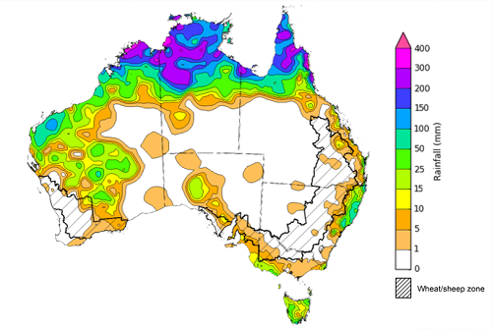
©Commonwealth of Australia 2023, Australian Bureau of Meteorology Issued: 01/03/2023
Note: The rainfall analyses and associated maps utilise data contained in the Bureau of Meteorology climate database, the Australian Data Archive for Meteorology (ADAM). The analyses are initially produced automatically from real-time data with limited quality control. They are intended to provide a general overview of rainfall across Australia as quickly as possible after the observations are received. For further information go to http://www.bom.gov.au/climate/rainfall/

Monthly Rainfall
For Australia as a whole, rainfall during February 2023 was around 4% above the 1961-1990 average. Rainfall was above average for much of the Northern Territory away from the southern districts, most of north-western Queensland and the Cape York Peninsula, and for south-west Victoria, and a pocket of northern and central Western Australia. For both Queensland and the Northern Territory, area-averaged February rainfall was the highest since 2014. In contrast, rainfall was below average for much of eastern and southern Queensland, New South Wales extending into adjacent eastern South Australia, parts of northern and eastern Victoria, the Southwest Land Division and much of the interior of Western Australia, extending to the Nullarbor coast and coastal South Australia.
Rainfall across Australia in February was likely influenced by a weakening La Niña in the tropical Pacific, and monsoonal activity across the north associated with a pulse of the Madden-Julian Oscillation.
February rainfall was below average across much of the cropping regions in Queensland, northern and southern New South Wales, eastern South Australia and in the western half of the Western Australia. Average February rainfall was recorded across the remaining cropping regions. These below average falls have likely negatively affected the growth and yield prospects of later sown summer crops in Queensland and northern New South Wales.

Rainfall percentiles for February 2023

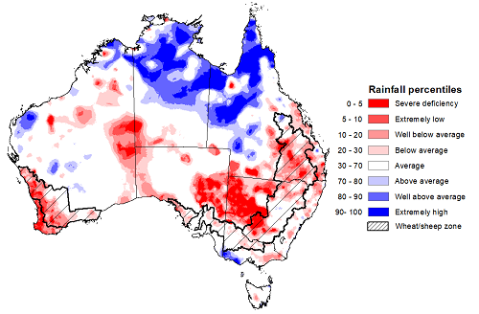
Note: Rainfall for February 2023 is compared with rainfall recorded for that period during the historical record (1900 to present). For further information, go to http://www.bom.gov.au/jsp/awap/
Source: Bureau of Meteorology

Seasonal Rainfall
Summer rainfall was variable across Australia but was 27% above the long-term average for Australia as a whole. Much of northern Australia experienced a wetter than normal summer, while large areas of eastern and southern Australia recorded below average rainfall over summer as the influence of La Niña started to wane. Despite the influence of the 2022-23 La Niña event starting to wane during summer, parts of Queensland recorded extremely high rainfall, with some regions recording their highest summer rainfall total on record. However, high pressure systems and weaker than average westerly winds to the south led to below average rainfall to many coastal regions in southern Australia.
The season began with above average rainfall during December for Australia as a whole, although much of the rainfall occurred across northern and western parts of Australia. The above average rainfall at the start of summer followed one of the wettest Novembers on record, boosting soil moisture levels across summer cropping regions. Continued rainfall into early January will have supported yield potentials through critical periods of flowering and grain filling for early sown crops, while dry conditions in late January and much of February allowed field access for harvesting activities.
Owing to the favourable soil moisture conditions at sowing, the yield potential of early sown summer crops across northern New South Wales and southern Queensland remains well above average despite extremely low rainfall over the summer period. However, the yield prospects for later sown crops have been reduced by the lack of summer rainfall. Timely and adequate rainfall during autumn will be critical to the ongoing development of dryland summer crops and prevent any further reduction in yields.

Rainfall percentiles for summer 2023 (1 December 2022 to 28 February 2023)
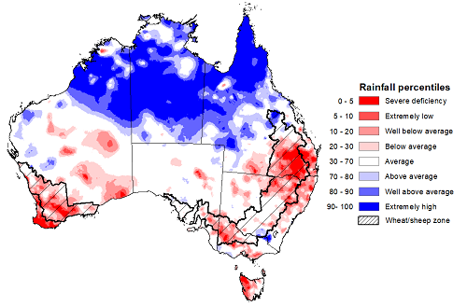
Note: Rainfall for December 2022 to February 2023 is compared with rainfall recorded for that period during the historical record (1900 to present). For further information, go to http://www.bom.gov.au/jsp/awap/
Source: Bureau of Meteorology

Monthly Soil Moisture
Modelled upper layer soil moisture for February 2023 was variable across Australia. It had significantly geographic differences between the north and south of Australia, reflecting the spatial pattern of rainfall during February 2023. Extremely low upper soil moisture was evident for south-eastern Queensland, parts of western New South Wales and southwest Western Australia, as well as parts of western Tasmania. Above average upper layer moisture was evident across far north and central Queensland, southern Victoria, the central and northern areas of the Northern Territory, parts of central and west Western Australia. Upper layer soil moisture was generally average elsewhere.
At this time of year, upper layer soil moisture is important for late planted summer crops in the Central Queensland growing region and for pasture growth across northern Australia since plant germination and establishment utilise this moisture. It is also an important indicator of the ability to access paddocks for crop harvesting and planting activities.
Upper layer soil moisture was extremely low to average for this time of year across most of cropping regions, except for the central New South Wales where it was above average. Low levels of upper layer soil moisture would have allowed paddock access to harvest early planted summer crops for northern cropping region. However, a lack of upper layer soil moisture is likely to have negatively affected the establishment and yield potential of later sown crops.

Modelled upper layer soil moisture for February 2023
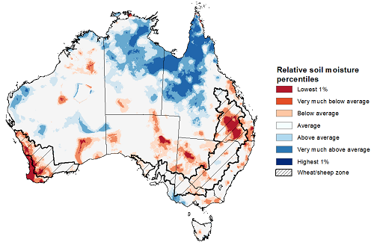
Note: This map shows the levels of modelled upper layer soil moisture (0 to 10 centimetres) during February 2023. This map shows how modelled soil conditions during February 2023 compare with the February conditions modelled over the reference period (1911 to 2016). Dark blue areas on the maps were much wetter in February 2023 than during the reference period. The bulk of plant roots occur in the top 20 centimetres of the soil profile. Soil moisture in the upper layer of the soil profile is therefore useful indicator of the availability of water, particularly for germinating seed.
Source: Bureau of Meteorology (Australian Water Resources Assessment Landscape model)

Lower layer soil moisture for February 2023 was well above average to extremely high for this time of year across northern and central Queensland, much of the Northern Territory, parts of Western Australia, South Australia, Victoria and New South Wales.
Lower layer soil moisture is important to support summer crops and pasture growth during the peak growth period. In Australian cropping regions, lower layer soil moisture was extremely low in the southern Queensland and Western Australia, while it was average in the remaining cropping regions.

Modelled lower layer soil moisture for February 2023
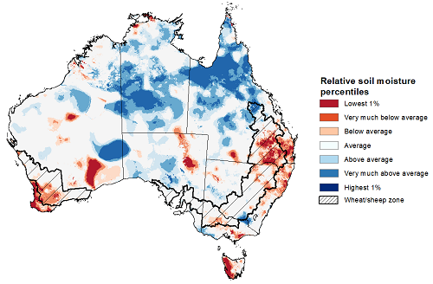
Note: This map shows the levels of modelled lower layer soil moisture (10 to 100 centimetres) during February 2023. This map shows how modelled soil conditions during February 2023 compare with January conditions modelled over the reference period (1911 to 2016). Dark blue areas on the maps were much wetter in February 2023 than during the reference period. The dark red areas were much drier than during the reference period. The bulk of plant roots occur in the top 20 centimetres of the soil profile. The lower layer soil moisture is a larger, deeper store that is slower to respond to rainfall and tends to reflect accumulated rainfall events over longer time periods.
Source: Bureau of Meteorology (Australian Water Resources Assessment Landscape model)

Pasture Growth
December to February is the peak pasture growth period for northern Australia which typically provides the bulk of feed to maintain production through the low pasture growth months of the northern dry season. Across southern Australia, December to February pasture growth is typically low reflecting lower rainfall totals, high temperatures and high evapotranspiration rates at this time of year. Pasture availability during this period influences the growth, branding and marking rates of lambs and calves, livestock turnoff and the production of meat, milk, and wool.
For the 3 months to February 2023, above average rainfall totals and mild summer temperatures resulted in average to well above average pasture production for this time of year across most grazing regions. However, extremely low to below average pasture growth rates were recorded across southwest and central Western Australia, northern Victoria, across much of New South Wales, and in the southeast Queensland consistent with above average temperatures and/or below average rainfall.
Average to extremely high pasture production occurred across central New South Wales, much of Queensland, parts of South Australia, southern Victoria, western Tasmania, northern Western Australia and much of Northern Territory. This will likely enable farmers to continue to rebuild stock numbers and provide opportunities to build standing dry matter availability. Above average rainfall in southern Victoria would allow above average pasture availability and ample opportunities to conserve excess fodder.

Relative pasture growth for 3-months ending February 2023 (1 December 2022 to 28 February 2023)
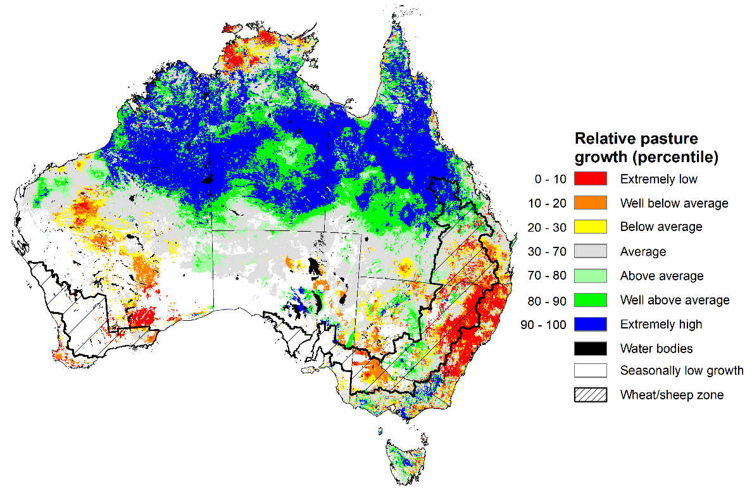
Notes: AussieGRASS pasture growth estimates are relative to the long-term record and shown in percentiles. Percentiles rank data on a scale of zero to 100. This analysis ranks pasture growth for the selected period against average pasture growth for the long-term record (1957 to 2016). Pasture growth is modelled at 5km2 grid cells.
Source: Queensland Department of Science, Information Technology, and Innovation

Rainfall forecast for the next eight days
Over the 8-days to 9 March 2023, a monsoon trough and embedded tropical low in northern Australia is expected to trigger intense rain and storms across Australia’s northern tropics. Meanwhile, low-pressure troughs across eastern Australia are expected to bring scattered rainfall to the eastern coast of New South Wales, Victoria and western Tasmania. A trough will bring showers in the northwest Western Australia. A high pressure system is bringing mainly dry conditions elsewhere.
Rainfall totals exceeding 150 millimetres are expected across the northern tropics of Australia. Rainfall totals in excess of 50 millimetres are expected for the Kimberly region of Western Australia, the Cape York Peninsula of Queensland, much of the north of the Northern Territory and for western Tasmania. Little to no rainfall is forecast for the remaining area of Australia for the next eight days.
Across Australian cropping regions, little to no rainfall is expected in the next 8 days. This would further improve access to the fields for crop maintenance activities and allow for the harvest of early sown crops to continue for the summer cropping regions in New South Wales and Queensland. If realised, continued dry conditions in regions with low levels of soil moisture is likely to lead to further yield reductions for late sown summer crops. The forecast rainfall over much of northern Australia is likely to benefit pasture growth rates and availability.

Total forecast rainfall for the period 2 March to 9 March 2023
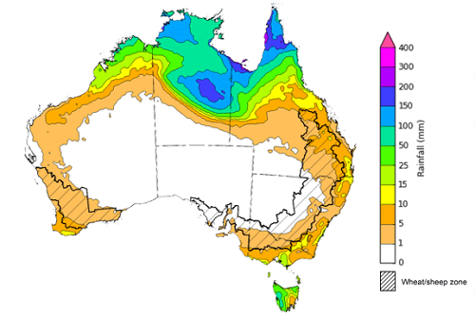

©Commonwealth of Australia 2023, Australian Bureau of Meteorology Issued 02/03/2023
Note: This rainfall forecast is produced from computer models. As the model outputs are not altered by weather forecasters, it is important to check local forecasts and warnings issued by the Bureau of Meteorology.

Water

Water markets – current week
Water storage levels in the Murray-Darling Basin (MDB) decreased between 22 February 2023 and 1 March 2023 by 237 gigalitres (GL). Current volume of water held in storage is 22 816 GL which represents 90 per cent of total capacity. This is 2 percent or 408 GL more than at the same time last year.

Water storages in the Murray-Darling Basin, 2013–2023
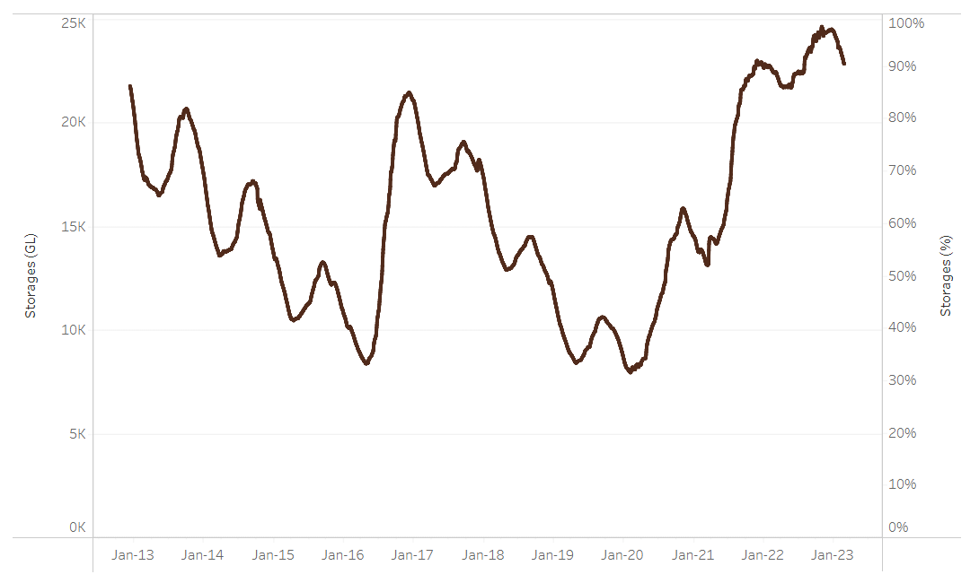
Water storage data is sourced from the Bureau of Meteorology.
Allocation prices in the Victorian Murray below the Barmah Choke decreased from $15 per ML on 23 February 2023 to $9 per ML on 2 March 2023. Prices are lower in the Murrumbidgee due to the binding of the Murrumbidgee export limit.
Region | $/ML
NSW Murray Above | 7
NSW Murrumbidgee | 9
VIC Goulburn-Broken | 14
VIC Murray Below | 15

Surface water trade activity, Southern Murray–Darling Basin
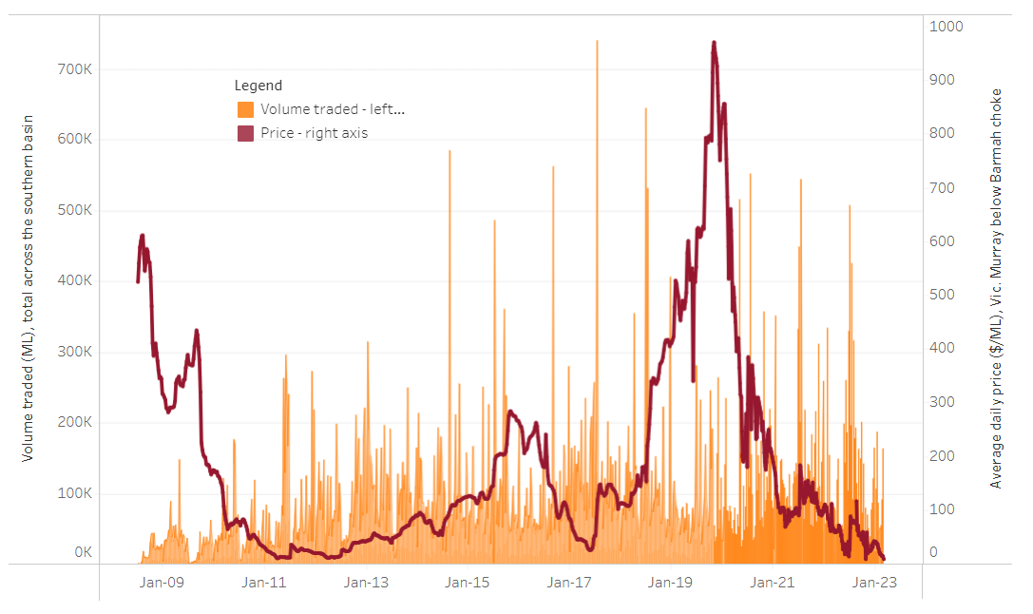
The trades shown reflect estimated market activity and do not encompass all register trades. The price is shown for the VIC Murray below the Barmah choke. Historical prices (before 1 July 2019) are ABARES estimates after removing outliers from BOM water register data. Prices after 1 July 2019 and prior to the 30 October 2019 reflect recorded transaction prices as sourced from Ruralco. Prices after the 30 October 2019 are sourced from Waterflow. Data for volume traded is sourced from the BOM water register. Data shown is current on 2 March 2023.

To access the full, interactive, weekly water dashboard, which contains the latest and historical water storage, water market and water allocation information, please visit http://www.agriculture.gov.au/abares/products/weekly_update/weekly-update-020323

Commodities
Indicator | Week ended | Unit | Latest Price | Previous Week | Weekly change | Price 12 months ago | Annual change
Selected world indicator prices
AUD/USD Exchange rate | 01-Mar | A$/US$ | 0.68 | 0.69 | -2% | 0.73 | -8%
Wheat – US no. 2 hard red winter wheat, fob Gulf | 01-Mar | US$/t | 377 | 404 | -7% | 499 | -24%
Corn – US no. 2 yellow corn, fob Gulf | 01-Mar | US$/t | 290 | 301 | -4% | 337 | -14%
Canola – Rapeseed, Canada, fob Vancouver | 01-Mar | US$/t | 658 | 667 | -1% | 930 | -29%
Cotton – Cotlook 'A' Index | 01-Mar | USc/lb | 98 | 97 | 1% | 134 | -27%
Sugar – Intercontinental Exchange, nearby futures, no.11 contract | 01-Mar | USc/lb | 20.1 | 19.9 | 1% | 19 | 5%
Wool – Eastern Market Indicator | 08-Feb | Ac/kg clean | 1,374 | 1,400 | -2% | 1,346 | 2%
Wool – Western Market Indicator | 08-Feb | Ac/kg clean | 1,525 | 1,570 | -3% | 1,368 | 11%
Selected Australian grain export prices
Milling Wheat – APW, Port Adelaide, SA | 01-Mar | A$/t | 499 | 509 | -2% | 564 | -12%
Feed Wheat – ASW, Port Adelaide, SA | 01-Mar | A$/t | 467 | 503 | -7% | 529 | -12%
Feed Barley – Port Adelaide, SA | 01-Mar | A$/t | 409 | 414 | -1% | 435 | -6%
Canola – Kwinana, WA | 01-Mar | A$/t | 971 | 1,051 | -8% | 1,144 | -15%
Grain Sorghum – Brisbane, QLD | 01-Mar | A$/t | 509 | 505 | 1% | 374 | 36%
Selected domestic livestock indicator prices
Beef – Eastern Young Cattle Indicator | 01-Mar | Ac/kg cwt | 734 | 741 | -1% | 1,125 | -35%
Mutton – Mutton indicator (18–24 kg fat score 2–3), Vic | 01-Mar | Ac/kg cwt | 328 | 308 | 7% | 570 | -42%
Lamb – Eastern States Trade Lamb Indicator | 01-Mar | Ac/kg cwt | 734 | 736 | 0% | 839 | -13%
Pig – Eastern Seaboard (60.1–75 kg), average of buyers & sellers | 15-Feb | Ac/kg cwt | 367 | 367 | 0% | 357 | 3%
Goats – Eastern States (12.1–16 kg) | 01-Mar | Ac/kg cwt | 325 | 325 | 0% | 813 | -60%
Live cattle – Light steers ex Darwin to Indonesia | 17-Aug | Ac/kg lwt | 420 | 480 | -13% | 320 | 31%
Live sheep – Live wethers (Muchea WA saleyard) to Middle East | 14-Sep | $/head | 93 | 113 | -18% | 114 | -18%
Global Dairy Trade (GDT) weighted average prices ª
Dairy – Whole milk powder | 22-Feb | US$/t | 3,264 | 3,329 | -2% | 3,458 | -6%
Dairy – Skim milk powder | 22-Feb | US$/t | 2,769 | 2,829 | -2% | 3,198 | -13%
Dairy – Cheddar cheese | 22-Feb | US$/t | 5,086 | 4,980 | 2% | 4,178 | 22%
Dairy – Anhydrous milk fat | 22-Feb | US$/t | 5,447 | 5,586 | -2% | 5,463 | 0%
a Global Dairy Trade prices are updated twice monthly on the first and third Tuesday of each month.

Selected world indicator prices
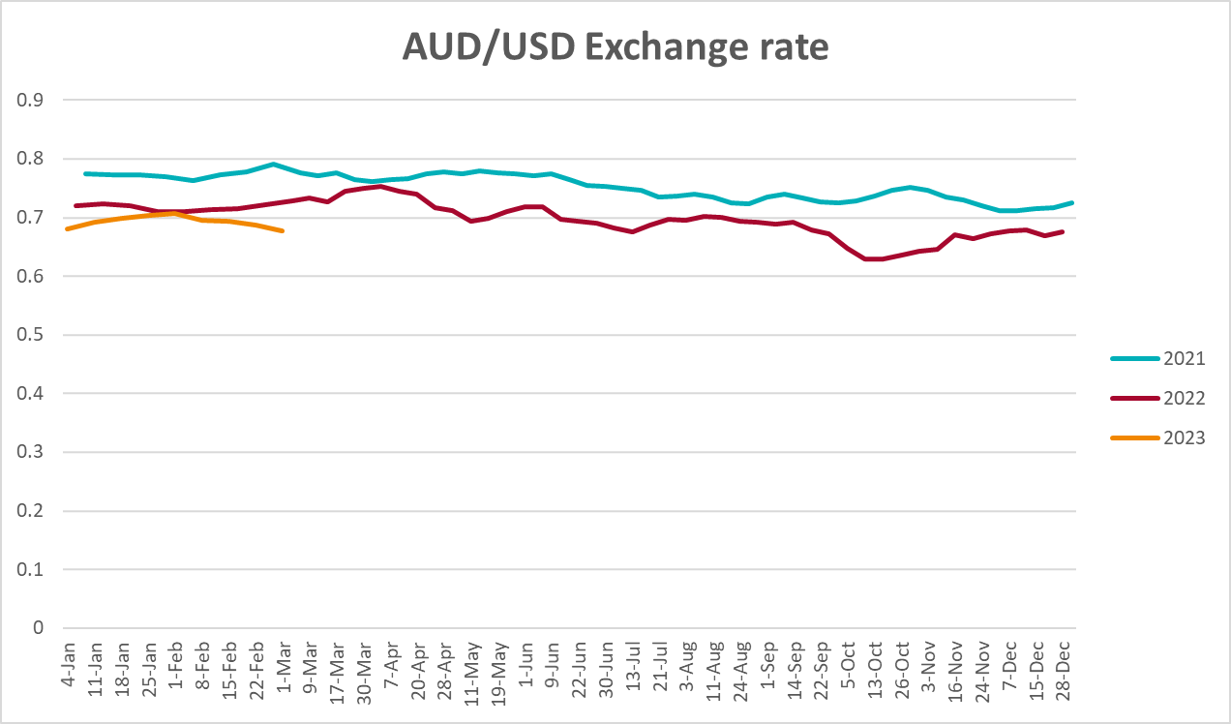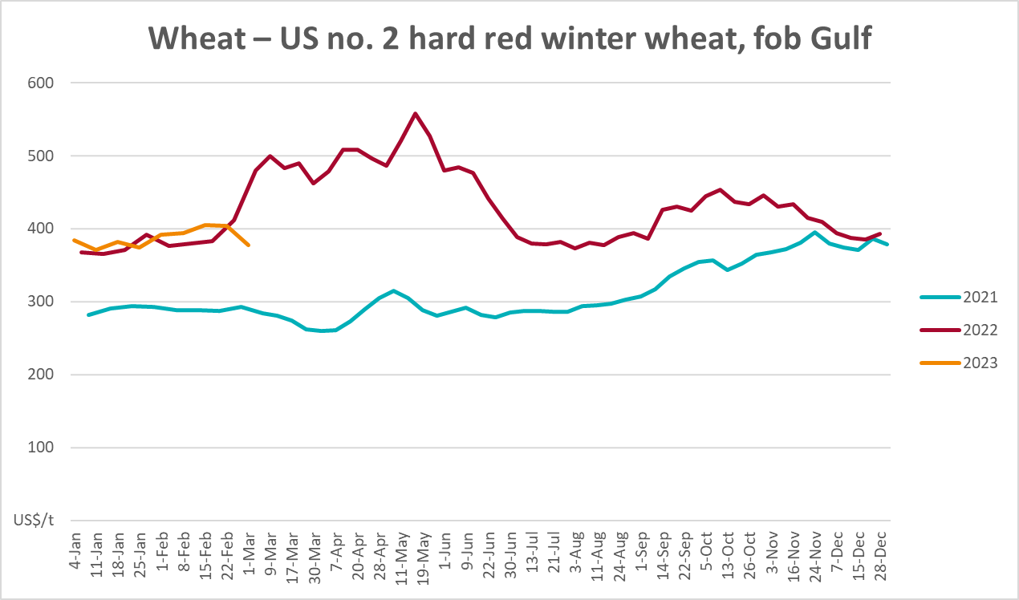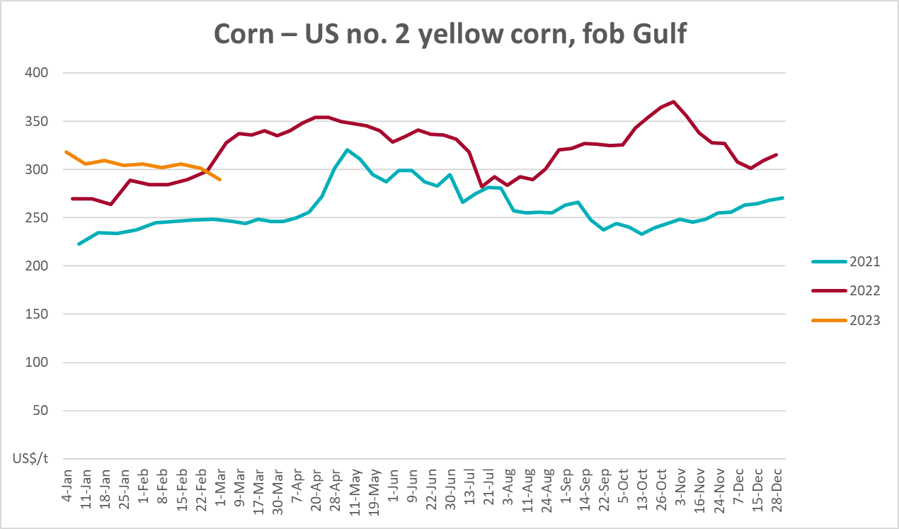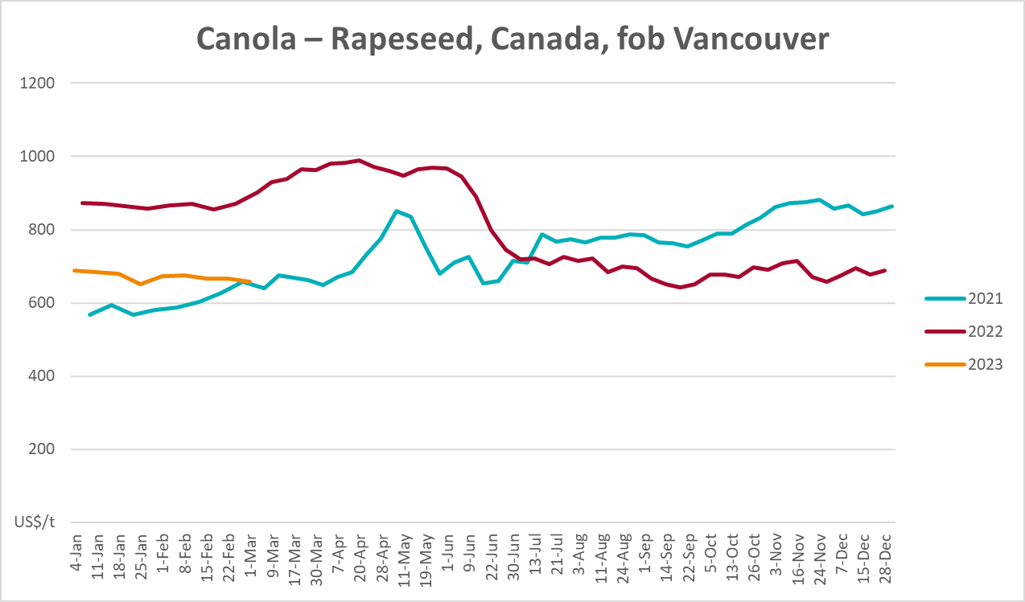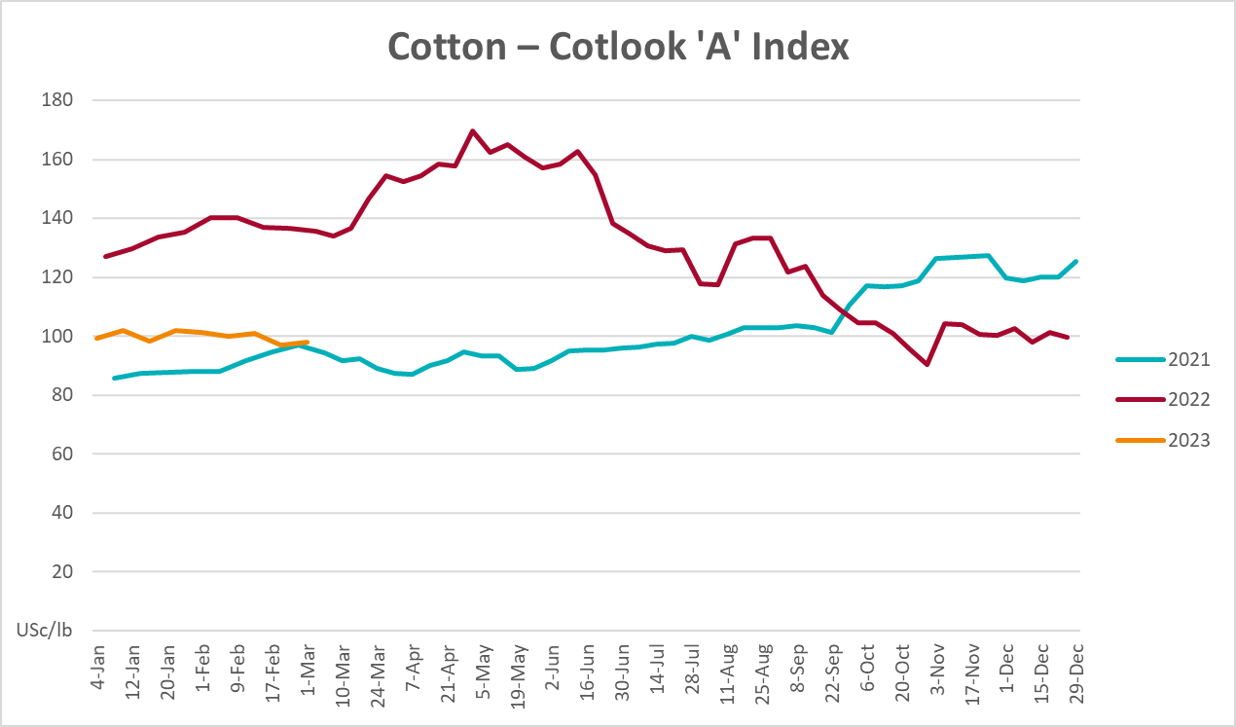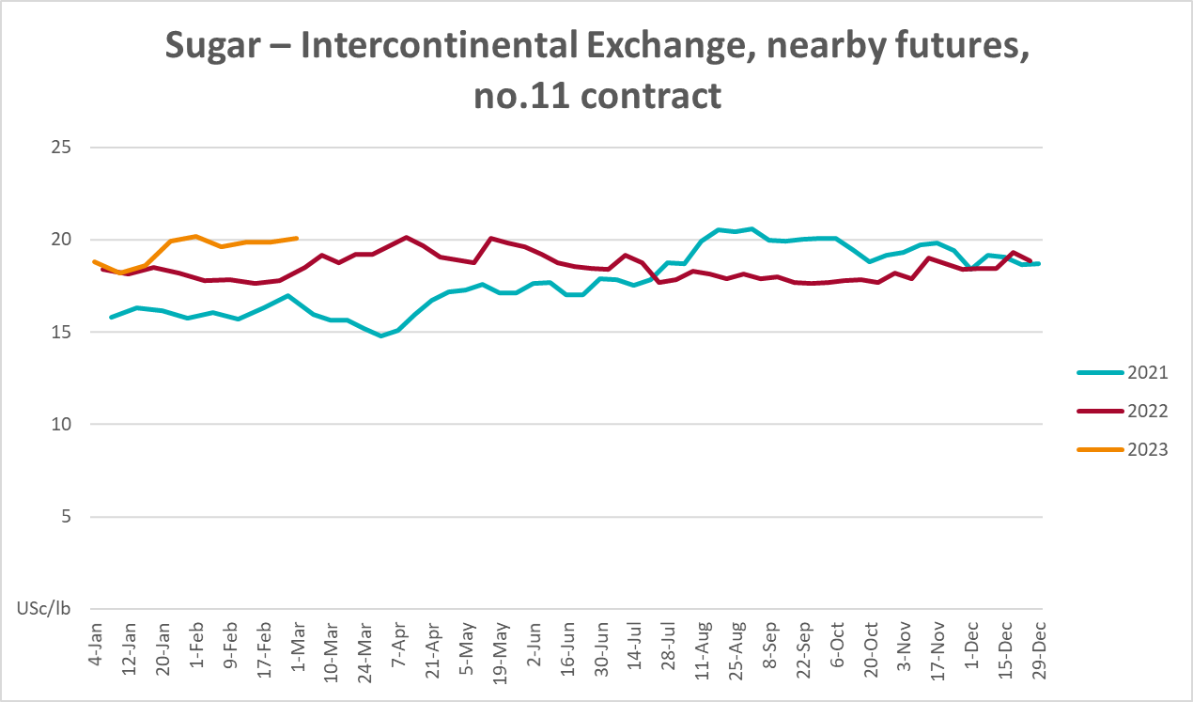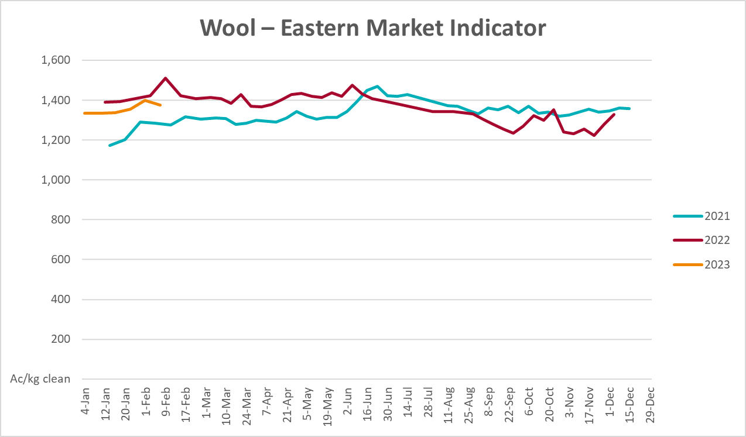

Selected domestic crop indicator prices
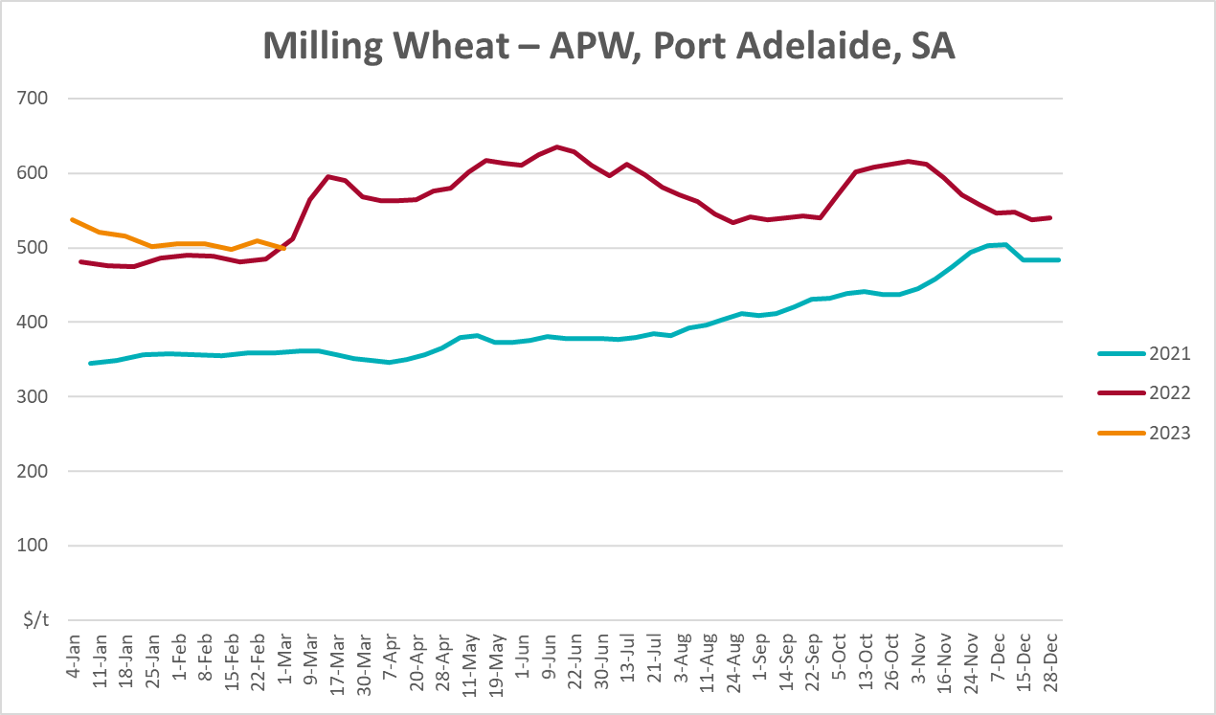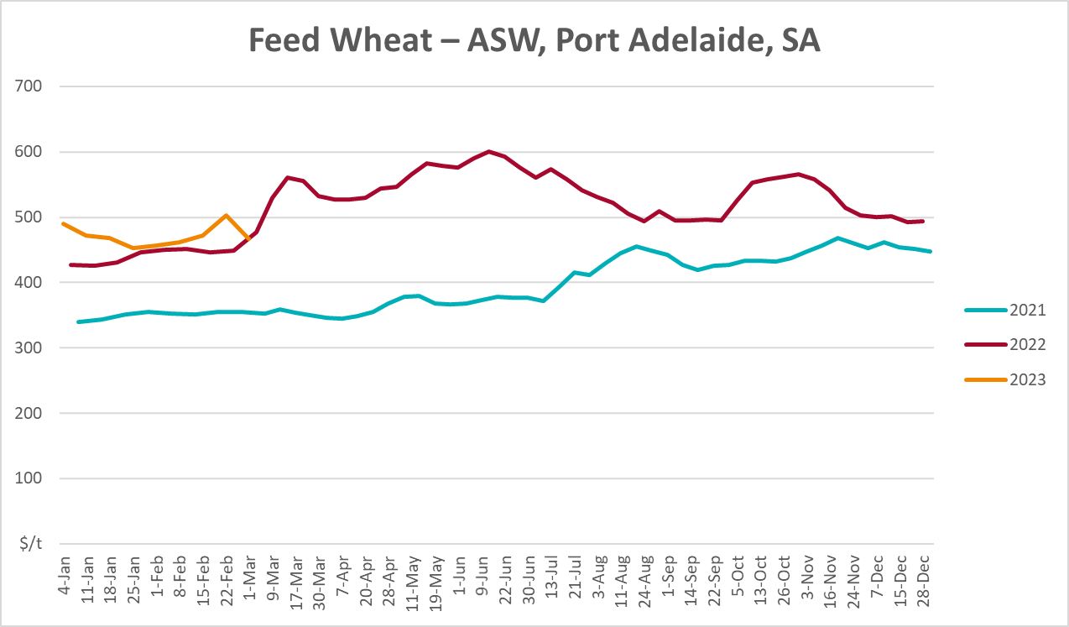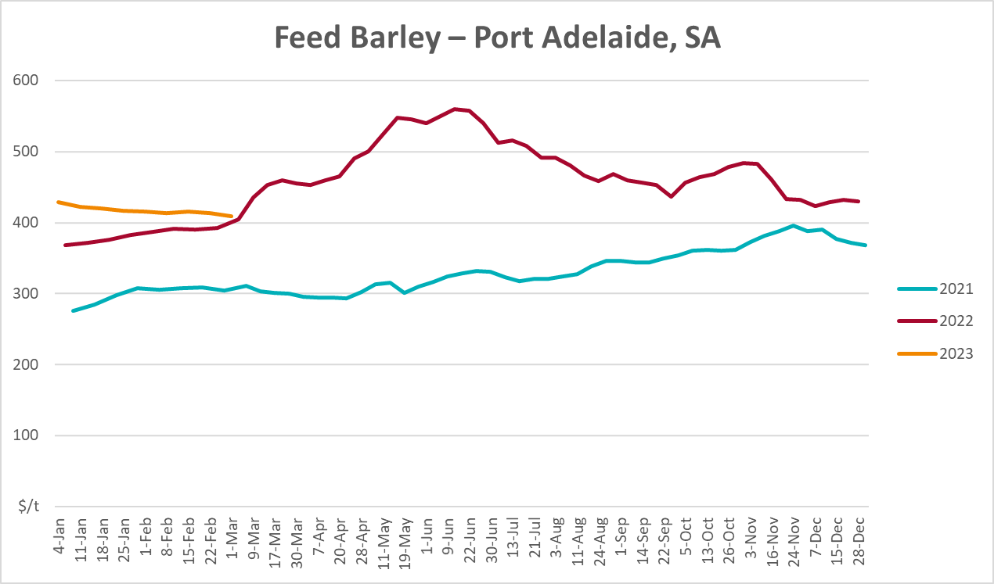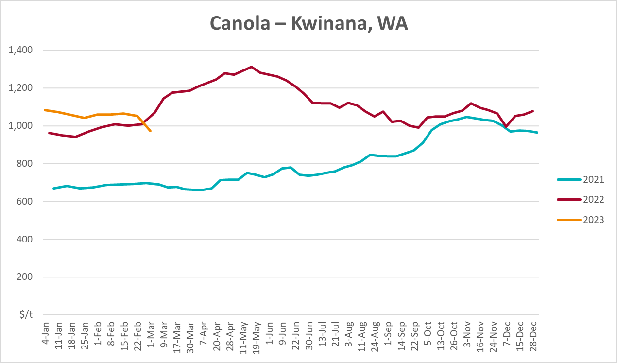
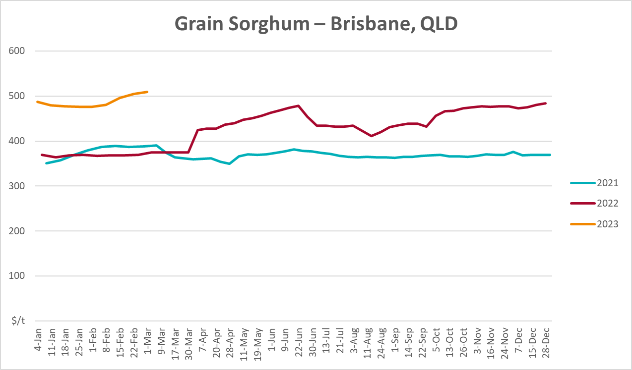

Selected domestic livestock indicator prices
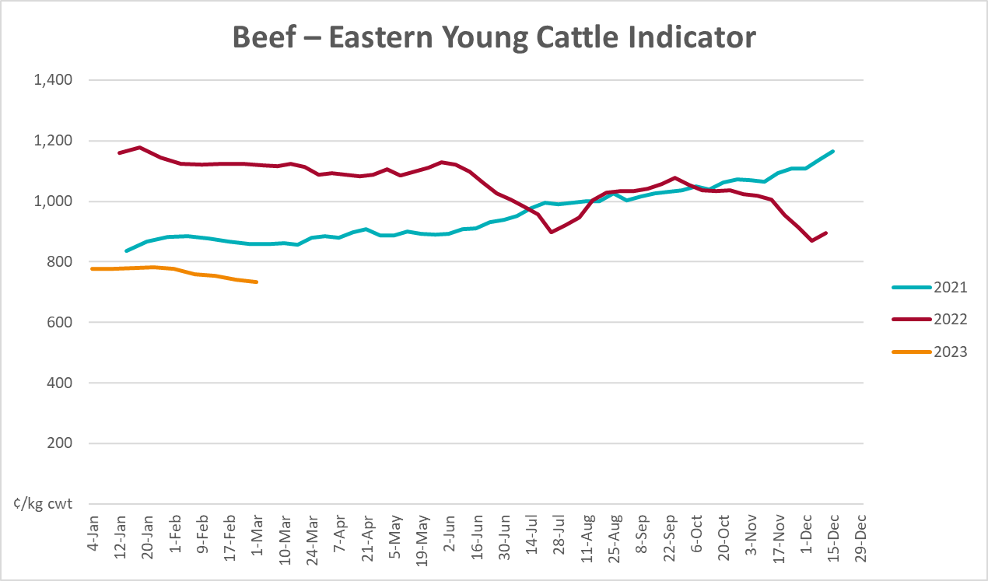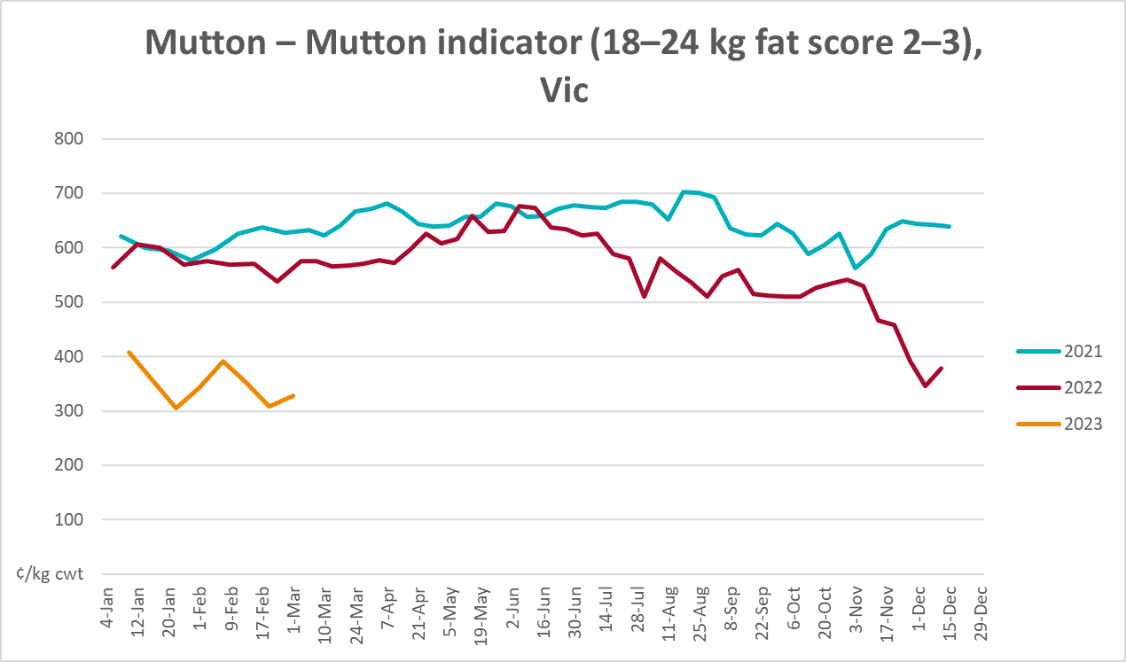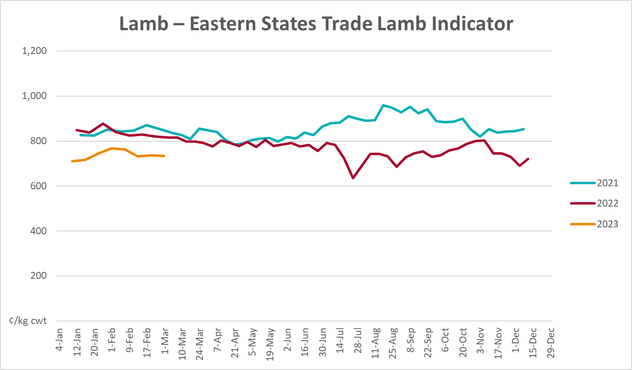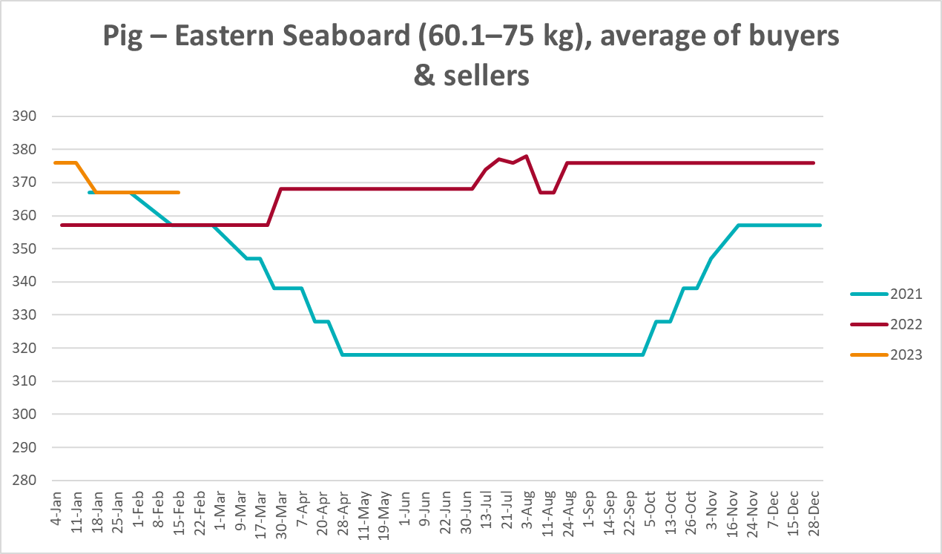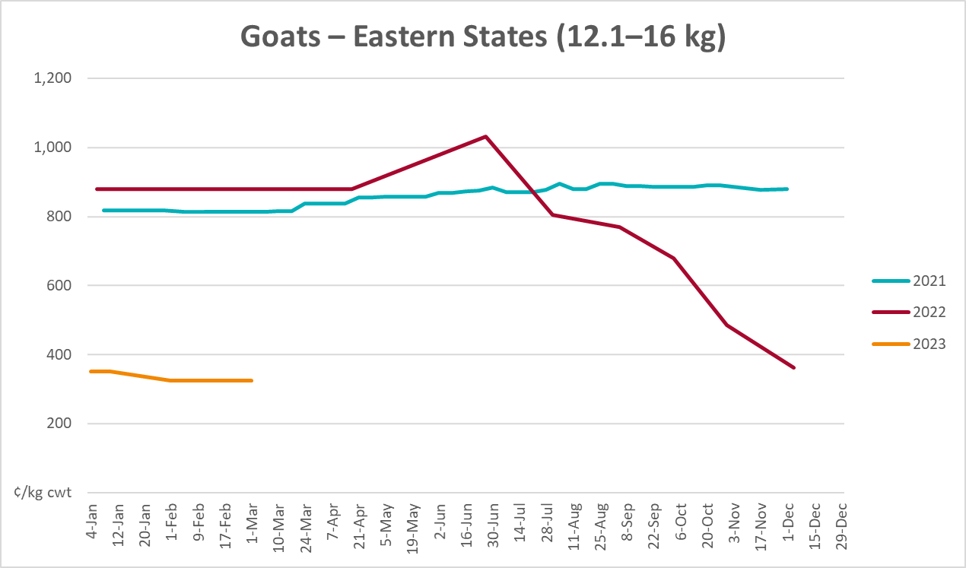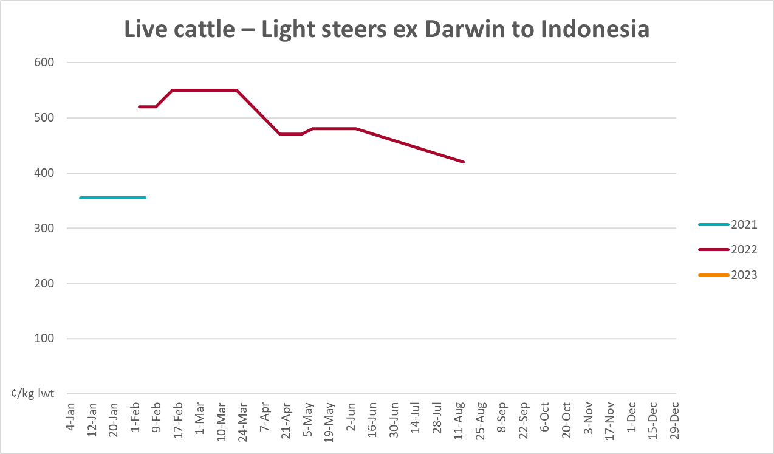
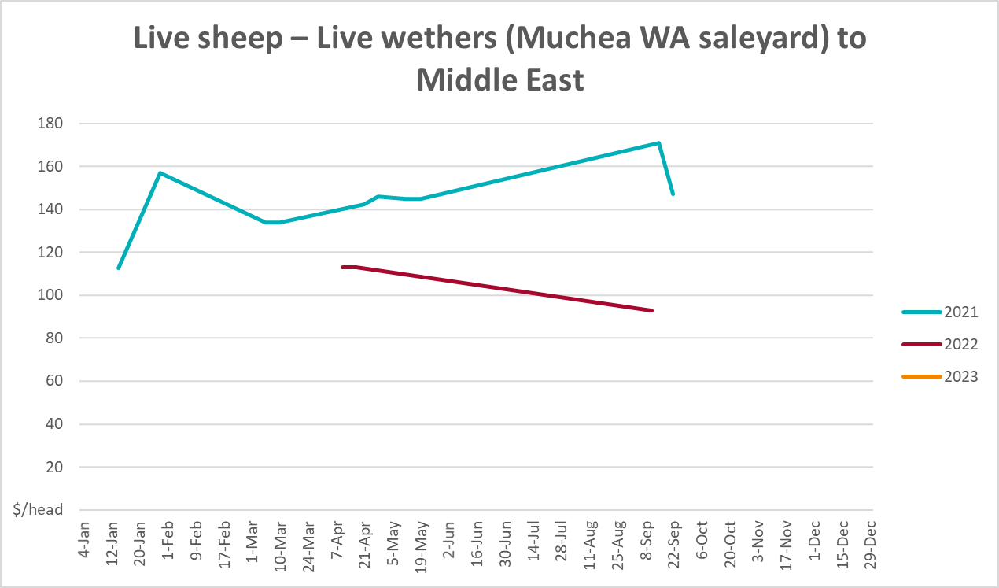

Global Dairy Trade (GDT) weighted average prices
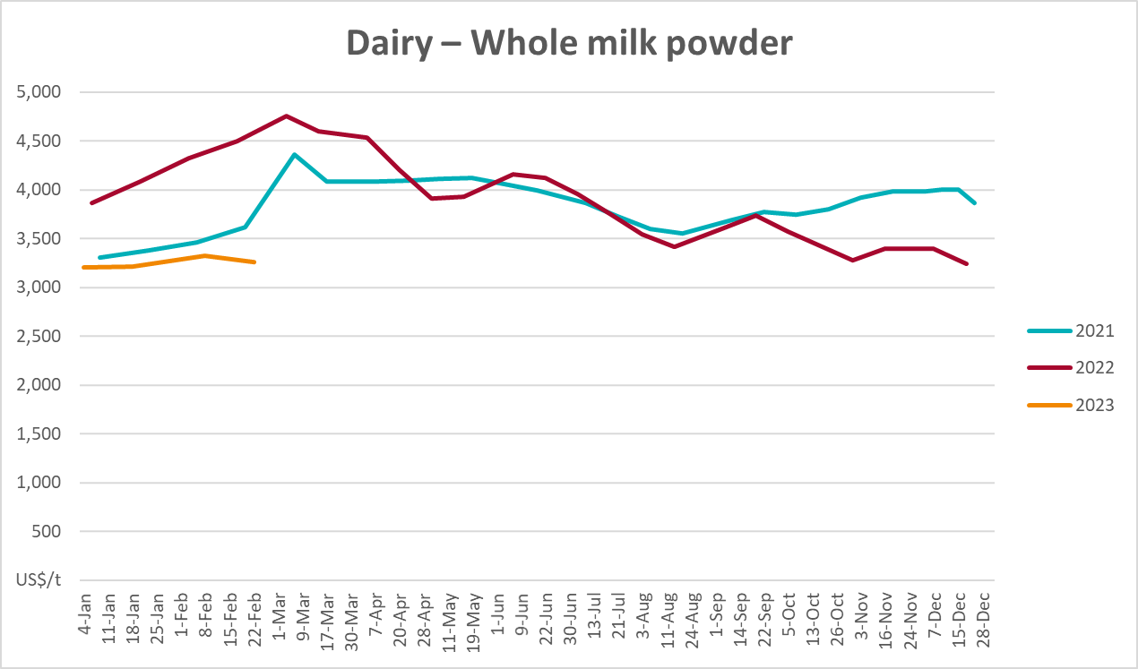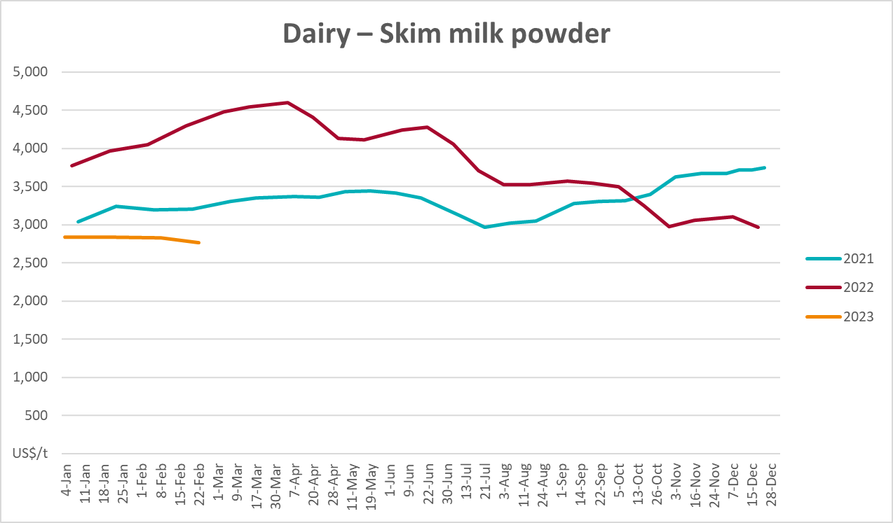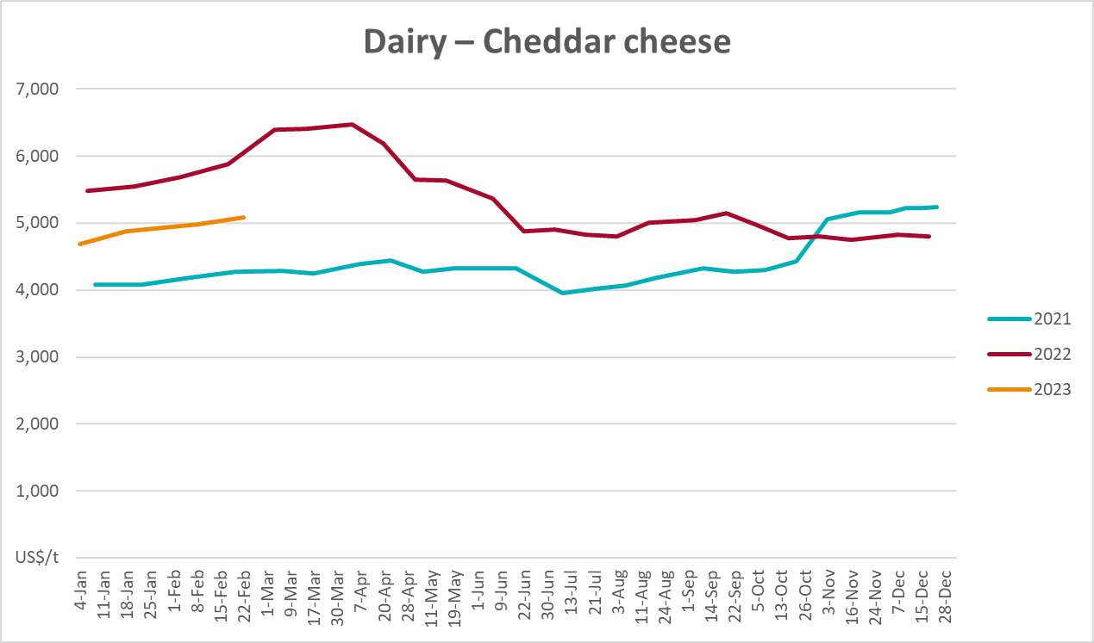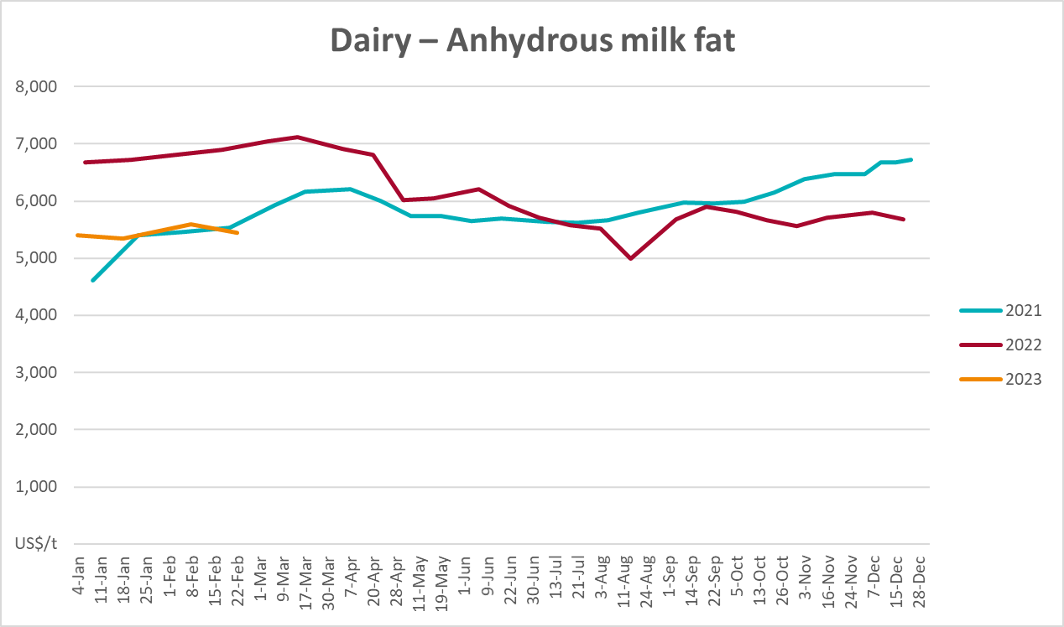

Selected fruit and vegetable prices
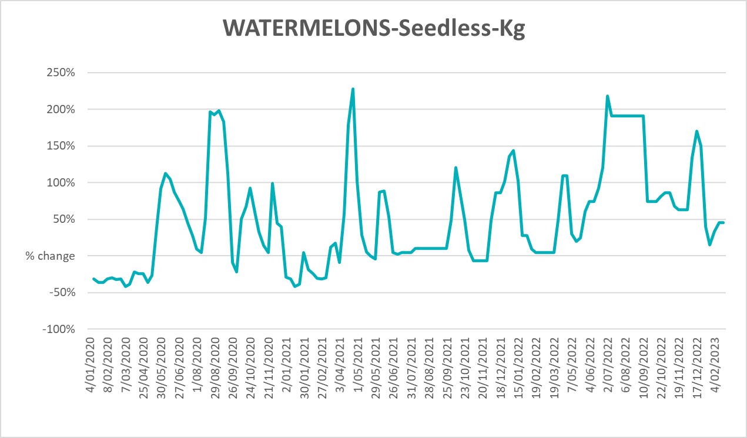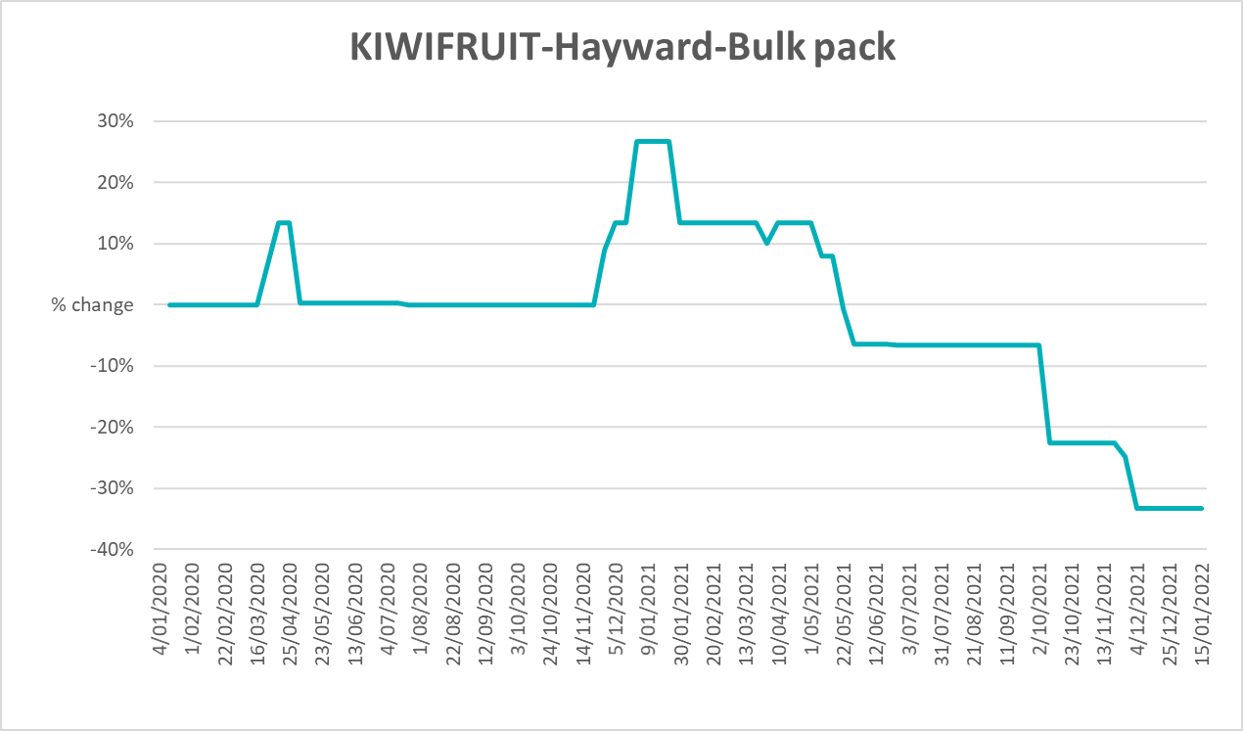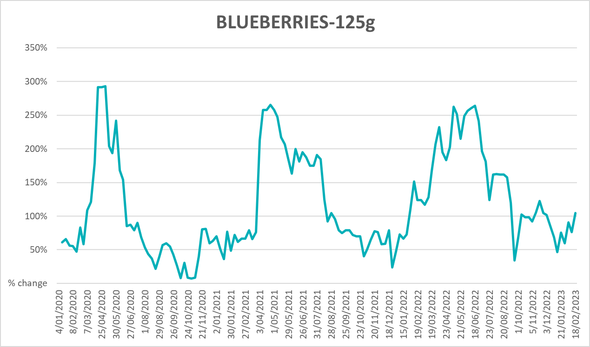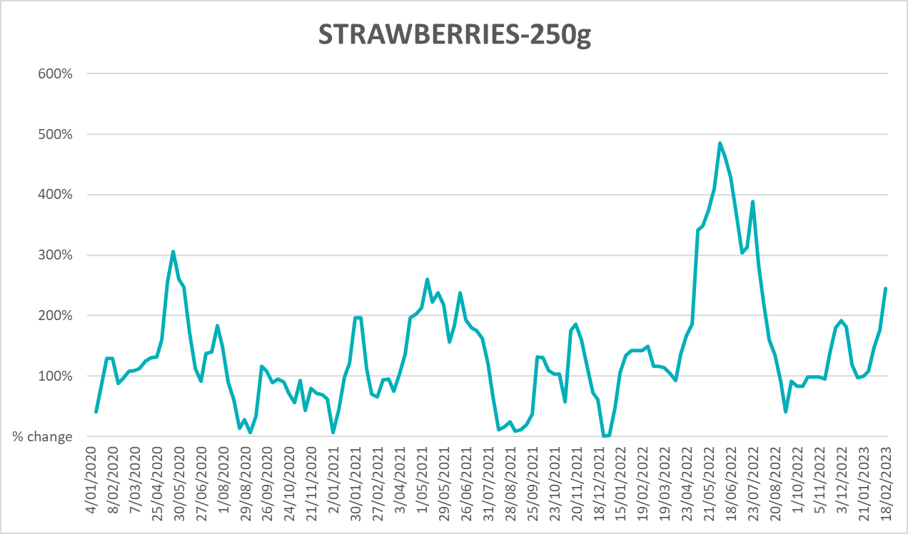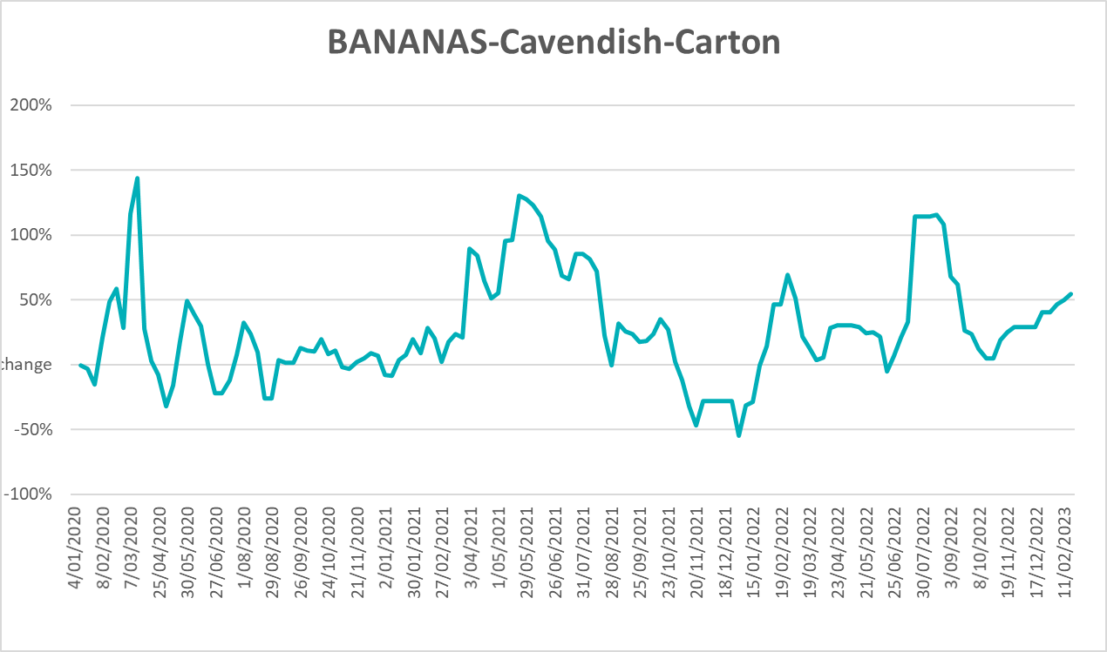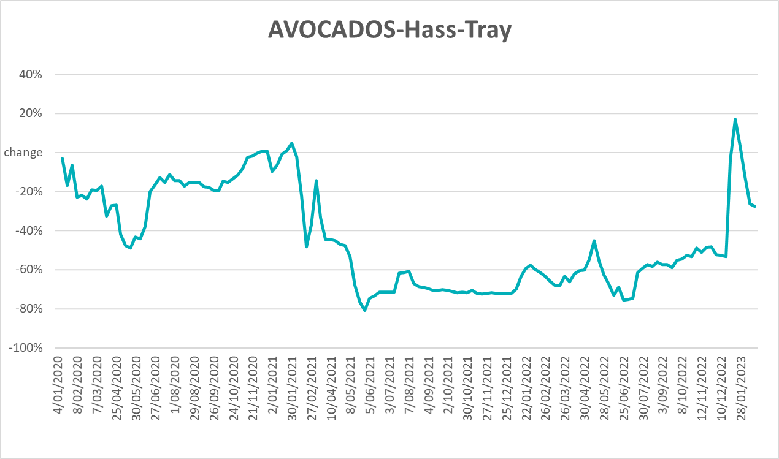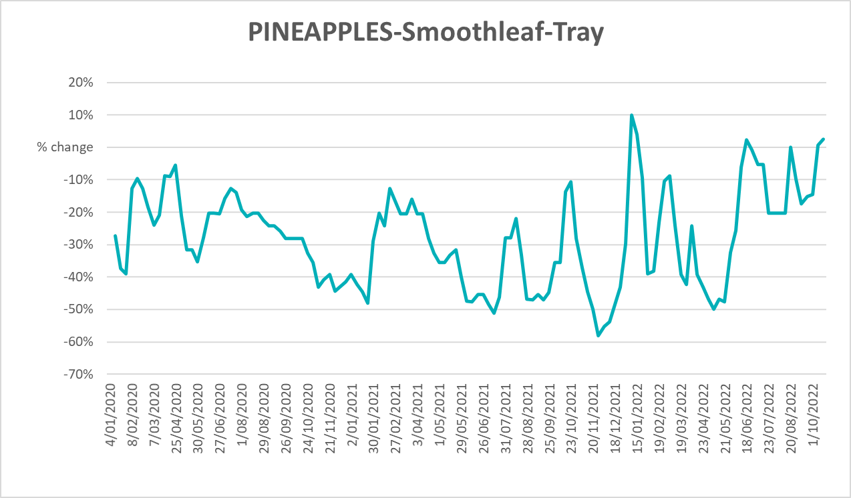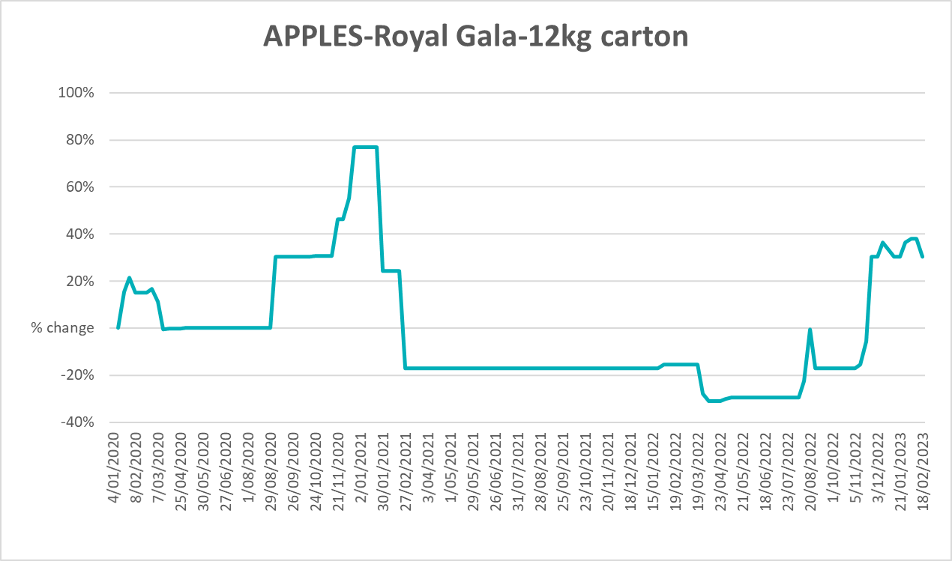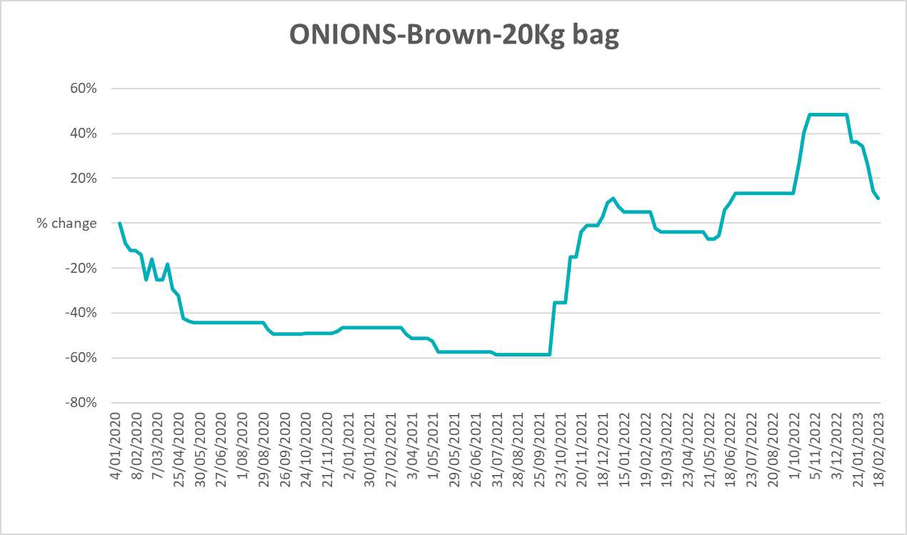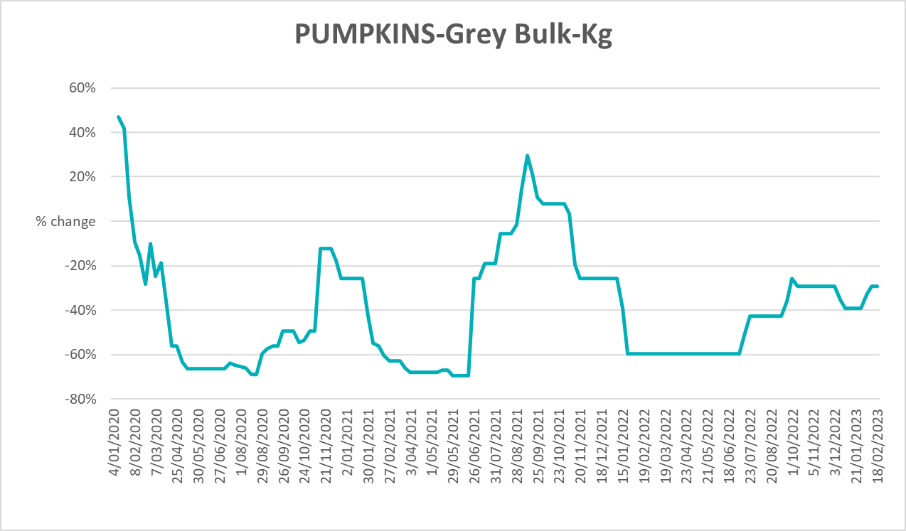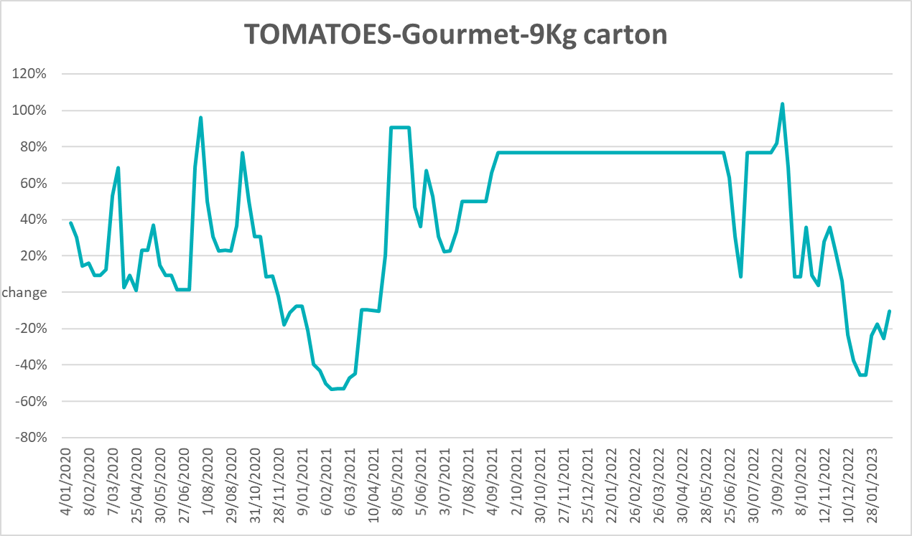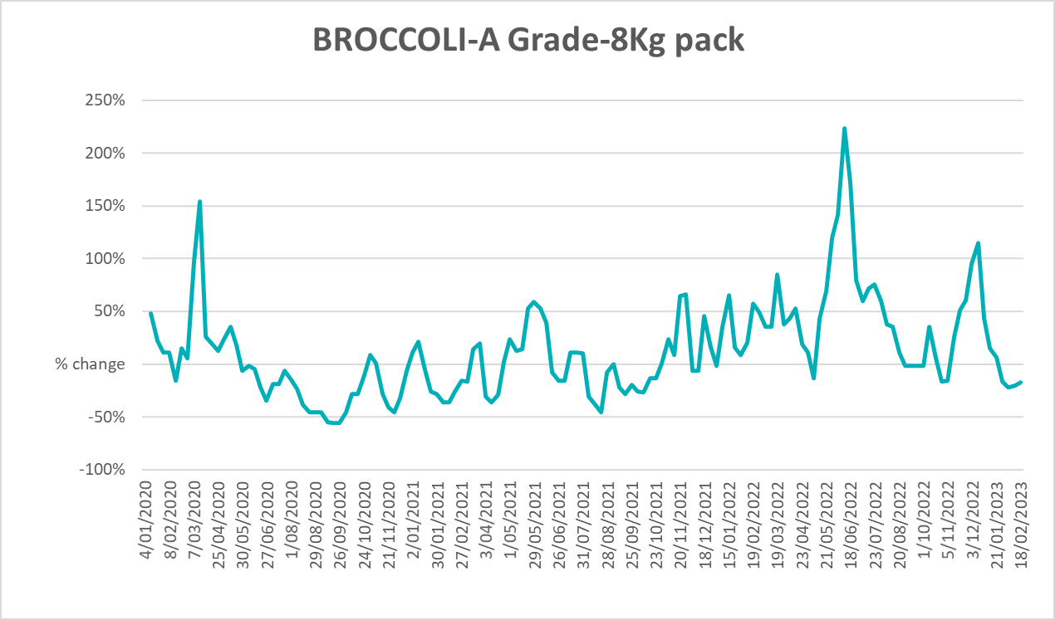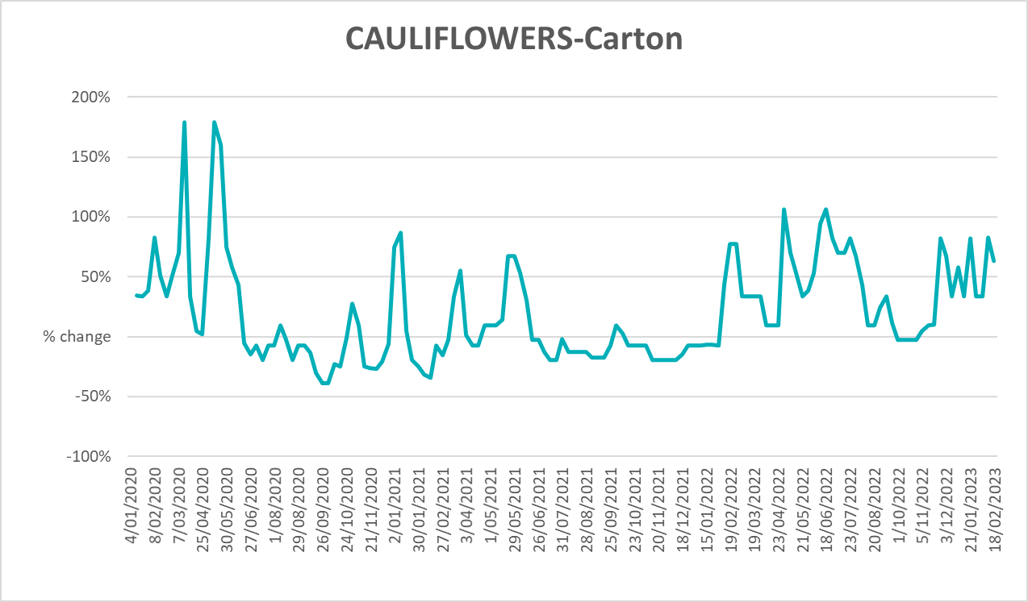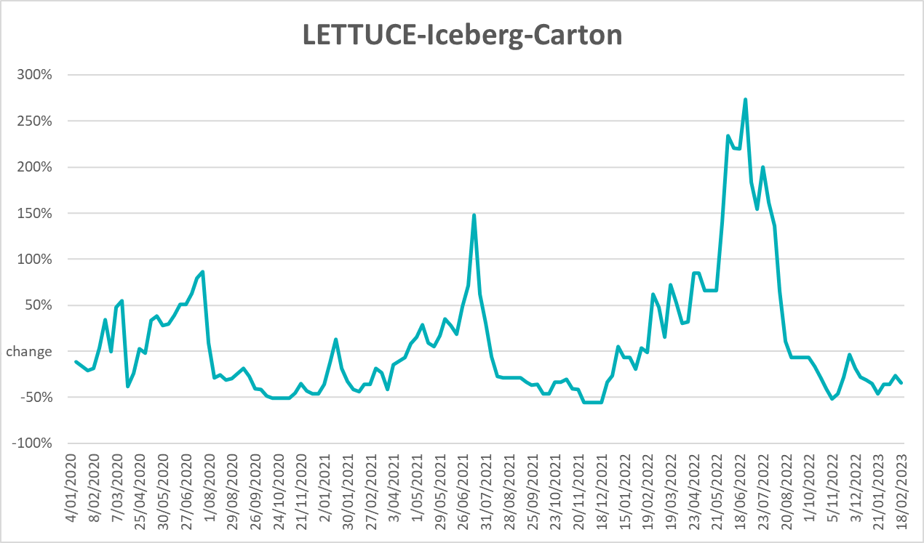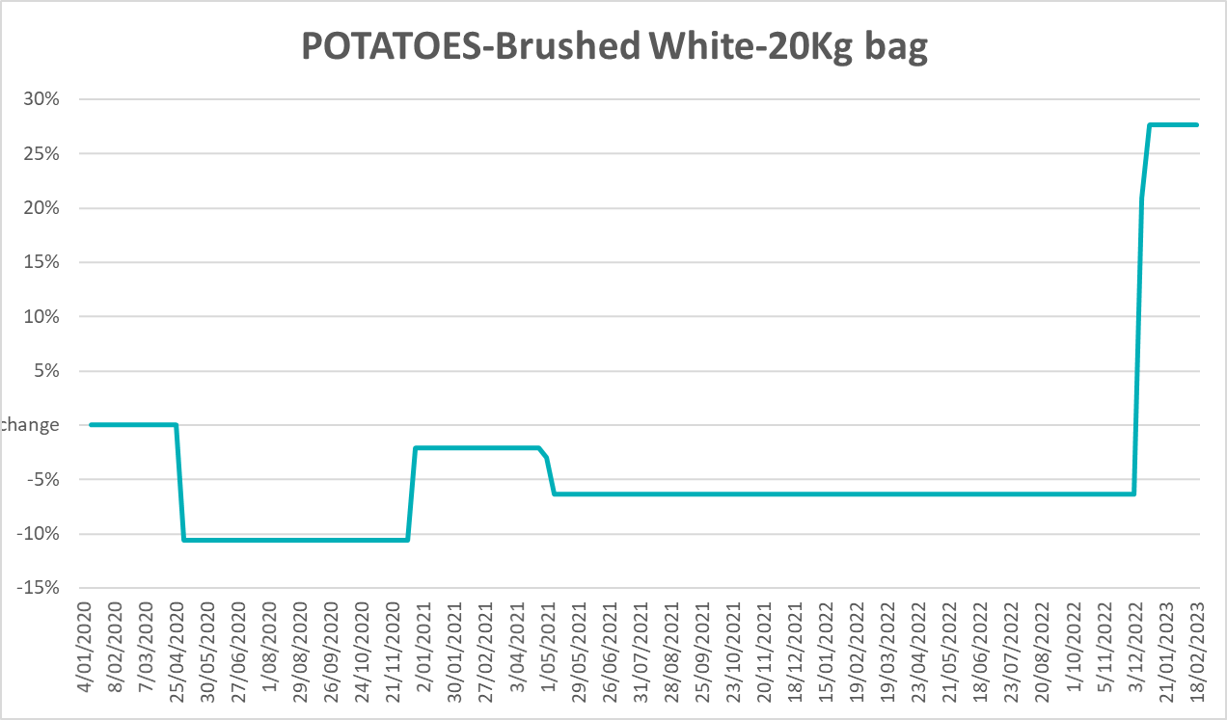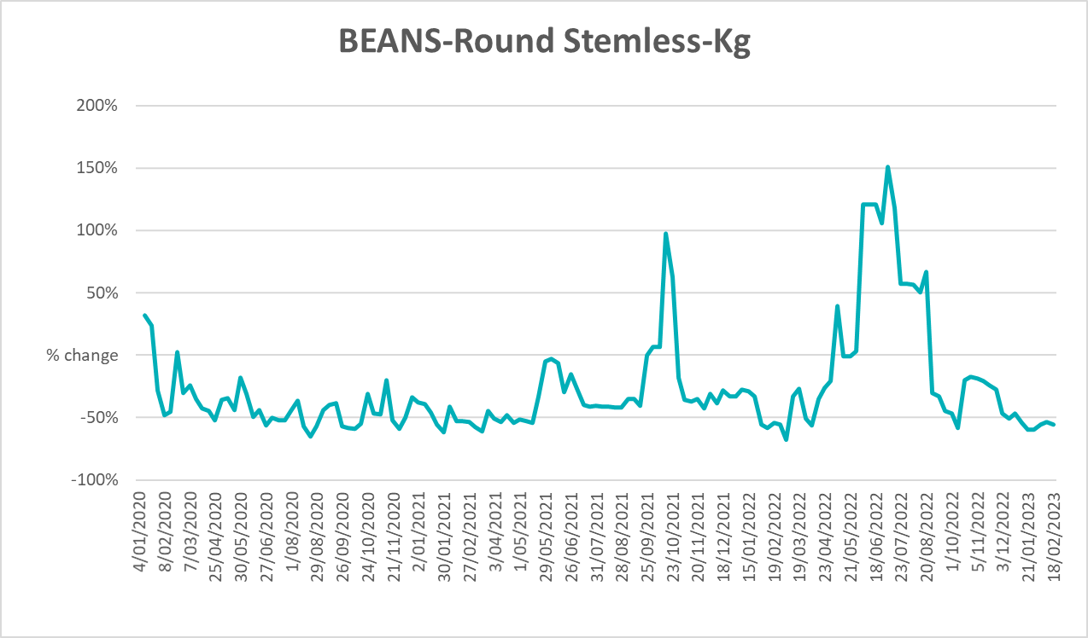

3.6 Selected domestic fodder indicator prices
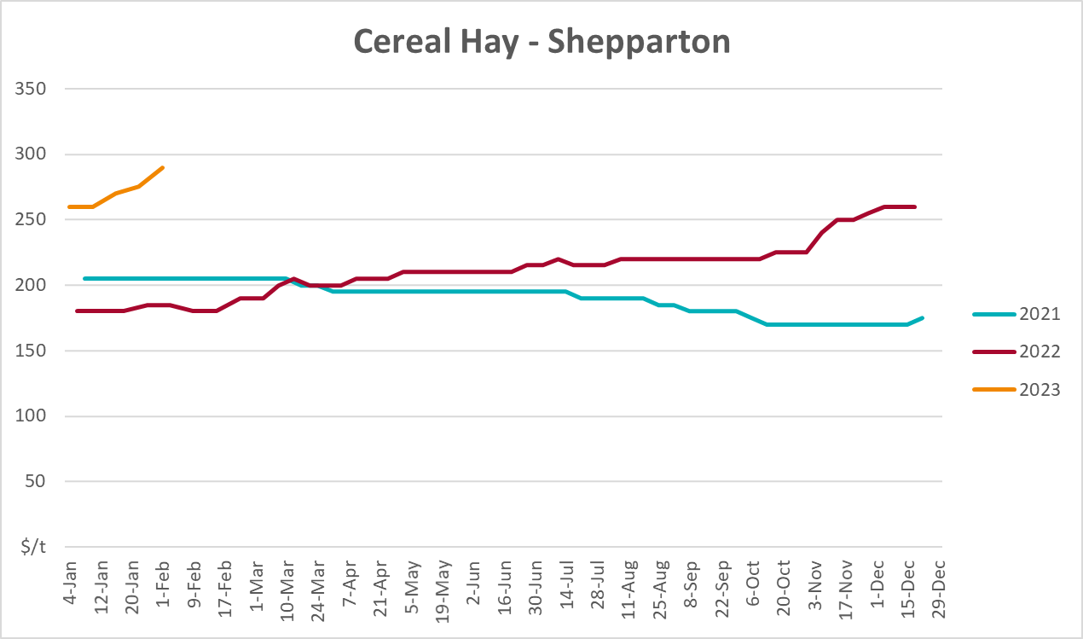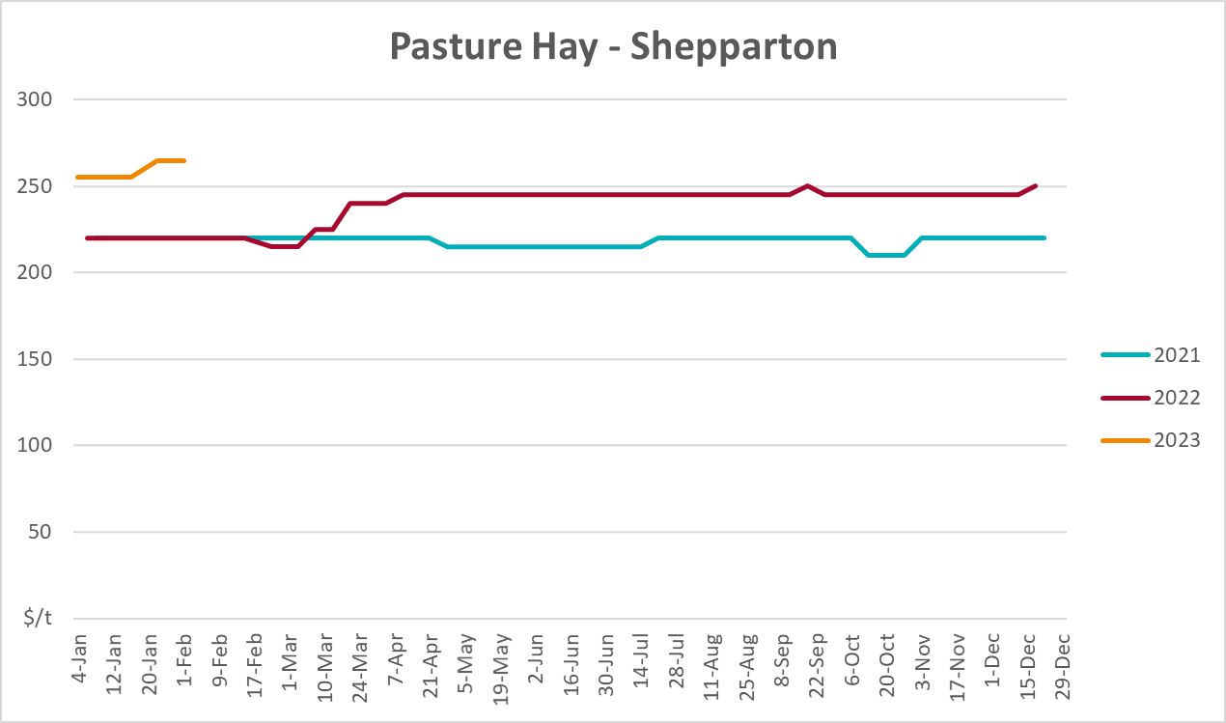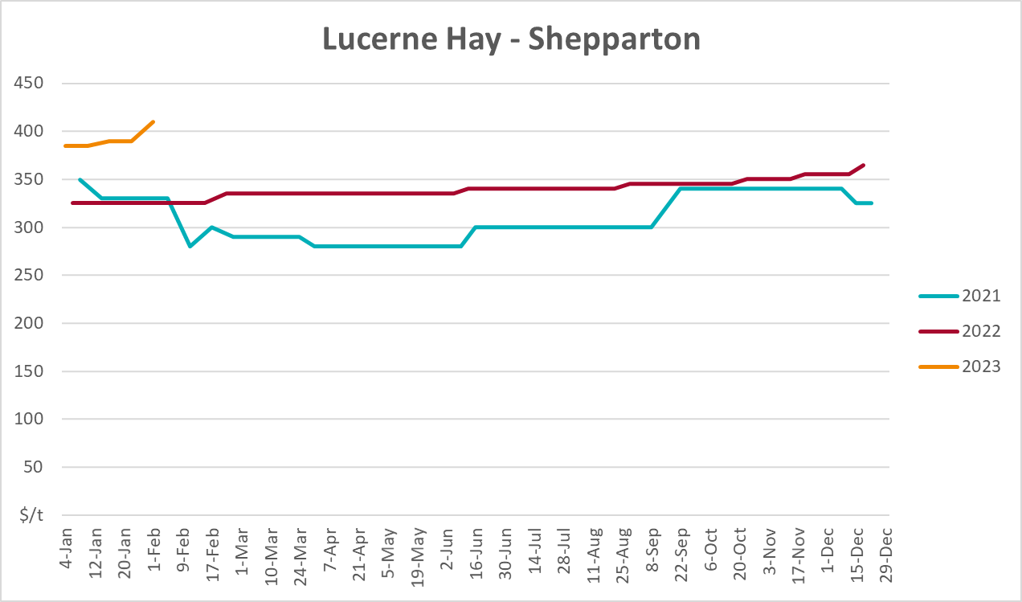

4. Data attribution

Climate
Bureau of Meteorology
- Weekly rainfall totals: www.bom.gov.au/climate/maps/rainfall/
- Monthly and last 3-month rainfall percentiles: www.bom.gov.au/water/landscape/
- Temperature anomalies: www.bom.gov.au/jsp/awap/temp/index.jsp
- Rainfall forecast: www.bom.gov.au/jsp/watl/rainfall/pme.jsp
- Seasonal outlook: www.bom.gov.au/climate/outlooks/#/overview/summary/
- Climate drivers: http://www.bom.gov.au/climate/enso/
- Soil moisture: www.bom.gov.au/water/landscape/
Other
- Pasture growth: www.longpaddock.qld.gov.au/aussiegrass/
- 3-month global outlooks: Environment and Climate Change Canada, NOAA Climate Prediction Center, EUROBRISA CPTEC/INPE, European Centre for Medium-Range Weather Forecasts, Hydrometcenter of Russia, National Climate Center Climate System Diagnosis and Prediction Room (NCC), International Research Institute for Climate and Society
- Global production: https://ipad.fas.usda.gov/ogamaps/cropmapsandcalendars.aspx
- Autumn break: Pook et al., 2009, https://rmets-onlinelibrary-wiley-com.virtual.anu.edu.au/doi/epdf/10.1002/joc.1833

Water
Prices
- Waterflow: https://www.waterflow.io/
- Ruralco: https://www.ruralcowater.com.au/
Bureau of Meteorology:
- Allocation trade: http://www.bom.gov.au/water/dashboards/#/water-markets/mdb/at
- Storage volumes: http://www.bom.gov.au/water/dashboards/#/water-storages/summary/drainage
Trade constraints:
- Water NSW: https://www.waternsw.com.au/customer-service/ordering-trading-and-pricing/trading/murrumbidgee
- Victorian Water Register: https://www.waterregister.vic.gov.au/TradingRules2019/

Commodities
Fruit and vegetables
- Datafresh: www.freshstate.com.au
Pigs
- Australian Pork Limited: www.australianpork.com.au
Dairy
- Global Dairy Trade: www.globaldairytrade.info/en/product-results/
World wheat, canola
- International Grains Council
World coarse grains
- United States Department of Agriculture
World cotton
- Cotlook: www.cotlook.com/
World sugar
- New York Stock Exchange - Intercontinental Exchange
Wool
- Australian Wool Exchange: www.awex.com.au/
Domestic wheat, barley, sorghum, canola and fodder
- Jumbuk Consulting Pty Ltd: http://www.jumbukag.com.au/
Cattle, beef, mutton, lamb, goat and live export
- Meat and Livestock Australia: www.mla.com.au/Prices-and-market
© Commonwealth of Australia 2023

Ownership of intellectual property rights
Unless otherwise noted, copyright (and any other intellectual property rights, if any) in this publication is owned by the Commonwealth of Australia (referred to as the Commonwealth).

Creative Commons licence
All material in this publication is licensed under a Creative Commons Attribution 4.0 International Licence except content supplied by third parties, logos and the Commonwealth Coat of Arms.
Inquiries about the licence and any use of this document should be emailed to copyright@awe.gov.au.


Cataloguing data
This publication (and any material sourced from it) should be attributed as:
ABARES 2023, Weekly Australian Climate, Water and Agricultural Update, Australian Bureau of Agricultural and Resource Economics and Sciences, Canberra, 2 March 2023. CC BY 4.0 DOI: https://doi.org/10.25814/5f3e04e7d2503
ISSN 2652-7561
This publication is available at https://www.agriculture.gov.au/abares/products/weekly_update
Department of Agriculture, Fisheries and Forestry
GPO Box 858 Canberra ACT 2601
Telephone 1800 900 090
Web agriculture.gov.au/abares

Disclaimer
The Australian Government acting through the Department of Agriculture, Fisheries and Forestry, represented by the Australian Bureau of Agricultural and Resource Economics and Sciences, has exercised due care and skill in preparing and compiling the information and data in this publication. Notwithstanding, the Department of Agriculture, Fisheries and Forestry, ABARES, its employees and advisers disclaim all liability, including liability for negligence and for any loss, damage, injury, expense or cost incurred by any person as a result of accessing, using or relying on any of the information or data in this publication to the maximum extent permitted by law.

Statement of Professional Independence
The views and analysis presented in ABARES publications, including this one, reflect ABARES professionally independent findings, based on scientific and economic concepts, principles, information and data. These views, analysis and findings may not reflect or be consistent with the views or positions of the Australian Government, or of organisations or groups who have commissioned ABARES reports or analysis. More information on professional independence is provided on the ABARES website.

Acknowledgements
This report was prepared by Kavina Dayal, Ruirui Zhu and Matthew Miller.

