
No. 9/2023 9 March 2023

Summary of key issues
- For the week ending 8 March 2023, a monsoon burst has brought thunderstorms and heavy rain across the northern tropics throughout the week, with weekly totals greater than 150 millimetres recorded in parts of central Northern Territory and adjacent areas of north-west Queensland.
- Little to no rainfall was recorded in cropping regions over the past 7 days, except for parts of Queensland. Ongoing dry conditions across most summer cropping regions would have allowed for uninterrupted access to fields for crop maintenance activities and for the harvesting of early sown crops. However, in regions with below average soil moisture levels, little to no rainfall is likely to have negatively affected the growth and yield potential of late sown summer crops (see Section 1.1).
- La Niña is likely near its end. The oceanic indicators of La Niña have returned to neutral levels, while the atmospheric indicators that remain at La Niña levels are continuing to weaken. The Madden–Julian Oscillation (MJO) is currently weak; however, it is forecast to strengthen and re-emerge over the western Pacific during the coming fortnight. This may initially contribute to increased monsoonal activity across northern Australia, but as it progresses eastward it will increasingly favour drier conditions for tropical Australia (see Section 1.2).
- The outlook for April 2023 indicates that there is a 75% chance of rainfall totals between 10 and 50 millimetres for tropical northern Australia, eastern and south-eastern coastal areas, parts of Western Australia, as well as much of Tasmania. Rainfall totals in excess of 100 millimetres are expected in western Tasmania and in parts of north-eastern Queensland. For the remainder of Australia, rainfall totals are not expected to exceed 10 millimetres (see Section 1.3).
- The outlook for April to June 2023 suggests there is a 75% chance of rainfall totals between 25 and 100 millimetres across central and eastern New South Wales, northern and eastern Queensland, southern parts of South Australia and Western Australia, northern parts of the Northern Territory and much of Victoria and Tasmania. Rainfall totals in excess of 200 millimetres are forecast for coastal parts of New South Wales and Queensland, as well as western Tasmania.
- Over the 8-days to 16 March 2023, the monsoon trough is expected to generate rain and storms across the tropical north of Australia. Meanwhile, a low-pressure trough across eastern Australia is forecast to generate rainfall in excess of 25 mm, particularly over much of Queensland and in the northeast and coastal New South Wales. A high-pressure system is expected to bring mainly dry conditions elsewhere (see Section 1.4).
- Water storage levels in the Murray-Darling Basin (MDB) decreased between 27 February 2023 and 6 March 2023 by 271 gigalitres (GL). Current volume of water held in storage is 22 580 GL which represents 89 per cent of total capacity. This is 1 percent or 174 GL more than at the same time last year.
- Allocation prices in the Victorian Murray below the Barmah Choke remained steady at $15 per ML from 2 March 2023 to 9 March 2023. Prices are lower in the Murrumbidgee and in regions above the Barmah choke due to the binding of the Murrumbidgee export limit and Barmah choke trade constraint.

Climate

Rainfall this week
For the week ending 8 March 2023, the northern monsoon has brought thunderstorms and heavy rainfall to much of Australia’s tropical north throughout the week. Weekly totals between 25 and 150 millimetres were recorded in the north of the Northern Territory, northern Queensland, and parts of northern Western Australia. Weekly totals greater than 150 millimetres recorded in parts of central Northern Territory and adjacent areas of north-west Queensland. Frontal activity in southern Australia brought rainfall totals of between 10 and 50 millimetres to Tasmania and southern Victoria, as well as pockets of eastern Queensland and New South Wales over the past week.
Little to no rainfall was recorded across the cropping regions over the past 7 days, except for parts of central Queensland. Ongoing dry conditions across most summer cropping regions would have allowed for uninterrupted access to fields for crop maintenance activities and for the harvesting of early sown crops. However, in regions with below average soil moisture levels, little to no rainfall is likely to have negatively affected the growth and yield potential of late sown summer crops.

Rainfall for the week ending 8 March 2023
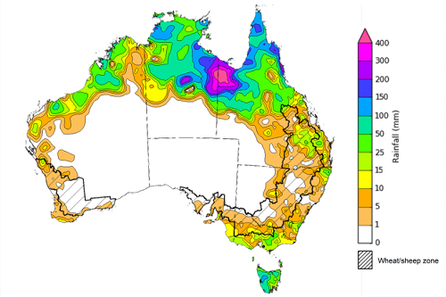
©Commonwealth of Australia 2023, Australian Bureau of Meteorology Issued: 08/03/2023
Note: The rainfall analyses and associated maps utilise data contained in the Bureau of Meteorology climate database, the Australian Data Archive for Meteorology (ADAM). The analyses are initially produced automatically from real-time data with limited quality control. They are intended to provide a general overview of rainfall across Australia as quickly as possible after the observations are received. For further information go to http://www.bom.gov.au/climate/rainfall/

Climate Drivers
Throughout autumn the climate drivers with the largest potential impact on Australia’s climate patterns are the El Niño–Southern Oscillation (ENSO) and the Madden-Julian Oscillation (MJO). These climate drivers are likely to influence the growth and development of later planted summer crops in northern growing regions, pasture growth across both northern and southern Australia and planting opportunities for winter crops.
La Niña has weakened in the tropical Pacific Ocean and is likely near its end. Oceanic indicators of La Niña have returned to neutral levels, while atmospheric indicators of La Niña continue to weaken. The Southern Annular Mode (SAM) is currently positive but is expected to return to neutral during the coming week where it is anticipated to remain neutral for the coming month. Neutral SAM has little influence on the rainfall and temperature outlook for Australia.

Difference from average sea surface temperature observations 20 February 2023 to 26 February 2023
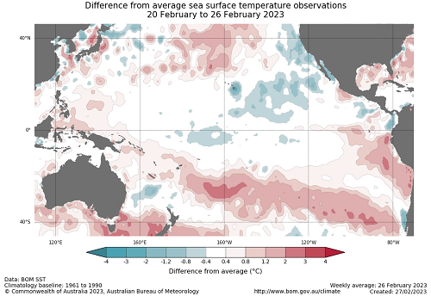

International climate model outlooks for the NINO 3.4 region in March 2023
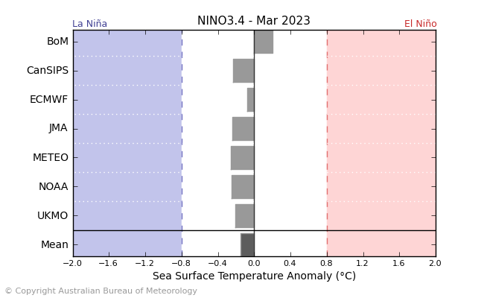
©Commonwealth of Australia 2023, Australian Bureau of Meteorology Issued: 28/02/2023
All, but one, international climate model surveyed by the Australian Bureau of Meteorology suggest sea-surface temperatures in the tropical Pacific will remain neutral through the southern hemisphere autumn, with one model reaching El Niño thresholds in May. For the period ending 6 March 2023, the 30-day Southern Oscillation Index (SOI) value was +9.0, which has decreased slightly over the past weeks; another indicator of the weakening La Niña.
It is important to note that while most models suggest there is an increased chance of El Niño developing in mid-to-late 2023, the model accuracy when forecasting through autumn is low, and therefore ENSO outlooks that extend past autumn should be viewed with caution.

30-day Southern Oscillation Index (SOI) values ending 6 March 2023
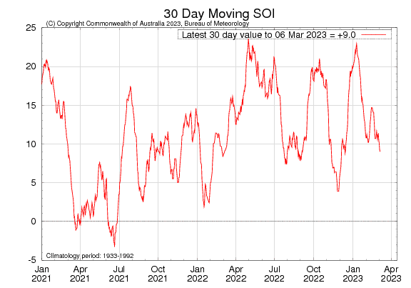

The Madden–Julian Oscillation (MJO) is currently weak, however, it is forecast to strengthen and re-emerge over the western Pacific during the coming fortnight. This may initially contribute to increased monsoonal activity across northern Australia, but as it progresses eastward it will increasingly favour drier conditions for tropical Australia. While over the Pacific Ocean, the westerly winds associated with the MJO are expected to bring about the weakening of the trade winds, which may further contribute to the breakdown of La Niña in the coming fortnight.

Madden–Julian Oscillation (MJO) daily index
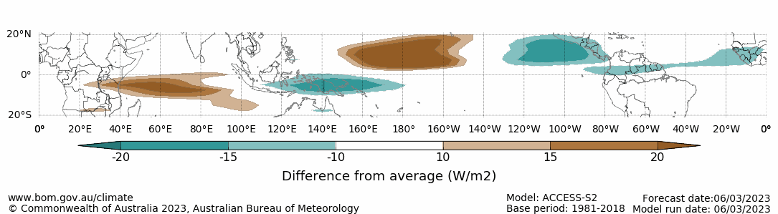
Note: This map displays the forecast outgoing longwave radiation (OLR) difference from expected cloudiness to identify convective rain clouds and the position of the Madden–Julian Oscillation (MJO). The blue shading indicates higher than normal, active or enhanced tropical weather and the brown shading indicates lower than normal clouds or suppressed conditions.

National Climate Outlook
These climate outlooks are generated by ACCESS–S (Australian Community Climate Earth-System Simulator–Seasonal). ACCESS–S is the Bureau of Meteorology's dynamic (physics-based) weather and climate model used for monthly, seasonal, and longer-lead climate outlooks. For further information, go to http://www.bom.gov.au/climate/ahead/about/.
The Bureau of Meteorology’s latest rainfall outlook for April 2023 indicates drier than average conditions are expected across much of Australia.
The ACCESS-S climate model suggests that there is a 75% chance of rainfall totals between 10 and 50 millimetres for tropical northern Australia, eastern and south-eastern coastal areas, parts of Western Australia, as well as much of Tasmania. Rainfall totals in excess of 100 millimetres are expected in western Tasmania and in parts of north-eastern Queensland. For the remainder of Australia, rainfall totals are not expected to exceed 10 millimetres.
Across much of the cropping regions there is a 75% chance of rainfall totals less than 10 mm, except for in eastern Victoria, and in south-eastern New South Wales and Western Australia where it may total up to 25 mm.
Rainfall totals that have a 75% chance of occurring in April 2023
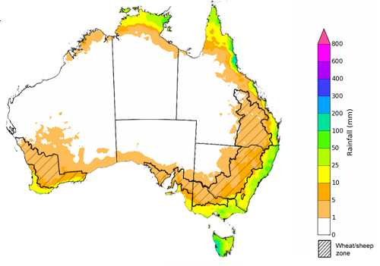

©Commonwealth of Australia 2023, Australian Bureau of Meteorology Issued:09/03/2023

The rainfall outlook for April to June 2023 suggests that below median rainfall is likely to very likely (60% to greater than 80% chance) for most of Australia the next three months. However, for tropical northern Queensland, parts of coastal New South Wales and southern Tasmania there is have close to equal chances of above or below median rainfall.
Chance of exceeding the median rainfall April to June 2023
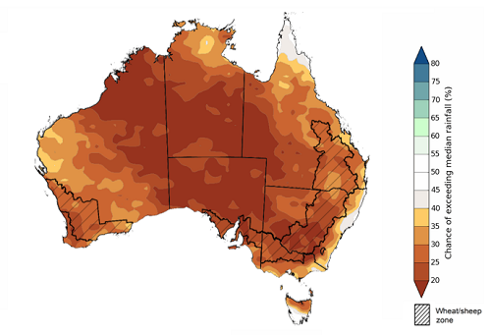
©Commonwealth of Australia 2023, Australian Bureau of Meteorology Issued: 09/03/2023

The outlook for April to June 2023 suggests there is a 75% chance of rainfall totals between 25 and 100 millimetres across central and eastern New South Wales, northern and eastern Queensland, southern parts of South Australia and Western Australia, northern parts of the Northern Territory and much of Victoria and Tasmania. Rainfall totals in excess of 200 millimetres are forecast for isolated coastal areas of New South Wales and Queensland, as well as western Tasmania.
Across cropping regions, there is a 75% chance of receiving between 25 and 100 millimetres across much of New South Wales, parts of eastern Queensland, Victoria, South Australia and Western Australia.
These rainfall totals are well below average for this three-month period across most of Australia. Relatively dry conditions during February and early March have seen soil moisture levels decline across large areas of Australia. This lack of rainfall and decline in soil moisture levels has led to reductions in yield potentials for later sown summer crops. Given these recent declines in soil moisture levels and the increased likelihood of below average rainfall over the next three months, crop producers will require adequate and timely rainfall to maintain current summer crop yield potentials to support the sowing and establishment of winter crops. For livestock producers experiencing below average rainfall, particularly across southern Australia, this will likely result in below average pasture production. However, ample supplies of conserved fodder will likely enable most producers to maintain current production levels and stocking rates.
Rainfall totals that have a 75% chance of occurring April to June 2023
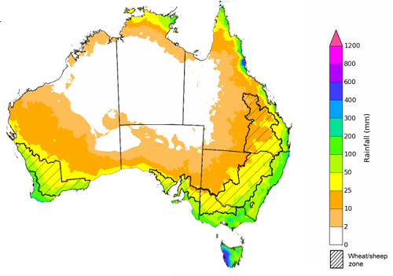
©Commonwealth of Australia 2023, Australian Bureau of Meteorology Issued: 09/03/2023
The temperature outlook for April to June 2023 indicates that maximum temperatures across most of Australia are likely to be close to the 1990-2012 average (the difference between -1°C to +1°C) while slightly warmer (up to +2°C) across much of Western Australia and South Australia and in isolated parts of Northern Territory, Queensland and New South Wales. The minimum temperatures across most of Australia are expected to be close to the 1990-2012 average (the difference in the range of -1°C to +1°C).
Predicted maximum temperature anomaly for April to June 2023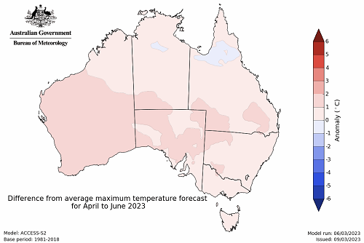
Predicted minimum temperature anomaly for April to June 2023
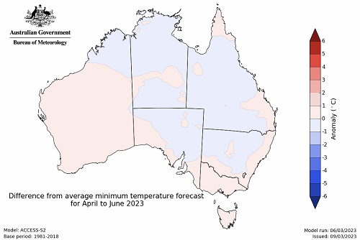

Rainfall forecast for the next eight days
Over the 8-days to 16 March 2023, the monsoon trough is expected to generate rain and storm across the tropical north of Australia. Meanwhile, a low-pressure trough across eastern Australia is forecast to generate rainfall in excess of 25 mm, particularly over much of Queensland and in the northeast and coastal New South Wales. A high-pressure system is expected to bring mainly dry conditions elsewhere.
Across Australian cropping regions, rainfall totals up to 100 millimetres are expected for much of Queensland, and up to 50 millimetres in much of the northeast of New South Wales over the next 8 days. Little to no rainfall in expected in the remaining cropping regions. If realised these falls are likely limit field access for crop maintenance activities and delay the harvest of early sown crops across summer cropping regions in Queensland and the far northeast of New South Wales. These falls are likely to provide a timely boost to soil moisture levels and stabilises yield potentials for late sown summer crops following recent reductions due to predominantly dry conditions during February and early March. The forecast rainfall over much of central and northern Queensland is likely to further benefit pasture growth rates and availability.

Total forecast rainfall for the period 9 March to 16 March 2023
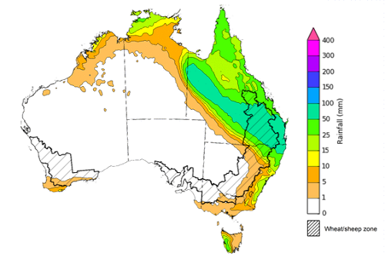

©Commonwealth of Australia 2023, Australian Bureau of Meteorology Issued 09/03/2023
Note: This rainfall forecast is produced from computer models. As the model outputs are not altered by weather forecasters, it is important to check local forecasts and warnings issued by the Bureau of Meteorology.

Water

Water markets – current week
Water storage levels in the Murray-Darling Basin (MDB) decreased between 27 February 2023 and 6 March 2023 by 271 gigalitres (GL). Current volume of water held in storage is 22 580 GL which represents 89 per cent of total capacity. This is 1 percent or 174 GL more than at the same time last year.

Water storages in the Murray-Darling Basin, 2013–2023
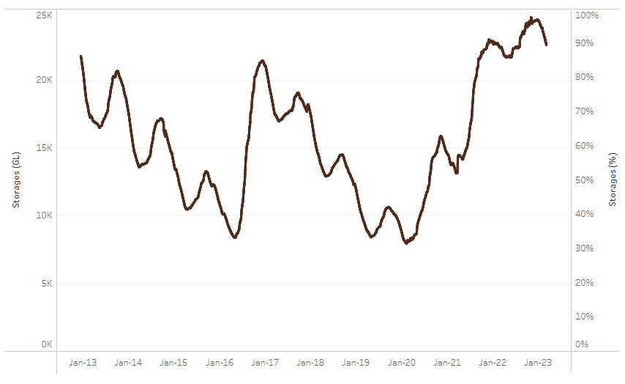
Allocation prices in the Victorian Murray below the Barmah Choke remained steady at $15 per ML from 2 March 2023 to 9 March 2023. Prices are lower in the Murrumbidgee and in regions above the Barmah choke due to the binding of the Murrumbidgee export limit and Barmah choke trade constraint.
Water storage data is sourced from the Bureau of Meteorology.
Region | $/ML
NSW Murray Above | 7
NSW Murrumbidgee | 9
VIC Goulburn-Broken | 14
VIC Murray Below | 15

Surface water trade activity, Southern Murray–Darling Basin
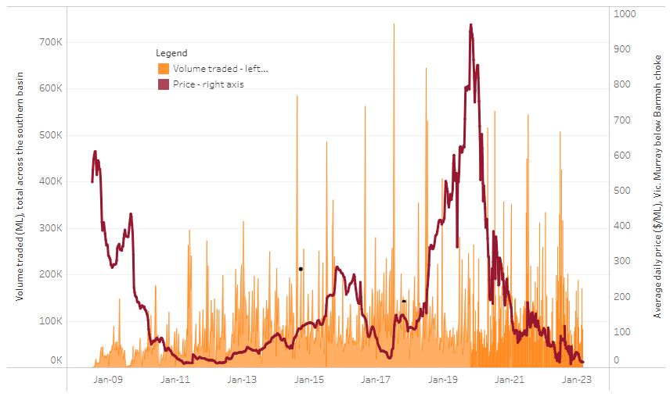
The trades shown reflect estimated market activity and do not encompass all register trades. The price is shown for the VIC Murray below the Barmah choke. Historical prices (before 1 July 2019) are ABARES estimates after removing outliers from BOM water register data. Prices after 1 July 2019 and prior to the 30 October 2019 reflect recorded transaction prices as sourced from Ruralco. Prices after the 30 October 2019 are sourced from Waterflow. Data for volume traded is sourced from the BOM water register. Data shown is current on 9 March 2023.

To access the full, interactive, weekly water dashboard, which contains the latest and historical water storage, water market and water allocation information, please visit https://www.agriculture.gov.au/abares/products/weekly_update/weekly-update-9323

Commodities
Indicator | Week ended | Unit | Latest Price | Previous Week | Weekly change | Price 12 months ago | Annual change
Selected world indicator prices
AUD/USD Exchange rate | 08-Mar | A$/US$ | 0.67 | 0.68 | -1% | 0.73 | -8%
Wheat – US no. 2 hard red winter wheat, fob Gulf | 08-Mar | US$/t | 358 | 377 | -5% | 483 | -26%
Corn – US no. 2 yellow corn, fob Gulf | 08-Mar | US$/t | 286 | 290 | -1% | 336 | -15%
Canola – Rapeseed, Canada, fob Vancouver | 08-Mar | US$/t | 654 | 658 | -1% | 938 | -30%
Cotton – Cotlook 'A' Index | 08-Mar | USc/lb | 99 | 98 | 1% | 137 | -27%
Sugar – Intercontinental Exchange, nearby futures, no.11 contract | 08-Mar | USc/lb | 20.3 | 20.1 | 1% | 19 | 9%
Wool – Eastern Market Indicator | 08-Feb | Ac/kg clean | 1,374 | 1,400 | -2% | 1,346 | 2%
Wool – Western Market Indicator | 08-Feb | Ac/kg clean | 1,525 | 1,570 | -3% | 1,368 | 11%
Selected Australian grain export prices
Milling Wheat – APW, Port Adelaide, SA | 08-Mar | A$/t | 497 | 499 | 0% | 595 | -17%
Feed Wheat – ASW, Port Adelaide, SA | 08-Mar | A$/t | 458 | 467 | -2% | 560 | -18%
Feed Barley – Port Adelaide, SA | 08-Mar | A$/t | 405 | 409 | -1% | 452 | -11%
Canola – Kwinana, WA | 08-Mar | A$/t | 1,014 | 971 | 4% | 1,175 | -14%
Grain Sorghum – Brisbane, QLD | 08-Mar | A$/t | 512 | 509 | 1% | 375 | 37%
Selected domestic livestock indicator prices
Beef – Eastern Young Cattle Indicator | 08-Mar | Ac/kg cwt | 698 | 734 | -5% | 1,118 | -38%
Mutton – Mutton indicator (18–24 kg fat score 2–3), Vic | 08-Mar | Ac/kg cwt | 354 | 328 | 8% | 538 | -34%
Lamb – Eastern States Trade Lamb Indicator | 08-Mar | Ac/kg cwt | 719 | 734 | -2% | 825 | -13%
Pig – Eastern Seaboard (60.1–75 kg), average of buyers & sellers | 15-Feb | Ac/kg cwt | 367 | 367 | 0% | 357 | 3%
Goats – Eastern States (12.1–16 kg) | 01-Mar | Ac/kg cwt | 325 | 325 | 0% | 813 | -60%
Live cattle – Light steers ex Darwin to Indonesia | 17-Aug | Ac/kg lwt | 420 | 480 | -13% | 320 | 31%
Live sheep – Live wethers (Muchea WA saleyard) to Middle East | 14-Sep | $/head | 93 | 113 | -18% | 114 | -18%
Global Dairy Trade (GDT) weighted average prices ª
Dairy – Whole milk powder | 22-Feb | US$/t | 3,264 | 3,329 | -2% | 3,458 | -6%
Dairy – Skim milk powder | 22-Feb | US$/t | 2,769 | 2,829 | -2% | 3,198 | -13%
Dairy – Cheddar cheese | 22-Feb | US$/t | 5,086 | 4,980 | 2% | 4,178 | 22%
Dairy – Anhydrous milk fat | 22-Feb | US$/t | 5,447 | 5,586 | -2% | 5,463 | 0%
a Global Dairy Trade prices are updated twice monthly on the first and third Tuesday of each month.

Selected world indicator prices
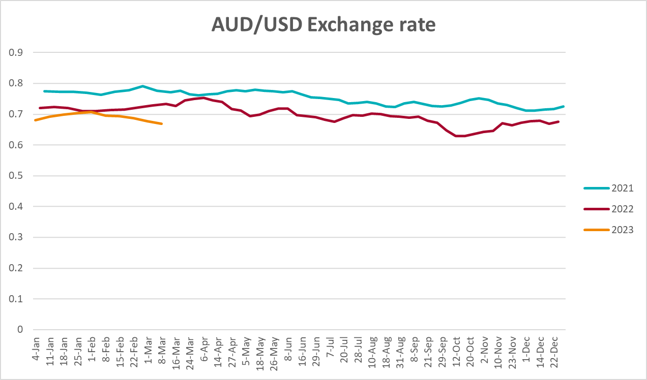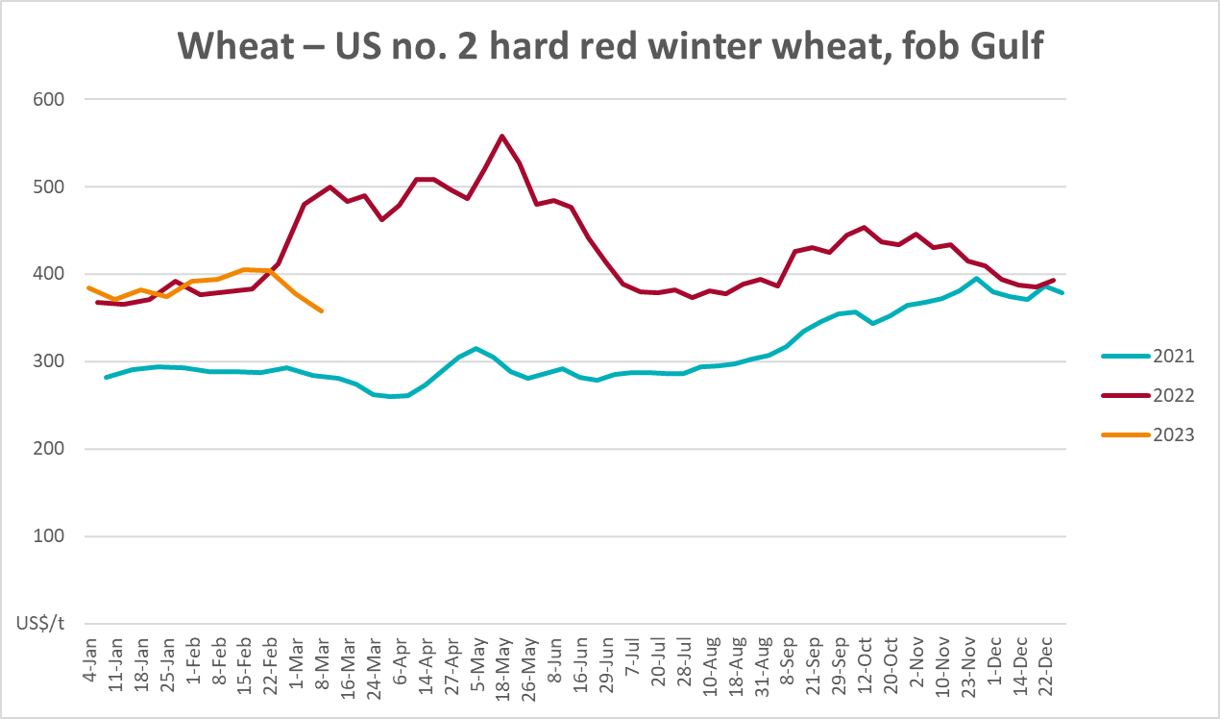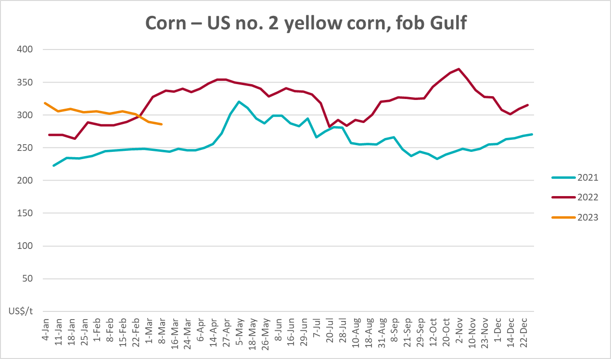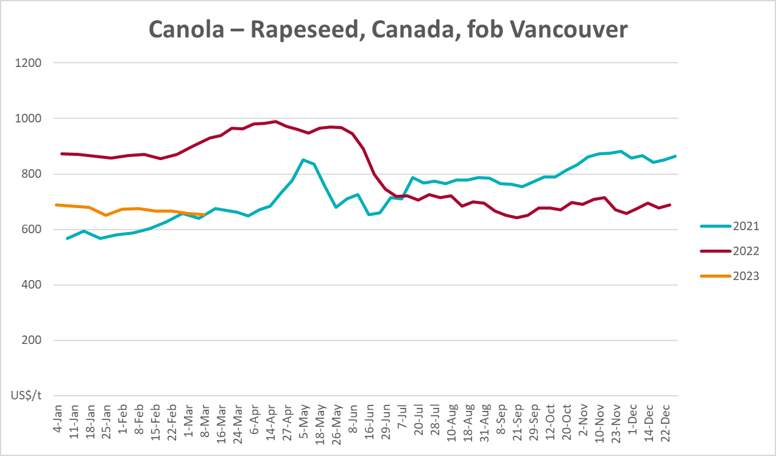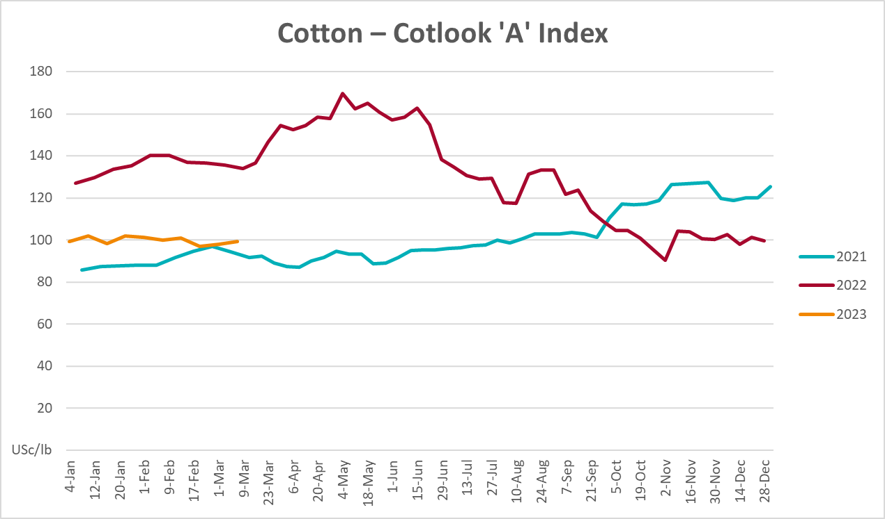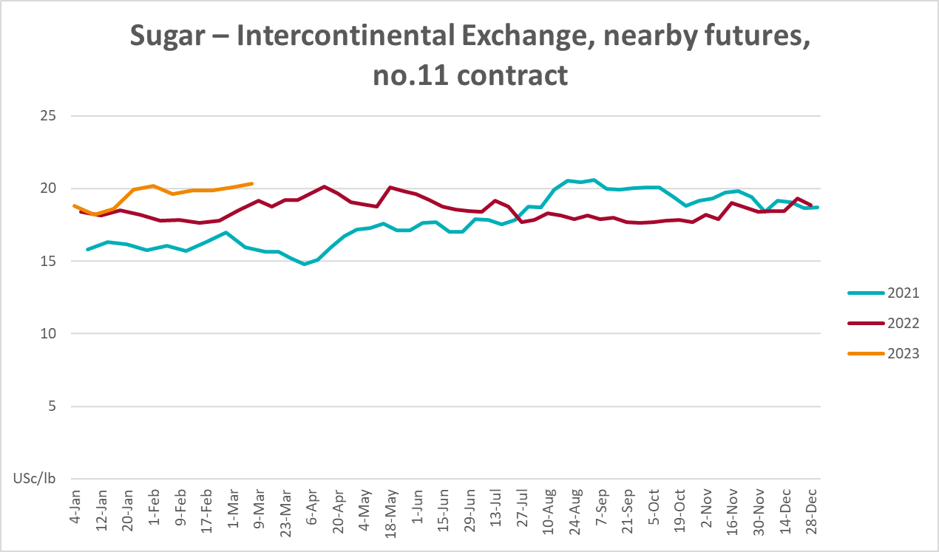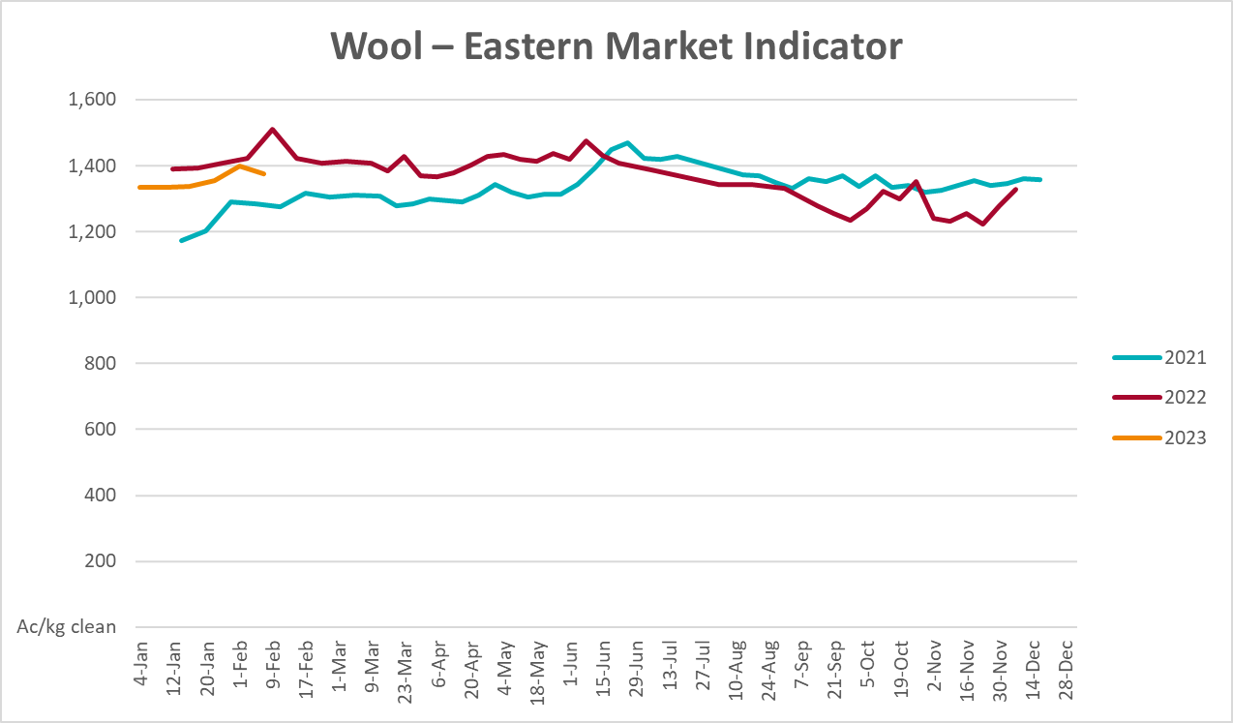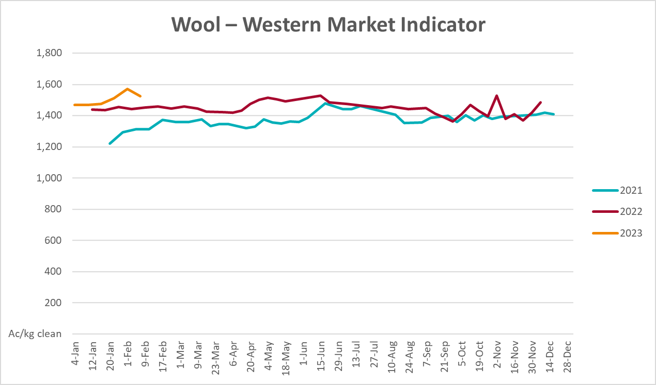

Selected domestic crop indicator prices
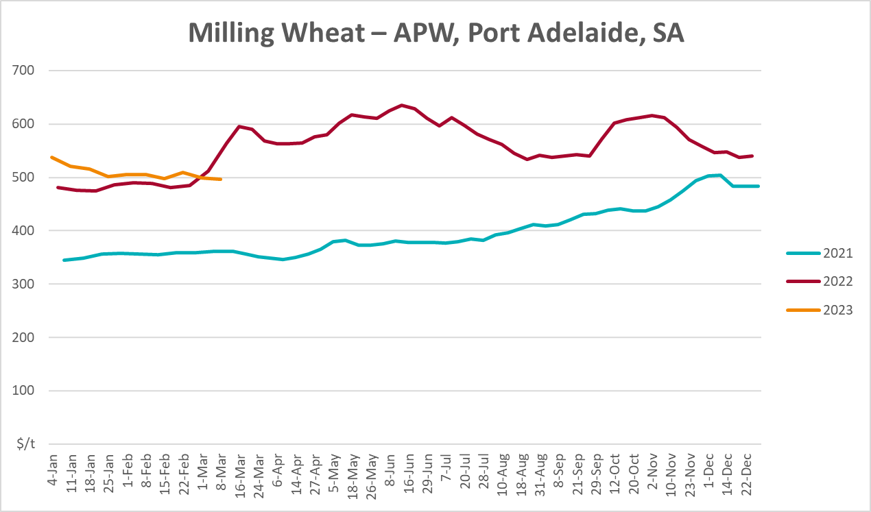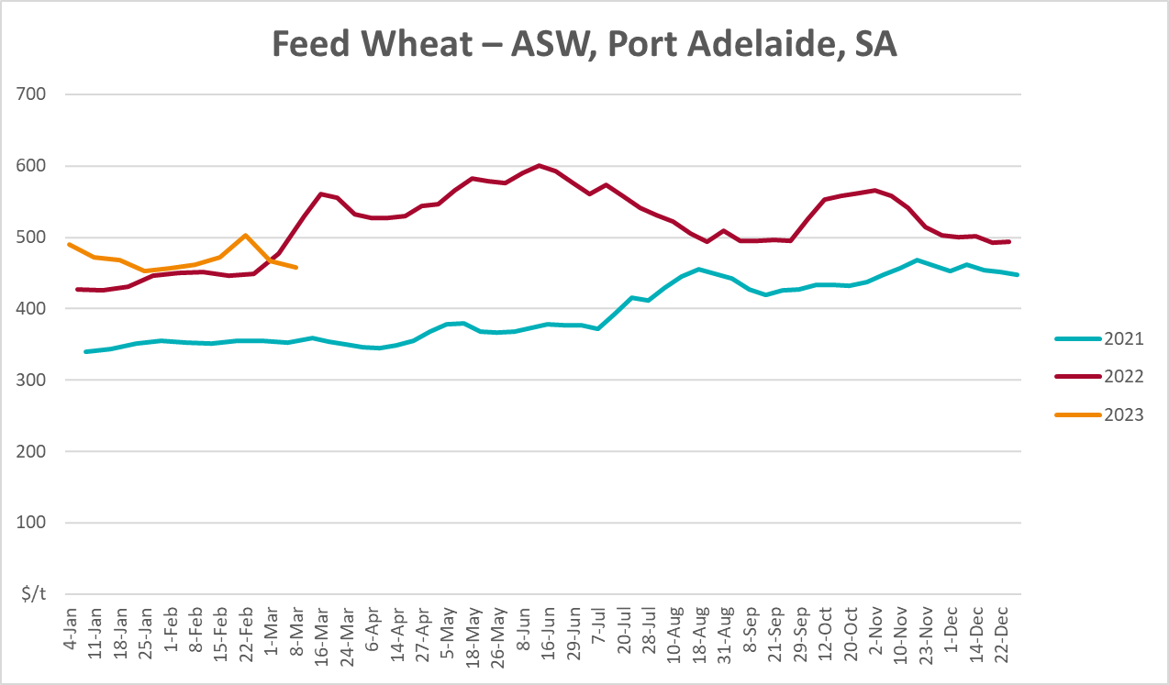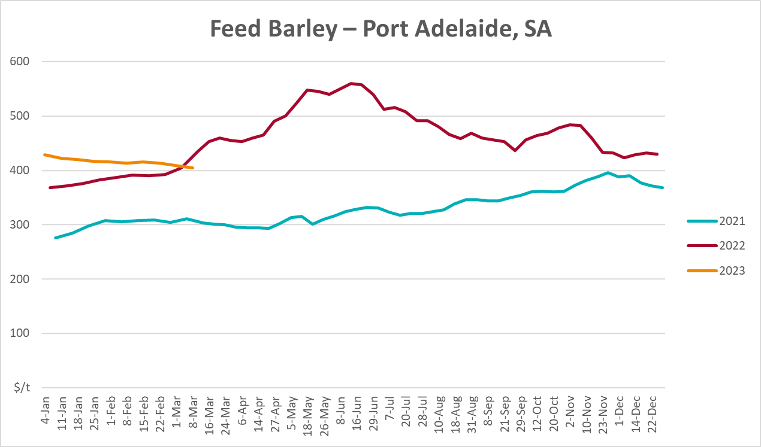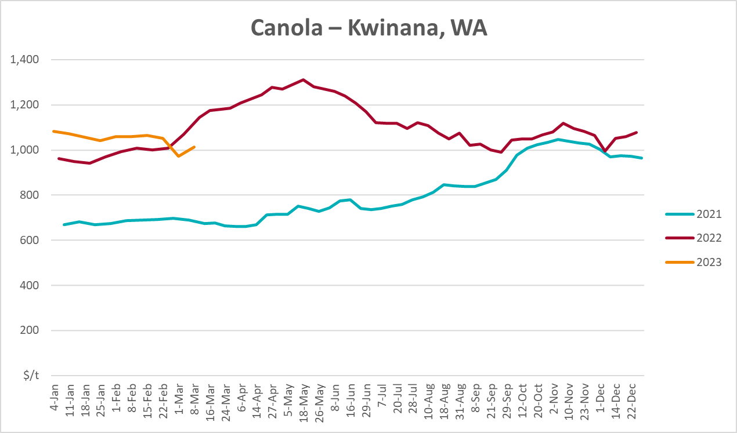
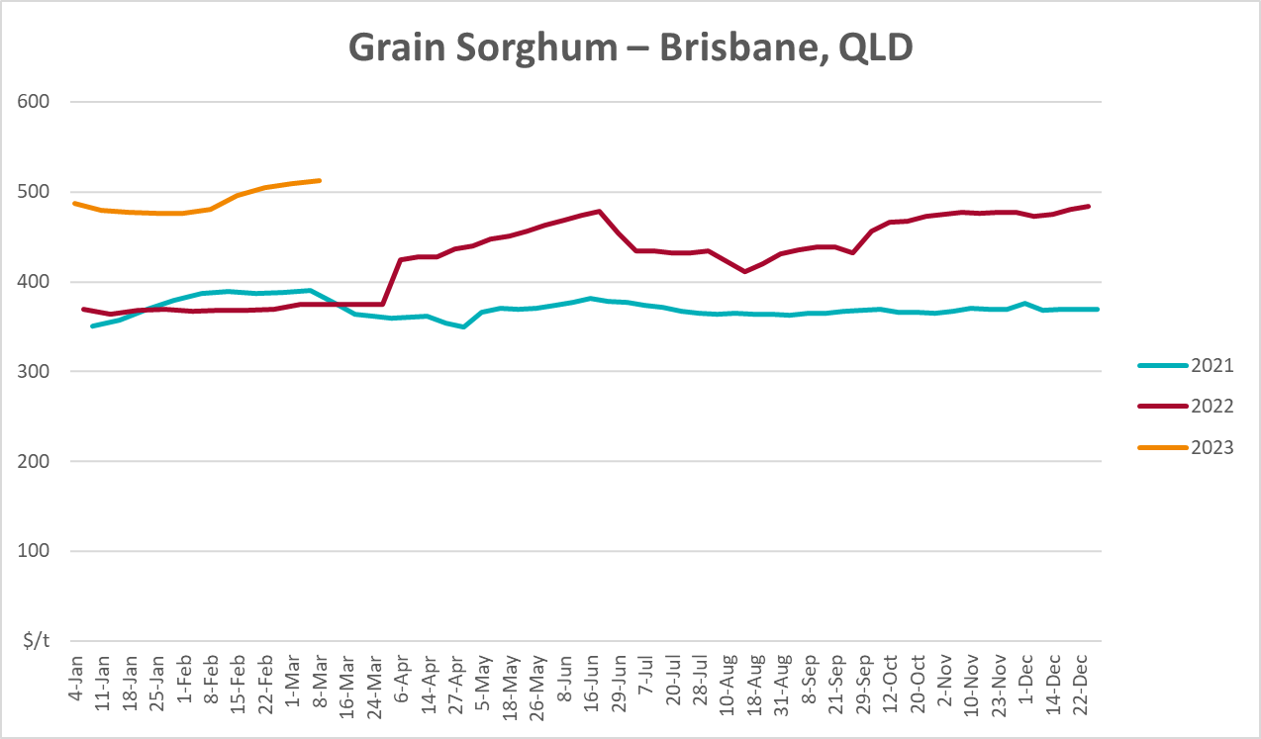

Selected domestic livestock indicator prices
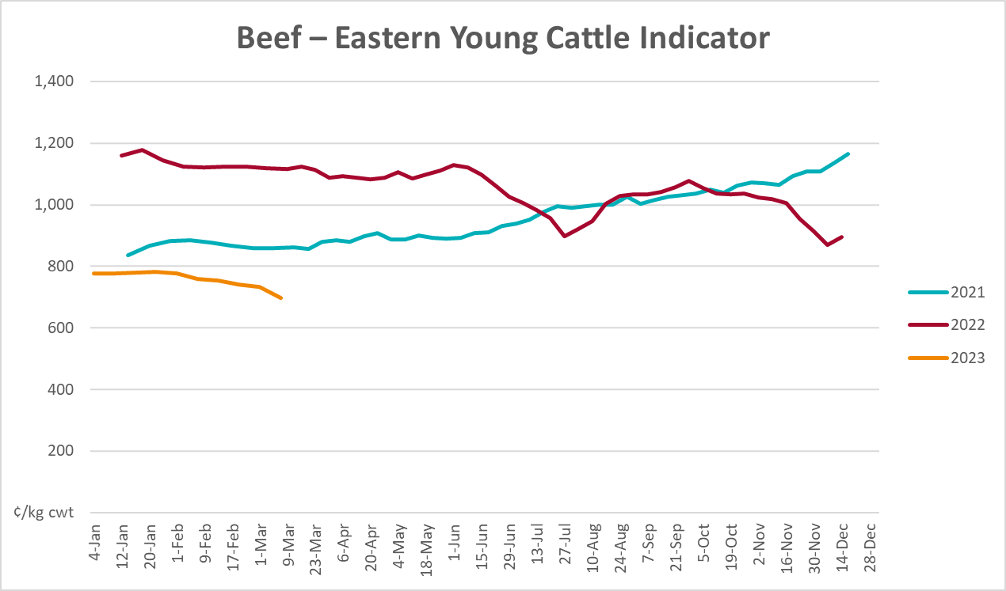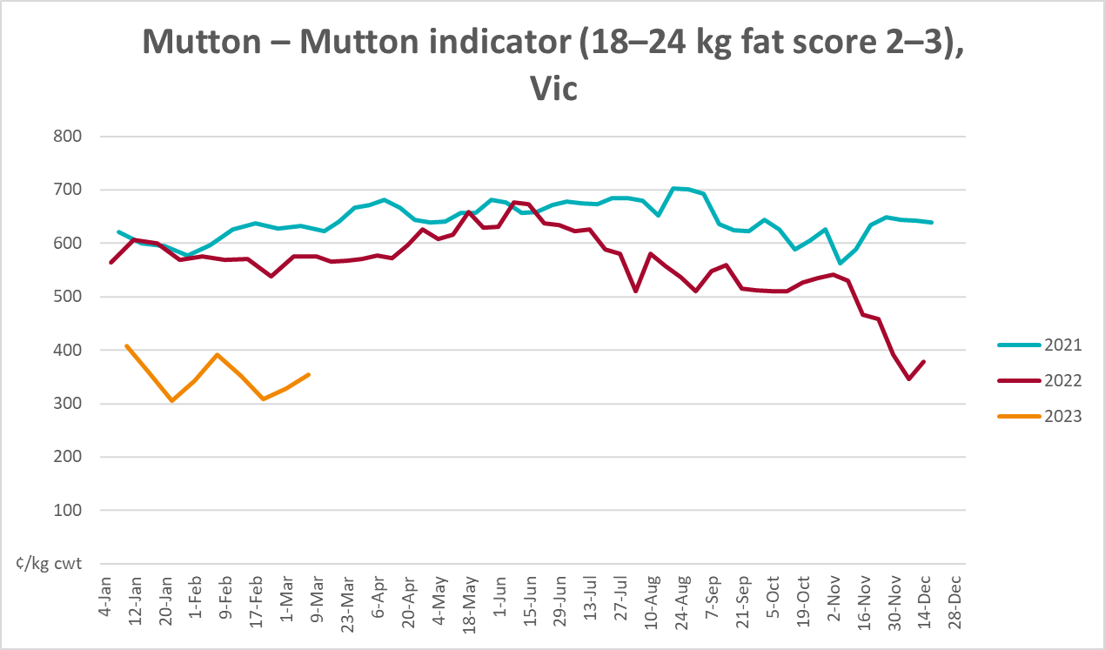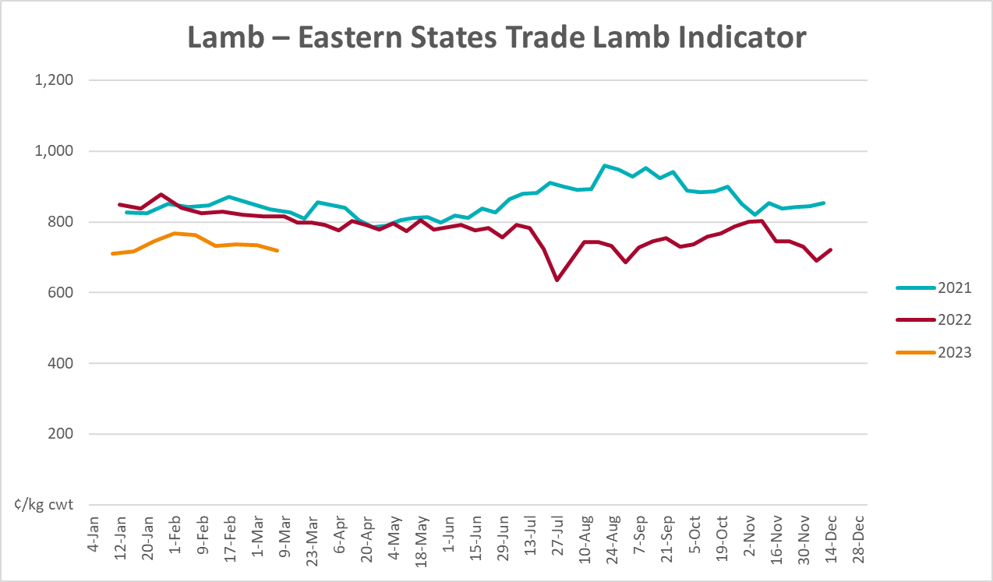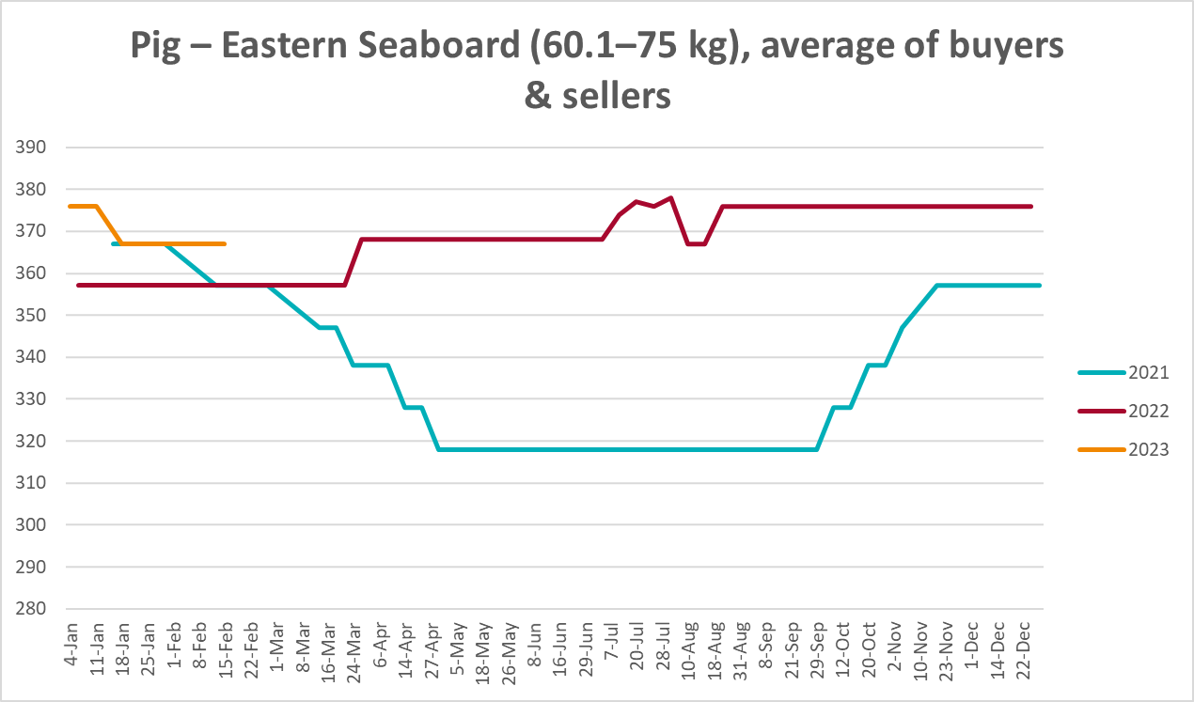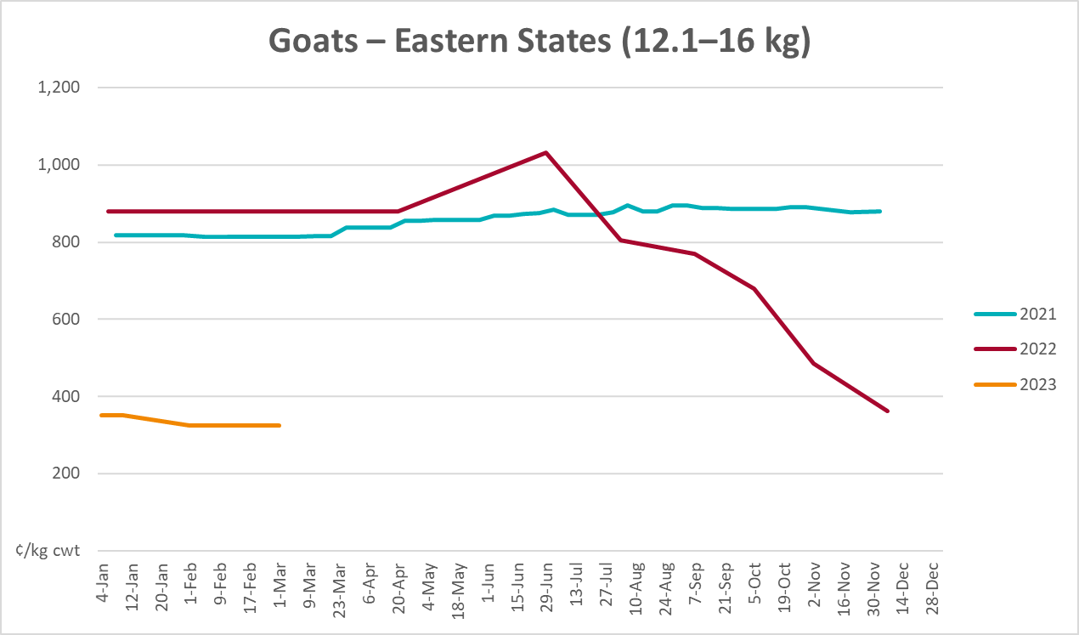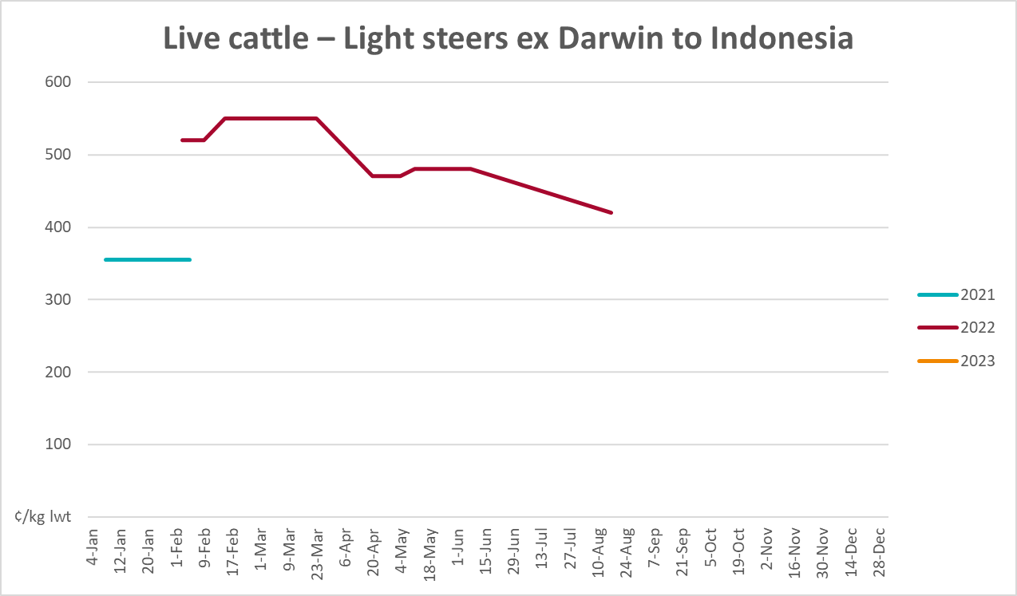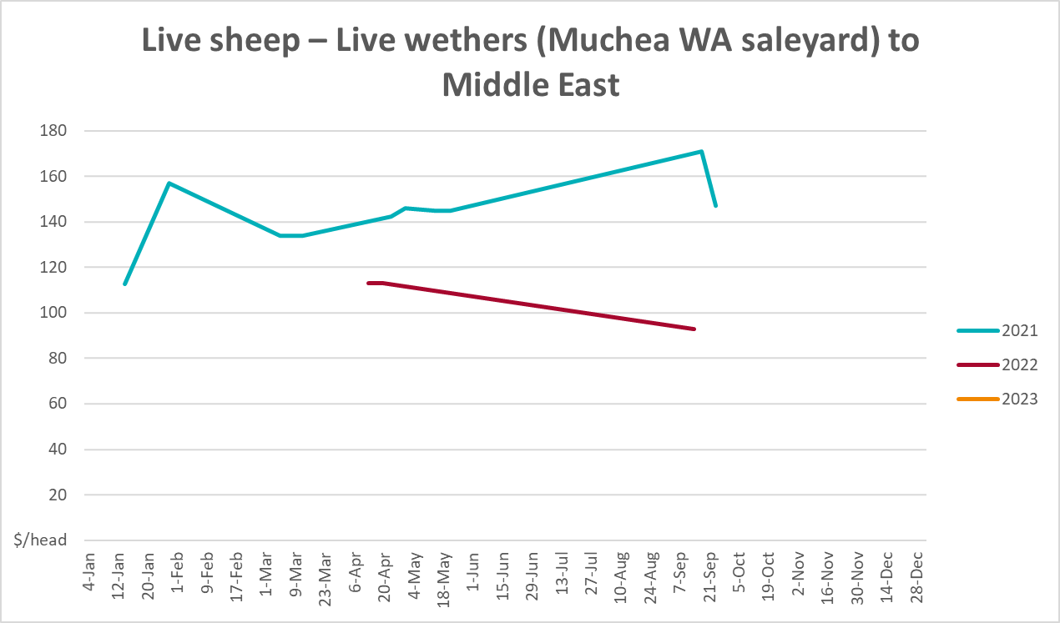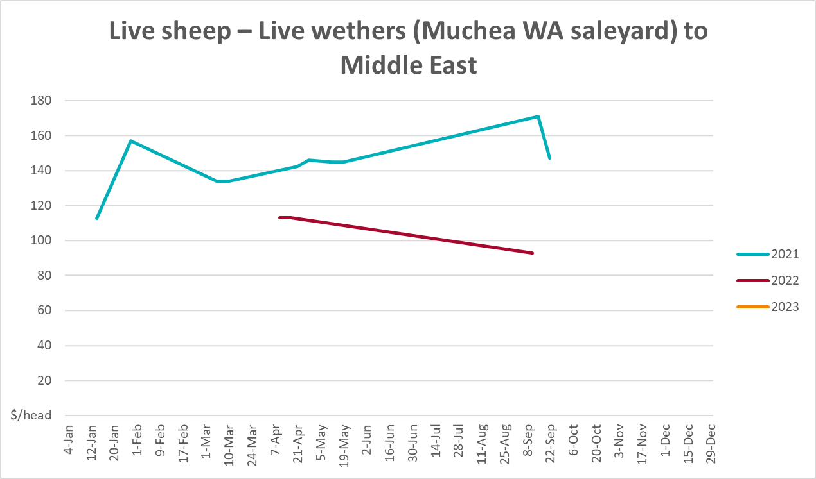

Global Dairy Trade (GDT) weighted average prices
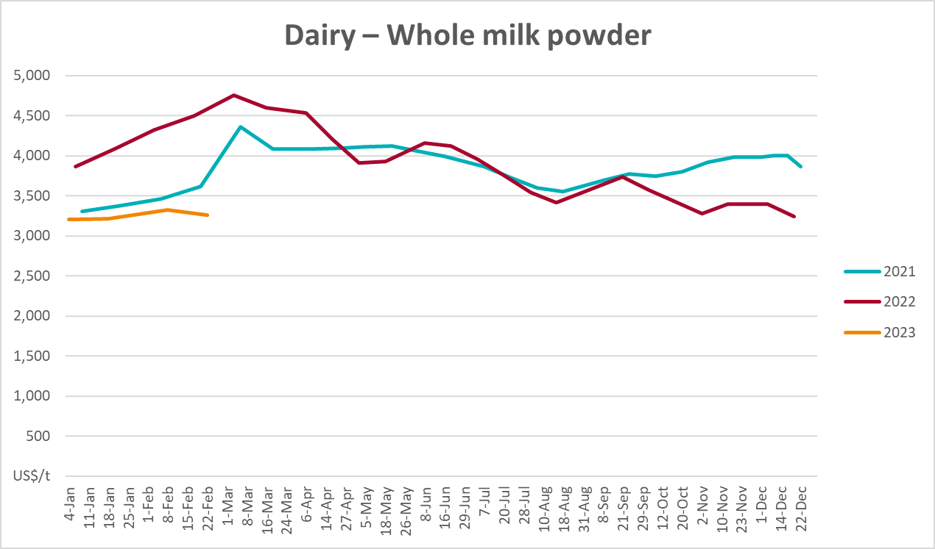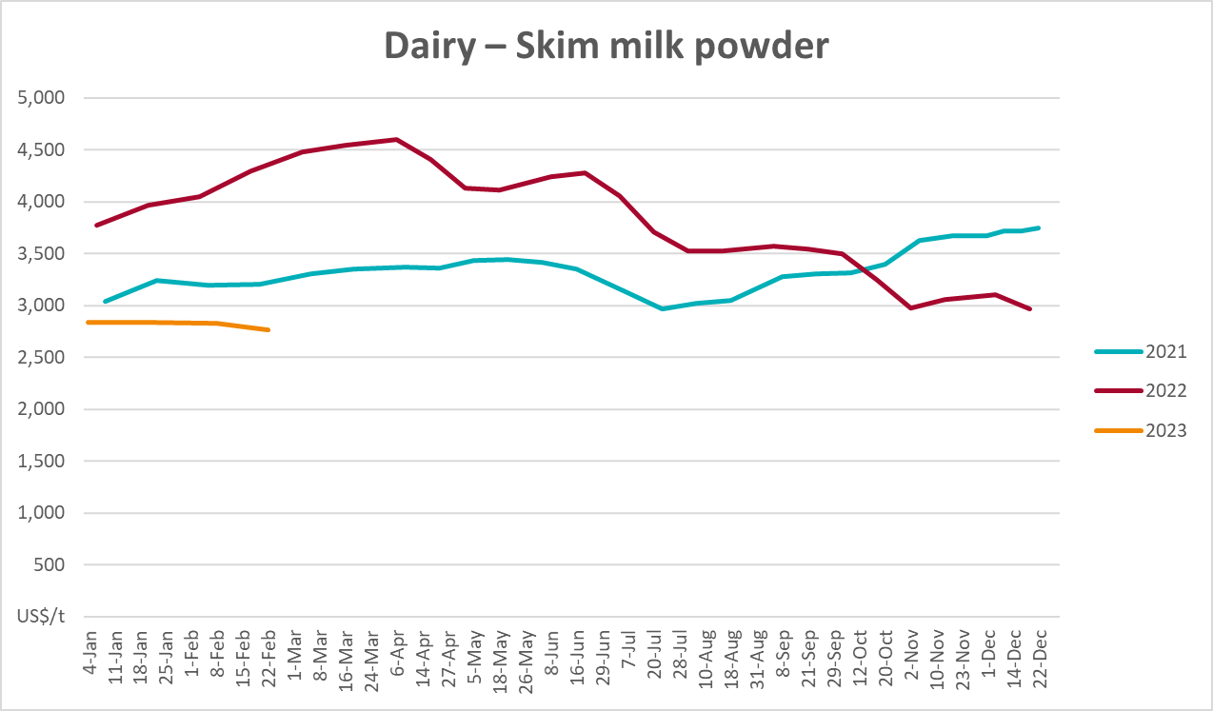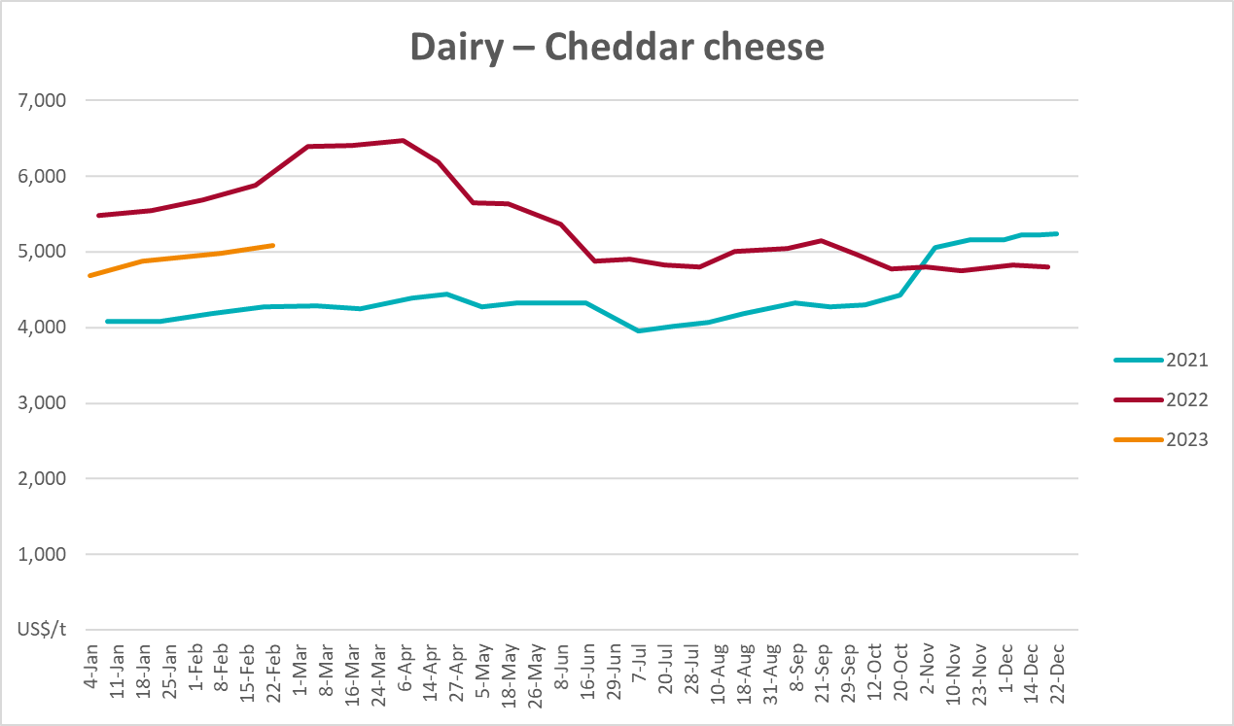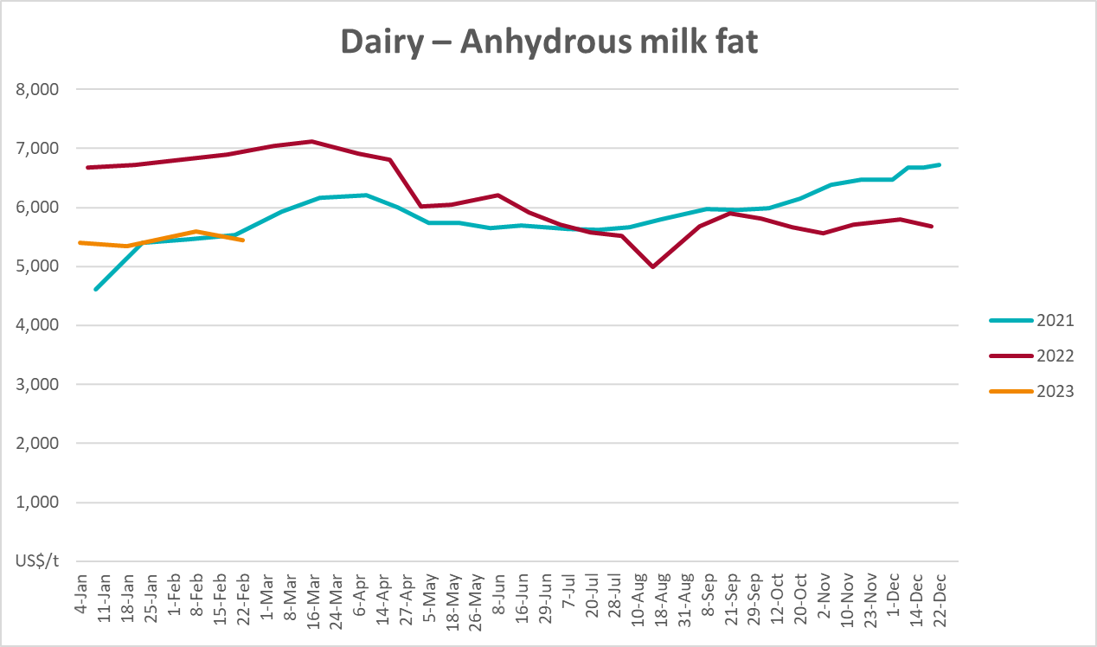

Selected fruit and vegetable prices
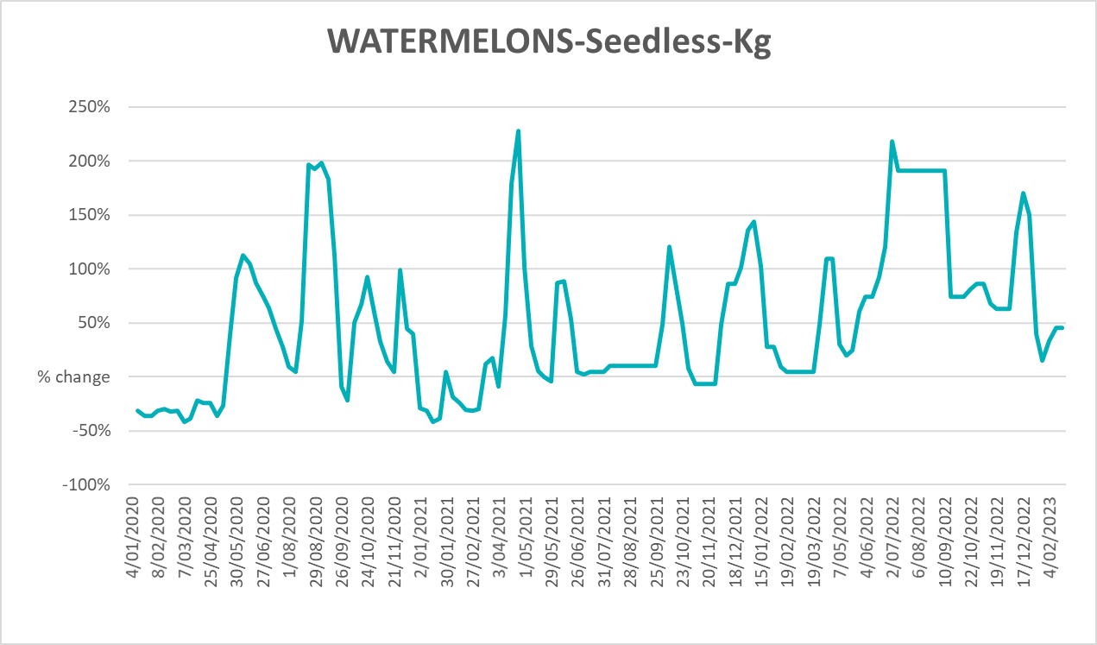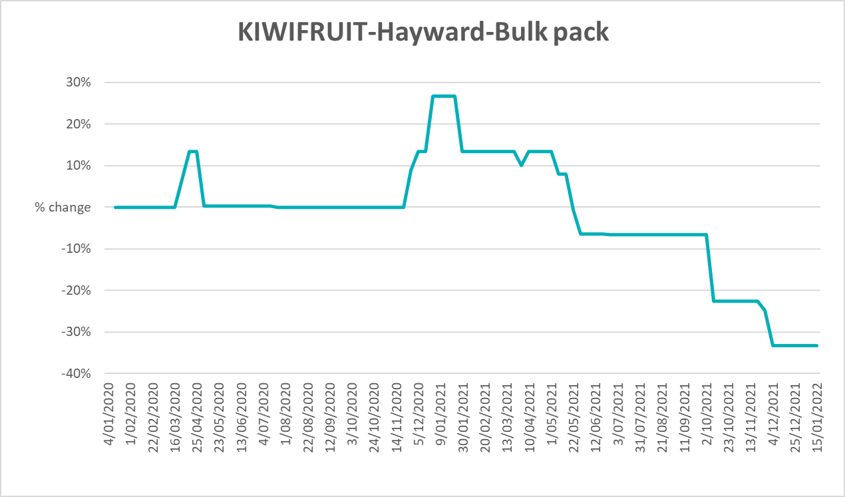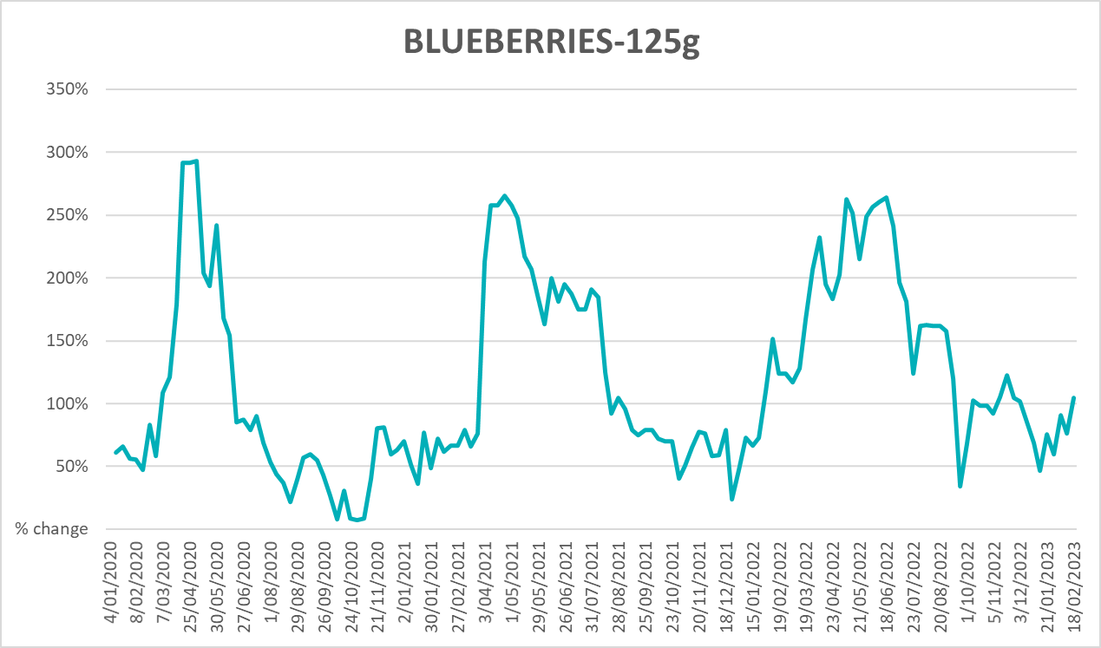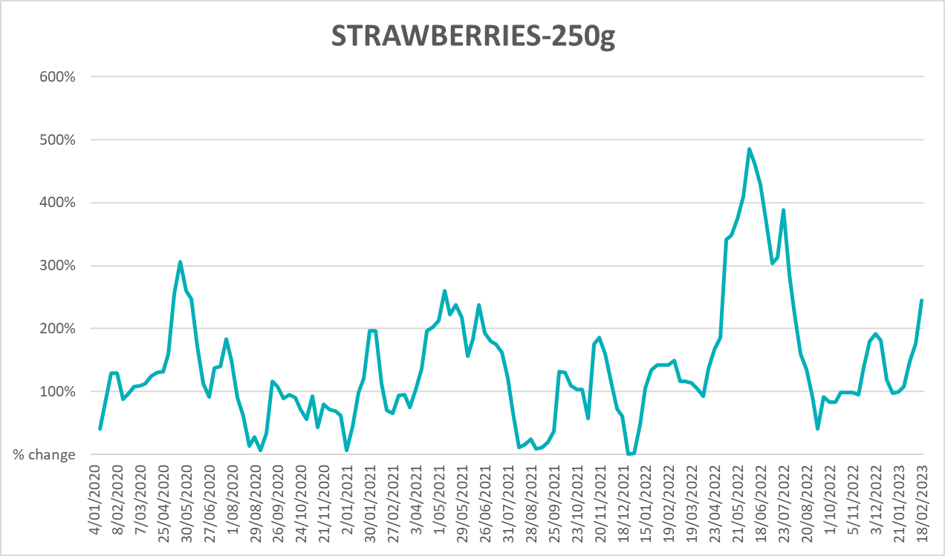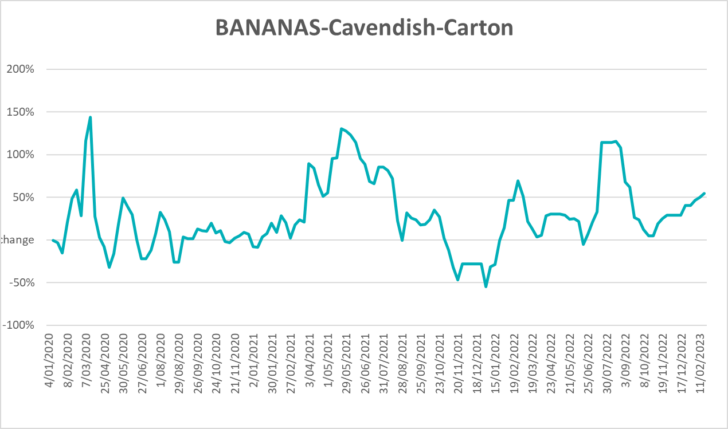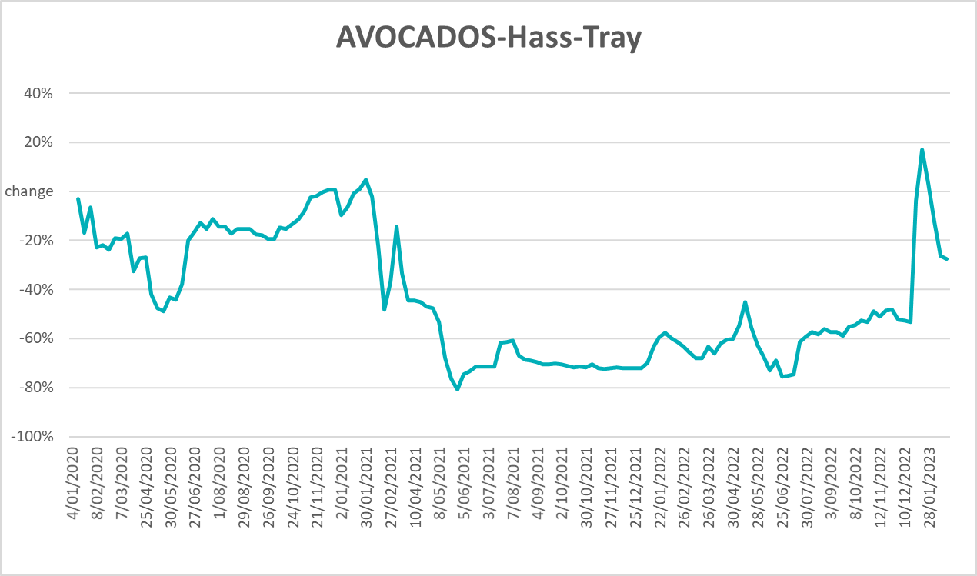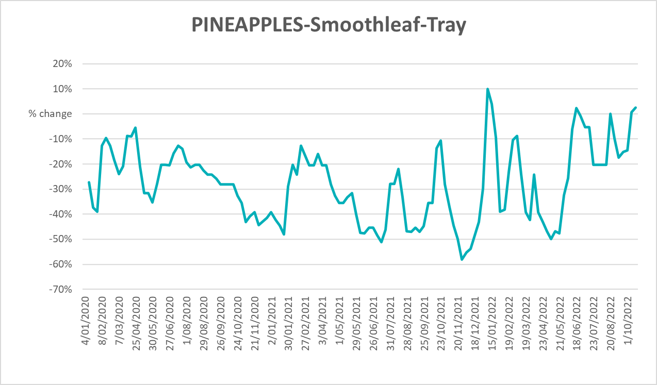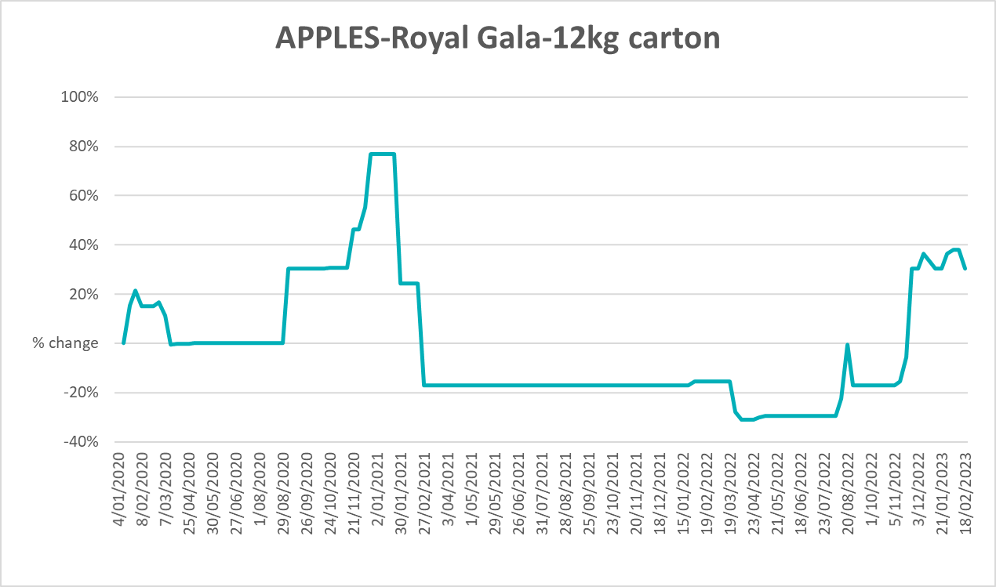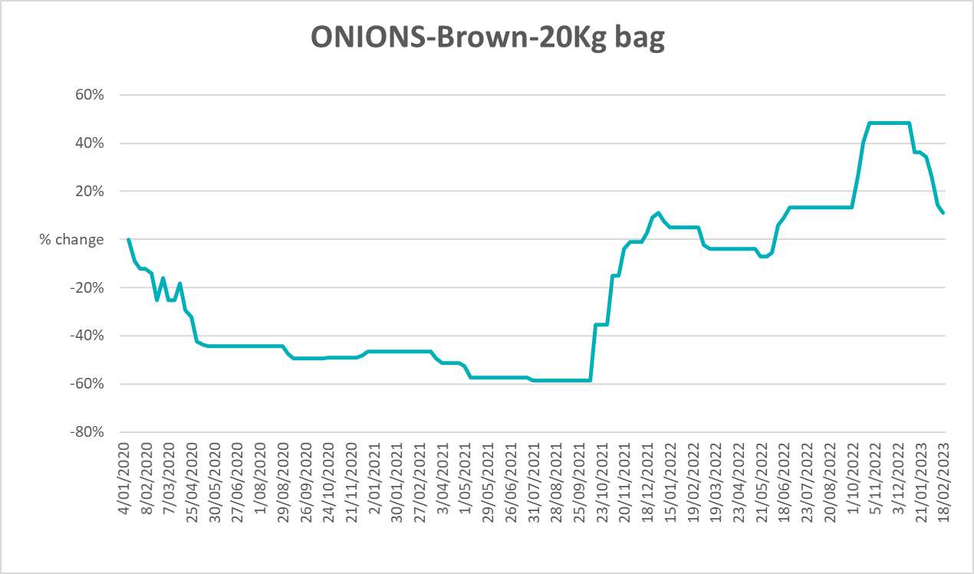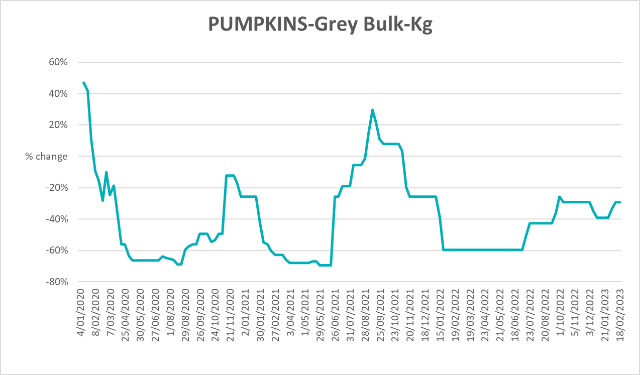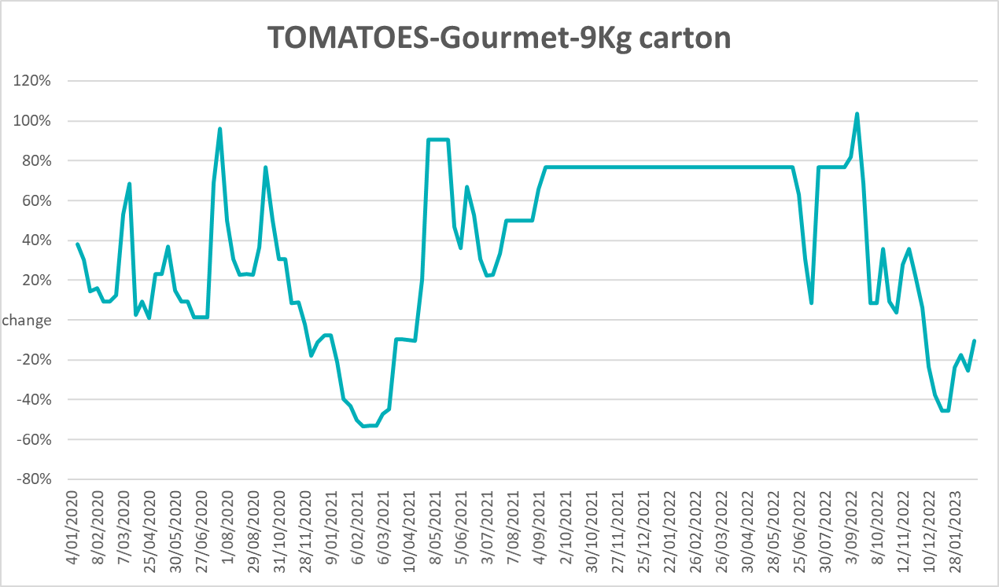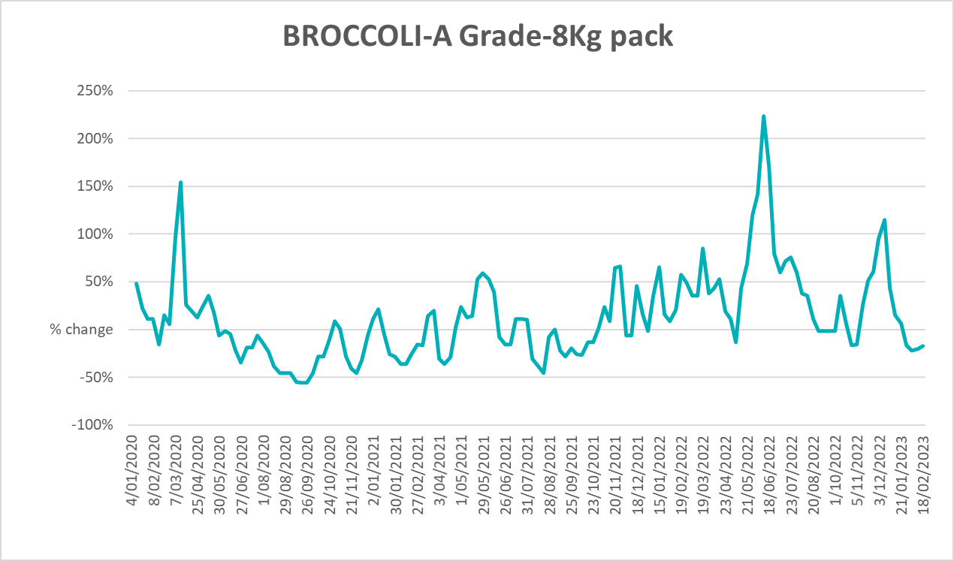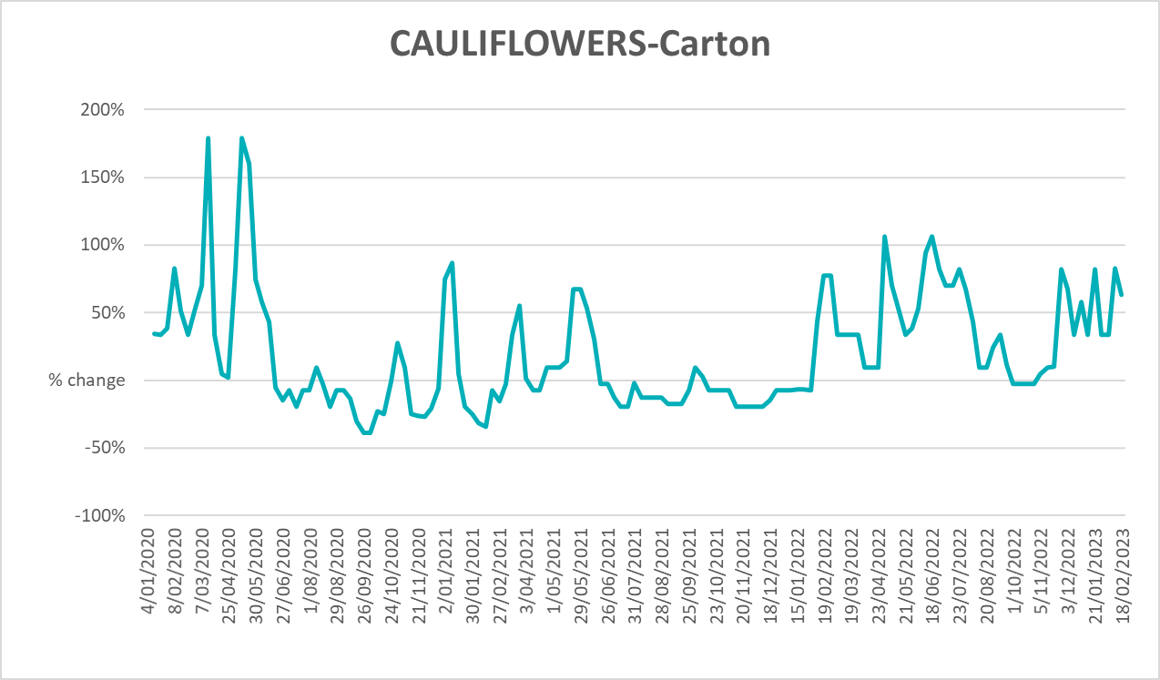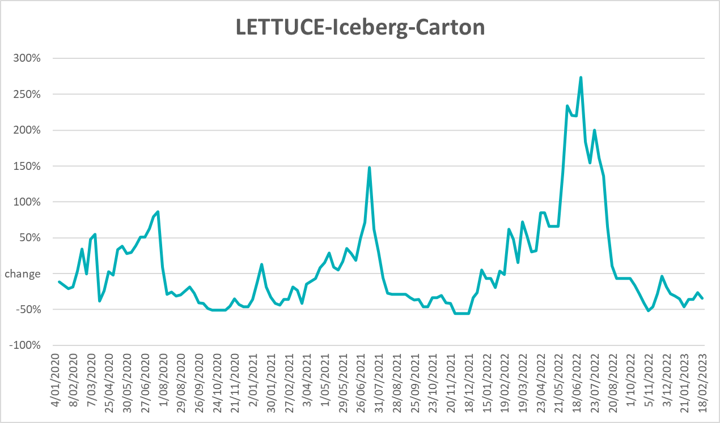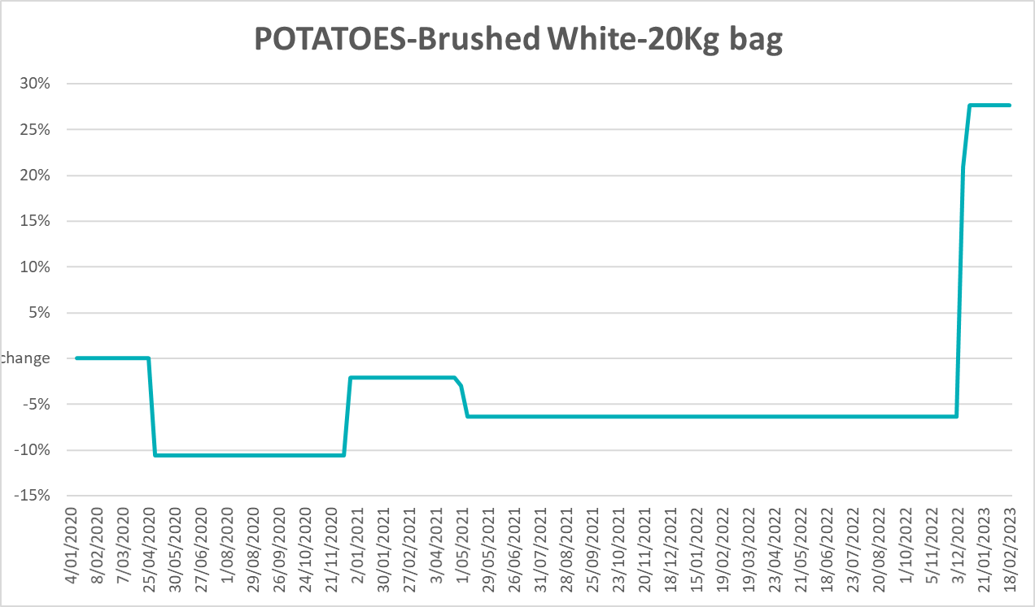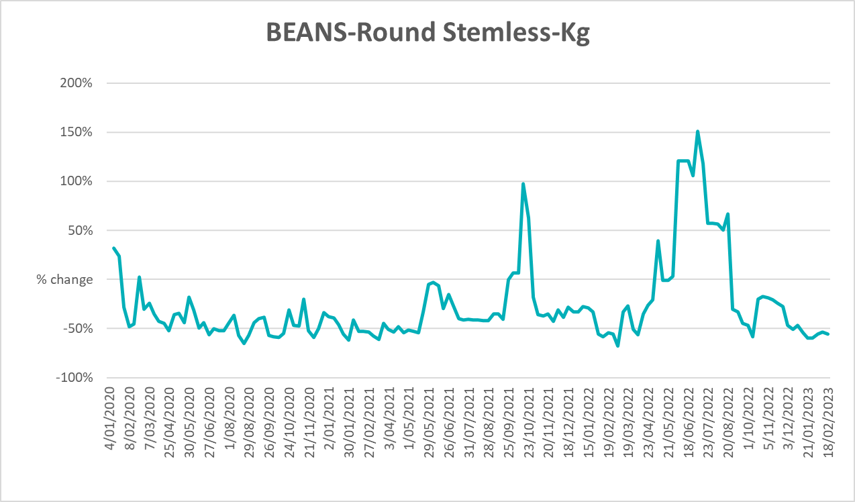

3.6 Selected domestic fodder indicator prices

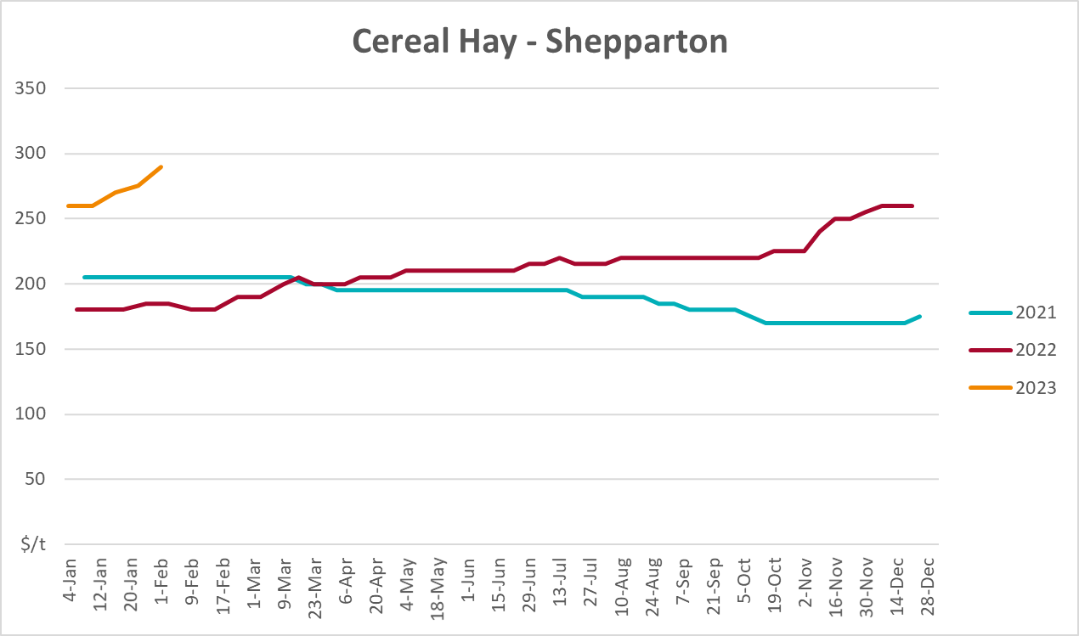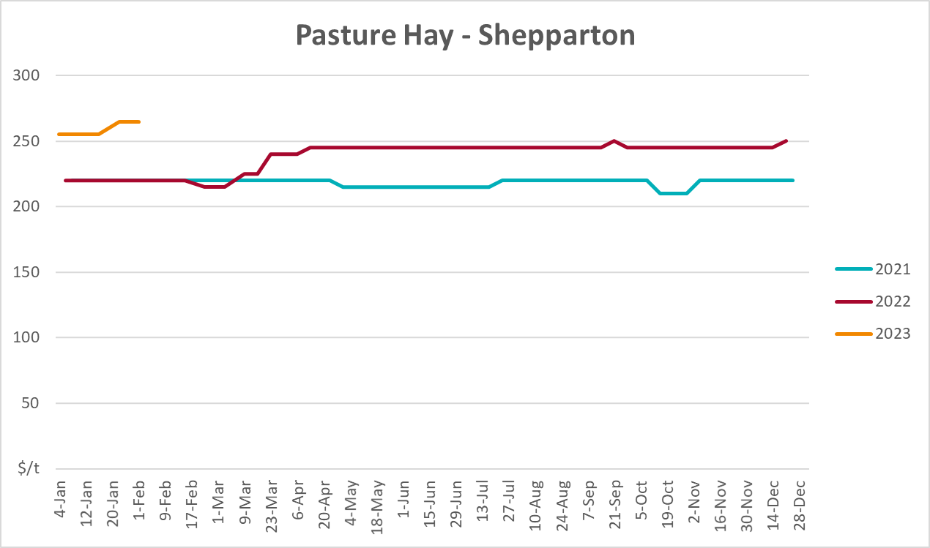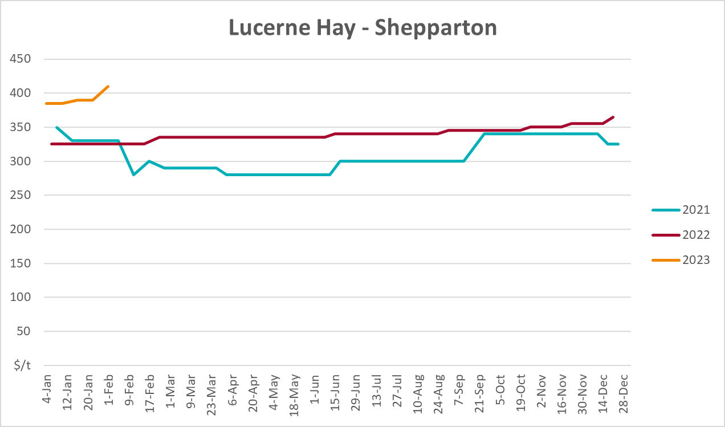

4. Data attribution

Climate
Bureau of Meteorology
- Weekly rainfall totals: www.bom.gov.au/climate/maps/rainfall/
- Monthly and last 3-month rainfall percentiles: www.bom.gov.au/water/landscape/
- Temperature anomalies: www.bom.gov.au/jsp/awap/temp/index.jsp
- Rainfall forecast: www.bom.gov.au/jsp/watl/rainfall/pme.jsp
- Seasonal outlook: www.bom.gov.au/climate/outlooks/#/overview/summary/
- Climate drivers: http://www.bom.gov.au/climate/enso/
- Soil moisture: www.bom.gov.au/water/landscape/
Other
- Pasture growth: www.longpaddock.qld.gov.au/aussiegrass/
- 3-month global outlooks: Environment and Climate Change Canada, NOAA Climate Prediction Center, EUROBRISA CPTEC/INPE, European Centre for Medium-Range Weather Forecasts, Hydrometcenter of Russia, National Climate Center Climate System Diagnosis and Prediction Room (NCC), International Research Institute for Climate and Society
- Global production: https://ipad.fas.usda.gov/ogamaps/cropmapsandcalendars.aspx
- Autumn break: Pook et al., 2009, https://rmets-onlinelibrary-wiley-com.virtual.anu.edu.au/doi/epdf/10.1002/joc.1833

Water
Prices
- Waterflow: https://www.waterflow.io/
- Ruralco: https://www.ruralcowater.com.au/
Bureau of Meteorology:
- Allocation trade: http://www.bom.gov.au/water/dashboards/#/water-markets/mdb/at
- Storage volumes: http://www.bom.gov.au/water/dashboards/#/water-storages/summary/drainage
Trade constraints:
- Water NSW: https://www.waternsw.com.au/customer-service/ordering-trading-and-pricing/trading/murrumbidgee
- Victorian Water Register: https://www.waterregister.vic.gov.au/TradingRules2019/

Commodities
Fruit and vegetables
- Datafresh: www.freshstate.com.au
Pigs
- Australian Pork Limited: www.australianpork.com.au
Dairy
- Global Dairy Trade: www.globaldairytrade.info/en/product-results/
World wheat, canola
- International Grains Council
World coarse grains
- United States Department of Agriculture
World cotton
- Cotlook: www.cotlook.com/
World sugar
- New York Stock Exchange - Intercontinental Exchange
Wool
- Australian Wool Exchange: www.awex.com.au/
Domestic wheat, barley, sorghum, canola and fodder
- Jumbuk Consulting Pty Ltd: http://www.jumbukag.com.au/
Cattle, beef, mutton, lamb, goat and live export
- Meat and Livestock Australia: www.mla.com.au/Prices-and-market
© Commonwealth of Australia 2023

Ownership of intellectual property rights
Unless otherwise noted, copyright (and any other intellectual property rights, if any) in this publication is owned by the Commonwealth of Australia (referred to as the Commonwealth).

Creative Commons licence
All material in this publication is licensed under a Creative Commons Attribution 4.0 International Licence except content supplied by third parties, logos and the Commonwealth Coat of Arms.
Inquiries about the licence and any use of this document should be emailed to copyright@awe.gov.au.


Cataloguing data
This publication (and any material sourced from it) should be attributed as:
ABARES 2023, Weekly Australian Climate, Water and Agricultural Update, Australian Bureau of Agricultural and Resource Economics and Sciences, Canberra, 9 March 2023. CC BY 4.0 DOI: https://doi.org/10.25814/5f3e04e7d2503
ISSN 2652-7561
This publication is available at https://www.agriculture.gov.au/abares/products/weekly_update
Department of Agriculture, Fisheries and Forestry
GPO Box 858 Canberra ACT 2601
Telephone 1800 900 090
Web agriculture.gov.au/abares

Disclaimer
The Australian Government acting through the Department of Agriculture, Fisheries and Forestry, represented by the Australian Bureau of Agricultural and Resource Economics and Sciences, has exercised due care and skill in preparing and compiling the information and data in this publication. Notwithstanding, the Department of Agriculture, Fisheries and Forestry, ABARES, its employees and advisers disclaim all liability, including liability for negligence and for any loss, damage, injury, expense or cost incurred by any person as a result of accessing, using or relying on any of the information or data in this publication to the maximum extent permitted by law.

Statement of Professional Independence
The views and analysis presented in ABARES publications, including this one, reflect ABARES professionally independent findings, based on scientific and economic concepts, principles, information and data. These views, analysis and findings may not reflect or be consistent with the views or positions of the Australian Government, or of organisations or groups who have commissioned ABARES reports or analysis. More information on professional independence is provided on the ABARES website.

Acknowledgements
This report was prepared by Kavina Dayal and Matthew Miller.

