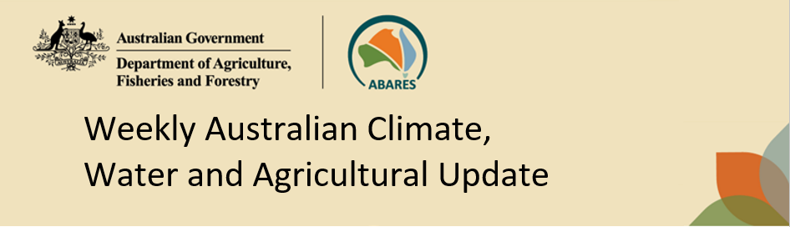
No. 11/2023 23 March 2023

Summary of key issues
- For the week ending 22 March 2023, surface troughs and thunderstorm activity brought rainfall to the north and east of the country. Weekly rainfall totals of between 15 and 100 millimetres were recorded across most of the coastal northern tropics. Similar rainfall totals were recorded in western Tasmania, central Northern Territory and across scattered pockets of the eastern mainland.
- In cropping regions, rainfall totals of between 15 to 50 millimetres were recorded across parts of northern Queensland, southern New South Wales, and eastern Victoria. Little to no rainfall was recorded across the remaining cropping regions over the past 7 days. Dry conditions across most summer cropping regions would have allowed for uninterrupted access to fields for crop maintenance activities and for the harvesting of early sown crops. In regions with below average soil moisture levels, little to no rainfall is likely to have negatively affected the growth and yield potential of late sown summer crops (see Section 1.1).
- The 2022-23 La Niña event has ended. The ENSO is now in its neutral phase with both oceanic and atmospheric indicators having returned to neutral levels. The Madden–Julian Oscillation (MJO) is currently very strong over the Atlantic Ocean. This is resulting in drier than normal conditions over tropical Australia (see Section 1.2).
- The outlook for April 2023 indicates there is a 75% chance of rainfall totals between 10 and 100 millimetres for tropical northern Australia, eastern and south-eastern coastal areas, parts of Western Australia, as well as much of Tasmania. Rainfall totals in excess of 100 millimetres are expected in western Tasmania and in parts of north-eastern Queensland. For the remainder of Australia, rainfall totals are not expected to exceed 10 millimetres (see Section 1.3).
- The outlook for April to June 2023 suggests there is a 75% chance of rainfall totals between 25 and 100 millimetres across central and eastern New South Wales, northern and eastern Queensland, southern parts of South Australia and Western Australia, northern parts of the Northern Territory and much of Victoria and Tasmania. Rainfall totals in excess of 200 millimetres are forecast for parts of northeast New South Wales and Queensland, as well as much of western Tasmania.
- Over the 8-days to 30 March 2023, widespread rainfall is expected across western, south-eastern and in the tropical north of Australia. Troughs will trigger showers and storms over Western Australia, New South Wales, Victoria and Tasmania. Onshore winds will drive showers into southeast Queensland and northeast New South Wales. Humid and unstable winds will generate showers over northern tropics. A high-pressure system is expected to bring mainly dry conditions for much of central Australia (see Section 1.4).
- Due to unavailability of new water information from the Bureau of Meteorology, the water storage levels in the Murray-Darling Basin (MDB) have not been updated this week.
- Allocation prices in the Victorian Murray below the Barmah Choke decreased from $15 on 15 March 2023 to $14 on 22 March 2023.

Climate

Rainfall this week
For the week ending 22 March 2023, surface troughs and thunderstorm activity brought rainfall to the north and east of the country. Weekly rainfall totals of between 15 and 100 millimetres were recorded across most of the coastal northern tropics. Similar rainfall totals were recorded in western Tasmania, central Northern Territory and across scattered pockets of the eastern mainland.
In cropping regions, rainfall totals of between 15 to 50 millimetres were recorded across parts of northern Queensland, southern New South Wales, and eastern Victoria. Little to no rainfall was recorded across the remaining cropping regions over the past 7 days. Dry conditions across most summer cropping regions would have allowed for uninterrupted access to fields for crop maintenance activities and for the harvesting of early sown crops. However, in regions with below average soil moisture levels, little to no rainfall is likely to have negatively affected the growth and yield potential of late sown summer crops.

Rainfall for the week ending 22 March 2023
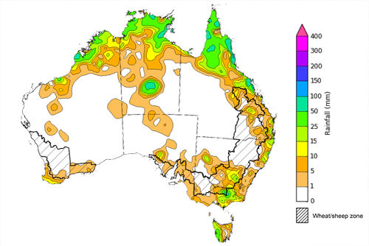
©Commonwealth of Australia 2023, Australian Bureau of Meteorology Issued: 22/03/2023
Note: The rainfall analyses and associated maps utilise data contained in the Bureau of Meteorology climate database, the Australian Data Archive for Meteorology (ADAM). The analyses are initially produced automatically from real-time data with limited quality control. They are intended to provide a general overview of rainfall across Australia as quickly as possible after the observations are received. For further information go to http://www.bom.gov.au/climate/rainfall/

Climate Drivers
Throughout autumn the climate drivers with the largest potential impact on Australia’s climate patterns are the El Niño–Southern Oscillation (ENSO) and the Madden-Julian Oscillation (MJO). These climate drivers are likely to influence the growth and development of later planted summer crops in northern growing regions, pasture growth across both northern and southern Australia and planting opportunities for winter crops.
The 2022-23 La Niña event has ended. The ENSO is now in its neutral phase with both oceanic and atmospheric indicators having returned to neutral levels. Oceanic indicators are measured in terms of the sea surface temperature (SST) anomalies. The weekly difference from average SST between 6 to 12 March in the equatorial Pacific is in the neutral range (-0.4°C to +0.4°C).
Despite both oceanic and atmospheric indicators having returned to neutral levels the Bureau of Meteorology has moved its ENSO Forecast to El Niño WATCH. This indicates that there is around a 50% chance that an El Niño may develop later in 2023. El Niño WATCH is not a guarantee that El Niño will occur, but it is an indication that some of the typical precursors are currently observed. A significant amount of warmer than average water exists in the western and central tropical Pacific sub-surface, and warmer than average SSTs have emerged in parts of the eastern tropical Pacific in recent weeks.
The Southern Annular Mode (SAM) is currently positive but is expected to return to neutral during the coming week where it is anticipated to remain neutral for the coming month. Neutral SAM has little influence on the rainfall and temperature outlook for Australia.

Difference from average sea surface temperature observations 6 to 12 March 2023
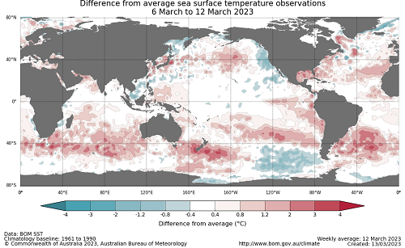

International climate model outlooks for the NINO 3.4 region in April 2023
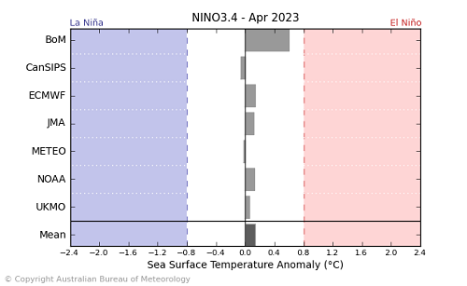
©Commonwealth of Australia 2023, Australian Bureau of Meteorology Issued: 14/3/2023
All but one international climate model surveyed by the Australian Bureau of Meteorology suggest sea-surface temperatures in the tropical Pacific will remain neutral through the southern hemisphere autumn, with one model exceeding El Niño thresholds in May. For the period ending 12 March 2023, the 30-day Southern Oscillation Index (SOI) value was +5.0, while the latest update as of March 20, it is +0.2. The SOI values between +7 and −7 generally indicates ENSO neutral conditions.
It is important to note that while most models suggest there is an increased chance of El Niño developing in mid-to-late 2023, the model accuracy when forecasting through autumn is low, and therefore ENSO outlooks that extend past autumn should be viewed with caution.

30-day Southern Oscillation Index (SOI) values ending 20 March 2023
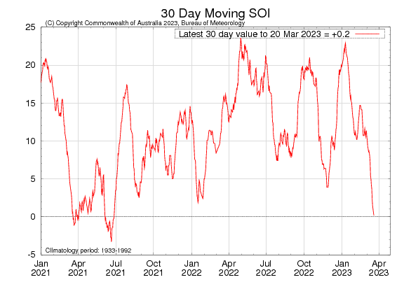

The Madden–Julian Oscillation (MJO) is currently very strong over the Atlantic Ocean. This is resulting in drier conditions over tropical Australia owing to the suppressed convection over the Maritime continent. The MJO is likely to weaken and become indiscernible at the end of March. In this scenario, the MJO would exert minimal influence on weather patterns across northern Australia.

Madden–Julian Oscillation (MJO) daily index
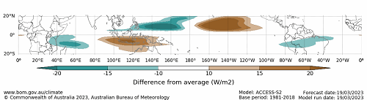
Note: This map displays the forecast outgoing longwave radiation (OLR) difference from expected cloudiness to identify convective rain clouds and the position of the Madden–Julian Oscillation (MJO). The blue shading indicates higher than normal, active or enhanced tropical weather and the brown shading indicates lower than normal clouds or suppressed conditions.

National Climate Outlook
These climate outlooks are generated by ACCESS–S (Australian Community Climate Earth-System Simulator–Seasonal). ACCESS–S is the Bureau of Meteorology's dynamic (physics-based) weather and climate model used for monthly, seasonal, and longer-lead climate outlooks. For further information, go to http://www.bom.gov.au/climate/ahead/about/.
The Bureau of Meteorology’s latest rainfall outlook for April 2023 indicates drier than average conditions are expected across much of Australia.
The ACCESS-S climate model suggests that there is a 75% chance of rainfall totals between 10 and 100 millimetres for tropical northern Australia, eastern and south-eastern coastal areas, parts of Western Australia, as well as much of Tasmania. Rainfall totals in excess of 100 millimetres are expected in western Tasmania and in parts of north-eastern Queensland. For the remainder of Australia, rainfall totals are not expected to exceed 10 millimetres.
Across most cropping regions there is a 75% chance of rainfall totals less than 10 millimetres. In eastern Victoria and New South Wales, and in south-eastern Queensland, rainfall totals are expected to reach up to 25 millimetres.
Rainfall totals that have a 75% chance of occurring in April 2023
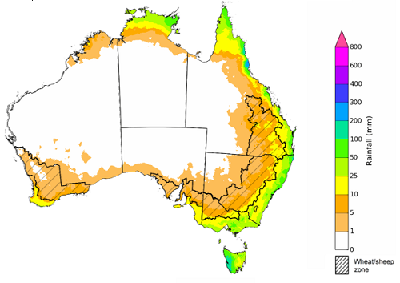

©Commonwealth of Australia 2023, Australian Bureau of Meteorology Issued:23/03/2023

The rainfall outlook for April to June 2023 suggests that below median rainfall is likely to very likely (60% to greater than 80% chance) for most of Australia the next three months. However, for tropical northern Queensland and Northern Territory, parts of coastal New South Wales and southern Tasmania there is close to equal chances of above or below median rainfall.
Chance of exceeding the median rainfall April to June 2023
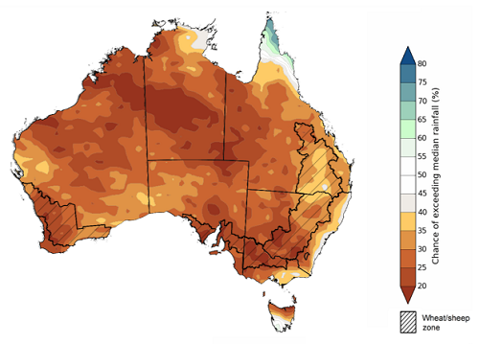
©Commonwealth of Australia 2023, Australian Bureau of Meteorology Issued: 23/03/2023

The outlook for April to June 2023 suggests there is a 75% chance of rainfall totals between 25 and 200 millimetres across central and eastern New South Wales, northern and eastern Queensland, southern parts of South Australia and Western Australia, northern parts of the Northern Territory and much of Victoria and Tasmania. Rainfall totals in excess of 200 millimetres are forecast for parts of northeast New South Wales and Queensland, as well as much of western Tasmania.
Across cropping regions, there is a 75% chance of receiving between 25 and 100 millimetres except for northern Queensland where rainfall is forecast for below 25 millimetres.
These rainfall totals are well below average for this three-month period across most of Australia. Relatively dry conditions during February and early March have seen soil moisture levels decline across large areas of Australia. This lack of rainfall and decline in soil moisture levels has led to reductions in yield potentials for later sown summer crops. Given these recent declines in soil moisture levels and the increased likelihood of below average rainfall over the next three months, crop producers will require adequate and timely rainfall to maintain current summer crop yield potentials to support the sowing and establishment of winter crops. For livestock producers experiencing below average rainfall, particularly across southern Australia, this will likely result in below average pasture production. However, ample supplies of conserved fodder will likely enable most producers to maintain current production levels and stocking rates.
Rainfall totals that have a 75% chance of occurring April to June 2023
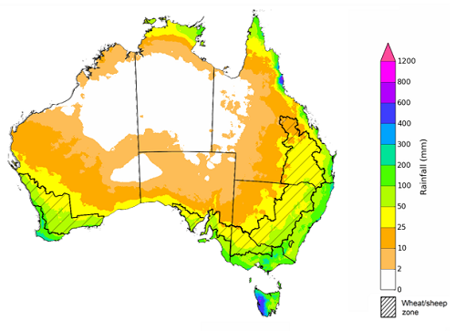
©Commonwealth of Australia 2023, Australian Bureau of Meteorology Issued: 23/03/2023
The temperature outlook for April to June 2023 indicates that maximum temperatures across most of Australia are likely to be close to the 1990-2012 average (the difference between -1°C to +1°C) while slightly warmer (up to +2°C) across much of Western Australia and in parts of Northern Territory, South Australia, Queensland and New South Wales. The minimum temperatures across most of Australia are expected to be close to the 1990-2012 average (the difference in the range of -1°C to +1°C).
Predicted maximum temperature anomaly for April to June 2023 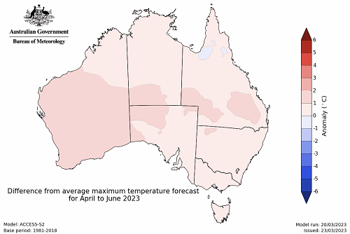
Predicted minimum temperature anomaly for April to June 2023
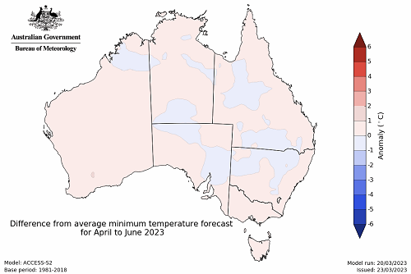

Rainfall forecast for the next eight days
Over the 8-days to 30 March 2023, widespread rainfall is expected across western, south-eastern and in the tropical north of Australia. Troughs will trigger showers and storms over Western Australia, New South Wales, Victoria and Tasmania. Onshore winds will drive showers into southeast Queensland and northeast New South Wales. Humid and unstable winds will generate showers over northern tropics. A high-pressure system is expected to bring mainly dry conditions for much of central Australia.
Across Australian cropping regions, rainfall totals of between 15 and 50 millimetres are expected for southeast Queensland eastern New South Wales, southern Victoria, and much of Western Australia. Little to no rainfall is expected for the remaining cropping regions in the next eight days.
If realised, the rainfall in the cropping regions is likely to result in some harvest delays for summer crops. The forecast rainfall over much of the Western Australian wheatbelt, as well as in the northern and eastern Australia is likely to build soil moisture levels in the led up to the winter cropping season and also benefit pasture growth rates and availability.

Total forecast rainfall for the period 23 March to 30 March 2023
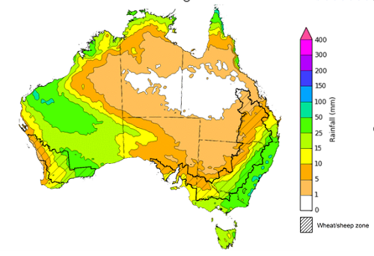

©Commonwealth of Australia 2023, Australian Bureau of Meteorology Issued 23/03/2023
Note: This rainfall forecast is produced from computer models. As the model outputs are not altered by weather forecasters, it is important to check local forecasts and warnings issued by the Bureau of Meteorology.

Water

Water markets – current week
Due to unavailability of new water information from the Bureau of Meteorology, the water storage levels in the Murray-Darling Basin (MDB) have not been updated this week.

Water storages in the Murray-Darling Basin, 2013–2023
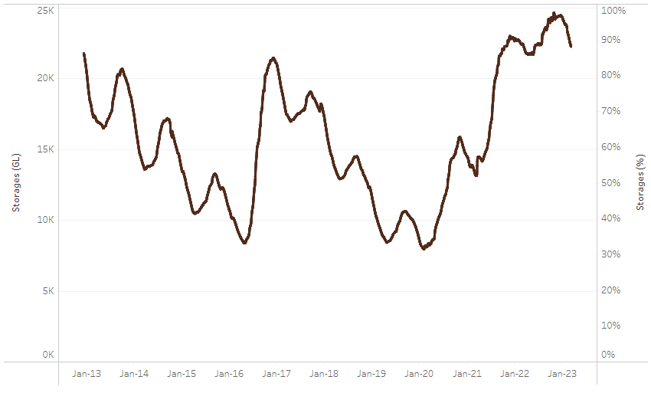
Allocation prices in the Victorian Murray below the Barmah Choke decreased from $15 on 15 March 2023 to $14 on 22 March 2023.
Water storage data is sourced from the Bureau of Meteorology.

Region | $/ML
NSW Murray Above | 10
NSW Murrumbidgee | 9
VIC Goulburn-Broken | 14
VIC Murray Below | 14

Surface water trade activity, Southern Murray–Darling Basin
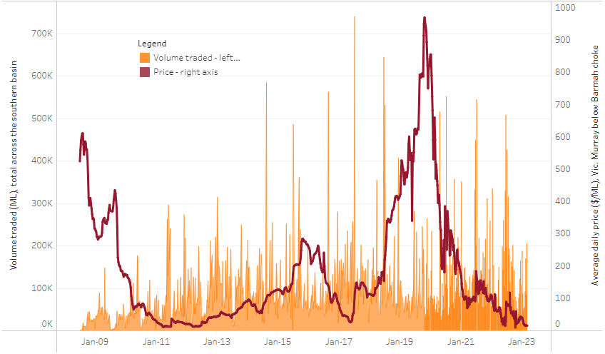
The trades shown reflect estimated market activity and do not encompass all register trades. The price is shown for the VIC Murray below the Barmah choke. Historical prices (before 1 July 2019) are ABARES estimates after removing outliers from BOM water register data. Prices after 1 July 2019 and prior to the 30 October 2019 reflect recorded transaction prices as sourced from Ruralco. Prices after the 30 October 2019 are sourced from Waterflow. Data for volume traded is sourced from the BOM water register. Only the price data shown is current on 23 March 2023.

To access the full, interactive, weekly water dashboard, which contains the latest and historical water storage, water market and water allocation information, please visit https://www.agriculture.gov.au/abares/products/weekly_update/weekly-update-23323

Commodities
Indicator | Week ended | Unit | Latest Price | Previous Week | Weekly change | Price 12 months ago | Annual change
Selected world indicator prices
AUD/USD Exchange rate | 22-Mar | A$/US$ | 0.67 | 0.67 | 0% | 0.75 | -11%
Wheat – US no. 2 hard red winter wheat, fob Gulf | 22-Mar | US$/t | 367 | 362 | 2% | 462 | -20%
Corn – US no. 2 yellow corn, fob Gulf | 22-Mar | US$/t | 288 | 280 | 3% | 335 | -14%
Canola – Rapeseed, Canada, fob Vancouver | 22-Mar | US$/t | 593 | 612 | -3% | 963 | -38%
Cotton – Cotlook 'A' Index | 22-Mar | USc/lb | 92 | 95 | -3% | 155 | -40%
Sugar – Intercontinental Exchange, nearby futures, no.11 contract | 22-Mar | USc/lb | 20.3 | 20.7 | -2% | 19 | 6%
Wool – Eastern Market Indicator | 08-Mar | Ac/kg clean | 1,317 | 1,358 | -3% | 1,392 | -5%
Wool – Western Market Indicator | 08-Mar | Ac/kg clean | 1,445 | 1,501 | -4% | 1,401 | 3%
Selected Australian grain export prices
Milling Wheat – APW, Port Adelaide, SA | 22-Mar | A$/t | 477 | 486 | -2% | 569 | -16%
Feed Wheat – ASW, Port Adelaide, SA | 22-Mar | A$/t | 452 | 455 | -1% | 533 | -15%
Feed Barley – Port Adelaide, SA | 22-Mar | A$/t | 409 | 407 | 1% | 455 | -10%
Canola – Kwinana, WA | 22-Mar | A$/t | 946 | 980 | -3% | 1,185 | -20%
Grain Sorghum – Brisbane, QLD | 22-Mar | A$/t | 521 | 514 | 1% | 375 | 39%
Selected domestic livestock indicator prices
Beef – Eastern Young Cattle Indicator | 22-Mar | Ac/kg cwt | 677 | 691 | -2% | 1,123 | -40%
Mutton – Mutton indicator (18–24 kg fat score 2–3), Vic | 22-Mar | Ac/kg cwt | 300 | 302 | -1% | 576 | -48%
Lamb – Eastern States Trade Lamb Indicator | 22-Mar | Ac/kg cwt | 664 | 676 | -2% | 820 | -19%
Pig – Eastern Seaboard (60.1–75 kg), average of buyers & sellers | 08-Mar | Ac/kg cwt | 357 | 367 | -3% | 357 | 0%
Goats – Eastern States (12.1–16 kg) | 01-Mar | Ac/kg cwt | 325 | 325 | 0% | 813 | -60%
Live cattle – Light steers ex Darwin to Indonesia | 17-Aug | Ac/kg lwt | 420 | 480 | -13% | 320 | 31%
Live sheep – Live wethers (Muchea WA saleyard) to Middle East | 14-Sep | $/head | 93 | 113 | -18% | 114 | -18%
Global Dairy Trade (GDT) weighted average prices ª
Dairy – Whole milk powder | 22-Mar | US$/t | 3,228 | 3,277 | -1% | 4,364 | -26%
Dairy – Skim milk powder | 22-Mar | US$/t | 2,648 | 2,739 | -3% | 3,302 | -20%
Dairy – Cheddar cheese | 22-Mar | US$/t | 4,052 | 4,509 | -10% | 4,280 | -5%
Dairy – Anhydrous milk fat | 22-Mar | US$/t | 5,150 | 5,340 | -4% | 5,929 | -13%
a Global Dairy Trade prices are updated twice monthly on the first and third Tuesday of each month.

Selected world indicator prices
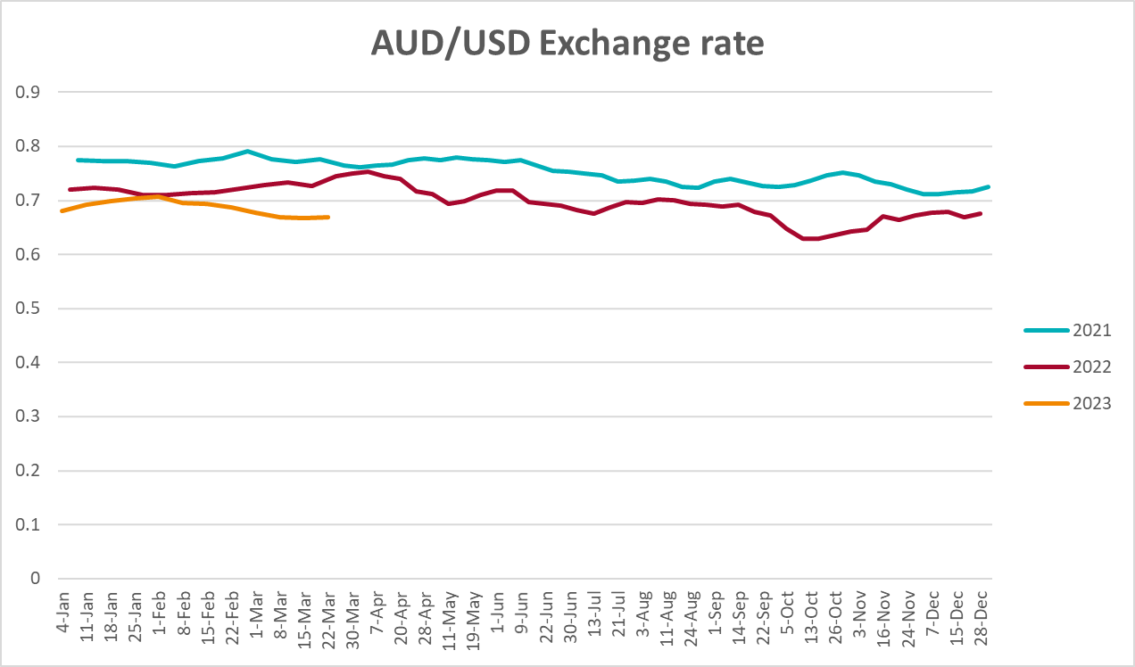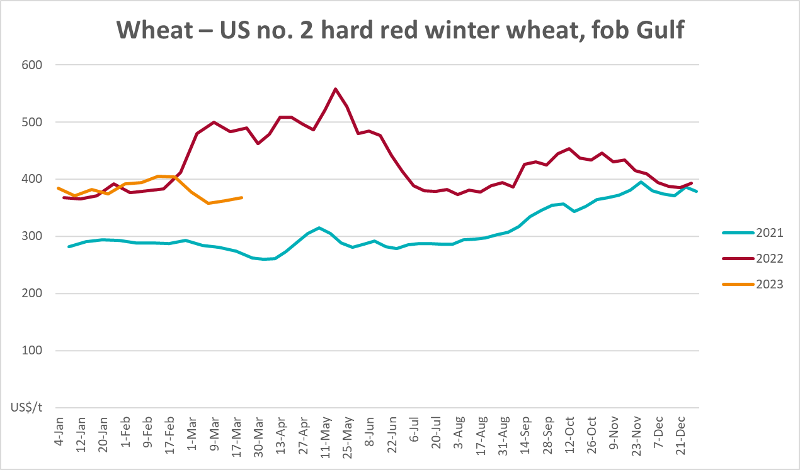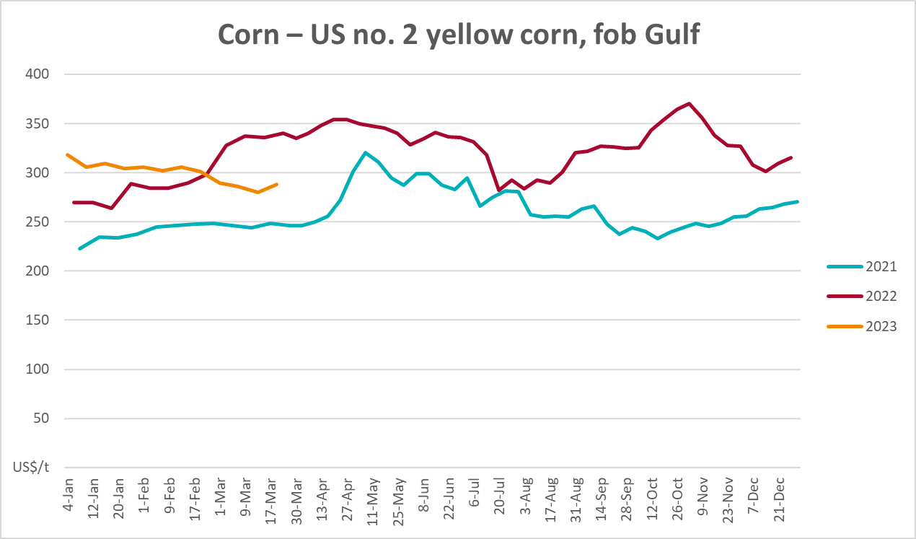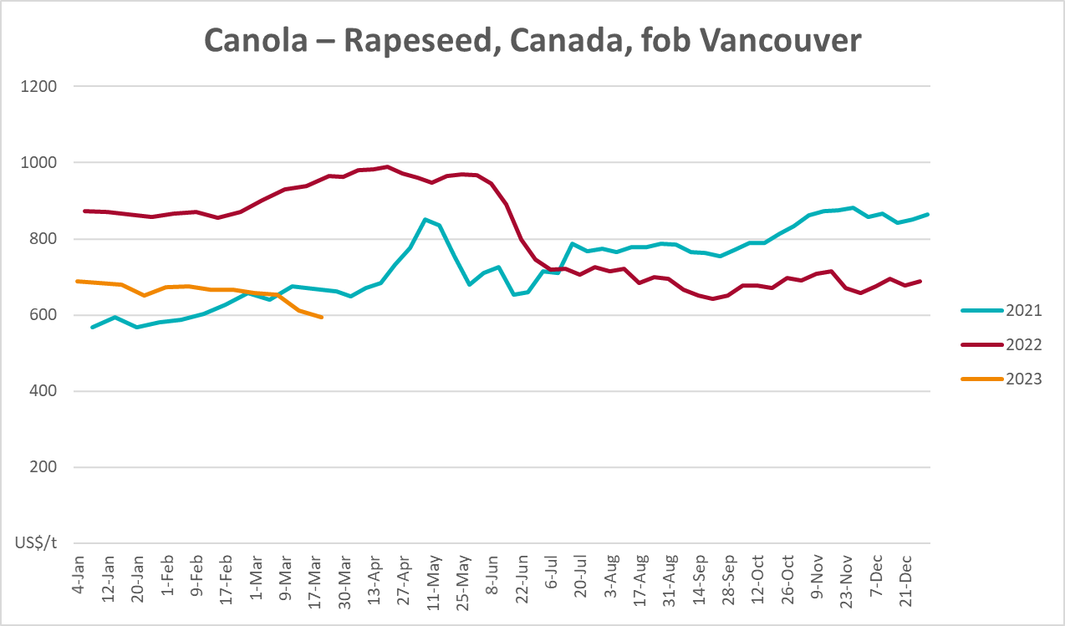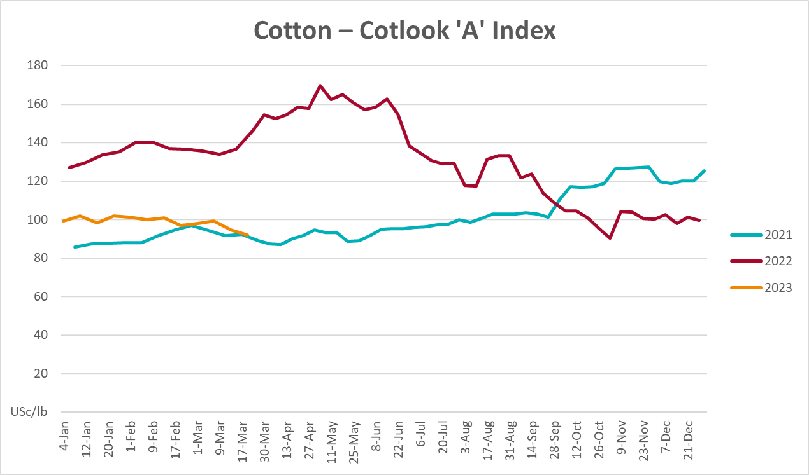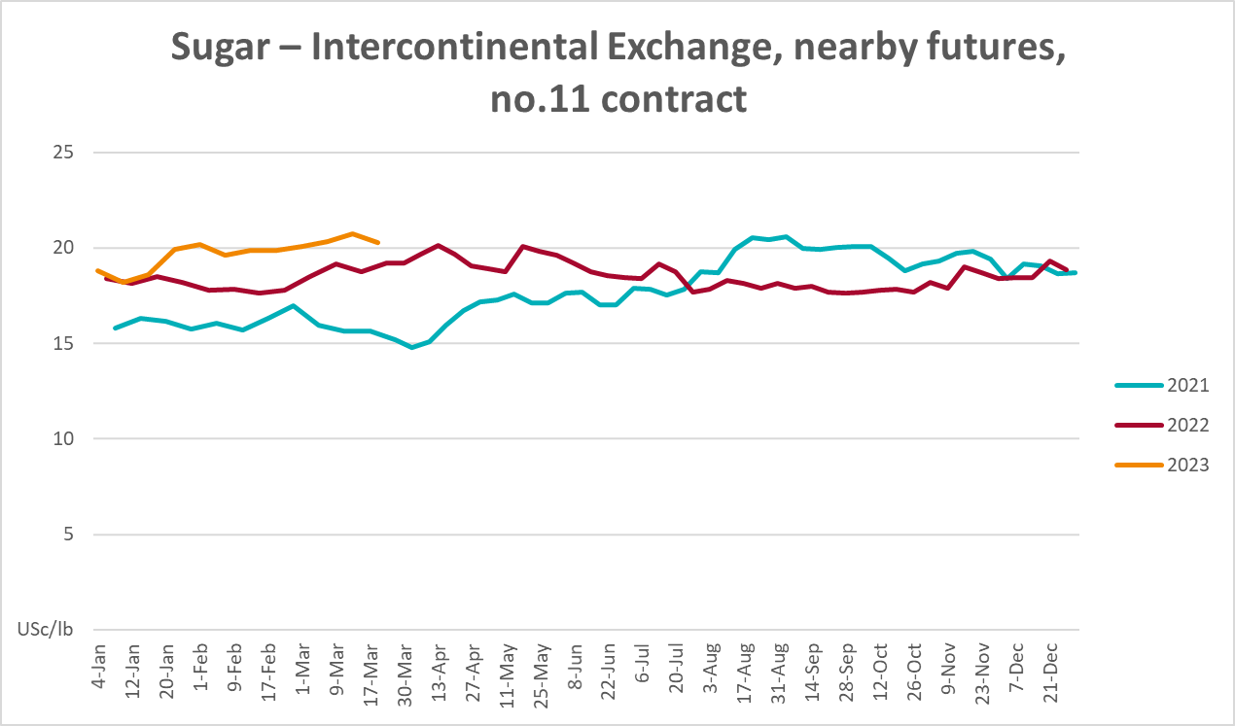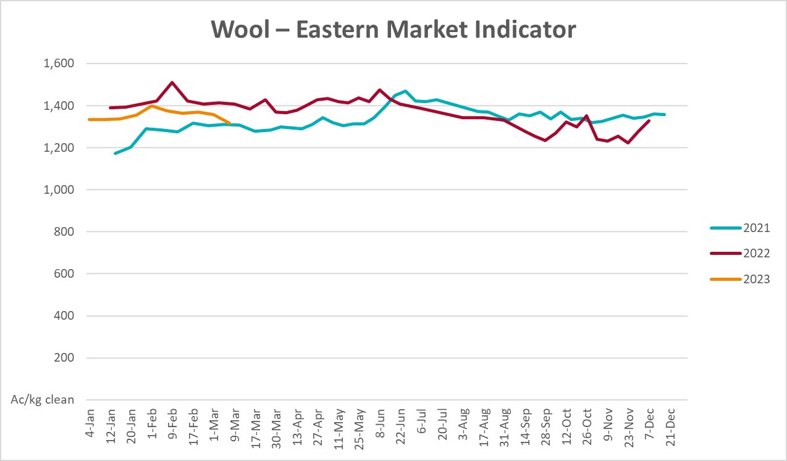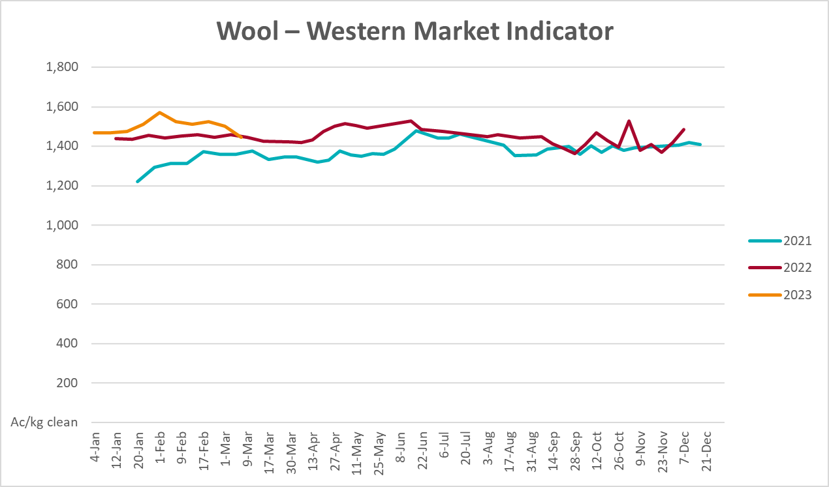

Selected domestic crop indicator prices
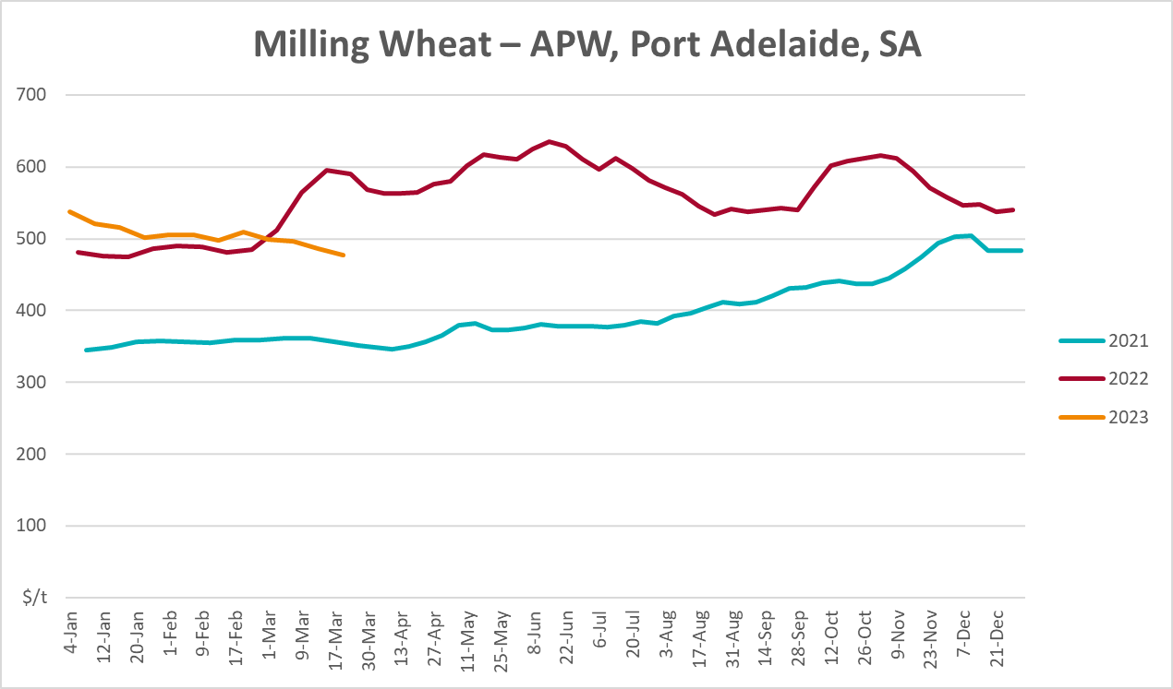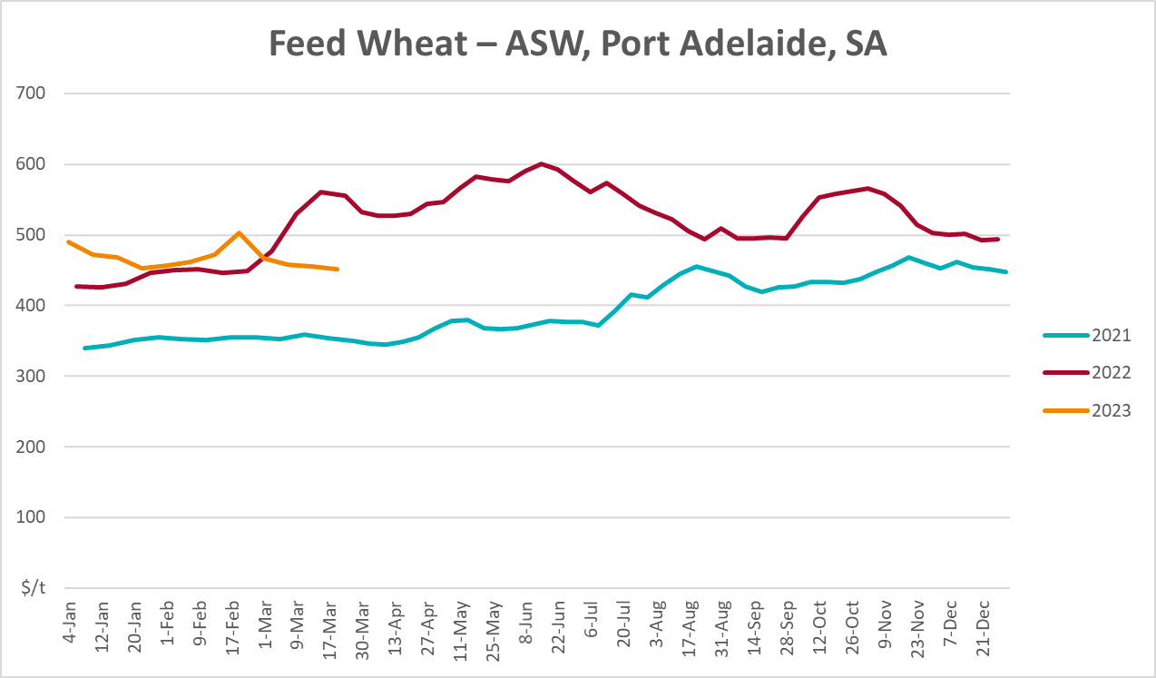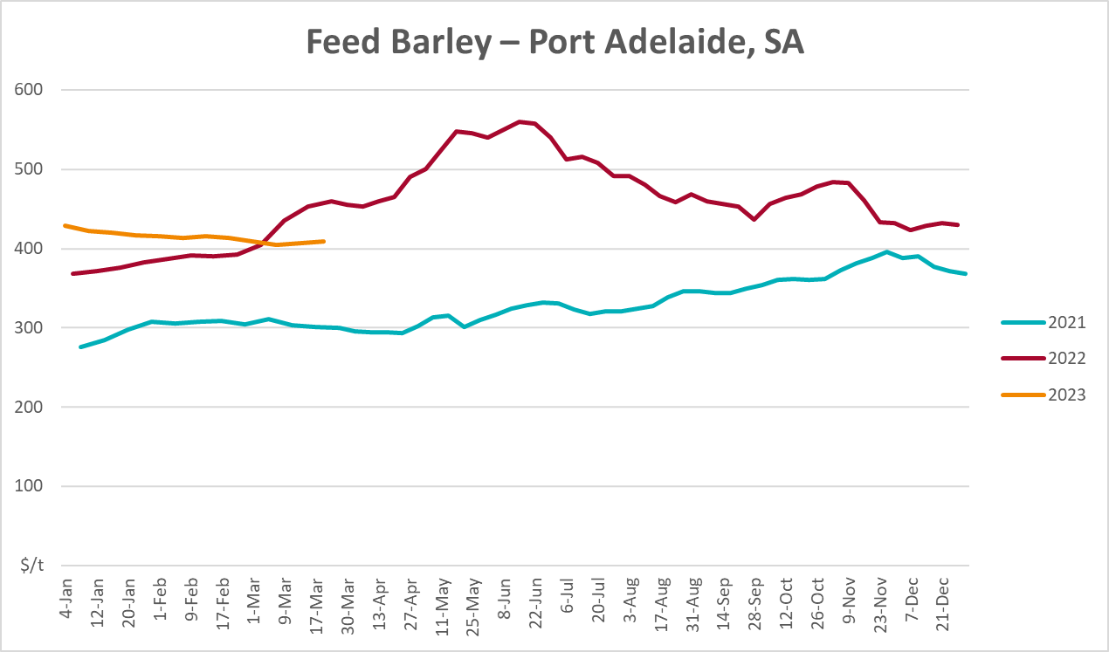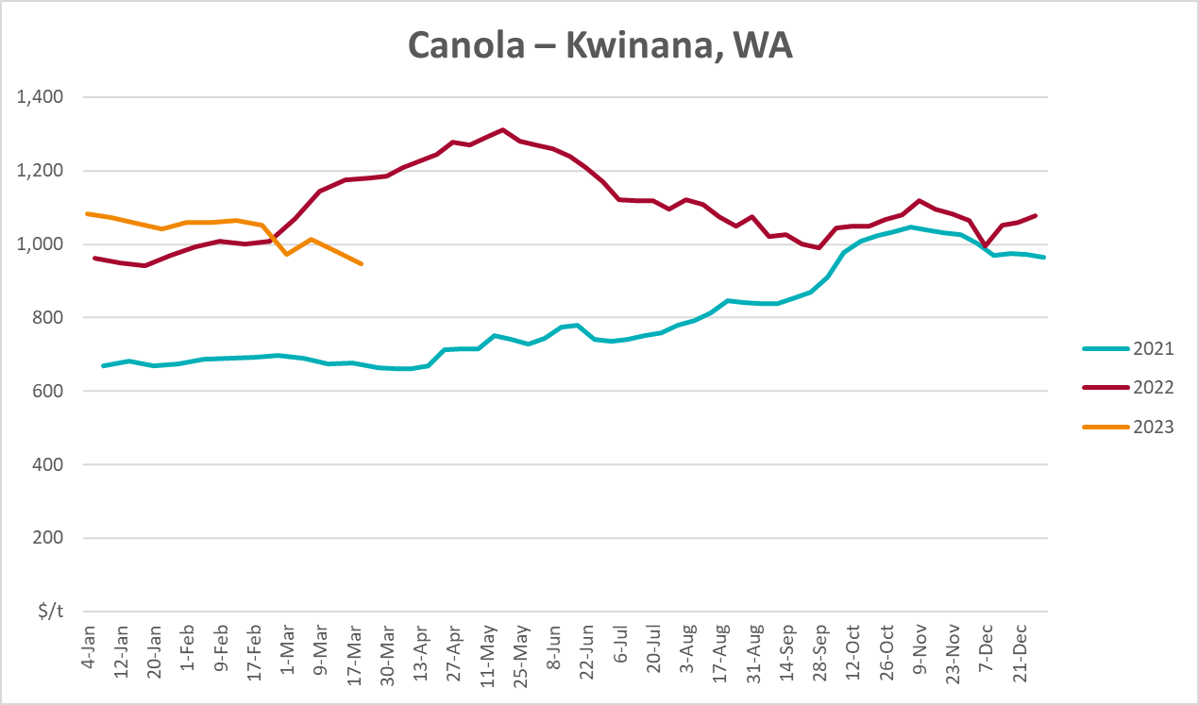
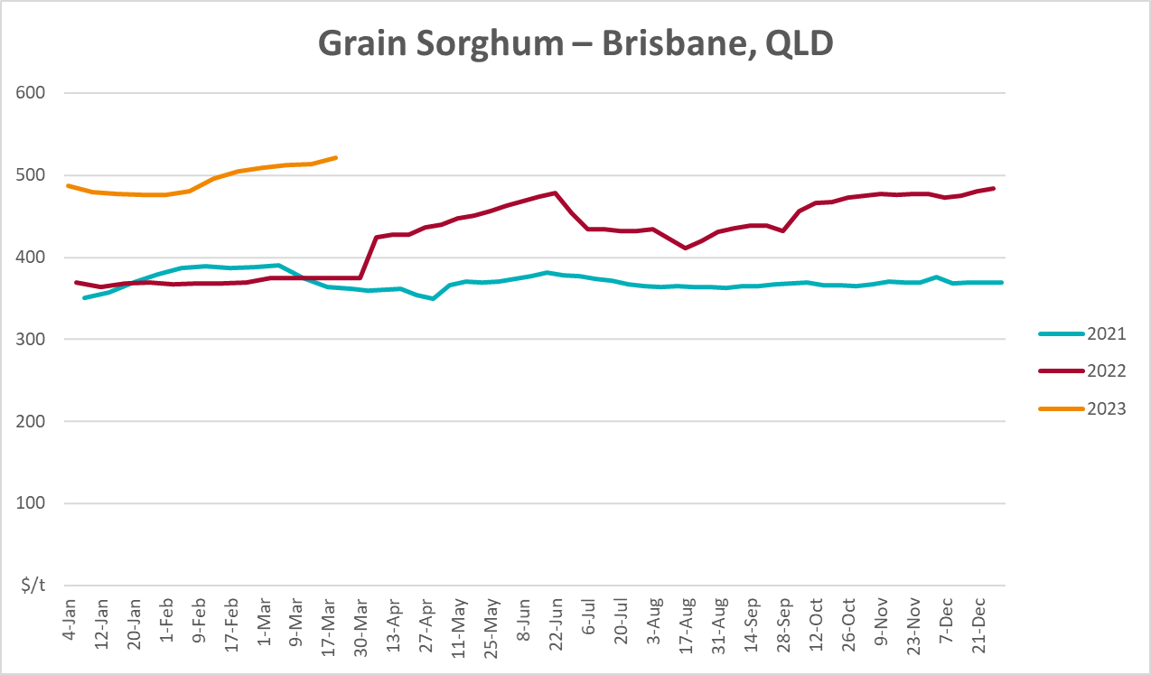

Selected domestic livestock indicator prices
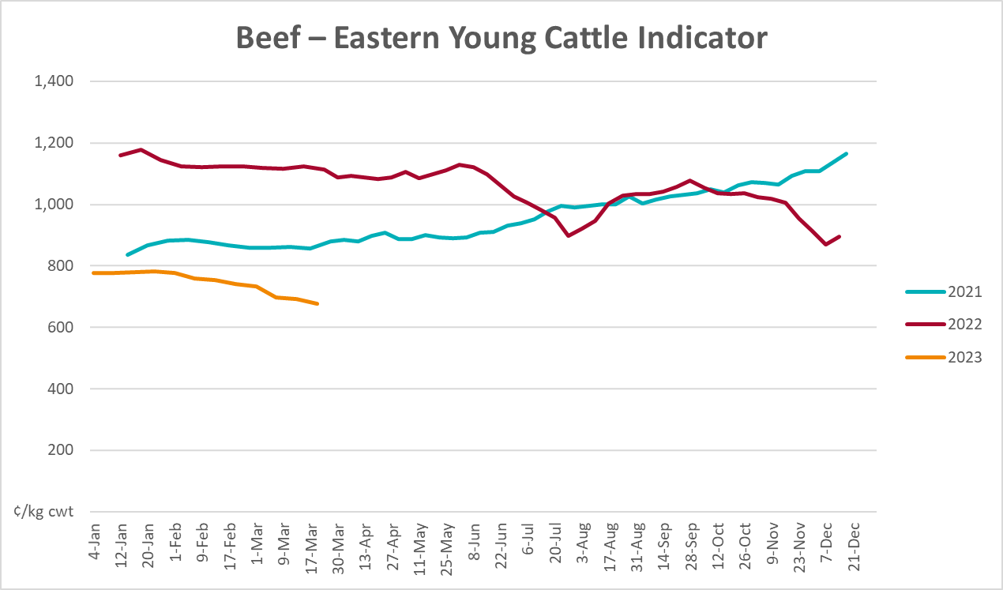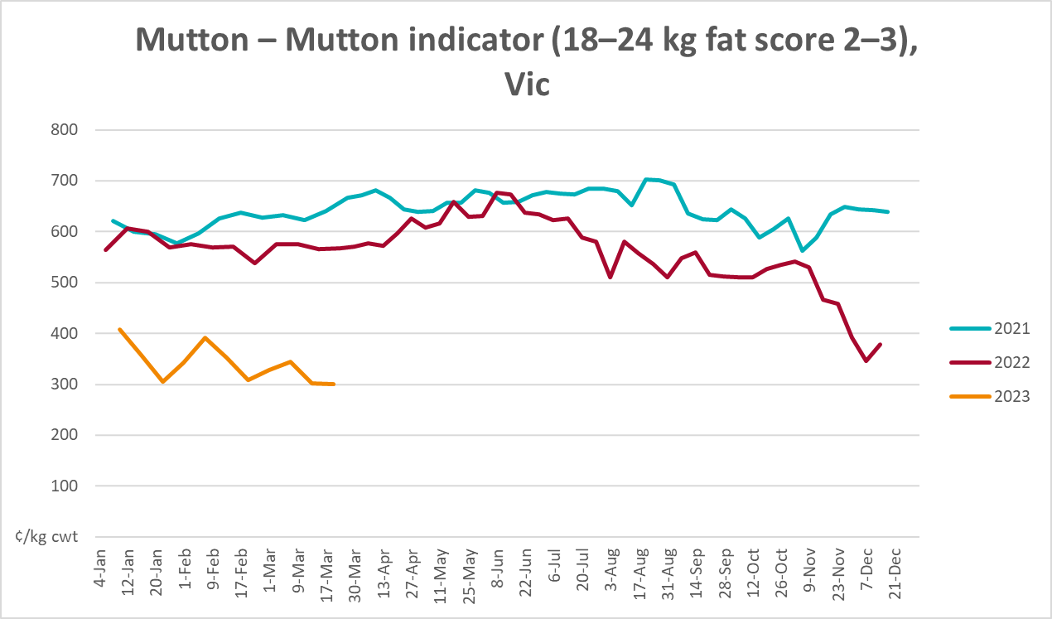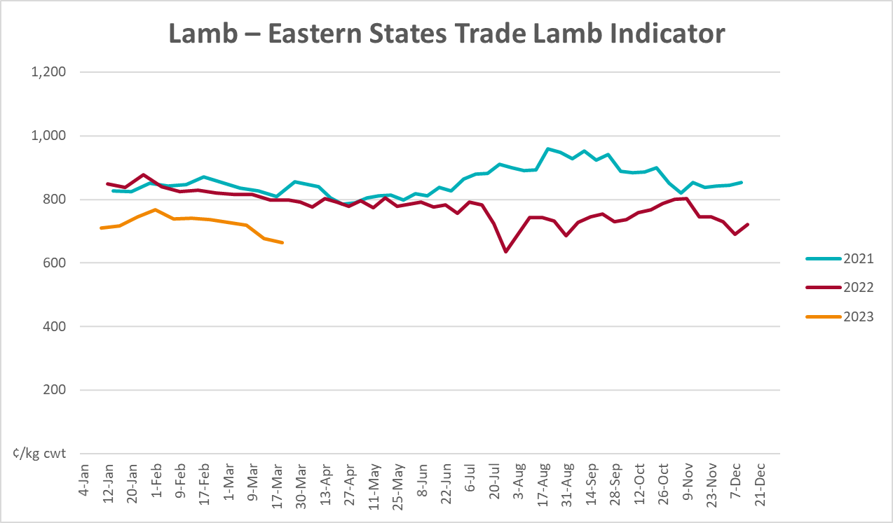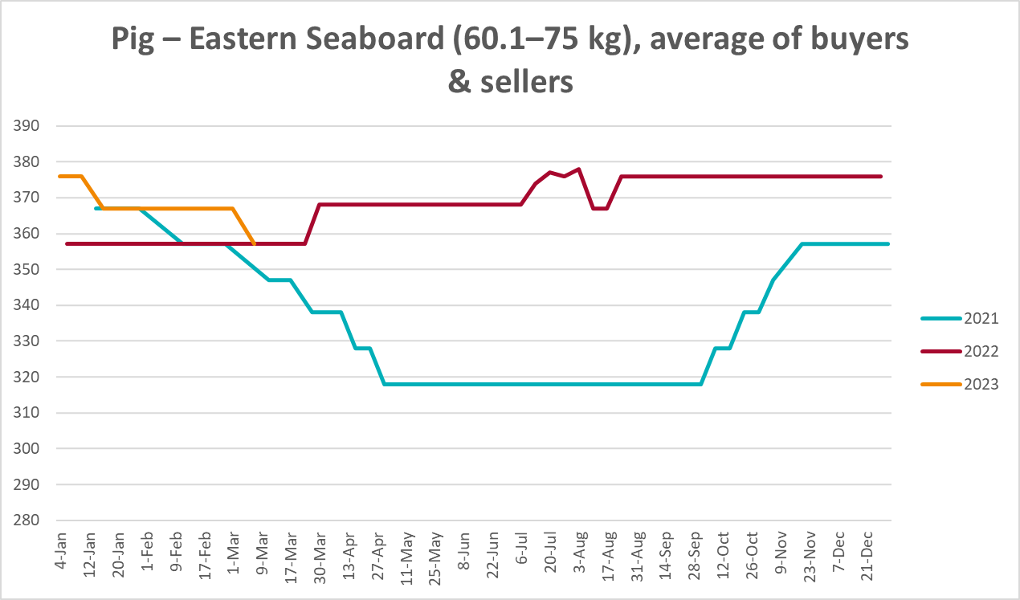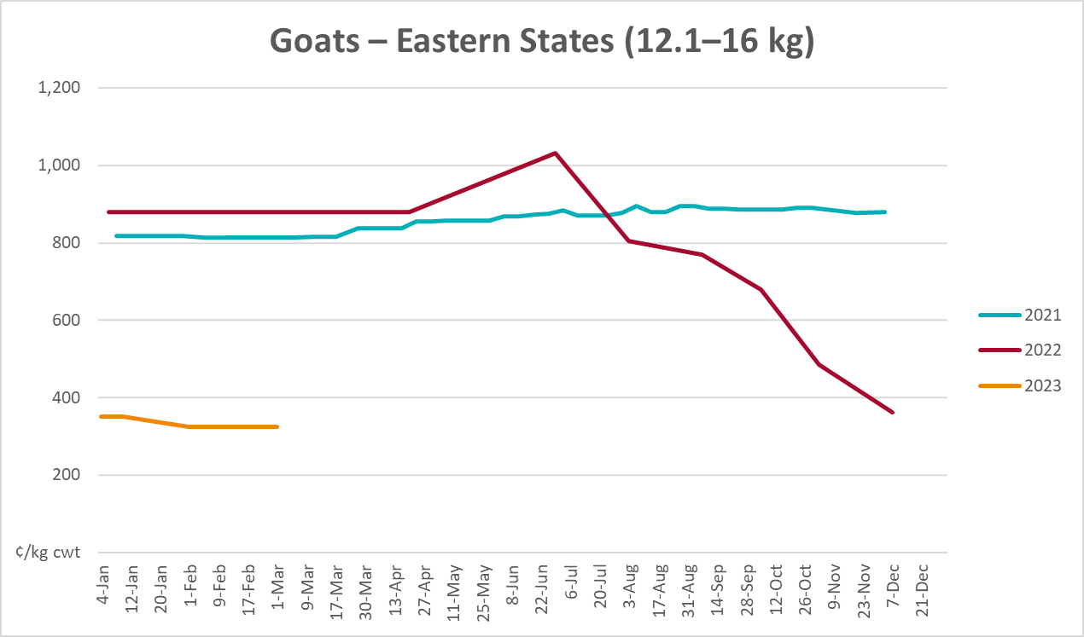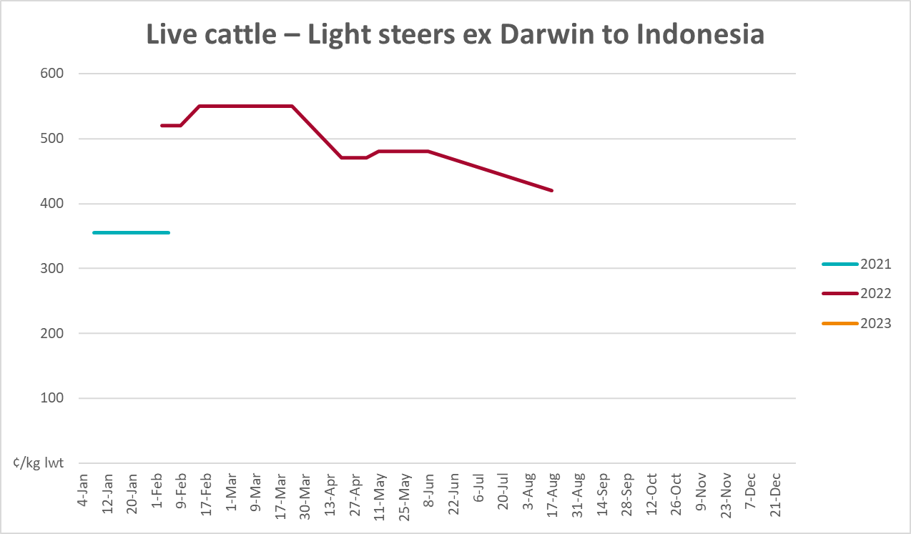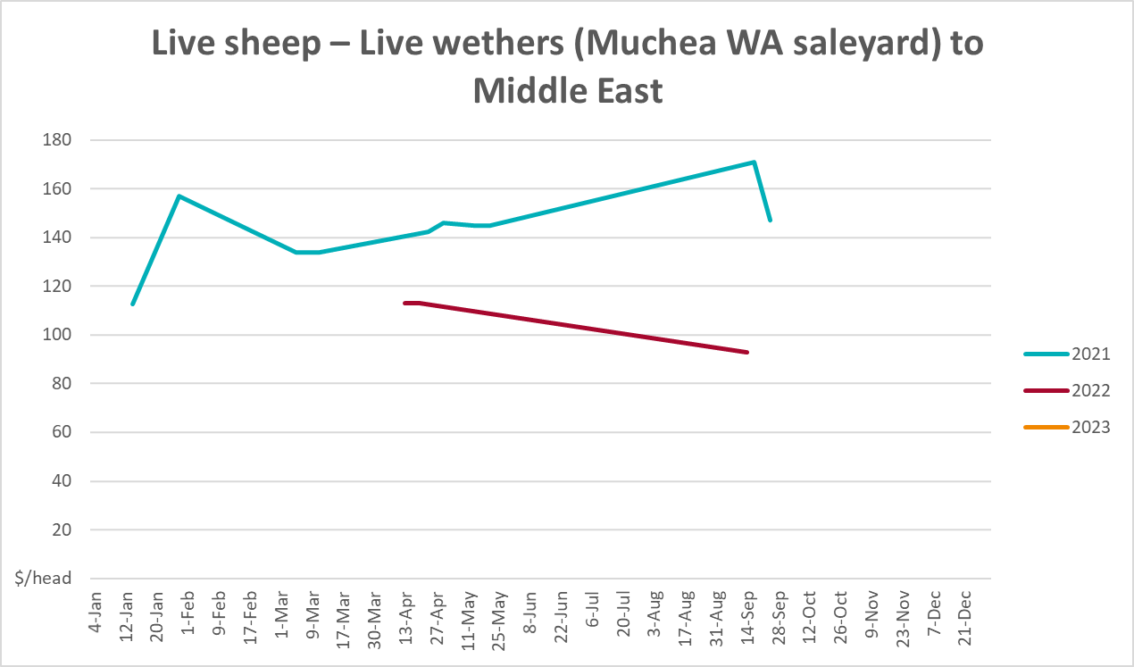

Global Dairy Trade (GDT) weighted average prices
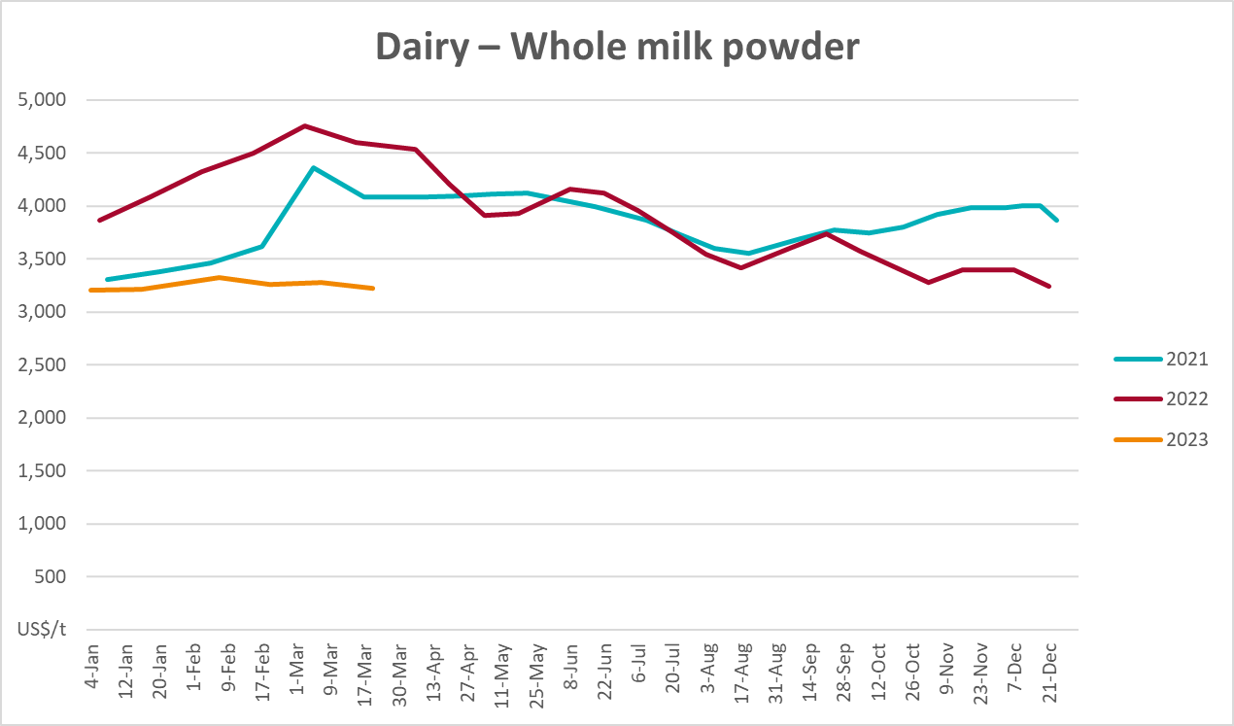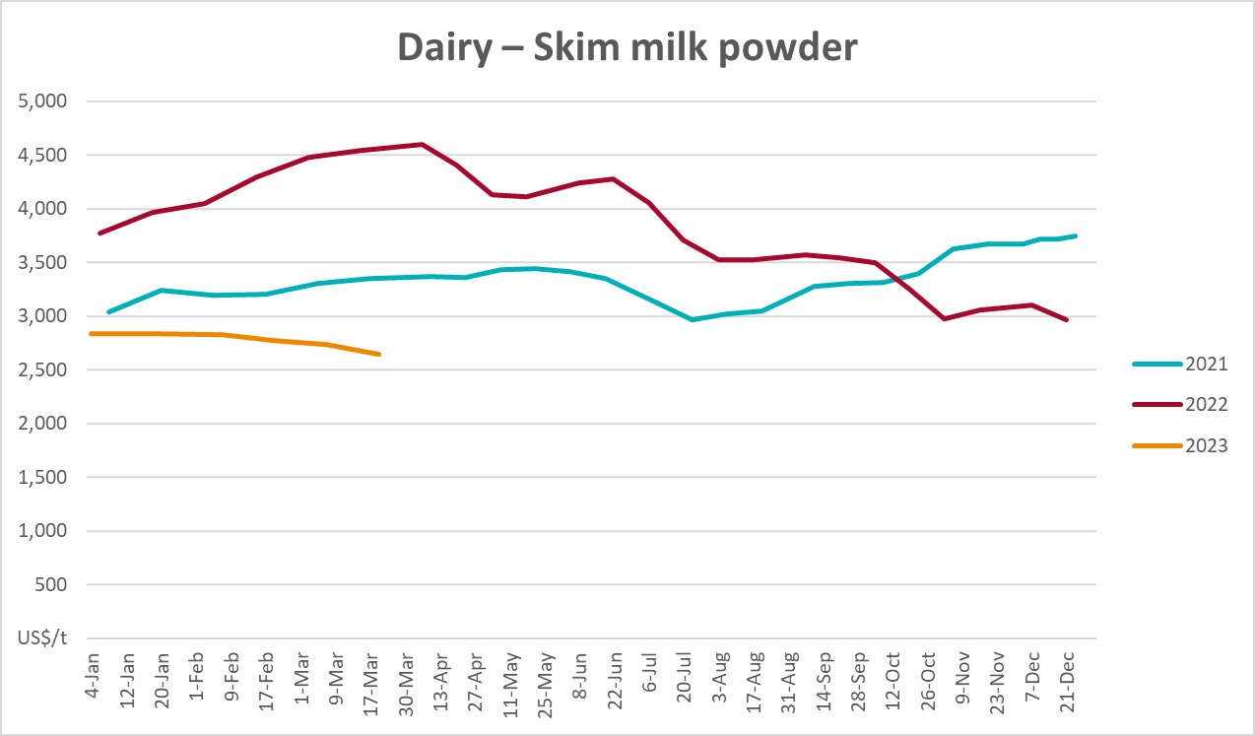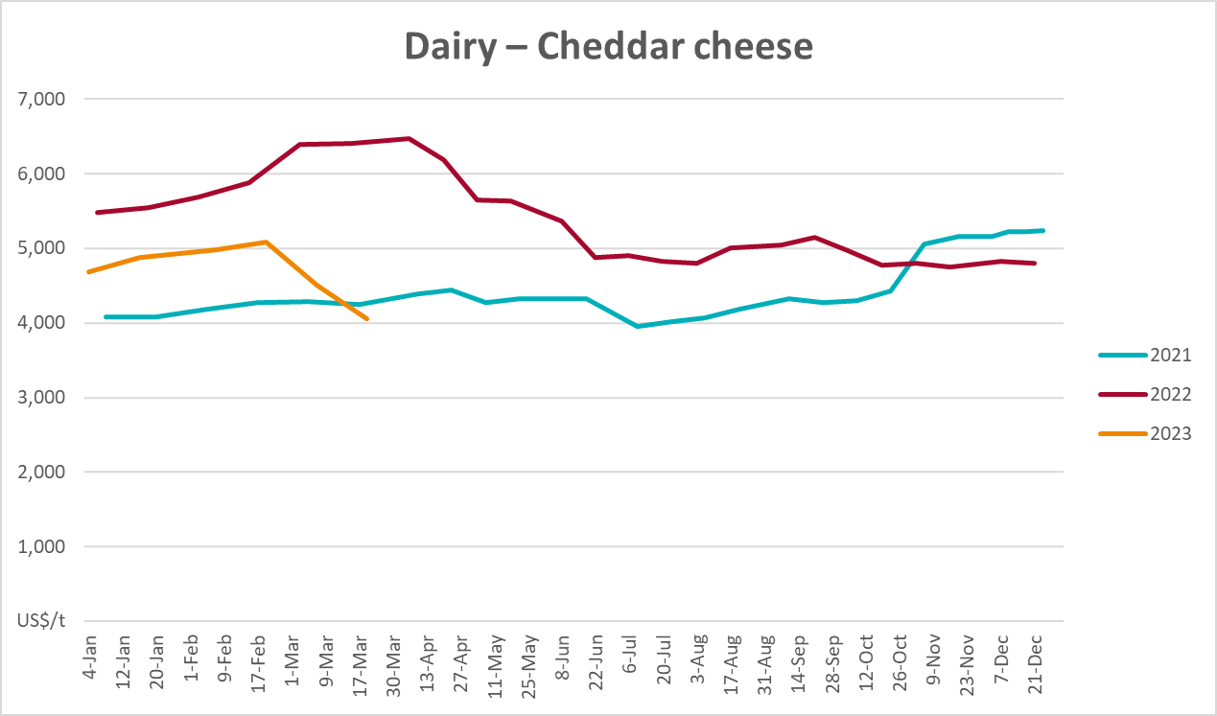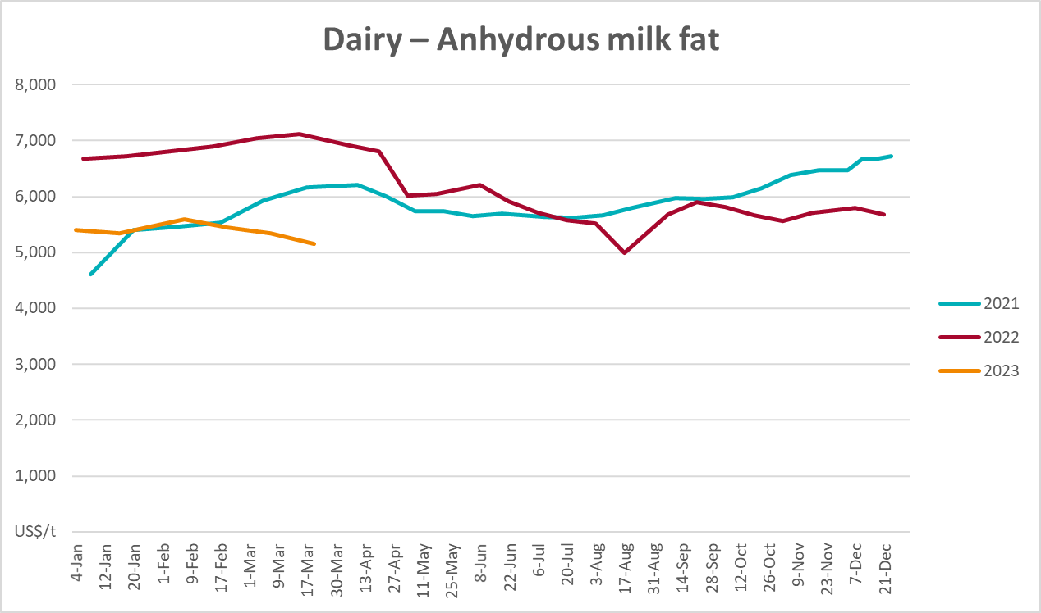

Selected fruit and vegetable prices
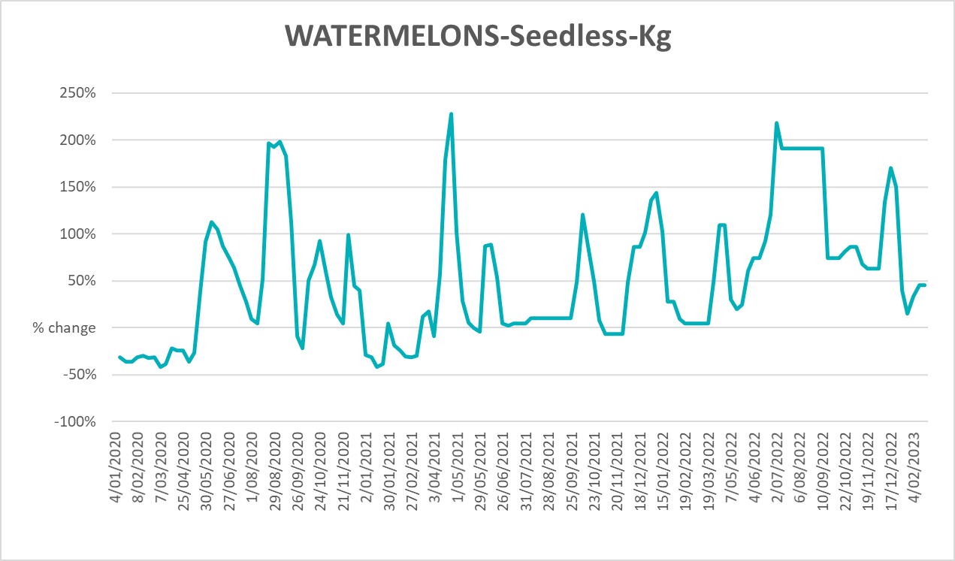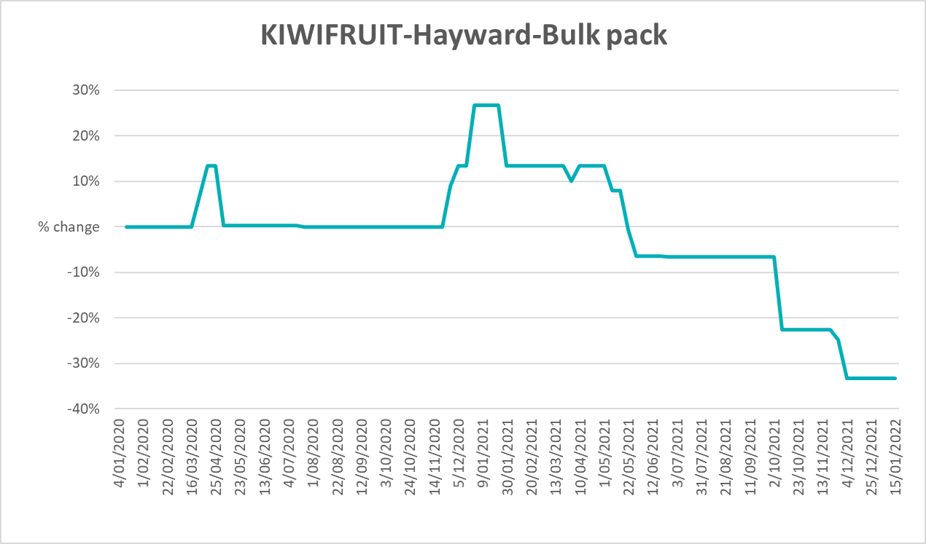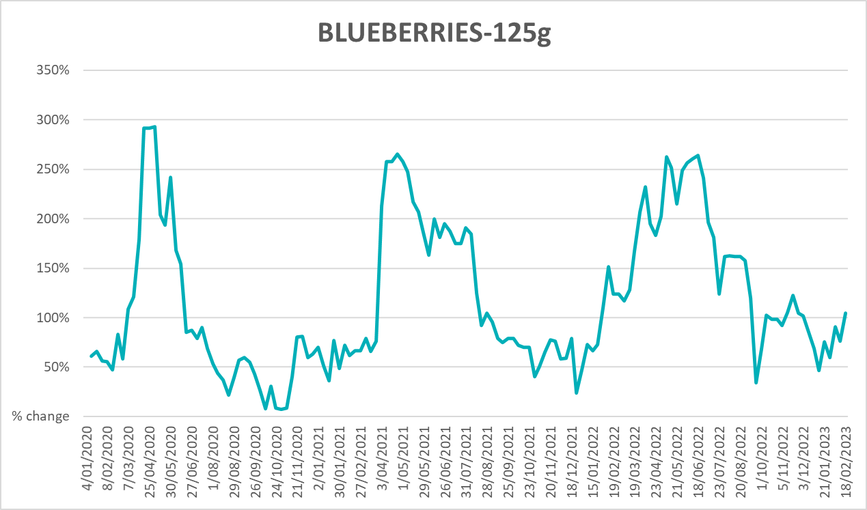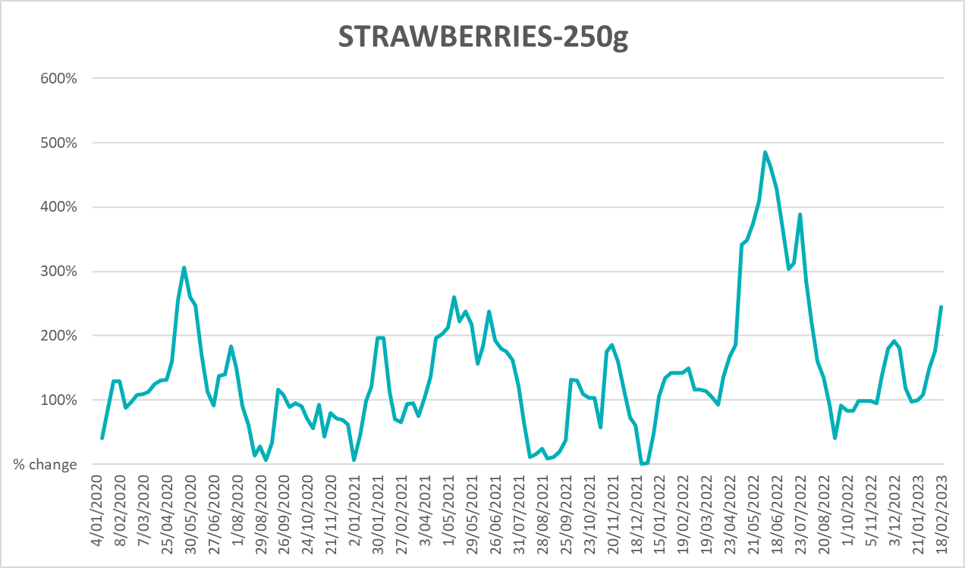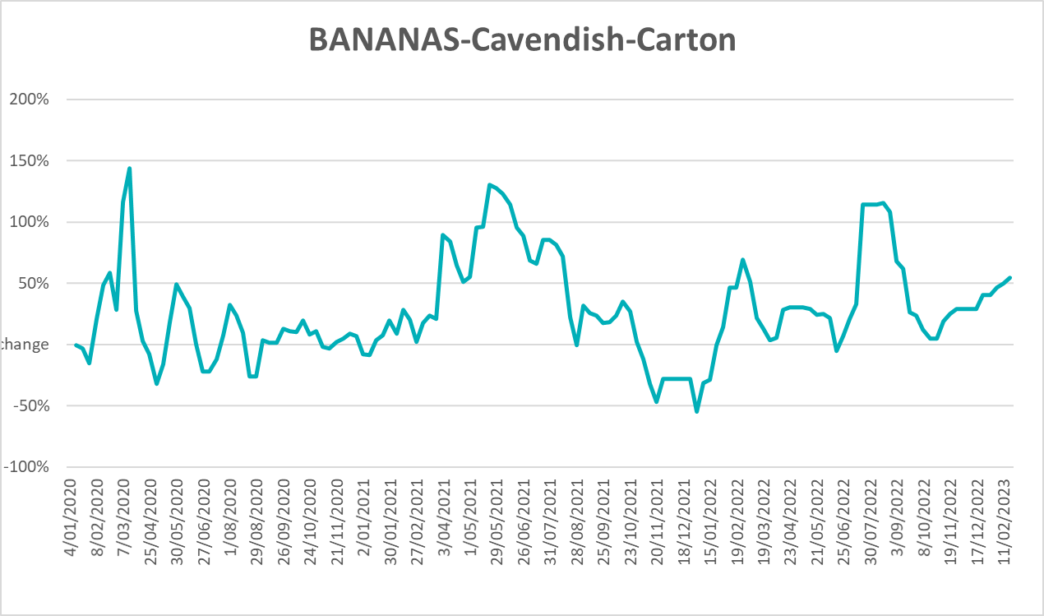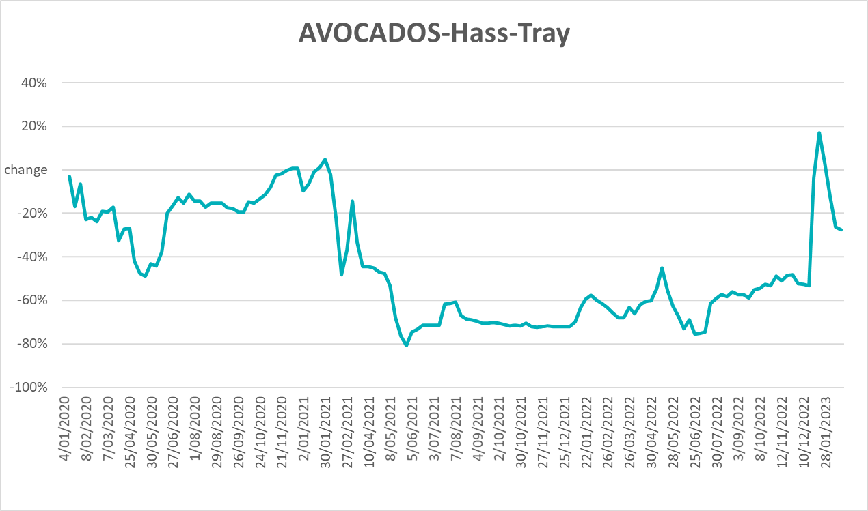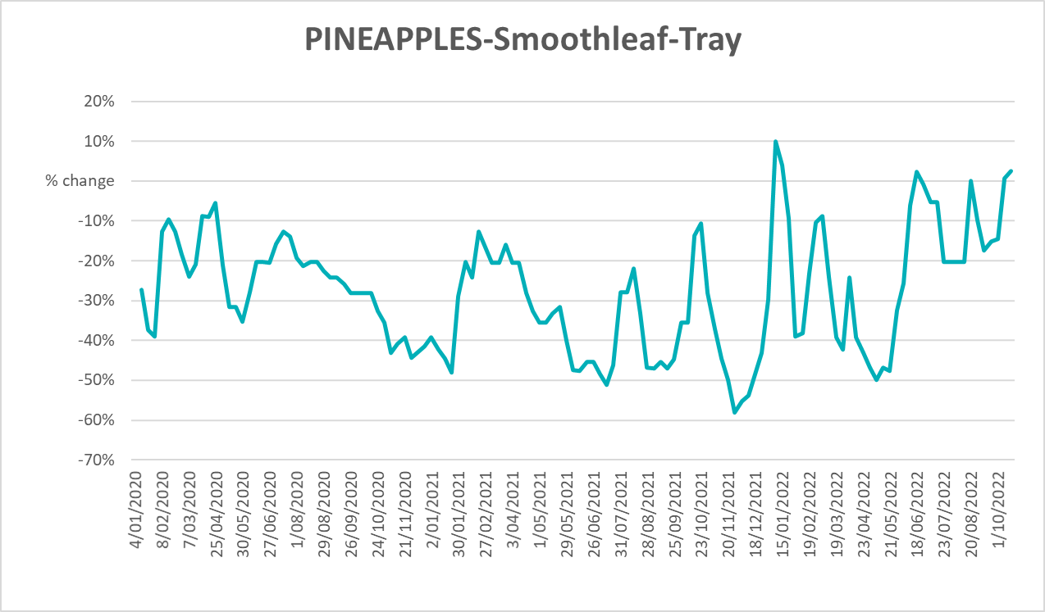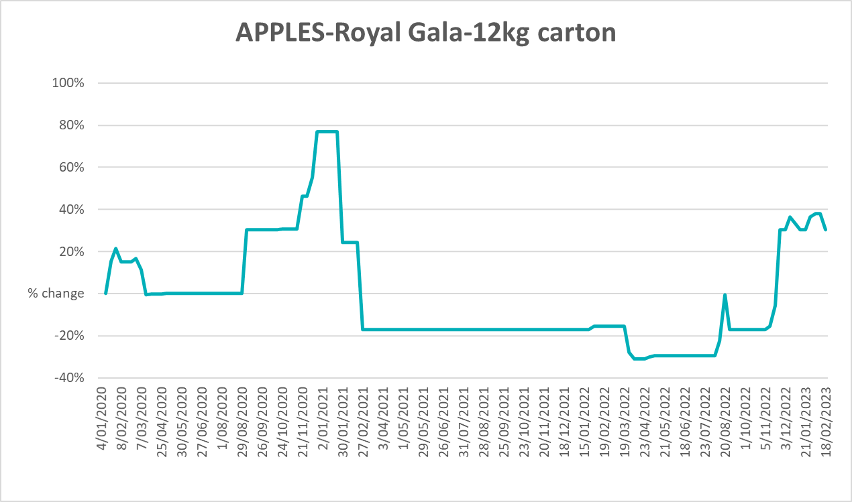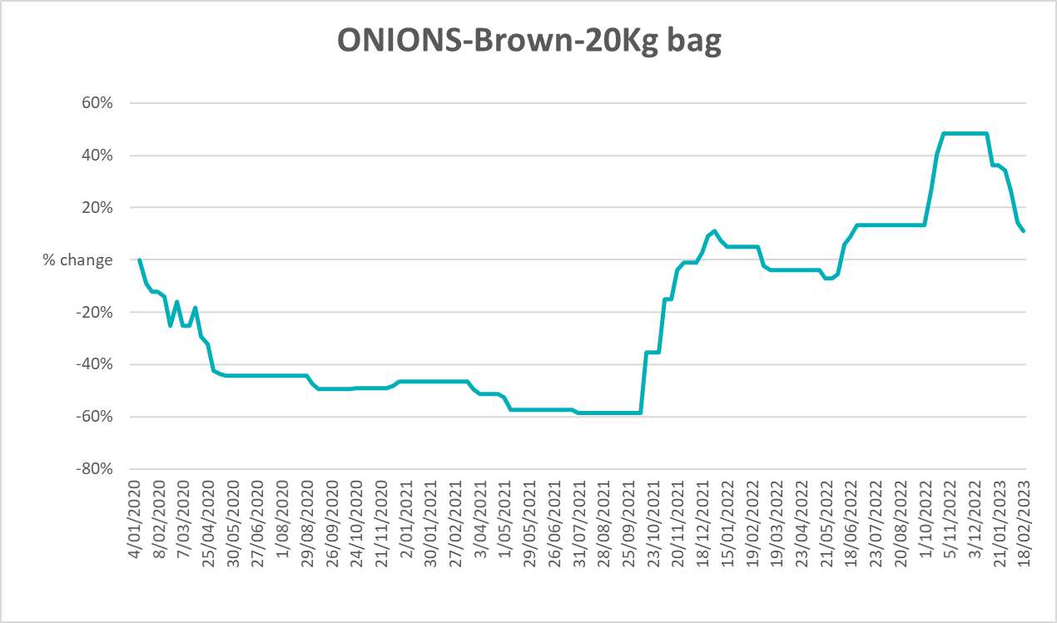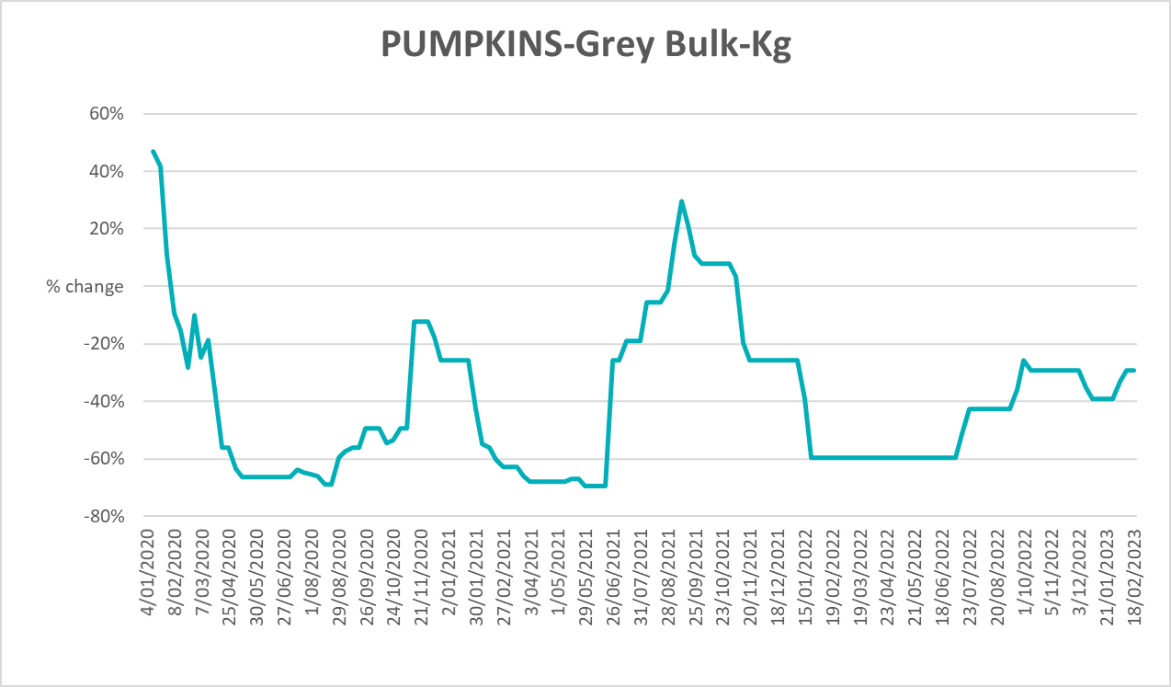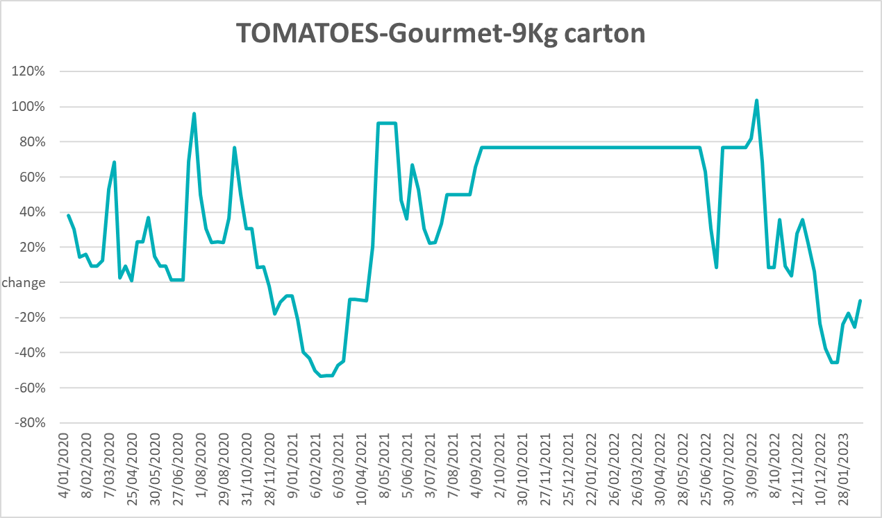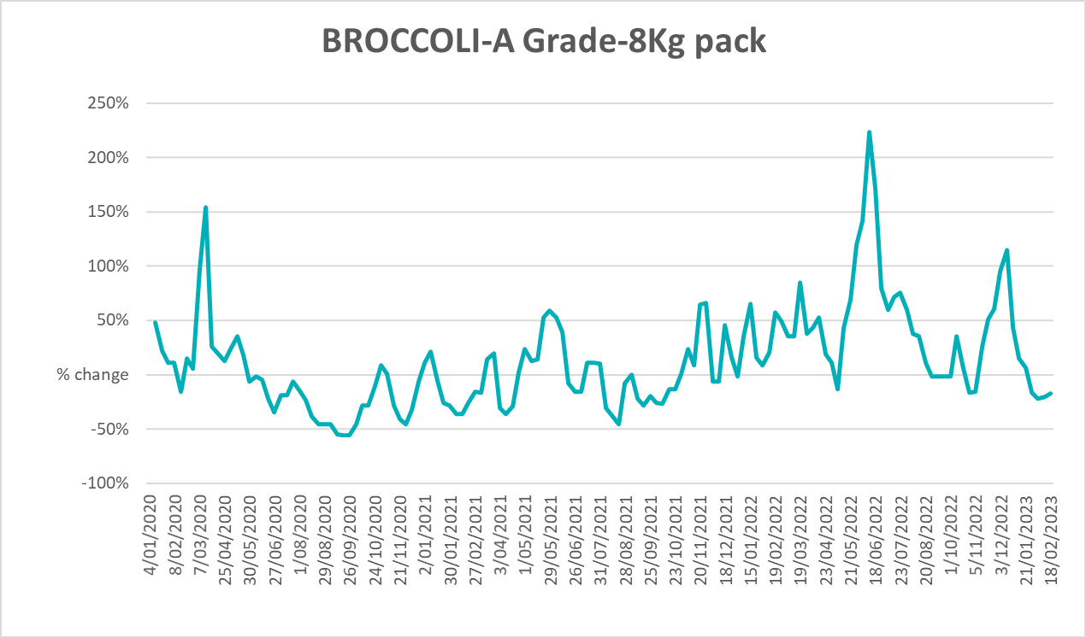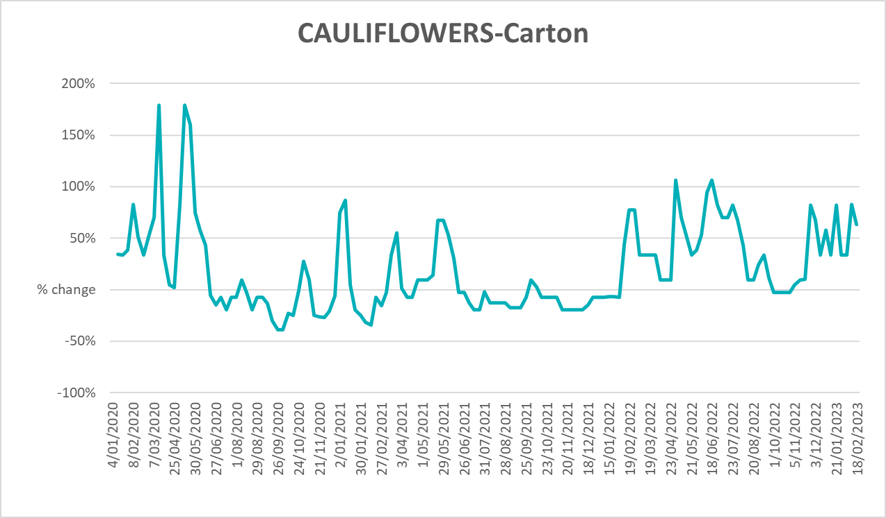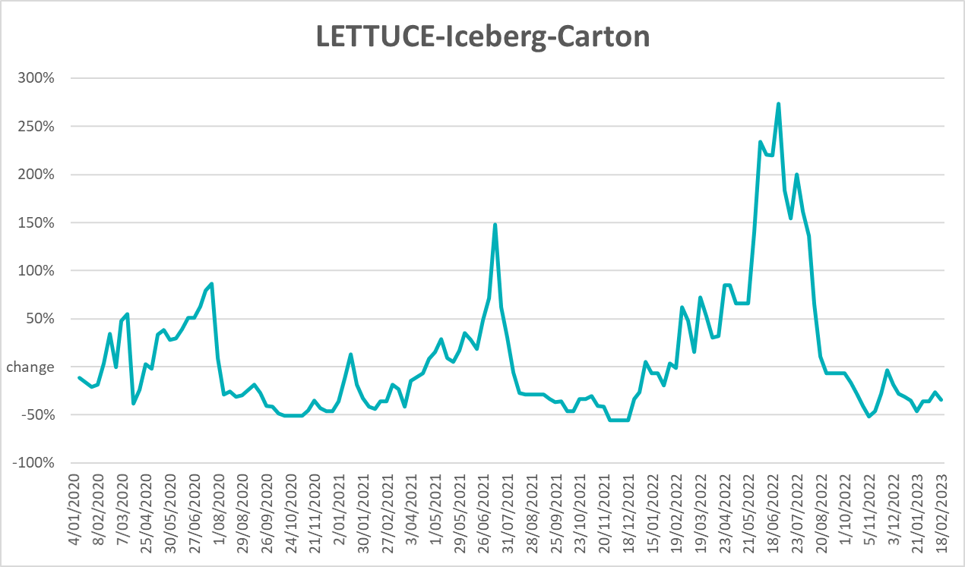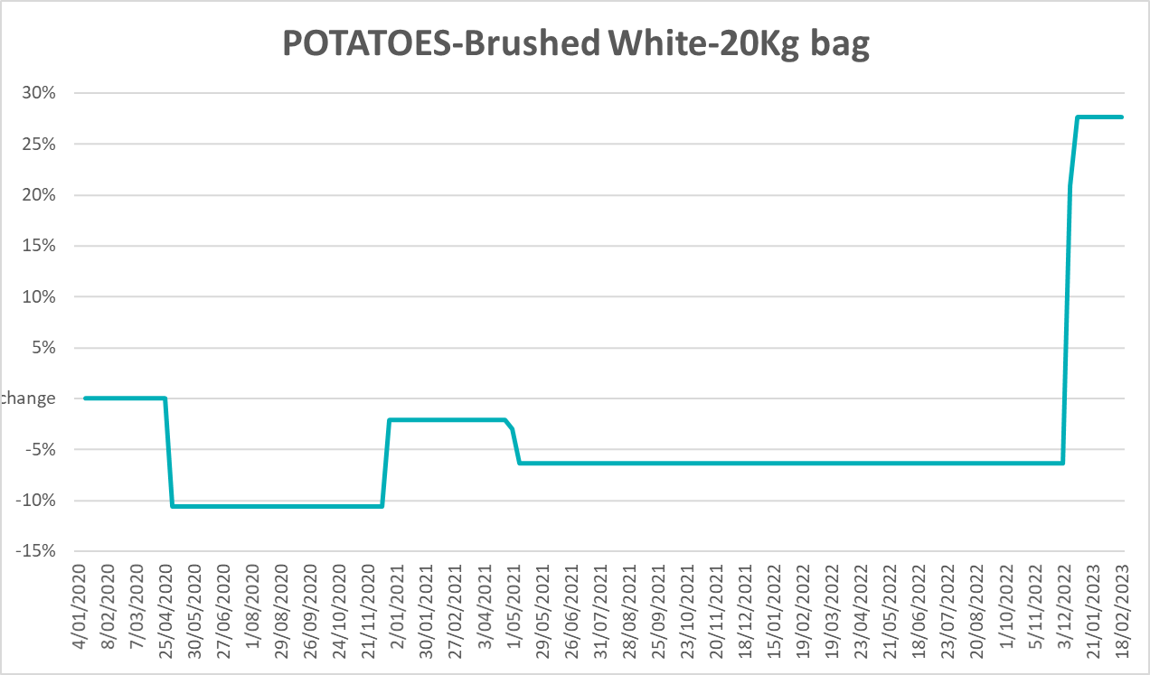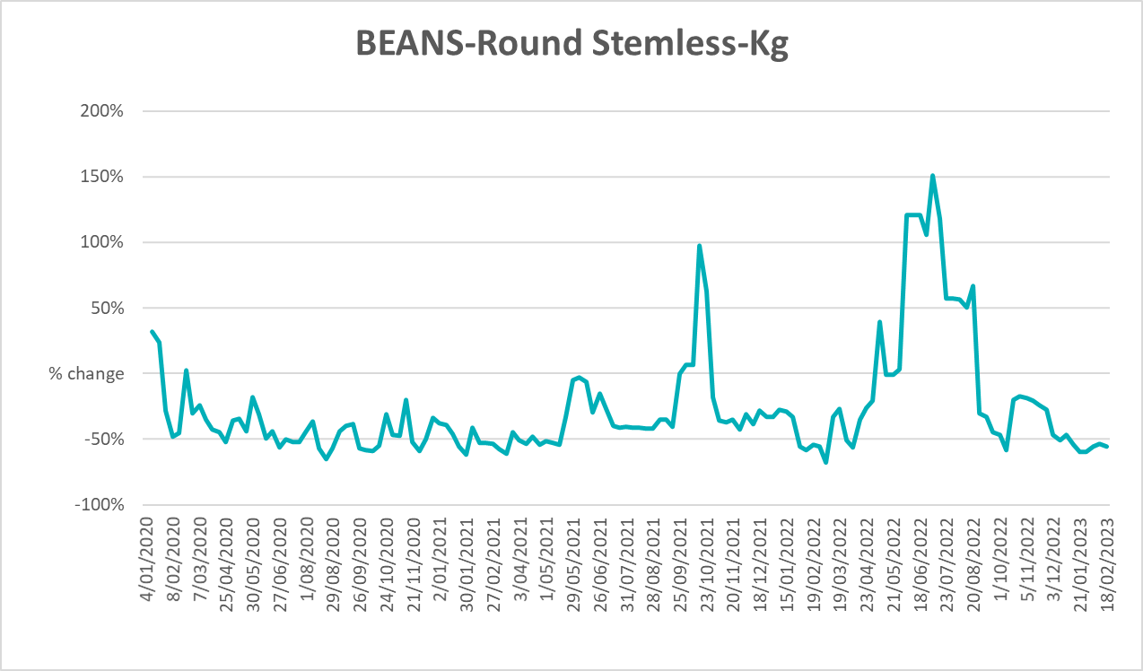

3.6 Selected domestic fodder indicator prices
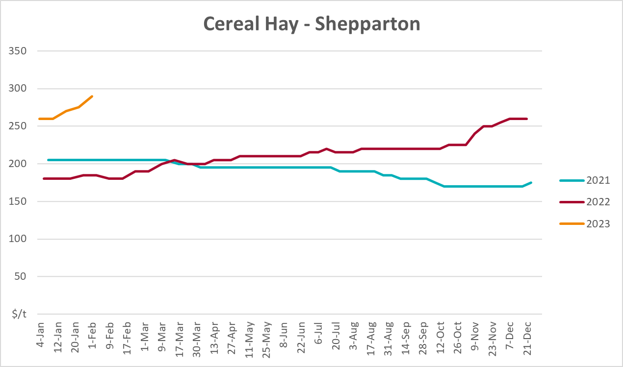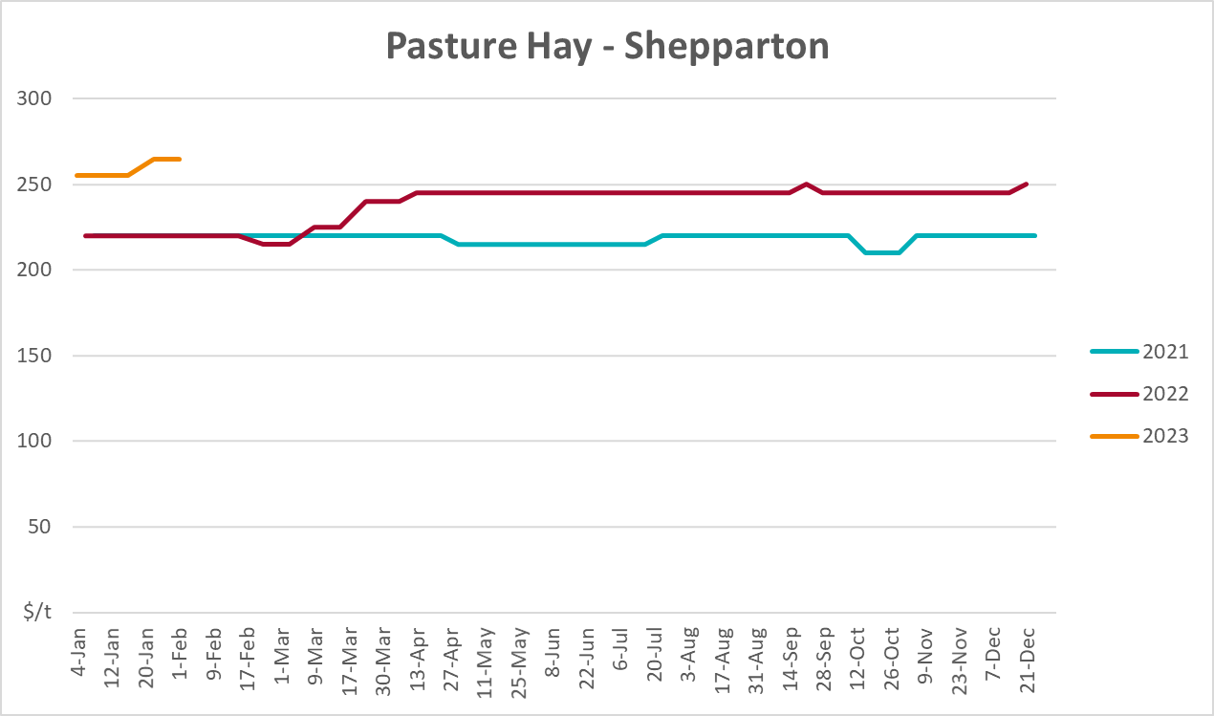
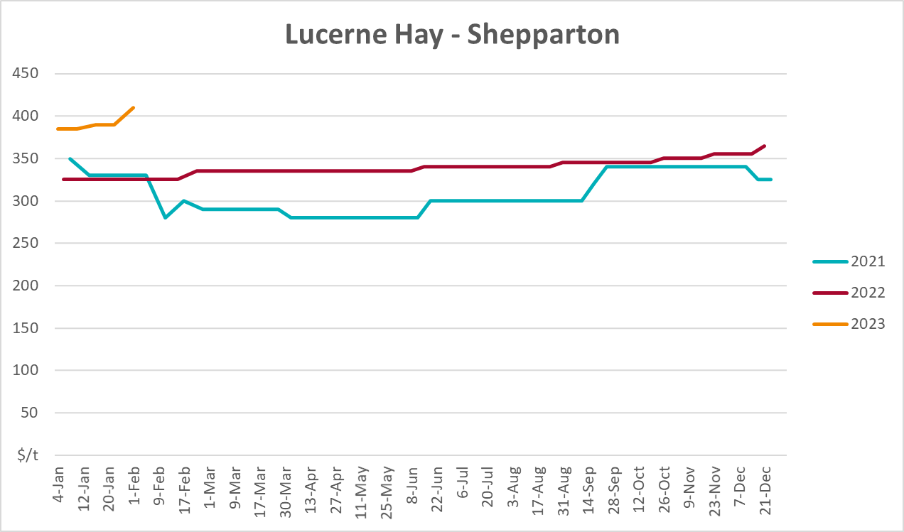

4. Data attribution

Climate
Bureau of Meteorology
- Weekly rainfall totals: www.bom.gov.au/climate/maps/rainfall/
- Monthly and last 3-month rainfall percentiles: www.bom.gov.au/water/landscape/
- Temperature anomalies: www.bom.gov.au/jsp/awap/temp/index.jsp
- Rainfall forecast: www.bom.gov.au/jsp/watl/rainfall/pme.jsp
- Seasonal outlook: www.bom.gov.au/climate/outlooks/#/overview/summary/
- Climate drivers: http://www.bom.gov.au/climate/enso/
- Soil moisture: www.bom.gov.au/water/landscape/
Other
- Pasture growth: www.longpaddock.qld.gov.au/aussiegrass/
- 3-month global outlooks: Environment and Climate Change Canada, NOAA Climate Prediction Center, EUROBRISA CPTEC/INPE, European Centre for Medium-Range Weather Forecasts, Hydrometcenter of Russia, National Climate Center Climate System Diagnosis and Prediction Room (NCC), International Research Institute for Climate and Society
- Global production: https://ipad.fas.usda.gov/ogamaps/cropmapsandcalendars.aspx
- Autumn break: Pook et al., 2009, https://rmets-onlinelibrary-wiley-com.virtual.anu.edu.au/doi/epdf/10.1002/joc.1833

Water
Prices
- Waterflow: https://www.waterflow.io/
- Ruralco: https://www.ruralcowater.com.au/
Bureau of Meteorology:
- Allocation trade: http://www.bom.gov.au/water/dashboards/#/water-markets/mdb/at
- Storage volumes: http://www.bom.gov.au/water/dashboards/#/water-storages/summary/drainage
Trade constraints:
- Water NSW: https://www.waternsw.com.au/customer-service/ordering-trading-and-pricing/trading/murrumbidgee
- Victorian Water Register: https://www.waterregister.vic.gov.au/TradingRules2019/

Commodities
Fruit and vegetables
- Datafresh: www.freshstate.com.au
Pigs
- Australian Pork Limited: www.australianpork.com.au
Dairy
- Global Dairy Trade: www.globaldairytrade.info/en/product-results/
World wheat, canola
- International Grains Council
World coarse grains
- United States Department of Agriculture
World cotton
- Cotlook: www.cotlook.com/
World sugar
- New York Stock Exchange - Intercontinental Exchange
Wool
- Australian Wool Exchange: www.awex.com.au/
Domestic wheat, barley, sorghum, canola and fodder
- Jumbuk Consulting Pty Ltd: http://www.jumbukag.com.au/
Cattle, beef, mutton, lamb, goat and live export
- Meat and Livestock Australia: www.mla.com.au/Prices-and-market
© Commonwealth of Australia 2023

Ownership of intellectual property rights
Unless otherwise noted, copyright (and any other intellectual property rights, if any) in this publication is owned by the Commonwealth of Australia (referred to as the Commonwealth).

Creative Commons licence
All material in this publication is licensed under a Creative Commons Attribution 4.0 International Licence except content supplied by third parties, logos and the Commonwealth Coat of Arms.
Inquiries about the licence and any use of this document should be emailed to copyright@awe.gov.au.


Cataloguing data
This publication (and any material sourced from it) should be attributed as:
ABARES 2023, Weekly Australian Climate, Water and Agricultural Update, Australian Bureau of Agricultural and Resource Economics and Sciences, Canberra, 23 March 2023. CC BY 4.0 DOI: https://doi.org/10.25814/5f3e04e7d2503
ISSN 2652-7561
This publication is available at https://www.agriculture.gov.au/abares/products/weekly_update
Department of Agriculture, Fisheries and Forestry
GPO Box 858 Canberra ACT 2601
Telephone 1800 900 090
Web agriculture.gov.au/abares

Disclaimer
The Australian Government acting through the Department of Agriculture, Fisheries and Forestry, represented by the Australian Bureau of Agricultural and Resource Economics and Sciences, has exercised due care and skill in preparing and compiling the information and data in this publication. Notwithstanding, the Department of Agriculture, Fisheries and Forestry, ABARES, its employees and advisers disclaim all liability, including liability for negligence and for any loss, damage, injury, expense or cost incurred by any person as a result of accessing, using or relying on any of the information or data in this publication to the maximum extent permitted by law.

Statement of Professional Independence
The views and analysis presented in ABARES publications, including this one, reflect ABARES professionally independent findings, based on scientific and economic concepts, principles, information and data. These views, analysis and findings may not reflect or be consistent with the views or positions of the Australian Government, or of organisations or groups who have commissioned ABARES reports or analysis. More information on professional independence is provided on the ABARES website.

Acknowledgements
This report was prepared by Kavina Dayal and Matthew Miller.

