
No. 12/2024 28 March 2024

Summary of key issues
- In the week ending 27 March 2024, widespread rainfall and isolated thunderstorms associated with monsoonal activity, ex-Tropical Cyclone Megan, and series of troughs were recorded across northern, central and eastern Australia.
  - Across cropping regions, rainfall totals up to 150 millimetres were recorded across Queensland and up to 100 millimetres recorded across parts of northern New South Wales. Heavy falls in Queensland would have disrupted harvest of summer crops.
- Over the coming days, showers and storms associated with a low-pressure system are expected to result in rainfall totals of up to 100 millimetres in the northern tropics and up to 50 millimetres in the central and eastern parts of the country.
  - A wet week in much of Queensland’s cropping region will likely interrupt harvest of summer crops but boost soil moisture levels for winter crops, including in Victoria and New South Wales.
  - A drier week is expected in remaining cropping regions and will likely see a decline in soil moisture levels.
- The national rainfall outlook is for a heightened probability of below average rainfall for much of Australia over the next three months.
  - Considering the recent declines in upper layer soil moisture levels and the heightened probability of below average rainfall over the next three months, livestock producers, especially those in southern Australia, are expected to experience below-average pasture production.
  - However, availability of accumulated standing dry matter and ample conserved fodder is likely to enable most livestock producers to maintain current production levels and stocking rates.
- Water storage levels in the Murray-Darling Basin (MDB) decreased between 21 March 2024 and 28 March 2024 by 152 gigalitres (GL). Current volume of water held in storage is 17 114 GL, equivalent to 77% of total storage capacity. This is 13 percent or 2645 GL less than at the same time last year.
- Allocation prices in the Victorian Murray below the Barmah Choke increased from $30 on 21 March 2024 to $37 on 28 March 2024. Prices are lower in the Murrumbidgee and regions above the Barmah choke due to the binding of the Murrumbidgee export limit and Barmah choke trade constraint.

Climate

Rainfall this week
For the week ending 27 March 2024, widespread rainfall of up to 400 millimetres and isolated thunderstorms associated with monsoonal activity and ex-Tropical Cyclone Megan were recorded across northern Australia. A series of troughs moved across eastern parts of the country, bringing moderate rainfall totals. High-pressure systems in the south kept South Australia, Victoria and Western Australia and southern parts of New South Wales generally dry.
In Tasmania, a cold front brought rainfall to the west coast exceeding 50 millimetres in some areas.

Across cropping regions, rainfall totals up to 150 millimetres were recorded across Queensland and up to 100 millimetres recorded across parts of northern New South Wales. Heavy falls in Queensland would have disrupted harvest of summer crops. No rainfall was recorded across remaining cropping areas and would rely on autumn break to prepare the soil moisture levels for winter crops.

Rainfall for the week ending 27 March 2024
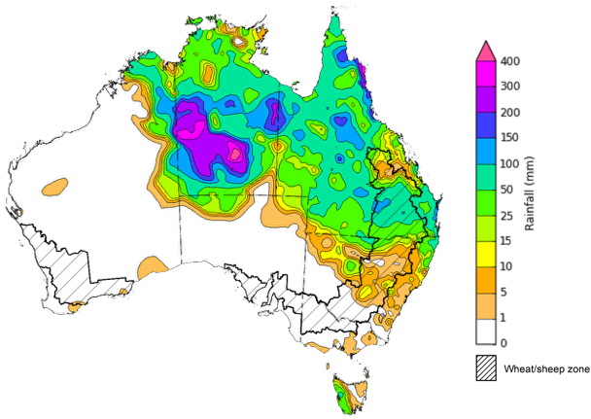

©Commonwealth of Australia 2024, Australian Bureau of Meteorology Issued: 27/03/2024
Note: The rainfall analyses and associated maps utilise data contained in the Bureau of Meteorology climate database, the Australian Data Archive for Meteorology (ADAM). The analyses are initially produced automatically from real-time data with limited quality control. They are intended to provide a general overview of rainfall across Australia as quickly as possible after the observations are received. For further information go to http://www.bom.gov.au/climate/rainfall/

Rainfall forecast for the next eight days
Over the 8 days to 4 April 2024, showers and storms associated with a low-pressure system are expected to result in rainfall totals of up to 100 millimetres in the northern tropics and up to 50 millimetres in the central and eastern parts of the country. A high-pressure system is expected to keep the west generally dry. A cold front is expected to bring rainfall totals of up to 25 millimetres in Tasmania and 50 millimetres in Victoria.

Across cropping regions, rainfall totals of up to 50 millimetres are forecast for central Queensland cropping regions and up to 25 millimetres across New South Wales and Victoria. Little to no rainfall is expected in the remaining cropping areas. Rainfall in Queensland is likely to disrupt harvest of summer crops. Dry conditions in Western Australia will likely see a decline in soil moisture levels.

Total forecast rainfall for the period 28 March to 4 April 2024
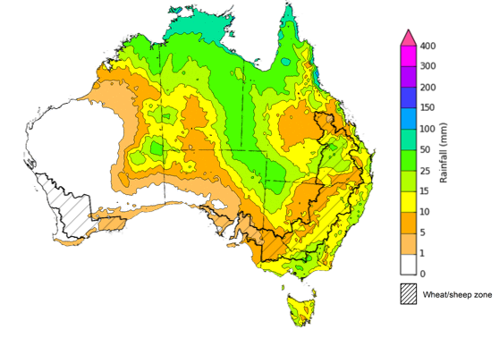

©Commonwealth of Australia 2024, Australian Bureau of Meteorology Issued 28/03/2024
Note: This rainfall forecast is produced from computer models. As the model outputs are not altered by weather forecasters, it is important to check local forecasts and warnings issued by the Bureau of Meteorology.

National Climate Outlook
The most recent rainfall outlook for April 2024 provided by the Bureau of Meteorology indicates a high likelihood (60 to 80% chance) of below-median rainfall across a significant portion of Australia. Notable exceptions being southern Tasmania, and eastern parts of Queensland, which are showing a probability of slightly above median rainfall.
According to Bureau of Meteorology’s climate model, there is a 75% probability of rainfall totals up to 200 millimetres in western Tasmania, and parts of northern coastal Queensland for April 2024. Up to 100 millimetres of rainfall is likely in coastal parts of New South Wales, Victoria, and the northern tropics.
Within cropping regions, there is at least 75% chance of rainfall totals up to 25 millimetres expected along the eastern fringes of New South Wales, Victoria, and parts of Queensland. The remaining cropping regions have a 75% chance of receiving up to 10 millimetres of rainfall.
A lack of sufficient rainfall in April is likely to result in an increased disconnect between upper- and lower-layer soil moisture, meaning that there would be limited opportunities to plant winter crops under ideal conditions. This may see many grain producers opt to dry sow crops, which presents some production risk outcomes if May rainfall is not sufficient to support germination and establishment.
Rainfall totals that have a 75% chance of occurring in April 2024
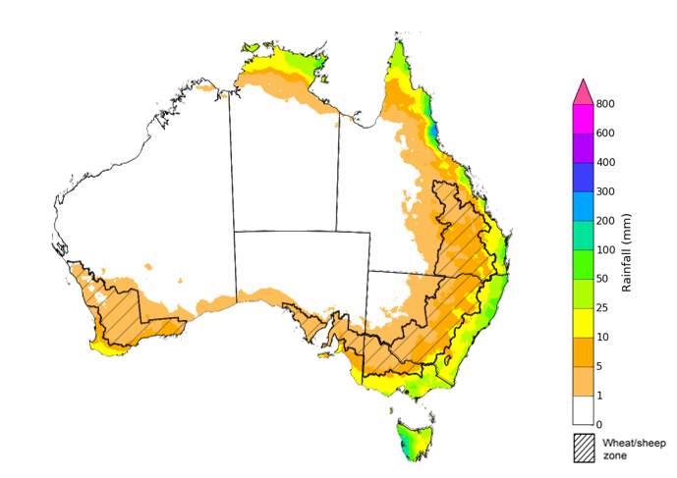

©Commonwealth of Australia 2024, Australian Bureau of Meteorology Issued: 28/03/2024

The El Niño event of 2023 is nearing its end, with the anticipation of returning to neutral ENSO conditions during the current 2024 autumn. The rainfall outlook for April through June 2024 indicates a probability of below-median rainfall across much of Australia.
Across cropping regions, there is an equal chance of rainfall being above median in Queensland and northern New South Wales. Below median rainfall is expected in the remaining cropping areas. This presents a risk for declining upper layer moisture levels that is necessary for winter crop plantings.
Chance of exceeding the median rainfall April to June 2024 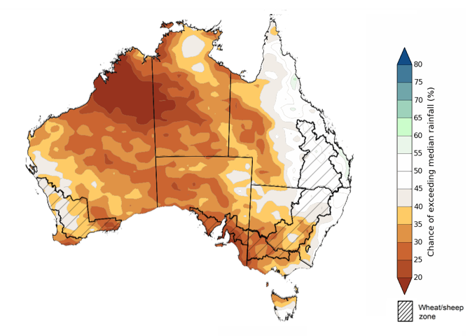
©Commonwealth of Australia 2024, Australian Bureau of Meteorology Issued: 28/03/2024

The outlook for April to June 2024 suggests there is at least 75% chance of rainfall exceeding 25 millimetres throughout much of southern and eastern Australia, with notable exceptions in large sections of the interior and northern regions where rainfall below 25 millimetres is more likely. Along isolated parts of Australia’s eastern and southern coastline, as well as western Tasmania, rainfall totals in excess of 200 millimetres are expected during this period.
Across cropping regions, there is at least a 75% chance of receiving 25 millimetres or more.
Considering the recent declines in upper layer soil moisture levels and the heightened probability of below average rainfall over the next three months, livestock producers, especially those in southern Australia, are expected to experience below-average pasture production. However, the availability of accumulated standing dry matter and ample conserved fodder is likely to enable most producers to maintain current production levels and stocking rates.
Rainfall totals that have a 75% chance of occurring April to June 2024
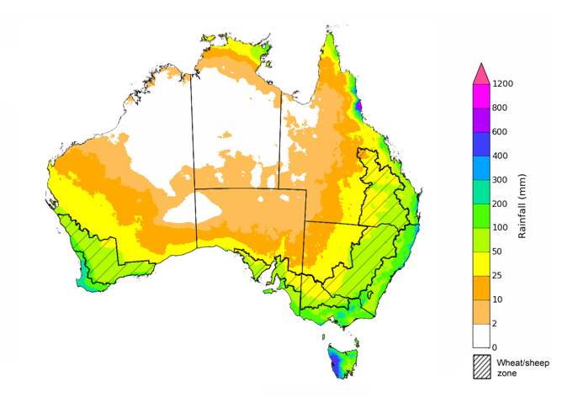
©Commonwealth of Australia 2024, Australian Bureau of Meteorology Issued: 28/03/2024

Water

Water markets – current week
Water storage levels in the Murray-Darling Basin (MDB) decreased between 21 March 2024 and 28 March 2024 by 152 gigalitres (GL). Current volume of water held in storage is 17 114 GL, equivalent to 77% of total storage capacity. This is 13 percent or 2645 GL less than at the same time last year.

Water storages in the Murray-Darling Basin, 2013–2024
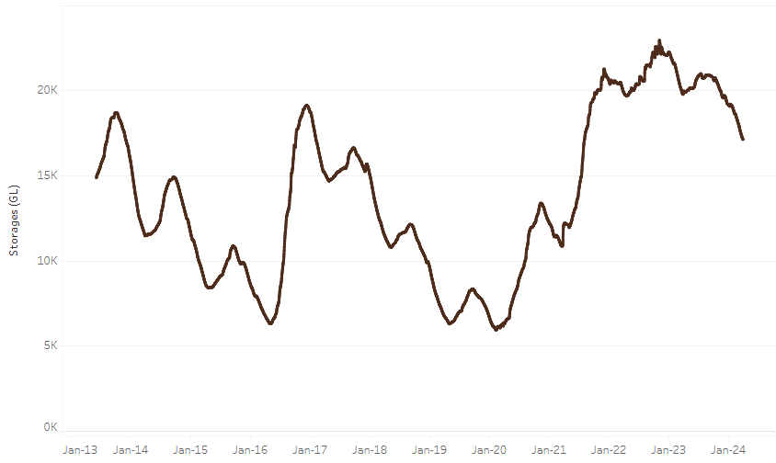
Water storage data is sourced from the Bureau of Meteorology.
Allocation prices in the Victorian Murray below the Barmah Choke increased from $30 on 21 March 2024 to $37 on 28 March 2024. Prices are lower in the Murrumbidgee and regions above the Barmah choke due to the binding of the Murrumbidgee export limit and Barmah choke trade constraint.

Region | $/ML
NSW Murray Above | 18
NSW Murrumbidgee | 23
VIC Goulburn-Broken | 28
VIC Murray Below | 37

Surface water trade activity, Southern Murray–Darling Basin
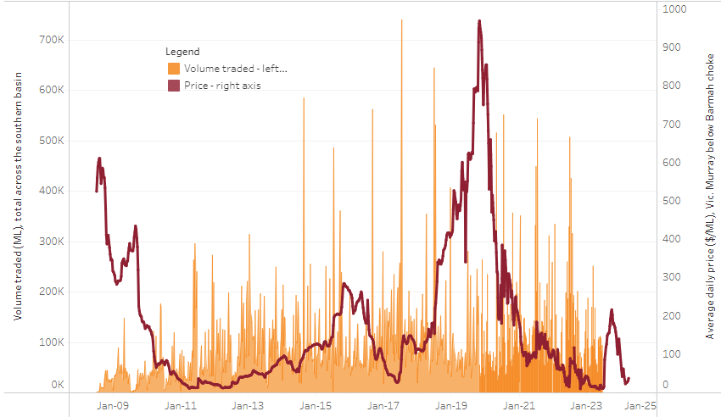
The trades shown reflect estimated market activity and do not encompass all register trades. The price is shown for the VIC Murray below the Barmah choke. Historical prices (before 1 July 2019) are ABARES estimates after removing outliers from BOM water register data. Prices after 1 July 2019 and prior to the 30 October 2019 reflect recorded transaction prices as sourced from Ruralco. Prices after the 30 October 2019 are sourced from Waterflow. Data for volume traded is sourced from the BOM water register. Only the price data shown is current on 28 March 2024.

To access the full, interactive, weekly water dashboard, which contains the latest and historical water storage, water market and water allocation information, please visit https://www.agriculture.gov.au/abares/products/weekly_update/weekly-update-28324

Commodities
Indicator | Week ended | Unit | Latest Price | Previous Week | Weekly change | Price 12 months ago | Annual change
Selected world indicator prices
AUD/USD Exchange rate | 27-Mar | A$/US$ | 0.65 | 0.66 | 0% | 0.67 | -3%
Wheat – US no. 2 hard red winter wheat, fob Gulf | 27-Mar | US$/t | 274 | 271 | 1% | 387 | -29%
Corn – US no. 2 yellow corn, fob Gulf | 27-Mar | US$/t | 189 | 192 | -2% | 293 | -36%
Canola – Rapeseed, Canada, fob Vancouver | 27-Mar | US$/t | 512 | 508 | 1% | 621 | -18%
Cotton – Cotlook 'A' Index | 27-Mar | USc/lb | 97 | 98 | -1% | 96 | 1%
Sugar – Intercontinental Exchange, nearby futures, no.11 contract | 27-Mar | USc/lb | 21.8 | 21.6 | 1% | 23 | -3%
Wool – Eastern Market Indicator | 27-Mar | Ac/kg clean | 1,142 | 1,152 | -1% | 1,400 | -18%
Wool – Western Market Indicator | 27-Mar | Ac/kg clean | 1,284 | 1,289 | 0% | 1,475 | -13%
Selected Australian grain export prices
Milling Wheat – APW, Port Adelaide, SA | 27-Mar | A$/t | 390 | 392 | 0% | 476 | -18%
Feed Wheat – ASW, Port Adelaide, SA | 27-Mar | A$/t | 370 | 372 | 0% | 447 | -17%
Feed Barley – Port Adelaide, SA | 27-Mar | A$/t | 353 | 350 | 1% | 413 | -15%
Canola – Kwinana, WA | 27-Mar | A$/t | 682 | 685 | 0% | 926 | -26%
Grain Sorghum – Brisbane, QLD | 27-Mar | A$/t | 455 | 455 | 0% | 511 | -11%
Selected domestic livestock indicator prices
Beef – Eastern Young Cattle Indicator | 27-Mar | Ac/kg cwt | 582 | 575 | 1% | 675 | -14%
Mutton – Mutton indicator (18–24 kg fat score 2–3), Vic | 27-Mar | Ac/kg cwt | 252 | 241 | 4% | 348 | -28%
Lamb – National Trade Lamb Indicator | 27-Mar | Ac/kg cwt | 613 | 591 | 4% | 731 | -16%
Pig – Eastern Seaboard (60.1–75 kg), average of buyers & sellers | 13-Mar | Ac/kg cwt | 411 | 411 | 0% | 357 | 15%
Goats – Eastern States (10.1–12 kg) | 27-Dec | Ac/kg cwt | 170 | 170 | 0% | 350 | -51%
Live cattle – Light steers to Indonesia | 27-Mar | Ac/kg lwt | 350 | 350 | 0% | 380 | -8%
Global Dairy Trade (GDT) weighted average prices ª
Dairy – Whole milk powder | 20-Mar | US$/t | 3,143 | 3,286 | -4% | 3,277 | -4%
Dairy – Skim milk powder | 20-Mar | US$/t | 2,517 | 2,640 | -5% | 2,739 | -8%
Dairy – Cheddar cheese | 20-Mar | US$/t | 4,192 | 4,277 | -2% | 4,509 | -7%
Dairy – Anhydrous milk fat | 20-Mar | US$/t | 6,794 | 6,637 | 2% | 5,340 | 27%
a Global Dairy Trade prices are updated twice monthly on the first and third Tuesday of each month.

Selected world indicator prices
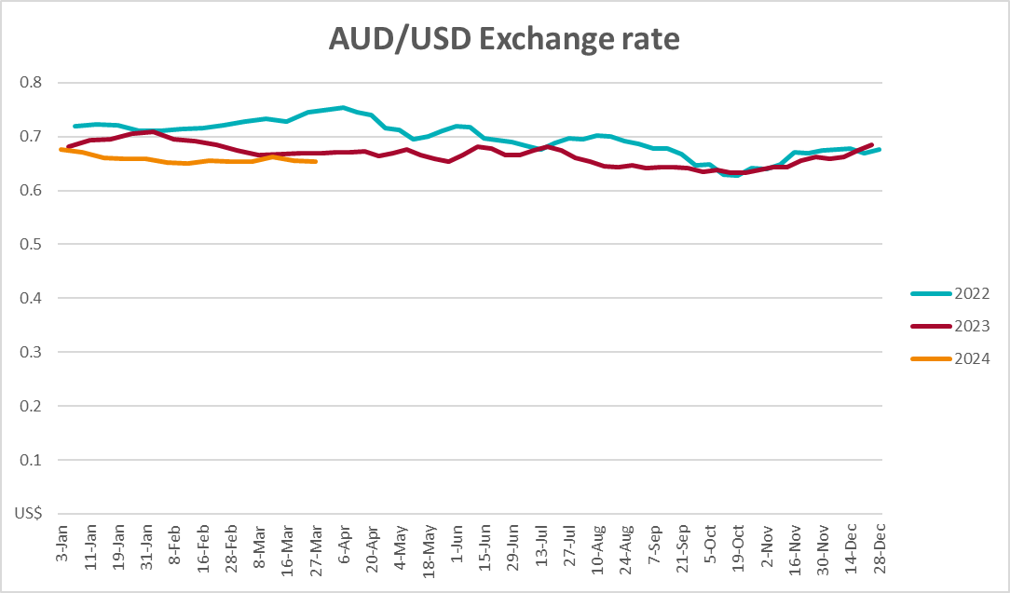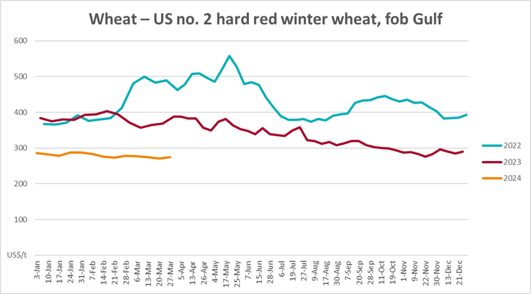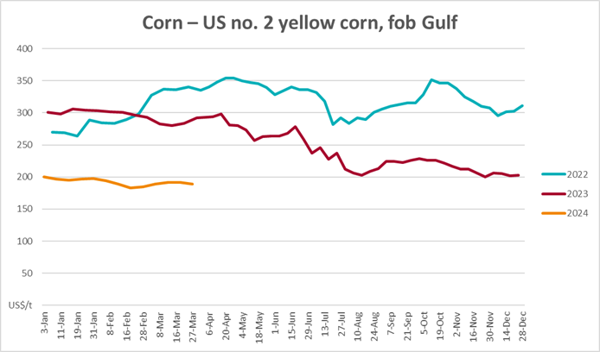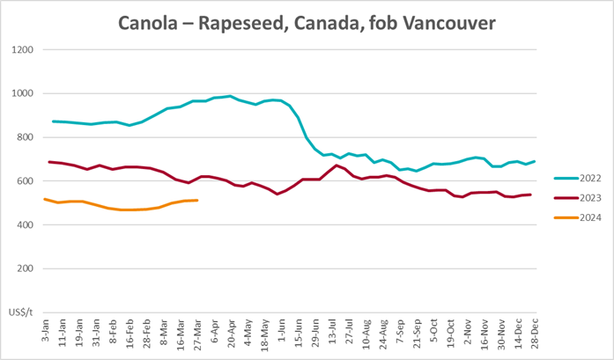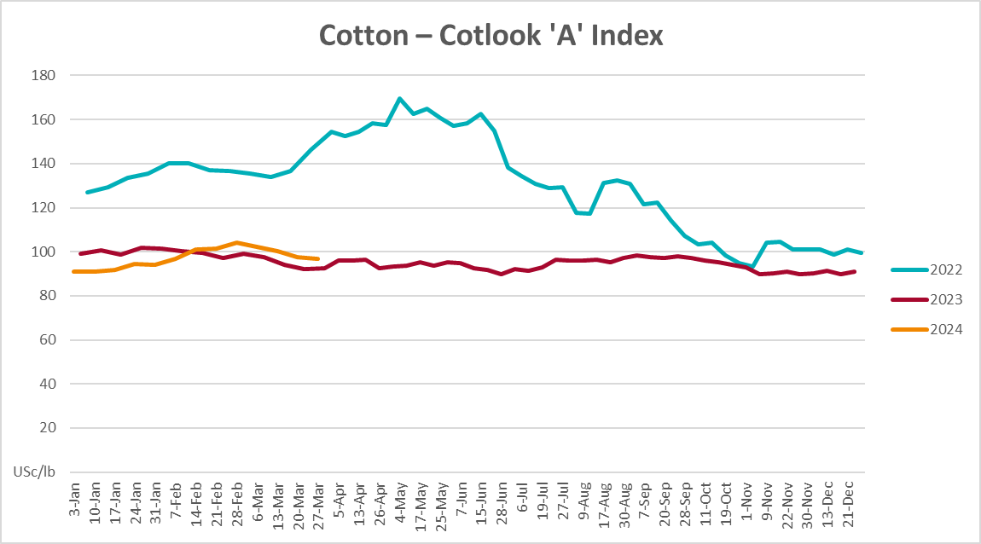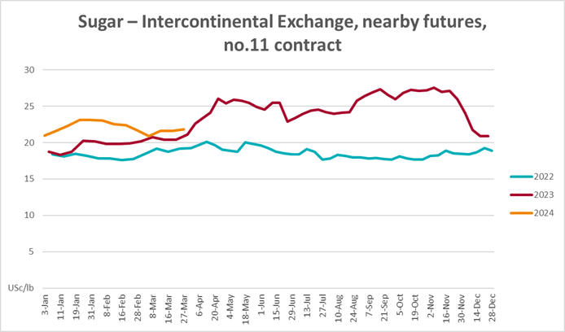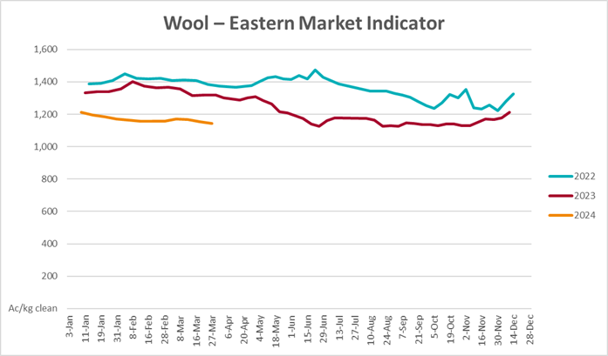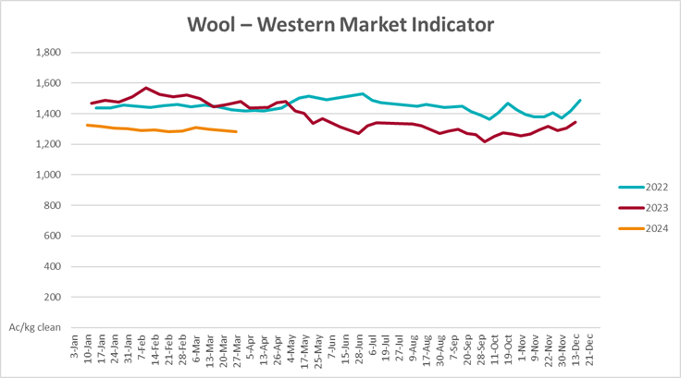

Selected domestic crop indicator prices
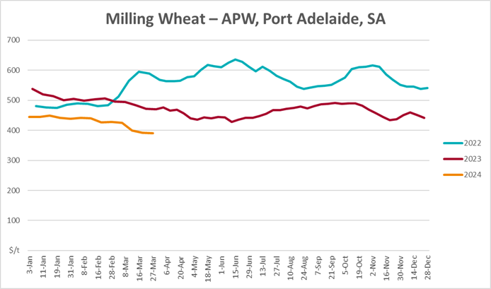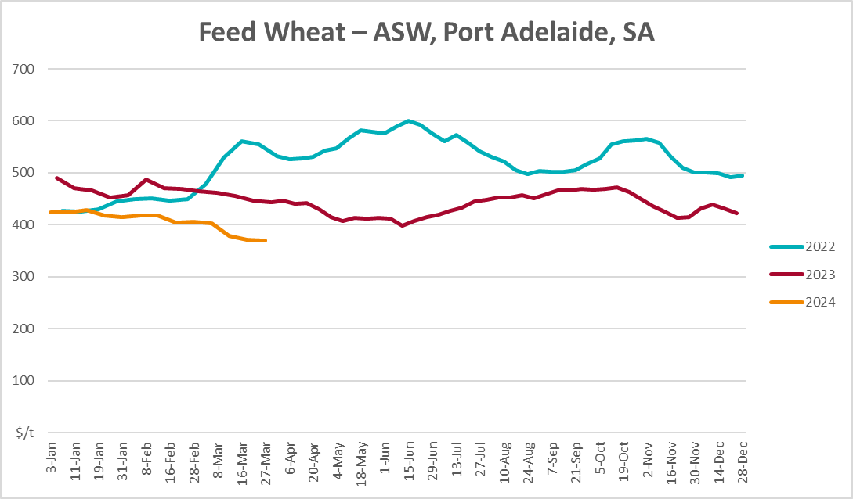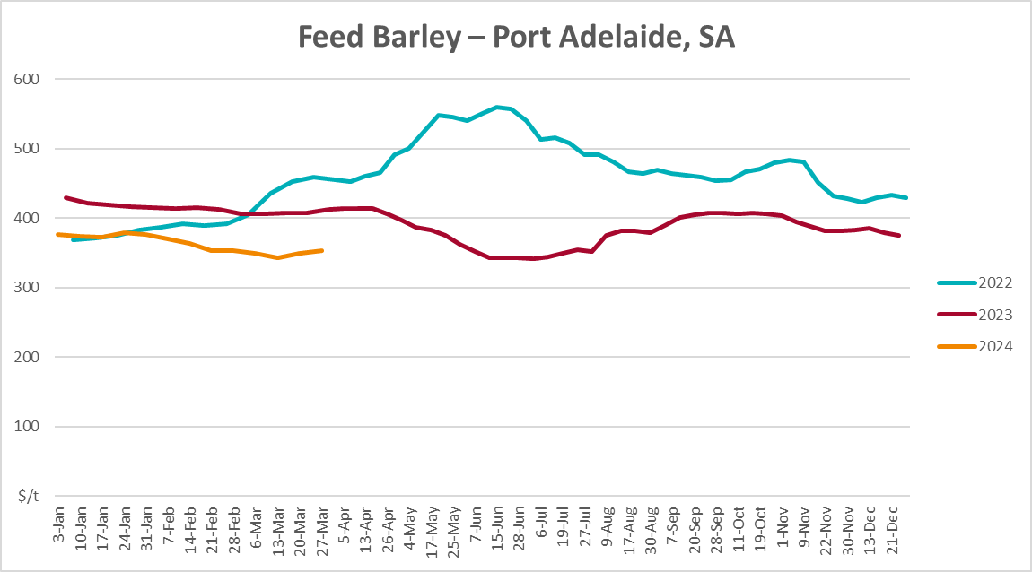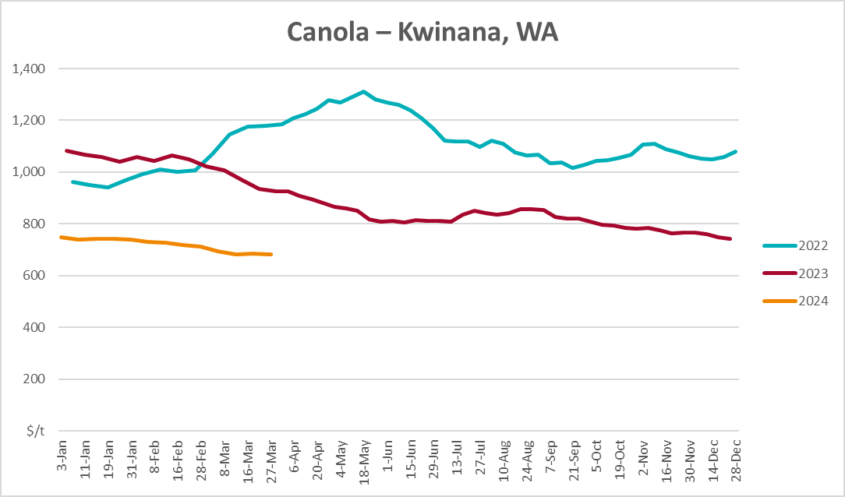
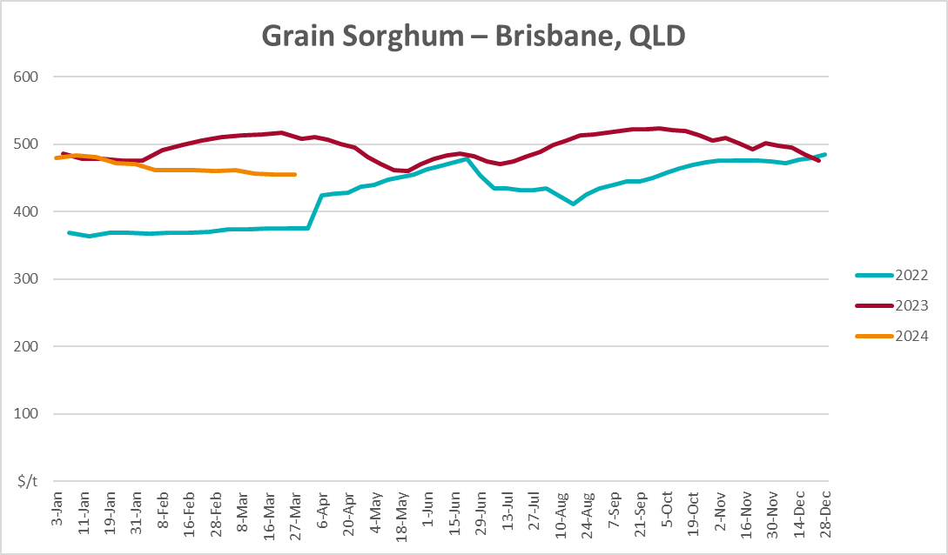

Selected domestic livestock indicator prices
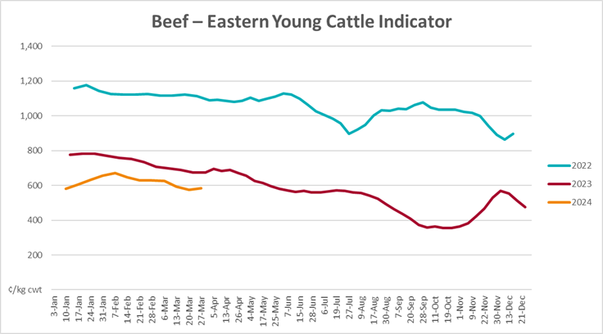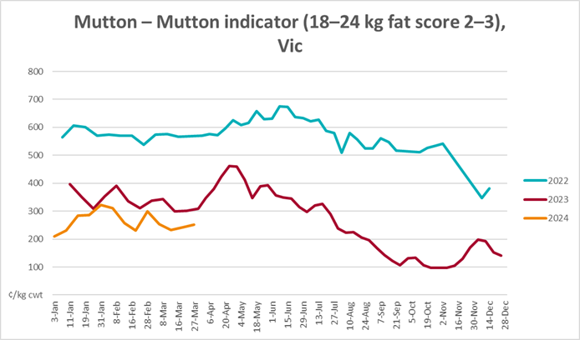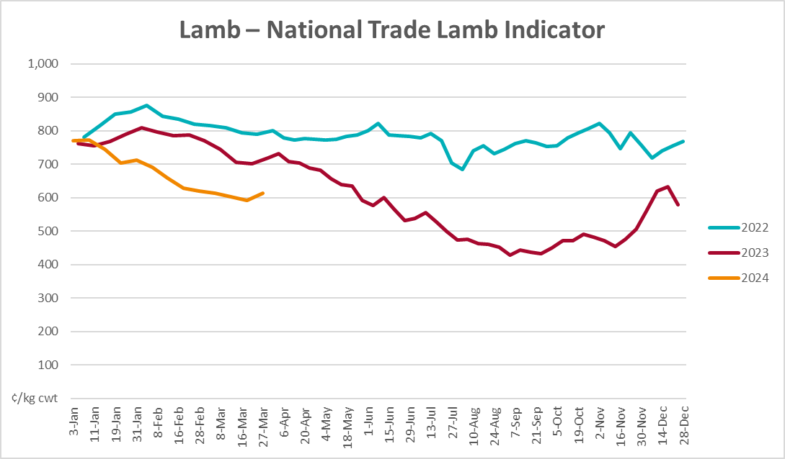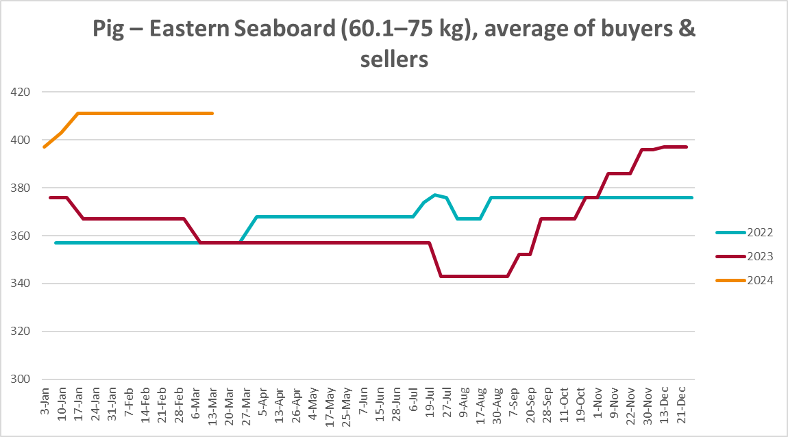
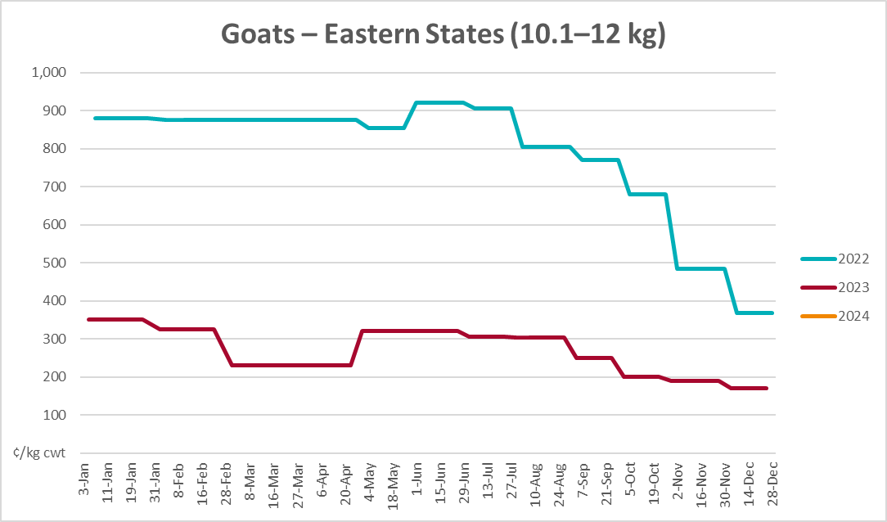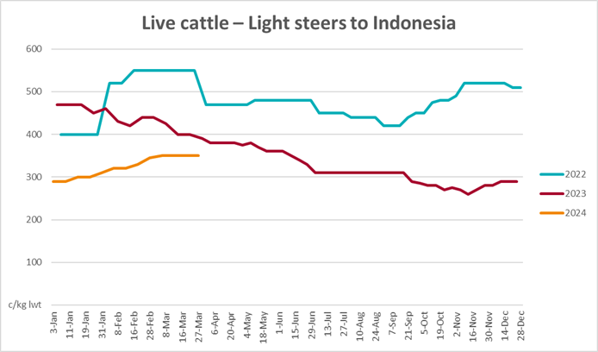

Global Dairy Trade (GDT) weighted average prices
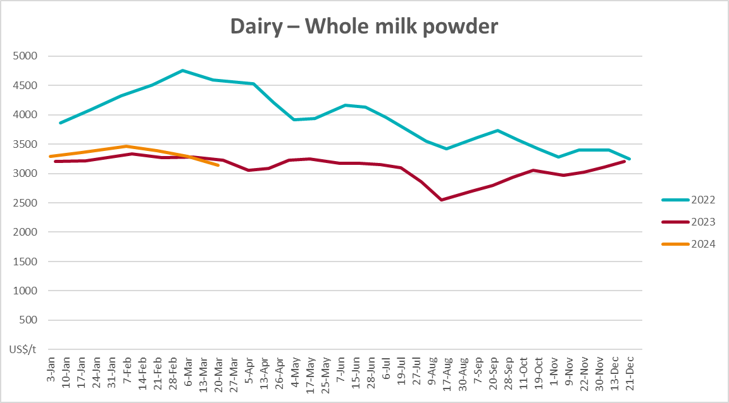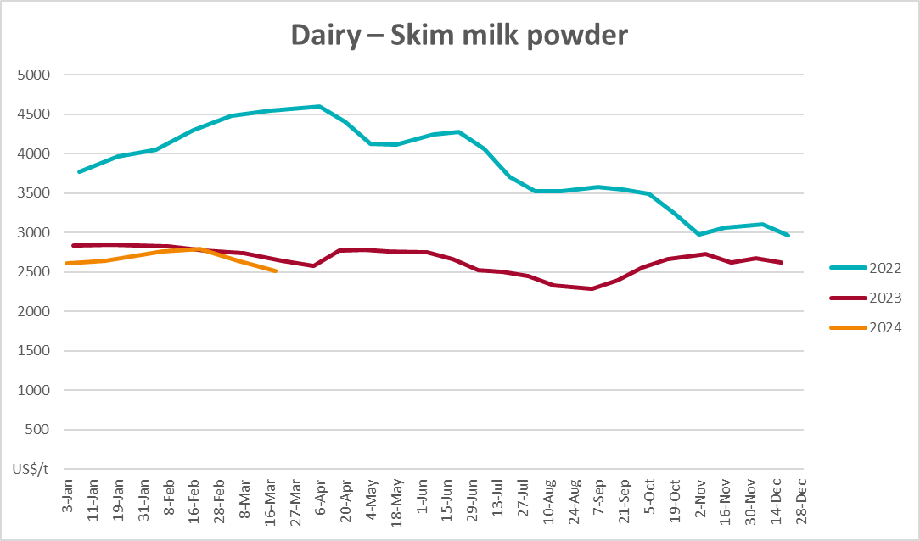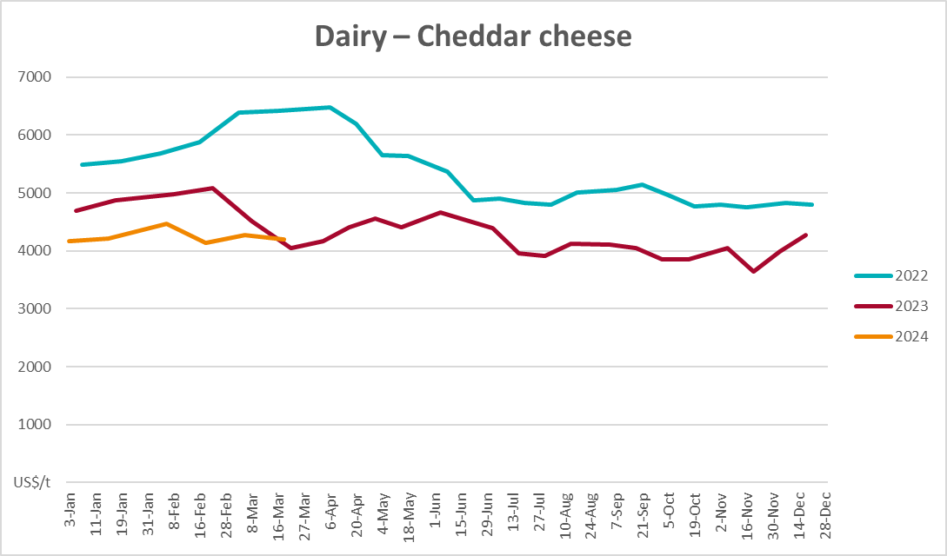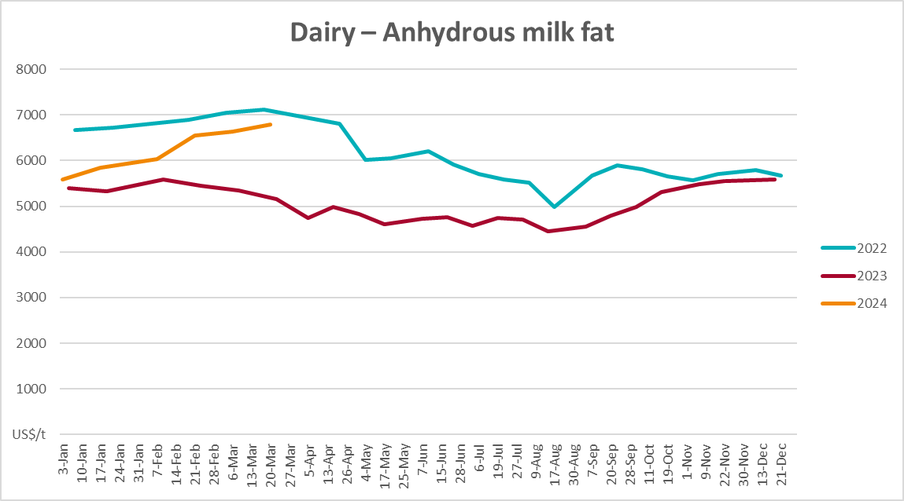

Selected fruit and vegetable prices
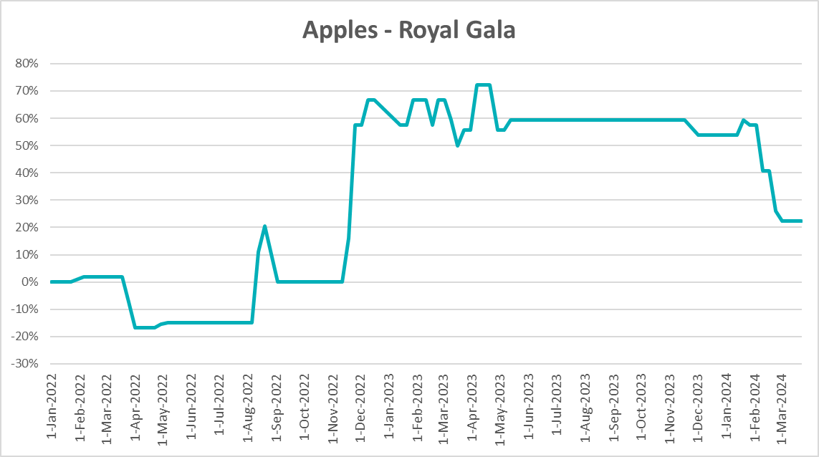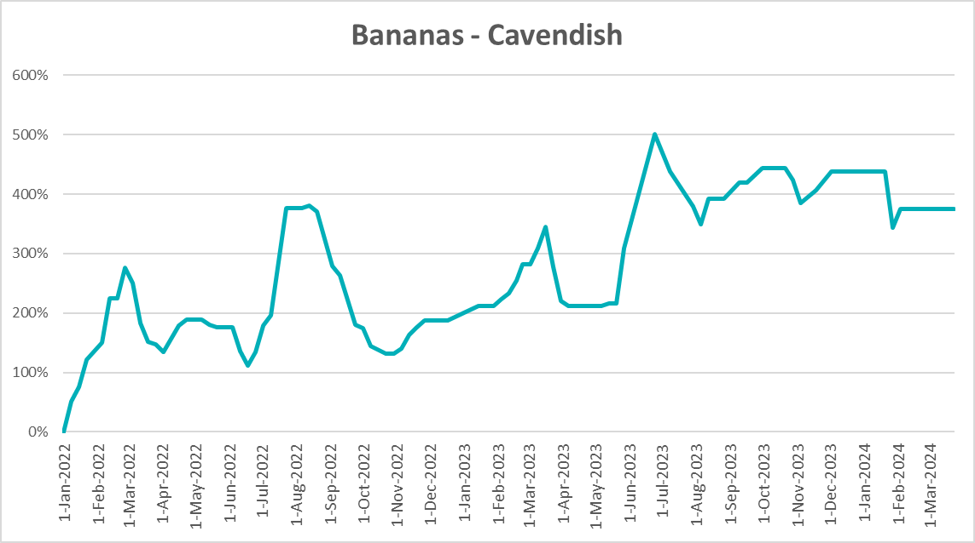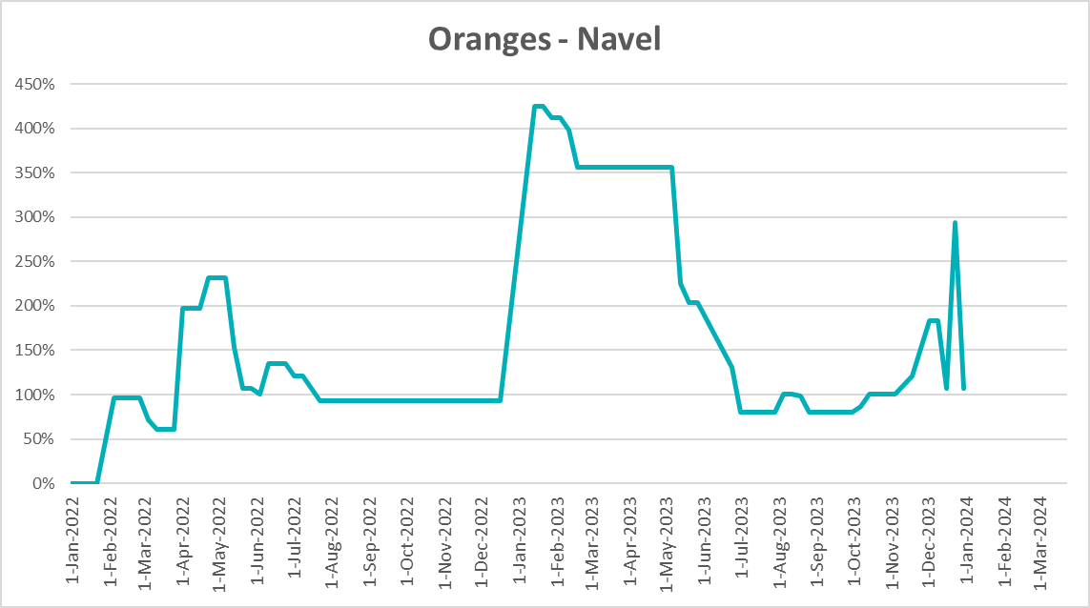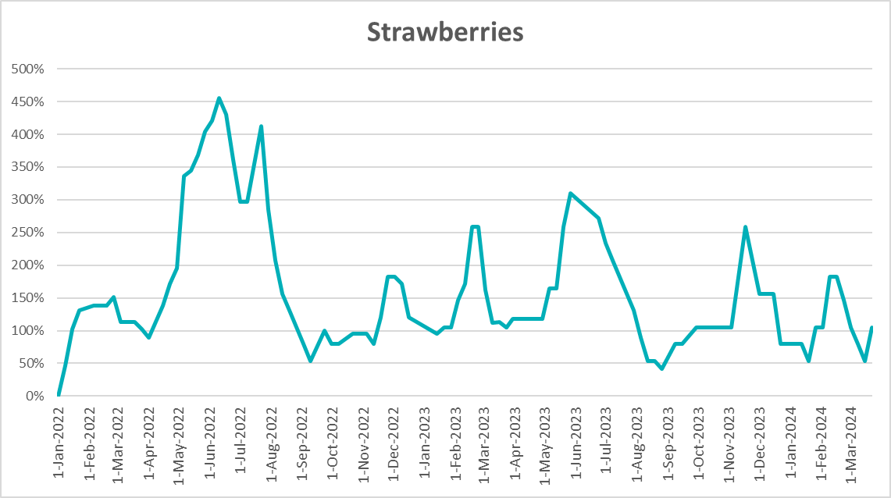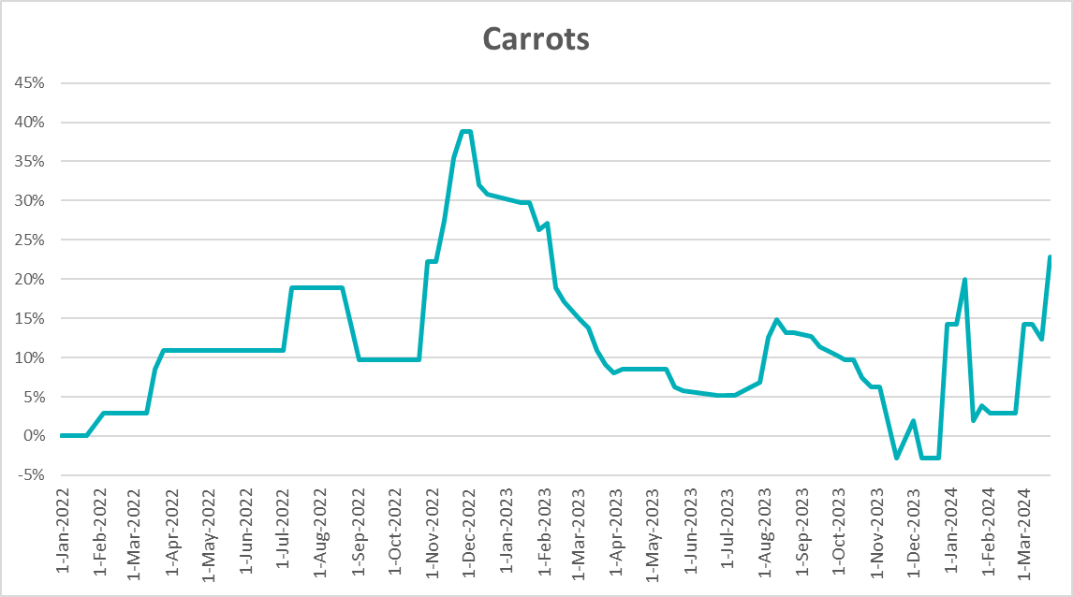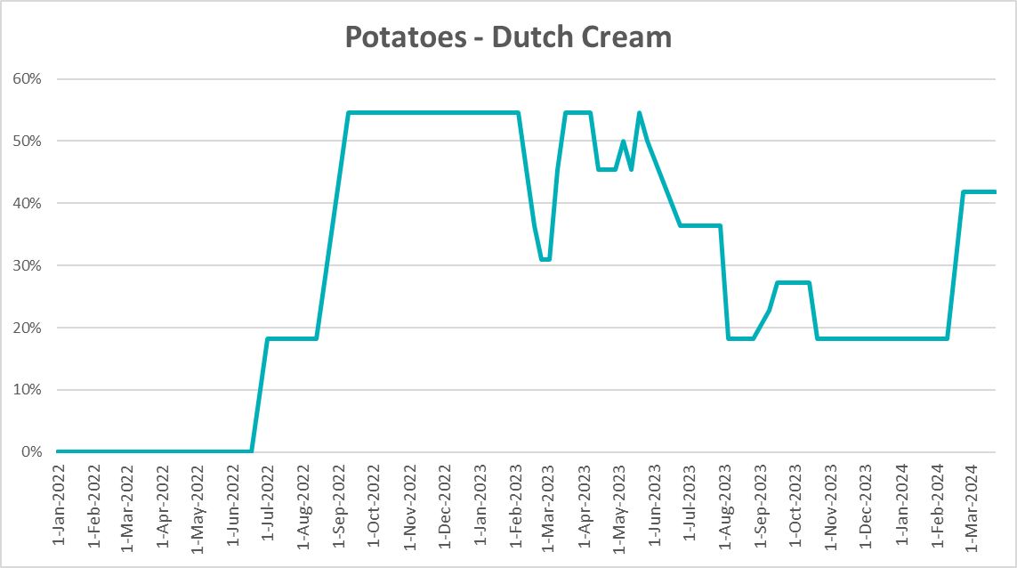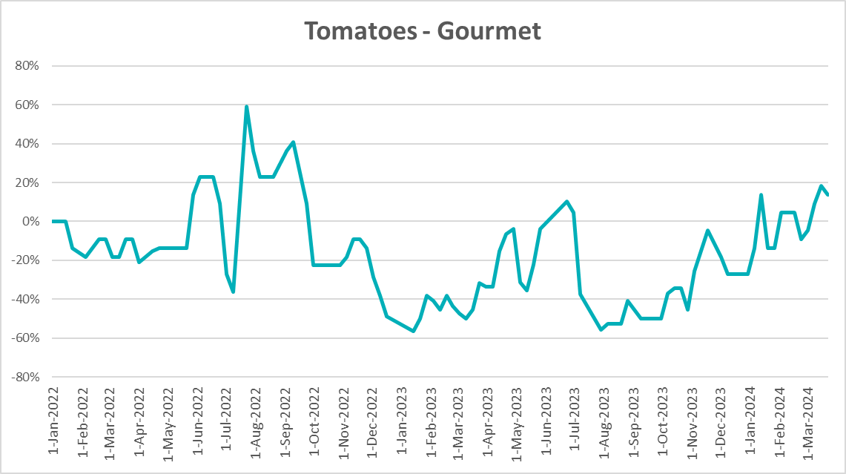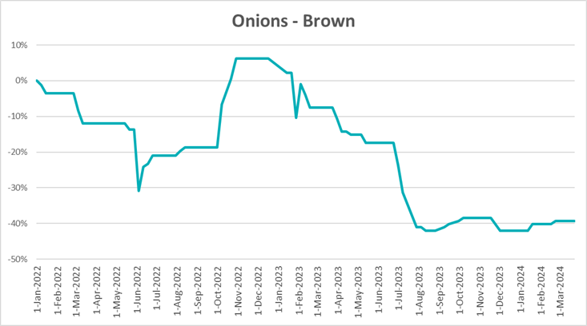

3.6 Selected domestic fodder indicator prices

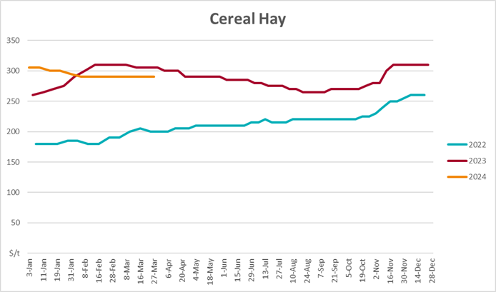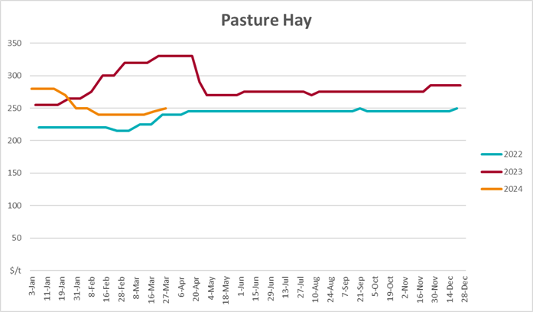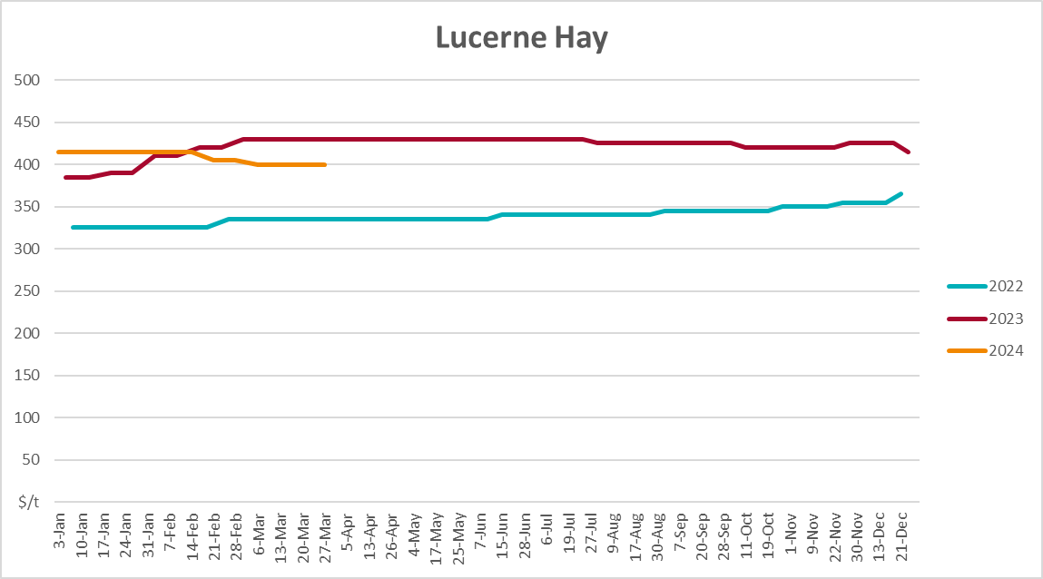

4. Data attribution

Climate
Bureau of Meteorology
- Weekly rainfall totals: www.bom.gov.au/climate/maps/rainfall/
- Monthly and last 3-month rainfall percentiles: www.bom.gov.au/water/landscape/
- Temperature anomalies: www.bom.gov.au/jsp/awap/temp/index.jsp
- Rainfall forecast: www.bom.gov.au/jsp/watl/rainfall/pme.jsp
- Seasonal outlook: www.bom.gov.au/climate/outlooks/#/overview/summary/
- Climate drivers: http://www.bom.gov.au/climate/enso/
- Soil moisture: www.bom.gov.au/water/landscape/
Other
- Pasture growth: www.longpaddock.qld.gov.au/aussiegrass/
- 3-month global outlooks: Environment and Climate Change Canada, NOAA Climate Prediction Center, EUROBRISA CPTEC/INPE, European Centre for Medium-Range Weather Forecasts, Hydrometcenter of Russia, National Climate Center Climate System Diagnosis and Prediction Room (NCC), International Research Institute for Climate and Society
- Global production: https://ipad.fas.usda.gov/ogamaps/cropmapsandcalendars.aspx
- Autumn break: Pook et al., 2009, https://rmets-onlinelibrary-wiley-com.virtual.anu.edu.au/doi/epdf/10.1002/joc.1833

Water
Prices
- Waterflow: https://www.waterflow.io/
- Ruralco: https://www.ruralcowater.com.au/
Bureau of Meteorology:
- Allocation trade: http://www.bom.gov.au/water/dashboards/#/water-markets/mdb/at
- Storage volumes: http://www.bom.gov.au/water/dashboards/#/water-storages/summary/drainage
Trade constraints:
- Water NSW: https://www.waternsw.com.au/customer-service/ordering-trading-and-pricing/trading/murrumbidgee
- Victorian Water Register: https://www.waterregister.vic.gov.au/TradingRules2019/

Commodities
Fruit and vegetables
- Datafresh: www.freshstate.com.au
Pigs
- Australian Pork Limited: www.australianpork.com.au
Dairy
- Global Dairy Trade: www.globaldairytrade.info/en/product-results/
World wheat, canola
- International Grains Council
World coarse grains
- United States Department of Agriculture
World cotton
- Cotlook: www.cotlook.com/
World sugar
- New York Stock Exchange - Intercontinental Exchange
Wool
- Australian Wool Exchange: www.awex.com.au/
Domestic wheat, barley, sorghum, canola and fodder
- Jumbuk Consulting Pty Ltd: http://www.jumbukag.com.au/
Cattle, beef, mutton, lamb, goat and live export
- Meat and Livestock Australia: www.mla.com.au/Prices-and-market
© Commonwealth of Australia 2023

Ownership of intellectual property rights
Unless otherwise noted, copyright (and any other intellectual property rights, if any) in this publication is owned by the Commonwealth of Australia (referred to as the Commonwealth).

Creative Commons licence
All material in this publication is licensed under a Creative Commons Attribution 4.0 International Licence except content supplied by third parties, logos and the Commonwealth Coat of Arms.
Inquiries about the licence and any use of this document should be emailed to copyright@awe.gov.au.


Cataloguing data
This publication (and any material sourced from it) should be attributed as:
ABARES 2023, Weekly Australian Climate, Water and Agricultural Update, Australian Bureau of Agricultural and Resource Economics and Sciences, Canberra, 28 March 2024. CC BY 4.0 DOI: https://doi.org/10.25814/5f3e04e7d2503
ISSN 2652-7561
This publication is available at https://www.agriculture.gov.au/abares/products/weekly_update
Department of Agriculture, Fisheries and Forestry
GPO Box 858 Canberra ACT 2601
Telephone 1800 900 090
Web agriculture.gov.au/abares

Disclaimer
The Australian Government acting through the Department of Agriculture, Fisheries and Forestry, represented by the Australian Bureau of Agricultural and Resource Economics and Sciences, has exercised due care and skill in preparing and compiling the information and data in this publication. Notwithstanding, the Department of Agriculture, Fisheries and Forestry, ABARES, its employees and advisers disclaim all liability, including liability for negligence and for any loss, damage, injury, expense or cost incurred by any person as a result of accessing, using or relying on any of the information or data in this publication to the maximum extent permitted by law.

Statement of Professional Independence
The views and analysis presented in ABARES publications, including this one, reflect ABARES professionally independent findings, based on scientific and economic concepts, principles, information and data. These views, analysis and findings may not reflect or be consistent with the views or positions of the Australian Government, or of organisations or groups who have commissioned ABARES reports or analysis. More information on professional independence is provided on the ABARES website.

Acknowledgements
This report was prepared by Kavina Dayal and Holly Beale.

