## No. 14/2025 10 April 2025

# Summary of key issues

* In the week ending 9 April 2025 low-pressure systems and troughs brought rainfall to the north and east of Australia.
  + High rainfall continued in much of northern and central Australia, including Queensland   
    (5- 200 millimetres), the Northern Territory and northern Western Australia   
    (5-100 millimetres). Rainfall was also recorded in south-west western Australia (5-100 millimetres).
  + Across cropping regions rainfall totals were high in the east – in Queensland, rainfall totals of 0-100 millimetres were recorded. Meanwhile, northern New South Wales saw between   
    5-50 millimetres of rainfall.
  + In summer cropping regions, rainfall totals were generally high. This is expected to see an improvement in stored soil moisture but is likely to lead to delays to the harvesting of unharvested summer crops.
* Over the coming eight days, wet conditions are expected across the north, south and east of the country.
  + Rainfall totals of between 10-50 millimetres are expected in Western Australia; while remaining cropping regions are likely to see little to no rainfall.
  + In summer cropping regions the low rainfall is likely to see a drying down of saturated soils and support the resumption of harvesting of summer crop and planting of winter crops in coming weeks.
* The **national rainfall outlook** for May to July 2025 indicates an increased probability of above median rainfall across the west of the country.
  + Higher than average rainfall is expected in much of Western Australia, while below average rainfall is likely in parts of the south and far north of the country.
* There is a 75% chance of rainfall totals being between 100-200 millimetres across most cropping regions, with exceptions in Queensland. These expected falls are likely to be sufficient to support pasture growth and soil moisture in winter cropping regions**.**
* Water storage levels in the Murray-Darling Basin (MDB) decreased between 03 April 2025 and 10 April 2025 by 35 gigalitres (GL). Current volume of water held in storage is 12,147 GL, equivalent to 54% of total storage capacity. This is 29 percent or 4,863 GL less than at the same time last year. Water storage data is sourced from the Bureau of Meteorology.
* Allocation prices in the Victorian Murray below the Barmah Choke increased from $190 on   
  03 April to $193 on 10 April. Prices are lower in regions above the Barmah choke due to the binding of the Barmah choke trade constraint.

## **Climate**

### Rainfall this week

In the week ending 9 April 2025, **low-pressure systems and troughs** brought rainfall to northern, eastern, and southwest regions of the country. High-pressure systems kept much of the remainder of Australia largely dry.

* Elevated rainfall totals continued in much of northern Australia, including Queensland   
  (10-200 millimetres), the Northern Territory and northern Western Australia   
  (5-100 millimetres).
* Rainfall totals of between 5-100 millimetres were also recorded across northern New South Wales, Tasmania, and southwestern Western Australia.
* Little to no rainfall was observed in remaining southern and central areas, including much of South Australia, Victoria, southern New South Wales, and central Australia.

Rainfall was received in some cropping regions of Australia, particularly the western and northern regions, while relatively little was received in the south.

* In Queensland, rainfall totals of 0-100 millimetres were recorded, with lower rainfall totals in the south, while northern New South Wales saw between 5-50 millimetres of rainfall. This is expected to see an improvement in stored soil moisture but is likely to lead to delays to the harvesting of remaining summer crops.
* Meanwhile, parts of Western Australia received 0-50 millimetres of rainfall. Cropping regions in southern New South Wales, Victoria, and South Australia saw little to no rainfall over the period.

#### Rainfall for the week ending 9 April 2025

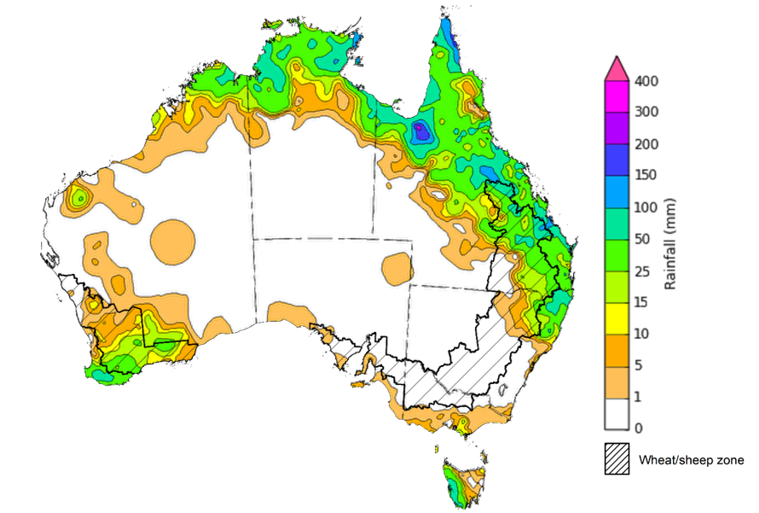

©Commonwealth of Australia 2025, Australian Bureau of Meteorology Issued: 9/4/2025

Note: The rainfall analyses and associated maps utilise data contained in the Bureau of Meteorology climate database, the Australian Data Archive for Meteorology (ADAM). The analyses are initially produced automatically from real-time data with limited [quality control](http://www.bom.gov.au/climate/headers/qc.shtml). They are intended to provide a general overview of rainfall across Australia as quickly as possible after the observations are received. For further information go to <http://www.bom.gov.au/climate/rainfall/>

### Rainfall forecast for the next eight days

Over the 8 days to 17 April 2025, **low-pressure systems** are expected to bring rainfall to all parts of Australia.

* Falls of between 10-100 millimetres are likely for much of northern tropics, including the north of the Northern Territory and northern Queensland, with northern Western Australia expected to see between 10-50 millimetres.
* Southern regions of Western Australia and Tasmania are both expected to receive   
  15-50 millimetres.
* Coastal regions of southeast Queensland and northern New South Wales are forecast to receive 5-50 millimetres of rainfall.
* High-pressure systems are expected to keep central and remaining southern regions relatively dry, with 1-10 millimetres of rainfall expected.

Rainfall totals across cropping regions over the coming week are forecast to be low in the east and higher in the west.

* Rainfall totals of between 10-50 millimetres are expected in Western Australia
* In contrast, remaining cropping regions are expected to receive 1-10 millimetres of rainfall.
* If realised, these low rainfall totals across Queensland and northern New South Wales are likely to support the drying down of saturated soils and support the resumption of harvesting of summer crop and planting of winter crops in coming weeks.

#### Total forecast rainfall for the period 10 April to 17 April 2025

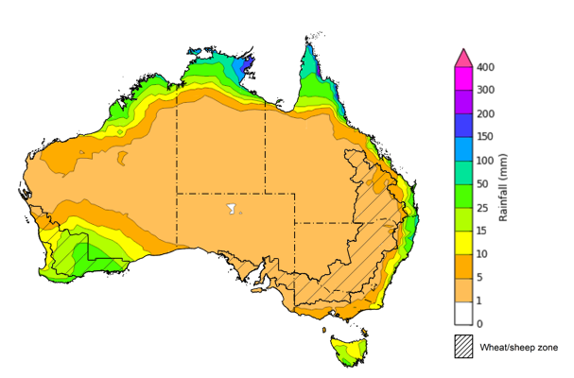

©Commonwealth of Australia 2025, Australian Bureau of Meteorology Issued 10/4/2025

Note: This rainfall forecast is produced from computer models. As the model outputs are not altered by weather forecasters, it is important to check local forecasts and warnings issued by the Bureau of Meteorology.

* 1. **National Climate Outlook**

The El Niño Southern Oscillation (ENSO), Southern Annular Mode (SAM), and Indian Ocean Dipole (IOD) climate drivers are currently neutral and having minimal influence on Australian rainfall. The IOD is likely to remain neutral over the coming months. Additionally, the ENSO is likely to remain neutral until August, suggesting climate drivers will also have little impact on Australian rainfall over the coming months.

The most recent **rainfall outlook for May 2025** provided by the Bureau of Meteorology indicates that much of northern Australia, and parts of the east and south are likely to see **below median rainfall**.

* The Bureau of Meteorology’s climate model indicates a 75% chance of May rainfall totals between 5-100 millimetres across parts of the south, including southern Western Australia and Victoria. Tasmania is expected to see as much as 200 millimetres.
* Eastern Australia, including southeast Queensland and eastern New South Wales are likely to see between 5-50 millimetres of rainfall. In northeastern Queensland, rainfall totals of up to 200 millimetres are expected in some coastal regions.
* Lower rainfall totals are expected across western, central and northern Australia, with much of Western Australia, Northern Territory, South Australia, and western Queensland likely to see little to no rainfall.
* Across cropping regions, there is a **75% chance** of rainfall totals of between **5-25 millimetres across most cropping regions.** If realised, **these rainfall totals** would be considered **below average for this time of year**.A lack of sufficient rainfall in May is likely to result in an increased disconnect between upper- and lower-layer soil moisture. This may reduce opportunities to plant winter crops under ideal conditions, particularly in some southern growing regions.

**Rainfall totals that have a 75% chance of occurring in May 2025**

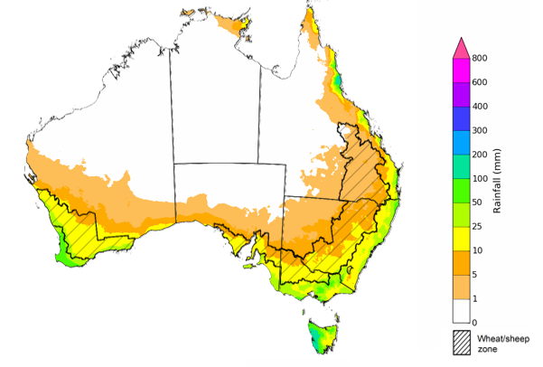

©Commonwealth of Australia 2025, Australian Bureau of Meteorology Issued: 10/4/2025

The **rainfall outlook for May to July 2025** indicates an increased probability of **above median rainfall across much of Western Australia**. In contrast, much of the north and parts of the southeast are showing an increased likelihood of receiving below median rainfall.

Across cropping regions, the chance of receiving above median rainfall is between 45–55% across much of Queensland and New South Wales, with Western Australia, South Australia, and Victoria generally having a 35–55% chance of above median rainfall.

**Chance of exceeding the median rainfall** **May 2025 to July 2025**

©Commonwealth of Australia 2025, Australian Bureau of Meteorology Issued: 10/4/2025

The **rainfall outlook for May through to July 2025** suggests a 75% chance of receiving rainfall totals of between 100–600 millimetres across southwest Western Australia, Tasmania, and alpine areas of New South Wales and Victoria. Between 50–200 millimetres of rainfall are forecast across much of southern Queensland, New South Wales, Victoria and South Australia. In northern and central Australia, little to no rainfall is forecast over the period.

In **cropping regions**, there is a **75% chance** of receiving between **100-200 millimetres** in the south, including Western Australia, South Australia, Victoria and New South Wales. In Queensland, falls of 10-100 millimetres are expected. These falls are likely to support soil moisture and pasture growth in winter cropping regions.

**Rainfall totals that have a 75% chance of occurring May 2025 to July 2025**

©Commonwealth of Australia 2025, Australian Bureau of Meteorology Issued: 10/4/2025

## **Water**

### Water markets – current week

Water storage levels in the Murray-Darling Basin (MDB) decreased between 03 April 2025 and   
10 April 2025 by 35 gigalitres (GL). Current volume of water held in storage is 12,147 GL, equivalent to 54% of total storage capacity. This is 29 percent or 4,863 GL less than at the same time last year. Water storage data is sourced from the Bureau of Meteorology.

Allocation prices in the Victorian Murray below the Barmah Choke increased from $190 on 03 April to $193 on 10 April. Prices are lower in regions above the Barmah choke due to the binding of the Barmah choke trade constraint.

#### Surface water trade activity, Southern Murray–Darling Basin

|  |
| --- |
| The trades shown reflect estimated market activity and do not encompass all register trades. The price is shown for the VIC Murray below the Barmah choke. Historical prices (before 1 July 2019) are ABARES estimates after removing outliers from BOM water register data. Prices after 1 July 2019 and prior to the 30 October 2019 reflect recorded transaction prices as sourced from Ruralco. Prices after the 30 October 2019 are sourced from Waterflow. Data for volume traded is sourced from the BOM water register. Only the price data shown is current on 17 October 2024. |

To access the full, interactive, weekly water dashboard, which contains the latest and historical water storage, water market and water allocation information, please visit <https://www.agriculture.gov.au/abares/products/weekly_update/weekly-update-1004324>

## **Commodities**

|  |  |  |  |  |  |  |  |  |
| --- | --- | --- | --- | --- | --- | --- | --- | --- |
| **Indicator** | **Week average** | **Unit** | **Latest Price** | **Previous Week** | **Weekly change** | | **Price 12 months ago** | **Annual change** |
| **Selected world indicator prices** |  |  |  |  |  |  | |  |
| AUD/USD Exchange rate | 09-Apr | A$/US$ | 0.60 | 0.63 | -4% | 0.65 | | -7% |
| Wheat – US no. 2 hard red winter wheat, FOB Gulf | 09-Apr | US$/t | 252 | 253 | 0% | 272 | | -7% |
| Corn – US no. 2 yellow corn, FOB Gulf | 09-Apr | US$/t | 215 | 210 | 2% | 191 | | 13% |
| Canola – Rapeseed, Canada, FOB Vancouver | 09-Apr | US$/t | 495 | 482 | 3% | 502 | | -1% |
| Cotton – Cotlook A Index | 09-Apr | USc/lb | 77 | 79 | -3% | 90 | | -15% |
| Sugar – Intercontinental Exchange, nearby futures, no.11 contract | 09-Apr | USc/lb | 18 | 19 | -4% | 20 | | -10% |
| Wool – Eastern Market Indicator | 09-Apr | Ac/kg clean | 1,262 | 1,249 | 1% | 1,157 | | 9% |
| Wool – Western Market Indicator | 09-Apr | Ac/kg clean | 1,425 | 1,414 | 1% | 1,291 | | 10% |
| **Selected Australian grain export prices** |  |  |  |  |  |  | |  |
| Australian Premium White (APW) Wheat, FOB Port Adelaide, SA | 09-Apr | A$/t | 410 | 394 | 4% | 391 | | 5% |
| Australian Standard White (ASW) Wheat, FOB Port Adelaide, SA | 09-Apr | A$/t | 402 | 386 | 4% | 371 | | 8% |
| Feed Barley – FOB Port Adelaide, SA | 09-Apr | A$/t | 380 | 363 | 5% | 360 | | 5% |
| Canola – FOB Kwinana, WA | 09-Apr | A$/t | 802 | 791 | 1% | 692 | | 16% |
| Grain Sorghum – FOB Brisbane, QLD | 09-Apr | A$/t | 447 | 434 | 3% | 451 | | -1% |
| **Selected domestic livestock indicator prices** |  |  |  |  |  |  | |  |
| Beef – Eastern Young Cattle Indicator | 09-Apr | Ac/kg cwt | 704 | 683 | 3% | 603 | | 17% |
| Mutton – Mutton indicator (18–24 kg fat score 2–3), VIC | 09-Apr | Ac/kg cwt | 538 | 480 | 12% | 256 | | 110% |
| Lamb – National Trade Lamb Indicator | 09-Apr | Ac/kg cwt | 809 | 790 | 2% | 642 | | 26% |
| Pig – Eastern Seaboard (60.1–75 kg), NSW buyer price | 26-Mar | Ac/kg cwt | 448 | 453 | -1% | 418 | | 7% |
| Live cattle – Light steers to Indonesia | 09-Apr | Ac/kg lwt | 360 | 360 | 0% | 350 | | 3% |
| **Global Dairy Trade (GDT) weighted average prices** |  |  |  |  |  |  | |  |
| Dairy – Whole milk powder | 02-Apr | US$/t | 4,062 | 4,052 | 0% | 3,258 | | 25% |
| Dairy – Skim milk powder | 02-Apr | US$/t | 2,876 | 2,729 | 5% | 2,546 | | 13% |
| Dairy – Cheddar cheese | 02-Apr | US$/t | 5,018 | 4,976 | 1% | 4,157 | | 21% |
| Dairy – Anhydrous milk fat | 02-Apr | US$/t | 6,705 | 6,561 | 2% | 6,998 | | -4% |
|  | | | | | | | | |

### Selected world indicator prices

### 3.2 Selected domestic crop indicator prices

### Selected domestic livestock indicator prices

### Global Dairy Trade (GDT) weighted average prices

### Selected fruit and vegetable prices

### 3.6 Selected domestic fodder indicator prices

## **4. Data attribution**

### Climate

* Bureau of Meteorology
* Weekly rainfall totals: www.bom.gov.au/climate/maps/rainfall/
* Monthly and last 3-month rainfall percentiles: [www.bom.gov.au/water/landscape/](http://www.bom.gov.au/water/landscape/)
* Temperature anomalies: [www.bom.gov.au/jsp/awap/temp/index.jsp](http://www.bom.gov.au/jsp/awap/temp/index.jsp)
* Rainfall forecast: [www.bom.gov.au/jsp/watl/rainfall/pme.jsp](http://www.bom.gov.au/jsp/watl/rainfall/pme.jsp)
* Seasonal outlook: [www.bom.gov.au/climate/outlooks/#/overview/summary/](http://www.bom.gov.au/climate/outlooks/#/overview/summary/)
* Climate drivers: <http://www.bom.gov.au/climate/enso/>
* Soil moisture: [www.bom.gov.au/water/landscape/](http://www.bom.gov.au/water/landscape/)
* Other
* Pasture growth: [www.longpaddock.qld.gov.au/aussiegrass/](http://www.longpaddock.qld.gov.au/aussiegrass/)
* 3-month global outlooks: [Environment and Climate Change Canada](https://weather.gc.ca/saisons/image_e.html?img=s234pfe1p_cal&bc=prob), [NOAA Climate Prediction Center](https://www.cpc.ncep.noaa.gov/products/predictions/long_range/seasonal.php?lead=2), [EUROBRISA CPTEC/INPE](http://eurobrisa.cptec.inpe.br/), European Centre for Medium-Range Weather Forecasts, [Hydrometcenter of Russia](https://meteoinfo.ru/en/climate/seasonal-forecasts), [National Climate Center Climate System Diagnosis and Prediction Room (NCC)](https://cmdp.ncc-cma.net/pred/cs2gen.php?pred_elem=RAINP#pred_seasonal), [International Research Institute for Climate and Society](https://iri.columbia.edu/our-expertise/climate/forecasts/seasonal-climate-forecasts/)
* Global production: <https://ipad.fas.usda.gov/ogamaps/cropmapsandcalendars.aspx>
* Autumn break: Pook et al., 2009, <https://rmets-onlinelibrary-wiley-com.virtual.anu.edu.au/doi/epdf/10.1002/joc.1833>

### Water

Prices

* Waterflow: <https://www.waterflow.io/>
* Ruralco: <https://www.ruralcowater.com.au/>
* Bureau of Meteorology:
* Allocation trade: <http://www.bom.gov.au/water/dashboards/#/water-markets/mdb/at>
* Storage volumes: <http://www.bom.gov.au/water/dashboards/#/water-storages/summary/drainage>
* Trade constraints:
* Water NSW: <https://www.waternsw.com.au/customer-service/ordering-trading-and-pricing/trading/murrumbidgee>
* Victorian Water Register: <https://www.waterregister.vic.gov.au/TradingRules2019/>

### Commodities

* Fruit and vegetables
* Datafresh: [www.freshstate.com.au](http://www.freshstate.com.au)
* Pigs
* Australian Pork Limited: [www.australianpork.com.au](http://www.australianpork.com.au)
* Dairy
* Global Dairy Trade: [www.globaldairytrade.info/en/product-results/](http://www.globaldairytrade.info/en/product-results/)
* World wheat, canola
* International Grains Council
* World coarse grains
* United States Department of Agriculture
* World cotton
* Cotlook: [www.cotlook.com/](http://www.cotlook.com/)
* World sugar
* New York Stock Exchange - Intercontinental Exchange
* Wool
* Australian Wool Exchange: [www.awex.com.au/](http://www.awex.com.au/)
* Domestic wheat, barley, sorghum, canola and fodder
* Jumbuk Consulting Pty Ltd: http://www.jumbukag.com.au/
* Cattle, beef, mutton, lamb, goat and live export
* Meat and Livestock Australia: [www.mla.com.au/Prices-and-market](http://www.mla.com.au/Prices-and-market)

© Commonwealth of Australia 2025

### Ownership of intellectual property rights

Unless otherwise noted, copyright (and any other intellectual property rights, if any) in this publication is owned by the Commonwealth of Australia (referred to as the Commonwealth).

### Creative Commons licence

All material in this publication is licensed under a [Creative Commons Attribution 4.0 International Licence](https://creativecommons.org/licenses/by/4.0/legalcode) except content supplied by third parties, logos and the Commonwealth Coat of Arms.

Inquiries about the licence and any use of this document should be emailed to [copyright@awe.gov.au](mailto:copyright@awe.gov.au).

https://www.agriculture.gov.au/sites/default/files/images/creative-commons-logo-small.png

### Cataloguing data

This publication (and any material sourced from it) should be attributed as:

ABARES 2025, Weekly Australian Climate, Water and Agricultural Update, Australian Bureau of Agricultural and Resource Economics and Sciences, Canberra, 10 April 2025. CC BY 4.0 DOI: <https://doi.org/10.25814/5f3e04e7d2503>

ISSN **2652-7561**

This publication is available at https://www.agriculture.gov.au/abares/products/weekly_update

Department of Agriculture, Fisheries and Forestry

GPO Box 858 Canberra ACT 2601

Telephone 1800 900 090

Web [agriculture.gov.au/abares](http://awe.gov.au/abares)

### Disclaimer

The Australian Government acting through the Department of Agriculture, Fisheries and Forestry, represented by the Australian Bureau of Agricultural and Resource Economics and Sciences, has exercised due care and skill in preparing and compiling the information and data in this publication. Notwithstanding, the Department of Agriculture, Fisheries and Forestry, ABARES, its employees and advisers disclaim all liability, including liability for negligence and for any loss, damage, injury, expense or cost incurred by any person as a result of accessing, using or relying on any of the information or data in this publication to the maximum extent permitted by law.

### Statement of Professional Independence

The views and analysis presented in ABARES publications, including this one, reflect ABARES professionally independent findings, based on scientific and economic concepts, principles, information and data. These views, analysis and findings may not reflect or be consistent with the views or positions of the Australian Government, or of organisations or groups who have commissioned ABARES reports or analysis. More information on [professional independence](https://www.agriculture.gov.au/abares/about/research-and-analysis#professional-independence) is provided on the ABARES website.

### Acknowledgements

This report was prepared by Holly Beale and Matthew Miller.