## No. 16/2025 24 April 2025

# Summary of key issues

* In the week ending 23 April 2025 low-pressure systems and troughs brought rainfall to the west, far north and east of Australia.
  + Rainfall totals were low in many cropping regions, with exceptions in Western Australia where 5-50 millimetres of rainfall were recorded.
  + Little to no rainfall across most eastern cropping regions is likely to contribute to a drawdown in soil moisture and allow for the resumption of the harvest of remaining summer crops.
* Over the coming eight days, wet conditions are expected across parts of northern and south-eastern Australia.
  + Rainfall totals of between 5-50 millimetres are expected in New South Wales and Victoria, with southern Queensland expected to receive up to 25 millimetres of rainfall. Remaining cropping regions are forecast to receive little to no rainfall.
* The **national rainfall outlook** for May to July 2025 indicates an increased probability of below median rainfall across much of Australia.
* Lower than average rainfall is expected in the Northern Territory, Queensland, New South Wales, Victoria, South Australia, and southwest Western Australia.
* In contrast, parts of western and central Western Australia and Tasmania are expected to see median to above median rainfall.
* This edition does not contain a water market update.

## **Climate**

### Rainfall this week

In the week ending 23 April 2025, **low-pressure systems and troughs** brought rainfall to northern, eastern, and western regions of the country. High-pressure systems kept much of the remainder of Australia largely dry.

* The Northern Tropics, including Cape York Peninsula and the far north of the Northern Territory saw rainfall of between 5-200 millimetres of rainfall, while parts of northern Western Australia recorded between 5-100 millimetres.
* Rainfall totals of between 5-150 millimetres were also recorded across coastal areas of southern New South Wales and eastern Victoria. In contrast, southern Queensland, northern New South Wales and Tasmania were relatively dry, with between 5-25 millimetres of rainfall observed over the period.
* In southern and central Western Australia, between 5-50 millimetres of rainfall was recorded, with up to 100mm recorded in some isolated areas.
* Little to no rainfall was observed across much of the remainder of the country

Cropping regions were largely dry, with the exception of parts of Western Australia:

* Western Australia cropping regions received between 5-50 millimetres.
* Cropping regions in Queensland, New South Wales, Victoria, and South Australia saw little to no rainfall over the period, with exceptions in northern Queensland where up to 25 millimetres of rainfall occurred.
* Little to no rainfall across most eastern cropping regions is likely to contribute to a drawdown in soil moisture and allow for the resumption of the harvest of remaining summer crops.

#### Rainfall for the week ending 23 April 2025

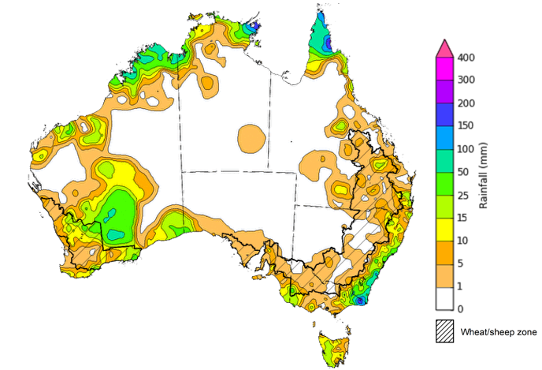

©Commonwealth of Australia 2025, Australian Bureau of Meteorology Issued: 23/4/2025

Note: The rainfall analyses and associated maps utilise data contained in the Bureau of Meteorology climate database, the Australian Data Archive for Meteorology (ADAM). The analyses are initially produced automatically from real-time data with limited [quality control](http://www.bom.gov.au/climate/headers/qc.shtml). They are intended to provide a general overview of rainfall across Australia as quickly as possible after the observations are received. For further information go to <http://www.bom.gov.au/climate/rainfall/>

### Rainfall forecast for the next eight days

Over the 8 days to 1 May 2025, **low-pressure systems and cold fronts** are expected to bring rainfall to northern and south-eastern Australia.

* Falls of between 10-100 millimetres are likely for much of the northern tropics, including the north of the Northern Territory and northern Queensland, while northern Western Australia is forecast to remain dry.
* In the southeast, between 10-100 millimetres of rainfall is forecast for southern Queensland and much of New South Wales and Victoria, while Tasmania is expected to receive 10-50 millimetres with lower rainfall totals in the east.
* High-pressure systems are expected to keep most central and western regions of the country relatively dry, with 1-10 millimetres of rainfall expected.

Rainfall totals across cropping regions over the coming week are forecast to be low in the west, but higher in the east.

* Rainfall totals of between 5-50 millimetres are expected in New South Wales and Victoria, with southern Queensland expected to receive up to 25 millimetres of rainfall.
* In contrast, Western Australia, South Australia, and northern Queensland are expected to receive little to no rainfall.
* If realised, the lack of autumn rainfall will continue to present a downside risk to the timely planting of winter crops particularly in areas with low stored soil moisture.

#### Total forecast rainfall for the period 24 April to 1 May 2025

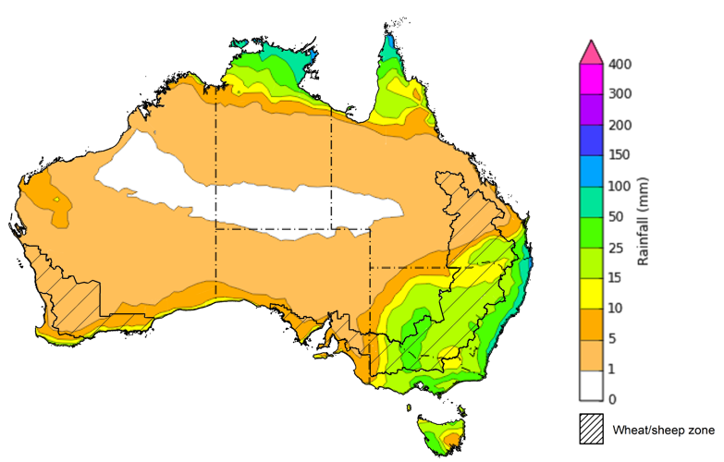

©Commonwealth of Australia 2025, Australian Bureau of Meteorology Issued 24/4/2025

Note: This rainfall forecast is produced from computer models. As the model outputs are not altered by weather forecasters, it is important to check local forecasts and warnings issued by the Bureau of Meteorology.

* 1. **National Climate Outlook**

The El Niño Southern Oscillation (ENSO) and Indian Ocean Dipole (IOD) climate drivers are currently neutral and having minimal influence on Australian rainfall. The IOD is likely to remain neutral over the coming months. Additionally, the ENSO is likely to remain neutral until August. The Southern Annual Mode (SAM) is currently positive but is likely to return to neutral in May. This suggests that climate drivers will have little impact on Australian rainfall over the coming months.

The most recent **rainfall outlook for May 2025** provided by the Bureau of Meteorology indicates that much of Australia, is likely to see **below median rainfall**.

* The Bureau of Meteorology’s climate model indicates a 75% chance of May rainfall totals between 5-100 millimetres across parts of the south, including southern Western Australia and Victoria, and parts of South Australia. Tasmania is expected to see as much as 200 millimetres.
* Eastern Australia, including southeast Queensland and eastern New South Wales are likely to see between 5-50 millimetres of rainfall. In northeastern Queensland, rainfall totals of up to 200 millimetres are expected in some coastal regions.
* Lower rainfall totals are expected across western, central and northern Australia, with much of Western Australia, Northern Territory, South Australia, and western Queensland likely to see little to no rainfall.
* Across cropping regions, there is a **75% chance** of rainfall totals of between **5-25 millimetres across most cropping regions.** If realised, **these rainfall totals** would be considered **below average for this time of year**.A lack of sufficient rainfall in May is likely to result in an increased disconnect between upper- and lower-layer soil moisture. This may reduce opportunities to plant winter crops under ideal conditions, particularly in some southern growing regions.

**Rainfall totals that have a 75% chance of occurring in May 2025**

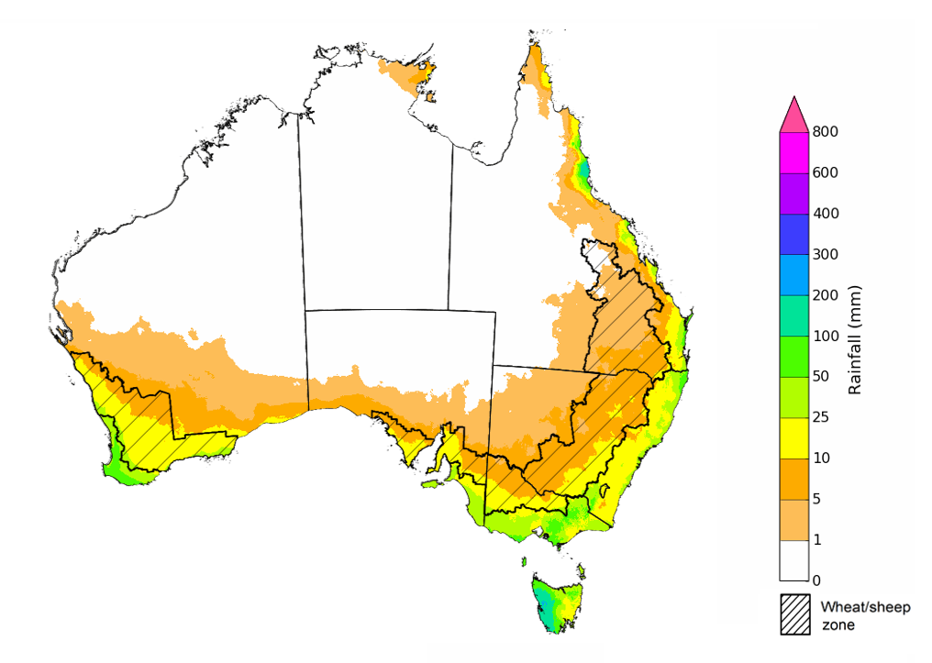

©Commonwealth of Australia 2025, Australian Bureau of Meteorology Issued: 10/4/2025

The **rainfall outlook for May to July 2025** indicates an increased probability of **below median rainfall across most of Australia,** including the Northern Territory, Queensland, New South Wales, Victoria, South Australia, and southwest Western Australia. In contrast, parts of western Western Australia and Tasmania are expected to see median to slightly above median rainfall.

Across cropping regions, the chance of receiving above median rainfall is between 35–55% across Queensland, New South Wales and Western Australia, with South Australia and Victoria having a 40–55% chance of above median rainfall.

**Chance of exceeding the median rainfall** **May 2025 to July 2025**

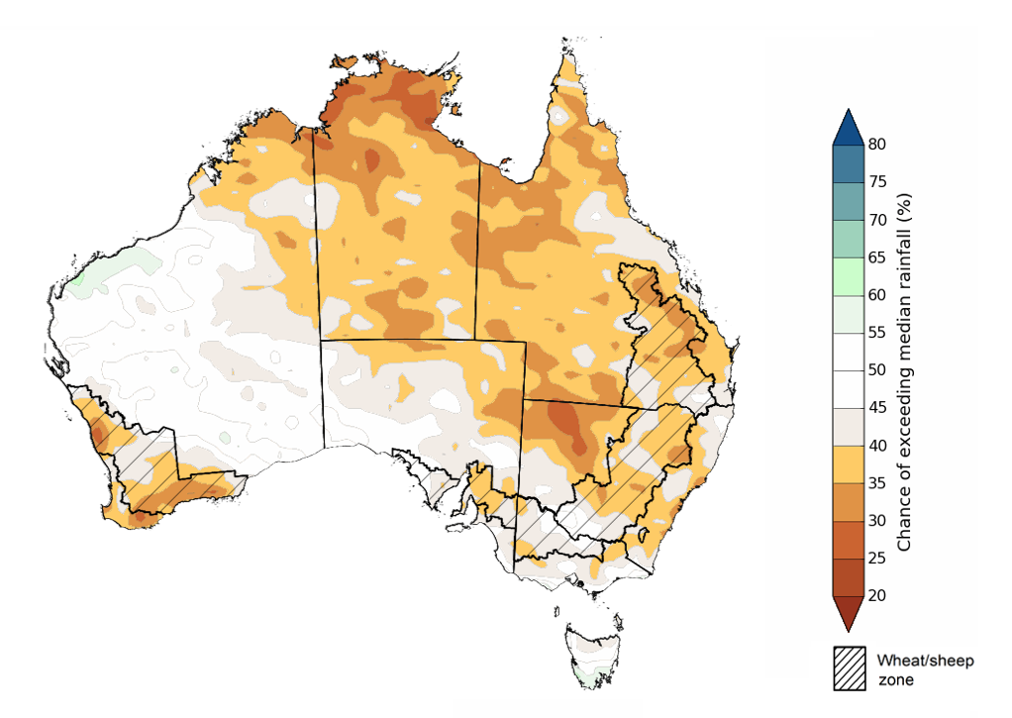

©Commonwealth of Australia 2025, Australian Bureau of Meteorology Issued: 24/4/2025

The **rainfall outlook for May through to July 2025** suggests a 75% chance of receiving rainfall totals of between 100–600 millimetres across southwest Western Australia, Tasmania, and alpine areas of New South Wales and Victoria. Between 50–200 millimetres of rainfall are forecast across much of southern Queensland, New South Wales, Victoria and South Australia. In northern and central Australia, little to no rainfall is forecast over the period.

In **cropping regions**, there is a **75% chance** of receiving between **100-200 millimetres** in the south, including Western Australia, South Australia, Victoria and New South Wales. In Queensland, falls of 10-100 millimetres are expected. These falls are likely to support soil moisture and pasture growth in winter cropping regions.

**Rainfall totals that have a 75% chance of occurring May 2025 to July 2025**

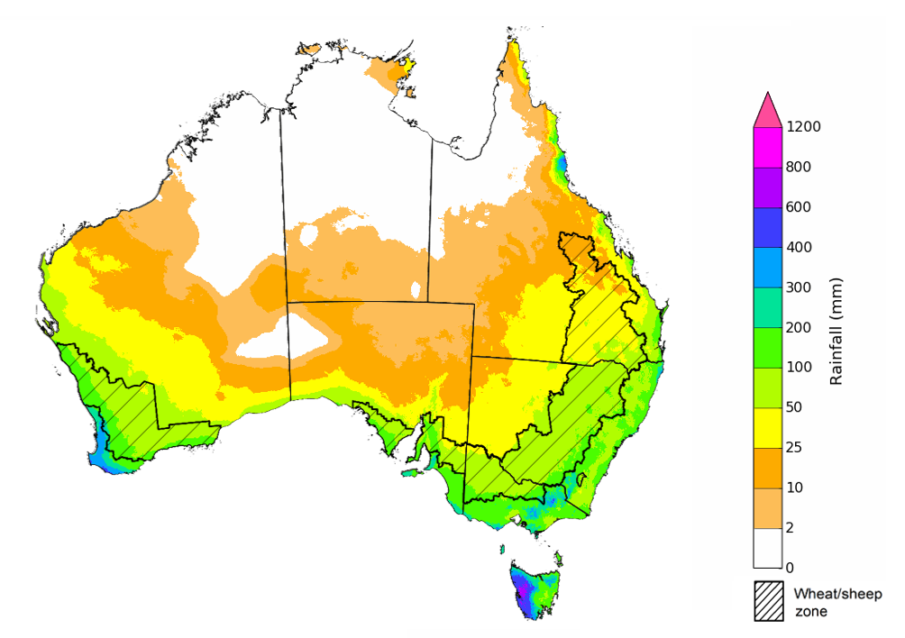

©Commonwealth of Australia 2025, Australian Bureau of Meteorology Issued: 24/4/2025

## **Commodities**

|  |  |  |  |  |  |  |  |  |
| --- | --- | --- | --- | --- | --- | --- | --- | --- |
| **Indicator** | **Week average** | **Unit** | **Latest Price** | **Previous Week** | **Weekly change** | | **Price 12 months ago** | **Annual change** |
| **Selected world indicator prices** |  |  |  |  |  |  | |  |
| AUD/USD Exchange rate | 23-Apr | A$/US$ | 0.64 | 0.64 | 1% | 0.65 | | -2% |
| Wheat – US no. 2 hard red winter wheat, FOB Gulf | 23-Apr | US$/t | 249 | 250 | 0% | 272 | | -8% |
| Corn – US no. 2 yellow corn, FOB Gulf | 23-Apr | US$/t | 217 | 220 | -2% | 191 | | 14% |
| Canola – Rapeseed, Canada, FOB Vancouver | 23-Apr | US$/t | 518 | 525 | -1% | 502 | | 3% |
| Cotton – Cotlook A Index | 23-Apr | USc/lb | 78 | 77 | 1% | 90 | | -14% |
| Sugar – Intercontinental Exchange, nearby futures, no.11 contract | 23-Apr | USc/lb | 18 | 18 | 1% | 20 | | -13% |
| Wool – Eastern Market Indicator | 16-Apr | Ac/kg clean | 1,273 | 1,262 | 1% | 1,157 | | 10% |
| Wool – Western Market Indicator | 16-Apr | Ac/kg clean | 1,373 | 1,425 | -4% | 1,291 | | 6% |
| **Selected Australian grain export prices** |  |  |  |  |  |  | |  |
| Australian Premium White (APW) Wheat, FOB Port Adelaide, SA | 23-Apr | A$/t | 399 | 399 | 0% | 391 | | 2% |
| Australian Standard White (ASW) Wheat, FOB Port Adelaide, SA | 23-Apr | A$/t | 395 | 394 | 0% | 371 | | 6% |
| Feed Barley – FOB Port Adelaide, SA | 23-Apr | A$/t | 375 | 373 | 1% | 360 | | 4% |
| Canola – FOB Kwinana, WA | 23-Apr | A$/t | 803 | 796 | 1% | 692 | | 16% |
| Grain Sorghum – FOB Brisbane, QLD | 23-Apr | A$/t | 436 | 440 | -1% | 451 | | -3% |
| **Selected domestic livestock indicator prices** |  |  |  |  |  |  | |  |
| Beef – Eastern Young Cattle Indicator | 23-Apr | Ac/kg cwt | 699 | 700 | 0% | 603 | | 16% |
| Mutton – Mutton indicator (18–24 kg fat score 2–3), VIC | 23-Apr | Ac/kg cwt | 459 | 444 | 3% | 256 | | 79% |
| Lamb – National Trade Lamb Indicator | 23-Apr | Ac/kg cwt | 812 | 806 | 1% | 642 | | 26% |
| Pig – Eastern Seaboard (60.1–75 kg), NSW buyer price | 09-Apr | Ac/kg cwt | 448 | 450 | 0% | 418 | | 7% |
| Live cattle – Light steers to Indonesia | 23-Apr | Ac/kg lwt | 360 | 360 | 0% | 350 | | 3% |
| **Global Dairy Trade (GDT) weighted average prices** |  |  |  |  |  |  | |  |
| Dairy – Whole milk powder | 16-Apr | US$/t | 4,171 | 4,062 | 3% | 3,258 | | 28% |
| Dairy – Skim milk powder | 16-Apr | US$/t | 2,795 | 2,876 | -3% | 2,546 | | 10% |
| Dairy – Cheddar cheese | 16-Apr | US$/t | 4,923 | 5,018 | -2% | 4,157 | | 18% |
| Dairy – Anhydrous milk fat | 16-Apr | US$/t | 6,838 | 6,705 | 2% | 6,998 | | -2% |
|  | | | | | | | | |

### Selected world indicator prices

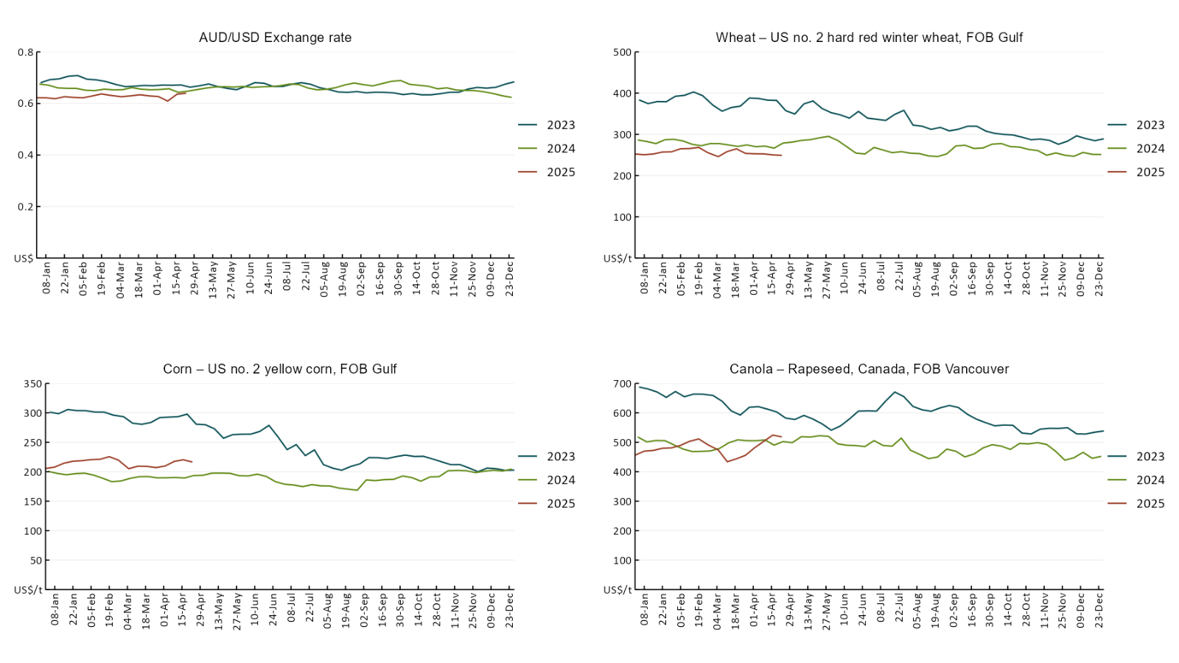

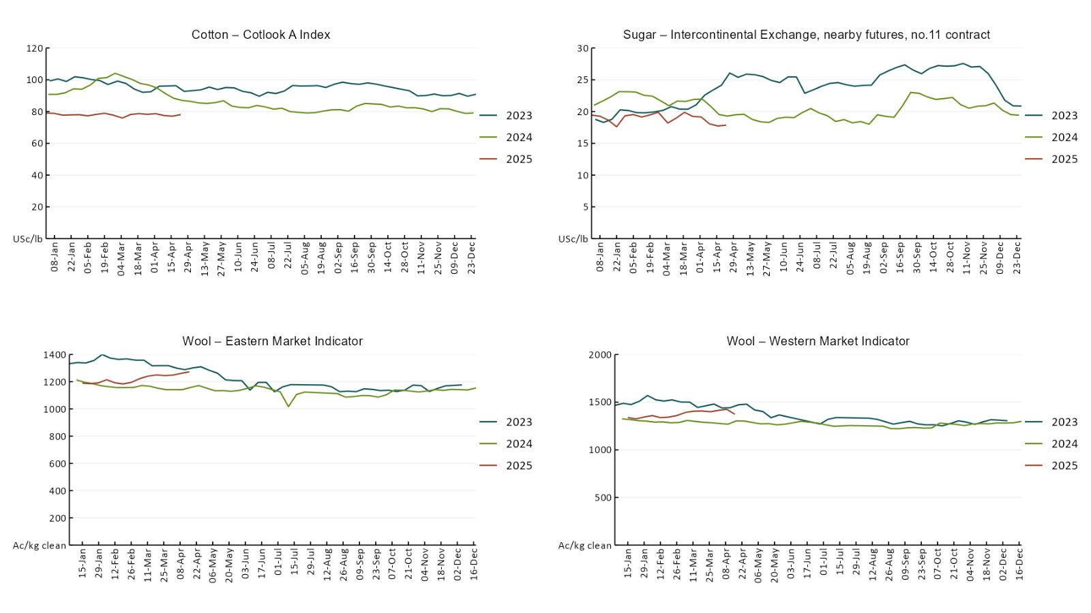

### 2.2 Selected domestic crop indicator prices

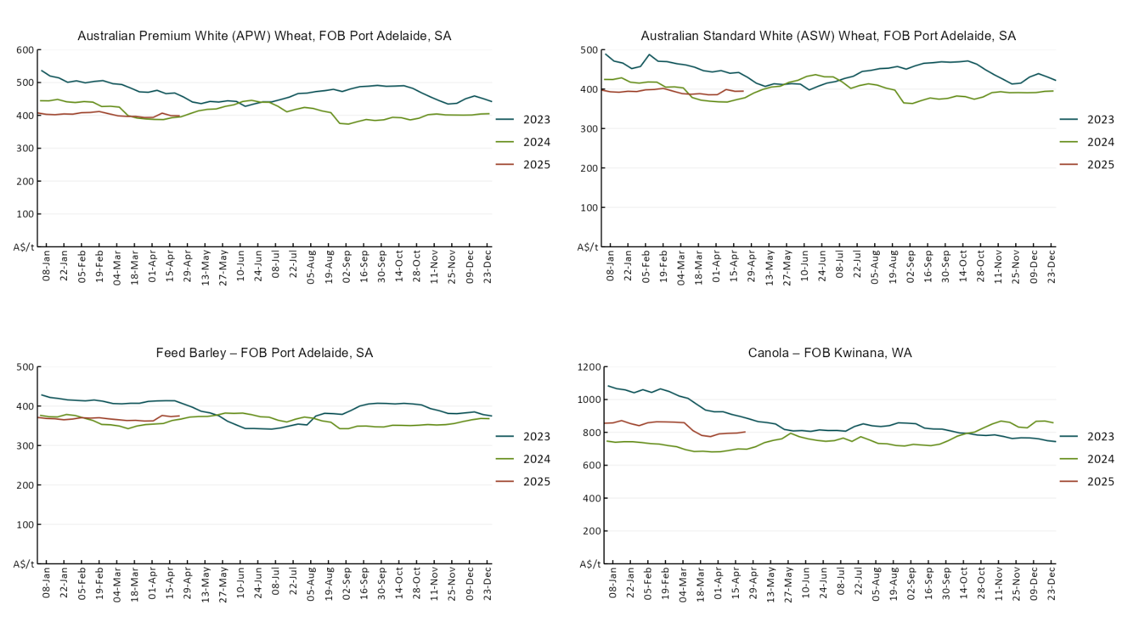

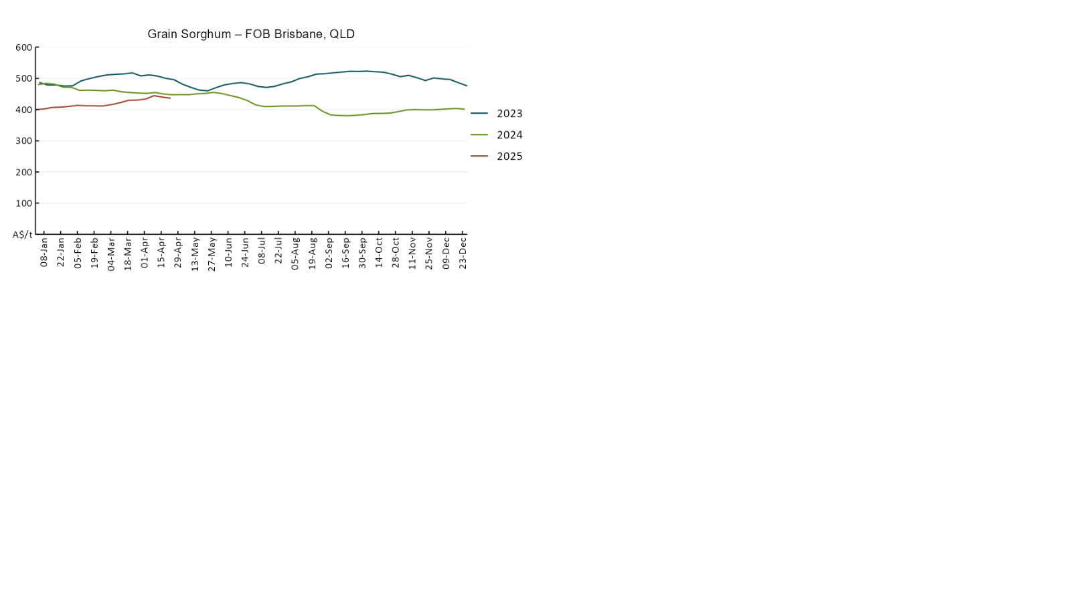

### 2.3 Selected domestic livestock indicator prices

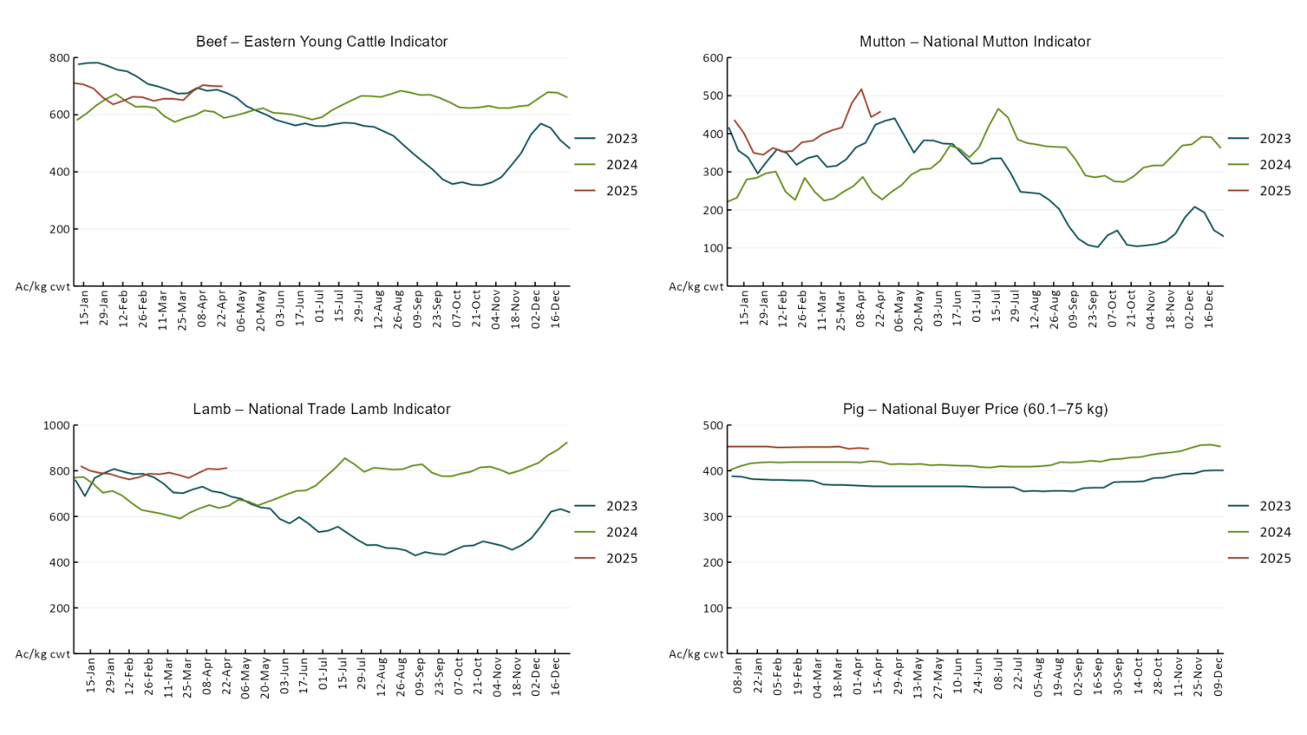

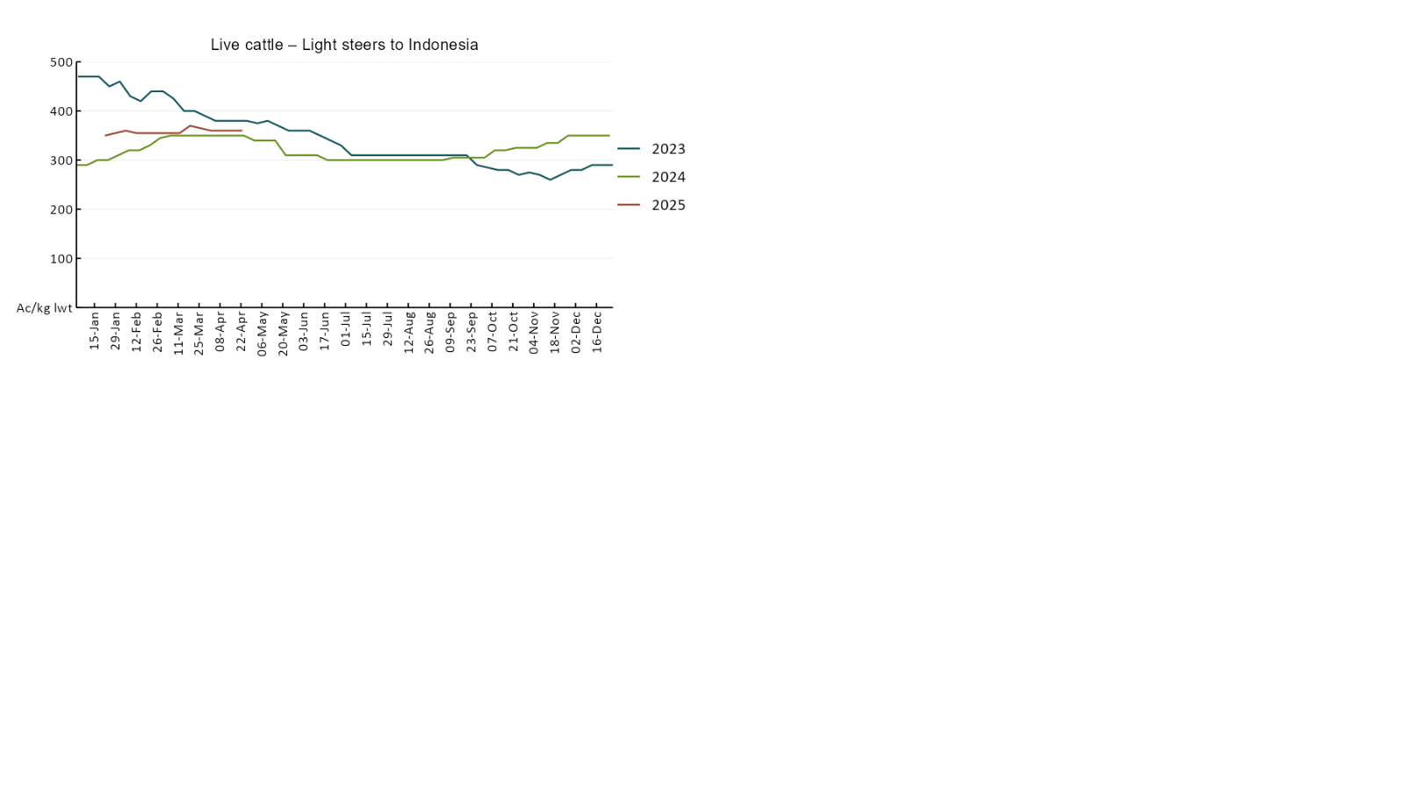

### Global Dairy Trade (GDT) weighted average prices

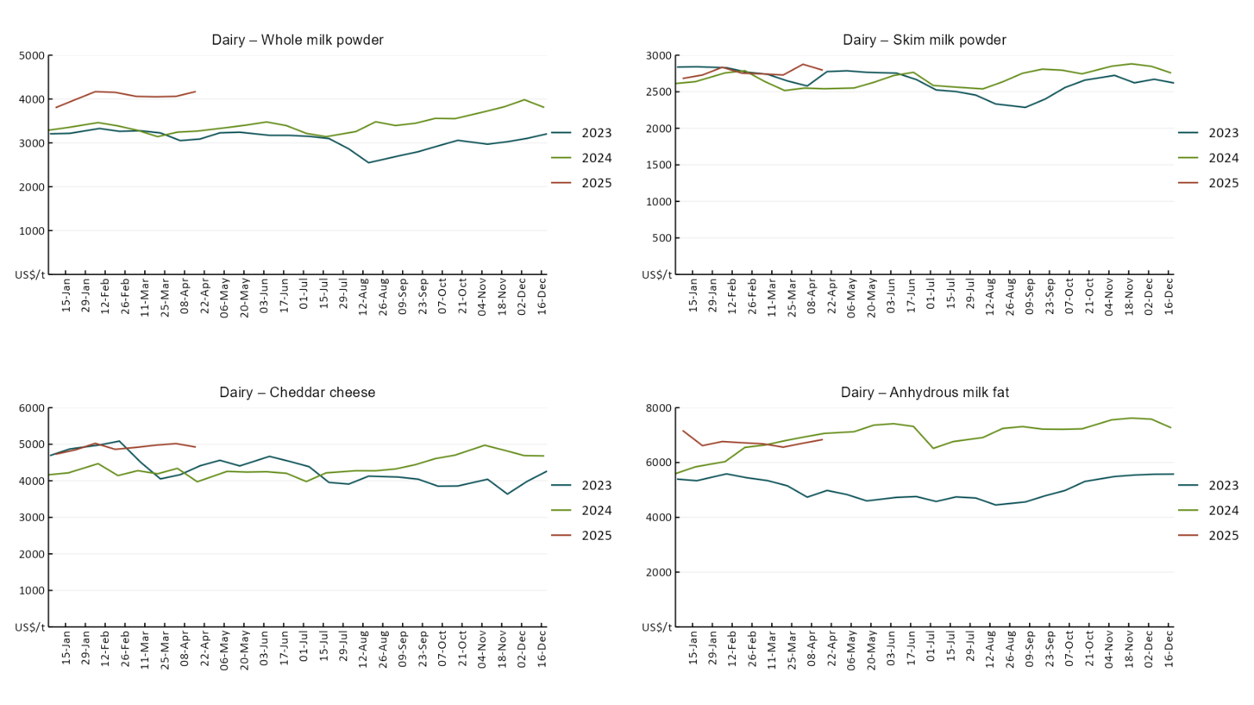

### Selected fruit and vegetable prices

Due to technical issues updated fruit and vegetable price data is not available this week, data in the charts below is current as at 10 April 2025

### 2.6 Selected domestic fodder indicator prices

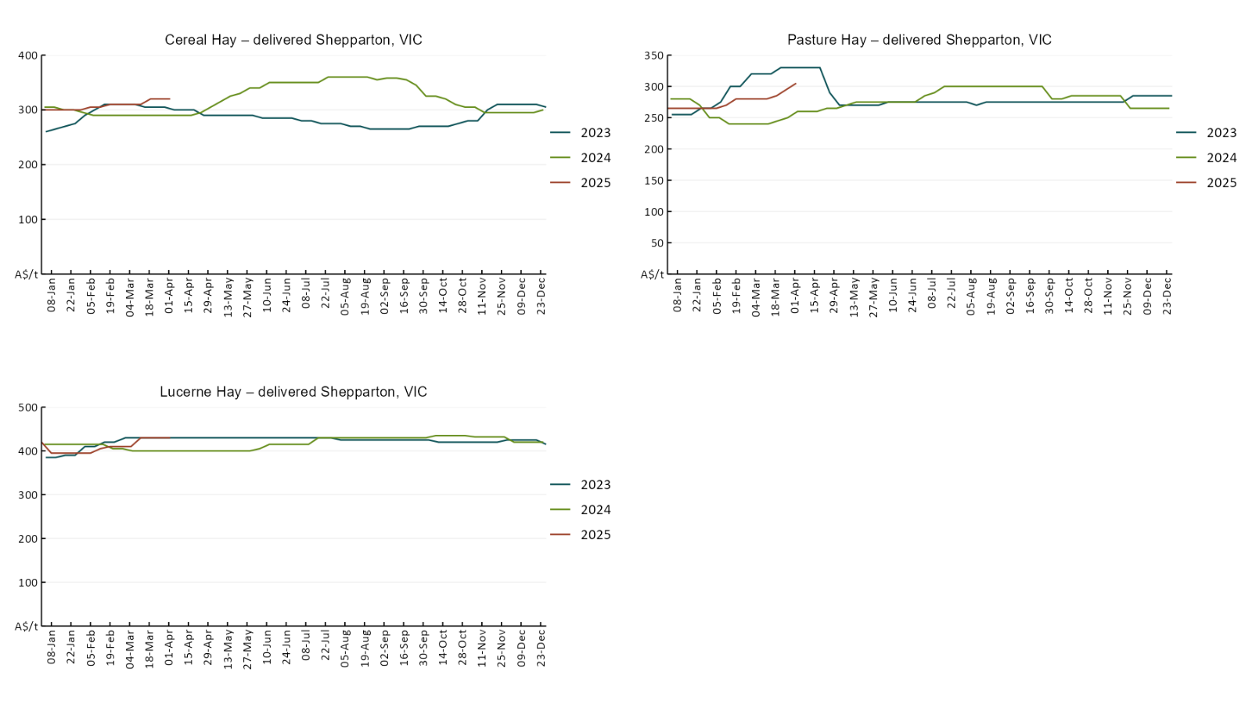

## **3. Data attribution**

### Climate

* Bureau of Meteorology
* Weekly rainfall totals: www.bom.gov.au/climate/maps/rainfall/
* Monthly and last 3-month rainfall percentiles: [www.bom.gov.au/water/landscape/](http://www.bom.gov.au/water/landscape/)
* Temperature anomalies: [www.bom.gov.au/jsp/awap/temp/index.jsp](http://www.bom.gov.au/jsp/awap/temp/index.jsp)
* Rainfall forecast: [www.bom.gov.au/jsp/watl/rainfall/pme.jsp](http://www.bom.gov.au/jsp/watl/rainfall/pme.jsp)
* Seasonal outlook: [www.bom.gov.au/climate/outlooks/#/overview/summary/](http://www.bom.gov.au/climate/outlooks/#/overview/summary/)
* Climate drivers: <http://www.bom.gov.au/climate/enso/>
* Soil moisture: [www.bom.gov.au/water/landscape/](http://www.bom.gov.au/water/landscape/)
* Other
* Pasture growth: [www.longpaddock.qld.gov.au/aussiegrass/](http://www.longpaddock.qld.gov.au/aussiegrass/)
* 3-month global outlooks: [Environment and Climate Change Canada](https://weather.gc.ca/saisons/image_e.html?img=s234pfe1p_cal&bc=prob), [NOAA Climate Prediction Center](https://www.cpc.ncep.noaa.gov/products/predictions/long_range/seasonal.php?lead=2), [EUROBRISA CPTEC/INPE](http://eurobrisa.cptec.inpe.br/), European Centre for Medium-Range Weather Forecasts, [Hydrometcenter of Russia](https://meteoinfo.ru/en/climate/seasonal-forecasts), [National Climate Center Climate System Diagnosis and Prediction Room (NCC)](https://cmdp.ncc-cma.net/pred/cs2gen.php?pred_elem=RAINP#pred_seasonal), [International Research Institute for Climate and Society](https://iri.columbia.edu/our-expertise/climate/forecasts/seasonal-climate-forecasts/)
* Global production: <https://ipad.fas.usda.gov/ogamaps/cropmapsandcalendars.aspx>
* Autumn break: Pook et al., 2009, <https://rmets-onlinelibrary-wiley-com.virtual.anu.edu.au/doi/epdf/10.1002/joc.1833>

### Water

Prices

* Waterflow: <https://www.waterflow.io/>
* Ruralco: <https://www.ruralcowater.com.au/>
* Bureau of Meteorology:
* Allocation trade: <http://www.bom.gov.au/water/dashboards/#/water-markets/mdb/at>
* Storage volumes: <http://www.bom.gov.au/water/dashboards/#/water-storages/summary/drainage>
* Trade constraints:
* Water NSW: <https://www.waternsw.com.au/customer-service/ordering-trading-and-pricing/trading/murrumbidgee>
* Victorian Water Register: <https://www.waterregister.vic.gov.au/TradingRules2019/>

### Commodities

* Fruit and vegetables
* Datafresh: [www.freshstate.com.au](http://www.freshstate.com.au)
* Pigs
* Australian Pork Limited: [www.australianpork.com.au](http://www.australianpork.com.au)
* Dairy
* Global Dairy Trade: [www.globaldairytrade.info/en/product-results/](http://www.globaldairytrade.info/en/product-results/)
* World wheat, canola
* International Grains Council
* World coarse grains
* United States Department of Agriculture
* World cotton
* Cotlook: [www.cotlook.com/](http://www.cotlook.com/)
* World sugar
* New York Stock Exchange - Intercontinental Exchange
* Wool
* Australian Wool Exchange: [www.awex.com.au/](http://www.awex.com.au/)
* Domestic wheat, barley, sorghum, canola and fodder
* Jumbuk Consulting Pty Ltd: http://www.jumbukag.com.au/
* Cattle, beef, mutton, lamb, goat and live export
* Meat and Livestock Australia: [www.mla.com.au/Prices-and-market](http://www.mla.com.au/Prices-and-market)

© Commonwealth of Australia 2025

### Ownership of intellectual property rights

Unless otherwise noted, copyright (and any other intellectual property rights, if any) in this publication is owned by the Commonwealth of Australia (referred to as the Commonwealth).

### Creative Commons licence

All material in this publication is licensed under a [Creative Commons Attribution 4.0 International Licence](https://creativecommons.org/licenses/by/4.0/legalcode) except content supplied by third parties, logos and the Commonwealth Coat of Arms.

Inquiries about the licence and any use of this document should be emailed to [copyright@awe.gov.au](mailto:copyright@awe.gov.au).

https://www.agriculture.gov.au/sites/default/files/images/creative-commons-logo-small.png

### Cataloguing data

This publication (and any material sourced from it) should be attributed as:

ABARES 2025, Weekly Australian Climate, Water and Agricultural Update, Australian Bureau of Agricultural and Resource Economics and Sciences, Canberra, 17 April 2025. CC BY 4.0 DOI: <https://doi.org/10.25814/5f3e04e7d2503>

ISSN **2652-7561**

This publication is available at https://www.agriculture.gov.au/abares/products/weekly_update

Department of Agriculture, Fisheries and Forestry

GPO Box 858 Canberra ACT 2601

Telephone 1800 900 090

Web [agriculture.gov.au/abares](http://awe.gov.au/abares)

### Disclaimer

The Australian Government acting through the Department of Agriculture, Fisheries and Forestry, represented by the Australian Bureau of Agricultural and Resource Economics and Sciences, has exercised due care and skill in preparing and compiling the information and data in this publication. Notwithstanding, the Department of Agriculture, Fisheries and Forestry, ABARES, its employees and advisers disclaim all liability, including liability for negligence and for any loss, damage, injury, expense or cost incurred by any person as a result of accessing, using or relying on any of the information or data in this publication to the maximum extent permitted by law.

### Statement of Professional Independence

The views and analysis presented in ABARES publications, including this one, reflect ABARES professionally independent findings, based on scientific and economic concepts, principles, information and data. These views, analysis and findings may not reflect or be consistent with the views or positions of the Australian Government, or of organisations or groups who have commissioned ABARES reports or analysis. More information on [professional independence](https://www.agriculture.gov.au/abares/about/research-and-analysis#professional-independence) is provided on the ABARES website.

### Acknowledgements

This report was prepared by Holly Beale and Matthew Miller.