## No. 17/2025 1 May 2025

# Summary of key issues

* In the week ending 30 April 2025 low-pressure systems and troughs brought rainfall to the north and southeast.
  + Rainfall totals were low in many cropping regions, with exceptions in New South Wales (5- 100 millimetres) and Victoria and parts of southern Queensland where 5-50 millimetres of rainfall was recorded.
  + The recent week will likely delay germination of dry sown winter crops in areas where upper layer soil moisture is low. However, the rainfall recorded across central and northern New South Wales and parts of southern Queensland will likely support the germination and establishment of early sown winter crops.
* Over the coming eight days, rainfall is expected across limited parts of northern, eastern and the far southwest of Australia.
  + Rainfall totals of between 5-10 millimetres are expected across parts of northern Queensland and the far southwest of Western Australia. Little to no rainfall is expected across remaining cropping regions.
* Most of Australia received average to above average rainfall over April 2025, with below average rainfall across parts of southeastern and west of Australia.
  + As we transition into the remainder of autumn, the focus shifts from summer cropping and pasture growth across Northern Australia to winter cropping and peak pasture production in the south.
  + The lack of rainfall in April and the below median rainfall outlook for May to July in southern New South Wales, western Victoria and South Australia present a downside risk to the timely planting of winter crops.
  + This necessitates a careful monitoring and strategic planning to mitigate potential impacts on upcoming winter crops and managing ground cover and livestock numbers.
* Water storage levels in the Murray-Darling Basin (MDB) decreased between 24 April 2025 and 01 May 2025 by 17 gigalitres (GL). Current volume of water held in storage is 11,761 GL, equivalent to 53% of total storage capacity. This is 29 percent or 4,841 GL less than at the same time last year. Water storage data is sourced from the Bureau of Meteorology.
* Allocation prices in the Victorian Murray below the Barmah Choke increased from $262 on 17 April to $258 on 01 May April. Trade between Murrumbidgee and Murray IVTs are open.

## **Climate**

### Rainfall this week

In the week ending 30 April 2025, **low-pressure systems and troughs** brought rainfall to some northern, south-eastern, and south-western regions of the country. High-pressure systems kept much of the remainder of Australia largely dry.

* The Northern Tropics, including Cape York Peninsula and the far north of the Northern Territory saw rainfall totals of between 5-200 millimetres, while northern Western Australia remained dry.
* Rainfall totals of between 5-150 millimetres were also recorded across much of New South Wales and parts of southern Queensland. In contrast, some areas of Victoria, Tasmania, and southwest Western Australia saw lower rainfall totals of between 5-50 millimetres.
* Little to no rainfall was observed across much of the remainder of the country

Cropping regions were largely dry, with the exception of parts of eastern Australia:

* Northern, central and southwest New South Wales cropping regions received between 5-100 millimetres. In Victoria and parts of southern Queensland, 5-50 millimetres of rainfall was recorded.
* Cropping regions in Western Australia, South Australia, and northern Queensland saw little to no rainfall over the period.
* Moving into the winter growing season, a lack of rainfall in the recent week will likely delay germination of dry sown winter crops in areas where upper layer soil moisture is low. However the rainfall recorded across central and northern New South Wales and parts of southern Queensland will likely support the germination and establishment of early sown winter crops.

#### Rainfall for the week ending 30 April 2025

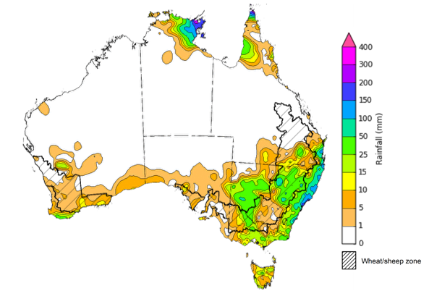

©Commonwealth of Australia 2025, Australian Bureau of Meteorology Issued: 30/4/2025

Note: The rainfall analyses and associated maps utilise data contained in the Bureau of Meteorology climate database, the Australian Data Archive for Meteorology (ADAM). The analyses are initially produced automatically from real-time data with limited [quality control](http://www.bom.gov.au/climate/headers/qc.shtml). They are intended to provide a general overview of rainfall across Australia as quickly as possible after the observations are received. For further information go to <http://www.bom.gov.au/climate/rainfall/>

### Rainfall forecast for the next eight days

Over the 8 days to 8 May 2025, **low-pressure systems** are expected to bring limited rainfall to northern, eastern and the far southwest of Australia.

* Falls of between 5-50 millimetres are likely for parts of the northern tropics, including the north of the Northern Territory and northern Queensland, as well as parts of eastern Queensland and New South Wales, southern Victoria, and the far southwest of Western Australia.
  + Isolated areas of northeast Queensland are expected to up to 300 millimetres of rainfall.
* Tasmania is expected to receive falls of between 10-100 millimetres, with higher rainfall totals in the west.
* High-pressure systems are expected to keep much of the remainder of Australia relatively dry.

Rainfall totals over the coming week are forecast to be low across most cropping regions.

* Rainfall totals of between 5-10 millimetres are expected across parts of northern Queensland and the far southwest of Western Australia. Little to no rainfall is expected across remaining cropping regions.
* If realised, the continued lack of autumn rainfall will continue to present a downside risk to the timely planting of winter crops particularly in those areas of southern New South Wales, western Victoria and South Australia with low stored soil moisture.

#### Total forecast rainfall for the period 1 May to 8 May 2025

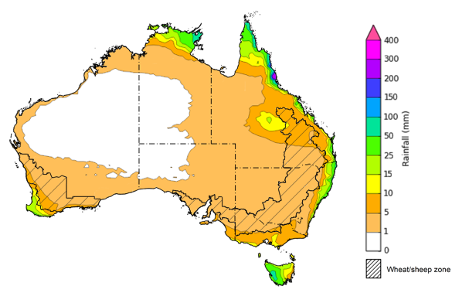

©Commonwealth of Australia 2025, Australian Bureau of Meteorology Issued 1/5/2025

Note: This rainfall forecast is produced from computer models. As the model outputs are not altered by weather forecasters, it is important to check local forecasts and warnings issued by the Bureau of Meteorology.

### Monthly rainfall

Rainfall during April 2025 was highly variable:

* Rainfall was **very much below average** to **below average** across parts of south-eastern Australia, including large areas of southern New South Wales, Victoria, South Australia, and Tasmania, as well as coastal regions of west Western Australia
* **Above average** to **very much above average** rainfall was recorded across much of the Northern Territory and Queensland, as well as much of southern Western Australia, and coastal and inland regions of New South Wales.
* The remainder of Australia saw generally average April rainfall.

In cropping regions, April rainfall was variable, with generally below average and average rainfall in the southeast and average to above rainfall in the north and west:

* Much of South Australia, Victoria, southern New South Wales and the west of Western Australia observed very much below average to average rainfall.
* In Queensland, northern New South Wales and the remainder of Western Australia average to very much above average rainfall was experienced over the period.

As we transition into the remainder of the autumn season, the focus shifts from summer crop and pasture growth across Northern Australia to preparing for the winter cropping season and peak pasture production in the south. This is especially crucial in regions that received below average rainfall in April. Given a below median rainfall outlook for May, and May to July period in parts of the southern regions, this necessitates a careful monitoring and strategic planning to mitigate potential impacts on upcoming winter crops and managing ground cover and livestock numbers.

**Rainfall percentiles for April 2025**

Note: Rainfall for April 2025 is compared with rainfall recorded for that period during the historical record (1900 to present). For further information, go to <http://www.bom.gov.au/climate/austmaps/about-rain-maps.shtml>

Source: Bureau of Meteorology

## **Water**

### Water markets – current week

Water storage levels in the Murray-Darling Basin (MDB) decreased between 24 April 2025 and 01 May 2025 by 17 gigalitres (GL). Current volume of water held in storage is 11,761 GL, equivalent to 53% of total storage capacity. This is 29 percent or 4,841 GL less than at the same time last year. Water storage data is sourced from the Bureau of Meteorology.

Allocation prices in the Victorian Murray below the Barmah Choke increased from $262 on 17 April to $258 on 01 May April. Trade between Murrumbidgee and Murray IVTs are open.

#### Surface water trade activity, Southern Murray–Darling Basin

|  |
| --- |
| The trades shown reflect estimated market activity and do not encompass all register trades. The price is shown for the VIC Murray below the Barmah choke. Historical prices (before 1 July 2019) are ABARES estimates after removing outliers from BOM water register data. Prices after 1 July 2019 and prior to the 30 October 2019 reflect recorded transaction prices as sourced from Ruralco. Prices after the 30 October 2019 are sourced from Waterflow. Data for volume traded is sourced from the BOM water register. Only the price data shown is current on 17 October 2024. |

To access the full, interactive, weekly water dashboard, which contains the latest and historical water storage, water market and water allocation information, please visit <https://www.agriculture.gov.au/abares/products/weekly_update/weekly-update-170425>

## **Commodities**

|  |  |  |  |  |  |  |  |  |
| --- | --- | --- | --- | --- | --- | --- | --- | --- |
| **Indicator** | **Week average** | **Unit** | **Latest Price** | **Previous Week** | **Weekly change** | | **Price 12 months ago** | **Annual change** |
| **Selected world indicator prices** |  |  |  |  |  |  | |  |
| AUD/USD Exchange rate | 30-Apr | A$/US$ | 0.64 | 0.64 | 1% | 0.65 | | -1% |
| Wheat – US no. 2 hard red winter wheat, FOB Gulf | 30-Apr | US$/t | 240 | 247 | -3% | 272 | | -12% |
| Corn – US no. 2 yellow corn, FOB Gulf | 30-Apr | US$/t | 211 | 216 | -2% | 191 | | 11% |
| Canola – Rapeseed, Canada, FOB Vancouver | 30-Apr | US$/t | 536 | 534 | 0% | 502 | | 7% |
| Cotton – Cotlook A Index | 30-Apr | USc/lb | 80 | 79 | 1% | 90 | | -12% |
| Sugar – Intercontinental Exchange, nearby futures, no.11 contract | 30-Apr | USc/lb | 18 | 18 | -1% | 20 | | -13% |
| Wool – Eastern Market Indicator | 16-Apr | Ac/kg clean | 1,273 | 1,262 | 1% | 1,157 | | 10% |
| Wool – Western Market Indicator | 16-Apr | Ac/kg clean | 1,373 | 1,425 | -4% | 1,291 | | 6% |
| **Selected Australian grain export prices** |  |  |  |  |  |  | |  |
| Australian Premium White (APW) Wheat, FOB Port Adelaide, SA | 30-Apr | A$/t | 395 | 398 | -1% | 391 | | 1% |
| Australian Standard White (ASW) Wheat, FOB Port Adelaide, SA | 30-Apr | A$/t | 390 | 394 | -1% | 371 | | 5% |
| Feed Barley – FOB Port Adelaide, SA | 30-Apr | A$/t | 373 | 375 | -1% | 360 | | 3% |
| Canola – FOB Kwinana, WA | 30-Apr | A$/t | 797 | 807 | -1% | 692 | | 15% |
| Grain Sorghum – FOB Brisbane, QLD | 30-Apr | A$/t | 436 | 438 | 0% | 451 | | -3% |
| **Selected domestic livestock indicator prices** |  |  |  |  |  |  | |  |
| Beef – Eastern Young Cattle Indicator | 30-Apr | Ac/kg cwt | 712 | 700 | 2% | 603 | | 18% |
| Mutton – Mutton indicator (18–24 kg fat score 2–3), VIC | 30-Apr | Ac/kg cwt | 588 | 488 | 21% | 256 | | 130% |
| Lamb – National Trade Lamb Indicator | 30-Apr | Ac/kg cwt | 836 | 818 | 2% | 642 | | 30% |
| Pig – Eastern Seaboard (60.1–75 kg), NSW buyer price | 16-Apr | Ac/kg cwt | 448 | 448 | 0% | 418 | | 7% |
| Live cattle – Light steers to Indonesia | 30-Apr | Ac/kg lwt | 350 | 360 | -3% | 350 | | 0% |
| **Global Dairy Trade (GDT) weighted average prices** |  |  |  |  |  |  | |  |
| Dairy – Whole milk powder | 16-Apr | US$/t | 4,171 | 4,062 | 3% | 3,258 | | 28% |
| Dairy – Skim milk powder | 16-Apr | US$/t | 2,795 | 2,876 | -3% | 2,546 | | 10% |
| Dairy – Cheddar cheese | 16-Apr | US$/t | 4,923 | 5,018 | -2% | 4,157 | | 18% |
| Dairy – Anhydrous milk fat | 16-Apr | US$/t | 6,838 | 6,705 | 2% | 6,998 | | -2% |
|  | | | | | | | | |

### Selected world indicator prices

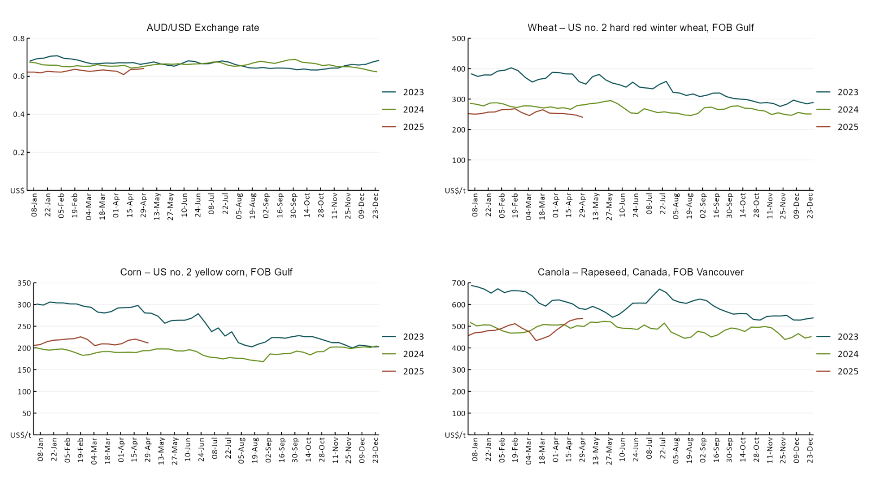

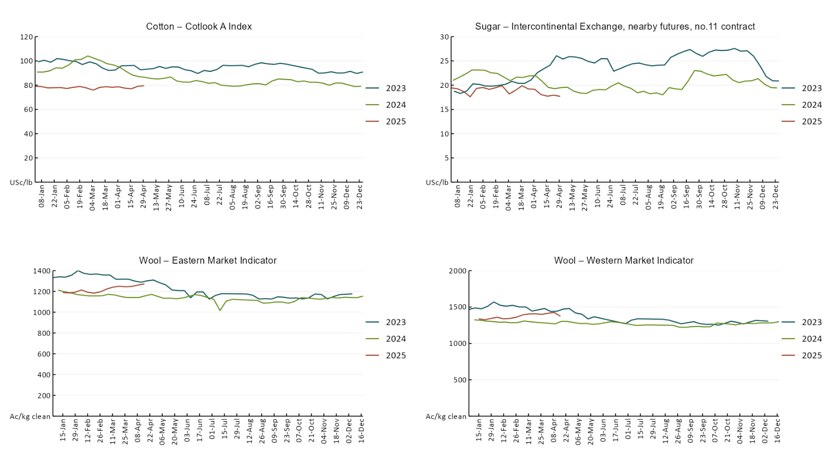

### 3.2 Selected domestic crop indicator prices

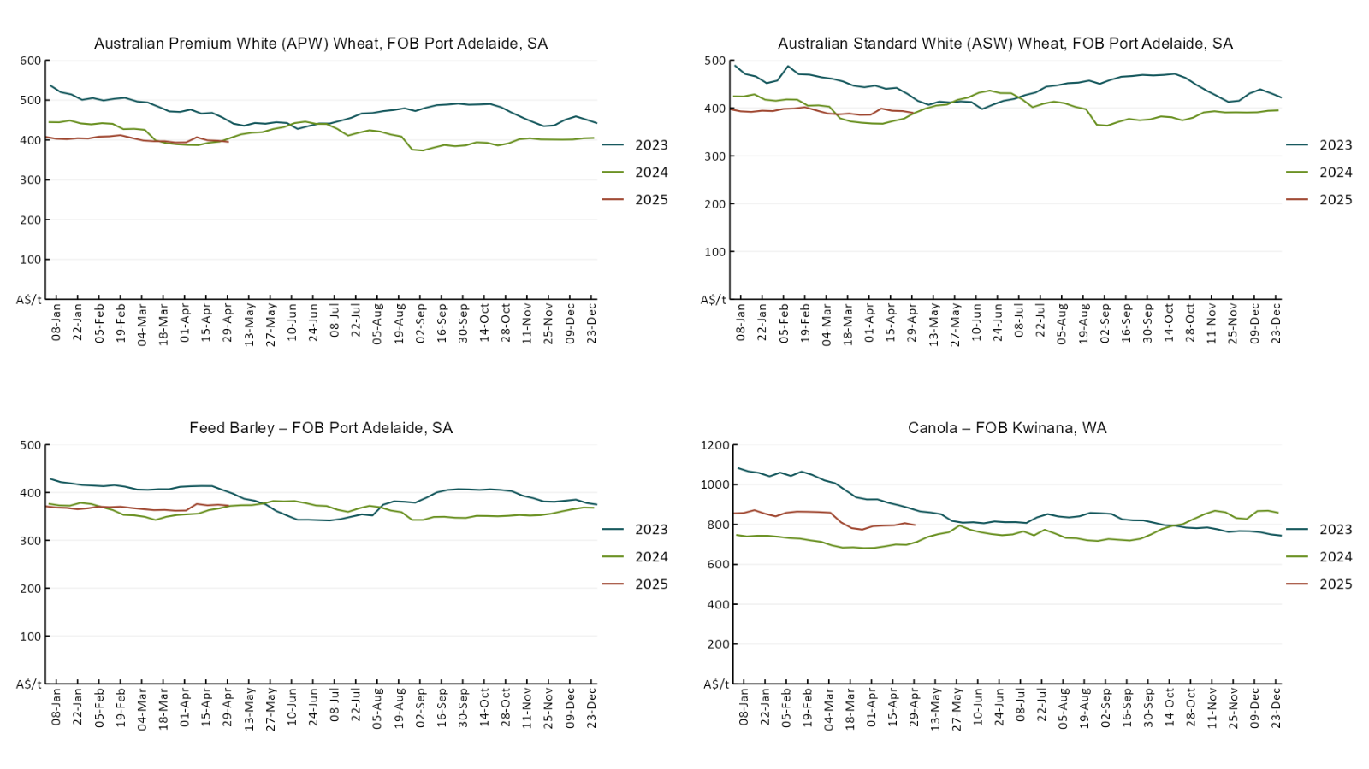

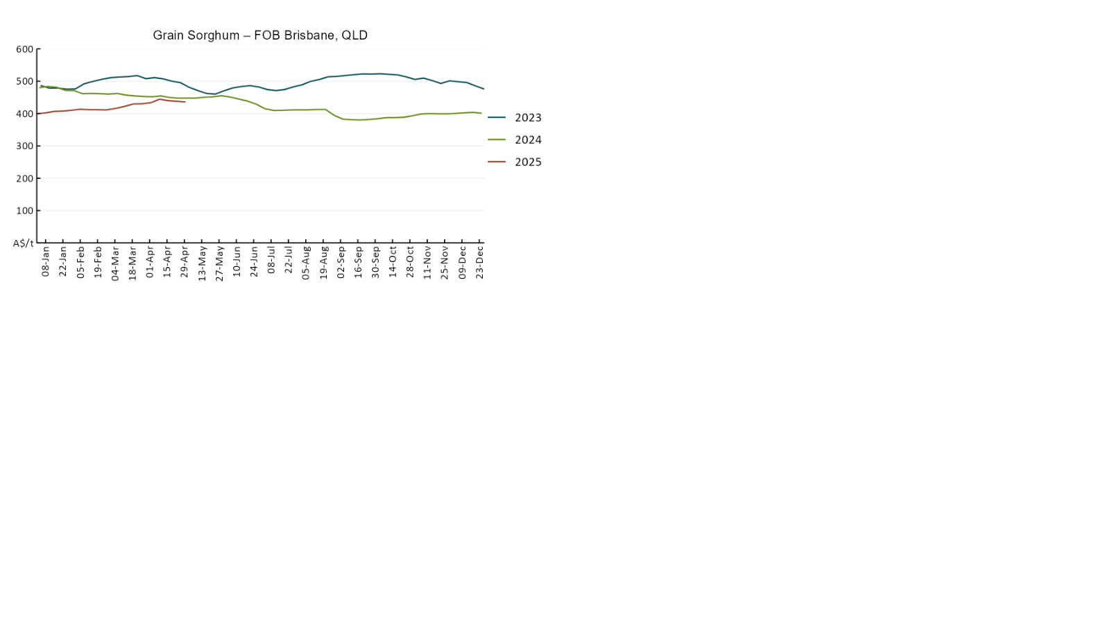

### 3.3 Selected domestic livestock indicator prices

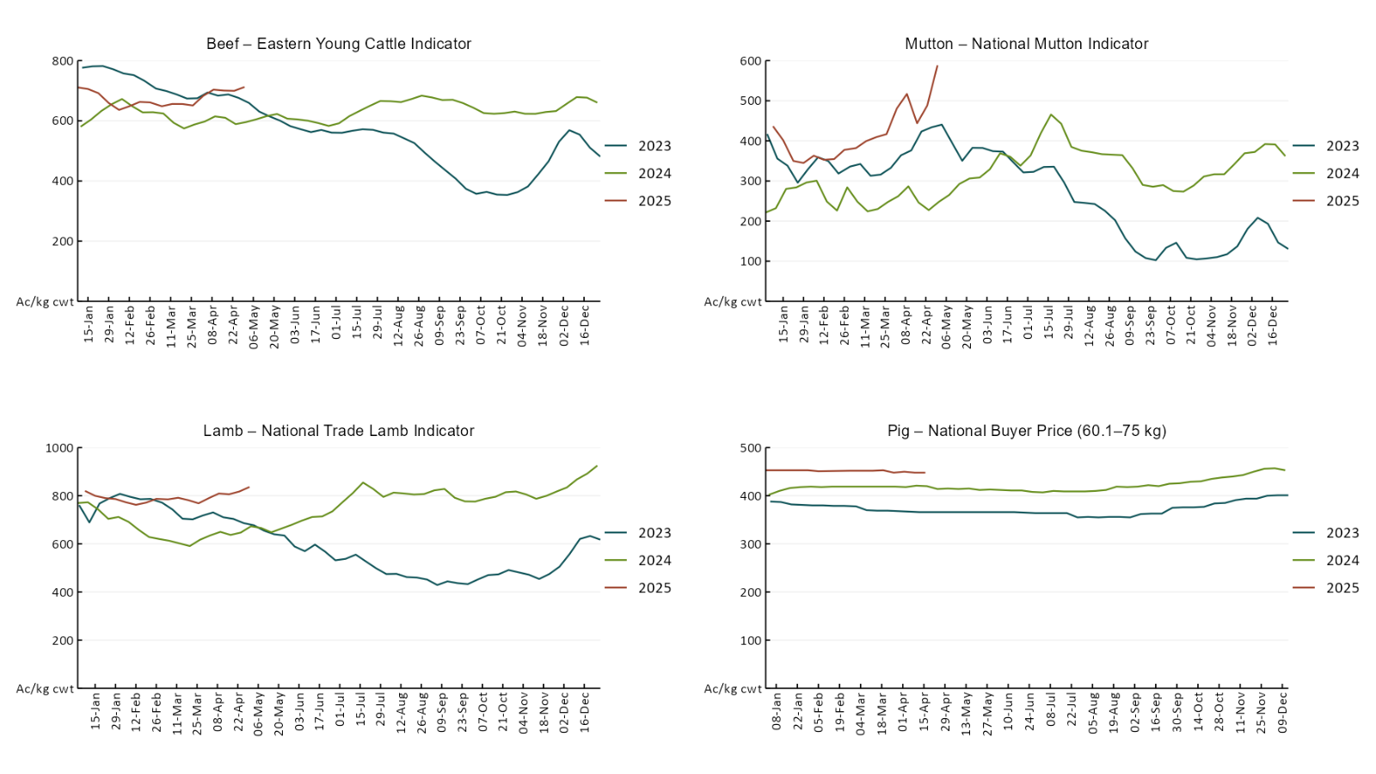

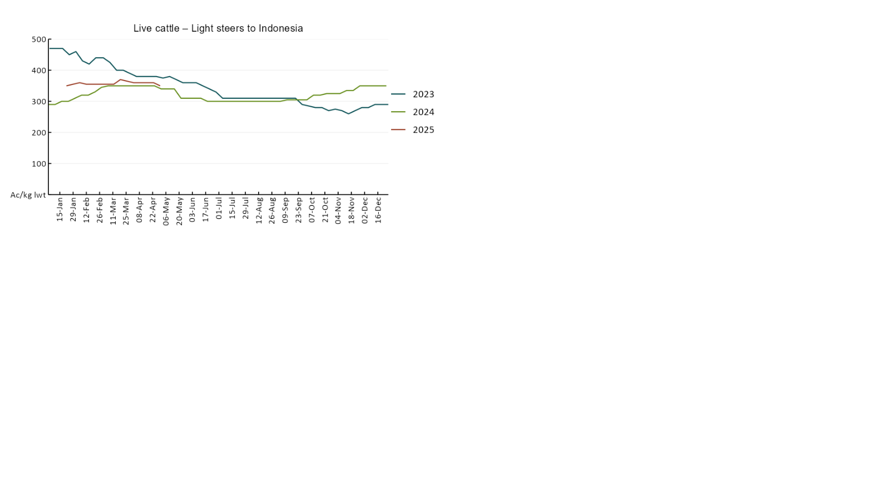

### 3.4 Global Dairy Trade (GDT) weighted average prices

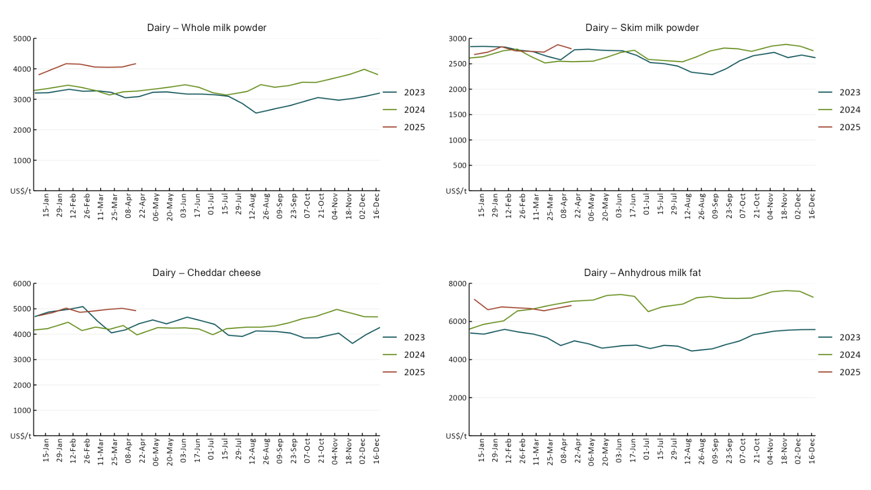

### 3.5 Selected fruit and vegetable prices

Due to technical issues updated fruit and vegetable price data is not available this week, data in the charts below is current as at 10 April 2025

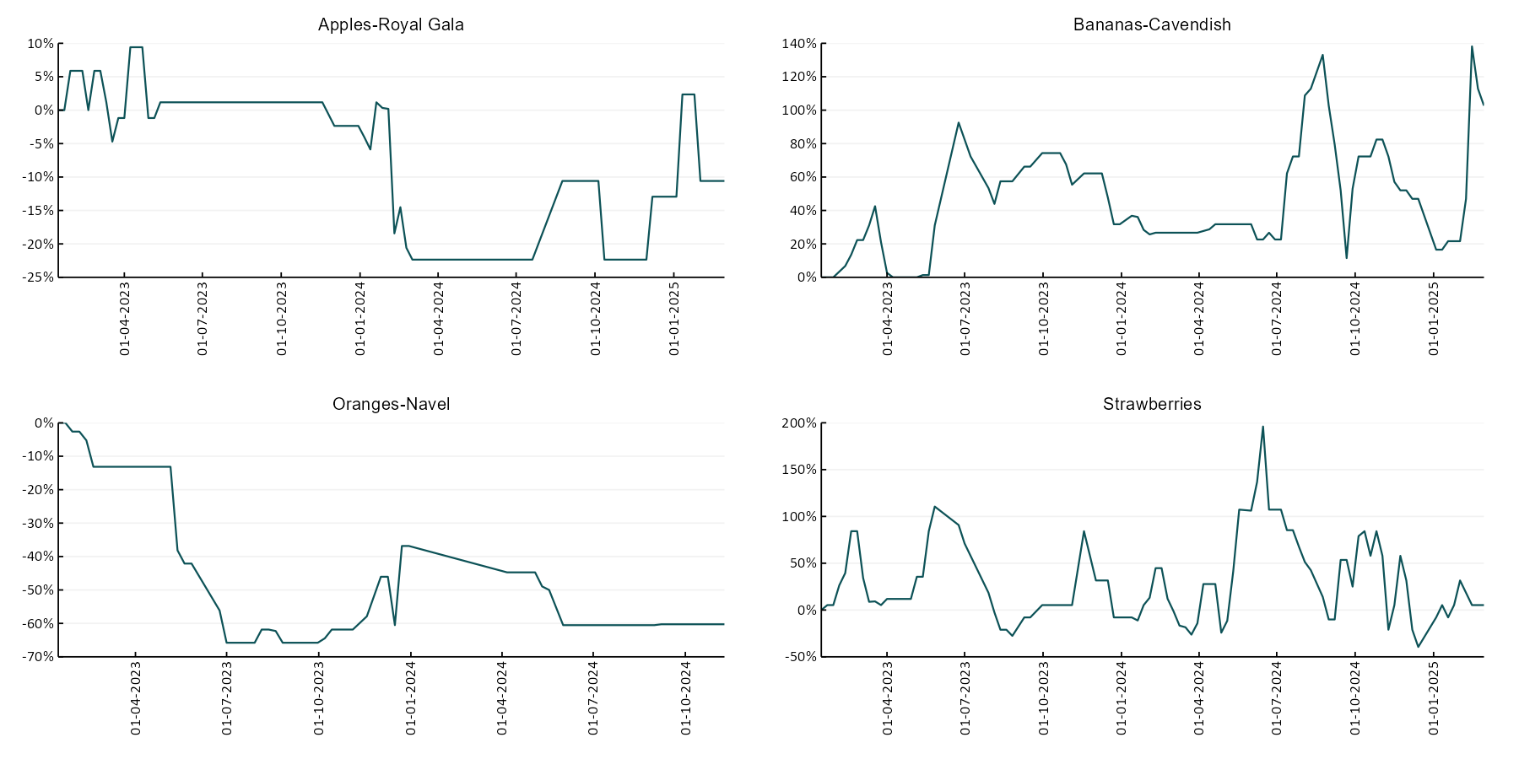

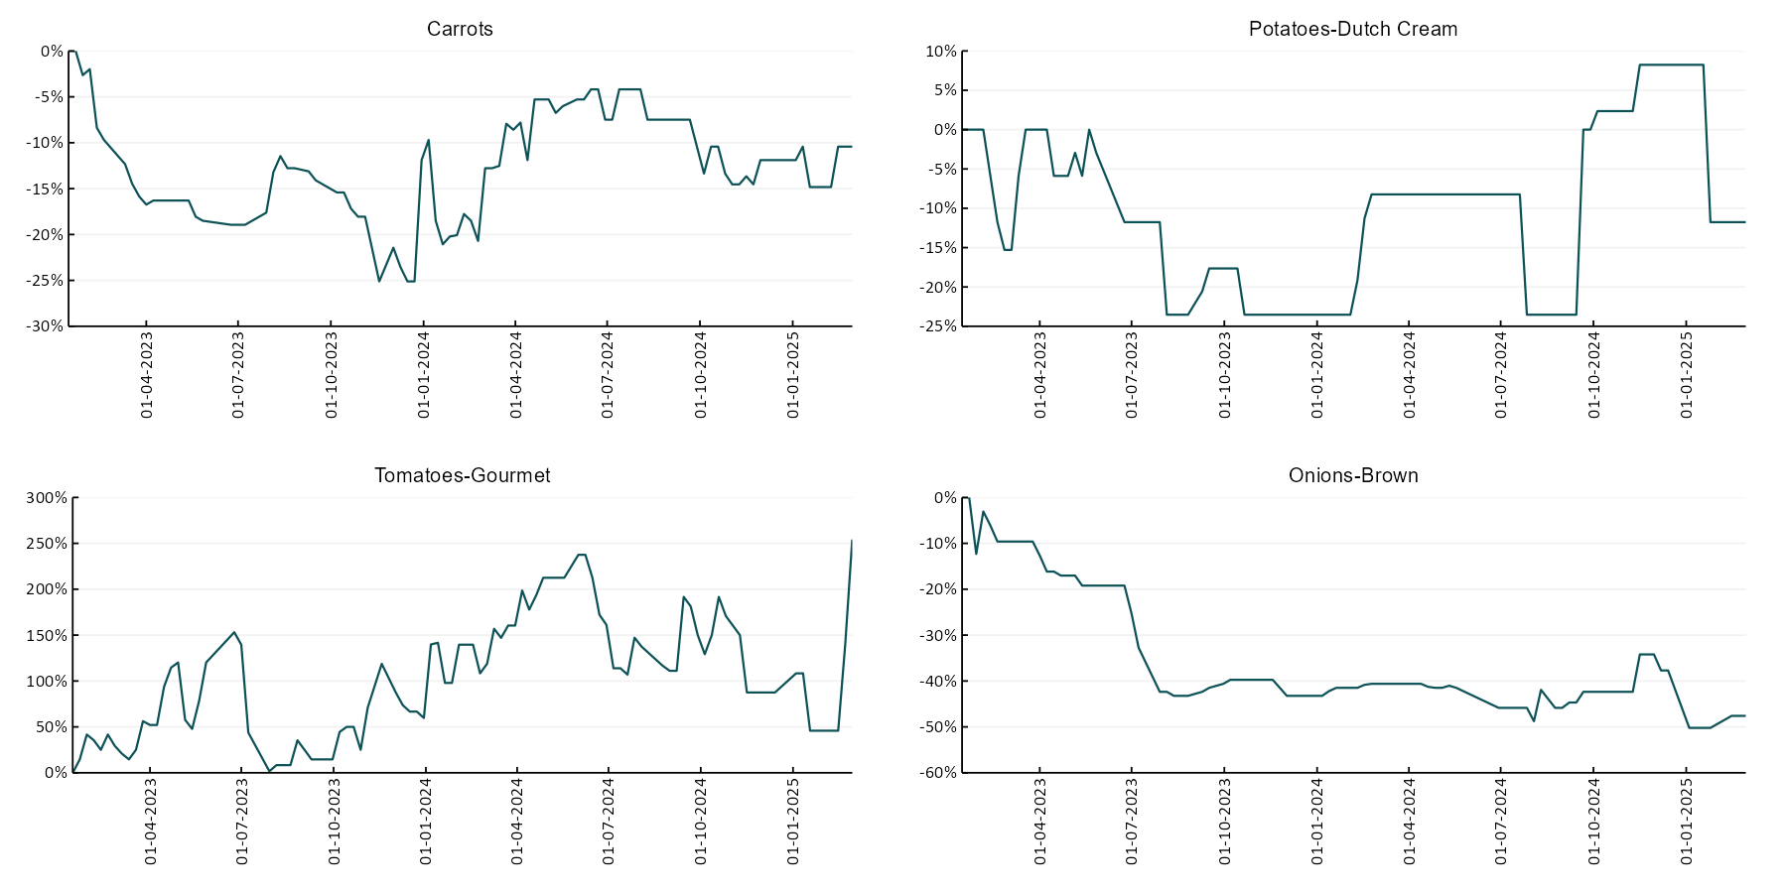

### 3.6 Selected domestic fodder indicator prices

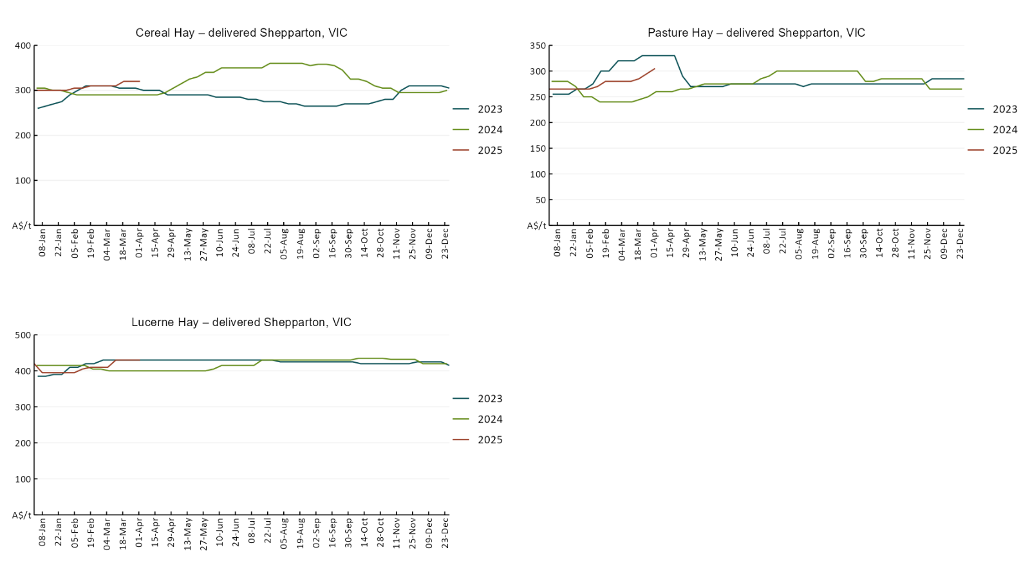

## **4. Data attribution**

### Climate

* Bureau of Meteorology
* Weekly rainfall totals: www.bom.gov.au/climate/maps/rainfall/
* Monthly and last 3-month rainfall percentiles: [www.bom.gov.au/water/landscape/](http://www.bom.gov.au/water/landscape/)
* Temperature anomalies: [www.bom.gov.au/jsp/awap/temp/index.jsp](http://www.bom.gov.au/jsp/awap/temp/index.jsp)
* Rainfall forecast: [www.bom.gov.au/jsp/watl/rainfall/pme.jsp](http://www.bom.gov.au/jsp/watl/rainfall/pme.jsp)
* Seasonal outlook: [www.bom.gov.au/climate/outlooks/#/overview/summary/](http://www.bom.gov.au/climate/outlooks/#/overview/summary/)
* Climate drivers: <http://www.bom.gov.au/climate/enso/>
* Soil moisture: [www.bom.gov.au/water/landscape/](http://www.bom.gov.au/water/landscape/)
* Other
* Pasture growth: [www.longpaddock.qld.gov.au/aussiegrass/](http://www.longpaddock.qld.gov.au/aussiegrass/)
* 3-month global outlooks: [Environment and Climate Change Canada](https://weather.gc.ca/saisons/image_e.html?img=s234pfe1p_cal&bc=prob), [NOAA Climate Prediction Center](https://www.cpc.ncep.noaa.gov/products/predictions/long_range/seasonal.php?lead=2), [EUROBRISA CPTEC/INPE](http://eurobrisa.cptec.inpe.br/), European Centre for Medium-Range Weather Forecasts, [Hydrometcenter of Russia](https://meteoinfo.ru/en/climate/seasonal-forecasts), [National Climate Center Climate System Diagnosis and Prediction Room (NCC)](https://cmdp.ncc-cma.net/pred/cs2gen.php?pred_elem=RAINP#pred_seasonal), [International Research Institute for Climate and Society](https://iri.columbia.edu/our-expertise/climate/forecasts/seasonal-climate-forecasts/)
* Global production: <https://ipad.fas.usda.gov/ogamaps/cropmapsandcalendars.aspx>
* Autumn break: Pook et al., 2009, <https://rmets-onlinelibrary-wiley-com.virtual.anu.edu.au/doi/epdf/10.1002/joc.1833>

### Water

Prices

* Waterflow: <https://www.waterflow.io/>
* Ruralco: <https://www.ruralcowater.com.au/>
* Bureau of Meteorology:
* Allocation trade: <http://www.bom.gov.au/water/dashboards/#/water-markets/mdb/at>
* Storage volumes: <http://www.bom.gov.au/water/dashboards/#/water-storages/summary/drainage>
* Trade constraints:
* Water NSW: <https://www.waternsw.com.au/customer-service/ordering-trading-and-pricing/trading/murrumbidgee>
* Victorian Water Register: <https://www.waterregister.vic.gov.au/TradingRules2019/>

### Commodities

* Fruit and vegetables
* Datafresh: [www.freshstate.com.au](http://www.freshstate.com.au)
* Pigs
* Australian Pork Limited: [www.australianpork.com.au](http://www.australianpork.com.au)
* Dairy
* Global Dairy Trade: [www.globaldairytrade.info/en/product-results/](http://www.globaldairytrade.info/en/product-results/)
* World wheat, canola
* International Grains Council
* World coarse grains
* United States Department of Agriculture
* World cotton
* Cotlook: [www.cotlook.com/](http://www.cotlook.com/)
* World sugar
* New York Stock Exchange - Intercontinental Exchange
* Wool
* Australian Wool Exchange: [www.awex.com.au/](http://www.awex.com.au/)
* Domestic wheat, barley, sorghum, canola and fodder
* Jumbuk Consulting Pty Ltd: http://www.jumbukag.com.au/
* Cattle, beef, mutton, lamb, goat and live export
* Meat and Livestock Australia: [www.mla.com.au/Prices-and-market](http://www.mla.com.au/Prices-and-market)

© Commonwealth of Australia 2025

### Ownership of intellectual property rights

Unless otherwise noted, copyright (and any other intellectual property rights, if any) in this publication is owned by the Commonwealth of Australia (referred to as the Commonwealth).

### Creative Commons licence

All material in this publication is licensed under a [Creative Commons Attribution 4.0 International Licence](https://creativecommons.org/licenses/by/4.0/legalcode) except content supplied by third parties, logos and the Commonwealth Coat of Arms.

Inquiries about the licence and any use of this document should be emailed to [copyright@awe.gov.au](mailto:copyright@awe.gov.au).

https://www.agriculture.gov.au/sites/default/files/images/creative-commons-logo-small.png

### Cataloguing data

This publication (and any material sourced from it) should be attributed as:

ABARES 2025, Weekly Australian Climate, Water and Agricultural Update, Australian Bureau of Agricultural and Resource Economics and Sciences, Canberra, 1 May 2025. CC BY 4.0 DOI: <https://doi.org/10.25814/5f3e04e7d2503>

ISSN **2652-7561**

This publication is available at https://www.agriculture.gov.au/abares/products/weekly_update

Department of Agriculture, Fisheries and Forestry

GPO Box 858 Canberra ACT 2601

Telephone 1800 900 090

Web [agriculture.gov.au/abares](http://awe.gov.au/abares)

### Disclaimer

The Australian Government acting through the Department of Agriculture, Fisheries and Forestry, represented by the Australian Bureau of Agricultural and Resource Economics and Sciences, has exercised due care and skill in preparing and compiling the information and data in this publication. Notwithstanding, the Department of Agriculture, Fisheries and Forestry, ABARES, its employees and advisers disclaim all liability, including liability for negligence and for any loss, damage, injury, expense or cost incurred by any person as a result of accessing, using or relying on any of the information or data in this publication to the maximum extent permitted by law.

### Statement of Professional Independence

The views and analysis presented in ABARES publications, including this one, reflect ABARES professionally independent findings, based on scientific and economic concepts, principles, information and data. These views, analysis and findings may not reflect or be consistent with the views or positions of the Australian Government, or of organisations or groups who have commissioned ABARES reports or analysis. More information on [professional independence](https://www.agriculture.gov.au/abares/about/research-and-analysis#professional-independence) is provided on the ABARES website.

### Acknowledgements

This report was prepared by Holly Beale and Matthew Miller.