## No. 18/2025 8 May 2025

# Summary of key issues

* In the week ending 7 May 2025 low-pressure systems and troughs brought rainfall to parts of the north, south and east of the country.
  + Rainfall totals were low in many cropping regions, with northern Queensland receiving 5- 15 millimetres, while remaining areas receiving 0-10 millimetres.
* Over the coming eight days, rainfall is expected across limited parts of eastern Australia.
  + Little to no rainfall is expected across all cropping regions.
  + A continued lack of rainfall will likely delay the germination of dry sown winter crops in south-eastern growing regions where upper layer soil moisture is low.
* Pasture growth for the three months to April 2025 has been mixed across Australia. Above average rainfall totals resulted in average to extremely high pasture growth across much of northern Australia and parts of eastern Australia. However, scattered areas of below average to extremely low pasture growth were also recorded across parts of southern, western, and eastern Australia.
* Soil moisture models indicate low soil moisture levels across large areas of south-eastern Australia, with above average soil moisture modelled in Queensland, the Northern Territory, Western Australia and northern New South Wales.
* The **national rainfall outlook** for June to August 2025 indicates an increased probability of above median rainfall across much of central and western Australia. Lower than average rainfall is expected some eastern and southern regions.
  + If realised, the expectation of close to average June to August 2025 rainfall across most winter cropping regions is likely be sufficient to support the establishment and growth of winter crops.
* Water storage levels in the Murray-Darling Basin (MDB) increased between 1 May 2025 and 8 May 2025 by 45 gigalitres (GL). Current volume of water held in storage is 11,806 GL, equivalent to 53% of total storage capacity. This is 29 percent or 4,736 GL less than at the same time last year. Water storage data is sourced from the Bureau of Meteorology.
* Allocation prices in the Victorian Murray below the Barmah Choke increased from $258 on 1 May 2025 to $343 on 8 May 2025. Due to the relaxing of constraints for trade between regions, prices are equal in the Murrumbidgee and VIC Murray Below.

## **Climate**

### Rainfall this week

In the week ending 7 May 2025, **low-pressure systems and troughs** brought limited rainfall to parts of eastern, northern and southern Australia. High-pressure systems kept much of the remainder of Australia largely dry.

* Parts of the Northern Tropics, including Cape York Peninsula and the far north of the Northern Territory saw rainfall totals of between 1-100 millimetres.
* Rainfall totals of between 5-50 millimetres were also recorded across parts of eastern New South Wales and Queensland, Tasmania and southwest Western Australia.
* Little to no rainfall was observed across much of the remainder of the country

Cropping regions were largely dry:

* In northern Queensland, 5-15 millimetres of rainfall was observed.
* Remaining cropping regions saw little to no rainfall over the period.
* Moving into the winter growing season, a lack of rainfall in the recent week will likely delay germination of dry sown winter crops in areas where upper layer soil moisture is low.

#### Rainfall for the week ending 7 May 2025

©Commonwealth of Australia 2025, Australian Bureau of Meteorology Issued: 7/5/2025

Note: The rainfall analyses and associated maps utilise data contained in the Bureau of Meteorology climate database, the Australian Data Archive for Meteorology (ADAM). The analyses are initially produced automatically from real-time data with limited [quality control](http://www.bom.gov.au/climate/headers/qc.shtml). They are intended to provide a general overview of rainfall across Australia as quickly as possible after the observations are received. For further information go to <http://www.bom.gov.au/climate/rainfall/>

### Rainfall forecast for the next eight days

Over the 8 days to 15 May 2025, **low-pressure systems** are expected to bring limited rainfall to parts of eastern and northern Australia.

* Falls of between 5-100 millimetres are expected for northern Queensland, while the north Northern Territory may see falls of between 5-25 millimetres.
* Eastern coastal areas, including south-eastern Queensland, northeastern New South Wales, and western Tasmania, are forecast to receive 5-50 millimetres of rainfall
* High-pressure systems are expected to keep most of Australia relatively dry.

Rainfall totals over the coming week are forecast to be low across most cropping regions.

* Little to no rainfall is expected all cropping regions.
* If realised, the continued lack of autumn rainfall will continue to present a downside risk to the timely planting and germination of winter crops particularly in those areas of southern New South Wales, western Victoria and South Australia with low stored soil moisture.

#### Total forecast rainfall for the period 8 May to 15 May 2025

©Commonwealth of Australia 2025, Australian Bureau of Meteorology Issued 8/5/2025

Note: This rainfall forecast is produced from computer models. As the model outputs are not altered by weather forecasters, it is important to check local forecasts and warnings issued by the Bureau of Meteorology.

### 1.3 Monthly Soil Moisture

In April 2025, modelled **upper layer soil moisture** was generally average to above average across much of Australia, except for the southeast of the country.

* Large areas of Tasmania, southern South Australia, Victoria, and southern New South Wales saw **very much below average to below average upper layer soil moisture.**
* In contrast, much of Queensland and northern New South Wales, as well as the northern tropics, southwest Western Australia and central Australia saw **average to very much above upper layer soil moisture.**

At this time of year, upper layer soil moisture is important for the germination and establishment of early sown winter crops across Australian cropping regions. Across cropping regions, modelled **upper layer soil moisture** in April was generally average across much of the north-east and west, while most cropping regions in the south-east saw below average soil moisture.

* Across most South Australian, Victorian, and southern New South Wales cropping regions upper layer soil moisture was **very much below** **average to below average**, with scattered areas of average soil moisture in central Victoria and south-western New South Wales.
* In Western Australia, Queensland and northern New South Wales, upper layer soil moisture was **average to very much** **above average**.

Average to above average upper layer soil moisture across much of New South Wales, Queensland and Western Australia is likely to have led to the timely planting and germination of winter crops.

**Modelled upper layer soil moisture for April 2025**

Note: This map shows the levels of modelled upper layer soil moisture (0 to 10 centimetres) during April 2025. This map shows how modelled soil conditions during April 2025 compare with February conditions modelled over the reference period (1911 to 2016). Dark blue areas on the maps were much wetter in April 2025 than during the reference period. The bulk of plant roots occur in the top 20 centimetres of the soil profile. Soil moisture in the upper layer of the soil profile is therefore useful indicator of the availability of water, particularly for germinating seed.

Source: Bureau of Meteorology (<https://awo.bom.gov.au/about/overview>)

Similar to upper layer soil moisture, modelled **lower layer soil moisture** in April 2025 was average to very much above average across much of Australia, with areas of below average lower layer soil moisture across the south and west of the country.

* Large areas of the Northern Territory, northern South Australia, northern and southern Western Australia, Queensland, and northern New South Wales were modelled as having **very much above average soil moisture.**
* By contrast, much of south-eastern Australia, including southern New South Wales, Victoria, South Australia and Tasmania were modelled as having **average to very much below average soil moisture over the period.**

Lower layer soil moisture is a larger, deeper store that is slower to respond to seasonal conditions and tends to reflect the accumulated effects of events that have occurred over longer periods. Crop development and pasture growth in areas of above average lower layer soil moisture are typically less reliant on in-season rainfall than in areas with below average lower layer soil moisture.

Across cropping regions, modelled lower layer soil moisture was generally average to very much above average, with areas of extremely low moisture modelled in the southeast and northwest.

* Much of Queensland, New South Wales and southern Western Australia saw above **average modelled soil moisture.** In contrast, South Australia, western Victoria, and parts of southern New South Wales saw **below average soil moisture for this time of year.**

Deficient levels of soil moisture in South Australia, western Victoria and parts of southern New South Wales are likely to impact the establishment of forthcoming winter crops and these growing regions will require sufficient and timely rainfall throughout the growing season to support the growth and development of crops and pastures.

**Modelled lower layer soil moisture for April 2025**

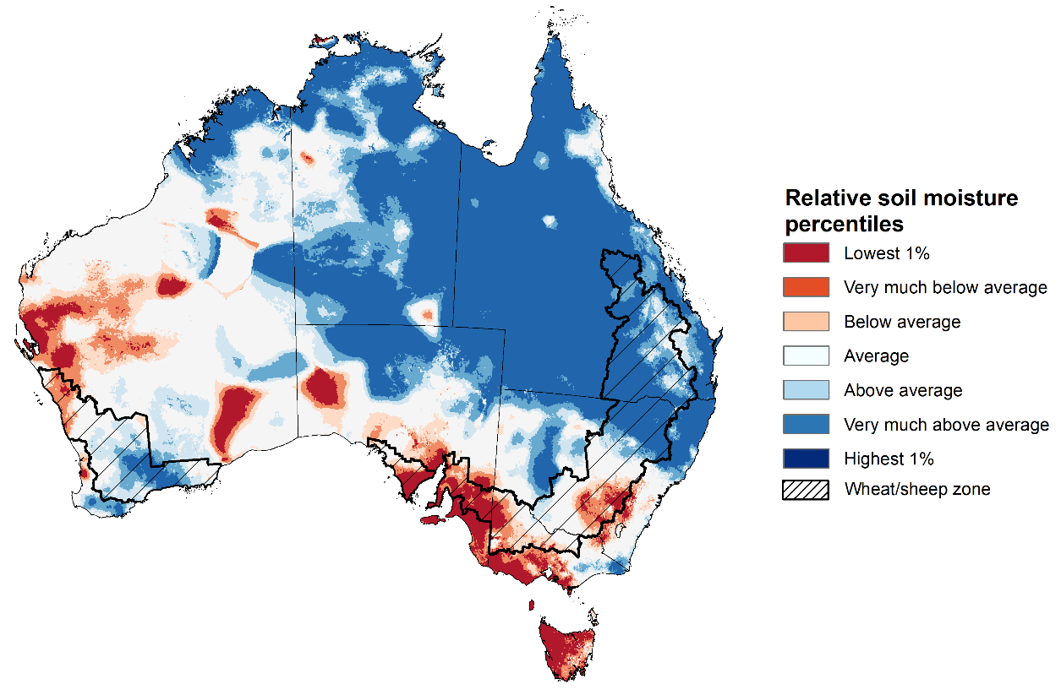

Note: This map shows the levels of modelled lower layer soil moisture (10 to 100 centimetres) during April 2025. This map shows how modelled soil conditions during April 2025 compare with April conditions modelled over the reference period (1911 to 2016). Dark blue areas on the maps were much wetter in April 2025 than during the reference period. The dark red areas were much drier than during the reference period. The bulk of plant roots occur in the top 20 centimetres of the soil profile. The lower layer soil moisture is a larger, deeper store that is slower to respond to rainfall and tends to reflect accumulated rainfall events over longer time periods.

Source: Bureau of Meteorology (<https://awo.bom.gov.au/about/overview>)

### 1.4 Pasture Growth

Pasture growth for the three months to April 2025 has been mixed across much of country, with northern and parts of eastern Australia experiencing improved pasture growth.

* **Average** to **extremely high** pasture growth was modelled across large areas of northern and eastern Australia, including Queensland, northern New South Wales, the eastern Northern Territory, and eastern Victoria.

This pasture growth is expected to support farmers maintaining stock numbers, provide opportunities to build standing dry matter availability and decrease the reliance on fodder to maintain livestock condition over the winter period.

* By contrast, large areas of western and southern Australia and parts of eastern Australia, including Victoria, South Australia, Western Australia, south-eastern Queensland and north-eastern New South Wales and saw relatively low pasture growth for this time of year.

This lower pasture growth will likely see graziers in affected regions actively destocking or increased reliance on supplemental feed to maintain current stocking rates and production.

**Relative pasture growth for 3-months ending April 2025 (1 February to 30 April 2025)**

Notes: AussieGRASS pasture growth estimates are relative to the long-term record and shown in percentiles. Percentiles rank data on a scale of zero to 100. This analysis ranks pasture growth for the selected period against average pasture growth for the long-term record (1957 to 2016). Pasture growth is modelled at 5km2 grid cells.  
Source: Department of Environment, Science and Innovation

* 1. **National Climate Outlook**

The El Niño Southern Oscillation (ENSO) and Indian Ocean Dipole (IOD) climate drivers are currently neutral and having minimal influence on Australian rainfall. The IOD is likely to remain neutral over the coming months. Additionally, the ENSO is likely to remain neutral until August. The Southern Annual Mode (SAM) is currently positive but is likely to return to neutral in May. This suggests that climate drivers will have little impact on Australian rainfall over the coming months.

The most recent **rainfall outlook for June 2025** provided by the Bureau of Meteorology indicates that much of Australia, is likely to see close to or above **median rainfall,** with exceptions of northern Queensland.

* The Bureau of Meteorology’s climate model indicates a 75% chance of June rainfall totals between 10-100 millimetres across much of southern Australia, including Victoria, southern and eastern New South Wales and parts of South Australia. Tasmania and southern Western Australia are expected to see between 10-200 millimetres.
* Lower rainfall totals are expected across central and northern Australia, with much of northern Western Australia, the Northern Territory, northern South Australia, and central and northern Queensland likely to see little to no rainfall.
* Across cropping regions, there is a **75% chance** of rainfall totals of between **10-50 millimetres across most southern cropping regions.** In contrast, northern New South Wales and Queensland, are likely to see little to no rainfall. If realised, this is may provide sufficient moisture to support the germination of dry sown winter crops in southern regions.

**Rainfall totals that have a 75% chance of occurring in June 2025**

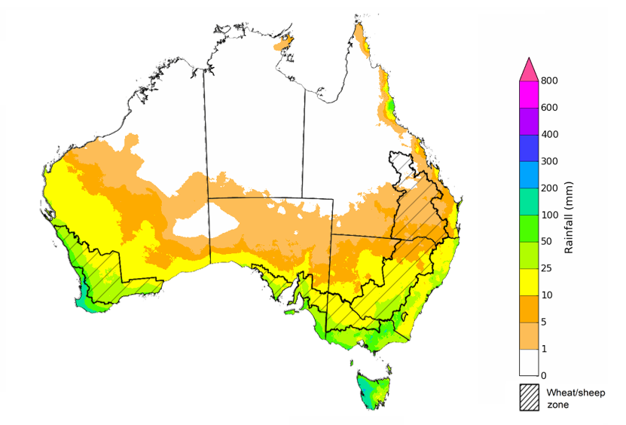

©Commonwealth of Australia 2025, Australian Bureau of Meteorology Issued: 8/5/2025

The **rainfall outlook for June to August 2025** indicates an increased probability of **above median rainfall across western and central Australia,** including much of Western Australia, the Northern Territory, and South Australia. In contrast, some eastern and southern regions are likely to see below median rainfall, including parts of eastern New South Wales and Victoria, Tasmania, south Western Australia and large areas of Queensland.

Across cropping regions, the chance of receiving above median rainfall is between 40–55% across Queensland, South Australia and New South Wales, while, while Western Australia and Victoria have a 35–55% chance of recording above median rainfall.

**Chance of exceeding the median rainfall** **June 2025 to August 2025**

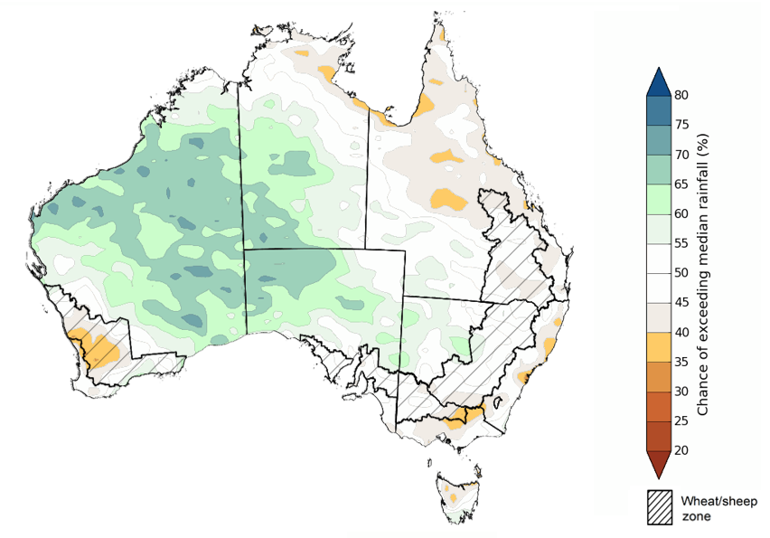

©Commonwealth of Australia 2025, Australian Bureau of Meteorology Issued: 8/5/2025

The **rainfall outlook for June through to August 2025** suggests a 75% chance of receiving rainfall totals of between 100–600 millimetres across southwest Western Australia, Tasmania, and alpine areas of New South Wales and Victoria. Between 25–200 millimetres of rainfall are forecast across much of south-eastern Queensland, New South Wales, Victoria and southern South Australia. In northern and central Australia, little to no rainfall is forecast over the period.

In **cropping regions**, there is a **75% chance** of receiving between **50-200 millimetres** in the south, including Western Australia, South Australia, Victoria and New South Wales. In Queensland, falls of 10-100 millimetres are expected. If realised, these falls are likely be sufficient to support the establishment and growth of winter crops.

**Rainfall totals that have a 75% chance of occurring June 2025 to August 2025**

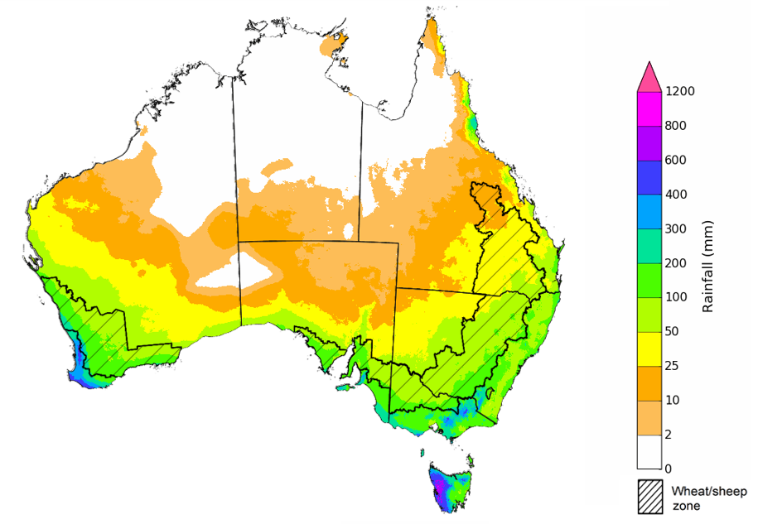

©Commonwealth of Australia 2025, Australian Bureau of Meteorology Issued: 8/5/2025

### Water markets – current week

Water storage levels in the Murray-Darling Basin (MDB) increased between 1 May 2025 and 8 May 2025 by 45 gigalitres (GL). Current volume of water held in storage is 11,806 GL, equivalent to 53% of total storage capacity. This is 29 percent or 4,736 GL less than at the same time last year. Water storage data is sourced from the Bureau of Meteorology.

Allocation prices in the Victorian Murray below the Barmah Choke increased from $258 on 1 May 2025 to $343 on 8 May 2025. Due to the relaxing of constraints for trade between regions, prices are equal in the Murrumbidgee and VIC Murray Below.

#### Surface water trade activity, Southern Murray–Darling Basin

|  |
| --- |
| The trades shown reflect estimated market activity and do not encompass all register trades. The price is shown for the VIC Murray below the Barmah choke. Historical prices (before 1 July 2019) are ABARES estimates after removing outliers from BOM water register data. Prices after 1 July 2019 and prior to the 30 October 2019 reflect recorded transaction prices as sourced from Ruralco. Prices after the 30 October 2019 are sourced from Waterflow. Data for volume traded is sourced from the BOM water register. Only the price data shown is current on 17 October 2024. |

To access the full, interactive, weekly water dashboard, which contains the latest and historical water storage, water market and water allocation information, please visit <https://www.agriculture.gov.au/abares/products/weekly_update/weekly-update-80525>

## **Commodities**

|  |  |  |  |  |  |  |  |  |
| --- | --- | --- | --- | --- | --- | --- | --- | --- |
| **Indicator** | **Week average** | **Unit** | **Latest Price** | **Previous Week** | **Weekly change** | | **Price 12 months ago** | **Annual change** |
| **Selected world indicator prices** |  |  |  |  |  |  | |  |
| AUD/USD Exchange rate | 07-May | A$/US$ | 0.65 | 0.64 | 1% | 0.66 | | -2% |
| Wheat – US no. 2 hard red winter wheat, FOB Gulf | 07-May | US$/t | 241 | 240 | 0% | 288 | | -16% |
| Corn – US no. 2 yellow corn, FOB Gulf | 07-May | US$/t | 205 | 211 | -3% | 196 | | 4% |
| Canola – Rapeseed, Canada, FOB Vancouver | 07-May | US$/t | 543 | 540 | 0% | 516 | | 5% |
| Cotton – Cotlook A Index | 07-May | USc/lb | 79 | 78 | 0% | 86 | | -8% |
| Sugar – Intercontinental Exchange, nearby futures, no.11 contract | 07-May | USc/lb | 18 | 17 | 1% | 19 | | -7% |
| Wool – Eastern Market Indicator | 07-May | Ac/kg clean | 1,191 | 1,210 | -2% | 1,138 | | 5% |
| Wool – Western Market Indicator | 07-May | Ac/kg clean | 1,353 | 1,363 | -1% | 1,273 | | 6% |
| **Selected Australian grain export prices** |  |  |  |  |  |  | |  |
| Australian Premium White (APW) Wheat, FOB Port Adelaide, SA | 07-May | A$/t | 398 | 396 | 1% | 417 | | -4% |
| Australian Standard White (ASW) Wheat, FOB Port Adelaide, SA | 07-May | A$/t | 393 | 391 | 1% | 404 | | -3% |
| Feed Barley – FOB Port Adelaide, SA | 07-May | A$/t | 375 | 373 | 1% | 376 | | 0% |
| Canola – FOB Kwinana, WA | 07-May | A$/t | 781 | 789 | -1% | 751 | | 4% |
| Grain Sorghum – FOB Brisbane, QLD | 07-May | A$/t | 439 | 436 | 1% | 451 | | -3% |
| **Selected domestic livestock indicator prices** |  |  |  |  |  |  | |  |
| Beef – Eastern Young Cattle Indicator | 07-May | Ac/kg cwt | 707 | 713 | -1% | 609 | | 16% |
| Mutton – Mutton indicator (18–24 kg fat score 2–3), VIC | 07-May | Ac/kg cwt | 601 | 599 | 0% | 284 | | 112% |
| Lamb – National Trade Lamb Indicator | 07-May | Ac/kg cwt | 839 | 839 | 0% | 666 | | 26% |
| Pig – Eastern Seaboard (60.1–75 kg), NSW buyer price | 23-Apr | Ac/kg cwt | 447 | 448 | 0% | 414 | | 8% |
| Live cattle – Light steers to Indonesia | 07-May | Ac/kg lwt | 345 | 350 | -1% | 333 | | 4% |
| **Global Dairy Trade (GDT) weighted average prices** |  |  |  |  |  |  | |  |
| Dairy – Whole milk powder | 07-May | US$/t | 4,374 | 4,171 | 5% | 3,379 | | 29% |
| Dairy – Skim milk powder | 07-May | US$/t | 2,828 | 2,795 | 1% | 2,590 | | 9% |
| Dairy – Cheddar cheese | 07-May | US$/t | 5,519 | 4,923 | 12% | 4,248 | | 30% |
| Dairy – Anhydrous milk fat | 07-May | US$/t | 7,212 | 6,838 | 5% | 7,245 | | 0% |
|  | | | | | | | | |

### Selected world indicator prices

### 3.2 Selected domestic crop indicator prices

### 3.3 Selected domestic livestock indicator prices

### 3.4 Global Dairy Trade (GDT) weighted average prices

### 3.5 Selected fruit and vegetable prices

### 3.6 Selected domestic fodder indicator prices

## **4. Data attribution**

### Climate

* Bureau of Meteorology
* Weekly rainfall totals: www.bom.gov.au/climate/maps/rainfall/
* Monthly and last 3-month rainfall percentiles: [www.bom.gov.au/water/landscape/](http://www.bom.gov.au/water/landscape/)
* Temperature anomalies: [www.bom.gov.au/jsp/awap/temp/index.jsp](http://www.bom.gov.au/jsp/awap/temp/index.jsp)
* Rainfall forecast: [www.bom.gov.au/jsp/watl/rainfall/pme.jsp](http://www.bom.gov.au/jsp/watl/rainfall/pme.jsp)
* Seasonal outlook: [www.bom.gov.au/climate/outlooks/#/overview/summary/](http://www.bom.gov.au/climate/outlooks/#/overview/summary/)
* Climate drivers: <http://www.bom.gov.au/climate/enso/>
* Soil moisture: [www.bom.gov.au/water/landscape/](http://www.bom.gov.au/water/landscape/)
* Other
* Pasture growth: [www.longpaddock.qld.gov.au/aussiegrass/](http://www.longpaddock.qld.gov.au/aussiegrass/)
* 3-month global outlooks: [Environment and Climate Change Canada](https://weather.gc.ca/saisons/image_e.html?img=s234pfe1p_cal&bc=prob), [NOAA Climate Prediction Center](https://www.cpc.ncep.noaa.gov/products/predictions/long_range/seasonal.php?lead=2), [EUROBRISA CPTEC/INPE](http://eurobrisa.cptec.inpe.br/), European Centre for Medium-Range Weather Forecasts, [Hydrometcenter of Russia](https://meteoinfo.ru/en/climate/seasonal-forecasts), [National Climate Center Climate System Diagnosis and Prediction Room (NCC)](https://cmdp.ncc-cma.net/pred/cs2gen.php?pred_elem=RAINP#pred_seasonal), [International Research Institute for Climate and Society](https://iri.columbia.edu/our-expertise/climate/forecasts/seasonal-climate-forecasts/)
* Global production: <https://ipad.fas.usda.gov/ogamaps/cropmapsandcalendars.aspx>
* Autumn break: Pook et al., 2009, <https://rmets-onlinelibrary-wiley-com.virtual.anu.edu.au/doi/epdf/10.1002/joc.1833>

### Water

Prices

* Waterflow: <https://www.waterflow.io/>
* Ruralco: <https://www.ruralcowater.com.au/>
* Bureau of Meteorology:
* Allocation trade: <http://www.bom.gov.au/water/dashboards/#/water-markets/mdb/at>
* Storage volumes: <http://www.bom.gov.au/water/dashboards/#/water-storages/summary/drainage>
* Trade constraints:
* Water NSW: <https://www.waternsw.com.au/customer-service/ordering-trading-and-pricing/trading/murrumbidgee>
* Victorian Water Register: <https://www.waterregister.vic.gov.au/TradingRules2019/>

### Commodities

* Fruit and vegetables
* Datafresh: [www.freshstate.com.au](http://www.freshstate.com.au)
* Pigs
* Australian Pork Limited: [www.australianpork.com.au](http://www.australianpork.com.au)
* Dairy
* Global Dairy Trade: [www.globaldairytrade.info/en/product-results/](http://www.globaldairytrade.info/en/product-results/)
* World wheat, canola
* International Grains Council
* World coarse grains
* United States Department of Agriculture
* World cotton
* Cotlook: [www.cotlook.com/](http://www.cotlook.com/)
* World sugar
* New York Stock Exchange - Intercontinental Exchange
* Wool
* Australian Wool Exchange: [www.awex.com.au/](http://www.awex.com.au/)
* Domestic wheat, barley, sorghum, canola and fodder
* Jumbuk Consulting Pty Ltd: http://www.jumbukag.com.au/
* Cattle, beef, mutton, lamb, goat and live export
* Meat and Livestock Australia: [www.mla.com.au/Prices-and-market](http://www.mla.com.au/Prices-and-market)

© Commonwealth of Australia 2025

### Ownership of intellectual property rights

Unless otherwise noted, copyright (and any other intellectual property rights, if any) in this publication is owned by the Commonwealth of Australia (referred to as the Commonwealth).

### Creative Commons licence

All material in this publication is licensed under a [Creative Commons Attribution 4.0 International Licence](https://creativecommons.org/licenses/by/4.0/legalcode) except content supplied by third parties, logos and the Commonwealth Coat of Arms.

Inquiries about the licence and any use of this document should be emailed to [copyright@awe.gov.au](mailto:copyright@awe.gov.au).

https://www.agriculture.gov.au/sites/default/files/images/creative-commons-logo-small.png

### Cataloguing data

This publication (and any material sourced from it) should be attributed as:

ABARES 2025, Weekly Australian Climate, Water and Agricultural Update, Australian Bureau of Agricultural and Resource Economics and Sciences, Canberra, 8 May 2025. CC BY 4.0 DOI: <https://doi.org/10.25814/5f3e04e7d2503>

ISSN **2652-7561**

This publication is available at https://www.agriculture.gov.au/abares/products/weekly_update

Department of Agriculture, Fisheries and Forestry

GPO Box 858 Canberra ACT 2601

Telephone 1800 900 090

Web [agriculture.gov.au/abares](http://awe.gov.au/abares)

### Disclaimer

The Australian Government acting through the Department of Agriculture, Fisheries and Forestry, represented by the Australian Bureau of Agricultural and Resource Economics and Sciences, has exercised due care and skill in preparing and compiling the information and data in this publication. Notwithstanding, the Department of Agriculture, Fisheries and Forestry, ABARES, its employees and advisers disclaim all liability, including liability for negligence and for any loss, damage, injury, expense or cost incurred by any person as a result of accessing, using or relying on any of the information or data in this publication to the maximum extent permitted by law.

### Statement of Professional Independence

The views and analysis presented in ABARES publications, including this one, reflect ABARES professionally independent findings, based on scientific and economic concepts, principles, information and data. These views, analysis and findings may not reflect or be consistent with the views or positions of the Australian Government, or of organisations or groups who have commissioned ABARES reports or analysis. More information on [professional independence](https://www.agriculture.gov.au/abares/about/research-and-analysis#professional-independence) is provided on the ABARES website.

### Acknowledgements

This report was prepared by Holly Beale and Matthew Miller.