## No. 19/2025 15 May 2025

# Summary of key issues

* In the week ending 14 May 2025 tropical lows and troughs brought rainfall to parts of eastern and northern Australia.
  + Rainfall totals were low in all cropping regions, with 0-5 millimetres recorded in most areas.
* Over the coming eight days, rainfall is expected across limited parts of eastern Australia.
  + Little to no rainfall is expected across most cropping regions in the south and west. Eastern regions, including much of Queensland and New South Wales, are forecast to receive 5-50 millimetres.
  + The lack of autumn rainfall continues to present a risk to the timely germination and establishment of winter crops – particularly in those areas of southern New South Wales, western Victoria and South Australia where there is low stored soil moisture.
* Rainfall in April 2025 was variable across the world’s major grain- and oilseed-producing regions, leading to differing crop production outcomes.
  + Global production conditions were generally favourable for rice, soybeans and maize, but variable for wheat.
  + Global production conditions have been slightly more favourable to those used to formulate ABARES 2024-25 forecasts of global grain supplies and world prices in the March 2025 Agricultural Commodities Report. As a result, global grain and oilseed production are likely to increase beyond the numbers in the March forecast, due to improvements in global wheat, maize and rice production.
* Water storage levels in the Murray-Darling Basin (MDB) increased between 08 May 2025 and 15 May 2025 by 98 gigalitres (GL). Current volume of water held in storage is 11,904 GL, equivalent to 53% of total storage capacity. This is 28 percent or 4,737 GL less than at the same time last year. Water storage data is sourced from the Bureau of Meteorology.
* Allocation prices in the Victorian Murray below the Barmah Choke decreased from $343 on 08 May to $316 on 15 May. Trade between Murrumbidgee and Murray IVTs are open.

## **Climate**

### Rainfall this week

In the week ending 14 May 2025, **tropical lows and troughs** brought limited rainfall to parts of eastern and northern Australia. High-pressure systems kept the remainder of Australia largely dry.

* Falls of between 5-150 millimetres of rainfall were observed in isolated areas of northern Queensland, across parts of northern Western Australia and the west of the Northern Territory.
* Rainfall totals of between 5-100 millimetres were recorded across parts of eastern New South Wales and southeast Queensland.
* In Tasmania, rainfall totals of up to 50 millimetres were recorded in the west.
* Little to no rainfall was observed across remaining areas of the country.

Cropping regions received little to no rainfall in the week ending 14 May 2025.

* Moving into the winter growing season, a lack of rainfall in the recent week will continue to delay the germination of dry sown winter crops in areas of south-eastern and Western Australia where upper layer soil moisture is low.

#### Rainfall for the week ending 14 May 2025

©Commonwealth of Australia 2025, Australian Bureau of Meteorology Issued: 14/5/2025

Note: The rainfall analyses and associated maps utilise data contained in the Bureau of Meteorology climate database, the Australian Data Archive for Meteorology (ADAM). The analyses are initially produced automatically from real-time data with limited [quality control](http://www.bom.gov.au/climate/headers/qc.shtml). They are intended to provide a general overview of rainfall across Australia as quickly as possible after the observations are received. For further information go to <http://www.bom.gov.au/climate/rainfall/>

### Rainfall forecast for the next eight days

Over the 8 days to 22 May 2025, **low-pressure systems** are expected to bring rainfall to parts of eastern Australia.

* Large areas of eastern Australia, including south-eastern Queensland, eastern New South Wales, eastern Victoria and western Tasmania are forecast to receive 5-50 millimetres.
* High-pressure systems are expected to keep most of remainder of Australia relatively dry.

Rainfall totals over the coming week are forecast to be low across most western and southern cropping regions.

* In Queensland and much of New South Wales, rainfall totals of 5-50 millimetres of rainfall are expected.
* Little to no rainfall is expected across south-western New Sloth Wales, Victoria, South Australia and Western Australia.
* If realised, the lack of autumn rainfall continues to present a downside risk to the timely germination and establishment of winter crops particularly in those areas of southern New South Wales, western Victoria and South Australia with low stored soil moisture.

#### Total forecast rainfall for the period 15 May to 22 May 2025

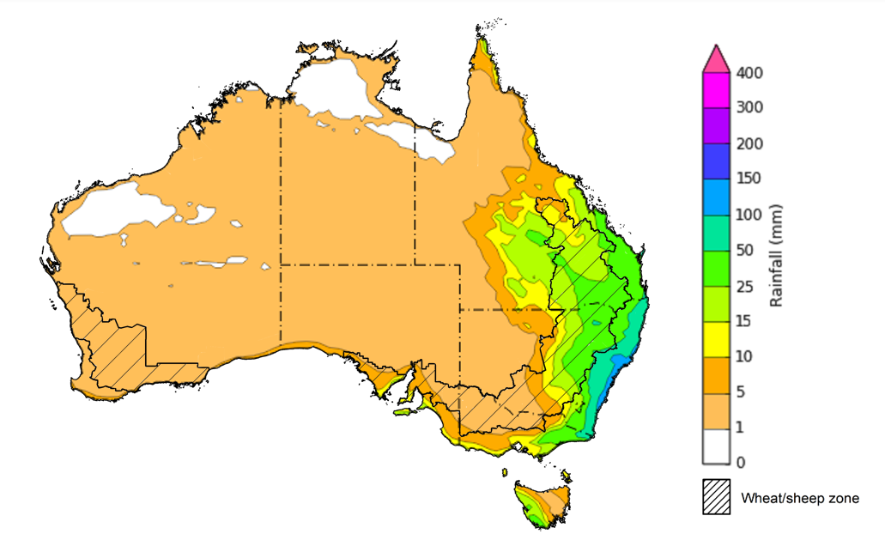

©Commonwealth of Australia 2025, Australian Bureau of Meteorology Issued 15/5/2025

Note: This rainfall forecast is produced from computer models. As the model outputs are not altered by weather forecasters, it is important to check local forecasts and warnings issued by the Bureau of Meteorology.

### 1.3 April precipitation percentiles and current production conditions

Crop production is affected by long-term trends in average rainfall and temperature, interannual climate variability, shocks during specific growth stages, and extreme weather events. Some crops are more tolerant than others to certain types of stresses, and at each growth stage, different types of stresses affect crop species in different ways.

Precipitation anomalies and outlooks presented below indicate the current and expected future production conditions for major grain and oilseed producing countries (responsible for over 80% of global crop production). This is an important input to assessing the global grain supply outlook.

Rainfall in April 2025 was variable across the world’s major grain- and oilseed-producing regions:

* In the **southern hemisphere**, precipitation was below average across parts of northern and southern Brazil, and northern Argentina. Above average precipitation occurred in parts of southeast Asia, including much of Indonesia, southern Africa and eastern Australia. Precipitation was generally average across remaining major southern hemisphere grain- and oilseed-producing regions.
* In the **northern hemisphere**, precipitation was below average across scattered areas of the western United States, parts of northern and south-eastern Europe, and across parts of central China. Precipitation was above average across parts of central United States, parts of the Russian Federation, north-eastern China, and southern and eastern India. Precipitation was generally average across remaining major northern hemisphere grain- and oilseed-producing regions.

**Global precipitation percentiles, April 2025**

Note: The world precipitation percentiles indicate a ranking of precipitation for April, with the driest (0th percentile) being 0 on the scale and the wettest (100th percentile) being 1 on the scale. Percentiles are based on precipitation estimates from the NOAA Climate Prediction Center’s [Climate Anomaly Monitoring System Outgoing Precipitation Index](https://iridl.ldeo.columbia.edu/maproom/Global/Precipitation/Percentiles.html) dataset. Precipitation estimates for April 2025 are compared with rainfall recorded for that period during the 1981 to 2010 base period.

Source: International Research Institute for Climate and Society

As of 28 April 2025, global production conditions are generally favourable for rice, soybeans and maize, but variable for wheat:

* **Wheat –** conditions are highly variable in major northern hemisphere growing regions, with dryness negatively impacting yield potential of winter wheat parts of Europe, the United States and the Black Sea region.
* **Maize –** Conditions are mixed in the southern hemisphere with some downturns in production are expected in parts of northern Brazil and Argentina. Sowing is progressing under generally favourable conditions in the northern hemisphere.
* **Rice –** Favourable conditions are supporting the harvest of rice in much of Southeast Asia and South America. Sowing is beginning in the northern hemisphere.
* **Soybeans –** Harvest is progressing in the southern hemisphere under generally favourable conditions, except for parts of southern Brazil and northern Argentina where dryness has negatively impacted yields. Sowing is beginning in the northern hemisphere under favourable conditions.

**Crop conditions, AMIS countries, 28 April 2025**

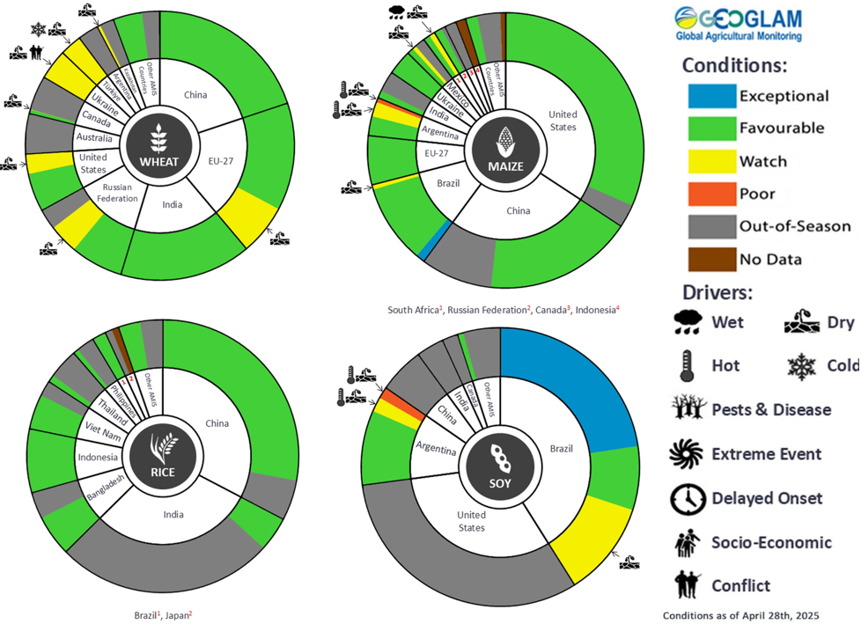

**AMIS** Agricultural Market Information System.

Source: AMIS

The global climate outlook for June 2025 to August 2025 indicates that mixed rainfall conditions are expected for the world’s major grain-producing and oilseed-producing regions. Outlooks and potential production impacts for major grain- and oilseed-producing countries are presented in the following table.

**Rainfall outlook and potential impact on the future state of production conditions, June-August 2025**

|  |  |  |
| --- | --- | --- |
| **Region** | **Rainfall outlook** | **Potential impact on production** |
| **Argentina** | Average to above average rainfall is likely across much of Argentina. | Anticipated rainfall is likely to support to the vegetative development of wheat, but could delay the planting of wheat and harvesting of other major grains and oilseeds. |
| **Black Sea Region** | Below average rainfall is expected across much of the Black Sea region, including the southeast of the Russian Federation, Türkiye, and Ukraine. | Anticipated rainfall is likely to adversely affect grain filling of wheat, as well as development cotton, corn and sunflower from July 2025. |
| **Brazil** | Below average rainfall likely in southern areas. Much of the remainder of Brazil is likely to record average to above average rainfall. | Anticipated rainfall across southern Brazil may impede the germination and establishment of wheat in June and July, as well as present a downside risk to yield during heading. |
| **Canada** | Generally average rainfall is expected over much of Canada, with exceptions in the southwest where rainfall is likely to be below average. | Average rainfall is likely to support the development of spring wheat and canola, and the planting and development of corn, soybeans and sunflower. Below average rainfall in isolated areas may adversely affect the development of crops in these locations. |
| **China** | Above average rainfall is expected throughout much of western and northern China, with average rainfall expected in remaining areas. | Anticipated rainfall is likely to support the flowering of major crops over the season, including spring wheat, rice, cotton, corn and soybeans. |
| **Europe** | Below average rainfall is likely for most of Europe. | Below average rainfall is likely to pose a risk to the flowering and heading of wheat, and the growth and development of corn and soybeans in the north, and sorghum, corn and cotton in the south. |
| **South Asia (India)** | Above average rainfall is expected across much of northern and southern India, with remaining areas forecast to receive average rainfall. | Anticipated rainfall is likely to support the flowering of many major grains and oilseeds, including corn, rice and sorghum. |
| **Southeast Asia (SEA)** | Average to above average rainfall is likely across much of Indonesia and the Philippines. Below average rainfall expected Malaysia and Thailand. In the remaining regions, average rainfall if likely. | Average to above average rainfall in SEA may support the flowering of rice and corn in major growing regions. |
| **The United States of America** | Below average rainfall is likely for much northern and central United States, with average rainfall more likely across the east and southwest. | Anticipated rainfall in northern and central areas is likely to impact yield potential of major grains and oilseeds, but may support the planting and harvesting of various crops, over the period. |

### Water markets – current week

Water storage levels in the Murray-Darling Basin (MDB) increased between 1 May 2025 and 8 May 2025 by 45 gigalitres (GL). Current volume of water held in storage is 11,806 GL, equivalent to 53% of total storage capacity. This is 29 percent or 4,736 GL less than at the same time last year. Water storage data is sourced from the Bureau of Meteorology.

Allocation prices in the Victorian Murray below the Barmah Choke increased from $258 on 1 May 2025 to $343 on 8 May 2025. Due to the relaxing of constraints for trade between regions, prices are equal in the Murrumbidgee and VIC Murray Below.

#### Surface water trade activity, Southern Murray–Darling Basin

|  |
| --- |
| The trades shown reflect estimated market activity and do not encompass all register trades. The price is shown for the VIC Murray below the Barmah choke. Historical prices (before 1 July 2019) are ABARES estimates after removing outliers from BOM water register data. Prices after 1 July 2019 and prior to the 30 October 2019 reflect recorded transaction prices as sourced from Ruralco. Prices after the 30 October 2019 are sourced from Waterflow. Data for volume traded is sourced from the BOM water register. Only the price data shown is current on 17 October 2024. |

To access the full, interactive, weekly water dashboard, which contains the latest and historical water storage, water market and water allocation information, please visit <https://www.agriculture.gov.au/abares/products/weekly_update/weekly-update-80525>

## **Commodities**

|  |  |  |  |  |  |  |  |  |
| --- | --- | --- | --- | --- | --- | --- | --- | --- |
| **Indicator** | **Week average** | **Unit** | **Latest Price** | **Previous Week** | **Weekly change** | | **Price 12 months ago** | **Annual change** |
| **Selected world indicator prices** |  |  |  |  |  |  | |  |
| AUD/USD Exchange rate | 14-May | A$/US$ | 0.64 | 0.65 | 0% | 0.66 | | -3% |
| Wheat – US no. 2 hard red winter wheat, FOB Gulf | 14-May | US$/t | 230 | 238 | -3% | 288 | | -20% |
| Corn – US no. 2 yellow corn, FOB Gulf | 14-May | US$/t | 202 | 204 | -1% | 196 | | 3% |
| Canola – Rapeseed, Canada, FOB Vancouver | 14-May | US$/t | 552 | 544 | 1% | 516 | | 7% |
| Cotton – Cotlook A Index | 14-May | USc/lb | 78 | 79 | -1% | 86 | | -9% |
| Sugar – Intercontinental Exchange, nearby futures, no.11 contract | 14-May | USc/lb | 18 | 18 | 3% | 19 | | -4% |
| Wool – Eastern Market Indicator | 14-May | Ac/kg clean | 1,189 | 1,191 | 0% | 1,138 | | 5% |
| Wool – Western Market Indicator | 14-May | Ac/kg clean | 1,352 | 1,353 | 0% | 1,273 | | 6% |
| **Selected Australian grain export prices** |  |  |  |  |  |  | |  |
| Australian Premium White (APW) Wheat, FOB Port Adelaide, SA | 14-May | A$/t | 399 | 399 | 0% | 417 | | -4% |
| Australian Standard White (ASW) Wheat, FOB Port Adelaide, SA | 14-May | A$/t | 395 | 394 | 0% | 404 | | -2% |
| Feed Barley – FOB Port Adelaide, SA | 14-May | A$/t | 375 | 376 | 0% | 376 | | 0% |
| Canola – FOB Kwinana, WA | 14-May | A$/t | 782 | 784 | 0% | 751 | | 4% |
| Grain Sorghum – FOB Brisbane, QLD | 14-May | A$/t | 441 | 440 | 0% | 451 | | -2% |
| **Selected domestic livestock indicator prices** |  |  |  |  |  |  | |  |
| Beef – Eastern Young Cattle Indicator | 14-May | Ac/kg cwt | 679 | 702 | -3% | 609 | | 11% |
| Mutton – Mutton indicator (18–24 kg fat score 2–3), VIC | 14-May | Ac/kg cwt | 517 | 581 | -11% | 284 | | 82% |
| Lamb – National Trade Lamb Indicator | 14-May | Ac/kg cwt | 827 | 834 | -1% | 666 | | 24% |
| Pig – Eastern Seaboard (60.1–75 kg), NSW buyer price | 30-Apr | Ac/kg cwt | 446 | 447 | 0% | 414 | | 8% |
| Live cattle – Light steers to Indonesia | 14-May | Ac/kg lwt | 345 | 345 | 0% | 333 | | 4% |
| **Global Dairy Trade (GDT) weighted average prices** |  |  |  |  |  |  | |  |
| Dairy – Whole milk powder | 07-May | US$/t | 4,374 | 4,171 | 5% | 3,379 | | 29% |
| Dairy – Skim milk powder | 07-May | US$/t | 2,828 | 2,795 | 1% | 2,590 | | 9% |
| Dairy – Cheddar cheese | 07-May | US$/t | 5,519 | 4,923 | 12% | 4,248 | | 30% |
| Dairy – Anhydrous milk fat | 07-May | US$/t | 7,212 | 6,838 | 5% | 7,245 | | 0% |
|  | | | | | | | | |

### Selected world indicator prices

### 3.2 Selected domestic crop indicator prices

### 3.3 Selected domestic livestock indicator prices

### 3.6 Selected domestic fodder indicator prices

## **4. Data attribution**

### Climate

* Bureau of Meteorology
* Weekly rainfall totals: www.bom.gov.au/climate/maps/rainfall/
* Monthly and last 3-month rainfall percentiles: [www.bom.gov.au/water/landscape/](http://www.bom.gov.au/water/landscape/)
* Temperature anomalies: [www.bom.gov.au/jsp/awap/temp/index.jsp](http://www.bom.gov.au/jsp/awap/temp/index.jsp)
* Rainfall forecast: [www.bom.gov.au/jsp/watl/rainfall/pme.jsp](http://www.bom.gov.au/jsp/watl/rainfall/pme.jsp)
* Seasonal outlook: [www.bom.gov.au/climate/outlooks/#/overview/summary/](http://www.bom.gov.au/climate/outlooks/#/overview/summary/)
* Climate drivers: <http://www.bom.gov.au/climate/enso/>
* Soil moisture: [www.bom.gov.au/water/landscape/](http://www.bom.gov.au/water/landscape/)
* Other
* Pasture growth: [www.longpaddock.qld.gov.au/aussiegrass/](http://www.longpaddock.qld.gov.au/aussiegrass/)
* 3-month global outlooks: [Environment and Climate Change Canada](https://weather.gc.ca/saisons/image_e.html?img=s234pfe1p_cal&bc=prob), [NOAA Climate Prediction Center](https://www.cpc.ncep.noaa.gov/products/predictions/long_range/seasonal.php?lead=2), [EUROBRISA CPTEC/INPE](http://eurobrisa.cptec.inpe.br/), European Centre for Medium-Range Weather Forecasts, [Hydrometcenter of Russia](https://meteoinfo.ru/en/climate/seasonal-forecasts), [National Climate Center Climate System Diagnosis and Prediction Room (NCC)](https://cmdp.ncc-cma.net/pred/cs2gen.php?pred_elem=RAINP#pred_seasonal), [International Research Institute for Climate and Society](https://iri.columbia.edu/our-expertise/climate/forecasts/seasonal-climate-forecasts/)
* Global production: <https://ipad.fas.usda.gov/ogamaps/cropmapsandcalendars.aspx>
* Autumn break: Pook et al., 2009, <https://rmets-onlinelibrary-wiley-com.virtual.anu.edu.au/doi/epdf/10.1002/joc.1833>

### Water

Prices

* Waterflow: <https://www.waterflow.io/>
* Ruralco: <https://www.ruralcowater.com.au/>
* Bureau of Meteorology:
* Allocation trade: <http://www.bom.gov.au/water/dashboards/#/water-markets/mdb/at>
* Storage volumes: <http://www.bom.gov.au/water/dashboards/#/water-storages/summary/drainage>
* Trade constraints:
* Water NSW: <https://www.waternsw.com.au/customer-service/ordering-trading-and-pricing/trading/murrumbidgee>
* Victorian Water Register: <https://www.waterregister.vic.gov.au/TradingRules2019/>

### Commodities

* Fruit and vegetables
* Datafresh: [www.freshstate.com.au](http://www.freshstate.com.au)
* Pigs
* Australian Pork Limited: [www.australianpork.com.au](http://www.australianpork.com.au)
* Dairy
* Global Dairy Trade: [www.globaldairytrade.info/en/product-results/](http://www.globaldairytrade.info/en/product-results/)
* World wheat, canola
* International Grains Council
* World coarse grains
* United States Department of Agriculture
* World cotton
* Cotlook: [www.cotlook.com/](http://www.cotlook.com/)
* World sugar
* New York Stock Exchange - Intercontinental Exchange
* Wool
* Australian Wool Exchange: [www.awex.com.au/](http://www.awex.com.au/)
* Domestic wheat, barley, sorghum, canola and fodder
* Jumbuk Consulting Pty Ltd: http://www.jumbukag.com.au/
* Cattle, beef, mutton, lamb, goat and live export
* Meat and Livestock Australia: [www.mla.com.au/Prices-and-market](http://www.mla.com.au/Prices-and-market)

© Commonwealth of Australia 2025

### Ownership of intellectual property rights

Unless otherwise noted, copyright (and any other intellectual property rights, if any) in this publication is owned by the Commonwealth of Australia (referred to as the Commonwealth).

### Creative Commons licence

All material in this publication is licensed under a [Creative Commons Attribution 4.0 International Licence](https://creativecommons.org/licenses/by/4.0/legalcode) except content supplied by third parties, logos and the Commonwealth Coat of Arms.

Inquiries about the licence and any use of this document should be emailed to [copyright@awe.gov.au](mailto:copyright@awe.gov.au).

https://www.agriculture.gov.au/sites/default/files/images/creative-commons-logo-small.png

### Cataloguing data

This publication (and any material sourced from it) should be attributed as:

ABARES 2025, Weekly Australian Climate, Water and Agricultural Update, Australian Bureau of Agricultural and Resource Economics and Sciences, Canberra, 15 May 2025. CC BY 4.0 DOI: <https://doi.org/10.25814/5f3e04e7d2503>

ISSN **2652-7561**

This publication is available at https://www.agriculture.gov.au/abares/products/weekly_update

Department of Agriculture, Fisheries and Forestry

GPO Box 858 Canberra ACT 2601

Telephone 1800 900 090

Web [agriculture.gov.au/abares](http://awe.gov.au/abares)

### Disclaimer

The Australian Government acting through the Department of Agriculture, Fisheries and Forestry, represented by the Australian Bureau of Agricultural and Resource Economics and Sciences, has exercised due care and skill in preparing and compiling the information and data in this publication. Notwithstanding, the Department of Agriculture, Fisheries and Forestry, ABARES, its employees and advisers disclaim all liability, including liability for negligence and for any loss, damage, injury, expense or cost incurred by any person as a result of accessing, using or relying on any of the information or data in this publication to the maximum extent permitted by law.

### Statement of Professional Independence

The views and analysis presented in ABARES publications, including this one, reflect ABARES professionally independent findings, based on scientific and economic concepts, principles, information and data. These views, analysis and findings may not reflect or be consistent with the views or positions of the Australian Government, or of organisations or groups who have commissioned ABARES reports or analysis. More information on [professional independence](https://www.agriculture.gov.au/abares/about/research-and-analysis#professional-independence) is provided on the ABARES website.

### Acknowledgements

This report was prepared by Holly Beale and Matthew Miller.