## No. 20/2025 22 May 2025

# Summary of key issues

* In the week ending 22 May 2025 low pressure systems and troughs brought rainfall to parts of eastern and southern Australia, with rainfall totals of between 5-100 millimetres recorded across much of northern and eastern New South Wales and south-eastern Queensland.
  + A lack of rainfall elsewhere over the recent week will continue to delay the germination of dry sown winter crops in areas of south-eastern and Western Australia where upper layer soil moisture is low.
* Falls of 200-400 millimetres were recorded across the Mid-Coast and Northern Rivers regions of New South Wales. These heavy falls have led to widespread flooding.
  + Until access to properties and damage assessments can be undertaken the full impact of flooding on agricultural production remains largely unknown. However, this flooding is expected to cause significant impacts on some individuals and businesses, including heavy losses to livestock and farm infrastructure in some instances.
* Over the coming eight days, rainfall is expected across much of north-western and south-eastern Australia.
  + In southern New South Wales, between 10-100 millimetres of rainfall is expected over the period, while lower rainfall totals are expected across parts of South Australia (10- 25 millimetres) and Victoria (5-50 millimetres). Little to no rainfall is expected across Queensland, northern New South Wales, much of South Australia, northwestern Victoria and much of Western Australia.
  + The lack of autumn rainfall continues to present a risk to the timely germination and establishment of winter crops – particularly in those areas of western Victoria and South Australia where there is low stored soil moisture.
* The **national rainfall outlook** for June to August 2025 indicates an increased probability of above median rainfall across much of inland Australia. Some northern and southern regions are less likely to see above median rainfall.
  + If realised, the expectation of close to average June to August 2025 rainfall across most winter cropping regions is likely be sufficient to support the establishment and growth of winter crops.
* Water storage levels in the Murray-Darling Basin (MDB) increased by 188 gigalitres (GL) between 15 May 2025 and 22 May 2025. The current volume of water held in storages is 12,092 GL, equivalent to 54% of total storage capacity. This is 28% or 4,634 GL less than at the same time last year. Water storage data is sourced from the Bureau of Meteorology.
* Allocation prices in the Victorian Murray below the Barmah Choke decreased from $316 on 15 May to $314 on 22 May. Trade through the Goulburn IVT to the Murray is closed. Trade downstream through the Barmah Choke is closed. Trade out of the Murrumbidgee is open.

## **Climate**

### Rainfall this week

In the week ending 22 May 2025, **low pressure systems and troughs** brought rainfall to parts of eastern and southern Australia. High-pressure systems kept the remainder of Australia largely dry.

* Rainfall totals of between 5-100 millimetres were recorded across parts of northern and eastern New South Wales and south-eastern Queensland.
* Falls of 200-400 millimetres were recorded across the Mid-Coast and Northern Rivers regions of New South Wales. These heavy falls have led to widespread flooding. As at 1000 AEST May 22, there are currently 34 Emergency Warnings and 81 Watch and Acts across New South Wales.
  + Until access to properties and damage assessments can be undertaken the full impact of flooding on agricultural production remains largely unknown. However, the flooding associated with this heavy and intense rainfall event is expected to cause significant impacts on some individuals and businesses, including heavy losses to livestock and farm infrastructure in some instances.

Cropping regions in the south received little to no rainfall in the week ending 22 May 2025.

* Most Queensland and northern New South Wales cropping regions recorded rainfall totals of between 5-50 millimetres. In South Australia, between 1-15 millimetres was recorded.
* Remaining cropping regions, including southern New South Wales, Victoria and Western Australia recorded little to no rainfall over the period.
* A lack of rainfall in the recent week will continue to delay the germination of dry sown winter crops in areas of south-eastern and Western Australia where upper layer soil moisture is low.

#### Rainfall for the week ending 22 May 2025

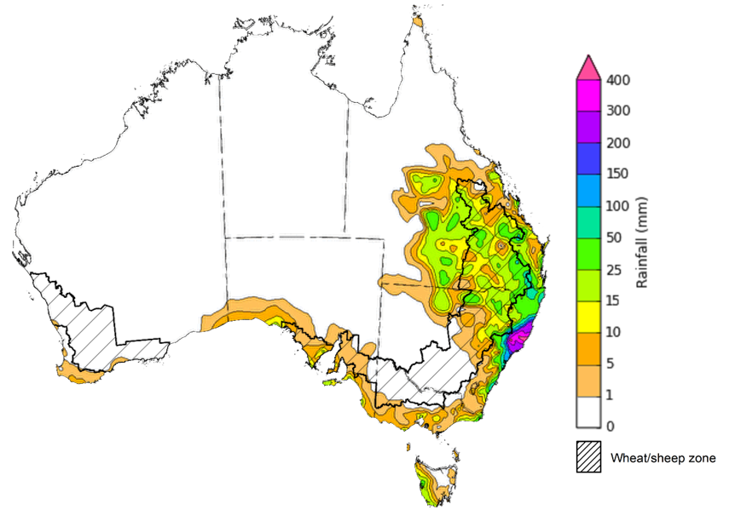

©Commonwealth of Australia 2025, Australian Bureau of Meteorology Issued: 22/5/2025

Note: The rainfall analyses and associated maps utilise data contained in the Bureau of Meteorology climate database, the Australian Data Archive for Meteorology (ADAM). The analyses are initially produced automatically from real-time data with limited [quality control](http://www.bom.gov.au/climate/headers/qc.shtml). They are intended to provide a general overview of rainfall across Australia as quickly as possible after the observations are received. For further information go to <http://www.bom.gov.au/climate/rainfall/>

### Rainfall forecast for the next eight days

Over the 8 days to 29 May 2025, **low-pressure systems and cold fronts** are expected to bring rainfall to parts of south-eastern and north-western Australia.

* Large areas of northern Australia, including northern Western Australia and the Northern Territory, are forecast to receive 5-100 millimetres of rainfall, with higher rainfall totals in western regions.
  + Parts of far-northern Queensland are expected to see 5-50 millimetres of rainfall.
* In the south, rainfall totals of 15-200 millimetres are expected across much of eastern and southern New South Wales, while parts of South Australia and Victoria are likely to see 5 - 50 millimetres. In Tasmania, 50-100 millimetres of rainfall are forecast, with higher totals in the west.
* High-pressure systems are expected to keep most of remainder of Australia relatively dry.

Rainfall totals over the coming week are forecast to be high across south-eastern cropping regions.

* In central and southern New South Wales, between 10-100 millimetres of rainfall is expected over the period.
  + In contrast, lower rainfall totals are expected in South Australia and Victoria, with a rainfall forecast of 10-25 millimetres and 5-50 millimetres, respectively
* Little to no rainfall is expected across cropping zones in Queensland, northern New South Wales and Western Australia.
* If realised, the lack of autumn rainfall continues to present a downside risk to the timely germination and establishment of winter crops particularly in those areas of western Victoria and South Australia with low stored soil moisture.

#### Total forecast rainfall for the period 22 May to 29 May 2025

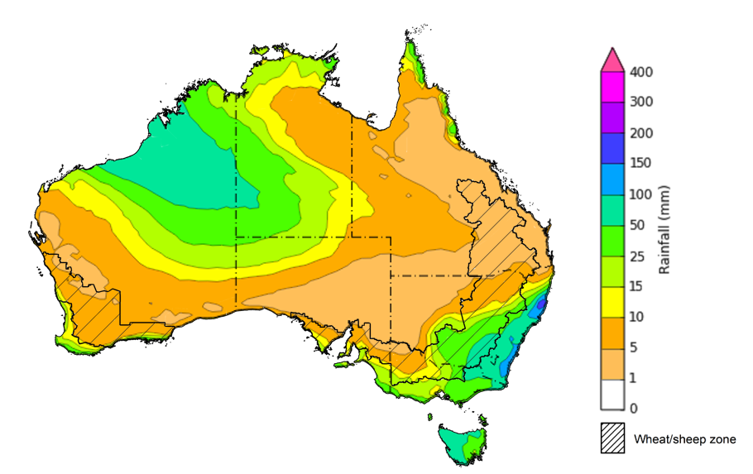

©Commonwealth of Australia 2025, Australian Bureau of Meteorology Issued 22/5/2025

Note: This rainfall forecast is produced from computer models. As the model outputs are not altered by weather forecasters, it is important to check local forecasts and warnings issued by the Bureau of Meteorology.

* 1. **National Climate Outlook**

The El Niño Southern Oscillation (ENSO), Southern Annular Mode (SAM), and Indian Ocean Dipole (IOD) climate drivers are currently neutral and having minimal influence on Australian rainfall. The ENSO is likely to remain neutral until October.

However, while the IOD is likely to remain neutral over the coming months, the Bureau of Meteorology’s model predicts a fall in the IOD index over the coming months, dipping into negative IOD values in July. This is consistent with a range of international models that are also predicting a fall in the IOD index over the next 2 months. A negative IOD typically results in above-average winter–spring rainfall over parts of southern Australia as the warmer waters off northwest Australia provide more available moisture to weather systems crossing the country.

The most recent **rainfall outlook for June 2025** provided by the Bureau of Meteorology indicates that much of Australia is likely to see close to or above **median rainfall,** while parts of northern Australia and the southeast are less likely to see above median rainfall.

* The Bureau of Meteorology’s climate model indicates a 75% chance of June rainfall totals between 10-100 millimetres across much of southern Australia, including Victoria, southern and eastern New South Wales and southern South Australia. Tasmania and southern Western Australia are expected to see between 10-200 millimetres.
* Lower rainfall totals are expected across central and northern Australia, with much of northern Western Australia, the Northern Territory, northern South Australia, and central and northern Queensland likely to see little to no rainfall which is quite typical for this time of year.
* Across cropping regions, there is a **75% chance** of rainfall totals of between **10-50 millimetres across most southern cropping regions.** In contrast, northern New South Wales and Queensland, are likely to see less than 10 millimetres. If realised, this is expected to provide sufficient moisture to support the germination of dry sown winter crops in southern regions.

**Rainfall totals that have a 75% chance of occurring in June 2025**

©Commonwealth of Australia 2025, Australian Bureau of Meteorology Issued: 22/5/2025

The **rainfall outlook for June to August 2025** indicates an increased probability of **above median rainfall across much of inland Australia,** including much of Western Australia, the Northern Territory, South Australia and western Queensland. In contrast, some northern and southern regions are less likely to see above median rainfall, including parts of south-western Western Australia, Victoria and the northern tropics.

Across cropping regions, the chance of receiving above median rainfall is between 50-60% across Queensland, while New South Wales, Victoria and South Australia have a 50-65% probability of receiving above median rainfall over the period. In Western Australia, the rainfall outlook is mixed, with western regions having a 40-50% chance of above median rainfall, and eastern regions having an up to 70% chance of seeing above median rainfall.

**Chance of exceeding the median rainfall** **June 2025 to August 2025**

©Commonwealth of Australia 2025, Australian Bureau of Meteorology Issued: 22/5/2025

The **rainfall outlook for June through to August 2025** suggests a 75% chance of receiving rainfall totals of between 200–600 millimetres across the far south-west of Western Australia, western Tasmania, and alpine areas of New South Wales and Victoria. Between 25–200 millimetres of rainfall are forecast across much of south-eastern Queensland, New South Wales, Victoria, southern South Australia, south-western Western Australia and eastern Tasmania. In northern and central Australia, little to no rainfall is forecast over the period.

In **cropping regions**, there is a **75% chance** of receiving between **50-200 millimetres** in the south, including Western Australia, South Australia, Victoria and New South Wales. In Queensland, falls of 10-100 millimetres are expected. If realised, these falls are likely be sufficient to support the establishment and growth of winter crops.

**Rainfall totals that have a 75% chance of occurring June 2025 to August 2025**

©Commonwealth of Australia 2025, Australian Bureau of Meteorology Issued: 22/5/2025

### Water markets – current week

Water storage levels in the Murray-Darling Basin (MDB) increased by 188 gigalitres (GL) between 15 May 2025 and 22 May 2025. The current volume of water held in storages is 12,092 GL, equivalent to 54% of total storage capacity. This is 28% or 4,634 GL less than at the same time last year. Water storage data is sourced from the Bureau of Meteorology.

Allocation prices in the Victorian Murray below the Barmah Choke decreased from $316 on 15 May to $314 on 22 May. Trade through the Goulburn IVT to the Murray is closed. Trade downstream through the Barmah Choke is closed. Trade out of the Murrumbidgee is open.

#### Surface water trade activity, Southern Murray–Darling Basin

|  |
| --- |
| The trades shown reflect estimated market activity and do not encompass all register trades. The price is shown for the VIC Murray below the Barmah choke. Historical prices (before 1 July 2019) are ABARES estimates after removing outliers from BOM water register data. Prices after 1 July 2019 and prior to the 30 October 2019 reflect recorded transaction prices as sourced from Ruralco. Prices after the 30 October 2019 are sourced from Waterflow. Data for volume traded is sourced from the BOM water register. Only the price data shown is current on 17 October 2024. |

To access the full, interactive, weekly water dashboard, which contains the latest and historical water storage, water market and water allocation information, please visit <https://www.agriculture.gov.au/abares/products/weekly_update/weekly-update-220525>

## **Commodities**

|  |  |  |  |  |  |  |  |  |
| --- | --- | --- | --- | --- | --- | --- | --- | --- |
| **Indicator** | **Week average** | **Unit** | **Latest Price** | **Previous Week** | **Weekly change** | | **Price 12 months ago** | **Annual change** |
| **Selected world indicator prices** |  |  |  |  |  |  | |  |
| AUD/USD Exchange rate | 21-May | A$/US$ | 0.64 | 0.64 | 0% | 0.66 | | -3% |
| Wheat – US no. 2 hard red winter wheat, FOB Gulf | 21-May | US$/t | 239 | 233 | 3% | 288 | | -17% |
| Corn – US no. 2 yellow corn, FOB Gulf | 21-May | US$/t | 205 | 202 | 2% | 196 | | 5% |
| Canola – Rapeseed, Canada, FOB Vancouver | 21-May | US$/t | 546 | 546 | 0% | 516 | | 6% |
| Cotton – Cotlook A Index | 21-May | USc/lb | 78 | 78 | 0% | 86 | | -10% |
| Sugar – Intercontinental Exchange, nearby futures, no.11 contract | 21-May | USc/lb | 17 | 18 | -3% | 19 | | -8% |
| Wool – Eastern Market Indicator | 21-May | Ac/kg clean | 1,203 | 1,189 | 1% | 1,138 | | 6% |
| Wool – Western Market Indicator | 21-May | Ac/kg clean | 1,364 | 1,352 | 1% | 1,273 | | 7% |
| **Selected Australian grain export prices** |  |  |  |  |  |  | |  |
| Australian Premium White (APW) Wheat, FOB Port Adelaide, SA | 21-May | A$/t | 399 | 399 | 0% | 417 | | -4% |
| Australian Standard White (ASW) Wheat, FOB Port Adelaide, SA | 21-May | A$/t | 395 | 395 | 0% | 404 | | -2% |
| Feed Barley – FOB Port Adelaide, SA | 21-May | A$/t | 376 | 375 | 0% | 376 | | 0% |
| Canola – FOB Kwinana, WA | 21-May | A$/t | 798 | 791 | 1% | 751 | | 6% |
| Grain Sorghum – FOB Brisbane, QLD | 21-May | A$/t | 430 | 440 | -2% | 451 | | -5% |
| **Selected domestic livestock indicator prices** |  |  |  |  |  |  | |  |
| Beef – Eastern Young Cattle Indicator | 21-May | Ac/kg cwt | 677 | 677 | 0% | 609 | | 11% |
| Mutton – Mutton indicator (18–24 kg fat score 2–3), VIC | 21-May | Ac/kg cwt | 530 | 517 | 2% | 284 | | 87% |
| Lamb – National Trade Lamb Indicator | 21-May | Ac/kg cwt | 848 | 832 | 2% | 666 | | 27% |
| Pig – Eastern Seaboard (60.1–75 kg), NSW buyer price | 07-May | Ac/kg cwt | 446 | 446 | 0% | 414 | | 8% |
| Live cattle – Light steers to Indonesia | 21-May | Ac/kg lwt | 345 | 345 | 0% | 333 | | 4% |
| **Global Dairy Trade (GDT) weighted average prices** |  |  |  |  |  |  | |  |
| Dairy – Whole milk powder | 21-May | US$/t | 4,332 | 4,374 | -1% | 3,379 | | 28% |
| Dairy – Skim milk powder | 21-May | US$/t | 2,817 | 2,828 | 0% | 2,590 | | 9% |
| Dairy – Cheddar cheese | 21-May | US$/t | 5,007 | 5,519 | -9% | 4,248 | | 18% |
| Dairy – Anhydrous milk fat | 21-May | US$/t | 7,273 | 7,212 | 1% | 7,245 | | 0% |
|  | | | | | | | | |

### 3.2 Selected domestic crop indicator prices

### 3.3 Selected domestic livestock indicator prices

### 3.5 Selected fruit and vegetable prices

### 3.6 Selected domestic fodder indicator prices

## **4. Data attribution**

### Climate

* Bureau of Meteorology
* Weekly rainfall totals: www.bom.gov.au/climate/maps/rainfall/
* Monthly and last 3-month rainfall percentiles: [www.bom.gov.au/water/landscape/](http://www.bom.gov.au/water/landscape/)
* Temperature anomalies: [www.bom.gov.au/jsp/awap/temp/index.jsp](http://www.bom.gov.au/jsp/awap/temp/index.jsp)
* Rainfall forecast: [www.bom.gov.au/jsp/watl/rainfall/pme.jsp](http://www.bom.gov.au/jsp/watl/rainfall/pme.jsp)
* Seasonal outlook: [www.bom.gov.au/climate/outlooks/#/overview/summary/](http://www.bom.gov.au/climate/outlooks/#/overview/summary/)
* Climate drivers: <http://www.bom.gov.au/climate/enso/>
* Soil moisture: [www.bom.gov.au/water/landscape/](http://www.bom.gov.au/water/landscape/)
* Other
* Pasture growth: [www.longpaddock.qld.gov.au/aussiegrass/](http://www.longpaddock.qld.gov.au/aussiegrass/)
* 3-month global outlooks: [Environment and Climate Change Canada](https://weather.gc.ca/saisons/image_e.html?img=s234pfe1p_cal&bc=prob), [NOAA Climate Prediction Center](https://www.cpc.ncep.noaa.gov/products/predictions/long_range/seasonal.php?lead=2), [EUROBRISA CPTEC/INPE](http://eurobrisa.cptec.inpe.br/), European Centre for Medium-Range Weather Forecasts, [Hydrometcenter of Russia](https://meteoinfo.ru/en/climate/seasonal-forecasts), [National Climate Center Climate System Diagnosis and Prediction Room (NCC)](https://cmdp.ncc-cma.net/pred/cs2gen.php?pred_elem=RAINP#pred_seasonal), [International Research Institute for Climate and Society](https://iri.columbia.edu/our-expertise/climate/forecasts/seasonal-climate-forecasts/)
* Global production: <https://ipad.fas.usda.gov/ogamaps/cropmapsandcalendars.aspx>
* Autumn break: Pook et al., 2009, <https://rmets-onlinelibrary-wiley-com.virtual.anu.edu.au/doi/epdf/10.1002/joc.1833>

### Water

Prices

* Waterflow: <https://www.waterflow.io/>
* Ruralco: <https://www.ruralcowater.com.au/>
* Bureau of Meteorology:
* Allocation trade: <http://www.bom.gov.au/water/dashboards/#/water-markets/mdb/at>
* Storage volumes: <http://www.bom.gov.au/water/dashboards/#/water-storages/summary/drainage>
* Trade constraints:
* Water NSW: <https://www.waternsw.com.au/customer-service/ordering-trading-and-pricing/trading/murrumbidgee>
* Victorian Water Register: <https://www.waterregister.vic.gov.au/TradingRules2019/>

### Commodities

* Fruit and vegetables
* Datafresh: [www.freshstate.com.au](http://www.freshstate.com.au)
* Pigs
* Australian Pork Limited: [www.australianpork.com.au](http://www.australianpork.com.au)
* Dairy
* Global Dairy Trade: [www.globaldairytrade.info/en/product-results/](http://www.globaldairytrade.info/en/product-results/)
* World wheat, canola
* International Grains Council
* World coarse grains
* United States Department of Agriculture
* World cotton
* Cotlook: [www.cotlook.com/](http://www.cotlook.com/)
* World sugar
* New York Stock Exchange - Intercontinental Exchange
* Wool
* Australian Wool Exchange: [www.awex.com.au/](http://www.awex.com.au/)
* Domestic wheat, barley, sorghum, canola and fodder
* Jumbuk Consulting Pty Ltd: http://www.jumbukag.com.au/
* Cattle, beef, mutton, lamb, goat and live export
* Meat and Livestock Australia: [www.mla.com.au/Prices-and-market](http://www.mla.com.au/Prices-and-market)

© Commonwealth of Australia 2025

### Ownership of intellectual property rights

Unless otherwise noted, copyright (and any other intellectual property rights, if any) in this publication is owned by the Commonwealth of Australia (referred to as the Commonwealth).

### Creative Commons licence

All material in this publication is licensed under a [Creative Commons Attribution 4.0 International Licence](https://creativecommons.org/licenses/by/4.0/legalcode) except content supplied by third parties, logos and the Commonwealth Coat of Arms.

Inquiries about the licence and any use of this document should be emailed to [copyright@awe.gov.au](mailto:copyright@awe.gov.au).

https://www.agriculture.gov.au/sites/default/files/images/creative-commons-logo-small.png

### Cataloguing data

This publication (and any material sourced from it) should be attributed as:

ABARES 2025, Weekly Australian Climate, Water and Agricultural Update, Australian Bureau of Agricultural and Resource Economics and Sciences, Canberra, ww May 2025. CC BY 4.0 DOI: <https://doi.org/10.25814/5f3e04e7d2503>

ISSN **2652-7561**

This publication is available at https://www.agriculture.gov.au/abares/products/weekly_update

Department of Agriculture, Fisheries and Forestry

GPO Box 858 Canberra ACT 2601

Telephone 1800 900 090

Web [agriculture.gov.au/abares](http://awe.gov.au/abares)

### Disclaimer

The Australian Government acting through the Department of Agriculture, Fisheries and Forestry, represented by the Australian Bureau of Agricultural and Resource Economics and Sciences, has exercised due care and skill in preparing and compiling the information and data in this publication. Notwithstanding, the Department of Agriculture, Fisheries and Forestry, ABARES, its employees and advisers disclaim all liability, including liability for negligence and for any loss, damage, injury, expense or cost incurred by any person as a result of accessing, using or relying on any of the information or data in this publication to the maximum extent permitted by law.

### Statement of Professional Independence

The views and analysis presented in ABARES publications, including this one, reflect ABARES professionally independent findings, based on scientific and economic concepts, principles, information and data. These views, analysis and findings may not reflect or be consistent with the views or positions of the Australian Government, or of organisations or groups who have commissioned ABARES reports or analysis. More information on [professional independence](https://www.agriculture.gov.au/abares/about/research-and-analysis#professional-independence) is provided on the ABARES website.

### Acknowledgements

This report was prepared by Holly Beale and Matthew Miller.