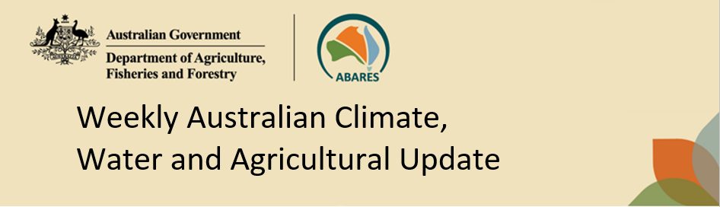
No. 21/2025 29 May 2025

Summary of key issues
- In the week ending 28 May 2025, tropical and polar lows brought rainfall to parts of north-western and south-eastern Australia respectively.
  - Cropping regions in New South Wales received 5-100 millimetres of rainfall, while rainfall was limited in Western Australia, South Australia, Victoria and Queensland.
  - Low rainfall over the recent week will continue to delay the germination of dry sown winter crops in areas where upper layer soil moisture is low.
- Over the coming eight days, rainfall is expected across much of western and eastern Australia.
  - In Western Australia and Queensland, between 10-100 millimetres of rainfall is expected over the period, while lower rainfall totals are expected across parts of northern New South Wales (10- 25 millimetres). Little to no rainfall is expected across southern New South Wales, Victoria and South Australia.
  - The lack of autumn rainfall continues to present a risk to the timely germination and establishment of winter crops – particularly in those areas of western Victoria and South Australia where there is low stored soil moisture.
- Water storage levels in the Murray-Darling Basin (MDB) increased by 185 gigalitres (GL) between 22 May 2025 and 29 May 2025. The current volume of water held in storages is 12,340 GL, equivalent to 55% of total storage capacity. This is 27% or 4,486 GL less than at the same time last year. Water storage data is sourced from the Bureau of Meteorology.
- Allocation prices in the Victorian Murray below the Barmah Choke decreased from $314 on 22 May to $291 on 29 May. Trade from the Goulburn to the Murray is closed. Trade downstream through the Barmah Choke is closed. Trade from the Murrumbidgee to the Murray is open.

Climate

Rainfall this week
In the week ending 28 May 2025, tropical and polar lows brought rainfall to parts of north-western and south-eastern Australia respectively. High-pressure systems kept the remainder of Australia largely dry.
- Between 5-100 millimetres of rainfall was recorded across much of the Northern Territory and northern Western Australia, as well as eastern and central New South Wales, eastern and southern Victoria and Tasmania.
  - Isolated areas recorded as much as 300 millimetres of rainfall over the period.
- In parts of southern Queensland and southern regions of South Australia and Western Australia, rainfall totals of between 5-50 millimetres were observed.
- Remaining areas of the country received little to no rainfall over the period.
Cropping regions across the south and north received mixed rainfall in the week ending 29 May 2025.
- Rainfall totals between 5-50 and as high as 100 millimetres occurred over much of New South Wales, with highest totals recorded in eastern areas.
- In remaining southern regions, including Western Australia, South Australia and Victoria, between 1-10 millimetres fell over most cropping regions.
- Queensland received little to no rainfall over the period.
- Low rainfall in the recent week will continue to delay the germination of dry sown winter crops in areas of south-eastern and Western Australia where upper layer soil moisture is low.

Rainfall for the week ending 29 May 2025
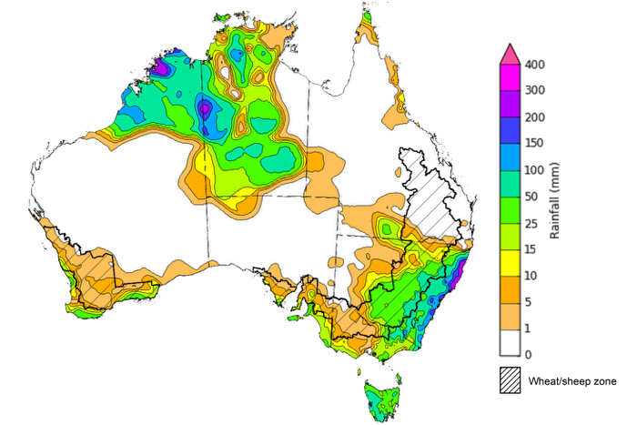
©Commonwealth of Australia 2025, Australian Bureau of Meteorology Issued: 29/5/2025
Note: The rainfall analyses and associated maps utilise data contained in the Bureau of Meteorology climate database, the Australian Data Archive for Meteorology (ADAM). The analyses are initially produced automatically from real-time data with limited quality control. They are intended to provide a general overview of rainfall across Australia as quickly as possible after the observations are received. For further information go to http://www.bom.gov.au/climate/rainfall/

Rainfall forecast for the next eight days
Over the 8 days to 5 June 2025, low-pressure systems and cold fronts are expected to bring rainfall to parts western, eastern and southern Australia.
- Large areas of western and central Western Australia and eastern Queensland are expected to see 10-100 millimetres of rainfall.
  - Meanwhile, far-north Queensland is expected to see a lower rainfall total of 10-25 millimetres.
- A low-pressure system is expected to bring 15-50 millimetres of rainfall to northern New South Wales and Tasmania, and southern areas of Victoria and South Australia.
- High-pressure systems are expected to keep most of remainder of Australia relatively dry.
Rainfall totals over the coming week are forecast to be low across south-eastern cropping regions, and higher in the west and northeast.
- In Western Australia, cropping regions are forecast to see 15-100 millimetres of rainfall, while Queensland is forecast to see 10-100, with higher rainfall totals in the north. In northern New South Wales, 10-25 millimetres of rain is expected.
- Little to no rainfall is expected across cropping zones in South Australia, Victoria, and southern New South Wales.
- If realised, the lack of autumn rainfall continues to present a downside risk to the timely germination and establishment of winter crops particularly in those areas of western Victoria and South Australia with low stored soil moisture.

Total forecast rainfall for the period 29 May to 5 June 2025
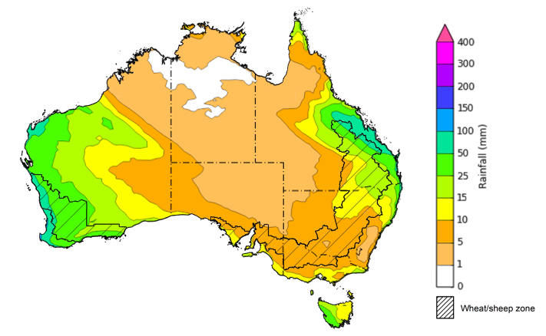
©Commonwealth of Australia 2025, Australian Bureau of Meteorology Issued 29/5/2025
Note: This rainfall forecast is produced from computer models. As the model outputs are not altered by weather forecasters, it is important to check local forecasts and warnings issued by the Bureau of Meteorology.

Water markets – current week
Water storage levels in the Murray-Darling Basin (MDB) increased by 185 gigalitres (GL) between 22 May 2025 and 29 May 2025. The current volume of water held in storages is 12,340 GL, equivalent to 55% of total storage capacity. This is 27% or 4,486 GL less than at the same time last year.
Water storage data is sourced from the Bureau of Meteorology.

Water storages in the Murray-Darling Basin, 2013–2025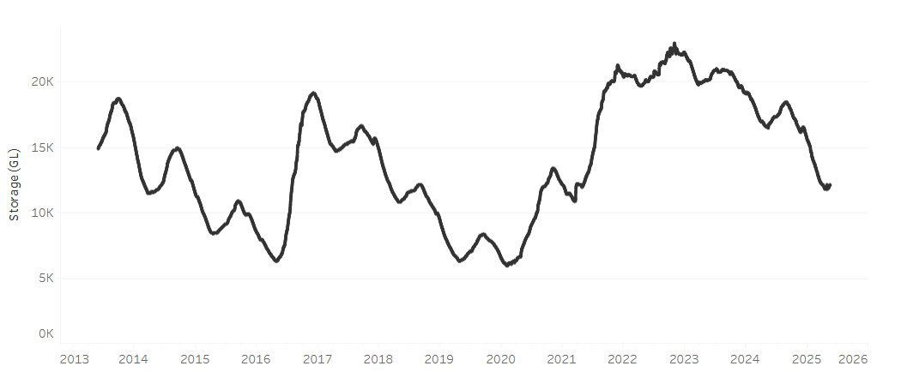
Allocation prices in the Victorian Murray below the Barmah Choke decreased from $314 on 22 May to $291 on 29 May. Trade from the Goulburn to the Murray is closed. Trade downstream through the Barmah Choke is closed. Trade from the Murrumbidgee to the Murray is open.

Surface water trade activity, Southern Murray–Darling Basin
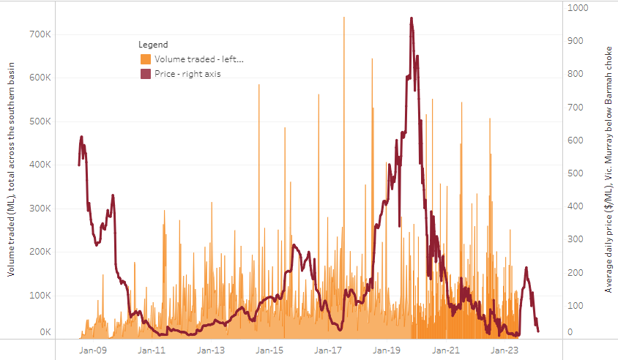
The trades shown reflect estimated market activity and do not encompass all register trades. The price is shown for the VIC Murray below the Barmah choke. Historical prices (before 1 July 2019) are ABARES estimates after removing outliers from BOM water register data. Prices after 1 July 2019 and prior to the 30 October 2019 reflect recorded transaction prices as sourced from Ruralco. Prices after the 30 October 2019 are sourced from Waterflow. Data for volume traded is sourced from the BOM water register. Only the price data shown is current on 17 October 2024.

To access the full, interactive, weekly water dashboard, which contains the latest and historical water storage, water market and water allocation information, please visit https://www.agriculture.gov.au/abares/products/weekly_update/weekly-update-290525

Commodities
Indicator | Week average | Unit | Latest Price | Previous Week | Weekly change |  | Price 12 months ago | Annual change
Selected world indicator prices
AUD/USD Exchange rate | 28-May | A$/US$ | 0.65 | 0.64 | 1% | 0.66 |  | -2%
Wheat – US no. 2 hard red winter wheat, FOB Gulf | 28-May | US$/t | 238 | 241 | -1% | 288 |  | -18%
Corn – US no. 2 yellow corn, FOB Gulf | 28-May | US$/t | 206 | 206 | 0% | 196 |  | 5%
Canola – Rapeseed, Canada, FOB Vancouver | 28-May | US$/t | 565 | 552 | 2% | 516 |  | 9%
Cotton – Cotlook A Index | 28-May | USc/lb | 78 | 78 | 0% | 86 |  | -9%
Sugar – Intercontinental Exchange, nearby futures, no.11 contract | 28-May | USc/lb | 17 | 18 | -1% | 19 |  | -8%
Wool – Eastern Market Indicator | 28-May | Ac/kg clean | 1,204 | 1,203 | 0% | 1,138 |  | 6%
Wool – Western Market Indicator | 28-May | Ac/kg clean | 1,366 | 1,364 | 0% | 1,273 |  | 7%
Selected Australian grain export prices
Australian Premium White (APW) Wheat, FOB Port Adelaide, SA | 28-May | A$/t | 396 | 399 | -1% | 417 |  | -5%
Australian Standard White (ASW) Wheat, FOB Port Adelaide, SA | 28-May | A$/t | 392 | 395 | -1% | 404 |  | -3%
Feed Barley – FOB Port Adelaide, SA | 28-May | A$/t | 375 | 377 | -1% | 376 |  | 0%
Canola – FOB Kwinana, WA | 28-May | A$/t | 802 | 798 | 0% | 751 |  | 7%
Grain Sorghum – FOB Brisbane, QLD | 28-May | A$/t | 428 | 429 | 0% | 451 |  | -5%
Selected domestic livestock indicator prices
Beef – Eastern Young Cattle Indicator | 28-May | Ac/kg cwt | 705 | 680 | 4% | 609 |  | 16%
Mutton – Mutton indicator (18–24 kg fat score 2–3), VIC | 28-May | Ac/kg cwt | 585 | 541 | 8% | 284 |  | 106%
Lamb – National Trade Lamb Indicator | 28-May | Ac/kg cwt | 910 | 856 | 6% | 666 |  | 37%
Pig – Eastern Seaboard (60.1–75 kg), NSW buyer price | 14-May | Ac/kg cwt | 445 | 446 | 0% | 414 |  | 8%
Live cattle – Light steers to Indonesia | 28-May | Ac/kg lwt | 345 | 345 | 0% | 333 |  | 4%
Global Dairy Trade (GDT) weighted average prices
Dairy – Whole milk powder | 21-May | US$/t | 4,332 | 4,374 | -1% | 3,379 |  | 28%
Dairy – Skim milk powder | 21-May | US$/t | 2,817 | 2,828 | 0% | 2,590 |  | 9%
Dairy – Cheddar cheese | 21-May | US$/t | 5,007 | 5,519 | -9% | 4,248 |  | 18%
Dairy – Anhydrous milk fat | 21-May | US$/t | 7,273 | 7,212 | 1% | 7,245 |  | 0%

Selected world indicator prices
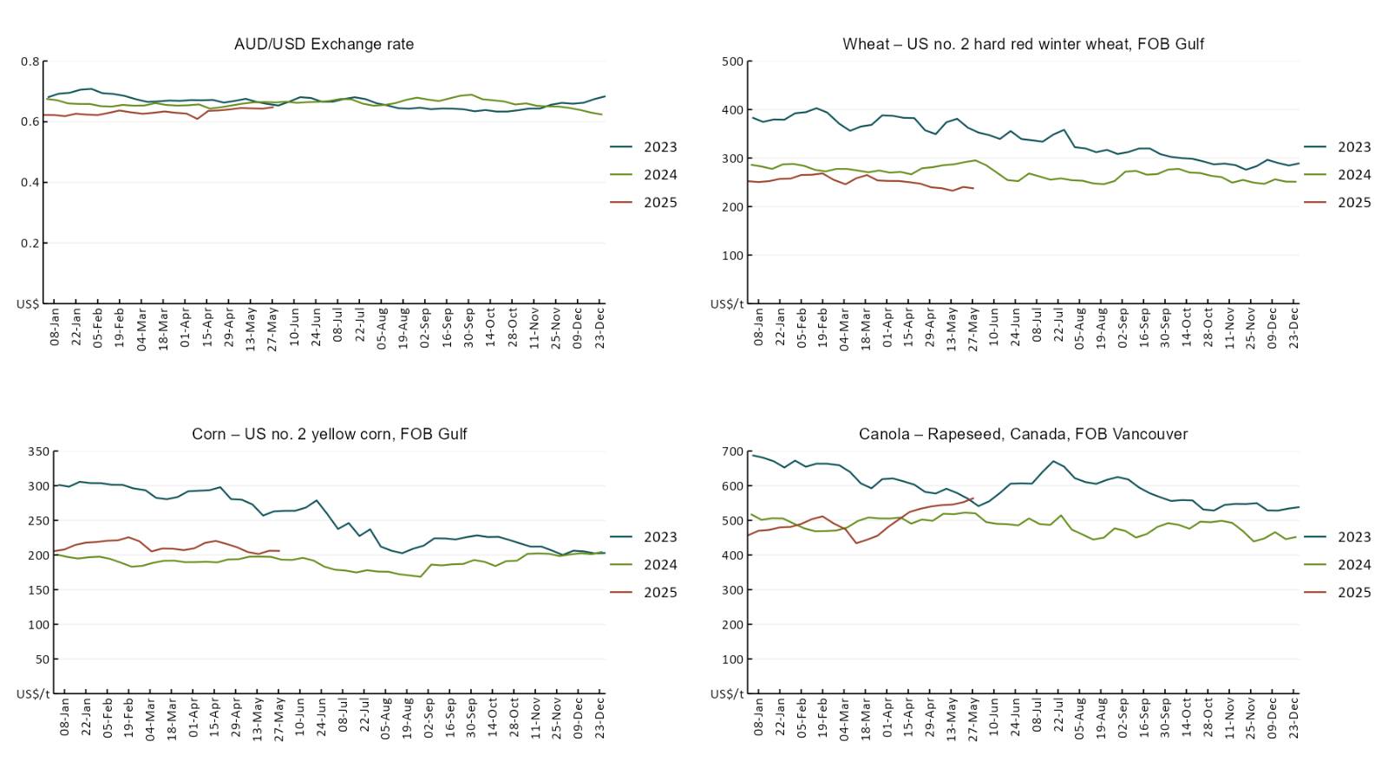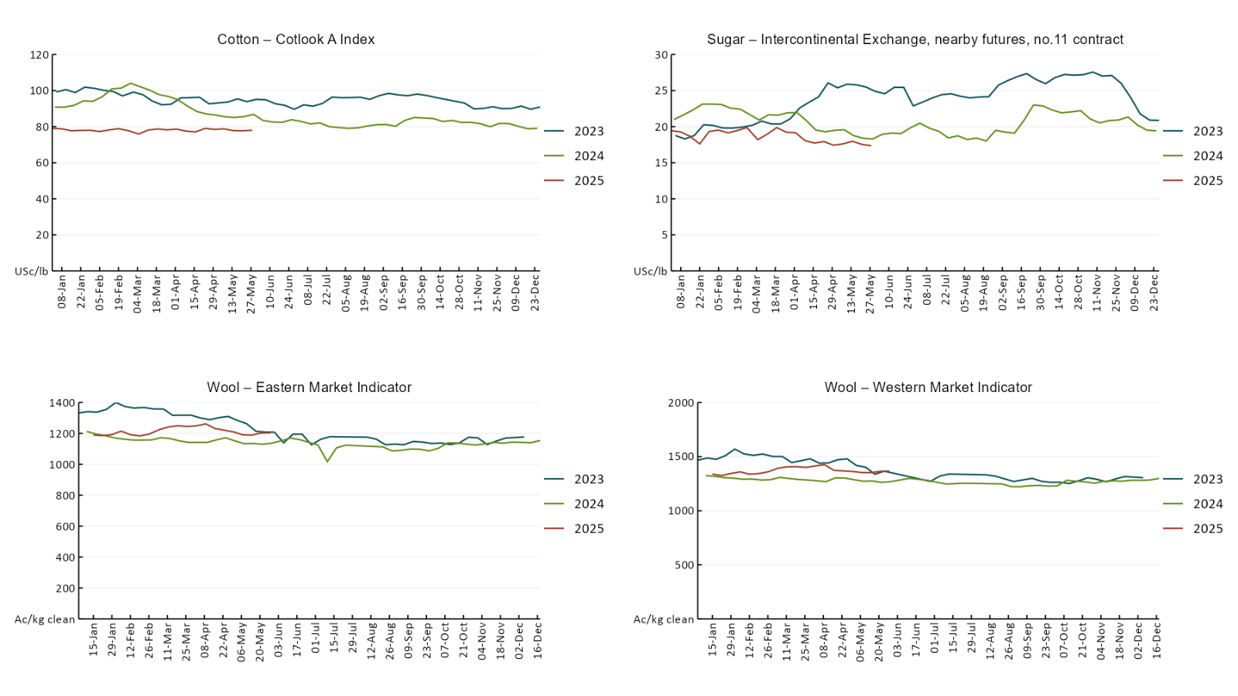

3.2 Selected domestic crop indicator prices
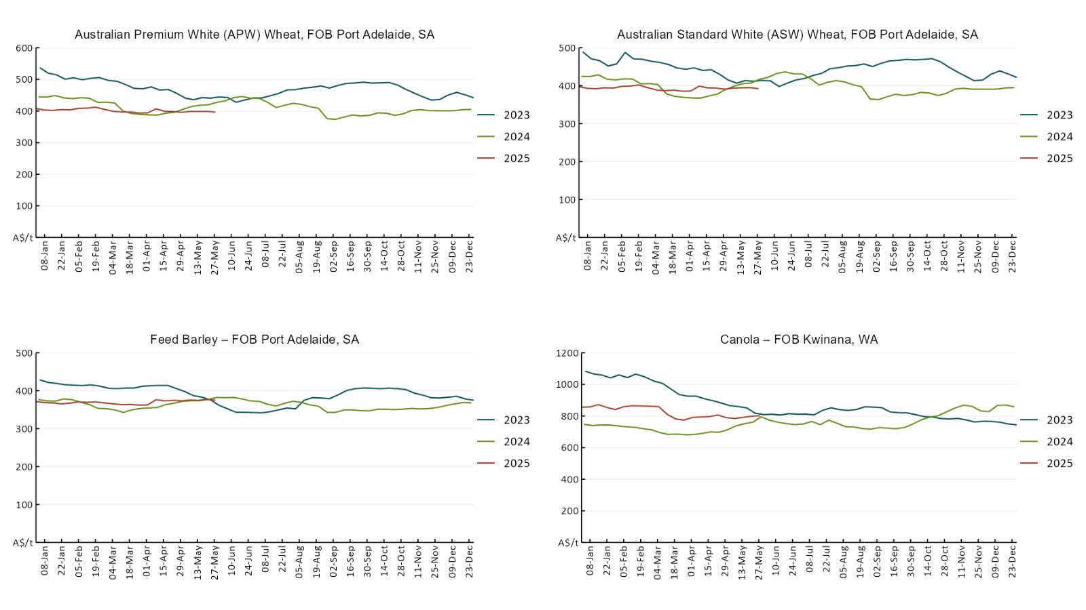

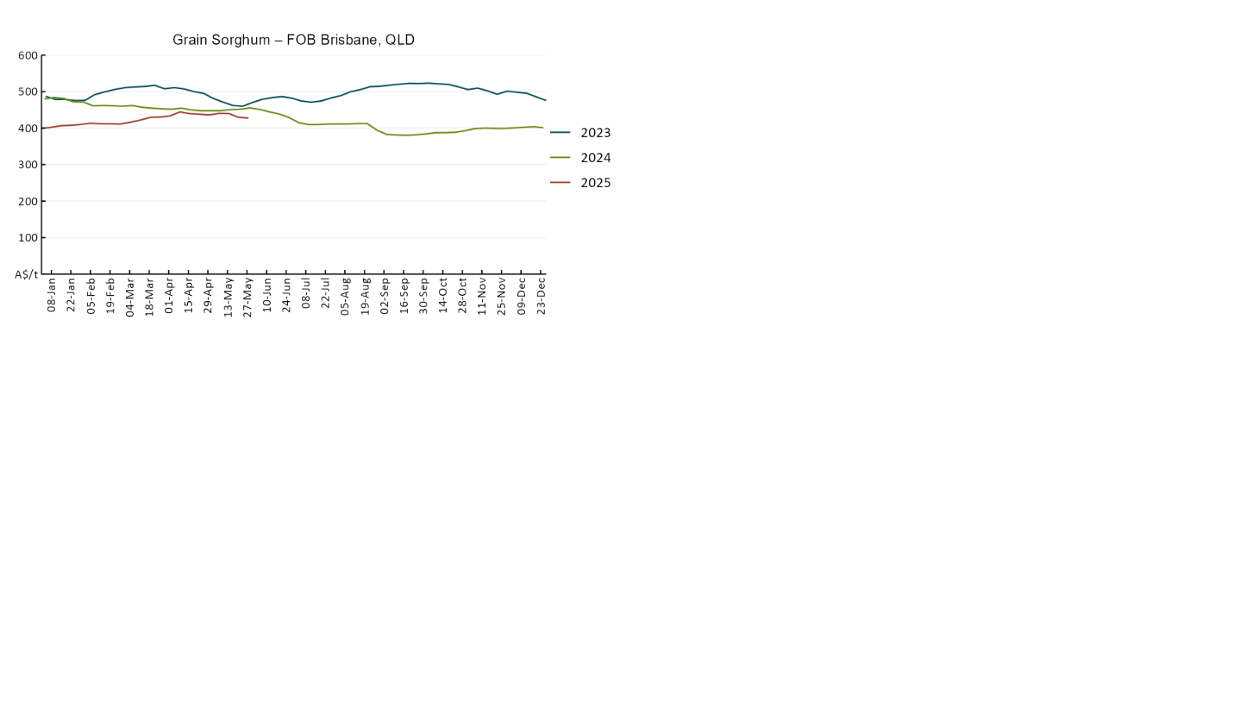

3.3 Selected domestic livestock indicator prices
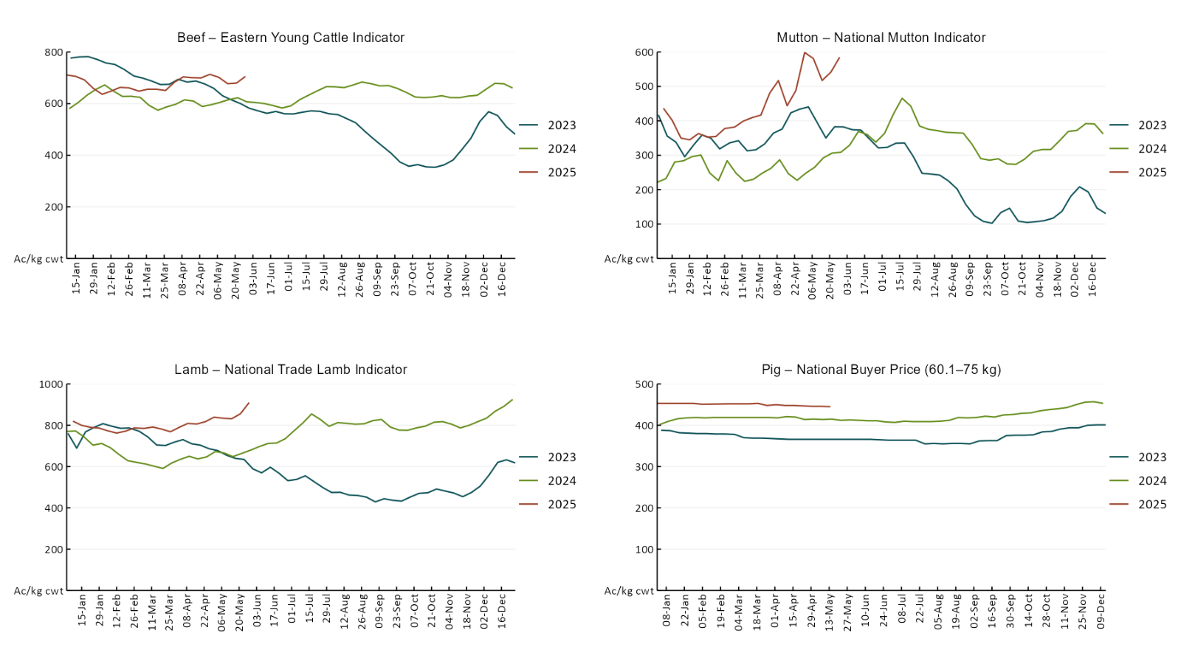

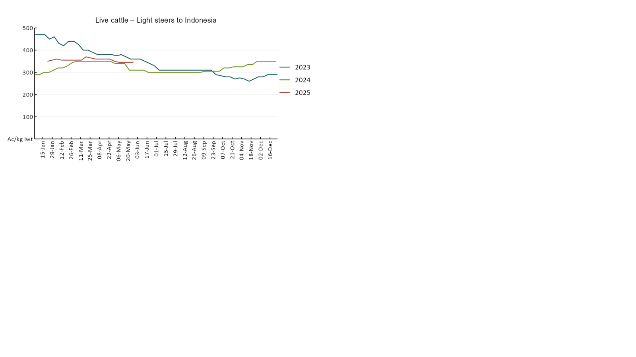

3.4 Global Dairy Trade (GDT) weighted average prices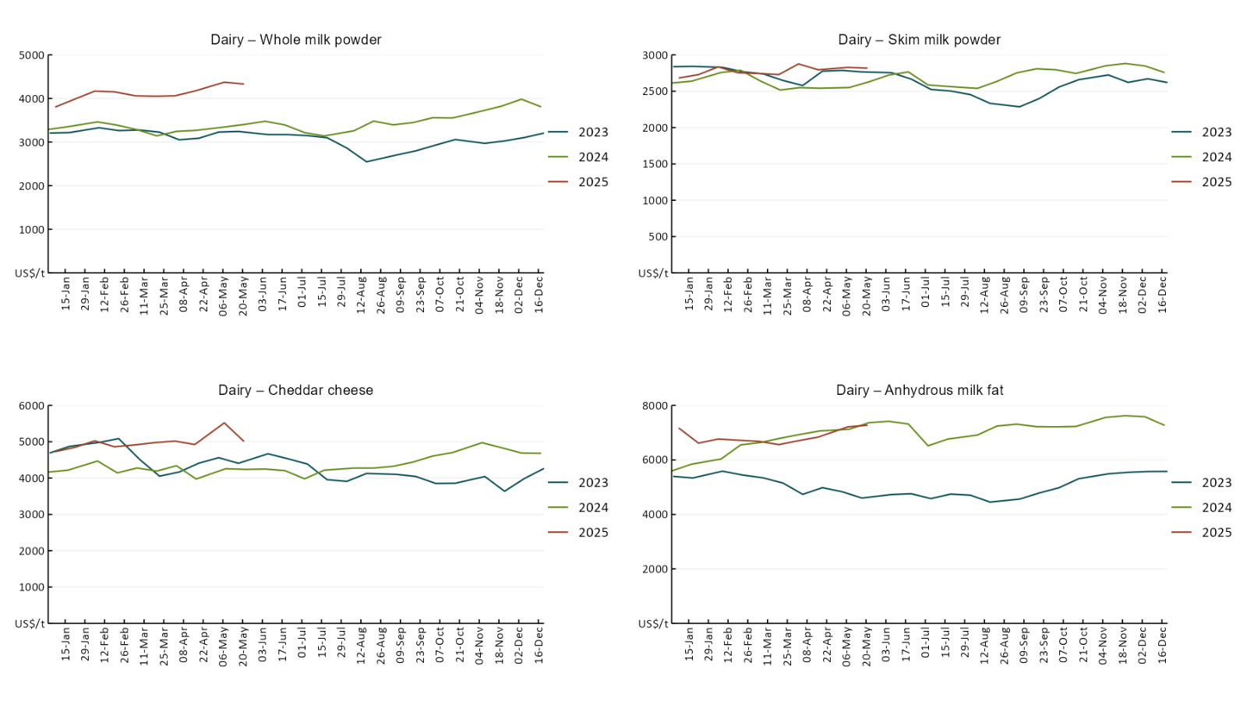

3.5 Selected fruit and vegetable prices

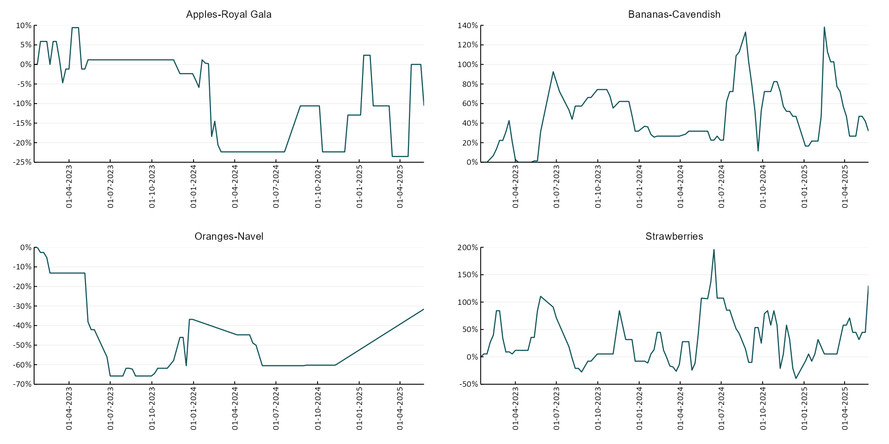

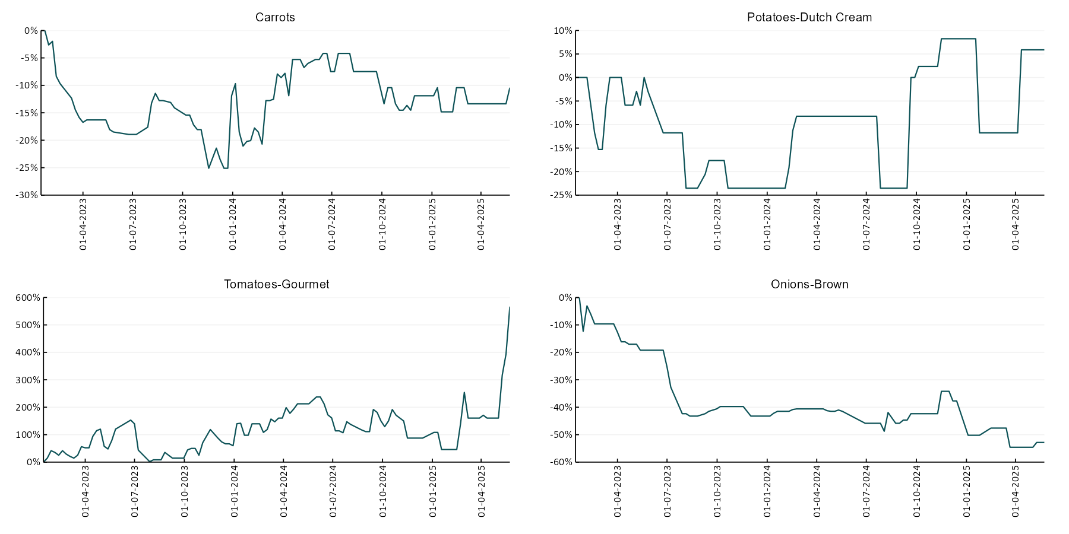

3.6 Selected domestic fodder indicator prices
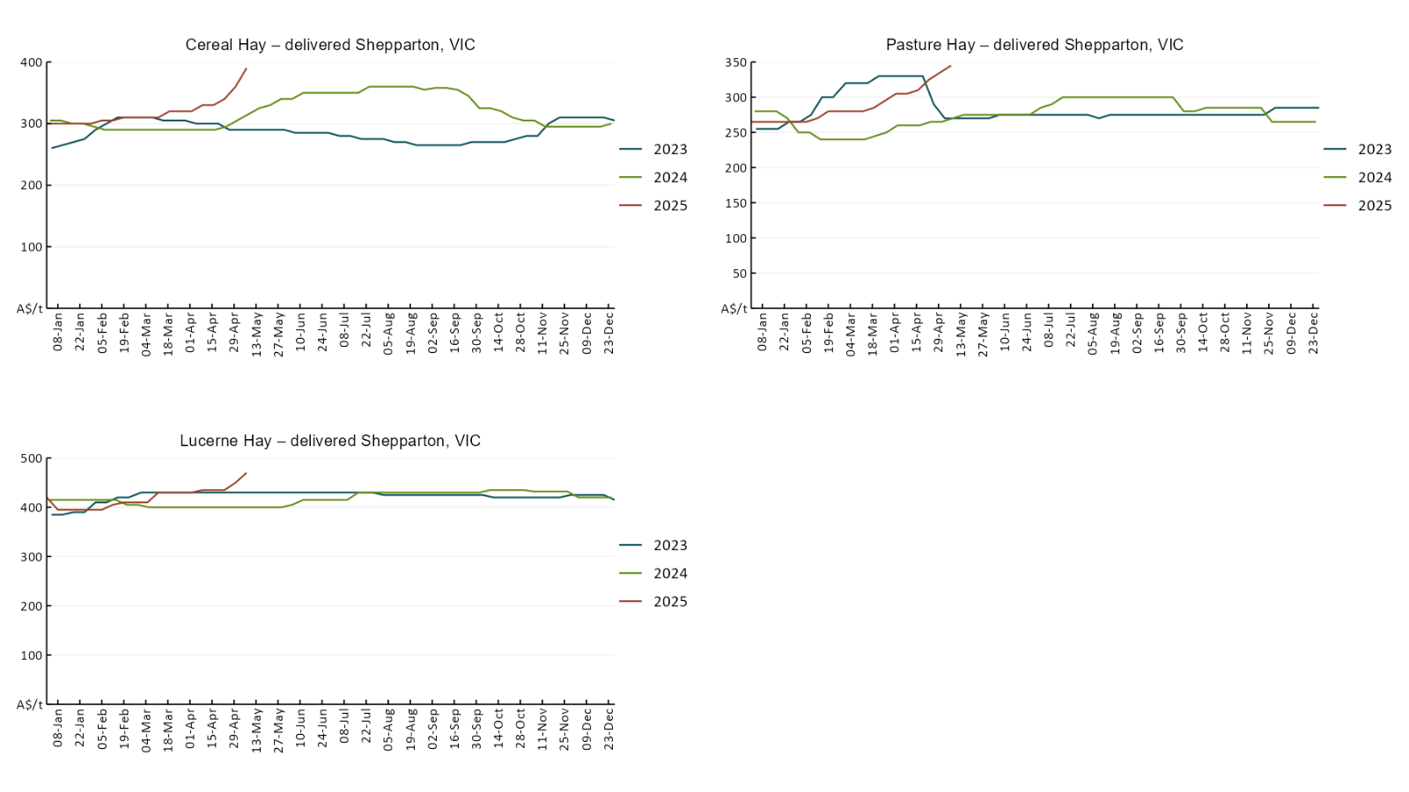

4. Data attribution

Climate
- Bureau of Meteorology
- Weekly rainfall totals: www.bom.gov.au/climate/maps/rainfall/
- Monthly and last 3-month rainfall percentiles: www.bom.gov.au/water/landscape/
- Temperature anomalies: www.bom.gov.au/jsp/awap/temp/index.jsp
- Rainfall forecast: www.bom.gov.au/jsp/watl/rainfall/pme.jsp
- Seasonal outlook: www.bom.gov.au/climate/outlooks/#/overview/summary/
- Climate drivers: http://www.bom.gov.au/climate/enso/
- Soil moisture: www.bom.gov.au/water/landscape/
- Other
- Pasture growth: www.longpaddock.qld.gov.au/aussiegrass/
- 3-month global outlooks: Environment and Climate Change Canada, NOAA Climate Prediction Center, EUROBRISA CPTEC/INPE, European Centre for Medium-Range Weather Forecasts, Hydrometcenter of Russia, National Climate Center Climate System Diagnosis and Prediction Room (NCC), International Research Institute for Climate and Society
- Global production: https://ipad.fas.usda.gov/ogamaps/cropmapsandcalendars.aspx
- Autumn break: Pook et al., 2009, https://rmets-onlinelibrary-wiley-com.virtual.anu.edu.au/doi/epdf/10.1002/joc.1833

Water
Prices
- Waterflow: https://www.waterflow.io/
- Ruralco: https://www.ruralcowater.com.au/
- Bureau of Meteorology:
- Allocation trade: http://www.bom.gov.au/water/dashboards/#/water-markets/mdb/at
- Storage volumes: http://www.bom.gov.au/water/dashboards/#/water-storages/summary/drainage
- Trade constraints:
- Water NSW: https://www.waternsw.com.au/customer-service/ordering-trading-and-pricing/trading/murrumbidgee
- Victorian Water Register: https://www.waterregister.vic.gov.au/TradingRules2019/

Commodities
- Fruit and vegetables
- Datafresh: www.freshstate.com.au
- Pigs
- Australian Pork Limited: www.australianpork.com.au
- Dairy
- Global Dairy Trade: www.globaldairytrade.info/en/product-results/
- World wheat, canola
- International Grains Council
- World coarse grains
- United States Department of Agriculture
- World cotton
- Cotlook: www.cotlook.com/
- World sugar
- New York Stock Exchange - Intercontinental Exchange
- Wool
- Australian Wool Exchange: www.awex.com.au/
- Domestic wheat, barley, sorghum, canola and fodder
- Jumbuk Consulting Pty Ltd: http://www.jumbukag.com.au/
- Cattle, beef, mutton, lamb, goat and live export
- Meat and Livestock Australia: www.mla.com.au/Prices-and-market
© Commonwealth of Australia 2025

Ownership of intellectual property rights
Unless otherwise noted, copyright (and any other intellectual property rights, if any) in this publication is owned by the Commonwealth of Australia (referred to as the Commonwealth).

Creative Commons licence
All material in this publication is licensed under a Creative Commons Attribution 4.0 International Licence except content supplied by third parties, logos and the Commonwealth Coat of Arms.
Inquiries about the licence and any use of this document should be emailed to copyright@awe.gov.au.


Cataloguing data
This publication (and any material sourced from it) should be attributed as:
ABARES 2025, Weekly Australian Climate, Water and Agricultural Update, Australian Bureau of Agricultural and Resource Economics and Sciences, Canberra, 29 May 2025. CC BY 4.0 DOI: https://doi.org/10.25814/5f3e04e7d2503
ISSN 2652-7561
This publication is available at https://www.agriculture.gov.au/abares/products/weekly_update
Department of Agriculture, Fisheries and Forestry
GPO Box 858 Canberra ACT 2601
Telephone 1800 900 090
Web agriculture.gov.au/abares

Disclaimer
The Australian Government acting through the Department of Agriculture, Fisheries and Forestry, represented by the Australian Bureau of Agricultural and Resource Economics and Sciences, has exercised due care and skill in preparing and compiling the information and data in this publication. Notwithstanding, the Department of Agriculture, Fisheries and Forestry, ABARES, its employees and advisers disclaim all liability, including liability for negligence and for any loss, damage, injury, expense or cost incurred by any person as a result of accessing, using or relying on any of the information or data in this publication to the maximum extent permitted by law.

Statement of Professional Independence
The views and analysis presented in ABARES publications, including this one, reflect ABARES professionally independent findings, based on scientific and economic concepts, principles, information and data. These views, analysis and findings may not reflect or be consistent with the views or positions of the Australian Government, or of organisations or groups who have commissioned ABARES reports or analysis. More information on professional independence is provided on the ABARES website.

Acknowledgements
This report was prepared by Holly Beale and Matthew Miller.

