## DecorativeNo. 23/2025 12 June 2025

# Summary of key issues

* In the week ending 11 June 2025 cold fronts and low-pressure systems brought rainfall to much of southern Australia.
  + Cropping regions in Victoria, South Australia and parts of southern New South Wales received 5-50 millimetres of rainfall. Western Australian cropping regions recorded between 1-10 millimetres of rainfall. Meanwhile, little or no rainfall was recorded in eastern and northern regions.
  + Across most cropping regions in South Australia, Victoria and southern New South Wales these falls have likely provided sufficient moisture to support the germination of dry sown winter crops and may see some improvement in soil moisture levels.
  + However, across parts of the Eyre Peninsula and the Mallee regions in South Australia and Victoria recorded totals were lower than previously forecast. This means that crops in these areas have received sufficient rainfall to trigger germination of dry sown crops but will require follow-up rainfall in the coming weeks to ensure successful crop establishment.
* Over the coming eight days, rainfall is expected across parts of southern Australia.
  + 10-50 millimetres of rainfall is expected in Western Australian cropping regions, while other southern cropping regions are expected to receive lower rainfall totals of 5-25 millimetres. Eastern cropping regions are likely to have little to no rainfall.
* The **national rainfall outlook** for July to September 2025 indicates an increased probability of above median rainfall across much of inland Australia. However, some southern regions are likely to see below median rainfall.
  + If realised, the expectation of close to average July to September 2025 rainfall across most winter cropping regions is likely be sufficient to support the establishment and growth of winter crops.
* Water storage levels in the Murray-Darling Basin (MDB) increased by 49 gigalitres (GL) between 5 June 2025 and 12 June 2025. The current volume of water held in storages is 12,661 GL, equivalent to 57% of total storage capacity. This is 26% or 4,477 GL less than at the same time last year. Water storage data is sourced from the Bureau of Meteorology.
* Allocation prices in the Victorian Murray below the Barmah Choke decreased from $290/ML on 5 June to $250/ML on 12 June. Trade from the Goulburn to the Murray is closed. Trade downstream through the Barmah Choke is closed. Trade from the Murrumbidgee to the Murray is open.

## **Climate**

### Rainfall this week

In the week ending 11 June 2025, **cold fronts and low-pressure systems** brought rainfall to much of southern Australia. High-pressure systems kept the rest of Australia largely dry.

* Between 5-100 millimetres of rainfall was recorded across Victoriaand parts of southern Western Australia. In Tasmania, 15-100 millimetres of rainfall was observed. Meanwhile, much of southern and parts of eastern New South Wales and South Australia recorded between 5- 50 millimetres of rainfall.
* Northern and central regions of the country received little to no rainfall over the period.

Rainfall was recorded across cropping regions in the southeast, while western and north-eastern areas remained largely dry in the week ending 11 June 2025.

* Rainfall totals of between 5-50 millimetres occurred over much of South Australia, Victoria and southern New South Wales. Meanwhile, Western Australian cropping regions recorded between 1-10 millimetres of rainfall over the period. Little to no rainfall was recorded across remaining cropping regions, including northern New South Wales and Queensland.
* Across most cropping regions in South Australia, Victoria and southern New South Wales these falls have likely provided sufficient moisture to support the germination of dry sown winter crops and may see some improvement in soil moisture levels.
* However, across parts of the Eyre Peninsula and the Mallee regions in South Australia and Victoria recorded totals were lower than previously expected. This means that crops in these areas are at risk of suffering a false break, which is where a rainfall event is sufficient to triggers germination of seeds, however if it is followed by a dry period this often results in the failure of these newly germinated seedlings.

#### Rainfall for the week ending 11 June 2025

[alt text: Map showing weekly rainfall totals in Australia. Image provided by the Bureau of Meteorology. Please refer to accompanying text for a more detailed description.] 


©Commonwealth of Australia 2025, Australian Bureau of Meteorology Issued: 4/6/2025

Note: The rainfall analyses and associated maps utilise data contained in the Bureau of Meteorology climate database, the Australian Data Archive for Meteorology (ADAM). The analyses are initially produced automatically from real-time data with limited [quality control](http://www.bom.gov.au/climate/headers/qc.shtml). They are intended to provide a general overview of rainfall across Australia as quickly as possible after the observations are received. For further information go to <http://www.bom.gov.au/climate/rainfall/>

### Rainfall forecast for the next eight days

Over the 8 days to 19 June 2025, **high-pressure systems** are expected to keep most of Australia largely dry, with exceptions in the far north and south.

* Large areas of southern Western Australia are expected to see between 10-50 millimetres, with some regions to see falls of up to 100 millimetres, while far-north Queensland and Tasmania are forecast to see 5-50 millimetres.
  + Meanwhile, southern regions of South Australia and Victoria are forecast to see 5- 25 millimetres in isolated areas.
  + Little to no rainfall is expected across much of the remainder of the country over this period.

Some rainfall is expected across most southern cropping regions over the coming week, with little expected in the east.

* In Western Australia, between 5-50 millimetres is expected over the period. If realised, this should provide sufficient moisture to support the establishment and growth of winter crops.
* Meanwhile, lower rainfall totals of between 5 and 15 millimetres are expected across South Australia and southern and eastern Victoria.
  + If realised these falls will add some useful follow-up moisture to those regions that received rainfall last week. However, further rainfall will be required in coming week to support the establishment of newly germinated crops in some areas.
* Little to no rainfall is expected across cropping zones in Queensland and New South Wales.

#### Total forecast rainfall for the period 12 June to 19 June 2025

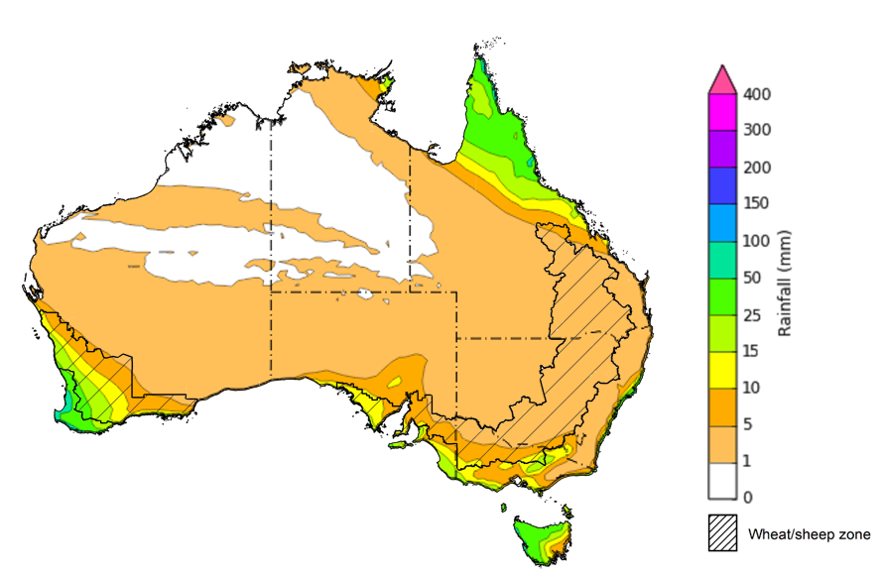

©Commonwealth of Australia 2025, Australian Bureau of Meteorology Issued 19/6/2025

Note: This rainfall forecast is produced from computer models. As the model outputs are not altered by weather forecasters, it is important to check local forecasts and warnings issued by the Bureau of Meteorology.

* 1. **National Climate Outlook**

The El Niño Southern Oscillation (ENSO), Southern Annular Mode (SAM), and Indian Ocean Dipole (IOD) climate drivers are currently neutral and having minimal influence on Australian rainfall. The ENSO is likely to remain neutral until October. Meanwhile, the Bureau of Meteorology’s model predicts a fall in the IOD index over the coming months, dipping into negative IOD values in July. This is consistent with a range of international models that are also predicting a fall in the IOD index over the next 2 months. A negative IOD typically results in above-average winter–spring rainfall over parts of southern Australia as the warmer waters off northwest Australia provide more available moisture to weather systems crossing the country.

The most recent **rainfall outlook for July 2025** provided by the Bureau of Meteorology indicates that much of Australia is likely to see close to or above **median rainfall.** However**,** large areas of south-eastern, south-western and north-western are more likely to see below median rainfall.

* The Bureau of Meteorology’s climate model indicates a 75% chance of July rainfall totals between 10-100 millimetres across much of southern Australia, including Victoria, central and eastern New South Wales and southern South Australia. Tasmania and southern Western Australia are expected to see between 10-200 millimetres.
* Lower rainfall totals are expected across central and northern Australia, with much of northern Western Australia, the Northern Territory, northern South Australia, and central and northern Queensland likely to see little to no rainfall, which is quite typical for this time of year.
* Across cropping regions, there is a **75% chance** of rainfall totals of between **10-50 millimetres across most southern cropping regions.** If realised, this is expected to provide sufficient moisture to support the establishment and growth of winter crops across most southern growing regions. In contrast, most Queensland cropping regions are likely to see less than 10 millimetres while northern Queensland to see between 0-10 millimetres. These lower expected rainfall totals are unlikely to adversely impact crop growth as crops will be able to utilise soil moisture reserves to support their growth and development.

**Rainfall totals that have a 75% chance of occurring in July 2025**

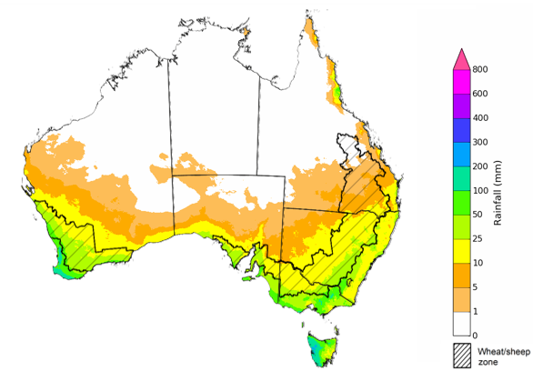

©Commonwealth of Australia 2025, Australian Bureau of Meteorology Issued: 12/6/2025

The **rainfall outlook for July to September 2025** indicates an increased probability of **above median rainfall across much of inland Australia,** including much of eastern Western Australia, the Northern Territory, South Australia, northern New South Wales and Queensland. In contrast, some southern regions are more likely to see below median rainfall, including parts of south-western Western Australia, Victoria and Tasmania.

Across cropping regions, the chance of receiving above median rainfall is between 50-65% across Queensland and New South Wales, while Victoria and Western Australia have a 30-50% probability of receiving above median rainfall over the period. In South Australia, the probability of below or above median rainfall is largely equal.

**Chance of exceeding the median rainfall July 2025 to September 2025**

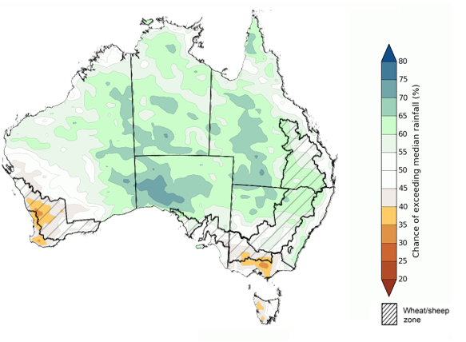

©Commonwealth of Australia 2025, Australian Bureau of Meteorology Issued: 12/6/2025

The **rainfall outlook for July through to September 2025** suggests a 75% chance of receiving rainfall totals of between 200–600 millimetres across the far south-west of Western Australia, western Tasmania, and alpine areas of New South Wales and Victoria. Between 25–200 millimetres of rainfall are forecast across much of south-eastern Queensland, New South Wales, Victoria, southern South Australia, south-western Western Australia and eastern Tasmania. In northern and central Australia, little to no rainfall is forecast over the period.

In **cropping regions**, there is a **75% chance** of receiving between **50-200 millimetres** in the south, including Western Australia, South Australia, Victoria and New South Wales. In Queensland, falls of 10-100 millimetres are expected. If realised, these falls are likely be sufficient to support the establishment and growth of winter crops.

**Rainfall totals that have a 75% chance of occurring July 2025 to September 2025**

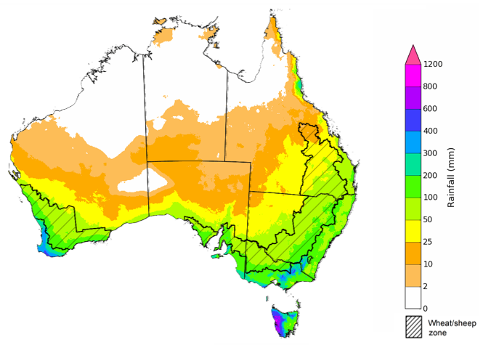

©Commonwealth of Australia 2025, Australian Bureau of Meteorology Issued: 12/6/2025

### Water markets – current week

Water storage levels in the Murray-Darling Basin (MDB) increased by 49 gigalitres (GL) between 5 June 2025 and 12 June 2025. The current volume of water held in storages is 12,661 GL, equivalent to 57% of total storage capacity. This is 26% or 4,477 GL less than at the same time last year. Water storage data is sourced from the Bureau of Meteorology.

#### Water storages in the Murray-Darling Basin, 2013–2025Alt Text: A chart showing water storage in the Murray-Darling Basin. For more information, refer to accompanying text

Allocation prices in the Victorian Murray below the Barmah Choke decreased from $290/ML on 5 June to $250/ML on 12 June. Trade from the Goulburn to the Murray is closed. Trade downstream through the Barmah Choke is closed. Trade from the Murrumbidgee to the Murray is open.

#### Surface water trade activity, Southern Murray–Darling Basin

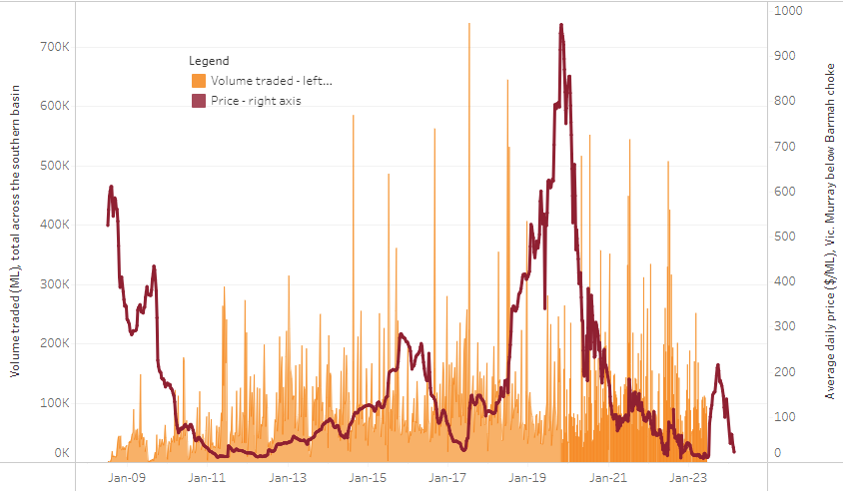

|  |
| --- |
| The trades shown reflect estimated market activity and do not encompass all register trades. The price is shown for the VIC Murray below the Barmah choke. Historical prices (before 1 July 2019) are ABARES estimates after removing outliers from BOM water register data. Prices after 1 July 2019 and prior to the 30 October 2019 reflect recorded transaction prices as sourced from Ruralco. Prices after the 30 October 2019 are sourced from Waterflow. Data for volume traded is sourced from the BOM water register. Only the price data shown is current on 17 October 2024. |

To access the full, interactive, weekly water dashboard, which contains the latest and historical water storage, water market and water allocation information, please visit <https://www.agriculture.gov.au/abares/products/weekly_update/weekly-update-126525>

## **Commodities**

|  |  |  |  |  |  |  |  |  |
| --- | --- | --- | --- | --- | --- | --- | --- | --- |
| **Indicator** | **Week average** | **Unit** | **Latest Price** | **Previous Week** | **Weekly change** | | **Price 12 months ago** | **Annual change** |
| **Selected world indicator prices** |  |  |  |  |  |  | |  |
| AUD/USD Exchange rate | 11-Jun | A$/US$ | 0.65 | 0.65 | 1% | 0.66 | | -2% |
| Wheat – US no. 2 hard red winter wheat, FOB Gulf | 11-Jun | US$/t | 238 | 241 | -1% | 266 | | -10% |
| Corn – US no. 2 yellow corn, FOB Gulf | 11-Jun | US$/t | 198 | 199 | -1% | 191 | | 4% |
| Canola – Rapeseed, Canada, FOB Vancouver | 11-Jun | US$/t | 556 | 547 | 2% | 490 | | 13% |
| Cotton – Cotlook A Index | 11-Jun | USc/lb | 78 | 78 | 0% | 83 | | -6% |
| Sugar – Intercontinental Exchange, nearby futures, no.11 contract | 11-Jun | USc/lb | 17 | 17 | 0% | 19 | | -12% |
| Wool – Eastern Market Indicator | 04-Jun | Ac/kg clean | 1,199 | 1,204 | 0% | 1,156 | | 4% |
| Wool – Western Market Indicator | 28-May | Ac/kg clean | 1,366 | 1,364 | 0% | 1,290 | | 6% |
| **Selected Australian grain export prices** |  |  |  |  |  |  | |  |
| Australian Premium White (APW) Wheat, FOB Port Adelaide, SA | 11-Jun | A$/t | 386 | 386 | 0% | 440 | | -12% |
| Australian Standard White (ASW) Wheat, FOB Port Adelaide, SA | 11-Jun | A$/t | 381 | 381 | 0% | 431 | | -11% |
| Feed Barley – FOB Port Adelaide, SA | 11-Jun | A$/t | 369 | 370 | 0% | 379 | | -3% |
| Canola – FOB Kwinana, WA | 11-Jun | A$/t | 811 | 795 | 2% | 758 | | 7% |
| Grain Sorghum – FOB Brisbane, QLD | 11-Jun | A$/t | 426 | 426 | 0% | 441 | | -3% |
| **Selected domestic livestock indicator prices** |  |  |  |  |  |  | |  |
| Beef – Eastern Young Cattle Indicator | 11-Jun | Ac/kg cwt | 716 | 725 | -1% | 595 | | 20% |
| Mutton – Mutton indicator (18–24 kg fat score 2–3), VIC | 11-Jun | Ac/kg cwt | 635 | 629 | 1% | 349 | | 82% |
| Lamb – National Trade Lamb Indicator | 11-Jun | Ac/kg cwt | 995 | 978 | 2% | 714 | | 39% |
| Pig – Eastern Seaboard (60.1–75 kg), NSW buyer price | 28-May | Ac/kg cwt | 446 | 447 | 0% | 411 | | 9% |
| Live cattle – Light steers to Indonesia | 11-Jun | Ac/kg lwt | 340 | 345 | -1% | 305 | | 11% |
| **Global Dairy Trade (GDT) weighted average prices** |  |  |  |  |  |  | |  |
| Dairy – Whole milk powder | 04-Jun | US$/t | 4,173 | 4,332 | -4% | 3,436 | | 21% |
| Dairy – Skim milk powder | 04-Jun | US$/t | 2,807 | 2,817 | 0% | 2,744 | | 2% |
| Dairy – Cheddar cheese | 04-Jun | US$/t | 4,759 | 5,007 | -5% | 4,227 | | 13% |
| Dairy – Anhydrous milk fat | 04-Jun | US$/t | 7,373 | 7,273 | 1% | 7,367 | | 0% |
|  | | | | | | | | |

### Selected world indicator prices

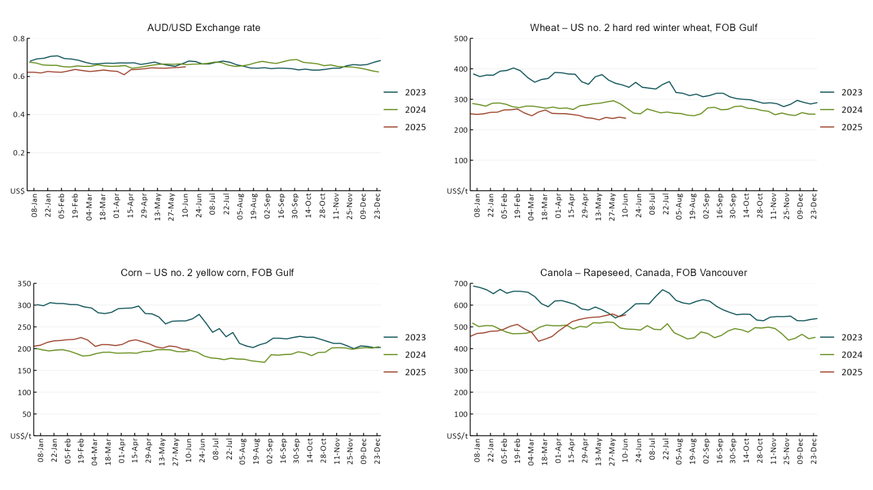

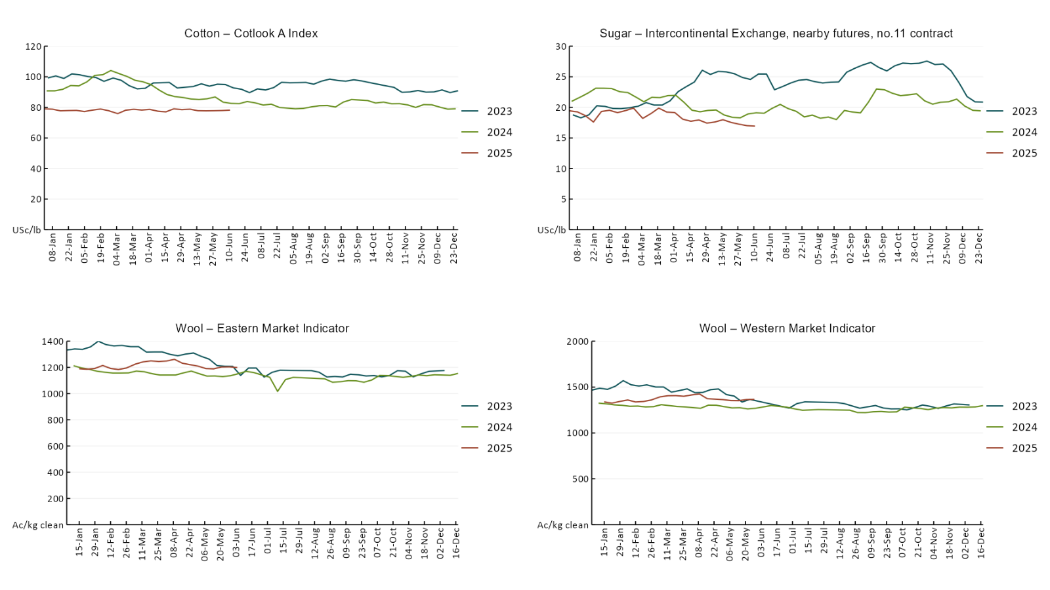

### 3.2 Selected domestic crop indicator prices

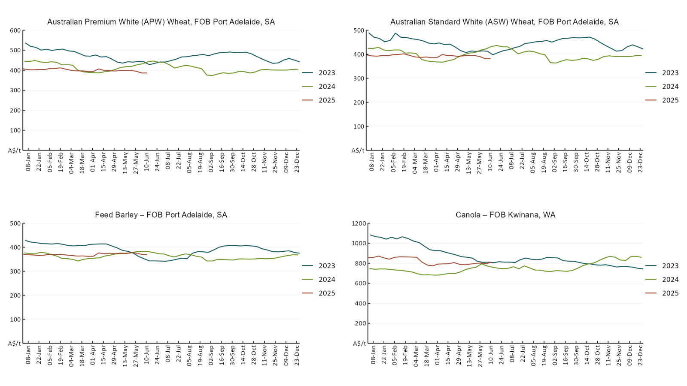

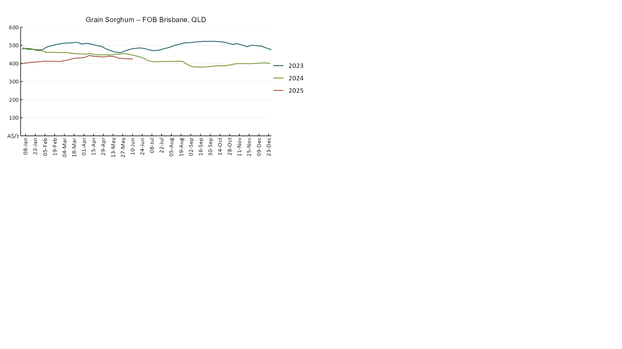

### 3.3 Selected domestic livestock indicator prices

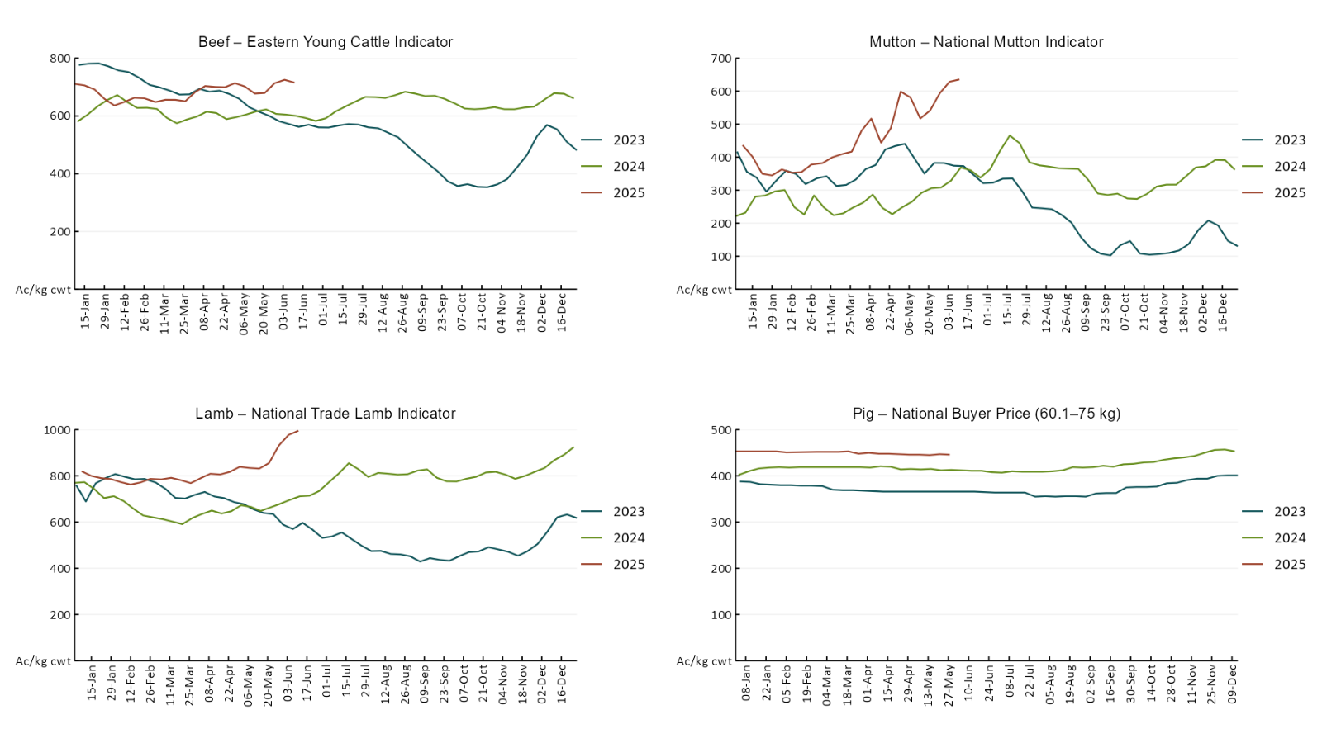

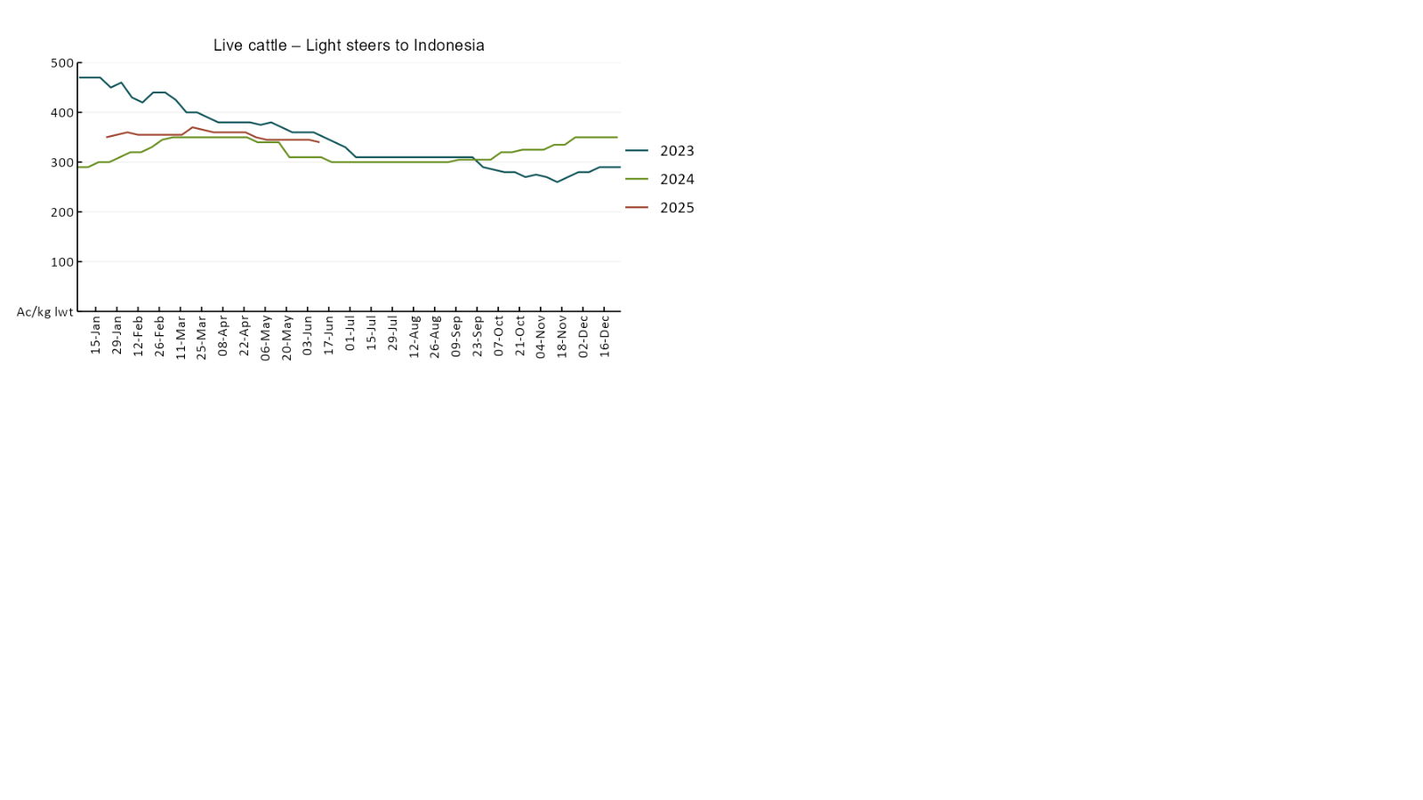

### 3.4 Global Dairy Trade (GDT) weighted average pricesAlt Text: A line chart of Global Dairy Trade prices. For more information, refer to https://www.agriculture.gov.au/abares/data/weekly-commodity-price-update/world-agricultural-prices

### 3.5 Selected fruit and vegetable prices

### Alt Text: A line chart of fruit and vegatable prices. For more information, refer to https://www.agriculture.gov.au/abares/data/weekly-commodity-price-update/world-agricultural-prices

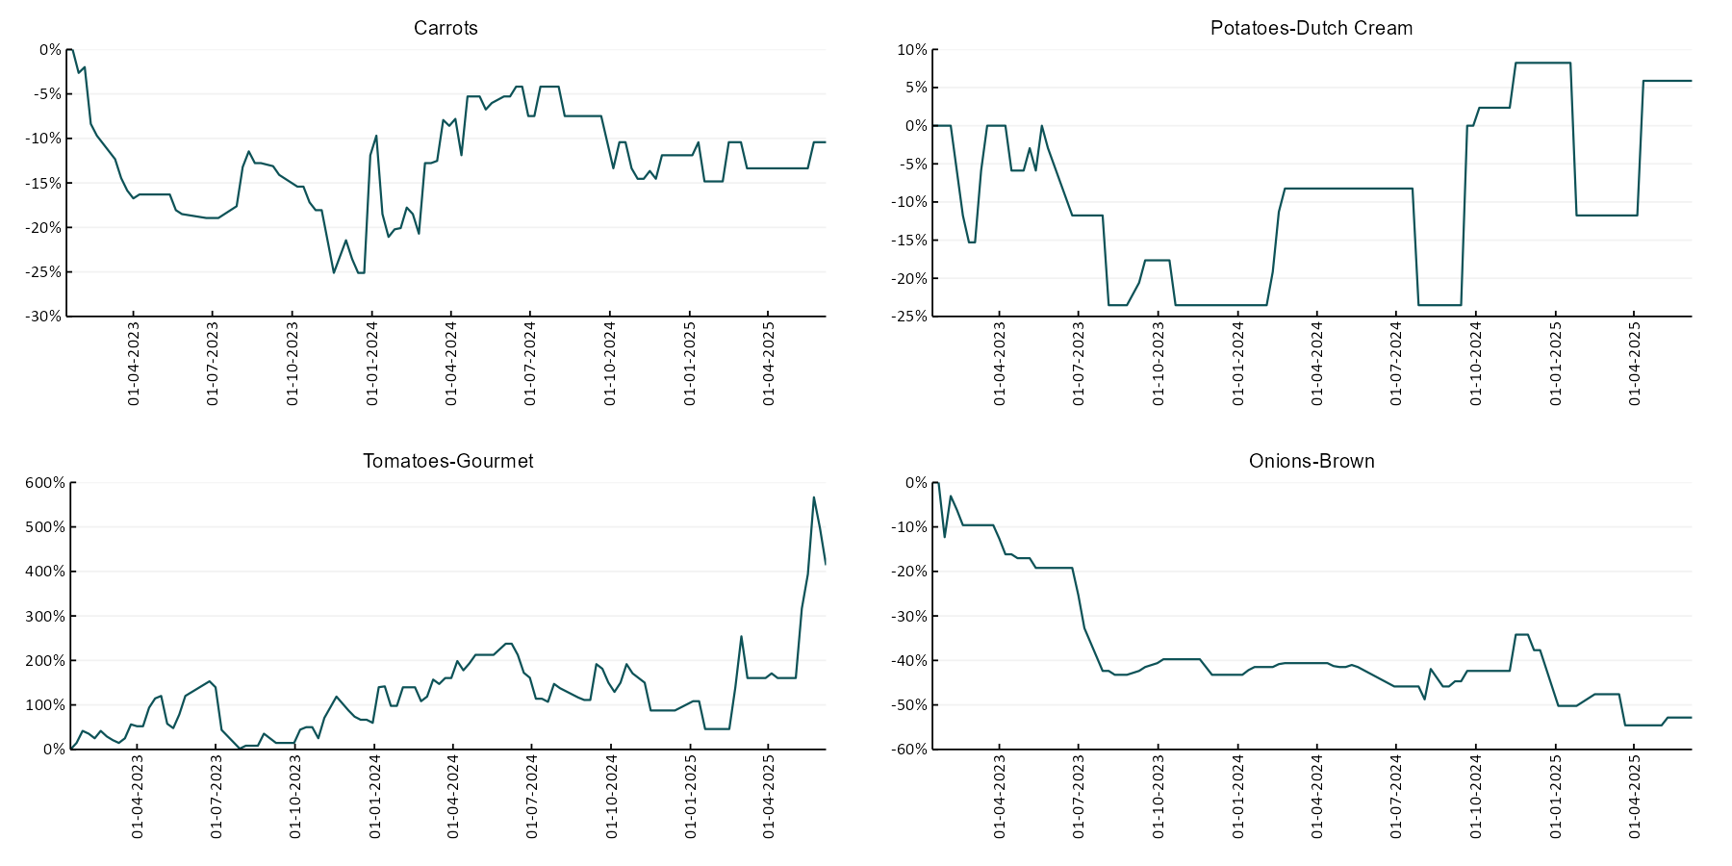

### 3.6 Selected domestic fodder indicator prices

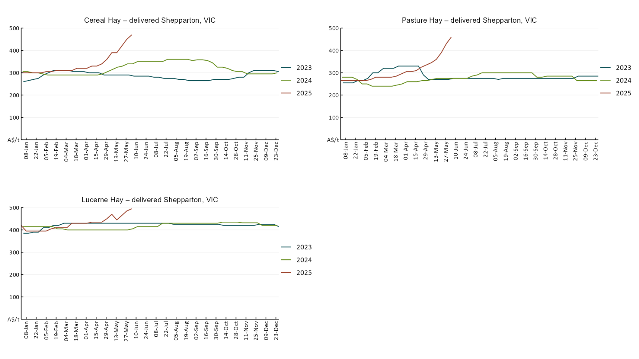

## **4. Data attribution**

### Climate

* Bureau of Meteorology
* Weekly rainfall totals: www.bom.gov.au/climate/maps/rainfall/
* Monthly and last 3-month rainfall percentiles: [www.bom.gov.au/water/landscape/](http://www.bom.gov.au/water/landscape/)
* Temperature anomalies: [www.bom.gov.au/jsp/awap/temp/index.jsp](http://www.bom.gov.au/jsp/awap/temp/index.jsp)
* Rainfall forecast: [www.bom.gov.au/jsp/watl/rainfall/pme.jsp](http://www.bom.gov.au/jsp/watl/rainfall/pme.jsp)
* Seasonal outlook: [www.bom.gov.au/climate/outlooks/#/overview/summary/](http://www.bom.gov.au/climate/outlooks/#/overview/summary/)
* Climate drivers: <http://www.bom.gov.au/climate/enso/>
* Soil moisture: [www.bom.gov.au/water/landscape/](http://www.bom.gov.au/water/landscape/)
* Other
* Pasture growth: [www.longpaddock.qld.gov.au/aussiegrass/](http://www.longpaddock.qld.gov.au/aussiegrass/)
* 3-month global outlooks: [Environment and Climate Change Canada](https://weather.gc.ca/saisons/image_e.html?img=s234pfe1p_cal&bc=prob), [NOAA Climate Prediction Center](https://www.cpc.ncep.noaa.gov/products/predictions/long_range/seasonal.php?lead=2), [EUROBRISA CPTEC/INPE](http://eurobrisa.cptec.inpe.br/), European Centre for Medium-Range Weather Forecasts, [Hydrometcenter of Russia](https://meteoinfo.ru/en/climate/seasonal-forecasts), [National Climate Center Climate System Diagnosis and Prediction Room (NCC)](https://cmdp.ncc-cma.net/pred/cs2gen.php?pred_elem=RAINP#pred_seasonal), [International Research Institute for Climate and Society](https://iri.columbia.edu/our-expertise/climate/forecasts/seasonal-climate-forecasts/)
* Global production: <https://ipad.fas.usda.gov/ogamaps/cropmapsandcalendars.aspx>
* Autumn break: Pook et al., 2009, <https://rmets-onlinelibrary-wiley-com.virtual.anu.edu.au/doi/epdf/10.1002/joc.1833>

### Water

Prices

* Waterflow: <https://www.waterflow.io/>
* Ruralco: <https://www.ruralcowater.com.au/>
* Bureau of Meteorology:
* Allocation trade: <http://www.bom.gov.au/water/dashboards/#/water-markets/mdb/at>
* Storage volumes: <http://www.bom.gov.au/water/dashboards/#/water-storages/summary/drainage>
* Trade constraints:
* Water NSW: <https://www.waternsw.com.au/customer-service/ordering-trading-and-pricing/trading/murrumbidgee>
* Victorian Water Register: <https://www.waterregister.vic.gov.au/TradingRules2019/>

### Commodities

* Fruit and vegetables
* Datafresh: [www.freshstate.com.au](http://www.freshstate.com.au)
* Pigs
* Australian Pork Limited: [www.australianpork.com.au](http://www.australianpork.com.au)
* Dairy
* Global Dairy Trade: [www.globaldairytrade.info/en/product-results/](http://www.globaldairytrade.info/en/product-results/)
* World wheat, canola
* International Grains Council
* World coarse grains
* United States Department of Agriculture
* World cotton
* Cotlook: [www.cotlook.com/](http://www.cotlook.com/)
* World sugar
* New York Stock Exchange - Intercontinental Exchange
* Wool
* Australian Wool Exchange: [www.awex.com.au/](http://www.awex.com.au/)
* Domestic wheat, barley, sorghum, canola and fodder
* Jumbuk Consulting Pty Ltd: http://www.jumbukag.com.au/
* Cattle, beef, mutton, lamb, goat and live export
* Meat and Livestock Australia: [www.mla.com.au/Prices-and-market](http://www.mla.com.au/Prices-and-market)

© Commonwealth of Australia 2025

### Ownership of intellectual property rights

Unless otherwise noted, copyright (and any other intellectual property rights, if any) in this publication is owned by the Commonwealth of Australia (referred to as the Commonwealth).

### Creative Commons licence

All material in this publication is licensed under a [Creative Commons Attribution 4.0 International Licence](https://creativecommons.org/licenses/by/4.0/legalcode) except content supplied by third parties, logos and the Commonwealth Coat of Arms.

Inquiries about the licence and any use of this document should be emailed to [copyright@awe.gov.au](mailto:copyright@awe.gov.au).

Creative commons license attribution logo

### Cataloguing data

This publication (and any material sourced from it) should be attributed as:

ABARES 2025, Weekly Australian Climate, Water and Agricultural Update, Australian Bureau of Agricultural and Resource Economics and Sciences, Canberra, 5 June 2025. CC BY 4.0 DOI: <https://doi.org/10.25814/5f3e04e7d2503>

ISSN **2652-7561**

This publication is available at https://www.agriculture.gov.au/abares/products/weekly_update

Department of Agriculture, Fisheries and Forestry

GPO Box 858 Canberra ACT 2601

Telephone 1800 900 090

Web [agriculture.gov.au/abares](http://awe.gov.au/abares)

### Disclaimer

The Australian Government acting through the Department of Agriculture, Fisheries and Forestry, represented by the Australian Bureau of Agricultural and Resource Economics and Sciences, has exercised due care and skill in preparing and compiling the information and data in this publication. Notwithstanding, the Department of Agriculture, Fisheries and Forestry, ABARES, its employees and advisers disclaim all liability, including liability for negligence and for any loss, damage, injury, expense or cost incurred by any person as a result of accessing, using or relying on any of the information or data in this publication to the maximum extent permitted by law.

### Statement of Professional Independence

The views and analysis presented in ABARES publications, including this one, reflect ABARES professionally independent findings, based on scientific and economic concepts, principles, information and data. These views, analysis and findings may not reflect or be consistent with the views or positions of the Australian Government, or of organisations or groups who have commissioned ABARES reports or analysis. More information on [professional independence](https://www.agriculture.gov.au/abares/about/research-and-analysis#professional-independence) is provided on the ABARES website.

### Acknowledgements

This report was prepared by Holly Beale and Matthew Miller.