## DecorativeNo. 24/2025 19 June 2025

# Summary of key issues

* In the week ending 18 June 2025 cold fronts and low-pressure systems brought rainfall to parts of southern Australia.
  + Rainfall was highly variable across cropping regions this week. The western margins of Western Australia received 5-50 millimetres, South Australian regions recorded between 1- 25 millimetres, and Victoria, southern New South Wales and northern Queensland between 1-15 millimetres.
  + Across most cropping regions in South Australia, Victoria and southern New South Wales these falls have likely provided some useful follow-up moisture to support crop establishment. However, further rainfall will be required in across parts of southern Western Australia, the Eyre Peninsula and the Mallee regions in South Australia and Victoria in the coming weeks to support the establishment of newly germinated crops.
* Over the coming eight days, rainfall is expected across parts of southern Australia.
  + 10-50 millimetres of rainfall is expected in Western Australian cropping regions, while other southern cropping regions are expected to receive lower rainfall totals of 10-25 millimetres.
  + If realised these falls will add some useful follow-up moisture to those regions that received little to no rainfall in recent weeks. However, further rainfall will be required in the coming weeks in Eyre Peninsula and the Mallee regions in South Australia and Victoria to support the establishment of newly germinated crops.
* Rainfall in May 2025 was variable across the world’s major grain- and oilseed-producing regions, leading to differing crop production outcomes.
  + Global production conditions were generally favourable for rice and maize, but variable for wheat and soybeans.
  + Global production conditions have been slightly more favourable to those used to formulate ABARES 2024–25 forecasts of global grain supplies and world prices in the June 2025 Agricultural Commodities Report. As a result, global grain and oilseed production are likely to increase beyond the numbers in the June forecast, due to improvements in global wheat, maize and rice production.
* Water storage levels in the Murray-Darling Basin (MDB) increased by 237 gigalitres (GL) between 12 June 2025 and 19 June 2025. The current volume of water held in storages is 12,898 GL, equivalent to 58% of total storage capacity. This is 25% or 4,325 GL less than at the same time last year. Water storage data is sourced from the Bureau of Meteorology.
* Allocation prices in the Victorian Murray below the Barmah Choke increased from $250/ML on 12 June 2025 to $311/ML on 19 June 2025. Trade from the Goulburn to the Murray is closed. Trade downstream through the Barmah Choke is closed. Trade from the Murrumbidgee to the Murray is open.

## **Climate**

### Rainfall this week

In the week ending 18 June 2025, **cold fronts and low-pressure systems** brought rainfall to parts of southern and northern Australia, while high-pressure systems kept the rest of Australia largely dry.

* Rainfall totals of between 5-50 millimetres were recorded across much of Tasmania, the southwest of Western Australia, and parts of southern South Australia and northeastern Queensland.
* Meanwhile falls of between 5-25 millimetres were observed across much of Victoria and parts of southern New South Wales.
* Remaining regions of the country received little to no rainfall over the period.

Rainfall was recorded across cropping regions in the south, while eastern areas remained largely dry in the week ending 18 June 2025.

* Rainfall totals of between 5-50 millimetres occurred over the western margins of Western Australia. Most South Australian cropping regions recorded between 5-25 millimetres, while in Victoria, southern New South Wales and northern Queensland falls of between 1-15 millimetres were recorded. Little to no rainfall was recorded across remaining cropping regions, including northern New South Wales, Queensland and Western Australia.
  + These falls have provided some useful follow-up moisture to those regions that received rainfall last week. However, further rainfall will be required across parts of southern Western Australia, the Eyre Peninsula and the Mallee regions in South Australia and Victoria in the coming weeks to support the establishment of newly germinated crops.

#### Rainfall for the week ending 18 June 2025

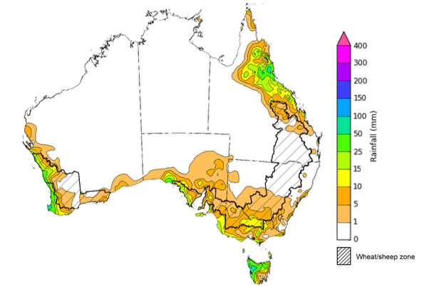

©Commonwealth of Australia 2025, Australian Bureau of Meteorology Issued: 18/6/2025

Note: The rainfall analyses and associated maps utilise data contained in the Bureau of Meteorology climate database, the Australian Data Archive for Meteorology (ADAM). The analyses are initially produced automatically from real-time data with limited [quality control](http://www.bom.gov.au/climate/headers/qc.shtml). They are intended to provide a general overview of rainfall across Australia as quickly as possible after the observations are received. For further information go to <http://www.bom.gov.au/climate/rainfall/>

### Rainfall forecast for the next eight days

Over the 8 days to 26 June 2025, **frontal systems** are expected to bring rainfall to much of southern Australia, with high-pressure systems expected to keep northern regions largely dry.

* Large areas of southern Western Australia and Tasmania are expected to see between 15- 50 millimetres, with some regions to see falls of up to 100 millimetres, while isolated areas of far-north Queensland are forecast to see 5-100 millimetres.
  + Meanwhile, southern regions of South Australia are forecast to see 5- 25 millimetres, with much of Victoria and New South Wales expected to record 5- 50 millimetres.
* Little to no rainfall is expected across much of the remainder of the country over this period.

Some rainfall is expected across most southern cropping regions over the coming week, with little expected in the Queensland.

* In Western Australia between 10-50 millimetres is expected over the period, with Victoria and New South Wales expected to see 5-50 millimetres. If realised, this should provide sufficient moisture to support the establishment and growth of winter crops.
* Meanwhile, lower rainfall totals of between 5-25 millimetres are expected across South Australia.
  + If realised these falls will add some useful follow-up moisture in Western Australia, following a relatively dry late May-early June and for to those regions in eastern and southern Australia that received rainfall last weeks. However, further rainfall will be required in the Eyre Peninsula and the Mallee regions in South Australia and Victoria in the coming weeks to support the establishment of newly germinated crops.
* Little to no rainfall is expected across cropping zones in Queensland.

#### Total forecast rainfall for the period 19 June to 26 June 2025

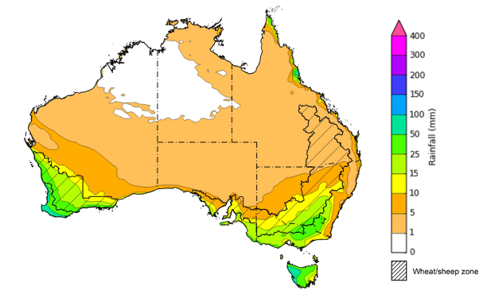

©Commonwealth of Australia 2025, Australian Bureau of Meteorology Issued 19/6/2025

Note: This rainfall forecast is produced from computer models. As the model outputs are not altered by weather forecasters, it is important to check local forecasts and warnings issued by the Bureau of Meteorology.

### May precipitation percentiles and current production conditions

Crop production is affected by long-term trends in average rainfall and temperature, interannual climate variability, shocks during specific growth stages, and extreme weather events. Some crops are more tolerant than others to certain types of stresses, and at each growth stage, different types of stresses affect crop species in different ways.

Precipitation anomalies and outlooks presented below indicate the current and expected future production conditions for major grain and oilseed producing countries (responsible for over 80% of global crop production). This is an important input to assessing the global grain supply outlook.

Rainfall in May 2025 was variable across the world’s major grain- and oilseed-producing regions:

* In the **southern hemisphere**, precipitation was below average across much of northern and southern Brazil, southern Argentina and southern Australia. Above average precipitation occurred in parts of Indonesia and eastern Australia. Precipitation was generally average across remaining major southern hemisphere grain- and oilseed-producing regions.
* In the **northern hemisphere**, precipitation was below average across scattered areas of the northern United States, southern Canada, parts of West Asia and France. Precipitation was above average across parts of the eastern United States, parts of the Russian Federation and Black Sea Region, southern and eastern China, and much of India. Precipitation was generally average across remaining major northern hemisphere grain- and oilseed-producing regions.

**Global precipitation percentiles, May 2025**

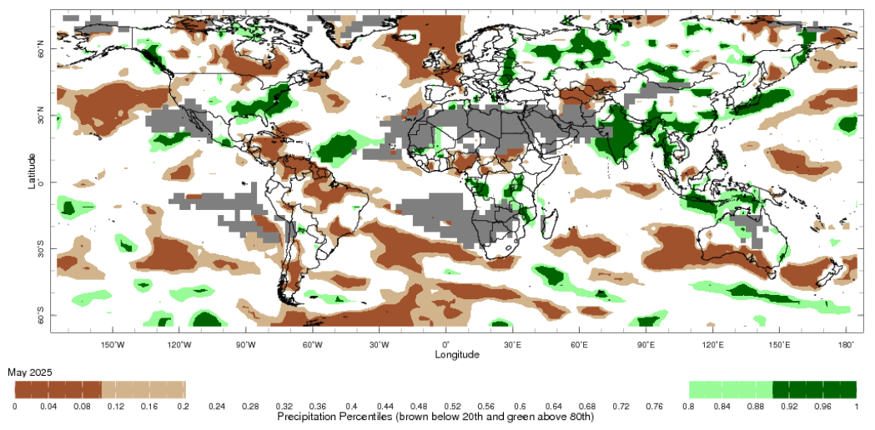

Note: The world precipitation percentiles indicate a ranking of precipitation for May, with the driest (0th percentile) being 0 on the scale and the wettest (100th percentile) being 1 on the scale. Percentiles are based on precipitation estimates from the NOAA Climate Prediction Center’s [Climate Anomaly Monitoring System Outgoing Precipitation Index](https://iridl.ldeo.columbia.edu/maproom/Global/Precipitation/Percentiles.html) dataset. Precipitation estimates for May 2025 are compared with rainfall recorded for that period during the 1981 to 2010 base period.

Source: International Research Institute for Climate and Society

As of 28 May 2025, global production conditions are generally favourable for rice and maize, but variable for wheat and soybeans:

* **Wheat –** Dry conditions remain a concern for wheat production in isolated parts of the northern hemisphere, including parts of China, the European Union, the Russian Federation, Türkiye, the Unites States and Ukraine. However, recent rainfall has resulted in generally favourable production conditions elsewhere in the northern hemisphere. In the southern hemisphere, sowing is underway with generally favourable conditions in most regions, despite a dry start to the season in parts of south-eastern Australia and southern Brazil.
* **Maize** **–** Conditions are generally favourable in the southern hemisphere, despite some downturns in production are expected in parts of northern Brazil and Argentina. Conditions are also generally favourable in the northern hemisphere, but some areas of production concern due to dryness across parts of the European Union, the Russian Federation and Ukraine.
* **Rice –** Global conditions are broadly favourable for major rice production regions.
* **Soybeans –** Harvest is concluding in the southern hemisphere under generally favourable conditions, except for parts of southern Brazil and northern Argentina where dryness has negatively impacted yields. Sowing is beginning in the northern hemisphere under favourable conditions.

**Crop conditions, AMIS countries, 28 May 2025**

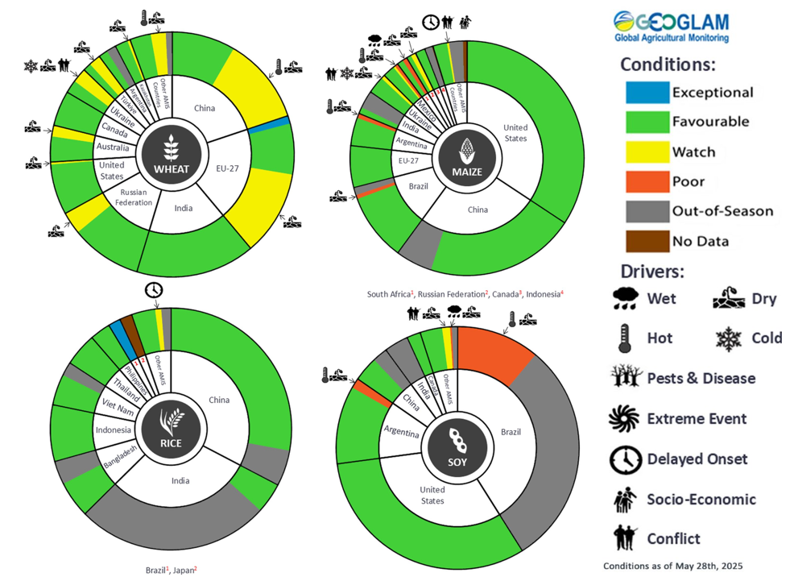

**AMIS** Agricultural Market Information System.

Source: AMIS

The global climate outlook for July 2025 to September 2025 indicates that mixed rainfall conditions are expected for the world’s major grain-producing and oilseed-producing regions. Outlooks and potential production impacts for major grain- and oilseed-producing countries are presented in the following table

**Rainfall outlook and potential impact on the future state of production conditions, July-September 2025**

|  |  |  |
| --- | --- | --- |
| **Region** | **Rainfall outlook** | **Potential impact on production** |
| **Argentina** | Average rainfall is likely across much of Argentina. | A generally favourable rainfall outlook is likely to support the heading of wheat in Argentina, and allow for the largely uninterrupted planting of cotton and corn. |
| **Black Sea Region** | Average rainfall is expected across much of the Black Sea region, with some areas below average rainfall expected across isolated part, including the southwest of the Russian Federation and Türkiye. | Anticipated below average rainfall is likely to adversely affect the flowering of the critical development stages of spring wheat, cotton, corn, and sunflower in July in parts of Türkiye and the Russian Federation. Average rainfall is expected to support the growth of these crops elsewhere in the Black Sea region. |
| **Brazil** | Much of Brazil is likely to record average rainfall. | Anticipated rainfall is expected to support wheat production, and the planting of corn and soybeans from September 2025. |
| **Canada** | Generally, average rainfall is likely across much of Canada. Below average rainfall is likely in scattered areas in the southern regions. | Average rainfall is likely to support the flowering of wheat, canola, corn, soybean, and sunflower crops, and allow for the harvesting of spring wheat and canola in September. Average rainfall in isolated areas may benefit the development of crops in these locations. |
| **China** | Above average rainfall is expected throughout much of western China, with below average rainfall expected in scattered eastern. | Anticipated rainfall is likely to support the flowering of major crops over the season, including rice, corn, cotton, and oilseeds. |
| **Europe** | Average rainfall is more likely for much of central Europe between July and September 2024. Below average rainfall is likely in the south. | Average rainfall across much of Europe is likely to benefit the development of corn, soybeans, and sunflower in the north. In the south, below average rainfall may negatively affect the flowering of sorghum. |
| **South Asia (India)** | Above average rainfall is expected across much of northern and central India, with remaining areas forecast to receive average rainfall. | Anticipated rainfall is likely to support the flowering of many major grains and oilseeds, including corn, rice and sorghum. |
| **Southeast Asia (SEA)** | Average to above average rainfall is likely across much of Indonesia, while Malaysia is likely to see below average rainfall. Precipitation in remaining Southeast Asian nations is likely to be average. | Average to above average rainfall in SEA may support the flowering of rice and corn in major growing regions. |
| **The United States of America** | Below average rainfall is likely for much northern and central United States, with average rainfall more likely across the east and southwest. | Anticipated rainfall in northern and central areas is likely to impact yield potential of major grains and oilseeds, but may support the planting and harvesting of various crops, over the period. |

### Water markets – current week

Water storage levels in the Murray-Darling Basin (MDB) increased by 237 gigalitres (GL) between 12 June 2025 and 19 June 2025. The current volume of water held in storages is 12,898 GL, equivalent to 58% of total storage capacity. This is 25% or 4,325 GL less than at the same time last year. Water storage data is sourced from the Bureau of Meteorology.

#### Water storages in the Murray-Darling Basin, 2013–2025Alt Text: A chart showing water storage in the Murray-Darling Basin. For more information, refer to accompanying text

Allocation prices in the Victorian Murray below the Barmah Choke increased from $250/ML on 12 June 2025 to $311/ML on 19 June 2025. Trade from the Goulburn to the Murray is closed. Trade downstream through the Barmah Choke is closed. Trade from the Murrumbidgee to the Murray is open.

#### Surface water trade activity, Southern Murray–Darling Basin

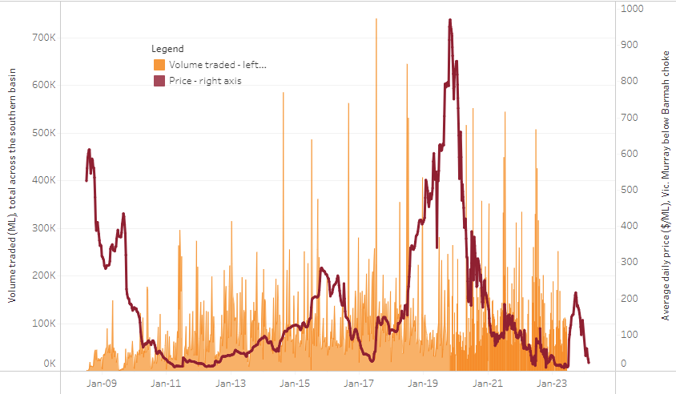

|  |
| --- |
| The trades shown reflect estimated market activity and do not encompass all register trades. The price is shown for the VIC Murray below the Barmah choke. Historical prices (before 1 July 2019) are ABARES estimates after removing outliers from BOM water register data. Prices after 1 July 2019 and prior to the 30 October 2019 reflect recorded transaction prices as sourced from Ruralco. Prices after the 30 October 2019 are sourced from Waterflow. Data for volume traded is sourced from the BOM water register. Only the price data shown is current on 17 October 2024. |

To access the full, interactive, weekly water dashboard, which contains the latest and historical water storage, water market and water allocation information, please visit <https://www.agriculture.gov.au/abares/products/weekly_update/weekly-update-126525>

## **Commodities**

|  |  |  |  |  |  |  |  |  |
| --- | --- | --- | --- | --- | --- | --- | --- | --- |
| **Indicator** | **Week average** | **Unit** | **Latest Price** | **Previous Week** | **Weekly change** | | **Price 12 months ago** | **Annual change** |
| **Selected world indicator prices** |  |  |  |  |  |  | |  |
| AUD/USD Exchange rate | 18-Jun | A$/US$ | 0.65 | 0.65 | 0% | 0.66 | | -2% |
| Wheat – US no. 2 hard red winter wheat, FOB Gulf | 18-Jun | US$/t | 241 | 237 | 2% | 266 | | -9% |
| Corn – US no. 2 yellow corn, FOB Gulf | 18-Jun | US$/t | 197 | 199 | -1% | 191 | | 3% |
| Canola – Rapeseed, Canada, FOB Vancouver | 18-Jun | US$/t | 582 | 564 | 3% | 490 | | 19% |
| Cotton – Cotlook A Index | 18-Jun | USc/lb | 78 | 78 | 0% | 83 | | -6% |
| Sugar – Intercontinental Exchange, nearby futures, no.11 contract | 18-Jun | USc/lb | 17 | 17 | 0% | 19 | | -13% |
| Wool – Eastern Market Indicator | 18-Jun | Ac/kg clean | 1,207 | 1,199 | 1% | 1,156 | | 4% |
| Wool – Western Market Indicator | 28-May | Ac/kg clean | 1,366 | 1,364 | 0% | 1,290 | | 6% |
| **Selected Australian grain export prices** |  |  |  |  |  |  | |  |
| Australian Premium White (APW) Wheat, FOB Port Adelaide, SA | 18-Jun | A$/t | 383 | 386 | -1% | 440 | | -13% |
| Australian Standard White (ASW) Wheat, FOB Port Adelaide, SA | 18-Jun | A$/t | 378 | 381 | -1% | 431 | | -12% |
| Feed Barley – FOB Port Adelaide, SA | 18-Jun | A$/t | 369 | 370 | 0% | 379 | | -2% |
| Canola – FOB Kwinana, WA | 18-Jun | A$/t | 830 | 816 | 2% | 758 | | 10% |
| Grain Sorghum – FOB Brisbane, QLD | 18-Jun | A$/t | 425 | 427 | -1% | 441 | | -4% |
| **Selected domestic livestock indicator prices** |  |  |  |  |  |  | |  |
| Beef – Eastern Young Cattle Indicator | 18-Jun | Ac/kg cwt | 708 | 713 | -1% | 595 | | 19% |
| Mutton – Mutton indicator (18–24 kg fat score 2–3), VIC | 18-Jun | Ac/kg cwt | 678 | 645 | 5% | 349 | | 94% |
| Lamb – National Trade Lamb Indicator | 18-Jun | Ac/kg cwt | 1,047 | 1,011 | 4% | 714 | | 47% |
| Pig – Eastern Seaboard (60.1–75 kg), NSW buyer price | 04-Jun | Ac/kg cwt | 452 | 446 | 1% | 411 | | 10% |
| Live cattle – Light steers to Indonesia | 18-Jun | Ac/kg lwt | 335 | 340 | -1% | 305 | | 10% |
| **Global Dairy Trade (GDT) weighted average prices** |  |  |  |  |  |  | |  |
| Dairy – Whole milk powder | 18-Jun | US$/t | 4,084 | 4,173 | -2% | 3,436 | | 19% |
| Dairy – Skim milk powder | 18-Jun | US$/t | 2,775 | 2,807 | -1% | 2,744 | | 1% |
| Dairy – Cheddar cheese | 18-Jun | US$/t | 4,992 | 4,759 | 5% | 4,227 | | 18% |
| Dairy – Anhydrous milk fat | 18-Jun | US$/t | 7,276 | 7,373 | -1% | 7,367 | | -1% |
|  | | | | | | | | |

### Selected world indicator prices

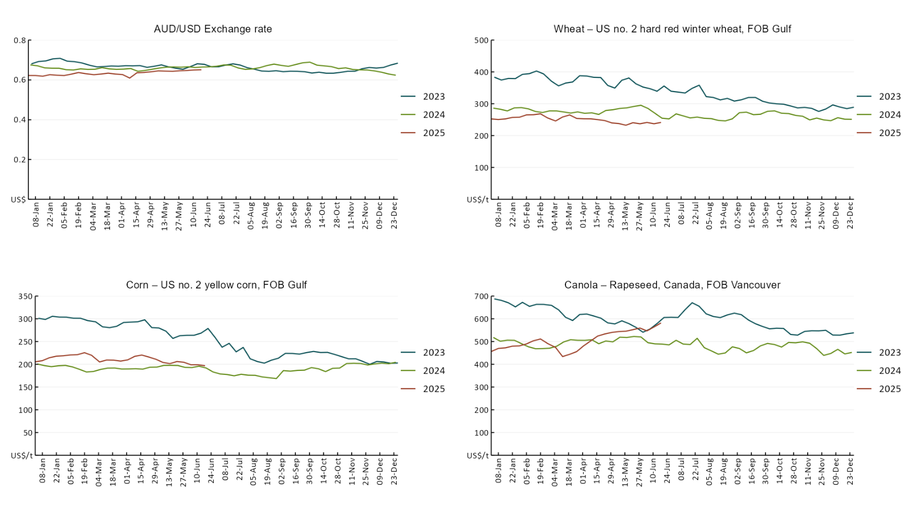

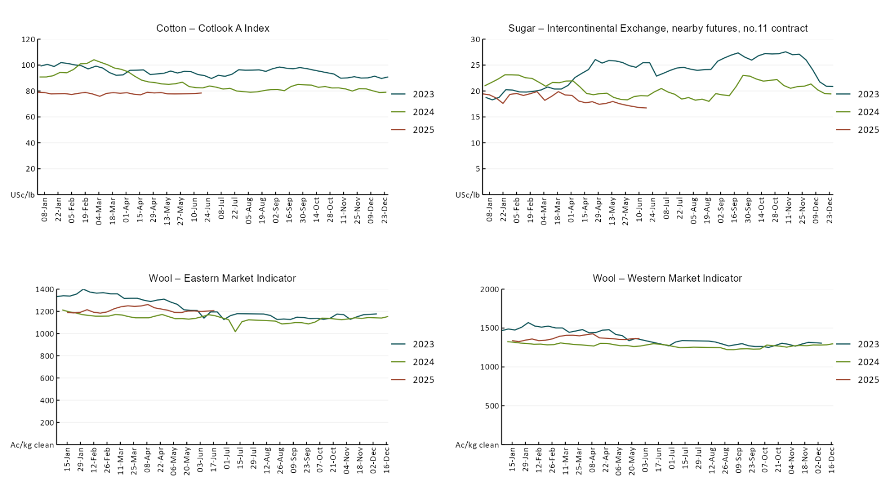

### 3.2 Selected domestic crop indicator prices

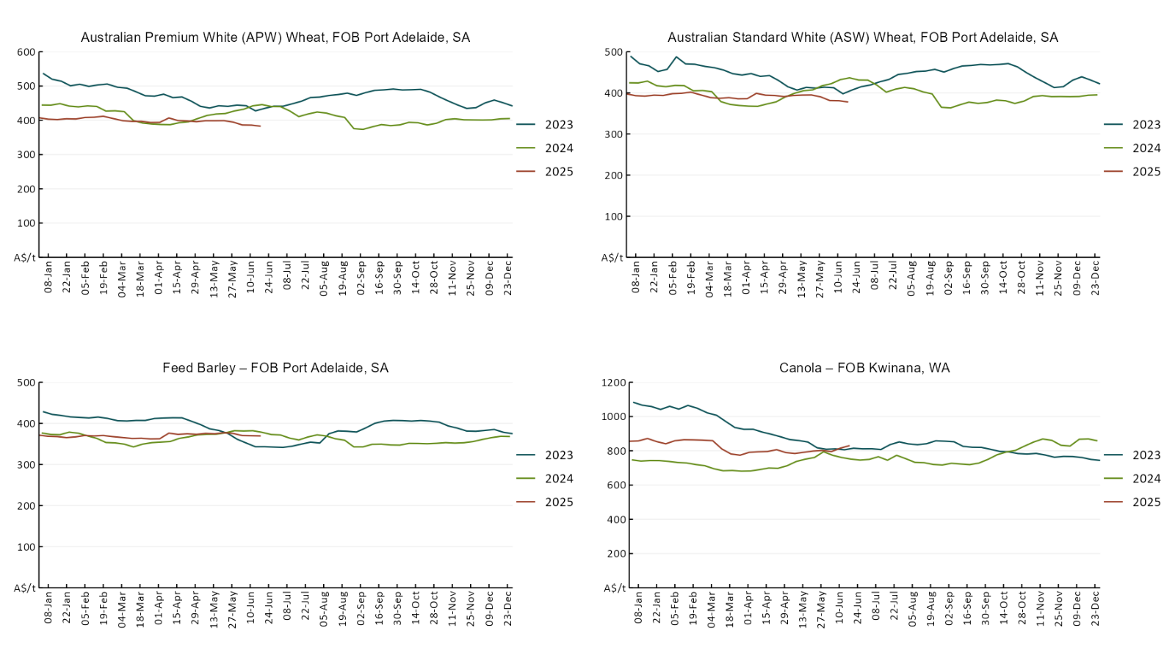

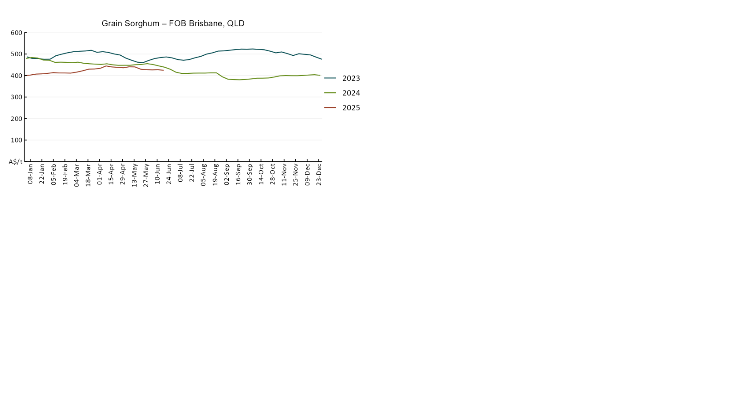

### 3.3 Selected domestic livestock indicator prices

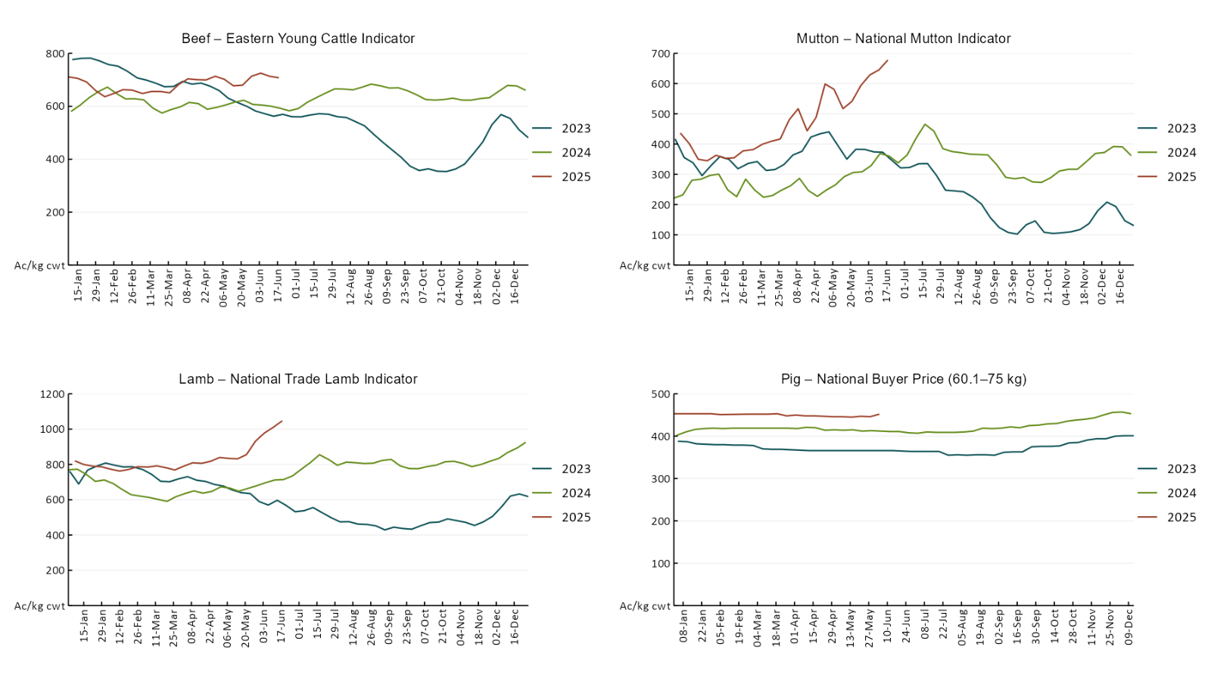

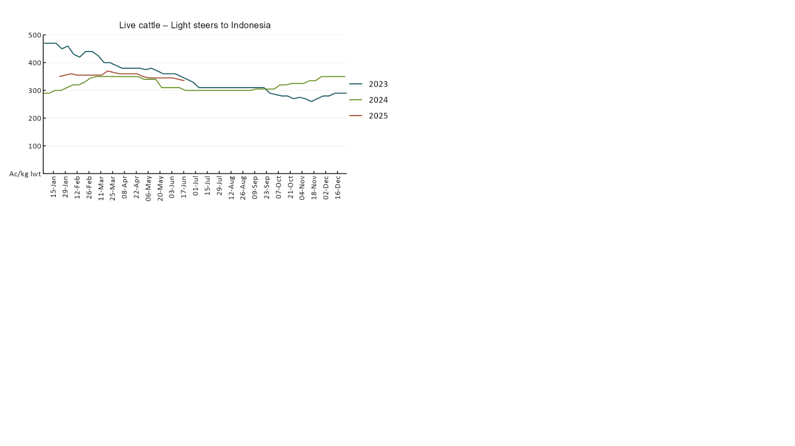

### 3.4 Global Dairy Trade (GDT) weighted average pricesA line chart of Global Dairy Trade prices. For more information, refer to https://www.agriculture.gov.au/abares/data/weekly-commodity-price-update/world-agricultural-prices

### 3.5 Selected fruit and vegetable prices

### A line chart of fruit and vegetable prices. For more information, refer to https://www.agriculture.gov.au/abares/data/weekly-commodity-price-update/world-agricultural-prices

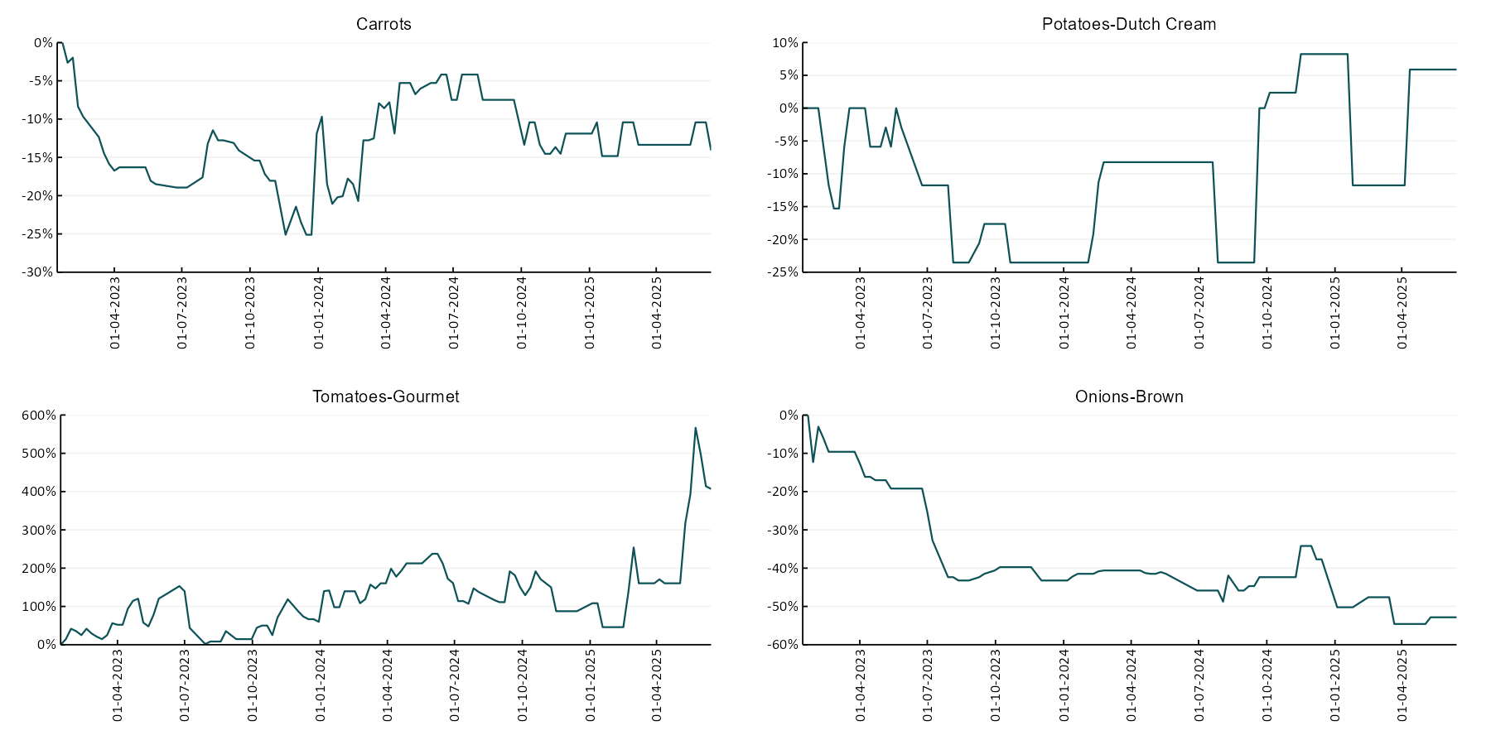

### 3.6 Selected domestic fodder indicator prices

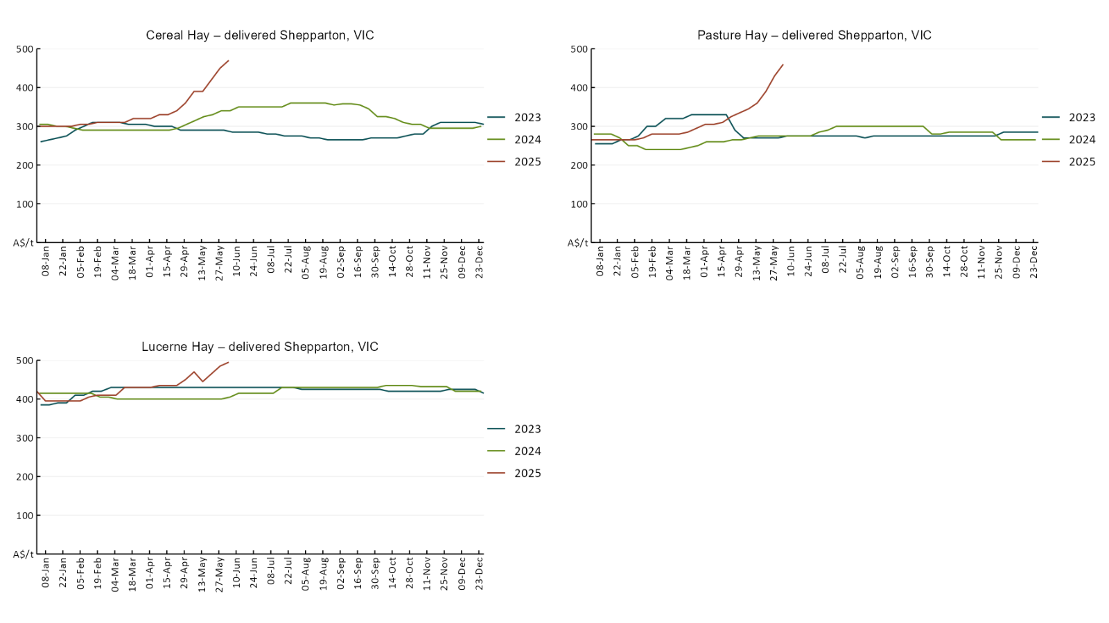

## **4. Data attribution**

### Climate

* Bureau of Meteorology
* Weekly rainfall totals: www.bom.gov.au/climate/maps/rainfall/
* Monthly and last 3-month rainfall percentiles: [www.bom.gov.au/water/landscape/](http://www.bom.gov.au/water/landscape/)
* Temperature anomalies: [www.bom.gov.au/jsp/awap/temp/index.jsp](http://www.bom.gov.au/jsp/awap/temp/index.jsp)
* Rainfall forecast: [www.bom.gov.au/jsp/watl/rainfall/pme.jsp](http://www.bom.gov.au/jsp/watl/rainfall/pme.jsp)
* Seasonal outlook: [www.bom.gov.au/climate/outlooks/#/overview/summary/](http://www.bom.gov.au/climate/outlooks/#/overview/summary/)
* Climate drivers: <http://www.bom.gov.au/climate/enso/>
* Soil moisture: [www.bom.gov.au/water/landscape/](http://www.bom.gov.au/water/landscape/)
* Other
* Pasture growth: [www.longpaddock.qld.gov.au/aussiegrass/](http://www.longpaddock.qld.gov.au/aussiegrass/)
* 3-month global outlooks: [Environment and Climate Change Canada](https://weather.gc.ca/saisons/image_e.html?img=s234pfe1p_cal&bc=prob), [NOAA Climate Prediction Center](https://www.cpc.ncep.noaa.gov/products/predictions/long_range/seasonal.php?lead=2), [EUROBRISA CPTEC/INPE](http://eurobrisa.cptec.inpe.br/), European Centre for Medium-Range Weather Forecasts, [Hydrometcenter of Russia](https://meteoinfo.ru/en/climate/seasonal-forecasts), [National Climate Center Climate System Diagnosis and Prediction Room (NCC)](https://cmdp.ncc-cma.net/pred/cs2gen.php?pred_elem=RAINP#pred_seasonal), [International Research Institute for Climate and Society](https://iri.columbia.edu/our-expertise/climate/forecasts/seasonal-climate-forecasts/)
* Global production: <https://ipad.fas.usda.gov/ogamaps/cropmapsandcalendars.aspx>
* Autumn break: Pook et al., 2009, <https://rmets-onlinelibrary-wiley-com.virtual.anu.edu.au/doi/epdf/10.1002/joc.1833>

### Water

Prices

* Waterflow: <https://www.waterflow.io/>
* Ruralco: <https://www.ruralcowater.com.au/>
* Bureau of Meteorology:
* Allocation trade: <http://www.bom.gov.au/water/dashboards/#/water-markets/mdb/at>
* Storage volumes: <http://www.bom.gov.au/water/dashboards/#/water-storages/summary/drainage>
* Trade constraints:
* Water NSW: <https://www.waternsw.com.au/customer-service/ordering-trading-and-pricing/trading/murrumbidgee>
* Victorian Water Register: <https://www.waterregister.vic.gov.au/TradingRules2019/>

### Commodities

* Fruit and vegetables
* Datafresh: [www.freshstate.com.au](http://www.freshstate.com.au)
* Pigs
* Australian Pork Limited: [www.australianpork.com.au](http://www.australianpork.com.au)
* Dairy
* Global Dairy Trade: [www.globaldairytrade.info/en/product-results/](http://www.globaldairytrade.info/en/product-results/)
* World wheat, canola
* International Grains Council
* World coarse grains
* United States Department of Agriculture
* World cotton
* Cotlook: [www.cotlook.com/](http://www.cotlook.com/)
* World sugar
* New York Stock Exchange - Intercontinental Exchange
* Wool
* Australian Wool Exchange: [www.awex.com.au/](http://www.awex.com.au/)
* Domestic wheat, barley, sorghum, canola and fodder
* Jumbuk Consulting Pty Ltd: http://www.jumbukag.com.au/
* Cattle, beef, mutton, lamb, goat and live export
* Meat and Livestock Australia: [www.mla.com.au/Prices-and-market](http://www.mla.com.au/Prices-and-market)

© Commonwealth of Australia 2025

### Ownership of intellectual property rights

Unless otherwise noted, copyright (and any other intellectual property rights, if any) in this publication is owned by the Commonwealth of Australia (referred to as the Commonwealth).

### Creative Commons licence

All material in this publication is licensed under a [Creative Commons Attribution 4.0 International Licence](https://creativecommons.org/licenses/by/4.0/legalcode) except content supplied by third parties, logos and the Commonwealth Coat of Arms.

Inquiries about the licence and any use of this document should be emailed to [copyright@awe.gov.au](mailto:copyright@awe.gov.au).

Creative Commons Attribution 4.0 license logo

### Cataloguing data

This publication (and any material sourced from it) should be attributed as:

ABARES 2025, Weekly Australian Climate, Water and Agricultural Update, Australian Bureau of Agricultural and Resource Economics and Sciences, Canberra, 19 June 2025. CC BY 4.0 DOI: <https://doi.org/10.25814/5f3e04e7d2503>

ISSN **2652-7561**

This publication is available at https://www.agriculture.gov.au/abares/products/weekly_update

Department of Agriculture, Fisheries and Forestry

GPO Box 858 Canberra ACT 2601

Telephone 1800 900 090

Web [agriculture.gov.au/abares](http://awe.gov.au/abares)

### Disclaimer

The Australian Government acting through the Department of Agriculture, Fisheries and Forestry, represented by the Australian Bureau of Agricultural and Resource Economics and Sciences, has exercised due care and skill in preparing and compiling the information and data in this publication. Notwithstanding, the Department of Agriculture, Fisheries and Forestry, ABARES, its employees and advisers disclaim all liability, including liability for negligence and for any loss, damage, injury, expense or cost incurred by any person as a result of accessing, using or relying on any of the information or data in this publication to the maximum extent permitted by law.

### Statement of Professional Independence

The views and analysis presented in ABARES publications, including this one, reflect ABARES professionally independent findings, based on scientific and economic concepts, principles, information and data. These views, analysis and findings may not reflect or be consistent with the views or positions of the Australian Government, or of organisations or groups who have commissioned ABARES reports or analysis. More information on [professional independence](https://www.agriculture.gov.au/abares/about/research-and-analysis#professional-independence) is provided on the ABARES website.

### Acknowledgements

This report was prepared by Holly Beale and Matthew Miller.