## No. 26/2025 3 July 2025

# Summary of key issues

* In the week ending 2 July 2025, troughs, frontals systems and an east coast low brought rainfall totals of up to 200 millimetres to parts of eastern Australia. High-pressure systems kept much of the remainder of Australia largely dry.
  + Across cropping regions, rainfall totals of between 5-50 millimetres occurred over scattered areas of north-eastern Queensland and eastern New South Wales. Other cropping regions were largely dry.
  + Heavy rainfall and damaging wind have impacted roads and infrastructure in the Hunter region, Sydney and the Illawarra, and South Coast regions of New South Wales. Until access to properties and damage assessments can be undertaken the full impact of flooding on agricultural production remains largely unknown.
* Over the coming eight days, rainfall is expected across much of southern Australia, while northern regions are likely to stay dry.
  + Cropping regions in Western Australia, South Australia, Victoria, and southern New South Wales are expected to record between 5-50 millimetres over the period. If realised, this should provide timely moisture to support the establishment and growth of winter crops across most southern cropping regions.
* Below average rainfall during June across parts of central Western Australia and the Mallee region of South Australia, would have provide sufficient rainfall to germinate dry sown crops but little follow-up moisture to support their establishment. Upper layer soil moisture in southern cropping regions has improved compared to May 2025, however lower layer soil moisture has remained below average to extremely low in many areas.
* Below average pasture growth for the three months to June 2025 across large areas of Victoria, South Australia, Western Australia, and north-western and southern New South Wales will likely see graziers in these regions actively destocking or becoming increasingly reliant on supplemental feed to maintain current stocking rates and production.
* Water storage levels in the Murray-Darling Basin (MDB) increased by 146 gigalitres (GL) between 26 June 2025 and 3 July 2025. The current volume of water held in storages is 13,146 GL, equivalent to 59% of total storage capacity. This is 24% or 4,171 GL less than the same time last year. Water storage data is sourced from the Bureau of Meteorology.
* Allocation prices in the Victorian Murray below the Barmah Choke decreased from $301/ML on 26 June 2025 to $300/ML on 3 July 2025. Trade from Goulburn to the Murray is open. Trade downstream through the Barmah Choke is open. Trade from the Murrumbidgee to the Murray is open.

## **Climate**

### Rainfall this week

In the week ending 2 July 2025, **troughs, frontals systems and an east coast low** brought rainfall to parts of eastern Australia, while high-pressure systems kept much of Australia largely dry.

* Rainfall totals of between 5-50 millimetres were recorded across much of eastern Queensland, southern Victoria and western Tasmania, with isolated areas seeing up to 100 millimetres.
* The eastern seaboard of New South Wales has recorded falls of between 5-100 millimetres, with falls in excess of 200 millimetres in the South Coast region as a result of the developing east coast low system.
  + High rainfall and damaging wind have impacted roads and infrastructure in the Hunter region, Sydney and the Illawarra and South Coast regions. Until access to properties and damage assessments can be undertaken the full impact of flooding on agricultural production remains largely unknown.

Rainfall was recorded across isolated cropping regions in the north-east, with most winter cropping regions little to no rainfall in the week ending 2 July 2025.

* Rainfall totals of between 5-50 millimetres occurred over scattered areas of north-eastern Queensland and eastern New South Wales.
* In contrast, South Australia and Victoria, much of New South Wales, southern and western Queensland, and Western Australia were comparatively dry, with falls of between 0-5 millimetres recorded.
  + These conditions have provided some useful follow-up moisture in northern Queensland. However, this continues to present an increasing downside production risk for winter crops across the Mallee regions of South Australia and Victoria that have received sufficient rainfall to germinate dry sown crops but little follow-up rainfall to support their establishment.

#### Rainfall for the week ending 2 July 2025

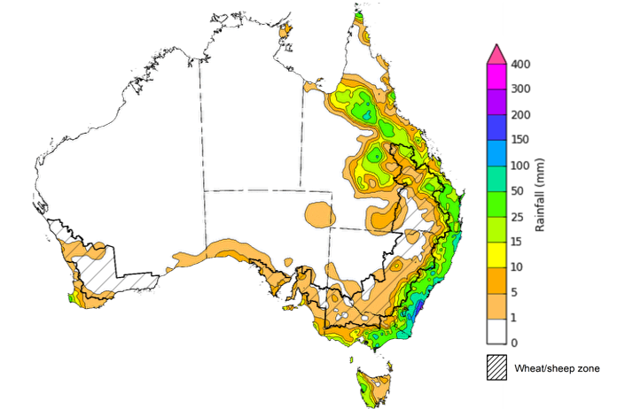

©Commonwealth of Australia 2025, Australian Bureau of Meteorology Issued: 2/7/2025

Note: The rainfall analyses and associated maps utilise data contained in the Bureau of Meteorology climate database, the Australian Data Archive for Meteorology (ADAM). The analyses are initially produced automatically from real-time data with limited [quality control](http://www.bom.gov.au/climate/headers/qc.shtml). They are intended to provide a general overview of rainfall across Australia as quickly as possible after the observations are received. For further information go to <http://www.bom.gov.au/climate/rainfall/>

### Rainfall forecast for the next eight days

Over the 8 days to 10 July 2025, **low-pressure systems and cold fronts** are expected to bring rainfall to large areas of southern Australia, with high-pressure systems expected to keep central and northern regions largely dry.

* Victoria, southern South Australia, southern New South Wales, and Tasmania are expected to see between 5-50 millimetres, with some regions in western Tasmania to see falls of up to 100 millimetres.
* In southern Western Australia, falls of between 5-100 millimetres are expected.
* Isolated falls of between 5-25 millimetres are expected across north-eastern Queensland.
* Little to no rainfall is expected across much of the remainder of the country over this period.

Some timely rainfall is expected across southern cropping regions over the coming week, with little expected in the northeast.

* Falls of between 5-50 millimetres are forecast across cropping regions in Western Australia, South Australia, Victoria and southern New South Wales. 
  + If realised, this should provide timely moisture to support the establishment and growth of winter crops across most southern cropping regions, particularly in southern Western Australia, and the Mallee regions of South Australia and Victoria following a relatively dry conditions during June 2025.
* Meanwhile, little to no rainfall is expected in Queensland and much of northern New South Wales.

#### Total forecast rainfall for the period 3 July to 10 July 2025

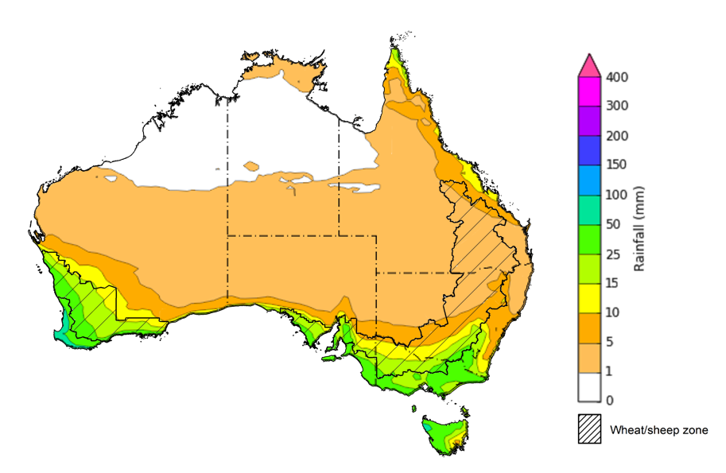

©Commonwealth of Australia 2025, Australian Bureau of Meteorology Issued 3/7/2025

Note: This rainfall forecast is produced from computer models. As the model outputs are not altered by weather forecasters, it is important to check local forecasts and warnings issued by the Bureau of Meteorology.

### Monthly rainfall

Rainfall during June 2025 was generally below average to average, with isolated areas of extremely high rainfall:

* Rainfall was extremely low to below average across large areas of central Australia, including east Western Australia, the south of the Northern Territory, western and southern Queensland and northern South Australia, as well as much of the southwest of Western Australia, eastern New South Wales and parts of western Tasmania.
* Above average to extremely high rainfall was recorded across much of the northern Queensland and the south coast of Victoria.
* The remainder of Australia saw generally average June rainfall.

In cropping regions, June rainfall was generally extremely low to average in the west and northeast, and generally average rainfall in the southeast:

* June rainfall was highly variable across cropping regions in Western Australia, Queensland, and northern New South Wales with falls ranging from extremely low to average.
* In South Australia, Victoria and southern New South Wales, average rainfall was experienced over the period with isolated areas seeing below average and above average rainfall.

The broadly average rainfall conditions recorded across most cropping regions in South Australia, Victoria, southern New South Wales and parts Western Australia are likely to have been sufficient to support germination and establishment of dry sown crops. However, below average rainfall during June across parts of central Western Australia and the Mallee region of South Australia, would provide sufficient rainfall to germinate dry sown crops but little follow-up moisture to support their establishment. Below average rainfall across northern New South Wales and Queensland during June 2025 are unlikely to have adversely affected crop growth as crops in these areas will have been able to utilise soil moisture reserves to support their growth and development.

**Rainfall percentiles for June 2025**

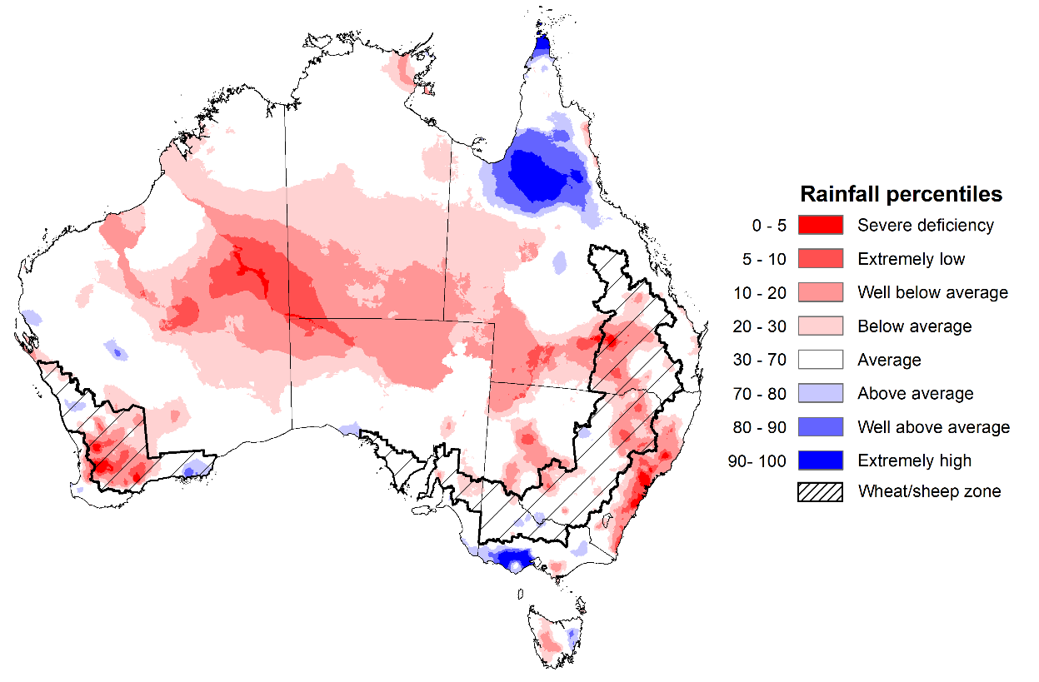

Note: Rainfall for June 2025 is compared with rainfall recorded for that period during the historical record (1900 to present). For further information, go to <http://www.bom.gov.au/climate/austmaps/about-rain-maps.shtml>

Source: Bureau of Meteorology

### Monthly Soil Moisture

In June 2025, modelled **upper layer soil moisture** was generally average to above average, with areas of below average in central, western and eastern regions.

* Large areas of southern Queensland, eastern New South Wales, northern South Australia and southern Western Australia saw very much below average to below average upper layer soil moisture.
* In contrast, much of the northern tropics, southern Victoria and parts of central Western Australia saw above average to very much above upper layer soil moisture.

At this time of year, upper layer soil moisture is important for the establishment and vegetative growth of winter crops across Australian cropping regions. Across most eastern and western cropping regions, modelled upper layer soil moisture in June was generally **below average to average**. In contrast, most cropping regions in the south saw **average** upper layer soil moisture.

* Across parts of southern Western Australia, central Queensland, and northern New South Wales, upper layer soil moisture was extremely low to below average, remaining areas saw average upper layer soil moisture.
* In southern New South Wales, Victoria and South Australia, upper layer soil moisture was average.

This represents a substantial improvement in growing conditions in southern cropping regions compared to May 2025, however adequate and timely rainfall throughout the remainder of the growing season will be needed to support ongoing improvements in cropping and pasture growth outcomes.

**Modelled upper layer soil moisture for June 2025**

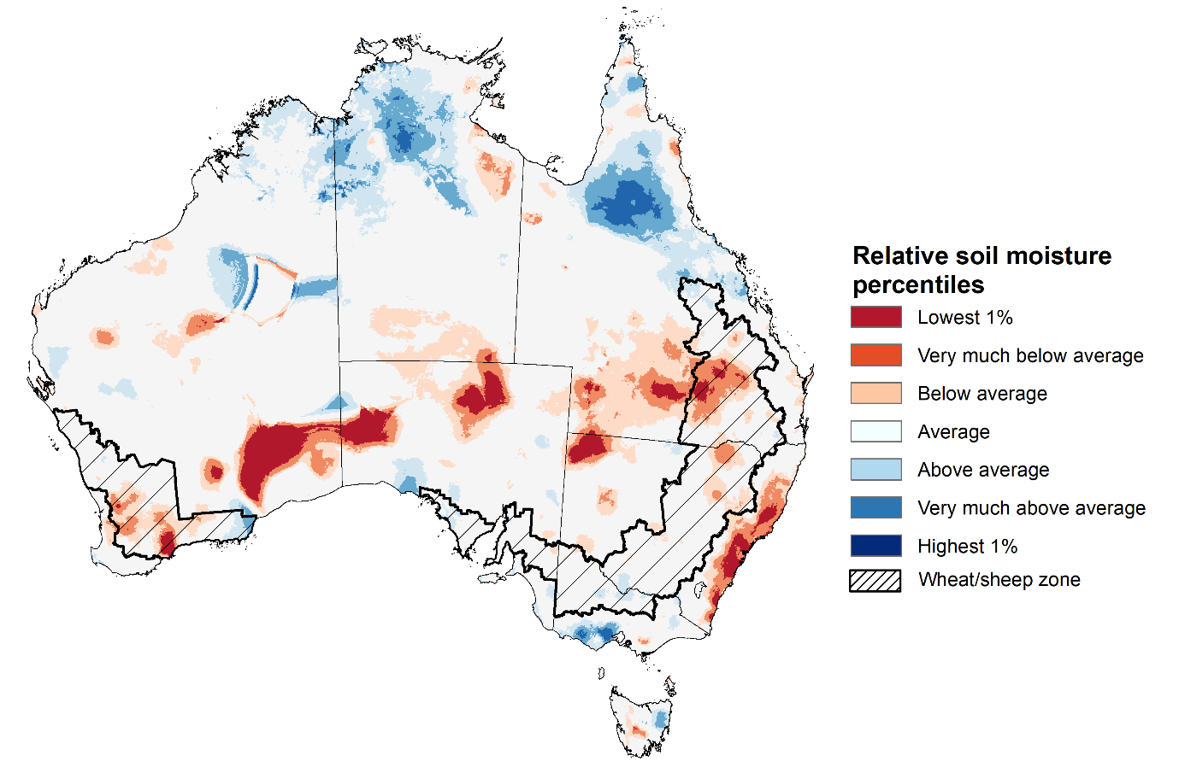

Note: This map shows the levels of modelled upper layer soil moisture (0 to 10 centimetres) during June 2025. This map shows how modelled soil conditions during June 2025 compare with June conditions modelled over the reference period (1911 to 2016). Dark blue areas on the maps were much wetter in June 2025 than during the reference period. The bulk of plant roots occur in the top 20 centimetres of the soil profile. Soil moisture in the upper layer of the soil profile is therefore useful indicator of the availability of water, particularly for germinating seed.

Source: Bureau of Meteorology (<https://awo.bom.gov.au/about/overview>)

Modelled **lower layer soil moisture** in June 2025 was average to very much above average across much of northern and eastern Australia, while extremely low to below average in southern and western areas.

* Large areas of the Northern Territory, northern Western Australia, Queensland, and eastern New South Wales were modelled as having **very much above average soil moisture.**
* By contrast, much of south-eastern Australia, including parts of western New South Wales, Victoria, South Australia and Tasmania, as well as western and southern regions of Western Australia were modelled as having **extremely low to below average soil moisture** over the period**.**

Lower layer soil moisture is a larger, deeper store that is slower to respond to seasonal conditions and tends to reflect the accumulated effects of events that have occurred over longer periods. Crop development and pasture growth in areas of above average lower layer soil moisture are typically less reliant on in-season rainfall than in areas with below average lower layer soil moisture.

* Across cropping regions, much of Queensland, New South Wales and the northwest and southeast of Western Australia saw average to very much above average modelled lower layer soil moisture. In contrast, South Australia, central Western Australia, and Victoria saw extremely low to below average soil moisture for this time of year.

Low levels of lower layer soil moisture across cropping region in south-east Australia and parts of Western Australia present an ongoing downside production risk to the 2025-26 winter crop. These growing regions will require sufficient and timely rainfall throughout the remainder of the growing season to support the growth and development of crops and pastures.

**Modelled lower layer soil moisture for June 2025**

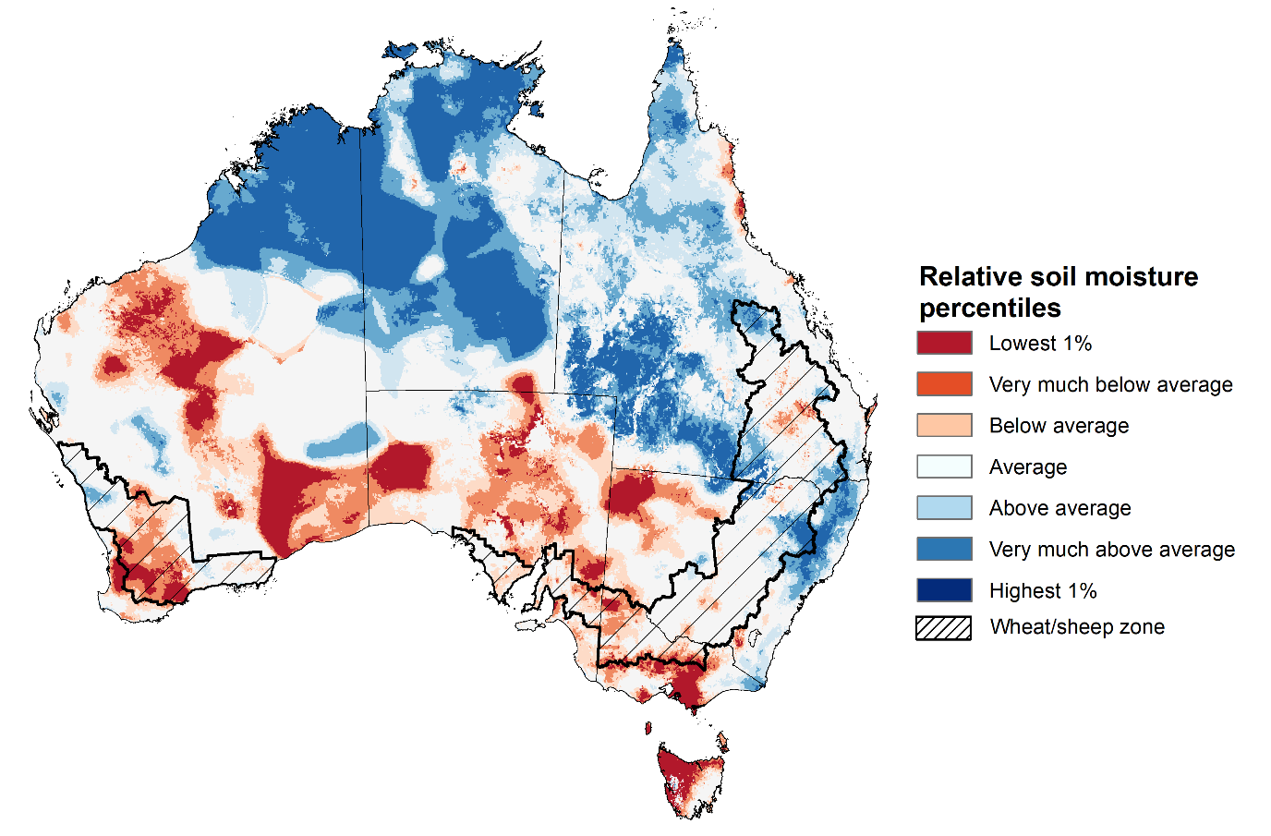

Note: This map shows the levels of modelled lower layer soil moisture (10 to 100 centimetres) during May 2025. This map shows how modelled soil conditions during June 2025 compare with June conditions modelled over the reference period (1911 to 2016). Dark blue areas on the maps were much wetter in June 2025 than during the reference period. The dark red areas were much drier than during the reference period. The bulk of plant roots occur in the top 20 centimetres of the soil profile. The lower layer soil moisture is a larger, deeper store that is slower to respond to rainfall and tends to reflect accumulated rainfall events over longer time periods.

Source: Bureau of Meteorology (<https://awo.bom.gov.au/about/overview>)

### Pasture Growth

Pasture growth for the three months to June 2025 was highly variable across much of country, with northern and parts of eastern Australia experiencing improved pasture growth.

* **Average to extremely high** pasture growth was modelled across large areas of northern and eastern Australia, including Queensland, northern New South Wales, much of the Northern Territory, and northern regions of South Australia and Western Australia.
* This pasture growth is expected to allow farmers to maintain stock numbers, provide opportunities to build standing dry matter availability and decrease the reliance on fodder to maintain livestock condition over the winter period.

By contrast, large areas of Victoria, South Australia, Western Australia, and north-western and southern New South Wales saw relatively low pasture growth for this time of year.

* This below average pasture growth will likely see graziers in affected regions actively destocking or becoming increasingly reliant on supplemental feed to maintain current stocking rates and production.

**Relative pasture growth for 3-months ending June 2025 (1 April to 30 June 2025)**

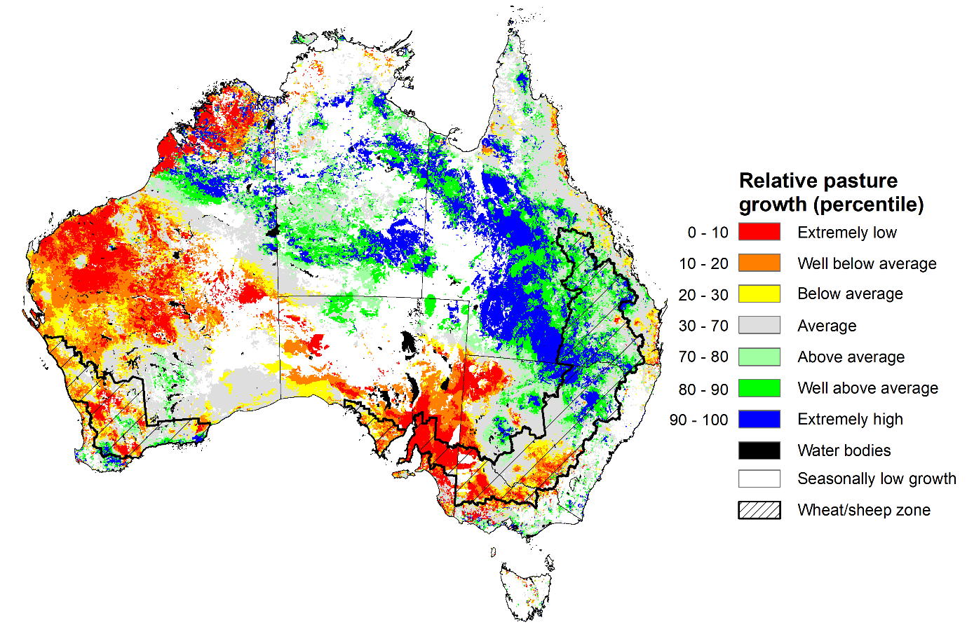

Notes: AussieGRASS pasture growth estimates are relative to the long-term record and shown in percentiles. Percentiles rank data on a scale of zero to 100. This analysis ranks pasture growth for the selected period against average pasture growth for the long-term record (1957 to 2016). Pasture growth is modelled at 5km2 grid cells.  
Source: Department of Environment, Science and Innovation

### Water markets – current week

Water storage levels in the Murray-Darling Basin (MDB) increased by 146 gigalitres (GL) between 26 June 2025 and 3 July 2025. The current volume of water held in storages is 13,146 GL, equivalent to 59% of total storage capacity. This is 24% or 4,171 GL less than the same time last year. Water storage data is sourced from the Bureau of Meteorology.

#### Water storages in the Murray-Darling Basin, 2013–2025Alt Text: A chart showing water storage in the Murray-Darling Basin. For more information, refer to accompanying text

Allocation prices in the Victorian Murray below the Barmah Choke decreased from $301/ML on 26 June 2025 to $300/ML on 3 July 2025. Trade from the Goulburn to the Murray is open. Trade downstream through the Barmah Choke is open. Trade from the Murrumbidgee to the Murray is open.

#### Surface water trade activity, Southern Murray–Darling Basin

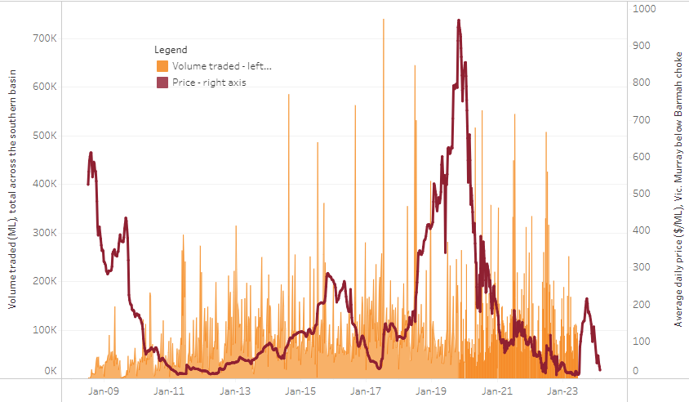

|  |
| --- |
| The trades shown reflect estimated market activity and do not encompass all register trades. The price is shown for the VIC Murray below the Barmah choke. Historical prices (before 1 July 2019) are ABARES estimates after removing outliers from BOM water register data. Prices after 1 July 2019 and prior to the 30 October 2019 reflect recorded transaction prices as sourced from Ruralco. Prices after the 30 October 2019 are sourced from Waterflow. Data for volume traded is sourced from the BOM water register. Only the price data shown is current on 17 October 2024. |

To access the full, interactive, weekly water dashboard, which contains the latest and historical water storage, water market and water allocation information, please visit [https://www.agriculture.gov.au/abares/products/weekly_update/weekly-update-030725](https://www.agriculture.gov.au/abares/products/weekly_update/weekly-update-03072525)

## **Commodities**

|  |  |  |  |  |  |  |  |  |
| --- | --- | --- | --- | --- | --- | --- | --- | --- |
| **Indicator** | **Week average** | **Unit** | **Latest Price** | **Previous Week** | **Weekly change** | | **Price 12 months ago** | **Annual change** |
| **Selected world indicator prices** |  |  |  |  |  |  | |  |
| AUD/USD Exchange rate | 02-Jul | A$/US$ | 0.66 | 0.65 | 1% | 0.67 | | -1% |
| Wheat – US no. 2 hard red winter wheat, FOB Gulf | 02-Jul | US$/t | 233 | 237 | -2% | 260 | | -10% |
| Corn – US no. 2 yellow corn, FOB Gulf | 02-Jul | US$/t | 194 | 189 | 2% | 177 | | 10% |
| Canola – Rapeseed, Canada, FOB Vancouver | 02-Jul | US$/t | 547 | 545 | 0% | 494 | | 11% |
| Cotton – Cotlook A Index | 02-Jul | USc/lb | 79 | 79 | 1% | 81 | | -2% |
| Sugar – Intercontinental Exchange, nearby futures, no.11 contract | 02-Jul | USc/lb | 16 | 17 | -4% | 19 | | -18% |
| Wool – Eastern Market Indicator | 02-Jul | Ac/kg clean | 1,208 | 1,207 | 0% | 1,093 | | 10% |
| Wool – Western Market Indicator | 02-Jul | Ac/kg clean | 1,352 | 1,354 | 0% | 1,254 | | 8% |
| **Selected Australian grain export prices** |  |  |  |  |  |  | |  |
| Australian Premium White (APW) Wheat, FOB Port Adelaide, SA | 02-Jul | A$/t | 391 | 392 | 0% | 424 | | -8% |
| Australian Standard White (ASW) Wheat, FOB Port Adelaide, SA | 02-Jul | A$/t | 387 | 388 | 0% | 415 | | -7% |
| Feed Barley – FOB Port Adelaide, SA | 02-Jul | A$/t | 374 | 375 | 0% | 367 | | 2% |
| Canola – FOB Kwinana, WA | 02-Jul | A$/t | 831 | 847 | -2% | 757 | | 10% |
| Grain Sorghum – FOB Brisbane, QLD | 02-Jul | A$/t | 424 | 423 | 0% | 411 | | 3% |
| **Selected domestic livestock indicator prices** |  |  |  |  |  |  | |  |
| Beef – Eastern Young Cattle Indicator | 02-Jul | Ac/kg cwt | 716 | 706 | 2% | 631 | | 13% |
| Mutton – Mutton indicator (18–24 kg fat score 2–3), VIC | 02-Jul | Ac/kg cwt | 663 | 653 | 2% | 415 | | 60% |
| Lamb – National Trade Lamb Indicator | 02-Jul | Ac/kg cwt | 1,038 | 1,023 | 1% | 813 | | 28% |
| Pig – Eastern Seaboard (60.1–75 kg), NSW buyer price | 18-Jun | Ac/kg cwt | 451 | 451 | 0% | 409 | | 10% |
| Live cattle – Light steers to Indonesia | 02-Jul | Ac/kg lwt | 335 | 335 | 0% | 300 | | 12% |
| **Global Dairy Trade (GDT) weighted average prices** |  |  |  |  |  |  | |  |
| Dairy – Whole milk powder | 02-Jul | US$/t | 3,859 | 4,084 | -6% | 3,180 | | 21% |
| Dairy – Skim milk powder | 02-Jul | US$/t | 2,718 | 2,775 | -2% | 2,576 | | 6% |
| Dairy – Cheddar cheese | 02-Jul | US$/t | 4,860 | 4,992 | -3% | 4,099 | | 19% |
| Dairy – Anhydrous milk fat | 02-Jul | US$/t | 6,928 | 7,276 | -5% | 6,641 | | 4% |
|  | | | | | | | | |

### Selected world indicator prices

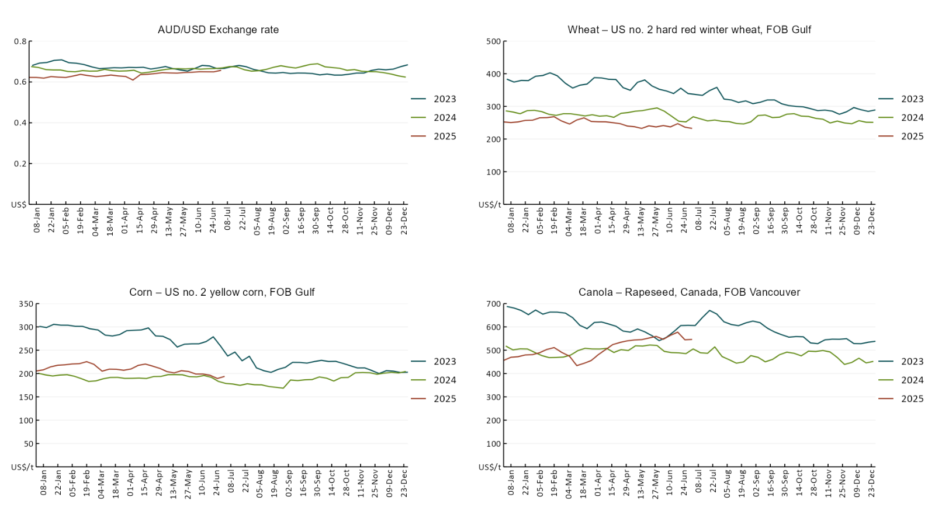

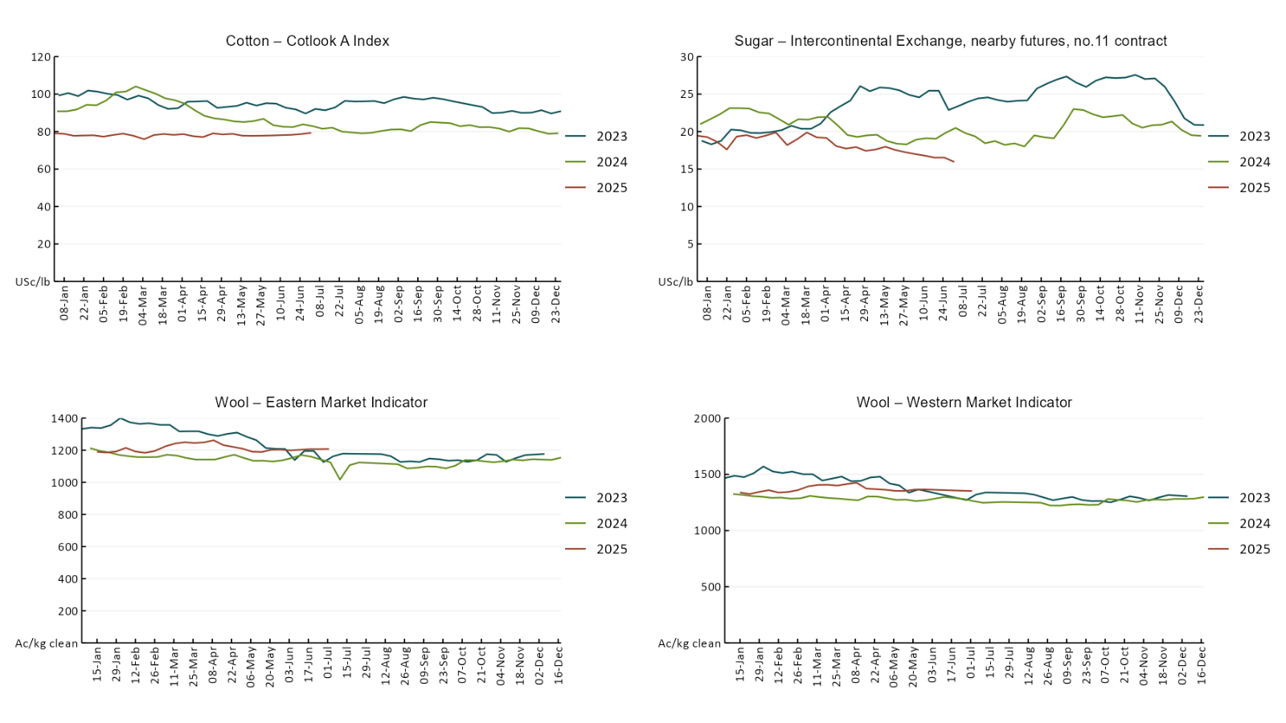

### 3.2 Selected domestic crop indicator prices

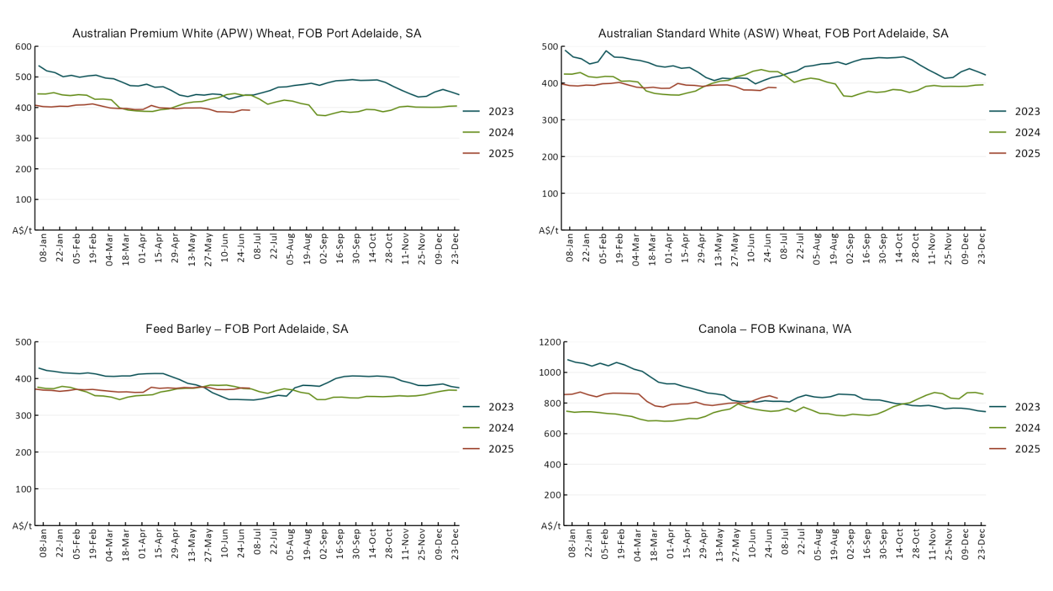

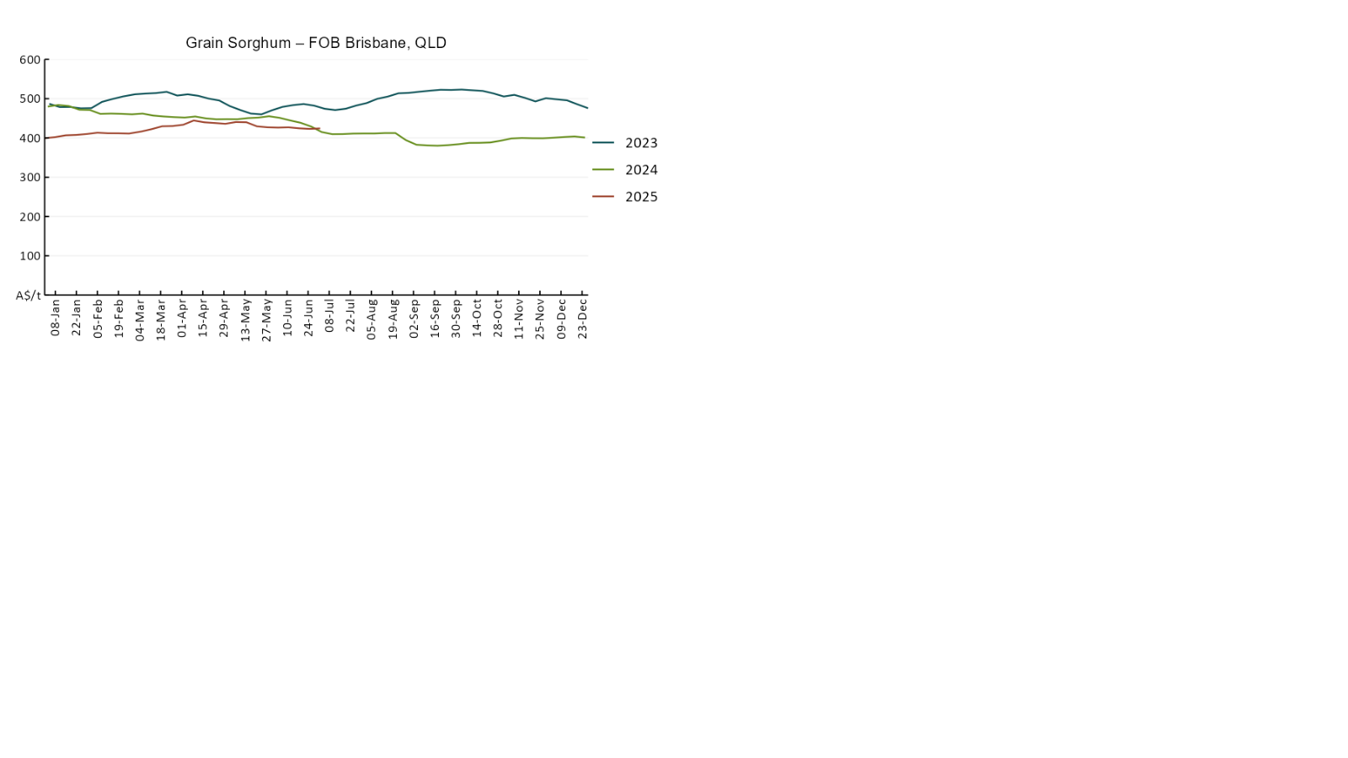

### 3.3 Selected domestic livestock indicator prices

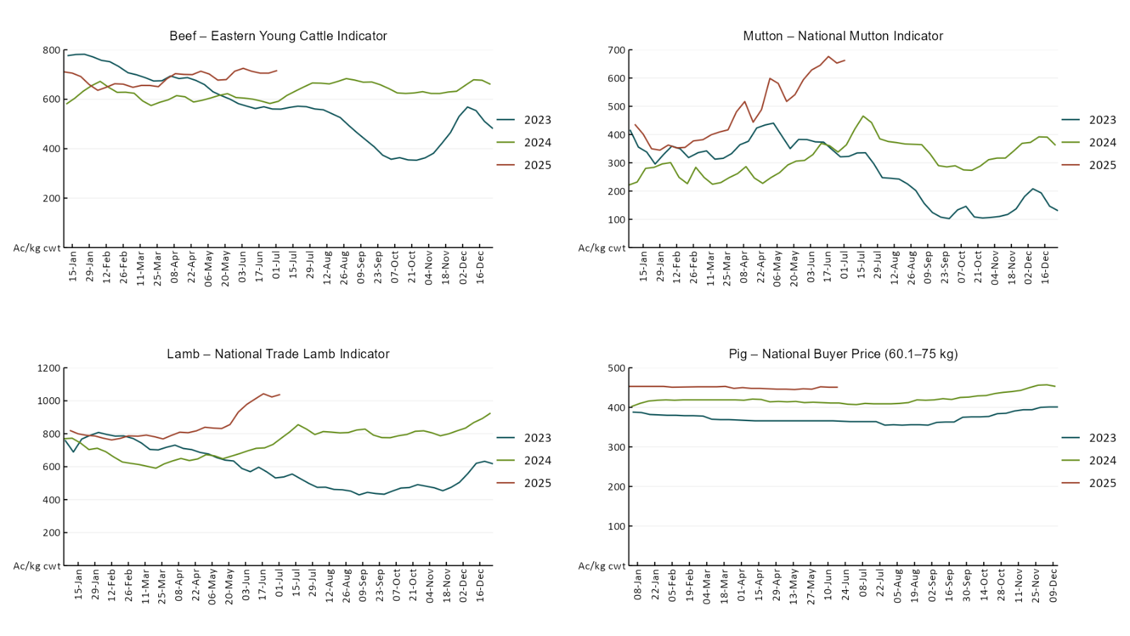

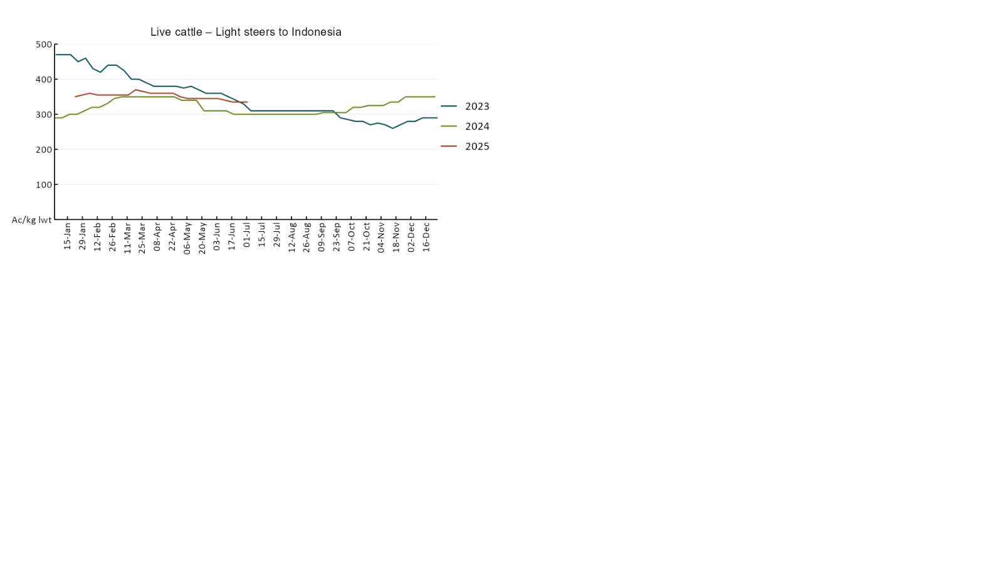

### 3.4 Global Dairy Trade (GDT) weighted average pricesA line chart of Global Dairy Trade prices. For more information, refer to https://www.agriculture.gov.au/abares/data/weekly-commodity-price-update/world-agricultural-prices

### 3.5 Selected fruit and vegetable prices

### A line chart of fruit and vegetable prices. For more information, refer to https://www.agriculture.gov.au/abares/data/weekly-commodity-price-update/world-agricultural-prices

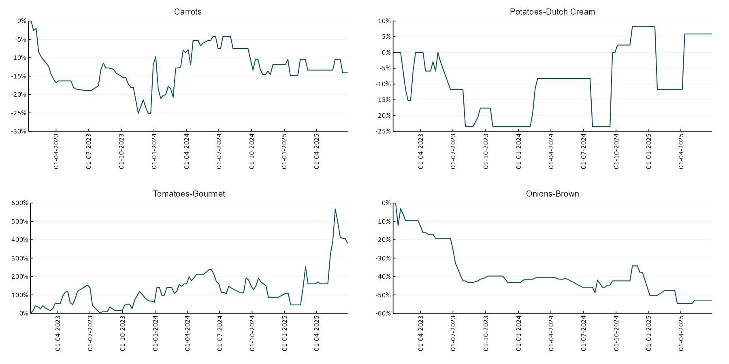

### 3.6 Selected domestic fodder indicator prices

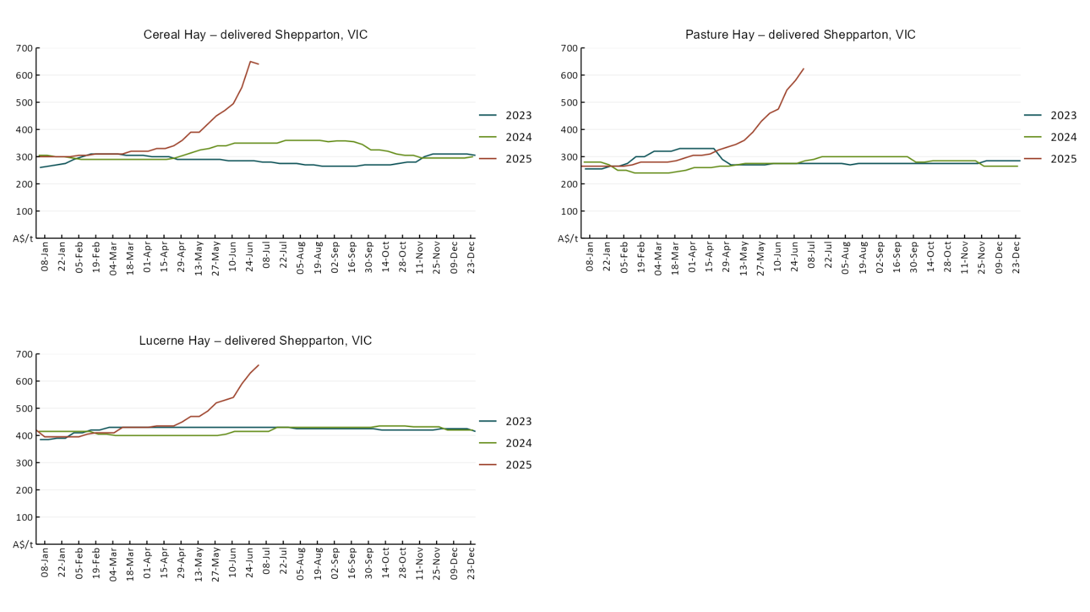

## **4. Data attribution**

### Climate

* Bureau of Meteorology
* Weekly rainfall totals: www.bom.gov.au/climate/maps/rainfall/
* Monthly and last 3-month rainfall percentiles: [www.bom.gov.au/water/landscape/](http://www.bom.gov.au/water/landscape/)
* Temperature anomalies: [www.bom.gov.au/jsp/awap/temp/index.jsp](http://www.bom.gov.au/jsp/awap/temp/index.jsp)
* Rainfall forecast: [www.bom.gov.au/jsp/watl/rainfall/pme.jsp](http://www.bom.gov.au/jsp/watl/rainfall/pme.jsp)
* Seasonal outlook: [www.bom.gov.au/climate/outlooks/#/overview/summary/](http://www.bom.gov.au/climate/outlooks/#/overview/summary/)
* Climate drivers: <http://www.bom.gov.au/climate/enso/>
* Soil moisture: [www.bom.gov.au/water/landscape/](http://www.bom.gov.au/water/landscape/)
* Other
* Pasture growth: [www.longpaddock.qld.gov.au/aussiegrass/](http://www.longpaddock.qld.gov.au/aussiegrass/)
* 3-month global outlooks: [Environment and Climate Change Canada](https://weather.gc.ca/saisons/image_e.html?img=s234pfe1p_cal&bc=prob), [NOAA Climate Prediction Center](https://www.cpc.ncep.noaa.gov/products/predictions/long_range/seasonal.php?lead=2), [EUROBRISA CPTEC/INPE](http://eurobrisa.cptec.inpe.br/), European Centre for Medium-Range Weather Forecasts, [Hydrometcenter of Russia](https://meteoinfo.ru/en/climate/seasonal-forecasts), [National Climate Center Climate System Diagnosis and Prediction Room (NCC)](https://cmdp.ncc-cma.net/pred/cs2gen.php?pred_elem=RAINP#pred_seasonal), [International Research Institute for Climate and Society](https://iri.columbia.edu/our-expertise/climate/forecasts/seasonal-climate-forecasts/)
* Global production: <https://ipad.fas.usda.gov/ogamaps/cropmapsandcalendars.aspx>
* Autumn break: Pook et al., 2009, <https://rmets-onlinelibrary-wiley-com.virtual.anu.edu.au/doi/epdf/10.1002/joc.1833>

### Water

Prices

* Waterflow: <https://www.waterflow.io/>
* Ruralco: <https://www.ruralcowater.com.au/>
* Bureau of Meteorology:
* Allocation trade: <http://www.bom.gov.au/water/dashboards/#/water-markets/mdb/at>
* Storage volumes: <http://www.bom.gov.au/water/dashboards/#/water-storages/summary/drainage>
* Trade constraints:
* Water NSW: <https://www.waternsw.com.au/customer-service/ordering-trading-and-pricing/trading/murrumbidgee>
* Victorian Water Register: <https://www.waterregister.vic.gov.au/TradingRules2019/>

### Commodities

* Fruit and vegetables
* Datafresh: [www.freshstate.com.au](http://www.freshstate.com.au)
* Pigs
* Australian Pork Limited: [www.australianpork.com.au](http://www.australianpork.com.au)
* Dairy
* Global Dairy Trade: [www.globaldairytrade.info/en/product-results/](http://www.globaldairytrade.info/en/product-results/)
* World wheat, canola
* International Grains Council
* World coarse grains
* United States Department of Agriculture
* World cotton
* Cotlook: [www.cotlook.com/](http://www.cotlook.com/)
* World sugar
* New York Stock Exchange - Intercontinental Exchange
* Wool
* Australian Wool Exchange: [www.awex.com.au/](http://www.awex.com.au/)
* Domestic wheat, barley, sorghum, canola and fodder
* Jumbuk Consulting Pty Ltd: http://www.jumbukag.com.au/
* Cattle, beef, mutton, lamb, goat and live export
* Meat and Livestock Australia: [www.mla.com.au/Prices-and-market](http://www.mla.com.au/Prices-and-market)

© Commonwealth of Australia 2025

### Ownership of intellectual property rights

Unless otherwise noted, copyright (and any other intellectual property rights, if any) in this publication is owned by the Commonwealth of Australia (referred to as the Commonwealth).

### Creative Commons licence

All material in this publication is licensed under a [Creative Commons Attribution 4.0 International Licence](https://creativecommons.org/licenses/by/4.0/legalcode) except content supplied by third parties, logos and the Commonwealth Coat of Arms.

Inquiries about the licence and any use of this document should be emailed to [copyright@awe.gov.au](mailto:copyright@awe.gov.au).

https://www.agriculture.gov.au/sites/default/files/images/creative-commons-logo-small.png

### Cataloguing data

This publication (and any material sourced from it) should be attributed as:

ABARES 2025, Weekly Australian Climate, Water and Agricultural Update, Australian Bureau of Agricultural and Resource Economics and Sciences, Canberra, 3 July 2025. CC BY 4.0 DOI: <https://doi.org/10.25814/5f3e04e7d2503>

ISSN **2652-7561**

This publication is available at https://www.agriculture.gov.au/abares/products/weekly_update

Department of Agriculture, Fisheries and Forestry

GPO Box 858 Canberra ACT 2601

Telephone 1800 900 090

Web [agriculture.gov.au/abares](http://awe.gov.au/abares)

### Disclaimer

The Australian Government acting through the Department of Agriculture, Fisheries and Forestry, represented by the Australian Bureau of Agricultural and Resource Economics and Sciences, has exercised due care and skill in preparing and compiling the information and data in this publication. Notwithstanding, the Department of Agriculture, Fisheries and Forestry, ABARES, its employees and advisers disclaim all liability, including liability for negligence and for any loss, damage, injury, expense or cost incurred by any person as a result of accessing, using or relying on any of the information or data in this publication to the maximum extent permitted by law.

### Statement of Professional Independence

The views and analysis presented in ABARES publications, including this one, reflect ABARES professionally independent findings, based on scientific and economic concepts, principles, information and data. These views, analysis and findings may not reflect or be consistent with the views or positions of the Australian Government, or of organisations or groups who have commissioned ABARES reports or analysis. More information on [professional independence](https://www.agriculture.gov.au/abares/about/research-and-analysis#professional-independence) is provided on the ABARES website.

### Acknowledgements

This report was prepared by Holly Beale and Matthew Miller.