## No. 27/2025 10 July 2025

# Summary of key issues

* In the week ending 9 July 2025, frontal systems brought rainfall totals of up to 100 millimetres to parts of southern Australia. High-pressure systems kept much of the remainder of Australia largely dry.
* Rainfall was highly variable across cropping regions in the week ending 9 July 2025
  + Rainfall totals of between 5-50 millimetres occurred across Western Australia, southern Victoria and across western and central regions of South Australia. Remaining areas recorded little to no rainfall, with falls ranging between 0-5 millimetres.
  + The ongoing lack of rainfall across the Mallee regions of South Australia and Victoria continues to present an increasing downside production risk for winter crops. These areas have likely received sufficient rainfall to germinate dry sown crops but little follow-up rainfall during late June and early July to support their establishment and growth.
* Over the coming eight days, rainfall is expected across much of southern Australia, while the northern two thirds of Australia are likely to stay dry.
  + Cropping regions in Victoria, South Australia, and southern central New South Wales are expected to record between 5-50 millimetres of rainfall, with falls of between 5-25 millimetres expected in Western Australia. If realised, this should provide timely moisture to support the establishment and growth of winter crops across most southern cropping regions.
* The **national rainfall outlook** for August to October 2025 indicates an increased probability of above median rainfall across much of central and eastern Australia. Western regions are likely to see close to average rainfall.
  + If realised, the expectation of above average August to October 2025 rainfall across most winter cropping regions is likely be sufficient to support the growth and development of winter crops.
* Water storage levels in the Murray-Darling Basin (MDB) increased by 137 gigalitres (GL) between 3 July 2025 and 10 July 2025. The current volume of water held in storages is 13,284 GL, equivalent to 60% of total storage capacity. This is 24% or 4,090 GL less than the same time last year. Water storage data is sourced from the Bureau of Meteorology.
* Allocation prices in the Victorian Murray below the Barmah Choke decreased from $300/ML on 3 July 2025 to $318/ML on 10 July 2025. Trade from the Goulburn to the Murray is **closed**. Trade downstream through the Barmah Choke is **closed**. Trade from the Murrumbidgee to the Murray is **open**. The water allocation prices shown are volume weighted average prices based on the last 10 trades. Price data is sourced from Waterflow.

## **Climate**

### Rainfall this week

In the week ending 9 July 2025, **a series of cold fronts** brought rainfall to parts of southern Australia, while high-pressure systems kept much of Australia largely dry.

* Rainfall totals of between 5-100 millimetres were recorded across much of southern Western Australia and Victoria.
* Falls of between 5-50 millimetres occurred across parts of Tasmania, southern South Australia, and southeast New South Wales.
* Remaining areas of Australia received little to no rainfall over the period.

Rainfall was highly variable across cropping regions in the week ending 9 July 2025.

* Rainfall totals of between 5-50 millimetres occurred across Western Australia, southern Victoria and across western and central regions of South Australia.
* In contrast, much of northern Victoria, New South Wales, Queensland, and eastern South Australia recorded little to no rainfall, with falls ranging between 0-5 millimetres.
  + These conditions have provided some useful follow-up moisture in Western Australia and parts of South Australia, to support crop establishment and development.
  + However, the ongoing lack of rainfall across the Mallee regions of South Australia and Victoria continues to present an increasing downside production risk for winter crops. These areas have likely received sufficient rainfall to germinate dry sown crops but little follow-up rainfall during late June and early July to support their establishment and growth.

#### Rainfall for the week ending 9 July 2025

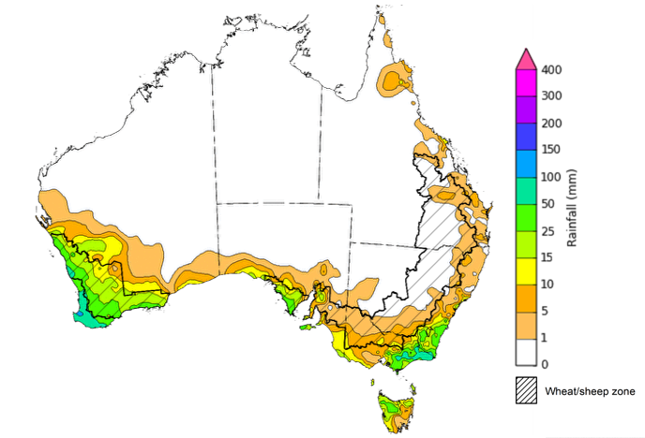

©Commonwealth of Australia 2025, Australian Bureau of Meteorology Issued: 9/7/2025

Note: The rainfall analyses and associated maps utilise data contained in the Bureau of Meteorology climate database, the Australian Data Archive for Meteorology (ADAM). The analyses are initially produced automatically from real-time data with limited [quality control](http://www.bom.gov.au/climate/headers/qc.shtml). They are intended to provide a general overview of rainfall across Australia as quickly as possible after the observations are received. For further information go to <http://www.bom.gov.au/climate/rainfall/>

### Rainfall forecast for the next eight days

Over the 8 days to 17 July 2025, **cold fronts** are expected to bring rainfall to parts of southern Australia, with high-pressure systems expected to keep central and northern regions largely dry.

* Southern parts of Western Australia and South Australia are expected to see between 5-50 millimetres, with Victoria, Tasmania and southern New South Wales forecast to receive 10-100 millimetres.
* Little to no rainfall is expected across much of the remainder of the country over this period.

Some rainfall is expected across south-eastern and south-western cropping regions over the coming week, with little expected in the northeast.

* Falls of between 5-50 millimetres are forecast across cropping regions Victoria, South Australia and southern and central New South Wales, while much of Western Australia is likely to see 5-25 millimetres. 
  + If realised, this should provide timely moisture to support the establishment and growth of winter crops across most southern cropping regions, particularly in the Mallee regions of South Australia and Victoria following a relatively dry conditions during late June and early July.
* Meanwhile, little to no rainfall is expected in Queensland and much of northern New South Wales. These low expected rainfall totals are unlikely to adversely impact crop growth as crops will be able to utilise soil moisture reserves to support their growth and development.

#### Total forecast rainfall for the period 10 July to 17 July 2025

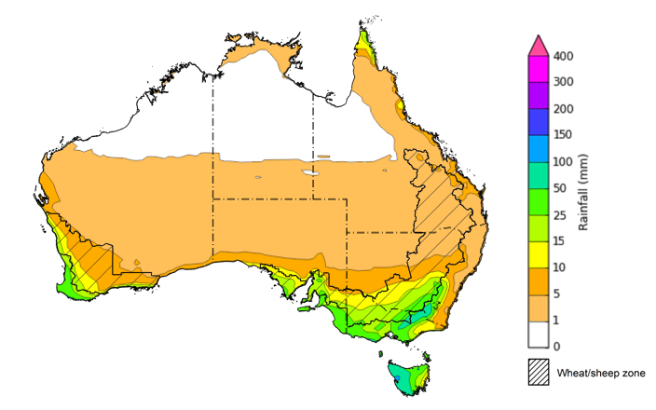

©Commonwealth of Australia 2025, Australian Bureau of Meteorology Issued 10/7/2025

Note: This rainfall forecast is produced from computer models. As the model outputs are not altered by weather forecasters, it is important to check local forecasts and warnings issued by the Bureau of Meteorology.

* 1. **National Climate Outlook**

The El Niño Southern Oscillation (ENSO) and Indian Ocean Dipole (IOD) climate drivers are currently neutral and having minimal influence on Australian rainfall. The ENSO is likely to remain neutral until December. In contrast, the Southern Annular Mode (SAM) is currently positive, with the highest index value since 2023. A positive SAM has contributed to reduced cold front rainfall across parts of south-eastern Australia over recent weeks relative to a neutral SAM expectation. The SAM is expected to return to neutral values in the coming fortnight.

The most recent **rainfall outlook for August 2025** provided by the Bureau of Meteorology indicates that much of central, northern, and eastern Australia is likely to see **above median rainfall,** with western regions likely to see close to average falls**.**

* The Bureau of Meteorology’s climate model indicates a 75% chance of August rainfall totals between 5-50 millimetres across much of southern Australia, including southern South Australia, Victoria, eastern and central New South Wales, Tasmania, southern Western Australia and Tasmania. Meanwhile, parts of south-western Western Australia, western Tasmania and alpine regions of New South Wales and Victoria are expected to see between 50-200 millimetres.
* Despite the increased probabilities of above average across much of northern Australia, August is within the northern Australian dry season. During this time of year, most of the northern two-thirds of Australia typically receives very low rainfall, with average rainfall less than 5 millimetres for the month of August.
* Across cropping regions, there is a **75% chance** of rainfall totals of between **10-50 millimetres across most southern cropping regions.** If realised, this is expected to provide sufficient moisture to support the growth and development of winter crops across most southern growing regions. In contrast, most Queensland and northern New South Wales cropping regions are likely to see less than 25 millimetres while northern Queensland to see between 0-10 millimetres. These lower expected rainfall totals are unlikely to adversely impact crop growth as crops will be able to utilise soil moisture reserves to support their growth and development.

**Rainfall totals that have a 75% chance of occurring in August 2025**

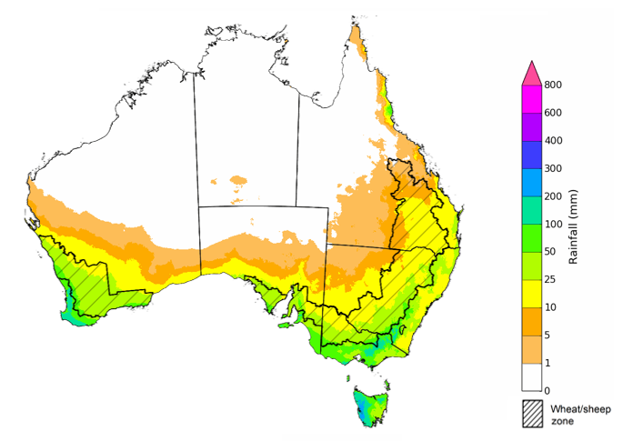

©Commonwealth of Australia 2025, Australian Bureau of Meteorology Issued: 10/7/2025

The **rainfall outlook for August to October 2025** indicates an increased probability of **above median rainfall across much of central and eastern Australia,** including much of Queensland, New South Wales, Victoria, South Australia and the Northern Territory. In contrast, isolated areas of Tasmania and northern Western Australia are showing an increased probability of **below median rainfall**.

Across cropping regions, the chance of receiving above median rainfall is between 65-90% across Queensland and New South Wales, while Victoria and Southern Australia have a 60-75% probability of receiving above median rainfall over the period. In Western Australia, the probability of above median rainfall is slightly lower at 50-70%.

**Chance of exceeding the median rainfall August 2025 to October 2025**

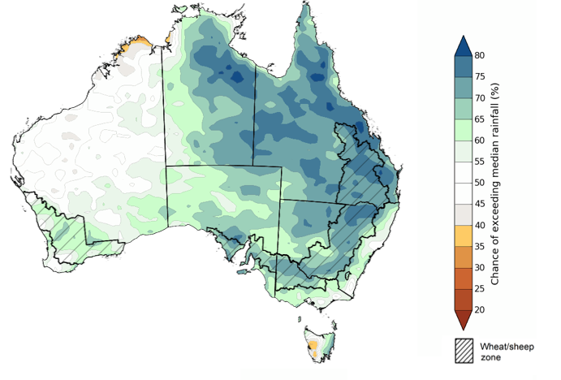

©Commonwealth of Australia 2025, Australian Bureau of Meteorology Issued: 10/7/2025

The **rainfall outlook for August through to October 2025** suggests a 75% chance of receiving rainfall totals of between 200-600 millimetres across the far south-west of Western Australia, western Tasmania, and alpine areas of New South Wales and Victoria. Between 25-200 millimetres of rainfall are forecast across much of south-eastern Queensland, New South Wales, Victoria, southern South Australia and southern Western Australia, and eastern Tasmania. Across much of northern and central Australia, little to no rainfall is forecast over the period.

In **cropping regions**, there is a **75% chance** of receiving between **50-200 millimetres** in the south, including Western Australia, South Australia, Victoria and New South Wales. In Queensland, falls of 25-200 millimetres are expected. If realised, these falls are likely be sufficient to support the growth and development of winter crops.

**Rainfall totals that have a 75% chance of occurring August 2025 to October 2025**

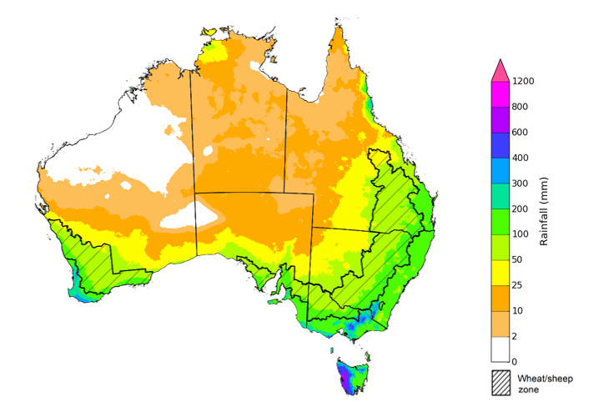

©Commonwealth of Australia 2025, Australian Bureau of Meteorology Issued: 10/7/2025

### Water markets – current week

Water storage levels in the Murray-Darling Basin (MDB) increased by 137 gigalitres (GL) between 3 July 2025 and 10 July 2025. The current volume of water held in storages is 13,284 GL, equivalent to 60% of total storage capacity. This is 24% or 4,090 GL less than the same time last year. Water storage data is sourced from the Bureau of Meteorology.

#### Water storages in the Murray-Darling Basin, 2013–2025Alt Text: A chart showing water storage in the Murray-Darling Basin. For more information, refer to accompanying text

Allocation prices in the Victorian Murray below the Barmah Choke decreased from $300/ML on 3 July 2025 to $318/ML on 10 July 2025. Trade from the Goulburn to the Murray is **closed**. Trade downstream through the Barmah Choke is **closed**. Trade from the Murrumbidgee to the Murray is **open**. The water allocation prices shown are volume weighted average prices based on the last 10 trades. Price data is sourced from Waterflow

#### Surface water trade activity, Southern Murray–Darling Basin

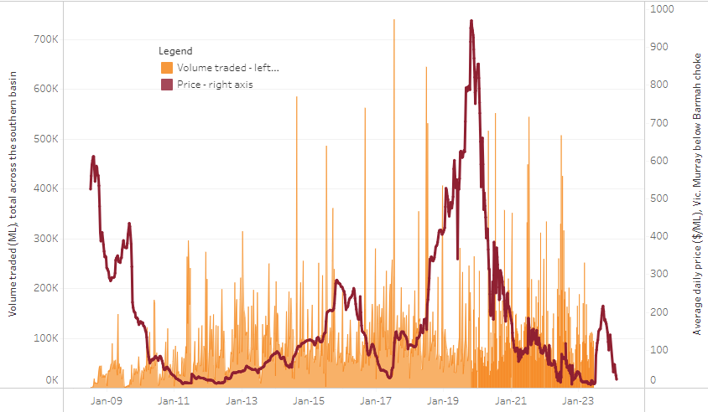

|  |
| --- |
| The trades shown reflect estimated market activity and do not encompass all register trades. The price is shown for the VIC Murray below the Barmah choke. Historical prices (before 1 July 2019) are ABARES estimates after removing outliers from BOM water register data. Prices after 1 July 2019 and prior to the 30 October 2019 reflect recorded transaction prices as sourced from Ruralco. Prices after the 30 October 2019 are sourced from Waterflow. Data for volume traded is sourced from the BOM water register. Only the price data shown is current on 17 October 2024. |

To access the full, interactive, weekly water dashboard, which contains the latest and historical water storage, water market and water allocation information, please visit <https://www.agriculture.gov.au/abares/products/weekly_update/weekly-update-100725>

## **Commodities**

|  |  |  |  |  |  |  |  |  |
| --- | --- | --- | --- | --- | --- | --- | --- | --- |
| **Indicator** | **Week average** | **Unit** | **Latest Price** | **Previous Week** | **Weekly change** | | **Price 12 months ago** | **Annual change** |
| **Selected world indicator prices** |  |  |  |  |  |  | |  |
| AUD/USD Exchange rate | 09-Jul | A$/US$ | 0.65 | 0.66 | -1% | 0.67 | | -2% |
| Wheat – US no. 2 hard red winter wheat, FOB Gulf | 09-Jul | US$/t | 235 | 237 | -1% | 260 | | -9% |
| Corn – US no. 2 yellow corn, FOB Gulf | 09-Jul | US$/t | 192 | 195 | -2% | 177 | | 8% |
| Canola – Rapeseed, Canada, FOB Vancouver | 09-Jul | US$/t | 543 | 554 | -2% | 494 | | 10% |
| Cotton – Cotlook A Index | 09-Jul | USc/lb | 79 | 79 | -1% | 81 | | -3% |
| Sugar – Intercontinental Exchange, nearby futures, no.11 contract | 09-Jul | USc/lb | 16 | 16 | 1% | 19 | | -16% |
| Wool – Eastern Market Indicator | 09-Jul | Ac/kg clean | 1,212 | 1,208 | 0% | 1,093 | | 11% |
| Wool – Western Market Indicator | 09-Jul | Ac/kg clean | 1,355 | 1,352 | 0% | 1,254 | | 8% |
| **Selected Australian grain export prices** |  |  |  |  |  |  | |  |
| Australian Premium White (APW) Wheat, FOB Port Adelaide, SA | 09-Jul | A$/t | 394 | 392 | 1% | 424 | | -7% |
| Australian Standard White (ASW) Wheat, FOB Port Adelaide, SA | 09-Jul | A$/t | 390 | 388 | 1% | 415 | | -6% |
| Feed Barley – FOB Port Adelaide, SA | 09-Jul | A$/t | 376 | 375 | 0% | 367 | | 3% |
| Canola – FOB Kwinana, WA | 09-Jul | A$/t | 826 | 828 | 0% | 757 | | 9% |
| Grain Sorghum – FOB Brisbane, QLD | 09-Jul | A$/t | 426 | 425 | 0% | 411 | | 4% |
| **Selected domestic livestock indicator prices** |  |  |  |  |  |  | |  |
| Beef – Eastern Young Cattle Indicator | 09-Jul | Ac/kg cwt | 727 | 719 | 1% | 631 | | 15% |
| Mutton – Mutton indicator (18–24 kg fat score 2–3), VIC | 09-Jul | Ac/kg cwt | 682 | 668 | 2% | 415 | | 64% |
| Lamb – National Trade Lamb Indicator | 09-Jul | Ac/kg cwt | 1,088 | 1,048 | 4% | 813 | | 34% |
| Pig – Eastern Seaboard (60.1–75 kg), NSW buyer price | 25-Jun | Ac/kg cwt | 452 | 451 | 0% | 409 | | 11% |
| Live cattle – Light steers to Indonesia | 25-Jun | Ac/kg lwt | 335 | 335 | 0% | 300 | | 12% |
| **Global Dairy Trade (GDT) weighted average prices** |  |  |  |  |  |  | |  |
| Dairy – Whole milk powder | 02-Jul | US$/t | 3,859 | 4,084 | -6% | 3,180 | | 21% |
| Dairy – Skim milk powder | 02-Jul | US$/t | 2,718 | 2,775 | -2% | 2,576 | | 6% |
| Dairy – Cheddar cheese | 02-Jul | US$/t | 4,860 | 4,992 | -3% | 4,099 | | 19% |
| Dairy – Anhydrous milk fat | 02-Jul | US$/t | 6,928 | 7,276 | -5% | 6,641 | | 4% |
|  | | | | | | | | |

### Selected world indicator prices

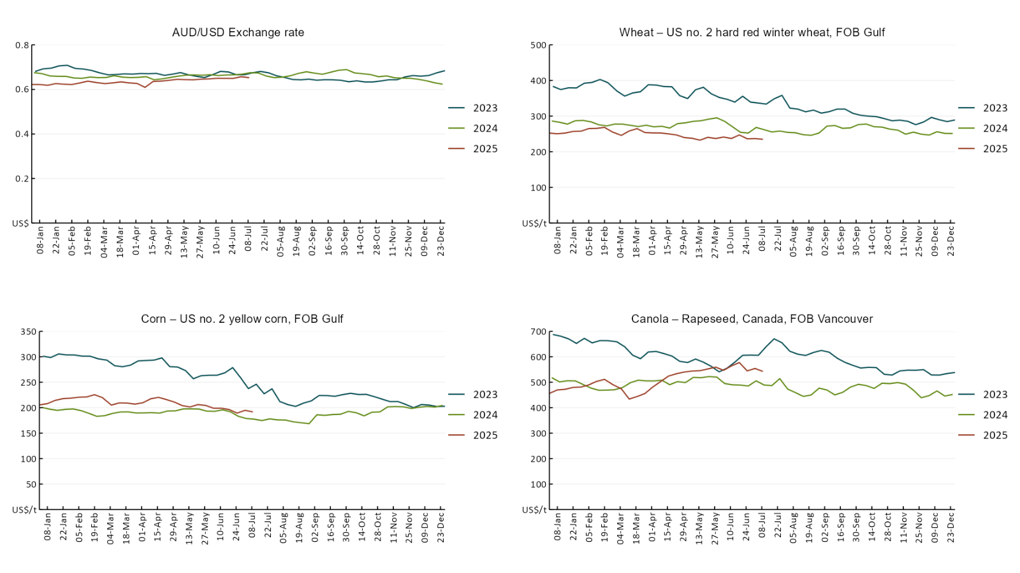

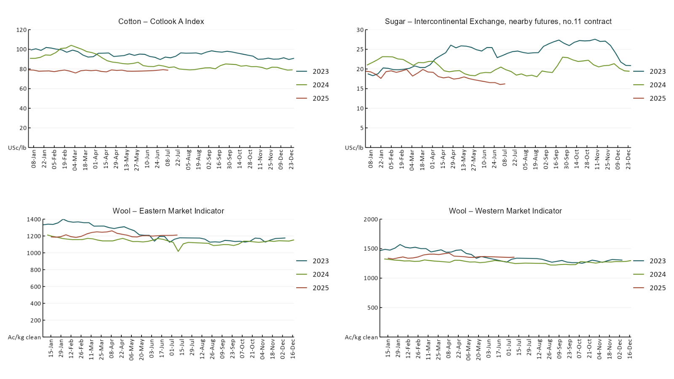

### 3.2 Selected domestic crop indicator prices A line chart of major domestic crop prices. For more information, refer to https://www.agriculture.gov.au/abares/data/weekly-commodity-price-update/world-agricultural-prices

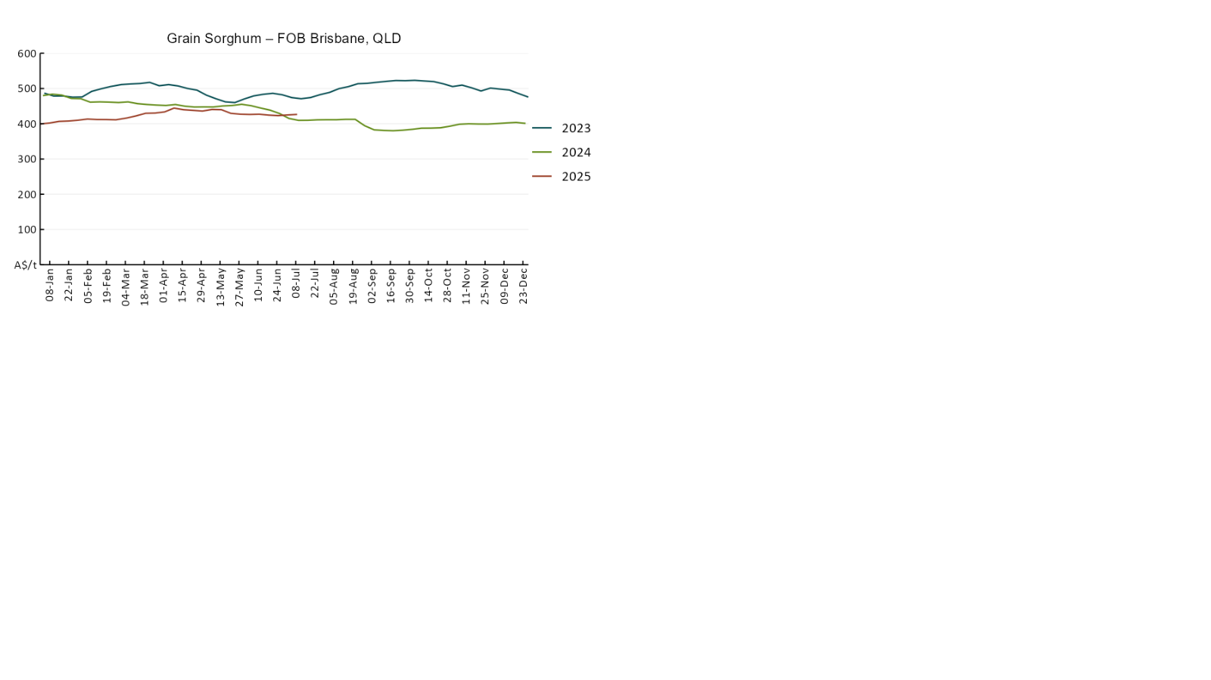

### 3.3 Selected domestic livestock indicator prices

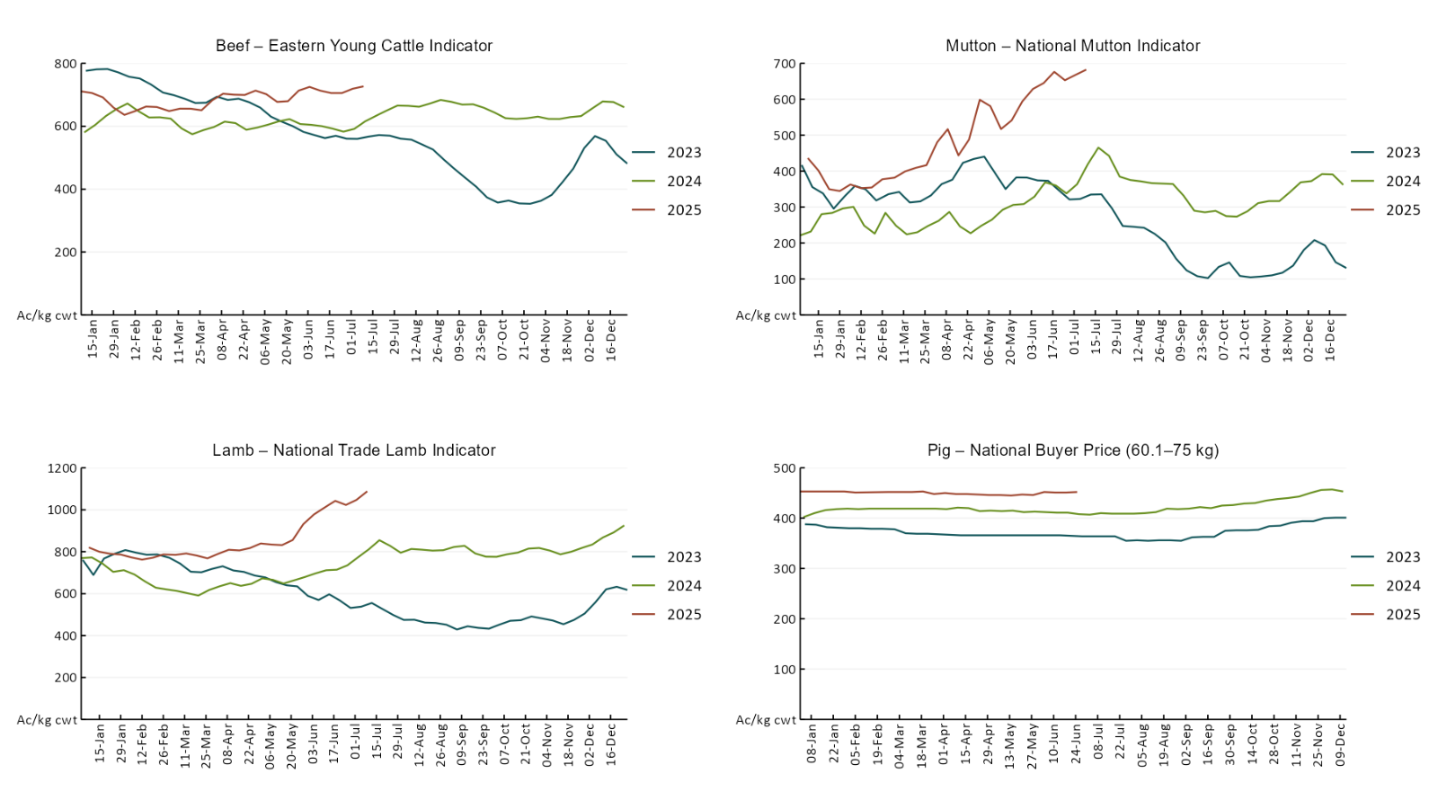

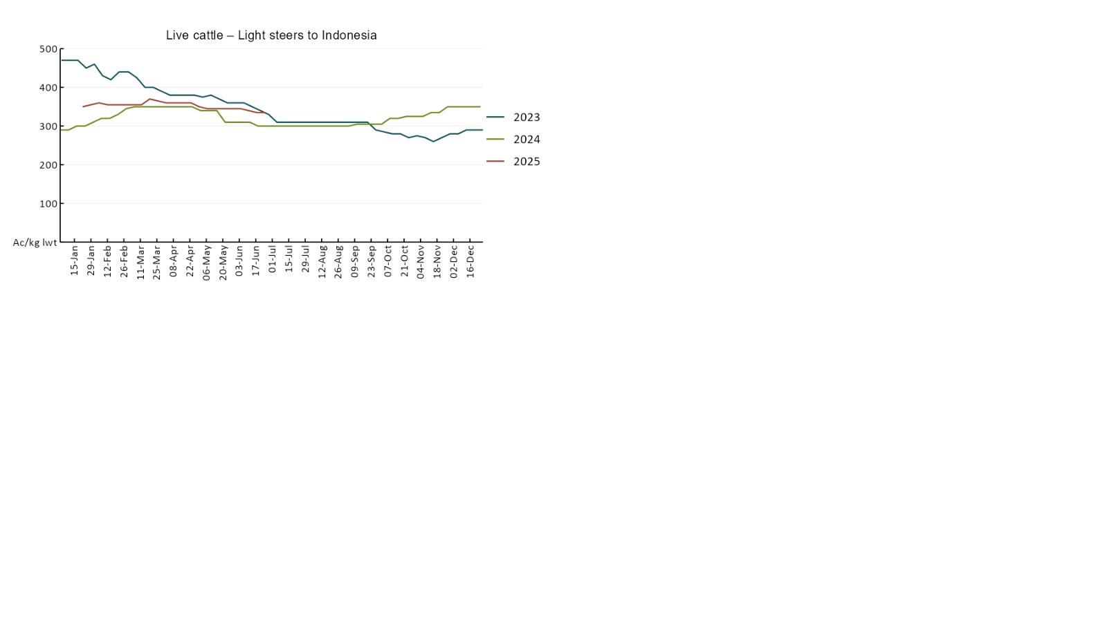

### 3.4 Global Dairy Trade (GDT) weighted average pricesA line chart of Global Dairy Trade prices. For more information, refer to https://www.agriculture.gov.au/abares/data/weekly-commodity-price-update/world-agricultural-prices

### 3.5 Selected fruit and vegetable prices

### A line chart of fruit and vegetable prices. For more information, refer to https://www.agriculture.gov.au/abares/data/weekly-commodity-price-update/world-agricultural-prices

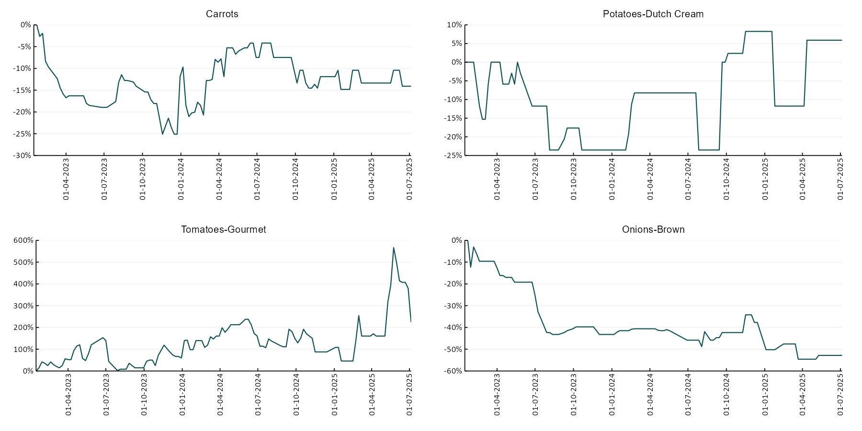

### 3.6 Selected domestic fodder indicator prices

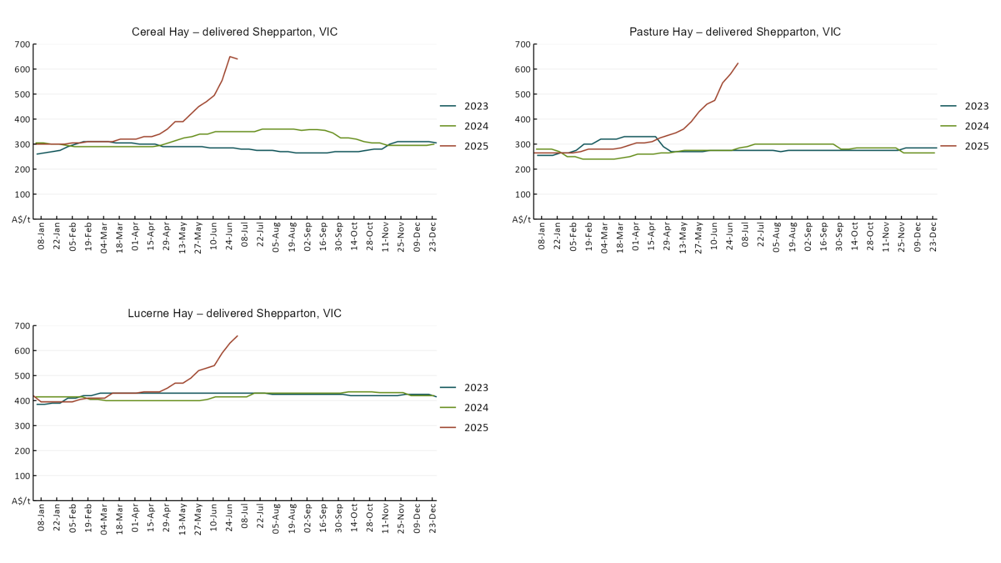

## **4. Data attribution**

### Climate

* Bureau of Meteorology
* Weekly rainfall totals: www.bom.gov.au/climate/maps/rainfall/
* Monthly and last 3-month rainfall percentiles: [www.bom.gov.au/water/landscape/](http://www.bom.gov.au/water/landscape/)
* Temperature anomalies: [www.bom.gov.au/jsp/awap/temp/index.jsp](http://www.bom.gov.au/jsp/awap/temp/index.jsp)
* Rainfall forecast: [www.bom.gov.au/jsp/watl/rainfall/pme.jsp](http://www.bom.gov.au/jsp/watl/rainfall/pme.jsp)
* Seasonal outlook: [www.bom.gov.au/climate/outlooks/#/overview/summary/](http://www.bom.gov.au/climate/outlooks/#/overview/summary/)
* Climate drivers: <http://www.bom.gov.au/climate/enso/>
* Soil moisture: [www.bom.gov.au/water/landscape/](http://www.bom.gov.au/water/landscape/)
* Other
* Pasture growth: [www.longpaddock.qld.gov.au/aussiegrass/](http://www.longpaddock.qld.gov.au/aussiegrass/)
* 3-month global outlooks: [Environment and Climate Change Canada](https://weather.gc.ca/saisons/image_e.html?img=s234pfe1p_cal&bc=prob), [NOAA Climate Prediction Center](https://www.cpc.ncep.noaa.gov/products/predictions/long_range/seasonal.php?lead=2), [EUROBRISA CPTEC/INPE](http://eurobrisa.cptec.inpe.br/), European Centre for Medium-Range Weather Forecasts, [Hydrometcenter of Russia](https://meteoinfo.ru/en/climate/seasonal-forecasts), [National Climate Center Climate System Diagnosis and Prediction Room (NCC)](https://cmdp.ncc-cma.net/pred/cs2gen.php?pred_elem=RAINP#pred_seasonal), [International Research Institute for Climate and Society](https://iri.columbia.edu/our-expertise/climate/forecasts/seasonal-climate-forecasts/)
* Global production: <https://ipad.fas.usda.gov/ogamaps/cropmapsandcalendars.aspx>
* Autumn break: Pook et al., 2009, <https://rmets-onlinelibrary-wiley-com.virtual.anu.edu.au/doi/epdf/10.1002/joc.1833>

### Water

Prices

* Waterflow: <https://www.waterflow.io/>
* Ruralco: <https://www.ruralcowater.com.au/>
* Bureau of Meteorology:
* Allocation trade: <http://www.bom.gov.au/water/dashboards/#/water-markets/mdb/at>
* Storage volumes: <http://www.bom.gov.au/water/dashboards/#/water-storages/summary/drainage>
* Trade constraints:
* Water NSW: <https://www.waternsw.com.au/customer-service/ordering-trading-and-pricing/trading/murrumbidgee>
* Victorian Water Register: <https://www.waterregister.vic.gov.au/TradingRules2019/>

### Commodities

* Fruit and vegetables
* Datafresh: [www.freshstate.com.au](http://www.freshstate.com.au)
* Pigs
* Australian Pork Limited: [www.australianpork.com.au](http://www.australianpork.com.au)
* Dairy
* Global Dairy Trade: [www.globaldairytrade.info/en/product-results/](http://www.globaldairytrade.info/en/product-results/)
* World wheat, canola
* International Grains Council
* World coarse grains
* United States Department of Agriculture
* World cotton
* Cotlook: [www.cotlook.com/](http://www.cotlook.com/)
* World sugar
* New York Stock Exchange - Intercontinental Exchange
* Wool
* Australian Wool Exchange: [www.awex.com.au/](http://www.awex.com.au/)
* Domestic wheat, barley, sorghum, canola and fodder
* Jumbuk Consulting Pty Ltd: http://www.jumbukag.com.au/
* Cattle, beef, mutton, lamb, goat and live export
* Meat and Livestock Australia: [www.mla.com.au/Prices-and-market](http://www.mla.com.au/Prices-and-market)

© Commonwealth of Australia 2025

### Ownership of intellectual property rights

Unless otherwise noted, copyright (and any other intellectual property rights, if any) in this publication is owned by the Commonwealth of Australia (referred to as the Commonwealth).

### Creative Commons licence

All material in this publication is licensed under a [Creative Commons Attribution 4.0 International Licence](https://creativecommons.org/licenses/by/4.0/legalcode) except content supplied by third parties, logos and the Commonwealth Coat of Arms.

Inquiries about the licence and any use of this document should be emailed to [copyright@awe.gov.au](mailto:copyright@awe.gov.au).

https://www.agriculture.gov.au/sites/default/files/images/creative-commons-logo-small.png

### Cataloguing data

This publication (and any material sourced from it) should be attributed as:

ABARES 2025, Weekly Australian Climate, Water and Agricultural Update, Australian Bureau of Agricultural and Resource Economics and Sciences, Canberra, 10 July 2025. CC BY 4.0 DOI: <https://doi.org/10.25814/5f3e04e7d2503>

ISSN **2652-7561**

This publication is available at https://www.agriculture.gov.au/abares/products/weekly_update

Department of Agriculture, Fisheries and Forestry

GPO Box 858 Canberra ACT 2601

Telephone 1800 900 090

Web [agriculture.gov.au/abares](http://awe.gov.au/abares)

### Disclaimer

The Australian Government acting through the Department of Agriculture, Fisheries and Forestry, represented by the Australian Bureau of Agricultural and Resource Economics and Sciences, has exercised due care and skill in preparing and compiling the information and data in this publication. Notwithstanding, the Department of Agriculture, Fisheries and Forestry, ABARES, its employees and advisers disclaim all liability, including liability for negligence and for any loss, damage, injury, expense or cost incurred by any person as a result of accessing, using or relying on any of the information or data in this publication to the maximum extent permitted by law.

### Statement of Professional Independence

The views and analysis presented in ABARES publications, including this one, reflect ABARES professionally independent findings, based on scientific and economic concepts, principles, information and data. These views, analysis and findings may not reflect or be consistent with the views or positions of the Australian Government, or of organisations or groups who have commissioned ABARES reports or analysis. More information on [professional independence](https://www.agriculture.gov.au/abares/about/research-and-analysis#professional-independence) is provided on the ABARES website.

### Acknowledgements

This report was prepared by Holly Beale and Matthew Miller.